Safety Evaluation of Leak in a Storage Tank using Fault Tree Analysis and Risk Matrix Analysis
Favour Ikwan¹, David Sanders MBE TD¹ and Mohamed Hassan²
¹School of Engineering, Anglesea Building, University of Portsmouth, Portsmouth, Hampshire, PO1 3DJ, U.K.
²School of Chemical Engineering, University of Southampton, University road, Southampton, SO17 1BJ, U.K.
The authors have no competing interests to declare.
Corresponding Author:
David Sanders, Professor in Systems & Knowledge Engineering
School of Engineering,
Anglesea building,
University of Portsmouth,
Portsmouth, Hampshire, PO1 3DJ
United Kingdom
Tel: 02392842562
Email: david.sanders@port.ac.uk

KEYWORDS: Fault Tree Analysis, Decision making, Risk Analysis, Storage Tank, Risk Prediction.

Safety Evaluation of Leak in a Storage Tank using Fault Tree Analysis and Risk Matrix Analysis
Ikwan F, Sanders D and Hassan M
Abstract
The work presented in this paper used a quantitative analysis of relevant risks through the development of fault tree analysis and risk analysis methods to aid real time risk prediction and safety evaluation of leak in a storage tank. Criticality of risk elements and their attributes can be used with real time data to predict potential failures likely to occur. As an example, a risk matrix was used to rank risk of events that could lead to a leak in a storage tank and to make decisions on risks to be allowed based on past statistical data. An intelligent system that recognizes increasing level(s) and draws awareness to the possibility of additional increase before unsafe levels are attained was used to analyse and make critical decisions. After a visual depiction of relationships between hazards and controls had been actualized, dynamic risk modelling was used to quantify the effect controls can potentially have on hazards by applying historical and real-time data into a probabilistic model. The output of a dynamic risk model is near real-time quantitative predictions of risk likelihood. Results from the risk matrix analysis method mixed with RTD and FTA were analysed, evaluated, and compared.
Keywords: Fault Tree Analysis; Decision making; Risk Analysis; Storage Tank; Risk Prediction.
- Introduction
Complexity in chemical and petroleum plants has increased, with advances in technology and social development. Safety of chemical industrial plants has seen increased interest in recent times (Alkazimi, 2015) and has led to the development of safety processes that focusses on prevention of fires, explosions, and unintended chemical releases. Risk of leakage is considered in this paper. Risk is described as the likelihood of an individual or an object being impacted by a hazard, while danger is a hazardous situation or any possible source of an unwanted event (Ikwan, 2018). Research presented in this paper used a combination of fishbone diagram (FD), a quantitative analysis of the most significant risks through the development of fault trees, fault tree analysis (FTA), and risk matrix analysis method to aid real time risk prediction and safety evaluation in a storage tank.
FD identified likely fault root causes and FTA provided a fault propagation pathway to give a quantitative probability ranking of root causes. Risk matrix analysis aided in identifying threats and hazards, identifying the cause and effect relationships, incorporating exposure and weaknesses to risks, and describing potential risk. A risk matrix was used to rank and prioritize risk of events and decide if the risk could be tolerated based on historically statistic data (Huihui et al., 2010; Duijm, 2015). Daqing et al (2013) described crude oil tank fire and explosion as the most recurring type of accident in petroleum refineries, oil terminals or storage and they often resulted in human fatality, environmental pollution and economic loss. This paper focuses on real time risk prediction and safety evaluation of a leak in the storage tank.
- Literature review
Koivisto (2009) identified that FTA and other risk assessment processes can be integrated to aid decision making. Risk analysis and has been applied to the engineering sector, transportation sector, security and defense sector, medical sector and legal sector and has been used to find appropriate solutions to technical, safety, economic and environmental problems (Aven, 2016). Risk of multi-factor disaster and disaster control in oil and gas storage tanks was analyzed by Feng et.al (2018). Risk analysis in the LNG sector was comprehensively reviewed by Isaac et.al (2019).

Fault tree analysis
Fault tree analysis (FTA) is a technique that identifies and analyses factors that may cause an undesirable specified event called the “top or main event” (José et al, 2017). Causal effects are categorized deductively, structured in a logical manner and depicted using a tree diagram that explains causal factors and their analytical relationships regarding the top event. FTA can be used in safety engineering and reliability engineering for understanding the way that systems can fail. Logic gates describe relationships between input events required for a fault to occur at the output of a gate. A fault tree can be used as a qualitative tool to ascertain likely causes and ways in which failure occurs or quantitatively to estimate the likelihood of the top event from the likelihood of causal events or both. The resulting data allow preventive actions and risk control efforts to be prioritized.

Risk Analysis
Risk analysis was conducted to consider risk control measures against potential hazards, increase reliability of production and decrease occupational accidents. Main risk analysis steps defined by Pham (2011) included recognizing the threats and hazards, identifying the cause and effect relationships including exposure and weaknesses to risks, and defining the potential risk. Risk analysis approaches are moving from conventional approaches to dynamic approaches (Villa et al. 2016). Risk can be defined as a consequence of an event occurring over time. An increase in probability and consequence would lead to an increase in risk. Risk analysis was performed to understand risk and the equation used for risk calculation is shown in equation 1.
$Risk\left[\frac{Consequence}{Time}\right]=Probability\left[\frac{event}{Time}\right]* Impact\left[\frac{Consequence}{Event}\right]$ (1)
Risk analysis provided an input to decisions on how risks could be treated in an appropriate and cost-effective way. The consequence could be considered from economic impact, human impact and environmental impact as seen in Table 1.
Table 1: Factors to be considered in assessing Impact (Tongyuan et.al 2018)
Human Impact | Economic Impact | Environmental Impact
Shock burst | Equipment damage repair and acquisition | Toxic gas leakage
Fragment shooting | Equipment parts instalment and commissioning | Smoke
Flame | Economic losses | Secondary leakage of oil
Burn | Social impact and reputation loss | Noxious liquid leak into soil
High-pressure fluid | Human loss damages | Aquatic life damages
Security damage | Raw materials rebuy fee | Contamination

Risk analysis in the petroleum industry was categorized into four subheadings, as shown in Figure 1. Risk analysis methods, risk analysis tools, output/strategy and data sources.
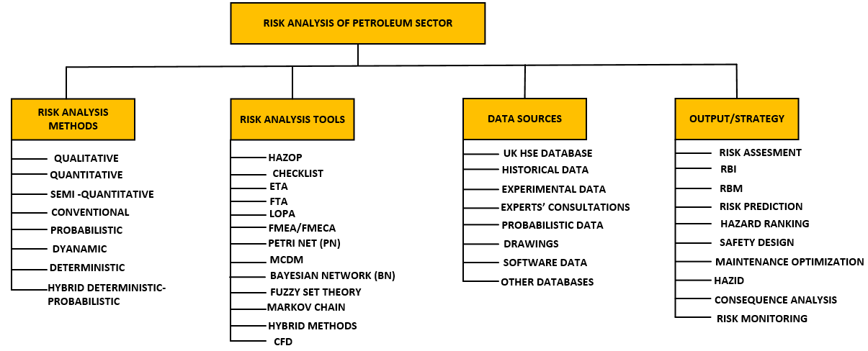
Figure 1: Classification framework for risk analysis in the Petroleum sector (Isaac et al. 2018)

Risk Matrix
A risk matrix was constructed using a structured approach that identified relevance of project risk. It assessed potential consequences of project risk by combining qualitative and quantitative analysis. A risk matrix is a semi-quantitative assessment tool used to categorize and prioritize risk of events and to decide if certain risks can be accepted based on historic statistical data (Huihui et al., 2010, Duijm, 2015). Two input variables were needed to determine risk level, a combination of risk probability and the severity of impact (Tongyuan et.al 2018). Using the criticalities of risks, different priorities of risks were indicated, signifying hazardous risks and which risk could be ignored (Huihui et al., 2010).
The likelihood of the risk level and the risk of potential consequences in a traditional risk matrix had three levels “high, medium, low”. Chen et al., (2008) described that division of risk as simple, brief and not accurate. To improve the reliability and rationality, a scale of 1-9 was divided into five risk levels: very low, low, medium, high, and very high (Table 2). The 5 by 5 risk matrix graph was constructed with the probability as the x-axis and impact as the y-axis.
Table 2: Risk Matrix graph
Probability
 | A | Frequent |  | Low |  | Medium |  | High |  | Very High |  | Very High
 | B | Probable |  | Very Low |  | Low |  | Medium |  | High |  | Very High
 | C | Occasional |  | Very Low |  | Low |  | Medium |  | High |  | High
 | D | Remote |  | Very Low |  | Low |  | Low |  | Medium |  | High
 | E | Improbable |  | Very Low |  | Low |  | Low |  | Medium |  | Medium
 |  |  | 1 |  | 2 |  | 3 |  | 4 |  | 5
 |  |  | Negligible |  | Minor |  | Moderate |  | Major |  | Catastrophic
 |  |  | -----------------------Impact Severity Increases --------------------->

Impact of failure was divided into three criteria human, economic and environmental as seen in Table 3. A bow tie analysis was conducted and possible outcomes of the bow tie analysis were estimated using this impact of failure and places in the risk matrix (Table 3).
Table 3: Impact of Failure (ISO 17776 Risk Ranking)
 | Severity Rating | Negligible | Minor | Moderate | Major | Catastrophic
Consequences | Human | Slight Injury | Minor Injury | Major Injury | Single Fatality | Multiple fatalities
 | Economic | Slight Damage | Minor damage | Local damage | Major damage | Massive effect
 | Environmental | Slight effect | Minor effect | Localised effect | Major effect | Massive effect

The risk matrix was constructed using the International Organization for standardization requirement (ISO, 2009). Within the matrix, as shown in Table 4, the green region indicates reasonably tolerable risk, the yellow region indicates risk that is tolerable with control, the orange and red regions indicate unwanted and intolerable risk.
Table 4: Color code description
Color | Risk description | Risk qualitative description
Red | Intolerable | Risk must be mitigated; either decreases the probability or relieve consequence
Orange | Unwanted | Unwanted and only accepted when risk reduction is impracticable
Yellow | Tolerable with control | Acceptable after review, and safety measures imposed
Light Green | Reasonably tolerable | Risk reduction not needed
Dark Green | Tolerable | Risk could be neglected

Real time decision making incorporating dynamic risk management
Risk Management in the oil and gas industry is complex. To make sense of it, dynamic risk modelling which incorporates the effect of human decisions with technical conditions is implemented. Paltrinieri et.al (2016) described four classes of approaches signifying different levels of correlation to the overall risk picture. The classes ranged from methods for safety indicator development, whose connection was assumed based on past accident analysis, to methodologies based on a broad set of technical, human, and organizational indicators as seen in Figure 2.
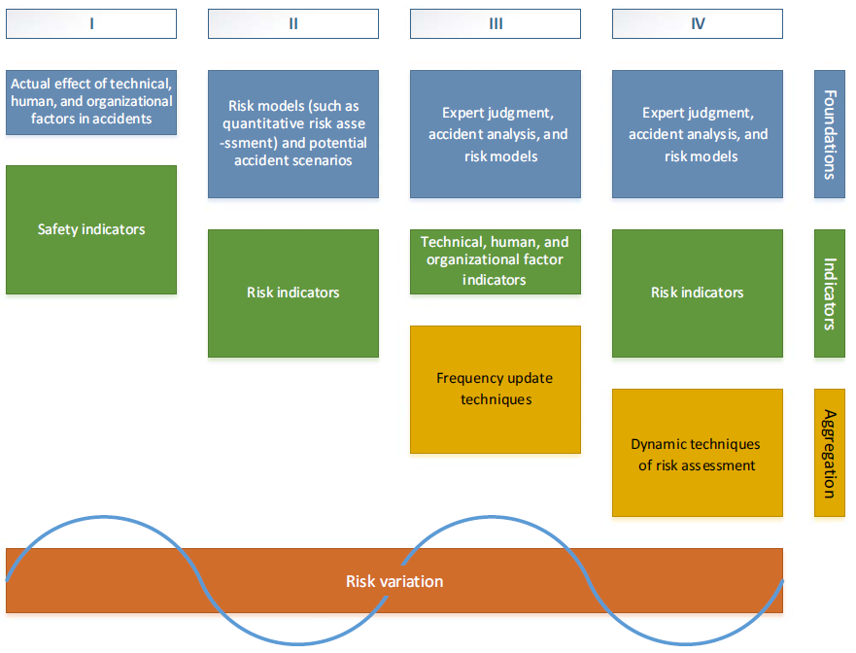
Figure 2: Classes of approaches for dynamic risk assessment through monitoring of technical, human, and organizational factors (Paltrinieri et.al 2016)
Risk variations may be expressed in terms of metrics by aggregating the information provided by all indicators to assess the overall risk level.
Dynamic risk modelling enabled three evolutionary capabilities in risk management:
- Awareness of cumulative and current risk based on input from multiple points and times of origin.
- Quantitative insight into the coupling effect of multiple hazards when barriers or controls change conditions or fail.
- The integration of real-time data into risk understanding, management and decisions.
Dynamic risk modelling is a natural advancement in risk management based on existing methods. It supports critical decision making by quantifying, aggregating, and understanding current risk at the time decisions are made. It aids in applying real-time data to predictive decision making. A model obtaining incessant data could be processed with human and environmental factors and interpreted into real time perception and risk awareness (Ikwan, 2020). After a visual depiction of relationships between hazards and controls had been actualized, dynamic risk modelling was used to quantify the effect controls can potentially have on hazards by applying historical and real-time data into a probabilistic model. The output of a dynamic risk model is near real-time quantitative predictions of risk likelihood. The dynamic risk modelling was represented using FTA. The Logic gates were coded so that the ‘OR’ gate was indicated the maximum number and the ‘AND’ gate was the sum of events / the number of events.

Leak in a storage tank
A combination of FD, FTA and risk matrix analysis methods were used, to produce quantitative risk prediction for a storage tank to aid decision making. The quantitative evaluation included probability categorization of basic events that could lead to a tank leak and severity of accident occurrence. At the same time, the risk level of events was given from the risk matrix.
An integrated method was created to categorize, evaluate and predict risk. The evaluation process detailed in the technical roadmap shown in Figure 3 included four steps: establishment of FD and FTA model, processing of probability and impact analysis for risk value calculation and RM analysis to develop a risk level. The third step was to introduce RTD together with the risk value and risk matrix into the FTA. Fourth part was the analysis, evaluation, and comparison of results from the risk matrix analysis method mixed with RTD and FTA.
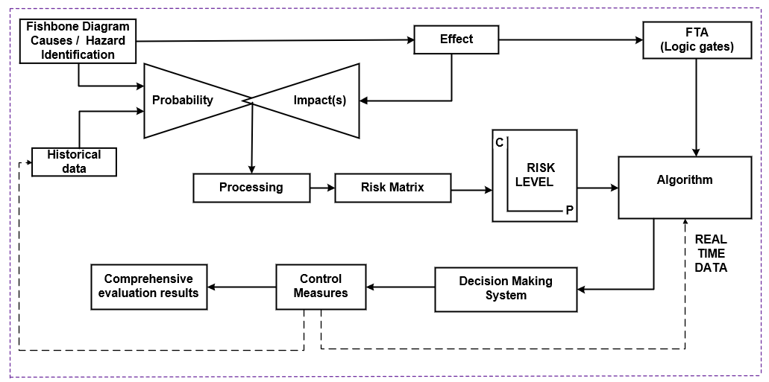
Figure 3: Systemic representation of the new comprehensive evaluation method
FD was used to describe problems that could occur, aid identification of risk and potential problems or failure that could lead to a leak in a storage tank. The FD was used for root cause analysis to investigate and identify the underlying causes or events that can lead to a leak in a storage tank. The four main components leading to direct causes of a leak in a storage tank included: management limitations, human/equipment failure factors, hazardous state of tank and environmental effects.
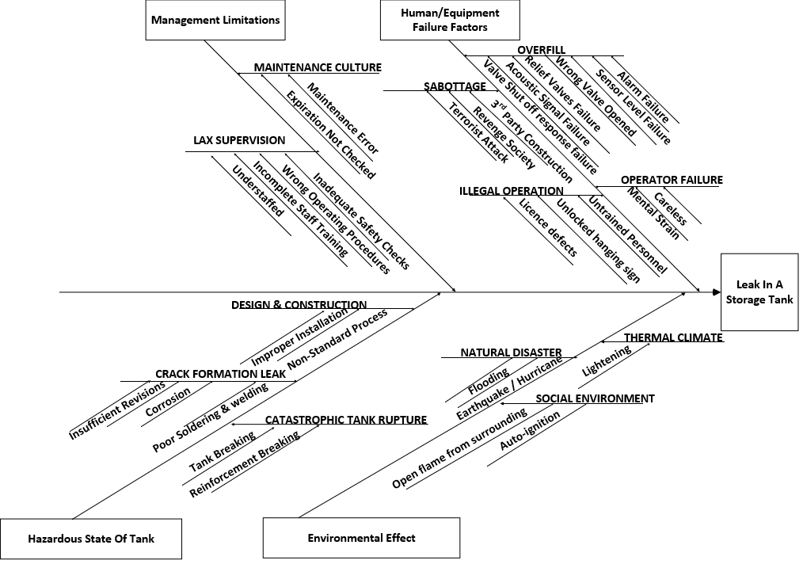
Figure 4: Fishbone diagram of a leak in a storage tank
FTA was constructed using gate symbols to describe the relationship between events as shown in Figure 5. FTA was used to determine the root causes of leak in a storage tank. The fault tree was constructed using ‘OR’ gates to suggest that an event would happen if one or more of the input events arose and ‘AND’ gates would occur if all input events occurred.
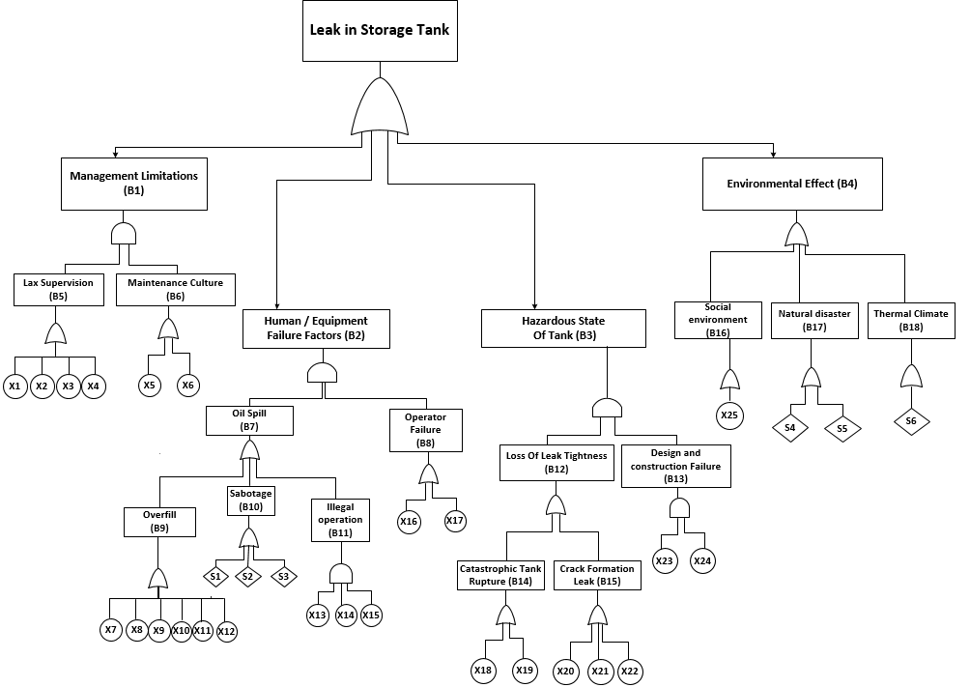
Figure 5: FTA showing leak in a storage tank
To calculate risk of hazards, the probabilities of basic events or undesired events occurring needed to be determined. For the analyzed top event, some 25 basic events and 6 secondary events were defined (Table 5). Fault probabilities were determined using data from research on fuel storage (Jose et.al 2017, Tongyuan et al. 2018, Daqing et.al 2013).
Table 5: Index and description of events in the FTA diagram
Index | Description | Index | Description
T | Leak in storage tank | X₁ | Wrong Operating Procedure
B₁ | Management Limitations | X₂ | Understaffed
B₂ | Human/Equipment Failure Factors | X₃ | Incomplete Training
B₃ | Hazardous State of Tank | X₄ | Inadequate Safety Check
B₄ | Environmental Effect | X₅ | Maintenance Error
B₅ | Lax Supervision | X₆ | Expiration not checked
B₆ | Maintenance Culture | X₇ | Sensor Level Failure
B₇ | Oil Spill | X₈ | Valve Shut Off Response Failure
B₈ | Operator Failure | X₉ | Acoustic Signal Failure
B₉ | Overfill | X₁₀ | Wrong Valve Opened
B₁₀ | Sabotage | X₁₁ | Alarm Failure
B₁₁ | Illegal Operation | X₁₂ | Relief Valves Failure
B₁₂ | Loss of Leak Tightness | X₁₃ | Unlocked hanging sign
B₁₃ | Design and Construction | X₁₄ | License defects
B₁₄ | Catastrophic Tank Rupture | X₁₅ | Untrained Personnel
B₁₅ | Crack Formation Leak | X₁₆ | Mental load
B₁₆ | Social Environment | X₁₇ | Careless
B₁₇ | Natural Disaster | X₁₈ | Reinforcement breaking
B₁₈ | Thermal Climate | X₁₉ | Tank Breaking
S₁ | Terrorist Attack | X₂₀ | Corrosion
S₂ | Revenge Society | X₂₁ | Insufficient Revisions
S₃ | 3rd party construction | X₂₂ | Poor Soldering
S₄ | Earthquake/Hurricane | X₂₃ | Improper Installation
S₅ | Flooding | X₂₄ | Non-standard process
S₆ | Lightening | X₂₅ | Open Flame from Surrounding

The impact was considered for human loss, economic loss and environmental damage as seen in Table 1. Using information from Table 1, Table 3 and research literature (Jose et.al 2017, James et.al 2009, Feng et.al 2018), the basic and secondary events were ranked on a scale of 1-9 in terms of economic, human and environmental impact. Probability and impact values were ranked from 1-9 for ease of representation, where 1 described lowest probability or impact and 9 described highest probability or impact. Individual risk for human, environmental and economic impact was calculated using equation 1. To improve rationality, the scale of 1- 9 was divided into five risk levels: very low, low, medium, high, very high. A risk matrix graph was constructed based on probability as x-axis and impact as the y-axis. The RM graph used is shown in Table 2. A RM of probability vs impacts (economic, environmental and human) were plotted. As an example, Figure 6 and Table 6 shows the risk matrix and risk levels for environmental impact vs probability. Risk levels was extracted from the chart in Figure 6 and sequenced in Table 6. X7 and X11 had ‘very high’ risk, X8, X10, S2, X16 were categorized as ‘high’ risk, and X3 was categorized as ‘low risk’. Other events were categorized as ‘medium’ risk for environmental effect.
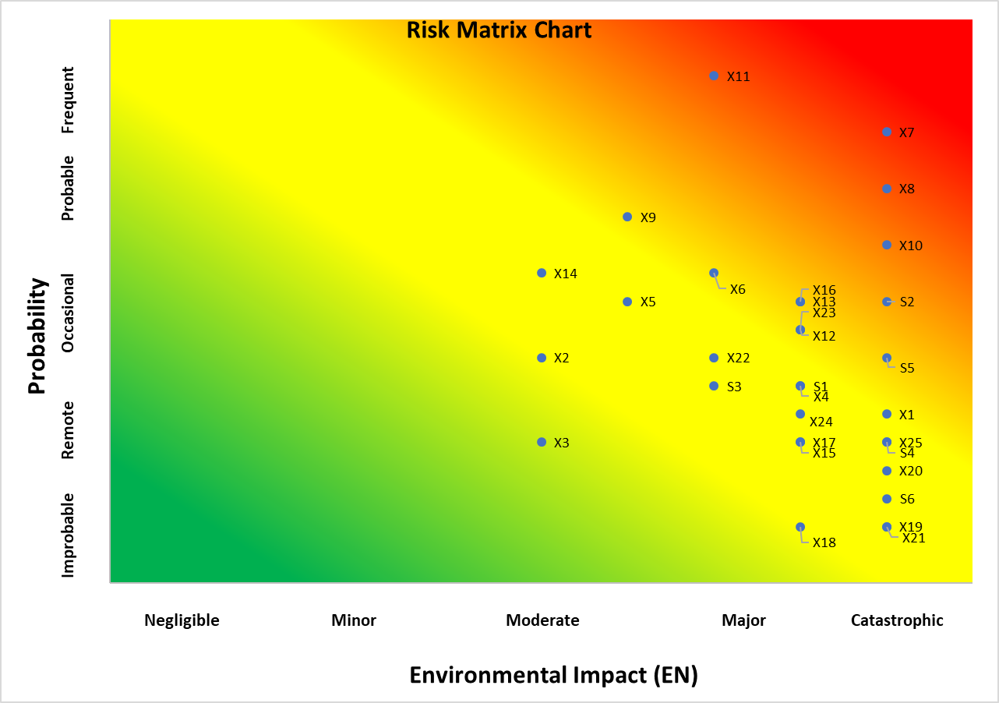
Figure 6: Risk matrix chart of environmental impact
Table 6 shows that X7, X8, X11 were ‘High’ or ‘Very High’ in all three impact categories. X3 was Low risk for environmental impact. X13, X21, S4, S6 were “Low” risk for economic impact. X18, X19, X20, were “Low” risk for human impact. Others were “medium" risk.
Table 6: Risk Matrix Analysis of Economic, Human and Environmental Impact
Index | Risk Matrix Analysis (Economic Impact) | Risk Matrix Analysis (Human Impact) | Risk Matrix Analysis (Environmental Impact) | Index | Risk Matrix Analysis (Economic Impact) | Risk Matrix Analysis (Human Impact) | Risk Matrix Analysis (Environmental Impact)
X1 | Medium | Medium | Medium | X14 | Medium | Medium | Medium
X2 | Medium | Medium | Medium | X15 | Medium | Medium | Medium
X3 | Medium | Medium | Low | X16 | Medium | Medium | Medium
X4 | Medium | Medium | Medium | X17 | Medium | Medium | Medium
X5 | Medium | Medium | Medium | X18 | Medium | Low | Medium
X6 | Medium | Medium | Medium | X19 | Medium | Low | Medium
X7 | High | High | Very High | X2 | Medium | Medium | Medium
X8 | High | High | High | X20 | Medium | Low | Medium
X9 | Medium | Medium | Medium | X21 | Low | Medium | Medium
X10 | Medium | Medium | Major | X22 | Medium | Medium | Medium
X11 | High | High | Very High | X23 | Medium | Medium | Medium
X12 | Medium | Medium | Medium | X24 | Medium | Medium | Medium
S1 | High | Medium | Medium | X25 | Medium | Medium | Medium
S2 | Medium | Medium | High | S4 | Low | Medium | Medium
S3 | Medium | Medium | Medium | S5 | Medium | Medium | Medium
X13 | Low | Medium | Medium | S6 | Low | Medium | Medium

  - Incorporating Real time data and Risk matrix into FTA
Dynamic risk modeling involves the cumulative and current risk based on input from multiple points and times of origin and incorporation of real-time data (RTD) into risk awareness, management and decisions. The dynamic risk modeling was represented using FTA. The RTD were assumed to be numbers inputted from sensors, switches or maintenance reports for monitoring purposes. Reliability scenarios were used to test the system and fed into the algorithm. The logic gates were coded in a way that the ‘OR’ gate was indicating the maximum number and the ‘AND’ gate was the sum of events / the number of events. Using ‘B2’ (Table 5), human/equipment failure of environmental impact vs probability as an example, Figure 7 shows the risk level produced from the risk value mixed with real time data. The sum of the RTD and risk level for environmental impact were divided by two to generate a new number.
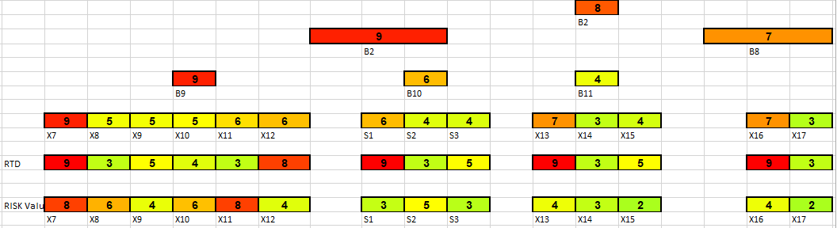
Figure 7: Risk level from risk value mixed with real time data for human/equipment failure of environmental (Scenario 1)
  - Testing of System and Results
The model was initially tested using reliability scenario data that covered all possible eventualities. The purpose for testing the system was to show components likely to fail and needs immediate attention. Figure 7 which shows B2 was used as an example for scenario 1. Each possible failure (event) has different decisions that could be made. This section assessed decisions that could be made on B8 and B9.
Failure in these systems could be caused by faulty level sensor, incorrect valve setting or operators failure to recognize problems. Failures could result to product over ﬂow, spill of liquid down external tank walls, formation of inﬂammable atmosphere as fuel hits ﬂoor. There could be a serious risk of explosion and/or pool ﬁre with chain reaction to affect nearby tanks if source of ignition exists. Figure 8 shows risk level from risk value mixed with real time data for human/equipment failure of environmental (Scenario 2).
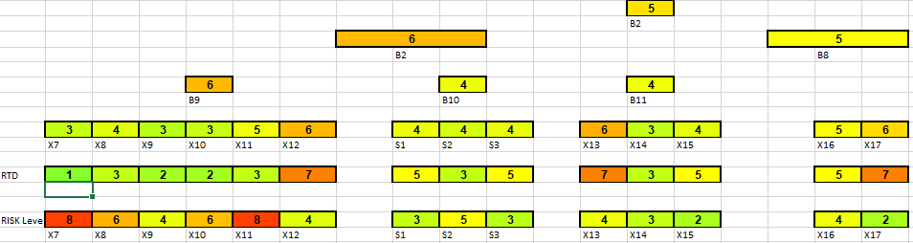
Figure 8: Risk level from risk value mixed with real time data for human/equipment failure of environmental (Scenario 2)
An operator failure could be caused by X16 or X17. Table 7 shows decisions made based on the different warning scenarios for operator failure. The first scenario assumes that a failure might soon occur as operator might be fatigued and the second scenario assumes no failure has occurred in the system.
Table 7: Decisions made based on the different warning scenarios for operator failure
B8  (Operator Failure) | X16 | X17 | Decision
Scenario one | 7 | 3 | Continue Inflow of products to tank and appropriate measures should be taken immediately. Operator is getting towards the end of shift. A break could be taken to reduce mental load.
Scenario two | 5 | 6 | Continue Inflow of products to tank.

An overfill could be caused by X7, X8, X9, X10, X11 or X12. Table 8 shows decisions made based on the different warning scenarios for overfill. The first scenario assumes that a failure has occurred in the sensor level and the second scenario assumes no failure has occurred in the system.
Table 8: Decisions made based on the different warning scenarios for overfill
B9(Overfill) | X7 | X8 | X9 | X10 | X11 | X12 | Decision
Scenario one | 9 | 5 | 5 | 5 | 6 | 6 | An overfill has occurred and this was as a result of X7 (sensor level). Halt and divert inflow of product into tank and carry out maintenance/troubleshooting.
Scenario two | 3 | 4 | 3 | 3 | 5 | 6 | Continue Inflow of products to tank and appropriate measures should be taken immediately on X12.

The pattern showing the ‘States’ (shown in Fig. 7, 8) illustrated a change in ‘State’ (that is a change in color) when the inputs were updated. An operator observing a steady increase in risk level(s) could reasonably predict that the level could continue increasing until a dangerous level was reached. Values shown, depict the effect of the analysis for impacts (Human, environmental, economic) mixed with RTD on the top event (T). The operator is likely to identify a system that could go into a fail state, decide and avert catastrophe. To ensure that all basic events were tackled, all processes including the risk levels were evaluated. Basic event that could lead to the incident under study was highlighted and preventive measures put in place to guarantee elimination of their influences. This method could be applied to the Buncefield incident. The Buncefield storage tank had two forms of level control: a gauge that enabled the employees to monitor the filling operation; and an independent high-level switch (IHLS) (BMIIB, 2005). The first gauge stuck, and the IHLS was inoperable and there was no means to alert the control room staff that the tank was filling to dangerous levels. Eventually, large quantities of petrol overflowed from the top of the tank. A vapour cloud formed, ignited, and caused a massive explosion and fire that lasted five days. This system could have identified the root causes that could have been triggered and led to the incident. An evaluation and representation using this system could have given the operator a real time insight of the current state of the Buncefield Tank 912, allowing the operator time to proffer control measures to prevent the catastrophe from happening.
- Conclusion
Risk assessment is vital for safety management. Leak of storage tank could lead to loss of lives, environmental defects and economic losses, so there is a need for a comprehensive risk evaluation method to identify risk sources before things go wrong.
This paper established a dynamic risk assessment method that combined risk levels and real time data to predict leak in a storage tank. FD was used as a qualitative analysis method. A combined quantitative risk analysis method of risk levels and FTA was calculated using Boolean logic.
A dynamic model obtaining incessant data was processed with human, environmental factors and interpreted into real time perception and risk awareness to aid operators to recognize a potentially dangerous circumstances and act in a timely manner. An intelligent system that recognized increasing level(s) and drew attention to the possibility of further increase before unsafe levels are reached was used to analyse and make critical decisions. This method could show the operator the current state of risk of basic events.
A risk matrix was used to rank and prioritize risk of leak in a storage tank and make decisions about risks that could be tolerated based on historically statistic data. To improve the reliability and rationality, the initial scale of 1- 9 was divided into five risk levels: very low, low, medium, high, and very high. Individual risk and the total risk of human, environmental and economic impact was calculated.
The combined method of Risk matrix, FD, FTA and RTD created a new comprehensive risk evaluation method. This method could guide operators to mitigate or avoid potential process hazards. Immediate corrective measures to reduce or eradicate the occurrence of the risk of leak accident of the tank must be taken. Predicted ‘states’ of intermediate events could aid evaluation of causes, effects, safety risk, timely control and reduce hidden hazards where necessary.
Future work will include using multicriteria decision making methods such as Analytical Hierarchy Process and Preference Ranking Organization Method for Enrichment Evaluation to predict risk (Ikwan et.al 2020) (Haddad et.al 2021). A rule-based method could be used to generate data from reliability engineering calculations, multicriteria decision making methods and sequenced in machine learning to further reduce dependency on human judgement and better predict failures (Sanders et al 2018, Haddad et.al 2020, Omoarebun et.al 2021).

References
- Alkazimi, M.A., Grantham, K., 2015. Investigating new risk reduction and mitigation in the oil and gas industry. J. Loss. Prev. Process. Ind. 34, 196-208. https://doi.org/10.1016/j.jlp.2015.02.003.
- Aven, T., 2016. Risk assessment and risk management: review of recent advances on their foundation. Eur. J. Oper. Res. 253, 1–13. https://doi.org/10.1177/1748006X17699145.
- Buncefield Major Incident Investigation Board (BMIIB)(2005). The Buncefield Incident: The final report of the Major Incident Investigation Board. HSE Books. ISBN:9780717662708 www.buncefieldinvestigation.gov.uk
- Chen, J., Li, Z., Tang, S., Zhao, G., 2008. Acquisition risk evaluation for weapon and equipment based on improved risk matrix method. Syst. Eng. Electron. 30(10), 1918-1923.
- Daqing, W., Peng, Z., Liqiong, C., 2013. Fuzzy fault tree analysis for fire and explosion of crude oil tanks. J Loss. Prev. Process. Ind. 26,1390-1398. https://doi.org/10.1016/j.jlp.2013.08.022.
- Duijm, N.J., 2015. Recommendations on the use and design of risk matrices. Saf. Sci. 76, 21-31. https://doi.org/10.1016/j.ssci.2015.02.014.
- Feng, Z., Ming-guang, Z., Jian, S., Fu-zhen, C., 2018. Analysis on Risk of Multi - factor Disaster and Disaster Control in Oil and Gas Storage Tank. Procedia. Eng. 211,1058-1064.
- Huihui, N., Chen, A., Chen., N, 2010. Some extensions on risk matrix approach. Saf. Sci. 48, 1269-1278. https://doi.org/doi: 10.1016/j.ssci.2010.04.005.
- Haddad, M., Sanders, D., Thabet, M., Gegov, A., Ikwan, F., Omoarebun, P., Tewkesbury, G., Hassan, M., 2021. Use of the Analytical Hierarchy Process to Determine the Steering Direction for a Powered Wheelchair. In: Arai K., Kapoor S., Bhatia R. (eds) Intelligent Systems and Applications. IntelliSys 2020. Advances in Intelligent Systems and Computing, Springer, Cham; 1252, 617-630.
- Haddad, M., and Sanders, D., 2020. Artificial Neural Network approach for business decision making applied to a corporate relocation problem. Arc. Bus. Res. 8(6), 180-195.
- Ikwan, F., 2018. Reducing energy losses and alleviating risk in petroleum engineering using decision making and alarm systems. J. comput. Syst. Eng. ISSN 1472-9083, 422-429.
- Ikwan, F., Sanders, D., Haddad, M. 2020. A Combined AHP-PROMETHEE Approach for Intelligent Risk Prediction of Leak in a Storage Tank. Int. J. Rel. Risk Saf.: Theory and Application. Accepted and In Press.
- Ikwan, F., Sanders, D., Haddad, M., Hassan, M.G, Omoarebun, P., Thabet, M., Tewkesbury, G., Vuksanovic, B., 2021. Intelligent Risk Prediction of Storage Tank Leakage Using an Ishikawa Diagram with Probability and Impact Analysis. In: Arai K., Kapoor S., Bhatia R. (eds). Intelligent Systems and Applications. IntelliSys 2020. Advances in Intelligent Systems and Computing, Springer, Cham. 1252, 601-616.
- Ilie, G., Ciocoiu, C.N., 2010. Application of fishbone diagram to determine the risk of an event with multiple causes. Manage. Res. Prac. 2(1), 1–20.
- Isaac, A., Mahmood, S., 2019. Application of risk analysis in the liquefied natural gas (LNG) sector: An overview. J. Loss. Prev. Process. Ind. 63,1-34. https://doi.org/10.1016/j.jlp.2019.103980.
- ISO., 2009. Risk management principles and guidelines. ISO 31000:2009. https://www.iso.org/standard/43170.html. Accessed June 25, 2020.
- James, C., Cheng-Chung, L., 2009. A study of storage tank accidents. J. Loss. Prev. Process. Ind. 19(1): 51-59. https://doi.org/10.1016/j.jlp.2005.05.015.
- José, L., Carmen, G-C., Cristina, G-G., Piedad, B., (2017) Risk Analysis of a Fuel Storage Terminal Using HAZOP and FTA. Int. J. Environ. Res. Public. Health.14(7),705. https://doi.org/0.3390/ijerph14070705.
- Juran, J.M., 2009. Juran's Quality Handbook. New York: McGraw-Hill.
- Koivisto, R., Wessberg, N., Eerola, A., Ahlqvist, T., Kivisaari, S., Myllyoja, J., Halonen, M., (2009). Integrating Future Oriented Technology Analysis and Risk Assessment Methodologies. J. Tech. Fore. Social. Change. 76(9), 1163-1176. https://doi.org/10.1016/j.techfore.2009.07.012.
- Omoarebun, P., Sanders, D., Ikwan, F., Hassan, M., Haddad, M., Thabet, M., Piner, J., Shah, A, 2021. Intelligent Monitoring Using Hazard Identification Technique and Multi-sensor Data Fusion for Crude Distillation Column. In: Arai K., Kapoor S., Bhatia R. (eds). Intelligent Systems and Applications. IntelliSys 2020. Advances in Intelligent Systems and Computing, Springer, Cham, (1252):730-741.
- Paltrinieri, N., Landucci, G., Nelson, W., Hauge, S., 2016. Proactive Approaches of Dynamic Risk Assessment Based on Indicators. In: Dynamic Risk Analysis in the Chemical and Petroleum Industry: Evolution and Interaction with Parallel Disciplines in the Perspective of Industrial Application. United Kingdom, Elsevier, 89-99.
- Paltrinieri, N., Khan, F., 2016. Dynamic Risk Analysis in the Chemical and Petroleum Industry: Evolution and Interaction with Parallel Disciplines in the Perspective of Industrial Application. United Kingdom, UK, Elsevier, 65-70.
- Pham, H., 2011. Safety and Risk Modelling and its Applications. Spr. Ser. Rel. Eng. 60(1),125-133.
- Sanders, D., Gegov, A., Haddad, M., Ikwan, F., Wiltshire, D., Chai, T., 2018. A Rule-Based Expert System to Decide on Direction and Speed of a Powered Wheelchair. IntelliSys. 1, 822-838.
- Tongyuan, L., Chao, W., Lixiang, D., 2018. Fishbone diagram and risk matrix analysis method and its application in safety assessment of natural gas spherical tank. J. Cleaner. Prod. 174, 296-304. https://doi.org/10.1016/j.jclepro.2017.10.334
- Villa, V., Paltrinieri, N., Khan, F., Cozzani, V., 2016. Towards dynamic risk analysis: a review of the risk assessment approach and its limitations in the chemical process industry. Saf. Sci. 89, 77-93. https://doi.org/10.1016/j.ssci.2016.06.002.
- Watson G. The Legacy Of Ishikawa. Quality Prog. 37(4), 47-54.

This research did not receive any specific grant from funding agencies in the public, commercial, or not-for-profit sectors.

