The proportion of periportal mesenchyme to ductal epithelial cells acts as a rheostat for liver cell proliferation
Lucía Cordero-Espinoza^{1,2,3*}, Anna M. Dowbaj^{4*}, Timo N. Kohler^{2,5}, Bernhard Strauss¹, Olga
Sarlidou¹, German Belenguer⁴, Clare Pacini⁶, Nuno P. Martins⁴, Ross Dobie⁷, John R. Wilson Kanamori⁷, Richard Butler¹, Nicole Prior⁴, Palle Serup⁹, Florian Jug⁴, Neil C. Henderson^{7,8}, Florian Hollfelder⁵ and Meritxell Huch^{1,2,3,4,$}

¹ Wellcome Trust/Cancer Research UK Gurdon Institute, Cambridge, CB2 1QN, UK
² Wellcome Trust–Medical Research Council Stem Cell Institute Cambridge, CB2 1QR, UK
³ Department of Physiology, Development and Neuroscience, University of Cambridge, Cambridge, CB2 3DY, UK
⁴ Max Planck Institute of Molecular Cell Biology and Genetics, Dresden 01307, Germany
⁵ Department of Biochemistry, University of Cambridge, Cambridge, CB2 1GA, UK
⁶ Wellcome Sanger Institute, Wellcome Genome Campus, Hinxton, Cambridge, CB10 1SA, UK
⁷Centre for Inflammation Research, The Queen’s Medical Research Institute, University of Edinburgh, UK
⁸ MRC Human Genetics Unit, Institute of Genetics and Cancer, University of Edinburgh, UK
⁹Novo Nordisk Foundation Center for Stem Cell Biology (DanStem), University of Copenhagen 17 *, equal contribution
$, correspondence: Meritxell Huch, huch@mpi-cbg.de

Keywords: liver, organoid, niche, mesenchyme, regeneration, organotypic, co-culture

Summary:
In the liver, ductal cells rarely proliferate during homeostasis, but do so transiently after tissue injury. These cells can be expanded as organoids that recapitulate several of the cell-autonomous mechanisms of regeneration but lack the stromal interactions of the native tissue. Here, using novel organotypic co cultures that recapitulate the ductal-to-mesenchymal cell architecture of the portal tract, we demonstrate that a sub-population of periportal mesenchymal cells exerts a dual control on proliferation of the epithelium. Ductal cell proliferation is either induced and sustained, or conversely, completely abolished depending on the dosage of direct mesenchymal cell-cell contacts, through a mechanism mediated -at least in part- by Notch signaling. Our findings re-evaluate the concept of the cellular niche, whereby not only soluble factors but also cell-cell contacts are the key regulatory cues involved in the control of cellular behaviors, suggesting a critical role for cell-cell contacts during regeneration.

Introduction:

The adult liver epithelium comprises laminae of hepatocyte cords and an arborising network of biliary ducts, lined by cholangiocytes (also known as ductal cells), which run through the tissue along the portal tract axis. The hepatic epithelium is mostly mitotically dormant in homeostasis, yet proliferates swiftly upon damage, enabling rapid regeneration (Miyajima et al., 2014). Although hepatocytes comprise the bulk of the regenerative response (Malato et al., 2011), ductal cells also respond to proliferative stimuli in the context of injury (Furuyama et al., 2011). In addition, severe tissue damage, as well as hepatocyte senescence/cytostasis, induce cellular plasticity in the ductal compartment, and endow the otherwise unipotent cholangiocytes with the capacity to replace lost hepatocyte mass (Choi et al., 2014; Raven et al., 2017). Healthy adult ductal cells can be expanded in vitro as bi-potent self-renewing liver organoids in a 3D extracellular matrix (Matrigel) and a defined cocktail of growth factors –RSPO-1, FGF10, EGF and HGF (Huch et al., 2013; Huch et al., 2015), which aim to recapitulate the transient mitogenic milieu of the regenerating liver (Apte et al., 2008). Using this model system, we have recently shown that liver ductal organoids recapitulate many aspects of liver regeneration in a dish (Aloia et al., 2019). Notwithstanding, across multiple mammalian tissues, regeneration relies on the dynamic crosstalk between the epithelium and its respective tissue microenvironment (Gurtner et al., 2008). The contribution and role of the latter in the ductal-mediated regeneration of the liver is largely unknown. Current ex vivo adult liver organoid models are epithelial-centric and fail to recapitulate the multicellular complexity of the adult tissue (Prior et al., 2019), hampering an in-depth understanding of the stromal niche-to-epithelial cell interactions during homeostasis and regeneration.

The patterning of hepatic epithelium throughout development is intricately dependent on cues from apposed mesenchymal tissues. During development, hepatic endodermal progenitors (known as hepatoblasts) invade the adjacent septum transversum mesenchyme (STM) (Zaret, 2002), whilst cholangiocyte commitment at the ductal plate is guided by the neighboring portal mesenchyme (Hofmann et al., 2010). Previous studies have shown that incorporation of embryonic mesenchymal stem cells to iPSC-derived hepatic epithelial cultures facilitates the organization of 3D liver buds ex vivo (Takebe et al., 2013), and mesenchyme-secreted factors like FGF, BMP and HGF are routinely used for the stepwise differentiation of pluripotent stem cells into liver tissue (Si-Tayeb et al., 2010; Touboul et al., 2010). In the adult liver, the hepatic mesenchymal pool, whose ontogeny traces back to the STM (Zorn, 2008), diversifies into centro-lobular fibroblasts and smooth muscle cells, lobuleinterspersed hepatic stellate cells (HSCs) and a portal tract restricted population referred to as portal fibroblasts (PFs) (Lepreux and Desmouliere, 2015). For many years the physiology of these cells has been appraised in the context of various disease-states including fibrosis, steatohepatitis and cancer, following their transformation into a collagen-depositing myofibroblast state (Mederacke et al., 2013; Ramachandran et al., 2019). Despite being susceptible to pathological subversion, the hepatic mesenchyme is crucial for maintaining tissue homeostasis and orchestrating normal regenerative responses (Coll et al., 2018; Ouchi et al., 2019). Non-genetic methods to inhibit HSC activation in vivo exacerbate liver damage whilst diminishing ductal cell expansion and negatively impacting animal survival (Pintilie et al., 2010; Shen et al., 2011). Mechanistically, Thy1⁺ HSCs and PFs have been identified as a source of FGF7 that sustains ductal cell proliferation during regeneration (Takase et al., 2013), whilst Jagged1⁺ myofibroblasts direct ductal lineage differentiation in mouse models of chronic liver damage (Boulter et al., 2012). Although these studies highlight discrete cases of mesenchymal-toductal cell signaling, they do not address the dynamic interactions of these lineages in homeostasis nor throughout the different phases of the regenerative cascade. In addition, in vitro co-culture models with different stromal populations including endothelium and mesenchymal cells, have been devised to enhance the stability and functions of hepatocytes (Berger et al., 2015; Bhatia et al., 1998; Coll et al., 2018; Davidson et al., 2017; Nguyen et al., 2015; Ouchi et al., 2019; Taymour et al., 2021; Ware et al., 2018). However, ductal-mesenchymal co-cultures have not been reported yet.

Here, we describe that a sub-population of peri-portal mesenchymal cells (labelled by SCA1 and PDGFRα) act as a rheostat that regulates the proliferation capacity of the ductal cells. Mesenchymalsecreted mitogens support organoid formation and expansion. However, direct mesenchymal-to-ductal cell-cell contact abolishes ductal cell proliferation in a mesenchyme-dose dependent manner, through mechanisms that involve, at least in part, Notch signaling activation. Hence, our results indicate that the number of cellular contacts between epithelium and mesenchyme, rather than the absolute number of cells in both populations, controls ductal cell proliferation dynamics.

Results:

Periportal PDGFRα⁺SCA1⁺ mesenchymal cells surrounding the biliary duct epithelium express a pro-regenerative growth factor signature

The process of tissue regeneration is a joint endeavor between the parenchymal epithelium and the adjacent surrounding stromal cell compartment. Accordingly, we first sought to characterize the proximate neighbors of the ductal epithelium, which we hypothesized could act as a regulatory niche for ductal cell-driven regeneration. Hepatic biliary duct cells (DCs, also known as cholangiocytes) reside at the portal tract (PT) area of the liver lobule (Figure 1A), spatially separated from the midlobular and central vein (CV) zones. We found that the hematopoietic and cancer stem cell and surface marker SCA1 (Stem Cell Antigen 1, encoded by the gene Ly6a (Upadhyay, 2019), labelled cells exclusively localized at the PT, in proximity to and including the biliary duct epithelium itself, as identified by the marker Osteopontin (OPN). In contrast, SCA1 expression was absent or below detection limit in the remainder of the liver parenchyma, including the peri-central zone (Figure 1A-B and S1A-B). SCA1 expression was also detected in the CD31⁺ endothelium lining the portal vein, but not the VEGFR3⁺ sinusoidal network nor liver-resident macrophages expressing F4/80 (Figure S1AB).

To determine whether the SCA1⁺CD31⁻OPN⁻ cells encompassed a population of periportal mesenchyme, we analyzed the expression of SCA1 in livers derived from Pdgfra-H2B-GFP mice, which readily report expression of the archetypal mesenchymal marker PDGFR (platelet derived growth factor receptor alpha) (Figure S1C). We found that SCA1 labels a subpopulation of mesenchymal cells that closely surround and directly contact the biliary duct epithelium (Figure 1B-D and S1D-G, Supplementary Video 1) and express mesenchymal markers such as CD34 and Elastin, Desmin and Reelin (Figure 1C-D and S1D-F). PDGFRα⁺SCA1⁺ cells were located at a median distance of 8m from the center of the biliary duct, whereas this distance was more than tripled for the PDGFR⁺SCA1⁻ fraction (Figure S1H). Accordingly, we utilized PDGFRα⁺SCA1⁺ expression as a proxy for identifying the mesenchymal cells nearest to the biliary epithelium and focused on this population from here onwards. Pericytes, labelled by SMA expression, appeared to be distinct from the PDGFR⁺SCA1⁺ mesenchyme (Figure S1G).

For an in-depth analysis of the peri-ductal associated stroma, we used Pdgfra-H2B-GFP mouse livers and following Huch et al. (2013) (Figure 2A) we isolated PDGFR⁺SCA1⁺ as well as PDGFR⁻SCA1⁺ and PDGFR⁺SCA1⁻ and EpCAM+ (ductal cells) from healthy murine livers, and obtained their transcriptional profile (Figure 2B). Transcriptome and qRT-PCR analysis confirmed that the PDGFR⁺SCA1⁺ and PDGFR⁺SCA1⁻ cells expressed a clear mesenchymal gene signature, including markers such as Pdgfra, Pdgfrb, Eln, Cd34, Des, Vim, and various collagen (Col1a1, Col1a2 and Col3a1). In contrast, endothelial (e.g. Kdr, Pecam1) genes were highly expressed in the PDGFRSCA1⁺ fraction while ductal (e.g. Krt19, Epcam)-specific genes were highly expressed in the EpCAM⁺ fraction, as expected. Endothelial and ductal cell markers were weakly expressed or absent in the PDGFR⁺SCA1⁺ (Figure 2C-D and S2A-B). Moreover, Thy1 (Katsumata et al., 2017), and Lrat (Mederacke et al., 2013), purported portal fibroblast and HSC markers, respectively, were also expressed in both PDGFR⁺SCA1⁺ and SCA1⁻ populations (Figure 2C-D) while Reelin (Reln), a wellknown hepatic stellate cells (HSCs), was mainly present in the PDGFR⁺SCA1⁻ fraction (Figure 2CD), in agreement with our immunostaining results (Figure S1E). These results thereby suggested high degree of mesenchymal cell heterogeneity.

To gain deeper insight into this heterogeneity and increase the resolution of the SCA1⁺ mesenchymal cell expression profile, we utilized our recently published scRNAseq data of murine liver mesenchyme (Dobie et al., 2019), where three distinct mesenchymal cell clusters are readily identified (Figure 2E): an Acta2-enriched Vascular Smooth Muscle Cell (VSMC) population, a Hepatic Stellate Cell cluster (HSC) marked by Lrat and Reelin-positive cells, and a Portal Fibroblast (PF) cluster marked by Cd34expressing cells (Figure S2C). High Ly6a (SCA1) positive cells were identified in the PF cluster whilst cells expressing weaker levels were detectable within the HSC fraction (Figure 2E). Notably, both HSCs and PFs expressed various members of the WNT and BMP families, including Rspo1, Rspo3, Fgf7, Hgf and Igf1 (Figure 2F and S2D), all of them essential for duct and hepatocyte specification (Rossi et al., 2001), pro-regenerative activation (Hu et al., 2007; Kan et al., 2009; Yang et al., 2014) and organoid formation (Huch et al., 2013; Huch et al., 2015). These results were confirmed in sorted PDGFR⁺SCA1⁺ cells (Figure 2G and S2B) as well as in PDGFR⁺SCA1⁺ after sub-fractioning the cells into PFs and HSCs using the bona-fide PF marker CD34 (PFs, CD34⁺; HSCs, CD34⁻) (Figure S2E-F).
Collectively, these results suggested that double positive PDGFR⁺SCA1⁺ cells (SCA1⁺Msc from hereon) represent a periportal, duct-contacting, mesenchymal sub-population that expresses markers of both PFs and HSCs, and is enriched in paracrine mitogens capable of modulating DC expansion during liver regeneration.

The cellular ratios and cell-cell contacts between DC and SCA1⁺ mesenchyme change dynamically during the damage-regenerative response and negatively correlate with ductal cell proliferation
In vivo, the damaged-induced proliferation of ductal cells is facultative and arrests once the tissue is regenerated, thus warranting the return to homeostasis and preventing disease states (Cordero-Espinoza and Huch, 2018). Having observed that SCA1⁺mesenchymal cells express mitogens known to regulate ductal cell expansion during regeneration and organoid formation, we hypothesized that the relative abundance and proximity of both populations at the portal tract could dictate the proliferative state of the ductal cells during regeneration.
To test this hypothesis, we modelled acute liver damage by feeding mice with 0.1% 3,5diethoxycarbonyl-1,4- dihydrocollidine (DDC) for 5 days, followed by a recovery period in normal diet for 7 and 38 days (Figure 3A and S3A-B) and quantified total cell numbers, cell ratios and cell-cell contacts between ductal cells and SCA1⁺Msc (Figure 3B-D). In healthy tissue, ductal cells (DC) display limited proliferation (Figure S3C), PDGFR⁺SCA1⁺ and DC (OPN⁺) co-exist periportally within close proximity (~11m) (Figure 3A and S3A-B, D), with a median population ratio of 0.3 Msc per 1 DC (0.3:1, from hereon) (Figure 3C) and the majority of DCs (~93%) contacted by a PDGFR⁺SCA1⁺ Msc
(Figure 3A,D and S3E). Following tissue damage (DDC d5), DCs, but not PDGFR⁺ (SCA1⁺ or SCA1) cells increase in numbers (Figure 3B and S3C). This results in a significant drop in the PDGFR⁺SCA1⁺:DC cell ratio (from 0.3:1 to 0.1:1) (Figure 3C), increased distance between both compartments (from ~11m to ~30m) and a significant decrease in the number of cell-cell contacts between both populations (from ~93% to ~84%) (Figure 3D and S3E). By the early phase of recovery (DDC d5+7), the DC pool was still enlarged (Figure 3B) but the percentage of proliferating cells had diminished significantly to its pre-damage condition (Figure S3C). This coincided with an increase in the absolute number of SCA1⁺Msc cells (Figure 3B), a raise in the cell ratios from 0.1:1 to 0.5:1 (Figure 3C), a return to the baseline distance (Figure 3A, S3A-B, D) and a re-establishment of the cell-cell contacts (from ~84% to 96%) (Figure 3A,D). At day 38 of recovery (termination phase), both the DC and PDGFR⁺SCA1⁺ mesenchymal compartments significantly shrank to approximate of their steady state numbers, ratios, spatial disposition and cell-cell contacts (Figure 3A-D, S3A-B, E). Of note, the PDGFR⁺SCA1⁻ mesenchymal compartment did not increase its numbers during the entire damageregenerative response (Figure 3B).
Taken together, these results indicate that both cell populations proliferate, but at different tempo; the ductal cells proliferate first, during damage phase (Day 5, damage), followed by the mesenchymal cells after the damage is removed (Day 7, after recovery). This asynchrony results in a significant and dynamic change in the distance, cellular ratios and number of cell-cell contacts between both populations. Accordingly, we can hypothesize a scenario whereby in steady state the PDGFR⁺SCA1⁺ mesenchyme holds the ductal epithelium in a non-proliferative state; in contrast, upon damage, ductal cell proliferation is prioritized, presumably by mitogenic signals, which results in a temporary drop in the steady-state ratios and cell-cell contacts. Upon cessation of damage, the mesenchymal cells expand and re-establish physical contacts with the ductal epithelium, which eventually reinstates the homeostatic, non-proliferative, steady state.

Secreted factors released by mesenchymal cells activate ductal cell proliferation and organoid formation
The cellular dynamics observed in vivo prompted us to hypothesize that the relative abundance, proximity and cell-cell contacts between the two populations could control the proliferative state of the ductal cells during regeneration. Therefore, we next studied how dynamic changes in Msc:ductal cell numbers and cell-cell contacts impact epithelial cell behavior. For that, we opted to manipulate the cellular ratios between both populations in vitro, in organoid co-cultures, where experimental conditions can be controlled.
Like the regenerating tissue, organoids also depend on key growth factors that mimic the mitogenic microenvironment of the damaged liver. Considering that the SCA1⁺ mesenchymal population expressed a battery of mitogens (Figure 2D-G and S2B,D) that are required for liver organoids to expand (Huch et al., 2013), we first sought to determine whether these cells would support the growth of ductal liver organoids in vitro, interpreted as a functional read-out of being a bona-fide proregenerative niche population. For that, we first identified culture conditions that would enable the maintenance of these mesenchymal cells in vitro. Following several iterations of growth factor and matrix combinations, we selected AdDMEM/F12 supplemented with FBS and WNT3A (hereon called mesenchymal medium-MM) and culturing on plastic to enhance mesenchymal cell viability (Figure S4A-B). Given the low yield of primary PDGFRα⁺ SCA1⁺ and PDGFRα⁺ SCA1⁻ mesenchymal cells isolated from murine livers (Figure S4C), we opted to investigate if our optimized culture conditions would enable serial passaging of these cells, prior to co-culture. We readily expanded PDGFRα⁺SCA1⁺ cells (~2 months in culture, passage 5) (Figure S4D-G) while the endothelial PDGFRα⁻SCA1⁺ cells could not be consistently grown (Figure S4H). Notably, sub-fractioning the PDGFRα⁺SCA1⁺ cells into HSCs and PFs using CD34 (PFs, CD34⁺ and HSCs, CD34⁻), indicated that the cells that expanded in culture were mainly PFs (CD34⁺), since we did not manage to expand the HSC (CD34⁻) fraction, except for one occasion (Figure S4I). Similarly, from the PDGFRα⁺SCA1⁻ fraction, only PF (CD34⁺) cells could be expanded, although only up to P1 and at much lower efficiency (Figure S4I). Expanded PDGFRα⁺SCA1⁺ cells conserved their morphology, secretome and marker expression for the first 3 passages in culture (Figure S4D-G). However, at passage 2 the cells acquired αSma expression, which indicated that they became activated (Rockey et al., 1992), and also exhibited a dramatic drop in Rspo1 expression at passage 3 (Figure S4F).

Next, we co-isolated PDGFR⁺SCA1⁺ mesenchymal cells and EpCAM⁺ ductal dells and embedded them together inside of 3D Matrigel droplets that were overlaid with MM-medium. Interestingly, we observed that co-cultures with SCA1⁺Msc cells sustained organoid formation at an efficiency close to 4%, which was comparable to control organoids receiving the media supplemented with the complete cocktail of growth factors and 4-fold higher compared to DC alone (Figure 4A). This effect was independent of WNT3A and FBS in the mesenchymal medium, since similar results were obtained when basal medium devoid of these components was used (Figure S4J, basal). Culturing SCA1⁺Msc cells on their own did not generate organoids, as expected (Figure 4A, Msc alone panel). Notably, subfractioning for CD34⁺ portal fibroblasts indicated that both SCA1⁺ and SCA1⁻ portal fibroblast mesenchymal fractions were able to support organoid growth when expanded (Figure S4K), in contrast to mouse embryonic fibroblasts, which failed to do so (Figure S4L).
However, considering (1) the low yield of all the sub-fractioned populations, (2) the inability to expand the CD34⁻ cells in our medium, (3) that only the PDGFRα⁺SCA1⁺CD34⁺ fraction can be readily expanded further than P1 and (4) that the majority of the PDGFRα⁺SCA1⁺ are CD34⁺ (~ 85% of all SCA1⁺ are CD34⁺) from hereon we only used PDGFRα⁺SCA1⁺ cells without sub-fractioning for CD34.

To decipher whether the organoid-supportive ability of the SCA1⁺Msc relied on close proximity or soluble growth factors, we co-cultured DC and PDGFR⁺SCA1⁺ cells within transwell-fitting plates, such that contact between both populations was prevented through a cell-impermeable membrane (Figure 4B-E). Under these conditions, we observed a remarkably similar 4-fold increase in organoid formation efficiency in DC/SCA1⁺ Msc co-cultures compared to DC seeded alone (Figure 4B), suggesting that the secreted growth factor repertoire of the SCA1⁺ Msc was directly responsible for supporting DC proliferation and organoid formation. To determine the nature of the organoid structures formed upon co-culture, we compared their molecular identity to that of control organoids grown in standard growth factor-rich medium. For that, we performed RNA sequencing of DC immediately after sorting (d0) and following 15 days (d15) of culture alone in EM (medium supplemented with growth factors) or in a transwell co-culture with SCA1⁺ mesenchymal cells in MM (medium devoid of growth factors) (Figure 4C-E). Control organoids exposed to MM alone displayed minimal growth and could not be sequenced. The use of transwells enabled us to obtain the expression profile of each population independently before and after co-culture. Hierarchical clustering analysis revealed that organoids supported by SCA1⁺Msc closely resembled organoids cultured in EM (Figure 4D). Moreover, they expressed the progenitor markers Tacstd2, Sox9 and Lgr5 (the latter at very low levels) as well as ductal cell markers (Prom1, Krt19 and Epcam) (Figure 4E), suggesting that SCA1⁺Msc are capable of activating differentiated ductal cells to a proliferative state that enables organoid formation. Notably, the expression prolife – including lineage markers and secretome – of the SCA1⁺Msc remained relatively unaltered upon 15 days in culture, either alone or when co-cultured with DC in a transwell (Figure 4E), in agreement with our characterization upon passages (Figure S4D-G) and arguing against a phenotypic transformation in vitro. Remarkably, conditioned medium from serially passaged mesenchymal cells supported organoid formation at a similar mean efficiency (3.3%) than nonexpanded SCA1⁺Msc, suggesting that the cells remain functional even upon expansion (compare Figure 4F with 4A-B). Immunofluorescence analysis indicated that the mesenchymal-supported organoids were formed by a single-layer epithelium (E-cadherin⁺) of proliferative ductal cells (Krt19⁺, Ki67⁺), similar to organoids grown in standard growth factor supplemented medium (Figure 4G).

Collectively, these results highlighted that both freshly isolated and in vitro expanded PDGFRα⁺SCA1⁺, secrete pro-mitogenic factors that enable the activation of differentiated ductal cells into self-renewing liver organoids in vitro.

SCA1⁺ mesenchymal cells dually control ductal cell behavior by promoting or arresting ductal cell proliferation in a cell-cell contact dependent manner
The capacity of the PDGFRα⁺SCA1⁺ mesenchyme to induce ductal cell proliferation and organoid formation in vitro resembled the context of a regenerating liver, yet was seemingly at odds with the low proliferative index of the ductal epithelium in homeostatic (undamaged) tissue (Aloia et al., 2019), from where both cell populations were derived. This led us to re-examine the fidelity of our culturing methods and re-design a culture system that would recapitulate physiological liver architecture. At the portal tract, PDGFRα⁺SCA1⁺ mesenchymal cells are found in the immediate vicinity of DC, physically wrapping the duct epithelium (refer to Figure 1B-D). Recapitulating this cell-cell contact was crucial to characterize the interaction between ductal cells and their niche beyond paracrine signaling; yet such cell proximity became unavoidably disrupted following cell sorting, and our culturing methods – including the mixed co-culture within Matrigel droplets (Figure 4A), the transwell co-culture (Figure 4B-E), and the conditioned media (Figure 4F) – failed to re-establish it (Figure S4M).

Aiming to reconstitute the ductal-to-mesenchymal cell architecture of the portal tract in vitro, we tested a microfluidics-based approach for co-encapsulating ductal and mesenchymal cells into microgel droplets (70m in diameter), such that by restricting the spatial surroundings of the two cell types we would increase the probability of their physical aggregation. As an experimental set-up, we utilized ductal organoids and in vitro expanded SCA1⁺Msc cells tagged with ubiquitously expressed fluorescent reporters, which allowed tracking and live imaging of the cells. After single cell dissociation, the epithelial and mesenchymal populations were resuspended in agarose and loaded separately at a 1:1 ratio onto custom-designed microfluidic flow-focusing devices (FFD (Figure 5A). As the encapsulation process follows a Poisson distribution, multiple permutations were observed, including separate encapsulation of both cell-types and a large number of gels without cells (Figure 5A, S5A). Coencapsulation (i.e., presence of both cell types in one microgel) occurred in ~6% of all events (Figure S5A).
Following encapsulation, the agarose microgels were embedded into 3D Matrigel and cultured in MM for 4-5 days to allow organoid growth. No organoids were formed when seeding the microgels into agarose, nor in Matrigel, when encapsulation was performed in the absence of mesenchyme (Figure S5B-C). We detected the formation of multicellular complex organoids containing both ductal epithelial (nuclear GFP⁺) and mesenchymal (nuclear tdTomato⁺) cells that had established contact at an efficiency of ~25% (Figure 5B). The layout of the Msc-ductal structures was reminiscent of the spatial arrangement between ductal and SCA1⁺Msc in vivo, with the mesenchymal cell(s) positioned on the basal surface of the biliary epithelium (compare Figure 5C, S5D with Figure 1B). We observed a preferential radial distribution (~51%) of the mesenchyme around the ductal structure, as it occurs in vivo (Figure S5D-F, category b), but we also encountered unilateral segregation of multiple SCA1⁺ Msc cells (~28% of cases) (Figure S5D-F, category c). The organoids in contact with mesenchymal cells exhibited additional diversity in terms of their epithelial architecture. We found some complex organoids retaining the single layer epithelial architecture of the biliary duct, with cells encircling a central lumen, typical of ductal organoids, whilst others were characterized by a pseudo-stratified epithelium evident in single z-stack confocal images (Figure 5D). We noted that these two types of architectural arrangements correlated with the proportions of Msc and DC within the complex organoids, such that structures with an Msc:DC ratio of 0.1 retained their single layer epithelial architecture, but in ratios of >0.1 a stratified epithelium developed (Figure 5D).
To probe the effect of mesenchymal cell contact on ductal cell expansion we tracked individual organoids in culture and performed time-lapse imaging from day 4-5 of seeding, when the process of organoid formation had commenced. Surprisingly, we found a very interesting dichotomous behavior. The majority of non- Msc contacted organoids (GFP⁺ only) augmented in cell numbers and organoid area as time progressed (Figure 5E, Figure S5G) (Supplementary video 2-3), as expected from being in the presence of mesenchyme-derived mitogens and reminiscent of our conditioned medium and transwell experiments (Figure 4B-G). In stark contrast, mesenchyme-contacted organoids exhibited a significant paucity in growth (Figure 3E, Figure S5G and Supplementary video 2, 4). This correlated with a reduced proliferative potential in the ductal compartment, assayed by EdU incorporation; which was exacerbated with higher doses of mesenchymal contact (Figure 5F-G). Moreover, we noted a correlation between pseudo-stratified epithelial organization and decreased ductal cell proliferation in the organoids (Figure 5G). Mesenchymal cells forming part of multicellular complex organoids, on the other hand, rarely increased in numbers over the time assayed (Figure S5H).

These observations suggested that SCA1⁺Msc regulate ductal cell behavior in two ways: secreting proproliferative signals yet inducing growth arrest via cell-cell contact and/or physical proximity.

SCA1⁺ mesenchymal niche cells mediate ductal cell proliferation arrest through Notch cell-cell contact inhibition
Having observed the paradoxical behavior of the SCA1⁺Msc population in vitro –whereby the absence of contact induced ductal cell expansion but its physical contact prevented it, in a dose dependent manner, we hypothesized that is the number of contacts and ratios between the two populations (SCA1+ Msc and DC), which ultimately control the ductal cell state.
To test this hypothesis, we opted to recapitulate the regeneration spectrum of PDGFR⁺SCA1⁺: DC ratios under contact-permissive culture conditions in vitro. The microfluidics-based encapsulation method allowed this to a certain extent (Figure 5), but the formation of multicellular organoids was stochastic and there was no exogenous control on the final output of the aggregated PDGFR⁺SCA1⁺ Msc:DC cells, which hampered the systematic analysis of mesenchymal-to-ductal cell interactions at different ratios. We thus devised a new contact-permissive co-culture method wherein DC and PDGFR⁺SCA1⁺ Msc cells were seeded on a 2D layer of Matrigel in 96-well plates, which enabled them to self-aggregate within 48 hours (Figure 6A and S6A). At a 1:1 ratio of cell mixing, this method generated multicellular complex organoids at an efficiency of 94.6% (Figure S6B), from which we inferred that the contact between both populations was directly proportional to the ratio of cells seeded. This was essential, as it allowed the systematic study of cell interactions, both paracrine and cell-bound, at the whole population level instead of on an organoid per organoid basis as required with the microfluidics approach.
Using this co-culture method, we seeded increasing numbers of SCA1⁺Msc (nuclear GFP⁺) with a fixed number of sorted DC (nuclear tdTomato⁺) both in our mesenchymal medium (MM) devoid of growth factors as well as in medium supplemented with the complete cocktail (EM) (Figure 6B-D). In MM, a co-culturing ratio of 0.1:1 (PDGFRα⁺SCA1⁺: DC) –where the probability of mesenchymal contact is rare– resulted in a 3.8-fold increase in organoid formation relative to DC alone (Figure 6B-D), resembling the organoid formation efficiency obtained when DC where co-cultured in transwell or using condition medium (see Figure 4B-G). The ductal cell expansion at 0.1:1 was gradually reversed with increasing ratios of mesenchyme –as epithelial to mesenchymal cell contact augmented– until nearly abolishing organoid growth at ratios of 1:1 and higher (Figure 6B-D). Remarkably, this effect was could not be compensated by a mitogen-rich microenvironment (Figure 6B-D, EM), highlighting the strong cytostatic effect of the contacting mesenchyme. Moreover, at ratios higher than 0.1:1 (Msc: DC) we observed a direct negative correlation between mesenchymal cell dosage and the total number of dividing ductal cells, while the number of apoptotic ductal cells significantly increased (Figure 6EH and S6C-D). Importantly, this phenotype was indeed reliant on physical contact and/or proximity between the two cell types, given that transwell co-cultures between SCA1⁺Msc and DC at a 5:1 ratio robustly promoted, instead of inhibited, organoid expansion (compare Figure S6E with Figure 6C-D). Interestingly, in vitro lineage tracing of Lgr5⁺ progenitors –which are activated from differentiated ductal cells upon organoid culture – revealed a decreased percentage of proliferating Lgr5⁺ cells in organoids contacted by the mesenchyme, even in the presence of complete medium containing RSPO1 and supplemented with WNT3a (EM + WNT) (Figure S6F-G).

Collectively, these results suggest a potential mechanism whereby it is the relative abundance of contacts between ductal cells and their mesenchymal niche cells what curtails the size of the ductal pool. Taking into account the strong correlation between the in vivo and in vitro results (see Figure 3 vs Figure 6) regarding the number cellular ratios, cell-cell contacts and ductal proliferation, our co-culture results suggest a potential scenario whereby in vivo, during the damage regenerative response, the Msc population could act as a direct upstream regulator of the ductal proliferative rheostat.

We next sought to investigate the molecular basis for this cell-to-cell contact inhibition. For that, we examined our RNAseq dataset from the ductal and mesenchymal populations in quest for proximitybased or juxtacrine signaling pathways wherein receptor(s) and ligand(s) could be paired between the two cell populations. We found several components of the Hippo, Notch and TGF pathways to be expressed in ductal cells, SCA1⁺Msc or both (Supplementary Dataset 1), and hence we studied these as putative molecular mediators of such phenotype. DC expressed Notch1 and Notch 2 as well as Tgfbr1 and Tgfbr2 receptors, but not Notch3 and Notch4 (Figure 7A and S7A). The PDGFRα⁺SCA1⁺ cells on the other hand expressed the Notch ligand Jag1 and all Tgfb ligands, most abundantly Tgfb3 (Figure 7A and S7A, Supplementary Dataset 1). Whilst the ligand-receptor pairings of the Hippo pathway have not been fully characterized in the literature, their downstream effectors Yap1 and Wwtr1 (TAZ) were both expressed by the ductal epithelium (Supplementary Dataset 1), as we and others recently reported (Aloia et al., 2019; Pepe-Mooney et al., 2019).

To functionally test whether any of the signaling pathways above could mediate the cell-cell contact inhibition observed in our DC/mesenchymal co-cultures, we devised a small-scale screening assay using small molecule inhibitors of the Notch, Hippo and TGF pathways. For that, freshly sorted DC were pre-treated for 3h with vehicle DMSO or the indicated inhibitor(s) prior to being co-cultured with the mesenchyme, so as to preclude any confounding factors from inhibiting the SCA1⁺ mesenchyme, and organoid formation was scored (Figure 7B). We first confirmed that downstream targets of the aforementioned pathways were indeed downregulated upon treatment (Figure S7B). Then, pre-treated ductal cells were cultured on their own or in the presence of SCA1⁺Msc cells in a ratio expected to suppress cystic (single layer) organoid growth (Figure 7B). Results were normalized to DC cultured alone to account for non-mesenchymal derived phenotypes (Figure 7C). Compared to DMSO controls, pre-treatment with the gamma secretase inhibitors DAPT and DBZ and the YAP inhibitor verteporfin (VP) yielded a significant increase in organoid formation, while TGF inhibitors (A8301 and SB431542) had no significant effect (Figure 7C-D). Interestingly, though, the combination treatment between Notch and TGF inhibitors (A8301 + DAPT or DBZ) also showed organoid rescue (Figure 7C). Notably, organoids arising from DAPT pre-treated DC (labelled by nuclear tdTomato⁺) were proliferative while retaining physical interactions with the PDGFRα⁺SCA1⁺ Msc cells (Figure 7E). To identify the potential effectors/receptors that regulate the mesenchymal cell-contact inhibition on the DC, we next performed a small-scale siRNA knockdown of some components of the aforementioned pathways. We used a similar approach whereby silencing was induced in ductal cells prior to co-culturing with the SCA1⁺ Msc cells and results were normalized to DC monocultures. Notably, Notch2, but not Notch1 knockdown significantly increased ductal cell expansion in co-cultures as assessed through median organoid area (Figure 7F, S7C), while silencing of Notch3, which is not expressed in DC (Figure 7A and S7A), showed no effect. Amongst the other genes knocked-down, only Tgfbr1 showed a milder, yet significant, increase in organoid expansion (Figure 7F, S7C).

Based on the above, and given that Notch signaling is a well-known inducer of ductal cell fate in hepatoblasts (Hofmann et al., 2010; Sparks et al., 2010; Zong et al., 2009) and adult hepatocytes (Jeliazkova et al., 2013), we decided to focus on this pathway as one (of multiple) potential mechanisms through which the mesenchyme modulates DC behavior in adulthood. To visualize Notch signaling in ductal cells upon Msc contact we made use of the Hes1-GFP mouse, which readily reports the downstream Notch target gene Hes1 (Klinck et al., 2011). We detected Hes1 expression and thereby active Notch signaling within the biliary duct epithelium in homeostatic livers (Figure S7D). Hes1 expression was heterogeneous amongst DC, displaying a salt and pepper pattern of expression even when all DC were physically wrapped by the PDGFRα⁺SCA1⁺ mesenchyme (Figure S7D). DC sorted from Hes1-GFP mice cultured in growth factor-rich medium (EM) generated organoids with limited GFP fluorescence, which was evident on stratified structures with a more differentiated morphology (Figure S7E-1). On the other hand, co-sorted SCA1⁺Msc had undetectable Hes1 expression (Figure S7E-2), suggesting that these cells do not signal via Notch amongst each other. Co-culturing of Hes1GFP organoid cells with nuclear tdTomato⁺SCA1⁺ Msc cells under contact-permissive conditions led to a higher percentage of Hes1-GFP DC relative to DC monocultures (Figure S7F). This was specific to co-cultures where cell-cell contacts had been established, since Notch activation was not recapitulated upon addition of mesenchymal conditioned medium to DC (Figure S7G). To better assess if mesenchymal-to-epithelial contact was required for Notch signaling, we co-cultured Hes1-GFP ductal organoids with nuclear tdTomato⁺SCA1⁺ Msc at a 1:0.5 ratio, so as to generate a mix of Msccontacted and non- contacted organoid structures within the same well. Under these conditions, we found increased Hes1-GFP fluorescence in mesenchyme-containing structures (Figure 7G-H, S7H and methods). Notably, by co-culturing with SCA1⁺ Msc cells expressing a membrane-anchored tdTomato (isolated from mTmG reporter mice), we confirmed that direct mesenchymal-to-epithelial membrane contact can indeed activate Hes1-GFP expression in ductal cells (Figure 7I), albeit not in all cases (reminiscent to Figure S7D), likely due to this being a snapshot of an otherwise dynamic process. In addition, we found that activation of Notch signaling in co-cultured ductal cells significantly diminished their proliferation (Figure S7I).

454 Altogether, these results suggest a mechanism by which, at least in vitro, SCA1⁺ Msc -induce the arrest 455 of ductal cell proliferation, partly, by the juxtacrine activation of Notch signaling in the ductal organoids
456 cells.
457

Discussion
The regenerative capacity of the liver epithelium bespeaks of cell-intrinsic plasticity but also of an instructive microenvironment capable of guiding epithelial fate choices (Boulter et al., 2013). In contrast to the homogeneous spread of hepatocytes across the liver parenchyma, ductal cells cluster exclusively at the portal tract; highlighting the periportal stroma as a niche of putative interest in homeostasis and regeneration. Previous work had reported on a hepatic population of SCA1⁺ cells residing at the portal tract, which expanded in damaged livers (Clayton and Forbes, 2009) and contributed to fibrosis (Katsumata et al., 2017). Here we identify PDGFR⁺SCA1⁺ cells as a periportal mesenchymal sub-population whose stoichiometry with respect to the ductal compartment – dynamic in regeneration – dictates its behavior as a pro-proliferative or a cytostatic niche. We demonstrate a very interesting paradox behind the relationship between mesenchymal and neighboring ductal populations. Whilst PDGFR⁺SCA1⁺ mesenchymal-secreted factors induce DC proliferation, physical cell-cell contact with the mesenchyme itself is cytostatic. This growth-inhibitory effect is capable of overriding mitogenic signals, since supplementation of a mitogen-rich medium cannot rescue co-cultures with high mesenchymal-to-ductal cell contact. Our results might reconcile the apparent dichotomy behind a regenerative, pro-proliferative cellular environment and a pro-quiescent, post-mitotic homeostatic cellular environment. We suggest a new concept whereby it is the number of cell-cell contacts with the mesenchymal niche that determines the outcome (proliferation or cellular arrest) of ductal cell behavior. While we formally demonstrate this paradox in vitro, using organoid co-cultures, future studies will aim at elucidating this mechanism in vivo.
To mechanistically dissect the pro-quiescent signal imposed by the mesenchymal population to the ductal epithelium we focused on the well-characterized cell-cell contact inhibition pathway, Notch signaling, as it is a well-known regulator of ductal cell fate in liver development and disease (Boulter et al., 2012; Fiorotto et al., 2013; Hofmann et al., 2010; Loomes et al., 2007; Sparks et al., 2010; Zong et al., 2009). The mesenchymal repression on organoid growth reported here, which was ameliorated upon pharmacological and genetic silencing of the Notch pathway, may thus be the by-product of DC re-acquiring a mature cell identity and becoming mitotically dormant. The direct link between Notch activity and cytostasis is, on the other hand, contentious across multiple other tissues (Radtke and Raj, 2003). In the liver, constitutive activation of Notch1 intracellular domain (NICD) during development results in hyper-arborization of the biliary compartment but also in a lower proliferative index of the ductal epithelium in adulthood (Sparks et al., 2010); by contrast, adult Notch1 mutants do no exhibit aberrant DC proliferation (Croquelois et al., 2005), but it is Notch2 not Notch1, that is indispensable for perinatal and postnatal intrahepatic bile duct development (Geisler et al., 2008). Interestingly, it was also ductal specific inhibition of Notch2, but not Notch1, that rescued mesenchymal-mediated growth arrest in vitro. If the mesenchymal-to-DC ratios are dynamic throughout regeneration, so is the requirement for Notch signaling to maintain DC differentiation/mitotic dormancy in homeostasis and re-establishing it later on. This calls for future studies aiming at the careful dissection of this and other pathways throughout the time-course of liver regeneration. While, at least in vitro, Notch activation explains part of the epithelial arrest observed, the plethora of phenotypes observed upon direct mesenchymal-to-epithelial contact namely, ductal cell apoptosis and/or organoid collapse, cannot depend on a sole mechanism. It is tempting to speculate that it is the coalescence of several mechanisms, including biochemical signals and mechanical forces exerted by the Msc in the ductal epithelium, that explains the full phenotype. Accurately detangling ones from the others will be a demanding task, yet not a totally unsurmountable challenge, to pursue in future studies.

It is well established that juxtacrine or contact-dependent signaling like that of Notch occurs either between adjacent cells or proximate neighbors aided by filopodia extensions (Cohen et al., 2010; De Joussineau et al., 2003); in contrast, secreted ligands such as FGF (Christen and Slack, 1999) and HGF (Patel et al., 2015) are diffusible and span a signaling range of multiple cell diameters (Perrimon et al., 2012). The integration of paracrine and juxtacrine signals antagonistic to each other can potentially explain part of the population dynamics between DC and PDGFR⁺SCA1⁺ mesenchyme as follows: a low mesenchymal-to-DC ratio (0.1:1) maximizes DC proliferation via soluble factors whilst limiting mesenchymal cell contact to a few DC; higher ratios, on the other hand, engage more DC via juxtacrine signaling and eventually abolish DC proliferation. This is reminiscent of the concept of stem cell niche occupancy, whereby restrictions on niche factors –including abundance and signaling range– cause cells to compete with one another and regulate population asymmetry (Klein and Simons, 2011; Stine and Matunis, 2013). We showed that DC expansion precedes that of PDGFR⁺SCA1⁺ cells after liver damage, thereby reducing the ratio from 0.3:1 to 0.1:1 and the number of cell-cell contacts by 10% (from ~93% to ~84%). An outstanding question is the stimulus that first signals for DC proliferation and spreading at the PT. Mitogenic cytokines from the inflammatory cascade could be responsible for launching this process; simultaneously, the loss of contact from the surrounding PDGFR⁺SCA1⁺ cells could also be a permissive cue for ductal cell motility. Future in-depth studies will aim at addressing this question.

The organotypic co-cultures in our study were instrumental for deciphering the population dynamics and molecular crosstalk between the ductal epithelium and the PDGFRα⁺SCA1⁺ cells, but also hinted at the possibility of modelling adult liver histoarchitecture in a dish. Complex liver buds have been previously generated using embryonic/iPSC-derived epithelium and mesenchymal populations (Ouchi et al., 2019; Takebe et al., 2013), but not with primary adult liver populations and in the absence of tissue engineering. In our study, DC and SCA1⁺ mesenchymal cells displayed cohesiveness by spontaneously aggregating with each other, a mechanism that could relate to mesenchymal-induced cell condensation (Takebe et al., 2015), yet promptly segregated into their respective compartments to recapitulate the spatial arrangement of homeostatic biliary ducts in vivo, whereby PDGFRα⁺SCA1⁺ mesenchymal cell(s) are wrapped around and contact the ductal epithelium but do not intermingle with it. The principles governing this were beyond the scope of our current work, but are subject of great interest in understanding the self-organization of multicellular tissues (Takeichi, 2011). One limitation still to overcome is the low efficiency of our microfluidics co-encapsulation system. Methods combining flow-based microfluidics could be leveraged to increase the yield of structures with the appropriate cellular ratios (Li et al., 2013). Alternatively, dense packing of beads with one cell type could overcome Poisson distribution (Abate et al., 2009) or arrayed droplets with each cell type could be combined by in situ electrocoalescence (Huebner et al., 2011).

In summary, our findings re-evaluate the concept of cellular niche, in that it is the relative abundance of cell-cell contacts between mesenchyme and ductal cells, and not the absolute number of the former, which dictates the final outcome of epithelial proliferation during the different phases of the damageregenerative response. Interestingly, in mouse prostate and muscle, mesenchymal SCA1⁺ populations have also been found to modulate epithelial proliferation and myogenic differentiation, respectively (Joe et al., 2010; Wei et al., 2019). In addition, it would be of great interest to study whether our observations translate to human tissue. A direct homolog of Sca-1/Ly6a in humans is yet to be identified (Upadhyay, 2019), although it is known that the LY6 human gene family, characterized by the presence of the LUdomain, exists in the syntenic region of the mouse chromosome 15, which contains Ly6a. Future studies will investigate whether similar mesenchymal subpopulations exist in human livers, and will explore their role in ductal-mediated regeneration. While our studies have focused on the liver ductal cell interactions in the portal tract area, we envision that similar mechanisms could be at play in any other system where cell numbers dynamically change as a consequence of external cues, such as the lung or breast epithelium.

Acknowledgements
M.H. is a Lise Meitner Fellow from the Max Planck Gesellshaft. This work was funded by a Wellcome Trust Sir Henry Dale Fellowship from the Wellcome Trust and Royal Society awarded to
- H.(104151/Z/14/Z). L.C-E was funded by a Wellcome Trust Four-Year PhD Studentship with the Stem Cell Biology and Medicine Program, by a Wellcome Cambridge Trust Scholarship and by a European Commission H2020 LSMF4LIFE grant (ECH2020-668350). T.N.K. was supported by an AstraZeneca Graduate Studentship. A.M.D. is supported by a Lise Meitner grant awarded to M.H. N.C.H. is supported by a Wellcome Trust Senior Research Fellowship in Clinical Science (ref. 219542/Z/19/Z), Medical Research Council and a Chan Zuckerberg Initiative Seed Network Grant. F.H. is an H2020 ERC Advanced Investigator [695669]. P.S. received grants from the Novo Nordisk Foundation (NNF16076 and NNF10717). This work was partially funded by a H2020 LSMF4LIFE (ECH2020-668350) awarded to M.H. and by the Wellcome Trust (WT108438/C/15/Z) awarded to F.H. The authors acknowledge core funding to the Gurdon Institute from the Wellcome Trust (092096) and CRUK (C6946/A14492). The authors also thank Mr Robert Arnes-Benito for technical assistance. Prof Anne Grapin-Botton and Prof Magdalena Zernicka-Goetz for providing mouse strains. Mr Kay Harnish and Dr Charles Bradshaw of the Gurdon Institute genomic and bioinformatic facility for highthroughput sequencing; The Gurdon Institute facilities for assistance with imaging, animal care and bioinformatics analysis; Dr Andy Riddell (Cambridge Stem Cell Institute) and Ms Joana Cerveira (Department of Pathology, University of Cambridge) for assistance with FACS sorting, and Dr Maike Paramor (Cambridge Stem Cell Institute) for library preparation. The authors also thank Dr Jan Peychl and Dr Sebastian Bundschuh from the MPI-CBG Light Microscopy Facility, Ms Julia Jarrells and Ms Ina Nuesslein from the MPI-CBG FACS facility and the MPI-CBG animal house for the assistance with experiments.

Author Contributions
M.H and L.C-E. designed the project. L.C-E. and A.M.D performed most of the experiments and, together with M.H. interpreted results. L.C-E., A.M.D and T.N.K. performed and F.H. supervised the microfluidics experiments. O.S., N.P., B.S. and G.B. performed experiments. C.P. performed the bioinformatics analyses. R.D., JRW-K. and N.C.H. provided and analyzed the scRNAseq data. R.B. generated the imaging analysis software; F.J. and N.P.M. assisted with image analysis. P.S. provided the Hes1-GFP mice. L.C-E., A.M.D and M.H. wrote the manuscript. All authors read and commented on the manuscript.

Declaration of Interests
Authors declare no competing financial interests. M.H. is inventor in a patent on liver organoids.

Figure legends
Figure 1. PDGFRα⁺SCA1⁺ mesenchymal cells reside near the portal tract (see also Figure S1 and Video 1).
A-D) SCA1 immunofluorescence analysis in the homeostatic liver. A) SCA1 marks exclusively the portal tract region of the liver lobule. Top, schematic of a liver lobule, spanning from the portal tract [formed by the Portal Vein (PV), hepatic artery (HA) and bile duct (BD)] to the central vein (CV) area. Bottom, representative single z-stack images of liver sections, stained for SCA1 (green), Vimentin (red) and the ductal marker Osteopontin (OPN, white). Nuclei were counterstained with Hoechst (blue). B) Representative single z-stack images of Pdgfra-H2B-GFP (nuclear red) mouse livers co-stained with SCA1 (green) and the ductal marker osteopontin (OPN^{+,} white). Note that, PDGFRα⁺SCA1⁺ cells (B1, close up underneath) reside in close proximity to the ductal epithelium (orange arrow), whereas PDGFRα⁺SCA1⁻ cells (B2) are spread throughout the liver parenchyma.
- Representative single z-stack images of Pdgfra-H2B-GFP (nuclear white) mouse livers co-stained with SCA1 (green), portal fibroblast marker Elastin (red) and epithelial marker β-catenin (white, membrane). Yellow arrow, PDGFRα⁺SCA1⁺.
- Representative maximum intensity projection image of PDGFRα⁺SCA1⁺ cells (nuclear magenta) contacting bile duct cells (OPN, yellow) through desmin (magenta) membrane protrusions; SCA1 staining (green), membrane marker tdTomato (white) and DNA (SiR DNA, blue) are also shown.

Figure2: Periportal PDGFRα⁺SCA1⁺ mesenchymal cells express a pro-regenerative growth factor signature (see also Figure S2).
(A-B) Isolation of PDGFRα⁺SCA1⁺ and PDGFRα⁺SCA1⁻ mesenchymal cells and PDGFRα⁻SCA1⁺ stromal cells and EpCAM⁺ ductal cells (DC) from Pdgfra-H2B-GFP mouse livers. (A) Scheme of the experimental design. (B) Representative FACS plots indicating the gating strategy: DC (gate 1), PDGFRα⁺SCA1⁻ (gate 2a), PDGFRα⁺SCA1⁺ (gate 2b) and PDGFRα⁻SCA1⁺ cells (gate 2c).
(C) RNAseq analysis on the 4 populations sorted in B. Heatmap represents the TPM values from the RNAseq for the indicated genes from n=3 biological replicates. H/E, hematopoietic / endothelial cell markers.
D) RT-qPCR expression analysis of selected genes from freshly sorted DC and specified niche cells sorted in B; Graph represents mean ± SEM on n=9 (DC, PDGFRα⁺SCA1⁺, PDGFRα⁻SCA1⁺) and n=8 (PDGFRα⁺SCA1⁻) biological replicates (mice) from n=3 independent experiments. p-values were obtained using Welch’s test (** p<0.01, ns p>0.1).
E-F) scRNAseq analysis of mouse hepatic mesenchymal cell populations published in Dobie et al, 2019. PF, portal fibroblast; HSC, hepatic stellate cell; VSMC vascular smooth muscle cell. tSNE (left) and violin plots (right) indicating the mRNA expression levels for SCA1 (Ly6a (E)) or the indicated growth factors (F) in mouse hepatic mesenchymal cell populations.
G) Gene expression analysis of selected secreted growth factor genes in the indicated sorted populations. Graph represents mean ± SD on n=3 biological replicates (mice).

Figure 3. The relative abundance and cell-cell contacts between DC and PDGFRα⁺SCA1⁺ mesenchymal cells change dynamically during the different phases of the damage-regenerative response (see also Figure S3).
A-D) The number of ductal, SCA1⁺ and SCA1⁻ Msc cells, their relative distribution and cell-cell contacts was quantified in mouse livers during the different phases of liver regeneration. Liver injury was induced by supplementing the diet with DDC for 5 days, followed by a recovery period for 7 and 38 days as described in methods.
A) Top, scheme of experimental approach. Bottom, representative maximum intensity projection images of livers from Pdgfra-H2B-GFP/mTmG mice stained for desmin (magenta), SCA1 (green) and OPN (yellow); Pdgfra-H2B-GFP (nuclear magenta) membrane tdTomato (white) and nuclei (SiRDNA, blue) are also shown.
(B) Box and whiskers Tukey plot (median, whiskers are 1.5 interquartile range) represents the absolute number of mesenchymal (PDGFRα⁺SCA1⁺ and PDGFRα⁺SCA1⁻) and ductal (OPN⁺) cells per field-ofview (FOV) of portal vein-centered confocal images from DDC-damaged livers at d0 (n=3), d5 (n=3), d5+7 (n=3) and d5+38 (n=2). Dots represent outliers. p-values were obtained with Mann Whitney tests.
OPN⁺ d0 vs d5, p<0.0001 (****); OPN⁺ d5 vs d5+7, p=0.0007 (***); OPN⁺ d5+7 vs d5+38, p<0.0001 (****); PDGFRα⁺SCA1⁺ Msc d0 vs d5, p=0.9504 (ns); PDGFRα⁺SCA1⁺ Msc d5 vs d5+7, p<0.0001 (****); PDGFRα⁺SCA1⁺ Msc d5+7 vs d5+38, p<0.0001 (****). PDGFRα⁺SCA1⁺Msc vs PDGFRα⁺SCA1⁻ Msc d0 p<0.0001 (****); PDGFRα⁺SCA1⁺ Msc vs PDGFRα⁺SCA1⁻ Msc d5 p=0.9599 (ns); PDGFRα⁺SCA1⁺ Msc vs PDGFRα⁺ SCA1⁻ Msc d5+7 p<0.0001 (****); PDGFRα⁺SCA1⁺ Msc vs PDGFRα⁺ SCA1⁻ Msc d5+38 p=0.4138 (ns).
- Box and whiskers Tukey plot (median, whiskers are 1.5 interquartile range) represents the ratio of the number of PDGFRα⁺SCA1⁺ Msc cells relative to OPN⁺ ductal cells. Dots represent outliers. p-values were obtained via non-parametric Mann-Whitney t-tests. ****, p<0.0001 for d0 vs d5 and d5 vs d5+7; ***, p=0.0002 for d5+7 vs d5+38.
- Box and whiskers Tukey plot (median, whiskers are 1.5 interquartile range) represents the percentage of OPN⁺ DC contacted by a Desmin protrusion (see methods) in DDC-damaged livers at d0, d5 (n=3), d5+7 and d5+38 (n=4). Dots represent outliers. p-values were obtained using Mann-Whitney test (** p=0.0017, **** p<0.0001, ns p=0.6755).

Figure 4. PDGFRα⁺SCA1⁺ mesenchymal cells support organoid formation via secreted growth factors (see also Figure S4).
A) EpCAM⁺ ductal cells (DC) and PDGFRα⁺SCA1⁺ Mesenchymal cells (Msc) were isolated from Pdgfra-H2B-GFP mice and immediately embedded in Matrigel either alone (monoculture) or together (co-culture) and cultured in mesenchymal medium (MM) as described in methods. As control, DC were also cultured alone in the presence of growth factor-rich expansion medium (EM). Ten days later, organoid formation efficiency was quantified. Left panel, schematic of experimental design. Middle panel, representative brightfield images of monocultures of PDGFRα⁺SCA1⁺ or DC and co-cultures between DC and PDGFRα⁺SCA1⁺. Right panel, graph representing mean ± SEM of the % of organoid formation obtained from at least n=3 independent biological replicates. p-values were calculated with Student t-test: DC EM vs DC + PDGFRα⁺SCA1⁺ Msc, p=0.4066 (not significant, ns); DC MM vs DC + PDGFRα⁺SCA1⁺ Msc, ***, p=0.0009.
B-E) Transwell co-cultures where DC were seeded on a transwell insert within a 3D Matrigel bubble and co-cultured with PDGFRα⁺SCA1⁺ plated on the lower chamber of the well. B) Organoid formation from freshly sorted EpCAM⁺ DC seeded on a transwell insert alone in EM or MM, or co-cultured for 10 days with freshly sorted PDGFRα⁺SCA1⁺ in MM. Left, schematic of a transwell co-culture. Middle, representative brightfield images of a transwell co-culture at d10. Organoids, upper chamber. Msc, bottom chamber. Graph represents mean ± SEM of the % of organoid formation obtained from n=3 independent biological replicates. p-values were calculated with Student t-test: DC MM vs DC + PDGFRα⁺SCA1⁺ MM *, p=0.0116; DC EM vs DC + PDGFRα⁺SCA1⁺ MM, p=0.1257 (ns). C-E)
RNAseq analysis of DC and SCA1⁺ Msc sorted cells collected at d0 (prior to culture) or cultured alone or co-cultured in a transwell as in B and collected 15 days later (d15) C) Scheme of the experimental design. D) Unsupervised clustering analysis of global mRNA expression in DC and SCA1⁺ Msc cells. E) Heatmap representing the mean log TPM value of the indicated genes from n=2 independent biological replicates.
- In vitro-passaged PDGFRα⁺SCA1⁺ cells were cultured in MM for 48h to generate conditioned medium (CM). PDGFRα⁺SCA1⁺ CM or unconditioned MM were added to freshly sorted EpCAM⁺ cells and organoid formation was assessed 10 days later. Top, scheme of the experimental design. Bottom, representative brightfield images of organoids grown in PDGFRα⁺ SCA1⁺ CM. Graph represents % of organoid formation efficiency. Results are shown as mean ± SEM of n=3 independent experiments, each with 2 biological replicates. p-value was obtained by unpaired t-test with Welsch correction. **, p=0.0045.
- Immunofluorescence analysis of organoids derived from sorted EpCAM⁺ DC cultured for 10 days in complete medium (EM) or in conditioned medium (CM) derived from PDGFRα⁺SCA1⁺. Single zstack images of organoids stained for E-cadherin (magenta), KRT19 (green) and proliferation (Ki67, yellow). Nuclei were counterstained with Hoechst (blue). Representative images of n=3 independent experiments are shown.

Figure 5. Msc-contacted organoids recapitulate in vitro the duct/Msc architecture of the in vivo portal tract and exhibit reduced proliferation (see also Figure S5 and Video S2-S4).
To generate chimeric organoids, nuclear GFP (nGFP)-expressing organoids and nuclear tdTomato (ntdTom)-expressing SCA1⁺ mesenchymal cells were resuspended in 1.5% agarose and injected as single cells into a two-inlet microfluidic flow focusing device (FFD). The microgels were embedded in Matrigel and incubated with MM and evaluated for Msc-contacted organoid formation and cellular proliferation. See methods for details.
- FFD containing two separate inlets for cell loading (input A and input B, in aqueous phase), one inlet for the continuous phase (oil) and one outlet. Representative bright field images show the FFD and the de novo encapsulated microgels. Note that, a wide range of organoid-to-mesenchyme cell ratios was detected.
- Pie chart summarizing the frequency of Msc-contacted organoid (containing DC and SCA1⁺ Msc cells) formation at d4 following microfluidic encapsulation. Results obtained from n=4 independent biological replicates.
- Representative single z-stack image of a Msc-contacted organoid at d4 post-encapsulation exhibiting a single-layer ductal (nGFP⁺) epithelium surrounded by mesenchymal (ntdTom⁺) cells on the periphery. See Figure S4D for additional examples.
- Representative single z-stack immunofluorescence images of Msc-contacted organoids exhibiting cystic/single layer epithelium (left) and stratified epithelium (right). Nuclei were counterstained with Hoechst (white). Graph represents the percentage of organoid morphologies observed according to the ratio of SCA1⁺ Msc per DC. Data is presented as mean from n=3 independent biological replicates. Note that, higher ratios of SCA1⁺ Msc to organoid cells (≤1:1 and ≤10:1) induce stratified morphology while lower ratios (≤0.1:1 and 0:1) result in single layered/cystic epithelial organoids.
- Time-lapse imaging of Msc-contacted vs non-contacted organoids grown within the same Matrigel droplet and culture medium. Left, scheme of experimental design. Middle, stills of a time-lapse imaging experiment showing non-contacted (nGFP⁺) and Msc-contacted (nGFP⁺ and ntdTom⁺) organoids at d4 post co-encapsulation. Note that the non-contacted organoid grows during the 24h of imaging (blue arrow), whereas the Msc-contacted organoid collapses (orange arrow). Violin plot graphs indicate the data-point distribution, median and interquartile range (IQR) of the fold change on number of DC following 24h of imaging in non-contacted vs Msc-contacted structures obtained from n=3 experiments. Dot, independent organoid. p-value was obtained using Mann-Whitney test. ***, p=0.0003.
F-G) Cell proliferation was assessed in d5 co-cultures following incubation with 10 μM EdU for 16h.
- Representative maximum projected z-stacks images of organoids immunostained for EdU (white). G) Violin graphs represent the distribution, median and IQR of the percentage of EdU⁺ ductal cells in non-contacted vs Msc-contacted organoids (left) and in single layer/cystic vs stratified organoids (right) from n=3 independent biological replicates. p-values were obtained by Mann-Whitney test. ****, p<0.0001; *, p=0.0178.

Figure 6. The dosage of physical contact between PDGFRα⁺SCA1⁺ Msc and ductal cells determines the net outcome of ductal cell proliferation (see also Figure S6).
A-G) Co-culture between mesenchymal and ductal cells in a Matrigel layer. DC derived from nuclear tdTomato livers (red) were mixed with PDGFRα⁺SCA1⁺ derived from Pdgfra-H2B-GFP livers (green) and seeded on top of a 2D Matrigel layer as described in methods. Within 2 days, the two cell populations generated 3D chimeric organoids according to the DC : PDGFRα⁺ SCA1⁺ ratios seeded, 6-8 days later organoid formation and ductal cell proliferation was evaluated.
A) Representative image of a co-culture between ductal cells (red) and PDGFRα-GFP⁺ SCA1⁺ Msc cells (green) at a 1:1 ratio.
B-C) Freshly sorted EpCAM⁺ DC (red) were co-cultured with increasing ratios of PDGFRα⁺ SCA1⁺ Msc (green) in either growth-factor devoid, MM, or growth factor enriched, EM, for 8 days. B) Representative images of organoids are shown.
C) Quantification of cystic/single layer organoid formation efficiency at the indicated ratios in MM (orange) or EM (blue), normalized to the DC alone culture in MM (ratio 0:1). Graphs denote mean ± SD of n=3 (EM) and n=4 (MM) independent experiments. D) Total numbers of organoids from C.
E-F) DC co-cultured with increasing numbers of PDGFRα⁺ SCA1⁺Msc cells were incubated with 10μM EdU at d6 and the number of proliferating cells was quantified 16h later. E) Representative images of EdU immunostainings (white) at the indicated ratios are shown. Nuclei were counterstained with Hoechst (blue). F) Graph representing the total number of EdU⁺ ductal cells in the co-cultures at the indicated ratios. Mean ± SD of n=2 independent experiment with >22 organoid samples per condition. G-H) DC co-cultured with PDGFRα⁺ SCA1⁺Msc cells for 7 days were stained for Cleaved Caspase 3. G) Representative maximum intensity projection of Msc-contacted (PDGFRα⁺SCA1⁺, nuclear green) and non-contacted organoids (nuclear magenta), stained for Cleaved Caspase 3 (white) and nuclei counterstained with DAPI (blue); the ratio of Msc to DC is specified for each shown structure; H) Percentage of organoid ductal cells stained with Cleaved Caspase 3 in non-contacted or Msc-contacted structures; graphs show mean ± SD of n=3 independent experiments with bins specified by the ratio of Msc to DC cells in each organoid structure.

Figure 7. Cell-cell contact from PDGFRα⁺SCA1⁺ Msc inhibits DC proliferation via Notch signaling (see also Figure S7).
A) RT-qPCR gene expression analysis on selected genes of the Notch pathway in freshly sorted EpCAM⁺ DC (grey bars) and PDGFRα⁺SCA1⁺ Msc cells (orange bars). Graphs represent mean ± SD of n=3 independent experiments.
B-E) 5,000 freshly sorted EpCAM⁺ DC cells were pre-treated for 3h with DMSO, A8301 (5μM), SB431542 (10μM), DAPT (10μM), DBZ (10μM) or Verteporfin (0.1μM) prior to being co-cultured with 5,000 PDGFRα⁺SCA1⁺ Msc cells (1:1 ratio DC: Msc) in growth factor devoid mesenchymal medium (without the abovementioned inhibitors) as described in methods. Organoid formation and cell proliferation was assessed 10 days later. B) Scheme of experimental design. C) Graph represents cystic/single layer organoid formation in the DC: PDGFRα⁺SCA1⁺ Msc co-cultures normalized to that of the respective DC monocultures. Data is presented as bar graphs displaying mean ± SEM from n=4 (DMSO, A8301, SB431542, DAPT and DBZ) and n=3 (Verteporfin (VP), A8301 + DAPT, A8301 + DBZ) independent experiments. p-values were calculated with a Student t-test and all treatments were compared to the DMSO control. A8301, p=0.2871 (ns); DBZ, p=0.0026 (**); SB431542, p=0.3224 (ns); DAPT, p=0.0636 (ns); VP, p=0.0028 (**), A8301 + DAPT, p=0.0155 (*); A8301 + DBZ, p=0.0815 (ns). D) Representative bright field images from d10 co-cultures are shown. E) Maximum projected images from Z-stack of chimeric organoids (DC, in red, Msc in green) immunostained for Ki67 (white) at d10 after DAPT treatment. Nuclei were counterstained with Hoechst (blue).
F) 5,000 freshly sorted DC were transfected with siRNA oligos and then cultured alone or with 2,500 PDGFR⁺SCA1⁺ Msc cells in mesenchymal medium on a 96-well plate well layered with Matrigel to obtain a 1:0.5 ratio co-culture. Organoid formation was assessed 10 days later. Bar graph represents mean ± SEM of median organoid area normalized to that of the respective DC monocultures from n=3 independent experiments. p-values were calculated using a Student t-test and compared to the negative control siRNA. *, p=0.0138 (siNotch2) and p=0.0260 (siTgfbr1); the remainder were not significant p=0.3688 (siNotch1); p=0.1973 (siNotch3); p=0.0655 (siTgfbr2); p=0.0959 (siYap1); p=0.1958 (siWwtr1).
G-I) Co-cultures between DC sorted from Hes1-GFP mouse livers (green) and nuclear tdTomato SCA1⁺ Msc (red) seeded at a 1:0.5 as described in methods. The number of Hes1-GFP⁺ cells was assessed 8 days later. G) Representative bright field and fluorescence image showing a contacted organoid (grey and red) with active Hes1-GFP (green) and non-contacted, Hes1-GFP⁻ organoids (grey). H) Graph represents the Hes1-GFP mean fluorescence intensity and area per z-stack, normalized to total area, in non-contacted vs Msc-contacted organoids analyzed after 8 days of culture. Data is presented as violin plots showing data point distribution, median and IQR of n=2 independent experiments (46 mesenchyme contacted organoids and 68 non-contacted organoids were analyzed). pvalue was calculated using Mann Whitney test, p=0.0051 (**). I) Single z-stack images of membrane tdTomato⁺ SCA1⁺ Msc cells (magenta) establishing cell-cell contact with Hes1-GFP ductal cells. Ductal cell membranes were immunostained with Keratin-19 (white, left) or Phalloidin (white, right) and nuclei were counterstained with DAPI.

Supplementary Figure 1. Periportal SCA1⁺ cells express mesenchymal markers and are close to the bile duct epithelium.
A-F) Immunofluorescence analysis of WT (A left, B) and Pdgfra-H2B-GFP (A right, C-F) mouse livers indicates that the PDGFRα⁺SCA1⁺ cell population at the portal tract co-stains with CD34 and Reelin, but not with α-SMA, CD31, VEGFR3, and F4/80. Images are presented as single z-stacks and nuclei are all counterstained with Hoechst (blue). PV, portal vein.
- SCA1 (green) immunostaining with CD31 (red, left panel) and VEGFR3 (red, right panel) endothelial markers, and the ductal cell markers Osteopontin (OPN, white, left panel) or pancytokeratin (PCK, white membrane, right panel).
- Consecutive (cons) 5μm-liver sections stained with the ductal marker Osteopontin (OPN, white) and the macrophage marker F4/80 (red) (left panel) or SCA1 (green) (right panel).
- PDGFRα immunostaining (green) in Pdgfra-H2B-GFP (nuclear red) mouse livers indicate that the reporter faithfully recapitulates endogenous PDGFRα expression.
- Representative single z-stack images of Pdgfra-H2B-GFP (nuclear red) mouse livers co-stained with SCA1 (green), the portal fibroblast marker CD34 (red) and the actin marker Phalloidin (white, membrane). Orange arrow, PDGFRα⁺SCA1⁺ Msc.
- SCA1 (green) immunostaining with the hepatic stellate cell marker Reelin (red) in Pdgfra-H2B-GFP (white) mouse livers. Yellow arrow, PDGFRα⁺SCA1⁺ Msc.
- Representative single z-stack images of Pdgfra-H2B-GFP (nuclear white) mouse livers co-stained with SCA1 (green), mesenchymal marker Desmin (red) and epithelial marker β-catenin (white, membrane). Yellow arrows, PDGFRα⁺SCA1⁺ Msc.
- SCA1 (green) immunostaining with the pericyte marker α-SMA (red) and the epithelial marker βcatenin (white, membrane) in Pdgfra-H2B-GFP (white, nuclear) mouse livers. Yellow arrows, PDGFRα⁺SCA1⁺ Msc.
- Violin plot graph representing the distribution, median and IQR of distances between PDGFRα⁺SCA1⁺ Msc and PDGFR⁺SCA1⁻ Msc to the center of the nearest biliary duct in homeostatic liver sections (n=3). P-value was calculated using Mann Whitney test, p<0.0001 (****).

Supplementary Figure 2. scRNAseq analysis on liver mesenchymal populations.
A) mRNA expression levels of selected genes measured via RT-qPCR in freshly sorted DC and specified niche cells; Graph represents mean ± SEM on n=9 (Pdgfr) or n=6 (Krt19) (DC, PDGFRα⁺SCA1⁺, PDGFRα⁻SCA1⁺ Msc), n=8 (Pdgfr) or n=5 (Krt19) (PDGFRα⁺SCA1⁻ Msc) biological replicates (mice) from 3 independent experiments.
(B) Heatmap representing TPM values of the indicated secretome genes from n=3 biological replicates from the RNAseq analysis of ductal cells (DC), mesenchymal PDGFR⁺SCA1⁺ cells, mesenchymal PDGFRα⁺SCA1⁻ cells and stromal PDGFRα⁻SCA1⁺ cells.
C-D) scRNAseq analysis of sorted mouse hepatic mesenchymal cell populations published in Dobie et al, 2019. tSNE plots show the expression of the indicated genes in each mesenchymal cluster. Violin plots indicate the data point distribution of gene expression for the indicated genes. PF: portal fibroblasts, HSC: hepatic stellate cells. VSMC vascular smooth muscle cell.
(E) FACS sorting strategy to separate the portal fibroblasts from hepatic stellate cells (HSC) in the PDGFRα⁺SCA1+ and PDGFRα⁺SCA1- fractions, based on the portal fibroblast specific marker CD34. (F) qRT-PCR gene expression analysis of Sca1, Cd34 and Reelin markers, and selected secretome genes Rspo1, Hgf and Fgf7, in the specified mesenchymal subpopulations (PDGFRα⁺SCA1⁺CD34⁻, red⁻; PDGFRα⁺SCA1⁺CD34⁺, yellow, PDGFRα⁺SCA1⁻CD34⁺, green, PDGFRα⁺ SCA1⁻CD34⁻, purple). Graph represents the mean ± SEM of n=4 biological replicates in 3 independent experiments. p-values were obtained using Mann-Whitney test.

Supplementary Figure 3. SCA1⁺ mesenchyme in vivo during regeneration.
A) Representative single z-stack images of livers from Pdgfra-H2B-GFP (nuclear red) mice damaged as above and stained for SCA1 (green) and OPN (white). Nuclei were counterstained with Hoechst (blue). PV, portal vein.
(B) Representative maximum intensity projection images of livers from Pdgfra-H2B-GFP/mTmG (nuclear magenta and membrane white) mice before (d0) and at different time points during damage (d5) and after damage (d5+7, d5+38) as detailed in methods. Sections were stained for desmin (magenta), SCA1 (green) and OPN (yellow). Nuclei were stained with SiR-DNA (blue).
- Violin plot graph representing the data point distribution, median and IQR of the percentage of Ki67⁺
OPN⁺ ductal cells in undamaged (d0), d5 (damaged) and d5+7 (recovery) livers from n=3 independent experiments. p-values were obtained via Mann-Whitney t-tests. d0 vs d5 and d5 vs d5+7, p<0.0001 (****); d0 vs d5+7, p=0.1168 (ns).
- Box and whiskers Tukey plot (median, whiskers are 1.5 interquartile range) represents the distance between OPN⁺ DC and PDGFRα⁺SCA1⁺ Msc cells (see methods) in DDC-damaged livers at d0, d5 and d5+7 (n=2). Dots are outliers. P-values were obtained via Mann-Whitney tests. ****, p<0.0001. (E) Frequency distribution and Gaussian curve of the percentages for contacts, presented in Figure 3B.

Supplementary Figure 4. Growth and expansion of SCA1⁺ mesenchymal cells in vitro.
- Cell viability assay indicates that SCA1⁺ mesenchymal cells grow best in MM medium. SCA1⁺ Msc cells were cultured within 3D Matrigel droplet in Basal (n=3), MM (n=4) and Basal + 3% FBS medium (n=3) and 6 days later cells were incubated with the cell viability dye calcein (4μM, green) and the cell death dye EthD-III (8μM, red) and imaged using a fluorescence microscope.
- Gene expression analysis of SCA1⁺ Msc secretome and markers in presence or absence of 30% WNT 3a conditioned media in MM or Basal media supplemented with 3%FBS. Fold change normalized to basal media condition (n=2 biological and independent replicates).
- Number of sorted cells from each isolation performed for the specified Msc subpopulations.
- Representative images of Msc cells in passage 0, passage1, passage 2 and passage 3 grown on plastic in MM showing brightfield and Pdgfra-H2BGFP expression (green).
E-F) mRNA expression of Sca1, Cd34, aSma, Rspo1 and Fgf7 by qRT-PCR analysis (n=4, from 2 independent experiments) of serially passaged SCA1⁺ PDGFRα⁺ cells. p-values were obtained using Mann-Whitney test, ns p> 0.1, * p=0.0286.
- Representative images of Msc PDGFRα⁺SCA1⁺ cells in sparse and confluent culture conditions (passage 3), stained for marker SCA1 (cyan) and phalloidin (magenta) to visualize actin network. Nuclei from Pdgfra-H2B-GFP are also shown (green).
- Brightfield and fluorescence images of PDGFRα ⁺SCA1⁺ Msc following 2 serial passages (p2) of culture on plastic and with MM. Note that, PDGFRα⁻SCA1⁺ cells cannot be expanded under these culture conditions.
- Total cell number counted as at passage when cells were expanded.
- Organoid formation efficiency correlates with the number of mesenchymal cells in the co-culture. Increasing numbers of freshly sorted Msc cells were cultured alone or with EpCAM⁺ DC in a 3D Matrigel droplet overlaid with medium w/o any growth factors (basal medium) and 10 days later organoid formation was assessed. Representative bright field images are shown. Scale bar, 100m. Graph represents the mean ± SD of n=2 independent experiments.
- Organoid formation efficiency assessed after 7 days of Matrigel droplet co-culture of 5000 freshly sorted ductal cells with 4000 mesenchymal cells of the specified fraction. p-values were obtained using Welch’s test, p<0.01 (**), p<0.1 (*); n=5 for MM, EM and CD34⁺ SCA1⁺, and n=2 for CD34⁺SCA1⁻ cells.
- Organoid formation efficiency assessed after 7 days of Matrigel droplet co-culture of 5000 freshly sorted ductal cells with 5000 or 25 000 MEF (mouse embryonic fibroblast) cells. P-values were obtained using Mann-Whitney test, p<0.01 (**), ns> 0.1.
(M) Representative image of an 8-day co-culture between ductal cells and mesenchymal cells (green) seeded within a 3D Matrigel droplet. Note that most of the mesenchymal cells attach to the bottom of the culture plate and spatially segregate from the DC-derived organoids, not establishing any cell-cell contact. Nuclei were counterstained with Hoechst (white).

Supplementary Figure 5. Msc-contacted organoids containing ductal and mesenchymal cells recapitulate in vitro the ductal : mesenchymal architecture of the portal tract.
Organoid cells were encapsulated alone or with SCA1⁺ Msc cells into agarose droplets using an FFD, seeded into 8-μ well dishes, imaged live for 24h at day 4 post-encapsulation and evaluated for the generation of organoids containing ductal and mesenchymal cells.
A) Pie chart summarizing the frequency of microgels containing no cells (grey), only one cell-type (either DC or Msc PDGFRα⁺SCA1⁺ cells, teal), or both cell types (purple) at time t=0 following microfluidic encapsulation. n=5 independent experiments were performed.
B-C) Agarose microgels were seeded into 8-μ well dishes containing a 3D Matrigel or agarose layer and cultured in MM. B) Scheme of the experimental design. C) Representative brightfield images of organoid formation. Note that organoids were only generated when agarose microgels were embedded in Matrigel following a co-encapsulation with ductal and mesenchymal cells (n=3).
- Representative single z-stack snapshots of Msc-contacted organoids at d4 post microfluidic encapsulation showing different ductal-mesenchymal cell dispositions categorized as a (1 mesenchymal cell attached), b (mesenchymal cells spread on the periphery of the organoid) or c (mesenchymal cells segregated to one side of the organoid).
- Representative single z-stack images of homeostatic Pdgfra-H2B-GFP (nuclear green) mouse livers co-stained with SCA1 (red), Osteopontin (OPN, white) and counter-stained with Hoechst (blue). Categories as in D: a (1 mesenchymal cell attached), b (mesenchymal cells spread on the periphery of the organoid) or c (mesenchymal cells segregated to one side of the organoid).
- Pie chart summarizing the array of ductal-mesenchymal cell dispositions in vitro (left) and in vivo (right) from n=3 independent experiments (n=40 organoids in total).
- Violin plot graph representing the data point distribution, median and IQR of fold changes in organoid area in mesenchyme-contacted and non-contacted structures within a 24h-period of time-lapse imaging at d4 following microfluidic encapsulation. P-value was obtained by Mann-Whitney test. ***, p=0.0006, n=3 independent experiments.
- Violin plot graph representing the data point distribution, median and IQR of the fold change of mesenchymal cell numbers in Msc-contacted organoids within a 24h-period of time-lapse imaging at d4 following microfluidic encapsulation, n=3 independent experiments.

Supplementary Figure 6. The ratio between ductal cells and mesenchymal cells in co-cultures determines the net outcome of ductal cell proliferation.
- 5,000 ductal cells from organoids were co-cultured with 5,000 PDGFRα-GFP⁺ SCA1⁺Msc (green, 1:1 ratio) in a 96-well plate by either culturing them on top of a well pre-coated with a Matrigel layer (top) or embedding them within a Matrigel droplet (bottom). Representative pictures at 16h and 36h after seeding are shown.
- Aggregation efficiency of nuclear tdTomato⁺ DC (red) and PDGFRα-GFP⁺ SCA1⁺ Msc (green) seeded at a 1:1 ratio (5,000 cells each) on a Matrigel layer. Representative images of one of n=4 independent biological replicates are shown.
C-D) Mitoses decrease with increasing co-culture ratios of Msc to DCs. C) Msc-contacted (PDGFRα⁺SCA1⁺ Msc, nuclear green) and non-contacted organoids (nuclear magenta), stained for phospho-Serine10-Histone H3 (pSer10-H3, marker of mitosis, white); ratio of Msc to DC is specified for each structure; orange arrows point to dividing cells. D) Graph represents mean ± SEM of n=3 independent experiment quantification of detected pSer10-H3 staining in organoid structures has been divided into bins specified by the ratio of Msc to DC cells in each structure.
- Freshly sorted EpCAM⁺ DC were cultured in a transwell alone or with SCA1⁺Msc at a 1:5 ratio for 8 days in MM. Note that in the absence of cell-cell contact, SCA1⁺ mesenchymal cells do not inhibit ductal cell proliferation even at a >10-fold higher ratio (1:5) than the homeostatic ratio. Representative images of the top and bottom parts of the transwell are shown. Graph represents the quantification of organoid formation. Data is plotted as mean ± SD of n=3 independent experiments.
- Single Lgr5CreERT2, R26-tdTomato ductal organoid cells were cultured alone or co-cultured with PDGFRα-GFP⁺SCA1⁺ Msc cells (1:1 ratio) on top of Matrigel and overlaid with EM + WNT3a CM medium. On day 3, cultures were incubated with 10μM of 4-hydroxytamoxifen (4-HT) and analyzed for percentage of tdTomato⁺ organoid cells via flow cytometry 24h later. Graph represents the mean ± SD (n=3) of the number of Lgr5⁺ cells quantified by FACS. Note that upon contact-permissive coculture the number of Lgr5⁺ cells is significantly reduced even in the presence of all growth factors and WNT3a ligand. P-value was obtained by Student t-test. *, p=0.0137.
- Single Lgr5CreERT2/ R26-tdTomato liver organoid cells were co-cultured with PDGFRα-GFP⁺ SCA1⁺Msc cells at a 1:0.5 ratio in complete EM + WNT3a CM medium in a 96-well plate. At day 3 of culture, cells were treated with 4-HT and fixed/stained 24h later. Representative single z-stack immunofluorescence images of same-well organoids counter-stained with Hoechst (blue) and Phalloidin (white). Violin plot graph represents the percentage of Lgr5-tdTomato⁺ cells/organoid in Msc-Contacted vs non-contacted organoids. Note that in Msc-contacted organoids, where cell-cell contact is established, the number of Lgr5⁺ cells is significantly reduced even in the presence of all growth factors and WNT3a ligand in the medium. P-value was obtained by Mann-Whitney test. *, p=0.0348 from n=23 organoids each from two independent experiments.

Supplementary Figure 7. Cell-cell contact from PDGFRα⁺SCA1⁺ Msc inhibits DC proliferation via Notch signaling
- Gene expression analysis on selected genes of the Notch pathway in freshly sorted EpCAM⁺ DC (grey bars) and PDGFRα⁺SCA1⁺ Msc cells (orange bars) subject to RNA sequencing. Graphs represent mean ± SEM of n=3 mice.
- Ductal organoid cells were treated with DMSO, A8301 (5μM), SB431542 (10μM), DAPT (10μM), DBZ (10μM) or Verteporfin (VP, 0.1μM) for 24h and mRNA expression of Ctgf and Hes1 was measured via RT-qPCR. Graph shows mean ± SD of n=3 independent experiments. P values were calculated with a Student t-test. All treatments were compared to DMSO control. For Ctgf expression: A8301, p=0.1132 (ns); SB431542, p=0.1713 (ns); DAPT, p=6207 (ns); DBZ, p=0.6621 (ns); VP, p=0.1688 (ns). For Hes1 expression: A8301, p=0.2086 (ns); SB431542, p=0.0953 (ns); DAPT, p=0.0799 (ns); DBZ, p=0.0285 (*); VP, p=0.2419 (ns).
- 50,000 ductal organoid cells were transfected with siRNAs oligos against the indicated genes and efficiency of knockdown was assessed 24h later by determining the expression of the corresponding genes via RT-qPCR. Graph represents the mean ± SEM of n=3 biological replicates.
- Single z-stack images of Hes1-GFP mouse livers immunostained against OPN (white) and SCA1 (red) (top) or PCK (red) and PDGFRα (white) (bottom) and counterstained with Hoechst. Note that Hes1-GFP expression (green) is restricted to the ductal compartment (OPN⁺ or PCK⁺ cells).
- Ductal cells (DC) and SCA1⁺ Msc were isolated from Hes1-GFP mice and cultured in EM and MM respectively. Representative images of GFP fluorescence are shown (DC, n=4; SCA1⁺ Msc n=2).
- Single Hes1-GFP ductal organoid cells were cultured alone or with nuclear tdTomato⁺ SCA1⁺ Msc cells at 1:1 ratio in growth factor rich medium (EM + WNT3a CM medium) and on top of a well coated with a layer of Matrigel. On day 8, the cultures were analyzed for Hes1-GFP expression via flow cytometry. Graph presents mean ± SD of the number of Hes1-GFP+ organoid cells in co-culture vs monocultures. n=2 independent experiments.
- Single Hes1-GFP ductal organoid cells were cultured in conditioned media from PDGFRα⁺SCA1⁺ Msc cells or non-conditioned media control (refreshed every 48h) for 8 days. On day 8, the cultures were analyzed for Hes1-GFP expression via flow cytometry. Graph presents Mean ± SD of the number of Hhes1-GFP + cells (n=4).
- Representative signal masks generated by a custom-made ImageJ script detecting organoid area (yellow outline), nuclear tdTomato fluorescence (cyan outline) and Hes1-GFP fluorescence (purple outline) in single z-stack images of Hes1-GFP organoid cells co-cultured with nuclear tdTomato⁺ SCA1⁺ Msc cells at 1:0.5 ratio in mesenchymal medium (MM).
- Ki67 immunostaining in 5-day Matrigel co-cultures between Hes1-GFP organoid cells and nuclear tdTomato⁺ SCA1⁺ Msc cells (seeded at 1:0.5) (left). Quantification of the percentage of Ki67⁺ cells in Hes1-GFP⁻ vs Hes1-GFP⁺ ductal cells per organoid. Tukey box plot displaying the median and IQR (n=3). p=0.0076, Mann Whitney test (right).

METHODS

RESOURCE AVAILIBILITY

Lead contact
Further information and requests for resources and reagents should be directed to and will be fulfilled by the lead contact, Meritxell Huch (huch@mpi-cbg.de).

Materials availability
This study did not generate new unique reagents.

Data and code availability
The RNAseq datasets generated during this study are available at Gene Expression Omnibus (https://www.ncbi.nlm.nih.gov/geo/info/seq.html) under accession numbers GSE140697 (Token ylcnkcomllenhcb).

Software/packages used to analyze the dataset are either freely or commercially available. The custom scripts described in this manuscript are deposited on Github repository.

EXPERIMENTAL MODEL AND SUBJECT DETAILS

Cell culture
Organoids were cultured in AdDMEM/F12 (ThermoFisher, 12634010) medium containing HEPES (ThermoFisher, #15630-056), Penicillin/Streptomycin (ThermoFisher, #15140-122), Glutamax (ThermoFisher, #35050-068), 1% B27 (Invitrogen, #17504-044), 1% N2 (ThermoFisher, #17502-048) and 1.25mM N-acetylcysteine (Merck/Sigma, #A9165) –referred to as Basal medium–, which was further supplemented with 10nM gastrin (Merck/Sigma, #G9145), 50ng/ml mEGF (ThermoFisher, #PMG8043), 5% RSPO1 conditioned medium (homemade), 100ng/ml FGF10 (Peprotech, #100-26), 10mM nicotinamide (Merck/Sigma, #N0636) and 50ng/ml HGF (Peprotech, #100-39) –referred to as expansion medium (EM). Following isolation, EpCAM+ DC were embedded in Matrigel and cultured in EM supplemented with 30% WNT3a conditioned medium (WNT CM) (homemade), 25ng/ml Noggin (Peprotech, #120-10C) and 10 M ROCK inhibitor (Ri) (Y-27632, Merck/Sigma, #Y0503) for 3 days and then were switched to standard EM. Organoids were passaged at a 1:3 ratio once a week or when fully grown through mechanical dissociation and re-embedded in fresh Matrigel and cultured in EM.

Mesenchymal cells were cultured in Basal medium supplemented with WNT CM (30%) referred to as mesenchymal medium (MM). Cells were passaged at 1:3 and 1:2 ratios, through enzymatic digestion using TrypLE Express (ThermoFisher, #12605010) for 5 min at 37°C. Ri was added to the MM when cells were seeded right after sorting or following passage. Mouse embryonic fibroblasts (MEFs) were cultured in DMEM (ThermoFisher, #31966021) supplemented with 10% FBS (Merck/Sigma, #F7524) and Penicillin/Streptomycin (ThermoFisher, #15140-122). Both mesenchymal cells and organoids were cultured in 37°C with 21% O₂ and 5% CO₂. When required cells were grown in 3% FBS in the absence of WNT CM.

Mouse models
Mouse experiments were performed under the Animal (Scientific Procedures) Act 1986 Amendment Regulations 2012 following ethical review by the University of Cambridge Animal Welfare and Ethical Review Body (AWERB). In addition, mouse experiments conducted in Germany were performed in accordance with the German animal welfare legislation and in strict pathogen free conditions in the animal facility of the MPI CBG. Protocols were approved by the Institutional Animal Welfare Officer (Tierschutzbeauftragter), and all necessary licenses were obtained from the regional Ethical Commission for Animal Experimentation of Dresden, Germany (Tierversuchskommission, Landesdirektion Dresden).

Mouse lines Rosa26-nTnG [Gt(ROSA)26Sortm1(CAG-tdTomato*,-EGFP*)Ees] and Rosa26-mTmG
[Gt(ROSA)26Sortm4(ACTB-tdTomato,-EGFP)Luo/J] were obtained from the Jackson Laboratory (JAX). The Rosa26-nGFP line was obtained by germline recombination of the Rosa26-nTnG using a ubiquitous Cre. The Lgr5iresCreERT/RosatdTom was described in (Huch et al., 2013) and kindly donated by Prof Hans Clevers (Hubrecht Institute). The Hes1-GFP was reported in (Klinck et al., 2011) and kindly donated by Prof Anne Grapin-Botton (MPI-CBG). The Pdgfra-H2B-GFP was described in (Hamilton et al., 2003) and obtained from Prof Magdalena Zernicka-Goetz. The Pdgfra-H2B-GFP mTmG mouse was obtained by crossing the Pdgfra-H2B-GFP and Rosa26-mTmG strains.

Mice were kept under standard husbandry in a pathogen-free environment with a 12 h day/night cycle. Sterile food and water were given ad libitum. Healthy adult mice (8-12 weeks of age) of both sexes were used for experiments. To induce liver damage, 8-12 weeks old mice were transferred to individual wheat-free cages and were fed with diet pellets supplemented with 0.1% DDC (3,5-diethoxycarbonyl1,4- dihydrocollidine) (Custom Animal diets, LLC, #AD5001). Littermates from up to 3 litters of similar age and both sexes were randomly assigned to experimental groups. The diet was provided ad libitum for the duration of the experiment (up to 5 days or until weight drop reached a maximum of 20%), after which the mice were either sacrificed (DDC day 5) or switched back to normal chow to allow recovery (DDC day 5+6 days, DDC day 5+38 days). Untreated mice were used as controls (DDC Ctrl day 0). For each condition in each separate experiment, n=3 mice were used, plus one additional mouse (n=4) for the recovery groups to account any potential unexpected deaths. No mice were excluded from analysis.

METHOD DETAILS

Liver ductal isolation
To enrich for the biliary duct compartment, mouse livers were harvested and digested enzymatically as previously reported (Huch et al., 2013). In short, minced livers were incubated in a solution containing 0.0125% (mg/ml) collagenase (Merck/Sigma, #C9407), 0.0125% (mg/ml) dispase II (ThermoFisher, #17105-041) and 1% fetal bovine serum (FBS) (Merck/Sigma, #F7524) in DMEM/Glutamax (ThermoFisher, #31966-021) supplemented with HEPES (ThermoFisher, #15630-056) and Penicillin/Streptomycin (ThermoFisher, #15140-122) and 0.1 mg/ml of DNAase (Merck/Sigma, #DN25) in a shaker at 37°C and 150 rpm for 3h as detailed in (Broutier et al., 2016). The biliary tree fragments and associated stroma were then dissociated into single cells with TrypLE diluted to 5x (Gibco, #A12177-01).

FACS (Fluorescence activated cell sorting) and flow cytometry analysis
For live cell sorting, single cells were incubated with fluorophore-conjugated antibodies for 30min and
FACS-sorted using MoFlo Legacy, Astrios (Beckman Coulter), BD FACSAria (BD Biosciences) or SH800S (SONY) cell sorters. Cells were sequentially gated based on size and granularity (forward scatter, FSC, vs side scatter, SSC) and singlets (FSC-Area vs FSC-Height); after which ductal cells
(DC) were selected based on EpCAM positivity and negative exclusion of the hematopoietic/endothelial markers CD31, CD45 and CD11b. The mesenchyme was enriched based on SCA1 positivity from the EpCAM⁻CD31⁻CD45⁻CD11b⁻ fraction, or in the case of Pdgfra-H2B-GFP mice, as double positive PDGFR-GFP⁺SCA1⁺ cells gated from the EpCAM⁻CD31⁻CD45⁻CD11b⁻ fraction. For the isolation of PF and HSC the SCA1⁺/SCA1⁻ fractions were subsequently gated on CD34⁺ (PF) and CD34⁻ (HSC). Cells derived from Rosa26-nTnG or Rosa26-mTmG livers were further gated for tdTomato positivity. DC from Hes1-GFP livers were sorted as EpCAM⁺CD31⁻CD45⁻CD11b⁻ regardless of GFP positivity.

For analysis of Hes1-GFP expression following culture in conditioned medium (CM), 30,000 Hes1GFP organoid cells were cultured in mesenchymal CM from PDGFR⁺SCA1⁺ cells or non-conditioned media control (refreshed every 48h) for 8 days. For analysis of Hes1-GFP expression upon cell-cell contact with mesenchymal cells, 30,000 Hes1-GFP organoid cells were seeded alone or with 30,000 tdTomato⁺SCA1⁺ mesenchymal cells in EM + WNT CM (refreshed every 48h) on 2D Matrigel-layered 48-well plates for 8 days. Lgr5CreERT2, R26-tdTomato organoids were derived from Lgr5CreERT2, R26-tdTomato mice. 30,000 Lgr5CreERT2, R26-tdTomato organoid cells were cultured alone or cocultured with PDGFRα-GFP⁺SCA1⁺ Msc cells on 2D Matrigel-layered 48-well plates overlaid with EM + WNT CM medium. On day 3, cultures were incubated with 10 μM of 4-hydroxytamoxifen (4-HT, Merck/Sigma, #H7904-5MG) and analyzed 24h later. Prior to all flow cytometric analysis, cultures were extracted from Matrigel with Cell Recovery solution (Corning, #354253), dissociated into single cells and analyzed with a Fortessa cell analyzer (BD Bioscience).

Matrigel co-culture
For matrigel bubble co-cultures, 5000 freshly isolated and FACS-sorted ductal cells were embedded in
25 μl Matrigel bubble with mesenchymal cells, which number is indicated in the figure legend (4000, 5000, 25 000, 50 000, or 100 000), and overlayed with 250 μl of MM. The organoid formation efficiency was assessed at day 7 after seeding.

Conditioned medium and transwell co-cultures
To generate mesenchymal conditioned medium (CM), sorted mesenchymal cells (PDGFR⁺SCA1⁺) were first expanded in vitro (up to passage 2 or 3) as detailed above. When reaching 80-90% confluency, cells were incubated with fresh MM medium. This was conditioned for 48h, centrifuged at 500g for 10 min and filtered prior to being added to freshly sorted EpCAM⁺ DC. For transwell co-cultures, freshly sorted or in vitro passaged mesenchymal cells were seeded on the bottom of 24 transwell-fitting plates (Corning, #3470) and cultured in MM medium for 5-7 days until reaching 80-90% confluency. Freshly sorted EpCAM⁺ DC were then seeded on top on cell-impermeable transwell inserts within a 25 μl drop of 100% Matrigel. Both the top and bottom compartments of the transwell were maintained in either Basal or MM for 10 days.

2D Matrigel co-cultures
For cell aggregation on 96–well plates pre-coated with a Matrigel-layer, single PDGFR⁺SCA1⁺ cells and DC were mixed in the following mesenchyme-to- ductal cell ratios: 0:1, 0.1:1, 0.2:1, 0.5:1, 1:1, 1:2 and 5:1. After mixing, cells were centrifuged at 300g for 5 min and seeded on top of a 2D-layer of solidified Matrigel (100%) covering the bottom of a 96-well plate. The medium of choice was dependent on experimental context, but consisted on either growth factor-reduced mesenchymal medium (MM) or complete organoid expansion medium (EM) supplemented with WNT CM to enhance mesenchymal cell survival. After 48h, organoids containing ductal and mesenchymal cells were detected.

Microfluidic chip production
Polydimethylsiloxane (PDMS) microfluidic chips were produced using soft lithography and replica molding as described elsewhere (Kleine-Bruggeney et al., 2019). Ductal and mesenchymal cells were co-encapsulated into microgels using a microfluidic flow-focusing device (FFD) that was a modified version of the microfluidic chip previously described in (Kleine-Bruggeney et al., 2019; Kumachev et al., 2011) and used to compartmentalize cells in droplets. Chips were designed to contain two separate inlets for the loading of two distinct cell populations (in aqueous phase): one inlet for the continuous phase (fluorinated oil HFE 7500 (Fluorochem, #051243)) containing 0.3% Pico Surf 1 surfactant (Sphere Fluidics, #C022) and one outlet. To maximize the chance of cell-cell encounters by proximity, the cross geometry of the chip where droplet formation occurs was limited to a width of 70 μm and a height of 75 μm.

Microfluidic cell encapsulation
EpCAM⁺ ductal cells and SCA1⁺ mesenchymal cells were isolated from Rosa26-nGFP and Rosa26nTnG mice, respectively or vice versa, and were expanded in vitro as detailed above. The organoid and mesenchymal cell populations were dissociated into single cells, filtered through 40 μm cell strainers and resuspended as 0.75 x 10⁵⁻⁶ cells/50 μl of MM + Ri medium, respectively. The cell suspensions were mixed with ultralow melting agarose solution (3% SeaPrep®, LONZA, #50302) in a volume ratio of 1:1 and were loaded onto the two aqueous phase inlets of the FFD. A flow rate of 3 μl/min was used for both aqueous phase channels and a flow rate of 30 μl/min for the continuous phase. The nascent emulsion droplet containing liquid agarose and cell suspension was collected in an ice cooled test tube resulting in agarose polymerization and microgel formation. The gels were subsequently demulsified with 45 µl 1H,1H,2H,2H Perfluoro-1-octanol (PFO) (Merck, #370533) into 200 μl of MM+ Ri medium. μ-slide 8-well dishes (ibidi, #80826) were layered with 130 μl of ice-cold Matrigel/well and 10-15 μl of the microgel/cell suspension was seeded within each well. The cultures were maintained in MM medium.

Small molecule inhibitor and siRNA treatment
For the small-molecule inhibitor experiments, 10,000 freshly sorted EpCAM⁺ DC were incubated in MM + Ri medium supplemented with one of the following inhibitors: A8301 (5 μM), SB431542 (10 μM), DAPT (10 μM), DBZ (10 μM) or Verteporfin (0.1 μM) or a combination of these, for 3h at 37°C. Cells treated with the same % of the vehicle DMSO were used as controls. The DC-treated cells were divided in half: 5,000 cells were seeded alone as monoculture, 5,000 were mixed with PDGFR⁺SCA1^{+.}in a 1:1 ratio. Cells were seeded in MM + Ri on top of a Matrigel-coated well in a 96wp as above. For the siRNA screen, 10,000 freshly sorted EpCAM⁺ DC were transfected with 10pmol of a pool of 4 ON-Targetplus siRNA (Dharmacon) (see Supplementary Table 4) for each candidate gene using Lipofectamine RNAimax (Life Technologies, # 13778030) according to manufacturer’s instruction. Cells suspended in Basal + Ri medium were centrifuged for 45 minutes at 600g at 32°C and then incubated 3h at 37°C. 5,000 transfected DC were seeded alone, 5,000 were co-cultured with PDGFR⁺SCA1^{+.} mesenchymal cells at 1:0.5 ratio in MM + Ri on 2D Matrigel-layered 96wp. Organoid formation was assayed at d10.

Mouse tissue sections staining
For tissue staining, livers were washed in PBS, diced with a razor blade and fixed for 2h or overnight in 10% formalin whilst rolling at 4°C. Tissues were then incubated with 30% sucrose PBS for 24-48h, embedded into cryomolds (Sakura, #4566) with OCT compound (VWR, #361603E) and snap-frozen. Tissue blocks were cryo-sectioned with a Leica CM-3050S cryostat or on Thermo Scientific CryoStar NX70 cryostat. For Ki67 staining, thick liver sections (100 μm) were blocked/permeabilized in PBS containing 1% Triton X-100 (Merck/Sigma, #T8787), 5% dimethyl sulfoxide (DMSO; Merck/Sigma, #D8418), 1% bovine serum albumin (BSA; Merck/Sigma #A8806) and 2% donkey serum (DS; Merck/Sigma, #D9663) for 16h at 4°C, and incubated with primary antibodies diluted in PBS + 0.5% Triton X-100, 1% DMSO, 2% DS for 72h at 4°C on an orbital shaker. Tissues were washed thoroughly over 24h with PBS + 0.5% Triton X-100 and 1% DMSO and then incubated with fluorophoreconjugated secondary antibodies in PBS + 0.5% Triton X-100, 1% DMSO and 2% DS for 48 at 4°C (see Table 1-2). Tissues were counterstained in PBS containing 1:1000 Hoechst 33342 (ThermoFisher, # H3570) for 1h and then washed in ascending glycerol concentrations (10%, 30%, 50%, 70%, 90%) for 1h. Sections were mounted in Vectashield (Vector Laboratories, #H-1000-10). All other liver immunostainings were performed on thin (8 or 12 μm) sections. For detection of surface antigens (e.g., SCA1), sections were blocked in PBS with 2% DS and 1% BSA for 2h at RT, incubated with primary antibodies in 1/100-diluted blocking buffer overnight at 4°C and with secondary antibodies for 2h at RT in 0.05% BSA PBS. Sections were counterstained with 1:1000 Hoechst for 10min and mounted in Vectashield. The stainings for PDGFR, VEGFR3, -catenin, and PCK were all enhanced with an additional Tris-EDTA pH9 antigen retrieval step (3min, 65 C) prior to blocking. Non-membrane stains were performed as above but with a blocking buffer supplemented with 0.5% Triton X-100. Images were acquired using a confocal microscope (Leica SP8 or Zeiss LSM 880) and processed using Volocity software (PerkinElmer), ZEN software (Zeiss), or ImageJ/Fiji.

For spectral unmixing of SCA1, OPN, and SiR DNA stainings in Pdgfra-H2B-GFP mTmG liver mouse section, 8 μm or 12 μm mouse tissue sections were imaged on Zeiss LSM 880 using a LD LCI PlanApochromat 40x glycerol immersion correction NA 1.2 objective (Zeiss). Laser lines at 405nm, 488nm, 561nm and 633nm were used to excite the fluorophores. Lambda mode scanning (detecting 410-687nm) was used to detect AF405, AF488, EGFP, tdTomato, AF633 and SiR-DNA. For all images, tile scans and z-stacks were acquired with a step size of 1.1 μm and a pinhole of 20 airy unit. Images were taken at 1024x1024 voxel density with a line averaging of 8. Fluorophores and autofluorescence were unmixed into separate channels using the unmixing algorithm provided in the Zen software (Zeiss). Additionally, for each of the pictures a scan in the same Z-stack was acquired using usual confocal set up as a control. Single stained slides were used to obtain the reference spectra of the different fluorophores.

Refer to Supplementary Tables 1, 2 for the complete list of primary antibody dilutions and secondary antibodies used.

Organoid and mesenchyme staining
For in vitro stainings, organoids and/or co-cultures were first extracted from Matrigel to facilitate immunostaining with ice-cold Cell Recovery solution (Corning, #354253) and then fixed with 4% paraformaldehyde (PFA) (Electron Microscopy Sciences, #15713-S) for 30min at RT; alternatively, cells were fixed in situ to preserve mesenchymal-to-epithelial interactions. Blocking and permeabilization was performed for 2h at RT in PBS containing 0.5% Triton X-100, 2% DMSO, 1% BSA and 2% DS. EdU incorporation assays were performed with the Click-iT® EdU Alexa Fluor 594 Imaging Kit (Life Technologies, #C10339) according to the manufacturer’s protocol. Cells were incubated for 16h with 10 μM EdU in their respective culture medium, after which they were fixed in 4% PFA for 30 min, permeabilized with 0.5% Triton X-100 for 20 min and incubated with freshly prepared 1X Click-iT EdU cocktail for 30 min at RT. Nuclei were stained with Hoechst 33342 (Life Technologies, # 23491-52-3), DAPI (BD-Biosciences, # BD564907) or SiR-DNA (Spirochrome, # CYSC007) for 15 min.

For Cleaved Caspase 3, pSer10-Histone3 and Krt19 staining, organoids were fixed with 4% PFA in
Matrigel for 30min on ice, washed in 0.01% Triton X-100 PBS and permeabilized in 0.2% Triton X100 PBS for 30min at RT. After 1hr blocking in 3% BSA 0.01% Triton X-100 PBS, the samples were incubated with primary antibodies overnight at 4°C in blocking solution. Following 3 washes with 0.01% Triton X-100 PBS, the samples were incubated 1hr at RT with secondary antibodies and Phalloidin/DAPI in blocking solution.

For live/dead staining in live cultures, Viability/Cytotoxicity Assay Kit for Animal Live & Dead Cells (Biotium, #30002) was used according to the manufacturer’s protocol. Briefly, 2 μM Calcein and 4 μM EthDIII in PBS was added to cover the cells, and incubated for 30 min before washing, and imaging in normal media. Immunofluorescence images were acquired using a confocal microscope (Leica SP8 or Zeiss LSM 880) and processed using Volocity software (PerkinElmer), ZEN software (Zeiss), or
ImageJ/Fiji. Live cell images were acquired in a Leica DMIL LED (brightfield only) using a Leica DF C450C camera or an EVOS FL (brightfield and fluorescence) microscope. Whole well pictures were acquired with a Leica M80 microscope using a Leica MC170 HD camera.

Time-lapse imaging and processing
Time-lapse imaging of cells was carried out at 37°C and 5% CO₂ for 24h periods. A 20x air objective on a spinning- disk confocal microscope system (Intelligent Imaging Innovations, Inc. 3i) comprising an Observer Z1 inverted microscope (Zeiss), a CSU X1 spinning disk head (Yokogawa), and a QuantEM 512SC camera (Photometrics), was used to perform time-lapse imaging. Imaging was performed at 15 min intervals, with a z-step of 7 μm and a low laser power. A 10x air objective on a Zeiss 710 confocal microscope was also used perform time-lapse imaging at 15 min intervals, with a zstep of 9 μm, and 1024 x 1024 bidirectional scanning. Videos were generated with the Slidebook6 software and were analyzed with ImageJ/Fiji.

qRT-PCR
Total RNA was extracted from cells using the Arcturus PicoPure RNA Isolation Kit (Applied Biosystems, #12204-01) according to the manufacturer’s protocol; including a 15 min digestion step with DNAse to remove traces of genomic DNA. The RNA (50-250 ng) was reverse-transcribed with the Moloney Murine Leukemia Virus reverse transcriptase (M-MLVRT) (Promega, #M368B) and amplified using the iTaqTM Universal SYBR Green Supermix (Bio-Rad, #172-5124) on the CFX ConnectTM Real-Time PCR Detection System (Bio-Rad) or using FastStart Essential DNA Green Master (Roche, #06402712001) on the LightCycler 96 machine (Roche). The list of primers used for qRT-PCR is provided in Supplementary Table 3. Gene expression levels were normalized to the housekeeping gene Hprt, 18S or Gapdh as specified in the graph axis labels.

RNA sequencing and analysis
DC (EpCAM⁺ CD45⁻ CD11b⁻ CD31⁻) and mesenchymal/stromal sub-population (PDGFR⁺/⁻ SCA1⁺/⁻ CD45⁻ CD11b⁻ CD31⁻) hepatic fractions were sorted from three healthy mouse littermates for analysis of gene expression in homeostasis. For co-culture analyses, mesenchymal cells (SCA1⁺ CD45⁻ CD11b⁻ CD31⁻) from two littermates were first expanded on the bottom of 24 transwell-fitting plates (50000 cells/well) for 7 days in MM medium, after which freshly sorted DC (EpCAM⁺ CD45⁻ CD11b⁻ CD31⁻) from two other littermates were cultured on a cell-impermeable transwell insert (5000 cells/Matrigel bubble) alone in EM or in MM with the mesenchymal cells at the bottom for 15 days. Total RNA was extracted from all samples with the Picopure RNA Extraction Kit according to manufacturer’s instructions (including DNAse digestion).

RNA libraries were prepared using Smartseq2 (Picelli et al., 2014) and were sequenced on an Illumina HiSeq 4000 or Illumina HiSeq1500 instrument in single read mode at 50 base length. FastQC (version 0.11.4) was used for initial quality control of the reads. Reads were then mapped to the GRCm38/mm10 UCSC reference genome using STAR aligner (version 2.5.0a). Samtools was used to filter unmapped and low-quality reads (-F 1804 and -q 20). Raw counts were generated using featureCounts from the Rsubread package (version 1.24.2) including all exons for a gene from the mm10 GTF file (Mus_musculus.GRCm38.87.gtf). RPKMs were generated with raw counts and gene lengths reported by featureCounts. TPM and log(TPM+1) values were generated by normalizing the RPKM values. Dendograms were generated using hclust from the R stats package (version 3.5.1). Scaled RPKM values were used with Euclidean distance and the ward.d method for performing hierarchical clustering. For clustering of all samples, the top 2,000 most variable genes were used. Heatmaps were prepared based on TPM and logTPM values using the Prism9 software. All data has been deposited in GEO database. GEO accession number GSE140697 (Token ylcnkcomllenhcb).

Mesenchymal scRNAseq
Data was obtained from Dobie et al., 2019 and analyzed for the expression of specific genes as detailed in their methods section (Dobie et al., 2019).

QUANTIFICATION AND STATISTICAL ANALYSIS

Organoid formation efficiency and size
Organoid formation efficiency was quantified by counting the total number of cystic/single layer (lumen-containing) organoid structures after 7-10 days in culture and normalizing it to the total number of EpCAM⁺ cells seeded (typically 5000). Organoids were selected as regions of interest (ROI) with the blow/lasso tool and measured for area using Fiji (Schindelin et al., 2012).

Liver section analysis and processing
In order to quantify the relative positions of OPN⁺ ductal cells from PDGFR⁺SCA1⁺ mesenchymal cells in liver tissue slices we developed Liver Cell Distances, a custom pipeline for Fiji implemented as a Jython script. Liver Cell Distances generates signal masks from maximum intensity z-projections using parameter sets appropriate for the size and morphology of the labelled structures of interest (Supplementary Table 5). Single channel masks are combined to create SCA1/GFP and Hoescht/OPN double labelled area masks, allowing extraction of areas expressing SCA1 and GFP, and nuclei expressing OPN. To allow unsupervised use of automatic thresholding methods on images with varying signal levels including those with only background present, minimum intensity values can be set to discard mask areas containing raw mean intensity values too low to be signal of interest.

Distances from each OPN labelled nucleus with an area of at least 5 µm² to the nearest SCA1/GFP area are calculated by measuring the mean value of the SCA1/GFP signed Euclidean distance transform inside the nucleus. Liver Cell Distances script has been deposited in the publicly available GitHub repository: https://github.com/gurdon-institute/Liver-Cell-Distances. The analysis of liver sections with Desmin staining has been performed manually. The Desmin pictures have been denoised with Noise2Void (Krull, 2020), and were deconvolved with Huygens Professional version 19.04 (Scientific Volume Imaging, The Netherlands, http://svi.nl), using a theoretical PSF and the CMLE algorithm with a SNR:20, 0.05 quality threshold and for a maximum of 40 iterations.

Fluorescence analysis
In order to quantify Hes1-GFP and tdTomato fluorescence within organoid structures, we developed Chimeric Organoid Analyser, a script for Fiji that automatically applies custom segmentation pipelines for each of the image channels. Chimeric Organoid Analyser measures organoid area in a single slice of a z-stack chosen for optimal focus and measures the area of GFP and Tomato signal inside the organoid. Organoid area is mapped by calculating smoothed local variance and applying the Triangle automatic thresholding method (Zack et al., 1977). GFP signal is segmented using the Otsu threshold (Otsu, 1979) on smoothed signal, and Tomato-containing cell clusters are segmented using Kapur's maximum entropy threshold (Kapur et al., 1985) on difference of Gaussians processed images. These methods were chosen to detect the features of interest in each channel, namely textured regions, large, homogenous signal areas and discrete clusters of cells in the brightfield, GFP and Tomato channels respectively. Chimeric Organoid Analyser has been deposited in the publicly available GitHub repository: https://github.com/gurdon-institute/Chimeric-Organoid-Analyser.

Statistics
Data were analyzed as detailed in Figure legends and as appropriate for each experiment by using Mann–Whitney test, Welch’s t-test, unpaired t-test with Welch’s correction or a Student’s t-test. P<0.05 was considered statistically significant. Calculations were performed using the Prism 9 software package. All P-values are given in the corresponding figure legends. Dispersion and precision measures (e.g., mean, median, SD, SEM) are specified in the figure legends. All the independent and biological replicates are specified in figure legends. Additionally, we provide Supplementary Table 6 with all the manual quantification data.

Supplemental Information

Supplementary Dataset_1: RNAseq analysis

Supplementary Table 1 and 2: List of Antibodies used
Supplementary Table 3: RT-qPCR Primer list
Supplementary Table 4: siRNA sequences used
Supplementary Table 5: Parameters of the FIJI scripts
Supplementary Table 6: All quantification

Supplementary video 1: Ductal cells are contacted by PDGFR+SCA1⁺ mesenchyme in vivo Video shows a representative Z-stack of a liver section (8 μm) from a Pdgfr-H2B-GFP/mTmG mouse stained for SCA1 (green), OPN (yellow) and Desmin (magenta). PDGFR (magenta, nuclear) and membrane (white) are also shown, together with SiR-DNA nuclear staining (blue).

Supplementary video 2: Non-contacted and mesenchyme-contacted chimeric organoids
Video shows mesenchymal contacted and non-contacted organoids. Mesenchymal (SCA1⁺) cells are shown in nuclear red while ductal cells are nuclear green. Note that, while the mesenchymal contacted organoid involutes and collapses, the non-contacted organoid keeps expanding through the course of the analysis. Stills from this video are provided in main Figure 3E.

Supplementary video 3: Non-contacted organoid
Video shows a growing organoid (nuclear green) next to, but not contacted by, a mesenchymal
(SCA1⁺) cell (nuclear red).

Supplementary video 4: Mesenchyme-contacted organoid
Video shows an organoid (nuclear green) contacted by a mesenchymal cell (nuclear red). Note that on the course of the imaging the contacted organoid collapses and loses its initial structure.

References

Abate, A.R., Chen, C.H., Agresti, J.J., and Weitz, D.A. (2009). Beating Poisson encapsulation statistics using close-packed ordering. Lab Chip 9, 2628-2631.
Aloia, L., McKie, M.A., Vernaz, G., Cordero-Espinoza, L., Aleksieva, N., van den Ameele, J., Antonica, F., Font-Cunill, B., Raven, A., Aiese Cigliano, R., et al. (2019). Epigenetic remodelling licences adult cholangiocytes for organoid formation and liver regeneration. Nat Cell Biol 21, 1321-1333.
Apte, U., Thompson, M.D., Cui, S., Liu, B., Cieply, B., and Monga, S.P. (2008). Wnt/beta-catenin signaling mediates oval cell response in rodents. Hepatology 47, 288-295.
Berger, D.R., Ware, B.R., Davidson, M.D., Allsup, S.R., and Khetani, S.R. (2015). Enhancing the functional maturity of induced pluripotent stem cell-derived human hepatocytes by controlled presentation of cell-cell interactions in vitro.
Hepatology 61, 1370-1381.
Bhatia, S.N., Balis, U.J., Yarmush, M.L., and Toner, M. (1998). Microfabrication of hepatocyte/fibroblast co-cultures: role of homotypic cell interactions. Biotechnol Prog 14, 378-387.
Boulter, L., Govaere, O., Bird, T.G., Radulescu, S., Ramachandran, P., Pellicoro, A., Ridgway, R.A., Seo, S.S., Spee, B., Van Rooijen, N., et al. (2012). Macrophage-derived Wnt opposes Notch signaling to specify hepatic progenitor cell fate in chronic liver disease. Nat Med 18, 572-579.
Boulter, L., Lu, W.Y., and Forbes, S.J. (2013). Differentiation of progenitors in the liver: a matter of local choice. J Clin Invest 123, 1867-1873.
Broutier, L., Andersson-Rolf, A., Hindley, C.J., Boj, S.F., Clevers, H., Koo, B.K., and Huch, M. (2016). Culture and establishment of self-renewing human and mouse adult liver and pancreas 3D organoids and their genetic manipulation. Nat Protoc 11, 1724-1743.
Choi, T.Y., Ninov, N., Stainier, D.Y., and Shin, D. (2014). Extensive conversion of hepatic biliary epithelial cells to hepatocytes after near total loss of hepatocytes in zebrafish. Gastroenterology 146, 776-788.
Christen, B., and Slack, J.M. (1999). Spatial response to fibroblast growth factor signalling in Xenopus embryos.
Development 126, 119-125.
Clayton, E., and Forbes, S.J. (2009). The isolation and in vitro expansion of hepatic Sca-1 progenitor cells. Biochem Biophys Res Commun 381, 549-553.
Cohen, M., Georgiou, M., Stevenson, N.L., Miodownik, M., and Baum, B. (2010). Dynamic filopodia transmit intermittent Delta-Notch signaling to drive pattern refinement during lateral inhibition. Dev Cell 19, 78-89.
Coll, M., Perea, L., Boon, R., Leite, S.B., Vallverdu, J., Mannaerts, I., Smout, A., El Taghdouini, A., Blaya, D., RodrigoTorres, D., et al. (2018). Generation of Hepatic Stellate Cells from Human Pluripotent Stem Cells Enables In Vitro Modeling of Liver Fibrosis. Cell Stem Cell 23, 101-113 e107.
Cordero-Espinoza, L., and Huch, M. (2018). The balancing act of the liver: tissue regeneration versus fibrosis. J Clin Invest 128, 85-96.
Croquelois, A., Blindenbacher, A., Terracciano, L., Wang, X., Langer, I., Radtke, F., and Heim, M.H. (2005). Inducible inactivation of Notch1 causes nodular regenerative hyperplasia in mice. Hepatology 41, 487-496.
Davidson, M.D., Kukla, D.A., and Khetani, S.R. (2017). Microengineered cultures containing human hepatic stellate cells and hepatocytes for drug development. Integr Biol (Camb) 9, 662-677.
De Joussineau, C., Soule, J., Martin, M., Anguille, C., Montcourrier, P., and Alexandre, D. (2003). Delta-promoted filopodia mediate long-range lateral inhibition in Drosophila. Nature 426, 555-559.
Dobie, R., Wilson-Kanamori, J.R., Henderson, B.E.P., Smith, J.R., Matchett, K.P., Portman, J.R., Wallenborg, K., Picelli, S., Zagorska, A., Pendem, S.V., et al. (2019). Single-Cell Transcriptomics Uncovers Zonation of Function in the Mesenchyme during Liver Fibrosis. Cell Rep 29, 1832-1847 e1838.
Fiorotto, R., Raizner, A., Morell, C.M., Torsello, B., Scirpo, R., Fabris, L., Spirli, C., and Strazzabosco, M. (2013). Notch signaling regulates tubular morphogenesis during repair from biliary damage in mice. J Hepatol 59, 124-130.
Furuyama, K., Kawaguchi, Y., Akiyama, H., Horiguchi, M., Kodama, S., Kuhara, T., Hosokawa, S., Elbahrawy, A., Soeda, T., Koizumi, M., et al. (2011). Continuous cell supply from a Sox9-expressing progenitor zone in adult liver, exocrine pancreas and intestine. Nat Genet 43, 34-41.
Geisler, F., Nagl, F., Mazur, P.K., Lee, M., Zimber-Strobl, U., Strobl, L.J., Radtke, F., Schmid, R.M., and Siveke, J.T.
(2008). Liver-specific inactivation of Notch2, but not Notch1, compromises intrahepatic bile duct development in mice.
Hepatology 48, 607-616.
Gurtner, G.C., Werner, S., Barrandon, Y., and Longaker, M.T. (2008). Wound repair and regeneration. Nature 453, 314-321. Hamilton, T.G., Klinghoffer, R.A., Corrin, P.D., and Soriano, P. (2003). Evolutionary divergence of platelet-derived growth factor alpha receptor signaling mechanisms. Mol Cell Biol 23, 4013-4025.
Hofmann, J.J., Zovein, A.C., Koh, H., Radtke, F., Weinmaster, G., and Iruela-Arispe, M.L. (2010). Jagged1 in the portal vein mesenchyme regulates intrahepatic bile duct development: insights into Alagille syndrome. Development 137, 40614072.
Hu, M., Kurobe, M., Jeong, Y.J., Fuerer, C., Ghole, S., Nusse, R., and Sylvester, K.G. (2007). Wnt/beta-catenin signaling in murine hepatic transit amplifying progenitor cells. Gastroenterology 133, 1579-1591.
Huch, M., Dorrell, C., Boj, S.F., van Es, J.H., Li, V.S., van de Wetering, M., Sato, T., Hamer, K., Sasaki, N., Finegold, M.J., et al. (2013). In vitro expansion of single Lgr5+ liver stem cells induced by Wnt-driven regeneration. Nature 494, 247-250. Huch, M., Gehart, H., van Boxtel, R., Hamer, K., Blokzijl, F., Verstegen, M.M., Ellis, E., van Wenum, M., Fuchs, S.A., de Ligt, J., et al. (2015). Long-term culture of genome-stable bipotent stem cells from adult human liver. Cell 160, 299-312. Huebner, A.M., Abell, C., Huck, W.T.,
Baroud, C.N., and Hollfelder, F. (2011). Monitoring a reaction at submillisecond resolution in picoliter volumes. Anal Chem 83, 1462-1468.
Jeliazkova, P., Jors, S., Lee, M., Zimber-Strobl, U., Ferrer, J., Schmid, R.M., Siveke, J.T., and Geisler, F. (2013). Canonical Notch2 signaling determines biliary cell fates of embryonic hepatoblasts and adult hepatocytes independent of Hes1. Hepatology 57, 2469-2479.
Joe, A.W., Yi, L., Natarajan, A., Le Grand, F., So, L., Wang, J., Rudnicki, M.A., and Rossi, F.M. (2010). Muscle injury activates resident fibro/adipogenic progenitors that facilitate myogenesis. Nat Cell Biol 12, 153-163.
Kan, N.G., Junghans, D., and Izpisua Belmonte, J.C. (2009). Compensatory growth mechanisms regulated by BMP and FGF signaling mediate liver regeneration in zebrafish after partial hepatectomy. FASEB J 23, 3516-3525.
Kapur, J.N., Sahoo, P.K., and Wong, A.K.C. (1985). A New Method for Gray-Level Picture Thresholding Using the Entropy of the Histogram. Comput Vision Graph 29, 273-285.
Katsumata, L.W., Miyajima, A., and Itoh, T. (2017). Portal fibroblasts marked by the surface antigen Thy1 contribute to fibrosis in mouse models of cholestatic liver injury. Hepatol Commun 1, 198-214.
Klein, A.M., and Simons, B.D. (2011). Universal patterns of stem cell fate in cycling adult tissues. Development 138, 3103-
3111.
Kleine-Bruggeney, H., van Vliet, L.D., Mulas, C., Gielen, F., Agley, C.C., Silva, J.C.R., Smith, A., Chalut, K., and
Hollfelder, F. (2019). Long-Term Perfusion Culture of Monoclonal Embryonic Stem Cells in 3D Hydrogel Beads for Continuous Optical Analysis of Differentiation. Small 15, e1804576.
Klinck, R., Fuchtbauer, E.M., Ahnfelt-Ronne, J., Serup, P., Jensen, J.N., and Jorgensen, M.C. (2011). A BAC transgenic Hes1-EGFP reporter reveals novel expression domains in mouse embryos. Gene Expr Patterns 11, 415-426.
Krull, A.V., T.; Prakash, M.; Lalit, M.; Jug, F. (2020). Probabilistic Noise2Void: Unsupervised Content-Aware Denoising. Front Comput Sci 2.
Kumachev, A., Greener, J., Tumarkin, E., Eiser, E., Zandstra, P.W., and Kumacheva, E. (2011). High-throughput generation of hydrogel microbeads with varying elasticity for cell encapsulation. Biomaterials 32, 1477-1483.
Lepreux, S., and Desmouliere, A. (2015). Human liver myofibroblasts during development and diseases with a focus on portal (myo)fibroblasts. Front Physiol 6, 173.
Li, C.Y., Wood, D.K., Huang, J.H., and Bhatia, S.N. (2013). Flow-based pipeline for systematic modulation and analysis of 1499 3D tumor microenvironments. Lab Chip 13, 1969-1978.
Loomes, K.M., Russo, P., Ryan, M., Nelson, A., Underkoffler, L., Glover, C., Fu, H., Gridley, T., Kaestner, K.H., and Oakey, R.J. (2007). Bile duct proliferation in liver-specific Jag1 conditional knockout mice: effects of gene dosage. Hepatology 45, 323-330.
Malato, Y., Naqvi, S., Schurmann, N., Ng, R., Wang, B., Zape, J., Kay, M.A., Grimm, D., and Willenbring, H. (2011). Fattracing of mature hepatocytes in mouse liver homeostasis and regeneration. J Clin Invest 121, 4850-4860.
Mederacke, I., Hsu, C.C., Troeger, J.S., Huebener, P., Mu, X., Dapito, D.H., Pradere, J.P., and Schwabe, R.F. (2013). Fate tracing reveals hepatic stellate cells as dominant contributors to liver fibrosis independent of its aetiology. Nat Commun 4, 2823.
Miyajima, A., Tanaka, M., and Itoh, T. (2014). Stem/progenitor cells in liver development, homeostasis, regeneration, and reprogramming. Cell Stem Cell 14, 561-574.
Nguyen, T.V., Ukairo, O., Khetani, S.R., McVay, M., Kanchagar, C., Seghezzi, W., Ayanoglu, G., Irrechukwu, O., and Evers, R. (2015). Establishment of a hepatocyte-kupffer cell coculture model for assessment of proinflammatory cytokine effects on metabolizing enzymes and drug transporters. Drug Metab Dispos 43, 774-785.
Otsu, N. (1979). Threshold Selection Method from Gray-Level Histograms. Ieee T Syst Man Cyb 9, 62-66. Ouchi, R., Togo, S., Kimura, M., Shinozawa, T., Koido, M., Koike, H., Thompson, W., Karns, R.A., Mayhew, C.N., McGrath, P.S., et al. (2019). Modeling Steatohepatitis in Humans with Pluripotent Stem Cell-Derived Organoids. Cell Metab 30, 374-384 e376.
Patel, D., Haque, A., Gao, Y., and Revzin, A. (2015). Using reconfigurable microfluidics to study the role of HGF in autocrine and paracrine signaling of hepatocytes. Integr Biol (Camb) 7, 815-824.
Pepe-Mooney, B.J., Dill, M.T., Alemany, A., Ordovas-Montanes, J., Matsushita, Y., Rao, A., Sen, A., Miyazaki, M., Anakk, S., Dawson, P.A., et al. (2019). Single-Cell Analysis of the Liver Epithelium Reveals Dynamic Heterogeneity and an Essential Role for YAP in Homeostasis and Regeneration. Cell Stem Cell 25, 23-38 e28.
Perrimon, N., Pitsouli, C., and Shilo, B.Z. (2012). Signaling mechanisms controlling cell fate and embryonic patterning. Cold Spring Harb Perspect Biol 4, a005975.
Picelli, S., Faridani, O.R., Bjorklund, A.K., Winberg, G., Sagasser, S., and Sandberg, R. (2014). Full-length RNA-seq from single cells using Smart-seq2. Nat Protoc 9, 171-181.
Pintilie, D.G., Shupe, T.D., Oh, S.H., Salganik, S.V., Darwiche, H., and Petersen, B.E. (2010). Hepatic stellate cells' involvement in progenitor-mediated liver regeneration. Lab Invest 90, 1199-1208.
Prior, N., Inacio, P., and Huch, M. (2019). Liver organoids: from basic research to therapeutic applications. Gut 68, 2228-2237.
Radtke, F., and Raj, K. (2003). The role of Notch in tumorigenesis: oncogene or tumour suppressor? Nat Rev Cancer 3, 756-767.
Ramachandran, P., Dobie, R., Wilson-Kanamori, J.R., Dora, E.F., Henderson, B.E.P., Luu, N.T., Portman, J.R., Matchett, K.P., Brice, M., Marwick, J.A., et al. (2019). Resolving the fibrotic niche of human liver cirrhosis at single-cell level. Nature
575, 512-518.
Raven, A., Lu, W.Y., Man, T.Y., Ferreira-Gonzalez, S., O'Duibhir, E., Dwyer, B.J., Thomson, J.P., Meehan, R.R., Bogorad, R., Koteliansky, V., et al. (2017). Cholangiocytes act as facultative liver stem cells during impaired hepatocyte regeneration. Nature 547, 350-354.
Rockey, D.C., Boyles, J.K., Gabbiani, G., and Friedman, S.L. (1992). Rat hepatic lipocytes express smooth muscle actin upon activation in vivo and in culture. J Submicrosc Cytol Pathol 24, 193-203.
Rossi, J.M., Dunn, N.R., Hogan, B.L., and Zaret, K.S. (2001). Distinct mesodermal signals, including BMPs from the septum transversum mesenchyme, are required in combination for hepatogenesis from the endoderm. Genes Dev 15, 1998-2009.
Schindelin, J., Arganda-Carreras, I., Frise, E., Kaynig, V., Longair, M., Pietzsch, T., Preibisch, S., Rueden, C., Saalfeld, S., Schmid, B., et al. (2012). Fiji: an open-source platform for biological-image analysis. Nat Methods 9, 676-682.
Shen, K., Chang, W., Gao, X., Wang, H., Niu, W., Song, L., and Qin, X. (2011). Depletion of activated hepatic stellate cell
correlates with severe liver damage and abnormal liver regeneration in acetaminophen-induced liver injury. Acta Biochim Biophys Sin (Shanghai) 43, 307-315.
Si-Tayeb, K., Noto, F.K., Nagaoka, M., Li, J., Battle, M.A., Duris, C., North, P.E., Dalton, S., and Duncan, S.A. (2010).
Highly efficient generation of human hepatocyte-like cells from induced pluripotent stem cells. Hepatology 51, 297-305. Sparks, E.E., Huppert, K.A., Brown, M.A., Washington, M.K., and Huppert, S.S. (2010). Notch signaling regulates formation of the three-dimensional architecture of intrahepatic bile ducts in mice. Hepatology 51, 1391-1400.
Stine, R.R., and Matunis, E.L. (2013). Stem cell competition: finding balance in the niche. Trends Cell Biol 23, 357-364.Takase, H.M., Itoh, T., Ino, S., Wang, T., Koji, T., Akira, S., Takikawa, Y., and Miyajima, A. (2013). FGF7 is a functional niche signal required for stimulation of adult liver progenitor cells that support liver regeneration. Genes Dev 27, 169-181.
Takebe, T., Enomura, M., Yoshizawa, E., Kimura, M., Koike, H., Ueno, Y., Matsuzaki, T., Yamazaki, T., Toyohara, T.,
Osafune, K., et al. (2015). Vascularized and Complex Organ Buds from Diverse Tissues via Mesenchymal Cell-Driven Condensation. Cell Stem Cell 16, 556-565.
Takebe, T., Sekine, K., Enomura, M., Koike, H., Kimura, M., Ogaeri, T., Zhang, R.R., Ueno, Y., Zheng, Y.W., Koike, N., et al. (2013). Vascularized and functional human liver from an iPSC-derived organ bud transplant. Nature 499, 481-484.
Takeichi, M. (2011). Self-organization of animal tissues: cadherin-mediated processes. Dev Cell 21, 24-26.
Taymour, R., Kilian, D., Ahlfeld, T., Gelinsky, M., and Lode, A. (2021). 3D bioprinting of hepatocytes: core-shell structured co-cultures with fibroblasts for enhanced functionality. Sci Rep 11, 5130.
Touboul, T., Hannan, N.R., Corbineau, S., Martinez, A., Martinet, C., Branchereau, S., Mainot, S., Strick-Marchand, H., Pedersen, R., Di Santo, J., et al. (2010). Generation of functional hepatocytes from human embryonic stem cells under chemically defined conditions that recapitulate liver development. Hepatology 51, 1754-1765.
Upadhyay, G. (2019). Emerging Role of Lymphocyte Antigen-6 Family of Genes in Cancer and Immune Cells. Front Immunol 10, 819.
Ware, B.R., Durham, M.J., Monckton, C.P., and Khetani, S.R. (2018). A Cell Culture Platform to Maintain Long-term Phenotype of Primary Human Hepatocytes and Endothelial Cells. Cell Mol Gastroenterol Hepatol 5, 187-207.
Wei, X., Zhang, L., Zhou, Z., Kwon, O.J., Zhang, Y., Nguyen, H., Dumpit, R., True, L., Nelson, P., Dong, B., et al. (2019). Spatially Restricted Stromal Wnt Signaling Restrains Prostate Epithelial Progenitor Growth through Direct and Indirect Mechanisms. Cell Stem Cell 24, 753-768 e756.
Yang, J., Mowry, L.E., Nejak-Bowen, K.N., Okabe, H., Diegel, C.R., Lang, R.A., Williams, B.O., and Monga, S.P. (2014).
beta-catenin signaling in murine liver zonation and regeneration: a Wnt-Wnt situation! Hepatology 60, 964-976.
Zack, G.W., Rogers, W.E., and Latt, S.A. (1977). Automatic measurement of sister chromatid exchange frequency. J Histochem Cytochem 25, 741-753.
Zaret, K.S. (2002). Regulatory phases of early liver development: paradigms of organogenesis. Nat Rev Genet 3, 499-512.
Zong, Y., Panikkar, A., Xu, J., Antoniou, A., Raynaud, P., Lemaigre, F., and Stanger, B.Z. (2009). Notch signaling controls liver development by regulating biliary differentiation. Development 136, 1727-1739.
Zorn, A.M. (2008). Liver development. In StemBook (Cambridge (MA).
Figures 1-7
Figure 1
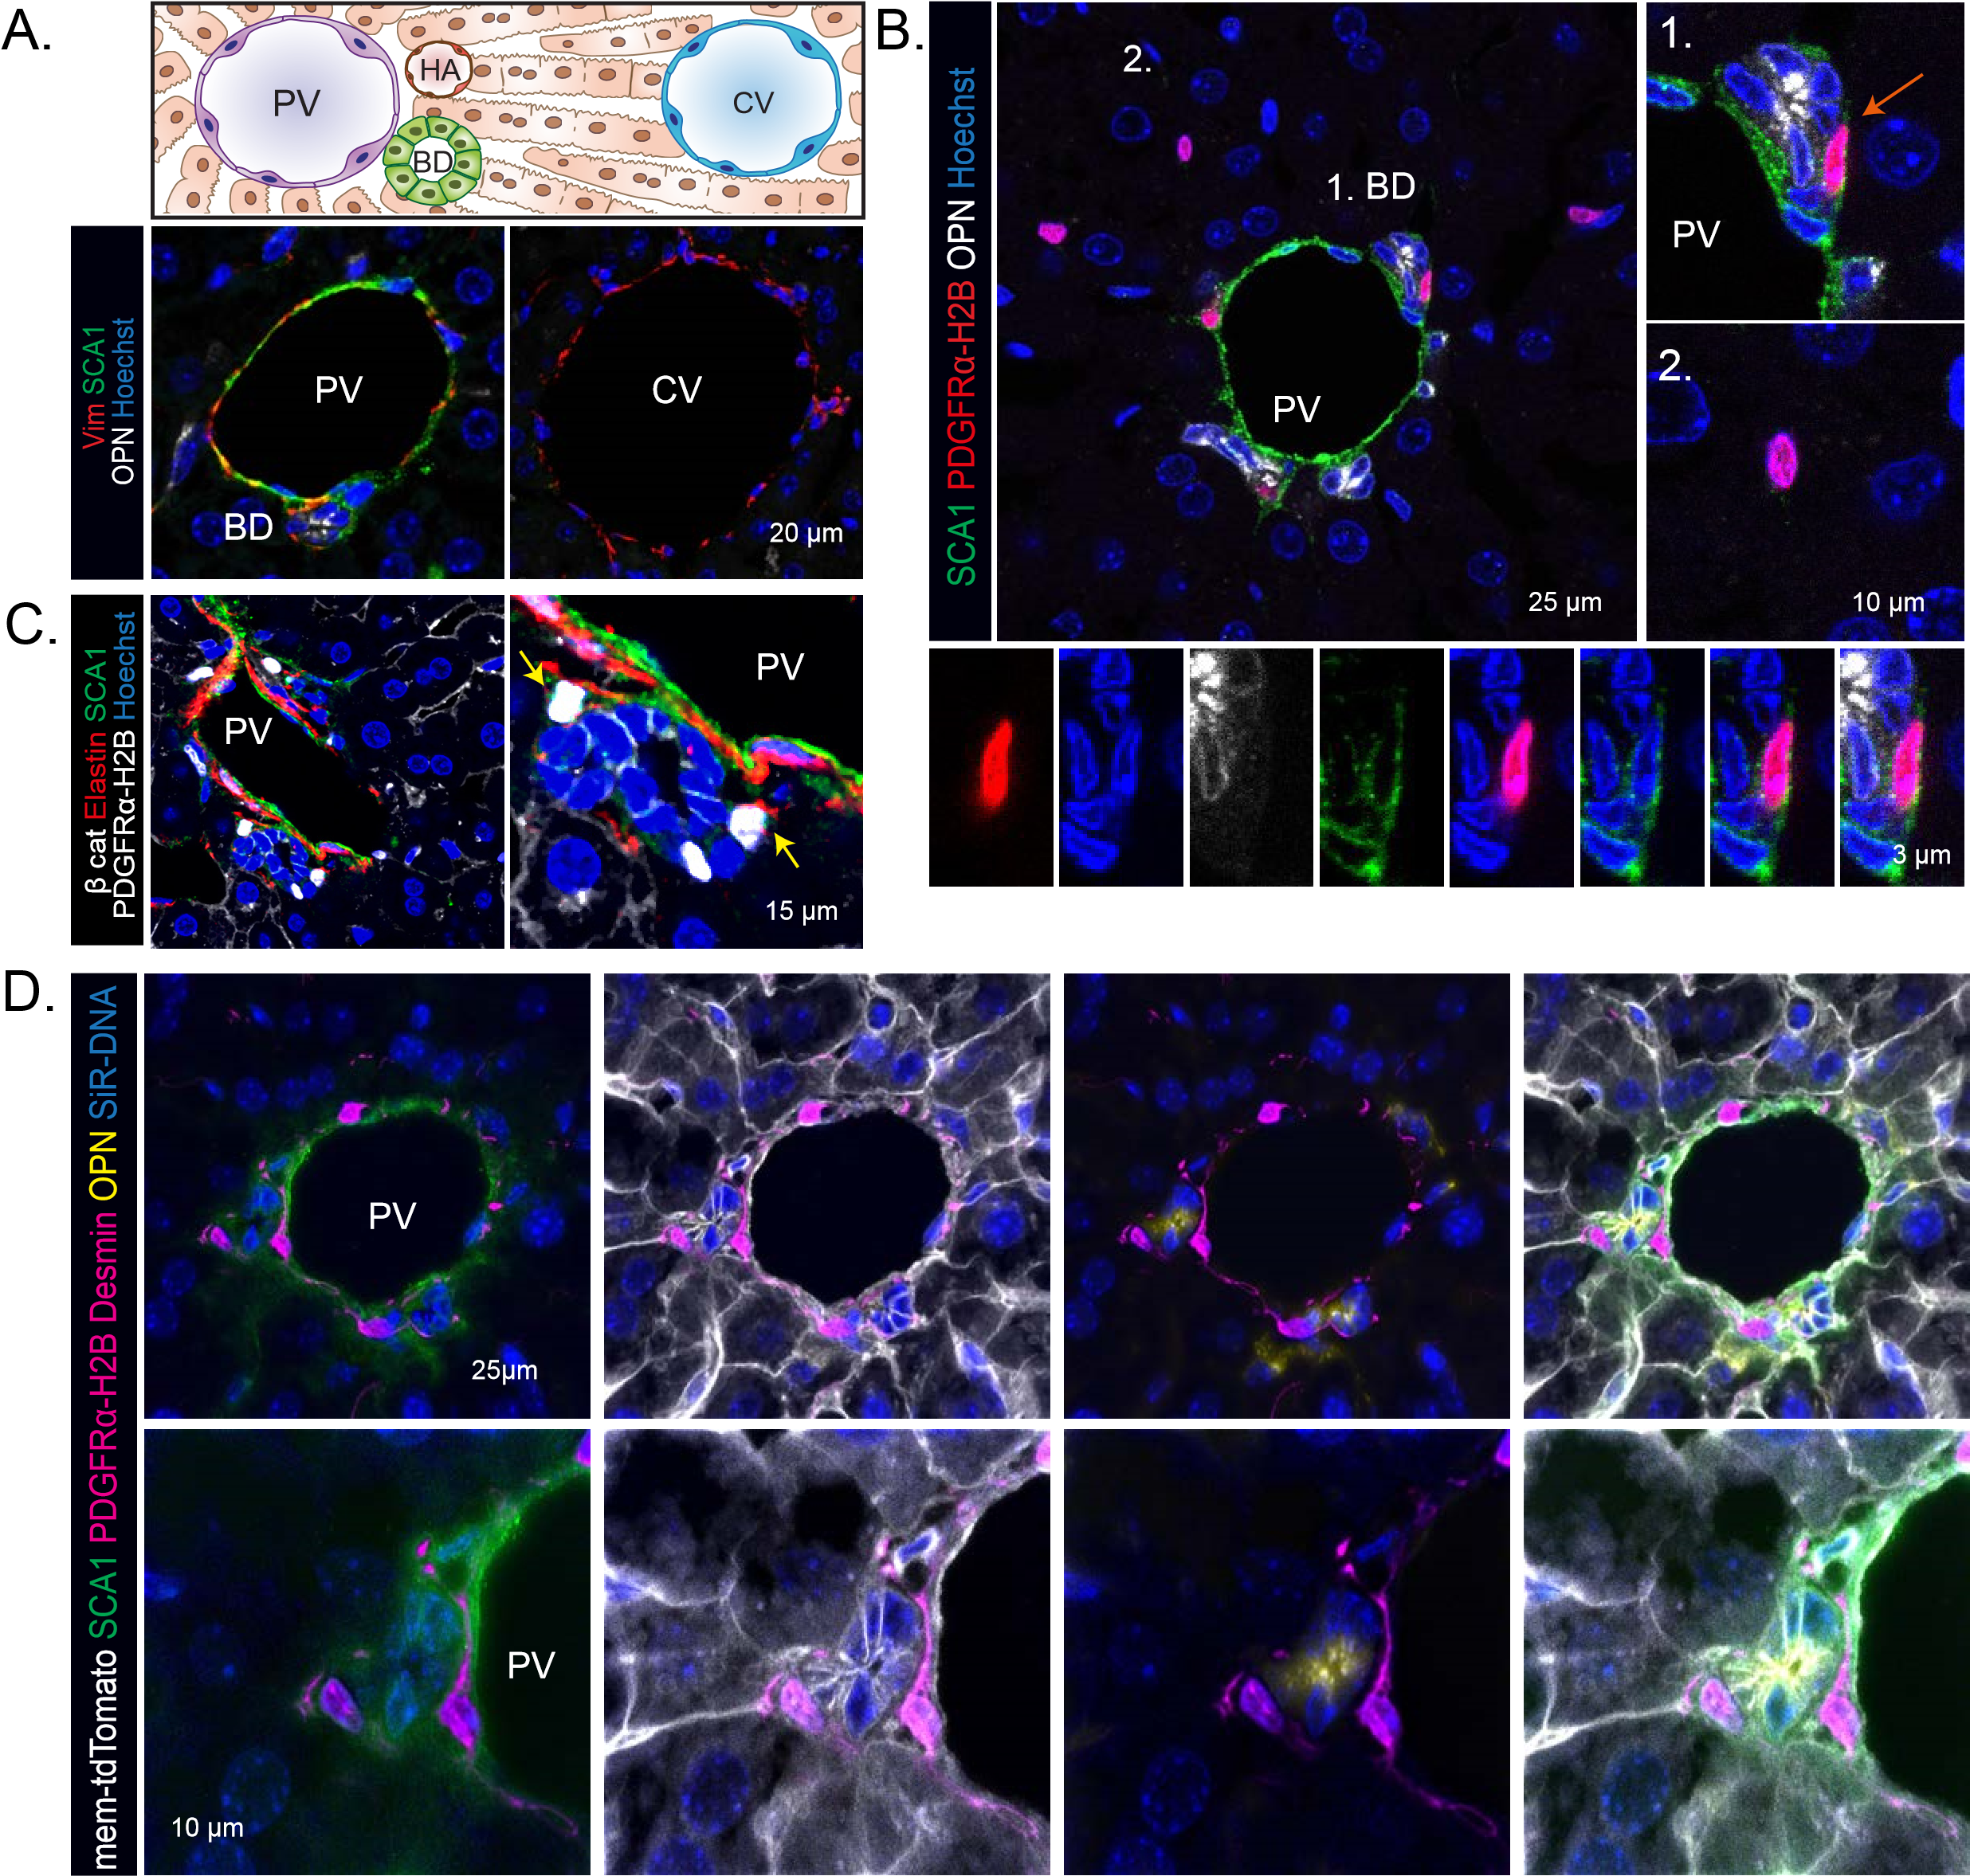
Figure 1. PDGFRα+SCA1+ mesenchymal cells reside near the portal tract (see also Figure S1 and Video 1).
A-D) SCA1 immunofluorescence analysis in the homeostatic liver. A) SCA1 marks exclusively the portal tract region of the liver lobule. Top, schematic of a liver lobule, spanning from the portal tract [formed by the Portal Vein (PV), hepatic artery (HA) and bile duct (BD)] to the central vein (CV) area. Bottom, representative single z-stack images of liver sections, stained for SCA1 (green), Vimentin (red) and the ductal marker Osteopontin (OPN, white). Nuclei were counterstained with Hoechst (blue).
- Representative single z-stack images of Pdgfra-H2B-GFP (nuclear red) mouse livers co-stained with SCA1 (green) and the ductal marker osteopontin (OPN+, white). Note that, PDGFRα+SCA1+ cells (B1, close up underneath) reside in close proximity to the ductal epithelium (orange arrow), whereas PDGFRα+SCA1- cells (B2) are spread throughout the liver parenchyma.
- Representative single z-stack images of Pdgfra-H2B-GFP (nuclear white) mouse livers co-stained with SCA1 (green), portal fibroblast marker Elastin (red) and epithelial marker β-catenin (white, membrane). Yellow arrow, PDGFRα+SCA1+.
- Representative maximum intensity projection image of PDGFRα+SCA1+ cells (nuclear magenta) contacting bile duct cells (OPN, yellow) through desmin (magenta) membrane protrusions; SCA1 staining (green), membrane marker tdTomato (white) and DNA (SiR DNA, blue) are also shown.
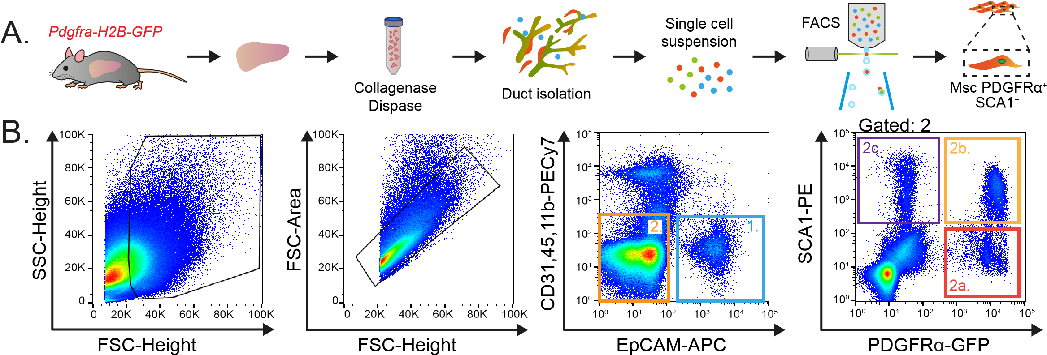
Figure 2
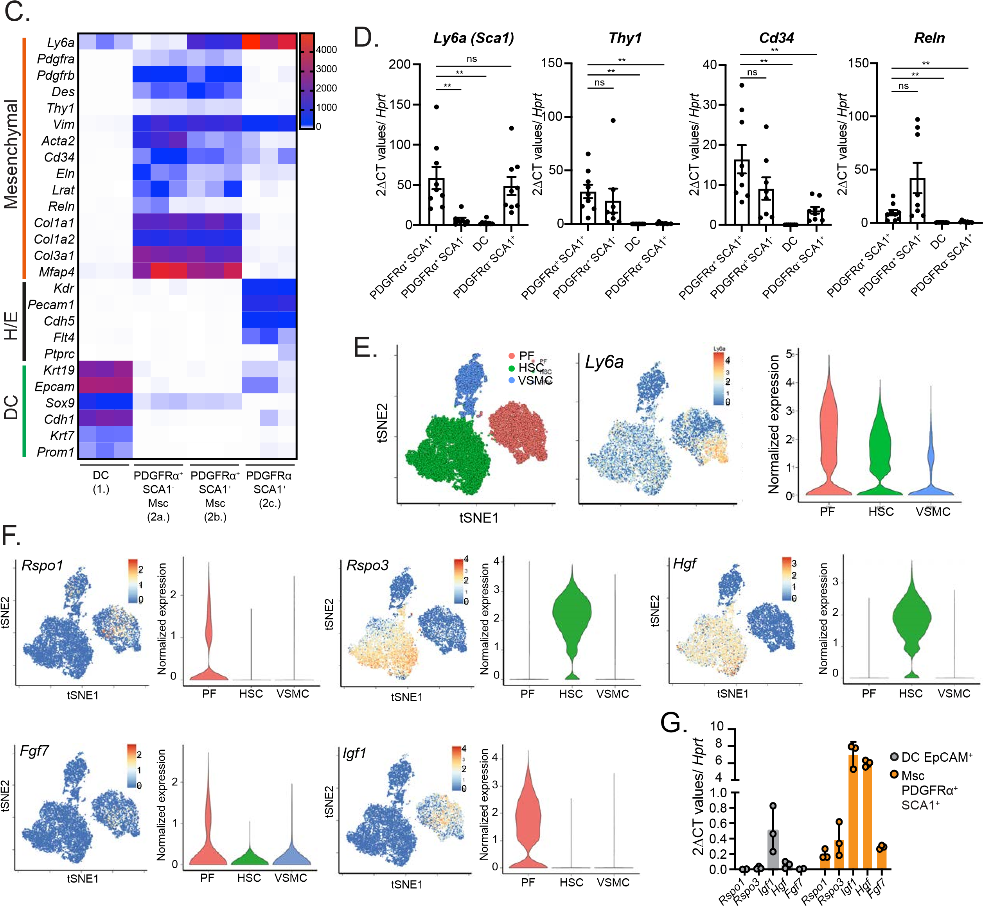
Figure2: Periportal PDGFRα+SCA1+ mesenchymal cells express a pro-regenerative growth factor signature (see also Figure S2).
(A-B) Isolation of PDGFRα+SCA1+ and PDGFRα+SCA1- mesenchymal cells and PDGFRα-SCA1+ stromal cells and EpCAM+ ductal cells (DC) from Pdgfra-H2B-GFP mouse livers. (A) Scheme of the experimental design. (B) Representative FACS plots indicating the gating strategy: DC (gate 1), PDGFRα+SCA1- (gate 2a), PDGFRα+SCA1+ (gate 2b) and PDGFRα-SCA1+ cells (gate 2c).
(C) RNAseq analysis on the 4 populations sorted in B. Heatmap represents the TPM values from the RNAseq for the indicated genes from n=3 biological replicates. H/E, hematopoietic / endothelial cell markers.
D) RT-qPCR expression analysis of selected genes from freshly sorted DC and specified niche cells sorted in B; Graph represents mean ± SEM on n=9 (DC, PDGFRα+SCA1+, PDGFRα-SCA1+) and n=8 (PDGFRα+SCA1-) biological replicates (mice) from n=3 independent experiments. p-values were obtained using Welch’s test (** p<0.01, ns p>0.1).
E-F) scRNAseq analysis of mouse hepatic mesenchymal cell populations published in Dobie et al, 2019. PF, portal fibroblast; HSC, hepatic stellate cell; VSMC vascular smooth muscle cell. tSNE (left) and violin plots (right) indicating the mRNA expression levels for SCA1 (Ly6a (E)) or the indicated growth factors (F) in mouse hepatic mesenchymal cell populations.
G) Gene expression analysis of selected secreted growth factor genes in the indicated sorted populations. Graph represents mean ± SD on n=3 biological replicates (mice).

Figure 3
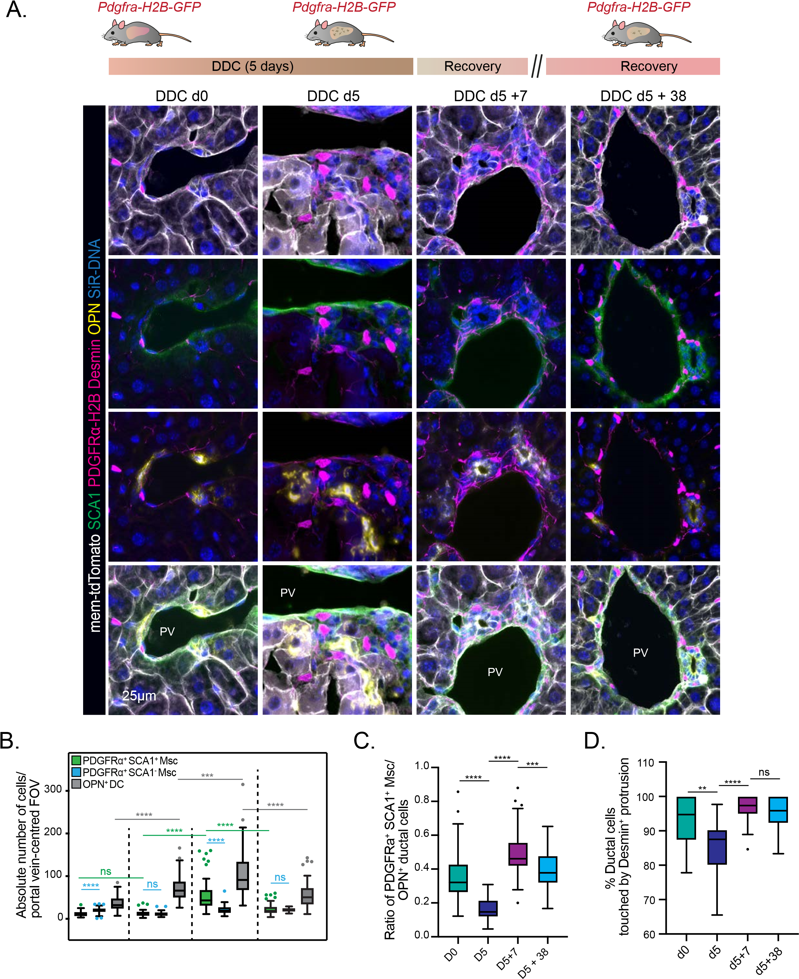DDC d0 DDC d5 DDC d5+7 DDC d5+38
Figure 3. The relative abundance and cell-cell contacts between DC and PDGFRα+SCA1+ mesenchymal cells change dynamically during the different phases of the damage-regenerative response (see also Figure S3).
A-D) The number of ductal, SCA1+ and SCA1- Msc cells, their relative distribution and cell-cell contacts was quantified in mouse livers during the different phases of liver regeneration. Liver injury was induced by supplementing the diet with DDC for 5 days, followed by a recovery period for 7 and 38 days as described in methods.
A) Top, scheme of experimental approach. Bottom, representative maximum intensity projection images of livers from Pdgfra-H2B-GFP/mTmG mice stained for desmin (magenta), SCA1 (green) and OPN (yellow); Pdgfra-H2B-GFP (nuclear magenta) membrane tdTomato (white) and nuclei (SiR-DNA, blue) are also shown.
(B) Box and whiskers Tukey plot (median, whiskers are 1.5 interquartile range) represents the absolute number of mesenchymal (PDGFR α+SCA1+ and PDGFRα+SCA1-) and ductal (OPN+) cells per field-of-view (FOV) of portal vein-centered confocal images from DDC-damaged livers at d0 (n=3), d5 (n=3), d5+7 (n=3) and d5+38 (n=2). Dots represent outliers. p-values were obtained with Mann Whitney tests. OPN+ d0 vs d5, p<0.0001 (****); OPN+ d5 vs d5+7, p=0.0007 (***); OPN+ d5+7 vs d5+38, p<0.0001 (****); PDGFRα+SCA1+ Msc d0 vs d5, p=0.9504 (ns); PDGFRα+SCA1+ Msc d5 vs d5+7, p<0.0001 (****); PDGFRα+SCA1+ Msc d5+7 vs d5+38, p<0.0001 (****). PDGFRα +SCA1+Msc vs PDGFRα+SCA1- Msc d0 p<0.0001 (****); PDGFRα+SCA1+ Msc vs PDGFRα+SCA1- Msc d5 p=0.9599 (ns); PDGFRα +SCA1+ Msc vs PDGFRα+ SCA1- Msc d5+7 p<0.0001 (****); PDGFRα+SCA1+ Msc vs PDGFRα+ SCA1- Msc d5+38 p=0.4138 (ns).
- Box and whiskers Tukey plot (median, whiskers are 1.5 interquartile range) represents the ratio of the number of PDGFRα+SCA1+ Msc cells relative to OPN+ ductal cells. Dots represent outliers. p-values were obtained via non-parametric Mann-Whitney t-tests. ****, p<0.0001 for d0 vs d5 and d5 vs d5+7; ***, p=0.0002 for d5+7 vs d5+38.
- Box and whiskers Tukey plot (median, whiskers are 1.5 interquartile range) represents the percentage of OPN+ DC contacted by a Desmin protrusion (see methods) in DDC-damaged livers at d0, d5 (n=3), d5+7 and d5+38 (n=4). Dots represent outliers. p-values were obtained using Mann-Whitney test (** p=0.0017, **** p<0.0001, ns p=0.6755).
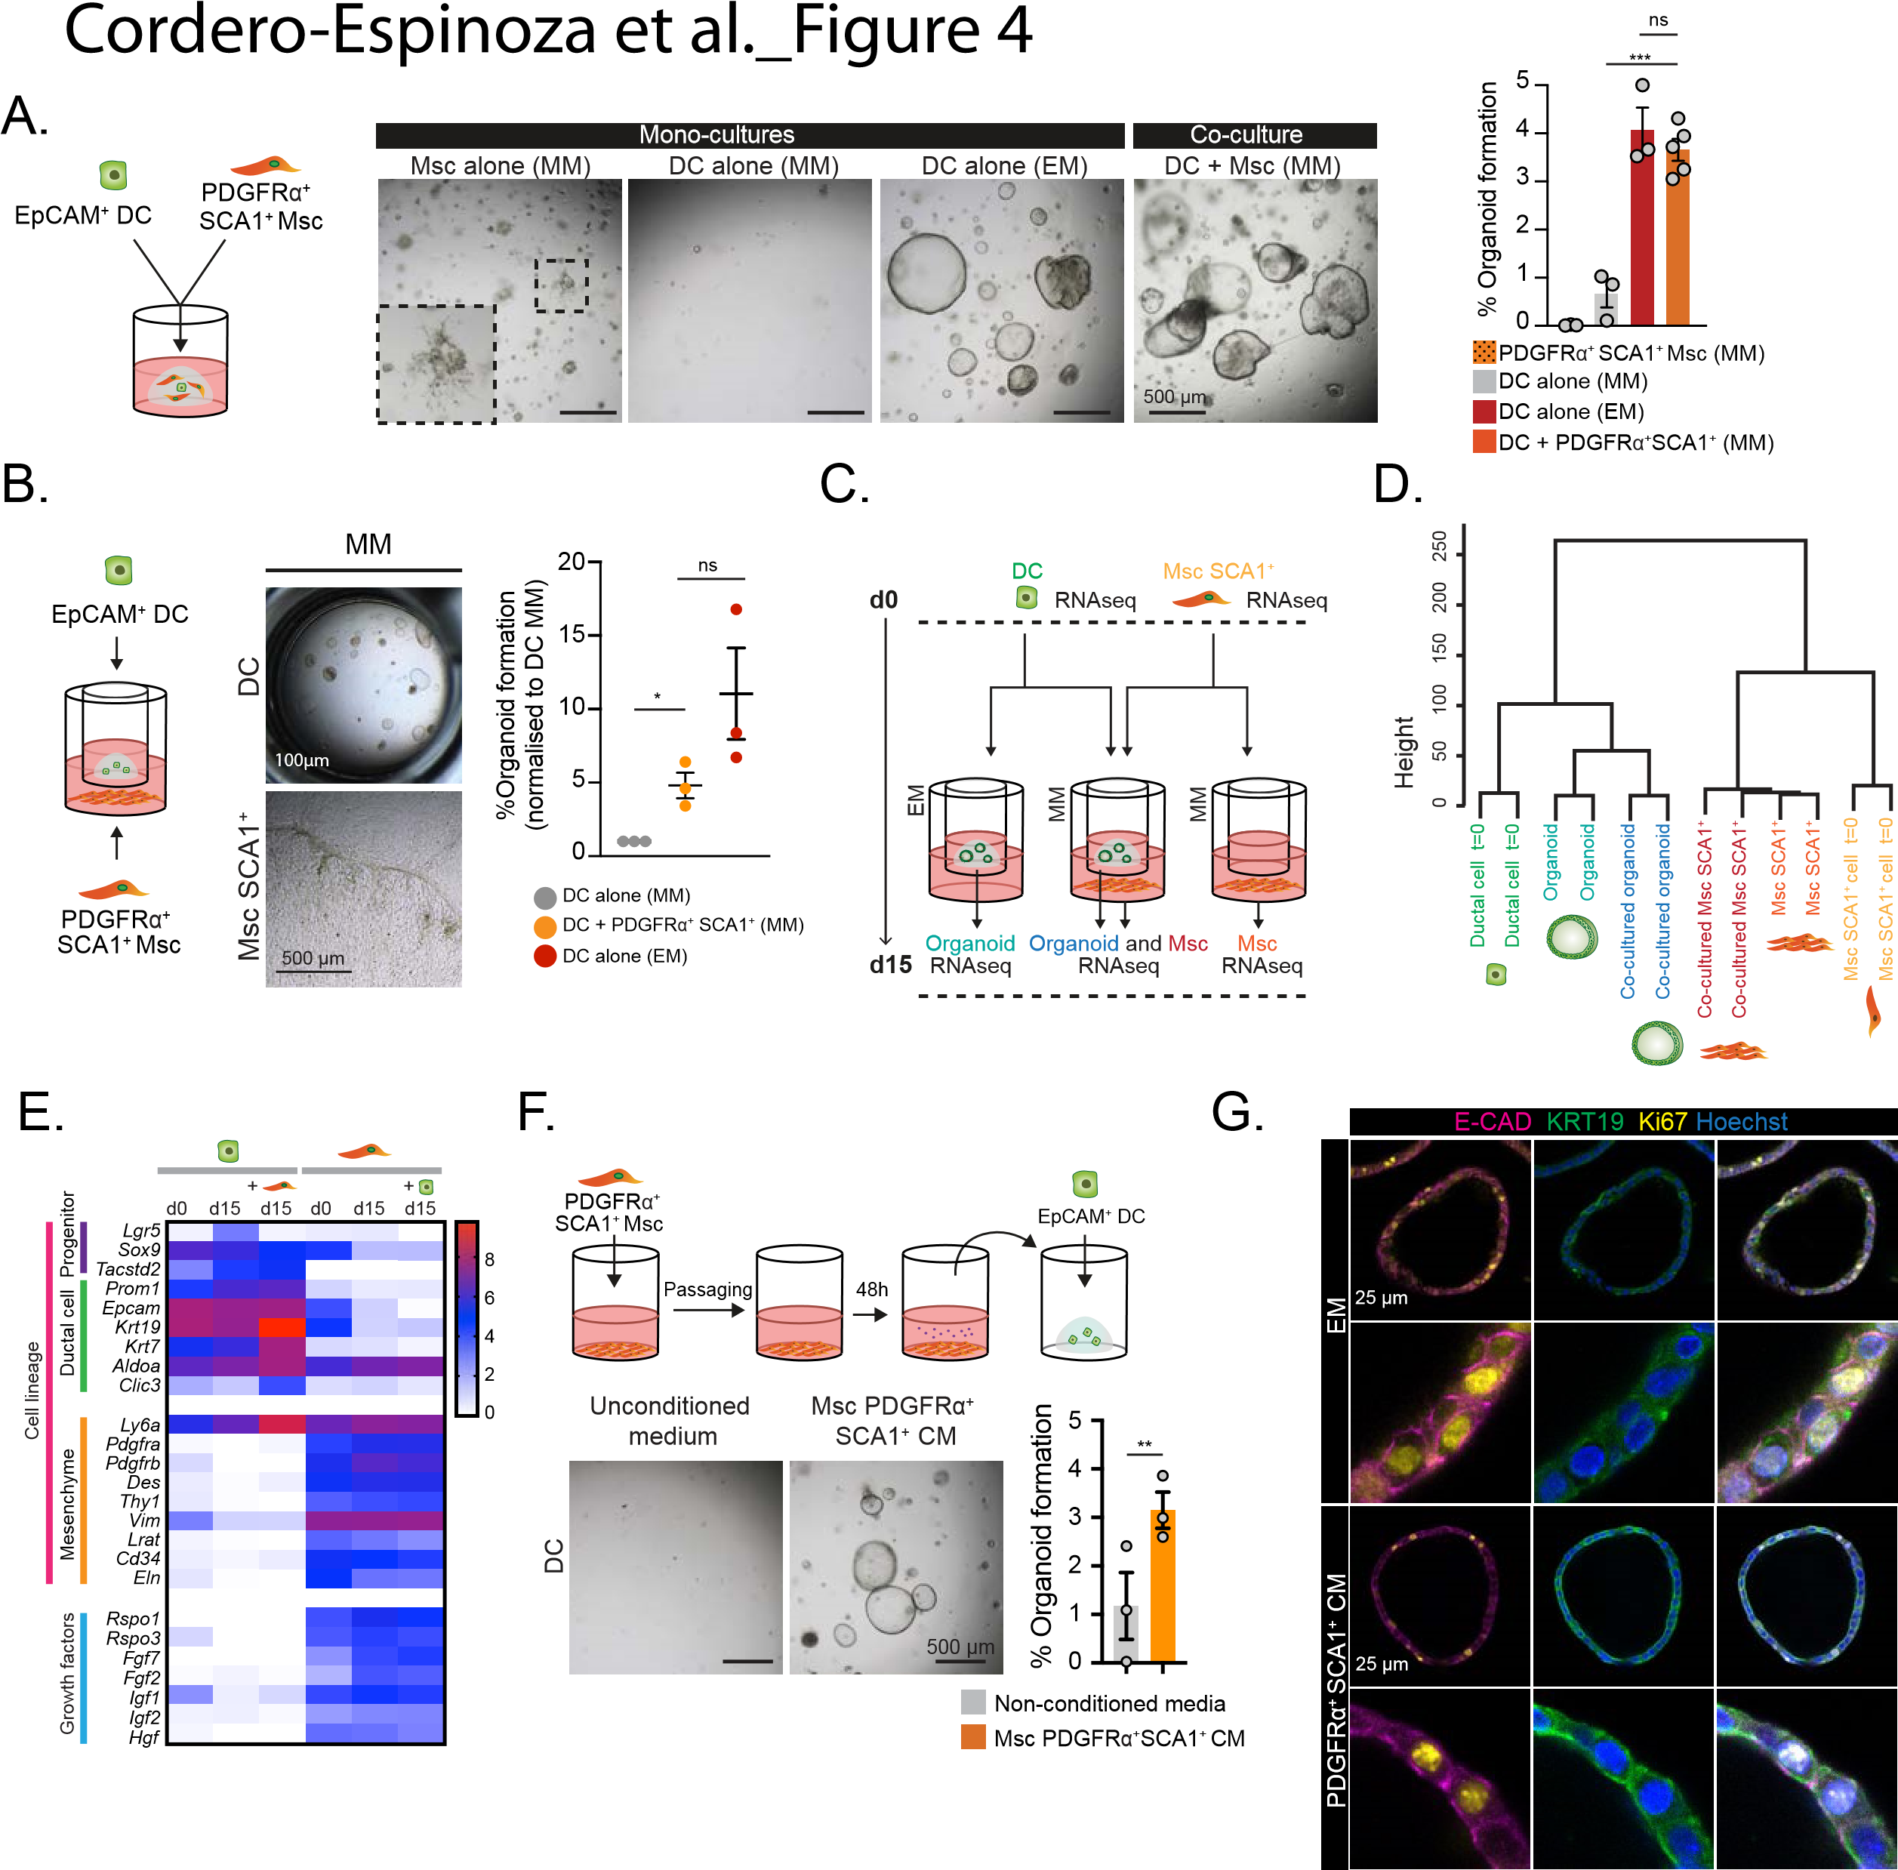
Figure 4. PDGFRα+SCA1+ mesenchymal cells support organoid formation via secreted growth factors (see also Figure S4).
A) EpCAM+ ductal cells (DC) and PDGFRα+SCA1+ Mesenchymal cells (Msc) were isolated from Pdgfra-H2B-GFP mice and immediately embedded in Matrigel either alone (monoculture) or together (co-culture) and cultured in mesenchymal medium (MM) as described in methods. As control, DC were also cultured alone in the presence of growth factor-rich expansion medium (EM). Ten days later, organoid formation efficiency was quantified. ¬Left panel, schematic of experimental design. Middle panel, representative brightfield images of monocultures of PDGFRα+SCA1+ or DC and co-cultures between DC and PDGFRα+SCA1+. Right panel, graph representing mean ± SEM of the % of organoid formation obtained from at least n=3 independent biological replicates. p-values were calculated with Student t-test: DC EM vs DC + PDGFRα+SCA1+ Msc, p=0.4066 (not significant, ns); DC MM vs DC + PDGFRα+SCA1+ Msc, ***, p=0.0009.
B-E) Transwell co-cultures where DC were seeded on a transwell insert within a 3D Matrigel bubble and co-cultured with PDGFRα+SCA1+ plated on the lower chamber of the well. B) Organoid formation from freshly sorted EpCAM+ DC seeded on a transwell insert alone in EM or MM, or co-cultured for 10 days with freshly sorted PDGFRα+SCA1+ in MM. Left, schematic of a transwell co-culture. Middle, representative brightfield images of a transwell co-culture at d10. Organoids, upper chamber. Msc, bottom chamber. Graph represents mean ± SEM of the % of organoid formation obtained from n=3 independent biological replicates. p-values were calculated with Student t-test: DC MM vs DC + PDGFRα+SCA1+ MM *, p=0.0116; DC EM vs DC + PDGFRα+SCA1+ MM, p=0.1257 (ns). C-E) RNAseq analysis of DC and SCA1+ Msc sorted cells collected at d0 (prior to culture) or cultured alone or co-cultured in a transwell as in B and collected 15 days later (d15) C) Scheme of the experimental design. D) Unsupervised clustering analysis of global mRNA expression in DC and SCA1+ Msc cells. E) Heatmap representing the mean log TPM value of the indicated genes from n=2 independent biological replicates.
- In vitro-passaged PDGFRα+SCA1+ cells were cultured in MM for 48h to generate conditioned medium (CM). PDGFRα+SCA1+ CM or unconditioned MM were added to freshly sorted EpCAM+ cells and organoid formation was assessed 10 days later. Top, scheme of the experimental design. Bottom, representative brightfield images of organoids grown in PDGFRα+ SCA1+ ¬CM. Graph represents % of organoid formation efficiency. Results are shown as mean ± SEM of n=3 independent experiments, each with 2 biological replicates. p-value was obtained by unpaired t-test with Welsch correction¬. **, p=0.0045.
- Immunofluorescence analysis of organoids derived from sorted EpCAM+ DC cultured for 10 days in complete medium (EM) or in conditioned medium (CM) derived from PDGFRα+SCA1+. Single z-stack images of organoids stained for E-cadherin (magenta), KRT19 (green) and proliferation (Ki67, yellow). Nuclei were counterstained with Hoechst (blue). Representative images of n=3 independent experiments are shown.
Figure 5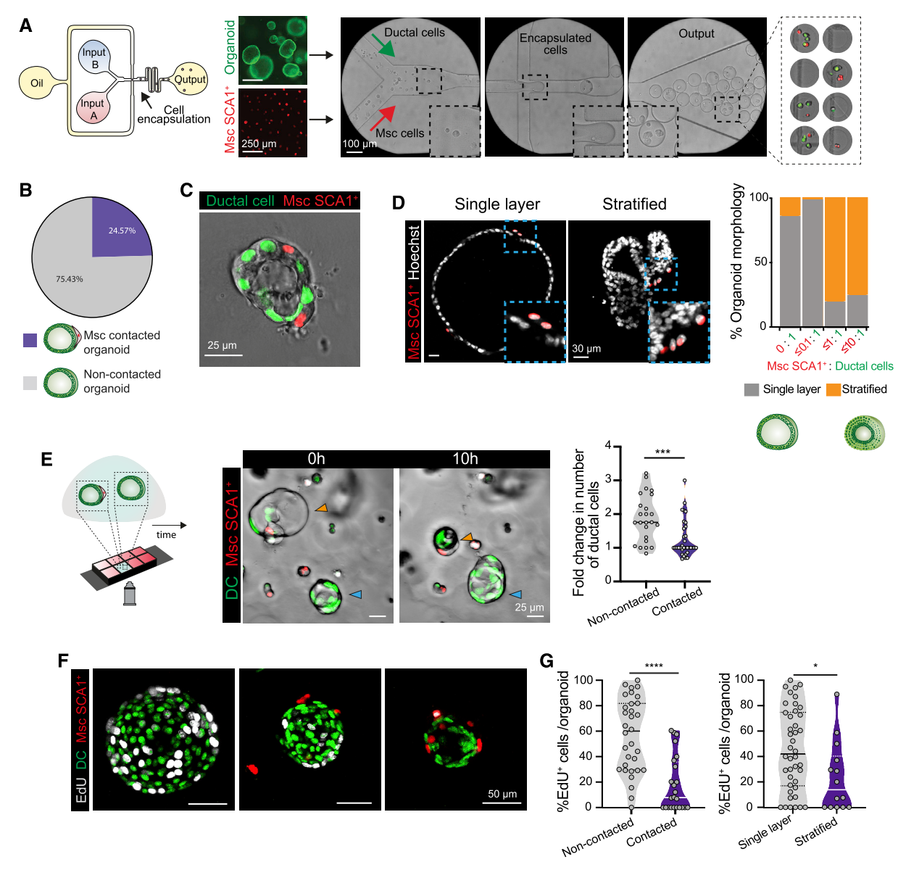
Figure 5. Msc-contacted organoids recapitulate in vitro the duct/Msc architecture of the in vivo portal tract and exhibit reduced proliferation (see also Figure S5 and Video S2-S4).
To generate chimeric organoids, nuclear GFP (nGFP)-expressing organoids and nuclear tdTomato (ntdTom)-expressing SCA1+ mesenchymal cells were resuspended in 1.5% agarose and injected as single cells into a two-inlet microfluidic flow focusing device (FFD). The microgels were embedded in Matrigel and incubated with MM and evaluated for Msc-contacted organoid formation and cellular proliferation. See methods for details. A) FFD containing two separate inlets for cell loading (input A and input B, in aqueous phase), one inlet for the continuous phase (oil) and one outlet. Representative bright field images show the FFD and the de novo encapsulated microgels. Note that, a wide range of organoid-to-mesenchyme cell ratios was detected.
- Pie chart summarizing the frequency of Msc-contacted organoid (containing DC and SCA1+ Msc cells) formation at d4 following microfluidic encapsulation. Results obtained from n=4 independent biological replicates.
- Representative single z-stack image of a Msc-contacted organoid at d4 post-encapsulation exhibiting a single-layer ductal (nGFP+) epithelium surrounded by mesenchymal (ntdTom+) cells on the periphery. See Figure S4D for additional examples.
- Representative single z-stack immunofluorescence images of Msc-contacted organoids exhibiting cystic/single layer epithelium (left) and stratified epithelium (right). Nuclei were counterstained with Hoechst (white). Graph represents the percentage of organoid morphologies observed according to the ratio of SCA1+ Msc per DC. Data is presented as mean from n=3 independent biological replicates. Note that, higher ratios of SCA1+ Msc to organoid cells (≤1:1 and ≤10:1) induce stratified morphology while lower ratios (≤0.1:1 and 0:1) result in single layered/cystic epithelial organoids.
- Time-lapse imaging of Msc-contacted vs non-contacted organoids grown within the same Matrigel droplet and culture medium. Left, scheme of experimental design. Middle, stills of a time-lapse imaging experiment showing non-contacted (nGFP+) and Msc-contacted (nGFP+ and ntdTom+) organoids at d4 post co-encapsulation. Note that the non-contacted organoid grows during the 24h of imaging (blue arrow), whereas the Msc-contacted organoid collapses (orange arrow). Violin plot graphs indicate the data-point distribution, median and interquartile range (IQR) of the fold change on number of DC following 24h of imaging in non-contacted vs Msc-contacted structures obtained from n=3 experiments. Dot, independent organoid. p-value was obtained using Mann-Whitney test. ***, p=0.0003.
F-G) Cell proliferation was assessed in d5 co-cultures following incubation with 10 μM EdU for 16h. F) Representative maximum projected z-stacks images of organoids immunostained for EdU (white). G) Violin graphs represent the distribution, median and IQR of the percentage of EdU+ ductal cells in non-contacted vs Msc-contacted organoids (left) and in single layer/cystic vs stratified organoids (right) from n=3 independent biological replicates. p-values were obtained by Mann-Whitney test. ****, p<0. 0001; *, p=0.0178.
Figure 6

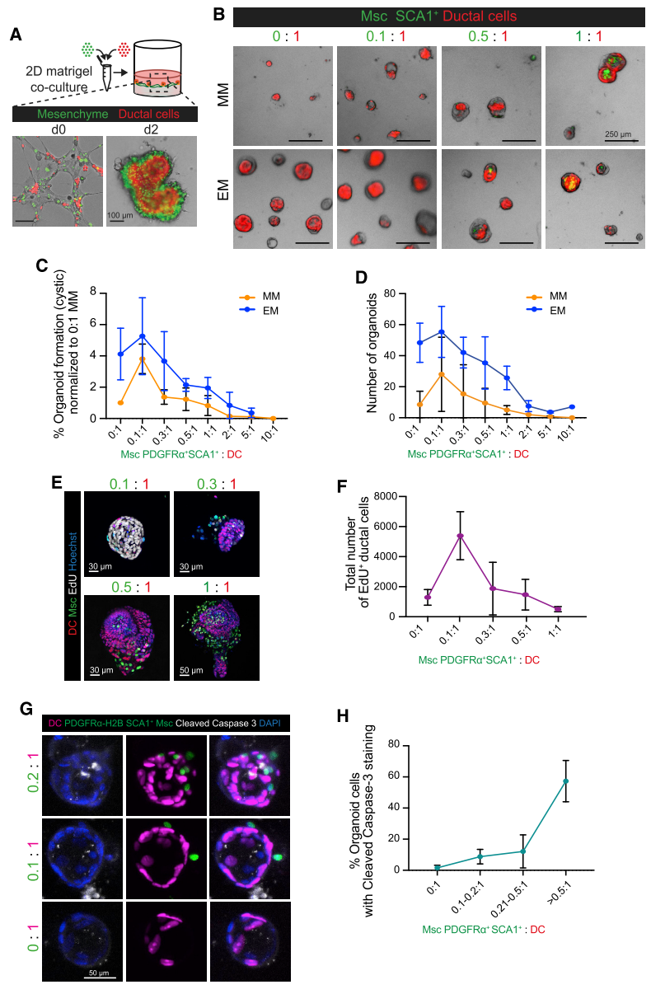

Figure 6. The dosage of physical contact between PDGFRα+SCA1+ Msc and ductal cells determines the net outcome of ductal cell proliferation (see also Figure S6).
A-G) Co-culture between mesenchymal and ductal cells in a Matrigel layer. DC derived from nuclear tdTomato livers (red) were mixed with PDGFRα+SCA1+ derived from Pdgfra-H2B-GFP livers (green) and seeded on top of a 2D Matrigel layer as described in methods. Within 2 days, the two cell populations generated 3D chimeric organoids according to the DC : PDGFRα+ SCA1+ ratios seeded, 6-8 days later organoid formation and ductal cell proliferation was evaluated.
A) Representative image of a co-culture between ductal cells (red) and PDGFRα-GFP+ SCA1+ Msc cells (green) at a 1:1 ratio. B-C) Freshly sorted EpCAM+ DC (red) were co-cultured with increasing ratios of PDGFRα+ SCA1+ Msc (green) in either growth-factor devoid, MM, or growth factor enriched, EM, for 8 days. B) Representative images of organoids are shown.
C) Quantification of cystic/single layer organoid formation efficiency at the indicated ratios in MM (orange) or EM (blue), normalized to the DC alone culture in MM (ratio 0:1). Graphs denote mean ± SD of n=3 (EM) and n=4 (MM) independent experiments. D) Total numbers of organoids from C.
E-F) DC co-cultured with increasing numbers of PDGFRα+ SCA1+Msc cells were incubated with 10μM EdU at d6 and the number of proliferating cells was quantified 16h later. E) Representative images of EdU immunostainings (white) at the indicated ratios are shown. Nuclei were counterstained with Hoechst (blue). F) Graph representing the total number of EdU+ ductal cells in the co-cultures at the indicated ratios. Mean ± SD of n=2 independent experiment with >22 organoid samples per condition.
G-H) DC co-cultured with PDGFRα+ SCA1+Msc cells for 7 days were stained for Cleaved Caspase 3. G) Representative maximum intensity projection of Msc-contacted (PDGFRα+SCA1+, nuclear green) and non-contacted organoids (nuclear magenta), stained for Cleaved Caspase 3 (white) and nuclei counterstained with DAPI (blue); the ratio of Msc to DC is specified for each shown structure; H) Percentage of organoid ductal cells stained with Cleaved Caspase 3 in non-contacted or Msc-contacted structures; graphs show mean ± SD of n=3 independent experiments with bins specified by the ratio of Msc to DC cells in each organoid structure.
Figure 7
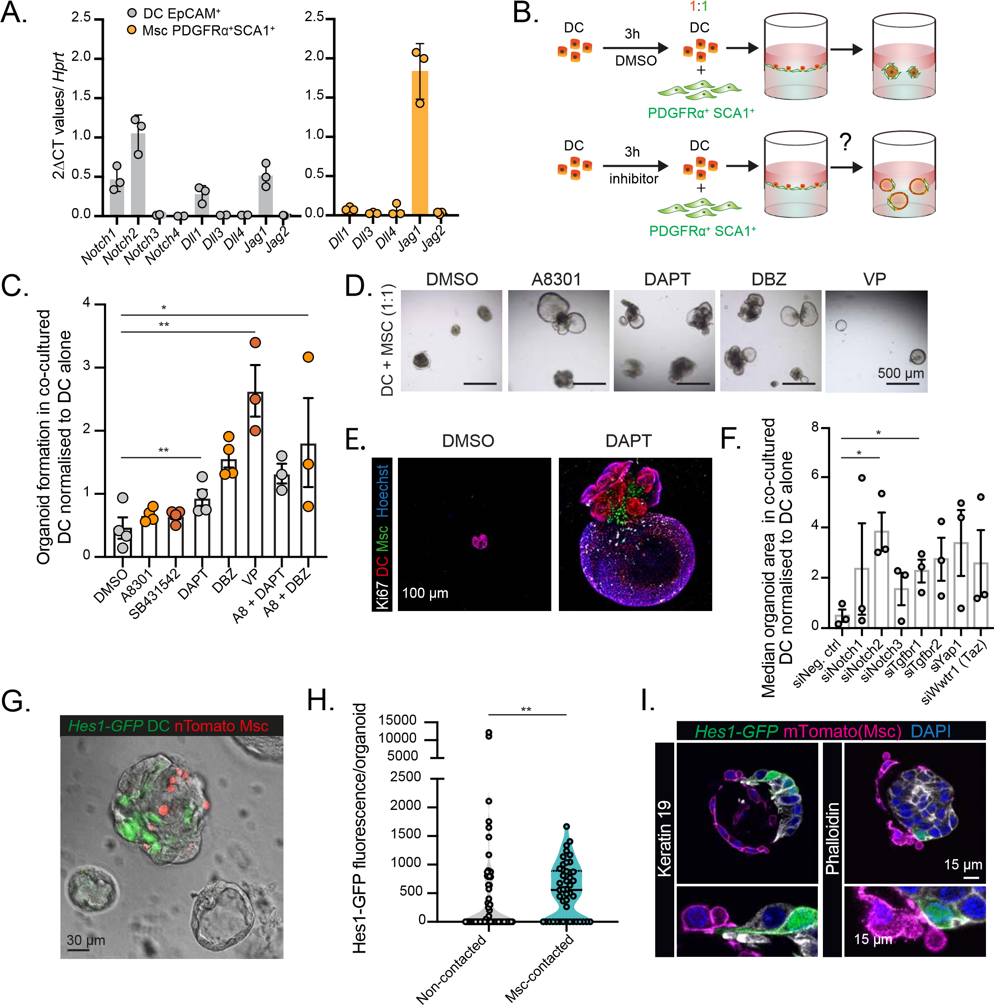
Figure 7. Cell-cell contact from PDGFRα+SCA1+ Msc inhibits DC proliferation via Notch signaling (see also Figure S7).
A) RT-qPCR gene expression analysis on selected genes of the Notch pathway in freshly sorted EpCAM+ DC (grey bars) and PDGFR α+SCA1+ Msc cells (orange bars). Graphs represent mean ± SD of n=3 independent experiments.
B-E) 5,000 freshly sorted EpCAM+ DC cells were pre-treated for 3h with DMSO, A8301 (5μM), SB431542 (10μM), DAPT (10μM), DBZ (10μM) or Verteporfin (0.1μM) prior to being co-cultured with 5,000 PDGFRα+SCA1+ Msc cells (1:1 ratio DC: Msc) in growth factor devoid mesenchymal medium (without the abovementioned inhibitors) as described in methods. Organoid formation and cell proliferation was assessed 10 days later. B) Scheme of experimental design. C) Graph represents cystic/single layer organoid formation in the DC: PDGFRα+SCA1+ Msc co-cultures normalized to that of the respective DC monocultures. Data is presented as bar graphs displaying mean ± SEM from n=4 (DMSO, A8301, SB431542, DAPT and DBZ) and n=3 (Verteporfin (VP), A8301 + DAPT, A8301 + DBZ) independent experiments. p-values were calculated with a Student t-test and all treatments were compared to the DMSO control. A8301, p=0.2871 (ns); DBZ, p=0.0026 (**); SB431542, p=0.3224 (ns); DAPT, p=0.0636 (ns); VP, p=0.0028 (**), A8301 + DAPT, p=0.0155 (*); A8301 + DBZ, p=0.0815 (ns). D) Representative bright field images from d10 co-cultures are shown. E) Maximum projected images from Z-stack of chimeric organoids (DC, in red, Msc in green) immunostained for Ki67 (white) at d10 after DAPT treatment. Nuclei were counterstained with Hoechst (blue).
F) 5,000 freshly sorted DC were transfected with siRNA oligos and then cultured alone or with 2,500 PDGFRα+SCA1+ Msc cells in mesenchymal medium on a 96-well plate well layered with Matrigel to obtain a 1:0.5 ratio co-culture. Organoid formation was assessed 10 days later. Bar graph represents mean ± SEM of median organoid area normalized to that of the respective DC monocultures from n=3 independent experiments. p-values were calculated using a Student t-test and compared to the negative control siRNA. *, p=0.0138 (siNotch2) and p=0.0260 (siTgfbr1); the remainder were not significant p=0.3688 (siNotch1); p=0.1973 (siNotch3); p=0.0655 (siTgfbr2); p=0.0959 (siYap1); p=0.1958 (siWwtr1).
G-I) Co-cultures between DC sorted from Hes1-GFP mouse livers (green) and nuclear tdTomato SCA1+ Msc (red) seeded at a 1:0.5 as described in methods. The number of Hes1-GFP+ cells was assessed 8 days later. G) Representative bright field and fluorescence image showing a contacted organoid (grey and red) with active Hes1-GFP (green) and non-contacted, Hes1-GFP- organoids (grey). H) Graph represents the Hes1-GFP mean fluorescence intensity and area per z-stack, normalized to total area, in non-contacted vs Msc-contacted organoids analyzed after 8 days of culture. Data is presented as violin plots showing data point distribution, median and IQR of n=2 independent experiments (46 mesenchyme contacted organoids and 68 non-contacted organoids were analyzed). p-value was calculated using Mann Whitney test, p=0.0051 (**). I) Single z-stack images of membrane tdTomato+ SCA1+ Msc cells (magenta) establishing cell-cell contact with Hes1-GFP ductal cells. Ductal cell membranes were immunostained with Keratin-19 (white, left) or

