Rimantadine binds to and inhibits the influenza A M2 proton channel without enantiomeric specificity

Jessica L. Thomaston¹, Marley L. Samways², Athina Konstantinidi³, Chunlong Ma⁴, Yanmei Hu⁴, Hannah E. Bruce Macdonald⁵ , Jun Wang⁴, Jonathan W. Essex², William F. DeGrado^{1,}*, Antonios Kolocouris^{3,}*

¹ Department of Pharmaceutical Chemistry, School of Pharmacy, University of California, San Francisco, CA 94158, USA
² School of Chemistry, University of Southampton, Southampton, SO17 1BJ, UK
³ Department of Pharmaceutical Chemistry, School of Pharmacy, National and Kapodistrian University of Athens, 15771 Athens, Greece.
⁴ Department of Pharmacology and Toxicology, College of Pharmacy, University of Arizona, Tucson, Arizona 85721, USA
⁵ Computational and Systems Biology Program, Memorial Sloan Kettering Cancer Center, New York, NY, 10065, USA
* Authors to whom correspondences should be addressed.

Corresponding author e-mail: ankol@pharm.uoa.gr; bill.degrado@ucsf.edu

Abstract
The influenza A M2 wild type proton channel is the target of the anti-influenza drug rimantadine. Rimantadine has two enantiomers, though most investigations into drug binding and inhibition have used a racemic mixture. Solid state NMR experiments have shown significant spectral differences that were interpreted to indicate tighter binding for (R)- vs. (S)-rimantadine. However, it was unclear if this correlates with a functional difference in drug binding and inhibition. Using X-ray crystallography, we have determined that both (R)- and (S)-rimantadine bind to the M2 pore with slight differences in the hydration of each enantiomer. However, this does not result in a difference in potency or binding kinetics, as shown by similar values for k_{on}, k_{off}, and K_{d} in electrophysiological assays and for EC₅₀ values in cellular assays. We conclude that the slight differences in hydration for the (R)- and (S)-rimantadine enantiomers are not relevant to drug binding or channel inhibition. To further explore the effect of the hydration of the M2 pore on binding affinity, the water structure was evaluated by GCMC/MD simulations as a function of the chemical potential of the water. Initially, the two layers of ordered water molecules between the bound drug and the channel's gating His37 residues mask the drug’s chirality. As the chemical potential becomes more unfavorable the drug translocates down to the lower water layer and the interaction becomes more sensitive to chirality. These studies suggest the feasibility of displacing the upper water layer and specifically recognizing the lower water layers in novel drugs.

Introduction
The influenza A matrix 2 (M2) protein is the most extensively studied viroporin, and is currently considered the most well-validated viroporin antiviral drug target.¹ It is an attractive target for anti-influenza medications because it mutates less frequently than other proteins within the virus.² However, though the M2 channel mutates infrequently, drug-resistant mutations have become prevalent since the early 2000s and currently this class of drugs is no longer recommended for treatment of influenza infections.^{3, 4} The rise of adamantane-resistant influenza necessitates an in-depth understanding of the stereochemical requirements for M2 channel blockers so that new drugs can be developed.
The M2 protein is a homotetrameric proton channel⁵⁻⁸ whose minimally functional transmembrane core consists of residues 22-46.^{9, 10} The gating residues involved in proton conductance are His37 and Trp41.^{11, 12} After an influenza virus particle is endocytosed by the host cell, proton transport through the M2 channel lowers the pH within the viral envelope and allows viral ribonucleoproteins (RNPs) to unpack from M1.¹³ Blocking proton transport through the M2 wild type (WT) channel using adamantanes^{14, 15} prevents this dissociation from happening and thus prevents viral replication from occurring.¹⁶⁻¹⁸ The proton transport function of M2 plays a second role in the viral life cycle; M2 inhibits the acidification of the trans Golgi compartment, thereby preventing premature activation of the acid-sensitive hemagglutinin protein.^{19, 20}
Structural biology studies of M2-drug complexes have been performed using racemic rimantadine, ²¹⁻²³ but in a solid state NMR (ssNMR) spectra using deuterium-labeled (R)- and (S)-rimantadine the authors showed differences in chemical shifts when the two enantiomers bind to full-length M2 WT.²⁴ These spectral differences were considered to arise from differences in potency and affinity of the isomers. However, electrophysiological (EP), isothermal titration calorimetry (ITC), and antiviral assays carried out using enantiomerically pure rimantadine indicated that the two enantiomers have equal potency against M2 WT.^{16, 25} Additionally, in vivo experiments in mice have shown similar antiviral activity for both enantiomers.²⁶ One possible explanation for the difference in ssNMR chemical shifts for the two rimantadine enantiomers might relate to differences in the kinetics of binding, which are particularly important for the potency of M2 inhibitors. In the earlier EP study examining rimantadine enantiomer binding to M2 WT,¹⁸ the time traces were conducted under kinetic control, which did allow sufficient time to determine accurate measurement of k_{off} (K_{diss} is computed from the ratio of k_{on} to k_{off}). Here we perform a more stringent kinetic study by recording both the binding and washing curves so that we can more accurately measure k_{off}. Using this improved methodology, we did not observe any difference in binding kinetics between the (R)- and (S)- enantiomers, as shown by similar values for k_{on}, k_{off} and K_{d} in EP assays. We also tested the potency of the two enantiomers against an amantadine-sensitive strain of influenza in an antiviral plaque assay and found that the EC₅₀ values are indistinguishable.
We also report the crystal structure of M2(22-46) WT in complex with enantiomerically pure (R)- and (S)-rimantadine. Earlier, a crystal structure had been solved for the complex of M2 with racemic rimantadine, but the density could be interpreted equally well for models involving both enantiomers (as would be expected if they bound with equal affinity) or a single high-affinity enantiomer in multiple conformations. We now show that although the crystals of each rimantadine enantiomer complex had different space groups and unit cell dimensions, we observed that the electron density corresponding to bound drug is similar for the two enantiomers. The density indicates a mechanism of binding in which the rimantadine ethylamine can rotate to four positions to form hydrogen bonds with ordered waters in the M2 pore. We observed slight differences between the hydration of the two enantiomers within the pore.
Finally, we employed grand canonical ensemble molecular dynamics simulations (GCMC/MD) to provide further insight into the water network present in the rimantadine binding site. GCMC²⁷⁻²⁹ can be used in combination with MD simulations in order to bypass the kinetic barriers associated with the binding and unbinding of occluded water sites. This is done by simulating the system at a constant chemical potential, whilst inserting and deleting waters from a region of interest (defined as the rimantadine binding site, in this case). Additionally, carrying out these simulations at a range of chemical potential values – referred to as GCMC titration – allows the binding free energy of the water network to be rigorously calculated. It is of interest that the titration analysis indicates that a chiral difference is apparent when the upper water layer of the binding site is displaced compared to the two layers which are sufficiently flexible to eliminate a chiral preference. To validate our GCMC/MD simulations we first calculated the relative binding free energy of the (R)- and (S) enantiomers to the M2 pore.

Results and Discussion
X-ray crystal structures
We have solved two X-ray crystal structures of (R)-rimantadine and (S)-rimantadine bound to M2(22-46) WT through co-crystallization experiments (Table S1). Crystals of (R)-rimantadine bound to M2(22-46) (PDB ID 6US9) formed at pH 8.5 in the P 2₁ space group with unit cell dimensions a, b, c (Å) = 48.18, 48.70, 71.67 and α, β, γ (˚) = 90, 90, 90, and the diffraction was limited to 2.00 Å. Crystals of (S)-rimantadine bound to M2(22-46) (PDB ID 6US8) formed at pH 7.5 in the P 2₁ 2₁ 2₁ space group with unit cell dimensions a, b, c (Å) = 49.39, 76.09, 98.63 and α, β, γ (˚) = 90, 90, 90. These crystals diffracted to a resolution of 1.70 Å, making this the highest-resolution structure of M2 bound to a drug or inhibitor.³⁰⁻³²
As in previously solved structures of M2 bound to drugs and inhibitors,^{31, 32} M2 is in the Inward_{closed} conformation and we observed electron density corresponding to bound drug at the channel's N-terminus near Ser31, with two layers of ordered water molecules between the bound drug and the channel's gating His37 residues (Figs 1a-d). These waters form hydrogen bonds to pore-facing carbonyl groups from residues Ala30 and Gly34, and also form a vertical hydrogen bonding network leading down to His37. The X-ray crystal structures remained unchanged during 300 ns MD simulations in hydrated POPC bilayers (Figs 1c, 1d).
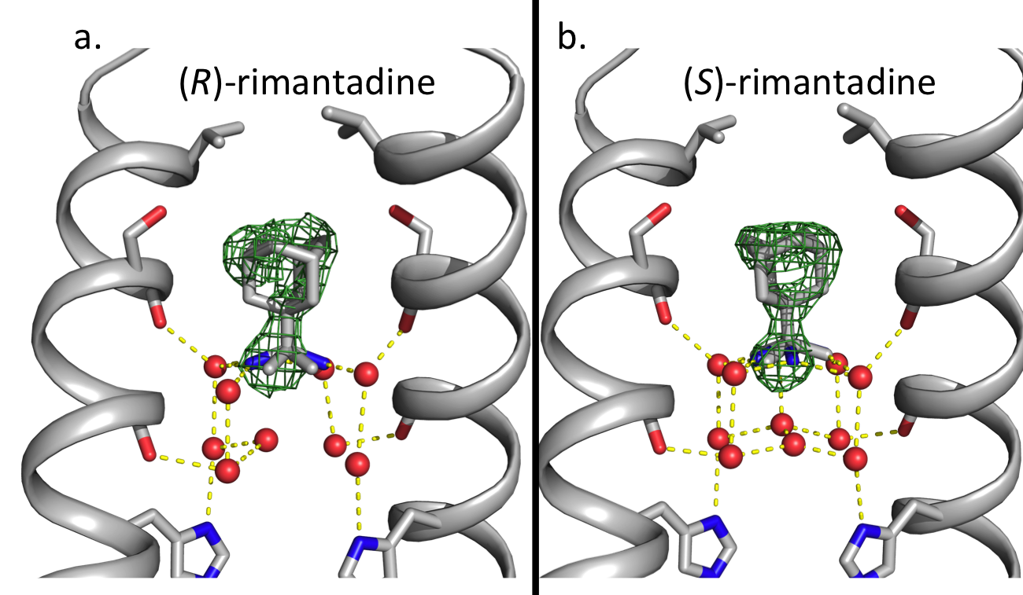

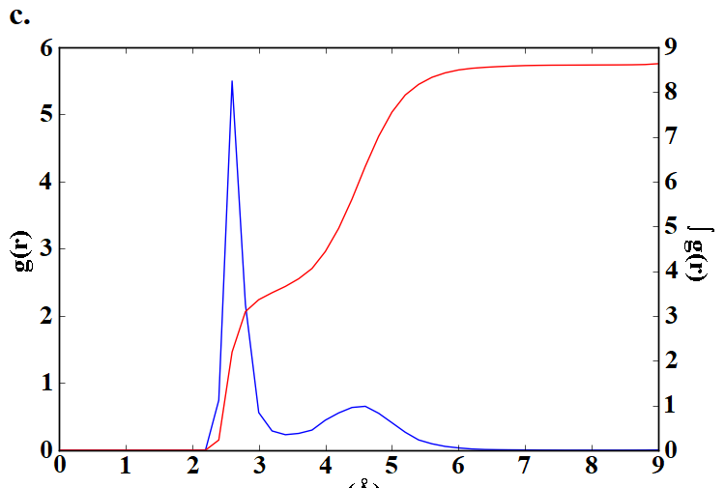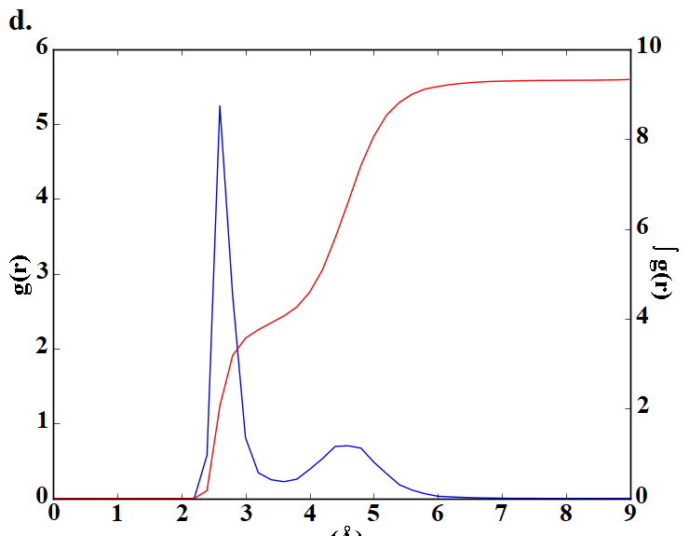

Figure 1. (a), (b) Polder maps calculated in the absence of bound rimantadine are shown here to a contour of 3 σ (dark green mesh) for the X-ray crystal structures of (R)-rimantadine (a) and (S)-rimantadine (b) bound to M2(22-46) WT. Front and back monomer helices have been removed to show the contents of the pore. For both structures, the density corresponding to the rimantadine ethylammonium group has been modeled as the average of four rotational conformers. We observed a network of ordered waters between the bound rimantadine and the gating His37 residues; the waters form hydrogen bonds with pore-facing carbonyl groups and also form a vertical H-bond network leading down to the gating His37 residues. (c), (d), The radial distribution function (RDF) g(r) for (R)-rimantadine (c) and (S)-rimantadine (d) between the ammonium group and water oxygen atoms from the 200 ns MD simulation, shows a strong peak at 2.7 Å which corresponds to the upper waters layer, forming hydrogen bonds with the ammonium group of rimantadine and the carbonyl groups of Ala30. The cumulative integrated intensity ∫g(r), shown in the right axis, at 2.7 Å indicates ca. 4 waters. The second broad peak at 4.8 Å corresponds to ca. 5-6 waters of the lower layer, which form hydrogen bonds with the His37 imidazole groups and the carbonyl groups of Gly34.

Though enantiomerically pure (R)- or (S)-rimantadine was used in these crystallization trials, the chirality of the drug is not obvious from the electron density in either structure. This is presumably a result of averaging more than one binding position within the crystal lattice. Thus, we have modeled the bound drug for each of the structures as a superposition of four rotational – by rotation of C1_{Ad}-C_{Ethyl} bond - conformers, with the drug ammonium group forming hydrogen bonds to two of the four top layer waters in each position. In our previous crystal structure of racemic rimantadine bound to M2(22-46) WT (PDB ID 6BKL),³² we observed this same ambiguity regarding the position of the rimantadine ethylammonium group, which we interpreted as an effect of co-crystallizing using racemic rimantadine.
The occupancies of the four rotational conformers of (R)- or (S)-rimantadine were allowed to float during refinement; alternate conformers were removed from the model if their occupancy was refined to zero. Each structure contains four tetramers per asymmetric unit; the refined occupancies for the four rimantadine rotational conformers for each tetramer are shown in Table S2. To summarize, for the structure of (R)-rimantadine bound to M2(22-46), three conformers were observed per tetramer with some variations in the occupancy of each (R)-rimantadine conformer depending on the tetramer. In the structure of (S)-rimantadine bound to M2(22-46), three of the tetramers have relatively high (> 0.30) occupancy for two of the (S)-rimantadine conformers, with the other two conformers having either zero or < 0.05 occupancy. The fourth tetramer has low occupancy (0.01 and 0.11) for two of the conformers and relatively high occupancy (>0.40) for the other two. These data suggest that the binding mechanism remains the same for both enantiomers with the observed slight differences likely due to the hydration of each enantiomer as shown in Fig. 1. We subsequently explored the hydration of each enantiomer inside the M2 pore using GCMC/MD simulations.
In addition to the density associated with (S)-rimantadine in the pore, we unexpectedly observe electron density that we provisionally assign to rimantadine in the structure of the complex at 1.7 Å. The additional (S)-rimantadine lies at locations that stabilize the packing of individual tetramers in the crystal lattice (Figs S1,2). The two tetramers have an antiparallel orientation, and the rimantadine makes contacts to residues near the N-terminus of one tetramer and residues near the C-terminus of the other tetramer. The location of the ethylamonnium group is not clear from the electron density, so we have only modeled the adamantyl group. The C-terminal contacts are similar to those proposed for a weak, exterior site observed in solution and ssNMR studies that indicate binding of the adamantanes to the exterior of the channel's C-terminus at high concentrations of drug (including Leu 40, Ile42, Asp44, Arg45, and Leu46).^{33, 34} However, these previous spectroscopic studies did not identify contacts near the N-terminus (Leu26, Val28, Ala29, Ile32). Thus, it is likely that the exterior site see here is a crystallographic artifact.

Electrophysiology and antiviral plaque assays
To study whether chirality has an effect on the functional activity against the M2 WT channel, we determined the association constant (k_{on}), the dissociation constant (k_{off}), and the binding affinity (K_{d}) for (R)- and (S)-rimantadine in a two-electrode voltage clamp electrophysiological (TEVC) assay using kinetic studies.³⁵⁻³⁷
Figure 2. Rimantadine enantiomers and amantadine binding kinetics against Udorn M2 WT were determined using a combined application and washout procedure TEVC assay. (A) Racemic rimantadine (B) (R)-rimantadine, (C) (S)-rimantadine, or (D) amantadine was applied to oocytes for 5 to 7 min after the inward current reached its maximum, then a washout protocol was applied to the oocytes. During the washout, pH 8.5 pulses were applied to make sure the current went to baseline to ensure the oocyte quality. The blue bar above the recording trace indicates the period in which the pH 5.5 Barth solution was applied; the red bar indicates the period in which compounds in pH 5.5 Barth solution were applied. Representative recording traces are shown on the left side of each figure. Data extracted from the recording traces were plotted with an association then dissociation equation in GraphPad Prism 5 as shown in the right side of each figure. The best-fit values are shown in the Table 1.
Drugs bind slowly to the channel, and dissociate very slowly, so special procedures are required to determine the on- and off-rates. We first apply relatively high concentrations (100 micromolar) of the test compound to fully inhibit the channel. The second-order rate constant for inhibition (k_{on}) is determined from the time course of inhibition. The drug is then washed out and the time required to recover from inhibition is measured to determine k_{off}. Full length M2 WT from the amantadine-sensitive Udorn strain was expressed in oocytes, and a low pH 5.5 solution was applied to activate the M2 channel. Next, a pH 5.5 solution containing testing compound was applied to inhibit the M2 channel. Once the current reached the steady state, compound dissociation was initiated by changing the oocyte bathing solution to pH 5.5 without drug. During the washout, a few pH 8.5 pulses were applied to make sure the current went to baseline to ensure the oocyte quality. The recording traces are shown in Fig. 2.

Table 1. Summary of the binding affinity of amantadine and rimantadine enantiomers against Udorn M2 WT

 | Rimantadine (racemic) | (R)-rimantadine | (S)-rimantadine | Amantadine
Concentration tested | 50 µM | 50 µM | 50 µM | 100 µM
k_{on} (min⁻¹M⁻¹) | 19600 ± 300 | 20800 ± 700 | 22500 ± 300 | 20500 ± 300
k_{off} (min⁻¹) | (9.1 ± 0.8)*10⁻⁴ | (9 ± 2)*10⁻⁴ | (8.8 ± 0.8)*10⁻⁴ | (119 ± 2)* 10⁻⁴
K_{d} = k_{off}/k_{on} (nM) | 46 ± 4 | 41 ± 9 | 39± 4 | 580 ± 20

Fitting the binding and washing curves with association and dissociation equations yielded the k_{on}, k_{off}, and K_{d} values for (R)-, (S)-, and racemic rimantadine.³⁷ As shown in Table 1, the binding kinetics parameter (k_{on}, k_{off} and K_{d}) values for (R)-, (S)- and racemic rimantadine are not significantly different, which suggests that both the (R)- and (S)-enantiomers of rimantadine bind to the M2 channel with equal potency. We also included amantadine as a control: the k_{on} of amantadine is comparable with that of rimantadine, however the calculated k_{off} of amantadine is more than 10-fold faster than that of (R)- and (S)-enantiomers of rimantadine, therefore the binding affinity of amantadine to Udorn M2 is about 10-fold weaker than rimantadine to M2. Overall, there is no significant difference among the K_{d} values for (R)- and (S)-enantiomers as well as the racemic mixture of rimantadine. We note that a previous study¹⁶ reported 100-fold higher k_{off} values, resulting in significantly higher K_{d} values for (R)- and (S)-enantiomers and the racemic mixture of rimantadine with 3.2, 3.9 and 7 µM, respectively, as opposed to the values of 41, 39, and 46 nM, respectively, reported here. In the previous study,¹⁶ only the binding curve was recorded and used for data fitting to derive both k_{on} and k_{off}, which might result in significant variations of k_{off} values (personal communication with Dr. David Busath, the lead author who performed the electrophysiological assay in the previous study); the time traces were not recorded for sufficient time to allow accurate measurement of k_{off} and thus, the previous values are an upper limit of the true K_{d} value. In contrast, we performed more stringent kinetic studies by recording both the binding and washing curves in the current study. As such, the k_{off} values were accurately quantified from the washing curve, which was then used to fit the binding curve to determine k_{on}. The validity of this methodology in determining the K_{d} values of M2-S31N and M2-V27A inhibitors has been demonstrated in several studies, which showed a positive correlation between the K_{d} values and the cellular antiviral activity.³⁵⁻³⁷
To further confirm that the (R)- and (S)-enantiomers of rimantadine have indistinguishable potency in blocking the M2 channel, we tested these compounds against the amantadine-sensitive A/Soloman Island/3/2006 (H1N1) strain (Fig. 3). As expected,²⁷ both (R)- and (S)-rimantadine inhibit viral replication with EC₅₀ values of 19.62 and 24.44 nM, respectively. Taken together, results from both the electrophysiological assay and the antiviral plaque assay showed that both (R)- and (S)-rimantadine have equal potency in blocking the M2 WT channel.

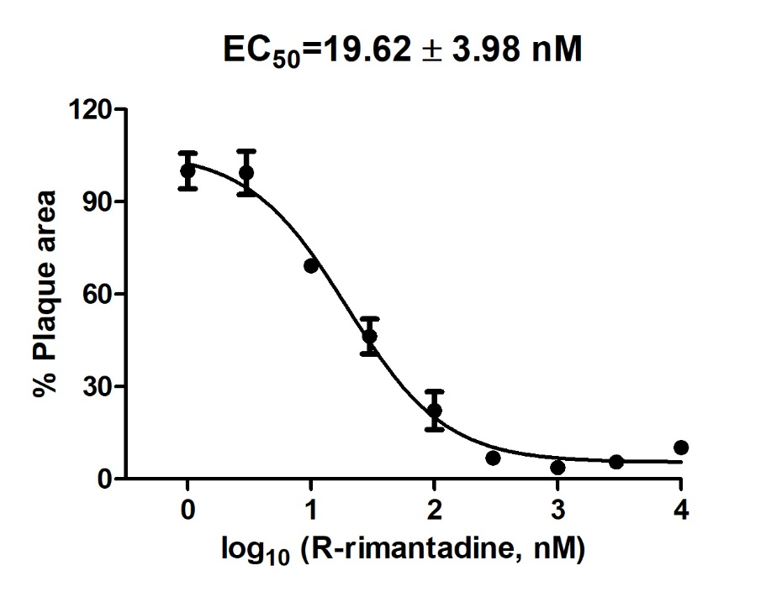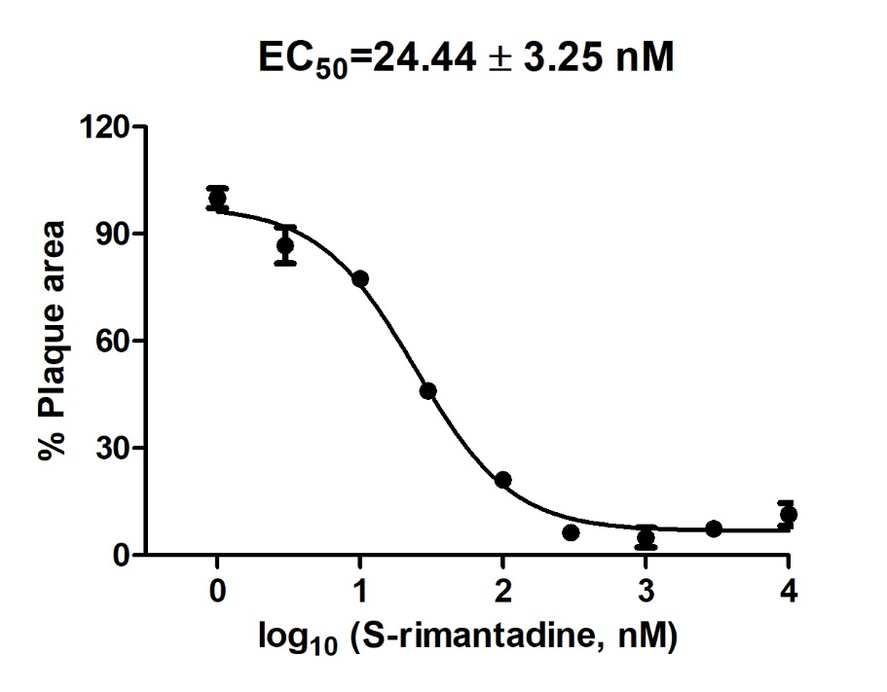

Figure 3. Cellular antiviral assay results of (R)- and (S)-rimantadine against the amantadine-sensitive A/Soloman Island/3/2006 (H1N1) strain. The antiviral potency was determined in a plaque assay. The EC₅₀ values are the mean ± standard deviation of two independent repeats.

Binding Free Energy Calculations
To validate our experimental results, the relative binding free energies of binding and hydration for the (R)- and (S)- enantiomers were calculated using the free energy perturbation method^{38, 39} (see Fig. S3) coupled with MD simulations (FEP/MD) and the multistate Bennett acceptance ratio (MBAR) method for processing the free energy data.^{40, 41} The free energy perturbations carried out show that the hydration free energy difference between the two enantiomers (where a positive value would indicate that the (R)-enantiomer is favored, and vice versa) is -0.06 ± 0.03 kcal mol⁻¹ when starting the calculation from the (R)-enantiomer, and 0.000 ± 0.005 kcal mol⁻¹ when starting from the (S)-enantiomer (the uncertainties given represent the standard errors over the three runs). Given that bulk water is an achiral environment, the true value of this hydration free energy difference is zero, and these values therefore appear correct. This result therefore supports the view that the free energy protocol used (see Supporting Information) is suitable for this perturbation.
The relative binding free energy difference between the two enantiomers was calculated as +0.29 ± 0.04 kcal mol⁻¹, and +0.33 ± 0.06 kcal mol⁻¹, when starting the calculations from the (R)- or (S)-enantiomer, respectively, and the accuracy of the free energy calculations from molecular simulations is typically considered to be around 1 kcal mol⁻¹. ⁴² These values show also that the two enantiomers bind equally to M2TM without any chiral preference. These FEP/MD calculation results with the MBAR method are also in agreement with previous measurements of enantiomers binding affinities using ITC and calculation of their relative binding free energy using FEP/MD simulations with the BAR method and different alchemical intermediates.^{16, 43}
Figure 4. Comparison of the two titration plots with the average number of waters observed plotted against the B value (water binding free energy profiles). The curve was fitted as the mean from 1000 bootstraps of a sum of four sigmoid curves. Results for rimantadine enantiomers are shown as inset images added to show representative structures from different points on the curve. The (R)-enantiomer is shown in cyan and the (S)-enantiomer is shown in pink. The m=4 in the legend refers to the fact that a sum of four sigmoid functions were fitted to the data.

GCMC Titration
In the experimental structures, the number of waters in the upper layer (i.e. close to Ala30) is 4 and in the lower layer (i.e. close to Gly34) is 5 (PDB ID 6US9) or 6 (PDB ID 6US8).³²

The GCMC titration calculations involve progressively reducing the chemical potential applied to the water molecules in the ligand binding site. As the chemical potential is reduced, the more weakly bound water molecules are removed from the binding site, until eventually an entirely dry site results (Fig. 4). In addition, the binding free energy of the water network may be calculated from the water occupancy as a function of chemical potential data. The resulting free energy data as a function of water occupancy may be used to determine the equilibrium hydration level, which corresponds to the minimum on the curve of the free energy profile (Fig. 5).
Figure 5. Water binding free energy plots for both enantiomers.

For both of the enantiomers, the free energy profile (Fig. 5) shows a minimum for $N=9$, indicating that this is the most favourable number of water molecules in the binding site, in agreement with our crystal structures. Also, in agreement with the experiments is that there was no significant difference in the calculated binding energy for the (R)-enantiomer(-30 ± 1 kcal mol⁻¹), versus the (S)-enantiomer (-29 ± 1 kcal mol⁻¹). Interestingly, the free energy change associated with adding a tenth water to the binding site for the (R)- and (S)-enantiomers are +0.1 ± 0.1 and +0.3 ± 0.2 kcal mol⁻¹, respectively, indicating that the $N=10$ state is only slightly less stable at equilibrium.
We next asked whether there might be a difference if the waters were virtually “squeezed out” at low potential. This can be observed by a selection of simulation snapshots shown in Fig. 6 and the violin plots shown in Figs. 7, which show the distribution of the number of waters observed (via their z-coordinate, given that this is the normal to the membrane), as well as that of the ligand position within the channel.
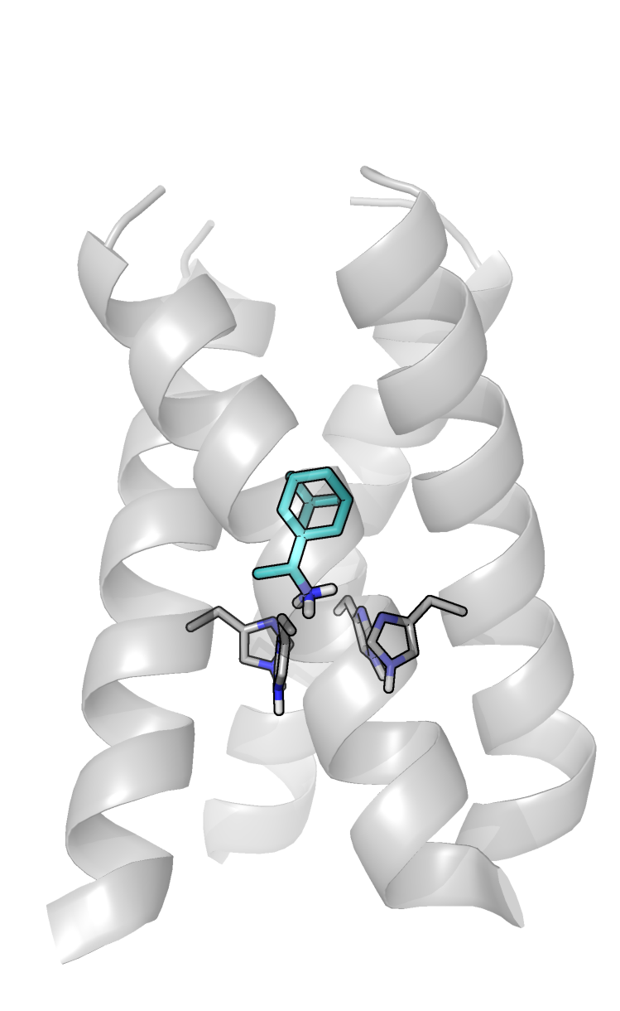  Fig. 6a: B = -24.820 | 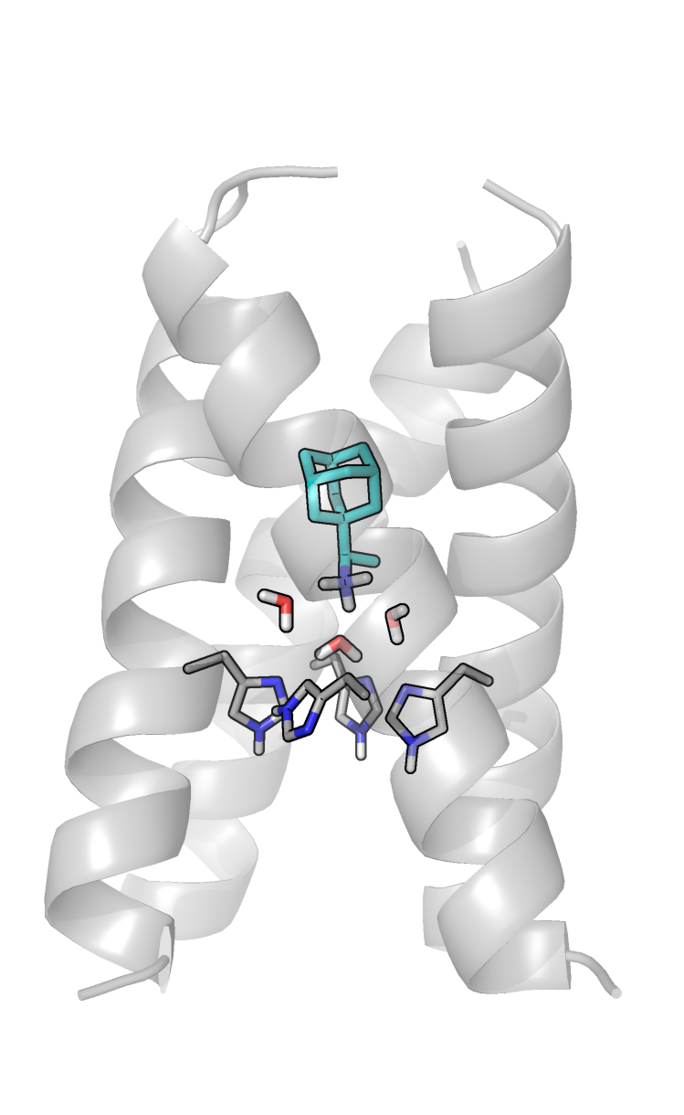  Fig. 6b: B = -15.820 | 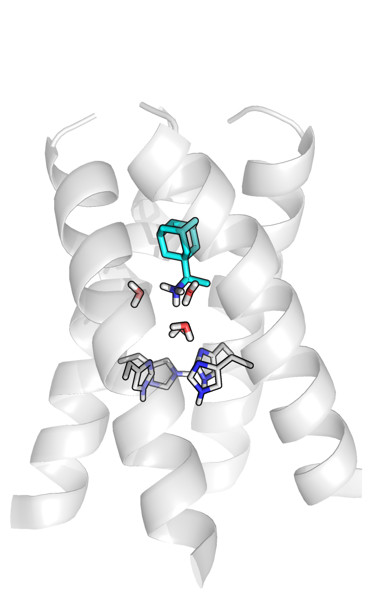  Fig. 6c: B = -11.820 | 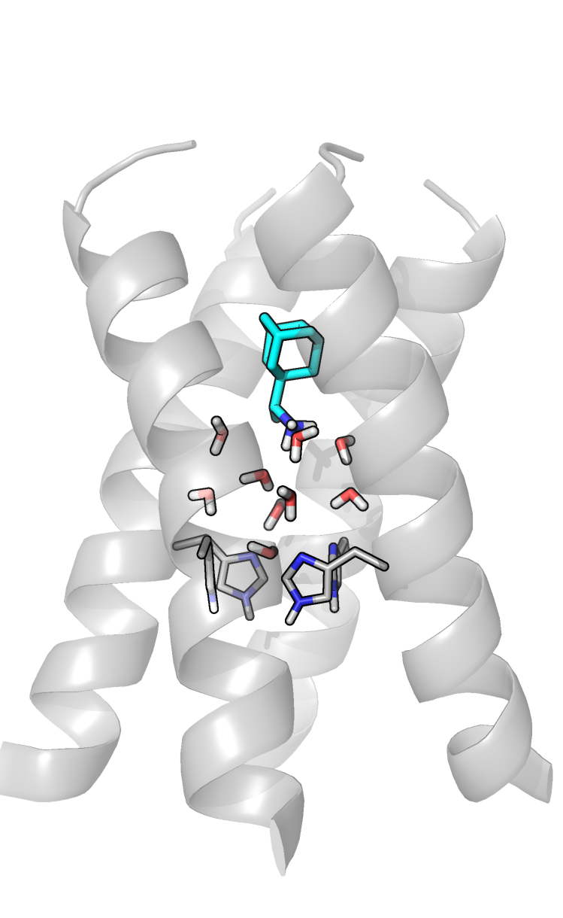  Fig. 6d: B = -6.820
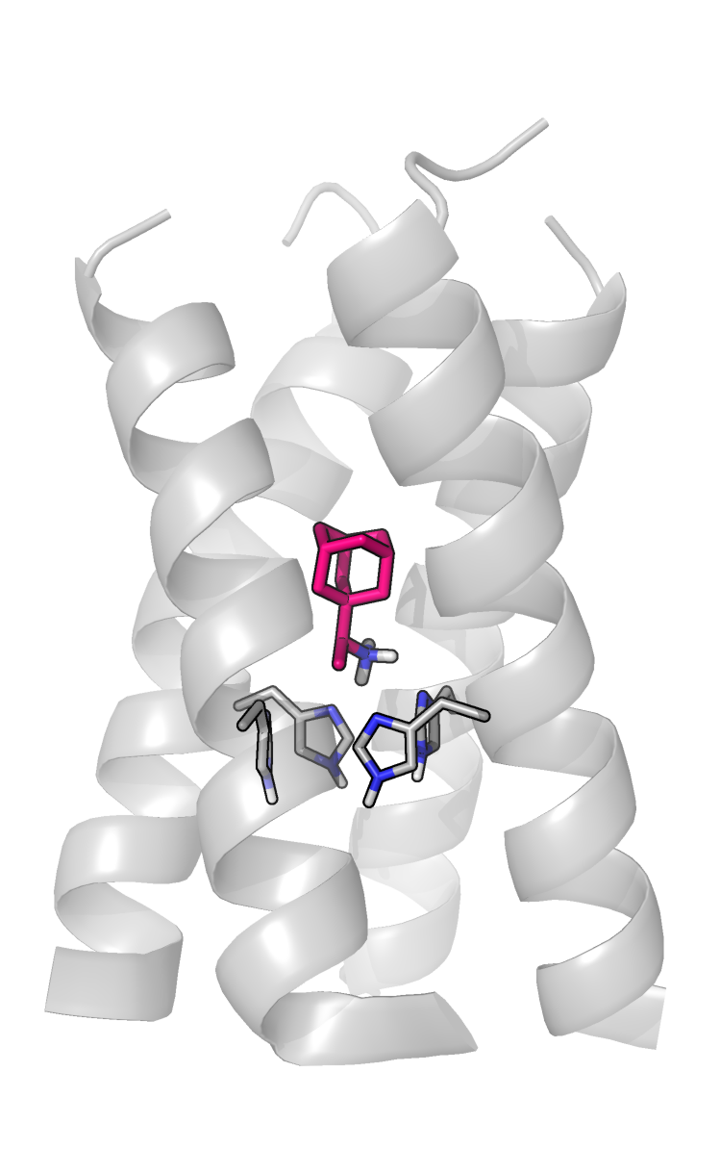  Fig. 6e: B = -24.820 | 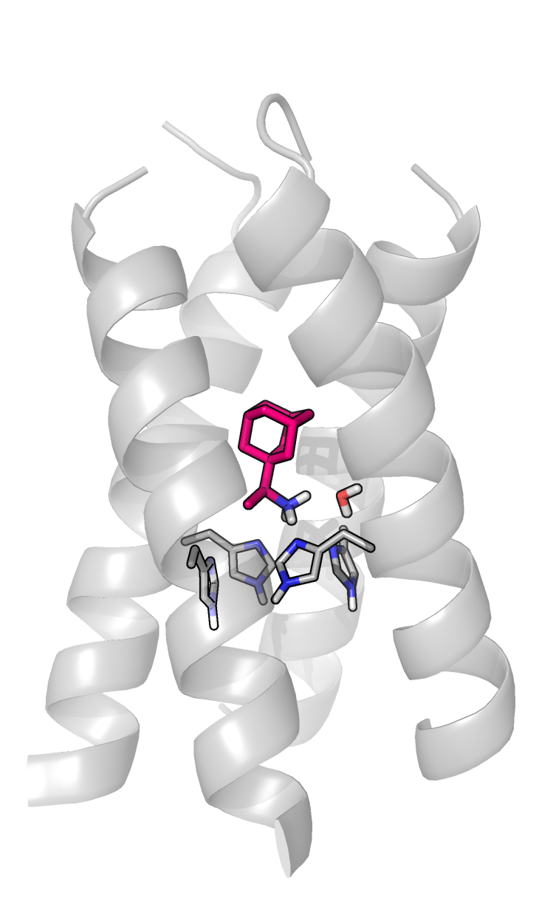  Fig. 6f: B = -15.820 | 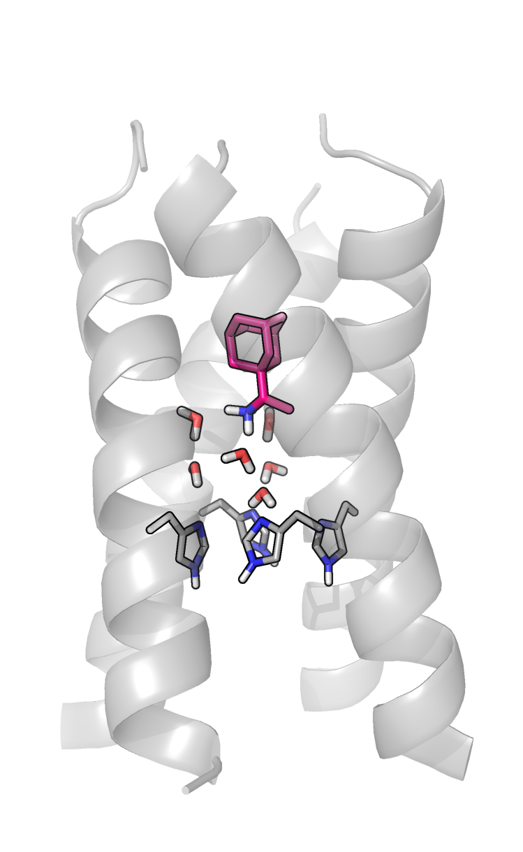  Fig. 6g: B = -11.820 | 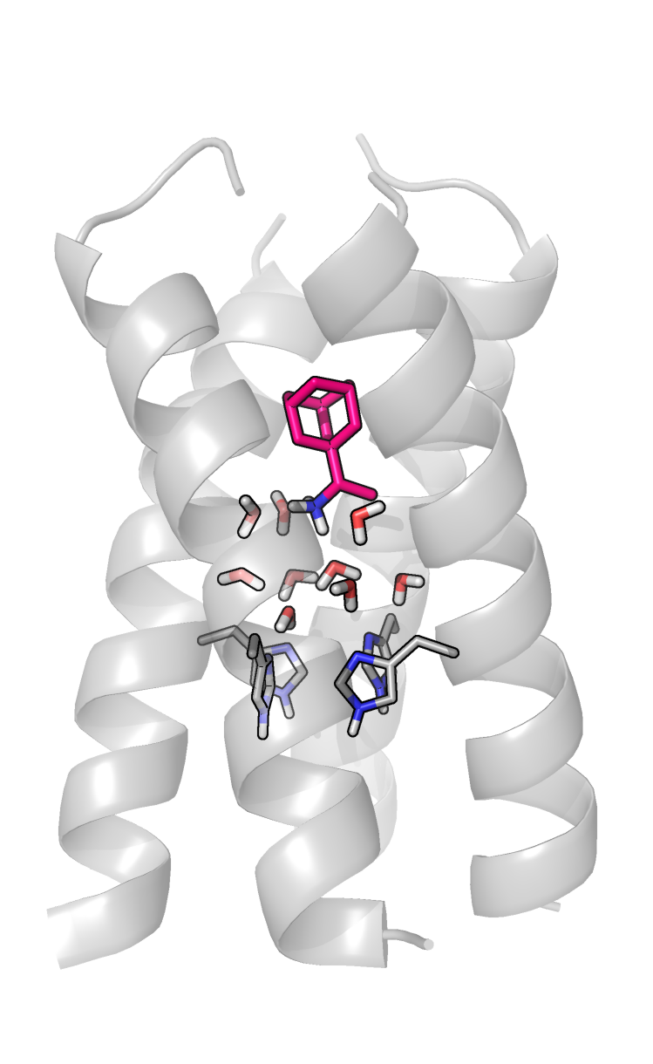  Fig. 6h: B = -6.820
Figure 6. A selection of representative frames from the simulations performed, showing the structural trends as the waters are removed from the GCMC region. The (R)-enantiomer is shown in cyan, and the (S)-enantiomer is shown in pink.

The general trend observed was that, as the chemical potential or B value value decreases and waters are removed from the GCMC region, waters from the upper layer, ie. close to Ala30 are removed first (see Fig. 7a), and the ligand gradually descends further into the protein to interact directly with the lower layer, ie. close to Gly34 (Figs. 6b & 6f), and then the His37 residues (Figs. 6a,e, 7b). It becomes clear that the (R)-enantiomer is more resistant to dehydration (see Figs. 4, 6b,f, 7a) and descends further into the channel than the (S)-enantiomer (see Figs. 6a, e, 7b) and the data shown in Fig. S5 shows that the (R)-enantiomer appears to show a greater propensity for hydrogen-bonding with the His37 residues (see also additional discussion in the Supporting Information). In parallel, when less water is in the binding site, the difference in the computed water network binding free energies between the two enantiomers becomes more significant. For example, a network of 4 water molecules which form the lower water layer appear to be 2.6 ± 0.6 kcal mol⁻¹ more stable in the presence of the (R)-enantiomer (N = 4 in Table S4). Thus, there is a hypothetical stereochemical difference when the upper water layer is removed from the binding site.
a.
b.
Figure 7. Violin plots depicting (a) the water distributions observed at each Adams value during the titration calculations; each water point is considered as its $z$-coordinate (the $z$-axis is perpendicular to the membrane), relative to the mean $z$-coordinate of the C_{α} atoms of the four His37 residues. (b) the ligand positions observed at each Adams value during the titration calculations; each point is considered as the $z$-coordinate (the $z$-axis is perpendicular to the membrane) of the nitrogen atom of the ligand, relative to the mean $z$-coordinate of the C_{α} atoms of the four His37 residues. The data for the (R)- and (S)-enantiomer are shown in blue and red, respectively. The plots are normalized such that all violins have the same width.

The free energy results obtained also imply that it would be very difficult for a ligand to gain a significant affinity increase by displacing the lower water layer. Given that the binding free energy of the network of 9-10 waters is in the vicinity of c.a. 30 kcal mol⁻¹, displacement of the upper layer would result in a network of 4 waters, with a binding free energy in the vicinity of 20 kcal mol⁻¹ (Table S4). This would imply a significant thermodynamic cost associated with the displacement of the lower water layer, in addition to the cost of displacing the upper layer. This is consistent with previous studies of drugs such as spiro-adamantyl amines, which are more extended than rimantadine; these compounds, which bind with high affinity, displace the upper, but not the lower layer of waters in the lumen of the channel^{32, 44}.
At lower levels of hydration, due to the chirality of the protein, there is a difference in terms of the computed stability of the water network, which can differentiate the binding of a chiral ligand. Thus, chirality might be an important factor in designing new, novel drugs, which displace the upper layer of waters and tightly engage to tightly-bound lower water layer.

Conclusions
The environment within the M2 pore is chiral: L-amino acids form right-handed α-helical monomers which come together to form a left-handed tetrameric helical bundle. Since this chiral environment has the potential to create enantiospecific binding, it was important to investigate whether the chirality of drugs had an effect on drug binding and inhibition. Though the chirality of the M2 protein creates the possibility of preferential binding of rimantadine enantiomers, we do not observe this in X-ray crystal structures of M2(22-46) WT bound to (R)- and (S)-rimantadine, in EP kinetics assays using the full-length channel, or in antiviral plaque assays. Instead, the crystal structures show that both rimantadine enantiomers bind to the M2 pore, and that the ethylammonium headgroup of both rimantadine enantiomers averages over four orientations. We observe slight differences in the hydration of each rimantadine enantiomer in the crystal structures. However, these slight differences in hydration do not have an effect on drug binding or channel inhibition. We hypothesize that the two layer water network, the upper layer adjacent to Ala30 and the lower layer to Gly34, is sufficiently flexible to mask the chirality of the binding site. The GCMC/MD simulation analysis indicates that, as the upper layer of waters is removed, a more substantial chiral difference is observed in the stability of the water networks, i.e., two layers of water are needed to lose this chiral templating effect. This potential enantiomeric selectivity may be of interest for compounds that are able to displace the upper water layer.

Materials and Methods
Sample preparation, crystallization, diffraction, and structure solving. Solid phase peptide synthesis using FMOC chemistry, and sample preparation and peptide-drug samples reconstitution into the lipid cubic phase (LCP) was carried out using previously described methods ^{32,45, 46} and the Supporting Information. Data collection was carried out at 100 K at the Advanced Light Source (ALS) beam 8.3.1. Data processing was carried out in Mosflm⁴⁷ and data were scaled in the CCP4 suite.⁴⁸ The structure was solved using molecular replacement in Phaser-MR⁴⁹ with structure PDB ID 6BKL³² as a search model. See the Supporting Information for detailed methods regarding crystallization and data collection.
TEVC assay. mRNA synthesis expressing the WT of A/Udorn/72 full M2 protein, oocyte culture, microinjection of oocytes, and electrophysiological TEVC recordings were carried out as previously described.^{35, 50} The K_{d} measurement and curve fitting were carried out as previously described.^{36, 37} Briefly, the percentage of current during the application of rimantadine enantiomers and washout protocol was plotted with an association then dissociation equation in GraphPad Prism 5.
Plaque reduction assay. Plaque reduction assays were performed in MDCK cells with A/Soloman Island/3/2006 (H1N1) virus as previously described.^{36, 50-52} A/Soloman Island/3/2006 (H1N1) M2 contains the same sequence as A/Udorn/72. Briefly, confluent cells were washed with PBS and infected with virus diluted in DMEM medium supplemented with 0.5% BSA for a final concentration of approximately 100 PFU per well. Viral infection was synchronized for 30 min at 4 °C, then incubated for 1 h at 37 °C in a 5% CO₂ atmosphere. The inoculum was aspirated, cells were washed and incubated in a DMEM overlay media containing different concentrations of compound, 2 μg/ml N-acetyl trypsin and 1.2% avicel microcrystalline cellulose (FMC BioPolymer, Philadelphia, PA) at 37 °C in a 5% CO₂ atmosphere. Cells were stained 2 days post infection with 0.2% crystal violet dye. EC₅₀ values were calculated by plotting the plaque area per well against the rimantadine concentration applied with a dose response function in Prism 5.
Molecular dynamics simulations. The complex of M2TM WT with (S)-rimantadine (PDB ID 6US8) or (R)-rimantadine (PDB ID 6US9) was embedded in a POPC lipid bilayer extending 30 Å beyond the solutes and the system was placed in an orthorhombic box (90×90×105 Ǻ³). The number of lipids added were ca 200. The bilayer was then solvated by a 30 Å-thick layer of waters. Na⁺ and Cl⁻ ions were placed in the water phase to neutralize the systems and to reach the experimental salt concentration of 0.150 M NaCl. The total number of atoms was ca 80,000. Membrane generation and system solvation was carried out using the “System Builder” utility of Maestro-Desmond 2020⁵³ and periodic boundary conditions were applied. We performed 300 ns MD simulations using an amber99sb force field using Desmond 2020^{54, 55} for the two enantiomers in complex with the X-ray crystal structures embedded in a hydrated lipid bilayer to test the stability of the experimental structures. See the Supporting Information for a detailed description of the simulation conditions and protocol.
GCMC Titration Calculations. GCMC method was used to allow the number of waters within a simulation to vary according to the chemical potential, in order to simulate the grand canonical (μVT) ensemble. This allows the waters within the M2 pore to exchange with bulk water much more rapidly, bypassing the kinetic barriers which can limit water sampling in conventional MD simulations (see Supporting Information and Fig. S4). GCMC is adequate for the simulation of the hydration of M2 pore at equilibrium with bulk water using the chemical potential reflected by the $B_{equil}$ value. Description of the theory upon which GCMC is based and a detailed description of the simulation conditions can be found in the Supporting Information. The GCMC simulations were carried out using version 7.3.1 of OpenMM.⁵⁶ Version 1.0.0 of the grand Python module⁵⁷ was used with OpenMM to carry out the GCMC sampling, with the MD sampling carried out using the native OpenMM functionality.
The region in which GCMC moves were carried out was defined as a sphere with radius 6.0 Å (for which $B_{equil}=-6.820$), centred on the average coordinate of the C_{α} atoms of the Gly34 residues. This was chosen to ensure that the two water layers of interest are covered by the GCMC sampling. Version 1.0.0 of the grand Python module⁵⁷ was used alongside OpenMM to carry out the GCMC sampling, with the MD sampling carried out using the native OpenMM functionality.
For each enantiomer, an initial equilibration procedure was applied, beginning with a very short minimization, following which the waters present in the GCMC region were deleted. This was followed by GCMC/MD equilibration at $B_{equil}$, to allow the waters in the GCMC region to be repopulated without bias, and then constant pressure equilibration to allow the volume of the system to equilibrate. The GCMC/MD stage was carried out in three phases to ensure rigorous equilibration of the waters before significant movement of the protein complex: first 1 ps of MD, with 5k moves attempted every 100 fs; then 10 ps of MD, with 100 moves every 200 fs; and finally, 50 ps of MD, with 500 moves every 250 fs. The constant pressure equilibration was carried out for 500 ps. The resulting equilibrated structure for each enantiomer was used as a starting point for each set of independent repeats, in order to ensure that they all had the same system volume, and therefore sampled the same ensemble.
For each independent set of repeats, for each enantiomer, a further GCMC/MD equilibration was carried out at $B_{equil}$ for 500 ps, with 50 GCMC moves executed every 250 fs. From this, multiple simulations were run at 21 equally-spaced $B$ values, from -24.820 to -4.820. Each of these simulations was equilibrated for 500 ps, with 50 GCMC moves every 250 fs, to allow the number of waters to adjust to the new $B$ value. This was followed by a production run of 2.5 ns, with 20 GCMC moves per 500 fs, with simulation frames written out every 5 ps. The average number of waters observed in the GCMC region, $〈N〉$, was calculated over these production runs. Three sets of these simulations were carried out for each enantiomer, generating three values of $〈N〉$ per $B$ value, per enantiomer (Table S3).
Free Energy Calculations. In order to determine the relative free energies of both hydration and binding for the two enantiomers, free energy calculations were performed in OpenMM, using version 0.7.1 of the perses Python module.⁵⁸ This involved perturbing each of the enantiomers into an achiral intermediate compound, in which the methyl group of rimantadine is replaced by a hydrogen atom. Full details of these calculations are provided in the Supporting Information.

Supporting Information. Details for sample preparation and crystallization data, for equilibrium molecular dynamics simulations, GCMC Theory, simulation details and additional results for GCMC titration of waters, simulation detail for the alchemical free energy calculations and supporting information references.

Five Figs and four Tables; Two Figs showing both pore-located rimantadines and rimantadines outside the pore with one describing tetramer bundles packing. Fig. showing the thermodynamic cycle depicting the free energy calculations performed; Fig. showing the total flux of waters in or out of the GCMC region via MD diffusion, at each Adams value, for both enantiomers; Fig. with bar charts showing the hydrogen bonding observed between the ligand and the protein at different Adams values Table with data processing for the X-ray structures, Table with refined occupancies for rimantadine rotational alternate conformers, Table with average number of waters observed for each repeat at each Adams value for both enantiomers, Table with calculated water binding free energies for each water determined from titration data.

Acknowledgements
J.L.T. and W.F.D. were supported by NIH grants R35-GM122603 and R01-GM117593. M.L.S. is supported by the EPSRC-funded CDT in Next Generation Computational Modelling, under grant EP/L015382/1. H.E.B.M acknowledges support from a Molecular Sciences Software Institute Fellowship and Relay Therapeutics. J.W. was supported by NIH grants AI119187 and AI144887. Use of the LCP crystallization robot was made possible by National Center for Research Resources Grant 1S10RR027234-01. The authors thank Pil Seok Chae (Hanyang University, Seoul, South Korea) for providing MNG detergent for crystallization trials. Data collection was carried out at ALS 8.3.1. Beamline 8.3.1 at the Advanced Light Source is operated by the University of California Office of the President, Multicampus Research Programs and Initiatives grant MR-15-328599 and NIGMS grants P30 GM124169 and R01 GM124149. The authors thank George Meigs and James Holton at ALS 8.3.1 for support during data collection. A.K. thanks Chiesi Hellas, which supported this research through the purchase of two workstations equipped with GPUs (SARG No 10354). The authors acknowledge the use of the IRIDIS High Performance Computing Facility, and associated support services at the University of Southampton, in the completion of this work.

Accession Codes
PDB ID 6US9, PDB ID 6US8

References

[1] To, J., Surya, W. & Torres, J. Targeting the Channel Activity of Viroporins. Advances in protein chemistry and structural biology 104, 307-355, To, J., Surya, W. & Torres, J. Targeting the Channel Activity of Viroporins. Advances in protein chemistry and structural biology 104, 307-355, doi:10.1016/bs.apcsb.2015.12.003 (2016).

[2] Dong, G., Peng, C., Luo, J., Wang, C., Han, L., Wu, B., Ji, G., and He, H. (2015) Adamantane-resistant influenza A viruses in the world (1902-2013): frequency and distribution of M2 gene mutations, Plos One 10, e0119115.
[3] Bright, R. A., Medina, M. J., Xu, X. Y., Perez-Oronoz, G., Wallis, T. R., Davis, X. H. M., Povinelli, L., Cox, N. J., and Klimov, A. I. (2005) Incidence of adamantane resistance among influenza A (H3N2) viruses isolated worldwide from 1994 to 2005: a cause for concern, Lancet 366, 1175-1181.
[4] Lampejo, T. (2020) Influenza and antiviral resistance: an overview, Eur J Clin Microbiol Infect Dis 39, 1201-1208.
[5] Chizhmakov, I. V., Geraghty, F. M., Ogden, D. C., Hayhurst, A., Antoniou, M., and Hay, A. J. (1996) Selective proton permeability and pH regulation of the influenza virus M2 channel expressed in mouse erythroleukaemia cells, Journal of Physiology-London 494, 329-336.
[6] Lin, T. I., and Schroeder, C. (2001) Definitive assignment of proton selectivity and attoampere unitary current to the M2 ion channel protein of influenza A virus, Journal of Virology 75, 3647-3656.
[7] Mould, J. A., Drury, J. E., Frings, S. M., Kaupp, U. B., Pekosz, A., Lamb, R. A., and Pinto, L. H. (2000) Permeation and activation of the M-2 ion channel of influenza A virus, Journal of Biological Chemistry 275, 31038-31050.
[8] Shimbo, K., Brassard, D. L., Lamb, R. A., and Pinto, L. H. (1996) Ion selectivity and activation of the M2 ion channel of influenza virus, Biophysical Journal 70, 1335-1346.
[9] Duff, K. C., and Ashley, R. H. (1992) The transmembrane domain of influenza A M2 protein forms amantadine-sensitive proton channels in planar lipid bilayers, Virology 190, 485-489.
[10] Ma, C. L., Polishchuk, A. L., Ohigashi, Y., Stouffer, A. L., Schon, A., Magavern, E., Jing, X. H., Lear, J. D., Freire, E., Lamb, R. A., DeGrado, W. F., and Pinto, L. H. (2009) Identification of the functional core of the influenza A virus A/M2 proton-selective ion channel, Proceedings of the National Academy of Sciences 106, 12283-12288.
[11] Tang, Y. J., Zaitseva, F., Lamb, R. A., and Pinto, L. H. (2002) The gate of the influenza virus M-2 proton channel is formed by a single tryptophan residue, Journal of Biological Chemistry 277, 39880-39886.
[12] Wang, C., Lamb, R. A., and Pinto, L. H. (1995) Activation of the M2 ion channel of influenza virus: a role for the transmembrane domain histidine residue, Biophysical Journal 69, 1363-1371.
[13] Martin, K., and Helenius, A. (1991) Nuclear transport of influenza virus ribonucleoproteins: The viral matrix protein (M1) promotes export and inhibits import, Cell 67, 117-130.
[14] Hay, A. J., Wolstenholme, A. J., Skehel, J. J., and Smith, M. H. (1985) The molecular basis of the specific anti-influenza action of amantadine, The EMBO Journal 4, 3021-3024.
[15] Wang, C., Takeuchi, K., Pinto, L. H., and Lamb, R. A. (1993) Ion-channel activity of influenza-A virus M(2) protein - characterization of the amantadine block, Journal of Virology 67, 5585-5594.
[16] Drakopoulos, A., Tzitzoglaki, C., McGuire, K., Hoffmann, A., Konstantinidi, A., Kolokouris, D., Ma, C., Freudenberger, K., Hutterer, J., Gauglitz, G., Wang, J., Schmidtke, M., Busath, D. D., and Kolocouris, A. (2018) Unraveling the Binding, Proton Blockage, and Inhibition of Influenza M2 WT and S31N by Rimantadine Variants, ACS Medicinal Chemistry Letters 9, 198-203.
[17] Duque, M. D., Ma, C., Torres, E., Wang, J., Naesens, L., Juárez-Jiménez, J., Camps, P., Luque, F. J., DeGrado, W. F., Lamb, R. A., Pinto, L. H., and Vázquez, S. (2011) Exploring the Size Limit of Templates for Inhibitors of the M2 Ion Channel of Influenza A Virus, Journal of Medicinal Chemistry 54, 2646-2657.
[18] Skehel, J. J., Hay, A. J., and Armstrong, J. A. (1978) On the mechanism of inhibition of influenza virus replication by amantadine hydrochloride, The Journal of general virology 38, 97-110.
[19] Ciampor, F., Bayley, P. M., Nermut, M. V., Hirst, E. M. A., Sugrue, R. J., and Hay, A. J. (1992) Evidence that the amantadine-induced, M2-mediated conversion of influenza-A virus hemagglutinin to the low pH conformation occurs in an acidic transgolgi compartment, Virology 188, 14-24.
[20] Sugrue, R. J., Bahadur, G., Zambon, M. C., Hall-Smith, M., Douglas, A. R., and Hay, A. J. (1990) Specific structural alteration of the influenza haemagglutinin by amantadine, The EMBO Journal 9, 3469-3476.
[21] Cady, S. D., Schmidt-Rohr, K., Wang, J., Soto, C. S., Degrado, W. F., and Hong, M. (2010) Structure of the amantadine binding site of influenza M2 proton channels in lipid bilayers, Nature 463, 689-692.
[22] Andreas, L. B., Barnes, A. B., Corzilius, B., Chou, J. J., Miller, E. A., Caporini, M., Rosay, M., and Griffin, R. G. (2013) Dynamic nuclear polarization study of inhibitor binding to the M2(18-60) proton transporter from influenza A, Biochemistry 52, 2774-2782.
[23] Thomaston, J. L., Polizzi, N. F., Konstantinidi, A., Wang, J., Kolocouris, A., and DeGrado, W. F. (2018) Inhibitors of the M2 proton channel engage and disrupt transmembrane networks of hydrogen-bonded waters, J. Am. Chem. Soc. 140, 15219-15226.
[24] Wright, A. K., Batsomboon, P., Dai, J., Hung, I., Zhou, H.-X., Dudley, G. B., and Cross, T. A. (2016) Differential Binding of Rimantadine Enantiomers to Influenza A M2 Proton Channel, Journal of the American Chemical Society 138, 1506-1509.
[25] Drakopoulos, A., Tzitzoglaki, C., Ma, C., Freudenberger, K., Hoffmann, A., Hu, Y., Gauglitz, G., Schmidtke, M., Wang, J., and Kolocouris, A. (2017) Affinity of rimantadine enantiomers against influenza A/M2 protein revisited, ACS Medicinal Chemistry Letters 8, 145-150.
[26] Aldrich, P. E., Hermann, E. C., Meier, W. E., Paulshock, M., Prichard, W. W., Synder, J. A., and Watts, J. C. (1971) Antiviral agents. 2. Structure-activity relations of compounds related to 1-adamantanamine, Journal of Medicinal Chemistry 14, 535-543.
[27] Bruce Macdonald, H. E., Cave-Ayland, C., Ross, G. A., and Essex, J. W. (2018) Ligand Binding Free Energies with Adaptive Water Networks: Two-Dimensional Grand Canonical Alchemical Perturbations, Journal of chemical theory and computation 14, 6586-6597.
[28] Ross, G. A., Bodnarchuk, M. S., and Essex, J. W. (2015) Water Sites, Networks, And Free Energies with Grand Canonical Monte Carlo, Journal of the American Chemical Society 137, 14930-14943.
[29] Ross, G. A., Bruce Macdonald, H. E., Cave-Ayland, C., Cabedo Martinez, A. I., and Essex, J. W. (2017) Replica-Exchange and Standard State Binding Free Energies with Grand Canonical Monte Carlo, Journal of chemical theory and computation 13, 6373-6381.
[30] Stouffer, A. L., Acharya, R., Salom, D., Levine, A. S., Di Costanzo, L., Soto, C. S., Tereshko, V., Nanda, V., Stayrook, S., and DeGrado, W. F. (2008) Structural basis for the function and inhibition of an influenza virus proton channel, Nature 451, 596-599.
[31] Thomaston, J. L., Konstantinidi, A., Liu, L., Lambrinidis, G., Tan, J., Caffrey, M., Wang, J., Degrado, W. F., and Kolocouris, A. (2020) X-ray Crystal Structures of the Influenza M2 Proton Channel Drug-Resistant V27A Mutant Bound to a Spiro-Adamantyl Amine Inhibitor Reveal the Mechanism of Adamantane Resistance, Biochemistry 59, 627-634.
[32] Thomaston, J. L. P., N.F.; Konstantinidi, A.; Wang, J.; Kolocouris, A.; DeGrado, W.F. (2018) Inhibitors of the M2 proton channel engage and disrupt transmembrane networks of hydrogen-bonded waters, Journal of the American Chemical Society 140, 15219-15226.
[33] Schnell, J. R., and Chou, J. J. (2008) Structure and mechanism of the M2 proton channel of influenza A virus, Nature 451, 591-U512.
[34] Cady, S. D., Schmidt-Rohr, K., Wang, J., Soto, C. S., DeGrado, W. F., and Hong, M. (2010) Structure of the amantadine binding site of influenza M2 proton channels in lipid bilayers, Nature 463, 689-U127.
[35] Musharrafieh, R., Lagarias, P., Ma, C., Hau, R., Romano, A., Lambrinidis, G., Kolocouris, A., and Wang, J. (2020) Investigation of the Drug Resistance Mechanism of M2-S31N Channel Blockers through Biomolecular Simulations and Viral Passage Experiments, ACS Pharmacology & Translational Science 3, 666-675.
[36] Musharrafieh, R., Ma, C., and Wang, J. (2018) Profiling the in vitro drug-resistance mechanism of influenza A viruses towards the AM2-S31N proton channel blockers Antiviral Research 153, 10-22.
[37] Wang, Y., Hu, Y., Xu, S., Zhang, Y., Musharrafieh, R., Hau, R. K., Ma, C., and Wang, J. (2018) In Vitro Pharmacokinetic Optimizations of AM2-S31N Channel Blockers Led to the Discovery of Slow-Binding Inhibitors with Potent Antiviral Activity against Drug-Resistant Influenza A Viruses, Journal of medicinal chemistry 61, 1074-1085.
[38] Tembre, B. L., and Mc Cammon, J. A. (1984) Ligand-receptor interactions, Computers & Chemistry 8, 281-283.
[39] Zwanzig, R. W. (1954) High‐Temperature Equation of State by a Perturbation Method. I. Nonpolar Gases, The Journal of Chemical Physics 22, 1420-1426.
[40] Bennett, C. H. (1976) Efficient estimation of free energy differences from Monte Carlo data, Journal of Computational Physics 22, 245-268.
[41] Shirts, M. R., and Chodera, J. D. (2008) Statistically optimal analysis of samples from multiple equilibrium states, The Journal of chemical physics 129, 124105-124105.
[42] Cournia, Z., Allen, B., and Sherman, W. (2017) Relative Binding Free Energy Calculations in Drug Discovery: Recent Advances and Practical Considerations, Journal of Chemical Information and Modeling 57, 2911-2937.
[43] Ioannidis, H., Drakopoulos, A., Tzitzoglaki, C., Homeyer, N., Kolarov, F., Gkeka, P., Freudenberger, K., Liolios, C., Gauglitz, G., Cournia, Z., Gohlke, H., and Kolocouris, A. (2016) Alchemical Free Energy Calculations and Isothermal Titration Calorimetry Measurements of Aminoadamantanes Bound to the Closed State of Influenza A/M2TM, Journal of Chemical Information and Modeling 56, 862-876.
[44] Wang, J., Ma, C. L., Fiorin, G., Carnevale, V., Wang, T., Hu, F. H., Lamb, R. A., Pinto, L. H., Hong, M., Kein, M. L., and DeGrado, W. F. (2011) Molecular dynamics simulation directed rational design of inhibitors targeting drug-resistant mutants of influenza A virus M2, Journal of the American Chemical Society 133, 12834-12841.
[45] Thomaston, J. L., Alfonso-Prieto, M., Woldeyes, R. A., Fraser, J. S., Klein, M. L., Fiorin, G., and DeGrado, W. F. (2015) High-resolution structures of the M2 channel from influenza A virus reveal dynamic pathways for proton stabilization and transduction, Proceedings of the National Academy of Sciences 112, 14260-14265.
[46] Thomaston, J. L., and DeGrado, W. F. (2016) Crystal structure of the drug-resistant S31N influenza M2 proton channel, Protein Science 25, 1551-1554.
[47] Battye, T. G. G., Kontogiannis, L., Johnson, O., Powell, H. R., and Leslie, A. G. W. (2011) iMOSFLM: a new graphical interface for diffraction-image processing with MOSFLM, Acta Crystallographica Section D-Biological Crystallography 67, 271-281.
[48] Winn, M. D., Ballard, C. C., Cowtan, K. D., Dodson, E. J., Emsley, P., Evans, P. R., Keegan, R. M., Krissinel, E. B., Leslie, A. G. W., McCoy, A., McNicholas, S. J., Murshudov, G. N., Pannu, N. S., Potterton, E. A., Powell, H. R., Read, R. J., Vagin, A., and Wilson, K. S. (2011) Overview of the CCP4 suite and current developments, Acta Crystallographica Section D-Biological Crystallography 67, 235-242.
[49] McCoy, A. J., Grosse-Kunstleve, R. W., Adams, P. D., Winn, M. D., Storoni, L. C., and Read, R. J. (2007) Phaser crystallographic software, Journal of Applied Crystallography 40, 658-674.
[50] Hu, Y., Musharrafieh, R., Ma, C., Zhang, J., Smee, D. F., DeGrado, W. F., and Wang, J. (2017) An M2-V27A channel blocker demonstrates potent in vitro and in vivo antiviral activities against amantadine-sensitive and -resistant influenza A viruses, Antiviral Research 140, 45-54.
[51] Ma, C., Li, F., Musharrafieh, R. G., and Wang, J. (2016) Discovery of cyclosporine A and its analogs as broad-spectrum anti-influenza drugs with a high in vitro genetic barrier of drug resistance, Antiviral research 133, 62-72.
[52] Ma, C., Zhang, J., and Wang, J. (2016) Pharmacological Characterization of the Spectrum of Antiviral Activity and Genetic Barrier to Drug Resistance of M2-S31N Channel Blockers, Mol Pharmacol 90, 188-198.
[53] Schrödinger, L. (2020) Maestro-Desmond Interoperability Tools.
[54] Bowers, K. J., Chow, D. E., Xu, H., Dror, R. O., Eastwood, M. P., Gregersen, B. A., Klepeis, J. L., Kolossvary, I., Moraes, M. A., Sacerdoti, F. D., Salmon, J. K., Shan, Y., and Shaw, D. E. (2006) Scalable Algorithms for Molecular Dynamics Simulations on Commodity Clusters, In SC '06: Proceedings of the 2006 ACM/IEEE Conference on Supercomputing, pp 43-43.
[55] Schrodinger, L. (2020) Release 2020-4: Desmond Molecular Dynamics System, D.E. Shaw Research, New York, NY.
[56] Eastman, P., Swails, J., Chodera, J. D., McGibbon, R. T., Zhao, Y., Beauchamp, K. A., Wang, L. P., Simmonett, A. C., Harrigan, M. P., Stern, C. D., Wiewiora, R. P., Brooks, B. R., and Pande, V. S. (2017) OpenMM 7: Rapid development of high performance algorithms for molecular dynamics, PLoS computational biology 13, e1005659.
[57] Samways, M. L., Bruce Macdonald, H. E., and Essex, J. W. (2020) grand: A Python Module for Grand Canonical Water Sampling in OpenMM, Journal of Chemical Information and Modeling 60, 4436-4441.
[58] Rufa, D. A., Bruce Macdonald, H. E., Fass, J., Wieder, M., Grinaway, P. B., Roitberg, A. E., Isayev, O., and Chodera, J. D. (2020) Towards chemical accuracy for alchemical free energy calculations with hybrid physics-based machine learning / molecular mechanics potentials, bioRxiv, 2020.2007.2029.227959.

TOC: For Table of Contents use only

