Supplementary Material

Supplementary Figures
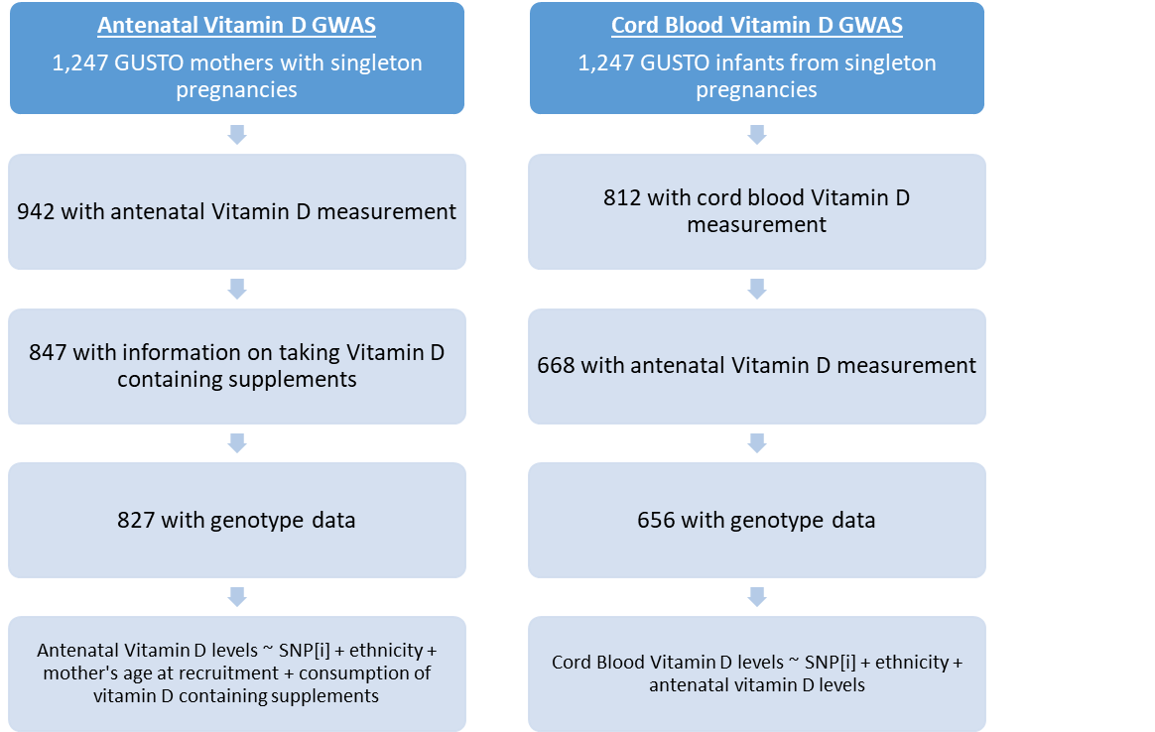
Supplementary Figure 1. Flow chart to show how the final sample size used for GWAS was derived.

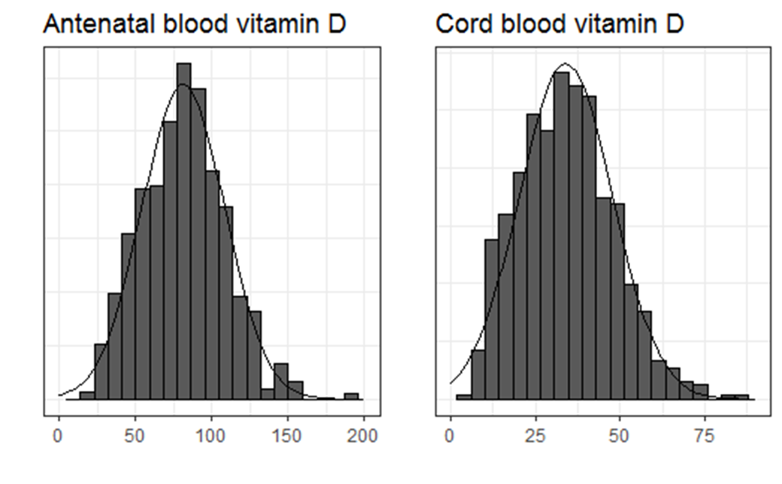
Supplementary Figure 2. Distribution of the measured values for antenatal and cord blood vitamin D in nmol/L.
Antenatal Vitamin D (trans-ethnic) Cord Blood Vitamin D (trans-ethnic)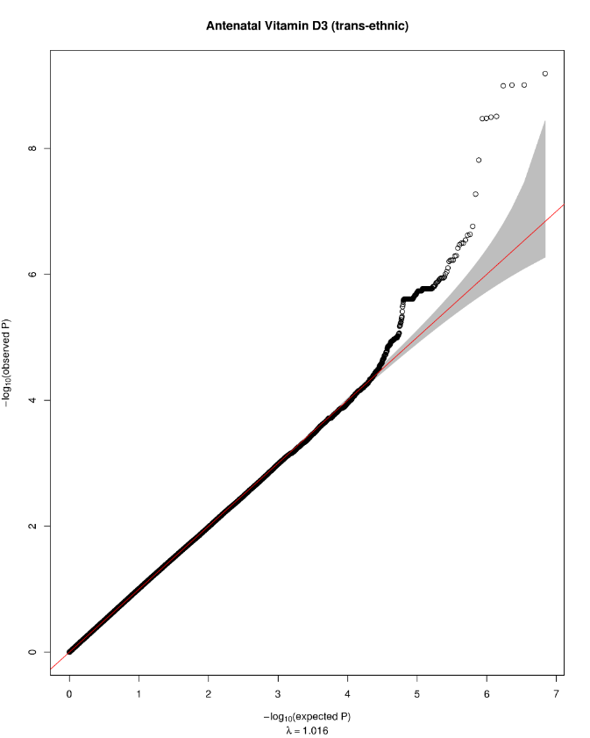 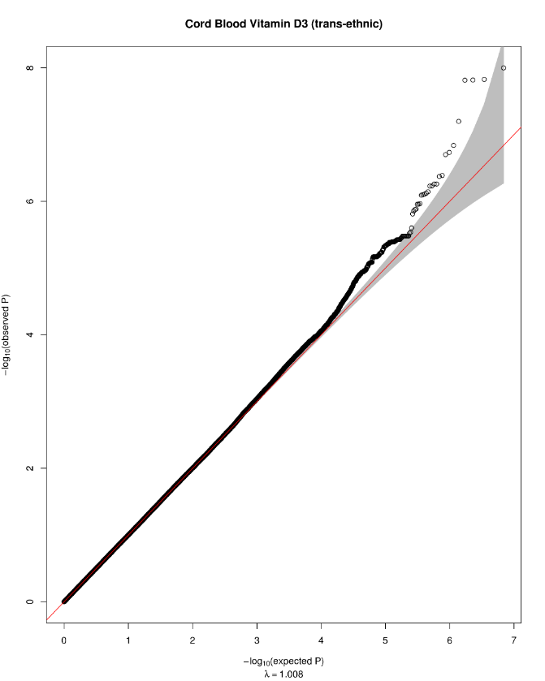
Supplementary Figure 3. QQ plot for the antenatal (left) and cord blood (right) GWAS on vitamin D.

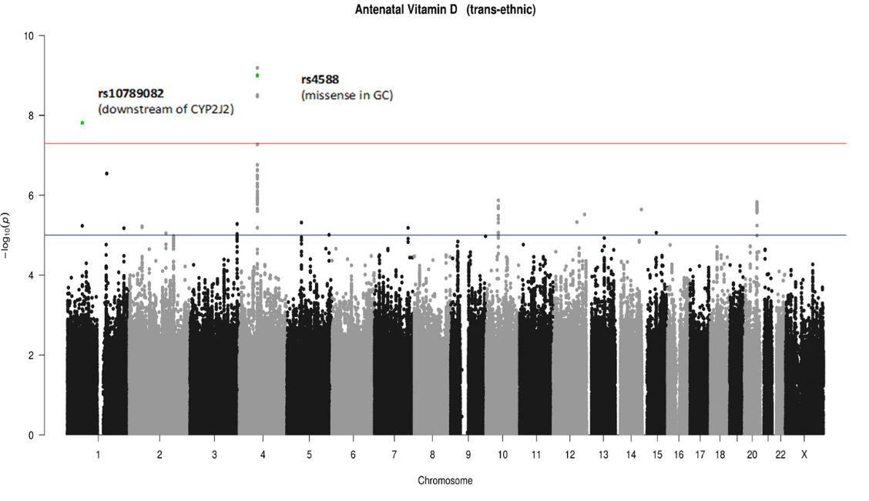
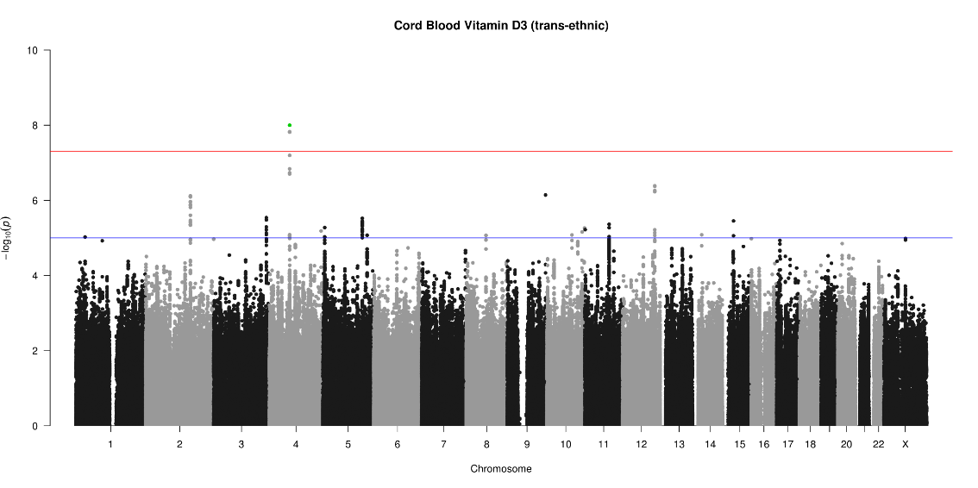
rs4588
(missense in GC)
Supplementary Figure 4. Manhattan plots for GWAS for vitamin D levels in antenatal and cord blood in trans-ethnic model. The red line in the Manhattan plot depicts the genome-wide significance threshold of 5 x 10⁻⁸ and the blue line depicts the suggestive threshold of 1 x 10⁻⁵.

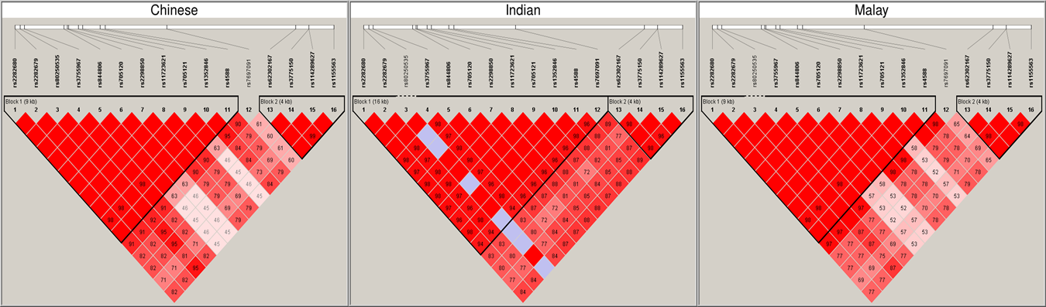
Supplementary Figure 5. The linkage disequilibrium plot using R² with the 16 SNPs with p < 10⁻⁵ in the antenatal vitamin D (12 of which also achieve p < 10⁻⁵ in cord blood vitamin D) in the GC gene region. Similar haplotype blocks are seen across the three ethnicities among the selected SNPs. All of the variants that pass genome-wide significance in antenatal vitamin D (see Table 3) are located in Block 1: rs1352846 (p=6·5x10⁻¹⁰), rs2298850 (p=9·8 x10⁻¹⁰), rs11723621 (p=9·90 x10⁻¹⁰), rs4588 (p=1·00 x10⁻⁹), rs3755967 (p=3·1x10⁻⁹), rs2282679 (p=3·2x10⁻⁹), rs17467825 (p=3·3x10⁻⁹), rs2282680 (p=3·4x10⁻⁹). All of the variants that pass genome-wide significance in cord blood vitamin D (see Table 3) are located in Block 1: rs4588 (p=1·0x10⁻⁸), rs2298850 (p=1·5x10⁻⁸), rs11723621 (p=1·5x10⁻⁸), rs1352846 (p=1·5x10⁻⁸).

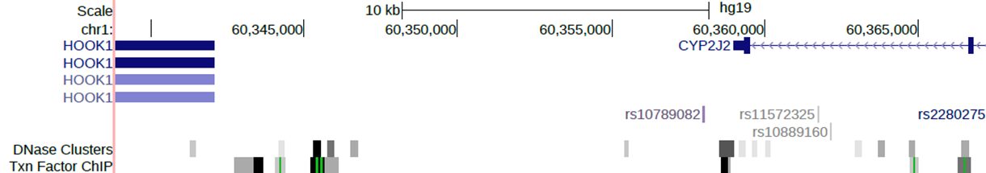

Supplementary Figure 6. Snapshot of UCSC genome browser depicting the SNP rs10789082 (boxed in red) in relation to the CYP2J2 gene.

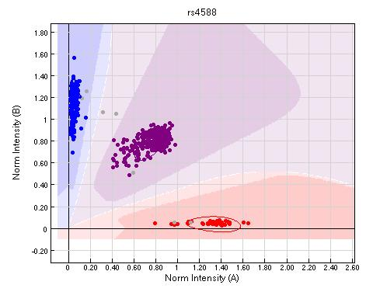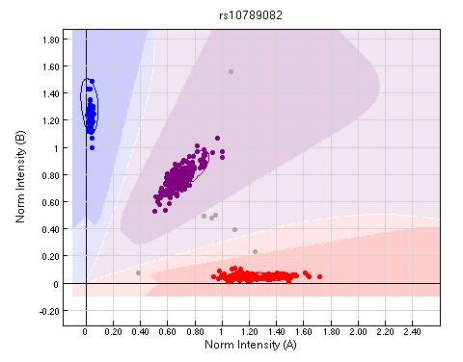
Supplementary Figure 7. The allele intensity signals for the two significant SNPs identified in GUSTO mothers that are typed on the genotyping chip showing good separation of the signals indicating accurate genotype calling.

