Design and application of photocatalysts using porous materials

Priyanka Verma1,2, Yoshifumi Kondo1, Yasutaka Kuwahara1,3,4, Takashi Kamegawa1,5, Kohsuke Mori1,3, Robert Raja2 and Hiromi Yamashita1,3*

*1Division of Materials and Manufacturing Science, Graduate School of Engineering, Osaka University, 2-1 Yamadaoka, Suita, Osaka 565-0871, Japan*

*E-mail:* [*yamashita@mat.eng.osaka-u.ac.jp*](mailto:yamashita@mat.eng.osaka-u.ac.jp)

*Fax: +81-6-6879-7457; Tel: +81-6-6879-7457*

*2School of Chemistry, University of Southampton, University Road, Highfield, Southampton, SO17 1BJ, United Kingdom*

*3Elements Strategy Initiative for Catalysts & Batteries ESICB, Kyoto University, Katsura, Kyoto 615-8520, Japan*

*4JST, PRESTO, 4-1-8 Honcho, Kawaguchi, Saitama 332-0012, Japan*

*5Department of Applied Chemistry, Graduate School of Engineering, Osaka Prefecture University, 1-2, Gakuen-cho, Naka-ku, Sakai, Osaka 599-8570, Japan*

# Short title

Nano-confined photocatalysts in porous materials

# Abstract

Porous materials have attracted considerable attention in materials science, chemistry and multidisciplinary areas of research due to their diverse structures, tailorable functionalities, large surface areas, remarkable optical transparency, confinement and shape selectivity effects. The precise architecture of porous photocatalytic materials has been extensively reported by the hybridisation of semiconducting nanoparticles (NPs), light-responsive metal complexes and plasmonic metal NPs with silica-based micro-, meso- and macro-porous nanostructures. This review targets to cover state-of-the-art accomplishments in the surface engineering chemistry of zeolites, mesoporous silica, and metal-organic frameworks (MOFs) as excellent host materials for solar to chemical energy conversion and environmental remediation. The specific advantages and disadvantages of representative porous materials in photocatalysis have also been elaborated and summarised. Finally, key advances and prospects are presented to overcome the current challenges in photocatalysis and to inspire further studies in this rapidly evolving research field.

# Keywords

Porous materials, single-site photocatalysts, zeolites, mesoporous silica, metal organic frameworks and plasmonic catalysts

# 1. Introduction

The global reliance on finite resources, ever-increasing energy demands, and environmental concerns have necessitated the development of green and clean processes [1–3]. The future of low-carbon economy depends on the current progress and research efforts in decreasing the dependence on non-renewable energy sources [4, 5]. However, the implementation of renewable energy-based technologies is greatly hindered by various limitations for developing sustainable alternatives [6], for example, high cost [7], low activity [8] and poor thermal stability [9]. It is highly crucial to design cost-effective multifunctional materials that can address the aforementioned challenges [10]. The versatile and abundant solar energy has become a promising alternative to replace non-renewable fossil fuels [11]. The amount of solar energy reaching on the earth’s surface (3 X 1024 J year-1) is much higher than the world’s total annual energy consumption. The efficient utilisation of solar energy can immensely assist in solving the issues of energy storage and environmental pollution [12]. Significant efforts have been devoted in realising its potential to drive chemical transformation reactions by converting solar energy to chemical energy [13].

The path-breaking research work on photoelectrochemical water splitting using TiO2 electrode by Fujishima and Honda was reported as early as in 1972, which stimulated the steadfast research activities in the visible-light driven artificial photosynthesis [14]. The diverse applications using TiO2 as aphotocatalyst like water splitting, CO2 utilisation, pollutant degradation, self-cleaning materials and solar cells have been explored in order to mitigate the effects arising from energy crisis and environmental issues [15–17]. The decrease in the size of semiconducting particles to ultimate small size limit of single-atom species, is capable of displaying superior photocatalytic performances due to quantum size effects. The evaluation of photocatalytic performances by semiconducting nanoparticles (NPs) revealed excellent reaction yields under shorter wavelength light irradiation. The novelty aspect in these photocatalysts is the formation of low-coordinated and isolated single-atom species with increased overall surface energy. However, such isolated species are prone to undergo aggregation in the absence of suitable support material. Hence, the design and selection of appropriate support material is essential in order to preserve the structural and catalytic properties of single-atom species and facilitating strong metal-support interactions [18]. Porous materials are appealing because of their ability to adsorb and interact with substrate molecules, thereby, promoting diffusion within the pore spaces [19, 20]. The use of porous materials is ubiquitous in designing new materials owing to their outstanding properties such as high surface area, large pore volumes, enhanced accessibility and the surface engineering ability by multifunctionalities. According to IUPAC nomenclature, porous materials fall into three simple categories based on the pore sizes within the framework: (i) microporous (< 2 nm), (ii) mesoporous (2-50 nm) and (iii) macroporous (> 50 nm). In particular, the microporous zeolites and mesoporous silica-based materials have proven to be excellent host materials in the design of unique photocatalytic systems [21, 22]. They provide a restricted environment and nanospaces for the confinement of photoreaction within the rigid porous matrix [23–25]. Furthermore, their adjustable pore sizes and excellent transparency to UV-vis light assist in the evaluation of photocatalytic responses. These materials are opaque in powdered form and can be employed as thin films or suspensions for photoirradiation reactions. Additionally, the fine connectivity of pores within the framework facilitates improved accessibility of the substrate molecules to reach the active sites [26–28].

Very recently, metal-organic frameworks (MOFs) have gained recent research attention as a new class of porous materials [29, 30]. They are three-dimensional organic-inorganic microporous materials fabricated with metal ions/clusters coordinated to organic linkers. Their high chemical versatility has led to the synthesis of numerous frameworks using transition metals with a variety of different organic linkers, leading to different structural and chemical properties. In addition, the observed large specific surface area values and semiconducting behaviour suggests great potential in gas adsorption [31], photocatalysis [32], separation [33] and sensor technology [34]. However, the thermal and chemical stability of MOFs is relatively low and dependent on metal-linker interactions. The specific structural, physical and chemical characteristics of the three representative types of porous materials; zeolites, mesoporous silica and MOFs has been enlisted in Table 1. Based on their diverse physico-chemical properties, it is possible to select a suitable porous support material in order to achieve excellent catalytic and photocatalytic responses.

Table 1. Comparison of specific structural, physical and chemical characteristics of zeolites, mesoporous silica and MOFs.

|  |  |  |  |
| --- | --- | --- | --- |
| **Characteristics** | **Zeolites** | **Mesoporous silica** | **MOFs** |
| Structure | Crystalline | Amorphous | Crystalline |
| Structural composition | Aluminosilicates | Silicates | Metal ions coordinated to organic linkers |
| Commonly used supports | Zeolite-Y, zeolite beta, ZSM-5, | SBA-15, MCM-41, MCM-48 | ZIF-67, MIL-100, MIL-125, UiO-66 |
| Surface area | ~500 m2g-1 | ~1000 m2g-1 | ~7500 m2g-1 |
| Molecular tunability | Low | Medium | High |
| Chemical versatility | Low | Medium | High |
| Pore size | 0.5 - 2.0 nm | 2 - 50 nm | 0.3 - 10 nm |
| Pore volume | 0.1-0.5 cm3 | < 1 cm3 | > 1 cm3 |
| Active metal site density | Low | Variable | High |
| Stability / inertness | High thermal stability up to 800 °C, high hydrothermal stability | High thermal stability up to 850 °C, lower hydrothermal stability than zeolites | Lower thermal stability up to 300 °C, lower hydrothermal stability |
| Diffusion | Low | High | Low to high |
| Conductivity | Absent | Absent | Semiconductor type behaviour |
| Light absorption | Transparent above 240 nm | Transparent to visible light | Strong absorption in the UV-vis region |
| Recyclability | Good | Good | Poor |
| Lewis acidity | High | Low | Medium |
| Brønsted acidity | Due to Si(OH)/Al hydroxyl groups | Introduced by post-synthetic functionalisation | Introduced by post-synthetic functionalisation |
| Catalytic applications | Acid catalysis, redox catalysis, supports for metal ions by cation exchange, gas-phase catalysis and size selectivity | Acid catalysis, redox catalysis, heteroatom doping within the framework, active sites on the surface or within the porous channels | Acid catalysis, redox catalysis, size-selectivity, support for metal NP deposition |

The advancements in the rational design and synthesis of photocatalysts have evolved from bulk semiconductors to molecular-based systems with transition metal complexes [35, 36]. It is possible to combine the single-site photocatalysts and porous materials with controlled morphology and pore size to prepare a variety of advanced functional materials because of the following advantages; (i) porous framework facilitates the easy adsorption of substrate molecules, (ii) large surface area of supports assist in exposing the active sites to the outer surface, (iii) optical transparency of zeolites and mesoporous silica material allows the penetration of light to reach within the pores of the framework. The incorporation of transition metal oxides of Ti, V, Cr, Mo or W replaces the Si atoms within the framework of porous (zeolites, mesoporous silica) materials and exhibit unique photocatalytic activities by forming a charge-transfer excited state under light irradiation conditions [27, 37, 38]. The spectroscopic evidences and several operando techniques have confirmed the existence of such single-site species in a highly dispersed manner in contrast to conventional semiconductor photocatalysts [39].

The photophysical and photochemical behaviour of cation and guest molecules and their interaction within the cavities of zeolites was investigated by Ramamurthy and Turro [40]. The size of cations can affect the mobility of molecules and hence the product selectivity. Moreover, the presence or absence of water coordination can further influence the properties of cations and guest molecules within the supercage network of zeolite framework [41]. The ship-in-a-bottle synthesis method, first coined by Herron, for microporous solids in which the empty pore spaces and cavities linked with windows of smaller dimensions are appropriate for chemical transformation reactions [42, 43]. The metallic complex such as, [Ru(bpy)3]2+,can be encapsulated within the supercages of Zeolite Y based on ship-in-a-bottle synthesis method. The large-sized complexes such as metal-salen, metalloporphyrin and metallophthalocyanine were prepared in the cavities of zeolites through coordination bond formation between ligands and metal ions of zeolites. Jacobs et al. studied the encapsulation of [Mn(bpy)2]2+ complexes in the supercages of zeolite X and Y for the selective epoxidation of alkenes [44]. The formation of 2,4,6- triphenylpyrylium by condensation of chalcone and acetophenone inside the cages of zeolite Y (TP@Y) was reported by ship-in-a bottle synthesis method to act as a photocatalyst [45]. Corma et al. identified the enhancement in the thermal and photochemical stability of TP sensitiser after encapsulating in zeolite Y [46]. The use of large pore sized zeolites, mesoporous materials and MOFs have also been subject of interest for the synthesis of supramolecular host-guest species [47].Based on the discussion above, we have identified some excellent review articles on porous materials (Table 2) that can be referred to for gaining an in-depth knowledge of diverse applications in this research field.

In this review, we have highlighted the progress in the design and application of silica-supported single-site photocatalysts, metal complexes, metal NPs and thin films for various applications, mainly focusing on the results in our research group. It has also been demonstrated that the confined nanospaces of porous materials can assist in tuning the size and morphology of metal NPs. Specifically, the growth of color and morphology controlled plasmonic metal NPs (Ag, Au) has been displayed, as these metal NPs can, not only absorb light but can also induce catalysis on their surface, owing to the localised surface plasmon resonance (LSPR) effect. A brief discussion on the TiO2 functionalised macro-mesoporous silica and yolk-shell type composite systems has been presented. Additionally, the use of MOFs as a nanoporous support material has been discussed for the photocatalytic production of hydrogen and hydrogen peroxide as a clean energy carrier. The specific advantages and disadvantages of each porous material for catalytic and photocatalytic applications have been elaborated and summarised [48–51]. Finally, the conclusion and future prospects with respect to the current research scenario has been identified. The present review has been written with an aim to open up a new avenue for readers to obtain extensive knowledge in the rational design and functionalisation of porous systems, not only as support materials, but also as photocatalytic components for mitigating the concerns arising from energy crisis and environmental pollution.

Table 2. Synoptic table of various review papers based on porous materials for photocatalytic applications.

|  |  |  |  |  |
| --- | --- | --- | --- | --- |
| **Type of porous materials** | **Properties**  **(structural/spectroscopic)** | **Scope** | **Key impacts** | **Ref** |
| Zeolites and mesoporous silica-based | Incorporation of heteroatoms (Sn, Si) within silica and zeolites in tetrahedral and octahedral coordination, characterised by ESR, XAS and UV-vis spectroscopy | Synthesis, properties and catalytic performance of porous, layered and pillared systems for oxidation reactions | Architectural concept for the synthesis of porous photocatalytic materials was discussed in depth for oxidation reactions | [25] |
| FeII or RuII complexes within zeolite cages can be synthesised by ship-in-a-bottle method. Intercalation of IrIII, RhIII, PtII complexes within interlayer spaces create desired photochemical properties | Immobilisation of metal complexes within zeolites, mesoporous silica, resins and layered materials for enhanced photocatalytic applications | Design strategy for metal complex immobilisation within solid matrices for hydrogen generation from water was described | [52] |
| Zeolites | Relative intensity of pre-edge peaks in the XANES spectra gives information on coordination number and dispersion of titanium oxide species within zeolites | Discussion on the TiO2 supported zeolites as highly efficient photocatalyst for various different types of reactions | Nano-sized TiO2 prepared within zeolites displaying superior photocatalytic rate enhancement than various phases of TiO2 | [53] |
| Utilising photoluminescence, XAFS and diffuse reflectance optical analysis, the aggregation and coordination state of metal complexes, semiconducting oxides and ion-exchanged zeolites can be studied | The use of zeolites as an attractive host material to construct organic photocatalysts. A special emphasis on the commercial application of these photocatalysts has been provided | The potential of zeolite as photocatalysts in the degradation of organic pollutants, gas and air treatments has been elaborated | [28] |
| The topology and structure of siliceous zeolites can be characterised by the combination of 29Si DQ MAS NMR spectroscopy and XRD, to elucidate the local chemical environment of the framework | Application of solid-state NMR (SSNMR) to study the local structure and chemical processes in the confined spaces of microporous materials | A detailed information relating the local structure and confined spaces of porous materials using SSNMR was provided | [54] |
| The addition of water in Ti-β(OH) zeolite system leads to the decrease in the peak intensity with shift towards higher energy in the XANES spectra, suggesting H2O can directly interact with single-site Ti-oxide species. | Transition metal (Ti, Cr) oxides and metal ions doped zeolites and mesoporous materials for photocatalytic decomposition of NOx and CO2 reduction | The promising approaches for the utilisation of porous materials were identified for the design of highly efficient photocatalysts with well-defined local structures | [39] |
| Titania loading on zeolites had no effect on the hydrophilicity, whereas for USY and MCM-41, the hydrophilic nature was found to increase and decrease, respectively. | A brief discussion on TiO2 incorporated zeolites and mesoporous silica for photodegradation of salicylic acid with the assistance of ultrasonic field | Enhancement in the rate of photodegradation was summarised using titania loaded zeolites and mesoporous silica | [55] |
| Mesoporous silica-based | The tetrahedral coordination of binary metal oxides (Cr, Ti) within mesoporous silica can be elucidated by XANES, UV-Vis and photoluminescence spectroscopy | An overview of surface chemistry engineering of TiO2/mesoporous silica and fabrication of single-site based photocatalysts | The developments on single-site photocatalysts, metal complexes and noble metal nanostructures were highlighted | [56] |
| The development of superhydrophilic nature in W-containing mesoporous silica thin films was attributed to the isolated metal oxide species and presence of hydroxyl groups | The heteroatom modified-mesoporous silica based thin films for hydrophilic properties and photocatalysis under UV-light irradiation | The superior hydrophilic properties of W-containing mesoporous silica thin film and surface recovery of Ti-based photocatalysts was presented | [27] |
| Thick walled hexagonal porous framework with uniform and large pore-diameter allows the incorporation of metal oxides, NPs and single-site species as catalytically active sites | Various strategies to functionalise mesoporous silica have been presented to evaluate their efficiency in catalytic and photocatalytic transformations | The catalytic descriptors for functionalisation of SBA-15 were identified for its use as a novel porous material for industrial applications | [23] |
| Meso- and Macroporous-based materials | Mesoporous materials based on carbon, metal oxides, metal nitrides discussed along with their synthesis methods by soft templating, nano-casting, electrochemical and surface functionalisation methods | Synthesis of mesoporous materials with controlled pore size and morphologies investigated in diverse applications | Various methods for the synthesis of diverse mesoporous materials for photocatalytic and biological applications were discussed | [26] |
| Single-site Cr-oxide photocatalysts display photoluminescence emission (550–750 nm), attributed to the charge transfer on tetrahedrally coordinated Cr-oxide moieties, evidenced by the XAFS and optical analysis | A detailed summary and discussion on the design of single-site and nano-confined photocatalysts using porous materials for environment remediation | The hybridisation of silica-based micro, meso and macroporous supports with single site photocatalysts and metal NPs were introduced for solar light harvesting | [38] |
| MOFs | The diverse metal centers and ligands in MOFs with enormous surface area values allows flexibility for various applications in catalysis, gas storage and drug delivery | Basic concepts and synthetic methodologies of MOFs for their photocatalytic applications in hydrogen production, CO2 reduction and oxidative degradation reactions has been reviewed | A concise review of recent progress of MOFs in photocatalysis along with a systematic discussion of its structure and preparative methods | [57] |
| The active-site engineering in MOFs by choosing appropriate linker or post synthesis modification allows the tunability in the optical absorption for maximum light harvesting | Active-site engineering and efficient light harvesting in MOF-based photocatalysts are briefly discussed along with the current challenges in the research field | The concept of MOFs as semiconductors was critically reviewed and discussed by highlighting their advantages in designing efficient photocatalysts | [58] |
| The rational improvement of the three key processes in photocatalysis by MOFs; light harvesting, charge separation and surface redox reactions, was demonstrated | Rational design and catalytic performance of MOFs and a discussion on understanding the mechanistic pathways for solar energy conversion | The three key processes, light harvesting, charge carrier generation and redox reactions for MOF photocatalysts was exemplified | [59] |

# 2. Photocatalysis on Zeolites

Zeolites are microporous aluminosilicates formed by the tetrahedral units of SiO44- and AlO45- species. They can be expressed as Mm[AlmSinO2(m+n)]·xH2O, where M is an exchangeable cation (H+, Na+, K+, Ca2+ and Mg2+) present at the tetrahedral aluminium sites in the extra framework. These electrostatic interactions assist in the adsorption of small organic reactants and guest molecules. Zeolites generally offer confined microspaces, which are three-dimensionally interconnected through periodically-aligned micropore channels (< 2 nm) as well as large surface areas. Therefore, zeolites have long been utilised as nano-host materials to immobilize active catalytic components, including metal NPs, metal oxide NPs and metal complexes. Owing to the compartmentation effect of zeolite, the active metal species are highly dispersed, being prohibited from aggregation/sintering under harsh reaction conditions and show improved stability and reusability compared to unsupported counterparts. Furthermore, micro-environments around the active metal species, such as surface area, pore size, inner cavity volume, electrostatic potential, hydrophilicity/hydrophobicity, can be tuned by altering the structural and chemical properties of zeolite hosts (e.g., topology, Si/Al ratio, kind of alkali metal cations), hence enabling us to construct advanced heterogeneous catalytic systems [60–63]. Table 3 summarises the zeolite based photocatalytic systems discussed in this section.

Table 3. Zeolite-based photocatalytic systems.

|  |  |  |  |  |  |
| --- | --- | --- | --- | --- | --- |
| **Catalyst** | **Photocatalytic reaction** | **Reaction conditions** | **Light source** | **Catalytic performance** | **Ref.** |
| 10 wt % TiO2-zeolite (H-ZSM-5) | Degradation of 2-propanol | 2-PrOH (2.6 mmol L-1, 25 mL), catalyst (50 mg), 298 K, O2 bubbling (0.5 h),  reaction time (6 h) | 100 W Hg lamp; UV light  (λ > 250 nm) | 1.5 mmol·h-1 ·g-TiO2-1 | [64] |
| TiO2/HY (810) | Degradation of 2-propanol | 2-PrOH (2.6 mmolL-1), catalyst amount = 2 gL-1 at room temperature | 100 W Hg lamp; UV light  (λ = 360 nm nm) | 15.4 10-3 min-1 | [65] |
| AF-TiO2/Y | Degradation of 2-propanol | Reaction time: 1 h, aqueous 2-PrOH= 25 mL | 100 W high-pressure Hg lamp | ~33 % conversion | [66, 67] |
| TiO2@USY | Epoxidation of cyclooctene | catalyst (20 mg), olefins (2 mmol), acetonitrile (20 ml), O2 bubbling (3 mL/min), RT | 100 W Hg lamp UV-light (5 mW/cm2) | > 99 % selectivity | [68] |
| TS-2 | Conversion of dichlorophenols to trihydroxy-benzenes | Substrates (20 µmol), catalyst (10 mg), photoirradiation time (2 h), H2O (10 mL) at 313 K | 300 W high pressure Hg lamp (λ > 280 nm) | 74 % conversion; >99 % selectivity | [69] |
| Ti oxide/Y-zeolite | Decomposition of NO to N2 | Catalyst (150 mg), NO (7.8 µmol) | 75 W  high-pressure Hg lamp (λ > 280 nm) | 91 % selectivity | [70] |
| Ti oxide/Y-zeolite | CO2 reduction to CH3OH | Catalyst (150 mg), CO2 (24 µmol), H2O (120 µmol) | high-pressure Hg lamp (λ > 280 nm) | ~5 µmolg-1-TiO2 h-1 | [71] |
| Ru(bpy)32+-zeolite Y | Oxidation of α-methyl styrene | catalyst (20 mg), CH3CN (15 mL), α-methyl styrene (10 mmol), O2 (1 atm),  reaction time (24 h) | 500 W Xe lamp  (λ > 430 nm) | TON = 100 | [72] |
| Ag+/ZSM-5 | Decomposition of NO to N2 | Catalyst (100 mg), NO (10 Torr) at 298 K | high-pressure Hg lamp (λ > 250 nm) | 110 µmolg-cat-1 | [73] |

## 2.1. Zeolites with TiO2 photocatalyst

TiO2 has long been used as a practical photocatalyst because of its band gap energy suitable for driving photo-induced redox reactions, low cost for production, chemical stability and low toxicity. It has found many applications especially in large-scale environmental issues, including water/air remediation, sterilisation, antibacterial coating and antifouling, while applications in solar-to-energy conversion, energy storage and green chemical synthesis have attracted tremendous scientific interests as well [1, 74, 75]. Among those, the overwhelming majority of applications of TiO2 photocatalyst is the degradation of organic pollutants in water and air for environmental remediation. Under ultraviolet (UV) light irradiation, the band-gap excitation creates pairs of electrons and holes in TiO2. These photo-generated species react with O2 and H2O molecules on its surface to produce superoxide anions (·O2-) and hydroxyl radicals (·OH), respectively, which are capable of mineralizing a variety of organic reactants into CO2 and H2O [76]. To prevent TiO2 particle aggregation during the reaction and facilitate the catalyst recovery, TiO2 particles are typically fixed on stable inorganic support materials, such as silica, alumina and clay minerals [77, 78]. Zeolites with intriguing and tunable nano-architectures can be deemed as alternative supports for TiO2 photocatalyst, because of their specific surface areas, adsorption properties towards small reactant molecules, and transparency to UV and visible light. Scaiano et al. reported the encapsulation of TiO2 within the voids of various zeolites (Y, Beta, mordenite and ZSM-5) for the photocatalytic oxidation of thianthrene, which was found to be superior than that of the commercial anatase TiO2 [79]. The photocatalytic activity varied based on the framework of zeolite and loading amounts of TiO2. They also investigated the photophysical properties of TiO2 nanoclusters using time-resolved fluorescence technique to study the effect of Ti coordination environment in enhancing the catalytic performances [80]. A blue shift in the absorption spectra in zeolite samples was observed due to the size quantization effect in comparison to the bulk TiO2. The presence of two different Ti species in the nanocluster, differing in the presence of hydroxyl group ligand, was assigned based on the decrease in the emission intensity in the time resolved fluorescence spectra. The time-resolved emission and absorption spectroscopy revealed an efficient electron or hole relay synergism when a combination of photosensitiser dye/TiO2 was encapsulated within the zeolites [81].

Yamashita et al. prepared a series of TiO2 immobilised on various types of zeolites and compared their activities in the photocatalytic degradation of 2-propanol diluted in water under UV light irradiation (**Figure 1**) [64]. Titanium ammonium oxalate ((NH4)2[TiO(C2O4)2]) dissolved in water was used as a titanium precursor to immobilise 10 wt % of TiO2 on zeolites, which was followed by calcination at 550 °C in air. They found that the photocatalytic activity (normalised by the mass of TiO2 in the catalyst) was dominantly correlated with the SiO2/Al2O3 ratio of the zeolite framework as well as its adsorption capacities of water, while it was less correlated with the topology and surface area. This result demonstrates that the hydrophobicity of the zeolite surface plays an important role in deciding the photocatalytic activity in such TiO2–zeolite composite photocatalytic systems working in an aqueous medium, rather than other structural factors. Water is a highly polarised molecule, therefore, is easily adsorbed on an Al-rich hydrophilic surface, which hinders the adsorption of organic reactants and hence leads to a decreased degradation efficiency. On the other hand, a high-silica hydrophobic surface interrupts adsorption of water, facilitates the mass transfer of organic reactants to the active TiO2 sites, and thus leads to an increased degradation efficiency.



Figure 1. Comparison of the photocatalytic activities of TiO2 photocatalysts immobilised on various types of zeolites (the number in parenthesis represents nominal SiO2/Al2O3 ratio of zeolite) and their water adsorption capacities and surface areas. The catalytic activities were determined by the photocatalytic degradation of 2-propanol diluted in water under UV light irradiation. Reprinted with permission from ref. [64]. Copyright 2011 The Royal Society of Chemistry.

Dealumination is a traditional technique to improve the hydrophobicity of zeolite framework, by which both the extraframework and intraframework Al species are removed while retaining the framework structure unchanged. For example, a highly hydrophobic FAU zeolite (namely USY (ultrastable Y-zeolite)) can be prepared from as-synthesised Al-rich FAU zeolite by an easy two-step preparation method; first, Al-rich zeolite is treated with strong protonic acids (*e.g.* HNO3, HCl) to expel the extra/intra-framework Al species, and then calcined at elevated temperature (up to 1000 °C) to heal the defective silanol sites. Yamashita and co-workers investigated the hydrophobicity of the dealuminated FAU zeolites treated under various conditions through sorption studies (water and toluene adsorptions) and verified that the degree of hydrophobicity greatly increased on increasing the post-calcination treatment temperature (**Figure 2**) [65]. Thermogravimetric, pyridine-IR, and 29Si solid NMR analysis verified that silanol nests once formed by the acid-dealumination treatment are healed via thermal healing to form refined silica surface, and thus highly hydrophobic surface is formed. As expected, TiO2 immobilised on these hydrophobic Y zeolites exhibited significantly higher photocatalytic degradation rates both in aqueous- and in gaseous phase compared with those immobilised on the pristine Y zeolites because of their improved hydrophobic property.



Figure 2. (A) Change in the hydrophobicity index (HI; filled circle), BET surface area (*S*BET; filled square), and total pore volume (*V*total; filled triangle) of dealuminated Y-zeolite as a function of post-calcination temperature (open symbols correspond to HY(5.8) zeolite precursor). (B) Correlation between rate constant in photocatalytic degradation (*k*) and hydrophobicity index (HI) of zeolite supports (filled circles: photocatalytic degradation of 2-propanol diluted in water; open circles: photocatalytic degradation of acetaldehyde diluted in air; triangle symbols correspond to the physically mixed sample). Reprinted with permission from ref [65]. Copyright 2012 Elsevier.

A critical drawback of TiO2 photocatalyst is the inactivity under the irradiation of visible light. Doping of impurity elements into TiO2 crystals can offer some improved functionalities over TiO2/zeolite composite photocatalysts. For example, the use of Ti precursor containing fluoride ions, ammonium hexafluorotitanate (AF: (NH4)2[TiF6]), could provide multiple effects. During the thermal decomposition of AF in air to create TiO2 particles in Y-zeolite nano-cages, fluorinated groups are formed on zeolite surface due to the evolution of hydrofluoric acid gas, which reacts with the surface hydroxyl groups [66, 67]. FT-IR analysis verified the decrease in the hydroxyl group density on Y-zeolite, and water adsorption isotherms clarified that more hydrophobic surface was created on AF-TiO2/Y compared with AO-TiO2/Y synthesised using titanium ammonium oxalate (AO: (NH4)2[TiO(C2O4)2]) as a precursor. The F-doping could help to extend the absorption wavelength of TiO2 toward visible light region compared with TiO2 synthesised with AO precursor, giving a yellow coloration. As a consequence, AF-TiO2/Y functioned as a superior photocatalyst compared with AO-TiO2/Y in the degradation of 2-propanol in water and air under UV light and was also photocatalytically active under visible light (λ > 420 nm) irradiation condition.

Another possible photocatalytic application of Ti-containing zeolites (including microporous titanosilicates) is selective oxidation reactions. The oxygen radical species (*e.g.* superoxide anions (·O2-) or singlet oxygens (1O2)) photo-generated on TiO2 particles under UV-light irradiation are also capable of oxidising organic compounds to produce desirable oxygenate products. These reactions are typically performed in an inert organic medium (e.g. acetonitrile) instead of water to prevent the generation of hydroxyl radicals (·OH) with a strong, non-selective oxidation ability. For example, TiO2-loaded zeolite photocatalyst has been demonstrated to be active in the selective oxidation of olefins to afford epoxides as a main product in the presence of molecular O2 and in an organic medium under UV light, although other undesirable oxidised products, such as ketones, alcohols and CO2, are also produced due to non-selective oxidation by the radical species. Yamashita and co-workers showed that TiO2 supported on a hydrophobic zeolite (USY) provides a high catalytic activity in the epoxidation of cyclic and aliphatic olefins using O2 as an oxidant, which outperforms TiO2 alone and TiO2 supported on untreated hydrophilic zeolites [68]. This was attributed to the high dispersion of TiO2 NPs within zeolite nano-cages and the hydrophobic surface of zeolite, facilitating the mass transfer of reactant molecules and the access to the active TiO2 particles. Corma et al. studied the effect of Si/Al ratio in Ti-beta catalyst for the epoxidation of 1-hexene with H2O2 and concluded that on increasing the Si/Al ratio from 43 to 700, a dramatic increase in the epoxide selectivity from 3 to 85 % was observed [21]. A synthetic modification in F- medium to create hydrophobic Ti-beta(F) catalyst was reported to display enhanced epoxidation abilities especially for unsaturated acids and esters containing polar groups [82, 83]. Titanosilicates, with tetrahedrally-coordinated Ti4+ ions embedded in crystalline zeolite frameworks, also work as heterogeneous photocatalysts for the liquid-phase selective oxidation reactions, although their absorption bands are ranging in UV light regions around ca. 200-300 nm. For example, size-selective conversion of harmful dichlorophenols to trihydroxy-benzenes [69], selective oxidation of cyclooctene to epoxycyclooctane [84] have been demonstrated over titanosilicate molecular sieve catalysts, under the irradiation of UV-light in the presence of oxygen as an oxidant. In such photocatalytic systems, the relationships between zeolites’ structural and chemical properties (topology, crystallinity, pore size, surface area and hydrophobicity) and the final photocatalytic activities have not fully been understood yet. In both cases, the oxidation reactions are believed to proceed *via* reaction kinetics similar to TiO2 photocatalyst (*i.e.* via a formation of oxygen radical species), which results in a low carbon atom utilisation efficiency and technical difficulties such as uncontrollable synthesis of target products and post-separation of products. Therefore, improving the selectivity toward targeted products, while suppressing the formation of undesirable oxidised products and CO2, is the key to substantiate them as promising photocatalysts applicable in green chemical synthesis.

## 2.2. Single-site photocatalysts anchored within zeolites

The implanted isolated metal oxides (Ti, V, Cr and Mo-oxides) moieties in a tetrahedral coordination geometry within the microporous zeolites are called as “single-site photocatalysts” [13, 85–87]. Unlike semiconducting bulk TiO2 materials, the ligand to metal charge transfer (LMCT) from the oxygen (O2-) to Mn+ ions mainly contributes to the photocatalytic activities of single-site photocatalysts, which forms the pairs of trapped hole centers (O-) and electron centers (M(n-1)+) (**Figure 3**). Among several single-site photocatalysts, the incorporation of titanium have been intensively investigated, which are implanted by various strategy, such as sol-gel method, hydrothermal synthesis, chemical vapor deposition and their isolated local structures in a tetrahedral coordination were well charaterised by photoluminescence, ESR, and UV-vis spectra [39, 88, 89]. Particularly, Ti K-edge XANES analysis is a useful technique to probe the chemical and structural environment of titanium surrounding [90], in which strong single pre-edge peak can be seen at 4967 eV. [91]. In the FT-EXAFS data, the peak suggestive of contiguous Ti-O-Ti bond was observed in the TiO2 powder, whereas the single-site Ti-oxide photocatalysts showed only a strong peak at around 1.6 Å assignable to the neighboring oxygen atoms due to a Ti-O bond.

In the presence of NO, the single-site Ti-oxide moieties anchored in the Y-zeolite cavities exhibited high activity and selectivity for the selective formation of N2 under UV-light irradiation [70, 92]. By contrast, N2O was obtained predominantly over the bulk TiO2 and the catalysts containing octahedrally coordinated Ti-oxide aggregation in the presence of NO, the single-site Ti-oxide photocatalyst showed the appearance of a new ESR signal with a g value of g┴= 2.0015 at 77 K, which is due to the adsorbed NO species. The UV-light irradiation onto the photocatalyst gradually decreased the intensity of this ESR signal, which returned to its original level when UV irradiation was turned off. These changes in the ESR signal indicate that the adsorbed NO species act as reaction precursors, and that the decomposition of NO proceeds photocatalytically. TS-1 zeolite is also photocatalytically active for the reduction of CO2 in the presence of H2O under UV-irradiation, giving CH3OH and CH4 as the main products [71, 93–96]. A detailed XAFS study was performed on Ti-based zeolites to understand the changes in their structure and framework in the presence of reactive molecules such as H2O and NH3 [97, 98]. Anpo et al. reported a detailed synthesis and characterisation of tetrahedrally coordinated V-oxide in VS-2, VS-1, V-oxide/ZSM-5 and zeolite framework by various spectroscopic techniques including photoluminescence, XAFS, UV-Vis and FT-IR. These V-oxide based catalysts were tested for its catalytic performance in NO decomposition, CO2 reduction and butene isomerisation reaction [99–103].

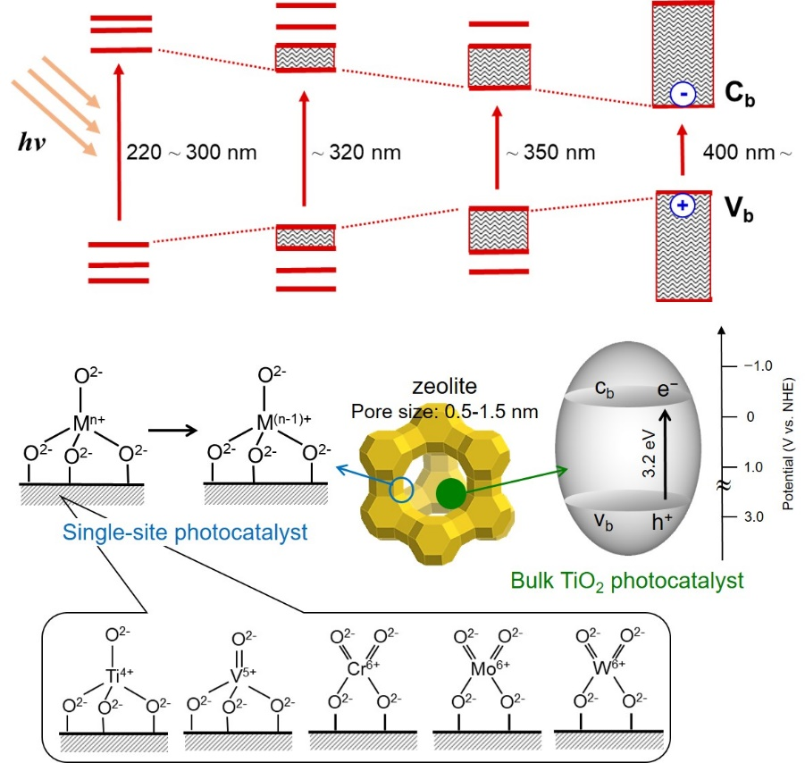

Figure 3. The isolated single-site photocatalysts and the semiconducting bulk TiO2 photocatalysts implanted within the zeolite cavities and the formation of charge transfer excited state with tetrahedrally coordinated metal oxide moieties under UV-light irradiation.

## 2.3. Encapsulation of metal complexes within zeolites

Zeolites are regarded as promising host materials that can encapsulate a wide variety of metal complexes [104–106]. Their restricted pore structure can stabilise the unstable reaction intermediates. Moreover, not only the electronic field but also the volume of space inside the zeolite supercage are easily tuned by varying the alkali metal cations from small Li+ to large Cs+. The zeolite Y, which belongs to the faujasite family, allows the encapsulation of polybipyridyl complexes (~ 1.2 nm) and phthalocyanine complexes (~ 1.3 nm) because the diameter of the supercage is ca, 1.3 nm, but the direct exchange through the tunnels and/or windows is impossible because their diameter is less than 0.8 nm. This means that the ship in a bottle technique would be a strong protocol for the encapsulation of such complexes [107–109].

The phosphorescence emission intensity due to the excited metal-to-ligand charge transfer (3MLCT) state of Ru(bpy)32+ complexes encapsulated within the supercage increased with decreasing the size of the alkali metal cations [72]. It was found that this result is correlated with the increased turnover number (TON) for the oxidation of styrene derivatives using O2 under visible-light irradiation **(Figure** **4)**. In the Stern-Volmer equation, lighter alkali metal cation gave larger quenching rate constant using O2 as a quencher, indicating that the zeolite cavity can control the emission properties of Ru(bpy)32+ complex related with the electronic configuration of the excited 3MLCT state, which finally influence on the photocatalytic activities. Additionally, the encapsulated Fe(bpy)32+ complexes have been proven to act as a heterogeneous catalyst for the oxidation of benzene to phenol using H2O2 as an oxidant. The catalytic activity was found to be enhanced in the presence of lighter alkali metal cations, which can be explained by stabilisation of the carbocation intermediate with the more electron-rich Fe species. The reaction of Co-ion-exchanged faujasites X with 1,2-dicyanobenzene formed the cobalt phthalocyanine within its framework. UV-vis spectra showed the shift of the characteristic band of phthalocyanine to lower frequency by the encapsulation within the faujasite matrix, while no significant stabilizing or destabilizing effect was found in the thermal analysis. The encapsulated cobalt phthalocyanine exhibit capabilities for the selective oxidation of propene but suffer from rapid deactivation caused by high acidity of the zeolites.

A CdS/zeolite-Y hybrid photocatalyst was reported to be active in the photocatalytic hydrogen generation from water/ethanol solutions under visible light irradiation [110]. Interestingly, a highly efficient catalyst was also designed by co-anchoring of CdS and Pt NPs within the mesoporous channels of hierarchically porous zeolite Beta under solar light irradiation with a hydrogen evolution rate of 3.09 mmolh-1gcatalyst-1 [111]. Garcia et al. compared the photocatalytic water splitting of Co ions or CoO small clusters within in silicate or zeolite framework with superior catalytic performance of 127.56 µmol (g of Co)-1 shown by Co-magadiite [112]. Chica et al. studied the immobilisation of Co catalysts on mesoporous Y zeolite to be highly active and selective in the steam reforming of ethanol with lower coke deposition [113].

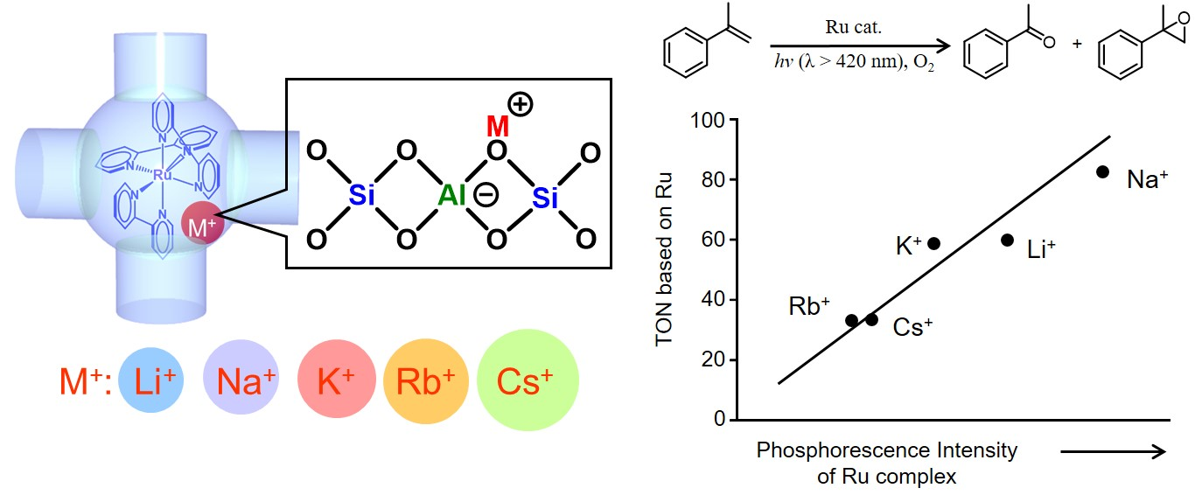

Figure 4. Schematic illustration of Ru(bpy)32+-encapsulated zeolite Y with extra framework alkali metal cations and relationship between phosphorescence intensity and photocatalytic activity.

## 2.4. Metal ion (Cu, Ag)-based photocatalysts

Cu ion-exchanged zeolites show unique activities in various catalytic reactions. Particularly, the direct decomposition of NOx into N2 and O2 on copper/ZSM-5 photocatalyst has attracted much attention [114]. In order to elucidate the structure-activity relationship, the characterisation of Cu-exchanged zeolites has been extensively performed. A combination of in-situ XAFS, photoluminescence, and IR measurements proved that the Cu+ ions included within the ZSM-5 and Mordenite zeolite cavities exist as isolated Cu+ species with linear 2-coordinate or planar 3-coordinate geometry. By contrast, they exist not only as the isolated Cu+ monomer, but also the Cu+-Cu+ dimer species in the zeolite Y cavities. The CO molecules selectively adsorbed on the isolated Cu+ monomer species to form thermally stable one-on-one Cu+-CO complexes. The desorption of CO molecules from the complexes occurred under the vacuum at 573 K. This one-on-one Cu+-12CO complexes showed a characteristic IR absorption peak at 2156 cm-1 and emission at around 430 nm. Furthermore, the actual number of isolated Cu+ ions embedded within the zeolite cage can be determined by counting the number of CO molecules adsorbed on the Cu+/ZSM-5 catalyst.

Ag+-exchanged ZSM-5 also active for the photocatalytic decomposition of NO into N2, N2O and NO2. Ag+/ZSM-5 exhibits a characteristic absorption band at around 220 nm attribute to the 4d10 → 4d95s1 transition of the Ag+ ions [73]. No peak due to the Ag0 clusters was observed. The shape of XANES spectra of the Ag+/ZSM-5 lacks the peak due to multi-scattering at around 25.5 kV, which differed from those of the Ag foil and Ag2O. The ESR measurement indicated that the addition of O2 or NO did not oxidise the Ag+ to Ag2+ on the Ag+/ZSM-5. This suggests that the chemically stable and isolated Ag+ ions play a crucial role in the photocatalytic decomposition of NO, in which electron transfer from the photoexcited Ag+ into the π anti-bonding molecular orbital of NO weakens the N-O bond and the promote the decomposition of NO molecules.

# 3. Mesoporous silica-based catalysts

The channel size of zeolite is intrinsically narrow (less than 2 nm); therefore, the adsorption and mass transfer of large organic compounds within zeolite crystals are significantly limited especially in liquid-phase reactions. Mesoporous silica materials possessing pores size within 2–50 nm can provide more extended catalytic opportunities as host materials [115, 116]. Mesoporous silica materials with interesting and tunable nano-architectures periodically aligned in the nanoscale offer large surface areas, adsorption and condensation properties towards guest molecules, and transparency to UV and visible light, which can serve as suitable hosts for the design of heterogeneous photocatalytic systems. Table 4 enlists the photocatalytic systems and their performances for mesoporous silica-based catalysts discussed in this section.

Table 4. Mesoporous silica-based photocatalytic systems.

|  |  |  |  |  |  |
| --- | --- | --- | --- | --- | --- |
| **Catalyst** | **Photocatalytic reaction** | **Reaction conditions** | **Light source** | **Catalytic performance** | **Ref.** |
| TiO2/FS-HMS | Degradation of 2-propanol | Catalyst (50 mg), 2-propanol (2.6 mmolL-1) | high-pressure Hg lamp | 3.0 mmolh-1g-TiO2-1 | [117, 118] |
| Cs+-TiO2/m-SiO2 | Degradation of phenol | Catalyst (5 mg), Phenol (2.2 mmolL-1) | 100 W high-pressure Hg lamp (λ > 300 nm) | 0.213 h-1 | [119] |
| CaP@TiO2/SBA-15 | Degradation of methylene blue | Methylene blue (200 ppm), catalyst (1.0 mg mL-1) | 100 W high-pressure Hg lamp (λ = 360 nm) | 100 % removal efficiency | [120] |
| G-TiO2/MCM-41 | Degradation of 2-propanol | Catalyst (50 mg), 2-propanol (2.6 mmolL-1) | 100 W high-pressure Hg lamp (λ = 360 nm) | ~45 % conversion | [121] |
| [Ir(Mebib)(ppy)]+/SBA-15 | Oxidation of *trans*-stilbene and 1-naphthol | Catalyst (20 mg), substrate (0.04 mmol), O2 (1 atm) | 500 W Xe lamp (λ > 420 nm) | TON (*trans*-stilbene) = 78  TON (1-naphthol) = 11 | [122] |
| Pt(tpy)/MCM-48 | Oxidation of styrene | Catalyst (10 mg), styrene (10 mmol), O2 (1 atm) | 500 W Xe lamp | TON = 256 | [123] |
| Ag/SBA-15 | Ammonia borane dehydrogenation | Catalyst (20 mg), ammonia borane (20 µmol) | 500 W Xe lamp  (λ > 420 nm) | Reaction rate = 1.60 mol % min-1 | [124] |
| PdAg/SBA-15 | Ammonia borane dehydrogenation | Catalyst (20 mg), ammonia borane (20 µmol) | 500 W Xe lamp  (λ > 420 nm) | Reaction rate = 4.64 mol % min-1 | [125] |
| PdAu/SBA-15 | Suzuki-Miyaura coupling reaction | Catalyst (20 mg), haloarene (0.2 mmol), Ethanol, K2CO3 (41.5 mg) | 500 W Xe lamp  (λ > 420 nm) | Yield of biphenyl = 70 % | [126] |
| RuAg/SBA-15 | Reduction of nitrophenol | Catalyst (5 mg), 4-NP (0.4 mM), AB (0.05 M) | 500 W Xe lamp  (λ > 420 nm) | Rate constant, *k* = 0.8 min-1 | [127] |
| Ag/Ti-SBA-15 | Ammonia borane dehydrogenation | Catalyst (20 mg), AB (20 µmol) | 500 W Xe lamp (λ > 200 nm) | 3.3 µmol min-1 | [128] |

## 3.1. Mesoporous silica with TiO2 photocatalyst

Mesoporous silicas can be used as alternative supports for TiO2 photocatalyst, because of their extended size of pores and cavity spaces (larger than 2 nm) for mass transfer of reactant molecules, large surface areas for adsorption of reactants and surface-functionalisation, and transparency to UV and visible light [23, 56]. For the sake of improving the photocatalytic efficiency of TiO2 photocatalyst, a number of post-synthetic technique to functionalise mesoporous silica surface (namely “surface-chemistry engineering”), which improve the adsorption/enrichment of targeted organic pollutants on the catalyst surface, have been developed. Organosilane coupling agents containing functional groups (e.g. methyl, propyl, octyl and phenyl) have been used as major modifiers to functionalise silica surface. For example, Inumaru et al. prepared *n*-octyl-grafted TiO2/MCM-41 composite for photocatalytic degradation of 4-nonylphenol polyethoxylate (NEPO), one of endocrine disrupters, diluted in water under UV light irradiation [129]. The prepared composite photocatalyst exhibited an improved photocatalytic activity compared with an un-functionalised counterpart, which was attributed to the hydrophobic nano-environment around TiO2 particles enabling selective adsorption/condensation of NEPO molecules from water.

Although these organo-functionalities significantly improve the hydrophobicity of silica surface, they are thermally unstable. Triethoxyfluorosilane (TEFS) can be used as an alternative silane coupling agent to improve hydrophobicity of mesoporous silica surface with high thermal stability as illustrated in **Figure 5(A)** [117]. Yamashita and co-workers found that grafting of TEFS onto mesoporous silica is an effective method to dramatically improve hydrophobicity of silica surface, by reducing the surface density of silanol groups *via* formation of thermally stable Si-F bond, with retaining the original mesoporous structure (**Figure 5(B)**) [118]. The TiO2 immobilised on TEFS-modified HMS-type mesoporous silica (pore diameter of 2–3 nm; named as TiO2/FS-HMS) exhibited a higher photocatalytic activity toward organic pollutants (*e.g.* 2-propanol, phenol) diluted in water and volatile organic compounds (*e.g.* acetaldehyde) in air compared to that immobilised on pristine HMS silica and TiO2 alone (**Figure 5(C)**), because of improved adsorption ability towards these organic molecules.

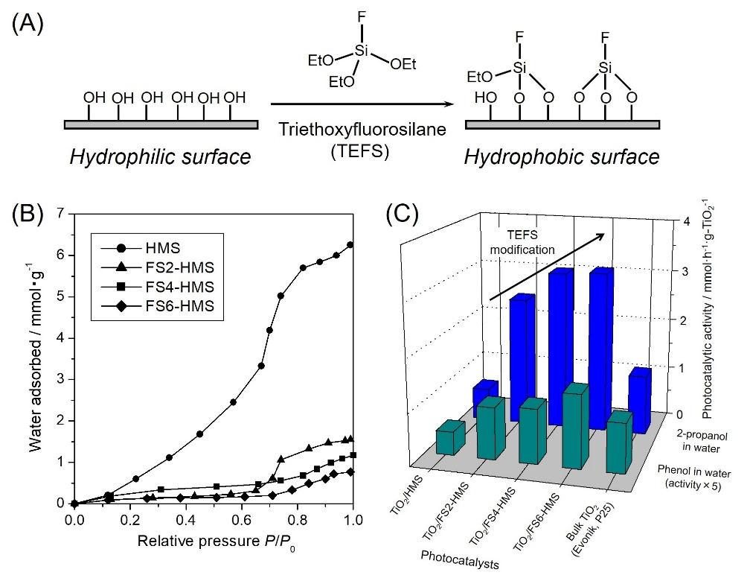

Figure 5. (A) Schematic illustration of the surface modification of a silica surface with triethoxyfluorosilane (TEFS) as a silylation agent. (B) Water adsorption isotherms of TEFS-modified HMS silicas measured at 25 °C. (C) Comparison of the photocatalytic activities of TiO2 photocatalysts supported on TEFS-modified HMS silicas and commercial TiO2 (Evonik, P25®) in the photocatalytic degradation of 2-propanol in water (2.6 mmol/L) and phenol diluted in water (0.23 mmol/L) under UV-light irradiation. Adapted with permission from ref. [118]. Copyright 2009 American Chemical Society.

Another viable approach to enhance surface-guest interaction is the employment of specific intermolecular interactions. Cation-π interaction is an intermolecular interaction working between the face of a π system and an adjacent cation. The strength of cation-π interaction is several times greater than other interactions, such as hydrogen bonding and van der Waals force. Yamashita and co-workers synthesised a series of alkali metal cation-anchored TiO2/mesoporous silica hybrid (TiO2/m-SiO2) catalysts, in which alkali metal cations were immobilised on the mesoporous silica surface through alkyl-carboxylate functional groups, and found that heavier alkali metal cations (e.g. Rb+ and Cs+) acted as promoters in diffusion of phenol in water, and thus provided a dramatic enhancement in a photocatalytic degradation efficiency under UV light, while such an activity enhancement was not observed in the degradation of cyclohexanol without π systems diluted in water [119]. This was attributed to a specific cation-guest interaction, *i.e.* cation-π interaction between the immobilised heavier alkali metal cations and the face of π system of phenol, which improved the diffusibility of phenols within the mesopore channels and hence resulted in an enhanced photocatalytic degradation efficiency.

Calcium phosphates, e.g. hydroxyapatite (Ca10(PO4)6(OH)2), are known to be biocompatible compounds with a strong affinity toward protein molecules. Yamashita et al. also examined to modify CaP on a SBA-15 silica surface to construct an efficient photocatalytic system for degradation of dye molecules diluted in water [120]. The loading of CaP species was achieved by an impregnation method using an ethanolic solution containing calcium nitrate tetrahydrate (Ca(NO3)2·4H2O) and phosphoric pentoxide (P2O5) with a Ca/P molar ratio of 1.67. In the adsorption studies and photocatalytic activity tests using methylene blue (MB) as a model dye molecule diluted in water, CaP-modified TiO2/SBA-15 composite provided an increased MB uptake and an improved photocatalytic degradation performance compared with unmodified TiO2/SBA-15 (**Figure 6 (A)**). This was attributed to a moderate interaction between MB with positively charged nitrogen-alkyl groups and the surface of CaP-modified SBA-15 with abundant PO43- groups through electrostatic interactions, which led to the adsorption and condensation of MB near the TiO2 particles and the enhanced photocatalytic degradation efficiency (**Figure 6 (B)**).

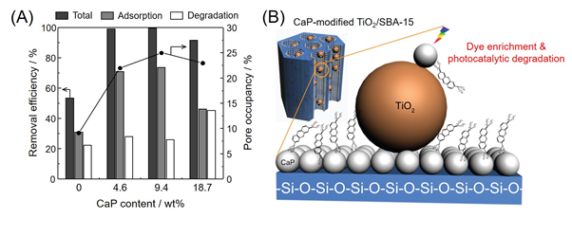

Figure 6. (A) Removal efficiency of MB by adsorption, photocatalytic degradation, and sum of them (total) on TiO2/SBA-15 hybrid photocatalysts modified with different amounts of CaP (0–18.7 wt%) and (B) schematic illustration of the adsorption and photocatalytic degradation kinetics of MB dye on CaP-coated TiO2/SBA-15. Adapted with permission from ref. [120]. Copyright 2013 American Chemical Society.

Carbon coating is also a common strategy to improve surface hydrophobicity and the affinity towards organic molecules. Selective coating of TiO2 surface with graphene layer is achievable *via* the coordination of 2,3-dihydroxynaphthalene (DN) on the surface of TiO2 and the subsequent carbonisation at high temperature in an inert gas atmosphere, because aromatic alcohols (*e.g.* phenol, catechol and salicylic acid) form Ti-coordinated complex species on the surface of TiO2 [130]. By applying this technique, Yamashita and co-workers selectively modified TiO2 surface immobilised on MCM-41 mesoporous silica with graphene layers (G-TiO2/MCM-41) [121]. The formation of the graphene layer was confirmed by Raman and UV-vis spectroscopy, and the water adsorption capacity was found to increase as the graphene content in the sample was increased. G-TiO2/MCM-41 composite with an optimised amount of graphene exhibited the highest photocatalytic activity in the photocatalytic degradation of 2-propanol in water, due to an increased affinity towards organic reactant, which outperformed the pristine TiO2/MCM-41 photocatalyst. However, deposition of an excess amount of graphene layers resulted in a reduced photocatalytic activity. This was mainly because of the interruption of incident light absorption on TiO2 due to the presence of thick graphene layer, which caused an adverse effect on the photocatalytic performance.

As summarised above, surface-chemistry engineering is a key to constructing efficient TiO2/mesoporous silica photocatalytic systems, in which controlling adsorption kinetics and adsorption/enrichment of targeted organic pollutants nearby the active TiO2 center play critical roles in achieving high photocatalytic efficiency.

## 3.2. Thin film type single-site photocatalysts for surface wettability control

The flexible controlling of surface properties of materials is a key issue for realising advanced functions. Coating technologies of thin films are strongly related to dramatic changes of properties on the surface of the material. In material design, controlling surface wettability, i.e. hydrophilicity and hydrophobicity, has also received a lot of attention for realising additional functions in recent years. Water contact angle (θ) measurement is often adopted as an easy method for the evaluation of surface wettability of materials [131, 132]. Water droplet uniformly spreads on the superhydrophilic surface (θ: less than 5˚). Meanwhile, the hydrophobic surface repels water droplet and it has a spherical shape on the superhydrophobic surface (θ: larger than 150˚). Such surface property can be designed by the application of coating techniques.

Porous siliceous materials are also applicable in the controlling of surface properties. Coatings of mesoporous silica thin films (MSF) on various materials have been achieved by spin-coating and dip-coating methods [133, 134]. Controlling of the chemical composition of precursor solution, isolated tetrahedrally coordinated transition metal species (Me = Ti, V, Cr, Mo, W) can be designed within the MSF. These species are embedded within the silica matrix with a single-site nature and also to be well-defined and uniform active sites. In our work, the design and application of tetrahedral Ti-containing porous silica thin films (TiMSF) was carried out as a photocatalyst for surface wettability controlling. Precursor solution prepared by mixing of water, Si source, Ti source and a structure-directing agent was spin-coated on quartz glass substrate, followed by calcination at elevated temperature [27, 135–141]. TiMSF was well-fixed on quartz substrate, colorless and transparent (**Figure 7 (B)**). In UV-vis measurement, TiMSF exhibited an absorption peak at around 210 nm, which is the ligand to metal charge transfer (LMCT) transition from O2‑ to Ti4+ of tetrahedral Ti species. The typical and sharp XRD peak was observed at 2θ = 2-3˚, which can be indexed as the (100) reflection of ordered mesoporous structure. The water contact angle on the pure mesoporous silica thin films (MSF) was 20-30˚, which was almost the same before and after UV light irradiation (**Figure 7 (A)**). In contrast, TiMSF exhibits more hydrophilic surface properties. The water contact angle on the original TiMSF was smaller than 10˚. The surface wettability changes of TiMSF to highly hydrophilic state occurred in response to the UV light irradiation. The water droplets uniformly spread on TiMSF after UV light irradiation (**Figure 7 (C)**). This behavior is similar phenomenon, i.e. photoinduced hydrophilicity, observed in TiO2 thin films. However, this phenomenon in TiMSF was attributed to photoexcitation of tetrahedral Ti-species with single-site nature. The water contact angle on TiMSF was also smaller than that on TiO2 thin films even before UV light irradiation. Tetrahedral Ti species within MSF matrix play a significant role for realising surface hydrophilicity. The architectures of TiMSF surface were also important in the improvement of surface hydrophilicity. The construction of a well-ordered macroporous structure in TiMSF was achieved by using poly(methyl methacrylate) (PMMA) microspheres as a hard template in the preparation step [141]. A significant improvement of surface hydrophilicity as compared to that on TiMSF was observed in this thin film. The dense and flat TiMSF is divided by macropores, leading to the increases of the fine roughness on the surface of TiMSF. The strong hydrophilic nature of this thin film attributes to the positive effects by a combination of tetrahedral Ti-species as well as macroporous-mesoporous structures.

In addition, the incorporation of the other types of transition metal oxide species such as chromium and tungsten with a single-site nature was effective method for improvement of the hydrophilicity of MSF surface [27, 37, 142–144]. Tetrahedral Cr-species exhibited light absorption in visible light region. Thus, similar surface wettability change was observed on tetrahedral Cr-containing MSF (CrMSF) under irradiation of visible light, which was advantages for application in the indoor uses. It was also found that tetrahedral W-containing MSF (WMSF) exhibited a good hydrophilic property in the series of tetrahedral metal-containing MSF. The initial water contact angle was ca. 3˚ and changed to almost 0˚ after UV light irradiation. When UV light irradiation was stopped after confirmation of a low water contact angle, the water contact angle on each sample gradually increased and recovered to almost the initial angle in the dark. A good durability of superhydrophilicity was observed on WMSF after keeping in the dark for a long period.

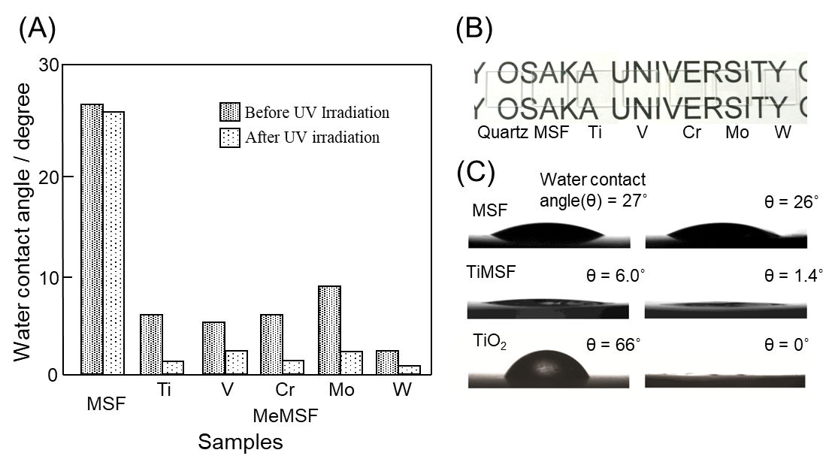

Figure 7. (A) Contact angles of water droplets on the surface of a MSF and tetrahedral transition metal (Me)-containing MSF (MeMSF, Me = Ti, V, Cr, Mo, and W) before and after UV light irradiation. (B) photographic image of quartz substrate, MSF, and MeMSF. (C) photographic images of the water droplet on the surface of each sample before (left) and after (right) UV light irradiation (irradiation time: 3 h). Adapted with permission from ref. [38]. Copyright 2018 The Royal Society of Chemistry.

In the design of superhydrophobic surface, TiMSF was also applicable as a platform for surface modification [145]. In this case, cobalt and molybdenum (Co-Mo) binary catalysts were adopted for synthesis of carbon nanotubes (CNTs) on thin film surface. Co-Mo binary catalysts were deposited on TiMSF under microwave irradiation (500 W; 2450 MHz). The formation of NPs with a narrow size distribution was achieved by rapid and uniform heating under microwave irradiation. Tetrahedral Ti-species showed a positive effect on the formation of highly dispersed metal NPs [145–148]. Through the catalytic reaction of Co-Mo and alcohol vapor at 1073 K, Co-Mo deposited-TiMSF (Co-Mo/TiMSF) surface was modified by CNTs [145]. The surface was covered with CNTs with an average diameter of ca. 15 nm. This film surface showed superhydrophobic property, which realised a water contact angle at 165˚. The existence of tetrahedral Ti-species in MSF, TiMSF, led to the formation of the active Co–Mo catalysts and the dense CNTs. In fact, the superhydrophobic state was hardly realised on MSF after surface modification by CNTs. The Co-Mo catalyst is not uniformly formed on MSF. The conventional thermal heating was also ineffective for the formation of the active Co-Mo catalysts on MSF and TiMSF.

## 3.3. Metal complexes anchored mesoporous silica matrices

The introduction of large size molecules while keeping their well-defined structure as well as higher concentration can be attained with the mesoporous silica materials, which is sharp contrast to the zeolite cavity [52]. Their surfaces property can also be readily tailored giving unique characteristics with versatile silane coupling reagents with specific functional groups [149]. The modification of mesoporous silica surface by using (3-aminopropyl)triethoxysilane (APTES), followed by the reaction with the [Ir(Mebib)(ppy)Cl] (Mebib: bis(N-methylbenzimidazolyl)pyridine, ppy: phenylpyridine) realized the anchoring via the formation of the new Ir–N bond (**Figure 8**). At 77 K in acetonitrile solution, the original [Ir(Mebib)(ppy)Cl] complex shows intense luminescence due to the 3MLCT transition, while the anchored Ir complex on mesoporous silica exhibited a high phosphorescence emission even at room temperature [122]. More interestingly, the emission intensity increased in the order of MCM-41 < MCM-48 < SBA-15. The emission spectra generally influenced by the ligand field strength, the redox properties of the metal center, and the intrinsic properties of the ligands. Therefore, a slight change in the surroundings of the Ir complex induced by differences in pore dimension and structure of the mesoporous silica supports may influences on their excited state.

Upon irradiation of visible-light, the anchored ones were active for the oxidation of *trans*-stilbene and 1-naphthol in the presence of O2, while the activity of the original Ir complex under homogeneous conditions was negligible. It can be said that the excitation rate and quantum efficiency of the anchored Ir ones are boosted, which is explained by the efficient suppression of the undesired deactivation inside the mesoporous channel. This further increase the energy-transfer from the excited 3MLCT to O2, and finally increase the photooxidation activity. The photocatalytic activity changed by changing the kind of mesoporous silica material employed; the total TON increases in the order of MCM-41 < MCM-48 < SBA-15. The higher activity of SBA-15 is presumably ascribed to its large pore structure, which allows the diffusion of O2 within the channels. For MCM-48 and MCM-41, the 3D-connected channel structure increases the efficiency compared to the one-dimensional hexagonal channel structures.

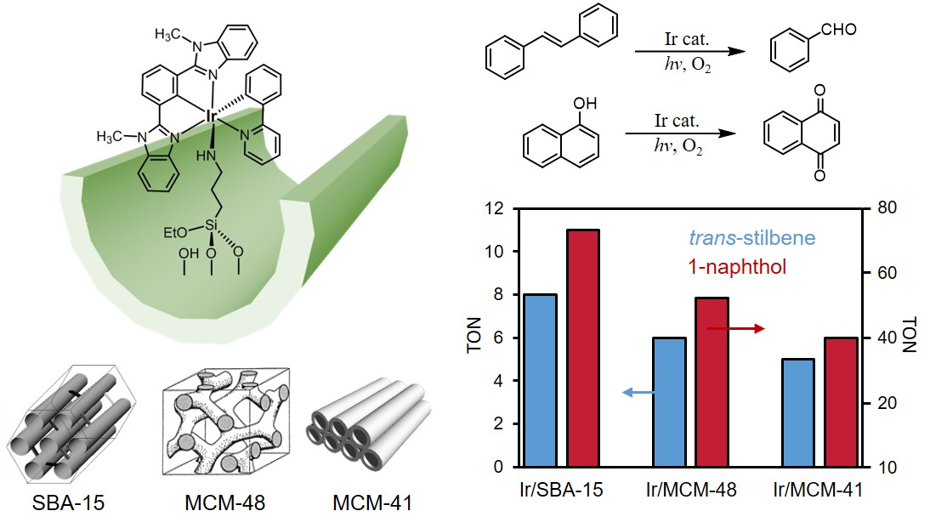

Figure 8. [Ir(Mebib)(ppy)]+ anchored on a series of mesoporous silica and TON in the photooxidation of *trans*-stilbene and 1-naphthol under atmospheric O2.

The [Pt(tpy)Cl]Cl (tpy: terpyridine) complex can also be anchored on the mesoporous silica by the same method using APTES [123, 150, 151]. At low Pt loading, the anchoring of Pt complex is realised without self-interaction and which exhibits emission due to 3MLCT transitions at 530 nm. This isolated species is capable of facilitating the photocatalytic oxidation by generating potentially active oxygen species via the efficient energy and/or electron transfer from 3MLCT to O2. At high loading levels, the emission due to the metal-metal-to-ligand charge-transfer (3MMLCT) transition was prominently observed at around 620 nm, with is originated from the short Pt---Pt interactions with close proximity. This emission efficiently catalyse H2-evolving reaction in aqueous media in the presence of EDTA under visible-light irradiation (λ > 420 nm).

The traditional molecule-based photocatalytic H2-evolution system contains various reagents including EDTA as a sacrificial electron donor, Ru(bpy)32+ as a photosensitiser, methylviologen as an electron rely reagent, and colloidal Pt as a H2-evolving catalyst [152]. Remarkably, Pt(tpy)Cl+ anchored system is a single-component because of its bifunctionality capable of visible-light photosensitisation associated with the 3MMLCT excited states and evolution of hydrogen without an electron relay. The short Pt---Pt interactions is important because short-lived 3MMLCT excited states act as more appropriate photosensitiser compared to the long-lived 3MLCT transitions. The formation of the proposed hydride-diplatinum (II, III) intermediate by the cooperative action of Pt complexes with close proximity is another reason for high activity at higher Pt loadings.

## 3.4. Plasmonic Ag NPs confined within mesoporous silica

In recent years, the localised surface plasmon resonance (LSPR) absorption by noble metal (Ag, Au) NPs has gained significant research attention owing to their higher absorption intensity and superior catalytic performances [153]. Moreover, the tunable plasmonic behaviour by precisely controlling the size, shape and composition has led to its development in various applications including photocatalysis, optical sensing, nanophotonics and artificial photosynthesis. Hofkens et al. have recently explored the remarkable luminescence properties of Ag nanoclusters in confined Linde Type A zeolites by a combination of EXAFS, DFT and time-resolved spectroscopic techniques [154]. These nanoclusters are capable of displaying a green-yellow luminescence tuned by hydration-dehydration cycles. For example, water coordinated Ag4 nanoclusters are photoluminescent and upon dehydration these nanoclusters are transformed into non-luminescent Ag atoms. This unique reversible optical switch of Ag4 clusters has potential applications in sensors and erasable optical memory technologies [155]. Corma et al. investigated the aerobic oxidation of aromatic anilines to azo compounds using Au NPs deposited on TiO2 and CeO2 with yields above 98 % [156]. Further, Au/CeO2 catalyst was also reported to be highly active and selective for the Suzuki-Miyaura coupling, in which Au3+ were reported to be the active site for the reaction [157]. An important conclusion of varying the size of support crystallites was studied in the CO oxidation reaction using Au/CeO2. The Au deposited on nanocrystallites of CeO2 were found to be twice as active relative to the regular CeO2 oxide support [158] with cationic Au acting as the active sites as evidenced by the spectroscopic investigation [159]. This report can be cited as an important example demonstrating the tuning of catalytic performance based on the particle size of support materials. The immobilisation of Ag NPs on a suitable support material has been extensively researched because of strong optical absorption and lower cost of synthesis. In order to focus on the direct plasmonic catalysis of Ag NPs, it is essential to use insulator support material for enhanced quantum efficiency. Mesoporous SBA-15 silica (**Figure 9** **(a)**), with a pore size of 9 nm, is one of the potential support materials to induce direct plasmon excitation in the NPs because of their optical transparency in the solar spectrum [23]. In this section, we will describe a series of Ag-based plasmonic nanocatalysts immobilised on mesoporous silica along with their characterisation and catalysis under visible light irradiation [160–162]. The morphology-controlled Ag NPs are shown in **Figure 9 (b)** along with their surface modification with active metal specie such as Pd (**Figure 9 (c)).** A unique combination of Ag nanorods with Ru, Ni, Co and Pd is depicted in **Figure 9 (d)** and a comparative case study of PdAu and PdAg NPs was performed in **Figure 9 (e).** Finally, a novel synthetic approach of combining plasmonic Ag NPs with single-site Ti-oxide species was investigated as shown in **Figure 9 (f).**

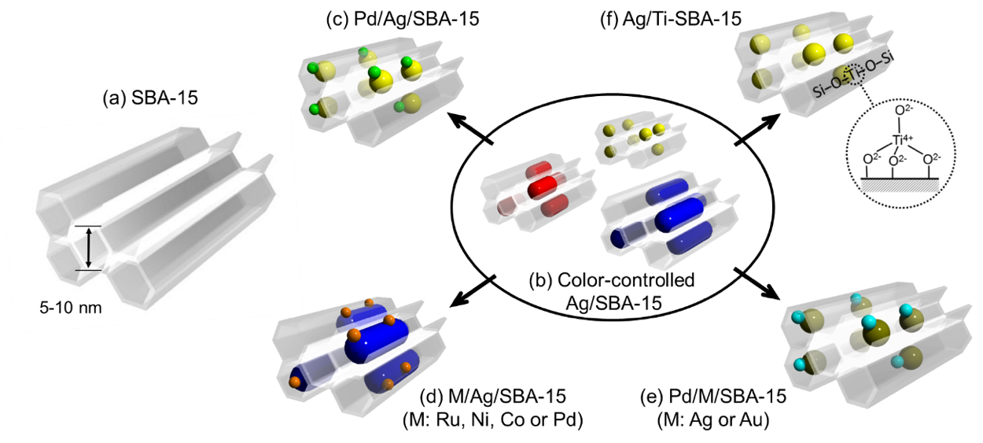

Figure 9. An illustration of mesoporous silica supported Ag-based plasmonic nanocatalysts. Adapted with permission from ref. [38]. Copyright 2018 The Royal Society of Chemistry.

### 3.4.1. Color and morphology-controlled Ag NPs

The use of mesoporous silica, SBA-15, as a support material was employed to immobilise plasmonic Ag NPs [124]. The morphology of Ag NPs was carefully controlled within the channels of mesoporous silica, SBA-15. The highly dispersed NPs can be synthesised by microwave (MW) assisted alcohol reduction technique, in which 1-hexanol was employed as a solvent and reducing agent to reduce Ag+ to Ag NPs [163, 164]. The size of Ag NPs was tuned in the presence or absence of a surface directing agent to yield spherical, rod with short aspect ratio and rod with longer aspect ratio NPs associated with yellow, red and blue colors, respectively. The MW irradiation of the suspension for 3 min in the presence of sodium laurate (Lau) as a surface directing agent led to the synthesis of spherical yellow NPs, denoted as Ag/SBA-15 (Y). The irradiation of suspension in the absence of Lau for 3 and 5 min yielded red (Ag/SBA-15 (R)) and blue nanorods (Ag/SBA-15 (B)), respectively. **Figure 10** summarises the TEM micrograph of plasmonic NPs confined within the channels of mesoporous silica. The average diameter of Ag/SBA-15 (Y) spherical NPs grown within the channels of mesoporous silica was 4 nm. The nanorods grew parallel to the mesopores with an approximate aspect ratio of 2.8 and 6.1 nm for Ag/SBA-15 (R) and Ag/SBA-15 (B), respectively. The structural characterisation of catalysts was confirmed by X-ray absorption spectroscopy studies. The extended X-ray absorption fine structure (EXAFS) spectra for the three catalysts displayed a strong peak at 2.5 Å indicating the contiguous Ag-Ag metallic bonding. Further, X-ray absorption near edge structure (XANES) spectra showed spectral peaks similar to that of Ag foil, confirming the metallic nature of Ag in the prepared catalysts. The morphological symmetry of plasmonic NPs had a significant contribution in the positioning and number of LSPR peaks in the absorption spectra. For example; the spherical Ag/SBA-15 (Y) NPs displayed a single intense peak at 400 nm and rod-structured Ag/SBA-15 (R) and Ag/SBA-15 (B) displayed two peaks in the absorption spectra at 400 and 1200 nm as depicted in **Figure 11 (e)**. The appearance of two strong absorption peaks were allocated to the presence of transverse and longitudinal modes in nanorods.

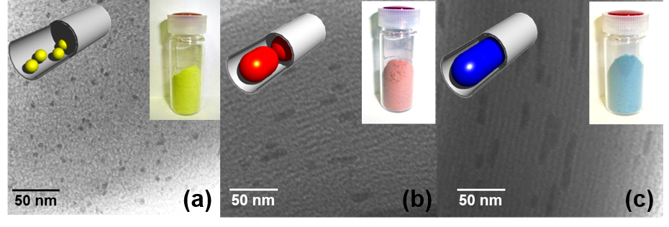

Figure 10. TEM micrographs and their corresponding samples along with illustrations (inset) for (a) Ag/SBA-15 (Y), (b) Ag/SBA-15 (R) and (c) Ag/SBA-15 (B). Adapted with permission from ref. [125]. Copyright 2015 The Royal Society of Chemistry.

The size and color-controlled Ag nanocatalysts were tested for their application in the hydrogen generation from ammonia borane (NH3BH3; AB). AB is a non-toxic white solid powder, which is known for its high hydrogen content of 19.6 wt % [165, 166]. It is highly soluble in polar solvents and can release 3 moles of hydrogen per mole of AB only in the presence of a suitable catalyst as shown in equation (1):

$NH_{3}BH_{3}\left(aq\right)+2H_{2}O\left(l\right)→{NH}_{4}BO_{2}\left(aq\right)+ {3H}_{2}(g)$ (1)

The catalytic activities were compared in the dark and under visible light irradiation (λ > 420 nm, 320 mWcm-2) at room temperature conditions. The smallest sized spherical Ag/SBA-15 (Y) catalyst displayed superior catalytic performance with a reaction rate of 0.94 mol % min-1 followed by Ag/SBA-15 (R) and Ag/SBA-15 (B) in dark conditions. Under visible light irradiation, all catalysts displayed significant enhancements because of the LSPR effect originating from the strong optical absorption of Ag NPs and especially nanorods in the near-infrared (NIR) region. The observed trend in the rate of enhancement followed the order; Ag/SBA-15 (B) > Ag/SBA-15 (R) > Ag/SBA-15 (Y). Ag/SBA-15 (B) exhibited a reaction rate of 0.22 mol % min-1 in dark and a much higher rate of 1.13 mol % min-1 under visible light irradiation conditions. Further, the effect of wavelength dependence in the hydrogen generation ability of plasmonic Ag nanocatalysts was studied under the monochromatic lights of different wavelengths, λ = 400, 460 and 650 nm. The enhancement in the rate of hydrogen generation was found to be highly consistent with the optical absorption and color of Ag/SBA-15 plasmonic catalysts as depicted in **Figure 11 (e)**. It can be argued that the light source used in photocatalytic experiments contains not only visible light but also parts of infrared light, which can be one of the reasons for activity enhancements by heating effects of infrared light. In fact, we observed an increment in the temperature of the catalytic reactor by 5 °C for Ag/SBA-15 (B) because of its wide range of absorption arising from transverse and longitudinal modes of nanorods. To evaluate the contribution of plasmonic and thermal effects, a test reaction was carried out at 30 °C. The obtained thermal catalytic performance was higher than the activity observed in dark conditions but significantly lower than the catalytic performance under visible light irradiation. This observation further supported the negligible contribution of heating effects in enhancing the rate of reaction under illumination conditions. The size and color-controlled Ag nanostructures were successfully recovered after the reaction and retained their morphology and color even after three catalytic runs, as confirmed by XRD, UV-vis and TEM spectroscopic techniques.

The three different Ag catalysts were also found to be active in the 4-nitrophenol reduction to 4-aminophenol. AB was used as a reducing agent to generate in situ hydrogen over Ag NPs for the reduction reaction. It was observed that Ag/SBA-15 (Y) displayed the highest rate constant values than Ag/SBA-15 (R) and Ag/SBA-15 (B). Under visible light irradiation, the catalytic activities were significantly enhanced and displayed the trend; Ag/SBA-15 (B) > Ag/SBA-15 (R) > Ag/SBA-15 (Y). This trend was found to be similar in the catalytic performance and enhancements in the AB dehydrogenation. The enhanced photocatalytic activities were attributed to the origination of surface charge density due to charge polarisation derived from the LSPR effect of Ag NPs [160, 161].

### 3.4.2. Ag, Au-based plasmonic catalysts in combination with active metal species

The integration of active metal species with plasmonic metals can create improved optical, catalytic, electric and magnetic properties in comparison to their monometallic counterparts. Precise control of the relative concentration, size and shape of metallic components can lead to significantly enhanced catalytic activity and selectivity. The size and color-controlled Ag NPs supported on mesoporous silica were decorated with Pd NPs in order to improve their overall catalytic performance in the hydrogen generation from storage materials [125, 167]. The synthetic methodology of bimetal deposition on Ag NPs was very simple and straightforward, named as LSPR-assisted deposition. An aqueous suspension of yellow, red and blue Ag/SBA-15 catalysts was photo-irradiated in an inert atmosphere condition to activate the plasmonic Ag NPs. The Pd precursor solution, Pd(OAc)2, was then introduced into the reactor and allowed to stir continuously for 2 h. The mechanism of uniform distribution of Pd on Ag NPs was attributed to two main factors; (i) presence of visible light irradiation for plasmon activation; (ii) galvanic displacement reaction between Ag and Pd2+ ions with a high equilibrium constant value of K = 1.30 104. The bimetallic catalysts were denoted as Pd/Ag/SBA-15 (Y), Pd/Ag/SBA-15 (R) and Pd/Ag/SBA-15 (B). The surface deposition of Pd did not affect the morphology and chemical state of Ag nanostructures, which was confirmed by XAS, XPS and HR-TEM spectroscopic techniques. A strong plasmonic absorption at λ = 400 nm for Pd/Ag/SBA-15 (Y) and two absorption peaks centered at visible and NIR region of the spectrum was observed for Pd/Ag/SBA-15 (R) and Pd/Ag/SBA-15 (B) (**Figure 11 (f)**). However, a decrease in the intensity of optical absorption for bimetallic catalysts was observed due to the surface coverage of plasmonic NPs by active metal species of Pd. **Figure 11 (a-d)** displays the HR-TEM and HAADF image along with the elemental mapping of Pd and Ag for Pd/Ag/SBA-15 (B) catalyst. The bimetallic catalysts were investigated for the hydrogen generation from AB in dark and under visible light irradiation. The obtained reaction rate for Pd/Ag/SBA-15 (Y), Pd/Ag/SBA-15 (R) and Pd/Ag/SBA-15 (B) in dark conditions was 3.22, 2.38 and 1.24 mol % min-1, respectively. The observed trend in the catalytic performance of morphology-controlled bimetallic nanocatalysts was found to be similar to monometallic Ag/SBA-15 catalysts, as discussed in the previous section. Under visible light irradiation, all catalysts displayed an enhanced rate of reaction and in particular, Pd/Ag/SBA-15 (B) exhibited a maximum enhancement with a hydrogen generation rate of 3.80 mol % min-1. The synergistic cooperation of Pd and Ag NPs also displayed enhanced product yields in the Suzuki-Miyaura coupling reaction under visible light irradiation. The generation of hot electrons on Ag NPs transfers to the active site Pd making them electron rich species. The rate-determining oxidative addition step in the Suzuki–Miyaura coupling reaction gets accelerated due to the presence of activated Pd species, leading to the enhancement of intrinsic catalytic performance under light irradiation conditions. A slight increase in the temperature of the reaction system due to the energy release by hot carriers in the surrounding environment can also contribute in the enhancement of catalytic activity.

The design of Ag and Pd/Ag-based plasmonic catalysts was further extended to investigate the effects of plasmonic absorption and catalytic performance of Au and Pd/Au nanostructures [126]. A characteristic LSPR absorption of Ag/SBA-15, Pd/Ag/SBA-15 and Au/SBA-15, Pd/Au/SBA-15 catalysts was obtained at 400 and 520 nm, respectively [168, 169]. The average diameter of spherical Pd/Ag/SBA-15 and Pd/Au/SBA-15 nanostructures was found to be 4.2 and 4.9 nm, respectively. It was interesting to observe that Pd/Ag/SBA-15 displayed superior catalytic activity in the AB dehydrogenation in dark and visible light irradiation, whereas, Pd/Au/SBA-15 displayed remarkable performance in the Suzuki-Miyaura coupling reaction. It was proposed that the hot electrons generated by the plasmon excitation gets transferred to the active metal Pd and then to the lowest unoccupied molecular orbitals (LUMO) of adsorbate molecules assisting in the bond weakening and hence enhancing the rate of reaction. The unique combination of Ag nanorods with catalytically active metals such as Ru, Pd, Ni and Co were also studied in order to design and develop visible-light sensitive plasmonic catalysts [127, 170]. The choice of the second metal is based on their theoretical work function values, which decide the lower positioning of Fermi energy level than that of Ag. The lower work function value of Ag (4.3 eV) than those of Pd (5.0 eV), Ru (4.8 eV), Ni (4.7 eV) and Co (4.7 eV) makes the electron transfer from Ag to second metal feasible because of their positioning of Fermi energy level lower than that of Ag. The photo-excited plasmonic states of the Ag transfer energy to the unoccupied adsorbate (reactant) states, leading to the bond weakening and hence cleavage of reactants to products. This further assists in the effective electron transfer from Ag to active metal NPs. These bimetallic nanocatalysts displayed excellent catalytic performances and enhancements under visible light irradiation in the AB dehydrogenation and 4-nitrophenol reduction reaction.

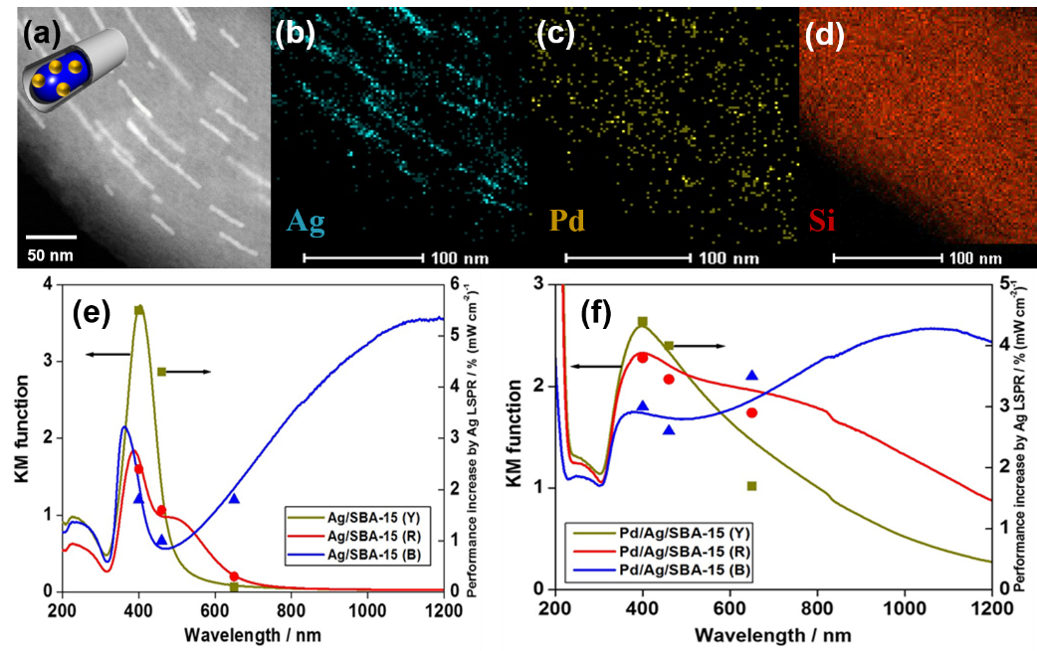

Figure 11. (a) High-angle annular dark-field-STEM image of Pd/Ag/SBA-15 (B), (b-d) elemental mapping of Ag, Pd and Si, (e) UV-vis spectra of morphology-controlled monometallic Ag/SBA-15(Y), Ag/SBA-15 (R), Ag/SBA-15 (B), (f) UV-vis spectra of bimetallic Pd/Ag/SBA-15 (Y), Pd/Ag/SBA-15 (R) and Pd/Ag/SBA-15 (B). Adapted with permission from ref. [125]. Copyright 2015 The Royal Society of Chemistry.

### 3.4.3. Plasmonic Ag NPs in heterojunction with Ti-oxide single-site photocatalyst

A novel plasmonic hybrid photocatalyst supported on mesoporous silica, Ag/Ti-SBA-15, was developed by combining the unique visible light sensitivity of Ag NPs and UV-light absorption of single-site Ti-oxide moieties to utilise the entire spectrum of solar energy [148]. The single-site Ti-oxide moieties were highly dispersed, isolated and present in tetrahedral-coordination as confirmed by XANES and UV-vis spectroscopy [171]. **Figure 12 (a)** shows the Ti K-edge XANES spectra of Ag/Ti-SBA-15 in comparison to Ti-SBA-15, titanium butoxide (TBOT) and bulk TiO2. An intense single peak at 4968 eV for Ag/Ti-SBA-15, similar to TBOT, affirms the electronic transition from 1s to t2g and confirmed the tetrahedral coordination of Ti-oxide moieties in Ti-SBA-15 and Ag/Ti-SBA-15. The presence of pre-edge peaks, in TiO2, from 4964 to 4974 eV was assigned to the octahedral coordination of titanium. The Ti-SBA-15 support material was then employed to grow Ag NPs within the mesoporous channels of silica by MW irradiation for 3 min in the presence of sodium laurate as the surface directing agent. A uniform particle size distribution of 3.2 nm along with characteristic plasmonic absorption at 410 nm was observed for the prepared Ag/Ti-SBA-15 catalyst. Further, XPS analysis confirmed the electronic interaction between the Ag NPs and Ti-oxide by displaying shifts in the binding energy (B.E.) towards lower values in comparison to the reference, Ag/SBA-15 catalyst. The optimum doping of 0.5 mol % Ti-oxide in Ag/Ti-SBA-15 gave an unexpected high reaction rate of 3.3 µmolmin-1 in the AB dehydrogenation, which was two times higher than Ag/SBA-15 and six times higher than Ag/TiO2/SBA-15 catalyst as shown in **Figure 12 (b)**. **Figure 12 (c)** illustrates the formation of a charge-transfer excited state of Ti-oxide and plasmon excitation of Ag NPs under UV and visible light irradiation, respectively. For Ag NPs, the resonant condition lies in the visible region of the spectrum and Ti-oxide moieties display excitation at 200-270 nm forming a charge transfer excited state with electron and hole centres much closer to each other in comparison to bulk TiO2, leading to unique photocatalytic activity. The heterojunction created between Ag and Ti-oxide moieties allows both UV and visible light irradiation to be exploited by possible charge transfer from Ti-oxide moieties to the plasmonic Ag nanostructures and further to antibonding molecular orbitals of reactant, AB. The effective charge relay and the synergistic interactions between Ag and Ti-oxide species assisted in the weakening of the B-N bond of AB and hence led to the excellent catalytic performance under UV-vis light irradiation conditions.

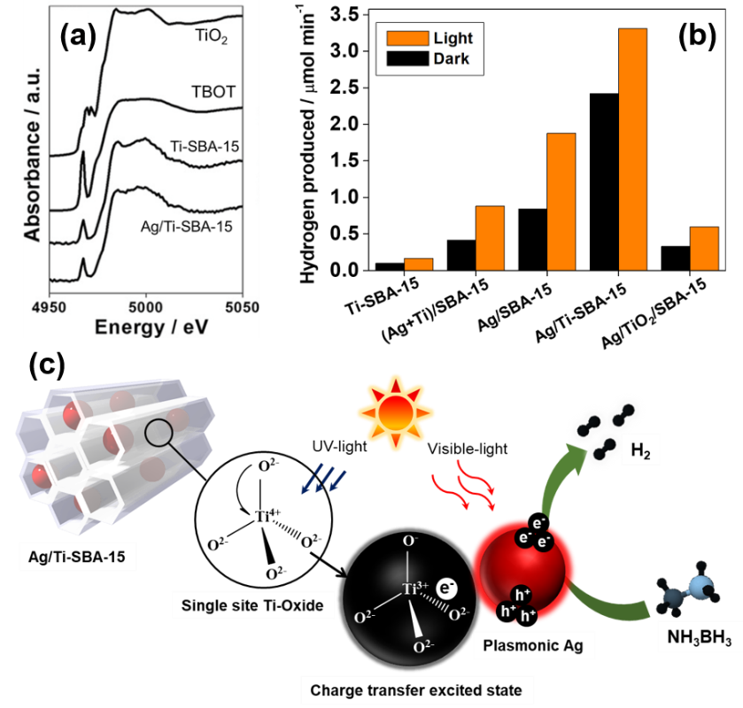

Figure 12. (a) Ti K-edge XANES spectra of Ag/Ti-SBA-15, Ti-SBA-15, TBOT, TiO2 (b) Comparison of hydrogen production rate for the prepared catalysts in dark and UV-vis light irradiation at room temperature and (c) Charge transfer pathway in Ag/Ti-SBA-15 catalyst under UV-vis light irradiation. Adapted with permission from ref. [148]. Copyright 2017 Wiley-VCH.

# 4. Macro-mesoporous and yolk-shell type porous photocatalysts

A summary of macro-mesoporous and yolk-shell type photocatalytic systems along with their reaction conditions and catalytic performances has been summarised in Table 5.

Table 5. Macropore and yolk-shell-based photocatalytic systems.

|  |  |  |  |  |  |
| --- | --- | --- | --- | --- | --- |
| **Catalyst** | **Photocatalytic reaction** | **Reaction conditions** | **Light source** | **Catalytic performance** | **Ref.** |
| TiO2/MMS | Degradation of methylene blue | Catalyst (10 mg), MB (1.0 mmol L-1), | 100 W high pressure Hg lamp (λ = 360 nm) | Rate constant = 0.4 h-1 | [172] |
| Degradation of acetone | Catalyst (10 mg) | 200 W Xe lamp (λ = 360 nm) | ~13 µmol h-1 | [173] |
| Degradation of 2-propanol | Catalyst (10 mg) | 200 W Xe lamp (λ = 360 nm) | ~15 µmol h-1 |
| TiO2@SiO2 | Degradation of acetone | Catalyst (60 mg), acetone (26 µmol) | 300 W Xe lamp | 1.7 µmol min-1 | [174] |
| TiO2@HSS | Decomposition of VOCs (acetaldehyde and 2-propanol) | Catalyst (5 mg), acetaldehyde (10 µmol), 2-propanol (100 µmol) | 200 W Hg/Xe lamp  (λ > 300 nm) | 2-propanol *k* = 3.2 10-3 min-1, acetaldehyde decomposition rate = 0.137 µmol min-1 | [175] |
| Pt/WO3@SiO2 | Degradation of acetic acid | Catalyst (30 mg), acetic acid (17.5 µmol) | 300 W Xe lamp | CO2 evolved = 35 µmol h-1 | [176] |

## 4.1. Composite photocatalyst of TiO2 and macro-mesoporous silica

A variety of nanostructured materials have been designed by many researchers based on the advances in nanoscience and nanotechnology. Porous siliceous materials such as zeolite and mesoporous silica are also well-known materials having unique morphologies, structures with nano spaces, pores with narrow size distributions (less than 50 nm) and fascinating properties. These materials are often used in the design of catalytic and photocatalytic materials [56, 177–181]. Templating synthesis is one of the most promising techniques for the synthesis of porous siliceous materials. An organic structure-directing agent is generally used for the construction of micropores in zeolite and mesopores in mesoporous silica. In the construction of macropores (greater than 50 nm), periodically aligned oxide particles and spherical polymers are utilised as hard templates [182–187]. Until now, the investigations on the functions of materials with macropores are insufficient.

In this context, we carried out the design of porous siliceous materials with hierarchical macroporous and mesoporous architectures (MMS) and investigated the specific functions as a support of TiO2 photocatalyst [172, 173]. Porous siliceous materials having only mesopores (MS) and MMS were prepared from the same precursor solution in the presence or absence of poly(methyl methacrylate) (PMMA) as a hard template. TiO2-loaded MMS and MS (denoted as TiO2/MMS and TiO2/MS) were prepared by a conventional impregnation method. The existence of the uniform macropores was confirmed by ultrasmall angle X-ray scattering, FE-SEM and TEM measurements. The hierarchical macroporous structure of TiO2/MMS is an inverse structure of aligned PMMA particles (**Figure 13 (A)**). Although a smooth surface was observed in TiO2/MS with a dense powder form, uniform macropores were observed in TiO2/MMS. The size of macropores was slightly smaller as compared to the size of spherical PMMA particles. The walls separating macropores consist of mesoporous structure. This structure led to the formation of entrances of mesopores and shortening of the length of mesoporous channels. In the liquid phase reaction system, the photocatalytic performance was investigated in the degradation of model contaminants such as phenol (PH) and bisphenol A (BPH) in water on TiO2/MMS and TiO2/MS under UV light irradiation [172]. These two organic compounds have different molecular size in the long axis direction (ca. 0.7 nm (PH) and 1.3 nm (BPH)). TiO2/MMS exhibited higher photocatalytic activity in the degradation of BPH in water, while the photocatalytic activity was slightly small in the degradation of PH. This result indicated that the combined porous structure in TiO2/MMS is advantageous to diffusion of relatively large molecules, which realised good accessibility of BPH to TiO2 photocatalyst. On this point, adsorption profiles of methylene blue (MB, ca. 1.6 nm in the long axis direction) and photocatalytic decolorisation was also investigated on TiO2/MMS. MB is soluble in water and easily adsorbed on the surface of siliceous materials. TiO2/MMS exhibited about two times higher photocatalytic activity than that on TiO2/MS. A good correlation between adsorption capability and apparent rate constants in decolorisation was observed in this reaction system (**Figure 13 (B)**). TiO2/MMS also showed a much higher decolorisation rate of MB than bulk TiO2 (P25).

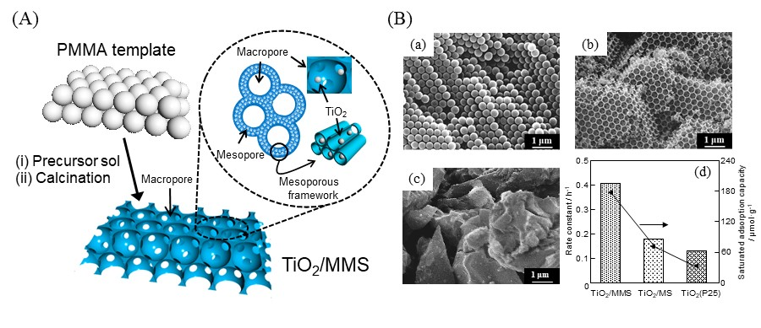

Figure 13. (A) Schematic diagram of the procedures for the synthesis of TiO2/MMS, (B, a-c) FE-SEM image of (a) PMMA particles, (b) TiO2/MMS, and (c) TiO2/MS and (B, d) relationship between the rate constants in the photocatalytic decolourisation of MB and saturated adsorption capacities of MB diluted in water on TiO2/MMS, TiO2/MS and TiO2 (P25). Adapted with permission from ref. [172] Copyright 2015 The Royal Society of Chemistry.

Moreover, in the gas phase reaction system, we also found the unique properties of macropores in TiO2/MMS. The photocatalytic degradation of 2-propanol and acetone in a gas phase as model organic molecules was carried out under UV light irradiation [173]. In the case of acetone gas, almost same behaviors in adsorption profile and rate were observed in TiO2/MS and TiO2/MMS. It becomes clear that the structural difference in these samples showed little effect in adsorption of acetone gas. These samples showed almost same photocatalytic activity in the degradation of acetone gas in air. However, the noticeable improvement in the photocatalytic activity was observed on TiO2/MMS in the degradation of 2-propanol gas in air. TiO2/MMS exhibited two times higher photocatalytic activity in the formation of CO2 than that on TiO2/MS. As compared to the behaviors of TiO2/MS, a high adsorption rate of 2-propanol gas was observed in TiO2/MMS at low relative pressure. On this point, the efficient transport of 2-propanol leads to an enhancement of photocatalytic performance. TiO2/MMS also showed a large adsorbed amount of 2-propanol gas at high relative pressure. The adsorption profile was almost same in TiO2/MS and TiO2/MMS in the range where the relative pressure of 2-propanol gas is below 0.8. There was a sharp increase of adsorbed amount of 2-propanol gas on TiO2/MMS at relative pressure above 0.8 [140]. The existence of macroporous structure influences the adsorption profile of molecules at high relative pressure. The differences in the adsorption profiles of 2-propanol gas and acetone gas are also based on the properties of each molecule. Intermolecular hydrogen bonding is formed in the hydroxyl group of 2-propanol molecules. However, acetone has no hydroxyl group, which shows a quite different behaviour in these systems. A large adsorbed amount of 2-propanol on TiO2/MMS probably due to the condensation and formation of 2-propanol clusters in macropores. There are also good relationships between the photocatalytic activity and adsorption profiles. The adsorption of 2-propanol on TiO2 and its surroundings seems to play crucial roles in the efficient photocatalytic degradation of 2-propanol. Consequently, TiO2/MMS exhibited superior photocatalytic performance in the degradation of 2-propanol in air.

## 4.2. Yolk-shell structured photocatalysts

Yolk-shell nanostructured materials constructed from catalytically active core particles encapsulated by a hollow shell (also known as a rattle-like structure) is an emerging category of nanomaterials. The enclosed void space can be used for the accommodation of catalytically active components (e.g., metal NPs, metal oxides, and metal complexes), and provides a confined nanospace where reactant molecules are adsorbed and concentrated. The void space also allows the reflection of light inside shells, enhancing the scattering of incident light, which leads to an enhanced photon utilisation efficiency of photocatalytic components. With these intriguing physicochemical properties, yolk-shell nanostructures can be regarded as an ideal platform for the design of elaborated photocatalytic systems [188–190]. The overwhelming majority of yolk-shell structured photocatalysts developed so far are constructed with single photocatalytic components (*e.g.* TiO2@TiO2, ZnO@ZnO and Cu2O@Cu2O) or dual photocatalytic components (*e.g.* Fe2O3@TiO2, Au@TiO2, Au@CeO2 and Au@CdS), and they have already been summarized in excellent reviews [189]. In this section, some representative yolk-shell structured photocatalysts, in which core photocatalyst particles are encapsulated by porous materials (porous silicas) are briefly summarised to highlight the importance of porous materials as a “nano-container” for the design of functionalised photocatalysts.

Compared to the conventional periodic silica materials with defined micro/meso-porous channels (e.g., zeolite and mesoporous silica), hollow silica materials provide enclosed large cavity spaces that can accommodate a variety of photocatalytically active components (e.g., TiO2, Au NPs etc.), and the outer silica shell serves as a physical barrier to protect the encapsulated components. Continuous pores created in the silica shell region allow mass transfer of target reactant molecules and sometimes endow molecular sieving effect. A pioneering work was done by Ikeda et al., who synthesised a yolk-shell structured TiO2@SiO2 composite, containing TiO2 particles inside the hollow silica shell, by a layer by-layer fabrication technique using carbon as a sacrificial layer [174, 191, 192]. The synthesised yolk-shell structured composite exhibited a photocatalytic performance comparable to or even better than naked TiO2 in the photocatalytic degradation of acetaldehyde and acetone in air. The possible reasons for this activity enhancement are the existence of free (uncovered) core TiO2 particles, which allowed them to retain their inherent catalytic activities, and the void space between the core TiO2 and the silica shell, which facilitated diffusion of reactant molecules to the core TiO2. Yang et al. employed poly(methacrylic acid) (PMAA) as an organic template to synthesise a similar yolk-shell structured TiO2@SiO2 composite photocatalyst [193]. Wu et al. synthesised a similar photocatalyst using two kinds of polyelectrolytes with different electric charges as templates [194]. However, synthesis of such yolk-shell TiO2@SiO2 structures always suffer from costly, complex preparation procedures. Therefore, developing simple and low-cost methods for large-scale preparations with desired morphology, porosity and catalytic performances is also important for their practical applications. In this regard, Yamashita and co-workers reported an alternative facile method to prepare yolk-shell structured TiO2@HSS (HSS = hollow silica spheres). They used an oil-in-water (O/W) microemulsion as an organic template to encapsulate commercial TiO2 particles (Evonik, P25®) within the hollow silica spheres with an average particle size of 160 nm (**Figure 14 (A-C)**) [175, 195]. The prepared yolk-shell structured TiO2@SiO2 composite showed a superior photocatalytic performance in the photocatalytic decomposition of VOCs (acetaldehyde and 2-propanol) in air compared with the bareTiO2. This was attributed to the adsorption/condensation effect of the hollow silica toward VOC molecules and the efficient mass diffusion of these molecules to the nearby active TiO2 particles (**Figure 14 (D)**). Furthermore, they fabricated a photocatalytic paper composite comprised of TiO2@HSS particles and a cellulose fiber (CF) via a physical adhesion process using a dual polymer system [196]. Direct deposition of TiO2 particles on papers is usually anticipated to cause self-degradation of papers under light illumination because of the strong photo-oxidation ability of TiO2. However, the fabricated TiO2@HSS/paper composite was hardly degraded even after long-term UV light illumination, with retaining its inherent photocatalytic activity towards the degradation of VOCs diluted in air. This was due to the protective effect of the silica shell to prevent direct contact between CFs and TiO2 particles. Thus, encapsulation of TiO2 photocatalyst within hollow silica spheres allows us to add functionalities on TiO2 and to fabricate a promising photocatalytic paper composite material applicable in real air cleaning.



Figure 14. (A) FE-SEM and (B) TEM images and (C) illustration of a TiO2@HSS composite photocatalyst. (D) Reaction kinetics in the photocatalytic degradation of 2-propanol in air over (left) commercial TiO2 (Evonik, P25®) and (right) the TiO2@HSS composite photocatalyst under UV light irradiation. Adapted with permission from ref. [175]. Copyright 2016 Wiley-VCH.

As an alternative example of yolk-shell structured photocatalyst, Harada et al. synthesised tungsten oxide (WO3) particles encapsulated in hollow silica spheres (WO3@SiO2) using calcium tungstate (CaWO4) particles as a starting core material [176]. They first synthesised calcium tungstate particles covered with a porous silica shell, which were then subjected to nitric acid treatment and heat treatment to obtain WO3@SiO2. The WO3@SiO2 (after loading of the small amount of Pt) showed a high photocatalytic activity in the photocatalytic degradation of acetic acid diluted in air under UV or visible light illumination conditions, which outperformed that of Pt-loaded bulk WO3 photocatalysts without a SiO2 shell. Thus, porous hollow silica can be used as a promising platform material to construct functionalised and efficient photocatalytic systems, especially useful for photocatalytic degradation of VOCs diluted in air.

# 5. MOFs-based porous photocatalysts

Metal-organic frameworks (MOFs) are a kind of coordination porous nanomaterials, consisting of metal oxide nanoclusters and organic linkers [197, 198]. Owing to their inherent structural characteristics, porosity, high surface area, high content of active sites, and versatile modularity have great potential as catalyst materials. MOFs provide significant chemical diversity because the organic linkers can be modified by functional groups and the nodes can be partially replaced by other metal ions [199–206]. In this section, we will briefly cover the recently investigated photocatalytic applications of MOFs in the production of hydrogen and hydrogen peroxide under visible light irradiation as summarised in Table 6.

Table 6. Metal-organic framework (MOF)-based photocatalytic systems.

|  |  |  |  |  |  |
| --- | --- | --- | --- | --- | --- |
| **Catalyst** | **Photocatalytic reaction** | **Reaction conditions** | **Light source** | **Catalytic performance** | **Ref.** |
| Pd/CeMIL-101 | Ammonia borane dehydrogenation | Catalyst (10 mg), AB (0.5 M) | 500 W Xe lamp  (λ > 420 nm) | 117 µmol h-1 | [207] |
| Au@Pd/UiO-66(Zr/Ti)-NH2 | Formic acid dehydrogenation | Catalyst (10 mg), FA (0.2 mL) | 500 W Xe lamp (λ > 420 nm) | TOF = 200 h-1 | [208] |
| Ni/MIL-125-NH2 | H2O2 production | Catalyst (5 mg), TEOA (1.0 mL), CH3CN (4.0 mL) | 500 W Xe lamp (λ > 420 nm) | [H2O2] = 1500 µM | [209] |
| MIL-125-Rn | H2O2 production | Catalyst (5 mg), benzyl alcohol (5.0 mL), water (2.0 mL) | 500 W Xe lamp (λ > 420 nm) | [H2O2] = 2348 µM | [210] |
| OPA/MIL-125-NH2 | H2O2 production | Catalyst (5 mg), benzyl alcohol (5.0 mL), water (2.0 mL) | 500 W Xe lamp (λ > 420 nm) | [H2O2] = 6600 µM | [211] |
| OPA/UiO-66(Zr/Ti)-NH2 | H2O2 production | Catalyst (5 mg), benzyl alcohol (5.0 mL), water (2.0 mL) | 500 W Xe lamp (λ > 420 nm) | [H2O2] 3000 µM | [212] |

## 5.1. MOFs for hydrogen production

Hydrogen has received significant attention as a clean and sustainable energy carrier [213–215]. Considerable efforts have been devoted to developing the semiconductor-type photocatalysts to promote the photocatalytic hydrogen production process. However, some photocatalysts can only be active under UV-light irradiation and their efficiency for hydrogen production is still very low.

The amine-functionalised MOFs, whose organic linkers involve amino group substituent (–NH2), are known to work as visible-light responsive photocatalysts [202–204, 216–219]. For example, amine-functionalised Ti-based MOF (MIL-125-NH2) was reported to be active towards photocatalytic reactions under visible-light irradiation, such as hydrogen production and CO2 reduction [202–204]. MIL-125-NH2 consists of Ti8O8(OH)4 clusters and 2-aminoterephthalate linkers. The visible light irradiation on MIL-125-NH2 leads to the electron transfer process from the photo-excited organic linker to the titanium-oxo cluster. This process is termed as a linker-to-cluster charge transfer (LCCT) mechanism. Then, the reduction reaction occurs at the Ti3+ site in the clusters reduced by the photo-generated electrons [203, 204]. Moreover, metal NP deposition on a photoactive MOF is a very effective approach to enhance photocatalytic activity. The Pt NPs supported on MIL-125-NH2 exhibited a higher photocatalytic activity than MIL-125-NH2 due to the efficient charge separation caused by Pt NPs as a co-catalyst [203]. This approach is also applicable to the other metal NPs or various MOFs [216–219].

The position of metal nanoparticle deposition over MOFs is very important to enhance the photocatalytic activity. The Pt NPs deposited inside a MOF (Pt@UiO-66-NH2) or on the MOF surface (Pt/UiO-66-NH2) were synthesised [218]. In both cases, the content and size of Pt NPs was found to be similar. Pt@UiO-66-NH2 exhibited a drastically enhanced hydrogen production rate, which was about 15 and 150 times higher than the pristine Pt/UiO-66-NH2 and UiO-66-NH2, respectively. The distance of electron transfer pathway form MOF to the internal Pt site is much shorter than to the outer Pt sites. In addition, Pt@UiO-66-NH2 had excellent stability and reusability, while the photocatalytic activity of Pt/UiO-66-NH2 showed a gradual decrease after several runs because of the leaching and/or aggregation of Pt NPs on Pt/UiO-66-NH2. Thus, the deposition of Pt NPs inside the MOF attains a more efficient charge separation and high stability of Pt NPs, resulting in the higher photocatalytic activity and excellent recyclability.

The additional metal ion doping was found to enhance the photo-generated electron transfer because the doped metal ions act as an electron mediator [206]. In the case of a Ti-doped Zr-based MOF (UiO-66(Zr/Ti)-NH2), the Ti4+ species in the Zr-oxo cluster acts as an electron mediator, which initially accepts the photo-generated electrons from the photo-excited organic linker to form Ti3+ state in the bimetal cluster. As formed Ti3+-O-Zr4+ is transformed into the Ti4+-O-Zr3+ by a metal-to-metal electron exchange. As a result, the photocatalytic activity is enhanced due to the slow recombination of photo-generated electrons and holes in the mixed UiO-66(Zr/Ti)-NH2.

Inspired by the possibility to enhance the photocatalytic activity by introducing a mediator into the nodes of photoactive MOFs, Ce-doped amine-functionalised Cr-based MIL-101 (CeMIL-101) was successfully synthesised via direct hydrothermal synthesis from Cr(NO3)3 and Ce(NO3)3 [207, 220]. The hydrogen production from AB over palladium NPs supported on CeMIL-101 (Pd/CeMIL-101) was comparable to that of Pd/MIL-101 under dark condition. Interestingly, hydrogen production of Pd/CeMIL-101 was much higher than that of Pd/MIL-101 under visible-light irradiation (**Figure 15**). Compared with the activity obtained under dark conditions, hydrogen production utilising Pd/CeMIL-101 was approximately four times higher under visible-light irradiation. Pd/CeMIL-101 generated more hydroxyl radicals from the oxidation of water or hydroxyl ions than Pd/MIL-101 under visible-light irradiation. The dissociation of the B-N bond of AB, which is a rate-determining step, was not only facilitated by photo-generated electrons on the Pd NPs but also promoted by the as-formed hydroxyl radicals and superoxide anions from the reduction of dissolved oxygen under visible-light irradiation. Thus, Pd/CeMIL-101 exhibited greatly enhanced catalytic activity under visible-light irradiation because of the transportation from MOFs to Pd NPs and the separation of photo-generated charge carriers accelerated by the redox cycle of the doped Ce ions (Ce4+/Ce3+).

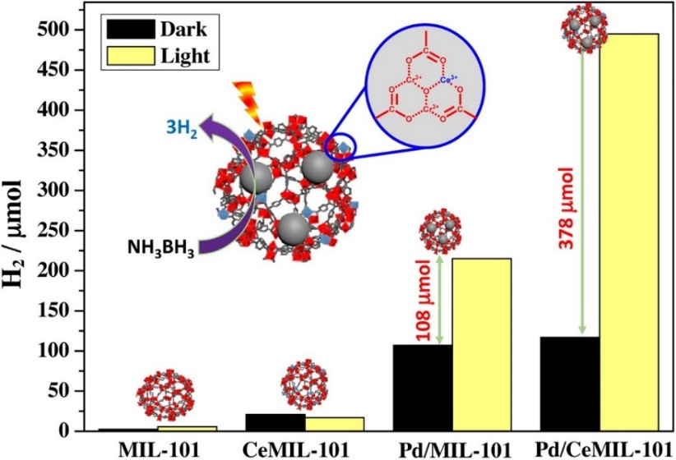

Figure 15. The hydrogen production from AB hydrolysis utilising different catalysts under dark condition and visible-light condition. Reprinted with permission from ref. [220]. Copyright 2017 Elsevier.

Plasmonic NPs such as Au and Ag have also been incorporated within MOFs in order to enhance their optical absorption and photocatalytic activities. In particular, the LSPR of Au NPs has been widely explored in conjunction with MOFs due to its higher stability and strong absorption in the visible region of the solar spectrum [221]. The combination of plasmonic catalysts and MOFs expects to improve catalytic activity because of the generation of hot electrons by LSPR [208, 222]. Plasmonic Au@Pd NPs supported on Ti-doped amine-functionalised Zr-based MOF (Au@Pd/UiO-66(Zr/Ti)-NH2) showed a dramatic enhancement in the selective hydrogen production from formic acid (FA) decomposition [208]. Au@Pd NPs were highly dispersed on the MOFs and Au@Pd/UiO-66(Zr/Ti)-NH2 exhibited much higher activity than monometallic NP supported MOFs (Pd/ UiO-66(Zr/Ti)-NH2) and AuPd alloy NPs supported MOFs (AuPd/UiO-66(Zr/Ti)-NH2). Therefore, Au@Pd core-shell structure was essentially important to enhance the catalytic activity due to the electron-rich Pd species arising from the difference in the work function of Au and Pd. The electron-rich Pd species had a positive effect on the adsorption and activation of FA. The Au@Pd/UiO-66(Zr/Ti)-NH2 had a strong visible-light absorption due to the presence of amino-functionalised organic linkers and the LSPR effect of Au@Pd NPs. The hydrogen production amount increased by utilising Au@Pd/UiO-66(Zr/Ti)-NH2 under visible-light irradiation compared to the dark condition. To investigate the synergistic effect between Au@Pd NPs and photoactive MOFs, the wavelength-dependent catalytic reactions were performed (**Figure 16 (a)**) and a significant enhancement in the catalytic activity under monochromatic light (*λ*= 400 nm) irradiation was observed. This can be explained due to the electron-rich Pd species formed by the photo-generated electrons through LCCT process. The LSPR effect of Au was confirmed to be the positive effect in enhancing the catalytic performance from wavelength-dependent catalytic reaction under the LED light (*λ*= 530 nm) irradiation. Thus, the Au@Pd core-shell structure provided not only the electron-rich Pd species but also the enhancement of the light absorption from the Au LSPR effect as illustrated in **Figure 16 (b)**. In addition, amino-functionalised organic linkers provided a visible-light responsive property, and the weak amine groups promoted O-H bond dissociation of formate. Under visible-light irradiation, photo-generated electrons migrated to the Pd site from the Au LSPR effect and photoactive MOFs. Such electron-rich Pd species significantly facilitated the C-H bond cleavage from the Pd-formate intermediates. The weakly basic amine groups within MOFs, the LSPR effect of Au@Pd NPs, and photoactive MOFs induced the formation of electron-rich Pd species and the synergistic effect toward catalytic activity. This work can be considered as a remarkable example and successful approach of integrating plasmonic NPs with MOFs for superior photocatalytic activities.

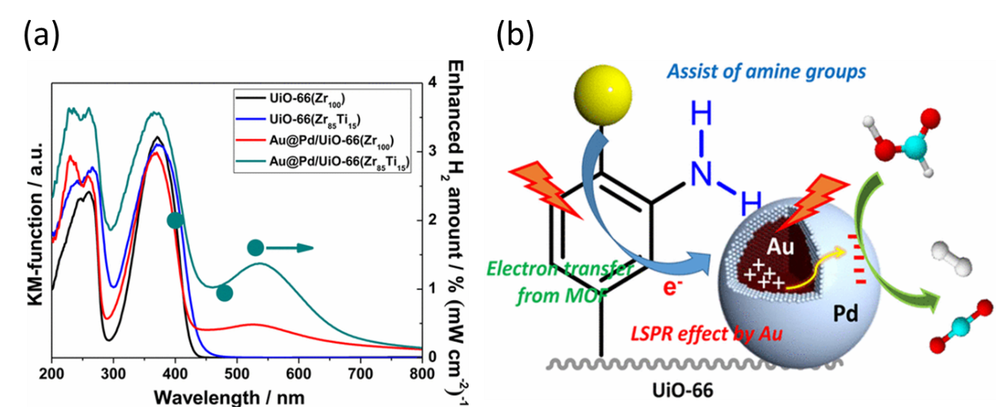

Figure 16. (a) UV-Vis spectra of samples and wavelength dependence of Au@Pd/UiO-66(Zr/Ti)-NH2 under various light irradiation. (b) Graphical representation of visible-light enhanced hydrogen production from FA decomposition utilising Au@Pd/UiO-66(Zr/Ti)-NH2. Adapted with permission from ref. [208]. Copyright 2017 American Chemical Society.

## 5.2. MOFs for hydrogen peroxide production

Hydrogen peroxide (H2O2) has recently attracted much attention as a promising green fuel because of its advantages on an easy-to-handle liquid fuel, high volumetric energy under ambient conditions and possible utilisation in a compact one-compartment fuel cell [223–226]. Therefore, much effort has been devoted to H2O2 production technology by oxygen reduction [227–230].

Our group has recently reported the construction of a photocatalytic H2O2 production system utilising MOFs for the first time [209]. H2O2 was photocatalytically generated under visible-light irradiation utilising amino-functionalised MIL-125 (MIL-125-NH2). **Figure 17** depicts the possible reaction mechanism. The photo-generated electrons are produced through LCCT upon visible-light irradiation. The electrons reduce oxygen molecules to form superoxide anions (O2·-), and H2O2 is generated through a disproportionation of O2·-. In addition, when NiO NPs were deposited on MIL-125-NH2, H2O2 production concentration (1487 µM after 3 h visible light irradiation) was three times higher than MIL-125-NH2 (471 µM after 3 h visible light irradiation). The effect of NiO NPs deposition enhanced the selectivity of two-electron reduction of O2 by the fast O2·- disproportionation. This work shows that MOFs not only have the enormous potential of photocatalysts for H2O2 production but also provide a method to enhance H2O2 production by non-noble metal oxide deposition.

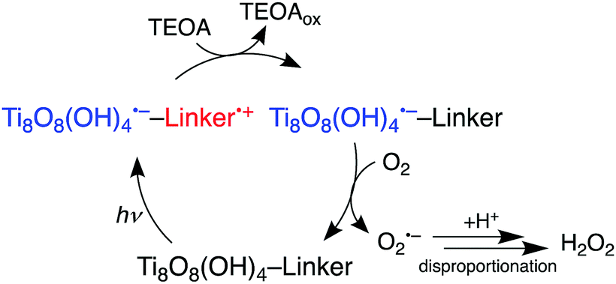

Figure 17. The photocatalytic H2O2 production mechanism utilising MIL-125-NH2. Reprinted with permission from ref. [209]. Copyright 2018 The Royal Society of Chemistry.

In a single-phase reaction system, the separation of the produced H2O2, the oxidation products, and photocatalysts is difficult, and subsequent H2O2 decomposition by the photocatalysts may also take place. To solve these problems, photocatalytic H2O2 production utilising hydrophobic MOFs in two-phase reaction system composed of water and benzyl alcohol (water/BA) was developed (**Figure 18**) [210]. Hydrophobic MOFs (MIL-125-Rn) were synthesised through alkylation of the organic linker of a hydrophilic MOF (MIL-125-NH2) by post-synthetic modification. When hydrophobic MIL-125-Rn was dispersed in the two-phase system, it was selectively dispersed in the BA phase. The H2O2 and benzaldehyde were formed under visible-light irradiation utilising MIL-125-Rn in the two-phase system. The H2O2 formation was observed only in the aqueous phase while benzaldehyde was only present in BA phase. This clearly showed that the H2O2 separation was easily realised in the two-phase system. The H2O2 production concentration utilising MIL-125-Rn was four times higher than that obtained by MIL-125-NH2 in the two-phase system because the reduction of H2O2 by photocatalysts was inhibited due to the spatial separation of H2O2 and photocatalysts. In the advantage of the two-phase system, produced H2O2 can be concentrated by reducing the volume of the aqueous phase. Moreover, H2O2 production was accelerated by changing the aqueous phase condition, such as low pH (~0.3) condition and saturated NaCl aqueous solution where the efficient disproportionation of O2·-to H2O2 took place.

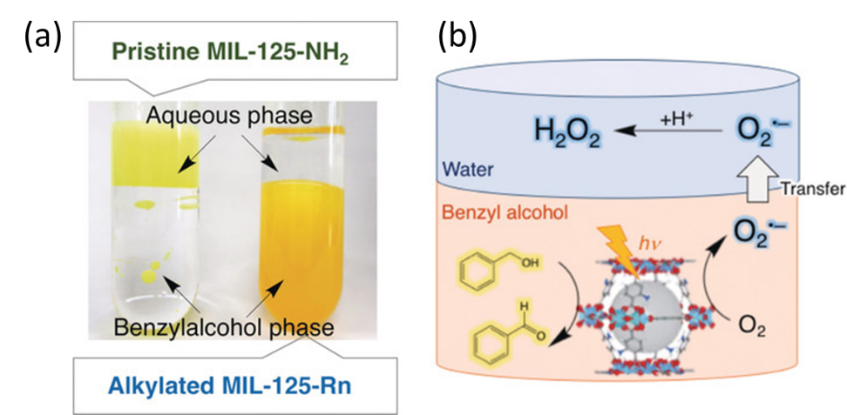

Figure 18. (a) Digital photographs of the two-phase system composed of an aqueous phase and a benzyl alcohol phase containing MIL-125-NH2 (left) and MIL-125-Rn (right), (b) Reaction mechanism of photocatalytic H2O2 production in the two-phase system. Adapted with permission from ref. [210]. Copyright 2019 Wiley-VCH.

Hydrophobic MIL-125-Rn, which was synthesised through alkylation of the organic linkers had a much smaller specific surface area than pristine MIL-125-NH2 because the grafted alkyl chains blocked the pores of MIL-125-Rn [210]. As a consequence, the diffusion of the reactants might be suppressed in the case of MIL-125-Rn. Without blocking the pores, the outermost surface of MIL-125-NH2 was selectively modified by Ti-cluster alkylation using octadecylphosphonic acid (OPA) (**Figure 19**) [211]. The OPA/MIL-125-NH2 was hydrophobic and maintained its original pore volume and specific surface area. As expected, in water/BA two-phase system, maximum H2O2 concentration (6660 µM) obtained by utilising OPA/MIL-125-NH2, which was three times higher than MIL-125-R7 (2348 µM). The H2O2 decomposition was suppressed and benzyl alcohol oxidation was enhanced due to the faster diffusion of O2・- and benzyl alcohol through unblocked open pores. Moreover, OPA hydrophobic modification was further applied to the Ti-doped Zr-based MOF (UiO-66(Zr/Ti)-NH2), and the thus synthesised hydrophobic MOF (OPA/UiO-66(Zr/Ti)-NH2) was also effective in the photocatalytic H2O2 production in the two-phase system [212]. Photocatalytic H2O2 production at two-phase reaction system utilising hydrophobic MOFs is greatly effective because highly concentrated H2O2 aqueous solution can be easily obtained without additional separation steps.

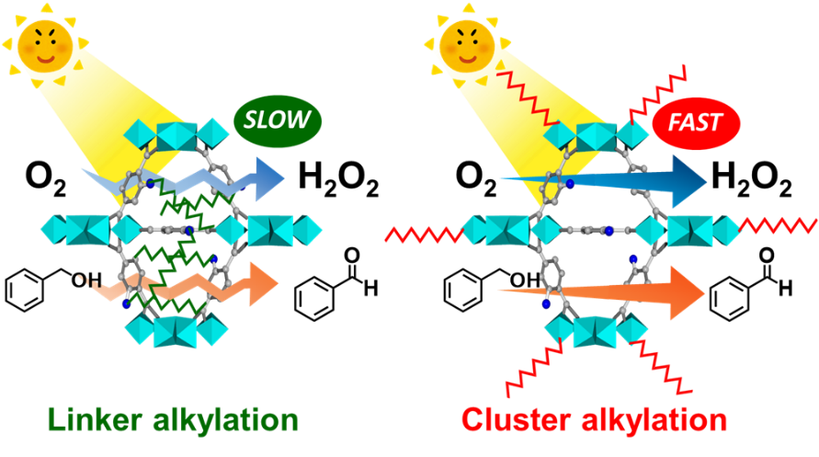

Figure 19. Graphical representation of linker-alkylated MIL-125-NH2, MIL-125-R7 (Left), and cluster-alkylated MIL-125-NH2, OPA/MIL-125-NH2 (Right). Reprinted with permission from ref. [211]. Copyright 2019 The Royal Society of Chemistry.

# 6. Advantages and disadvantages of porous materials for photocatalysis

Porous materials have gained tremendous research attention from both fundamental and technological perspectives [231, 232]. The porous framework combines high specific surface areas and large porous volumes, which makes them promising materials for heterogeneous photocatalytic applications [233]. Unlike conventional photocatalysts, the use of porous materials can provide well-defined pores to immobilise the photoactive component, thereby displaying superior catalytic performances with improved accessibility and light responsiveness [38]. In this section, we will briefly discuss the advantages and disadvantages of three representative types of porous materials; zeolites, mesoporous silica and MOFs to establish their structure-property relationships [9, 28, 50, 234].

Zeolites and mesoporous silica-based materials are attractive hosts to design and functionalise photocatalytic systems because of the presence of a confined micro-molecular environment and their remarkable transparency in the UV-vis spectrum, providing a photo-inactive surface for the chemical reactions [235–239]. They are identified as versatile molecular structures for facilitating photocatalytic reactions because of the following reasons: (i) the precise control in the tunability of pore size at the atomic level; (ii) enhanced diffusion rate of substrate molecules towards active sites due to the fine connectivity of pores within the framework; (iii) presence of silanol groups facilitating the easy functionalisation and (iv) chemical and thermal stability of frameworks.

The zeolitic and mesoporous material can accommodate photoactive guest molecules such as photosensitisers and inorganic semiconductors within the pore spaces of their rigid framework [53]. The integration with photoactive components generates unique photocatalysts with large surface area and high adsorption capacity. The chemical and thermal inertness of these supports further makes them suitable hosts for encapsulating photoactive species. Especially, the incorporation of TiO2 photocatalyst within the porous framework can form unique particles fitted within the pore spaces exhibiting superior catalytic performances due to the quantum size effect. The inherent stability and band gap energy of TiO2 makes them suitable for their application in environmental remediation under UV-light irradiation. The band gap engineering by heteroatom doping and defect engineering are one of the effective strategies to extend the photoabsorption of TiO2 in the visible-light region. It is possible to replace the silica atom in the framework with transition metals such as Ti, V, Cr, Mo and W, to create a heteroatom functionalised silica framework, popularly known as ‘single-site photocatalysts’. The heteroatoms are highly dispersed at the atomic level and display tetrahedrally coordinated geometry. Under light irradiation conditions, the formation of charge-transfer excited state accounts for their unique photocatalytic activity. Zeolites and mesoporous silica materials are advantageous support materials for the preparation of single-site photocatalysts due to (i) the presence of restricted and porous nanospaces in the framework; (ii) large surface values assisting in exposing the active sites on the surface; (iii) UV-vis light transparency allowing the light to reach inside the pores for enhanced photocatalytic activity; (iv) a significant change in the reaction environment with the addition of small amounts of heteroatoms and (v) the ability of the porous structure to adsorb and concentrate reactants.

The superior adsorption ability of organic substrates by zeolites assist in allowing the access of substrates to the active sites thereby leading to enhanced photocatalytic performances. The use of zeolites as a porous support matrix for encapsulating photocatalysts has a few drawbacks including the dilution effect, which explains that the photoactive component is only a very small proportion amongst the total weight percentage of the catalyst [28]. The incorporation of photoactive species within the framework requires additional steps in the synthesis and processing. The diverse zeolite framework compositions present a huge challenge in investigating the quality-control and their structural characterisation by available operando techniques [48, 49, 240]. Mesoporous materials were developed in order to overcome the restriction of small pore size of microporous zeolites (0.5-2.0 nm) and facilitate the transport of larger substrate molecules to reach the active sites in the framework [9, 26, 50, 233, 234, 241]. Mesoporous silica is synthesised by a templating approach, in which organic surfactant is used as the surface directing agents (SDA). The surfactant molecules assemble into a mesostructure in the presence of a silica precursor solution. The removal of surfactant by calcination forms a mesoporous material with a large surface area, tunable pore size and narrow pore size distribution. Although mesoporous materials cannot match up with the high hydrothermal stability of zeolites, they have found their use in many applications including photocatalysis, batteries, solar and fuel cells [9, 50, 242]. The poor hydrothermal stability is due to the presence of a large number of silanol groups on the wall and the absence of crystallinity. The selection of a suitable template allows the synthesis of mesoporous materials with controlled pore size, composition and morphology, which can be targeted for a specific application. The functionalisation of mesoporous silica to tailor the physical and chemical properties can be achieved by wet-impregnation, co-condensation, sol-gel processes and inner-pore hydrolysis. However, the pristine mesoporous silica displays a few limitations including its high hydrophilic nature and poor selectivity to organic compounds [56].

Metal-organic frameworks (MOFs) are a new class of porous crystalline solids made of metal ions/clusters and organic ligands leading to the formation of single-site solid catalysts [243]. The large surface area, high porosity and tailorable structural characteristics have stimulated the widespread research interest in various applications including gas sorption, drug delivery, sensors, catalysis and electrocatalysis [244]. In particular, MOFs have represented as a promising material as heterogeneous photocatalysts because of their easy separation from the reaction mixture and excellent product selectivity due to tailorable pore spaces [51, 59, 245]. The versatile coordination of different metal centers with diverse organic ligands determines not only the structural unit of the MOF but also affects the characteristics such as pore size, reactivity, stability, substrate adsorption and light absorption. In comparison to conventional inorganic semiconductors, MOFs exhibit the following unprecedented advantages; (i) highly porous structure and open channels ease the substrate diffusion ability towards active sites, (ii) tunable structural characteristics assist in the extending the visible light absorption, (iii) the presence of structural defects reduces the recombination rate of electron-hole pairs and (iv) the choice and positioning of suitable cocatalyst in the porous space or within the framework. MOF-based photocatalysts have also been used as precursors and templates to fabricate functional nanomaterials, which can preserve the intriguing features of parent MOFs such as porosity and large surface area but can exhibit enhanced photocatalytic activities. Various strategies have been developed to enhance the photocatalytic activity of MOFs by extending their light absorption from UV to the visible region of the solar spectrum. The choice of selection of metal ions and functionalisation of the organic linker can assist in the tuning of light absorption properties for the efficient solar utilisation.

Despite the remarkable properties and recent advancements in the MOF-based photocatalysts, the research field is in its infancy and there are still some critical challenges and limitations that need to be addressed for practical applications. The poor thermal and chemical stability of MOFs in comparison to zeolites is a major drawback for catalytic applications. The organic ligands often undergo degradation at temperatures above 350 °C and deposit as carbon species by blocking the active sites. Garcia et al. investigated the photostability of most used MOFs by UV-vis light irradiation for several weeks and concluded that they undergo decomposition by evolving large amounts of CO2 depending on the structure and composition of MOF [246]. The strengthening of structural stability between metal centers and organic ligands should be envisaged for future studies. They are extremely sensitive towards change in pressure, moisture and pH of the reaction system. Under harsh reaction conditions, for example, strongly acidic or basic medium, MOFs are unstable and lead to possible leaching or degradation of the framework. The selection of an appropriate solvent due to the coordinative nature of organic ligands is also essential in studying the photocatalytic applications of MOFs. The significantly higher catalytic performance of MOFs than many inorganic semiconductors is observed, however, the decrease in the overall activity during recycling test runs inhibit their large-scale application. The reaction mechanism of MOFs including the migration of charge carriers under light irradiation conditions and the relationship between the local structure of MOFs and their catalytic performance is still unclear and requires further operando techniques to unveil the reaction pathway and structure-property relationship for efficient solar utilisation.

It can be concluded that each of the group of porous materials has its own set of advantages and disadvantages. They differ in terms of their pore size, surface area, stability and catalytic applications and is unlikely that one has the potential to replace the other [49, 51, 240, 247]. Table 7 enlists the comparison of structural advantages and disadvantages of different porous materials. The recent advances in the design and synthesis of ZIFs, covalent organic frameworks (COFs) and MIL technology can potentially lead to the discovery of more versatile MOFs with enhanced stability, compared to zeolites and mesoporous materials. The rich catalysis chemistry of these porous solids because of their unique structural advantages can complement each other for attaining superior activity in heterogeneous catalysis. Zeolites are well known for their stability and therefore widely used in gas phase industrial catalysis, whereas mesoporous materials possess the largest pore spaces, which can assist in the diffusion of larger sized substrate molecules towards the active sites.

Table 7. Summary of advantages and disadvantages of porous materials for catalytic and photocatalytic applications.

|  |  |  |  |
| --- | --- | --- | --- |
| **Porous material** | **Advantages** | **Disadvantages** | **Ref** |
| Zeolites | Uniform pore size; high porosity; higher thermal, hydrothermal and photo-stability; ion-exchangeable; UV-vis light transparency; highly crystalline product; ordered nanoarrays structure; high-quality product; low-sensitivity to reaction conditions | Small pore size (< 2 nm); high cost; time-consuming | [28, 48, 49, 240] |
| Mesoporous silica | Tailorable larger pore size; controllable mesostructure and morphologies; high thermal stability; the presence of many surface silanol groups; facile anchoring and functionalisation; UV-vis light transparency; easily processable; high-quality product; large-scale production | Poor selectivity; hydrophilic nature; lower hydrothermal stability; uses surfactants in synthesis; relatively low crystallinity | [9, 26, 50, 241] |
| MOFs | Large specific surface area; tunable micropore size; metal active sites; electron conductivity; adjustable surface properties; a variety of hybrid types; no templates; highly crystalline product | Poor recyclability; lower thermal and hydrothermal stability; smaller pore size; extremely sensitive towards reaction conditions (pressure, moisture and pH); high cost; complicated synthesis; not easily processable | [51, 57–59, 243, 248–251] |

# 7. Summary and future prospects

The research efforts on nanoporous photocatalysts are continuously fuelled by the immense interests in the exploitation of their diverse structures, chemical composition and unique properties. Several targeted applications can be easily facilitated, based on the unique characteristics of these porous support materials. They have been shown to display superior activity and selectivity than conventional semiconductors because of the feasibility to fine-tune the coordination structure and reaction field microenvironment adjacent to the active sites. It is also possible to drastically alter the characteristics by introducing multifunctionalities, hydrophilicity/hydrophobicity, metal ions and metal complexes within the framework. In this review, we have highlighted the synthesis, properties and advances in the photocatalytic applications of micro-, meso- and macroporous framework supported single-site photocatalysts, thin films, anchored metal complexes and plasmonic NPs. The use of nanoporous spaces in the preparation of porous photocatalytic materials has been demonstrated. Additionally, the preparation of heteroatom-doped silica frameworks has been discussed for the photocatalytic pollutant degradation, selective oxidation and reduction reactions under UV-vis light irradiation. The unique architecture of TiO2 combined with macro-mesoporous silica and yolk-shell structured composites were identified as promising host materials for photocatalytic degradation of organic compounds.

The creation of light-sensitive plasmonic materials using porous supports has opened a new avenue in the field of photocatalysis popularly known as ‘*direct plasmonic catalysis’*. The discovery and design of such materials in the last decade has shown a great potential to be the next generation photocatalytic materials for solar to chemical conversion pathway. In particular, Ag-based plasmonic NPs have displayed superior catalytic performances because of their strong optical absorption characteristics. The synthetic strategy of hybrid plasmonic NPs and evaluation of their catalytic performances in the hydrogen production from AB, reduction of nitroaromatics, Suzuki-Miyaura coupling reaction has been discussed. The integration of MOFs with plasmonic and active metal NPs along with its functionalisation with hydrophobic groups in a two-phase reaction system has been explored for efficient catalysis in the sustainable production of hydrogen and hydrogen peroxide under visible light irradiation. The high cost of noble plasmonic metals, poor thermal stability of MOFs and lack of mechanistic insights are some of the major limitations currently being faced in this field.

The development and application of porous materials in photocatalysis requires the amalgamation of knowledge, skills and efforts of chemists and materials scientists. Although great progress has been made in recent years, there are still several challenges that need to be addressed especially in the design of new types of materials in order to have better control of active sites. It is still a challenge to optimise the exact dopant concentration and to segregate the different types of species in multifunctional silica frameworks. Theoretical simulations studies, along with an in-depth characterisation at the atomic scale, are crucial for a better understanding of these micro- and mesoporous systems. One of the limitations in the use of zeolites is their very small pore diameter, which could be addressed by evolving 2D, hierarchical and pillared architectures [252–254] and through development of new synthetic protocols for preparing high-quality nanostructured frameworks with large pore sizes. There have been reports exploring the preparation of germanosilicates, but their application is restricted because of poor hydrothermal stability.

Future studies in the design and architecture of porous photocatalytic nanomaterials may extend along the lines of several topics that have been introduced in this review article. Some of our perspectives for future research direction in this field are; (i) the first obstacle is to develop a cost-effective, template-free and simple method for the large-scale production of porous supports with controlled synthesis similar to the MOFs synthesis strategy; (ii) porous materials are introduced in designing photocatalysts in order to increase the accessibility of substrate molecules to reach the active sites. It is highly desirable that the materials are synthesised with high purity with good catalytic activity and stability[50]. Recently, the plasma-induced structural defect engineering in MOFs was reported to be an important strategy to enhance the photocatlytic hydrogen evolution from water [255]; (iii) the thermal stability of porous photocatalysts is an important concern for catalytic reactions performed at higher temperature conditions. It is essential to develop advanced materials with a balance of various properties including stability, surface area and structured framework. For example; the poor stability of MOFs and small pore size in zeolites restricts their use in various industrial applications; (iv) extensive knowledge of the electronic, surface and structural properties at an atomic scale will be advantageous for the advancements in the synthesis of multifunctional materials with superior catalytic performance. Hence, the development of *in situ* and operando techniques for characterising and studying the silica-based porous materials at a molecular scale should be developed [26]. The combination of X-ray absorption spectroscopy (XAS) along with other strong spectroscopic tools such as NMR and XPS would provide the atomic-level insights and assist in establishing structure-property relationships and new materials discovery.

The future of nanomaterials in chemistry involves continuous research efforts for the development of environment-friendly and sustainable alternatives. The fundamental research, combined with technological advancements supported with economic analysis, is essential in order to accommodate the use of mesoporous based photocatalysts for renewable energy systems. The use of titania-based mesoporous materials as electrodes in DSSCs and as photocatalytic materials for energy applications display an immense potential in photoelectronic, solar cells and thermoelectric technologies. The slow-photon effect reported in hierarchically structured porous materials play an important role in enhancing the rate of photocatalysis [256]. Such photonic nanostructures hold significant promise in the research field of artificial photosynthesis and solar cells. The development of functionalised MOFs for water splitting, CO2 reduction and photodegradation reactions is one of most studied area of research. A great progress has been made in the last decade, however, the photocatalytic efficiencies still needs to be improved and an alternative to the use of sacrificial agents must be explored. Very recently, the preparation of homochiral MOFs for asymmetric catalysis has been reported, however, very limited examples are available in the literature [257]. Their synthesis can be easily done in comparison to other porous materials (For example; zeolites) by introducing chiral groups by post synthesis modification or by the use of enantiotropic ligands. The development of more robust MOFs and their transformation to stable carbon materials for catalytic applications are some of the strategies for future work. We expect that the research on the discovery and design of novel photofunctional materials will continue to move in a forward direction focusing on the intriguing features of porous materials in the implementation of artificial photosynthesis for solar energy exploitation. We hope that this review can stimulate new insights and research innovations for exciting discoveries in the pursuit of a green and sustainable future.

# Acknowledgements

This work was supported by the International Joint Research Promotion Program of Osaka University. The present work was partially supported by Grants-in-Aid for Scientific Research (No. 19K15311, 26220911, 18K14056, and 19H00838) from the Japan Society for the Promotion of Science (JSPS) and MEXT. YK, KM and HY thank the MEXT program “Element Strategy Initiative” (No. JPMXP0112101003). PV acknowledges the Royal Society for Newton International Fellowship (NIF\R1\180185) at the University of Southampton, UK.

# References

[1] Fujishima, A.; Rao, T. N.; Tryk, D. A. Titanium Dioxide Photocatalysis. *J. Photochem. Photobiol. C*, **2000**, *1* (1), 1–21.

[2] Jiménez-González, C.; Constable, D. J. C.; Ponder, C. S. Evaluating the “Greenness” of Chemical Processes and Products in the Pharmaceutical Industry—a Green Metrics Primer. *Chem. Soc. Rev.*, **2012**, *41* (4), 1485–1498. https://doi.org/10.1039/c1cs15215g.

[3] Clarke, C. J.; Tu, W. C.; Levers, O.; Bröhl, A.; Hallett, J. P. Green and Sustainable Solvents in Chemical Processes. *Chem. Rev.*, **2018**, *118* (2), 747–800. https://doi.org/10.1021/acs.chemrev.7b00571.

[4] Kitagawa, S. Future Porous Materials. *Acc. Chem. Res.*, **2017**, *50* (3), 514–516. https://doi.org/10.1021/acs.accounts.6b00500.

[5] Panwar, N. L.; Kaushik, S. C.; Kothari, S. Role of Renewable Energy Sources in Environmental Protection: A Review. *Renew. Sustain. Energy Rev.*, **2011**, *15* (3), 1513–1524. https://doi.org/10.1016/j.rser.2010.11.037.

[6] Chen, X.; Li, C.; Grätzel, M.; Kostecki, R.; Mao, S. S. Nanomaterials for Renewable Energy Production and Storage. *Chem. Soc. Rev.*, **2012**, *41* (23), 7909–7937. https://doi.org/10.1039/c2cs35230c.

[7] Dresselhaus, M. S.; Thomas, I. L. Alternative Energy Technologies. *Nature*, **2001**, *414* (6861), 332–337.

[8] Fresno, F.; Portela, R.; Suárez, S.; Coronado, J. M. Photocatalytic Materials: Recent Achievements and near Future Trends. *J. Mater. Chem. A*, **2014**, *2* (9), 2863–2884. https://doi.org/10.1039/c3ta13793g.

[9] Linares, N.; Silvestre-Albero, A. M.; Serrano, E.; Silvestre-Albero, J.; García-Martínez, J. Mesoporous Materials for Clean Energy Technologies. *Chem. Soc. Rev.*, **2014**, *43* (22), 7681–7717. https://doi.org/10.1039/c3cs60435g.

[10] Hu, X.; Li, G.; Yu, J. C. Design, Fabrication, and Modification of Nanostructured Semiconductor Materials for Environmental and Energy Applications. *Langmuir*, **2010**, *26* (5), 3031–3039. https://doi.org/10.1021/la902142b.

[11] Wang, Y.; Vogel, A.; Sachs, M.; Sprick, R. S.; Wilbraham, L.; Moniz, S. J. A.; Godin, R.; Zwijnenburg, M. A.; Durrant, J. R.; Cooper, A. I.; et al. Current Understanding and Challenges of Solar-Driven Hydrogen Generation Using Polymeric Photocatalysts. *Nature Energy*, **2019**, 746–760. https://doi.org/10.1038/s41560-019-0456-5.

[12] Grätzel, M. Mesoscopic Solar Cells for Electricity and Hydrogen Production from Sunlight. *Chem. Lett.,* 2005, 8–13. https://doi.org/10.1246/cl.2005.8.

[13] Mori, K.; Qian, X.; Kuwahara, Y.; Horiuchi, Y.; Kamegawa, T.; Zhao, Y.; Louis, C.; Yamashita, H. Design of Advanced Functional Materials Using Nanoporous Single-Site Photocatalysts. *Chem. Rec.*, **2020**, *20* (7), 660–671. https://doi.org/10.1002/tcr.201900085.

[14] Fujishima, A.; Honda, K. Electrochemical Photolysis of Water at a Semiconductor Electrode. *Nature*, **1972**, *238* (5358), 38–40. https://doi.org/10.1038/238038a0.

[15] Eisenberg, R. Rethinking Water Splitting. *Science*, **2009**, *324* (5923), 44–45. https://doi.org/10.1126/science.1172247.

[16] Maschmeyer, T.; Che, M. Catalytic Aspects of Light‐Induced Hydrogen Generation in Water with TiO2 and Other Photocatalysts: A Simple and Practical Way Towards a Normalization? *Angew. Chem. Int. Ed.*, **2010**, *49* (9), 1536–1539. https://doi.org/doi:10.1002/anie.200903921.

[17] Kudo, A.; Miseki, Y. Heterogeneous Photocatalyst Materials for Water Splitting. *Chem. Soc. Rev.*, **2009**, *38* (1), 253–278. https://doi.org/10.1039/b800489g.

[18] Lambert, J. F.; Che, M. The Molecular Approach to Supported Catalysts Synthesis: State of the Art and Future Challenges. *J. Mol. Catal. A Chem.*, **2000**, *162* (1), 5–18. https://doi.org/https://doi.org/10.1016/S1381-1169(00)00318-6.

[19] Liang, J.; Liang, Z.; Zou, R.; Zhao, Y. Heterogeneous Catalysis in Zeolites, Mesoporous Silica, and Metal–Organic Frameworks. *Advanced Materials*. 2017, 29 (30), 1701139. https://doi.org/10.1002/adma.201701139.

[20] Szczȩśniak, B.; Choma, J.; Jaroniec, M. Major Advances in the Development of Ordered Mesoporous Materials. *Chem. Commun.*, **2020**, *56* (57), 7836–7848. https://doi.org/10.1039/d0cc02840a.

[21] Corma, A. State of the Art and Future Challenges of Zeolites as Catalysts. *J. Catal.*, **2003**, *216* (1), 298–312. https://doi.org/https://doi.org/10.1016/S0021-9517(02)00132-X.

[22] Wan, Y.; Zhao. On the Controllable Soft-Templating Approach to Mesoporous Silicates. *Chem. Rev.*, **2007**, *107* (7), 2821–2860. https://doi.org/10.1021/cr068020s.

[23] Verma, P.; Kuwahara, Y.; Mori, K.; Raja, R.; Yamashita, H. Functionalized Mesoporous SBA-15 Silica: Recent Trends and Catalytic Applications. *Nanoscale*, **2020**, *12* (21), 11333–11363. https://doi.org/10.1039/d0nr00732c.

[24] Qian, X.; Fuku, K.; Kuwahara, Y.; Kamegawa, T.; Mori, K.; Yamashita, H. Design and Functionalization of Photocatalytic Systems within Mesoporous Silica. *ChemSusChem*, **2014**, *7*, 1528–1536. https://doi.org/10.1002/cssc.v7.6/issuetoc.

[25] Suib, S. L.; Přech, J.; Čejka, J.; Kuwahara, Y.; Mori, K.; Yamashita, H. Some Novel Porous Materials for Selective Catalytic Oxidations. *Mater. Today*, **2020**, *32*, 244–259. https://doi.org/10.1016/j.mattod.2019.06.008.

[26] Suib, S. L. A Review of Recent Developments of Mesoporous Materials. *Chem. Rec.*, **2017**, *17* (12), 1169–1183. https://doi.org/10.1002/tcr.201700025.

[27] Horiuchi, Y.; Yamashita, H. Design of Mesoporous Silica Thin Films Containing Single-Site Photocatalysts and Their Applications to Superhydrophilic Materials. *Appl. Catal. A Gen.*, **2011**, *400* (1–2), 1–8. https://doi.org/10.1016/j.apcata.2011.04.027.

[28] Corma, A.; Garcia, H. Zeolite-Based Photocatalysts. *Chem. Commun.*, **2004**, 1443–1459.

[29] Wang, C. C.; Wang, X.; Liu, W. The Synthesis Strategies and Photocatalytic Performances of TiO2/MOFs Composites: A State-of-the-Art Review. *Chem. Eng. J.,* **2020**, 391, 123601. https://doi.org/10.1016/j.cej.2019.123601.

[30] Dhakshinamoorthy, A.; Asiri, A. M.; García, H. Metal-Organic Framework (MOF) Compounds: Photocatalysts for Redox Reactions and Solar Fuel Production. *Angew. Chem. Int. Ed.,* **2016**, 55, 5414–5445. https://doi.org/10.1002/anie.201505581.

[31] Zhang, Z.; Zhao, Y.; Gong, Q.; Lib, Z.; Li, J. MOFs for CO2 Capture and Separation from Flue Gas Mixtures: The Effect of Multifunctional Sites on Their Adsorption Capacity and Selectivity. *Chem. Commun.*, **2013**, *49* (7), 653–661. https://doi.org/10.1039/c2cc35561b.

[32] Zhang, T.; Lin, W. Metal-Organic Frameworks for Artificial Photosynthesis and Photocatalysis. *Chem. Soc. Rev.,* **2014**, 43, 5982–5993. https://doi.org/10.1039/c4cs00103f.

[33] Li, J. R.; Kuppler, R. J.; Zhou, H. C. Selective Gas Adsorption and Separation in Metal-Organic Frameworks. *Chem. Soc. Rev.*, **2009**, *38* (5), 1477–1504. https://doi.org/10.1039/b802426j.

[34] Campbell, M. G.; Liu, S. F.; Swager, T. M.; Dinca, M. Chemiresistive Sensor Arrays from Conductive 2D Metal − Organic Frameworks. *J. Am. Chem. Soc.*, **2015**, 137, 13780-13783. https://doi.org/10.1021/jacs.5b09600.

[35] Che, M.; Mori, K.; Yamashita, H. Elaboration, Characterization and Properties of Silica-Based Single-Site Heterogeneous Photocatalysts. *Proc. R. Soc. A,* **2012**, 468, 2113–2128. https://doi.org/10.1098/rspa.2012.0139.

[36] Wei, X.; Wang, K. X.; Guo, X. X.; Chen, J. S. Single-Site Photocatalysts with a Porous Structure. *Proc. R. Soc. A*, **2012**,468, 2099–2112. https://doi.org/10.1098/rspa.2012.0071.

[37] Mori, K.; Imaoka, S.; Nishio, S.; Nishiyama, Y.; Nishiyama, N.; Yamashita, H. Investigation of Local Structures and Photo-Induced Surface Properties on Transparent Me(Ti, Cr)-Containing Mesoporous Silica Thin Films. *Microporous Mesoporous Mater.*, **2007**, 101,288–295. https://doi.org/10.1016/j.micromeso.2006.10.031.

[38] Yamashita, H.; Mori, K.; Kuwahara, Y.; Kamegawa, T.; Wen, M.; Verma, P.; Che, M. Single-Site and Nano-Confined Photocatalysts Designed in Porous Materials for Environmental Uses and Solar Fuels. *Chem. Soc. Rev.*, **2018**, *47*, 8072–8096. https://doi.org/10.1039/c8cs00341f.

[39] Yamashita, H.; Anpo, M. Local Structures and Photocatalytic Reactivities of the Titanium Oxide and Chromium Oxide Species Incorporated within Micro- and Mesoporous Zeolite Materials: XAFS and Photoluminescence Studies. *Curr. Opin. Solid State Mater. Sci.*, **2003**, *7* (6), 471–481. https://doi.org/10.1016/j.cossms.2004.02.003.

[40] Ramamurthy, V.; Turro, N. J. Photochemistry of Organic Molecules within Zeolites: Role of Cations. *J. Incl. Phenom. Mol. Recognit. Chem.*, **1995**, *21* (1–4), 239–282. https://doi.org/10.1007/BF00709418.

[41] Zhang, Z.; Turro, N. J.; Johnston, L.; Ramamurthy, V. Role of Water in Intrazeolite Photochemistry. *Tetrahedron Lett.*, **1996**, *37* (28), 4861–4864. https://doi.org/10.1016/0040-4039(96)00971-9.

[42] Herron, N. A Cobalt Oxygen Carrier in Zeolite Y. A Molecular “Ship in a Bottle.” *Inorg. Chem.*, **1986**, *25* (26), 4714–4717. https://doi.org/10.1021/ic00246a025.

[43] Herron, N.; Stucky, G. D.; Tolman, C. A. Shape Selectivity in Hydrocarbon Oxidations Using Zeolite Encapsulated Iron Phthalocyanine Catalysts. *J. Chem. Soc. Chem. Commun.*, **1986**, 20, 1521–1522. https://doi.org/10.1039/C39860001521.

[44] Vos, D. De; Thibault-starzyk, F.; Jacobs, P. A. Zeolite-Encapsulated Mn(II) Complexes as Catalysts for Selective Alkene Oxidation. *Nature*, **1994**, *369*, 543–546.

[45] Corma, A.; García, H.; Llabrés I Xamena, F. X. Engineering Metal Organic Frameworks for Heterogeneous Catalysis. *Chem. Rev.*, **2010**, *110* (8), 4606–4655. https://doi.org/10.1021/cr9003924.

[46] Corma, A.; Fornùs, V.; Garcia, H.; Miranda, M. A.; Primo, J.; Sabater, M. J. Photoinduced Electron Transfer within Zeolite Cavities: Cis-Stilbene Isomerization Photosensitized by 2, 4, 6-Triphenylpyrylium Cation Imprisoned inside Zeolite Y. *J. Am. Chem. Soc.*, **1994**, *116* (6), 2276–2280. https://doi.org/10.1021/ja00085a006.

[47] Corma, A.; Garcia, H. Supramolecular Host-Guest Systems in Zeolites Prepared by Ship-in-a-Bottle Synthesis. *Eur. J. Inorg. Chem.*, **2004**, 6, 1143–1164. https://doi.org/10.1002/ejic.200300831.

[48] Anpo, M. Preparation, Characterization, and Reactivities of Highly Functional Titanium Oxide-Based Photocatalysts Able to Operate under UV-Visible Light Irradiation: Approaches in Realizing High Efficiency in the Use of Visible Light. *Bull. Chem. Soc. Jpn.*, **2004**, *77* (8), 1427–1442. https://doi.org/10.1246/bcsj.77.1427.

[49] Li, T.; Liu, H.; Fan, Y.; Yuan, P.; Shi, G.; Bi, X. T.; Bao, X. Synthesis of Zeolite y from Natural Aluminosilicate Minerals for Fluid Catalytic Cracking Application. *Green Chem.*, **2012**, *14* (12), 3255–3259. https://doi.org/10.1039/c2gc36101a.

[50] Li, W.; Liu, J.; Zhao, D. Mesoporous Materials for Energy Conversion and Storage Devices. *Nat. Rev. Mater.*, **2016**, *1* (6). https://doi.org/10.1038/natrevmats.2016.23.

[51] Liu, J.; Chen, L.; Cui, H.; Zhang, J.; Zhang, L.; Su, C. Y. Applications of Metal-Organic Frameworks in Heterogeneous Supramolecular Catalysis. *Chem. Soc. Rev.*, **2014**, *43* (16), 6011–6061. https://doi.org/10.1039/c4cs00094c.

[52] Mori, K.; Yamashita, H. Metal Complexes Supported on Solid Matrices for Visible-Light-Driven Molecular Transformations. *Chem. Eur. J.*, **2016**, *22* (32), 11122–11137. https://doi.org/10.1002/chem.201600441.

[53] Anandan, S.; Yoon, M. Photocatalytic Activities of the Nano-Sized TiO2-Supported Y-Zeolites. *J. Photochem. Photobiol. C Photochem. Rev.*, **2003**, *4* (1), 5–18. https://doi.org/10.1016/S1389-5567(03)00002-9.

[54] Li, S.; Lafon, O.; Wang, W.; Wang, Q.; Wang, X.; Li, Y.; Xu, J.; Deng, F. Recent Advances of Solid-State NMR Spectroscopy for Microporous Materials. *Adv. Mater.*, **2020**, *2002879*, 1–22. https://doi.org/10.1002/adma.202002879.

[55] Reddy, E. P.; Davydov, L.; Smirniotis, P. TiO2-Loaded Zeolites and Mesoporous Materials in the Sonophotocatalytic Decomposition of Aqueous Organic Pollutants: The Role of the Support. *Appl. Catal. B Environ.*, **2003**, *42* (1), 1–11. https://doi.org/10.1016/S0926-3373(02)00192-3.

[56] Qian, X.; Fuku, K.; Kuwahara, Y.; Kamegawa, T.; Mori, K.; Yamashita, H. Design and Functionalization of Photocatalytic Systems within Mesoporous Silica. *ChemSusChem*, **2014**, *7* (6), 1528–1536. https://doi.org/10.1002/cssc.201400111.

[57] Huang, C. W.; Nguyen, V. H.; Zhou, S. R.; Hsu, S. Y.; Tan, J. X.; Wu, K. C. W. Metal-Organic Frameworks: Preparation and Applications in Highly Efficient Heterogeneous Photocatalysis. *Sustain. Energy Fuels*, **2020**, *4* (2), 504–521. https://doi.org/10.1039/c9se00972h.

[58] Nasalevich, M. A.; Van Der Veen, M.; Kapteijn, F.; Gascon, J. Metal-Organic Frameworks as Heterogeneous Photocatalysts: Advantages and Challenges. *CrystEngComm*, **2014**, *16* (23), 4919–4926. https://doi.org/10.1039/c4ce00032c.

[59] Xiao, J. D.; Jiang, H. L. Metal-Organic Frameworks for Photocatalysis and Photothermal Catalysis. *Acc. Chem. Res.*, **2018**, No. 4. https://doi.org/10.1021/acs.accounts.8b00521.

[60] Burton, A. Recent Trends in the Synthesis of High-Silica Zeolites. *Catal. Rev. Sci. Eng.*, **2018**, *60* (1), 132–175. https://doi.org/10.1080/01614940.2017.1389112.

[61] Přech, J.; Pizarro, P.; Serrano, D. P.; Áejka, J. From 3D to 2D Zeolite Catalytic Materials. *Chem. Soc. Rev.*, **2018**, *47* (22), 8263–8306. https://doi.org/10.1039/c8cs00370j.

[62] Přech, J. Catalytic Performance of Advanced Titanosilicate Selective Oxidation Catalysts – a Review. *Catal. Rev. Sci. Eng.*, **2018**, *60* (1), 71–131. https://doi.org/10.1080/01614940.2017.1389111.

[63] Shamzhy, M.; Opanasenko, M.; Concepción, P.; Martínez, A. New Trends in Tailoring Active Sites in Zeolite-Based Catalysts. *Chem. Soc. Rev.*, **2019**, *48* (4), 1095–1149. https://doi.org/10.1039/c8cs00887f.

[64] Kuwahara, Y.; Yamashita, H. Efficient Photocatalytic Degradation of Organics Diluted in Water and Air Using TiO2designed with Zeolites and Mesoporous Silica Materials. *J. Mater. Chem.*, **2011**, *21* (8), 2407–2416. https://doi.org/10.1039/c0jm02741c.

[65] Kuwahara, Y.; Aoyama, J.; Miyakubo, K.; Eguchi, T.; Kamegawa, T.; Mori, K.; Yamashita, H. TiO2 Photocatalyst for Degradation of Organic Compounds in Water and Air Supported on Highly Hydrophobic FAU Zeolite: Structural, Sorptive, and Photocatalytic Studies. *J. Catal.*, **2012**, *285* (1), 223–234. https://doi.org/10.1016/j.jcat.2011.09.031.

[66] Kamegawa, T.; Kido, R.; Yamahana, D.; Yamashita, H. Design of TiO2-Zeolite Composites with Enhanced Photocatalytic Performances under Irradiation of UV and Visible Light. *Microporous Mesoporous Mater.*, **2013**, *165*, 142–147. https://doi.org/10.1016/j.micromeso.2012.08.013.

[67] Kamegawa, T.; Ishiguro, Y.; Kido, R.; Yamashita, H. Design of Composite Photocatalyst of TiO2 and Y-Zeolite for Degradation of 2-Propanol in the Gas Phase under UV and Visible Light Irradiation. *Molecules*, **2014**, *19* (10), 16477–16488. https://doi.org/10.3390/molecules191016477.

[68] Kuwahara, Y.; Magatani, Y.; Yamashita, H. Photocatalytic Epoxidation of Olefins Using Molecular O2 by TiO2 Incorporated in Hydrophobic Y Zeolite. *Rapid Commun. Photosci.*, **2015**, *4* (1), 19–21. https://doi.org/10.5857/rcp.2015.4.1.19.

[69] Shiraishi, Y.; Saito, N.; Hirai, T. Titanosilicate Molecular Sieve for Size-Screening Photocatalytic Conversion. *J. Am. Chem. Soc.*, **2005**, *127* (23), 8304–8306.

[70] Yamashita, H.; Ichihashi, Y.; Anpo, M.; Hashimoto, M.; Louis, C.; Che, M. Photocatalytic Decomposition of NO at 275 K on Titanium Oxides Included within Y-Zeolite Cavities: The Structure and Role of the Active Sites. *J. Phys. Chem.*, **1996**, *100* (40), 16041–16044. https://doi.org/10.1021/jp9615969.

[71] Yamashita, H.; Fujii, Y.; Ichihashi, Y.; Zhang, S. G.; Ikeue, K.; Park, D. R.; Koyano, K.; Tatsumi, T.; Anpo, M. Selective Formation of CH3OH in the Photocatalytic Reduction of CO2 with H2O on Titanium Oxides Highly Dispersed within Zeolites and Mesoporous Molecular Sieves. *Catal. Today*, **1998**, *45* (1), 221–227. https://doi.org/https://doi.org/10.1016/S0920-5861(98)00219-3.

[72] Mori, K.; Kawashima, M.; Kagohara, K.; Yamashita, H. Influence of Exchanged Alkali Metal Cations within Zeolite Y Cages on Spectroscopic and Photooxidation Properties of the Incorporated Tris(2,2’-Bipyridine)Ruthenium(II) Complexes. *J. Phys. Chem. C*, **2008**, 112, 19449–19455. https://doi.org/10.1021/jp807210q.

[73] Masaya, M.; Emi, M.; Kouji, T.; Hiromi, Y.; Masakazu, A. The Photocatalytic Decomposition of Nitric Oxide on the Silver(I) Ion-Exchanged ZSM-5 Catalyst. *Chem. Lett.*, **1995**, *24* (5), 375–376. https://doi.org/10.1246/cl.1995.375.

[74] Chen, X.; Mao, S. S. Titanium Dioxide Nanomaterials: Synthesis, Properties, Modifications, and Applications. *Chem. Rev.*, **2007**, *107* (7), 2891–2959.

[75] Hoffmann, M. R.; Martin, S. T.; Choi, W.; Bahnemann, D. W. Environmental Applications of Semiconductor Photocatalysis. *Chem. Rev.*, **1995**, *95* (1), 69–96.

[76] Linsebigler, A. L.; Lu, G.; Yates, J. T. Photocatalysis on TiO2 Surfaces: Principles, Mechanisms, and Selected Results. *Chem. Rev.*, **1995**, *95* (3), 735–758.

[77] Yamashita, H.; Nose, H.; Kuwahara, Y.; Nishida, Y.; Yuan, S.; Mori, K. TiO2 Photocatalyst Loaded on Hydrophobic Si3N4 Support for Efficient Degradation of Organics Diluted in Water. *Appl. Catal. A*, **2008**, *350* (2), 164–168.

[78] Ooka, C.; Yoshida, H.; Horio, M.; Suzuki, K.; Hattori, T. Adsorptive and Photocatalytic Performance of TiO2 Pillared Montmorillonite in Degradation of Endocrine Disruptors Having Different Hydrophobicity. *Appl. Catal. B*, **2003**, *41* (3), 313–321.

[79] Cosa, G.; Galletero, M. S.; Fernández, L.; Márquez, F.; García, H.; Scaiano, J. C. Tuning the Photocatalytic Activity of Titanium Dioxide by Encapsulation inside Zeolites Exemplified by the Cases of Thianthrene Photooxygenation and Horseradish Peroxidase Photodeactivation. *New J. Chem.*, **2002**, *26* (10), 1448–1455. https://doi.org/10.1039/b201397e.

[80] Zeolites, Y.; Corrent, S.; Cosa, G.; Scaiano, J. C.; Galletero, M. S.; Alvaro, M.; Garcia, H. Articles Properties of Nanosized TiO 2 Clusters Included In. *Chem. Mater.*, **2001**, *13* (15), 715–722.

[81] Cosa, G.; Chrétien, M. N.; Galletero, M. S.; Fornés, V.; García, H.; Scaiano, J. C. Photocatalytic Activity of a Multicomponent System Assembled within Zeolites: Case of 2,4,6-Triphenylpyrylium or Ruthenium Tris(Bipyridyl) Photosensitizers and Titanium Dioxide Relays within Zeolite Y. *J. Phys. Chem. B*, **2002**, *106* (10), 2460–2467. https://doi.org/10.1021/jp012163v.

[82] Blasco, T.; Camblor, M. A.; Corma, A.; Esteve, P.; Guil, J. M.; Martínez, A.; Perdigón-Melón, J. A.; Valencia, S. Direct Synthesis and Characterization of Hydrophobic Aluminum-Free Ti-Beta Zeolite. *J. Phys. Chem. B*, **1998**, *102* (1), 75–88. https://doi.org/10.1021/jp973288w.

[83] Camblor, M. A.; Corma, A.; Esteve, P.; Martínez, A.; Valencia, S. Epoxidation of Unsaturated Fatty Esters over Large-Pore Ti-Containing Molecular Sieves as Catalysts: Important Role of the Hydrophobic-Hydrophilic Properties of the Molecular Sieve. *Chem. Commun.*, **1997**, 8, 795–796. https://doi.org/10.1039/a700448f.

[84] Yamazaki, Y.; Přech, J.; Kuwahara, Y.; Mori, K.; JiříČejka; Yamashita, H. Catalytic and Photocatalytic Epoxidation over Microporous Titanosilicates with Nanosheet or Layered Structure . *Catal. Today*, in press. https://doi.org/10.1016/j.cattod.2020.08.034

[85] Yamashita, H.; Mori, K. Applications of Single-Site Photocatalysts Implanted within the Silica Matrixes of Zeolite and Mesoporous Silica. *Chem. Lett.*, **2007**, 36, 348–353. https://doi.org/10.1246/cl.2007.348.

[86] Yamashita, H.; Mori, K.; Shironita, S.; Horiuchi, Y. Applications of Single-Site Photocatalysts to the Design of Unique Surface Functional Materials. *Catal. Surv. Asia*, **2008**, *12*, 88–100. https://doi.org/10.1007/s10563-008-9042-8.

[87] Yamashita, H.; Anpo, M. Application of an Ion Beam Technique for the Design of Visible Light-Sensitive, Highly Efficient and Highly Selective Photocatalysts: Ion-Implantation and Ionized Cluster Beam Methods. *Catal. Surv. Asia*, **2004**, *8* (1), 35–45. https://doi.org/10.1023/b:cats.0000015113.75529.08.

[88] Ichihashi, Y.; Yamashita, H.; Anpo, M.; Souma, Y.; Matsumura, Y. Photoluminescence Properties of Tetrahedral Titanium Oxide Species in Zeolitic Materials. *Catal. Lett.*, **1998**, *53* (1), 107–109. https://doi.org/10.1023/a:1019057906526.

[89] Yamashita, H.; Kawasaki, S.; Ichihashi, Y.; Harada, M.; Takeuchi, M.; Anpo, M.; Stewart, G.; Fox, M. A.; Louis, C.; Che, M. Characterization of Titanium-Silicon Binary Oxide Catalysts Prepared by the Sol-Gel Method and Their Photocatalytic Reactivity for the Liquid-Phase Oxidation of 1-Octanol. *J. Phys. Chem. B*, **1998**, *102* (30), 5870–5875.

[90] Thomas, J. M.; Sankar, G. The Role of Synchrotron-Based Studies in the Elucidation and Design of Active Sites in Titanium−Silica Epoxidation Catalysts. *Acc. Chem. Res.*, **2001**, *34* (7), 571–581. https://doi.org/10.1021/ar010003w.

[91] Mori, K.; Kondo, Y.; Morimoto, S.; Yamashita, H. Synthesis and Multifunctional Properties of Superparamagnetic Iron Oxide Nanoparticles Coated with Mesoporous Silica Involving Single-Site Ti−Oxide Moiety. *J. Phys. Chem. C*, **2008**, *112* (2), 397–404. https://doi.org/10.1021/jp076165c.

[92] Zhanpeisov, N. U.; Matsuoka, M.; Yamashita, H.; Anpo, M. Cluster Quantum Chemical Ab Initio Study on the Interaction of NO Molecules with Highly Dispersed Titanium Oxides Incorporated into Silicalite and Zeolites. *J. Phys. Chem. B*, **1998**, *102* (35), 6915–6920.

[93] Anpo, M.; Yamashita, H.; Ichihashi, Y.; Fujii, Y.; Honda, M. Photocatalytic Reduction of CO2 with H2O on Titanium Oxides Anchored within Micropores of Zeolites:  Effects of the Structure of the Active Sites and the Addition of Pt. *J. Phys. Chem. B*, **1997**, *101* (14), 2632–2636. https://doi.org/10.1021/jp962696h.

[94] Ikeue, K.; Yamashita, H.; Anpo, M.; Takewaki, T. Photocatalytic Reduction of CO2 with H2O on Ti−β Zeolite Photocatalysts:  Effect of the Hydrophobic and Hydrophilic Properties. *J. Phys. Chem. B*, **2001**, *105* (35), 8350–8355. https://doi.org/10.1021/jp010885g.

[95] Yamashita, H.; Ikeue, K.; Takewaki, T.; Anpo, M. In Situ XAFS Studies on the Effects of the Hydrophobic-Hydrophilic Properties of Ti-Beta Zeolites in the Photocatalytic Reduction of CO2 with H2O. *Top. Catal.*, **2002**, *18* (1–2), 95–100.

[96] Mori, K.; Yamashita, H.; Anpo, M. Photocatalytic Reduction of CO2 with H2O on Various Titanium Oxide Photocatalysts. *RSC Adv.*, **2012**, *2* (8), 3165–3172. https://doi.org/10.1039/C2RA01332K.

[97] Bordiga, S.; Boscherini, F.; Coluccia, S.; Genonic, F.; Lamberti, C.; Leofanti, G.; Marchese, L.; Petrini, G.; Vlaic, G.; Zecchina, A. XAFS Study of Ti-Silicalite: Structure of Framework Ti(IV) in Presence and in Absence of Reactive Molecules (H2O, NH3). *Catal. Letters*, **1994**, *26* (1–2), 195–208. https://doi.org/10.1007/BF00824045.

[98] Bordiga, S.; Coluccia, S.; Lamberti, C.; Marchese, L.; Zecchina, A.; Boscherini, F.; Buffa, F.; Genoni, F.; Leofanti, G.; Petrini, G.; et al. XAFS Study of Ti-Silicalite: Structure of Framework Ti(IV) in the Presence and Absence of Reactive Molecules (H2O, NH3) and Comparison with Ultraviolet-Visible and IR Results. *J. Phys. Chem.*, **1994**, *98* (15), 4125–4132. https://doi.org/10.1021/j100066a036.

[99] Anpo, M.; Zhang, S. G.; Yamashita, H. In Situ Characterization of the Vanadium Silicalite Catalyst (VS-2) and Its Photocatalytic Reactivity. *Stud. Surf. Sci. Catal.*, **1996**, *101 B*, 941–950. https://doi.org/10.1016/s0167-2991(96)80305-3.

[100] Zhang, S. G.; Higashimoto, S.; Yamashita, H.; Anpo, M. Characterization of Vanadium Oxide/ZSM-5 Zeolite Catalysts Prepared by the Solid-State Reaction and Their Photocatalytic Reactivity: In Situ Photoluminescence, XAFS, ESR, FT-IR, and UV-Vis Investigations. *J. Phys. Chem. B*, **1998**, *102* (29), 5590–5594. https://doi.org/10.1021/jp981230r.

[101] Zhang, S. G.; Ariyuki, M.; Mishima, H.; Higashimoto, S.; Yamashita, H.; Anpo, M. Photoluminescence Property and Photocatalytic Reactivity of V-HMS Mesoporous Zeolites Effect of Pore Size of Zeolites on Photocatalytic Reactivity. *Microporous Mesoporous Mater.*, **1998**, *21* (4–6), 621–627. https://doi.org/10.1016/S1387-1811(98)00027-4.

[102] Anpo, M.; Zhang, S. G.; Mishima, H.; Matsuoka, M.; Yamashita, H. Design of Photocatalysts Encapsulated within the Zeolite Framework and Cavities for the Decomposition of NO into N2 and O2 at Normal Temperature. *Catal. Today*, **1997**, *39* (3), 159–168. https://doi.org/10.1016/S0920-5861(97)00097-7.

[103] Higashimoto, S.; Matsuoka, M.; Zhang, S. G.; Yamashita, H.; Kitao, O.; Hidaka, H.; Anpo, M. Characterization of the VS-1 Catalyst Using Various Spectroscopic Techniques and Its Unique Photocatalytic Reactivity for the Decomposition of NO in the Absence and Presence of C3H8. *Microporous Mesoporous Mater.*, **2001**, *48* (1–3), 329–335. https://doi.org/10.1016/S1387-1811(01)00349-3.

[104] Fierro-Gonzalez, J. C.; Kuba, S.; Hao, Y.; Gates, B. C. Oxide- and Zeolite-Supported Molecular Metal Complexes and Clusters:  Physical Characterization and Determination of Structure, Bonding, and Metal Oxidation State. *J. Phys. Chem. B*, **2006**, *110* (27), 13326–13351. https://doi.org/10.1021/jp0571123.

[105] Kim, H. S.; Pham, T. C. T.; Yoon, K. B. A Novel Class of Nonlinear Optical Materials Based on Host-Guest Composites: Zeolites as Inorganic Crystalline Hosts. *Chem. Commun.*, **2012**, *48* (39), 4659–4673. https://doi.org/10.1039/c2cc30919j.

[106] Kim, H. S.; Yoon, K. B. Preparation and Characterization of CdS and PbS Quantum Dots in Zeolite Y and Their Applications for Nonlinear Optical Materials and Solar Cell. *Coord. Chem. Rev.*, **2014**, *263*–*264* (1), 239–256. https://doi.org/10.1016/j.ccr.2013.12.001.

[107] Mori, K.; Kagohara, K.; Yamashita, H. Synthesis of Tris(2,2’-Bipyridine)Iron(II) Complexes in Zeolite Y Cages: Influence of Exchanged Alkali Metal Cations on Physicochemical Properties and Catalytic Activity. *J. Phys. Chem. C*, **2008**, 112, 2593–2600. https://doi.org/10.1021/jp709571v.

[108] Martis, M.; Mori, K.; Yamashita, H. Control of Physicochemical Properties and Catalytic Activity of Tris(2,2[Prime or Minute]-Bipyridine)Iron(Ii) Encapsulated within the Zeolite Y Cavity by Alkaline Earth Metal Cations. *Dalt. Trans.*, **2014**, *43* (3), 1132–1138. https://doi.org/10.1039/c3dt52408f.

[109] Diggruber, H.; Plath, P. J.; Schulz-Ekloff, G.; Mohl, M. Study on the Structure, Stability and Propene Oxidation Capability of Faujasite-Encaged Cobalt Chelate Complexes. *J. Mol. Catal.*, **1984**, *24* (1), 115–126. https://doi.org/10.1016/0304-5102(84)85046-4.

[110] Ryu, S. Y.; Balcerski, W.; Lee, T. K.; Hoffmann, M. R. Photocatalytic Production of Hydrogen from Water with Visible Light Using Hybrid Catalysts of CdS Attached to Microporous and Mesoporous Silicas. *J. Phys. Chem. C*, **2007**, *111* (49), 18195–18203. https://doi.org/10.1021/jp074860e.

[111] Zhou, X.; Chen, H.; Sun, Y.; Zhang, K.; Fan, X.; Zhu, Y.; Chen, Y.; Tao, G.; Shi, J. Highly Efficient Light-Induced Hydrogen Evolution from a Stable Pt/CdS NPs-Co-Loaded Hierarchically Porous Zeolite Beta. *Appl. Catal. B Environ.*, **2014**, *152*–*153* (1), 271–279. https://doi.org/10.1016/j.apcatb.2014.01.024.

[112] Neatu, S.; Puche, M.; Fornés, V.; Garcia, H. Cobalt-Containing Layered or Zeolitic Silicates as Photocatalysts for Hydrogen Generation. *Chem. Commun.*, **2014**, *50* (93), 14643–14646. https://doi.org/10.1039/c4cc05931j.

[113] da Costa-Serra, J. F.; Navarro, M. T.; Rey, F.; Chica, A. Sustainable Production of Hydrogen by Steam Reforming of Ethanol Using Cobalt Supported on Nanoporous Zeolitic Material. *Nanomaterials*, **2020**, *10* (10), 1–13. https://doi.org/10.3390/nano10101934.

[114] Yamashita, H.; Matsuoka, M.; Tsuji, K.; Shioya, Y.; Anpo, M.; Che, M. In-Situ XAFS, Photoluminescence, and IR Investigations of Copper Ions Included within Various Kinds of Zeolites. Structure of Cu(I) Ions and Their Interaction with CO Molecules. *J. Phys. Chem.*, **1996**, *100* (1), 397–402. https://doi.org/10.1021/jp952666z.

[115] C. T. Kresge; M. E. Leonowicz; W. J. Roth; J. C. Vartuli; J. S. Beck. Ordered Mesoporous Molecular Sieves Synthesized by a Liquid-Crystal Template Mechanism. *Nature*, **1992**, *359* (22), 710–712.

[116] Kresge, C. T.; Roth, W. J. The Discovery of Mesoporous Molecular Sieves from the Twenty Year Perspective. *Chem. Soc. Rev.*, **2013**, *42* (9), 3663–3670. https://doi.org/10.1039/c3cs60016e.

[117] Kuwahara, Y.; Kamegawa, T.; Mori, K.; Yamashita, H. Fabrication of Hydrophobic Zeolites Using Triethoxyfluorosilane and Their Application as Supports for TiO2 Photocatalysts. *Chem. Commun.*, **2008**, No. 39, 4783–4785.

[118] Kuwahara, Y.; Maki, K.; Matsumura, Y.; Kamegawa, T.; Mori, K.; Yamashita, H. Hydrophobic Modification of a Mesoporous Silica Surface Using a Fluorine-Containing Silylation Agent and Its Application as an Advantageous Host Material for the TiO2 Photocatalyst. *J. Phys. Chem. C*, **2009**, *113* (4), 1552–1559.

[119] Magatani, Y.; Kuwahara, Y.; Nishizawa, K.; Yamashita, H. Dramatically Enhanced Phenol Degradation on Alkali Cation-Anchored TiO2/SiO2 Hybrids: Effect of Cation-Pi Interaction as a Diffusion-Controlling Tool in Heterogeneous Catalysis. *ChemistrySelect*, **2017**, *2*, 4332 –4337.

[120] Qian, X. F.; Kamegawa, T.; Mori, K.; Li, H. X.; Yamashita, H. Calcium Phosphate Coatings Incorporated in Mesoporous TiO2/SBA-15 by a Facile Inner-Pore Sol–Gel Process toward Enhanced Adsorption-Photocatalysis Performances. *J. Phys. Chem. C*, **2013**, *117*, 19544–19551. https://doi.org/10.1021/jp4071373.

[121] Kamegawa, T.; Yamahana, D.; Yamashita, H. Graphene Coating of TiO2 Nanoparticles Loaded on Mesoporous Silica for Enhancement of Photocatalytic Activity. *J. Phys. Chem. C*, **2010**, *114*, 15049–15053.

[122] Mori, K.; Tottori, M.; Watanabe, K.; Che, M.; Yamashita, H. Photoinduced Aerobic Oxidation Driven by Phosphorescence Ir(III) Complex Anchored to Mesoporous Silica. *J. Phys. Chem. C*, **2011**, *115* (43), 21358–21362. https://doi.org/10.1021/jp208357e.

[123] Mori, K.; Watanabe, K.; Kawashima, M.; Che, M.; Yamashita, H. Anchoring of Pt(II) Pyridyl Complex to Mesoporous Silica Materials: Enhanced Photoluminescence Emission at Room Temperature and Photooxidation Activity Using Molecular Oxygen. *J. Phys. Chem. C*, **2011**, 115, 1044–1050. https://doi.org/10.1021/jp105577f.

[124] Mori, K.; Verma, P.; Hayashi, R.; Fuku, K.; Yamashita, H. Color-Controlled Ag Nanoparticles and Nanorods within Confined Mesopores: Microwave-Assisted Rapid Synthesis and Application in Plasmonic Catalysis under Visible-Light Irradiation. *Chem. Eur. J.*, **2015**, *21*, 11885–11893. https://doi.org/10.1002/chem.201501361.

[125] Verma, P.; Kuwahara, Y.; Mori, K.; Yamashita, H. Synthesis and Characterization of a Pd/Ag Bimetallic Nanocatalyst on SBA-15 Mesoporous Silica as a Plasmonic Catalyst. *J. Mater. Chem. A*, **2015**, *3* (37), 18889–18897. https://doi.org/10.1039/c5ta04818d.

[126] Verma, P.; Kuwahara, Y.; Mori, K.; Yamashita, H. Pd/Ag and Pd/Au Bimetallic Nanocatalysts on Mesoporous Silica for Plasmon-Mediated Enhanced Catalytic Activity under Visible Light Irradiation. *J. Mater. Chem. A*, **2016**, *4* (26), 10142–10150. https://doi.org/10.1039/c6ta01664b.

[127] Verma, P.; Kuwahara, Y.; Mori, K.; Yamashita, H. Synthesis of Mesoporous Silica-Supported Ag Nanorod-Based Bimetallic Catalysts and Investigation of Their Plasmonic Activity under Visible Light Irradiation. *Catal. Sci. Technol.*, **2017**, *7* (12), 2551–2558. https://doi.org/10.1039/c7cy00321h.

[128] Verma, P.; Kuwahara, Y.; Mori, K.; Yamashita, H. Enhancement of Ag-Based Plasmonic Photocatalysis in Hydrogen Production from Ammonia Borane by the Assistance of Single-Site Ti-Oxide Moieties within a Silica Framework. *Chem. Eur. J.*, **2017**, *23* (15), 3616–3622. https://doi.org/10.1002/chem.201604712.

[129] Kasahara, T.; Inumaru, K.; Yamanaka, S. Enhanced Photocatalytic Decomposition of Nonylphenol Polyethoxylate by Alkyl-Grafted TiO2-MCM-41 Organic-Inorganic Nanostructure. *Microporous Mesoporous Mater.*, **2004**, *76* (1–3), 123–130. https://doi.org/DOI: 10.1016/j.micromeso.2004.08.005.

[130] Kamegawa, T.; Seto, H.; Matsuura, S.; Yamashita, H. Preparation of Hydroxynaphthalene-Modified TiO2 via Formation of Surface Complexes and Their Applications in the Photocatalytic Reduction of Nitrobenzene under Visible-Light Irradiation. *ACS Appl. Mater. Interfaces*, **2012**, *4* (12), 6635–6639. https://doi.org/10.1021/am3017762.

[131] Kumar, G.; Prabhu, K. N. Review of Non-Reactive and Reactive Wetting of Liquids on Surfaces. *Adv. Colloid Interface Sci.*, **2007**, *133* (2), 61–89. https://doi.org/10.1016/j.cis.2007.04.009.

[132] Lafuma, A.; Quéré, D. Superhydrophobic States. *Nat. Mater.*, **2003**, *2* (7), 457–460. https://doi.org/10.1038/nmat924.

[133] Ogawa, M. A Simple Sol-Gel Route for the Preparation of Silica-Surfactant Mesostructured Materials. *Chem. Commun.*, **1996**, 10, 1149–1150. https://doi.org/10.1039/CC9960001149.

[134] Nishiyama, N.; Tanaka, S.; Egashira, Y.; Oku, Y.; Ueyama, K. Enhancement of Structural Stability of Mesoporous Silica Thin Films Prepared by Spin-Coating. *Chem. Mater.*, **2002**, *14* (10), 4229–4234. https://doi.org/10.1021/cm0201246.

[135] Yamashita, H.; Mori, K.; Shironita, S.; Horiuchi, Y. Applications of Single-Site Photocatalysts to the Design of Unique Surface Functional Materials. *Catal. Surv. from Asia*, **2008**, *12* (2), 88–100. https://doi.org/10.1007/s10563-008-9042-8.

[136] Yamashita, H.; Nishio, S.; Katayama, I.; Nishiyama, N.; Fujii, H. Photo-Induced Super-Hydrophilic Property and Photocatalysis on Transparent Ti-Containing Mesoporous Silica Thin Films. *Catal. Today*, **2006**, *111* (3–4), 254–258. https://doi.org/10.1016/j.cattod.2005.10.061.

[137] Horiuchi, Y.; Ura, H.; Kamegawa, T.; Mori, K.; Yamashita, H. Design of Superhydrophilic Surfaces on Metallic Substrates by the Fabrication of Ti-Containing Mesoporous Silica Thin Film. *Appl. Catal. A Gen.*, **2010**, *387* (1–2), 95–99. https://doi.org/10.1016/j.apcata.2010.08.011.

[138] Yamashita, H.; Nishio, S.; Imaoka, S.; Shimada, M.; Mori, K.; Tanaka, T.; Nishiyama, N. Photo-Induced Surface Property on Transparent Mesoporous Silica Thin Films Containing Single-Site Photocatalyst. *Top. Catal.*, **2008**, *47* (3–4), 116–121. https://doi.org/10.1007/s11244-007-9023-6.

[139] Horiuchi, Y.; Ura, H.; Kamegawa, T.; Mori, K.; Yamashita, H. Low-Temperature Synthesis of Highly Hydrophilic Ti-Containing Mesoporous Silica Thin Films on Polymer Substrates by Photocatalytic Removal of Structure-Directing Agents. *J. Mater. Chem.*, **2011**, *21* (1), 236–241. https://doi.org/10.1039/c0jm01404d.

[140] Horiuchi, Y.; Ura, H.; Kamegawa, T.; Mori, K.; Yamashita, H. Controlled Synthesis and Surface Hydrophilic Properties of Ti-Containing Mesoporous Silica Thin Films Using Various Structure-Directing Agents. *J. Phys. Chem. C*, **2011**, *115* (31), 15410–15415. https://doi.org/10.1021/jp202833z.

[141] Kamegawa, T.; Masuda, Y.; Suzuki, N.; Horiuchi, Y.; Yamashita, H. Design of Single-Site Ti Embedded Highly Hydrophilic Silica Thin Films with Macro-Mesoporous Structures. *ACS Appl. Mater. Interfaces*, **2011**, *3* (12), 4561–4565. https://doi.org/10.1021/am201265r.

[142] Horiuchi, Y.; Mori, K.; Nishiyama, N.; Yamashita, H. Preparation of Superhydrophilic Mesoporous Silica Thin Films Containing Single-Site Photocatalyst (Ti, V, Cr, Mo, and W Oxide Moieties). *Chem. Lett.*, **2008**, *37* (7), 748–749. https://doi.org/10.1246/cl.2008.748.

[143] Horiuchi, Y.; Kamegawa, T.; Mori, K.; Yamashita, H.; Nishiyama, N. Preparation of W-Containing Mesoporous Silica Thin Films and Their Surface Hydrophilic Properties. *e-Journal Surf. Sci. Nanotechnol.*, **2009**, *7*, 141–144. https://doi.org/10.1380/ejssnt.2009.141.

[144] Yamashita, H.; Horiuchi, Y.; Imaoka, S.; Nishio, S.; Nishiyama, N.; Mori, K. Surface Hydrophilic-Hydrophobic Property on Transparent Mesoporous Silica Thin Films Containing Chromium Oxide Single-Site Photocatalyst. *Catal. Today*, **2008**, *132* (1–4), 146–152. https://doi.org/10.1016/j.cattod.2007.12.041.

[145] Horiuchi, Y.; Shimizu, Y.; Kamegawa, T.; Mori, K.; Yamashita, H. Design of Superhydrophobic Surfaces by Synthesis of Carbon Nanotubes over Co-Mo Nanocatalysts Deposited under Microwave Irradiation on Ti-Containing Mesoporous Silica Thin Films. *Phys. Chem. Chem. Phys.*, **2011**, *13* (13), 6309–6314. https://doi.org/10.1039/c0cp02215b.

[146] Shironita, S.; Takasaki, T.; Kamegawa, T.; Mori, K.; Yamashita, H. Application of Microwave-Assisted Deposition for the Synthesis of Noble Metal Particles on Ti-Containing Mesoporous Silica. *Catal. Letters*, **2009**, *129* (3–4), 404–407. https://doi.org/10.1007/s10562-009-9861-x.

[147] Shironita, S.; Takasaki, T.; Kamegawa, T.; Mori, K.; Yamashita, H. Synthesis of Nano-Sized Platinum Metal Particles on Ti-Containing Mesoporous Silica Using Microwave-Assisted Deposition Method. *Top. Catal.*, **2010**, *53* (3–4), 218–223. https://doi.org/10.1007/s11244-009-9414-y.

[148] Verma, P.; Kuwahara, Y.; Mori, K.; Yamashita, H. Enhancement of Ag-Based Plasmonic Photocatalysis in Hydrogen Production from Ammonia Borane by the Assistance of Single-Site Ti-Oxide Moieties within a Silica Framework. *Chem. Eur. J.*, **2017**, *23* (15), 3616–3622. https://doi.org/10.1002/chem.201604712.

[149] Kuwahara, Y.; Nishizawa, K.; Nakajima, T.; Kamegawa, T.; Mori, K.; Yamashita, H. Enhanced Catalytic Activity on Titanosilicate Molecular Sieves Controlled by Cation−π Interactions. *J. Am. Chem. Soc.*, **2011**, *133* (32), 12462–12465. https://doi.org/10.1021/ja205699d.

[150] Mori, K.; Watanabe, K.; Terai, Y.; Fujiwara, Y.; Yamashita, H. Hybrid Mesoporous-Silica Materials Functionalized by PtII Complexes: Correlation between the Spatial Distribution of the Active Center, Photoluminescence Emission, and Photocatalytic Activity. *Chem. Eur. J.*, **2012**, *18* (36), 11371–11378. https://doi.org/10.1002/chem.201200959.

[151] Mori, K.; Watanabe, K.; Fuku, K.; Yamashita, H. Photoluminescence Emission and Photoinduced Hydrogen Production Driven by PtII Pyridyl Complexes Anchored onto Mesoporous Silica. *Chem. Eur. J.*, **2012**, *18* (2), 415–418. https://doi.org/10.1002/chem.201102452.

[152] Kalyanasundaram, K.; Kiwi, J.; Grätzel, M. Hydrogen Evolution from Water by Visible Light, a Homogeneous Three Component Test System for Redox Catalysis. *Helv. Chim. Acta*, **1978**, *61* (7), 2720–2730. https://doi.org/10.1002/hlca.19780610740.

[153] Verma, P.; Mori, K.; Kuwahara, Y.; Raja, R.; Yamashita, H. Plasmonic Nanocatalysts for Visible-NIR Light Induced Hydrogen Generation from Storage Materials. *Mater. Adv.*, **2021**, in press. https://doi.org/10.1039/D0MA00761G.

[154] Grandjean, D.; Coutiño-Gonzalez, E.; Cuong, N. T.; Fron, E.; Baekelant, W.; Aghakhani, S.; Schlexer, P.; D’Acapito, F.; Banerjee, D.; Roeffaers, M. B. J.; et al. Origin of the Bright Photoluminescence of Few-Atom Silver Clusters Confined in LTA Zeolites. *Science*, **2018**, *361* (6403), 686–690. https://doi.org/10.1126/science.aaq1308.

[155] Aghakhani, S.; Grandjean, D.; Baekelant, W.; Coutiño-Gonzalez, E.; Fron, E.; Kvashnina, K.; Roeffaers, M. B. J.; Hofkens, J.; Sels, B. F.; Lievens, P. Atomic Scale Reversible Opto-Structural Switching of Few Atom Luminescent Silver Clusters Confined in LTA Zeolites. *Nanoscale*, **2018**, *10* (24), 11467–11476. https://doi.org/10.1039/c8nr03222j.

[156] Grirrane, A.; Corma, A.; Garcia, H. Gold-Catalyzed Synthesis Of Aromatic Azo Compounds from Anilines and Nitroaromatics. *Science*, **2008**, 322, 1661–1664.

[157] Carrettin, S.; Guzman, J.; Corma, A. Supported Gold Catalyzes the Homocoupling of Phenylboronic Acid with High Conversion and Selectivity. *Angew. Chem.Int. Ed.*, **2005**, *44* (15), 2242–2245. https://doi.org/10.1002/anie.200462560.

[158] Carrettin, S.; Concepción, P.; Corma, A.; López Nieto, J. M.; Puntes, V. F. Nanocrystalline CeO2 Increases the Activity of Au for CO Oxidation by Two Orders of Magnitude. *Angew. Chem. Int. Ed.*, **2004**, *43* (19), 2538–2540. https://doi.org/10.1002/anie.200353570.

[159] Guzman, J.; Carrettin, S.; Corma, A. Spectroscopic Evidence for the Supply of Reactive Oxygen during CO Oxidation Catalyzed by Gold Supported on Nanocrystalline CeO2. *J. Am. Chem. Soc.*, **2005**, *127* (10), 3286–3287. https://doi.org/10.1021/ja043752s.

[160] Verma, P.; Kuwahara, Y.; Mori, K.; Yamashita, H. Visible-Light-Driven Reduction of Nitrostyrene Utilizing Plasmonic Silver Nanoparticle Catalysts Immobilized on Oxide Supports. *Catal. Today*, **2020**, *355*, 620–626. https://doi.org/10.1016/j.cattod.2019.03.058.

[161] Verma, P.; Kuwahara, Y.; Mori, K.; Yamashita, H. Plasmonic Catalysis of Ag Nanoparticles Deposited on CeO2 Modified Mesoporous Silica for the Nitrostyrene Reduction under Light Irradiation Conditions. *Catal. Today*, **2019**, *324*, 83–89. https://doi.org/10.1016/j.cattod.2018.06.051.

[162] Verma, P.; Kuwahara, Y.; Mori, K.; Yamashita, H. Mesoporous Silica–Supported Ag-Based Plasmonic Photocatalysts. In *Current Developments in Photocatalysis and Photocatalytic Materials, Chapter 22*; Elsevier Inc., **2020**, 353–368. https://doi.org/10.1016/b978-0-12-819000-5.00022-9.

[163] Fuku, K.; Hayashi, R.; Takakura, S.; Kamegawa, T.; Mori, K.; Yamashita, H. The Synthesis of Size- and Color-Controlled Silver Nanoparticles by Using Microwave Heating and Their Enhanced Catalytic Activity by Localized Surface Plasmon Resonance. *Angew. Chem. Int. Ed.*, **2013**, *52* (29), 7446–7450. https://doi.org/10.1002/anie.201301652.

[164] Verma, P.; Kuwahara, Y.; Mori, K.; Yamashita, H. Design of Silver-Based Controlled Nanostructures for Plasmonic Catalysis under Visible Light Irradiation. *Bull. Chem. Soc. Jpn.*, **2019**, *92* (1), 19–29. https://doi.org/10.1246/bcsj.20180244.

[165] Navlani-García, M.; Verma, P.; Kuwahara, Y.; Kamegawa, T.; Mori, K.; Yamashita, H. Visible-Light-Enhanced Catalytic Activity of Ru Nanoparticles over Carbon Modified g-C3N4. *J. Photochem. Photobiol. A Chem.*, **2018**, *358*, 327–333. https://doi.org/10.1016/j.jphotochem.2017.09.007.

[166] Navlani-García, M.; Verma, P.; Mori, K.; Kuwahara, Y.; Yamashita, H. Morphology-Controlled Pd Nanocrystals as Catalysts in Tandem Dehydrogenation-Hydrogenation Reactions. *J. Chem. Sci.*, **2017**, *129* (11), 1695–1703. https://doi.org/10.1007/s12039-017-1370-7.

[167] Verma, P.; Navlani-García, M.; Kuwahara, Y.; Mori, K.; Yamashita, H. Mesoporous Silica Supported Pd/Ag Bimetallic Nanoparticles as a Plasmonic Catalyst for Chemoselective Hydrogenation of p-Nitrostyrene under Visible Light Irradiation. *J. Chem. Sci.*, **2017**, *129* (11), 1661–1669. https://doi.org/10.1007/s12039-017-1364-5.

[168] Jo, S.; Verma, P.; Kuwahara, Y.; Mori, K.; Choi, W.; Yamashita, H. Enhanced Hydrogen Production from Ammonia Borane Using Controlled Plasmonic Performance of Au Nanoparticles Deposited on TiO2. *J. Mater. Chem. A*, **2017**, *5* (41), 21883–21892. https://doi.org/10.1039/c7ta07264c.

[169] Verma, P.; Mori, K.; Kuwahara, Y.; Cho, S. J.; Yamashita, H. Synthesis of Plasmonic Gold Nanoparticles Supported on Morphology-Controlled TiO2 for Aerobic Alcohol Oxidation. *Catal. Today*, **2020**, *352* (June 2019), 255–261. https://doi.org/10.1016/j.cattod.2019.10.014.

[170] Verma, P.; Yuan, K.; Kuwahara, Y.; Mori, K.; Yamashita, H. Enhancement of Plasmonic Activity by Pt/Ag Bimetallic Nanocatalyst Supported on Mesoporous Silica in the Hydrogen Production from Hydrogen Storage Material. *Appl. Catal. B Environ.*, **2018**, *223*, 10–15. https://doi.org/10.1016/j.apcatb.2017.05.017.

[171] Navlani-García, M.; Verma, P.; Salinas-torres, D.; Raja, R.; Mori, K.; Yamashita, H. Single - Site Heterogeneous Catalysts and Photocatalysts for Emerging Applications. *Adv. Heterog. Catal. Vol. 2 Appl. Single-Atom Scale, chapter 7*, **2020**, *2*, 151–188. https://doi.org/10.1021/bk-2020-1360.ch007.

[172] Kamegawa, T.; Ishiguro, Y.; Seto, H.; Yamashita, H. Enhanced Photocatalytic Properties of TiO2-Loaded Porous Silica with Hierarchical Macroporous and Mesoporous Architectures in Water Purification. *J. Mater. Chem. A*, **2015**, *3* (5), 2323–2330. https://doi.org/10.1039/c4ta06020b.

[173] Kamegawa, T.; Ishiguro, Y.; Yamashita, H. Photocatalytic Properties of TiO 2 -Loaded Porous Silica with Hierarchical Macroporous and Mesoporous Architectures in the Degradation of Gaseous Organic Molecules. *Catal. Today*, **2019**, 332, 222–226. https://doi.org/10.1016/j.cattod.2018.06.055.

[174] Ikeda, S.; Kobayashi, H.; Sugita, T.; Ikoma, Y.; Harada, T.; Matsumura, M. Efficient Photodecomposition of Gaseous Organics Catalyzed by Titanium(IV) Oxide Encapsulated in a Hollow Silica Shell with High Porosity. *Appl. Catal. A*, **2009**, *363* (1–2), 216–220. https://doi.org/10.1016/j.apcata.2009.05.019.

[175] Kuwahara, Y.; Sumida, Y.; Fujiwara, K.; Yamashita, H. Facile Synthesis of Yolk-Shell Nanostructured Photocatalyst with Improved Adsorption Properties and Molecular-Sieving Properties. *ChemCatChem*, **2016**, *8* (17), 2781–2788. https://doi.org/10.1002/cctc.201600505.

[176] Harada, T.; Yagi, E.; Ikeda, S. Synthesis of Nano-Sized Tungsten Oxide Particles Encapsulated in a Hollow Silica Sphere and Their Photocatalytic Properties for Decomposition of Acetic Acid Using Pt as a Co-Catalyst. *RSC Adv.*, **2020**, *10* (26), 15360–15365. https://doi.org/10.1039/d0ra01988g.

[177] Kamegawa, T.; Kuwahara, Y.; Yamashita, H. Design of TiO2-Loaded Porous Siliceous Materials and Application to Photocatalytic Environmental Purification. *J. Japan Pet. Inst.*, **2016**, *59* (5), 165–173. https://doi.org/10.1627/jpi.59.165.

[178] Kamegawa, T.; Yamashita, H. Development of Nanostructured Titania-Based Photocatalysts and Their Applications. *J. Japan Pet. Inst.*, **2019**, *62* (3), 97–105. https://doi.org/10.1627/jpi.62.97.

[179] Kamegawa, T.; Yamahana, D.; Yamashita, H. Graphene Coating of TiO2 Nanoparticles Loaded on Mesoporous Silica for Enhancement of Activity Photocatalytic. *J. Phys. Chem. C*, **2010**, *114* (35), 15049–15053. https://doi.org/10.1021/jp105526d.

[180] Kamegawa, T.; Kido, R.; Yamahana, D.; Yamashita, H. Design of TiO 2-Zeolite Composites with Enhanced Photocatalytic Performances under Irradiation of UV and Visible Light. *Microporous Mesoporous Mater.*, **2013**, *165*, 142–147. https://doi.org/10.1016/j.micromeso.2012.08.013.

[181] Kamegawa, T.; Ishiguro, Y.; Magatani, Y.; Yamashita, H. Spherical TiO2/Mesoporous SiO2 Core/Shell Type Photocatalyst for Water Purification. *J. Nanosci. Nanotechnol.*, **2016**, *16* (9), 9273–9277. https://doi.org/10.1166/jnn.2016.12894.

[182] Stein, A.; Schroden, R. C. Colloidal Crystal Templating of Three-Dimensionally Ordered Macroporous Solids: Materials for Photonics and Beyond. *Curr. Opin. Solid State Mater. Sci.*, **2001**, *5* (6), 553–564. https://doi.org/10.1016/S1359-0286(01)00022-5.

[183] Stein, A.; Wilson, B. E.; Rudisill, S. G. Design and Functionality of Colloidal–Crystal–Templated Materials—Chemical Applications of Inverse Opals. *Chem. Soc. Rev.*, **2013**, *42* (7), 2763–2803. https://doi.org/10.1039/c2cs35317b.

[184] Phillips, K. R.; England, G. T.; Sunny, S.; Shirman, E.; Shirman, T.; Vogel, N.; Aizenberg, J. A Colloidoscope of Colloid-Based Porous Materials and Their Uses. *Chem. Soc. Rev.*, **2016**, *45* (2), 281–322. https://doi.org/10.1039/c5cs00533g.

[185] Kamegawa, T.; Suzuki, N.; Che, M.; Yamashita, H. Synthesis and Unique Catalytic Performance of Single-Site Ti-Containing Hierarchical Macroporous Silica with Mesoporous Frameworks. *Langmuir*, **2011**, *27* (6), 2873–2879. https://doi.org/10.1021/la1048634.

[186] Kamegawa, T.; Tanaka, S.; Seto, H.; Zhou, D.; Yamashita, H. Preparation of Aluminum-Containing Mesoporous Silica with Hierarchical Macroporous Architecture and Its Enhanced Catalytic Activities. *Phys. Chem. Chem. Phys.*, **2013**, *15* (32), 13323–13328. https://doi.org/10.1039/c3cp51022k.

[187] Kamegawa, T.; Ando, T.; Ishiguro, Y.; Yamashita, H. Hydroxylation of Phenol on Iron- Containing Mesoporous Silica with Hierarchical Macroporous Architecture. *Bull. Chem. Soc. Jpn.*, **2015**, *88* (4), 572–574. https://doi.org/10.1246/bcsj.20140408.

[188] Prieto, G.; Tuysuz, H.; Duyckaerts, N.; Knossalla, J.; Wang, G. H.; Schuth, F. Hollow Nano- and Microstructures as Catalysts. *Chem. Rev.*, **2016**, *116* (22), 14056–14119. https://doi.org/10.1021/acs.chemrev.6b00374.

[189] Li, A.; Zhu, W.; Li, C.; Wang, T.; Gong, J. Rational Design of Yolk-Shell Nanostructures for Photocatalysis. *Chem. Soc. Rev.*, **2019**, *48* (7), 1874–1907. https://doi.org/10.1039/c8cs00711j.

[190] Chiu, Y.-H.; Naghadeh, S. B.; Lindley, S. A.; Lai, T.-H.; Kuo, M.-Y.; Chang, K.-D.; Zhang, J. Z.; Hsu, Y.-J. Yolk-Shell Nanostructures as an Emerging Photocatalyst Paradigm for Solar Hydrogen Generation. *Nano Energy*, **2019**, *62*, 289–298. https://doi.org/10.1016/j.nanoen.2019.05.008.

[191] Ikeda, S.; Ikoma, Y.; Kobayashi, H.; Harada, T.; Torimoto, T.; Ohtani, B.; Matsumura, M. Encapsulation of Titanium(IV) Oxide Particles in Hollow Silica for Size-Selective Photocatalytic Reactions. *Chem. Commun.*, **2007**, 36, 3753–3755. https://doi.org/10.1039/b704468b.

[192] Ikeda, S.; Kobayashi, H.; Ikoma, Y.; Harada, T.; Torimoto, T.; Ohtani, B.; Matsumura, M. Size-Selective Photocatalytic Reactions by Titanium(IV) Oxide Coated with a Hollow Silica Shell in Aqueous Solutions. *Phys. Chem. Chem. Phys.*, **2007**, *9* (48), 6319–6326. https://doi.org/10.1039/b705094a.

[193] Li, G.; Kang, E. T.; Neoh, K. G.; Yang, X. Concentric Hollow Nanospheres of Mesoporous Silica Shell-Titania Core from Combined Inorganic and Polymer Syntheses. *Langmuir*, **2009**, *25* (8), 4361–4364. https://doi.org/10.1021/la900756u.

[194] Ren, Y.; Chen, M.; Zhang, Y.; Wu, L. Fabrication of Rattle-Type TiO2/SiO2 Core/Shell Particles with Both High Photoactivity and UV-Shielding Property. *Langmuir*, **2010**, *26* (13), 11391–11396. https://doi.org/10.1021/la1008413.

[195] Fujiwara, K.; Kuwahara, Y.; Sumida, Y.; Yamashita, H. Controlling Photocatalytic Activity and Size Selectivity of TiO2 Encapsulated in Hollow Silica Spheres by Tuning Silica Shell Structures Using Sacrificial Biomolecules. *Langmuir*, **2017**, *33* (25), 6314–6321. https://doi.org/10.1021/acs.langmuir.7b01528.

[196] Fujiwara, K.; Kuwahara, Y.; Sumida, Y.; Yamashita, H. Fabrication of Photocatalytic Paper Using TiO2 Nanoparticles Confined in Hollow Silica Capsules. *Langmuir*, **2017**, *33* (1), 288–295. https://doi.org/10.1021/acs.langmuir.6b04003.

[197] Furukawa, H.; Cordova, K. E.; O’Keeffe, M.; Yaghi, O. M. The Chemistry and Applications of Metal-Organic Frameworks. *Science*, **2013**, *341* (6149), 1230444. https://doi.org/10.1126/science.1230444.

[198] Kitagawa, S.; Kitaura, R.; Noro, S. Functional Porous Coordination Polymers. *Angew. Chem. Int. Ed.*, **2004**, *43* (18), 2334–2375. https://doi.org/10.1002/anie.200300610.

[199] Chen, D.; Yang, W.; Jiao, L.; Li, L.; Yu, S. H.; Jiang, H. L. Boosting Catalysis of Pd Nanoparticles in MOFs by Pore Wall Engineering: The Roles of Electron Transfer and Adsorption Energy. *Adv Mater*, **2020**, *32* (30), 1–6. https://doi.org/10.1002/adma.202000041.

[200] Kuwahara, Y.; Kango, H.; Yamashita, H. Catalytic Transfer Hydrogenation of Biomass-Derived Levulinic Acid and Its Esters to γ-Valerolactone over Sulfonic Acid-Functionalized UiO-66. *ACS Sustain. Chem. Eng.*, **2017**, *5* (1), 1141–1152. https://doi.org/10.1021/acssuschemeng.6b02464.

[201] Chambers, M. B.; Wang, X.; Ellezam, L.; Ersen, O.; Fontecave, M.; Sanchez, C.; Rozes, L.; Mellot-Draznieks, C. Maximizing the Photocatalytic Activity of Metal-Organic Frameworks with Aminated-Functionalized Linkers: Substoichiometric Effects in MIL-125-NH2. *J. Am. Chem. Soc.*, **2017**, *139* (24), 8222–8228. https://doi.org/10.1021/jacs.7b02186.

[202] Chen, X.; Xiao, S.; Wang, H.; Wang, W.; Cai, Y.; Li, G.; Qiao, M.; Zhu, J.; Li, H.; Zhang, D.; et al. MOFs Conferred with Transient Metal Centers for Enhanced Photocatalytic Activity. *Angew. Chem. Int. Ed.*, **2020**, *125*, 1–6. https://doi.org/10.1002/anie.202002375.

[203] Horiuchi, Y.; Toyao, T.; Saito, M.; Mochizuki, K.; Iwata, M.; Higashimura, H.; Anpo, M.; Matsuoka, M. Visible-Light-Promoted Photocatalytic Hydrogen Production by Using an Amino-Functionalized Ti(IV) Metal–Organic Framework. *J. Phys. Chem. C*, **2012**, *116* (39), 20848–20853. https://doi.org/10.1021/jp3046005.

[204] Fu, Y.; Sun, D.; Chen, Y.; Huang, R.; Ding, Z.; Fu, X.; Li, Z. An Amine-Functionalized Titanium Metal-Organic Framework Photocatalyst with Visible-Light-Induced Activity for CO2 Reduction. *Angew. Chem. Int. Ed.*, **2012**, *51* (14), 3364–3367. https://doi.org/10.1002/anie.201108357.

[205] Rice, A. M.; Leith, G. A.; Ejegbavwo, O. A.; Dolgopolova, E. A.; Shustova, N. B. Heterometallic Metal–Organic Frameworks (MOFs): The Advent of Improving the Energy Landscape. *ACS Energy Lett.*, **2019**, *4* (8), 1938–1946. https://doi.org/10.1021/acsenergylett.9b00874.

[206] Santiago Portillo, A.; Baldoví, H. G.; García Fernandez, M. T.; Navalón, S.; Atienzar, P.; Ferrer, B.; Alvaro, M.; Garcia, H.; Li, Z. Ti as Mediator in the Photoinduced Electron Transfer of Mixed-Metal NH2–UiO-66(Zr/Ti): Transient Absorption Spectroscopy Study and Application in Photovoltaic Cell. *J. Phys. Chem. C*, **2017**, *121* (12), 7015–7024. https://doi.org/10.1021/acs.jpcc.6b13068.

[207] Wen, M.; Kuwahara, Y.; Mori, K.; Zhang, D.; Li, H.; Yamashita, H. Synthesis of Ce Ions Doped Metal–Organic Framework for Promoting Catalytic H2 Production from Ammonia Borane under Visible Light Irradiation. *J. Mater. Chem. A*, **2015**, *3* (27), 14134–14141. https://doi.org/10.1039/c5ta02320c.

[208] Wen, M.; Mori, K.; Kuwahara, Y.; Yamashita, H. Plasmonic Au@Pd Nanoparticles Supported on a Basic Metal–Organic Framework: Synergic Boosting of H2 Production from Formic Acid. *ACS Energy Lett.*, **2016**, *2* (1), 1–7. https://doi.org/10.1021/acsenergylett.6b00558.

[209] Isaka, Y.; Kondo, Y.; Kawase, Y.; Kuwahara, Y.; Mori, K.; Yamashita, H. Photocatalytic Production of Hydrogen Peroxide through Selective Two-Electron Reduction of Dioxygen Utilizing Amine-Functionalized MIL-125 Deposited with Nickel Oxide Nanoparticles. *Chem. Commun.*, **2018**, *54* (67), 9270–9273. https://doi.org/10.1039/c8cc02679c.

[210] Isaka, Y.; Kawase, Y.; Kuwahara, Y.; Mori, K.; Yamashita, H. Two-Phase System Utilizing Hydrophobic Metal-Organic Frameworks (MOFs) for Photocatalytic Synthesis of Hydrogen Peroxide. *Angew. Chem. Int. Ed.*, **2019**, *58* (16), 5402–5406. https://doi.org/10.1002/anie.201901961.

[211] Kawase, Y.; Isaka, Y.; Kuwahara, Y.; Mori, K.; Yamashita, H. Ti Cluster-Alkylated Hydrophobic MOFs for Photocatalytic Production of Hydrogen Peroxide in Two-Phase Systems. *Chem. Commun.*, **2019**, *55* (47), 6743–6746. https://doi.org/10.1039/c9cc02380a.

[212] Chen, X.; Kuwahara, Y.; Mori, K.; Louis, C.; Yamashita, H. A Hydrophobic Titanium Doped Zirconium-Based Metal Organic Framework for Photocatalytic Hydrogen Peroxide Production in a Two-Phase System. *J. Mater. Chem. A*, **2020**, *8* (4), 1904–1910. https://doi.org/10.1039/c9ta11120d.

[213] Moriarty, P.; Honnery, D. Hydrogen’s Role in an Uncertain Energy Future. *Int. J. Hydrogen Energy*, **2009**, *34* (1), 31–39. https://doi.org/10.1016/j.ijhydene.2008.10.060.

[214] Yang, J.; Sudik, A.; Wolverton, C.; Siegel, D. J. High Capacity Hydrogen Storage Materials: Attributes for Automotive Applications and Techniques for Materials Discovery. *Chem. Soc. Rev.*, **2010**, *39* (2), 656–675. https://doi.org/10.1039/b802882f.

[215] Eberle, U.; Felderhoff, M.; Schuth, F. Chemical and Physical Solutions for Hydrogen Storage. *Angew Chem Int Ed Engl*, **2009**, *48* (36), 6608–6630. https://doi.org/10.1002/anie.200806293.

[216] Sun, D.; Liu, W.; Fu, Y.; Fang, Z.; Sun, F.; Fu, X.; Zhang, Y.; Li, Z. Noble Metals Can Have Different Effects on Photocatalysis over Metal-Organic Frameworks (MOFs): A Case Study on M/NH2-MIL-125(Ti) (M=Pt and Au). *Chem. Eur. J.*, **2014**, *20* (16), 4780–4788. https://doi.org/10.1002/chem.201304067.

[217] Gomes Silva, C.; Luz, I.; Llabres i Xamena, F. X.; Corma, A.; Garcia, H. Water Stable Zr-Benzenedicarboxylate Metal-Organic Frameworks as Photocatalysts for Hydrogen Generation. *Chem. Eur. J.,* **2010**, *16* (36), 11133–11138. https://doi.org/10.1002/chem.200903526.

[218] Xiao, J. D.; Shang, Q.; Xiong, Y.; Zhang, Q.; Luo, Y.; Yu, S. H.; Jiang, H. L. Boosting Photocatalytic Hydrogen Production of a Metal-Organic Framework Decorated with Platinum Nanoparticles: The Platinum Location Matters. *Angew. Chem. Int. Ed.*, **2016**, *55* (32), 9389–9393. https://doi.org/10.1002/anie.201603990.

[219] Wen, M.; Mori, K.; Kamegawa, T.; Yamashita, H. Amine-Functionalized MIL-101(Cr) with Imbedded Platinum Nanoparticles as a Durable Photocatalyst for Hydrogen Production from Water. *Chem. Commun.*, **2014**, *50* (79), 11645–11648. https://doi.org/10.1039/c4cc02994a.

[220] Wen, M.; Mori, K.; Kuwahara, Y.; An, T.; Yamashita, H. Design and Architecture of Metal Organic Frameworks for Visible Light Enhanced Hydrogen Production. *Appl. Catal. B Environ.*, **2017**, *218*, 555–569. https://doi.org/10.1016/j.apcatb.2017.06.082.

[221] Yoshii, T.; Kuwahara, Y.; Mori, K.; Yamashita, H. Design of Pd–Graphene–Au Nanorod Nanocomposite Catalyst for Boosting Suzuki–Miyaura Coupling Reaction by Assistance of Surface Plasmon Resonance. *J. Phys. Chem. C*, **2019**, *123* (40), 24575–24583. https://doi.org/10.1021/acs.jpcc.9b06609.

[222] Xiao, J. D.; Han, L.; Luo, J.; Yu, S. H.; Jiang, H. L. Integration of Plasmonic Effects and Schottky Junctions into Metal-Organic Framework Composites: Steering Charge Flow for Enhanced Visible-Light Photocatalysis. *Angew. Chem. Int. Ed.*, **2018**, *57* (4), 1103–1107. https://doi.org/10.1002/anie.201711725.

[223] Mase, K.; Yoneda, M.; Yamada, Y.; Fukuzumi, S. Seawater Usable for Production and Consumption of Hydrogen Peroxide as a Solar Fuel. *Nat. Commun.*, **2016**, *7*, 1–7. https://doi.org/10.1038/ncomms11470.

[224] Isaka, Y.; Kato, S.; Hong, D.; Suenobu, T.; Yamada, Y.; Fukuzumi, S. Bottom-up and Top-down Methods to Improve Catalytic Reactivity for Photocatalytic Production of Hydrogen Peroxide Using a Ru-Complex and Water Oxidation Catalysts. *J. Mater. Chem. A*, **2015**, *3* (23), 12404–12412. https://doi.org/10.1039/c5ta02446c.

[225] Yamada, Y.; Yoneda, M.; Fukuzumi, S. High and Robust Performance of H2O2 Fuel Cells in the Presence of Scandium Ion. *Energy Environ. Sci.*, **2015**, *8* (6), 1698–1701. https://doi.org/10.1039/c5ee00748h.

[226] Kato, S.; Jung, J.; Suenobu, T.; Fukuzumi, S. Production of Hydrogen Peroxide as a Sustainable Solar Fuel from Water and Dioxygen. *Energy Environ. Sci.*, **2013**, *6* (12), 3756–3764. https://doi.org/10.1039/c3ee42815j.

[227] Fuku, K.; Takioka, R.; Iwamura, K.; Todoroki, M.; Sayama, K.; Ikenaga, N. Photocatalytic H2O2 Production from O2 under Visible Light Irradiation over Phosphate Ion-Coated Pd Nanoparticles-Supported BiVO4. *Appl. Catal. B Environ.*, **2020**, *272*. https://doi.org/10.1016/j.apcatb.2020.119003.

[228] Teranishi, M.; Hoshino, R.; Naya, S.; Tada, H. Gold-Nanoparticle-Loaded Carbonate-Modified Titanium(IV) Oxide Surface: Visible-Light-Driven Formation of Hydrogen Peroxide from Oxygen. *Angew. Chem. Int. Ed.*, **2016**, *55* (41), 12773–12777. https://doi.org/10.1002/anie.201606734.

[229] Hirakawa, H.; Shiota, S.; Shiraishi, Y.; Sakamoto, H.; Ichikawa, S.; Hirai, T. Au Nanoparticles Supported on BiVO4: Effective Inorganic Photocatalysts for H2O2 Production from Water and O2 under Visible Light. *ACS Catal.*, **2016**, *6* (8), 4976–4982. https://doi.org/10.1021/acscatal.6b01187.

[230] Shiraishi, Y.; Kanazawa, S.; Kofuji, Y.; Sakamoto, H.; Ichikawa, S.; Tanaka, S.; Hirai, T. Sunlight-Driven Hydrogen Peroxide Production from Water and Molecular Oxygen by Metal-Free Photocatalysts. *Angew. Chem. Int. Ed.*, **2014**, *53* (49), 13454–13459. https://doi.org/10.1002/anie.201407938.

[231] Thomas, J. M.; Raja, R. Catalytic Significance of Organometallic Compounds Immobilized on Mesoporous Silica: Economically and Environmentally Important Examples. *J. Organomet. Chem.*, **2004**, *689*, 4110–4124. https://doi.org/10.1016/j.jorganchem.2004.07.052.

[232] Thomas, J. M.; Raja, R. Exploiting Nanospace for Asymmetric Catalysis: Confinement of Immobilized, Single-Site Chiral Catalysts Enhances Enantioselectivity. *Acc. Chem. Res.*, **2008**, *41* (6), 708–720. https://doi.org/10.1021/ar700217y.

[233] Sun, M. H.; Huang, S. Z.; Chen, L. H.; Li, Y.; Yang, X. Y.; Yuan, Z. Y.; Su, B. L. Applications of Hierarchically Structured Porous Materials from Energy Storage and Conversion, Catalysis, Photocatalysis, Adsorption, Separation, and Sensing to Biomedicine. *Chem. Soc. Rev.*, **2016**, *45* (12), 3479–3563. https://doi.org/10.1039/c6cs00135a.

[234] Lang, X.; Chen, X.; Zhao, J. Heterogeneous Visible Light Photocatalysis for Selective Organic Transformations. *Chem. Soc. Rev.*, **2014**, *43* (1), 473–486. https://doi.org/10.1039/c3cs60188a.

[235] Raja, R.; Khimyak, T.; Thomas, J. M.; Hermans, S.; Johnson, B. F. G. Single-Step, Highly Active, and Highly Selective Nanoparticle Catalysts for the Hydrogenation of Key Organic Compounds. *Angew. Chem.Int. Ed.*, **2001**, *40* (24), 4638–4642. https://doi.org/10.1002/1521-3773(20011217)40:24<4638::AID-ANIE4638>3.0.CO;2-W.

[236] Thomas, J. M.; Johnson, B. F. G.; Raja, R.; Sankar, G.; Midgley, P. A. High-Performance Nanocatalysts for Single-Step Hydrogenations. *Acc. Chem. Res.*, **2003**, *36* (1), 20–30. https://doi.org/10.1021/ar990017q.

[237] Raja, R.; Thomas, J. M.; Jones, M. D.; Johnson, B. F. G.; Vaughan, D. E. W. Constraining Asymmetric Organometallic Catalysts within Mesoporous Supports Boosts Their Enantioselectivity. *J. Am. Chem. Soc.*, **2003**, *125* (49), 14982–14983. https://doi.org/10.1021/ja030381r.

[238] Newland, S. H.; Xuereb, D. J.; Gianotti, E.; Marchese, L.; Rios, R.; Raja, R. Highly Effective Design Strategy for the Heterogenisation of Chemo- and Enantioselective Organocatalysts. *Catal. Sci. Technol.*, **2015**, *5* (2), 660–665. https://doi.org/10.1039/c4cy00895b.

[239] Jones, M. D.; Raja, R.; Thomas, J. M.; Johnson, B. F. G.; Lewis, D. W.; Rouzaud, J.; Harris, K. D. M. Enhancing the Enantioselectivity of Novel Homogeneous Organometallic Hydrogenation Catalysts. *Angew. Chem. Int. Ed.*, **2003**, *42* (36), 4326–4331. https://doi.org/10.1002/anie.200250861.

[240] Vermeiren, W.; Gilson, J. P. Impact of Zeolites on the Petroleum and Petrochemical Industry. *Top. Catal.*, **2009**, *52* (9), 1131–1161. https://doi.org/10.1007/s11244-009-9271-8.

[241] Dong, C.; Liu, J.; Xing, M.; Zhang, J. Development of Titanium Oxide-Based Mesoporous Materials in Photocatalysis. *Res. Chem. Intermed.*, **2018**, *44* (11), 7079–7091. https://doi.org/10.1007/s11164-018-3543-5.

[242] Ye, Y.; Jo, C.; Jeong, I.; Lee, J. Functional Mesoporous Materials for Energy Applications: Solar Cells, Fuel Cells, and Batteries. *Nanoscale*, **2013**, *5* (11), 4584–4605. https://doi.org/10.1039/c3nr00176h.

[243] Zhang, Y.; Mao, F.; Wang, L.; Yuan, H.; Liu, P. F.; Yang, H. G. Recent Advances in Photocatalysis over Metal–Organic Frameworks-Based Materials. *Sol. RRL*, **2020**, *4* (5), 1–29. https://doi.org/10.1002/solr.201900438.

[244] Verma, P.; Stewart, D. J.; Raja, R. Recent Advances in Photocatalytic CO 2 Utilisation Over Multifunctional Metal – Organic Frameworks. *Catalysts*, **2020**, *10*, 1176.

[245] Liu, Y.; Huang, D.; Cheng, M.; Liu, Z.; Lai, C.; Zhang, C.; Zhou, C.; Xiong, W.; Qin, L.; Shao, B.; et al. Metal Sulfide/MOF-Based Composites as Visible-Light-Driven Photocatalysts for Enhanced Hydrogen Production from Water Splitting. *Coord. Chem. Rev.*, **2020**, *409*, 213220. https://doi.org/10.1016/j.ccr.2020.213220.

[246] Mateo, D.; Santiago‐Portillo, A.; Albero, J.; Navalón, S.; Alvaro, M.; García, H. Long‐Term Photostability in Terephthalate Metal–Organic Frameworks. *Angew. Chem. Int. Ed.,* **2019**, *131* (49), 18007–18012. https://doi.org/10.1002/ange.201911600.

[247] Hong, D. Y.; Hwang, Y. K.; Serre, C.; Férey, G.; Chang, J. S. Porous Chromium Terephthalate MIL-101 with Coordinatively Unsaturated Sites: Surface Functionalization, Encapsulation, Sorption and Catalysis. *Adv. Funct. Mater.*, **2009**, *19* (10), 1537–1552. https://doi.org/10.1002/adfm.200801130.

[248] Fang, Z.; Bueken, B.; De Vos, D. E.; Fischer, R. A. Defect-Engineered Metal-Organic Frameworks. *Angew. Chem. Int. Ed.*, **2015**, *54* (25), 7234–7254. https://doi.org/10.1002/anie.201411540.

[249] Morris, R. E.; Cejka, J. Exploiting Chemically Selective Weakness in Solids as a Route to New Porous Materials. *Nat. Chem.*, **2015**, *7* (5), 381–388. https://doi.org/10.1038/nchem.2222.

[250] Parent, L. R.; Pham, C. H.; Patterson, J. P.; Denny, M. S.; Cohen, S. M.; Gianneschi, N. C.; Paesani, F. Pore Breathing of Metal–Organic Frameworks by Environmental Transmission Electron Microscopy. *J. Am. Chem. Soc.*, **2017**, *139* (40), 13973–13976. https://doi.org/10.1021/jacs.7b06585.

[251] Ramsahye, N. A.; Maurin, G.; Bourrelly, S.; Llewellyn, P. L.; Loiseau, T.; Serre, C.; Férey, G. On the Breathing Effect of a Metal-Organic Framework upon CO2 Adsorption: Monte Carlo Compared to Microcalorimetry Experiments. *Chem. Commun.*, **2007**, No. 31, 3261–3263. https://doi.org/10.1039/b702986a.

[252] Chapman, S.; Carravetta, M.; Miletto, I.; Doherty, C. M.; Dixon, H.; Taylor, J. D.; Gianotti, E.; Yu, J.; Raja, R. Probing the Design Rationale of a High‐Performing Faujasitic Zeotype Engineered to Have Hierarchical Porosity and Moderated Acidity. *Angew. Chem. Int. Ed.*, **2020**, 19729–19737. https://doi.org/10.1002/ange.202005108.

[253] Newland, S. H.; Sinkler, W.; Mezza, T.; Bare, S. R.; Carravetta, M.; Haies, I. M.; Levy, A.; Keenan, S.; Raja, R. Expanding beyond the Micropore: Active-Site Engineering in Hierarchical Architectures for Beckmann Rearrangement. *ACS Catal.*, **2015**, *5* (11), 6587–6593. https://doi.org/10.1021/acscatal.5b01595.

[254] Chapman, S.; O’Malley, A. J.; Miletto, I.; Carravetta, M.; Cox, P.; Gianotti, E.; Marchese, L.; Parker, S. F.; Raja, R. Integrated Theoretical and Empirical Studies for Probing Substrate–Framework Interactions in Hierarchical Catalysts. *Chem. Eur. J.*, **2019**, *25* (42), 9938–9947. https://doi.org/10.1002/chem.201901188.

[255] Cabrero-Antonino, M.; Albero, J.; García-Vallés, C.; Álvaro, M.; Navalón, S.; García, H. Plasma-Induced Defects Enhance the Visible-Light Photocatalytic Activity of MIL-125(Ti)-NH2 for Overall Water Splitting. *Chem. Eur. J.*, **2020**, *26* (67), 15682–15689. https://doi.org/10.1002/chem.202003763.

[256] Li, Y.; Fu, Z. Y.; Su, B. L. Hierarchically Structured Porous Materials for Energy Conversion and Storage. *Adv. Funct. Mater.*, **2012**, *22* (22), 4634–4667. https://doi.org/10.1002/adfm.201200591.

[257] Huang, Y. B.; Liang, J.; Wang, X. S.; Cao, R. Multifunctional Metal-Organic Framework Catalysts: Synergistic Catalysis and Tandem Reactions. *Chem. Soc. Rev.*, **2017**, *46* (1), 126–157. https://doi.org/10.1039/c6cs00250a.

# Graphical abstract

