Physical Characterisation of Chia Mucilage Polymeric Gel and its Implications on Rhizosphere Science - Integrating Imaging, MRI, and Modelling to Gain Insights into Plant and Microbial Amended Soils
Authors: K. A. Williams^{1*}, S. A. Ruiz^{1*}, C. Petroselli¹, N. Walker¹, D. M. McKay Fletcher¹, G. Pileio², T. Roose¹
¹Bioengineering Sciences Research Group, Department of Mechanical Engineering, School of Engineering, Faculty of Engineering and Physical Sciences, University of Southampton
²School of Chemistry, Faculty of Engineering and Physical Sciences, University of Southampton
*authors contributed equally to this work
Abstract

Root-secreted mucilage and microbial produced extracellular polymeric substances (EPS) modify soil physical and biogeochemical processes. Most studies infer the effects of these polymeric substances from soil bulk behaviour rather than investigating the pore scale. This investigation quantified the isolated physical behaviour of mucilage in a simplified pore-scale setup. We placed drops of mucilage of different concentrations between two flat surfaces to form liquid bridges and monitored their drying using optical imaging and magnetic resonance imaging (MRI). We used our observations to validate a polymer-based multi-phase model that characterises the gel-water-air interactions. In the experiments, while pure water liquid bridges rupture, the mucilage buckled under drying, but maintained connection between the surfaces. MRI showed more water was lost from the central region in the middle of the two plates. In the model, mucilage gel accumulated near the boundaries where surface adhesion occurs. The modelled accumulation times overlapped with monitored bridge buckling for the different concentrations, showing the model can predict the observed transition at which the mixture no longer behaves like a pure liquid. Results suggest that the earlier phase transitions observed for higher mucilage concentrations show a potential mechanism for the greater drought tolerance for plant roots and increase the soil water holding capacity. Furthermore, we discuss potential applications of our model for describing the impacts that microbial biofilms may have on soil structure along with impacts of soil fauna on soil physical functions.

Keywords: soil, mucilage, EPS, nuclear magnetic resonance, rhizosphere, polymer physics, fluid mechanics
1. Introduction
Plant and microbial interactions with soil play an important role in regulating a variety of soil biogeochemical cycles and altering soil physical behaviour. During root growth, as much as 20-40% of photosynthetically fixed carbon can be exuded by plants into the soil in the form of a hydrated gel mixture made up of high molecular weight carbohydrates and a small percentage of phospholipids known as mucilage (Badri and Vivanco, 2009). Root mucilage is a specific extra-cellular polymeric substance (EPS) that is secreted at a high carbon cost. Thus, it is likely to provide benefits to the plant that offset its energetic expense. Consequently, mucilage or EPS has been proposed to aid in a plethora of soil biophysical and chemical processes. Root exudates have been suggested to provide lubrication for the growing root, thereby reducing the mechanical impedance to growth (Iijima et al., 2004). Residual exudates are thought to contribute to a microclimate that stimulates soil microbial activity that, in turn, is beneficial to the plant in terms of nutrient acquisition (Or et al., 2007; Ahmed et al., 2018). In addition, mucilage changes the mechanical and hydraulic properties of the rhizosphere in ways that benefit the plant, including modifying soil aggregation (Di Marsico et al., 2018) and potentially aiding in drought tolerance (North and Nobel, 1992; Carminati et al., 2016). The fact that mucilage is co-located in the rhizosphere that is physically separated from the bulk soil by mechanical sealing action due to root growth further complicates its expected effects (Van Veelen et al., 2020).
Improving drought tolerance is hypothesised to be one of the key functions of root mucilage (Carminati et al., 2016). Experiments using neutron imaging to observe soil moisture during water uptake have demonstrated that the rhizosphere can be wetter than the surrounding soil (Carminati et al., 2010), and this has been linked to the presence of exuded mucilage (Carminati et al., 2010). In addition, models of gradients in water potential in soil near roots with and without mucilage have suggested that mucilage could enhance water uptake (Carminati et al., 2011), a hypothesis that was experimentally validated by the finding that unsaturated hydraulic conductivity in dry soils was higher into the artificial roots that were covered with mucilage compared with those that were not (Ahmed et al., 2014). This finding suggests the presence of mucilage could help with water uptake when soils are drier. Mucilage may increase hydraulic conductivity by binding water more tightly to its matrix and thus reducing water drainage from soil. In the absence of mucilage the water might drain away more easily leaving empty pores through which water will need to overcome the surface tension at the air-water interface to flow again (Or et al., 2007).
Perhaps surprisingly, dried mucilage can also have the opposite effect on rewetting of soil. The presence of dried mucilage has been shown to slow soil rewetting in a region of 1.5 mm around root, an effect that appears to be temporary (Moradi et al., 2012), but notable: it can reduce root water uptake by 4-8 times in the affected regions (Zarebanadkouki and Carminati, 2014; Zarebanadkouki et al., 2018). Mucilage dried onto glass slides provides a hydrophobic surface (Ahmed et al., 2016), which may increase the hydrophobicity of the surface of individual soil grains. Additionally, Benard et al. (Benard et al., 2016) proposed a model for water percolation through a soil pore network, which suggested that a certain mucilage concentration induces bulk-scale hydrophobicity due to blockage of soil pores. The same effect has also been demonstrated for bacterial secretions EPS, which behave in a similar way to root mucilage (Or et al., 2007). These studies present clear observations that, upon drying, mucilage might form films, filaments, and tube-shaped structures between particles all of which are likely to affect its behaviour in dynamically changing soil moisture scenarios (Benard et al., 2018). However, the described studies of mucilage effects were limited to impacts on soil physical properties (i.e. soil water retention and hydraulic conductivity), which are dependent on soil particle size distributions (Kroener et al., 2018).
To better interpret many of these findings, mathematical models have been developed to capture the physical influence that mucilage has on soil bulk properties. Kroener et al. (Kroener et al., 2015) proposed a model that describes the influence of mucilage on non-equilibrium wetting and drying dynamics and first hypothesized that roots overcome the mucilage hydrophobicity by operating at the percolation threshold in order to take up water. This model was subsequently enhanced to empirically consider the effect of mucilage bulk soil matric potential, thus resulting in enhanced soil water retention (Kroener et al., 2018). Cooper et al. (Cooper et al., 2018) developed a pore scale air-water flow model that explicitly considered the influence of mucilage on soil pore water viscosity and associated grain surface wettability. This model accounted for the rate of diffusion of mucilage and its microbial degradation in the soil pore space, but it did not account for the morphological hydrogel/polymer structures that can form as soils dry rapidly (Benard et al., 2018).
Despite the range of studies highlighting the important interplay between root mucilage and soil physical properties (i.e. hydraulic conductivity, water retention, and mechanical properties), the underlying physical processes driving these effects are not well understood. In particular, studies report physical properties of mucilage-soil mixtures (Naveed et al., 2017; Naveed et al., 2018). There are few studies focusing on the physical properties of root mucilage alone.
Furthermore, as the mucilage behaves similarly to a hydrogel, simplified diffusion-based models are not adequate for describing critical transitions in the drying process. Thus, the aim of this study was to establish a basic understanding of the fundamental properties of mucilage under controlled experimental conditions of drying by integrating a theoretical framework with experimental measurements. Our objectives were to:
- Monitor the basic relevant pore scale drying behaviour of mucilage water mixtures in a controlled experimental design,
- Use magnetic resonance imaging (MRI) measurements to better understand water dynamics in the mucilage,
- Develop a physical model to describe the mucilage/EPS-water drying dynamics
- Interpret and quantify the behaviour utilizing fundamental physical principles,
We began by taking time lapsed images of mucilage-water liquid bridges drying at different mass fractions between two glass slides. This emulated liquid bridges that would be found in a soil pores. We then used MRI measurements to monitor mucilage water dynamics in more detail and developed a multi-phase mathematical model considering water evaporation from the bridge to describe and predict the spatial partitioning of pure water and polymer bound water in the mixture. Lastly, we discussed these laboratory and model results in the context of real soil systems.

2. Materials and Methods
2.1 Experimental setup
2.1.1. Mucilage sample preparation
We used Chia seed (Salivia hispanica L.) mucilage as previous studies have reported that it behaves as a good analogue to plant root mucilage (Ahmed et al., 2014). Chia seed mucilage was prepared by adding chia seeds to ultrapure (MilliQ, 18 MΩ) water at a ratio of 1:20 seeds:water (mass:mass). The mixture was stirred at 50˚C for 2 minutes using a magnetic stirrer then left to cool at room temperature for 2 hours. The mucilage was then pushed through a 300 µm nylon mesh (Plastock) using a 5 ml syringe with the end cut off, following the protocol of (Ahmed et al., 2014). This filtration step was repeated 5 times to remove as much mucilage from the seeds as possible, though the most tightly bound mucilage fraction likely remained attached to the seeds.
The extracted mucilage was stirred using a magnetic stirrer for 30 minutes to homogenise and then poured into petri dishes and dried in a Conviron CMP6010 Growth Chamber set to 30˚C and 0% relative humidity (RH) (Controlled Environments Ltd, Winnipeg, Canada). The dried mucilage was weighed and MilliQ water was added to give mucilage concentrations of 2.3 mg g⁻¹, 4.6 mg g⁻¹, and 9.2 mg g⁻¹. The mixtures were stirred to homogenize.
2.1.2. Contact angles – Liquid bridges between two flat surfaces
10 µl drops of mucilage at concentrations of: 0 mg g⁻¹ (MilliQ water), 2.3 mg g⁻¹, 4.6 mg g⁻¹, and 9.2 mg g⁻¹ were added to a glass slide. 2 mm thick glass spacers were adhered to the slide and a cleaned glass coverslip placed on top. The coverslip was pushed gently to bend and touch the drops and therefore form a liquid bridge. The coverslip then returned to a flat surface by mechanical beam action.
The setup was imaged from the side using a Dino-Lite Edge digital microscope. The bridges were allowed to dry at 20˚C and 30% RH and were imaged every 10 s during drying. The setup was replicated 3 times. The contact angle on the lower slide was measured for a subset of the images using a custom ImageJ macro. The point where the bridge met the glass slide was defined by the user and then four additional points were added to the edge of the liquid bridge within the lower 1/3 of the height. These points were used to fit a circle and the angle of the tangent was measured at the point where the circle met the glass slide. This measurement was repeated on both sides of the bridge and a mean value calculated.
2.1.3. MRI setup
MRI was used to visualise the distribution of water within the liquid bridge. A liquid bridge setup was designed for use inside a standard 10-mm OD MRI sample tube using a combination of 3D printed and laser cut components (Fig. 1). A single liquid bridge was formed from a 10 µl droplet of mucilage at a concentration of 4.6 mg g⁻¹ and allowed to dry. MRI images were collected periodically, and we report results for 0, 2h, 3h, 4h, 5h, and 5.5h.
MRI images were taken using a standard multi-spin-multi-echo (MSME) pulse sequence with field of view (FOV) = 10 mm, a 128 x 128 pixel matrix, echo time (TE) = 7.7 ms and repetition time (TR) = 2 s. The slice thickness was 2 mm for axial (top view), 3 mm for coronal (side view) and 4 mm for sagittal (side view) images.
2.2. Theoretical considerations
2.2.1. Conceptual overview of mucilage model
To gain fundamental understanding of pore scale mucilage dynamics, we developed a model that simulates a mucilage liquid bridge drying between two flat surfaces. Our model allowed us to quantify drying behaviour and the re-distribution of pure water and polymer bound water within the mixture, which is difficult to measure in situ. The model considered a mucilage-water mixed phase domain forming a liquid bridge between two flat surfaces (Fig. 2 A). We adopted a polymeric description on the basis of Flory’s theory of polymer mixtures (Flory, 1953) to assess the energetic and dynamic behaviour of the mucilage gel (Fig. 2 B). The mixed phase domain considered two distinct fluid states; mobile water that is free to evaporate at the air exposed edges and polymer bound water that cannot readily evaporate (Levick, 1987) (Fig. 2 A). For the remainder of the text, the mixed phase domain will be denoted as ‘the mixture’, the polymer bound water will be denoted as ‘gel’, and the free pure water will be simply denoted as ‘water’. We note that due to the chain like structure of the polymer network, the polymer volume (reflected by polymer mass fraction) is considered to occupy 25% of the volume of bound water (Kim et al., 2009). This conversion was considered in the model initialisation as to be consistent with the experimental set up.
The model considered water evaporating through the air-exposed surfaces. As the water leaves the mixture, the domain size reduces and condenses (Fig. 2 C). We expected that unlike a pure water liquid bridge that would disconnect after a certain point, the mucilage mixture stays connected between the two surfaces (Benard et al., 2018). In turn, we expected to see distinct volume fractions of mobile water segregated from the accumulating gel volume fraction (Flory, 1953). If a sufficient quantity of gel was present in the mixture, we expected that the gel may also span across the two solid boundaries and ‘coalesce’, forming a gel wall around the liquid bridge similar to observations by Benard et al., 2018 (Benard et al., 2018). We note that the strict polymer volume in the accumulated gel phase is 25% of the total gel volume fraction.

2.2.2. Model for mucilage liquid bridge
The mixture volume was modelled as a dynamic mathematical domain ($\tilde{Ω}$) consisting of two phases; namely free water and a gel, expressed as volume fractions ($V_{tot}$=$V_{g}$+$V_{f}$), where $V_{tot}$[m³_{bulk}] is the total volume of the mixture, $V_{f}$ [m³_{free water}] is the mobile free water volume, and $V_{g}$ [m³_{gel}] is denoted as gel volume. The mixture domain is bordered by air ($\tilde{Γ}$) and the cover slips ($∂\tilde{Ω}$) (Fig. 2). We defined the phases in the domain such that $ϕ=\frac{V_{g}}{V_{tot}}$ is the gel phase, and thus $\frac{V_{f}}{V_{tot}}=(1-ϕ)$ is the water phase (Fig. 2). Assuming ${\tilde{v}}_{g}=({\tilde{u}}_{g}, {\tilde{v}}_{g}, {\tilde{w}}_{g})$ and ${\tilde{v}}_{f}=({\tilde{u}}_{f}, {\tilde{v}}_{f}, {\tilde{w}}_{f})$ [m s⁻¹] are the velocities of the gel and the water respectively, conservation of mass requires that the changes in the respective phases are dependent on the quantity moving in and out of a given control volume:
 | $$\frac{∂ϕ}{∂\tilde{t}}+\tilde{∇}⋅\left(ϕ{\tilde{v}}_{g}\right)=-\tilde{β}ϕ, \tilde{x}∈\tilde{Ω},$$ | (1)

 | $$\frac{∂(1-ϕ)}{∂\tilde{t}}+\tilde{∇}⋅\left(\left(1-ϕ\right){\tilde{v}}_{f}\right)=0, \tilde{x}∈\tilde{Ω},$$ | (2)
where $\tilde{β}$ [s⁻¹] is the biodegradation rate of the gel phase. While microbial activity will likely break down plant exudates, microbes will likely produce similar polymeric structured EPS. For parsimony, we do not consider the effects of biodegradation in this study ($\tilde{β}$=0) as its parameterisation is challenging. We defined the phase averaged velocity of the mixture (i.e. water and gel) as
 | $$\tilde{v}=ϕ{\tilde{v}}_{g}+\left(1-ϕ\right){\tilde{v}}_{f}, \tilde{x}∈\tilde{Ω}.$$ | (3)
Combining (1) and (2) resulted in an expression for the divergence of the phase averaged velocity via mass conservation
 | $$\tilde{∇}⋅\tilde{v}=-βϕ, \tilde{x}∈\tilde{Ω}.$$ | (4)
The thermodynamic state of mucilage in the mixture regulates the organization of the two volume fractions. In our formulation, we considered the gel system to be dominated by three free energy terms:
 | $$\tilde{F}={\tilde{F}}_{int}+{\tilde{F}}_{elas}+{\tilde{F}}_{cor},$$ | (5)
where ${\tilde{F}}_{int}$ [J]is the interaction energy, ${\tilde{F}}_{elas}$[J] is the elastic energy, and ${\tilde{F}}_{cor}$ [J] is the correlation energy. We first defined the interaction energy, which is representative of the interaction between long chain fibres and free water:
 | $${\tilde{F}}_{int}=\int_{\tilde{Ω}}{{\tilde{f}}_{int}}d\tilde{x},$$ | (6)
where
 | $${\tilde{f}}_{int}=\frac{k_{B}T}{ν}\left(\left(1-ϕ\right)\ln\left(1-ϕ\right)+χϕ\left(1-ϕ\right)\right),$$ | (7)
with $k_{B}$ [J K⁻¹]is the Boltzmann constant, $T$ [K] is the temperature, $ν$ [m³]is the monomer volume in the fibre chain and $χ$ is the fibre-solvent interaction parameter (Table 1). The logarithmic term quantifies the change in the mixture entropy, while the term multiplied by $χ$ quantifies the change in the mixture enthalpy. The second energy term in eq. (5), elastic energy, quantifies the elastic energy of the gel. Again, following Flory theory, we have (Flory, 1953):
 | $${\tilde{f}}_{elas}=\frac{K_{B}T}{v}\left(\frac{1}{2N_{x}}\right)\left(ϕ_{0}-ϕ-\frac{1}{3}ϕ\ln\left(\frac{ϕ_{0}}{ϕ}\right)\right),$$ | (8)
where $N_{x}$ represents the average number of monomers between cross links of different fibres (Flory, 1953). We added the two energy density terms together to get the overall free energy of the bulk gel
 | $$\tilde{f}={\tilde{f}}_{int}+{\tilde{f}}_{elas}.$$ | (9)
Finally, we defined the energy term that induces phase segregation, the correlation energy:
 | $${\tilde{F}}_{cor}=\int_{\tilde{Ω}}{\frac{\tilde{λ}}{2}{\left(\tilde{∇}ϕ\right)}^{2}d\tilde{x}},$$ | (10)
where $\tilde{λ}$ [N] is the correlation energy parameter, which is the proportional to the correlation length (Flory, 1953) (Wolgemuth et al., 2004). Combining all of the energy terms yields the following expression for the total free energy:
 | $$\tilde{F}=\int_{\tilde{Ω}}{\left(\tilde{f}\left(ϕ\right)+\frac{\tilde{λ}}{2}{\left(\tilde{∇}ϕ\right)}^{2}\right)d\tilde{x}}.$$ | (11)
Similar to the principle of least action, we implemented the same variational principles to optimize an energetic dissipation functional. We wish to find the extrema of the Rayleighian, which is defined as:
 | $$\tilde{R}=\frac{∂\tilde{F}}{∂\tilde{t}}+\int_{\tilde{Ω}}{\left(\frac{1}{2}\tilde{ζ}{\left({\tilde{v}}_{g}-{\tilde{v}}_{f}\right)}^{2}+\left(\tilde{σ}-\tilde{p}I\right)\tilde{∇}⋅\tilde{v}\right)d\tilde{x}},$$ | (12)

where $\tilde{ζ}$ [Pa s m⁻²] is a dampening coefficient between the gel and water flow, $I$ is the identity matrix, $\tilde{p}$ [Pa] is a Lagrangian multiplier used to account for incompressibility of the separated phases, and $\tilde{σ}$ [Pa] is the flow stress tensor represented in matrix form
 | $$\tilde{σ}= \tilde{η}\left(\tilde{∇}\tilde{v}+\tilde{∇}{\tilde{v}}^{T}\right),$$ | (13)
where $\tilde{η}$ [Pa s] is the viscosity of the mixture. The mixture viscosity is expressed as
 | $$\tilde{η}={(η}_{g}-η_{f})ϕ+η_{f},$$ | (14)
where $η_{f}$ is the viscosity of pure water and $η_{g}$ is the gel viscosity. We note that our linear description of viscosity is an operative approach, as viscosity is expected to vary non-linearly with the gel fraction. However, this linear estimate is sufficient given the small size of the phase transition interface. The extrema of the Rayleighian with respect to two velocity components yields two equations of motion (Flory, 1953; Edwards, 1965; Doi, 2013):
 | $$-\tilde{ζ}\left({\tilde{v}}_{g}-{\tilde{v}}_{f}\right)+\left(1-ϕ\right)\left(\tilde{∇}\tilde{p}-\tilde{∇}⋅\tilde{σ}\right)=0.$$ | (15)
and
 | $$ϕ\tilde{∇}\tilde{μ}-ϕ\tilde{∇}⋅\tilde{σ}+\tilde{ζ}\left({\tilde{v}}_{g}-{\tilde{v}}_{f}\right)=0,$$ | (16)
where the gel chemical potential $μ$ is defined as:
 | $$\tilde{μ}=\frac{{∂\tilde{f}}_{ }}{∂ϕ}-\tilde{λ}{\tilde{∇}}^{2}ϕ, \tilde{x}∈\tilde{Ω}.$$ | (17)
Combining eqs. (15) and (16) yields
 | $$\tilde{∇}⋅\tilde{σ}-ϕ\tilde{∇}\tilde{μ}-\tilde{∇}\tilde{p}=0, \tilde{x}∈\tilde{Ω}.$$ | (18)
Substituting in the expression for the flow stress tensor (13) results in the equation for Stokes flow:
 | $$\tilde{∇}⋅\left(\tilde{η}\left(\tilde{∇}\tilde{v}+\tilde{∇}{\tilde{v}}^{T}\right)\right)-ϕ\tilde{∇}\tilde{μ}-\tilde{∇}\tilde{p}=0, \tilde{x}∈\tilde{Ω}.$$ | (19)
Combining eqs. (15) with (18) yields a Darcy like expression for relative movement of water with respect to gel:
 | $$\left({\tilde{v}}_{f}-{\tilde{v}}_{g}\right)=-\frac{\left(\left(1-ϕ\right)ϕ\right)}{\tilde{ζ}} \tilde{∇}\tilde{μ}.$$ | (20)
We solved eq. (3) for ${\tilde{v}}_{f}$ and substitute into (20) to get the expression for gel velocity:
 | $${\tilde{v}}_{g}=\frac{\left({ϕ\left(1-ϕ\right)}^{2}\right)}{\tilde{ζ}} \tilde{∇}\tilde{μ}+\tilde{v}.$$ | (21)
We substituted eq. (21) into eq. (1) to derive to the Cahn-Hilliard equation (Doi, 2013):
 | $$\frac{∂ϕ}{∂\tilde{t}}+\tilde{∇}⋅\left(ϕ{\tilde{v}}_{ }\right)= \tilde{∇}⋅\left(\frac{{\left(ϕ\left(1-ϕ\right)\right)}^{2}}{\tilde{ζ}}\tilde{∇}{\tilde{μ}}_{ }\right)-\tilde{β}ϕ, \tilde{x}∈\tilde{Ω}.$$ | (22)
This is the fundamental equation describing the behaviour of the mixture and next we will discuss the boundary conditions needed for solving this.
2.2.3. Boundary conditions
When the mixture sits between two glass slides, the droplet between the flat surfaces forms a bridge (Fig. 2). For simplicity, this liquid bridge is assumed to be cylindrically axisymmetric. Considering no slip on both the walls and the axisymmetric boundary we have
 | $$\tilde{v}=0, \tilde{x}∈∂\tilde{Ω}.$$ | (23)
On the air interface, we considered water evaporation
 | $${\hat{n}}_{ }⋅\left(1-ϕ\right){\tilde{v}}_{f}={\tilde{J}}_{e}, \tilde{x}∈\tilde{Γ},$$ | (24)
where ${\tilde{J}}_{e}$ [m³_{fluid} m⁻²_{bulk} s⁻¹] is the evaporative flux of fluid from the liquid mixture domain, $\tilde{Γ}$ is the air interface with the mixture, and ${\hat{n}}_{ }$ is the normal to the boundary. For simplicity, our model considers a constant evaporative flux. However, we expect that these evaporative fluxes should reduce under drying. We assumed that there is zero gel flux across mixture-air interface:
 | $${\hat{n}}_{ }⋅ϕ{\tilde{v}}_{g}=0, \tilde{x}∈\tilde{Γ}.$$ | (25)
This in turn translates to the domain average velocity on the air interface being
 | $${\hat{n}}_{ }⋅{\tilde{v}}_{ }={\tilde{J}}_{e}, \tilde{x}∈\tilde{Γ.}$$ | (26)
Combining eq. (21) with eq. (25) results in the boundary condition for eq. (22):
 | $${\hat{n}}_{ }⋅\left(ϕ{\tilde{v}}_{ }-\frac{{\left(ϕ\left(1-ϕ\right)\right)}^{2}}{\tilde{ζ}}{\tilde{μ}}_{ }\right)=0, \tilde{x}∈\tilde{Γ.}$$ | (27)
Lastly, the gel is assumed to bind to the top and bottom boundaries. We invoked the following equation to describe the gel surface geometric contact angle interaction:
 | $${\hat{n}}_{ }⋅\tilde{∇}ϕ=-||\tilde{∇}ϕ||_{2 }cos\left(θ_{c}\right), \tilde{x}∈\tilde{Γ}∪∂\tilde{Ω},$$ | (28)
where $θ_{c}$ [rad] is the contact angle between the gel and the flat surfaces. Note that the term $||\tilde{∇}ϕ||_{2}$ denotes the Euclidian norm of the phase field gradient given as
 | $$||\tilde{∇}ϕ||_{2}={\left({\frac{∂ϕ}{∂\tilde{r}}}^{2}+{\frac{∂ϕ}{∂\tilde{z}}}^{2}\right)}^{\frac{1}{2}}.$$ | (29)

2.2.4. Kinematic boundary condition and interfacial shape
The mixed phase does not have fixed geometry. As such, we described the air interface boundary $\tilde{Γ}$ with the following kinematic boundary condition (Fowler et al., 1997):
 | $$\frac{∂\tilde{S}}{∂\tilde{t}}+\tilde{v}⋅\tilde{∇}\tilde{S} =0,$$ | (30)

where the free surface is along the radial direction $\tilde{r}=\tilde{Γ}(\tilde{t},\tilde{z})$, and $\tilde{S}=\tilde{Γ}(\tilde{t},\tilde{z})-\tilde{r}$. Therefore, we have the velocity in the radial direction on the surface defined by
 | $$\frac{∂\tilde{Γ}(\tilde{t},\tilde{z})}{∂\tilde{t}}+\tilde{w}\frac{∂\tilde{Γ}(\tilde{t},\tilde{z})}{∂\tilde{z}}=\tilde{u} .$$ | (31)
The contact angle formed between the mixed phase and the walls was described by
 | $${\hat{n}}_{ }⋅\tilde{∇}\tilde{S}=-||\tilde{∇}\tilde{S} ||_{2 }\cos\left(θ_{c,m}\right), \tilde{x}∈∂\tilde{Ω},$$ | (32)
where $θ_{c,m}$ [rad] is the contact angle between the air, surface, and mixed phase. For the radial symmetric coordinates, this became
 | $$\frac{∂\tilde{Γ}}{∂\tilde{z}}=-{\left(1+{\frac{∂\tilde{Γ}}{∂\tilde{z}}}^{2}\right)}^{\frac{1}{2}}\cos\left(θ_{c,m}\right), \tilde{x}∈∂\tilde{Ω}.$$ | (33)
The shape of the interface away from the boundaries relies on the force balance between the air and mixed phase described by
 | $${\hat{n}}_{ }⋅(-\tilde{p}I+\tilde{η}\left(\tilde{∇}\tilde{v}+\tilde{∇}{\tilde{v}}^{T}\right))=\left(\tilde{γ}\tilde{κ}\right){\hat{n}}_{ }, \tilde{x}∈\tilde{Γ},$$ | (34)
where $\tilde{γ}$ [N m⁻¹] is the mixed phase surface tension and $\tilde{κ}$ [m⁻¹] is the curvature of the interface. We consider a fixed value for γ ̃ based on measurements from Read and Gregory, 1997 (Read and Gregory, 1997). The interface curvature was expressed as
 | $$\tilde{κ}=\tilde{∇}⋅\left(\hat{n}\right), \tilde{x}∈\tilde{Γ}.$$ | (35)
The surface norm was given in terms of the kinematic boundary condition as
 | $$\hat{n}=\left(\frac{\tilde{∇}\tilde{S} }{||\tilde{∇}\tilde{S} ||_{ 2}}\right) .$$ | (36)
In radial symmetric coordinates eq. (36) expanded explicitly to become
 | $$\hat{n}={\left(-\frac{1}{{\left(1+{\frac{∂\tilde{Γ}\left(\tilde{t},\tilde{z}\right)}{∂\tilde{z}}}^{2}\right)}^{\frac{1}{2}}},\frac{\frac{∂\tilde{Γ}\left(\tilde{t},\tilde{z}\right)}{∂\tilde{z}}}{{\left(1+{\frac{∂\tilde{Γ}\left(\tilde{t},\tilde{z}\right)}{∂\tilde{z}}}^{2}\right)}^{\frac{1}{2}}}\right)}^{T} .$$ | (37)

2.2.5. General non-dimensional formulation
We considered the general scaling rules in order to non-dimensionalise the full system of equations. Space and time were scaled as $\tilde{x}=lx$ and $\tilde{t}=τt$, where $l$ and $τ$ are based on the experimental spatial and temporal scales (Table 1). We non-dimensionalise velocities $\tilde{v}=Uv$, the Lagrange multiplier $\tilde{p}=Pp$, the chemical potential as $\tilde{μ}=Pμ$ and the free energy as $\tilde{f}=Pf$, where
 | $$U=\frac{l}{τ}, P=\frac{k_{B}T}{ν}.$$ | (38)
This resulted in the introduction of the following dimensionless coefficients:
 | $$Pe=\frac{Ul{\tilde{ζ}}^{ }}{P}, Ca=\frac{η_{f}U}{Pl}, J_{e}=\frac{{\tilde{J}}_{e}}{U}, λ=\frac{\tilde{λ}}{l^{2}P}$$  $$η=\frac{\tilde{η}}{η_{f}}, β=\frac{l^{2}\tilde{ζ}}{P}\tilde{β}, γ=\frac{\tilde{γ}}{lP}.$$ | (39)
The resulting i non-dimensional equations were thus
 | $$Pe\left(\frac{∂ϕ}{∂t}+∇⋅\left(ϕv\right)\right)=( ∇⋅\left({\left(ϕ\left(1-ϕ\right)\right)}^{2}{∇μ}_{ }\right)-βϕ), x∈Ω,$$ | (40)
 | $$μ= \frac{{∂f}_{ }}{∂ϕ}-λ∇^{2}ϕ, x∈Ω,$$ | (41)
 | $$∇⋅\left(Ca η \left(∇v+∇v^{T}\right)\right)-ϕ∇μ-∇p=0, x∈Ω,$$ | (42)
 | $$∇⋅v=-βϕ, x∈Ω.$$ | (43)
Likewise, the boundary conditions became
 | $${\hat{n}}_{ }⋅\left(Peϕv-{\left(ϕ\left(1-ϕ\right)\right)}^{2}∇μ\right)=0 , x∈Γ∪∂Ω,$$ | (44)
 | $${\hat{n}}_{ }⋅∇ϕ=-{\left\|∇ϕ\right\|}_{2}\cos\left(θ_{c}\right), x∈Γ∪∂Ω,$$ | (45)
 | $${\hat{n}}_{ }⋅v_{ }=J_{e}, x∈Γ,$$ | (46)
 | $${\hat{n}}_{ }⋅\left(-pI+Ca η\left(∇v+∇v^{T}\right)\right)=\left(γκ\right){\hat{n}}_{ }, x∈Γ$$ | (47)
 | $$v=0, x∈∂Ω,$$ | (48)
 | $$\frac{∂Γ(t,z)}{∂t}+w\frac{∂Γ(t,z)}{∂z}=u.$$ | (49)
 | $$\frac{∂^{ }Γ}{∂z^{ }}=-{\left(1+{\left(\frac{∂^{ }Γ}{∂z^{ }}\right)}^{2}\right)}^{\frac{1}{2}}cos\left(θ_{c,m}\right), x∈ ∂Ω$$ | (50)
All of the numerical values associated with the non-dimensionalisation parameters are listed in Table 2.

2.2.6. Assessing critical phase transitions in the modelled system
Because a key focus of the model was to infer when the mixture undergoes a phase transition, we monitored changes in the mean domain gel volume fraction for the different initial mixed phase mucilage volume fractions:
 | $$〈ϕ〉=\frac{1}{\left\|Ω\right\| }\int_{Ω}{ϕ}dx,$$ | (51)
where $\left\|Ω\right\|$ is the mixture volume at a given time. We defined the term ‘accumulation’ as the onset of phase segregation in the mixture. Upon segregation, we expected a rapid formation of an interface between pure water and the gel phase, which would form a steep gradient between the volume fractions of the two phases. We intended to capture the emergence of the phase partitioning by monitoring the magnitude of the gradient across the entire mixture, which is given by the following expression:
 | $$\left\|∇ϕ\right\|=\int_{Ω}{{\left({\left(\frac{∂ϕ}{∂r}\right)}^{2}+{\left(\frac{∂ϕ}{∂z}\right)}^{2}\right)}^{\frac{1}{2}}}dx,$$ | (52)

Subsequent to the emergence of the interface, we expected that mucilage segregated zones will eventually span across the domain for sufficiently high initial gel volume fractions. We denote this spanning behaviour as ‘coalescence’ and anticipated perturbation in our interface expression defined by eq. (52) as a result.
2.2.7 Simulation protocol
Simulations were conducted for three initial uniform mucilage volume fractions corresponding to the three mass fractions used in the experiments (9.2, 4.6, and 2.3 mg g⁻¹ corresponding to $ϕ_{0}$= 0.04, 0.02, and 0.01 in Table 1). The dimensionless model was constructed considering a unit square rotated about the origin (i.e. axisymmetric model about the centreline), which represents an initial cylinder with radius 2 $×$ 10⁻³ m (Table 1). Numerical analysis was carried out using the finite element method (FEM) (Reddy, 1993). In order to implement the boundary condition in Eq. (50) numerically, we modified Eq. (49) using a Rhie-Chow smoothening scheme, which introduced a small second order spatial derivative (Kuzmin, 2010; Yi et al., 2016). As a result, eq. (49) was re-written as
 | $$\frac{∂Γ(t,z)}{∂t}+w\frac{∂Γ(t,z)}{∂z}=ϵ\frac{∂^{2}Γ(t,z)}{∂z^{2}}+u,$$ | (53)
where $ϵ=1×{10}^{-3}$was taken as a small parameter that eased the implementation of the boundary conditions in Eq. (50), but retains the functional form as $ϵ→0$. The domain was partitioned into 5000 quad elements with quadratic basis functions (Reddy, 1993), and numerical solution carried out using COMSOL MULTIPHYSICS 5.4 (Multiphysics, 2015). Bespoke equations and boundary conditions were formulated in the coefficient form PDE module in accordance to Eqs. (40)-(50) and (53).
3. Results
3.1 Modelled and measured liquid bridge morphologies
Experiments and simulations were carried out to characterise the behaviour of the drying of mucilage droplet between glass slides, representing a simplified structure that might be found within a soil pore. Experimental results of the morphological evolution of the liquid bridges are illustrated in Fig. 3. Fig. 3 A-E illustrates how a liquid bridge comprised of pure water dries over time, with an abrupt bridge rupture occurring between 11,480s and 11,490s (Fig. 3 B-C). The resulting droplets are completely evaporated after 13,330s (Fig. 3 D). By contrast, even in the lowest mucilage content (2.3 mg g⁻¹, Fig. 3 F-J), the persistence of the liquid bridge volume appears to indicate that the evaporation rate is reduced. Furthermore, none of the experiments with mucilage exhibit a completely rupturing liquid bridge. In contrast with pure water, liquid bridges of the mucilage mixtures exhibit a morphological collapsing over time. In particular, for the lowest mucilage contents (2.3 mg g⁻¹, Fig. 3 F-J), the liquid bridge appears to have buckled by the 19,770s mark (Fig. 3 J). The liquid bridge for the 4.6 mg g⁻¹ appears to begin to buckle in on itself at around 13,330s (Fig. 3 N). While it is not clear where this buckle occurs exactly for the highest mucilage content (9.2 mg g⁻¹), the liquid bridge morphology already looks severely distorted at the contact angles by 11,490s, with a very wide base radius and narrow centre that appears to resist mechanical yielding (Fig. 3 R).
We saw the simulated time evolution of a 2D slice of these droplets for the three initial gel contents in Fig. 4. Simulation results for the lowest gel content (Fig. 4 A-C) exhibited a critical accumulation of gel in the corners resulting in phase segregation late into the simulation (22,250s). For the medium gel content (Fig. 4 D-F), accumulation occurred earlier (18,250s, Fig. 4 E) and a subsequent coalescence of the two regions occurred towards the end of the simulation (22,500s, Fig. 4 F). For the highest gel content (9.2 mg g-1, Fig. 4 G-I), simulations exhibited an early accumulation at 13,500s (Fig. 4 H) and a coalescence of the regions at 18,000s (Fig. 4 I).

Comparison between the modelled 3D geometry and the MRI measured liquid bridges were highlighted in Fig. 5. MRI images were taken both from the top and from the side, and the outcome is the water distribution in the different regions of the liquid bridge with yellow highlighting the region with high water content (Fig. 5. D-I). From the top view of both model and experiments, water appeared to be centred in high concentrations for most of the images. The axisymmetric compatibility appeared to be consistent up to 14400s (Fig. 5 G), which would have been taken after the accumulation phase at 13,500s (Fig. 5 B).

3.2 Quantifying modelled and measured transition stages
In order to quantify more general physical trends, we used the model to monitor the evolution of the gradient between the pure water and mucilage gel phase (Fig. 6). Fig. 6 A demonstrated that the magnitude of the gradient (a measure of the water-gel interface) spikes up in correspondence with the accumulation times seen in Fig. 4. Subsequently, a sudden drop occurred in the gradient at the corresponding times of coalescence (Fig. 6 A and Fig. 4). Monitoring the evolution of the gradient with respect to the domain mean gel volume fraction instead of time highlighted two critical mean volume fractions that more generally induced accumulation and coalescence (Fig. 6 B). Results indicated that under the current simulation geometries, accumulation occurred near a domain average gel volume fraction of $〈ϕ〉=0.18$ and coalescence was guaranteed just after the domain average gel volume fraction exceeds$〈ϕ〉=0.36$. Due to the curves collapsing on one another in Fig. 6 B, we concluded that this is a general trend for all initial gel volume fractions considering the initial geometry in this study.
Finally, we monitored the experimental changes in the liquid bridge contact angles in order to identify when bridge buckles occur (Fig. 7). Results showed that the bridges with mucilage content 9.2 mg g⁻¹ buckled earliest, with the mean contact angle beginning to increase at around 12,000s. The contact angles of bridges with mucilage content 4.6 mg g⁻¹ began to rise at around 13,000s. The mixtures with the lowest mucilage content began a monotonic increase at around 18,000s. For the highest and lowest initial gel contents, the measured contact angles begin to rise (Fig. 7) at times close to the model predicted accumulation times (as illustrated with dashed lines at 13,500s and 22,250s respectively), indicating a likely link between the accumulation times and the liquid bridge buckle times.

4. Discussion
This study presented a complimentary coupling of experimental measurements and model predictions outlining relevant pore scale processes associated with drying mucilage mixtures. This approach allows us to investigate the mechanisms behind experimental observations such as increased water retention in the rhizosphere (Carminati et al., 2010), and provides a basis for understanding the spatial extent of rhizosphere influence (Kuzyakov and Razavi, 2019). Introducing mucilage-water mixtures between glass slides produced liquid bridges, which was an idealised representation of how a water-mucilage mixture would orient itself within the pore space of a sandy soil fixing many of the geometric complexities. Results in this study reiterated previous findings suggesting the role of mucilage in increasing soil water retention properties potentially leading to increased drought tolerance (Carminati et al., 2016). However, our modelling approach can explain these phenomena without relying on top down empirical assumptions.
Experimental results highlighted the persistence of mucilage bridge structures between the two glass slides over the entire duration of the experiments (Fig. 3). These bridge structures were maintained long after a liquid bridge of pure water would have snapped and completely evaporated (Fig. 3 A-E). Modelling of liquid bridges predicted a spatial distribution of mucilage gel under drying that would further impede evaporative fluxes (Fig. 4). Model predictions and MRI images (Fig. 5 A-C) suggested that gel and the resulting polymeric structures can span between the glass slides, which would also act to physically impede evaporation and retain water. In soil, the persistence of mucilage bridges compared with water is expected to enhance water retention by modifying pore geometry in a way that would allow capillary bridges to form. They may also increase water uptake by plants by maintaining hydraulic connectivity (Carminati et al., 2011; Ahmed et al., 2014). These morphological characteristics provide predictable pore-scale details that explain the enhanced soil water retention seen in previous studies while relinquishing their explicit reliance on soil water characteristic parameters (Ahmed et al., 2014). This study therefore develops our understanding of how plants can modify their local environment to construct a niche in which they can grow.
Modelled and measured liquid bridges were consistent while the experimental bridges were symmetric. Asymmetries could not be captured in the numerical simulations since the model setup assumed cylindrically axisymmetric; as a result cylindrical structures were retained about the central axis throughout the entirety of all of the simulations (Fig. 5 A-C). The modelled liquid bridge morphology and, to some extent, the accumulation of phases had similar features to those seen in the MRI images (Fig. 5 D-G). However, MRI images showed a critical moment when the liquid bridge changed its morphology and ultimately buckled (Fig. 5 H-I). The buckling can be explained by mechanical instabilities similar to fine sinusoidal wrinkling that occurs on the surface of mechanically compressed solid capillaries, which indicated that a phase transition had taken place (MacLaurin et al., 2012, 2013). The model predicted a local onset of gel accumulation around the outer edge corners of the drying mixture (Fig. 5 B and G). These subdomains of gel would have the aforementioned characteristics (i.e. high viscosity), which would likely lead to asymmetries that occur prior to the subsequent buckling as seen in the MRI experiments (Fig. 5 H-I). Assuming the gel accumulation in our model can be associated with those asymmetric patterns in the experiments, our model provides a method for characterising critical transition points without the need for modelling the actual change from liquid to solid or resolving the capillary bucking, which would require an entirely different approach (MacLaurin et al., 2012, 2013). Currently this is beyond the scope of this paper, but we will in future use this approach to better understand state changes in rhizosphere gels, which would enable us to investigate critical timings and moisture contents of soil for water retention, capillarity, and therefore drought tolerance of different plants.
Comparison between the mucilage accumulation times (i.e. formation of phase gradient, Fig. 6) and the times of liquid bridge buckle (i.e. rise of the measured contact angle, Fig. 7), illustrated a correlation between the occurrence of these events and the mucilage concentration, which is consistent with the aforementioned assumptions. While there was agreement between the model and experimental measurements, there were still certain minor discrepancies between the two. The strict symmetric condition imposed in the model resulted in uniform recession of the liquid bridge based on uniform evaporative fluxes across the surface (Fig. 4). This is unlikely to be the case in the actual measured system, as regions with highly accumulated gel are likely to reduce the local evaporative fluxes, thus non-uniform evaporation rates are likely to occur (see accumulation regions in Fig. 4). Furthermore, the frictional effects that likely occurred in the experimental measurements will further perturb the uniformity of evaporation along with the uniformity of the surface recession. Minor differences between the modelled and measured results (particularly for the 4.6 mg g⁻¹ case) can be attributed to the experimental variability (Fig. 7). As a result, liquid bridges may have buckled slightly earlier than the model would have predicted this onset to take place for the low mucilage content experiment (2.3 mg g⁻¹).
Results highlighted several mechanistic behaviours that were either overlooked or oversimplified in earlier studies. The multifaceted manner by which the liquid bridges dry (i.e. gel accumulation, gel coalesces shield, evolution in contact angle) provides information that fundamentally explains the impact that mucilage has on water retention and flow. This was previously handled by inclusion of a semi-empirical adsorptive potential (Carminati et al., 2017) or changes and soil hydraulic conductivity (Landl et al., 2021), which are both functions of mucilage concentration, and neglecting explicit water-gel interfaces. In our model we identify the regions of accumulation where fluid is reduced in mobility, which would impede flow of water within subdomains. This explains on a mechanistic level the impact of mucilage on water, and in particular immobilisation in places where mucilage accumulates. In previous studies, these effects were assumed but never investigated mechanistically (Carminati et al., 2017).
Our results also show that the volume fraction of the gel phase may be able to diffuse freely at low volume fractions (i.e. low fibre concentrations in the water), which is consistent with previous pore scale models (Cooper et al., 2018). However, a fibre concentration gradient resulting from strict Fickian diffusion might not adequately capture gel distributions in the soil pore space, especially when considering pore scale evaporative fluxes of water. At the rhizosphere scale, our results demonstrate that the gel accumulates on surfaces adjacent to the evaporation front. This allows for a mechanistic description of the steep drops in fibre concentrations previously monitored (Ahmed et al., 2014). Furthermore, plant mucilage provides a source of carbon that primes and stimulates soil microbial activity (Kuzyakov and Blagodatskaya, 2015). The locality of the gel accumulation after a drying cycle would restrict the spatial availability of nutrient sources for microbial activity to distinct pockets in the soil pore space.
The current model proposed in this study is one of the first multi-phase descriptions of pure water and gel surrounded by air in a deforming mixed phase domain, demonstrating the feasibility of modelling domains that change in shape and size. This model demonstrates the importance of considering multiphase soil models that no longer rely on fixed domain skeletons, thus allowing for potential evolution of particle boundaries and the pore space. However, for the purpose of describing the current experimental system, the model considers several simplifications as stated before. Many of these were due to the difficulties associated with numerical stability. Future studies might be able to overcome some of these shortcomings by estimating the gel accumulation on a non-deforming domain considering indicator function that quantifies the virtual boundary of the mixed phase subdomain. This would enable application of the current model for image based studies, similar to Cooper et al. (Cooper et al., 2018). Furthermore, consideration of frictional affects will help to describe the heterogeneous drying and possibly even the bridge buckle seen in the measurements. We note that the model was developed for Chia mucilage. However, the model description is general, thus we expect similar characteristics for actual root mucilage (Flory, 1953) and even EPS formed by bacteria colonies (Or et al., 2007). This approach could also be used to compare exudates from different plants (Naveed et al., 2017) or bacterial EPS, which may have different compositions and therefore slightly different polymer behaviour, or at different scales of domain (i.e. changing soil structures) furthering our understanding of how different plants modify their environments in different ways.
Extending our modelling approach to bacterially formed EPS in the soil pore space can improve our understanding of microbial habitats under dynamic environmental conditions (i.e. wetting and drying events). Bacteria without flagella cannot actively manoeuvre in soil, thus changes in moisture content can potentially flush these bacteria out of the soil (Tecon and Or, 2017). Furthermore, as soil dries, microbial communities may become locally pinned down resulting in death(Dechesne et al., 2010). Production of EPS would enable the microbial community to form a potentially resilient biofilm that can retain fluids internally under drying. This can also help to keep the community adhered and healthy in their location. These polymeric structures will further enhance local soil aggregation and formation(Six et al., 2000), which will also enhance soil water retention characteristics. Furthermore, while not explicitly included in the current study, microbial activity will likely break down rhizodeposits within soil. While microbial assimilated carbon will be respired, microbes will invest certain proportions (~30%) to form EPS and other extracellular enzymes essential for breaking down soil organic matter (Schimel and Schaeffer, 2012). Thus, a proportion of microbial assimilated plant exudates (<30%) can be redistributed in the soil in the form of microbial communities in EPS at scales smaller than that of the rhizosphere. It’s worth noting that the exact rates and proportions of these carbon transformations in soil are thought to vary widely (Schimel and Schaeffer, 2012).
Besides plant roots and microbial communities, soil fauna such as earthworms also produce mucus and casts that they use to line and, thus, reinforce their burrows (Jégou et al., 2001). Earthworm excretion is notably rich in adhesive compounds (Brown et al., 2000), which are likely to have similar physical characteristics to microbial EPS. Our model predicts that a drying water EPS mixture would result in a hydrophobic outer layer. If such a layer were present along the surface of earthworm galleries, this would enable their burrowing structures to persist after mild precipitation events. Similar compounds are excreted by other soil fauna, such as termites (Jouquet et al., 2021). In more arid regions where termites reside, the polymeric compounds that they excrete act to reduce the adverse impacts of wind erosion on soil through mechanical binding (i.e. soil aggregation). These mechanical effects are currently considered to be out of the scope of the current study, but will be looked at in further studies.
In conclusion, we have combined experimental and modelling approaches to provide a mechanistic underpinning for experimental observations of the behaviours of plant and potentially microbial derived EPS in soil. Our work contributes to the understanding of how plant mucilage or more generally EPS in soil changes over time under drying conditions, identifies indicators of the transition from liquid to solid film in accordance with the modelled onset of accumulation, which helps to explain the localised increases in water retention observed in the EPS modified soil structure. We found that higher mucilage concentration was associated with earlier polymer accumulation and bridge buckling. Although it is difficult to measure in situ mucilage concentrations, previous studies have reported increased mucilage exudation in drier conditions (Albalasmeh and Ghezzehei, 2014), which may mean that local concentrations are higher in dry soils. Although the carbon cost of exudation is high, mucilage exudation contributes to the formation of a rhizosheath (Ruiz et al., 2019) (Albalasmeh and Ghezzehei, 2014), the presence and thickness of which is associated with drought tolerance (Basirat et al., 2019). If mucilage drying and phase transition contributes to soil aggregation and rhizosheath formation, then earlier phase transitions could help with a more rapid formation of the rhizosheath. If so, exuding mucilage at a higher concentration (and therefore carbon cost) could help plants respond more rapidly to drying conditions, granting them enhanced drought tolerance early on.
The model we have developed provides the basis for an approach that could be developed further to test evolution of mucilage in realistic and even image-based geometries, allowing us to better understand how mucilage affects the behaviour of real soil. As well as the drying process investigated here, it would be possible to build a model to investigate rewetting, which could elucidate the water repellency observed in dried mucilage (Moradi et al., 2012). However, to apply the approach to image-based models and to test different scenarios, it will be necessary to adapt the model, perhaps taking a different approach to building the deforming boundary which is currently the major factor causing difficulties with the model. Lastly, while the pore scale information is useful for describing how these mechanisms work fundamentally, upscaling these results is important to incorporate this information into typical larger scale soil modelling (Daly and Roose, 2015).
Acknowledgements:
K.A.W, S.A.R., C.P, D.M.M.F and T.R. are funded by ERC Consolidator grant 646809 (Data Intensive Modelling of the Rhizosphere Processes).
N.W. and T.R. are funded by NERC grant NE/S00720/1
G.P. is funded by EPSRC grant EP/N033558/1 and The Leverhulme Trust grant RPG-2019-298
T.R. is also funded by, BBSRC SARIC BB/P004180/1, BBSRC SARISA BB/L025620/1 and EPSRC EP/M020355/1.
We would also like to extend our acknowledgement to the reviewers of this manuscript, as your comments helped to elevate our manuscript to a broader readership.
Data availability:
All data supporting this study are openly available from the University of Southampton repository at https://doi.org/10.5258/SOTON/D1803
Competing interest:
Authors declare no competing interest.
Author contributions:
KAW designed and conducted the experiments, and drafted the manuscript. SAR developed the model, ran all simulations, and drafted the manuscript. CP helped with polymer chemistry formulation, and made significant edits to finalised manuscript. NW helped with model development, DMMF helped with model testing, and drafting the manuscript. GP designed and carried out MRI experiments. TR conceived of the study, acquired funding, and guided model development. All authors critically revised the manuscript. All authors gave final approval for publication and agree to be held accountable for the work performed therein.

References:
Ahmed, M.A., Kroener, E., Benard, P., Zarebanadkouki, M., Kaestner, A., Carminati, A., 2016. Drying of mucilage causes water repellency in the rhizosphere of maize: measurements and modelling. Plant and Soil 407, 161-171.
Ahmed, M.A., Kroener, E., Holz, M., Zarebanadkouki, M., Carminati, A., 2014. Mucilage exudation facilitates root water uptake in dry soils. Functional Plant Biology 41, 1129-1137.
Ahmed, M.A., Sanaullah, M., Blagodatskaya, E., Mason-Jones, K., Jawad, H., Kuzyakov, Y., Dippold, M.A., 2018. Soil microorganisms exhibit enzymatic and priming response to root mucilage under drought. Soil Biology and Biochemistry 116, 410-418.
Albalasmeh, A.A., Ghezzehei, T.A., 2014. Interplay between soil drying and root exudation in rhizosheath development. Plant and Soil 374, 739-751.
Badri, D.V., Vivanco, J.M., 2009. Regulation and function of root exudates. Plant, Cell & Environment 32, 666-681.
Basirat, M., Mousavi, S.M., Abbaszadeh, S., Ebrahimi, M., Zarebanadkouki, M., 2019. The rhizosheath: a potential root trait helping plants to tolerate drought stress. Plant and Soil 445, 565-575.
Benard, P., Kroener, E., Vontobel, P., Kaestner, A., Carminati, A., 2016. Water percolation through the root-soil interface. Advances in water resources 95, 190-198.
Benard, P., Zarebanadkouki, M., Hedwig, C., Holz, M., Ahmed, M.A., Carminati, A., 2018. Pore-Scale Distribution of Mucilage Affecting Water Repellency in the Rhizosphere. Vadose Zone Journal 17.
Brown, G.G., Barois, I., Lavelle, P., 2000. Regulation of soil organic matter dynamics and microbial activityin the drilosphere and the role of interactionswith other edaphic functional domains. European Journal of Soil Biology 36, 177-198.
Carminati, A., Benard, P., Ahmed, M.A., Zarebanadkouki, M., 2017. Liquid bridges at the root-soil interface. Plant and Soil 417, 1-15.
Carminati, A., Kroener, E., Ahmed, M.A., Zarebanadkouki, M., Holz, M., Ghezzehei, T., 2016. Water for Carbon, Carbon for Water. Vadose Zone Journal 15.
Carminati, A., Moradi, A.B., Vetterlein, D., Vontobel, P., Lehmann, E., Weller, U., Vogel, H.J., Oswald, S.E., 2010. Dynamics of soil water content in the rhizosphere. Plant and Soil 332, 163-176.
Carminati, A., Schneider, C.L., Moradi, A.B., Zarebanadkouki, M., Vetterlein, D., Vogel, H.J., Hildebrandt, A., Weller, U., Schuler, L., Oswald, S.E., 2011. How the Rhizosphere May Favor Water Availability to Roots. Vadose Zone Journal 10, 988-998.
Cooper, L., Daly, K., Hallett, P., Koebernick, N., George, T., Roose, T., 2018. The effect of root exudates on rhizosphere water dynamics. Proceedings of the Royal Society A: Mathematical, Physical and Engineering Sciences 474, 20180149.
Daly, K.R., Roose, T., 2015. Homogenization of two fluid flow in porous media. Proceedings of the Royal Society A: Mathematical, Physical and Engineering Sciences 471, 20140564.
Daussy, C., Guinet, M., Amy-Klein, A., Djerroud, K., Hermier, Y., Briaudeau, S., Bordé, C.J., Chardonnet, C., 2007. Direct determination of the Boltzmann constant by an optical method. Physical review letters 98, 250801.
Dechesne, A., Wang, G., Gülez, G., Or, D., Smets, B.F., 2010. Hydration-controlled bacterial motility and dispersal on surfaces. Proceedings of the National Academy of Sciences 107, 14369-14372.
Di Marsico, A., Scrano, L., Labella, R., Lanzotti, V., Rossi, R., Cox, L., Perniola, M., Amato, M., 2018. Mucilage from fruits/seeds of chia (Salvia hispanica L.) improves soil aggregate stability. Plant and Soil 425, 57-69.
Doi, M., 2013. Soft matter physics. Oxford University Press.
Edwards, S.F., 1965. The statistical mechanics of polymers with excluded volume. Proceedings of the Physical Society 85, 613.
Flory, P.J., 1953. Principles of polymer chemistry. Cornell University Press.
Fowler, A.C., Fowler, A.C., Fowler, A., 1997. Mathematical models in the applied sciences. Cambridge University Press.
Iijima, M., Higuchi, T., Barlow, P.W., 2004. Contribution of root cap mucilage and presence of an intact root cap in maize (Zea mays) to the reduction of soil mechanical impedance. Annals of Botany 94, 473-477.
Jégou, D., Schrader, S., Diestel, H., Cluzeau, D., 2001. Morphological, physical and biochemical characteristics of burrow walls formed by earthworms. Applied Soil Ecology 17, 165-174.
Jouquet, P., Henry-des-Tureaux, T., Bouet, C., Labiadh, M., Caquineau, S., Boukbida, H.A., Ibarra, F.G., Hervé, V., Bultelle, A., Podwojewski, P., 2021. Bioturbation and soil resistance to wind erosion in Southern Tunisia. Geoderma 403, 115198.
Kim, J., Yaszemski, M.J., Lu, L., 2009. Three-dimensional porous biodegradable polymeric scaffolds fabricated with biodegradable hydrogel porogens. Tissue Engineering Part C: Methods 15, 583-594.
Kroener, E., Ahmed, M.A., Carminati, A., 2015. Roots at the percolation threshold. Physical Review E 91, 042706.
Kroener, E., Holz, M., Zarebanadkouki, M., Ahmed, M., Carminati, A., 2018. Effects of Mucilage on Rhizosphere Hydraulic Functions Depend on Soil Particle Size. Vadose Zone Journal 17.
Kuzmin, D., 2010. A guide to numerical methods for transport equations, Friedrich-Alexander-Universität Erlangen-Nürnberg.
Kuzyakov, Y., Blagodatskaya, E., 2015. Microbial hotspots and hot moments in soil: Concept & review. Soil Biology and Biochemistry 83, 184-199.
Kuzyakov, Y., Razavi, B.S., 2019. Rhizosphere size and shape: Temporal dynamics and spatial stationarity. Soil Biology and Biochemistry 135, 343-360.
Landl, M., Phalempin, M., Schlüter, S., Vetterlein, D., Vanderborght, J., Kroener, E., Schnepf, A., 2021. Modeling the Impact of Rhizosphere Bulk Density and Mucilage Gradients on Root Water Uptake. Frontiers in Agronomy 3, 6.
Levick, J., 1987. Flow through interstitium and other fibrous matrices. Quarterly Journal of Experimental Physiology: Translation and Integration 72, 409-437.
MacLaurin, J., Chapman, J., Jones, G.W., Roose, T., 2012. The buckling of capillaries in solid tumours. Proceedings of the Royal Society A: Mathematical, Physical and Engineering Sciences 468, 4123-4145.
MacLaurin, J., Chapman, J., Jones, G.W., Roose, T., 2013. The study of asymptotically fine wrinkling in nonlinear elasticity using a boundary layer analysis. Journal of the Mechanics and Physics of Solids 61, 1691-1711.
Moradi, A.B., Carminati, A., Lamparter, A., Woche, S.K., Bachmann, J., Vetterlein, D., Vogel, H.J., Oswald, S.E., 2012. Is the Rhizosphere Temporarily Water Repellent? Vadose Zone Journal 11.
Multiphysics, C., 2015. v. 5.2. COMSOL AB, Stockholm, Sweden.
Naveed, M., Brown, L., Raffan, A., George, T.S., Bengough, A.G., Roose, T., Sinclair, I., Koebernick, N., Cooper, L., Hackett, C.A., 2017. Plant exudates may stabilize or weaken soil depending on species, origin and time. European Journal of Soil Science 68, 806-816.
Naveed, M., Brown, L., Raffan, A.C., George, T.S., Bengough, A., Roose, T., Sinclair, I., Koebernick, N., Cooper, L., Hallett, P.D., 2018. Rhizosphere-scale quantification of hydraulic and mechanical properties of soil impacted by root and seed exudates. Vadose Zone Journal 17.
North, G.B., Nobel, P.S., 1992. Drought‐induced changes in hydraulic conductivity and structure in roots of Ferocactus acanthodes and Opuntia ficus‐indica. New Phytologist 120, 9-19.
Or, D., Phutane, S., Dechesne, A., 2007. Extracellular polymeric substances affecting pore-scale hydrologic conditions for bacterial activity in unsaturated soils. Vadose Zone Journal 6, 298-305.
Read, D., Gregory, P., 1997. Surface tension and viscosity of axenic maize and lupin root mucilages. New Phytologist 137, 623-628.
Reddy, J.N., 1993. An introduction to the finite element method. McGraw-Hill New York.
Roose, T., Fowler, A.C., 2008. Network development in biological gels: role in lymphatic vessel development. Bulletin of mathematical biology 70, 1772.
Ruiz, S., Koebernick, N., Duncan, S., Fletcher, D.M., Scotson, C., Boghi, A., Marin, M., Bengough, A.G., George, T., Brown, L., 2019. Significance of root hairs at the field scale–modelling root water and phosphorus uptake under different field conditions. Plant and Soil, 1-24.
Schimel, J., Schaeffer, S.M., 2012. Microbial control over carbon cycling in soil. Frontiers in microbiology 3, 348.
Six, J., Elliott, E.T., Paustian, K., 2000. Soil macroaggregate turnover and microaggregate formation: a mechanism for C sequestration under no-tillage agriculture. Soil Biology and Biochemistry 32, 2099-2103.
Tecon, R., Or, D., 2017. Biophysical processes supporting the diversity of microbial life in soil. FEMS microbiology reviews 41, 599-623.
Van Veelen, A., Koebernick, N., Scotson, C.S., McKay‐Fletcher, D., Huthwelker, T., Borca, C.N., Mosselmans, J.F.W., Roose, T., 2020. Root‐induced soil deformation influences Fe, S and P: rhizosphere chemistry investigated using synchrotron XRF and XANES. New Phytologist 225, 1476-1490.
Wolgemuth, C.W., Mogilner, A., Oster, G., 2004. The hydration dynamics of polyelectrolyte gels with applications to cell motility and drug delivery. European Biophysics Journal 33, 146-158.
Yi, W., Corbett, D., Yuan, X.F., 2016. An improved Rhie–Chow interpolation scheme for the smoothed‐interface immersed boundary method. International Journal for Numerical Methods in Fluids 82, 770-795.
Zarebanadkouki, M., Ahmed, M., Hedwig, C., Benard, P., Kostka, S.J., Kastner, A., Carminati, A., 2018. Rhizosphere hydrophobicity limits root water uptake after drying and subsequent rewetting. Plant and Soil 428, 265-277.
Zarebanadkouki, M., Carminati, A., 2014. Reduced root water uptake after drying and rewetting. Journal of Plant Nutrition and Soil Science 177, 227-236.

Figures and Tables

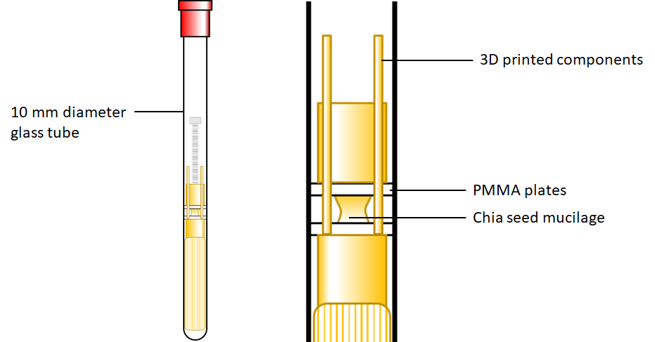
Fig. 1 Illustration of the custom setup for imaging liquid bridge drying using MRI imaging. Poly(methyl methacrylate) (PMMA) plates are suspended using 3D printed rods that pass through them, allowing some vertical movement during setup so that the mucilage can be added between the plates. The setup is designed so that the liquid bridge can be established outside the glass tube then the whole rig inserted into the tube for imaging.

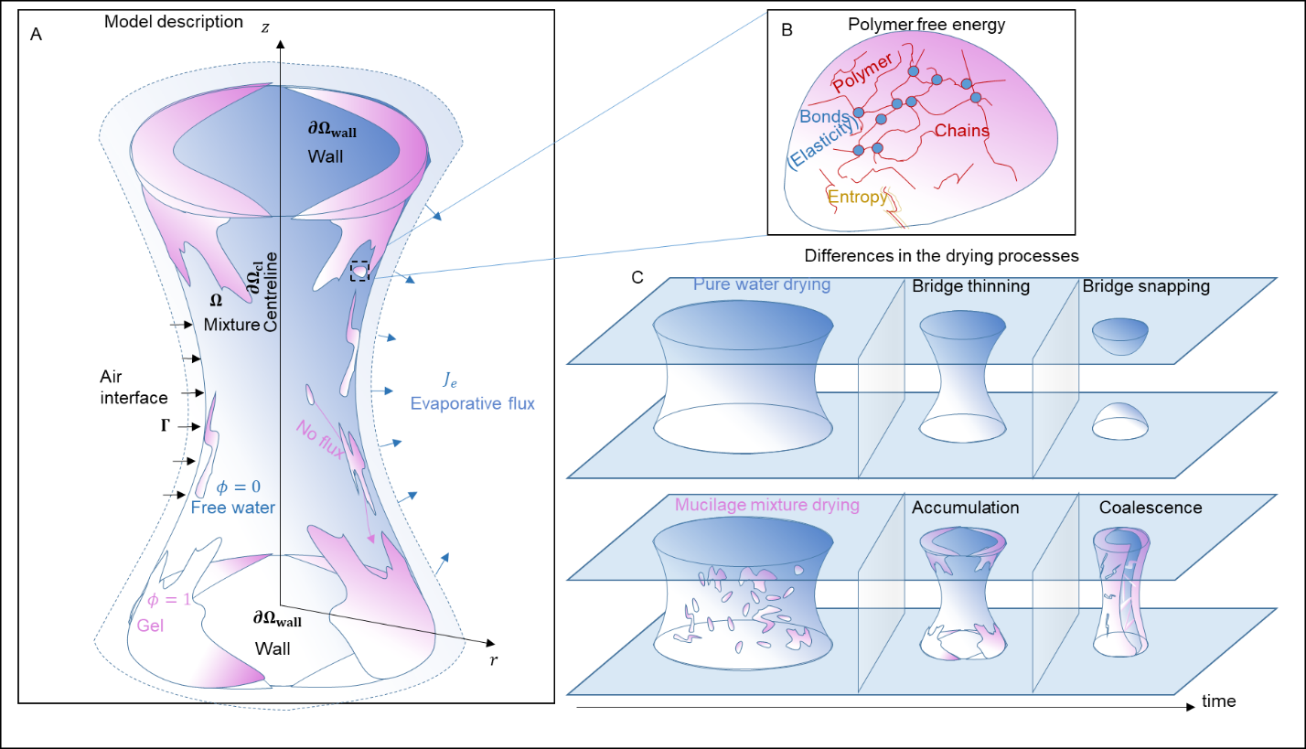
Fig. 2 Illustration of the model/process description of drying mucilage gel-water mixture and liquid bridge formation. (A) A liquid bridge forms due to capillarity between upper and lower surfaces (walls). Under drying, the mixed phase outer boundary recedes. While mobile water vapour leaves the domain, the immobilized gel is assumed to remain in the mixture. The mucilage gel phase description (B) is comprised of polymers dispersing (entropy) and linking to create chains that exhibit an elastic energy. As the mixture dries (C) it exhibits different characteristics compared with pure water evaporating. As water evaporates, the liquid bridge becomes thin and eventually snaps. The mucilage gel begins to accumulate and potentially coalesces.

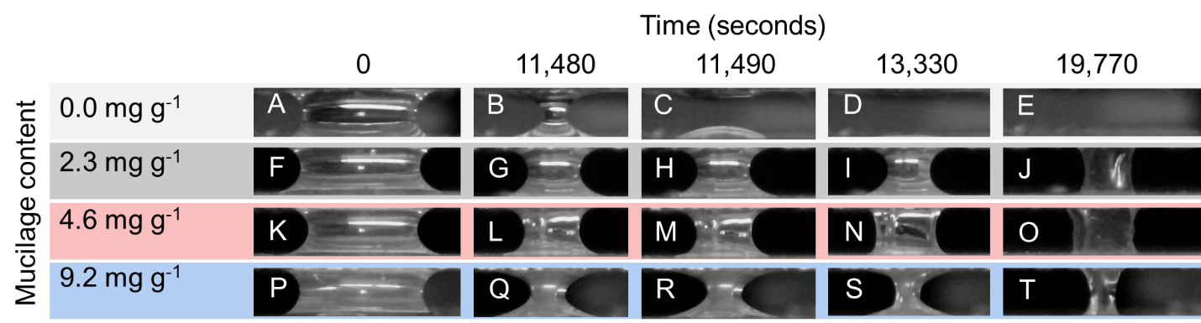
Fig. 3 Digital microscope results of the morphological evolution of mucilage-water liquid bridges drying. A-E illustrate the drying for 0.0 mg g⁻¹ (pure water), F-J for 2.3 mg g⁻¹, K-O for 4.6 mg g⁻¹, and P-T for 9.2 mg g⁻¹. B-C highlight the snapping of the liquid bridge and D-E illustrates the complete evaporations. For the subsequent mixtures F-T, connection between the two surfaces appear to remain for all of the time points.

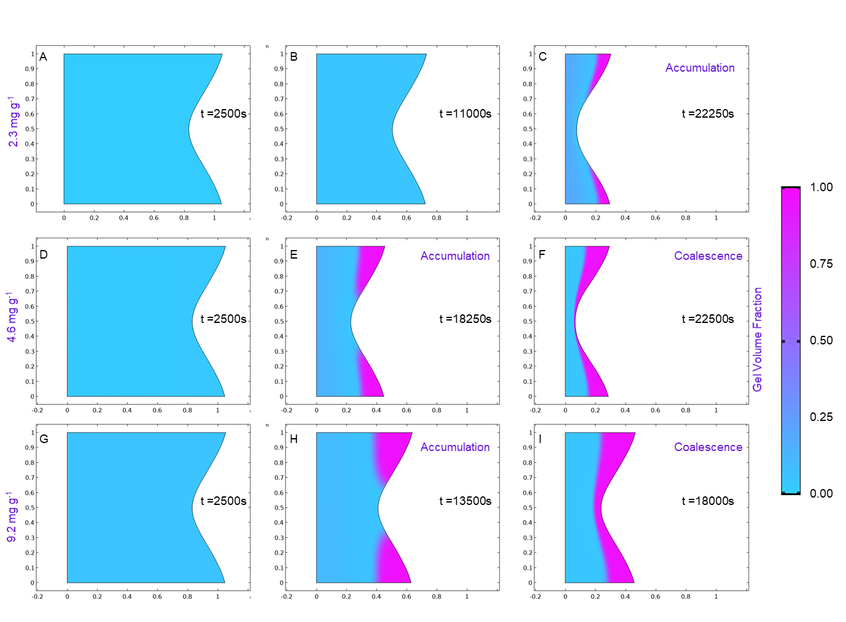
Fig. 4 Simulation results for drying mucilage mixture for initial uniform gel content of (A-C) 2.3 mg g⁻¹, (D-F) 4.6 mg g⁻¹, and (G-I) 9.2 mg g⁻¹. The 2.3 mg g⁻¹ mixture exhibits accumulation at 22,250s The 4.6 mg g⁻¹ accumulating at 18,250s (g) and coalescing at 22,500s (h). As the 9.2 mg g⁻¹ mixture dries, gel begins to accumulate after 13,500s (K) and coalesce 18,000s (L).
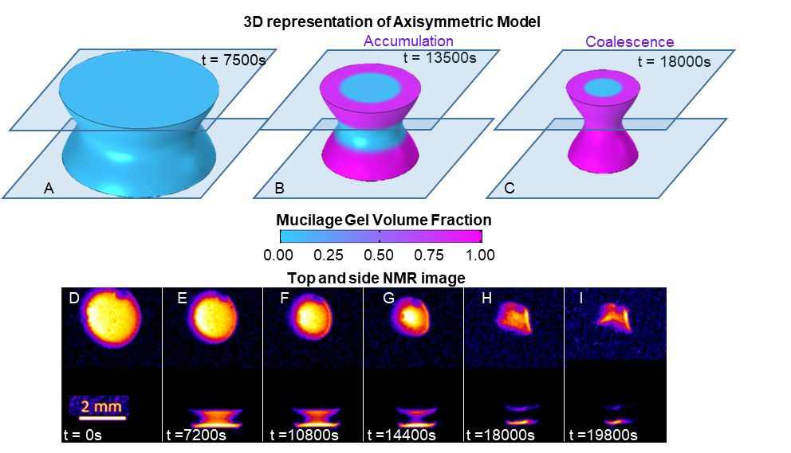
Fig. 5 Comparison of 3D morphological features from the modelled liquid bridge and the MRI measured liquid bridge experiments. A-C highlight the 3D representation of the 2D axisymmetric simulation, highlighting the accumulation (B) and potential coalescence (C) with a narrowing pure water subdomain in the simulated system. MRI experiments (D-I) illustrate top and side view of a liquid bridge drying, with the bright yellow spot highlighting the region with high water content. As the bridge dries, the top view illustrates a narrowing of the region with highest water content in the centre (D-G) up to the moment when the liquid bridge begins to buckle (H-I).
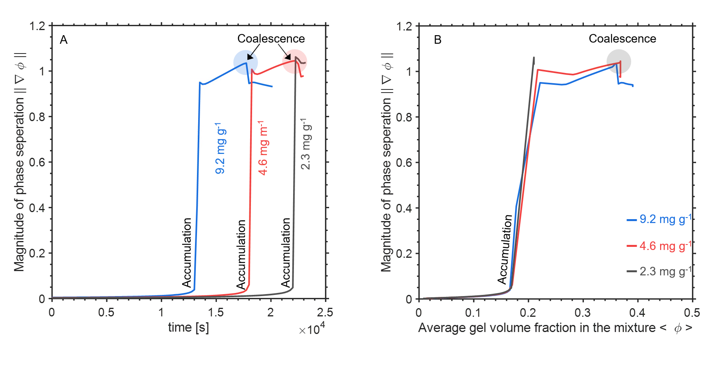
Fig. 6 Quantification of accumulation and coalescence dynamics in the simulated drying liquid bridge mucilage mixtures. A illustrates that accumulation results in a sharp increase in the phase gradient for all simulated initial volume fractions (9.2, 4.6, and 2.3 mg g⁻¹) corresponding to the simulated time that segregation occurs. For the 9.2 and 4.6 mg g⁻¹ simulations, coalescence occurs at times corresponding to the drop in the norm of the gradients. B highlights that all of the various curves buckle onto one another when looking at the norm of the gradient as a function of the domain mean mucilage volume fraction, indicating that there are critical gel volume fractions that trigger accumulation and coalescence.

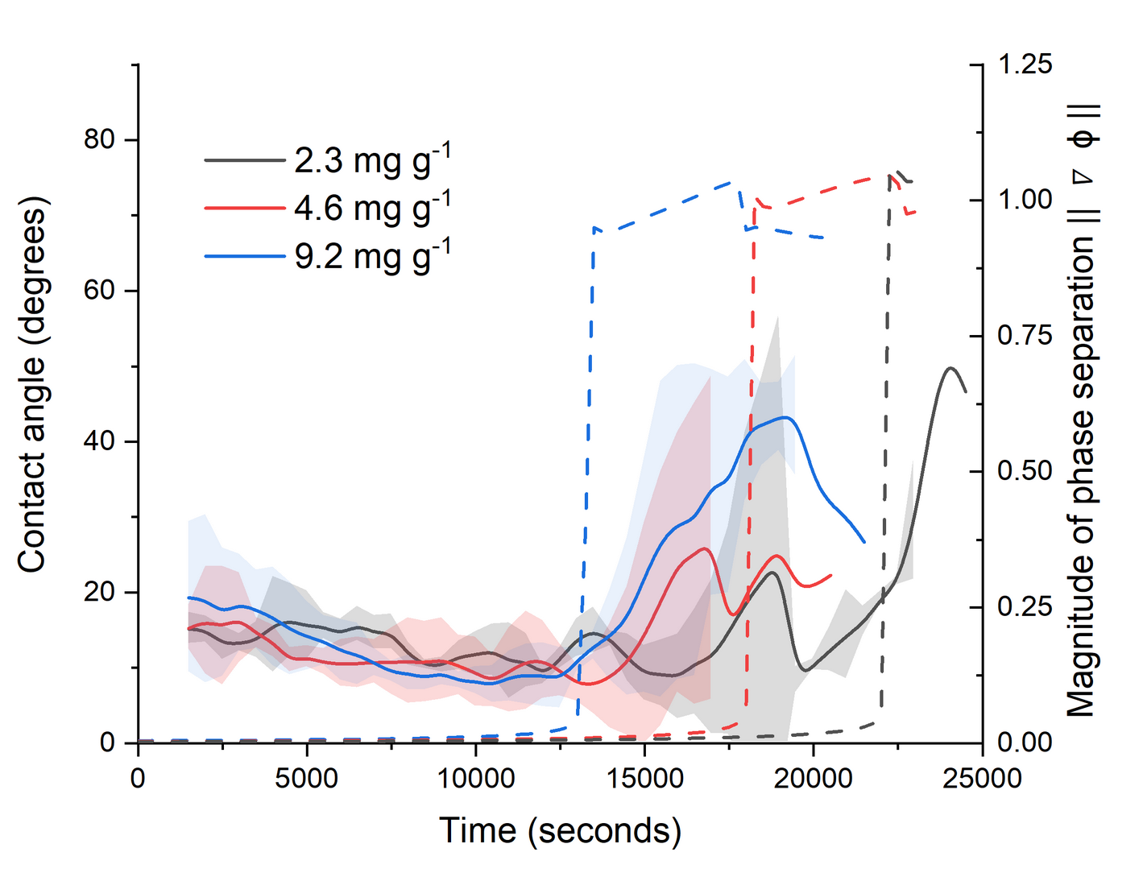
Fig. 7 Evolution of the measured mean contact angle over time. The left axis corresponds to the solid curves and details the contact angle of measured liquid bridges. The right axis corresponds to the dashed lines and detail the formation of an interface between gel and water within the mixture. Contact angles appear to reduce over time up to a certain point and then begin to rapidly rise. This rapid rise in contact angle is likely results from the liquid bridge collapsing. The buckle occurs earliest for the 9.2 mg g⁻¹ mixture, slightly later for the 4.6 mg g⁻¹ mixture and much later for the 2.3 mg g⁻¹ mixture. Shaded regions represent standard deviations (n=3). Simulated magnitudes of phase separation is plotted behind the data to demonstrate consistency with trends.

Table 1: List of model parameters for dimensional inputs. Inputs come from experimental information or from literature.
Symbol | Description | Magnitude | Unit | References
$$l$$ | Experimental length scale | 2 $×$ 10⁻³ | m | From experiment
$$\tilde{λ}$$ | Gel-water correlation energy parameter | 3.28$×$10⁻⁵ | N | (Wolgemuth et al., 2004)
$$k_{B}$$ | Boltzmann constant | 1.38 $×$ 10⁻²³ | J$⋅$K | (Daussy et al., 2007)
$$T$$ | Temperature | 293 | K | From experiment
$$ν$$ | Monomer molecular volume | 1 $×$ 10⁻²⁴ | m³ | (Roose and Fowler, 2008)
$$η_{f}$$ | Dynamic viscosity of water | 0.89$×$10⁻³ | Pa$⋅$s | (Wolgemuth et al., 2004)
$$η_{g}$$ | Dynamic viscosity of mucilage gel | 1.06 | Pa$⋅$s | (Cooper et al., 2018)
$$\tilde{γ}$$ | Scaled mixture-air surface tension | 48$×$10⁻³ | N m⁻¹ | (Read and Gregory, 1997)
$$τ$$ | Experimental time scale | 25 | s | From experiment
$$N_{x}$$ | Monomers between cross links | 10 | - | (Roose and Fowler, 2008)
$$χ$$ | Interaction parameter | 0.5 | - | (Roose and Fowler, 2008)
$$J_{e}$$ | Evaporation flux rate | 8.4$×$10⁻⁸ | m³_{water}$⋅$m⁻²_{bulk}$⋅$s⁻¹ | From experiment
$\tilde{ζ}$ | Gel-water Drag coefficient | 2.5$×$10¹⁰ | Pa$⋅$s$⋅$m⁻² | (Roose and Fowler, 2008)
$$β$$ | Biodegradation rate | 0 | s⁻¹ | Assumption
$$θ_{c}$$ | Gel-water contact angle | 20 | degrees | Assumption
$$θ_{c,m}$$ | Mixed phase-air contact angle | 20 | degrees | Experiment
$$\frac{m_{g,0}}{m_{w}}$$ | Initial polymer mass fraction | 9.2,4.6,2.3 | mg_{polymer} g⁻¹_{water} | From experiment
$$ϕ_{0}$$ | Respective gel volume fractions | 0.04, 0.02, 0.01 | m³_{gel} m⁻³_{bulk} | (Levick, 1987)

Table 2: Non-dimensional parameter values.
Symbol | Description | Magnitude | Unit
$$l$$ | Experimental length scale | 2 $×$ 10⁻³ | m
$$τ$$ | Experimental time scale | 25 | s
$$U$$ | Characteristic velocity | 6.7$×$10⁻⁵ | m$⋅$s⁻¹
$$P$$ | Characteristic potential | 4$×$10³ | Pa
$$Pe$$ | Peclet number | 0.99 | -
$$Ca$$ | Capillary number | 1.0$×$10⁻⁸ | -
$$J_{e}$$ | Dimensionless evaporative flux | 1.0 $×$ 10⁻³ | -
$$λ$$ | Dimensionless gel-water correlation energy parameter | 2$×$10⁻⁴ | -

