ABSTRACT

Background: Childhood head circumference correlates with brain volume. Little is known about the most critical periods for head growth in relation to cognitive ability.

Objective: To determine the relationship of newborn head size and head growth during infancy, childhood and adolescence with attained education, a proxy for cognitive ability.

Study design: Adult follow-up of a birth cohort

Participants: The New Delhi Birth Cohort study followed up 8,030 newborns in 1969-1973 with head circumference, weight and height measurements at birth and 6-12 monthly until adulthood. Of these,1,526 men and women were followed up at age 26-32 years.

Outcomes: Years of schooling, as an indicator of cognitive ability, in relation to newborn head circumference and conditional measures of head growth during infancy, childhood and adolescence. Associations were adjusted for socio-economic status at birth, gestational age and growth in height and body mass index (BMI).

Results: In unadjusted analyses, newborn head size was positively associated with years of education (β=0.30 years (95% CI: 0.14 to 0.47) per SD head circumference), as was head growth from birth-6m (β=0.44years (0.28 to 0.60) per SD conditional head growth), 6m-2y (β=0.31 (0.15 to 0.47)) and 2-11y (β=0.20 (0.03 to 0.36)). There were similar findings for height and BMI. In a model containing all growth measures, gestational age, and SES at birth as predictors, only SES was positively associated with educational attainment.
Conclusion: Educational attainment in this population is positively related to several inter-related early life (fetal, infant and childhood) factors, including SES, nutritional status and brain growth.
Keywords: Birth cohort study, Head circumference, Growth, Educational attainment, Cognitive development
INTRODUCTION
Head circumference during fetal life and childhood correlates with brain size. Post mortem studies have shown that fetal and newborn head circumference correlate with brain weight [1]. Magnetic resonance imaging (MRI) has shown that in normal pre-pubertal children head circumference correlates with total brain volume, with correlation coefficients of 0.8-0.9 [2-4]. Growth in head circumference closely matches growth in brain volume; head circumference is approximately 65% of adult values at birth, 85% at 1 year, 90% at 2 years and 94% at 5 years [5], while the equivalent values for brain volume are 36%,72%, 83 and >95% [6,7]. In cross-sectional studies, both head circumference and brain volume in children and young adult correlate with cognitive ability assessed at the same ages [3,4,7].
Population-based studies in various settings have shown that larger fetal [8], newborn [9-14], infant (up to 2 post-natal years) [8,9,15,16] and childhood [18] head circumference is associated with higher cognitive ability assessed later in childhood or adult life. Few studies have examined associations of head growth during different age windows in early life, to identify potential critical windows of brain growth for later cognitive ability. A UK study showed that greater growth in head circumference from birth to 1 year, was associated with higher cognitive scores at age 8 years, while head growth from 1-4 and 4-8 years was not [9]. Data from eight LMICs showed that head growth from 6-12 and 12-18 months, but not newborn head circumference or growth from birth-6months or 18-24 months, was associated with higher cognitive scores at 24 months [19]. These findings suggest that infant brain growth may be more critical for cognitive ability than fetal or later childhood brain growth. It is not clear how specific the associations are to head growth, or whether overall nutrition also predicts cognitive function. Several studies have shown that infant/child weight (or BMI) and length (or height) are, like head circumference, related to later cognitive function [11,13,20], but did not mutually adjust for these. However, in large European studies [10.18], newborn and 5-year head circumference respectively were positively associated with later cognitive scores, independent of concurrent weight and height.
We have used the conditional analysis method to investigate associations of head size at birth and head growth during specific periods in infancy and childhood with educational attainment, as a proxy for cognitive ability, in the New Delhi Birth Cohort [21].

METHODS

During 1969-73, 20,755 married women living in South Delhi were recruited, of whom 9,169 became pregnant, resulting in 8,030 singleton live newborns, forming the New Delhi Birth Cohort [21]. Nurses followed the women up every two months after recruitment, and recorded serial last menstrual period dates in order to detect pregnancy and calculate the gestational age of newborns. Trained personnel recorded the occipito-frontal head circumference, weight and length of the babies within 72 hours of birth, and at ages 3, 6, 9 and 12 months and 6-12 monthly thereafter until age 21 years. Head circumference was measured using steel measuring tapes to the nearest 0.1 cm. Height and weight were measured using standardised procedures. Follow-up was interrupted between 1980 and 1983 due to a lack of funding, and removal of unauthorised housing, which led to a large drop in cohort numbers [21].Socioeconomic indicators(both parents’ education, household size, type of housing, household income, toilet facilities, drinking water source and use of health facilities) were collected in pregnancy or <3 months post-natally.

Between 1999-2002, 2,584 men and women, then aged 26-32 years, were retraced and 1,526 participated in a study of cardio-metabolic risk markers in relation to early life growth [21].Participants’ educational attainment was recorded, in seven categories from no schooling to a professional qualification. Paternal occupation at the time of the cohort member’s birth was recorded at this follow-up. Head circumference, height and weight were re-measured.

Approval was obtained from the ethics committees of Maulana Azad Medical College, Sunderlal Jain Hospital and the All India Institute of Medical Sciences, New Delhi. Informed written consent was obtained from all participants.

Statistical analysis

We converted head circumference measurements (Supplementary Table 1) to SD scores using Royston’s method [22] based on a cubic spline fit to the head measurements and assuming the head measurements are symmetrical at the defined ages, and used linear interpolation to estimate head circumference SD scores at the exact ages of 6 months, 2 years and 11 years, provided that genuine measurements were made within 6 months, 1 year and 2 years respectively. Ninety-eight percent of 6-month measurements were made within 2 weeks of that age; 80% of 2-year measurements were made within one month, and 76% of 11-year measurements were made within 6 months. We back-transformed the SD scores to provide estimates of head circumference at these ages in cm. We followed similar procedures for height and BMI. The ages chosen define clinically important stages of human growth: newborn size as a summary of fetal growth; six months as the end of predominant breast-feeding; two years as the end of infancy, completion of weaning and growth hormone becoming the main endocrine regulator of growth; eleven years as the approximate end of pre-pubertal growth; and young adulthood reflecting the completion of adolescent growth.

We calculated sex-specific conditional growth variables for head circumference, height and BMI. These are the standardised residuals resulting from regression of the SD score for the body measurement at a particular age on the SD scores for the same measurement at preceding ages [9,23]. For example, conditional head growth from 6 months to 2yearsis the standardised residual from the regression of head SD score at 2 years on the SD scores for head size at birth and 6 months. These growth measures, which were calculated for birth-6m (early infancy), 6m-2y (late infancy), 2y-11y (childhood) and 11y-adult (adolescence) are, by construction, uncorrelated, and represent growth during specific age periods, independent of earlier growth. Further details about conditional growth variables are provided in Supplementary Methods.

The outcome, educational attainment, was converted from the original seven categories into years of education, from none (0 years) to a professional qualification (17 years).

Socio-economic status (SES) is a potential confounder of the association between childhood growth and educational attainment. We created a combined measure of SES at birth by standardising the individual variables and deriving the first principal component [24].

Using all recorded measurements, we used multiple imputation [25] to generate values for missing entries of head circumference, height and BMI at birth, 6 months, 2 years, 11 years and adulthood, SES components and gestational age at birth.

We used regression to examine associations between growth and educational attainment. We first considered head circumference, height and BMI separately (Model 1), and then in combination (Model 2). We adjusted for gestational age and the combined SES variable (Model 3). Finally, we replaced the combined SES variable with its individual components (Model 4). We compared the results between men and women; 7 out of 73 interaction terms (sex x growth)were statistically significant at the 5% level, which is compatible with chance. We therefore report pooled analyses, adjusted for sex. We present the multiple imputation-based results for the full study sample (all who had educational attainment ascertained in young adulthood, N=1,526), and show the (similar) results from the complete case analysis (participants with complete growth, SES and gestational age data, N=558) in supplementary material.

To check the representativeness of our sample, we used independent sample t-tests to compare newborn and infant measurements between those studied as adults and included in this analysis and the remainder of the original cohort, and (among those studied as adults) between those with complete growth, SES, and education data (complete case sample) and the remainder.

Analyses were conducted using SPSS version 20 and STATA version 14.

RESULTS

Table I shows the cohort’s childhood head circumference, height, weight and educational attainment; Table II shows their socio-economic status (SES) data. Eighty-four percent of the men and 92 percent of the women were educated to secondary school level or above; 52% of men and 64% of women were graduates. Compared with the remainder of the original cohort, participants studied as adults were longer at birth, and shorter and lighter at age 11 years, but these differences were small [birth length: 0.15 cm (95% CI 0.02 to 0.28); 11-year height 0.77 cm (95% CI 0.29 to 1.24); 11-year BMI 0.21 kg/m² (95% CI 0.07 to 0.34)] (Supplementary Table II). Compared with the remainder of those studied as adults, the complete case sample had a lower BMI at age 11 years (0.22 kg/m² (95% CI 0.03 to 0.40) but there were no significant differences for the other measurements.

In the unadjusted model, head size at birth and head growth 0-6m, 6m-2y and 2-11y were positively associated with years of attained education (Model 1 in Figure 1 (a),Table III and Supplementary Table III). The strongest association was with head growth from birth-6m; one SD increase in head growth between birth and 6 months was associated with a 0.44 year increase in education. There were similar findings for height and BMI. There was a significant interaction of birth head circumference with head growth birth-6 months in relation to educational attainment (p=0.02). The positive association of 0-6m conditional head growth with attained education was significant in all four quartiles of birth head circumference, but stronger in the smallest quartile at birth (β=0.875 years of education per SD 0-6m head growth, p<0.001) compared with the 2nd, 3rd and 4th quartiles (β=0.467, p=0.002; β=0.464, p=0.02; β=0.328, p=0.04).

The positive associations of head size were no longer significant after adjusting for height and BMI (Model 2). In this joint model, height growth 0-6m and 6m-2y, and BMI gain 6m-2y remained positively associated with attained education. Gestational age was unrelated to educational attainment, while higher SES (the first principle component and individual components) was strongly positively associated with both educational attainment and childhood growth (Model 3, Supplementary Tables IV and V). After adjusting for gestational age and SES (models 3 and 4) there were no associations with childhood head, height or BMI growth. Model 4 had a better overall fit than Model 3. The body size/growth measurements explained approximately 8% of the variability in attained education and SES a further 16%. Similar results were obtained in the complete case sample (Supplementary Table 3) except for a positive association of BMI gain from 6m-2y with educational attainment.

DISCUSSION

Newborn head size and head growth up to 11 years were positively associated with years of education, which we used as a proxy for cognitive ability. The strongest associations were with early head growth (birth to 2 years). Height growth up to 2 years, and BMI at birth and BMI gain 6m-2y were also positively associated with educational attainment. The associations of head size and growth with attained education were not significant after adjusting for height and BMI during the same age intervals. None of the associations of body size with educational attainment were significant after further adjustment for SES at birth, which was strongly positively related to attained education.

The main strengths of the study were the frequent longitudinal body measurements from birth to adulthood, and detailed early life SES indicators. A limitation was that educational attainment, though frequently used in epidemiological studies, is a fairly crude measure of cognitive ability. In high income countries, cognitive function and years of education are strongly correlated (r~0.5) [26], but may be less so in India, where access to education is influenced by family wealth and other socio-cultural factors. Nevertheless, it constitutes practical metric for improving human capital in LMICs; for example, educational attainment constitutes a core qualification for employment. Further, we adjusted for several socio-economic factors. Another limitation was cohort attrition. The study sample was 19% of the original cohort births. Major losses to follow-up were mortality and clearance of unauthorised housing in early phases, and later out-migration, losses that did not occur randomly. However, early life head size was similar between the analysis sample and the original cohort.

The positive association between newborn head circumference and attained education is consistent with previous literature. Studies in different populations have shown positive associations between head circumference at birth and later cognitive ability, assessed using psychometric testing or achieved education [9-18] although others found no association [16-18]. In our study, a one SD higher head circumference at birth was associated with approximately 0.3 years more education, a modest effect. Among the positive studies, most reported similarly modest effects: +0.6-2 IQ points [9,12] and 0.06-0.2 SD increase in cognitive scores [13,14] per SD increase in newborn head circumference. In Delhi, the association was non-significant after adjusting for newborn length and BMI, suggesting that overall pre-natal growth, rather than specifically brain growth, was related to later educational attainment. Many previous studies reported that, as well as newborn head circumference, birth weight and length were positively related to later cognitive performance [10-14]. Only one, a large Swedish study, adjusted the head circumference association for weight and length, and head circumference remained a significant predictor [10].

In unadjusted analyses, head growth at all post-natal ages up to 11 years was positively associated with attained education. The strongest association was with head growth between birth and 6 months (a 0.44 year increase in education per SD greater conditional growth). These findings are consistent with previous studies and suggest that early infancy brain growth is most strongly associated with later cognitive function, while head growth up to the end of the pre-pubertal period continues to have a positive association [9,11,16,18,19]. Infant brain development is characterised by rapid increases in connectivity between neurones and brain regions through dendritic sprouting, synapse formation and myelination, processes that continue at a slower rate throughout the growth period [6]. The association of early infancy head growth with educational attainment was stronger among participants in the lowest quartile of birth head circumference, possibly reflecting severe intra-uterine constraint followed by relatively favourable conditions in infancy. We did not find any studies with longitudinal measures of head growth through adolescence, highlighting the rarity of the New Delhi cohort growth data. In our study, head growth after 11 years was not significantly related to attained education. MRI studies have shown that brain volume peaks in late childhood, before the onset of puberty, after which skull growth and brain re-modelling continue until young adulthood, but the correlation between head circumference and brain size becomes weaker [2,7].

Infant and childhood head growth was not related to attained education after adjustment for concurrent height and BMI gain which, independently of head growth, predicted higher attained education. We found only one other study in which post-natal head growth associations were adjusted for weight and height; the 1970 UK birth cohort study found that head growth, independent of weight and height, was associated with cognitive scores at 10 years [18]. We conclude that overall nutritional status in infancy, as reflected in somatic growth, is important for cognitive development. Good overall nutrition, freedom from illness and healthy physical development, enabling exploration and play, are important contributors to neuro-development [27]. Many studies have reported that infant weight and length gain are positively related to later cognitive scores [11,19,20]. A meta-analysis of data from five LMIC cohorts showed that height gain from birth to 2 years is positively associated with attained schooling (0.5 years of additional schooling per SD increase in height gain, adjusted for SES), a stronger association than was found for later height gain, or for weight gain during either period [28].

SES at birth was a powerful independent predictor of attained education in the Delhi study. This is likely to work through multiple mechanisms, including nutrition; exposure to childhood illness/other adversities; availability of playthings and learning materials; quality of parental stimulation; and quality of education [29,30]. SES is thus likely to be both a confounder of the association between head size/growth and education, and an ‘upstream’ factor determining head growth and brain development.

In conclusion, inter-related early life factors, including larger newborn head size, greater head growth during infancy, better overall nutritional status, and higher socio-economic status predicted greater educational attainment in this urban Indian population. The findings support measures to reduce socio-economic inequalities, promote maternal health and support infant nutrition and nurturing, for optimal neuro-development.

REFERENCES

- Cooke RW, Lucas A, Yudkin PL, Pryse-Davies J. Head circumference as an index of brain weight in the fetus and newborn. Early Hum Dev1977;1:145-9.
- Bartholomeusz HH, Courchesne E, Karns CM. Relationship between head circumference and brain volume in healthy normal toddlers, children, and adults. Neuropediatrics2002;33:239-41.
- Lange N, Froimowitz MP, Bigler ED, et al and Brain Development Cooperative Group. Associations between IQ, total and regional brain volumes, and demography in a large normative sample of healthy children and adolescents. Dev Neuropsychol2010;35:296–317.
- Catena A, Martínez-Zaldívar C, Diaz-Piedra C, et al. On the relationship between head circumference, brain size, prenatal long-chain PUFA/5-methyltetrahydrofolate supplementation and cognitive abilities during childhood. Br J Nutr 2017 Mar 29 :1-9. doi: 10.1017/S0007114516004281.
- Tanner 1978 Growth and Development Record for Head Circumference; Boys and Girls Birth-16 years. Castlemead Publications, Ware, England; 1983.
- Knickmeyer RC, Gouttard S, Kang C, et al. A structural MRI study of human brain development from birth to 2 years. J Neurosci2008;28:12176-82.
- Reiss AL, Abrams MT, Singer HS, et al. Brain development, gender and IQ in children. A volumetric imaging study. Brain1996;119:1763-74.
- Norris T, Johnson W, Petherick E, et al. Investigating the relationship between fetal growth and academic attainment: secondary analysis of the Born in Bradford (BiB) cohort. Int J Epidemiol2018;doi: 10.1093/ije/dyy157.
- Gale CR, O’Callaghan FJ, Bredow M, et al. The influence of head growth in fetal life, infancy and childhood on intelligence at the ages of 4 and 8 years. Pediatrics2006;118:1486-92.
- Bergvall N, Iliadou A, Tuvemo T, et al. Birth characteristics and risk of low intellectual performance in early adulthood: are the associations confounded by socioeconomic factors in adolescence or familial effects? Pediatrics2006;117:714-21.
- Heinonen K, Räikkönen K, Pesonen AK, et al. Prenatal and postnatal growth and cognitive abilities at 56 months of age: a longitudinal study of infants born at term. Pediatrics 2008;121:e1325-33.
- Broekman BF, Chan YH, Chong YS, et al. The influence of birth size on intelligence in healthy children. Pediatrics 2009;123:e1011-6;doi: 10.1542/peds.2008-3344.
- Raikonnen K, Forsen T, Henriksson M, et al. Growth trajectories and intellectual abilities in young adulthood: the Helsinki Birth Cohort Study. Am J Epidemiol2009;170:447-55.
- Veena SR, Krishnaveni GV, Wills AK, et al. Association of birth weight and head circumference at birth to cognitive function in 9 to 10-year-old children in South India: prospective birth cohort study. Pediatr Res2010;67:424-9.
- Nelson KB, Deutschberger J. Head size at one year as a predictor of four-year IQ. Dev Med Child Neurol1970;12:487-95.
- Gale CR, O’Callaghan FJ, Godfrey KM, et al. Critical periods of brain growth and cognitive function in children. Brain2004;127:321-9.
- Li H, DiGirolamo AM, Barnhart HX, et al. Relative importance of birth size and postnatal growth for women’s educational achievement. Early Hum Dev2004;76:1-16.
- Silva A, Metha Z, O’Callaghan FJ. The relative effect of size at birth, postnatal growth and social factors on cognitive function in late childhood. Ann Epidemiol2006;16:469–476.
- Scharf RJ, Rogawski ET, Murray Kolb LE, et al. Early childhood growth and cognitive outcomes: Findings from the MAL-ED study. Matern Child Nutr 2018;14:e12584.
- Huang C, Martorell R, Ren A, et al. Cognition and behavioural development in early childhood: the role of birth weight and postnatal growth. Int J Epidemiol2013;42:160-71.
- Bhargava SK, Sachdev HS, Fall CH et al. Relation of serial changes in childhood body-mass index to impaired glucose tolerance in young adulthood. N Eng J Med2004;350:865-75.
- Royston P. Constructing time-specific reference ranges. Stat Med1991;10:675-90.
- Osmond C, Fall CHD. Conditional growth Models: An exposition and some extensions. In handbook of Statistics: Disease Modelling and Public Health, Part B (pp 275-99). Eds: Arni SR, Rao S, Pyne S, Rao CR. Oxford, UK: Elsevier, 2017.
- Vyas S, Kumaranayake L. Constructing socioeconomic status indices: how to use principal component analyses. Health Policy Plan 2006; 21:459-68.
- Little RJA, Rubin DB. Statistical analysis with missing data; 2nd ed. New Jersey: John Wiley and Sons; 2002.
- Deary I, Johnson W. Intelligence and education: causal perceptions drive analytic processes and therefore conclusions. Int J Epidemiol2010;39:1362-9.
- Sudfeld CR, McCoy DC, Danaei G, et al. Linear growth and child development in low- and middle-income countries: a meta-analysis. Pediatrics 2015;135:e1266-75.
- Adair LS, Fall CH, Osmond C, et al. Associations of linear growth and relative weight gain during early life with adult health and human capital in countries of low and middle income: findings from five birth cohort studies. Lancet2013;382:525-34.
- Ceci SJ, Williams WM. Schooling, intelligence, and income. Am Psychol 1997; 52:1051–8.
- Bradley RH, Caldwell BM, Rock SL. Home environment and school performance: a ten-year follow-up and examination of three models of environmental action. Child Dev1988;59:852-67.

Acknowledgements: We thank the members of the New Delhi Birth Cohort who took part in the study, and the data collection teams.

Competing Interests: None of the authors has competing interests.

Funding: Adult follow-up was funded by the British Heart Foundation (grant RG 98001). The original cohort study was supported by the National Center for Health Statistics (USA) and the Indian Council of Medical Research. Shivam Pandey was supported by a PhD fellowship from the DBT-Wellcome Trust-India Alliance.
What is already known on this subject?
Previous studies have shown positive associations between newborn, infant and child head circumference and later cognition, but the most critical periods of head growth are unknown.

What this study adds
Newborn head circumference and head growth in infancy are positively associated with educational attainment, though associations were no longer significant after adjusting for socio-economic status, itself a strong predictor of educational attainment in this population.

Figure legend

Figure 1: Change in years of attained education per SD change in head circumference, height and body mass index at birth, and conditional growth in head circumference, height and BMI during infancy, childhood and adolescence

(a)

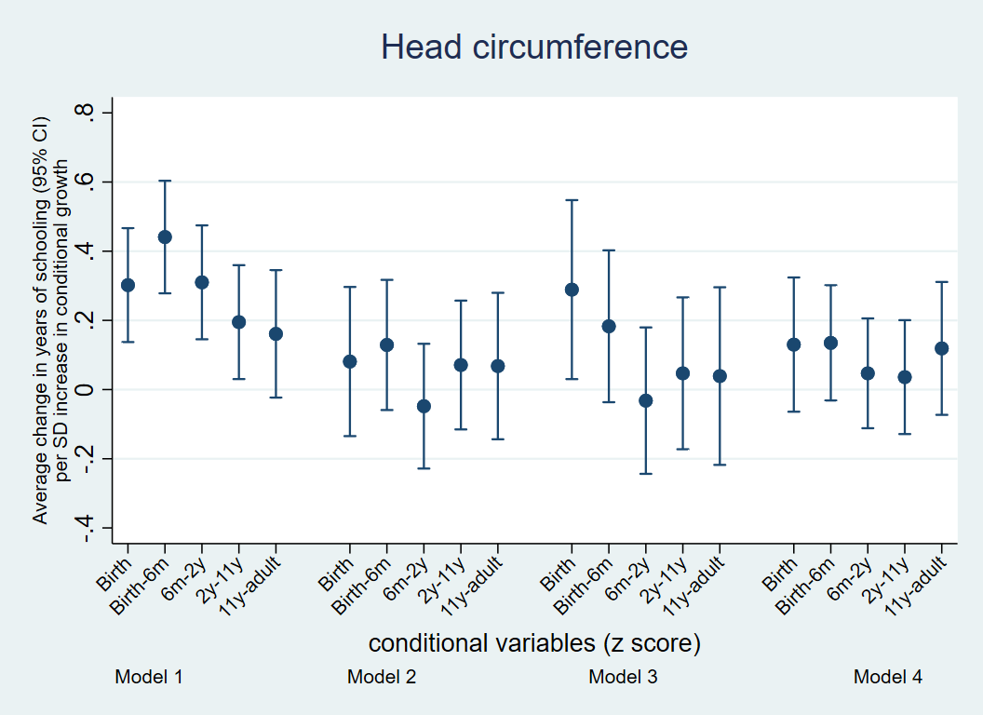(b) 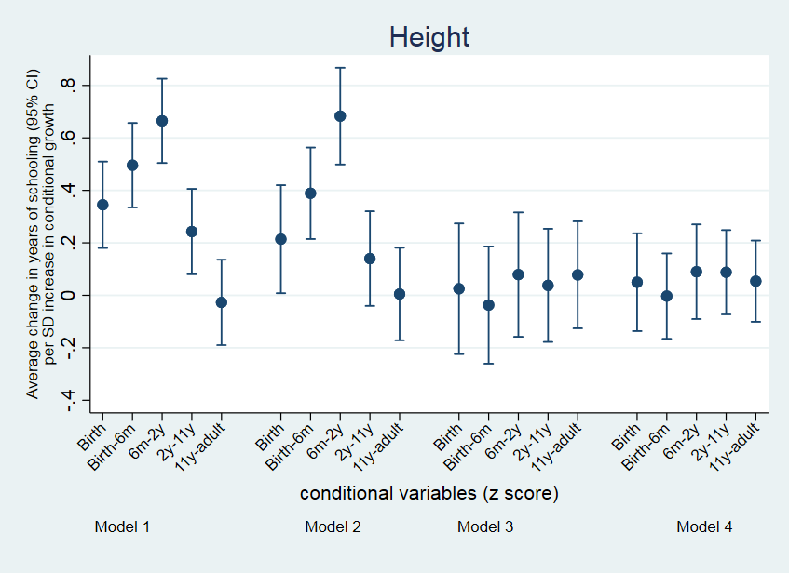

(c)
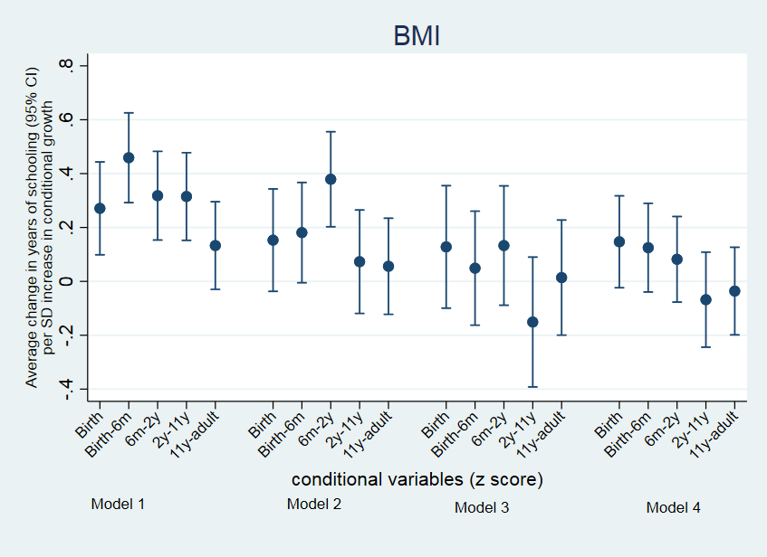
Footnote: Model 1: Head circumference (a), height (b) or BMI (c) separately; Model 2: Head circumference, height and BMI included together in the model; Model 3: Additionally adjusted for gestational age and the combined SES variable; Model 4: Replacing the combined SES variable with its individual components. Associations are statistically significant where the confidence intervals exclude 0.

Table I. Anthropometry of the cohort members studied, at birth, in childhood and at adult follow-up, and their educational attainment

 | FULL SAMPLE  N=1,526 |  |  |  |  |  |  |  | COMPLETE CASE SAMPLE  N=558
 | Males  (Max N=886) |  |  |  | Females  (Max N=640) |  |  |  | Males  (Max N=322) |  |  |  | Females  (Max N=236)
Characteristic | N | Mean | (SD) |  | N | Mean | (SD) |  | N | Mean | (SD) |  | N | Mean | (SD)
At birth
Gestational age (weeks) | 791 | 38.7 | (2.6) |  | 588 | 39.1 | (2.5) |  | 322 | 38.7 | (2.4) |  | 236 | 39.2 | (2.3)
Head circumference(cm) | 851 | 33.7 | (1.3) |  | 612 | 33.2 | (1.1) |  | 322 | 33.7 | (1.3) |  | 236 | 33.2 | (1.0)
Height (cm) | 820 | 48.6 | (2.1) |  | 590 | 48.1 | (1.9) |  | 322 | 48.6 | (2.1) |  | 236 | 48.3 | (1.9)
Weight (kg) | 834 | 2.9 | (0.4) |  | 592 | 2.8 | (0.4) |  | 322 | 2.8 | (0.4) |  | 236 | 2.7 | (0.4)
Body mass Index (kg/m²) | 820 | 12.0 | (1.2) |  | 590 | 11.9 | (1.2) |  | 322 | 12.1 | (1.3) |  | 236 | 11.8 | (1.2)
At 6 months
Head circumference (cm) | 869 | 42.1 | (1.2) |  | 629 | 40.9 | (1.2) |  | 322 | 42.1 | (1.2) |  | 236 | 41.0 | (1.0)
Height (cm) | 836 | 65.3 | (2.4) |  | 613 | 63.7 | (2.4) |  | 322 | 65.3 | (2.4) |  | 236 | 63.6 | (2.1)
Weight (kg) | 836 | 7.0 | (0.9) |  | 613 | 6.4 | (0.9) |  | 322 | 7.1 | (0.8) |  | 236 | 6.3 | (0.8)
Body mass index (kg/m²) | 836 | 16.4 | (1.6) |  | 613 | 15.7 | (1.6) |  | 322 | 16.5 | (1.6) |  | 236 | 15.7 | (1.5)
At 2 years
Head circumference (cm) | 838 | 46.9 | (1.3) |  | 606 | 45.7 | (1.2) |  | 322 | 46.8 | (1.3) |  | 236 | 45.7 | (1.2)
Height (cm) | 840 | 81.1 | (3.6) |  | 609 | 79.6 | (3.6) |  | 322 | 80.9 | (3.4) |  | 236 | 79.4 | (3.4)
Weight (kg) | 834 | 10.3 | (1.3) |  | 609 | 9.8 | (1.2) |  | 322 | 10.3 | (1.2) |  | 236 | 9.7 | (1.2)
Body mass index (kg/m²) | 833 | 15.8 | (1.2) |  | 604 | 15.4 | (1.2) |  | 322 | 15.8 | (1.2) |  | 236 | 15.3 | (1.2)
At 11 years
Head circumference (cm) | 832 | 52.1 | (1.4) |  | 603 | 52.2 | (1.5) |  | 322 | 52.1 | (1.4) |  | 236 | 52.1 | (1.5)
Height (cm) | 831 | 135.9 | (5.7) |  | 607 | 134.2 | (7.4) |  | 322 | 135.4 | (5.6) |  | 236 | 134.0 | (6.9)
Weight (kg) | 834 | 28.4 | (4.7) |  | 608 | 27.6 | (5.4) |  | 322 | 27.9 | (4.1) |  | 236 | 27.3 | (5.2)
Body mass index (kg/m²) | 830 | 15.3 | (1.7) |  | 606 | 15.2 | (1.8) |  | 322 | 15.2 | (1.5) |  | 236 | 15.1 | (1.7)
Adult
Head circumference (cm) | 884 | 56.6 | (1.8) |  | 640 | 53.8 | (1.7) |  | 322 | 56.6 | (1.7) |  | 236 | 53.8 | (1.7)
Height (cm) | 886 | 169.7 | (6.4) |  | 638 | 154.9 | (5.7) |  | 322 | 169.7 | (6.2) |  | 236 | 154.5 | (4.9)
Weight (kg) | 886 | 71.8 | (14.0) |  | 640 | 59.2 | (13.4) |  | 322 | 71.5 | (14.0) |  | 236 | 58.2 | (12.9)
Body mass index (kg/m²) | 886 | 24.9 | (4.3) |  | 638 | 24.6 | (5.1) |  | 322 | 24.7 | (4.2) |  | 236 | 24.3 | (5.1)
Years of education (n %) | 886 |  |  |  | 640 |  |  |  | 322
No education (0 years) |  | 10 | (1.1) |  |  | 10 | (1.6) |  |  | 1  ((0(0.3%) | (0.3) |  | 236 | 1 | (0.4)
Primary school (3 years) |  | 29 | (3.3) |  |  | 14 | (2.2) |  |  | 14 | (4.3) |  |  | 5 | (2.1)
Middle school (8 years) |  | 99 | (11.2) |  |  | 25 | (3.9) |  |  | 32 | (9.9) |  |  | 8 | (3.4)
Secondary school (12 years) |  | 150 | (16.9) |  |  | 82 | (12.8) |  |  | 46 | (14.3) |  |  | 36 | (15.3)
Secondary school + (13.5 years) |  | 138 | (15.5) |  |  | 99 | (15.5) |  |  | 59 | (18.3) |  |  | 34 | (14.4)
Graduate (15 years) |  | 354 | (40.0) |  |  | 312 | (48.8) |  |  | 135 | (41.9) |  |  | 121 | (51.3)
Professional (17 years) |  | 106 | (12.0) |  |  | 98 | (15.3) |  |  | 35 | (11.0) |  |  | 31 | (13.1)

Table II: Socioeconomic characteristics of cohort members at birth

Variables | Full sample  (N=1,526) | Complete case sample  (N=558) | Correlation with first principal component
 | n measured (%) | n measured (%)
Maternal years of education | 1366 (89.5) |  | 0.78
Illiterate (0 years) | 386 (28.3) | 178 (31.9)
Completed primary school (3 years) | 264 (19.3) | 105 (18.8)
Completed middle school (7 years) | 236 (17.3) | 114 (20.4)
Matriculation (10 years) | 293 (21.4) | 120 (21.5)
College (12 years) | 187 (13.7) | 41 (7.3)
Type of Housing | 1055 (69.1) |  | 0.47
Thatched hut (rented) | 5 (0.5) | 0 (0)
Thatched hut (owned) | 4 (0.4) | 1 (0.2)
Masonry build (rented) | 135 (12.8) | 58 (10.4)
Masonry build (owned) | 539 (51.1) | 283 (50.7)
Flat (rented) | 175 (16.6) | 105 (18.8)
Flat (owned) | 165 (15.6) | 94 (16.8)
Bungalow (rented) | 8 (0.8) | 5 (0.9)
Bungalow (owned) | 24 (2.2) | 12 (2.2)
Household Income (in rupees) | 1056 (69.2) |  | 0.79
Median (LQ, UQ) | 690 (459, 1200) | 696 (456,1200)
Father’s occupation | 1504 (98.6) |  | 0.28  0.59  0.63
Unemployed | 3 (0.2)
Unskilled manual labour | 28 (1.9) | 11 (2.0)
Semi-skilled manual labour | 161 (10.7) | 62 (11.1)
Skilled manual labour | 328 (21.8) | 124 (22.2)
Clerical | 741 (49.3) | 286 (51.3)
Professional or running a large business | 243 (16.2) | 75 (13.4)
Health service usage¥ | 1057 (69.3)
No/low health services use | 336 (31.8) | 163 (29.2)
Intermediate use | 366 (34.6) | 201 (36.0)
Highest use | 355 (33.6) | 194 (34.8)
Sanitation | 1057 (69.3)
No household toilet | 179 (16.9) | 66 (11.8)
Non-flush toilet | 495 (46.9) | 275 (49.3)
Flush toilet | 383 (36.2) | 217 (38.9)
Water supply | 1057 (69.3) |  | 0.60
No piped water | 124 (11.7) | 54 (9.7)
Shared piped water | 540 (51.1) | 277 (49.6)
Sole use piped water | 393 (37.2) | 227 (40.7)
Crowding index(people/rooms) | 1055 (69.1) |  | -0.72
Median (LQ, UQ) | 4 (3,6) | 4 (3,5.5)
Child dependency ratio(children/adults) | 1057 (69.3) |  | -0.56
Median (LQ, UQ) | 1.0 (0.7, 2.0) | 1.0 (0.6, 1.6)
Paternal years of schooling | 1430 (93.7) |  | 0.31
Illiterate (0 years) | 123 (8.6) | 2 (0.4)
Completed primary school (3 years) | 132 (9.2) | 19 (3.4)
Completed middle school (8 years) | 211 (14.8) | 40 (7.2)
High school certificate (12 years) | 404 (28.3) | 82 (14.7)
High school+ (13.5 years) | 155 (10.8) | 93 (16.7)
Graduate (15 years) | 280 (19.6) | 256 (45.9)
Professional degree (17 years) | 125 (8.7) | 66 (11.7)

¥ Combination score of any health-promotion or preventative health service utilization during the antenatal and postnatal period (e.g. antenatal care, child immunization)

Table III: Associations of head circumference, height and BMI at birth and growth during childhood with years of education (Data used to generate Figure 1)
Predictor  (Standardised score) | Model 1:Unadjusted |  | Model 2:Mutually adjusted for other body measurements |  | Model 3:Further adjusted for SES, gestation |  | Model 4:Further adjusted for SES components and gestation
 | β (95% CI) | p-value | β (95% CI) | p-value | β (95% CI) | p-value | β (95% CI) | p-value
Head circumference
Birth | 0.30 (0.14 to 0.46) | <0.001 | 0.10 (-0.12 to 0.32) | 0.3 | 0.32 (0.06 to 0.58) | 0.01 | 0.15 (-0.05 to 0.34) | 0.1
Birth-6m | 0.44 (0.28 to 0.60) | <0.001 | 0.14 (-0.05 to 0.33) | 0.1 | 0.18 (-0.04 to 0.40) | 0.1 | 0.14 (-0.03 to 0.31) | 0.1
6m-2y | 0.30 (0.14 to 0.46) | <0.001 | -0.06 (-0.24 to 0.12) | 0.5 | -0.05 (-0.26 to 0.17) | 0.6 | 0.03 (-0.13 to 0.19) | 0.6
2y-11y | 0.20 (0.04 to 0.38) | 0.01 | 0.07 (-0.12 to 0.25) | 0.4 | 0.05 (-0.17 to 0.27) | 0.6 | 0.03 (-0.14 to 0.20) | 0.7
11y-adult | 0.15 (-0.02 to 0.33) | 0.07 | 0.05 (-0.14 to 0.23) | 0.6 | 0.04 (-0.20 to 0.27) | 0.7 | 0.08 (-0.10 to 0.26) | 0.3
R-square | 0.05
Height
Birth | 0.31 (0.14 to 0.48) | <0.001 | 0.16 (-0.06 to 0.37) | 0.1 | -0.05 (-0.31 to 0.21) | 0.7 | 0.01 (-0.18 to 0.20) | 0.9
Birth-6m | 0.49 (0.33 to 0.66) | <0.001 | 0.38 (0.20 to 0.56) | <0.001 | -0.02 (-0.25 to 0.21) | 0.8 | 0.00 (-0.17 to 0.17) | 0.9
6m-2y | 0.68 (0.52 to 0.85) | <0.001 | 0.69 (0.50 to 0.88) | <0.001 | 0.10 (-0.13 to 0.34) | 0.3 | 0.11 (-0.08 to 0.28) | 0.2
2y-11y | 0.24 (0.08 to 0.40) | 0.003 | 0.13 (-0.05 to 0.31) | 0.1 | 0.04 (-0.18 to 0.25) | 0.7 | 0.09 (-0.07 to 0.24) | 0.2
11y-adult | -0.01 (-0.17 to 0.16) | 0.9 | 0.05 (-0.13 to 0.22) | 0.6 | 0.10 (-0.10 to 0.31) | 0.3 | 0.10 (-0.06 to 0.25) | 0.2
R-square | 0.09
Body Mass Index
Birth | 0.27 (0.09 to 0.44) | 0.004 | 0.15 (-0.05 to 0.35) | 0.1 | 0.13 (-0.10 to 0.37) | 0.2 | 0.14 (-0.04 to 0.33) | 0.1
Birth-6m | 0.44 (0.27 to 0.62) | <0.001 | 0.17 (-0.03 to 0.36) | 0.08 | 0.03 (-0.19 to 0.24) | 0.8 | 0.13 (-0.04 to 0.30) | 0.1
6m-2y | 0.31 (0.14 to 0.48) | <0.001 | 0.37 (0.19 to 0.55) | <0.001 | 0.12 (-0.10 to 0.34) | 0.2 | -0.02 (-0.20 to 0.15) | 0.8
2y-11y | 0.35 (0.19 to 0.51) | <0.001 | 0.13 (-0.06 to 0.32) | 0.1 | -0.11 (-0.35 to 0.13) | 0.3 | -0.03 (-0.18 to 0.13) | 0.7
11y-adult | 0.13 (-0.04 to 0.29) | 0.1 | 0.06 (-0.11 to 0.23) | 0.5 | 0.02 (-0.19 to 0.23) | 0.8 | -0.00 (-0.17 to 0.17) | 0.9
 |  |  |  |  | -
Gestational age | - | - | - | - | -0.09 (-0.30 to 0.13) | 0.4 | - | -
Socio-economic status | - | - | - | - | 1.55 (1.33 to 1.77) | <0.001
R-square | 0.05 |  | 0.08 |  | 0.10 |  | 0.24

