Supplementary data

Selective depletion of radiolabeled HER2-specific antibody for PET contrast improvement

Priyanka Khare, Wei Sun, Sreevidhya Ramakrishnan, Rafal Swiercz,Guiyang Hao, Su-Tang Lo, Kien Nham, Xiankai Sun, Raimund J. Ober and E. Sally Ward

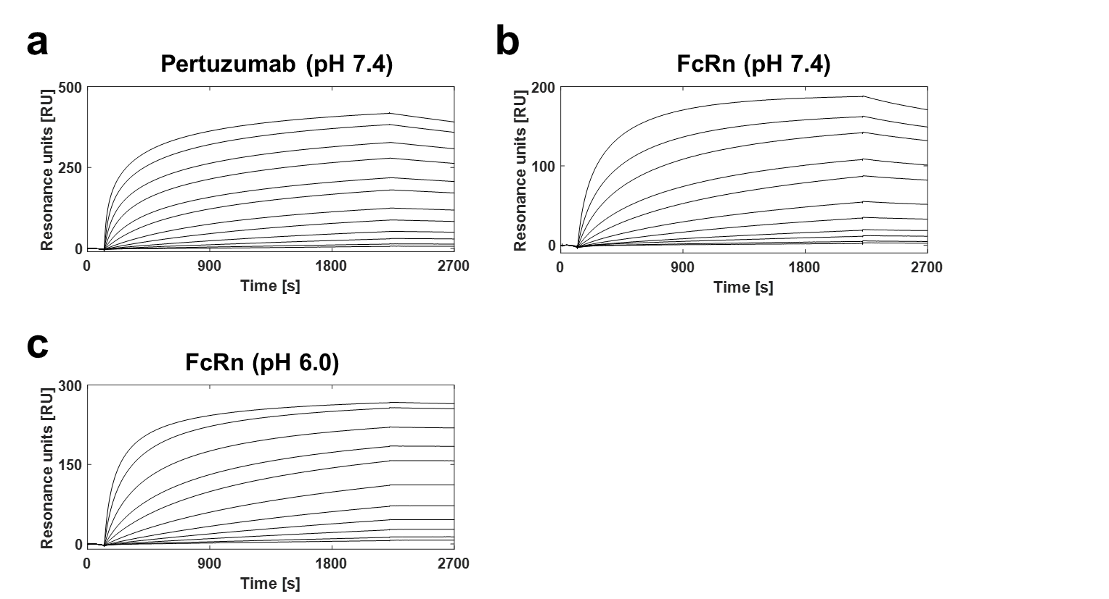

Supplementary Figure 1. Surface plasmon resonance analyses of the interaction of immobilized pertuzumab (572.6 RU) or mouse FcRn (672.8 RU) with HER2-Seldeg. HER2-Seldeg was injected at either pH 7.4 (a,b) or 6.0 (c) at concentrations ranging from 0.195-400 nM (a), 0.195-200 nM (b) or 0.195-100 nM (c) at a flow rate of 10 μl/min and equilibrium dissociation constants (K_{D}s) determined. Flow cells were regenerated at the end of each cycle using 0.1 M glycine/1 M NaCl/10% v/v glycerol pH 2.0 (pertuzumab) or 0.1 M NaHCO₃/0.15 M NaCl pH 9 (mouse FcRn). Representative traces for duplicate or triplicate injections for each analyte concentration are presented.

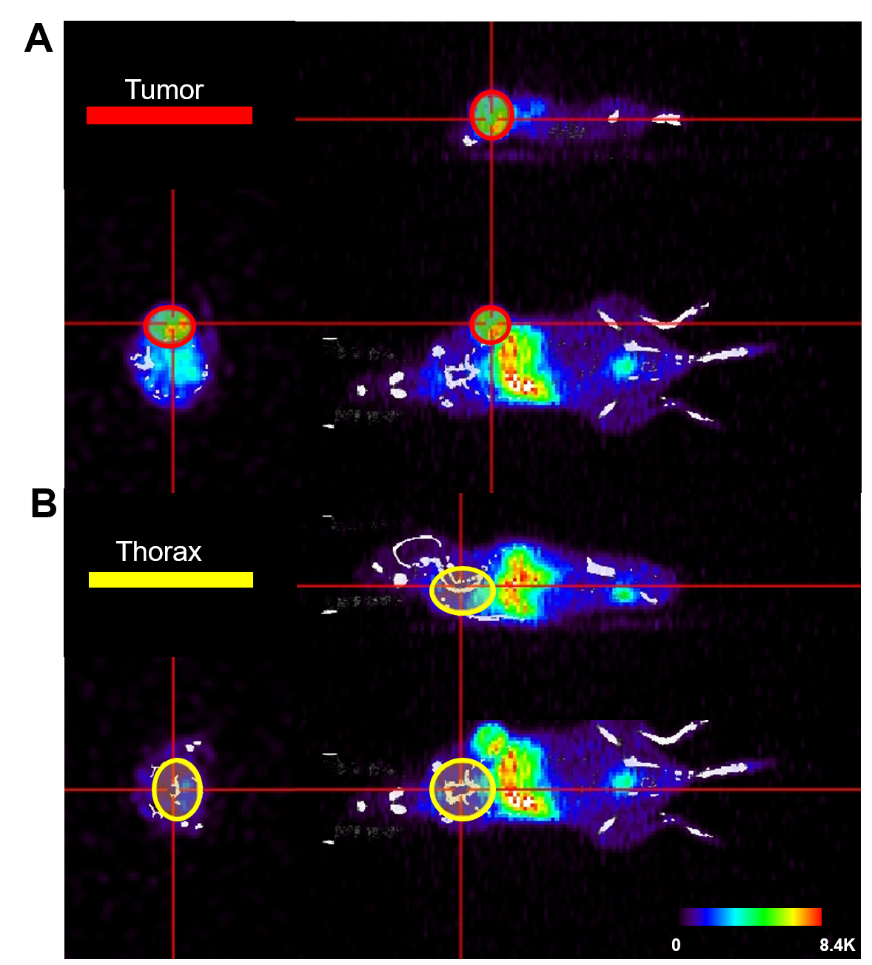
Supplementary Figure 2. Different views of the regions of interest (ROIs). The tumor ROI (a) and the thorax ROI (b) were overlaid with PET and CT images to determine contrast measures (ROIs for a PBS-treated mouse from the experiment described in Figure 2 is shown as an example). The intensity in the displays is linearly adjusted.
Supplementary Videos
Supplementary Video SV1: PET/CT 3D volume rendering of the PBS-treated mouse shown in Figure 2b at 30 h following ¹²⁴I-pertuzumab injection (6 h post-PBS injection).
Supplementary Video SV2: PET/CT 3D volume rendering of the HER2-Seldeg-treated mouse shown in Figure 2b at 30 h following ¹²⁴I-pertuzumab injection (6 h post-Seldeg injection).
Supplementary Video SV3: PET/CT 3D volume rendering of the MOG-Seldeg-treated mouse shown in Figure 2b at 30 h following ¹²⁴I-pertuzumab injection (6 h post-Seldeg injection).
Supplementary Video SV4: PET/CT 3D volume rendering of the PBS-treated mouse shown in Figure 2b at 44 h following ¹²⁴I-pertuzumab injection (20 h post-PBS injection).
Supplementary Video SV5: PET/CT 3D volume rendering of the HER2-Seldeg-treated mouse shown in Figure 2b at 44 h following ¹²⁴I-pertuzumab injection (20 h post-Seldeg injection).
Supplementary Video SV6: PET/CT 3D volume rendering of the MOG-Seldeg-treated mouse shown in Figure 2b at 44 h following ¹²⁴I-pertuzumab injection (20 h post-Seldeg injection).

