Price vs. clinical guidelines in primary care statin prescribing: a retrospective cohort study and cost simulation model

Matias Ortiz De Zarate, Emmanouil Mentzakis, Simon Fraser,
Paul Roderick, Paul Rutter and Carmine Ornaghi

Matias Ortiz De Zarate, Department of Economics, Faculty of Social Sciences, University of Southampton
Emmanouil Mentzakis, Department of Economics, Faculty of Social Sciences, University of Southampton
Simon DS Fraser, School of Primary Care, Population Sciences and Medical Education, Faculty of Medicine, University of Southampton, Southampton General Hospital
Paul Roderick, School of Primary Care, Population Sciences and Medical Education, Faculty of Medicine, University of Southampton, Southampton General Hospital
Paul Rutter, School of Pharmacy and Biomedical Sciences, Faculty of Health and Science, University of Portsmouth
Carmine Ornaghi, Department of Economics, Faculty of Social Sciences, University of Southampton
Correspondence to: Carmine Ornaghi C.Ornaghi@soton.ac.uk

Abstract
Objective: To investigate the relative impact of generic entry and NICE clinical guidelines on prescribing using statins as an exemplar.
Design: Retrospective analysis of statin prescribing in primary care, and cost simulation model.
Setting: Royal College of General Practitioners Research and Surveillance Centre (RCGP R&SC) database and Prescription Cost Analysis (PCA) database.
Participants: New patients prescribed statins for the first time between July 2003 and September 2018.
Results: General trends of statins' prescriptions were largely driven by a decrease in acquisition costs triggered by patent expiration, preceding NICE guidelines which themselves did not seem to affect prescription trends. We also observe significant heterogeneity in the prescription of the most cost-effective statin across GPs. A cost simulation shows that, between 2004 and 2018, the NHS could have saved £2.8bn (around 40% of the £6.3bn spent on statins during this time) if all GP practices had prescribed only the most cost-effective treatment.
Conclusions: There is potential for large savings for the NHS if new and, whenever possible, on-going patients are promptly switched to the first medicine that becomes available as generic within a therapeutic class as long as it has similar efficacy to still patented medicines.

INTRODUCTION
In a context where national health systems of all high and medium income countries are confronted by ballooning costs of caring for an ageing population and an increase in prevalence of long-term conditions, promoting cost-effective prescribing represents an important part of controlling health care expenditure.^{1,2} In the English National Health Services (NHS), the National Institute for Health and Care Excellence (NICE) publishes national guidance aimed at promoting clinical and cost-effective evidence-based recommendations for the management and therapeutic treatment of different conditions. In therapeutic markets where treatments have similar safety and effectiveness, NICE-recommendations may vary over time following changes in acquisition costs, e.g., due to patent expirations and the ensuing entry of generics. However, persistence of prescribing habits as well as prescribers’ lack of awareness of actual cost of medicines may mean that the uptake of NICE recommended medicines can vary substantially across GPs and practices, despite efforts at local level, including Clinical Commissioning Groups (CCG), to encourage more cost effective prescribing.^{3–7} Since low responsiveness to adopt NICE recommendations can substantially undermine the effort of the NHS to contain drug expenditure, it is important to understand the pervasiveness of such behaviour.

Statins represent an ideal market to investigate the relative importance of prices and clinical guidelines in explaining prescribing behaviour for at least two reasons. First, statins are the most widely used treatment for primary and secondary prevention of cardiovascular disease (CVD) risk, conditions with an estimated cost to the NHS of roughly £7.4 billion a year.^{8,9} Second, there are five main events that have shaped the statins market over the last two decades. In May 2003, simvastatin (brand name Zocor) lost patent protection and became available as generic drug. In January 2006, NICE published Technological Appraisal 94 (TA-94), stating that all statins were equally effective from a therapeutic point of view, advising GPs to take into consideration costs of statins when choosing the initial treatment and informing that simvastatin was the cheapest of all statins.¹⁰ Clinical Guideline 67 (CG-67), released in May 2008, explicitly stated that treatment initiation should start with simvastatin.¹¹ In May 2012, atorvastatin (brand name Lipitor) also lost patent protection and became available as generic drug. Finally, two years later, in May 2014, NICE published Clinical Guidelines 181 (CG-181) recommending atorvastatin as initial treatment.¹² The reduced cost after patent expiration coupled with its relatively greater potency meant that atorvastatin was now the most cost-effective statin in the market.

Using statins as an exemplar, this study investigated the prescription dynamics in a large sample of the English primary care sector between 2004 and 2018. First, we explored the relationship between aggregate prescription trends and two sets of events that shaped the statin market: patent expirations and generic entry, on the one hand, and publication of national clinical guidelines, on the other hand. Second, we investigated variation in prescribing activity across GP practices. Third, we quantified the forsaken savings for the NHS by assuming perfect therapeutic substitution, that is by comparing actual treatment choices to a hypothetical scenario where only the most cost-effective treatments are prescribed.

METHODS

Data
The main data source for our analysis was the Royal College of General Practitioners Research and Surveillance Centre (RCGP R&SC) database, a nationally representative sample of 243 GP practices in England. The population representativeness of this database has been addressed in previous studies, including its representativeness of the distribution of cardiovascular disease in England.^{13,14} From this database, we
retrieved all first prescription episodes for more than 400,000 patients, treated with statins between Q3-2003 and Q4-2018. This database contains complete information of each prescription issued (active ingredient, quantity, strength, formulation, and date) as well as an anonymised identity code of the GP practice that issued the prescription.

We also retrieved from the Prescription Cost Analysis (PCA) database, yearly statistics on the total quantities of each drug prescribed and dispensed in primary care in England, as well as the corresponding total spending, represented by the net ingredient cost (NIC).¹⁵ The latter represents the basic cost of any drug prescribed in primary care and is used in Prescription Services reports and other analyses, as it standardises prescribing cost nationally.
By aggregating the total spending of each strength of statin prescribed and dividing it by the corresponding total quantity, we obtained a measure of the average acquisition cost per strength of each statin in each year. In Appendix A we compare the prescription data in the PCA dataset to those in the RCGP R&SC dataset to demonstrate that the latter constitutes a representative sample of national prescription of statins, as well.

Trends and Heterogeneity in Statins Prescription
Since 2003 the statins' market has experienced five exogenous changes to prices and clinical standards (i.e., in May 2003, January 2006, May 2008, May 2012 and May 2014, as explained in the Introduction) that may have triggered significant changes in GPs’ prescribing choice. To document how prescription trends change in proximity of those events, we plotted the average proportion (across the 243 practices in the RCGP R&SC dataset) of new patients starting with one of the five statins for the period 2004 to 2018, as well as the average acquisition cost per defined daily dose (DDD) for each statin. To explore heterogeneity in prescription patterns, we split GP practices in the RCGP R&SC dataset into quintiles for every month in the data according to their share of new patients treated with simvastatin and plotted the average shares of new patients treated with simvastatin in each of the resulting five groups. Although this offers an insight into the evolution of overall heterogeneity in the data, it does not allow us to characterise persistence in GPs’ prescribing choices. Hence, we additionally plot the average share of new patients treated with simvastatin keeping the composition of groups fixed at the quintile computed at Q3-2003.

Cost savings simulation
According to NICE, all statins are equally effective from a therapeutic point of view. As stated in TA-94 introduced in 2006, "from the evidence available […] [and] for the purpose of initiating therapy, there were no data on clinical events to suggest the superiority of any one Statin over all the others in reducing cardiovascular events".^{10,16–20} Under the assumption that GPs cannot consistently anticipate whether a new patient would benefit from starting treatment with any given statin different from the one recommended by NICE, we evaluated prescription decisions according to a cost-minimization criterion. Specifically, we quantified the potential savings for the NHS by comparing the actual cost of the observed prescription decisions with a hypothetical cost constructed by substituting the actual original treatments with a therapeutically similar treatment containing either simvastatin (for prescriptions issued between 2004 and May 2012) or atorvastatin (from May 2012 onwards). By computing the difference between actual and hypothetic costs, we obtained a measure of the potential savings, both in absolute and relative terms.

The cost simulation was performed under two different scenarios. In the first scenario, the analysis was limited to the first prescription episode (i.e., the first 28 days of treatment) for patients newly treated with statins. By focusing only on the first prescription episode we compared the evolution of the spending on statin treatments using the same unit on analysis (that is, the cost of the first prescription episode) in different time periods, leaving aside the problem of following patients throughout their drug-treatment history. Clearly, the absolute value of savings obtained by considering only the first prescription episode for new patients is a partial account of the overall potential savings, as patients treated for cardiovascular disease risk will usually be on treatment indefinitely.

For this reason, we considered a second scenario where we computed hypothetical costs and savings if practitioners had changed all drug treatments to ones containing only simvastatin (for those prior to May 2012) and atorvastatin (after May 2012) to all existing patients (that is, new and on-going patients). This second simulation can be considered an upper bound to the absolute savings under the strong assumption that existing patients could be immediately switched to the NICE-recommended treatments, regardless of any medical consideration, patient’s preference or professional decision that led to the observed prescription choices, and that indeed play a role when assigning treatments in actual clinical practice. A detailed explanation of the methodology used for our cost simulation is presented in Appendix B.

RESULTS

Trends in Prescription and Price
Figure 1, panel (a) plots the evolution of the market shares for new patients starting treatment with statins between 2004 and 2018, using data from the RCGP R&SC database. In the time window considered, simvastatin and atorvastatin were the most frequently prescribed among the five statins, representing approximately 96% of all initial prescriptions. The dominance of these two drugs in treating CVDs in primary care resulted in the evolution of their shares following mirror image patterns.

The share of simvastatin increased rapidly after its patent expiration in 2003, from around 50% to more than 90% in May 2008, when NICE published CG-67. While this guideline explicitly recommended simvastatin for treatment initiation, the percentage of new patients prescribed simvastatin stayed constant over the next four years up to May 2012, and, if anything, slightly decreased. We also note that the introduction of TA-94 in 2006 failed to accelerate the uptake of simvastatin. Upon atorvastatin’s patent protection expiration in May 2012, simvastatin’s share started decreasing steadily from around 85% in 2012 to around 10% in 2018. Once again, the publication of CG-181 in 2014, updating the recommendation for treatment initiation to atorvastatin, had minimal effect in speeding up the declining trend of simvastatin.

Figure 1, panel (b) shows the average acquisition costs per daily-defined-dose of each Statin over time. The figure makes apparent the large drop in the acquisition cost of simvastatin soon after patent expiration of Zocor.²¹ Similarly, for atorvastatin a sharp drop in acquisition cost (to virtually the same level of simvastatin) was observed shortly after Lipitor patent expiration.

Figure 1: Trends in the Statins’ prescribed for Drug Treatment Initiation

(a) Proportion of new patients on each drug
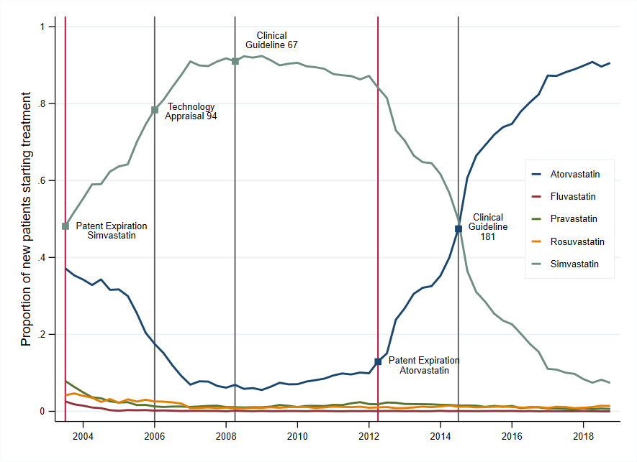
(b) Average Acquisition Cost per Defined Daily Dose (DDD) of each drug
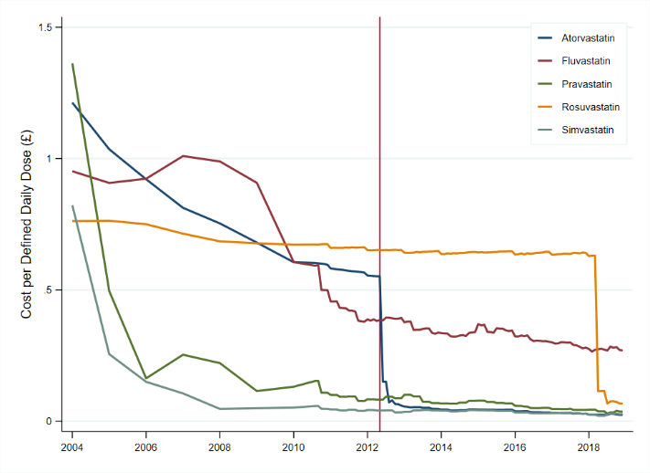
Notes: Panel (a) shows the proportion of new patients starting drug treatment with each statin over time. The main five events are marked with vertical lines and small squares. The two vertical red lines marks the patent expiration of Zocor (simvastatin) and Lipitor (atorvastatin) in 2003 and May 2012, respectively; and the grey vertical lines indicate the publishing date of NICE’s statin-related national guidance. Panel (b) shows the average acquisition cost per defined daily dose for each statin over time. Statins’ DDDs (or daily strength per day of treatment) established by the WHO are the following: for atorvastatin, 20 mg; fluvastatin 60 mg; pravastatin 30 mg; rosuvastatin 10 mg; and simvastatin 30 mg. Costs are obtained from Net Ingredient Cost figures from PCA, and are expressed in constant 2018 GBP using the GDP deflators at market prices, and money GDP from https://www.gov.uk/government/statistics/gdp-deflators-at-market-prices-and-money-gdp-march-2019-spring-statement. Source: Panel (a) from RCGP R&SC database, and panel (b) from Prescription Cost Analysis data series.

Heterogeneity in Prescriptions across GP practices
Figure 2 panel (a) presents average shares of new patients treated with simvastatin for each of the five quintiles of the GP practices prescription distribution. The figure makes apparent the existence of a significant heterogeneity in prescribing choices across general practices during the time window of our study. At the time of simvastatin patent expiration in May 2003, the proportion of patients treated with simvastatin ranged from less than 20% for GP practices in the bottom quintile to more than 80% for the top quintile. The period up to 2006 saw an increase in the proportion of new patients treated with simvastatin across all GP practices. At the time of the TA-94 introduction in January 2006, the difference in simvastatin prescription shares between second and fifth quintiles is around 20 percentage points, while the difference between first and fifth quintiles is still at more than 50 percentage points. Following the introduction of CG-67 in May 2006, differences across practices fluctuated around 25 percentage points with most compliant with the NICE guideline practices treating almost all of their new patients with simvastatin, while least compliant practices prescribed simvastatin to less than 80% of their patients. Heterogeneity in prescription increased again following atorvastatin patent expiration in May 2012, when the difference in the share of new patients being prescribed simvastatin between top and bottom quintiles reached about 50 percentage points. The subsequent CG-181 further reduced the overall levels of simvastatin prescriptions across the distribution but did little to reduce heterogeneity in the share of patients treated with simvastatin in the following years, with the difference between top and bottom quintiles remaining at about 25 percentage points.
Figure 2 panel (b) tracks the evolution of prescription for five quintiles of GPs as constructed in Q3-2003. The dynamics up to 2006 suggest the uptake of cost-effective prescribing for GPs in the lower quintiles is rather slow. However, the disappearance of major differences in prescribing among the five groups from 2007 onwards indicates that any given GP practice does not systematically deviate from prescribing the cost-effective statin. These dynamics suggest that the overall heterogeneity observed in panel (a) is due to slow learning and fluctuation between cost-effective and non-cost-effective prescribing.
Figure 2: Heterogeneity in Initial Prescriptions at the GP practice level

- Proportion of new patients on Simvastatin with quantiles calculated quarterly
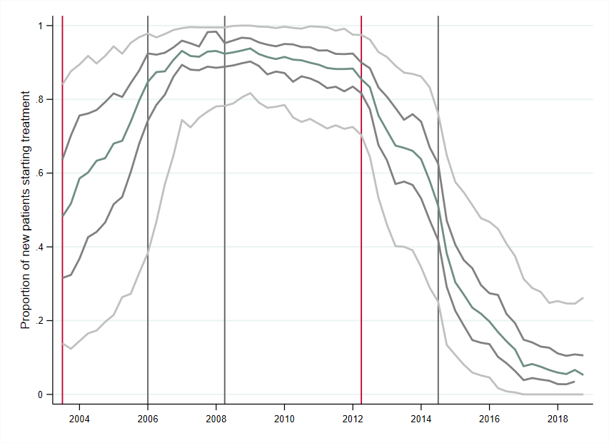
(b) Proportion of new patients on Simvastatin with fixed quantile composition calculated on Q3-2003

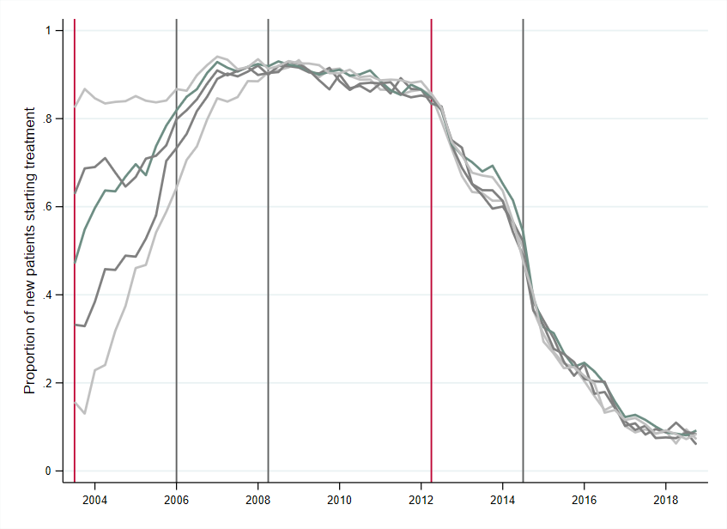
Notes: Panel (a) shows the average proportion of new patients treated with simvastatin within five quintiles of GP practices ranked by proportion of simvastatin prescriptions (e.g., the top line represents the average proportion of patients initially treated with simvastatin, by the top 20th percent of GP practices, etc.), where the quintiles of practices are obtained separately for each month (i.e., practices in each quantile may be different). Panel (b) shows the average proportion of new patients treated with simvastatin but for quintiles of practices obtained at Q3-2003, (i.e., the practices in each quintile are the same). Source: RCGP R&SC database.

Spending Simulations
Spending simulation results for the ‘First Scenario’, which considered only the first prescription episode, are presented on the left-hand side panel of Table 1. Column (1) shows the estimated number of new patients taking statins in every year from Q3-2003 to Q4-2018. We observed a decrease in the number of new patients from 1.15 million in 2004 to 782,000 in 2018. The total cost of the first prescription episode for these new patients decreased from £26.9 million in 2004 to £862,000 in 2018 (a 96.8 percentage decrease), due to the reduction in the number of new patients as well as the acquisition costs of statins.

Overall, a saving of £16.67 million, or 21.8 percent of the total actual cost could have been realised for the first 28 days of treatment alone if GPs had prescribed simvastatin as initial drug treatment before May 2012 and atorvastatin after May 2012. Most of the hypothetical savings accrued over the period 2008-2012 when cheap generic versions of simvastatin became available on the market and atorvastatin was still under patent protection. After May 2012, once generics of atorvastatin also entered the market, hypothetical savings on first prescription episodes were mainly accredited to switching from rosuvastatin to atorvastatin. However, the implied savings were not large as rosuvastatin only held a small share of the market.
Table 1: Spending Simulation Exercise

Notes. Cost figures are expressed in constant 2018 GBP using the GDP deflators at market prices, and money GDP from https://www.gov.uk/government/statistics/gdp-deflators-at-market-prices-and-money-gdp-march-2019-spring-statement.

Results for the ‘Second Scenario’ regarding total prescriptions for all existing patients are presented in the right-hand side panel of Table 1. The total number of patients on treatment every year increased from 3.8 million in 2004 to 7.6 million in 2018. However, the significant drop in price due to generic entries led to a drastic drop in spending over the same period: from just under £1 billion in 2004 to £95 million in 2018, a 90-percentage decrease. Cumulate spending on statins over the period 2004-2018 totalled £6.3 billion and estimated potential savings were £2.8 billion, or 43.9 percent of the actual spending on statins. As previously, large savings could have been obtained in the period 2004-2012 by switching patients from atorvastatin, which was available only as a branded drug, to simvastatin, that was generic.

DISCUSSION

In resource constrained health care systems promoting cost-effective prescribing behaviour is an important component of their cost containment strategy. Using data on statins we investigated how GPs' prescription choice in England changed in the face of (i) a large reduction in the cost of available treatments and (ii) the introduction of specific clinical guidelines. We demonstrated substantial increases in market shares for simvastatin (from 2004) and atorvastatin (since 2012) as their patents expired and cheap generics of the two medicines entered the market, but well before the introduction of NICE guidelines recommending the use of simvastatin, first, and atorvastatin, later on.

Those trends suggest that practitioners in primary care are sensitive to the price of alternative treatments, and that their choices even anticipate the recommendation of future clinical guidelines. Indeed, it took four years from the generic availability of simvastatin for NICE to explicitly recommend it for treatment initiation, by which point the share of new patients being prescribed the drug was already at 90 percent. Similarly, migration from simvastatin to atorvastatin started soon after it became available as a generic drug in May 2012, despite the fact that atorvastatin was only recommended as the preferred treatment in the updated NICE guideline two years afterwards.

Previous studies have shown that medicine management teams from CCGs do play a role in informing and influencing the prescription choices made by the practices and practitioners under their watch.^{3–5} Whether prescriptions are autonomously chosen by GPs or are influenced by the different actors within the primary care sector, our results suggest that ultimately prescribing decisions are more responsive to the acquisition cost of alternative treatments than clinical guidelines.

Although our analysis shows that, on average, practitioners treating patients at risk of cardiovascular events prescribed cost-effectively, we also identified substantial heterogeneity in the use of the two medicines across GP practices, which remains even after the publication of official guidelines.. Our descriptive analysis indicates some GPs took longer to adopt cost-effective prescribing and some switched in and out of cost-effective prescribing throughout the study period, thus generating large overall heterogeneity.. A number of explanations can be put forward for such behaviours. For example, medicolegally, GPs may have felt inhibited to change prescribing habits simply on the basis of cost, without having had guidelines to justify the decision.²² Equally, GPs and patients’ characteristics, practices’ characteristics (e.g. practice list size, staff mix, dispensing/non-dispensing status), geo-social conditions, as well as local CCG prescribing guidelines and monitoring activities may influence prescribing decisions.²³ Moreover, statins have been widely perceived as causing side effects such as muscle pains (and there was intermittent media coverage that influenced prescribing behaviour)²⁴ and GPs and patients may have been reluctant to switch from one statin to another for fear of inducing adverse events.²⁵

Under the plausible assumption that GPs cannot consistently anticipate whether a new patient would benefit from taking a drug that is different from the one recommended by NICE, we evaluated prescription choices in this market according to a cost-minimization criterion where choosing statins other than simvastatin (before May 2012) or atorvastatin (after May 2012) can be considered suboptimal. Our cost-savings simulation analysis suggested that low responsiveness comes at a high price for the NHS. Namely, if all new patients had received the most cost-effective treatment (as later recommended in the guidelines), the NHS could have saved around 22% of the actual spending on initial prescriptions. Looking at all prescriptions for new and on-going patients, we compute savings of £2.7bn, mainly between 2004 and 2012, representing roughly 44 percent of total spending on statins during this period. We acknowledge that this figure is an upper bound of potential savings, based on the strong assumption that all existing patients on drug treatment could be seamlessly switched to other statins, without considering side effects (e.g. myopathy) or other practicalities (e.g. planned-patient reviews) . Looking at the data, we find that around 7% and 12% of patients are switched to simvastatin and then switched away from it in the next 4 and 12 months, respectively. Although this proportion is not insignificant, there is no doubt that large savings are still present if all GPs follow the example of the most cost-sensitive physicians.

We anticipate that the experience of statins would be similarly observed in other therapeutic areas where treatments have similar modes of action and comparable levels of efficacy, for instance Angiotensin-converting enzyme (ACE) inhibitors and proton pump inhibitors. Looking ahead, our analysis suggests that cost-conscious centralised public health systems, could save substantial sums if new and, whenever possible, on-going patients are promptly switched to cost-effective alternatives, in particular when the first medicine in a therapeutic class loses patent protection. The observed heterogeneity in prescribing behaviour suggests that an important step forward towards achieving this goal would be a timely dissemination of best practices, with the aim of promoting cost-conscious prescribing behaviour among primary care physicians. In the UK, where GP practices are grouping into Primary Care Networks and there is growing co-working and co-location with pharmacists, such collaborative efforts are likely to drive future prescribing. Given GPs limited time available to acquire information on market developments (e.g. new medicines coming into the market or brand-name medicines losing patent protection) across all drug classes they prescribe, there is an important role for academic detailing as well as online/computerised systems and prompts such as ScriptSwitch, rather than paper-based (e.g. Prescribing Outlook), to educate and offer updated advice on cost-effective medicines while preserving physicians’ freedoms to prescribe and patients’ ability to discuss their preferred choice of treatment.²⁶ It is of note that the recently announced NICE strategy for 2021 to 2026 aims to “provide dynamic, living guideline recommendations that are useful, useable and rapidly updated” (p. 19) and to speed up the process of identifying new medicines and disseminating knowledge.²⁷

Strengths and Limitations
We study prescription dynamics of statins, a class of drugs widely prescribed in primary care, using a representative dataset of English practices for the period 2004-2018, a time window that includes important changes in the patent protection of brand-name statins and in the statin related NICE guidelines. There is no reason to believe that the large forsaken savings we have identified would not generalize to other important therapeutic areas of the English NHS or to other health care systems. Admittedly, the extent of the savings is an empirical matter and crucially depends on the structure of health care systems, the penetration of generics within them and the incentives of different players in prescribing, dispensing, and reimbursing pharmaceutical treatments.

We acknowledge a few limitations for this study. We only observe a first prescription issued to patients treated in primary care, without being able to account for prescribing influences that come from other settings. For example, patients experiencing a first cardiovascular event may well have received their first statin prescription in secondary care, and such decision might have influenced ongoing prescribing in primary care. However, it is unlikely that this can explain to a large extent the significant heterogeneity in prescribing choices and the large forsaken savings shown in Table 1. Further, we have access only to limited data on GP characteristics to examine factors associated with the observed heterogeneity, while analysis of free text accompanying routine clinical data to explore any documented decision points about reasons for statin prescription choice was beyond the scope of this project.

CONCLUSIONSThe fact that GPs react to prices illustrates the strengths of a health care system that pays attention to cost effectiveness. There is potential for large savings for the NHS if new and, whenever possible, on-going patients are promptly switched to the first medicine that becomes available as generic within a therapeutic class where all other medicines have similar efficacy. On-going efforts to create a system infrastructure to support and monitor GP prescribing locally could prove effective in aligning incentives to select cost-effective treatments while preserving physicians’ freedoms to prescribe and patients’ ability to discuss their preferred choice of treatment.

Contributors: MO, EM and CO contributed to the design of the study. MO extracted the data and wrote the statistical programmes. CO, EM, and MO wrote the first draft. All authors contributed to further drafts, conceptualization and approved the final manuscript. CO is guarantor.

Competing interests: All authors declare that they have not received any funding related to this project and there are is no conflict of interest.

Ethical approval: The study was approved by the Ethics committee of the University of Southampton (submission ID 52995). The nature of the research question does not pose threats to the privacy rights of patients and GP practises.

Data sharing: The data were obtained from the Royal College of General Practitioners Research and Surveillance Centre (RCGP R&SC). Data were extracted in January 2019 and analysis was performed from a laboratory at the University of Surrey through a secure network and remote desktop connection. RCGP R&SC data governance and our own license to use those data do not allow us to distribute or make available patient data directly to other parties. Researchers can apply for data access at https://www.rcgp.org.uk/clinical-and-research/our-programmes/research-and-surveillance-centre/supporting-research-teams/submit-a-data-request-online-form.aspx

Transparency: The corresponding author affirms that the manuscript is an honest, accurate, and transparent account of the study being reported, and that no important aspects of the study have been omitted.

Acknowledgements: We would like to thank: Patients for allowing their data to be used for surveillance and research. Practices who have agreed to be part of the Oxford RCGP RSC and allow us to extract and used health data for surveillance and research. Filipa Ferreira (Senior Project Manager) from RCGP and from University of Surrey. Apollo Medical Systems for data extraction. Collaboration with EMIS, TPP, In-Practice and Micro-test CMR supplier for facilitating data extraction. Colleagues at Public Health England.
REFERENCES

1. Organization WH. Global spending on health: a world in transition. Published online 2019. Accessed April 13, 2021. https://apps.who.int/iris/handle/10665/330357
2. Dall TM, Gallo PD, Chakrabarti R, West T, Semilla AP, Storm MV. An Aging Population And Growing Disease Burden Will Require A Large And Specialized Health Care Workforce By 2025. Health Aff (Millwood). 2013;32(11):2013-2020. doi:10.1377/hlthaff.2013.0714
3. Mason A. New medicines in primary care: a review of influences on general practitioner prescribing. J Clin Pharm Ther. 2008;33(1):1-10. doi:https://doi.org/10.1111/j.1365-2710.2008.00875.x
4. Wathen B, Dean T. An evaluation of the impact of NICE guidance on GP prescribing. Br J Gen Pract. Published online 2004:5.
5. Stephen Harrison, George Dowswell, John Wright, , Ian Russell, George Dowswell, John Wright. General practitioners’ uptake of clinical practice guidelines: a qualitative study. J Health Serv Res Policy. 2003;8(3):149-153. doi:10.1258/135581903322029494
6. Bedson J, Belcher J, Martino OI, et al. The effectiveness of national guidance in changing analgesic prescribing in primary care from 2002 to 2009: An observational database study. Eur J Pain. 2013;17(3):434-443. doi:https://doi.org/10.1002/j.1532-2149.2012.00189.x
7. Walker AJ, Pretis F, Powell-Smith A, Goldacre B. Variation in responsiveness to warranted behaviour change among NHS clinicians: novel implementation of change detection methods in longitudinal prescribing data. BMJ. 2019;367:l5205. doi:10.1136/bmj.l5205
8. Health Matters: Preventing cardiovascular disease - Public health matters. Accessed April 13, 2021. https://publichealthmatters.blog.gov.uk/2019/02/14/health-matters-preventing-cardiovascular-disease/
9. Luengo‐Fernández R, Leal J, Gray A, Petersen S, Rayner M. Cost of cardiovascular diseases in the United Kingdom. Heart. 2006;92(10):1384. doi:10.1136/hrt.2005.072173
10. Statins for the prevention of cardiovascular events | Guidance | NICE. Accessed April 13, 2021. https://www.nice.org.uk/guidance/ta94
11. Lipid modification: Cardiovascular risk assessment and the modification of blood lipids for the primary and secondary prevention of cardiovascular disease | Guidance | NICE. Accessed April 13, 2021. https://www.nice.org.uk/guidance/cg67
12. Cardiovascular disease: risk assessment and reduction, including lipid modification | Guidance and guidelines | NICE. Accessed January 13, 2019. https://www.nice.org.uk/guidance/cg181/chapter/appendix-a-grouping-of-statins
13. Correa A, Hinton W, McGovern A, et al. Royal College of General Practitioners Research and Surveillance Centre (RCGP RSC) sentinel network: a cohort profile. BMJ Open. 2016;6(4):e011092. doi:10.1136/bmjopen-2016-011092
14. Hinton W, McGovern A, Coyle R, et al. Incidence and prevalence of cardiovascular disease in English primary care: a cross-sectional and follow-up study of the Royal College of General Practitioners (RCGP) Research and Surveillance Centre (RSC). BMJ Open. 2018;8(8):e020282. doi:10.1136/bmjopen-2017-020282
15. Prescription Cost Analysis. NHS Digital. Accessed April 13, 2021. https://digital.nhs.uk/data-and-information/publications/statistical/prescription-cost-analysis
16. Law MR, Wald NJ, Rudnicka AR. Quantifying effect of statins on low density lipoprotein cholesterol, ischaemic heart disease, and stroke: systematic review and meta-analysis. BMJ. 2003;326(7404):1423. doi:10.1136/bmj.326.7404.1423
17. Efficacy and safety of cholesterol-lowering treatment: prospective meta-analysis of data from 90 056 participants in 14 randomised trials of statins. The Lancet. 2005;366(9493):1267-1278. doi:10.1016/S0140-6736(05)67394-1
18. Moon JC, Bogle RG. Switching statins. BMJ. 2006;332(7554):1344-1345.
19. Armitage J. The safety of statins in clinical practice. The Lancet. 2007;370(9601):1781-1790. doi:10.1016/S0140-6736(07)60716-8
20. Amarenco P, Labreuche J. Lipid management in the prevention of stroke: review and updated meta-analysis of statins for stroke prevention. Lancet Neurol. 2009;8(5):453-463. doi:10.1016/S1474-4422(09)70058-4
21. Medicinal product regulation and product liability in the UK (England and Wales): overview. Practical Law. Accessed April 23, 2021. http://uk.practicallaw.thomsonreuters.com/3-500-9763?transitionType=Default&contextData=(sc.Default)&firstPage=true&bhcp=1
22. Tony Avery, Nick Barber, Maisoon Ghaleb, Bryony, Dean Franklin, Sarah Armstrong, Sarah Crowe, Soraya Dhillon, Anette Freyer, Rachel Howard, Cinzia Pezzolesi, Brian Serumaga, Glen Swanwick, Olanrewaju Talabi. Investigating the prevalence and causes of prescribing errors in general practice: The PRACtICe Study (PRevalence And Causes of prescrIbing errors in general practiCe) A report for the GMC. Published online 2012. https://www.gmc-uk.org/-/media/gmc-site-images/about/investigatingtheprevalenceandcausesofprescribingerrorsingeneralpracticethepracticestudyreoprtmay2012.pdf?la=en&hash=21B05525C5FEF17C832EF985D8636C08E524A6C9
23. Goldacre B, Reynolds C, Powell-Smith A, et al. Do doctors in dispensing practices with a financial conflict of interest prescribe more expensive drugs? A cross-sectional analysis of English primary care prescribing data. BMJ Open. 2019;9(2):e026886. doi:10.1136/bmjopen-2018-026886
24. Matthews A, Herrett E, Gasparrini A, et al. Impact of statin related media coverage on use of statins: interrupted time series analysis with UK primary care data. BMJ. 2016;353:i3283. doi:10.1136/bmj.i3283
25. Ju A, Hanson CS, Banks E, et al. Patient beliefs and attitudes to taking statins: systematic review of qualitative studies. Br J Gen Pract. 2018;68(671):e408-e419. doi:10.3399/bjgp18X696365
26. Hire C, Rushforth B. General practitioners’ views on using a prescribing substitution application (ScriptSwitch®). J Innov Health Inform. 2013;21(1):1-11. doi:10.14236/jhi.v21i1.6
27. NICE strategy 2021 to 2026: Dynamic, Collaborative, Excellent. :35.

APPENDIX A

In this Appendix we compare the data in the PCA dataset to those in the RCGP R&SC dataset to demonstrate that the latter constitutes a representative sample of national prescription. One advantage of the PCA database is that prescription data go back to the year 1998. However, the PCA database cannot be used to investigate heterogeneity in prescription choice because data are available only at national level, no at GP practice level.

Figure A1 compares the data over time in our two data sources: Panel (a) on the left shows the figures from the PCA dataset between 1998-2018. Panel (b) on the right shows the figures from RCGP R&SC database from 2004-2018. Top panels display the total quantity in terms of daily-defined-doses (DDDs) while the bottom panels display the shares of each of the five statins in the market. The similarity in the trends reported in panel (a) and (b) confirms that the RCGP R&SC database is a representative sample of national data of statins prescription.

Figure A1: Volume of statin’s prescribed in main data sources
(a) Prescription Cost Analysis data (b) RCGP R&SC data
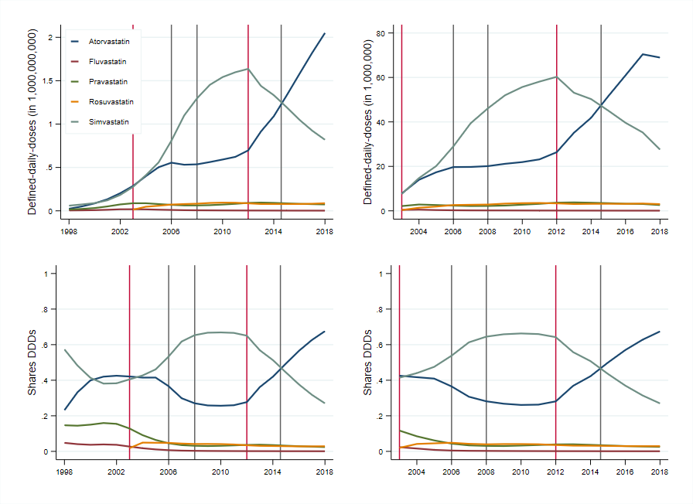

APPENDIX B

Spending Savings Simulation Exercise Methodology

This appendix describes the methodology used for the spending savings simulation exercise, by which we estimate the potential savings for the NHS that could have been achieved if GPs had prescribed simvastatin or atorvastatin as active ingredients, whenever these two medicines were the prescribing standard in this market according to the observed preferences of GPs and the recommendations in national guidance. We start by describing the computations of actual and hypothetical cost for the first scenario, in which the analysis refers to the first prescription episode, i.e., the first 28 days of drug treatment, for new patients only; and then the second scenario, in which we apply the same methodology to all prescriptions issued to all existing patients being treated in every period.

First scenario

To compute actual and hypothetical cost we use information on the number of new patients treated, their initial drug treatment (i.e., a specific statin and strength), and a measure of each treatment’s acquisition cost to the NHS per day of treatment. From the RCGP R&SC database, we count the number of new patients being prescribed statin treatment s in period t for the first time, denoted by $n_{st}$.

From the Prescription Cost Analysis (PCA) series, containing data on all medicines prescribed and dispensed and their corresponding cost to the NHS at the national level, we retrieve a measure of the actual acquisition cost of each statin treatment. To compute the average acquisition cost of treatment s in period t, denoted by $C_{st}$, we take the ratio between the Net Ingredient Cost ($NIC_{st}$) and the corresponding Total Quantity ($Q_{st}$) prescribed of each different strength of statin, that is $C_{st}=\frac{NIC_{st}}{Q_{st}}$. Cost figures are then expressed in constant 2018 GBP using the GDP deflators at market prices (see https://www.gov.uk/government/statistics/gdp-deflators-at-market-prices-and-money-gdp-march-2019-spring-statement)

Since data on the total number of new patients starting treatment on each statin nationally is not publicly available, we estimate such figure by combining information from the RCGP R&SC database (which is a nationally representative sample of GP practices in England) with national aggregated data from the Prescription Cost Analysis series. Concretely, we compute the total number of new patients nationally, denoted by $\hat{N}$, as follows: ${\hat{N}}_{st}=\frac{n_{st}}{ q_{st}}×Q_{st}$, where $q_{st}$ denotes the total quantity of each statin treatment prescribed in every period in the RCGP R&SC database. Indeed, since the RCGP R&SC sample of GP practices is representative of the English general practice sector, then the ratio of new patients to total quantities prescribed in both data sources should be equivalent. Aggregating ${\hat{N}}_{st}$ over all treatments at the year-level, ${\hat{N}}_{t}=\sum_{s}{{\hat{N}}_{st}}$, results in the figure reported in column (1) of Table 2, i.e., the estimated number of new patients treated with statins in each year.

Finally, we compute the actual cost of first prescription episodes for each statin treatment s in every period $t$ by multiplying the total number of new patients on each treatment ${\hat{N}}_{st}$ with the cost per day of treatment $C_{st}$ times 28, that is ${AC}_{st}= {\hat{N}}_{st}×C_{st}×28$. Then we aggregate ${AC}_{st}$ over all treatments at the year-level, $AC_{t}=\sum_{s}{{AC}_{st}}$, which is the figure reported in column (2) of Table 2.

As explained above, practitioners’ preferences when treating patients for CVDs risk moved towards simvastatin since its patent expiration (May 2003) until atorvastatin’s patent expiration (May 2012); and from then onwards, they tended towards atorvastatin. Our cost simulation exercise extremes this observed behaviour by asking what would have been the cost savings if either simvastatin or atorvastatin had been the active ingredients originally prescribed to new patients, whenever these two medicines were the prescribing standard in specific periods. Accordingly, the hypothetical cost is constructed by substituting the originally prescribed treatment $s$, with a therapeutically similar one, denoted by $s^{*}$, containing simvastatin for those first-time prescriptions issued between 2004 and May 2012, or atorvastatin for those issued after May 2012.

The therapeutic similarity criteria we use is based on the ability of each strength of each drug (e.g., 1 tablet of atorvastatin 20 mg. a day, 1 tablet of simvastatin 40 mg. a day, etc.) in reducing low-density lipoprotein (LDLP) cholesterol levels per day of treatment. The percentage reduction in low density lipoprotein cholesterol is used in NICE’s CG-181 to group the five statins (and each of their corresponding strengths) according to their intensity. The relationship between the strengths of the statins and reduction in LDLP cholesterol is stated in NICE's CG-181, which in turn is based on the paper by Law et al. (2003).¹⁶ A reproduction of this information is presented in Table B1.

Table B1: Percentage Reduction in low-density lipoprotein cholesterol
Notes. 20%-30%: low intensity. 31%-40%: medium intensity. Above 40%: high intensity.

To make this operative, for each level of percentage reduction in LDLP cholesterol achieved by the originally prescribed treatment, i.e., a drug-strength pair, we look for the closest strength of both simvastatin and atorvastatin that achieves a similar level in LDLP reduction to the originally prescribed one. The correspondence between original treatments and the substitutes is presented in Table B2. Columns (3) and (4) show the strength of simvastatin and atorvastatin, respectively, that achieves the closest percentage reduction in LDLP cholesterol than the original treatments listed in columns (1) and (2). For example, if a patient was prescribed atorvastatin 10 mg a day for treatment initiation before 2012, the hypothetical prescription for this patient is a treatment of simvastatin 40 mg a day, as both achieve a reduction of 37% in LDLP cholesterol. Second example, if a patient was prescribed rosuvastatin 10 mg for treatment initiation after 2012, then the hypothetical prescription for this patient is a treatment of atorvastatin 20 mg, as both achieve a reduction of 43%.

Table B2: Correspondence between all Statins’ treatments based on LDL cholesterol reduction
Notes. This table is based on the Grouping from Table A1.

Finally, the hypothetical cost is computed by multiplying the total number of new patients times the cost of the therapeutically similar treatments $C_{s^{*}t}$ times 28, that is ${HC}_{st}= {\hat{N}}_{st}×C_{s^{*}t}×28$. Then we aggregate ${HC}_{st}$ over all treatments at the year-level, $HC_{t}=\sum_{s}{{HC}_{st}}$, which is the figure reported in column (3) of Table 2.

Second scenario

The second scenario considers not only first-time prescriptions for new patients, but all prescriptions for all existing patients treated with statins. For this, we use the information on total quantity and spending from the PCA database. The actual cost is obtained by aggregating spending on all statins prescribed in each year. The hypothetical cost is computed by replacing the per unit cost of the original treatment (statins and strength) with the corresponding cost of the therapeutically similar treatment (either simvastatin or atorvastatin), as described above. Additionally, to provide an estimate of the total number of all existing patients treated with statins in every period, ${\hat{P}}_{t}$ (the figure reported in column (6) of Table 2), we compute ${\hat{P}}_{t}=\sum_{s}{\frac{p_{st}}{ q_{st}}×Q_{st}}$, where $p_{st}$ denotes the total number of all existing patients using treatment s at time t as reported in the RCGP R&SC database.

