**A hybrid corrosion-structural model for simulating realistic corrosion topography of maritime structures**

Eko C. Ilmana,b Yikun Wanga,[1], Julian A. Whartonc, Adam J. Sobeya,d,

a Maritime Engineering Group, University of Southampton, Boldrewood Innovation Campus, Highfield, Southampton SO16 7QF, UK

b Ocean Engineering Program, Institut Teknologi Bandung, Bandung 40132, Indonesia

c National Centre of Advanced Tribology at Southampton (nCATS), University of Southampton, Highfield, Southampton SO17 1BJ, UK

d Marine and Maritime Group, Data-centric Engineering Programme, The Alan Turing Institute, The British Library, London, NW1 2DB, UK

# Abstract

A multiscale multiphysics model has been developed coupling nonlinear structural behaviour and the corrosion kinetics. This study develops a hybrid mechano-electrochemical corrosion model using finite element method to evaluate long-term topography evolution on carbon steel stiffened plates for marine applications. A parametric study is performed on a stiffened plate (1.5 m × 0.95 m) with different localised corrosion locations (0.75 m × 0.045 m) at different load levels. Stress-based anodic and cathodic surfaces are defined using a level-set function to solve the transport equation, facilitated by the moving boundary technique. Key model insights show broad-pitted corrosion features with benching, closely resembling those found in actual ship inspections and/or surveys.

**Keywords:** multiphysics; finite element; marine corrosion; carbon steels; stiffened plates.

# Nomenclature

$N_{i}$ Flux of species *i* (mol m–2 s–1)

Ionic valence

$c_{i}$ Concentration of species *i* (mol m–3)

Mobility (s mol kg–1)

*F* Faraday constant (C mol–1)

*Di* Diffusion coefficient (m2 s–1)

ulk electrolyte velocity (m s–1)

Potential (V)

*b*f Stiffener flange width (mm)

$a$ Sitffened planel length (mm)

$ϕ_{L}$ Level-set function to define the anodic and cathodic sites

$r\left(σ\right)$ Stress ranking function

$σ$ Surface von Mises stress (MPa)

$s$ Electrical conductivity of the electrolyte (S m–1)

Current densities of the anodic surface (A m–2)

Current densities of the cathodic surface (A m–2)

Molar mass of iron (kg mol–1)

Current density, derived from the polarisation curve input for or (A m-2)

Number of electrons involved in the electrode reaction

$ρ$ Density of steel (kg m–3)

Stoichiometric coefficients, 1 for the anodic area and 0 for the cathodic area

# Introduction

Generally, research interest in marine corrosion is driven to improve structural safety at sea. Accurate prognosis of the thickness reduction is key to determining how and when a structural failure is likely to occur. Due to the large scale of the structures under investigation, corrosion is often simplified as either a uniform plate thinning or perforations in pre-defined shapes [1-3]. However, the recent literature indicates the importance of incorporating realistic corrosion features to achieve better predictions of the structural behaviour. Models are often based on physical measurements of the actual corrosion topography [4, 5], where an image of a corroded surface, *in situ* or from laboratory-based experiments, has been imported into the structural model. However, these models cannot effectively simulate the change in corrosion characteristics with time. Alterntaively, models have utilised a mechano-electrochemical effect [6-8], in terms of a stress factor to simulate the corrosion evolution in finite element (FE) structural models [9, 10]. The stress factor quantifies the corrosion rate ratio between stressed and stress-free conditions as a function of the surface von Mises stress level. This function is obtained from physical measurements. The stress factor is subsequently applied to each element within the model. As stimulated service time increases, the variation in the surface von Mises stress field leads to different levels of plate thinning within the surface area of interest, hence achieving a crude simulation of a rough/corroded surface as shown in Fig. 1(a). However, when compared to an actual corroded surface from a bulk carrier (Fig. 1(b-c)), none of the simulations in the literature are able to predict similar topographies without the facilitation of advanced imaging techniques. The broad pit features are tens of millimetres in diameter with distinct edges and steps [11, 12] and are characteristic for carbon steel corroding in seawater. Pit depths can be 2-10 times greater than the mean corrosion based on a generalised mass loss assessment [13-15], with pit depths varing between 0.5 mm and 5 mm after five years [14, 15]. Such marked differences provide insights into the complexity that underlines the mechanical factors affecting the corrosion kinetics and surface topography. For elastic loading conditions, which typically represent the real-time load experienced by most marine structures, Gutman reported that both tensile and compressive elastic stresses have equivalent effects and lead to comparable changes in corrosion rates [6]. Similar conclusions have also been reported by Zhang et al. [17]. A recent FE study attempted to implement the uniaxial elastic load in a two-dimensional model with pre-defined broad pits [18]. The elastic load led to higher anodic kinetics and metal dissolution in the centre of the defect [18]. However, the study did not consider changes in corrosion topography with time.

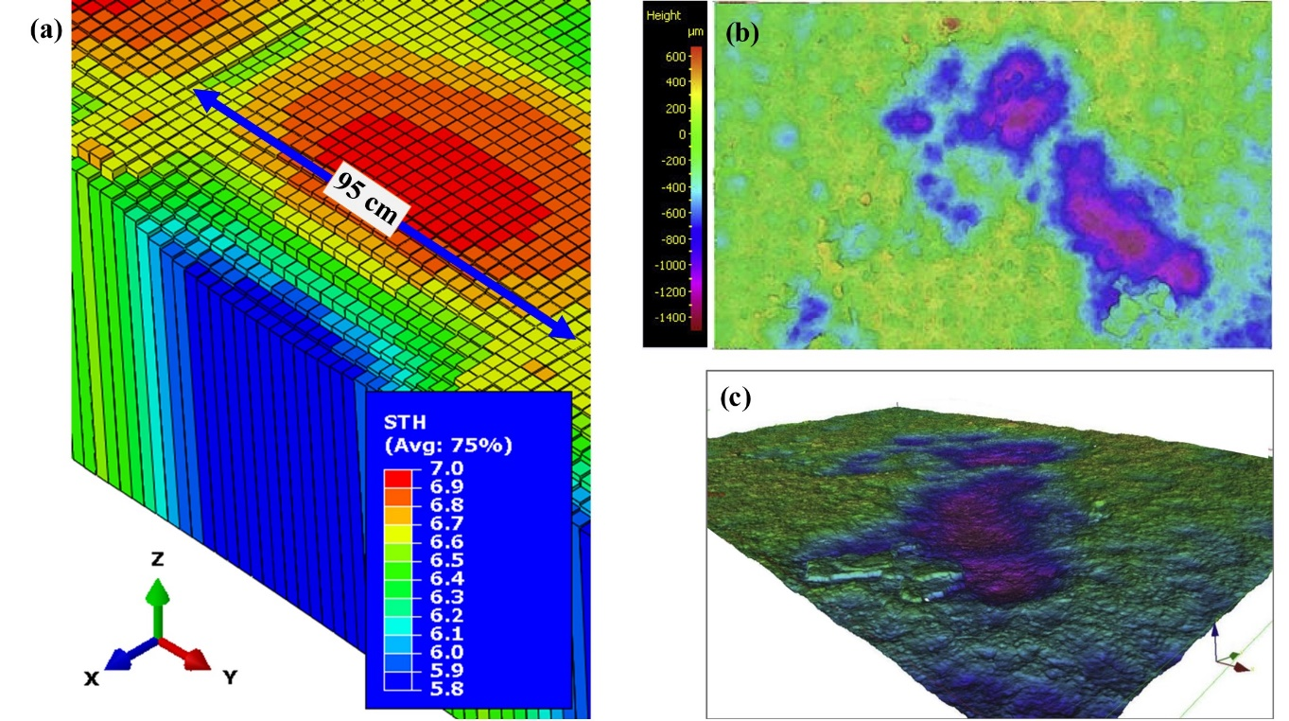

**Remaining thickness [mm]**

**Fig. 1**. Corrosion surface topography: **(a)** illustrated of simulated corrosion topography from a FE simulation, (shell thickness ×100) [16]; **(b)** Real corrosion surface topography with broad pits and benched features on the inner bottom plate of an aged bulk carrier showing two-dimensional contour plot, with scan area: 6 cm × 4 cm [8]; **(c)** three-dimensional surface contour map of Fig. 1(b) [8].

Corrosion processes involving metal dissolution within an adjacent electrolyte, transport of metal ions in the surrounding environment, and material surface degradation [19, 20], are often examined using numerical methods at different scales, e.g., atomistic scale, micro/meso scale and macroscale. At atomistic scales, methods such as molecular dynamics and Kinetic Monte Carlo simulation are often used to analyse the hypothetical corrosion process [21-23]. To estimate topographical changes linked to surface degradation such as pit damage, more appropriate scales are in the order of either micrometres or millimetres depending on the physical phenomenon [19]. Standard computational corrosion models use methods such as FE to solve the soluble species transport equation, usually the Nernst-Planck equation, and then utilise a separate technique to move the corroding surface boundary based on Arbitrary Lagrangian-Eulerian (ALE) method to simulate pit growth [19, 22, 24]. A recent application for micro-galvanic corrosion provides an alternative approach by introducing a level-set function to determine scattered anode and cathode regions, followed by a moving boundary technique [25]. Other methods either adopt a discrete approach that mimics the corrosion process, such as cellular automata [26], or apply mathematical formulations coupling anodic kinetics and pit growth such as finite volume [27], peridynamics [28] and phase-field models [29]. Within the continuum scale, most corrosion studies use probabilistic and phenomenological approaches, focusing mainly on idealised general/localised corrosion [30]. The FE with ALE method is well-established in corrosion modelling; however, it can be time consuming when solving boundary remeshing and faces convergence issues for complex electrolyte-metal boundary conditions. Peridynamic and phase-field applications in corrosion studies are alternative new approaches to estimate corrosion evolution by modifying the governing equations which also lead to computationally expensive formulations, and require further validation. However, none of the above mentioned corrosion process simulation is able to inform the structural integrity assessment, which is the ultimate goal.

This present study explores a mechano-electrochemical modelling approach to study corrosion topography evolution with time. The model incorporates a structural component to provide a realistic stress profile and *in situ* corrosion-tensile test data are applied as kinetic input parameters to analyse the effect of the modelled mechano-electrochemical corrosion. Separate stress-based anodic and cathodic areas are defined based on the level-set function [25, 31]. Twelve case studies are conducted to simulate the service conditions of a stiffened plate in a ship ballast tank subject to different loads, corrosion locations and plate thickness. The simulations are performed until there is either a thickness perforation of the stiffened plate or 20 years of service life is achieved, whichever comes first.

# Multiphysics mechano-electrochemical corrosion model

The structural and corrosion models are linked as illustrated in Fig. 2. The process highlighted within the red box represents the nonlinear FE assessment at a structural scale, assessing a stiffened plate under uniaxial compressive service load. The corrosion assessment is shown in the blue box, simulating the corrosion process within a pre-defined corrosion location, assuming there was no corrosion protection. The first step was to perform a structural analysis on the intact structure and von Mises stresses were extracted from the surface. Based on these surface von Mises stress levels, the anodic and cathodic areas at the corrosion location are defined, using the level-set method [25]. Mechano-electrochemical analysis was performed for a one-year simulation using an *in situ* experimental dataset to determine the thickness reduction [10], resulting in thickness changes at the corrosion location. Each element thickness of the stiffened plate model was subsequently updated based on the corrosion model results. The surface von Mises stresses of the stiffened plate were therefore updated annually for the mechano-electrochemical corrosion assessment. This assessment was performed for a total service life of 20 years or until there was a perforation in the structure, whichever came first.

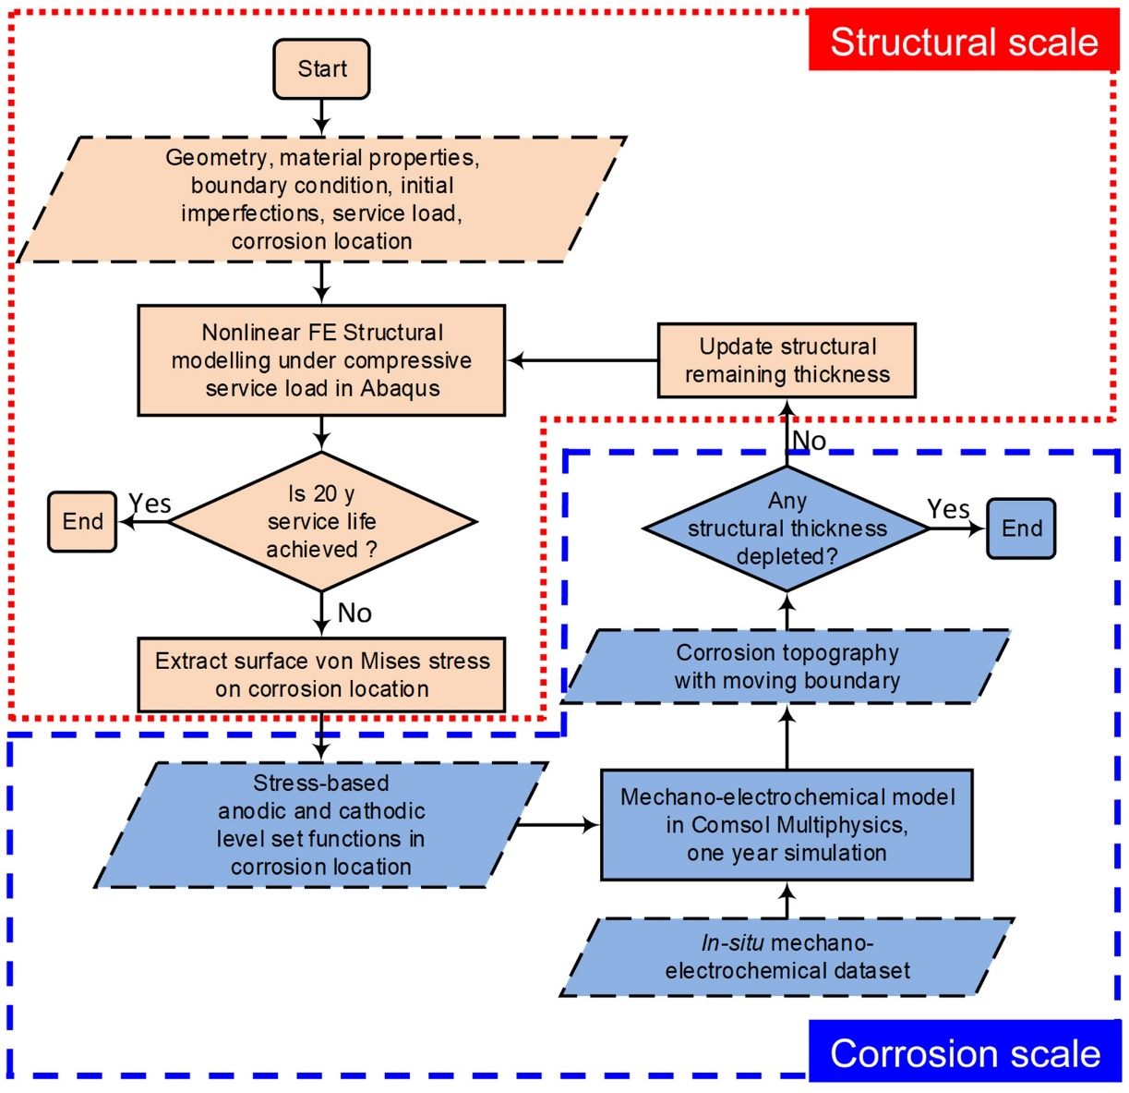

**Fig. 2.** General procedure to link structural scale and mechano-electrochemical corrosion scale assessments.

## Multiscale multiphysics electrochemical corrosion-structural mechanics hybrid model

### Governing equations and level-set parameters for FE-based mechano-electrochemical corrosion model

The total flux of species *i* represents the transport phenomena of a dilute species *i*, in an electrolyte which is given by the full Nernst-Planck equation as expressed in Eqn. 1,

$N_{i}=-z_{i}Fu_{i}c_{i}∇ϕ-D_{i}∇c_{i}+c_{i}v,$ (1)

where $N_{i}$ is the flux of species $i$, $z_{i}$ is the ionic valence, $c_{i}$ is the concentration, $u_{i}$ is the mobility, $F$ is the Faraday constant, $D_{i}$ is the diffusion coefficient*, $v$*  is the bulk electrolyte velocity and $ϕ$ is the electrolyte potential. Each species is affected by three additive fluxes: migration, diffusion and convection, where the conservation of species $i$ is described in Eqn. 2.

$∂c_{i}/∂t ={-∇⋅N}_{i}=z_{i}Fu_{i}∇⋅(c_{i}∇ϕ)+D_{i}∇^{2}c_{i}-{∇⋅(c}_{i}v)$ (2)

Assuming the electrolyte solution is well-mixed, resulting in no concentration gradients, the electrolyte is incompressible and electroneutral. Thus, the migration and convection terms vanish in Eqn. 2. The Poisson’s equation is reduced to the Laplace equation for the electrolyte potential (Eqn. 3).

$∇^{2}ϕ=0$ (3)

The Laplace equation (Eqn. 3) was solved in Comsol Multiphysics version 5.4 using a three-dimensional electrolyte domain shown in Fig. 3, where $s$ is the electrical conductivity. Both $b_{f}$ and $a$ refer to geometry dimensions for the strucutural component, defined in Fig. 5.

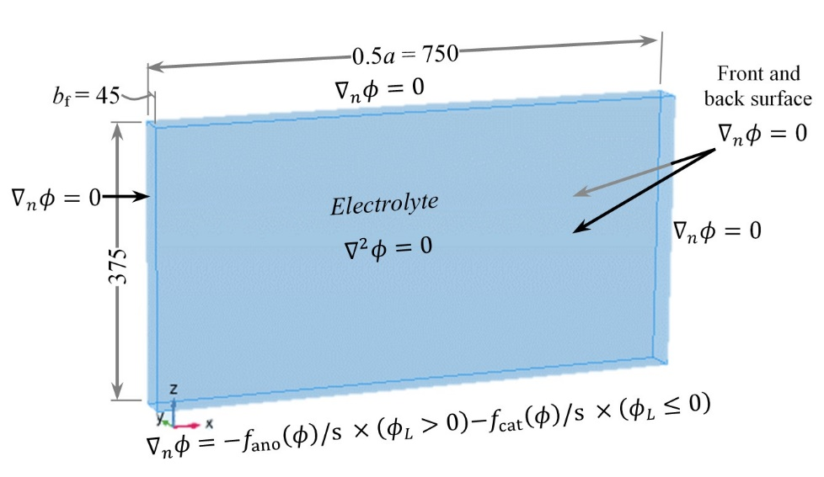

**Fig. 3.** Schematic of the level-set function ($ϕ_{L}$) configuration at the corrosion boundary and electrolyte domain boundary conditions (dimensional units: mm).

The corrosion kinetics were obtained by the authors through a set of *in situ* corrosion measurements on high strength carbon steel specimens [10]. Grade UNS G10210 (shipbuilding grade) specimens were subject to tensile stresses when immersed in a naturally aerated 3.5 wt.% NaCl solution. With a 2 mm2 area exposed to the electrolyte, the specimens were initially immersed for 30 mins, where open-circit potentials were measured to assess for pseudo steady-state conditions, before performing a potentiodynamic polarisation [10]. The potentiodynamic polarisations for various applied mechanical stress levels are shown in Fig. 4(b). These were utilised within the mechano-electrochemical FE model in Comsol. Overall, the cathodic kinetics remained relatively unchanged with applied stress (0 MPa to 420 MPa), indicating the oxygen reduction mass transfer kinetics were unaffected by the load level. This phenomenon was previously reported by Gutman [6, 17] and Zhang et al. [6, 17]. Tafel fitting was performed to assess the corrosion current density for a given stress state, and expressed as a corrosion rate using Faraday’s laws of electrolysis, see Fig. 4(b). A bilinear regression was fitted to the corrosion rate data. It should be noted that for these experimentally derived corrosion rates are expected to be higher than the overall long-term behaviour due to the short immersion time prior to measurement. The bilinear behaviour implies the corrosion rates above 120 MPa are modified by the mechanical stresses, which would nominally enhance the anodic kinetics. Although oxide film formation was not explicitly simulated in the modelling work, it is considered that the polarisation curves implicitly reflect the oxide film effect. The lowering of the net overall kinetics with a commensurate loss of reactivity at higher stress states suggests a more rapid formation of oxide layers, thus hindering the iron dissolution. The short-term data is used since corrosion products are not explicitly considered and appropriate long-term corrosion data in seawater is not readily available in the open literature. The oxide film simulation will be explored in the authors’ future work.

|  |
| --- |
|  |
| (a) |
|  |
| (b) |
|  |
| (c) |

**Fig. 4.** Inputs for the mechano-electrochemical FE model: **(a)** polarisation curves obtained from experiments; **(b)** polarisation curves used in the numerical modelling; **(c)** calculated corrosion rate showing a ranking based on the corrosion rate at each measurement point to determine the anodic level-set [10].

A level-set function, $ϕ_{L}$, was utilised to define the anodic and cathodic zones, similar to an approach used to model micro-galvanic corrosion [25]. A value of 1 was set for the anodic area and 0 for the cathodic area. The determination of anode and cathode was based on the surface von Mises stresses within the corrosion location using the level-set function, as illustrated in Fig. 3. For a specific stress distritbuon, it was assumed that there was only one anodic site on the surface. Each stress-based measurement data presented in Fig. 4(b) was ranked based on the average corrosion rate and defined as a $r\left(σ\right)$ function, where $σ$ is the surface von Mises stress in MPa:

$r\left(σ\right)= \left\{\begin{aligned}\begin{matrix}\begin{matrix}1 \\ 5\end{matrix} & \begin{matrix} 0≤σ<60 \\ 60≤σ<105\end{matrix} \\ 7 & 105≤σ<165 \\ 6 & 165≤σ<255\end{matrix} \\ \begin{matrix}4 & 255≤σ<345 \\ 3 & 345≤σ<405 \\ 2 & 405≤σ<420.\end{matrix}\end{aligned}\right.$ (4)

A single anodic area was identified based on the highest ranking number, corresponding to the highest corrosion rate. The remainder of the structural surface was then defined as the cathodic site. As the service time increases, the anodic and cathodic location redistribute depending on the surface roughness and stress distribution.  Additionally, the anodic area becomes more localised. The anodic and cathodic interface (Fig. 3) was represented as a single boundary condition in the direction normal to the metal surface, as described in Eqn. 5,

$$∇_{n}ϕ=-\frac{f_{ano}\left(ϕ\right)}{s}×\left(ϕ_{L}>0\right)-\frac{f_{cat}\left(ϕ\right)}{s}×\left(ϕ_{L}≤0\right) (5)$$

where $s$ is the electrical conductivity of the electrolyte, which was assumed to be uniform at 5 S m1 for seawater; $f_{ano}\left(ϕ\right)$ and $f_{cat}\left(ϕ\right)$ are the current densities of the anodic and cathodic surfaces, respectively. Both $f_{ano}\left(ϕ\right)$ and $f_{cat}\left(ϕ\right)$ are piecewise cubic linear interpolations of the potentiodynamic polarisation curves shown in Fig. 4(b). The potential gradient $∇_{n}ϕ$ was calculated by dividing the current density related to the anodic and cathodic level-sets with the electrolyte conductivity. The insulation/Neumann boundary condition (Eqn. 6) in the normal direction was applied to all the other boundaries.

$∇_{n}ϕ=0$ (6)

### Moving boundary technique based on Arbitrary Lagrangian-Eulerian (ALE)

The deformed electrode-electrolyte interface was simulated using the Arbitrary Lagrangian-Eulerian (ALE) method. This method incorporates features from the Lagrangian and Eulerian frames of reference to allow boundaries to move without the requirement for the mesh to follow the material [32]. The deformed interface consisted of the material (reference) frame with (*X*, *Y*, *Z*) coordinates, and the geometry frame with (*X*g, *Y*g, *Z*g) coordinates. The former had fixed coordinates, while the latter deformed with time, with the deformation controlled by the boundary conditions. Each mesh element was updated using the hyperelastic smoothing method to obtain the new geometry with time. The dissolution at the electrode-electrolyte interface was evaluated using Faraday’s laws of electrolysis with the normal velocity defined in Eqn. 7,

$$n∙v=\sum_{i}{\frac{Mj_{i}}{z_{i}Fρk}=\sum_{i}{\frac{Mf_{i}\left(ϕ\right)}{z_{i}Fρk}}} (7)$$

where $M$ is the molar mass of iron, 55.845 g mol1; is the current density, derived from the polarisation curve input for either $f_{ano}\left(ϕ\right)$ or $f_{cat}\left(ϕ\right)$, depending on the electrode surface; $z_{i}$ is the number of electrons involved in the electrode reaction, which for iron dissolution in the anodic area is 2, while for the oxygen reduction reaction the value is 4; $ρ$ is the density of steel, 7858 kg m3; and is the stoichiometric coefficients, 1 for the anodic area and 0 for the cathodic area. All the boundaries except for the electrode-electrolyte interface were set to have zero deformation.

The mesh pattern was a free tetrahedral mesh with normal element size calibrated for the general physics settings. The maximum mesh size away from the electrode-electrolyte interface was 75 mm and maximum element growth rate was 1.5. The refinement mesh at the corrosion boundary was 3 mm, which was assessed to be adequate to provide accuracy and convergence when assessing the topological changes due to the mechano-electrochemical corrosion.

### Structural scale FE model to obtain surface mechanical stress

To determine the surface von Mises stresses, a nonlinear FE structural analysis was performed using the Riks method and a quasi-static analysis in Abaqus 6.14-3. The analysis used an elastic-plastic material model with large geometric deformations. The structural model was a stiffened plate with angle bar stiffener, as shown in Fig. 5. A stiffener flange is often the most exposed structure within a seawater ballast tank, with corrosion frequently reported in ship surveys. Two plate thicknesses were analysed, *i.e.*, *t* = 6 mm and 12 mm. The model was constructed using the linear quadrilateral S4R element, a four-node shell element in Abaqus with reduced integration and hour-glassing control. Each element contained 11 integration points through-thickness. A convergence analysis indicated that a mesh size of 10 mm resulted in reasonable accuracy and optimal computational cost [9]. The edges of the plate were simply supported based on the 2012 ISSC benchmark studies and previous research [10, 33]. The UNS G10210 high-strength carbon steel used in the *in situ* corrosion test was simulated with a yield strength of 340 MPa and a Young's modulus of 214 GPa. The plastic range of the material model is defined in Fig. 6, where true stress and strain values were used.

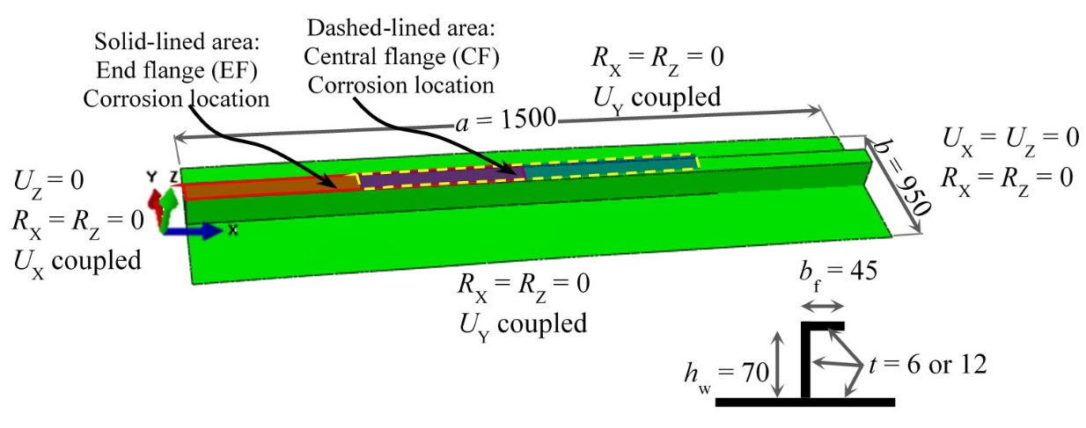

**Fig. 5.** Model geometry and boundary condition definition of a stiffened plate FE model showing two corrosion location scenarios at the central flange (CF) and end flange (EF) (unit length : mm).

Two localised corrosion locations were investigated on the surface of the stiffener flange, namely the central flange (CF) and the end flange (EF) top surfaces to determine how location affects the corrosion topography. Both had the same corrosion area of 750 mm  45 mm, stretching half the length of the stiffened plate. A uniform mesh refinement was defined at the corrosion location with an element length of 3 mm and an aspect ratio of 1. The mesh transition was produced based on the recommendations in the IACS Common Structural Rules [34]. Initial geometric imperfections, defined in Table 1, were applied to simulate the fabrication-induced deformations by modifying the nodal coordinates for each element.

**Table 1.** Initial geometric imperfections [35]

|  |  |
| --- | --- |
| Initial imperfection | Expression |
| Global initial imperfection / mm | $z=0.1β^{2}t[0.8sin⁡(πx/a)+0.2sin⁡(3πx/a)+0.01sin(3πx/a)+ 0.01sin(4πx/a)]sin(πy/b)$; where $=(b/{t)({}_{y}/E)}^{0.5}$ |
| Stiffener sideways initial / mm | $$y=-0.0015(z/h_{w})sin⁡(πx/a)$$ |
| Plate initial imperfection / mm | $$z=0.0015a sin⁡(πx/a)$$ |

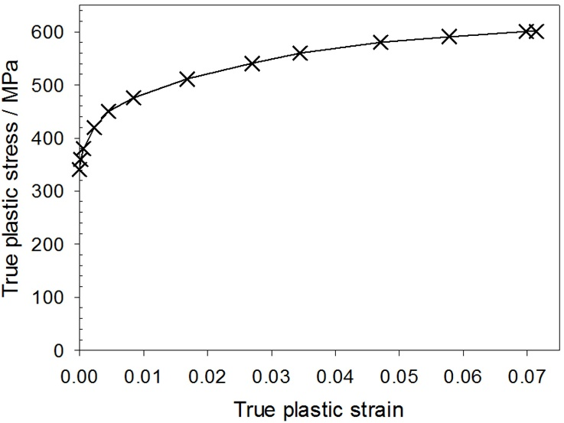

**Fig. 6.** Material plasticity for the structural scale FE model [10].

In general, stress responses within a ship under service load are designed to be generally within the elastic range, especially in the primary structural members. However, plastic stress and strain could develop in localised areas during operation [36]. This study assessed several loading conditions to understand the structural behaviour under low (20% *σ*y), medium (50% *σ*y) and high (80% *σ*y) external loads, where *σ*y represents the yield strength of the material. The overall test matrix is shown in Table 2.

**Table 2.** Test matrix for corroded stiffened plate assessment under compressive load

|  |  |  |  |  |  |  |
| --- | --- | --- | --- | --- | --- | --- |
| Case study | Thickness / mm | Corrosion location | Applied load | Case ID | End-simulation time / y | End-simulation reason |
| 1 | 6 | CF | 20% *σ*y | T06CF20 | 20 | Service life |
| 2 | 50% *σ*y | T06CF50 | 9 | Zero thickness |
| 3 | 80% *σ*y | T06CF80 | 8 | Zero thickness |
| 4 | EF | 20% *σ*y | T06EF20 | 20 | Service life |
| 5 | 50% *σ*y | T06EF50 | 5 | Zero thickness |
| 6 | 80% *σ*y | T06EF80 | 5 | Zero thickness |
| 7 | 12 | CF | 20% *σ*y | T12CF20 | 20 | Service life |
| 8 | 50% *σ*y | T12CF50 | 20 | Service life |
| 9 | 80% *σ*y | T12CF80 | 20 | Service life |
| 10 | EF | 20% *σ*y | T12EF20 | 20 | Service life |
| 11 | 50% *σ*y | T12EF50 | 18 | Zero thickness |
| 12 | 80% *σ*y | T12EF80 | 20 | Service life |

## Model verification

The model verification consisted of two parts. The first part was focused on the mechanical performance of the stiffened plate model, which was verified against a validated numerical model that was simply supported and subject to uniaxial compression. Good agreement was achieved in both the elastic and plastic regimes, leading to matched ultimate strength with a difference of less than 2% [9]. The shell elements for corrosion assessment were able to estimate stress concentration with reasonable accuracy [37], which were also verified against a set of experiments on steel plates with artificial corrosion damage and subject to uniaxial compression [8, 9, 37]. Good agreements were obtained in terms of load-shortening curves, the ultimate strength and the strain/deformation distributions on the specimen surfaces thanks to the use of 3D Digital Image Correlation. The second part of the verification was conducted on the electrochemistry modelling. This was performed by comparing the output of the surface potential distribution from time-dependent simulations and their corresponding polarisation data points from the *in situ* measurements with a difference of less than 1%. Fuller details are available in Section D (Supplementary Data).

# Results

## Corroded surface characterisation

A representative case study is selected where the corrosion zone on the flange is located at the centre (CF), with a 6 mm initial plate thickness and where a 50% *σ*y uniaxial compressive load was applied (Case 2 – T06CF50). Fig. 7 shows the remaining thickness of the stiffened plate after five years of corrosion simulation. It can be seen the greatest thickness reduction, up to 2.76 mm, is localised within the central part along the connection with the stiffener web. Uneven surface features due to mechano-electrochemical corrosion is observed across the surface. Fig. 8(a) shows the potential distribution within the electrolyte domain adjacent to the corrosion location at Year 5. A distinct anodic region is evident in the centre associated with an electronegative potential of 0.483 V *vs*. SHE. The remainder of the surface is cathodic with the area close to the edge being the least electronegative. The magnified surface topography shown in Fig. 8(b) reveals a broad-bench type of pit morphology. This is similar to actual features often observed for corroded ship structures Fig. 1(b-c). The width of the broad pits range between 10 mm and 100 mm. The thickness variation across the modelled plate surface is affected by the stress levels during the simulated 5 years, leading to a spatially uneven corrosion surface profile.

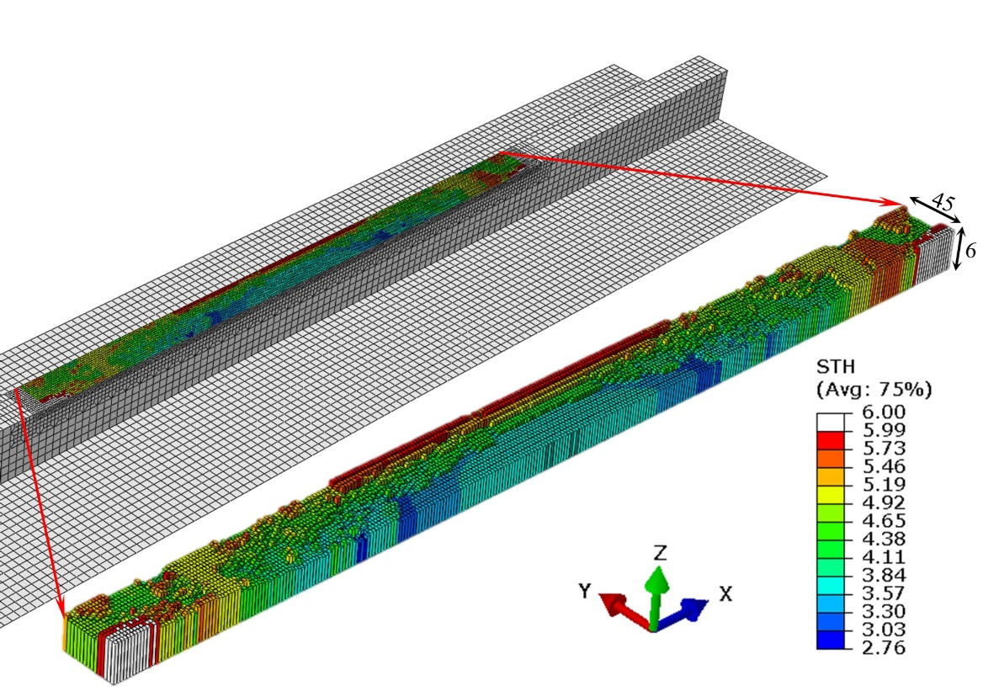

**Fig. 7.** Corrosion topography of stiffened plate flange with central flange corrosion (CF) and a 6 mm initial thickness at Year 5 for a 50% *σ*y service load (Case 2 – T06CF50), (unit = mm); shell thickness scale factor ×5.

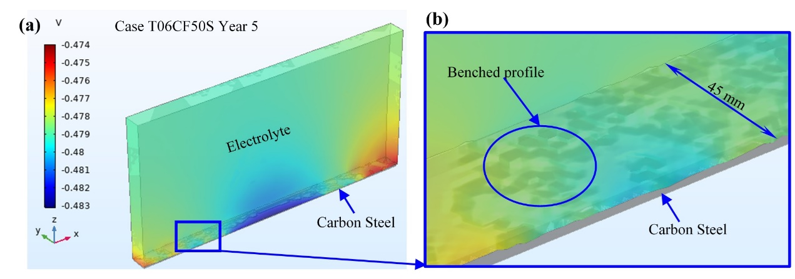

**Fig. 8.** Stiffened plate with central flange corrosion (CF) and a 6 mm initial thickness at Year 5 under a 50% *σ*y service load (Case 2 – T06CF50): **(a)** the electrolyte potential (V *vs*. SHE); **(b)** the corrosion profile on the flange surface.

Fig. 9 presents the corrosion evolution for the simulation over nine years. At Year 1, the thickness reduction predominantly occurs in a region defined within the central part of the stiffened flange, forming a semi-oval shape. This is primarily due to the initial surface stress distribution within the corrosion area. The surface topography is smooth, except for marked steps at the anodic/cathodic interface. At Year 3, with the increased interaction between corrosion activity and stress redistributions, localised irregular surface features starts to form. As time increases to Years 7 and 9, the simulated topography becomes much more complex, showing a more spatially random and rougher surface profile. The simulation terminated at Year 9 as the thickness of several elements was reduced to zero, indicating the plate thickness was perforated. The corrosion pattern resembles the real-world measurements, such as presented in Fig. 1(c).

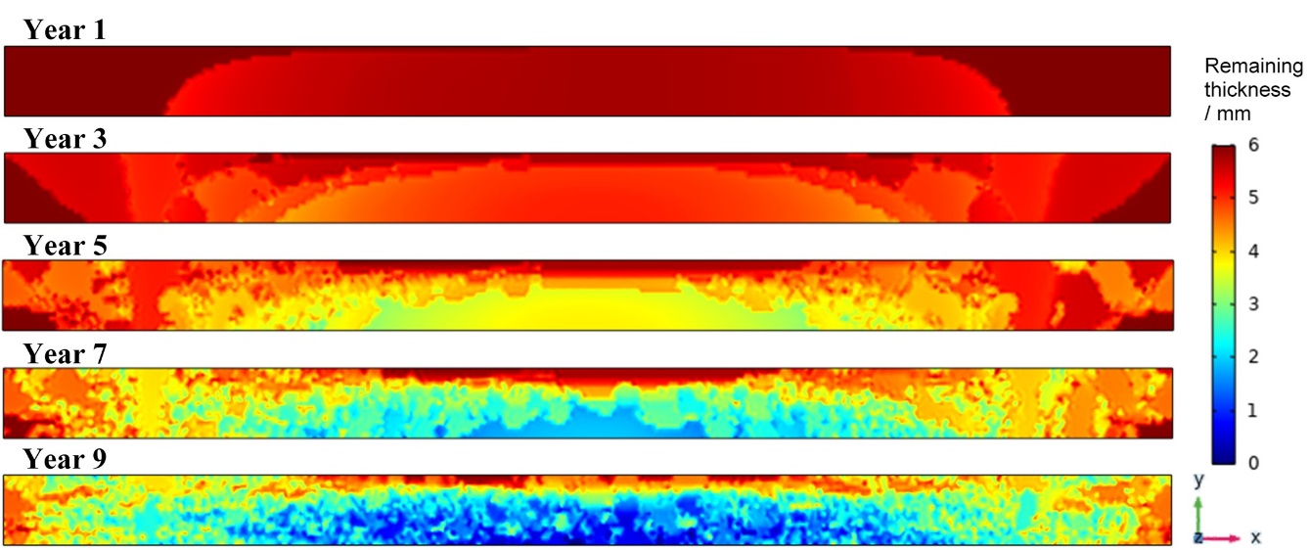

**Fig. 9.** Corrosion topography evolution within the pre-defined corrosion area on the stiffener flange surface (Case 2 – T06CF50; initial thickness = 6 mm; load = 50% *σ*y).

## Surface stress assessment and determination of anodic and cathodic kinetics

As the simulation of corrosion kinetics is explicitly linked to the stress level, it is essential to accurately predict the surface stresses on the structure with high fidelity. Fig. 10 shows an example of the von Mises stress change with time. At the first annual assessment (Year 1), the stress profile is simple with values ranging between 120 MPa and 175 MPa. The slightly higher stress region produces smooth corrosion features at the central zone of the corroded flange as shown in Fig. 9. At Year 3, the stress range increases between 107 MPa and 245 MPa, with stress concentrations aligned with features across the corroded surface. The number of local stress concentrations increases further for Year 5 as a result of cumulative irregular corrosion damage. At Years 7 and 9, multiple localised stress concentrations are irregularly scattered across the surface, where the stresses range between 11 MPa and 390 MPa for Year 9. This corresponds to the irregular thickness reduction accumulated prior to the Year 9 simulation.

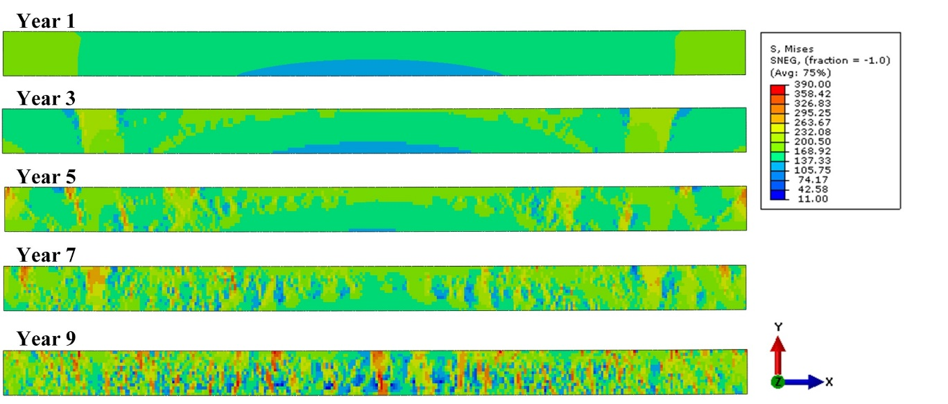

**Fig. 10.** Surface von Mises stress evolution for the stiffened plate with central corrosion and 6 mm initial thickness subject to 50% *σ*y service load (Case 2 – T06CF50), (unit: MPa).

Taking an imaginary path A-A’ (between *X* = 520 mm and *X* = 990 mm) across the corrosion area, Fig. 11 shows the level-set function ($ϕ_{L}$) for the surface von Mises stress distributions Year 1 and 9. The shaded region in Fig. 11(b) represents the anodic area with stress ranging from 105 MPa to 165 MPa. This is assigned the highest ranking number $r\left(σ\right)$ = 7 and given the level-set function of $ϕ_{L}$ = 1. The anodic polarisation curve for the 120 MPa stress level in Fig. 6(a) was used for the mechano-electrochemical modelling. The cathodic branch of the polarisation curve was used for the remaining part ( $r\left(σ\right)$ = 4 to 6) with a level-set function of $ϕ_{L}$ = 0. As time increases, the redistribution of anodic and cathodic sites due to the mechano-electrochemical effect alters the stress distribution, leading to more small localised corrosion features towards the end of simulation (Fig. 9).

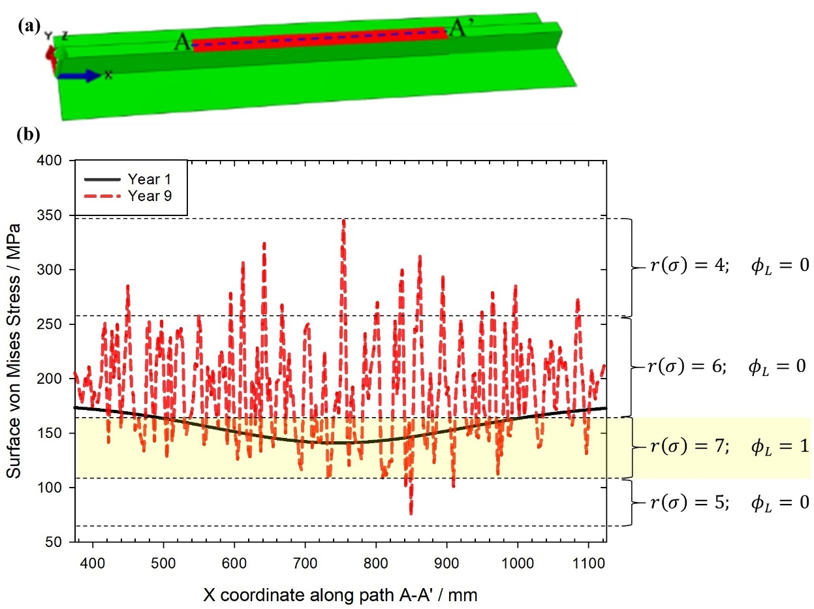

**Fig. 11.** Level-set function ($ϕ_{L}$) assessment using the surface von Mises stress for the stiffened plate with central corrosion and 6 mm initial thickness subject to 50% *σ*y service load (Case 2 – T06CF50): **(a)** path A-A’ across the corroded surface; **(b)** surface von Mises stress along A-A’ for Years 1 and 9.

## Potential distribution and corrosion current density

Fig. 12 shows the two-dimensional electrolyte potential field (colour map), the net current flow (streamlines) adjacent to path A-A’, defined in Fig. 11(a), and von Mises stress distributions along path A-A’. There are discernible changes in the electrolyte potential linked to the evolution of the irregular net current flow within the electrolyte domain. At Year 1, there are three distinct regions along path A-A’ with anodic area in the centre and cathodic area on both sides. At Years 3 and 5, the central region of the electrolyte potential field domain is still predominantly anodic. However, isolated cathodes emerge due to changes in the surface von Mises stress. For instance, the stress concentration of 220 MPa for Year 5 induces a local anodic site switching to cathodic due to the defined stress range ranking. Likewise, several smaller anodic sites of net current flow away from the steel surface and appear towards locations A and A’. More irregular thickness reductions are evident at Years 7 and 9, which result in more complex net current flow. In general, the electrolyte potential close to the metal surface becomes less electronegative.

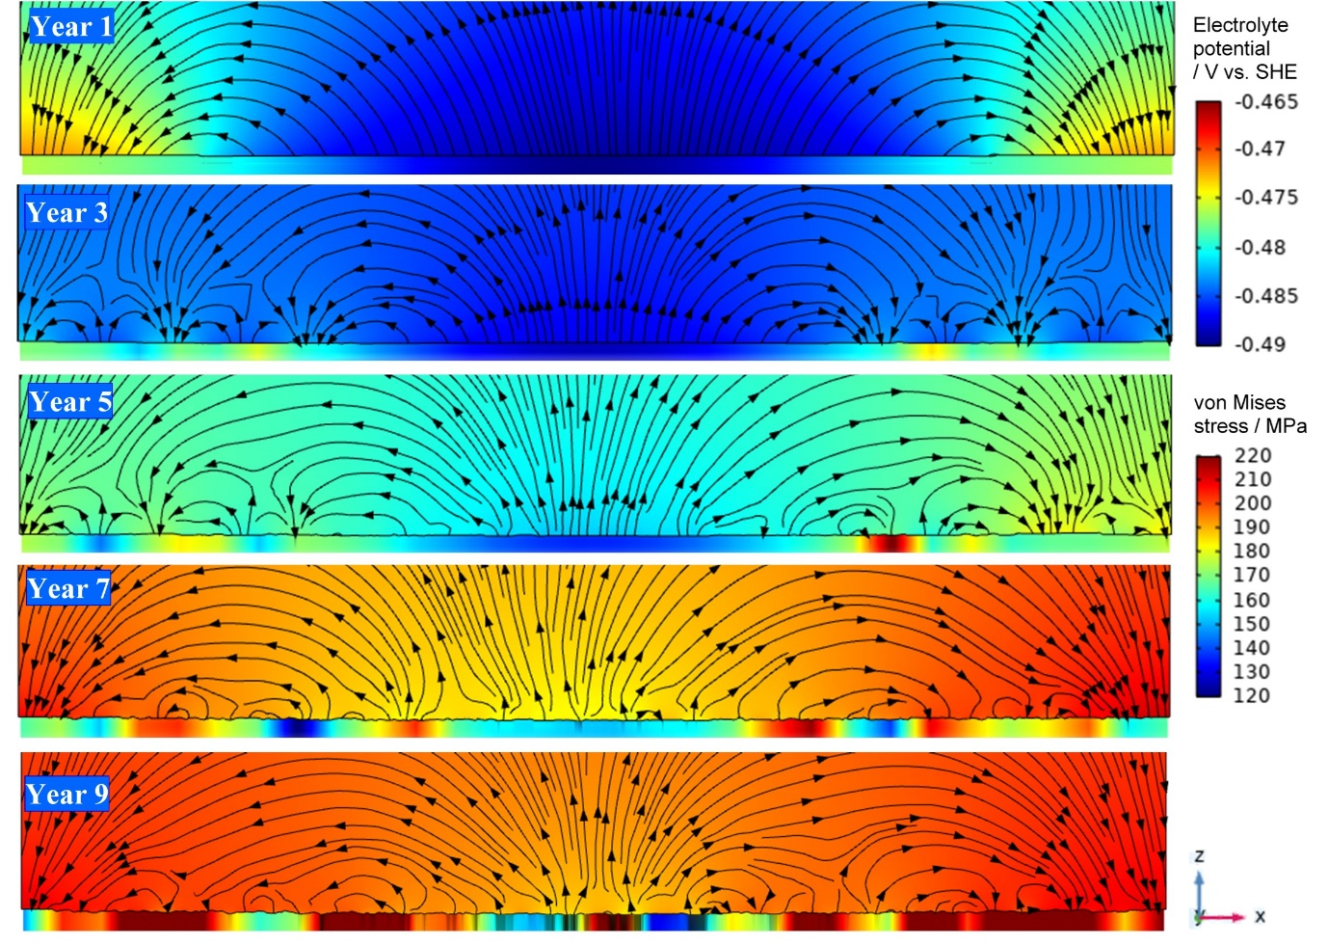

**Fig. 12.** Modelled electrolyte potential (top colour map) and net current flow (lines and arrow) above path A-A’; and the corresponding surface von Mises stress (bottom colour map) for the stiffened plate with central corrosion and 6 mm initial thickness loaded at 50% *σ*y service load (Case 2 – T06CF50); only a quarter depth of the electrolyte field (in Z-direction) is shown in each electrolyte potential colour map.

The surface potential profiles along the path A-A’ are extracted and are presented in Fig. 13. Between Year 1 and 9 the overall potential shifts in the electropositive direction by roughly 20 mV, and the difference between the maximum-minimum potential reduces from about 17 mV in Year 1 to 7 mV in Year 9. Due to the thickness reductions and stress redistributions, the central anodic site becomes smaller as time increases, with localised anodes appearing within the original cathodic area. When the simulation time reaches Years 7 and 9, the potential change reduces between the two simulations. Greater irregularity can be seen in the potential profile. However, the value of the central zone is still more electronegative than areas close to the edge.



**Fig. 13.** Evolution of potential along path A-A’ for the stiffened plate with central corrosion and 6 mm initial thickness loaded at 50% *σ*y service load (Case 2 – T06CF50).

The corrosion current density of the metal surface along A-A’ is evaluated using the Nernst-Planck equation (Eqn. 2) and presented in Fig. 14. The positive current densities represent anodes, and negative current densities are extracted from the cathodes. For Year 1, a single large anodic site is evident at the centre with a maximum anodic current density of 0.72 A m2, whereas the cathodic surfaces are situated at either end, along the *x*-coordinate, with a maximum current density of –0.57 A m2. At Year 3, more anodic sites are generated due to the stress redistribution but the maximum anodic current density remains similar. At Year 5 and 7, the anodic area spreads along the surface, with maximum anodic current densities increasing to 0.93 A m2 and 1.41 A m2, respectively. For Year 9, it is evident the anodic-cathodic locations have greater scatter across the surface and the maximum anodic current density slightly increases to 1.46 A m2. Throughout the simulation, the current density magnitude for cathodic sites remains uniform, due to the selection of the 0 MPa cathodic branch to represent the cathodic kinetics, see Fig 4(b).

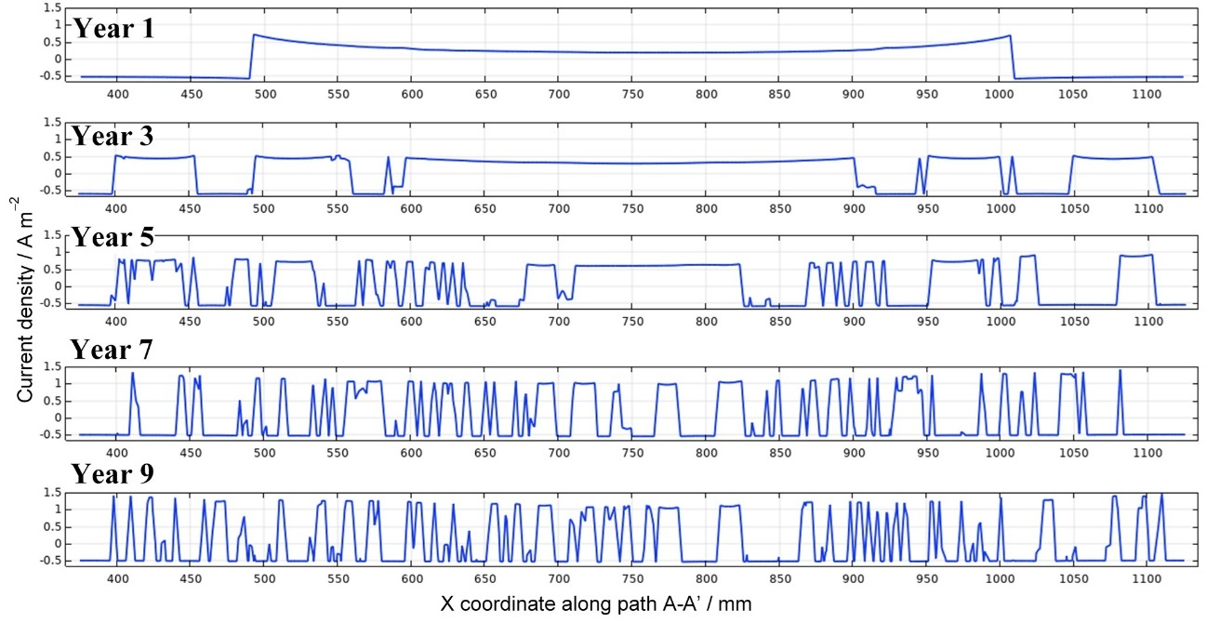

**Fig. 14.** Evolution of current density distribution along path A-A’ for the stiffened plate with central corrosion and 6 mm initial thickness loaded at 50% *σ*y service load (Case 2 – T06CF50).

## Influence of corrosion topography on structural failure mode

For most case studies corrosion has minimal effect on the overall buckling failure mode. Typically, the ultimate strength reduction due to corrosion was approximately 2%. This implies that the stress concentrations induced by the uneven surfaces do not significantly influence the structural collapse behaviour. Rather this behaviour is dominated by the corrosion location, geometric characteristics (aspect and slenderness ratios) and boundary conditions.The level of external load mainly determines the time point when perforation occurs, and hence the change in the buckling behaviour. However, when there are thick plates, T12CF50 for example, highly localised corrosion can also have a direct effect on the buckling mode. The load-shortening curves for all 12 case studies have been made available in the Supplementary Data file. Fig. 15 provides three specific case study examples, where Cases T06CF80 and T12CF50 show failure mode changes when corrosion progresses to Year 9 and Year 15, respectively. For Case T06CF80, the analysis stops at Year 9, due to perforation of the flange plate. A 6% ultimate strength reduction is observed due to a change in failure mode linked to localised buckling on the stiffener flange. In comparison, the mode change in Case T12CF50 at Year 15 is not associated with plate perforation. There is even an increase in the ultimate strength by approximately 3% compared to the intact condition. However, the new buckling mode may not be favarouble to the functional requirements of the overall structure.

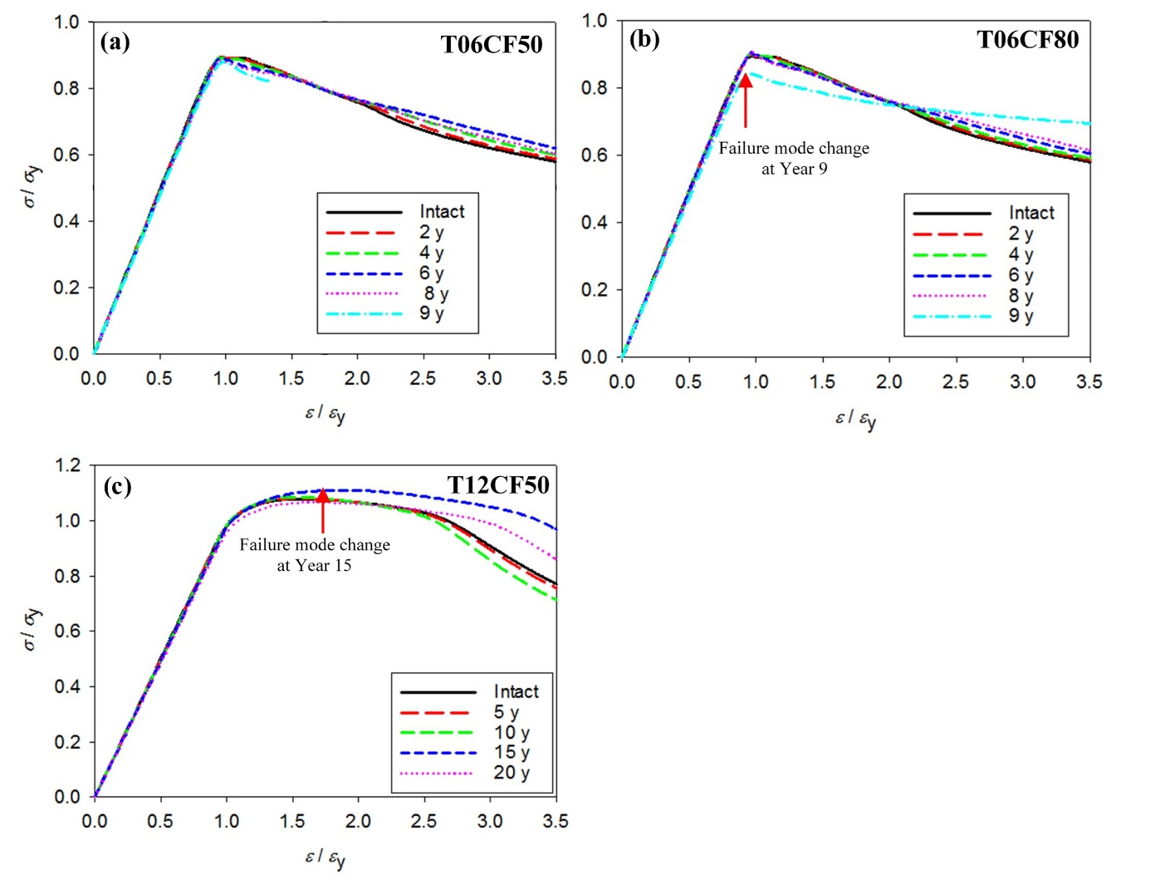

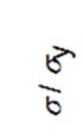



**Fig. 15.** Load-shortening curves for a stiffened plate with central flange corrosion: **(a)** 6 mm initial thickness and a 50% *σ*y service load (Case 2 – T06CF50); **(b)** 6 mm initial thickness and an 80% *σ*y service load (Case 3 – T06CF80); **(c)** 12 mm initial thickness and a 50% *σ*y service load (Case 8 – T12CF50).

Case T12CF50 highlights the importance of the structural model and long-term effects when determining the corrosion topography. In this instance, the corrosion thickness reduction is relatively uniform over 90% of the centralised exposed surface, until it reaches approximately 3 mm at Year 10, as shown in Fig. 16(a). As the surface stresses evolve from this point then two-patches of more severe localised corrosion appear at the central area at Year 15. These patches have a thickness reduction of up to 6 mm, which is half of the initial plate thickness. These patches of localised corrosion are the reason for the evident change in the direction of vertical deformation from upward at Year 10 to downward at Year 15, as seen in Fig. 16(b). This illustrates the importance of capturing the interplay between corrosion and the structural response, thus leading to more accurate predictions of failure mode changes.

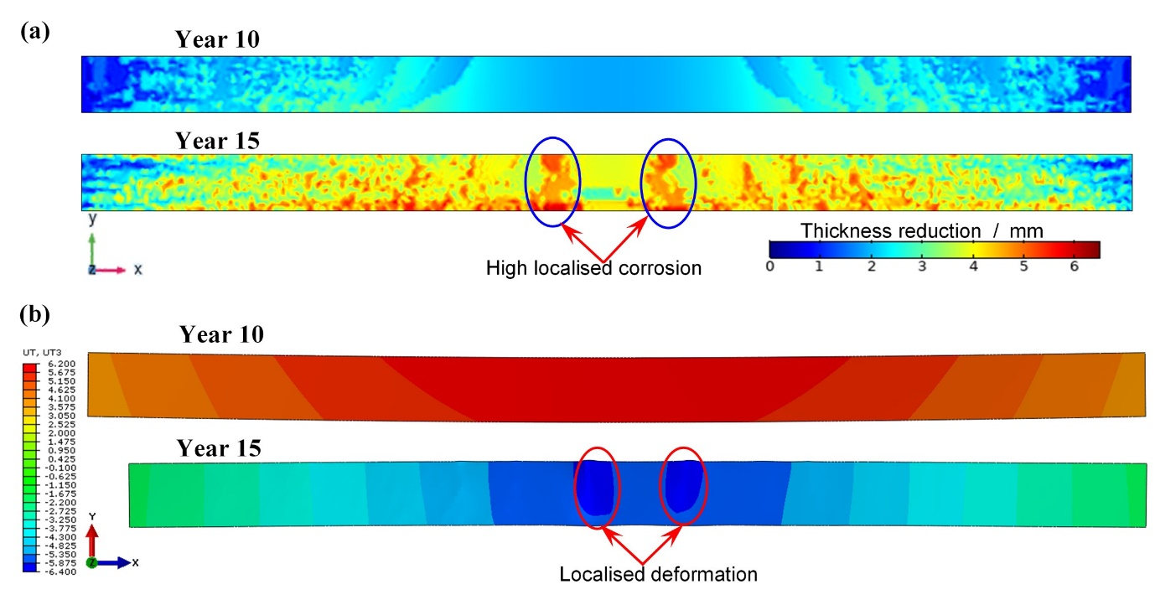

**Fig. 16.** Long-term corrosion evolution due to changes in the vertical structural deformation for stiffened plate with central corrosion, 12 mm initial thickness and service load of 50% *σ*y (Case 8 – T12CF50): **(a)** Thickness reduction, showing the distribution of material loss in the electrode; **(b)** Vertical deformation in the *Z*-direction, plotted with deformation scale × 10, affecting the Year 15 deformation which looks shorter than Year 10.

# Discussion

The present study has established a numerical framework to simulate the evolving corrosion topographies in steel structures, which are governed by coupling electrochemical and mechanical behaviour. Specifically, the formation of broad and shallow pit morphologies on structural steel are observed from the modelling results. Broad pits are typically reported during ship surveys to be of tens of millimetres in diameter, with clearly defined walls and steps, *i.e.,* benching [11, 12]. This type of corrosion feature potentially has a more pronounced effect on the overall structural integrity compared with uniform thinning of plates [9, 38]. To perform this type of modelling, the number of corrosion datasets under different stress levels is essential for accurate determination of the level-set function and to predict corrosion on structures under a wide range of stress distributions.

The modelled material loss due to mechano-electrochemical corrosion shown in Fig. 9 is further evaluated to assess the distribution of thickness reduction. The results are shown as box plots in Fig. 17. The whisker lines above and below the boxes represent the 10th and 90th percentiles and the scatter plots beyond the whiskers are extreme values (outliers). The dashed red lines are the mean thickness reductions. It can be seen that thickness decreases non-uniformly with time. The maximum thickness decreases by 1 mm in Year 1 and nearly 6 mm in Year 9. This maximum thickness reduction occurs on the edge of the stiffener flange surface, as shown in Fig. 9. The thickness reduction in Year 1 is associated with two peaks in the anodic current density distribution in Fig. 14 at *X* = 500 mm and *X* = 1000 mm along the path A-A’. Continuous long-term corrosion prediction provides a more complex corrosion topography, as seen in Year 9 in Fig. 9, which shows the development of a rougher surface from accelerated corrosion within the benches. The Year 9 analysis in Fig. 17 indicates extreme thickness reductions ranging from 0 mm to 6 mm. The increased outliers as service time increases indicates the greater number of high stress concentrations across the structural surface. Excessive thickness reductions were observed in Year 9 which ultimately leads to local perforations due to enhanced anodic activity.  As shown in Table 2, the end-simulation time for Case 12 (T12EF80) is longer than for Case 11 (T12EF50). This is due to the reduced corrosion rate as stress increases, as shown in Fig. 4c. Comparing the von Mises stress distributions at Year 15 between the two cases, see Figs. S22 and S23 (Supplementary Data), the maximum stress reaches 340 to 360 MPa for Case 12 as opposed to 210 to 220 MPa for Case 11. From Fig. 4c the corrosion rate is lower corresponding to the higher stress range. Similarly, for the electrolyte potential, it can be seen in Figs. S22 and S23 (Supplementary Data) for the higher stress range (Case 12) the potential gradient/variation is smaller than that for Case 11.

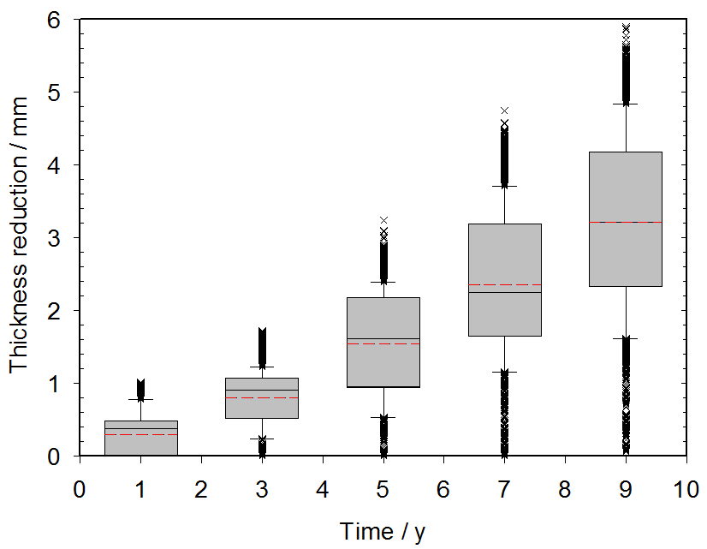

**Fig. 17.** Thickness reduction evolution of stiffened plate with central corrosion (CF) and 6 mm initial thickness; corrosion rate was affected by 50% *σ*y service load (Case 2 – T06CF50).

The simulated mean corrosion rate after nine years is about 0.35 mm y1 (thickness reduction of 3.15 mm in 9 years, from Fig. 17) with a maximum of 0.67 mm y1, which is still reasonable considering the broad variety of conditions encountered in the marine environment. It is evident from real world measurements that carbon steel pit depths can be between 2 and 10 times higher than the mean corrosion based on the mass loss principle [13-15], with pit depths varying between 0.5 mm and 5.0 mm after five years of service. This means the corrosion rate can range between 0.1 and 1.0 mm y1. It provides critical insights into the complexity of the influencing factors other than mechanical stresses affecting the corrosion kinetics and surface topography. It needs to be noted that simplifications were made in this study, *i.e*., to consider a singular anodic kinetics based on the highest corrosion rate and to assume an annual surface stress increment. The influence of rust layers is implicitly incorporated in the corrosion model due to the use of experimental corrosion kinetics data, whereas any polymeric coating effects have not been considered.

With time the surface stress range increases as shown by the stress bar changes in Fig. 10. This behaviour reduces the proportion of anodic area across the corrosion location. Table 3 summarises the percentage fractions from Year 1 to Year 9 for case T06CF50 and the statistics of the anodic current density and corrosion potential. With a decrease in the percentage of anodic area, the maximum anodic current density is increased [25]. Nonetheless, from Table 3, the maximum anodic current density is the lowest in Year 3 before increasing until year 7. The reduction from Year 1 to Year 3 is also shown along the path A-A in Fig. 14. In general, the higher the anodic current density the less negative the mean electrode potential, as shown in Table 3. The exception is for Year 9, where the maximum anodic current density decreases slightly, with zero thickness in some elements in the electrode surface. It can be seen from Fig. 13 that, between Year 7 and Year 9 of the simulation, the decrease in the current density is affected by the potential irregularity across Path A-A’. Table 3 also shows that the reduction in the anodic percentage fraction is proportional to the increase in the maximum electrode potential.

**Table 3.** Comparison of the anode fraction, maximum anodic current density, mean potential and maximum electrode potential evolution with time across corrosion location for T06CF50 (Case 2)

|  |  |  |  |  |
| --- | --- | --- | --- | --- |
| Year | Anode fraction  / % | Maximum anodic current density / A m−2 | Mean potential  / V *vs*. SHE | Maximum potential  / V *vs*. SHE |
| 1 | 65 | 0.82 | –0.483 | –0.489 |
| 3 | 60 | 0.61 | –0.485 | –0.488 |
| 5 | 45 | 1.01 | –0.479 | –0.483 |
| 7 | 31 | 1.49 | -0.472 | –0.477 |
| 9 | 29 | 1.46 | -0.470 | –0.475 |

# Conclusions

A multiscale multiphysics finite element model has been developed coupling nonlinear structural behaviour and the corrosion kinetics. The model is used to explore 12 case studies using a corroded stiffened plate (1.5 m  0.95 m) under compressive loads (20%, 50% and 80% yield stress) for a service life up to 20 years. Uniquely, the model can map distinct changes at the stress-influenced anodic and cathodic locations. The key findings are as follows:

* The new modelling approach enables the “natural” formation of broad corrosion pits with benched-shaped features as seen during ship surveys;
* The modelled corrosion topography is similar to what is observed in reality:
  + within the first couple of years in service, there is a uniform material loss within the corrosion zone;
  + broad pits develop from Year 2 or 3 with the emergence of clearly defined bench features several centimetres in size due to the interplay between stresses and corrosion kinetics;
  + as time increases, localised thickness reduction enhances the mechano-electrochemical interactions leading ultimately to plate perforation.
* The simulation captures corrosion with greater fidelity than assuming a uniform thickness reduction.
* Corrosion rates are comparable with the actual measurements of 0.1 mm y–1 for general conditions and 1.0 mm y–1 for localised corrosion.
* The irregular corrosion features may change the structural failure mode and reduce the ultimate strength by up to 6%.
* Future work will focus on the effect of rust layers and the local acidification at anodic sites.

# Acknowledgement

The authors gratefully acknowledge the Indonesia Endowment Fund for Education (LPDP), Indonesia and the Lloyd’s Register Foundation, UK for the sponsorship of this research.

# Data availability

The data that support the findings of this study are available from the corresponding author Dr Yikun Wang upon reasonable request.

# References

[1] J.K. Paik, A.K. Thayamballi, Y.I. Park, J.S. Hwang, A time-dependent corrosion wastage model for seawater ballast tank structures of ships, Corros. Sci., 46 (2004) 471-486.

[2] J.E. Silva, Y. Garbatov, C. Guedes Soares, Ultimate strength assessment of rectangular steel plates subjected to a random localised corrosion degradation, Eng. Struct., 52 (2013) 295-305.

[3] L. Feng, J. He, L. Hu, H. Shi, C. Yu, S. Wang, S. Yang, A parametric study on effects of pitting corrosion on steel plate's ultimate strength, Applied Ocean Research, 95 (2020) 102026.

[4] S. Saad-Eldeen, Y. Garbatov, C. Guedes Soares, Strength assessment of a severely corroded box girder subjected to bending moment, J. Constr. Steel Res., 92 (2014) 90-102.

[5] G. Qin, S. Xu, D. Yao, Z. Zhang, Study on the degradation of mechanical properties of corroded steel plates based on surface topography, J. Constr. Steel Res., 125 (2016) 205-217.

[6] E.M. Gutman, Mechanochemistry of solid surfaces, World Scientific, 1994.

[7] H.-Q. Yang, Q. Zhang, S.-S. Tu, Y. Wang, Y.-M. Li, Y. Huang, A study on time-variant corrosion model for immersed steel plate elements considering the effect of mechanical stress, Ocean Eng., 125 (2016) 134-146.

[8] Y. Wang, J.A. Wharton, R.A. Shenoi, Mechano-electrochemical modelling of corroded steel structures, Eng. Struct., 128 (2016) 1-14.

[9] E.C. Ilman, J.A. Wharton, Y. Wang, A.J. Sobey, Non-uniform corrosion prediction of stiffened plates due to interactions with mechanical stress, in: 1st Int. Conf. on Structural Integrity for Offshore Energy Industry, ASRANet Ltd, Aberdeen, 2018.

[10] Y. Wang, E.C. Ilman, N. Sohan Roy, A.J. Sobey, J.A. Wharton, R.A. Shenoi, Implementation of in situ corrosion measurements in structural analysis, in: 7th Int. Conf. on Mar. Struct., Dubrovnik, Croatia, 2019.

[11] R. Jeffrey, R.E. Melchers, The changing topography of corroding mild steel surfaces in seawater, Corros. Sci., 49 (2007) 2270-2288.

[12] A.D. Mercer, E.A. Lumbard, Corrosion of mild steel in water, British Corrosion Journal, 30 (1995) 43-55.

[13] B. Phull, 2.18 - Marine Corrosion, in: B. Cottis, M. Graham, R. Lindsay, S. Lyon, T. Richardson, D. Scantlebury, H. Stott (Eds.) Shreir's Corrosion, Elsevier, Oxford, 2010, pp. 1107-1148.

[14] B.W. Forgeson, C.R. Southwell, A.L. Alexander, Part 3—Underwater Corrosion of Ten Structural Steels Corrosion of Metals in Tropical Environments, Corrosion, 16 (1960) 105t-114t.

[15] C.R. Southwell, J.D. Bultman, A.L. Alexander, Corrosion of metals in tropical environments. Final report of 16-year exposures, Materials Performance (MP), 15 (1976).

[16] E.C. Ilman, Y. Wang, J.A. Wharton, A.J. Sobey, The impact of corrosion-stress interactions on the topological features and ultimate strength of large-scale steel structures, Thin-Walled Struct, (2020).

[17] S. Zhang, X. Pang, Y. Wang, K. Gao, Corrosion behavior of steel with different microstructures under various elastic loading conditions, Corros. Sci., 75 (2013) 293-299.

[18] L. Xu, Y. Cheng, Development of a finite element model for simulation and prediction of mechanoelectrochemical effect of pipeline corrosion, Corros. Sci., 73 (2013) 150-160.

[19] S. Jafarzadeh, Z. Chen, F. Bobaru, Computational modeling of pitting corrosion, Corros. Rev., 37 (2019) 419-439.

[20] A. Anderko, 2.38 - Modeling of Aqueous Corrosion A2 - Cottis, Bob, in: M. Graham, R. Lindsay, S. Lyon, T. Richardson, D. Scantlebury, H. Stott (Eds.) Shreir's Corrosion, Elsevier, Oxford, 2010, pp. 1585-1629.

[21] C.D. Taylor, P. Marcus, Molecular modeling of corrosion processes: scientific development and engineering applications, Wiley Online Library, , 2015.

[22] N.J. Laycock, D.P. Krouse, S.C. Hendy, D.E. Williams, Computer simulation of pitting corrosion of stainless steels, Electrochemical Society Interface, 23 (2014) 65.

[23] D.R. Gunasegaram, M.S. Venkatraman, I.S. Cole, Towards multiscale modelling of localised corrosion, Int. Mater. Rev., 59 (2014) 84-114.

[24] C. Bataillon, F. Bouchon, C. Chainais-Hillairet, J. Fuhrmann, E. Hoarau, R. Touzani, Numerical methods for the simulation of a corrosion model with moving oxide layer, Journal of Computational Physics, 231 (2012) 6213-6231.

[25] K.B. Deshpande, Numerical modeling of micro-galvanic corrosion, Electrochim Acta, 56 (2011) 1737-1745.

[26] C. Cui, R. Ma, A. Chen, Z. Pan, H. Tian, Experimental study and 3D cellular automata simulation of corrosion pits on Q345 steel surface under salt-spray environment, Corros. Sci., 154 (2019) 80-89.

[27] S. Scheiner, C. Hellmich, Finite volume model for diffusion-and activation-controlled pitting corrosion of stainless steel, Computer Methods in Applied Mechanics and Engineering, 198 (2009) 2898-2910.

[28] Z. Chen, F. Bobaru, Peridynamic modeling of pitting corrosion damage, Journal of the Mechanics and Physics of Solids, 78 (2015) 352-381.

[29] W. Mai, S. Soghrati, R.G. Buchheit, A phase field model for simulating the pitting corrosion, Corros. Sci., 110 (2016) 157-166.

[30] Y. Wang, J.A. Wharton, R.A. Shenoi, Ultimate strength analysis of aged steel-plated structures exposed to marine corrosion damage: A review, Corros. Sci., 86 (2014) 42-60.

[31] M. Verbrugge, Galvanic corrosion over a semi-infinite, planar surface, Corros. Sci., 48 (2006) 3489-3512.

[32] J. Donea, A. Huerta, J.P. Ponthot, A. Rodríguez‐Ferran, Arbitrary L agrangian–E ulerian Methods, Encyclopedia of Computational Mechanics Second Edition, (2017) 1-23.

[33] ISSC, Report of specialist committee III. 1 ultimate strength, in: Proceedings of the 18th International Ship and Offshore Structures Congress, Rostock, Germany 2012, pp. 285–363.

[34] IACS, Common structural rules for bulk carriers and oil tankers, in, International Association of Classification Societies, 2019.

[35] ISSC, Report of specialist committee III. 1 ultimate strength, in: Proceedings of the 17th International Ship and Offshore Structures Congress, Seoul, Korea, 2009, pp. 375-474.

[36] IACS, Common structural rules for double hull oil tankers, in, International Association of Classification Societies, London, 2012.

[37] Y. Wang, J. Downes, J.A. Wharton, R.A. Shenoi, Assessing the performances of elastic-plastic buckling and shell-solid combination in finite element analysis on plated structures with and without idealised corrosion defects, Thin-Walled Struct, 127 (2018) 17-30.

[38] Y. Wang, J.A. Wharton, R.A. Shenoi, Influence of Localized Pit Distribution and Bench-Shaped Pits on the Ultimate Compressive Strength of Steel Plating for Shipping, Corrosion, 70 (2014) 915-927.

1. Corresponding author’s email address: [yikun.wang@soton.ac.uk](mailto:yikun.wang@soton.ac.uk)