Low pressure CVD of GeE (E = Te, Se, S) thin films from alkylgermanium chalcogenolate precursors and effect of the deposition temperature on the thermoelectric performance of GeTe
Fred Robinsonª, Vikesh Sethi^{b}, C. H. (Kees) de Groot^{b}, Andrew L. Hectorª, Ruomeng Huang^{b}, Gillian Reidª; email: R.Huang@soton.ac.uk, G.Reid@soton.ac.uk
ª School of Chemistry, University of Southampton, Southampton, SO17 1BJ, UK
^{b} School of Electronics and Computer Science, University of Southampton, Southampton, SO17 1BJ, UK
Keywords
chemical vapor deposition, single source precursor, GeTe, GeSe, GeS, thermoelectric, thin film
Abstract
The homologous series, [Ge^{n}Bu₃(E^{n}Bu)] (E = Te, Se, S; (1), (3) and (4)) and [[Ge^{n}Bu₂(Te^{n}Bu)₂] (2) have been synthesized as mobile oils in excellent yield (72-93%) and evaluated as single source precursors for the low pressure chemical vapor deposition (LPCVD) of GeE thin films on silica. Compositional and structural characterization of the deposits have been performed by grazing incidence X-ray diffraction, scanning electron microscopy, energy dispersive X-ray analysis and Raman spectroscopy, confirming the phase purity and stoichiometry. Electrical characterization via variable temperature Hall effect measurements are also reported. Given the strong interest in GeTe and its alloys for thermoelectric applications, variable temperature Seebeck data were also investigated for a series of p-type GeTe films. The data show that it is possible to tune the thermoelectric response through intrinsic Ge vacancy regulation by varying the deposition temperature, with the highest power factor (40 μW/K²cm @629 K) and effective ZT values observed for the films deposited at higher temperatures.
- Introduction
The germanium monochalcogenides, GeE (E = Te, Se, S) constitute a very interesting family of layered semiconductor materials with band gaps of 0.6, 1.33 and 1.60 eV, respectively, attracting attention for a wide range of potential applications in low power electronics and thermoelectrics. Among this family, GeTe has attracted most research endeavor because of its high electrical conductivity, reversible amorphous–crystalline phase transition behavior and its applications for solid state memory.,, The two lighter congeners, GeS and GeSe, are also of interest for photovoltaic devices, while GeS has attracted consideration as a battery material.,,,
Recently, the germanium monochalcogenides have also received emergent attention as thermoelectric materials. Thermoelectric technology enables direct conversion between heat and electricity and has been considered as a clean and sustainable technology for power generation. It offer maintenance-free, solid-state operation, as well as very good reliability and a long operational lifetime. The conversion efficiency for power generation essentially requires thermoelectric materials that exhibit a high dimensionless figure-of-merit ($ZT={S^{2}σT}/k$), where $S$ is the Seebeck coefficient, $σ$ denotes the electrical conductivity, $T$ is the temperature (in Kelvin), $k$ represents the thermal conductivity which contains contribution from electrons ($k_{el}$) and phonons ($k_{l}$). Larger $ZT$ values can be achieved by improving the power factor ($PF=S^{2}σT$), while also reducing the thermal conductivity. Significant effort has been devoted to developing thermoelectric materials with ZT values in different temperature regimes. SiGe alloys and half-Heusler are strong candidates for high temperature applications, while Bi₂Te₃ based chalcogenides are among the best known materials for near-room-temperature applications, and PbTe-based alloys for mid-temperature applications., GeTe has demonstrated outstanding thermoelectric performance especially in the temperatures range 500-800 K. This makes it a promising candidate to replace the conventional Pb-based chalcogenide (e.g. PbTe) whose mass-market application is hindered by its toxicity.⁸
GeTe has been shown to be fabricated into both bulk and thin film forms through a variety of different techniques. These include high-temperature melting, spark plasma sintering (SPS), and solid-state reactions., In addition, deposition of thin film GeTe has also been reported using sputtering,, thermal evaporation, molecular beam epitaxy, and pulsed laser deposition., Chemical vapor deposition (CVD) can produce thin films with superior quality compared to those from sputtering techniques in terms of conformity, coverage and stoichiometry control. Conventionally in CVD, deposition of binary GeTe uses dual precursors, which require careful control to obtain high quality stoichiometric thin films. As an alternative solution, single source precursors can provide much easier handling and high atom efficiency for the CVD process. In addition, properties such as stoichiometry, morphology and area selectivity of the target material can be directly controlled in the precursor design. We have previously demonstrated the deposition of a range of high-quality binary (e.g. SnSe₂, TiSe₂, Bi₂Te₃ and Sb₂Te₃) and ternary (e.g. Bi₂(Se_{1-x}Te_{x})₃ and (Bi_{1-y}Sb_{y})₂Te₃) chalcogenide materials via single source precursors.,,,,,
Only a small number of single source precursors for the deposition of GeTe thin films and the formation of GeTe nanoparticles have been reported previously. The benefits of using a single source precursor include fine control over the stoichiometry, as this is designed into the precursor. These precursors include: (R₂GeTe)₃, where R is Et or Bu, as described by Gupta et al. for the thermal decomposition synthesis of GeTe nanoparticles; Some often quite elaborate species, including [Ge({N(Me₂SiCH₂CH₂Me₂Si)}₂^{i}Pr(Te^{i}Pr)] used in the metal organic CVD of GeTe thin films by Chen et al.; [Ge(Me₂NCH₂CMe₂O)₂S] and [Ge(Me₂NCH₂CMe₂S)₂E] (where E is Se or Te) described for the thermal decomposition synthesis of GeE by Kim et al.;⁸ [Ge(S₂COR’)₄] (R’=Et or ^{i}Pr) and [^{n}Bu₂Ge(S₂CO^{i}Pr)₂] described by Shah et al. for the thermolysis of GeS; and the use of [Ge(Te^{n}Bu)₄] in LPCVD described in our previous work. These precursors are unsuitable for a large number of deposition techniques due to their high molecular weights and low volatilities, as well as poorly defined thermal decomposition pathways, or, in the case of [Ge(Te^{n}Bu)₄], the unbalanced stoichiometry, which leads to some contamination by excess tellurium.
In the present study, we report the preparation and characterization of the novel single source precursors, [Ge^{n}Bu₃(Te^{n}Bu)] (1) and [Ge^{n}Bu₂(Te^{n}Bu)₂] (2), together with the lighter congeners, [Ge^{n}Bu₃(E^{n}Bu)] (E= Se (3), S (4)), and their utilization for the controlled growth of single phase GeE thin films by LPCVD onto silica substrates. The resultant films demonstrate high purity and the thermoelectric properties of the GeTe films are competitive with the state-of-art values. We also present temperature-dependent thermoelectric properties (Seebeck coefficient, electrical conductivity, carrier concentration and mobility) for the GeTe films, demonstrating a highly competitive performance. Moreover, an effective strategy for improving power factor to achieve high power factor values is by tuning the carrier concentration and using our CVD approach we also demonstrate the capability of tuning the thermoelectric performance by modifying the CVD conditions, i.e. by optimizing the deposition temperature, the p-type GeTe thin films demonstrate significantly improved thermoelectric properties, with maximum power factor of 40 μW/K²cm achieved at 629 K.
- Materials and methods
  - Single source precursor synthesis
The syntheses of the target used a dry N₂ atmosphere and employed Schlenk and glove box techniques. THF and hexane solvents were distilled from sodium wire immediately before use, while NMR solvents were stored over molecular sieves in the glove box. The ^{n}Bu₃GeCl and ^{n}Bu₂GeCl₂ were obtained from Alfa, while the ^{n}BuSH, Se and Te pellets were purchased from Sigma. ¹H, ¹³C{¹H}, ⁷⁷Se{¹H} and ¹²⁵Te{¹H} NMR spectra were recorded at room temperature using a Bruker AV400 spectrometer in CDCl₃ and referenced against residual solvent signals (¹H and ¹³C{¹H}) or against external neat SeMe₂ or TeMe₂ (⁷⁷Se and ¹²⁵Te, respectively). Elemental analyses were undertaken by Medac Ltd.
The thermal properties of the new precursor compounds were explored by TGA, using ca. 10-20 mg of each compound, which was transferred into an Al₂O₃ crucible inside a dry, N₂-purged glove box before moving into the TGA instrument which was under flowing argon. The temperature of the sample was increased at a rate of 5 °C min⁻¹ under flowing Ar, across the range 30–600 °C and the mass loss was monitored simulataneously (SI Figs. S6-S9).
[Ge^{n}Bu₃(Te^{n}Bu)] (1): Tellurium granules (0.297 g, 2.33 × 10⁻³ mol) were ground to form a fine powder in the glovebox before being suspended in THF (20 mL) and then cooling to 77 K (liquid N₂), at which point ^{n}BuLi solution in hexanes (1 mL, 1.60 × 10⁻³ mol) was added dropwise. After thawing, the solution was stirred, at which point it turned yellow and then red. A further aliquot of ^{n}BuLi solution (0.5 mL, 8.0 × 10⁻⁴ mol) was added dropwise until a light yellow color remained. A solution of ^{n}Bu₃GeCl (0.651 g, 2.33 × 10⁻³ mol) in THF (20 mL) was then added dropwise. The reaction mixture was then refluxed to 90 °C and allowed to stir for 24 h, forming an amber solution. After cooling the solution, the volatiles were removed in vacuo and hexane (30 mL) was added, causing the solution to turn cloudy (due to precipitation of the LiCl by-product). The mixture was filtered by cannula filter before removing the volatiles under vacuum, washing with further hexane (30 mL) and then taken to dryness under vacuum, leaving an orange-red oil. Yield 0.836 g, 84 %. Elemental analysis: calc. for C₁₆H₃₆GeTe (428.77 gmol⁻¹): C 44.83, H 8.46 %. Found: C 44.05, H 8.07 %. ¹H NMR (CDCl₃): δ/ppm = 0.90 (two overlapping t, J = 8.00 Hz, [12H], CH₃) 1.11 (t, [6H], GeCH₂) 1.36 and 1.40 (overlapping tq, tq and t, [14H], CH₂) 1.65 (tq, [2H], CH₂) 2.47 (t, [2H], TeCH₂). ¹³C{¹H} NMR (CDCl₃): δ/ppm = -5.51 (CH₂), 13.31 (CH₂), 13.70 (CH₃), 16.68 (CH₂), 25.01 (CH₂), 26.02 (CH₂), 28.32 (CH₂), 36.37 (CH₂). ¹²⁵Te {¹H} NMR (CDCl₃): δ/ppm = -400.1 (s).
[GeBu₂(TeBu)₂] (2): Method as described above, but using tellurium granules (2.1784 g, 1.71 × 10⁻² mol), ^{n}BuLi solution in hexanes (11 mL) and ^{n}Bu₂GeCl₂ (2.000 g, 7.76 × 10⁻³ mol). Orange oil. Yield 4.001 g, 93%. Elemental analysis: calc. for C₁₆H₃₆GeTe₂ (556.47 gmol⁻¹): C 34.55, H 6.52 %. Found: C 34.52, H 6.51 %. ¹H NMR (CDCl₃): δ/ppm = 0.89 (two overlapping t, J = 8.00 Hz, [12H], CH₃), 1.37-1.49 ( two overlapping tt and two tq, [16H], GeCH₂ and CH₂), 1.69 (overlapping t quart, [4H], CH₂), 2.58 (t with overlapping ¹²⁵Te satellites, [4H], TeCH₂). ¹³C{¹H} NMR (CDCl₃): δ/ppm = 1.97 (¹J_{125Te13C} = 138 Hz, CH₂), 13.34 (CH₃), 13.58 (CH₃), 21.52 (CH₂), 25.01 (CH₂), 25.29 (CH₂), 29.36 (CH₂), 35.55 (³J_{125Te13C} = 16 Hz, CH₂). ¹²⁵Te{¹H} NMR (CDCl₃): δ/ppm = -294.9 (s).
[Ge^{n}Bu₃(Se^{n}Bu)] (3): Selenium granules (0.229 g, 2.89 × 10⁻³ mol) were ground into a fine powder under an N₂ atmosphere (glove box) before being suspended in THF (20 mL). After freezing the solution to 77 K (liq. N₂), ^{n}BuLi solution in hexanes (1.1 mL, 1.76 × 10⁻³ mol) was added dropwise before the mixture was allowed to thaw. Upon stirring the solution turned pale yellow initially and then deepened to a red colour. Further ^{n}BuLi solution (0.6 mL, 9.64 × 10⁻⁴ mol) was then added dropwise until the pale-yellow color persisted. ^{n}Bu₃GeCl (0.735 g, 2.63 × 10⁻³ mol) in THF (20 mL) was then added dropwise and the reaction mixture was refluxed (85 °C) with stirring for 12 h. After cooling the yellow solution, the solvent was removed in vacuo and hexane (30 mL) was added, causing the LiCl by-product to precipitate. This was removed by cannula filtration and the remaining filtrate was evaporated to dryness in vacuo, washed with further hexane (30 mL) and dried under vacuum, to produce a yellow oil. Yield 0.767 g, 77 %. Elemental analysis: calc. for C₁₆H₃₆GeSe (380.03 gmol⁻¹): C 50.57, H 9.55 %. Found: C 51.11, H 9.67 %. ¹H NMR (CDCl₃): δ/ppm = 0.89 (two overlapping t, J = 8.00 Hz, [12H], CH₃) 1.04 (t, [6H], GeCH₂) 1.29 - 1.46 (overlapping tt, qt and tt, [14H] CH₂), 1.62 (tq, [2H], CH₂) 2.47 (t with overlapping ⁷⁷Se satellites, [2H], SeCH₂). ¹³C {¹H} NMR (CDCl₃): δ/ppm = 13.50 (CH₃), 13.65 (CH₂), 16.18 (CH₃), 17.36 (CH₂), 22.95 (CH₂), 26.11 (CH₂), 27.43 (CH₂), 35.53 (CH₂). ⁷⁷Se {¹H} NMR (CDCl₃): δ/ppm = -144.8 (s).
[Ge^{n}Bu₃(S^{n}Bu)] (4): To a solution of sodium metal (0.076 g, 2.52 × 10⁻³ mol) in anhydrous ethanol (15 mL) was added butane thiol (0.227 g, 2.52 × 10⁻³ mol) and the reaction mixture was stirred for 2 h forming a colorless solution. The volatiles were then removed in vacuo, depositing a white powdered solid which was then suspended in THF (15 mL) and a solution of tributylgermanium chloride (0.704 g, 2.52 × 10⁻³ mol) in THF (15 mL), was added dropwise over 5 min., to form a clear reaction mixture, which was stirred for 1 h before being refluxed at 70 °C. The resulting cloudy reaction mixture was then concentrated in vacuo and washed with hexane (15 mL) before being filtered. After removal of the solvent, the colorless oil was washed with dry hexane (20 mL) and dried under vacuum. Yield: 0.607 g, 72%. Elemental analysis: calc for C₁₆H₃₆GeS (333.12 g mol⁻¹). C 57.69, H 10.89 %. Found: C 57.54, H 10.93 %. ¹H NMR (CDCl₃): δ/ppm = 0.90 (t, J = 8.00 Hz, [12H], CH₃) 1.01 (t, [6H], CH₂) 1.35-1.42 (two tq and a tt, [14H], CH₂), 2.47 (t, [2H], CH₂) 3.65 (t, [2H], CH₂). ¹³C {¹H} NMR (CDCl₃) δ/ppm = 13.62 (CH₃), 13.67 (CH₃), 15.72 (CH₂), 21.89 (CH₂), 26.19 (CH₂), 26.26 (CH₂), 27.06 (CH₂), 35.61 (CH₂).
  - LPCVD onto fused quartz substrates
Before use, the fused quartz substrates were prepared by washing with deionized water, followed by ethanol and then drying thoroughly in an oven. Typically, the precursor (5-50 mg) and substrates were loaded into a closed ended quartz tube within a glove box. The precursor was then carefully introduced into the precursor bulb at the other end of the tube via a syringe, before the substrate tiles were placed lengthways end-to-end (usually between 0 to 4 cm away from the precursor bulb) in the CVD tube. The tube was then placed horizontally into the furnace and positioned so that the precursor bulb was protruding from the furnace, before evacuating the tube to 0.01 - 0.40 mmHg (0.01 – 0.40 Torr). The furnace was then heated to the requisite temperature (using the TGA data as a guide) and allowed to stabilize. In this study the furnace temperature settings were 550-650 ˚C (GeTe), 600 ˚C (GeSe) and 700 ˚C (GeS); with the higher temperatures required for the lighter chalcogens most likely a consequence of the higher stability of the Se-C and S-C bonds in (3) and (4) compared to the Te-C bonds in (1) and (2). At lower temperatures no GeSe or GeS films were observed.
The tube was positioned so that the precursor was sufficiently close to the heated region for evaporation to occur and this position was then maintained for 5-10 mins. until all of the precursor had vaporized. After the deposition was complete, the tube was removed from the furnace, cooled to room temperature and then transferred to the glovebox, before the substrates were removed and stored for characterization.
These experiments formed continuous reflective silver films of GeTe, grey films of GeSe, each with coverages of ca. 1 cm², and grey/black GeS films with lower coverage.
  - Thin film characterization
Scanning electron microscopy (SEM) experiments used a Zeiss EVO LS 25 with an accelerating voltage of 10 kV, and energy-dispersive X-ray (EDX) analysis were obtained from an Oxford INCAx-act X-ray detector. Raman spectra from the thin film deposits were measured at room temperature using a Renishaw InVia micro Raman spectrometer fitted with a He-Ne laser (wavelength = 633 nm) with an incident laser power of ca. 1 mW in each case.
Grazing incidence X-ray diffraction (XRD) patterns were collected using a Rigaku SmartLab system with a Hypix detector, using Cu-K_{α} radiation with a 2θ scan range from 10 – 80º and a 1° ω-offset. The crystalline phase of the deposited material was determined by comparison with an XRD pattern from the Inorganic Crystal Structure Database (ICSD), and lattice parameters were refined by optimization of the fit using PDXL.
Variable temperature electrical characterization was undertaken using the Nanometrics HL5500PC Hall effect system to determine resistivity, carrier concentration ($n_{H}$) and in-plane mobility ($μ_{H}$) using a van der Pauw method. Measurements were conducted in a range between 125 K to 450 K at 25 K step under a magnetic field of 0.5 T. Probes were ensured to be appropriately in contact with samples before each measurement. I-V curves were also recorded before each measurement to ensure Ohmic conduction as well as to optimize current for maximized voltage signal. Variable temperature Seebeck coefficient and electrical resistivity were measured using a commercial JouleYacht thin-film thermoelectric parameter test system (MRS-3L). The system was calibrated using a nickel foil reference standard and the measurement accuracy was found to be within 5%. Seebeck coefficients were determined using the differential method with a maximum temperature difference of 10 K. The resistivity was corrected for geometric error using the results from the Hall measurement system.
- Results and Discussion
  - Single source precursor synthesis and thermogravimetric evaluation
The germanium(IV) precursors (1)-(4) (Scheme 1) were identified as potential candidates for the growth of the germanium monochalcogenides, GeE (E = Te, Se, S), as they incorporate direct bonds between the Ge and E atoms, have sufficient volatility to allow vaporization in the CVD reactor and contain n-butyl groups that can readily undergo elimination reactions, leading to clean deposition of the target binary semiconductor. The target compounds (1)-(4) were isolated in very good yields as mobile oils using slightly modifications of the methods developed for [Bu₃Sn(EBu)] (E = Te, Se, S), which we have shown to be effective precursors for the LPCVD growth of SnE thin films., The synthesis of the selenolate and tellurolate precursors (1-3) require a different synthetic route to that of (4). For the latter, a range of thiols are widely available commercially and simple deprotonation and salt elimination, as illustrated in Scheme 1 (bottom), yields the target thiolate precursor, (4). In contrast, selenols (RSeH) and tellurols (RTeH) are much less readily available, less stable and more toxic than thiols, and hence the insertion of elemental Se or Te into ^{n}BuLi to obtain the selenolate or tellurolate ions directly is much preferred, as shown in Scheme 1 (top). Precursors (1)-(4) are readily hydrolyzed, but can be handled briefly in air and are stable for several months when stored under an inert atmosphere. Their purity was confirmed by a combination of NMR spectroscopic data (¹H, ¹³C{¹H}, ⁷⁷Se{¹H} and ¹²⁵Te{¹H} – see SI Figs. S10-S22) and elemental analysis.
Scheme 1: Synthesis of precursors (1)-(4).
The TGA data (Figure 1, Table 1) indicate that the temperature associated with the onset of evaporation is lowest for (3) and (4), ca. 200 ˚C, then (1), ca. 250 ˚C, before (2) at ca. 260 ˚C. From these experiments furnace temperatures were selected that would allow for the precursor bulb to reach the temperature needed for vaporization. Although the CVD experiments are performed at reduced pressure, while the TGA are performed at atmospheric pressure, the TGA data do provide a useful guide to whether a precursor may be suitable for LPCVD.
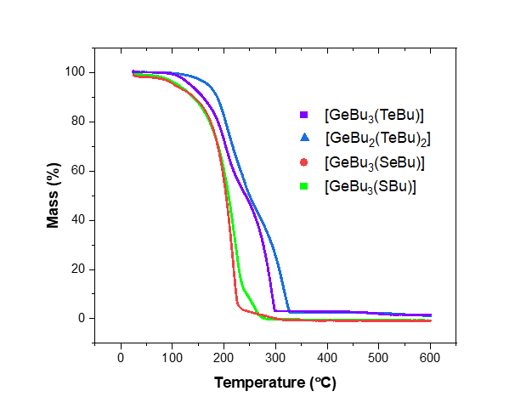
Figure 1 TGA data for precursors (1)-(4)

Table 1: Boiling points, T_{vap}, from the Sigma Aldrich material safety data sheet (for ^{n}Bu₄Sn) and estimated from the measured TGA data; enthalpy of vaporization calculated using the Clausius–Clapeyron equation, with reference values for ^{n}Bu₄Sn; entropy of vaporization calculated from ΔH_{vap}/T_{vap}, together with reference values for ^{n}Bu₄Sn.
Compound | T_{vap}  (K) | ΔH_{vap}  (kJ mol⁻¹) | ΔS_{vap}  (J K⁻¹ mol⁻¹)
Bu₄Sn* | 518.15 | 69 ± 8 (61.3)³⁰ | 137 ± 15
(1) | 493.15 | 38 ± 8 | 77 ± 19
(2) | 493.15 | 37 ± 8 | 75 ± 19
(3) | 453.15 | 76 ± 17 | 169 ± 39
(4) | 453.15 | 81 ± 18 | 178 ± 41

  - LPCVD of binary GeE films
Morphological, compositional and structural properties of GeTe
Figure 2(a)-(d) present the top-view SEM images of the four GeTe films deposited from (1) at temperatures ranging from 336 to 452 ºC (measured by T profiling across the reactor furnace); good quality crystalline GeTe thin films could be produced reliably across this temperature range, enabling thorough characterization, including thermoelectric and electrical data to identify trends. All films display arrays of continuously interconnected polycrystalline films comprised of block-like grains with varying sizes. Cross sectional SEM analysis reveal that all film thicknesses are approximately 1 µm, as shown in Figure S1. EDX analysis of the four films also appear to be similar, revealing no significant impurities (Figure S2), and confirming the Ge : Te ratios are 51(2)% : 49(2)%.
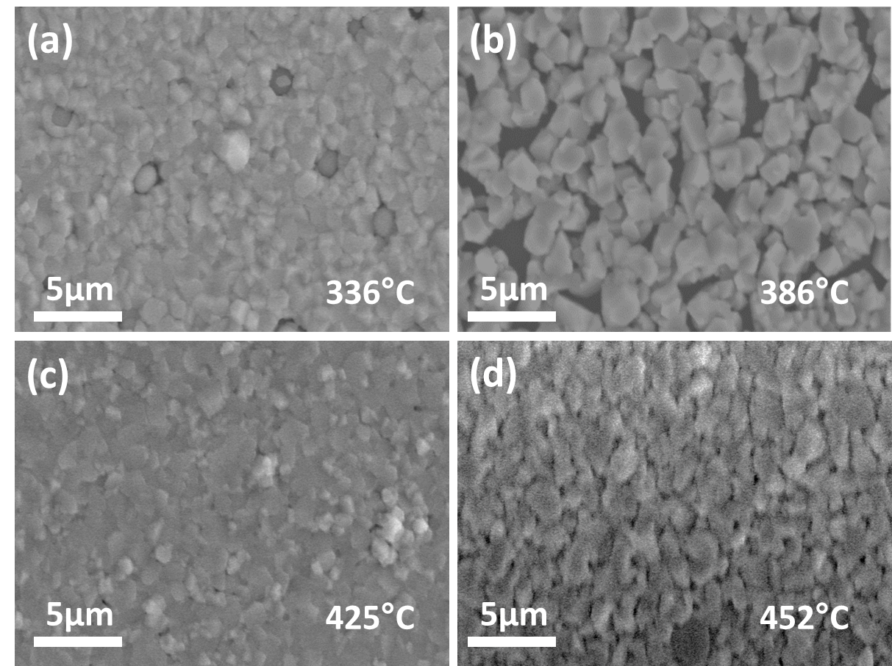
Figure 2 Top-view SEM images showing the morphologies of the GeTe films deposited by LPCVD at temperatures of (a) 336 °C, (b) 386 °C, (c) 425 °C and (d) 452 °C onto silica substrates.
Grazing incidence XRD analysis, as displayed in Figure 3a, confirms that all GeTe films deposited are rhombohedral GeTe in the space group of $R\overline{3}mh$. This is in good agreement with literature from low temperature synthesis of GeTe. The lattice parameters (a, c) of all films are very similar, as shown in Figure 3b, and are well matched with the values reported in literature (a = b = 4.1519 and c = 10.710 Å). The XRD pattern from the T_{dep} = 425 °C sample shows some evidence fore preferred orientation, with enhancement of the 021 and 220 reflections and suppression of 202 reflection; the cause of this is not certain.
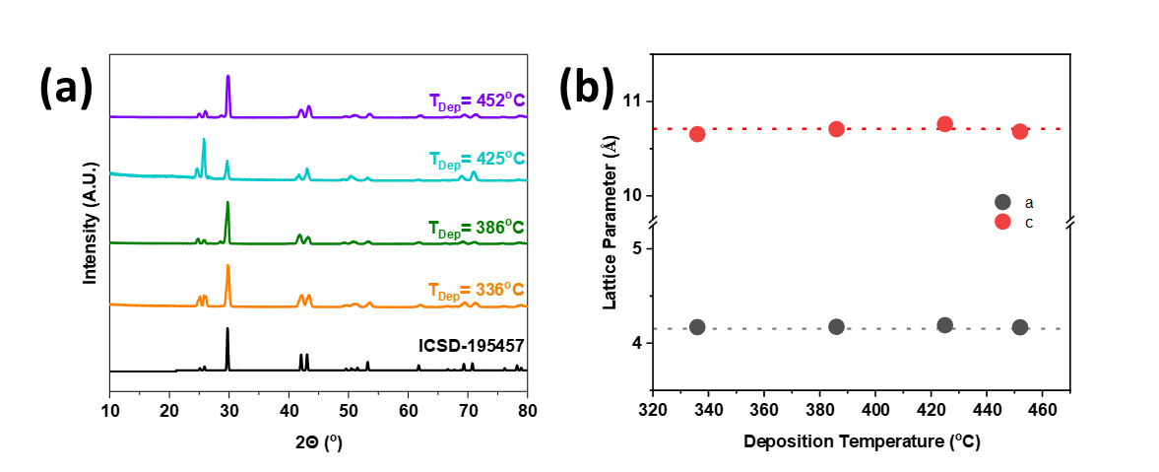
Figure 3 (a) XRD patterns of as-deposited GeTe films grown by LPCVD at a range of temperatures; (b) refined lattice parameters as a function of T_{dep} for the as-deposited GeTe films produced from precursor (1). The dotted lines represent the lattice parameter values from ref. 41.
Vibrational mode studies were conducted on these four films using Raman spectroscopy. The samples all displayed three peaks at similar positions, as shown in Figure 4a. The peak at ca. 125 cm⁻¹ (black) is suggested to be related to the symmetric stretching vibrations of GeTe₄ tetrahedra, commonly referred as the A_{1g} mode., The peak at 140 cm⁻¹ (blue peak) has been assigned previously to the aging of the sample,, while the peak at 155 cm⁻¹ (red peak) is due to vibrations of Ge atoms distinct from their distorted octahedral site.^{42,43} A red shift of the A_{1g} peak can be observed with films deposited at higher temperature and is plotted in Figure 3b. Studies conducted by Kalra et al suggest that the shift is related to screening caused by free charge carriers.⁴³ The abundance of the free charge carriers is correlated to the number of Ge vacancies found in our film. This implies that GeTe films deposited at higher temperature could result in more Ge vacancies due to the low vacancy formation energy of GeTe.⁴³ Precursor (2) also produced polycrystalline GeTe films under similar conditions by LPCVD, with closely comparable structural, compositional and thermoelectric data (Figure S3).
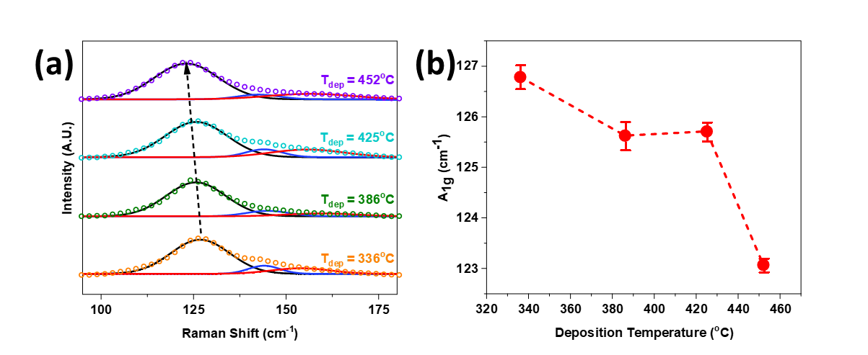
Figure 4 (a) The Raman spectra for GeTe thin films deposited from (1) at different temperatures, the open dotted curves are the Raman spectra while the black, blue and red curves represent the fitting of three vibration modes; (b) the peak positions of the A_{1g} mode of the GeTe films as a function of deposition temperature.
  - LPCVD of GeSe and GeS
LPCVD experiments at 600 °C using precursor (3) gave grey films of GeSe with morphology as illustrated in Figure 5(a). The EDX analysis in Figure 5(b) shows no significant impurities, with the Ge:Se ratio determined to be 47% : 53%. Grazing incidence XRD analysis (Figure 5(c)) suggests the GeSe film is orthorhombic and the refined lattice parameters are a = 10.8089(7), b = 3.8222(2) and c = 4.3679(3) Å. This is in good agreement with the literature (a = 10.9208(4), b = 3.8708(3) and c = 4.4075(4) Å). The film demonstrates some preferred orientation, which is supported by the enhancement of the 002 and 004 reflections in the XRD pattern. Similar preferred orientation has also been seen in previous work on GeSe films deposited by thermal transport, and is common for these types of van der Waals materials. The Raman spectrum (Figure 5(d)) is also consistent with GeSe; the peak at 151 cm⁻¹ corresponding to the B_{3g} mode, and the 175 and 189 cm⁻¹ peaks due to the A_{g} modes.

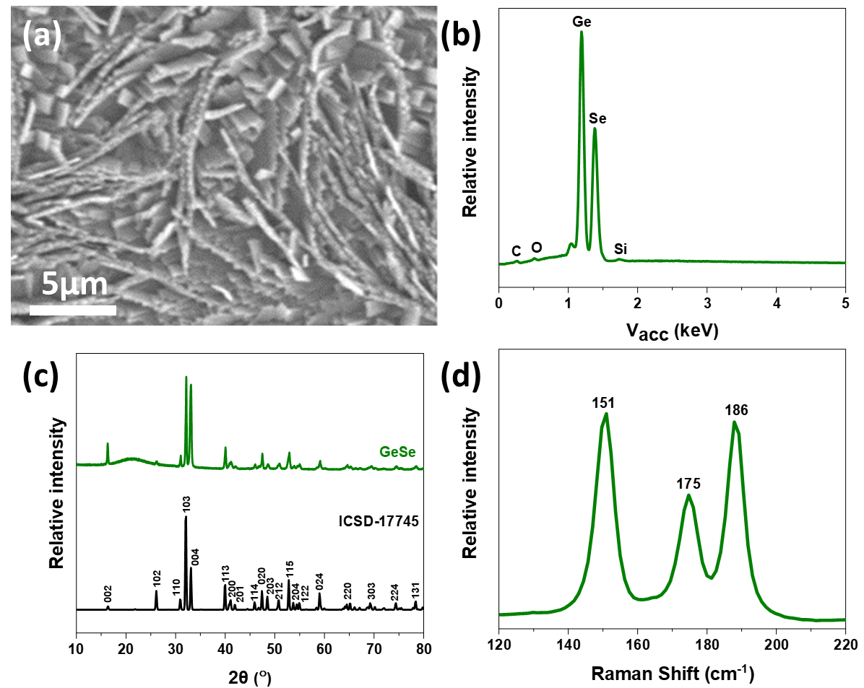
Figure 5: (a) Top view SEM image and (b) EDX spectrum of the GeSe thin film deposited from (3); (c) grazing incidence XRD pattern measured for GeSe deposited from (3) (green) and the matched literature pattern for bulk GeSe (black).⁴⁶ The broad peak around 21° arises from the quartz substrate; (d) Raman spectrum of the GeSe thin film.
Similarly, using precursor (4) produced dark grey/black GeS thin films by LPCVD at a furnace temperature of 600 °C, although the coverage was less extensive than for the heavier chalcogenides. The SEM image in Figure 6(a) shows a film of GeS, formed of large /platelet crystallites. The EDX analysis (Figure 6(b)) shows the film is sulfur deficient with a Ge : S ratio of 54.8% : 45.2%. The grazing incidence XRD pattern displayed in Figure 6(c) (blue) matches well with the literature pattern for bulk orthorhombic GeS (black), with refined lattice parameters: a = 10.4661(5), b = 4.2792(2) and 3.63594(18) Å (literature: a = 10.470(2), b 4.297(1), c = 3.641(1) Å). The Raman spectrum, displayed in Figure 6(d), is also consistent with GeS; the peak at 211 cm⁻¹ corresponds to the B_{3g} mode, the 112, 239 and 267 cm⁻¹ peaks are associated with the A_{g} modes.
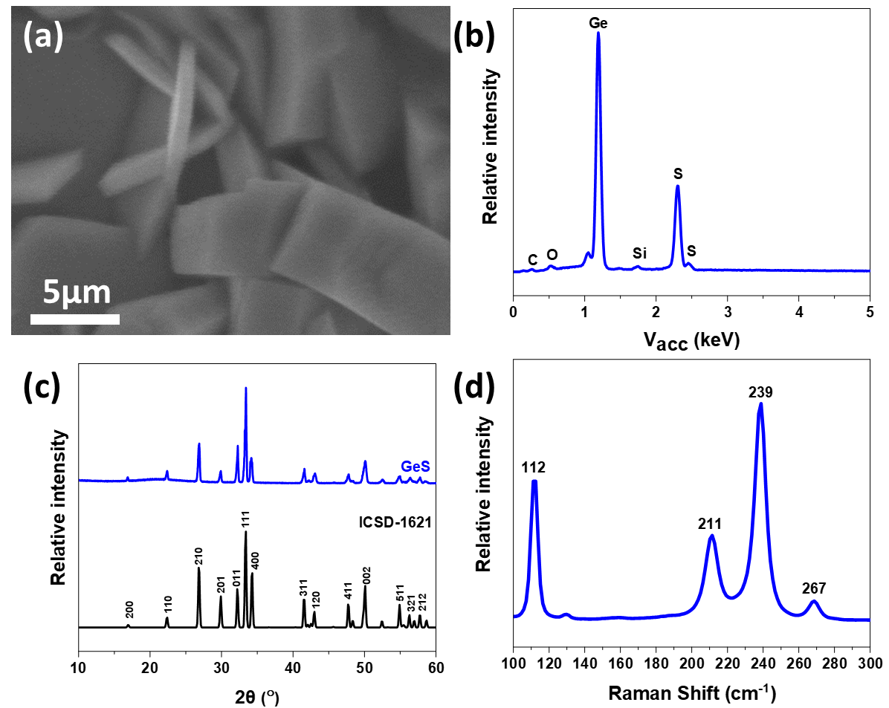
Figure 6 (a) Top-view SEM, and (b) EDX spectrum of the GeS film deposi5ed from (4); (c) grazing incidence XRD pattern for the GeS thin film (black) and the pattern from bulk GeS (black)⁴⁹ (d) Raman spectrum of the same GeS film showing with A_{g}³, B_{3g}, A_{g}¹ and A_{g}² stretches at 112, 211, 239 and 267 cm⁻¹, respectively.
3.4 Thermoelectric evaluation of GeTe films grown from (1):
The high level of interest in GeTe as a thermoelectric material prompted a study to determine the thermoelectric performance of the GeTe thin films grown using our CVD process. To this end, temperature dependent Seebeck measurements were performed. Precursor (1) was used for this study since it contains a 1:1 Ge : Te ratio and produced stoichiometric GeTe films reliably (whereas films from (2) sometimes also contained small amounts of elemental Te). Figure 7(a) presents the electrical conductivity of the four as-deposited GeTe films at a range of temperatures. It is clear that all films exhibit metallic-like electrical transport behavior as the conductivity reduces with increasing temperature. Additionally, significant variations of the electrical conductivity are observed for GeTe films deposited at different temperatures. To gain insight into the electrical transport mechanism of our GeTe films, temperature-dependent Hall measurements were made to determine the film carrier concentration and mobility. Figure 7(b) reveals that all GeTe films are p-type semiconducting with very high carrier concentrations of over 10²¹ cm⁻³. Such high carrier density results from the formation of a significant amount of Ge vacancies during the deposition process and is the main contributor to the high electrical conductivity exhibited by our GeTe films., It is also clear that the carrier concentration increases with increasing deposition temperature as suggested by the red shift of the A_{1g} Raman peak in Figure 4(b). This implies the formation of Ge vacancies is further enhanced at higher temperature, suggesting our LPCVD approach is capable of tuning the film carrier concentration by controlling the deposition temperature. On the other hand, the Hall mobility is less dependent on deposition temperature, as shown in Figure 7(c). The overall mobilities for the four GeTe films are relatively low compared with the reported values in bulk GeTe. One limiting factor could be the strong electron scattering from the Ge vacancies. Figure 7(d) plots the film mobility as a function of the crystallite size obtained from the XRD data. It appears that the mobility of the GeTe films is governed by the size of the crystallites. Smaller crystallite sizes could lead to increased frequency of boundary scattering events, resulting in lower carrier mobility. This is consistent with the lowest mobility being observed for the GeTe film deposited at 425 °C. We note that the different crystallite orientation exhibited by this film (Figure 2(a)) may also contribute to the suppression of its mobility and electrical conductivity due to the anisotropic behavior of GeTe.
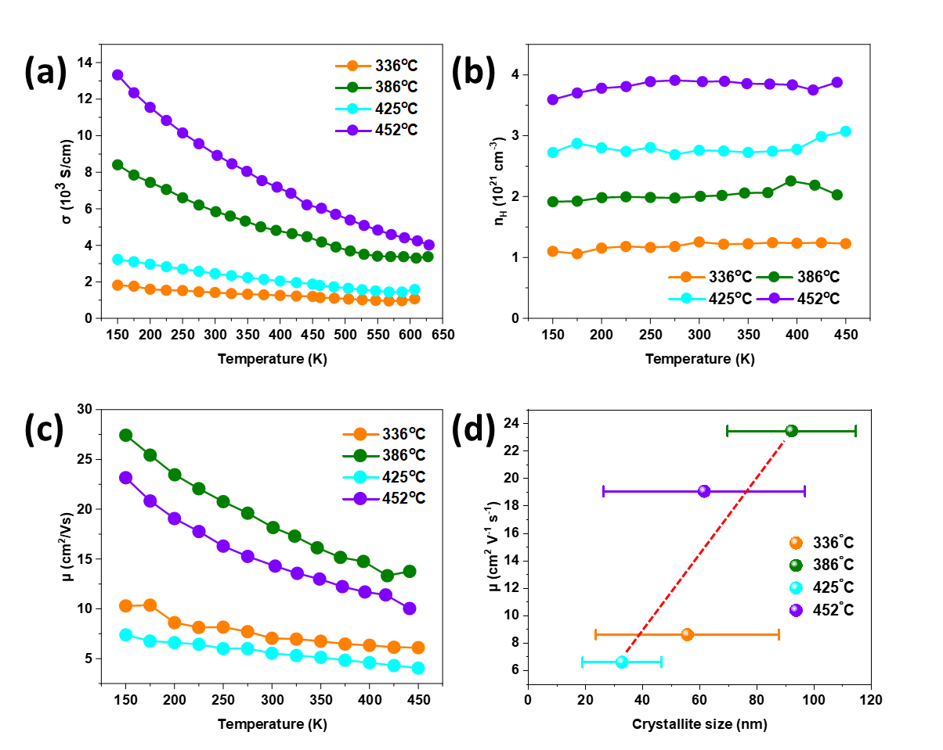
Figure 7 Temperature-dependent (a) electrical conductivity, (b) Hall carrier concentration, and (c) Hall mobility of the GeTe films deposited by LPCVD from (1) at different temperatures; (d) Room-temperature Hall mobility of the GeTe films as a function of crystallite size.
The temperature dependent Seebeck coefficients of GeTe thin films are displayed in Figure 8(a). The measurements confirm that all as-deposited GeTe films are p-type. However, unlike the electrical conductivity, the Seebeck values are less dependent on the deposition temperature and all four films are characterized by similar values. Figure 8(b) presents the Pisarenko plot of the GeTe films at 300 K. A simple electron transport model is used to calculate the dotted lines, which serve as guidelines. The model can be written as:
$$S=\frac{8π^{2}k_{B}^{2}}{3eh^{2}}{\left(\frac{π}{3n}\right)}^{2/3}m^{*}T$$
where $k_{B}$ is the Boltzmann constant, $h$ is the Planck constant, m* is the effective mass, $n$ and $T$ are the carrier concentration and temperature, respectively. This equation assumes a degenerate semiconductor with a single parabolic band and energy-independent carrier scattering.⁹ The effective mass was found to increase with higher deposition temperature, suggesting the modification of the band structure.⁵⁵ The similar Seebeck values observed from the different GeTe films is therefore a balance between the improvement brought by the increment of the effective mass and the deterioration resulting from the increasing carrier concentration. The power factors of the GeTe films can then be derived and are shown in Figure 8(c). Highly competitive power factor values are obtained from the films deposited at 452 and 386 °C, with a maximum value of 40 µW/cm·K² achieved at 629 K. This is consistent with literature regarding high-quality pristine bulk GeTe samples and to the best of our knowledge is the highest presented for pristine GeTe in thin film form.,,, Such competitive values obtained speaks to the high-quality nature of GeTe films produced from the single source precursor used in this work.
Reliable determination of the thermal conduction properties of thin films is very challenging and often prone to error. Here we estimate the total thermal conductivity by assuming a constant lattice contribution ($k_{l}$) of 0.5 W/mK. This is in-line with the values reported by others.⁵⁴ The electrical part of the thermal conductivity ($k_{e}$) was calculated from the electrical conductivity by adopting the Wiedemann-Franz law ($k_{e}=LσT$). The Lorenz number $L$ in the equation was calculated using empirical equation derived from the Seebeck coefficient proposed by Snyder et al. Unsurprisingly, $k_{e}$ is the dominating factor of the total thermal conductivity, as displayed in Figure S4. The estimated $ZT$ values are plotted in Figure 5d, showing a highest figure-of-merit of ca. 0.46 at 629 K. Thermoelectric properties of GeTe film deposited from precursor (2) were also investigated. The film was deposited at a temperature of 356 °C and demonstrate comparable performance to the films from precursor (1), as shown in Figure S5. The maximum power factor achieved is 26 µW/cm·K² at 629 K.
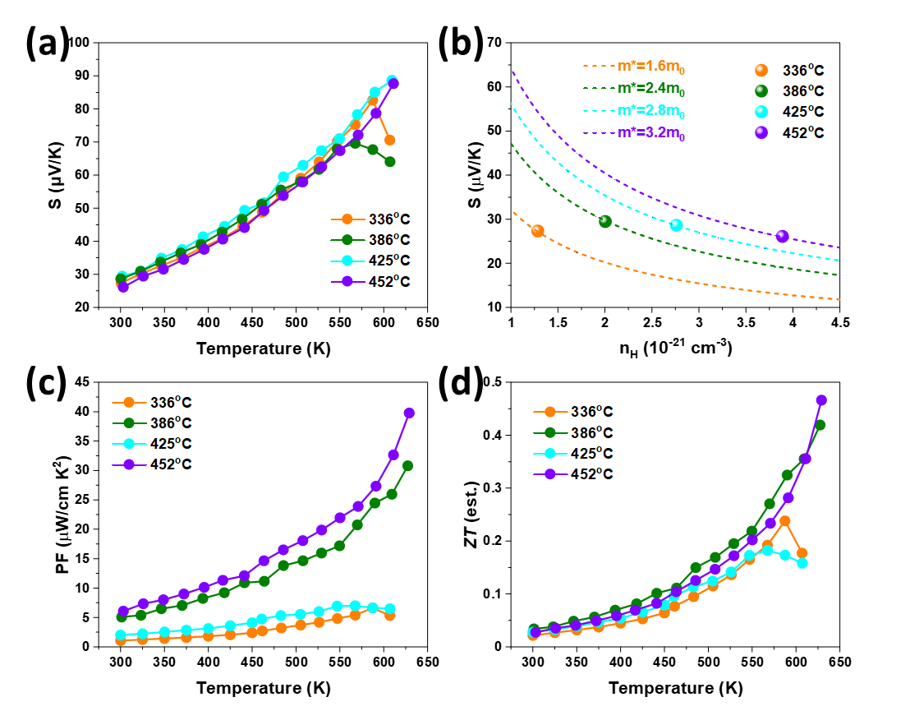
Figure 8 (a) Temperature-dependent in-plane Seebeck coefficient of the GeTe films deposited by LPCVD at different temperatures; (b) Pisarenko plot of the GeTe films at room-temperature; Temperature-dependent (c) in-plane power factors, and (d) estimated $ZT$ values of the the GeTe films deposited by LPCVD at different temperatures.
We note that the performance of our pristine GeTe is limited by its modest Seebeck coefficient and its high thermal conductivity (especially $k_{e}$), both of which have strong correlations with its high carrier concentration from inherent germanium vacancies. Further optimization of its carrier concentration is often obtained by substituting Ge with the group-15 elements (e.g. Sb and Bi).^{14,56} In addition, alloying with GeS and GeSe has also been proposed to be an effective way to improve its thermoelectric performance. The formation of a GeTe_{1-2x}Se_{x}S_{x} system introduces mass fluctuations and point defects which reduces the thermal conductivity, resulting in a significantly improved $ZT$ of 2.1. We have previously demonstrated the alloying of Bi₂Te₃ thin films with both Bi₂Se₃ and Sb₂Te₃ using our homologous single source precursors.^{30,} This highlights other potential avenues to further optimize the thermoelectric properties of the GeTe films deposited in this work.
Conclusions
The homologous series of single source precursors, [Ge^{n}Bu₃(E^{n}Bu)] (E = Te, Se, S), and [Ge^{n}Bu(Te^{n}Bu)₂], (1)-(4)), have been synthesized in good yields, fully characterized and their utility for the deposition of GeE thin films evaluated using LPCVD. The characterization of all the resulting films includes grazing incidence XRD, Raman spectroscopic data and SEM with EDX analysis. The GeE thin films produced are of good quality with little to no contamination, as shown by the EDX and Raman analysis.
Detailed thermoelectric measurements conducted on the GeTe thin films deposited using (1) indicate that the films are competitive with the literature data on bulk samples. Also identified is a correlation between the deposition temperature and the thermoelectric performance of the GeTe films. This effect could be exploited to further optimize the thermoelectric properties by adjusting the deposition temperature and mass of precursor to influence the grain size and electrical properties. Further optimization may also be possible by using a combination of precursor (1) or (2) with (3) and/or (4) to create ternary and/or quaternary alloys, leading to more profound changes in the band and crystal structures, and hence increasing the ZT value.
Acknowledgements
We thank the Engineering and Physical Sciences Research Council and Deregallera Ltd. for a CASE studentship for F.R. (EP/N509747/1) and Drs P. Curran and D. Hardie (Deregallera Ltd.) for valuable discussions.
Conflicts of Interest
The authors have no conflicts to declare.
Supporting Information (SI) includes SEM cross-sections and EDX spectra for the GeTe films from (1); SEM, EDX, XRD and Raman data for the GeTe films from (2); temperature dependent Lorentz number and total thermal conductivity for the GeTe films from (1); temperature-dependent electrical conductivity, Hall carrier concentration and mobility, Seebeck coefficient and power factor of the GeTe films from (2); isothermal TGA (Figs. S6-S9) and original NMR spectra (Figs. S10-S22) for (1)-(4).
References

. Wuttig, M.; Yamada, N. Phase-Change Materials for Rewriteable Data Storage, Nat. Mater. 2007, 6, 824-832.
. Chen, M.; Rubin, K. A.; Barton, R. W. Compound Materials for Reversible, Phase-Change Optical Data Storage, Appl. Phys. Lett., 1986, 49, 502-504.
. Raoux, S.; Welnic, W.; Ielmini, Phase Change Materials and Their Application to Nonvolatile Memories, Chem. Rev., 2010, 110, 240-267.
. Cho, Y. J.; Im, H. S.; Myung, Y.; Kim, C. H.; Kim, H. S.; Back, S. B; Lim, Y. K; Jung, C. S.; Jang, D. M; Park, J.; Cha, E. H.; Choo, S. H.; Song, M. S.; Cho, W. Germanium Sulfide(ii and iv) Nanoparticles for Enhanced Performance of Lithium Ion Batteries. Chem. Commun., 2013, 49, 4661-4663.
. Kim, H.-S.; Jung, E. A.; Han, S. H.; Han, J. H.; Park, B. K.; Kim, C. G.; Chung, T.-M. Germanium Compounds Containing Ge=E Double Bonds (E = S, Se, Te) as Single-Source Precursors for Germanium Chalcogenide Materials. Inorg. Chem., 2017, 56, 4084−4092.
. Im, H. S.; Myung, Y.; Park, K.; Jung, C. S.; Lim, Y. R.; Jang, D. M.; Park, J. Ternary Alloy Nanocrystals of Tin and Germanium Chalcogenides. RSC Adv., 2014, 4, 15695-15701.
. Talapin, D.; Lee, J.-S.; Kovalenko, M. V.; Shevchenko, E. V. Prospects of Colloidal Nanocrystals for Electronic and Optoelectronic Applications, Chem. Rev., 2010, 110, 389–458
. Roychowdhury, S.; Samanta, M.; Perumal, S.; Biswas, K., Germanium Chalcogenide Thermoelectrics: Electronic Structure Modulation and Low Lattice Thermal Conductivity, Chem. Mater. 2018, 30, 5799–5813.
. Snyder, G. J.; Toberer, E. S., Complex Thermoelectric Materials, Nature Mater. 2008, 7, 105– 114.
. Tritt, T. M., Thermoelectric Phenomena, Materials, and Applications, Ann. Rev. Mater, Sci., 2011, 41, 433-448.
. Zhou, X.; Yan, Y.; Lu, X.; Zhu, H.; Han, X.; Chen, G.; Ren, Z., Routes for High-Performance Thermoelectric Materials, 2018, 21, 974-988.
. He, J.; Tritt, T. M., Advances in Thermoelectric Materials Research: Looking Back and Moving Forward, Science, 2017, 357, eaak9997.
. Cai, B.; Hu, H.; Zhuang, H.-L.; Li, J.-F., Promising Materials for Thermoelectric Applications, J. Alloys Cmpds. 2019, 806, 471-486.
. Perumal, S.; Roychowdhury, S.; Biswas, K., Reduction of Thermal Conductivity Through Nanostructuring Enhances the Thermoelectric Figure of Merit in Ge_{1−x}Bi_{x}Te, Inorg. Chem. Front., 2016, 3, 125-132.
. Xu, X.; Lou, Q.; Wu, D, He, J., Boosting the Thermoelectric Performance of Pseudo-Layered Sb₂Te₃(GeTe)_{n} via Vacancy Engineering, Adv. Sci. 2018, 5, 1801514.
. Luo, Z.-Z.; Zhang, X.; Hua, X, Tan, G.; Bailey, T. P. Xu, J.; Uher, J.; Wolverton, C.; Dravid, V. P.; Yan, Q,; Kanatzidis, M. G., High Thermoelectric Performance in Supersaturated Solid Solutions and Nanostructured n-Type PbTe–GeTe, Adv. Funct. Mater. 2018, 28, 1801617.
. Ortiz, B. R.; Gordiz, K.; Gomes, L. C.; Braden, T.; Adamczyk, J. M.; Qu, J.; Ertekin, E.; Toberer, E. S., Carrier Density Control in Cu₂HgGeTe₄ and Discovery of Hg₂GeTe₄ via Phase Boundary Mapping, J. Mater. Chem. A, 2019, 7, 621-631.
. Srinivasan, B.; Gautier, R.; Gucci, F.; Fontaine, B.; Halet, J.-F.; Chevire, F.; Boussard-Pledel, C.; Reece, M. J.; Bureau, B., Impact of Coinage Metal Insertion on the Thermoelectric Properties of GeTe Solid-State Solutions, J. Phys. Chem. C 2018, 122, 227–235.
. Lan, R.; Otoo, S. L.; Yuan, P.; Wang, P.; Yuan, Y.; Jiang, X., Thermoelectric Properties of Sn Doped GeTe Thin Films, Appl. Surf. Sci. 2020, 507. 145025.
. Morgan, K. A.; Tang, T.; Zeimpekis, I.; Ravagli, A.; Craig, C.; Yao, J.; Feng, Z.; Yarmolich, D.; Barker, C.; Assender, H.; Hewak, D. W., High-Throughput Physical Vapour Deposition Flexible Thermoelectric Generators, Sci. Rep. 2019, 9, 4393.
. Kumar, S.; Singh, D.; Sandhu, S.; Thangaraj, R., Structural, Electrical, and Optical Properties of Thermally Evaporated Ge–Te, Ge–Sb–Te, and Sb–Te Thin Films, Phys. Stat. Solidi A, 2012, 209, 2014–2019.
. Hilmi, I.; Latnyk, A.; Gerlack, J. W.; Schmacher, P.; Rauschembach, B., Influence of Substrate Dimensionality on the Growth Mode of Epitaxial 3D-bonded GeTe Thin Films: From 3D to 2D Growth, Mater. Des. 2019, 168, 107657.
. Sun, X.; Roβ, U.; Gerlach, J. W.; Lotnyk, A.; Rauschenbach, B., Nanoscale Bipolar Electrical Switching of Ge₂Sb₂Te₅ Phase-Change Material Thin Films, Adv. Func. Mater. 2017, 3, 1700283.
. Sun, X.; Thelander, E.; Lorenz, P.; Gerlach, J. W.; Decker, U.; Rauschenbach, Nanosecond Laser-Induced Phase Transitions in Pulsed Laser Deposition-Deposited GeTe Films, J. Appl. Phys. 2014, 116, 133501.
. Aoukar, M.; Szkutnik, P. D.; Jourde, D.; Pelissier, B., Control of Carbon Content in Amorphous GeTe Films Deposited by Plasma Enhanced Chemical Vapor deposition (PE-MOCVD) for Phase-Change Random Access Memory applications, J. Phys. D Appl. Phys. 2015, 48, 265203.
. de Groot, C. H.; Gurnani, C.; Hector, A. L.; Huang, R.; Jura, M,; Levason, W.; Reid, G., Highly Selective Chemical Vapor Deposition of Tin Diselenide Thin Films onto Patterned Substrates via Single Source Diselenoether Precursors, Chem. Mater. 2012, 24, 4442−4449.
. Gurnani, C.; Hawken, S. L.; Hector, A. L.; Huang, R.; Jura, M.; Levason, W.; Perkins, J.; Reid, G.; Stenning, G. B. G., Tin(IV) Chalcogenoether Complexes as Single Source Precursors for the Chemical Vapour Deposition of SnE₂ and SnE (E = S, Se) Thin Films. Dalton Trans., 2018, 47, 2628-2637.
. Benjamin, S. L.; de Groot, C. H.; Gurnani, C.; Hector, A. L.; Huang, R.; Ignatyev, K.; Levason, W.; Pearce, S. J.; Thomas, F.; Reid, G., Area Selective Growth of Titanium Diselenide Thin Films into Micropatterned Substrates by Low-Pressure Chemical Vapor Deposition. Chem. Mater., 2013, 25, 4719-4724.
. Benjamin, S. L.; de Groot, C. H.; Gurnani, C.; Hector, A. L.; Huang, R.; Koukharenko, E.; Levason, W.; Reid, G., Controlling the Nanostructure of Bismuth Telluride by Selective Chemical Vapour Deposition from a Single Source Precursor. J. Mater. Chem. A, 2014, 2, 4865-4869.
. Benjamin, S. L.; de Groot, C. H.; Hector, A. L.; Huang, R.; Koukharenko, E.; Levason, W.; Reid, G., Chemical Vapour Deposition of Antimony Chalcogenides with Positional and Orientational Control: Precursor Design and Substrate Selectivity. J. Mater. Chem. C, 2015, 3, 423-430.
. Benjamin, S. L.; de Groot, C. H. ; Hawken, S. L.; Hector, A. L.; Huang, R.; Jura, M.; Levason, W.; Reid, E.; Reid, G.; Richards, S. P.; Stenning, G. B. G., Compositionally Tunable Ternary Bi₂(Se_{1-x}Te_{x})₃ and (Bi_{1-y}Sb_{y})₂Te₃ Thin Films via Low Pressure Chemical Vapour Deposition. J. Mater. Chem. C, 2018, 6, 7734-7739.
. Gupta, G.; Jeong, T.-M.; Kim, C. G.; Kim, J., Syntheses of Pure GeTe Crystals From Single Source Precursors (R₂GeTe)₃ (R=Et, Bu), Mater. Lett. 2015, 156, 121-124.
. Chen,, T.; Hunks, W.; Chen, P. S.; Stauf, G. T.; Cameron, T. M.; Xu, C.; DiPasquale, A. G.; Rheingold, A. L., Insertion Reactions of an Aminogermylene and Formation of a Single-Source Precursor for GeTe Thin Films, Eur. J. Inorg. Chem., 2009, 2047-2049.
. Shah, A.; Kedarnath, G.; Tyagi, A.; Betty, C. A.; Jain, V. K.; Vishwanadh, B., Germanium Xanthates: Versatile Precursors for Photo Responsive Germanium Sulfide Nanostructures, Chem. Select, 2017, 2, 4598-4604.
. Hawken, S, L; Huang, R.; de Groot, C, H,; Hector, A. L.; Jura, M.; Levason, W.; Reid, G.; Stenning, G. B. G., [Ge(Te^{n}Bu)₄] – A Single Source Precursor for the Chemical Vapour Deposition of Germanium Telluride Thin Films, Dalton Trans., 2019, 48, 117-124.
. ICSD: Inorganic Crystal Structure Database (ICSD), Fachinformationszentrum Karlsruhe (FIZ), accessed via the EPSRC funded Physical Sciences Data-Science Service hosted by the University of Southampton.
. Gražulis, S,; Chateigner, D.; Downs, R. T.; Yokochi, A. F. T. ; Quirós, M.; Lutterotti, L.; Manakova, E.; Butkus, J.; Moeck, P.; Le Bail, A., Crystallography Open Database – An Open-Access Collection of Crystal Structures, J. Appl. Crystallog., 2009, 42, 726-729.
. Robinson, F.; Newbrook, D. W.; Curran, P. J.; de Groot, C. H.; Hardie, D.; Hector, A. L.; Huang, R.; Reid, G., Low Temperature CVD of Thermoelectric SnTe Thin Films From the Single Source Precursor, [^{n}Bu₃S^{n}(Te^{n}Bu). Dalton Trans., 2021, 50, 998-1006.
. Robinson, F.; Curran, P. J.; de Groot, C. H.; Hardie, D.; Hector, A. L.; Holloway, K.; Huang, R.; Newbrook, D.; Reid, G., ^{n}Bu₂Sn(S^{n}Bu)₂ and ^{n}Bu₃SnE^{n}Bu (E = S or Se) – Effective Single Source Precursors for the CVD of SnS and SnSe Thermoelectric Thin Films. Mater. Adv., 2021, 2, 4814-4823.
. Pereira, P. B.; Sergueev, I.; Gorsse, S.; Dadda, J.; Müller, E.; Hermann, R. P., Lattice Dynamics and Structure of GeTe, SnTe and PbTe, Phys. Stat. Solidi, 2013, 250, 1300-1307.
. Goldak, J.; Barrett, C. S., Structure of Alpha GeTe, J. Chem. Phys. 1966, 44, 3323-3825.
. Polking,, M. J.; Zheng, H.; Ramesh, R.; Alivisatos, A. P., Controlled Synthesis and Size-Dependent Polarization Domain Structure of Colloidal Germanium Telluride Nanocrystals, J. Am. Chem. Soc. 2011, 133, 2044–2047.
. Kalra, G.; Murugavel, S., The Role of Atomic Vacancies on Phonon Confinement in α-GeTe, AIP Adv. 2015, 5, 047127.
. Upadhyay, M.; Murugavel, S.; Anbarasu, M.; Ravindran, T. R., Structural Study on Amorphous and Crystalline State of Phase Change Material, J. Appl. Phys. 2011, 110, 083711.
. De Bastiani, R.; Carria, E.; Gibilisco, S.; Grimaldi, M. G.; Pennisi, A. R.; Gotti, A.; Pirovano, A.; Bez, R.; Rimini, E., Ion-Irradiation-Induced Selective Bond Rearrangements in Amorphous GeTe Thin Films, Phys. Rev. B, 2009, 80, 245205.
. Okazaki, A., The Crystal Structure of Germanium Selenide GeSe, J. Phys. Soc. Jpn, 1958, 13, 1151-1155.
. Murgatroyd, P. A. E.; Smiles, M. J.; Savory, C. N.; Shalvey, T. P.; Swallow, J. E. N.; Fleck, N.; Robertson, C. M.; Jackel, F.; Alaria, J.; Major, J. D.; Scanlon, D. O.; Veal, T. D., GeSe: Optical Spectroscopy and Theoretical Study of a van der Waals Solar Absorber, Chem. Mater. 2020, 32, 3245-3253.
. Chandrasekhar, H. R.; Zwick, L., Raman Scattering and Infrared Reflectivity in GeSe, Sol. St. Commun. 1976, 18, 1509-1513.
. Bissert, G,; Hesse, K.-F., Verfeinerung der Struktur von Germanium(II)-sulfid, GeS, Acta Crystallogr. Sect. B Struct. Crystallogr. Cryst. Chem., 1978, 34, 1322-1323.
. Tan, D.; Lim, H. E.; Wang, F.; Mohamed, N. B.; Mouri, S.; Sandhaya, K.; Zhang, W.; Miyauchi, Y.; Ohfuchi, M.; Matsuda, K., Anisotropic Optical and Electronic Properties of Two-Dimensional Layered Germanium Sulfide, Nano Res., 2017, 10, 546-555.
. Zhang, X.; Bu, Z.; Lin, S.; Chen, Z.; Li, W.; Pei, Y., GeTe Thermoelectrics, Joule, 2020, 4, 986- 1003.
. Liu, W.-D.; Wang, D.-Z.; Liu, Q.; Zhou, W.; Shao, Z.; Chen, Z.-G., High-Performance GeTe- Based Thermoelectrics: from Materials to Devices, Adv. Energy, Mater., 2020, 10, 2000367.
. Bayikadi, K. S.; Sankar, R.; Wu, C. T.; Xia, C.; Chen, Y.; Chen, L.-C.; Chen, K.-H.; Chou, F.-C., Enhanced Thermoelectric Performance of GeTe Through in situ Microdomain and Ge-Vacancy Control, J. Mater. Chem. A, 2019,7, 15181-15189.
. Askarpour, V. Maassen, J., Unusual Thermoelectric Transport Anisotropy in Quasi-two-dimensional Rhombohedral GeTe, Phys. Rev. B 2019, 100, 075201.
. Yang, L.; Li, J. Q.; Chen, R.; Li, Y.; Liu, F. S.; Ao, W. Q., Influence of Se Substitution in GeTe on Phase and Thermoelectric Properties, J. Electron. Mater. 2016, 45, 5533–5539.
. Perumal,, S.; Roychowdhury, S.; Negi, D. S.; Datta, R.; Biswas, K., High Thermoelectric Performance and Enhanced Mechanical Stability of p-type Ge_{1–x}Sb_{x}Te, Chem. Mater. 2015, 27, 7171–7178.
. Ghandi, J. R.; Sankar, R., Influence Na in GeTe for Thermoelectric Applications, Mater. Today, Proc. 2020, 33, 4332–4335.
. Lan, R.; Otoo, S. L.; Yuan, P.; Wang, P.; Yuan, Y.; Jiang, X., Thermoelectric Properties of Sn doped GeTe thin films, Appl. Surf. Sci. 2020, 507, 1450254.
. Kim, H.-S.; Gibbs, Z. M.; Tang, Y.; Wang, H.; Snyder, G. J., Characterization of Lorenz Number with Seebeck Coefficient Measurement, APL Mater. 2015, 3, 041506.
. Fahmbauer, F.; Souchay, D.; Wagner, G.; Oekler, O., High Thermoelectric Figure of Merit Values of Germanium Antimony Tellurides with Kinetically Stable Cobalt Germanide Precipitates, J. Am. Chem. Soc. 2015, 137, 12633-12638.
. Newbrook, D. W.; Richards, S. P.; Greenacre, V. K.; Hector, A. L.; Levason, W.; Reid, G.; de Groot, C. H.; Huang, R., Improved Thermoelectric Performance of Bi₂Se₃ Alloyed Bi₂Te₃ thin Films via Low Pressure Chemical Vapour Deposition, J. Alloys Compds. 2020, 848, 156523.

