Recurring photic zone euxinia in the northwest Tethys impinged end-Triassic extinction recovery
Sarah J. Beith¹, Calum P. Fox², John E. A. Marshall¹, Jessica H. Whiteside^{1*}
¹ School of Ocean and Earth Science, University of Southampton, National Oceanography Centre Southampton, SO14 3ZH, UK
² Department of Earth Science, Khalifa University of Science and Technology, PO Box 127788, Abu Dhabi, United Arab Emirates
*To whom correspondence should be addressed: J.Whiteside@soton.ac.uk

Abstract
The end-Triassic extinction (ETE) is associated with rapid atmospheric CO₂-driven warming amplified by positive feedbacks involving weathering, nutrient oversupply, water column anoxia and sulphate reduction. These conditions culminated in photic zone euxinia (PZE) at least locally in the Western Tethys, but its broader extent across northwest Europe has yet to be identified. Here we present new biomarker and bulk δ¹³C_{org} isotopic data that document redox and palaeoecological changes from two end-Triassic sites in the Western Tethys: Felixkirk, in the Cleveland Basin, NE England, and Lavernock Point, in the Bristol Channel Basin, S Wales. The presence of aryl isoprenoids and Chlorobi-derived isorenieratane indicates shoaling of anoxia and toxic H₂S to the photic zone caused by flooding in restricted or semi-enclosed basins. Oscillating redox conditions and severe PZE prevented a swift recovery of at least the benthic ecosystem across several British basins. Additionally, in concert with recent discoveries at the Bristol Channel Basin, in the Cleveland Basin we find that the ‘initial’ negative carbon isotope excursion (CIE) is related to a localised change in organic matter sources. PZE in British and other European basins points towards H₂S toxicity as an extinction driver for the Western Tethys, highlighting the need for a global characterisation of redox changes across the end-Triassic and other extinction events.

Highlights:
- Redox conditions at end-Triassic extinction reconstructed by biomarkers and δ¹³C_{org}
- Severe photic zone euxinia revealed by biomarkers inhibited swift recovery from extinction
- Organic carbon isotope perturbations reflect palaeoecological shifts
- Biomarker-inferred flooding events occurred across multiple British basins
- Photic zone euxinia was possibly a Tethys-wide, even global extinction driver

Keywords: end-Triassic mass extinction; photic zone euxinia; lipid biomarkers; Chlorobi; Tethys Ocean

- Introduction
Understanding the response of marine redox systems to past intervals of global warming has become an urgent societal issue, as anthropogenic climate change is causing modern oceans to become increasingly deoxygenated. Arguably, the pulsed CO₂ outgassing from giant flood basalt eruptions of the Central Atlantic Magmatic Province (CAMP) that triggered the end-Triassic extinction (ETE) ~201.6 million years ago (Schoene et al., 2010) are a deep-time analogue to the rapid CO₂ increases observed over the last ~300 years. However, the chronology and specific roles of numerous factors, particularly deoxygenation and the spread of anoxia, that led to cascading profound biotic disruptions are not yet clearly understood.
At several ETE sections in the Tethys Ocean and the Panthalassic Ocean (Wignall et al., 2007; Williford et al., 2009; Fujisaki et al., 2018, 2020), a seemingly global ‘signature’ of carbon isotopic excursions (CIEs) in the composition of bulk organic material (δ¹³C_{org}) is recorded, along with comparable excursions in carbonate and fossil wood (e.g., Hesselbo et al., 2002). Similar excursions are identified in the sedimentary records of other mass extinctions and oceanic anoxic events and are generally interpreted as large-scale perturbations to the global carbon cycle. The ETE bulk δ¹³Corg ‘signature’ is comprised of a group of two, sometimes three, carbon isotope excursions: an abrupt, large magnitude ‘initial’ CIE followed by a more gradual ‘main’ CIE, which are commonly accompanied by a smaller amplitude ‘precursor’ CIE prior to the ‘initial’ CIE (Figure 1). In recent years the ‘initial’ CIE has been routinely used as a chemostratigraphic marker for the beginning of the ETE; however, by using a multiproxy approach to investigate two ETE sections on the far northwestern margins of the Tethys, we show there are other means of producing δ¹³Corg excursions, such as shifts in source(s) of organic matter type, which directly affect interpretations of the cause(s), effect(s) and correlations of the ETE (Whiteside and Ward, 2011; Jaraula et al., 2013; van de Schootbrugge et al., 2013; Zaffani et al., 2018; Fox et al., 2020).

  - Lavernock Point palaeogeography and palaeoecology
During the Late Triassic and Early Jurassic (232-190 Ma), continental rifting over a broad zone between the nascent North American Plate and the rest of Pangaea opened up the east-west trending Central Atlantic Ocean seaway that linked the Panthalassic and Tethys oceans and created subtropical, shallow epicontinental seas around low-lying islands in central Europe and the UK (Bradshaw et al., 1992; Golonka, 2007). The Bristol Channel Basin is an east-west elongated extension of the Celtic Sea Basin (Evans and Thompson, 1979; van Hoorn, 1987). In the Bristol Channel opposite the classic Tethyan ETE section at St. Audrie’s Bay, Somerset, SW England, lies the outcrop of Lavernock Point [ST 18732 68152] on the Glamorgan coast in South Wales, within the Penarth Special Site of Scientific Interest (Figure 2). Lavernock Point sediments were laid down close to at least one low relief palaeoisland (Bradshaw et al., 1992). The outcrop comprises the uppermost formation in the Late Triassic (Rhaetian) Mercia Mudstone Group, the Blue Anchor Formation, the Penarth Group, and the lower Lias Group (Jurassic; Hettangian) (Warrington and Ivimey-Cook, 1995). The succession records an arid continental red bed system terminated by a marine transgression, a subsequent regression-transgression pair, then a return to fully marine conditions. The Penarth Group contains the Westbury Formation, comprising transgressive deposits of dark grey, richly fossiliferous mudstones with subordinate limestones and sandstones, and the overlying more calcareous Lilstock Formation.
The lowest unit of the Lilstock Formation, the Cotham Member, consists of lowstand grey-green mudstones demonstrating intervals of subaerial exposure in the form of mudcracks and wave rippled surfaces. It contains a richly diverse bivalve fossil fauna in the lower section but a paucity of fossils one metre higher in the upper portion (Warrington and Ivimey-Cook, 1995), though in other parts of the SW UK, the Cotham Member is characterised by terrestrial plants such as the bryophyte Naiadita frequently represented by its spore Porcellispora (Poole, 1979). Above the Cotham Member is the Langport Member, a pale white-grey micritic limestone and calcareous mudstones with sparse fossils; this unit was deposited during a marine incursion (Swift, 1995). Two specimens of a new ammonite, Neophyllites lavernockensis. sp. nov., were recently discovered in the Langport Member at Lavernock Point, although not in situ (Hodges, 2021). Fully marine conditions are recorded in the succeeding basal Bull Cliff Member, the lowest unit of the earliest Jurassic Lias Group, which comprises a thin layer of paper shales below a series of intercalated dark grey mudstones and paler grey-white limestones and an increasing diversity of marine fauna (Mander et al., 2008).

  - Felixkirk palaeogeography and palaleoecology
Approximately 330 km northeast of Lavernock Point, the Felixkirk Borehole [SE48 NE/2] is located in North Yorkshire, NE England, on the western margin of the Cleveland Basin, relatively further away from land in comparison to Lavernock Point (Figure 2). Both Lavernock Point and Felixkirk are at the interface between the subtropical Tethyan and rather colder Boreal marine provinces (Cope et al., 1980; Bradshaw et al., 1992). The Cleveland Basin was connected to the North Sea Basin via the Sole Pit Basin (Zeigler, 1982) and underwent higher sedimentation rates than the East Midlands Shelf to the south (Kent, 1974). Felixkirk was drilled by the British Geological Survey in 1982 as a stratigraphic borehole to examine the succession from the Late Triassic (Rhaetian) Penarth Group to the earliest Jurassic (Hettangian) Lias Group (Powell et al., 1992).
The base of the borehole recovered the Westbury Formation of the Late Triassic (Rhaetian) Penarth Group, overlain by the Lilstock Formation and Lias Group (Ivimey-Cook and Powell, 1991). As at Lavernock Point, the Westbury Formation comprises dark grey, silty shales containing an assemblage of marine bivalve fossils and benthic fauna along with fish fragments and coprolites. The Lilstock Formation was widely reported to be represented by only the Cotham Member in this northern region of England, which consists of grey-green ‘soapy’ calcareous mudstone containing layers of a single species of bivalve along with fish fragments (Benfield and Warrington, 1988). No micritic porcellaneous limestones which typify the Langport Member in South Wales, SW England or in the Midlands were recognised above the Cotham Member at Felixkirk (Ivimey-Cook and Powell, 1991). Powell (1984) categorised the locally shelly calcareous mudstones above the Cotham Member as the basal part of the Redcar Mudstone Formation (Lias Group) due to their lithological similarity with the basal Lias Group, constrained biostratigraphically to be latest Rhaetian age, correlating with the equivalent beds of the Acklam Borehole further south in the Cleveland Basin (Gaunt et al., 1980). Our Felixkirk biomarker results provide further late Rhaetian age control (Section 3.4). Due to lithological changes and low TOC, we identified the unit between 287.18 and 288.87 m as representative of the Langport Member, and the TOC-rich mudstone units above 287.18 m as representative of the Redcar Mudstone Formation (Figures 3, 4, 5 and 6). The Redcar Mudstone Formation has a similar lithology to that exposed in outcrops across England and Wales: a relatively thin bed of fissile paper shales overlain by alternate limestones and mudstones which contain a fully marine faunal assemblage.

- Materials and methods
2.1 Sample collection and preparation
High resolution sampling was conducted every 40 cm or less through the end-Triassic interval in the Felixkirk Borehole (SE48 NE/2) from the British Geological Survey, Keyworth, UK. The outer rims of samples were trimmed with a saw, and the interiors finely powdered using a benchtop IKA-WERKE grinder. For the Lavernock Point outcrop succession, sampling was conducted every 50 cm or less. All samples were wrapped and stored in aluminium foil that had previously been heated to 400°C to remove any organic contaminants. All glassware, quartz sand, glass wool and silica gel was furnaced at 400°C for 12 hours to remove any organic contaminants and metal implements were solvent-rinsed.

2.2 Total Organic Carbon and bulk δ¹³Corg analyses
Powders were decarbonated by reaction with 10% HCl overnight, centrifuged, and rinsed with MilliQ water until pH neutral. The decantant was dried in a 50 °C oven and weighed (~10 or ~30 mg) into clean tin capsules then analysed for organic carbon and the carbon isotopic composition of bulk organic δ¹³C at the National Oceanography Centre Southampton, using an Elementar PYRO Cube Elemental Analyser in CNS mode equipped with a thermal conductivity detector (TCD), interfaced with an Isoprime visION continuous flow isotope ratio mass spectrometer (IRMS). Acetanilide was the elemental standard for C. Total Organic Carbon (TOC) values were corrected for sample loss on decarbonation. δ¹³C_{org} data were calibrated with international reference materials USGS-40 and USGS-41a, and are expressed in standard delta notation relative to Vienna Pee Dee Belemnite. Precision of the method was 0.6% for TOC and 0.2 - 0.3% for δ¹³Corg.

2.3 Biomarker preparation and analysis
Before extraction, 50 µl 1-bromohexadecane and 9-bromophenanthrene were added to assess recoveries for aliphatics and aromatics respectively (Table S.1). Approximately 6 g of rock powder for samples with TOC contents ≤1% and ~1 g for samples with TOC content >1% were extracted with DCM:MeOH (9:1 v/v) using a Dionex ASE 350 accelerated solvent extractor with the following program: preheat 5 min; heat 5 min; static 5 min; pressure 1500 psi; flush 70%, purge 300 s; cycles 3. Total lipid extracts (TLEs) were concentrated in a GeneVac EZ-2 vacuum centrifuge, transferred into pre-weighed vials, gently evaporated below a stream of pure N₂ at 80°C, and dried and weighed (Table S.1). TLEs were then fractionated into three fractions by liquid chromatography in glass pipette columns packed with activated silica gel. Aliphatic hydrocarbons were eluted with hexane, aromatic hydrocarbons with hexane:DCM (4:1 v/v) and polar fractions with DCM:MeOH (1:1 v/v). Elemental sulphur (S) was removed from aliphatic fractions using acid-activated (4N HCl) Cu beads. Aliphatic and aromatic fractions were then blown down with N₂, transferred in hexane (aliphatic) and DCM (aromatic) to GC vials, then blown down again and made up in DCM to a 50 µl or 150 µl final volume.
Aliphatic and aromatic hydrocarbons were analysed by GC-MS using a Thermo Trace 1310 gas chromatograph (GC) coupled to a Thermo TSQ8000 mass spectrometer (MS). The carrier gas was He with a flow rate of 2 ml/min; injection volume was 1 µl. The column was a DB-5 (30 m; 0.25 mm i.d.; 0.25 µm film thickness). The temperature program was 40°C held for 2 min, increased to 310°C at 6°C/min, held at 310°C for 20 min. The MS was operated in electron ionisation mode (EI, 70 eV) in full scan mode (50 – 650 m/z). The data acquisition software used was Xcalibur 3.0; biomarker identification was made using mass spectra and relative retention time with Norwegian Geochemical Standard North Sea Oil 1 (NSO-1) as a reference standard. The GC-MS was run in selected ion monitoring (SIM) mode using m/z 191 and 205 to aid in identification of gammacerane in addition to a sediment extract from the basal Blue Lias at St. Audrie’s Bay (SAB, 5/5/11 27) characterised by Fox et al. (2020).
Semi-quantitative measurements of isorenieratane and C30 4-methylsterane (Supplementary Information) concentrations were achieved by the use of butylbenzene and cholestane as external standards.
Data quality was ensured using one procedural blank (quartz sand) analysed every ten samples. An instrument blank (DCM) and the NSO reference were used at the beginning of each sample sequence and repeated after every ten measurements. Repeatability of the GC-MS injection was 1.1– 2.3% for all batches.

2.4 Vitrinite reflectance
Approximately 5 g of each sample was crushed into small pieces with a lump hammer and put into a 500 ml plastic bottle. Carbonates were removed by reaction with ~ 30 ml of 37% HCl overnight. The acid was then decanted and the residue was repeatedly decant washed with deionised water until pH neutral and again decanted. Silicates were removed using 60% HF and left overnight, then shaken vigorously and left for 5 hours before repeatedly decant washing until pH neutral. The final rinse was decanted, the residue was sieved through a 15 µm nylon mesh and poured into a 250 ml glass beaker. Water was aspirated out of the beaker using a suction tube until 25 ml remained; 25 ml of 37% HCl was then added. Using a Bunsen burner, the acidified residue was boiled for 60 seconds, diluted, and sieved again through a 15 µm mesh back into the beaker and allowed to settle overnight. After removing half the volume of clear water, the residue was concentrated on a 15 µm mesh and then stored in a small plastic vial. Polished thins were then made using the method of Hillier and Marshall (1988). After being allowed to settle, most of the clear water above the vialed residue, now mainly kerogen, was removed by pipette and a small amount of the residue was pipetted onto a PTFE (polytetrafluoroethylene)-sprayed coverslip, allowed to dry and then mounted on a frosted microscope slide with Fastglass® resin. Once set, the PTFE cover was carefully prised off using a razor blade. Mean vitrinite reflectance in oil (R_{o}) was measured at 546 nm using a Zeiss UMSP microscope equipped with a x40 oil immersion objective, taking the average value of 50 measurements of the percentage of incident white light reflected from the vitrinite phytoclasts. Standards used to calibrate the microscope were YAG (yttrium-aluminium-garnet) with R_{o} = 0.919% and spinel (R_{o} = 0.413%).

- Results
  - Bulk geochemistry
Throughout the upper two metres of the Cotham Member and the first metre of the Langport Member at Felixkirk, TOC ranged from 0.2 to 0.5% (Table S.1; Figures 3 and 4). Based on laboratory observation, elemental S was not recovered during removal with activated Cu, with the exception of depth 289.10 m near the top of the Cotham Member and again in quantity at 288.50 and 288.30 m in the Langport Member. Above 287.90 m, TOC exhibits a series of fluctuations, first rising to 3.0% then dropping down to 0.7%, and thereafter varying in the range 2.1 to 5.1%. Some elemental S was observed at depths of 286.90 m and 285.40 m in the Redcar Mudstone Formation. Smaller amounts of elemental S were observed above 285.40 m in all samples but two (285.35 and 284.65 m). Above 285.40 m TOC fluctuated much more sharply, with a maximum of 8.0% at 285.30 m then oscillating between 1.7 and 7.4%.
Throughout deposition of the upper 1.24 m portion of Langport Member limestones at Lavernock Point, TOC remained low, between 0.2 and 0.4% (Table S.1; Figures 3 and 4). Pronounced organic matter enrichment is seen at the base of the Bull Cliff Member; TOC percentages abruptly increase to 4.2 % at 1.34 m, followed by a drop to 1.4% at 1.48 m and a subsequent sharp increase to a maximum of 8.6% at 1.74 m. Throughout the remainder of the Bull Cliff Member above this maximum, TOC oscillates between 0.7 and 4.8 % as alternating mudstones and limestones were deposited. Elemental S was not observed in any Lavernock Point samples.
At Felixkirk, the Cotham Member mudstone bulk δ¹³C_{org} trend is mostly monotonic at ~ -24.8‰, with the exception of a small 1.7‰ positive excursion from 290.10 to 290.00 m during deposition of a fine-grained calcareous limestone (Figures 3 and 4). The uppermost Cotham Member, at 289.50 m, marks the beginning of a pronounced excursion, labelled in this study as the Upper Cotham Carbon Isotope Excursion (UC-CIE), that spans two metres of sediment across the Cotham - Langport boundary. The negative portion of this CIE (highlighted by a yellow band, Figure 3) between 289.50 and 288.50 m forms a series of transient negative and positive fluctuations, the largest of which shows an abrupt ~5.5‰ decrease from -23.3‰ at 288.94 m to -28.8‰ at 288.92 m. The positive portion of the CIE (highlighted by a purple band, Figure 3), the majority of which is recorded in the Langport Member non-micritic, silty limestone, lies between 288.50 and 287.50 m and shows no oscillations; instead, the isotope profile shows a steady increase from -28.2‰ to -25.6‰, then a more gradual climb to -25.4‰ by 287.50 m. Throughout the remaining Felixkirk Langport Member and Redcar Mudstone Formation up to 284.45 m, the bulk δ¹³Corg never fully returns to its Cotham Member value of ~24.8‰ but does exhibit relatively stable behaviour with values becoming gradually more negative above 285.70 m.
Unlike Felixkirk, the Lavernock Point sampling interval begins in the Langport Member. Here, from an oyster bed at 0.26 m, the bulk δ¹³Corg increases from -28.1‰ to -26.8‰ at 1.22 m (albeit with some fluctuation). Succeeding this, in the paper shales of the basal Bull Cliff Member, there is a pronounced isotopic shift (-2.1‰ then +2.0‰), exhibiting the largest transient change in bulk δ¹³C_{org}. Above the paper shales, up through the Bull Cliff Member intercalated mudstones and limestones from 1.94 m to 4.48 m, the bulk δ¹³C_{org} depicts a variable but strong, gradual negative trend, with the most depleted value of -29.8‰ recorded at 3.87 m.

  - Thermal maturity
Assessments of thermal maturity obtained from vitrinite reflectance measurements showed Ro = 0.6 (284.85 m), very early mature, at Felixkirk, and R_{o} = 0.5 (2.62 m), immature, at Lavernock Point (Figure S.1). These values will be entirely representative of the short sections investigated in our study.

  - Biomarker indicators of depositional environment and redox change
A suite of biomarkers was used to evaluate redox conditions in the water column and at the sediment-water interface, including the pristane/phytane ratio (Pr/Ph) (Table S.2), the homohopane index (HHI) (Table S.2), and concentrations of isorenieratane (Table S.2; Figure 3). These biomarkers can be affected by several factors such as degree of preservation, source inputs, and diagenetic alteration/thermal maturity; these influences are subsequently considered in the Discussion.
The main sources of Pr and Ph are the phytyl side chain of chlorophylls a and b in phototrophic organisms and bacteriochlorophylls a and b from a range of photosynthetic bacteria including purple and green sulphur bacteria (Brooks et al., 1969; Powell and McKirdy, 1973). Cleavage of the phytyl side chain of chlorophyll produces phytol; under anoxic conditions phytol is reduced and dehydrated to phytane via dihydrophytol and phytene, whereas oxic conditions promote oxidation of phytol to phytenic acid which is decarboxylated to pristene which undergoes reduction to pristane. These redox-dependent processes led Didyk et al. (1978) to propose Pr/Ph as a ratio to assess redox conditions at the sediment-water interface, with anoxia generally characterised by Pr/Ph <1 and oxicity generally indicated by Pr/Ph >1. However, Pr and Ph can have additional sources: archaea such as halophiles and methanogens can produce Ph (ten Haven et al., 1987) and pristenes from zooplankton and tocopherols produced by most photosynthesising organisms (e.g., cyanobacteria, algae and higher plants) are sources of Pr (Goosens et al., 1984). Hence, inferences from Pr/Ph should be used with caution and ideally should be corroborated with other lines of evidence (e.g., homohopane index). In the upper Cotham Member and negative phase of the UC-CIE at Felixkirk, Pr/Ph values vary between ~1 and 1.5, with generally more positive values in the negative phase of the UC-CIE (Figure 3). In the positive phase of the UC-CIE, Pr/Ph tends towards more anoxic values decreasing from 1.2 at 288.30 m to 0.7 at 287.50 m. Note that the most positive Pr/Ph value, 1.5, occurs at the transition between the positive and negative UC-CIE. Above the UC-CIE, the Pr/Ph ratios slowly become more positive but do not exceed the values at the negative to positive UC-CIE transition; the Pr/Ph ratio is between 0.7 and 0.8 from 287.20 to 286.30 m, increases to values between 0.8 and 1.0 from 286.10 to 284.85 m, then slightly exceeds 1.0 at and above 284.65 m. At Lavernock Point, Pr/Ph ratios are more variable. Above the Langport Member oyster bed, Pr/Ph ratios show a large increase from 1.5 to 2.7 followed by a sharp drop to 1.3. Values then broadly stabilise to ~1.5, then decrease towards anoxic condition values of 0.8 just prior to paper shale deposition at the base of the Bull Cliff Member. The paper shales show relatively low Pr/Ph values between 0.8 and 1.0 indicative of mostly anoxic conditions, whereas the remaining Bull Cliff Member values are much more variable and range mostly between 1.0 and 2.0, suggesting sub-oxic conditions, although low values periodically occur (e.g., an anoxic value of 0.5 at 3.97 m).
The homohopane index (HHI), a proxy for redox potential, is a measure of the abundance of C₃₅ homohopane relative to that of the summed C₃₁ – C₃₅ homohopanes (Peters and Moldowan, 1991); preservation of C₃₅ bacteriohopanetetrol, the precursor of C₃₅ hopanes, is enhanced in the presence of sulphides such as H₂S in early diagenesis but in sub-oxic to oxic conditions the extended alkyl sidechain is broken down, yielding the shorter chain molecules (Sinninghe Damsté et al., 1995a; Köster et al., 1997). Furthermore, the index typically appears low in shales and high in carbonates, and is affected by thermal maturity, with values decreasing with increasing thermal maturity (Peters et al., 2005). At Felixkirk, this index could only be calculated from above the UC-CIE, as below this interval only C₃₁ and C₃₂ homohopanes were present (Figure 3). The HHI more than doubles from 3.7 % at 287.50 m to 8.5% at 286.90 m then decreases by more than two thirds to 2.6% at 286.30 m. Above this depth HHI increases slightly and remains ~4 %. At Lavernock Point, the lack of HHI data in the Langport Member is also due to the absence of C₃₅ homohopanes, although longer chain C₃₃ and C₃₄ homohopanes were detected despite the overall more oxic conditions. The two HHI data points in the Langport Member at 0.26 and 1.22 m are relatively high (~11 %), initially suggesting lack of oxygen but it is not possible to gauge how the HHI behaved between these depths and high values are likely related to other factors such as carbonate content. In the paper shales, the HHI drops rapidly to a low of 4.9% then increases to 7.7% at 1.40 m and remains at ~7 %. Throughout the remaining Bull Cliff Member, the HHI exhibits varying amplitude oscillations, much like the Pr/Ph record, with values in the range of 4.0 to 9.3%.
The Gammacerane Index (GI; Table S.2), expressed as a ratio of gammacerane/(gammacerane + 17α,21β C₃₀ hopane), was initially used as a palaeosalinity proxy (e.g. ten Haven et al., 1989; Sinninghe Damsté et al., 1995b) after gammacerane was found to be biosynthesised mostly by bacterivorous marine ciliates (Harvey and McManus, 1991). However, the precursor to gammacerane, tetrahymanol, occurs widely in freshwater sediments (e.g., Venkatesan,1989; Banta et al., 2015) amongst other sources including ciliates that live at or below the chemocline. In anoxic conditions when sterols are unavailable, these organisms instead biosynthesise tetrahymanol; as such, GI has found most use as a reliable proxy for water column redox stratification (Schoell et al., 1994; Grice et al., 1998).
Despite running the GC-MS in both scan and single ion monitoring mode, the gammacerane peak in the chromatogram co-eluted with two other biomarkers, reducing the dominant gammacerane 191 m/z base ion in the mass spectrum to an approximately 50:50 ratio with a fragment of mass 205 m/z (the base ion for C₃₁ 3β-methylhopane) and broadening the GC peak. An unknown methylalkane is suspected as the second co-eluting compound. We describe GI results here, but use caution in the interpretation and compare the GI against other proxies typically associated with stratification (e.g. isorenieratane).
At Felixkirk, gammacerane is first recorded at the beginning of the UC-CIE and values vary between 21.6 and 31.2% during the negative phase (Figure 3). Some of the largest GI increases are observed as the bulk δ¹³C_{org} signal returns to more positive values in the Langport Member. Above, in the Redcar Mudstone Formation, the GI oscillates between 11.5 and 59.5% with a trend to more elevated values at 285.15 m, and a maximum of 66.4% at 284.45 m. At Lavernock Point, the GI is relatively more stable. Langport Member GI values are steady at ~40% then decrease in the paper shales to a minimum value of 4.5% at 1.34 m and remain ≤ 10% throughout the paper shales. Above this, the GI remains between 7.0 and 17.0%.
Bacteriochlorophylls and C₄₀ carotenoids are biosynthesised by obligate anaerobic purple sulphur bacteria (PSB; Chromaticeae) and strict anaerobic green- and brown-pigmented green sulphur bacteria (GSB; Chlorobiaceae). Carotenoids act as light accessory pigments and protect the bacteriochlorophyll molecules from breakdown via photo oxidation (Maresca et al., 2008). GSB and PSB require different light intensities and utilise H₂S as an electron donor in photosynthesis. The carotenoid-derived biomarkers isorenieratane and chlorobactane from brown-pigmented and green-pigmented GSB, respectively, and okenane from PSB, are well preserved in the anoxic sediments of a euxinic water column and thus are robust proxies for PZE (e.g., Summons and Powell, 1987; Brocks et al., 2005; French et al., 2014; Jaraula et al., 2013). However, these biomarkers can be biosynthesised from organisms in non-euxinic environments e.g., some marine sponges and soil actinomycetes (Krügel et al., 1999; Liasen-Jensen et al., 1982) and some cyanobacteria and algae (Jiang and Fowler, 1986). Chlorobactane and okenane can also show evidence for microbial mats inhabited by phototrophic sulphur bacteria (Fox et al., 2020), thus, if palaeo-water depth or compound-specific carbon isotopic values are not taken into account, it can be difficult to distinguish between PZE and a stromatolitic palaeoenvironment. At Felixkirk, isorenieratane was detected at 287.50 m as the UC-CIE returned to more positive values, at a concentration of 146.1 μg/g TOC (Figure 3). Above the UC-CIE isorenieratane concentrations increase steadily to a very high value of 476.4 μg/g TOC at 284.65 m in the Redcar Mudstone Formation. At Lavernock Point isorenieratane is absent from the Langport Member but is present at 157.9 μg/g TOC in the paper shales. In the remaining Bull Cliff Member, isorenieratane concentrations vary but generally remain high; concentrations are between 120.5 and 408.8 μg/g TOC from the paper shales to 2.29 m, concentrations then decrease to much lower values and isorenieratane becomes absent at 2.85 m. Above 3.09 m isorenieratane is once more detected with a value of 96.5 μg/g TOC at 3.36 m, but then decreases to zero again at 3.97 m. Above this depth isorenieratane concentration again increases, to 228.2 μg/g TOC at 4.48 m.
The first appearance of Chlorobi-derived C₄₀ carotenoid breakdown products, the 2,3,6–trimethyl substituted aryl isoprenoids (Koopmans et al., 1996a,b; Summons et al., 1987), at Felixkirk occurs at 288.30 m (Figures 3 and 6). Above this depth, aryl isoprenoid abundances range between 89.9 and 1475.6 μg/g TOC and generally follow a similar pattern to the isorenieratane profile, suggesting these aryl isoprenoids mostly derive from C₄₀ carotenoid-producing sulphur bacteria. At Lavernock Point the sum of all aryl isoprenoids also, in general, follows the pattern of isorenieratane (Figures 3 and 6). Values remain low throughout the Langport Member, between 11.8 and 87.8 μg/g TOC (note that this highest value occurs just prior to the paper shales and that samples below this do not exceed 54.7 μg/g TOC), and increase throughout and above the paper shales, ranging between 44.1 and 519.7 μg/g TOC (note that the three lowest values, 44.1, 68.1, and 72.6 μg/g TOC, coincide with isorenieratane concentrations of zero).
The ratio of low to medium carbon-chain aryl isoprenoids (C₁₃ – C₁₇)/(C₁₈ – C₂₂), the Aryl Isoprenoid Ratio (AIR; Table S.2), was developed to assess the ratio of abundances of short chain to intermediate chain aryl isoprenoids as a reflection of the degree of aerobic degradation of their carotenoid precursor for a study of the Toarcian Posidonia Black Shale in southwest Germany (Schwark and Frimmel, 2004). Values of AIR towards 3 are inferred to indicate more sustained oxic breakdown (i.e. more transient PZE), while AIR values towards 0.5 are associated with more persistent PZE conditions in the water column. Given that this ratio provides greater detail on the state of PZE, we only use AIR values from those samples with an abundance of isorenieratane and therefore a meaningful sum of aryl isoprenoids (Figure 6). At Felixkirk, the AIR remains below 1.5 and occurs mostly in the Redcar Mudstone Formation, ranging between 0.6 and 1.2 and suggesting mostly persistent PZE, although a general trend to more positive values is observed through the section (Figure 3). At Lavernock Point, the AIR also remains below 1.5, with values ranging between 0.3 and 1.2 throughout the Bull Cliff Member. However, unlike the Felixkirk section, the AIR trend becomes more negative throughout the Bull Cliff Member, suggesting that when PZE is present it becomes increasingly persistent and thus a severe ecological stressor.

3.4 Biomarker indicators of organic matter source
To assess source changes that influenced the depositional environment at Felixkirk and Lavernock Point we used a variety of organic matter source-specific biomarkers such as the odd-over-even predominance (OEP) ratio, C31-methylhopane indexes (2α- and 3β- MHI), C27 – C30 sterane indexes (αββ R and S epimers) and concentrations of C30 4-methylsteranes (Table S.2; Figure 4) derived from dinoflagellates (Figure 4).
Odd carbon-numbered n-alkanes (C25 – C35) are the hydrophobic constituents of epicuticular waxes that protect leaves of higher land plants (Eglinton et al., 1962; Eglinton and Hamilton, 1967) with the C29 n-alkane often most abundant, whereas marine organic matter e.g., photosynthetic bacteria and algae, produce shorter chain n-alkanes in the range C15 – C20 with no carbon-number preference (Peters et al., 2005). Mid-chain odd numbered n-alkanes are derived from boggy, moisture-loving, ground cover ferns and bryophytes and aquatic plants. The OEP is defined as (C25+ (6 x C27) + C29)/(4 x C26) + (4 x C28) and serves to assess the extent of terrigenous input relative to marine (Peters et al., 2005 and references within); OEP values significantly above or below 1 can be indicative of low thermal maturity (Scalan and Smith, 1970; Peters et al., 2005) as confirmed by the vitrinite reflectivity results. At Felixkirk, below the UC-CIE, the OEP is ~ 1. At the negative phase of the UC-CIE, the OEP undergoes an increase to 1.5 indicating terrigenous influx followed by a decrease to ~1 (Figure 4). In the positive phase of the UC-CIE, OEP values stabilise just below 1. Above the Langport-Redcar Mudstone boundary, OEP values fluctuate between 0.9 and 1.1 then stabilise at ~ 0.8 until transitioning to slightly less marine-influenced values of ~ 0.9. The Lavernock Point Langport Member OEP profile shows a consistent terrestrial influence, displaying small oscillations between 1.2 and 1.5, apart from a brief, abrupt drop to 0.6 at 0.60 m. As the paper shales are deposited at the base of the Jurassic Bull Cliff Member OEP values continue low amplitude variations showing terrestrial influx, and thereafter decrease from 1.5 at 1.74 m to 1 at 2.62 m before stabilising just above 1.
Regular isoprenoid/n-alkane ratios Pr/n-C17 and Ph/n-C18 (Table S.2) provide an estimate of sediment maturity and/or microbial biodegradation (ten Haven et al., 1987). Ratios derived from biomarkers extracted from immature sediments indicate the extent of biodegradation via reworking: as an aerobic microbial population grows it tends to re-work the n-alkanes preferentially. At Felixkirk, in the upper Cotham Member and the negative phase of the UC-CIE, both Pr/n-C17 and Ph/n-C18 show near identical values averaging ~ 0.5 up to 288.30 m, indicating a diminished microbial community in the Cotham Member (Figure 4). As the excursion turns to the positive, the values of Pr/n-C17 and Ph/n-C18 diverge, Pr/n-C17 increasing to 1.0 and Ph/n-C18 increasing much more significantly to 2.3. Thereafter, during deposition of the remaining Langport Member and then the Redcar Mudstone Formation, Pr/n-C17 and Ph/n-C18 are both variable then settle into corresponding steady ratios of ~ 1.5 to 1.6 and ~ 1.8 to 2.0 respectively, before beginning a decrease above 284.85 m. In the Lavernock Point Langport Member Pr/n-C17 and Ph/n-C18 exhibit low values, implying a lean marine ecosystem during this time. Ph/n-C18 is very steady, remaining close to 0.4, and Pr/n-C17 shows slightly more variation, within 0.6 to 1.1. The paper shales record the start of a large spike in both Pr/n-C17 and Ph/n-C18 ratios, with the Pr/n-C17 maximum of 1.6 and that of Ph/n-C18 at 2.5 both at 1.74 m in the first mudstone layer above the shales. Both ratios then show a return similar to their Langport Member values, before starting a slight increase above 3.97 m.
Steranes are derived from eukaryotes, which use steroidal molecules (functionalised steranes) as rigidifiers in their cell walls. Steranes are ubiquitous in marine and lacustrine ancient sediments and are formed via a multitude of diagenetic pathways (Mackenzie et al., 1982; Volkman, 2003). C27, C28 and C29 steranes derive mainly from red algae, chlorophyll c-containing algae (and prasinophytes), and green algae/terrigenous plants, respectively (Patterson, 1971; Kodner et al, 2008). Marine pelagophytes (oceanic algal taxa) are the main source of the C30 sterane 24-n-propylcholestane (24-npc; Volkman, 2003; Giner et al., 2009). Relative proportions of C27-C30 steranes are represented by sterane indexes e.g. C27 sterane abundance (%) = (C27 steranes) x 100/∑(C27-30 steranes). At Felixkirk, prior to the UC-CIE, the proportion of C27 steranes drops from 54.6% at 290.10 m to 38.8% at 289.20 m whereas C28, C29 and C30 sterane indices all increase in this interval (Figure 4). As the Cotham Member gives way to the Langport Member during the negative UC-CIE phase, C27, C28 and C29 sterane indices show more dramatic shifts but in opposing directions: C27 sterane index showing a sharp rise to 71.2% then halving to 35.2%, C28 sterane index decreasing to 20.2% then increasing to 39.3% and C29 sterane index dropping to 13.6% then rising to 23.2%. The C30 sterane index could not be calculated below the UC-CIE except for a single data point at 289.70 m showing a minor contribution of 7.3% marine-derived C30 steranes to the overall microbial community, but a clear increase to 17.6 % in C30 sterane relative abundance is observed by the end of the negative UC-CIE phase at 288.50 m. The positive UC-CIE phase sees the C27, C28 and C29 sterane values stabilise at 47.6, 24.2 and 21.0% respectively, whilst the C30 sterane value falls sharply to 6.4% before beginning to stabilise at ~ 6%. During the remainder of the Langport Member and the deposition of the Redcar Mudstone Formation at Felixkirk, C27, C28 and C29 sterane indices all show stable trends, their relative proportions showing little variation after the end of the UC-CIE. Only the C30 sterane index continues to fluctuate (7.6 to 12.7%).
During deposition of the Langport Member at Lavernock Point, the short-lived but dramatic shift to marine input exhibited in the OEP appears modest in the C27, C28 and C29 sterane indices. C30 steranes were not detected in the Lavernock Point Langport Member until just prior to the paper shales, likely due to the flooding event and return of fully marine conditions that occurred at this transition. All four sterane indices show their most significant relative changes across the paper shales: the C27 index drops from 48.2 to 32.5% then recovers back to 46.3% at 1.48 m, the C28 sterane abundance appears rather less perturbed, rising slightly from 15.9 to 24.3%, the proportion of C29 steranes halves from 41.0 to 19.7%, and the C30 sterane index exhibits a dramatic increase from 1.6% up to 19.8% at 1.34 m, reducing down to 8.6% at 1.48 m. Throughout the rest of the Bull Cliff Member, the sterane indices are all moderately stable at or close to these values.
C30 4-methylsteranes are diagnostic for dinoflagellates as their precursors, the 4α- methyl-24-ethyl- and 4α,23,24-trimethyl-sterols, are biosynthesised by these algae. C30 4-methylsteranes in freshwater lacustrine sediments possess only the 4α- methyl-24-ethyl- structure whereas marine sediments often contain both 4α- methyl-24-ethyl- and 4α,23,24-trimethylsteranes (dinosteranes) (Goodwin et al., 1988; Summons et al., 1992). With no m/z 98 fragment ions (produced only by dinosteranes) visible in the GC-MS spectra, Felixkirk sediments produced solely the 4α- methyl-24-ethyl-steranes, indicative of a non-marine dinoflagellate source (Curiale, 1987). No 4α- methyl-24-ethylcholestanes were detected before the UC-CIE or during its negative phase; however, a large but transient elevated concentration of 494.3 μg/g TOC is evident at 287.90 m in the middle of the positive phase, in the Langport Member limestones, before dropping down to 63.2 μg/g TOC just as abruptly (Figure 4). The appearance of C30 4α- methyl-24-ethylcholestanes in the Felixkirk Langport Member helps constrain its latest Rhaetian age, as shales from Watchet, North Somerset, produced abundant 4-methylsteranes along with R. rhaetica cysts, the first dinoflagellate species to be found in abundance in the European Upper Triassic (Thomas et al., 1989). C30 4-methylsteranes are present in the range ~ 77 to ~ 149 μg/g TOC throughout the Redcar Mudstone Formation except for a brief disappearance at 286.10 m, demonstrating a fairly stable dinoflagellate population. In the Lavernock Point Langport Member and basal Lias paper shales, C30 4-methylsteranes could not be detected, and although present in small amounts in the Lavernock Point Hettangian samples above 2.62 m, C30 4-methylsterane GC peaks closely co-eluted with a hopane and could not be separated for quantification (Supplementary Information).
2α-methylhopanes have multiple origins (e.g. Type II methanotrophic bacteria; Renoux and Rohmer, 1985) and have been mainly used as proxies for cyanobacterial oxygenic photosynthesisers (Summons et al., 1999). However, more recently 2α-methylhopanes have been associated with α-proteobacteria (Rashby et al., 2007; Ricci et al., 2015), ecological stress (Ricci et al., 2017), shifts in environment to include soil and degraded wood (Ricci et al., 2014 and references therein), nitrite-oxidising bacteria (Elling et al., 2020) and microbial mats (which contain cyanobacteria and α-proteobacteria). In fact, modern marine aerobic cyanobacteria have been found to be minor contributors to 2α-methylhopanes, therefore we attribute an aerobic cyanobacterial source to the 2α-methylhopanes tentatively. The geological isomer 2β-methyl configuration undergoes conversion to 2α- as thermal maturity increases. The 2αMHI index measures the ratio of C31 2α-methylhopanes to C30 hopanes, reflecting the proportion of different bacterial sources: 2αMHI = 2αMH/ (2αMH + C₃₀αβ hopane). The Cotham Member below the UC-CIE records an absence of C31 2α-methylhopanes, only one datum of 0.4% at 289.20 m in the negative part of the UC-CIE and another solitary data point of 0.4% at 288.30 m in the early part of the UC-CIE positive return phase (Figure 4). Absence of cyanobacteria in the succeeding Langport Member and Redcar Mudstone Formation is demonstrated by the lack of C31 2α-methylhopanes at Felixkirk. 2α-Methylhopanes first appear at Lavernock Point at 1.34 m during paper shale deposition, with 2αMHI at 0.4%, and values remain relatively stable in the Bull Cliff Member.
3β-methylhopanes are attributed to an aerobic methanotrophic bacterial origin (Zundel and Rohmer, 1985; Welander and Summons, 2012). 3β-methylhopanes are found mainly in well oxygenated lacustrine sediments or in very productive marine environments (Farrimond et al., 2004). The C31 3βMHI index is 3βMHI = 3βMH/ (3βMH + C30αβ hopane). 3β-methylhopanes are present in the Felixkirk Cotham Member at 0.4%, increasing slightly to 0.6 % then decreasing again slightly during the UC-CIE negative portion (Figure 4). 3βMHI then stays around 0.5% but increases sharply to 0.8% at the very end of the negative phase of the UC-CIE. During the positive portion of the UC-CIE, 3βMHI values slow slight variability, decreasing to 0.7% then increasing to 0.8%. Thereafter, the 3βMHI remains at ~ 0.8%. At Lavernock Point, the 3βMHI is ~0.8% in the Langport Member. 3βMHI values decrease slightly in the basal Lias paper shales to 0.7% at 1.40 m and thereafter display reasonably stable values, varying only slightly between 0.8 and 0.9%.

- Discussion
  - Latest Cotham Member (Rhaetian) lowstand at Felixkirk
Our interpretation of water column chemistry changes and biotic disturbances is illustrated in Figure 5. To the base of the UC-CIE, the biomarker and geochemical profiles of the Cotham Member at Felixkirk suggest a marine-species-poor, shallow lagoonal depositional environment, in line with facies models and published palynology from across the UK. The fine-grained calcareous nature and low TOC of the Cotham mudstones represent an oxygenated, non-stratified, non-euxinic water column, as shown by the absence of gammacerane, isorenieratane and aryl isoprenoids. The 2αMHI suggests an absence of cyanobacteria and/or other possible origins of 2α-methylhopanes whilst the 3βMHI supports the presence of aerobic methanogenic bacteria, albeit marginal. There is sufficient oxygen to support an algal community dominated by red algae with smaller proportions of prasinophyte and green algae. The OEP is stable at ~1.1, supporting steady aeolian/riverine land plant influx to the basin which may influence algal production. The presence of the short chain C31 and C32 homohopanes also implies a depositional environment that is either oxygenated enough to break down the parent C35 bacteriohopanetetrol or of low enough energy to allow microbial degradation as OM detritus falls through the water column. Pr/Ph indicates some degree of anoxia, likely in the sediment or at the sediment-water interface. The nutrient load delivered to the basin could be a cause of oxygen deprivation in the top layers of the bottom sediment. Alternatively, a proportion of Ph in the Cotham Member possibly originates from other sources, e.g., methanogens (ten Haven et al., 1987) rather than from phototrophs (i.e., Pr/Ph only partially represents redox conditions in this scenario). Although not measured in this section, Wignall and Atkinson (2020) suggest the Westbury Formation-Cotham Member transition represents an extinction horizon. The low Pr/Ph values in the mid-Cotham at Felixkirk and across the upper Westbury Formation- lower Cotham Member at St. Audrie’s Bay (Supplemental information in Fox et al., in review) support that this event could be related to anoxia, although the disappearance of marine organisms at this transition could also be related to changing salinity marked by reduction in C30 steranes (Fox et al., 2020) or changes in sea level (Wignall and Atkinson, 2020). C30 4-methylsteranes are absent despite recovery of dinoflagellate cysts in the Felixkirk Cotham Member sediments (Powell et al., 1992); its absence is likely an artifact of the low TOC coupled with terrestrial influence.

4.2 Ecosystem change across the Upper Cotham-Carbon Isotope Excursion (UC-CIE)
The high-resolution sampling at the UC-CIE at Felixkirk allows for nuanced reconstruction of the ‘initial’ CIE at this locale. There is little observable facies change at the top of the Cotham Member above 289.50 m but the multiple δ¹³C excursions identified in the one metre containing the pronounced overall negative ‘initial’ CIE indicate that these excursions are representative of regional changes in local water-mass properties i.e., a brief marine incursion. This is mirrored in the abrupt changes in other biomarker abundances (Figures 3 and 4). The negative phase of the UC-CIE (highlighted in yellow) saw increased terrestrial input, reflected by the sharp OEP increase to 1.50 at 288.87 m. Similar fluctuations are seen in Pr/Ph values (between 1 and 1.5), and in addition to the continued absence of longer chain (C₃₄ and C₃₅) homohopanes, indicating an oxidising environment. Algal community composition is variable in this negative phase, with sterane indices indicating an interplay between the dominant algal groups as they adjust to the changing terrestrially-derived N and P inputs. Increased relative abundances of C₃₀ steranes at the uppermost negative phase of the UC-CIE are also observed in the Bristol Channel Basin (Fox et al., 2020). This signal reflects a very short-lived input of marine algae spanning SW and NE England and is supported by significant amounts of elemental S observed at 289.10 and 288.50 m. Oxygenic cyanobacteria and/or other sources of 2α-methylhopanes emerge at 289.20 m coupled with an increasing proportion of aerobic methanotrophs; these provide further indications of a newly oxygenated habitat. However, the implied aquatic ecological growth from biomarker abundances is not reflected in the proxies for microbial degradation (Pr/n-C₁₇ and Ph/n-C₁₈) although this may be related to the degree of oxygenation.
A potential redox shift to more anoxic conditions in the positive phase of the UC-CIE (highlighted in purple) by the Pr/Ph ratio accompanies increases in the GI. Albeit affected by interferences (Section 3.3) the GI could indicate a stratified water column that developed after the initial seawater influx ceased, or possibly other sources of tetrahymanol from which gammacerane originates. Freshwater transport into the basin and its associated excess nutrient run-off plausibly led to reduced salinity in the surface waters (Allison and Wright, 2005; van Soelen et al., 2018) as evidenced by the drop in marine algae and bloom of freshwater dinoflagellates. This bloom is reflected in the increased Pr/n-C17 and Ph/n-C18 values. Despite low Pr/Ph ratios, euxinic conditions did not extend to the photic zone during this interval due to an absence of C₄₀ carotenoids, in agreement with Fe speciation and δ¹⁵N data (D. Gröcke, pers.comm). The detection of isorenieratane at 287.50 m in the very uppermost Langport Member indicates the first occurrence of PZE conditions.

  - Photic zone euxinia in a dynamic landscape
Biomarkers through the Redcar Mudstone Formation at Felixkirk show a stabilising post-CIE stratified aquatic ecosystem. Higher TOC values recorded in the silty mudstones, low Pr/Ph and high HHI (Figure 3), show best evidence of anoxia. The AIR and isorenieratane (Figure 3 and Figure 5) depict a stifled, euxinic bottom water layer that extends into the photic zone; thin seams of bivalves and broader, silty laminations indicate the lifeless, undisturbed dead zone of these waters. The GI fluctuates then stabilises suggesting persistent redox stratification. Further seawater ingresses, recurring at intervals, are shown in the rising C30 sterane index, elemental S abundance, decreasing OEP values and a diminished (but stable) freshwater dinoflagellate abundance. Arguably, fully marine conditions are established at ~286.80 m where the C₃₀ sterane index increases coincident with isorenieratane and a stabilisation of the δ¹³C_{org}, Pr/n-C₁₇, and Ph/n-C₁₈ records. Since increases in isorenieratane and aryl isoprenoid coincide with increases in the C₃₀ sterane index and deposition of dark organic rich mudstones, this interval likely corresponds to the Bull Cliff Member at Lavernock Point which shows similar increases (Section 4.5), providing such conditions were established at the same time.

  - Calm before the storm at Lavernock Point
The more typical micritic limestone sediments of the Langport Member at Lavernock Point depict a generally oxic environment (Figure 4), but still exhibit low local diversity (marine macrofossil evidence, Mander et al., 2008). This shallow water body is usually interpreted as marginal marine, although the lack of elemental S and marine algae in our mudstone samples is less supportive of this interpretation (however, the low TOC may preclude detection of the C30 steranes). An individual low OEP indicates a short-lived interval with predominantly marine organic matter input (between 0.44 and 0.70 m) but this is not reflected in any other biomarker trends. Source-specific biomarker ratios are stable with red and green algae equally dominant. Aerobic methanotrophs are present and the uniform aquatic composition is shown in the low regular isoprenoid/n-alkane ratios. OEP values are consistent with predominantly land plant input from the small low lying palaeoislands in the vicinity of Lavernock Point (Bradshaw et al., 1992). Freshwater dinoflagellates are present, as shown by the 4α-methyl-24-ethyl-steranes, but could not be quantified (SuppIementary Information). The two Langport Member pyrite framboid size analyses (Atkinson and Wignall, 2019) support dysoxic conditions, although two HHI data points suggest anoxia. High values of GI may relate to GC-MS co-elution (Section 3.3) but stratification can be inferred from OEP values greater than 1 likely supplying land-derived nutrients.

4.5 Redox fluctuations and recurrent PZE impinged the post-ETE recovery at Lavernock Point
The biomarkers recorded during paper shale deposition at the base of the Bull Cliff Member (1.24 to 1.56 m) are dramatically different compared to those of the Langport Member. Major increases in the C30 sterane index, likely representing a major flooding event, were also recognised on the opposite side of the Bristol Channel Basin at St. Audrie’s Bay and Lilstock (Fox et al., 2020, in review). However, whereas those sections show increases in the GI and development of stratification, at Lavernock Point the GI decreases. Possibly, mixing caused by this substantial marine influx eliminated stratification at the Lavernock Point side of the basin; however co-eluting compounds convolute a clear signal (Section 3.3) and development of PZE suggests otherwise. The low-magnitude negative then positive excursion in the δ¹³Corg (~ 2‰) record is also observed in the equivalent paper shales at St. Audrie’s Bay and Lilstock that mark the ETE (Atkinson and Wignall, 2019; Fox et al., 2020). Pr/Ph reflects anoxic conditions consistent with the fine laminations of the paper shales and evidence of persistent PZE (Figures 3 and 6) and the sterane-inferred changes to the algal communities and the emergence of 2α-methylhopanes are also reflected in the increased regular isoprenoid/n-alkane ratios (Figure 4). Established fully marine conditions at and above the paper shales are supported by decreasing OEP values. The sharply elevated regular isoprenoid/n-alkane ratios above the paper shales are likely related to increases in TOC and the anoxic-suboxic oscillating Pr/Ph values, combined with the occasional presence of bivalve fossils, suggests a highly dynamic situation of alternating redox conditions also apparent in the cyclical mudstone-limestone deposition. Recurrent episodes of PZE, that when present were persistent, above the paper shales suggest these recurrences are a major contributor to the sluggish recovery of the benthos after the ETE. PZE has been found in multiple European sections (Figure 7) as well as open ocean successions (Kasprak et al., 2015) and may be a significant driving force for the ETE, similar to the end-Permian extinction event (Grice et al., 2005).
Wignall and Atkinson (2020) postulate a two-phased extinction for the ETE in the British basins, with the first phase at the Westbury Formation-Cotham Member boundary and the second at the base of the Bull Cliff Member and its Lias equivalents. Although our study did not analyse samples from the Westbury-Cotham boundary in Felixkirk and Lavernock Point, the biomarker-evidenced anoxic conditions in the Cotham Member at Felixkirk and across the Westbury Formation-Cotham Member boundary at St. Audrie’s Bay in addition to the stratigraphically higher Bull Cliff Member and other Lias-equivalents (Fox et al., 2020, in review) support anoxia as an important extinction mechanism if the ETE did occur in two phases.

- Conclusions
New biomarker data reported here from Felixkirk and Lavernock Point demonstrate that PZE extended further north and west across the Tethys Ocean in the end-Triassic and earliest Jurassic. The Cleveland and Bristol Channel Basins experienced diachronous tectonic regimes and varying sedimentation rates in restricted settings, leading to terrigenous inputs that increased during periods of eustatic sea level rise. Excess nutrient loading into the basins led to large increases in primary production, expanding the oxygen minimum zones within a potentially salinity-stratified water column. Post-flood anoxia developed, leading to a protracted interval of euxinia in the lower reaches of the photic zone.
In the early Hettangian (Lavernock Point), PZE became increasingly severe, sufficient to inhibit rapid recovery of the benthos. This disruption represents one in a series of biotic turnovers that developed throughout the Norian and Rhaetian due to several cycles of transgression and regression and unstable water-column chemistry. Similar disruptions throughout other European basins suggest PZE was at least a regional, possibly global, driver for the end-Triassic mass extinction event. In line with conclusions drawn from recent findings at St. Audrie’s Bay and Lilstock, we find that the ‘initial’ CIE is not the signature expression of a global carbon cycle perturbation that initiated the ETE; rather it represents minor changes in the sources of organic matter in response to a rise in sea level, with the true extinction marker located within the ‘main’ CIE and ultimately associated with the development of PZE.
Acknowledgements
P. Sargent Bray and Megan Wilding are thanked for laboratory assistance and the British Geological Survey staff in Keyworth, during core sampling. We thank Darren Gröcke for kindly generating some of the bulk carbon isotopic data from Felixkirk. Matthew Strongman and Jack Oughton are acknowledged for assisting with sample collection during fieldwork. Amy L. Elson is thanked for her helpful feedback on an earlier draft of the manuscript. Zhong-Qiang Chen and an anonymous reviewer are thanked for helpful comments during the review process. Support for analytical funding was provided by an Annual Adventures in Research award to J.H.W. C.P.F acknowledges Khalifa University of Science and Technology (Grant CIRA-2019-066).

References
Allison, P.A. and Wright, V.P., 2005. Switching off the carbonate factory: A-tidality, stratification and brackish wedges in epeiric seas. Sediment. Geol. 179, 175-184. https://doi:10.1016/j.sedgeo.2005.05.004
Atkinson, J.W. and Wignall, P.B., 2019. How quick was marine recovery after the end-Triassic mass extinction and what role did anoxia play? Palaeogeog., Palaeoclim., Palaeoecol. 528, 99-119. https://doi.org/10.1016/j.palaeo.2019.05.011
Banta, A.B., Wei, J.H. and Welander, P.V., 2015. A distinct pathway for tetrahymanol synthesis in bacteria. Proc. Nat. Acad. Sci. 112(44), 13478-13483. https://doi:10.1073/pnas.1511482112
Benfield, A.C. and Warrington, G., 1988. New records of the Westbury Formation (Penarth Group, Rhaetian) in North Yorkshire, England. Proc. Yorks. Geol. Soc. 47(1), 29-32.
Blackburn, T. Olsen, P.E., Bowring, S.A., McLean, N.M., Kent, D.V., Puffer, J., McHone, G., Rasbury, E.T. and Et-Touhami, M., 2013. Zircon U-Pb geochronology links the end-Triassic extinction with the Central Atlantic Magmatic Province. Science. 340, 941-945. https://doi:10.1126/science.1234204
Blumenberg, M., Heunisch, C., Lückge, A., Scheeder, G. and Wiese, F., 2016. Photic zone euxinia in the central Rhaetian Sea prior the Triassic-Jurassic boundary. Palaeogeog., Palaeoclim., Palaeoecol. 461, 55-64. http://dx.doi.org/10.1016/j.palaeo.2016.08.007
Bonis, N.R., Ruhl, M. and Kürschner, W.M., 2010. Milankovitch-scale palynological turnover across the Triassic-Jurassic transition at St. Audrie’s Bay, SW UK. J. Geol. Soc. Lond. 167, 877–888. https://doi:10.1144/0016-76492009-141.
Bradshaw, M.J.; Cope, J.C.W.; Cripps, D.W.; Donovan, D.T.; Howarth, M.K.; Rawson, P.F.; West, I.M. and Wimbledon, W.A., 1992. Jurassic. Mem. Geol. Soc. Lond. 13, 107-129.
Brocks, J.J., Love, G.D., Summons, R.E., Knoll, A.H., Logan, G.A. and Bowden, S.A., 2005. Biomarker evidence for green and purple sulphur bacteria in a stratified Palaeoproterozoic sea. Nature. 437(7060), 866-870. https://doi:10.1038/nature04068
Brooks, J.D., Gould, K. and Smith, J.W., 1969. Isoprenoid hydrocarbons in coal and petroleum. Nature. 222, 257-259.
Cope, J.C.W., Getty, T.A., Howarth, M.K., Morton, N. and Torrens, H.S., 1980. A correlation of Jurassic rocks in the British Isles. Part 1. Introduction and Lower Jurassic. Spec. Rep. Geol. Soc. Lond. 14.
Copestake, P., 1989. Triassic, in: Jenkins, D.G., Murray, J.W., (Eds.), Stratigraphical Atlas of Fossil Foraminifera, 2nd ed. Ellis Horwood, Chichester, pp. 97-124.
Curiale, J.A., 1987. Steroidal hydrocarbons of the Kishenehn Formation, northwest Montana. Org. Geochem. 11 (4), 233-244. https://doi.org/10.1016/0146-6380(87)90034-9
Davies, J.H.F.L., Marzoli, A., Bertrand, H., Youbi, N., Ernesto, M. and Schaltegger, U., 2017. End-Triassic mass extinction started by intrusive CAMP activity. Nat. Commun. 8, 1-8. https://doi:10.1038/ncomms15596
Didyk, B.M., Simoneit, B.R.T., Brassell, S.C. and Eglinton, G., 1978. Organic geochemical indicators of palaeoenvironmental conditions of sedimentation. Nature. 272, 216-222.
Donovan, S.K., 1989. Taphonomic significance of the encrustation of the dead shell of recent Spirula spirula (Linné) (Cephalopoda: Coleoidea) by Lepas anatifera Linné (Cirripedia: Thoracia). J. Paleontol. 63 (5), 698-702. https://doi.org/10.1017/S0022336000041354
Eglinton, G. and Hamilton, R.J., 1967. Leaf epicuticular waxes. Science. 156, (3780) 1322-1335. https://doi:10.1126/science.156.3780.1322
Eglinton, G., Gonzalez, A.G., Hamilton, R.J. and Raphael, R.A., 1962. Hydrocarbon constituents of the wax coatings of plant leaves: a taxonomic survey. Phytochem. 1, 89-102.
Elling, F.J., Hemingway, J.D., Evans, T.W., Kharbush, J.J., Spieck. E., Summons, R.E. and Pearson, A., 2020. Vitamin B₁₂-dependent biosynthesis ties amplified 2-methylhopanoid production during oceanic anoxic events to nitrification. Proc. Nat. Acad. Sci. 117(52), 32996-33004. https://doi/10.1073/pnas.2012357117
Evans, D.J. and Thompson, M.S., 1979. The geology of the central Bristol Channel and the Lundy area, south western approaches, British Isles. Proc. Geol. Ass. 90(1), 1-14.
Farrimond, P., Talbot, H.M., Watson, D.F., Schulz, L.K. and Wilhelms, A., 2004 Methylhopanoids: molecular indicators of ancient bacteria and a petroleum correlation tool. Geochim. Cosmochim. Acta. 68, 3873-3882. https://doi:10.1016/j.gca.2004.04.011
Fox, C.P., Cui, X., Whiteside, J.H., Olsen, P.E., Summons, R.E. and Grice, K., 2020. Molecular and isotopic evidence reveals the end-Triassic carbon isotope excursion is not from massive exogenous light carbon. Proc. Nat. Acad. Sci. 117(48), 30171-30178. https://doi.org/10.1073/pnas.1917661117
Fox, C.P., Whiteside, J.H., Olsen, P.E., Summons, R.E. and Grice, K., (in review, Geology) Two-pronged kill mechanism at the end-Triassic mass extinction.
French, K.L., Sepúlveda, J., Trabucho-Alexandre, J., Gröcke, D.R. and Summons, R.E., 2014. Organic geochemistry of the early Toarcian oceanic anoxic event in Hawsker Bottoms, Yorkshire, England. Earth Planet. Sci. Lett. 390, 116-127. http://dx.doi.org/10.1016/j.epsl.2013.12.033
Fujisaki, W., Matsui, Y., Asanuma, H., Sawaki, Y., Suzuki, K. and Maruyama, S., 2018. Global perturbations of carbon cycle during the Triassic-Jurassic transition recorded in the mid-Panthalassa. Earth Planet. Sci. Lett. 500, 105-116. https://doi.org/10.1016/j.epsi.2018.07.026
Fujisaki, W., Fukami, Y., Matsui, Y., Sato, T., Sawaki, Y. and Suzuki, K., 2020. Redox conditions and nitrogen cycling during the Triassic-Jurassic transition: A new perspective from the mid-Panthalassa. Earth-Sci. Rev. 204, 103173. https://doi.org/10.1016/j.earscirev.2020.103173
Gaunt. G.D., Ivimey-Cook, H.C. Penn, I.E. and Cox. B.M., 1980. Mesozoic Rocks Proved by IGS Boreholes in the Humber and Acklam Areas. Institute of Geological Sciences, Nottingham, UK.
Giner, J-L., Zhao, H., Boyer, G.L., Satchwell, M.F. and Andersen, R.A., 2009. Sterol chemotaxonomy of marine pelagophyte algae. Chemistry & Biodiversity, 6(7), 1111-1130. https://doi.org/10.1002/cbdv.200800316
Golonka, J., 2007. Late Triassic and Early Jurassic palaeogeography of the world. Palaeogeog. Palaeoclim. Palaeoecol. 244, 297-307. https://doi:10.1016/j.palaeo.2006.06.041
Goodwin, N.S., Mann, A.L. and Patience, R.L., 1988. Structure and significance of C₃₀ 4-methyl steranes in lacustrine shales and oils. Org. Geochem. 12(5) 495-506.
Goosens, H., de Leeuw, J.W. Schenck, P.A. and Brassell, S.C., 1984. Tocopherols as likely precursors of pristane in ancient sediments and crude oils. Nature. 312, 440-442.
Grice, K., Schouten, S., Peters, K.E. and Sinninghe Damsté, J.S., 1998. Molecular isotopic characterisation of hydrocarbon biomarkers in Palaeocene–Eocene evaporitic, lacustrine source rocks from the Jianghan Basin, China. Org. Geochem. 29, 1745-1764. https://doi.org/10.1016/S0146-6380(98)00075-8
Grice, K., Cao, C., Love, G.D., Böttcher, M.E., Twitchett, R.J., Grosjean, E., Sumons, R.E., Turgeon, S.C., Dunning, W. and Jin, Y., 2005. Photic zone euxinia during the Permian-Triassic Superanoxic event. Science. 307 (5710), 706-709. https://doi:10.1126/science.1104323
Harvey, H.R. and McManus, G.B., 1991. Marine ciliates as a widespread source of tetrahymanol and hopan-3β-ol in sediments. Geochim. Cosmochim. Acta. 55, 3387-3390. https://doi.org/10.1016/0016-7037(91)90496-R
Hesselbo, S.P.; Robinson, S.A.; Surlyk, F. and Piasecki, S., 2002. Terrestrial and marine extinction at the Triassic-Jurassic boundary synchronised with major carbon-cycle perturbation: A link to initiation of massive volcanism? Geology. 30, (3) 251-254. https://doi.org/10.1130/0091-7613(2002)030<0251:TAMEAT>2.0C;2
Hesselbo, S.P., Robinson, S.A. and Surlyk, F., 2004. Sea-level change and facies development across potential Triassic–Jurassic boundary horizons, SW Britain. J. Geol. Soc. Lond. 161, 365–379. https://doi.org/10.1144/0016-764903-033
Hillebrandt, A.v., Krystyn, L., Kürschner, W.M., Bonis, N.R., Ruhl, M., Richoz, S., Schobben, M.A.N., Urlichs, M., Bown, P.R., Kment, K., McRoberts, C.A., Simms, M. and Tomãsových, A., 2013. The Global Stratotype Sections and Point (GSSP) for the base of the Jurassic System at Kuhjoch (Karwendel Mountains, Northern Calcareous Alps, Tyrol, Austria). Episodes. 36(3), 162-198.
Hillier, S. and Marshall, J., 1988. A rapid technique to make polished thin sections of sedimentary organic matter concentrates. J. Sed. Res. 58(4), 754-755.
Hodges, P., 2021. A new ammonite from the Penarth Group, South Wales and the base of the Jurassic System in SW Britain. Geological Magazine. 158, 1109-1114. https://doi.org/10.1017/S0016756820001107
Hounslow, M.W. and Ruffell, A.H., 2006. Triassic: seasonal rivers, dusty deserts and saline lakes, in: Brenchley, P.J., Rawson, P.F (Eds.), Geology of England and Wales. Geological Society of London, London, pp. 295-324.
Hounslow, M.W., Posen, P.E. and Warrington, G., 2004, Magnetostratigraphy and biostratigraphy of the Upper Triassic and lowermost Jurassic succession, St. Audrie’s Bay, UK: Palaeogeog., Palaeoclim., Palaeoecol., 213, 331–358. https://doi:10.1016/j.palaeo.2004.07.018
Ivimey-Cook, H.C. and Powell, J.H., 1991. Late Triassic and early Jurassic biostratigraphy of the Felixkirk Borehole, North Yorkshire. Proc. Yorks. Geol. Soc. 48(4), 367-374. https://doi.org/10.1144/pygs.48.4.367
Jaraula, C.M.B., Grice, K., Twitchett, R.J., Böttcher, M.E., LeMetayer, P., Dastidar, A.G. and Opazo, L.F., 2013. Elevated pCO₂ leading to Late Triassic extinction, persistent photic zine euxinia, and rising sea levels. Geology. 41(9), 955-958. https://doi:10.1130/G34183.1
Jiang, Z.S. and Fowler, M.G., 1986. Carotenoid-derived alkanes in oils from northwestern China. Org. Geochem. 10, 831-839. https://doi.org/10.1016/S0146-6380(86)80020-1
Kasprak, A.H., Sepúlveda, J., Price-Waldman, R., Williford, K.H., Schoepfer, S.D., Haggart, J.W., Ward, P.D., Summons, R.E. and Whiteside, J.H., 2015. Episodic photic zone euxinia in the northeastern Panthalassic Ocean during the end-Triassic extinction. Geology. 43(4), 307-310. https://doi:10.1130/G36371.1
Kent, D.V. and Tauxe, L., 2005. Corrected late Triassic latitudes for continents adjacent to the North Atlantic. Science. 307, 240-244. https://doi:10.1126/science.1105826
Kent, P.E., 1974. Structural history, in: The geology and mineral resources of Yorkshire. (Raynor, D.H., Hemingway, J.E. (Eds.), Yorkshire Geological Society, Leeds pp.13-28.
Kodner, R.B., Pearson, A., Summons, R.E. and Knoll, A.H., 2008. Sterols in red and green algae: quantification, phylogeny, and relevance for the interpretation of geologic steranes. Geobiol. 6(4), 411-420. https://doi.org/10.1111/j.1472-4669.2008.00167.x
Koopmans, M.P., Köster, J., van Kaam –Peters, H.M.E., Kenig, F., Schouten, S., Hartgers, W.A., de Leeuw, J.W. and Sinninghe Damsté, J.S., 1996a. Diagenetic and catagenetic products of isorenieratene: Molecular indicators for photic zone anoxia. Geochim. Cosmochim. Acta. 60(22), 4467-4496. https://doi.org/10.1016/S0016-7037(96)00238-4
Koopmans, M.P., Schouten, S., Kohnen, M.E.L. and Sinninghe Damsté, J.S., 1996b. Restricted utility of aryl isoprenoids as indicators for photic zone anoxia. Geochim. Cosmochim. Acta. 60(23), 4873-4876. https://doi.org/10.1016/S0016-7037(96)00303-1
Köster, J., van Kaam-Peters, H.M.E., Koopmans, M.P., de Leeuw, J.W. and Sinninghe Damsté, J.S., 1997. Sulphurisation of homohopanoids: effects on carbon number distribution, speciation, and 22S/22R epimer ratios. Geochim. Cosmochim. Acta. 61(12), 2431-2452. https://doi.org/10.1016/S0016-7037(97)00110-5
Krügel, H., Krubasik, P., Weber, K., Saluz, H.P. and Sandmann, G., 1999. Functional analysis of genes from Streptomyces griseus involved in the synthesis of isorenieratene, a carotenoid with aromatic end groups, revealed a novel type of carotenoid desaturase. Biochim. Biophys. Acta. 1439, 57-64. https://doi.org/10.1016/S1388-1981(99)00075-X
Liaaen-Jensen, S., Renstrøm, B., Ramdahl, T., Hallenstvet, M. and Bergquist, P., 1982. Carotenoids of marine sponges. Biochem. Syst. Ecol. 10, 167-174. https://doi.org/10.1016/0305-1978(82)90024-2
Lindström, S., van de Schootbrugge, B., Dybkjær, K., Pedersen, G.K., Fiebig, J., Nielsen, L.H. and Richoz, S., 2012, No causal link between terrestrial ecosystem change and methane release during the end-Triassic mass extinction: Geology. 40, 531–534. https://doi.org/10.1130/G32928.1
Mackenzie, A.S., Brassell, S.C., Eglinton, G. and Maxwell, J.R., 1982. Chemical fossils: the geological fate of steroids. Science. 217(4559), 491-504. https://doi:10.1126/science.217.4559.491
Mander, L., Twitchett, R.J. and Benton, M.J., 2008. Palaeoecology of the Late Triassic extinction event in the SW UK. J. Geol. Soc. Lond. 165, 319-332. https://doi.org/10.1144/0016-76492007-029
Maresca, J.A., Graham, J.E. and Bryant, D.A., 2008. The biochemical basis for structural diversity in the carotenoids of chlorophototrophic bacteria. Photosynth. Res. 97, 121-140. https://doi:10.1007/s11120-008-9312-3
Patterson, G.W., 1971. The distribution of sterols in algae. Lipids, 6(2), 120-127.
Peters, K.E. and Moldowan, J.M., 1991. Effects of source, thermal maturity, and biodegradation on the distribution and isomerization of homohopanes in petroleum. Org. Geochem. 17(1), 47-61. https://doi.org/10.1016/0146-6380(91)90039-M
Peters, K.E., Walters, C.C. and Moldowan, J.M., 2005. The Biomarker Guide Volume 2 Biomarkers and isotopes in petroleum exploration and Earth history, second ed, Cambridge University Press, New York.
Poole, E.G., 1979. The Triassic-Jurassic boundary in Great Britain. Geol. Mag., 116(4), 303-311. https://doi.org/10.1017/S0016756800043788
Powell, J.H., 1984. Lithostratigraphical nomenclature of the Lias Group in the Yorkshire Basin. Proc. Yorks. Geol. Soc. 45, 51-57. https://doi.org/10.1144/pygs.45.1-2.51
Powell, J.H. and McKirdy, D.M., 1973. Relationship between ratio of pristane to phytane, crude oil composition and geological environment in Australia. Nat. Phys. Sci. 243(124), 37-39.
Powell, J.H., Cooper, A.H. and Benfield, A.C., 1992. Geology of the country around Thirsk. Memoir of the British Geological Survey, Sheet 52 (England and Wales)
Rashby, S.E., Sessions, A.L., Summons, R.E. and Newman, D.K., 2007, Biosynthesis of 2-methylbacteriohopanepolyols by an anoxygenic phototroph. Proc. Nat. Acad. Sci. 104, 15099–15104. https://doi.org/10.1073/pnas.0704912104
Renoux, J-M. and Rohmer, M., 1985. Prokaryotic triterpenoids: New bacteriohopanetetrol cyclitol ethers from the methylotrophic bacterium Methylobacterium organophilum. Eur. J. Biochem, 151(2), 405-410. https://doi.org/10.1111/j.1432-1033.1985.tb09116.x
Ricci, J.N., Coleman, M.L., Welander, P. V., Sessions, A.L., Summons, R.E., Spear, J.R. and Newman, D.K., 2014. Diverse capacity for 2-methylhopanoid production correlates with a specific ecological niche. ISME Journal. 8, 675–684. https://doi.org/10.1038/ismej.2013.191
Ricci, J.N., Michel, A.J. and Newman, D.K., 2015. Phylogenetic analysis of HpnP reveals the origin of 2-methylhopanoid production in Alphaproteobacteria. Geobiol. 13, 267–277. https://doi.org/10.1111/gbi.12129
Ricci, J.N., Morton, R., Kulkarni, G., Summers, M.L. and Newman, D.K., 2017. Hopanoids play a role in stress tolerance and nutrient storage in the cyanobacterium Nostoc punctiforme. Geobiol. 15, 173–183. https://do.org/10.1111/gbi.12204
Richoz, S., van de Schootbrugge, B., Pross, J., Püttmann, W., Quan, T.M., Lindström, S., Heunisch, C., Fiebig, J., Maquil, R., Schouten, S., Hauzenberger, C.A. and Wignall, P.B., 2012. Hydrogen sulphide poisoning of shallow seas following the end-Triassic extinction. Nat. Geo. 5, 1–6. https://doi.org/10.1038/ngeo1539
Ruhl. M., Deenen, M.H.L., Abels, H.A., Bonis, N.R., Krijgsman, W. and Kürschner, W.M., 2010. Astronomical constraints on the duration of the early Jurassic Hettangian stage and recovery rates following the end-Triassic mass extinction (St. Audrie’s Bay/East Quantoxhead, UK). Earth Planet. Sci. Lett. 295(1-2), 262-276. https://doi.org/10.1016/j.epsl.2010.04.008
Scalan, R.S. and Smith, J.E., 1970. An improved measure of the odd-even predominance in the normal alkanes of sediments and petroleum. Geochim. Cosmochim. Acta. 34, 611-620. https://doi.org/10.1016/0016-7037(70)90019-0
Schoell, M., Hwang, R.J., Carlson, R.M.K. and Welton, J.E., 1994. Carbon isotopic composition of individual biomarkers in gilsonites (Utah). Org. Geochem. 21, 673-683. https://doi.org/10.1016/0146-6380(94)90012-4
Schoene, B., Guex, J., Bartolini, A., Schaltegger, U. and Blackburn, T.J., 2010. Correlating the end-Triassic mass extinction and flood basalt volcanism at the 100ka level. Geology. 38(5), 387-390. https://doi.org/10.1130/G30683.1
Schwab, V.F. and Spangenberg, J.E., 2007. Molecular and isotopic characterization of biomarkers in the Frick Swiss Jura sediments: A palaeoenvironmental reconstruction on the northern Tethys margin. Org. Geochem. 38, 419-439. https://doi.org/10.1016/j.orggeochem.2006.06.013
Schwark, L. and Frimmel, A., 2004. Chemostratigraphy of the Posidonia Black Shale, SW-Germany: II. Assessment of extent and persistence of photic-zone anoxia using aryl isoprenoid distributions. Chem. Geol. 206, 231-248. https://doi.org/10.1016/j.chemgeo.2003.12.008
Sinninghe Damsté, J.S., van Duin, A.C.T., Hollander, D., Kohnen, M.E.L. and de Leeuw, J.W., 1995a. Early diagenesis of bacteriohopanepolyol derivatives: Formation of fossil homohopanoids. Geochim. Cosmochim. Acta. 59, 5141-5147. https://doi.org/10.1016/0016-7037(95)00338-X
Sinninghe Damsté, J.S., Kenig, F., Koopmans, M.P., Köster, J., Schouten, S., Hayes, J.M. and de Leeuw, J.W., 1995b. Evidence for gammacerane as an indicator of water column stratification. Geochim. Cosmochim. Acta. 59, 1895-1900. https://doi.org/10.1016/0016-7037(95)00073-9
Summons, R.E. and Powell, T.G., 1987. Identification of aryl isoprenoids in source rocks and crude oils: Biological markers for the green sulphur bacteria. Geochim. Cosmochim. Acta. 51, 557-566. https://doi.org/10.1016/0016-7037(87)90069-X
Summons, R.E., Thomas, J., Maxwell, J.R. and Boreham, C.J., 1992. Secular and environmental constraints on the occurrence of dinosterane in sediments. Geochim. Cosmochim. Acta. 56, 2437-2444. https://doi.org/10.1016/0016-7037(92)90200-3
Summons, R.E., Jahnke, L.L., Hope, J.M. and Logan, G.A., 1999. 2-Methylhopanoids as biomarkers for cyanobacterial oxygenic photosynthesis. Nature. 400, 554-557. https://doi.org/10.1038/23005
Swift, A., 1989. First records of conodonts from the Late Triassic of Britain. Palaeontology 32, 325–333.
Swift, A., 1995. A review of the nature and outcrop of the ‘White Lias’ facies of the Langport Member (Penarth Group: Upper Triassic) in Britain. Proc. Geol. Ass. 106, 247-258. https://doi.org/10.1016/S0016-7878(08)80236-2
ten Haven, H.L., de Leeuw, J.W., Rullkötter, J. and Sinninghe Damsté, J.S., 1987. Restricted utility of the pristane/phytane ratio as a palaeoenvironmental indicator. Nature. 330, 641-643. https://doi.org/10.1038/330641a0
ten Haven, H.L., Rohmer, M., Rullkötter, J. and Bisseret, P., 1989. Tetrahymanol, the most likely precursor of gammacerane, occurs ubiquitously in marine sediments. Geochim. Cosmochim. Acta. 53, 3073-3079. https://doi.org/10.1016/0016-7037(89)90186-5
Thomas, B., 1981. The evolution of plants and flowers, first ed. Peter Lowe, UK.
Thomas, J.B., Mann, A.L., Brassell, S.C. and Maxwell, J.R., 1989. 4-Methyl steranes in Triassic sediments: molecular evidence for the earliest dinoflagellates, in: Durand, B., Behar, H. (Eds.), Advanced in Organic Geochemistry. Pergamon Press, Oxford. pp. 425 432.
Van Hoorn, B., 1987. The south Celtic Sea/Bristol Channel Basin: origin, deformation and inversion history. Tectonophys. 137, 309-334. https://doi.org/10.1016/0040-1951(87)90325-8
Van de Schootbrugge, B., Bachan, A., Suan, G., Richoz, S. and Payne, J.L., 2013. Microbes, mud and methane: cause and consequence of recurrent Early Jurassic anoxia following the end-Triassic mass extinction. Palaeontology. 56, 685-709. https://doi.org/10.1111/pala.12034
Van Soelen, E.E., Twitchett, R.J. and Kürschner, W.M., 2018. Salinity changes and anoxia resulting from enhanced run-off during the late Permian global warming and mass extinction event. Clim. Past. 14, 441-453. https://doi.org/10.5194/cp-14-441-2018
Venkatesan, M.I., 1989. Tetrahymanol: Its widespread occurrence and geochemical significance. Geochim. Cosmochim. Acta. 53, 3095-3101. https://doi.org/10.1016/0016-7037(89)90190-7
Volkman, J.K., 2003. Sterols in microorganisms. Appl. Microbiol. Biotechnol. 60, 495-506. https://doi.org/10.1007/s00253-002-1172-8
Warrington, G. and Ivimey-Cook, H.C., 1995. The Late Triassic and Early Jurassic of coastal sections in west Somerset and South and Mid-Glamorgan, in: Taylor, P.D. (Ed.), Field Geology of the British Jurassic. Geological Society, London, pp. 9-30.
Welander, P.V. and Summons, R.E., 2012. Discovery, taxonomic distribution, and phenotypic characterization of a gene required for 3-methylhopanoid production. Proc. Nat. Acad. Sci. 109, 12905-12910. https://doi.org/10.1073/pnas.1208255109
Whiteside, J.H. and Ward, P.D., 2011. Ammonoid diversity and disparity track episodes of chaotic carbon cycling during the early Mesozoic. Geology. 39, 99-102. https://doi.org/10.1130/G31401.1
Wignall, P.B. and Bond, D.P.G., 2008. The end-Triassic and Early Jurassic mass extinction records in the British Isles. Proc. Geol. Ass. 119, 73–84. https:// doi.org/10.1016/S0016-7878(08)80259-3
Wignall, P.B. and Atkinson, J.W., 2020. A two-phased end-Triassic mass extinction. Earth Sci. Rev. 208, 103282. https://doi.org/10.1016/j.earscirev.2020.103282
Wignall, P.B., Zonneveld, J.-P., Newton, R.J., Amor, K., Sephton, M.A. and Hartley, S., 2007. The end Triassic mass extinction record of Williston Lake, British Columbia. Palaeog., Palaeoclim., Palaeoecol. 253, 385–406. https://doi.org/10.1016/j.palaeo.2007.06.020
Williford, K.H., Foriel, J., Ward, P.D., and Steig, E.J., 2009. Major perturbation in sulfur cycling at the Triassic-Jurassic boundary. Geology. 37, 835–838. https://doi.org/10.1130/G30054A.1
Zaffani, M., Jadoul, F. and Rigo, M., 2018. A new Rhaetian δ¹³C_{org} record: Carbon cycle disturbances, volcanism, End-Triassic mass Extinction (ETE). Earth Sci. Rev. 178, 92-104. https://doi.org/10.1016/j.earscirev.2018.01.004
Zeigler, P.A., 1982. Geological Atlas of Western and Central Europe. Shell International Petroleum. Elsevier, Maatschappij.
Zundel, M. and Rohmer, M., 1985. Prokaryotic triterpenoids 1. 3β-Methylhopanoids from Acetobacter species and Methylococcus capsulatus. Eur. J. Biochem. 150, 23-27. https://doi.org/10.1111/j.1432-1033.1985.tb08980.x

Figures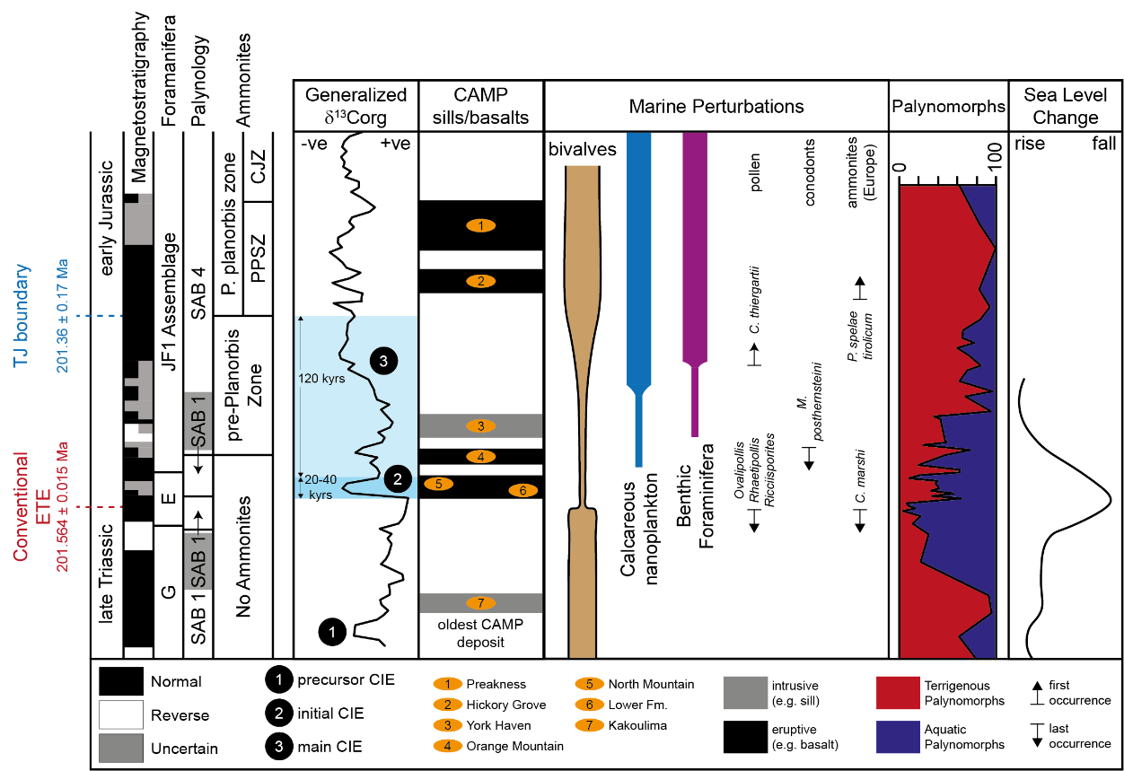
Figure 1: Temporal relationships among the conventional end-Triassic extinction (ETE), disappearances and emergences of biota, Triassic-Jurassic (TJ) boundary interval, CAMP pulses and eustatic sea level change keyed into geomagnetic polarity reversal stratigraphy and biostratigraphy. Magnetostratigraphy from Hounslow et al. (2004). Foraminifera assemblages, based on Copestake (1989): G - G. glomospirella assemblage, E - E. liassica assemblage. Palynology (SAB 1 - 4) based on Bonis et al. (2010). Ammonite zones relative to the δ¹³C_{org} record based on Hesselbo et al. (2002). Timings based on astrochronology (Ruhl et al., 2010). CAMP intrusives (in grey, nos. 3 and 7) and lavaflows (in black, nos. 1, 2, 4-6) dated using ²⁰⁶Pb/²³⁸U single crystal CA-TIMS ages (Schoene et al., 2010; Blackburn et al., 2013). The Kakoulima layered mafic intrusion in Guinea is the oldest CAMP activity at 201.630 ± 0.029 Ma (Davies et al., 2017). CAMP magmas were deposited in North America, Europe, South America and Africa. Marine ecology perturbations: bivalve data from Wignall and Bond (2008); calcareous nanoplankton, benthic foraminifera and palynomorph changes from Bonis et al. (2010) based on Lindström et al. (2012). Conodont species M. posthernsteini (Swift, 1989) and ammonoid species C. marshi extinctions mark the top of the Rhaetian (Triassic). In the UK, the ammonite genus Psiloceras first occurrence (FO) indicates the base of the Hettangian (Jurassic), however the GSSP (Global Boundary Stratotype Section and Point) for the TJB in Europe at Kuhjoch, Austria, is defined by P. spelae tirolicum FO (Hillebrandt et al. (2013). A questionable solitary specimen of Psiloceras is recorded in the Westbury Fm (Triassic) at Chipping Sodbury, England (Donovan, 1989). Terrestrial TJB interval: marked by Triassic pollen species extinctions (Ovalipollis, Rhaetipollis, Riccisporites). The eustatic sea level change based on Hesselbo et al. (2004). Note, the ‘main’ CIE is gradual, persisting into the Hettangian and ‘precursor’ CIEs are not recorded in all ETE sections.
Figure 1- 2 column fitting figure

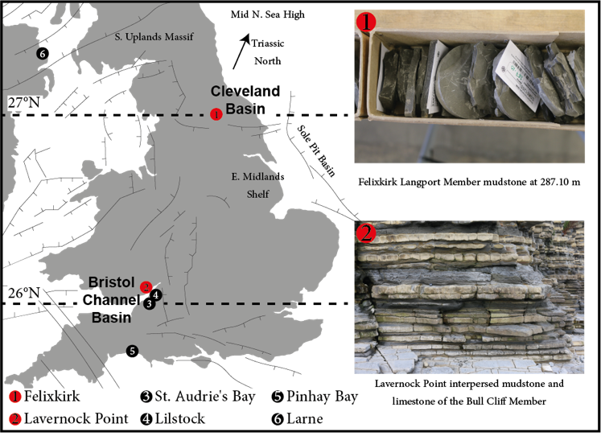
Figure 2: Triassic-Jurassic palaeogeographical setting of studied sedimentary successions (in red) at Felixkirk, Cleveland Basin, NE England, UK [SE48 NE/2] and Lavernock Point, Bristol Channel Basin, S Wales, UK [ST 18732 68152] and other correlative strata (in black) in the Tethys Ocean. Map outline adapted from Hounslow and Ruffell (2006). Palaeolatitudes estimated from Kent and Tauxe (2005). Top right: Photograph of Felixkirk core, Langport Member showing laminated siltstone-mudstones. Bottom right: Photograph of typical interspersed mudstone and limestones of Lavernock Point outcrop, basal Lias Group.
Figure 2- single column fitting figure

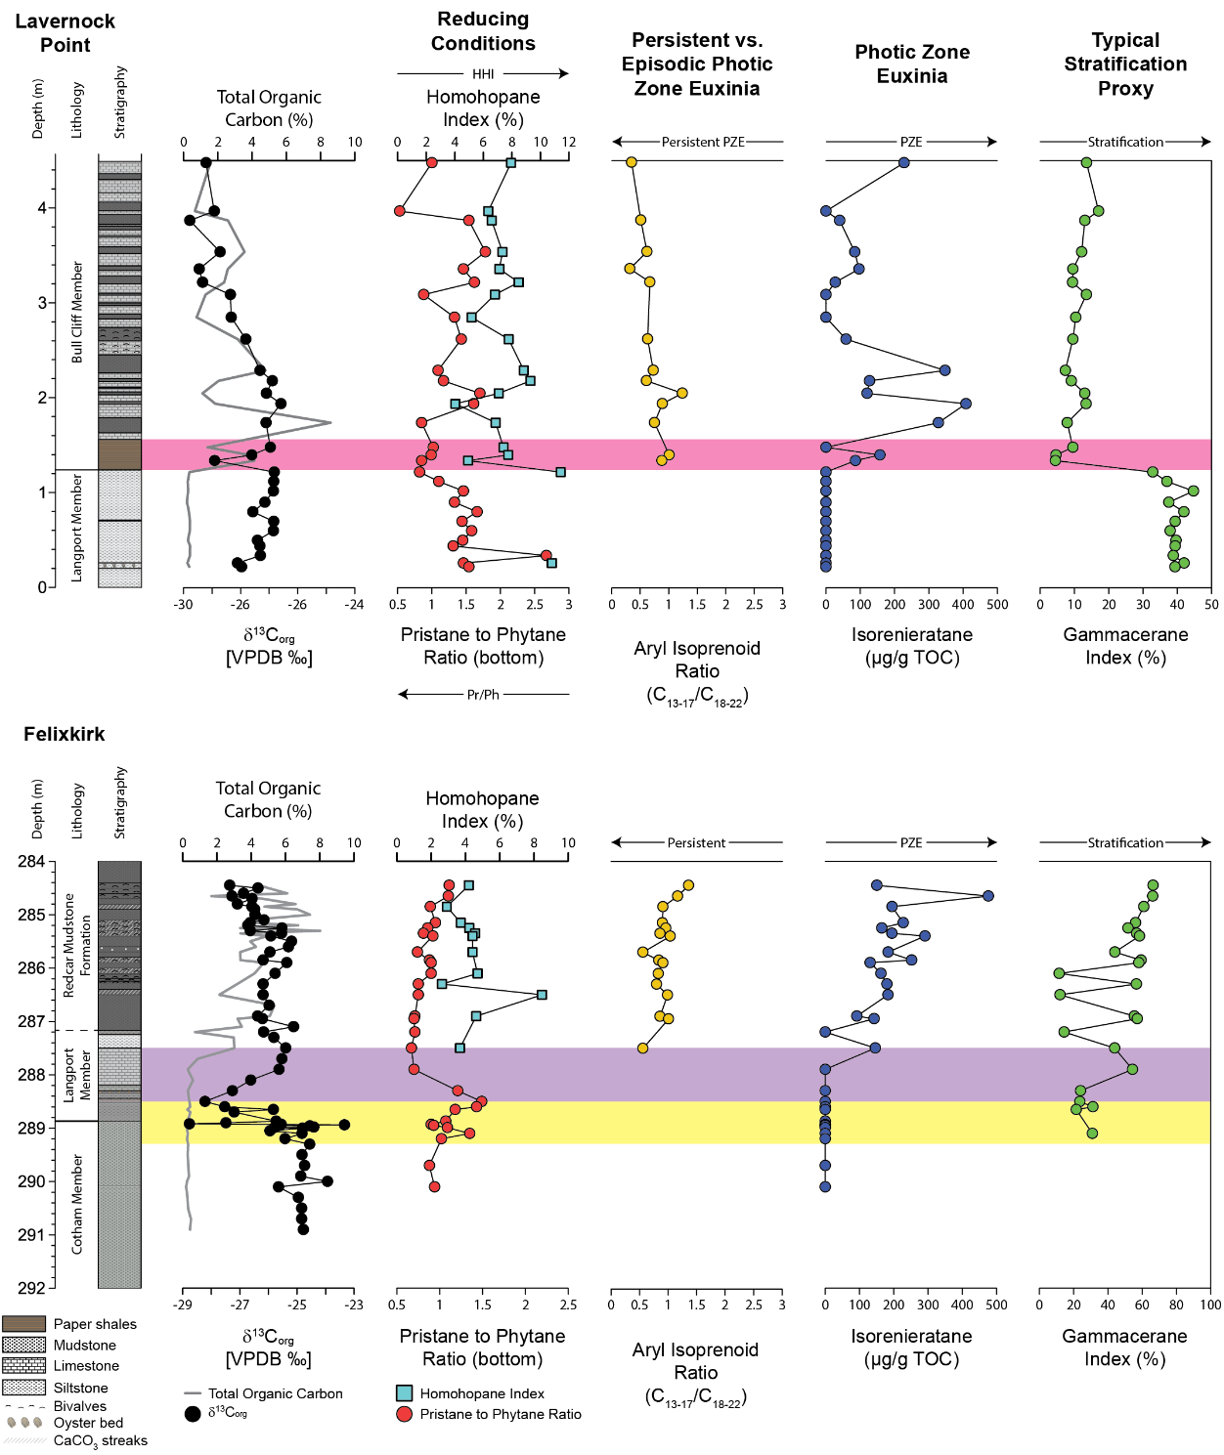
Figure 3: Biomarker data indicative of redox state and environment at Lavernock Point (upper panel) and Felixkirk (lower panel) compared to bulk δ¹³C_{org} and TOC records. The Upper Cotham carbon isotope excursion is highlighted in yellow (negative phase) and purple (positive phase). Paper shale deposition is highlighted in pink. Dashed line at 287.18 m defines the boundary between the Langport Member and the Redcar Mudstone Formation. An interpretation of each biomarker proxy is in bold above each column. VPBD: Vienna Pee Dee Belemnite. TOC: total organic carbon. Full details of the biomarker analyses are in the Supplementary Information.
Figure 3- 2 column fitting figure

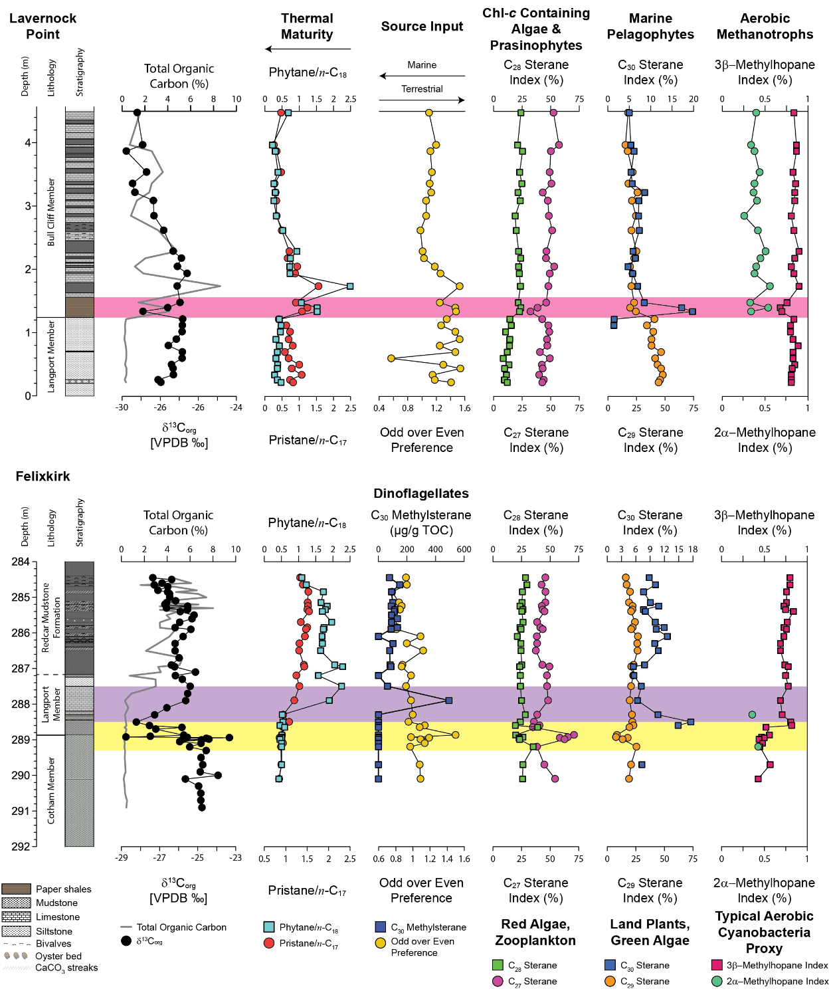
Figure 4: Biomarker evidence of organic matter source changes at Lavernock Point (upper panel) and Felixkirk (lower panel) compared to bulk δ¹³Corg and TOC records. The UC-CIE is highlighted in yellow (negative phase) and purple (positive phase). Paper shale deposition under is highlighted in pink. Dashed line at 287.18 m defines the boundary between the Langport Member and the Redcar Mudstone Formation. An interpretation of each biomarker proxy is in bold above each column. Chl-c: chlorophyll-c containing. VPBD: Vienna Pee Dee Belemnite. TOC: total organic carbon. Full details of the biomarker analyses are in the Supplementary Information.
Figure 4- 2 column fitting figure

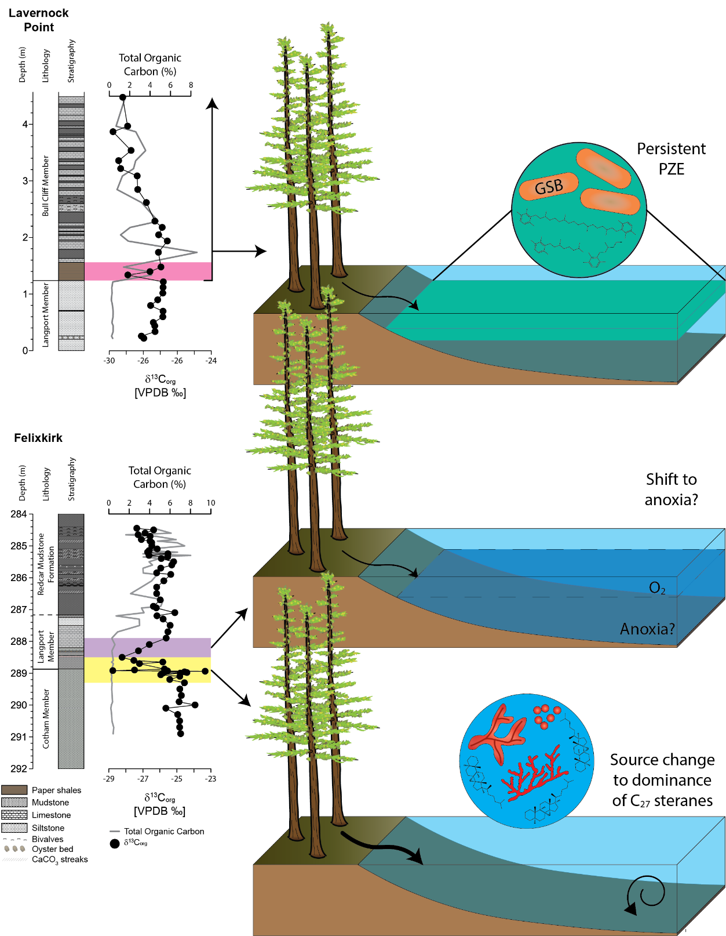
Figure 5: Schematic showing environmental and ecological changes at Lavernock Point (upper panel) and Felixkirk (lower two panels). The Upper Cotham CIE negative phase (bottom panel, yellow) shows increased land material (thick arrow), well mixed water column and shift to predominance of C₂₇ steranes (red algae, possibly soft coral and zooplankton). The positive phase of the upper Cotham CIE (middle panel, purple) represents development of stratification, reduction in land-derived material (thinner arrow), and possibility of anoxia in the sediments or at the sediment-water interface. Deposition of paper shales is highlighted in pink. Dashed line at 287.18 m defines the boundary between the Langport Member and the Redcar Mudstone Formation. The Bull Cliff Member (top panel) indicates persistent (recurrent) PZE impinging the end-Triassic extinction recovery, in a possibly stratified water column. Terrestrial flora represented by Classopollis bearing conifers (after reconstruction in Thomas, 1981); forest floor is comprised of ferns and mosses e.g. Alisporites, Deltoidospora.
Figure 5- 2 column fitting figure

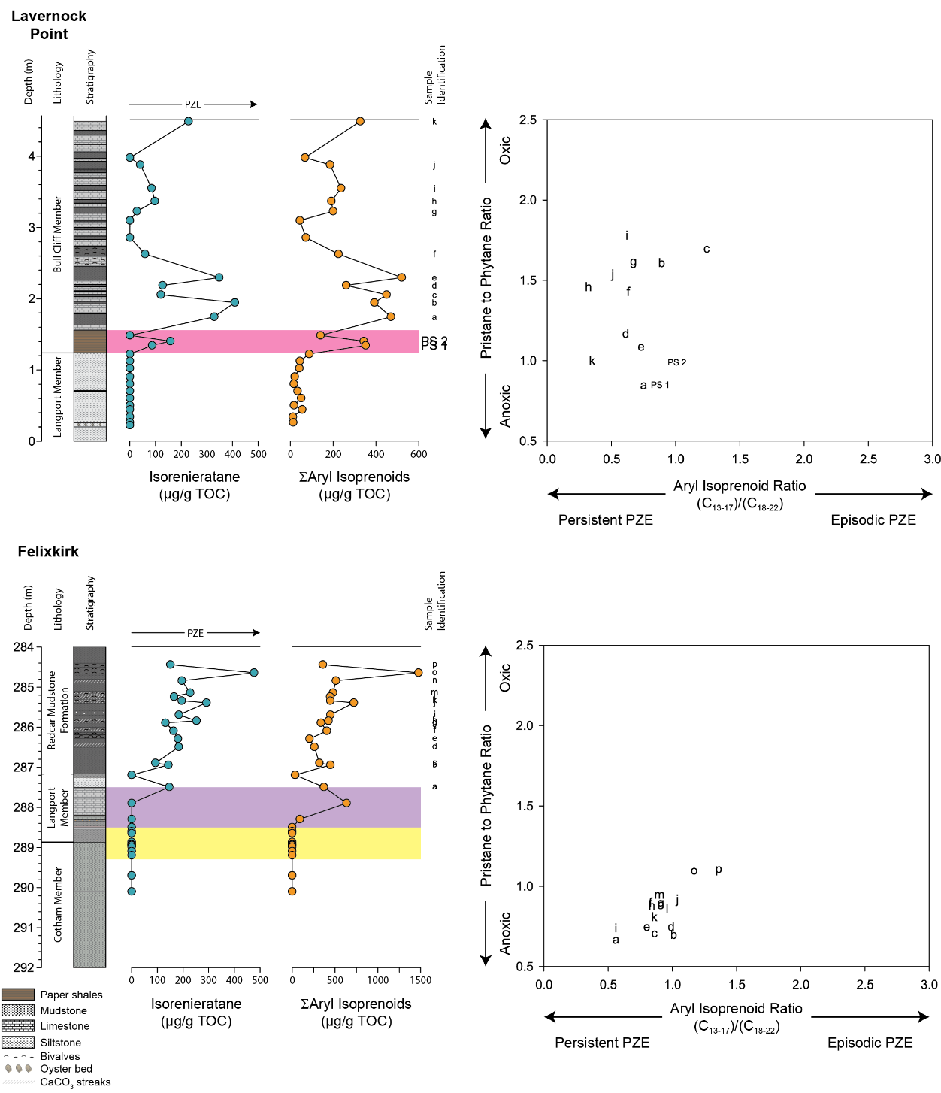
Figure 6: Isorenieratane and aryl isoprenoid evidence (left) with plots of AIR vs. Pr/Ph (right) for Lavernock Point (upper panel) and Felixkirk (lower panel), used to infer persistent vs. episodic PZE. The Upper Cotham CIE is highlighted in yellow (negative phase) and purple (positive phase). Paper shale deposition under anoxic conditions is highlighted in pink. Dashed line at 287.18 m defines the boundary between the Langport Member and the Redcar Mudstone Formation. Isorenieratane and aryl isoprenoid concentrations are normalised to TOC (μg/g TOC). ∑ - summed. Labels a – p, PS1 and PS2 identify the data points in each crossplot (right hand side). Full details of the biomarker analyses are in the Supplementary Information.
Figure 6- 2 column fitting figure

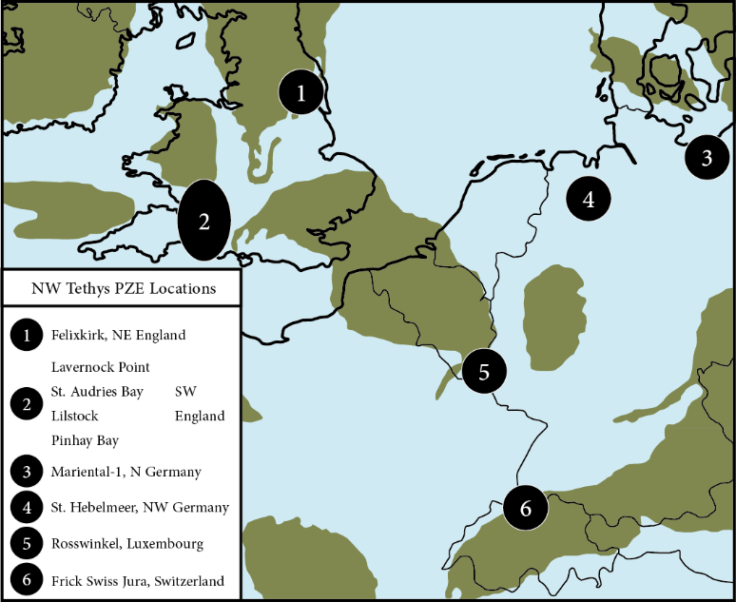
Figure 7: Map showing the latest Rhaetian-earliest Hettangian extent of marine PZE in the Tethys. Studied sections extend PZE to the northwestern Tethys from previously reported sites 2-6 in the Central European Basin. Map outline (200 Ma) based on the Colorado Plateau Geosystems (2012). PZE at St. Audrie’s Bay and Lilstock (Jaraula et al., 2013; Fox et al., in review), Pinhay Bay (framboid analysis; Atkinson and Wignall, 2019), Mariental-1 and Rosswinkel (Richoz et al., 2012), St. Hebelmeer (Blumenberg et al., 2016) and Frick Swiss Jura (Schwab et al., 2007).
Figure 7- single column fitting figure

