Supplemental Information for Beith et al Recurring photic zone euxinia in the northwest Tethys impinged end-Triassic extinction recovery
Table S2. Biomarkers: their principal palaeoecological/environmental interpretations
C₄₀ carotenoids
Isorenieratane | Brown-pigmented Chlorobiaceae | Summons and Powell, 1987; Koopmans et al, 1996a,b
Chlorobactane | Green-pigmented Chlorobiaceae | Grice et al, 1998
Okenane | Chromaticeae | Brocks et al, 2005
Hopanes
C₃₅ Homohopane Index (%) | Redox conditions | Peters and Moldowan, 1991; Sinninghe Damsté et al, 1995
Gammacerane Index (%) | Stratification | ten Haven et al, 1989; Harvey and McManus, 1991
C₃₁ 2α-Methylhopane Index (%) | Aerobic cyanobacteria; other sources | Summons et al, 1999; Renoux and Rohmer, 1985
C₃₁ 3β-Methylhopane Index (%) | Aerobic methanotrophs | Zundel and Rohmer, 1985; Farrimond et al, 2004
Steranes
C₂₇ Sterane Index (%) | Red algae; zooplankton | Patterson, 1971; Kodner et al, 2008
C₂₈ Sterane Index (%) | Prasinophytes; Chlorophyll c algae | Volkman et al, 1994; 1998
C₂₉ Sterane Index (%) | Green algae; land plants | Volkman et al, 1994; Kodner et al, 2008
C₃₀ Sterane Index (%) | Marine pelagophytes | Volkman, 2003
C₃₀ 4-Methylsterane | Freshwater dinoflagellates | Curiale, 1987; Goodwin et al, 1988
Other Ratios
Pristane/Phytane (Pr/Ph) | Redox conditions | Powell and McKirdy, 1973; Didyk et al, 1978
Pr/n-C₁₇ and Ph/n-C₁₈ | Thermal maturity | ten Haven et al, 1987
Aryl Isoprenoid Ratio (AIR) | Persistent vs Episodic photic zone euxinia | Schwark and Frimmel, 2004
Odd over Even Predominance (OEP) | Terrestrial vs Marine input | Scalan and Smith, 1970; Peters et al, 2005

GC-MS analytical difficulties
Okenane and chlorobactane: GC-MS analyses were run in selected ion monitoring mode (SIM) using primary fragment ions 133 and 134 m/z and molecular ion 554 m/z. Due to low % TOC, Felixkirk samples showed very poorly resolved trace chromatographic peaks for okenane and chlorobactane which were well below the acceptable signal/noise ratio of 3. Quantification was not possible; molecular sieving was not done due to low TOC.
C₃₀ 4-methylsterane: Felixkirk samples were analysed using fragment ions 231 and 98 m/z on a separate DB-5 column from Lavernock samples. Lavernock samples showed a co-elution of C₃₀ 4-methylsteranes as an unresolved shoulder on a much larger hopane peak, prohibiting peak resolution and quantification.

Figure S1. Vitrinite Reflectance Histograms

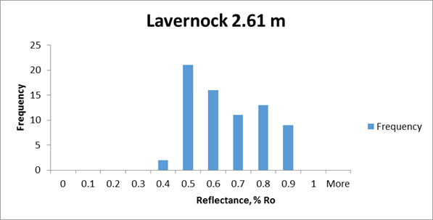
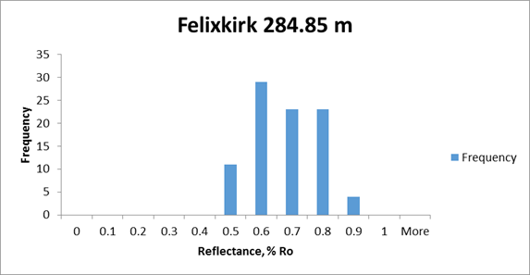

References
Brocks, J.J., Love, G.D., Summons, R.E., Knoll, A.H., Logan, G.A. and Bowden, S.A., 2005. Biomarker evidence for green and purple sulphur bacteria in a stratified Palaeoproterozoic sea. Nature. 437(7060), 866-870. https://doi:10.1038/nature04068
Curiale, J.A., 1987. Steroidal hydrocarbons of the Kishenehn Formation, northwest Montana. Org. Geochem, 11(4), 233-244. https://doi.org/10.1016/0146-6380(87)90034-9
Didyk, B.M., Simoneit, B.R.T., Brassell, S.C. and Eglinton, G., 1978. Organic geochemical indicators of palaeoenvironmental conditions of sedimentation. Nature. 272, 216-222
Farrimond, P., Talbot, H.M., Watson, D.F., Schulz, L.K. and Wilhelms, A., 2004. Methylhopanoids: molecular indicators of ancient bacteria and a petroleum correlation tool. Geochim. Cosmochim. Acta. 68, 3873-3882. https://doi:10.1016/j.gca.2004.04.011
Goodwin, N.S., Mann, A.L. and Patience, R.L., 1988. Structure and significance of C₃₀ 4-methyl steranes in lacustrine shales and oils. Org. Geochem. 12(5) 495-506.
Grice, K., Schouten, S., Peters, K.E. and Sinninghe Damsté, J.S., 1998. Molecular isotopic characterisation of hydrocarbon biomarkers in Palaeocene–Eocene evaporitic, lacustrine source rocks from the Jianghan Basin, China. Org. Geochem. 29, 1745-1764. https://doi.org/10.1016/S0146-6380(98)00075-8
Harvey, H.R. and McManus, G.B., 1991. Marine ciliates as a widespread source of tetrahymanol and hopan-3β-ol in sediments. Geochim. Cosmochim. Acta. 55, 3387-3390. https://doi.org/10.1016/0016-7037(91)90496-R
Kodner, R.B., Pearson, A., Summons, R.E. and Knoll, A.H., 2008. Sterols in red and green algae: quantification, phylogeny, and relevance for the interpretation of geologic steranes. Geobiol. 6(4), 411-420. https://doi.org/10.1111/j.1472-4669.2008.00167.x
Koopmans, M.P., Köster, J., van Kaam –Peters, H.M.E., Kenig, F., Schouten, S., Hartgers, W.A., de Leeuw, J.W. and Sinninghe Damsté, J.S., 1996a. Diagenetic and catagenetic products of isorenieratene: Molecular indicators for photic zone anoxia. Geochim. Cosmochim. Acta. 60(22), 4467-4496. https://doi.org/10.1016/S0016-7037(96)00238-4
Koopmans, M.P., Schouten, S., Kohnen, M.E.L. and Sinninghe Damsté., 1996b. Restricted utility of aryl isoprenoids as indicators for photic zone anoxia. Geochim. Cosmochim. Acta. 60(23), 4873-4876. https://doi.org/10.1016/S0016-7037(96)00238-4
Patterson, G.W., 1971. The distribution of sterols in algae. Lipids. 6(2), 120-127.
Peters, K.E. and Moldowan, J.M., 1991. Effects of source, thermal maturity, and biodegradation on the distribution and isomerization of homohopanes in petroleum. Org. Geochem. 17(1), 47-61. https://doi.org/10.1016/0146-6380(91)90039-M
Peters, K.E., Walters, C.C. and Moldowan, J.M., 2005. The Biomarker Guide Volume 2 Biomarkers and isotopes in petroleum exploration and Earth history, second ed. Cambridge University Press, New York
Powell, J.H. and McKirdy, D.M., 1973. Relationship between ratio of pristane to phytane, crude oil composition and geological environment in Australia. Nat. Phys. Sci. 243(124), 37-39.
Renoux, J-M. and Rohmer, M., 1985. New bacteriohopanetetrol cyclitol ethers from the methylotrophic bacterium Methylobacterium organophilum. Eur. J. Biochem. 151(2), 405-410. https://doi.org/10.1111/j.1432-1033.1985.tb09116.x
Scalan, R.S. and Smith, J.E., 1970. An improved measure of the odd-even predominance in the normal alkanes of sediments and petroleum. Geochim. Cosmochim. Acta. 34, 611-620. https://doi.org/10.1016/0016-7037(70)90019-0
Schwark, L. and Frimmel, A., 2004. Chemostratigraphy of the Posidonia Black Shale, SW-Germany: II. Assessment of extent and persistence of photic-zone anoxia using aryl isoprenoid distributions. Chem. Geol. 206, 231-248. https://doi.org/10.1016/j.chemgeo.2003.12.008
Sinninghe Damsté, J.S., Kenig, F., Koopmans, M.P., Köster, J., Schouten, S., Hayes, J.M. and de Leeuw, J.W., 1995. Evidence for gammacerane as an indicator of water column stratification. Geochim. Cosmochim. Acta. 59, (9) 1895-1900. https://doi.org/10.1016/0016-7037(95)00073-9
Summons, R.E. and Powell, T.G., 1987. Identification of aryl isoprenoids in source rocks and crude oils: Biological markers for the green sulphur bacteria. Geochim. Cosmochim. Acta. 51, 557-566. https://doi.org/10.1016/0016-7037(87)90069-X
Summons, R.E., Jahnke, L.L., Hope, J.M. and Logan, G.A., 1999. 2-Methylhopanoids as biomarkers for cyanobacterial oxygenic photosynthesis. Nature. 400, 554-557. https://doi.org/10.1038/23005
ten Haven, H.L., de Leeuw, J.W., Rullkötter, J. and Sinninghe Damsté, J.S., 1987. Restricted utility of the pristane/phytane ratio as a palaeoenvironmental indicator. Nature. 330, 641-643. https://doi.org/10.1038/330641a0
ten Haven, H.L., Rohmer, M., Rullkötter, J. and Bisseret, P., 1989. Tetrahymanol, the most likely precursor of gammacerane, occurs ubiquitously in marine sediments. Geochim. Cosmochim. Acta. 53, 3073-3079. https://doi.org/10.1016/0016-7037(89)90186-5
Volkman, J.K., Barrett, S.M., Dunstan, G.A. and Jeffrey, S.W., 1994. Sterol biomarkers for microalgae from the green algal class Prasinophyceae. Org.Geochem. 21, 1211-1218. https://doi.org/10.1016/0146-6380(94)90164-3
Volkman, J.K., Barrett, S.M., Blackburn, S.I., Mansour, M.P., Sikes, E.L. and Gelin, F., 1998. Microalgal biomarkers: A review of recent research developments. Org. Geochem. 26, 1163-1179. https://doi.org/10.1016/S0146-6380(98)00062-X
Volkman, J.K., 2003. Sterols in microorganisms. Appl. Microbiol. Biotechnol. 60, 495-506. https://doi.org/10.1007/s00253-002-1172-8
Zundel, M. and Rohmer, M., 1985. Prokaryotic triterpenoids 1. 3β-Methylhopanoids from Acetobacter species and Methylococcus capsulatus. Eur. J. Biochem. 150, 23-27. https://doi.org/10.1111/j.1432-1033.1985.tb08980.x

