Development of Tibia & Fibula Bone Deficits in Children With Neurofibromatosis Type I – A Longitudinal Case-Control Comparison
Alex Ireland¹, Amy Riddell^{2,3}, Ann Prentice^{3,4}, Judith Eelloo⁵, ,M. Zulf Mughal*^{5,6,7}, Kate A. Ward*⁸
¹Musculoskeletal Science and Sports Medicine Research Centre, Department of Life Sciences, Manchester Metropolitan University, Manchester, UK
²Institute for Infection and Immunity, Paediatric Infectious Diseases Research Group, St. George’s University of London
³previously at MRC Human Nutrition Research, Elsie Widdowson Laboratory, Cambridge, UK
⁴MRC Nutrition and Bone Health Group, Cambridge, UK†
⁵Nationally Commissioned Complex NF1 Service, Manchester Centre for Genomic Medicine, St Mary’s Hospital, Manchester University NHS Foundation Trust, Manchester
⁶Department of Paediatric Endocrinology, Royal Manchester Children’s Hospital, Manchester University NHS Foundation Trust, Manchester
⁷School of Health Sciences, Faculty of Biology, Medicine and Health, University of Manchester, UK
⁸MRC Lifecourse Epidemiology Unit, Human Development and Health, University of Southampton, Southampton, UK

Corresponding Author: Dr Alex Ireland, Manchester Metropolitan University, John Dalton Building, Chester Street, Manchester, M1 5GD. a.ireland@mmu.ac.uk. +44 (0)161 247 1987.
*Joint senior authors
†Current address c/o MRC Epidemiology Unit, Cambridge, UK

Abstract
Neurofibromatosis type 1 (NF1) is associated with lower bone mass and increased risk of fracture. Children with NF1 display faltering growth from mid-childhood. However, to date tibia bone development in children with NF1 across childhood and the role of body size have not been explored.
Therefore, we recruited 24 children with NF1 (12 girls, mean age 8.2±1.1y) and 104 children without NF1 (52 girls, mean age 11±1.7y). Tibia and fibula bone characteristics were assessed at 4% and 38% distal-proximal tibia length in all children at baseline using peripheral quantitative computed tomography (pQCT). Longitudinal scans were obtained in 21 children with NF1 (12 girls) over 3.4±0.3y and 71 children without NF1 (34 girls) over 1.1±0.1y, such that at follow-up mean age of both groups (NF1 10.9±1.3y, controls 11.4±1.4y) were similar. Effects of group (NF1/control) on bone outcomes as well as group-by-age interactions, indicating differences in rate of change in bone outcome bone outcomes were assessed via linear mixed effects models with adjustment for sex, age, pubertal status and in additional models with adjustment for height and weight Z-scores.
Group (NF1/control)-by-age interactions indicated a slower rate of tibia and fibula bone mass accrual in children with NF1 at all measured sites. These associations were attenuated by 25-50% by adjustment for height and weight Z-scores. At the 4% site, deficits in bone mass at older ages were related to slower trabecular BMD accrual. At the 38% site, group-by-age interactions suggested that bone mass deficits resulted from poorer accrual of cortical CSA and to a lesser extent cortical BMD.
Lower limb bone mass deficits evident in children with NF1 appear to be progressive and emerge in mid-childhood. In part, they are related to development of a similar pattern of deficits in longitudinal growth and body weight in NF1. Interventions promoting muscle development or physical activity may be partially effective in attenuating bone mass accrual deficits in this population.
Keywords
pQCT, Muscle, Growth, Loading

Introduction
Neurofibromatosis type 1 (NF1, otherwise known as von Recklinghausen’s disease) is a rare autosomal dominant neuro-cutaneous syndrome (incidence 1/3,500) associated with café au lait spots, axillary & inguinal freckling cutaneous and plexiform neurofibromas,. NF1 is also associated with skeletal abnormalities including short stature, scoliosis, sphenoid wing dysplasia, congenital pseudoarthrosis and osteopenia [1]. Individuals with NF1 have an increased risk of fracture across both sexes and throughout childhood and older adulthood, with 3-fold and 5-fold increase in risk respectively [2]. Children with NF1 have lower bone mass, area and density at key clinical sites including the lumbar spine and femoral neck, [3]. These differences have been characterised in greater detail using peripheral quantitative computed tomography. At trabecular-rich epiphyseal regions, low bone mass in children with NF1 results from both smaller bone size and lower trabecular bone mineral density (BMD) [4]. In contrast, at the mainly cortical diaphyseal sites children with NF1 have narrower bones with smaller cortical area but there is little or no deficit in cortical BMD [4, 5]. Previous studies have included children with NF1 across a wide range of ages, from early childhood (4-5y) to late adolescence (18y) [3-5]. However, to date trajectories of bone development across childhood in children with NF1 have not been described in comparison to those of children without NF1. In particular, as shorter stature in children with NF1 only becomes evident in mid-childhood [6] it is unclear whether these diverging patterns of body growth contribute to bone deficits in this population. Fibula deformities are common in children with NF1, occurring in around 40-70% of children with lower limb deformities [7-9] and are associated with a higher incidence of fusion surgery [8]. Despite this evidence that NF1 also affects fibular development, and that fibula as well as tibia fractures are common in children with NF1 [10], fibula bone characteristics have not previously been assessed in this population. There is some evidence that assessment of fibula and tibia characteristics could help to discriminate between e.g. endocrine-related or iatrogenic bone impairment, and that caused by neuromuscular disorders [11], given the apparent independence of the fibula from effects of disuse [12]. Therefore, we examined tibia and fibula bone health longitudinally in a cohort of children with NF1 across a three-year period and compared this to longitudinal changes in a cohort of control children. We hypothesised that, consistent with previously reported height deficits from mid-childhood, slower bone mass accrual would be evident in children with NF1 as they transition through puberty.

Methods
Twenty four participants (12 girls, 12 boys; mean age 8.2±1.1y) with NF1 between 6 and 10 years of age were identified from the NF1 Genetic Register obtained from the Manchester Centre for Genomic Medicine, St. Mary’s Hospital, Manchester, UK. All eligible children were sent child and parent information leaflets, and families who returned the reply letter were contacted and informed consent was obtained. Children with NF1 who had any leg deformity, such as pseudoarthrosis of the tibia, fibula, or plexiform neurofibroma in the lower limb were excluded from the study. This study received ethical approval from the Liverpool Region Ethics Committee (REC Number: 10/H1002/17).
Control participants (52 girls, 52 boys; mean age 11.0±1.7y) were recruited as part of a separate study, via educational establishments in Cambridgeshire, who advertised the study by distributing leaflets and placing posters around the school/college This study was approved by the Cambridge South Research Ethics Committee (REC Number: 13/EE/0078).
In both cohorts, standing height was measured using a stadiometer and body mass was measured using a digital scale with shoes and outdoor clothing removed. Body mass index (BMI) was calculated by using the formula mass (kg)/height(m)². Height, weight and BMI Z-scores were calculated using World Health Organisation normative reference values [13]. Pubertal stage was assessed using Tanner criteria [14], with children at Tanner stage 1 classified as prepubertal and those at stages 2-5 as pubertal.
Peripheral quantitative computed tomography (pQCT) scans of the shank were taken with two Stratec XCT-2000 scanners (Stratec Medizintechnik GmbH, Pforzheim, Germany), one for controls and one for children with NF1. In both cases, the same protocol was used across both sites, including reference line placement. Scanners were cross-calibrated using a standard manufacturer phantom across a range of densities and showed excellent agreement (R² = 0.99998) with <1% difference in BMD values, including 0.9% difference between scanners at typical cortical BMD values. Scans were taken in the self-selected dominant leg in both groups, with voxel size of 0.5mm. Scans were taken at 4% and 38% distal-proximal tibia length, measured from the medial malleolus to the medial knee joint cleft. Where evidence of an open growth plate was seen in the scout view (a low-resolution anterior-posterior projection scan used to identify correct location for reference line placement) , the reference line from which the scanner calculates the correct location for 4% and 38% distal-proximal length was set at the most distal point of the growth plate. In cases where a growth plate was not evident, the reference line was set at the distal end plate. Measurements were then completed using analysis tools in Version 6.00 of the software supplied with the scanner. A peeling threshold of 180mg.cm⁻³ was used to delineate the outer perimeter of bone, with a threshold of 710mg.cm⁻³ used for cortical bone and contour, peeling and cortical modes set at 1. These modes are built into the analysis software, and consist of a threshold algorithm (contour and cortical modes) and the concentric peeling of pixels from the outside area of bone (peeling mode). Muscle and fat were delineated using thresholds of -50mg.cm⁻³ and 40mg.cm⁻³ respectively, with contour mode 3 (using an iterative contour detection procedure with user-defined threshold) and peeling mode 1. At the 4% site, total bone mineral content (BMC) and total cross-sectional area (CSA) were assessed for both tibia and fibula. For the tibia, trabecular BMD was assessed from the inner 45% of bone area whereas total BMD was assessed in the fibula due to the thicker cortical wall at the corresponding fibula site which would have encroached on the 45% region. At the 38% diaphyseal site, total BMC, total and cortical CSA, cortical thickness, periosteal and endocortical circumferences and polar cross-sectional moment of inertia (CSMI, indicating bone torsional stiffness) were assessed in both bones. Anterior-posterior and mediolateral axial CSMIs (indicating bending stiffness) were also examined in the tibia, as was circularity. The latter was calculated as the ratio of the ‘true’ polar CSMI with that obtained from a ring model with values closer to 1 reflecting greater circularity.
Longitudinal assessment
In addition to baseline assessments, anthropometric data, pubertal status and pQCT scans were obtained longitudinally in the same individuals. Longitudinal data were obtained in 21/24 children with NF1 (12 girls) over 3.4±0.3y, with the oldest child being 13.3 years old at final follow-up. Whilst most children were assessed twice over this period, seven children had three assessments over this period and one had four assessments. In addition, longitudinal data were obtained in children without NF1 after approximately 12 months and in order to maximise data relevance for comparison to NF1 group only datapoints obtained up to the age of 14 (maximum age 13.9) were included in analysis for this study. Therefore longitudinal data were available for 71 participants (34 girls) taken 1.1±0.1y after baseline – in all cases participants were assessed twice.
Statistical Analysis
Associations between group (control/NF1) and pQCT outcomes were then assessed with linear mixed effects models using the R statistical environment (version 3.6.2, www.rproject.org). Inclusion of a random participant effect allowed us to account for data clustering caused by differences in number of observations and time between observations. Model 1 was adjusted for age and sex, and also for pubertal status. Model 2 was further adjusted for height and weight Z-scores, in order to examine whether body size differences contributed to any observed differences in bone characteristics. Group-by-age interactions were assessed in order to examine whether age-related bone changes differed between the two groups. Where there was no evidence of an interaction (P > 0.1) the interaction term was removed from models and main effect of group was assessed. Due to the difference in age at recruitment, analyses were repeated excluding scan timepoints before the age of 8 (which were only available in individuals with NF1). In addition, given the small differences between groups typically observed with cortical BMD we wished to ensure that the small inter-scanner differences in cortical BMD did not contribute to observed findings. Therefore we adjusted values in the NF1 by the inter-scanner difference (0.9%) and repeated relevant analyses. All control participants and all but three individuals with NF1 were of white ethnicity, with one child with NF1 of East Asian ethnicity and two of South Asian ethnicity. Therefore we assessed the effects of removal of these individuals from analysis or inclusion of ethnicity in additional sensitivity analyses.

Results
Participants with NF1 were younger at baseline, but at follow-up age was similar in both groups (Table 1). At both timepoints, individuals with NF1 were shorter and lighter than controls, with lower BMI at baseline. There was evidence of an group-by-age interaction for body mass, such that control participants had a greater increase with age (Figure 1). Whilst all participants in the NF1 group were pre-pubertal at baseline, by follow-up the proportions of pre- and pubertal individuals were similar in both groups.
pQCT-derived bone, muscle and fat characteristics are detailed in Table 2. At the distal tibia site, group-by-age interactions indicated a greater increase in total BMC with age in controls in both models (Figure 2 and Table 3). Whilst a similar interaction was observed for total bone CSA in model 1, this was attenuated by adjustment for body size in model 2 although a main effect of group with higher values in the NF1 group was still evident. There was no evidence of a group-by-age interaction for trabecular BMD in either model (both P > 0.5), but values were lower in individuals with NF1 i.e. main effect of group prior to but not following adjustment.
At the proximal tibia site, group-by-age interactions were found in model 1 for total and cortical BMC, cortical BMD, cortical thickness (all Figure 3) and axial and polar moments of inertia (Figure 4), with greater increases with age in control participants. These associations were partially attenuated by adjustment for body size in model 2, with the exception of total CSA which was fully attenuated. In the resultant simplified and fully adjusted model following removal of the interaction term, total CSA was greater in individuals with NF1. Periosteal and endocortical circumferences were both greater in individuals with NF1 in model 2. Whilst there was a group-by-age interaction for muscle CSA in model 1, this was attenuated by adjustment for body size such that muscle CSA was greater in individuals with NF1. There were no group or group-by-age differences for fat CSA in either model.
Similar patterns were observed for the fibula (Table 4), with group-by-age interactions indicating greater age-related increases in control participants evident for total BMC at both sites in both models, as well as total CSA, periosteal and endocortical circumferences and polar moment of inertia at the 38% site. Main effects of group with lower values in individuals with NF1 were observed for total BMD at the 4% site, cortical BMD and thickness at the 38% sites and, following adjustment, 38% cortical CSA. The exception was group differences in 4% total CSA, for which values were greater in individuals with NF1.
Sensitivity analyses involving removal of scan timepoints before the age of 8 in NF1, adjustments for inter-scanner differences in cortical BMD, removal of pubertal status from models, removal of the three non-white individuals from analysis or inclusion of ethnicity in additional sensitivity analyses did not substantially influence results.

Discussion
In this study, we found that the bone mass deficit in the tibia previously reported in children with NF1 appears to develop throughout mid-late childhood. This pattern is evident both at the trabecular-rich epiphyseal distal tibia site, and at the predominately cortical tibia shaft. At the 38% site, children with NF1 had thinner cortices and reduced derived bone strength parameters (anterior-posterior, mediolateral and polar CSMIs). These age-related changes appear in part attributable to a slower rate of height and body mass gain in children with NF1 in later childhood, but not to differences in pubertal timing. Similar patterns were also evident in the fibula, but not calf muscle and subcutaneous fat.
These findings extend previous studies of bone health in children with NF1 by examining patterns of change throughout childhood and adolescence, which to our knowledge has not previously been reported. Whilst the findings of low bone mass are similar to previous studies, the pattern of observed group differences in detailed bone geometry and density differ between studies. Our unadjusted results were similar qualitatively to previous studies [4, 5, 15], in that deficits in bone mass at distal tibia resulted from trabecular BMD deficits, whilst those in the tibia shaft primarily resulted from lower cortical CSA. However, following adjustment for body size there was no deficit in trabecular BMD. Similarly, at the tibia shaft we observed greater bone CSA in children with NF1, but also a small deficit in cortical BMD. Two factors may explain the discrepancies between ours and previous results; first, we used height and weight Z-scores rather than ‘raw’ data used in adjustments in previous studies. Age, height and weight have substantial collinearity (variance inflation factors were typically 5-10 in our data), which may have influenced previous published data. In addition, our use of longitudinal data at multiple timepoints may have increased our power to detect small group differences in cortical BMD.
A number of factors may explain observed differences in bone and age-related patterns. It appears that slower growth from mid-childhood in children with NF1 [6] contributes to development of bone deficits, with around 25-50% of the deficit in bone variables attributable to height and weight differences in our analyses as evidenced by changes in regression coefficients in height and weight-adjusted models. Bone loading by muscle forces during physical activity has a key role in childhood skeletal development [16]. Children with NF1 display delayed motor development[17], which is associated with impaired bone loading and resultant deficits in skeletal development through childhood [18]. Previous studies have also identified muscle weakness in children with NF1 [19-21], although there is limited evidence of how this develops across childhood [20]. To date, we are only aware of one study which assessed physical activity in children with NF1, finding no difference from controls [19], but this was based on questionnaire assessments which may be less accurate and more prone to bias than objective accelerometer measures. More detailed assessments of physical activity and muscle development in children with NF1 across childhood would help reveal their contribution to impaired skeletal development. The increase in total bone CSA identified in this study may be an attempt to maintain whole bone strength despite decreased BMD, as a similar pattern of adaptation occurs with older age [22]. Given that we excluded individuals with tibia deformities, we are confident that this is not the cause of these findings.
There are clear clinical implications of these findings, as fracture risk is elevated in children and older adults with NF1 [2]. Whilst this suggests that fracture risk in children with NF1 might increase throughout childhood, to date this remains unexplored. Given the importance of peak bone mass for fracture incidence in later life [23], impaired accrual of bone in children with NF1 likely contributes to increased risk across most of the lifespan. Given the potential role of muscle and bone loading in development of impaired bone mass in NF1 identified above and in a recent review (CHINOY ET AL, UNDER REVIEW), interventions aimed at improving muscle strength or increasing vigorous physical activity known to improve bone mass [24] may be effective. This is particularly important given previous reports of muscle weakness in children with NF1 [19]. In contrast, that larger muscle CSA was observed in individuals with NF1, the rationale for promoting physical activity to promote muscle mass per se is not obvious. However, this may relate to known limitations of muscle mass as an indicator of muscle function.
The strengths of this study include the collection of longitudinal bone data for the first time in this clinical population. In addition, the inclusion of detailed modelling which allowed us to both adjust for potential confounders and identify the potentially mediating role of body size. By using pQCT, we were able to describe bone geometry and structure in detail. The use of different pQCT scanners for the two groups may have contributed to observed differences, but given the high correlation between repeated phantom measures on the two scanners we believe that these effects would be minimal. In addition, that the focus of this study was group-by-age interactions i.e. the slope of the age-bone outcome plots means that any small differences in the intercept caused by scanner differences would not impact on these findings. In support of this, in additional sensitivity analyses with adjustment to cortical BMD (most sensitive to scanner error relative to population variance) for inter-scanner differences we observed similar findings to those from unadjusted values. Whilst the groups were of similar age at final follow-up, at baseline NF1 children were younger and so the age groups do not overlap completely. However, similar results were obtained when younger individuals were removed from analyses therefore we believe that this would not have substantially influenced the results. In a previous study individuals with NF1 with lower limb deformities had 5% lower sex, height, age and pubertal stage-adjusted bone total CSA than individuals with NF1 but no deformities, although the number of participants meant that statistical evidence for these group differences was weak [5]. Therefore, had we included these individuals in the current study we may have observed a smaller group difference in total CSA in adjusted models but it is unclear how other parameters would have been affected. Collection of more detailed information on pubertal development e.g. hormonal changes or more frequent assessment of growth trajectories may have improved our ability to assess any contribution of differences in pubertal timing to observed group differences in bone.
NF1 is associated with large deficits at multiple lower limb bone sites in children, which appear to increase throughout childhood. These deficits are partially explained by reduced growth through later childhood in children with NF1. These results suggest that older children with NF1, particularly those with smaller body size, may be at greater risk of lower limb fracture. Interventions aimed at improving muscle strength and/or physical activity may be effective in attenuating these deficits.

Acknowledgements
The Cambridge study was funded through UKRI-MRC Programme Number U105963071, and AR was funded by an MRC PhD Studentship. The Manchester study was funded through NIH grant number NS050509-01A1. AI’s work on this study was supported by a Barbara Mawer Travelling Fellowship from the Bone Research Society.

References
[1] F. Elefteriou, M. Kolanczyk, A. Schindeler, D.H. Viskochil, J.M. Hock, E.K. Schorry, A.H. Crawford, J.M. Friedman, D. Little, J. Peltonen, J.C. Carey, D. Feldman, X. Yu, L. Armstrong, P. Birch, D.L. Kendler, S. Mundlos, F.C. Yang, G. Agiostratidou, K. Hunter-Schaedle, D.A. Stevenson, Skeletal abnormalities in neurofibromatosis type 1: approaches to therapeutic options, Am J Med Genet A 149A(10) (2009) 2327-38.
[2] E. Heervä, A. Koffert, E. Jokinen, T. Kuorilehto, S. Peltonen, H.T. Aro, J. Peltonen, A controlled register-based study of 460 neurofibromatosis 1 patients: increased fracture risk in children and adults over 41 years of age, J Bone Miner Res 27(11) (2012) 2333-7.
[3] D.A. Stevenson, L.J. Moyer-Mileur, M. Murray, H. Slater, X. Sheng, J.C. Carey, B. Dube, D.H. Viskochil, Bone mineral density in children and adolescents with neurofibromatosis type 1, J Pediatr 150(1) (2007) 83-8.
[4] D.A. Stevenson, D.H. Viskochil, J.C. Carey, H. Slater, M. Murray, X. Sheng, J. D'Astous, H. Hanson, E. Schorry, L.J. Moyer-Mileur, Tibial geometry in individuals with neurofibromatosis type 1 without anterolateral bowing of the lower leg using peripheral quantitative computed tomography, Bone 44(4) (2009) 585-9.
[5] D.A. Stevenson, L.J. Moyer-Mileur, J.C. Carey, J.L. Quick, C.J. Hoff, D.H. Viskochil, Case-control study of the muscular compartments and osseous strength in neurofibromatosis type 1 using peripheral quantitative computed tomography, J Musculoskelet Neuronal Interact 5(2) (2005) 145-9.
[6] M. Clementi, S. Milani, I. Mammi, S. Boni, C. Monciotti, R. Tenconi, Neurofibromatosis type 1 growth charts, Am J Med Genet 87(4) (1999) 317-23.
[7] M.G. Vitale, A. Guha, D.L. Skaggs, Orthopaedic manifestations of neurofibromatosis in children: an update, Clin Orthop Relat Res (401) (2002) 107-18.
[8] D. Keret, G. Bollini, P. Dungl, J. Fixsen, F. Grill, F. Hefti, E. Ippolito, B. Romanus, C. Tudisco, S. Wientroub, The fibula in congenital pseudoarthrosis of the tibia: the EPOS multicenter study. European Paediatric Orthopaedic Society (EPOS), J Pediatr Orthop B 9(2) (2000) 69-74.
[9] D.A. Stevenson, P.H. Birch, J.M. Friedman, D.H. Viskochil, P. Balestrazzi, S. Boni, A. Buske, B.R. Korf, M. Niimura, E.K. Pivnick, E.K. Schorry, M.P. Short, R. Tenconi, J.H. Tonsgard, J.C. Carey, Descriptive analysis of tibial pseudarthrosis in patients with neurofibromatosis 1, Am J Med Genet 84(5) (1999) 413-9.
[10] J.K. George-Abraham, L.J. Martin, H.J. Kalkwarf, M.B. Rieley, D.A. Stevenson, D.H. Viskochil, R.J. Hopkin, A.M. Stevens, H. Hanson, E.K. Schorry, Fractures in children with neurofibromatosis type 1 from two NF clinics, Am J Med Genet A 161A(5) (2013) 921-6.
[11] M. Jenkins, N.H. Hart, S. Nimphius, P. Chivers, T. Rantalainen, K.M. Rothacker, B.R. Beck, B.K. Weeks, F. McIntyre, B. Hands, B.P. Beeson, A. Siafarikas, Characterisation of peripheral bone mineral density in youth at risk of secondary osteoporosis - a preliminary insight, J Musculoskelet Neuronal Interact 20(1) (2020) 27-52.
[12] A. Ireland, R.F. Capozza, G.R. Cointry, L. Nocciolino, J.L. Ferretti, J. Rittweger, Meagre effects of disuse on the human fibula are not explained by bone size or geometry, Osteoporos Int 28(2) (2017) 633-641.
[13] World Health Organisation, WHO child growth standards: length/height for age, weight-for-age, weight-for-length, weight-for-height and body mass index-for-age, methods and development. , World Health Organization, Geneva, Switzerland, 2006.
[14] P.M. Duke, I.F. Litt, R.T. Gross, Adolescents' self-assessment of sexual maturation, Pediatrics 66(6) (1980) 918-20.
[15] L. Armstrong, K. Jett, P. Birch, D.L. Kendler, H. McKay, E. Tsang, D.A. Stevenson, D.A. Hanley, D. Egeli, M. Burrows, J.M. Friedman, The generalized bone phenotype in children with neurofibromatosis 1: a sibling matched case-control study, Am J Med Genet A 161A(7) (2013) 1654-61.
[16] A. Ireland, J. Rittweger, H. Degens, The Influence of Muscular Action on Bone Strength Via Exercise, Clinical Reviews in Bone and Mineral Metabolism 12 (2013) 93-102.
[17] J. Lorenzo, B. Barton, M.T. Acosta, K. North, Mental, motor, and language development of toddlers with neurofibromatosis type 1, J Pediatr 158(4) (2011) 660-5.
[18] A. Ireland, A. Sayers, K.C. Deere, A. Emond, J.H. Tobias, Motor Competence in Early Childhood Is Positively Associated With Bone Strength in Late Adolescence, J Bone Miner Res 31(5) (2016) 1089–1098.
[19] C.W. Hockett, J. Eelloo, S.M. Huson, S.A. Roberts, J.L. Berry, C. Chaloner, R. Rawer, M.Z. Mughal, Vitamin D status and muscle function in children with neurofibromatosis type 1 (NF1), J Musculoskelet Neuronal Interact 13(1) (2013) 111-9.
[20] K.M. Cornett, K.N. North, K.J. Rose, J. Burns, Muscle weakness in children with neurofibromatosis type 1, Dev Med Child Neurol 57(8) (2015) 733-6.
[21] G. Vassallo, Z. Mughal, L. Robinson, D. Weisberg, S.A. Roberts, E. Hupton, J. Eelloo, E.M. Burkitt Wright, S. Garg, L. Lewis, D.G. Evans, S.M. Stivaros, Perceived fatigue in children and young adults with neurofibromatosis type 1, J Paediatr Child Health 56(6) (2020) 878-883.
[22] F. Lauretani, S. Bandinelli, M.E. Griswold, M. Maggio, R. Semba, J.M. Guralnik, L. Ferrucci, Longitudinal changes in BMD and bone geometry in a population-based study, J Bone Miner Res 23(3) (2008) 400-8.
[23] R.P. Heaney, S. Abrams, B. Dawson-Hughes, A. Looker, R. Marcus, V. Matkovic, C. Weaver, Peak bone mass, Osteoporos Int 11(12) (2000) 985-1009.
[24] K. Deere, A. Sayers, J. Rittweger, J.H. Tobias, Habitual levels of high, but not moderate or low, impact activity are positively related to hip BMD and geometry: results from a population-based study of adolescents, J Bone Miner Res 27(9) (2012) 1887-95.

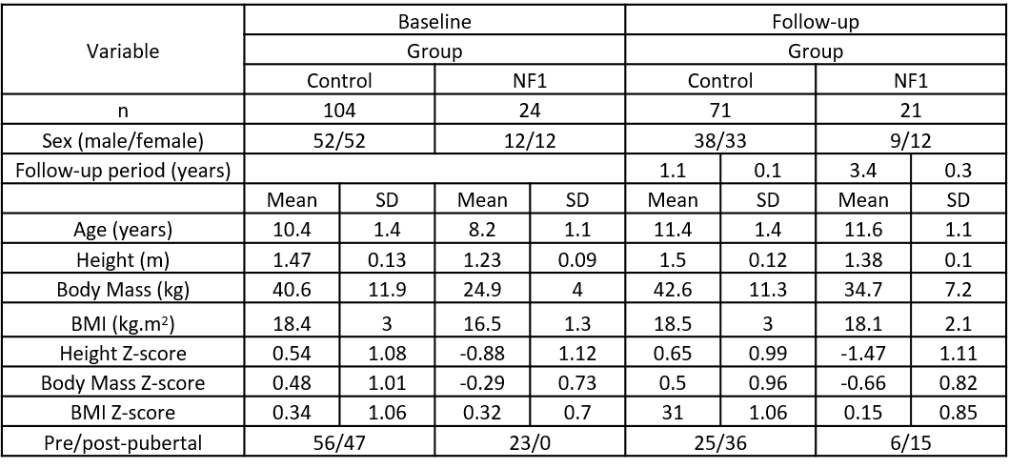Table 1. Participant characteristics at baseline and follow-up, separated by group. BMI – Body Mass Index. Follow-up data are shown for the last timepoint at which the participant was assessed.

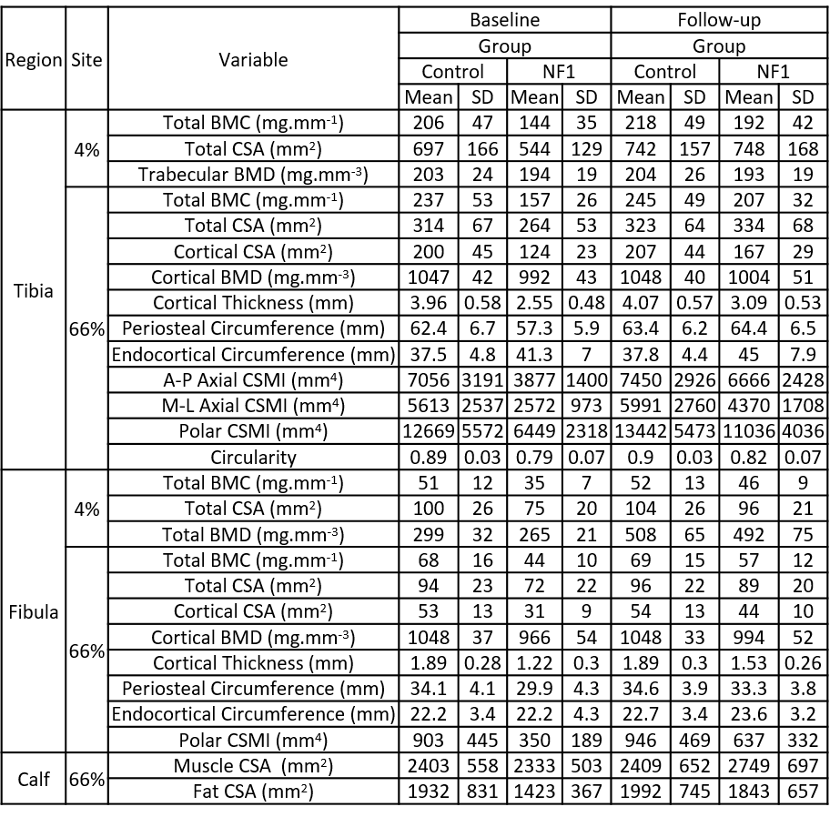
Table 2. Bone, muscle and fat characteristics assessed by pQCT. BMC – bone mineral content, CSA – cross-sectional area, BMD – bone mineral density, CSMI – cross-sectional moment of inertia. Follow-up data are shown for the last timepoint at which the participant was assessed.

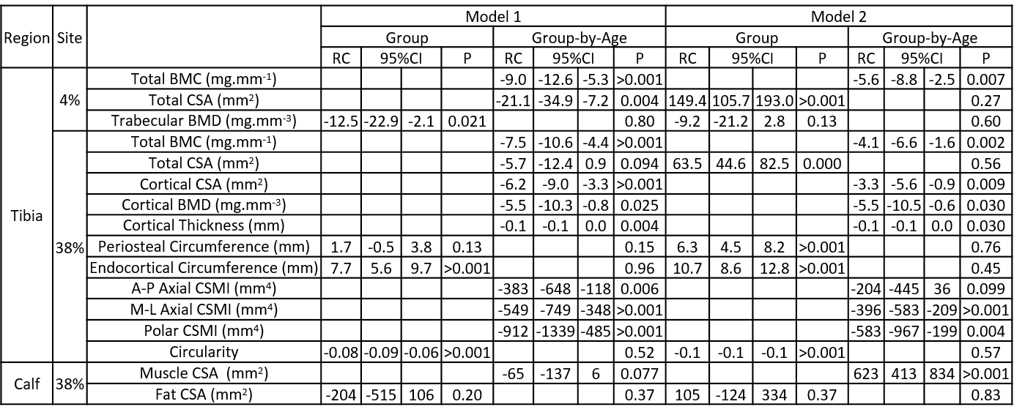
Table 3. Associations between group (control/NF1) and tibia bone and calf fat/muscle characteristics, including group-by-age interactions. RC – regression coefficient, indicating group difference for effect of group, and change in group difference per year of age for group-by-age interaction. BMC – bone mineral content, BMD – bone mineral density, CSA – cross-sectional area, CSMI – cross-sectional moment of inertia.

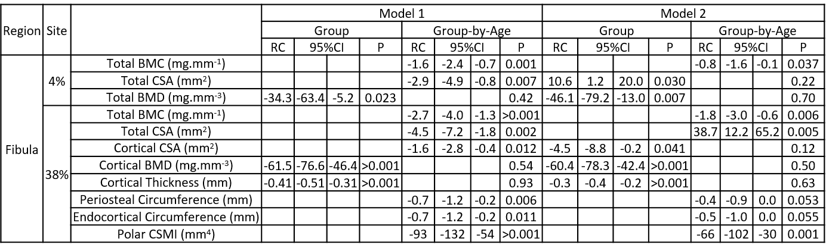
Table 4. Associations between group (control/NF1) and fibula bone characteristics, including group-by-age interactions. RC – regression coefficient, indicating group difference for effect of group, and change in group difference per year of age for group-by-age interaction. BMC – bone mineral content, BMD – bone mineral density, CSA – cross-sectional area, CSMI – cross-sectional moment of inertia.

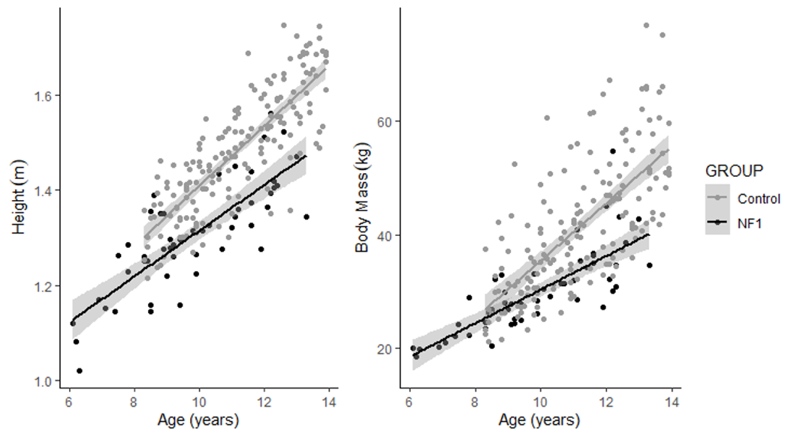
Figure 1. Body size differences with age, separated by group. Grey region indicates 95% confidence interval of estimated values.

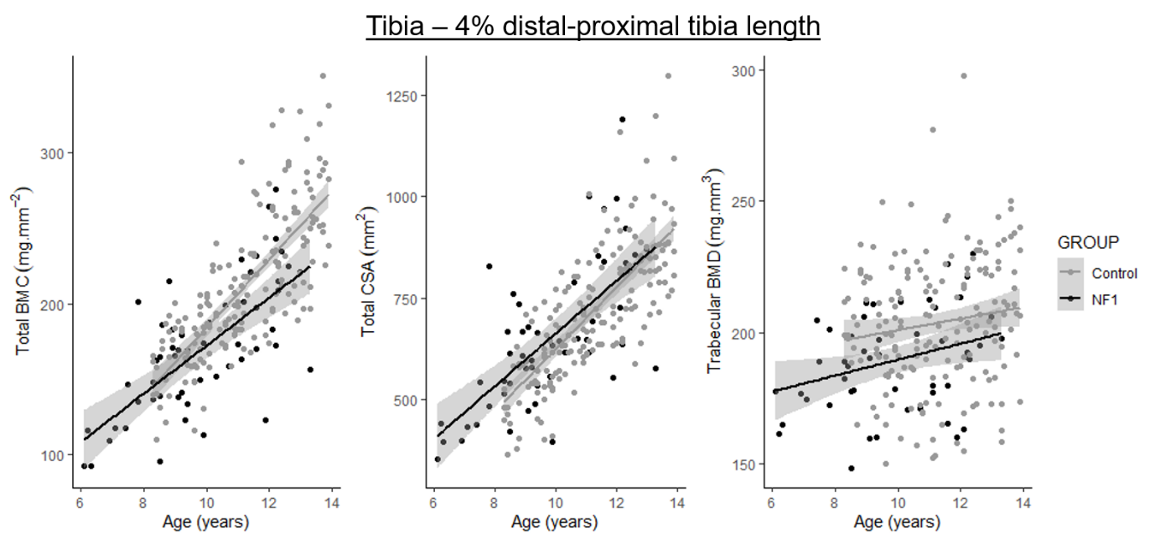
Figure 2. Tibia characteristics at the 4% site, separated by group. Grey region indicates 95% confidence interval of estimated values. BMC – bone mineral content, CSA – cross-sectional area, BMD – bone mineral density.

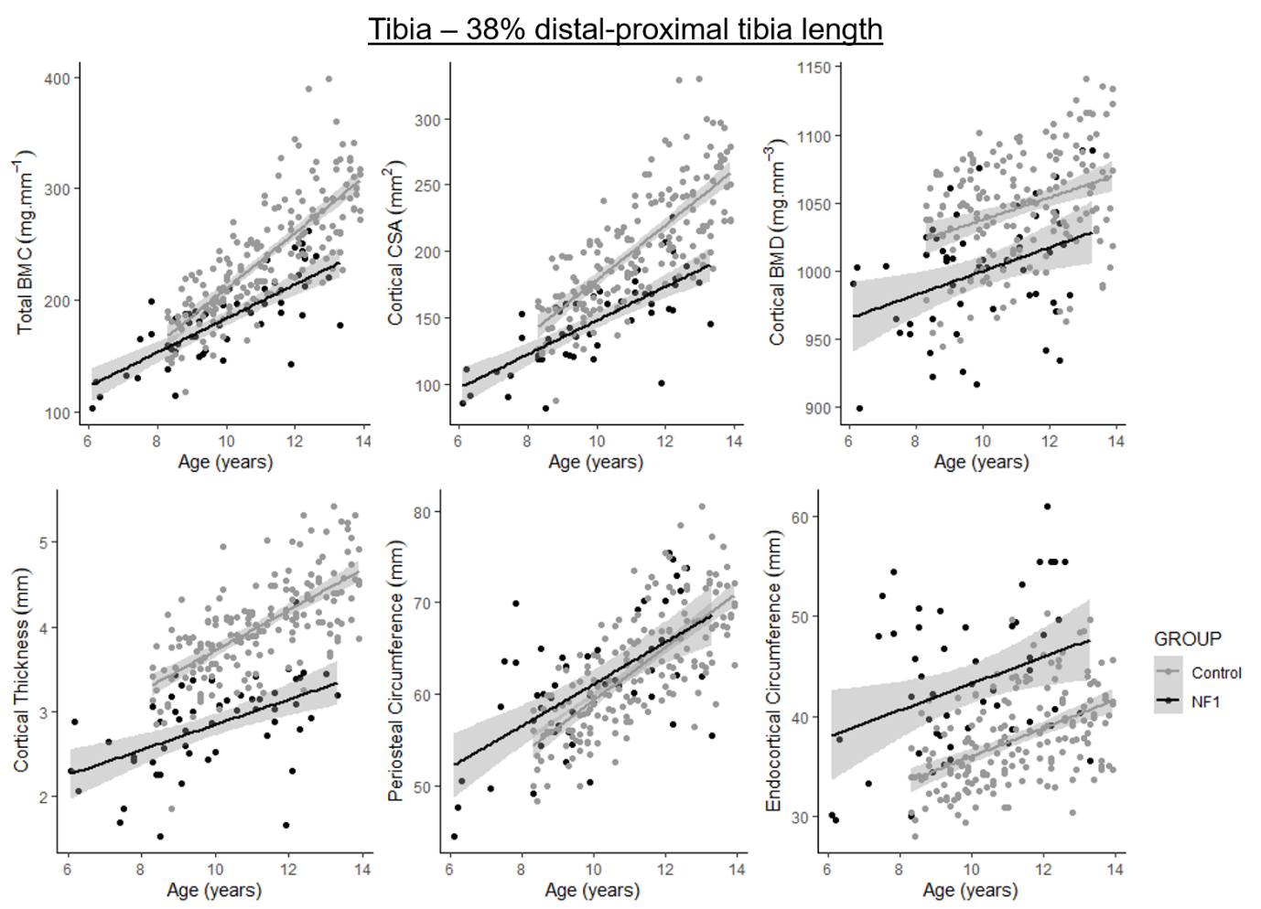
Figure 3. Tibia characteristics at the 38% site, separated by group. Grey region indicates 95% confidence interval of estimated values. BMC – bone mineral content, CSA – cross-sectional area, BMD – bone mineral density.

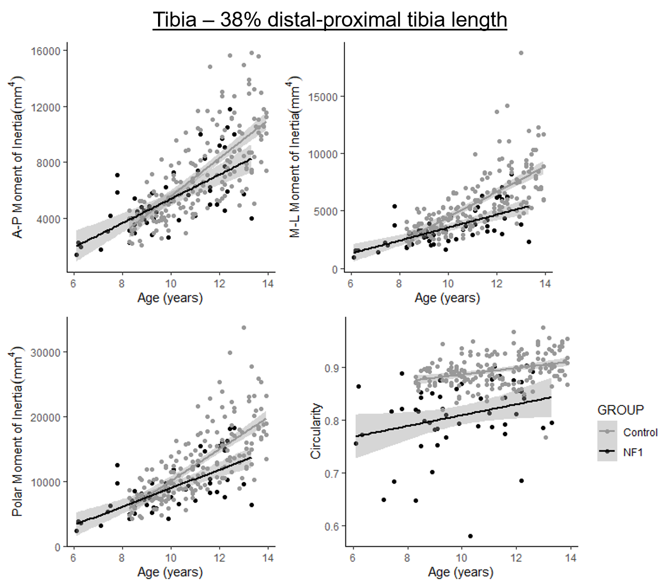
Figure 4. Tibia derived geometrical characteristics at the 38% site, separated by group. A-P – anterior-posterior, M-L – mediolateral. Grey region indicates 95% confidence interval of estimated values.

