Evidence of underestimation in microplastic research: a meta-analysis of recovery rate studies.
Chloe Wayª*, Malcolm D. Hudsonª, Ian D. Williams^{b}, G. John Langley^{c}

ª Faculty of Environmental and Life Sciences, University of Southampton, Highfield Campus, University Road, Southampton SO17 1BJ, United Kingdom
^{b}Faculty of Engineering and Physical Sciences, University of Southampton, Highfield Campus, University Road, Southampton SO17 1BJ, United Kingdom
^{c}School of Chemistry, Faculty of Engineering and Physical Sciences, University of Southampton, Highfield Campus, University Road, Southampton SO17 1BJ, United Kingdom

*Corresponding author: C.J.Way@soton.ac.uk
Malcolm D. Hudson: mdh@soton.ac.uk
Ian D. Williams: idw@soton.ac.uk
G. John Langley: G.J.Langley@soton.ac.uk

Abstract
Research on microplastics in the environment is of high interest to many scientists and industries globally. Key to the success of this research is the accuracy, efficiency, reliability, robustness and repeatability of the method(s) used to isolate the microplastics from environmental media. However, with microplastics now being found in new complex media, many multifaceted methods have been developed to research the quantities of these pollutants. To validate new methods, recovery studies can be undertaken by spiking the test medium with known quantities of plastics. The method is typically run as normal, and the recovered plastics counted to give a recovery rate. A current issue in this field is that methods are rarely or poorly validated in this way. Here, we conducted a meta-analysis on 71 recovery rate studies. We found sediment was the most studied medium and saline solutions were the most used reagents. Polyethylene and polystyrene were the most used spiking polymers, which is relevant to the most common polymers in the environment. We found that recovery rates were highest from plant material, whole organisms and excrement (>88%), and lowest from fishmeal, water and soil (58-71%). Moreover, all reagents but water were able to recover more than 80% of the spiked plastics. We believe we are the first (to our knowledge) to provide an overarching indication for the underestimation of microplastics in the environment of approximately 14% across the studies we reviewed, varying with the methods used. Furthermore, we recommend that the quality, use and reporting of recovery rate studies should be improved to aid the standardisation and replication of microplastic research.

Keywords
Microplastics, Recovery Rate, Method, Validation, Standardisation, Underestimation

Introduction
Currently, global microplastic research has a high public profile, is of high importance and includes many research avenues within one field. Crucially, it is primarily focused on the amount of these pollutants in different environmental matrices. For example, microplastics have now been found in wastewater and sludge from China (Li et al., 2018), Finland (Railo et al., 2018) and Australia (Ziajahromi et al., 2017), in soil samples from Chile (Corradini et al., 2019) and Switzerland (Scheurer and Bigalke, 2018), and in aquatic sediments from Belgium (Claessens et al., 2011), England (Horton et al., 2017) and the Arctic (Kanhai et al., 2019). Research has also focused on the sources of this pollutant. For instance, it has been estimated that a single washing machine load of clothing could release approximately 700,000 microplastic fibres into waste water systems (Napper and Thompson, 2016), and similarly one use of a face wash could release up to 94,000 microbeads (Napper et al., 2015). Some of this research has resulted in policy change, like the banning of facial cleansers containing microbeads (Guerranti et al., 2019).
However, a key to successful microplastic research lies within the method used to extract these small pollutants. Researchers in this discipline face criticism for their lack of standardisation and comparative approaches (Underwood et al., 2017). Methods can vary significantly; density separation methods use many different saline solutions such as sodium chloride (NaCl) (Nuelle et al., 2014; Pagter et al., 2018; Quinn et al., 2017), zinc chloride (ZnCl₂) (Imhof et al., 2012; Wang et al., 2018) and sodium iodide (NaI) (Nuelle et al., 2014; Roch and Brinker, 2017); various acids, bases and oxidising agents have been used (Bianchi et al., 2020; Schirinzi et al., 2020; Yu et al., 2019). Enzymes (Catarino et al., 2017; Loder et al., 2017), and oils (Radford et al., 2021) are also being utilised, with or without the use of additional reagents such as dispersants. Many of the methods are used in combination – for example combining in sequence oxidising agents with density separation methods. Also, new equipment and devices are being developed to assist in the extraction of microplastics (Coppock et al., 2017; Imhof et al., 2012; Nakajima et al., 2019). However, with some methods inaccessible due to cost or limited access to equipment, this is not always achievable. For example, spectroscopic equipment such as Fourier transform infrared (FTIR) and Raman spectroscopy, used to identify polymers often come at very high cost, with some systems priced between US$200,000 - 300,000 (Primpke et al., 2020). Similarly, saline solutions used in density separations can be expensive when needed in large quantities. For instance, NaI may cost US$69 for just 100ml and ZnCl₂ can cost US$710 for just 30 litres (Crichton et al., 2017). More complex matrices such as fishmeal (Gündoğdu et al., 2021; Thiele et al., 2021) and terrestrial soils (Corradini et al., 2019) are being found to contain microplastics, thus many multifaceted methods are being developed and published to cater for this, or current methods are being developed further to combat current limitations.
For this suite of methods to be replicated and used by others, they should be verified and validated in some way. However, method verification/validation is not as common as it may need to be in this developing field of research. For example, Underwood et al. (2017, p.1337) stated “Methods used have not been analysed experimentally to determine the relative importance of the different thermal, physical and chemical techniques on rates of recovery and dissolution of different sizes and polymers of microplastic”. To verify and validate new methods, so called “recovery rate” studies are sometimes undertaken alongside the main microplastic extraction. This entails ‘spiking’ the studied matrix with known types and configurations of spiking polymers, running a method considered for use in further study of that matrix, and then establishing the amount of spiking plastics recovered. This provides an indication of how effective the method is at extracting plastics from a specific matrix, typically as a percentage recovery rate. When implemented effectively, this could provide an insight in to how well a method could perform compared to others. Further to this, a recovery below 100% could suggest how using a certain method may underestimate the amount of microplastics in a matrix, and a recovery over 100% could show a potential for overestimation. Under and/or overestimating the number of microplastics in the environment could have further implications. For example, underestimating the number provides the chance of underplaying the severity of this pollution, whereas overestimating may allow for scaremongering of an issue which is not that severe. Both of these scenarios can have a negative impact if used in the media, particularly to those readers in the wider non-scientific population.
This meta-analysis aims to identify the recovery rates from multiple studies, and critically review how they vary when using different methods to extract microplastics from a wide range of matrices. The analysis is the first (to our knowledge) to provide an estimate of how much microplastic research may be under or over-estimating current levels of microplastics based on the methods utilised and the recovery rates found. Finally, recommended reporting criteria are provided for future recovery rate studies to allow for improved validation and simpler replication.

Method

Methodology for literature search – Identification
The methodological approach of this meta-analysis was carried out by following the guidance of the PRISMA 2020 flow diagram (Page et al., 2021) (Figure 1). The PRISMA flow diagram allows for a visual depiction of the different stages of the systematic literature search; including how sources were identified and how many were found, how many were screened for suitability, how many were included in the analysis and reasons for those excluded. Sections of the PRISMA 2020 checklist (Page et al., 2021) were also complied and followed, with the inclusion of the eligibility criteria, information sources, a full search strategy, study selection, the data collections process and the data extracted. The PRISMA approach has been widely applied to optimise methodologies and reporting quality in research studies (e.g. Haihua Liu et al 2019)
During January 2021, a database search was undertaken using Web of Science, Scopus, GreenFILE and PubMed search engines. The search was conducted using the following search terms: “recovery rate” OR “recovery efficiency” AND microplastic OR plastic OR nanoplastic AND extraction OR identification OR validation.
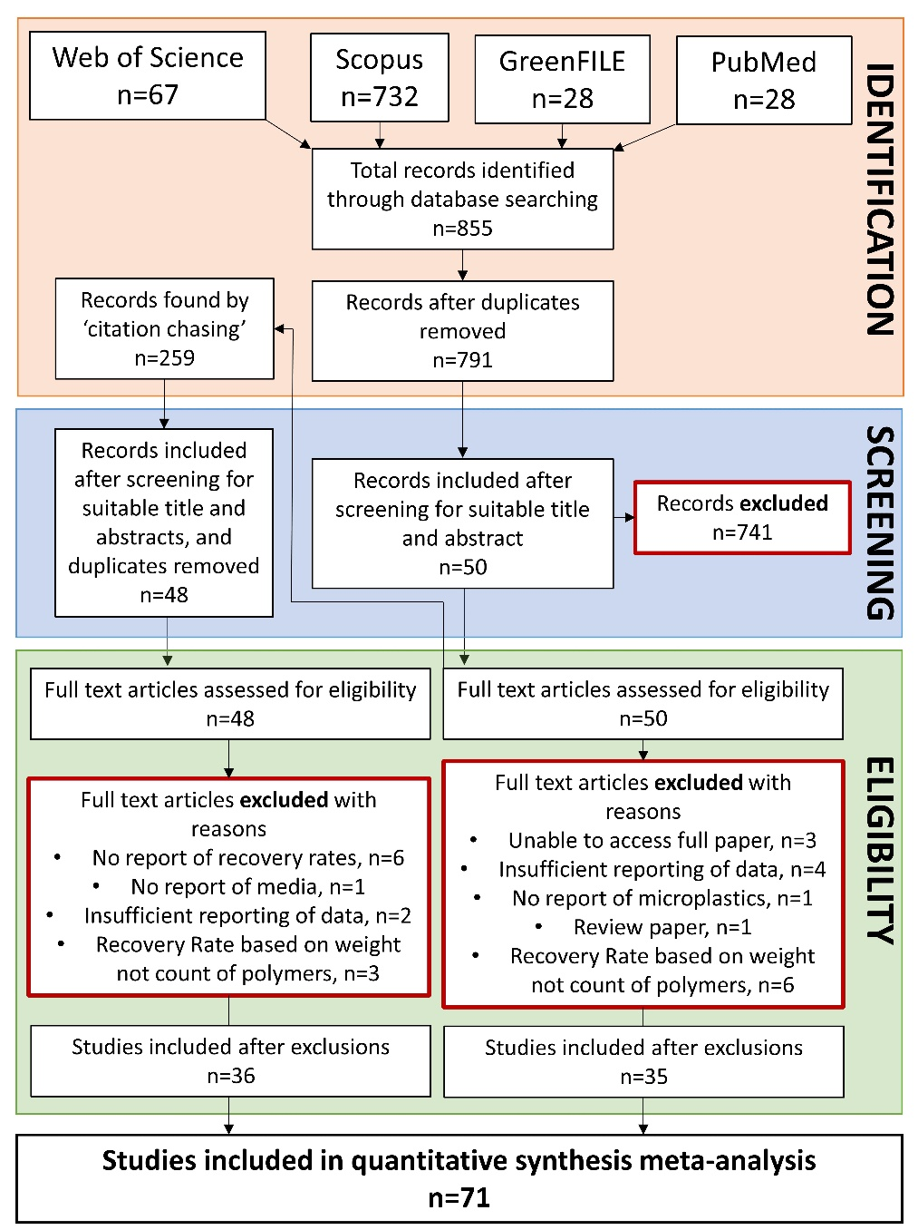
The search was filtered further to only include peer-reviewed articles; however, no limit was put on date of publication. Following from the database searches, 855 records were found, and a reference manager (Endnote) was used to organise the articles. Duplicates were removed, leaving 791 papers to be screened for suitable titles and abstracts (Figure 1).
Figure 1. Literature search flowchart. Including literature identification, screening and eligibility process. Including number of articles found and/or excluded at each stage. Adapted from PRSMAflow diagram (Page et al 2021)

Criteria for inclusion – Screening and Eligibility
During the screening for suitable titles and abstracts, certain inclusion criteria were applied. Articles incorporated must include plastics that are either below 5 mm (large microplastics) or plastics between 1 µm-1 mm (microplastics) (International Organization for Standardization, 2020). The titles and/or abstract must also indicate that the method used was validated in some way, either by including a recovery rate or using another term such as efficiency. The media tested in the studies were not limited.
Following on from screening for suitable title and abstracts, 50 full text articles were assessed for eligibility. Articles were excluded for the following reasons: No access to the full paper and data, insufficient reporting of data (recovery rates were reported in graphs/figures, but an accurate average and/or variation could not be extracted and used), no report of using microplastics in the study or spiking trial, no report of recovery rates, any review papers and recovery rates calculated by weight difference, not count.
Due to recovery rate studies being often undertaken as a side project alongside microplastic extraction/identification studies, many recovery rate studies may have not been identified during screening titles and abstracts. Therefore, “citation chasing” (Barrett, 2005) was carried out to counterbalance this. When reading the full text articles, suitable references were identified and pooled. A total of 259 potentially suitable articles were identified and managed within the reference manager. After duplicates were removed and abstracts and titles were screened for the same inclusions mentioned previously, 48 articles were selected to be checked for full paper eligibility.
After all articles were assessed for eligibility, including those found by citation chasing, 71 papers were included for the meta-analysis.

Data Extracted
Data extracted from the articles included basic information such as the authors’ names, the journal name and date of publication. Other material extracted included a short detail on the method used, the test media, the types of reagent used, the spiking microplastic polymer types, the spiking microplastic shapes, the spiking microplastic sizes and the recovery rates found.
The quantitative analysis was further conducted in Microsoft Excel and RStudio (version 3.6.1). The microplastic size category was further subdivided into MP (microplastic) (any microplastics between 1µm and 1mm) and LMP (large microplastic) (any microplastics between 1mm and 5mm) (International Organization for Standardization, 2020). Similarly, the test reagents were categorised into oils, alcohols, dyes, acids, oxidising agents, bases, saline solutions, water, enzymes and solvents. The test media were categorised into plant material (vegetal plant material), air, fishmeal, biofilms, excrement, whole organisms, tissues of organisms, soil (horticultural/agricultural soil, farmland soil, compost), wastewater effluent/sludge, water and sediment (marine and freshwater sediment/beach and river sediment). All information on studies included is provided in the supplementary material (Table S1).
Due to the lack of control samples used in recovery rate studies, and lack of reported sample sizes for the recovery rate part of a study, a sample effect size was not able to be calculated. However, this limitation will be examined in the discussion.

Quality of selected studies
The quality of the selected studies in this analysis are assessed by ranking each study subjectively from 1 to 5 (1 being low quality, 5 being high quality). The criteria (Table S3) are adapted from Porter et al. (2014) and Fidai et al. (2020), and is based on the quality of the recovery rate method, comprising of the inclusion of the test media, the reagent used and information on the spiking plastics used. Furthermore the criteria included whether the studies have potential for replication and the clarity and presentation of results.

Results

Summaries of studies included in meta-analysis

Quality of selected studies
The purpose of reviewing the quality of included studies is to highlight the areas of recovery rate studies which need improvement. The mode score for the 71 studies included in this meta-analysis is 4. With only 14 studies achieving the rank of 5, it shows there are many limitations of recovery rate studies to be discussed.

Media and reagent used
A total of 12 different types of media were studied, including fishmeal (Thiele et al., 2021), plant material (Herrera et al., 2018), air (Prata et al., 2020a), biofilms (Peez et al., 2019), excrement (Wu et al., 2020; Yan et al., 2020), whole organisms (Catarino et al., 2017; Karlsson et al., 2017; Peez et al., 2019; Thiele et al., 2019; Yu et al., 2019), tissues of organisms (Claessens et al., 2013; Dawson et al., 2020; Dehaut et al., 2016; Digka et al., 2018; Jaafar et al., 2020), soil (Büks et al., 2021; Corradini et al., 2019; Scopetani et al., 2020), wastewater/sludge (Dyachenko et al., 2017; Scopetani et al., 2020; Xu et al., 2020), gastrointestinal tracts (Munno et al., 2018; Tsangaris et al., 2020; Yu et al., 2019), water (Birkenhead et al., 2020; Hildebrandt et al., 2019; Wiggin and Holland, 2019) and sediment (Mahon et al., 2017; Mohamed Nor and Obbard, 2014; Pagter et al., 2018) (for a breakdown of these media categories see section 3.3 Data Extracted). One study did not report the medium used (N/A in Figure 2). The most tested medium is sediment (n=26), followed by water (n=14) and gastrointestinal tracts (n=12) (Figure 2).
Several different reagents were used in the studies when performing recovery rate trials. These include solvents (Peez et al., 2019; Scopetani et al., 2020), enzymes (Catarino et al., 2017; Karlsson et al., 2017), dyes (Prata et al., 2020b; Vermeiren et al., 2020), bases (Dawson et al., 2020; Jaafar et al., 2020), acids (Hernández-Arenas et al., 2021; Weber et al., 2021), oxidising agents (Nuelle et al., 2014; Stolte et al., 2015), water (Lares et al., 2019; Mahon et al., 2017), alcohol (Hildebrandt et al., 2019; Palermo et al., 2020), oil (Karlsson et al., 2017; Scopetani et al., 2020) and saline solutions (Büks et al., 2021; Crichton et al., 2017). The most frequently used reagents were saline solutions (n=39), followed by oxidising agents (n=31), oxidising agents combined with saline solutions (n=17) and bases (n=14) (Figure 2). The most commonly used saline solutions include sodium chloride (n=15), sodium iodide (n=10) and zinc chloride (n=10) (Table S2). Moreover, five studies did not state what reagent was used in the recovery trial (N/A in Figure 2).

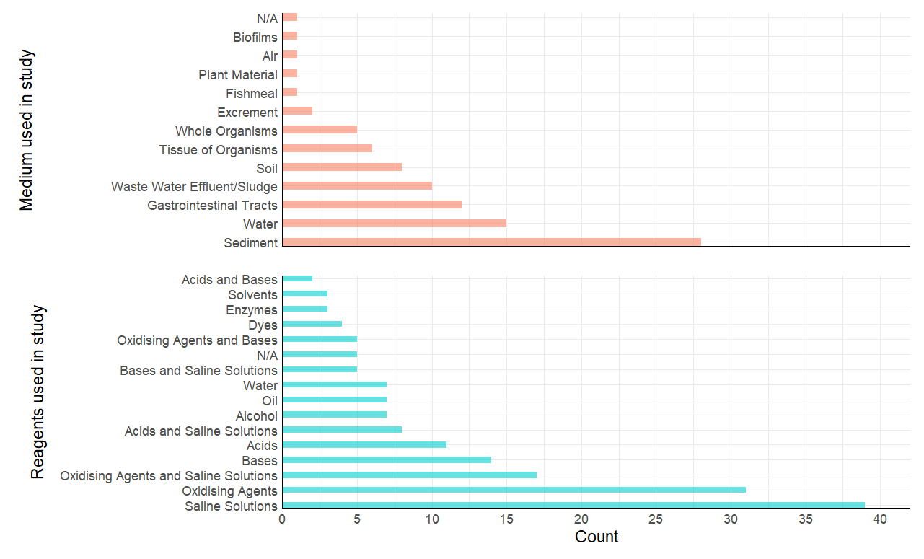
Type of spiking polymer used
Figure 2. Count of studies included in meta-analysis using different media and reagents. The count of studies included in this meta-analysis which used each medium and each reagent during a recovery rate experiment. N/A represents number of studies which did not report the medium or reagent used.
A total of 27 different spiking polymers were used in the microplastic recovery experiments reviewed. The most commonly used polymer was polyethylene (PE) (n=44), followed by polystyrene (PS) (n=36) and polyethylene terephthalate (PET) (n=35) (Figure 3). One study did not report the type of spiking polymer used. From here forward, the eight most used polymers (used in more than eight studies), were further analysed. These eight polymers have been further categorised into high- density (PET, PVC and PA) and low-density (PE, PS, PP, LDPE and HDPE) polymers (Figure 3). At least one or more of these polymers are used in 98.5% of the studies selected for this meta-analysis (70 out of 71 studies).

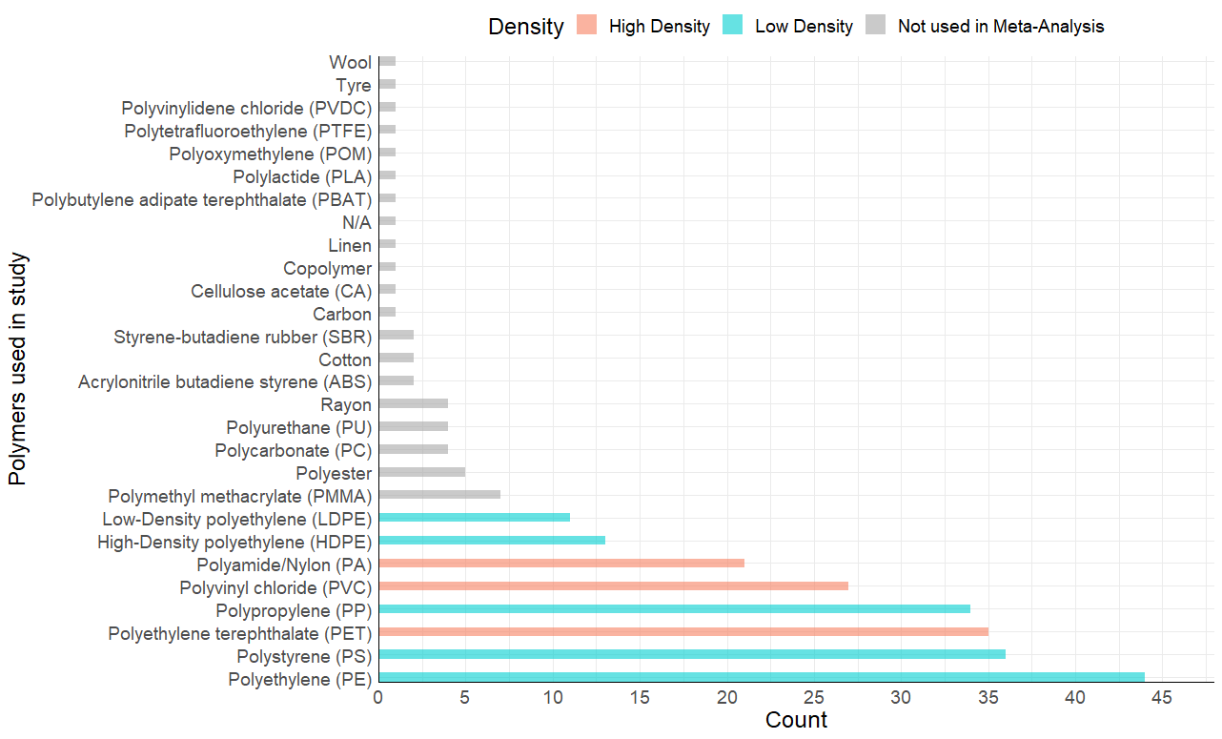
Shape and size of spiking polymers used
Figure 3. Count of the types of spiking polymers used in the studies examined in this meta-analysis. Those polymers used in more than 8 studies are further split into high (red) and low-density (blue) polymers for further investigation. The polymers used in less than 8 of the studies were not used for further investigation (grey).
The most common shape spiking polymer used was fragments (n=27), followed by fibres (n=22) (Figure 4). A large number of studies did not report the shape of the spiking polymer (n=10). Furthermore, 11 studies used the word “particle” to describe the spiking polymer used. This is an ambiguous term which could be interpreted and described as many shapes, so this term was given its own category. With regard to the size of spiking polymers used, the majority of the studies (n=60) used microplastics (1µm-1mm) as their spiking polymers. However, four studies did not report the size of the spiking polymer used (Figure 4).

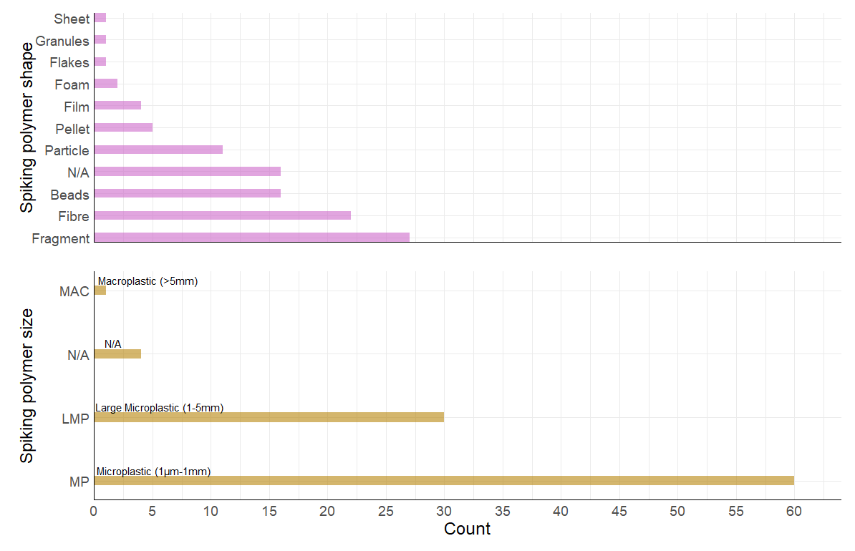
Meta-analysis of recovery rates across studies
Figure 4. The count of different shape and size of spiking plastics used in the studies selected for this meta-analysis. Large microplastics are those classed between 1 mm-5 mm, microplastics are those classed between 1 µm-1 mm (International Organization for Standardization, 2020). N/A represents the number of studies not reporting the spiking polymer shape or size. Many studies used more than one different shape and size of spiking plastic.

Recovery rates of different sized spiking plastics
On average, recovery rates of spiking plastics increased with the size of the plastics (Figure 5). Studies using the smallest spiking plastics (microplastics (<1mm)) recovered 84.5% on average, whereas the studies using the large microplastics (1-5mm) and the macroplastics (>5mm) as spiking plastics, recovered 84.8% and 100% respectively. Notably, four studies did not report the size of the spiking plastics used but achieved a recovery rate of 95.1% on average.

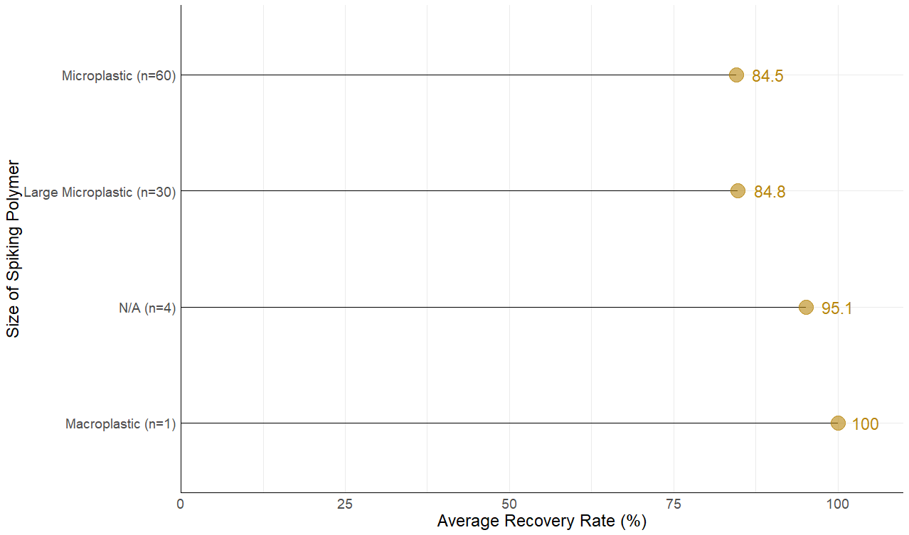
Recovery rates of polymers from different media
Figure 5. Average recovery rates across studies of different sized spiking plastics. Macroplastics are those plastics above 5mm, large microplastics are those classed between 1 mm-5 mm, microplastics are those classed between 1 µm-1 mm (International Organization for Standardization, 2020). N/A represents the studies which did not classify the size of the spiking plastics used.
The majority of the lower recovery rates in each media type came from the high-density polymers (PVC, PET and PA). This is the case for fishmeal, water, wastewater/sludge, tissues of organisms and whole organisms (Figure 6). However, in the studies that have used gastrointestinal tracts and excrement as the study medium, the opposite is found, with lower recovery rates of low-density polymers (PS, PP, PE, LDPE, HDPE). Overall, polymers were recovered more effectively from plant material (all 100%), biofilms (96%), whole organisms (91-95%) and excrement (88-95%); and recovered least from fishmeal (58-70%), water (67-82%) and wastewater effluent/sludge (76-89%) (Figure 6). The difference in recovery rates between high and low-density polymers is much larger in some media compared to others. For example, 22% more low-density polymer were recovered from soil than high-density polymers. However, from tissues of organisms only 3% more low-density polymers were recovered than high-density polymers (Figure 6).
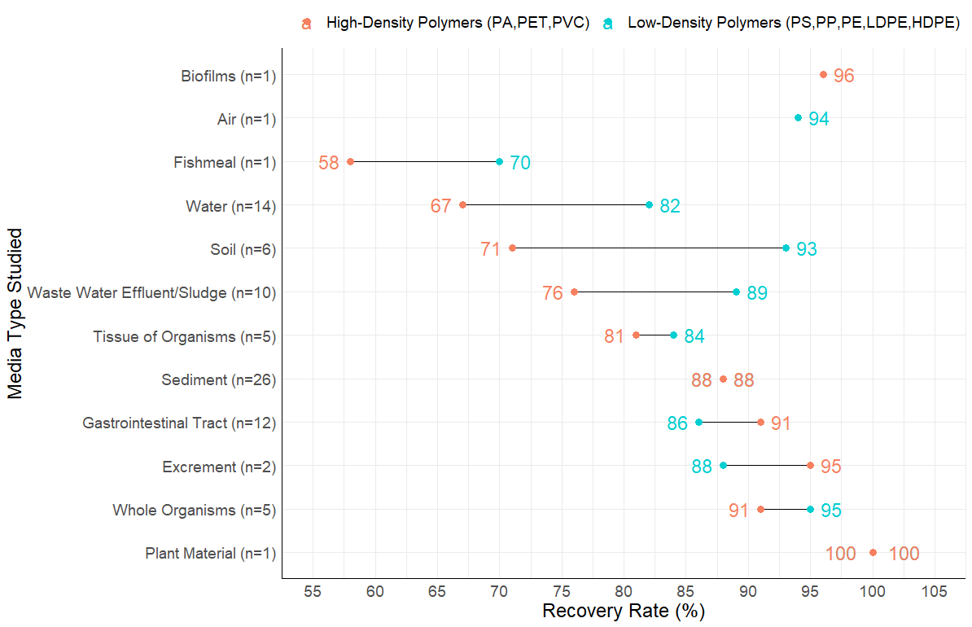
Figure 6. Average recovery rates across studies of high and low-density polymers when extracted from different media. Numbers against the media represent number of studies in this meta-analysis using each medium.

Recovery rates of polymers using different reagents
Similarly to the trend found in the recovery of polymers in different media, most reagents recovered more low-density polymers than high density polymers, which is the case for water, saline solutions, oxidising agents, bases and dyes. However, the opposite is found when studies used solvents, alcohols, acids and oils, which removed more high-density polymers. Moreover, all but one reagent (water) recovered more than 80% of spiking polymers on average. However, the studies that used water as a reagent to recover the polymers showed the lowest recovery rates (averages 53% for high-density polymers, 65% for low-density polymers) (Figure 7).
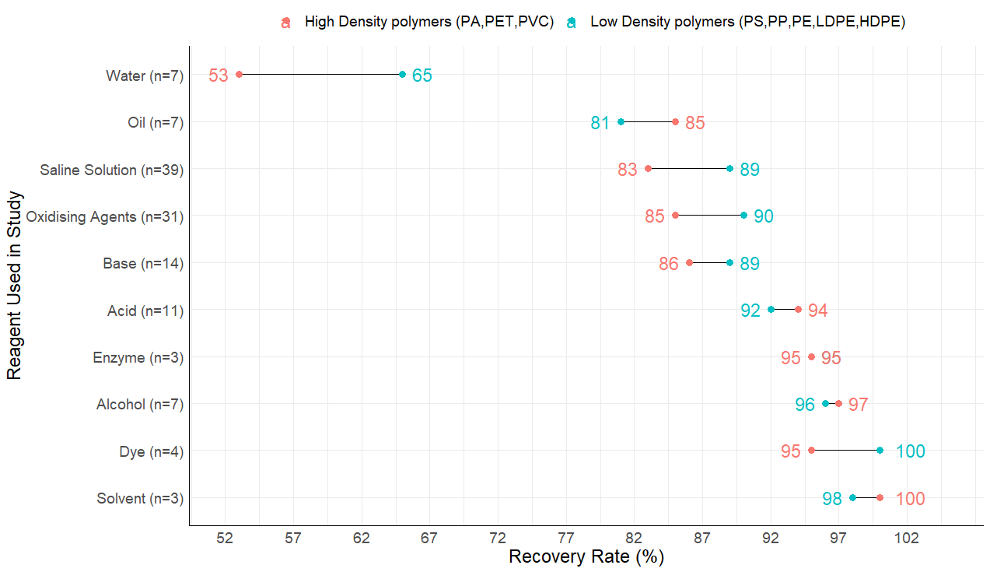
Figure 7. Average recovery rates across studies of high and low polymers when extracted using different reagents. Numbers against the reagents represent number of studies in this meta-analysis using each reagent.

Combination of different reagents and media on the recovery rates of polymers
Individually, reagents and type of media have an effect on recovery of microplastic polymers (Figure 6 & 7), however they can also have an effect on recovery when combined (Figure 8). For example, the use of an acid as a reagent results in higher recovery than other reagents when used in the same media. This is the case for excrement, sediment and whole organisms. However, when an acid is used to recover polymers from wastewater/sludge and water, lower recovery rates are found (Figure 8). The use of oxidising reagents recovered the most polymers from air, excrement, gastrointestinal tracts and plant material, however, these reagents resulted in very low recoveries of high-density polymers from soil (Figure 8).
Similarly, saline solutions recover high amounts of polymers from air and whole organisms, but lower amounts from media such as excrement, fishmeal, soil, tissues of organisms and wastewater/sludge (Figure 8).
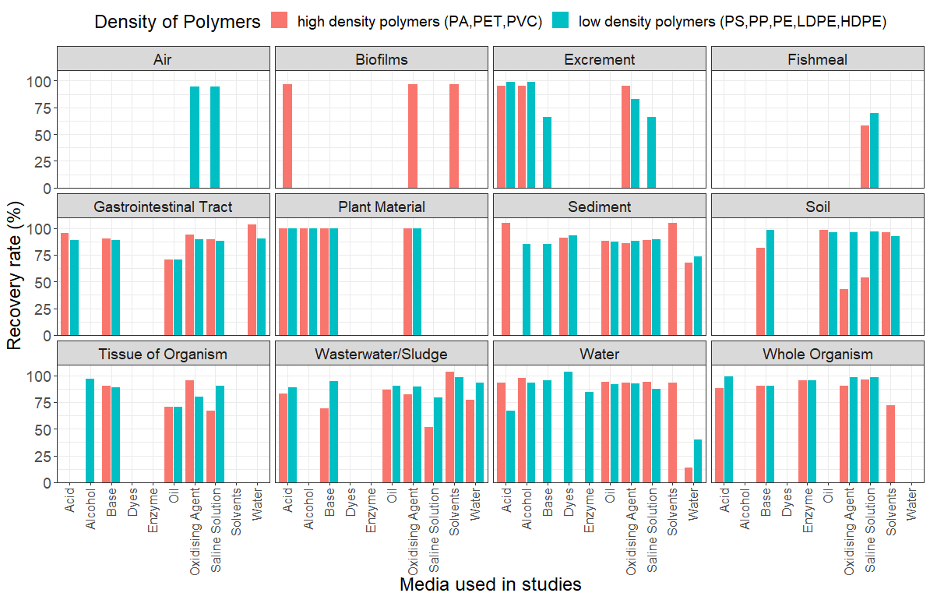
Moreover, the use of an oil as reagent to recover plastics produced high recovery rates in soil. However, much lower recovery rates were found when using the same reagent to extract polymers from gastrointestinal tracts and tissues of organisms.
Figure 8. Recovery rates of media and reagents combined. Average recovery rates across studies of high and low-density spiking polymers when using different reagents and test on different media.

Assessment of underestimation
As seen in Figures 6-8, very few combinations of reagents and media tested result in 100% recovery of spiking microplastics, meaning there is a level of underestimation when using these methods to extract polymers. Due to the lack of consistent information reported and the low importance given to recovery experiments in much microplastic research, an effect size could not be calculated for this meta-analysis. Therefore, we have counterbalanced this by calculating a weighted mean based on equations provided by Gurnsey (2017). Here we estimate that microplastic research could be underestimating how many microplastics are found by approximately 14% (calculation in supplementary material (Equation S1)), based on the type of reagents and medium used. We recommend taking any underestimations found by method validation into account when concluding how many microplastics are found in environmental samples. Underestimations may be higher or lower than 14% depending on the method used, including the medium and reagents used.

Discussion
This meta-analysis has gathered recovery rates from studies that have used a wide array of media (Figure 2), including plant material, fishmeal, biofilms, air, excrement, whole and tissues of organisms, soil, wastewater treatment plant products, gastrointestinal tracts, water and sediments. There are benefits to studying such different types of media as it has been increasingly evident that microplastic contamination of the environment is enormously widespread. For example, Ross et al. (2021) found polyester fibres in remote environments such as the Arctic. However, with regards to the method used with these new media types, problems can arise, specifically with the ability to standardise. Microplastic researchers have been calling for standardisation when it comes to methods for extraction (Skalska et al., 2020). However, a “one-size-fits-all” kind of method is extremely difficult to achieve when properties of the study media vary so drastically. Lusher et al. (2020) explained how methods could be divided depending on their complexity and the number of steps needed.
Similarly, with new methods being developed to extract microplastics from complex media, often new reagents are used. This meta-analysis found a range of reagents including solvents, enzymes, dyes, bases, acids, oxidising agents, water, alcohols, oils and saline solutions (Figure 2). These were either used individually (Digka et al., 2018; Thiele et al., 2019) or sometimes combined (Hurley et al., 2018; Yu et al., 2019). With the aim of microplastic research to identify harmful microplastics in the environment to eventually find solutions for their removal, it could be argued that harmful/toxic reagents should not be used in methods. For example, zinc chloride (ZnCl₂) and sodium hypochlorite (NaOCl) are commonly used to extract microplastics (Collard et al., 2015; Coppock et al., 2017), however both of these reagents can be toxic to the environment and marine life and have multiple hazard statements in safety data sheets. For example, zinc chloride can alter bone development of zebrafish (Salvaggio et al., 2016), and similarly sodium hypochlorite can cause acute toxicity on the same species (Emmanuel et al., 2004). However, high recovery rates (>80%) of microplastics have been found when using less harmful alternatives such as sodium chloride (Quinn et al., 2017). Moreover, it could be the case that certain regents are more suited at extracting microplastics from certain media. For example oil works as a better reagent to recover microplastics from soil than gastrointestinal tracts and tissues of organisms (Figure 8). Reasons for this could be due to the majority of soils having less than 30% of organic matter, allowing oil to work well as a density separation (Radford et al., 2021). Whereas oil may not work as well at separating microplastics from biological material such as gastrointestinal tracts or tissues, which often need to be digested beforehand with use of a strong oxidising agent such as hydrogen peroxide (H₂O₂) (Avio et al., 2015).
As a part of a recovery rate study, spiking polymers/microplastics are used. This meta-analysis identified that a wide range of type, shape and size polymers were used (Figures 3 and 4), with little explanation or justification in each of the studies. The most commonly used spiking polymers were PE, PS, PET and PP. It would be most reflective of real environmental conditions if the spiking polymers used would be the same as those commonly found in the environment. Phuong et al. (2016)) found that most studies use more plastics in experiments than those in the environment, but the most common microplastics found in the environment are polyethylene, polypropylene and polystyrene. Therefore, the four most widely used spiking polymers in this meta-analysis are environmentally relevant if used in the correct quantity. Similarly, it is important that the shape and size of the spiking plastics is environmentally relevant. The most common shape used in the studies in this meta-analysis is fragments (Figure 4). A review by Phuong et al. (2016)) confirmed that this is also the most commonly found shape in sediment and water samples, however other shapes such as fibres were also predominant depending on the type of method used. The shape of the spiking polymer is an important aspect to consider as different shape microplastics may be recovered easier than others. For instance, researchers have reported some microplastics sticking to glassware (Thiele et al., 2019). Also, foam-like microplastics such as polystyrene have a low density of 0.028-0.045 g/cm³ (British Plastics Federation, 2020) which enables it to float more readily than other denser microplastics, thus enabling easier density separation. Micro-sized plastics (1 µm- 1 mm) (International Organization for Standardization, 2020) were the most commonly sized spiking plastic identified in this meta-analysis. This is environmentally relevant. However, it is becoming apparent that smaller nano-sized (<1µm) particles may be more abundant in the environment but have yet to be studied in depth due to technological limitations. An example of this limitation is the ability to identify and quantify such small particles. Even if nanoplastics are in high abundance, their mass could be so low that it is difficult to detect with current technology and methods, or nanoplastics may be found aggregated to other particles due to their size, making them difficult to isolate (Jakubowicz et al., 2021). This provides further evidence that smaller microplastics are more difficult to isolate, with this analysis showing that on average, macroplastics and larger microplastics were recovered at a higher rate than the smaller microplastics (Figure 5).
The environmental relevance of the types of plastics used as spiking polymers is crucial as it must represent as close to a true environmental sample as possible. Microplastics in the environment may vary in bioavailability and toxicity depending on many factors including the aforementioned type, shape and size, but also due to their colour, crystallinity and stability (Ma et al., 2020). These properties will not only affect the organisms in the environment but will also affect the way in which the plastics can be extracted from the environmental medium. Furthermore, these type of spiking recovery studies typically use new or ‘virgin’ plastic to spike the sample. However, true extractions from environmental media will usually involve isolating material that has been subjected to some ageing and weathering thus will behave differently from the virgin spiking material. Routine spiking studies with weathered microplastics would be challenging to deliver but is an area that could reward some further study.
When looking at the recovery of microplastics from different media types, microplastics were recovered at higher rates from some types over others. For example, plant material, biofilms, air, whole organisms and excrement had recovery rates over 95%, whereas fishmeal, water, soil and wastewater effluent/sludge had recovery rates below 80% (Figure 6). This could be due to some of the properties of those media types. For example, there would be less organic material to breakdown in air than in fishmeal and soil. Radford et al. (2021) found organic material was one of the key factors in hindering the recovery of microplastics. Similarly, Wang et al. (2018) found that particle size influences the ability to extract microplastics from soil and biosolids, as some nano and micro-sized plastics take longer to float than larger sized plastics. Moreover, the range of recovery between low and high-density microplastics varies considerably between the different media types. For example, there is 22% difference between low and high-density microplastics recovered from soil (71-93%) (Figure 6), but only 3% different from those recovered from tissues of organisms (81-84%). This could be due to the complexity of the test media. For example, the soil used in the different studies may vary considerably in regards to particle size distribution and organic matter which depending on the quantity of each, may benefit the lower-density plastics, but hinder the high-density plastics.
Similarly, this meta-analysis has revealed that using different reagents can yield different recovery rates. The majority of the reagents (oil, saline solutions, bases, acids, oxidising agents, enzymes, alcohols, dyes and solvents) recovered more than 80% of the spiking plastics (Figure 7). However, in the studies which used water, recovery rates were below 65% (53-65%) (Figure 7). This is not surprising as the density of water is approximately 0.99 g/cm³ (Tanaka et al., 2001), which is lower than many plastics (PET: 1.37 g/cm³, PVC: 1.38 g/cm³ (British Plastics Federation, 2020)). However, what is surprising is that in some cases when using oils, alcohols and solvents, more high-density polymers were recovered than low density polymers (Figure 7). A reason for this could be due to the density of these reagents. Chloroform has a density of 1.49 g/cm³ but is corrosive enough to attack plastics (National Center for Biotechnology Information, 2021). The high density of chloroform will allow for higher density plastics to float, however, depending on the concentration of chloroform and length of exposure, certain types and sizes of microplastics may corrode.
What is overwhelmingly clear from the results of this meta-analysis is that it is rare for all spiking plastics to be recovered, thus a 100% recovery rate is seldom achieved. This meta-analysis found that on average- across all studies, microplastics could be underestimated by approximately 14% (See Supplementary information for calculation). More so, studies rarely account for any underestimation brought about by the methods used. If underestimations are accounted for, the amounts of microplastics in the environment could be a lot larger than estimated to date.
Overall, this meta-analysis has highlighted many issues within recovery rate studies and microplastic research. Firstly, recovery rate studies are rarely used to validate methods in published studies. For example, the 71 studies found and used in this analysis is a minute size compared to the large number of microplastic research papers and methods that have been published over time (Provencher et al., 2020). Furthermore, those papers that are published with a recovery rate study are often poorly executed with key information missing, such as sample size and the type, shape and size of the spiking plastic used. With this missing information, it is difficult to make further inferences regarding the effect size and publication bias, also this makes it problematic for others to replicate the method used. Often recovery rate results are poorly displayed and are seen as unimportant compared to the main results of a study. A standardisation needs to be agreed on in several aspects of these studies. Firstly, it should be agreed on whether recoveries are calculated by weight difference or difference by count; and secondly, the terms used to describe the shapes of the spiking polymers, often the term ‘particle’ is used, which can be interpreted in many ways. Due to the aforementioned limitations we have assembled recommended reporting criteria specifically for recovery rate studies, with the intention of making validation of microplastic extraction methods clearer to others.

Conclusions and Recommendations
The varying range of recovery rates found in the studies included in this meta-analysis were dependent on the media types and reagents used. However, very rarely were 100% of the spiking plastics recovered, and overall an underestimation of 14% was discovered, meaning the amount of microplastics in the environment could be higher than estimated from research studies to date. From this meta-analysis it is clear that recovery studies are not utilised enough and, on the occasion, when they are, they are often poorly executed. It could be argued, that with a more holistic approach to validating methods, by studying the properties of the test medium, and clearly and concisely reporting the recoveries, it could help with the ever-growing issue of standardisation in microplastics research. This meta-analysis flagged several limitations within recovery rate studies, which we recommend improvements:
Report all raw or average recovery rates with variance in both tabulate AND graphical form. Include this in supplementary material if needed. Many studies either reported a single percentage in the text or displayed recovery rates in graphical form, often making it difficult to extract an exact percentage, thus making it difficult for others to accurately assess the effectiveness of the method.
Calculate the recovery rate by count of recovered plastics. Few studies calculated the recovery rate by change in weight, these studies were removed from this meta-analysis as they were not comparable to the majority which use counts. If this is adopted by all, it allows for standardisation.
Use triangulation: have multiple researchers count recovered plastics in a study. If counted by eye, counts of recovered microplastics could be different depending on the observer’s experience carrying out this task.
Report the number of samples used in the recovery rate study. Many studies did not report the sample size, making it difficult for further analysis.
Report the shape, size, type and size of spiking plastics used. The reporting style of the spiking plastics across the studies varied considerably. For example, one study did not state the type of polymer used, ten studies did not state the shape of the polymer used, eleven studies used the word ‘particle’ to describe the shape, which could be interpreted differently by others, and four studies did not report the size of the polymer used. We recommend reporting these properties clear enough for replication and to use environmentally relevant quantities which are reported in the literature for each test medium.
Do the recovery rate study on the same media which is to be tested for the main experiment. Methods will work differently on media with different properties, thus different recovery rates will be found.
The aim of this meta-analysis is to highlight the importance to researchers of using a recovery rate study/trial to validate their methods, with the proposal that in the future this becomes a “new normal” during method development, and the quality of these types of studies are up to a standard that can be replicated. Furthermore, if the amount of underestimation, brought about by the methods used is accounted for in each study, the amounts of microplastics reported will probably be higher but more realistic, which can offer more robust evidence for policy makers.

Credit author statement
Chloe Way: Conceptualisation, methodology, validation, formal analysis, investigation, data curation, writing-original draft, visualisation. Malcolm Hudson: Supervision, project administration, funding acquisition, writing-review and editing. Ian Williams: Supervision, writing-review and editing. John Langley: Supervision, writing-review and editing.

Data availability
Data supporting this study are openly available from the University of Southampton repository at: [insert link]

Acknowledgments
This work was funded by the School of Geography and Environmental Science at the University of Southampton; and a Southampton Marine and Maritime Institute Leverhulme Trust Doctoral Scholarship. We would like to thank Philip Wells for his help with underestimation equations and calculations.

References
Avio CG, Gorbi S, Regoli F. Experimental development of a new protocol for extraction and characterization of microplastics in fish tissues: First observations in commercial species from Adriatic Sea. Marine Environmental Research 2015; 111: 18-26. https://doi.org/10.1016/j.marenvres.2015.06.014.
Barrett A. The Information-Seeking Habits of Graduate Student Researchers in the Humanities1. The Journal of Academic Librarianship 2005; 31: 324-331. https://doi.org/10.1016/j.acalib.2005.04.005.
Bianchi J, Valente T, Scacco U, Cimmaruta R, Sbrana A, Silvestri C, et al. Food preference determines the best suitable digestion protocol for analysing microplastic ingestion by fish. Marine Pollution Bulletin 2020; 154: 111050. https://doi.org/10.1016/j.marpolbul.2020.111050.
Birkenhead J, Radford F, Stead JL, Cundy AB, Hudson MD. Validation of a method to quantify microfibres present in aquatic surface microlayers. Scientific Reports 2020; 10. https://doi.org/10.1038/s41598-020-74635-3.
British Plastics Federation, 2020. Plastipedia. https://www.bpf.co.uk/plastipedia/default.aspx (Accessed March 2020).
Büks F, Kayser G, Zieger A, Lang F, Kaupenjohann M. Particles under stress: Ultrasonication causes size and recovery rate artifacts with soil-derived POM but not with microplastics. Biogeosciences 2021; 18: 159-167. https://doi.org/10.5194/bg-18-159-2021.
Catarino AI, Thompson R, Sanderson W, Henry TB. Development and optimization of a standard method for extraction of microplastics in mussels by enzyme digestion of soft tissues. Environmental Toxicology and Chemistry 2017; 36: 947-951. https://doi.org/10.1002/etc.3608.
Claessens M, De Meester S, Van Landuyt L, De Clerck K, Janssen CR. Occurrence and distribution of microplastics in marine sediments along the Belgian coast. Marine Pollution Bulletin 2011; 62: 2199-2204. https://doi.org/10.1016/j.marpolbul.2011.06.030.
Claessens M, Van Cauwenberghe L, Vandegehuchte MB, Janssen CR. New techniques for the detection of microplastics in sediments and field collected organisms. Marine Pollution Bulletin 2013; 70: 227-233. https://doi.org/10.1016/j.marpolbul.2013.03.009.
Collard F, Gilbert B, Eppe G, Parmentier E, Das K. Detection of Anthropogenic Particles in Fish Stomachs: An Isolation Method Adapted to Identification by Raman Spectroscopy. Archives of Environmental Contamination and Toxicology 2015; 69: 331-339. https://doi.org/10.1007/s00244-015-0221-0.
Coppock RL, Cole M, Lindeque PK, Queirós AM, Galloway TS. A small-scale, portable method for extracting microplastics from marine sediments. Environmental Pollution 2017; 230: 829-837. https://doi.org/10.1016/j.envpol.2017.07.017.
Corradini F, Meza P, Eguiluz R, Casado F, Huerta-Lwanga E, Geissen V. Evidence of microplastic accumulation in agricultural soils from sewage sludge disposal. Science of The Total Environment 2019; 671: 411-420. https://doi.org/10.1016/j.scitotenv.2019.03.368.
Crichton EM, Noel M, Gies EA, Ross PS. A novel, density-independent and FTIR-compatible approach for the rapid extraction of microplastics from aquatic sediments. Analytical Methods 2017; 9: 1419-1428. https://doi.org/10.1039/C6AY02733D.
Dawson AL, Motti CA, Kroon FJ. Solving a Sticky Situation: Microplastic Analysis of Lipid-Rich Tissue. Frontiers in Environmental Science 2020; 8. https://doi.org/10.3389/fenvs.2020.563565.
Dehaut A, Cassone A-L, Frère L, Hermabessiere L, Himber C, Rinnert E, et al. Microplastics in seafood: Benchmark protocol for their extraction and characterization. Environmental Pollution 2016; 215: 223-233. https://doi.org/10.1016/j.envpol.2016.05.018.
Digka N, Tsangaris C, Torre M, Anastasopoulou A, Zeri C. Microplastics in mussels and fish from the Northern Ionian Sea. Marine Pollution Bulletin 2018; 135: 30-40. https://doi.org/10.1016/j.marpolbul.2018.06.063.
Dyachenko A, Mitchell J, Arsem N. Extraction and identification of microplastic particles from secondary wastewater treatment plant (WWTP) effluent. Analytical Methods 2017; 9: 1412-1418. https://doi.org/10.1039/C6AY02397E.
Emmanuel E, Keck G, Blanchard JM, Vermande P, Perrodin Y. Toxicological effects of disinfections using sodium hypochlorite on aquatic organisms and its contribution to AOX formation in hospital wastewater. Environ Int 2004; 30: 891-900. https://doi.org/10.1016/j.envint.2004.02.004.
Fidai Y, Dash J, Tompkins EL, Tonon T. A systematic review of floating and beach landing records of Sargassum beyond the Sargasso Sea. Environmental Research Communications 2020; 2. https://doi.org/10.1088/2515-7620/abd109.
Guerranti C, Martellini T, Perra G, Scopetani C, Cincinelli A. Microplastics in cosmetics: Environmental issues and needs for global bans. Environmental Toxicology and Pharmacology 2019; 68: 75-79. https://doi.org/10.1016/j.etap.2019.03.007.
Gündoğdu S, Eroldoğan OT, Evliyaoğlu E, Turchini GM, Wu XG. Fish out, plastic in: Global pattern of plastics in commercial fishmeal. Aquaculture 2021; 534: 736316. https://doi.org/10.1016/j.aquaculture.2020.736316.
Gurnsey R. 2017. Statistics for Research in Psychology: A Modern Approach Using Estimation. SAGE Publications.
Hernández-Arenas R, Beltrán-Sanahuja A, Navarro-Quirant P, Sanz-Lazaro C. The effect of sewage sludge containing microplastics on growth and fruit development of tomato plants. Environmental Pollution 2021; 268. https://doi.org/10.1016/j.envpol.2020.115779.
Herrera A, Garrido-Amador P, Martínez I, Samper MD, López-Martínez J, Gómez M, et al. Novel methodology to isolate microplastics from vegetal-rich samples. Marine Pollution Bulletin 2018; 129: 61-69. https://doi.org/10.1016/j.marpolbul.2018.02.015.
Hildebrandt L, Voigt N, Zimmermann T, Reese A, Proefrock D. Evaluation of continuous flow centrifugation as an alternative technique to sample microplastic from water bodies. Marine Environmental Research 2019; 151: 104768. https://doi.org/10.1016/j.marenvres.2019.104768.
Horton AA, Svendsen C, Williams RJ, Spurgeon DJ, Lahive E. Large microplastic particles in sediments of tributaries of the River Thames, UK – Abundance, sources and methods for effective quantification. Marine Pollution Bulletin 2017; 114: 218-226. https://doi.org/10.1016/j.marpolbul.2016.09.004.
Hurley RR, Lusher AL, Olsen M, Nizzetto L. Validation of a Method for Extracting Microplastics from Complex, Organic-Rich, Environmental Matrices. Environmental Science & Technology 2018; 52: 7409-7417. https://doi.org/10.1021/acs.est.8b01517.
Imhof HK, Schmid J, Niessner R, Ivleva NP, Laforsch C. A novel, highly efficient method for the separation and quantification of plastic particles in sediments of aquatic environments. Limnology and Oceanography-Methods 2012; 10: 524-537. https://doi.org/10.4319/lom.2012.10.524.
International Organization for Standardization, 2020. ISO/TR 21960:2020(en) Plastics - Environmental aspects - State of knowledge and methodologies. https://www.iso.org/standard/72300.html (Accessed April 2020).
Jaafar N, Musa SM, Azfaralariff A, Mohamed M, Yusoff AH, Lazim AM. Improving the efficiency of post-digestion method in extracting microplastics from gastrointestinal tract and gills of fish. Chemosphere 2020; 260. https://doi.org/10.1016/j.chemosphere.2020.127649.
Jakubowicz I, Enebro J, Yarahmadi N. Challenges in the search for nanoplastics in the environment—A critical review from the polymer science perspective. Polymer Testing 2021; 93: 106953. https://doi.org/10.1016/j.polymertesting.2020.106953.
Kanhai LK, Johansson C, Frias J, Gardfeldt K, Thompson RC, O'Connor I. Deep sea sediments of the Arctic Central Basin: A potential sink for microplastics. Deep-Sea Research Part I-Oceanographic Research Papers 2019; 145: 137-142. https://doi.org/10.1016/j.dsr.2019.03.003.
Karlsson TM, Vethaak AD, Almroth BC, Ariese F, van Velzen M, Hassellov M, et al. Screening for microplastics in sediment, water, marine invertebrates and fish: Method development and microplastic accumulation. Marine Pollution Bulletin 2017; 122: 403-408. https://doi.org/10.1016/j.marpolbul.2017.06.081.
Lares M, Ncibi MC, Sillanpaa M, Sillanpaa M. Intercomparison study on commonly used methods to determine microplastics in wastewater and sludge samples. Environmental Science and Pollution Research 2019; 26: 12109-12122. https://doi.org/10.1007/s11356-019-04584-6.
Li X, Chen L, Mei Q, Dong B, Dai X, Ding G, et al. Microplastics in sewage sludge from the wastewater treatment plants in China. Water Research 2018; 142: 75-85. https://doi.org/10.1016/j.watres.2018.05.034.
Loder MGJ, Imhof HK, Ladehoff M, Loschel LA, Lorenz C, Mintenig S, et al. Enzymatic Purification of Microplastics in Environmental Samples. Environmental Science & Technology 2017; 51: 14283-14292. https://doi.org/10.1021/acs.est.7b03055.
Lusher AL, Munno K, Hermabessiere L, Carr S. Isolation and Extraction of Microplastics from Environmental Samples: An Evaluation of Practical Approaches and Recommendations for Further Harmonization. Appl Spectrosc 2020; 74: 1049-1065. https://doi.org/10.1177%2F0003702820938993.
Ma H, Pu S, Liu S, Bai Y, Mandal S, Xing B. Microplastics in aquatic environments: Toxicity to trigger ecological consequences. Environmental Pollution 2020; 261: 114089. https://doi.org/10.1016/j.envpol.2020.114089.
Mahon AM, O’Connell B, Healy MG, O’Connor I, Officer R, Nash R, et al. Microplastics in Sewage Sludge: Effects of Treatment. Environmental Science & Technology 2017; 51: 810-818. https://doi.org/10.1021/acs.est.6b04048.
Mohamed Nor NH, Obbard JP. Microplastics in Singapore’s coastal mangrove ecosystems. Marine Pollution Bulletin 2014; 79: 278-283. https://doi.org/10.1016/j.marpolbul.2013.11.025.
Munno K, Helm PA, Jackson DA, Rochman C, Sims A. Impacts of Temperature and Selected Chemical Digestion Methods on Microplastic Particles. Environmental Toxicology and Chemistry 2018; 37: 91-98. https://doi.org/10.1002/etc.3935.
Nakajima R, Tsuchiya M, Lindsay DJ, Kitahashi T, Fujikura K, Fukushima T. A new small device made of glass for separating microplastics from marine and freshwater sediments. Peerj 2019; 7. https://doi.org/10.7717/peerj.7915.
Napper IE, Bakir A, Rowland SJ, Thompson RC. Characterisation, quantity and sorptive properties of microplastics extracted from cosmetics. Marine Pollution Bulletin 2015; 99: 178-185. https://doi.org/10.1016/j.marpolbul.2015.07.029.
Napper IE, Thompson RC. Release of synthetic microplastic plastic fibres from domestic washing machines: Effects of fabric type and washing conditions. Marine Pollution Bulletin 2016; 112: 39-45. https://doi.org/10.1016/j.marpolbul.2016.09.025.
National Center for Biotechnology Information, 2021. PubChem Compound Summary for CID 6212, Chloroform. https://pubchem.ncbi.nlm.nih.gov/compound/Chloroform (Accessed June 3 2021).
Nuelle M-T, Dekiff JH, Remy D, Fries E. A new analytical approach for monitoring microplastics in marine sediments. Environmental Pollution 2014; 184: 161-169. https://doi.org/10.1016/j.envpol.2013.07.027.
Page MJ, McKenzie JE, Bossuyt PM, Boutron I, Hoffmann TC, Mulrow CD, et al. The PRISMA 2020 statement: an updated guideline for reporting systematic reviews. Systematic Reviews 2021; 10: 89. https://doi.org/10.1186/s13643-021-01626-4.
Pagter E, Frias J, Nash R. Microplastics in Galway Bay: A comparison of sampling and separation methods. Marine Pollution Bulletin 2018; 135: 932-940. https://doi.org/10.1016/j.marpolbul.2018.08.013.
Palermo JDH, Labrador KL, Follante JD, Agmata AB, Pante MJR, Rollon RN, et al. Susceptibility of Sardinella lemuru to emerging marine microplastic pollution. Global Journal of Environmental Science and Management-Gjesm 2020; 6: 373-384. https://doi.org/10.22034/gjesm.2020.03.07.
Peez N, Becker J, Ehlers SM, Fritz M, Fischer CB, Koop JHE, et al. Quantitative analysis of PET microplastics in environmental model samples using quantitative H-1-NMR spectroscopy: validation of an optimized and consistent sample clean-up method. Analytical and Bioanalytical Chemistry 2019; 411: 7409-7418. https://doi.org/10.1007/s00216-019-02089-2.
Phuong NN, Zalouk-Vergnoux A, Poirier L, Kamari A, Châtel A, Mouneyrac C, et al. Is there any consistency between the microplastics found in the field and those used in laboratory experiments? Environmental Pollution 2016; 211: 111-123. https://doi.org/10.1016/j.envpol.2015.12.035.
Porter JJ, Dessai S, Tompkins EL. What do we know about UK household adaptation to climate change? A systematic review. Climatic Change 2014; 127: 371-379. https://doi.org/10.1007/s10584-014-1252-7.
Prata JC, Castro JL, da Costa JP, Duarte AC, Cerqueira M, Rocha-Santos T. An easy method for processing and identification of natural and synthetic microfibers and microplastics in indoor and outdoor air. MethodsX 2020a; 7: 1-9. https://doi.org/10.1016/j.mex.2019.11.032.
Prata JC, Manana MJ, da Costa JP, Duarte AC, Rocha-Santos T. What is the minimum volume of sample to find small microplastics: Laboratory experiments and sampling of Aveiro Lagoon and Vouga River, Portugal. Water (Switzerland) 2020b; 12. https://doi.org/10.3390/w12041219.
Primpke S, Christiansen SH, Cowger W, De Frond H, Deshpande A, Fischer M, et al. Critical Assessment of Analytical Methods for the Harmonized and Cost-Efficient Analysis of Microplastics. Applied Spectroscopy 2020; 74: 1012-1047. https://doi.org/10.1177%2F0003702820921465.
Provencher JF, Covernton GA, Moore RC, Horn DA, Conkle JL, Lusher AL. Proceed with caution: The need to raise the publication bar for microplastics research. Science of The Total Environment 2020; 748: 141426. https://doi.org/10.1016/j.scitotenv.2020.141426.
Quinn B, Murphy F, Ewins C. Validation of density separation for the rapid recovery of microplastics from sediment. Analytical Methods 2017; 9: 1491-1498. https://doi.org/10.1039/C6AY02542K.
Radford F, Zapata-Restrepo LM, Horton AA, Hudson MD, Shaw PJ, Williams ID. Developing a systematic method for extraction of microplastics in soils. Analytical Methods 2021; 13: 1695-1705. https://doi.org/10.1039/D0AY02086A.
Railo S, Talvitie J, Setala O, Koistinen A, Lehtiniemi M. Application of an enzyme digestion method reveals microlitter in Mytilus trossulus at a wastewater discharge area. Marine Pollution Bulletin 2018; 130: 206-214. https://doi.org/10.1016/j.marpolbul.2018.03.022.
Roch S, Brinker A. Rapid and Efficient Method for the Detection of Microplastic in the Gastrointestinal Tract of Fishes. Environmental Science & Technology 2017; 51: 4522-4530. https://doi.org/10.1021/acs.est.7b00364.
Ross PS, Chastain S, Vassilenko E, Etemadifar A, Zimmermann S, Quesnel S-A, et al. Pervasive distribution of polyester fibres in the Arctic Ocean is driven by Atlantic inputs. Nature Communications 2021; 12: 106. https://doi.org/10.1038/s41467-020-20347-1.
Salvaggio A, Marino F, Albano M, Pecoraro R, Camiolo G, Tibullo D, et al. Toxic Effects of Zinc Chloride on the Bone Development in Danio rerio (Hamilton, 1822). Frontiers in Physiology 2016; 7. https://doi.org/10.3389/fphys.2016.00153.
Scheurer M, Bigalke M. Microplastics in Swiss Floodplain Soils. Environmental Science & Technology 2018; 52: 3591-3598. https://doi.org/10.1021/acs.est.7b06003.
Schirinzi GF, Pedà C, Battaglia P, Laface F, Galli M, Baini M, et al. A new digestion approach for the extraction of microplastics from gastrointestinal tracts (GITs) of the common dolphinfish (Coryphaena hippurus) from the western Mediterranean Sea. Journal of Hazardous Materials 2020; 397: 122794. https://doi.org/10.1016/j.jhazmat.2020.122794.
Scopetani C, Chelazzi D, Mikola J, Leiniö V, Heikkinen R, Cincinelli A, et al. Olive oil-based method for the extraction, quantification and identification of microplastics in soil and compost samples. Science of the Total Environment 2020; 733. https://doi.org/10.1016/j.scitotenv.2020.139338.
Skalska K, Ockelford A, Ebdon JE, Cundy AB. Riverine microplastics: Behaviour, spatio-temporal variability, and recommendations for standardised sampling and monitoring. Journal of Water Process Engineering 2020; 38: 101600. https://doi.org/10.1016/j.jwpe.2020.101600.
Stolte A, Forster S, Gerdts G, Schubert H. Microplastic concentrations in beach sediments along the German Baltic coast. Marine Pollution Bulletin 2015; 99: 216-229. https://doi.org/10.1016/j.marpolbul.2015.07.022.
Tanaka M, Girard G, Davis R, Peuto A, Bignell N. Recommended table for the density of water between 0 C and 40 C based on recent experimental reports. Metrologia 2001; 38: 301-309. https://doi.org/10.1088/0026-1394/38/4/3.
Thiele CJ, Hudson MD, Russell AE. Evaluation of existing methods to extract microplastics from bivalve tissue: Adapted KOH digestion protocol improves filtration at single-digit pore size. Marine Pollution Bulletin 2019; 142: 384-393. https://doi.org/10.1016/j.marpolbul.2019.03.003.
Thiele CJ, Hudson MD, Russell AE, Saluveer M, Sidaoui-Haddad G. Microplastics in fish and fishmeal: an emerging environmental challenge? Scientific Reports 2021; 11: 2045. https://doi.org/10.1038/s41598-021-81499-8.
Tsangaris C, Digka N, Valente T, Aguilar A, Borrell A, de Lucia GA, et al. Using Boops boops (osteichthyes) to assess microplastic ingestion in the Mediterranean Sea. Marine Pollution Bulletin 2020; 158: 111397. https://doi.org/10.1016/j.marpolbul.2020.111397.
Underwood AJ, Chapman MG, Browne MA. Some problems and practicalities in design and interpretation of samples of microplastic waste. Analytical Methods 2017; 9: 1332-1345. https://doi.org/10.1039/C6AY02641A.
Vermeiren P, Muñoz C, Ikejima K. Microplastic identification and quantification from organic rich sediments: A validated laboratory protocol. Environmental Pollution 2020; 262: 114298. https://doi.org/10.1016/j.envpol.2020.114298.
Wang Z, Taylor SE, Sharma P, Flury M. Poor extraction efficiencies of polystyrene nano- and microplastics from biosolids and soil. Plos One 2018; 13. https://doi.org/10.1371/journal.pone.0208009.
Weber F, Kerpen J, Wolff S, Langer R, Eschweiler V. Investigation of microplastics contamination in drinking water of a German city. Science of the Total Environment 2021; 755. https://doi.org/10.1016/j.scitotenv.2020.143421.
Wiggin KJ, Holland EB. Validation and application of cost and time effective methods for the detection of 3–500 μm sized microplastics in the urban marine and estuarine environments surrounding Long Beach, California. Marine Pollution Bulletin 2019; 143: 152-162. https://doi.org/10.1016/j.marpolbul.2019.03.060.
Wu RT, Cai YF, Xing SC, Yang YW, Mi JD, Liao XD. A novel method for extraction of polypropylene microplastics in swine manure. Environmental Science and Pollution Research 2020. https://doi.org/10.1007/s11356-020-11111-5.
Xu Q, Gao Y, Xu L, Shi W, Wang F, LeBlanc GA, et al. Investigation of the microplastics profile in sludge from China's largest Water reclamation plant using a feasible isolation device. Journal of Hazardous Materials 2020; 388. https://doi.org/10.1016/j.jhazmat.2020.122067.
Yan Z, Zhao H, Zhao Y, Zhu Q, Qiao R, Ren H, et al. An efficient method for extracting microplastics from feces of different species. Journal of Hazardous Materials 2020; 384. https://doi.org/10.1016/j.jhazmat.2019.121489.
Yu Z, Peng B, Liu L-Y, Wong CS, Zeng EY. Development and Validation of an Efficient Method for Processing Microplastics in Biota Samples. Environmental Toxicology and Chemistry 2019; 38: 1400-1408. https://doi.org/10.1002/etc.4416.
Ziajahromi S, Neale PA, Rintoul L, Leusch FDL. Wastewater treatment plants as a pathway for microplastics: Development of a new approach to sample wastewater-based microplastics. Water Research 2017; 112: 93-99. https://doi.org/10.1016/j.watres.2017.01.042.

Method verification is an assessment that focuses on how a specified analytical test procedure is suitable for its intended use under authentic experimental conditions. Method validation is an evaluation process on the performance characteristics of a recognised analytical procedure via laboratory studies with all performance characteristics meeting the anticipated analytical applications. An analytical method should be scrutinised from a range of positions to prove that the arising test result is reliable, replicable authoritative and can be appropriately applied to its intended purpose.

