Exploring volcanic-intrusive connections and chemical differentiation of high silica magmas in the Early Cretaceous Yanbei caldera complex hosting a giant tin deposit, Southeast China
Qian Liª, Kui-Dong Zhaoª,*, Martin R. Palmer^{b}, Wei Chenª, Shao-Yong Jiangª
a State Key Laboratory of Geological Processes and Mineral Resources, Collaborative Innovation Center for Exploration of Strategic Mineral Resources, School of Earth Resources, China University of Geosciences, Wuhan 430074, PR China
b National Oceanography Centre, School of Ocean and Earth Science, University of Southampton, SO14 3ZH Southampton, UK
* Corresponding author

Abstract

Study of the origin and chemical differentiation of silicic magmas can provide important insights into crustal evolution and rare metal metallogeny. Tin mineralization always tends to form in relatively reduced, highly fractionated granite systems. Recognition of distinctions between fertile and barren magmas is of enormous benefit to mineral exploration. The Yanbei caldera complex (YCC), is a typical inland volcanic-intrusive complex that also hosts a giant porphyry-type tin ore deposit in Southeast China. To study the origin and chemical differentiation of the YCC and constrain its relationship with tin mineralization, a comprehensive petrological, whole-rock major and trace element geochemical data, along with zircon U–Pb ages, trace element and Hf isotopic data of the Yanbei caldera complex (YCC) and the Xiaoji granite (XG) near the YCC are carried out. LA-ICP-MS zircon U–Pb dating indicates that the generation and evolution of the YCC and the XG took place in a short time (4 M.y.) of between 142.4 and 138.4 Ma. Distinct zircon Hf isotopic compositions of the volcanic and intrusive units from the YCC suggest that they were derived from different magma sources. The volcanic rocks and the XG have consistent and low zircon Hf isotopic compositions (ε_{Hf}(t) = -14.9 ~ -9.0), implying that they were almost exclusively derived from melting of Paleoproterozoic crustal rocks. But the magma source of the intrusive units (the granite porphyry, GP and the biotite granite, BG) (ε_{Hf}(t) = -6.0 ~ -0.8) contains a significant mantle-derived component input. The whole-rock and zircon compositions suggest that the compositionally zoned volcano of the YCC can be interpreted in terms of the “crystal mush model”. The rhyolite has the geochemical characteristics of highly evolved magmas which undergo crystal fractionation, while the dacite displays a complementary geochemical signature implying that it represents the residual crystal mush after extraction of the rhyolitic melts. The XG displays similar chronological, compositional, and isotopic features to the rhyolite, suggesting that it is the intrusive equivalent of the rhyolite. The intrusive units (GP and BG) of the YCC are highly-evolved granites with elevated tin contents, responsible for tin mineralization. By comparison of fertile and barren systems in the YCC, we suggest that simple crystal fractionation for the high-evolved/extracted granitic melt does not necessarily lead to tin mineralization. A tin-bearing and volatile-rich melt originated under high-temperature partial melting of crustal source induced by underplating/input of a hot mantle magma is an essential precondition for some magmatic-hydrothermal tin mineralization systems.

- Introduction
Silicic intrusive and volcanic rocks dominate the igneous rock assemblage of the continental crust and are derived from both juvenile and recycled sources. These silicic rock associations also host many of the economically important examples of W-Sn-Nb-Ta mineralization. Hence, the origin and geochemical differentiation of silicic igneous systems play an important role in discussions of the growth of the continents, crustal evolution, and metallogeny (e.g. Bachmann et al., 2007; Bryan et al., 2010; Cheng et al., 2018; Laurent et al., 2020). Various mechanisms have been proposed for the generation and evolution of silicic magmas, including differentiation of primary magmas by crystallization within the crust or uppermost mantle (e.g. Müntener et al., 2001; Grove et al., 2002, 2003; Lee and Bachmann, 2014), partial melting of older crustal rocks (e.g. Petford and Atherton, 1996; Chappell and White, 2001; Izebekov et al., 2004), or a combination of these processes (assimilation-fractional crystallization, AFC) (e.g. Rooney and Deering, 2014; Lee and Bachmann, 2014; Clemens and Stevens, 2016; Forst et al., 2016). Recently, the “crystal mush model” has been provided as an alternative mechanism for the generation of voluminous high-silica rocks (Gualda and Ghiorso, 2013). In this model, high silica rhyolites are “erupted batholiths”, formed by thermal rejuvenation of near-solidus granitic mushes (Bachmann et al., 2002; Bachmann and Bergantz, 2004) or by the evacuation of long-lived, shallow-crustal magma chambers (Vasquez and Reid, 2005), with the crystalline residues solidifying as plutons (Bachmann and Bergantz, 2004; Hildreth, 2004; Miller and Wark, 2008). The primary tin deposits are mostly related to the highly evolved granites (tin-bearing granites) or pegmatites (Heinrich, 1990; Lehmann, 2020), only a tiny proportion of which however host economically significant mineralization. So, recognition of distinctions between fertile and barren magmas is of enormous benefit to mineral exploration. Previous studies suggest that redox state and crystal fractionation play the key role in the evolution of granitic magmas, metal concentration, and final mineralization (Lehmann, 2020). Sn mineralization always tends to form in relatively reduced, highly fractionated granite systems. Thus, studies of magma fertility associated with Sn mineralization tend to focus on granitic rocks, rather than any associated volcanic rocks (Cheng et al., 2018). It's worth noting that volcanic rocks are widespread in some Sn mineral districts, e.g., the Herberton Sn–W–Mo Mineral Field in Queensland (Cheng et al., 2018), the Bolivian Sn belt (Mitchell, 1979), the coastal tin metallogenic belt in South China (Liu et al., 2018; Qiu et al., 2017), and our studied giant Yanbei porphyry type tin deposit (Liu et al., 1999). Although Cheng et al. (2018) demonstrate that the links between volcanic and plutonic rocks can identify the potential fertility of the magmatic system by a case study of the Herberton Sn–W–Mo Mineral Field. However, more volcanic-intrusive magma systems still need being studied to investigate and illustrate their links to economic mineralization.
As an important part of the circum-Pacific active continental margin, Southeast China (SE China) is famous for the intensive and extensive Late Mesozoic volcanic-plutonic magmatism that is intimately associated with significant economic and world-class W-Sn-Nb-Ta-Cu-Au polymetallic deposits (Sun et al., 2012; Mao et al., 2013; Xu et al., 2020). In the past decades, much attention has been focused on the spatial and temporal distribution of igneous rocks (especially granitoids), the petrogenesis and the genetic relationship between granite and regional metallogeny (Zhou and Li, 2000; Sun, 2006; Zhou et al., 2006; Li and Li, 2007; Guo et al., 2012; Mao et al., 2013; Cao et al., 2020). It is widely accepted that the late Jurassic to Cretaceous magmatism forms in an extensional setting related to the northwestward subduction of the paleo-Pacific oceanic plate and subsequent rollback (Jahn et al., 1990; Liu et al., 2016). In this framework, upwelling of the asthenosphere and underplating of basaltic magma fuel the partial melting of crustal rocks. Thus, melts are mainly generated from partial crystallization of basalt sills and partial melting of pre-existing crustal rocks to form the voluminous granitic rocks (Xu et al., 1999; Annen et al., 2006; Karakas and Dufek, 2015; Moyen, 2020). Although these deep processes are well recognized, how the primary magmas evolved in the middle-upper crust and finally explosively erupted, and the relationship between magmatic evolution and tin mineralization are still unclear and debated (Xu et al., 2020). The Yanbei caldera complex (YCC) within the South China Block (SCB) is a typical inland caldera complex (Fig. 1), which hosts a giant porphyry-type tin deposit with prospective metal reserves of approximately 0.3 Mt. (Li et al., 2013). The YCC consists of massive explosively-effusively felsic volcanic rocks and several high-evolved granites and minor mafic dikes (Fig. 2; Li et al., 2018). Previous studies on this magmatic assemblage suggest that the YCC was formed in an extensional arc-back setting during the Early Cretaceous (Li et al., 2018; Qiu et al., 2005). The remarkable thing is that the massive volcanic rocks of the YCC show compositional zonation with chemical compositions from rhyolite to dacite. Besides, a newly discovered granite (named Xiaoji granite, XG) is a barren evolved granite near the YCC (Fig. 2). Thus, the YCC and the Xiaoji granite provide a good natural laboratory to study the highly evolved magmatic systems and their relationship with tin mineralization. Here, we present a petrological, whole-rock major and trace element geochemical study of the YCC, together with zircon U–Pb ages, trace element, and Hf isotopic data. Combined with published studies, we use these data to 1) constrain the formation timing and origin of different units of the YYC and the Xiaoji granite; 2) decipher complex magmatic evolution processes involving crystal fractionation and accumulation, crystal-melt separation, melt extraction and magma recharge to generate the YCC; and 3) throw new light on the generation of tin-bearing granites and the difference between fertile and barren magma systems.

- Geological background
The SCB consists of the Yangtze Block in the northwest and the Cathaysia Block in the southeast, which were amalgamated in the early Neoproterozoic (Fig. 1, Li et al., 2009). After amalgamation, the SCB was reworked by multiple intraplate tectonic and magmatic events. During the Jurassic to Cretaceous, the SCB hosted extensive magmatism which mainly occurred during three periods (180-152 Ma, 130-120, and 107-87 Ma) with peaks at 158 Ma, 125 Ma, and 93 Ma (Fig. 1; Zhou and Li, 2000; Zhou et al., 2006). The extensive Cretaceous volcanism in the coastal area of SE China was generated in an active continental margin associated with westward subduction of the paleo-Pacific plate. The volcanic products mainly consist of rhyolitic pyroclastic rocks and rhyolites with a total outcrop area of ca. 90,000 km² (Yan et al., 2018). Most outcrop areas contain several calderas, or caldera complexes, that are intimately associated with intracaldera plutons, constituting a large-scale volcanic-intrusive complex belt (Fig. 1; Zhou et al., 2006). The YCC comprises a collapsed caldera and resurgent dome association, located in the interior of the SCB and near to the west of the coastal Cretaceous volcanic belt (Fig. 1). It is centered on the Mikengshan pluton and forms an area of ~70 km² (Fig. 2; Qiu et al., 2005). The YCC was developed in the Neoproterozoic Xunwu group basement, basins. The caldera complex is the product of multiple magmatic activities, composed of dacitic to rhyolitic volcanic rocks (termed the Jilongzhang Formation in previous studies), the Mikengshan biotite granite, the Yanbei granite porphyry, and minor mafic dikes (Fig. 2b-c, Liu et al., 1999; Li et al., 2018). Besides, a giant porphyry-type tin deposit (138 Ma, cassiterite U–Pb dating) and several tin occurrences lie along the contact zone between the intrusive and volcanic rocks in the YCC (Li et al., 2013). The main orebodies are hosted by the granite porphyry. The ore consists of disseminated cassiterite with minor chalcopyrite and fluorite in a hydrothermal alteration assemblage of quartz-topaz-muscovite. Hydrothermal alteration includes potassic alteration, silicification, sericitization and carbonatization. Potassic alteration mostly occurs as pervasive K-feldspar dissemination in the granite porphyry.
Pre-caldera magmatic activity in the adjacent area is mainly characterized by the presence of large granitic plutons (Fig. 2a). The Sanbiao pluton on the west of the caldera complex is a typical Caledonian peraluminous biotite granite, formed at ~438 Ma (zircon U-Pb dating, our unpublished data). The two Indosinian plutons (the Guikeng and Fucheng-Hongshan complex) to the east are peraluminous biotite granite or monzogranite. Zircon U-Pb dating indicates that the Guikeng pluton was emplaced at ~220 Ma (Mao et al., 2011), and different phases of the Fucheng-Hongshan complex formed at 239-219 Ma (Yu et al., 2007; Ren et al., 2013). Finally, the Yanshanian Danguanzhang biotite monzogranite pluton was emplaced at ~144 Ma (Chen et al., 2002). In addition to this pre-caldera magmatic activity, a few coeval igneous rocks formed near the YCC, including the Tongkengzhang granite porphyry and a few volcanic basins. The Tongkengzhang granite porphyry (~138 Ma; Su et al., 2010) with ε_{Nd}(t) value of -6.9 is thought to reflect the crust-mantle interaction. Coeval volcanic rocks mainly formed in the Early Cretaceous, and comprise an assemblage of high-potassium, calc-alkaline, rhyolitic to dacitic pyroclastic rocks in the Caifang, Banshi, and Sanbaishan basins (Fig. 2a; Xu and Wu, 2010; Cen et al., 2017). The most recent volcanism in the study area developed in the Xunwu and Rencha basins with the emplacement of bimodal volcanic rocks composed mainly of rhyolite with minor basalt. Zircon U-Pb dating of the felsic volcanic rocks in the Xunwu basin yielded an age of 95.5 Ma (Wu et al., 2012).

- Sampling and petrography
Sampling sites across the YCC are shown in Fig. 2b and cross the whole caldera complex. The samples in this study are volcanic and intrusive rocks, including dacite, rhyolite, the Mikengshan biotite granite, the Yanbei granite porphyry, and the newly discovered Xiaoji granite near the YCC.
The YCC is characterized by concentrically zoned volcanic rocks and ring-faults (Fig. 2b). The results of this and previous studies (Wang et al., 1994; Liu et al., 1999), suggest that the caldera-forming volcanic rocks can be divided into three volcanic lithofacies. The early voluminous eruption is characterized by rhyolitic pyroclastic rock of ignimbrite with minor tuffs and tuff breccia. All samples are gray and partially display a flow-band and fragmental texture. The first volcanic unit (Yr1) covers almost the entire basin between the central and marginal areas of the caldera. The samples from the Yr1 are crystal-poor, consisting of crystal phenocrysts (0.1-0.5 mm, <20 vol%), fine-grained volcanic ash (<0.05 mm,), and few lithic fragments (Fig. 3a). The main phenocryst minerals include euhedral quartz (~10 vol%), alkali feldspar (~5 vol%), and minor plagioclase. The common accessory minerals such as zircon, needle-like apatite, and Fe-Ti oxides are distributed in a matrix. The second volcanic unit (Yr2), located in the central area, contains more phenocrysts (20-30 vol%) compared to the first unit. The phenocrysts are mainly anhedral quartz (~0.5 mm, ~10 vol%) and large fritted alkali feldspar (~0.5 mm, ~15 vol%) with a rounded or irregular crystal edge (Fig. 3b). The third volcanic unit (Yd) is dominated by massive dacitic ignimbrite in the marginal area of the caldera along the ring fault (Fig. 2b). It has a dark gray color and exhibits crystal-rich porphyritic textures with ~40-50 vol% phenocrysts (1-2 mm) in a fine-grained groundmass. The phenocrysts also display a rounded or irregular crystal edge and are generally composed of plagioclase, alkali feldspar, and minor quartz and biotite (Fig. 3c-d). Besides, many accessory mineral aggregates are comprised of zircon, apatite, rutile, and Fe–Ti oxide within the groundmass (Fig. 3e).
After the formation of the Yanbei volcanic rocks, the Mikengshan pluton and several high-level granitic stocks, including the Yanbei granite porphyry, intruded along the ring-faults or vertical faults formed by the caldera collapse (Fig. 2b). The fresh granite porphyry (GP) is pinkish and exhibits a massive, porphyritic texture (Fig. 3f). K-feldspar and quartz are the predominant phenocrysts (40-45 vol%) within the alkali feldspar (15–20 vol%), quartz (15-20 vol%), and biotite (2-5 vol %), with accessory zircon, topaz, and fluorite. The biotite is mainly siderophyllite and occurs as interstitial crystals within the groundmass, implying a primary dry and reduced magmatic source (Li et al., 2007). Abundant micrographic intergrowths of quartz and K-feldspar occur throughout the groundmass, suggesting shallow emplacement of the granite magma (Fig. 3f). The Mikengshan pluton has an outcrop area of ~7 km² and consists of coarse- to fine-grained biotite granite (BG). The granite is pinkish and displays equigranular textures (0.5-1 mm). The mineral assemblage is composed of quartz (~35 vol%), K-feldspar (~45 vol%), plagioclase (~10 vol%) and, minor biotite (~5 vol%). Various accessory minerals are present, such as zircon, titanite, cassiterite, fluorite, and topaz (Fig. 3g).
In addition, the Xiaoji granite was intruded into the metamorphic basement near the YCC, and large xenoliths of this basement were found within the granite (Fig. 3h). The Xiaoji granite (XG) is light gray, with a porphyritic texture (Fig. 3i). The phenocrysts (~45 vol%) are mainly K-feldspar, plagioclase, and quartz, up to 2 cm in length. The phenocrysts are subhedral to anhedral with irregular boundaries. The groundmass has a fine-grained graphic texture consisting mainly of alkali feldspar (~45 vol%), quartz (~35 vol%), with minor biotite, zircon, and apatite.

- Analytical methods
  - Whole-rock major and trace element compositions
Samples for whole-rock geochemical analysis were crushed to a 200- mesh powder using an agate mill. Major oxide and trace element compositions were determined at ALS Chemex, Guangzhou. Each sample of 900 mg was mixed with 9 g of lithium borate flux and fused in an auto fluxer between 1050 and 1100ºC. A flat glass disc was prepared from the resulting melt and then analyzed using a PANalytical Axios X-ray spectrometer. The XRF analysis is determined in conjunction with a loss-on-ignition at 1000ºC. For trace element analyses, a prepared sample (~0.1 g) is added to lithium metaborate/lithium tetraborate flux, mixed well, and fused in a furnace at 1025ºC. The resulting melt is then cooled and dissolved in an acid mixture containing nitric, hydrochloric, and hydrofluoric acids. This solution is then analyzed by ICP-MS. The analytical precision for major and trace elements is typically better than 2% and 10%, respectively. Major and trace element concentrations measured on international reference materials in this study are presented in Supplementary Table S1.
  - Zircon U-Pb dating and trace element analyses
Zircon sample pretreatment and analyses were carried out in the State Key Laboratory of Geological Processes and Mineral Resources (GPMR), China University of Geosciences, Wuhan. Zircon grains were separated and mounted in epoxy resin and polished to approximately half their thickness. Examination of the internal structures was performed using cathodoluminescence (CL) with an Electron Microprobe. In situ zircon U-Pb isotopic and trace element analyses were undertaken synchronously by LA-ICP-MS. Laser ablation was accomplished by a RESOlution-S155 193 nm ArF excimer laser, operated at energy density of 3.5 J/cm², frequency of 10 Hz, and spot diameter of 33 μm. Each analysis consists of 30 s of background acquisition followed by 40 s ablation and 50 s washout. Helium mixed with a trace amount of nitrogen was used as carrier gas to transport the ablated materials into a Thermo Scientific iCAP Qc ICP-MS. Each run comprised 8-10 unknown samples, bracketed by four 91,500 zircon standards (1065.4 ± 0.6 Ma; Wiedenbeck et al., 1995) for isotope calibration and two Plešovice zircon standards (337.13 ± 0.37 Ma; Sláma et al., 2008) as unknowns to monitor the accuracy and precision. The Plešovice zircon standard result of the repeated analysis is 339.9 ± 2.2 Ma in this study. For data calibration of zircon major and trace element, the glass reference material NIST SRM 612 and 91,500 zircons were used as multiple external standards and ²⁹Si were used as an internal standard. All analysis results were calculated using ICPMSDataCal software (Liu et al., 2008, 2010). The obtained chemical compositions of the Pleˇsovice zircon vary within the reference range reported by Sláma et al. (2008). Precision and accuracy for the major and trace elements are 5-10%. In this study, Concordia diagrams and weighted means were calculated by using Isoplot 3.70 (Ludwig, 2003).
  - Zircon Hf isotope analyses
In-situ zircon Hf isotope analyses were carried out using the same laser ablation system, attached to a Nu Plasma II multi-collector ICP-MS at GPMR. A stationary spot was used for the analyses, with a beam diameter of 50 μm. For instrumental mass bias correction, Yb isotope ratios were normalized to ¹⁷²Yb/¹⁷³Yb of 1.35274 (Chu et al., 2002), and Hf isotope ratios normalized to ¹⁷⁹Hf/¹⁷⁷Hf of 0.7325 using an exponential law. The mass bias behavior of Lu was assumed to follow that of Yb, and the mass bias correction protocol details are described by Hou et al. (2007). Zircon Penglai was used as the reference standard, with a weighted mean ¹⁷⁶Hf/¹⁷⁷Hf ratio of 0.282899 ± 0.000007 (2σ) during routine analyses, which is consistent with the reference value (0.282906 ± 0.000010, Li et al., 2010). For the calculation of ε_{Hf}(t) values, we used a decay constant for ¹⁷⁶Lu of 1.867 × 10⁻¹¹ yr⁻¹ (Söderlund et al., 2004) and chondritic present-day values of ¹⁷⁶Lu/¹⁷⁷Hf (0.0336) and ¹⁷⁶Hf/¹⁷⁷Hf (0.282785) derived from Bouvier et al. (2008). Depleted mantle Hf model ages (TDM) were calculated using the measured ¹⁷⁶Lu/¹⁷⁷Hf ratios of zircon, assuming that the depleted mantle reservoir has a ¹⁷⁶Hf/¹⁷⁷Hf = 0.283250 at the present day, with a ¹⁷⁶Lu/¹⁷⁷Hf value of 0.0384 (Griffin et al., 2000). The mantle extraction model age (or two-stage model age: TDM2) for the source rocks of the magmas was calculated by projecting initial ¹⁷⁶Hf/¹⁷⁷Hf ratio of the zircon to the depleted mantle model growth line using a mean ¹⁷⁶Lu/¹⁷⁷Hf value (0.015) for the average continental crust (Griffin et al., 2002).

- Results
  - Whole-rock major and trace element compositions
Whole-rock major and trace element composition data of the volcanic and intrusive rocks from the YCC are presented in Supplementary Table S2, together with data from the Xiaoji granite. Volcanic rocks. The volcanic rocks on the TAS diagram can be divided into two groups separated by a significant composition gap (Fig. 4a). Compared to the rhyolitic samples, the Yd samples have lower SiO₂ (64.0-67.4 wt%) and higher alkali concentration classified as trachyte (Fig. 4a). The rhyolitic volcanic samples have relatively high and variable SiO₂ contents (71.1 to 79.1 wt%). The Yr1 samples have relatively higher SiO₂ contents (74.3-79.1 wt%) than Yr2 samples (71.1-74.6 wt %). All volcanic rocks have high alumina saturation indexes [A/CNK = molar Al₂O₃/(CaO + Na₂O + K₂O)] and K₂O contents (Fig. 4b and c). A relative increase in A/CNK (> 1.5) and decrease in Na₂O content (< 3 wt %) is observed in few samples (Fig. 4a and b), probably reflecting alkali loss due to weakly low-temperature alteration that however has a little influence on the variation of other elements. Most major elements vary regularly with SiO₂; when SiO₂ increases, Al₂O₃, CaO, TFe₂O₃, and TiO₂ decrease monotonically (Fig. 5 a-d). All volcanic samples show similar chondrite-normalized REE patterns with LREE enrichment, but with distinct Eu anomalies (Fig. 6a, c and e). From early-erupted Yr1 to late-erupted Yd, the Eu/Eu* values rapidly increase (Fig. 7a). The rhyolitic ignimbrite samples (Yr1) are moderately enriched in Rb but strongly depleted in Ba, Nb, Ta, Sr, Eu, P, Ti, and Zr, Hf (Fig. 6b). In addition, the Yr1 samples have low Zr/Hf ratios (25-31), in contrast to chondritic and typical crustal Zr/Hf values of 35-40. The rhyolitic lava samples (Yr2) are less depleted in Ba, Nb, Ta, Sr, Eu, P, Ti, and show moderate Eu anomalies (Eu/Eu*: 0.46-0.63) (Fig. 6c-d). The chemical compositions of the Yr2 are intermediate between those for the Yr1 and the Yd (Fig. 5 and Fig. 7). Compared to the rhyolite samples, the dacitic samples (Yd) are relatively enriched in Ba, Nb, Ta, Sr, Eu, P, Ti, and Zr, Hf and show insignificant negative Eu anomalies (Eu/Eu* = 0.75-0.95, Fig. 6e-f). Secondly, the Yd samples have higher Zr and Hf contents and display the positive Zr-Hf anomalies (Fig. 6f and 7b) with the highest Zr/Hf ratios (37-41). Meanwhile, the high Zr concentrations of the dacitic samples also yield higher Zr-saturation temperatures (TZr: up to 900ºC; Supplementary Table S2).
Intrusive rocks. All intrusive rocks (PG and BG) in this study have high SiO₂ (>70 wt%), K2O contents and they are peraluminous (Fig. 4). A few samples possess anomalously A/CNK values (up to 2.5), suggesting they may be self-altered by late-stage fluid, which is often observed in haplogranitic systems. Besides, they display similar major oxide compositions and consistent REE and trace element spider curves (Fig. 5 and Fig. 6g-h), both of which are characterized by the enrichment of Rb and HREE and the strong depletion of Eu, Sr, and Ba (Fig. 6g-h). In addition, remarkable negative Eu anomalies with the extremely low Eu/Eu* values (mostly <0.1) and Zr/Hf ratios (<25) suggest both are highly evolved granites (Fig. 7). Compared to the volcanic units, the elevated Sn concentrations in GP and BG (28–217 ppm and 43–498 ppm, respectively) likely account for the local economic tin mineralization (Fig. 5i, Li et al., 2018).
Xiaoji granite. Compared to the GP and BG, the XG samples have higher K₂O contents and belongs to the ultrahigh-K series (Fig. 4). They have overlapped geochemical features with the rhyolitic samples, such as negative Eu, Ba, Sr, P, Ti, Nb, Ta, Zr, and Hf anomalies (Fig. 6c-d). The similarity and overlap of major and trace element data support a correlation between the Xiaoji granite and the rhyolitic units of the YCC. Besides, the XG has common and relatively low Sn contents (mostly <5 ppm, Fig. 5i).
  - Zircon morphology and trace element compositions
Zircon grains separated from ten samples show characteristic morphologies and complex internal structures in the CL images (Fig. 8). Most zircon grains are largely euhedral with oscillatory growth zoning (Fig. 8a-i), which suggests that they crystallized from the magma (Wu and Zheng, 2004). Zircon grains from the Mikengshan biotite granite are mostly metamict and porous, dark in color, and display cloudy CL-dark internal structures (Fig. 8j), indicating that they may have suffered late-stage F-rich hydrothermal alteration (e.g., Chen et al., 2014).
In volcanic rocks of the YCC, three distinct internal structures of euhedral magmatic zircons are apparent: oscillatory zoned CL-bright (type A), oscillatory zoned CL-dark (type B), and unzoned or weak-zoned CL-bright overgrowth (type C). Bright overgrowths are well-developed in zircons from the Yr2 and Yd. For example, the typical zircon grains from the Yd have CL-bright oscillatory (type A) cores surrounding by unzoned CL-bright rims (type C, Fig. 8a and b). The zircon grains from the Yr2 display similar morphological features, characterized by CL-dark oscillatory zoned cores (type B), surrounded by weakly zoned or unzoned bright rims (type C) with resorption boundaries (Fig. 8c-e). A few grains from the Yr2 are unzoned CL-bright (type C) through the whole crystal (Fig. 8e). Typical zircon grains from the Yr1 tend to be darker with clear oscillatory zoning (type B, Fig. 8f-g). The homogeneous structures of the zircon grains do not suggest there was any chemical modification after crystallization. In addition, a few zircon grains from the Yr1 display relatively CL-bright zoning but without unzoned bright rims (similar to type A), which may indicate they crystallized from the initial dacite magma and were entrapped during the eruption (Fig. 8g).
The zircon grains from the XG samples display similar morphological features to the Yr2, characterized by CL-dark oscillatory zoned cores (type B), surrounded by weakly zoned or unzoned bright rims (type C) with resorption boundaries (Fig. 8h). The zircon grains from the GP display uniform texture, characterized by CL-dark oscillatory zonation (type B) (Fig. 8i).
Trace element compositions of zircons from various samples were analyzed to study chemical variations across the CL zones, taking account of variations within single crystals as well as those between normal cores and bright rims. As in all microanalytical approaches to mineral chemistry, there is a risk of the analyses reflecting contamination by melt or crystal inclusions. We used elements that are normally found in very low concentrations in zircon to monitor such contamination; i.e., La for LREE-rich minerals and fluid inclusions, Ti for Fe-Ti oxides, and Nb and Ta for coltan. In our study, these spots with possible contamination are omitted. The used data are given in Supplementary Table S3.
All zircons from different rocks show a similar REE pattern of the extreme enrichment in HREE (Fig. 9), suggesting a magmatic origin. However, different domains in individual zircon grains and different zircon grains have distinct trace element compositions in Ti, Hf, and Eu/ Eu*, Zr/Hf, Th/U ratios (Fig. 10). For example, the CL-dark zoned grains or core (type B) from the earlier-erupted rhyolite samples tend to have Eu/Eu* ratios of less than 0.2, whereas the CL-bright zoned domains (type A) from later-erupted dacite samples have higher values (>0.2) (Fig. 10a). This likely reflects crystallization from a (still evolved) melt that has experienced less plagioclase fractionation (Reid et al., 2011). Moreover, the fractionation-driven trends measured by Hf concentrations or Eu/Eu* ratios also show that the type B spots contain lower Ti contents, Zr/Hf and Th/U ratios, but higher Hf contents compared to type A spots (Fig. 10). However, the bright rims (type C) display higher Ti contents and Zr/Hf ratios indicating they crystallized from less evolved and hotter melts (Fig. 10).
In contrast, zircon grains from the GP and BG have much lower Eu/ Eu* (mostly <0.1) than the volcanic rocks, suggesting they crystallized from highly evolved magma. Due to metamictisation, the trace element compositions of zircon from the Mikengshan biotite granite display high U and LREE contents and variable Zr/Hf and Th/U ratios, affected by reacting with late-stage F-rich melt/fluid (Chen et al., 2014).
  - Zircon U-Pb chronology
The U–Pb age data are presented in Supplementary Table S4. The laser ablation spots are marked in Fig. 8, and the geochronological interpretation is presented in Fig. 11 and Fig. 12. Despite the chemical differences between the distinct domains, most of the CL-bright unzoned domains yield ²⁰⁶Pb/²³⁸U ages similar to those of the oscillatory-zoned domains.
Volcanic rocks. Two Yd samples (17HC-25 and 17HC-28) have weighted average ²⁰⁶Pb/²³⁸U ages of 140.3 ± 1.0 Ma (MSWD = 1.09, n = 24) and 141.3 ± 1.1 Ma (MSWD = 0.65, n = 27), respectively. In addition, five discordant spots constitute an isochron with a lower intercept age of 139.6 ± 1.8 Ma (MSWD = 0.65) and one concordant spot of detrital zircon shows an older age of 225.9 Ma from sample 17HC-25. Similarly, three Yr2 samples (17HC-33, 17HC-74 and 17HC- 76) were analyzed. In sample 17HC-33 five discordant spots form an isochron with a lower intercept age of 139.3 ± 1.0 Ma (MSWD = 1.19) and yield a slightly older weighted average ²⁰⁶Pb/²³⁸U age of 141.0 ± 1.5 Ma (MSWD = 2.7, n = 25). The spots from the other two samples are concordant and give weighted average ages of 140.3 ± 0.8 Ma (MSWD = 0.58, n = 20) and 140.1 ± 1.6 Ma (MSWD = 2.5, n = 22), respectively. In addition, three older ages of 185.1, 412.4 and 442.2 Ma are found in the samples. Two Yr1 samples (17HC-40 and 17HC-72) show identical ages within analytical error, with weighted average ²⁰⁶Pb/²³⁸U ages of 142.4 ± 0.6 Ma (MSWD = 1.12, n = 28) and 141.0 ± 1.0 Ma (MSWD = 1.4, n = 19), respectively.
Xiaoji granite. The age spectrum of zircons from the Xiaoji granite (17HC-11) is more complicated. Several detrital zircons scatter on the U–Pb concordant line with variable 206Pb/238U ages (177.4 to 1866.5 Ma). The youngest cluster of ~140 Ma is composed of 16 spots, which give a weighted average age of 141.8 ± 1.4 Ma (MSWD = 2.4) and several highly discordant spots form an isochron with a lower intercept age of 140.6 ± 2.1 Ma (MSWD = 2.4). Both these ages overlap the formation ages of the volcanic rocks.
Intrusive rocks. Most zircons from the Yanbei granite porphyry have concordant ²⁰⁶Pb/²³⁸U ages, two of which show Early Yanshanian ages around ~180 Ma. The rest of the spots yield consistent ²⁰⁶Pb/²³⁸U ages with a weighted average of 138.4 ± 1.6 Ma (MSWD = 4.1, n = 17). Most spots of zircons from the Mikengshan biotite granite (BG) are discordant with variable ages that do not yield a convincing weighted average or isochron ages (Supplementary Table S4).
  - Hf isotopic compositions
The initial Hf isotopic compositions of the zircon grains were calculated based on the U–Pb isotopic ages and are summarized in Supplementary Table S5. Because of the failure of dating the Mikengshan biotite granite, an alternative zircon U-Pb age (136.0 ± 1.7 Ma) as reported by Qiu et al. (2006) was adopted.
The ε_{Hf}(t) values of zircons from the Yd samples range from -13.8 to -9.3 (n = 65), and are similar to those of zircons from the Yr1 and Yr2 (εHf(t) values of -12.9 to -9.0 (n = 60) and -14.9 to -9.5 (n = 87), respectively). The ε_{Hf}(t) values of most of the zircon grains from the XG are between -13.3 to -9.9 (n = 25), but the detrital zircon grains formed at 177.4 to 1866.5 Ma have heterogeneous ε_{Hf}(t) values that range from -18.0 to +8.5. Compared to the volcanic rocks and the Xiaoji granite, the GP and BG have significantly higher zircon ε_{Hf}(t) values (Fig. 12 and Fig. 13a), which range from -6.0 to -1.8 (n = 26) and -3.4 to -0.7 (n = 26), respectively. The zircon Hf model ages (1.21–1.53 Ga) of both granites are younger than the Paleoproterozoic ages of the Cathaysia crustal basement (1.77-2.40 Ga, Fig. 13b), which are deduced from the whole-rock Nd and zircon Hf model ages of the extensive intrusive granitoids, volcanic, sedimentary and metamorphic rocks from the Cathaysia Block (Xu et al., 2007; He et al., 2010; Yu et al., 2010; Q. Liu et al., 2014).

- Discussion
  - Magmatic sources of the YCG and XG
The detrital zircons trapped in different units of the YCC, and particularly in the Xiaoji granite, display a variable age spectrum composed of several discrete groups at 177.4-185.1 Ma (n = 5); 225.9-243.9 Ma (n = 2); 315.8 Ma; 412.4-446.0 Ma; 710.9 Ma and 1866.5 Ma. The first four groups correspond to the major magmatic events in South China since the Phanerozoic (Sun, 2006; Wang et al., 2013), two of which occurred in the study region (the Sanbiao, Fucheng, and Guikeng plutons). Similarly, the Paleoproterozoic age of 1866.5 Ma is coincident with the formation ages of the Paleoproterozoic Mayuan Group and Badu Group in South China (Chen and Jahn, 1998; Xu et al., 2007). Besides, the oldest zircon has an older two-stage Hf model age of 2353 Ma, suggesting that it may reflect the recycling of older Paleoproterozoic crust (Xu et al., 2007; Q. Liu et al., 2014).
Previous researchers also proposed that massive Cretaceous volcanism in SE China is derived from a modified crustal source with significant involvement of mantle material (Li et al., 2020; Guo et al., 2012). In the coastal Yandangshan and Yunshan caldera complexes, mafic microgranular enclaves (MME) is abundant in the volcanic rock and intracaldera plutons and have elevated, mantle-derived Hf isotopic signatures (Fig. 13b), which suggests volcanic rocks are derived from the hybrid magma and have a genetic relationship with the mafic rock in the same region (Yan et al., 2016, 2018). However, the zircon εHf(t) values of the volcanic rocks from the YCC are negative and lower than those of the intrusive units (GP and BG) and regional mantle-derived magmas (Li et al., 2018; He and Xu, 2012). Hence, their formation by extensive fractional crystallization from a single juvenile mafic magma can be eliminated.
The volcanic rocks and the Xiaoji granite have low ε_{Hf}(t) values (-12.9 to -9.0) and Paleoproterozoic model ages, consistent with bulk-rock Nd isotopic compositions (ε_{Nd}(t) = ~ 9.0; Li et al., 2018). The most spots plot in the isotopic range of Paleoproterozoic crust in the Cathaysia Block (Fig. 13b). These features imply that the melting of the Paleoproterozoic basement is a likely source for the volcanic rocks in the YCC. Although the oldest basement outcropping in the study region is the Neoproterozoic Xunwu group rather than Paleoproterozoic, the detrital zircon records a Paleoproterozoic age, and the Caledonian and Indosinian detrital zircons also yield Paleoproterozoic model Hf isotope ages. When combined with data from the Caledonian Sanbiao pluton and the Indosinian plutons from the study region, these data plot in the evolved area of the Proterozoic crust (Fig. 13a). Again, this evidence supports the hypothesis that the partial melting of the Paleoproterozoic metamorphic basement was the magma source for the dacite-rhyolite volcanic rocks and the Xiaoji granite (Fig. 14a). Except for the YCC volcanic rocks, the coeval Caifang volcanic rocks (138 ± 2.4 Ma) also have similar Hf isotopic composition (-13.6 ~ -6.7; Cen et al., 2017; Fig. 13b). Thus, the magma source of this Early Cretaceous volcanism within the inland of SE China requires less addition of mantle materials than that of the coastal volcanism.
Compared to the volcanic units, the GP and BG display elevated ε_{Hf}(t) values (-5.8 ~ -1.8 and -3.4 ~ -0.7, respectively) with younger Mesoproterozoic two-stage model ages than the Paleoproterozoic crust (Fig. 13). Similar features are recorded by the Nd isotopic compositions of the GP (ε_{Nd}(t) = -4.0 ~ -2.3, Li et al., 2018) and the BG (ε_{Nd}(t) = -5.1 ~ -3.6, Qiu et al., 2005). Hence, the melting of ancient crustal sources together with variable mantle input is a more viable hypothesis for the origin of the granite porphyry and the biotite granite (Fig. 14a). Indeed, this mechanism has been proposed for the generation of the late Mesozoic high-ε_{Nd}(t) and high-ε_{Hf}(t) granitoids over the entire SE China region (Zhou et al., 2006; Guo et al., 2012; Liu et al., 2016; Li et al., 2018). Note, however, that mafic microgranular enclaves (MME) are rare in high-level granites, which suggests that mixing of crust-mantle magmas occurred in the deep crust rather than in the shallow crust (Qiu et al., 2005; Yan et al., 2018).
In conclusion, in the extensional arc-back setting during the Early Cretaceous, upwelling of the asthenosphere and underplating of hot basalt magma provide plenty of mantle-derived materials, energy and heat flux to trigger the partial melting of crustal sources (Fig. 14a). The distinct source contribution does control the isotopic difference between volcanic and intrusive units from the YCC (Fig. 14a, Li et al., 2018). Such is the case, the primary magma of the volcanic units and the Xiaoji granite were derived from partial melting of the crust materials, while that of the GP and BG from modified crustal materials with involvement of mantle-derived magma.
  - Magma evolution and compositional differentiation of the YCC
The Yr1 from the YYC are crystal-poor and display typical geochemical characteristics of high-silica rhyolite (Gualda and Ghiorso, 2013) with extremely high SiO₂ contents (> 75 wt%). In most large silicic magmatic systems, crystal-poor silica-rich rhyolites are often interpreted to have formed by the direct extraction of melt from shallow crystal mushes with a high fraction of crystals (~50-60 vol%) where an efficient separation of crystals and interstitial liquid subsequently occurs (e.g., Bachmann and Bergantz, 2004; Hildreth, 2004; Eichelberger et al., 2006; Hildreth and Wilson, 2007; Lipman and Bachmann, 2015; Cashman et al., 2017). In this framework, a complementary intermediate crystal-rich residue is required and must display a less evolved signature than the silica-rich extracted melt. If the crystalline residue solidifies as plutons, the “crystal mush model” can be used to explain the genetic relationship between the volcanic rocks and the associated plutons (Bachmann and Bergantz, 2004; Hildreth, 2004; Miller and Wark, 2008). In our study, although the GP and BG are the important plutons components of the YCC overlain by massive volcanic rocks, both are highly evolved with high SiO₂ concentration (>70 wt%, Fig. 5) and Rb/ Sr ratios. Besides, these intrusions have much lower Zr/Hf ratios than the Yr1. What's more important, these elevated Hf isotope compositions compared to all volcanic units imply that the intrusive units and volcanic units of the YCC are not from one magma source. Thus, the GP and BG can't be regarded as the solidified cumulate residue. Thus, the evidence above strongly suggests that the volcanic and intrusive units of the YCC are derived from different felsic highly evolved magmatic systems (Fig. 14a).
6.2.1. A rejuvenated crystal mush by reheating of magma charge responsible for compositional differentiation of volcanic units
Zircons from all volcanic units have consistent U-Pb ages and Hf isotope compositions, suggesting they were derived from the same magma system. The major and trace element compositions of the dacitic and silica-rich rhyolitic rocks are consistent with expectations for cumulates and extracted melts, respectively, given the observed phenocryst assemblages (e.g., Bachl et al., 2001; Deering and Bachmann, 2010; Pamukcu et al., 2013). The bulk compositions of late-erupted Yd are extremely rich in major and trace elements relative to the early-erupted rhyolite (typical concentrations are >1000 ppm Ba, >300 ppm Sr, >500 ppm Zr, and Zr/Hf values >35 in the Yd, compared with <100 ppm Ba, <30 ppm Sr, <180 ppm Zr, and Zr/Hf <35 in the Yr1). These selected elements mostly concentrate in feldspars and accessory minerals, observed as crystal assemblage in the Yd, thus suggesting that crystal accumulation occurs in a shallow magma chamber.
As discussed above, the Yr1 displays typical geochemical characteristics of highly evolved SiO₂-rich magmas. For instance, their high Ga/Al ratios (2.42-3.94, Supplementary Table S2) and negative Ba anomalies likely result from feldspar dominated fractionation (Fig. 7; Macdonald et al., 2010). Positive Rb and negative Sr anomalies, both of which are associated with negative Eu anomalies, are consistent with dominant plagioclase fractionation (Fig. 7a-b; Nash and Crecraft, 1985; Klimm et al., 2008; Deering and Bachmann, 2010). The P and Zr depletions are probably due to the fractionation of magma where apatite and zircon are saturated (Lee and Bachmann, 2014). The presence of detrital zircons in the volcanic system implies early saturation of zircon. Besides, the depletions of Ti and Hf are attributed to Fe-Ti oxides (magnetite, ilmenite, and rutile) and zircon fractionation, respectively (Fig. 7; Klimm et al., 2008).
Zircon is one of the most common accessory minerals in felsic magmatic rocks. The trace element compositions of zircon can reliably reflect the geochemical features of their parent magma; for example, Zr/ Hf ratios and the Eu anomalies (Eu/Eu*) in zircon can be used to monitor the co-crystallization of zircon and feldspars (e.g., Barth et al., 2013; Chamberlain et al., 2014; Deering et al., 2016; Yan et al., 2020). Following zircon saturation, crystal cumulates are expected to have higher Zr/Hf ratios than the residual melt (Lee et al., 2014). Besides, Hf and Ti contents in zircon can act as proxies for the magma temperature (Reid et al., 2011), with Hf contents increasing with decreasing temperatures and increasing SiO₂ contents of the melt, whereas Ti contents decrease (Claiborne et al., 2006). The type B core domains in crystals from the Yr1 and Yr2 display highly evolved signatures with relatively high Hf, but low Ti contents and Eu/Eu*, Th/U, and Zr/Hf ratios Yd and trace type A crystals in the Yr1 have relatively high Ti contents, Eu/Eu* and Zr/Hf ratios, and low Hf contents. Eu/Eu* ratios decrease steadily with decreasing Zr/Hf ratios over a continuous compositional range in zircons from the dacite to the rhyolite units, suggesting a strong influence of feldspar crystallization on zircon chemistry. Therefore, zircon trace element compositions in the dacite and rhyolite samples support crystal fractionation and accumulation processes (Fig. 14b, Deering et al., 2016; Yan et al., 2020).
Compared with the homogeneous texture of zircon grains from the Yr1, two distinct zircon types occur in the Yr2 and Yd. The occurrence of a transgressive boundary between the type A/B zircon core and the type C zircon rim indicates mixing with magma of contrasting compositions, or any changes in physical conditions may have caused the partial dissolution of pre-existing grains (Chamberlain et al., 2014; Yan et al., 2020). The field of type C zircon is distinct from that of type B, implies a distinct chemical gradient between both. In the Yr2 and the Xiaoji granite, the type C zircon domains or crystals show comparatively lower Hf contents, and higher Ti contents, as well as higher Zr/Hf, Th/U, and Eu/Eu* values compared to the type B zircon cores (Fig. 10). Their high- Ti and low-Hf overgrowth rims indicate that they crystallized in a high-temperatures and less-evolved magmatic environment. The increase in temperature is also indicated by the high zircon saturation temperatures (Tzr, mostly >850ºC), which contribute to a reaction between phenocrysts and interstitial liquid and crystal dissolution. The resorbed and embayed shapes of the phenocrysts and fritted feldspar present to varying degrees in all Yr2 and Yd samples also witness this process. Compared to type B zircon, type A zircon displays the concentrated chemical compositions which overprint in the variate field of type C (Fig. 10b-d), suggesting a smaller concentration gradient. As a whole, the type C zircon has relatively high Ti contents, Zr/Hf, and Th/U ratios. Hence, these composition changes suggest rejuvenation and remobilization of the cumulate by reheating which is always linked to the underplating of a hotter and less evolved melt and a magma recharge event (Fig. 14b, Foley et al., 2020).
Magma recharge processes are often accompanied by the presence of sparse but widespread mafic microgranular enclaves (MME) in outflow (Yan et al., 2018; Pamukcu et al., 2013). Whole-rock and zircon Hf isotope compositions for all volcanic samples are relatively uniform and different from those of mantle-derived magmas. Meanwhile, MMEs are not found in all the volcanic units. Thus, these features are inconsistent with appreciable mafic chemical input. Therefore, we interpret the composition differences between the Yr1 and the Yr2 as a product of cumulate dissolution and dacite-rhyolite interaction (Boro et al., 2020; Foley et al., 2020). The bulk rock compositions of the Yr2 display less evolved features to the Yr1 and relatively depleted in Rb (329-527 ppm) and rich in Sr (29.5-191 ppm), Ba (696-1090 ppm), and Zr (216-308 ppm), which supports dissolution dominated by feldspars (Wolff et al., 2020) and strongly influenced by accessory minerals. At the same time, the reassembly of less-evolved liquid and refractory crystals generated the melt of the Yr2 and the Yd before they erupted.
6.2.2 Implications for the petrogenesis of the Xiaoji granite (XG)
In our study, the XG displays overlapped chronological and Hf isotope features with the volcanic units of the YCC, implying both are from a contemporaneous crust-derived magmatic system. The XG has relatively high SiO₂ contents (71.8-75.1 wt%), and is moderately enriched in Rb and depleted in Ba, Sr and Eu. In addition, it has the intermediate Rb/Sr, Zr/Hf ratios, and Eu/Eu* values between the Yr1 and the Yd. These chemical compositions of the XG vary between the early-erupted Yr1 and Yr2, thus showing a close correlation between the XG and the rhyolitic units of the YCC. Note that the complex core-rim textures are also presented in zircons from the XG, similar to those from the Yr2. The growth of these zircons underwent two distinct stages. The Ti-rich rims have much higher Zr/Hf, Eu/Eu*, and Th/U ratios than the cores, which suggests that early crystallized zircons react with a hotter and less-evolved magma.
Thus, these similar chronological, isotopic, and elemental geochemical features of the XG, combined with consistent textures and chemistry of zircons to the rhyolitic lava (Yr2), suggesting that both are from a parent magma that undergoes the same magma evolution processes involving crystal fractionation and rejuvenation of the cumulate. Thus, this magma evolution model of the YYC calderas depicted in Fig. 14 is probably applicable for the formation of the inland compositional zoned volcanic complexes and widespread fractionated granite as well within SE China.
6.2.3 Petrogenesis of the highly-evolved GP and BG of YCC
Zircons from the PG and BG have similar U-Pb ages and consistent Hf isotope compositions, implying they are the product of another independent magmatic system, different from the system of volcanic rocks. For the PG and BG, the consistent geochemical features and overlap of the geochemical and isotopic data indicate that the GP and the BG also suffer similar magmatic evolution, in particular regarding the crystallization differentiation discussed by Qiu et al. (2006) and Li et al. (2018). The GP and the BG have high SiO₂ (mostly >75 wt%) and alkaline contents, and low MgO, TFe₂O₃ contents and extremely low Eu/ Eu* values. They are also depleted in Sr, Ba, P, and Ti contents (Fig. 7). These geochemical features suggest that the initial magma underwent crystal fractionation of plagioclase, K-feldspar, and accessory minerals (principally zircon, apatite and Fe-Ti oxides). Similarly, fractionated features are also recorded in the chemical compositions of zircon grains from the PG and BG. These zircons display dark-CL oscillatory growth zoning and have low Ti contents, Eu/Eu* values (mostly <0.1) and Zr/ Hf ratios, suggesting they crystallized from a fractionated magma (Fig. 10).
Note that the biotite in both granites occurs as interstitial crystals within the groundmass, implying that biotite as hydrated mineral crystallizes later than feldspar and quartz. Thus, the initial magma of granites is H₂O-poor. Because of high viscosity, crystal fractionation as we discuss above generally is difficult to occur in H₂O-poor felsic magma. However, the infrequent presence of F-rich minerals (topaz and fluorite) in groundmass and thus high F contents of the BG imply the enrichment of F in evolved magma. The important role of F is to decrease melt viscosities and rise diffusion rates and structural modifications in the melt, which extending the temperature range of crystallization of silicate magmas and promote the accumulation of ore elements in residual magmas through fractionation processes (Pollard et al., 1987). Ce⁴⁺/Ce³⁺ ratio of zircon provides a useful tool to estimating the oxygen fugacity of magma (Ballard et al., 2003). In our study, the zircons from both granites have much lower Ce⁴⁺/Ce³⁺ ratio of <50 (Fig. 15) than that from the oxidized porphyry-copper magmatic system (generally, Ce⁴⁺/Ce³⁺ > 300; Ballard et al., 2003), suggesting the granite magma is reduced when the magmatic zircons crystallize.
Thus, the GP and BG of YYC are originated from a H₂O-poor and F-bearing reduced magma system. During this process of crystal fractionation, the continuous concentrations of volatiles (e.g. F, CO₂) and metals (e.g. Sn) in the highly evolved and reduced magma likely contributed to the economic tin mineralization in the YCC (Li et al., 2018).
6.3. New insight into fractionated magmatic systems and their potentials of tin mineralization
The increasing interest is focused on exploring the distinctions between fertile and barren granites, because of great importance to deeply understand tin metallogeny and of enormous benefit to mineral exploration. It is widely accepted that fractional crystallization of the reduced magma generally controls the gradual concentration of Sn in the residual melt (Linnen et al., 1995; Kesler and Wilkinson, 2013; Cheng et al., 2018), because a low oxidation state favors incompatible behavior of divalent tin (Lehmann, 2020). However, Wolf et al. (2018) proposed mineralization also could be obtained at considerably less fractionation if initial melts already had enhanced Sn contents. Thus, partial melting plays an important role in the genesis of tin-bearing granites and associated tin deposits, such as the melting temperature, protolith composition. In high-temperature melts, Sn partition preferentially into the melt (Wolf et al., 2018). Melt generation at high temperature therefor may release Sn, when Sn-hosted in protolith become unstable. If melt has not been lost before the breakdown of Sn-hosts, Sn contents in the melt will increase but never will be high. Besides, mantle input is under debated. Because of the low Sn content of the mantle (0.6 ppm; Lehmann, 2020), the mantle melt/materials can't provide a source for Sn. However, Yuan et al. (2019) reported that the tin-bearing granites present higher bulk-rock ε_{Nd}(t) values and their higher zircon ε_{Hf}(t) values and also contain abundant mantle-derived mafic microgranular enclaves. These evidences suggest a significant mantle input. Therefore, the role of mantle input is to supply the heat generating high-temperature granitic melts (Walshe et al., 2011; Yuan et al., 2019).
In the Yanbei ore district, tin deposits mainly occur at the top of the GP and the BG (Liu et al., 1999; Li et al., 2013). The GP and BG have elevated Sn contents (28-217 ppm and 43-498 ppm, respectively) and are typical tin-bearing granites, whereas no tin mineralization is observed in the XG, which has also low Sn contents of 4-9 ppm. Meanwhile, the chemically differential volcanic rocks provide a good case to study tin behavior within a close and fractionated magmatic system.
In our study, tin contents slowly decrease from the Yd (4-48 ppm) to the Yr2 (2-13 ppm) and Yr1 (2-17 ppm) with SiO₂ increasing (Fig. 5i). The extracted high-silica rhyolite melt (Yr1) is not enriched in tin contents as the GP and the BG. Oxygen fugacity of granitic magma has been considered as an important factor controlling tin behavior in crystallization fractionation (Lehmann, 2020; Yang et al., 2020). However, the close oxygen fugacity (fO₂) between tin-bearing granites (the GP and BG) with the Yr1 and XG estimated by zircon Ce⁴⁺/Ce³⁺ ratios (Supplementary Table S6, Ballard et al., 2002; Li et al., 2019), rules out the difference of magma redox states as the key controlling factor (Fig. 15). Thus, a simple and expected fractional crystallization along magmatic evolution does not necessarily lead to tin concentration in the high-evolved/extracted rhyolite melt and thus the formation of tin-bearing granites, which can be an alternative explanation for widespread barren highly-evolved granites in South China.
Besides, Walshe et al. (2011) suggest that mantle input played a significant role in the genesis of Sn granites related to the Ardlethan Sn deposit in eastern Australia, the initial εNd isotope of which increases with increasing fractionation. A similar feature is observed in this study, that the GP and BG have higher zircon Hf isotopic compositions than the volcanic units and the XG (Fig. 15). In addition, the GP and BG are likely more fractionated than the XG and even the Yr1, because of their extremely low Eu/Eu* values and the lowest Rb/Sr and Zr/Hf ratios. Thus, a contribution of mantle components (melts or mantle volatiles) likely is beneficial to the genesis of tin-bearing granites. The mantle components may simply be sustaining a thermal flux that allows extreme fractionation of the residual melt. On the other hand, high-temperature partial melting of source leads to the breakdown of Sn-host and volatile-bearing minerals (like biotite) which release Sn and F into melts (Wolf et al., 2018; Yuan et al., 2019). Meanwhile, mantle-derived fluids also probably contribute to formation of a volatile-rich initial magma (Walshe et al., 2011).
Thus, by comparison of the fertile and barren systems in our study, a tin-bearing and volatile-rich melt origin is an essential precondition for some magmatic-hydrothermal tin mineralization systems. Then, the Sn fertile primary magma undergoes prolonged fractional crystallization with gradual enrichment of Sn and volatile in melt and finally evolves to the tin-bearing granite of huge potential to generate a giant tin deposit. So, some giant tin deposits or several important ore district form at an active continental margin, like in an extensional arc-back setting induced by the retreat of the subducted slab, such as tin-tungsten province of Southeast China (Mao et al., 2013) and Peruvian-Bolivian- Argentine tin belt in South America (Mlynarczy and Williams-Jones, 2005). The formation of these tin-bearing granites usually accompanies intense mantle-derived magma activity and massive volcanic eruption.

- Conclusions
Based on new petrological, whole-rock major and trace element geochemical data, along with zircon U-Pb ages, trace element and Hf isotopic data of the Yanbei caldera complex (YCC) and the Xiaoji granite (XG) near the YCC in the inland region of SE China, we conclude the following:
(1) The YCC is composed of three volcanic lithologies (early erupted rhyolitic Yr1 and Yr2, and late erupted dacitic Yd) and two highly-evolved intrusions (the Mikengshan biotite granite (BG) and the Yanbei granite porphyry (GP)). The Xiaoji granite intruded into the metamorphic basement near the YCC. LA-ICP-MS zircon U-Pb dating indicates that the generation and evolution of the YCC and XG took place in a short time of between 142.4 and 138.4 Ma.
(2) Distinct zircon Hf isotopic compositions of the volcanic rocks and the intrusive units from the YCC suggest that they were derived from different magma sources. The volcanic rocks and the Xiaoji granite have consistent and low zircon Hf isotopic compositions, implying that they were almost exclusively derived from the melting of Paleoproterozoic crustal rocks, whereas the magma source of the GP and BG contains a significant mantle-derived component input.
(3) The chemical differentiation of the Yanbei volcanic rocks can be interpreted in terms of the “crystal mush model”. The rhyolite has the geochemical characteristics of highly evolved magmas which undergo crystal fractionation, while the dacite displays a complementary geochemical signature implying that it represents the residual crystal mush after extraction of the rhyolitic melts. The XG displays similar chronological, compositional, and isotopic features to the rhyolitic units, suggesting that it is the intrusive equivalent of the rhyolite.
(4) The GP and BG are highly evolved tin-bearing granites and undergo a prolonged crystal fractionation process. Compared to the barren fractionated magmatic rocks such as the rhyolitic units and the Xiaoji granite, the tin-bearing granites have elevated tin contents. Thus, a tin-bearing and volatile-rich melt origin is an essential precondition for some magmatic-hydrothermal tin mineralization systems.

Declaration of Competing Interest
The authors declare that they have no known competing financial interests or personal relationships that could have appeared to influence the work reported in this paper.

Acknowledgements
The study was supported by the National Key R & D Plan (No. 2017YFC0601404), the National Natural Science Foundation of China Projects (No. 91755208, No. 41673043), and a special fund from the State Key Laboratory of Geological Processes and Mineral Resources (No. MSFGPMR03-2). Qian Li is also grateful for the financial support by the Fundamental Research funds for National Universities, China University of Geosciences (Wuhan), and a scholarship from the China Scholarship Council. Prof. Catherine Chauvel, Prof. Jean-François Moyen and an anonymous review are thanked for their constructive reviews, which improved this paper significantly.

References
Annen, C., Blundy, J.D., Sparks, R.S.J., 2006. The genesis of intermediate and silicic magmas in deep crustal hot zones. J. Petrol. 47, 505-539.
Bachl, C.A., Miller, C.F., Miller, J.S., Faulds, J.E., 2001. Construction of a pluton: evidence from an exposed cross-section of the Searchlight pluton, Eldorado Mountains, Nevada. Geol. Soc. Am. Bull. 113, 1213-1228.
Bachmann, O., Bergantz, G.W., 2004. On the origin of crystal-poor rhyolites: extracted from batholithic crystal mushes. J. Petrol. 45, 1565-1582.
Bachmann, O., Dungan, M.A., Lipman, P.W., 2002. The fish Canyon magma body, San Juan volcanic field, Colorado: rejuvenation and eruption of an upper-crustal batholith. J. Petrol. 43, 1469-1503.
Bachmann, O., Miller, C.F., De Silva, S.L., 2007. The volcanic-plutonic connection as a stage for understanding crustal magmatism. J. Volcanol. Geotherm. Res. 167, 1-23.
Barth, A.P., Wooden, J.L., Jacobson, C.E., Economos, R.C., 2013. Detrital zircon as a proxy for tracking the magmatic arc system: the California arc example. Geology 41, 223-226.
Boro, J.R., Wolff, J.A., Neill, O.K., 2020. Anatomy of a recharge magma: hornblende Dacite Pumice from the rhyolitic Tshirege Member of the Bandelier Tuff, Valles Caldera, New Mexico, USA. Contrib. Mineral. Petrol. 175, 96. https://doi.org/ 10.1007/s00410-020-01725-w.
Bouvier, A., Vervoort, J.D., Patchett, P.J., 2008. The Lu-Hf and Sm-Nd isotopic composition of CHUR: constraints from unequilibrated chondrites and implications for the bulk composition of terrestrial planets. Earth Planet. Sci. Lett. 273, 48-57.
Boynton, W.V., 1984. Geochemistry of the rare earth elements: Meteorite studies. In: Henderson, P. (Ed.), Rare Earth Element Geochemistry. Elsevier, New York, pp. 63-114.
Bryan, S.E., Peate, I.U., Peate, D.W., Self, S., Jerram, D.A., Mawby, M.R., Marsh, J.S., Miller, J.A., 2010. The largest volcanic eruptions on Earth. Earth Sci. Rev. 102, 207-229.
Cao, M.X., Chu, P.L., Duan, Z., Yu, M.G., Chen, R., Fan, F.P., Xing, G.F., 2020. Spatial-temporal evolution and controversy of the Mesozoic volcanism in South China. Geol. Rev. 66, 795-812 (in Chinese with English abstract).
Cashman, K.V., Sparks, R.S.J., Blundy, J.D., 2017. Vertically extensive and unstable magmatic systems: a unified view of igneous processes. Science 355 (6331) eaag3055.
Cen, T., Li, W.X., Tao, J.H., Zhao, X.L., Xing, G.F., 2017. Geochronology, geochemistry and zircon Hf isotope for Banshi and Caifang volcanic rocks from Southern Jiangxi Province and their geological implications. Geotecton. Metallog. 44, 933-949 (in Chinese with English abstract).
Chamberlain, K., Wilson, C., Wooden, J.L., Charlier, B., Ireland, T., 2014. New perspectives on the Bishop Tuff from zircon textures, ages and trace elements. J. Petrol. 55, 395-426.
Chappell, B.W., White, J.R., 2001. Two contrasting granite types: 25 years later. Aust. J. Earth Sci. 48, 489-499.
Chen, J.F., Jahn, B.-M., 1998. Crustal evolution of southeastern China: Nd and Sr isotopic evidence. Tectonophysics 284, 101-133.
Chen, P.R., Hua, R.M., Zhang, B.T., Lu, J.J., Fan, C.F., 2002. Early Yanshanian post-orogenic granitoids in the Nanling region: petrological constraints and geodynamic settings. Sci. China (Series D) 45, 755-768.
Chen, B., Ma, X.H., Wang, Z.Q., 2014. Origin of the fluorine-rich highly differentiated granites from the Qianlishan composite plutons (South China) and implications for polymetallic mineralization. J. Asian Earth Sci. 93, 301-314.
Cheng, Y.B., Spandler, C., Chang, Z.S., Clarke, G., 2018. Volcanic-plutonic connections and metal fertility of highly evolved magma systems: a case study from the Herberton Sn-W-Mo Mineral Field, Queensland, Australia. Earth Planet. Sci. Lett. 486, 84-93.
Chu, N.C., Taylor, R.N., Chavagnac, V., Nesbitt, R.W., Boella, R.M., Milton, J.A., German, C.R., Bayon, G., Burton, K., 2002. Hf isotope ratio analysis using multi-collector inductively coupled plasma mass spectrometry: an evaluation of isobaric interference corrections. J. Anal. At. Spectrom. 17, 1567-1574.
Claiborne, L.L., Miller, C., Walker, B., Wooden, J., Mazdab, F., Bea, F., 2006. Tracking magmatic processes through Zr/Hf ratios in rocks and Hf and Ti zoning in zircons: an example from the Spirit Mountain batholith, Nevada. Mineral. Mag. 70, 517-543.
Clemens, J.D., Stevens, G., 2016. Melt segregation and magma interactions during crustal melting: breaking out of the matrix. Earth Sci. Rev. 160, 333-349.
Deering, C.D., Bachmann, O., 2010. Trace element indicators of crystal accumulation in silicic igneous rocks. Earth Planet. Sci. Lett. 297, 324-331.
Deering, C.D., Keller, B., Schoene, B., Bachmann, O., Beane, R., Ovtcharova, M., 2016. Zircon record of the plutonic-volcanic connection and protracted rhyolite melt evolution. Geology 44, 267-270.
Foley, M.L., Miller, C.F., Gualda, G.A., 2020. Architecture of a super-sized magma chamber and remobilization of its basal cumulate (Peach Spring Tuff, USA). J. Petrol. 61 egaa020.
Frost, C.D., Frost, B.R., Beard, J.S., 2016. On silica-rich granitoids and their eruptive equivalents. Am. Mineral. 101, 1268-1284.
Griffin, W.L., Pearson, N.J., Belousova, E., Jackson, S.E., Van Achterbergh, E., O’Reilly, S.Y., Shee, S.R., 2000. The Hf isotope composition of cratonic mantle: LAM-MC-ICPMS analysis of zircon megacrysts in kimberlites. Geochim. Cosmochim. Acta 64, 133-147.
Griffin, W.L., Wang, X., Jackson, S.E., Pearson, N.J., O'Reilly, S.Y., Xu, X.S., Zhou, X.M., 2002. Zircon chemistry and magma mixing, SE China: in-situ analysis of Hf isotopes, Tonglu and Pingtan igneous complexes. Lithos 61, 237-269.
Grove, T.L., Parman, S.W., Bowring, S.A., Price, R.C., Baker, M.B., 2002. The role of an H₂O-rich fluid component in the generation of primitive basaltic andesites and andesites from Mt. Shasta region, N California. Contrib. Mineral. Petrol. 142, 375-396.
Grove, T.L., Elkins-Tanton, L.T., Parman, S.W., Chatterjee, N., Müntener, O., Gaetani, G. A., 2003. Fractional crystallization and mantle-melting controls on calc-alkaline differentiation trends. Contrib. Mineral. Petrol. 145, 515-533.
Gualda, G.A.R., Ghiorso, M.S., 2013. Low-pressure origin of high-silica rhyolites and granites. J. Geol. 121, 537–545. Guo, F., Fan, W., Li, C., Zhao, L., Li, H., Yang, J., 2012. Multi-stage crust-mantle interaction in SE China: temporal, thermal and compositional constraints from the Mesozoic felsic volcanic rocks in eastern Guangdong-Fujian provinces. Lithos 150, 62-84.
He, Z.Y., Xu, X.S., 2012. Petrogenesis of the Late Yanshanian mantle-derived intrusions in southeastern China: response to the geodynamics of paleo-Pacific plate subduction. Chem. Geol. 328, 208-221.
He, Z.Y., Xu, X.S., Niu, Y.L., 2010. Petrogenesis and tectonic significance of a Mesozoic granite-syenite-gabbro association from inland South China. Lithos 119, 621–641. Heinrich, C.A., 1990. The chemistry of hydrothermal tin(-tungsten) ore deposits. Econ. Geol. 85, 457-481.
Hildreth, W., 2004. Volcanological perspectives on Long Valley, Mammoth Mountain, and Mono Craters: several contiguous but discrete systems. J. Volcanol. Geotherm. Res. 136, 169-198.
Hildreth, W., Wilson, C.J., 2007. Compositional zoning of the Bishop Tuff. J. Petrol. 48, 951-999.
Hou, K.J., Li, Y.H., Zou, T.R., Qu, X.M., Shi, Y.R., Xie, G.Q., 2007. Laser ablation-MC-ICP-MS technique for Hf isotope microanalysis of zircon and its geological applications. Acta Petrol. Sin. 23, 2595-2604 (in Chinese with English abstract).
Izebekov, P., Gardner, J.E., Eichelberger, J.C., 2004. Comagmatic granophyre and dacite from Karymsky volcanic center, Kamchatka: experimental constraints and magma storage conditions. J. Volcanol. Geotherm. Res. 131, 1-18.
Jahn, B.M., Zhou, X.H., Li, J.L., 1990. Formation and tectonic evolution of southeastern China and Taiwan: isotopic and geochemical constraints. Tectonophysics 183, 145-160.
Karakas, O., Dufek, J., 2015. Melt evolution and residence in extending crust: thermal modeling of the crust and crustal magmas. Earth Planet. Sci. Lett. 425, 131-144.
Kesler, S.E., Wilkinson, B.H., 2013. Tectonic-diffusion estimates of global mineral resources: Extending the method: granitic tin deposits. Geol. Soc. Lond. Spec. Publ. 393, 277-290.
Klimm, K., Holtz, F., King, P.L., 2008. Fractionation vs. magma mixing in the Wangrah Suite A-type granites, Lachlan Fold Belt, Australia: experimental constraints. Lithos 102, 415-434.
Laurent, O., Björnsen, J., Wotzlaw, J.F., Bretscher, S., Silva, M.P., Moyen, J.F., Ulmer, P., Bachmann, O., 2020. Earth’s earliest granitoids are crystal-rich magma reservoirs tapped by silicic eruptions. Nat. Geosci. 13, 163-169.
Lee, C.-T.A., Bachmann, O., 2014. How important is the role of crystal fractionation in making intermediate magmas? Insights from Zr and P systematics. Earth Planet. Sci. Lett. 393, 266-274.
Lehmann, B., 2020. Formation of tin ore deposits: a reassessment. Lithos. https://doi. org/10.1016/j.lithos.2020.105756.
Li, Z.X., Li, X.H., 2007. Formation of the 1300 km-wide intra-continental orogen and post orogenic magmatic province in Mesozoic South China: a flat-slab subduction model. Geology 35, 179-182.
Li, H.L., Bi, X.W., Tu, G.Z., Hu, R.Z., Peng, J.T., Wu, K.X., 2007. Mineral chemistry of biotite Yanbei pluton: implication for Sn metallogeny. J. Mineral. Petrol. 27, 49-54 (in Chinese with English abstract).
Li, X.H., Li, W.X., Li, Z.X., Lo, C.H., Wang, J., Ye, M.F., Yang, Y.H., 2009. Amalgamation between the Yangtze and Cathaysia Blocks in South China: constraints from SHRIMP U-Pb zircon ages, geochemistry and Nd-Hf isotopes of the Shuangxiwu volcanic rocks. Precambrian Res. 174, 117-128.
Li, X.H., Long, W.G., Li, Q.L., Liu, Y., Zheng, Y.F., Yang, Y.H., Chamberlain, K.R., Wan, D. F., Guo, C.H., Wang, X.C., 2010. Penglai zircon megacrysts: a potential new working reference material for microbeam determination of Hf-O isotopes and U-Pb age. Geostand. Geoanal. Res. 34, 117-134.
Li, X.Q., Zhao, Y.P., Wu, Z.C., Xu, M.L., 2013. Study on metallogenic regularity of Xikengjing tin ore field in Huichang county, Jiangxi Province. Resour. Surv. Environ. 34, 109-115 (in Chinese with English abstract).
Li, Q., Zhao, K.D., Lai, P.C., Jiang, S.Y., Chen, W., 2018. Petrogenesis of Cretaceous volcanic-intrusive complex from the giant Yanbei tin deposit, South China: implication for multiple magma sources, tin mineralization, and geodynamic setting. Lithos 296-299, 163-180.
Li, W.K., Cheng, Y.Q., Yang, Z.M., 2019. Geo-fO2: integrated software for analysis of magmatic oxygen fugacity. Geochem. Geophys. Geosyst. 20 https://doi.org/ 10.1029/2019GC008273.
Li, X.Y., Li, S.Z., Suo, Y.H., Huang, F., Wang, P.C., Luan, S.R., Zhou, J., 2020. High-silica rhyolites in the terminal stage of massive Cretaceous volcanism, SE China: modified crustal sources and low-pressure magma chamber. Gondwana Res. https://doi.org/ 10.1016/j.gr.2020.10.007.
Linnen, R.L., Pichavant, M., Holtz, F., Burgess, S., 1995. The effect of fO₂ on the solubility, diffusion, and speciation of tin in haplogranitic melt at 850ºC and 2 kbar. Geochim. Cosmochim. Acta 59, 1579-1588.
Lipman, P.W., Bachmann, O., 2015. Ignimbrites to batholiths: integrating perspectives from geological, geophysical, and geochronological data. Geosphere 11, 705-743.
Liu, C.S., Ling, H.F., Xiong, X.L., Shen, W.Z., Wang, D.Z., Huang, X.L., Wang, R.C., 1999. An F-rich, Sn-bearing volcanic-intrusive complex in Yanbei, South China. Econ. Geol. 94, 325-342.
Liu, Y.S., Hu, Z.C., Gao, S., Günther, D., Xu, J., Gao, C.G., Chen, H.H., 2008. In situ analysis of major and trace elements of anhydrous minerals by LA-ICP-MS without applying an internal standard. Chem. Geol. 257, 34-43.
Liu, Y.S., Gao, S., Hu, Z.C., Gao, C.G., Wang, D.B., 2010. Continental and oceanic crust recycling-induced melt-peridotite interactions in the Trans-North China Orogen: U-Pb dating, Hf isotopes and trace elements in zircons from mantle xenoliths. J. Petrol. 51, 537-571.
Liu, Q., Yu, J.H., O’Reilly, S.Y., Zhou, M.F., Griffin, W.L., Wang, L., Cui, X., 2014. Origin and geological significance of Paleoproterozoic granites in the northeastern Cathaysia Block, South China. Precambrian Res. 248, 72-95.
Liu, L., Xu, X.S., Xia, Y., 2016. Asynchronizing paleo-Pacific slab rollback beneath SE China: insights from the episodic Late Mesozoic volcanism. Gondwana Res. 37, 397-407.
Liu, P., Mao, J.W., Santosh, M., Xu, L.G., Zhang, R.Q., Jia, L.H., 2018. The Xiling Sn deposit, eastern Guangdong Province, Southeast China: a new genetic model from ⁴⁰Ar/³⁹Ar muscovite and U-Pb cassiterite and zircon geochronology. Econ. Geol. 113, 511-530.
Ludwig, K.R., 2003. Isoplot: A Geochronological Toolkit for Microsoft Excel. Special Publication, Berkeley Geochronology Center, pp. 1-70.
Macdonald, R., Rogers, N., Bagński, B., Dzierźanowski, P., 2010. Distribution of gallium between phenocrysts and melt in peralkaline salic volcanic rocks, Kenya Rift Valley. Mineral. Mag. 74, 351-363.
Mao, J.R., Takahashi, Y., Kee, W.S., Li, Z.L., Ye, H.M., Zhao, X.L., Liu, K., Zhou, J., 2011. Characteristics and geodynamic evolution of Indosinian magmatism in South China: a case study of the Guikeng pluton. Lithos 127, 535-551.
Mao, J.W., Cheng, Y.B., Chen, M.H., Pirajno, F., 2013. Major types and time-space distribution of Mesozoic ore deposits in South China and their geodynamic settings. Mineral. Deposita 48, 267-294.
McDonough, W.F., Sun, S.S., 1995. The composition of the earth. Chem. Geol. 120, 223–253. Miller, C.F., Wark, D.A., 2008. Supervolcanoes and their explosive supereruptions. Elements 4, 11-16.
Mitchell, A.H.G., 1979. Rift, subduction and collision-related tin belts. Geol. Soc. Malaysia Bull. 11, 81-102.
Mlynarczy, M.S.J., Williams-Jones, A.E., 2005. The role of collisional tectonics in the metallogeny of the Central Andean tin belt. Earth Planet. Sci. Lett. 240, 656-667.
Moyen, J.F., 2020. Thermal constrains on the origin of I-type batholiths. In: Janousek, V., Bonin, B., Collins, W.J., Farina, F., Bowden, P. (Eds.), Post-Archean Granitic Rocks: Petrogenetic Processes and Tectonic Environments. Geological Society of London, pp. 77-100.
Müntener, O., Kelemen, P.B., Grove, T.L., 2001. The role of H2O during crystallization of primitive arc magmas under uppermost mantle conditions and genesis of igneous pyroxenites: an experimental study. Contrib. Mineral. Petrol. 141, 643-658.
Nash, W., Crecraft, H., 1985. Partition coefficients for trace elements in silicic magmas. Geochim. Cosmochim. Acta 49, 2309-2322.
Pamukcu, A.S., Carley, T.L., Gualda, G.A.R., Miller, C.F., Ferguson, C.A., 2013. The evolution of the peach spring giant magma body: evidence from accessory mineral textures and compositions, bulk pumice and glass geochemistry, and rhyolite-MELTS modeling. J. Petrol. 54, 1109-1148.
Petford, N., Atherton, M., 1996. Na-rich partial melts from newly underplated basaltic crust: the Cordillera Blanca Batholith, Peru. J. Petrol. 37, 1491-1521.
Pollard, P.J., Pichavant, M., Charoy, B., 1987. Contrasting evolution of fluorine- and boron-rich tin systems. Mineral. Deposita 22, 315-321.
Qiu, J.S., McInnes, B.I.A., Jiang, S.Y., Hu, J., 2005. Geochemistry of the Mikengshan pluton in Huichang Country, Jiangxi Province and new recognition about its genetic type. Geochimica 34, 20-32 (in Chinese with English abstract).
Qiu, J.S., Jiang, S.Y., Hu, J., McInnes, B.I.A., Ling, H.F., 2006. Isotopic dating of the Mikengshan tin ore-field in Huichang county, Jiangxi Province, and its implications to metallogenesis. Acta Petrol. Sin. 22 (10), 2444-2450 (in Chinese with English abstract).
Qiu, Z.W., Yan, Q.H., Li, S.S., Wang, H., Tong, L.X., Zhang, R.Q., Wei, X.P., Li, P., Wang, L.M., Bu, A., Yan, L.M., 2017. Highly fractionated Early Cretaceous I-type granites and related Sn polymetallic mineralization in the Jinkeng deposit, eastern Guangdong, SE China: constraints from geochronology, geochemistry, and Hf isotopes. Ore Geol. Rev. 88, 718-738.
Reid, M.R., Vazquez, J.A., Schmitt, A.K., 2011. Zircon-scale insights into the history of a supervolcano, Bishop Tuff, Long Valley, California, with implications for the Ti-in-zircon geothermometer. Contrib. Mineral. Petrol. 161, 293-311.
Ren, H.T., Wu, J.Q., Ye, X.F., Ling, H.F., Chen, P.R., 2013. Zircon U-Pb age and geochemical characteristics of peraluminous fine-grained granite in western part of the Fucheng Pluton, Jiangxi Province. Geol. J. China Univ. 19, 327-345 (in Chinese with English abstract).
Rooney, T.O., Deering, C.D., 2014. Conditions of melt generation beneath the Taupo Volcanic Zone: the influence of heterogeneous mantle inputs on large-volume silicic systems. Geology 42, 3-6.
Sláma, J., Košler, J., Condon, D.J., Crowley, James L., Gerdes, A., Hanchar, J.M., Horstwood, M.S.A., Morris, G.A., Nasdala, L., Norberg, N., Schaltegger, U., Schoene, B., Tubrett, M.N., Whitehouse, M.J., 2008. Plešovice zircon - a new natural reference material for U-Pb and Hf isotopic microanalysis. Chem. Geol. 249, 1-35.
Söderlund, U., Patchett, P.J., Vervoort, J.D., Isachsen, C.E., 2004. The ¹⁷⁶Lu decay constant determined by Lu-Hf and U-Pb isotope systematics of Precambrian mafic intrusions. Earth Planet. Sci. Lett. 219, 311-324.
Su, H.M., Xie, G.Q., Zhang, C.S., Cheng, Y.B., 2010. Zircon U-Pb dating for the granite porphyries in Hongshan porphyry copper deposit and Tongkengzhang porphyry molybdenum deposit in East Jiangxi Province and their significance. Acta Petrol. Sin. 26, 819-829 (in Chinese with English abstract).
Sun, T., 2006. A new map showing the distribution of granites in South China and its explanatory notes. Geol. Bull. China 25, 332-335 (in Chinese with English abstract).
Sun, W.D., Yang, X.Y., Fan, W.M., Wu, F.Y., 2012. Mesozoic large scale magmatism and mineralization in South China: preface. Lithos 150, 1-5.
Vasquez, J.R., Reid, M.R., 2005. Probing the accumulation history of the voluminous Toba Tuff. Science 305, 991-994.
Walshe, J.L., Solomon, M., Whitford, D.J., Sun, S.S., Foden, J.D., 2011. The role of the mantle in the genesis of tin deposits and tin provinces of Eastern Australia. Econ. Geol. 106, 297-305.
Wang, D.Z., Shen, W.Z., Liu, C.S., Xiong, X.L., 1994. Geochemical characteristics and origin of the volcanic-intrusive complex in Yanbei, Jiangxi Province. Sci. China (Series B) 37, 1367-1378.
Wang, Y.J., Fan, W.M., Zhang, G.W., Zhang, Y.H., 2013. Phanerozoic tectonics of the South China Block: key observations and controversies. Gondwana Res. 23, 1273-1305. Wiedenbeck, M., Alle, P., Corfu, F., Griffin, W.L., Meier, M., Oberli, F., Vonquadt, A., Roddick, J.C., Speigel, W., 1995. Three natural zircon standards for U-Th-Pb, Lu-Hf, trace-element and REE analyses. Geostand. Newslett. 19, 1-23.
Wolf, M., Romer, R.L., Franz, L., Lopez-Moro, F.J., 2018. Tin in granitic melts: the role of melting temperature and protolith composition. Lithos 310-311, 20-30.
Wolff, J.A., Forni, F., Ellis, B.S., Szymanowski, D., 2020. Europium and barium enrichments in compositionally zoned felsic tuffs: a smoking gun for the origin of chemical and physical gradients by cumulate melting. Earth Planet. Sci. Lett. 540, 116251.
Wu, Y.B., Zheng, Y.F., 2004. Genesis of zircon and its constraints in interpretation of U-Pb age. Chin. Sci. Bull. 49 (15), 1554-1569 (in Chinese with English abstract).
Wu, J.H., Xu, X.S., Liu, S., 2012. SHRIMP zircon U- Pb dating of the early Late Cretaceous felsic volcanic rock in southern Jiangxi-northern Guangdong area and its geological significance. Geol. Bull. China 31 (8), 1296-1305 (in Chinese with English abstract).
Xu, S.X., Wu, J.H., 2010. Stratigraphical sequence and geochronology of the volcanic rock series in Caifang Basin, South Jiangxi. J. East China Inst. Technol. 33 (3), 211-218 (in Chinese with English abstract).
Xu, X.S., Dong, C.W., Li, W.X., Zhou, X.M., 1999. Late Mesozoic intrusive complexes in the coastal area of Fujian, SE China: the significance of the gabbro-diorite-granite association. Lithos 46, 299-315.
Xu, X.S., O’Reilly, S.Y., Griffin, W.L., Wang, X.L., Pearson, N.J., He, Z.Y., 2007. The crust of Cathaysia: age, assembly and reworking of two terranes. Precambrian Res. 158, 51-78.
Xu, X.S., Zhao, K., He, Z.Y., Liu, L., Hong, W.T., 2020. Cretaceous volcanic-plutonic magmatism in SE China and a genetic model. Lithos. https://doi.org/10.1016/j. lithos.2020.105728.
Yan, L.L., He, Z.Y., Jahn, B.-M., Zhao, Z.D., 2016. Formation of the Yandangshan volcanic-plutonic complex (SE China) by melt extraction and crystal accumulation. Lithos 266, 287-308.
Yan, L.L., He, Z.Y., Beier, C., Klemd, R., 2018. Geochemical constraints on the link between volcanism and plutonism at the Yunshan caldera complex, SE China. Contrib. Mineral. Petrol. 173, 4.
Yan, L.L., He, Z.Y., Klemd, R., Beier, C., Xu, X.S., 2020. Tracking crystal-melt segregation and magma recharge using zircon trace element data. Chem. Geol. 542, 119596.
Yang, J.H., Zhou, M.F., Zhong, H., Willian-Jones, A.E., Lin, L., Zhang, X.C., Fu, Y.Z., Mao, W., 2020. Granite-Related tin metallogenic events and key controlling factors in Peninsular Malaysia, Southeast Asia: new insights from cassiterite u-pb dating and zircon geochemistry. Econ. Geol. 115, 581-601.
Yu, J.H., Wang, L.J., Wang, X.L., Qiu, J.S., Zhao, L., 2007. Geochemistry and geochronology of the Fucheng Complex in the Southeast Jiangxi Province, China. Acta Petrol. Sin. 23, 1441-1456 (in Chinese with English abstract).
Yu, J.H., O’Reilly, S.Y., Wang, L., Griffin, W.L., Zhou, M.F., Zhang, M., Shu, L., 2010. Components and episodic growth of Precambrian crust in the Cathaysia Block, South China: evidence from U-Pb ages and Hf isotopes of zircons in Neoproterozoic sediments. Precambrian Res. 181, 97-114.
Yuan, S.D., William-Jones, A.E., Romer, R.L., Zhao, P.L., Mao, J.W., 2019. Protolith-related thermal controls on the decoupling of Sn and W in Sn-W metallogenic provinces: insights from the Nanling region, China. Econ. Geol. 114, 1005-1012.
Zhou, X.M., Li, W.X., 2000. Origin of late Mesozoic igneous rocks in southeastern China: implication for lithosphere subduction and underplating of mafic magmas. Tectonophysics 326, 269-287.
Zhou, X.M., Sun, T., Shen, W.Z., Su, L.S., Niu, Y.L., 2006. Petrogenesis of Mesozoic granitoids and volcanic rocks in South China: a response to tectonic evolution. Episodes 29, 26-33.

Figures
Fig. 1. Simplified geological map showing the distribution of Late Mesozoic granitoids and volcanic rocks within the South China Block (modified from Zhou et al., 2006). The Yanbei caldera complex is located within the interior of Southeast China.
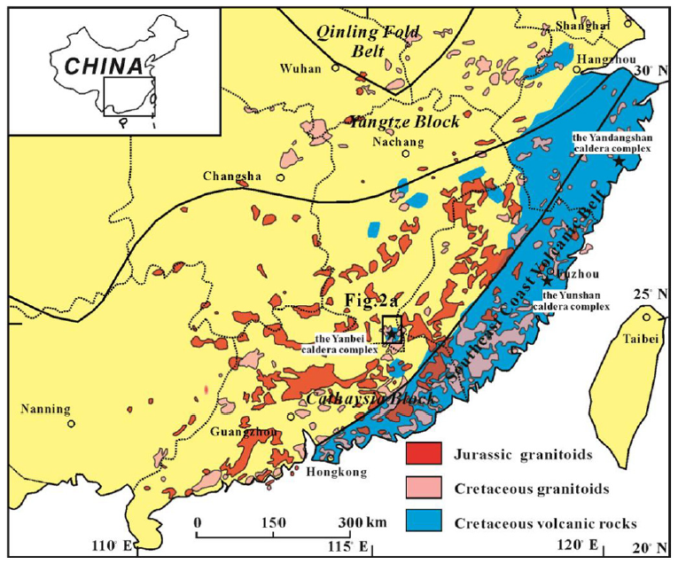

Fig. 2. a) Geological map of the adjacent region of the Yanbei caldera complex, showing the distribution of main plutons and volcanic calderas. b) Geological map of the Yanbei caldera complex, showing the distribution of the volcanic and intrusive rocks, and sampling localities. c) Schematic cross section of A-A'-A".
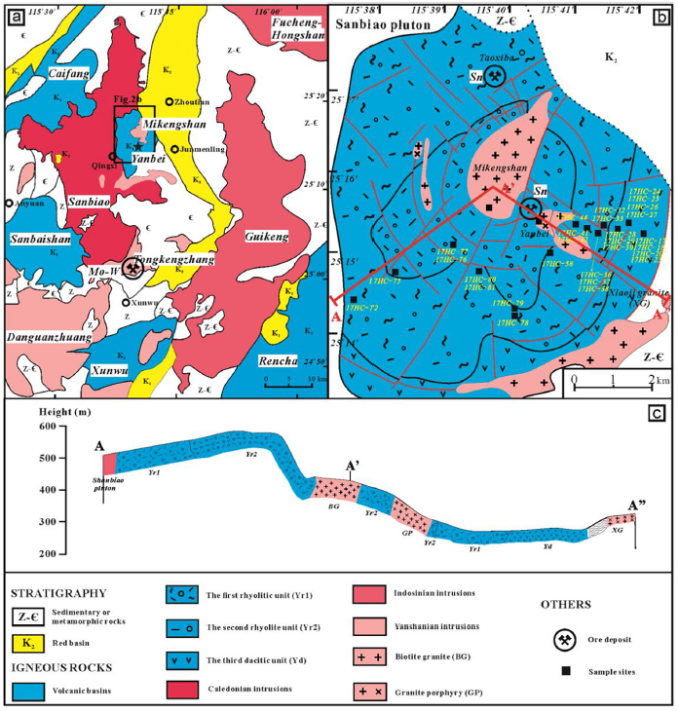

Fig. 3. Representative photomicrographs of volcanic and intrusive rocks from YCC and Xiaoji granite. a) the crystal-poor first unit (Yr1). b) the second unit (Yr2). c-d) the crystal-rich third unit dacitic ignimbrite (Yd). e) backscattered electron (BSE) image of accessory mineral aggregate within Yd matrix. f) the Yanbei granite porphyry (GP). g) the Mikengshan biotite granite (BG). h) the boundary of the Xiaoji granite and xenolith of basement rocks in outcrop. i) the Xiaoji granite(XG). Afs-alkali feldspar, Ap-apatite, Kf-K-feldspar, Pl-plagioclase, Qtz-quartz, Rt-rutile, Tpz-topaz, Zr-zircon.
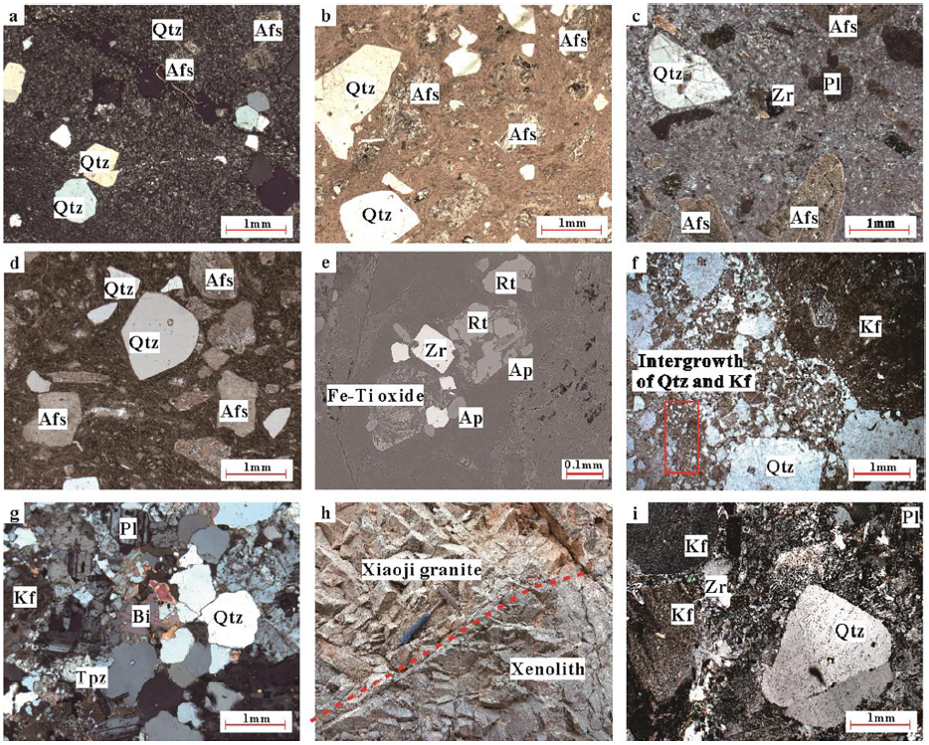

Fig. 4. Classification of the YCC and the Xiaoji granite based on a) the total alkali vs. silica (TAS) diagram; b) A/NK (molar ratio Al₂O3/(Na₂O + K₂O)) vs. A/CNK (molar ratio Al₂O₃/(CaO + Na₂O + K₂O)) diagram; c) SiO₂ vs. K₂O diagram.
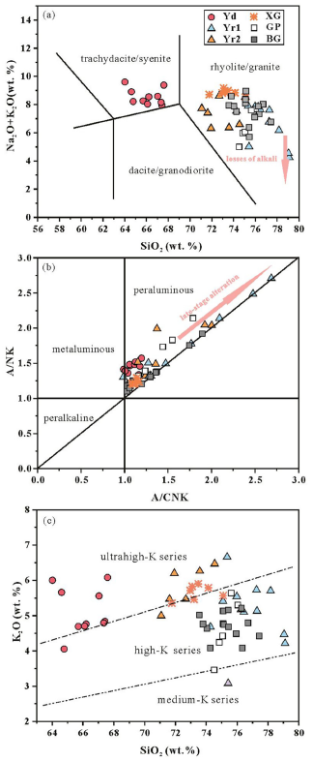
Fig. 5. Chemical variation diagrams (selected major oxide or trace element vs. SiO₂) for the different units of the YYC and the Xiaoji granite. A part of data of the Mikengshan biotite granite come from Qiu et al., 2005.
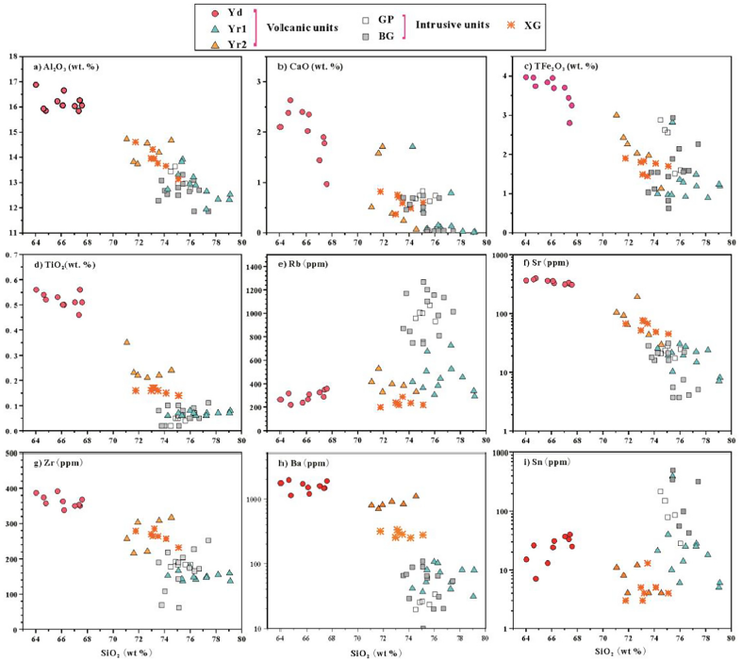

Fig. 6. Chondrite-normalized (Boynton, 1984) REE diagrams and primitive-mantle-normalized (McDonough and Sun, 1995) incompatible element spidergrams for the different units of the YCC and the Xiaoji granite. a-b) for the Yr1, c-d) for the Yr2 and the XG, e-f) for the Yd, and g-f) for the GP and BG.
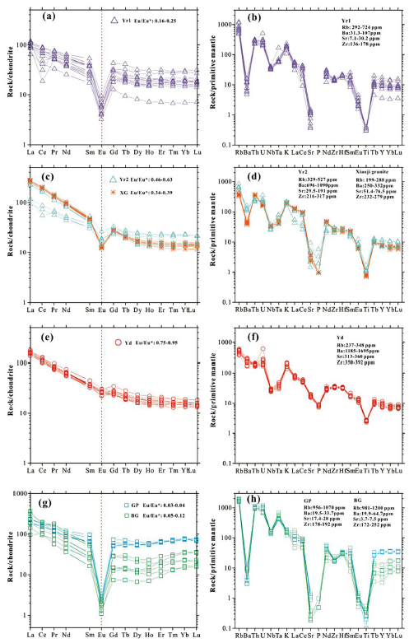
Fig. 7. Whole-rock bivariate plots of trace element concentrations (ppm). a) Eu/Eu* vs Sr; b) Zr vs Hf; c) Rb vs Sr.
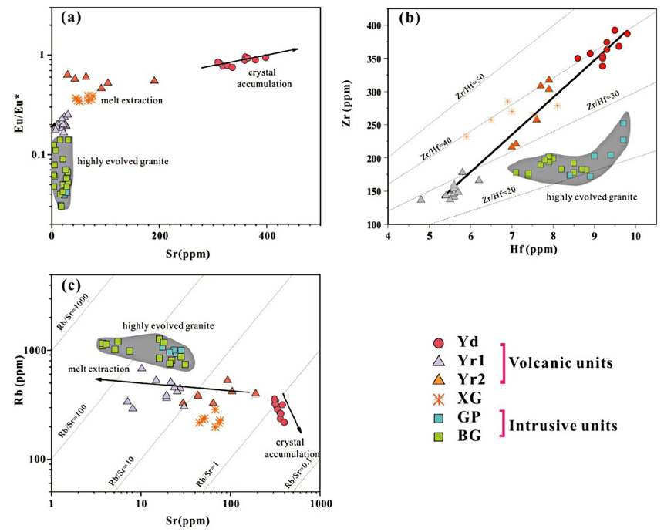

Fig. 8. Cathodoluminescence (CL) images of representative zircon grains including detrital zircons, corresponding ²⁰⁶Pb/²³⁸U ages, Hf isotopic compositions, and Eu/Eu* values of samples from a-b) dacite; c-e) low-silica rhyolite; f-g) high-silica rhyolite; h) the Xiaoji granite; i) the Yanbei granite porphyry; j) the Mikengshan biotite granite. White open circles (33 um) represent the spots for LA-ICP-MS U–Pb dating and trace element analyses, whereas white dashed circles (50 um) indicate the spots for Hf isotope analyses.
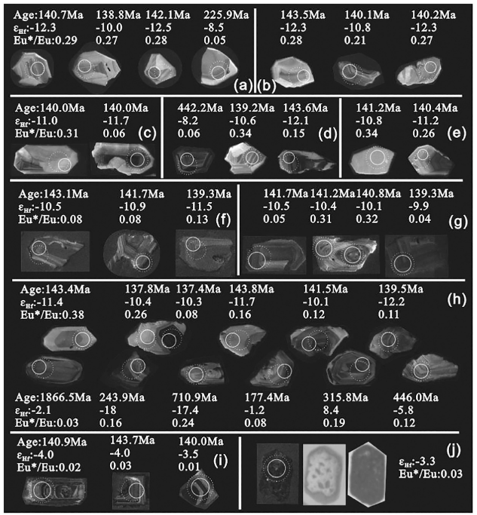

Fig. 9. REE pattern and compositional variations in zircons from the YCC and the Xiaoji granite.
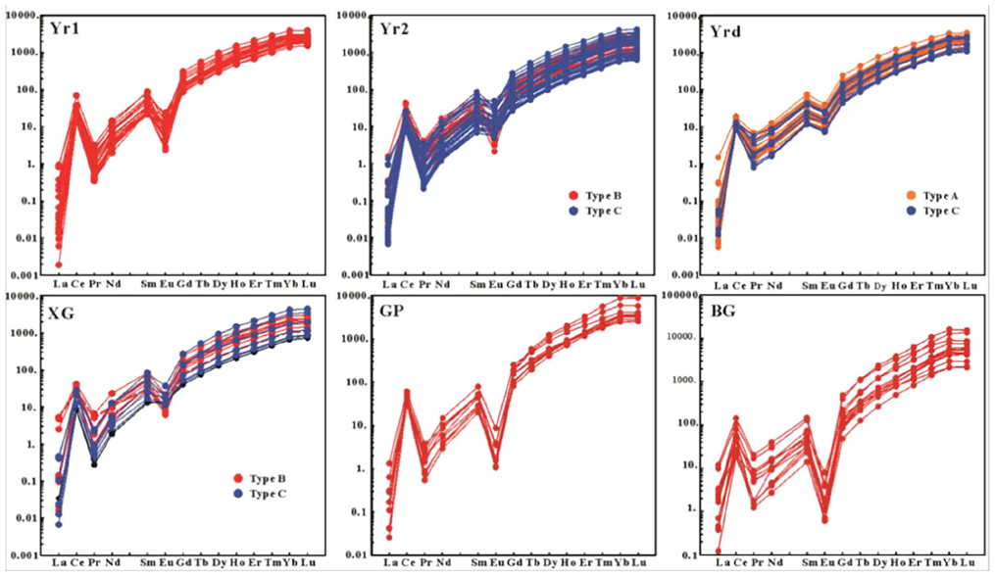

Fig. 10. Compositional variations in zircons from the YCC and the Xiaoji granite. a) 3-D scatter diagram (X axis-Eu/Eu*, Y axis-Zr/Hf, Z axis-Ti); b) plot of Eu/Eu* vs Zr/Hf); c) plot of Eu/Eu* vs Ti); d) plot of Th/U vs Hf.
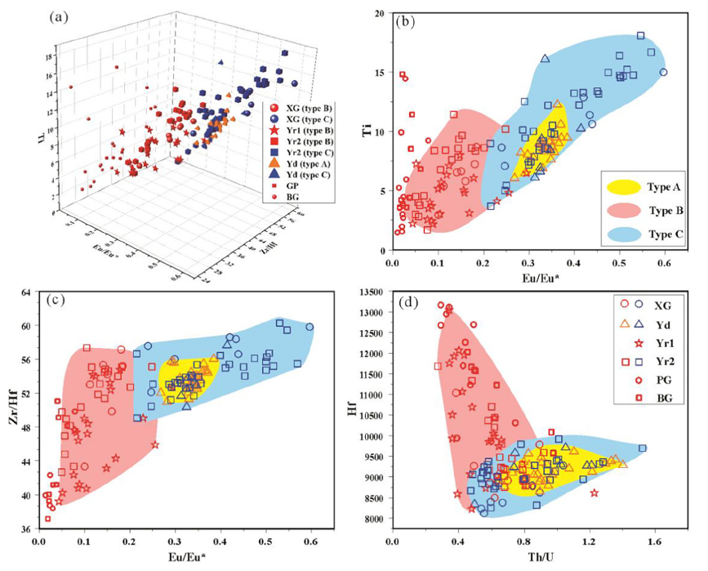

Fig. 11. Zircon U-Pb Concordia diagrams for the different units of the YCC and the Xiaoji granite.
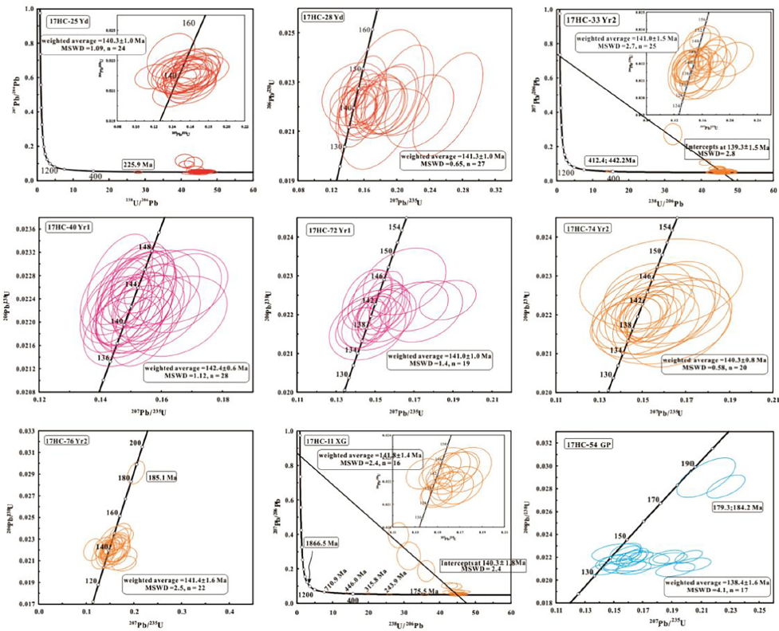

Fig. 12. Weighted average ²⁰⁶Pb/²³⁸U ages and the distribution histogram of zircon ε_{Hf}(t).
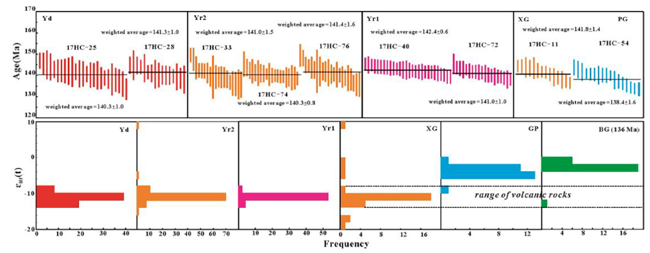

Fig. 13. Diagram of ε_{Hf}(t) vs. U–Pb ages for zircons from the YCC and the Xiaoji granite, combined with the data of the Fucheng pluton (Ren et al., 2013), the Sanbiao pluton (our unpublished data), the Caifang volcanic rocks (Cen et al., 2017), and felsic volcanic rocks in the coastal region of Southeast China (Guo et al., 2012) including two representative volcanic-intrusive complex (the Yandangshan caldera complex, Yan et al., 2016; the Yunshan caldera complex, Yan et al., 2018). The Hf isotope evolution for Cathaysia crustal basement was collected from Xu et al. (2007), He et al. (2010), and Yu et al. (2010).
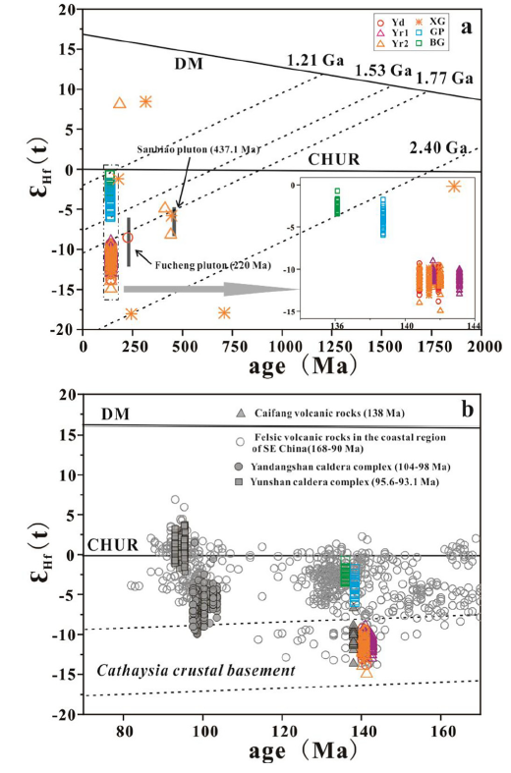

Fig. 14. a) Schematic model illustrating the difference of magma source of different units of the YCC and the Xiaoji granite. In an extensional arc-back setting during the Early Cretaceous, upwelling of asthenosphere and underplating of hot basalt magma trigger the partial melting of the crust materials. The primary magma of the volcanic units and the Xiaoji granite were derived from partial melting of the crust materials, while that of the GP and BG from modified crustal materials with involvement of mantle-derived materials. b) Schematic model illustrating the generation of volcanic rocks from the YCC and the Xiaoji granite. The intermediate crystal mush was rejuvenated by a less evolved and hot magma recharge, which was recorded by the distinct textures of zircons.
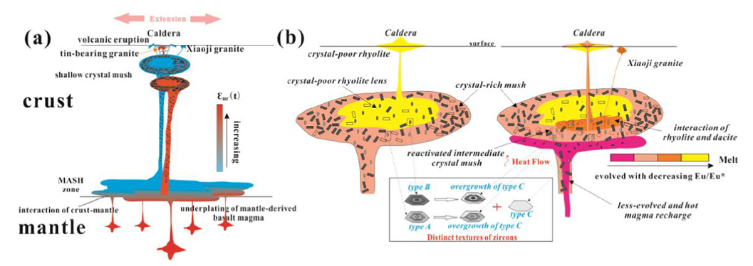

Fig. 15. Plots of magmatic oxygen fugacity for both tin-bearing and barren fractionated magmatic systems. The data of tin-bearing and barren granites in Permian- Triassic tin metallogenic belt in Peninsular Malaysia are from Yang et al. (2020).
