Exploration of the Pharmacodynamics for Pseudomonas aeruginosa Biofilm Eradication by Tobramycin

Devin Sindeldecker^{ab#}, Shaurya Prakash^{cd}, Paul Stoodley^{aef}

Department of Microbial Infection and Immunity, The Ohio State University, Columbus, Ohio, USAª, Biomedical Sciences Graduate Program, The Ohio State University, Columbus, Ohio, USA^{b}, Department of Mechanical & Aerospace Engineering, The Ohio State University, Columbus, Ohio, USA^{c}, Comprehensive Cancer Center, The Ohio State University, Columbus, Ohio, USA^{d}, Department of Orthopaedics, The Ohio State University, Columbus, Ohio, USA^{e}, National Center for Advanced Tribology at Southampton (nCATS), Mechanical Engineering, University of Southampton, Southampton, UK^{f}.
Running Head: Biofilm Eradication

#Address correspondence to Devin Sindeldecker, Devin.Sindeldecker@osumc.edu.
Department of Microbial Infection & Immunity,
The Ohio State University,
760 BRT, 460 West, 12th Avenue,
Columbus, OH 43210, USA.
E-mail: Devin.Sindeldecker@osumc.edu

Prepared for ASM Antimicrobial Agents and Chemotherapy
Abstract
Pseudomonas aeruginosa is a Gram-negative, opportunistic pathogen which is involved in numerous infections. It is of growing concern within the field of antibiotic resistant and tolerance and often exhibits multi-drug resistance. Previous studies have shown the emergence of antibiotic resistant and tolerant variants within the zone of clearance of a biofilm lawn after exposure to aminoglycosides. As concerning as the tolerant variant emergence is, there was also a zone of killing (ZOK) immediately surrounding the antibiotic source from which no detectable bacteria emerged or were cultured. In this study, the ZOK was analyzed using both in vitro and in silico methods to determine if there was a consistent antibiotic concentration versus time constraint (area under the curve, (AUC)) which is able to completely kill all bacteria in the lawn biofilms in our in vitro model. Our studies revealed that by achieving an average AUC of 4,372.5 µg*hr/mL, complete eradication of biofilms grown on both agar and hydroxyapatite was possible. These findings show that appropriate antibiotic concentrations and treatment duration may be able to treat antibiotic resistant and tolerant biofilm infections.

Introduction
Pseudomonas aeruginosa is a Gram-negative bacterium and opportunistic pathogen. Most commonly, it is associated with cystic fibrosis (CF) related lung infections but is also implicated in chronic wounds and post-surgical site infections (1-3). Antimicrobial tolerance and resistance are also major concerns with P. aeruginosa, as the formation of biofilms, variant populations, and multidrug resistance mechanisms are also prevalent (4-8). A recent study on the antibiotic resistance rates of P. aeruginosa have shown a minimum 20% rate of resistance for carbapenems, cephalosporins, aminoglycosides, and piperacillin/tazobactam (9). In addition, multi-drug resistance was also found in 20% of infections (9).

In a previous study, variant colony phenotypes of P. aeruginosa emerging within the region cleared by a tobramycin-loaded calcium sulfate bead were identified (8). This region of bacterial lawn clearance is referred to as the zone of clearance (ZOC, Figure 1). These variant colonies included classical resistance, persister cells, viable but non-culturable like colonies (VBNC-like), and newly identified, tolerant, phoenix colonies (8). While the significance of these emergent phenotypes may be of concern from a clinical standpoint, it is important to note that there was also a smaller, consistent region within the ZOC, immediately adjacent to the antibiotic source, from which no variants emerged or were cultured (8, 10). This previously reported zone, referred to as the zone of killing (ZOK), represents a region of complete biofilm killing including antibiotic tolerant and resistant variants (Figure 1, (8, 10)).

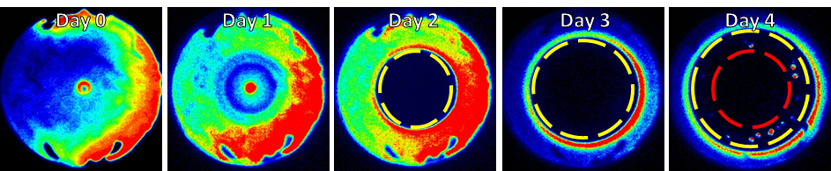
Figure 1 – Emergence of ZOC and ZOK. IVIS images of a representative P. aeruginosa Xen41 plate showing ZOC emergence after exposure to tobramycin. A biofilm lawn was grown for 24 hours before being exposed to tobramycin on Day 0. Over time, a ZOC (yellow dotted circle) can be seen as the antibiotic clears the background lawn. On Day 4, variant colonies begin to grow within the ZOC and a ZOK (red dotted circle) becomes apparent. The ZOK is the region in which there are no variant colonies or other discernable bacterial activity. In the images, red indicates high levels of metabolic activity, blue indicates low levels of metabolic activity, and black indicates no metabolic activity.

While pharmacodynamic studies have been done using planktonic P. aeruginosa exposed to antibiotics (11, 12), further research into the pharmacodynamics necessary to eliminate biofilms is needed. Currently, the primary method for measuring pharmacokinetics and pharmacodynamics (PK/PD) in vitro is the modified Calgary biofilm device method (13). This method is used to grow biofilms on pegs which are suspended in wells of a 96-well plate before exposing the biofilms to antibiotics (13). Use of this method can be complicated by contamination risks, variation in recovered biofilm after antibiotic exposure due to the rinsing steps necessary, and residual antibiotics left after rinses (13). In this study, the ZOK from which no bacteria could be cultured was further analyzed using a new method for exploring PK/PD in vitro. We hypothesized that the junction between the outer edge of the ZOK and the region containing the emergent variants represents an antibiotic concentration versus treatment time constraint in which complete bacterial biofilm eradication can be achieved. In order to evaluate our hypothesis, a combination of a biofilm plate in vitro model and an in silico approach was used to identify the concentration and time (AUC) necessary to eliminate a P. aeruginosa biofilm, including variants which can typically survive antibiotic therapy, using tobramycin. Additionally, substrates using both a tissue mimic (agar, (14, 15)) and a bone mimic (hydroxyapatite (HA), (16)) were used to determine if the biofilm substrate would affect the ability of an AUC to completely eradicate the biofilm.

Results
Zones of Clearance of Biofilms Exhibit Dose-dependency
In order to begin assessing the possible correlation between the ZOK and an antibiotic concentration versus time constraint, twenty-four hour biofilm lawns of P. aeruginosa Xen41 were generated as reported previously (8, 14) before being exposed to various weight quantities of tobramycin (Figure 2). In vitro Imaging System (IVIS) evaluation of the biofilm lawns post tobramycin exposure showed the emergence of dose-dependent ZOCs which continued to expand over time. Within the ZOC, variant colonies began to emerge and encroach on the ZOC which had formed. However, there was also a dose-dependent ZOK within the ZOC from which no discernable bacterial activity was detected (Figure 2). It should also be noted that the luminescence which appears to overly the antibiotic disks is likely due to surface associated biofilm growth. The presence of the disk likely provides an additional substrate for biofilm growth and allows for initial levels of high bioluminescence before the tobramycin ultimately is able to clear the formed biofilm.

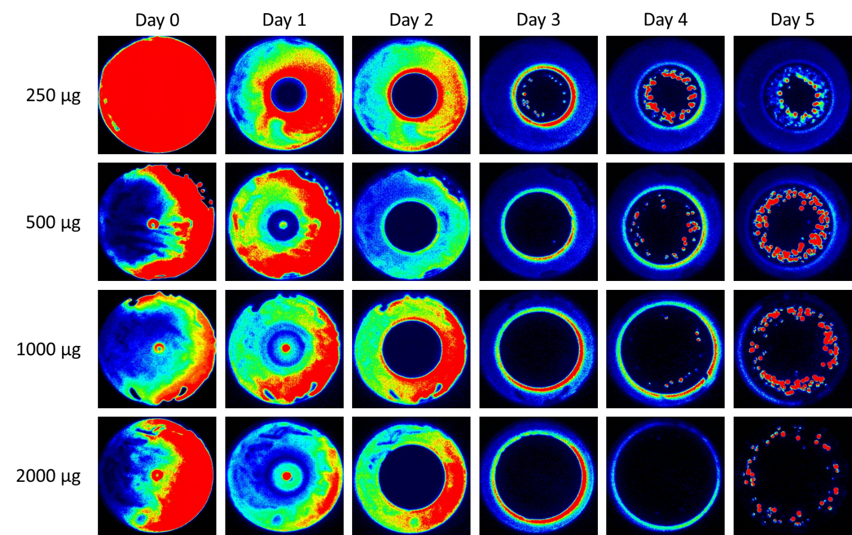
Figure 2 – IVIS Imaging of P. aeruginosa Biofilms Exposed to Tobramycin. Biofilm lawns of P. aeruginosa Xen41 were generated on agar before being exposed to various amounts of tobramycin for a total of five days. Zones of clearance (ZOC) can be seen growing over time for each mass of tobramycin. Although variant colonies emerge from the ZOC, there is a distinct region within the ZOC, marked explicitly in Figure 1, known as the zone of killing (ZOK). In the images, red indicates high levels of metabolic activity, blue indicates low levels of metabolic activity, and black indicates no metabolic activity.

Profiling of the ZOK Confirms Dose-dependency
After exposure of the biofilm lawns to tobramycin, the plates were further analyzed to obtain measurements of the ZOK over time. These measurements were used to generate plots (Figure 3) which show the linear generation of the ZOC, followed by a ZOC peak right before variant colonies began to emerge. The peak of the plot for each weight quantity of tobramycin shifts to a later time point as the weight quantity increases. This is likely due to the time necessary for the antibiotic to diffuse to low enough concentrations to allow variant colonies to begin to emerge. As variant colonies began to emerge and grow within the ZOC, this allows the ZOK to be visualized. The plots then plateaued as the ZOK became more apparent in which no detectable bacteria emerged or grew. Once the ZOK stabilized, the radius of the edge of the ZOK was noted, as this is the point likely to represent the minimum antibiotic concentration away from the antibiotic source versus time constraint necessary for complete biofilm eradication including the killing of any antibiotic tolerant or resistant variants. These radii values and time points were then used to generate antibiotic diffusion plots using numerical modeling. In addition, a time-kill curve was generated for the ZOK of a 1 mg tobramycin loaded disk. At 40 hours post tobramycin exposure, a slight decrease in CFUs/cm² can be seen which further decreases and becomes significant (p=0.017) by 48 hours. At 72 hours of tobramycin exposure and thereafter, no CFUs are able to be recovered from within the ZOK (Figure 4).

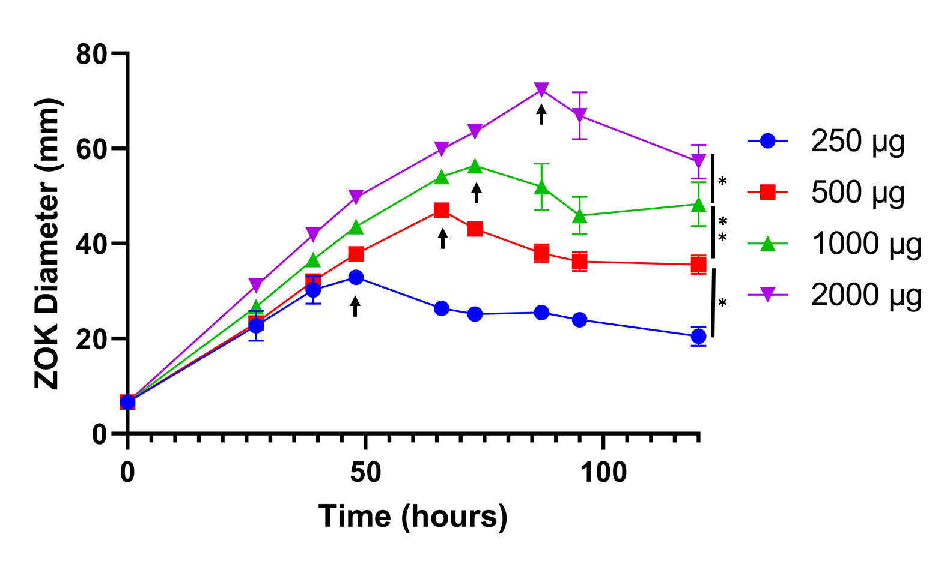
Figure 3 – ZOK Expansion Curves for Tobramycin. The ZOK of the plates from Figure 2 were measured over time. The zones follow linearly until the peak (indicated by black arrows), which occurs as variant colonies begin to emerge within the ZOC, and the diameter of the ZOK becomes evident. As these variant colonies continue to emerge and begin to grow, the ZOK reduces. After the peak, the ZOK continues to become more apparent as the area lacking emergence of variant colonies. The ZOK decrease continues as variant colonies emerge until the plot begins to plateau, at which point the ZOK was stable. Data are reported as mean ± SD (n=3). *p<0.05, **p<0.01.

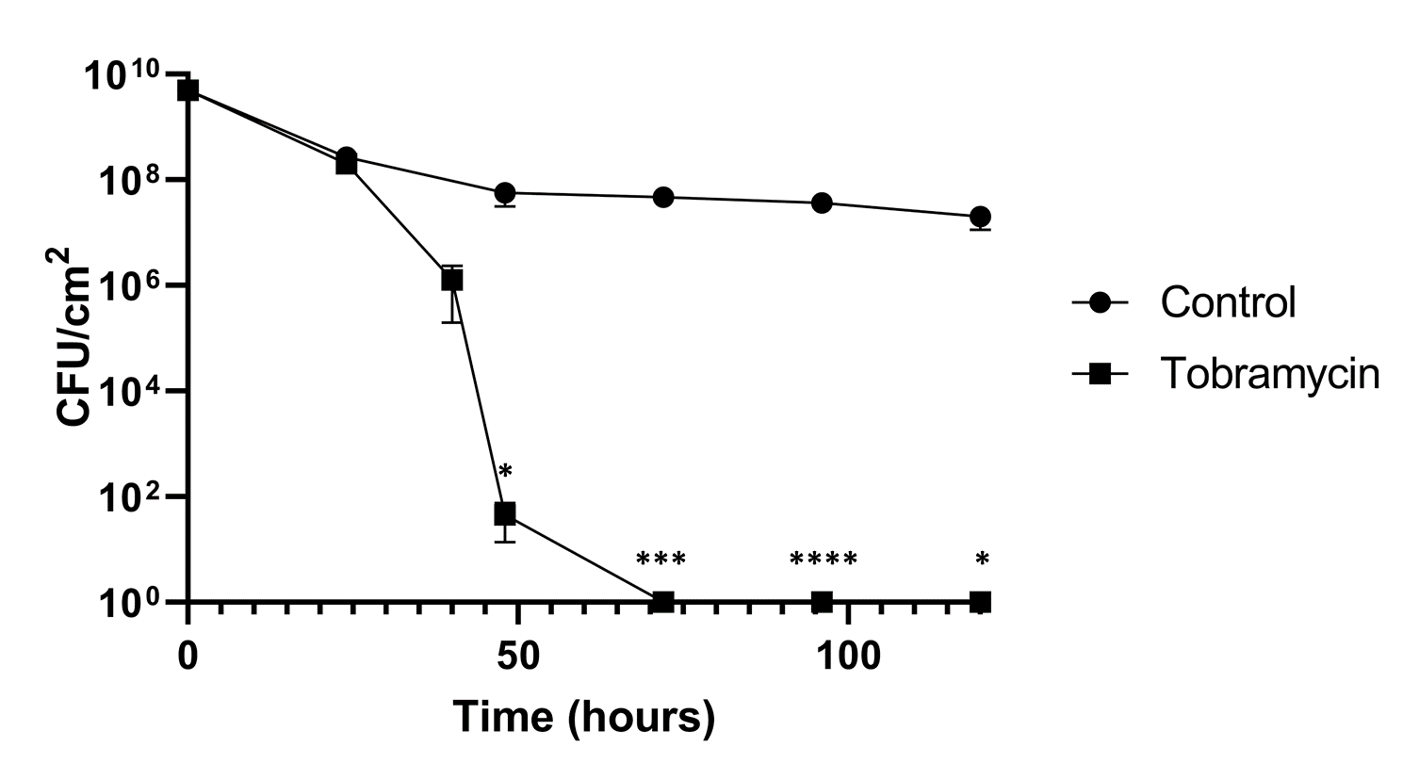
Figure 4 – Time-kill Curve for the ZOK. CFUs within the ZOK of 1 mg of tobramycin were measured over time. Controls CFUs were measured for plates without tobramycin exposure. At 48 hours post tobramycin exposure, a decrease in CFUs begins to be seen, and by 72 hours post tobramycin exposure, no CFUs were able to be recovered from within the ZOK. Data are reported as mean±SD. *p<0.05, ***p<0.001, ****p<0.0001, n=3.

Computational Modeling Identified an Area Under the Curve Value for Biofilm Eradication
Using the data collected from the profiling of the ZOC and ZOK, a model was used (17) to predict the tobramycin concentration over time at the ZOK radius identified for each mass of tobramycin used (Figure 5). The model calculates the concentration of tobramycin over time assuming Fickian diffusion in a finite space (17, 18). The plots in Figure 3 show a dose-dependent increase in the antibiotic concentration after antibiotic placement until concentrations for each weight quantity of antibiotic peaked (120.9, 241.9, 483.8, and 967.5 µg/mL, respectively). The concentration then gradually begins to decrease and plateau as the system continues to approach equilibrium (12.5, 25, 50, 100 mg/mL, respectively) for each weight quantity (250, 500, 1000, 2000 µg, respectively). An AUC (µg*hr/mL) was calculated for each plot to determine the necessary minimum value necessary for ZOK generation for each of the amounts of tobramycin (Table 1). Interestingly, despite a 4-fold change in the starting tobramycin weight quantity, the AUCs for each were relatively similar. This observation highlights the importance of an AUC being taken into consideration during antibiotic dosing as opposed to purely relying on the antibiotic concentration alone. The mean of the AUC values was also calculated to determine that the average minimum value necessary for biofilm eradication, including antibiotic tolerant and resistant variants, was approximately 4,372.5 µg*hr/mL. The concentration of antibiotic needed here is much higher than standard minimum inhibitory concentrations (MIC) for tobramycin and P. aeruginosa PAO1 (4 µg/mL). Additionally, by dividing the AUC by the MIC, an AUC/MIC ratio of 46 can be calculated when normalizing for 24 hours. This higher concentration ratio is likely responsible for the ability to kill even antibiotic resistant and tolerant variants.

Figure 5 – Computational Modeling of Antibiotic Diffusion. The diffusion model shows the spread of tobramycin over time. The radii used to determine the zones of killing for each antibiotic quantity was experimentally measured (Figure 2) and used as an input to the model for the computation of the concentration. All plots show an increase in tobramycin concentration followed by a decrease following the Fickian diffusion model.

Table 1 – AUC Values Associated with Complete Biofilm Eradication in Our Agar Plate Biofilm Model. Values for the AUC (µg*hr/mL) for each mass of tobramycin were calculated from the plots of Figure 4. The mean of each of these values was also calculated and likely represents the minimum AUC necessary for complete eradication of biofilms, including antibiotic resistant and tolerant variants.
 | 250 µg | 500 µg | 1000 µg | 2000 µg | Average
AUC | 3560 µg*hr/mL | 4730 µg*hr/mL | 4330 µg*hr/mL | 4870 µg*hr/mL | 4372.5 µg*hr/mL

Identified AUC Can Eradicate Biofilms Grown on an Alternate Substrate
In order to test the AUC value associated with complete P. aeruginosa biofilm eradication by tobramycin, biofilms were grown on LB agar coated pegs, as well as HA coupons and plastic pegs as alternate biofilm substrates. Biofilm colony forming units (CFUs) were measured for biofilms exposed to tobramycin at the approximate 4,372.5 µg*hr/mL AUC. LB agar coated peg, HA coupon, and plastic peg biofilms were exposed to tobramycin for 24 hours at a stable concentration of 182 µg/mL (Figure 6) which equals an approximate AUC value of 4372.5 µg*hr/mL. In all tobramycin exposure samples, no CFUs were recovered, indicating a complete eradication of the biofilms. Additionally, a control was run at a 0.1 AUC equivalent on agar grown biofilms. The control samples showed full lawns of growth after tobramycin treatment, indicating minimal effectiveness of biofilm clearance. These results confirm that by obtaining a high concentration of antibiotics for at least 24 hours, complete eradication of a P. aeruginosa lawn biofilm including any antibiotic resistant or tolerant variants was possible and, substrate differences were not relevant.

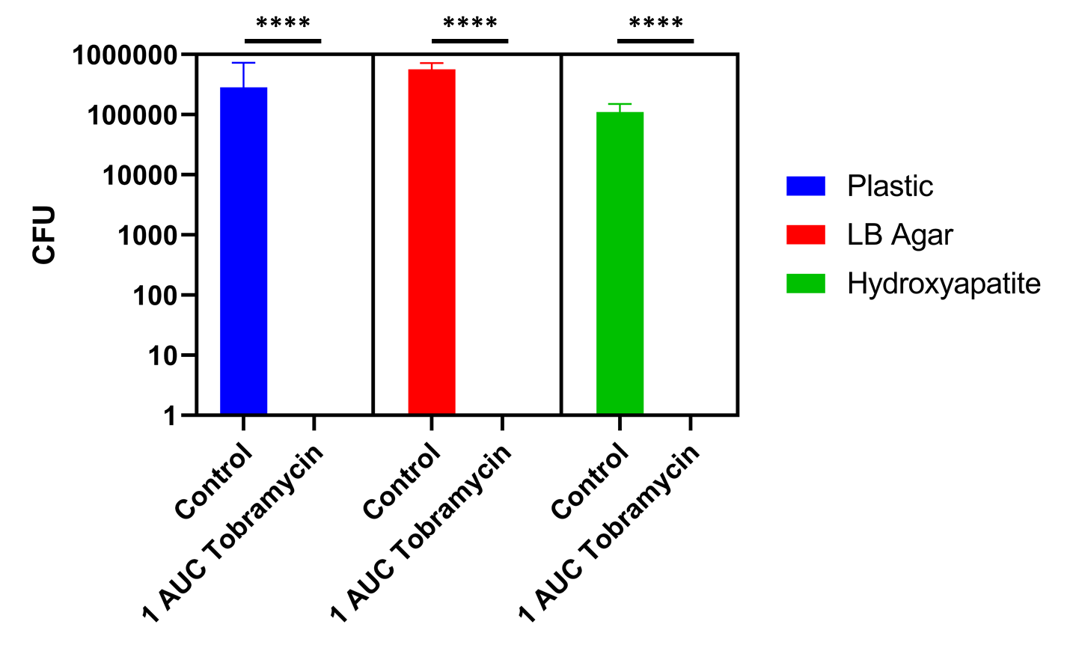
Figure 6 – Eradication of P. aeruginosa Biofilms Grown on Plastic, LB Agar, and Hydroxyapatite. P. aeruginosa PAO1 biofilms grown on plastic pegs, LB agar coated pegs, and hydroxyapatite coupons were exposed to 182 µg/mL of tobramycin for 24 hours, equaling an AUC value of approximately 4372.5 µg*hr/mL. Complete biofilm eradication was seen in all of the tobramycin treated samples. ****p<0.0001, n=3.

Discussion
P. aeruginosa is an opportunistic, bacterial pathogen which has been associated with numerous infection sites. It has also been shown to readily develop tolerance and resistance to multiple antibacterial drugs leading to an increased concern for complicated and difficult to treat infections (19-21). Previously, the antibiotic tolerant phoenix and the VBNC-like phenotypes were identified, in addition to classically resistant colonies and persister cells, within the ZOC of produced by antibiotics released from tobramycin loaded Kirby-Bauer filter disks and CaSO₄ beads (8). While the emergence of these variant colonies is concerning, it was also shown that there was a consistent ZOK immediately adjacent to the antibiotic source from which no bacteria emerged or were cultured. Replica plating was also performed on these plates and showed no growth within the ZOK, indicating that this region is sterile (8). In these studies, both the ZOC and ZOK were measured since it is not possible to differentiate between the two zones at early time points before variant colonies begin to emerge. The distinct ZOK within the ZOC indicates a smaller region where we may be able to eliminate antibiotic resistance and tolerance with high enough concentrations of antibiotics over extended time frames. By understanding how antibiotic kinetics effect biofilms and antibiotic resistant and tolerant variants, we will be better prepared to control and prevent the rise of these dangerous biofilm infections.
In this study, the ZOK of P. aeruginosa biofilms was analyzed to determine the antibiotic pharmacodynamics necessary for its generation. For our study, a combination of a biofilm plate model and numerical modeling was used as a simpler alternative to the modified Calgary biofilm plate model (13). The methods presented here could be adapted for further in vitro biofilm PK/PD studies including the use of other bacterial species and antibiotics. Previous studies have shown the importance of not only the concentration of antibiotic used but also the exposure time of the biofilm-growing bacteria to the antibiotic. These studies on the antibiotic AUC have shown that as exposure time increases, the minimum concentration needed for biofilm eradication (MBEC) decreases (22). In addition, pharmacodynamic studies on the efficacy of antibiotics against bacteria have shown an importance in the ratio of AUC/MIC (23, 24). The AUC/MIC ratio necessary for bactericidal activity against P. aeruginosa by tobramycin has been shown to be approximately 42. For our studies, various weight quantities of tobramycin were used which allowed for a more complete understanding of these required pharmacodynamics. While the varying masses of antibiotic used showed large, dose-dependent variations in the ZOK diameters, it was interesting that the AUCs calculated for each mass did not scale similar to the weight of the antibiotic, ranging from 3560-4870 µg*hr/mL, although there was a nearly 8-fold increase in antibiotic dosing (250-2000 µg). At an approximate AUC of 4372.5 µg*hr/mL and an MIC of 4 µg/mL, the AUC/MIC ratio for biofilm eradication by tobramycin would be approximately 46 when normalized for a 24-hour timeframe. Previous studies on local tobramycin concentrations achieved when treating orthopedic infections with tobramycin loaded methylmethacrylate bone cement has shown that the concentrations peak at approximately 40 µg/mL around 1 hour after beginning exposure. The concentration then drops to approximately 20 µg/mL through 24 hours (25). These lower concentrations may explain the prevalence of post-surgical infection treatment failure, as antibiotic tolerant or resistant variants may be able to survive. In addition, while C_{max}/MIC is the metric typically used in relation to tobramycin (23), it has been shown that by using AUC/MIC, better clinical outcomes are able to be achieved (24). This may be especially true when treating biofilm infections as biofilms are inherently more tolerant of antibiotics due to slow diffusion of the antibiotic into the biofilm matrix as well as heterogeneity in the biofilm metabolism (26), increasing the importance of time-dependence. Our observations suggest that a minimum AUC representing the total treatment effect (concentration x time) may be used to facilitate the complete eradication of P. aeruginosa biofilms, including variants that without this treatment could re-seed infection (27). It is also important to note that although VBNC-like colonies may be present in our systems, they would not be apparent as they are unable to be cultured by nature. However, this characteristic also would likely prevent re-emergence in a clinical environment.
In addition to using different weight quantities of tobramycin, different substrates were also used to provide breadth to the relevance of the identified 4,372.5 µg*hr/mL necessary for biofilm eradication. It is possible that biofilms grown on different substrates could have differing phenotypes, including variations in metabolic pathways which may play a role in the efficacy of antibiotics (28, 29). Although biofilm phenotypic variations can occur, the identified AUC was able to eradicate biofilms grown on both a tissue mimic such as agar (14, 15) and a material commonly known to be important for bone infections (HA, (16)), indicating that the use of the AUC metric for biofilm treatment is independent of the substrate rigidity and providing relevance to other fields such as dentistry and orthopedics. The observation evaluating the clearance of biofilms from two distinct substrates is important clinically as biofilms are able to grow in the human body on soft tissues such as lung tissue or skin and on hard substrates such as bone or implanted devices (16, 30, 31). Clearly, optimizing the AUC as a treatment effect metric needs further work, but the values reported here provide a specific evaluation for tobramycin and P. aeruginosa. Therefore, further research, including studies involving other antibiotic classes and bacterial species, is needed for a more complete understanding of the ability to eradicate bacterial biofilm infections.

Methods and Methods
Bacterial strains and culture conditions
The metabolically driven, bioluminescent strain P. aeruginosa Xen41 (Xenogen Corp., USA) was used for the imaging portion of this study. Additionally, P. aeruginosa PAO1 (15) which is both a standard lab strain and the parent strain for P. aeruginosa Xen41 was used in this study. Culture plates were prepared by from glycerol stock cultures stored at -80°C using 100 mm petri plates (Fisher Scientific, USA) containing 20 mL of Luria-Bertani (LB) agar. Streaked plates were incubated at 37°C for 24 hours to allow for individual colonies to grow. Individual colonies were examined for proper morphology and then isolated and transferred to 20 mL of LB broth. Broth cultures were incubated overnight in a shaking incubator set to 37°C and 200 rpm.

Generation of Biofilm Lawns
Overnight broth cultures of P. aeruginosa Xen41 were diluted to an OD₆₀₀ of 0.1 in LB broth and 100 µL aliquots were spread onto plates containing 20 mL of sterile, LB agar. These plates were incubated at 37°C with 5% CO₂ for 24 hours to allow for biofilm lawns to generate. Lawn generation was confirmed both visually and by using in vitro imaging system (IVIS) imaging.

Bioluminescence Imaging
Bioluminescence imaging was completed using thirty second exposures in an IVIS system. A pseudo-color heatmap was overlaid to aid in visualization of the metabolic activity of the biofilms. The scale for the heatmap is as follows: red indicates high levels of metabolic activity, blue indicates low levels of metabolic activity, and black indicates no metabolic activity.

Exposure of Biofilm Lawns to Antibiotic
After lawn generation, the biofilms were exposed to set masses of tobramycin (250 µg, 500 µg, 1000 µg, and 2000 µg). Briefly, a 100 mg/mL stock solution of tobramycin was created using tobramycin powder (TCI America, USA) and sterile water. This solution was then used to create dilutions for the other necessary masses of tobramycin. A sterile, filter paper disk was placed in the center of each of the lawn biofilms and then 20 µL of the appropriate tobramycin solution was placed on the disk to allow for exposure of the biofilm lawns to the desired masses of tobramycin. After antibiotic placement, the plates continued to be incubated at 37°C with 5% CO₂ for five additional days. IVIS images were taken and the zones of killing measured daily.

Time-kill Curve Generation
In order to measure the CFUs within the ZOK over time, time-kill curves were generated. Biofilm lawns were generated as above and were either exposed to 1 mg of tobramycin on a filter paper disk or not exposed for controls. At various time points, a 1 cm x 1 cm area of biofilm lawn, located between 1 and 2 cm from the disk, was scraped using a sterile loop and placed into 1 mL of sterile PBS. A dilution series was then made and plated. CFUs were counted for each sample and curves were generated.

Computational Modeling
In order to calculate the antibiotic concentration versus time necessary for development of the ZOK, an analytical solution was used to estimate the tobramycin concentration, c(r, t) for a 120 hour treatment time. The solution for the diffusion of antibiotic bead or disk in an agar plate is given by:
$$\text{c(r, t) =}\frac{\text{m}}{{\text{h}}_{\text{0}}}\frac{\text{1}}{\text{4π}\text{D(t+}{\text{t}}_{\text{o}}\text{)}}\text{exp}\left(\text{-}\frac{{\text{r}}^{\text{2}}}{\text{4}\text{D(t+}{\text{t}}_{\text{o}}\text{)}}\right)\text{,}$$
where the diffusion coefficient of tobramycin in agar is D and was experimentally determined to be 3.84 × 10⁻¹⁰ m²/s, m is the mass of antibiotic added to the source, ${\text{h}}_{\text{0}}$ is the height of the agar, and r is the position coordinate relative to the center of a paper disk (15, 17, 18, 32). The model assumes that antibiotic source is finite with a radius, r_{o} = 3 mm. The model assumed that the inner radius of the petri dish, 70 mm (inner diameter is 140 mm), was >10 times the radius of the paper disks (3 mm) used, whereas the depth of agar layer was ~3.6 mm. After model generation, an area under the curve (AUC) value was calculated in MATLAB for each curve using the trapezoidal rule function, and the mean of the AUCs was also calculated.

Testing of AUC on Hydroxyapatite
In order to assess whether the AUC required for P. aeruginosa biofilm eradication could be translated to biofilms grown on alternative surfaces, biofilms of P. aeruginosa PAO1 were grown on 0.5 inch hydroxyapatite (HA) coupons (Biosurface Technologies, USA). Overnight LB broth cultures of P. aeruginosa PAO1 were prepared as above. Overnight cultures were diluted to an OD₆₀₀ of 0.1 in LB broth. HA coupons were added to the wells of a 12 well plate before 3 mL of the diluted overnight culture were also added to the wells. The well plate was incubated at 37°C with 5% CO₂ for 24 hours to allow biofilms to form on the HA coupons. Three coupons were then exposed to tobramycin, and three coupons were exposed to PBS only as a control. Briefly, the coupons were removed from the well plate and rinsed in PBS to remove any planktonic bacteria. The coupons were then placed in a fresh 12 well plate for exposure to tobramycin or PBS only. Three mL of a tobramycin solution was used for antibiotic exposure of the coupons for 24 hours at a concentration of 182 µg/mL in order to equal the mean AUC value of 4,368 µg*hr/mL. During the tobramycin exposure, the coupons continued to be incubated at 37°C with 5% CO₂. After 24 hours, coupons were removed from the well plate to obtain CFU counts. The coupons were rinsed in PBS before being placed into wells of a fresh 12 well plate containing 3 mL of PBS. This plate was then placed into a water bath sonicator and sonicated for 30 minutes. After sonication, the PBS was removed from each well and centrifuged in order to pellet the bacteria. The pellet was then resuspended in 200 µL of LB broth and a dilution series was created. The dilution series was plated on 20 mL of LB agar and CFU counts were obtained.

Testing of AUC on Plastic and Agar
In addition to AUC validation on HA coupons, the AUC was also validated on plastic pegs of an MBEC assay biofilm inoculator plate (Innovotech, Canada) as well as MBEC assay biofilm inoculator plate pegs coated in LB agar. Briefly, LB agar coated pegs were prepared as follows. 200 µL of molten LB agar was placed into the wells of a 96 well plate. The MBEC plate, which had previously been cooled to -80°C, was then placed onto the 96 well plate to allow the pegs to dip into the molten LB agar. After 3 seconds, the plate was removed and the agar was allowed to finish cooling in a coating on the pegs. After LB agar coating, both LB agar coated pegs and uncoated pegs were exposed to P. aeruginosa PAO1 to allow biofilms to form. An overnight culture of PAO1 was diluted in LB broth at a ratio of 1:1000. 150 µL of the diluted culture was added to wells of 96 well plates. MBEC plates both coated in LB agar and uncoated were placed onto the 96 well plates with diluted culture. These plates were then incubated at 37°C with 110 rpm shaking for 24 hours to allow biofilms to develop. After incubation, the pegs were rinsed in 200 µL of PBS for 10 seconds. After rinsing, the MBEC plates were placed on 96 well plates containing either 200 µL of 182 µg/mL tobramycin or 200 µL of PBS as a control. These plates were then incubated for an additional 24 hours at 37°C with 110 rpm shaking. After incubation, the MBEC plates were rinsed in wells containing 200 µL PBS and then placed on a fresh 96 well plate with wells containing 200 µL PBS. These plates were then sonicated in a water bath sonicator for 30 minutes. After sonication, the bacteria containing PBS was removed and plated in a dilution series. CFU counts were obtained for each sample.

Statistical analysis
All experiments were replicated in triplicate. ANOVA analysis was completed by GraphPad Prism (v8.2.1) with a p-value of 0.05 being considered significant.

Acknowledgements
This work was supported in part by the Ohio State University College of Medicine and R01 NIH- GM124436 (PS). We also acknowledge partial support from the National Heart, Lung, and Blood Institute (R01HL141941; SP).
Conflict of interest - None declared.

References
1. Hoiby N, Ciofu O, Bjarnsholt T. 2010. Pseudomonas aeruginosa biofilms in cystic fibrosis. Future Microbiol 5:1663-74.
2. Serra R, Grande R, Butrico L, Rossi A, Settimio UF, Caroleo B, Amato B, Gallelli L, de Franciscis S. 2015. Chronic wound infections: the role of Pseudomonas aeruginosa and Staphylococcus aureus. Expert Rev Anti Infect Ther 13:605-13.
3. Shah NB, Osmon DR, Steckelberg JM, Sierra RJ, Walker RC, Tande AJ, Berbari EF. 2016. Pseudomonas Prosthetic Joint Infections: A Review of 102 Episodes. J Bone Jt Infect 1:25-30.
4. Lewis K. 2010. Persister cells. Annu Rev Microbiol 64:357-72.
5. Lewis K. 2008. Multidrug tolerance of biofilms and persister cells. Curr Top Microbiol Immunol 322:107-31.
6. Hall-Stoodley L, Stoodley P. 2005. Biofilm formation and dispersal and the transmission of human pathogens. Trends Microbiol 13:7-10.
7. Zavascki AP, Carvalhaes CG, Picao RC, Gales AC. 2010. Multidrug-resistant Pseudomonas aeruginosa and Acinetobacter baumannii: resistance mechanisms and implications for therapy. Expert Rev Anti Infect Ther 8:71-93.
8. Sindeldecker D, Moore K, Li A, Wozniak DJ, Anderson M, Dusane DH, Stoodley P. 2020. Novel Aminoglycoside-Tolerant Phoenix Colony Variants of Pseudomonas aeruginosa. Antimicrob Agents Chemother 64.
9. Appaneal HJ, Caffrey AR, Jiang L, Dosa D, Mermel LA, LaPlante KL. 2018. Antibiotic resistance rates for Pseudomonas aeruginosa clinical respiratory and bloodstream isolates among the Veterans Affairs Healthcare System from 2009 to 2013. Diagn Microbiol Infect Dis 90:311-315.
10. Devendra H. Dusane JRB, Devin Sindeldecker, Casey W. Peters, Anthony Li, Nicholas R. Farrar, Scott M. Diamond, Cory S. Knecht, Roger D. Plaut, Craig Delury, Sean S. Aiken, Phillip A. Laycock, Anne Sullivan, Jeffrey F. Granger, and Paul Stoodley. 2019. Complete Killing of Agar Lawn Biofilms by Systematic Spacing of Antibiotic-Loaded Calcium Sulfate Beads. Materials.
11. MacGowan AP, Wootton M, Holt HA. 1999. The antibacterial efficacy of levofloxacin and ciprofloxacin against Pseudomonas aeruginosa assessed by combining antibiotic exposure and bacterial susceptibility. J Antimicrob Chemother 43:345-9.
12. Madaras-Kelly KJ, Ostergaard BE, Hovde LB, Rotschafer JC. 1996. Twenty-four-hour area under the concentration-time curve/MIC ratio as a generic predictor of fluoroquinolone antimicrobial effect by using three strains of Pseudomonas aeruginosa and an in vitro pharmacodynamic model. Antimicrob Agents Chemother 40:627-32.
13. Hengzhuang W, Hoiby N, Ciofu O. 2014. Pharmacokinetics and pharmacodynamics of antibiotics in biofilm infections of Pseudomonas aeruginosa in vitro and in vivo. Methods Mol Biol 1147:239-54.
14. Dusane DH, Lochab V, Jones T, Peters CW, Sindeldecker D, Das A, Roy S, Sen CK, Subramaniam VV, Wozniak DJ, Prakash S, Stoodley P. 2019. Electroceutical Treatment of Pseudomonas aeruginosa Biofilms. Sci Rep 9:2008.
15. Lochab V, Jones TH, Dusane DH, Peters CW, Stoodley P, Wozniak DJ, Subramaniam VV, Prakash S. 2020. Ultrastructure imaging of Pseudomonas aeruginosa lawn biofilms and eradication of the tobramycin-resistant variants under in vitro electroceutical treatment. Sci Rep 10:9879.
16. Moley JP, McGrath MS, Granger JF, Stoodley P, Dusane DH. 2018. Reduction in Pseudomonas aeruginosa and Staphylococcus aureus biofilms from implant materials in a diffusion dominated environment. J Orthop Res 36:3081-3085.
17. Hoiby N, Henneberg KA, Wang H, Stavnsbjerg C, Bjarnsholt T, Ciofu O, Johansen UR, Sams T. 2019. Formation of Pseudomonas aeruginosa inhibition zone during tobramycin disk diffusion is due to transition from planktonic to biofilm mode of growth. Int J Antimicrob Agents 53:564-573.
18. Gefen O, Chekol B, Strahilevitz J, Balaban NQ. 2017. TDtest: easy detection of bacterial tolerance and persistence in clinical isolates by a modified disk-diffusion assay. Sci Rep 7:41284.
19. Pang Z, Raudonis R, Glick BR, Lin TJ, Cheng Z. 2019. Antibiotic resistance in Pseudomonas aeruginosa: mechanisms and alternative therapeutic strategies. Biotechnol Adv 37:177-192.
20. Pachori P, Gothalwal R, Gandhi P. 2019. Emergence of antibiotic resistance Pseudomonas aeruginosa in intensive care unit; a critical review. Genes Dis 6:109-119.
21. Ciofu O, Tolker-Nielsen T. 2019. Tolerance and Resistance of Pseudomonas aeruginosa Biofilms to Antimicrobial Agents-How P. aeruginosa Can Escape Antibiotics. Front Microbiol 10:913.
22. Castaneda P, McLaren A, Tavaziva G, Overstreet D. 2016. Biofilm Antimicrobial Susceptibility Increases With Antimicrobial Exposure Time. Clin Orthop Relat Res 474:1659-64.
23. Burkhardt O, Lehmann C, Madabushi R, Kumar V, Derendorf H, Welte T. 2006. Once-daily tobramycin in cystic fibrosis: better for clinical outcome than thrice-daily tobramycin but more resistance development? J Antimicrob Chemother 58:822-9.
24. Smith PF, Ballow CH, Booker BM, Forrest A, Schentag JJ. 2001. Pharmacokinetics and pharmacodynamics of aztreonam and tobramycin in hospitalized patients. Clin Ther 23:1231-44.
25. Gonzalez Della Valle A, Bostrom M, Brause B, Harney C, Salvati EA. 2001. Effective bactericidal activity of tobramycin and vancomycin eluted from acrylic bone cement. Acta Orthop Scand 72:237-40.
26. Stewart PS. 2002. Mechanisms of antibiotic resistance in bacterial biofilms. Int J Med Microbiol 292:107-13.
27. Swearingen MC, Granger JF, Sullivan A, Stoodley P. 2016. Elution of antibiotics from poly(methyl methacrylate) bone cement after extended implantation does not necessarily clear the infection despite susceptibility of the clinical isolates. Pathog Dis 74:ftv103.
28. Dutta Sinha S, Chatterjee S, Maiti PK, Tarafdar S, Moulik SP. 2017. Evaluation of the role of substrate and albumin on Pseudomonas aeruginosa biofilm morphology through FESEM and FTIR studies on polymeric biomaterials. Prog Biomater 6:27-38.
29. Song F, Wang H, Sauer K, Ren D. 2018. Cyclic-di-GMP and oprF Are Involved in the Response of Pseudomonas aeruginosa to Substrate Material Stiffness during Attachment on Polydimethylsiloxane (PDMS). Front Microbiol 9:110.
30. Hoiby N, Bjarnsholt T, Moser C, Jensen PO, Kolpen M, Qvist T, Aanaes K, Pressler T, Skov M, Ciofu O. 2017. Diagnosis of biofilm infections in cystic fibrosis patients. APMIS 125:339-343.
31. Wilkinson HN, Iveson S, Catherall P, Hardman MJ. 2018. A Novel Silver Bioactive Glass Elicits Antimicrobial Efficacy Against Pseudomonas aeruginosa and Staphylococcus aureus in an ex Vivo Skin Wound Biofilm Model. Front Microbiol 9:1450.
32. Nichols WW, Dorrington SM, Slack MP, Walmsley HL. 1988. Inhibition of tobramycin diffusion by binding to alginate. Antimicrob Agents Chemother 32:518-23.

