Magmatic-Hydrothermal Mineralization Processes at the Yidong Tin Deposit, South China: Insights from In Situ Chemical and Boron Isotope Changes of Tourmaline

He-Dong Zhao,¹ Kui-Dong Zhao,^{1,†} Martin R. Palmer,² Shao-Yong Jiang,¹ and Wei Chen¹

1 State Key Laboratory of Geological Processes and Mineral Resources, Collaborative Innovation Center for Exploration of Strategic Mineral Resources, School of Earth Resources, China University of Geosciences, Wuhan 430074, P. R. China
2 School of Ocean and Earth Sciences, University of Southampton, National Oceanography Centre, Southampton SO14 3ZH, UK
† Corresponding author: e-mail, zhaokd@cug.edu.cn

Abstract
Owing to the superimposition of water-rock interaction and external fluids, magmatic source signatures of ore-forming fluids for vein-type tin deposits are commonly overprinted. Hence, there is uncertainty regarding the involvement of magmatic fluids in mineralization processes within these deposits. Tourmaline is a common gangue mineral in Sn deposits and can crystallize from both the magmas and the hydrothermal fluids. We have therefore undertaken an in situ major, trace element, and B isotope study of tourmaline from the Yidong Sn deposit in South China to study the transition from late magmatic to hydrothermal mineralization. Six tourmaline types were identified: (1) early tourmaline (Tur-OE) and (2) late tourmaline (Tur-OL) in tourmaline-quartz orbicules from the Pingying granite, (3) early tourmaline (Tur-DE) and (4) late tourmaline (Tur-DL) in tourmaline-quartz dikelets in the granite, and (5 and 6) core (Tur-OC) and rim (Tur-OR), respectively of hydrothermal tourmaline from the Sn ores. Most of the tourmaline types belong to the alkali group and the schorl-dravite solid-solution series, but the different generations of magmatic and hydrothermal tourmaline are geochemically distinct. Key differences include the hundredfold enrichment of Sn in hydrothermal tourmaline compared to magmatic tourmaline, which indicates that hydrothermal fluids exsolving from the magma were highly enriched in Sn. Tourmaline from the Sn ores is enriched in Fe3+ compared to the hydrothermal tourmaline from the granite and displays trends of decreasing Al and increasing Fe content from core to rim, relating to the exchange vector Fe³⁺Al_{–1}. This reflects oxidation of fluids during the interaction between hydrothermal fluids and the mafic-ultramafic wall rocks, which led to precipitation of cassiterite. The hydrothermal tourmaline has slightly higher δ¹¹B values than the magmatic tourmaline (which reflects the metasedimentary source for the granite), but overall, the tourmaline from the ores has δ¹¹B values similar to those from the granite, implying a magmatic origin for the ore-forming fluids. We identify five stages in the magmatic-hydrothermal evolution of the system that led to formation of the Sn ores in the Yidong deposit based on chemical and boron isotope changes of tourmaline: (1) emplacement of a B-rich, S-type granitic magma, (2) separation of an immiscible B-rich melt, (3) exsolution of an Sn-rich, reduced hydrothermal fluid, (4) migration of fluid into the country rocks, and (5) acid-consuming reactions with the surrounding mafic-ultramafic rocks and oxidation of the fluid, leading to cassiterite precipitation.

Introduction
Most primary tin ore deposits occur in close spatial association with differentiated granites (Heinrich, 1990; Lehmann, 1990). These Sn ore deposits show a diversity of mineralization types, from porphyry, greisen, pegmatite, skarn, and carbonate replacement to hydrothermal vein (Lehmann, 1990, and references therein). However, there is debate as to whether the granite association implies a direct genetic link between the silicic magmatism and the Sn mineralization, especially for vein-type deposits hosted by sedimentary, metamorphic, or volcanic rocks (Wilkinson, 1990; Forster et al., 2009; Liu et al., 2018; Li et al, 2019). The debate is complicated by the observation that magmatic source signatures in mineral deposits and the composition of the ore-forming fluids are commonly overprinted or transformed by late-stage water-rock interaction and mixing with external fluids (Heinrich, 1990; Polya et al., 2000). Hence, use of the stable isotope composition of the fluids and fluid inclusion data alone makes it difficult to recognize the role of magmatic fluids in the Sn mineralization processes and identify the direct genetic relationship between the granitic magmas and the Sn deposits. Attention has therefore turned to the processes associated with the precipitation of cassiterite, such as fluid mixing, fluid boiling, and fluid interaction with wall rocks (e.g., Heinrich, 1990; Wagner et al., 2009; Sushchevskaya et al., 2011).
In the face of these difficulties, an alternative approach is to trace the geochemical evolution from late magma to exsolved hydrothermal fluid, and then to Sn mineralization, by tracking chemical changes in a specific mineral that formed throughout the evolutionary process (e.g., Slack and Trumbull, 2011). Some minerals are better suited for this role than others, and tourmaline is one of the best. It is an accessory phase that can form in both magmas and hydrothermal fluids, and it possesses a complex crystal structure that can accommodate a variety of major and trace elements, with low diffusion rates in the tourmaline structure (van Hinsberg et al., 2011). It can thus provide valuable information on the nature of the melts and fluids from which it formed (Marks et al., 2013; Yang et al., 2015; Iveson et al., 2016; Duchoslav et al., 2017; Hong et al., 2017; Dutrow and Henry, 2018; Su et al., 2019; Zhao et al., 2019) and hence can be used to trace the magmatic-hydrothermal mineralization processes (Slack and Trumbull, 2011).
The Yidong Sn deposit in South China is particularly well suited as a case study for using tourmaline to decipher the ore-forming processes since (1) tourmaline is widely distributed in the Pingying granite and the Sn orebodies in the Yidong deposit, (2) both magmatic tourmaline and hydrothermal tourmaline occur in the Pingying granite, and the chemical changes from the magmatic tourmaline to the hydrothermal tourmaline accurately record the fluid exsolution processes, and (3) the distinct difference in compositions between the Pingying granite and the mafic-ultramafic wall rocks makes it easy to track the evolution of the ore-forming fluids during the water-rock interaction. Here, we present an investigation of in situ major, trace element, and boron isotope variations in both occurrences of tourmaline in order to trace the fluid sources and track the ore-forming processes from late magma to exsolved fluid, and then to tin mineralization.

Geologic Setting and Geology of the Deposit
The 835 ± 5 Ma (Zhang et al., 2016) Pingying granite is located in the southwest of the Jiangnan fold belt. The granites are postcollisional and formed through amalgamation of the Cathaysia and the Yangtze blocks (Fig. 1A) in the Neoproterozoic (Li et al., 2009; Wang et al., 2014). The Yidong Sn deposit occurs in the outer contact zone of the Pingying granite and is hosted by rocks of the Sibao Group (Fig. 1B). The Sibao Group formed at 871-835 Ma (Zhou et al., 2014; Su et al., 2018) and is composed of sandy argillaceous, terrigenous, sedimentary rocks with mafic-ultramafic volcanic intercalations that include tholeiite, spilite with pillow structures, and volcaniclastic rocks. The mafic-ultramafic rocks have experienced alteration, with primary mafic minerals replaced by tremolite, epidote, carbonate, zoisite, and chlorite, and some primary plagioclase has been replaced by albite and epidote. The mafic-ultramafic rocks show light rare earth element (LREE)-rich chondrite-normalized REE patterns with negative Eu anomalies and negative Nb and Ti anomalies, similar to typical island-arc volcanic rocks (Chen et al., 2018). Most bulk analyses of the mafic-ultramafic rocks report low Sn contents varying from 3.05 to 4.46 ppm (Chen et al., 2018). The Danzhou Group (819-765 Ma) unconformably overlaps the Sibao Group and is composed of metasiltstone, phyllite, and small amounts of carbonate (Zhou et al., 2014; Su et al., 2018). In addition, minor outcrops of late Neoproterozoic-Cambrian sedimentary strata (mainly of sandstone, siltstone, and sandy slate) and Devonian carbonate strata occur around the edges of the study area.
The Pingying granite has an irregular shape, and the outcrop area is about 18 km2 (Fig. 1A). From the core to the rim, the granite changes from coarse grained to fine grained and is composed of quartz (35-42 vol %), K-feldspar (28-35 vol %), plagioclase (anorthite composition [An] = 5-10, 20-30 vol %), biotite (3-5 vol %), and minor muscovite (1–3 vol %). Accessory minerals include tourmaline, zircon, monazite, rutile, apatite, titanite, and ilmenite. The granite is peraluminous (A/CNK = 1.09-1.37) and exhibits mineralogical and geochemical features typical of an S-type granite (e.g., enriched in Cs, Rb, U, and Ta and depleted in Ba, Sr, and Ti) (Zhang et al., 2016). The granite is LREE-rich, with an anomalously low Eu content, and has a high Sn content, from 8.1 to 14.9 ppm (Zhang et al., 2016). It is also boron rich with the average of boron concentration up to ~230 ppm (Peng, 1988) and contains abundant quartz-tourmaline orbicules in the marginal facies.
There are five Sn orebodies (Yidong, Wudi, Menggongshan, Shaping, and Honggang) that are all located at the southeastern or northeastern corners of the Pingying granite (Fig. 1A). Of these orebodies, the Yidong deposit is the largest, with Sn reserves >50,000 tons (t) at an ore grade of about 0.43%. Emplacement of the Sn orebodies was controlled by NNE-trending faults, and the orebodies occur in the outer contact zone of the Pingying granite, mainly as veins, stringers, and stratiform-like orebodies hosted by the Sibao Group (Fig. 1B). The ore veins range from 10 to 300 m in length and 0.1 to 4 m in width and mostly extend 10 to 500 m downdip. About 80% of the orebodies are hosted in the mafic-ultramafic rocks of the Sibao Group, and the rest are hosted by metasandstones (Fig. 1B). The main ore mineral is cassiterite, which is accompanied by minor sulfides (pyrite, chalcopyrite, galena, and sphalerite). Gangue minerals include chlorite, tourmaline, and quartz. Cassiterite occurs in the tourmaline-quartz veins and their adjacent tourmalinized mafic and metasedimentary rocks. Cassiterite U-Pb dating yielded an Sn mineralization age of 834-832 Ma (Zhang et al., 2019), consistent with the emplacement age of the Pingying granite.
Tourmaline Occurrences
Tourmaline is widespread in the granite and orebodies in the Yidong deposit. On the basis of field occurrences and petrographic characteristics, the tourmaline can be divided into six types: (1) early (Tur-OE) and (2) late tourmaline (Tur-OL) in the tourmaline-quartz orbicules, (3) early (Tur-DE) and (4) late tourmaline (Tur-DL) in the tourmaline-quartz dikelets in the Pingying granite, and (5) core (Tur-OC) and (6) rim (Tur-OR) of tourmaline in the Sn orebodies.
Tur-OE and Tur-OL types
The tourmaline-quartz orbicules are widely distributed in the marginal facies of the granite (Fig. 2A) as distinct, round aggregates up to tens of centimeters in diameter (Fig. 2B). The orbicules consist of tourmaline (~50 vol %), quartz (~35 vol %), and a lesser proportion of K-feldspar and plagioclase (~15 vol %). Smaller proportions of biotite and muscovite and accessory minerals, such as apatite, are also present in the orbicules. Most of the orbicules are surrounded by a leucocratic halo, with a thickness ranging from 0.2 to 2 cm (Fig. 2A, B), which is positively correlated with the size of orbicules. The leucocratic halo is mainly composed of fine-grained quartz and feldspar, exhibiting a granitic texture but lacking mafic minerals.
Tourmaline in the orbicules is present as subhedral to euhedral crystals with diameters of 0.3 to 2 mm. Two types of distinctly colored tourmaline can be distinguished in photomicrographs: earlier tourmaline (Tur-OE) occurs in the cores of the crystals, and later tourmaline (Tur-OL) is found at the Tur-OE rims (Fig. 2C, D) or even invading the Tur-OE and/or replacing plagioclase (Fig. 2E). The Tur-OE type shows yellowish pale-green to brown pleochroism, whereas the Tur-OL type exhibits bluish to green pleochroism. In backscattered electron (BSE) images, the Tur-OE cores are homogeneous without obvious compositional zoning, and the Tur-OL rims are distinctly zoned (Fig. 2F).
Tur-DE and Tur-DL types
Tourmaline-quartz dikelets occasionally are found in the granite. They commonly occur in healed cracks and have widths varying from several millimeters to several centimeters and variable lengths ranging from several centimeters to several decimeters (Fig. 3A, B). In the dikelets, the main minerals are tourmaline (~50 vol %) and quartz (>40 vol %), with plagioclase, biotite, and muscovite as minor phases, and accessory apatite. Tourmaline in the dikelets occurs as subhedral crystals with diameters mainly from 0.2 to 3 mm. The earlier Tur-DE type forms the cores of the grains, with the later Tur-DL type either forming the rims, replacing the Tur-DE tourmaline (Fig. 3C, D), present as individual crystals scattered around the Tur-DE tourmaline (Fig. 3D), or forming veinlets crosscutting the Tur-DE tourmaline (Fig. 3E). The Tur-DE type exhibits yellowish to brownish pleochroism, and the Tur-DL type shows gray to dark-blue pleochroism. In BSE images (Fig. 3F), the Tur-DE tourmaline is dark gray and the Tur-DL tourmaline is commonly pale gray.
Tur-OC and Tur-OR types
Tourmaline is abundant in the Sn ores (Fig. 4A, B), where it occurs as subhedral to euhedral black crystals, coexisting with cassiterite, chlorite, quartz, and minor sulfides in the altered mafic rocks (Fig. 4C-E). Most tourmaline grains have concentrically zoned hydrothermal overgrowths. The cores (Tur-OC) and the overgrown rims (Tur-OR) of the tourmaline crystals are distinguished by their mode of occurrence and colors (Fig. 4C-E). The Tur-OC tourmaline generally displays bluish to dark-blue pleochroism and the Tur-OR tourmaline yellowish to brown pleochroism. In BSE images, the Tur-OC cores are commonly dark gray, whereas the Tur-OR rims are characterized by oscillatory-zoned textures of bright- to dull-gray colors (Fig. 4F).
Analytical Methods
Major element compositions of tourmaline were determined using a JEOL JXA-8100 electron probe microanalyzer at the State Key Laboratory of Geological Processes and Mineral Resources (GPMR), China University of Geosciences (CUG). An accelerating voltage of 15 kV, a defocused beam diameter of 10 μm, and a beam current of 20 nA were adopted during the analyses. Acquired data were corrected online using a modified atomic number, absorption, and fluorescence correction (ZAF) procedure. The peak counting time was 10 s for Na, Mg, Al, Si, K, Ca, and Fe and 20 s for Ti, Mn, F, and Cl. The following standards were used: sanidine (K), pyrope garnet (Fe, Al), diopside (Ca, Mg), jadeite (Na), rhodonite (Mn), olivine (Si), rutile (Ti), topaz (F), and halite (Cl). Tourmaline structural formulae of samples were calculated by normalizing to 15 cations in the octahedral and tetrahedral (T + Z + Y) sites (i.e., Mg + Fe + Al + Ti + Mn + Cr + Si = 15) and assuming B = 3 atoms per formula unit (apfu). The equation of Bosi (2018) for allocating Al was used to assign cations based on the chemical data. The Fe²⁺ and Fe³⁺ contents in tourmaline cannot be determined directly by electron microprobe analysis (EPMA) and were estimated using the method of Jiang et al. (2008). Despite the large uncertainty for the estimates, we consider that the calculated trend from the early to the late stage still records the variation of the oxidative-reductive conditions for tourmaline formation.
In situ trace element analyses of tourmaline were conducted at locations close to those of the EPMA. A RESOlution S-155 laser ablation system coupled to a Thermo iCAP-Qc inductively coupled plasma-mass spectrometer (LA-ICP-MS) at GPMR was used for the trace element analyses. The U.S. Geological Survey (USGS) reference glasses (BIR-1G, BCR-2G, and BHVO-2G) and the NIST SRM 612 and 610 glasses were analyzed after every eight tourmaline sample spots. The ablation protocol employed a spot diameter of 33 μm at a 10-Hz repetition rate for 40 s. The approximate depth of ablation was 30-50 μm. Helium was used as the carrier gas to the ICP-MS. The isotope ²⁹Si was used as the internal standard in conjunction with the Si concentrations determined by EPMA. External calibration was performed using the USGS reference glasses. The NIST glasses were used for correcting the signal drift. Raw data reduction was performed offline using the ICPMSDataCal software (Liu et al., 2010), and in order to reduce the effect of the signal variability with depth on the test results, the same integral interval of the signal was chosen for the sample and standard. As estimated from repeated analyses of NIST SRM 610 glass, the reproducibility is as follows (2σ for all elements): Li, Sc, V, Co, Ga, Rb, Sr, In, Sn, Cs, La, Ce, Pr, Nd, Sm, Eu, Gd, Tb, Dy, Ho, Er, Tm, Yb, Lu, and Pb <3%; Be, Ni, Zn, and Ba <5%; and Cr <7%. Time-resolved LA-ICP-MS signals for elements were routinely monitored for effects of inclusions of other minerals, such as quartz, plagioclase, muscovite, biotite, and chlorite.
In situ boron isotope compositions of tourmaline were measured using the same laser ablation system coupled to a Nu Plasma II multicollector ICP-MS (LA-MC-ICP-MS). Analyses were carried out with a beam diameter of 50 μm and a 10-Hz repetition rate. The ¹¹B and ¹⁰B were collected statically and simultaneously by two Faraday cups. The instrumental mass fractionation (IMF) was calibrated using the sample-standard bracketing (SSB) method. The international tourmaline standard IAEA B4 (δ¹¹B = –8.71‰; Tonarini et al., 2003b) was adopted as the external standard. The similarity of IMF values determined for the chemically distinct tourmaline standards, including the tourmaline reference materials, schorl (HS#112566), and dravite (HS#108796) from the Harvard Mineralogical Museum (Dyar et al., 2001), demonstrates insignificant matrix effects. The analytical precision is estimated to be better than 0.5‰ (±2σ) based on the replicated analyses of reference tourmalines of schorl (HS#112566) and dravite (HS#108796).
Results
Major elements
Representative major elemental compositions and structural formulae of selected spot analyses of tourmaline from the Yidong tin ore deposit are listed in Table 1, and the whole data set can be found in Appendix Table A1.
Tourmaline from the Pingying granite
According to the classification of Henry et al. (2011), the tourmaline types from the Pingying granite (including Tur-OE, Tur-OL, Tur-DE, and Tur-DL) belong to the alkali group (Fig. 5). They mainly plot in the schorl field (Fig. 6A, B), with Mg/(Mg + Fe) < 0.33. In Al-Fe-Mg and Ca-Fe-Mg ternary diagrams (Henry and Guidotti, 1985), they plot in field 2, consistent with tourmaline associated with Li-poor granitoids and associated pegmatites and aplites (Fig. 7A, B). The 1:1 negative slope in the Mg-Fe plot (Fig. 8A) reflects the exchange vector FeMg_{–1}. The low contents of Li, Mn, and Ti, values of Σ(Mg + Fe) < 3 apfu, and values of Σ(Si + Al_{total}) > 12 apfu for all the tourmaline types in the granite indicate the presence of Al in the Y site, which may result from the proton- and alkali-deficient vectors. Incorporation of the substitution vector (X□, Al) (Na, R²⁺)_{–1} may explain the large number of vacancies with low contents of Na and Ca at the X site (Fig. 8B, C). The major element composition of the tourmaline from the orbicules and dikelets in the granite shows similar trends, with an increase in the Fe content and a decrease in the Na, Ca, Mg, Ti, and Al contents from the earlier tourmaline (Tur-OE or Tur-DE) to the later tourmaline (Tur-OL or Tur-DL) (Fig. 9A-F).
Tourmaline from the Sn ores
Compared to tourmaline in the granite, tourmaline in the Sn ores is enriched in Mg, Ca, Ti, and Fe³⁺ and depleted in Al and Fe²⁺ (Fig. 9A-G; Table 2). The Tur-OC and Tur-OR tourmalines in the ores mostly belong to the alkali group (Fig. 5) and plot near the boundary among the dravite, uvite, feruvite, and schorl fields (Fig. 6A, B). The Mg/(Mg + Fe) ratios for Tur-OC and Tur-OR are 0.36-0.55 (mean 0.44) and 0.28-0.60 (mean 0.47), respectively. In contrast to the small range of Ca contents (0.00-0.16 apfu) in tourmaline from the granite, tourmaline in the ores displays a wider range in Ca content (0.07-0.55 apfu) (Fig. 9A). The Tur-OR tourmaline has lower Na/(Na + Ca) ratios than the Tur-OC tourmaline (Fig. 6A), and the negative correlation between Ca and X-site vacancy (Fig. 8B) with slope of -0.60 (R² = 0.75) indicates the synergistic influence of (Ca, R²⁺, O^{2–})(X□, Al, OH–)_{–1} and (Ca, R²⁺)(Na, Al)_{–1} substitution in Tur-OC and Tur-OR. However, the variation of Al (5.14-6.50 apfu) in these tourmaline types is larger than the Ca variation (0.07-0.55 apfu), implying that other exchange vectors, such as Fe³⁺Al_{–1} and (R²⁺, OH–)(Al, O^{2–})_{–1} may have operated to charge balance the excess Al. This hypothesis is supported by the observation that the analyses fall on an array between (Ca, R²⁺,O^{2–})(X□, Al, OH–)_{–1}, (R²⁺, OH–)(Al, O^{2–})_{–1} and Fe³⁺Al_{–1} exchange vectors in the AFM ternary diagram and Al-Ca and (Al-Ca)-(Fe + Ca) plots (Figs. 7A, 8C, D). Furthermore, the tourmaline in the Sn ores has a higher Fe³⁺ content than the tourmaline in the granite, with the former having Fe³⁺/(Fe²⁺ + Fe³⁺) ratios of 0.00–0.40 and the latter having Fe³⁺/(Fe²⁺ + Fe³⁺) ratios of 0.00–0.15 (Fig. 9G; Table 2). The above observations suggest that the Fe³⁺Al_{–1} substitution mechanism was more important in the ore tourmaline than in the granitic tourmaline and that the ore tourmaline contains a larger povondraite component. In the AFM diagram of Henry and Guidotti (1985), the Tur-OC tourmaline is distributed at the junction of field 2 (Li-poor granitoids and associated pegmatites and aplites), field 5 (metapelites and psammites not coexisting with Al-saturating phases), and field 6 (Fe³⁺-rich quartz-tourmaline rocks, calc-silicate rocks, and metapelites). The Tur-OR tourmaline mostly clusters in field 6 of Fe³⁺-rich quartz-tourmaline rocks, calc-silicate rocks, and metapelites (Fig. 7A). In the CFM ternary diagram, the two types of tourmaline mainly plot in field 2 and field 10 (Ca-rich metapelites, psammites, and calcsilicate rocks) (Fig. 7B). The Tur-OR tourmaline has higher Ca, Ti, Mg, and Fe contents and lower Al and Na contents than the Tur-OC tourmaline (Fig. 9). There are also clear differences in the nature of the chemical zonation and overall compositional variations in individual crystals (Fig. 10).
Trace elements
The trace element contents of selected tourmaline crystals analyzed by LA-ICP-MS are listed in Table 1 and all the data are tabulated in Appendix Table A1. The concentrations of most of the trace elements range from 0.1 to tens of parts per million. The highest median concentrations are for Li, Zn, and Ga and vary from several tens to hundreds of parts per million. In contrast, Mo, Pd, Ag, Cd, Lu, Hf, W, Th, U, and most of the REEs have concentrations <1 ppm. A few elements (V and Sn) in the ore tourmaline reach concentrations of >1,000 ppm. Many trace elements show concentra-tion variations over several orders of magnitude, especially V, Cr, Co, Ni, Rb, Sr, In, Sn, Cs, and Ba. Furthermore, all the tourmaline types have lower REE contents than the granite and mafic-ultramafic rocks (Fig. 11).
Tourmaline from the Pingying granite
The elemental compositions of tourmaline from the orbicules
and dikelets in the granite display similar trends. The later
tourmaline (Tur-OL or Tur-DL) has higher Sr, Pb, In, and Sn
contents and lower V, Sc, Co, Ni, and Cr contents than the
earlier tourmaline (Tur-OE or Tur-DE) (Fig. 9). Among all
the types of tourmaline in the granite, Tur-DL has the highest
In and Sn contents, but it is depleted in Li, V, REEs, Co,
and Cr (Fig. 9). The Tur-OE and Tur-DE types generally display
LREE-rich chondrite-normalized profiles and negative
Eu anomalies of variable strength, whereas the Tur-OL and
Tur-DL types have higher heavy REE contents and display
positive Eu anomalies (Fig. 11A-D).
Tourmaline from the Sn ores
Tourmaline in the ores (Tur-OC and Tur-OR) has higher V, Sc, Sr, Ba, In, Sn, Co, Ni, Cr, REE, and Pb contents than tourmaline in the granite (Fig. 9). Tur-OC has higher V, Sc, Ba, In, Sn, Cr, REE, and Pb contents and lower Sr and Ni contents than Tur-OR (Fig. 9). Tourmaline from the ores (Tur-OC and Tur-OR) displays concave profiles depleted in middle REEs with positive Eu anomalies (Fig. 11E, F).
Boron isotope composition
A total of 191 tourmaline boron isotope compositions were determined by LA-MC-ICP-MS; the data are listed in Table 3.
Tourmaline from the Pingying granite
The total variation of δ¹¹B values in all the types of tourmaline from the Pingying granite is –14.4 to –8.4‰. Similar trends are shown by δ¹¹B values for tourmaline from the orbicules and dikelets in the granite. The δ¹¹B values increase from the earlier tourmaline (Tur-OE values vary from –14.4 to –10.0‰, mean –12.1‰; Tur-DE values range from –14.2 to –11.1‰, mean –12.0‰) to the later tourmaline (Tur-OL values range from –10.9 to –8.4‰, mean –10.1‰; Tur-DL values vary from –10.3 to –9.1‰, mean –9.8‰) (Fig. 12A, B).
Tourmaline from the Sn ores
The δ¹¹B values of tourmaline from the Sn ores range from –13.5 to –9.2‰. In general, the average δ¹¹B values of tourmaline in the ores (Tur-OC and Tur-OR) are higher than those of the earlier tourmaline in the orbicules and dikelets of the granite (Tur-OE and Tur-DE) but lower than the average δ¹¹B values of the later tourmaline in the granite (Tur-OL and Tur-DL) (Fig. 12; Table 3). In the ores, the δ¹¹B difference between the cores (Tur-OC values range from –12.9 to –9.2‰, mean –10.9‰) and the rims (Tur-OR values range from –13.5 to –9.2‰, mean –11.3‰) is insignificant (Fig. 12C).

Discussion
Formation of tourmaline in the Pingying granite
Origin of the tourmaline-quartz orbicules: Tourmaline-quartz orbicules are abundant in the granite and account for about 2% of the outcrop area of the granitic body. Similar quartz-tourmaline orbicules are found in leucocratic granitic rocks elsewhere, such as the Seagull batholith of the Yukon, Canada (Samson and Sinclair, 1992), the Erongo granite from Namibia (Trumbull et al., 2008), and the Land’s End granite, southwest England (Drivenes et al., 2015). At least three models have been proposed to explain the origin of these tourmaline orbicules: (1) postmagmatic metasomatism by external fluids (Rozendaal and Bruwer, 1995), (2) synmagmatic crystallization related to late-magmatic immiscibility (Samson and Sinclair, 1992; Trumbull et al., 2008; Drivenes et al., 2015), and (3) direct crystallization from a B-rich granitic melt via diffusion-limited aggregation (Perugini and Poli, 2007). The orbicules form physically isolated bodies within the Pingying granite independent of any fractures or veins extending into the surrounding granite, and they show crystalline magmatic textures. Therefore, we conclude that the orbicules did not form from postmagmatic replacement by external fluids. Syn-magmatic crystallization related to late-magmatic immiscibility, however, is supported by the experiments of Veksler et al. (2002) and melt inclusion observations of Thomas et al. (2003). These studies provided evidence for the coexistence of aluminosilicate melt and hydrosaline melt during the last stage of crystallization of granitic magma. Moreover, they show that B, Na, and Fe are preferentially partitioned into the hydrosaline melt, whereas K, Si, and Al favor the aluminosilicate melt (e.g., Veksler and Thomas, 2002; Veksler et al., 2002; Thomas et al., 2003). Almost every tourmaline orbicule is surrounded by a leucocratic halo (Fig. 2A, B), which is composed dominantly of quartz + feldspar and might represent the residual K-, Si-, Al-rich melt after separation of the B-, Na-, Fe-rich fraction. In addition, the hydrous saline borosilicate melt is predicted to be low in Al because of the preference of the latter for the aluminosilicate melt (Veksler and Thomas, 2002; Veksler et al., 2002; Thomas et al., 2003). The Al required for tourmaline growth could have come from replacement of feldspars, relics of which are commonly observed in the tourmaline-quartz orbicules of the Pingying granite. Finally, we could find no evidence to support the hypothesis of direct crystallization from a B-rich granitic melt via diffusion-limited aggregation. Accordingly, we favor a model in which the orbicules formed by crystallization from isolated immiscible boron-rich globules within coexisting granitic magma.
The morphological and microtextural characteristics of the two types of tourmaline in the tourmaline-quartz orbicules suggest that the earlier Tur-OE tourmaline crystallized in a hydrous magmatic environment, and that the later Tur-OL tourmaline, which replaced the Tur-OE and/or plagioclase, is of hydrothermal origin. This hypothesis is supported by the sharp rise of δ¹¹B values from the Tur-OE tourmaline to the Tur-OL tourmaline (Fig. 2C, D) and studies showing that ¹¹B is preferentially partitioned into aqueous fluids (Palmer et al., 1992; Meyer et al., 2008). Similar observations and conclusions have been made for the boron isotope compositions of tourmaline in orbicules from the Erongo granite, Namibia (Trumbull et al., 2008) and the Land’s End granite, southwest England (Drivenes et al., 2015).
Origin of the tourmaline-quartz dikelets: The tourmaline-quartz dikelets commonly occur in healed cracks that cut the granite, but these features are local and have typical length scales of only several centimeters to several decimeters (Fig. 3A, B). Significantly, the tourmaline in the dikelets and that in the orbicules are indistinguishable in term of mineral morphology and chemistry (major, trace, and B isotope compositions). This suggests that the dikelets and orbicules had a similar origin - i.e., that they are both the products of an immiscible hydrous borosilicate magma and formed during the transition period from magmatic to hydrothermal processes. Similar observations have been made of tourmaline-quartz occurrences from the Erongo granite in Namibia (Trumbull et al., 2008) and the Mashhad granite in Iran (Zall et al., 2019). It is also noteworthy that the later Tur-DL tourmaline has a heavier δ¹¹B value and higher Sn concentration than the earlier Tur-DE tourmaline in the tourmaline-quartz dikelets (Fig. 3C, D), which can be ascribed to fluid-melt fractionation similar to that proposed for the tourmaline-quartz orbicules. For these reasons, we conclude that the dikelets originated from an immiscible magma-aqueous fluid borosilicate melt, in which the Tur-DE tourmaline crystallized under magmatic conditions and the Tur-DL tourmaline precipitated from the exsolved magmatic-hydrothermal fluid. The distinctly different morphology of the dikelets and orbicules, however, does require explanation. A possible explanation is that the dikelets formed later than the orbicules after much of the granite had crystallized and fractures were able to form, providing pathways for the hydrous borosilicate magma to form dikelets that locally crosscut the granite. This hypothesis is supported by the observation that the tourmaline-quartz dikelets are relatively rare in the Pingying granite, which could have been owing to the consumption of most of the boron during orbicule formation.
Factors controlling tourmaline chemistry
Before discussing the tourmaline chemistry regarding geologic processes, it is important to first evaluate the balance between crystallographic/mineralogical control and tourmaline simply as a passive geochemical monitor of its environment.
The composition of hydrothermal tourmaline mainly depends on the geochemistry of both the fluids (e.g., Jiang et al., 2002, 2008; Pal et al., 2010; Slack and Trumbull, 2011; Huang et al., 2016) and the host rocks (e.g., Henry and Guidotti, 1985; Slack, 1996; Pal et al., 2010) and the pressure-temperature (P-T) conditions in which the tourmaline is formed (e.g., von Goerne and Franz, 2000; von Goerne et al., 2001, 2011; Berryman et al., 2014, 2015). Although some tourmaline may not fractionate some trace elements from melts or fluids and simply monitor changes in the composition of the external environment (Klemme et al., 2011; van Hinsberg, 2011), recent studies have shown correlations among several trace and major elements that likely reflect crystal a chemical control (Marks et al., 2013; Yang et al., 2015; Zhao et al., 2019). Hence, it is important to identify which trace elements are free from crystal chemistry effects before they are used to study magmatic-hydrothermal evolution.
In this study, only V and Sr show significant positive correlations with Mg/(Mg + Fe) or Ca/(Ca + Na) ratios (Figs. 13, 14), implying a crystal chemical control on their incorporation in tourmaline. For most of the trace elements (e.g., Sc, Ba, Li, Pb, In, Sn, REEs, Cr), there is no statistically significant correlation with Mg/(Mg + Fe) or Ca/(Ca + Na) ratios (Figs. 13, 14). Hence, we hypothesize that most trace elements in tourmaline (except V and Sr) can be used to study the changes in the composition of the melt/fluid from which the tourmaline crystallized.
Monitoring late-magmatic to hydrothermal mineralization processes
In the Pingying granite, the younger hydrothermal tourmaline (Tur-OL and Tur-DL) is enriched in Fe, Ba, Pb, In, and Sn, and depleted in Ca, Mg, Ti, V, Sc, Li, REEs, and Cr compared to the late-magmatic tourmaline (Tur-OE and Tur-DE), with no systematic changes in Na, Al, Sr, Co, and Ni contents (Fig. 9). The enhancement in the positive Eu anomaly from the magmatic to hydrothermal tourmaline (Fig. 11) probably resulted from the dissolution of the magmatic plagioclase, which generally displays a positive Eu anomaly. All the hydrothermal tourmaline in the granite has a low Fe³⁺ concentrations, with negligible Fe³⁺/(Fe³⁺ + Fe²⁺) ratios (Fig. 9G; Table 2), which implies that the tourmaline crystallized from a reduced fluid. In addition, the hydrothermal tourmaline has a higher Sn content than the magmatic tourmaline (Fig. 9N), suggesting that an Sn-rich fluid, which may have been the ore-forming fluid, exsolved from the melt.
Ore-forming fluids exsolving from the granitic magma are proposed to have migrated outward from the granite and reacted with the mafic-ultramafic rocks in the Sibao Group. During subsequent fluid-rock interaction, tourmaline presumably crystallized from solution because of the changes in pressure-temperature-composition (P-T-X) conditions (Morgan and London, 1989; London and Manning, 1995; van Hinsberg et al., 2011). The composition of this tourmaline was probably inherited from the host mafic-ultramafic rocks, resulting in enrichments in Mg, Ca, Ti, V, Sc, Sr, Ba, Co, Ni, Cr, Pb, and REEs and depletion in Li relative to the hydrothermal tourmaline (Tur-OL and Tur-DL) in the granite (Fig. 9). All the tourmaline analyses from the Sn ores display concave-upward REE profiles with positive Eu anomalies, which further reflect plagioclase dissolution during fluid-rock interaction (e.g., Marks et al., 2013). Furthermore, the tourmaline most closely associated with mineralization shows clear concentric growth zoning (Fig. 10), which might result from a progressive change in fluid chemistry (Codeço et al., 2017). The Al content decreases with increasing Fe content from Tur-OC to Tur-OR (Fig. 10), and the Tur-OR tourmaline has a slightly higher Fe3+ content than the content estimated in the Tur-OC tourmaline (Table 2), implying an increase of Fe³⁺ in the hydrothermal fluids. This interpretation is supported by the exchange vectors identified in the tourmaline crystals (Fig. 8). We suggest, therefore, that incorporation of Fe³⁺ in the tourmaline is evidence of increasingly oxidizing conditions that also promoted cassiterite precipitation (Heinrich, 1990; Duchoslav et al., 2017). This may explain why Tur-OR has a lower Sn concentration than Tur-OC (Figs. 4C, D, 9N), i.e., it reflects the incorporation of Sn in cassiterite. In reduced, acidic, and high-temperature magmatic fluids, the divalent Sn is mainly transported as chloro complexes (Heinrich, 1990) or hydroxy complexes (Pohl, 2011). Heinrich (1990) suggested that precipitation of cassiterite is dominated by redox chang-es and acid-consuming reactions, which are both needed to form a high-grade deposit. In the case of the Yidong deposit, interaction between the hydrothermal fluids and the mafic-ultramafic rocks in the Sibao Group was probably a key factor controlling formation of the Sn ores, because the interaction would have consumed acid and increased the pH values of the fluids, which would have destabilized the Sn(II)-Cl complexes. This may also explain why the ores selectively occur in the mafic-ultramafic rocks. Addition of meteoric groundwater might have increased the oxygen fugacity of the fluids and further promoted cassiterite precipitation through a combination of oxidation, acid neutralization, dilution, and perhaps cooling (Wagner et al., 2009).
B isotope variation
Given a ~55‰ range in δ¹¹B values for tourmaline in natural rocks and the correlation of certain B isotope compositions with particular environments (e.g., Palmer and Swihart, 1996; van Hinsberg et al., 2011), boron isotopes are a sensitive indicator of source. In this study, the total range of δ¹¹B values of tourmaline in the Pingying granite is from –14.4 to –8.4‰ with the peak values varying from –13.0 to –10‰ (Fig. 12). This is similar to the δ¹¹B alues of average continental crust (–10 ± 3‰) (Marschall and Jiang, 2011) and S-type granites (–11 ± 4‰) (Trumbull and Slack, 2018) (Fig. 12D). Hence, boron in the granite was likely derived from metasedimentary rocks, consistent with the S-type nature of the Pingying granite (Zhang et al. 2016).
In general, variations in δ¹¹B values are largely controlled by the source-rock composition and the fractionation processes related to the coordination of B in the participating phases, with ¹¹B preferring trigonal sites, and tetrahedral sites favouring ¹⁰B (Palmer and Swihart, 1996). Although minor amounts of boron may substitute for Si4+ in the tetrahedrally coordinated T site (Ertl et al., 2006), boron coordination is mainly trigonal in tourmaline, making tourmaline a reservoir for predominantly ¹¹B. In aqueous fluids with sufficiently acidity for tourmaline stability, boron is preferentially complexed as planar [B(OH)₃], even at high P and T conditions (Palmer and Swihart, 1996; Schmidt et al., 2005), which also favors ¹¹B. Although tourmaline and fluid are both prefer ¹¹B, experimental studies of B isotope fractionation between tourmaline and aqueous fluid (Palmer et al., 1992; Meyer et al., 2008) show enrichment of ¹¹B in the fluid under all conditions. In addition, the B coordination in silicate melts is a complex issue depending on other variables such as water content, alkali/aluminium ratio, and the speciation of aluminum (Dingwell et al., 1996), but hydrous, peraluminous granitic melts contain a mix of both trigonally and tetrahedrally coordinated B (Geisinger et al., 1988; Tonarini et al., 2003a), resulting in a reservoir of both ¹⁰B and ¹¹B. In summary, compared to tourmaline, fluid and melt are enriched in ¹¹B and ¹⁰B, respectively, resulting in the enrichment of ¹¹B in the fluid (Trumbull et al., 2008) and the depletion of ¹¹B in the residual magma (Trumbull et al., 2013; Drivenes et al., 2015; Zhao et al., 2019). Hence, the most negative and positive δ¹¹B values record the primitive B isotope compositions of fluid and melt, respectively.
Boron isotope fractionation between fluid and tourmaline has been determined experimentally (Meyer et al., 2008), and the B isotope fractionation factors for melt-tourmaline and melt-fluid can be estimated using the experimental data of Meyer et al. (2008) and Hervig et al. (2002). Before this is done, an assumption must be made about the proportion of trigonal and tetrahedral sites, and the crystallization temperature must be known. Following Kaliwoda et al. (2011), Trumbull et al. (2013), and Drivenes et al. (2015), this proportion can be assumed to be 50:50 in peraluminous, hydrous melts, i.e., melts of the type considered in this study. By using a combination of the ternary-feldspar geothermometer and magnetite-quartz oxygen isotope geothermometer, the late crystallization temperature of the Pingying granite was estimated to be about 650°C by Mao (1988). This temperature is assumed to be the formation temperature of the tourmaline from the orbicules and dikelets and is in good agreement with the crystallization temperature of tourmaline from similar occurrences (e.g., Trumbull et al., 2008; Drivenes et al., 2015). Combining the most positive δ¹¹B value of Tur-OE and Tur-DE (–10.0‰) with the tourmaline-melt fractionation factor (2.8‰, calculated by the method of Trumbull et al., 2013), we propose the δ¹¹B value of the B-rich magma to be –12.8‰. Rayleigh fractionation will result in progressive depletion of 11B in the evolved melt (δ¹¹B = –17.2‰) during the crystallization of magmatic tourmaline. As there is limited B isotope fractionation between coexisting immiscible B-rich magma and residual silicate magma (Gurenko et al., 2005), the δ¹¹B values of the initial magma, B-rich magma, and residual silicate magma would have been similar.
Some authors (Pichavant, 1981, 1987; Holtz et al., 1993; London, 2009) found that the presence of B₂O₃ enhances the solubility of water in the melt. Accordingly, during the crystallization of magmatic tourmaline, fluid will exsolve from the magma because the crystallization of tourmaline consumes a large amount of B₂O₃ and sharply lowers the solubility of water in the magma. Combining the minimum crystallization temperature estimated from the homogenization temperatures of fluid inclusions (~550°C, Mao, 1988) and the maximum values constrained by the crystallization temperature of the earlier magmatic tourmaline (~650°C), we propose that the hydrothermal tourmaline (Tur-OL and Tur-DL) in the granite crystallized at ~600°C. Hence, the B isotope fractionation factor for tourmaline-fluid is –1.3‰ (using data from Meyer et al., 2008). Given the most negative δ¹¹B values of Tur-OL and Tur-DL (–10.9‰), the δ¹¹B value for the exsolved B-rich fluid would be –9.6‰.
We hypothesize that the hydrothermal fluids exsolving from the B-rich magma were likely the source of the ore-forming fluids. This was tested by estimating the boron isotope composition of the ore-forming fluid required to produce the most negative δ¹¹B value of –12.9‰ in the Tur-OC tourmaline. Using the pressure-correction method for H₂O-NaCl fluids of Potter (1977) to correct the homogenization temperature of fluid inclusions studied by Mao (1988), we estimate the trapping temperature for the fluid inclusions to have been ~390°C, which may represent the crystallization temperature of the Tur-OC tourmaline. Application of the fractionation factor at 390°C (–2.8‰) from Meyer et al. (2008) suggests that the fluid had a δ¹¹B value of –9.9‰, in good agreement with that calculated for the hydrothermal fluid exsolving from the B-rich magma. In addition, the Tur-OR tourmaline is isotopically lighter than the Tur-OC tourmaline (Fig. 12C; Table 3), which cannot be explained by Rayleigh fractionation because the Δtur-fluid fractionation factors are negative (Palmer et al., 1992; Meyer et al., 2008), and tourmaline crystallizing from the exsolved fluid would have an increasingly heavier isotopic composition. Hence, we suggest that the decrease in δ¹¹B values from Tur-OC to Tur-OR is due to the decrease in the formation temperature, probably from 390°C to 350°C, and the correspondingly higher fractionation factor. The overall evolution of boron isotope change from the late magma to the magmatic fluids and then to mineralization from the Pingying granite and Sn ores is illustrated in Figure 15A. Moreover, the B isotope composition of the tourmaline from the Yidong Sn ores agrees well with that from other granite-related W-Sn deposits (Fig. 12D), including the Baiganhu W-Sn deposit (Zheng et al., 2016), the Panasqueira W-Sn-Cu deposit (Codeço et al., 2017), the Cligga Head W-Sn deposit (Smith and Yardley, 1996), the Qiman Tagh W-Sn deposit (Zheng et al., 2019), and the Baotan Sn deposit (Zhang et al., 2014), indicating a similar origin.
Metallogenic model of the Sn deposit
The metallogenic model for the Yidong Sn deposit is illustrated in Figure 15B. In summary, formation of the Sn ores in the Yidong deposit involved the interplay of magmatic and hydrothermal processes. The key steps in ore formation were as follows:
1. During the Neoproterozoic, the partial melting of B-rich basement rocks caused the generation of a boron-rich, S-type granitic magma (Zhang et al., 2016). The initial magma had a δ¹¹B value of about –12.8‰, indicating that it was derived from metasedimentary source rocks.
2. Owing to extreme magma differentiation, an immiscible late-magmatic B-rich phase separated from the granitic magma, with partitioning of B, Na, and Fe into hydrous-saline borosilicate melts. The high boron and water contents of the borosilicate melts produced a low-density melt (Knoche et al., 1992; Lange, 1994), which rose buoyantly to coalesce and form the orbicules and dikelets.
3. The crystallization of earlier magmatic tourmaline (Tur-OE and Tur-DE) in this immiscible B-rich melt consumed a large amount of B₂O₃, which resulted in a sharp decrease in the solubility of water in the magma (Pichavant, 1981, 1987; Holtz et al., 1993; London, 2009) and exsolution of a boron- and Sn-rich, reduced hydrothermal fluid. The later hydrothermal tourmaline (Tur-OL and Tur-DL) precipitated locally from this fluid.
4. In the granite, low abundances of ferromagnesian components may have caused the tourmaline to be unstable (Morgan and London, 1989; London and Manning, 1995), and hence large amounts of boron were expelled from the granite and migrated with the magmatic fluid into the wall rocks.
5. Chemical variations of tourmaline reflect the intense interaction of the hydrothermal fluid with the mafic-ultramafic rocks in the Sibao Group. The alteration of these rocks resulted in consumption of acid in the fluids and destabilization of Sn(II)-Cl complexes. Oxidation of the fluid (probably due to mixing with meteoric groundwater), which is indicated by the higher Fe³⁺/(Fe³⁺+Fe²⁺) ratios of tourmaline in the Sn ores, also promoted cassiterite precipitation.

Acknowledgments
This work is supported by the National Key R&D Plan projects (2017YFC0601404 and 2016YFC0600205), the National Natural Science Foundation of China projects (91755208, 41673043), and the special fund from the State Key Laboratory of Geological Processes and Mineral Resources (MSFGPMR03-2). The authors would like to express their sincere gratitude to Larry Meinert (editor in chief), Anthony Williams-Jones (associate editor), and reviewers Kristen Rempel and Eleanor Berryman for helpful remarks and constructive comments, which have improved the quality of this paper.

References
Berryman, E., Wunder, B., and Rhede, D., 2014, Synthesis of K-dominant tourmaline: American Mineralogist, v. 99, p. 539-542.
Berryman, E.J., Wunder, B., Wirth, R., Rhede, D., Schettler, G., Franz, G., and Heinrich, W., 2015, An experimental study on K and Na incorporation in dravitic tourmaline and insight into the origin of diamondiferous tourmaline from the Kokchetav Massif, Kazakhstan: Contributions to Mineralogy and Petrology, v. 169, p. 1-16.
Bosi, F., 2018, Tourmaline crystal chemistry: American Mineralogist, v. 103, p. 298-306.
Boynton, W.V., 1984, Geochemistry of the rare earth elements: Meteorite studies, in Henderson P., ed., Rare earth element geochemistry: Amsterdam, Elsevier, p. 63-114.
Chen, X., Wang, X.L., Wang, D., and Shu, X.J., 2018, Contrasting mantle-crust melting processes within orogenic belts: Implications from two episodes of mafic magmatism in the western segment of the Neoproterozoic Jiangnan orogen in South China: Precambrian Research, v. 309, p. 123-137.
Codeco, M.S., Weis, P., Trumbull, R.B., Pinto, F., Lecumberri-Sanchez, P., and Wilke, F.D.H., 2017, Chemical and boron isotopic composition of hydrothermal tourmaline from the Panasqueira W-Sn-Cu deposit, Portugal: Chemical Geology, v. 468, p. 1-16.
Dingwell, D.B., Pichavant, M., and Holtz, F., 1996, Experimental studies of boron in granitic melts: Reviews in Mineralogy and Geochemistry: v. 33, p. 330-385.
Drivenes, K., Larsen, R.B., Muller, A., Sorensen, B.E., Wiedenbeck, M., and Raanes, M.P., 2015, Late-magmatic immiscibility during batholith formation: Assessment of B isotopes and trace elements in tourmaline from the Land’s End granite, SW England: Contributions to Mineralogy and Petrology, v. 169, p. 1-27.
Duchoslav, M., Marks, M.A.W., Drost, K., Mccammon, C., Marschall, H.R., Wenzel, T., and Markl, G., 2017, Changes in tourmaline composition during magmatic and hydrothermal processes leading to tin-ore deposition: The Cornubian batholith, SW England: Ore Geology Reviews, v. 83, p. 215-234.
Dutrow, B.L., and Henry, D.J., 2018, Tourmaline compositions and textures: Reflections of the fluid phase: Journal of Geosciences, v. 63, p. 99-110.
Dyar, M.D., Wiedenbeck, M., Robertson, D., Cross, L.R., Delaney, J.S., Ferguson,
K., Francis, C.A., Grew, E.S., Guidotti, C.V., Hervig, R.L., et al., 2001, Reference minerals for the microanalysis of light elements: Geostandards Newsletter, v. 25, p. 441-463.
Ertl, A., Hughes, J.M., Prowatke, S., Ludwig, T., Pinnelli, S.P., Brandstaetter, F., Koerner, W., Schuster, R., Pertlik, F., and Marschall, H., 2006, Tetrahedrally coordinated boron in tourmalines from the liddicoatite-elbaite series from Madagascar: Structure, chemistry, and infrared spectroscopic studies: American Mineralogist, v. 91, p. 1847-1856.
Forster, H.J., Romer, R.L., Gottesmann, B., Tischendorf, G., and Rhede, D., 2009, Are the granites of the Aue-Schwarzenberg zone (Erzgebirge, Germany) a major source for metalliferous ore deposits? A geochemical, Sr-Nd-Pb isotopic, and geochronological study: Journal of Mineralogy and Geochemistry, v. 186, p. 163-184.
Geisinger, K.L., Oestrike, R., Navrotsky, A., Turner, G.L., and Kirkpatrick, R.J., 1988, Thermochemistry and structure of glasses along the join NaAl₃SiO₈-NaBSi₃O₈: Geochimica et Cosmochimica Acta, v. 52, p. 2405-2414.
Gurenko, A.A., Veksler, I.V., Meixner, A., Thomas, R., Dorfman, A.M., and Dingwell, D.B., 2005, Matrix effect and partitioning of boron isotopes between immiscible Si-rich and B-rich liquids in the Si-Al-B-Ca-Na-O system: A SIMS study of glasses quenched from centrifuge experiments: Chemical Geology, v. 222, p. 268-280.
Heinrich, C.A., 1990, The chemistry of hydrothermal tin(-tungsten) ore deposition: Economic Geology, v. 85, p. 457-481.
Henry, D.J., and Guidotti, C.V., 1985, Tourmaline as a petrogenetic indicator mineral: An example from the staurolite-grade metapelites of NW Maine: American Mineralogist, v. 70, p. 1-15.
Henry, D.J., Novak, M., Hawthorne, F.C., Ertl, A., Dutrow, B.L., Uher, P., and Pezzotta, F., 2011, Nomenclature of the tourmaline-supergroup minerals: American Mineralogist, v. 96, p. 895-913.
Hervig, R.L., Moore, G.M., Williams, L.B., Peacock, S.M., Holloway, J.R., and Roggensack, K., 2002, Isotopic and elemental partitioning of boron between hydrous fluid and silicate melt: American Mineralogist, v. 87, p. 769-774.
Holtz, F., Dingwell, D.B., and Behrens, H., 1993, Effects of F, B₂O₃ and P₂O₅ on the solubility of water in haplogranite melts compared to natural silicate melts: Contributions to Mineralogy and Petrology, v. 113, p. 492-501.
Hong, W., Cooke, D.R., Zhang, L.J., Fox, N., and Thompson, J., 2017, Tourmaline-rich features in the Heemskirk and Pieman Heads granites from western Tasmania, Australia: Characteristics, origins, and implications for tin mineralization: American Mineralogist, v. 102, p. 876-899.
Huang, S.Q., Song, Y.C., Hou, Z.Q., and Xue, C.D., 2016, Chemical and stable isotopic (B, H, and O) compositions of tourmaline in the Maocaoping vein-type Cu deposit, western Yunnan, China: Constraints on fluid source and evolution: Chemical Geology, v. 439, p. 173-188.
Iveson, A.A., Webster, J.D., Rowe, M.C., and Neill, O.K., 2016, Magmatic-hydrothermal fluids and volatile metals in the Spirit Lake pluton and Margaret Cu-Mo porphyry system, SW Washington, USA: Contributions to Mineralogy and Petrology, v. 171, p. 1-32.
Jiang, S.Y., Palmer, M.R., and Yeats, C.J., 2002, Chemical and boron isotopic compositions of tourmaline from the Archean Big Bell and Mount Gibson gold deposits, Murchison Province, Yilgarn craton, Western Australia: Chemical Geology, v. 188, p. 229-247.
Jiang, S.Y., Radvanec, M., Nakamura, E., Palmer, M.R., Kobayashi, K., Zhao, H.X., and Zhao, K.D., 2008, Chemical and boron isotopic variations of tourmaline in the Hnilec granite-related hydrothermal system, Slovakia: Constraints on magmatic and metamorphic fluid evolution: Lithos, v. 106, p. 1-11.
Kaliwoda, M., Marschall, H.R., Marks, M.A.H., Ludwig, T., Altherr, R., and Markl, G., 2011, Boron and boron isotope systematics in the peralkaline Ilimaussaq intrusion (South Greenland) and its granitic country rocks: A record of magmatic and hydrothermal processes: Lithos, v. 125, p. 51-64.
Klemme, S., Marschall, H.R., Jacob, D.E., Prowatke, S., and Ludwig, T., 2011, Trace-element partitioning and boron isotope fractionation between white mica and tourmaline: The Canadian Mineralogist, v. 49, p. 165-176.
Knoche, R., Webb, S.L., and Dingwell, D.B., 1992, A partial molar volume for B₂O₃ in haplogranitic melt: The Canadian Mineralogist, v. 30, p. 561-569.
Lange, R.A., 1994, The effect of H2O, CO2 and F on the density and viscosity of silicate melts: Reviews in Mineralogy and Geochemistry, v. 30, p. 331-369.
Lehmann, B., 1990, Metallogeny of tin: Lecture notes in earth sciences, v. 32: Berlin, Springer, p. 1-211.
Li, X., Zhao, K.D., Jiang, S.Y., and Palmer, M.R., 2019, In-situ U-Pb geochronology and sulfur isotopes constrain the metallogenesis of the giant Neves Corvo deposit, Iberian pyrite belt: Ore Geology Reviews, v. 105, p. 223-235.
Li, X.H., Li, W.X., Li, Z.X., Lo, C.H., Wang, J., Ye, M.F., and Yang, Y.H., 2009, Amalgamation between the Yangtze and Cathaysia blocks in South China: Constraints from SHRIMP U-Pb zircon ages, geochemistry and Nd-Hf isotopes of the Shuangxiwu volcanic rocks: Precambrian Research, v. 174, p. 117-128.
Liu, P., Mao, J.W., Santosh, M., Xu, L.G., Zhang, R.Q., and Jia, L.H., 2018, The Xiling Sn deposit, eastern Guangdong province, Southeast China: A new genetic model from ⁴⁰Ar/³⁹Ar muscovite and U-Pb cassiterite and zircon geochronology: Economic Geology, v. 113, p. 511-530.
Liu, Y.S., Hu, Z.C., Zong, K.Q., Gao, C.G., Gao, S., Xu, J., and Chen, H.H., 2010, Reappraisement and refinement of zircon U-Pb isotope and trace element analyses by LA-ICP-MS: Chinese Science Bulletin, v. 55, p. 1535-1546.
London, D., 2009, The origin of primary textures in granitic pegmatites: The Canadian Mineralogist, v. 47, p. 697-724.
London, D., and Manning, D.A.C., 1995, Chemical variation and significance of tourmaline from southwest England: Economic Geology, v. 90, p. 495-519.
Mao, J.W., 1988, Igneous rock series and metallogenic series of tin polymetallic deposits in Jiuwandashan-Yuanbaoshan region, North Guangxi: Ph.D. thesis, China, Chinese Academy of Geological Sciences, 188 p. (in Chinese with English abs.).
Marks, M.A.W., Marschall, H.R., Schuhle, P., Guth, A., Wenzel, T., Jacob, D.E., Barth, M., and Markl, G., 2013, Trace element systematics of tourmaline in pegmatitic and hydrothermal systems from the Variscan Schwarzwald (Germany): The importance of major element composition, sector zoning, and fluid or melt composition: Chemical Geology, v. 344, p. 73-90.
Marschall, H.R., 2018, Boron isotopes in the ocean floor realm and the mantle, in Marschall, H.R., and Foster, G.L., eds., Boron isotopes: The fifth element: Switzerland, Springer, p. 189-216.
Marschall, H.R., and Jiang, S.Y., 2011, Tourmaline isotopes: No element left behind: Elements, v. 7, p. 313-319.
Meyer, C., Wunder, B., Meixner, A., Romer, R.L., and Heinrich, W., 2008, Boron-isotope fractionation between tourmaline and fluid: An experimental re-investigation: Contributions to Mineralogy and Petrology, v. 156, p. 259-267.
Morgan, G.B., and London, D., 1989, Experimental reactions of amphibolite with boron-bearing aqueous fluids at 200 MPa: Implications for tourmaline stability and partial melting in mafic rocks: Contributions to Mineralogy and Petrology, v. 102, p. 281-297.
Pal, D.C., Trumbull, R.B., and Wiedenbeck, M., 2010, Chemical and boron isotope compositions of tourmaline from the Jaduguda U (-Cu-Fe) deposit, Singhbhum shear zone, India: Implications for the sources and evolution of mineralizing fluids: Chemical Geology, v. 277, p. 245-260.
Palmer, M.R., and Swihart, G.H., 1996, Boron isotope geochemistry: An overview: Reviews in Mineralogy, v. 33, p. 709-744.
Palmer, M.R., London, D., Morgan, G.B., and Babb, H.A., 1992, Experimental determination of fractionation of ¹¹B/¹⁰B between tourmaline and aqueous vapor: A temperature- and pressure-dependent isotopic system: Chemical Geology, v. 101, p. 123-129.
Peng, D.L., 1988, Some controlling factors of migration and enrichment of W, Sn, Nb and Ta in Nanning granite: Mineral Resources and Geology, v. 2, p. 98-106 (in Chinese with English abs.).
Perugini, D., and Poli, G., 2007, Tourmaline nodules from Capo Bianco aplite (Elba Island, Italy): An example of diffusion limited aggregation growth in a magmatic system: Contributions to Mineralogy and Petrology, v. 153, p. 493-508.
Pichavant, M., 1981, An experimental study of the effect of boron on a water saturated haplogranite at 1 kbar vapour pressure: Contributions to Mineralogy and Petrology, v. 76, p. 430-439.
——1987, Effects of B and H₂O on liquidus phase relations in the haplogranite system at 1 kbar. American Mineralogist, v. 72, p. 1056-1070.
Pohl, W.L., 2011, Economic geology: Principles and practice: Oxford, Wiley- Blackwell, 496 p.
Polya, D.A., Foxford, K.A., Stuart, F., Boyce, A., and Fallick, A.E., 2000, Evolution and paragenetic context of low δD hydrothermal fluids from the Panasqueira W-Sn deposit, Portugal: New evidence from microthermometric, stable isotope, noble gas and halogen analyses of primary fluid inclusions: Geochimica et Cosmochimica Acta, v. 64, p. 3357-3371.
Potter, R.W., 1977, Pressure corrections for fluid-inclusion homogenization temperatures based on the volumetric properties of the system NaCl-H₂O: Journal of Research of the U.S. Geological Survey, v. 5, p. 603-607.
Rozendaal, A., and Bruwer, L., 1995, Tourmaline nodules: Indicators of hydrothermal alteration and Sn-Zn-(W) mineralization in the Cape Granite Suite, South Africa: Journal of African Earth Sciences, v. 21, p. 141-155.
Samson, I.M., and Sinclair, W.D., 1992, Magmatic hydrothermal fluids and the origin of quartz-tourmaline orbicules in the Seagull batholith, Yukon Territory: The Canadian Mineralogist, v. 30, p. 937-954.
Schmidt, C., Thomas, R., and Heinrich, W., 2005, Boron speciation in aqueous fluids at 22 to 600°C and 0.1 MPa to 2 GPa: Geochimica et Cosmochimica Acta, v. 69, p. 275-281.
Slack, J.F., 1996, Tourmaline associations with hydrothermal ore deposits: Reviews in Mineralogy and Geochemistry, v. 33, p. 559-643.
Slack, J.F., and Trumbull, R.B., 2011, Tourmaline as a recorder of ore-forming processes: Elements, v. 7, p. 321-326.
Smith, M.P., and Yardley, B.W.D., 1996, The boron isotopic composition of tourmaline as a guide to fluid processes in the southwestern England orefield: An ion microprobe study: Geochimica et Cosmochimica Acta, v. 60, p. 1415-1427.
Su, H.M., Jiang, S.Y., Mao, J.W., Zhang, D.Y., Wu, X.K., and Qin, H.F., 2018, U-Pb Ages and Lu-Hf isotopes of detrital zircons from sedimentary units across the mid-Neoproterozoic unconformity in the Western Jiangnan orogeny of South China and their tectonic implications: The Journal of Geology, v. 126, p. 207-228.
Su, Z.K., Zhao, X.F., Zeng, L.P., Zhao, K.D., and Hofstra, A.H., 2019, Tourmaline boron and strontium isotope systematics reveal magmatic fluid pulses and external fluid influx in a giant iron oxide-apatite (IOA) deposit: Geochimica et Cosmochimica Acta, v. 259, p. 233-252.
Sushchevskaya, T., Ignatiev, A., and Velivetskaya, T., 2011, Magmatic nature of mineralizing fluids in the Solnechnoye Sn deposit (Russia) deduced from isotopic (H, O) compositions of tourmaline: Resource Geology, v. 61, p. 407-413.
Thomas, R., Forster, H.J., and Heinrich, W., 2003, The behaviour of boron in a peraluminous granite-pegmatite system and associated hydrothermal solutions: A melt and fluid-inclusion study: Contributions to Mineralogy and Petrology v. 144, p. 457-472.
Tonarini, S., Forte, C., Petrini, R., and Ferrara, G., 2003a, Melt/biotite ¹¹B/¹⁰B isotopic fractionation and the boron local environment in the structure of volcanic glasses: Geochimica et Cosmochimica Acta, v. 67, p. 1863-1873.
Tonarini, S., Pennisi, M., Adorni-Braccesi, A., Dini, A., Ferrara, G., Gonfiantini, R., Wiedenbeck, M., and Groning, M., 2003b, Intercomparison of boron isotope and concentration measurements. Part I: Selection, preparation and homogeneity tests of the intercomparison materials: Geostandards and Geoanalytical Research, v. 27, p. 21-39.
Trumbull, R.B., and Slack, J.F., 2018, Boron isotopes in the continental crust: Granites, pegmatites, felsic volcanic rocks, and related ore deposits, in Marschall, H., and Foster, G., eds., Boron isotopes: The fifth element: Switzerland, Springer, p. 249-272.
Trumbull, R.B., Krienitz, M.S., Gottesmann, B., and Wiedenbeck, M., 2008, Chemical and boron-isotope variations in tourmalines from an S-type granite and its source rocks: The Erongo granite and tourmalinites in the Damara belt, Namibia: Contributions to Mineralogy and Petrology, v. 155, p. 1-18.
Trumbull, R.B., Beurlen, H., Wiedenbeck, M., and Soares, D.R., 2013, The diversity of B-isotope variations in tourmaline from rare-element pegmatites in the Borborema province of Brazil: Chemical Geology, v. 352, p. 47-62.
van Hinsberg, V.J., 2011, Preliminary experimental data on trace-element partitioning between tourmaline and silicate melt: The Canadian Mineralogist, v. 49, p. 153-163.
van Hinsberg, V.J., Henry, D.J., and Marschall, H.R., 2011, Tourmaline: An ideal indicator of its host environment: The Canadian Mineralogist, v. 49, p. 1-16.
Veksler, I.V., and Thomas, R., 2002, An experimental study of B-, P- and F-rich synthetic granite pegmatite at 0.1 and 0.2 GPa: Contributions to Mineralogy and Petrology, v. 143, p. 673-683.
Veksler, I.V., Dorfman, A.M., Dingwell, D.B., and Zotov, N., 2002, Element partitioning between immiscible borosilicate liquids: A high-temperature centrifuge study: Geochimica et Cosmochimica Acta, v. 66, p. 2603-2614.
von Goerne, G., and Franz, G., 2000, Synthesis of Ca-tourmaline in the system CaO-MgO-Al₂O₃-SiO₂-B₂O₃-H₂O-HCl: Mineralogy and Petrology, v. 69, p. 161-182.
von Goerne, G., Franz, G., and Heinrich, W., 2001, Synthesis of tourmaline solid solutions in the system Na₂O-MgO-Al₂O₃-SiO₂-B₂O₃-H₂O-HCl and the distribution of Na between tourmaline and fluid at 300 to 700°C and 200 MPa: Contributions to Mineralogy and Petrology, v. 141, p. 160-173.
von Goerne, G., Franz, G., and van Hinsberg, V.J., 2011, Experimental determination of Na-Ca distribution between tourmaline and fluid in the system CaO-Na₂O-MgO-Al₂O₃-SiO₂-B₂O₃-H₂O: The Canadian Mineralogist, v. 49, p. 137-152.
Wagner, T., Mlynarczyk, M.S.J, Williams-Jones, A.E., and Boyce, A.J., 2009, Stable isotope constraints on ore formation at the San Rafael tin-copper deposit, southeast Peru: Economic Geology, v. 104, p. 223-248.
Wang, X.L., Zhou, J.C., Griffin, W.L., Zhao, G.C., Yu, J.H., Qiu, J.S., Zhang, Y.J., and Xing, G.F., 2014, Geochemical zonation across a Neoproterozoic orogenic belt: Isotopic evidence from granitoids and metasedimentary rocks of the Jiangnan orogen, China: Precambrian Research, v. 242, p. 154-171.
Wilkinson, J.J., 1990, The role of metamorphic fluids in the development of the Cornubian orefield: Fluid inclusion evidence from south Cornwall: Mineralogical Magazine, v. 54, p. 219-230.
Yang, S.Y., Jiang, S.Y., Zhao, K.D., Dai, B.Z., and Yang, T., 2015, Tourmaline as a recorder of magmatic-hydrothermal evolution: An in situ major and trace element analysis of tourmaline from the Qitianling batholith, South China: Contributions to Mineralogy and Petrology, v. 170, p. 1-21.
Zall, F., Tahmasbi, Z., Jiang, S.Y., Danyushevsky, L.V., and Harris, C., 2019, Elemental and B-O-H isotopic compositions of tourmaline and associated minerals in biotite-muscovite granite of Mashhad, NE Iran: Constraints on tourmaline genesis and element partitioning: Lithos, v. 324, p. 803-820.
Zhang, S.T., Ma, D.S., Lu, J.J., Zhang, R.Q., and Gao, S.Y., 2014, Chemical and boron isotopic composition of tourmaline in Baotan tin deposit, northern Guangxi, South China: Acta Geologica Sinica, v. 88, p. 485-486.
Zhang, S.T., Ma, D.S., Lu, J.J., Zhang, R.Q., Cai, Y., and Ding, C.C., 2016, Geochronology, Hf isotopic compositions and geochemical characteristics of the Pingying granite pluton in northern Guangxi, South China, and its geological significance: Geological Journal of China Universities, v. 22, p. 92-104 (in Chinese with English abs.).
Zhang, S.T., Zhang, R.Q., Lu, J.J., Ma, D.S., Ding, T., Gao, S.Y., and Zhang, Q., 2019, Neoproterozoic tin mineralization in South China: Geology and cassiterite U-Pb age of the Baotan tin deposit in northern Guangxi: Mineralium Deposita, v. 54, p. 1125-1142.
Zhao, H.D., Zhao, K.D., Palmer, M.R., and Jiang, S.Y., 2019, In-situ elemental and boron isotopic variations of tourmaline from the Sanfang granite, South China: Insights into magmatic-hydrothermal evolution: Chemical Geology, v. 504, p. 190-204.
Zheng, Z., Deng, X.H., Chen, H.J., Yue, S.W., Dong, L.H., Qu, X., and Chen, Y.J., 2016, Fluid sources and metallogenesis in the Baiganhu W-Sn deposit, East Kunlun, NW China: Insights from chemical and boron isotopic compositions of tourmaline: Ore Geology Reviews, p. 72, v. 1129-1142.
Zheng, Z., Chen, Y.J., Deng X.H., Yue, S.W., Chen, H.J., and Wang, Q.F., 2019, Tourmaline geochemistry and boron isotopic variations as a guide to fluid evolution in the Qiman Tagh W-Sn belt, East Kunlun, China: Geoscience Frontiers, v. 10, p. 569-580.
Zhou, J.C., Wang, X.L., and Qiu, J.S., 2014, The Neoproterozoic tectonic-magmatic evolution of the Jiangnan orogenic belt: Beijing, Science Press, 282 p.
Figures
Fig. 1. (A) Geologic map of the Pingying granite and the Yidong Sn deposit (modified after Mao, 1988). (B) Cross section of the No. 459 exploration line showing the distribution of orebodies of the Yidong Sn deposit (modified after Mao, 1988).
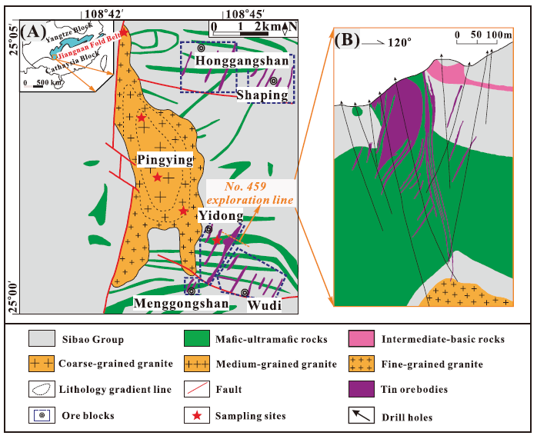

Fig. 2. Photographs showing texture, mineralogy, and geochemical characteristics of tourmaline-quartz orbicules in the Pingying granite. (A) Outcrop photograph and (B) hand specimen showing typical occurrences of quartz-tourmaline orbicules in the Pingying granite. (C, D) Photomicrographs of tourmaline in orbicules, with analytical spots and values showing the B isotope compositions (red top number in circle) and Sn contents (green bottom number in circle). (E) Photomicrographs of color-zoned tourmaline in orbicules, showing that the later tourmaline (Tur-OL) crosscuts the earlier tourmaline (Tur-OE) as dikelets. (F) The BSE image displays that the zoned tourmaline crystals in orbicules have a homogeneous core (Tur-OE) and a growth margin (Tur-OL). Bt = biotite, Chl = chlorite, Pl = plagioclase, Qtz = quartz, Tur = tourmaline.
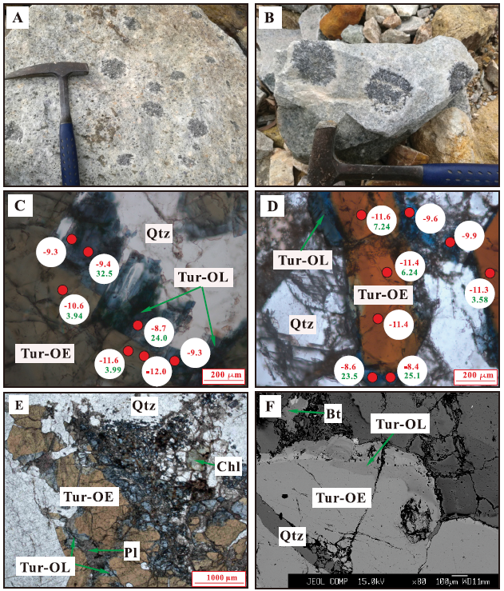

Fig. 3. Photographs showing texture, mineralogy, and geochemical characteristics of tourmaline-quartz dikelets in the Pingying granite. (A, B) The tourmaline-quartz dikelets occur as millimeter- and centimeter-wide dikelets in the granite. (C, D) Photomicrographs of tourmaline grains with color zonation show the increase in B isotope compositions (red top number in circle) and Sn contents (green bottom number in circle) from Tur-DE to Tur-DL. (E) The Tur-DL occurs as veinlets and crosscuts the Tur-DE. (F) In the BSE images, the Tur-DE are dark gray, and the Tur-DL are commonly pale gray. Qtz = quartz, Tur = tourmaline.
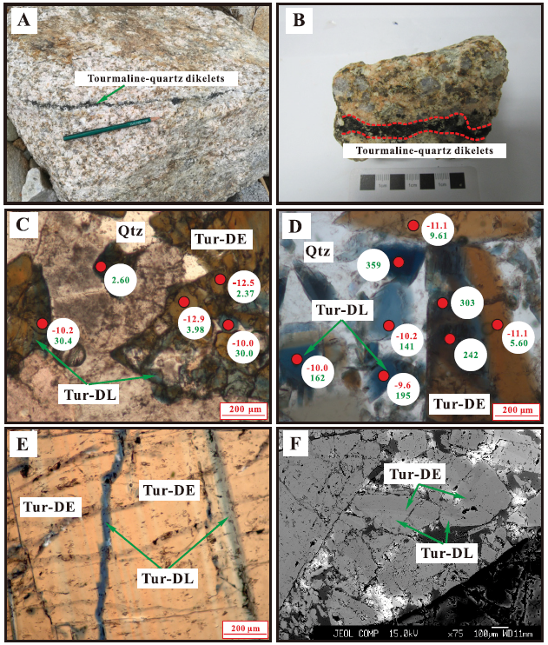

Fig. 4. Photographs showing texture, mineralogy, and geochemical characteristics of tourmaline from the Sn ores in the Yidong tin deposit. (A) The open pit of the Yidong Sn deposit. (B) Cassiterite-tourmaline-quartz dikelets in the Sn ores in the Yidong Sn deposit. (C, D) Tourmaline grains from the Sn ores generally show zoned hydrothermal overgrowth and a decrease in B isotope compositions (red top number in circle) and Sn contents (green bottom number in circle) from Tur-OC to Tur-OR. (E) Tourmaline coexists with cassiterite, quartz, and chlorite. (F) In the BSE image, tourmaline cores are commonly dark gray, while the tourmaline rims are characterized by oscillatory-zoned textures. Bt = biotite, Chl = chlorite, Cst = cassiterite, Qtz = quartz, Tur = tourmaline.
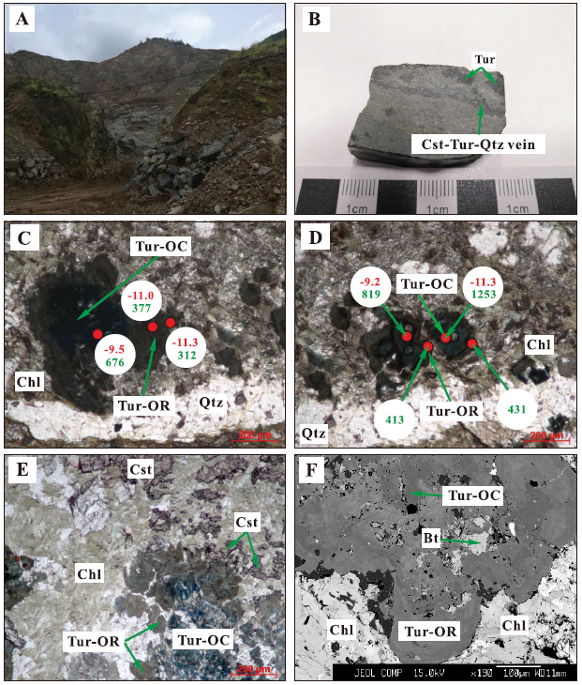

Fig. 5. Classification of the principal groups of tourmalines from the Pingying granite and Sn ores in the Yidong tin ore deposit based on X-site occupancy (after Henry et al., 2011).
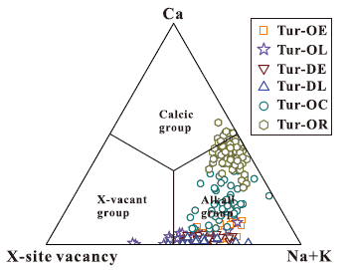

Fig. 6. Plots of (A) Mg/(Mg + Fe) versus Na/(Na + Ca) and (B) Mg/(Mg + Fe) versus X-site vacancy of tourmalines from the Pingying granite and Sn ores.
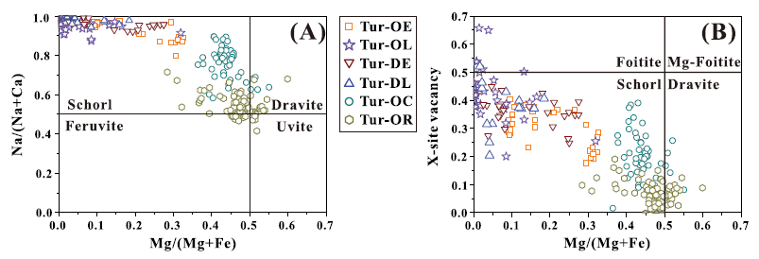

Fig. 7. (A) Al-Fe-Mg and (B) Ca-Fe-Mg ternary diagrams showing tourmalines from the Pingying granite and Sn ores. The regions define the compositions of tourmaline from various source rocks, according to Henry and Guidotti (1985). 1 = Li-rich granitoid pegmatites and aplites, 2 = Li-poor granitoids and their associated pegmatites and aplites, 3 = Fe³⁺-rich quartz-tourmaline rocks (hydrothermally altered granites), 4 = metapelites and metapsammites coexisting with an Al-saturating phase, 5 = metapelites and metapsammites not coexisting with an Al-saturating phase, 6 = Fe³⁺-rich quartz-tourmaline rocks, calc-silicate rocks, and metapelites, 7 = low-Ca meta-ultramafics and Cr, V-rich sediments, 8 = metacarbonates and metapyroxenites, 9 = Ca-rich metapelites, psammites, and calc-silicate rocks, 10 = Ca-poor metapelites, psammites, and quartz-tourmaline rocks, 11 = metacarbonates, 12 = meta-ultramafics. M1 = Fe³⁺Al_{–1} and (Fe²⁺, OH–)(Al, O^{2–})_{–1}, M₂ = (Mg, OH–)(Al, O^{2–})_{–1}.
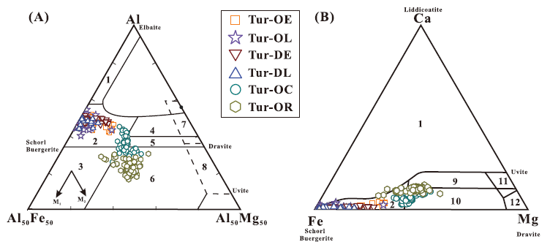

Fig. 8. (A) Plot of Mg versus Fe, (B) plot of Ca versus X-site vacancy, (C) plot of Al versus Ca, and (D) plot of Al-Ca versus Fe + Ca of cation occupancies in tourmalines from the Pingying granite and Sn ores with common exchange vectors as reference. All values are in atoms per formula unit (apfu). R²⁺ = Mg + Fe²⁺.
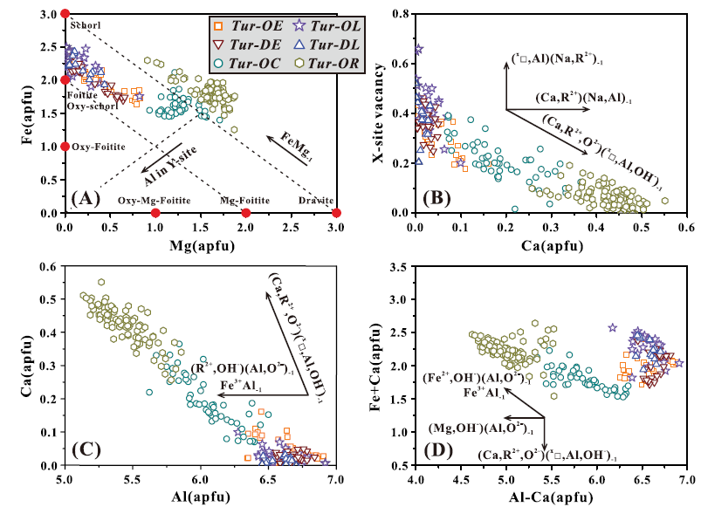

Fig. 9. (A-S) Percentile box and whisker plots showing comparisons of selected major and trace elements in tourmalines from the Pingying granite and Sn ores. The shaded areas in plots represent tourmalines from the tourmaline-quartz dikelets in the Pingying granite.
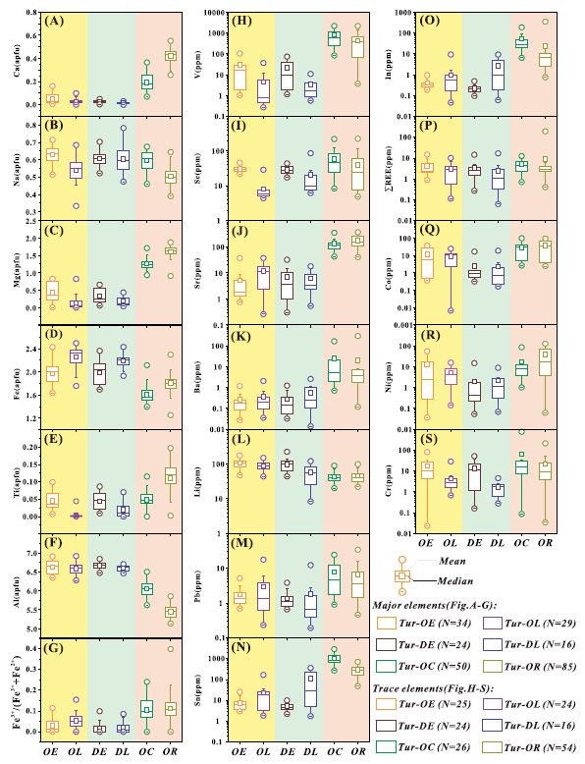

Fig. 10. (A-C) Representative electron probe microanalysis profiles show chemical variations for tourmalines from the Sn ores. Analyzed numbers and sites are marked in the backscattered electron images (left) and the corresponding contents of elements are showed in the form of change curves (right). The shaded areas in chemical plots represent the Tur-OC. apfu = atoms per formula unit.
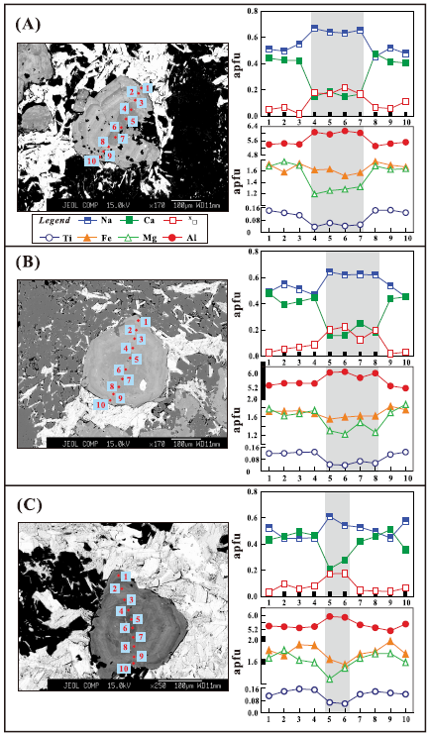
Fig. 11. (A-F) Chondrite-normalized rare earth element patterns (normalized values are from Boynton, 1984) of tourmalines from the Pingying granite and Sn ores.
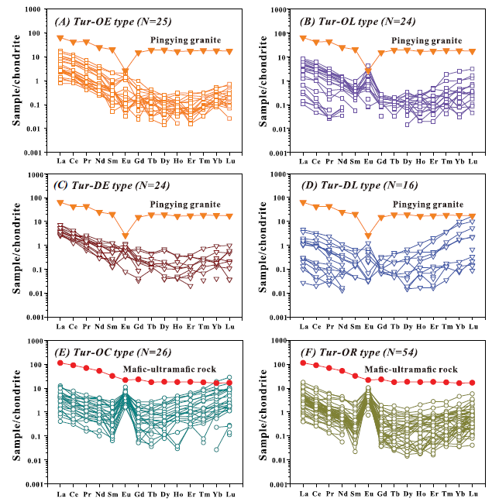

Fig. 12. (A-C) Histograms representing the δ11B values of tourmalines from the Pingying granite and Sn ores. (D) Summary of B isotope compositions for global boron reservoirs and granites and for tourmaline from the Yidong Sn deposit (shaded area) and other related W-Sn deposits. Data sources: Palmer and Swihart (1996), Smith and Yardley (1996), Marschall and Jiang (2011), Zhang et al. (2014), Zheng et al. (2016), Codeco et al. (2017), Marschall (2018), Trumbull and Slack (2018), Zheng et al. (2019). Cst = cassiterite, MORB = mid-ocean ridge basalt, Qtz = quartz, Tur = tourmaline.
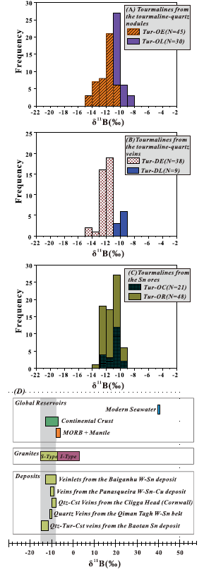

Fig. 13. (A-L) Correlation diagrams between selected trace elements (V, Sc, Sr, Ba, In, Sn, Li, Pb, rare earth elements, Co, Ni, and Cr) and Mg/(Mg + Fe) ratios in tourmalines from the Pingying granite and Sn ores.
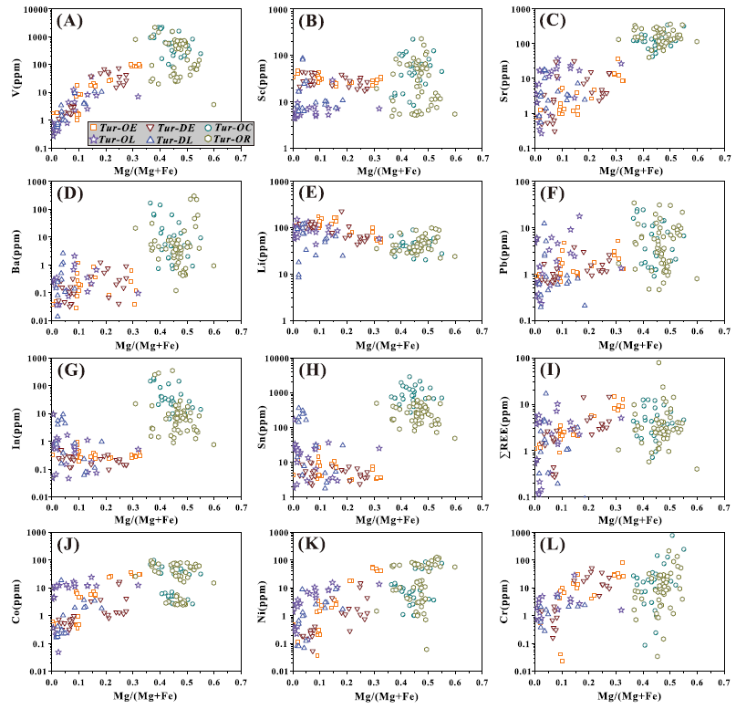

Fig. 14. (A-L) Correlation diagrams between selected trace elements (V, Sc, Sr, Ba, In, Sn, Li, Pb, rare earth elements, Co, Ni, and Cr) and Ca/(Ca + Na) ratios in tourmalines from the Pingying granite and Sn ores.
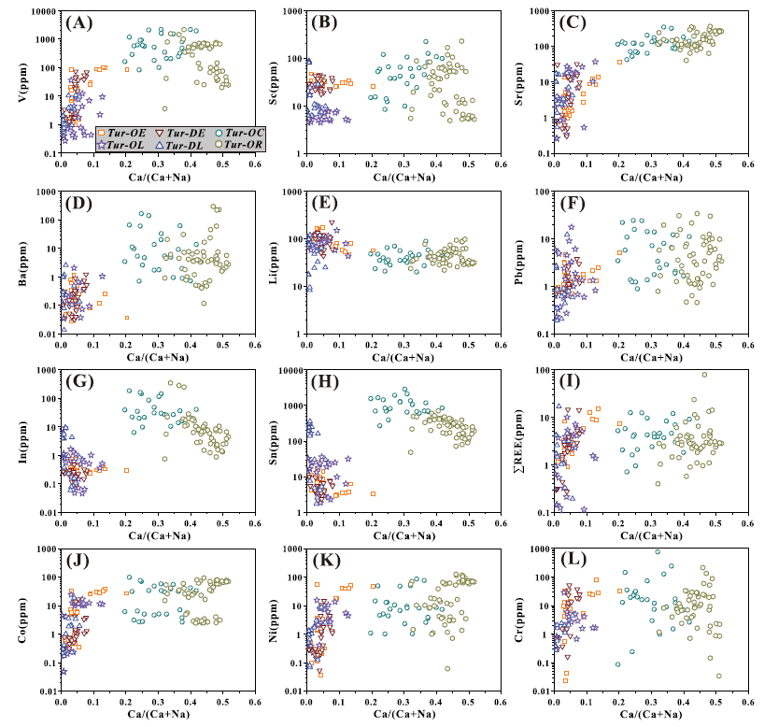

Fig. 15. (A) Summary figure showing the formation of tourmalines from the Pingying granite and Sn ores and corresponding B isotope variations from the late magma to fluid exsolution, then to mineralization. (B) Idealized metallogenic model illustrating the formation of the Yidong Sn deposit. See discussion for the detailed processes.
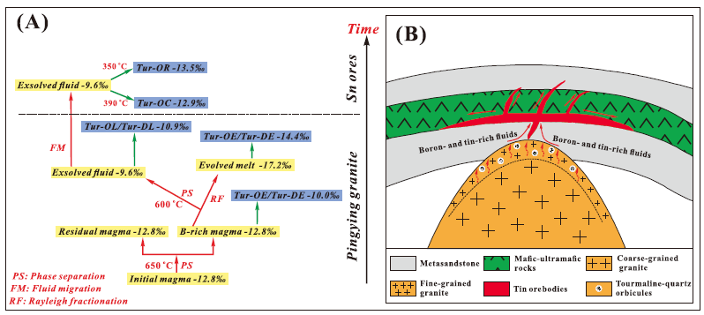

Tables
Table 1. The Selected Chemical Compositions of Tourmalines from the Pingying Granite and Sn Ores
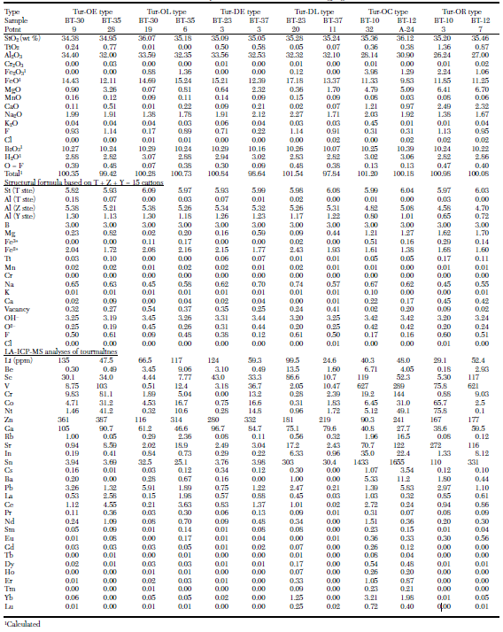

Table 2. The Range and Average of Ferric and Ferrous Fe in Tourmalines from the Pingying Granite and Sn Ores
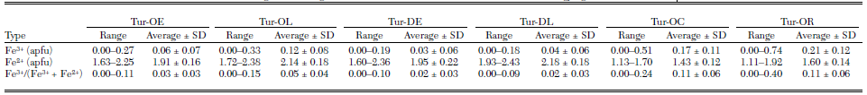
apfu = atoms per formula unit, SD = standard deviation

Table 3. LA-MC-ICP-MS B Isotope Analyses of Tourmalines from the Pingying Granite and Sn Ores
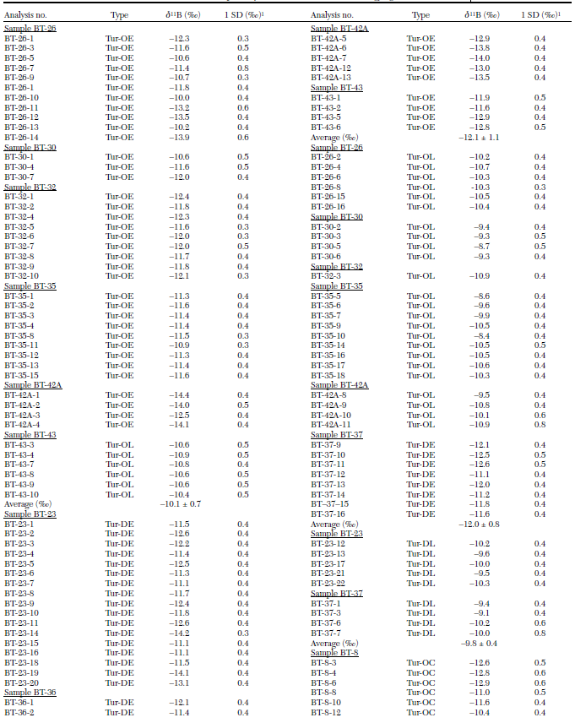

Table 3 (cont)
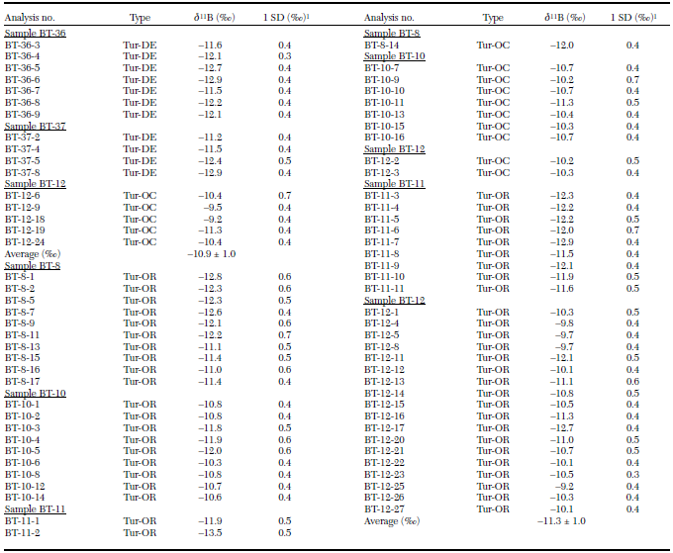
LA-MC-ICP-MS = laser ablation-multicollector-inductively coupled plasma-mass spectrometry, SD = standard deviation ¹Internal precision in per mil for single analysis is calculated from about 100 cycles (standard deviation/mean) × 1000 during each analysis; external precision is better than 0.5‰

