**LIGHT SCATTERING FROM BLACK SILICON SURFACES AND ITS BENEFITS FOR ENCAPSULATED SOLAR CELLS**

Tudor E. Scheul*, Edris Khorani, Tasmiat Rahman, Martin D.B. Charlton and Stuart A. Boden

*School of Electronics and Computer Science, University of Southampton, SO17 1BJ, UK*

*\*corresponding author: T.E.Scheul@soton.ac.uk*

***Abstract:*** *Black silicon (b-Si) has been widely investigated as a potential replacement for more traditional antireflective schemes for silicon solar cells, such as random pyramids, due to its reduced broadband reflectance and improved light-trapping properties. Wavelength and angle resolved scattering (WARS) reflectance measurements provide the means of analysing the amount of light scattered from a textured surface, which can be of interest when considering the amount of light trapped through total internal reflectance (TIR) at various interfaces in an encapsulated photovoltaic module. Here we present and analyse results from WARS measurements on b-Si surfaces fabricated using metal assisted chemical etching (MACE). Large angle scattering is observed for the entire spectrum, increasingly so for shorter incident wavelengths and increasing height of texture features. This is predicted to result in 35-40% of the reflected light being trapped by TIR at the glass-air interface and redirected back onto the sample, when the sample is encapsulated in standard PV module materials. This leads to a calculated additional boost of up to 0.45% in the photogenerated current of an encapsulated black silicon solar cell. This exceeds the calculated 0.21% boost due to TIR predicted for an encapsulated solar cell employing the industry-standard random pyramid texture with a thin film antireflective coating.*

***Keywords:*** *Black silicon,**Scattering, Light trapping, Texture, Optics, Antireflection*

**INTRODUCTION**

Black silicon (b-Si) is a promising candidate to replace more traditional textures used on the top surface of silicon photovoltaic (PV) devices, due to its inherently low fabrication cost via several methods and superior optical properties [1]. A multitude of nanostructure shapes and sizes can be obtained via reactive ion etching (RIE) or metal-assisted chemical etching (MACE) that can be employed as antireflective schemes on top of silicon solar cells, with demonstrated power conversion efficiencies above 20% [2-3]. The main interest in these textures arises from their low broadband reflectance, with values below 3% [4-5], and the significantly improved absorption and thus enhanced photo-generation inside the silicon bulk. Another important property of the b-Si textures, albeit more difficult to demonstrate and quantify, is the scattering of incident light both in reflection and transmission. The implications of such characteristics are multiple: the transmitted photons inside the silicon substrate may experience increased optical pathlengths, thus improving absorption. Likewise, the reflected light that is scattered to large angles may be trapped by means of total internal reflection (TIR) at the interfaces created by the encapsulant materials and glass in a PV module, and thus be redirected back onto the cell, increasing the total amount of light coupled into the substrate. These mechanisms are illustrated in Figure 1. For these reasons, angular scattering profiles of various textures are needed to quantify their light-trapping properties and enable the engineering of new interfaces and materials that can minimise optical losses. While the scattering profiles of traditional micron-scale pyramid textures can be simulated via ray tracing to identify the distinct photon paths emerging from the texture [6-7], the size of the b-Si features (i.e. nano-scale) as compared to the wavelength of the incident light makes it considerably more difficult to do so. This work focuses on experimentally determining and analysing the angular scattering profiles in reflection from MACE-fabricated b-Si surfaces.

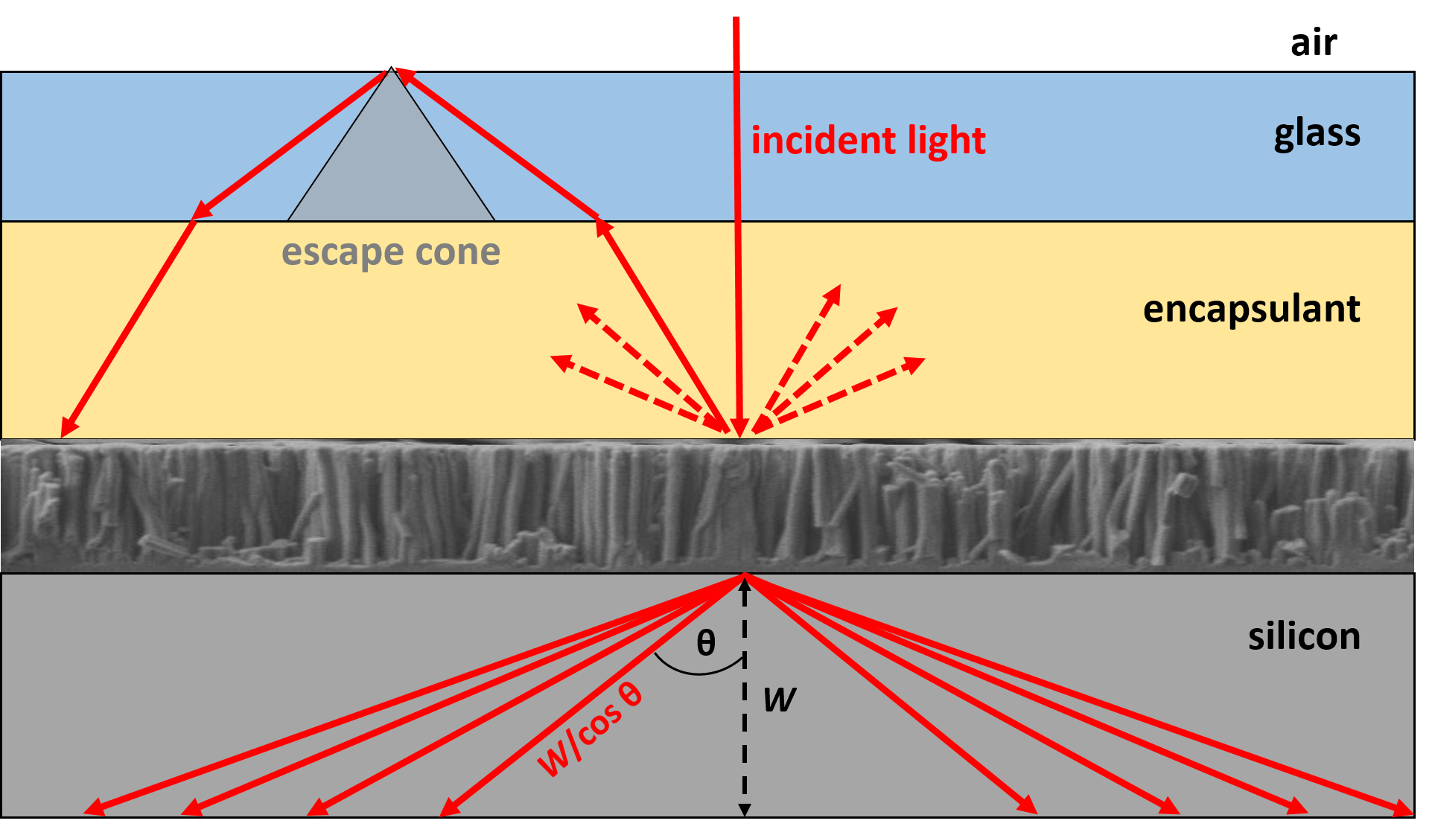

*Fig. 1: Schematic of reflected and transmitted scattering arising from an encapsulated black silicon surface. Reflected scattered light can be redirected onto the solar cell if outside the critical escape cone at the glass-air interface.*

The figure of merit commonly used to describe and quantify diffusely-scattered light from a surface is the ‘reflectance haze’. This can be experimentally determined using an integrating sphere set-up and is defined as the ratio of the diffuse hemispherical reflectance to the total hemispherical reflectance [8]. However, the data collected from the system includes the reflected light across all polar and azimuth angles. As such, information on the angular distribution of reflected light is missing from the reflectance haze results, which can have paramount implications for designing or comparing textured surfaces. Only a few setups and methods have been proposed to overcome this limitation and expand on the scattering description of textured surfaces, mainly aimed at alkaline-etched upright and inverted pyramids [9-12]. One example of a study of scattering by MACE fabricated structures is from Kurokawa et al. (2013) [12] who studied the scattering of transmitted light by MACE nanowires embedded into a transparent PDMS substrate, employing a similar setup to the one used here. In this work, we fully describe the angular and wavelength distribution of the reflections arising from MACE structures. We present wavelength and angle resolved scattering (WARS) measurements of a b-Si texture fabricated via a one-step MACE process, along with hemispherical reflectance measurements as obtained from an integrating sphere set-up. We identify the main characteristics of the collected signal from both a polar and azimuthal angular perspective and then show the impact of varying feature height on the reflected scattering profile. We discuss the key implications at device level, by predicting the proportion of light reflected from b-Si surfaces that would undergo total internal reflection in an encapsulation stack and be redirected back onto the cell. Finally, we calculate the boost in photogenerated current that this would confer and compare our results to the industry-standard alkaline-etched random upright pyramids using scattering profiles reported in our previous work [13].

**1. EXPERIMENTAL METHODS**

**1.1. SAMPLE FABRICATION**

Single crystal n-type, <100>, 1-5 Ω-cm Cz silicon wafers were cleaved into 4 x 4 cm2 pieces, then cleaned using a 3:1 (H2SO4:H2O2) Piranha solution for 20 minutes, followed by copious rinsing in de-ionised water. In order to remove the surface oxide, the samples were submerged into a diluted 7:1 H2O:HF bath for 5 minutes. The MACE process used in this work employed a single aqueous solution comprised of 0.06 M AgNO3 (Sigma-Aldrich, > 99.5% purity) and 14 M HF mixed in a PTFE beaker at room temperature for 8 minutes. For comparison, MACE black silicon samples were also fabricated for etch times of 6 mins and 12 mins. The etched silicon was then thoroughly rinsed in DI water and dipped into a 1:1 HNO3:H2O solution in order to remove the silver particles formed between the nanowires [14].

**1.2. CHARACTERISATION**

Scanning electron microscope (SEM) images were captured using a Carl Zeiss NVision40 microscope, with an accelerating voltage of 2 kV and an aperture of 30 μm. Cross-sectional images were taken by exposing a freshly cleaved surface of the sample perpendicular to the electron beam for morphological characterisation. Total hemispherical reflectance (*RTOT*) was measured with a DTR6 integrating sphere as part of a Bentham PVE 300 system in the 400-1100 nm wavelength range, at 8° angle of incidence and using a 2% LabSphere diffuse black reflective standard (SRS-02-010). For measuring diffuse reflectance (*RDIFF*), one of the ports of the integrating sphere was replaced with a light trap to remove the specular reflected beam from the measurement (removing light scattered within ± 6° from the specular reflection direction). Specular reflectance, *RSPEC,* can then be calculated using:

$R_{SPEC}\left(λ\right)=R_{TOT}\left(λ\right)-R_{DIFF}(λ)$ (1)

The reflectance haze for each sample, *HREFL*, was then calculated using:

$H_{REFL}\left(λ\right)$*= $\frac{R_{DIFF} (λ)}{R_{TOT} (λ)}$* (2)

The measured hemispherical reflectance for each sample, *RTOT*, was then related to the AM 1.5G incident spectrum [15] and its corresponding photon flux density (*FPH*) as in Equation (3) to obtain the weighted average reflectance RAW in the 300-1100 nm wavelength range. The weighted average reflectance haze *HAW* was calculated using a similar approach as in Equation (4).

$R_{AW}$*= $\frac{\int_{λ_{min}}^{λ_{max}}{R_{TOT} \left(λ\right){ F}_{PH} \left(λ\right) dλ}}{\int_{λ_{min}}^{λ_{max}}{F_{PH}}\left(λ\right) dλ}$*  (3)

$H_{AW}$*= $\frac{\int_{λ_{min}}^{λ_{max}}{H_{REFL} \left(λ\right) F_{PH} \left(λ\right) dλ}}{\int_{λ_{min}}^{λ_{max}}{F_{PH}}\left(λ\right) dλ}$*  (4)

WARS measurements were carried out with a home-built system [13, 16], which uses a white super-continuum laser source (Finanium SC-450) to provide irradiation in the 450-2000 nm wavelength range. The data was collected using a multimode optical fibre attached to a spectrophotometer (BWTek Glacier X) sensitive in the 350-950 nm range. Motorized rotation stages enable precise control over the sample and the detector positioning, alignment, orientation and angle of incidence. The textured sample was illuminated with p-polarized light under normal incidence while the detector swept around in an arc covering polar angles in the range 6°-80°, as in Figure 2. Although a more complete data set can be obtained by averaging the responses of both p and s polarized incident light, the measurements are expected to remain similar under normal incidence.

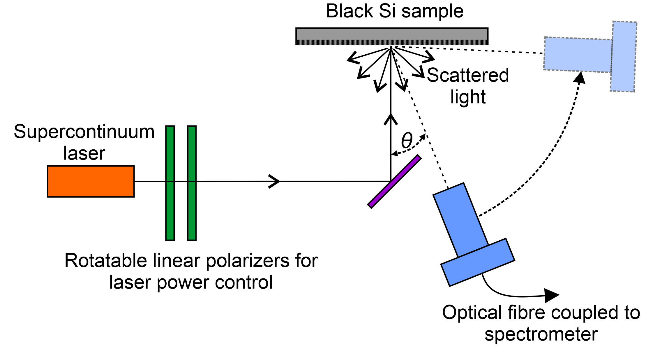

Fig. 2: Schematic of the WARS system used in this study, showing optical components, sample illumination and detector movement.

Due to the in-plane movement of the detector for reflection measurements, a scaling factor is applied to geometrically correct for the scattering cone occurring out of plane as in Equation (5). Here, *r* is the radius of the detector, *a* is the distance between the detector and the textured sample and $θ$ is the angular positioning of the detector relative to the specimen’s surface normal. Data was collected for every 1° movement of the detector and for every 30° azimuth rotation. The angular resolution of the system is ± 0.4° which prevents overlapping of the data in consecutive measurements. Noise and various artefacts in the measured data were filtered out using a moving average method with a window size of 25 nm. The collected data were then normalized to unity relative to the largest intensity point measured in a dataset.

$I_{SCATTERED}\left(θ, λ\right)$*= $\frac{{\text{I}}_{\text{MEASURED}}\text{ (θ, λ) 4 a sinθ}}{\text{r}}$*  (5)

The scattering measurements are conducted on black silicon surfaces in air but the light trapping through TIR will occur for surfaces encapsulated in materials with a higher refractive index. To account for this, Finite-difference time-domain (FDTD) simulations of single nanowires were carried out in a commercial simulation package by Lumerical [17] to investigate the optical impact of encapsulant refractive index on the scattering angles.

A strongly absorbing perfectly matched layer (PML) boundary was set in all directions (i.e. x, y, z) to prevent reflections at these interfaces. The light source is a total-field scattered-field (TFSF) plane wave in the 300 – 1100 nm wavelength range and is normally incident onto the silicon substrate. Unless stated otherwise, the nanowires have a diameter of 100 nm and length of 1 µm. A reflection monitor was placed above the silicon nanostructure and data was gathered in the far field. For this, the simulation software assumes a hemispherical monitor with radius of 1 m situated 1 m above the silicon substrate. A diagram of the simulation set-up which included all the previously mentioned elements can be seen in Fig. 3. To assess the impact of the encapsulant refractive index on the scattered reflections with minimal film absorptions, the imaginary part (i.e. *k*) was kept the same as for ethyl-vinyl acetate (EVA) from tabulated data [18]. The real part of the encapsulant refractive index (i.e. *n*) was varied in the range 1-2.5 in steps of 0.25 and scattering profiles were simulated. The data was integrated over the entire 300-1100 nm wavelength range and over the azimuth angles in the range 0°-360°, then normalised relative to the highest intensity point to produce plots of total reflected intensity vs. polar scattering angle. This was done for nanowires surrounded by encapsulant material and compared to the results for nanowires in air to determine the angular shift to apply to the experimental results.



*Fig. 3: FDTD simulation set-up used in Lumerical, showing the boundaries, the monitors, the source and the silicon material.*

**2. OPTICAL AND MORPHOLOGICAL PROPERTIES**

Figure 4 a) shows a cross-sectional SEM image of the black silicon sample etched for 8 minutes. The resulting surface exhibits a dense array of vertical standing nanowires with high aspect ratio and varying diameters in the range 20 – 100 nm. The nanostructure height is highly uniform due to the mechanism of the etching process [14] and well controlled through altering the etching time. The length of the structures can be measured directly from the SEM image as 1790 nm ± 30 nm.



*Fig. 4: a) Cross-sectional SEM image of the MACE b-Si structures; b) Hemispherical reflectance measurements of the MACE b-Si specimen (blue traces) along with total reflectance for coated and uncoated random alkaline-etched pyramids (black traces [29]) and the calculated reflectance haze (red trace) on right y-axis.*

Figure 4 b) shows the measured total hemispherical reflectance (solid blue trace), the measured diffuse hemispherical reflectance (dashed blue trace) and the calculated specular reflectance (dotted blue trace) of the black silicon MACE sample. As is typical with these nanotextures, the total reflectance is below 3% in the 400- 1000 nm wavelength range and the surface exhibits near-zero specular reflectance. The increase in total reflectance above 1000 nm is due to incomplete absorption of light as the photon energy approaches that of the band gap of silicon, i.e. light that passes through the silicon substrate, is reflected off the rear inner surface and re-emerges out of the top of the sample. For reference and comparison, the total hemispherical reflectance of an alkaline-etched upright random pyramid sample is shown for both uncoated texture and coated with silicon nitride antireflective coating [29] (black traces, corresponding to left y-axis).

It is well established that the excellent absorption properties of silicon nanowires arise from the presence of confined modes inside the nanostructures, such as leaky modes and strong Fabry-Perot resonances, which emerge as consequences of the structure geometry and size [19]. For a periodic nanowire array, the fundamental mode and the first few key modes are strongly absorbing in the short wavelength region and decay with increased wavelength. Upon a nanowire radius increase, these confined modes are red-shifted and more propagating modes emerge towards larger wavelengths which are better coupled to by the incident plane waves [20]. It has been previously reported [21-22] that the Mie absorption efficiency for nanowire diameters below 100 nm reaches its maximum at short wavelengths λ < 500 nm due to the presence of the fundamental mode. As such, in a heterogenic nanowire array fabricated via MACE, it is hypothesised that the multitude of radii leads to a superposition of these associated optical responses and enhanced absorption (i.e. supressed reflectance) across the entire wavelength spectrum. Furthermore, a large silicon to air material fill factor promotes reduced reflectance in the short wavelength region, as in the case of MACE black silicon arrays that are extremely dense. Moreover, a smooth graded transition in the refractive index occurs for nanotextured silicon surfaces, from the refractive index of the surrounding medium (air) to that of the substrate (silicon) [1], which translates into exceptionally low broadband surface reflectance. The weighted average reflectance (*RAW*) for the b-Si sample is 1.62 %. The reflectance haze, calculated as the ratio between the diffuse hemispherical reflectance and the total hemispherical reflectance (Equation (2)) is shown as a red trace corresponding to the right-hand y-axis in Figure 3 b). Indeed, the weighted average reflectance haze (*HAW*) of 94% suggests that the black silicon array redirects most of the incoming light away from the specular reflectance angle, confirming the superior scattering capabilities of such structures compared to standard alkaline-etched micropyramids. However, as common with haze measurements, this figure indicates only the percentage of photons of various energies reflected to angles larger than 6° from the specular direction, but provides no information on the angular distribution of the scattered light. As such, haze measurements remain complementary to other characterisation methods that provide a more detailed description of the scattered light angular distribution.

**3. WAVELENGTH AND ANGLE RESOLVED SCATTERING (WARS)**

The wavelength and angle resolved reflectance map of the MACE b-Si sample imaged in Figure 4 is shown in Figure 5, with p-polarized light normally incident on the surface, for wavelengths between 480 nm and 950 nm and polar angles in the range 6°- 80°. The reflected intensity is normalised relative to the highest value and shown in colour. The measurement shows a broad angular distribution of reflected light, with scattering maxima at around 40° for wavelengths above 900 nm. The wavelength distribution agrees well with hemispherical measurements, where the total reflectance increases with wavelength. This is a consequence of incomplete absorption of long wavelength light, which passes through the silicon substrate, is reflected at the rear surface and re-emerges out of the top of the sample. The scattering profile of b-Si is different to the measurements of alkaline-etched upright random pyramids on a Si substrate, described in a previous work [13], where specific photons paths are observed due to the fixed geometry of the microstructures. In this case, the random size distribution of the nanowires leads to a much larger distribution in the scattering angles across the entire wavelength spectrum.

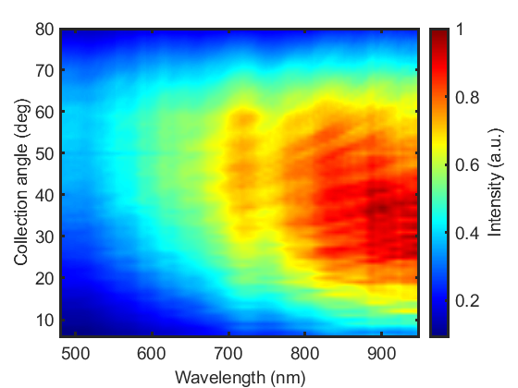

*Fig. 5: Wavelength and angle resolved reflectance measurement of the b-Si structure; intensity indicated in colour (a.u.).*

More insight is provided by an analysis of the signals at specific wavelengths to identify their maximum scattering angles, such as Figure 6 a). Here, it is found that the b-Si nanostructures do not only reduce top surface reflectance preferentially at shorter wavelengths, as indicated by the intensity peaks of the curves, but also redirect shorter wavelength photons to higher angles than those of larger wavelengths. For this sample, the maximum scattering angle at 500 nm (blue trace) of 54° is gradually reduced as wavelength is increased, to 33° at 900 nm (black trace). For short wavelengths, scattering of light occurs only upon initial reflection from the top surface since this region of the spectrum is readily absorbed by the substrate. The reflectance losses for longer wavelengths are greater because of the increasing proportion made up from light that initially passes into the cell but is not absorbed and exits out of the front surface. For this light, scattering in transmission on the way out contributes to the scattering distribution. The different scattering mechanism operating for longer wavelength light may be the cause of the peak shift to smaller scattering angles. Nevertheless, scattering of longer wavelength light is still sufficient to steer an appreciable proportion away from the escape cone resulting in light trapping through TIR at the overlying layer interfaces.

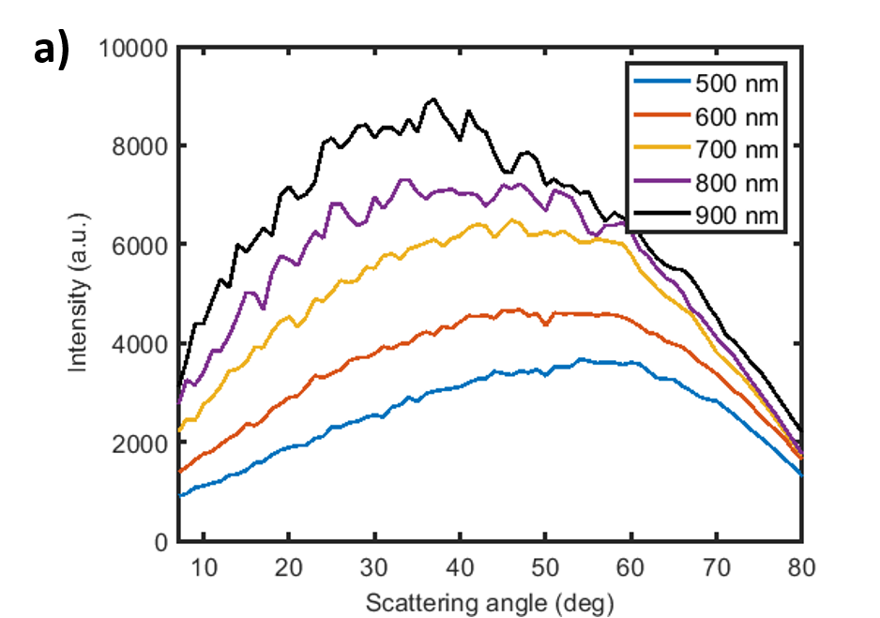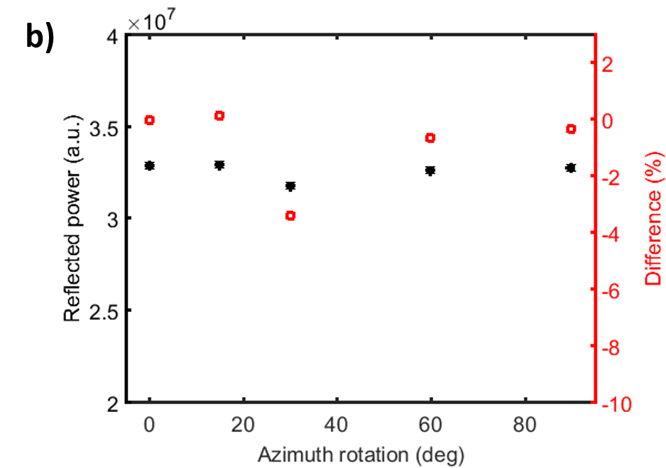

*Fig. 6: WARS measurement of 1.8 μm height b-Si sample a) Raw signal as a function of scattering angle for selected wavelengths; b) Total reflected power integrated over both the angular and wavelength ranges, as a function of azimuthal rotation of the texture. Difference (right-hand axis) is calculated with respect to initial measurement at 0⁰ azimuth.*

The random distribution of nanowires as a result of the non-masked etching process should result in a stable optical response as azimuthal angle is varied. This is shown in Figure 6 b), which plots the total reflected power for various sample azimuth angles. The difference for each measurement is calculated with respect to the initial measurement at 0° azimuth (no rotation) and yields errors < 3.5% for all rotations studied.

**3.1. Impact of b-Si height**

For comparison, MACE b-Si samples were also etched for 6 minutes and 12 minutes, resulting in nanostructure lengths of 1190 nm ± 30 nm and 3580 nm ± 50 nm respectively. The corresponding *RAW* are 2.24 % and 1.32 %, respectively, with *HAW* values of 90 % and 97 %, as shown in Table 1, along with values for alkaline-etched upright micropyramids. This is in line with what is traditionally expected from the optical response of longer b-Si structures [14]. Figure 7 a) shows the maximum scattering angles for the three samples over the entire wavelength range. On top of yielding reduced broadband surface reflectance, the longer nanowires redirect the reflected light towards larger angles for all the wavelengths. Moreover, the taller the nanowires are, the smaller the reduction of maximum scattering angles across the wavelength range. This demonstrates the increasingly superior scattering properties of longer nanostructures over the entire spectrum. Figure 7 b) further summarises this key point, showing the measured maximum scattering angles for b-Si samples with increasing nanowires length for several selected wavelengths.

|  |  |  |
| --- | --- | --- |
| **Texture** | **RAW (%)** | **HAW (%)** |
| Random pyramids | 11.3 | 92 |
| 1.2 μm b-Si | 2.2 | 90 |
| 1.8 μm b-Si | 1.6 | 94 |
| 3.6 μm b-Si | 1.3 | 97 |

Table 1: Summary of optical properties for MACE b-Si samples and alkaline-etched upright random pyramids.

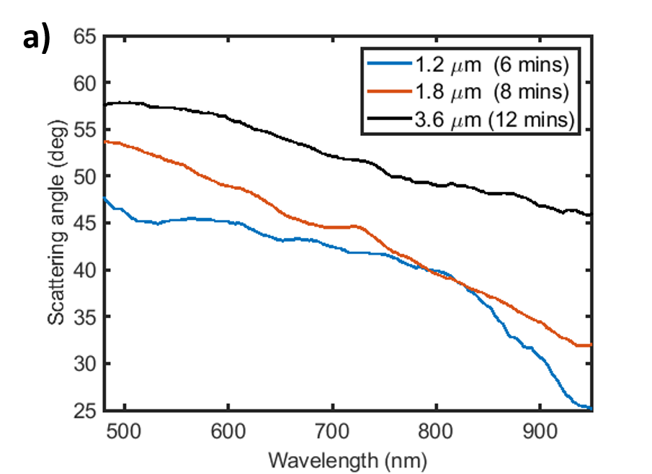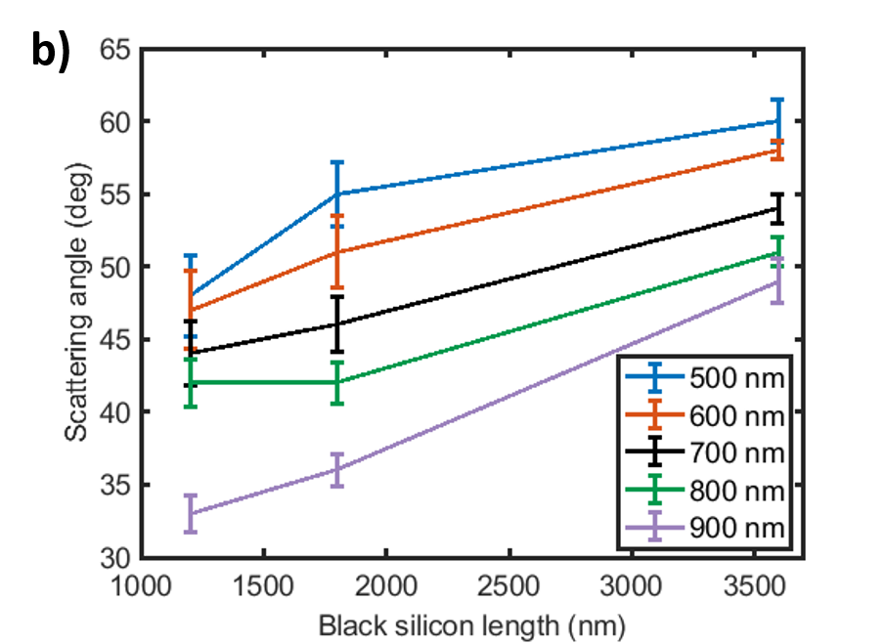

*Fig. 7: a) Maximum scattering angles for the entire wavelength spectrum for three different MACE durations yielding different nanowire heights; b) Maximum scattering angles with error bars as function of nanostructure height for selected wavelengths.*

**4. OPTICAL IMPACT OF ENCAPSULATION**

In a PV module, silicon solar cells are encapsulated to protect the substrate from moisture and damage. As the black silicon samples measured with the WARS system are surrounded by air, it is of interest to predict the change in the angular distribution of the scattered light if the black silicon was to be surrounded by various encapsulants. To this end, Finite-Difference Time-Domain (FDTD) simulations were carried out using the Lumerical simulation package, as detailed in Section 1.2, to investigate the far field response arising from a silicon nanowire with and without an encapsulant. In order to faithfully recreate the variations in diameter and periodicity of MACE fabricated black silicon, a number of simulations were performed. It is found that minimal change in the angular scattering profile of the reflected light occurs by changing the diameters or the heights of the nanowires upon normalisation relative to the highest intensity value, irrespective of the surrounding medium (see Appendix A). This indicates the presence of more complex mechanisms contributing to the scattering of light than just a simple change in scattered angle based on an effective refractive index of the silicon/air stack calculated from various effective medium approximation (EMA) techniques and the silicon to air volume fill fraction [23]. In contrast, the experimental results show a larger angular shift arising from height variation of the nanostructures. This is attributed to the tendency for longer nanowires to bend and coalesce into bunches towards their tips due to various nanoscopic forces at play, as well as their aspect-ratio, thus affecting the optics and changing scattering angles beyond what can be predicted through our simple simulations.

Figure 8 shows the total reflectance versus scattering angle obtained from FDTD simulations for 1 µm long nanowires with diameters of 100 nm, surrounded by air (blue trace) and surrounded by ethyl-vinyl acetate (EVA – orange trace). The broad distribution of the reflections over the angular range and the peaks situated at angles above 40° for the nanowire surrounded by air match well the measured angular distribution. A decrease in the scattered polar angles is visible for the nanostructure surrounded by EVA compared to air, which is a direct consequence of photons travelling into a denser medium (i.e. higher refractive index) than air. As such, the angular maximum at 46° for the bare nanowire is reduced to 35° when the nanowire is surrounded by EVA.



*Fig. 8: Total reflection integrated over wavelength and azimuthal range for a 1 µm long silicon nanowire of 100 nm diameter surrounded by air (blue trace) and by EVA encapsulant (orange trace).*

Figure 9 shows the change in the angular location of the peak of the reflected signal for encapsulant refractive indices in the range of 1-2.5 for a 1 µm long nanowire of 100 nm diameter. As before, the maximum scattering angles decrease with increasing refractive indices. In order to replicate the morphology distribution commonly observed in MACE samples, the maximum polar angles were averaged over the diameter and height range for each encapsulant refractive index (see Appendix A). Figure 9 (right y-axis) also shows the ratio of these angle averages for each encapsulant refractive index in relation to the angle values obtained from simulating the nanowire surrounded by air. These ratio averages can then be used as coefficients for shifting the reflected scattering angles measured in the WARS system to predict the change in angular distribution compared to the non-encapsulated black silicon and correctly include this mechanism in the calculation of light trapped by total internal reflection at various cell interfaces in the next section.



*Fig. 9: Peak scattering angle (left y-axis in black) predicted by a simulation of 1 µm long nanowire of 100 nm diameter. Average angular ratios (right y-axis in red) as a function of surrounding encapsulant refractive index for a range of nanowire heights and diameters.*

**5. TOTAL INTERNAL REFLECTION**

WARS data can be used to predict the amount of light reflected from the top surface of the cell that would subsequently undergo total internal reflection at the glass-air interface in an encapsulated module structure and be redirected back onto the cell, providing a further boost to the photogenerated current. This is aided by the creation of a virtual encapsulant-air interface where the critical angle is lower than at the encapsulant-glass interface which defines the critical angle for total internal reflection *θenc*, as shown by Yang et al. [10]. By calculating the ratio of the reflected power outside the escape cone to the total reflected power, as in Equation (6), the fraction of reflected light that would undergo total internal reflection (*fTIR*) can be computed as a function of the surrounding encapsulant refractive index. Here, $\overline{I_{scattered}}$ represents the circular average of the intensities calculated in Equation (5) to account for measurements at all azimuth orientations, *θcrit* is the calculated critical angle corresponding to the surrounding encapsulant refractive index and *λ* is the wavelength of the incident light. For encapsulant materials that are not index-matched to the surrounding glass layer, a change in the propagation direction will occur for the reflected light that travels through this interface, as deduced from Snell’s Law. This effect was included in the calculation of *fTIR* as a function of the refractive index of the encapsulant (n) for the scattered reflections arising from MACE surfaces. Furthermore, the angular averages for various encapsulant refractive indices (see Fig. 9 right y-axis)) were included in the calculation of the fraction of light trapped by total internal reflection to accurately predict the decrease in scattering angles upon encapsulation when compared to the WARS measurements taken in air.

*fTIR (n)* = $\frac{\int_{θ_{crit }}^{80°}{\int_{λ=480 nm}^{950 nm}{\overline{I_{scattered}}\left(θ_{crit}(n), λ\right) dλ dθ_{crit}}}}{\int_{6°}^{80°}{\int_{λ=480 nm}^{950 nm}{\overline{I_{scattered}}\left(θ_{crit}(n), λ\right) dλ dθ_{crit}}}}$ (6)

Figure 10 shows the calculated fractions of light trapped (*fTIR*) for the three b-Si samples previously described, for surrounding encapsulant refractive indices values from 1 - 2.5, corresponding to critical angles in the range 90°-23.57°. The shifting of the maximum scattering angles to larger values with increased b-Si feature height translates into a larger fraction of reflected photons being trapped at the glass-air interface and redirected back towards the cell. This is due to an increase in the proportion of light satisfying the requirements of total internal reflection at that interface, i.e. incident at an angle larger than the critical angle. It is important to notice that even though the fraction of light trapped increases with increasing encapsulant refractive index due to geometric requirements being more easily fulfilled, the increase in encapsulant refractive index renders the textured surface less optically active. As such, the overall surface reflectance decreases with increased surrounding refractive index and becomes the dominant factor in calculating the overall optical gain (i.e. decreased surface reflectance arising from increased refractive index outweighs the benefit of having larger fTIR). For reference, the fraction trapped for a potassium hydroxide (KOH) etched random pyramid sample from a previous study is also shown (purple dashed line) [13]. The b-Si samples exhibit a much larger fraction of light trapped compared to the industry-standard pyramidal texture by scattering the reflected light to higher angles, especially for a surrounding encapsulant refractive index below 2.



*Fig. 10: Experimental fraction of light trapped by the b-Si textures at virtual encapsulant-air interface (blue trace – 1.2 μm, red trace – 1.8 μm, black trace – 3.6 μm) along with experimental fraction trapped by random pyramids from previous work (dashed purple trace) [13].*

For a typical PV encapsulant, such as ethylene-vinyl acetate (EVA) with a refractive index of 1.5 [18] at wavelength of 600 nm, b-Si surfaces scatter light such that 27.6%, 33% and 39.9% of the reflected light will be trapped via TIR at the glass/air interface for nanostructure lengths of 1200 nm, 1800 nm and 3600 nm, respectively, while the random pyramids trap approximately 14.5% of the light by TIR. Given similar levels of surface passivation to ensure comparable electrical losses [5], this optical gain can lead to more power output at the device level. In addition, emergence of new encapsulating materials in the PV field, such as polydimethylsiloxane (PDMS) [24], thermoplastic polyurethane (TPU) or higher refractive index polyolefins [25] would further benefit from the scattering profiles of these nanowires by leading to an even higher fraction of light trapped. Table 2 shows a summary of the fTIR values calculated for several PV-compliant emerging encapsulants surrounding the black silicon and pyramidal textures.

|  |  |  |  |  |
| --- | --- | --- | --- | --- |
| **Texture** | **Fraction trapped by TIR (%)** | | | |
| **PDMS**  **n = 1.42 [25]** | **PVB**  **n = 1.485 [26]** | **EVA**  **n = 1.5 [18]** | **Polyolefin**  **n = 1.53 [27]** |
| Random pyramids | 13.6 | 14.1 | 14.5 | 14.7 |
| 1.2 μm b-Si | 24.2 | 26.7 | 27.6 | 28.9 |
| 1.8 μm b-Si | 29.3 | 32.3 | 33 | 34.2 |
| 3.6 μm b-Si | 35.8 | 39.1 | 39.9 | 41.2 |

*Table 2: Summary of values of fraction of light trapped via TIR at glass-air interface for several PV relevant encapsulants. Random pyramids values taken from previous work [13].*

**6. PHOTOCURRENT GAIN**

Information on the fraction of light trapped at glass-air interface and on the angular distribution of the reflected light for different textures can be used in the creation of a more comprehensive model for calculating the photocurrent density (*JPH*) generated from a photovoltaic device, than one that just considers surface reflectance. As such, Equation (7) is used to calculate *JPH*, taking into account the impact of the reflections at different material interfaces in the stack on the incident AM1.5G photon flux density (*FPH*) [28]. For consistency with previously presented WARS data, *FPH* was standardised to 100 mW/cm2 in the spectrum, but only wavelengths from 480 nm to 950 nm were considered in the calculation as this is the range over which the experimental set-up can measure accurately. Thus, the absolute photocurrent calculated values will be lower than what is traditionally expected from a state-of-the-art silicon solar cell, where the full incident spectrum is available. In Equation (7), *q* is the elementary charge (1.602 × 10-19 C), *RGLASS* is the reflectance at air-glass interface, *IQE* is the internal quantum efficiency of a silicon solar cell and *RESCAPED* is the total light reflected from the cell that escapes the module, where the fraction of light trapped has been accounted for (Equation (8)). The reflectance spectrum for the air-glass interface (i.e. *RGLASS*) is calculated using the Fresnel equation for reflectance at normal incidence. Reflectance at the glass-encapsulant interface is assumed to be zero for all incident wavelengths, i.e. the glass material and the encapsulant material are index-matched.

*JPH (n) = q $\int_{\text{480 nm}}^{\text{950 nm}}{\left(\text{1-}{\text{R}}_{\text{GLASS}}\text{ (λ)}\right) F_{PH} \left(\text{λ}\right)} \left(\text{1-}{\text{R}}_{\text{ESCAPED}}\text{ (λ, n)}\right)\text{ IQE(}\text{λ)}$*  (7)

*RESCAPED (λ, n) = M (n) RTEXTURE (λ) (1 – fTIR(n)) ($\text{1-}{\text{R}}_{\text{GLASS}}\text{ (λ}\text{)}$)* (8)

In Equation (8), *RTEXTURE* is the measured hemispherical reflectance of the textured surface (see Fig. 4 b) and *fTIR* is the fraction of reflected light trapped by TIR at the glass-air interface for the combination of texture and encapsulant refractive index (see Fig. 9). This accounts for the reduction in the reflection due to TIR at glass-air interface, indicating a smaller amount of light exiting the whole PV module stack than the initial reflection from the textured surface. The hemispherical reflectance for the random pyramids sample with an industry standard antireflective coating (ARC) consisting of 75 nm of plasma-enhanced chemical vapour deposition (PECVD) silicon nitride (SiNx) was taken from Duttagupta et al. [29]. The cell quantum efficiency (IQE) is assumed to be 100% for all incident wavelengths (i.e. each photon passing into the silicon contributes to photogeneration). Reflectance of photons travelling away from the silicon that are incident on the glass-air interface inside the escape cone is included via the RGLASS term in Equation (8), although normal incidence (0°) is assumed here. In reality, most of this light will be incident at larger angles onto this interface, leading to an underestimation of *RGLASS* in the Equation 8 and therefore an underestimation in *JPH*. Moreover, it is assumed that all light trapped by total internal reflection and re-incident on the cell will be absorbed. The factor *M (n)* has been introduced to account for the surface reflectance reduction that arises from coating the nanotexture with encapsulants. This factor has been calculated from the FDTD simulations and is the ratio between the total surface reflectance from a bare nanowire and the total surface reflectance from an encapsulated nanowire with the respective encapsulant refractive index, averaged over the entire wavelength spectrum.

For a typical encapsulant refractive index of 1.5, such as EVA, the *JPH* data is summarised in Table 3. The photogenerated current was calculated with and without consideration of the photons trapped by total internal reflection for all textures. The corresponding gain associated with the inclusion of fTIR is shown in the right-most column of Table 3. All of the black silicon textures aid in more substantial photogeneration than in the random pyramids case. This arises from reduced top surface reflectance, as well as a higher fTIR, increasingly so for longer nanostructures. For the shortest MACE duration black silicon sample (1.2 μm), photocurrent gains in excess of 0.4% are possible due to fTIR. For longer wires, the fTIR increase is outweighed by the decreased surface reflectance, which plays a more important role in photogeneration, leading to reduced gains in photocurrent due to fTIR alone. In contrast, a more modest JPH gain of 0.21% is observed for the random pyramids texture due to the low fTIR of 14.5 % (i.e. low-angle reflected scattering). As such, the preferential redirection of photons into oblique angles and entrapment of a large proportion of these at the stack interfaces has a more significant effect for the nanotextured black silicon surfaces. Moreover, scattering of transmitted photons by black silicon (not considered in this study) may provide even higher electrical gains at device level, due to promotion of high-angle scattering inside the semiconductor substrate, thereby increasing the optical pathlength and therefore the absorption of longer wavelength photons.

|  |  |  |  |  |
| --- | --- | --- | --- | --- |
| **Texture** | **JPH (mA/cm2)** | | **Gain (%)** | **Absolute gain (mA/cm2)** |
| **without fTIR** | **with fTIR** |  |
| Random pyramids with SiNx ARC | 28.22 | 28.28 | 0.21 | 0.07 |
| 1.2 μm b-Si | 28.74 | 28.87 | 0.45 | 0.13 |
| 1.8 μm b-Si | 28.89 | 29.02 | 0.44 | 0.13 |
| 3.6 μm b-Si | 28.97 | 29.09 | 0.41 | 0.12 |

*Table 3: JPH calculated for four types of textures with and without accounting for the fraction of light trapped at encapsulant-air interface, as well as resulting gain.*

**7. CONCLUSIONS**

Wavelength and angle resolved reflectance measurements used to characterise light scattering by b-Si MACE textures are presented in this work. The b-Si textures show a strong wavelength dependency in the reflected signal, in line with hemispherical reflectance measurements, and redistribute the reflected light to large angles for the entire spectrum. It is found that taller nanowires promote not only reduced surface reflectance, but also more oblique angle scattering, increasingly so for shorter incident wavelengths. The fraction of light trapped by total internal reflection predicted for an EVA/glass encapsulated silicon solar cell increases with increased b-Si height, reaching a value of 40% for ~ 3.6 μm long nanostructures, compared to only 14.5 % for an alkaline-etched random pyramids array. Moreover, all the b-Si textures greatly outperform the industry standard random pyramids texture in terms of fraction of light trapped for a wide range of PV compliant encapsulants. Given similar levels of surface passivation to ensure comparable electrical losses, the resulting calculated photocurrent shows gains up to 0.45% due to TIR of scattered light. In contrast, a more modest gain of 0.21% is obtained for the alkaline-etched random pyramids sample for an industry-standard surrounding encapsulant refractive index of 1.5. These findings highlight the potential of black silicon textures for high-efficiency silicon PV integration.

**Appendix A**

Figure A1 a) shows the simulated maximum scattering angles for nanowire height of 1 µm, and diameters of 75 nm, 100 nm and 150 nm respectively. The blue trace shows the peak scattering angles for the nanostructures surrounded by air, while the red trace is for simulations carried out with nanowires surrounded by EVA. The small changes in angles found in all cases (< 3°) suggest that the diameter of the structures does not play a major role in dictating the angular positioning of the reflections, irrespective of the surrounding medium. Similarly, Figure A1 b) shows the change in angular scattering arising from various nanostructures heights in the range 500 – 2000 nm with a fixed diameter of 100 nm. Again, minimal impact is attributed to the length of the periodic nanowire array resulted from FDTD simulations in this case, which is contrary to the trend observed in the experimental data when nanowire heights are changed. This is due to the FDTD model representing a simplified view of the fabricated texture in which some of the more complex characteristics (e.g. bending and bunching of the nanostructures and the random nature of the closely-spaced features) are not reproduced in the simulation. These simplified simulations cannot entirely encompass the complex mechanisms at play arising from the interaction of light with these nanotexturing silicon substrates. Nevertheless, they help evaluate the optical impact of encapsulation and predict the shift in angular scattering distribution expected if the medium surrounding the nanostructures were to be changed from air to encapsulant, which is the approach we have used here.



*Figure A1: Simulated angle of maximum scattering for a single nanowire as a function of a) nanowire diameter (with a fixed height of 1* *µm) and b) nanowire height (with a fixed diameter of 100 nm) when surrounded by air (blue traces) and EVA (red traces).*

**ACKNOWLEDGEMENTS**

This work was supported by the EPSRC funded University of Southampton Doctoral Training Partnership (EP/M508147/1); the Centre for Doctoral Training in New and Sustainable Photovoltaics (EP/L01551X/1); and EPSRC grants EP/S000763/1 and EP/R005303/1.

**REFERENCES**

[1] Liu, X., Coxon, P. R., Peters, M., Hoex, B., Cole, J. M., & Fray, D. J. (2014). *Black silicon: fabrication methods, properties and solar energy applications*. Energy Environ. Sci*.*, *7*(10), 3223–3263. https://doi.org/10.1039/C4EE01152J

[2] Savin, H., Repo, P., von Gastrow, G., Ortega, P., Calle, E., Garín, M., & Alcubilla, R. (2015). *Black silicon solar cells with interdigitated back-contacts achieve 22.1% efficiency*. *Nature Nanotechnology*, *10*(7), 624–628. https://doi.org/10.1038/nnano.2015.89

[3] Zhang, C., Chen, L., Zhu, Y., & Guan, Z. (2018). *Fabrication of 20.19% Efficient Single-Crystalline Silicon Solar Cell with Inverted Pyramid Microstructure*. Nanoscale Research Letters, *13*, 4–11. <https://doi.org/10.1186/s11671-018-2502-9>

[4] Rahman, T., Navarro-Cía, M., & Fobelets, K. (2014). *High density micro-pyramids with silicon nanowire array for photovoltaic applications*. Nanotechnology, 25(48), 485202.

[5] Rahman, T., Bonilla, R. S., Nawabjan, A., Wilshaw, P. R., & Boden, S. A. (2017). *Passivation of all-angle black surfaces for silicon solar cells.*Solar Energy Materials and Solar Cells, 160, 444-453.

[6] Baker-finch, S. C., & Mcintosh, K. R. (2011). *Reflection of normally incident light from silicon solar cells with pyramidal texture*, Prog. Photovolt: Res. Appl. 2011; 19:406–416, DOI: 10.1002/pip.1050

[7] Yang, S., Ge, P., & Zhang, L. (2016). *The effects of different parameters of pyramidal textured silicon surface on the optical reflectance*. Solar Energy, *134*, 392–398. <https://doi.org/10.1016/j.solener.2016.05.025>

[8] D. Payne, M.D. Abbott, A. Claville Lopez, Y. Zeng, T.H. Fung, K.R. McIntosh, J. Cruz-Campa, R. Schmidt Davidson, M. Plakhotnyuk, D.M. Bagnall (2017). *Rapid Optical Modelling of Plasma Textured Silicon.* 33rd European Photovoltaic Solar Energy Conference and Exhibition, 897-901, 10.4229/EUPVSEC20172017-2CV.2.48

[9] Baker-finch, S. C., & Mcintosh, K. R. (2013). *Reflection distributions of textured monocrystalline silicon : implications for silicon solar cells*, Prog. Photovolt: Res. Appl.; 21:960–971. DOI: 10.1002/pip.2186

[10] Yang, Y., Green, M. A., Ho-Baillie, A., Kampwerth, H., Pillai, S., & Mehrvarz, H. (2013). *Characterization of 2-D reflection pattern from textured front surfaces of silicon solar cells.* Solar Energy Materials and Solar Cells, 115, 42–51. <https://doi.org/10.1016/j.solmat.2013.03.026>

[11] Parretta, A. (2003). *Camera for recording light backscattered from textured photovoltaic samples*, J. Opt. A: Pure Appl. Opt. 5, S284–S292

[12] Kurokawa, Y., Watanabe, Y., Kato, S., Yamada, Y., Yamada, A., Ohta, Y., Hirota, M. (2013). *Observation of Light Scattering Properties of Silicon Nanowire Arrays*. 2013 IEEE 39th Photovoltaic Specialists Conference (PVSC), 1880–1884. https://doi.org/10.1109/PVSC.2013.6744510

[13] Scheul, T.E., Khorani, E., Rahman, T., Charlton, M.D.B., Boden, S.A. (2020). *Wavelength and angle resolved reflectance measurements of pyramidal textures for crystalline silicon photovoltaics*, Prog Photovolt Res Appl*.* 2020; 1-10. http://doi.org/10.1002/pip.3319

[14] Srivastava, S. K., Kumar, D., Schmitt, S. W., Sood, K. N., Christiansen, S. H., & Singh, P. K. (2014). *Large area fabrication of vertical silicon nanowire arrays by silver-assisted single-step chemical etching and their formation kinetics.* Nanotechnology, *25*(17), 175601. <https://doi.org/10.1088/0957-4484/25/17/175601>

[15] AM 1.5G spectrum web source, available at https://www.nrel.gov/grid/solar-resource/spectra-am1.5.html

[16] Payne, D. N. R., Charlton, M. D. B., & Bagnall, D. M. (2015). *Broadband wavelength and angle-resolved scattering characterization for nanophotonics investigations*. Applied Optics, 54(24). <https://doi.org/10.1364/AO.54.007224>

[17] Ansys Lumerical web source, available at https://www.lumerical.com/downloads/

[18] Vogt, M. R., Holst, H., Schulte-Huxel, H., Blankemeyer, S., Ahrens, I., Köntges, M. et al (2016). *Optical constants of UV transparent EVA and the impact on the PV module output power under realistic irradiation.* Energy Procedia, 92, 523–530. <https://doi.org/10.1016/j.egypro.2016.07.136>

[19] Alaeian, H., Atre, A. C., & Dionne, J. A. (2012). *Optimized light absorption in Si wire array solar cells*. Journal of Optics, *14*(2). <https://doi.org/10.1088/2040-8978/14/2/024006>

[20] Sturmberg, B. C. P., Dossou, K. B., Botten, L. C., Asatryan, A. A., Poulton, C. G., Martijn de Sterke, C., & McPhedran, R. C. (2011). *Analysis of enhanced absorption in dense silicon nanowire arrays*. Optics InfoBase Conference Papers, 19 (September), 1136–1138. <https://doi.org/10.1364/iqec.2011.i1062>

[21] Cao, L., Fan, P., Vasudev, A. P., White, J. S., Yu, Z., Cai, W., Brongersma, M. L. (2010). *Semiconductor nanowire optical antenna solar absorbers*. Nano Letters, *10*(2), 439–445. <https://doi.org/10.1021/nl9036627>

[22] Brönstrup, G., Jahr, N., Leiterer, C., Csäki, A., Fritzsche, W., & Christiansen, S. (2010). *Optical properties of individual silicon nanowires for photonic devices*. ACS Nano, 4(12), 7113–7122. <https://doi.org/10.1021/nn101076t>

[23] Rahman, T., & Boden, S. (2017*). Optical Modeling of Black Silicon for Solar Cells Using Effective Index Techniques. IEEE Journal of Photovoltaics*, *7*(6), 1556–1562. https://doi.org/10.1109/JPHOTOV.2017.2748900

[24] Meichner, C., Schedl, A. E., Neuber, C., Kreger, K., Schmidt, H. W., & Kador, L. (2015*). Refractive-index determination of solids from first-and second-order critical diffraction angles of periodic surface patterns*. AIP Advances, 5(8). https://doi.org/10.1063/1.4928654

[25] International Technology Roadmap for Photovoltaic (ITRPV), 11th Edition, 28 April 2020

[26] El-Din, N. M. S., & Sabaa, M. W. (1995). *Thermal degradation of poly(vinyl butyral) laminated safety glass*. Polymer Degradation and Stability, 47(2), 283–288. <https://doi.org/10.1016/0141-3910(94)00118-R>

[27] Shamim, A., Noman, M., Zubair, M., Khan, A. D., & Saher, S. (2018*). A facile approach to determine the unknown refractive index (n) and extinction coefficient (k) of novel encapsulant materials used in back contact PV modules*. Applied Physics A: Materials Science and Processing, *124*(8), 1–6. https://doi.org/10.1007/s00339-018-1974-x

[28] Zhao, J., & Green, M. A. (1991). *Optimized Antireflection Coatings for High-Efficiency Silicon Solar Cells*. IEEE Transactions on Electron Devices, *38*(8), 1925–1934. <https://doi.org/10.1109/16.119035>

[29] Duttagupta, S., Ma, F., Hoex, B., Mueller, T., & Aberle, A. G. (2012). *Optimised antireflection coatings using silicon nitride on textured silicon surfaces based on measurements and multidimensional modelling.* Energy Procedia, *15*(2011), 78–83. https://doi.org/10.1016/j.egypro.2012.02.009