High Pressure Direct Injection of Gaseous Fuels using a Discrete Phase Methodology for Engine Simulations
C.J. Ramsay, K.K.J. Ranga Dinesh*

Energy Technology Research group, School of Engineering, Faculty of Engineering and Physical Sciences, University of Southampton, Southampton, SO17 1BJ, UK.

Corresponding author email address: dinesh.kahanda-koralage@soton.ac.uk
Telephone: +44 (0)23 8059 2872

Revised Manuscript Prepared for the submission of International Journal of Hydrogen Energy

Abstract
Direct gaseous fuel injection in internal combustion engines is a potential strategy for improving in-cylinder combustion processes, performance and emissions outputs and, in the case of hydrogen, could facilitate a transition away from fossil fuel usage. Computational fluid dynamic studies are required to fully understand and optimise the combustion process, however, the fine grids required to adequately model the underexpanded gas jets which tend to result from direct injection make this a difficult and cumbersome task. In this paper the gaseous sphere injection (GSI) model, which utilises the Lagrangian discrete phase model to represent the injected gas jet, is further improved to account for the variation in the jet core length with better estimation due to total pressure ratio change. The improved GSI model is then validated against experimental hydrogen and methane underexpanded freestream jet studies, mixing in a direct injection hydrogen spark ignition engine and combustion in a pilot ignited direct injection methane compression ignition engine. The improved GSI model performs reasonably well across all cases examined which cover various pressure ratios, injector diameters, injection conditions and disparate gases (hydrogen and methane) while also allowing for relatively coarse meshes (cheaper computational cost) to be used when compared to those needed for fully resolved modelling of the gaseous injection process. The improved GSI model should allow for efficient and accurate investigation of direct injection gaseous fuelled engines.

Key Words: Gaseous sphere injection model, High pressure direct injection, Underexpanded hydrogen jet, Hydrogen engine, Dual-fuel engine

1. Introduction
The use of gaseous fuels, such as hydrogen or natural gas in internal combustion engines (ICEs) is one way in which harmful pollutant emissions can be reduced while maintaining or even improving engine performance when compared to pure diesel or gasoline operation [1,2].

Currently the most common way in which gaseous fuels are utilised in ICEs is through intake port induction where the gas is injected at low pressure into the intake manifold prior to the inlet valve opening, leading to homogenous air-fuel mixtures [3,4]. Hydrogen and natural gas intake induction has been utilised in both spark ignition [5,6] and compression ignition [7,8] engines in pure [9–11] and dual-fuel [12–15] operational modes. Due to hydrogen’s high reactivity it is also often inducted in small quantities to enhance the combustion quality of low reactivity liquid fuels such as methanol [16,17] and ammonia [18,19]. While intake induction operation has its advantages, e.g. minimal alterations required to convert a conventional engine [20], well mixed fuel which should lead to less carbon based emissions [14,21,22] and so forth, it also suffers from a number of issues. The most significant issues of gaseous intake port induction are reduced control over combustion [7,14], generally higher nitric oxide ($NO_{x}$) emissions as substitution levels increase at medium/high load due to rapid chamber wide combustion at higher equivalence ratios [21,23] and difficulties when substituting in high levels of the gaseous fuel due to oxidiser displacement/reduced power density [4,12,24], knocking [25,26], backfiring [27,28] and struggles to ignite a lean premixed charge at lower loads [15,29,30]. Some of these issues such as high $NO_{x}$ emissions, engine knocking and backfiring are even more critical for intake inducted hydrogen fuelled ICEs [21,23,25–28].

A promising solution for a number of these issues is direct injection of the gaseous fuel into the combustion chamber. High pressure direct injection (HPDI) of gaseous fuels allows for flexible engine operation as the likes of injector orientation, injection duration, injection pressure, injection timing, number of injections and ignition timing can be optimised to improve engine performance, reduce harmful emissions and increase the amount of liquid fuel which can be substituted out for gaseous fuel in the likes of dual-fuel compression ignition engines. Backfire is also not an issue for HPDI due to all fuel injections occurring after the inlet valve has closed and injectors can be orientated in such a way to avoid hot spots within the chamber to reduce the likelihood of pre-ignition. The biggest problems facing this method is the need to fit new injectors which can handle the high pressures and velocities of the injected gases while also using materials which won’t rapidly degrade to allow for commercial uses and the need to maintain these high injection pressures across a reasonable vehicle operating range (either an additional compressor is required or onboard high pressure gaseous storage tanks can only be depleted until they drop below the pressure required for injection) [2,31–33]. There is also a general lack of research into injection strategies and injector orientation for optimal combustion which needs to be addressed. Multiple manufacturers are currently in the process of developing high pressure gaseous injection systems such as Westport [34,35] and Woodward L’Orange [36,37] who have both released commercial versions of their injectors.

Gaining a deeper understanding of the mixing process and the impact of various injection strategies and injector properties on HPDI of gaseous fuels is essential for improving the combustion and emissions characteristics of gaseous fuelled engines. While a fair amount of experimental research has been carried out on direct injection gaseous fuelled engines there is a lack of numerical studies on the full engine mixing and combustion process by comparison [2,3,21,32]. Numerical studies are required to properly understand the mixing and combustion process for better design and optimisation of direct injection gaseous fuelled engines.

Particularly, HPDI of gaseous fuel into a combustion chamber will lead to the occurrence of highly compressible flow structures in the form of an underexpanded gas jet, see Fig.1. Much modelling work has been carried out on underexpanded gas jets with the majority requiring a very fine mesh at the injector nozzle and in the near-nozzle region of the jet to properly resolve the flow [38–41]. This, however, is not fully scalable for efficient parametric investigation of engine operating points as any changes to injector orientation or design would require a full remeshing of the combustion chamber and nozzle, while the very fine mesh required also leads to much higher computational expense than is generally feasible during an engine simulation. As a result, a number of authors have proposed physics based theoretical and numerical models which can be used to circumvent fully resolving the nozzle/near-nozzle region while still maintaining jet characteristics at a given distance downstream of the complicated flow regime in the near-nozzle region.

This type of approach first began with the finding that the behaviour of an underexpanded jet may be treated as a usual compressible perfectly expanded jet once far enough downstream of the near nozzle shock region given a characteristic length is found which can scale all variable [42,43]. Early models used an approach which set an “equivalent/pseudo/notional/fictional nozzle” downstream of the near-nozzle region, based solely on the real nozzles exit conditions and physical hypotheses, eliminating the need to model the complex turbulent structures prior to the equivalent nozzle, see Fig.2. Examples include the pseudo-diameter approaches of Birch et al. [44,45]., the sonic jet approach of Ewan and Moodie. [46], the Mach disk approach of Harstad and Bellan [47], the adiabatic expansion approach of Yüceil and Ötügen [48]. and a number of others [42,49–51]. In the review of underexpanded jets by Franquet et al. [43] it was noted that while it is true that the actual jet may be approximated accurately by the equivalent nozzle approaches there exists discrepancies between the results of each of the proposed models and thus further analysis is required to determine which offers the best predictions. A number of other models have been proposed and directly integrated with CFD codes. Ra et al. [52] used a hybrid combination of a theoretical model to describe the near-nozzle region and CFD to describe the remainder of the underexpanded jet with good agreement for freestream results. A phenomenological model was created by Andreassi et al. [53,54] to describe the near-nozzle region without need for a fine mesh, and good validation was found for both freestream and impinging jets. Other models have also been suggested [55–58]. While good validation of the mentioned models is achieved, in most cases mesh adaption will likely be required as injection parameters vary or other difficulties in implementation are present. Hessel et al. [59] proposed the gaseous sphere injection (GSI) model which modifies the previously developed Lagrangian liquid spray model for use with high pressure gaseous injections on coarse meshes. A number of studies have used the GSI modelling approach with reasonable agreement for jet characteristics and mixing at engine relevant conditions using coarse grids [59–67]. Particularly, four separate authors have carried out successful combustion modelling for HPDI of natural gas; both Choi et al [63] and Wang et al. [66] in pure natural gas spark ignition engines and both Zoldak et al. [62] and Liu et al. [67] in natural gas-diesel dual fuel compression ignition engines. Due to the ease of implementation, relative familiarity, no remeshing/fine grid constraints and extensive capabilities due to the basis of the GSI model being that of the mature strongly developed discrete phase liquid injection model this approach is a promising one. Nevertheless, the original GSI model still has some limitations with regards to accurately predicting high pressure underexpanded gas jet characteristics which means the model is likely not generally applicable to all/many injectors/injection conditions, due to several assumptions made, e.g. the core length estimate. These shortcomings are discussed in detail in the next section.

The objective of this work is to further improve the original gaseous sphere injection model with a focus on strengthening the core length estimation which determines the transition from the Lagrangian discrete phase particles of the GSI model to the Eulerian bulk gas. In this work the GSI model has been improved so that it can be applied to any underexpanded straight/converging nozzle injector at varying upstream/downstream injection conditions. Previously the GSI model did not account for differences in pressure ratio nor the likes of Mach disk length, velocity or temperature, all of which are of vital importance when ensuring the general applicability of the model to any given injector or injection conditions. The improvements made also allow for the removal of the original GSI model’s alteration of turbulence quantities in the jet region, which makes the model far easier to implement and also removes uncertainty with regards to how the altered turbulence would impact combustion and the progress of other injections, e.g. the pilot, or various flow properties. The validation study of the improved model is carried out for a range of applications covering underexpanded natural gas and hydrogen freestream jets, mixture formation in a hydrogen direct injection engine and combustion in a dual direct injection natural gas-diesel dual-fuel compression ignition engine. Validation across numerous distinct cases which use differing injection systems, fuels and chamber conditions shows that the model can be applied to any circular straight/converging nozzle injector. The proposed novel modifications will help apply the GSI model with greater accuracy to the prediction of high pressure direct injection of gaseous fuels, such as hydrogen and natural gas, in internal combustion engine simulations where computational costs are already high before even considering gaseous injection. This should then allow for much more efficient parametric sweeps of various operating points to design and optimise high pressure gaseous fuel injection strategies for improved mixing and efficient combustion due to the significantly lower computational cost and setup time involved. If desired, this could then guide a more advanced fully resolved simulation or prototype experimental testing at a later design stage.

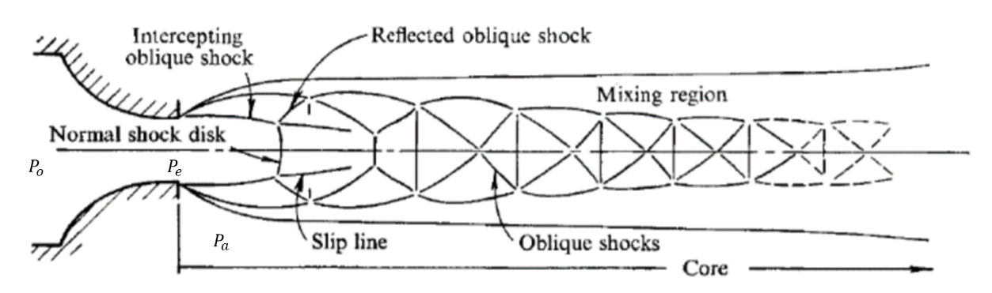
Fig.1. Highly underexpanded gas jet structure. Source: Donaldson and Snedeker [68]

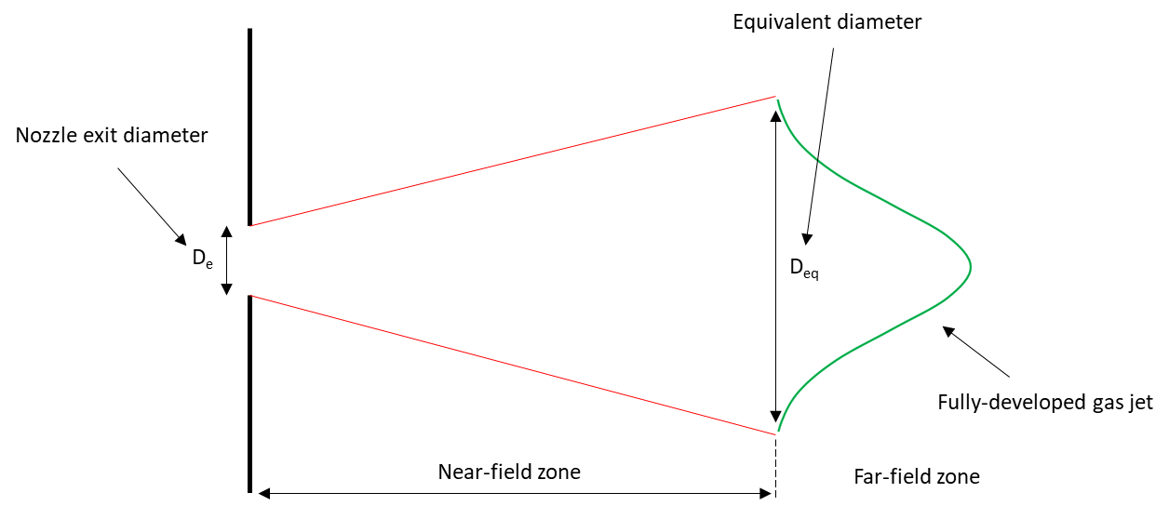
Fig.2. Schematic of the equivalent-source approach.

2. Numerical methodology and modelling details
The following section details the basis of the GSI model and the proposed improvements, along with descriptions of the overall modelling approach.
2.1 Underexpanded gas jet theory
Before describing underexpanded gas jets further we make the distinction between the total pressure ratio, $η_{0}$, nozzle pressure ratio, $η_{e}$ and the critical pressure ratio $η^{*}$. Total pressure ratio is given by
$$\begin{aligned}η_{0}=\frac{P_{0}}{P_{a}},\#\left(1\right)\end{aligned}$$
where $P_{0}$ is the total pressure and $P_{a}$ is the ambient pressure. Nozzle pressure ratio (NPR) is given by
$$\begin{aligned}η_{e}=\frac{P_{e}}{P_{a}},\#\left(2\right)\end{aligned}$$
where $P_{e}$ is nozzle exit pressure. The critical pressure ratio is given by
$$\begin{aligned}η^{*}=\frac{P^{*}}{P_{0}} ,\#\left(3\right)\end{aligned}$$
where $P^{*}$ is the critical nozzle exit pressure.
Total pressure ratio refers to source pressure divided by ambient pressure, i.e. pressure at the compressor or gas storage tank upstream of the nozzle divided by chamber pressure downstream of the nozzle. Nozzle pressure ratio refers to pressure at the nozzle exit divided by ambient pressure downstream of the nozzle. While critical pressure ratio refers to the nozzle exit pressure at which choked flow will first occur divided by the total pressure.

In isentropic choked flow of a perfect gas through a converging/straight nozzle, nozzle exit pressure can be calculated using the ratio of specific heat of the injected gas, $γ$, along with the total pressure such that
$$\begin{aligned}P_{e}=P_{0}{\left(\frac{2}{γ+1}\right)}^{\frac{γ}{γ-1}}.\#\left(4\right)\end{aligned}$$
Isentropic choked mass flow rate, ${\dot{m}}_{theory}$, of an ideal gas can be calculated using
$$\begin{aligned}{\dot{m}}_{theory}=AP_{0}\sqrt{\frac{γ}{{T_{0}R}_{I}}} {\left(\frac{γ+1}{2}\right)}^{\frac{γ+1}{2\left(1-γ\right)}},\#\left(5\right)\end{aligned}$$
where $A$ is the area of the nozzle exit, $T_{0}$ is the temperature upstream of the nozzle and $R_{I}$ is the individual gas constant of the injected gas.

However, in the real-world flow is not isentropic and thus other factors can cause losses within the nozzle and so a discharge coefficient, $C_{d}$, must also be accounted for. Most commonly discharge coefficient is expressed as the ratio of the actual mass flow rate, ${\dot{m}}_{actual}$, over the theoretical isentropic mass flow rate such that
$$\begin{aligned}C_{d}=\frac{{\dot{m}}_{actual}}{{\dot{m}}_{theory}}.\#\left(6\right)\end{aligned}$$
Typically discharge coefficients are in the region of 0.6-0.9 [31,69–71] but values of 0.1 and lower have been observed in the literature [72].

During gaseous injection if nozzle exit pressure equals the critical pressure then the flow will be choked. Any further increases of the total pressure cannot cause the velocity of the gas travelling through the nozzle to increase further, however, mass flow rate through the nozzle will continue to increase as total pressure increases causing rapid expansion of the gas once it exits the nozzle, i.e., the gas jet is underexpanded. The rapid expansion of the gas upon exiting the nozzle causes the flow to accelerate, becoming supersonic, and producing expansion waves which reflect at the flow boundaries creating a complex shock structure. At NPRs greater than roughly 2 the jet will be highly underexpanded and the core structure will contain a barrel-shaped shock and normal shock termed the Mach disk at its leading edge just downstream of the nozzle exit. Downstream of the Mach disk oblique shocks will continue to propagate extending the core region. At NPRs less than 2, but still at exit pressures greater than the critical pressure, a moderately underexpanded jet will form with a core region made up of oblique shocks. In both cases a small mixing layer will form around the compressible core region however no mixing of ambient gas and injected gas will occur within the core shock structures. As the jet travels further downstream this core region will begin to diminish due to momentum decay and the mixing layer surrounding it will grow until the core regions eventual collapse where full mixing of the injected and ambient gases will begin. After a transition region the jet will achieve self-similarity and thus can be termed fully developed.

2.2 Gaseous Sphere Injection Model
The basis of the GSI model is rooted in the findings of Ouellette [73] and Ouellette and Hill [74] which state that momentum injection rate of the gas must be reproduced if mixing rate of the gas is to be reproduced. This is backed up by the findings of the various other equivalent nozzle approaches.

As noted previously, simulating flow through the nozzle and the proceeding shock structures is computationally expensive. The GSI model aims to simplify this and allow for simulations to be carried out on coarse grids by adapting the Lagrangian liquid spray model for gaseous injections. The main difference between the liquid and gaseous injection models is when the transition from the discrete Lagrangian droplet phase to the continuous Eulerian bulk phase occurs. In liquid injection droplets will vaporise and transition to the bulk phase over a period of time once they have been heated to a given vaporisation temperature. In gaseous injection droplets will instead transition instantaneously once they have travelled a given distance from the injector nozzle defined by the length of the previously described jet core region. Energy exchange only occurs at the moment of transition and thus gaseous droplets stay at the same temperature they were injected at. Breakup, collision and droplet deformation, which play a pivotal role in liquid injections, are also neglected as surface tension is a property which only occurs at a liquid’s interface. Injected gaseous droplets are essentially treated as “pseudo-liquids” until transition but will have all the correct properties of the intended gaseous fuel when transferred to the bulk phase. Momentum exchange is coupled between the discrete and continuous phase throughout. Upon transition all mass, energy and momentum of the droplet are handed over to the cell in which it transitioned producing a gas jet which is free to mix with the surrounding bulk gases.

Using the core length to determine transition of the spheres should be a reasonable approach as in a real underexpanded jet the ambient gases are not able to enter and mix with the injected gases in the jet core. This in turn means combustion of an underexpanded jet should be largely limited to the far-field zone as the fuel needs to mix with oxidiser for ignition/combustion to take place. Some optical experiments in the literature have backed up this assumption with the likes of Ishibashi and Tsuru [75] showing the natural gas flame being unable to traverse the near-field region directly following the nozzle exit during or after injection. Admittedly some combustion could take place in the transition region between the near and far-field and also in the mixing layer surrounding the jet core, however, the amount of mixing occurring in either region will be hard to quantify, yet further focus on this area could be a direction for future improvements to the model, e.g. something analogous to the liquid core length used in the KHRT breakup model for liquid injections where child droplets are shed from the core.

2.2.1 Original GSI model
Core length in the original GSI model was estimated using the findings of a study by Witze on air injection into air [76]. Witze defines the jet core as an inviscid region near the nozzle and through theoretical derivation, based on an incompressible form of Warrens axisymmetric jet theory [77], finds the core length, $L_{c-orig}$, to be

$\begin{aligned}L_{c-orig}=6{.25D}_{e},\#\left(7\right)\end{aligned}$
where $D_{e}$ is the nozzle exit diameter. Having an accurate core length estimation is vital for the success of the GSI model as it greatly influences jet penetration, with longer core lengths leading to greater penetration. The original GSI model was implemented in KIVA-3V CFD software and went on to alter the turbulence length scales, turbulent kinetic energy and turbulent kinetic energy dissipation rates in cells within the jet core and fully developed region, citing the tendency for the RNG $k$-$ϵ$ model to overpredict gas jet diffusion and therefore underpredict penetration. While the turbulent round/plane jet anomaly is well known and may be the crux of the issue it may also indicate some other underlying issues with the model as there are turbulence models which are fairly well suited to dealing with the issue such as the Realizable $k$-$ϵ$ model.

Helldorff and Micklow [78] examined a modified implementation of the GSI model in KIVA-3V and identified that part of the issue is likely the result of incorrect momentum coupling of the gas and droplet phase in KIVA-3V and shows good agreement with experimental data for subsonic jets without need for turbulence correction given the momentum coupling is adjusted. KIVA-3V stores the flow velocity field at cell vertices while all other properties are stored at cell centres, leading to a slight offset in momentum compared to mass placement in the mesh when transition occurs. The issue is exacerbated due to the velocity at each vertex being derived from the momentum equation leading to a single vertex greatly overpredicting velocity with the remainder underpredicting. The problem is more apparent in the GSI model compared to normal liquid injections due to a large number of parcels transitioning simultaneously in close proximity to one another at the end of the core length. The improved GSI model was implemented in Ansys Fluent CFD software which uses a co-located scheme where the velocity field is stored at cell centres along with all other variables and thus should not suffer from the same issues.

2.2.2 Core length review
The core length derivation is another issue as pressure ratio is not factored in. Pressure ratio however, determines the makeup of the entire jet core [43] and thus its length is strongly dependant on the pressure ratio. If core length is underpredicted not only will penetration likely be underpredicted but full mixing of the injected fuel and oxidiser will take place too early leading to an earlier than desired onset of combustion.

The review of Franquet et al. [43] showed there is a clear correlation across a number of cases for supersonic core length increase as total pressure ratio increases. The supersonic core can extend further than the actual jet core but is nonetheless indicative of an increasing core length.
Many other authors have noted the increase of pressure ratio leading to an increase in core length and Witze himself in an earlier paper [50] noted that jet core length can be estimated by the compressible free jet theory of Kleinstein [49] and stated
$$\begin{aligned}L_{c-KW}=9.46{\left(\frac{ρ_{e}}{ρ_{a}}\right)}^{\frac{1}{2}},\#\left(8\right)\end{aligned}$$
where $L_{c-KW }$is the Kleinstein-Witze core length, $ρ_{e}$ is the injected gas density at nozzle exit and $ρ_{a}$ the density of the ambient gas downstream of the nozzle. Witze reviewed several experimental studies on underexpanded air jets and found the core length estimate fit well when compared to jet centerline velocity decay. A number of other studies have noted that the Kleinstein-Witze correlation can accurately predict jet centreline velocity decay [46,79–82] indicating the core length estimation is likely reasonable.

The following review of core lengths focusses on recent studies using choked convergent or straight nozzles with circular exit geometries at total pressure ratios which are most likely to be applicable at engine relevant conditions. An attempt is made to be consistent about where the core ends as the definition varies in the literature. Where reported the value at which centerline pressure/density ceases to fluctuate is taken or, if not available, mass fraction contours are used ($Y_{i}<1).$ Experimental and both RANS and large eddy simulation (LES) based CFD works are presented.

Table.1. Summary of core length review (*denotes when mass fraction contours were required).
Reference | Type of study | Jet composition | Total pressure ratio ($η_{0})$ | Core length normalised by nozzle exit diameter
Banholzer et al. [40] | Exp &  CFD-RANS | Methane | 5  10  15  20  25 | 15*  20.7  26.5  28  30.6
André et al. [83] | Exp | Air | 2.14  2.27  2.97  3.67 | 8  8.5  11  11.7
Li et al. [84] | CFD-LES | Nitrogen  Hydrogen | 5.6  5.6 | 11  18
Vuorinen et al. [39] | CFD-LES | Methane  Nitrogen | 4.5  6.5  8.5  10.5  4.5  6.5  8.5  10.5 | 8.9  10.1  11  11.6  8  11.7  12.2  13.8
Bonelli et al. [85] | CFD-RANS | Hydrogen | 7.6 | 16
Traxinger et al. [41] | CFD-RANS | n-Hexane | 60  150  600 | 48*  79*  124*

While not exhaustive, the review gives a clear indication of the importance of accounting for pressure ratio when estimating core length. As can be seen in Table.1 and Fig.3a an increase in pressure ratio leads to an increase in core length in all gases examined. There is however, clearly a wide variance in the reported core length values. This can be attributed to the differing experimental/setup conditions along with the difficulties associated with accurately modelling, and or measuring, the characteristics of the jet core. There is also not a clear indication of how exactly differing gases affect core length. From the two cases which examine multiple gases, Vuorinen et al. [26] showed that nitrogen, the denser gas, has slightly greater core lengths than methane, whereas, Li et al. [71] showed a considerable increase in core length for hydrogen (less dense) compared to nitrogen. As a result, the proposed improved core length will simply depend on pressure ratio as the relationship between differing gases still appears to be unclear.
A clear correlation between jet core length, $L_{c},$ and total pressure ratio is found and a new core length estimation of
$$\begin{aligned}L_{c}=5D_{e}\sqrt{η_{0 }},\#\left(9\right)\end{aligned}$$
is proposed. Fig. 3 compares the core length prediction of Eq. 9 with that of the original GSI model, Eq. 7, and the Kleinstein-Witze correlation, Eq. 8, for hydrogen and methane assuming they are ideal gases and nozzle exit temperature is equal to ambient temperature. The original GSI model prediction is only adequate for very low pressure ratios and is likely only truly applicable for subsonic jets. For a very low density gas such as hydrogen the Kleinstein-Witze correlation proves to be a poor indicator of core length. This is somewhat to be expected as most of the studies for which it is based dealt with higher density air jets. The correlation is much better when applied to methane (quite similar density to air) and fits remarkably well with the plotted data. The proposed improved core length estimation of Eq. 9 gives almost exactly the same trend as the Kleinstein-Witze methane case and fits equally well with the data without the need to account for the variable density of the gases. Furthermore, the high pressure ratio cases studied in Traxinger et al. [41] of supercritical n-hexane fit very well with the core length estimate, Fig.3b, indicating applicability over the full range of possible pressure ratios and fuel densities which will be present in HPDI engine operation.
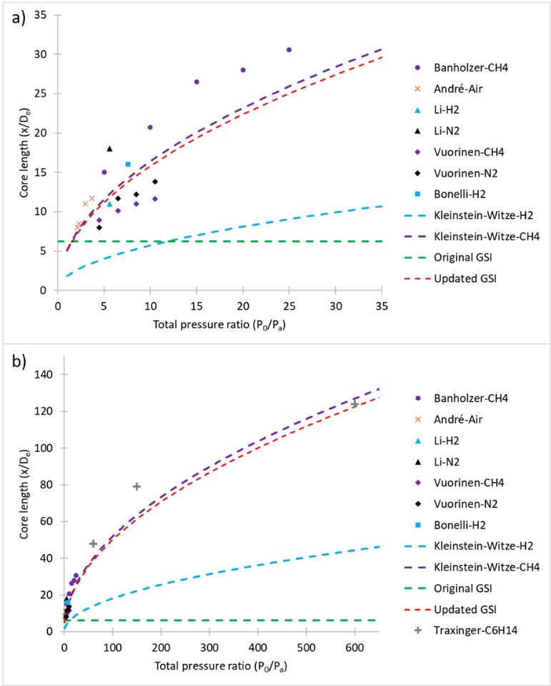
Fig.3. Core length review summary. Core length normalised by nozzle exit diameter plotted vs. total pressure ratio, a) low to moderate pressure ratios, b) high pressure ratios.

We find that there is a general lack of studies dedicated to characterising core length with Banholzer et al. [40] being the only recent study found which specifically focusses on it. Further research into identifying the various factors which may affect its value such as pressure ratio, differing gases, discharge coefficient, nozzle geometries, cross flows, combustion, etc. must be carried out.

In terms of modelling, core length is calculated at each time step in the simulations and thus will account for changes due to pressure ratio decrease when compression and combustion are present. When a particles distance from the injector exceeds the core length it will entirely transition to the bulk phase, transferring all its mass, momentum and energy to the cell in which it resides. It should be noted that one of the main assumptions of the GSI model is that combustion in the mixing layer is negligible. Using a variable core length increases the reliance on this assumption but it should still be reasonable as very high pressure ratios will only be present in cases where gas is injected much earlier than TDC, e.g. spark ignition or some form of homogenous compression ignition, and thus combustion would not be taking place during injection anyway. Further improvements to the model should address this assumption however.

2.2.3 Injection and particle properties
As we are not modelling the actual underexpansion process in which the injected gas quickly expands to reach ambient pressure once exiting the nozzle, another method must be applied to properly define the jet properties. Currently the GSI model relies on experimental data to set cone angle. While using experimental data to determine jet width and cone angle is likely the best course of action, said data is rarely available so a theoretical derivation is better suited. The original implementation of the GSI model [59] simply used the real nozzle exit diameter with a cone angle measured from images of the jet but as noted this isn’t practical. Whitesides et al. [60] and Wang et al. [66] used the pseudo-Mach disk assumption [73] to set gas and injector properties. The pseudo-Mach disk assumption assumes the nozzle is choked and isentropic expansion of the gas occurs at nozzle exit. Mass flow rate and velocity at the Mach disk is assumed to be equivalent to nozzle exit conditions and injected gas density is assumed to be equal to the density at chamber conditions, then the equivalent injection diameter can be calculated as mass flow rate at the injector is equivalent to that at the Mach disk. In a real underexpanded jet the expansion process at nozzle exit leads to a rapid acceleration of the jet. Velocity on the centerline within the jet core will fluctuate at values about Mach 1 while the surrounding core is supersonic, this is then followed by rapid decay once the core region ends. The acceleration of the jet caused by the expansion means that setting an initial jet velocity of Mach 1 may lead to underprediction in jet penetration rate.

The derivation of Yüceil et al. [48], which assumes adiabatic expansion of the injected gas to chamber pressure, is used instead as it provides a way to estimate jet velocity, $V_{M},$ temperature, $T_{M}$, and diameter, $D_{M}$, at the Mach disk leading edge which is then used to set initial injection conditions. Assuming an ideal gas and choked converging/straight nozzle
velocity is given by
$$\begin{aligned}V_{M}=V_{e}\left(1+\frac{η_{e}-1}{γη_{e}}\right),\#\left(10\right)\end{aligned}$$
temperature by
$$\begin{aligned}T_{M}=T_{e}\left(1+\frac{γ-1}{2}\left(1-{\left(\frac{V_{M}}{V_{e}}\right)}^{2}\right)\right),\#\left(11\right)\end{aligned}$$
and diameter by
$$\begin{aligned}D_{M}=\sqrt{η_{e}\frac{T_{M}}{T_{e}}\frac{V_{e}}{V_{M}}} ,\#\left(12\right)\end{aligned}$$
where $V_{e}$is the isentropic nozzle exit velocity and $T_{e}$ is the temperature of the gas at nozzle exit. Pressure ratio can vary and therefore so can the above values, however, for simplicity an expected average value of $η_{e}$ is taken on a case by case basis.

Whitesides et al. [60] and Wang et al. [66] also assumed the leading edge of the Mach disk barrel was at the injector nozzle, but the length of the Mach disk increases with pressure ratio so this assumption will become increasingly more inaccurate as pressure ratios increase. Mach disk length is well studied, and a number of authors have proposed estimates [86–89]. The detailed review of Franquet et al. [43] on the topic comes to the conclusion that the best estimate for Mach disk length, $L_{M}$, for a converging nozzle was provided by Crist et al. [87] which uses the assumption that pressure behind the Mach disk is equivalent to chamber pressure to find
$$\begin{aligned}L_{M}=C_{x}D_{e}\sqrt{η_{0 }} ,\#\left(13\right)\end{aligned}$$
where $C_{x}=0.645$is a constant. More recent works are in agreement with Crist and have shown only small variations of the constant $C_{x}$ [31,46,90,91]. This estimate is then used when determining the position of the injector in the computational domain (also factored into core length computation) with an assumed average value of $η_{0}$.

Half jet cone angle, $θ_{e}$, is sensitive to a number of factors and there exist many discrepancies in the literature both in how to go about measuring spreading and the difficulties in doing so as well as the results themselves. This means that it will be difficult to adequately define a method for setting cone angle so tuning will likely be necessary. The half jet cone angle which is input in Fluent, $θ_{M},$ defined at the Mach disk leading edge, will generally be different to $θ_{e}$ as depending on the pressure ratio, the initial expansion may be much more or less rapid than the proceeding spreading and can be estimated using
$$\begin{aligned}θ_{M}=\arctan\left( \frac{L_{c}tan{(θ}_{e})-\frac{D_{M}-D_{e}}{2}}{L_{c}-L_{M}}\right)=\arctan\left(\frac{tan{(θ}_{e})-\frac{D_{M}-D_{e}}{2L_{C}}}{0.871}\right).\#\left(14\right)\end{aligned}$$
Again, an average value of $η_{0}$ is used to determine $L_{c}$. For consistency, in the remainder of this study a commonly reported value in the literature of $θ_{e}={12}^{°}$ [31,69,92] is used, this value is also in line with those used in previous implementations of the GSI model [59,60].

In the GSI model the density and diameter assigned to the injected droplets is only relevant to the particle force balance equation as the modelling of breakup, collision, coalescence, etc. is not required. Fluent struggles to properly model particle drag when droplet density is less than 10 times greater than the fluid density, as is the case in gaseous injections. It makes sense to use a pseudo-density as particle density has no impact on the actual mass delivered at the end of the core length, only on the amount of drag the particle experiences throughout its trajectory and therefore final velocity at the end of the core.
The particle force balance can be written as
$$\begin{aligned}\frac{d{\overline{u}}_{p}}{dt}=\frac{18μC_{D}R_{e}}{24ρ_{p}d_{p}^{2}} \left(\overline{u}-{\overline{u}}_{p}\right),\#\left(15\right)\end{aligned}$$
where ${\overline{u}}_{p}$ is the particle velocity, $\overline{u}$ the fluid phase velocity, $μ$ is the molecular viscosity of the fluid, $ρ$ is the fluid density, $ρ_{p}$ is the particle density, $d_{p}$ is the particle diameter, $R_{e}$ is the relative Reynolds number defined as
$$\begin{aligned}R_{e}=\frac{ρd_{p}\left|{\overline{u}}_{p}- \overline{u}\right|}{μ},\#\left(16\right)\end{aligned}$$
and $C_{D}$ is the drag coefficient for a spherical particle which is set equal to $0.424$ as $R_{e}$ is assumed to be large.

Small amounts of momentum shedding will occur as the core region penetrates the chamber which leads to the eventual collapse of the core. Using the assumption that velocity of the jet at the end of core should be roughly equal to velocity at the nozzle exit [49,50], the average rate of velocity decay throughout the core can be estimated by
$$\begin{aligned}\frac{d{\overline{u}}_{p}}{dt} \left(x=L_{c}\right)=\frac{{(V}_{M}-{C_{d}V}_{e})(V_{M}+{C_{d}V}_{e})}{2L_{c}}, \#\left(17\right)\end{aligned}$$
where nozzle discharge has been accounted for and is assumed to apply only to the exit velocity. Then using Eqs. 15 and 17 with $\overline{u}≪{\overline{u}}_{p}$ it follows that the particle density required to achieve a reasonable velocity at the end of the core can be approximated by
$$\begin{aligned}ρ_{p}=ρ\left(\frac{0.159L_{c}(V_{M}+C_{d}V_{e}) }{d_{p}{(V}_{M}-C_{d}V_{e})}\right). \#\left(18\right)\end{aligned}$$
Particle density is then adjusted at each time step throughout a given particles trajectory and a constant (arbitrary) particle diameter of $5e$-$6$ is used.

2.2.5 Improvements to the GSI model
The proposed improved model will forgo the alterations of the turbulence model. Instead, an improved core length estimation using Eq. 9, along with the use of the previously described theoretical derivations to define injector and particle properties are implemented. Both the variable core length and various Mach disk quantities used in this study have not been previously applied to the GSI model. Fig.4. shows a schematic representation of the updated GSI model.
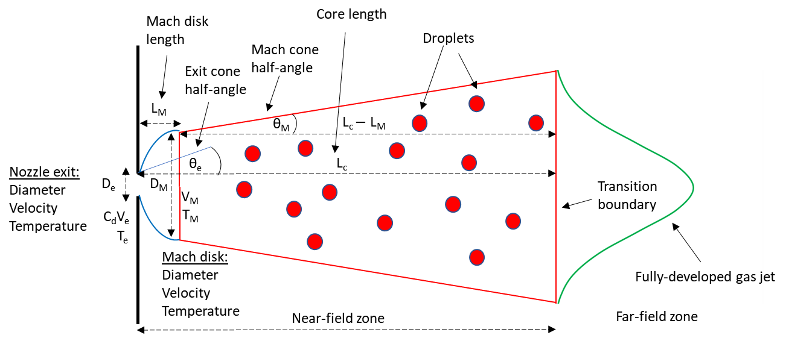
Fig.4 Schematic of the modified GSI model.

2.3 Governing equations and modelling setup
The numerical simulations were carried out using three-dimensional unsteady Reynolds Averaged Navier-Stokes (URANS) approach. Simulations were performed on the University of Southampton IRIDIS 4 high performance computing cluster by employing commercial CFD software Ansys Fluent 19.1.

Simulations were carried out by solving compressible URANS equations for mass, momentum, energy and $N-1$ species transport equations, where $N$ is the total number of species, in the main solver for a chemically reacting mixture using finite volume method,

Mass:
$$\begin{aligned}\frac{∂ρ}{∂t}+\frac{∂ρ{\overline{u}}_{j}}{∂x_{j}}=S_{m},\#\left(19\right)\end{aligned}$$
Momentum:
$$\begin{aligned}\frac{∂ρ{\overline{u}}_{i}}{∂t}+\frac{∂ρ\overline{u_{i}u_{j}}}{∂x_{j}}=-\frac{∂\overline{P}}{∂x_{i}}+\frac{∂}{∂x_{j}}\left(μ\left(\frac{∂{\overline{u}}_{j}}{∂x_{i}}+\frac{∂{\overline{u}}_{i}}{∂x_{j}}-\frac{2}{3}δ_{ij}\frac{∂{\overline{u}}_{k}}{∂x_{k}}\right)\right)-\frac{∂ρ\overline{u_{i}^{'}u_{j}^{'}}}{∂x_{j}}+S_{i},\#\left(20\right)\end{aligned}$$
Energy:
$$\begin{aligned}\frac{∂ρ\overline{H}}{∂t}+\frac{∂ρ{\overline{u}}_{j}\overline{H}}{∂x_{j}}=\frac{∂}{∂x_{j}}\left(\frac{k_{eff}}{C_{p}}\frac{∂\overline{H}}{∂x_{j}}\right)+S_{h},\#\left(21\right)\end{aligned}$$
Species:
$$\begin{aligned}\frac{∂\left(ρ{\overline{Y}}_{n}\right)}{∂t}+\frac{∂\left(ρ{\overline{u}}_{j}{\overline{Y}}_{n}\right)}{∂x_{j}}=-\frac{∂J_{n}}{∂x_{j}}+R_{n}+S_{n} ,\#\left(22\right)\end{aligned}$$
In combustion simulations the $NO_{x}$ and soot emissions were calculated by solving transport equations at a post-processing stage as this method was found to be more computationally efficient.

The transport equation for $NO_{x}$ mass fraction, $Y_{NO}$, due to thermal [93] and prompt [94] mechanisms is given by:

$$\begin{aligned}\frac{∂ρ{\overline{Y}}_{NO}}{∂t}+\frac{∂ρ{\overline{u}}_{j}{\overline{Y}}_{NO}}{∂x_{j}}=\frac{∂}{∂x_{j}}\left(ρD\frac{∂{\overline{Y}}_{NO}}{∂x_{j}}\right)+S_{NO}. \#\left(23\right)\end{aligned}$$
The Moss-Brookes soot model [95] was employed to predict soot formation using acetylene as the inception species. This model solves a two transport equations for soot mass fraction, $Y_{soot}$, and normalised radical nuclei concentration, b*_{nuc}:

$$\begin{aligned}\frac{∂ρ{\overline{Y}}_{soot}}{∂t}+\frac{∂ρ{\overline{u}}_{j}{\overline{Y}}_{soot}}{∂x_{j}}=\frac{∂}{∂x_{j}}\left(\frac{μ_{t}}{σ_{soot}}\frac{∂{\overline{Y}}_{soot}}{∂x_{j}}\right)+\frac{dM}{dt},\#\left(24\right)\end{aligned}$$

$$\begin{aligned}\frac{∂ρ{\overline{b^{*}}}_{nuc}}{∂t}+\frac{∂ρ{\overline{u}}_{j}{\overline{b^{*}}}_{nuc}}{∂x_{j}}=\frac{∂}{∂x_{j}}\left(\frac{μ_{t}}{σ_{nuc}}\frac{∂{\overline{b^{*}}}_{nuc}}{∂x_{j}}\right)+\frac{1}{N_{norm}^{*}}\frac{dN^{*}}{dt} ,\#\left(25\right)\end{aligned}$$
where $ρ$ is the density of the fluid, $t$ is time, ${\overline{u}}_{j}$a component of the mean velocity vector, $u_{j}^{'}$a component of the fluctuating velocity vector, $x_{j}$ a component of the position vector, $S_{m}$the source term accounting for mass added by fuel spray, $P$is pressure, $μ$is molecular viscosity, $S_{i}$a component of the body forces, $δ_{ij}$the Kronecker delta, $\overline{H}$ the mean total enthalpy, $k_{eff}$ the effective conductivity, $C_{p}$ the specific heat capacity of the fluid, $S_{h}$ the source term accounting for any further heat losses, ${\overline{Y}}_{n}$ is the mass fraction of species $n$, $J_{n}$ is the diffusion flux of the given species, $R_{n}$ the net rate of production of the given species by chemical reaction, $S_{n}$ the rate of creation of the species by the discrete phase injection and any other sources, $D$ is the effective diffusion coefficient, $S_{NO}$ is the source term for any other $NO_{x}$ production due to thermal or prompt mechanisms, $σ_{soot}$ is the turbulent Prandtl number for soot transport, $M$ is the soot mass concentration, $σ_{nuc}$ is the turbulent Prandtl number for radical nuclei transport, $N^{*}$ is the soot particle number density and $N_{norm}^{*}$ is ${10}^{15}$ particles.

Gaseous injections are dealt with using the modified GSI model which is implemented through use of user-defined functions (UDFs) which allow for customisation of Fluent’s Lagrangian discrete phase model (DPM). In simulations requiring liquid injection the liquid fuel spray is handled by the DPM employing KHRT primary and secondary breakup [96], stochastic collision [97], dynamic-drag [98] and an impingement/splashing wall-film model [99,100]. In both types of injection, the DPM analytically tracks the injected droplets, grouped into parcels, with the fluid flow time step and models their coupled interactions with the continuous phase. The discrete random walk (DRW) stochastic tracking model [101] is used to predict turbulent dispersion of the particles. Realizable $k$-$ϵ$ model [102] with standard wall functions is employed to model turbulent flow characteristics due to the models improvements over the standard $k$-$ϵ$ model with regards to the round-jet anomaly [102]. Two additional transport equations for turbulent kinetic energy, $k$, and turbulent dissipation rate, $ϵ$, are solved. In simulations requiring combustion the finite rate combustion model, with an adequately fine mesh such that the majority of the RANS scales are resolved, is used to couple the flow and chemical kinetics. The Chemkin-CFD solver along with Fluent’s in situ adaptive tabulation (ISAT) algorithm [103] is employed to integrate reaction rates. The reduced Chalmers n-heptane mechanism [104] is supplemented with the GRI mech 3.0 [105] to represent diesel-natural gas fuel chemistry leading to a chemical mechanism containing $48$ species and $273$ reactions. The nitrogen mechanism was removed from the GRI mech to reduce computational time and instead pollutant emissions are modelled postprocess at the end of each time step. The Moss-Brookes soot model [95] is used to predict soot emissions and thermal and prompt $NO_{x}$development are accounted for to predict $NO_{x}$ emissions. In engine simulations dynamic mesh layering and smoothing is used to compute mesh motion, along with remeshing to ensure high mesh quality during the engine combustion network (ECN) hydrogen engine simulations and keygrids during the diesel-methane combustion simulations. Table 2 summarises the numerical models used.

Table.2. Summary of numerical models employed during simulations.
Description | Model
Viscous | Realizable $k$-$ϵ$
Energy/Species | Species transport finite-rate combustion  Chemkin-CFD solver with ISAT  Chemkin mechanism and thermodynamic database (n-heptane & methane)
Discrete Phase | GSI  Droplet particle  No breakup  No collision  Constant high Re spherical drag  DRW turbulent dispersion  Wall-reflection  Laws: density-drag adjustment,  core length transition | Liquid  Droplet particle  KHRT primary & secondary breakup  Stochastic collision  Dynamic drag  DRW turbulent dispersion  Wall-film  Laws: Inert heating, vapourisation, boiling
$NO_{x}$ | Thermal & Prompt
Soot | Moss-Brookes
Dynamic mesh | Layering and Smoothing (+ remeshing for ECN )

A 3-D double precision analysis is carried out using Fluent’s pressure based solver. The PISO pressure-velocity coupling algorithm is used to reformat the continuity equation and obtain a pressure field. Second order upwind schemes are used for the spatial discretisation. Least squares cell-based method is used to compute gradients. First-order implicit time-stepping is employed due to variable time step profiles generally being used in engine simulations during fuel injection and combustion. Convergence criteria are set to converge at residuals of 10⁻³ apart from energy and post-processed scalars which are set to 10⁻⁶ . In all cases injected mass is also monitored to ensure the correct intended mass is delivered. Max iterations per time step are set to 50 with up to 10 post time-step iterations. Table 3 outlines a summary of numerical discretisation methods employed during calculations.
Table.3. Summary of numerical methods employed during simulations.
Description | Parameter | Method/Model/Value
Solver | General | Pressure-based
Pressure-velocity coupling | Flux type  Scheme  Skewness correction  Neighbour correction | Rhie-Chow  PISO  1  1
Spatial discretisation | Gradient  Density  Momentum  Energy  k  $ε$  Species (N-1 equations)  Pollutant $NO_{x}$  Pollutant soot mass  Pollutant soot nuclei | Least square cell based  Second order upwind  Second order upwind  Second order upwind  Second order upwind  Second order upwind  Second order upwind  Second order upwind  Second order upwind  Second order upwind
Temporal discretisation | Time | First order implicit

3. Results and discussion
Validation of the modified GSI model is first carried out via comparison of simulations with experimental studies on underexpanded hydrogen as well as methane freestream jets injected into constant volume chambers. Next comparisons are made to experimental optical mixture formation imaging in a hydrogen direct injection engine. Finally, combustion in a diesel pilot ignited methane direct injection compression ignition engine is simulated and the various combustion and emissions characteristics are compared against the experimental data.

3.1 Freestream hydrogen and methane jets
Two experimental freestream studies on underexpanded gas jets are chosen to assess jet penetration and spreading when using the improved GSI model. The first is Tsujimura et al. [69] which examines underexpanded hydrogen jets injected into nitrogen and the second is Rogers [31] which studies high pressure ratio compressed natural gas (CNG) jets injected into nitrogen. These experimental studies are chosen as they are good sources of both experimental measurement and optical imaging of the gas jets and will help show the applicability of the improved GSI model to the two gaseous fuels most likely to be utilised in engines under various injection conditions.

3.1.1 Numerical setup
Numerical setups for the freestream test cases are presented. A $120$ x $80$ x $80$cuboid geometry was created in Ansys SpaceClaim and a hex mesh was generated using Ansys meshing Fig.5. The geometry represents the constant volume vessels used in the two freestream studies and is large enough such that walls will not impact the injected gas jets development. Three mesh densities with even cell sizes of $0.75 mm$ $(≈1800k$ cells), $1 mm$ ($≈800k$ cells) and $2 mm$ $(≈100k$ cells) were tested with a single case from each experimental study to ensure the GSI models applicability and insensitivity to mesh refinement at mesh densities typical for engine simulation. All mesh densities provided reasonable agreement with experimental data and only minor variations were observed between the $2 mm$ and $1 mm$ meshes and next to no variation between the $1 mm$ and $0.75 mm$ meshes. The $1 mm$ mesh was deemed to give a sufficiently mesh independent solution and is used for all the freestream tests presented.

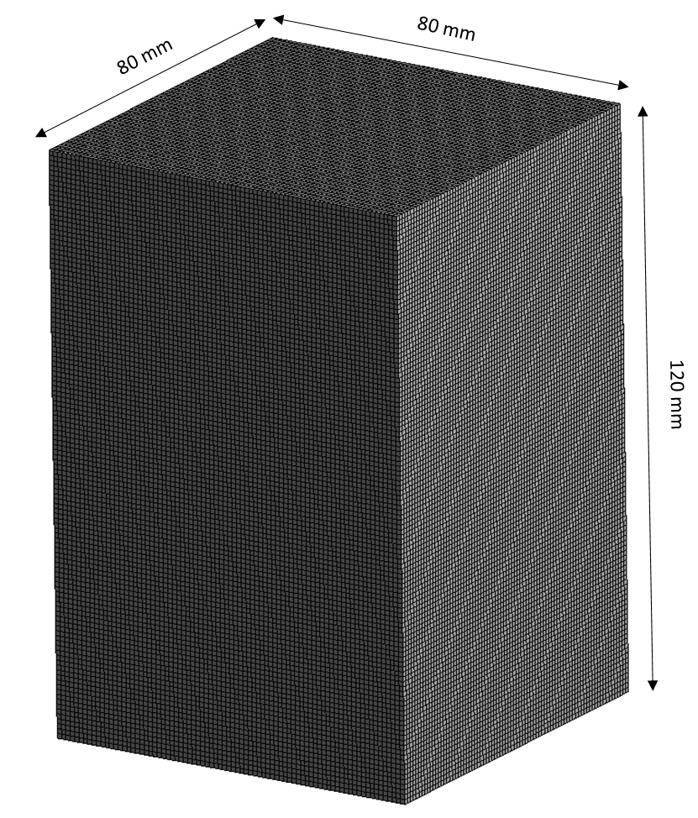
Fig.5. Mesh of constant volume vessel used in freestream studies, $1 mm$ cell size.

Table 4 outlines the relevant operating conditions for each freestream case. As instantaneous injector mass flow rate was not measured for either study the initial injector transients are not modelled. Instead a constant steady mass flow rate is prescribed based on the overall average mass flow rates which were measured in the studies. Mach disk quantities are calculated using the previously described methods. No slip boundary conditions with no heat transfer allowed are set at the solid walls enclosing the chamber. A constant time step size of $1$e-$6 s$is used throughout.
Table.4. Summary of freestream test cases.
Operating Conditions | Tsujimura [69] | Rogers [31]
Ambient gas | Nitrogen | Nitrogen
Ambient temperature (K) | 298 | 298
Ambient pressure (MPa) | 1 | 0.1, 0.05, 0.025
Injected gas | Hydrogen | Methane
Upstream temperature (K) | 298 | 298
Actual nozzle exit diameter (mm) | 0.3, 0.7, 1 | 1
Injection total pressure (MPa) | 8 | 4
Total pressure ratio | 8 | 40, 80, 160
Discharge coefficient | 0.9 | 0.482
Steady mass flow rate (kg/s) | 3.50e-4, 1.91e-3, 3.89e-3 | 5.41e-3

Jet axial penetration length is measured normal to the nozzle exit plane to the furthest axial position with greater than $0.005$ mass fraction of the injected gas. Half jet dispersion angle is calculated using the same method as the given experimental study (Tsujimura and Rogers use different methods which are detailed in each article/thesis) and the jet boundary is taken to be at $0.005$ mass fraction of the injected gas.

3.1.2 Validation
Figs. 6a and 7a show that the initial jet penetration trends are overpredicted for all cases. This is most likely due to injector ramp up/energizing time not being accounted for but could also be because of difficulties in carrying out experimental measurement of the highly complicated initial flow development or a need to tune the cone angle setting on a case by case basis to limit initial penetration. However, after roughly $0.5 ms$ in both studies penetration matches experimental results rather well which indicates the fully developed region is predicted reasonably. Penetration in the Tsujimura $0.3 mm$ case is largely underpredicted which could be due to changes in discharge coefficient as nozzle geometry varies, which is not accounted for, and Tsujimura also notes that the $0.3 mm$ orifice has the greatest normalised jet volume and spreading rate which may indicate a need to increase cone angle at smaller orifice sizes. In the Rogers PR160 test, Fig.7a, the jet does not have time to fully develop before being influenced by the wall in the experiments, nonetheless, simulation results appear to be converging towards the experimental trend had it been able to continue. Even with the noted issues jet penetration is well captured for both hydrogen and methane at various pressure ratios and injector nozzle diameters.

Figs. 6b and 7b show the measured and calculated half jet dispersion angles for hydrogen and methane free jets respectively. At areas close to the end of the core length, where transition of the gaseous droplets occurs, there tends to be an overprediction in spreading. This is likely partly due to the neglect to model injector transients but also results from the deacceleration of the injected gas upon transition. This is not so dissimilar to a real underexpanded jet where vortex rings form at the tip of the jet, nevertheless, dispersion is somewhat higher than expected at this point. Fig.6b shows that the simulated values of jet dispersion tend to fluctuate in the early parts of the injection before beginning to converge to a lower value after roughly $0.5 ms$. Experiments also show this fluctuating behaviour to a lesser degree and the behaviour is expected due to the jet needing time to fully develop during the transition region following the core. The methane cases, Fig.7b, also exhibit this behaviour in both experiments and simulations but due to the very high pressure ratios there does not appear to be time for this fluctuation to stop before the end of the tests. The simulations tend to show an increase in dispersion angle as pressure ratio increases, however, the experimental results show an inconsistent trend. In further tests of even higher pressure ratios carried out by Rogers, it was found that generally dispersion angle does increase with pressure ratio which indicates the simulation trends are reasonable. Considering a constant cone angle of $θ_{e}=12°$ is set throughout all the simulations jet dispersion is relatively well represented and, while not ideal, should be adequate for use in further study and failing that can be tuned on a case by case basis.

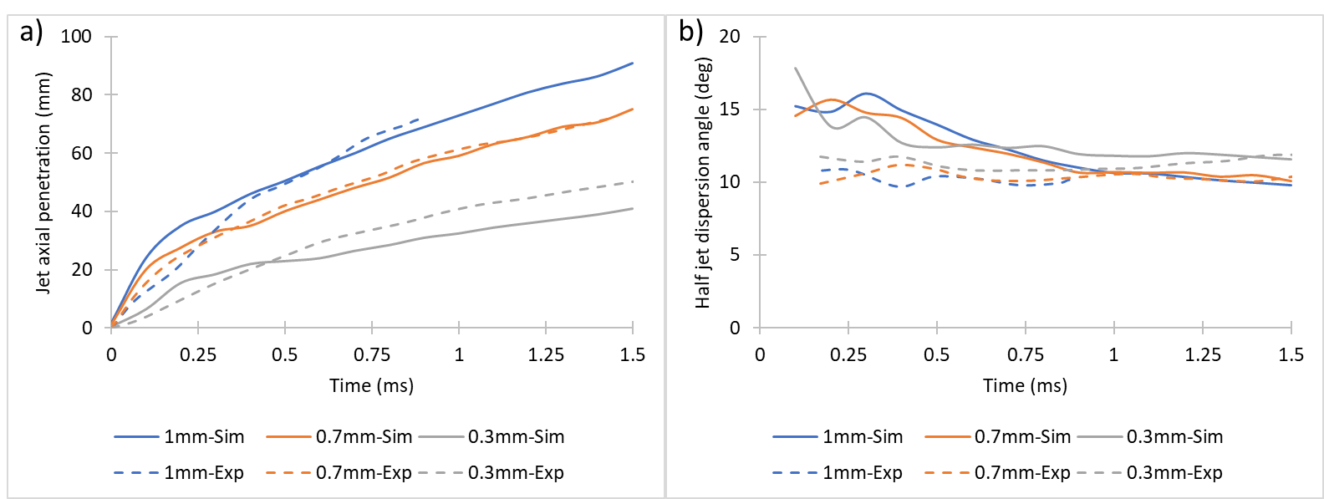
Fig.6. Hydrogen freestream simulation temporal development comparison with experimental data [69] for a) jet tip axial penetration and b) half jet dispersion angle for $1 mm$, $0.7 mm$ and $0.3 mm$ nozzle exit diameters at $η_{0}=8$.

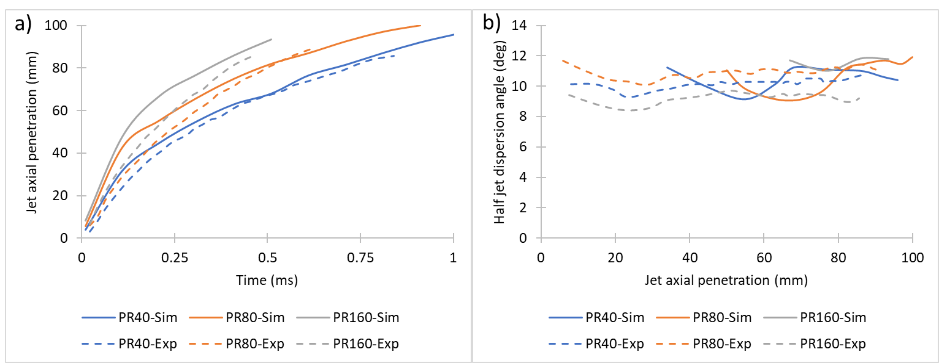

Fig.7. Methane freestream simulation comparison with experimental data [31] for a) jet tip axial penetration temporal development and b) half jet dispersion angle axial development measured at 70% of the jet tips penetration at $η_{0}=40, 80$ and $160$.

Fig.8 compares the experimental shadowgraph images taken by Tsujimura for the $0.7 mm$ nozzle and the mass fraction contours of the present CFD results. As previously noted, and illustrated by Fig.8., there is a clear overprediction of the initial jet penetration, yet as time progresses the jet penetration of the experiment “catches up” and proceeds at a very similar rate to the simulations. The spreading rate demonstrates a similar story with the $0.4 ms$ simulation snapshot showing a much wider jet than its experimental counterpart, however, at $0.8 ms$and $1.2 ms$ the predicted jet widths are very similar to that of the experimental shadowgraph images.
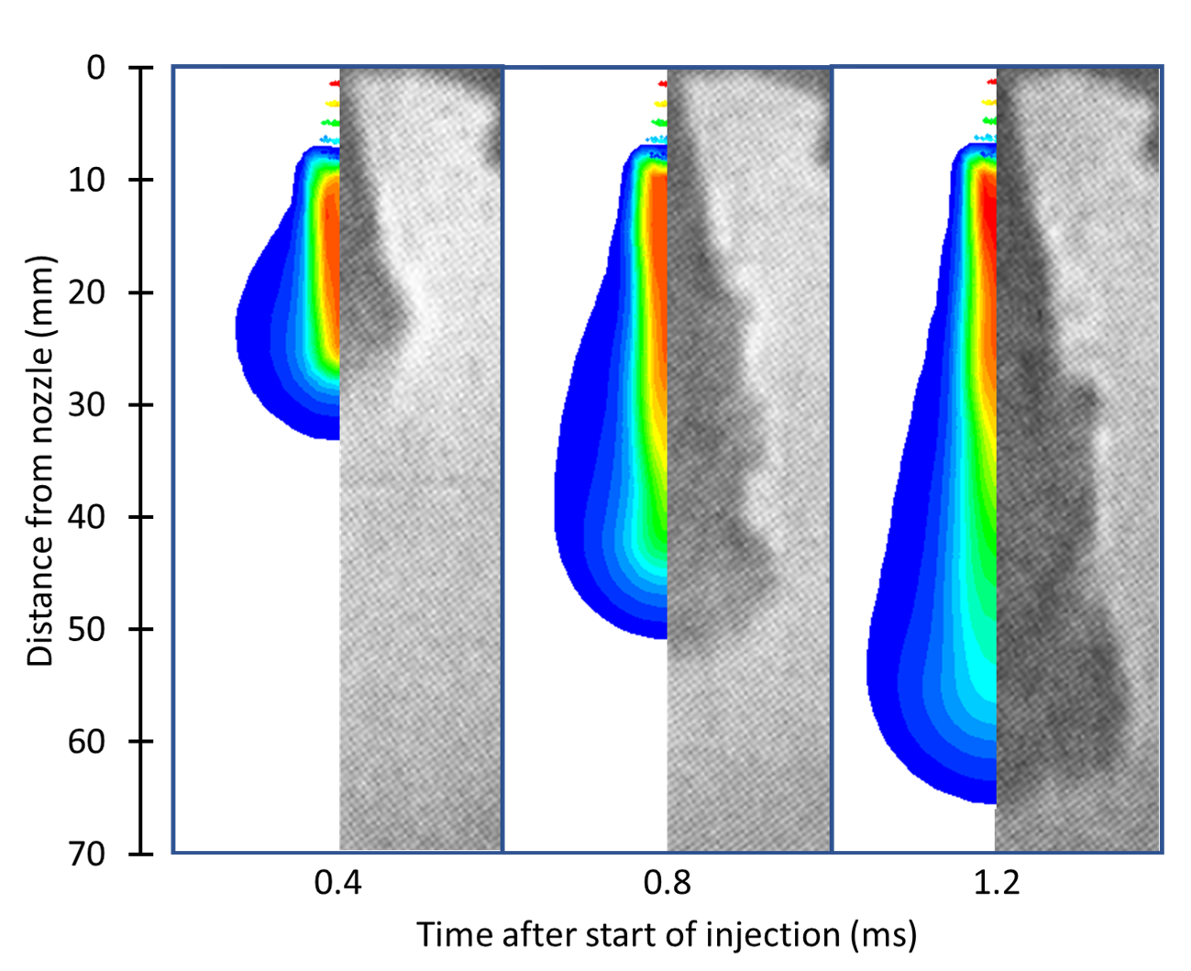
Fig.8. Hydrogen freestream comparison of experimental shadowgraph imaging and CFD simulation mass fraction (min $= 0.005$) contours for the $0.7 mm$ nozzle exit diameter at $η_{0}=8$. Source: Tsujimura et al. [69].
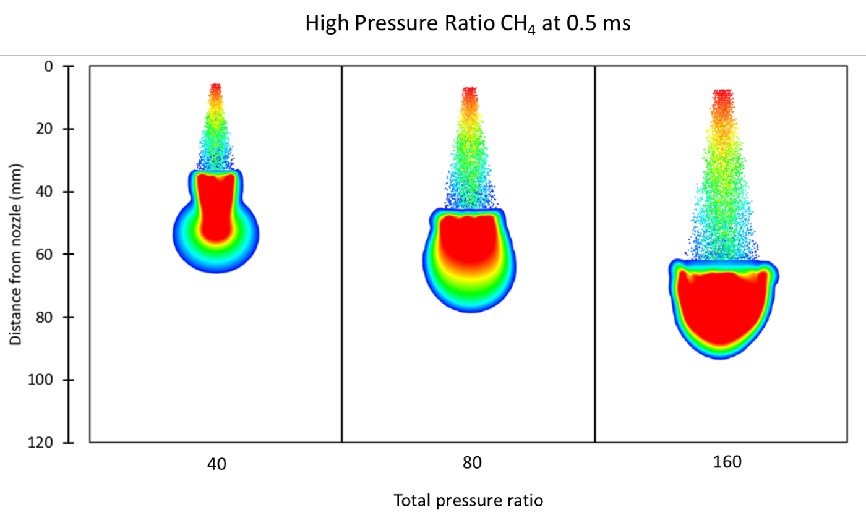
Fig.9. Comparison of methane freestream jets $0.5 ms$after the start of injection at $η_{0}=40, 80$and $160.$ Shown are simulation mass fraction contours (min $= 0.005$) and particles coloured by velocity $(250$– $775$ $ms^{-1}$).

Fig.9 backs up the findings of Figs.7a and 7b and shows the expected increase in jet penetration rate as pressure ratio is increased even though injection pressure (and thus mass flow rate) are constant between all cases.

Overall, the modified GSI model results, in terms of jet penetration and spreading rate, are in good agreement with the experimental freestream studies across a wide range of pressure ratios, disparate injected gases and multiple nozzle diameters. This implies the improved GSI model should be sufficient for predicting gaseous injections when extended to more practical applications such as direct injection in engines.

3.2 Mixture formation in a hydrogen direct injection engine
An experimental study on the direct injection of hydrogen into an optically accessible spark ignition combustion chamber is used to assess the improved GSI model’s ability to accurately predict mixture formation in a realistic engine setup. The study chosen is that of the engine combustion network (ECN) on mixture formation in a hydrogen direct injection engine [106,107] as this is an excellent source of publicly available experimental and optical measurement which also provides an accurate engine geometry. The ECN study uses particle image velocimetry (PIV) for flow-field measurement and planar laser-induced fluorescence (PLIF) to capture images of the fuel mole fraction distribution. Another advantage of the ECN study is the ability to test the GSI model improvements in a high pressure ratio ($≈$ 81) engine case.

3.2.1 Numerical setup
Numerical setup for the mixture formation of hydrogen direct injection into a spark ignition engine is presented. Initially, the full combustion chamber along with intake/exhaust valves and ducts is meshed using Ansys meshing, Fig.10a, leading to a grid with about $1100k$ cells at IVC. A layered sliding hex mesh is created at the valves to allow for valve motion as well as in the main chamber to simulate piston motion, while the rest of the geometry is meshed using tets, Fig.10b. This mesh is then used to compute the in-cylinder flow field which develops due to the gas exchange process. One full $720°CA$ cycle starting from exhaust valve open (EVO) is run to remove any initial transients, followed by another from EVO to inlet valve close (IVC). After this a higher quality but reduced grid, roughly $1300k$ cells at IVC with a max cell size of $1.4 mm$, detailing only the combustion chamber is produced, Fig.10c, and the previous results of the gas exchange process are interpolated as initial conditions. A further refined grid with roughly $2000k$ cells at IVC was also tested but results did not differ significantly. The compression stroke is then simulated from IVC to top dead centre (TDC) which includes the full hydrogen injection and mixture formation process. A constant time step size of 0.25°CA is used throughout the simulations and is only lowered to 0.025°CA from the start of injection until 10°CA after the end of injection. Results are then compared to the experimental measurements and optical imaging. Throughout this analysis the convention that 720°CA is TDC of the compression stroke is followed.

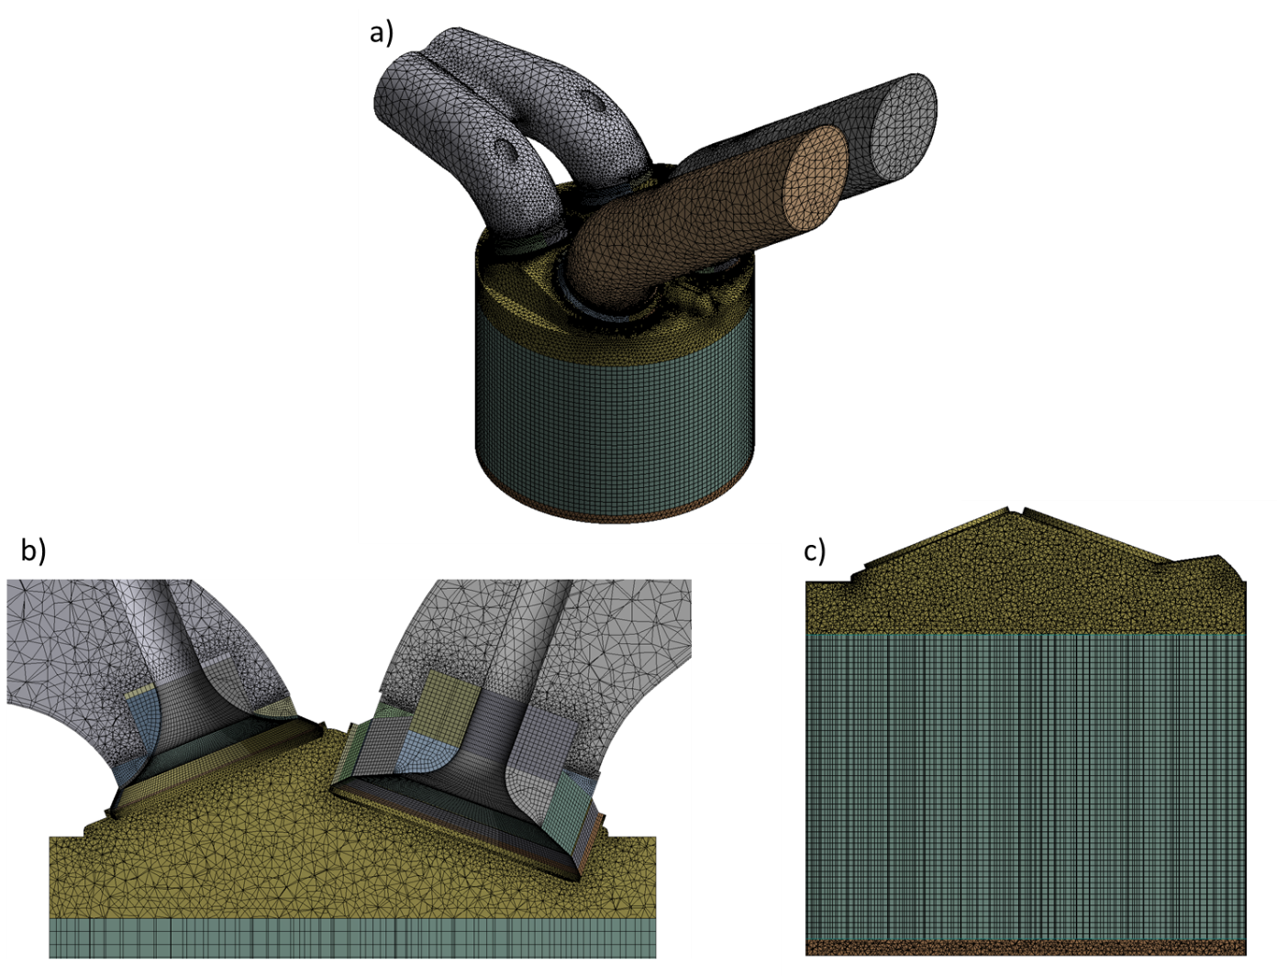
Fig.10 a) Full geometry mesh including valves, ducts and chamber for gas exchange process, b) cut-plane view of full mesh demonstrating valve layering motion, c) cut-plane view of reduced chamber only mesh for hydrogen mixture formation analysis.

During the gas exchange simulation, experimentally measured pressure profiles are set at the inlets of the intake ducts and outlet of the exhaust duct, Fig.11, and temperatures at the inlets and outlet are set to $309.15 K$. In both stages of the simulation all chamber, piston head and valve wall temperatures are set to a constant $353.15 K$ and in the gas exchange process duct walls are set to $309.15 K$. The bulk gas used is nitrogen and the engine runs at a speed of $1500 rpm$. Table 5 summarises the operating conditions and engine geometry and further information about the experimental setup can be found at the ECN website [106].

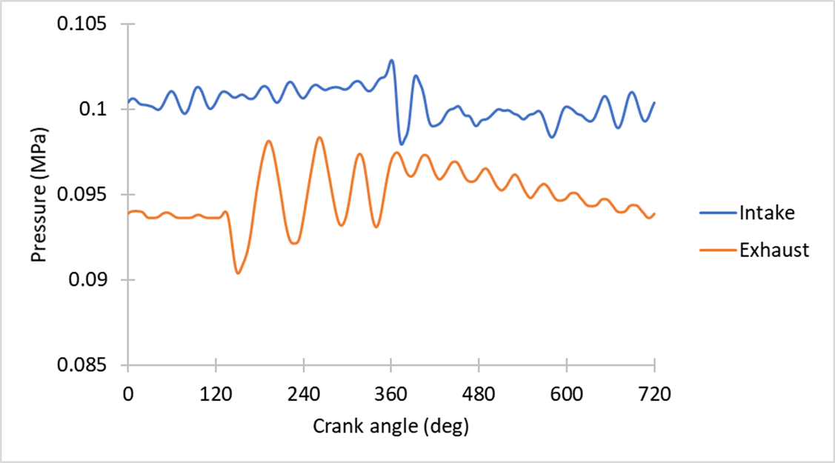
Fig.11. Experimentally measured pressure profiles used as boundary conditions at inlet and exhaust ducts.

Table 5. Summary of ECN mixture fraction test case
Operating conditions | ECN
Bore x stroke (mm) | 92 x 85
Displacement volume (L) | 0.56
Compression ratio | 11
Engine speed (rpm) | 1500
Ambient gas | Nitrogen
Initial ambient temperature (K) | 309.15
Initial ambient pressure (MPa) | 0.1
Intake valve timing (CA) | open: 346° / close: 580°
Exhaust valve timing (CA) | open: 130° / close: 364°
Injected gas | Hydrogen
Upstream temperature (K) | 300
Actual nozzle exit diameter (mm) | 1.46
Injection total pressure (MPa) | 10
Total pressure ratio | $≈$ 81
Discharge coefficient | 0.248
Steady mass flow rate (kg/s) | 2.56e-3
Injection period (CA) | 583°-600.5°

The actual nozzle exit diameter is $1.46 mm$ and is directed at a $50°$ angle with respect to the cylinder axis downwards towards the intake squish region ($90°$ included spray angle). The prescribed hydrogen injection mass flow rate is shown in Fig.12. and the remainder of the initial injection quantities are calculated at the Mach disk via the previously described methods.

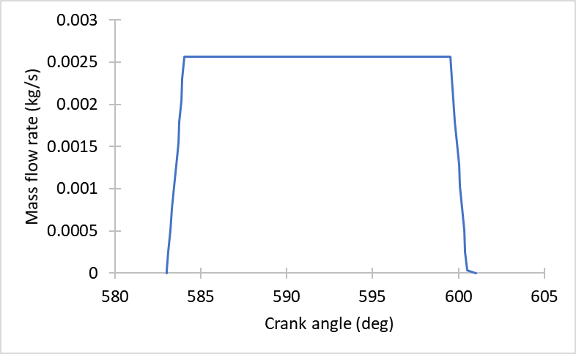
Fig.12. Mass flow rate profile for hydrogen injection.

Fig.13 shows the mean velocity vector field on the cylinder symmetry plane (in-plane) at IVC calculated by the CFD gas exchange simulation and that of the experimentally measured field. The simulation matches reasonably well with the experiments and captures the recirculation zones at the bottom and top of the chamber. There is a slight shift of the recirculation zones downwards and to the right in the simulations but overall, the velocity field is predicted adequately. Calculated pressure throughout the cycle also matches with the data provided by the experiments. Data from the gas exchange process is then interpolated to the reduced grid for initial conditions in the mixture formation simulations.

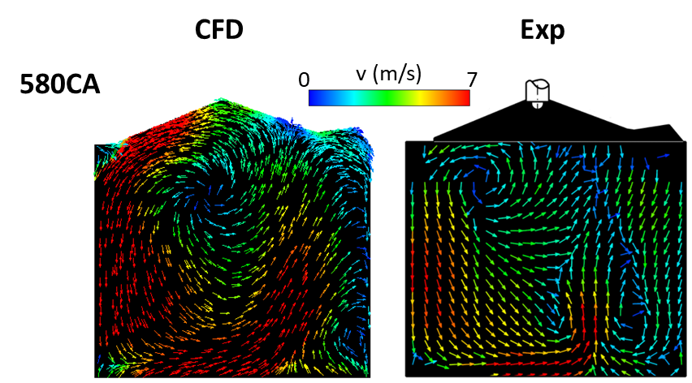
Fig.13. Initial mean in-plane velocity vector field at IVC calculated by CFD after initial gas exchange modelling compared with experimental PIV measurement.

In-plane mean velocity vector fields calculated by the simulations and the measured experimental values during the hydrogen injection and mixture formation process are presented in Fig.14. At each crank angle the velocity field is predicted well, with the general flow development induced by the injected gas jets penetration, such as recirculation zones and the wall jet, being reproduced. Velocity magnitudes are largely also well captured.
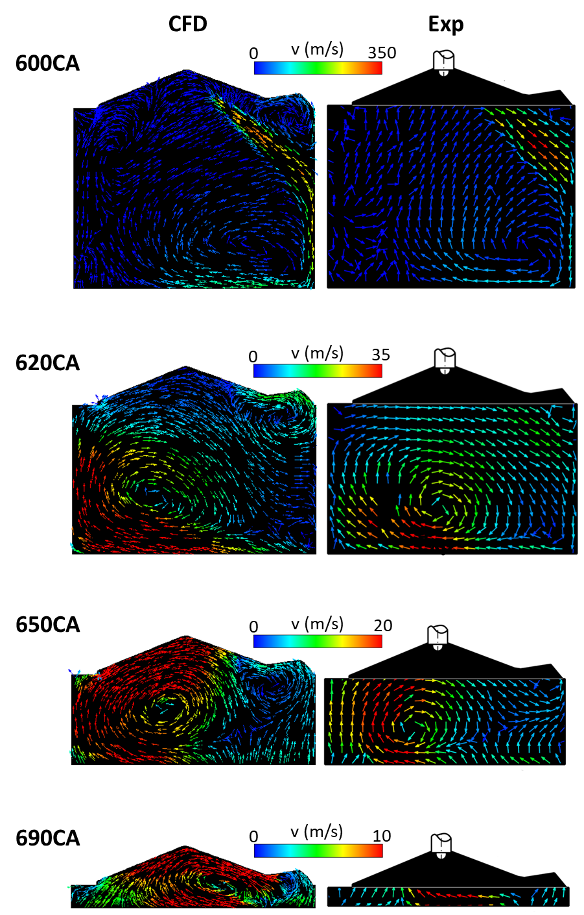
Fig.14. Mean in-plane velocity vector field calculated by CFD during compression stroke including hydrogen injection from $583°CA$ to $600.5°CA$ compared with experimental PIV measurement.

In-plane hydrogen mole fractions are shown in Fig.15. One of the major differences observed is the lack of hydrogen close to the injector at $600°CA$. This is expected due to the estimated core length extending deep into the chamber, thus no droplet transition, and is backed up by the rich hydrogen concentration measured in the experiments at the center of the jet all the way up to the chamber wall. It should be noted that the jet core should have a mole fraction of 1 and the experiments may not show this due to difficulties in measuring the value experimentally, influence of the wall on the core structure or the high injector discharge coefficient leading to a reduced core. There is also a hydrogen rich portion of the wall jet formed directly after impingement which is not well captured by the CFD indicating the potential need for enhanced wall treatments (the higher concentration is predicted by the CFD but the colour scale does not show this well as the peak value is underpredicted compared to the experiments). Nonetheless, the general mixture formation excluding these regions is well predicted at $600°CA$. At $620°CA$ the hydrogens progress penetrating the chamber, traversing the top of the piston and up the left wall, as well as the secondary zone at the top right corner is in good agreement with the experimental measurement. However, again there is an underprediction in the richness of the mixture along the wall preceding the head of the jet. There is also a general lack of hydrogen dispersion in the chamber. The simulation at $650°CA$ suffers from much of the same issues as the previous crank angles whereby the rich region behind the head of the jet is not well defined and the concentration in the lean areas is lower compared to the experiments indicating a lack of hydrogen dispersion. The final measured mixture formation at $690°CA$ matches the simulations rather well with the two clear rich and two clear lean regions present.

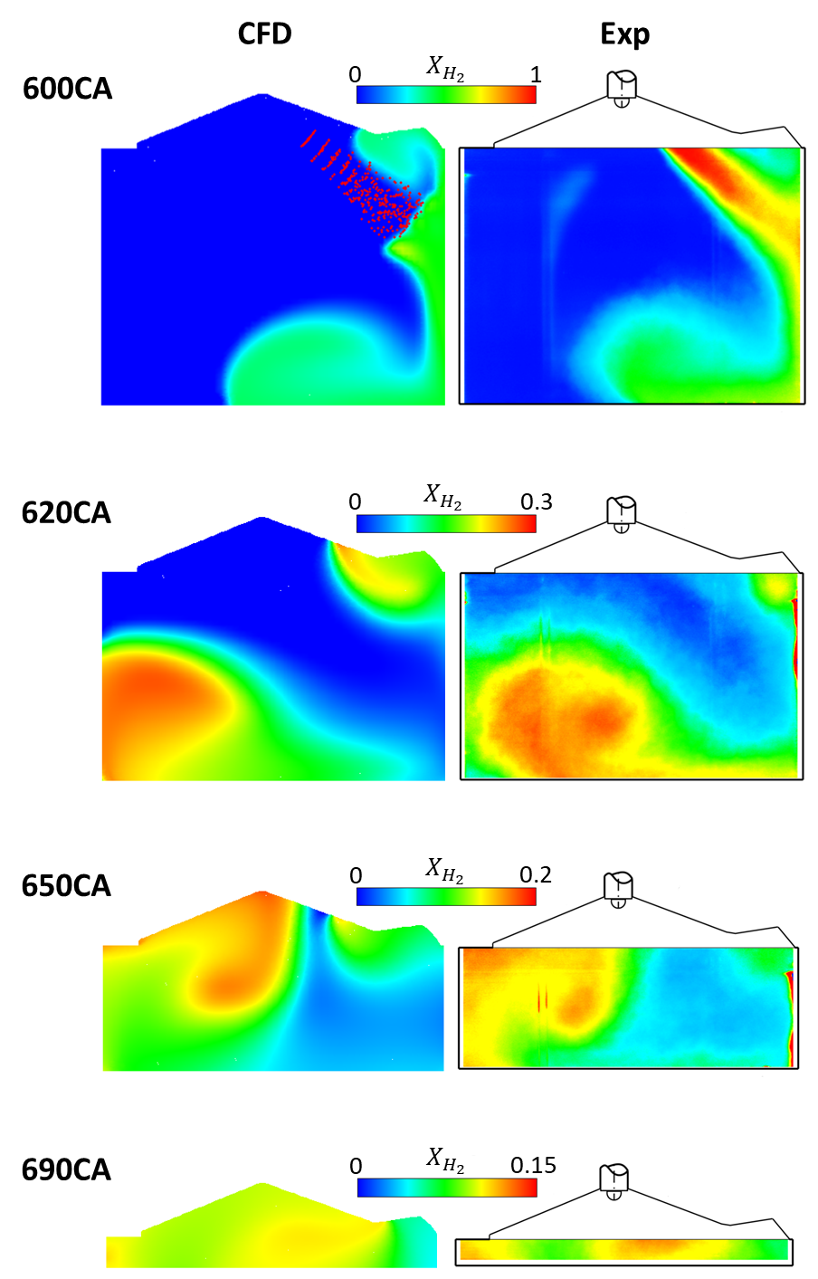
Fig.15. Hydrogen mole fraction (${X_{H}}_{2}$) contours for hydrogen injection from $583°CA$to $600.5°CA$ during the compression stroke calculated by CFD compared with experimental PLIF measurement.
Other RANS based CFD studies using refined injector inlets appear to suffer from similar issues in terms of adequately predicting jet dispersion and wall jet features [107–109]. This indicates that the problem is likely not to do with the GSI model and more so shows a need for enhanced wall treatments, fine tuning of the turbulence model, multi-component diffusion or use of a more detailed mass flow rate profile as the simplified ramp up/down may be inadequate.

Overall agreement of the mixture formation and flow field between the present CFD study and experiments is very good with only minor differences being observed throughout the entire process. This indicates the improved GSI model can be a valuable tool in efficiently exploring direct injection gaseous fuelled engine nozzle configurations and injection strategies.

3.3 Combustion in a dual-direct injection compression ignition engine
An experimental study on combustion in a dual direct injection diesel-methane compression ignition engine is used to assess the applicability of the improved GSI model to predicting combustion characteristics in direct injection gaseous fuelled engine. The study chosen is that of Faghani [110] as it is one of the few experimental works on gaseous direct injection and combustion in an engine which provides sufficient details for numerical model validation [111,112].

3.3.1 Validation
Numerical setup for the reacting compression ignition dual direct injection diesel-methane engine is presented. As there are $7$evenly spaced diesel and gas injectors in the engine a sector geometry representing $1/7$^{th} of the combustion chamber is created in Ansys SpaceClaim and meshed using Ansys meshing, Fig.16. The sector contains one gas and one diesel injector both with an included spray angle of $140°$ and an interlace angle of $0°$. The Westport HPDI 2.0 injector used in the experiments is depicted in Fig.16. Periodic boundary conditions are set at the side faces of the sector and constant temperature boundary conditions of $600 K$ are set at the sector top face and piston bowl walls and $500 K$ at the remainder of the chamber walls. Exhaust gas recirculation (EGR) level is adjusted by varying the initial charge composition, temperature and pressure using values measured in the experimental reference. Simulations are run from IVC to EVO and layering is used to compute piston motion during the compression and expansion strokes. Results are then compared to the experimental measurements. The prescribed diesel and methane injection mass flow rates are shown in Fig.17 and the remainder of the initial injection quantities are calculated at the Mach disk via the previously described methods. The injection profiles are based on those detailed in the reference study [110]. As seen in Fig. 17, the gas injection takes place around TDC because a non-premixed mode of combustion is targeted as it allows for much finer control over the combustion and engine operating parameters compared to an early injection, or intake inducted, premixed combustion strategy. This type of strategy should allow for both the maximum torque and highest gaseous fuel energy share and is likely the direction in which gaseous fuelled compression ignition engines are headed, as noted by Westport/AVL [35], and thus is an ideal case to test the GSI model on. Throughout this analysis the convention that $720°CA$ is TDC of the compression stroke is followed. Table.6. summarises the operating conditions and engine geometry.

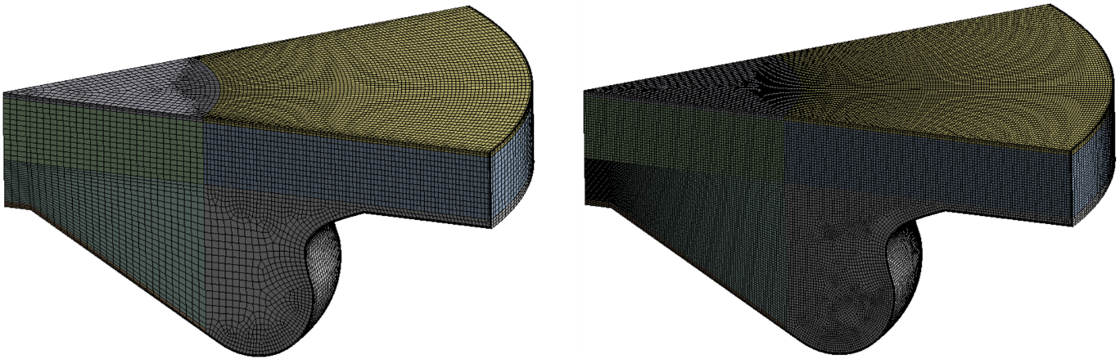
Fig.16. Sector mesh at $700°CA$ used in combustion simulations. Left shows the “coarse” grid used to compute the compression stroke prior to injection and right shows the “fine” keygrid, with a maximum mesh size of $0.35 mm$, used during injection and combustion.

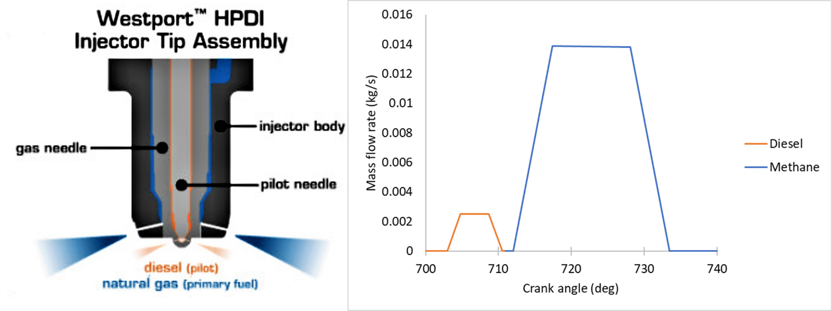
Fig.17. Schematic of the Westport HPDI 2.0 injector used in experiments (Source: Westport Inc [113]) and injection mass flow rate profiles for diesel and methane used in the simulations.

Table.6. Summary of dual direct injection diesel-natural gas combustion case.
Operating conditions | Faghani
Bore x stroke (mm) | 137 x 169
Connecting rod (mm) | 262
Displacement volume (L) | 2.5
Swirl ratio | 1.5
Compression ratio | 17
Engine speed (rpm) | 1500
IVC-EVO (CA) | 630°-860°
Ambient gas | Air + EGR
EGR (%) | 0%, 18%, 25%
Initial ambient pressure (MPa) | 0.382, 0.448, 0.450
Initial ambient temperature (K) | 431, 441, 428
Ambient gas composition | 0%: $O_{2}$ = 0.233, $N_{2}$ = 0.767  $CO_{2}$ = 0.0, $H_{2}O$ = 0.0  18%: $O_{2}$ = 0.205, $N_{2}$ = 0.760  $CO_{2}$ = 0.0194, $H_{2}O$ = 0.0156  25%: $O_{2}$ = 0.198, $N_{2}$ = 0.7583  $CO_{2}$ = 0.0240, $H_{2}O$ = 0.0194
Injection Properties | Gas | Liquid
Number of injectors | 7 | 7
Injected fuel | Methane | Diesel
Upstream temperature (K) | 370 | 320
Actual nozzle exit diameter (mm) | 0.73 | 0.16
Injection total pressure (MPa) | 25 | 27
Total pressure ratio | $≈$ 2 | -
Mass of fuel injected-sector (kg) | 2.48e-5 | 1.57e-6
Discharge coefficient | 0.87 | 0.8
Steady mass flow rate (kg/s) | 1.39e-2 | 2.5e-3

Accurate combustion results can be obtained through direct use of detailed chemistry given the mesh is adequately refined such that the majority of the turbulence scales are resolved to minimise sub-grid effects [114–117]. In this study, we employ a RANS based turbulence model, species transport finite-rate combustion and a detailed methane/n-heptane chemistry mechanism to simulate combustion in a diesel-natural gas dual direct injection engine. The discrete phase modified GSI model and discrete phase liquid injection model are used to represent the methane and n-heptane fuel injections respectively. Table.2 provides a breakdown of the numerical models employed for the simulation.

An extensive mesh sensitivity study is carried out using $4$ different grid resolutions; coarse, medium, fine and very fine with maximum cell sizes of $1 mm$, $0.4 mm$, $0.35 mm$ and $0.3 mm$ respectively, Table.7. To allow for reasonable computation times keygrids are used in all but the coarse mesh simulation. In the medium, fine and very fine cases the coarse grid is used from IVC to $700°CA$ (3°$CA$before pilot injection start) before being replaced by a finer mesh, Fig.16. This fine mesh is then used throughout both injections and the power stroke until EVO with a variable layering height which begins to coarsen after injections have finished. A variable time step size is used with $0.25°CA$ steps from IVC to $702°CA$ followed by $0.025°CA$ steps until $755°CA$ then $0.25°CA$ again until EVO.

Table.7. Mesh densities for the mesh independence study.
Mesh | Cell count at TDC | Max cell size (mm)
Coarse | 50k | 1
Medium | 300k | 0.4
Fine | 400k | 0.35
Very Fine | 550k | 0.3

As can be seen in Fig.18. all grids apart from the most coarse predict in-cylinder pressure and heat release fairly well for the $18\%$ EGR test case. The coarse grid predicts a slightly later ignition of the methane injection compared to the other grids and generally underpredicts the rate of combustion until around the time that the gaseous injection finishes, leading to a lower pressure than desired. Only small variation between the medium and fine grid is observed. The variation is largely during the diesel injection where the medium grid has a similar peak HRR but lower level of mixing controlled diesel combustion than the fine grid which leads to lower pressures. The difference between the fine and very fine grids is even smaller with the only significant change being a slightly earlier diesel ignition which leads to a lower peak diesel HRR in the very fine grid. This could be due to grid effects but may simply be due to the cycle to cycle variation which the discrete phase model can cause. Results indicate that the RANS scales are adequately resolved when using a maximum cell size of $0.35 mm$, in line with the expected $0.1$ – $1 mm$ minimum length scale discussed in the literature [114–117], so for the remainder of this study the $0.35 mm$ fine mesh is used and deemed insensitive to further mesh refinement.

Comparing simulation results to the experimental study, the heat released from the combustion of the pilot injection is overpredicted leading to an overprediction in pressure during this period. This could be due to a number of reasons such as the use of n-heptane as a surrogate for the diesel blend used in the experiments which has a slightly smaller lower heating value than n-heptane as well as a likely different cetane number and thus expected ignition delay. For the gaseous injection, ignition delay and peak heat release are predicted well, however, heat release rate during the mixing-controlled combustion phase is somewhat underpredicted and tends to remain at a higher level for longer when compared with experimental results. This again could be due to the use of methane as a surrogate for natural gas whose composition can vary greatly, or potentially a need to tune the likes of the cone angle in the GSI model for the specific case or to use a more accurate mass flow rate profile which accounts for the transients at the start and end of injection. It’s also true that Mach disk properties (injection properties) will vary during combustion and thus a more complete approach would use a moving injector position as Mach disk length decreases, as well as variable Mach disk diameter, velocity and temperature rather than the expected averages used in these simulations. Another potential reason for the under prediction in mixing controlled combustion rate is the mixing layer surrounding the jet core being neglected which could lead to an offset in the combustion similar to the observed difference. Introducing a secondary transition criterion which would allow for particles at the outer limits of the core to be shed and transition to the bulk phase at a specific rate may be a good approach. Implementing these improvements should lead to better agreement with the experimental results and could be the focus of future work. All in all, the combustion trends are captured very well indicating the potential for the improved GSI models use in direct injection engine studies.

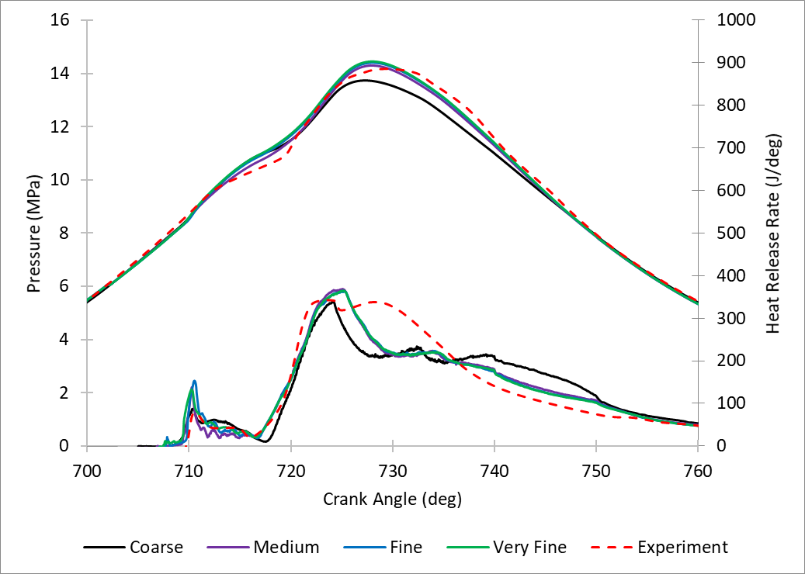
Fig.18. Pressure and heat release rate predictions and mesh sensitivity study for the 18% EGR test case with comparison to experimental data.

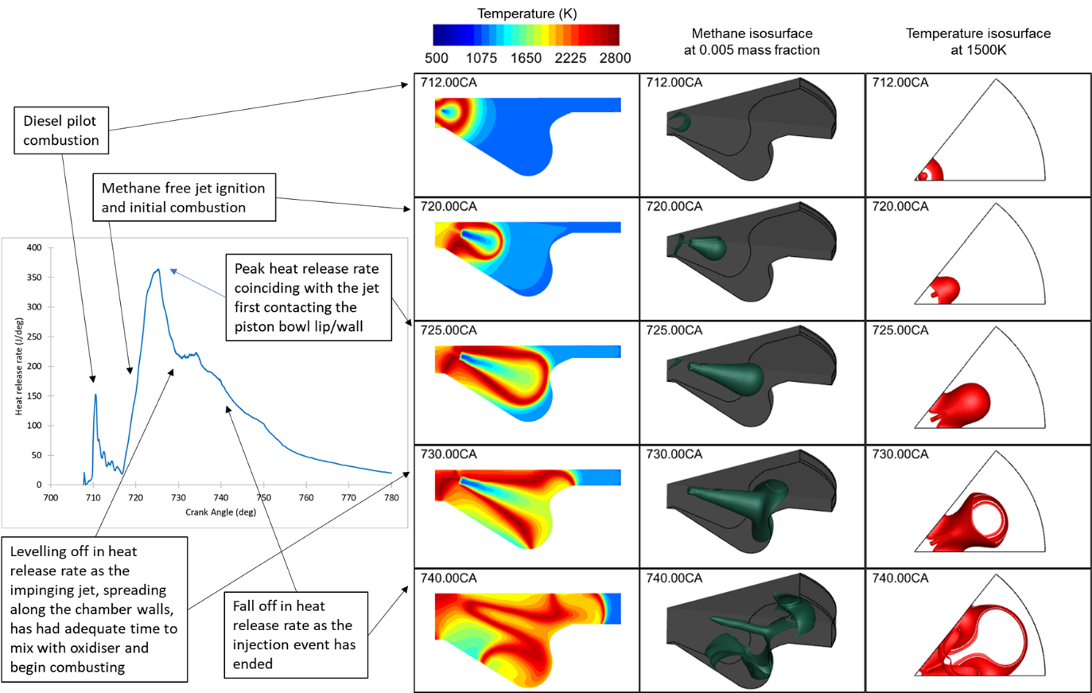
Fig.19. Breakdown of the diesel pilot ignited direct injection methane jet combustion process using calculated HRR (left), cylinder axis plane temperature contour slices (middle left), methane jet isosurfaces at 0.005 mass fraction (middle right) and top-view flame front temperature isosurfaces at $1500 K$ (right).

Furthermore, Fig.19. shows the various stages of combustion are captured well by the model. Initially the pilot diesel combustion occurs, beginning at roughly $708°CA$ and peaking around $712°CA$. The pilot combustion is largely confined to the near injector region/center of the chamber, see first row. The main injection of methane then begins and interacts with the high temperature region where the pilot combustion is occurring leading to ignition of the jet around $718°CA.$ Heat release rate then begins to climb rapidly due to the injector finishing its ramp up to peak mass flow rate, which is further enhanced by the free jet penetrating deeper into the chamber and mixing with oxidiser, second row of Fig.19. The majority of the combustion occurs at the outer edges of the jet where stoichiometry is achieved as the core of the jet is still too rich for combustion. The peak heat release rate coincides with the jets first contact with the piston bowl lip/wall at about $725°CA$, third row, which is then followed by a rapid fall off in combustion rate, due to both quenching of the flame front at the wall and also the accumulation of methane in the region which can’t combust due to a lack of oxidiser. As shown in the fourth row the jets momentum eventually leads to the spreading of the fuel both deeper into the piston bowl, up towards the top of the chamber and outwards towards the other sectors of the chamber. This allows for the flame front to spread and the fall in heat release rate levels off around $730°CA$. Row 5 shows the flame front travelling towards the chamber liner and also curling up in the piston bowl and travelling back towards the injectors. As the main injection has ended heat release rate falls off and combustion starts to occur in the core/center of the jet as the rich core has decayed and is no longer too rich for combustion to take place. Interaction with the jet/flame from other chamber sector injections is also beginning to occur as can be seen in the temperature isosurface.

Assessing the CFD modelling framework along with the improved GSI model’s ability to predict pollutant emissions under differing conditions is important for gaining insight into various engine operating strategies. As pollutant soot and $NO_{x}$ predictions are decoupled from the main flow solution the absolute values predicted are not of much importance, but the trends predicted should still follow those of the experimental data. As can be seen in Figs. 20a) and 20b), the overall trends of both $NO_{x}$ and soot emission as EGR rate is increased are predicted fairly well with $NO_{x}$ showing a decrease between $0\%$ and $25\%$ EGR rates and soot showing an increase. The percentage decrease in $NO_{x}$ is also well predicted with simulations showing a decrease of $82\%$ between $0\%$ and $25\%$ EGR rates and experiments showing a decrease of $80\%$. The findings are in line with the expected effect of EGR on $NO_{x}$ development, whereby reduction in oxidiser leads to lower combustion temperatures which is further aided by the dissociation of $H_{2}O$and $CO_{2}$ during combustion and the higher heat capacity of exhaust gases acting as heat sinks [118,119]. The percentage increase in soot is underpredicted in comparison to experiments which likely indicates a need to tune model parameters, include a soot mechanism in the chemical kinetics, improve initial charge composition as EGR rate is increased or various other factors. However, the general increasing trend of soot emissions being captured is deemed sufficient for the current work. Increased soot emissions with increased EGR use is expected due to the decrease of oxygen availability leading to an increase in fuel rich areas and thus soot formation as well as the reduced in-cylinder temperatures being better suited for soot development [118,120].

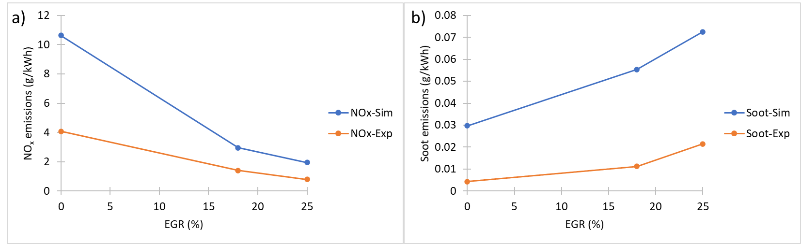
Fig.20. Pollutant trend predictions of a) $NO_{x}$ and b) soot at EVO for increasing levels of EGR compared with experimental measurement.

Overall, the CFD model predicts the gaseous combustion and emissions characteristics relatively well and thus indicates that the improved GSI model should be suitable for use in the investigation of combustion in direct injection gaseous fuelled engines.

4. Conclusion
The capability of the improved discrete phase gaseous sphere injection (GSI) model to accurately predict the direct injection of gaseous fuels, such as hydrogen and natural gas, into internal combustion engines has been demonstrated. A change to the core length estimation which determines when gaseous droplets transition to the bulk phase was introduced. An empirical estimate based on recent experimental and numerical data is proposed which accounts for the variation in the jet core length due to total pressure ratio change. Other theoretical estimates are also used to determine injection and discrete phase particle properties. The improved GSI model was implemented into a CFD code and used to simulate the gaseous direct injection process at various engine relevant conditions. Both experimental freestream and engine studies are considered for model validation. The main findings of the paper are summarised as follows:
- The gaseous fuel injection process was successfully simulated by the improved GSI model across a wide range of cases including both hydrogen and methane direct fuel injection. Good agreement with experimental data is met using coarse meshes without need for turbulence model alteration or model tuning, unlike in the original GSI model, given the proposed modifications to core length, drag and initial injection quantities are applied. This indicates that the improved GSI model can be applied to any underexpanded straight/converging nozzle injector at varying upstream/downstream injection conditions.
- Good agreement with experimental data is found in terms of penetration and spreading in freestream studies; mixture formation and velocity field in a non-reacting hydrogen direct injection spark ignition engine and combustion and emissions characteristics in a dual direct injection methane-diesel compression ignition engine.
- Future improvements to the model could account for variations in Mach disk properties as pressure ratio changes throughout a given simulation by using a variable Mach disk length, velocity, diameter and temperature; implementing a secondary condition criteria which allows for shedding/transition of particles on the outer edge of the core to model the mixing layer; cone angle tuning or more accurate mass flow rate profiles which account for the various transients during injection.
- Additionally, further experimental and high fidelity numerical studies focussed on the fundamental mixing and non-premixed combustion processes of underexpanded gaseous jets is required for a more complete validation of the GSI model.

References
[1] Chen H, He J, Zhong X. Engine combustion and emission fuelled with natural gas: A review. Journal of the Energy Institute 2019;92:1123–36. https://doi.org/10.1016/j.joei.2018.06.005.
[2] Yip HL, Srna A, Yuen ACY, Kook S, Taylor RA, Yeoh GH, et al. A Review of Hydrogen Direct Injection for Internal Combustion Engines: Towards Carbon-Free Combustion. Applied Sciences 2019;9:4842. https://doi.org/10.3390/app9224842.
[3] Wei L, Geng P. A review on natural gas/diesel dual fuel combustion, emissions and performance. Fuel Processing Technology 2016;142:264–78. https://doi.org/10.1016/j.fuproc.2015.09.018.
[4] Dimitriou P, Tsujimura T. A review of hydrogen as a compression ignition engine fuel. International Journal of Hydrogen Energy 2017;42:24470–86. https://doi.org/10.1016/j.ijhydene.2017.07.232.
[5] Karim GA. Hydrogen as a spark ignition engine fuel. International Journal of Hydrogen Energy 2003;28:569–77. https://doi.org/10.1016/S0360-3199(02)00150-7.
[6] Ma F, Wang Y. Study on the extension of lean operation limit through hydrogen enrichment in a natural gas spark-ignition engine. International Journal of Hydrogen Energy 2008;33:1416–24. https://doi.org/10.1016/j.ijhydene.2007.12.040.
[7] Dimitriou P, Kumar M, Tsujimura T, Suzuki Y. Combustion and emission characteristics of a hydrogen-diesel dual-fuel engine. International Journal of Hydrogen Energy 2018;43:13605–17. https://doi.org/10.1016/j.ijhydene.2018.05.062.
[8] Kobayashi K, Sako T, Yoshimi Sakaguchi, Morimoto S, Kanematsu S, Suzuki K, et al. Development of HCCI natural gas engines. Journal of Natural Gas Science and Engineering 2011;3:651–6. https://doi.org/10.1016/j.jngse.2011.07.002.
[9] Kahraman E, Cihangir Ozcanlı S, Ozerdem B. An experimental study on performance and emission characteristics of a hydrogen fuelled spark ignition engine. International Journal of Hydrogen Energy 2007;32:2066–72. https://doi.org/10.1016/j.ijhydene.2006.08.023.
[10] Cho HM, He B-Q. Spark ignition natural gas engines—A review. Energy Conversion and Management 2007;48:608–18. https://doi.org/10.1016/j.enconman.2006.05.023.
[11] Gomes Antunes JM, Mikalsen R, Roskilly AP. An investigation of hydrogen-fuelled HCCI engine performance and operation. International Journal of Hydrogen Energy 2008;33:5823–8. https://doi.org/10.1016/j.ijhydene.2008.07.121.
[12] Sahoo BB, Sahoo N, Saha UK. Effect of engine parameters and type of gaseous fuel on the performance of dual-fuel gas diesel engines—A critical review. Renewable and Sustainable Energy Reviews 2009;13:1151–84. https://doi.org/10.1016/j.rser.2008.08.003.
[13] Chintala V, Subramanian KA. A comprehensive review on utilization of hydrogen in a compression ignition engine under dual fuel mode. Renewable and Sustainable Energy Reviews 2017;70:472–91. https://doi.org/10.1016/j.rser.2016.11.247.
[14] Zheng J, Wang J, Zhao Z, Wang D, Huang Z. Effect of equivalence ratio on combustion and emissions of a dual-fuel natural gas engine ignited with diesel. Applied Thermal Engineering 2019;146:738–51. https://doi.org/10.1016/j.applthermaleng.2018.10.045.
[15] Ramsay CJ, Ranga Dinesh KKJ, Fairney W, Vaughan N. A numerical study of a compression ignition engine operating with constant volume combustion phase: Effects of constant volume phase on combustion performance and emissions. Fuel 2020;280:118657. https://doi.org/10.1016/j.fuel.2020.118657.
[16] Gong C, Li Z, Yi L, Liu F. Comparative study on combustion and emissions between methanol port-injection engine and methanol direct-injection engine with H2-enriched port-injection under lean-burn conditions. Energy Conversion and Management 2019;200:112096. https://doi.org/10.1016/j.enconman.2019.112096.
[17] Gong C, Li Z, Sun J, Liu F. Evaluation on combustion and lean-burn limitof a medium compression ratio hydrogen/methanol dual-injection spark-ignition engine under methanol late-injection. Applied Energy 2020;277:115622. https://doi.org/10.1016/j.apenergy.2020.115622.
[18] Lhuillier C, Brequigny P, Contino F, Mounaïm-Rousselle C. Experimental study on ammonia/hydrogen/air combustion in spark ignition engine conditions. Fuel 2020;269:117448. https://doi.org/10.1016/j.fuel.2020.117448.
[19] Chiong M-C, Chong CT, Ng J-H, Mashruk S, Chong WWF, Samiran NA, et al. Advancements of combustion technologies in the ammonia-fuelled engines. Energy Conversion and Management 2021;244:114460. https://doi.org/10.1016/j.enconman.2021.114460.
[20] Ismail MM, Zulkifli FH, Fawzi M, Osman SA. Conversion method of a diesel engine to a CNG-diesel dual fuel engine and its financial savings. ARPN Journal of Engineering and Applied Sciences 2016;11:5078–83.
[21] Tsujimura T, Suzuki Y. The utilization of hydrogen in hydrogen/diesel dual fuel engine. International Journal of Hydrogen Energy 2017;42:14019–29. https://doi.org/10.1016/j.ijhydene.2017.01.152.
[22] Liew C, Li H, Liu S, Besch MC, Ralston B, Clark N, et al. Exhaust emissions of a H2-enriched heavy-duty diesel engine equipped with cooled EGR and variable geometry turbocharger. Fuel 2012;91:155–63. https://doi.org/10.1016/j.fuel.2011.08.002.
[23] Chintala V, Subramanian KA. Hydrogen energy share improvement along with NOx (oxides of nitrogen) emission reduction in a hydrogen dual-fuel compression ignition engine using water injection. Energy Conversion and Management 2014;83:249–59. https://doi.org/10.1016/j.enconman.2014.03.075.
[24] Papagiannakis RG, Hountalas DT. Experimental investigation concerning the effect of natural gas percentage on performance and emissions of a DI dual fuel diesel engine. Applied Thermal Engineering 2003;23:353–65. https://doi.org/10.1016/S1359-4311(02)00187-4.
[25] Kawahara N, Tomita E. Visualization of auto-ignition and pressure wave during knocking in a hydrogen spark-ignition engine. International Journal of Hydrogen Energy 2009;34:3156–63. https://doi.org/10.1016/j.ijhydene.2009.01.091.
[26] Selim MYE. Sensitivity of dual fuel engine combustion and knocking limits to gaseous fuel composition. Energy Conversion and Management 2004;45:411–25. https://doi.org/10.1016/S0196-8904(03)00150-X.
[27] Menaa A, Lounici MS, Amrouche F, Loubar K, Kessal M. CFD analysis of hydrogen injection pressure and valve profile law effects on backfire and pre-ignition phenomena in hydrogen-diesel dual fuel engine. International Journal of Hydrogen Energy 2019;44:9408–22. https://doi.org/10.1016/j.ijhydene.2019.02.123.
[28] Dhyani V, Subramanian KA. Control of backfire and NOx emission reduction in a hydrogen fueled multi-cylinder spark ignition engine using cooled EGR and water injection strategies. International Journal of Hydrogen Energy 2019;44:6287–98. https://doi.org/10.1016/j.ijhydene.2019.01.129.
[29] Dimitriou P, Tsujimura T, Suzuki Y. Low-load hydrogen-diesel dual-fuel engine operation – A combustion efficiency improvement approach. International Journal of Hydrogen Energy 2019;44:17048–60. https://doi.org/10.1016/j.ijhydene.2019.04.203.
[30] Lounici MS, Loubar K, Tarabet L, Balistrou M, Niculescu D-C, Tazerout M. Towards improvement of natural gas-diesel dual fuel mode: An experimental investigation on performance and exhaust emissions. Energy 2014;64:200–11. https://doi.org/10.1016/j.energy.2013.10.091.
[31] Rogers T. Mixture preparation of gaseous fuels for internal combustion engines using optical diagnostics. PhD. RMIT University, 2014.
[32] Li M, Wu H, Zhang T, Shen B, Zhang Q, Li Z. A comprehensive review of pilot ignited high pressure direct injection natural gas engines: Factors affecting combustion, emissions and performance. Renewable and Sustainable Energy Reviews 2020;119:109653. https://doi.org/10.1016/j.rser.2019.109653.
[33] Welch A, Mumford D, Munshi S, Holbery J, Boyer B, Younkins M, et al. Challenges in Developing Hydrogen Direct Injection Technology for Internal Combustion Engines. Warrendale, PA: SAE International; 2008. https://doi.org/10.4271/2008-01-2379.
[34] TUPY, Westport Fuel Systems and AVL to Collaborate in Demonstration of World’s Most Efficient Hydrogen-Fueled Internal Combustion Engine n.d. https://investors.wfsinc.com/news/news-details/2021/TUPY-Westport-Fuel-Systems-and-AVL-to-Collaborate-in-Demonstration-of-Worlds-Most-Efficient-Hydrogen-Fueled-Internal-Combustion-Engine/default.aspx (accessed October 13, 2021).
[35] Munshi S, Garner G, Theissl H, Hofer F, Razer B. Total Cost of Ownership (TCO) Analysis for Heavy Duty Hydrogen Fueled Powertrains. Westport Fuel Systems and AVL; 2021.
[36] Gleis S, Frankl S, Prager M, Wachtmeister G. Optical analysis of the combustion of potential future E-Fuels with a high pressure dual fuel injection system, 2020.
[37] The Motorship | WOODWARD L’ORANGE EXPANDS INJECTOR RANGE FOR NEW FUELS n.d. https://www.motorship.com/news101/ships-equipment/woodward-lorange-expands-injector-range-for-new-fuels (accessed October 13, 2021).
[38] Hamzehloo A, Aleiferis PG. LES and RANS modelling of under-expanded jets with application to gaseous fuel direct injection for advanced propulsion systems. International Journal of Heat and Fluid Flow 2019;76:309–34. https://doi.org/10.1016/j.ijheatfluidflow.2019.01.017.
[39] Vuorinen V, Wehrfritz A, Duwig C, Boersma BJ. Large-eddy simulation on the effect of injection pressure and density on fuel jet mixing in gas engines. Fuel 2014;130:241–50. https://doi.org/10.1016/j.fuel.2014.04.045.
[40] Banholzer M, Vera-Tudela W, Traxinger C, Pfitzner M, Wright Y, Boulouchos K. Numerical investigation of the flow characteristics of underexpanded methane jets. Physics of Fluids 2019;31:056105. https://doi.org/10.1063/1.5092776.
[41] Traxinger C, Pfitzner M. Effect of nonideal fluid behavior on the jet mixing process under high-pressure and supersonic flow conditions. The Journal of Supercritical Fluids 2021;172:105195. https://doi.org/10.1016/j.supflu.2021.105195.
[42] Thring M, Newby MP. Combustion length of enclosed turbulent jet flames, 1953. https://doi.org/10.1016/S0082-0784(53)80103-7.
[43] Franquet E, Perrier V, Gibout S, Bruel P. Free underexpanded jets in a quiescent medium: A review. Progress in Aerospace Sciences 2015;77:25–53. https://doi.org/10.1016/j.paerosci.2015.06.006.
[44] Birch AD, Brown DR, Dodson MG, Swaffield F. The Structure and Concentration Decay of High Pressure Jets of Natural Gas. Combustion Science and Technology 1984;36:249–61. https://doi.org/10.1080/00102208408923739.
[45] Birch AD, Hughes DJ, Swaffield F. Velocity Decay of High Pressure Jets. Combustion Science and Technology 1987;52:161–71. https://doi.org/10.1080/00102208708952575.
[46] Ewan BCR, Moodie K. Structure and Velocity Measurements in Underexpanded Jets. Combustion Science and Technology 1986;45:275–88. https://doi.org/10.1080/00102208608923857.
[47] Harstad K, Bellan J. Global analysis and parametric dependencies for potential unintended hydrogen-fuel releases. Combustion and Flame 2006;144:89–102. https://doi.org/10.1016/j.combustflame.2005.07.005.
[48] Yüceil KB, Ötügen MV. Scaling parameters for underexpanded supersonic jets. Physics of Fluids 2002;14:4206–15. https://doi.org/10.1063/1.1513796.
[49] Kleinstein G. Mixing in turbulent axially symmetric free jets. Journal of Spacecraft and Rockets 1964;1:403–8. https://doi.org/10.2514/3.27669.
[50] Witze P. Centerline Velocity Decay of Compressible Free Jets. AIAA 1974;12.
[51] Kerney PJ, Faeth GM, Olson DR. Penetration characteristics of a submerged steam jet. AIChE Journal 1972;18:548–53. https://doi.org/10.1002/aic.690180314.
[52] Ra Y, Kong SC, Reitz RD, Rutland CJ, Han Z. Multidimensional Modeling of Transient Gas Jet Injection Using Coarse Computational Grids. Warrendale, PA: SAE International; 2005. https://doi.org/10.4271/2005-01-0208.
[53] Andreassi L, Facci AL, Ubertini S. Numerical simulation of gaseous fuel injection: A new methodology for multi-dimensional modelling. International Journal for Numerical Methods in Fluids 2010;64:609–26. https://doi.org/10.1002/fld.2165.
[54] Andreassi L, Facci AL, Krastev VK, Ubertini S. Multidimensional modelling of gaseous injection: Analysis of an impinging jet. International Journal of Heat and Fluid Flow 2010;31:909–15. https://doi.org/10.1016/j.ijheatfluidflow.2010.05.013.
[55] Li X, Hecht ES, Christopher DM. Validation of a reduced-order jet model for subsonic and underexpanded hydrogen jets. International Journal of Hydrogen Energy 2016;41:1348–58. https://doi.org/10.1016/j.ijhydene.2015.10.071.
[56] Li X, Chowdhury BR, He Q, Christopher DM, Hecht ES. Validation of two-layer model for underexpanded hydrogen jets. International Journal of Hydrogen Energy 2021;46:12545–54. https://doi.org/10.1016/j.ijhydene.2020.08.204.
[57] Pan K. Computational Studies of Gas Injection, Ignition and Combustion Emissions in a Direct-Injection Natural Gas Engine. PhD. University of Toronto, 2019.
[58] Deshmukh AY, Giefer C, Goeb D, Khosravi M, van Bebber D, Pitsch H. A quasi-one-dimensional model for an outwardly opening poppet-type direct gas injector for internal combustion engines. International Journal of Engine Research 2020;21:1493–519. https://doi.org/10.1177/1468087419871117.
[59] Hessel RP, Abani N, Aceves SM, Flowers DL. Gaseous Fuel Injection Modeling Using a Gaseous Sphere Injection Methodology. Warrendale, PA: SAE International; 2006. https://doi.org/10.4271/2006-01-3265.
[60] Whitesides R, Hessel RP, Flowers DL, Aceves SM. Application of gaseous sphere injection method for modeling under-expanded H2 injection. Combustion Theory and Modelling 2011;15:373–84. https://doi.org/10.1080/13647830.2010.541286.
[61] Choi M, Lee S, Park S. Numerical and experimental study of gaseous fuel injection for CNG direct injection. Fuel 2015;140:693–700. https://doi.org/10.1016/j.fuel.2014.10.018.
[62] Zoldak P, Sobiesiak A, Wickman D, Bergin M. Combustion Simulation of Dual Fuel CNG Engine Using Direct Injection of Natural Gas and Diesel. SAE International Journal of Engines 2015;8:846–58.
[63] Choi M, Song J, Park S. Modeling of the fuel injection and combustion process in a CNG direct injection engine. Fuel 2016;179:168–78. https://doi.org/10.1016/j.fuel.2016.03.099.
[64] Yang R. Numerical investigation of the gas injection process in large marine DF engines. International Conference on Maritime Safety and Operations, Glasgow: 2016.
[65] Song J, Choi M, Kim D, Park S. Combustion Characteristics of Methane Direct Injection Engine Under Various Injection Timings and Injection Pressures. Journal of Engineering for Gas Turbines and Power 2017;139. https://doi.org/10.1115/1.4035817.
[66] Wang T, Zhang X, Zhang J, Hou X. Numerical analysis of the influence of the fuel injection timing and ignition position in a direct-injection natural gas engine. Energy Conversion and Management 2017;149:748–59. https://doi.org/10.1016/j.enconman.2017.03.004.
[67] Liu J, Zhao H, Wang J, Zhang N. Optimization of the injection parameters of a diesel/natural gas dual fuel engine with multi-objective evolutionary algorithms. Applied Thermal Engineering 2019;150:70–9. https://doi.org/10.1016/j.applthermaleng.2018.12.171.
[68] Donaldson C duP, Snedeker RS. A study of free jet impingement. Part 1. Mean properties of free and impinging jets. Journal of Fluid Mechanics 1971;45:281–319. https://doi.org/10.1017/S0022112071000053.
[69] Tsujimura T, Mikami S, Achiha N, Tokunaga Y, Senda J, Fujimoto H. A Study of Direct Injection Diesel Engine Fueled with Hydrogen. SAE Transactions 2003;112:390–405. https://doi.org/10.4271/2003-01-0761.
[70] Stratford BS. The Calculation of the Discharge Coefficient of Profiled Choked Nozzles and the Optimum Profile for Absolute Air Flow Measurement. The Aeronautical Journal 1964;68:237–45. https://doi.org/10.1017/S0001924000060905.
[71] Alam MMA, Setoguchi T, Matsuo S, Kim HD. Nozzle geometry variations on the discharge coefficient. Propulsion and Power Research 2016;5:22–33. https://doi.org/10.1016/j.jppr.2016.01.002.
[72] Shudo T, Oba S. Mixture distribution measurement using laser induced breakdown spectroscopy in hydrogen direct injection stratified charge. International Journal of Hydrogen Energy 2009;34:2488–93. https://doi.org/10.1016/j.ijhydene.2009.01.012.
[73] Ouellette P. Direct injection of natural gas for diesel engine fueling. PhD. University of British Columbia, 1996. https://doi.org/10.14288/1.0080880.
[74] Ouellette P, Hill PG. Turbulent Transient Gas Injections. Journal of Fluids Engineering 1999;122:743–52. https://doi.org/10.1115/1.1319845.
[75] Ishibashi R, Tsuru D. An optical investigation of combustion process of a direct high-pressure injection of natural gas. J Mar Sci Technol 2017;22:447–58. https://doi.org/10.1007/s00773-016-0422-x.
[76] Witze PO. Impulsively started incompressible turbulent jet. Sandia Labs., Livermore, CA (USA); 1980. https://doi.org/10.2172/5017517.
[77] Warren W. An Analytical and Experimental Study of Compressible Free Jets. Aeronautical Engineering Laboratory: Princeton University; 1957.
[78] Helldorff H von, Micklow G. Gaseous and Liquid Jet Direct Injection Simulations Using KIVA-3V. JMEST 2019;6:2458–9403.
[79] Jonassen DR, Settles GS, Tronosky MD. Schlieren “PIV” for turbulent flows. Optics and Lasers in Engineering 2006;44:190–207. https://doi.org/10.1016/j.optlaseng.2005.04.004.
[80] Lau JC. Effects of exit Mach number and temperature on mean-flow and turbulence characteristics in round jets. Journal of Fluid Mechanics 1981;105:193–218. https://doi.org/10.1017/S0022112081003170.
[81] Baert R, Klaassen A, Doosje E. Direct Injection of High Pressure Gas: Scaling Properties of Pulsed Turbulent Jets. SAE International Journal of Engines 2010;3:383–95.
[82] Gorhum JD. Development of a pneumatic infrasound generator. MSc. University of Texas at Austin, 2014.
[83] André B, Castelain T, Bailly C. Investigation of the mixing layer of underexpanded supersonic jets by particle image velocimetry. International Journal of Heat and Fluid Flow 2014;50:188–200. https://doi.org/10.1016/j.ijheatfluidflow.2014.08.004.
[84] Li X, Wu K, Yao W, Fan X. A comparative study of highly underexpanded nitrogen and hydrogen jets using large eddy simulation. International Journal of Hydrogen Energy 2016;41:5151–61. https://doi.org/10.1016/j.ijhydene.2016.01.120.
[85] Bonelli F, Viggiano A, Magi V. A Numerical Analysis of Hydrogen Underexpanded Jets, American Society of Mechanical Engineers Digital Collection; 2013, p. 681–90. https://doi.org/10.1115/ICES2012-81068.
[86] Ashkenas H, Sherman FS. The Structure and Utilization of Supersonic Free Jets in Low Density Wind Tunnels 1965:84.
[87] Crist S, Glass DR, Sherman PM. Study of the highly underexpanded sonic jet. AIAA Journal 1966;4:68–71. https://doi.org/10.2514/3.3386.
[88] Avduevskii VS, Ivanov AV, Karpman IM, Traskovskii VD, Yudelovich MYa. Flow in supersonic viscous under expanded jet. Fluid Dynamics 1973;5:409–14. https://doi.org/10.1007/BF01019275.
[89] Lengrand J-C, Allegre J, Raffin M. Underexpanded Free Jets and their Interaction with Adjacent Surfaces. AIAA Journal 1982;20:27–8. https://doi.org/10.2514/3.51040.
[90] Addy AL. Effects of axisymmetric sonic nozzle geometry on Mach disk characteristics. AIAA Journal 1981;19:121–2. https://doi.org/10.2514/3.7751.
[91] Vuorinen V, Yu J, Tirunagari S, Kaario O, Larmi M, Duwig C, et al. Large-eddy simulation of highly underexpanded transient gas jets. Physics of Fluids 2013;25:016101. https://doi.org/10.1063/1.4772192.
[92] Yip HL, Srna A, Liu X, Kook S, Hawkes ER, Chan QN. Visualization of hydrogen jet evolution and combustion under simulated direct-injection compression-ignition engine conditions. International Journal of Hydrogen Energy 2020;45:32562–78. https://doi.org/10.1016/j.ijhydene.2020.08.220.
[93] Zeldovich YB. Ch 26. Oxidation of Nitrogen in Combustion and Explosions". Selected Works of Yakov Borisovich Zeldovich, vol. 1, Princeton University Press; 2014.
[94] Fenimore CP. Formation of nitric oxide in premixed hydrocarbon flames. Symposium (International) on Combustion 1971;13:373–80. https://doi.org/10.1016/S0082-0784(71)80040-1.
[95] Brookes SJ, Moss JB. Predictions of soot and thermal radiation properties in confined turbulent jet diffusion flames. Combustion and Flame 1999;116:486–503. https://doi.org/10.1016/S0010-2180(98)00056-X.
[96] Beale JC, Reitz RD. Modeling Spray Atomization with the Kelvin-Helmholtz/Rayleigh-Taylor Hybrid Model. AAS 1999;9. https://doi.org/10.1615/AtomizSpr.v9.i6.40.
[97] O’Rourke PJ. Collective drop effects on vaporizing liquid sprays. Los Alamos National Lab., NM (USA); 1981.
[98] Liu AB, Mather D, Reitz RD. Modeling the Effects of Drop Drag and Breakup on Fuel Sprays. SAE Transactions 1993;102:83–95.
[99] O’Rourke PJ, Amsden AA. A Spray/Wall Interaction Submodel for the KIVA-3 Wall Film Model. SAE Transactions 2000;109:281–98.
[100] Stanton DW, Rutland CJ. Modeling Fuel Film Formation and Wall Interaction in Diesel Engines. SAE Transactions 1996;105:808–24.
[101] Gosman AD, loannides E. Aspects of Computer Simulation of Liquid-Fueled Combustors. Journal of Energy 1983;7:482–90. https://doi.org/10.2514/3.62687.
[102] Shih T-H, Liou WW, Shabbir A, Yang Z, Zhu J. A new k-ϵ eddy viscosity model for high reynolds number turbulent flows. Computers & Fluids 1995;24:227–38. https://doi.org/10.1016/0045-7930(94)00032-T.
[103] Pope SB. Computationally efficient implementation of combustion chemistry using in situ adaptive tabulation. Combustion Theory and Modelling 1997;1:41–63. https://doi.org/10.1080/713665229.
[104] Nordin N. Numerical Simulations of Non-Steady Spray Combustion Using a Detailed Chemistry Approach. Licentiate of Engineering. Chalmers University of Technology, 1998.
[105] Smith GP, Golden DM, Frenklach M, Moriarty NW, Eiteneer B, Goldenberg M, et al. GRI-Mech 3.0. Http://WwwMeBerkleyEdu/Gri_mech/ 1999.
[106] Engine Combustion Network Database n.d. https://ecn.sandia.gov/engines/hydrogen-engine/.
[107] Scarcelli R, Wallner T, Obermair H, Salazar VM, Kaiser SA. CFD and Optical Investigations of Fluid Dynamics and Mixture Formation in a DI-H2ICE, American Society of Mechanical Engineers Digital Collection; 2011, p. 175–88. https://doi.org/10.1115/ICEF2010-35084.
[108] Scarcelli R, Wallner T, Matthias N, Salazar V, Kaiser S. Numerical and Optical Evolution of Gaseous Jets in Direct Injection Hydrogen Engines. Warrendale, PA: SAE International; 2011. https://doi.org/10.4271/2011-01-0675.
[109] Lucchini T, D’Errico G, Fiocco M. Multi-Dimensional Modeling of Gas Exchange and Fuel-Air Mixing Processes in a Direct-Injection, Gas Fueled Engine. Warrendale, PA: SAE International; 2011. https://doi.org/10.4271/2011-24-0036.
[110] Faghani E. Effect of Injection Strategies on Particulate Matter Emissions from HPDI Natural-Gas Engines. PhD. The University of British Columbia, 2015.
[111] Kheirkhah P. CFD Modelling of Injection Strategies in a High-Pressure Direct-Injection (HPDI) Natural Gas Engine. MSc. The University of British Columbia, 2015.
[112] Mabson CWJ. Emissions Characterization of Paired Gaseous Jets in a Pilot-Ignited Natural-Gas Compression-Ignition Engine. MSc. The University of British Columbia, 2015.
[113] Westport, Zloty P. Westport HPDI 2.0 in Daimler AG engines 2015. https://cng-lng.pl/wiadomosci/Westport-HPDI-2.0-w-silnikach-Daimler-AG,wiadomosc,8751.html.
[114] Pomraning E, Richards K, Senecal PK. Modeling Turbulent Combustion Using a RANS Model, Detailed Chemistry, and Adaptive Mesh Refinement. Warrendale, PA: SAE International; 2014. https://doi.org/10.4271/2014-01-1116.
[115] Wijeyakulasuriya S, Jupudi RS, Givler S, Primus RJ, Klingbeil AE, Raju M, et al. Multidimensional Modeling and Validation of Dual-Fuel Combustion in a Large Bore Medium Speed Diesel Engine, American Society of Mechanical Engineers Digital Collection; 2016. https://doi.org/10.1115/ICEF2015-1077.
[116] Senecal PK, Richards KJ, Pomraning E, Yang T, Dai MZ, McDavid RM, et al. A New Parallel Cut-Cell Cartesian CFD Code for Rapid Grid Generation Applied to In-Cylinder Diesel Engine Simulations. Warrendale, PA: SAE International; 2007. https://doi.org/10.4271/2007-01-0159.
[117] Wang Z, Srinivasan KK, Krishnan SR, Som S. A computational investigation of diesel and biodiesel combustion and NOx formation in a light-duty compression ignition engine. Combustion Institute 2012. https://www.osti.gov/biblio/1079596.
[118] Heywood J. Internal Combustion Engine Fundamentals. McGraw-Hill Education; 1988.
[119] Gong C, Si X, Liu F. Combined effects of excess air ratio and EGR rate on combustion and emissions behaviors of a GDI engine with CO2 as simulated EGR (CO2) at low load. Fuel 2021;293:120442. https://doi.org/10.1016/j.fuel.2021.120442.
[120] Zhang W, Chen Z, Li W, Shu G, Xu B, Shen Y. Influence of EGR and oxygen-enriched air on diesel engine NO–Smoke emission and combustion characteristic. Applied Energy 2013;107:304–14. https://doi.org/10.1016/j.apenergy.2013.02.024.

