Channel-Form Adjustment of an Alluvial River under Hydrodynamic and Eco-Geomorphologic Controls: Insights from Applying Equilibrium Theory Governing Alluvial Channel Flow
Teng Su^{1,#}, He Qing Huang^{1,2,#,*}, Paul A. Carling³, Guoan Yu¹, Gerald C. Nanson⁴
1. Key Laboratory of Water Cycle and Related Land Surface Processes, Institute of Geographic Sciences and Natural Resources Research, Chinese Academy of Sciences, Beijing, 100101, China;
2. University of Chinese Academy of Sciences, Beijing, 100049, China
3. School of Geography and Environmental Science, University of Southampton, Southampton, UK
4. School of Earth Atmospheric and Life Sciences, University of Wollongong, Wollongong, New South Wales, 2522, Australia
* Correspondence to: Prof. H. Q. Huang, huanghq@igsnrr.ac.cn
# These authors contributed equally to this work.

Key Points:
1. A new framework is provided for measuring the integrated effects of hydrodynamic and eco-geomorphic controls on river channel adjustment;
2. A non-dimensional number reflecting the equilibrium state of alluvial channel flow is used to determine if hydrodynamic control is maximal;
3. Values of the non-dimensional number can be used to discriminate different channel patterns.

Abstract: Alluvial rivers commonly are subject to the integrated effects of hydrodynamic and eco-geomorphologic controls and there has been a lack of suitable methods to measure the effects. By taking the alluvial reach of the Yellow River over the Yinchuan Plain as a suitable example, this study evaluates the degree of hydrodynamic control in the channel-form adjustment of different channel patterns in light of the advances in equilibrium theory governing alluvial channel flow. In response to the significant variations in flow regime and channel forms, the non-dimensional number $H$ that measures the equilibrium state of alluvial channel flow varies in the ranges of 0.23-0.65, 0.047-0.17 and 0.0012-0.0024 respectively in the anabranching, meandering and braided reaches during 1993-2015. The significant differences among the H-ranges are mainly because the individual anabranches have neither very narrow nor very deep cross-sections, while the single-thread channels in the meandering and braided reaches take moderately and significantly wider and shallower cross-sections, respectively. These results demonstrate that the $H$ number is a good discriminator of river channel patterns, and the relatively small variability of $H$ within each channel pattern implies that the channels in the study reach are resilient to significant change in flow regime but yet hydrodynamic control is only partial. While the $H$ number is capable of embodying the outcome of the complex integrated effects of multiple localized eco-geomorphic controls with flow dynamics, more studies are required to define its specific varying ranges for different river channel patterns and differing eco-geomorphic controls.

Key words: River channel-form adjustment; River channel patterns; Hydrodynamic control; Eco-geomorphologic controls; Equilibrium theory; Yellow River.

1. Introduction
Rivers exhibit complex channel planforms due to the interactions between sediment-laden open channel flow and channel boundary conditions (Lewin & Ashworth, 2013; Rust, 1978; Rhoads, 2020; Schumm, 1985, 2005). Leopold and Wolman (1957) categorized river channel planforms into straight, meandering and braided patterns and proposed an empirical relationship between the variables: flow discharge and channel slope to discriminate channel patterns. Since then, numerous studies have adopted either pure theoretical, semi-empirical or empirical approaches to identify significant controlling variables and thus discriminate channel patterns. The results of these studies showed clearly that besides flow discharge and channel slope, the size of riverbed sediment, riparian vegetation, channel geometry and sinuosity, and the types of sediment load transported in river channels all play important roles in the development of different river channel patterns (e.g., Dade, 2001; Henderson, 1963; Kleinhans, 2010; Nicholas, 2013; Parker, 1976; van den Berg, 1995; Xu, 2004).
The extremal hypothesis approach has also gained considerable application in explaining and predicting the development of different river channel patterns, sometimes tested using empirical data (Eaton et al., 2009, 2010). This approach assumes that river systems adjust according to an extremal principle, such as to either minimize the expenditure of stream power, maximize sediment transport capacity or maximize the friction factor. Modifications to these basic principles can include the effects of factors such as valley slope, sediment size and riverbank strength (Bettess & White, 1983; Chang, 1979; Eaton et al., 2009, 2010; Millar, 2000; Yang, 1971; Yang & Wang, 2014).
Vegetation growing on the bed and banks of a river channel is an important allogenic variable that can exert a significant influence on the stability of bars and channel banks, channel geometry and the number of anabranches, thereby affecting the alluvial planform dynamics as part of an autogenic response (e.g., Bennett and Simon, 2004; Coulthard, 2005; Davies & Gibling, 2011; Gran & Paola, 2001; Gurnell et al., 2001; Tal et al., 2004; Tooth & Nanson, 2000; Wohl et al., 2017, 2018). While it is clear that the development of different river channel patterns is subject to the integrated effects of hydrodynamic, geomorphic and ecological factors (e.g., Brierley et al, 2005, 2013; Fotherby, 2009; Fryirs & Brierley, 2012; Rhoads, 2020; Schumm, 2005; Schumm et al., 2000; Yu et al., 2014), a suitable method to measure the integrated effects has been lacking.
In terms of hydrodynamic relationships governing flow in alluvial channels, Huang and collaborators developed a fully rational equilibrium theory using a channel-shape based variational approach to explain the self-adjustment of alluvial river channels (Huang & Nanson, 2000, 2002; Huang et al., 2002, 2004, 2014; Huang and Chang, 2006; Huang, 2010; Nanson & Huang, 2008, 2017, 2018). The variational approach yields a curvilinear equilibrium relationship between channel geometry and bedload sediment transport capacity, revealing an inherent optimum or maximum equilibrium condition termed maximum flow efficiency (MFE) where the imposed bedload within the channel can be moved using the least amount of energy. Not all rivers achieve MFE but, importantly, in all alluvial rivers it acts as the attractor state towards which they self-adjust. MFE has been applied and its validity tested in several single-channel and anabranching rivers in diverse settings, such as the middle and lower Yangtze River in China, the Marshall and Plenty Rivers in northern and central Australia and the Indus River in Pakistan (Carling et al., 2018; Huang and Nanson, 2007; Liu et al., 2016; Nanson & Huang, 2017). Importantly, MFE enables the determination of a non-dimensional number ($H$), which is defined as the ratio of excess shear stress (that above critical for bedload transport) to the increment of the channel width/depth ratio (Huang & Chang, 2006). When alluvial channel flow reaches the state of stationary equilibrium, the least amount of energy is spent in moving the imposed bedload and maintaining a straight stable channel. At this point $H$ takes a constant value of approximately 0.3. When an alluvial channel has excess energy it can adopt a dynamic equilibrium state, not that of stationary equilibrium, and $H$ takes a value either larger or smaller than 0.3 by adopting an anabranching, meandering or braided pattern in order to expend the excess energy and maintain channel stability, albeit not maximally (Nanson & Huang, 2008, 2017, 2018). Although it is evident that the value of the $H$ number is related to the development of different channel patterns, previous studies have focused mainly on the justification of the ideal state of $H=0.3$, and few of those studies have applied this non-dimensional number to understand channel-form adjustment where different channel patterns occur.
The Yinchuan Plain reach (YPR) of the Upper Yellow River is characterized by three different channel patterns over a length of 192km, and few tributaries join the trunk river over this distance. This reach has experienced a significant hydrological regime change over recent decades due to the coupled effects of human activities and climate change (Su et al., 2019; Wang et al., 2014; Yao et al., 2011, 2013). To assess the response of river channel-forms to the changes in flow regime, this study aims to: (1) develop a new theoretical framework to reflect the degree of hydrodynamic control in river channel-form adjustment in light of the advances in equilibrium theory; (2) investigate how the YPR of the Yellow River adjusts its channel cross-sectional geometry and planform; and (3) evaluate if the new theoretical framework and, in particular, the non-dimensional number $H$, is suitable for elucidating the integrated effects of hydrodynamic and eco-geomorphological controls. To address these aims, we present a detailed analysis of a large number of field hydrological and geomorphic measurements and available remote sensing images and then calculate the values of the $H$ number for the channel cross-sections that exhibit anabranching, meandering and braided channel patterns. A detailed evaluation of the relationship between the values of the non-dimensional number $H$ and the channel-form adjustments of different channel patterns is then performed, and finally eco-geomorphological controls and their effects are elucidated.

2. Theoretical Framework

2.1 Advances of Equilibrium Theory
Flow is the dynamic force shaping the channel form of an alluvial river, maintaining flow continuity, overcoming flow friction and transporting a given sediment load. To determine flow discharge in the channel, the following equation is applied:
$Q=VA$ (1)
where $Q$, $V$ and $A$ are respectively the flow discharge, average flow velocity and cross-sectional area of the channel.
The Manning-Strickler formula has been applied widely to determine flow friction in open channels without bedforms in the form:
$V=7.68({\frac{R}{d})}^{1/6}\sqrt{gRS}$ (2)
where $R$, $d$, $g$, and $S$ are the hydraulic radius of the channel, a representative size of sediment composing channel bed, acceleration due to gravity, and flow energy slope or channel slope in uniform flow, respectively.
For bedload transport in an alluvial channel with a plane bed, the following relationship is theoretically based and provides a high level of predictive accuracy (Huang, 2010; Huang et al., 2014):
$q_{b}^{*}=6.0{(τ_{0}^{*}-0.047)}^{5/3}$ (3)
where $q_{b}^{*}$ and $τ_{0}^{*}$ are the dimensionless bedload transport rate per unit channel-bed width and the dimensionless average shear stress of flow acting on the channel boundary, respectively.
For flow in a straight and single-thread alluvial open channel with a rectangular cross-section, Huang and Nanson (2000, 2002) and Huang et al. (2004) demonstrated analytically the general existence of a curvilinear equilibrium relationship between $Q_{s}$, the bedload transport discharge through the channel, and $ξ$, the channel cross-sectional shape factor of width/depth ratio. Importantly, the relationship yields a maximum bedload transport discharge, or $Q_{smax}$, at a specific width/depth ratio $ξ_{e}$ under given flow energy (flow discharge and energy gradient) and the channel boundary composition (sediment size):
$Q_{smax}={\left.Q_{s}\left(ξ\right)\right|}_{ξ=ξ_{e}}$ (4)
where $Q_{smax}$ is the maximum bedload transport discharge of flow through the channel, $Q_{s}$ is the bedload transport discharge of flow through the channel, i.e., $Q_{s}=q_{b}W$ ($q_{b}$ is the bedload transport rate per unit channel bed and $W$ is the channel width), $ξ$ is the width/depth ratio of the channel, i.e., $ξ=W/D$ ($D$ is the channel depth), and $ξ_{e}$ is the width/depth ratio at which $Q_{smax}$ occurs.
Importantly, the curvilinear relationship of $Q_{s}$ against $ξ$ shows clearly that when the bedload transport discharge reaches a maximum, or ${Q_{s}=Q}_{smax}$, under given flow discharge, energy slope and sediment size, a unique value of width/depth ratio $ξ_{e}$ occurs. This optimal condition is termed maximum flow efficiency (MFE) by Huang and Nanson (2000) and yet when the bedload transport discharge is less than the maximum, or ${Q_{s}<Q}_{smax}$, a single value of bedload transport discharge can be satisfied by either of two values of width/depth ratio, one smaller and the other larger than $ξ_{e}$. Within the context of general physics, MFE is defined as the stationary equilibrium state of river channel flow for it embodies the minimum or least use of available energy by flow for transporting the given bedload, or the maximum bedload discharge with the flow using the given quantity of energy. The other states are defined as the dynamic equilibrium states, at which flow has a ‘choice’ of taking one of the two channel cross-sections that have more than the least required resistance such that more than the minimally required energy can be expended (Huang et al., 2004; Nanson & Huang, 2008, 2018).
Within the context of the equilibrium theory, Huang and Chang (2006) identified theoretically that the following dimensionless number, H, can be used to quantitatively determine the equilibrium state of alluvial channel flow:
$H=\frac{{{∆τ}_{0}}/{τ_{c}}}{Δξ}=\frac{{τ_{0}}/{τ_{c}-1}}{ξ-ξ_{ec}}$ (5)
where $τ_{0}$ is the average shear stress of flow acting on the channel boundary and determined from the relationship of $τ_{o}=γRS$ ($γ$ is the density of water), $τ_{c}$ is the critical shear stress for the incipient motion of bed sediment and determined from the relationship of $τ_{c}=0.047\left(γ_{s}-γ\right)d$ ($γ_{s}$ is the density of sediment) in terms of the study by Huang (2010), and $ξ_{ec}$ is the optimal channel width/depth ratio when $τ_{o}=τ_{c}$ ($ξ_{ec}=2$ for a rectangular channel cross-section).
Importantly, the studies by Huang et al. (2004), Huang and Chang (2006), and Nanson and Huang (2008, 2017, 2018) together demonstrate clearly that the equilibrium state of alluvial channel flow and the corresponding channel geometry have a relationship with the value of the H number in the general form of:
${\left.H\right|}_{ξ=ξ_{e}}=0.3,$ most efficient channel in stationary equilibrium (6a)
${\left.H\right|}_{ξ>ξ_{e}}<0.3,$ wider and shallower channel in dynamic equilibrium (6b)
${\left.H\right|}_{ξ<ξ_{e}}>0.3,$ narrower and deeper channel in dynamic equilibrium (6c)

2.2 Relationship between $H$ Number and Controls on Channel-form Adjustment
Because there is a unique solution of river channel geometry when $H=0.3$, it has been shown that the mathematically-derived optimal channel geometries from the hydrodynamic relationships of Equations (1) to (3) are highly consistent with mean bankfull channel geometries observed from a very large sample of rivers across the world (e.g., Huang and Nanson, 2000, 2002; Huang et al., 2002, 2014). Hence, the stationary equilibrium, or MFE state, reflects the least resistance of the channel boundary to flow or the maximal effect of hydrodynamic force on the channel. In other words, the situation of $H=0.3$ means that the alluvial channel is maximally or fully under hydrodynamic autogenic control.
In the situation of $H≠0.3$, there are two theoretical solutions with respect to river channel geometry and the $H$ values of the two channel options are either smaller ($H<0.3$ when the width/depth ratio plays a more important role than the shear stress of flow) or larger ($H>0.3$ when the shear stress plays a more important role than the width/depth ratio) than the optimal value of 0.3 as demonstrated in Equations (5) and (6). Because the two channel cross-sections possess more resistant boundaries and expend more energy than that minimally required by flow for transporting the bedload, they cannot maintain autogenic stability. It can be noticed from Equation (5) that the shear stress of flow and/or channel width/depth need adjustment. The finally formed channels differ considerably from their previous forms, not only in channel cross-sectional geometry but also possibly in channel slope. In other words, the finally formed channels exhibit a channel pattern that is different from the ideal pattern of a straight and single-thread channel (Huang et al., 2004; Nanson and Huang, 2008, 2017, 2018). Hence, the ideal situation of $H=0.3$ rarely can be achieved in the finally formed channels, with the situations of $H>0.3$ or $H<0.3$ occurring much more frequently.
Within the context of the equilibrium theory governing alluvial channel flow, it is clear that only when an alluvial channel of an ideal straight and single-thread pattern can be shaped maximally or fully by hydrodynamic force under autogenic conditions does $H$ take a value of 0.3. When there are allogenic factors that can exert a degree of control on river channel flow, hydrodynamic force cannot take maximal or full control. As a result, diverse channel patterns develop, with $H$ taking a value either larger or smaller than 0.3 in the finally formed channels. Hence, the value of the $H$ number varies with the degree of hydrodynamic control and theoretically has a relationship with river channel pattern in the following forms:
$H=0.3,$ maximal or full hydrodynamic control,
straight and single-thread channel develops (7a)
$H≠0.3,$ partial hydrodynamic control, other channel patterns pertain (7b)
In the following parts of this study, we present a detailed investigation of the variations of the $H$ number in the alluvial channel over the YPR, along which anabranching, meandering and braided channel patterns develop in different reaches, and then use the criteria presented in Equation (7a-b) to evaluate if hydrodynamic control takes effect alone or in an integrated form with local eco-geomorphological controls.
In addition, the generally applied hydrodynamic relationships of Equations (1) to (3) yield solutions of channel geometry only when the energy of river flow is equal or larger than the minimal value required for transporting bedload. In the situation when the energy of flow is insufficient to transport bedload, aggradation and correspondingly channel-form adjustment and even channel slope change are inevitable. When a new equilibrium state for bedload transport is achieved after a certain period of adjustment, Equations (1) to (3) can apply. The Yinchuan Plain origin was as a Cenozoic fault basin, also known as the Yinchuan Graben in terms of geological tectonics (Wang, 2008; Wang et al., 2015). Although it formed from a long process of sedimentation and channel-form adjustment, the YPR has been in an equilibrium state for sediment transport over the last several hundreds of years at least (Wang, 2012). Hence, the hydrodynamic relationships of Equations (1) to (3) and the corresponding criteria presented in Equations (6a-c) and (7a-b) can be applied to understand the channel-form adjustment of the Yellow River over the Yinchuan Plain.

3. Study Area and Data Sources

3.1 Physical Characteristics of Study Area
The Yellow River (i.e., termed the Huanghe in China) originates on the Qinghai-Tibet Plateau and flows 5464km to the Bohai Sea (Figure 1b,c). After exiting the Qingtongxia Gorge in the middle of the upper reach, the Yellow River enters the Yinchuan Basin, which is predominately filled by alluvium deposited from the sediment laden river over a long period of time. The Yinchuan Basin is bordered by the Helan Mountains in the northwest, the Ordos Plateau in the southeast, the Qingtongxia Gorge in the southwest and Shizuishan Gorge in the northeast (Figure 1a). The 192km alluvial reach of the Yellow River down the Yinchuan Plain has a mean annual runoff of 32.4 billion m³ or 1027 m³s⁻¹ at Qingtongxia at its upstream end and 28.1 billion m³ or 891 m³s⁻¹ at Shizuishan where it exits the Plain, and a water level fall of 47m giving a down valley gradient of 0.24‰. The river has created a sequence of floodplains and low terraces in a shallow trench averaging 0.2 to 6.0km wide (Wang, 2008; Wang et al., 2015). Over the entire YPR, very few tributaries join the Yellow River and so they contribute very little runoff and sediment to the trunk river each year. The Kushui River is the largest, joining the Yellow River in Lingwu City with a drainage area of 5,218km² and an annual average runoff contribution of just 15.5 million m³ or 0.49 m³s⁻¹.
Due to the weak effect of East Asian monsoons, the Yinchuan Plain has a very low annual rainfall of ~290mm that decreases gradually northward, and is yet subject to very high evapotranspiration. About 75% of the precipitation occurs from June to September; agricultural extraction, industrial use, domestic consumption and ecosystem maintenance utilize about 7 billion m³ annually from the Yellow River. While the Yinchuan Plain has an average annual air temperature of around 9℃, this decreases northward such that the river near the Shizuishan Gorge in the north is often ice-covered from December to March, while the southern reach remains essentially ice-free (Su et al., 2019). Importantly, variable vegetation growth occurs on the in-channel islands, channel banks and floodplain of the river, with a dense cover downstream, near Qingtongxia station, a relatively dense cover in the middle reach of the Plain and a relatively sparse cover in the most northern part approaching Shizuishan station.

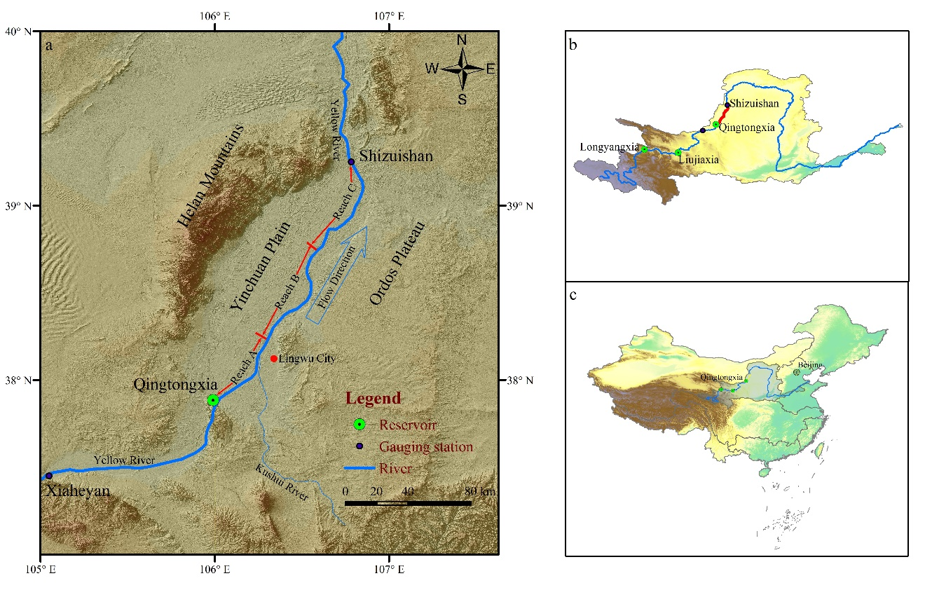
Figure 1. Location of the study area: (a) map of the YPR of the Yellow River, river flow from bottom to top; (b) locations of the study reach (red line) and major reservoirs upstream; (c) location of the entire Yellow River drainage basin in China.

The channel planform over the YPR is predominantly anabranching through reach A, single thread meandering through reach B, and mostly braiding through reach C (Figure 1a). The anabranching reach is 30km long and has many in-channel islands that are covered with dense grass mixed with willows (Figure 2a). From 1993 to 2015, the anabranching reach consisted of six stable vegetated islands on average at each cross section. The meandering reach has a sinuosity of 1.48 over a length of 71km, with many meanders and point bars being covered with a relatively dense vegetation of grass during summer (Figure 2b). The braided reach is about 85km long and generally occupies a very wide macrochannel, within which there are a large number of in-channel unvegetated sandy bars that are much lower than the bankfull level. Relatively sparse vegetation appears in the floodplain and channel banks during summer (Figure 2a-c). The number of large sandy bars across the channel over the braided reach varied from three to five on average during 1993-2015.
The variation in downstream riverbed gradients over the entire YPR is very significant, averaging 0.69‰, 0.28‰ and 0.14‰ in the anabranching, meandering and braided reaches, respectively. This variation means that the longitudinal profile of the channel over the entire YPR varies in a concave manner downstream (Figure 3a). Moreover, the sediment composing the banks of the channel over the entire reach also varies. As shown in Figure 3b, the channel banks in the anabranching reach are composed of sand on the top, with an average d₅₀ larger than 250μm, and pebbles at the bottom, with diameters of 1-12cm, similar to the in-channel islands. In the meandering reach, the left channel bank is composed of silt on the top and sand at the bottom, with a d₅₀ of less than 100μm, while the right bank is similar but in places it is also impacted by the Ordos Plateau which near the river is 4-5m higher than the water level at bankfull. The banks of the braided reach are composed of fine sand, with a d₅₀ of around 200μm.
The Longyangxia, Liujiaxia and Qingtongxia Reservoirs, located upstream of the study area, influence the flow into the YPR (Figure 1b). The Qingtongxia Reservoir, operating from 1968, is relatively small in regulating capacity (320 million m³ originally) so that its effect on the downstream channel is limited (Su et al., 2019), whereas the Liujiaxia and Longyangxia Reservoirs, operational respectively since 1968 and 1986, have larger regulating capacities (respectively 4.15 and 19.36 billion m³ originally) and greater impact. With the joint operation of the two large reservoirs and climate change in the region, the flow and sediment regime into the YPR has changed significantly and how the channel planform and cross-sectional geometry in the different reaches have responded is the focus of this study.
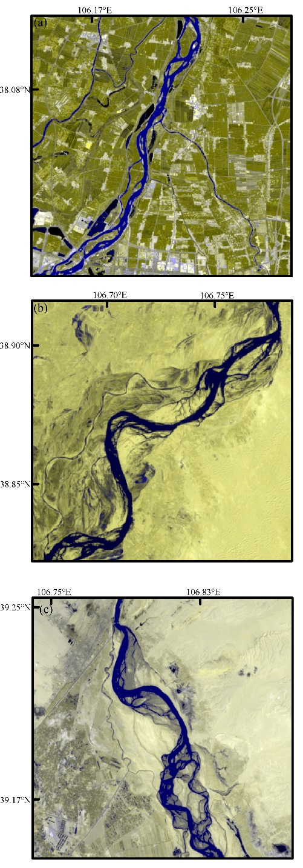
Figure 2. Enlarged planform maps of three channel patterns exhibited over the YPR in 2015 based on grid reference: (a) a view of the anabranching reach; (b) a view of the meandering reach; and (c) a view of the braided reach.

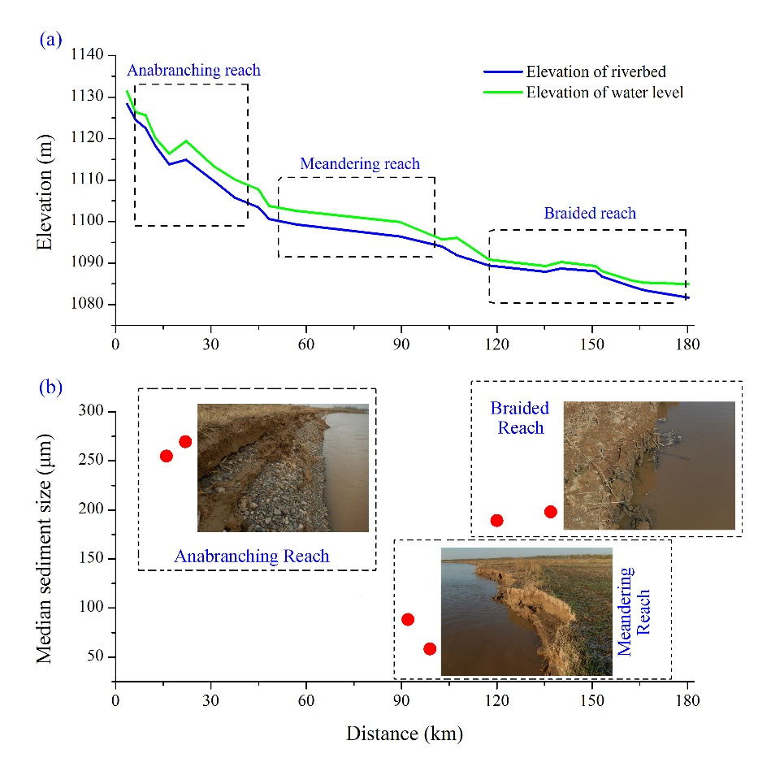
Figure 3. River bed elevation and grain size variations: (a) variations of riverbed elevation and water level; (b) photographic examples of bank sediment and the mean sediment size of each sample collected from the three reaches. Note: Qingtongxia Gorge and Shizuishan Gorge are located at the entrance and outlet of our study reach, respectively.

3.2 Data Sources
The gauging stations at Qingtongxia and Shizuishan Gorges have been measuring flow discharge and suspended sediment concentration daily since the 1950s, and 31 river cross-sections between them (including both channel and floodplain) were accurately surveyed in 1993, 1999, 2002, 2009, 2011, 2012 and 2015. .
Remote sensing images have been used widely in the study of river morphological changes (Abate et al., 2015; Rozo et al., 2014; Takagi et al., 2007; Wood et al., 2016; Xie et al., 2018). To evaluate the variations of channel planform after the joint operation of the Longyangxia and Liujiaxia Reservoirs became effective after 1986, we downloaded from the USGS website (https://www.usgs.gov/) Landsat 5 TM, Landsat 7 ETM and Landsat 8 OLI images taken from 1988 to 2015. The low flow season (November to June) was selected so as to avoid the submergence of in-channel bars and point bars by high water, thereby obtaining images that optimally revealed channel and floodplain dimensions. During the low flow season, base flow predominates with small almost constant discharges (Su et al., 2019).
Vegetation cover was used to extract the boundaries of river channels from remote sensing images, because channel banks are less frequently submersed by floods and therefore commonly support a cover of wild plants or crops (Gurnell, 1997; Richard et al., 2005; Winterbottom, 2000). To determine the areas of land surface covered with vegetation, we calculated the spatial variations of the Normalized Difference Vegetation Index ($NDVI$) using the following commonly applied equation:
$NDVI=(ρ_{NIR}-ρ_{R})/{(ρ}_{NIR}$+$ρ_{R})$ (8)
where $ρ_{NIR}$ is the reflectivity of the near infrared band, and $ρ_{R}$ is the reflectivity of the red light band.
With the determination of $NDVI$ over the YPR in terms of Equation (8), we conducted field investigations and identified that the areas with the $NDVI$ values of > 0.0 are covered with wild plants or crops, while the areas of water body and the sandy areas of in-channel bars and point bars have $NDVI$ values of ≤ 0.0. To accurately determine the boundary between the channel and floodplain of the river, we also used the images with a high resolution of up to 1m provided by Google Earth in combination with our field investigations. As a result, a belt along the river that is composed of the areas of water body, in-channel sandy bars and islands, and sandy point bars was determined on a GIS platform. This belt defines the planform of the channel. Figure 4 provides an example showing the morphology of the channel belt, as well as the boundaries of water body, river islands, and in-channel and point sandy bars determined on a GIS platform.

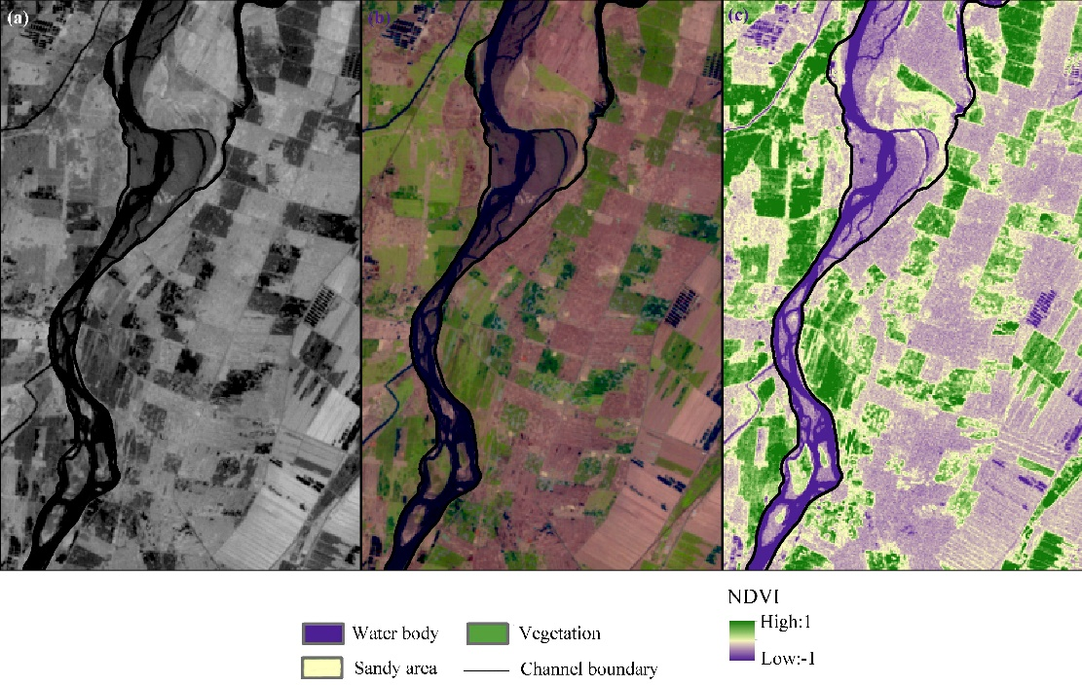
Figure 4. Channel planform of the YPR extracted from the original Landsat image taken in 2005 for a small area enlarged for a clearer visual comparison: (a) original image; (b) image with a false color composite; and (c) spatial distribution of $NDVI$ and objects including water area, sandy area, vegetation area, and the boundary of the channel belt extracted from the selected remote sensing images.

4. Variations in Flow Regime and River Channel-Forms

4.1 Variation in Flow Regime
Since 1986, after the joint operation of the Longyangxia and Liujiaxia Reservoirs commenced on the upper-reach of the study area, flow process in the Yellow River on the Yinchuan Plain has changed considerably (Figure 5). Because of few intervening tributaries, the annual runoff and sediment load measured at Qingtongxia and Shizuishan stations showed similar variability (Figure 5a,b). From 1988 to 2015 the two stations experienced complementary albeit complex changes in runoff, decreasing gradually with a degree of fluctuation during 1988-2003, then increasing gradually from 2004 to 2012, and finally decreasing again from 2013 (Figure 5a). Despite fluctuating considerably, the annual runoff varies broadly without an overall increase or decrease at both Qingtongxia and Shizuishan stations for the entire period 1988-2015.
In contrast, the annual sediment load at the two stations varied more simply, with a significant reduction in the range of the variation and a considerable decrease in the total amount since 2000 (Figure 5b). Over the entire period 1988-2015, sediment load reduced by nearly 60% at both stations. Due to the uneven inter-annual distribution of rainfall in the Upper Yellow River basin, the runoff and sediment load in the YPR is the greatest in the flooding season (July to October each year), and at both stations the trends are essentially in phase (Figure 5c,d).

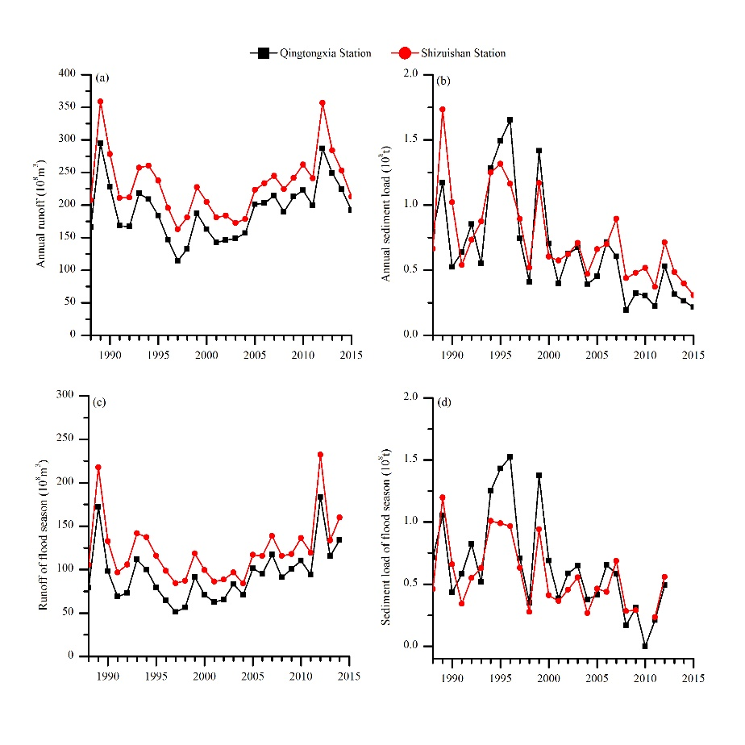
Figure 5. Variations of runoff and sediment load at Qingtongxia and Shizuishan stations during 1988 to 2015: (a) annual runoff; (b) annual sediment load; (c) flood season runoff; and (d) flood season sediment load.

4.2 Adjustment of River Channel Cross-sectional Geometry
In terms of the profiles of 31 river cross-sections along the YPR measured during 1993-2015, Figure 6 presents the profiles of representative river cross-sections at sites where anabranching, meandering and braided channel patterns occur. Because the locations of several cross-sections were changed in 2015, Figure 6 presents only the measurements made before 2015. Noticeable in the anabranching reach (Figure 6a,b) is that there are two significantly deep anabranches divided by a large island that is higher than the bankfull level. Although the two anabranches at each river cross-section adjust their cross-sectional geometries over time, lateral channel shifting is within a very small range, indicating that the river islands in both cross-sections have remained essentially stable.
Figure 6c,d shows the profiles of two representative river cross-sections within the single-thread meandering channel where point bars can be seen. Although the channel adjusts its geometries considerably over time, the channel width at bankfull has changed insignificantly at each cross-section. Figure 6e,f presents the profiles of two representative river cross-sections within the braided reach and there is a large area of in-channel bars within a considerably wide and shallow channel in both cross-sections. While the wide and shallow channel changes little at both cross-sections, all the in-channel bars have changed their position laterally very significantly.
The parameters of the channel cross-sections at bankfull computed from the measured cross-sections within each of the three channel patterns are shown in Table 1. The bankfull width of an individual anabranch within the anabranching reach is on average considerably smaller than the width of the single-thread channel within the meandering reach, but the total bankfull width of all anabranches within the anabranching reach is much larger. During 1993-2015, the bankfull widths of individual anabranches in the anabranching reach and the single-thread channel in the meandering reach remained little changed, while the bankfull width of the channel in the braided reach increased considerably.
Although the average depths of individual anabranches at bankfull in the anabranching reach are significantly larger than the single-thread channel depths in the meandering reach, they increased gradually with time in both reaches. The average depth of the channel at bankfull in the braided reach varies over a small range and on average takes the smallest value among the three reaches. In the anabranching reach, the width/depth ratios of individual anabranches at bankfull vary in a limited range and their average value is the smallest among the three reaches. In the braided reach, in contrast, the width/depth ratio of the channel at bankfull during 1993-2015 increased initially and then decreased continuously; yet the values are much larger than in the meandering and anabranching reaches. Although the width/depth ratios of the channel in the meandering reach are generally larger than that of individual anabranches in the anabranching reach, they do not change very significantly.

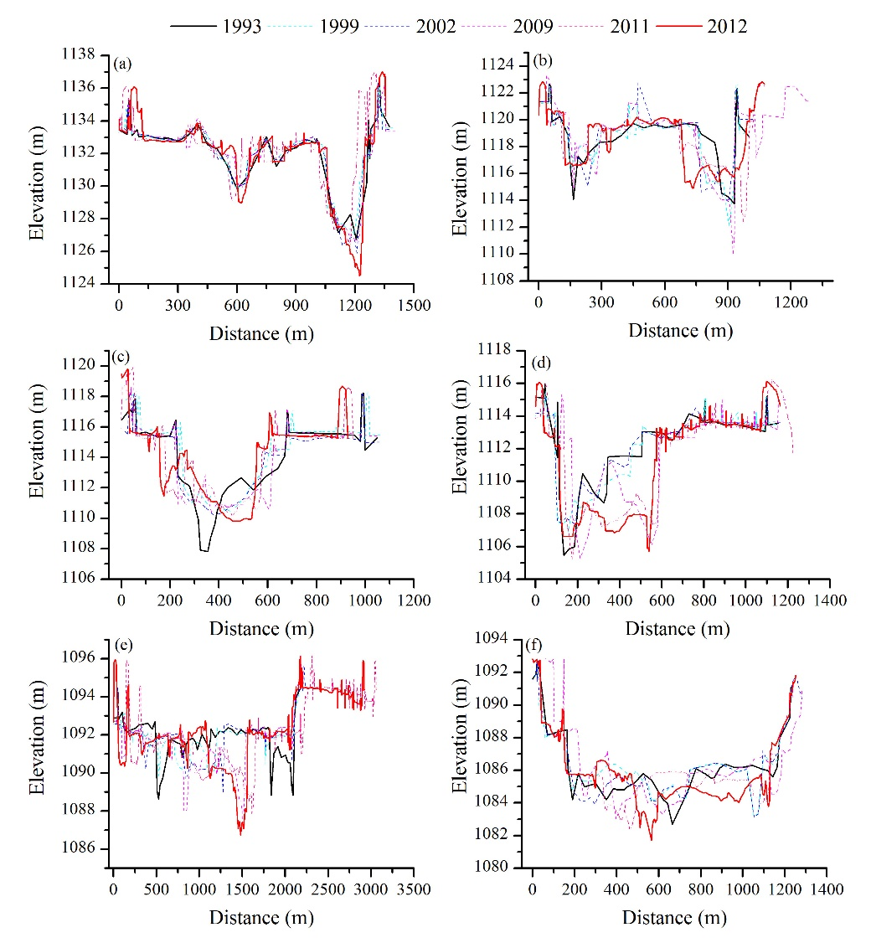
Figure 6. Representative river cross-sectional profiles measured in the anabranching reach (a,b), meandering reach (c,d), and braided reach (e,f) of the YPR.

Table 1
Channel/Anabranch Cross-sectional Parameters and the Dimensionless Number $H$ in the Anabranching, Meandering and Braided Reaches over the YPR
Reach | Year | W  (m) | D  (m) | A  (m²) | R  (m) | S (‰) | 𝜉 | H
Anabranching  reach | 1993 | 544 | 2.92 | 1588 | 2.89 | 0.77 | 186 | 0.42
 | 1999 | 453 | 3.21 | 1454 | 3.16 | 0.73 | 141 | 0.28
 | 2002 | 465 | 3.06 | 1422 | 3.02 | 0.58 | 151 | 0.23
 | 2009 | 605 | 2.68 | 1621 | 2.66 | 0.68 | 225 | 0.65
 | 2011 | 571 | 3.39 | 1935 | 3.35 | 0.67 | 168 | 0.35
 | 2012 | 581 | 3.23 | 1876 | 3.19 | 0.68 | 179 | 0.38
 | 2015 | 591 | 3.87 | 2287 | 3.82 | 0.63 | 152 | 0.33
 | average | 544 | 3.19 | 1740 | 3.16 | 0.68 | 172 | 0.38
Meandering  reach | 1993 | 846 | 2.51 | 2123 | 2.50 | 0.49 | 336 | 0.17
 | 1999 | 756 | 2.10 | 1587 | 2.08 | 0.48 | 360 | 0.11
 | 2002 | 802 | 2.24 | 1796 | 2.23 | 0.20 | 357 | 0.047
 | 2009 | 773 | 2.50 | 1932 | 2.48 | 0.14 | 309 | 0.054
 | 2011 | 850 | 2.39 | 2031 | 2.37 | 0.20 | 356 | 0.053
 | 2012 | 794 | 3.06 | 2429 | 3.03 | 0.20 | 259 | 0.12
 | 2015 | 829 | 3.17 | 2627 | 3.15 | 0.28 | 261 | 0.15
 | average | 807 | 2.57 | 2075 | 2.55 | 0.28 | 320 | 0.10
Braided  reach | 1993 | 1553 | 1.56 | 2422 | 1.55 | 0.18 | 995 | 0.0024
 | 1999 | 1636 | 1.31 | 2143 | 1.31 | 0.16 | 1248 | 0.0014
 | 2002 | 1591 | 1.22 | 1941 | 1.22 | 0.09 | 1304 | 0.0012
 | 2009 | 1680 | 1.26 | 2116 | 1.26 | 0.13 | 1333 | 0.0013
 | 2011 | 1725 | 1.43 | 2466 | 1.43 | 0.14 | 1206 | 0.0017
 | 2012 | 1738 | 1.44 | 2502 | 1.44 | 0.13 | 1206 | 0.0017
 | 2015 | 1747 | 1.58 | 2760 | 1.58 | 0.12 | 1105 | 0.0022
 | average | 1667 | 1.40 | 2336 | 1.40 | 0.14 | 1200 | 0.0017
Note: W, bankfull channel/anabranch width; D, average bankfull channel/anabranch depth; A, bankfull channel/anabranch area; R, bankfull hydraulic radius; S, channel/anabranch gradient; d₅₀, median size of bed sediment; 𝜉, ratio of channel/anabranch width to depth at bankfull.

The bankfull cross-sectional areas of the individual anabranches in the anabranching reach increase slightly through time, but generally take smaller values among the three reaches. In contrast, the cross-sectional areas of the channel in the braided reach show a slightly increasing trend and take much larger values among the three reaches. The cross-sectional areas of the channel in the meandering reach are slightly larger than those of individual anabranches in the anabranching reach and vary across a very small range. Furthermore, it is noticeable in Table 1 that the gradient of the channel/anabranch decreased in general terms in all three reaches, reducing by about 15% in the anabranching and braided reaches and by nearly 40% in the meandering reach over the period 1993-2015.

4.3 Adjustment of River Channel Planform
To evaluate the variations in river channel planform over the YPR (Yinchuan Plain reach), the successive belts covering the entire river channel, inclusive of the three reaches of anabranching, meandering and braided patterns, were extracted from remote sensing images by applying the method described earlier in section 3.2. Figure 7 shows the changes in river channel-planform over the anabranching reach and the increase/reduction in the areas of water body, vegetation and sandy bars within the channel belts. The water area in the belts shows a fluctuating variation from 1988 to 2006 followed by a gradually decreasing trend from 2007 to 2015, with a decrease by 38.10% until 2015. Over the entire period from 1988 to 2015, the water area increases, while the area of in-channel sandy bars is essentially unchanged. In addition, the islands within the channel belts are vegetated and have been stable since 1988. From 1993 to 2015, the anabranching reach consisted of six islands on average that are stable and vegetated. However, channel belts shrank since 1988, while in-channel islands remained stable, and consequently the channel planform index of the anabranching reach, calculated as the ratio of the area of stable vegetated islands to the water area, increased from 13.69% to 21.14% during 1988 to 2015.
In the meandering reach (Figure 8), many bends occur, while in-channel sandy bars are few. From 1988 to 1990, flow in the channel as illustrated in the red box in Figure 8 shifted from the left bank to the right and the left part of the channel was absent by 1992, with the formation of a typical meandering pattern. From 1992 to 2000, however, the sinuosity of the meandering channel decreased from 1.34 to 1.08; a significant straightening process. Indeed, a cut-off occurred in 2000 as shown in the red box in Figure 8. Since 2001, however, the sinuosity of the channel has gradually increases, reaching 1.48 by 2015.

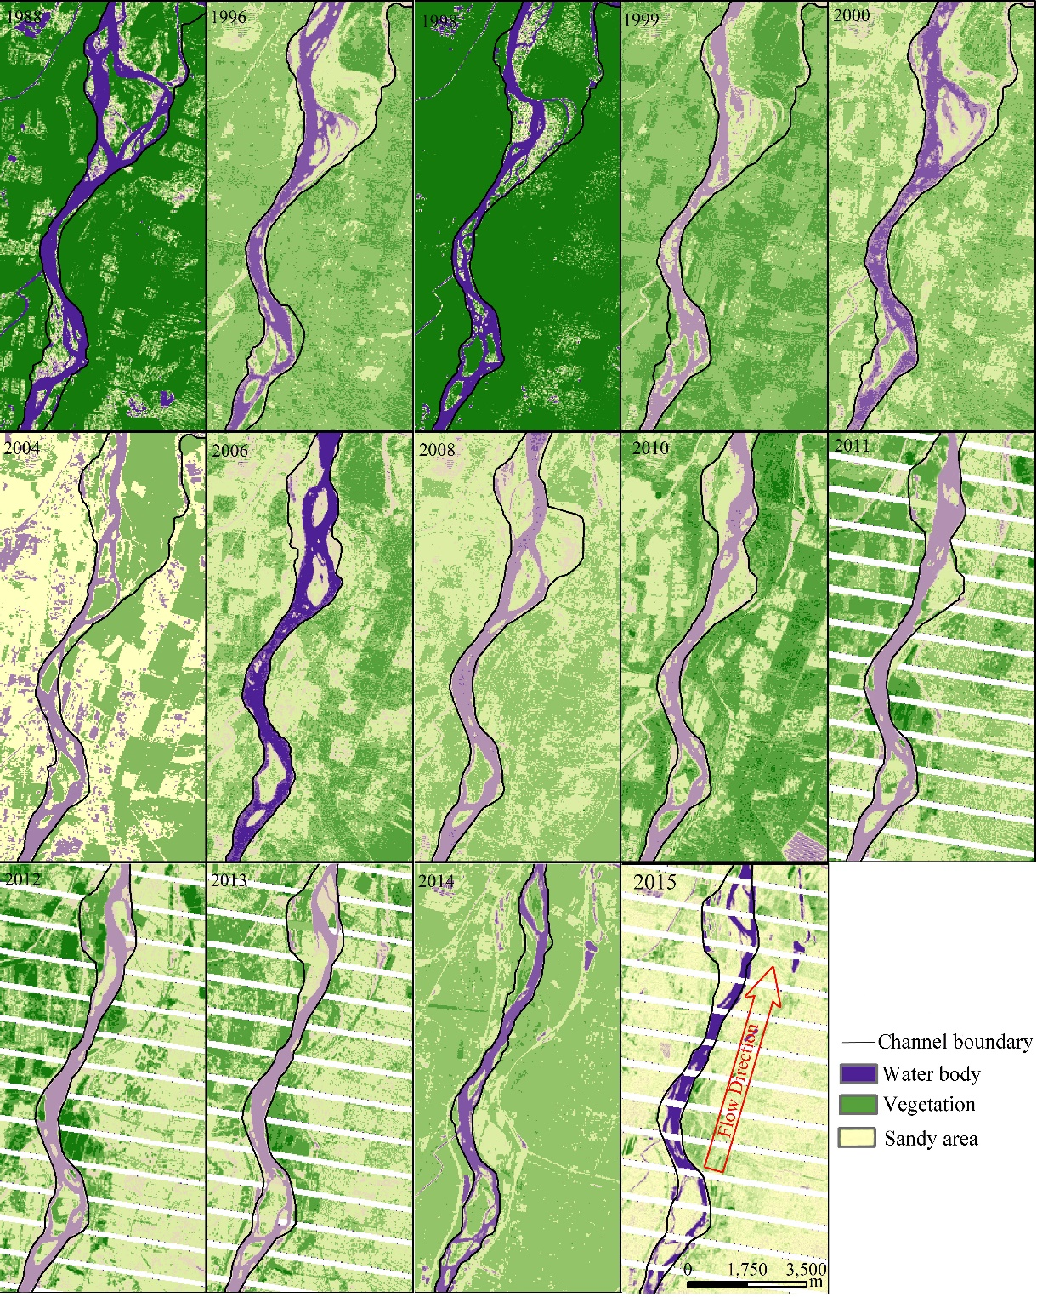
Figure 7. Channel planforms of the anabranching reach over the YPR extracted from the selected remote sensing images taken during 1988-2015. The black lines define the boundary of the channel belt that includes the area of water body, vegetated area and sandy area.

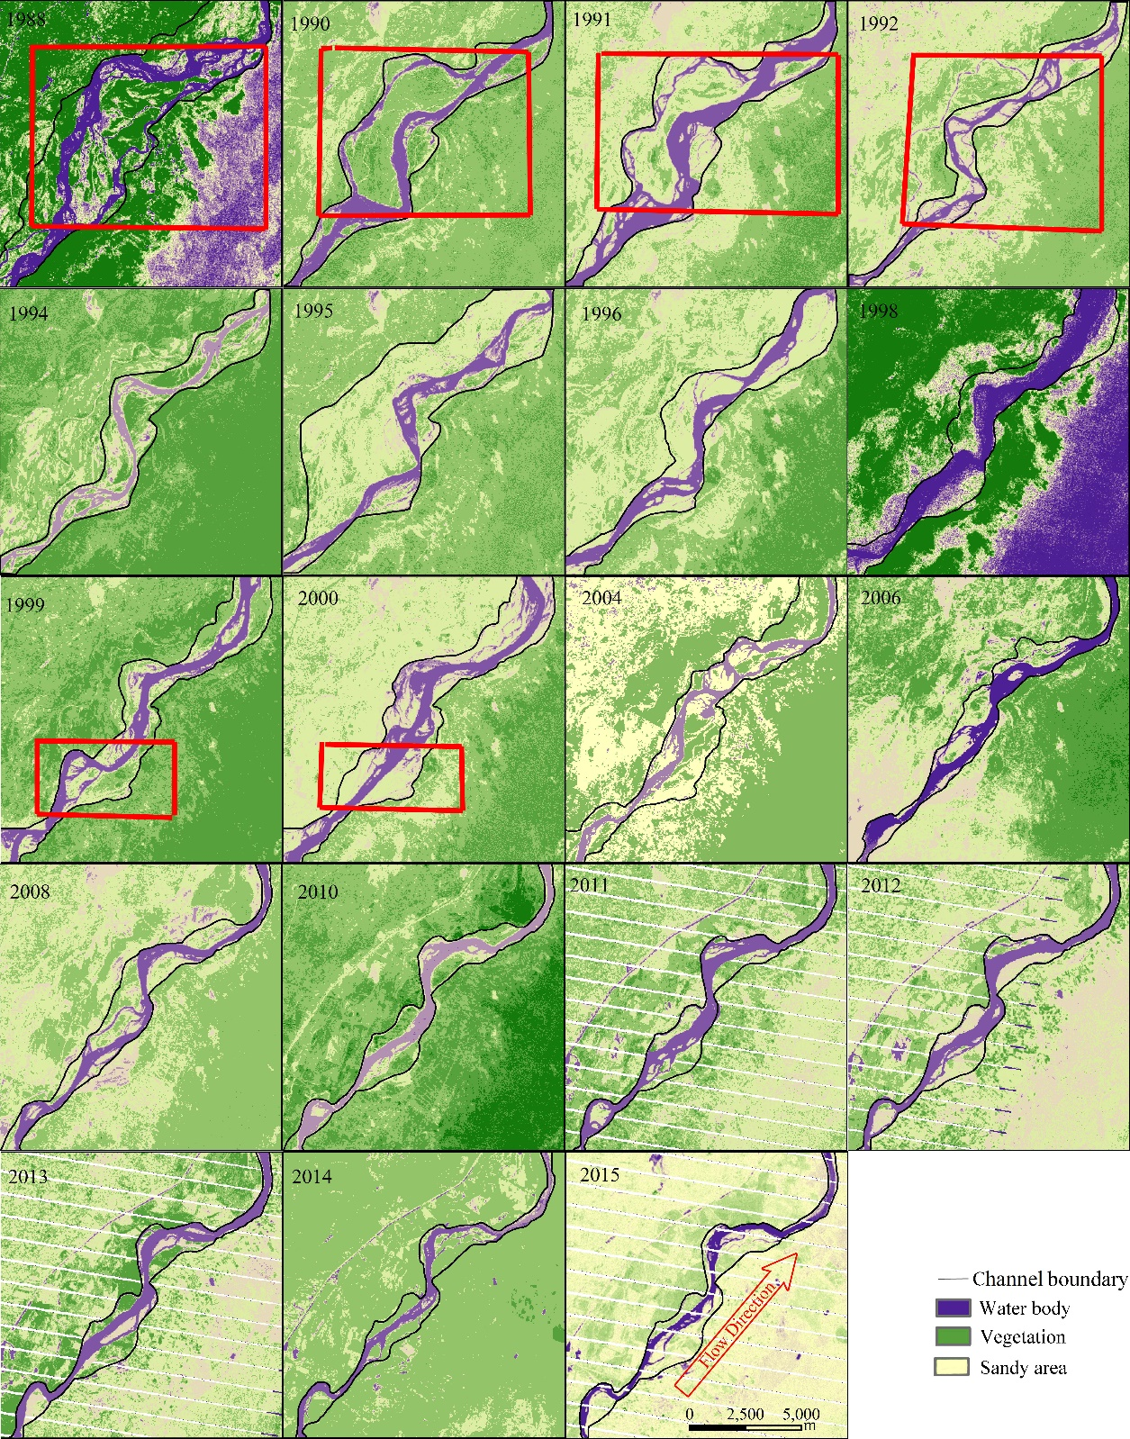

Figure 8. Channel planforms of the meandering reach over the YPR extracted from the selected remote sensing images taken during 1988-2015. Red boxes locate cutoff locations resulting in temporary anabranches.

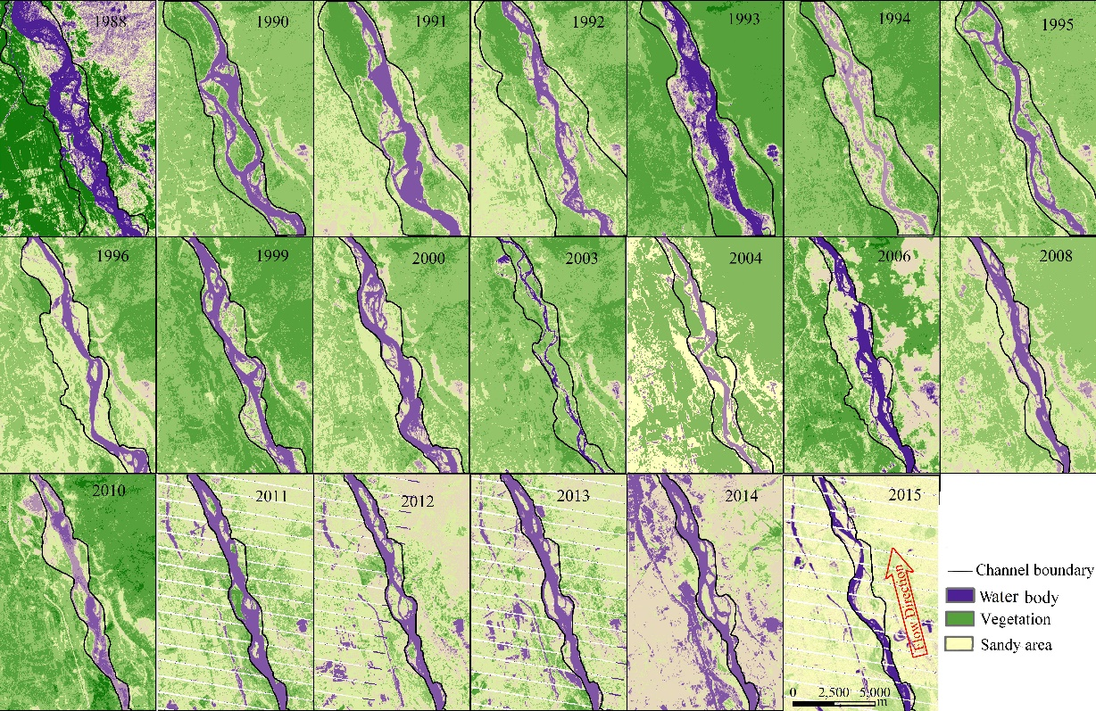

Figure 9. Channel planforms of the braided reach over the YPR extracted from the selected remote sensing images taken during 1988-2015.

In the braided reach (Figure 9), the width of the channel belt increased considerably from 1249m to 1523m during 1988-2015, in line with a significant increase in the number of in-channel sandy bars. During 1993-2015, the average number of in-channel sandy bars ranged from 3.2 to 4.43, which means that there are three to four in-channel sandy bars at each channel cross-section. The water area changed little from 1988 to 1993, while since 1994, it has fluctuated in a much wider range.
The main parameters determining the length and areal components of a channel planform include channel length and areas of channel belt, water body, river islands, point bars, and in-channel sandy bars for each of the three reaches (Table 2). In the whole study area from 1988 to 2015, the area of the channel belt and the summed area of point bars and in-channel sandy bars within the belt decreased respectively by 62.69% and 77.42%, while the water area decreased with considerable fluctuation by 23.98%. Thus, since 1988 the surface area of the channel on the Yinchuan Plain shrank to a significant degree. Spatially, the area occupied by in-channel sandy bars in the anabranching reach is the smallest among the three reaches, and the area of in-channel islands over the reach increased from 2006 to 2015.

Table 2
Variations of Main Parameters Determining the Channel-Planform over the YPR. Bar area per unit channel length given in parentheses.
Year | Channel pattern | Length of channel  (km) | Area of channel belt  (km²) | Water area  (km²) | Area of in-channel bars  (km²) | Area of point bars  (km²)
1988 | Braided | 98.04 | 223.39 | 53.65 | 42.53 | 127.21
 | Meandering | 69.67 | 130.13 | 33.97 | 18.17 | 77.99
 | Anabranching | 44.56 | 41.72 | 21.33 | 2.92 | 17.47
 | Total | 212.27 | 395.24 | 108.95 | 63.62 | 222.67
1998 | Braided | 92.64 | 125.49 | 37.47 | 36.82 | 51.20
 | Meandering | 71.07 | 110.04 | 29.15 | 26.88 | 54.01
 | Anabranching | 43.37 | 31.99 | 16.13 | 2.48 | 13.38
 | Total | 207.08 | 267.52 | 82.75 | 66.18 | 118.59
2006 | Braided | 88.34 | 104.53 | 46.95 | 16.36 | 41.22
 | Meandering | 65.91 | 56.08 | 34.86 | 5.97 | 15.25
 | Anabranching | 42.49 | 27.92 | 18.65 | 1.04 | 8.23
 | Total | 196.74 | 188.53 | 100.46 | 23.37 | 64.70
2015 | Braided | 91.47 | 84.06 | 44.97 | 4.70 | 34.39
 | Meandering | 66.93 | 41.01 | 24.37 | 3.12 | 13.52
 | Anabranching | 42.82 | 22.38 | 13.48 | 2.85 | 6.05
 | Total | 201.22 | 147.45 | 82.82 | 10.67 | 53.96

Furthermore, the area induced by the shifts of the left bank gradually decreased by 62% from 1988 to 2015, while the area induced by the shifts of the right bank fluctuated within a small range. This outcome is because the right bank adjacent to the Ordos Plateau is composed of coarse sand and much higher than the left bank that consists of the river floodplain that can be eroded more easily. In addition, our field investigations identified that river training work in the braided reach has been conducted at many places to prevent the right bank and floodplain from eroding and this has contributed to channel shrinkage.

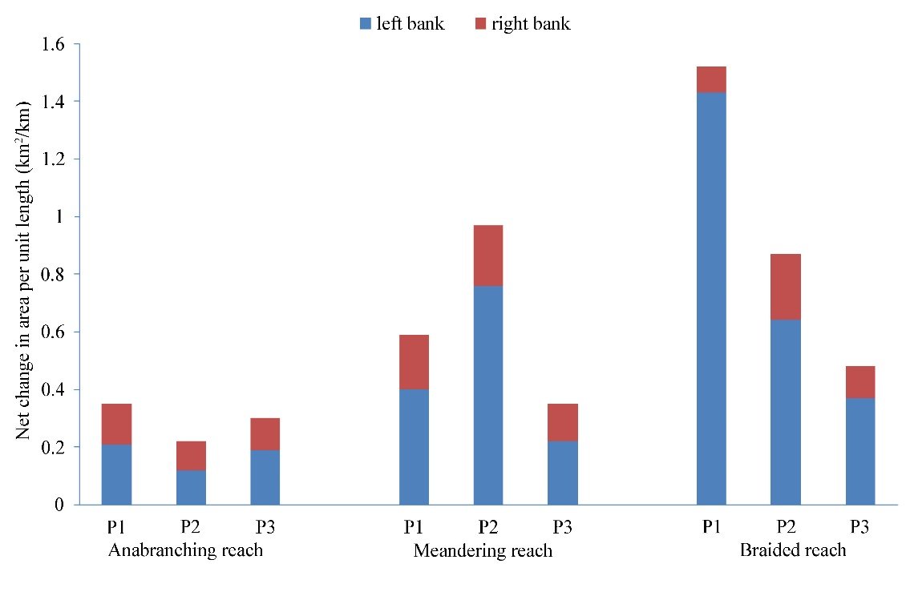
Figure 10. Changes in the area induced by the shifts of channel banks in the different reaches of the Yellow River on the Yinchuan Plain. Note: P1, P2 and P3 stand for the periods from 1988 to 1998, from 1998 to 2006 and from 2006 to 2015, respectively.

In company with the significant channel shrinkage, the banks of the channel along the YPR have shifted considerably but differently left and right between 1988 and 2015. According to the variations in the boundary of the channel belt, the area subject to the shifts of channel banks on the anabranching, meandering and braided reaches are presented in Figure 10. During the entire period 1988-2015, the area induced by the shifts of the left bank is about two to five times larger than that induced by those of the right bank. In addition, the area induced by the shifts of both left and right banks is the largest in the braided reach, following by the meandering reach and the anabranching reach. Hence, of all three reaches, the channel in the braided reach suffered the most serious shrinkage, while the channel in the anabranching reach only shrank slightly.

5. River Channel-form Adjustment in Relation to Hydrodynamic and Eco-Geomorphologic Controls

5.1 Degree of Hydrodynamic Control
To evaluate if the dimensionless number $H$ can measure the degree of hydrodynamic control on river channel-forms in the YPR, we calculated H numbers (Equation 5) by using the measured channel cross-sections. In Table 1, it is clear that in the anabranching reach, the mean $H$ values vary within the range 0.23-0.65 during 1993-2012 and then take the value of 0.33 in 2015. In comparison with the ideal value of $H=0.3$ for a straight and single-thread channel, the values of $H$ averaged from all individual anabranches vary around the ideal case of $H=0.3$. This outcome is consistent with the findings of Nanson and Huang (2017) from anabranching rivers in central Australia and with the comparison of single-thread channel to island reaches along the middle and lower Yangtze River by Huang et al. (2014) and Liu et al. (2016). The physical reason underpinning these results is that river islands or ridges established in the anabranching reach enable the excess energy of flow to be fully expended through an increase in the sum of the wetted perimeters of all anabranches such that individual anabranches provide the most efficient channel cross-sections for bedload transport that are neither too narrow nor too deep (Huang and Nanson, 2007). These results demonstrate clearly that while hydrodynamic adjustment is not maximally achieved in the anabranching reach due to the maintenance of river islands, the adjustments of individual anabranches retain close to the optimum stationary equilibrium state of MFE, an interesting phenomenon requiring further detailed investigations.
In the meandering reach, $H$ decreases gradually from 0.17 to 0.047 during 1993-2002 and increases gradually to 0.15 during 2011-2015. Within the varying range of 0.047-0.17, all of the $H$ values are considerably smaller than the ideal value of 0.3. This outcome means that the meandering channel has a moderately wider and shallower cross-section than the most efficient geometry for bedload transport. The deviation of the channel cross-section from the optimal through the development of the meandering pattern is accompanied by a decrease in channel slope such that excess energy is expended on a distortion of flow both laterally and longitudinally. Thus, it is clear that the hydrodynamic control is not maximized within the meandering reach.
In the braided reach, $H$ takes very small values that vary within the range of 0.0012 to 0.0024 during 1993-2015. These values are much smaller than the ideal value of 0.3 and the channel is much wider and shallower than one at MFE. This difference in the channel cross-sectional form coupled with many sandy bars across the very wide channel bed require a very large expenditure of excess energy compared with the anabranching and meandering reach. Hence, the hydrodynamic control is far from optimal in the braided reach.
As a whole, it is clear that the non-dimensional number, $H$, which measures the equilibrium state of alluvial channel flow, varies in the ranges of 0.23-0.65, 0.047-0.17 and 0.0012-0.0024 respectively in the anabranching, meandering and braided reaches on the Yinchuan Plain. The significant differences among the $H$-ranges are because the three reaches exhibit significantly different channel planforms with very different channel cross-sections: neither very narrow nor very deep cross-sections for individual anabranches in the anabranching reach, moderately wider and shallower cross-sections in the meandering reach, and significantly wider and shallower cross-sections in the braided reach. These results demonstrate that the $H$ number is a good discriminator of river channel patterns and accounts for how different channel patterns expend surplus energy to different degrees in order to remain as stable as possible. The range in the $H$ values for each channel pattern is relatively narrow, indicating that the $H$ number can be used to understand the resilience of river channel-form adjustment. In the YPR, these adjustments occurred against a significant variation in flow regime occurring during 1988-2015, with H providing a robust measure of river channel behavior.
In summary, the channel patterns developed in the YPR as detailed in this study and the anabranching rivers in central northern Australia as studied by Nanson and Huang (2017, 2018) show a relationship with the non-dimensional number $H$ in the following manner:
$\overline{H}≈0.3,$ anabranching channel; (9a)
$H<0.3,$ meandering channel; (9b)
$H≪0.3,$ braided channel (9c)
where $\overline{H}$ is the averaged value of the $H$ numbers of all individual anabranches in the anabranching reach.
In terms of a temporal shift over the 1993 to 2015 study period, it appears from Table 1 that the anabranching reach has fluctuated but remained close to, albeit on average slightly higher than, the stationary state of $H=0.3$. Both the meandering and braided reaches appear during first part of the period to have deteriorated to values even further below the optimum of $H=0.3$ but then to have both recovered moving closer to the optimum in the final part of the period, albeit remaining well below it. This behaviour may reflect the river as a whole adjusting to the 1968 to 1986 period of the Qingtongxia, Liujiaxia and Longyangxia Reservoirs impoundments and regional climate change, and its subsequent partial self-adjustment recovery. The meandering and braided reaches appear to have been the most affected and the anabranching reach most resistant to these changes.

5.2 Effects of Eco-Geomorphological Controls
With the Yinchuan Plain bordered by the Helan Mountains, the Ordos Plateau and the Qingtongxia and Shizuishan Gorges, considerable geomorphologic control has been imposed on this reach of the Yellow River. The first is the valley gradient imposed by the two gorges upstream and downstream of the reach. Although there are few tributaries joining the trunk river over the entire YPR, Figure 3 shows clearly that the longitudinal profile of the riverbed over the entire YPR is concave in form, and three channel patterns develop on significantly different gradients, the averages of which decrease in steepness from the anabranching to the meandering to the braided reach. Physically, these downstream changes in channel pattern and channel gradient are induced by the difference between the valley gradient imposed by geological and topographic conditions and the channel gradient on which hydrodynamic control takes maximal effect.
The second geomorphologic control is imposed by the sediment composing the banks of the channel in the study reach. Figure 3b presents the distribution of the median size of sediment collected from the channel banks at sites representative of the three channel pattern reaches on the Yinchuan Plain. In the anabranching reach, the bank sediment is generally very coarse gravel at the bottom and granule size sand on the top, while in the meandering reach it is mainly fine sand at the bottom and silt on the top. The bank sediment in the braided reach is essentially fine to medium sand (Figure 3b). This spatial variation in the sediment composition composing the banks of the channel over the YPR is consistent with the widely accepted knowledge that different sediment composition can change bank strength significantly and consequently exerts a considerable influence on the development of river channel patterns (e.g., Alabyan & Chalov, 1998; Brice, 1975; Carling et al., 2014; Nanson & Knighton, 1996; Rust, 1978; Schumm, 1985; Xu, 2004).

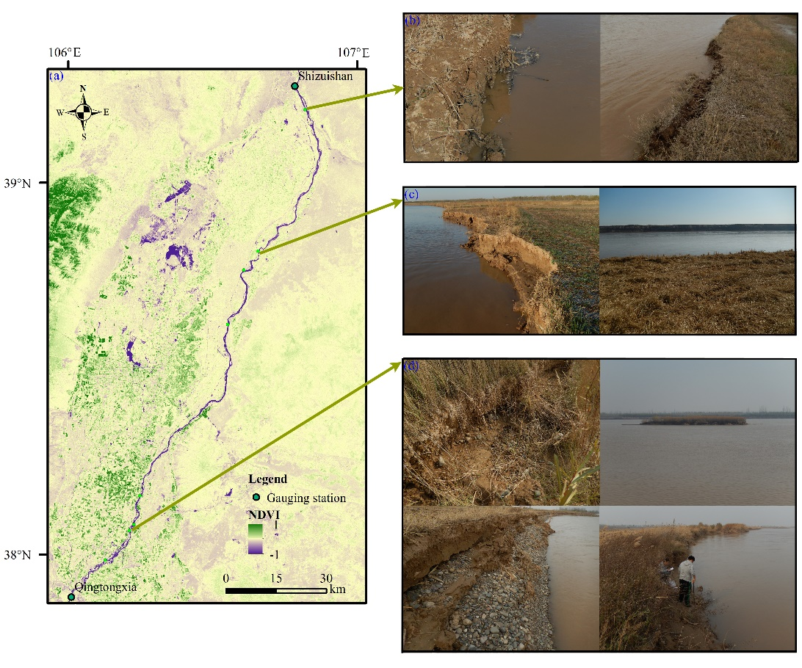
Figure 11. Riparian vegetation coverage over the YPR: (a) map of the distribution of $NDVI$ in 2012; (b-d) photographs representative of bank materials and vegetation cover in the braided, meandering, and anabranching reaches.

Riparian vegetation is a largely allogenic variable that can have a profound impact on river form and process but this can be difficult to quantify (Hickin, 1984; Corenblit et al., 2007). As described above, riparian vegetation over the Yinchuan Plain declines very significantly from the south to the north and this must also have an impact on the channel-form development in that direction. From the selected remote sensing images, we found from the values of $NDVI$ calculated according to Equation (8) that only in the area outside the floodplain of the Yellow River do the $NDVI$ values change significantly with time over the entire Yinchuan Plain area during 1988-2015, which is consistent with the studies of Hao et al. (2012) and He et al. (2019). This outcome is mainly because the local authorities have been trying to restore wetland area lost previously due to urbanization. In contrast, the $NDVI$ values vary significantly from one place to another. Figure 11a presents the spatial distribution map of the $NDVI$ values over the entire Yinchuan Plain computed from the remote sensing image taken in 2012. Importantly, the anabranching and braided reaches are in the areas respectively with the largest and smallest $NDVI$ values, while the meandering reach lies in the area between the two extremes.
Figure 11b-d presents the example photographs of river channel banks, covering the toe to the top, taken over the YPR. The channel banks in the braided reach are covered by sparse grass, the roots of which penetrate into the banks to a degree (Figure 11b). In contrast, the channel banks in the meandering reach are covered by dense grass and reeds (Figure 11c), while in the anabranching reach, the channel banks and in-channel islands are all covered by dense grass, reeds, shrub, and some trees (Figure 11d). These spatial variations in $NDVI$ and riparian vegetation are related to the spatial variation in the regional temperature, which is about 2 to 4ºC higher in the south of the Yinchuan Plain than in the north.
In addition to the regional variation in temperature, the variable sediment composition composing the banks of the channel along the study reach also can exert a significant influence on riparian vegetation growth, including the types of vegetation and the corresponding covering intensities and spatial distributions (Corenblit et al., 2007). In some cases the relationship is inverted as the type of vegetation can influence what size of sediment is deposited. Nevertheless, because the types, spatial distribution and growing processes of riparian vegetation can exert considerable influences on the strength of channel banks, their significant influences on the cross-sectional geometry and planform of river channels have long been identified (e.g., Abernethy & Rutherfurd, 2001; Bennett & Simon, 2004; Corenblit et al., 2007; Eaton and Giles, 2009; Huang and Nanson, 1998; Simon & Collison, 2002; Tal & Paola, 2007; Wohl et al., 2017, 2018).
While it is evident that there are several eco-geomorphic factors, each of which is able to exert an influence on the development of the three river channel patterns in the YPR, the main influences are the relationships between deposited sediment size and vegetation type and density which vary in complex integrated forms with flow dynamics (Simon & Collison, 2002). Although anabranching channels may occur in regions that are poorly vegetated, strong riparian vegetation growth may assist the stabilization of anabranching channels. For example, Tooth and Nanson (2000) demonstrated that strong riparian vegetation growth was capable of colonizing in-channel sandy bars in central Australia leading to enhanced sediment trapping and the development of anabranching with river islands or elongated ridges having elevations equal to or a little above bankfull level. In both the desert center and monsoon north of Australia, Nanson and Huang (2017) and Tooth et al. (2008) found that dense riparian vegetation could stabilize anabranching channels, even though the banks were formed largely of unconsolidated sand. In contrast, weak riparian vegetation growth cannot stabilize in-channel sandy bars, the heights of which remain below the bankfull water level, so the braided channel develops. Braiding tends to occur when the channel banks are composed of sand or gravel with no fine cohesive component and so the banks are vulnerable to lateral erosion. The trapping of cohesive silty sediment on channel banks by strong/moderate riparian vegetation growth, further promotes vegetation resilience, bank stabilization and assists in the development of the meandering channel. Schumm (1986) noted that channel sinuosity is closely related to the resistance of channel banks to flow dynamics.
Our theoretical framework presented earlier in this study demonstrates clearly that the values of the H number calculated in terms of Equation (5) embody the outcome of the complex integrated effects of several eco-geomorphic factors with the hydrodynamic control. The hydrodynamic control may be paramount, and yet the effects of both grain size of the depositing sediment and the erosion resistance of riparian vegetation likely account for the range of $H$-values reported for each reach type as these two factors influence the $H$ number. This conclusion is sound in-as-much as Equation (5) includes $τ_{c}$, the critical shear stress for the incipient motion of bed sediment, which varies with particle size and density, whilst the parameter $ξ=W/D$ reflects channel shape, which is influenced by both grain size and the vegetation present, as was detailed above. Typically, the results presented in Table 1 show clearly that the values of the H number are significantly different from one channel pattern to another in the YPR, and they also change over time as the river appears to adjust and accommodate past changes. Hence, the $H$ number as an indicator of flow efficiency is a reasonable discriminator of river channel patterns given its solid physical base on equilibrium theory governing alluvial channel flow and the successful application in our detailed case study.
Although Equation (9a-c) presents a summary of the relationship between the values of the H number and river channel patterns in terms of the results obtained in this study and previously by Nanson and Huang (2017, 2018), the criteria to differentiate the anabranching, meandering and braided patterns remain largely qualitative. Hence, more detailed studies are needed to evaluate the applicability of the theoretical framework in other fluvial systems. In particular, the applicability of the flow relationships governing alluvial channel flow and the values of the H number that can be used to quantitatively distinguish river channel patterns and their relative flow efficiency in different settings needs further exploration. It can also be used to evaluate changes occurring in the same reach of river over time. Such consideration should include the effects on the H number of other controlling factors, such as grain size and vegetation.
- Conclusions
Alluvial rivers are subject to the integrated effects of hydrodynamic and eco-geomorphologic controls. This study presents a theoretical framework in the light of the advances in equilibrium theory governing alluvial channel flow to distinguish the degree of hydrodynamic control. The Yellow River over the Yinchuan Plain is characterized by distinct reaches exhibiting anabranching, meandering and braided alluvial channel patterns. To understand the behavior of the three types of channel pattern in response to a significant change in flow regime, this study presents a detailed analysis of the adjustments in river-channel cross-sectional geometry and planform using a large number of field measurements and satellite based remote sensing images. The values of the non-dimensional number $H$ that measures the equilibrium state of river channel flow are calculated and their physical meaning explained in relation to the characters of channel-form adjustment in the anabranching, meandering and braided reaches. These detailed analyses yield the following important results:
1. During 1988-2015, flow regime into the YPR (Yinchuan Plain reach) encountered a joint effect of reservoir operations and regional climate change, yielding a significant fluctuation in runoff and yet a significant continuous decrease in sediment load, reducing by 60%.
2. In response to the change in flow regime, both of the width and average depth of individual channels at bankfull increased slightly in the anabranching and braided reaches, while the average depth of the channel at bankfull in the meandering reach increased considerably during 1993-2015. As a result, the width/depth ratio of channels at bankfull in the anabranching and braided reaches varied without a clear temporal trend, and yet an evident decreasing trend occurred in the meandering reach. In contrast, the gradient of the channels decreased in all three reaches, reducing by about 15% in the anabranching and braided reaches and by nearly 40% in the meandering reach.
3. During 1988-2015, the variation in the channel planform is characterized by continuous reduction in the surface area of channel belt, with the anabranching and braided reaches experiencing, respectively, the least and largest reduction. In company with the reduction, significant shifts in the banks of the channel took place.
4. The non-dimensional number $H$ that measures the equilibrium state of alluvial channel flow varies in the ranges of 0.23-0.65, 0.047-0.17 and 0.0012-0.0024 during 1993-2015 respectively in the anabranching, meandering and braided reaches. The significant differences among the $H$-ranges are mainly because individual anabranches in the anabranching reach adopt neither very narrow nor very deep cross-sections, while the single-thread channel in the meandering and braided reaches adopt cross-sections that are moderately wider and shallower and very much wider and shallower, respectively. This result demonstrates that the $H$ number is a good discriminator of river channel patterns.
5. The varying range in the $H$ values for each channel pattern is small, and the channel cross-sections of the Yellow River are considerably resilient to the significant change in flow regime. The small range in the $H$ values can reasonably be attributed to known variations in sediment and vegetation characteristics.

Acknowledgements
This work was supported financially by the National Key Research and Development Program of China (Grant No. 2016YFC0402502), the National Natural Science Foundation of China (Grant No. 41561144012), and the China Postdoctoral Science Foundation (Grant No. 2020M670435). The authors would like to thank the Yellow River Water Conservancy Commission and Ningxia Water Conservancy and Hydropower Survey Design & Research Institute Co., Ltd. of China for permission to access the measured hydrological and river cross-sectional data. All photographs presented in Figs. 3 and 11 on the channel banks of the YPR were taken by Dr. Suiji Wang in 2016. Particular thanks are given to anonymous reviewers, associate editor and Ellen Wohl for their valuable review comments, which significantly enhance the quality of this paper.
The authors declare no conflicts of interest.

Data Availability Statement
The hydrological data, including flow discharge and suspended sediment concentration, of Qingtongxia and Shizuishan stations and the cross-sectional profiles are provided by the Yellow River Conservancy Commission of China and by the Ningxia Water Conservancy and Hydropower Survey Design & Research Institute Co. Ltd. of China. Related data sets are available online (http://doi.org/10.5281/zenodo.4248173). The remote sensing images used in this article are downloaded from USGS website (https://www.usgs.gov/).

References
Abate, M., Nyssenb, J., Steenhuisa, T. S., Mogesa, M. M., Tilahuna, S., Enkua, T., & Adgo, E. (2015). Morphological changes of Gumara River channel over 50 years, upper Blue Nile basin, Ethiopia. Journal of Hydrology, 525, 152–164. http://doi.org/10.1016/j.jhydrol.2015.03.044
Abernethy, B., & Rutherfurd, I. D. (2001). The distribution and strength of riparian tree roots in relation to riverbank reinforcement. Hydrological Processes, 15 (1), 63-79.
Alabyan, A., & Chalov, R. S. (1998). Types of river channel patterns and their natural controls. Earth Surface Processes and Landforms, 23(5), 467-474. https://doi.org/10.1002/1096-9837(199805)23:5<467::AID-ESP861>3.0.CO;2-T
Ashmore, P. E. (1991). Channel morphology and bed load pulses in braided, gravel-bed streams. Geografiska Annaler Series A Physical Geography, 73, 37-52. https://doi.org/10.2307/521212
Beeson, C. E., & Doyle, P. F. (1995). Comparison of bank erosion at vegetated and non-vegetated channel bends. Journal of the American Water Resources Association, 31(6), 983-990. https://doi.org/10.1111/j.1752-1688.1995. tb03414.x
Bennett, S. J & Simon, A. (2004) (eds.). Riparian vegetation and fluvial geomorphology. Water Science and Application, Vol. 8, American Geophysical Union, Washington DC.
Bettess, R., & White, W. (1983). Meandering and braiding of alluvial channels. Proceedings of the Institution of Civil Engineers, 75, 525-538. https://doi.org/10.1680/iicep.1983.1443
Brierley, G., & Fryirs, K. (2005). Geomorphology and River Management: Applications of the River Styles Framework. Malden, MA: Blackwell Publishing.
Brierley, G., Fryirs, K., Cullum, C., Tadaki, M., Huang, H. Q., & Blue, B. (2013). Reading the landscape: Integrating the theory and practice of geomorphology to develop place-based understandings of river systems. Progress in Physical Geography, 37(5), 601-621. https://doi.org/10.1177/0309133313490007
Brice, J. (1975). Air photo interpretation of the form and behavior of alluvial rivers. St Louis, MO: Army Research Office.
Brice, J. (1983). Planform properties of meandering river, River Meandering. Proceedings of the October, Rivers 83 Conference, ASCE, New Orleans, Louisiana.
Brierley, G. J., & Fryirs, K. A. (2005). Geomorphology and River Management, Applications of the River Styles Framework. Oxford: Blackwell.
Carling, P., Jansen, J., & Meshkova, L. (2014). Multichannel rivers: their definition and classification. Earth Surface Processes and Landforms, 39, 26-37. https://doi.org/10.1002/esp.3419.
Carling, P., Triqu, H., Hornby, D., Huang, H. Q., Darby, S., Sear, D., Hutton, C., Hill, C., Ali, Z., Ahmed, A., Iqbal, I., & Hussain, Z. (2018). Are equilibrium multichannel networks predictable? The case of the regulated Indus River, Pakistan. Geomorphology, 302, 20-34. https://doi.org/10.1016/j.geomorph.2017.09.021
Catuneanua, O. H., & Elango, N. (2001). Tectonic control on fluvial styles: the Balfour Formation of the Karoo Basin, South Africa. Sedimentary Geology, 140, 291-313. https://doi.org/10.1016/S0037-0738(00)00190-1
Chang, H. H. (1979). Minimum stream power and river channel patterns. Journal of Hydrology, 41, 303–327. https://doi.org/10.1016/0022-1694(79)90068-4
Corenblit, D., Tabacchi, E., Steiger, J., & Gurnell, A. M. (2007). Reciprocal interactions and adjustments between fluvial landforms and vegetation dynamics in river corridors: A review of complementary approaches. Earth Science Reviews, 85, 56-86.
Coulthard, T. J. (2005). Effects of vegetation on braided stream pattern and dynamics. Water Resource Research, 41, W04003. https://doi.org/10.1029/2004WR003201
Dade, W. B. (2001). Grain size, sediment transport and alluvial channel pattern. Geomorphology, 35(1 /2), 119-126.
Davies, N. S., & Gibling, M. R. (2011). Evolution of fixed-channel alluvial plains in response to carboniferous vegetation. Nature Geoscience, 4, 629–632. https://doi.org/10.1038/ngeo1237
Eaton, B. C., Millar, R. G., & Davidson, S. (2010). Channel patterns: braided, anabranching, and single-thread. Geomorphology, 120 (3–4), 353–364. https://doi.org/10.1016/j.geomorph.2010.04.010
Eaton, B. C., & Giles, T. R. (2009). Assessing the effect of vegetation‐related bank strength on channel morphology and stability in gravel-bed streams using numerical models. Earth Surface Processes and Landforms, 34(5), 712-724. https://doi.org/10.1002/esp.1768
Fotherby, L. M. (2009). Valley confinement as a factor of braided river pattern for the Platte River. Geomorphology, 103, 562-576. https://doi.org/10.1016/j.geomorph.2008.08.001
Fryirs, K. A., & Brierley, G. J. (2012). Geomorphic Analysis of River Systems: An Approach to Reading the Landscape, Hoboken, NJ: John Wiley.
Gran, K., & Paola, C. (2001). Riparian vegetation controls on braided stream dynamics. Water Resources Research, 37, 3275–3283. https://doi.org/10.1029/2000WR000203
Gurnell, A. M., Petts, G. E., Hannah, D. M., Smith, B., Edwards, P. J., Kollmann, J., Ward, J. V., & Tockner, K. (2001). Riparian vegetation and island formation along the gravel-bed Fiume Tagliamento, Italy. Earth Surface Processes and Landforms, 26, 31–62. https://doi.org/10.1002/1096-9837(200101)26:1<31::AID-ESP155>3.0.CO;2-Y
Gurnell, A. M. (1997). Channel change on the River Dee meanders, 1946-1992, from the analysis of air photographs. Regulated Rivers: Research and Management, 12, 13-26. https://doi.org/10.1002/(SICI)1099-1646 (199701)13:1 <13::AID-RRR420>3.0.CO;2-W
Hao, F., Zhang, X., & Ouyang, W. (2012). Vegetation NDVI linked to temperature and precipitation in the upper catchments of the Yellow River. Environmental Modeling & Assessment, 17, 389－398. https://doi.org/10.1007/ s10666 - 011 -9297-8
He, Y., Yan, H., Ma, L., Zhang, L., Qiu, L., & Yang, S. (2019). Spatiotemporal dynamics of the vegetation in Ningxia, China using MODIS imagery. Frontiers of Earth Science, 14, 1-15. https://doi.org/10.1007/s11707-019-0767-7
Henderson, F. M. (1963). Stability of alluvial channels. Transactions of the ASCE, 128, 657–686.
Hickin, E. J. (1984). Vegetation and river channel dynamics. The Canadian Geographer, 28, 111-126.
Hinshaw, S., Wohl, E., Davis, D. (2020). The Effects of Longitudinal Variations in Valley Geometry and Wood Load on Flood Response. Earth Surface Processes and Landforms, 45, 2927–2939. https://doi.org/10.1002/esp.4940
Huang, H. Q. (2010). Reformulation of the bed load equation of Meyer-Peter and Muller in light of the linearity theory for alluvial channel flow. Water Resources Research, 46, W09533. https://doi.org/10.1029/2009WR008974
Huang, H. Q., Chang, H. H., & Nanson, G. C. (2004). Minimum energy as the general form of critical flow and maximum flow efficiency and for explaining variations in river channel pattern. Water Resources Research, 40, W04502. https://doi.org/10.1029/2003WR002539
Huang, H. Q., & Chang, H. H. (2006). Scale independent linear behavior of alluvial channel flow. Journal of Hydraulic Engineering, 132, 722-730. https://doi.org/10.1061/(ASCE)0733-9429(2006)132:7(722)
Huang, H. Q., Deng, C., Nanson, G. C., Fan, B., Liu, X., Liu, T., & Ma, Y. (2014). A test of equilibrium theory and a demonstration of its practical application for predicting the morphodynamics of the Yangtze River. Earth Surface Processes and Landforms, 39, 669-675. https://doi.org/10.1002/esp.3522
Huang, H. Q., & Nanson, G. C. (1997). Vegetation and channel variation: a case study of four small streams in southeastern Australia. Geomorphology, 18, 237-249. https://doi.org/10.1016/S0169-555X(96)00028-1
Huang, H. Q., & Nanson, G. C. (2000). Hydraulic geometry and maximum flow efficiency as products of the principle of least action. Earth Surface Processes and Landforms, 25, 1-16. https://doi.org/10.1002/(SICI)1096-9837 (200001)25:1<1::AID-ESP68>3.0.CO;2-2
Huang, H. Q., & Nanson, G. C. (2007). Why some alluvial rivers develop an anabranching pattern. Water Resources Research, 43, W07441. https://doi.org/10.1029/2006WR005223
Juha, J. (2005). Effect of submerged flexible vegetation on flow structure and resistance. Journal of Hydrology, 307, 233–241. https://doi.org/10.1016/j.jhydrol.2004.10.013
Kiczko, A., Vastila, K., Koziol, A., Kubrak, J., Kubrak, E., & Krukowski, M. (2020). Predicting discharge capacity of vegetated compound channels: uncertainty and identifiability of one-dimensional process-based models. Hydrology and Earth System Sciences, 24, 4135-4167. https://doi.org/10.5194/hess-2019-635
Kleinhans, M. G. (2010). Sorting out river channel patterns. Progress in Physical Geography, 34, 287-326. https://doi.org / 10.1177/ 0309133310365300
Leopold, L. B., & Wolman, M. G. (1957). River channel patterns: Braided, meandering and straight. The Professional Geographer, 9, 39–85.
Lewin, J., & Ashworth, P. J. (2013). Defining large river channel patterns: alluvial exchange and plurality. Geomorphology, 10, 1016. https://doi.org/10.1016/j.geomorph.2013.02.024
Liu, X., Huang, H. Q., & Nanson, G. C. (2016). The morphometric variation of islands in the middle and lower Yangtze River: a variational analytical explanation. Geomorphology, 261, 273-281.Mieheli, E. R., Kirehner, J. W., & Larsen, E. W. (2004). Quantifying the effect of riparian forest versus agricultural vegetation on river meander migration rates, central Sacramento River, California, USA. River Research and Applications, 20, 537-548. https://doi.org/10.1002/rra.756
Millar, R. G. (2000). Influence of bank vegetation on alluvial channel patterns. Water Resources Research, 36, 1109-1118. https://doi.org/10.1029/1999WR900346
Murray, A. B., & Paola, C. (2003). Modelling the effect of vegetation on channel pattern in bedload rivers. Earth Surface Processes and Landforms, 28, 131–143. https://doi.org/10.1002/esp.428
Nanson, G. C., & Knighton, A. D. (1996). Anabranching rivers: their cause, character and classification. Earth Surface Processes and Landforms, 21, 217–239. https://doi.org/10.1002/(SICI)1096-9837(199603)21:3<217::AID- ESP611>3.0.CO;2-U
Nanson, G. C., & Huang, H. Q. (2008). Least action principle, equilibrium states, iterative adjustment and the stability of alluvial channels. Earth Surface Processes and Landforms, 33, 923-942. https://doi.org/10.1002/esp.1584
Nanson, G. C., & Huang, H. Q. (2018). A philosophy of rivers: Equilibrium states, channel evolution, teleomatic change and least action principle. Geomorphology, 302, 3-19. https://doi.org/10.1016/j.geomorph.2016.07.024
Nanson, G. C., & Huang, H. Q. (2017). Self-adjustment in rivers: Evidence for least action as the primary control of alluvial-channel form and process. Earth Surface Processes and Landforms, 42, 575-594. https://doi.org/10.1002/ esp.3999
Nicholas, A. P. (2013). Modelling the continuum of river channel patterns. Earth Surface Processes and Landforms, 38, 1187-1196. https://doi.org/10.1002/esp.3431
Parker, G. (1976). On the cause and characteristic scales of meandering and braiding in rivers. Journal of Fluid Mechanics, 76, 457–480. https://doi.org/10.1017/S0022112076000748
Parker, G., Shimizu, Y., & Wilkerson, G. V. (2011). A new framework for modelling the migration of meandering rivers. Earth Surface Processes and Landforms, 36, 70-86. https://doi.org/10.1002/esp.2113
Rasche, D., Reinhardt-Imjela, C., Schulte, A., & Wenzel, R. (2019). Hydrodynamic simulation of the effects of stable in-channel large wood on the flood hydrographs of a low mountain range creek, Ore Mountains, Germany. Hydrology and Earth System Sciences, 23(10), 4349–4365. https://doi.org/10.5194/hess-23-4349-2019
Rhoads, B. L. (2020). River Dynamics – Geomorphology to Support Management. Cambridge University Press.
Rust, B. R. (1978). A classification of alluvial channel systems. Miall, A.D. (Edition), Fluvial Sedimentology. Calgary: Canadian Society of Petroleum Geologists Memoir 5.
Richard, G. A., Julien, P. Y., & Baird, D. C. (2005). Statistical analysis of lateral migration of confined meandering rivers on the Canadian prairies. Geomorphology, 71, 139-155. https://doi.org/10.1016/j.geomorph.2004.07.013
Rozo, M. G., Nogueira, A., & Castro, C. (2014). Remote sensing-based analysis of the planform changes in the Upper Amazon River over the period 1986-2006. Journal of South American Earth Science, 51, 28–44. https://doi.org/ 10.1016/ j.jsames.2013.12.004
Schumm, S. A. (1968). Speculation concerning paleohydrologic controls of terrestrial sedimentation. Geological Society of America Bulletin, 79, 1573-1588. https://doi.org/10.1130/0016-7606(1968)79[1573:SCPCOT]2.0.CO;2
Schumm, S. A. (1985). Patterns of alluvial rivers. Earth Planet Science, 13, 5–27. https://doi.org/10.1146/annurev.ea.13. 050185. 000253
Schumm, S. A. (2005). River Variability and Complexity. Cambridge, U.K.: Cambridge University Press.
Schumm, S. A., Dumont, J. F., & Holbrook J. M. (2000). Active Tectonics and Alluvial Rivers. Cambridge, U.K.: Cambridge University Press.
Simon, A., & Collison, A. J. C. (2002). Quantifying the mechanical and hydrologic effects of riparian vegetation on streambank stability, Earth Surface Processes and Landforms, 27(5), 527-546.
Sloff, K., & Mosselman, E. (2012). Bifurcation modelling in a meandering gravel-sand bed river. Earth Surface Processes and Landforms, 37, 1556–1566. https://doi.org/10.1002/esp.3305.
Su, T., Huang, H., Zhou, Y., & Yu, G. (2019). Dam operation for mitigating ice jam flooding risks under the adjustment of river channel-forms: implications from an evaluation in the Ningxia-Inner Mongolia reach of the upper Yellow River, China. Water, 11, 1136. http://doi.org/10.3390/w11061136.
Takagi, T., Oguchi, T., Matsumoto, J., Grossman, M., Sarker, M., & Matin, M. (2007). Channel braiding and stability of the Brahmaputra River, Bangladesh, since 1967, GIS and remote sensing analyses. Geomorphology, 85, 294–305.
Tal, M., & Paola, C. (2007). Dynamic single-thread channels maintained by the interactions of flow and vegetation. Geology, 35, 347–350. https://doi.org/10.1130/G23260A.1.
Tal, M., Gran, K., Murray, A. B., Paola, C., & Hicks, D. M. (2004). Riparian vegetation as a primary control on channel characteristics in multi-thread rivers. Bennett, S.J., Simon, A. (Eds.). Washington D.C.: American Geophysical Union.
Thorne, S. D., & Furbish, D. J. (1995). Influences of course bank roughness on flow within a sharply curved river bend. Geomorphology, 12, 241-257. https://doi.org/10.1016/0169-555X(95)00007-R.
Tooth, S., Jansen, J. D., Nanson, G. C., Coulthard, T. J. and Pietsch, T. (2008). Riparian vegetation and the late Holocene development of an anabranching river: Magela Creek, northern Australia. Geological Society of America Bulletin, 120(7-8), 1021-1035.
Tooth, S., & Nanson, G. C. (2000). The role of vegetation in the formation of anabranching channels in an ephemeral river, Northern Plains, arid central Australia. Hydrological Process, 14, 3099–3117. https://doi.org/10.1002/ 1099-1085 (200011/12)14:16/17<3099::AID-HYP136>3.0.CO; 2-4.
van Den Berg, J. H. (1995). Prediction of alluvial channel pattern of perennial rivers. Geomorphology, 12, 259-279. https://doi.org/10.1016/0169-555X(95)00014-V.
Wang, J. P., Shen, M. M., Hu, J. M., Wei, M. J. (2015). Magnetostratigraphy and its paleoclimatic significance of the PL02 borehole in the Yinchuan Basin. J. Asian Earth Sci., 114, 258–265.
Wang, M. F. (2008). Geological structural evolution of Yinchuan Basin in Ningxia. Sci.Tech. Inform. 3, 147–149.
Wang S. (2012). Variations of the channel sedimentation rate in the Yinchuan Plain reach of the Yellow River. Acta Seidmentologica Sinica, 30(3): 565–571. (in Chinese)
Wang, S., Li, L., & Cheng, W. (2014). Variations of bank shift rates along the Yinchuan Plain reach of the Yellow River and their influencing factors. Journal of Geographical Sciences, 24, 703-716. https://doi.org/10.1007/s11442-014- 1114-2.
Wohl, E. (2017). Bridging the gaps: an overview of wood across time and space in diverse rivers. Geomorphology, 279:3–26. https://doi.org/10.1016/j.geomorph.2016.04.014
Wohl, E., Scott, D. N., Lininger, K. B. (2018). Spatial Distribution of Channel and Floodplain Large Wood in Forested River Corridors of the Northern Rockies. Water Resources Research, 54(10):7879-7892. https://doi.org/10.1029/ 2018WR022750.
Winterbottom, S. (2000). Medium and short-term channel planform changes of the Rivers Tay and Tummel, Scotland. Geomorphology, 34, 195-208. https://doi.org/10.1016/S0169-555X(00)00007-6.
Wood, M., Hostache, R., Neal, J., Wagener, T., Giustarini, L., Chini, M., Corato, G., Matgen, P., & Bates, P. (2016). Calibration of channel depth and friction parameters in the LISFLOOD-FP hydraulic model using medium-resolution SAR data and identifiability techniques. Hydrology Earth System Science, 20, 4983–4997, https://doi.org/10.5194/hess-20-4983-2016.
Xie, Z., Huang, H., Yu, G., & Zhang, M. (2018). Quantifying the effects of dramatic changes in runoff and sediment on the channel morphology of a large, braided river using remote sensing images. Water, 10, 1767. http://doi.org /10.3390/w10121767.
Xu, J. (2004). Comparison of hydraulic geometry between sand- and gravel-bed rivers in relation to channel pattern discrimination. Earth Surface Processes and Landforms, 29, 645–657. https://doi.org/10.1002/esp.1059.
Yao, Z., Ta, W., Jia, X., & Xiao, J. (2011). Bank erosion and accretion along the Ningxia–Inner Mongolia reaches of the Yellow River from 1958 to 2008. Geomorphology, 127, 99-106. https://doi.org/10.1016/j.geomorph.2010.12.010.
Yao, Z., Xiao, J., Ta, W., & Jia, X. (2013). Planform channel dynamics along the Ningxia–Inner Mongolia reaches of the Yellow River from 1958 to 2008: analysis using Landsat images and topographic maps. Environmental Earth Sciences, 70, 97-106. https://doi.org/10.1007/s12665-012-2106-0.
Yang, C. T. (1971). On river meanders, Journal of Hydrology, 13, 231-253.
Yang, C. T. & Wang, L. K. (2014). Advances in Water Resources Engineering, Springer International Publishing, Berlin.
Yu, G., Brierley, G., Huang, H. Q., Wang, Z., Blue, B., & Ma Y. (2014). An environmental gradient of vegetative controls upon channel planform in the source region of the Yangtze and Yellow Rivers. Catena, 119, 143-153. https://doi.org/10.1016/j.catena.2014.02.010.

