Jiang, T., & Sedikides, C. (2021). Awe motivates authentic-self pursuit via self-transcendence: Implications for prosociality. Journal of Personality and Social Psychology. https://doi.org/10.1037/pspi0000381

2021, American Psychological Association. This paper is not the copy of record and may not exactly replicate the final, authoritative version of the article. Please do not copy or cite without authors' permission. The final article will be available, upon publication, via its DOI: https://doi.org/10.1037/pspi0000381

Awe Motivates Authentic-Self Pursuit via Self-Transcendence:
Implications for Prosociality

Tonglin Jiang
Peking University

Constantine Sedikides
University of Southampton

We thank Xinyu Pan, Yuwan Dai, Fei Wang, and Hao Li for their assistance with some of the reported studies. This research was supported by National Natural Science Foundation for Young Scholars awarded to Tonglin Jiang by the National Natural Science Foundation of China (Grant No.: 32000767). Tonglin Jiang, School of Psychological and Cognitive Sciences and Beijing Key Laboratory of Behavior and Mental Health, Peking University, China; Constantine Sedikides, Center for Research on Self and Identity, School of Psychology, University of Southampton, United Kingdom; Corresponding author: Tonglin Jiang, School of Psychological and Cognitive Sciences and Beijing Key Laboratory of Behavior and Mental Health, Peking University, Beijing 100871, China; Email address: tljiang@pku.edu.cn
Abstract
We propose that the emotion of awe (i.e., challenge that exceeds the scope of one’s mental structures, requiring cognitive accommodation) awakens self-transcendence (i.e., reaching beyond one’s self-boundary), which in turn invigorates pursuit of the authentic self (i.e., alignment with one’s true self). This process has implications for prosociality. We supported our theoretical model in 14 studies (N = 4438) using distinct awe manipulations or measures, employing different assessments of authentic-self pursuit, testing participants both in laboratory and field settings, and involving samples from both collectivistic and individualistic cultures. In Studies 1-2 (N = 828), dispositional awe was positively associated with authentic self-pursuit, and induced awe motivated authentic-self pursuit. In Studies 2-9 (N = 2461), dispositional awe was positively associated with, and induced awe strengthened, authentic-self pursuit via self-transcendence. These effects were independent of pride and happiness. In Study 10 (N = 281), self-smallness (i.e., a sense of self as small and insignificant), albeit induced by awe, did not account for the unique effects of awe on authentic self-pursuit via self-transcendence. Finally, in Studies 11-14 (N = 868), awe-induced authentic self-pursuit was linked with higher general prosociality, but lower inauthentic prosociality. The findings invite a re-examination of awe’s relation with the self, while highlighting the complexity and intricacy of that relation.
Keywords: awe, authentic self, self-transcendence, prosociality, small self

Awe Motivates Authentic-Self Pursuit via Self-Transcendence:
Implications for Prosociality

“Two things fill the mind with ever new and increasing admiration and awe, the more often and steadily we reflect upon them: the starry heavens above me and the moral law within me. I do not seek or conjecture either of them as if they were veiled obscurities or extravagances beyond the horizon of my vision; I see them before me and connect them immediately with the consciousness of my existence.”
–Immanuel Kant (2015, p. 129)

We focus on awe in this article, reexamining its relation with the self. Prior research suggests that awe diminishes the self. We complement this literature with an alternative theoretical model. In particular, we propose and show that awe instigates self-transcendence, which invigorates pursuit of the authentic self. Further, we propose and show that, by invigorating authentic-self pursuit, awe has implications for two kinds of prosociality.
Awe
Awe—a complex, mostly positive, and self-relevant emotion—is characterized by perceived vastness and need for cognitive accommodation (Gordon et al., 2017; Keltner & Haidt, 2003; Nelson-Coffey et al., 2019). Physically or spiritually large things (e.g., mountain peaks, starry sky) often challenge one’s worldview and exceed the scope of one’s current frames of reference, contributing to the experience of awe (Chirico & Yaden, 2018; Yaden et al., 2017).
Researchers have addressed both dispositional and induced or state awe. Dispositional awe refers to a person’s proclivity to experience the emotion (e.g., “I often feel awe”—Shiota et al., 2006; see also: Yaden et al., 2019). The emotion has been induced (or its state level examined) in laboratory contexts. Examples include (a) asking participant to recall and write down (Shiota et al., 2007; Piff et al., 2015) or keep a daily diary of (Bai et al., 2017, 2021) their awe experiences, (b) showing participants relevant videos or slides (Saroglou et al., 2008; Shiota et al., 2011; Piff et al., 2015), and (c) using Virtual Reality (Chirico et al., 2017; Nelson-Coffey et al., 2019). The emotion has also been induced (or its state level examined) in natural settings. Examples include (a) asking participants to take daily walks (Sturm et al., 2020) or spend one minute looking up at a grove of towering eucalyptus trees (vs. a tall building; Piff et al., 2015), (b) leading participants through a series of hallways to a full-sized replica of a Tyrannosaurus rex skeleton and instructing them to look at the skeleton for one minute (vs. leading them into the same building but instructing them to look at an empty hallway; Shiota et al., 2007), and (c) approaching tourists at Tunnel View Point, Yosemite National Park (vs. Fisherman’s Wharf, San Francisco; Bai et al., 2017).
Awe and Self-Smallness
Awe impacts the perception of self. By directing focus on one’s large-scale surroundings, awe diminishes the sense of self, reducing its perceived significance—a phenomenon we label self-smallness (Tyson et al., 2021). For example, participants who recalled a time when they felt awe in a natural scenery were more likely to report feeling small and insignificant compared to those who recalled a time when they felt proud of their achievements (Piff et al., 2015; Shiota et al., 2007; Stellar et al., 2018). The slow motion of droplets of colored water colliding with a bowl of milk, watching breathtaking scenery pictures or videos, going outside and standing in nature, and taking daily nature walks culminated in self-smallness (Bai et al., 2017; Joye & Bolderdijk, 2015; Piff et al., 2015; Sturm et al., 2020). Further, participants in awe-inducing conditions used a smaller circle, drew a smaller figure, and signed a smaller “me” than their counterparts in control conditions (Bai et al., 2017). Self-smallness as a function of awe has been observed in persons from both collectivistic (i.e., Chinese) and individualistic (i.e., American) cultural backgrounds (Bai et al., 2017).
An Alternative Model: Awe, Self-Transcendence, and Authentic-Self Pursuit
Theoretical considerations would pose a challenge to the scope of the awe—self-smallness connection. Awe is regarded as transformative (Chirico & Yaden, 2018; Chirico et al., 2016), as living through a critical moment of life that initiates a process of change (Maslow, 1962). The emotion affords an opportunity to reflect on one’s life and re-assess one’s value as a person (i.e., one’s self-worth; Bonner & Friedman, 2011; Schneider, 2009). As Keltner and Haidt (2003, p. 312) speculated, “awe-inducing events may be one of the fastest and most powerful methods of personal change and growth” (see also Stellar et al., 2017). In all, the experience of awe may impel the person to engulf open-mindedly the external world and ponder deeper questions (Danvers & Shiota, 2017; Nelson-Coffey et al., 2019). Self-smallness, then, could not easily account for the transformative character of awe. If the self is diminished and feels insignificant, what drives individuals to engage in reflection and initiate a transformative quest?
More generally, the self-smallness effect of awe has been criticized on three grounds (Perlin & Li, 2020). First, self-oriented and other-oriented concerns are not mutually exclusive. Shifting attention away from oneself does not require focusing attention on others, and vice-versa. Second, attention to others does not necessarily increase motivation to benefit them. Third, similar to our thesis above, self-smallness cannot easily account for the transformative capability of awe. If anything, as Tyson et al. (2021) concluded, self-smallness reflects in part “psychological expansion (rather than shrinking) of the self” (p. 1). As our opening quote suggests, Kant (2015) considered awe as tethered to the consciousness of one’s existence. We propose, consistent with Kant’s insight and our previously-stated analysis, that awe links the individual with their authentic self.
Awe and Authentic-Self Pursuit
We define authenticity as the perception that one is in alignment with their true or genuine self, that one is their real or unvarnished self (Sedikides et al., 2017, 2019). This perception may be due to several reasons, such as assessing one’s characteristics, emotions, and experiences in an unbiased manner, showing integrity and openness to others, or acting in accordance with the unfeigned self (Kernis & Goldman, 2006; Lenton et al., 2014; Sheldon et al., 2012). Further, this perception can be relatively durable (in the form of trait; Kernis & Goldman, 2006; Lenton et al., 2016; Wood et al., 2008) or transient (in the form of state; Chen, 2019; Kokkoris & Sedikides, 2019; Lenton et al., 2013a).
Authenticity can also be conceptualized as a goal that individuals may pursue. Humanistic psychologists, for example, regarded authenticity as an ideal that all can attain, implying that people have a strong desire to feel authentic (Maslow, 1954; Rogers, 1961). Indeed, the prospect of attaining authenticity may serve as a cue that one’s pivotal values are being upheld (Erickson, 1995). Furthers, social and personality psychologists (Aday et al., 2021; Schmader & Sedikides, 2018) argued that people are motivated to achieve authenticity in the form of self-concept fit (when the environment activated valued aspects of the self, such as feeling good for being at college), goal fit (when the environment supports one’s important goals), or social fit (when the environment accepts and validates one’s sense of self).
Awe is likely to be associated with, or initiate, pursuit of the authentic self (Ihm et al., 2019). Awe is a predominantly positive emotion, and positive emotions (e.g., positive affect; Heppner et al., 2008; Lenton et al., 2013b) engender authenticity. Also, awe is a self-focused and self-relevant emotion, and such emotions (e.g., nostalgia; Baldwin et al., 2015; Stephan et al., 2012) increase authenticity. Lastly, awe is an approach-oriented emotion, and approach motivation (Emmerich & Rigotti, 2017; Impett et al., 2013), including promotion focus (Kim et al., 2019), conduces to authenticity. Insofar as awe’s constituent parts lead to authenticity, we would expect awe itself to be associated with, or augment, authenticity. In all, awe is likely to galvanize the individual toward searching for the authentic self. This is our first hypothesis (H1): Awe motivates authentic-self pursuit.
Self-Transcendence as a Mediator of the Effect of Awe on Authentic-Self Pursuit
How does awe motivate authentic-self pursuit? We propose that it does so through self-transcendence. This construct refers to the process of expanding, or reaching beyond one’s self-boundary (Aron & Aron, 1997; Aron et al., 1992; Reed, 2013), as well as the outcome of this expansion (Garcia-Romeu, 2010; Reed, 1991). Self-transcendence is thought to involve a decrease in self-salience and an increase in feelings of connectedness with a larger context (Yaden et al., 2017).
Experiencing awe helps individuals to transcend the agendas and limits of the moment (or their daily life) and to free them from mundane trivialities (Bonner & Friedman, 2011; Jiang et al., 2018; Schneider, 2009). Moreover, experiencing awe allows individuals to expand their self-boundaries (Reed, 1991) and view themselves as less separate or more integrated into the larger surrounding world (Haidt, 2003; Halstead & Halstead, 2004; Pappas & Friedman, 2007). Stated otherwise, awe is likely to engender self-transcendence, and preliminary research points to that direction (Jiang et al., 2018).
Self-transcendence, in turn, is likely to conduce to pursuit of one’s authentic self (Conn, 1998; Frankl, 1985; Maslow, 1962). In particular, Reed (2013) proposed that individual can self-transcend in four ways: intrapersonally, by acquiring greater awareness of one’s values and goals; interpersonally, by connecting with others; temporally, by integrating one’s past and future into the present; and transpersonally, by connecting with higher dimensions beyond the mundane world. All four ways serve to strengthen authentic-self pursuit. Further, Wong (2016) suggested that self-transcendence frees people from the triviality and hollowness of a self-centered present, toward a more intrinsically-driven and full life. In addition, Maslow (1971) posited that psychological distance from oneself (i.e., self-distancing; Kross & Ayduk, 2017) is needed to be aware of one’s genuine self, and research has supported this proposition (Anderson et al., 2020). Self-transcendence presumably affords such self-distancing, as it shifts attention from one’s mundane preoccupancy to a larger context of being. Morgan (1976) similarly advocated that, despite being near-impossible for individuals to stand outside their social roles, role-distancing leaves room for reflection and thus nurtures authenticity. Consistent with this proposal, Israeli youngsters reported needing to distance themselves from societal expectations in their search for their authentic self (Scharf & Mayseless, 2010). Again, self-transcendence can afford such role-distancing.
Moreover, theorists directly associated self-transcendence with authentic self-pursuit. The most widespread version of Maslow’s (1954) hierarchy of needs model includes five motivational needs: physiological, safety, belongingness, esteem, and—at the top of the hierarchy—self-actualization. Maslow (1969) suggested that, when the five needs are fulfilled, a new picture emerges. People enter a transpersonal realm, in which they seek to answer the question of what moments make their work and life worthwhile, to pursue a cause beyond the self, and, more generally, to experience a sense of identity beyond the personal self. The fully developed human beings are those who are motivated by values that transcend the personal self. In his later work, Maslow (1999) emphasized the importance of self-transcendence in relation to peak experience (i.e., a state of consciousness marked by euphoria): Self-actualized individuals transcend the concerns of the personal self during peak experience. Although there is debate whether self-transcendence is set at the top of the revised hierarchy of needs model (Daniels, 1982; Koltko-Rivera, 2006), Maslow (1999, p. 117) acknowledged that “the greatest attainment of identity, autonomy, or selfhood is itself simultaneously a transcending of itself, a going beyond and above selfhood.” Likewise, Conn (1998) suggested that the authentic self is actualized when individuals reach out beyond the narrow confines of selfhood, and desire self-transcendence. In a similar vein, Frankl (1985) maintained that self-transcendence involves active engagement with what really matters in a meaningful way. Only to the extent that people are living out self-transcendence, do they fully become their authentic self. In summary, we hypothesize that awe motivates authentic self-pursuit by amplifying self-transcendence (H2).
Awe, Authentic-Self Pursuit, and Prosociality
We postulate that, by virtue of instigating authentic self-pursuit, awe impacts on two kinds of prosocial behavior. First, awe influences general prosociality, which refers to actions intended to benefit others or the collective (e.g., donating, volunteering; Penner et al., 2005; Pizarro et al., 2021). Second, awe influences inauthentic prosociality, which refers to actions that benefit others or the collective but go against one’s authentic self (e.g., granting a nepotistic favor that breaches one’s egalitarian values, writing a letter of reference that does not reflect one’s true beliefs about the candidate).
Our theoretical model offers a novel framework to understand prosociality in the wake of awe. This emotion, we posited, enables pursuit of the authentic self. We hypothesize that such a pursuit contributes to general prosociality, which broadly aligns with the authentic self (H3a). Authenticity is presumed to remind individuals that their pivotal values are being upheld and to motivate them to behave accordingly (Erickson, 1995; Schmader & Sedikides, 2018; Sedikides et al., 2019). Indeed, authenticity is positively associated with concern for others’ benefit (Kasser & Ryan, 1996; Koltko-Rivera, 2006; Lenton et al., 2013a). By analogy, we also hypothesize that awe-induced authentic-self pursuit hinders inauthentic prosociality (H3b). Reminded of their authentic self, individuals will be de-motivated to behave in a way that negates it.
Overview
We tested our theoretical model in 14 studies. We used a mix of correlational (three) and experimental (11) studies, and a mix of laboratory (10) and field (1) experiments. Our participants were community members, organizational employees, and high school students.
In correlational Study 1, we provided a preliminary test of H1, namely, that awe is linked to authentic-self pursuit. In experimental Study 2, we re-tested H1, namely that awe initiates authentic-self pursuit. We tested H1 in all subsequent studies, but, importantly, we also tested additional hypotheses. Specifically, in correlational Study 3, we tested H2, namely, that self-transcendence mediates the relation between awe and authentic-self pursuit. Next, in experimental Studies 4-8, we examined, using different awe inductions and authentic-self pursuit measures, whether self-transcendence mediates the effect of awe on authentic-self pursuit; we did so among both Chinese and U.S. participants in Study 8 (H2). In experimental Study 9, we aimed to isolate the effects of awe on authentic-self pursuit via self-transcendence from the effects of pride and happiness (H2). In experimental Study 10, we interrogated the role of self-smallness: Is awe-induced self-smallness linked to self-transcendence and authentic-self pursuit? Put otherwise, does awe-induced self-smallness account for the unique effects of awe on authentic self-pursuit via self-transcendence? In experimental Studies 11-13, we asked whether awe-induced authentic-self pursuit conduces to general prosociality (H3a), but impedes inauthentic prosociality (H3b). Finally, we re-tested H3a and H3b in correlational Study 14. We note that, in all studies, we relied on PROCESS 3.5, model 4 (Hayes, 2018; 5,000 iterations) to conduct the mediation analyses.
We received approval from the Ethics Committee of Peking University. Research Assistants in all experiments and studies were blind to the hypotheses. We provide the following in Supplementary Materials: (a) stimulus materials (including information about participants’ ethnicity and educational status) for all 14 studies, (b) correlations among all variables in Studies 1-14 (Table S1), (c) analyses showing that the experimental effects of awe on the variables of interest generally remain significant after controlling for emotions that are concurrently evoked by the awe manipulation, and (d) analyses of alternative mediation models, demonstrating a generally better fit for our hypothesized model. We deposited the data and code for analyses at the OSF (https://osf.io/8qyc2/?view_only=03b837b10c204b418fd639adee7f4c58).

Study 1
Correlational Study 1 tested H1 at the dispositional level: Awe is positively associated with authentic-self pursuit.
Method
Participants
Based on Monte Carlo simulations, Schönbrodt and Perugini (2013) recommended using a sample approaching 250 for stable estimates of bi-variate correlations. We advertised this study to employees of two Chinese companies (with branches in Beijing, Chengdu, Huhhot, and Shenyang), and all 644 of them (370 women, 274 men; M_{age} = 32.30, SD_{age} = 10.64) participated.
Procedure and Materials
We measured dispositional awe with the 6-item Dispositional Awe Subscale adopted from the Dispositional Positive Emotions Scale (Shiota et al., 2006). Sample items include: “I feel wonder almost everyday” and “I often feel awe” (1 = strongly disagree, 7 = strongly agree; M = 4.64, SD = 1.22, α = .84). We measured dispositional authentic-self pursuit by first instructing participants: “Please think about who you truly are, all the things that are important to you, such as your goals, aspirations, values. According to psychologists, this is your authentic self” (adapted from Baldwin et al., 2015, Study 3). Participants subsequently responded to the Southampton Authenticity Scale, which comprises five items adapted from Fleeson and Wilt (2010) and Milyavskaya et al. (2012; for validational information, see Kelley et al., 2021). Sample items are: “I am motivated to pursue my authentic self” and “I want to put more time and effort into pursuing my authentic self” (1 = not at all, 9 = extremely; M = 6.07, SD = 1.81, α = .94). Answers to demographic questions concluded the session in this and all subsequent studies.
Results and Discussion
As hypothesized, dispositional awe was positively associated with authentic-self pursuit, r(644) = .35, p < .001. We next tested the causal relation between awe and authentic-self pursuit.
Study 2
In experimental Study 2, we re-tested H1, namely, that awe motivates authentic-self pursuit.
Method
Participants
In previous research, the awe manipulation had a moderately sized effect on self-smallness (Bai et al., 2017). We surmised that the effect of awe on authentic-self pursuit would also be medium sized. We conservatively set power to .90 in this and all reported studies. According to G*Power analysis (Faul et al., 2007), at least 172 participants were needed to detect a medium effect size (f = .25) for a between-subjects design with power .90 (α = .05). In anticipation of attrition, we recruited 200 Chinese participants on the online platform Credamo (Gong et al., 2020). We excluded seven for failing an attention check, and nine for failing to follow instructions, leaving 184 participants (96 women, 88 men; M_{age} = 29.97, SD_{age} = 4.35) in the sample. We randomly assigned them to the experimental (i.e., awe; n = 90) or control (n = 94) condition.
Procedure and Materials
We manipulated awe by modifying a recall task introduced by Piff et al. (2015). Specifically, we presented participants in the experimental condition with six pictures pretested for their capacity to induce awe. The pictures depicted various scenes (e.g., Aurora Borealis, Milky Way Above Mountain Fiji). We asked participants to imagine themselves in the scenes. Then, we instructed them to recall an experience in their lives when they perceived vastness either in physical or social size, and felt a need to adjust their mental structures to accommodate this new experience. We further specified that “the personal experience could pertain, albeit not necessarily, to one of the scenes depicted in the pictures” and prompted them to “write at least five sentences describing the experience, the accompanying emotions, and what you were thinking about during the experience” in as much detail as possible. We presented participants in the control condition with six pictures depicting scenes from daily life (e.g., laundry, living room), and asked them to imagine that they were in them. Next, we instructed them to recall the last time they did laundry and to “write at least five sentences describing the experience, the accompanying emotions, and what you were thinking about during the experience” in as much detail as they could. The manipulation check followed. Participants indicated the extent to which they felt anger, awe, disgust, fear, pride, sadness, and happiness (presented in separate random order for each participant; 1 = not at all, 6 = extremely). Finally, we assessed authentic-self pursuit with the state version of the Southampton Authenticity Scale (i.e., “Please respond to the following statements based on how you are feeling right now”; 1 = not at all, 9 = extremely; M = 6.81, SD = 1.44, α = .95).
Results and Discussion
Awe Manipulation Check
We present means and standard deviations in Table 1. Participants in the experimental condition felt more awe than those in the control condition, F(1, 182) = 183.45, p < .001, η_{p}² = .502. Moreover, participants in the experimental (vs. control) condition felt more fear, F(1, 182) = 31.60, p < .001, η_{p}² = .148, and less disgust, F(1, 182) = 7.50, p = .007, η_{p}² = .040. The two conditions did not differ in anger, F(1, 182) = .02, p = .89, η_{p}² < .001, sadness, F(1, 182) = .95, p = .33, η_{p}² = .005, or happiness, F(1, 182) = 1.62, p = .21 η_{p}² = .009. Controlling for fear, and disgust, the difference in awe between the two conditions remained significant, F(1, 180) = 114.84, p < .001, η_{p}² = .390. The manipulation was effective.
Authentic-Self Pursuit
Participants in the experimental condition (M = 7.22, SD = 1.03) were more motivated to pursue their authentic self than those in the control condition (M = 6.41, SD = 1.66), F(1, 182) = 15.66, p < .001, η_{p}² = .079. Consistent with H1, awe motivates authentic-self pursuit.

Study | Condition | Anger |  | Awe |  | Disgust |  | Fear |  | Pride |  | Sadness |  | Happiness
 |  | M | SD | M | SD | M | SD | M | SD | M | SD | M | SD | M | SD
Study 2 | Awe | 1.84 | 1.29 | 5.04 | 1.06 | 1.68 | 1.08 | 2.67 | 1.72 | 3.69 | 1.48 | 2.23 | 1.55 | 4.16 | 1.56
 | Control | 1.87 | 1.35 | 2.50 | 1.45 | 2.21 | 1.52 | 1.52 | .96 | 3.29 | 1.72 | 2.03 | 1.25 | 3.85 | 1.69
Study 4 | Awe | 1.28 | .63 | 5.17 | 1.02 | 1.31 | .66 | 2.11 | 1.35 | 4.47 | 1.42 | 1.76 | 1.20 | 4.77 | 1.12
 | Control | 1.78 | 1.01 | 3.32 | 1.61 | 2.09 | 1.29 | 1.58 | .92 | 3.73 | 1.58 | 1.90 | 1.16 | 4.27 | 1.40
Study 5 | Awe | 1.96 | 1.21 | 5.02 | 1.02 | 1.90 | 1.09 | 2.82 | 1.48 | 4.62 | 1.30 | 2.60 | 1.40 | 4.67 | 1.11
 | Control | 2.36 | 1.39 | 3.56 | 1.59 | 2.58 | 1.51 | 2.01 | 1.19 | 3.72 | 1.51 | 2.42 | 1.30 | 4.08 | 1.51
Study 6 | Awe | 1.63 | 1.10 | 4.49 | 1.38 | 1.69 | 1.03 | 2.15 | 1.37 | 3.23 | 1.55 | 1.96 | 1.27 | 4.21 | 1.19
 | Control | 1.67 | 1.12 | 3.48 | 1.63 | 1.92 | 1.17 | 1.78 | 1.12 | 2.87 | 1.49 | 1.85 | 1.07 | 4.06 | 1.43
Study 7 | Awe | 1.35 | 1.07 | 4.73 | 1.53 | 1.26 | 1.03 | 1.56 | 1.32 | 4.07 | 1.70 | 1.68 | 1.37 | 4.93 | 1.31
 | Control | 1.89 | 1.29 | 2.69 | 1.65 | 1.89 | 1.18 | 1.81 | 1.26 | 2.65 | 1.37 | 2.11 | 1.34 | 3.82 | 1.45
Study 8 | Awe | 1.67 | 1.19 | 5.04 | 1.15 | 1.71 | 1.19 | 2.45 | 1.48 | 3.99 | 1.55 | 1.94 | 1.17 | 4.74 | 1.13
 | Control | 1.87 | 1.27 | 2.75 | 1.61 | 1.83 | 1.26 | 1.68 | 1.07 | 3.24 | 1.63 | 2.08 | 1.31 | 3.87 | 1.67
Study 10 | Awe | 1.51 | .79 | 5.18 | 1.03 | 1.54 | .74 | 2.27 | 1.35 | 4.40 | 1.35 | 1.83 | 1.02 | 4.70 | 1.11
 | Control | 1.96 | 1.16 | 3.46 | 1.44 | 2.06 | 1.09 | 1.96 | 1.17 | 3.71 | 1.42 | 2.19 | 1.27 | 4.34 | 1.38
Study 11 | Awe | 1.24 | .85 | 5.43 | 1.03 | 1.18 | .72 | 2.17 | 1.38 | 3.39 | 1.61 | 1.75 | 1.26 | 4.99 | 1.06
 | Control | 1.73 | 1.30 | 2.22 | 1.56 | 1.68 | 1.25 | 1.49 | 1.05 | 2.99 | 1.57 | 1.85 | 1.27 | 3.42 | 1.37
Study 12 | Awe | 2.16 | 1.55 | 4.04 | 1.62 | 2.18 | 1.61 | 2.21 | 1.53 | 3.67 | 1.69 | 2.40 | 1.57 | 4.13 | 1.56
 | Control | 2.94 | 1.57 | 2.89 | 1.49 | 3.09 | 1.69 | 2.14 | 1.25 | 3.08 | 1.68 | 2.75 | 1.46 | 3.25 | 1.59
Study 13 | Awe | 1.45 | .83 | 4.76 | 1.30 | 1.47 | .74 | 2.17 | 1.34 | 4.20 | 1.22 | 1.96 | 1.08 | 4.55 | 1.21
 | Control | 1.91 | 1.13 | 2.94 | 1.49 | 2.23 | 1.44 | 1.76 | 1.06 | 3.60 | 1.43 | 2.08 | 1.17 | 3.95 | 1.32
Table 1. Means and SD for Emotional States in the Experimental Studies

Study 3
In correlational Study 3, we first tested H2 at the dispositional level: Self-transcendence mediates the relation between awe and authentic-self pursuit. Here, and in all further studies, we re-tested H1.
Method
Participants
We needed at least 184 participants to reach a power of 0.90, assuming correlations of r = .30 (SD = .10) among the independent variable, the mediator, and the dependent variable (https://schoemanna.shinyapps.io/mc_power_med/; Schoemann et al., 2017). We advertised the study to a Chinese high school in the city of Nanyang, and 1147 students (92%) responded positively. We excluded 90 participants who did not complete the study, leaving 1057 in the sample (603 girls, 454 boys; M_{age} = 15.88, SD_{age} = .85).
Procedure and Materials
We measured dispositional awe with the 6-item Dispositional Awe Subscale as in Study 1 (M = 5.04, SD = 1.18, α = .90). We measured self-transcendence with the 4-item Jiang et al. (2018) scale (e.g., “I can move beyond the things that once seemed so important”; 1 = strongly disagree, 7 = strongly agree; M = 5.24, SD = 1.30, α = .80). Finally, we measured authentic self-pursuit with the Southampton Authenticity Scale, as in Study 1 (M = 6.21, SD = 1.73, α = .95).
Results and Discussion
Like in Study 1 and consistent with H1, dispositional awe was positively associated with authentic-self pursuit, r(1057) = .62, p < .001. Further, dispositional awe was positively associated with self-transcendence, r(1057) = .45, p < .001, and self-transcendence was positively associated with authentic-self pursuit, r(1057) = .48, p < .001.
We next conducted a mediation analysis. We entered awe as predictor, self-transcendence as mediator, and authentic-self pursuit as outcome. The indirect effect was significant, b = .16, SE = .03, 95% CI [.1110, .2266] (Figure 1). Consistent with H2, self-transcendence mediated the relation between awe and authentic-self pursuit.

Figure 1
Dispositional Self-Transcendence Mediates the Relation Between Dispositional Awe and Dispositional Authentic-Self Pursuit in Study 3

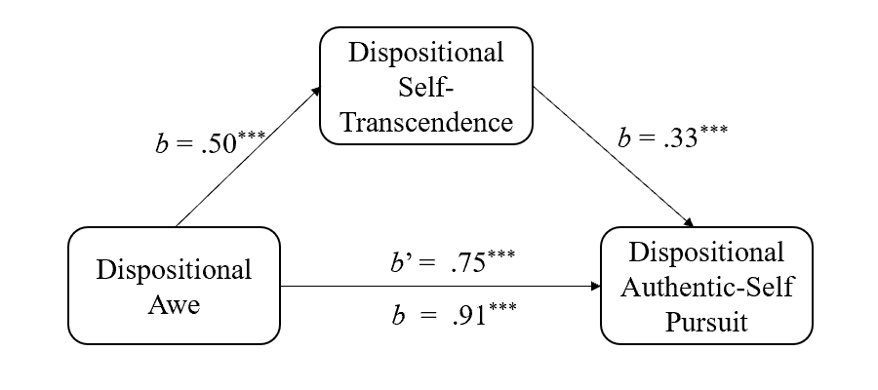
Study 4
In experiment Study 4, we re-tested H2, namely, that self-transcendence mediates the effect of awe on authentic-self pursuit.
Method
Participants
We used the Monte Carlo Power Analysis for Indirect Effects application (Schoemann et al., 2017) to determine the sample size for our proposed mediation model. As the awe manipulation has a medium sized effect on self-transcendence (Jiang et al., 2018) and on authentic-self pursuit (Study 2), we surmised that the relations among the awe manipulation, self-transcendence, and authentic-self pursuit would be medium. Thus, we estimated that we needed at least 184 participants to reach power .90, assuming inter-correlations of r = .30 (SD = .10). We recruited 200 Chinese participants on Credamo. We excluded three for failing an attention check, and two for not following instructions, resulting in a final sample of 195 participants (104 men, 91 women; M_{age} = 30.64, SD_{age} = 5.46) whom we randomly assigned to the experimental (n = 94) or control (n = 101) condition.
Procedure and Materials
First, we manipulated awe as in Study 2. Next, we assessed self-transcendence with the 4-item Jiang et al. (2018) scale (e.g., “I can move beyond the things that once seemed so important”, “I want to ﬁnd answers to some universal spiritual questions”; 1 = strongly disagree, 7 = strongly agree; M = 5.57, SD = .96, α = .72) by adapting the instructions to the state level (“Please indicate your agreement or disagreement with the following statements based on how you are feeling”). Subsequently, we measured authentic-self pursuit (M = 6.85, SD = 1.50, α = .95) as in Study 2. Finally, we assessed anger, awe, disgust, fear, pride, sadness, and happiness, as in Study 2. We moved the assessment of these emotional states to the end to minimize possible interference with responses to authentic-self pursuit.
Results and Discussion
Awe Manipulation Check
We present descriptive statistics in Table 1. Participants in the experimental condition felt more awe than their control condition counterparts, F(1, 193) = 90.89, p < .001, η_{p}² = .320. Moreover, participants in the experimental (vs. control) condition felt less anger, F(1, 193) = 17.40, p < .001, η_{p}² = .083, and disgust, F(1, 193) = 27.76, p < .001, η_{p}² = .126, but felt more fear, F(1, 193) = 10.11, p = .002, η_{p}² = .050, pride, F(1, 193) = 11.62, p = .001, η_{p}² = .057, and happiness, F(1, 193) = 7.47, p = .007, η_{p}² = .037. The two conditions did not differ in sadness, F(1, 193) = .74, p = .39, η_{p}² = .004. Controlling for anger, disgust, fear, pride, and happiness, the difference in awe between the two conditions remained significant, F(1, 188) = 45.56, p < .001, η_{p}² = .195. The manipulation was effective.
Self-Transcendence and Authentic-Self Pursuit
Experimental participants (M = 5.89, SD = .69) reported higher self-transcendence than controls (M = 5.28, SD = 1.07), F(1, 193) = 21.79, p < .001, η_{p}² = .101. Further, consistent with H1, experimental participants (M = 7.12, SD = 1.27) were more motivated to pursue their authentic self than controls (M = 6.59, SD = 1.66), F(1, 193) = 6.05, p = .015, η_{p}² = .030.
Mediation Analysis
We entered awe as independent variable (1 = experimental condition, 0 = control condition), self-transcendence as mediator, and authentic-self pursuit as dependent variable. The indirect effect was significant, b = .62, SE = .15, 95% CI [.3523, .9179] (Figure 2). Self-transcendence mediated the effect of awe on authentic-self pursuit, in support of H2.

Figure 2
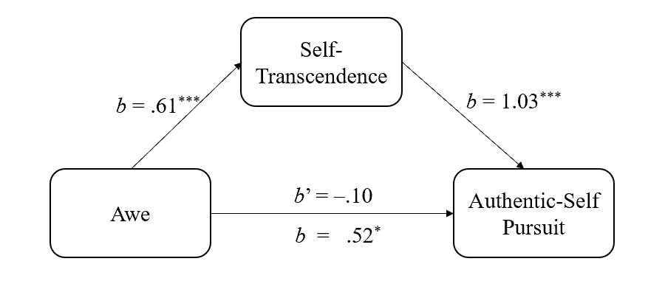
Self-Transcendence Mediates the Effect of Awe on Authentic-Self Pursuit in Study 4

Study 5
In experimental Study 5, we re-tested H2 with a novel measure of authentic-self pursuit.
Method
Participants
We recruited 200 Chinese participants on Credamo aiming for at least 184 (Schoemann et al., 2017). We excluded nine for failing an attention check, and two for failing to follow instructions. The final sample comprised 189 participants (110 women, 79 men; M_{age} = 27.50, SD_{age} = 5.95). We randomly allocated them to the experimental (n = 92) or control (n = 97) condition.
Procedure and Materials
We manipulated awe, and measured self-transcendence (M = 5.42, SD = .91, α = .68), as in Study 4. Next, we presented participants with four quotes from poets or novelists and asked them to indicate how accurately each quote reflected how they were feeling (i.e., the manipulation; 1 = not at all, 7 = extremely). A sample quote is: “I went to the woods because I wanted to live deliberately. I wanted to live deep and suck out all the marrow of life. To put to rout all that was not life, and not, when I had come to die, discover that I had not lived” (Thoreau, 2004, p. 88). We averaged responses to create an authentic-self pursuit index (M = 4.80, SD = 1.13, α = .77). Afterwards, we instructed participants to report their emotional states (as in Study 4). Finally, for validational purposes, we presented participants with a definition of the authentic self, and asked them to indicate the extent to which the quotes reflected a person’s efforts to be their authentic self (authentic-self pursuit manipulation check; 1 = not at all, 7 = extremely; M = 5.04, SD = 1.01, α = .74).
Results and Discussion
Awe Manipulation Check
We report descriptive statistics in Table 1. As intended, participants in the experimental condition felt more awe than those in the control condition, F(1, 187) = 56.09, p < .001, η_{p}² = .231. Also, participants in the experimental (vs. control) condition felt less anger, F(1, 187) = 4.54, p = .034, η_{p}² = .024, and disgust, F(1, 187) = 12.28, p = .001, η_{p}² = .062, but felt more fear, F(1, 187) = 17.08, p < .001, η_{p}² = .084, pride, F(1, 187) = 19.18, p < .001, η_{p}² = .093, and happiness, F(1, 187) = 9.37, p = .003, η_{p}² = .048. The two conditions did not differ in sadness (F(1, 187) = .80, p = .37, η_{p}² = .004). The difference in awe between the two conditions remained significant after controlling for anger, disgust, fear, pride, and happiness, F(1, 182) = 12.46, p = .001, η_{p}² = .064. The manipulation was successful.
Authentic-Self Pursuit Manipulation Check
We conducted a one sample t-test (comparing against 4, the scale mid-point) on the post-manipulation question of whether the quotes reflected one’s efforts to be their authentic self. This was indeed the case (M = 5.04, SD = 1.01), t(188) = 14.22, p < .001, d = 1.03. Participants’ perceptions of the content of the quotes did not differ in the experimental (M = 5.16, SD = 1.01) and control (M = 4.93, SD = 1.00) conditions, F(1, 187) = 2.41, p = .12, η_{p}² = .013.
Self-Transcendence and Authentic-Self Pursuit
Experimental participants (M = 5.57, SD = .80) reported greater self-transcendence than controls (M = 5.28, SD = .99), F(1, 187) = 5.15, p = .024, η_{p}² = .027. Consistent with H1, experimental participants (M = 5.03, SD = 1.01), more than controls (M = 4.58, SD = 1.20), indicated that the quotes were a better reflection of how they felt during the recall task (i.e., in pursuit of the authentic self), F(1, 187) = 7.92, p = .005, η_{p}² = .041.
Mediation Analysis
We entered awe as independent variable (1 = experimental condition, 0 = control condition), self-transcendence as mediator, and authentic-self pursuit as dependent variable. The indirect effect was significant, b =.21, SE = .10, 95% CI [.0285, .4053] (Figure 3). In support of H2, self-transcendence mediated the effect of awe on authentic-self pursuit.

Figure 3
Self-Transcendence Mediates the Effect of Awe on Authentic-Self Pursuit in Study 5
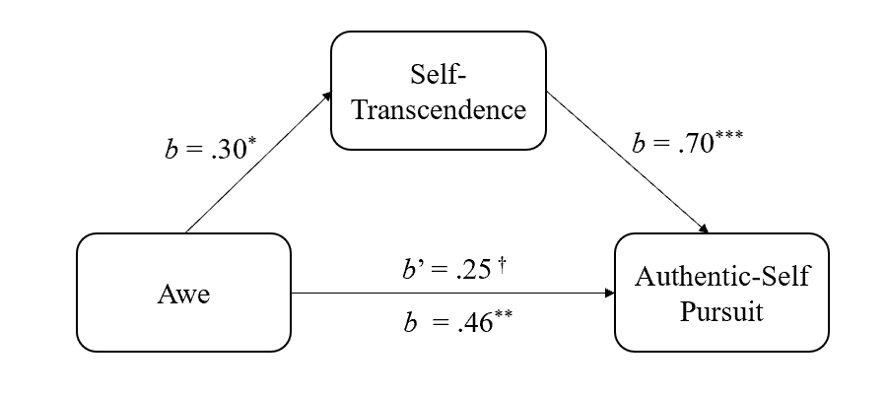
Study 6
We engaged in another replication in experimental Study 6. Specifically, we re-tested H2 with a video-based manipulation, a common awe induction (Algoe & Haidt, 2009; Piff et al. 2015; Prade & Saroglou, 2016; Van Cappellen & Saroglou, 2012). We used a video in which the earth was viewed from space (Hornsey et al., 2018; Nelson-Coffey et al., 2019; Yaden et al., 2016).
Method
Participants and Design
Aiming for an N of at least 184, we tested 240 Chinese participants on Credamo. We excluded nine for failing an attention check, leaving 231 participants (122 men, 109 women; M_{age} = 30.49, SD_{age} = 6.03) in the final sample. We randomly allocated them to the experimental (n = 107) or control (n = 124) condition.
Procedure and Materials
In the experimental condition, participants watched a 302-second video (validated by Hornsey et al., 2018), illustrating the comparative sizes of the earth and other celestial bodies. In the control condition, participants watched also a 302-second video illustrating an ordinary street scene in Guangzhou, China. Next, all participants reported their self-transcendence (M = 5.25, SD = 1.15, α = .82), authentic-self pursuit (M = 6.51, SD = 1.67, α = .95), and emotional states, as in Study 4.
Results and Discussion
Awe Manipulation Check
We present descriptive statistics in Table 1. As intended, experimental participants felt more awe than controls, F(1, 229) = 24.94, p < .001, η_{p}² = .098. Also, experimental (vs. control) participants felt more fear, F(1, 229) = 5.00, p = .026, η_{p}² = .021. Participants in the two conditions did not differ significantly in anger, F(1, 229) = .09, p = .77, η_{p}² < .001, disgust, F(1, 229) = 2.42, p = .12, η_{p}² = .010, sadness, F(1, 229) = .57, p = .45, η_{p}² = .002, and happiness, F(1, 229) = .65, p = .42, η_{p}² = .003. Controlling for fear, the difference in awe between the two conditions remained significant, F(1, 228) = 21.28, p < .001, η_{p}² = .085. The manipulation was effective.
Self-Transcendence and Authentic-Self Pursuit
Experimental participants (M = 5.55, SD = .89) reported more self-transcendence than controls (M = 4.99, SD = 1.27), F(1, 229) = 14.74, p < .001, η_{p}² = .060. Also, in line with H1, experimental participants (M = 6.86, SD = 1.43) reported stronger authentic-self pursuit than controls (M = 6.21, SD = 1.81), F(1, 229) = 8.85, p = .003, η_{p}² = .037.
Mediation Analysis
We entered awe as independent variable (1 = experimental condition, 0 = control condition), self-transcendence as mediator, and authentic-self pursuit as dependent variable. The indirect effect was significant, b = .63, SE =.16, 95% CI [.3109, .9435] (Figure 4). In further support of H2, self-transcendence mediated the effect of awe on authentic-self pursuit.

Figure 4
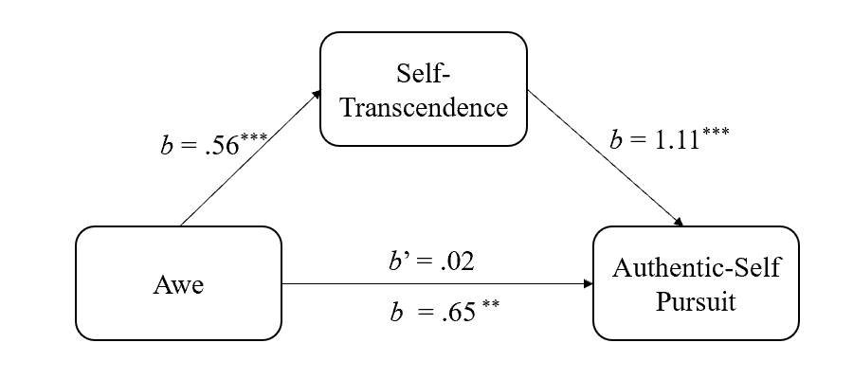
Self-Transcendence Mediates the Effect of Awe on Authentic-Self Pursuit in Study 6
Study 7
So far, we carried out all of our experimental studies in the laboratory. In Study 7, we tested H2 in a field experiment in Tibet, exploring boundaries of the putative effect. In particular, we induced awe in a different way, exposure to a nature site (Bai et al., 2017).
Method
Participants
Although we aimed for an N of 184, as in our prior studies evaluating the mediation model, we were successful in recruiting only 179 participants (96 women, 83 men; M_{age} = 27.88, SD_{age} = 5.90) in Tibet, within our temporal constraints. A post-hoc power sensitivity analysis (G*power; Faul et al., 2007) showed that our N = 179 (α = .05) allowed us to achieve 90% power for detecting effect sizes of f = .24 in a between-subjects Analysis of Variance (ANOVA). Eighty-five of them were in the experimental condition (i.e., tested at Yamdrok Lake—see below and Supplementary Materials) and 94 in the control condition (i.e., tested at Wanda Plaza).
Procedure and Materials
A research assistant approached individuals who visited either Yamdrok Lake, one of the three largest sacred lakes in Tibet, or Wanda Plaza, a shopping mall in Lahsa, the capital of the Tibet Autonomous Region, and asked them to complete a brief survey based on how they were feeling at each site (awe manipulation). Then, the research assistant asked participants to complete measures of self-transcendence (M = 4.78, SD = 1.55, α = .85), authentic-self pursuit (M = 5.87, SD = 1.78, α = .93), and emotional states, as per Study 4.
Results and Discussion
Awe Manipulation Check
We present descriptive statistics in Table 1. As intended, participants in the experimental condition felt more awe than those in the control condition, F(1, 177) = 73.11, p < .001, η_{p}² = .292. Also, participants in the experimental (vs. control) condition felt more pride, F(1, 177) = 38.29, p < .001, η_{p}² = .178, and happiness, F(1, 177) = 28.69, p < .001, η_{p}² = .139, and felt less anger, F(1, 177) = 9.23, p = .003, η_{p}² = .050, disgust, F(1, 177) = 14.66, p < .001, η_{p}² = .076, and sadness, F(1, 177) = 4.39, p = .038, η_{p}² = .024. The two groups did not differ significantly on fear, F(1, 177) = 1.60, p = .21, η_{p}² = .009. Controlling for anger, disgust, pride, sadness, and happiness, the difference in awe remained significant, F(1, 172) = 40.49, p < .001, η_{p}² = .191. The manipulation was effective.
Self-Transcendence and Authentic-Self Pursuit
Experimental participants (M = 5.46, SD = 1.42) reported greater self-transcendence than controls (M = 4.17, SD = 1.40), F(1, 177) = 37.58, p < .001, η_{p}² = .175. Additionally, experimental participants (M = 6.41, SD = 1.73) indicated stronger authentic-self pursuit than controls (M = 5.38, SD = 1.68), F(1, 177) = 16.43, p < .001, η_{p}² = .085, in accord with H1.
Mediation Analysis
We entered awe as independent variable (1 = experimental condition, 0 = control condition), self-transcendence as mediator, and authentic-self pursuit as dependent variable. The indirect effect was significant, b = .96, SE = .19, 95% CI [.6129, 1.3636] (Figure 5). Consistent with H2, self-transcendence mediated the effect of awe on authentic-self pursuit.

Figure 5
Self-Transcendence Mediates the Effect of Awe on Authentic-Self Pursuit in Study 7
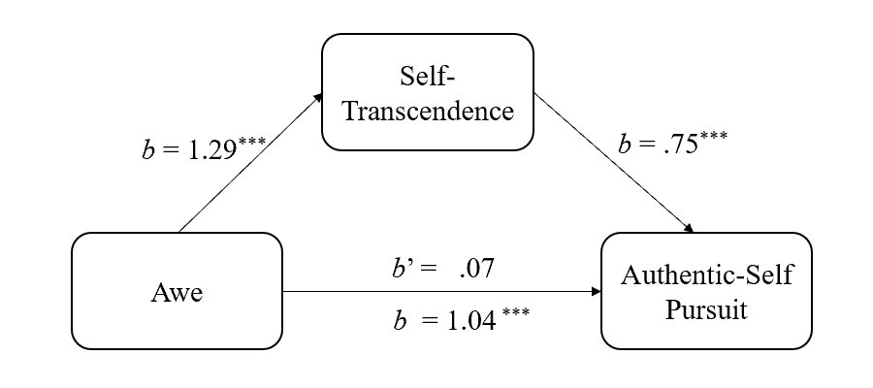
Study 8
Using multiple awe induction techniques and authentic-self pursuit measures, Study 2 and Studies 4-7 showed that awe motivates the pursuit of authentic self, and self-transcendence mediates this pursuit. Participants in these experiments were Chinese. Prior research on the link between awe and self-smallness reported consistent results across Chinese and US samples (Bai et al., 2017). Nevertheless, we opted to explore, in experimental Study 8, whether the effect of awe on authentic-self pursuit is transmitted by self-transcendence among both Chinese and US participants.
Method
Participants and Design
A meta-analysis of Studies 2 and 4-7 showed that awe has a moderately sized effect on authentic-self pursuit (d = 0.46, SE = .07, 95% CI [0.34, 0.59], Z = 7.13, p < .001). Thus, to detect a medium-sized effect (f = 0.25) of awe on authentic-self pursuit, aiming for 90% power, at least 172 participants were needed (G*Power; Faul et al., 2007). We recruited 200 Chinese participants via Credamo and 208 US participants via Prolific Academic into a 2 (culture: Chinese, US) × 2 (manipulation: awe, control) between-subjects design. We excluded 13 for failing an attention check, 17 for failing to follow the instructions, and four for noncompletion. We randomly assigned the remaining 374 participants (187 Chinese, 187 US; 193 women, 181 men; M_{age} = 32.63, SD_{age} = 6.40) either to the experimental (n = 201; 94 US, 107 Chinese) or control (n = 173; 93 US, 80 Chinese) condition.
Although Study 8 is well-powered to detect moderate main effects of the awe manipulation, we required a larger sample size to explore the role of culture. Given that G*Power gives comparable sample size estimates for two-cell between-subjects designs as it does for 2×2 between-subjects designs, some researchers have suggested that following these guidelines will produce underpowered interaction effects (Giner-Sorolla, 2018; https://approachingblog.wordpress.com/2018/01/24/powering-your-interaction-2/). Despite having no compelling reason to expect culture effects or cultural differences, we decided to double our sample size and recruit approximately 400 participants. Using a simulation approach (White, 2018; https://www.markhw.com/blog/power-twoway), we examined the sensitivity of our sample size to detect interaction effects. This approach suggests that the final sample of 374 participants gives us 99% power to detect a reversal effect (Cohen’s d_{CHINA} = 0.46 and d_{USA} = − 0.46) and 60% power to detect a knockout effect (Cohen’s d_{CHINA} = 0.46 and d_{USA} = 0).
Procedure and Materials
We manipulated awe as in Study 2. Next, we measured self-transcendence (M = 5.35, SD = 1.25, α = .83) and authentic-self pursuit (M = 6.92, SD = 1.60, α = .94) as in Study 4. Finally, we measured emotional states as before.
Results and Discussion
Awe Manipulation Check
We present descriptive statistics in Table 1. Experimental participants felt more awe than controls, F(1, 372) = 255.88, p < .001, η_{p}² = .408. They also felt more fear, F(1, 372) = 32.12, p < .001, η_{p}² = .079, pride, F(1, 372) = 20.34, p < .001, η_{p}² = .052, and happiness, F(1, 372) = 35.46, p < .001, η_{p}² = .087, than controls. The two groups of participants did not differ significantly in anger, F(1, 372) = 2.62, p = .11, η_{p}² = .007, disgust, F(1, 372) = .98, p = .32, η_{p}² = .003, and sadness, F(1, 372) = 1.20, p = .27, η_{p}² = .003. The two groups still differed significantly in awe, controlling for fear, pride, and happiness, F(1, 369) = 161.67, p < .001, η_{p}² = .305. The manipulation was successful.
Self-Transcendence and Authentic-Self Pursuit
We carried out a 2 (culture) × 2 (manipulation) ANOVA on self-transcendence. The awe main effect was significant: Experimental participants (M = 5.63, SD = .95) reported greater self-transcendence than controls (M = 5.03, SD = 1.47), F(1, 370) = 21.35, p < .001, η_{p}² = .055. The culture main effect, though, was not significant (Chinese participants: M = 5.48, SD = 1.00; US participants: M = 5.23, SD = 1.45), F(1, 370) = 2.65, p = .10, η_{p}² = .007. Importantly, the interaction was not significant either, F(1, 370) = .12, p = .73, η_{p}² < .001. Specifically, Chinese participants reported greater self-transcendence in the experimental (M = 5.75, SD = .67) than control (M = 5.12, SD = 1.23) condition, F(1, 370) = 12.23, p = .001, η_{p}² = .032; similarly, US participants reported greater self-transcendence in the experimental (M = 5.50, SD = 1.17) than control (M = 4.96, SD = 1.65) condition, F(1, 370) = 9.22, p = .003, η_{p}² = .024.
Next, we conducted a 2 × 2 ANOVA on authentic-self pursuit. We obtained a significant manipulation main effect. Consistent with H1, participants in the experimental condition (M = 7.19, SD = 1.31) were more likely to pursue their authentic self than those in the control condition (M = 6.62, SD = 1.83), F(1, 370) = 11.53, p = .001, η_{p}² = .030. The culture main effect was not significant (Chinese participants: M = 7.03, SD = 1.31; US participants: M = 6.82, SD = 1.84), F(1, 370) = 1.23, p = .27, η_{p}² = .003. Crucially, the interaction was not significant either, F(1, 370) = .07, p = .79, η_{p}² < .001. In particular, Chinese participants reporter stronger authentic-self pursuit in the experimental (M = 7.25, SD = .86) than control (M = 6.74, SD = 1.70) condition, F(1, 370) = 4.83, p = .029, η_{p}² = .013; likewise, US participants reported stronger authentic-self pursuit in the experimental (M = 7.11, SD = 1.69) than control (M = 6.51, SD = 1.95) condition, F(1, 370) = 6.79, p = .010, η_{p}² = .018.
Mediation and Moderated Mediation Analyses
We conducted a mediation analysis entering awe as independent variable (1 = experimental condition, 0 = control condition), self-transcendence as mediator, and authentic-self pursuit as dependent variable. The indirect effect was significant, b = .44, SE = .11, 95% CI [.2415, .6771] (Figure 6).

Figure 6
Self-Transcendence Mediates the Effect of Awe on Authentic-Self Pursuit in Study 8
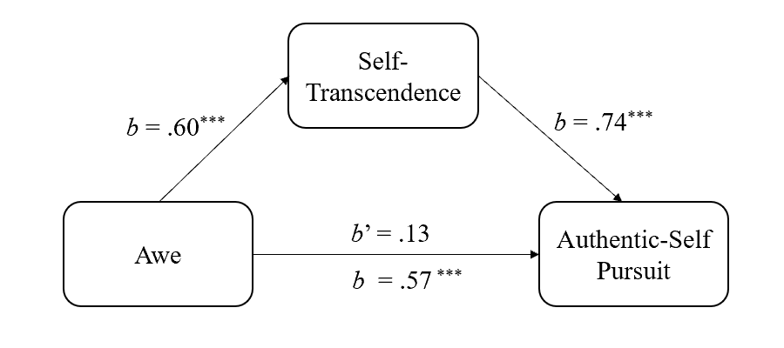
Next, we explored moderation by culture through two moderated mediation models. First, we entered awe as independent variable (1 = experimental condition, 0 = control condition), self-transcendence as mediator, authentic-self pursuit as dependent variable, and culture (1 = US, −1 = China) as moderator into model 8 (Hayes, 2018; PROCESS 3.5; 5,000 iterations). The Awe × Culture interaction effect on self-transcendence (b = −.04, SE = .13, 95% CI [−.2931, .2045]) was not significant, and neither was the interaction effect on authentic-self pursuit (b = .08, SE = .14, 95% CI [−.1888, .3426]), moderated mediation index = −.07, SE = .19, 95% CI [−.4714, .2978], suggesting culture did not moderate the effects of awe on self-transcendence and authentic-self pursuit.
Second, we entered awe as independent variable (1 = experimental condition, 0 = control condition), self-transcendence as mediator, authentic-self pursuit as dependent variable, and culture (1 = US, −1 = China) as moderator into model 15 (Hayes, 2018; PROCESS 3.5; 5,000 iterations). The Awe × Culture interaction effect on authentic-self pursuit was not significant, b = .18, SE = .14, 95% CI [−.0974, .4504]). However, the Self-Transcendence × Culture interaction effect on authentic-self pursuit was significant, b = −.17, SE = .06, 95% CI [−.2850, −.0505]), suggesting that culture influenced the relation between self-transcendence and authentic-self pursuit. Moderated mediation index = −.20, SE = .10, 95% CI [−.4107, −.0277] (Figure 7). For Chinese participants, the mediating effect of self-transcendence on authentic-self pursuit was significant, (b = .58, SE = .14, 95% CI [.3098, .8768]) and so was it for US participants (b = .38, SE = .10, 95% CI [.2015, .5900]. The cross-cultural difference, then, was ordinal. That is, self-transcendence mediated the effect of awe on authentic-self pursuit in both samples, but the effect was larger among Chinese participants. Taken together, the results provided plausible cross-cultural support for H2.

Figure 7
The Moderated Mediation Model in Study 8

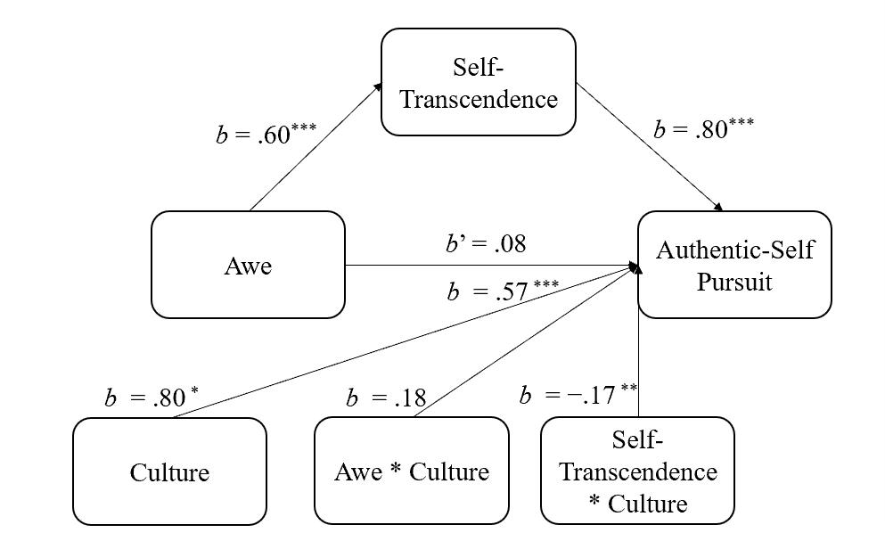

Study 9
In experimental Study 2 and Studies 4-8, the awe manipulation evoked not only awe but also other emotional states. Indeed, awe is a complex emotion that is naturally accompanied by a variety of other emotional states (e.g., contentment, joy, pride, happiness; Campos et al., 2013; Shiota et al., 2007; Valdesolo & Graham, 2014). Also, an awe manipulation may evoke different configurations of awe-related emotional states depending on method of elicitation and context. As such, it is not clear that those constituent emotional states should be covaried out in subsequent analyses, risking the disturbance of the “gestalt” character of awe. In addition, such covariance analyses have been criticized on methodological grounds (Huitema, 1980; Miller & Chapman, 2001; Tu et al., 2008—see Supplementary Materials). Further, in all our experiments awe was rated above the scale midpoint, and higher than any other emotional state. Nevertheless, we re-analyzed the data in all preceding and subsequent experimental studies, controlling for emotional states that were also evoked—alongside awe—by our manipulations. The result patterns were generally similar, albeit often weaker, to the reported ones (Supplementary Materials).
We note, however, that two of the most common emotional states that covaried with the elicitation of awe in Study 2 and Studies 4-8 were pride and happiness. Therefore, in experimental Study 9, we tested directly whether awe impacts uniquely on authentic-self pursuit, and whether this impact is uniquely mediated by self-transcendence, by manipulating awe vis a vis pride and happiness.
Method
Participants
According to G*Power analysis (Faul et al., 2007), at least 207 participants were needed to detect a medium effect size (f = .25) for a 3-way between-subjects design with power .90 (α = .05). We recruited 250 Chinese participants on Credamo. We excluded 14 for failing an attention check, resulting in a final sample of 236 participants (92 men, 144 women; M_{age} = 29.54, SD_{age} = 6.89) whom we randomly assigned to the awe (n = 79), pride (n = 77), or happiness (n = 80) condition.
Procedure and Materials
We used a scenario-based manipulation of awe, pride, and happiness (Rudd et al., 2012; Wilson-Mendenhall et al., 2013; Yeung & Shen, 2019). Participants imagined that they were a company employee. In the awe condition, they imagined that their company had recently organized a camping activity in the wild, during which they saw the Milky way and tried to absorb the scene. In the pride condition, participants imagine that their company has recently organized a walk in the wild activity, during which they won first place and were praised by others. In the happiness condition, they imagined that their company had recently organized a team-building activity at which they won the first prize in the luck draw. To aid their imagination, we supplied corresponding pictures in each condition. We instructed all participants to imagine the experience as vividly as possible and to list their thoughts and feelings.
Next, we assessed self-transcendence (1 = strongly disagree, 9 = strongly agree; M = 6.81, SD = 1.25, α = .77) and authentic-self pursuit (1 = not at all, 11 = extremely; M = 8.31, SD = 1.63, α = .94) as in Study 4. Subsequently, we assessed awe, pride, and happiness (1 = not at all, 7 = extremely), in a separate random order for each participant, to check the effectiveness of the manipulation. We also examined the vividness of participants’ imagination with two items: “I can vividly imagine the experience” and “I can imagine this experience well” (1 = strongly disagree, 7 = strongly agree; M = 6.06, SD = .79). Responses were correlated, r(236) = .57, p < .001, and so we computed a composite.
Results and Discussion
Manipulation Check
We conducted a Multivariate Analysis of Variance to test the effect of the manipulation (awe vs. happiness vs. pride) on the emotional states of awe, pride, and happiness. The manipulation main effect was significant, Pillai’s Trace = .42, F(6, 464) = 20.35, p < .001, η_{p}² = .208. We proceeded with analytical comparisons, testing the relative impact of the three conditions separately on each emotional state.
The effect of the manipulation on awe was significant, F(2, 233) = 55.33, p < .001, η_{p}² = .322. Participants in the awe condition (M = 6.11, SD = 1.01) felt more awe than those in the pride (M = 4.23, SD = 1.68; M_{diff} = 1.88, SE = .23, p < .001) or happiness (M = 3.84, SD = 1.59; M_{diff} = 2.28, SE = .23, p < .001) condition. Participants in the latter two condition did not differ on awe (M_{diff} = .40, SE = .23, p = .089).
The effect of the manipulation on pride was significant, F(2, 233) = 4.51, p =.012, η_{p}² = .037. Participants in the pride condition (M = 5.57, SD = 1.14) felt more pride than those in the awe (M = 4.99, SD = 1.38; M_{diff} = .58, SE = .22, p = .007) or happiness (M = 5.04, SD = 1.48; M_{diff} = .53, SE = .22, p = .014) condition. Participants in the latter two conditions did not differ on pride (M_{diff} = –.05, SE = .21, p = .81).
Lastly, the effect of the manipulation variable on happiness was significant, F(2, 233) = 5.00, p = .008, η_{p}² = .041. Participants in the happiness condition (M = 5.81, SD = 1.26) felt happier than those in the awe (M = 5.32, SD = 1.06; M_{diff} = .50, SE = .18, p = .005), but not the pride (M = 5.79, SD = 1.00; M_{diff} = .02, SE = .18, p = .91) condition. Further, participants in the awe condition felt less happy than those in the pride condition (M_{diff} = –.48, SE = .18, p = .008). Taken together, our manipulation was effective.
Self-Transcendence and Authentic-Self Pursuit
The main effect on self-transcendence was significant, F(2, 233) = 14.66, p <.001, η_{p}² = .112. Participants in the awe condition (M = 7.37, SD = .91) reported more self-transcendence than those in the pride condition (M = 6.69, SD = 1.23; M_{diff} = .68, SE = .19, p < .001) or happiness (M = 6.37, SD = 1.37; M_{diff} = 1.00, SE = .19, p < .001) condition. Participants in the latter two conditions did not differ on self-transcendence (M_{diff} = .32, SE = .19, p = .093).
The main effect on authentic-self pursuit was also significant, F(2, 233) = 13.47, p <.001, η_{p}² = .104. Participants in the awe condition (M = 8.90, SD = 1.15) reported greater authentic-self pursuit than those in the pride (M = 8.40, SD = 1.40; M_{diff} = .50, SE = .25, p = .044) or happiness (M =7.63, SD = 1.98; M_{diff} = 1.27, SE = .25, p < .001) condition. Participants in the pride condition reported greater authentic-self pursuit than those in the happiness condition (M_{diff} = .76, SE = .25, p = .002). The results are in accord with H1.
Finally, the main effect on vividness was not significant, F(2, 233) = 1.34, p = .26, η_{p}² = .011. Participants in the awe (M = 6.11, SD = .71), pride (M = 5.94, SD = .78), and happiness (M = 6.12, SD = .86) conditions did not differ in the vividness of their corresponding experience. The abovementioned effects were not due to differential vividness.
Mediation Analysis
We entered the manipulation as independent variable (1 = awe condition, 0 = pride and happiness conditions), self-transcendence as mediator, and authentic-self pursuit as dependent variable. The indirect effect was significant, b = .85, SE = .16, 95% CI [.5461, 1.1770] (Figure 8). Consistent with H2, awe had a unique effect on self-transcendence and authentic-self pursuit, and self-transcendence mediated the effect of awe on authentic-self pursuit above and beyond pride and happiness.

Figure 8
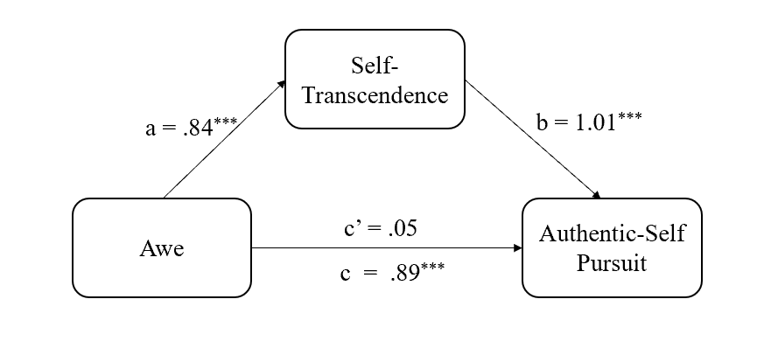
Self-Transcendence Mediates the Effect of Awe on Authentic-Self Pursuit in Study 9
Study 10
In experimental Study 10, we were concerned with the role of self-smallness in the relations among awe, self-transcendence, and authentic-self pursuit. We expected, in accord with prior research (Bai et al., 2017; Piff et al., 2015; Shiota et al., 2007), that awe would engender self-smallness. Beyond that, we engaged in exploratory mediation analyses. We wanted to know whether self-smallness (1) mediates the effect of awe on self-transcendence, (2) mediates the effect of awe on authentic-self pursuit, (3) is a more potent simultaneous mediator of the effect of awe on authentic-self pursuit than self-transcendence, and (5) serially mediates the effect of awe on self-transcendence (awe ⇒ self-smallness ⇒ self-transcendence ⇒ authentic-self pursuit).
Method
Participants
We relied on the Monte Carlo Power Analysis for Indirect Effects application (Schoemann et al., 2017) to determine the sample size for our proposed serial mediation model. We needed at least 274 participants to reach power .90, assuming correlations of r = .30 (SD = .10) among the independent variable (awe), the two putative mediators (self-smallness, self-transcendence), and the dependent variable (authentic-self pursuit).
We recruited 300 Chinese participants on Credamo. We excluded 11 for failing an attention check, and eight for not following instructions, leaving in the sample 281 participants (145 men, 136 women; M_{age} = 28.68, SD_{age} = 5.58). We randomly allocated them to the experimental (n = 141) or control (n = 140) condition.
Procedure and Materials
We manipulated awe as in Study 2. Afterward, we assessed self-smallness with the 5-item Bai et al. (2017) scale. Two items are narrative (i.e., “I feel relatively small”, “I feel insignificant”) and three are pictorial. The first pictorial item depicts seven circles that become progressively bigger, and participants are asked to select the circle that “best describes how big or small you feel about yourself.” The second pictorial item depicts seven full-body drawings (stick figures) that become increasingly bigger, and participants are asked to indicate “which one of the following drawings best describes yourself.” The third and final pictorial item depicts seven signatures that become progressively larger, and participants are instructed: “Looking at the drawing you selected in the question above, which of the following signatures below would most closely resemble your own?” Responses to all five items range from 1 to 7. After reverse-coding responses to the pictorial items, we computed the self-smallness index (M = 4.08, SD = 1.39, α = .88). We measured self-transcendence (M = 5.51, SD = .80, α = .61) and authentic-self-pursuit (M = 6.96, SD = 1.26, α = .92) as in Study 4. Finally, we assessed the emotional states as in Study 4.
Results and Discussion
Awe Manipulation Check
We present descriptive statistics in Table 1. Participants in the experimental condition felt more awe than those in the control condition, F(1, 279) = 134.13, p < .001, η_{p}² = .325. Moreover, participants in the experimental (vs. control) condition felt less anger, F(279) = 14.31, p < .001, η_{p}² = .049, disgust, F(1, 279) = 21.69, p < .001, η_{p}² = .072, and sadness, F(1, 279) = 6.99, p = .009, η_{p}² = .024, but felt more fear, F(1, 279) = 4.29, p = .039, η_{p}² = .015, pride, F(1, 279) = 17.52, p < .001, η_{p}² = .059, and more happiness, F(1, 279) = 5.56, p = .019, η_{p}² = .020. Controlling for anger, disgust, fear, pride, sadness, and happiness, the difference in awe between the two conditions remained significant, F(1, 273) = 73.30, p < .001, η_{p}² = .212. The manipulation was effective.
Self-Smallness, Self-Transcendence, and Authentic-Self Pursuit
Experimental participants (M = 4.89, SD = 1.19) reported more self-smallness than control ones (M = 3.27, SD = 1.06), F(1, 279) = 144.14, p < .001, η_{p}² = .341, replicating previous findings (Bai et al., 2017; Joye & Bolderdijk, 2015; Piff et al., 2015). As in prior studies, experimental participants (M = 5.69, SD = .69) reported more self-transcendence than controls (M = 5.33, SD = .86), F(1, 279) = 14.47, p < .001, η_{p}² = .049. Consistent with H1, experimental participants (M = 7.26, SD = .97) indicated stronger authentic-self pursuit than controls (M = 6.65, SD = 1.45), F(1, 279) = 17.36, p < .001, η_{p}² = .059.
Correlational and Mediation Analyses
We carried out correlational analyses among the three variables of interest. Self-smallness was positively and weakly correlated with self-transcendence, r(281) = .15, p = .013, but was uncorrelated with authentic-self pursuit, r(281) = .04, p = .48. Self-transcendence, though, was positively and strongly correlated with authentic-self pursuit, r(281) = .57, p < .001.
We proceeded with a series of five mediation analyses. First, we tested whether self-transcendence mediates the effect of awe on authentic-self pursuit. We entered awe as independent variable (1 = experimental condition, 0 = control condition), self-transcendence as mediator, and authentic-self pursuit as dependent variable. The indirect effect was significant, b = .31, SE = .09, 95% CI [.1450, .4976] (Figure 9). As in prior studies, self-transcendence mediated the effect of awe on authentic-self pursuit in support of H2.

Figure 9
Self-Transcendence Mediates the Effect of Awe on Authentic-Self Pursuit in Study 10
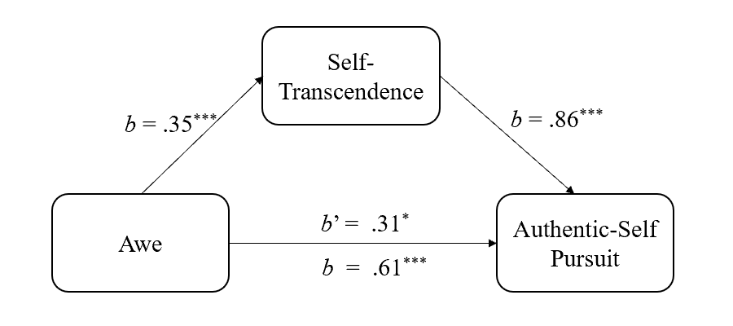
Second, we tested whether self-smallness mediates the effect of awe on self-transcendence. We entered awe as independent variable (1 = experimental condition, 0 = control condition), self-smallness as mediator, and self-transcendence as dependent variable. The indirect effect was not significant, b = .03, SE = .07, 95% CI [−.1060, .1633]. Self-smallness did not mediate the effect of awe on self-transcendence.
Third, we tested whether self-smallness mediates the effect of awe on authentic-self pursuit. We entered awe as independent variable (1 = experimental condition, 0 = control condition), self-smallness as mediator, and authentic-self pursuit as dependent variable. The indirect effect was not significant, b = −.22, SE = .12, 95% CI [−.4516, .0021], suggesting that self-smallness did not qualify as a mediator of the effect of awe on authentic-self pursuit.
Fourth, we tested whether self-smallness and self-transcendence simultaneously mediate the effect of awe on authentic-self pursuit. We entered awe as independent variable (1 = experimental condition, 0 = control condition), self-smallness and self-transcendence as mediators, and authentic-self as dependent variable. The indirect effect of self-smallness was significant but negative, b = −.24, SE = .09, 95% CI [−.4270, −.0759]. The indirect effect of self-transcendence was significant, b = .31, SE = .09, 95% CI [.1440, .5018]. Again, self-transcendence plausibly mediated the effect of awe on authentic-self pursuit, but self-smallness did not.
Lastly, we tested a serial mediation model (awe ⇒ self-smallness ⇒ self-transcendence ⇒ authentic-self pursuit). We entered awe as independent variable (1 = experimental condition, 0 = control condition), self-smallness and self-transcendence as mediators, and authentic-self pursuit as dependent variable. The indirect effect of self-smallness was significant and negative, b = −.24, SE = .09, 95% CI [−.4185, −.0682]. The indirect effect of self-transcendence was significant, b =.28, SE = .11, 95% CI [.0879, .5100]. However, the serial mediation effect was not significant, b = .02, SE = .06, 95% CI [−.0974, .1467].
In all, the results bolster H2, while limiting the role of self-smallness. Although awe induced self-smallness (consistent with the literature: Bai et al., 2017; Piff et al., 2015; Stellar et al., 2018), self-smallness did not conduce to self-transcendence or authentic-self pursuit.
Study 11
So far, we examined (1) the effect of awe on authentic-self pursuit (H1), (2) whether self-transcendence transmits the effect of awe on authentic-self pursuit (H2), and (3) the role of self-smallness in the process. In experimental Study 11, we were concerned with downstream consequences of awe. Specifically, we tested H3a: Awe strengthens general prosociality, and this effect is mediated by authentic-self pursuit.
Method
Participants and Design
Given that awe has a medium sized effect on authentic self-pursuit (Study 2) and on prosociality (Piff et al., 2015), we surmised the inter-relations among awe, authentic-self pursuit, and prosociality would be moderate. We recruited 207 US participants via TurkPrime (Litman et al., 2017), targeting an N of at least 184 (Schoemann et al., 2017). We excluded six for failing two attention check questions, seven for failing to follow the instructions, and six for noncompletion. We randomly assigned the remaining 188 participants (128 women, 60 men; M_{age} = 34.30, SD_{age} = 7.58) to the experimental (n = 89) or control (n = 99) condition.

Procedure and Materials
We manipulated awe as in Study 2. We measured authentic-self pursuit (M = 6.59, SD = 1.75, α = .95) as in Study 4. Finally, we measured general prosociality with the 16-item Prosocialness Scale for Adults (Caprara et al., 2005). We rephrased the items to reflect the state level; in particular, we emphasized the “right now,” preceded each item with the stem “I feel,” and replaced present tense with future tense. Sample items are: “I feel I would try to be close to and take care of those who are in need” and “I feel I would easily put myself in the shoes of those who are in discomfort” (1= not at all, 11 = extremely). We averaged their responses to form a general prosociality index (M = 7.96, SD = 1.91, α = .96). Lastly, we measured emotional states as in Study 4.
Results and Discussion
Manipulation Check
We provide descriptive statistics in Table 1. As intended, experimental participants felt more awe than controls, F(1, 186) = 268.95, p < .001, η_{p}² = .591. Moreover, experimental (vs. control) participants felt more fear, F(1, 186) = 14.27, p < .001, η_{p}² = .071, and happiness, F(1, 186) = 75.35, p < .001, η_{p}² = .288), and felt less anger, F(1, 186) = 9.16, p = .003, η_{p}² = .047, and disgust, F(1, 186) = 10.83, p = .001, η_{p}² = .055. The two conditions did not differ in sadness, F(1, 186) = .27, p = .60, η_{p}² = .001. Controlling for anger, disgust, fear, and happiness did not affect the difference in awe between the two conditions, F(1, 182) = 118.75, p < .001, η_{p}² = .395. Our manipulation was effective.
Authentic-Self Pursuit and General Prosociality
Experimental participants (M = 7.03, SD = 1.50) were more likely to pursue their authentic self than controls (M = 6.18, SD = 1.86), F(1, 186) = 11.81, p = .001, η_{p}² = .060. Further, experimental participants (M = 8.34, SD = 1.76) reported higher general prosociality than controls (M = 7.62, SD = 1.98), F(1, 186) = 6.97, p = .009, η_{p}² = .036.
Mediation Analysis
We examined whether authentic-self pursuit transmitted the effect of awe on general prosociality. We entered awe as independent variable (1 = experimental condition, 0 = control condition), authentic-self pursuit as mediator, and general prosociality as dependent variable. The indirect effect of authentic-self pursuit was significant, b =.28, SE =.13, 95% CI [.0745, .5820] (Figure 10). In support of H3a, authentic-self pursuit mediated the effect of awe on general prosociality.

Figure 10
Authentic-Self Pursuit Mediates the Effect of Awe on General Prosociality in Study 11

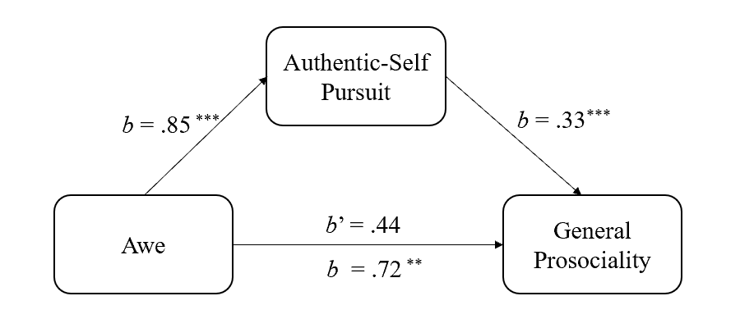
Study 12
We continued to examine downstream consequences of awe in experimental Study 12. In particular, we tested H3b: awe weakens inauthentic prosociality, and this effect is mediated by authentic-self pursuit.
Method
Participants and Design
We recruited 200 Chinese participants on Credamo, aiming for an N of at least 184. We excluded nine for failing an attention check, and one for quitting the experiment. We randomly assigned the remaining 190 participants (107 women, 83 men; M_{age} = 28.10, SD_{age} = 6.36) to the experimental awe (n = 97) or control (n = 93) condition.

Procedure and Materials
We manipulated awe and measured authentic-self pursuit (M = 6.69, SD = 1.65, α = .95) as in Study 2. Further, we measured inauthentic prosociality by presenting participants with the following dilemma vignette in which we asked them to imagine as vividly as possible being the protagonist (Chen—an androgynous name):
Chen works in the HR department of a company and is responsible for internal promotions. In an assessment of a regional manager promotion, Chen’s supervisor was one of the candidates. He asked Chen for help by sending him the materials of other candidates so that he could get fully prepared. This violated the principle of justice that Chen values, and Chen did not approve of it deeply in his heart. But refusing to help would be harmful to his career development in the company.
Subsequently, we instructed participants to respond to three items, preceded by the stem “If you were Chen …”: (a) “how likely would you be to help the supervisor” (1 = very unlikely, 9 = very likely), (b) “what would you do” (1 = help the supervisor, 9 = not help the supervisor), (c) “how likely would you be not to help the supervisor (1 = very unlikely, 9 = very likely)”. After reverse-coding responses to the last two items, we computed an inauthentic prosociality (i.e., helping) index (M = 5.10, SD = 2.24, α = .93).
We checked whether participants would regard helping as indeed being against their authentic self, using the item “Not helping the supervisor is consistent with Chen’s authentic self” (1 = strongly disagree, 7 = strongly agree; M = 5.67, SD = 1.34). We also measured emotional states as in Study 4.
Results and Discussion
Manipulation Check
We provide descriptives in Table 1. As intended, experimental participants felt more awe than controls, F(1, 188) = 25.90, p < .001, η_{p}² = .121. Moreover, experimental (vs. control) participants felt more pride, F(1, 188) = 5.92, p = .016, η_{p}² = .031, and happiness, F(1, 188) = 15.04, p < .001, η_{p}² = .074, and felt less anger, F(1, 188) = 11.60, p = .001, η_{p}² = .058, and disgust, F(1, 188) = 14.48, p < .001, η_{p}² = .072. We found no significant differences in fear, F(1, 188) = .11, p = .74, η_{p}² = .001, and sadness, F(1, 188) = 2.54, p = .11, η_{p}² = .013. The condition difference in awe remained significant controlling for anger, disgust, pride, and happiness, F(1,184) = 14.60, p < .001, η_{p}² = .074. The manipulation was successful.
Inauthentic Prosociality Manipulation Check
As a one sample t-test against the scale midpoint (i.e., 4) indicated, participants thought that not helping the supervisor (M = 5.67, SD = 1.34) was consistent with Chen’s authentic self, t(189) = 17.19, p < .001, d = 1.25. Participants in the two conditions (experimental: M = 5.70, SD = 1.42; control: M = 5.63, SD = 1.25) did not differ in their responses, F(1, 188) = .12, p = .73, η_{p}² = .001.
Authentic-Self Pursuit and Inauthentic Prosociality
Experimental participants (M = 7.15, SD = 1.49) manifested stronger authentic-self pursuit than controls (M = 6.20, SD = 1.67), F(1, 188) = 17.08, p < .001, η_{p}² = .083. The effect of awe on inauthentic prosociality was not significant. In an exploratory analysis, we found that experimental participants (M = 4.80, SD = 2.27) tended to indicate that, if they were Chen, they would be less likely to help the supervisor than control participants did (M = 5.40, SD = 2.18), F(1,188) = 3.43, p = .066, η_{p}² = .018; that is, experimental participants tended to show lower inauthentic prosociality than controls.
Mediation Analysis
We test if authentic-self pursuit transmitted the effect of awe on inauthentic prosociality. We entered awe as independent variable (1 = experimental condition, 0 = control condition), authentic-self pursuit as mediator, and inauthentic prosociality as dependent variable. The indirect effect of authentic-self pursuit was significant and negative, b = −.32, SE =.12, 95% CI [−.6090, −.1130] (Figure 11). Authentic-self pursuit, as triggered by awe, was linked to a reduction in inauthentic prosociality, in support of H3b.

Figure 11
Authentic-Self Pursuit Mediates the Effect of Awe on Inauthentic Prosociality in Study 12
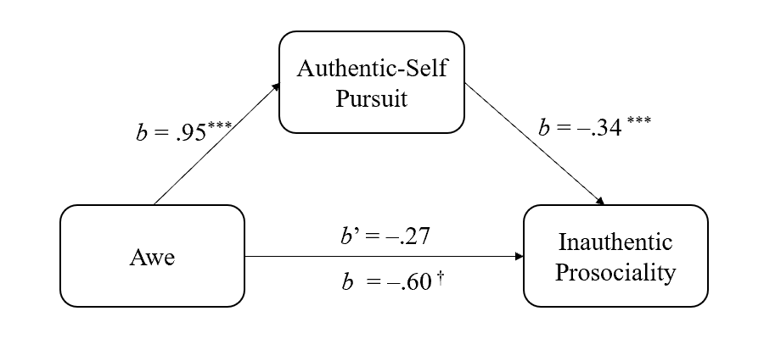
Study 13
Experimental Study 13 constituted an additional test of downstream consequences of awe. Here, we tested H3a and H3b in the same experiment and with difference measures of general prosociality and inauthentic prosociality.
Method
Participants and Design
Targeting an N of at least 184, we recruited 200 participants on Credamo. We excluded eight for failing an attention check, and two for failing to follow instructions. We randomly assigned the remaining 190 participants (118 women, 72 men; M_{age} = 27.98, SD_{age} = 6.74) to the experimental (n = 94) or control (n = 96) condition.
Procedure and Materials
We manipulated awe and measured authentic-self pursuit (M = 6.74, SD = 1.37, α = .92), as in Study 2. Next, we measured general and inauthentic prosociality in counterbalanced order.
We assessed general prosociality by adapting three items from the World Giving index (Charities Aid Foundation, 2019). To reflect the state level, we preceded the items with the stem: “Based on how you are feeling right now, how likely would you be to ...”. The items were: “Help a stranger, or someone I don’t know who needs help”, “Donate money to a charity, “Volunteer my time to an organization” (1 = not at all, 9 = extremely). The three items mapped on to our definition of general prosociality (Penner et al., 2005). We averaged responses to form a general prosociality index (M = 6.65, SD = 1.54, α = .80).
We assessed inauthentic prosociality with five items adapted from the altruism subscale of the Prosocial Tendencies Measure (Carlo & Randall, 2002), preceded by the stem “If helping is against my authentic self …”. Sample items: “I would not help even if it made me look like a good person”, “I would not help even if I expected them to help me in the future” (1 = strongly disagree, 9 = strongly agree). We reverse-scored, as appropriate, and averaged responses to form an inauthentic prosociality index (M = 4.24, SD = 1.73, α = .91). (Participants had already familiarized themselves with the definition of authentic self, as part of the instructions that accompanied the authentic-self pursuit measure.) We assessed emotional states as in Study 4.
Results and Discussion
Manipulation Check
We provide descriptives in Table 1. As intended, experimental participants felt more awe than controls, F(1, 188) = 80.40, p < .001, η_{p}² = .300. Moreover, experimental (vs. control) participants felt more fear, F(1, 188) = 5.46, p = .021, η_{p}² = .028, pride, F(1, 188) = 9.61, p = .002, η_{p}² = .049, and happiness, F(1, 188) = 10.91, p < .001, η_{p}² = .055, and felt less anger, F(1, 188) = 10.17, p = .002, η_{p}² = .051, and disgust, F(1, 188) = 20.83, p < .001, η_{p}² = .100. We observed no significant differences in sadness, F(1, 188) = .60, p = .44, η_{p}² = .003. The condition difference in awe remained significant controlling for anger, disgust, fear, pride, and happiness, F(1,183) = 38.67, p < .001, η_{p}² = .174. The manipulation was successful.
Authentic-Self Pursuit and Prosociality
We found no effects associated with counterbalancing order, and so omitted this variable from subsequent analyses. Experimental participants (M = 7.06, SD = 1.13) exhibited stronger authentic-self pursuit than controls (M = 6.43, SD = 1.50), F(1, 188) = 10.84, p = .001, η_{p}² = .055. Further, experimental participants (M = 7.06, SD = 1.36) reported higher general prosociality than control participants (M = 6.25, SD = 1.60), F(1, 188) = 14.36, p < .001, η_{p}² = .071, in replication of Experiment 8. However, experimental participants (M = 3.99, SD = 1.62) scored lower inauthentic prosociality than their control counterparts (M = 4.49, SD = 1.81), F(1, 188) = 4.09, p = .045, η_{p}² = .021, in replication of Study 12.
Mediation Analysis
We conducted two mediation analyses. First, we entered awe as independent variable (1 = experimental condition, 0 = control condition), authentic-self pursuit as mediator, and general prosociality as dependent variable. The indirect effect of authentic-self pursuit was significant, b =.32, SE =.11, 95% CI [.1221, .5443] (Figure 12). Consistent with Study 11, authentic-self pursuit, as triggered by awe, was linked to increases in general prosociality.

Figure 12
Authentic-Self Pursuit Mediates the Effect of Awe on General Prosociality in Study 13
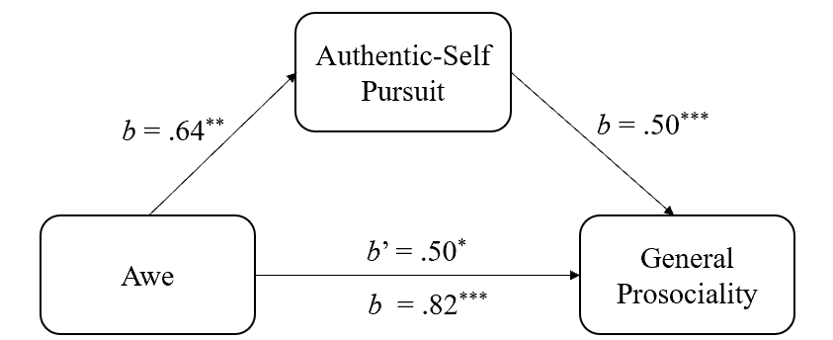

Second, we entered inauthentic prosociality as dependent variable. The mediating effect of authentic-self pursuit was significant, b = −.23, SE =.09, 95% CI [−.4294, −.0761] (Figure 13). Consistent with Study 12, authentic-self pursuit, as triggered by awe, conduced to decreases in inauthentic prosociality. The results of the last three experiments supported H3a and H3b both separately (Study 11: H3a; Study 12: H3b) and concurrently (Study 13).

Figure 13
Authentic-Self Pursuit Mediates the Effect of Awe on Inauthentic Prosociality in Study 13
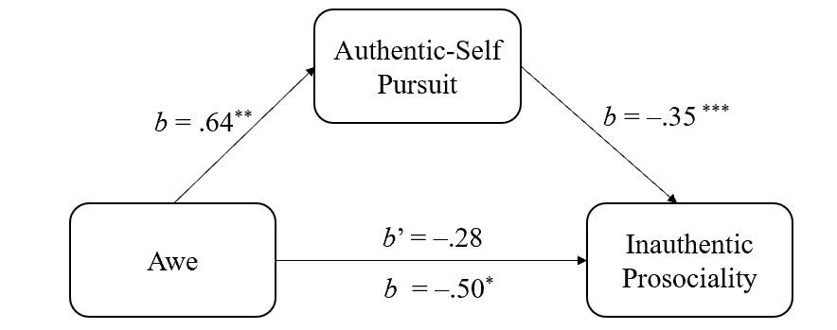

Study 14
In correlational Study 14, we tested H3a and H3b concurrently at the dispositional level. The hypotheses stated that authentic-self pursuit mediates the positive relation between awe and general prosociality, but it mediates the negative relation between awe and inauthentic prosociality.
Method
Participants
Aiming for least 184 (Schoemann et al., 2017), we recruited 300 participants (132 women, 168 men; M_{years} = 28.18, SD_{years} = 5.14) on Credamo. All of them passed an attention check.
Procedure and Materials
We assessed dispositional awe (M = 5.41, SD = .72, α = .77) and authentic-self pursuit (M = 7.04, SD = 1.11, α = .91), as in Study 1. We assessed general prosociality and inauthentic prosociality in fixed order. First, we assessed general prosociality by adapting three items from the World Giving index (Charities Aid Foundation, 2019), which mapped on to our definition of general prosociality (Penner et al., 2005). The items were: “Donate money to a charity,” “Help a stranger, or someone you don’t know who need help,” and “Volunteer your time to an organization.” Participants indicated the likelihood of behaving in accordance with each item (1 = not at all, 9 = extremely). We averaged responses to create a general prosociality index (M = 7.05, SD = 1.23, α = .79).
Second, we assessed inauthentic prosociality with five items adapted from the altruism subscale of the Prosocial Tendencies Measure (Carlo & Randall, 2002). Sample items, preceded by the stem “If helping others is against my authentic self…” are: “I will not help even if I receive attention and recognition for my time and effort,” I will not help even if I get a tax exemption.” Participants indicated the extent to which they disagreed or agreed with each item (1 = strongly disagree, 9 = strongly agree). We reversed-scored, as appropriate, and averaged responses to create an inauthentic prosociality index (M = 3.93, SD = 1.79, α = .94).
Results and Discussion
Awe, Authentic-Self Pursuit, and General and Inauthentic Prosociality
Dispositional awe was positively associated with authentic-self pursuit, r(300) = .71, p < .001. Dispositional awe was positively associated with general prosociality, r(300) = .56, p < .001, but negatively associated with inauthentic prosociality, r(300) = –.25, p < .001. Further, authentic-self pursuit was positively associated with general prosociality, r(300) = .55, p < .001, but negatively associated with inauthentic prosociality, r(300) = –.31, p < .001. General prosociality and inauthentic prosociality were negatively associated, r(300) = –.37, p < .001.
Mediation Analyses
We proceeded with two mediation analyses. First, we tested whether authentic-self pursuit mediates the awe-general prosociality link. We entered awe as predictor, authentic-self pursuit as mediator, and general prosociality as outcome. The indirect effect was significant, b =.37, SE =.10, 95% CI [.1940, .5826] (Figure 14). In support of H3a, authentic-self pursuit mediated the relation between awe and general prosociality.

Figure 14
Dispositional Authentic-Self Pursuit Mediates the Relation between Dispositional Awe and Dispositional General Prosociality in Study 14
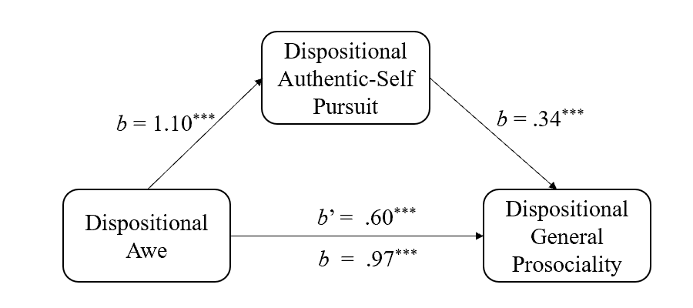
Next, we tested whether authentic-self pursuit mediates the awe-inauthentic prosociality link. We entered awe as predictor, authentic-self pursuit as mediator, and inauthentic prosociality as outcome. The indirect effect was significant and negative, b = –.48, SE =.11, 95% CI [–.7195, –.2736] (Figure 15). In support of H3b, authentic-self pursuit mediated the relation between awe and inauthentic prosociality.

Figure 15
Dispositional Authentic-Self Pursuit Mediates the Relation between Dispositional Awe and Dispositional Inauthentic Prosociality in Study 14

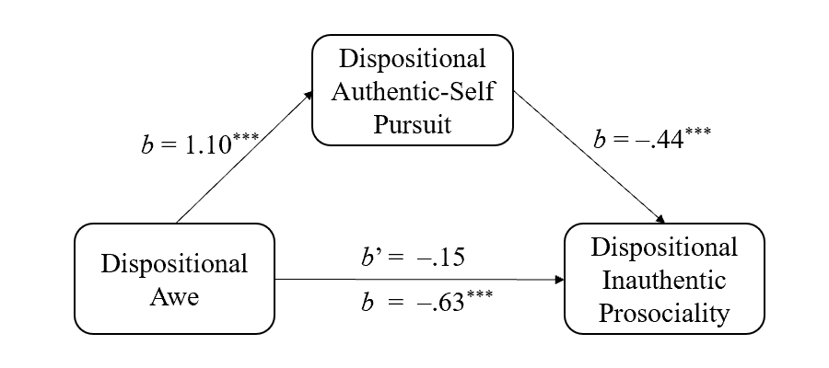
General Discussion
When people witness something that is imposing, grand, or sublime, they are struck with awe. A sense of self as small and insignificant ensues. The latter proposition has received compelling empirical support (Bai et al., 2017; Piff et al., 2015; Shiota et al., 2007). We complemented this literature but, importantly, re-conceptualized the relevance of awe for the self. Specifically, we proposed a theoretical model stating that awe elicits self-transcendence, which in turn awakens pursuit of the authentic self. We provided support for the model, and documented some of its psychological consequences (i.e., general vs. inauthentic prosociality), in 14 studies—11 experimental and three correlational.
Summary of Findings
We hypothesized that awe is associated with, or motivates, authentic-self pursuit (H1). We obtained evidence consistent with this hypothesis in all 14 studies. Also, we hypothesized that awe is associated with, or motivates, authentic-self pursuit through self-transcendence (H2). We obtained evidence for this hypothesis in Studies 3-10. Moreover, we found that self-transcendence mediated the effects of awe on authentic-self pursuit both in China and the US. However, the magnitude of this mediation varied by culture (Study 8). Further, by comparing awe with pride and happiness, we observed that awe exerts unique effects on authentic-self pursuit via self-transcendence (Study 9). In addition, our proposed mediation model was well-established beyond the impact of self-smallness (Study 10). Lastly, we hypothesized that, by invigorating pursuit of the authentic self, awe strengthens general prosociality (H3a) but weakens inauthentic prosociality (H3b). We presented relevant evidence in Studies 11-14. We reinforced the generality of our findings by using: cross-sectional and experimental design, different manipulations or measures of awe; distinct measures of authentic-self pursuit; both laboratory and field settings; samples derived from community members, organizational employees, and high school students; and, finally, samples from both collectivistic and individualistic cultures.
Implications and Future Research Directions
As mentioned, our theoretical model aims to complement and enrich the burgeoning awe literature. We replicated, in Study 10, the standard finding that awe triggers self-smallness. However, we also showed in the same experiment that self-smallness was only weakly related to higher self-transcendence, and self-smallness did not mediate the effect of awe on self-transcendence. Additionally, self-smallness did not mediate the effect of awe on authentic-self pursuit, nor was it involved significantly in the full mediation chain
(i.e., awe ⇒ self-smallness ⇒ self-transcendence ⇒ authentic-self pursuit).
Awe, then, appears to have independent effects on self-smallness and self-transcendence. Put otherwise, self-smallness is not a prerequisite for self-transcendence: The individual does not need to feel small and insignificant in order to feel transcendent. Additionally, although self-transcendence facilitates authentic-self pursuit, self-smallness does not seem to do so.
But how about prosociality? The literature has indicated that awe strengthens general prosociality via self-smallness (Joye & Bolderdijk, 2015; Piff et al., 2015). This is one path to general prosociality. We illustrated another path: Awe encourages general prosociality by strengthening authentic-self pursuit. Additionally, we showed that awe discourages inauthentic prosociality by invigorating authentic-self pursuit. These findings have implications for real-world prosociality. For prosocial behavior to be enacted most effectively, it will need to fit one’s authentic self (Schmader & Sedikides, 2018). Put differently, charitable organizations may need to tailor their campaigns in a way that these intersect with, or partially meet, the prospective donors’ authentic-self pursuit.
Awe has been linked to other outcomes. When in awe, individuals describe themselves in terms of belongingness in larger categories (e.g., inhabitant of the earth) rather than individuated categories (e.g., one-of-a-kind) and feel more socially connected (Bai et al., 2017; Krause & Hayward, 2015; Shiota et al., 2007; Van Cappellen & Saroglou, 2012). Perhaps these effects of awe on belongingness and socially connectedness are due to self-transcendence or the mediation sequence involving self-transcendence and authentic-self pursuit. Also, awe has been associated with decreases in daily stress and stress-related symptoms, as well as increases in well-being and daily life satisfaction (Anderson et al., 2018; Bai et al., 2021); it has further been associated with compassion, gratitude, optimism, and love (Nelson-Coffey et al., 2019). Again, self-transcendence, or self-transcendence followed by authentic-self pursuit, may be the underlying mechanisms. As a final example, awe has been linked with joy and positive prosocial emotions, with these outcomes being mediated by self-smallness (Sturm et al., 2020). Self-transcendence and authentic-self pursuit may be additional mediators.
Indeed, new vistas open up by considering the intervening role of authentic-self pursuit. Authenticity entails psychological benefits. These include affirmation of one’s self-integrity (Gino et al., 2015; Jongman-Sereno & Leary, 2016), positive and moral self-perceptions (Newman et al., 2014; Zhang & Alicke, 2021), decision satisfaction (Kim et al., 2021), sense of power (Gan et al., 2018; Kraus et al., 2011), and psychological well-being (Kifer et al., 2013; Thomaes et al., 2017). Further, feeling authentic at work is related to increased work engagement and job satisfaction (Metin et al., 2016), and to more self-determined, autonomous motivation (vs. controlled motivation and amotivation; Van den Bosch & Taris, 2018). All these benefits might be reaped from awe via the intervening role of authentic-self pursuit. The same applies to meaning in life, another psychological benefit. Authenticity is related to meaning in life (Lenton et al., 2016; Schlegel et al., 2011, 2016) and increases it (Schlegel et al., 2009). Awe, then, may imbue life with meaning by motivating authentic-self pursuit.
Future research would do well to examine the relevance of individual differences in awe, with implications for the mediation paths we discussed. Individuals who are extraverted (Shiota et al., 2006), open to experience (Shiota et al., 2006; Silvia et al., 2015), high in self-esteem (Hornsey et al., 2018), or religious (Preston & Shin, 2017) are more prone to awe than their counterparts, as are individuals high (vs. low) on socioeconomic status (Piff & Moskowitz, 2018). The effects we obtained, then, in support of our hypotheses (i.e., main effect of awe on authentic-self-pursuit, mediation by self-transcendence of awe’s effect on authentic-self pursuit, mediation by authentic-self pursuit of awe’s effect on general and inauthentic prosociality) may be exacerbated among these individuals.

Limitations
Most of the relevant literature has assumed that awe is a predominantly positive emotion, and has treated it as such. In an exception (Gordon et al., 2017), awe has been examined as a response to vast and threatening stimuli (e.g.., hurricanes, earthquakes, volcanic eruptions). This negative variant of awe was linked to fear, lower self-control, and higher situational control. Further, it elicited lower well-being than the typical, positive awe variant, with this effect being mediated by a sense of powerlessness. This emotion has more recently labelled threat-based awe (Chaudhury et al., 2021). We were not directly concerned with threat-based awe, although our manipulation occasionally gave rise to fear. Threat-based awe may not elicit self-transcendence, may not evoke authentic-self pursuit, and hence may not promote general prosociality or impair inauthentic prosociality.
Longitudinal and daily diary designs would need to complement our experimental and cross-sectional work. Such approaches, along with qualitative techniques (Schneider, 2017), could capture more faithfully the deeper, longer-term, and life-changing aspects of awe, and its downstream implications through self-transcendence and/or authentic-self pursuit. In addition, testing in a wider array of cultures, outside of China and the US, would provide more cogent cultural generality.
In Closing
Research on awe has flourished in the last few years, as this emotion is credited, not only for self-benefits (e.g., pleasant psychological states), but also for other-benefits (e.g., prosociality). We argued that prosociality, along with other outcomes of awe, can be further understood by appreciating the emotion’s self-transcendent character and thrust toward the authentic self.
References
Aday, A., Mehta, S., Chen, S., Sedikides, C., & Schmader, T. (2021). The SAFE model: State authenticity as a function of three types of fit. Unpublished manuscript, University of British Columbia.
Algoe, S. B., & Haidt, J. (2009). Witnessing excellence in action: The “other-praising” emotions of elevation, gratitude, and admiration. The Journal of Positive Psychology, 4(2), 105–127. http://dx.doi.org/10.1080/17439760802650519
Anderson, C. A., & Bushman, B. J. (1997). External validity of "trivial" experiments: The case of laboratory aggression. Review of General Psychology, 1(1), 19–41. https://doi.org/10.1037/1089-2680.1.1.19
Anderson, C. L., Chen, S., & Ayduk, O. (2020). When does changing emotions harm authenticity? Distinct reappraisal strategies differentially impact subjective and observer-rated authenticity. Self and Identity, 19(5), 590–612. https://doi.org/10.1080/15298868.2019.1645041
Anderson, C. L., Monroy, M., & Keltner, D. (2018). Awe in nature heals: Evidence from military veterans, at-risk youth, and college students. Emotion, 18(8), 1195–1202. https://doi.org/10.1037/emo0000442
Aron, A., & Aron, E. N. (1997). Self-expansion motivation and including other in the self. In S. Duck (Ed.), Handbook of personal relationships: Theory, research and interventions (pp. 251–270). John Wiley & Sons Inc.
Aron, A., Aron, E. N., & Smollan, D. (1992). Inclusion of Other in the Self Scale and the structure of interpersonal closeness. Journal of Personality and Social Psychology, 63(4), 596–612. https://doi.org/10.1037/0022-3514.63.4.596
Bai, Y., Maruskin, L. A., Chen, S., Gordon, A. M., Stellar, J. E., McNeil, G. D., Peng, K., & Keltner, D. (2017). Awe, the diminished self, and collective engagement: Universals and cultural variations in the small self. Journal of Personality and Social Psychology, 113(2), 185–209. https://doi.org/10.1037/pspa0000087
Bai, Y., Ocampo, J., Jin, G., Chen, S., Benet-Martinez, V., Monroy, M., Anderson, C., & Keltner, D. (2021). Awe, daily stress, and elevated life satisfaction. Journal of Personality and Social Psychology, 120(4), 837–860. https://doi.org/10.1037/pspa0000267
Baldwin, M., Biernat, M., & Landau, M. J. (2015). Remembering the real me: Nostalgia offers a window to the intrinsic self. Journal of Personality and Social Psychology, 108(1), 128–147. https://doi.org/10.1037/a0038033
Bonner, E. T., & Friedman, H. L. (2011). A conceptual clarification of the experience of awe: An interpretative phenomenological analysis. Humanistic Psychologist, 39(3), 222–235. https://doi.org/10.1080/08873267.2011.593372
Campos, B., Shiota, M. N., Keltner, D., Gonzaga, G. C., & Goetz, J. L. (2013). What is shared, what is different? Core relational themes and expressive displays of eight positive emotions. Cognition & Emotion, 27(1), 37–52. https://doi.org/10.1080/02699931.2012.683852
Caprara, G. V., Steca, P., Zelli, A., & Capanna, C. (2005). A new scale for measuring adults' prosocialness. European Journal of Psychological Assessment, 21(2), 77–89. https://doi.org/10.1027/1015-5759.21.2.77
Carlo, G., & Randall, B. A. (2002). The development of a measure of prosocial behaviors for late adolescents. Journal of Youth and Adolescence, 31(1), 31–44. https://doi.org/10.1023/A:1014033032440
Chaudhury, S. H., Garg, N., & Jiang, Z. (2021). The curious case of threat-awe: A theoretical and empirical reconceptualization. Emotion. Advance online publication.
https://doi.org/10.1037/emo0000984
Charities Aid Foundation. (2019). CAF World Giving Index 10th Edition. https://www.cafonline.org/docs/default-source/about-us-publications/caf_wgi_10th_edition_report_2712a_web_101019.pdf
Chen, S. (2019). Authenticity in context: Being true to working selves. Review of General Psychology, 23(1), 60–72. https://doi.org/10.1037/gpr0000160
Chirico, A., Cipresso, P., Yaden, D. B., Biassoni, F., Riva, G., & Gaggioli, A. (2017). Effectiveness of immersive videos in inducing awe: An experimental study. Scientific Reports, 7(1), 1218. https://doi.org/10.1038/s41598-017-01242-0
Chirico, A., & Yaden, D. B. (2018). Awe: A self-transcendent and sometimes transformative emotion. In H. C. Lench (Ed.), The function of emotions (pp. 221–233). Springer International Publishing. https://doi.org/10.1007/978-3-319-77619-4
Chirico, A., Yaden, D., Riva, G., & Gaggioli, A. (2016). The potential of virtual reality for the investigation of awe. Frontiers in Psychology, 7, 1766. https://doi.org/10.3389/fpsyg.2016.01766
Conn, W. E. (1998). Self-transcendence, the true self, and self-love. Pastoral Psychology, 46(5), 323–332. https://doi.org/10.1023/A:1023063820862
Daniels, M. (1982). The development of the concept of self-actualization in the writings of Abraham Maslow. Current Psychological Reviews, 2(1), 61–75. https://doi.org/10.1007/BF02684455
Danvers, A. F., & Shiota, M. N. (2017). Going off script: Effects of awe on memory for script-typical and -irrelevant narrative detail. Emotion, 17(6), 938–952. https://doi.org/10.1037/emo0000277
Emmerich, A. I., & Rigotti, T. (2017). Reciprocal relations between work-related authenticity and intrinsic motivation, work ability and depressivity: a two-wave study. Frontiers in Psychology, 8, 307. https://doi.org/10.3389/fpsyg.2017.00307
Erickson, R. J. (1995). The importance of authenticity for self and society. Symbolic Interaction, 18(2), 121–144. https://doi.org/10.1525/si.1995.18.2.121
Faul, F., Erdfelder, E., Lang, A., & Buchner, A. (2007). G*Power 3: A flexible statistical power analysis program for the social, behavioral, and biomedical sciences. Behavior Research Methods, 39(2), 175–191. https://doi.org/10.3758/BF03193146
Fiedler, K., Schott, M., & Meiser, T. (2011). What mediation analysis can (not) do. Journal of Experimental Social Psychology, 47(6), 1231–1236. https://doi.org/10.1016/j.jesp.2011.05.007
Fleeson, W., & Wilt, J. (2010). The relevance of Big Five trait content in behavior to subjective authenticity: Do high levels of within‐person behavioral variability undermine or enable authenticity achievement? Journal of Personality, 78(4), 1353–1382. https://doi.org/10.1111/j.1467-6494.2010.00653.x
Frankl, V. E. (1985). Man’s search for meaning (Revised & updated ed.). Washington Square Press.
Gan, M., Heller, D., & Chen, S. (2018). The power in being yourself: Feeling authentic enhances the sense of power. Personality and Social Psychology Bulletin, 44(10), 1460–1472. https://doi.org/10.1177/0146167218771000
Garcia-Romeu, A. (2010). Self-transcendence as a measurable transpersonal construct. Journal of Transpersonal Psychology, 42(1), 26–47.
Giner-Sorolla, R. (2018, January 24). Powering your interaction. Approaching Significance
A Methodology Blog for Social Psychology. https://approachingblog.wordpress.com/2018/01/24/powering-your-interaction-2
Gino, F., Kouchaki, M., & Galinsky, A. D. (2015). The moral virtue of authenticity: How inauthenticity produces feelings of immorality and impurity. Psychological Science, 26(7), 983–996. https://doi.org/10 .1177/0956797615575277
Gong, S., Lu, J. G., Schaubroeck, J. M., Li, Q., Zhou, Q., & Qian, X. (2020). Polluted psyche: Is the effect of air pollution on unethical behavior more physiological or psychological? Psychological Science, 31(8), 1040–1047. https://doi.org/10.1177/0956797620943835
Gordon, A. M., Stellar, J. E., Anderson, C. L., McNeil, G. D., Loew, D., & Keltner, D. J. (2017). The dark side of the sublime: Distinguishing a threat-based variant of awe. Journal of Personality and Social Psychology, 113(2), 310–328. https://doi.org/10.1037/pspp0000120
Haidt, J. (2003). The moral emotions. In R. J. Davidson, K. R. Scherer, & H. H. Goldsmith (Eds.), Handbook of affective sciences (pp. 852–870). Oxford University Press.
Halstead, J. M., & Halstead, A. O. (2004). Awe, tragedy and the human condition. International Journal of Children’s Spirituality, 9(2), 163–175. https://doi.org/10.1080/1364436042000234369
Hayes, A. F. (2018). Introduction to mediation, moderation, and conditional process analysis: A regression-based approach (2nd ed.). Guilford Press.
Heppner, W. L., Kernis, M. H., Nezlek, J. B., Foster, J., Lakey, C. E., & Goldman, B. M. (2008). Within-person relationships among daily self-esteem, need satisfaction, and authenticity. Psychological Science, 19(11), 1140–1145. https://doi.org/10.1111/j.1467-9280.2008.02215.x
Hornsey, M. J., Faulkner, C., Crimston, D., & Moreton, S. (2018). A microscopic dot on a microscopic dot: Self-esteem buffers the negative effects of exposure to the enormity of the universe. Journal of Experimental Social Psychology, 76, 198–207. https://doi.org/10.1016/j.jesp.2018.02.009
Huitema, B. E. (1980). The analysis of covariance and alternatives. Wiley.
Ihm, E. D., Paloutzian, R. F., van Elk, M., & Schooler, J. W. (2019). Awe as a meaning-making emotion: On the evolution of awe and the origin of religions. In J. R. Feierman & L. Oviedo (Eds.), The evolution of religion, religiosity and theology (pp. 138–153). Routledge.
Impett, E. A., Javam, L., Le, B. M., Asyabi-Eshghi, B., & Kogan, A. (2013). The joys of genuine giving: Approach and avoidance sacrifice motivation and authenticity. Personal Relationships, 20(4), 740–754. https://doi.org/10.1111/pere.12012
Jiang, L., Yin, J., Mei, D., Zhu, H., & Zhou, X. (2018). Awe weakens the desire for money. Journal of Pacific Rim Psychology, 12, e4. https://doi.org/10.1017/prp.2017.27
Jongman-Sereno, K. P., & Leary, M. R. (2016). Self-perceived authenticity is contaminated by the valence of one’s behavior. Self and Identity, 15(3), 283–301. https://doi.org/10.1080/15298868.2015.1128964
Joye, Y., & Bolderdijk, J. (2015). An exploratory experiment into the effects of extraordinary nature on emotions, mood, and prosociality. Frontiers in Psychology, 5, 1577. https://doi.org/10.3389/fpsyg.2014.01577
Kant, I. (2015). Critique of practical reason (M. Gregor, Trans.). Cambridge University Press. (Original work published 1788).
Kasser, T., & Ryan, R. M. (1996). Further examining the American dream: Differential correlates of intrinsic and extrinsic goals. Personality and Social Psychology Bulletin, 22(3), 80–87. https://doi.org/10.1177/0146167296223006
Kelley, N. J., Davis, W. E., Wildschut, T., & Sedikides, C. (2021). Authenticity mediates the effect of nostalgia on psychological wellbeing. Unpublished manuscript, University of Southampton.
Keltner, D., & Haidt, J. (2003). Approaching awe, a moral, spiritual, and aesthetic emotion. Cognition and Emotion, 17(2), 297–314. https://doi.org/10.1080/02699930302297
Kernis, M. H., & Goldman, B. M. (2006). A multicomponent conceptualization of authenticity: Research and theory. Advances in Experimental Psychology, 38, 284–357. https://doi.org/10.1016/S0065-2601(06)38006-9
Kifer, Y., Heller, D., Perunovic, W. Q. E., & Galinsky, A. D. (2013). The good life of the powerful: The experience of power and authenticity enhances subjective well-being. Psychological Science, 24(3), 280–288. https://doi.org/10.1177/0956797612450891
Kim, J., Chen, K., Davis, W. E., Hicks, J. A., & Schlegel, R. J. (2019). Approaching the true self: Promotion focus predicts the experience of authenticity. Journal of Research in Personality, 78, 165–176. https://doi.org/10.1016/j.jrp.2018.12.001
Kim, J., Christy, A. G., Rivera, G. N., Hicks, J. A., Schlegel, R. J. (2021). Is the illusion of authenticity beneficial? Merely perceiving decisions as guided by the true self enhances decision satisfaction. Social Psychological and Personality Science, 12(1), 80–90. https://doi.org/10.1177/1948550620903202
Kokkoris, M. D., & Sedikides, C. (2019). Can you be yourself in business? How reminders of business affect the perceived value of authenticity. Journal of Applied Social Psychology, 49(7), 448–458. https://doi.org/10.1111/jasp.12596
Koltko-Rivera, M. E. (2006). Rediscovering the later version of Maslow's hierarchy of needs: Self-transcendence and opportunities for theory, research, and unification. Review of General Psychology, 10(4), 302–317. https://doi.org/10.1037/1089-2680.10.4.302
Kraus, M. W., Chen, S., & Keltner, D. (2011). The power to be me: Power elevates self-concept consistency and authenticity. Journal of Experimental Social Psychology, 47(5), 974–980. https://doi.org/10.1016/j.jesp.2011.03.017
Krause, N., & Hayward, R. D. (2015). Awe of God, congregational embeddedness, and religious meaning in life. Review of Religious Research, 57(2), 219–238. https://doi.org/10.1007/s13644-014-0195-9
Kross, E., & Ayduk, O. (2017). Self-distancing: theory, research, and current directions. Advances in Experimental Social Psychology, 55, 81–136. https://doi.org/10.1016/bs.aesp.2016.10.002
Lemmer, G., & Gollwitzer, M. (2017). The “true” indirect effect won't (always) stand up: When and why reverse mediation testing fails. Journal of Experimental Social Psychology, 69, 144–149. https://doi.org/10.1016/j.jesp.2016.05.002
Lenton, A. P., Bruder, M., Slabu, L., & Sedikides, C. (2013a). How does “Being real” feel? The experience of state authenticity. Journal of Personality, 81(3), 276–289. https://doi.org/10.1111/j.1467-6494.2012.00805.x
Lenton, A. P., Slabu, L., Bruder, M., & Sedikides, C. (2014). Identifying differences in the experience of (in)authenticity: A latent class analysis approach. Frontiers in Psychology: Personality Science and Individual Differences, 5, 770. https://doi.org/10.3389/fpsyg.2014.00770
Lenton, A. P., Slabu, L., & Sedikides, C. (2016). State authenticity in everyday life. European Journal of Personality, 30(1), 64–82. https://doi.org/10.1002/per.2033
Lenton, A. P., Slabu, L., Sedikides, C., & Power, K. (2013b). I feel good, therefore I am real: Testing the causal influence of mood on state authenticity. Cognition and Emotion, 27(7), 1202–1224. https://doi.org/10.1080/02699931.2013.778818
Litman, L., Robinson, J., & Abberbock, T. (2017). TurkPrime.com: A versatile crowdsourcing data acquisition platform for the behavioral sciences. Behavior Research Methods, 49(2), 433–442. https://doi.org/10.3758/s13428-016-0727-z
Maslow, A. H. (1954). Motivation and personality. Harper and Row.
Maslow, A. H. (1962). Lessons from the peak-experiences. Journal of Humanistic Psychology, 2(1), 9–18. https://doi.org/10.1177/002216786200200102
Maslow, A. H. (1969). The farther reaches of human nature. Journal of Transpersonal Psychology, 1(1), 1–9.
Maslow, A. H. (1971). The farther reaches of human nature. Viking.
Maslow, A. H. (1999). Toward a psychology of being. Wiley.
Metin, U. B., Taris, T. W., Peeters, M. C. W., van Beek, I., & Van den Bosch, R. (2016). Authenticity at work – a job-demands resources perspective. Journal of Managerial Psychology, 31(2), 483–499. https://doi.org/10.1108/JMP-03-2014-0087
Miller, G. A., & Chapman, J. P. (2001). Misunderstanding analysis of covariance. Journal of Abnormal Psychology, 110(1), 40–48. https://doi.org/10.1037/0021-843X.110.1.40
Milyavskaya, M., Ianakieva, I., Foxen-Craft, E., Colantuoni, A., & Koestner, R. (2012). Inspired to get there: The effects of trait and goal inspiration on goal progress. Personality and Individual Differences, 52(1), 56–60. https://doi.org/10.1016/j.paid.2011.08.031
Morgan, J. H. (1976). Pastoral ecstasy and the authentic self: Theological meanings in symbolic distance. Pastoral Psychology, 25(2), 128–137. https://doi.org/10.1007/BF01759855
Nelson-Coffey, S. K., Ruberton, P. M., Chancellor, J., Cornick, J., Blascovich, J., & Lyubomirsky, S. (2019). The proximal experience of awe. PLoS One, 14(5), e0216780. https://doi.org/10.1371/journal.pone.0216780
Newman, G. E., Bloom, P., & Knobe, J. (2014). Value judgments and the true self. Personality and Social Psychology Bulletin, 40(2), 203–216. https://doi.org/10.1177/0146167213508791
Pappas, J. D., & Friedman, H. L. (2007). The construct of self expansiveness and the validity of the Transpersonal Scale of the Self-expansiveness Level Form. The Humanistic Psychologist, 35(4), 323–347. https://doi.org/10.1080/08873260701593334
Penner, L. A., Dovidio, J. F., Piliavin, J. A., & Schroeder, D. A. (2005). Prosocial behavior: multilevel perspectives. Annual Review of Psychology, 56(1), 365–392. https://doi.org/10.1146/annurev.psych.56.091103.070141
Perlin, J. D., & Li, L. (2020). Why does awe have prosocial effects? New perspectives on awe and the small self. Perspectives on Psychological Science, 15(2), 291–308. https://doi.org/10.1177/1745691619886006
Piff, P. K., Dietze, P., Feinberg, M., Stancato, D. M., & Keltner, D. (2015). Awe, the small self, and prosocial behavior. Journal of Personality and Social Psychology, 108(6), 883–899. https://doi.org/10.1037/pspi0000018
Piff, P. K. , & Moskowitz, J. P. . (2018). Wealth, poverty, and happiness: social class is differentially associated with positive emotions. Emotion, 18(6), 902–905.
https://doi.org/10.1037/emo0000387
Pizarro, J. J., Basabe, N., & Fernánde, I. (2021). Self-transcendent emotions and their social effects: Awe, elevation and Kama Muta promote a human identification and motivations to help others. Frontiers in Psychology, 12: 709859. https://doi.org/10.3389/fpsyg.2021.709859
Prade, C., & Saroglou, V. (2016). Awe's effects on generosity and helping. The Journal of Positive Psychology, 11(5), 522–530. https://doi.org/10.1080/17439760.2015.1127992
Preston, J. L., & Shin, F. (2017). Spiritual experiences evoke awe through the small self in both religious and non-religious individuals. Journal of Experimental Social Psychology, 70, 212–221. https://doi.org/10.1016/j.jesp.2016.11.006
Reed, P. G. (1991). Self-transcendence and mental health in oldest-old adults. Nursing Research, 40(1), 5–11. https://doi.org/10.1097/00006199-199101000-00002
Reed, P. G. (2013). Theory of self-transcendence. In M. J. Smith & P. R. Liehr (Eds.), Middle range theory for nursing (3rd ed., pp. 109–139). Springer International Publishing.
Rogers, C. R. (1961). On becoming a person: A therapist’s view of psychotherapy. Houghton Mifflin.
Rudd, M., Vohs, K. D., & Aaker, J. (2012). Awe expands people’s perception of time, alters decision making, and enhances well-being. Psychological Science, 23(10), 1130–1136. https://doi.org/10.1177/0956797612438731
Saroglou, V., Buxant, C., & Tilquin, J. (2008). Positive emotions as leading to religion and spirituality. The Journal of Positive Psychology, 3(3), 165–173. https://doi.org/10.1080/17439760801998737
Scharf, M., & Mayseless, O. (2010). Finding the authentic self in a communal culture: Developmental goals in emerging adulthood. In S. Shulman & J.-E. Nurmi (Eds.), New directions for child and adolescent development (pp. 83–95). Jossey-Bass. https://doi.org/10.1002/cd.283
Schoemann, A. M., Boulton, A. J., & Short, S. D. (2017). Determining power and sample size for simple and complex mediation models. Social Psychological and Personality Science, 8(4), 379–386. https://doi.org/10.1177%2F1948550617715068
Schlegel, R. J., Hicks, J. A., Arndt, J., & King, L. A. (2009). Thine own self: True self-concept accessibility and meaning in life. Journal of Personality and Social Psychology, 96(2), 473–490. https://doi.org/10.1037/a0014060
Schlegel R. J., Hicks J. A., & Christy A. G. (2016). The eudaimonics of the true self. In J. Vittersø (Ed.), Handbook of eudaimonic well-being. International handbooks of quality-of-life (pp. 205–213). Springer. https://doi.org/10.1007/978-3-319-42445-3_14
Schlegel, R. J., Hicks, J. A., King, L. A., & Arndt, J. (2011). Feeling like you know who you are: Perceived true self knowledge and meaning in life. Personality and Social Psychology Bulletin, 37(6), 745–756. https://doi.org/10.1177/0146167211400424
Schmader, T., & Sedikides, C. (2018). State authenticity as fit to environment: The implications of social identity for fit, authenticity, and self-segregation. Personality and Social Psychology Review, 22(3), 228–259. https://doi.org/10.1177/1088868317734080
Schneider, K. (2017). The resurgence of awe in psychology: Promise, hope, and perils. The Humanistic Psychologist, 45(2), 103–108. https://doi.org/10.1037/hum0000060
Schneider, K. J. (2009). Awakening to awe: Personal stories of profound transformation. Jason Aronson.
Schönbrodt, F. D., & Perugini, M. (2013). At what sample size do correlations stabilize? Journal of Research in Personality, 47(5), 609–612. https://doi.org/10.1016/j.jrp.2013.05.009
Sedikides, C., Lenton, A. P., Slabu, L., & Thomaes, S. (2019). Sketching the contours of state authenticity. Review of General Psychology, 23(1), 73–88. https://doi.org/10.1037/gpr0000156
Sedikides, C., Slabu, L., Lenton, A., & Thomaes, S. (2017). State authenticity. Current Directions in Psychological Science, 26(6), 521–525. https://doi.org/10.1177/0963721417713296
Sheldon, K. M., Gunz, A., & Schachtman, T. (2012). What does it mean to be in touch with oneself? Testing a social character model of self-congruence. Self and Identity, 11(1), 51–70. http://dx.doi.org/10.1080/15298868.2010.503130
Shiota, M. N., Keltner, D., & John, O. P. (2006). Positive emotion dispositions differentially associated with big five personality and attachment style. The Journal of Positive Psychology, 1(2), 61–71. https://doi.org/10.1080/17439760500510833
Shiota, M. N., Keltner, D., & Mossman, A. (2007). The nature of awe: Elicitors, appraisals, and effects on self-concept. Cognition and Emotion, 21(5), 944–963. https://doi.org/10.1080/02699930600923668
Shiota, M. N., Neufeld, S. L., Yeung, W. H., Moser, S. E., & Perea, E. F. (2011). Feeling good: Autonomic nervous system responding in five positive emotions. Emotion, 11(6), 1368–1378. https://doi.org/10.1037/a0024278
Silvia, P. J., Fayn, K., Nusbaum, E. C., & Beaty, R. E. (2015). Openness to experience and awe in response to nature and music: Personality and profound aesthetic experiences. Psychology of Aesthetics, Creativity, and the Arts, 9(4), 376–384. https://doi.org/10.1037/aca0000028
Stellar, J. E., Gordon, A., Anderson, C. L., Piff, P. K., McNeil, G. D., & Keltner, D. (2018). Awe and humility. Journal of Personality and Social Psychology, 114(2), 258–269. https://doi.org/10.1037/pspi0000109
Stellar, J. E., Gordon, A. M., Piff, P. K., Cordaro, D., Anderson, C. L., Bai, Y., Maruskin, L. A., & Keltner, D. (2017). Self-transcendent emotions and their social functions: Compassion, gratitude, and awe bind us to others through prosociality. Emotion Review, 9(3), 200–207. https://doi.org/10.1177/1754073916684557
Stephan, E., Sedikides, C., & Wildschut, T. (2012). Mental travel into the past: Differentiating recollections of nostalgic, ordinary, and positive events. European Journal of Social Psychology, 42(3), 290–298. https://doi.org/10.1002/ejsp.1865
Sturm, V. E., Datta, S., Roy, A. R. K., Sible, I. J., Kosik, E. L., Veziris, C. R., Chow, T. E., Morris, N. A., Neuhaus, J., Kramer, J. H., Miller, B. L., Holley, S. R., & Keltner, D. (2020). Big smile, small self: Awe walks promote prosocial positive emotions in older adults. Emotion. Advance online publication. https://doi.org/10.1037/emo0000876
Thomaes, S., Sedikides, C., van den Bos, N., Hutteman, R., & Reijntjes, A. (2017). Happy to be "me?": Authenticity, psychological need satisfaction, and subjective well-being in adolescence. Child Development, 88(4), 1045–1056. https://doi.org/10.1111/cdev.12867
Thoreau, H. D. (2004). Walden. Yale University Press.
Tyson, C., Hornsey, M. J., & Barlow, F. K. (2021). What does it mean to feel small? Three dimensions of the small self. Self and Identity. Advance online publication. https://doi.org/10.1080/15298868.2021.1921018
Tu, Y. K., Gunnell, D., & Gilthorpe, M. S. (2008). Simpson's Paradox, Lord's Paradox, and Suppression Effects are the same phenomenon–the reversal paradox. Emerging Themes in Epidemiology, 5(1), 1–9. https://doi.org/10.1186/1742-7622-5-2
Valdesolo, P., & Graham, J. (2014). Awe, uncertainty, and agency detection. Psychological Science, 25(1), 170–178. https://doi.org/10.1177/0956797613501884
Van Cappellen, P., & Saroglou, V. (2012). Awe activates religious and spiritual feelings and behavioral intentions. Psychology of Religion and Spirituality, 4(3), 223–236. https://doi.org/10.1037/a0025986
Van den Bosch, R., & Taris, T. (2018) Authenticity at work: Its relations with worker motivation and well-being. Frontiers in Communication, 3, 21. https://doi.org/10.3389/fcomm.2018.00021
White, M. H. II. (2018, April 14). On calculating power for interactions in 2 × 2 factorial designs. Mark H. White II, Phd. https://www.markhw.com/blog/power-twoway
Wilson-Mendenhall, C. D., Barrett Feldman, L., & Barsalou, L. (2013). Neural evidence that human emotions share core affective properties. Psychological Science, 24(6), 947–956. https://doi.org/10.1177/0956797612464242
Wong, P. T. (2016). From Viktor Frankl’s logotherapy to the four defining characteristics of self-transcendence. [Paper presentation]. The Research Working Group Meeting for Virtue, Happiness, and the Meaning of Life Project, Columbia, SC.
Wood, A. M., Linley, P. A., Maltby, J., Baliousis, M., & Joseph, S. (2008). The authentic personality: A theoretical and empirical conceptualization and the development of the authenticity scale. Journal of Counseling Psychology, 55(3), 385–399. https://doi.org/10.1037/0022-0167.55.3.385
Yaden, D. B., Haidt, J., Hood, R. W., Vago, D. R., & Newberg, A. B. (2017). The varieties of self-transcendent experience. Review of General Psychology, 21(2), 143–160. https://doi.org/10.1037/gpr0000102
Yaden, D. B., Iwry, J., Slack, K. J., Eichstaedt, J. C., Zhao, Y., Vaillant, G. E., & Newberg, A. B. (2016). The overview effect: Awe and self-transcendent experience in space flight. Psychology of Consciousness, 3(1), 1–11. https://doi.org/10.1037/cns0000086
Yaden, D. B., Kaufman, S. B., Hyde, E., Chirico, A., Gaggioli, A., Zhang, J. W., & Keltner, D. (2019). The development of the Awe Experience Scale (AWE-S): A multifactorial measure for a complex emotion. The Journal of Positive Psychology, 14(4), 474–488. https://doi.org/10.1080/17439760.2018.1484940
Yeung, E., & Shen, W. (2019). Can pride be a vice and virtue at work? Associations between authentic and hubristic pride and leadership behaviors. Journal of Organizational Behavior, 40(6), 605–624. https://doi.org/10.1002/job.2352
Zhang, Y., & Alicke, M. (2021). My true self is better than yours: Comparative bias in true self judgments. Self and Identity, 47(2), 216–231. https://doi.org/10.1177/0146167220919213

Testing our cross-sectional mediation model was informative, because it placed the theory at risk (Anderson & Bushman, 1997; Fiedler et al., 2011). Also, based on Monte Carlo simulations, researchers have cautioned against reverse mediation testing unless the mediator is demonstrably measured in a more reliably manner than the dependent variable (Lemmer & Gollwitzer, 2017), and evidence for this possibility is currently lacking. Nevertheless, here and all subsequent studies, we exploratorily tested reverse mediation models. The results generally indicated a better fit for our hypothesized model (Supplementary Materials).

