Gall-forming anther smut Microbotryum majus in Breckland
Paul A. Smith¹, Johanna Jones², Rob Dyke
¹S3RI, University of Southampton, p.a.smith@soton.ac.uk
²Plantlife, Johanna.Jones@plantlife.org.uk

The genus Microbotryum includes a wide range of forms (Kemler et al. 2020). Although they are in the class Urediniomycetes which also includes the rusts, they have traditionally been called smuts as they have more features in common with smut fungi. There has been a particular radiation of species among the so-called anther smuts, with many narrowly-defined, strongly host-specific species. There at least 23 different species infecting the anthers of various species in the Caryophyllaceae (Smith et al. 2020), and anther smuts also infect other genera (eg Pinguicula L., Ziegler et al. 2018). Most of these have a visible effect only on the anthers, which are converted to spore production, with spores often discolouring the anthers so that the infection is detectable. A few species, however, also cause gall-like swelling or deformation of other tissues (as do some other, true smuts, such as Thecaphora melandrii (Syd.) Vánky & M. Lutz (Smith et al. 2020)).
One such gall-forming species is Microbotryum majus (Schröter) Deml & Oberwinker, which infects Silene otites (L.) Wibel. and some closely-related species. First we make one of those regular digressions to consider the correct name for this species. CBIB (Legon & Henrici 2005) has it as M. major, based on its original description as Ustilago major, but following Vánky (2005) recent publications and websites such as https://bladmineerders.nl/ have changed to the grammatically corrected majus.
Silene otites is a species with a restricted distribution in Britain, it is now restricted to the Breckland of Norfolk and Suffolk in vice-counties 26 & 28, with a scattering of old records from elsewhere. Monitoring by the Breckland Flora Group, a partnership of Plantlife, Natural England and Forestry England, takes place regularly and during investigations at RAF Mildenhall base (TL 6791 7717) on 16/6/2021, Rob Dyke and Jo Jones found deformed plants of S. otites which proved to be infected with M. majus, with dark, swollen anthers, and flowers that remain more or less closed (Fig. 1-3).
M. majus has been known in Britain for a long time. Plowright (1889, p271) reports it from “near Brandon, Mr Frank Norgate, July and August”, and this seems likely to be the origin of the specimens dated 1888 in K(M) and the old FRDBI. But apart from these specimens, there are very few other records. Old FRDBI has a record by E.A. Ellis from Tuddenham, near Mildenhall on 1 October 1963, and one from Cambridge Botanic Gardens in 1961 (wonder whether that was a natural infection or was introduced to the gardens with its host?). Malcolm Storey made the most recent find, on 17 June 2012, at Cranwich Camp, W Norfolk (on NBN).
So it is good to have a further record for M. major in Britain, and RAF Mildenhall is not far from Ellis’s site. The Breckland Flora Group will add looking for the smut to its formal monitoring of populations of Silene otites, and this should generate more information on the distribution and dynamics of the species in the future.
Outside Britain S. otites and the other host species are rather more widespread, enough for Vánky (1994) to describe M. majus as “rather common” in Europe.

References
Kemler, M., Denchev, T. T., Denchev, C. M., Begerow, D., Piątek, M. & Lutz, M. (2020). Host preference and sorus location correlate with parasite phylogeny in the smut fungal genus Microbotryum (Basidiomycota, Microbotryales). Mycological Progress 19 481-493.
Legon, N.W. & Henrici, A. (2005). Checklist of the British and Irish Basidiomycota. Royal Botanic Gardens: Kew (+ updates available from https://basidiochecklist.science.kew.org/)
Plowright, C.B. (1889) A monograph of the British Uredineae and Ustilagineae. Kegan Paul, Trench & Co., London.
Smith, P. A., Lutz, M. & Piątek, M. (2020). The distribution and host range of Thecaphora melandrii, with first records for Britain. Kew Bulletin 75 39.
Vánky, K. (1994) European Smut Fungi. Gustav Fischer Verlag, Stuttgart.
Vánky, K. (2005). European smut fungi (Ustilaginomycetes p.p. and Microbotryales) according to recent nomenclature. Mycologia Balcanica 2 169-177.
Ziegler, R., Lutz, M., Piątek, J. & Piątek, M. (2018). Dismantling a complex of anther smuts (Microbotryum) on carnivorous plants in the genus Pinguicula. Mycologia 110 361‐374. doi: 10.1080/00275514.2018.1451697.

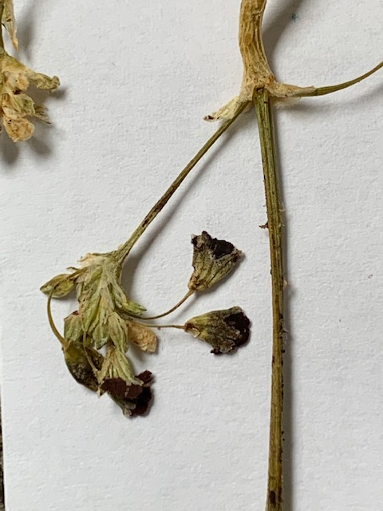

Fig. 1: Dried flowerheads showing the dark smut spores in the swollen anthers.
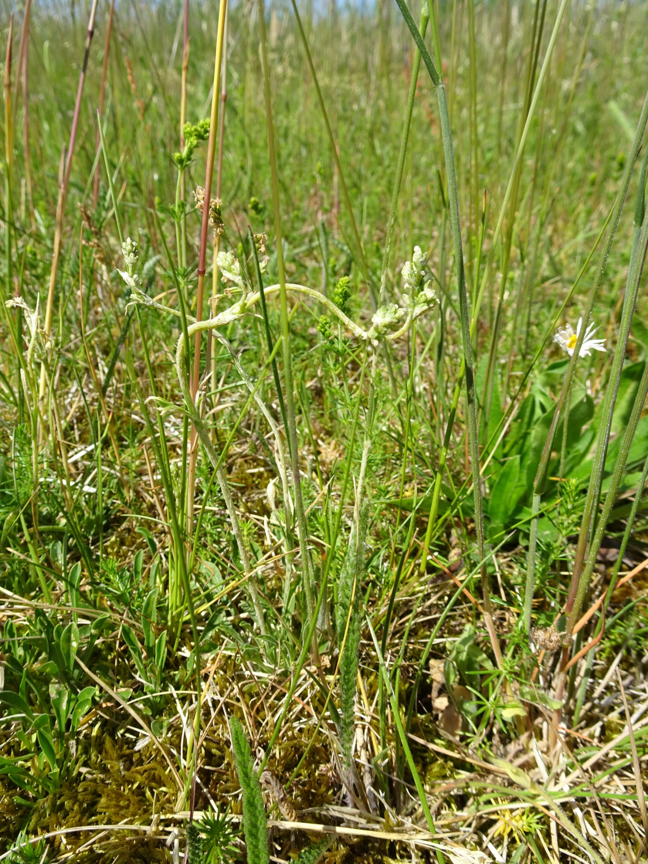

Fig. 2: Contorted (galled) plants in situ at RAF Mildenhall.
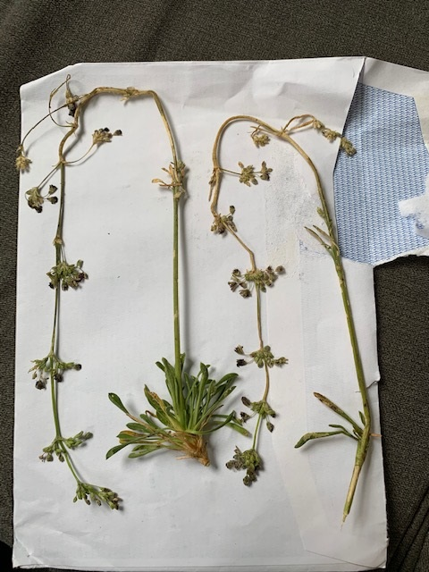

Fig. 3: Infected plants of Silene otites.

