Title Page
Type of manuscript: Original Article
Title: Weight-for-height is associated with an overestimation of thinness burden in comparison to BMI-for-age in under-five populations with high stunting prevalence
Author affiliations:
L Naga Rajeev,^{1,2} Monika Saini, ¹ Ashish Kumar, ¹ Sikha Sinha, ² Clive Osmond, ³ and Harshpal Singh Sachdev ² *
¹Department of Mathematics and Statistics, Manipal University Jaipur, Jaipur, Rajasthan, India, ²Division of Clinical Epidemiology and Pediatrics, Sitaram Bhartia Institute of Science and Research, New Delhi, India, and ³MRC Lifecourse Epidemiology Unit, University of Southampton, Southampton, UK
*Corresponding Author. Division of Clinical Epidemiology and Pediatrics, Sitaram Bhartia Institute of Science and Research, B-16 Qutub Institutional Area, New Delhi 110016, India. E-mail: hpssachdev@gmail.com
Word count (main text): 3314; Abstract: 250; Total: 3564
Abstract
Background: Thinness below five-years of age, also known as wasting, is used to assess the nutritional status of populations for programmatic purposes. Thinness may be defined, when either weight-for-height or Body-Mass-Index-for-age (BMI-for-age) are <-2SD of respective World Health Organization (WHO) standards. These definitions were compared for quantifying the burden of thinness.
Methods: Theoretical consequences of ignoring age were evaluated by comparing, at varying height-for-age z-scores, the age- and sex-specific cut-offs of BMI that would define thinness with these two metrics. Thinness prevalence was then compared in simulated populations (short, intermediate and tall) and real-life datasets from research and the National Family Health Survey-4 (NFHS-4) in India.
Results: In short (-2SD) children, the BMI cut-offs with weight-for-height criterion were higher in comparison to BMI-for-age after 1-year of age, but lower at earlier ages. In Indian research and NFHS-4 datasets (short populations), thinness prevalence with weight-for-height was lower from 0.5-1 years, but higher at subsequent ages. The absolute difference (weight-for-height - BMI-for-age) for 0.5-5 years was 4.6% (15.9%-11.3%) and 2.2% (19.2%-17.0%), respectively; this attenuated in the 0-5 years age group. The discrepancy was more in boys, and maximal for stunted children, reducing with increasing stature. In simulated datasets from intermediate and tall populations, there were no meaningful differences.
Conclusion: The two definitions produce cut-offs, and hence estimates of thinness, that differ with the age, sex and height of children. The relative invariance, with age and stature, of the BMI-for-age thinness definition favours its use as the preferred index for programmatic purposes.
Keywords: Anthropometry, Body-mass-index-for-age, Height-for-age, Stunting, Thinness, Under-five children, Wasting, Weight-for-height

Key Messages
- The two definitions of thinness based on weight-for-height or Body-Mass-Index-for-age (BMI-for-age) produce cut-offs, and hence estimates of thinness, that differ with the age, sex and height of under-five children.
- In Indian research and National Family Health Survey-4 (NFHS-4) datasets (short populations), the prevalence difference (weight-for-height vs BMI-for-age) for 0.5-5 years was 4.6% (15.9% vs 11.3%) and 2.2% (19.2% vs 17.0%), respectively; this attenuated in the 0-5 years age group.
- The discrepancy was more in boys, and maximal for stunted children, reducing with increasing stature.
- In simulated datasets from intermediate and tall populations, there were no meaningful differences.
- The relative invariance, with age and stature, of the BMI-for-age thinness definition favours its use as the preferred index for programmatic purposes.

Weight-for-height is associated with an overestimation of thinness burden in comparison to BMI-for-age in under-five populations with high stunting prevalence
Introduction
Conventionally, undernutrition in children below five years of age is measured by using three anthropometric indices: stunting, wasting, and underweight.^{1,2} Undernutrition is a major contributor to disease burden with roughly half of global deaths in under-five children being attributed to it.³⁻⁵ Even though there is an overall decline in undernutrition, it is still a major health problem in India and several Low-and-Middle-Income-Countries (LMICs). In the Global Nutrition Report (2020) estimates, among under-five children, 149.0 million are stunted and 49.5 million are wasted.⁶ In the recent Comprehensive National Nutrition Survey in India, 34.7% children were stunted, 17.3% were wasted, and 33.4% were underweight.⁷
Since childhood undernutrition has serious consequences for human health and capital,^{3-5,8,9} it is often used to rank the progress of nations and set their developmental goals. The Global Hunger Index used stunting and wasting as two of the four indicators to rank nations. India ranks poorly at 94 among 107 countries on this Index.¹⁰ In Sustainable Development Goal (SDG) 2: “End hunger, achieve food security and improved nutrition and promote sustainable agriculture”, India also has committed to reduce stunting and wasting to below 5% by the year 2025.¹¹ The magnitude and immediate consequences of undernutrition also constitute one core evidence base for the policy and programme response. This is particularly relevant for severe wasting, a perceived nutritional emergency, which provides input for the controversial Community Management for Acute Malnutrition (CMAM) program, primarily based on distribution of nutrition products like Ready-to-Use Therapeutic Foods (RUTF).^{12,13} Precise and bias free quantification of burden of wasting is, therefore, crucial.
Wasting or thinness in under-five children can be identified by either of the two anthropometric indices: (a) weight-for-height, and (b) BMI-for-age, with abnormality being defined as below -2SD of the respective World Health Organization (WHO) growth references.^{1,14} We refer to wasting or thinness, so determined, as thinness subsequently to avoid potential confusion in nomenclature. Low weight-for-height, is invariably used in public health settings. However, as evident from the WHO growth charts, weight-for-height ignores the physiological changes in BMI with age, whereas by construct BMI-for-age accounts for such alterations.¹⁴⁻¹⁶ Further, for a given weight and height at a particular age, the WHO SD (or Z) scores of the two indices could also differ. Theoretically, these incongruencies may introduce perceptible and systematic differences in thinness estimates of populations. Only two studies from Canada have partially explored this possibility after the introduction of the WHO Growth charts.^{17,18} However, there is no detailed and systematic evaluation from LMIC settings, in which the children are generally shorter and thinner. We therefore compare these two conventional indices for diagnosing thinness in under-five children, in populations with different heights, through theoretical considerations, simulation, and real-life data sets from research and survey settings in India.
Methods
An ethical clearance was not required for this study since it deals with theoretical considerations, simulations and secondary analyses of real-life data sets for which informed consent of parents of participants and ethical clearance of respective institutional boards had been obtained.^{19,20}
Theoretical Considerations
The BMI-for-age and weight-for-height cut-offs were compared, separately for boys and girls. At age t we looked up the values ht(t,z), bmi(t,z) and wt(t,z) which are the height, BMI and weight (at height ht(t,z)), respectively at which the WHO standard score of height, BMI and weight-for-height is z.¹⁴ We plotted bmi(t,-2) and wt(t,-2)/ht²(t,z) against age t. We considered t monthly from 0 to 60 months, and the values z = -2, 0 and +2 (short, intermediate, and tall). Subsequently, for a fixed weight-for-age (-2SD, 0SD, and +2SD) with a fixed height-for-age (-2SD, 0SD, and +2SD), at monthly intervals from 0 to 60 months, the SD scores of weight-for-height and BMI-for-age were compared, separately for boys and girls.
Simulation
The consequences of choice of metric on thinness estimates was explored in synthetic datasets, constructed separately for boys and girls, to represent short, intermediate and tall populations. In each context, 100,000 subjects were generated, uniformly in 6-monthly age groups from 0-5 years, from a bivariate distribution for the WHO z-scores of heights and weights with their respective mean, SD and correlation (Table 1).^{14,20-23} The Lambda Mu Sigma (LMS) parameters of WHO reference²⁴ were used for back-calculating absolute height and weight.
Real-life Datasets
The two data sources used were: (a) the Meerut study, specifically designed to estimate prevalence of severe acute malnutrition and suggest mid-arm circumference surrogates for the weight-for-height cut-offs.¹⁹ Briefly, this community-based cross-sectional study was conducted between September 2012 and October 2013 in Meerut District, Uttar Pradesh, India. Two adjoining rural blocks were identified and their seventy contiguous villages were selected. Children between 6 and 59 months old who were permanent residents of the study area and not suffering from severe illnesses and physical deformities were evaluated (n= 18,463). The research team members were trained in recording anthropometry by standard techniques, assessment of age and examination for severe visible thinness and bipedal oedema. Length was measured for infants below 24 months of age using a SECA 417 infantometer and height was measured for children 24–59 months old using a SECA 213 digital stadiometer, with a least count of 0·1 cm. Weight to the nearest 10 g was recorded using a SECA 383 digital weighing scale with minimal clothing. Technical errors of measurement for inter-observer and intra-observer variations were below 2%.¹⁹ (b) In the periodic, cross-sectional Demographic Health Survey or the National Family Health Survey-4 (2015 – 2016) data was collected on 241,531 children throughout India between 0-5 years age according to the usual methodology.²⁰ The NFHS-4 sample is a stratified two-stage sample where the Primary Sampling Units (PSUs) were villages in rural areas and Census Enumeration Blocks (CEBs) in urban areas. The final sample PSUs were selected with Probability proportional to size (PPS) sampling. In every selected rural and urban PSU, households and individuals were selected by a well-defined process. The SECA 874 digital scale was used to measure the weight of children and adults. The height of adults and children age 24-59 months was measured with the SECA 213 stadiometer, while SECA 417 infantometer was used for measuring the recumbent length <2 years age or below 85 cm. The report doesn’t mention the technical errors of measurement and the least count of measurements.²⁰ The measurement error was expected to be more in this demographic survey setting.
Occasional mismatches were detected in the NFHS-4 database for the depicted and calculated z-scores. We therefore used the computed WHO z-scores from the macro syntax for STATA.¹ The WHO criteria were followed to set to missing values (z-scores): weight-for-age <-6 or >5, height-for-age <-6 or >6, weight-for-height <-5 or >5, and BMI-for-age <-5 or >5. Supplementary Figure S1 depicts the flow chart for arriving at the analysed 207,364 subjects. In the Meerut study, we only set to missing height-for-age, weight-for-age and weight-for-height below -7 z-score as abnormally low measurements had been reverified in the field. Using this filter, 11 children were excluded, providing an analytic sample of 18452 subjects. Ten age categories were defined at 6-monthly intervals from 0-5 years age.
The proportions that were classified as thin with weight-for-height (<-2SD) metric but not with BMI-for-age (<-2SD) measure, and vice versa, were estimated from 2x2 tables. The prevalence of thinness, including for stratified ages, sex and height-for-age categories, was compared using the WHO weight-for-height (<-2SD) and BMI-for-age (<-2SD) criteria.¹⁴ Test of proportions was used to evaluate the statistical significance of the differences. Correlation between the two metrics was computed by Pearson correlation coefficient. Agreement between weight-for-height and BMI-for-age was examined by Bland-Altman plots with 95% limits of agreement.
Stata 16 version was used for the data analyses and the graphs were made using STATA software version 16 (StataCorp LLC, College Station, Texas, USA) and R software version 4.0.2 (R Core Team, 2020, Vienna, Austria; www.R-project.org/).
Results
Theoretical Considerations
Figure 1 compares the absolute BMI cut-offs for defining thinness according to weight-for-height and BMI-for-age criteria. In short (-2SD) children, the cut-offs with weight-for-height criteria were higher after 12 months of age, but lower at earlier ages. In children with median (0SD) height, both cut-offs were almost similar. In tall (+2SD) children, the cut-offs with weight-for-height criteria were higher prior to 3-4 months age and lower thereafter till 48 (girls) to 54 (boys) months of age.
For a given weight-for-age, the z-scores for weight-for-height and BMI-for-age were similar in children with median height-for-age (Supplementary Figure S2). However, in short (-2SD) children, weight-for-height z-scores were slightly higher from 0-6 months and lower thereafter till 42-60 months of age. An opposite pattern was evident in tall (+2SD) children.
Prevalence Comparison
Simulated datasets
Figure 2 and Supplementary Table S1 compare the estimated prevalence of thinness using weight-for-height and BMI-for-age metrics on simulated short, intermediate, and tall populations. In the short population, weight-for-height prevalence was significantly lower till one year of age and higher from 1-5 years of age with the differences being relatively more in 0-0.5, 1-2 and 3.5-5 years age categories. Using weight-for-height criterion, the overall (0-5 years) prevalence (%) of thinness was marginally higher (22.0-20.9=1.1; P<0.0001), with slightly greater difference among the intended beneficiaries for nutritional interventions, namely, 0.5-5 years old (22.5-20.9=1.6). In the intermediate population, except for marginally higher and lower prevalence with weight-for-height criterion in 0-0.5 and 0.5-5 years old, respectively, there were mostly no differences. A similar pattern emerged for the tall populations based on USA and Poland datasets; but the 0.5-5 years prevalence was comparable in the former. In the Greenland based simulation, weight-for-height prevalence was higher till 0.5 years and lower from 0.5-4 years; the composite 0-5 and 0.5-5 years prevalence was marginally lower.
Real-life datasets
In the Meerut study, the mean (SD) age (months), and height-for-age, weight-for-height and BMI-for-age (z-scores) were 32.6 (15.5), -1.87 (1.22), -1.11 (0.94), and -0.91 (0.94), respectively. Boys comprised 53.4% of the children. Thinness prevalence estimates with weight-for-height were higher (P<0.0001) between 1-5 years of age (Figure 3 and Supplementary Table S2); the absolute difference for 0.5-5 years was 4.6% (15.9%-11.3%). The difference was maximal (8.7%) for stunted children, diminishing with increasing stature to flip-over at height-for-age ≥-1z. In girls, the discrepancy was lower (3.6% vs 5.4%) and not evident for some age categories.
In the NHFS-4 dataset, the mean (SD) age (months), and height-for-age, weight-for-height and BMI-for-age (Z-scores) were 28.3 (16.2), -1.46 (1.7), -0.93 (1.40), and -0.81 (1.44), respectively. Boys comprised 51.7% of the children. Thinness prevalence with weight-for-height was comparable to BMI-for-age in 0-0.5 year, lower in 0.5-1 year, and higher from 1-5 years of age with greater differences among 1.5-2 and 3.5-4 years old (Figure 3 and Supplementary Table S3). The absolute differences for the entire population and 0.5-5 years were 1.8% (20.1%-18.3%) and 2.2% (19.2%-17.0%), respectively. In the 0.5-5-years old, this difference was maximal for severely stunted and stunted children being 7.3% (16.9%-9.6%) and 5.8% (16.4%-10.6%), respectively; the discrepancy reduced with increasing stature and flipped-over at height-for-age ≥-1z. The absolute difference was lower in girls.
Thinness misclassification
Disagreement in thinness classification between weight-for-height and BMI-for-age occurred in both directions, was greater in younger infants, and negligible in intermediate and tall populations. In children aged 0.5-5 years in short populations, being thin by weight-for-height and not thin by BMI-for-age was more frequent (2.7-12.4 times) than the reverse misclassification. An opposite pattern was observed in 0-0.5 years age group, as also in intermediate and tall populations (Supplementary Table S4).
The Bland-Altman plots varied with age for the simulated short population (Supplement Figure 3). In the 0-6 months age group, thinner infants had lower weight-for-height z-scores while obese infants had lower BMI-for-age z-scores (positive association between the difference and average of weight-for-height and BMI-for-age z-scores). An opposite, but milder association was evident for 6-59 months. A similar, but relatively milder pattern, was seen in other datasets (Supplementary Figures S4-S6 and Supplementary Table S5).
Metrics Correlation
There was an excellent correlation between the two metrics in all datasets (r=0.97 to 0.99; r²=0.94 to 0.98; P<0.0001) (Supplementary Table S6). In general, in thin (<-2Z) and obese (>+2Z) subjects, the correlation coefficients were significantly lower (non-overlapping 95% confidence intervals) than in those classified as normal with either the weight-for-height or BMI-for-age criteria. In the NFHS-4 population, the correlation was weaker for obese subjects in comparison to thin subjects, whereas the converse was true for the tall populations. Further, the correlations were significantly, but slightly, weaker in stunted participants.
Discussion
In under-five children, thinness definitions based on WHO’s weight-for-height and BMI-for-age standards produced cut-offs, and hence prevalence estimates, that differed with the age, sex and stature of subjects. Also, for a given weight and stature, there were minor variations with these characteristics in the computed z-scores for these two metrics. Consequently, in Indian real-life datasets, representative of a short population, prevalence estimates with weight-for-height were higher for 0.5-5 years, with the difference attenuating for the entire 0-5 years age range. The discrepancy was more in boys and maximal for stunted children. These findings are probably the first systematic comparison of these two metrics, using the WHO standards, for defining thinness in a LMIC setting. Consonance between theoretical considerations, simulations and real-life data sets with large sample-sizes encompassing the 0-5 years age range, enhances the robustness of findings. In simulated datasets from intermediate and tall populations, there were no meaningful differences in estimates with the two metrics; however, among the tallest populations (Greenland), the BMI-for-age estimates were marginally higher.
There is scarce published data, especially from the LMIC settings for comparison. On the basis of theoretical considerations related to the National Centre for Health Statistics (NCHS), USA standards, it was concluded that the index weight/height² should be used instead of weight-for-height in young children as the discontinuous pattern of change in 6-12 months leads to potentially misleading assessments in very tall or very short subjects with the latter metric.²⁵ NCHS standards were also employed to compare weight-for-height and BMI-for-age growth charts in 4348 children (aged 2–5 years) from the third National Health and Nutrition Examination Survey (NHANES). Children were more likely (0.9% to 5%) to be classified as thin (≤10th percentile) by weight-for-height. Differences were more pronounced in girls, at 2 years age, and in shorter children.²⁶ The disparities from our simulation findings could relate to the use of dissimilar classifications (percentile/Z-score and NCHS/WHO standards).
In a tertiary care field testing of the WHO growth charts in 547 diseased, 0-2 years old children, from Toronto, Canada, the prevalence of stunting was 23%. The BMI-for-age and weight-for-length percentiles were highly correlated (r²=0.83) but not interchangeable. For ∼9% of all children, and ∼16% of those aged ≤6 months, the metrics differed by >25 percentile points. However, there were no significant differences in the thinness prevalence using either <5th or <15th percentile cut-offs.¹⁷ In another practice-based research network in Toronto, Canada, a similar comparison was made in 1632 healthy, term-born children 0-2 years of age. The correlation between weight-for-length and BMI-for-age was strong (r = 0.986). Only 6.3% of the observations were misclassified and most of these occurred near the percentile cut-offs. The prevalence of thinness with BMI-for-age criterion was marginally higher (4.7% versus 3.8%).¹⁸ The findings from these two Canadian studies are in alignment with our simulations based on USA data.
An excellent correlation between weight-for-height and BMI-for-age metrics was evident in our and earlier studies.^{17,18,26} However, the correlation coefficient summarizes only the degree of linear relation between these two metrics, not the degree of identity, and thus cannot by itself establish the interchangeability of the two standards.²⁶ The misclassifications near the percentile cut-offs for defining thinness or obesity¹⁸ could be resulting from the weaker correlations observed by us in these categories. Similarly, a greater discrepancy among stunted subjects is partly reflective of the weaker correlations in them. The Bland Altman plots and 2x2 tabular depictions employed by us provided a deeper understanding of the disagreement patterns. Among the two real-life datasets, the higher discrepancy in the research setting¹⁹ is partly reflective of greater linear growth retardation (mean height-for-age z-scores: -1.87 vs -1.46). Further, this estimate is more precise because of lower measurement error,²⁷ as evidenced by smaller standard deviations for all anthropometric indices.^{28,29}
Recent evidence indicates that policy efforts should focus on concurrently thin and stunted children, since they have a greater risk of mortality than subjects with either of these deficits.³⁰⁻³² In a pooled analysis of datasets from 84 countries, the prevalence of concurrent stunting and thinness was 3% (range 0-8%) and 9 countries, including India, had estimates >5%.³¹ The prevalence of concurrence was highest in the 12- to 24-month age group, and was significantly higher among boys.^{31,32} Also, thinness was more common among those who were also stunted than among those who were not, and vice versa.³² Plausible explanations and future research priorities are predominantly focussed on biological and social mechanisms and policy domains.³⁰⁻³² However, our data is compatible with the hypothesis that some of this may be statistical in origin. A comparative analysis with the other thinness indicator (BMI-for-age) will help dissect out the relative roles of statistical, biological and social factors.
The following limitations merit consideration. We were unable to evaluate real-life datasets from intermediate and tall populations; however, simulations address this gap partly. Functional consequences could not be correlated for evaluating the comparative utility of the two metrics.
Future research could focus on: (i) Validation of these findings in diverse settings of linear growth failure; (ii) examining the differences in distribution of z-scores at population level, since thinness definition is based on an arbitrary cut-off of -2z; (iii) Comparative benefits, safety and cost-effectiveness of the two metrics for management of moderate and severe acute malnutrition (thinness); and (iv) Relative predictive ability of these measures for short-term mortality and morbidity, and long-term consequences on human capital and adult disease.
Are there any potential implications of our findings for global policy? In populations with substantial stunting, in under-five children and particularly those aged 6-59 months, thinness estimates are lower with BMI-for-age in comparison to weight-for-height definition. However, there are no meaningful differences in intermediate or tall populations. In contrast to BMI-for-age, using weight-for-height to quantify the thinness burden, inflates the gap between the High-Income-Countries and LMICs, and distorts the progress of nations in achieving the related SDG and ranking of nations for “hunger”¹⁰ based on indices dependent on such metrics. In routine Demographic National Surveys conducted in LMICs, this discrepancy may be small. It is, therefore unlikely that many countries will fail SDG 2.2.2 by using weight-for-height indicator instead of BMI-for-age. Nevertheless, the differences are likely to be large and relevant for granular planning, with over one-third of Districts in India having stunting prevalence above 40%.³³ BMI-for-age offers an additional advantage of using a uniform metric from birth till adulthood for identifying both thinness and obesity. Unlike weight-for-height, BMI-for-age like height- or weight-for-age, requires an accurate evaluation of age, which could become a limitation rarely. The misclassification also assumes importance for identifying individuals in supplementary feeding programmes to address thinness. Metric preference for this purpose is based upon key properties for screening and case detection in the community³⁴ and logistical considerations. Weight-for-height would be preferred if sensitivity is a priority, whereas BMI-for-age should be chosen when specificity is the prime consideration for 6 months to 5 years old; the choice of metric would reverse below 6 months age. Global stakeholders should take a decision on replacing or complementing the weight-for-height indicator with BMI-for-age, for national, sub-national and individual use, following evidence-based consideration of potential benefits, harms and costs (financial and logistic) involved.

In conclusion, weight-for-height and BMI-for-age definitions produce estimates of thinness, which differ with the age, sex and height of children. In populations with substantial stunting, in under-five children and particularly those aged 6-59 months, thinness estimates are lower with BMI-for-age criterion, but there are no meaningful differences in intermediate or tall populations. For estimating thinness in under-five children, the relative invariance with age and stature, of the BMI-for-age definition favours its use as the preferred index for policy and programmatic purposes.

Ethics approval: Authors confirm that such approval is not needed for these theoretical simulations and secondary analyses of data from other studies for which the requisite ethical permissions had been obtained. Authors declare that the study procedures conform to the principles laid down in Declaration of Helsinki.
Author contributions: HSS conceptualised the study. LNR did the primary analyses and interpretation under supervision of MS, CO and HSS. LNR and HSS drafted the initial manuscript. All authors provided critical inputs into revision of the article, and are willing to be accountable for all aspects of the study.
Data availability statement: NFHS-4 data is already available in public domain. We are willing to share the data from the Meerut study with bona fide researchers, who should contact the corresponding author; data sharing with researchers outside India will require application to and clearance by the Health Ministry.
Supplementary Data: Supplementary data are available at IJE online.
Funding: None.

Conflict of interest: None declared.

References
- World Health Organization. Training Course on Child Growth Assessment. Geneva, WHO, 2008.
- Sachdev HS. Overcoming challenges to accelerating linear growth in Indian Children. Indian Pediatr 2012;49:271-75.
- World Health Organization: UNICEF, WHO, World Bank, United Nations Population Division. Levels and trends in child mortality report 2017. : https://documents1.worldbank.org/curated/en/358381508420391876/pdf/120551-REVISED-PUBLIC-IGME-report-2017-child-mortality-final.pdf (29 June 2021, date last accessed).
- GBD 2017 Risk Collaborators (2018). Global, regional, and national comparative risk assessment of 84 behavioural, environmental and occupational, metabolic risks or clusters of risk for 195 countries and territories, 1990-2017: A systematic analysis for the Global Burden of Disease Study 2017. Lancet 2017;392:1923-94.
- India State-Level Disease Burden Initiative Malnutrition Collaborators. The burden of child and maternal malnutrition and trends in its indicators in the states of India: the Global Burden of Disease Study 1990-2017. Lancet Child and Adolesc Health 2019;3(12):855-70.
- 2020 Global Nutrition Report: Action on equity to end malnutrition. Bristol, UK: Development Initiatives. https://globalnutritionreport.org/documents/566/2020_Global_Nutrition_Report_2hrssKo.pdf (9 November 2021, date last accessed)

- Ministry of Health and Family Welfare, Government of India, UNICEF, Population Council. Comprehensive National Nutrition Survey 2016-2018. New Delhi, India: National Health Mission, 2019. Available from: https://nhm.gov.in/WriteReadData/l892s/1405796031571201348.pdf (16 March 2021, date last accessed).
- Victora CG, Adair L, Fall C, et al. Maternal and child undernutrition: consequences for adult health and human capital. Lancet 2008;371:340-57.
- Adair LS, Fall CHD, Osmond C, et al. for the COHORTS group (2013). Associations of linear growth and relative weight gain during early life with adult health and human capital in countries of low and middle income: findings from five birth cohort studies. Lancet 2013;382:525-34.
- von Grebmer K, Bernstein J, Wiemers M, et al. 2020 Global Hunger Index. One decade to zero hunger: Linking health and sustainable food systems. Welt Hunger Hilfe and Concern Worldwide. Chatham House, Dublin/ Bonn, 2020. Available from: https://www.globalhungerindex.org/pdf/en/2020.pdf (16 March 2021, date last accessed).
- Sustainable Development Goal India (2019). SDG India Index and Dashboard 2019-2020. Available from: https://niti.gov.in/sdg-india-index-dashboard-2019-20 (16 March 2021, date last accessed).
- World Health Organization (2013). Guideline: Updates on the Management of Severe Acute Malnutrition in Infants and Children. Geneva: World Health Organization.
- Food and Agriculture Organization, United Nations High Commission for Refugees, United Nations Children’s Fund, World Food Programme, World Health Organization. Global action plan on child wasting: A framework for action to accelerate progress in preventing and managing child wasting and the achievement of the Sustainable Development Goals, 2020. Available from: https://www.who.int/publications/m/item/global-action-plan-on-child-wasting-a-framework-for-action (16 March 2021, date last accessed).
- World Health Organization. Child Growth Standards. Available from: https://www.who.int/tools/child-growth-standards (29 June 2021, date last accessed).
- Rolland-Cachera MF, Sempé M, Guilloud-Bataille M, Patois E, Péquignot-Guggenbuhl F, Fautrad V. Adiposity indices in children. Am J Clin Nutr. 1982;36(1):178-84.
- Kang MJ. The adiposity rebound in the 21st century children: meaning for what? Korean J Pediatr. 2018;61:375-380.
- Nash A, Secker D, Corey M, et al. Field testing of the 2006 World Health Organization charts from birth to 2 years: Assessment of hospital undernutrition and overnutrition rates and the usefulness of BMI. JPEN J Parenter Enteral Nutr. 2008;32:145-53.
- Furlong KR, Anderson LN, Kang H, et al. BMI-for-age and weight-for-length in children 0 to 2 years. Pediatr. 2016;138:1-9.
- Kapil U, Pandey RM, Bansal R, et al. Mid-upper arm circumference in detection of weight-for-height Z-score below -3 in children aged 6-59 months. Public Health Nutr. 2018;21:1794-99.
- International Institute of Population Sciences, ICF International. National Family Health Survey (NFHS-4), 2015-16. Mumbai: International Institute of Population Sciences, 2017.
- Centers for Disease Control and Prevention. National Center for Health Statistics: National Health and Nutrition Survey dataset. Available from: https://wwwn.cdc.gov/nchs/nhanes/continuousnhanes/default.aspx?BeginYear=2017 (accessed March 16, 2021).
- Kulaga Z, Grajda A, Gurzkowska B, et al. Polish 2012 growth references for preschool children. Eur J Pediatr 2013;172:753-61.
- Klovgaard M, Nielsen NO, Sorensen TL, et al. Growth of children in Greenland exceeds the World Health Organization growth charts. Acta Paediatrica 2018;107:1953-65.
- The World Health Organization. LMS parameters for generating Z-scores. Available from: https://www.who.int/tools/child-growth-standards/software (accessed March 16, 2021).
- Cole TJ. A critique of the NCHS weight-for-height standard. Human Biol 1985;57(2):183-96.
- Flegal KM, Wei R, and Ogden C. Weight-for-stature compared with Body-Mass-Index-for-age growth charts for the United States from the Centers for Disease Control and Prevention. Am J Clin Nutr 2002;75(4):761-66.
- Grellety E, Golden MH. The effect of random error on diagnostic accuracy illustrated with the anthropometric diagnosis of malnutrition. PLoS One 2016;11(12):e0168585.
- Grellety E, Golden MH. Change in quality of malnutrition surveys between 1986 and 2015. Emerg Themes Epidemiol 2018; 15:8. Doi: 10.1186/s12982-018-0075-9.
- World Health Organization and United Nations Children Fund. Recommendations for data collection, analysis and reporting on anthropometric indicators in children under 5 years old. Geneva: World Health Organization and the United Nations Children’s Fund (UNICEF), 2019. Available from:
https://www.who.int/nutrition/publications/anthropomentry-data-quality-report-preliminarypages.pdf?ua=1 (29 June 2021, date last accessed).
- Angood C, Khara T, Dolan C, Berkley JA; WaSt Technical Interest Group. Research Priorities on the Relationship between Wasting and Stunting. PLoS One 2016;11(5):e0153221.
- Khara T, Mwangome M, Ngari M, Dolan C. Children concurrently wasted and stunted: A meta-analysis of prevalence data of children 6-59 months from 84 countries. Matern Child Nutr 2018;14(2):e12516.
- Schoenbuchner SM, Dolan C, Mwangome M, Hall A et al. The relationship between wasting and stunting: a retrospective cohort analysis of longitudinal data in Gambian children from 1976 to 2016. Am J Clin Nutr 2019;110(2):498-507.
- India State-Level Disease Burden Initiative CGF Collaborators. Mapping of variations in child stunting, wasting and underweight within the states of India: The Global Burden of Disease Study 2000-2017. EClinicalMedicine 2020;22:1-16.
- Myatt M, Khara T, Collins S. A review of methods to detect cases of severely malnourished children in the community for their admission into community-based therapeutic care programs. Food Nutr Bull. 2006; 27(Suppl. 3):S7–S23.

Table1. Details of anthropometric parameters used for creating the simulated populations.
Simulated Population | Height-for-age Z-score |  | Weight-for-age Z-score |  | Correlation
 | Mean | SD | Mean | SD
Short (National Family Health  Survey-4), India²⁰ | -1.89 to -0.44 | 1.28 to 1.92 | -1.69 to 1.11 | 1.07 to 1.39 | 0.55 to 0.69
Intermediate¹⁴ | 0 | 1 | 0 | 1 | 0.72
Tall
National Health and Nutrition  Examination Survey, USA²¹ | -0.18 to 0.29 | 0.96 to 1.32 | 0.21 to 0.58 | 0.94 to 1.26 | 0.63 to 0.75
Poland²² | 0.28 to 0.40 | 0.98 to 1.00 | 0.36 to 0.45 | 1.03 to 1.12 | 0.72
Greenland²³ | 0.80 to 0.83 | 1.17 to 1.18 | 0.80 to 0.83 | 0.98 to 1.07 | 0.72

The values under various columns depict either a single value (if applicable) or a range for the stratified six-monthly age groups from birth to five years of age.
The superscript Roman numerals under the column simulated population depict the reference numbers from where these anthropometric details were collected for creating the synthetic populations
Figure 1. Comparison of absolute Body Mass Index cut-offs for defining thinness according to weight-for-height and Body-Mass-Index-for-age criteria in boys (left side) and girls (right side) whose height is at -2SD, 0SD and +2SD of WHO growth standards.
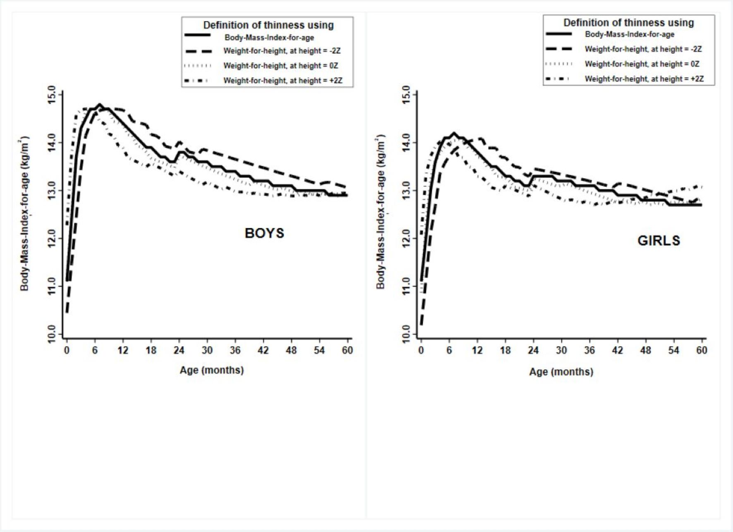
Figure 2. Comparison of estimated prevalence and 95% confidence intervals of thinness using weight-for-height and Body-Mass-Index-for-age criteria on simulated populations: Panel A - short based on the National Family Health Survey-4, India data; Panel B - intermediate; Panels C, D and E - tall based on Poland, Greenland and the National Health and Nutrition Examination Survey, USAdata, respectively.

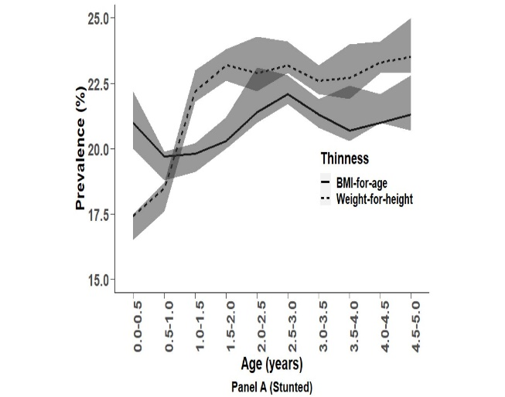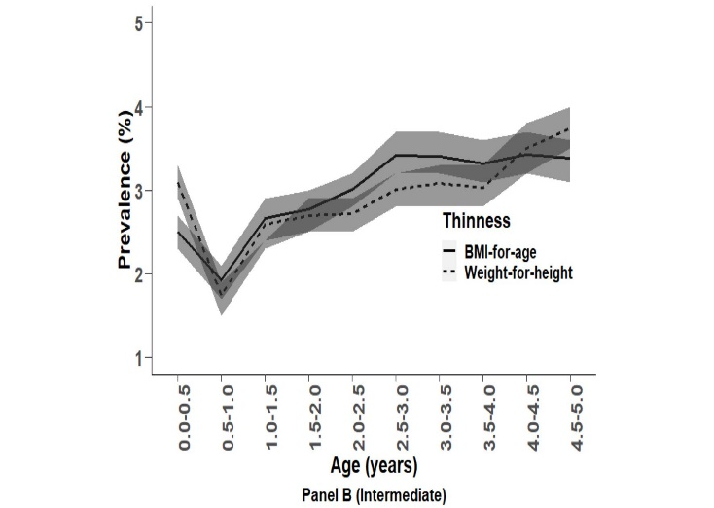
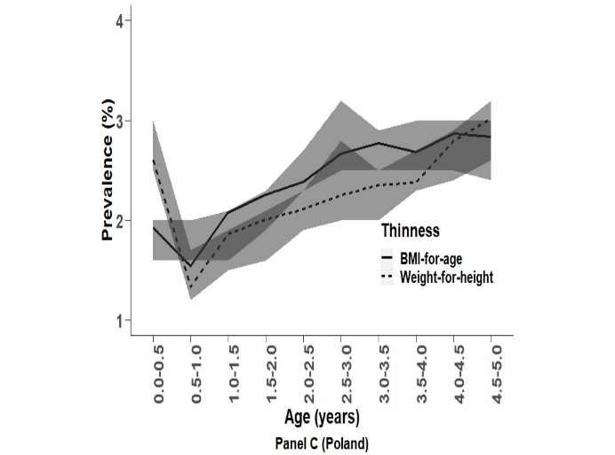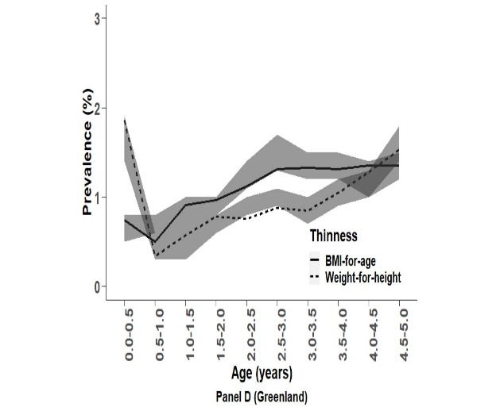
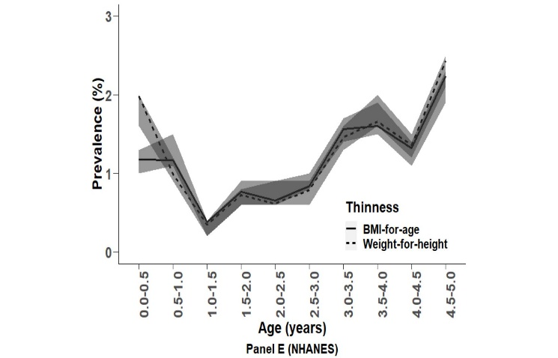

Figure 3. Comparison of estimated prevalence and 95% confidence intervals of thinness using weight-for-height and Body-Mass-Index-for-age criteria in Meerut and National Family Health Survey-4, India datasets: Panel A – Entire population, Panel B – Boys, and Panel C – Girls.
Meerut Study
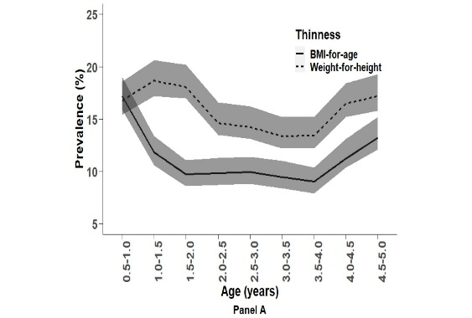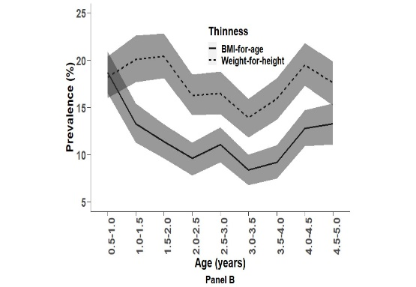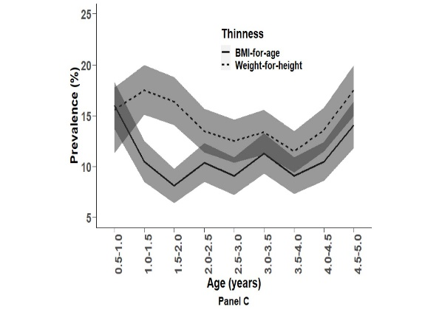

NFHS-4
