Chemical isolation and isotopic analysis of terrigenous sediments with emphasis on effective removal of contaminating marine phases including barite
Amy M. Jewell^{1*}, Matthew J. Cooper¹, J. Andrew Milton¹, Rachael H. James¹, Anya J. Crocker¹, Paul A. Wilson¹

- University of Southampton, Waterfront Campus, National Oceanography Centre Southampton, SO14 3ZH, UK

* Corresponding author

Highlights
- A systematic protocol for the effective removal of all contaminating marine phases from terrigenous sediments that can be tailored to site- and project- specific needs
- Marine barite contaminates measured terrigenous ⁸⁷Sr/⁸⁶Sr by up to 0.01 towards the seawater ratio but is removed by our protocol without compromising ε_{Nd} data.
- Extent of barite contamination depends on sedimentary barite content and the offset in ⁸⁷Sr/⁸⁶Sr between the terrigenous and seawater ratios.
- At least one treatment with DTPA-NaOH to remove marine barite should be applied in most marine investigations of terrigenous ⁸⁷Sr/⁸⁶Sr.

Keywords: Marine barite, terrigenous fraction of sediment, ⁸⁷Sr/⁸⁶Sr, ε_{Nd}.

Abstract
The radiogenic isotope composition (e.g. ⁸⁷Sr/⁸⁶Sr and ε_{Nd}) of the terrigenous fraction is commonly used to determine the provenance and transport history of sediments. In ocean sediments, the terrigenous fraction must be isolated prior to analysis to avoid contamination by marine phases. While the removal of calcium carbonate, organic matter, biogenic opal, authigenic coatings and adsorbed cations is widely advised, steps to remove all these phases are not consistently employed, and there is no standard procedure for the effective removal of marine barite. Marine barite is found throughout the world’s oceans, particularly in regions of high export production, is highly enriched in strontium (Sr) and therefore has the potential to bias measurements of terrigenous ⁸⁷Sr/⁸⁶Sr towards seawater. Here we present results from sequential leaching experiments on marine sediments from the Atlantic and the Pacific Oceans to quantitatively determine the contaminating effect on ⁸⁷Sr/⁸⁶Sr and ε_{Nd} exerted by the presence of barite and develop a protocol to successfully isolate the terrigenous fraction. Our results show that marine barite can skew measurements of terrigenous ⁸⁷Sr/⁸⁶Sr by > 0.01 towards the ⁸⁷Sr/⁸⁶Sr value of seawater, and we highlight the importance of assessing the location-specific impact of barite contamination on terrigenous ⁸⁷Sr/⁸⁶Sr. Our results show that marine barite can severely contaminate terrigenous ⁸⁷Sr/⁸⁶Sr, even where marine barite accumulation rates are modest (< ~5 mg/m³/yr and < ~20 g C/m²/yr, respectively). Barite contains Nd in very low concentrations so barite contamination of terrigenous ε_{Nd} is not a major concern but an important aspect of our protocol is that it has minimal effect on terrigenous ε_{Nd,} allowing ⁸⁷Sr/⁸⁶Sr and ε_{Nd} to be analysed on identically cleaned aliquots. Our systematic graduated approach will help standardise ⁸⁷Sr/⁸⁶Sr data, allow for robust comparisons between sites, and will contribute to an improved understanding of the provenance, transport and weathering histories of windblown continental dust and riverine sediments.

Introduction
Geochemical characterisation of terrigenous sediments is fundamental to determining sedimentary provenance, transport histories and palaeoenvironmental change. Strontium (Sr) and neodymium (Nd) isotopes are commonly used to determine the provenance of terrigenous material by comparison to continental isotope endmembers (e.g. Blanchet, 2019; Cole et al., 2009; Grousset et al., 1998; Jardine et al., 2021; Jewell et al., 2020; Lang et al., 2014; Spray et al., 2019; Wilson et al., 2018; Xie and Marcantonio, 2012). Several studies have investigated the effectiveness of different sample preparation protocols for isotopic analysis (e.g. Bayon et al., 2002; Povea et al., 2015; Simon et al., 2020), yet there is currently no standard accepted approach, making comparison between datasets less than straightforward. Analysis of the terrigenous fraction hosted in marine sediments is further complicated because some marine phases, if not removed effectively, have the potential to strongly bias results. Standard protocols have been developed to remove calcium carbonate (CaCO₃), organic matter, biogenic opal, adsorbed cations and authigenic coatings (e.g Bayon et al., 2002; Lang et al., 2014; Povea et al., 2015; Simon et al., 2020) but some steps are often excluded, and the removal of barite prior to Sr and Nd isotope analysis has received little attention.

Marine barite (BaSO₄) is found in sinking particulate matter throughout the world’s oceans, and occurs as dense, insoluble, typically ovoid crystals approximately 2 - 5 μm in diameter (Griffith and Paytan, 2012; Martin et al., 1995; Paytan et al., 2002, 1993; Yao et al., 2021). Excluding surface waters in specific regions of the Southern Ocean, intermediate depths in the Pacific Ocean and deep waters of the Gulf of Bengal, the global ocean is undersaturated with respect to barite (Monnin et al., 1999). The mechanisms by which barite forms are not fully understood, but biomineralization in the water column is suggested and is likely metabolically mediated by marine bacteria (Gonzalez-Muñoz et al., 2012). Barium release during the degradation of organic matter plays an important role, creating microenvironments within the upper water column that become supersaturated with respect to barite, instigating its precipitation (Ganeshram et al., 2003; Griffith and Paytan, 2012). Barite production, and therefore its export to underlying ocean sediments, is directly related to primary productivity and export production ﻿(Bishop, 1988; Eagle et al., 2003; Martin et al., 1995; Paytan et al., 1996; Paytan and Griffith, 2007) (Figure 1). In high productivity environments such as zones of equatorial upwelling (Figure 1), barite can constitute up to 1 - 2 wt% of the carbonate/opal free fraction in open ocean marine sediments (Paytan et al., 1993). Barite content is also affected by diagenesis, forming either in shallow settings within marine sediments from supersaturated pore fluids at the oxic-anoxic boundary where sulphide is oxidised to sulfate, or in deeper settings such as those associated with submarine hydrothermal activity, or where Ba-rich pore fluids are expelled from seeps or fractures and come into contact with sulphate-rich seawater (Hanor, 2000; Paytan et al., 1993; Torres et al., 1996; Yao et al., 2021). These precipitates can be distinguished from pelagic marine barite morphologically and geochemically (Paytan et al., 2002).

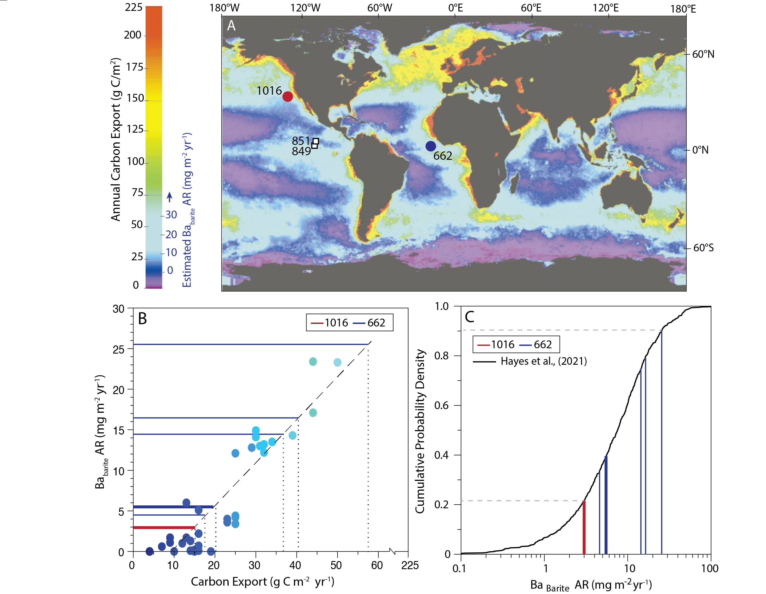
Figure 1 - Study sites and their relationship to global variability in annual carbon export (ACE) from the surface ocean (an indicator of barite accumulation rate at sites where ACE ≤ 70g C m⁻² a⁻¹). A) Figure adapted from Falkowski et al. (1998). Colours (see vertical bar) show marine annual carbon export (g C/m²). Accumulation rate of marine barite (Ba_{Barite} AR) estimated for sites of moderate annual carbon export (where relationship to Ba_{Barite} AR is linear) is also indicated on scale bar. In very high productivity zones, the relationship between carbon export and barite accumulation breaks down because of the influence of sulfate reduction-led diagenetic remobilization. Location of ODP sites 1016 (this study, red circle), 662 (this study, blue circle), 851 and 849 (Xie and Marcantonio, 2012, white squares) indicated by symbols. B) Relationship between carbon export and Ba_{Barite} AR from Eagle et al. (2003). Colour of the data points corresponds to the carbon export values shown in panel A. Estimated Ba_{Barite} AR from sites 662 (blue) and 1016 (red) shown by lines (this study, see section 3.1). C) Cumulative probability density of measurements of Ba_{Barite} AR from sites across the globe (Hayes et al., 2021, black). Vertical lines show Ba_{Barite} AR in samples from Site 1016 (red) and 662 (blue) calculated in section 3.1. Bold lines show youngest sample from each site.

Marine barite contains Nd and other rare earth elements (REEs) only in very low concentrations (likely <2 ppm; Martin et al., 1995), so its presence is not suggested to influence the ε_{Nd} signature of the terrigenous fraction. However, barite is typically extremely rich in Sr (~ 3mol%) (Monnin and Cividini, 2006) and it has even been used to undertake Sr isotope stratigraphy in carbonate-free marine sediments because barite ⁸⁷Sr/⁸⁶Sr values are aligned with values measured on foraminiferal calcite and hydroxyapatite from fish debris which both preserve a seawater signature (Martin et al., 1995; Mearon et al., 2003; Paytan et al., 1993). High Sr concentrations and the large ⁸⁷Sr/⁸⁶Sr offset between seawater and the continental crust (Figure 2) mean that even minor barite contamination has the potential to bias the isotopic signature of the terrigenous fraction of marine sediment towards ⁸⁷Sr/⁸⁶Sr_{seawater} (today, 0.709175 (Paytan et al., 1993)). Yet, despite a longstanding recognition of the Sr-rich nature of marine barite (Goldberg et al., 1969; Griffith and Paytan, 2012; Martin et al., 1995; Mearon et al., 2003; Payton et al., 1993), and evidence of the survival of marine barite following complex leaching protocols (Gonneea and Paytan, 2006; Paytan et al., 1993; Ziegler et al., 2007), we know of only two published studies (Wu et al., 2021; Xie and Marcantonio, 2012) that report attempts to remove barite from marine sediments prior to Sr isotope analysis of the terrigenous fraction. Wu et al., (2021) investigated the influence of barite on ⁸⁷Sr/⁸⁶Sr during sapropel intervals in the Mediterranean, and the effectiveness of ammonium chloride (NH₄Cl) in its removal. They suggested that treating sediments with NH₄Cl following aggressive decarbonation with hydrochloric acid (HCl) removes most of the Sr associated with barite and leads to a shift of up to 0.0018 in terrigenous ⁸⁷Sr/⁸⁶Sr away from modern seawater values. Xie and Marcantonio (2012) reported a significant influence from barite on ⁸⁷Sr/⁸⁶Sr of sediment samples within the equatorial upwelling zone of the Pacific Ocean. By contrast, sediments from sites located > 3° north of the equator, outside of the high productivity zone, were interpreted to be unaffected by barite Sr. Xie and Marcantonio (2012) showed that one treatment with a diethylene triamine pentaacetic acid - sodium hydroxide (DTPA-NaOH) mixture was moderately effective at removing barite from the operationally defined detrital component of the sediment by selective dissolution of barium sulfate precipitates, but they concluded that their approach did not achieve complete barite removal.
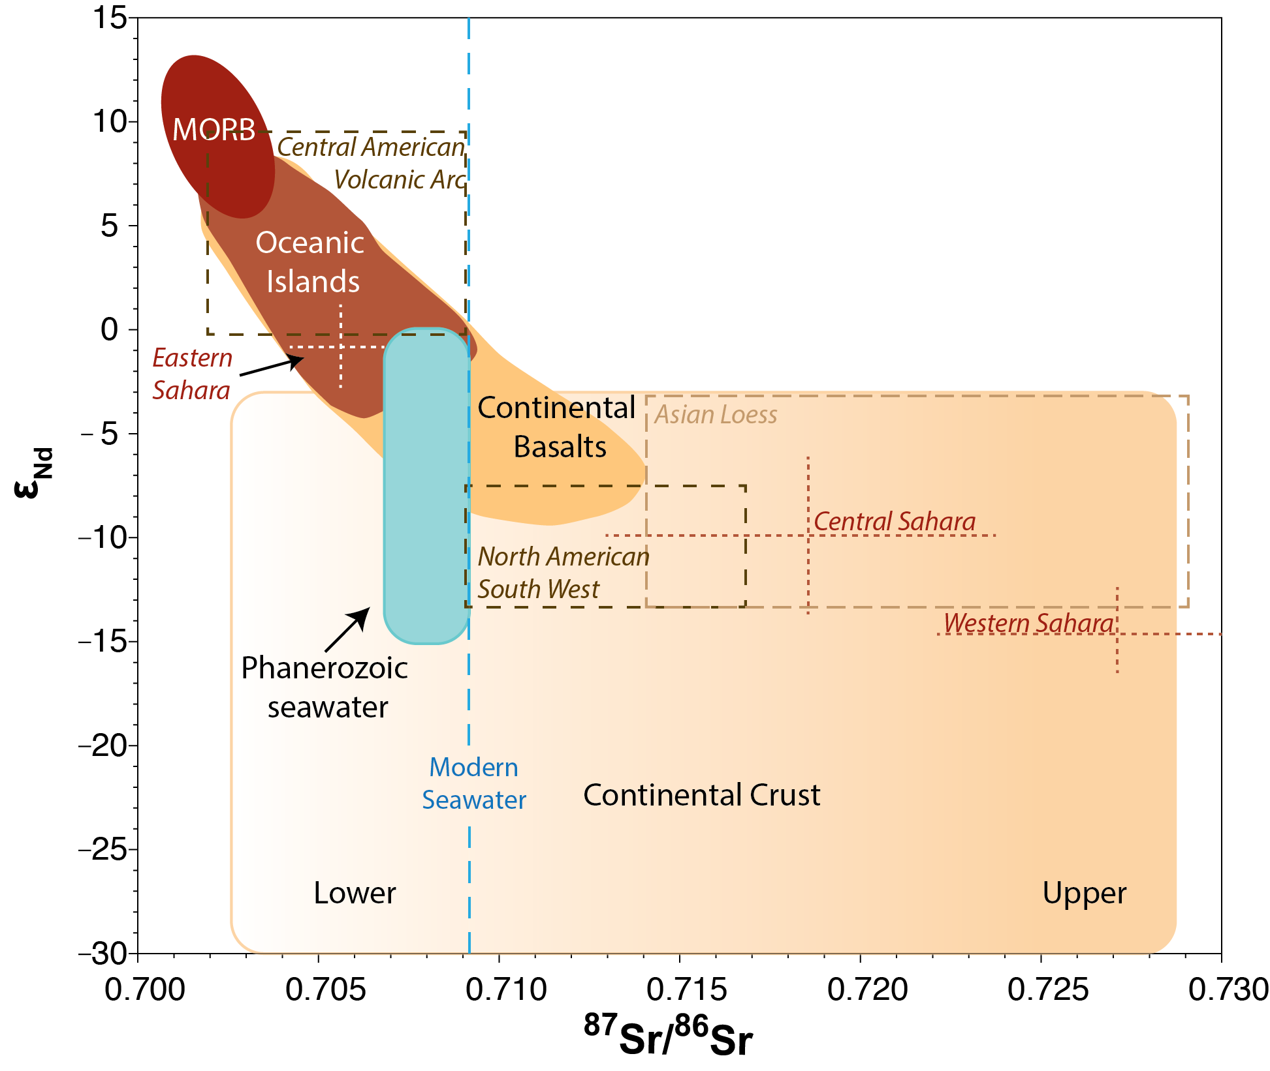
Figure 2 - Sr and Nd isotopic composition of seawater and Earth’s crust. Oceanic island basalts and mid ocean ridge basalts (MORB) sample major reservoirs in the mantle. Continental basalts represent mixtures of various components, including mantle plumes, subcontinental lithosphere, and continental crust (adapted from White, 2011)). ⁸⁷Sr/⁸⁶Sr_{seawater} range taken from (McArthur et al., 2001). Signatures of North African (Jewell et al., 2021), North/Central American (Aarons et al., 2017; Jardine et al., 2021) and Asian (Chen et al., 2007; Kanayama et al., 2005; Zeng et al., 2015; Zhao et al., 2015) dust sources are also shown.

Here we report the results of a Sr and Nd isotope study of the terrigenous fraction of marine sediments of Pliocene-Holocene age from two drill core sites (Table 1): Ocean Drilling Program (ODP) Site 1016 offshore California in the subtropical eastern Pacific Ocean and ODP Site 662 in the eastern equatorial Atlantic Ocean (Figure 1). Our study was designed to quantify barite contamination and to develop a systematic protocol for removing all contaminating marine phases from the terrigenous fraction, including barite. Building on previous work (Xie and Marcantonio., 2012), we investigate the effectiveness of using multiple DTPA-NaOH leaches to remove barite from marine sediments and to isolate a “true” terrigenous ⁸⁷Sr/⁸⁶Sr signal without altering the Nd isotope composition, in samples where Ba_{barite} is representative of much of the modern global ocean (Figure 1). Our protocol describes a systematic graduated approach to barite removal that can be tailored to site- and project-specific needs. Its application will help to standardise data, allow robust like-for-like comparisons between sites, and improve our understanding of the provenance and transport history of terrigenous sediments and their environmental interpretation. We focus on a marine sediment application but our method can also be applied to lacustrine sediments where barite may also contaminate the isotopic composition of the silicate fraction, especially in spring-fed systems (e.g. Ashley et al., 2016).

Sample ID | Site | ODP ID | Approx. Age
Sample A | ODP Site 662 | 662A 1H 1W 101-105cm | Holocene
Sample B | ODP Site 662 | 662B 1H 4W 93-95cm | Late Pleistocene
Sample C | ODP Site 662 | 662B 1H 5W 14-16cm | Late Pleistocene
Sample D | ODP Site 662 | 662B 8H 4W 108-110cm | Early Pleistocene
Sample E | ODP Site 662 | 662A 20H 2W 80-82cm | Pliocene
1016 | ODP Site 1016 | 1016B 2H 3W 90-92cm | Late Pleistocene

Table 1 - Sediment samples used for experimental DTPA leaching procedure. ODP = Ocean Drilling Program.

Materials and Methods
  - Sample material used
We worked on sediment samples from two Ocean Drilling Program (ODP) sites situated in today in moderately productive open ocean regions with significant terrigenous supply, one in the Pacific Ocean and one in the Atlantic Ocean, where export production is expected to control barite concentrations in the underlying sediments (Figure 1). Productivity at Site 662 shows strong temporal variability, with calculated Ba_{Barite} accumulation rates generally higher in the older samples (see section 3.1). Our sample set therefore spans a range of Ba_{Barite} accumulation rates comparable with modern values compiled from across the globe (Hayes et al., 2021), demonstrating that our sediments are representative of most global ocean settings (Figure 1C).

    - ODP Site 662
Ocean Drilling Program (ODP) Site 662 (1°23.41’ S, 11°44.35’ W, water depth of 3813.8m) is located in the eastern equatorial Atlantic Ocean (Ruddiman et al., 1988) (Figure 1). It was initially drilled to investigate contemporaneous changes in equatorial ocean circulation and North African aridity through the Late Neogene (Ruddiman et al., 1988). Site 662 is situated beneath the boreal winter Saharan dust plume and lies within a zone of equatorial upwelling (modern day annual carbon export values ~ 20 g C/m², Figure 1). Varying trade wind strength is hypothesised to have controlled changes in export production through the Plio-Pleistocene (Ruddiman and Janecek, 1989). We sampled sediments of late Pliocene through Holocene age (Table 1) from stratigraphic subunits 1A, 1C and 1D, comprising interbedded nannofossil and foraminifer-nannofossil oozes (Ruddiman et al., 1988).

    - ODP Site 1016
ODP Site 1016 (34°32’N, 122°17’W, water depth of 3835 m) is situated in the eastern North Pacific Ocean, approximately 150 km west of Point Conception, California (Figure 1) near the toe of the slope beyond the Santa Lucia Escarpment. This site is situated in a region of moderate productivity (modern day annual carbon export ~15 g C/m², Figure 1), under the influence of the California Current (Lyle et al., 1997), where terrigenous supply is dominated by transport from North America (Jardine et al., 2021), and marine barite has been documented in ocean sediments (Ziegler et al., 2007). We sampled shallowly buried sediments of late Pleistocene age from stratigraphic unit 1, a ﻿gradationally interbedded unit of siliclastic and diatomaceous components (Lyle et al., 1997).

  - Isolation of the terrigenous fraction of marine sediments
Our protocol for isolating the terrigenous fraction from contaminating marine phases is summarised in Figure 3 and detailed in Sections 2.2.1 to 2.2.6. We follow the approaches of Bayon et al. (2002), Lang et al. (2014) and Povea et al. (2015) to remove calcium carbonate, organic matter, adsorbed cations, authigenic coatings, and biogenic silica. The importance of these steps is widely recognised (Bayon et al. 2002; Lang et al. 2014; Povea et al. 2015 and references therein) but rarely are they all applied to the same sample set. Cleaned samples were then treated with DTPA-NaOH to remove marine barite using a protocol that builds on the work of Xie and Marcantonio (2012) who concluded that their approach (no treatment to remove organic matter or adsorbed cations, one DTPA-NaOH treatment to remove barite) did not effectively clean their samples because the change in ⁸⁷Sr/⁸⁶Sr following DTPA-NaOH treatment did not scale linearly with local productivity. Our goal was to remove the influence of marine barite on the isotopic composition of the terrigenous fraction. Our approach subjected samples to multiple DTPA-NaOH treatments to determine optimal site-specific treatment. All sample processing and analysis was undertaken at the University of Southampton’s Waterfront Campus laboratories. To test reproducibility, we repeated the whole protocol for several samples giving replicate measurements. In the discussion that follows, we refer to the first measurements from each experiment, replicates are listed in Tables S1 & S2 for reference.

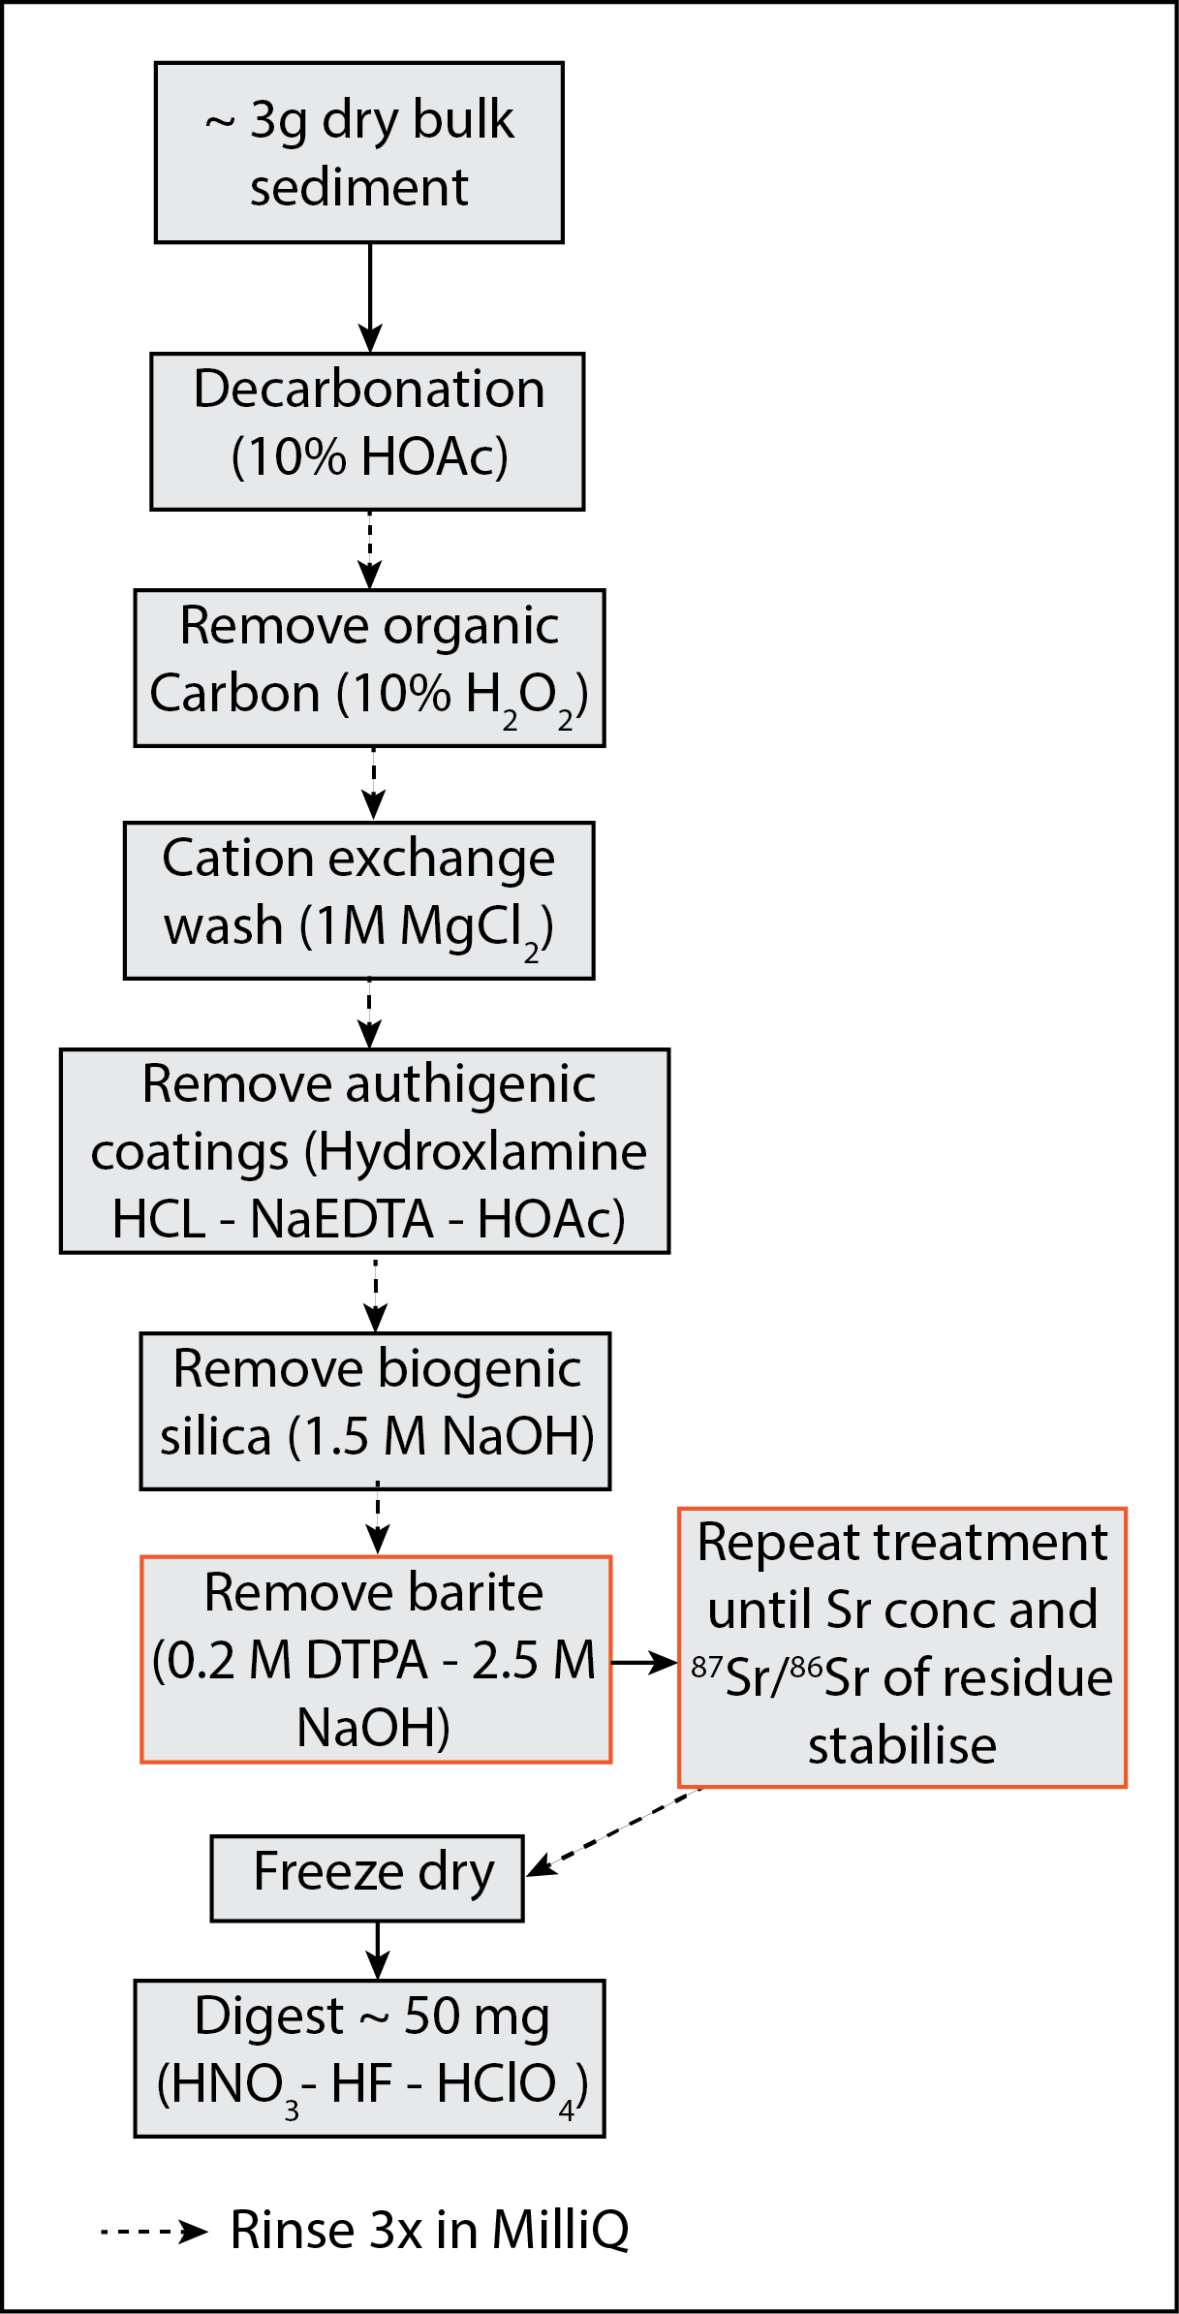
Figure 3 – Our method for isolating the terrigenous fraction from all contaminating phases, including barite (red boxes), to allow accurate determination of the radiogenic isotope composition.

    - Sample preparation and decarbonation
Dried samples of bulk sediment were ground in a pestle and mortar and approximately 2 - 5 g was transferred directly to Erlenmeyer flasks in preparation for leaching. To remove carbonate, ~ 50ml 10 % acetic acid (HOAc) was added and samples were agitated overnight on a shaker table (Bayon et al., 2002; Ostrom, 1961). The following day, sediment and reagent were transferred into acid-cleaned 50ml centrifuge tubes, centrifuged, and the supernatant decanted.

Following decarbonation, samples were rinsed three times with MilliQ water in the centrifuge tubes (vortexed in MilliQ to ensure they were well-mixed, centrifuged for at least 5 minutes, and the supernatant decanted). This rinse was also repeated after all subsequent leaching steps detailed in Sections 2.2.2 to 2.2.6. If the supernatant remained cloudy after centrifugation, approximately 100 μl of a Mg²⁺ -rich (10,000 ppm Mg²⁺, Sr of < 0.4 ppb) solution was added to aid flocculation. Once the supernatants were clear, the samples were centrifuged again and supernatants decanted.

    - Removal of organic carbon
To remove organic carbon while avoiding alteration of the Sr isotopic signature of clay minerals by roasting (Bayon et al., 2002), decarbonated samples were treated with 30 ml 10% H₂O₂ solution and left in an oven at 65 ° C for 48 hours (Bayon et al., 2002; Povea et al., 2015).

    - Cation exchange wash
Next we removed cations of a seawater origin (e.g. Sr) adsorbed onto terrigenous clay particles by adding 30ml of 1M magnesium chloride (MgCl₂) solution and agitating the samples on a shaker table for approximately 24 hours (Gutjahr et al., 2007; Lang et al., 2014; Simon et al., 2020; Tessier et al., 1979).

    - Removal of authigenic coatings
To remove authigenic coatings following the cation exchange wash, samples were treated with ~ 30 ml 0.05 M of hydroxylamine hydrochloride (HH) - 0.03 M Na-EDTA - 15 % acetic acid (HOAc) solution, buffered with sodium hydroxide (NaOH) to ~pH 4 (Bayon et al., 2002; Gutjahr et al., 2007; Hall et al., 1996). This procedure was carried out in two stages totalling 27 hours: after the first treatment, samples were agitated on a shaker table for three hours, the reagent was then removed and replaced with fresh HH-NaEDTA-HOAc, and samples were agitated for a further 24 hours. Retained leachates can be used for isotopic analysis of seawater-derived trace metals (e.g. Sr, Nd, Pb, Th). While this method is an effective way to thoroughly remove authigenic coatings, treatment with acetic acid risks dissolution of some reactive silicate phases (e.g., fresh volcanic glass, Blaser et al., 2016). Therefore, if isolation and analysis of the authigenic coatings themselves is desired or if these reactive silicate phases are abundant or of particular interest, a less aggressive method should be employed (Blaser et al., 2016; Dausmann et al., 2019; Huang et al., 2021).

    - Removal of biogenic silica
To remove biogenic silica, 20 ml of 1.5 M NaOH was added to each sample, then samples were sonicated for 10 minutes, and left overnight in an oven at 65 ° C. Samples were then transferred to an 80 ° C water bath for two hours, reagent was removed, new 1.5 M NaOH was added, and then samples were returned to the water bath for an additional 2 hours. Finally, samples were left in an oven at 65 ° C overnight (Povea et al., 2015, developed from Lyle and Lyle, 2002; Mortlock and Froelich, 1989). After rinsing, samples were freeze dried and subsampled for repeated barite removal leaching procedures.

    - Removal of marine barite
To remove marine barite, ~5ml of 0.2 M DTPA in 2.5 M NaOH was added to each subsample, and samples were left in a water bath set to 80 ° C for 30 minutes, following Xie and Marcantonio (2012). This process was repeated up to four times to determine the number of treatments required for complete barite removal. Samples were centrifuged, and the reagent decanted and refreshed between each repeat. DTPA-NaOH leachate solutions were retained and analysed for trace metal concentrations.

A DTPA-NaOH solution was first employed by Sill and Willis (1964) to dissolve barium sulphate precipitates and was later adapted to remove marine barite from foraminifera tests by Lea and Boyle (1991). DTPA is more effective at dissolving barite than other chelating agents because it has eight binding sites to form coordination bonds with metal ions, compared to, for example, Ethylenediaminetetraacetic acid (EDTA) which has only six (Shende, 2012). DTPA selectively dissolves barite and is suggested to have minimal effect on other phases, in particular the terrigenous fraction (House and Norris, 2020, Lea and Boyle, 1991). DTPA forms strong complexes with Ba under alkaline conditions, so DTPA concentrations many orders of magnitude in excess of the barite concentration causes rapid barite dissolution﻿ (Lea and Boyle, 1991; Sill and Willis, 1966, 1964). This approach was exploited to clean the abiogenic terrigenous fraction in marine sediments by Xie and Marcantonio (2012). They implemented a single DTPA-NaOH leach on samples from ODP Sites 849 and 851 (Figure 1) and found that the terrigenous Sr isotope value shifted away from a modern seawater value by approximately 0.001 to less radiogenic values (Figure 4B). Yet, a mismatch between the shift in terrigenous ⁸⁷Sr/⁸⁶Sr signature and expected productivity/barite concentration suggested that this treatment was insufficient to remove all marine barite from the operationally defined terrigenous fraction for samples from these two sites in the equatorial Pacific Ocean.

Increasing the reaction time is the optimal way to enhance barite dissolution using DTPA because increasing the DTPA concentration and increasing the reaction temperature are ineffective (Putnis et al., 2008). However, in this case, where the terrigenous fraction itself is of interest, it is important to balance the need for an extended reaction time against the risk of DTPA-NaOH attack on the clay fraction. Instead, therefore, we have devised a multiple DTPA-NaOH treatment approach that permits sample- and project- specific optimisation of our protocol (Figure 3). We consider marine sediments to be free of contaminating barite when, with repeated DTPA-NaOH treatments: (i) there is no appreciable further decrease in Sr or Ba concentration of the terrigenous fraction, (ii) no further change in ⁸⁷Sr/⁸⁶Sr of the terrigenous fraction, and (iii) no appreciable further Sr and Ba appear in sample leachates.

  - Sample digestion and column chemistry
Sample digestions and column chemistry were carried out under clean laboratory conditions. Approximately 50 mg of freeze-dried processed sample was digested overnight using a HF-HNO₃-HClO₄ acid mixture at 130 °C.

Nd and Sr were isolated using chromatographic column separation (see supplementary materials for detailed methods). A subsample containing a minimum of 1μg of Sr and 200ng of Nd was passed through a cation column (Bio-Rad AG-50W-X8 resin 200-400μm mesh) to ensure removal of barium in the sample fraction isolated for isotopic analysis. Fractions were collected for both Sr and Nd with average recoveries of 99.8 ± 4.7 % and 102.6 ± 5.9 % respectively. Nd was then isolated using a reverse phase column (Ln-spec resin 50-100 μm) (Pin and Zalduegui, 1997) to ensure good separation of the rare earth elements (REEs), especially Ce, to ensure minimal interference during mass spectrometry. Sr was isolated using Eichrom Sr-spec resin, with approximate recovery of 99.8 %. The total column blanks (i.e. when acid is run through the column procedure) were negligible (50 pg and 13 pg) compared to the total amounts analysed (≥ 1 μg and 200 ng) for Sr and Nd respectively.

  - Analytical procedure
    - Trace element concentrations
Element concentrations were determined using an Agilent 8900 TripleQuad inductively coupled plasma mass spectrometer (QQQ-ICP-MS) using standard, He and oxygen modes for the trace elements, and He with High Matrix Introduction (HMI) mode for the major elements. A suite of international rock standards was used for calibration (Jb-2, JB-3, JGb-1, BHVO2, AGV-2, BCR-2, BIR-1, JG-2 and JR-2). The precision of the analyses for all elements was better than ±10 % relative standard deviation (RSD).

    - Nd isotopes
Nd-isotope ratios were measured using a multi-collector ICP-MS (MC-ICP-MS, Thermo Fisher Scientific Neptune). Nd isotopic compositions were corrected following the method of Vance and Thirlwall, (2002) through adjustment to a ¹⁴⁶Nd/¹⁴⁴Nd ratio of 0.7219 and a secondary normalisation to ¹⁴²Nd/¹⁴⁴Nd = 1.141876. For convenience the Nd isotope ratios are reported in epsilon notation (ε_{Nd}), where ¹⁴³Nd/¹⁴⁴Nd_{CHUR} represents the Chondrite Uniform Reservoir value of 0.512638 (Jacobsen and Wasserburg, 1980):
Equation 1:
$$ε_{Nd}= \left[\frac{{{}_{ }^{143}{Nd}}/{{{}_{ }^{144}{Nd}}_{sample}}}{{{}_{ }^{143}{Nd}}/{{{}_{ }^{144}{Nd}}_{CHUR}}}-1\right]× {10}^{4}$$

    - Sr isotopes
After column separation, the Sr fraction was dried down and loaded onto an outgassed tantalum filament with 1ml of a tantalum activator solution. The samples were analysed on a Thermo Fisher Scientific Triton Thermal Ionisation Mass Spectrometer using a multidynamic procedure and an ⁸⁸Sr beam of 2V. Fractionation was corrected using an exponential correction normalised to ⁸⁶Sr/⁸⁸Sr = 0.1194. NIST987 was run as a standard in each turret and over the course of this study ⁸⁷Sr/⁸⁶Sr = 0.710241 ± 0.000008 (2sd; n = 20). The long-term average for NIST987 on this instrument is 0.710242 ± 0.000021 (2sd; n = 531).

The international rock standard BCR-2 was subjected to our column chromatographic separation scheme, and Sr and Nd isotopic signatures were analysed, giving 0.06 ± 0.17 (twice the mean internal standard error; 2SE) for ε_{Nd} and 0.705003 ± 0.000012 (2SE) for ⁸⁷Sr/⁸⁶Sr, well within the accepted values (Jochum et al., 2005).

Results and Discussion
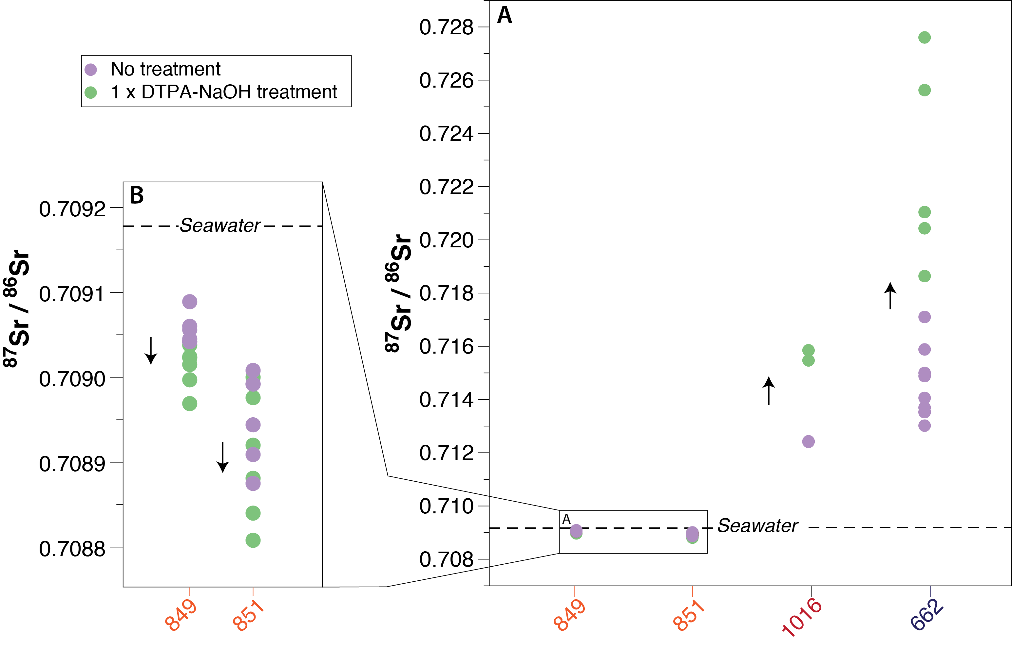
Figure 4 – Site-to-site comparison of the terrigenous ⁸⁷Sr/⁸⁶Sr change achieved by a single DTPA-NaOH treatment. A) Terrigenous ⁸⁷Sr/⁸⁶Sr before (purple) and after (green) one DTPA-NaOH treatment at Ocean Drilling Program (ODP) sites 849, 851 (Xie and Marcantonio, 2012), 1016 and 662 (this study). B) Detail of data from ODP Sites 849 and 851. Modern seawater ⁸⁷Sr/⁸⁶Sr shown by dashed line. Arrows show direction of ⁸⁷Sr/⁸⁶Sr change following DTPA-NaOH treatment. Error (2SE) falls within size of markers. Site locations shown in Figure 1.

⁸⁷Sr/⁸⁶Sr results
Our results show that one DTPA-NaOH treatment of sediment samples from ODP sites 662 and 1016 causes a shift in ⁸⁷Sr/⁸⁶Sr away from the modern seawater signature (0.709175) to more radiogenic values in all samples tested (Figure 4A). These shifts are up to an order of magnitude larger than those reported from the equatorial Pacific Ocean by Xie and Marcantonio (2012) and are in the opposite direction (Figure 4A). The direction of change in ⁸⁷Sr/⁸⁶Sr values realised by DTPA cleaning is controlled by the sign of the ⁸⁷Sr/⁸⁶Sr offset between the terrigenous and sea water (barite) values (Figures 2 and 4). The increases in ⁸⁷Sr/⁸⁶Sr evidenced at Site 662 following one DTPA-NaOH treatment are accompanied by large decreases in sample Sr and Ba concentration (Table S1) and high concentrations of Sr and Ba in the leachates (Table S2). The largest change in ⁸⁷Sr/⁸⁶Sr after one DTPA treatment is seen in Sample C from Site 662, where ⁸⁷Sr/⁸⁶Sr increases by 0.012 after one treatment (Figure 5), while the terrigenous Ba and Sr concentrations decrease from 7040 ppm to 649 ppm (Ba) and from 196 ppm to 54 ppm (Sr). In contrast, one DTPA-NaOH treatment at ODP Site 1016 yields an increase in ⁸⁷Sr/⁸⁶Sr of approximately 0.003 away from modern seawater (Figure 4), a far smaller shift than those observed at Site 662, and closer in magnitude, although of the opposite sign, to those reported for ODP Sites 849 and 851 by Xie and Marcantonio, (2012) (Figure 4).

Similar concentrations of Ba and Sr are found in the leachates of samples from both Site 662 and Site 1016 following the first DTPA-NaOH treatment (Table S2). This result suggests that the greater change in ⁸⁷Sr/⁸⁶Sr induced by one treatment recorded at Atlantic Ocean Site 662 compared to the Pacific sites (Figure 4) is not explained by higher concentrations of marine barite at Site 662, but instead by a larger offset in Sr isotope composition between the terrigenous fraction and modern seawater (Figures 2 and 4). North African dust sources upwind of Site 662 are markedly more radiogenic (~0.7186 - 0.7279, Jewell et al., 2020) than North American dust sources and the Central American Volcanic Arc (~0.709 - 0.717 and ~0.702 - 0.708, respectively) (Aarons et al., 2017; Jardine et al., 2021; Napier et al., 2020) and therefore lie further from the modern seawater ⁸⁷Sr/⁸⁶Sr value (Figure 2). In other words, the contamination effect of marine barite on terrigenous ⁸⁷Sr/⁸⁶Sr is greater in the North Atlantic Ocean than in the eastern and equatorial Pacific Ocean because the sources feeding terrigenous supply are more radiogenic there. For the same reason, all other things being equal, the potential for barite contamination of the terrigenous fraction in the Pacific Ocean is greatest at sites situated in the North Pacific where windblown transport is dominated by the Asian dust plume (Hyeong et al., 2016; Figure 2). The same phenomenon can be seen in the Eastern Mediterranean (Wu et al., 2021). Marine sediments in the Gulf of Sirte, which receive terrigenous material mainly from the Western Saharan preferential dust source area (PSA) (⁸⁷Sr/⁸⁶Sr 0.7279 ± 0.0052, Jewell et al., 2020) are more affected by barite contamination than marine sediments in the easternmost Mediterranean which are fed by non-radiogenic strontium (< 0.712) down the River Nile (Weldeab et al., 2002) and from the Eastern Saharan PSA (Jewell et al., 2020).
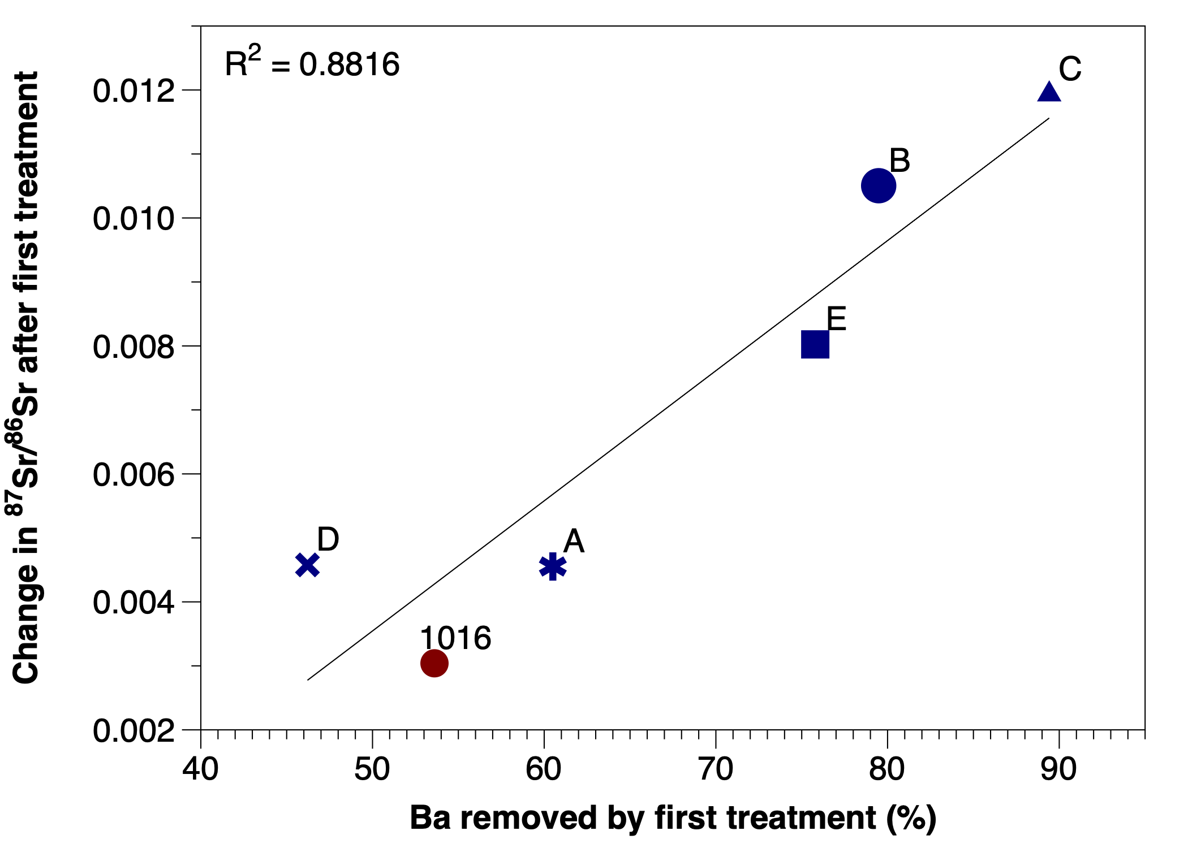
Figure 5 - Strong relationship between proportion of the Ba removed from sediment samples by the first DTPA-NaOH treatment and the corresponding change in ⁸⁷Sr/⁸⁶Sr. Samples from ODP Site 662 in blue, Site 1016 in red. Sample Identifiers shown by labels. A: 662A 1H 1W 101-105cm, B: 662B 1H 4W 93-95cm, C: 662B 1H 5W 14-16cm, D: 662B 8H 4W 108-110cm, E: 662A 20H 2W 80-82cm, 1016: 1016B 2H 3W 90-92cm.

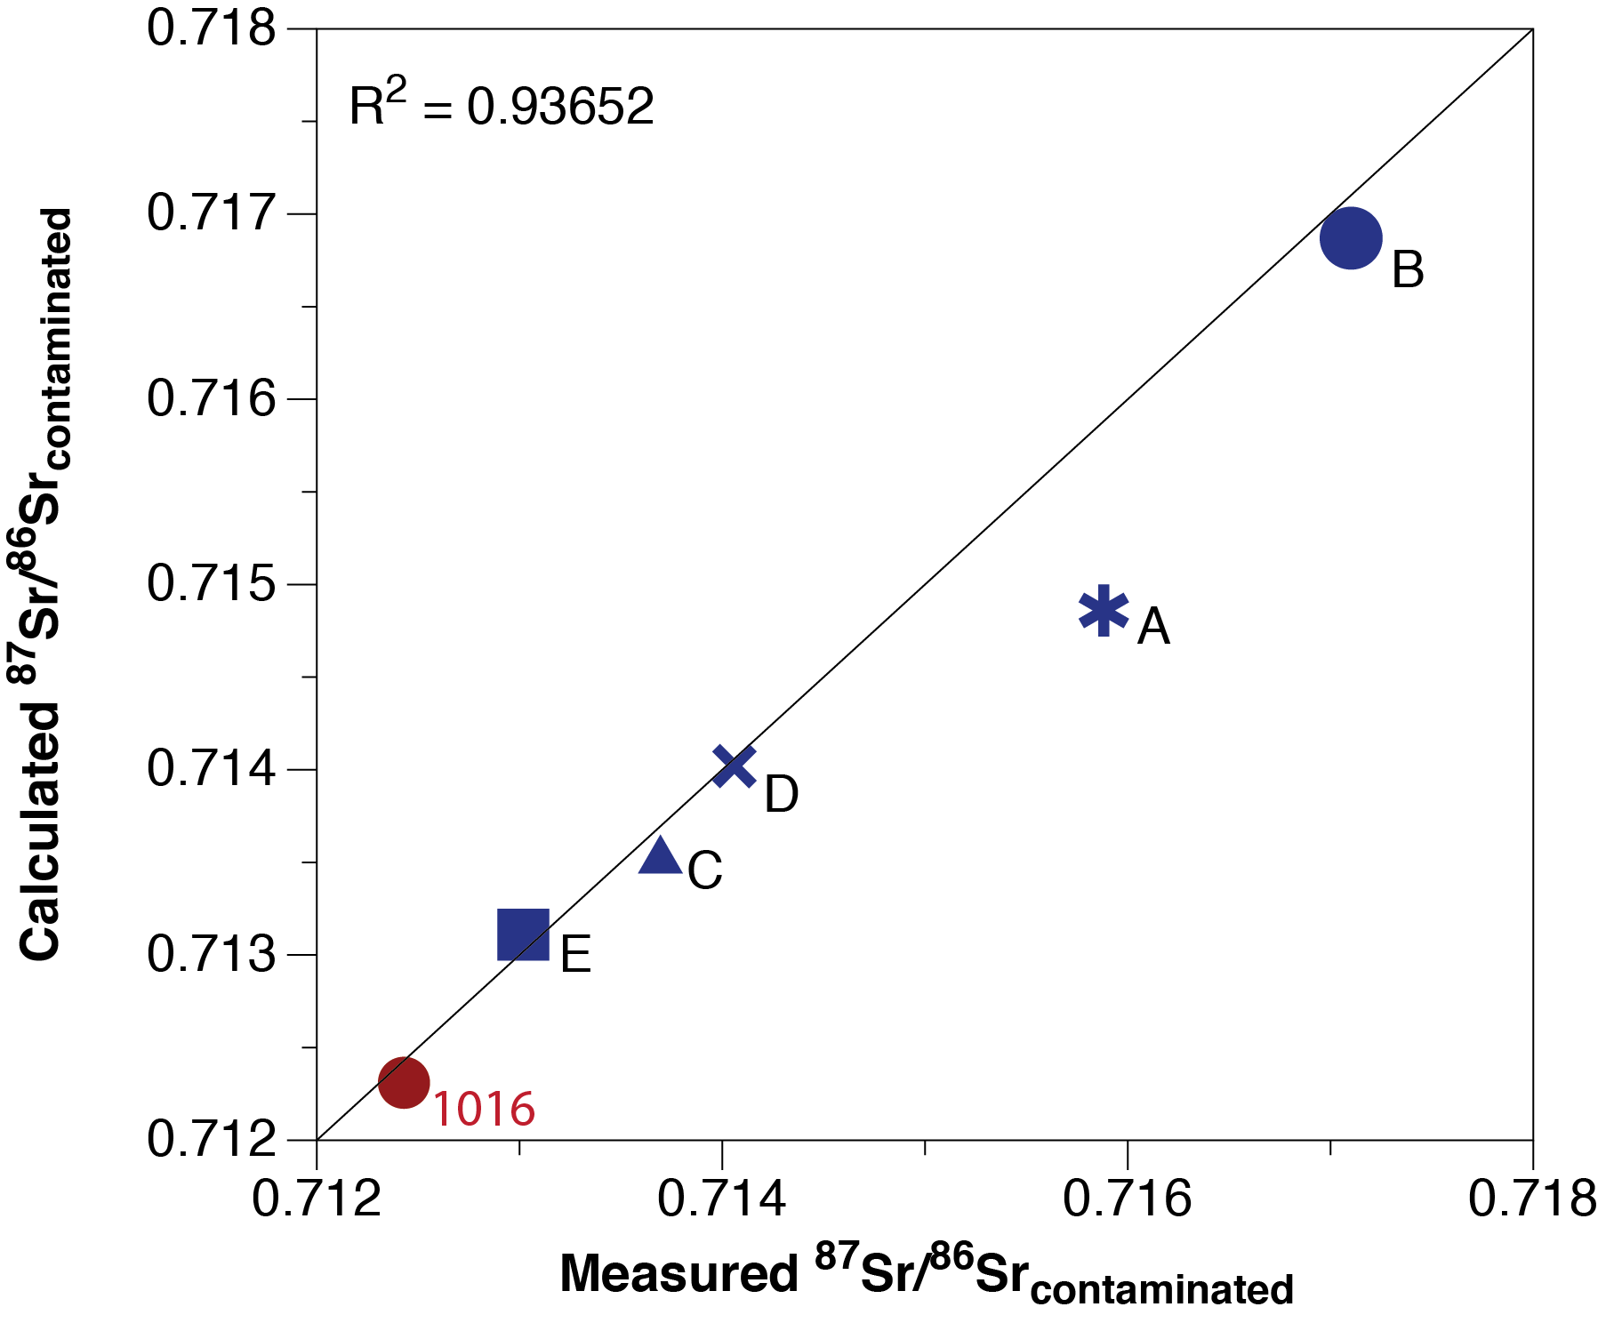
Figure 6 – Measured versus calculated Sr isotope composition of the contaminated sample (calculated value determined by equation 2). Samples from ODP Site 662 shown in blue, Site 1016 in red. Sample Identifiers shown by labels. A: 662A 1H 1W 101-105cm, B: 662B 1H 4W 93-95cm, C: 662B 1H 5W 14-16cm, D: 662B 8H 4W 108-110cm, E: 662A 20H 2W 80-82cm, 1016: 1016B 2H 3W 90-92cm. 1:1 line also shown.

We calculated the expected ⁸⁷Sr/⁸⁶Sr of the barite-contaminated terrigenous fraction using the measured terrigenous ⁸⁷Sr/⁸⁶Sr value following the final DTPA-NaOH treatment to represent the terrestrial ⁸⁷Sr/⁸⁶Sr endmember and by assuming all the Sr removed has the ⁸⁷Sr/⁸⁶Sr composition of modern seawater (0.709175) (equation 2). We find that calculated ⁸⁷Sr/⁸⁶Sr for the contaminated samples are almost identical to the measured values (Figure 6). This result shows that the phase (barite) removed by the DTPA-NaOH leaching step in our protocol is one with a strontium isotope signature very close to the modern seawater value (Figure 6).
Equation 2:
$${}_{}^{87}{Sr}/{}_{}^{86}{{Sr}_{contaminated}= }\left({}_{}^{87}{Sr}/{}_{}^{86}{{Sr}_{seawater}} × f_{removed}\right)+\left({}_{}^{87}{Sr}/{}_{}^{86}{{Sr}_{terrestrial}×f_{terrestrial}}\right)$$

$$f_{removed}= \frac{\left({Sr conc}_{before treatment}- {Sr conc}_{ after treatment}\right)}{{Sr conc}_{before treatment}}$$
$$f_{terrestrial}=1-f_{removed}$$

To determine the concentration of contaminating barite in our sediment samples, we first calculated the amount of Ba present in our samples that is not associated with the terrigenous fraction (Ba_{excess}, Equation 3). We then used Ba_{excess} to estimate both the sediment barite content (Ba_{barite}) and barite accumulation rate (AR Ba_{barite}) of Ba associated with barite (Equation 4) following Eagle et al., (2003). Results are shown in Table 2.

Equation 3:
$${[{Ba}_{excess}]}_{ppm}= {[{Ba}_{total}]}_{ppm}-\left({\frac{Ba}{Al}}_{terrigenous}\right)× {[{Al}_{total}]}_{ppm}$$
where Ba/Al_{terrigenous} is the Ba/Al of the sample residue following the final DTPA-NaOH treatment.

Equation 4:
$$AR {Ba}_{Barite }=\left({Ba}_{excess}× SR × DBD\right)× {10}^{-3}$$

Sedimentation rate (SR, m/yr) and dry bulk density (DBD, g/m³) for sites 662 and 1016 were taken from Ruddiman et al., (1988) and Lyle et al., (1997), respectively.

Our estimate for the Holocene barite accumulation rate at Site 662 (Sample A, 5.5 mg/m²/yr) agrees broadly with AR Ba_{barite} values estimated from the observed modern annual carbon export for the eastern equatorial Atlantic Ocean (Figure 1, Eagle et al., 2003). AR Ba_{barite} varies downcore by a factor of about four and increases to 16.4 and 25.6 mg/m²/yr for Pliocene samples D and E respectively, indicating that productivity in this region was likely much higher during the Pliocene than today (Table 2). The estimated AR Ba_{barite} from Site 1016 (3.0 mg/m²/yr) is lower than at Site 662 and also in agreement with expectations based on local annual carbon export production (Figure 1). Comparison of our estimates of AR Ba_{barite} at sites 662 and 1016 (Table 2) with global estimates of excess Ba flux (Hayes et al., 2021) and global annual carbon export (Falkowski et al., 1998) (Figure 1) indicate that our sample set is broadly representative of measured values from sediments across the globe (22nd - 91st percentile), with the exceptions of regions of extremely low and high export production.

We find large variability in the degree of ⁸⁷Sr/⁸⁶Sr contamination by marine barite among different samples from Site 662. The magnitude of increase in ⁸⁷Sr/⁸⁶Sr after one DTPA-NaOH treatment varies by approximately a factor of three among samples from this site (Figure 5). We attribute this result mainly to time-varying export production (Ruddiman and Janecek, 1989) which leads to marked downcore changes in sediment Ba_{Barite} content. There is a very strong linear correlation between the proportion of Ba removed and the extent of barite contamination measured by ⁸⁷Sr/⁸⁶Sr (Figure 5).

Sample | Al_{total} | Ba_{total} | Ba_{excess} | Dry Bulk Density | Sed. rate | Sediment Ba_{Barite} | AR Ba_{Barite}
 | ppm | ppm | ppm | g/cm³ | m/Myr | kg/m³ | mg/m²/yr
A | 97900 | 5000 | 4810 | 0.42 | 42 | 1.308 | 5.5
B | 87700 | 2690 | 2520 | 0.48 | 42 | 1.101 | 4.6
C | 80000 | 7040 | 6880 | 0.52 | 42 | 3.433 | 14.4
D | 99600 | 7260 | 7060 | 0.92 | 42 | 3.893 | 16.4
E | 80700 | 8160 | 8000 | 0.94 | 42 | 6.107 | 25.6
1016 | 96700 | 1710 | 1520 | 0.60 | 50 | 0.598 | 3.0

Table 2 - Calculated Ba_{excess}, sedimentary Ba_{Barite} concentration and Ba_{Barite} accumulation rate in samples from ODP sites 662 and 1016, following the methodology of Eagle et al. (2003). See Table 1 for sample IDs. Sedimentation rate and dry bulk density for Site 662 taken from ODP initial reports (Ruddiman et al., 1988). Sedimentation rate from Site 1016 from Lyle et al., (1997). Dry bulk density from correlative sediments in Hole 1016A.

Additional DTPA-NaOH treatments on samples from Site 662 lead to further but smaller changes in sediment ⁸⁷Sr/⁸⁶Sr (Figure 7). The amount of Ba_{Barite} removed by the first treatment varies between samples (0.546 to 5.969 kg/m³), but subsequent treatments remove significantly less Ba_{Barite} in all samples (0 - 0.640 kg/m³) (Figure 7). Ba concentrations in late Pleistocene samples B and C from Site 662 prior to DTPA-NaOH treatment (2690 ppm and 7040 ppm, respectively) are comparable to those expected for sediments with high barite contents (Gonneea and Paytan, 2006) and, after one DTPA-NaOH treatment, decrease to values (491 ppm and 649 ppm, respectively) broadly consistent with Ba concentrations reported from the detrital fraction of sediments from a range of environments (Gonneea and Paytan, 2006). Sr concentrations in Site 662 samples B and C decrease from 128 ppm and 196 ppm prior to DTPA-NaOH leaching, to 54 ppm in both samples respectively following the first treatment, with subsequent treatments yielding concentration decreases of less than 10 ppm Sr (Figure 8). Similarly, the DTPA-NaOH leachate of the first treatment has the highest Sr and Ba concentrations relative to subsequent leaches (Table S2).
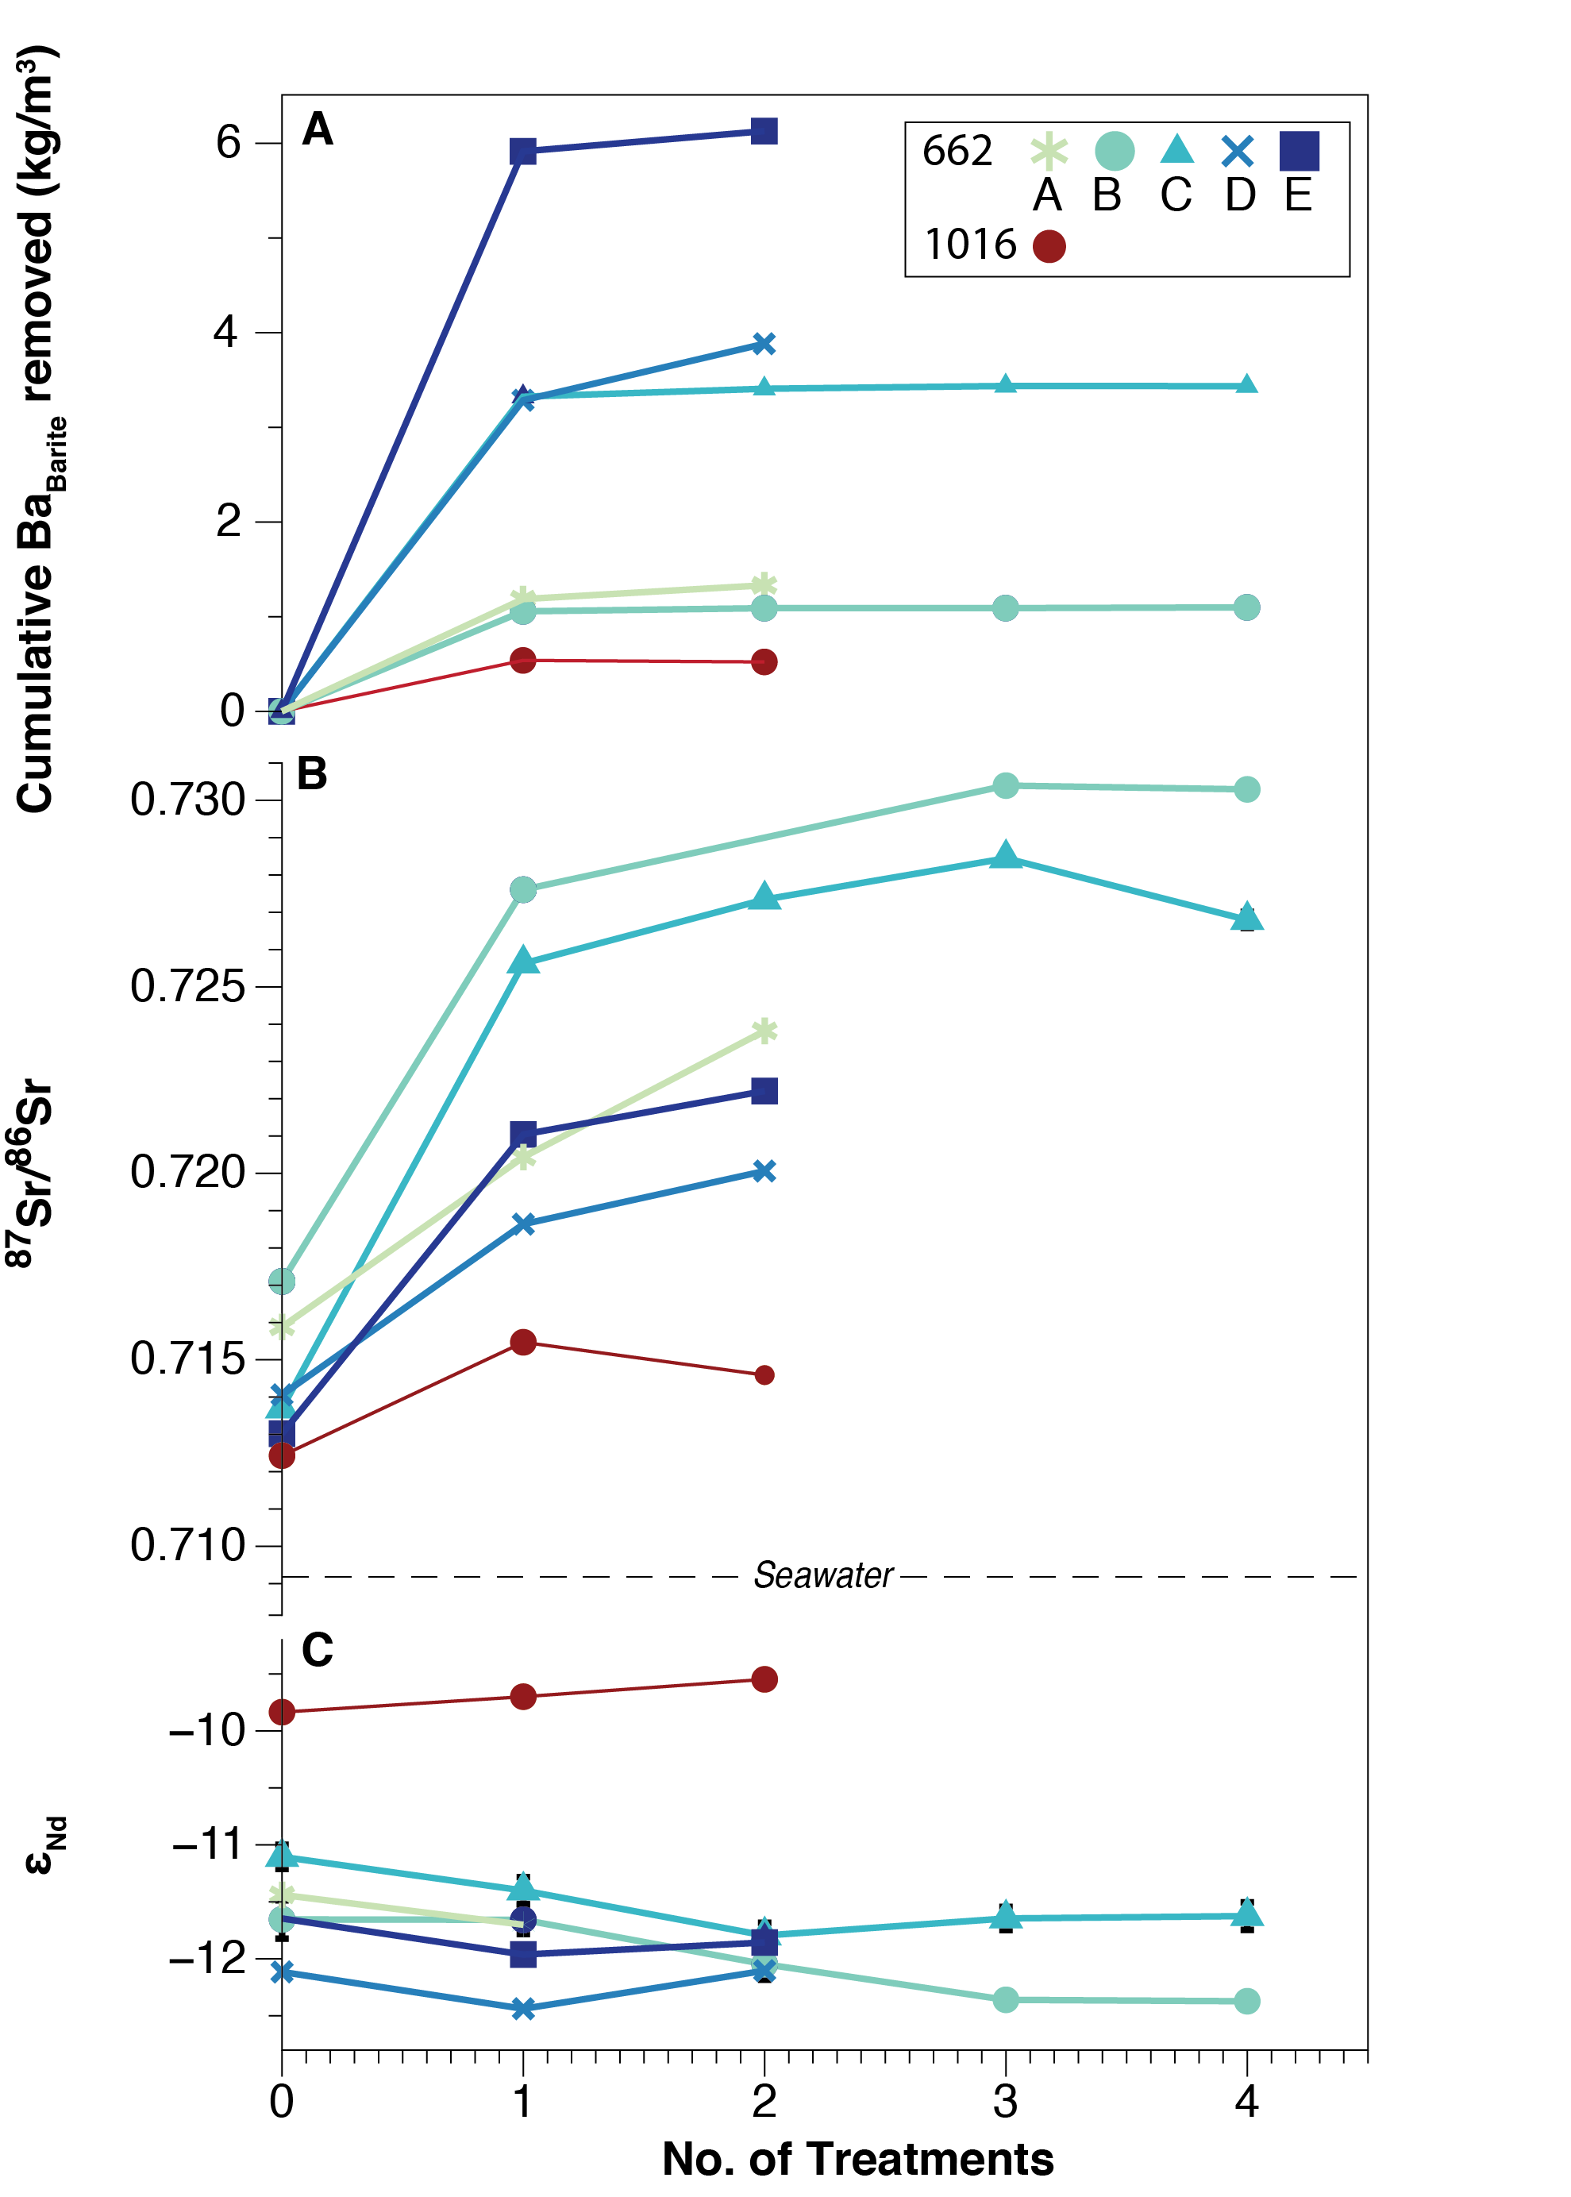
Figure 7 - Results of multiple DTPA-NaOH treatments on sediment sample geochemistry. A) Cumulative Ba_{Barite} removed (kg/m³) after 0, 1, 2, 3 & 4 DTPA-NaOH treatments in samples from Sites 662 (blue colours) and 1016 (red). B) Measured ⁸⁷Sr/⁸⁶Sr of terrigenous fraction after each DTPA-NaOH treatment. Dashed line denotes seawater ⁸⁷Sr/⁸⁶Sr. C) Corresponding ε_{Nd}. 2SE error bars shown by black vertical lines. Where error bars not shown, error falls within the marker. Most samples were subjected to two treatments, samples B and C from Site 662 were subjected to four treatments. Sample identifiers given in Table 1.

Sources of terrigenous sediment supply to Site 662 contain Sr with a concentration of less than ~100 ppm: the average Sr concentration of North African dust sources is 86.4 ± 44.3 ppm (Grousset et al., 1998), and the average Sr concentration of the River Congo suspended load is 61.0 ± 14.4 ppm (Allègre et al., 1996). The large Sr concentrations removed by our protocol reveal the importance of cleaning to successfully isolate the terrigenous fraction from marine sediment samples for Sr isotope analysis (Figure 8). While barite typically constitutes only ~1 - 2 wt% of the carbonate-/opal- free fraction of marine sediments (Paytan et al., 1993), the Sr- and Ba- rich composition of this mineral has a disproportionally large effect on sediment Sr and Ba concentrations. Thus, even modest barite concentrations may lead to a large bias in ⁸⁷Sr/⁸⁶Sr.
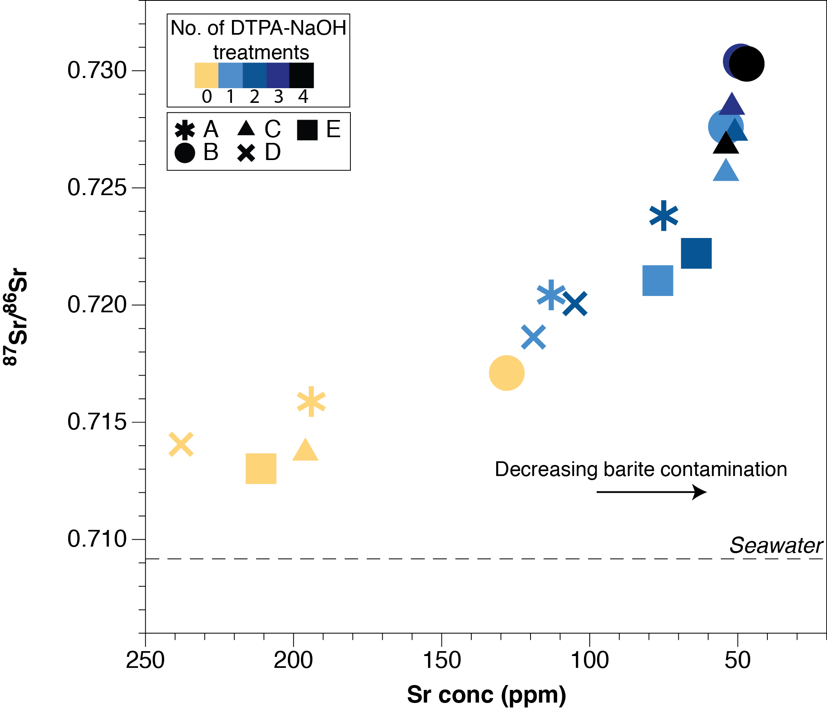
Figure 8 - Asymptote relationship between Sr concentration and ⁸⁷Sr/⁸⁶Sr of the terrigenous fraction of marine sediment from Site 662 with increasing number of DTPA-NaOH treatments. The asymptote relationship can be used to help determine the number of treatments needed to remove the effects of barite contamination. Symbol shape denotes sample ID. Colour indicates number of DTPA-NaOH treatments.

Our results reveal an asymptote relationship between Sr concentration and ⁸⁷Sr/⁸⁶Sr with increasing DTPA-NaOH treatments that can be used to help determine the number of treatments needed to remove the effects of barite contamination (Figure 8). The appropriate number of treatments required to constrain terrigenous ⁸⁷Sr/⁸⁶Sr in marine sediments will depend on the dynamic range in ⁸⁷Sr/⁸⁶Sr of the terrigenous fraction, its isotopic offset from the contaminating barite, the relative concentration of barite in the sediment and the scientific problem being addressed. Our estimates of the cumulative Ba_{Barite} removed with each treatment (Figure 7A) indicates that the first DTPA-NaOH treatment removes most of the contaminant at our study sites, both of which are situated outside of the most productive coastal regions in open ocean settings, with modern annual carbon export values of ~15 and ~20 g C/m² (Figure 1). Based on our findings, we suggest that sediment samples collected from all except the lowest productivity sites such as the subtropical gyres (Figure 1) should be assessed for potential barite contamination. Our results imply that at least one treatment with DTPA-NaOH to remove marine barite should be applied in most marine investigations of terrigenous ⁸⁷Sr/⁸⁶Sr.

3.2 ε_{Nd} results
Marine barite contains very low concentrations of REEs (Martin et al., 1995), so there is no reason to suspect that barite removal is required to determine the ε_{Nd} of the terrigenous fraction accurately. However, in many cases, it is desirable to measure both ⁸⁷Sr/⁸⁶Sr and ε_{Nd} on the same sample aliquots. We therefore studied the influence of our DTPA-NaOH treatment on ε_{Nd} in the terrigenous fraction at Site 662 and 1016. We document only modest variability in ε_{Nd} with successive DTPA-NaOH treatments (Figure 7). In most cases, samples from Site 662 yield lower ε_{Nd} values (by up to 0.7 ε_{Nd}) following DTPA-NaOH treatment while the sample from Site 1016 gives the opposite result (ε_{Nd} increases by up to 0.3). Bottom water at Site 662 likely has a very similar ε_{Nd} signature to the bulk terrigenous fraction (Howe et al., 2017; Piotrowski et al., 2008; Stichel et al., 2015), preventing a detailed assessment of the potential influence of seawater Nd at Site 662. However, at Site 1016, although no local bottom water measurements are available, there appears to be a large offset between regional bottom water signatures and terrigenous material (estimated modern/Holocene bottom water ε_{Nd} compositions are -2 to -4, Du et al., 2020, 2016; Hu and Piotrowski, 2018; Tachikawa et al., 2017). We record a small shift in ε_{Nd} of the terrigenous fraction with repeated DTPA-NaOH treatments but towards the local seawater composition (Figure 7). It is unlikely, therefore, that the small ε_{Nd} variability observed is caused by the removal of Nd carrying a seawater isotopic signal. Instead, we attribute small variability in ε_{Nd} measurements following repeated DTPA-NaOH treatment to a combination of i) intrinsic variability associated with the long complex sample processing procedure and/or ii) possible minor incongruent dissolution of the terrigenous fraction by DTPA-NaOH treatment. The second of these possibilities is suggested by modest decreases in residue Nd concentration with increased DTPA-NaOH treatment (Table S1) and low concentrations of Nd in the leachates (Table S2). Results from our multiple DTPA-NaOH treatment experiments help quantify any variability caused by these effects. Our replicate measurements show that the external error of ε_{Nd} measurements at Site 662 is on average ± 1.47 % RSD (0.36 ε_{Nd} (2 SD)), which is modest considering the sample leaching methods used to generate these data. This error is comparable to the variability in ε_{Nd} observed following multiple DTPA-NaOH leaching and the ε_{Nd} reproducibility found in other leaching studies (e.g. Blaser et al., 2016; Dausmann et al., 2019). Similarly, sample Al concentrations vary within 6 % RSD following repeated DTPA-NaOH treatment, within analytical error for these measurements, indicating limited modification of the terrigenous silicate fraction.

In practise, every step in a cleaning protocol risks incongruent dissolution of the terrigenous fraction. The abiogenic fraction of marine sediments is heterogenous and composed of terrigenous and volcanic components with different reactivities. Some of these components, such as volcanic glass, may be susceptible to acid dissolution, therefore the steps required to remove marine carbonates and authigenic coatings may modify the chemical composition of the terrigenous fraction (Elmore et al., 2011; Wilson et al., 2013). Gutjahr et al. (2007) found that only between 0.003 % and 0.3 % of the Sr and Nd removed by their HHCl-NaEDTA-HOAc leaching method (for removing authigenic coatings) was of terrigenous origin. However, Blaser et al. (2016) found that incongruent dissolution of volcanogenic material during weak acid leaching can lead to ε_{Nd} variability of one to three ε_{Nd} units. Therefore, it is important to consider both the composition of the sediment and the objective of the study when selecting a methodology.

In summary, we find that the influence of repeated DTPA-NaOH treatments on the terrigenous ε_{Nd} is too small to hamper reconstructions of provenance at our study sites. The geochemical variability following repeated DTPA-NaOH treatments at Sites 662 and 1016 is similar to that expected following all preceding leaching steps (i.e. removal of carbonate, authigenic coatings, opal, organic matter and adsorbed cations). In cases where more than one DTPA-NaOH treatment results in only small residual change in lithogenic ⁸⁷Sr/⁸⁶Sr, there is little to gain by repeatedly treating with DTPA-NaOH. One DTPA-NaOH leach should be sufficient in most ocean settings, more may be required in higher productivity coastal environments and the risk of barite contamination in mid-oceanic gyre sites is small. In rare cases, where the scientific problem being addressed requires the determination of very subtle variations in terrigenous ε_{Nd}, it may be advisable to undertake Nd isotope analysis on an aliquot prior to DTPA-NaOH treatment (Figure 3).

Implications for other isotope systems
Lead (Pb) isotopes (²⁰⁸Pb/²⁰⁴Pb, ²⁰⁷Pb/²⁰⁴Pb and ²⁰⁶Pb/²⁰⁴Pb) are commonly used as a tool to isotopically fingerprint terrigenous material (e.g. Abouchami et al., 2013; Grousset and Biscaye, 2005; Huang et al., 2021; Jardine et al., 2021). Lead substitutes for Ba in barite in much the same way as Sr because of the similarity in charge, ionic radius and electronegativity of these cations (Griffith and Paytan, 2012). As far as we are aware, no data exist on the concentration of Pb in marine barite. However, the concentration of Pb within our samples from Site 662 and 1016 decreases from 11 - 14 ppm to 6 - 9 ppm following the first DTPA treatment (Table S1). Following subsequent DTPA-NaOH treatments, Pb concentrations remain constant (variability of < 1ppm). These data suggest that Pb may behave in a similar way to other contaminating cations such as Sr, implying that, where present, marine barite may also contaminate Pb isotope data from terrigenous sediments.

Hf isotopes are also used to trace the provenance and transport history of terrigenous material accumulating in marine sediments (Aarons et al., 2017, 2013; Zhao et al., 2018). Hf concentrations do not vary systematically following DTAP-NaOH treatments (Table S1) suggesting that barite should not affect measurements of Hf isotopes on the terrigenous fraction, although further work is needed to corroborate this finding.

Synthesis
Where present, barite must be removed from marine sediments to determine the Sr isotope composition of the terrigenous fraction accurately. By analysing samples from two sites, where carbon export productivity and barite accumulation are moderate, we have shown that barite-hosted seawater Sr has the potential to contaminate the ⁸⁷Sr/⁸⁶Sr composition of the terrigenous fraction in marine sediments by > 0.01. We report a greater shift in the ⁸⁷Sr/⁸⁶Sr of the terrigenous fraction in our study site from the Atlantic Ocean (Site 662) than in the Pacific Ocean (Site 1016). We attribute this result to a greater difference in ⁸⁷Sr/⁸⁶Sr between sea water and the terrigenous sediment supplied to the North Atlantic (from North Africa) than between sea water and terrigenous sediment supplied to the eastern North Pacific (from North America).

Following the effective removal of carbonate, organic matter, opal, authigenic coatings and adsorbed cations such as Sr, we find that treatment with DTPA-NaOH provide a means to quantify the contaminating effect of barite. A single treatment with 0.2M DTPA - 2.5M NaOH leads to the removal of most Ba_{Barite} and the largest shift in ⁸⁷Sr/⁸⁶Sr. Additional treatments lead to further shifts in ⁸⁷Sr/⁸⁶Sr of diminishing amplitude away from the modern seawater value and towards the true terrigenous value. The optimum number of leaches to use will depend on site-specific factors such as sediment barite concentration, the magnitude of the ⁸⁷Sr/⁸⁶Sr offset between the terrigenous and seawater ratios, and the scientific question being addressed. We find a strong correlation between the extent of ⁸⁷Sr/⁸⁶Sr bias and the amount of Ba removed from samples during DTPA-NaOH treatment. This indicates that variability in the magnitude of ⁸⁷Sr/⁸⁶Sr contamination downcore is closely related to changing export productivity through time. By comparing our calculated Ba_{Barite} accumulation rates (Table 2) with global annual carbon export (Figure 1), we show that barite can lead to large ⁸⁷Sr/⁸⁶Sr contamination in even moderately productive open ocean settings (carbon export of 10 - 75 g C /m²). In such settings, one or two DTPA-NaOH treatments will likely be sufficient to remove the contaminating effect of barite on terrigenous ⁸⁷Sr/⁸⁶Sr for most purposes but more may well be required in high productivity coastal environments. Our results suggest that sediment samples collected from all except the lowest productivity sites, such as the subtropical gyres, should be assessed for the contaminating effect of barite on terrigenous ⁸⁷Sr/⁸⁶Sr.

ε_{Nd} measurements of the terrigenous fraction show only small variation with repeated DTPA-NaOH treatments, which is consistent with the low Nd content in marine barite. Trace concentrations of Nd and Ce in the leachate and the sign of the terrigenous ε_{Nd} shifts (opposite to that predicted by removal of a seawater Nd signal) suggests a potential minor Nd isotope fractionation of the terrigenous fraction by DTPA-NaOH. In most cases, the effect of DTPA-NaOH treatment on terrigenous ε_{Nd} is small enough to allow ⁸⁷Sr/⁸⁶Sr and ε_{Nd} to be analysed on the same (identically treated) aliquots of sample.

In summary, we provide quantitative estimates of the extent of ⁸⁷Sr/⁸⁶Sr contamination by barite in marine sediments and present a protocol to successfully isolate the terrigenous fraction. Our findings call into question results from previous studies where contamination by barite has not been addressed. For instance, the contaminating effect of barite on ⁸⁷Sr/⁸⁶Sr that we document is similar in magnitude to the offset in ⁸⁷Sr/⁸⁶Sr between different dust source areas in North Africa (Jewell et al., 2020), North America (Aarons et al., 2017; Jardine et al., 2021), the Middle East (Sirocko, 1994) and Asia (Chen et al., 2007; Kanayama et al., 2005; Zeng et al., 2015; Zhao et al., 2015). Thus, failure to remove barite risks misidentification of the source of terrigenous material accumulating in any of the world’s oceans. Our new sequential leaching protocol permits studies of terrigenous provenance and past changes in aridity/humidity using ⁸⁷Sr/⁸⁶Sr, even in regions of equatorial or coastal upwelling where the non-removal of marine barite severely skews results.

Acknowledgements
This work was supported by a PhD studentship from the Natural Environment Research Council [Grant number NE/L002531/1] to AMJ and Royal Society Challenge Grant CH160073 and Royal Society Wolfson Merit Award to PAW. ﻿Sediment core samples were provided by the IODP, funded by the U.S. National Science Foundation and participating countries. ﻿We are grateful to Gabriella Jardine and P. Sargent Bray for laboratory assistance. We thank Adina Paytan for useful discussions. We also thank Patrick Blaser and an anonymous reviewer for their helpful comments which improved this manuscript greatly. This contribution is dedicated to the memory of Harry Elderfield, who knew a thing or two about the chemistry of marine sediments and inspired so many of us to strive to unlock their secrets.

Declaration of competing interest
The authors declare that they have no known competing financial interests or personal relationships that could have appeared to influence the work reported in this paper.

References
- Aarons, S.M., Aciego, S.M., Gleason, J.D., 2013. Variable HfSrNd radiogenic isotopic compositions in a Saharan dust storm over the Atlantic: Implications for dust flux to oceans, ice sheets and the terrestrial biosphere. Chem. Geol. 349–350, 18–26. https://doi.org/10.1016/j.chemgeo.2013.04.010
- Aarons, S.M., Blakowski, M.A., Aciego, S.M., Stevenson, E.I., Sims, K.W.W., Scott, S.R., Aarons, C., 2017. Geochemical characterization of critical dust source regions in the American West. Geochim. Cosmochim. Acta 215, 141–161. https://doi.org/10.1016/j.gca.2017.07.024
- Abouchami, W., Näthe, K., Kumar, A., Galer, S.J.G., Jochum, K.P., Williams, E., Horbe, A.M.C., Rosa, J.W.C., Balsam, W., Adams, D., Mezger, K., Andreae, M.O., 2013. Geochemical and isotopic characterization of the bodélé depression dust source and implications for transatlantic dust transport to the Amazon basin. Earth Planet. Sci. Lett. 380, 112–123. https://doi.org/10.1016/j.epsl.2013.08.028
- Allègre, C.J., Dupre, B., Négrel, P., Gaillardet, J., 1996. Sr-Nd-Pb isotope systematics in Amazon and Congo River systems: Constraints about erosion processes. Chem. Geol. 131, 93–112. https://doi.org/10.1016/0009-2541(96)00028-9
- Ashley, G.M., Wet, C.B., Barboni, D., Magill, C.R., 2016. Subtle signatures of seeps: Record of groundwater in a Dryland, DK , Olduvai Gorge, Tanzania . Depos. Rec. 2, 4–21. https://doi.org/10.1002/dep2.11
- Bayon, G., German, C.R., Boella, R.M., Milton, J.A., Taylor, R.N., Nesbitt, R.W., 2002. An improved method for extracting marine sediment fractions and its application to Sr and Nd isotopic analysis. Chem. Geol. 187, 179–199. https://doi.org/10.1016/S0009-2541(01)00416-8
- Bishop, J.K.B., 1988. The barite-opal-organic carbon association in oceanic particulate matter. Nature 332, 341–343. https://doi.org/10.1038/332341a0
- Blanchet, C.L., 2019. A database of marine and terrestrial radiogenic Nd and Sr isotopes for tracing earth-surface processes. Earth Syst. Sci. Data 11, 742–759. https://doi.org/10.5194/essd-2018-109
- Blaser, P., Lippold, J., Gutjahr, M., Frank, N., Link, J.M., Frank, M., 2016. Extracting foraminiferal seawater Nd isotope signatures from bulk deep sea sediment by chemical leaching. Chem. Geol. 439, 189–204. https://doi.org/10.1016/j.chemgeo.2016.06.024
- Chen, J., Li, G., Yang, J., Rao, W., Lu, H., Balsam, W., Sun, Y., Ji, J., 2007. Nd and Sr isotopic characteristics of Chinese deserts: Implications for the provenances of Asian dust. Geochim. Cosmochim. Acta 71, 3904–3914. https://doi.org/10.1016/j.gca.2007.04.033
- Cole, J.M., Goldstein, S.L., DeMenocal, P.B., Hemming, S.R., Grousset, F.E., 2009. Contrasting compositions of Saharan dust in the eastern Atlantic Ocean during the last deglaciation and African Humid Period. Earth Planet. Sci. Lett. 278, 257–266. https://doi.org/10.1016/j.epsl.2008.12.011
- Dausmann, V., Gutjahr, M., Frank, M., Kouzmanov, K., Schaltegger, U., 2019. Experimental evidence for mineral-controlled release of radiogenic Nd, Hf and Pb isotopes from granitic rocks during progressive chemical weathering. Chem. Geol. 507, 64–84. https://doi.org/10.1016/j.chemgeo.2018.12.024
- Du, J., Haley, B.A., Mix, A.C., 2020. Evolution of the Global Overturning Circulation since the Last Glacial Maximum based on marine authigenic neodymium isotopes. Quat. Sci. Rev. 241. https://doi.org/10.1016/j.quascirev.2020.106396
- Du, J., Haley, B.A., Mix, A.C., 2016. Neodymium isotopes in authigenic phases, bottom waters and detrital sediments in the Gulf of Alaska and their implications for paleo-circulation reconstruction. Geochim. Cosmochim. Acta 193, 14–35. https://doi.org/10.1016/j.gca.2016.08.005
- Eagle, M., Paytan, A., Arrigo, K.R., van Dijken, G., Murray, R.W., 2003. A comparison between excess barium and barite as indicators of carbon export. Paleoceanography 18, 1–13. https://doi.org/10.1029/2002pa000793
- Elmore, A.C., Piotrowski, A.M., Wright, J.D., Scrivner, A.E., 2011. Testing the extraction of past seawater Nd isotopic composition from North Atlantic deep sea sediments and foraminifera. Geochemistry, Geophys. Geosystems 12. https://doi.org/10.1029/2011GC003741
- Falkowski, P.G., Barber, R.T., Smetacek, V., 1998. Biogeochemical controls and feedbacks on ocean primary production. Science (80-. ). 281, 200–206. https://doi.org/10.1126/science.281.5374.200
- Ganeshram, R.S., François, R., Commeau, J., Brown-Leger, S.L., 2003. An experimental investigation of barite formation in seawater. Geochim. Cosmochim. Acta 67, 2599–2605. https://doi.org/10.1016/S0016-7037(03)00164-9
- Goldberg, E.D., Somayajulu, B.L.K., Galloway, J., Kaplan, I.R., Faure, G., 1969. Differences between barites of marine and continental origins. Geochim. Cosmochim. Acta 33, 287–289. https://doi.org/10.1016/0016-7037(69)90145-8
- Gonneea, M.E., Paytan, A., 2006. Phase associations of barium in marine sediments. Mar. Chem. 100, 124–135. https://doi.org/10.1016/j.marchem.2005.12.003
- Gonzalez-Muñoz, M.T., Martinez-Ruiz, F., Morcillo, F., Martin-Ramos, J.D., Paytan, A., 2012. Precipitation of barite by marine bacteria: A possible mechanism for marine barite formation. Geology 40, 675–678. https://doi.org/10.1130/G33006.1
- Griffith, E.M., Paytan, A., 2012. Barite in the ocean - occurrence, geochemistry and palaeoceanographic applications. Sedimentology 59, 1817–1835. https://doi.org/10.1111/j.1365-3091.2012.01327.x
- Grousset, F.E., Biscaye, P.E., 2005. Tracing dust sources and transport patterns using Sr, Nd and Pb isotopes. Chem. Geol. https://doi.org/10.1016/j.chemgeo.2005.05.006
- Grousset, F.E., Parra, M., Bory, A., Martinez, P., Bertrand, P., Shimmield, G., Ellam, R.M., 1998. Saharan Wind Regimes Traced by the Sr-Nd Isotopic Composition of Subtropical Atlantic Sediments: Last Glacial Maximum vs Today. Quat. Sci. Rev. 17, 395–409.
- Gutjahr, M., Frank, M., Stirling, C.H., Klemm, V., van de Flierdt, T., Halliday, A.N., 2007. Reliable extraction of a deepwater trace metal isotope signal from Fe-Mn oxyhydroxide coatings of marine sediments. Chem. Geol. 242, 351–370. https://doi.org/10.1016/j.chemgeo.2007.03.021
- Hall, G.E.M., Vaive, J.E., Beer, R., Hoashi, M., 1996. Selective leaches revisited, with emphasis on the amorphous Fe oxyhydroxide phase extraction. J. Geochemical Explor. 56, 59–78. https://doi.org/10.1016/0375-6742(95)00050-X
- Hanor, J.S., 2000. Barite-celestine geochemistry and environments of formation. Rev. Mineral. Geochemistry 40, 193–275. https://doi.org/10.2138/rmg.2000.40.4
- Hayes, C.T., Costa, K.M., Anderson, R.F., Calvo, E., Chase, Z., Demina, L.L., Dutay, J.C., German, C.R., Heimbürger-Boavida, L.E., Jaccard, S.L., Jacobel, A., Kohfeld, K.E., Kravchishina, M.D., Lippold, J., Mekik, F., Missiaen, L., Pavia, F.J., Paytan, A., Pedrosa-Pamies, R., Petrova, M. V., Rahman, S., Robinson, L.F., Roy-Barman, M., Sanchez-Vidal, A., Shiller, A., Tagliabue, A., Tessin, A.C., van Hulten, M., Zhang, J., 2021. Global Ocean Sediment Composition and Burial Flux in the Deep Sea. Global Biogeochem. Cycles 35, 0–25. https://doi.org/10.1029/2020GB006769
- House, B.M., Norris, R.D., 2020. Unlocking the barite paleoproductivity proxy: A new high-throughput method for quantifying barite in marine sediments. Chem. Geol. https://doi.org/10.1016/j.chemgeo.2020.119664
- Howe, J.N.W., Piotrowski, A.M., Hu, R., Bory, A., 2017. Reconstruction of east–west deep water exchange in the low latitude Atlantic Ocean over the past 25,000 years. Earth Planet. Sci. Lett. 458, 327–336. https://doi.org/10.1016/j.epsl.2016.10.048
- Hu, R., Piotrowski, A.M., 2018. Neodymium isotope evidence for glacial-interglacial variability of deepwater transit time in the Pacific Ocean. Nat. Commun. 9, 1–12. https://doi.org/10.1038/s41467-018-07079-z
- Huang, H., Gutjahr, M., Kuhn, G., Hathorne, E.C., Eisenhauer, A., 2021. Efficient Extraction of Past Seawater Pb and Nd Isotope Signatures From Southern Ocean Sediments. Geochemistry, Geophys. Geosystems 22. https://doi.org/10.1029/2020GC009287
- Hyeong, K., Kuroda, J., Seo, I., Wilson, P.A., 2016. Response of the Pacific inter-tropical convergence zone to global cooling and initiation of Antarctic glaciation across the Eocene Oligocene Transition. Sci. Rep. 6, 1–8. https://doi.org/10.1038/srep30647
- Jacobsen, S.B., Wasserburg, G.J., 1980. Sm-Nd isotopic evolution of chondrites. Earth Planet. Sci. Lett. 50, 139–155. https://doi.org/10.1016/0012-821X(80)90125-9
- Jardine, G.E., Crocker, A.J., Bailey, I., Cooper, M.J., Milton, J.A., Wilson, P.A., 2021. The imprint of windblown dust from the North American Southwest on the California Channel Islands and Paci fic Ocean sediments. Quat. Sci. Rev. 261.
- Jewell, A.M., Drake, N., Crocker, A.J., Bakker, N.L., Kunkelova, T., Bristow, C.S., Cooper, M.J., Milton, J.A., Breeze, P.S., Wilson, P.A., 2020. Three North African dust source areas and their geochemical fingerprint. Earth Planet. Sci. Lett. 554, 116645. https://doi.org/10.1016/j.epsl.2020.116645
- Jochum, K.P., Nohl, U., Herwig, K., Lammel, E., Stoll, B., Hofmann, A.W., 2005. GeoReM: A new geochemical database for reference materials and isotopic standards. Geostand. Geoanalytical Res. 29, 333–338. https://doi.org/10.1111/j.1751-908x.2005.tb00904.x
- Kanayama, S., Yabuki, S., Zeng, F., Liu, M., Shen, Z., Liu, L., Yanagisawa, F., Abe, O., 2005. Size-dependent geochemical characteristics of Asian dust - Sr and Nd isotope compositions as tracers for source identification. J. Meteorol. Soc. Japan 83, 107–120. https://doi.org/10.2151/jmsj.83A.107
- Lang, D.C., Bailey, I., Wilson, P.A., Beer, C.J., Bolton, C.T., Friedrich, O., Newsam, C., Spencer, M.R., Gutjahr, M., Foster, G.L., Cooper, M.J., Milton, J.A., 2014. The transition on North America from the warm humid Pliocene to the glaciated Quaternary traced by eolian dust deposition at a benchmark North Atlantic Ocean drill site. Quat. Sci. Rev. 93, 125–141. https://doi.org/10.1016/j.quascirev.2014.04.005
- Lea, D.W., Boyle, E.A., 1991. Barium in planktonic foraminifera. Geochim. Cosmochim. Acta 55, 3321–3331. https://doi.org/10.1016/0016-7037(91)90491-M
- Lyle, A.O., Lyle, M.W., 2002. Determination of biogenic silica in pelagic marine sediments: a simple method revisted. Proc. ODP, Initial Reports 199, 1–21.
- Lyle, M., Koizumi, I., Richter, C., Moore, T.C., 1997a. Proceedings of the Ocean Drilling Program, Leg 167 Initial Reports.
- Lyle, M., Koizumi, I., Richter, C., Moore, T.C., 1997b. Site 1016, in: Proceedings of the Ocean Drilling Program, Initial Reports. pp. 239–283.
- Martin, E.E., Macdougall, J.D., Herbert, T.D., Paytan, A., Kastner, M., 1995. Strontium and neodymium isotopic analyses of marine barite separates. Geochim. Cosmochim. Acta 59, 1353–1361. https://doi.org/10.1016/0016-7037(95)00049-6
- McArthur, J.M., Howarth, R.J., Bailey, T.R., 2001. Strontium isotope stratigraphy: LOWESS version 3: Best fit to the marine Sr-isotope curve for 0-509 Ma and accompanying look-up table for deriving numerical age. J. Geol. 109, 155–170. https://doi.org/10.1086/319243
- Mearon, S., Paytan, A., Bralower, T.J., 2003. Cretaceous strontium isotope stratigraphy using marine barite. Geology 31, 15–18. https://doi.org/10.1130/0091-7613(2003)031<0015:CSISUM>2.0.CO;2
- Monnin, C., Cividini, D., 2006. The saturation state of the world’s ocean with respect to (Ba,Sr)SO4 solid solutions. Geochim. Cosmochim. Acta 70, 3290–3298. https://doi.org/10.1016/j.gca.2006.04.002
- Monnin, C., Jeandel, C., Cattaldo, T., Dehairs, F., 1999. The marine barite saturation state of the world’s oceans. Mar. Chem. 65, 253–261. https://doi.org/10.1016/S0304-4203(99)00016-X
- Mortlock, R.A., Froelich, P.N., 1989. A simple method for the rapid determination of biogenic opal in pelagic marine sediments. Deep Sea Res. Part A, Oceanogr. Res. Pap. 36, 1415–1426. https://doi.org/10.1016/0198-0149(89)90092-7
- Napier, T.J., Hendy, I.L., Fahnestock, M.F., Bryce, J.G., 2020. Provenance of detrital sediments in santa Barbara Basin, California, USA: Changes in source contributions between the Last Glacial Maximum and Holocene. Bull. Geol. Soc. Am. 132, 65–84. https://doi.org/10.1130/B32035.1
- Ostrom, M.E., 1961. Separation of clay minerals from carbonate rocks by using acid. J. Sediment. Petrol. 31, 123–129. https://doi.org/10.1306/74D70B1E-2B21-11D7-8648000102C1865D
- Paytan, A., Griffith, E.M., 2007. Marine barite: Recorder of variations in ocean export productivity. Deep. Res. Part II Top. Stud. Oceanogr. 54, 687–705. https://doi.org/10.1016/j.dsr2.2007.01.007
- Paytan, A., Kastner, M., Chavez, F.P., 1996. Glacial to interglacial fluctuations in productivity in the equatorial pacific as indicated by marine barite. Science (80-. ). 274, 1355–1357. https://doi.org/10.1126/science.274.5291.1355
- Paytan, A., Kastner, M., Martin, E., Macdougall, J.D., Herbert, T., 1993. Marine barite as a monitor of seawater strontium isotope composition. Nature 366, 445–449.
- Paytan, A., Mearon, S., Cobb, K., Kastner, M., 2002. Origin of marine barite deposits: Sr and S isotope characterization. Geology 30, 747–750. https://doi.org/10.1130/0091-7613(2002)030<0747:OOMBDS>2.0.CO;2
- Piotrowski, A.M., Goldstein, S.L., Hemming, S.R., Fairbanks, R.G., Zylberberg, D.R., 2008. Oscillating glacial northern and southern deep water formation from combined neodymium and carbon isotopes. Earth Planet. Sci. Lett. 272, 394–405. https://doi.org/10.1016/j.epsl.2008.05.011
- Povea, P., Cacho, I., Moreno, A., Menéndez, M., Méndez, F.J., 2015. A new procedure for the lithic fraction characterization in marine sediments from high productivity areas: Optimization of analytical and statistical procedures. Limnol. Oceanogr. Methods 13, 127–137. https://doi.org/10.1002/lom3.10013
- Putnis, C. V., Kowacz, M., Putnis, A., 2008. The mechanism and kinetics of DTPA-promoted dissolution of barite. Appl. Geochemistry 23, 2778–2788. https://doi.org/10.1016/j.apgeochem.2008.07.006
- Ruddiman, W., Sarnthein, M., Baldauf, J., 1988a. Proceedings of the Ocean Drilling Program, Leg 108 Initial Reports.
- Ruddiman, W., Sarnthein, M., Baldauf, J., 1988b. Site 662, in: Proceedings of the Ocean Drilling Program, Leg 108 Initial Reports. pp. 487–556.
- Ruddiman, W.F., Janecek, T.R., 1989. Pliocene-Pleistocene biogenic and terrigenous fluxes at equatorial Atlantic sites 662, 663, and 664. Proc. Ocean Drill. Program, Sci. Results 108, 211–240.
- Shende, A.V., 2012. Dissolution of barite scale using chelating agents. Master Sci. Texas A&M.
- Sill, C.W., Willis, C.P., 1966. Determination of Radioisotopes of Cerium, Barium, Lanthanum, and Neptunium after Separation by Barium Sulfate. Anal. Chem. 38, 97–102. https://doi.org/10.1021/ac60233a026
- Sill, C.W., Willis, C.P., 1964. Precipitation of Submicrogram Quantities of Thorium by Barium Sulfate and Application to Fluorometric Determination of Thorium in Mineralogical and Biological Samples. Anal. Chem. 36, 622–630. https://doi.org/10.1021/ac60209a020
- Simon, M.H., Babin, D.P., Goldstein, S.L., Cai, M.Y., Liu, T., Han, X., Haws, A.A., Johns, M., Lear, C., Hemming, S.R., 2020. Development of a protocol to obtain the composition of terrigenous detritus in marine sediments -a pilot study from International Ocean Discovery Program Expedition 361. Chem. Geol. 535. https://doi.org/10.1016/j.chemgeo.2019.119449
- Sirocko, F., 1994. Abrupt change in monsoonal climate: evidence from the geochemical composition of Arabian Sea sediments. Math. Fak. der Christ. zu Kiel.
- Spray, J.F., Bohaty, S.M., Davies, A., Bailey, I., Romans, B.W., Cooper, M.J., Milton, J.A., Wilson, P.A., 2019. North Atlantic Evidence for a Unipolar Icehouse Climate State at the Eocene-Oligocene Transition. Paleoceanogr. Paleoclimatology 34, 1124–1138. https://doi.org/10.1029/2019PA003563
- Stichel, T., Hartman, A.E., Duggan, B., Goldstein, S.L., Scher, H., Pahnke, K., 2015. Separating biogeochemical cycling of neodymium from water mass mixing in the Eastern North Atlantic. Earth Planet. Sci. Lett. 412, 245–260. https://doi.org/10.1016/j.epsl.2014.12.008
- Tachikawa, K., Arsouze, T., Bayon, G., Bory, A., Colin, C., Dutay, J.C., Frank, N., Giraud, X., Gourlan, A.T., Jeandel, C., Lacan, F., Meynadier, L., Montagna, P., Piotrowski, A.M., Plancherel, Y., Pucéat, E., Roy-Barman, M., Waelbroeck, C., 2017. The large-scale evolution of neodymium isotopic composition in the global modern and Holocene ocean revealed from seawater and archive data. Chem. Geol. 457, 131–148. https://doi.org/10.1016/j.chemgeo.2017.03.018
- Tessier, A., Campbell, P.G.C., Bisson, M., 1979. Sequential Extraction Procedure for the Speciation of Particulate Trace Metals. Anal. Chem. 51, 844–851. https://doi.org/10.1021/ac50043a017
- Torres, M.E., Brumsack, H.J., Bohrmann, G., Emeis, K.C., 1996. Barite fronts in continental margin sediments: A new look at barium remobilization in the zone of sulfate reduction and formation of heavy barites in diagenetic fronts. Chem. Geol. 127, 125–139. https://doi.org/10.1016/0009-2541(95)00090-9
- Vance, D., Thirlwall, M., 2002. An assessment of mass discrimination in MC-ICPMS using Nd isotopes. Chem. Geol. 185, 227–240. https://doi.org/10.1016/S0009-2541(01)00402-8
- Weldeab, S., Emeis, K.C., Hemleben, C., Siebel, W., 2002. Provenance of lithogenic surface sediments and pathways of riverine suspended matter in the Eastern Mediterranean Sea: Evidence from 143Nd/144Nd and 87Sr/86Sr ratios. Chem. Geol. 186, 139–149. https://doi.org/10.1016/S0009-2541(01)00415-6

- White, W.M., 2011. Radiogenic Isotope Geochemistry I : The Mantle, in: Isotope Geochemistry. pp. 145–173.
- Wilson, D.J., Bertram, R.A., Needham, E.F., van de Flierdt, T., Welsh, K.J., McKay, R.M., Mazumder, A., Riesselman, C.R., Jimenez-Espejo, F.J., Escutia, C., 2018. Ice loss from the East Antarctic Ice Sheet during late Pleistocene interglacials. Nature 561, 383–386. https://doi.org/10.1038/s41586-018-0501-8
- Wilson, D.J., Piotrowski, A.M., Galy, A., Clegg, J.A., 2013. Reactivity of neodymium carriers in deep sea sediments: Implications for boundary exchange and paleoceanography. Geochim. Cosmochim. Acta 109, 197–221. https://doi.org/10.1016/j.gca.2013.01.042
- Wu, J., Liu, Z., Michard, A., Tachikawa, K., Filippidi, A., He, Z., Hennekam, R., Yang, S., Davies, G.R., de Lange, G.J., 2021. Effect of barite-bound Sr on detrital Sr isotope systematics in marine sediments. Chem. Geol. 120613. https://doi.org/10.1016/j.chemgeo.2021.120613
- Xie, R.C., Marcantonio, F., 2012. Deglacial dust provenance changes in the Eastern Equatorial Pacific and implications for ITCZ movement. Earth Planet. Sci. Lett. 317–318, 386–395. https://doi.org/10.1016/j.epsl.2011.11.014
- Yao, W., Griffith, E., Paytan, A., 2021. Pelagic Barite. Pelagic Barite 7027. https://doi.org/10.1017/9781108847162
- Zhao, W., Balsam, W., Williams, E., Long, X., Ji, J., 2018. Sr–Nd–Hf isotopic fingerprinting of transatlantic dust derived from North Africa. Earth Planet. Sci. Lett. 486, 23–31. https://doi.org/10.1016/j.epsl.2018.01.004
- Zhao, W., Sun, Y., Balsam, W., Zeng, L., Lu, H., Otgonbayar, K., Ji, J., 2015. Clay-sized Hf-Nd-Sr isotopic composition of Mongolian dust as a fingerprint for regional to hemispherical transport. Geophys. Res. Lett. 42, 5661–5669. https://doi.org/10.1002/2015GL064357
- Ziegler, C.L., Murray, R.W., Hovan, S.A., Rea, D.K., 2007. Resolving eolian, volcanogenic, and authigenic components in pelagic sediment from the Pacific Ocean. Earth Planet. Sci. Lett. 254, 416–432. https://doi.org/10.1016/j.epsl.2006.11.049

