Mid and Late Upper Palaeolithic in the Adriatic Basin: chronology, transitions and human adaptations to a changing landscape
Aitor RUIZ-REDONDO, Nikola VUKOSAVLJEVIĆ, Antonin TOMASSO, Marco PERESANI, William DAVIES, Marc VANDER LINDEN*
ABSTRACT.
This paper presents the first attempt to establish a Mid and Late Upper Palaeolithic absolute chronology of the Adriatic basin, including both eastern and western Adriatic coasts and their hinterlands. The proposed chronology for Gravettian, Early and Late Epigravettian techno-complexes is based on statistical analysis of 190 ¹⁴C dates from 52 archaeological sites. Our analyses are directed towards 1) identifying whether major climatic episodes and corresponding transformations in the local environments are correlated with long-term demographic trends, and potential changes in spatial patterning of human occupation, and 2) identifying robust absolute chronological estimates of techno-complexes to establish the timing of their succession, including their possible overlaps. Results show that the Gravettian appears in the Adriatic area at c. 35-34ka cal BP and ends at c. 26-25ka cal BP. Early and Late Epigravettian timespans are between c. 26-25ka and 18.1-17.6ka cal BP and 17.6-17.1 ka and 11.9-11.6 ka cal BP respectively. The Early-Late Epigravettian transition in the Great Adriatic-Po Region coincides with the transition between GS-2.2 and GI-2.1 and is also associated with apparent transformations in settlement pattern as new biotopes appear to be occupied, particularly in the mountainous areas such as Alps and Dinaric Alps. According to our results, the timespan of Early Epigravettian covers the Badegoulian, Solutrean and even Lower Magdalenian periods in western Europe, hence challenging the earlier interpretations on Early Epigravettian and Solutrean contemporaneity. This suggests an independent cultural evolutionary path for territories that previously (during the Gravettian) showed a high degree of technological affinity.

KEY WORDS
Radiocarbon chronology, Bayesian modelling, Gravettian, Epigravettian, Great Adriatic-Po Region
1. Introduction
The Great Adriatic-Po Region (hereafter GAPR) during the Late Pleistocene is a key area for studying human response and adaptive strategies to climatic change and corresponding new environmental conditions. Partly due to the overall low gradient (0.02°) and shallow depth (down -100m at the latitude of Ancona; Surić and Juračić, 2010), the northern Adriatic Sea is strongly influenced by high and variable sediment supply rates under rapid high-magnitude relative sea-level change (Amorosi et al., 2016; Peresani et al., 2021; and references within). As a result, the emerged land surface of the Adriatic basin shrank from c. 230,000 km² at the peak of the LGM (19ka cal BP) to c. 160,000 km², towards the end the Pleistocene at 11.7ka cal BP (Brommer et al., 2009). The available territory for Upper Palaeolithic (UP) human groups was therefore constantly shrinking during the Late Pleistocene as the sea level rose and flooded the Adriatic Plain, although this loss was partly mitigated by the availability of new landscapes, especially mountain valley bottoms and higher-altitude mountainous areas in the hinterland freed from glacial cover (Mihailović, 2007; 2014; Fontana et al., 2018). The Adriatic basin is delimited by three high mountain ranges, all relatively close to the current seashore: the Apennines in the west, the Alps in the north and the Dinaric Alps in the East. Those were also the boundaries of the GAPR during Pleistocene (Peresani et al., 2021). The peak of the glacial advance occurred 25-24 and 23-22 ka cal BP (Monegato et al., 2017), leading to the expansion of the glacial fronts in the alpine piedmont area, reaching altitudes as low as 210m a.m.s.l., and thus covering a large extent of the GAPR. From 23-17ka cal BP onwards, Alpine glaciers started a regression phase, probably due to a decrease in the availability of moisture from southerly circulation (Monegato et al., 2017).
The archaeological record for the Late Pleistocene in the GAPR is rich in excavations offering invaluable information for site-based and, in few instances, micro-regional sequences. However, the present state of the archaeological documentation proves more challenging to assess how human activities unfolded upon the palaeoenvironmental framework at the scale of the entire GAPR. Such comparative exercise is indeed hindered by diverging definitions of the diverse techno-complexes (hereafter TC; see Clarke, 1968: 357) which characterise the period, a state of affairs largely related to diverging local research traditions. While the general succession of the TCs is not disputed, their absolute chronology, duration and temporal relationship with major environmental changes remain far from precise.
In order to address these numerous questions, we present here a georeferenced compilation and statistical analyses of all available radiocarbon dates from archaeological contexts related to the Gravettian and Epigravettian TCs in the GAPR down beyond its southern extreme. Firstly, we use this dataset to identify if major climatic episodes and corresponding transformations in the local environments are correlated with long-term demographic trends, and potential changes in spatial patterning of human occupation. Secondly, we model robust absolute chronological estimates of TCs to establish the timing of their succession, including their possible overlap. Particular attention is paid to identifying regional discrepancies in this process, which would inform about the potential direction of technological and/or cultural transfer across the GAPR. This quantitative analysis of the ¹⁴C record is informed by a review of the history and present state of affairs of the material and technological definition of the main TCs observed in this sequence, namely the Gravettian, and Early and Late Epigravettian.

2. Techno-complexes
From ca. 35 ka cal. BP, the Gravettian is considered as a pan-European TC (Otte, 1981; 1985; Kozłowski, 2015; Bicho et al., 2017). Its earliest appearance in Italy is identified in few sites in Italy, at least from 34-33 ka cal. BP in Paglicci cave (Palma di Cesnola, 1993; 2006), Rio Secco (Talamo et al., 2014), and, in the GAPR, Fonte delle Mattinate (Giaccio et al. 2004; Silvestrini et al., 2005) and Fumane cave, the latter with slightly older dates (see discussion in Falcucci and Peresani, 2019). Nevertheless, the knowledge about this TC is geographically restricted within Italy to few studies (e.g. Aranguren et al., 2015), so that the apparent complexity of the Italian Gravettian (Mussi, 2000) still has to be addressed in detail. In the Balkan Peninsula, radiometric dates are extremely sparse, but a few sites have been identified (Adam, 2007; Mihailović and Mihailović, 2007; Mihailović, 2008). The definition of the Gravettian in the GAPR and surroundings relies on several criteria including the presence of feminine statuettes (so-called ‘venuses’) (Mussi, 2012), straight-backed points (i.e. pointes de la Gravette and microgravettes) (Borgia and Wierer, 2005; Borgia, 2008), and funerary practices (Giacobini, 2006; Gazzoni and Fontana, 2011). Most scholars consider that the Gravettian differs in Italy between the Tyrrhenian and Adriatic coasts (Gambassini, 2007), the main argument being the absence of Noailles burins (Gambassini, 2007) and the production of truncated backed bladelets on the Adriatic side (Palma di Cesnola, 1993).
The Epigravettian was initially defined in Italy by G. Laplace (1964; 1997). The term was later applied to evidence from the Balkan Peninsula (see Kozłowski, 2005). While we assume that ‘Epigravettian’ is relevant to describe the Adriatic coast of Balkans, it is noteworthy that its definition varies amongst scholars. The initial splitting of this TC in successive phases (Laplace 1964) has been revised on several occasions (Bietti, 1990; Palma di Cesnola, 1993; Broglio, 1997; Montoya, 2008; Tomasso, 2017), though there is no consensus on a formalised division. In consequence, we lack a uniform vision of the Epigravettian sequence in Italy and the Balkan Peninsula, especially if bone industry, portable art and ornamental objects, burials, and funerary rituals are considered as cultural markers. For instance, studies devoted to osseous industries from either Italy or the Balkans remain sparse (but see Čečuk, 1996; Kujundžić, 1990; Karavanić et al., 2013; Cristiani, 2018; Vujević, 2018; Borić et al., 2021).
The definition of the Early Epigravettian is still vague and based on a limited number of lithic tool types. These are mostly produced on small blades (Broglio et al., 1993; Peresani, 2008; Tomasso, 2017). D. Mihailović (2014) noticed that, in the Balkans, the distinction between Late Gravettian and Early Epigravettian lithic assemblages is often problematic, as the material from these TCs presents many similarities. Typologically, some tools are frequently found in early Epigravettian assemblages, such as shouldered points (Broglio et al., 1993; Tomasso and Rots, 2021), large retouched blades, and long scrapers on blade with retouched edges. While Gravette points are most likely no longer present, microgravettes are still found, sharing similar features with the Gravettian examples (long, narrow and straight backed points manufactured on straight and regular bladelets with base and tip finely shaped by complementary accessory retouch).
The Late Epigravettian in the Adriatic area is characterised by the systematisation of integrated blades-bladelets production systems and increasing innovations in lithic production, especially for the time span between 15 and 11.5ka cal BP –which is more intensively investigated than the previous one (Bertola et al., 2007; Peresani, 2006; Cancellieri, 2015; Fontana et al., 2015; Tomasso, 2017; Montoya et al., 2018). Small backed points dominate the hunting tools. Despite often being called ‘microgravettes’, these points differ from those of the earlier TC: they are small and irregular, and also variable through space and time in terms of blanks and morphometry (Montoya and Peresani, 2005; Tomasso, 2016; Duches et al., 2017). Furthermore some local types appear, including backed knives (Bertola et al., 2007), curved or arched backed points (Mihailović, 1999; Vukosavljević, 2012; Vukosavljević et al., 2011; 2014), segments (Whallon, 1989; Mihailović, 1999; Vukosavljević et al., 2011; Vukosavljević, 2012) and triangles (Whallon, 1989; Broglio, 1993; Mihailović, 1999; Tomasso et al., 2014) related to the increasing use of microburin technique (Bassetti et al., 2009), and trapezoids (Ferrari and Peresani, 2003; Dalmeri et al., 2004; Vukosavljević, 2012). The most characteristic and widespread lithic tools from this period are short endscrapers on flakes or small blades (known as ‘thumbnail endscrapers’), circular endscrapers, and truncated bladelets (Whallon, 1999; Mihailović, 1999; 2009; Karavanić et al., 2013; Peresani et al., 2014; Vukosavljević et al., 2014). At the beginning of the Late Epigravettian, an increase of evidence in graphic productions is documented (Broglio and Montoya, 2005; Montoya, 2008; Ruiz-Redondo et al., 2019; 2020), a phenomenon observed across the rest of contemporary Europe (e.g. Sauvet et al., 2008; Ruiz-Redondo, 2014; 2016; 2019), parallel to an increase in the record of personal ornaments (Cristiani et al., 2014; Vukosavljević and Karavanić, 2015; Cvitkušić, 2017; Cvitkušić et al., 2018; Borić and Cristiani, 2019) and funerary practices in the Italian Peninsula (Mussi, 2002).

2. Material and methods
2.1. Materials and selection criteria
We defined a study area corresponding to the Adriatic basin, delimited by the Apennines in the west, the Alps in the north and the Dinaric Alps in the east. These were also the natural boundaries of the GAPR during the Upper Pleistocene. We compiled all radiocarbon results available for the Gravettian and Epigravettian periods for this area, excluding sites where the human presence is either elusive or not proven. It is clear that not all radiocarbon determinations have the same reliability and therefore cannot be used for all types of analyses. Different factors influence the quality of the data, such as the stratigraphic coherence of a series, diagenesis, contamination, etc. Further, radiocarbon dating methods have evolved and refined in the last decades. The application of Accelerator Mass Spectrometry methods from the 1980s onwards has deeper implications than just widening the range of suitable samples. Before its invention, only large samples (>150g) of organic material could be used to obtain a ¹⁴C age. Those are rare (or non-existent) in many archaeological contexts, so the solution was often to combine several bones or charcoal fragments from an entire archaeological layer or feature. Such “bulk sampling” presents several major issues: 1) the sample corresponds to an average age of the individual samples, thus affecting the relationship between the date and the event to be dated, especially as archaeological layers can cover a long timespan; 2) undetected taphonomic perturbations are more likely to affect the result when taking a number of samples than when taking a single one; 3) recent carbon contamination is statistically more probable in several samples than in a single one. In some cases, even a bulk sample from mixed-material layers corresponding to several thousands of years can yield an apparently ‘coherent’ date (e.g. Ducasse et al., 2019). The pre-treatment methods of the samples have also improved over time, especially for bone samples since the early 2000s (Higham et al., 2006). Despite the ultrafiltration protocol being proven to be more effective in removing contaminants than previous methods (Higham, 2011), it can still fail to eliminate entirely them in some cases, especially when dealing with low-collagen samples or approaching the temporal limit of the radiocarbon method (Marom et al., 2013). In addition to these technical factors, it is equally important to consider the quality of the TC identification. In some cases, a low quantity of archaeological material or its non-diagnostic character led researchers to assign assemblages to a TC based on its sole radiocarbon date. Using those dates for our analyses would inevitably lead to circular reasoning.
In order to take into account these potential sources of bias, we used two distinct sets of criteria to rate the reliability of radiocarbon determinations. The first criteria refer to the reliability of the date itself and, following earlier work (Pettitt et al. 2003), correspond to a ranking system, with dates belonging to categories 1-3 being used for all analyses, and to categories 4-5 being systematically excluded:
1) Highly reliable. This includes AMS dates obtained on samples in a coherent stratigraphic order within the sequence of the site and in a possible chronological range based on their associated archaeological materials.
2) Reliable. Similar to the previous category, but the result was obtained with conventional radiocarbon technique by dating charcoal samples. Bulk samples can still be found among these, but less likely than among the ones obtained from bone samples.
3) Slightly reliable. Such as categories 1 and 2, these dates seem internally and externally coherent. The difference is that in this category we include conventional ¹⁴C dates obtained from bone samples, more likely to correspond to bulk samples and thus, less reliable.
4) Potential contamination or mix. The result does not seem to be linked with the archaeological material (e.g. Holocene dates with clearly Palaeolithic material).
5) Non-reliable. This last category comprises radiocarbon determinations that do not present stratigraphic coherence.
The second set of criteria refers to the reliability of the association of that date with a particular TC. It is a binary classification. We discarded dates that do not come from a clear stratigraphic context (e.g. surface samples), those where the attribution to TC was made after the radiocarbon analysis (to avoid circular reasoning) and those coming from layers where the archaeological material suggests possible mixture (taphonomic and/or due to the excavation method). It must be stressed that we kept the TC attributions established by the authors of the original publications, in the absence of major contradictions between these and the material published. A possible difference of criteria in the TC definitions among the authors could be a source of bias in some particular cases, which we address in the discussion. For the specific chronological analysis referring to TCs (start and end dates, overlaps, etc), we excluded the ones with non-reliable TC identification.

2.2. Methods
Statistical analysis of the radiocarbon datasets was undertaken using two distinct software solutions, respectively the rcarbon R package for sensitivity and demographic analysis (Crema and Bevan, 2021), and OxCal 4.3 for Bayesian modelling (Bronk Ramsey, 2017). In both cases, all calibration was performed using IntCal20 (Reimer et al., 2020).
In order to investigate potential systematic chronological bias related to data quality (i.e. identifying periods only represented by either high- or low-quality dates), we performed permutations of subsets of the dataset based either on data quality (using the criteria outlined above) or date type (i.e. AMS vs. non-AMS) using the permTest function in rcarbon. Following several studies (e.g. Riede, 2009; Shennan, 2009; 2013; Bamforth and Grund, 2012; Kelly et al. 2013; for Palaeolithic studies see Schmidt et al., 2012; French, 2015; French and Collins, 2015), we also used summed probability distributions to investigate potential fluctuations in population size. In order to avoid over-representation of well-dated sequences, we grouped dates belonging to the same site using a 500 years-bin. We then fitted two null models to the empirical summed probability distribution, using the modelTest function in rcarbon: firstly, a uniform model assuming no change, and secondly an exponential model assuming a constant growth rate throughout the duration of the sequence. In order to identify potential changes in spatial distributions parallel to major climatic fluctuations, we compare our dataset to the chronology of the Last Glacial climatic events defined in the INTIMATE event stratigraphy (Rassmussen et al. 2014). This was undertaken by identifying, using the subset function in rcarbon, radiocarbon dates with a cumulative probability superior or equal to 68.2% falling within the chronological intervals of each climatic oscillation, using either the suggested timespan for each event, or longer, more conservative estimates which take into consideration the maximum counting errors reported by Rasmussen and colleagues (2014). For this exercise, we included all the dates within reliability categories 1, 2 and 3 (Tab. S1), associated with both certain or uncertain TCs. The aim was to have the largest possible amount of reliable dates in order to observe a potential evolution in the population spatial pattern over time; the “cultural” features associated to each of these human occupations is thus irrelevant.
Bayesian modelling of the radiocarbon dates was performed in OxCal 4.3 in order to investigate the duration of various TCs and to assess their potential chronological overlap. The Gravettian, Early and Late Epigravettian phases were modelled as overlapping sequences, with simple boundaries. Modelling using ‘trapezium’ priors was also attempted, but the results proved inconclusive given the limited amount of information as the model recurrently returned transitions lasting several millennia. The duration of phases was calculated using the duration function, and results are reported in Tab. S2. The potential chronological overlap between different TCs was estimated using the difference function. Given the limited amount of site-specific stratigraphic sequences with associated ¹⁴C dates, such priors were not used for any of the phase calculations. Two categories of dates were modelled. In the first instance, we included all dates considered as “Highly reliable” (1), “Reliable” (2) and “Slightly reliable” (3) in order to maximise the amount of information considered. However, given well-known issues in using “legacy” ¹⁴C dates and especially non-AMS dates for the Pleistocene (see above), we built an alternative model based only on AMS dates. Both models are in general good agreement. It must be pointed out that, while the use of AMS-only dates increases the accuracy of the second model, a negative side-effect of higher criteria for inclusion is the diminution of information available, sometimes resulting in long-lasting boundaries. Therefore, we hereafter report and discuss the results of the first model, with only occasional references to the possible longer overlaps suggested by the second model. We also re-ran both models using the Intcal13 calibration curve in order to assess possible offsets related to Intcal20, which would need to be taken into account when comparing our results to those from the literature. Lastly, we also mapped all sites according to TC attribution, with special attention to the Gravettian-Early Epigravettian and Early-Late Epigravettian chronological overlaps. Given the low sample size, this analysis also includes sites with reliable dates (1, 2 and 3 categories) but for which TC identification is uncertain, as this allows us to identify sequences which potentially deserve further studies to assess both transitions. To this purpose, we used the maximum temporal brackets for the chronological overlaps identified by the Bayesian modelling(at 95.4% confidence interval; 2σ), and then look for dates falling within these windows with a cumulative probability superior or equal to 68.2% (1σ). .
Detailed results of all models can be found in the SI, while R and Oxcal codes are available at the following: https://github.com/mavdlind/palaeo_adriatic.

3. Results
We compiled a dataset with 280 dates for the aforementioned period (Gravettian, Early Epigravettian and Late Epigravettian), corresponding to 63 archaeological sites (Fig. 1; Tab. S1). After applying the quality criteria previously outlined, the final dataset includes 190 dates from 52 archaeological sites.
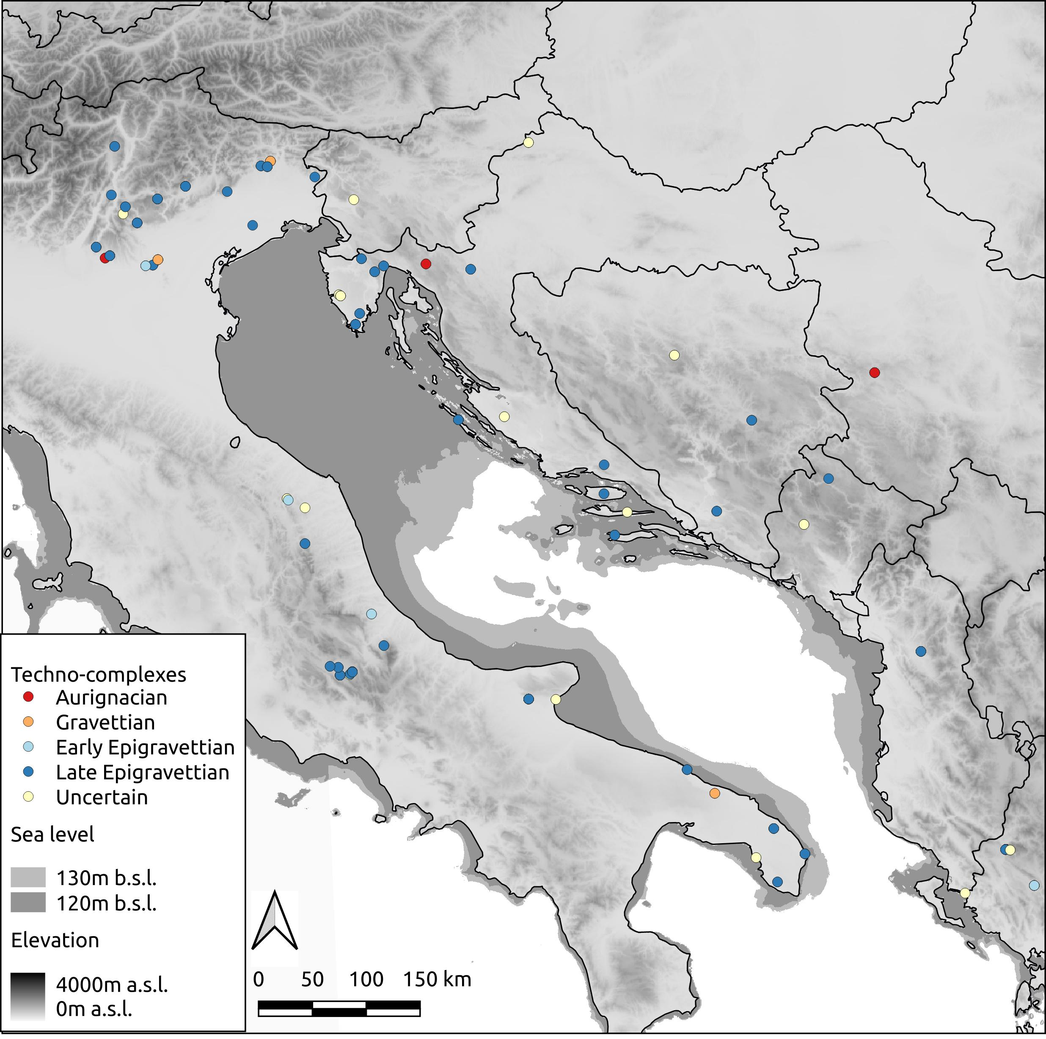
FIGURE 1. Distribution map of all sites included in the database

Results of the permutation test according to data quality criteria are presented on Fig. 2. We do not observe any systematic bias across the entire dataset, but rather a series of short-duration deviations between subsets happening within a relatively limited time-window between c. 27 and 21 ka calBP, including several episodes of over-representation of non-AMS dates. This being said, with the exception of a single episode between c. 27.2 and 27 ka calBP, this lower rate of AMS dates does not correspond to any higher presence of slightly reliable dates (i.e. lowest quality dates retained for analysis). On the contrary, we rather notice a higher frequency of highly reliable dates between c. 23 and 21 ka calBP.
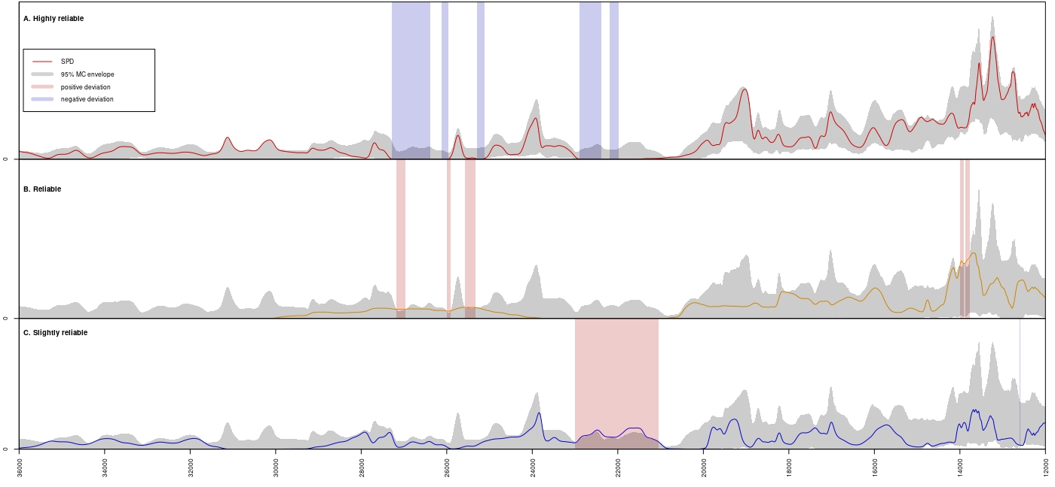
Figure 2: permutation test of 14C dates based on quality criteria (top: highly reliable dates; middle: reliable dates; bottom: slightly reliable dates)
Comparison between the two null demographic models and the empirical summed probability distribution (SPD) indicates, in both instances, three periods of potential interest (figure 3). Firstly, there is a small positive deviation immediately after 24 ka calBP, although its short duration (c. 150 years) makes it impossible to interpret. Secondly, both models present a negative deviation centred upon 21 ka calBP (uniform model: 20906-20571 calBP; exponential model: 21034-20465 calBP), for which the SPDs indicate a lack of available evidence. Thirdly, from c. 20.5 ka calBP onwards, the empirical SPD consistently presents higher density values, translating in a series of minor positive deviations with the constant null model, especially after 14 ka cal BP (14322-12024 calBP), which also corresponds to a couple of positive deviations to the exponential null models centered upon 13.5-13ka cal BP (13754-13498 calBP and 13321-13152 calBP)

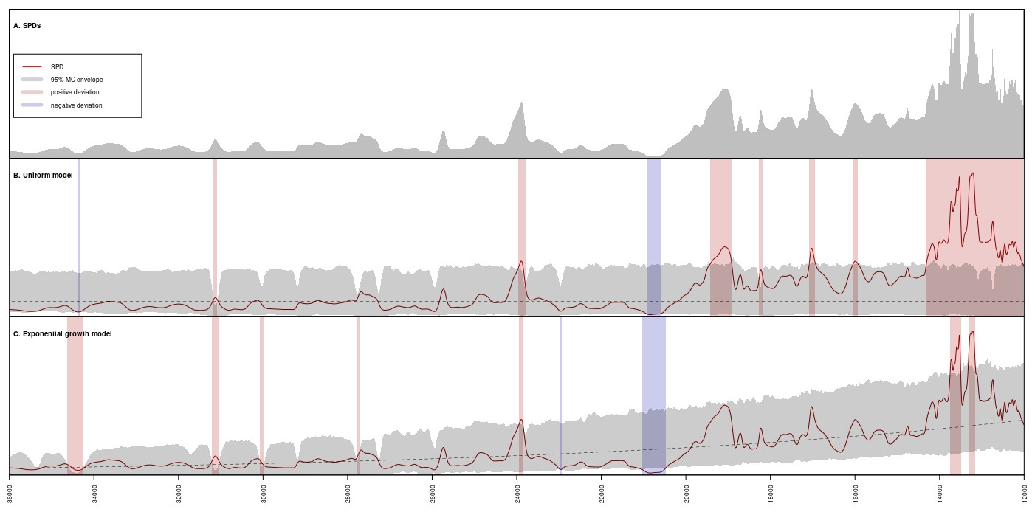
Figure 3 Summed probability distribution of 14C dates and associated demographic null models a. summed probability distribution. b. null constant model. c. fitted null exponential growth model. Blue and red bands indicate respectively negative and positive deviations from the null models

This temporal rise in the SPDs correlates with a gradual augmentation of the number of sites per periods, and a wider geographical distribution (figure 4). Despite having roughly comparable duration of c. 3,000 years, the GS-3 and GS-2-1c periods only comprise five and three sites respectively, while the GS2.1-b period counts 13 sites. This upwards trend continues during the Final Pleistocene (GS2.1-a and GI-1), with a relative shift of the settlement pattern towards higher elevation around the Po plain.
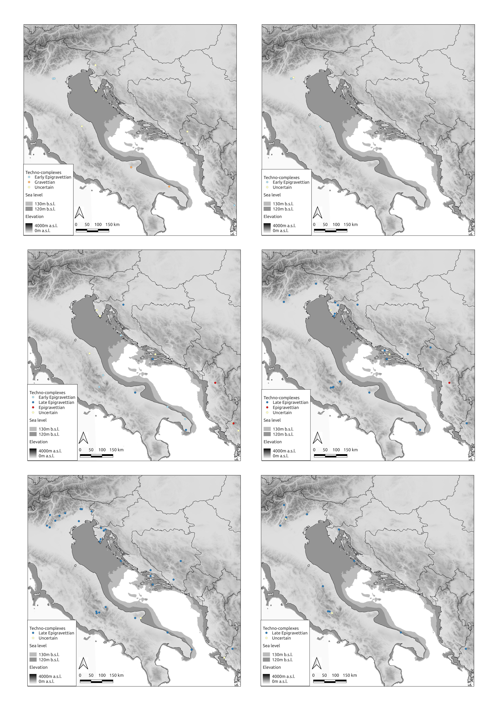
Figure 4: distribution of archaeological sites according to main climatic periods. Top left: GS 3. Top right: GS 2.1c. Middle left: GS2.1b. Middle right: GS 2.1a. Bottom left: GI 1. Bottom right: GS 1

The results of the duration of each TC, the boundaries between them and the potential chronological overlap are shown on Fig. 5. The Bayesian modelling for the Gravettian in the Adriatic using all reliable ¹⁴C dates indicates that this TC starts between 35,342 and 33,594 calBP (95.4%), possibly between 34,520 and 33,823 calBP (68.2%). This is also the only result for which we observe a difference between models using Intcal13 and Intcal20, with a three to four centuries offset between both (Intcal13: 34,907-33,321calBP, 95.4%; 34,121-33,493calBP, 68.2%). This TC ends between 26,390 and 24,232 calBP (95.4%), possibly between 25,973 and 25,037 calBP (68.2%). The Bayesian modelling for the Early Epigravettian in the Adriatic using all reliable ¹⁴C dates places its start between 26,474 and 25,328 calBP (95.4%), possibly between 26,115 and 25,361 calBP (68.2%). Estimates regarding the overlap between both TCs are very uncertain, suggesting an overlap lasting up to 1784 years or a difference of up to 691 years (95.4%), or a possible overlap lasting up to 922 years, or a difference up to 200 years (68.2%). The end of the Early Epigravettian is estimated between 18,165 and 17,106 calBP (95.4%), possibly between 18,061 and 17,580 calBP (68.2%). It is noticeable that our AMS-only model suggests much longer intervals for both the beginning (27,407-25,355 calBP at 95.4%, 26,388-25,668 calBP, 68.2%) and the end of this TC (18,192-16,169calBP, 95.4%; 18,059-17,239calBP, 68.2%), most probably as a result of the limited number of dates available, thus leading to uncertainty in the calculations.
The Bayesian modelling for the Adriatic Late Epigravettian indicates that this TC starts between 17,595 and 17,127 calBP (95.4%), possibly between 17,505 and 17,185 calBP (68.2%). The Bayesian model indicates that the Early and Late Epigravettian either overlap for up to 315 years (95.4%), or present a gap lasting up to 909 years (95.4%), possibly between 144 and 710 years (68.2%). Finally, the end of the Late Epigravettian is estimated between 11,969 and 11,627 calBP (95.4%), possibly between 11,906 and 11,750 calBP (68.2%).
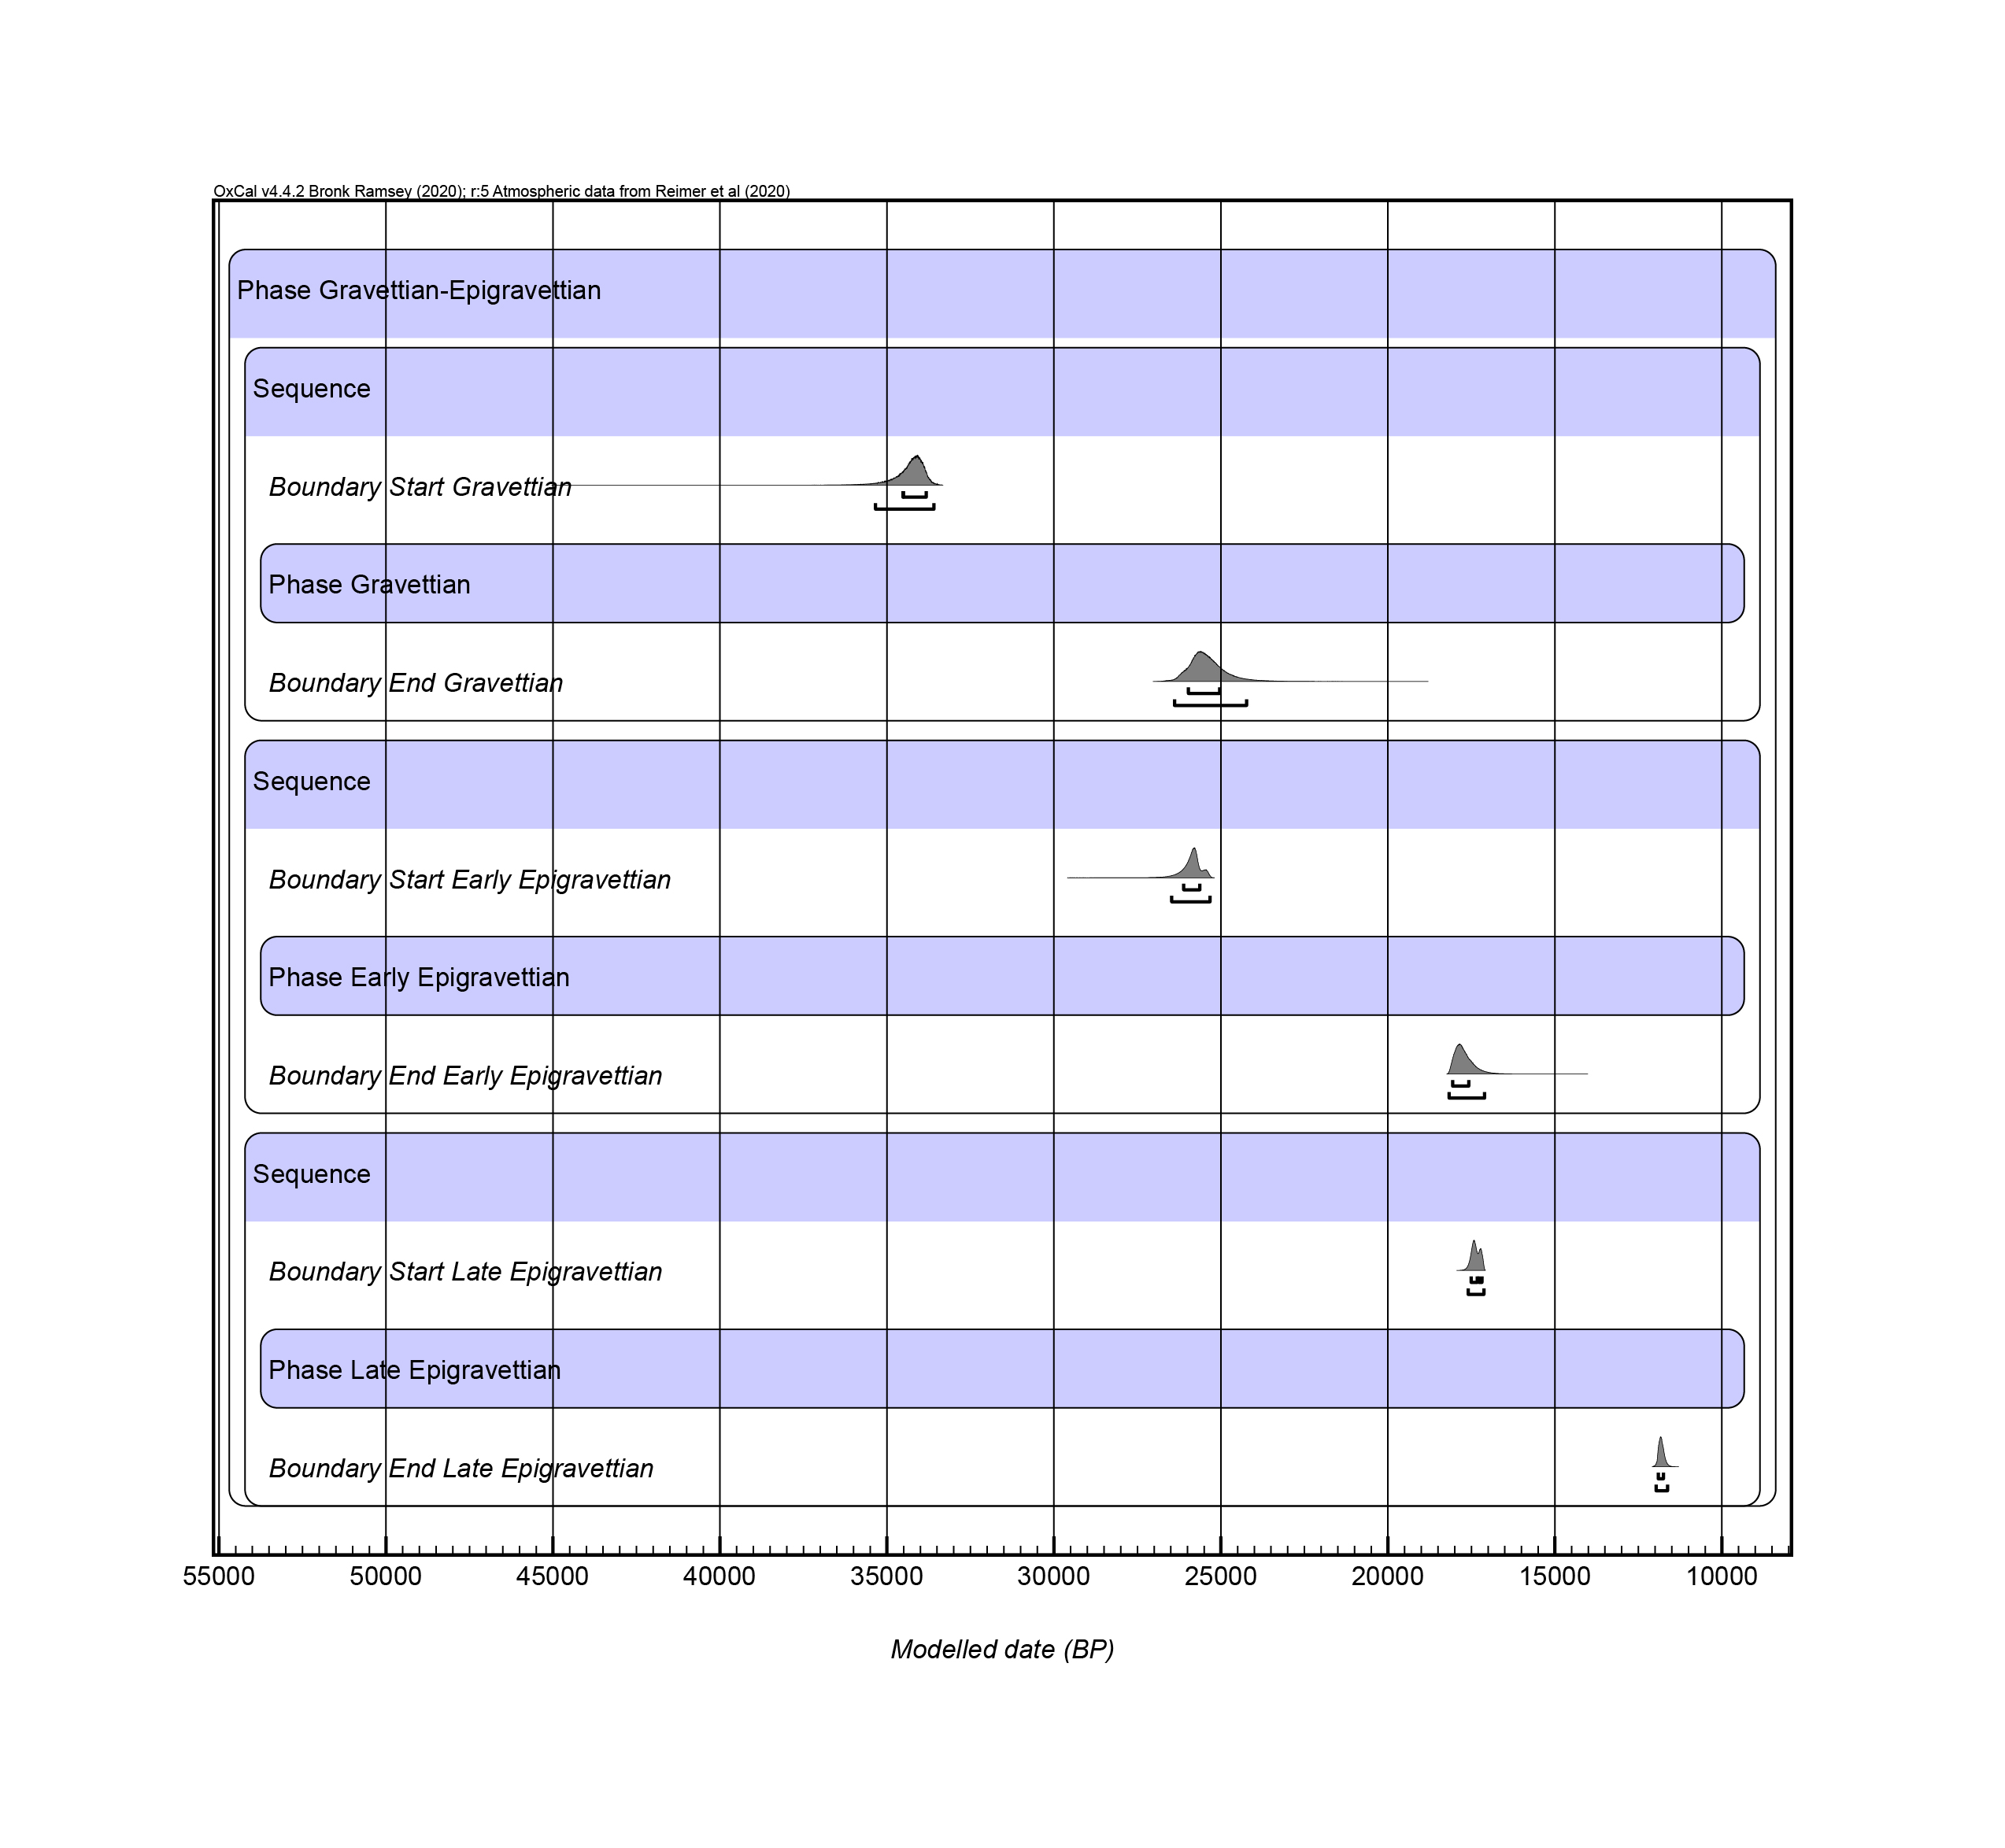
Figure 5: Bayesian model for the chronological boundaries of the Gravettian, Early Epigravettian and Late Epigravettian in the Adriatic Basin.

4. Discussion
We presented in this paper a corpus of critically assessed data to address the chronology and distribution of the TCs from the Middle and Late Upper Palaeolithic in the Adriatic basin. The Gravettian appears in the area at c. 35-34ka cal BP. These dates are similar to those recently proposed for this TC in France (Banks et al. 2019) and statistically indistinguishable from the oldest dates for the Gravettian in Europe: layers IIc, IId and IIe from Hohle Fels (Taller and Conard, 2019). The Gravettian covers a timespan of around 8,000-10,000 years, until c. 26-25 ka cal BP. Keeping in mind the patchiness of the documentation, our data suggest that the timespan of this TC matches with other areas, such as France and central Europe, where it apparently ends at c. 25.8ka cal BP and c. 25-24ka cal BP respectively (Banks et al., 2019; Maier and Zimmermann, 2017; Lengyel and Wilczyński, 2018). This ‘end date’ for the Gravettian in France is equivalent to the start date for the Early Epigravettian in the Adriatic basin (c. 26-25.6 vs. c. 26.1-25.4ka cal BP). Our analysis also suggests that the start date for the Early Epigravettian in the Adriatic region could be slightly earlier than in eastern Central Europe, where the boundary is set around 24ka cal BP (Lengyel and Wilczyński, 2018).
Based on the presence of shouldered points in the Early Epigravettian assemblages of the Balkan and Italian peninsulas, a technological transmission and influence coming from the North has been seen as the origin for this TC. These tools were taken as a marker of cultural influence or even as population movement from Central Europe during the LGM where shouldered points appear in the final Gravettian (Broglio, 1997; Kozłowski, 1999; 2008; Kozłowski and Kaczanowska, 2004). The appearance of this new hafting technology connected with shouldered points in the Balkans and Italy has been considered as indication of a knowledge transfer within well-connected social networks established in part as a response to LGM climatic deterioration (Borić and Cristiani, 2016). Despite purported Early Epigravettian sites being relatively common in the Adriatic basin, there is actually only a single site with both reliable radiocarbon dates and TC identification in the Eastern Adriatic, Kastritsa, located on the southern edge of the studied area (Galanidou and Tzedakis, 2001). Vela Špila’s basal levels also yielded dates that could correspond to this period (Farbstein et al., 2012), but the lithic assemblage from those layers is small, comprising only 95 artefacts (Vukosavljević, 2012), and does not allow a certain identification of this TC.
The end of the Early Epigravettian is set at c. 18.1-17.6ka cal BP. Several factors must be considered regarding these results. First, the aforementioned inconsistency of the definition(s) of the Early Epigravettian could influence our analysis. Despite some ‘markers’ (i.e. specific tools or technological features) being broadly agreed by scholars as characteristic from Gravettian and Early Epigravettian, others are not fully accepted and vary depending on individual authors’ criteria. Hence, in order to make clear the duration of this potential Gravettian-Early Epigravettian overlap, a global reassessment of the assemblages, combining technological and multi-criteria approaches to taxonomy, must be addressed in the future. Second, our results endorse criticisms of the model claiming contemporaneity between the Early Epigravettian and the western-European Solutrean, initially proposed by G. Laplace (1997), but never discussed in detail since. On the contrary, recent work on Early Epigravettian assemblages in the Western Mediterranean area point to affinities and analogies with the Badegoulian rather than the Solutrean (Tomasso, 2015; Tomasso and Rots, 2021). In light of our results, the timespan of the Early Epigravettian covers both TCs and even the Lower Magdalenian in France (Ducasse and Langlais, 2007; Renard and Ducasse, 2015; Banks et al., 2019). This suggests an independent cultural evolutionary path for territories that, during the Gravettian, showed a high degree of technological affinity.
Further, with no intention of falling into climatic determinism, we cannot ignore the fact that this phenomenon is coincident in time with the LGM, and includes for instance the negative deviation to both null models previously mentioned, which may be interpreted as a general contraction in human population density of the inner areas due to the harsh climatic conditions to settle in the Great Adriatic Plain, nowadays submerged. Furthermore, our results show that the Early-Late Epigravettian transition in the Adriatic took place probably around 17.6-17.1ka cal BP (95.4%). This date coincides with the transition between GS-2.2 and GI-2.1, fixed between 17.7-17.1ka cal BP (Rasmussen et al. 2014). The potential implications of this correlation should be explored in future research.

The start of the Late Epigravettian is almost synchronous with the disappearance of the last Early Epigravettian techno-typological forms, at c. 17.5-17.2ka cal BP. This short overlap –if real– suggests that the Late Epigravettian techniques and innovations could have spread quite rapidly along the Adriatic. Initial consideration of the distribution of sites dated to the Early-Late Epigravettian transition suggests a lack of patterning. However, the picture changes somewhat when considering the quality of the dates. In the eastern Adriatic, the sites of Vela Spila, Zala, Badanj u Pokriveniku and Romualdova pećina were recently AMS-dated to this overlap. The two former are confidently labelled as Late Epigravettian whereas for the last two the TC identification is uncertain. On the western Adriatic side, sites falling into the overlap include Campo delle Piane, Grotta di Pozzo, Grotta Paglicci and Pozzo Zecca. The former two have AMS dates and are identified as Early Epigravettian, with some reservations for both, especially for the former due to the lack of shouldered points. Grotta Paglicci and Pozzo Zecca are tentatively identified as Late Epigravettian, but the dates are non-AMS and old (published in 1977 and 1967 respectively). Although the raw data do not provide any clear information regarding the direction of the transmission of the Late Epigravettian innovations, it is thus noticeable that the earliest secure Late Epigravettian sites are located in the eastern Adriatic. By contrast, the last persistence of Early Epigravettian is only observed on the western side. This potential E-W axis is congruent with recent genomic data from the Late Epigravettian human fossil (Tagliente 2) from Riparo Tagliente. It is directly dated to 16,980-16,510 cal BP (95.4%), and indicates E-W directed population movements from Balkans/Anatolia to Southern Europe (Bortolini et al., 2020). Some authors consider population movement as at least one of the triggers for cultural change during the Early-Late Epigravettian transition. If confirmed, the direction for this transition is in good agreement with the appearance of genetic components connected with human groups from Eastern Europe/Anatolia. In such a scenario , we could expect the presence of the earliest Late Epigravettian sites in the eastern side of the Adriatic basin.
The Late Epigravettian is also associated with apparent transformations in settlement pattern, parallel to changing climatic and environmental conditions. While until the end of GS-2.1b, sites are largely restricted to the coastal areas, in the last moments of the Late Pleistocene (GS-2.1a and GI-1), several new biotopes appear to now be intensively occupied, especially the mountainous areas of the Alps (Bertola et al. 2007; Fontana et al., 2018), northern Istria (Komšo and Pellegatti, 2007) and the Dinaric Alps in the Balkans (Mihailović, 2007; 2014). This could be linked to the rapid reduction of the glaciers’ surface area detected in the Alps, starting at c. 17ka cal BP (Monegato et al., 2017). The milder climatic conditions of Gi-1 are also roughly contemporaneous with the most marked positive deviation of the SPD with both null models, suggesting either that the colonisation of new areas in the inner territories occurred upon a background of demographic growth, or that the rise in SPD is explained by a positive taphonomic bias with recent sites located in well-preserved areas, compared to a large fraction of older sites having been destroyed by post-LGM sea rise, both explanations not being mutually exclusive.
The end of the Late Epigravettian is estimated between 11,906 and 11,750 calBP (68.2%), thus overlapping with the Pleistocene-Holocene transition, set at 11.7ka calBP (Walker et al., 2009; Rasmussen et al. 2014). For some authors, the end of the Late Epigravettian is followed by the Terminal Epigravettian, a facies identified in both Italian and Balkan ridges of the Adriatic (Bartolomei et al. 1979; Palma di Cesnola and Bietti, 1983; Broglio, 1997; Basetti et al., 2009; Tomasso et al., 2020) and offering parallels with both the Epigravettian and the first Mesolithic. Other scholars suggest continuity between Late Epigravettian and early Holocene lithic technology in the eastern Adriatic (Kozłowski and Kozłowski, 1979; Mihailović, 2009; Vukosavljević et al., 2014). To accentuate this continuity, some use the term ‘Early Holocene Epigravettian’ for early postglacial lithic industries both in western (Bassetti et al., 2009) and eastern Adriatic (Kozłowski, 2009; Kaczanowska and Kozłowski, 2018).

5. Conclusion
The LGM and Late Glacial are key periods for understanding human response and cultural adaptation of Palaeolithic groups in the context of changing environmental conditions. The particularities of the Adriatic basin, make it an exceptional case-study within Europe. Nevertheless, the research on the subject is far from extensive. In comparison with other European regions, uncertainties and key questions remain largely open. In this paper, we offer a step forward to solve this issue, compiling and analysing the radiometric chronological data available for the period. The main result is the creation of a model for the duration of the TCs from the period. This rendered a more refined chronology, especially relevant for the transitions between the different TCs, previously quite imprecise and often showing large discrepancies between scholars. This enabled the comparison of the Adriatic basin with neighbouring areas, showing that the major changes in the material culture during the Upper Palaeolithic took place almost simultaneously in a large area, despite those changes followed separate paths. Could they have been influenced by a change in the social networks or were they different responses to a plurality of situations triggered by the same external factors (e.g. shifting ecological opportunities and economic strategies)?
It is evident that climatic events, for instance the peak of the LGM, would affect a constricted area such as the Adriatic Basin differently from the ‘open’ Central European plain. The comparison between the main cultural transformations defined in our study area and the climatic models for the period show some correlation that deserves to be mentioned. Despite our reluctance to fall into a ‘climatic determinism’, reducing the justification for complex changes in the social and cultural dynamics to environmentally-driven responses, our results suggest that some external events could have acted as major triggers for those changes.
Finally, this exploratory research has shown, once more, the high potential of an area not as intensively studied as other European territories. Many other questions remain open, but the archaeological research in the area addressing the UP period has intensified in the last years (especially in the Balkan Peninsula). Thus, we are optimistic that current and near-future investigations will lead to major advances in the knowledge of the Mid and Late UP societies in the Adriatic Basin.

ACKNOWLEDGEMENTS
This research has received financial support from the British Academy through the PALAEOARTEAST (‘Defining cultural boundaries in the European Upper PALAEOlithic: Archaeology and Rock arT in EASTern Europe’) project, led by AR-R within the framework of the Newton International Fellowship program (NIF\R1\180205). AR-R has also received financial support from the Spanish Ministry of Science and Innovation through the ‘Juan de la Cierva-incorporación’ programme. NV thanks to JESH (Joint Excellence in Science and Humanities) scholarship programme of the Austrian Academy of Sciences that supported his research on Eastern Adriatic Epigravettian. NV gratitude also goes to colleagues Thomas Einwögerer and Michael Brandl from Quaternary Archaeology Research Group of Austrian Archaeological Institute for their support. INCLUDE YOUR OWN.
REFERENCES
Adam, E., 2007. Looking out for the Gravettian in Greece. PALEO. Revue d’archéologie préhistorique 19, 145–158. https://doi.org/10.4000/paleo.579
Amorosi, A., Maselli, V., Trincardi, F., 2016. Onshore to offshore anatomy of a late Quaternary source-to-sink system (Po Plain–Adriatic Sea, Italy). Earth-Science Reviews, Source-to-Sink Systems: Sediment & Solute Transfer on the Earth Surface 153, 212–237. https://doi.org/10.1016/j.earscirev.2015.10.010
Aranguren, B., Cavulli, F., D’Orazio, M., Grimaldi, S., Longo, L., Revedin, A., Santaniello, F., 2015. Territorial exploitation in the Tyrrhenian Gravettian Italy: The case-study of Bilancino (Tuscany). Quaternary International, World of Gravettian Hunters 359–360, 442–451. https://doi.org/10.1016/j.quaint.2014.07.009
Aubert, M., Brumm, A., Ramli, M., Sutikna, T., Saptomo, E.W., Hakim, B., Morwood, M.J., van den Bergh, G.D., Kinsley, L., & Dosseto, A. (2014). Pleistocene cave art from Sulawesi, Indonesia. Nature, 514, 223–228.
Bamforth, D.B., Grund, B., 2012. Radiocarbon calibration curves, summed probability distributions, and early Paleoindian population trends in North America. Journal of Archaeological Science 39, 1768–1774. https://doi.org/10.1016/j.jas.2012.01.017
Banks, W.E., Bertran, P., Ducasse, S., Klaric, L., Lanos, P., Renard, C., Mesa, M., 2019. An application of hierarchical Bayesian modeling to better constrain the chronologies of Upper Paleolithic archaeological cultures in France between ca. 32,000–21,000 calibrated years before present. Quaternary Science Reviews 220, 188–214. https://doi.org/10.1016/j.quascirev.2019.07.025
Bartolomei, G., Broglio, A., Palma di Cesnola, A., 1979. Chronostratigraphie et écologie de l’Epigravettien en Italie, in: Coll. Int. CNRS 271 “La Fin Des Temps Glaciaires En Europe.” Paris, pp. 297–324.
Bassetti, M., Cusinato, A., Dalmeri, G., Kompatscher, M.H., Kompatscher, K., Wierer, U., 2009. Updating on the final Palaeolithic-mesolithic transition in Tentino (NE Italy). Preistoria Alpina 44, 121–135.
Bertola, S., Broglio, A., Cassoli, P., C., C., Cusinato, A., Dalmeri, G., Stefani, M., Fiore, I., Fontana, F., Giacobini, G., Guerreschi, A., Gurioli, F., Lemorini, C., Liagre, J., Malerba, G., Montoya, C., Peresani, M., Ris, A., Rossetti, P., Ziggiotti, S., 2007. L’Epigravettiano recente nell’area prealpina e alpina orientale, in: Martini, F. (Ed.), L’Italia Tra 15.000 e 10.000 Anni Fa Cosmopolitismo e Regionalità Nel Tardoglaciale, Milleni. Studi Di Archeologia Preistorica. Museo e Istituto Fiorentino di Preistoria “Paolo Graziosi,” Firenze, pp. 39–94.
Bicho, N., Cascalheira, J., Gonçalves, C., 2017. Early Upper Paleolithic colonization across Europe: Time and mode of the Gravettian diffusion. PLOS ONE 12, e0178506. https://doi.org/10.1371/journal.pone.0178506
Bietti, A., 1990. The late Upper Paleolithic in Italy: An overview. Journal of World Prehistory 4, 95–155. https://doi.org/10.1007/BF00974820
Borgia, V., 2008. Le Gravettien ancien dans le Sud de l’Italie : analyse fonctionnelle des pointes à dos de la Grotta Paglicci (Foggia) et de la Grotta della Cala (Salerno), in: Pétillon, J.-M., Dias-Meirinho, M.-H., Cattelain, P., Honegger, M., Normand, C., Valdeyron, N. (Eds.), Recherches Sur Les Armatures de Projectiles Du Paléolithique Supérieur Au Néolithique (Actes Du Colloque C83, XVe Congrès de l’UISPP, Lisbonne, 4-9 Septembre 2006), P@lethnologie 1, 47–68.
Borgia, V., Wierer, U., 2005. Le punte a dorso degli strati alla base della serie gravettiana di Grotta della Cala (Marina di Camerota, Salerno). Rivista di Scienze Preistoriche LV, 121–136. https://doi.org/10.1400/206807
Borić, D., Cristiani, E., 2016. Social networks and connectivity among the Palaeolithic and Mesolithic foragers of the Balkans and Italy, in: Krauss, R., Floss, H. (Eds.), Southeast Europe before Neolithisation (Proceedings of the Workshop Held in Tübingen, Germany, May 9th, 2014). Universität Tübingen, Tübingen, pp. 73–112.
Borić, D., Cristiani, E., 2019. Taking Beads Seriously: Prehistoric Forager Ornamental Traditions in Southeastern Europe. PaleoAnthropology 2019, 208–239. https://doi.org/10.4207/PA.2019.ART132
Borić, D., Emanuela Cristiani, Pravidur, A., Marić, A., Whallon, R., 2021. Osseous tools and personal ornaments from the Epigravettian sequence at Badanj. Research Square (preprint). https://doi.org/10.21203/rs.3.rs-209080/v1
Bortolini, E., Pagani, L., Oxilia, G., Posth, C., Fontana, F., Badino, F., Saupe, T., Montinaro, F., Margaritora, D., Romandini, M., Lugli, F., Papini, A., Boggioni, M., Perrini, N., Oxilia, A., Cigliano, R.A., Barcelona, R., Visentin, D., Fasser, N., Arrighi, S., Figus, C., Marciani, G., Silvestrini, S., Bernardini, F., Menghi Sartorio, J.C., Fiorenza, L., Cecchi, J.M., Tuniz, C., Kivisild, T., Gianfrancesco, F., Peresani, M., Scheib, C.L., Talamo, S., D’Esposito, M., Benazzi, S., 2021. Early Alpine occupation backdates westward human migration in Late Glacial Europe. Current Biology. https://doi.org/10.1016/j.cub.2021.03.078
Broglio, A., 1993. Mountain sites in the context of the North-East Italian Upper Palaeolithic and Mesolithic. Preistoria Alpina 28, 293–310.
Broglio, A., 1997. Considérations sur l’Épigravettien italien, in: Fullola, J.M., Soler, N. (Eds.), El Mòn Méditerrani Desprès Del Pleniglacial (18000-12000 BP). Museu d’Archeologia de Catalunya, Girona, pp. 147–158.
Broglio, A., Chelidonio, G., Longo, L., 1993. Analyse morphologique et fonctionelle des pointes à cran de l’Épigravettien ancien, in: Anderson, P., Beyries, S., Otte, M., Plisson, H. (Eds.), Traces et Fonction, Les Gestes Retrouvés: Actes Du Colloque International de Liège 8, 9, 10 Décembre 1990, E.R.A.U.L. Université de Liège, Liège, pp. 31–40.
Broglio, A., Montoya, C., 2005. Les transformations techniques lithiques et l’art mobilier de l’Epigravettien récent des Préalpes de Vénétie, in: Broglio, A., Dalmeri, G. (Eds.), Pitture Paleolitiche Nelle Prealpi Venete: Grotta Di Fumane e Riparo Dalmeri, Preistoria Alpina. Museo Civico di Storia Naturale di Verona, Verona, pp. 184–190.
Bronk Ramsey, C., 2017. Methods for Summarizing Radiocarbon Datasets. Radiocarbon 59, 1809–1833. https://doi.org/10.1017/RDC.2017.108
Brummer et al., 2009 Brommer, M.B., Weltje, G.J., Trincardi, F., 2009. Reconstruction of sediment supply from mass accumulation rates in the Northern Adriatic Basin (Italy) over the past 19,000 years. Journal of Geophysical Research: Earth Surface 114. https://doi.org/10.1029/2008JF000987
Cancellieri, E., 2015. Over The Hills and Far Away: Last Glacial Maximum Lithic Technology Around the Great Adriatic Plain. Archaeopress, Oxford. https://doi.org/10.2307/j.ctvxw3nhd
Čečuk, B., 1996. Špilja Kopačina kod Donjeg Humca na otoku Braču. Arheološki radovi i rasprave 12, 13–30.
Clark, D.L., 1968. Analytical Archaeology. Methuen, London.
Crema, E.R., Bevan, A., 2021. Inference from Large Sets of Radiocarbon Dates: Software and Methods. Radiocarbon 63, 23–39. https://doi.org/10.1017/RDC.2020.95
Cristiani, E., 2018. Epigravettian osseous technology from the eastern Alpine region of Italy. The case of Riparo Dalmeri (Trentino), in: Borgia, V., Cristiani, E. (Eds.), Palaeolithic Italy: Advanced Studies on Early Human Adaptations in the Apennine Peninsula. Sidestone press, pp. 311–334.
Cristiani, E., Farbstein, R., Miracle, P., 2014. Ornamental traditions in the Eastern Adriatic: The Upper Palaeolithic and Mesolithic personal adornments from Vela Spila (Croatia). Journal of Anthropological Archaeology 36, 21–31. https://doi.org/10.1016/j.jaa.2014.06.009
Cvitkušić, B., 2017. Upper Palaeolithic and Mesolithic Ornamental Traditions in the Eastern Adriatic Coast and Hinterland. Coll Antropol 41, 45–59.
Cvitkušić, B., Radović, S., Vujević, D., 2018. Changes in ornamental traditions and subsistence strategies during the Palaeolithic-Mesolithic transition in Vlakno cave. Quaternary International 494, 180–192. https://doi.org/10.1016/j.quaint.2017.08.053
Dalmeri, G., Ferrari, S., Peresani, M., 2004. Rise and fall in the utilization of trapezoidal microliths during the Late Upper Palaeolithic in Europe – an overview from the Italian record, in: Terberger, T., Eriksen, B.V. (Eds.), Hunters in Changing World. Environment and Archaeology of the Pleistocene - Holocene Transition (ca. 11000-9000 B.C.) in Northern Central Europe. Leidorf, Rahden, pp. 243–251.
Ducasse, S., Langlais, M., 2007. Entre Badegoulien et Magdalénien, nos cœurs balancent... Approche critique des industries lithiques du Sud de la France et du Nord-Est espagnol entre 19000 et 16500 BP. Bulletin de la Société préhistorique française 104, 771–785. https://doi.org/10.3406/bspf.2007.13622
Ducasse, S., Pétillon, J.-M., Chauvière, F.-X., Renard, C., Lacrampe-Cuyaubère, F., Muth, X., 2019. Archaeological recontextualization and first direct 14C dating of a “pseudo-excise” decorated antler point from France (Pégourié Cave, Lot). Implications on the cultural geography of southwestern Europe during the Last Glacial Maximum. Journal of Archaeological Science: Reports 23, 592–616. https://doi.org/10.1016/j.jasrep.2018.11.019
Duches, R., Peresani, M., Pasetti, P., 2018. Success of a flexible behavior. Considerations on the manufacture of Late Epigravettian lithic projectile implements according to experimental tests. Archaeol Anthropol Sci 10, 1617–1643. https://doi.org/10.1007/s12520-017-0473-x
Falcucci, A., Peresani, M., 2019. A pre-Heinrich Event 3 assemblage at Fumane Cave and its contribution for understanding the beginning of the Gravettian in Italy. Quartär 66, 135–154. https://doi.org/10.7485/QU66_6
Farbstein, R., Radić, D., Brajković, D., Miracle, P.T., 2012. First Epigravettian Ceramic Figurines from Europe (Vela Spila, Croatia). PLOS ONE 7, e41437. https://doi.org/10.1371/journal.pone.0041437
Ferrari, S., Peresani, M., 2003. Trapezoids and double truncations in the Epigravettian assemblages of northeastern Italy. Eurasian Prehistory 1, 83–106.
Fontana, F., Guerreschi, A., Bertola, S., Cremona, M.G., Cavulli, F., Falceri, L., Gajardo, A., Montoya, C., Ndiaye, M., Visentin, D., 2015. I livelli più antichi della serie epigravettiana “interna” di Riparo Tagliente: sfruttamento delle risorse litiche e sistemi tecnici, in: Leonardi, G., Tiné, V. (Eds.), Preistoria e Protostoria del Veneto. Atti della XLVIII Riunione Scientifica dell’Istituto Italiano di Preistoria e Protostoria (Padova 5-9 novembre 2013). Istituto Italiano di Preistoria e Protostoria, Firenze, pp. 43–52.
Fontana, F., Falceri, L., Gajardo, A., Bertola, S., Cremona, M.G., Cavulli, F., Guerreschi, A., Visentin, D., 2018. Diachronic data on the use of sheltered space in the Late Epigravettian site of Riparo Tagliente (Verona, Italy), in: Borgia, V., Cristiani, E. (Eds.), Palaeolithic Italy: Advanced Studies on Early Human Adaptations in the Apennine Peninsula. Sidestone Press, Leiden, pp. 287–310.
French, J.C., Collins, C., 2015. Upper Palaeolithic population histories of Southwestern France: a comparison of the demographic signatures of 14C date distributions and archaeological site counts. Journal of Archaeological Science 55, 122–134. https://doi.org/10.1016/j.jas.2015.01.001
French, J.C., 2015. The demography of the Upper Palaeolithic hunter–gatherers of Southwestern France: A multi-proxy approach using archaeological data. Journal of Anthropological Archaeology 39, 193–209. https://doi.org/10.1016/j.jaa.2015.04.005
Galanidou, N., Tzedakis, P.C., 2001. New AMS dates from Upper Palaeolithic Kastritsa. Proceedings of the Prehistoric Society 67, 271–278. https://doi.org/10.1017/S0079497X00001699
Gambassini, P., 2007. Traits essentiels du Gravettien en Italie. PALEO. Revue d’archéologie préhistorique 19, 105–108. https://doi.org/10.4000/paleo.542
Gamble, C., Davies, W., Pettitt, P., Hazelwood, L., Richards, M., 2005. The Archaeological and Genetic Foundations of the European Population during the Late Glacial: Implications for ‘Agricultural Thinking.’ Cambridge Archaeological Journal 15, 193–223. https://doi.org/10.1017/S0959774305000107
Gazzoni, V., Fontana, F., 2011. Quelle mort ? Quelle vie ? Pratiques funéraires et organisation sociale des chasseurs-cueilleurs de la péninsule italienne. Bull. Mém. Soc. Anthropol. 23, 52–69. https://doi.org/10.1007/s13219-010-0028-5
Giaccio, B., Rolfo, M.F., Bozzato, S., Galadini, F., Messina, P., Silvestrini, M., Sposato, A., 2004. La risposta ambientale ed umana alle oscillazioni climatiche sub-orbitali dell’OIS3: evidenze geoarcheologiche dalla Piana di Colfiorito (Appennino centrale). Il Quaternario: Italian Journal of Quaternary Sciences 17, 239–256.
Giacobini, G., 2006. Les sépultures du Paléolithique supérieur : la documentation italienne. Comptes Rendus Palevol 5(1), 169–176. https://doi.org/10.1016/j.crpv.2005.09.018
Higham, T., 2011. European Middle and Upper Palaeolithic radiocarbon dates are often older than they look: problems with previous dates and some remedies. Antiquity 85, 235–249. https://doi.org/10.1017/S0003598X00067570
Higham et al., 2006
Kaczanowska, M., Kozłowski, J.K., 2018. Before the neolithization: Causes of mesolithic diversity in the Southern Balkans. Acta Archaeologica Academiae Scientiarum Hungaricae 69, 253–270. https://doi.org/10.1556/072.2018.69.2.2
Karavanić, I., Vukosavljević, N., Šošić Klindžić, R., Kurtanjek, D., Zupanić, J., 2013. The lithic and bone industries of the Epigravettian layers from Šandalja II near Pula. Vjesnik za arheologiju i povijest dalmatinsku 106, 7–73.
Kelly, R.L., Surovell, T.A., Shuman, B.N., Smith, G.M., 2013. A continuous climatic impact on Holocene human population in the Rocky Mountains. PNAS 110, 443–447. https://doi.org/10.1073/pnas.1201341110
Komšo, D., Pellegatti, P., 2007. The Late Epigravettian in Istria. Late Paleolithic colonization and lithic technology in the northern Adriatic area., in: Whallon, R. (Ed.), Late Paleolithic Environments and Cultural Relations around the Adriatic, BAR International Series 1716. Archaeopress, Oxford, pp. 27–39.
Kozłowski, J.K., 1999. Gravettian/Epigravettian sequences in the Balkans: environment, technologies, hunting strategies and raw material procurement, in: Bailey, G.N., Adam, E., Perlès, C., Panagopoulou, E., Zachos, K. (Eds.), Palaeolithic Archaeology of Greece and Adjacent Areas. British School at Athens, London, pp. 319–329.
Kozłowski, J.K., 2008. The shouldered point horizon and the impact of the LGM on human settlement distribution in Europe, in: Svoboda, J. (Ed.), Petřkovice: On Shouldered Points and Female Figurines., The Dolní Věstonice Studies, Vol. 15. Academy of Sciences of the Czech Republic, Brno, pp. 181–192.
Kozłowski, J.K., 2015. The origin of the Gravettian. Quaternary International 359–360, 3–18. https://doi.org/10.1016/j.quaint.2014.03.025
Kozłowski, J.K., Kaczanowska, M., 2004. Gravettian/Epigravettian sequences in the Balkans and Anatolia. Mediterranean Archaeology and Archaeometry 4, 5–18.
Kozłowski, J.K., Kozłowski, S.K., 1979. Upper Palaeolithic and Mesolithic in Europe, Taxonomy and Palaeohistory, Ossolineum, Wroclaw.
Kozłowski, S.K., 2009. Thinking Mesolithic. Oxbow Books.
Kujundžić, Z., 1990. Najstariji ribolovci u kanjonu Bregave. Slovo Gorčina 18, 23–25.
Lambeck, K., Rouby, H., Purcell, A., Sun, Y., Sambridge, M., 2014. Sea level and global ice volumes from the Last Glacial Maximum to the Holocene. PNAS 111, 15296–15303. https://doi.org/10.1073/pnas.1411762111
Laplace, G., 1964. Les Subdivisions du Leptolithique italien. Étude de typologie analytique. Bullettino di paletnologia italiana 73, 25–63.
Laplace, G., 1997. Gravettien, Epigravettien et Tardigravettien. Rivista di Scienze Preistoriche 223–237.
Lengyel, G., Wilczyński, J., 2018. The Gravettian and the Epigravettian chronology in eastern central Europe: A comment on Bösken et al. (2017). Palaeogeography, Palaeoclimatology, Palaeoecology 506, 265–269. https://doi.org/10.1016/j.palaeo.2017.11.017
Maier, A., Zimmermann, A., 2017. Populations headed south? The Gravettian from a palaeodemographic point of view. Antiquity 91, 573–588. https://doi.org/10.15184/aqy.2017.37
Malnar, N., 2017. Epigravetijenski nalazi pećine Vlakno. Master’s dissertation. University of Zadar, Zadar.
Marom, A., McCullagh, J.S.O., Higham, T.F.G., Hedges, R.E.M., 2013. Hydroxyproline Dating: Experiments on the 14C Analysis of Contaminated and Low-Collagen Bones. Radiocarbon 55, 698–708. https://doi.org/10.1017/S0033822200057854
Mihailović, B., 2008. The Gravettian site Salitrena Pecina near Mionica (Western Serbia)., in: Mihailović, D., Darlas, A. (Eds.), The Palaeolithic of the Balkans, BAR International Series 1819. Archaeopress, Oxford, pp. 101–106.
Mihailović, D., 1999. The Upper Palaeolithic and Mesolithic stone industries of Montenegro, in: Bailey, G.N., Adam, E., Perlès, C., Panagopoulou, E., Zachos, K. (Eds.), Palaeolithic Archaeology of Greece and Adjacent Areas. British School at Athens, London, pp. 343–356.
Mihailović, D., 2007. Social and Cultural Integration in the Late Upper Palaeolithic of the Western Balkans, in: Whallon, R. (Ed.), Late Paleolithic Environments and Cultural Relations around the Adriatic, BAR International Series 1716. Archaeopress, Oxford, pp. 53–59.
Mihailović, D., 2009. Upper Palaeolithic and Mesolithic chipped stone industries from Crvena stijena. University of Belgrade, Belgrade.
Mihailović, D., 2014. Paleolit na centralnom Balkanu - kulturne promene i populaciona kretanja. Serbian Archaeological Society, Belgrade.
Mihailovic, D., Mihailovic, B., 2007. Considérations sur le Gravettien et l’Épigravettien ancien des Balkans de l’ouest. PALEO. Revue d’archéologie préhistorique 115–128. https://doi.org/10.4000/paleo.556
Monegato, G., Scardia, G., Hajdas, I., Rizzini, F., Piccin, A., 2017. The Alpine LGM in the boreal ice-sheets game. Scientific Reports 7, 2078. https://doi.org/10.1038/s41598-017-02148-7
Montoya, C., 2008. Apport de l’analyse technique à la compréhension de l’évolution des groupes humains épigravettiens d’Italie Nord Orientale: la production lithique de l’US 15a-65 du Riparo Dalmeri. Preistoria Alpina 43, 191–208.
Montoya, C., Duches, R., Fontana, F., Peresani, M., Visentin, D., 2018. Peuplement tardiglaciaire et holocène ancien des Préalpes de la Vénétie (Italie nord-orientale) : éléments de confrontation, in: Averbouh, A., Bonnet-Jacquement, P., Cleyet-Merle, J.-J. (Eds.), L’Aquitaine à La Fin Des Temps Glaciaires - Les Sociétés de La Transition Du Paléolithique Final Au Début Du Mésolithique Dans l’espace Nord Aquitain Actes de La Table Ronde Organisée En Hommage à Guy Célérier,Les Eyzies-de-Tayac, 24-26 Juin 2015, PALEO, Numéro Spécial. Musée National de Préhistoire, Les Eyzies-de-Tayac, pp. 193–202.
Montoya, C., Peresani, M., 2005. Premiers éléments d’analyse technologique de l’industrie lithique du gisement épigravettien de Val Lastari (Préalpes de la Vénétie), in: Montoya, J.-P.B.& C. (Ed.), D’un Monde à l’autre : Les Systèmes Lithiques Pendant Le Tardiglaciaire Autour de La Méditerranée Nord-Occidentale : Actes de La Table-Ronde Internationale, Aix-En-Provence, 6-8 Juin 2001, Mémoires de La Société Préhistorique Française. Société préhistorique française, pp. 103–121.
Mussi, M., 2000. Heading South: the Gravettian colonisation of Italy, in: Roebroeks W., Mussi M., Svoboda J., Fennema K. (Eds.), Hunters of the Golden Age: The Mid Upper Palaeolithic of Eurasia (30.000-20.000 Bp). Leiden University Press, Leiden, pp. 355–374.
Mussi, M., 2002. Earliest Italy: An Overview of the Italian Paleolithic and Mesolithic, Interdisciplinary Contributions to Archaeology. Springer US. https://doi.org/10.1007/b110672
Mussi, M., 2012. Les “Vénus” du Gravettien et de l’Épigravettien italien dans un cadre européen. Préhistoire, art et sociétés: bulletin de la Société Préhistorique de l’Ariège 65–66, 499–511.
Otte, M., 1981. Le Gravettien en Europe Centrale. Dissertationes Archaeologicae Gandenses vol. XX. De Tempel, Brugge.
Otte, M., 1985. Le Gravettien en Europe. L’Anthropologie 89, 479–503.
Palma di Cesnola, A., Bietti, A., 1983. Le Gravettien et l’Epigravettien ancien en Italie. Rivista di Scienze Preistoriche 38, 181–228.
Palma di Cesnola, A., 1993. La campagna di scavi 1991 a Grotta Paglicci, in: Atti 13 Convegno Nazionale Sulla Preistoria, Protostoria e Storia Della Daunia (San Severo, 1991). Archeoclub d’Italia - Sede di San Severo, Foggia, pp. 9–16.
Palma di Cesnola, A., 2006. L’Aurignacien et le Gravettien ancien de la grotte Paglicci au Mont Gargano. L’Anthropologie 110, 355–370. https://doi.org/10.1016/j.anthro.2006.06.011
Peresani, M., 2006. Cultures et traditions du Paléolithique supérieur dans les regions nord-méditerranéennes, in: Sanchidrián Torti, J.L., Márquez, A.M., Fullola, J.M. (Eds.), La cuenca mediterránea durante el Paleolítico Superior: (38.000-10.000 años). Fundación Cueva de Nerja, Nerja, pp. 408–429.
Peresani, 2008
Peresani, M., Tomio, C., Dalmeri, G., 2014. Les grattoirs épigravettiens et leur « raccourcissement » durant le Tardiglaciaire en Italie. Reflets d’un changement dans l’économie du débitage, in: Langlais, M., Naudinot, N., Peresani, M. (Eds.), Les Groupes Culturels de La Transition Pléistocène-Holocène Entre Atlantique et Adriatique- Acts de La Séances de La Société Préhistorique Française (Bordeaux 2012). Société Préhistorique Française, Paris, pp. 205–220.
Peresani, M., Monegato, G., Ravazzi, C., Bertola, S., Margaritora, D., Breda, M., Fontana, A., Fontana, F., Janković, I., Karavanić, I., Komšo, D., Mozzi, P., Pini, R., Furlanetto, G., Maria De Amicis, M.G., Perhoč, Z., Posth, C., Ronchi, L., Rossato, S., Vukosavljević, N., Zerboni, A., 2021. Hunter-gatherers across the great Adriatic-Po region during the Last Glacial Maximum: Environmental and cultural dynamics. Quaternary International 581–582, 128–163. https://doi.org/10.1016/j.quaint.2020.10.007
Rasmussen, S.O., Bigler, M., Blockley, S.P., Blunier, T., Buchardt, S.L., Clausen, H.B., Cvijanovic, I., Dahl-Jensen, D., Johnsen, S.J., Fischer, H., Gkinis, V., Guillevic, M., Hoek, W.Z., Lowe, J.J., Pedro, J.B., Popp, T., Seierstad, I.K., Steffensen, J.P., Svensson, A.M., Vallelonga, P., Vinther, B.M., Walker, M.J.C., Wheatley, J.J., Winstrup, M., 2014. A stratigraphic framework for abrupt climatic changes during the Last Glacial period based on three synchronized Greenland ice-core records: refining and extending the INTIMATE event stratigraphy. Quaternary Science Reviews 106, 14–28. https://doi.org/10.1016/j.quascirev.2014.09.007
Reimer, P.J., Austin, W.E.N., Bard, E., Bayliss, A., Blackwell, P.G., Bronk Ramsey, C., Butzin, M., Cheng, H., Edwards, R.L., Friedrich, M., Grootes, P.M., Guilderson, T.P., Hajdas, I., Heaton, T.J., Hogg, A.G., Hughen, K.A., Kromer, B., Manning, S.W., Muscheler, R., Palmer, J.G., Pearson, C., Plicht, J. van der, Reimer, R.W., Richards, D.A., Scott, E.M., Southon, J.R., Turney, C.S.M., Wacker, L., Adolphi, F., Büntgen, U., Capano, M., Fahrni, S.M., Fogtmann-Schulz, A., Friedrich, R., Köhler, P., Kudsk, S., Miyake, F., Olsen, J., Reinig, F., Sakamoto, M., Sookdeo, A., Talamo, S., 2020. The IntCal20 Northern Hemisphere Radiocarbon Age Calibration Curve (0–55 cal kBP). Radiocarbon 62, 725–757. https://doi.org/10.1017/RDC.2020.41
Renard, C., Ducasse, S., 2015. De la rupture typologique à la fracture socio-économique. Implications sur les systèmes de mobilité entre Solutréen récent et Badegoulien dans le Sud- Ouest français (24-21 ka cal. BP), in: Naudinot, N., Meignen, L., Binder, D., Querré, G., Moatti, C. (Eds.), Les Systèmes de Mobilité de La Préhistoire Au Moyen Age. Actes Des XXXVèmes Rencontres Internationales d’archéologie et d’histoire d’Antibes. Éditions APDCA, Antibes, pp. 193–218.
Riede, F., 2009. Climate and Demography in Early Prehistory: Using Calibrated 14C Dates as Population Proxies. Human Biology 81, 309–337. https://doi.org/10.3378/027.081.0311
Roberts, B.W., Vander Linden, M. (Eds.), 2011. Investigating Archaeological Cultures: Material Culture, Variability, and Transmission. Springer-Verlag, New York. https://doi.org/10.1007/978-1-4419-6970-5
Ruiz-Redondo, A., 2014. Entre el Cantábrico y los Pirineos: El conjunto de Altxerri en el contexto de la actividad gráfica magdaleniense. Nadir, Santander.
Ruiz-Redondo, A., 2016. Le comportement symbolique des derniers chasseurs cueilleurs paléolithiques : regard sur l’art rupestre du Magdalénien cantabrique. L’Anthropologie, Paléolithique supérieur 120, 568–587. https://doi.org/10.1016/j.anthro.2016.10.002
Ruiz-Redondo, A., 2019. El arte rupestre del Magdaleniense Reciente (14500-11500 BP) en la Región Cantábrica, in: Ontañón, R., Chauvín, A. (Eds.), Arte Paleolítico En La Región Cantábrica. Asociación de Amigos del Museo de Prehistoria y Arqueología de Cantabria, Santander, pp. 55–74.
Ruiz-Redondo, A., Komšo, D., Garate Maidagan, D., Moro-Abadía, O., González-Morales, M.R., Jaubert, J., Karavanić, I., 2019. Expanding the horizons of Palaeolithic rock art: the site of Romualdova Pećina. Antiquity 93, 297–312. https://doi.org/10.15184/aqy.2019.36
Ruiz-Redondo, A., Garate, D., González-Morales, M.R., Janković, I., Jaubert, J., Karavanić, I., Komšo, D., Kuhn, S.L., Mihailović, D., Moro Abadía, Ó., Vander Linden, M., Vukosavljević, N., 2020. Beyond the Bounds of Western Europe: Paleolithic Art in the Balkan Peninsula. J World Prehist 33, 425–455. https://doi.org/10.1007/s10963-020-09147-z
Sauvet, G., Fortea Pérez, F.J., Fritz, C., Tosello, G., 2008. Crónica de los intercambios entre los grupos humanos paleolíticos. La contribución del arte para el periodo 20000-12000 años BP. Zephyrus 61, 33–59.
Schmidt, I., Bradtmöller, M., Kehl, M., Pastoors, A., Tafelmaier, Y., Weninger, B., Weniger, G.-C., 2012. Rapid climate change and variability of settlement patterns in Iberia during the Late Pleistocene. Quaternary International 274, 179–204. https://doi.org/10.1016/j.quaint.2012.01.018
Shennan, S., 2009. Evolutionary Demography and the Population History of the European Early Neolithic. Human Biology 81, 339–355. https://doi.org/10.3378/027.081.0312
Shennan, S., 2013. Demographic Continuities and Discontinuities in Neolithic Europe: Evidence, Methods and Implications. J Archaeol Method Theory 20, 300–311. https://doi.org/10.1007/s10816-012-9154-3
Silvestrini, M., Peresani, M., Muratori, S., 2005. Frequentazioni antropiche allo spartiacque appenninico nella fase antica del Paleolitico superiore: il sito di Fonte delle Mattinate, Altopiano di Colfiorito, in: Atti della XXXVIII Riunione scientifica: preistoria e protostoria delle Marche. Istituto Italiano di Preistoria e Protostoria, Firenze, pp. 69–79.
Surić, M., Juračić, M., 2010. Late Pleistocene – Holocene environmental changes – records from submerged speleothems along the Eastern Adriatic coast (Croatia). Geologia Croatica 63, 155–169.
Talamo, S., Peresani, M., Romandini, M., Duches, R., Jéquier, C., Nannini, N., Pastoors, A., Picin, A., Vaquero, M., Weniger, G.-C., Hublin, J.-J., 2014. Detecting Human Presence at the Border of the Northeastern Italian Pre-Alps. 14C Dating at Rio Secco Cave as Expression of the First Gravettian and the Late Mousterian in the Northern Adriatic Region. PLOS ONE 9, e95376. https://doi.org/10.1371/journal.pone.0095376
Taller, A., Conard, N., 2019. Transition or Replacement? Radiocarbon Dates from Hohle Fels Cave (Alb-Donau-Kreis / D) and the Passage from Aurignacion to Gravettian. Archaologisches Korrespondenzblatt 49, 165–181.
Tomasso, A., 2015. Se déplacer moins ou se déplacer autrement. Que disent les assemblages de l’Épigravettien dans l’arc liguro-provençal sur les changements dans la mobilité à la fin du Paléolithique supérieur ?, in: Naudinot, N., Meignen, L., Binder, D., Querré, G., Moatti, C. (Eds.), Les Systèmes de Mobilité de La Préhistoire Au Moyen Age. Actes Des XXXVèmes Rencontres Internationales d’archéologie et d’histoire d’Antibes. Éditions APDCA, Antibes, pp. 197–214.
Tomasso, A., 2016. Une unité de façade : évolution des systèmes techniques épigravettiens entre l’Allerød et le Dryas récent au sud des Alpes. Bulletin de la Société préhistorique française 113, 241–264. https://doi.org/10.3406/bspf.2016.14623
Tomasso, A., 2017. L’épigravettien : variabilité diachronique et géographique, in: Olive, M. (Ed.), Campo Delle Piane : Un Habitat de Plein Air Épigravettien Dans La Vallée Du Gallero (Abruzzes, Italie Centrale). École Française de Rome, Rome, pp. 13–21.
Tomasso, A., Naudinot, N., Binder, D., Grimaldi, S., 2014. Unité et diversité dans l’Epigravettien récent de l’arc liguro-provençal, in: Langlais, M., Naudinot, N., Peresani, M. (Eds.), Les Groupes Culturels de La Transition Pléistocène-Holocène Entre Atlantique et Adriatique- Acts de La Séances de La Société Préhistorique Française (Bordeaux 2012). Société Préhistorique Française, Paris, pp. 155–184.
Tomasso, A., Rots, V., 2021. Looking into Upper Paleolithic gear: The potential of an integrated techno-economic approach. Journal of Anthropological Archaeology 61, 101240. https://doi.org/10.1016/j.jaa.2020.101240
Tomasso, A., Serradimigni, M., Ricci, G., Mihailovic, D., 2020. Lost in transition: Between late pleistocene and Early Holocene around the adriatic. Quaternary International 564, 3–15. https://doi.org/10.1016/j.quaint.2019.07.033
Vujević, D., 2018. Pećina Vlakno na Dugom otoku. Subterranea Croatica 16, 41–46.
Vukosavljević, N., 2012. Organizacija litičke proizvodnje lovačko sakupljačkih zajednica na prijelazu iz pleistocena u holocen u Dalmaciji. PhD dissertation. University of Zagreb, Zagreb.
Vukosavljević, N., Karavanić, I., 2015. Kasnogornjopaleolitički i mezolitički ukrasi od probušenih morskih i slatkovodnih puževa iz špilje Zale, in: Vukosavljević, N., Karavanić, I. (Eds.), Arheologija Špilje Zale: Od Paleolitičkih Lovaca Skupljača Do Rimskih Osvajača. Katedra Čakavskog sabora Modruše, Modruš, pp. 157–174.
Vukosavljević, N., Perhoč, Z., Altherr, R., 2014. Pleistocene-Holocene transition in the Vlakno Cave on the island of Dugi otok (Dalmatia, Croatia) – lithic perspective. Prilozi Instituta za arheologiju u Zagrebu 31, 5–72.
Vukosavljević, N., Perhoč, Z., Čečuk, B., Karavanić, I., 2011. Late Glacial knapped stone industry of Kopačina Cave. Vjesnik za arheologiju i povijest dalmatinsku 104, 7–54.
Walker, M., Johnsen, S., Rasmussen, S.O., Popp, T., Steffensen, J.-P., Gibbard, P., Hoek, W., Lowe, J., Andrews, J., Björck, S., Cwynar, L.C., Hughen, K., Kershaw, P., Kromer, B., Litt, T., Lowe, D.J., Nakagawa, T., Newnham, R., Schwander, J., 2009. Formal definition and dating of the GSSP (Global Stratotype Section and Point) for the base of the Holocene using the Greenland NGRIP ice core, and selected auxiliary records. Journal of Quaternary Science 24, 3–17. https://doi.org/10.1002/jqs.1227
Whallon, R., 1989. The Paleolithic site of Badanj: recent excavations and results of analysis. Glasnik Zemaljskog muzeja Bosne i Hercegovine u Sarajevu n.s. 44, 7–20.
Whallon, R., 1999. The lithic tool assemblages at Badanj within their regional context, in: Bailey, G.N., Adam, E., Perlès, C., Panagopoulou, E., Zachos, K. (Eds.), Palaeolithic Archaeology of Greece and Adjacent Areas. British School at Athens, London, pp. 330–342.

