Negating the Interfacial Resistance between Solid and Liquid Electrolytes for Next-Generation Lithium Batteries
J. Padmanabhan Vivek^{1,2} *, Nina Meddings^{1,3,}*, Nuria Garcia-Araez^{1,2}*
1. School of Chemistry, University of Southampton, Southampton, SO17 1BJ, United Kingdom.
2. The Faraday Institution, Quad One, Harwell Science and Innovation Campus, Didcot OX11 0RA, United Kingdom
3. National Physical Laboratory, Hampton Road, Teddington, Middlesex, TW11 0LW, United Kingdom (present address)
* vjp1v16@soton.ac.uk (J. Padmanabhan Vivek), nina.meddings@npl.co.uk (Nina Meddings), n.garcia-araez@soton.ac.uk (Nuria Garcia-Araez)

Keywords: solid-liquid hybrid electrolytes, solid-liquid electrolyte interphases, lithium metal batteries, electrolyte additives, lithium-ion transport
Abstract
The combination of solid and liquid electrolytes enables the development of safe and high-energy batteries where the solid electrolyte acts as a protective barrier for a high-energy lithium metal anode while the liquid electrolyte maintains facile electrochemical reactions with the cathode. However, the contact region between the solid and liquid electrolytes associates a very high resistance, which severely limits the specific energy that can be practically delivered. In this work, we demonstrate a suitable approach to virtually suppress such interfacial resistance. On the example of a NASICON-type solid electrolyte in a variety of liquid electrolytes (ethers, DMSO, acetonitrile, ionic liquids, etc.), we show that the addition of water as electrolyte additive decreases the interfacial resistance from > 100 Ω cm² to a negligible value (< 5 Ω cm²). XPS measurements reveal that the composition of the solid-liquid electrolyte interphase is very similar in wet and dry liquid electrolytes, and thus the suppression of the associated resistance is tentatively ascribed to a plasticiser or preferential ion solvation effect of water, or to a change in the interphase morphology or porosity caused by water. Our simple estimates show that the improvement in the solid-liquid electrolyte resistance observed here could translate to an enhancement of 15-22 % in the practical energy density of a Li-S or Li-O₂ battery and improvements in the roundtrip efficiency of 21-28 percentage points.

1. Introduction
The development of solid-state electrolytes holds the promise to enable the wide-spread commercialization of solid-state batteries, ^{1–4} which can offer key safety advantages with respect to the current lithium-ion batteries, which contain toxic and volatile liquid electrolytes that can trigger battery explosion in a thermal runaway event. In addition, due to their capacity to conduct exclusively lithium ions and their strong mechanical properties, solid state electrolytes also hold the potential to enable the implementation of lithium metal as anode, which would boost the energy that can be stored in the batteries.⁵ However, unfortunately, solid electrolytes and electrode materials react when they are put into contact, forming an interphase with new composition and poor conductivity.^{6–8} In addition, volumetric changes during battery cycling induce the formation of cracks and loss of contact between the solid electrolyte and the electrodes, resulting in severe capacity fade and poor cycle life.^{9,10}
A promising approach to overcome these issues is the incorporation of a hybrid solid-liquid electrolyte strategy.^{11,12} As illustrated in figure 1, the solid electrolyte can be used as a lithium-ion conductive solid barrier that enables the use of lithium metal electrodes, enhances battery safety and prevents damaging electrode cross-talk effects that limit the battery cycle life (e.g. transition metal dissolution from lithium-ion cathode materials, polysulfide shuttling in lithium-sulfur cells, redox mediator shuttling in lithium-oxygen cells, etc.). On the other hand, the liquid electrolyte is able to fill the pores of the composite electrodes thus facilitating fast lithium transfer kinetics, and maintaining good contact between the liquid electrolyte and the composite electrode active material despite the formation of cracks in the active material particles.¹³ Therefore, the implementation of the hybrid solid-liquid electrolyte approach in batteries opens the opportunity to design batteries with reasonably high power and long cycle life, as well as improved safety and enhanced energy density.
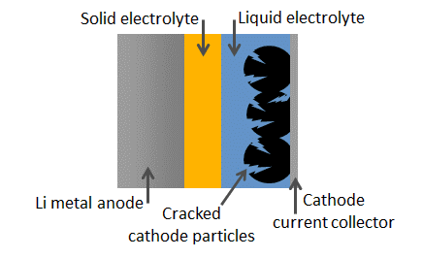
Figure 1. Sketch of a lithium metal anode battery with a hybrid solid-liquid electrolyte design. The solid electrolyte acts as a protective membrane enabling the use of a lithium metal anode and the liquid electrolyte impregnates the cathode particles, even in the presence of cracks, enabling fast kinetics and good utilization of the cathode composite electrode.
Unfortunately, when solid and liquid electrolytes are put in contact, they undergo a chemical reaction forming an interphase comprising the products of this reaction.¹¹ The solid-liquid electrolyte interphase (SLEI) has low conductivity, and consequently it contributes to a significant ohmic loss in the battery, which significantly decreases the specific energy at the required C-rates for commercial applications. However, despite its huge effect on battery performance, very few publications have studied the properties of the interphase formed between solid and liquid electrolytes.
Early work by Abe and coworkers reported the development of a powerful 4-point impedance setup that enabled the characterization of the conductive properties of the solid-liquid electrolyte interphase.^{14–17} Srinivasan and coworkers then reported an alternative approach for the determination of the resistance of the solid-liquid electrolyte interphase, employing polarization measurements in Li-Li symmetrical cells.¹⁸ It was then demonstrated by Janek and coworkers, by combining impedance, XPS and SIMS measurements, that the contact between solid and liquid electrolytes leads to the formation of an extended 3D interphase containing the products of the degradation reaction of the solid and liquid electrolytes.¹¹ Different driving forces were proposed that could contribute to the formation of the solid-liquid electrolyte interphase, such as ion solvation producing ‘swollen’ surface films, redistribution of charge carriers forming an electrified interphase, and decomposition of the liquid electrolyte triggered by the Lewis acidity of the solid electrolyte; all of which are expected to occur for any solid electrolyte. Korte and coworkers then used polarization measurements to show that the resistance across the solid-liquid electrolyte interphase is the sum of two contributions: i) a constant resistance attributed to the presence of a poorly conducting surface layer, and ii) a lithium-ion concentration dependent resistance attributed to the lithium-ion transfer process following Butler-Volmer kinetics.¹⁹ More recently, Bruce and coworkers studied the interphase formed between a garnet-type solid electrolyte and carbonate-based liquid electrolytes, where the garnet material is advantageous because of its stability in contact with lithium metal,²⁰ and Sakamoto and coworkers showed that the salt in the liquid electrolyte critically affects the interfacial properties.²¹ In another recent article, Janek and coworkers studied the interphase formed between ether-based liquid electrolytes and NASICON-type and LiPON solid electrolytes.²²
The previous studies clearly demonstrate the importance of understanding the mechanism of formation of the solid-liquid electrolyte interphase, and they also clearly show that the resistance growth caused by the degradation reaction of the solid and liquid electrolytes is currently the most important challenge that needs to be solved for the development of hybrid solid-liquid electrolyte batteries.^{11,20,21} The same problem of large interphasial resistance has also been recently demonstrated in hybrid polymer electrolyte batteries.²³ Now that the origin of the problem has been identified, research should also focus on the identification of possible solutions.
In this work, we study the interphase formed between a NASICON-type solid electrolyte (Ohara-LATGP) and various types of liquid electrolytes, using 4-point impedance measurements, and we demonstrate that the addition of water as an electrolyte additive produces the virtual suppression of the large resistance associated with the solid-liquid electrolyte interphase. We then performed XPS measurements to elucidate the differences in composition of the interphase formed with and without the water electrolyte additive. We believe that this work can found the basis of the development of strategies to ‘remove’ the resistance of the solid-liquid electrolyte interphase for other solid and liquid electrolyte combinations.

2. Experimental methods
The solid electrolyte used was an Ohara glass-ceramic membrane (AG-01 type, 150 μm thickness, Ohara Corporation, 1 inch diameter). The main crystalline phase is Li_{1+x+y}Al_{x}(Ge,Ti)_{2−x}P_{3−y}Si_{y}O₁₂, abbreviated as LATGP, which has a NASICON type structure, and AlPO₄ is present as a side phase (7.4%).^{22,24,25}
Impedance measurements of the solid electrolyte membrane in contact with liquid electrolytes were obtained in the 4-probe glass cell (PermeGear Ltd.) shown in Figure 2b. The cell contains four conical ground glass joints to introduce the electrodes, and a thin layer of vacuum grease was applied to the joints. The cell was encased in a PET box with gasketed lid to maintain inert Ar atmosphere inside the box. In the cell, the solid electrolyte was clamped between two liquid electrolyte compartments, each containing 4 ml of electrolyte, with a contact area of 0.785 cm². Outer (current probe) electrodes were spaced at approximately 80 mm and inner (voltage probe) electrodes at approximately 35 mm. Gaskets (Ekraz 9655B, 25 mm outer diameter x 10 mm inner diameter x 0.5 mm thickness, supplied by Polymax Ltd.) coated with a thin layer of vacuum grease (Dow-Corning high vacuum silicone grease) cushion the membrane from the glass joint.
The as-received LATGP-Ohara solid electrolytes were cleaned by sonicating in isopropyl alcohol (Fisher, 99.5%) and pre-dried overnight at 80 °C under vacuum (Thermo Scientific) prior to use. All cell components were pre-dried overnight at 80 °C under vacuum (Thermo Scientific). Cells were part-assembled then dried for a further two hours at 80 °C under vacuum before being transferred to an argon filled glovebox (< 1 ppm water, < 1 ppm oxygen, MBraun). Impedance measurements of liquid electrolytes were measured in the same 4-probe glass cell.
The impedance measurements with dry liquid electrolytes were done with lithium foil (Rockwood Lithium) electrodes. Due to the instability of lithium metal in the presence of water, for the measurements in water-containing liquid electrolytes, silver (Goodfellow), copper (Goodfellow) or gold (Goodfellow) were used as the electrode material. It was found that the choice of the electrode material (lithium, silver, copper or gold) did not affect the impedance response in the dry electrolytes (Figure S4). Outer electrodes were submerged approximately 8 mm in the electrolyte and the inner electrodes were submerged approximately 5 mm.
For the preparation of the liquid electrolytes, lithium bis(trifluoromethane)-sulfonimide salt (LiTFSI) (99.95%, Sigma-Aldrich) was dried and deoxygenated under vacuum at 120 °C for 24 hours. 1,3-dioxolane (DOL) (anhydrous, 99.8%, Sigma-Aldrich), 1,2-dimethoxyethane (DME) (anhydrous, 99.5%, inhibitor-free, Sigma-Aldrich), dimethyl sulfoxide (DMSO) (anhydrous, 99.9%, Sigma-Aldrich) and acetonitrile (ACN) (anhydrous, 99.9%, Sigma-Aldrich) were dried for 3 days using molecular sieves (4 Å beads, 4-8 mesh, Sigma-Aldrich) that had been dried under vacuum at 220 °C for 2 days. 1-ethyl-3-methylimidazolium bis(trifluoromethylsulfonyl)-imide (EMIMTFSI) (99.9%,) was purchased from Solvionic and dried under vacuum at 120 °C for 18 hours under constant stirring. For the water-containing liquid electrolytes, ultrapure water (Purite, 18.2 MΩ cm) was added to the solvents outside the glovebox and then, they were brought inside. Tributylamine (TBA) (puriss. plus, ≥99.5%), 2,2,2-Trifluoroethanol (TFEtOH) (analytical standard, ≥99.5%), 1,1,1,3,3,3-Hexafluoro-2-propanol (HFIP) (LiChropur, ≥99.8%), N-Methylformamide (NMF) (99%), ethylene carbonate (EC) (anhydrous, 99%) and ethanol (EtOH) (anhydrous, ≤0.005% water) were purchased from Sigma-Aldrich. LP57 (1 M LiPF₆ in EC:EMC, 3:7 volume ratio) was purchased from Soulbrain (battery grade) and LP30 (1 M LiPF₆ in EC:DMC, 1:1 volume ratio) was purchased from Sigma-Aldrich (battery grade), and were used as received. As usually done in the battery community to report concentrations, “1 M” stands for 1 mole of salt per litre of solvent or solvent mixture.
Electrochemical measurements were performed using a VMP3 Biologic potentiostat and EC-Lab software, with a voltage perturbation of 10 mV and a frequency range of 1 MHz – 1 Hz, but due to artefacts at high frequencies, the frequency range shown in the graphs is 0.3 MHz – 1 Hz. Measurements were carried out with the cells placed in a climatic chamber (Memmert HPP110) at a temperature of 25 °C unless specified, and the results reported were obtained 1 hour after cell assembly.
Unless otherwise stated, the impedance results are normalised by the area of the solid electrolyte in contact with the liquid electrolyte, and the resistance due to the liquid electrolyte compartment is subtracted from the data.
Samples were transported from the glovebox to the UHV system for XPS measurements using the Kratos air-sensitive transfer arm. XPS data was acquired using a Kratos Axis SUPRA using monochromated Al kα (1486.69 eV) X-rays at 12 mA emission and 15 kV HT (180W) and a spot size/analysis area of 700 x 300 µm. High resolution spectra were obtained using a pass energy of 20 eV, step size of 0.1 eV and sweep time of 60 s, resulting in a line width of 0.696 eV for Au 4f_{7/2}. Charge neutralisation was achieved using an electron flood gun with filament current = 0.38 A, charge balance = 2 V, filament bias = 4.2 V. All data was recorded at a base pressure of below 9 x 10⁻⁹ Torr and a room temperature of 21 °C. Data was analysed using the CasaXPS software. Binding energies were referenced to the main line of the carbon 1s spectrum (adventitious carbon) set to 285 eV, and a Shirley-type function was used for background subtraction. Peak fitting was done using 70% Gaussian and 30% Lorentzian line shapes (GL30) and, for each element, the FWHM of all the bands were constrained to be the same. For fitting the S 2p spectra, the ratio of areas of the 2p_{1/2} and 2p_{3/2} bands was fixed to 0.5.
For the acquisition of the XPS measurements, a new piece of the LATGP-Ohara solid electrolyte was broken into pieces of ca. 1 cm² area, and the pieces were cleaned and dried and transferred inside the glovebox as explained above. The pieces were then immersed in either dry or wet (5 vol% water content) electrolyte (1 M LiTFSI in DOL:DME in a 1:1 volume ratio) for one hour followed by rinsing the solid electrolyte surface with a volume of ca. 20 ml of either the dry or wet (5 vol% water content) solvent (DOL:DME in a 1:1 volume ratio). Then, the solid electrolyte samples were left to dry inside the glovebox and they were then transferred to the vacuum-tight XPS sample transfer arm. These samples will be referred as solid electrolyte samples immersed in the dry or wet electrolytes. The use of the XPS transfer arm ensures the transfer from the glovebox to the XPS chamber without any air exposure. Additional measurements were done with the pristine sample, without exposure to liquid electrolyte.

3. Results
3.1 Four-point impedance measurements and their validation
The key observation in this report is that the addition of water in organic liquid electrolytes dramatically decreases the ion-transfer resistance across the solid-liquid electrolyte interphase formed between the Ohara-LATGP solid lithium-ion conductor and an organic liquid electrolyte. This demonstrates, for the first time, that suitable additives in organic electrolytes can potentially solve the problem of the huge interphasial transport resistance in hybrid solid-liquid electrolyte batteries, and the principles shown here could also be applied to other material combinations. The quantification of the ion-transfer resistance across the solid-liquid electrolyte interphase is performed with 4-point impedance measurements, as discussed below.
Figure 2a shows the impedance response (Nyquist plot) of the Ohara-LATGP solid electrolyte in contact with a dry organic liquid electrolyte (1 M LiTFSI in DOL:DME), as measured with the 4-point impedance cell shown in Figure 2b. In the 4-point impedance method, current is passed between the two outer probes, while the two inner probes measure the potential difference between them. Since the voltage probe electrodes do not pass current, in principle, the 4-point impedance measurements are a powerful approach to effectively remove any contribution from the electrodes’ response. In order to test that, additional measurements were performed with the same 4-point impedance cell but without the solid electrolyte (Figure S1b), and the result is a constant resistance at all frequencies (Figure S2), which is the expected impedance response of the liquid electrolyte and thus demonstrates the absence of artefacts or contributions from electrodes’ response in these measurements.
In order to remove the response of the bulk liquid electrolyte, the liquid electrolyte resistance measured in the same cell but without the solid electrolyte, was subtracted from the impedance spectra of the solid electrolyte, as shown in figure 2a. The results prior to the removal of the bulk liquid electrolyte resistance are shown in figure S3. Additional measurements were performed by employing different materials (Li, Ag, Au and Cu) as electrodes, and consistent results were obtained (figure S4), again corroborating the absence of artefacts or contributions from the electrodes’ response in the 4-point impedance measurements.
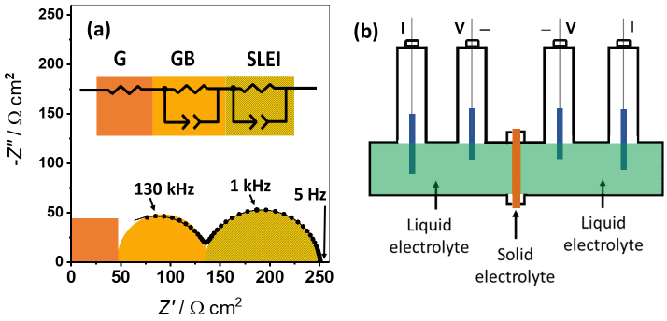
Figure 2. Validation of 4-point impedance measurements to study the solid-liquid electrolyte interphase (SLEI) resistance. a) 4-point impedance spectrum of a solid electrolyte (Ohara-LATGP 150 µm) in contact with a dry liquid electrolyte (1 M LiTFSI in DOL:DME, 1:1 volume ratio). The impedance results are normalised by the area of the solid electrolyte in contact with the liquid electrolyte, and the resistance due to the liquid electrolyte compartment is subtracted from the data. The inset shows the equivalent circuit used to fit the data, where G: solid electrolyte grain, GB: solid electrolyte grain boundary, SLEI: solid-liquid electrolyte interphase. b) Sketch of the 4-point cell, with two outer current probes and two inner voltage probes.
The impedance results in Figure 2a show the presence of two semicircles, of which the left semicircle (measured at higher frequencies) is not complete. Extending the measurements to higher frequencies would reveal the presence of a third semi-circle.^{11,22} However, the focus of this study is the analysis of the effect of electrolytes and electrolyte additives on the magnitude of the semicircle on the right on the graph, measured at lower frequencies, which is related to the ion transfer across the interphase between the solid and liquid electrolytes. Therefore, we did not extend the measurements to higher frequencies where measurement artefacts are common.
The impedance data has been fitted to the equivalent circuit shown in Figure 2a. The right (low frequency) semicircle corresponds to the impedance response of the solid-liquid electrolyte interphase, which is modelled as the parallel combination of a resistor (R_{SLEI}, quantifying the ion transfer at the solid-liquid electrolyte interphase) and a constant-phase element (CPE_{SLEI}, quantifying the double-layer charging of the solid-liquid electrolyte interphase). Then, the impedance results at higher frequencies (more left on the graph) correspond to the impedance response of the solid electrolyte, which is the sum of the responses of the grain boundaries (middle semicircle that is incomplete in our measurements) and the bulk material inside the grains (at even higher frequencies, which is not revealed in our measurements). In our fitting, the solid electrolyte response is modelled as the sum of a resistor (R_{G}, associated with the bulk Li⁺ conductivity of the grains) and the parallel combination of a resistor (R_{GB}, associated with the Li⁺ conductivity of the grain boundaries) and a constant-phase element (CPE_{GB}, associated with double-layer charging of the grain boundaries). More details about the assignment of the different impedance contributions are provided in the supporting information.
The results of the fitting are summarised in table S1. The sum of resistances R_{G}+R_{GB} accounts for the total Li⁺ resistance across the solid electrolyte, R_{SE}, and we found it to be 160 ± 2 Ω cm² (where the error equals the standard deviation of multiple measurements). Since the thickness of the solid electrolyte here employed is 150 µm, the Li⁺ ion conductivity is estimated to be around 0.015 cm / 160 Ω cm² ≈ 10⁻⁴ S/cm, which is in good agreement with the manufacturer’s specifications.²⁵ This conductivity value is also in line with the more accurate evaluation of the conductivity of the Ohara-LAGTP solid electrolyte of (8.3 ± 0.3) x 10⁻⁵ S/cm reported by Janek’s group,²² as obtained from impedance measurements of a gold-coated membrane. It is worth mentioning that the present 4-point impedance measurements can produce an overestimation of the conductivity of the solid electrolyte because the current inside the solid electrolyte can span a bigger area than the area of contact of the solid and liquid electrolytes. However, the 4-point impedance measurements provide an accurate measurement of the conductivity properties of the solid-liquid electrolyte interphase, which is the focus of this study. Interestingly, the ion-transfer resistance across the solid-liquid electrolyte interphase, which for the results in figure 2a is found to be R_{SLEI}≈106 Ω cm², varies substantially with the nature of the liquid electrolyte employed in the experiments, as discussed in the following.

3.2 Effect of water
We observe that the introduction of water as an additive in the liquid electrolyte produces a dramatic decrease in the resistance of ion transfer across the solid-liquid electrolyte interphase. Figure 3a illustrates the effect of water addition on the 4-point impedance response of the Ohara-LATGP solid electrolyte in contact with the organic liquid electrolyte 1 M LiTFSI in DOL:DME, for four different water concentrations. It is observed that the semicircle on the left of the graph (higher frequencies) remains essentially unaffected, as expected since it is determined by the impedance behaviour of the solid electrolyte. However, it is seen that the addition of water produces a drastic decrease in the magnitude of the semicircle on the right of the graph (lower frequencies), where this latter semicircle is associated with the solid-liquid electrolyte interphase, thus demonstrating that the presence of water accelerates ion transfer through the solid-liquid electrolyte interphase. Table S2 shows the quantitative analysis of selected impedance results, using the equivalent circuit in figure 2a, showing that the presence of water also increases the double-layer capacitance of the solid-liquid electrolyte interphase, which suggests that water might increase the interphasial surface area as a result of an increased porosity.
Figure 3b shows that the impedance response in the dry electrolyte is stable over a long period of time. Figure 3d shows that in the presence of 2% water, the impedance response is also stable over time, demonstrating that the capacity of the water electrolyte additive to speed up ion transfer at the interphase prevails over a long period of time. However, when the concentration of water in the liquid electrolyte is lower, the impedance response changes over time (figure 3c), showing that, unfortunately, the ion-transfer resistance across the solid-liquid electrolyte interphase increases over time when the water concentration is not sufficient. Figure S5 shows the evolution of the different resistances as a function of time for the dry and wet (0.8 vol%) electrolytes, as obtained by fitting the data to the equivalent circuit model in figure 2. During the whole measurement time, the solid-liquid electrolyte interphase resistance is smaller for the wet, compared to the dry, electrolyte, but further work is required to study the longer-term behaviour. The increase in the solid-liquid electrolyte resistance over time in the wet electrolyte with 0.8 vol% water can be tentatively attributed to losses of water in the cell (by absorption by the dry cell components or evaporation to the dry Ar cell atmosphere), which could be minimised by decreasing the volume of these dry cell components.
It is also important to note that the effect of water in negating the ion-transfer resistance across the solid-liquid electrolyte interphase can also be achieved by simply adding water to the liquid electrolyte after the solid electrolyte has been in contact with the dry electrolyte. Figure S6 shows a repeat of the impedance measurements of the Ohara-LATGP solid electrolyte in contact with dry 1 M LiTFSI in DOL:DME. After these measurements were taken, a volume of water was added to each liquid electrolyte compartment in the cell to produce a water concentration of around 2 vol%, and the impedance results after the addition of water are also shown in the figure, demonstrating the quantitative suppression of the semicircle associated to ion transfer across the solid-liquid electrolyte interphase. Consequently, these results show that the build-up of a high interphasial resistance between the solid electrolyte and the dry liquid electrolyte is not an irreversible process, since water addition can reverse the resistance to a negligible value. Therefore, the cause of the beneficial effect of water electrolyte additive is not simply the suppression of degradation reactions with the dry electrolyte, since such effect would rely on the presence of water at all times and prior to making contact of the solid and liquid electrolytes.

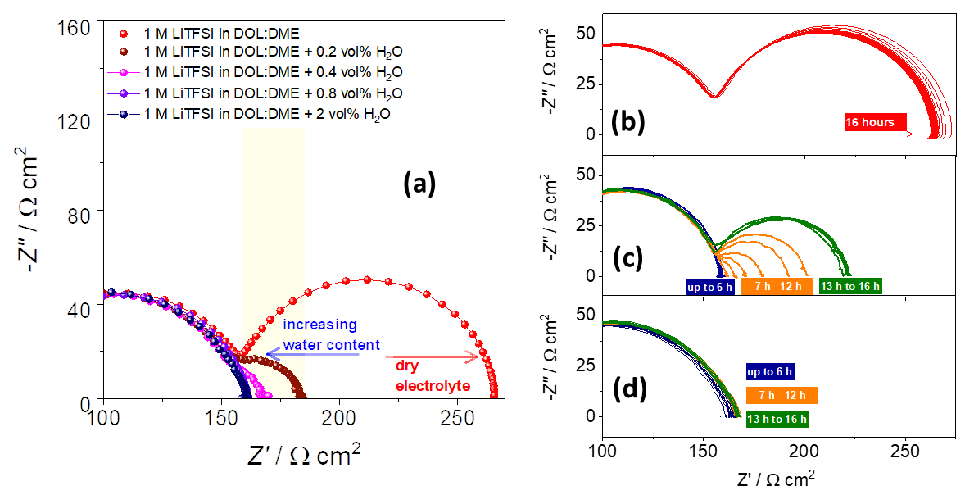
Figure 3. Beneficial effect of water electrolyte additive in the long-term suppression of the solid-liquid electrolyte interphase (SLEI) resistance. a) 4-point impedance spectra of a solid electrolyte (Ohara-LATGP 150 µm) in contact with liquid electrolyte (1 M LiTFSI in DOL:DME, 1:1 volume ratio) with various additions of water, as indicated. b,c,d) evolution of the impedance spectra in the dry electrolyte (b) and the electrolyte with addition of 0.8 vol% (c) and 2 vol% (d) of water.

3.3 Effect of water as a function of Li⁺ ion concentration
We carried out further experiments by varying the LiTFSI and water concentrations in the liquid electrolyte to provide further understanding of the causes behind the beneficial effect of water on the solid-liquid electrolyte resistance. Figure 4a shows the impedance response of the Ohara-LATGP solid electrolyte in contact with the dry DOL:DME liquid electrolyte for three different LiTFSI concentrations. A quantitative analysis of the data is done by fitting the results to the equivalent circuit model shown in figure 2, and the results are shown in figure 4d. The total resistance of the solid electrolyte equals the sum of resistances of Li⁺ transport through the grains and grain boundaries of the solid electrolyte: R_{SE} = R_{G} + R_{GB}, and it is found to be independent of the LiTFSI concentration in the liquid electrolyte, as expected. On the other hand, the resistance of the solid-liquid electrolyte interphase, R_{SLEI}, increases with increasing LiTFSI concentration. This is in contrast to the resistance of the liquid electrolyte, which shows a minimum at 1 M (figure 4e). Consequently, these results demonstrate that the processes that limit ion transport at the solid-liquid electrolyte interphase and in the bulk liquid electrolyte are different.
Figures 4b,c shows the effect of addition of water to the impedance response of the solid electrolyte in contact with the DOL:DME electrolyte with the LiTFSI concentrations of 0.5 M and 3 M, respectively. The quantitative analysis of the different resistance contributions is also shown in figure 4d, as obtained by the equivalent circuit model fitting. It is clear that, for all the LiTFSI concentrations studied, the addition of water produces a similar suppression of the ion-transfer resistance across the solid-liquid electrolytes interphase, which suggests that it is a general effect that would happen in any typical nonaqueous electrolyte. Indeed, in the following section, we demonstrate that it is also found in other solvents (DMSO, acetonitrile and the EMIMTFSI ionic-liquid).

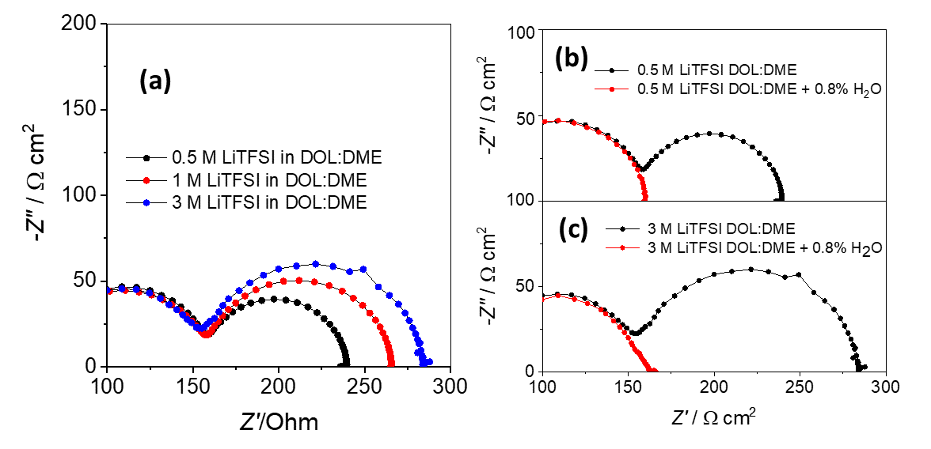
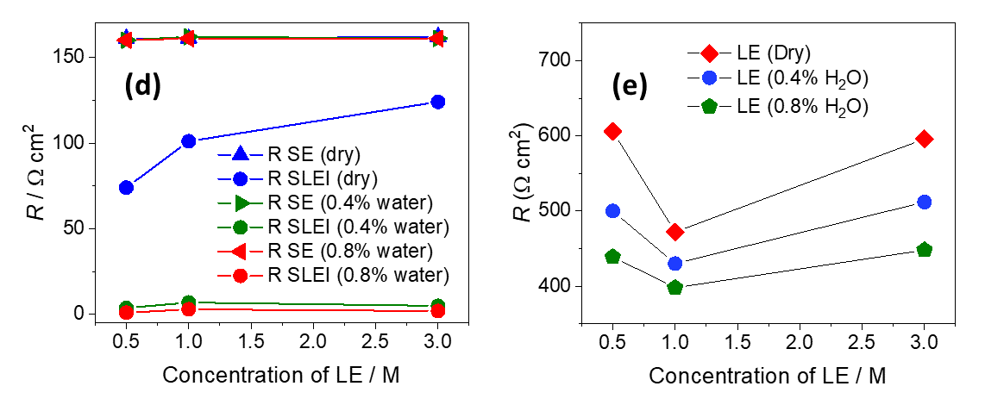
Figure 4. Beneficial effect of water in suppressing the solid-liquid electrolyte interphase (SLEI) resistance as a function of the Li⁺ concentration. a) 4-point impedance spectra of a solid electrolyte (Ohara-LATGP 150 µm) in contact with dry DOL:DME (1:1 volume ratio) liquid electrolyte with various concentrations of LiTFSI. b) As in (a) but in 0.5 M LiTFSI with various additions of water. c) As in (a) but in 3 M LiTFSI with various additions of water. d) Resistance contributions to the 4-point impedance spectra of the solid electrolyte (Ohara-LATGP 150 µm) in contact with DOL:DME (1:1 volume ratio) liquid electrolyte with different water concentrations, as a function of the LiTFSI concentration. e) Resistance of the liquid electrolyte measured in the 4-point impedance cell.

3.4 Effect of different solvents
The study of the ion transport properties at the interphase between the Ohara-LATGP solid electrolyte and liquid electrolytes has been extended to other liquid electrolytes made with different solvents. Figure 5 shows a comparison of the 4-point impedance response recorded with different dry electrolyte formulations (without water addition). In all cases, the semicircle associated to the ion transfer across the solid-liquid electrolytes interphase is clearly visible, and the associated resistance ranges from 90 to 150 Ω cm².
Figure S7 compares the values of the ion-transfer resistance of the solid-liquid electrolyte interphase and the bulk liquid electrolyte resistance, both measured with the 4-point impedance cell. It is evident that there is not a simple correlation, thus demonstrating that the processes that limit ion transport at the solid-liquid electrolyte interphase and in the bulk liquid electrolyte are different.
Interestingly, figure 5b,c shows that upon addition of water to DMSO or acetonitrile electrolytes, the semicircle associated to ion transfer across the solid-liquid electrolytes interphase almost disappears, demonstrating that the associated resistance becomes very small. Figure S8 shows that the same beneficial effect of water addition is found in the EMIMTFSI ionic-liquid. Since this effect is observed with electrolytes with very different properties (DOL:DME, DMSO, acetonitrile, ionic-liquid), we conclude that the effect is general and can potentially be obtained with any electrolyte formulation. In addition, the analysis of the impedance data in DMSO and acetonitrile shows that the presence of water increases the double-layer capacitance of the solid-liquid electrolyte interphase, as found in DOL:DME electrolytes (table S3). Addition of water to the LP57 or LP30 was not attempted because our 4-point impedance cell is made of glass, which could be attacked upon reaction with HF formed from the decomposition of LiPF₆ present in these electrolytes.
Additional measurements were performed in an electrolyte containing water as the sole solvent (1 M LiClO₄ in ultrapure water, figure S9). In fully aqueous electrolytes, the ion-transfer resistance across the solid-liquid electrolyte interphases remains very small/ negligible for a long period of time, in agreement with previous studies. ^{26–30}
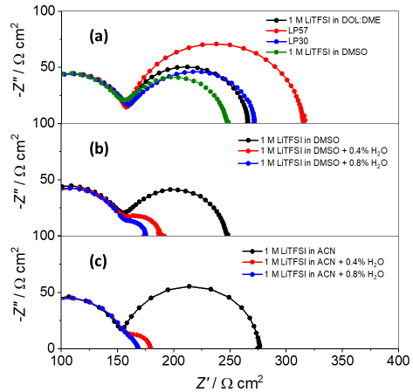
Figure 5. Beneficial effect of water in suppressing the solid-liquid electrolyte interphase (SLEI) resistance in electrolytes made with different solvents. a) 4-point impedance spectra of a solid electrolyte (Ohara-LATGP 150 µm) in contact with different dry electrolytes . b) As in (a) but in 1 M LiTFSI in DMSO with various additions of water. c) As in (a) but in 1 M LiTFSI in acetonitrile with various additions of water.
3.5 Effect of different electrolyte additives
In order to investigate the cause of the ability of water to enhance ion transfer at the solid-liquid electrolyte interphase, additional experiments were performed with other additives in the liquid electrolyte. For these studies, additives were selected so that they had a characteristic property (fundamental descriptor) that was similar or stronger than water, with the aim of identifying, one by one, if that investigated fundamental property was the cause of the ability of water to supress the ion-transfer solid-liquid electrolyte interphase resistance.

3.5.1 Brønsted acid/base additives
Our first working hypothesis was that the beneficial role of water in suppressing the solid-liquid electrolyte resistance was related to its acidity. Previous works^{11,20,22} have shown that the solid-liquid electrolyte interphase is made of a complex mixture of different compounds, formed in degradation reactions of the solid and liquid electrolytes, and that some of these degradation compounds are highly resistive, such as Li₂CO₃, Li₂O or LiOH. Based on that, we first considered that the suppression of the solid-liquid electrolyte resistance in the presence of water was caused by a Brønsted acid-base reaction in which water would induce the dissolution of highly resistive compounds such as Li₂CO₃ or Li₂O via:
Li₂CO₃ + H₂O → 2LiOH + CO₂
Li₂O + H₂O →2LiOH
and followed by the dissolution of LiOH in the presence of excess water.
Following this argument, addition of other Brønsted acid additives should also produce a decrease in the solid-liquid electrolyte resistance, since Li₂CO₃/Li₂O/LiOH would all react with protons. Therefore, a series of alcohols with increasing acidity (ethanol, trifluoroethanol and hexafluoroisopropanol, see pK_{a} values in table S6) were tested as electrolyte additives at a concentration of 0.8 vol%, and the results are shown in Figure 6a. It is clear that the Brønsted acid electrolyte additives (trifluoroethanol and hexafluoroisopropanol) did not produce a significant decrease in the magnitude of the semicircle associated with the solid-liquid electrolyte interphase impedance, thus ruling out our working hypothesis of the dissolution of Li₂CO₃/Li₂O/LiOH in the presence of proton donor. It is worth pointing out that the pK_{a} value of a Brønsted acid depends on the media where it is dissolved, as illustrated in table S6 on the example of water and DMSO as solvents, but the trend in Brønsted acidity strength holds in different solvents, and therefore, we can safely affirm that the acids trifluoroethanol and hexafluoroisopropanol are more acidic than water in any solvent under consideration.³¹
It is important to note that when water was added to the liquid electrolyte containing the acid additive hexafluoroisopropanol, then a drastic disappearance of the impedance semicircle associated with the solid-liquid electrolyte interphase was observed (Figure 6b). This comparison illustrates that the marked effect of water is definitively absent for the different acidic additives. It is also worth noting that the higher acidity of the electrolyte formulations with trifluoroethanol and hexafluoroisopropanol could be easily verified by introducing a lithium metal electrode in these solutions, which produced vigorous gassing (ascribable to proton reduction to H₂). In contrast, a very slow reaction, hardly discernible, took place when the lithium metal electrode was immersed in solution containing water as additive in the same concentration (0.8 vol%).
For completeness, additional experiments were performed in the presence of a Brønsted base (tri-n-butylamine, pK_{b}= 3.11).³² Again, no suppression of the semicircle associated with the solid-liquid electrolyte interphase impedance was observed (Figure 6c), from which we conclude that the beneficial effect of water at suppressing such semicircle is not due to a Brønsted acid-base reaction.
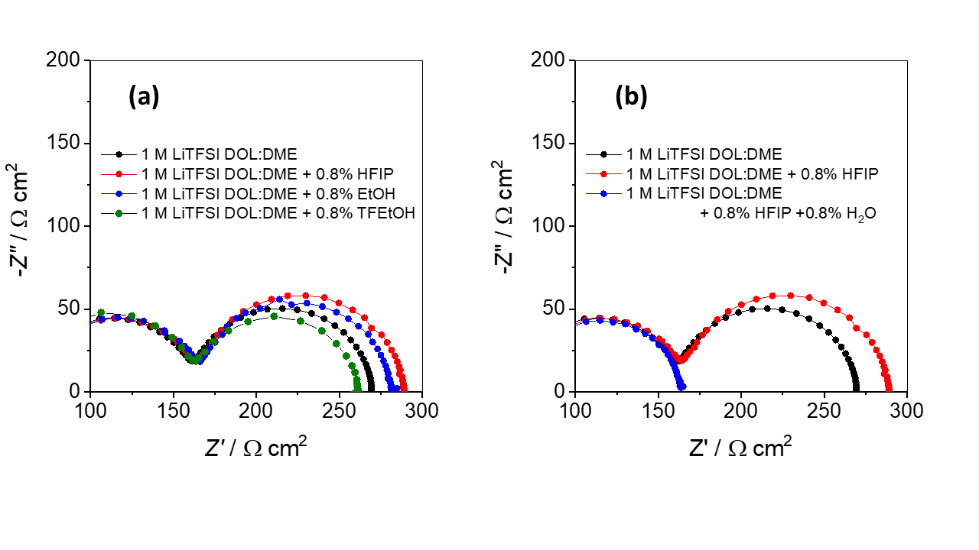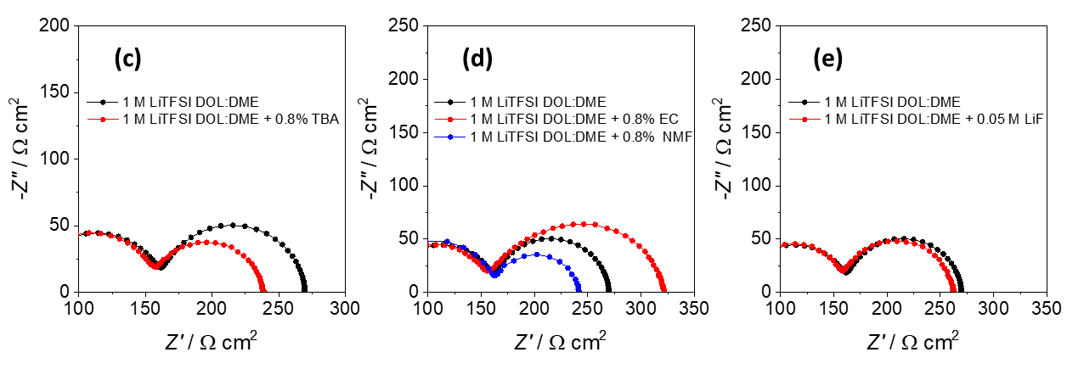
Figure 6. Effect of key properties of electrolyte additives on the solid-liquid electrolyte interphase (SLEI) resistance. a) 4-point impedance spectra of a solid electrolyte (Ohara-LATGP 150 µm) in contact with 1 M LiTFSI in DOL:DME with different Brønsted acid additives, as indicated. HFIP: hexafluoroisopropanol, EtOH: ethanol, TFEtOH: trifluoroethanol. b) The effect of water in Brønsted acid additive containing electrolyte. c) As in (a) but in a Brønsted base additive. TBA: tributylamine, NMF: d) As in (a) but with a high dielectric constant additive. EC: ethylene carbonate, NMF: N-methylformamide. e) As in (a) but with salt-reinforced electrolytes with LiF.

3.5.2 Lewis acid/base and high dielectric constant additives
Water has an unusually high solvating power due to its very high dielectric constant and Lewis acceptor and donor numbers.³³ The high dielectric constant enhances solubility and the high Lewis acceptor and donor numbers enhance interactions with other species such as anions and cations, respectively. Therefore, our second working hypothesis was that the unusual effect of water on the solid-liquid electrolyte interphase resistance could be related to its Lewis acid/base properties or its high dielectric constant. To evaluate this hypothesis, table S7 lists a matrix of six key properties (the donor and acceptor numbers, the dielectric constant, the hydrogen bond donation and acceptance ability and polarity/polarizability) of the solvents and additives employed in this work. The hydrogen bond donation or acceptance ability of compounds are correlated with their Lewis acid/based properties,³⁴ whereas the dielectric constant is correlated with the polarity/polarizability.
In view of table S7, we can conclude that some of the solvents and additives studied in this work have donor numbers that are lower or higher than water, but none of them exhibits the unusual effect that water has on the impedance results, which then implies that the origin of the unusual effect is not (solely) a Lewis donor number effect. Similarly, the hydrogen bond acceptance ability of water (which is the ability of the oxygen atom in water to form a hydrogen bond with a hydrogen atom in another compound) is also in between values of other solvents or additives, thus proving again that the hydrogen bond acceptance ability of water is not the (sole) cause of the unusual effect it has on the impedance results.
Then, we evaluated the comparison of the acceptor number of water with respect to other solvents and additives. While the acceptor number of water is higher than any of the solvents studied, table S7 also shows that the acceptor number of the fluorinated alcohols trifluoroethanol and hexafluoroisopropanol (which were tested as Brønsted acid electrolyte additives in section 3.4.1) are higher than that of water. Therefore, a high value of acceptor number, per se, does not produce the unusual effect that water has on the impedance of the solid-liquid electrolyte interphase. Similarly, the hydrogen bond donation ability of water (which is the ability of the hydrogen atom in water to receive electronic density from a heteroatom like N,O,S, etc. in another compound, thus forming a hydrogen bond) is not unusually high or low, compared to the other solvents and additives studied, which again suggests that it is not the key/sole driver of the unusual effect produced by water in the impedance results.
Finally, table S7 shows that water is one of the solvents with the highest dielectric constant. Since the dielectric constant is related to the polarity/polarizability, it is also seen that water has a very high polarity/polarizability. To study this effect, experiments were done in which ethylene carbonate (EC) or N-methylformamide (NMF), both with high values of dielectric constant, were added as additives to the base electrolyte (1 M LiTFSI in DOL:DME) and the effect was compared to the likewise addition of water to the same base electrolyte (Figure 6d). It is clear that the effect of water of suppression of the semicircle associated with the solid-liquid electrolyte interphase is not seen with these high dielectric constant additives, from which we conclude that a high dielectric constant or high polarity/polarizability is not the (sole) cause of the impedance suppression by water.

3.5.3 Salt-reinforced electrolytes
Archer and co-workers demonstrated that the addition of poorly soluble halide salts to liquid electrolytes produced a highly beneficial effect on lithium deposition.³⁵ By using salt-reinforced liquid electrolytes, made by blending a poorly soluble halide salt (such a LiF) in a liquid electrolyte, they obtained smooth and dendrite-free lithium deposition, with high Coulombic efficiency. It was found that the surface of the lithium metal electrodes cycled in LiF-reinforced liquid electrolyte was LiF-rich, and the improved lithium efficiency was attributed to an enhanced Li⁺ interfacial transport at the lithium metal-electrolyte interphase. Based on these findings, we tested the impedance response of the Ohara- LATGP solid electrolyte in salt-reinforced electrolytes made by blending LiF with our baseline electrolyte with LiTFSI in DOL:DME (Figure 6e). The magnitude of the semicircle associated with the solid-liquid electrolyte interphase does not decrease with the salt-reinforced electrolyte, thus showing that ion transport at the solid-liquid electrolyte interphase is not speeded up with salt-reinforced electrolytes.

3.6 Analysis of temperature effects
Further understanding into the process of ion transfer at the solid-liquid electrolyte interphase was obtained by analyzing the impedance results as a function of temperature. Figure S12 shows the impedance results of the Ohara- LATGP solid electrolyte in different liquid electrolytes as a function of the temperature. By fitting the data to the equivalent circuit shown in Figure 2, we evaluated the total resistance of solid electrolyte, R_{SE} (which is the sum of the grain and grain boundary resistances) and the resistance of the solid-liquid electrolyte interphase, R_{SLEI}. Additional measurements with the 4-point impedance cells filled with liquid electrolyte only (without the solid electrolyte) were carried out to obtain the liquid electrolyte resistance, R_{LE} (Figure S13).
Following previous work by Janek and coworkers,¹¹ a simple Arrhenius equation was used to analyze the effect of temperature on the liquid electrolyte resistance:
$\frac{1}{R}=A exp⁡\left(-\frac{E_{a}}{kT}\right)$ (Eq.1)
where R is the resistance, A is a constant and E_{a} is the activation energy, whereas for the solid electrolyte and the solid-liquid electrolyte interphase resistances, a temperature dependent pre-exponential factor was considered:
$\frac{1}{R}=\frac{B}{T} exp⁡\left(-\frac{E_{a}}{kT}\right)$ (Eq.2)
where B is a constant. The associated Arrhenius plots are shown in figures 7a,b,c and the activation energies, E_{a}, were obtained from the slopes of the Arrhenius plots and are shown in figure 7d.
It is seen from figure 7d that the activation energy associated with the Ohara- LATGP solid electrolyte resistance, R_{SE}, is found to be 290±12 meV, and independent of the Li⁺ concentration or water concentration in the liquid electrolyte, as expected. In previous work by Janek and coworkers, the activation energies associated with Li⁺ transport in the grains and grain boundaries of the Ohara- LATGP solid electrolyte were found to be (312 ± 9) and (406 ± 6) meV, in good agreement with the present findings.²²
Figure 7d also shows that the activation energy associated with the solid-liquid electrolyte interphase resistance, R_{SLEI}, is 605±25 meV for the dry liquid electrolyte, whereas for the wet electrolyte with 0.4 vol% water it is close to 475±24 meV. The fact that the activation energy of the solid-liquid electrolyte interphase resistance is higher than that of the solid electrolyte resistance, is in agreement with the previous findings by Janek and coworkers using a LAGP solid electrolyte in 1 M LiTFSI in DOL:DME liquid electrolyte, where the activation energies of the grain and intergrain conduction in the solid electrolyte were found to be (380 ±5) and (395 ±6) meV whereas for the solid-liquid electrolyte interphase conduction it was (440 ±11) meV.¹¹ In addition, the value of activation energy of solid-liquid electrolyte resistance in the dry LiTFSI in DOL:DME electrolyte, 605±25 meV, is comparable with the values of 0.594 eV (or 57.3 kJ mol⁻¹), 0.724 eV (or 56.2 kJ mol⁻¹) and 0.326 eV (or 31.5 kJ mol⁻¹) reported by Abe et al. for the interphase between the Ohara- LATGP solid electrolyte and liquid electrolytes made with 1 M LiCF₃SO₃ in PC, DMSO and FEC, respectively.¹⁴
Finally, figure 7d shows that the activation energy of the liquid electrolyte resistance is much smaller than that of the solid electrolyte or the solid-liquid electrolyte interphase. We found that for the 1 M LiTFSI in DOL:DME liquid electrolyte, the activation energy is 95±3 meV, in reasonably good agreement with the value of (65 ± 3) meV reported by Janek and coworkers.¹¹ Clearly, the activation energy of ion transport through the liquid electrolyte is much smaller than in the solid electrolyte or the solid-liquid electrolyte interphase, demonstrating that the process of ion conduction involves a different mechanism. Close inspection of figure 7d shows that the activation energy of the liquid electrolyte resistance increases slightly with the Li⁺ concentration, as expected with increasing ion association,³³ whereas the effect of water addition is very small for the 3 M LiTFSI electrolytes and negligible at lower concentrations, thus showing that the presence of water only produces a significant change in the ion conduction mechanism at the solid-liquid electrolyte interphase.
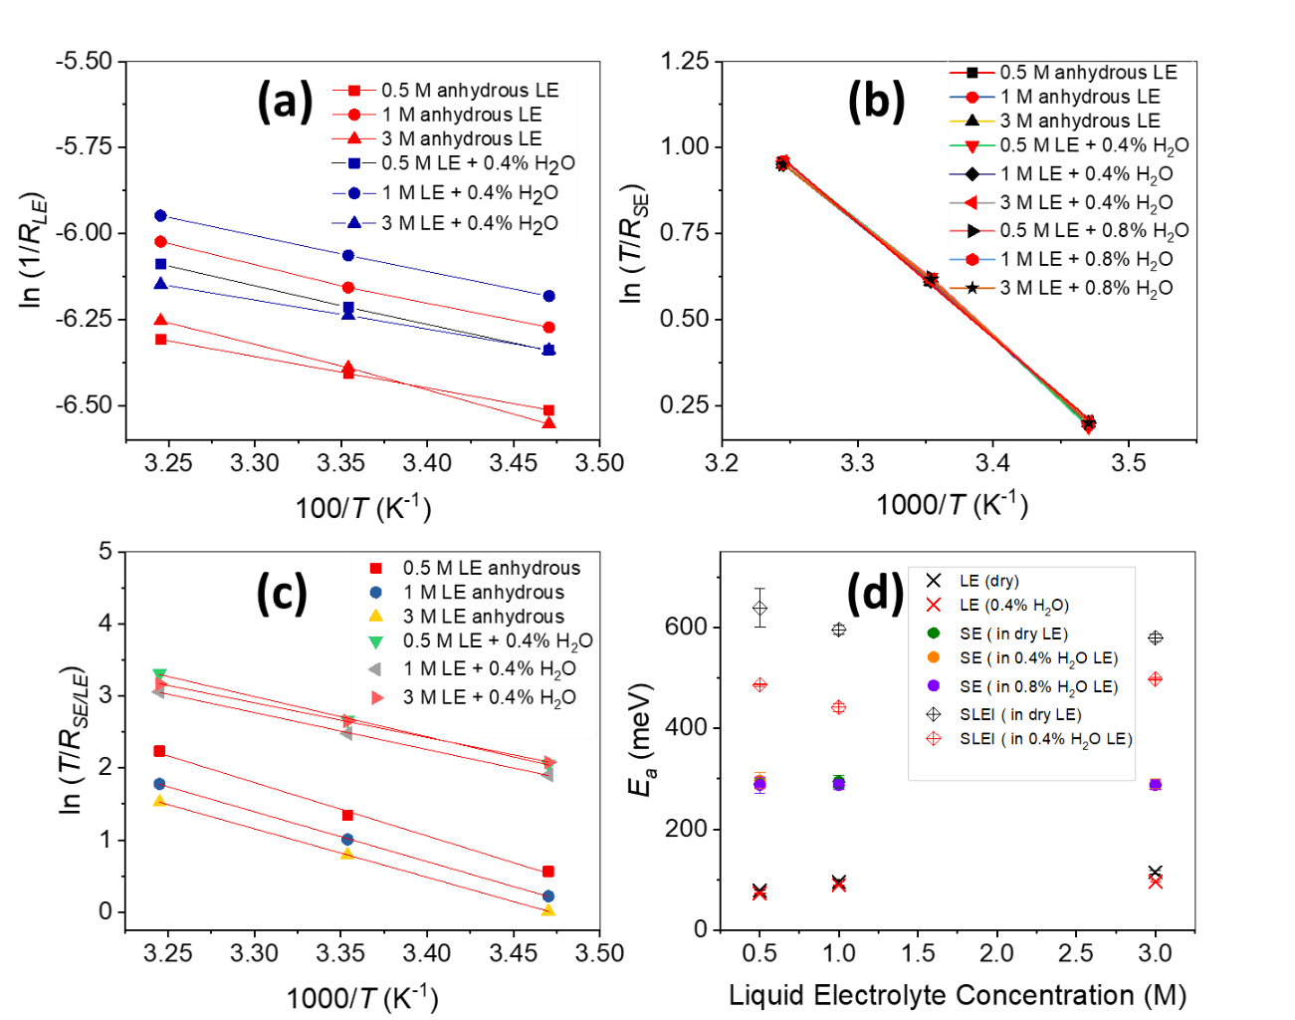
Figure 7. Evaluation of activation energies of ion transport from the analysis of temperature effects by Arrhenius equations. Arrhenius plots of: a) liquid electrolyte resistance (R_{LE}), b) solid electrolyte resistance (R_{SE}), and c) solid-liquid electrolyte interphase resistance (R_{SLEI}), for a Ohara-LATGP solid electrolyte in contact with liquid electrolytes of LiTFSI in DOL:DME, with and without water, as indicated in the figure legends. The associated activation energies are shown in (d).

3.7. XPS characterisation
Further understanding of the composition of the solid-liquid electrolyte interphase was obtained via ex-situ XPS characterisation. The solid electrolytes were immersed in the dry or wet (5 vol. % water content) 1 M LiTFSI in DOL:DME liquid electrolyte, and then they were rinsed in the dry or wet (5 vol% water content) solvent and transferred to the XPS chamber without any air exposure, using a vacuum-sealed XPS sample transfer arm. Figure 8 compares the C 1s XPS spectra of the samples treated in the dry or wet electrolyte. The spectra was fitted to four bands with the same FWHM, which can be attributed to CF₃, O-C=O, O-C and C-C or C-H environments, as indicated.^{11,22,36,37} It is clear that very similar results are observed for the samples treated in the dry or wet electrolytes, although for the wet electrolyte case, the magnitude of the O-C=O band is slightly smaller and the magnitude of the CF₃ band is slightly bigger. The relative contributions of the different bands in the C 1s spectra are shown in Figure S15, and tables S8-9 lists the attribution of the bands to possible origin compounds.
Figure 8. Analysis of the composition of the solid-liquid electrolyte interphase by ex-situ XPS. C 1s XPS spectra and peak fitting of the LATGP-Ohara solid electrolyte after immersion in dry (a) or wet (b, 5 vol% water content) electrolyte (with 1 M LiTFSI in DOL:DME). The spectra shown is the average of three sample spots, and figure S14 shows repeats of the same experiments with different samples.
Figures S16-17 shows the XPS measurements in the F 1s region, showing no significant differences between the samples that have been exposed to the dry or wet electrolytes (see quantitative analysis from the fitting in figure S18). It is worth mentioning that the results in figure S16 show the first XPS measurements that were recorded with these samples, whereas figure S17 show the last XPS measurements. The good consistency of the results showed that beam damage was negligible.³⁸ Figure S19 shows that there is no significant difference in the S 2p spectra of the samples exposed to the wet and dry electrolytes. Figure S20 shows the XPS spectra of the pristine solid electrolyte sample, prior to immersion in the liquid electrolyte, revealing the presence of only carbon contamination, in agreement with previous work by Janek’s group.²²
In summary, the XPS characterisation shows that the composition of the solid electrolyte samples exposed to wet or dry liquid electrolytes is essentially the same, and contains a complex mixture of inorganic (LiTFSI, Li₂CO₃, LiF, etc) and organic (‘PEO’ like oligomers, etc.) compounds.

4. Discussion
To briefly summarise the main results, water is found to speed up ion conduction at the solid-liquid electrolyte interphase, thus decreasing the solid-liquid electrolyte interphase resistance to a negligible value. A variety of other solvents and electrolyte additives have been tested (with different acidity/basicity, donor/acceptor numbers, polarity, etc.) but none of them produced the unique effect found with water. Interestingly, the presence of water also decreases the activation energy of ion conduction at the solid-liquid electrolyte interphase, and the XPS characterisation suggests that the presence of water produces minor changes in the composition of the solid-liquid electrolyte interphase.
In order to discuss the causes and the mechanism of the beneficial role of water in suppressing the solid-liquid electrolyte interphase resistance, it is useful to start with a discussion of the implications of the observed change in the activation energies. First, it is worth noting that the solid-liquid electrolyte interphase has a very high activation energy, much higher than that of the solid or liquid electrolytes, and thus ion conduction at the solid-liquid electrolyte interphase will be significantly suppressed at low temperatures, which is highly problematic for commercial applications.¹¹ Fortunately, the introduction of water electrolyte additive significantly decreases the activation energy, and at high enough water content, ion transport is so fast that the solid-liquid electrolyte interphase resistance becomes negligible.
The high activation energy of ion conduction at the solid-liquid electrolyte interphase can be ascribed to the sluggish rate of ion transport through the different components that make the interphase. Indeed, the activation energy barrier for Li⁺ diffusion through typical inorganic SEI components is very high: 0.5-0.7 eV for LiF^{39–41} and 0.7-0.8 eV for Li₂CO₃,^{42–44} and the XPS data suggest the presence of both Li₂CO₃ and LiF at the solid-liquid electrolyte interphase (see tables S8-9), albeit in small amounts. High values of activation energy of 0.6-0.9 eV have also been reported for Li⁺ ion conduction through the organic carbonates that typically constitute the organic part of the graphite SEI.^{45–48} Similarly high values of activation energy of 0.4-0.7 eV have been reported for ion conduction in Li⁺ salt-doped PEO polymer electrolytes.⁴⁹ All these values compare reasonably well with the experimental activation energy of the solid-liquid electrolyte interphase resistance of ca. 0.6 eV found with the dry LiTFSI in DOL/DME electrolyte, indicating that the slow transport of ions through the components that make the SLEI (inorganic salts and organic oligomers) is the main cause of the high solid-liquid electrolyte interphase resistance and associated activation energy.
Another possible origin of the high activation energy is the energy penalty associated to Li⁺ desolvation.¹⁴ The transfer of Li⁺ ions from the liquid electrolyte to the solid electrolyte necessarily involves cleavage of the solvation bonds between the Li⁺ ions and the liquid electrolyte solvent, and consequently, if the process of desolvation of Li⁺ ions was a rate determining step in the process of Li⁺ transfer across the interphase, then, stronger Li⁺ solvation would be expected to lead to slower Li⁺ transfer, thus higher resistance and higher activation energy. However, for many of the electrolytes employed in this work, Li⁺ ions are preferentially solvated by water, and, despite that, the addition of water is found to decrease the resistance of ion transport across the solid-liquid electrolyte interphase. The preferential solvation of Li⁺ ion by water in water-acetonitrile mixtures⁵⁰ and in water-ether mixtures⁵¹ has been reported before. In addition, the suppression of the solid-liquid electrolyte interphase resistance can be achieved with the addition of very small amounts of water (not enough to coordinate all the Li⁺ ions in the liquid electrolyte), which shows that, in the present case, the rate determining step of Li⁺ transport across the interphase is not Li⁺ desolvation.
Fortunately, the activation energy of Li⁺ transport across the solid-liquid electrolyte interphase is found to decrease from ca. 0.6 eV to 0.5 eV upon addition of 0.4 vol% water to the LiTFSI in DOL:DME electrolyte, and at higher water concentrations, the resistance is so small that it is not possible to evaluate the associated activation energy. Nevertheless, the XPS results suggest that the composition of the solid-liquid electrolyte interphase in dry and wet liquid electrolytes is very similar. It must be recalled, though, that the XPS measurements were done ex-situ under high vacuum conditions, and thus, they do not probe the presence of volatile components (e.g. water) that must be present at the solid-liquid electrolyte interphase.
It is also worth mentioning that the presence of residual water has been shown to lead to increased conductivity in a wide variety of polymer electrolytes.^{52–56} Two main factors have been proposed to explain this effect: i) the solvation of the polymer backbone by water, which thus acts as a plasticiser,⁵³ ii) the preferential solvation of Li⁺ ions by water, which decreases the interaction of Li⁺ ions with the polymer backbone and thus increases Li⁺ ion mobility.⁵⁴ Although these effects could also be claimed to explain the enhancement of the conductivity of the solid-liquid electrolyte by the presence of water, it should be noted that other polar solvents, such as DMSO, amides, etc., have also been reported to increase the conductivity of polymer electrolytes.⁵⁵ This contrasts with the behaviour of the solid-liquid electrolyte interphase shown here, in which the enhancement in conductivity achieved by water is not observed with any other solvent. Perhaps because water has a particularly strong solvating power, and it is thus able to ‘swell’ polymers and inorganic materials particularly well, or because water is very small, and thus produces a very mobile hydrated Li⁺ ion, the effect of water on the conductivity of the solid-liquid electrolyte interphase is particularly dramatic.
An alternative explanation for the beneficial effect of water on the solid-liquid electrolyte interphase is a change in morphology/porosity of the interphase in the presence of water, as a result of swelling/solvation processes. Indeed, the double-layer capacitance of the solid-liquid electrolyte interphase is found to increase in the presence of water, thus suggesting an increase in the total area of such interphase, and, consequently, also an increased porosity, which would promote deeper penetration of the liquid electrolyte and thus accelerate ion transport. However, further work is required to elucidate the exact origin of the beneficial effect of water.
From a practical point of view, the incorporation of water in lithium batteries with hybrid solid-liquid electrolytes is highly promising. Water has been found to significantly improve the performance of lithium-oxygen batteries by facilitating the oxygen electrode reactions,^{57–65} even when it has was added in high concentrations, >2 vol%.^{64–68} In lithium-sulfur batteries, the presence of water in low concentrations (0.025 vol%) has been found to improve performance.⁶⁹ In lithium-ion batteries, the presence of water in low concentrations (up to 0.1 vol%) did not impair performance.⁷⁰ However, it is worth noting that the introduction of water as an additive in the liquid electrolyte imposes restrictions in the choice of solid electrolyte materials, and those that are not stable in contact with water will require the incorporation of protective coatings. For example, previous work by Janek’s group with another solid electrolyte, LAGP, found that the presence of water in the liquid electrolyte was detrimental.¹¹ In conclusion, further work should look at judicious combinations of solid and liquid electrolytes that, in the presence of additives such as water that promote ion transfer kinetics, produce high energy and long lasting batteries.
The drastic reduction of the solid-liquid electrolyte resistance demonstrated here has, indeed, a high potential to enhance the practical performance of batteries incorporating a hybrid solid-liquid electrolyte. Table S10 reports the results of the calculations of the specific energy and round trip efficiency of lithium-sulfur and lithium-oxygen batteries incorporating a hybrid solid-liquid electrolyte, with a value of the solid-liquid electrolyte resistance of either 100 Ω cm² or 5 Ω cm². The decrease in the interphasial resistance enhances the round trip efficiency of 21-28 percentage points, and enhances the practical specific energy by 15-22%. Although these calculations neglect effects such as the presence of inactive components, kinetic overpotentials, etc., they serve to illustrate the key role of minimizing the solid-liquid electrolyte interphase to unlock the high potential of lithium metal batteries in the pathway towards commercialization. The here-demonstrated key role of electrolyte additives, and synergies between the solid and liquid electrolyte formulations, certainly warrants further work in this exciting and critical topic.

5. Conclusions
We have demonstrated that the addition of water as electrolyte additive produces a drastic enhancement of the kinetics of ion transfer at the interphase between solid and liquid electrolytes. These findings are highly significant since the slow ion transfer at the solid-liquid electrolyte interphase is currently the most important cause of loss of energy density and roundtrip efficiency of lithium metal batteries with hybrid solid-liquid electrolytes, which are otherwise the most promising approach to materialize a safe, long-lasting and high energy battery surpassing Li-ion batteries. The analysis of activation energies of ion transfer at the solid-liquid interphase indicates that the rate determining step is the slow ion transport through the compounds that compose the solid-liquid interphase, namely, a complex mixture of inorganic (LiTFSI, Li₂CO₃, LiF, etc.) and organic (PEO-type oligomers, etc.) compounds, as identified by XPS measurements. A variety of other solvents and additives have been investigated, but none of them exhibited the drastic effect of water in enhancing ion transfer at the solid-liquid electrolyte interphase, which we tentatively attribute to the combination of the strong solvating power and the small size of water molecules, which facilitates a strong plasticizer/solvation effect, fast transport of the hydrated Li⁺ ion and/or increased porosity of the interphase.
Further work should look into other solid and liquid electrolyte combinations with the water enhancer additive to construct new designs of safe, long lasting and high energy lithium batteries.

ASSOCIATED CONTENT
Supporting Information. The following information is available free of charge.
Additional figures detailing the four-point cell setup, impedance fitting, additional EIS spectra showing the influence of different solvents and water, tables showing the results of equivalent circuit model, figures and tables showing fitting, assignment and analysis of XPS bands, and calculations showing the effect of interfacial resistance in practical batteries. (PDF)
AUTHOR INFORMATION
Corresponding Author
* vjp1v16@soton.ac.uk (J. Padmanabhan Vivek), nina.meddings@npl.co.uk (Nina Meddings), n.garcia-araez@soton.ac.uk (Nuria Garcia-Araez)
Present Addresses
†National Physical Laboratory, Hampton Road, Teddington, Middlesex, TW11 0LW, United Kingdom (present address).
Author Contributions
Experiments and data analysis were performed by J. Padmanabhan Vivek and Nina Meddings. Nuria Garcia-Araez led the project and supervised all the work. The manuscript was written through contributions of all authors. All authors have given approval to the final version of the manuscript.
Funding Sources
This work was funded by the ISCF Faraday Challenge Fast Start project on “Degradation of Battery Materials” made available through grant EP/S003053/1. N.G.A. also thanks the EPSRC for an early career fellowship (EP/N024303/1).

ACKNOWLEDGMENTS
The X-ray photoelectron (XPS) data collection was performed at the EPSRC National Facility for XPS (“HarwellXPS”), operated by Cardiff University and UCL, under Contract No. PR16195. We also acknowledge Dr. Mark Isaacs and Dr. Sam Fitch for very helpful scientific discussions.

REFERENCES

(1) Janek, J.; Zeier, W. G. A Solid Future for Battery Development. Nature Energy. Nature Publishing Group September 8, 2016, pp 1–4. https://doi.org/10.1038/nenergy.2016.141.
(2) Zhang, Z.; Shao, Y.; Lotsch, B.; Hu, Y. S.; Li, H.; Janek, J.; Nazar, L. F.; Nan, C. W.; Maier, J.; Armand, M.; Chen, L. New Horizons for Inorganic Solid State Ion Conductors. Energy and Environmental Science. Royal Society of Chemistry August 1, 2018, pp 1945–1976. https://doi.org/10.1039/c8ee01053f.
(3) Kerman, K.; Luntz, A.; Viswanathan, V.; Chiang, Y.-M.; Chen, Z. Review—Practical Challenges Hindering the Development of Solid State Li Ion Batteries. J. Electrochem. Soc. 2017, 164 (7), A1731–A1744. https://doi.org/10.1149/2.1571707jes.
(4) Bachman, J. C.; Muy, S.; Grimaud, A.; Chang, H. H.; Pour, N.; Lux, S. F.; Paschos, O.; Maglia, F.; Lupart, S.; Lamp, P.; Giordano, L.; Shao-Horn, Y. Inorganic Solid-State Electrolytes for Lithium Batteries: Mechanisms and Properties Governing Ion Conduction. Chemical Reviews. American Chemical Society January 13, 2016, pp 140–162. https://doi.org/10.1021/acs.chemrev.5b00563.
(5) Randau, S.; Weber, D. A.; Kötz, O.; Koerver, R.; Braun, P.; Weber, A.; Ivers-Tiffée, E.; Adermann, T.; Kulisch, J.; Zeier, W. G.; Richter, F. H.; Janek, J. Benchmarking the Performance of All-Solid-State Lithium Batteries. Nat. Energy 2020, 5 (3), 259–270. https://doi.org/10.1038/s41560-020-0565-1.
(6) Chen, R.; Li, Q.; Yu, X.; Chen, L.; Li, H. Approaching Practically Accessible Solid-State Batteries: Stability Issues Related to Solid Electrolytes and Interfaces. Chemical Reviews. American Chemical Society July 22, 2020, pp 6820–6877. https://doi.org/10.1021/acs.chemrev.9b00268.
(7) Xiao, Y.; Wang, Y.; Bo, S. H.; Kim, J. C.; Miara, L. J.; Ceder, G. Understanding Interface Stability in Solid-State Batteries. Nature Reviews Materials. Nature Research February 1, 2020, pp 105–126. https://doi.org/10.1038/s41578-019-0157-5.
(8) Sångeland, C.; Mindemark, J.; Younesi, R.; Brandell, D. Probing the Interfacial Chemistry of Solid-State Lithium Batteries. Solid State Ionics. Elsevier B.V. December 15, 2019, p 115068. https://doi.org/10.1016/j.ssi.2019.115068.
(9) Koerver, R.; Zhang, W.; De Biasi, L.; Schweidler, S.; Kondrakov, A. O.; Kolling, S.; Brezesinski, T.; Hartmann, P.; Zeier, W. G.; Janek, J. Chemo-Mechanical Expansion of Lithium Electrode Materials-on the Route to Mechanically Optimized All-Solid-State Batteries. Energy Environ. Sci. 2018, 11 (8), 2142–2158. https://doi.org/10.1039/c8ee00907d.
(10) Kasemchainan, J.; Zekoll, S.; Spencer Jolly, D.; Ning, Z.; Hartley, G. O.; Marrow, J.; Bruce, P. G. Critical Stripping Current Leads to Dendrite Formation on Plating in Lithium Anode Solid Electrolyte Cells. Nat. Mater. 2019, 18 (10), 1105–1111. https://doi.org/10.1038/s41563-019-0438-9.
(11) Busche, M. R.; Drossel, T.; Leichtweiss, T.; Weber, D. A.; Falk, M.; Schneider, M.; Reich, M. L.; Sommer, H.; Adelhelm, P.; Janek, J. Dynamic Formation of a Solid-Liquid Electrolyte Interphase and Its Consequences for Hybrid-Battery Concepts. Nat. Chem. 2016, 8 (5), 426–434. https://doi.org/10.1038/nchem.2470.
(12) Zhao, C. Z.; Zhao, B. C.; Yan, C.; Zhang, X. Q.; Huang, J. Q.; Mo, Y.; Xu, X.; Li, H.; Zhang, Q. Liquid Phase Therapy to Solid Electrolyte–Electrode Interface in Solid-State Li Metal Batteries: A Review. Energy Storage Materials. Elsevier B.V. January 1, 2020, pp 75–84. https://doi.org/10.1016/j.ensm.2019.07.026.
(13) Ruess, R.; Schweidler, S.; Hemmelmann, H.; Conforto, G.; Bielefeld, A.; Weber, D. A.; Sann, J.; Elm, M. T.; Janek, J. Influence of NCM Particle Cracking on Kinetics of Lithium-Ion Batteries with Liquid or Solid Electrolyte. J. Electrochem. Soc. 2020, 167 (10). https://doi.org/10.1149/1945-7111/ab9a2c.
(14) Abe, T.; Sagane, F.; Ohtsuka, M.; Iriyama, Y.; Ogumi, Z. Lithium-Ion Transfer at the Interface Between Lithium-Ion Conductive Ceramic Electrolyte and Liquid Electrolyte-A Key to Enhancing the Rate Capability of Lithium-Ion Batteries. J. Electrochem. Soc. 2005, 152 (11), A2151. https://doi.org/10.1149/1.2042907.
(15) Yamada, Y.; Sagane, F.; Iriyama, Y.; Abe, T.; Ogumi, Z. Kinetics of Lithium-Ion Transfer at the Interface between Li 0.35La0.55TiO3 and Binary Electrolytes. J. Phys. Chem. C 2009, 113 (32), 14528–14532. https://doi.org/10.1021/jp9043539.
(16) Sagane, F.; Abe, T.; Ogumi, Z. LI+-Ion Transfer through the Interface between Li +-Ion Conductive Ceramic Electrolyte and LI+-Ion- Concentrated Propylene Carbonate Solution. J. Phys. Chem. C 2009, 113 (46), 20135–20138. https://doi.org/10.1021/jp908623c.
(17) Sagane, F.; Abe, T.; Ogumi, Z. Electrochemical Analysis of Lithium-Ion Transfer Reaction through the Interface between Ceramic Electrolyte and Ionic Liquids. J. Electrochem. Soc. 2012, 159 (11), A1766–A1769. https://doi.org/10.1149/2.027211jes.
(18) Mehrotra, A.; Ross, P. N.; Srinivasan, V. Quantifying Polarization Losses in an Organic Liquid Electrolyte/Single Ion Conductor Interface. J. Electrochem. Soc. 2014, 161 (10), A1681–A1690. https://doi.org/10.1149/2.0721410jes.
(19) Schleutker, M.; Bahner, J.; Tsai, C. L.; Stolten, D.; Korte, C. On the Interfacial Charge Transfer between Solid and Liquid Li+ Electrolytes. Phys. Chem. Chem. Phys. 2017, 19 (39), 26596–26605. https://doi.org/10.1039/c7cp05213h.
(20) Liu, J.; Gao, X.; Hartley, G. O.; Rees, G. J.; Gong, C.; Richter, F. H.; Janek, J.; Xia, Y.; Robertson, A. W.; Johnson, L. R.; Bruce, P. G. The Interface between Li6.5La3Zr1.5Ta0.5O12 and Liquid Electrolyte. Joule 2020, 4 (1), 101–108. https://doi.org/10.1016/j.joule.2019.10.001.
(21) Gupta, A.; Kazyak, E.; Dasgupta, N. P.; Sakamoto, J. Electrochemical and Surface Chemistry Analysis of Lithium Lanthanum Zirconium Tantalum Oxide (LLZTO)/Liquid Electrolyte (LE) Interfaces. J. Power Sources 2020, 474, 228598. https://doi.org/10.1016/j.jpowsour.2020.228598.
(22) Busche, M. R.; Weiss, M.; Leichtweiss, T.; Fiedler, C.; Drossel, T.; Geiss, M.; Kronenberger, A.; Weber, D. A.; Janek, J. The Formation of the Solid/Liquid Electrolyte Interphase (SLEI) on NASICON‐Type Glass Ceramics and LiPON. Adv. Mater. Interfaces 2020, 7 (19), 2000380. https://doi.org/10.1002/admi.202000380.
(23) Sångeland, C.; Tjessem, T.; Mindemark, J.; Brandell, D. Overcoming the Obstacle of Polymer-Polymer Resistances in Double Layer Solid Polymer Electrolytes. J. Phys. Chem. Lett. 2021, 12 (11). https://doi.org/10.1021/acs.jpclett.1c00366.
(24) KATOH, T.; INDA, Y.; BABA, M.; YE, R. Lithium-Ion Conductive Glass-Ceramics with Composition Ratio Control and Their Electrochemical Characteristics. J. Ceram. Soc. Japan 2010, 118 (1384), 1159–1162. https://doi.org/10.2109/jcersj2.118.1159.
(25) No Title https://www.oharacorp.com/lic-gc.html.
(26) Katoh, T.; Inda, Y.; Nakajima, K.; Ye, R.; Baba, M. Lithium/Water Battery with Lithium Ion Conducting Glass-Ceramics Electrolyte. J. Power Sources 2011, 196 (16). https://doi.org/10.1016/j.jpowsour.2011.01.093.
(27) Hasegawa, S.; Imanishi, N.; Zhang, T.; Xie, J.; Hirano, A.; Takeda, Y.; Yamamoto, O. Study on Lithium/Air Secondary Batteries-Stability of NASICON-Type Lithium Ion Conducting Glass-Ceramics with Water. J. Power Sources 2009, 189 (1), 371–377. https://doi.org/10.1016/j.jpowsour.2008.08.009.
(28) Shimonishi, Y.; Zhang, T.; Johnson, P.; Imanishi, N.; Hirano, A.; Takeda, Y.; Yamamoto, O.; Sammes, N. A Study on Lithium/Air Secondary Batteries-Stability of NASICON-Type Glass Ceramics in Acid Solutions. J. Power Sources 2010, 195 (18), 6187–6191. https://doi.org/10.1016/j.jpowsour.2009.11.023.
(29) Visco, S. J.; Nimon, V. Y.; Petrov, A.; Pridatko, K.; Goncharenko, N.; Nimon, E.; De Jonghe, L.; Volfkovich, Y. M.; Bograchev, D. A. Aqueous and Nonaqueous Lithium-Air Batteries Enabled by Water-Stable Lithium Metal Electrodes. J. Solid State Electrochem. 2014, 18 (5), 1443–1456. https://doi.org/10.1007/s10008-014-2427-x.
(30) Ioanniti, M. M.; Tenhaeff, W. E. Enhancing the Stability of Lithium Ion Li1+x+yAlxTi2−xSiyP3−yO12 Glass – Ceramic Conductors in Aqueous Electrolytes. J. Power Sources 2017, 371, 209–216. https://doi.org/10.1016/j.jpowsour.2017.10.040.
(31) Gupta, N.; Linschitz, H. Hydrogen-Bonding and Protonation Effects in Electrochemistry of Quinones in Aprotic Solvents. J. Am. Chem. Soc. 1997, 119 (27), 6384–6391. https://doi.org/10.1021/ja970028j.
(32) Hall, H. K. Correlation of the Base Strengths of Amines. J. Am. Chem. Soc. 1957, 79 (20), 5441–5444. https://doi.org/10.1021/ja01577a030.
(33) Borodin, O.; Suo, L.; Gobet, M.; Ren, X.; Wang, F.; Faraone, A.; Peng, J.; Olguin, M.; Schroeder, M.; Ding, M. S.; Gobrogge, E.; Von Wald Cresce, A.; Munoz, S.; Dura, J. A.; Greenbaum, S.; Wang, C.; Xu, K. Liquid Structure with Nano-Heterogeneity Promotes Cationic Transport in Concentrated Electrolytes. ACS Nano 2017, 11 (10), 10462–10471. https://doi.org/10.1021/acsnano.7b05664.
(34) Marcus, Y. The Properties of Organic Liquids That Are Relevant to Their Use as Solvating Solvents. Chemical Society Reviews. The Royal Society of Chemistry January 1, 1993, pp 409–416. https://doi.org/10.1039/CS9932200409.
(35) Lu, Y.; Tu, Z.; Archer, L. A. Stable Lithium Electrodeposition in Liquid and Nanoporous Solid Electrolytes. Nat. Mater. 2014, 13 (10), 961–969. https://doi.org/10.1038/nmat4041.
(36) Andersson, A. M.; Herstedt, M.; Bishop, A. G.; Edström, K. The Influence of Lithium Salt on the Interfacial Reactions Controlling the Thermal Stability of Graphite Anodes. Electrochim. Acta 2002, 47 (12), 1885–1898. https://doi.org/10.1016/S0013-4686(02)00044-0.
(37) Fiedler, C.; Luerssen, B.; Rohnke, M.; Sann, J.; Janek, J. XPS and SIMS Analysis of Solid Electrolyte Interphases on Lithium Formed by Ether-Based Electrolytes. J. Electrochem. Soc. 2017, 164 (14), A3742–A3749. https://doi.org/10.1149/2.0851714jes.
(38) Ciosek Högström, K.; Malmgren, S.; Hahlin, M.; Rensmo, H.; Thébault, F.; Johansson, P.; Edström, K. The Influence of PMS-Additive on the Electrode/Electrolyte Interfaces in LiFePO4/Graphite Li-Ion Batteries. J. Phys. Chem. C 2013, 117 (45), 23476–23486. https://doi.org/10.1021/jp4045385.
(39) Chen, Y. C.; Ouyang, C. Y.; Song, L. J.; Sun, Z. L. Electrical and Lithium Ion Dynamics in Three Main Components of Solid Electrolyte Interphase from Density Functional Theory Study. J. Phys. Chem. C 2011, 115 (14), 7044–7049. https://doi.org/10.1021/jp112202s.
(40) Guo, R.; Gallant, B. M. Li2O Solid Electrolyte Interphase: Probing Transport Properties at the Chemical Potential of Lithium. Chem. Mater. 2020, 32 (13), 5525–5533. https://doi.org/10.1021/acs.chemmater.0c00333.
(41) Ramasubramanian, A.; Yurkiv, V.; Foroozan, T.; Ragone, M.; Shahbazian-Yassar, R.; Mashayek, F. Lithium Diffusion Mechanism through Solid-Electrolyte Interphase in Rechargeable Lithium Batteries. J. Phys. Chem. C 2019, 123 (16), 10237–10245. https://doi.org/10.1021/acs.jpcc.9b00436.
(42) Shi, S.; Lu, P.; Liu, Z.; Qi, Y.; Hector, L. G.; Li, H.; Harris, S. J. Direct Calculation of Li-Ion Transport in the Solid Electrolyte Interphase. J. Am. Chem. Soc. 2012, 134 (37), 15476–15487. https://doi.org/10.1021/ja305366r.
(43) Shi, S.; Qi, Y.; Li, H.; Hector, L. G. Defect Thermodynamics and Diffusion Mechanisms in Li2CO 3 and Implications for the Solid Electrolyte Interphase in Li-Ion Batteries. J. Phys. Chem. C 2013, 117 (17), 8579–8593. https://doi.org/10.1021/jp310591u.
(44) Dunstan, M. T.; Griffin, J. M.; Blanc, F.; Leskes, M.; Grey, C. P. Ion Dynamics in Li2CO3 Studied by Solid-State NMR and First-Principles Calculations. J. Phys. Chem. C 2015, 119 (43), 24255–24264. https://doi.org/10.1021/acs.jpcc.5b06647.
(45) Wang, L.; Menakath, A.; Han, F.; Wang, Y.; Zavalij, P. Y.; Gaskell, K. J.; Borodin, O.; Iuga, D.; Brown, S. P.; Wang, C.; Xu, K.; Eichhorn, B. W. Identifying the Components of the Solid–Electrolyte Interphase in Li-Ion Batteries. Nat. Chem. 2019, 11 (9), 789–796. https://doi.org/10.1038/s41557-019-0304-z.
(46) Schafzahl, L.; Ehmann, H.; Kriechbaum, M.; Sattelkow, J.; Ganner, T.; Plank, H.; Wilkening, M.; Freunberger, S. A. Long-Chain Li and Na Alkyl Carbonates as Solid Electrolyte Interphase Components: Structure, Ion Transport, and Mechanical Properties. Chem. Mater. 2018, 30 (10), 3338–3345. https://doi.org/10.1021/acs.chemmater.8b00750.
(47) Bedrov, D.; Borodin, O.; Hooper, J. B. Li+ Transport and Mechanical Properties of Model Solid Electrolyte Interphases (SEI): Insight from Atomistic Molecular Dynamics Simulations. J. Phys. Chem. C 2017, 121 (30), 16098–16109. https://doi.org/10.1021/acs.jpcc.7b04247.
(48) Borodin, O.; Zhuang, G. V.; Ross, P. N.; Xu, K. Molecular Dynamics Simulations and Experimental Study of Lithium Ion Transport in Dilithium Ethylene Dicarbonate. J. Phys. Chem. C 2013, 117 (15), 7433–7444. https://doi.org/10.1021/jp4000494.
(49) Robitaille, C. D.; Fauteux, D. Phase Diagrams and Conductivity Characterization of Some PEO ‐ LiX Electrolytes. J. Electrochem. Soc. 1986, 133 (2), 315–325. https://doi.org/10.1149/1.2108569.
(50) Dubouis, N.; Serva, A.; Salager, E.; Deschamps, M.; Salanne, M.; Grimaud, A. The Fate of Water at the Electrochemical Interfaces: Electrochemical Behavior of Free Water Versus Coordinating Water. J. Phys. Chem. Lett. 2018, 9 (23), 6683–6688. https://doi.org/10.1021/acs.jpclett.8b03066.
(51) Tułodziecki, M.; Leverick, G. M.; Amanchukwu, C. V.; Katayama, Y.; Kwabi, D. G.; Bardé, F.; Hammond, P. T.; Shao-Horn, Y. The Role of Iodide on the Formation of Lithium Hydroxide in Lithium-Oxygen Batteries. Energy Environ. Sci. 2017, 1828–1842. https://doi.org/10.1039/C7EE00954B.
(52) Tanzella, F. L.; Bailey, W.; Frydrych, D.; Farrington, G. C.; Story, H. S. Ion Transport in Peo-Alkali Salt Complex Polymeric Electrolytes. Solid State Ionics 1981, 5 (C), 681–684. https://doi.org/10.1016/0167-2738(81)90345-3.
(53) Lauenstein, A.; Johansson, A.; Tegenfeldt, J. Water Absorption of the Polymer Electrolyte Systems Pb ( CF 3 SO 3 ) 2 PEO n and Zn ( CF 3 SO 3 ) 2 PEO N. J. Electrochem. Soc. 1994, 141 (7), 1819–1823. https://doi.org/10.1149/1.2055010.
(54) Johansson, A.; Lauenstein, Å.; Tegenfeldt, J. Effect of Water on Diffusion and Ionic Conductivity in PEG and LiCF3SO3PEG10. J. Phys. Chem. 1995, 99 (16), 6163–6166. https://doi.org/10.1021/j100016a061.
(55) Foran, G.; Mankovsky, D.; Verdier, N.; Lepage, D.; Prébé, A.; Aymé-Perrot, D.; Dollé, M. The Impact of Absorbed Solvent on the Performance of Solid Polymer Electrolytes for Use in Solid-State Lithium Batteries. iScience. Elsevier Inc. October 23, 2020, p 101597. https://doi.org/10.1016/j.isci.2020.101597.
(56) Mankovsky, D.; Lepage, D.; Lachal, M.; Caradant, L.; Aymé-Perrot, D.; Dollé, M. Water Content in Solid Polymer Electrolytes: The Lost Knowledge. Chem. Commun. 2020, 56 (70), 10167–10170. https://doi.org/10.1039/d0cc03556d.
(57) Schwenke, K. U.; Metzger, M.; Restle, T.; Piana, M.; Gasteiger, H. A. The Influence of Water and Protons on Li ₂ O ₂ Crystal Growth in Aprotic Li-O ₂ Cells. J. Electrochem. Soc. 2015, 162 (4), A573–A584. https://doi.org/10.1149/2.0201504jes.
(58) Aetukuri, N. B.; McCloskey, B. D.; García, J. M.; Krupp, L. E.; Viswanathan, V.; Luntz, A. C. Solvating Additives Drive Solution-Mediated Electrochemistry and Enhance Toroid Growth in Non-Aqueous Li–O2 Batteries. Nat. Chem. 2015, 7 (1), 50–56. https://doi.org/10.1038/nchem.2132.
(59) Staszak-Jirkovský, J.; Subbaraman, R.; Strmcnik, D.; Harrison, K. L.; Diesendruck, C. E.; Assary, R.; Frank, O.; Kobr, L.; Wiberg, G. K. H.; Genorio, B.; Connell, J. G.; Lopes, P. P.; Stamenkovic, V. R.; Curtiss, L.; Moore, J. S.; Zavadil, K. R.; Markovic, N. M. Water as a Promoter and Catalyst for Dioxygen Electrochemistry in Aqueous and Organic Media. ACS Catal. 2015, 5 (11), 6600–6607. https://doi.org/10.1021/acscatal.5b01779.
(60) Liu, T.; Leskes, M.; Yu, W.; Moore, A. J.; Zhou, L.; Bayley, P. M.; Kim, G.; Grey, C. P. Cycling Li-O2 Batteries via LiOH Formation and Decomposition. Science (80-. ). 2015, 350 (6260), 530–533.
(61) Zhu, Y. G.; Liu, Q.; Rong, Y.; Chen, H.; Yang, J.; Jia, C.; Yu, L. J.; Karton, A.; Ren, Y.; Xu, X.; Adams, S.; Wang, Q. Proton Enhanced Dynamic Battery Chemistry for Aprotic Lithium-Oxygen Batteries. Nat. Commun. 2017, 8, 4–11. https://doi.org/10.1038/ncomms14308.
(62) Qiao, Y.; Wu, S.; Yi, J.; Sun, Y.; Guo, S.; Yang, S.; He, P.; Zhou, H. From O ₂ ⁻ to HO ₂ ⁻ : Reducing By-Products and Overpotential in Li-O ₂ Batteries by Water Addition. Angew. Chemie Int. Ed. 2017, 56 (18), 4960–4964. https://doi.org/10.1002/anie.201611122.
(63) Liu, T.; Frith, J. T.; Kim, G.; Kerber, R. N.; Dubouis, N.; Shao, Y.; Liu, Z.; Magusin, P. C. M. M.; Casford, M. T. L.; Garcia-Araez, N.; Grey, C. P. The Effect of Water on Quinone Redox Mediators in Nonaqueous Li-O ₂ Batteries. J. Am. Chem. Soc. 2018, 140 (4), 1428–1437. https://doi.org/10.1021/jacs.7b11007.
(64) Temprano, I.; Liu, T.; Petrucco, E.; Ellison, J. H. J.; Kim, G.; Jónsson, E.; Grey, C. P. Toward Reversible and Moisture-Tolerant Aprotic Lithium-Air Batteries. Joule 2020, 4 (11), 2501–2520. https://doi.org/10.1016/j.joule.2020.09.021.
(65) Liu, T.; Kim, G.; Jónsson, E.; Castillo-Martinez, E.; Temprano, I.; Shao, Y.; Carretero-González, J.; Kerber, R. N.; Grey, C. P. Understanding LiOH Formation in a Li-O ₂ Battery with LiI and H ₂ O Additives. ACS Catal. 2019, 9 (1), 66–77. https://doi.org/10.1021/acscatal.8b02783.
(66) Liu, T.; Leskes, M.; Yu, W.; Moore, A. J.; Zhou, L.; Bayley, P. M.; Kim, G.; Grey, C. P. Cycling Li-O₂ Batteries via LiOH Formation and Decomposition. Science 2015, 350 (6260), 530–533. https://doi.org/10.1126/science.aac7730.
(67) Liu, T.; Frith, J. T.; Kim, G.; Kerber, R. N.; Dubouis, N.; Shao, Y.; Liu, Z.; Magusin, P. C. M. M.; Casford, M. T. L.; Garcia-Araez, N.; Grey, C. P. The Effect of Water on Quinone Redox Mediators in Nonaqueous Li-O2 Batteries. J. Am. Chem. Soc. 2018, 140 (4), 1428–1437. https://doi.org/10.1021/jacs.7b11007.
(68) Qiao, Y.; Wu, S.; Yi, J.; Sun, Y.; Guo, S.; Yang, S.; He, P.; Zhou, H. From O2− to HO2−: Reducing By-Products and Overpotential in Li-O2 Batteries by Water Addition. Angew. Chemie - Int. Ed. 2017, 56 (18), 4960–4964. https://doi.org/10.1002/anie.201611122.
(69) Wu, H. L.; Haasch, R. T.; Perdue, B. R.; Apblett, C. A.; Gewirth, A. A. The Effect of Water-Containing Electrolyte on Lithium-Sulfur Batteries. J. Power Sources 2017, 369, 50–56. https://doi.org/10.1016/j.jpowsour.2017.09.044.
(70) Burns, J. C.; Sinha, N. N.; Jain, G.; Ye, H.; VanElzen, C. M.; Scott, E.; Xiao, A.; Lamanna, W. M.; Dahn, J. R. The Impact of Intentionally Added Water to the Electrolyte of Li-Ion Cells. J. Electrochem. Soc. 2013, 160 (11), A2281–A2287. https://doi.org/10.1149/2.101311jes.

BRIEF
Water as electrolyte additive suppresses the high solid-liquid electrolyte interphasial resistance that currently impedes the successful commercial development of hybrid electrolyte lithium batteries
SYNOPSIS
