Structural Variability and Thermally-Induced Mesomorphisms in Complexes of Copper(II) with 4-Halobenzoates, 2,2'-Bipyridine and 4,4'-Bis(dodecyl)-2,2'-bipyridine
Norbani Abdullah¹, Lailatun N. Ozair*^{,2}, Habibah Samsudin¹, Graham J. Tizzard³, Simon J. Coles³, and Mohammad I. Mohamadin⁴
¹ Department of Chemistry, Faculty of Science, University of Malaya, 50603 Kuala Lumpur, Malaysia.
² Faculty of Science and Technology, Universiti Sains Islam Malaysia, 71800 Nilai, Negeri Sembilan, Malaysia.
³ UK National Crystallography Service, Department of Chemistry, University of Southampton, Southampton SO17 1BJ, United Kingdom.
⁴ Center of Applied Science Studies, Universiti Teknologi MARA Sarawak, 94300 Kota Samarahan, Sarawak, Malaysia.

ABSTRACT
[Cu₂(4-XC₆H₄COO)₄(C₂H₅OH)₂] (X = F, Br) reacted with 2,2′-bipyridine (bpy) to form mononuclear complexes, [Cu(4-FC₆H₄COO)₂(bpy)(H₂O)] (1) and [Cu(4-BrC₆H₄COO)₂(bpy)(H₂O)].H₂O (2), respectively. These complexes were single crystals. Complex 1 crystallised in the orthorhombic Pccn space group, while complex 2 crystallised in the triclinic P-1 space group. In addition, [Cu₂(4-XC₆H₄COO)₄(C₂H₅OH)₂] (X = F, Cl, Br, I) reacted with 4,4'-bis(dodecyl)-2,2'-bipyridine (L) to form mononuclear complexes, [Cu(4-FC₆H₄COO)₂(L)].H₂O (3), [Cu(4-ClC₆H₄COO)₂(L)].½H₂O (4), and [Cu(4-BrC₆H₄COO)₂(L)].½H₂O (5), and a dinuclear complex, [Cu₂(4-IC₆H₄COO)₄(L)₄] (6), respectively. Complex 3 was a semisolid at room temperature, while complexes 4 – 6 were single crystals. Complexes 4 and 5 crystallised in the triclinic P-1 space group, while 6 crystallised in the monoclinic P2₁/c space group. Comlexes 4 – 6 suffered structural changes on heating to form dinuclear thermotropic metallomesognic complexes. The electronic effect of halogens and linear alkyl chains were studied towards their molecular structures and mesomorphisms.

Keywords: Copper(II) 4-halobenzoates, 2,2'-Bipyridine, 4,4'-Bis(dodecyl)-2,2'-bipyridine, Crystals, Mesomorphisms

1. Introduction
Most copper(II) carboxylates are dimeric ([Cu₂(RCOO)₄]) with the paddle-wheel structure [1-16]. These dimers are further linked into a one-dimensional oligomeric chain in the solid state [17], and remained intact in solutions [18,19]. Even though the two Cu(II) atoms in each dimer are not bonded to each other and separated by a distance of about 2.6 Å [20], they experienced a strong antiferromagnetic interaction (-2J ~ 300 cm⁻¹) [5,21] postulated to occur through the bridging carboxylato ligands (the super-exchange pathway) [5]. Accordingly, early research on these complexes focussed on their potential use as molecular sieves and storage, molecular magnets, and redox catalysts [22-24]. Currently, there are only a few reports on the chemical properties of these complexes, even though both of their Cu(II) atoms are accessible for attacks by Lewis bases.
2,2'-Bipyridine (bpy) is a chelating bidentate N₂-donor ligand reported to form good quality crystals with many copper(II) carboxylates. Examples are mononuclear complexes, [Cu(RCOO)₂(bpy)(H₂O)] (R = CH₃ [25], C₆H₅ [26], 4-CH₃C₆H₄ [27], 4-ClC₆H₄ [28], 4-IC₆H₄ [29] and 3,5-(NO₂)₂C₆H₃ [30], and a dinuclear complex, [Cu₂(CH₃(CH₂)₁₄ COO)₄(bpy)₂].2CH₃OH [31]. Since the molecular structures of these complexes seemed to depend on the carboxylate ions and solvents used, we decided to explore the scope and limitation of this reaction.
This paper presents the reactions of [Cu₂(4-XC₆H₄COO)₄(C₂H₅OH)₂] with bpy to form [Cu(4-FC₆H₄COO)₂(bpy)(H₂O)] (1) and [Cu(4-BrC₆H₄COO)₂(bpy)(H₂O)].H₂O (2), and with 4,4'-bis(dodecyl)-2,2'-bipyridine (L) to form [Cu(4-FC₆H₄COO)₂(L)].H₂O (3), [Cu(4-ClC₆H₄COO)₂(L)].½H₂O (4), [Cu(4-BrC₆H₄COO)₂(L)].½H₂O (5) and [Cu₂(4-IC₆H₄COO)₄(L)₂] (6). The structural formulae of L and these complexes are shown in Scheme 1. Except for 3, these complexes were single crystals and their structures were determined by X-ray crystallography and supported by other analytical data. This paper also presents the mesomorphic studies of 3 – 6 by polarising optical microscopy (POM) and differential scanning calorimetry (DSC). The objectives were to compare the electronic effect of halogens and the effect of linear alkyl chains on molecular structures and mesomorphisms.

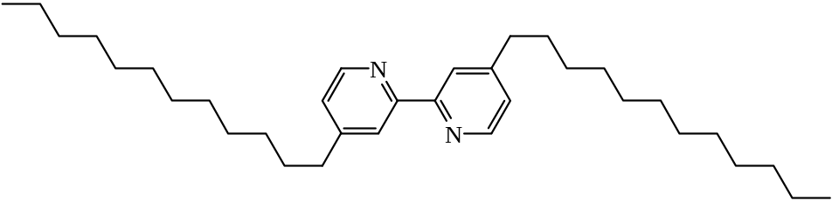
(a)
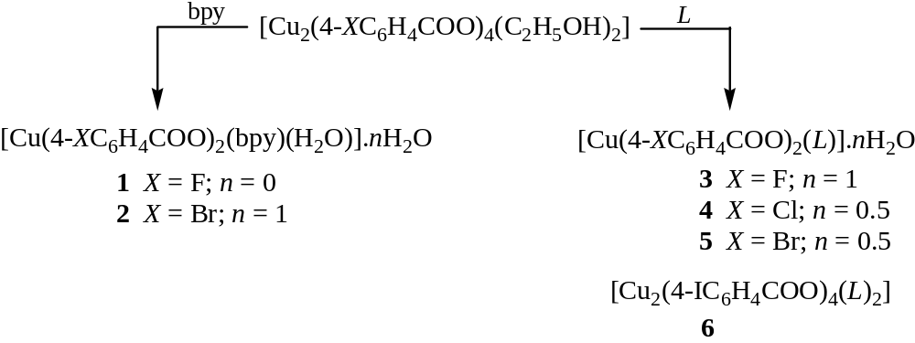
(b)
Scheme 1. The structural formulae of: (a) 4,4'-bis(dodecyl)-2,2'-bipyridine (L), and (b) complexes 1 – 6.

2. Experimental
2.1. Materials and instrumentations
4,4'-Bis(dodecyl)-2,2'-bipyridine (L) was a gift from Prof. D. W. Bruce, Department of Chemistry, University of York, United Kingdom. The syntheses of [Cu₂(4-XC₆H₄COO)₄(C₂H₅OH)₂] (X = F [32], Cl [28], I [29]) were reported previously. Other chemicals were commercially available and used as received.
The elemental analyses for carbon, hydrogen and nitrogen were carried out on a Thermo-Finnigan Flash EA 110 CHNS/O analyser, and the copper content was determined on a Perkin-Elmer Analyst 800 flame atomic absorption spectrometer.

2.1.1. Synthesis of [Cu₂(4-BrC₆H₄COO)₄(C₂H₅OH)₂
Copper(II) acetate monohydrate (3.99 g, 20.0 mmol) was added portion wise to a magnetically-stirred hot ethanolic solution (50 cm³) of 4-bromobenzoic acid (8.04 g, 40.0 mmol). The mixture was further heated for an hour, and the greenish-blue powder obtained was filtered from the hot solution, washed several times with hot ethanol, and dried in an oven at 90 ºC. Yield: 5.1 g (49.6%). Anal. Calcd. for C₁₆H₁₄Br₂CuO₅: C, 37.7; H, 2.8; Cu, 12.5. Found: C, 38.0; H, 2.7; Cu, 12.3. IR (neat, cm⁻¹): 3400 (br), 1560 (s), 1407 (s), 808 (m), 560 (m).

2.1.2. Synthesis of [Cu(4-FC₆H₄COO)₂(bpy)(H₂O)] (1)
2,2'-Bipyridine (0.12 g, 0.77 mmol) was added portion wise to a suspension of [Cu₂(4-FC₆H₄COO)₄(C₂H₅OH)₂] (0.23 g, 0.30 mmol) in ethanol (100 cm³), and the reaction mixture was heated until a green solution formed. The hot solution was filtered, and the filtrate was left to cool to room temperature. Blue crystals deposited after one week at room temperature. Yield: 0.25 g (80.8 %). Anal. Calcd. for C₂₄H₁₈CuF₂N₂O₅: C, 55.87; H, 3.52; N, 5.43%. Found: C, 55.24; H, 3.78; N, 3.75%. FTIR (neat): 3112-2063 (br,w), 1609 (s), 1599 (s), 1557 (s), 1372 (vs), 1219 (s), 1146 (m), 837 (s), 778 (vs), 764 (vs), 610 (vs) cm⁻¹.

2.1.3. Synthesis of [Cu(4-BrC₆H₄COO)₂(bpy)(H₂O)].H₂O (2)
The procedure was the same as for 1, using 2,2'-bipyridine (0.13 g, 0.80 mmol) and [Cu₂(4-BrC₆H₄COO)₄(C₂H₅OH)₂] (0.30 g, 0.29 mmol). The complex was greenish-blue crystals. Yield: 0.16 g (42.1%). Anal. Calcd. for C₂₄H₂₀Br₂CuN₂O₆: C, 43.96; H, 3.07; N, 4.27%. Found: C, 43.23; H, 3.51; N, 4.72%.

2.1.4. Synthesis of [Cu(4-FC₆H₄COO)₂(L)].H₂O (3)
[Cu₂(4-FC₆H₄COO)₄(C₂H₅OH)₂] (0.10 g, 0.13 mmol) was dissolved in hot ethanol (50 cm³). A solution of L (0.16 g, 0.33 mmol) in chloroform (20 cm³) was added portion wise to the magnetically-stirred hot solution. The reaction mixture was further heated for 30 minutes, filtered while still hot, and the solvent evaporated off from the filtrate. The bluish-black waxy solid obtained was washed with ethanol and dried in a warm oven. Yield: 0.15 g (67.7%). Anal. Calcd. for C₄₈H₆₆CuF₂N₂O₅: C, 67.62; H, 7.80; N, 3.29%. Found: C, 67.16; H, 8.21; N, 3.72%. FTIR (neat): 3065 (br, w), 2920 (vs), 2852 (s), 1694 (w), 1611 (vs), 1602 (s), 1570 (s), 1468 (m), 1407 (m), 1369 (vs), 1221 (s), 1148 (m), 858 (s), 782 (vs), 623 (s) cm⁻¹.

2.1. 5. Synthesis of [Cu(4-ClC₆H₄COO)₂(L)].½H₂O (4).
The procedure was the same as for 3, using [Cu₂(4-ClC₆H₄COO)₄(C₂H₅OH)₂] (0.11 g, 0.13 mmol) and L (0.16 g, 0.33 mmol). The product was a sky-blue powder. Yield: 0.20 g (87.8%). The powder was recrystallized from CHCl₃-C₂H₅OH to give blue crystals. Anal. Calcd. for C₄₈H₆₅Cl₂CuN₂O_{4.5}: C, 65.78; H, 7.47; N, 3.20%. Found: C, 64.85; H, 7.60; N, 3.12%. FTIR (neat): 3434 (br, w), 3068 (w), 2921 (vs), 2852 (s), 1683 (w), 1593 (vs), 1557 (s), 1467 (m), 1398 (vs), 1379 (vs), 1362 (vs), 1087 (m), 848 (vs), 772 (vs) cm⁻¹.

2.1.6. Synthesis of [Cu(4-BrC₆H₄COO)₂(L)].½H₂O (5).
The procedure was the same as for 3, using [Cu₂(4-BrC₆H₄COO)₄(C₂H₅OH)₂] (0.14 g, 0.14 mmol) and L (0.16 g, 0.33 mmol). The product was dark-blue crystals. Yield: 0.23 g (85.1%). Anal. Calcd. for C₄₈H₆₅Br₂CuN₂O_{4.5}: C, 59.72; H, 6.79; N, 2.90%. Found: C, 59.21; H, 6.83; N, 2.82%.FTIR (neat): 3436 (br, w), 3069 (w), 2953 (m), 2921 (vs), 2852 (s), 1615 (s), 1590 (vs), 1554 (s), 1467 (m), 1396 (vs), 1376 (vs), 769 (s) cm⁻¹.

2.1.7. Synthesis of [Cu₂(4-IC₆H₄COO)₄(L)₄] (6)
The procedure was the same as for 3, using [Cu₂(4-IC₆H₄COO)₄(C₂H₅OH)₂] (0.17 g, 0.14 mmol) and L (0.16 g, 0.33 mmol). The product was blue crystals. Yield: 0.21 g (71.4%). Anal. Calcd. for C₉₆H₁₂₈Cu₂I₄N₄O₈: C, 54.89; H, 6.14; N, 2.67%. Found: C, 54.69; H, 6.47; N, 2.64%. FTIR (neat): 3078 (w), 2921 (vs), 2852 (s), 1615 (vs), 1600 (s), 1583 (s), 1556 (m), 1462 (m), 1389 (s), 1369 (vs), 1329 (vs), 1008 (m), 841 (m), 823 (m), 766 (s) cm⁻¹.

2.2. X-ray crystallography
All diffraction data were collected at RT on a Bruker SMART APEX II fitted with Mo Kα radiation (λ = 0.71073Å) so that θ_{max} was 27.5° (1 and 2) or at 100K on a Rigaku AFC12 goniometer equipped with an enhanced sensitivity (HG) Saturn724+ detector mounted at the window of an FR-E+ SuperBright molybdenum rotating anode generator equipped with VHF Varimax optics (70 µm focus) for 4 and 5, or HF Varimax optics (100 µm focus) for 6. Data integration was carried out using Rigaku OD CrysAlisPro [33]. The structures were solved by direct methods using SHELXT-2014 [34] or charge-flipping methods using SUPERFLIP [35] and refined on F_{o}² by full-matrix least squares refinement using SHELXL-2014 [34] as implemented in OLEX2 [36]. All non-hydrogen atoms were refined with anisotropic displacement parameters. Hydrogen atoms were added at calculated positions and refined using a riding model with isotropic displacement parameters based on the equivalent isotropic displacement parameter (Ueq) of the parent atom. Additional refinement details are given below.
2: The bromine (Br1) substituent of one of the bromobenzoic acid ligands, the carbonyl oxygen (O4) of the other and the solvent water (O11) were modelled as disordered over two positions in the following approximate ratios of 57:43, 60:40 and 54:46 respectively.
4: Geometrical restraints were applied to the hydrocarbon chains of the bis-dodecyl-bipyridine ligand, thermal restraints were applied throughout.
5: The structure was refined as a 2-component (51.3:48.7) non-merohedral twin with the second component 2 rotated by 179.9781° around [0.95 -0.05 -0.29] (reciprocal) or [1.00 -0.00 -0.00] (direct) lattice vectors.

2.3. Spectroscopy
The FTIR spectra were recorded for neat samples from 4000 cm⁻¹ to 450 cm⁻¹ on a Perkin-Elmer Frontier FTIR spectrometer equipped with a diamond attenuated total reflectance attachment, while the UV-vis spectra were recorded on a Shimadzu UV-vis-NIR 3600 spectrophotometer.

2.4. Polarising Optical Microscopy
The optical textures were studied using an Olympus polarising microscope equipped with a Mettler Toledo FP90 central processor and a Linkam THMS 600 hot stage. The heating rate was 10 °C min⁻¹, the cooling rate was 2 °C min⁻¹, and the magnification was 50x.

2.5. Differential scanning calorimetry
The scans were carried out on a Mettler Toledo DSC 822 instrument in the temperature range of 30-150 °C and under N₂ at a flow rate of 20 cm³ min⁻¹ and a scan rate of 10 °C min⁻¹. The onset temperatures were quoted for all peaks observed.

3. Results and discussion
3.1. Reactions of copper(II) 4-halobenzoates with 2,2'-bipyridine
[Cu₂(4-XC₆H₄COO)₄(C₂H₅OH)₂] (X = F, Br) reacted with 2,2'-bipyridine (bpy) to form mononuclear complexes, [Cu(4-FC₆H₄COO)₂(bpy)(H₂O)] (1) and [Cu(4-BrC₆H₄COO)₂(bpy)(H₂O)].H₂O (2), respectively. Both complexes were single crystals. Their X-ray data and structure refinement details are shown in Table 1, and selected bond lengths and angles are shown in Table 2.

Table 1
Crystallographic and structure refinement details for 1 and 2.
Complex | 1 | 2
Empirical formula | CuC₂₄H₁₈N₂O₅F₂ | CuC₂₄H₂₀N₂O₆Br₂
Formula weight | 515.94 | 655.78
Temperature (K) | 298(2) | 298(2)
Crystal system, | Orthorhombic | Triclinic
Space group | Pccn | P-1
a (Å)  b (Å)  c (Å)  α (º)  β (º)  γ (º) | 21.9759(9)  17.1461(5)  11.6579(4)  90  90  90 | 6.8823(2)  12.6028(5)  15.1138(5)  78.629(3)  82.764(3)  74.749(3)
Volume (Å³) | 4392.7(3) | 1236.11(8)
Z, calc. density (g cm⁻³) | 8, 1.560 | 2, 1.762
Absorption coefficient (mm⁻¹) | 1.051 | 4.159
F(000) | 2104 | 650
θ range for data collection | 2.307 - 27.484º | 1.700 - 27.485º
Index ranges | −28 ≤ h ≤ 28  −22 ≤ k ≤ 22  −13 ≤ l ≤ 13 | −8 ≤ h ≤ 8  −16 ≤ k ≤ 16  −19 ≤ l ≤ 19
Reflections collected / unique | 51726 / 4853  [R_{int} = 0.0519] | 14860 / 5662  [R_{int} = 0.0362]
Data / restraints / parameters | 4853 / 0 / 308 | 5662 / 0 / 347
Goodness-of-fit on F² | 1.218 | 1.047
Final R indices  [I > 2σ(I)] | R₁ = 0.0572,  wR₂ = 0.1161 | R₁ = 0.0399,  wR₂ = 0.0939
∆ρ_{max,} ∆ρ_{min} (e Å⁻³) | 0.320, -0.383 | 1.363, -0.487

Table 2
Selected bond lengths (Å) and angles (º) for 1 and 2.
Complex | 1 | 2
Bond length
Cu-O1 | 1.953(2) | 1.982(2)
Cu-O2 | - | 2.603(2)
Cu-O3 | 2.265(2) | 1.941(2)
Cu-O_{w} | 1.967(2) | 2.301(2)
Cu-N1 | 2.002(2) | 2.021(3)
Cu-N2 | 2.008(2) | 2.020(3)
Angle
O1-Cu-O3 | 98.74(9) | 92.97(10)
O1-Cu-N1 | 90.86(9) | 162.39(10)
O1-Cu-N2 | 164.35(10) | 90.24(10)
O2-Cu-N1 | - | 108.22(9)
O2-Cu-N2 | - | 87.70(9)
O3-Cu-N1 | - | 93.95(11)
O3-Cu-N2 | - | 169.83(10)
O1-Cu-O_{w} | 93.90(9) | 103.34(8)
O3-Cu-O_{w} | 91.17(9) | 92.53(9)
N1-Cu-N2 | 80.69(10) | 80.36(12)
N1-Cu-O_{w} | 168.77(9) | 92.52(9)
N2-Cu-O_{w} | 92.26(9) | 96.11(9)

The molecular structure of 1 is shown in Fig. 1. The complex crystallised in the orthorhombic Pccn space group. Its molecular structure shows mononuclear units with square pyramidal Cu(II) atoms. At the basal plane of each Cu(II) atom were a chelating bpy ligand, a monodentate 4-FC₆H₄COO⁻ ligand and a H₂O ligand, while at its apex was a monodentate 4-FC₆H₄COO⁻ ligand. The non-coordinated oxygen atoms of both basal and apical 4-FC₆H₄COO⁻ ligands were intramolecularly H-bonded to H₂O ligand (bond lengths = 2.548(3) Å and 2.574(3) Å, respectively). It is noted that the structure of 1 was similar to [Cu(4-ClC₆H₄COO)₂(bpy)(H₂O)] [28] and [Cu(4-IC₆H₄COO)₂(bpy)(H₂O)] [29], but different from [Cu(CH₃COO)₂(bpy)(H₂O)] [25] and [Cu(C₆H₅COO)₂(bpy)(H₂O)] [26].

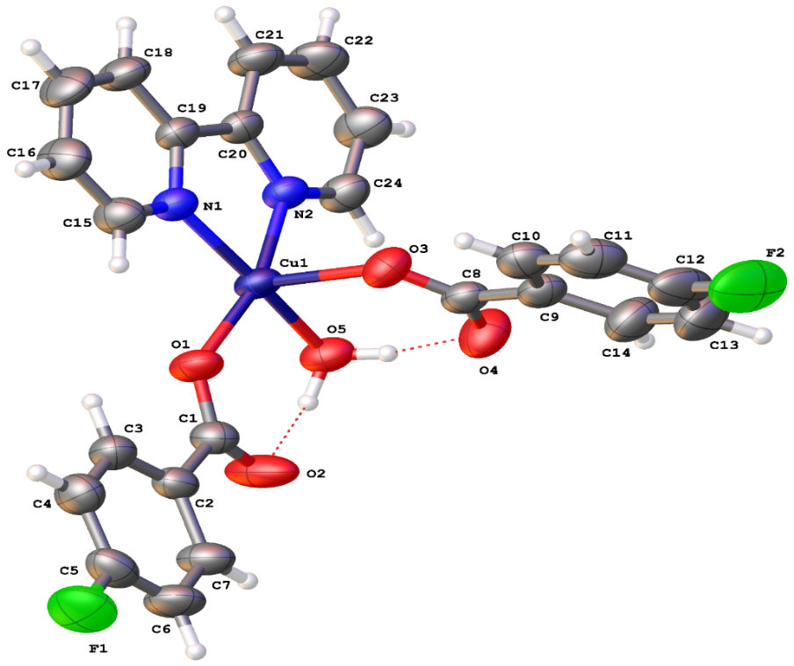
Fig. 1. The molecular structure of 1 with thermal ellipsoids drawn at 50% probability.
The molecular structure of 2 is shown in Fig. 2. The complex crystallised in the triclinic P-1 space group, It was made up of a distorted CuN₂O₄ octahedron, with a chelating bpy, a monodentate 4-BrC₆H₄COO⁻ ligand, a chelating bidentate 4-BrC₆H₄COO ligand, and a H₂O ligand. There was an intramolecular H-bond between H₂O ligand and the free O atom of the carboxyl group of 4-BrC₆H₄COO⁻ ligand (bond length = 2.775(3) Å) and an intermolecular H-bond between H₂O ligand and non-coordinated O atom of the carboxyl group of the chelating 4-BrC₆H₄COO⁻ ligand of its neighbouring molecule (the bond lengths were 2.712(7) Å and 2.598(8) Å, respectively). Thus, the structure of 2 was quite different from 1, but similar to [Cu(C₆H₅COO)₂(bpy)(H₂O)] [26].

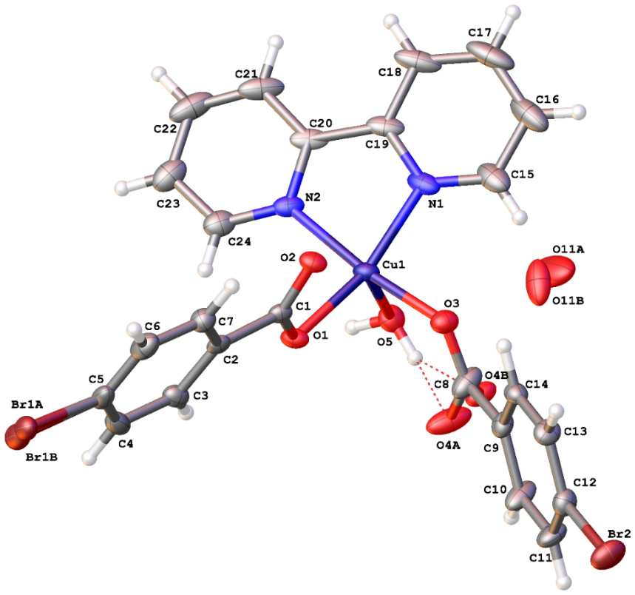
Fig. 2. The molecular structure of 2 with thermal ellipsoids drawn at 50% probability. Br1, O4 and O11 exhibit disorder over two positions in the approximate ratios of 57:43, 60:40 and 54:46, respectively. The H-atoms on the solvent water molecule are not located.
To summarise, all copper(II) 4-halobenzoates (F, Cl [28], Br, I [29]) reacted with bpy to form mononuclear complexes with the general formula [Cu(4-XC₆H₄COO)₂(bpy)(H₂O)]. Complexes with X = F (1), Cl and I have similar molecular structures, which differed from the complex with X = Br (2). In addition, these complexes crystallised in different crystal systems and space groups: orthorhombic Pccn for X = F (1), triclinic P-1 for X = Cl [28] and Br (2), and monoclinic P2₁/c for X = I [29].

3.2. Reactions of copper(II) 4-halobenzoates with 4,4'-bis(dodecyl)-2,2'-bipyridine (L)
[Cu₂(4-XC₆H₄COO)₄(C₂H₅OH)₂] (X = F, Cl, Br, I) reacted with 4,4'-bis(dodecyl)-2,2'-bipyridine (L) to form mononuclear complexes, [Cu(4-FC₆H₄COO)₂(L)].H₂O (3), [Cu(4-ClC₆H₄COO)₂(L)].½H₂O (4), and [Cu(4-BrC₆H₄COO)₂(L)].½H₂O (5), and a dinuclear complex, [Cu₂(4-IC₆H₄COO)₄(L)₂] (6), respectively. Complex 3 was a semisolid at room temperature, while complexes 4 – 6 were single crystals.
The molecular structure for 3 was deduced by comparing its IR and UV-vis spectral data with the corresponding data from crystals of 1 and 4 – 6 (Table 3). The IR spectrum was used to deduce the binding mode of the carboxylato ligands, based on the difference (Δ) between the ʋ_{asym} and ʋ_{sym} vibrational peaks of –COO, normally found as strong peaks at about 1600 cm⁻¹ and 1400 cm⁻¹, respectively. The UV-vis spectrum was used to deduce the geometry of Cu(II) centre, based on the wavelength of the d-d band. For 3, the Δ values were 163 cm⁻¹ and 242 cm⁻¹, suggesting chelating and monodentate binding modes for 4-FC₆H₄COO⁻ ligand, respectively [37], while the wavelength of the d-d band was 691 nm, suggesting square pyramidal geometry at Cu(II) [9, 38-40]. Accordingly, we infer that complex 3 have similar structure as 4 and 5 (discussed below).

Table 3
IR and UV-vis spectral data for complexes 1, 3 – 6 (in CHCl₃).
Complex | Δ /cm⁻¹ | λ/nm (ε_{max}/M⁻¹ cm⁻¹)
1 | 185 | 666 (109)
3 | 163, 242 | 691 (287)
4 | 159, 215 | 678 (189)
5 | 159, 215 | 678 (106)
6 | 214, 286 | 696 (346)

The crystallographic structure refinement details for 4 – 6 are shown in Table 4, and selected bond lengths and angles are shown in Table 5.

Table 4
Crystallographic and structure refinement details for 4 – 6.
Complex | 4 | 5 | 6
Formula | 2 (C₄₈H₆₄Cl₂CuN₂O₄), H₂O | 2 (C₄₈H₆₄Br₂CuN₂O₄), H₂O | C₉₆H₁₂₈Cu₂I₄N₄O₈
Formula weight | 1752.91 | 1930.75 | 2100.70
Temperature (K) | 100(2) | 100(2) | 100(2)
Crystal system | Triclinic | Triclinic | Monoclinic
Space group | P−1 | P−1 | P2₁/c
Unit cell dimension  a (Å)  b (Å)  c (Å)  α (º)  β (º)  γ (º) | 8.8260(3)  22.8275(7)  23.8238(8)  107.941(3)  93.280(3)  91.462(2) | 8.8155(2)  22.8792(6)  23.3943(7)  99.690(2)  96.625(2)  91.064(2) | 25.4683(9)  9.7597(2)  19.5409(5)  90  103.228(3)  90
Volume (Å³) | 4554.3(3) | 4616.6(2) | 4728.3(2)
Z, calc. density  (g cm⁻³) | 2, 1.278 | 2, 1.389 | 2, 1.476
Absorption coefficient (mm⁻¹) | 0.642 | 2.249 | 1.810
F(000) | 1864 | 2008 | 2132
θ range for data collection | 1.754 − 27.561° | 1.779 − 27.614° | 1.643 − 27.559°
Index ranges | −11 ≤ h ≤ 11  −29 ≤ k ≤ 29  −30 ≤ l ≤ 30 | −9 ≤ h ≤ 11  −29 ≤ k ≤ 29  −30 ≤ l ≤ 30 | −32 ≤ h ≤ 32  −12 ≤ k ≤ 9  −25 ≤ l ≤ 17
Reflections collected / unique | 59241 / 20996  [R_{int} = 0.0402] | 26389 / 26389  [R_{int} = merged] | 31804 / 10861  [R_{int} = 0.498]
Data / restraints / parameters | 20996 / 908 / 1043 | 26389 / 0 / 1044 | 10861 / 0 / 516
Goodness-of-fit on F² | 1.022 | 1.166 | 1.023
Final R indices  [F²> 2σ(F²)] | R1 = 0.0906,  wR2 = 0.2236 | R1 = 0.0614,  wR2 = 0.1394 | R1 = 0.0538,  wR2 = 0.0936
∆ρ_{max,} ∆ρ_{min} (e Å⁻³) | 1.531, -0.583 | 1.014, −0.615 | 1.279 / -0.751

Table 5
Selected bond lengths (Å) and angles (º) for 4 – 6.
 | 4 | 5 | 6
Bond length
Cu1-Cu1’ | - | - | 3.979(10)
Cu1-O1 | 1.973(4) | 1.973(4) | 1.974(3)
Cu1-O2 | 2.471(4) | 2.445(4) | 2.642(3)
Cu1-O3 | 1.918(3) | 1.926(3) | 1.953(3)
Cu1-O3’ | - | - | 2.355(3)
Cu1-O4 | 2.829(3) | 2.850(4) | -
Cu1-N1 | 1.985(3) | 1.988(4) | 1.995(3)
Cu1-N2 | 1.997(4) | 1.996(4) | 1.989(3)
Cu11-O101 | 1.969(4) | 1.967(4) | -
Cu11-O102 | 2.515(4) | 2.478(4) | -
Cu11-O103 | 1.948(4) | 1.953(4) | -
Cu11-O104 | 2.613(3) | 2.645(4) | -
Cu11-N101 | 1.993(4) | 2.003(4) | -
Cu11-N102 | 1.997(4) | 1.992(5) | -
Angle
Cu1-O3-Cu1’ | - | - | 99.49(10)
O1-Cu1-O2 | 58.38(12) | 58.45(13) | 55.26(10)
O1-Cu1-O3 | 92.00(17) | 91.26(15) | 90.07(11)
O1-Cu1-O3’ | - | - | 100.50(10)
O1-Cu1-O4 | 109.27(12) | 112.66(12) | -
O2-Cu1-O3 | 89.55(14) | 88.73(14) | 155.63(9)
O2-Cu1-O3’ | - | - | 95.7(1)
O2-Cu1-O4 | 140.42(11) | 139.65(12) | -
O3-Cu1-O4 | 51.64(13) | 51.02(13) | -
O1-Cu1-N1 | 94.13(14) | 95.45(16) | 168.35(12)
O1-Cu1-N2 | 166.22(14) | 164.95(16) | 93.08(12)
O2-Cu1-N1 | 101.32(12) | 103.54(15) | 114.54(11)
O2-Cu1-N2 | 109.73(13) | 107.94(14) | 91.39(11)
O3-Cu1-N1 | 169.11(15) | 167.72(16) | 97.01(12)
O3-Cu1-N2 | 94.98(18) | 95.03(16) | 172.83(12)
O4-Cu1-N1 | 117.65(12) | 116.75(14) | -
O4-Cu1-N2 | 84.32(12) | 81.75(13) | -
N1-Cu1-N2 | 80.98(15) | 81.00(17) | 80.97(13)
O101-Cu11-O102 | 57.43(12) | 58.21(14) | -
O101-Cu11-O103 | 91.67(16) | 91.37(17) | -
O101-Cu11-O104 | 99.89(12) | 101.20(14) | -
O102-Cu11-O103 | 93.30(14) | 92.54(15) | -
O103-Cu11-O104 | 55.94(14) | 55.35(14) | -
O101-Cu11-N101 | 95.08(16) | 95.55(18) | -
O101-Cu11-N102 | 171.54(14) | 171.75(17) | -
O102-Cu11-N101 | 98.83(13) | 95.14(15) | -
O102-Cu11-N102 | 115.35(13) | 114.49(15) | -
O103-Cu11-N101 | 171.39(16) | 171.60(18) | -
O103-Cu11-N102 | 93.26(17) | 92.88(18) | -
O104-Cu11-N101 | 117.39(14) | 118.32(15) | -
O104-Cu11-N102 | 88.58(3) | 87.03(15) | -
N101-Cu11-N102 | 80.70(17) | 80.85(19) | -

The molecular structure for 4 is shown in Fig. 3. The complex crystallised in the triclinic P-1 space group with two independent complexes of [Cu(4-ClC₆H₄COO)₂(L)] and a lattice H₂O in the asymmetric unit. Both [Cu(4-ClC₆H₄COO)₂(L)] display similar geometry involving chelating L, and chelating and monodentate 4-ClC₆H₄COO⁻ ligands adopting a distorted square pyramidal arrangement at the Cu(II) centre. The H₂O molecule bridges the two complexes via H-bonds to uncoordinated O atoms of 4-ClC₆H₄COO⁻ ligands (O201…O4 = 2.814(5), O201…O104 = 2.796(5)).
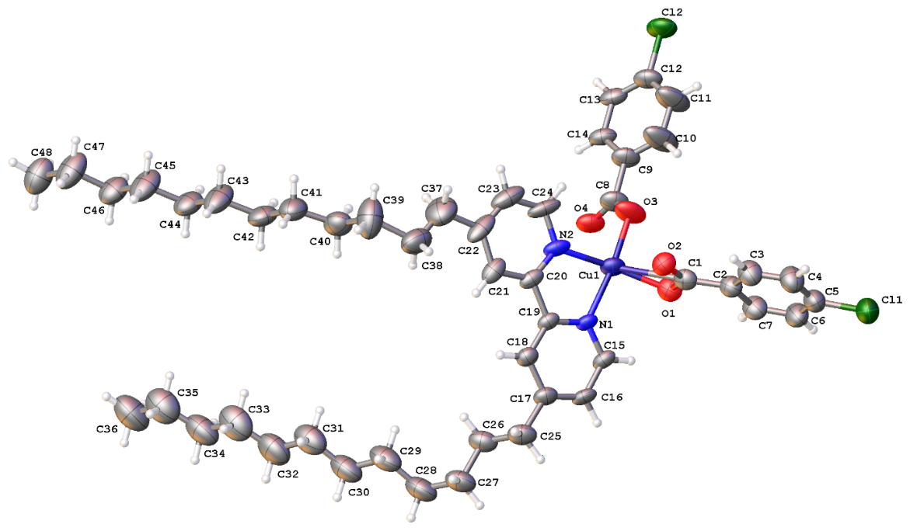
Fig. 3. The molecular structure of 4 with thermal ellipsoids drawn at 50% probability. One molecule of the asymmetric unit and a solvent water molecule are omitted for clarity.
The molecular structure for 5 is shown in Fig. 4. The complex crystallised in the triclinic P-1 space group with two independent complexes of [Cu(4-BrC₆H₄COO)₂(L)] and a lattice H₂O in the asymmetric unit. The structure is similar to 4, with the lattice H₂O bridging the complexes via H-bonds (O201…O4 = 2.819(5), O201…O104 = 2.826(5)).

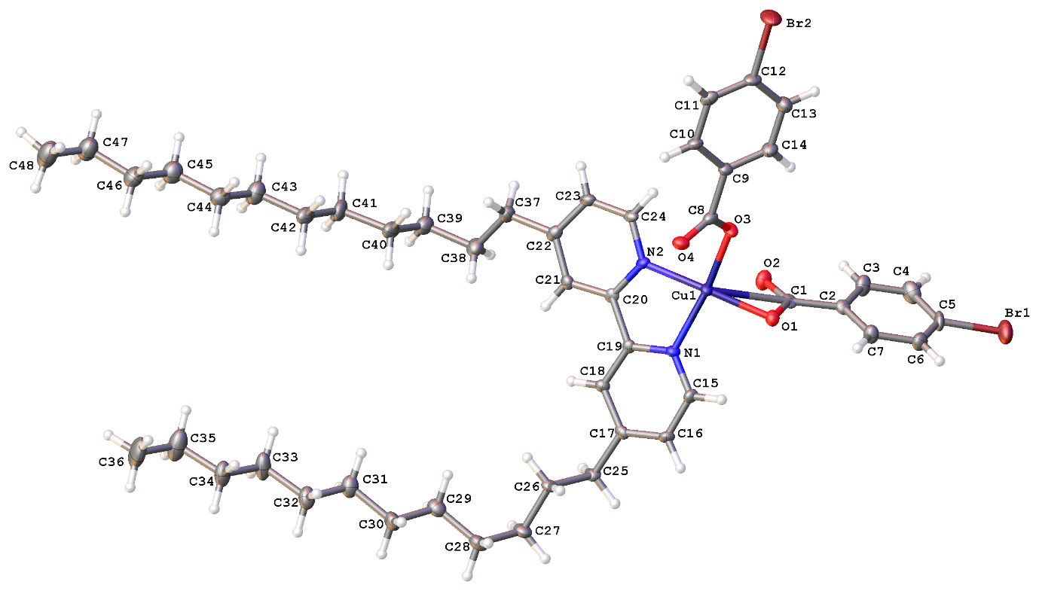
Fig. 4. The molecular structure of 5 with thermal ellipsoids drawn at 50% probability. One molecule of the asymmetric unit and a solvent water molecule are omitted for clarity.
The molecular structure for 6 is shown in Fig. 5. The complex crystallised in the monoclinic P2₁/c space group as a Z’ = 0.5 dinuclear complex. Each Cu(II) centre is chelated by one L and two monodentate 4-IC₆H₄COO⁻ ligands, one of which acts as a bridging ligand to the second Cu(II) centre so that the overall geometry at each Cu(II) centre is square pyramidal. Hence, its structure differs significantly from those of 4 and 5.
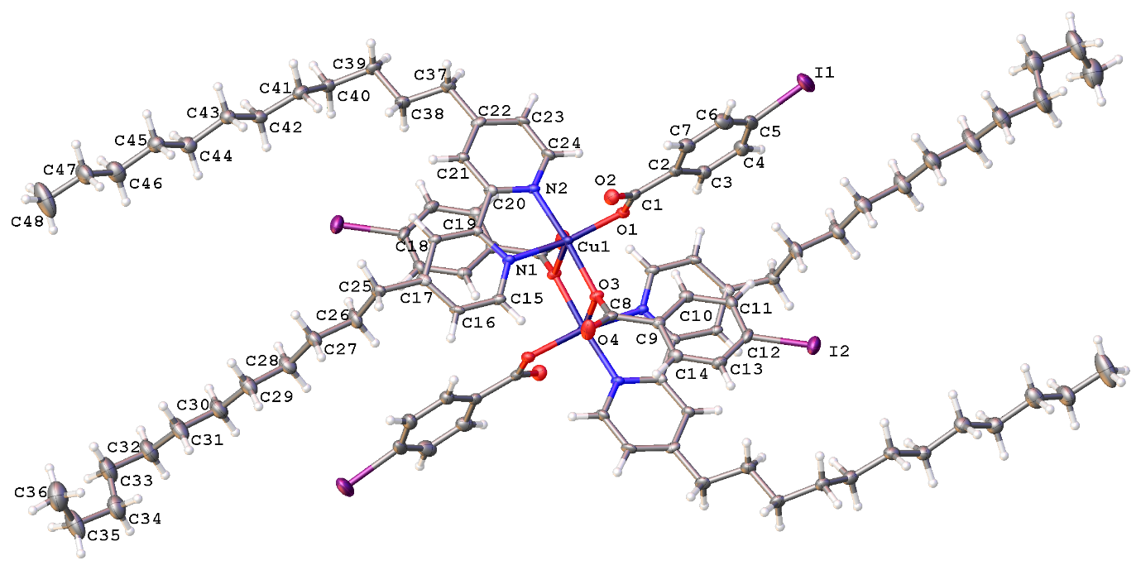
Fig. 5. The molecular structure of 6 with thermal ellipsoids drawn at 50% probability. The asymmetric unit contains half the molecule (labelled), the other half is symmetry generated.
We also recorded the IR and UV-vis spectral data for 4 – 6 (Table 3). The results were in agreement with the chelating and monodentate binding modes [37] of 4-XC₆H₄COO⁻ ligands and square pyramidal geometry at Cu(II) centres [38-40] these complexes, as revealed from their crystal structures.
Finally, we noted that even though the molecular structures of 4 – 6 were different from the corresponding bpy complexes, their crystal systems and space groups were similar. The differences may arise from the hydrophobic effect of linear alkyl chains appended at both aromatic rings of bpy ligand, and from the solvent (CHCl₃) used in their syntheses as has been reported before [28,41,42].

4. Conclusions
Copper(II) 4-Xbenzoates (X = F, Br) reacted with 2,2'-bipyridine (bpy) to form mononuclear complexes, Cu(4-FC₆H₄COO)₂(bpy)(H₂O)] (1) and [Cu(4-BrC₆H₄COO)₂(bpy)(H₂O)].H₂O (2), respectively. Complex 1 crystallised in the orthorhombic Pccn space group, while complex 2 crystallised in the triclinic P-1 space group. Copper(II) 4-Xbenzoates (X = F, Cl, Br, I) also reacted with 4,4'-bis(dodecyl)-2,2'-bipyridine (L) to form mononuclear complexes, [Cu(4-FC₆H₄COO)₂(L)].H₂O (3) [Cu(4-ClC₆H₄COO)₂(L)].½H₂O (4), and [Cu(4-BrC₆H₄COO)₂(L)].½H₂O (5), and a dinuclear complex, [Cu₂(4-IC₆H₄COO)₄(L)₄] (6). Complex 3 was a semisolid at room temperature, 4 and 5 crystallised in the triclinic P-1 space group, while 6 crystallised in the monoclinic P2₁/c space group. In addition, complexes 4 – 6 suffered structural changes on heating to become dinuclear thermotropic metallomesogenic complexes.

Acknowledgements
This research was funded by the Malaysia Ministry of Education for High Impact Research Grant (UM.C/625/1/HIR/MOHE/05) and Fundamental Research Grant Scheme (FP031-2013B), and University of Malaya for Postgraduate Research Grants (PG023-2013A and PG083-2014A). GJT would like to thank the UK Engineering and Physical Sciences Research Council for funding the National Crystallography Service. We thank Prof. D. W. Bruce, York University, UK for the ligand L and helpful suggestions and comments.

Supplementary Data
CCDC-1041887 (1), 1041886 (2), 1427690 (4), 1041884 (5) and 1041885 (6) contain the supplementary crystallographic data for this paper. These data can be obtained free of charge from the Cambridge Crystallographic Data Centre via www.ccdc.cam.ac.uk/data_request/cif.

References
[1] W. Harrison, S. Retig, J. Trotter, J. Chem. Soc. Dalton Trans., (1972) 1852.
[2] M. Melník, M. Dunaj Jurčo, M. Handlovič, Inorg. Chim. Acta, 86 (1984) 185.
[3] L. S. Erre, G. Micera, P. Piu, F. Cariati, G. Ciani, Inorg. Chem., 24 (1985) 2297.
[4] G. C. Campbell, J. F. Haw, Inorg. Chem., 27 (1988) 3706.
[5] M. Yamanaka, H. Uekusa, S. Ohba, Y. Saito, S. Iwata, M. Kato, T. Tokii, Y. Muto, O. Steward, Acta Cryst., B47 (1991) 344.
[6] T. Kawata, H. Uekusa, S. Ohba, T. Furukawa, T. Tokii, Y. Muto, M. Kato, Acta Cryst., B48 (1992) 253.
[7] F. P. W. Agterberg, H. A. J. P. Kluit, W. L. Driessen, H. Oevering, W. Buijs, M. T. Lakin, A. L. Spek, J. Reedijk, Inorg. Chem., 36 (1997), 4321.
[8] A. Elmali, Turk J. Phy., 24 (2000) 667.
[9] R. Cejudo, G. Alzuet, J. Borrás, M. Liu-González, F. Sanz-Ruiz, Polyhedron, 21 (2002) 1057.
[10] J. Jaškova, D. Mikloš, M. Korabik, V. Jorík, P. Segl’a, B. Kaliňaková, D. Hudecová, J. Švorec, A. Fischer, J. Mrozinski, T. Lis, M. Melník, Inorg. Chim. Acta, 360 (2007) 2711.
[11] J. Moncol, M. Mudra, P. Lönnecke, M. Hewit, M. Valko, H. Morris, J. Svorec, M. Melník, M. Mazur, M. Koman, Inorg. Chim. Acta, 360 (2007) 3213.
[12] C-S. Liu, J.-J. Wang, L-F. Yan, Z. Chang, X-H. Bu, E. C. Sañudo, J. Riba, Inorg. Chem., 46 (2007) 6299.
[13] J. Moncol, Z. Vasková, P. Stachová, J. Svorec, R. Sillanpää, M. Mazúr, D. Valigura, J. Chem. Crystallogr., 40 (2010) 179.
[14] M. Iqbal, I. Ahmad, S. Ali, N. Muhammad, S. Ahmed, M. Sohail, Polyhedron, 50 (2013), 524.
[15] N. Abdullah, Y. Al-Hakem, N. Abdullah, H. Samsudin, N. S. Ahmad Tajidi, Asian J. Chem., 26 (2014) 987.
[16] R. C. Santra, K. Sengupta, R. Dey, T. Shireen, P. Das, P. S. Guin, K. Mukhopadhyay, S. Das, J. Coord. Chem., 2 (2014) 265.
[17] D. Guillon, A. Skoulios, J. Phys. IV, C4 (1996) 41.
[18] M. Kondo, M. Kubo, J. Phys. Chem., 62 (1958) 468.
[19] J. F. Boas, J. R. Pilbrow, T. D. Smith, J. Chem. Soc. (A) (1969) 721.
[20] J. N. van Niekerk, F.R.L. Schoening, Acta Cryst., 6 (1953) 227.
[21] M. Kato, Y. Muto, Coord. Chem. Rev., 92 (1988) 45.
[22] O. M. Yaghi, H. Li, C. Davis, D. Richardson, T. L. Groy, Acc. Chem. Res., 31 (1998) 474.
[23] A. J. Blake, N. R. Champness, P. Hubberstey, W. –S. Li, M. A. Withersby, M. Schröder, Coord. Chem. Rev., 183 (1999) 117.
[24] B. Moulton, M. Zaworotko, Chem. Rev., 101 (2001) 1629.
[25] B. K. Koo, Bull. Korean Chem. Soc., 22 (2001) 113.
[26] M. Devereux, D. O'Shea, M. O'Connor, H. Grehan, G. Connor, M. McCann, G. Rosair, F. Lyng, A. Kellett, M. Walsh, D. Egan, B. Thati, Polyhedron, 26 (2007) 4073.
[27] F. Q. Liu, Q. X. Wang, K. Jiao, F. F. Jian, G. Y. Liu, R. X. Li, Inorg. Chim. Acta, 359 (2006) 1524.
[28] N. Abdullah, N. Sharmin, L. N. Ozair, A. Rahman Nordin, W. S. N. M Nasir, M. I. Mohamadin. J. Coord. Chem., 68 (2015) 1347.
[29] M. I. Mohamadin, N. Abdullah, K. M. Lo, S. W. Ng, Acta Cryst., E66 (2010) 1530.
[30] N. Abdullah, M. I. Mohamadin, A. P. Safwan, E. R. T. Tiekink, Acta Cryst.. E66 (2010) 1055.
[31] A. N. Che Mat, N. Abdullah, H. Khaledi, J. T. Tee, Acta Cryst.. E67 (2011) 599.
[32] M. I. Mohamadin, N. Abdullah, Inter. J. Phys. Sc., 6 (2011) 2526.
[33] CrysAlisPro Software System, Rigaku Oxford Diffraction, Yarnton, Oxford, UK (2015).
[34] G. M. Sheldrick, Acta Cryst., A71 (2015) 3.
[35] L. Palatinus, G. Chapuis, J. Appl. Cryst., 40 (2007) 786.
[36] O. V. Dolomanov, L. J. Bourhis, R.J. Gildea, J. A. K. Howard, H. Puschmann, J. Appl. Cryst., 42 (2009) 339.
[37] G. B. Deacon, R. J. Phillips, Coord. Chem. Rev., 33 (1980) 227.
[38] A. Garcis-Raso, J. J. Fiol, F. Badenas, E. Lago, E. Molins, Polyhedron 20 (2001) 2877.
[39] G. S. Siluvai, N. N. Murthy, Polyhedron, 28 (2009) 2149.
[40] C. Yenikaya, M. Poyraz, M. Sari, F. Demirci, H. Ilkimen, O. Buyukgungor, Polyhedron 28 (2009) 3526.
[41] L–G. Zhu, S. Kitagawa, Inorg. Chem. Commun., 6 (2003) 1051.
[42] N. Abdullah, R. Hashim, L. N. Ozair, Y. Al-Hakem, H. Samsudin, A. Marlina, M. Salim, S. M. Said, B. Subramanian, A. Rahman Nordin, J. Mat. Chem. C, 3 (2015) 11036.
[43] M. F. R. Moita, M. L. T. S. Duarte, R. Fausto, J. Chem. Soc. Faraday Trans., 90 (1994) 2953.

