Glacier surging controls glacier lake formation and outburst floods: the example of the Khurdopin Glacier, Karakoram

Nazir Ahmed Bazai ^{a,b,f}, Peng Cui ^{a,b,e*}, Dingzhu Liu ^{a,f*}, Paul A. Carling ^{c}, Hao Wang ^{b d}, Guotao Zhang ^{a, f}, Yao Li ^{a, f}, Javed Hassan ^{a,b, f}
ª Key Laboratory of Mountain Hazards and Earth Surface Process/Institute of Mountain Hazards and Environment, Chinese Academy of Sciences (CAS), Chengdu, China
^{b} China-Pakistan Joint Research Center on Earth Sciences, CAS-HEC, Islamabad 45320, Pakistan.
^{c} Geography and Environmental Science, University of Southampton, Southampton SO17 1BJ, UK
^{d} Institute of Geographic Sciences and Natural Resources Research, CAS, Beijing 100101, China
^{e} CAS Center for Excellence in Tibetan Plateau Earth Sciences, Beijing 100101, China
^{f} University of Chinese Academy of Sciences, Beijing,100039, China
* Corresponding Author: pengcui@imde.ac.cn (P. Cui); liudingzhu@imde.ac.cn (D. liu)

Abstract
Ice dammed glacial lake outburst floods (GLOFs) associated with surge glaciers are increasing in response to climate change. Predicting the phenomenon to protect downstream communities remains challenging around the globe. Surge-type glaciers are characterized by unsteady movements and frequent frontal advances, which cause natural hazards by obstructing river channels, forming ice-dammed lakes, which can cause GLOFs, posing threats downstream. The determination of the surge characteristics, timing and evolution of lakes and GLOFs is fundamental to flood control and disaster management. In this study, the case of the Khurdopin Glacier (Karakoram) is used to elucidate key behavioral characteristics of surging glaciers that usefully can be applied to understand the GLOF hazard from glaciers worldwide. Seven surge periodical cycles associated with the Khurdopin Glacier that occurred at intervals of 19–20 years between 1880 and 2020 were investigated using a GLOF dataset. The ice flow dynamics of three surge events that occurred between 1970 and 2020 were analyzed using high-resolution satellite imagery. The results indicate that the maximum and minimum surge velocities control the conduit development that drains lakes resulting in a number of GLOFs. A surge between 1998–2002 generated six GLOFs. A subglacial drainage model was developed to estimate the timing of the peak discharge in GLOF hydrographs. The results show that conduit melt enlargement becomes the dominant drainage process at one-third of the rising limb. These floods' high peak discharges and short durations are primarily due to the higher lake water temperature, which controls the conduit enlargement rate. Based on the current study results, the proposed model can be adopted worldwide for surge-type glaciers. The initiation of the main surge period, which leads to lake formation, can be anticipated, as the pre-surge period can be identified using remote-sensing analysis. The timing of ice-dammed lake formation and GLOFs can be estimated, providing residents and authorities time to take precautionary measures and thus limiting damage downstream.
Keywords: glacial lake, glacial lake outburst ﬂood, glacial surge, remote sensing, cross-correlation feature tracking, climate change

Introduction
Surge-type glaciers constitute one percent of the entire glaciated regions on Earth (Jiskoot et al., 2000; Sevestre et al., 2015). Due to their dynamic instability, some surge-type glaciers exhibit sudden and unpredictable advances and result in the formation of ice-dammed lakes and glacial lake outburst floods (GLOFs) (Harrison et al., 2015; Hewitt and Liu, 2010; Tweed and Russell, 1999). Surge-type glaciers are characterized by quasi-periodic variations between rapid and slow phases (alternatively known as the active and quiescent phases, respectively) of ice transfer from the accumulation zone to the terminus zone. This mass transfer can last from months to years (Meier and Post, 1969), and during these ice mass transferring periods, glacial lake formation and reformation are common and can result in a series of GLOFs during a single surge period (Bazai et al., 2021).
Worldwide among these surge-type glaciers, some exhibit hazardous rapid surge phases, responsible for glacier terminus advancements (Truffer et al., 2021), that block rivers, forming ice-dammed lakes with subsequent GLOFs and consequent downstream damage (Clague and O’Connor, 2021; Cui et al., 2014). For example, several glacier surges have been recorded in the Pamir Mountains range. Some of the most notable events include the example of the Medvezhiy Glacier, which surged four times since 1951, with a maximum speed of about 500 m/day (Dolgushin, 1982). Further surges in 1963, 1973, and 2011 generated a series of GLOFs which were responsible for destroying bridges, a highway and power lines, flooding of an airfield, and other damage in the Vanj Valley (Dyurgerov et al., 1985; Kotlyakov et al., 2018). In the same valley, surges of the Karayaylak (Shangguan et al., 2016) and the Geographical Society Glacier in 2000 and 2015 generated GLOFs that damaged farmland and buildings (Harrison et al., 2015; Truffer et al., 2021). In the European Alps, at least eight outburst floods are known to have originated from the Belvedere Glacier, in the period 1868-2003. In particular, the 1979 event caused severe damage to the Belvedere ski resorts, threatening the Macugnaga hamlet (Kääb et al., 2004). The Vernagtferner Glacier, surged in 1600, 1678, 1680, 1773, 1845, and 1848, has also been associated with substantial damage and property loss (Hoinkes, 1969; Reinwarth and Young, 1993). Three Icelandic glaciers, (i) Nordlingalaegdarjokull, (ii) Skeidararjokull, and (iii) Hagafellsjokull surged in 1869, 1929, and 1999, respectively resulting in the destruction of farmsteads and a telephone line by advancement of Nordlingalaegdarjokull and Skeidararjokull, while a flood from the Hagafellsjokull damaged two dams and a bridge (Russell et al., 2007; Truffer et al., 2021). Two Alaskan glaciers, the Variegated Glacier and Lowell Glacier, are responsible for repeated surge-generated GLOFs. The Variegated Glacier has an estimated recurrence surge period of about 17 to 20 years: the last surges occurred between 1994-1995, with a GLOF recorded on 11 June 1995 (Eisen et al., 2005; Kamb et al., 1985). The Lowell Glacier surged in 1948, 1968, 1983, 1993, and 2009 and generated GLOFs each time (Bevington and Copland, 2014). In South America (Mount Aconcagua, Central Andes), the Horcones Inferior Glacier surged in 1984 and 2003 (Pitte et al., 2016) and the Grande del Nevado Glacier surged in 1934, causing a catastrophic flood that resulted in 60 fatalities and the destruction of power plants (Del Rossrio Prieto, 1986; Espizua and Bengochea, 1990). Further large surges in 1984 and 2007 did not result in any damage (Espizua and Bengochea, 1990; Ferri and Espizúa, 2010).
The Karakoram region has a high concentration of surge-type glaciers (Sevestre and Benn, 2015), for which the frequency of GLOFs has been recorded as increasing since the 1970s (Bazai et al., 2021; Bhambri et al., 2019; Hewitt and Liu, 2010). Several individual studies have been conducted on the surging behavior of glaciers in this region, such as: the Kyager surges during 2014-2015 (Haemmig et al., 2014; Round et al., 2017); Khurdopin in 2000 and 2017 (Quincey and Luckman, 2014; Steiner et al., 2018); Shishper in 2000 and 2019 (Bhambri et al., 2020; Rashid et al., 2018); Chilinji in 2000 and 2013; Saklei Shuyinj in 2004; Chatahboi in 2005 (Iturrizaga, 2004; Iturrizaga, 2005a); Karamber in 1902; Aling in 1992; Kutiah in 1953; and the Yengutz Har Glacier in 1903 (Hewitt, 2014). Series of GLOFs have been recorded in association with each of these surge cycles by Bazai et al. (2021) and Bhambri et al. (2019). Glacier surges and associated hazards are expected to increase in response to further climate change (Bazai et al., 2021; Bhambri et al., 2019; Clague and O’Connor, 2021). The consequences of these hazards are difficult to predict. To date, only limited mitigation strategies are in place to address this problem, due to the lack of capabilities in detecting surge cycles, the timing of the formation of dammed lakes, and in predicting the triggering of GLOFs. Aside from inducing the formation of dammed lakes and triggering GLOFs, the glacier surges themselves may be disastrous, as in the cases of the Kutiah and Shishper glaciers, which advanced by 12 km and 7 km in 1952 and 1905, respectively (Bazai et al., 2021; Desio, 1954; Hewitt, 1982). The surging of the Shishper Glacier in 2019-2021 demolished the local power station water tank, water canal, and bridges and severely damaged the Karakorum Highway (Begum, 2019). The Karayaylak glacier and the Nordlingalaegdarjokull advanced during the 2015 surges and in 1869 damaged farmland and buildings (Truffer et al., 2021).
Although a glacier surge damages its immediate surroundings, GLOFs may result in extensive devastating impacts far downstream. Due to the severe consequences of GLOFs, attempts to predict their occurrence have received widespread attention within the scientific community (Ashraf et al., 2012; Bjrnsson, 2003; Hewitt and Liu, 2010; Huss et al., 2007; Liu, 1991; Liu, 1999; Ng, 2007; Richardson and Reynolds, 2000). In the case of moraine-dammed lakes, it is generally assumed that GLOF frequency is increasing due to global glacier retreats (Harrison et al., 2018; Veh et al., 2020). In contrast, the dynamics of ice-dammed lakes are less well-understood, being associated with surge glaciers, in particular, the dynamics of which involve sudden glacier advance and mass gain and then rapid thinning (Bazai et al., 2021; Bhambri et al., 2019; Carrivick and Tweed, 2016; Hewitt and Liu, 2010; Kotlyakov et al., 2018). Some examples from the Karakoram region, which produced the most catastrophic ice-dammed lake outbursts series on record, involved the Chong Kumdan (1926–1933), Kyager (2014–2019), Khurdopin (1999–2004, and 2017–2020) and Shishper (2019–2021) glaciers (Bazai et al., 2021; Bhambri et al., 2019; Bhambri et al., 2020; Round et al., 2017). However, the processes triggering GLOFs in the Karakoram are very poorly understood (Bhambri et al., 2019). Potential triggering mechanisms include subglacial breaching, overspill, ice flotation, deformation of subglacial cavities, and changes in the crevasses density and glacier velocity variations during and after the surge (Bazai et al., 2021; Bjrnsson, 2003; Haemmig et al., 2014; Round et al., 2017). However, it remains unclear why and how sudden lake outbursts occur (Ng, 1998; Ng, 2007). Several theoretical models have been established for the drainage of ice-dammed lakes (Carrivick et al., 2017; Clarke, 1982; Fowler, 1999; Kingslake and Ng, 2013; Nye, 1976; Spring and Hutter, 1981), following a previous approach (Nye, 1976). In particular, Carrivick et al. (2017) considered the initiation of floods due to the evolution of ice-dammed lakes and the opening and subsequent closure of ice-enclosed conduits during surges. The model is mainly based on the thermodynamic evaluation of conduit enlargement, which affects the flood hydrograph.
Direct observation of glacier surge temporal evolution and subsequent GLOF records are limited worldwide (Post, 1969; Sevestre and Benn, 2015). Consequently, indirect methods have been adopted for Icelandic glaciers wherein periodical surge intervals were derived from sediment sequences for future surge predictions (Striberger et al., 2011). A stratigraphic approach also could be used to determine the relationship between climatic variations and surge periodicities. A surge periodic reoccurrence interval (17 to 20 years) for the Variegated Glacier was based on a surge historical chronology (1906, 1920, 1930, 1947, 1964, 1981, 1995) (Eisen et al., 2001; Kamb et al., 1985; Post, 1969). For the above-mentioned glaciers, the GLOF records are longer than the corresponding surge records, hindering a comprehensive assessment of the relationship between the surge and GLOF periodicities.
Due to a limited knowledge base and archived data on surge behavior and reoccurrence intervals, predicting the timing of ice-dammed lake formation and associated GLOFs in response to surges remains challenging (Harrison et al., 2018; Vandekerkhove, 2021), as is the relationship with climate change. Advancing the knowledge related to glacier surge reoccurrence and their prediction is fundamental to developing future strategies to predict lake formation and mitigate GLOF-related risks worldwide. In contrast to a deficiency in the completeness of surge and GLOF records worldwide for individual glaciers, the Khurdopin Glacier in the Karakoram has a detailed surge and GLOF chronological record (Bhambri et al., 2019; Quincey and Luckman, 2014; Steiner et al., 2018) that can be used to elucidate the Khurdopin Glacier surge behavior and recurrence intervals. More importantly, the Khurdopin example can be used to develop a generic model of surge behavior, lake formation, flood evaluation, and subsequent GLOFs that might usefully be applied to other glaciers around the world for which records and data are incomplete. In this manner, a deeper understanding of the behavior of a specific surging-type glacier may aid in predicting and mitigate GLOF-inducing processes on a global scale.

Topographic and geomorphological setting and chronologic data of the study area:
The study area is the Hunza River Basin in the western Karakoram (36°N–75°E; Fig. 1a and b). The drainage area of the basin is 13,713 km², with an elevation range of 1432–7801 m a.s.l. Based on the Randolph Glacier Inventory (RGI 6.0) for the Karakoram, more than 15% of glaciers are located within the Hunza basin (Arendt et al., 2015; Consortium, 2017). The total number of glaciers in the Hunza Basin is estimated at 1384. Approximately 4,152 km² of catchment area is glaciated; clean and debris-covered glacier areas are 3,673 km² and 479 km², respectively (Fig. 1d). The basin hosts some of the highest mountain peaks in the region (seven >7500 m a.s.l., Fig. 1b); the highest are Rakaposhi (7788 m a.s.l.) and Disteghil (7785 m a.s.l.).
About 15 glaciers in the Hunza Basin are characterized by frequent surges (Bhambri et al., 2017; Copland et al., 2011; Quincey and Luckman, 2014; Rankl et al., 2014). The surging glaciers exhibit strong heterogeneous behaviors (Bolch et al., 2012; Quincey and Luckman, 2014). Fifteen repeated surge glacier historical records show that 12 of these glaciers (Khurdopin, Yazdghil, Malangutti, Balt Bare, Hoper, Shishper, Machuher, Balthar, Besk-i-Yeng, Yashkuk Yaz, and Batura; Fig. 1b, c and Table S1 and 2) have been responsible for GLOFs in each surge cycle (Bazai et al., 2021). The frequency of Karakoram GLOF events has increased in recent decades.
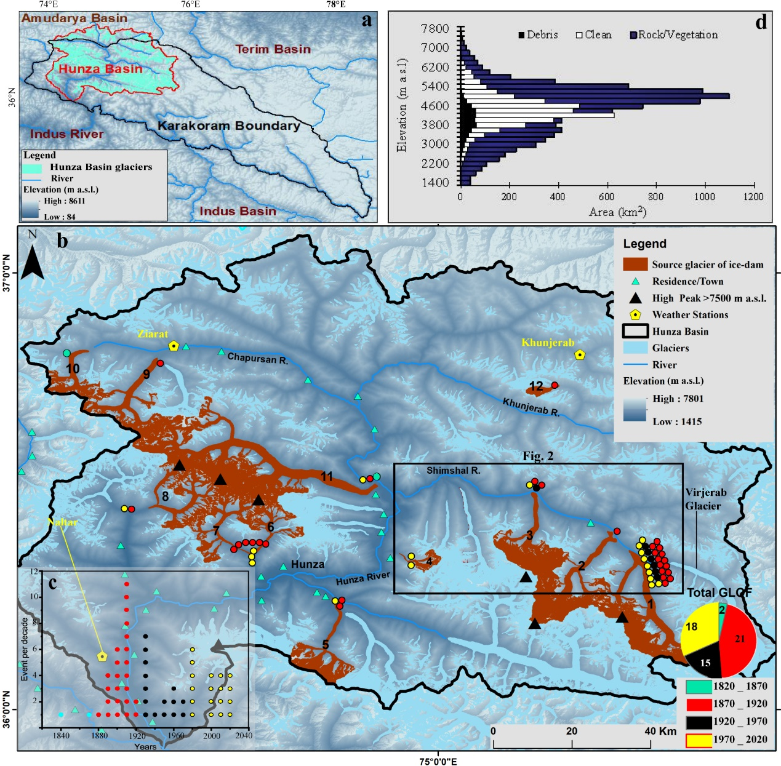
Figure 1. (a) Overview of the study area. The Shuttle Radar Topography Mission (SRTM) DEM was used as background. The main source glaciers of ice dams are: 1) Khurdopin; 2) Yazdghil; 3) Malangutti; 4) Belt-Bar; 5) Hoper; 6) Shishper; 7) Machuher; 8) Balthar; 9) Besk-i-Yeng; 10) Yashkuk-Yaz; 11) Batura, and 12) Unnamed; (b) Inventory of ice-dammed lake outburst floods related to glacial surges in the Hunza Basin, and; (c) Flood events in the period 1840–2020; (d) Hypsometric histograms for the Hunza River Basin, which describe the altimetric distribution of debris-covered glaciers, ‘clean’ glaciers and of the area of rock and vegetation cover; a rectangle outlining, anticipating the area shown in Figure 2.
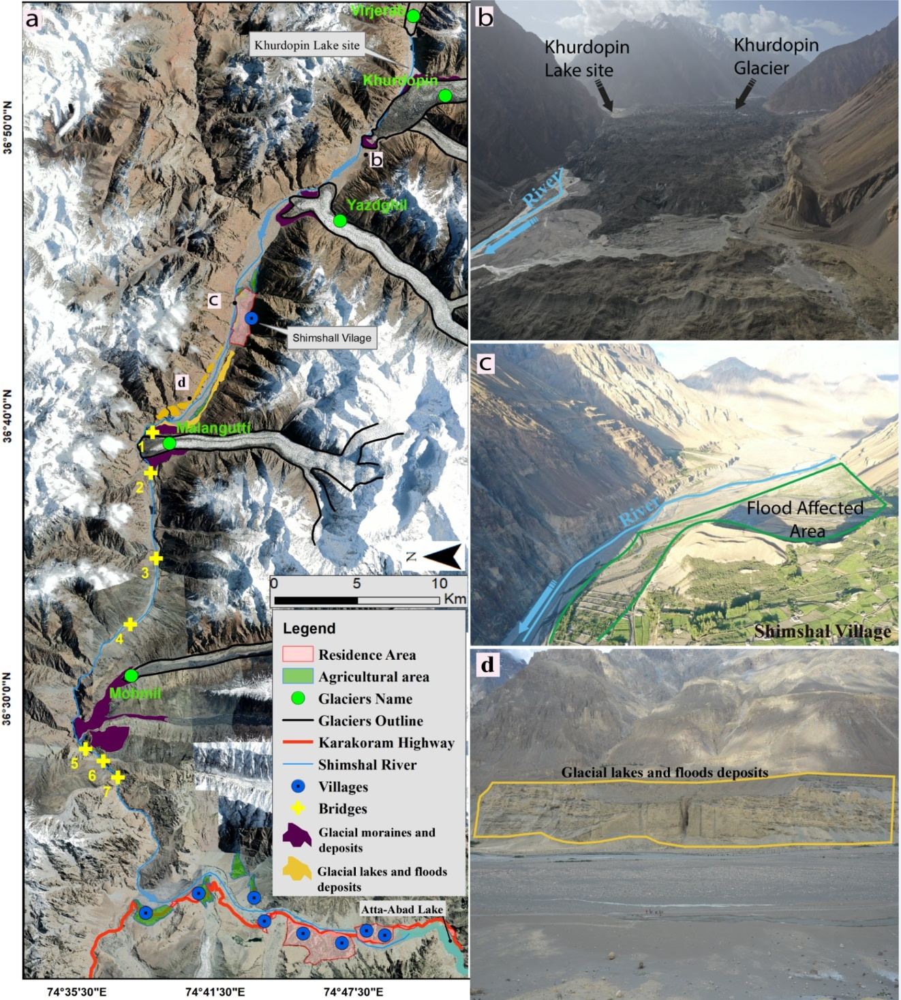
Three of these glaciers (the Khurdopin (ID:1) and Malangutti (ID: 3) glaciers located in the Shimshal Valley (Fig. 1b) and the Shishper Glacier (ID: 6) in the Hassanabad Valley) frequently contribute to the formation of lakes and generation of GLOFs (Table S1). These glaciers are located in some of the most densely populated areas of the region. Residences, farmlands, development projects, and powerhouses are distributed along the Hunza River or in glacierized tributaries and thus are highly at risk (Fig. 2a, c and d).

Based on the GLOF record (Bazai et al., 2021; Bhambri et al., 2019; Hewitt, 1982; Hewitt and Liu, 2010; Iturrizaga, 1997; Kreutzmann, 1994; Mason, 1935), the Khurdopin Glacier is associated with the highest number of glacial surges (Copland et al., 2011; Quincey et al., 2011; Quincey and Luckman, 2014; Rankl et al., 2014) and GLOFs in the Karakoram region (Fig. 1b) (Hewitt, 1982; Hewitt, 2014; Iturrizaga, 1997; Kreutzmann, 1994) after the Kyager Glacier in Shakusgume Valley (Bazai et al., 2021) (Kyager Glacier is inaccessible and the Shaksgam Valley not inhabited and not a threat to downstream severely as Khurdopin Glacier, which have several villages downstream valley). Therefore, the current study focused on the Khurdopin Glacier, which offers the best opportunity to investigate the relationships between glacier surges and GLOFs events.
Figure 2 Detailed valley-scale geomorphological map of Shimshal Valley (a); Khurdopin Glacier and lake site (b); the Shimshal village farmlands are affected by Khurdopin Glacier lake floods and a paleo deposits of glacial lakes and floods (c and d). The background of panel (a) is a high-resolution Google Earth image (September 2020) and for panels b-d UAV images are used, which were captured during the field trip in July 2019.

Methodology

3.1. Data acquisition
Satellite images of the Khurdopin Glacier from 1972 to 2020 were obtained from Landsat and Sentinel satellites; the data were downloaded from the United States Geological Survey (USGS) website (http://earthexplorer.usgs.gov/). High-resolution images Gaofen-1 (GF-1) and Gaofen-2 (GF-2) also were downloaded (http://36.112.130.153:7777/DSSPlatform/productSearch.html) (Table S3). In total, 195 Landsat images and ten GF-1 and GF-2 scenes were used to map the Khurdopin Glacier frontal changes, analyze surge events and annual surface displacements, and glacial lakes' extent. For the period 2003–2013, use was made of 55 Advanced Spaceborne Thermal Emission and Reﬂection Radiometer (ASTER) data scenes from the National Aeronautics and Space Administration (NASA) Earth Science Data Center website (https://search.earth data.nasa.gov/). Ten Sentinel scenes from 2015 were used to determine the annual glacier displacement and surge event cycles. Global Planet imagery was used to extract the lake extents during the 2016–2018 surge event. Cloud-free images are required to track the surface features and identify GLOFs during surge events. The formation of a particular lake area (imaged directly before the outburst flood) was considered by extracting the lake boundary from the optical images. In order to analyze the glacier surge records and associated GLOFs generated from the Khurdopin Glacier, we developed a glacier surge and GLOF database based on literature, scientific reports, and remote sensing data (Fig. 1b, c and Tables S1 and S2). The glacier outlines were obtained from the Randolph Glacier Inventory (RGI 6.0) (Consortium, 2017).
To assess the flood hazard downstream and lake volume estimation, an accurate digital elevation model (DEM) developed using the DEM differencing method is required to measure and identify the large-scale areas potentially affected by GLOFs (Westoby et al., 2014). Due to the narrow V-shape of the Shimshal Valley, the application of TanDEM-X DEMs (90 m) was not suitable. Therefore, ASTER (2000–2019), Phased Array type L-band Synthetic Aperture Radar (PALSAR)-DEM (June 2008), and Shuttle Radar Topography Mission (SRTM) (February 2000) data were used for the generation of the DEM (Table S4), based on which, the flow depth, erosion and deposition along the river could be quantified. The distance traveled by ice blocks released from the glacier snout during the floods could be estimated. The DEM generated by means of Unmanned Aerial Vehicle (UAV) and ASTER and PALSAR-DEM data were used to assess the glacier lake volume. Twelve ASTER stereo, four PALSAR-DEM, and two SRTM DEM scenes were used to characterize the Hunza Basin (Shimshal Valley).
Field observations were performed in the Shimshal Valley in July and August 2019 to investigate the glacier surges, glacier front dynamics and ice-dammed sites. The lake levels were measured, and evidence for floods and geomorphological changes of the Shimshal River was collected. Due to the rough terrain and glacier crevasses, it is difficult to traverse the Khurdopin Lake Basin, and the field evidence thus is limited. Nevertheless, the research team entered the lake basin, yet ground-truth field data do not include ice dam drainage processes. We measured the extent of the lake's shorelines, which formed in winter 2017 and drained on March 18, 2018, and identified the inlet and outlet positions of the conduit (Fig. S2a). In addition, we used an UAV (DJI Mavic 2 Pro) equipped with a high-resolution camera (4000 × 2250) to obtain multiple aerial photographs with a minimum of 90% image overlap. The UAV flew at a low uniform height (500 m - to reduce the image distortion) to generate a high-resolution orthomosaic and digital surface model (DSM) of the glacier's terminus. All the previously recorded lakes drained via subglacial conduits with stable inlets and varying outlet positions and lengths (Table 2 and Fig. S2a). Based on these inlet and outlet positions (Fig. S2a-e), we estimated the straight-line lengths of the conduits. The GLOFs that occurred in 2000 (2000a, 2000b, 2000c) and 2001 drained through the same general outlet, with an estimated length of 2.7 km (located at mid glacier within a thicker ice zone). The initial inlet conduit width was assumed 0.5m (after Chan (2016) and Walder and Costa (1996)), while floods in 1999, 2002, 2017, and 2018 drained through the marginal conduits with a length of 1.9 km (marginal conduit located within a thin ice zone) (Tables 2 and S2, Fig. S2a). The conduit flow paths of the 2017 and 2018 floods were identified during the field surveys, the inlets of the conduits (after the flood) were elliptical with a width between 14 and 16 m; the outlet sizes listed in Table 2 and flood evidence were collected from two cross-sections along the flood path downstream.

3.2. Glacier lake mapping
Landsat imagery was acquired from 1970 to 2020 with a spatial resolution of 15-30 m; details are presented in Table S3. The images were selected based on the visibility of the glacier surface and lake areas, and five ice-dammed lakes were identified through optical images and used for the volume measurements. Field data were compiled for the glacial lake of 2018, and the lake level obtained from field observations was coupled with the optical images. Model simulation results were validated using the flood evidence collected from two cross-sections (see text below). The lake extents were digitized manually using Landsat false-colour composites (near-infrared, red, and green bands) to distinguish water bodies from other objects (Huggel et al., 2002). First, the formation of the lake was identified based on the Normalized Difference Water Index. Second, lake polygons were generated, and the lake elevation was extracted from each available image until the breach occurred. In the case of images with partial cloud cover, the focus was placed on a specific lake area. Alternatively, high-resolution satellite images from Planet (3 m) and GaoFan1 and 2 (0.8 and 4 m resolution, respectively) were used to extract the lake boundaries and these were compared with the lake level determined in the field. Procedures for reducing the uncertainty of lake and glacier extent, lake depth and volume, are available in the Supplementary Material and Table 2.

3.3. Glacier surface velocity and frontal change
The Khurdopin Glacier is a surge-type glacier (Copland et al., 2011; Hewitt, 1998). Since 1972, three surges have occurred at an interval of 17–20 years. The Landsat MSS images available for this period have errors in the selected glacier area. Therefore, the initial surge in 1977–1979 was not considered for the estimation of the annual velocity, but the movement was highlighted through identification of surface features. Orthorectified Landsat scenes from TM were used to estimate the annual and event-based velocities of the Khurdopin Glacier from 1989 to 2020 to obtain information about the surge events and glacier front changes. Between this period (1989 to 2020), some satellite images are absent for continuous sequence of velocity measurement; for the precise result, the images that are free of clouds are chosen each year. The mass transfer in the terminus zone affects the subglacial flow paths and the consequent flood peak discharge model; thus, changes to the glacier front play a significant role in the formation of lakes and GLOFs. The surface velocity of the Khurdopin Glacier was obtained by image-to-image correlation using COSI-Corr (Leprince et al., 2012; Leprince et al., 2007). This software has been used frequently in the past, and good results have been obtained concerning estimating the glacier surface velocity (Bazai et al., 2021; Steiner et al., 2018). The image correlation with COSI-Corr is a two-step process. First, the shift between images concerning their correlation matrix is determined at a multi-pixel scale. The measurements then are refined at a sub-pixel scale based on the Fourier shift theorem. This technique is used for the co-registration and correlation of surface features based on the displacement calculation (Steiner et al., 2018). In general, this velocity estimation yields an accuracy of ¼ of a pixel (Sattar et al., 2019). To justify the image processing accuracy, we estimated the root-mean-square error (RMSE) for the velocities. The procedures are described in detail in the Supplementary Material.

3.4. Simulation of ice-dammed lake outburst floods
The ice-dammed GLOFs were simulated by considering two processes: 1) the GLOF discharge during dam breach; 2) the conduit melting process by applying the subglacial melting model. The discharge, Q, along a subglacial conduit, was predicted by using the subglacial model (Carrivick et al., 2017; Nye, 1976).
$Q=\sqrt{\frac{ϕ}{F}} S^{4/3}$ (1)
$ϕ=ϕ_{g}+\frac{N_{outlet}-N_{inlet}}{lc}$ (2)
where lc is the length of the conduit. The cross-sectional area S of the conduit is assumed semi-circular; F is a coefficient, determined by shape and Manning coefficient: F = (2(π + 2) / π )^{2/3} ρ_{w}gn’²; ϕ is the spatial hydraulic gradient, which is determined by static pressure, in which N is the glaciostatic pressure: $N=ρ_{i}gZ_{h}-Pw$ , where Z_{h} is the thickness of the ice dam at the interaction point of lake water and glacier ice, Pw is the static water pressure at Z_{h}; $ϕ_{g}$ is the water static pressure gradient. During the dam breach, by considering mass conservation, the lake volume changed:
$\frac{∂V}{∂t}=Q_{IN}-Q$ (3)
where Q_{IN} is the upstream flow rate. Conduit growth occurs due to melting of the ice-wall (at rate m, the mean melt rate along the conduit in the model) and viscous closure occurs at a rate that depends on the effective pressure N:
$\frac{∂S}{ ∂t}=\frac{m}{ρ_{i}}-k_{0}SN^{n}$ (4)
where k₀ is the creep closure rate; the effects of k₀ are negligible during the main phase of the flood:
$mL = \left(1 - α\right)Q ϕ + {αF_{0} \left(\frac{ϕ}{F_{1}}\right)}^{3/20} Q^{1/2} T_{L}$ (5)
$α = \left(\frac{1-e^{-β}}{β}\right)and β= \frac{F_{0}ls}{ρ_{w}c_{w\sqrt{Q}}}{ \left(\frac{ϕ}{F_{1}}\right)}^{3/20}$ (6)
where mL is the melt rate, T_{L} is lake temperature, α is the thermal partitioning coefficient (between 0 and 1) and $β$ is a coefficient used to calculate m; these physical parameters are listed in Table 1. The heat transfer between lake water and conduit walls depends on the changing discharge. The increase in temperature along the conduit can be distributed in two parts: first, the exponential growth due to potential energy (∝ 1−exp(−β x/lc)); second, the exponential decay due to entrance of water into the conduit with the lake temperature T_{L} (∝ exp(−β x/lc )), nevertheless heat is lost with the interaction of the water with the conduit walls (Carrivick et al., 2017).
Table 1. Physical parameters used for the conduit growth calculations.
Parameter | Symbol | Value
Acceleration due to gravity | g | 9.82 m²/s
Density of ice | ρ_{i} | 910 kg/m³
Density of water | ρ_{w} | 1000 kg/m³
Specific heat capacity of water | c_{w} | 4.22 × 10³ J/kg K
Heat transfer constant | F0 (= 0.205kw(2ρ_{w}/µ_{w}√π))0.8 | 5,000 kg/m^{3/5} /s^{11/5}
Thermal conductivity of water | kw | 0.558 W/m/ K
Latent heat of melting of water | L | 333.5 × 10³ J/kg
Glen’s flow-law exponent | n | 3
Manning roughness | n’ | 0.005 to 0.2 m³/s
Dynamic viscosity of water | µ_{w} | 1.787 × 10-3 kg/m/s

The maximum lake levels during two surge cycles were selected for the simulation process (due to their potential damage). The lake in 2000 had a mean lake depth of around 61.0 ± 4.3 m and the area covered was 1.87 ± 0.078 km², reaching the tongue of the Virjerab Glacier (see Fig.1). The glacier thickness was estimated as 76 m at the conduit inlet point. The volume of the 2018 lake was less than that of the 2000 lake, with a lake depth of 23.8 ± 1.2 m and an area of 0.40 ± 0.015 km² (Table 2). The glacier mean ice thickness was estimated as 110 m during the fieldwork. The value of Q_{IN} was assumed to be 100 m³/s (the natural inflow rate to the lake) which is appropriate given the hydraulic head and initial conduit diameter. In both GLOF cases, the use of spatial mean gradients is compatible with the approximation because the 2000 subglacial flood path is only roughly located in the satellite images, but the subglacial 2018 flood path was defined during the field trip (Fig. S2). While the mean hydraulic gradient was measured, the effective pressure gradient was neglected, as was the case for the prior model application to the Russell Glacier (Clarke, 1982; Nye, 1976). For both Khurdopin GLOFs, the lakes were close to the terminus, which means high ratios (nearly 1) of the lake water depths to the elevation drops along the conduit. When the lake level falls during an outburst, the effective pressure gradient is regulated strongly by ϕ; the simulated flood rises rapidly to peak and drops shortly before the lake finally drains.
The Khurdopin Glacier floods drained through different conduit lengths estimated as 2.7 and 1.9 km during the 2000 and 2018 events; the detailed dimensions are presented in Table 2 and Fig. S2. Determining the contribution of the melt rate during the flood from the conduit walls is challenging and it mainly depends on conduit length and hydraulic gradients, based on scaling analysis (Carrivick et al., 2017; Fowler, 1999; Ng, 1998; Ng and Björnsson, 2003) and the thermal energy from the lake during the draining process (small conduit) does not contribute significant extra melt within the conduit. Therefore, the time-dependent development of S will only be controlled by melting the conduit walls (equation 4).
For the lake in 2000, the image of May 30 (L5 TM) was used to define the lake extent and calculate the peak lake volume. In 2018 the lake elevation and area were determined in the field. These field data were compared with lake data extracted from optical images in order to estimate the lake volume accurately (Table 2 and accuracy detail in Supplementary Material). Due to the lack of in situ measurements, we could not determine temporal change in the lake temperature. Rather, the surface lake temperature was measured using the thermal band in the optical images (Chan, 2016). The results show that the temperature of the lake varied across a narrow range between (4.5–4.9 ± 1.2–1.3 °C in May 2000 and 4.5–4.7 ± 0.6–0.7 °C in March 2018); this is a reasonable range in agreement with (Carrivick et al., 2017; Ng, 2007); further details are provided in the Supplementary Material.
Table 2. Parameters used for the flood hydrograph simulations associated with the Khurdopin Glacier: and only a maximum volume lake (two events (2000 and 2018 GLOFs)) in each surge cycle were considered for simulation and inundation process.
Date | Sensor | UAV Mean Lake  Surface  Elevation (m a.s.l.) | UAV  Mean  Lake Bed  Elevation  (m a.s.l.) | Lake  Surface  Elevation  Error at  (+/- m) | Conduit Length (Km) | Mean Lake  Depth  (m) | Max Lake Level (m) | Lake  Area  km² | Estimated Mean Bias in Lake  Area (km²) | UAV DEM Peak Lake Volume Estimate  (10⁶ m³) | Estimated Bias in Lake Volume  (10⁶m³) | Mean Lake  Surface Temp. (°C) and uncertainty | Elevation of the Glacier Bed (glacier wall)  zb (m) | Conduit Cross-sectional Area (length) S  (km²) | Conduit Gradient  m/m | Initial Diameter of Conduit Inlet portals (m) | Diameter of Conduit (exit portals) vertically and horizontally (m) | Type of Drainage  Complete (C) partial (P). | Surge cycle detected by remote sensing
2000/05/30 | L5 TM | 3501 | 3341 | 1.6 | 2.7 | 61.0±4.3 | 81.1 | 1.87 | ±0.078 | 186 | ±2.1 | 4.9 ±1.3 | 110 | 2.7 | ∼0.016 | 0.5 | 35 and 42 | C | 2st
2001/04/07-20 | LE07 | 3396 | 3339 | 0.8 | 2.7 | 25.2±3.5 | 57.0 | 0.295 | ±0.05 | 19.5 | ±1.5 | 3.9 ±1.1 | 105 | 2.7 | ∼0.016 | 0.5 | 35 and 42 | C | 2st
2002/07/15 | LE07 | 3425 | 3335 | 0.9 | 1.9 | 35.6±3.8 | 66.1 | 0.476 | ±0.56 | 52.1 | ±1.6 | 5.2 ±1.3 | 98 | 1.9 | ∼0.016 | 0.5 | 35 and 42 | C | 2st
2017/07/24 | LE07 | 3385 | 3345 | 1.01 | 1.9 | 20.5±1.4 | 38.3 | 0.124 | ±0.010 | 5.9 | ±1.4 | 4.2 ±0.8 | 120 | 1.9 | ∼0.014 | 0.5 | 30 and 40 | C | 3rd
2018/03/18 | LC08 | 3420 | 3347 | 0.6 | 1.9 | 23.8±1.2 | 61.4 | 0.402 | ±0.015 | 19.8 | ±0.9 | 4.7 ±0.7 | 129 | 1.9 | ∼0.012 | 0.5 | 30 and 40 | C | 3rd

To validate the GLOF simulations and determine the reliability of the simulated discharge curve obtained from the subglacial model, the model output was used as input for the simulation of the two-dimensional (2D) hydrodynamic model of the downstream flood (details are provided in the Supplementary Material) for the 2000 and 2018 GLOF events. The hydrodynamic model results were then compared with downstream flood evidence collected during the fieldwork. Due to the breaching process of the ice dam, ice blocks released from the glacier margins were transported by the flood and deposited along the flood margins. After some time, following the 2000 flood event, hundreds of kettle holes (dead ice cavities) appeared in the newly deposited flood sediments. We adopted a previously reported method to identify these flood-induced kettle holes (Fay and Helen, 2001; Marren et al., 2014; Marren and Schuh, 2009), which allows to identify the flood inundated area, flood flow velocity, and flow depth, which transported these ice blocks. For the 2018 flood event, the sedimentary evidence and flood levels were surveyed at two cross-sections in Shimshal Valley during July 2019, for flood sedimentary evidence the method of Carling (2013) was adopted.
We modified the mass and momentum fluxes of the input cell based on the simulated discharge curve and conduit size. The velocity of the momentum flux was calculated by dividing the discharge by the cross-sectional area of the conduit. The shallow water equation was solved with a finite volume method. The Monotonic Upstream-centered Scheme for Conservation Laws (MUSCL) Hancock method (Harten et al., 1983; Liu et al., 2021; Van Leer, 1979) was adopted to calculate second-order accuracy results in space and time (Bohorquez et al., 2019). The intercell model flux was predicted by using the Harten, Lax, and van Leer solver (HLLC solver) (Liang and Borthwick, 2009; Toro, 2013). After the simulation of the flood evolution, we calculated the maximum flow depths of each cell and generated an ultimate flood depth map, which was compared with field evidence.

Results

4.1. Historical records of glacier surges and GLOF events associated with the Khurdopin Glacier
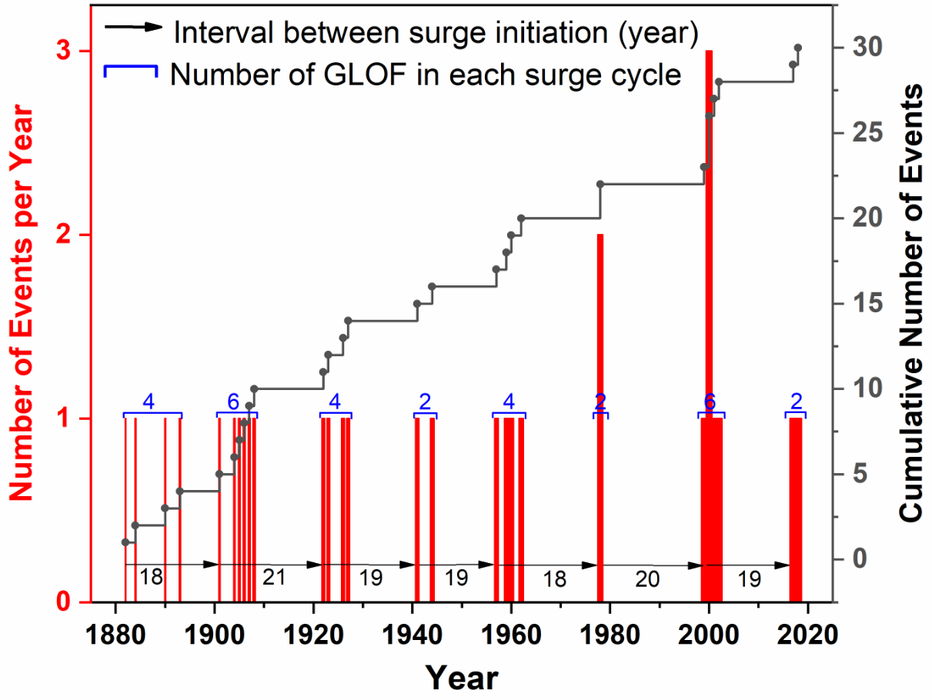
During an individual surge, GLOFs can occur grouped in time which grouping is referred to here as a ‘series’ of singular GLOF ‘events’; whilst an ‘interval’ is the period of time between surges. Figure 3 shows the correlation between the timing of the series of ice dams and surge intervals. From 1880 to 2020, eight series of GLOFs could be identified during which the river was blocked due to the surge, leading to GLOFs. There were seven periods of surges, at intervals of 19–20 years, during which 30 GLOF events occurred (within eight GLOFs series) with at least two GLOFs in each series. The average number of GLOFs in each series was three to four, with a maximum of six events (in 1901-1908 and again in 1999-2002) (Fig. 3). These intervals were recognized based on the first and last GLOF event of the series. An arrow in Fig. 3 shows the interval between surges. Three series of GLOFs were identified based on remote sensing, constituted of ten GLOF events (Table S2) between 1978–1979, 1999–2002, and 2017–2018. However, only two series were detected in the optical images (Table 2), that is, 1999–2002 (only three GLOFs out of six GLOF events in this time interval were detected (Table 2 and S2)) and 2017–2018 (two events). The other three events during 1999–2002 were confirmed from local information, news, and literature Hewitt and Liu (2010). Two events, for which optical images could not be captured, were reported for the surge period 1977–1979 (Goudie et al., 1984; Kreutzmann, 1994). The GLOFs occurred during the last two surges were used as evidence of the surge and GLOF relationship in Figure 4.
Figure 3. GLOF record for the Khurdopin Glacier from 1880 to 2020, obtained from the archive and remote sensing data. The red bars show the number of GLOFs per year, while the grey line shows the cumulative number of events in the investigated period.

4.2. Recent glacier surge characteristics and river flow disturbances
Figure 4 shows the flow dynamics of the Khurdopin Glacier from 1973 to 2020 and the three surge cycles (1977–1979, 1998–2002, and 2016–2020). Figures 4a–d present the changes of the surface features of the Khurdopin Glacier during the surge cycles. The glacier surface exhibits curved lines in 1973 (Fig. 4a) and also curved end moraines indicated that the glacier surged several times (Quincey and Luckman, 2014). Based on the Landsat imagery archive and the analysis of cross-section and terminus changes, the first surge occurred between 1973 and 1979. Figures 4a–b show that the glacier terminus remained unchanged between 1973–1977 and even slightly shrank (Quincey and Luckman, 2014). The glacier terminus started to advance in 1977, leading to disturbance in the terminus zone (Fig. 4b). This advance continued until 1978 and was associated with minor river blockage with production of a small GLOF. In the summer of 1979, the glacier movement reached its peak and blocked the river completely (Fig. 4d). Because of a lack of images, the glacier displacement after 1979 could not be analyzed. The next available image was for June 1986. At that time, the glacier surge had terminated, the glacier front had expanded sideways, and river blockage occurred on the right side of the glacier. During this period (1979-1986), there was no report of a GLOF from residents of Shimshal, local news, and the scientific literature. Overall the first surge only recorded two GLOF events during 1978 and 1979 (Kreutzmann, 1994).
We estimated the annual surface velocities of the glacier from 1986 to 2020 to detect surge events (Figs 4e and f) and to determine the correlations with GLOF events (Fig. 4g). Using the data obtained over 34 years, the mean surface velocity of the glacier during the quiescent phase was estimated to be 79 m/y (Fig. 4g). Based on Figs 4e, f, and g, the second surge active phase occurred between 1998–2002, with the pre-surge period between 1994 and 1997. The entire period lasted for eight years and included six recorded GLOF events. In contrast, the third surge (2016–2020) lasted for six years, with the pre-surge period initiated in 2014 and so far has produced two GLOF events. During the initial stage of the second (1994–1995) and third (2014–2015) surge cycles, the velocities reached more than 230 ± 8.94 m/y (Figs 4e and f). The maximum surge velocities were detected in 1998–1999 and 2016–2017, with values of 494 ± 12.2 and 573 ± 13.78 m/y, respectively (Figs 4e and f). In contrast, the average velocity during surge periods was 170 and 182 m/y (more than twice the average during quiescence) for the intervals 1995-2002 and 2014-2020, respectively (Fig. 4g). The peak velocities reached 314 ± 10.2 and 343 ± 10.5 m/y in 1998–1999 and 2016–2017, respectively (Fig. 4g). The surface profiles show that the glacier movement was highly variable in space and time.
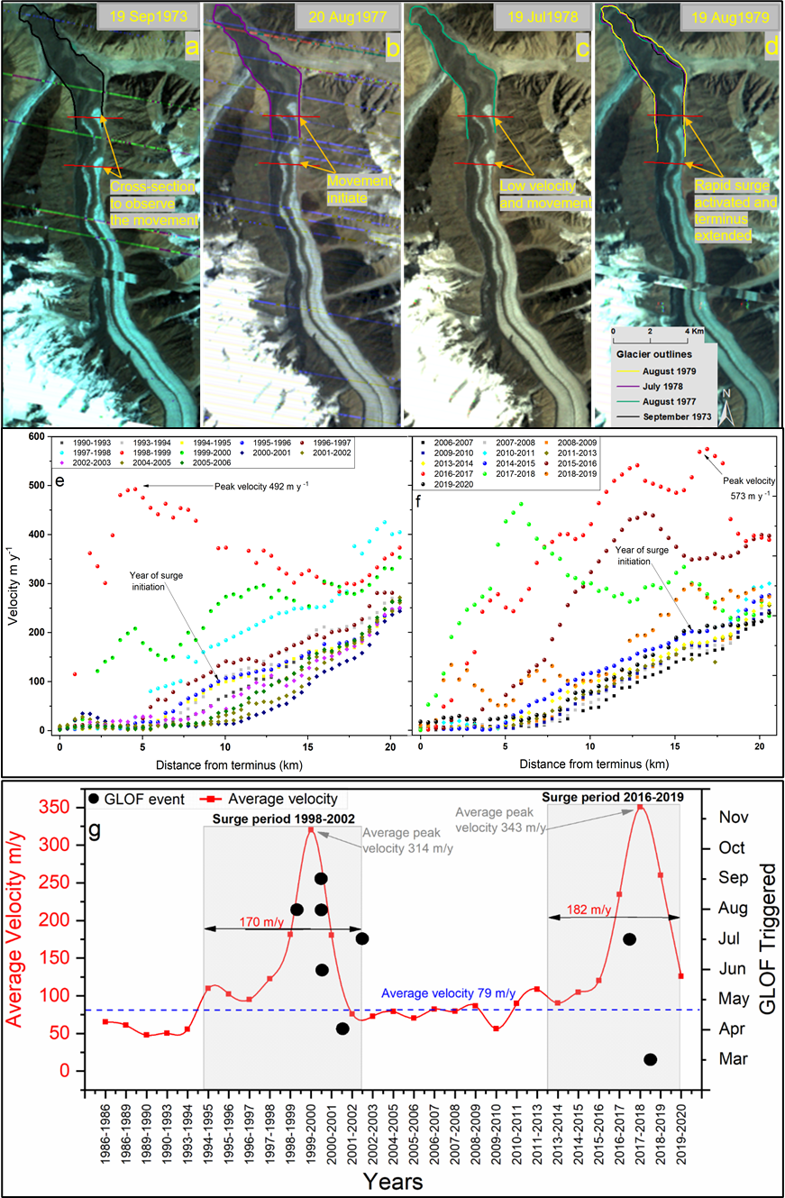
Figure 4. Variation in the annual velocity of the Khurdopin Glacier during three surge cycles in the periods 1973–1979 and 1986–2020: (a–d) Surface feature movement due to the first surge; (e–f) the glacier surge initiation, annual velocity peaked, and then in the phase of the quiescent period during both surge period; (g) average velocity of two surge cycles (based on e and f) and correlation between the glacier surges and GLOFs.
We determined the daily glacier surface velocities during the active phase of two surge cycles (1998–2002 and 2016–2020) to highlight the velocity change, which affected the glacier terminus, lake formation, river flow, subglacial flow, and GLOFs (Fig 5a–b). The quiescent phase between the first and second surges ended in 1994, and the glacier exhibited a higher velocity in the accumulation zone in 1995. The velocity gradually increased from 1994 to 1995 (Fig. 4e, g). During the initial surge, the velocity increased from 1.2 ± 0.01 to ~3.00 ± 0.20 m/d in the accumulation zone from August 1997 to July 1998. From July 1998, the glacier ice movement began to disturb the terminus zone, and it partially affected the river flow. Figure 5a shows that the glacier terminus moved by ~250 ± 8 m toward the river in November 1998 and partially blocked the flow. From November 1998 to August 1999, the maximum surface velocity of 2.30 ± 0.10 m/d was recorded in the terminus zone. The river flow was blocked, leading to a small flood (local sources and Hewitt and Liu (2010). At the same time, the glacier mass moved ~15 km downward from the accumulation zone at a low velocity of ~0.30 ± 0.04 m/d. The deceleration from the accumulation zone to the terminus continued until April 2002, with an average velocity of 0.50 ± 0.06 m/d. A mini-surge occurred, followed by an increase in the velocity in the accumulation zone by June, reaching a peak of 1.30 ± 0.08 m/d in the terminus zone in July. The surge lasted for seven years and terminated in winter 2002 with a velocity of ~0.30 ± 0.04 m/d. River flow through the subglacial conduit flowed for six years between August 1999 and April 2004 (Fig. 5a).
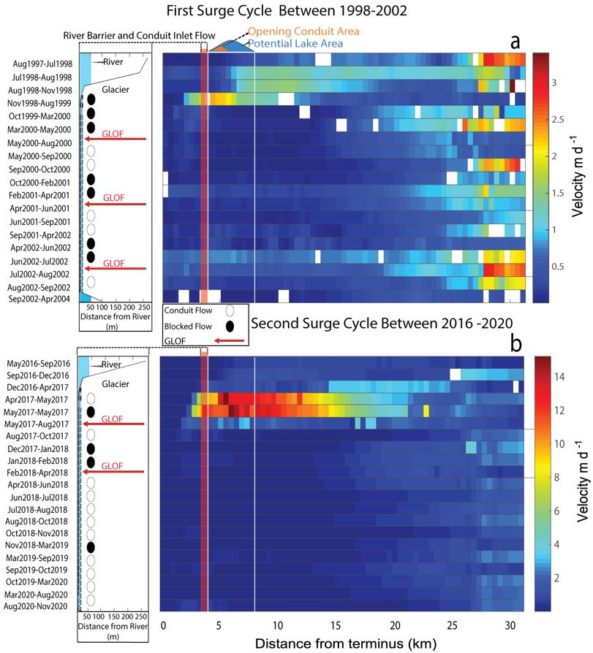
Figure 5. Surge cycle behavior: (a) 1998-2002; (b) 2016-2020. Measurement of the glacier velocity per day and the frontal changes which led to the development of ice-dammed lake (only major floods highlighted in the figure) due to blocked river flow for each surge, followed by re-establishment of river flow after GLOF events.
The third surge phase lasted for four years from winter 2016 to 2020, that is ~19 years after the previous one. The glacier quiescence and accumulation period lasted ~10 years from 2003 to 2013. Initially, glacier surface velocities above 0.50 ± 0.07 m/d were recorded in the steep section (14–20 km) in 2013, whereas the velocity in the terminus zone was only 0.100 ± 0.005 m/d. The velocities gradually increased within the accumulation zone from 2014 to 2016. For example, from May to September 2016, the velocity increased within the accumulation zone from 0.9 ± 0.003 m/d to 4.50 ± 0.21 m/d; from December 2016 to April 2017, an active surge started at the steep zone of the glacier (between 15-25 km above the terminus zone) (Fig. 5b). The terminus movements started to block the river flow. The maximum surface velocity reached ~15.00 ± 0.06 m/d between April and May 2017, three to eight kilometers above the glacier tongue, representing the highest value ever recorded for Karakoram glaciers (Fig. 5b). One GLOF occurred in July during the active surge phase. The surface velocity then decreased to ~1.00 ± 0.12 m/d in October 2017. Overall, the average surface velocity in the accumulation zone from May to August 2017 was below 1.00 ± 0.12 m/d (Fig. 5b). A high surface velocity may imply higher mass transfer from the accumulation zone to the terminus zone, resulting in a higher surface elevation in the ablation zone during the 2016–2020 surge than during the 1998–2002 surge (Bazai et al., 2021).

4.3 GLOF Simulation
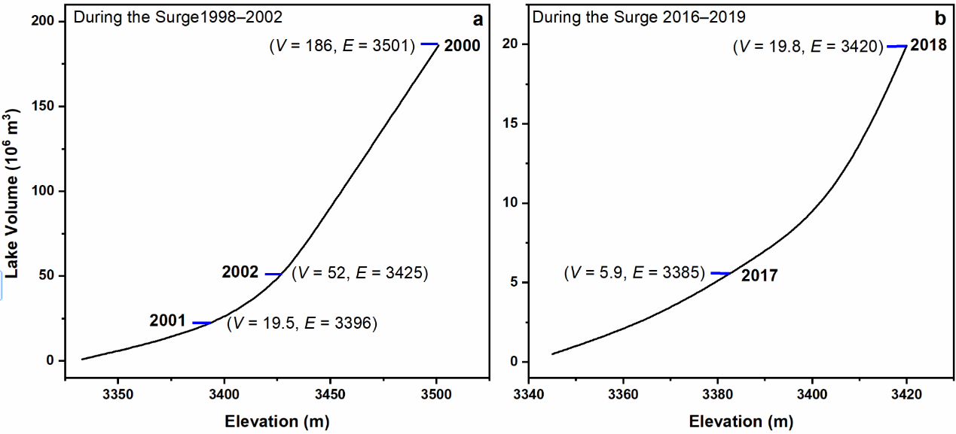
The surge periods produced a series of lakes in each cycle. Two lakes were selected for further analysis from these series because of the different conduit layouts, lengths, higher volumes, and greater disaster potential (Fig. 6 and Tables 2 and S2). During the second surge period, the first lake outburst flood occurred by August 1999; after four months, the second lake formed in December 1999, due to conduit blockage (Table S2). The lake gradually expanded until late spring, as captured in Landsat and TM images obtained from May 6–14, 2000. The peak lake volume before the flood was estimated to be 186 ± 2.1 × 10⁶ m³ using UAV DEM data (Fig. 6a); see also Cook and Quincey (2015) (Tables 2 and S2). This value represents the largest lake volume documented for the Karakoram in recent years. The lake drained through a 2.7 km long conduit in the thicker zone of the glacier terminus. During the third surge, the first lake outburst occurred between July 21 and 24, 2017. The lake reformed on November 1, 2017, and gradually expanded until March 2018. The lake volume was estimated to be 19.8 ± 0.9 × 10⁶ m³ on March 15. The lake drained on March 18, 2018, through a marginal conduit with a length of 1.9 km. Based on the field observations, we assume that the lake formed because of the conduit collapse, because the depression of the collapse was visible on high-resolution GF-2 images, instead of by glacier movement.
Figure 6. Estimated volumes (V) of five Khurdopin lake outburst floods that occurred during two surge cycles as lake elevation (E) varies: (a) 1998-2002; (b) 2016-2020. The maximum lake volume of each surge cycle was used for the simulations.
4.3.1 Breaching of ice dam
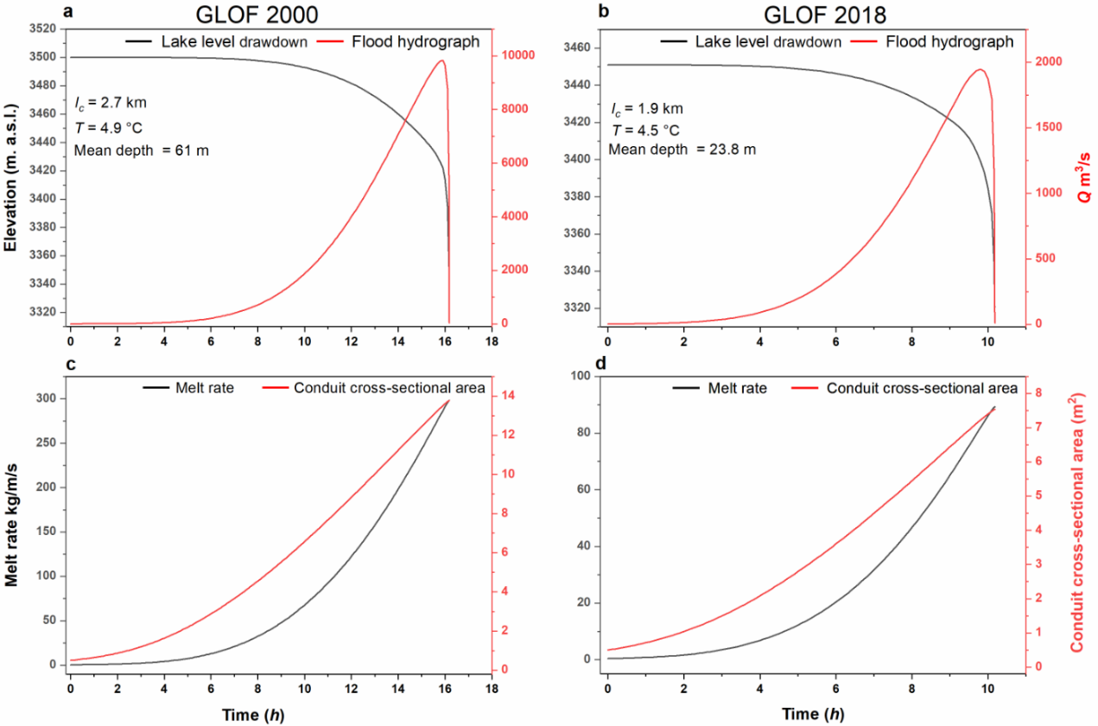
We employed the subglacial Nye (1976) model, which was updated by Carrivick et al. (2017) to simulate two GLOF events that occurred on June 11, 2000, and March 18, 2018, respectively. Based on the simulation, the peak discharges of the 2000 and 2018 GLOFs were 10,000 m³/s and 1960 m³/s, respectively. During the simulations, the melt rate reached 300 and 90 kg/m/s respectively (Figs 7c and d), and simulated final conduit diameters of 14 and 7.5 m were obtained, respectively. To reduce uncertainties, sensitivity analyses of the simulated discharge were conducted for the temperature, conduit length, Manning roughness (n’), and inflow rate variations, which were the main variables affecting the ice melting rate. To ensure that the simulated discharge results (Figs 7a and b) are reasonable, we input the simulated conduit discharge curve into the downstream channel geometry by using the 2D hydrodynamic model, thus simulating flood evolution, and found that the simulated flood flow depths fit well with the observed flood levels at two cross-sections in the field.
Figure 7. Khurdopin lake simulations: (a, b) Flood hydrographs and lake level drawdown; (c, d) Enlargement of cross-section and melt rate of conduit during the breaching process. The parameter l_{c} in panels a and b represents the conduit length, T is lake temperature.
The initial model was run with the data summarized in Tables 1 and 2. The modeled peak discharge, Q, shown in Fig 7a and b, decreases and reaches zero after 16 and 10 hours for the 2000 and 2018 flood events, respectively. Rapid recession also has been reported by Carling (2013) in the Altai palaeofloods and by other researchers (Bjornsson, 2009; Carrivick et al., 2017; Clarke and Garry, 2003; Roberts, 2005) for similar modern floods. Once the lake level falls lower than the conduit inlet elevation, the discharge rate abruptly decreases (Carrivick et al., 2017). While this decrease reflects the reservoir depletion, some water continues to drain from the conduit and crevasse system, leading to a tail to the hydrograph. In the above-mentioned simulated cases, the possibility of conduit collapse, partial closure, and ice jams in the conduit during the drainage were ignored, due to the lack of observation data and thus are assumed not to have occurred. The hydrograph shows a similar trend of rising and falling limbs to the observed data of outburst floods from a volcanically-dammed lake reported by Bjrnsson (2003) and slighter slower rising hydrograph limbs in comparison with Grímsvötn floods events ((Roberts, 2005).
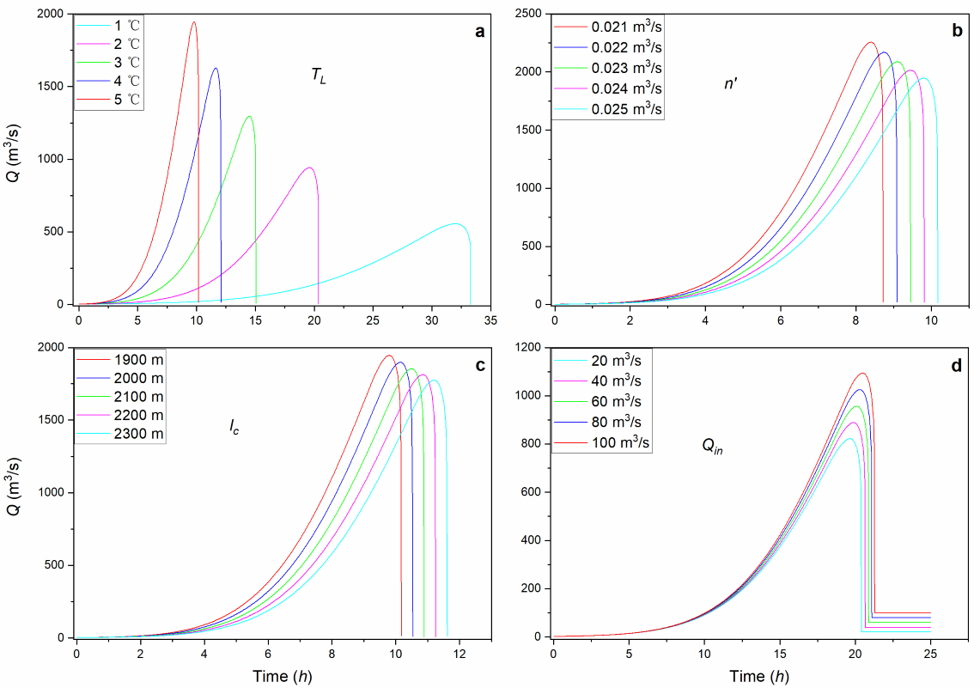
The results of the sensitivity analysis for the 2018 event, which included a specific set of model parameters, are shown in Figs 8a–d. The model sensitivity might differ outside of this parameter space. The sensitivity analysis shows that the lake water temperature has a stronger effect on the hydrograph than other variables. This result is in agreement with Werder et al. (2010), who studied modern cases of subglacial drainage of a supraglacial lake and showed the temperature effect on the hydrograph. A temperature change of a few degrees Celsius significantly affects the hydrograph, as shown in Fig. 8a and Fig S3. At 5 °C, the flood released suddenly (peak discharge reached after 8-10 hours) and hydrographs are similar for 4 or 5 °C, but become increasingly skewed as the temperature is reduced. Hence, at 1 °C, the discharge rate is low and the flood duration increases to nearly 34 h. During the sensitivity test, the conduit length l_{c} and Manning roughness n’ were varied within a conceivable range, but had a lower influence than the lake temperature. Carrivick et al. (2017) reported that the curve of the rising limb of the simulated hydrograph is sensitive to n’, but the maximum discharge is only sensitive to l_{c}. We did not observe a significant effect of n’ on the hydrograph shape but on the timing and magnitude of peak discharge, but we lacked specific roughness data. It has also been reported that the hydrograph is very sensitive to Q_{in} (Carrivick et al., 2017). Therefore, we varied the values of Q_{in}. Based on the flood sensitivity analysis result, we conclude that the temperature variations are the main control on the peak magnitude and flood duration.
Figure 8. Sensitivity analysis showing the effect of changes of individual parameters on the flood hydrograph for the 2018 event: a) lake water temperature; b) Manning roughness; c) conduit length; and d) estimated lake inflow rate.

4.3.2. Flood route and field evidence for the GLOF simulation
The ice-dammed lake, with an estimated volume of ~186 ± 2.1 × 10⁶ m³ (Fig. 6a), drained through a 2.7 km long subglacial conduit on June 11, 2000, and the peak discharge was simulated to be ~10,000 m³/s (Fig. 7a). The GLOF, which flowed downstream over a distance of ~78 km into the natural Atta-Abad Lake, was reconstructed using the 2D hydrodynamic model (Fig. 9a) assuming that the lake drained completely. The flow depth and field evidence are shown in Figs 9a–d. The flow depth and velocity varied greatly between the initiation point at the Khurdopin lake and the endpoint, that is, the Atta-Abad Lake, which was reached after 20 h (Fig. S5). After 2 h, the maximum flow depth at the terminus of the Yazdghil Glacier was ~27 m (5 km downstream from the Khurdopin Glacier; Figs S5a). The backwater at the channel narrowing in correspondence of the Yazdghil terminus contributed to the locally large flow depth. At the Malangutti Glacier (25 km downstream), the maximum depth also reached 27 m after 6 h (Fig S5b). These tributary glacier extensions delayed the downstream routing of the GLOF. The GLOF had a flow depth of 4 to 8 m in the main river close to Shimshal village, leading to ~1 to 4 m depth of inundation of residential areas and agricultural land. The flood washed out three bridges (1, 2, and 7) and caused major damage to other bridges (local source). It took ~16–17 h for this GLOF to propagate from the Shimshal Valley to the Passu village and the Karakoram Highway (Fig 9a and S5c-d). Greater damage was caused in the Hussaini and Gulmit villages due to the narrow river section: the flood reached the area ~19 to 20 h after the breach, with a flow depth of 8 to 12 m.
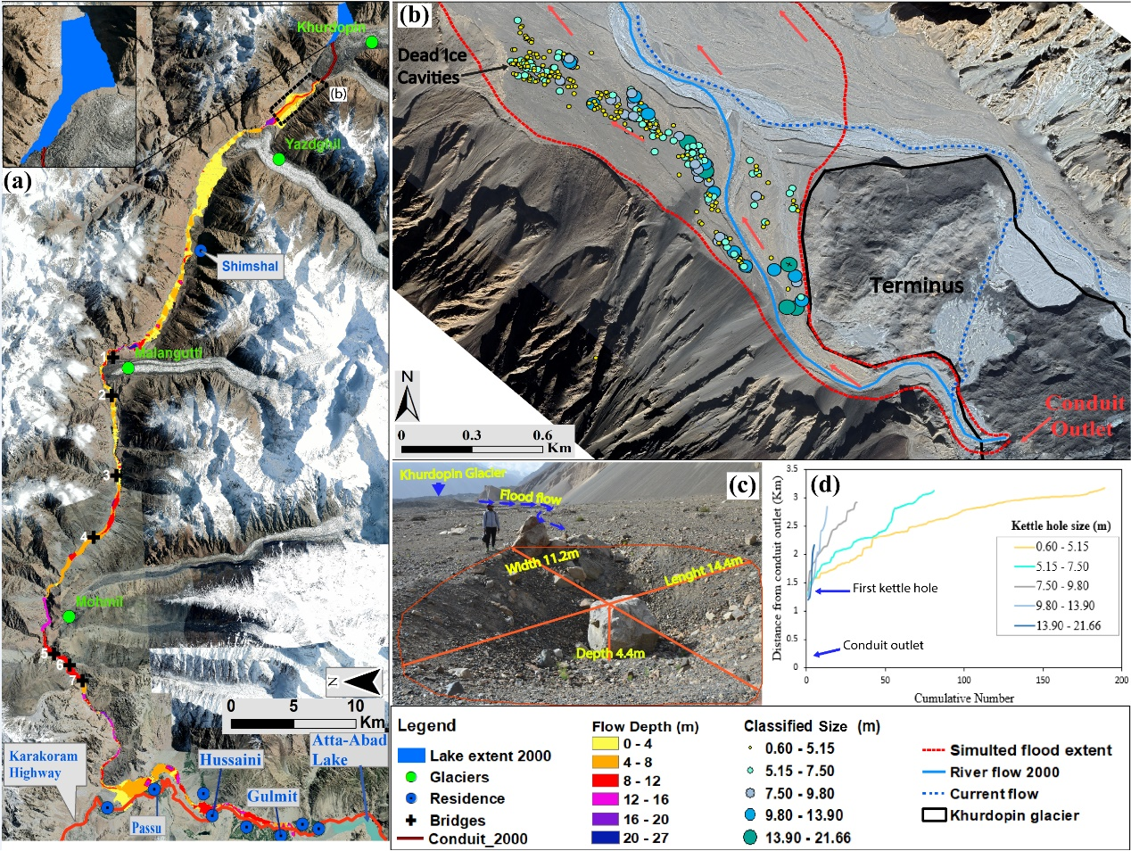
Figure 9. Flood simulation and field evidences for the 2000 GLOF event: (a) Simulations of the lake outburst flood depths; (b–c) Field evidence of compilation and measurement of kettle holes during the field survey: kettle holes/dead ice cavities areas were classified into five categories; (d) cumulative number of kettle holes with distance from conduit outlet. The red arrows in (b) and the blue arrows in (c) indicate the flood flow direction. Backgrounds in panels (a) and (b) are high-resolution Google Earth images (September 2020).
The presence of kettle holes is evidence of GLOFs, as has been reported for Iceland (Marren, 2002). In the area between 1.2 and 4 km downstream from the conduit outlet, we identified a group of kettle holes in the floodplain on the left bank of the Shimshal River (Figs. 9b and S4b). The kettle holes result from the melting of stranded ice floes from the ice dam during the 2000 GLOF (statement of local residents; Fig. 9c-d). GLOFs transport ice floes over a limited distance (Marren and Schuh, 2009), rarely exceeding a few hundred meters from the discharge outlet conduit. However, in our case, kettle holes also developed up to ~4 km downstream. As the largest kettle holes were identified along the river bank close to outlet point, simulation of the flow depth within the kettle hole region explored the possibility that the flood depth was sufficient to have transported the ice boulders. Where the simulated flood flow covered areas of kettle holes, the flood flow depth estimated was ~4–8 m (Figs 9a and S4a), with the depth in the main stream ~8 to 12 m. The downstream decrease in kettle hole size is consistent with a previous study conducted in Iceland (Marren et al., 2014; Marren, 2002); more detail in supplementary S5.
A minor flood occurred on March 18, 2018 related to the outburst of a lake that formed on November 1, 2017. The lake location is similar to that of the 2000 flood event, but the conduit differs. During the flood, the lake, with a volume of 19.8 ± 0.9 × 10⁶ m³ (Fig. 6b), completely drained along a conduit length of 1.9 km. The peak discharge was simulated to be 1960 m³/s, reaching the Atta-Abad Lake after 18 h (Figs 10a and S7a-d). The flood caused minor damage to agricultural land, bridges, and other infrastructure. The flow depth reached its maximum (~8–12 m) close to the termini of the Yazdghil and Malangutti glaciers. Downstream, the river cross-section narrows, impounding a considerable backwater until the end of the flood; the depth gradually decreased to ~6 m when the water flowed into the Atta-Abad Lake. Higher flow depths were found in the narrow outlet area of the valley (~9–12 m) and close to the Atta-Abad Lake residential area (~6–9 m). During the flood, bridges 5, 6, and 7 were severely damaged. The highest river level was simulated and recorded in the Husaini and Gulmit villages, but no damage was reported (Fig. 10a).
As a flood evolves, rheological transformations can occur in both space and time (Westoby et al., 2014; Worni et al., 2014) as sediment is entrained or disentrained. In the case of ice-dammed GLOFs, ice boulders are dominantly transported in the initial clear-water flood phase; the flood then entrains and transports river sediments and deposits them in flooded areas (Marren et al., 2014; Marren and Schuh, 2009; Russell et al., 2002), as identified for the 2018 flood. The sedimentary evidence of the flood extent for the 2018 GLOF (Figs S6a-d) was based on two cross-sections (Fig 10b, d). Both of them are well-confined bedrock channel sections in the front of the Yazdghil and Malangutti glacier tongues, respectively. The GLOF sediment consists of both moderately sorted sand and gravels which is stratified (Fig. S6a-d) (whoever, the majority of gigantic blocks (Fig. S6a) are already there, and it is the residue of the Yazdghil Glacier moraine or debris, but the smaller ones and the sediments around are all from the 2018 GLOF (Fig. S6b)). The sedimentary section at cross-section AA′, revealed a 0.4 m thick deposit, indicating a flood level ~8.9 m higher than the current water surface (Fig.S6a, b). At same point the simulated water depth was predicted to be ~7.2 m, 1.7 m lower than the observed level (Fig. 10c). As shown in Fig.S6c, d, only a thin sheet of flood deposits drapes the bedrock terrace at cross-section BB′ (Fig. 10d), which is composed of well-sorted sand and silt. Those deposits attest a flood level around 13.9 m higher than the current water surface. At this section, flood simulation predicts a maximum flood level of ~11.3 m, 2.6 m lower than the observed level (Fig. 10e). Given the difficulty in parameterizing the GLOF system, these discrepancies between simulated flood levels and the levels of sediment deposition are reasonable.
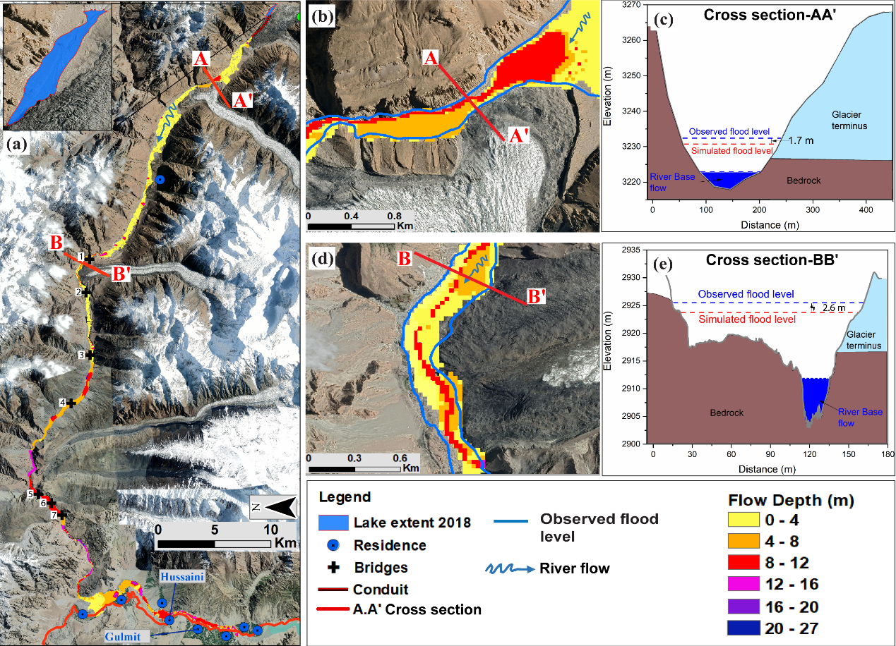
Figure 10. Relationship of sedimentary field data to flood simulations: (a) Simulated Lake outburst flood in 2018; (b-e) Simulated and observed flood levels for cross sections AA′ and BB′.

Discussion

5.1. Surge reoccurrence interval based on the GLOF database
The glacier surge interval in the Karakoram region has been documented to change in response to climate change worldwide (Kienholz et al., 2017; Striberger et al., 2011). The interval of glacier surges varies from region to region in response to climate change, and thus the ice-dammed lake outburst floods respond accordingly (Bazai et al., 2021; Bjrnsson, 2003; Carrivick and Tweed, 2016; Harrison et al., 2018). Striberger et al. (2011) concluded that the surge return period in Iceland for the Eyjabakkajokull changed from the 17th–18th century to modern times from 21–23 to 34–38 years, due to climate change. Svalbard glaciers shrunk between 1936 and 1990, with a concomitant change in the surge intervals (Dowdeswell et al., 1995). This surge variation, when contrasting glaciers, can be explained by the reduction of mass within the accumulation zone, often not being sufficient to modulate the surge behavior and the reoccurrence interval time (Cuffey and Paterson, 2010; Kienholz et al., 2017).
Considering regional variability, some glaciers surge at irregular intervals with sudden advances as surging in those cases only requires the mass gain in the accumulation zone to reach a well-defined value, as is the case for Variegated Glacier in southeast Alaska (Eisen et al., 2001; Eisen et al., 2005) and for the Medvezhiy Glacier, Pamirs (Dyurgerov et al., 1985). Some glacier surge intervals are not well defined but repeatedly produce GLOFs; for example, the Horcones Inferior and Grande del Nevado glaciers in Central Andes of Chile and Argentina (Pitte et al., 2016) and the glacier in Karamber and Shyok valleys, in the Karakoram (Bazai et al., 2021). Therefore, as GLOFs often are better recorded than glacier surges, there is the potential to explore surging through interrogating the intervals within GLOF data sets worldwide. Assuming that this assumption is correct, surge intervals can be back-calculated (Fig. 3) and compared to know timing of lake development (Fig. 4g). Such an approach may lead to better prediction of surge intervals, to advance the detection and timing of repeatedly forming ice-dammed lakes and the frequency and magnitude of GLOFs in response to climate change. Examples of surge glaciers where such analysis could prove fruitful include: Karakoram ─ Kyager, Shishper, Chilinji glaciers; Tian Shan ─ Merzbacher glacier; Pamirs ─ Medvezhi Glacier; West Greenland ─ Russell Glacier; Central Andes ─ Horcones Inferior and Grande del Nevado Glaciers; Yukon ─ Lowell and Donjek Glacier; Alaska ─ Hubbard Glacier, and some Norwegian glaciers.
It has been suggested that Karakoram lakes only form and generate floods during glacier surges and advances (Haemmig et al., 2014; Quincey and Luckman, 2014). Therefore, we developed a surge interval record for the Khurdopin Glacier based on the GLOF dataset (Fig. 3). We documented seven surge periods from 1880 to 2020 for the Khurdopin Glacier with a reoccurrence interval of 19–20 years (Table S2). Three surge cycles were identified by Quincey and Luckman (2014). The glacier area significantly decreased between 1940–1970 due to an increase in the winter temperature (Fowler and Archer, 2006), but the surge interval of the Khurdopin Glacier did not change (probably due to the short period of snow reduction); a similar response as over five decades (from 1970) for the Kyager, Chilinji and Shishper glaciers (Bazai et al., 2021). Where these glaciers surged the advancement and ice transfer to the termini were small in comparison with recent surges (Bazai et al., 2021; Hewitt, 2005). On the contrary, the surge interval of the Chong Kumdan and Kichik Kumdan glaciers in Shyok Valley; Shinghi in Shaksgam Valley; Machuher in Hassanabad and Karamber glacier in Ishkoman Valley changed after 1940 (Bhambri et al., 2019).
For all the three surges periods investigated in this study (1973–1979, 1998–2002, 2016–2020), the Khurdopin Glacier exhibited four years of pre-surge acceleration before the main surge occurred (Fig. 4a-d and g). During the pre-surge period the velocity rose to 1.2 ± 0.01 to ~3.00 ± 0.20 m/d and to 0.9 ± 0.003 m/d to 4.50 ± 0.21 m/d in the accumulation zone from August 1997 to July 1998 and from December 2016 to April 2017, respectively (Fig. 5a, b). Quincey and Luckman (2014) and Steiner et al. (2018) reported the same velocity behavior for the surges of 1973–1979 and 2016–2020, respectively. The glaciers exhibited the same behavior during the pre-surge period for all three cases; however, the peak surge velocity throughout the active surge phase was different. The surge velocity between 1998–2002 was slower than 2016–2020 (Fig. 5a, b), thus the 1998–2002 surge period generated a high number of GLOFs. It is difficult to establish the main drivers for regular pre-surge periods, reoccurrence intervals and surges velocity variation with respect to Khurdopin Glacier (Quincey and Luckman, 2014). Some other glaciers in the Karakoram show similar behavior, so a model for Khurdopin behavior has a potential regional application. For example, Round et al. (2017) observed a 2.5 year pre-surge period for the Kyager Glacier and an unnamed glacier in the Yarkand basin is thought to exhibit a four-year pre-surge period (Singh et al., 2020). In contrast, in some cases, such as the Shishper Glacier surge in 2017–2020 (Bazai et al., 2021; Bhambri et al., 2020) and the Hisper Glacier surge in 2015–2016 (Guo et al., 2020; Rashid et al., 2018), there was no evidence of a pre-surge. Thus, it appears that the timing of the active surge for the Khurdopin Glacier may be forecasted more readily than for some other glaciers in the region. Maximum surge velocities for surge-type glaciers tend to occur during summer seasons (Fig. 4 and 5), likely due to a thermal control (Farinotti et al., 2020; Quincey et al., 2011); however, the surge behavior is dominated by basal sliding (Quincey and Luckman, 2014), which also plays a dominant role in glacier advance (Mayer et al., 2011; Quincey and Luckman, 2014; Round et al., 2017). Similar conclusions have been developed for the Kyager Glacier (Round et al., 2017) and Alaskan glaciers (Kamb et al., 1985). This surge modulating behavior implies that the subglacial drainage process also is related to summer surface melt combined with basal sliding.
Changes in the magnitude and frequency of glacier surges and GLOFs around the world are assumed to be caused by climate change (Clague and O’Connor, 2021; Dyurgerov et al., 1985; Eisen et al., 2001; Hock et al., 2019; Kienholz et al., 2017; Pitte et al., 2016; Sevestre et al., 2015). Indeed, the glacial surge frequency for the Khurdopin, Kyager, Shishper, and Chilinji glaciers in the Karakoram remained constant throughout the previous century (Bazai et al., 2021; Steiner et al., 2018). However, in the Karakoram region, there was a decrease in GLOFs frequency during the glacier reduction period 1940–1970, and an increased surge and GLOF frequency in recent decades (Steiner et al., 2018). These magnitude and frequency changes of surges and GLOFs have been related to glacier mass balance induced by climatic conditions (Bazai et al., 2021; Bhambri et al., 2017). The increase and decrease numbers of GLOFs potentially can be linked to the negative and positive mass balance in response to climate change.

5.2. Lake formation in response to mass transfer
As shown in Figure 4g, the lakes formed during the active surge phase, when the glacier terminus expanded, advanced and blocked the river (Fig. 11a-l and Fig. S8a-q) (Bazai et al., 2021; Bhambri et al., 2019; Bjornsson, 2009). The 1999 and 2017 events are good examples of lake formation and subsequent GLOFs, due to glacier surging (Fig. 11k). Round et al. (2017) presented similar results for the Kyager Glacier Lake outburst flood in July 2015. The disturbances are evident when the active phase reaches the glacier terminus (highlighted in Fig. S8c and o). During these disturbances, the probability of forming small lakes increases, yet these quickly drain due to an active subglacial drainage system; subglacial-cavities form, open and close and crevasse density is generally increasing (Bazai et al., 2021; Iturrizaga, 2005b; Kamb et al., 1985; Round et al., 2017).
Despite some discrepancies in glacier behavior when compared with the Khurdopin, the same general behavior was seen for: Karakoram ─ Shishper, Chilinji and Kyager glaciers (Bazai et al., 2021; Bhambri et al., 2020; Round et al., 2017); Pamirs ─ Medvezhi (Dyurgerov et al., 1985; Kotlyakov et al., 2018), Karayaylak (Shangguan et al., 2016) and Geographical Society Glaciers; (Haeberli et al., 2014; Kotlyakov et al., 2018); Central Andes ─ the Horcones Inferior (Pitte et al., 2016) and Grande del Nevado Glacier (Del Rossrio Prieto, 1986; Espizua and Bengochea, 1990). In contrast, Björnsson (1998) presented an example of a GLOF that occurred after a surge had terminated for the Skeiðarárjökull, which may reflect different glacier geometry, topography and climatic conditions.
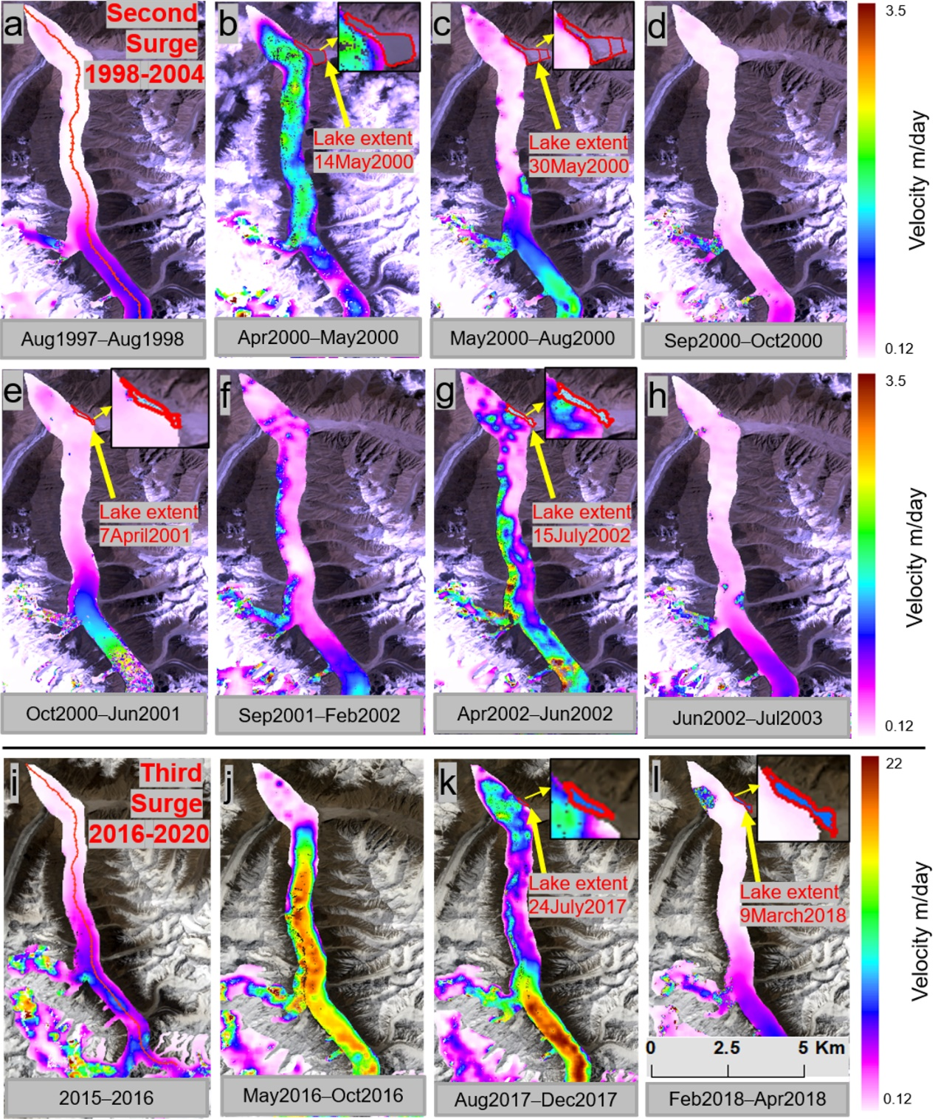
After the active surge period, we observed high volume lakes during 2000 and 2018 and following years, compared with the first lakes in 1999 and 2017 (Fig. 11 b-c and l and table 2). This effect primarily depends on glacier velocity, mass transfer, and subglacial system development (Bazai et al., 2021; Kamb et al., 1985; Round et al., 2017). Further, we observed a close relationship between average glacier velocity in the entire surge period and the number of GLOFs (Fig. 11 a-l and Fig. S8 a-q). Figures 4g, 5 and 11 show that the low-velocity surge in 1998–2002 led to the formation of more and larger lakes, compared with the surge of 2016–2020. Lower ice flow velocities, observed mainly in the winter, are associated with the formation of lakes during winter (except the first lakes in 1999, 2017) (Table S2). Based on these results, during the glacier surge, the quantity of ice moved towards the terminus can significantly influence conduit variations due to the crevasses’ fluctuation, directly impacting the number of lakes and lake volumes. This outcome indicates that slower ice flow in winter is favorable for the formation of larger ice-dammed lakes, which then outburst in summer due to the relatively stronger ice movement and higher ablation rates (Tweed and Russell, 1999).
Figure 11. Formation of the Khurdopin Glacier Lake (zoom in panels b, c, e, g, k, l) in response to mass transfer from the accumulation zone to the terminus zone during the second (a–h) and third surges.
The glacier movement is the source of outburst flood in the summer season, as we observed since 2000 that the triggered lakes from Khurdopin glaciers are mostly dominant during summer months (from July to August). Bazai et al. (2021) concluded that 67% of Karakorum region GLOFs have occurred between these months. Hewitt and Liu (2010) stated that the outburst floods are linked to summer temperatures which facilitate melting at the glacier surface, which water is transferred to the base, enhancing the basal movement of the glacier (Round et al., 2017) and initiate increased glacier velocities in late spring. These glacier movements in the summer months increase the number of crevasses and the connectivity of sub-glacial conduits. Inflow to reservoirs and pressure from the lakes promote the chances of GLOFs in these months (Bazai et al., 2021; Hewitt and Liu, 2010). One expects all these conditions to be affected by climate change, but present Karakoram developments suggest a complex rather than simple response to global warming.

5.3. Subglacial hydrological system, enlargement of the conduit, and downstream propagation of the flood
Several attempts have been made to analyze the subglacial outburst flow from the Russell Glacier in Greenland (Carrivick et al., 2017), the Merzbacher Glacier Lake in the Tianshan Mountains (Ng, 2007), and subglacial lakes of the Grímsvötn Glacier in Iceland (Einarsson et al., 2016; Roberts, 2005) using subglacial models (Clarke, 1982; Joseph et al., 1996; Nye, 1976; Spring and Hutter, 1981). However, the Karakoram glaciers have not been studied in detail. Our simulation highlights the thermomechanical characteristics of the floods simulated for the 2000 and 2018 events at the Khurdopin Glacier. Several features affect the dynamics of the subglacial hydrological system during the rapid change of the water input. Notably, the dynamics are complex and depend on the state of the subglacial drainage system and on the bed geometry of the glacier. Based on the simulated results (Figs 7 and 8), melt enlargement of the conduit is the dominant and most influencing factor, which is also reported for Merzbacher Glacier Lake in the Tianshan Mountains by Ng (2007), with viscous closure being negligible in comparison (Carrivick et al., 2017). Equation (4) shows that the deletion or doubling of the closure term merely affects the simulated peak discharge. The low value for the closure term is mainly due to the low overburden pressure of the thin ice dam in the case of the 2018 flood and partially due to other factors affecting the extreme melt rate. The rapid declining discharge is caused by the drop in the hydraulic gradient as the lake level drops towards zero after reaching the peak, rather than by conduit closure by the ice creep or ice collapse. It is important to model this behavior for the Khurdopin Glacier by including the effective pressure gradient in Eq (2). Our results, therefore, show that the conduit tends to expand during the peak discharge, with the developing hydraulic gradient causing the melt rate to reach a maximum and then decrease (Figs 7a, b). Rapidly rising limbs also have been reported prior: Merzbacher Glacier Lake in the Tianshan (Ng, 2007; Shen et al., 2007); Russell Glacier in Greenland (Carrivick et al., 2017); Skeiðarárjökull and Grímsvötn glaciers in Iceland (Bjornsson, 2009; Clarke and Garry, 2003); Lowell and Steele Glacier in Yukon region in northwest Canada (Clarke, 1982). Thus, the hydrographs obtained for the Khurdopin Glacier Lake are compatible with theory and with other modelled results and monitored GLOFs (Bjornsson, 2009; Björnsson, 1998; Bjrnsson, 2003; Carrivick et al., 2017; Clague and Connor, 2015; Ng, 2007).
The melt enlargement of the conduit dominated the evolution of the Khurdopin outburst floods, which enabled further determination of the contribution of m (melt rate) and S (cross-sectional area). In the case of the Khurdopin Glacier, the lake water temperature strongly determined the peak discharges and the durations of the floods. Dissipation of energy from the potential head loss of the flow (Q φ) and the lake thermal energy are two additional parameters as defined in Eq. (5). These contributions have a distinct additive influence on the melt rate for the conduit wall through their effects on water temperature (Fig. 8a). Figure 8 illustrates that the lake water temperature dominated the melting enlargement. The effects are dual. First, in both floods, the maximum potential water temperature increase, according to the potential head loss, is an order of magnitude lower than the lake temperature (several degrees Celsius). Second, because the conduit is relatively small, the same variables lead to an efficient thermal contribution from the lake. Thus, the water temperature insignificantly decreased compared with T_{L} by the time it reached the exit portal. Therefore, the mean temperature driving the heat transfer after melting along the conduit is high (a large fraction of T_{L}), which is manifest in the high α value in the last term of Eq. (6). Based on these assessments, the conduit heat transfer is captured adequately by Eq. (6).
The GLOFs of June 2000 and 2018 were both characterized by rapid discharge and high volume. The large volume of the 2000 GLOF, with a peak discharge of 10,000 m³/s, reflects the rapid enlargement of the conduit, including fracturing of the ice, such that glacier ice blocks were evacuated from the conduit and deposited up to 4 km from the breach (Fig. 9b, d). Nevertheless, during both events, the melt enlargement of the conduit was the dominant mechanism permitting discharge to peak rapidly (Fig. 7c, d), in accordance with the finding of Carrivick et al. (2017) for Russell Glacier in Greenland.
During the hydrodynamic model simulation, significant changes in the flood flow rate, depth and flood duration were observed at two cross-sections downstream. Depending on the cross-section shape and size, flood attenuation can occur leading to less damage downstream (Figure 9 and 10). Nonetheless, such sudden drainage events caused major destruction at the towns of Shimshal, Passu, Hussaini and Gulmit. These GLOFs eroded huge amounts of unconsolidated debris, carrying it down to the Hunza River (Iturrizaga, 2005b). Similar floods have occurred in the Chipurson and Karamber valleys (Iturrizaga, 2004), which have left distinct geomorphological signatures in the flood tract landscape at least as far as Gilgit (Iturrizaga, 2005b; Kreutzmann, 1994; Steiner et al., 2018).

5.4. Future risk and prevention measures
Detailed assessments, as exemplified by this study, can aid the prediction of flooding, allowing mitigation measures to be implemented. It is now possible to identify surge intervals, the signs of pre-surge activity and identify the active surge phase: this information can anticipate the formation of ice-dammed lakes. The volume of these short-lived lakes and the timing of GLOFs can be related to the velocity variations in the glacier and the location of the drainage conduits. High ice velocity and a marginal conduit failure led to a low number of lakes with low volume. In contrast, lower ice velocities and a conduit in the thicker portion of the glacier away from the margin are associated with a high number of lakes with high volume. Given the growing understanding of the precursor conditions associated with GLOFs, in-situ monitoring of changes in glacier termini using time-lapse cameras, together with the application of feature-tracking remote sensing techniques, can enhance the capability to formulate policies for disaster risk reduction. Furthermore, real-time lake water level and temperature measurement can help in the prediction of the peak discharge and volume of the flood through numerical modelling.

Conclusions
Seven glacier surge cycles, with an average reoccurrence interval of 19–20 years, that occurred from 1880 to 2020 can be closely related to the GLOF dataset for the Khurdopin Glacier. The Khurdopin surge reoccurrence period has not changed since the end of the Little Ice Age; however, with the feedback of positive and negative glacier mass balance, a change in the GLOF frequency was observed. The glacier surge periodicity has not been influenced for the moment by climate changes. Nonetheless, continued climate change may lead to change in the mass balance, surge and GLOF behavior. This observation suggests that the long-term climate changes largely control the surge periodicity whilst short-term local changes mediate the frequency of GLOFs.
The analysis of 30-years of glacier velocity data showed that the glacier pre-surge period can be identified, which enables the prediction of the surge. The high velocities during the summer season triggered GLOFs. In the winter season, a lower velocity was recorded, and ice-dammed lakes formed. The maximum and minimum velocities of the three surge cycles strongly correlate with the number of generated GLOFs, indicating the strong control of surge velocity on lake formation, conduit location and the size and numbers of GLOFs.
Ice dam failures were triggered by the terminus fluctuation and rapid thermal erosion of the conduit maintained the rapid subglacial water flow in the first third of the rising limb of floods. The temperature and water level of the lakes significantly affected the hydrographic evolution of the flood, peak discharge, timing and volume of GLOFs. Modelling implies that rapid thermal erosion of the 2000 conduit caused conduit collapse and the transport of large ice-floes downstream. The flood attenuation increased the time to peak downstream and reduced downstream water levels. Taken together, these results can be used by the local authorities to implement precautionary measures to protect residents, agriculture and infrastructure from the impacts of GLOFs.
Although the specific pre-surge period, variation of glacier surge reoccurrence period in response to climate change and timing of GLOFs from the Khurdopin may be locally determined, the generalities which have been extracted from observing and modelling the Khurdopin system can be applied to other surge-type glaciers, both regionally and globally where models of glacier surging, lake formation and GLOFs require monitoring, detection and prediction.

Conflict of interest
The authors declare no conﬂict of interest.

Acknowledgements
This study was supported by Second Tibet Plateau Scientific Expedition and Research Program (STEP) (Grant No.2019QZKK0906), National Natural Science Foundation of China (Grant no. 41941017) and Major International (Regional) Joint Research Project (Grant No.41520104002). Special thanks to monitoring team of Pakistan national Disaster Management Authority, China-Pakistan Joint Research Center on Earth Science, Quaid-i-Azam University and Karakoram International University for their support and data sharing. The research was sponsored by the CAS-TWAS President's Fellowship for international Ph.D. students.

Author contributions
Nazir Ahmed Bazai conceptualized and designed the study, methodology, processed the data and drafted the manuscript. Peng Cui proposed the methodology and contributed to the discussion and Dingzhu Liu conducted the GLOF simulations. Paul A. Carling contributed to conceptualization, interpretation, discussion, writing, review and editing. Hao Wang and Guotao Zhang contributed to methodology, data analysis, review and editing. Yao Li and Javed Hassan developed data analysis, curation, software implementation and visualization.

References
Arendt, A. et al., 2015. Randolph Glacier Inventory–A dataset of global glacier outlines: Version 5.0. Digital Media.
Ashraf, A., Naz, R. and Roohi, R., 2012. Glacial lake outburst flood hazards in Hindukush, Karakoram and Himalayan Ranges of Pakistan: implications and risk analysis. Geomatics Natural Hazards & Risk, 3(2), 113-132.
Bazai, N.A. et al., 2021. Increasing glacial lake outburst flood hazard in response to surge glaciers in the Karakoram. Earth-Science Reviews, 212, 103432.
Begum, F., 2019. Risk assessment of shishper glacier, hassanabad hunza, north pakistan. Journal of Himalayan Earth Sciences Volume, 52(1), 1-11.
Bevington, A. and Copland, L., 2014. Characteristics of the last five surges of Lowell Glacier, Yukon, Canada, since 1948. Journal of Glaciology, 60(219), 113-123.
Bhambri, R. et al., 2019. Ice-dams, outburst floods, and movement heterogeneity of glaciers, Karakoram. Global and Planetary Change, 180, 100-116.
Bhambri, R., Hewitt, K., Kawishwar, P. and Pratap, B., 2017. Surge-type and surge-modified glaciers in the Karakoram. Scientific reports, 7(1), 1-14.
Bhambri, R. et al., 2020. The hazardous 2017–2019 surge and river damming by Shispare Glacier, Karakoram. Scientific Reports, 10.
Bjornsson, H., 2009. Jokulhlaups in Iceland: sources, release and drainage. Megaflooding on Earth and Mars. Cambridge University Press, Cambridge, 50-64.
Björnsson, H., 1998. Hydrological characteristics of the drainage system beneath a surging glacier. Nature, 395(6704), 771-774.
Bjrnsson, H., 2003. Subglacial lakes and jkulhlaups in Iceland. Global & Planetary Change, 35(3–4), 255-271.
Bohorquez, P., Cañada-Pereira, P., Jimenez-Ruiz, P. and del Moral-Erencia, J., 2019. The fascination of a shallow-water theory for the formation of megaflood-scale dunes and antidunes. Earth-science reviews, 193, 91-108.
Bolch, T. et al., 2012. The state and fate of Himalayan glaciers. Science, 336(6079), 310-314.
Carling, P.A., 2013. Freshwater megaflood sedimentation: What can we learn about generic processes? Earth-Science Reviews, 125, 87-113.
Carrivick, J.L. and Tweed, F.S., 2016. A global assessment of the societal impacts of glacier outburst floods. Global and Planetary Change, 144, 1-16.
Carrivick, J.L. et al., 2017. Ice-Dammed Lake Drainage Evolution at Russell Glacier, West Greenland. Frontiers in Earth ence, 5, 100.
Chan, J., 2016. Monitoring ice-dammed Glacier Lake outburst floods in the Karakoram using visible-infrared satellite remote sensing observations, University of Waterloo.
Clague, J.J. and Connor, J.E., 2015. Glacier-Related Outburst Floods. Snow and Ice-Related Hazards, Risks and Disasters, 487-519.
Clague, J.J. and O’Connor, J.E., 2021. Glacier-related outburst floods, Snow and ice-related hazards, risks, and disasters. Elsevier, pp. 467-499.
Clarke and Garry, K.C., 2003. Hydraulics of subglacial outburst floods: new insights from the Spring–Hutter formulation. Journal of Glaciology, 49(165), 299-313.
Clarke, G.K.C., 1982. Glacier Outburst Floods From "Hazard Lake", Yukon Territory, and the Problem of Flood Magnitude Prediction. Journal of Glaciology, 28(98), 3-21.
Consortium, R., 2017. Randolph glacier inventory–a dataset of global glacier outlines: Version 6.0: technical report, global land ice measurements from space, Colorado, USA. Digital Media.
Cook, S. and Quincey, D., 2015. Estimating the volume of Alpine glacial lakes. Earth Surface Dynamics Discussions, 3((4)), pp. 559-575.
Copland, L. et al., 2011. Expanded and recently increased glacier surging in the Karakoram. Arctic, Antarctic, and Alpine Research, 43(4), 503-516.
Cuffey, K.M. and Paterson, W.S.B., 2010. The physics of glaciers. Academic Press.
Cui, P., Chen, R., Xiang, L. and Su, F., 2014. Risk analysis of mountain hazards in Tibetan plateau under global warming. Progressus Inquisitiones De Mutatione Climatis, 2, 103-109.
Del Rossrio Prieto, M., 1986. The glacier dam on the Rio Plomo: a cyclic phenomenon? Zeitschrift für Gletscherkunde und Glazialgeologie, 22(1), 73-78.
Desio, A., 1954. An exceptional glacier advance in the Karakoram-Ladakh region. Journal of Glaciology, 2(16), 383-385.
Dolgushin, L.D., Osipova, G.B., , 1982. Surging Glaciers. Gidrometeoizdat, Leningrad, p. 192 (in Russian).
Dowdeswell, J., Hodgkins, R., Nuttall, A.M., Hagen, J. and Hamilton, G., 1995. Mass balance change as a control on the frequency and occurrence of glacier surges in Svalbard, Norwegian High Arctic. Geophysical Research Letters, 22(21), 2909-2912.
Dyurgerov, M., Aizin, V. and Buynitskiy, A., 1985. Nakopleniye massy v oblasti pitaniya lednika Medvezh'yego za periody mezhdu yego podvizhkami [Mass accumulation in the accumulation area of Medvezhiy Glacier during its quiescence periods]. Mater. Glyatsiol. Issled, 54, 131-135.
Einarsson, B., Magnússon, E., Roberts, M.J., Pálsson, F. and Jóhannesson, T., 2016. A spectrum of jkulhlaup dynamics revealed by GPS measurements of glacier surface motion. Annals of Glaciology, -1(72), 1-15.
Eisen, O., Harrison, W. and Raymond, C., 2001. The surges of Variegated Glacier, Alaska, USA, and their connection to climate and mass balance. Journal of Glaciology, 47(158), 351-358.
Eisen, O. et al., 2005. Variegated Glacier, Alaska, USA: a century of surges. Journal of Glaciology, 51(174), 399-406.
Espizua, L.E. and Bengochea, J.D., 1990. Surge of Grande del Nevado Glacier (Mendoza, Argentina) in 1984: its evolution through satellite images. Geografiska Annaler: Series A, Physical Geography, 72(3-4), 255-259.
Farinotti, D., Immerzeel, W.W., de Kok, R.J., Quincey, D.J. and Dehecq, A., 2020. Manifestations and mechanisms of the Karakoram glacier Anomaly. Nature Geoscience, 13(1), 8-16.
Fay and Helen, 2001. The role of ice blocks in the creation of distinctive proglacial landscapes during and following glacier outburst floods (jokulhlaups), University of Keele.
Ferri, L. and Espizúa, L., 2010. A new surge event of Grande del Nevado glacier. Mendoza.
Fowler, A.C., 1999. Breaking the seal at Grímsvötn, Iceland. Journal of Glaciology, 45(151), 506-516.
Fowler, H. and Archer, D., 2006. Conflicting signals of climatic change in the Upper Indus Basin. Journal of Climate, 19(17), 4276-4293.
Goudie, A., Jones, D.C. and Brunsden, D., 1984. Recent fluctuations in some glaciers of the Western Karakoram mountains, Hunza, Pakistan, The international Karakoram Project. International conference, pp. 411-455.
Guo, L. et al., 2020. The Surge of the Hispar Glacier, Central Karakoram: SAR 3‐D Flow Velocity Time Series and Thickness Changes. Journal of Geophysical Research: Solid Earth, 125(7), e2019JB018945.
Haeberli, W., Whiteman, C.A. and Shroder, J.F., 2014. Snow and ice-related hazards, risks, and disasters. Academic Press Waltham, MA.
Haemmig, C. et al., 2014. Hazard assessment of glacial lake outburst floods from Kyagar glacier, Karakoram mountains, China. Annals of Glaciology, 55(66), 34-44.
Harrison, S. et al., 2018. Climate change and the global pattern of moraine-dammed glacial lake outburst floods. The Cryosphere, 12.
Harrison, W.D. et al., 2015. Glacier surges, Snow and ice-related hazards, risks and disasters. Elsevier, pp. 437-485.
Harten, A., Lax, P.D. and Leer, B.v., 1983. On upstream differencing and Godunov-type schemes for hyperbolic conservation laws. SIAM review, 25(1), 35-61.
Hewitt, K., 1982. Natural dams and outburst floods of the Karakoram Himalaya. IAHS, 138, 259-269.
Hewitt, K., 1998. Recent glacier surges in the Karakoram Himalaya, south central Asia. Eos, 78, 46.
Hewitt, K., 2005. The Karakoram anomaly? Glacier expansion and the ‘elevation effect,’Karakoram Himalaya. Mountain Research and Development, 25(4), 332-340.
Hewitt, K., 2014. Glaciers of the Karakoram Himalaya Glacial Environments. Processes, Hazards and Resources.
Hewitt, K. and Liu, J., 2010. Ice-dammed lakes and outburst floods, Karakoram Himalaya: historical perspectives on emerging threats. Physical geography, 31(6), 528-551.
Hock, R. et al., 2019. High mountain areas.
Hoinkes, H.C., 1969. Surges of the Vernagtferner in the Ötztal Alps since 1599. Canadian Journal of Earth Sciences, 6(4), 853-861.
Huggel, C., K??B, A., Haeberli, W., Teysseire, P. and Paul, F., 2002. Remote sensing based assessment of hazards from glacier lake outbursts: a case study in the Swiss Alps. Canadian Geotechnical Journal, 39(2), 316-330.
Huss, M., Bauder, A., Werder, M., Funk, M. and Hock, R., 2007. Glacier-dammed lake outburst events of Gornersee, Switzerland. Journal of Glaciology, 53(181), 189-200.
Iturrizaga, L., 1997. The valley of Shimshal–a geographical portrait of a remote high mountain settlement and its pastures with reference to environmental habitat conditions in the North-West Karakorum (Pakistan). GeoJournal, 42(2-3), 303-328.
Iturrizaga, L., 2004. Ice-dammed lakes in the Hindukush-Karakoram Mountains (Pakistan): Geomorphological impacts of outbursts floods in the Karambar valley. Himalayan Journal of Sciences, 2(4), 160-161.
Iturrizaga, L., 2005a. The historical Saklei Shuyinj and Chateboi Glacier Dams as triggers for lake outburst cascades in the Karambar Valley, Hindukush. Island Arc, 14(4), 389-399.
Iturrizaga, L., 2005b. New observations on present and prehistorical glacier-dammed lakes in the Shimshal valley (Karakoram Mountains). Journal of Asian Earth Sciences, 25(4), 545-555.
Jiskoot, H., Murray, T. and Boyle, P., 2000. Controls on the distribution of surge-type glaciers in Svalbard. Journal of Glaciology, 46(154), 412-422.
Joseph et al., 1996. OUTBURST FLOODS FROM GLACIER-DAMMED LAKES: THE EFFECT OF MODE OF LAKE DRAINAGE ON FLOOD MAGNITUDE. Earth Surface Processes and Landforms.
Kääb, A. et al., 2004. Glacier hazards at Belvedere Glacier and the Monte Rosa east face, Italian Alps: processes and mitigation. International Symposium, Interpraevent
Kamb, B. et al., 1985. Glacier surge mechanism: 1982-1983 surge of Variegated Glacier, Alaska. Science, 227(4686), 469-479.
Kienholz, C., Hock, R., Truffer, M., Bieniek, P. and Lader, R., 2017. Mass balance evolution of black rapids glacier, Alaska, 1980–2100, and its implications for surge recurrence. Frontiers in Earth Science, 5, 56.
Kingslake, J. and Ng, F., 2013. Quantifying the predictability of the timing of jökulhlaups from Merzbacher Lake, Kyrgyzstan. Journal of Glaciology, 59(217).
Kotlyakov, V. et al., 2018. Unique Surges of Medvezhy Glacier, Doklady Earth Sciences. Springer, pp. 1547-1552.
Kreutzmann, H., 1994. Habitat conditions and settlement processes in the Hindukush-Karakoram. Petermanns Geographische Mitteilungen, 138, 337-356.
Leprince, S., Avouac, J.-P. and Ayoub, F., 2012. Ortho-rectification, coregistration, and subpixel correlation of optical satellite and aerial images. Google Patents.
Leprince, S., Barbot, S., Ayoub, F. and Avouac, J.-P., 2007. Automatic and precise orthorectification, coregistration, and subpixel correlation of satellite images, application to ground deformation measurements. IEEE Transactions on Geoscience and Remote Sensing, 45(6), 1529-1558.
Liang, Q. and Borthwick, A.G., 2009. Adaptive quadtree simulation of shallow flows with wet–dry fronts over complex topography. Computers & Fluids, 38(2), 221-234.
Liu, D. et al., 2021. A New Method for Wet-Dry Front Treatment in Outburst Flood Simulation. Water 2021, 13, 221. s Note: MDPI stays neutral with regard to jurisdictional claims in published ….
Liu, J., 1991. Jkulhlaupsin the Kunmalike River, southern Tien Shan Mountains, China. Annals of Glaciology, 16.
Liu, J.S., Fukushima, Y., , 1999. Recent change and prediction of glacier-dammed lake outburst floods from Kunmalik River in southern Tien Shan, China In: Gottschalk, L., Olivry, J.C., Reed, D., Rosbjerg, D. (Eds.), Hydrological Extremes: Understanding, Predicting, Mitigating. Int Assoc Hydrological Sciences, Wallingford,. 99-107.
Marren, P., Fay, H. and Duller, R., 2014. Kettle holes formed by glacial outburst floods: identification when their surface expression has been removed?, Egu General Assembly Conference.
Marren, P.M., 2002. Fluvial–lacustrine interaction on Skeiðarársandur, Iceland: implications for sandur evolution. Sedimentary Geology, 149(1-3), 43-58.
Marren, P.M. and Schuh, M., 2009. Criteria for identifying jökulhlaup deposits in the sedimentary record. In: D.M. Burr, P.A. Carling and V.R. Baker (Eds.), Megaflooding on Earth and Mars. Cambridge University Press, Cambridge, pp. 225-242.
Mason, K., 1935. The study of threatening glaciers. The Geographical Journal, 85(1), 24-35.
Mayer, C., Fowler, A.C., Lambrecht, A. and Scharrer, K., 2011. A surge of North Gasherbrum Glacier, Karakoram, China. Journal of Glaciology, 57(205), 904-916.
Meier, M.F. and Post, A., 1969. What are glacier surges? Canadian Journal of Earth Sciences, 6(4), 807-817.
Ng, F., 1998. Mathematical modelling of subglacial drainage and erosion, D. Phil. thesis. Univ. of Oxford, Oxford, U.K.
Ng, F., 2007. Climatic control on the peak discharge of glacier outburst floods. Geophysical Research Letters.
Ng, F. and Björnsson, H., 2003. On the Clague-Mathews relation for jo¨kulhlaups. Journal of Glaciology, 49(165), 161-172.
Nye, J., 1976. Water flow in glaciers: jökulhlaups, tunnels and veins. Journal of Glaciology, 17(76), 181-207.
Pitte, P. et al., 2016. Geometric evolution of the Horcones Inferior Glacier (Mount Aconcagua, Central Andes) during the 2002–2006 surge. Journal of Geophysical Research: Earth Surface, 121(1), 111-127.
Post, A., 1969. Distribution of surging glaciers in western North America. Journal of Glaciology, 8(53), 229-240.
Quincey, D. et al., 2011. Karakoram glacier surge dynamics. Geophysical Research Letters, 38(18).
Quincey, D. and Luckman, A., 2014. Brief Communication: On the magnitude and frequency of Khurdopin glacier surge events. The Cryosphere, 8(2), 571-574.
Rankl, M., Kienholz, C. and Braun, M., 2014. Glacier changes in the Karakoram region mapped by multimission satellite imagery. The Cryosphere, 8(3), 977-989.
Rashid, I., Abdullah, T., Glasser, N.F., Naz, H. and Romshoo, S.A., 2018. Surge of Hispar Glacier, Pakistan, between 2013 and 2017 detected from remote sensing observations. Geomorphology, 303, 410-416.
Reinwarth, O. and Young, G., 1993. Glaciological research at Vernagtferner/Oetztal Alps: database and results of a hydrological subprogramme. IAHS Publications-Publications of the International Association of Hydrological Sciences, 218, 193-206.
Richardson, S.D. and Reynolds, J.M., 2000. An overview of glacial hazards in the Himalayas. Quaternary International, 65, 31-47.
Roberts, M.J., 2005. Jokulhlaups: A reassessment of floodwater flow through glaciers. Reviews of Geophysics, 43(1).
Round, V., Leinss, S., Huss, M., Haemmig, C. and Hajnsek, I., 2017. Surge dynamics and lake outbursts of Kyagar Glacier, Karakoram. The Cryosphere, 11(2), 723-739.
Russell, A.J., Gregory, A.R., Large, A.R., Fleisher, P.J. and Harris, T.D., 2007. Tunnel channel formation during the November 1996 jökulhlaup, Skeiðarárjökull, Iceland. Annals of Glaciology, 45, 95-103.
Russell, A.J. et al., 2002. The geomorphic impact and sedimentary characteristics of the July 1999 jökulhlaup on the Jökulsá á Sólheimasandi, Mýrdalsjökull, southern Iceland. International Association of Hydrological Sciences Red Book Publication 271 (Proceedings of ‘The Extremes of the Extremes’ Symposium, Reykjavík, July 2000).
Sattar, A., Goswami, A., Kulkarni, A.V. and Das, P., 2019. Glacier-Surface Velocity Derived Ice Volume and Retreat Assessment in the Dhauliganga Basin, Central Himalaya – A Remote Sensing and Modeling Based Approach. Frontiers in Earth ence, 7.
Sevestre, H., Benn, D.I., Hulton, N.R. and Bælum, K., 2015. Thermal structure of Svalbard glaciers and implications for thermal switch models of glacier surging. Journal of Geophysical Research: Earth Surface, 120(10), 2220-2236.
Sevestre, H.D. and Benn, D.I., 2015. Climatic and geometric controls on the global distribution of surge-type glaciers: Implications for a unifying model of surging. Journal of Glaciology, 61(228), 646-662.
Shangguan, D. et al., 2016. Characterizing the May 2015 Karayaylak Glacier surge in the eastern Pamir Plateau using remote sensing. Journal of Glaciology, 62(235), 944-953.
Shen et al., 2007. Response of Glacier Flash Flood to Climate Warming in the Tarim River Basin. Climate Change Research, 03(00).
Singh, R.M., Govil, H., Shahi, A.P. and Bhambri, R., 2020. Characterizing the glacier surge dynamics in Yarkand basin, Karakoram using remote sensing. Quaternary International.
Spring, U. and Hutter, K., 1981. Numerical studies of Jökulhlaups. Cold Regions ence & Technology, 4(3), 227-244.
Steiner, J.F., Kraaijenbrink, P.D., Jiduc, S.G. and Immerzeel, W.W., 2018. Brief communication: The Khurdopin glacier surge revisited-Extreme flow velocities and formation of a dammed lake in 2017. Cryosphere, 12(1), 95-101.
Striberger, J. et al., 2011. Climatic control of the surge periodicity of an Icelandic outlet glacier. Journal of Quaternary Science, 26(6), 561-565.
Toro, E.F., 2013. Riemann solvers and numerical methods for fluid dynamics: a practical introduction. Springer Science & Business Media.
Truffer, M. et al., 2021. Glacier surges, Snow and Ice-Related Hazards, Risks, and Disasters. Elsevier, pp. 417-466.
Tweed, F.S. and Russell, A.J., 1999. Controls on the formation and sudden drainage of glacier-impounded lakes: implications for jökulhlaup characteristics. Progress in Physical Geography, 23(1), 79-110.
Van Leer, B., 1979. Towards the ultimate conservative difference scheme. V. A second-order sequel to Godunov's method. Journal of computational Physics, 32(1), 101-136.
Vandekerkhove, E., 2021. Impact of climate change on the occurrence of late Holocene glacial lake outburst floods in Patagonia: A sediment perspective, Ghent University.
Veh, G., Korup, O. and Walz, A., 2020. Hazard from Himalayan glacier lake outburst floods. Proceedings of the National Academy of Sciences, 117(2), 907-912.
Walder, J.S. and Costa, J.E., 1996. Outburst Floods From Glacier‐Dammed Lakes: The Effect Of Mode Of Lake Drainage On Flood Magnitude. Earth Surface Processes & Landforms, 21(8), 701-723.
Werder, M.A., Bauder, A., Funk, M. and Keusen, H.R., 2010. Hazard assessment investigations in connection with the formation of a lake on the tongue of Unterer Grindelwaldgletscher, Bernese Alps, Switzerland. Natural Hazards & Earth System ences, 10(2), 474-479 Vol. 1.
Westoby, M.J. et al., 2014. Modelling outburst floods from moraine-dammed glacial lakes. Earth-Science Reviews, 134, 137-159.
Worni, R., Huggel, C., Clague, J.J., Schaub, Y. and Stoffel, M., 2014. Coupling glacial lake impact, dam breach, and flood processes: A modeling perspective. Geomorphology, 224, 161-176.

