Spatial segregation in a sexually-dimorphic central place forager: competitive exclusion or niche divergence?
Florian Orgeret^{1,*}, Ryan R. Reisinger², Tegan Carpenter-Kling^{1,3}, Danielle Z. Keys¹, Alexandre Corbeau⁴, Charles-André Bost⁴, Henri Weirmerskirch⁴, Pierre A. Pistorius^{1,3}
Affiliations
- Marine Apex Predator Research Unit (MAPRU), Department of Zoology, Institute for Coastal and Marine Research, Nelson Mandela University, Port Elizabeth, South Africa
- Institute of Marine Sciences, University of California Santa Cruz, 115 McAllister Way, Santa Cruz, CA 95060, USA
- DST-NRF Centre of Excellence at the FitzPatrick Institute of African Ornithology, Nelson Mandela University, Port Elizabeth, South Africa
- Centre d’Etudes Biologiques de Chizé, UMR 7372 du CNRS-Université de La Rochelle, Villiers-en-Bois, France
*correspondence: florianorgeret@gmail.com
ORCIDs
Florian Orgeret: https://orcid.org/0000-0002-1940-7797
Ryan R. Reisinger: https://orcid.org/0000-0002-8933-6875
Tegan Carpenter-Kling: https://orcid.org/0000-0001-8449-2409
Danielle Z. Keys: https://orcid.org/0000-0003-1812-5058
Alexandre Corbeau:https://orcid.org/0000-0002-7728-7199
Charles-André Bost:https://orcid.org/0000-0002-5259-9073
Henri Weirmerskirch:https://orcid.org/0000-0002-0457-586X
Pierre A. Pistorius:https://orcid.org/0000-0001-6561-7069

Abstract
- Sexual competition is increasingly recognized as an important selective pressure driving species distributions. However, few studies have investigated the relative importance of inter- vs. intrapopulation competition in relation to habitat availability and selection.
- To explain spatial segregation between sexes that often occurs in non-territorial and central place foragers, such as seabirds, two hypotheses are commonly used. The ‘competitive exclusion’ hypothesis states that dominant individuals should exclude subordinate individuals through direct competition whereas the ’niche divergence’ hypothesis states that segregation occurs due to past competition and habitat specialization.
- We tested these hypotheses in two populations of an extreme wide-ranging and sexually dimorphic seabird, investigating the relative role of intrapopulation and interpopulation competition in influencing sex specific distribution and habitat preferences.
- Using GPS loggers, we tracked 192 wandering albatrosses Diomedea exulans during four consecutive years (2016-2019), from two neighbouring populations in the Southern Ocean (Prince Edward and Crozet archipelagos). We simulated pseudo-tracks to create a null spatial distribution and used Kernel Density Estimates (KDE) and Resource Selection Functions (RSF) to distinguish the relative importance of within vs. between population competition.
- KDE showed that only intrapopulation sexual segregation was significant for each monitoring year, and that tracks between the two colonies resulted in greater overlap than expected from the null distribution, especially for the females. RSF confirmed these results and highlighted key at-sea foraging areas, even if the estimated of at-sea densities were extremely low. These differences in selected areas between sites and sexes were, however, associated with high interannual variability in habitat preferences, with no clear specific preferences per site and sex.
- Our results suggest that even with low at-sea population densities, historic intrapopulation competition in wide-ranging seabirds may have led to sexual dimorphism and niche specialization, favouring the ‘niche divergence’ hypothesis. In this study, we provide a protocol to study competition within as well as between populations of central place foragers. This is relevant for understanding their distribution patterns and population regulation, which could potentially improve management of threatened populations.
KEYWORDS
biologging, intraspecific competition, sexual segregation, kernel density estimates, resource selection functions, central-place foraging, ecological niche theory, wandering albatross
Introduction
A fundamental goal in the field of population ecology is to understand the factors that drive population distribution and abundance. With increasing population density, intraspecific competition becomes an important regulating mechanism that can largely impact on population growth and distribution (May et al. 1974, Turchin 2001). The distribution of an organism is, however, not only determined by competition but by its entire ecological niche, which can be formalized as an n-dimensional hypervolume, with each dimension influencing the persistence of an organism in its environment (Hutchinson, 1957). Together, ecological niche theory and density dependence mechanisms predict that organisms with similar ecological niches should segregate spatially, temporally or trophically, to limit competition for resources (Hutchinson, 1957; Pianka 1981, Schoener, 1974). At the species level, intraspecific competition is therefore expected to play an important role in driving the distribution of individuals, and potentially gives rise to diverging behaviours, diet preferences or habitat specializations (Bolnick et al., 2003; Polis, 1984).
Animals, including birds, mammals, and reptiles, often breed colonially, placing a high demand on surrounding resources (Ashmole 1963, Cairns 1989). As such, intraspecific competition often results in spatial segregation between foraging individuals to minimize the negative effects of intraspecific competition (Ashmole 1963, Cairns 1989). This extends beyond single colonies, with competition between neighboring colonies also often resulting in clear inter-colony segregation in foraging areas (e.g., in raptors, Cecere et al. 2018, seals, Breed et al. 2013, or seabirds, Wakefield et al. 2013). Thanks to advances in bio-logging technologies, distributional segregation within and between different colonies have increasingly been reported for marine predator species, especially in the case of seabirds (reviewed in Bolton, Conolly, Carroll, Wakefield, & Caldow, 2019). Many marine top predators, including seabirds, are central place foragers (Orians & Pearson, 1979), which means that they must commute between at-sea foraging areas and a central place on land where they breed in colonies, fulfilling their breeding duties (swapping with brooding or incubating partner, feeding and care of young). In addition, accessibility to potential foraging grounds is restricted in space and time, accessibility being inversely related to the distance travelled from the central place (Matthiopoulos, 2003; Orians & Pearson, 1979). In a dynamic marine environment characterized by patchy and ephemeral resource availability, segregation between colonies is likely to be dependent on prey field distribution, species dispersion capacities, distances between colonies and their relative population sizes, as characterized by the Density Dependent Hinterland model (DDH, Wakefield et al., 2013). In the DDH model, which combines both Ashmole’s (1963) and Cairns’s (1989) models, competition is a function of both population size and distance of foraging grounds from the colony. Therefore, the DDH model predicts elevated competition at the interface of dense, neighbouring colonies and, conversely, less segregation of individuals from small colonies and/or at more distant foraging grounds (Bolton et al., 2019).
The ecological implications of intraspecific competition have often been reported to be age and sex-specific (Polis, 1984; Ruckstuhl & Neuhaus, 2006; Wearmouth & Sims, 2008). With regards to the latter, there is a large body of literature on seabirds and ungulates that has demonstrated that the different sexes segregate by foraging in distinct habitats (Giery & Layman, 2019; Phillips, Lewis, González-Solís, & Daunt, 2017; Ruckstuhl & Neuhaus, 2006; Wearmouth & Sims, 2008). There are several non-exclusive hypotheses potentially explaining why sexes segregate (Ruckstuhl & Neuhaus, 2006, Wearmouth & Sims, 2008) but for species exhibiting sexual size dimorphism, the most likely explanations relate to differential energy requirements, activity budgets and/or foraging efficiencies between males and females. It is, however, often challenging to derive the causes of sexual segregation and there is little consensus on the evolutionary mechanisms driving this segregation (Ruckstuhl & Neuhaus, 2006, Wearmouth & Sims, 2008, Giery & Layman, 2019). Difficulties in testing potentially relevant hypotheses to explain sex-specific segregation have often led to multiple possible evolutionary drivers being proposed (Bonenfant et al. 2004, Loe et al. 2006, Alves et al. 2013, Whiteside et al. 2018). This ambiguity can at least partly be explained by resource availability, a fundamental component of competition (Courbin et al. 2018), often being poorly understood, particularly in the marine environment (Lehodey et al. 2010).
In the absence of information on prey resources, an assessment of competition involving neighbouring populations of a central place forager is likely to help better understand the drivers of sexual segregation. Indeed, spatial segregation between sexes arising due to processes originating from both within and between populations is thought to limit intraspecific competition. Site-specific competition is, however, theorized to have a stronger effect on a central-place forager’s distribution compared to competition between populations (Fretwell, 1972; Lewis et al., 2001). This is because individuals from the same population need to compete for the same resources situated in their surroundings. Therefore, assuming sex-specific segregation to be a function of current competition, this should lead to spatial segregation, both between sexes within and between colonies, with more dominant individuals excluding subordinate individuals (the “competitive exclusion” hypothesis, Ruckstuhl & Neuhaus, 2006). Alternatively, if past intraspecific competition gave rise to the evolution of sexual dimorphism and niche specialization between sexes, direct intraspecific competition between sexes should be relatively low. In such a case, sexes could be selecting different foraging areas/habitats (according to the “niche divergence” hypothesis, Ruckstuhl & Neuhaus, 2006), as a means to reduce the negative influence of competition. To demonstrate site and sex-specific competition, however, confounding factors such as resource availability should ideally be taken into account and results must be compared with an appropriate null model that assumes no segregation (Bolton et al., 2019). Competition is rarely taken into account in habitat selection models (Mc Loughlin et al. 2010, Bolton et al. 2019); doing so is particularly challenging in highly dynamic environments such as many marine ecosystems (Melo-Merino et al. 2020).
In this study, by comparing the relative importance of sex-specific competition within and between two neighbouring populations of one of the most sexually dimorphic and wide-ranging seabird species, the wandering albatross, Diomedea exulans (Shaffer, Weimerskirch, & Costa, 2001; Weimerskirch, Lequette, & Jouventin, 1989), we investigated which of the two hypotheses (“competitive exclusion” or “niche divergence”) would be more likely to explain at-sea sexual segregation. Wandering albatrosses are remarkable in that they are able to cover up to 15 000 km in a foraging trip during the incubation phase, through dynamic soaring flight (Jouventin & Weimerskirch, 1990). This low-cost flight tactic to cover extensive areas in search of prey is likely an adaptation to their diet, which consists of scavenged squid and fish, which have a patchy and extensive distribution (Grémillet, Prudor, le Maho, & Weimerskirch, 2012). The two studied populations, one on the Prince Edward Archipelago (Marion Island) and the other on the Crozet Archipelago (Possession Island) are situated in the Southern Indian Ocean, ~1000 km apart. The two populations together contain more than half of the world population: ~3,000 breeding pairs at Prince Edward Islands and ~2,000 breeding pairs at Crozet archipelago (Ryan, Jones, Dyer, Upfold, & Crawford, 2009; Weimerskirch et al., 2018).
Long-term monitoring of these two populations has shown an overall steep decline in numbers of breeding pairs from the 1970s to the mid-1980, followed by an increase and a stabilization but at lower levels than those of the 1960s (Nel et al. 2002a, Ryan et al. 2009, Weimerskirch et al. 2018). The decline in the 1970s and 1980s been attributed to bycatch associated with longline fisheries (Weimerskirch, Brothers & Jouventin 1997, Nel et al. 2002b) and the subsequent trends suggest that both populations are still below their carrying capacities. Even though these two populations represent a large proportion of the world population, the fact that they cover vast areas while foraging and the fact that both populations appear to be still recovering, suggests very low at-sea densities which would be in favor of the “niche divergence” hypothesis to explain possible sexual segregation. However, in support of the “competitive exclusion” hypothesis, it has been suggested that because wandering albatross males are ~20% larger than females (Shaffer et al., 2001), size-mediated competition could directly exclude females from some feeding grounds (Weimerskirch, Salamolard, Sarrazin, & Jouventin, 1993). Wandering albatrosses have indeed been shown to exhibit partial sexual segregation in their at-sea distribution during the breeding season, especially during incubation (Clay et al., 2020; Froy et al., 2015; Nel et al., 2002; Pinaud & Weimerskirch, 2007; Weimerskirch et al., 1993). To our knowledge this apparent segregation has, however, never been tested for large albatrosses against a null model constructed by randomization or simulation (e.g. Barbraud, Delord, Kato, Bustamante, & Cherel, 2019; Cleasby et al., 2015; Ito, Watanabe, Kokubun, & Takahashi, 2020) nor linked to differences in habitat preference models (sensu Aarts, MacKenzie, McConnell, Fedak, & Matthiopoulos, 2008; Wakefield et al., 2011) that explicitly account for site and sex-specific competition (but see Wakefield et al. 2011 and Catry et al. 2013 for habitat selection models that integrated ‘distance from neighboring colonies’ as a proxy of intraspecific competition).
Our aim was to test two hypotheses commonly used to explain sexual segregation in a central place forager characterized by sexual dimorphism: “competitive exclusion” (H1) vs. “niche divergence” (H2) (Phillips et al. 2004). Synchronously between populations and over four consecutive years, we tracked 192 wandering albatrosses (110 males, 82 females) during the incubation period. Tracking data were analyzed using two approaches. Firstly, we compared Kernel Density Estimates (KDE) of the tracking data against a null model to investigate whether spatial segregation or aggregation occurs more than expected by chance (Ito et al., 2020). Secondly, we used Resource Selection Functions (RSF, Boyce & McDonald, 1999) to investigate the relative influence of inter- and intrapopulation sexual competition while controlling for habitat availability and variability, to estimate at-sea densities for the two populations, weighted by their relative population size (following Wakefield et al., 2011). Because the Prince Edward Archipelago has ~1000 more breeding pairs, we expect that birds from this population should have a larger distribution range (due to greater intrapopulation competition), compared to birds breeding on the Crozet Archipelago and birds from the Prince Edward Archipelago might exert a greater influence on the distribution of birds from the Crozet Archipelago due to potential interpopulation competition. Moreover, because females are ~20% smaller than the males, females are expected to avoid areas selected by males as a result of direct competition (in favor of H1). However, because both populations appear to be below their carrying capacities, resulting in presumably low at-sea densities, we expect more pronounced sexual segregation than interpopulation segregation, which would suggest niche divergence (H2) rather than competitive exclusion (H1).
Materials and methods
Data collection and processing
Wandering albatrosses from Possession Island, Crozet Archipelago (46°24’S, 51°46’E, henceforth abbreviated as ‘Crozet’) and Marion Island, Prince Edward Archipelago (46°54’S, 37°48’E, henceforth abbreviated as ‘Marion’), were individually sexed from field observations or from genetic analyses. GPS loggers (CatLog-S, Catnip Technologies, Hong Kong, and Igot-U GPS, Mobile Action Technology, at Marion, and Igot-U and X-GPS at Crozet, Weimerskirch et al. 2018) were deployed on incubating birds and attached to the back feathers using Tesa© tape and left on birds for one (180 individuals) or two (12 individuals) at-sea trips. Tracking was conducted synchronously at Marion and Crozet. A total of 192 birds (Crozet: 66 males and 55 females totaling 121 birds; Marion: 44 males and 27 females totaling 71 birds, Table 1) were tracked during four subsequent years (2016-2019) with a relatively similar sample size (N) and sex ratio (SR; percentage of males) per year: 2016: N=42, SR=36%; 2017: N=35, SR=40%; 2018: N=48, SR=48%; 2019: N=67, SR=45%. GPS sampling rates were programmed to record locations at intervals from 1 to 90 min, depending on site and year.
Data processing and analyses were conducted in R v.3.6.3 (R Core Team 2020). Locations within 2 km of the islands were removed and locations were regularly interpolated every 90 min using the crawl package (Johnson, London, Lea, & Durban, 2008). Analyses described hereafter were performed with data projected in Lambert Equal-Area Azimuthal projection.
Null model and pseudo-track simulations
To examine the effect of intraspecific competition on the movements of birds, we used pseudo-tracks simulated with the availability package (Raymond et al., 2015) for two different purposes. Firstly, we simulated 1,000 pseudo-tracks per individual to build a null model that assumes no intraspecific competition between sexes and populations. This set of pseudo-tracks was used to quantify the degree of overlap expected by chance (Ito et al., 2020). Secondly, we randomly selected 10 pseudo-tracks per individual (Fig. S1) and used these to characterize the oceanic environment potentially available to birds (that is, where they could have been if they did not have any habitat preferences). Combined with the real tracks, the pseudo-tracks allow for a case-control design to be used in the habitat selection models (i.e. RSF, details below).
Pseudo-tracks were simulated by fitting a first order vector autoregressive model based on the parameters estimated from the real tracks; the pseudo-tracks maintain the step length and turning angle distributions of the real tracks to realistically estimate null movements for each population and sex (details in Raymond et al., 2015). A land mask was used to avoid pseudo-track locations on land.
Kernel density estimations and overlaps
To quantify the spatial overlap between populations and sexes we calculated Utilization Distributions (UD, see protocol in Fig. 1a) using Kernel Density Estimation (KDE) in the adehabitatHR package (Calenge, 2006). Following Lascelles et al. (2016), we estimated the smoothing parameter (h) based on the spatial scale of area-restricted search estimated with the first passage time method (adehabitatLT package, see details in Pinaud & Weimerskirch, 2007) and then averaged over all individuals (h=85 km). We calculated 95% UD, which represents most of the distribution range of the population, and 50% UD, which represents core distribution. To assess the effect of tracking sample size on the estimation of UD, we calculated ‘Representative Values’ from saturation curves, following Lascelles et al. (2016). Specifically, we randomly selected an increasing number of individual trips and at each step calculated the resulting UD size as a percentage of the UD size for all trips. We obtained Representative Values >85% for each population; this is considered sufficiently representative of the tracked populations (Lascelles et al., 2016, Fig. S2).
We then used Bhattacharyya’s Affinity index (BA, Fieberg & Kochanny, 2005) to calculate the overlap between each of the six combinations of site and sex, per year (Table 2), for the observed tracks. This was followed by calculating 6,000 overlap values for the 1,000 simulated pseudo-tracks datasets per year. For both observed and simulated tracks, only overlaps per year were considered (i.e. overlaps between two different years were not considered, as no direct interaction between individuals could have occurred). To estimate whether segregation and/or aggregation was greater than expected, P-values were estimated as the proportion of 1,000 simulated overlaps that were smaller (segregation) or greater (aggregation) than the observed overlap for each combination of site and sex (see details in Ito et al., 2020).
Resource Selection Functions (RSF)
Following Aarts et al. (2008), we used a habitat selection approach to investigate the relative effects and importance of habitat availability and competing groups on the distribution and habitat preferences of populations and sexes.
(i) Environmental covariates
We first selected three environmental variables that are known to have the most influence on albatross habitat preferences, namely sea surface temperature, wind speed and bathymetry (e.g., Louzao et al., 2011, Wakefield et al., 2011). Sea surface temperature (SST, °C) and wind speed (Wind, m.s⁻¹) variables were downloaded from U.E Copernicus Marine Service Information (http://marine.copernicus.eu/) at a monthly, 1/12° grid resolution and were extracted for each location along the real and pseudo-tracks using the SDMtools package. Bathymetry (m) was extracted at each location using the marmap package from the NOAA ETOPO1 1 arc-minute global relief model.
(ii) Intraspecific competition covariates
To estimate the influence of intraspecific competition for resources, data on prey distribution and densities would be necessary. However, direct data on prey availability are generally not available for marine top predators and/or would require complex mechanistic models to estimate mesopelagic prey biomass, which is especially difficult to perform in the Southern Ocean (Green et al. 2018). Based on the common assumption that highest habitat preferences should be correlated with higher prey availability (Torres et al. 2008, Boyd et al. 2015), we developed our own protocol (Fig. 1) to estimate sex and site-specific competition covariates. For this, we first estimated habitat preference models for each site and sex, which were then used to predict competition covariates for the other site and sex combinations (see protocol in Fig. 1b). For example, at each location for Crozet males, the habitat preferences of Crozet females, Marion males and Marion females were predicted separately, using in each of those cases estimates from each of the three other corresponding models (Fig. 1b).
We assessed habitat preferences (probability to select a grid cell relative to its availability) by modelling the ratio of used vs. available locations as a function of the three environmental covariates (SST, Wind and Bathymetry). To allow for non-linear relationships, we used Generalized Additive Mixed Models (GAMM) with a binomial distribution and a logit link, fitted in the mgcv package (Wood, 2017). The 1/0 response value represented each cell in the study area that contained either real (1) or only pseudo-locations (0) (Aarts et al., 2008). Following Fithian & Hastie (2013), we assigned “infinite weights” for availability points (using a weight of 1/1000 for used/available). Fitting random effects in large case-control tracking datasets can be computationally demanding (e.g. Raymond et al. 2015). However, greater efficiency has been achieved with recent GAMM algorithm techniques (Li & Wood, 2020), which we adopted to fit individuals (IDs) as random slope/intercept effects, thus taking the hierarchical structure of the data into account (Aarts et al., 2008). We therefore modeled habitat preference (w) following Wakefield et al. (2011):
w_{i,j}= b₀ + yr + s(bathy_{i,j}:yr) + s(sst_{i,j}:yr) +s(wind_{i,j}:yr) + s(IDs) + CorAR1 (1)
The logit of w gives the habitat preference for each site i and sex j, given the environmental covariates bathymetry (bathy), sea surface temperature (sst) and wind speed (wind), while s(IDs) corresponds to the random effects structure for each covariate. Because the random slope structure was non-significant for each covariate, we only retained the random intercept structure in the following models. Smooth functions of all covariates were fitted as cubic regression splines s_{1->n} with shrinkage to prevent overfitting (Wood, 2017). Study year ‘yr’ was added as an interaction (:) for each environmental covariate to control for potential interannual variability in habitat preferences and b₀ corresponds to the model intercept. Finally, to limit residual autocorrelation, a temporal autoregressive correlation structure of order 1 (CorAR1) was implemented (Beale et al. 2010, Wood, 2017). The habitat preference predictions, i.e., the competition covariates, were then scaled between 0 and 1 using a commonly used transformation (e.g. Wereszczuk & Zalewski 2015) that takes the following form:
C_{i,j}= ( w_{i,j} - w_{min} ) / ( w_{max} - w_{min} ) (2)
Where C_{i,j} is the resulting scaled competition covariate for each site and sex, and w_{i,j} is the output from Eq (1) with w_{min} and w_{max} representing the smallest and largest RSF values.
(iii) Disentangling environmental effects from intraspecific competition
For each site and sex, we finally used habitat selection GAMMs as above, but this time using all two types of covariates: three environmental covariates, and three competition covariates (Fig. 1b). Here, we therefore assumed that if all groups have the same preferences for a given cell, accounting for habitat preference, the second set of models will result in probabilities of spatial aggregation (or conversely, segregation) among sites and sexes. We also added an additional smoother - a two-dimensional spline on geographical projected coordinates - to take into account the spatial structure of the data (Beale et al. 2010). We then used Akaike’s Information Criterion corrected for small sample size (AICc, Burnham & Anderson, 2002) to select the most parsimonious model against all possible models including a null model, excluding covariates other than year and the spatio-temporal structure and random effects.
To estimate the proportion of Deviance Explained (DE) for each covariate j we used:
DEj = ( deviance (w_{j}) - deviance (w_{best}) ) / deviance (w₀) (3)
with w_{j} corresponding to the deviance for a model with only the covariate j, w_{best} corresponding to the deviance explained by the best model (estimated by AICc) and w₀ to deviance explained by the null model (Wood, 2017, which is similar to the D² statistic used for GLM, Guisan & Zimmermann 2000).
The different competition covariates were highly correlated per sex between the two populations, which could cause estimation biases (Dorman et al. 2013). We therefore also conducted the analyses without these highly correlated competition covariates (|r|>0.7), investigating the effects on the estimation of every other competition covariate. We found no strong effect of correlated covariates on the models’ estimations (Figs S3 to S7), and since our aim was to investigate the relative influence of the competition covariates, we retained all the competition covariates for model selection. However, we dropped the SST covariate because it was also highly correlated with several competition covariates (Fig. S3).
At-sea density estimates
To investigate the potential for direct competition between individuals we then used RSF to estimate the at-sea population densities (birds.km⁻¹). Following Aarts et al. (2008), we firstly estimated the distance covariate (d) for each site i and sex j with the same GAMM structure:
d_{i,j} = b₀ + yr + s(d_{i,j}) + s(IDs) (4)
with d_{i,j} being the distances from the colony for the corresponding site and sex. Following Aarts et al. (2008) and Wakefield et al. (2011), we then estimated spatial densities by calculating the probability of spatial usage (f) for each site and sex as:
f_{i,j}= w_{i,j} / (1-w_{i,j}) * r * d_{i,j} (5)
with r = k₀/k₁ where k₀ is the number of pseudo-locations (0) and k₁ the number of real locations (1) for a given cell, and w_{i,j} defined as in equation (1). We normalized f to the range 0-1 and then weighted estimates by the relative population size (Prince Edward islands = 3000/2 breeding pairs and Crozet archipelago=2000/2 breeding pairs) for each site and sex, assuming an equal sex ratio (Weimerskirch, Lallemand, & Martin, 2005).
Results
Trip characteristics
On average (±SD), trips lasted 12.6±5.3 days, for a maximum distance from the colony of 1523±971 km and a total traveled distance of 6342±4214 km (Table 1). On average, Marion birds had a maximum range that was 457±155 km further away from the breeding colony than Crozet birds (Linear Mixed Effects model, LMM, t₁₈₅=2.6, p<0.01), and Marion birds travelled a total distance of 2083±780 km further than Crozet birds (LMM, t₁₈₅=2.6, p<0.01), with trips lasting 2.9±1.0 days longer than Crozet birds (LMM, t₁₈₅=2.9, p<0.01). No detectable differences were evident between sexes for maximum range, total travel distance or trip duration, nor for the two-way interaction between site and sex (Table 1 and Tables S1 to S3). Some differences in trip parameters between years were, however, detected for each site and sex, with the year 2016 being characterized by longer distances travelled (LMM, F₁₈₅=4.2, p<0.01) and longer maximum ranges (LMM, F₁₈₅=3.6, p<0.01) for both sites. The year 2017 had the shortest trip duration at both sites (LMM, F₁₈₅=3.0, p=0.03, see Tables S1 to S3).
Sex and site-specific overlap in at-sea distribution
Birds ranged over an extensive area, from the Subtropics (up to 30°S) to Antarctica (down to 70°S) and from 42°W to 102°E, giving average 95% UD of ~9.0 million km² and 50% UD of ~1.4 million km² (Fig. 2). At both Marion and Crozet, females tended to travel farther north than males (Fig. 2). Even though overlap between sites and sexes varied substantially, sometimes reaching high values (ranging from 6% to 57%, Table 2), pronounced spatial segregation was consistent per year (Fig. 3). However, only intrapopulation segregation (i.e., between sexes) was detected even though these were also the highest overlap values (Table 2). Surprisingly, interpopulation segregation was not detected but greater interpopulation overlap than expected by chance was evident, resulting in more aggregation than expected, especially for females from different sites (Table 2).
Resource Selection Functions
For each RSF built per site and sex, different combinations of competition and environmental covariates were retained (ΔAICc>2, Fig. 4 and Fig. S8). This means that the relative importance of each covariate differed between sites and sexes (Fig. S8).
For each site, the intracolony competition covariate (opposite sex) was never selected in the best models, whereas the intercolony competition covariate was consistently selected, but the sex-specific covariates selected were different between sites and sexes (Fig. 4). Males from both sites preferred grid cells also selected by males from the other site, which is also the case for females from both sites (Fig. 4). This resulted in more aggregation than expected between individuals from the two colonies, for the same sex. Between sexes, only males from Marion avoided the grid cells selected by Crozet females and females from Marion avoided the ones selected by Crozet males.
Different combinations of environmental covariates were also selected depending on the site and sex considered (Fig. S8). However, strong interannual variability was detected per site and sex, with habitat preferences that could have opposite effects from one year to another, or with no effects at all in some years (Fig. S9). This demonstrates the absence of clear and consistent habitat preferences per site and sex across years.
When mapped, predicted densities (habitat and competition preferences weighted by population size) were very low. Key important areas of higher densities were situated within the KDE and differed between sites and sexes (Fig. 5). These areas of relatively high predicted densities confirmed the occurrence of sexual segregation between sexes per site (i.e., high intrapopulation competition) and aggregation between similar sexes between sites (i.e., low interpopulation competition).
Discussion
In this study, we highlighted that Kernel Density Estimations (KDE), together with Resource Selection Function (RSF), controlled for environmental availability and variability (Fig. 1), could be used to disentangle the relative importance of sexual competition, between and within neighboring populations. Both methods demonstrated that intrapopulation competition between sexes was systematically more important that interpopulation competition, which was relatively weak. This strongly supports the notion that sexual segregation is more likely to result from selection of specific areas (H2), rather than by direct interference competition (H1), at least for sexually-dimorphic central place foragers that have low at-sea densities.
Numerous studies have demonstrated that sexual segregation is widespread in animals, especially in polygamous species which are commonly characterized by sexual size dimorphism (Ruckstuhl & Neuhaus, 2006; Wearmouth & Sims, 2008). In dimorphic ungulates such sexual segregation has been hypothesized to stem from a range of factors (Bonenfant 2004, Loe 2006, Wearmouth & Sims 2008). These species generally associate with complex social systems, with the intensity of segregation usually changing during the breeding season. Sexual segregation also occurs frequently in monogamous species, such as seabirds (Phillips, McGill, Dawson, & Bearhop, 2011, Phillips et al., 2017), therefore sexual segregation seems to be relatively independent from the mating system (Catry et al. 2006). This segregation seems, however, to be exacerbated for some central place foragers, especially during the breeding season (reviewed in Phillips et al., 2017, our study) due to restricted access to foraging grounds in time and space (Orians & Pearson, 1979). The two main hypotheses commonly used to explain sexual segregation in central place foragers are (H1) competitive exclusion (through direct competition) or (H2) niche divergence (through indirect competition, Phillips et al., 2004).
A good example of where the first hypothesis (H1) has been used to explain sexual segregation is in the dimorphic, scavenging giant petrels Macronectes spp. The larger, dominant males have been observed to directly exclude females from seal and penguin carcasses on-land, forcing females to primarily forage at-sea (Gonzalez-Solis, Croxall, & Wood, 2000; but see discussions in Granroth-Wilding & Phillips, 2019 and Reisinger et al. 2020 that demonstrated more behavioural flexibility than previously thought for these species). Social dominance and competitive exclusion have also been suggested to explain sexual segregation in polygynous species. For example, in the Indo-Pacific bottlenose dolphin, Tursiops aduncus, females drive sexual segregation by directly avoiding male groups that are more aggressive (Galezo et al. 2018). This demonstrates the potential importance of social factors that can have a stronger effect than ecological factors (Galezo et al. 2018). Using habitat preferences from two different sites and both sexes as a proxy of intraspecific competition, we demonstrated in our study that intrapopulation competition covariates were never selected by the RSF (Fig. 4). This suggests that direct competition within each population is unlikely to occur. Because sexual segregation was higher than expected for both populations (Table 2), this suggests a shared constraint for both sexes to select different foraging areas. The only case of ‘direct’ avoidance shown by the RSF, was for males and females from Marion that were not avoiding individuals from the opposite sex but from the neighboring population (i.e., Crozet, Fig. 4). However, sexual segregation between populations was only detected once by KDE (Table 2, marginal significance in 2019), counter to the expectation that sexual segregation should occur both within and between populations. Moreover, because of very low at-sea population densities (<1.25 bird.km⁻², Fig. 5), the likelihood that wandering albatrosses encounter one another at sea must be low, and such at-sea exclusion through direct competition is thus unlikely to occur. This is particularly the case during incubation, when the at-sea distributional range is particularly large (Weimerskirch et al., 1993). In comparison, the at-sea density of black-browed albatrosses Thalassarche melanophrys can vary between 15 and 75 birds per km² in some areas during incubation and brooding (Wakefield et al., 2011) and in that case direct competition may be greater. However, sexual segregation in this species only occurs during incubation and surprisingly not during brood-guard, when individuals are more constrained to forage closer to the colony (Phillips et al. 2004). Our results also strongly suggest that the observed sexual segregation in albatrosses is due to niche divergence (H2) and suggests that competitive exclusion (H1) is probably not the main driver of this segregation.
Sexual size dimorphism might have had an influence on niche divergence, but from an eco-evolutionary perspective (Connell, 1980; Giery & Layman, 2019). Interestingly, wandering albatrosses have a unique courtship mating behaviour, where females can evaluate the wing size and quality of males (Pickering & Berrow, 2001), probably resulting in sexual selection for larger males during these display rituals (Xavier & Croxall, 2005). Different wing loading between males and females influences their flight capacities (Schaffer et al., 2001) and this could in turn have resulted in different windscape habitat specializations. Therefore, probably as a result of sexual selection (Giery & Layman, 2019), wandering albatross males with their higher wing-loading are more constrained as they require windier conditions for their gliding flight and taking-off (Clay et al., 2020; Cornioley, Börger, Ozgul, & Weimerskirch, 2016; Shaffer et al., 2001) which confirms the importance of sexually selected traits in ecology (Giery & Layman, 2019). Sex differences in foraging tactics in relation to wind conditions seems to be common in soaring birds that are often characterized by sexual size dimorphism such as albatrosses (Wakefield et al. 2009). This has also recently been demonstrated in shearwaters (De Pascalis et al. 2020) and shags (Lewis et al. 2015) as well as terrestrial species such as Andean condors (Vultur gryphus, Alarcon et al. 2017).
Sexual segregation could thus arise from sexual size dimorphism that would then result in niche divergence, potentially manifested as differences in habitat preferences (Barbraud et al., 2019; Cleasby et al., 2015, Paiva, Pereira, Ceia, & Ramos, 2017). However, in our study no clear and consistent habitat preferences could be detected (Fig. S9). While our aim in this study was not to investigate habitat preferences in detail, but rather to control habitat models by environmental variability to directly investigate intraspecific competition, our results confirmed that wandering albatrosses displayed high flexibility in habitat preferences (Carpenter-Kling et al. 2020), from both sexes and sites. While more advanced analyses on the differences in flight tactics between sexes in relation to more detailed wind measurements (e.g. wind directions) would be necessary to better investigate wind selectivity (Wakefield et al. 2009, Clay et al. 2020, De Pascalis et al. 2020), the sexual segregation in our study seems to be more related to differences in selection of specific areas per sex (even if they represent very large areas, Fig. 5) rather than having specific habitat preferences. This questions the evolutionary mechanisms behind the selection of these areas (Fagan et al. 2013): are they arising from spatial memory processes and/or from inherited migration programs? One way to answer this question would be to investigate the ontogeny of sexual segregation, which has hardly been investigated to date (Kernaleguen et al. 2016). In Antarctic fur seals, Arctocephalus gazella, for example, differences in behaviour and sexual segregation already occur before weaning (Jones et al. 2020) and are already significant just after weaning (Kernaleguen et al. 2016) indicating that sexual size dimorphism and breeding constraints are not the mains factors that drive sexual segregation in this species, but that sexual segregation can be caused by differential innate resource preferences of males and females (Kernaleguen et al. 2016). In wandering albatrosses, sexual segregation has also been described in juveniles after their first departure from land, where they used sex-specific foraging areas based on inherited preferred departure routes (Akesson & Weimerskirch 2014). Moreover, it seems that aging also plays a role in segregation for males; it has been shown that only older wandering albatross males forage in Antarctic waters whereas young breeding males do not forage south of the Antarctic Polar Front (Lecomte et al., 2010). These interesting patterns echo the age effects on segregation in dimorphic ungulates (Alves et al. 2013, Wang et al. 2018), highlighting the utility of studying ontogeny in ecology, to better understand complex eco-evolutionary mechanisms (Bon and Campan 1996, Stewart 1997).
Sexual size dimorphism may promote differences in reproductive roles between sexes, such as differences in foraging effort, due to different physiology, energy requirements, activity budgets and/or foraging efficiencies, which in turn could also drive sexual segregation (Phillips et al. 2004). We did not find sex differences in trip maximum ranges, travelled distance and duration, potentially indicating similar foraging effort, at least during incubation. Precise metrics of foraging behaviour and energetics, together with information on the effect of environmental conditions may, however, be required to elucidate differences in foraging effort that might only be evident in periods of relatively low food availability when competition is exacerbated. This has been recently demonstrated in shearwaters, where competition fluctuated with a global climatic index (Paiva et al., 2017). Because of the high energetic cost of egg production and differences in moult physiology (Weimerskirch, 1991), energy requirements may be higher for female wandering albatrosses during incubation, potentially explaining the higher foraging effort in females, compared to males, during incubation (Weimerskirch, 1995). However, when rearing chicks, it has been shown that the provisioning rate of males is lower than that of females (Weimerskirch, Barbraud, & Lys, 2000). Even though this is dependent on offspring sex and the male’s body condition (Cornioley, Jenouvrier, Börger, Weimerskirch, & Ozgul, 2017), it does result in unequal parental contributions, at least during chick rearing. Future studies that directly investigate intraspecific competition per breeding stage would be necessary to better understand whether differences in reproductive roles can explain sexual segregation in dimorphic species (e.g., in shearwaters, Yamamoto et al., 2011 or in penguins, Ludynia et al. 2013).
Sexual segregation has, however, also been described in monomorphic species (seabirds Phillips et al., 2011, dolphins, Galezo et al. 2018, bats, Levin et al. 2013, chamois, Crampe et al. 2021) suggesting that factors other than sexual size dimorphism can lead to sexual segregation, such as changes in environmental conditions (Paiva et al., 2017), breeding stages (Granroth-Wilding & Phillips, 2019), habitat preferences (Cleasby et al., 2015, Barbraud et al., 2019) and differences in diet (Phillips et al., 2011). Finally, segregation between sexes could also occurs in time rather than in space (for example in gannets Clark et al. 2021 and shags, Harris et al. 2013). It is therefore likely that several non-exclusive factors (size dimorphism, habitat preferences, timing, parental roles, breeding stages, foraging behaviour, age and diet) interact and should therefore be investigated together to better understand how sexual selection might influence ecological processes shaping individuals’ distribution (Wearmouth & Sims 2008, Giery & Layman, 2019).
Most previous studies on the distribution of neighbouring populations of central place foragers found partial or complete segregation (reviewed for seabirds in Bolton et al., 2019). Indeed, very few studies demonstrated aggregation of central place foragers in shared foraging areas (but see Dean et al., 2015, Evans et al., 2016). In our study, even though absolute overlap between populations’ at-sea distributions was relatively low, the overlap was higher than expected from the null model especially for females, or was non-significant (Table 2, Fig. 4). Our study is, to our knowledge, one of the first to robustly describe this configuration (Bolton et al., 2019). The absence of interpopulation segregation could be viewed in relation to the relatively large distance between the two islands (~1000 km) with both populations potentially being below carrying capacity, implying low levels of competition (Fig. 5). Marion birds had greater distribution range, travelling further and longer, which also confirmed that intrapopulation competition has a stronger effect than interpopulation competition. Between populations, some positive effect of density dependence could even occur through exchange of information (Wakefield et al. 2013) leading individuals to share common areas, if the strength of competition is reduced and/or with greater food availability. In our study, these shared areas were mainly on the African continental shelf, on the Del-Cano Rise (a shallow area situated between Marion and Crozet) and on the Kerguelen Plateau (Fig. 5). These are known to be productive areas also targeted by other marine predators (Koubbi et al., 2012; Thiers, Delord, Bost, Guinet, & Weimerskirch, 2017) including wandering albatrosses from these two populations (Nel et al., 2002b, Louzao et al., 2011, Corbeau et al. 2021a) and from the Kerguelen Archipelago (Pinaud & Weimerskirch, 2007, Corbeau et al. 2021a).
One important factor that was not considered in terms of influencing sexual segregation but also observed aggregation patterns, is the association of albatrosses with fisheries (as recently demonstrated over a large scale, in albatrosses, through the use of new radar-logger technology, Weimerskirch et al. 2020). Indeed, it is known that several seabird species are attracted by fisheries and suffer by-catch mortality (Gianuca et al. 2017). Sex-biased mortality rates due to by-catch have been observed, especially in species that displayed sexual segregation (Bugoni et al. 2011). This could be problematic for our study since if one sex is more attracted to fisheries (as recently demonstrated in shearwaters, Reyes-Gonzales et al. 2021), this could result in different areas used by sexes simply because of the distribution of fisheries fleets rather than natural ecological processes. However, a study recently demonstrated that male and female wandering albatrosses were similarly attracted by fisheries and found no evidence of competitive exclusion of females by larger males behind fishing vessels (Collet et al. 2017). This therefore suggests that female-biased by-catch rates in wandering albatrosses (Bugoni et al. 2011) are a result of differences in dispersion between the sexes, resulting in differential interactions with fisheries (Corbeau et al. 2021b). The relative importance of intraspecfic competition, food resource availability and the presence of fisheries should ideally be considered together (see habitat models with fisheries data in Catry et al. 2013) to better understand the effect of intraspecific competition on the distribution of populations. We believe that the protocol developed in this study (Fig. 1) could be a useful step to further investigate the importance of fisheries and intraspecific competition in a variety of seabird species. This might become possible soon, as data on the location of legal and illegal fisheries is becoming increasingly available (Park et al., 2020; Weimerskirch et al., 2020, Corbeau et al. 2021a).

Acknowledgments
We are grateful to all those involved in data collection at Possession Island and Albert Snyman, David Green and Stephan Keys who helped with the Marion field work. All experimental procedures were approved by the Nelson Mandela University’s animal ethics committee (A14-SCI-ZOO-012), the French ethics committee, the French Polar Environmental Committee. The Institut Polaire Français and the Terres Australes Antarctique Françaises provided logistical and financial support at the Crozet Islands. The study is a contribution to the Program EARLYLIFE funded by a European Research Council Advanced Grant under the European Community’s Seven Framework Program FP7/2007–2013 (Grant Agreement ERC-2012-ADG_20120314 to Henri Weimerskirch) and to the Program Ocean Sentinel funded by the ERC under European Community’s H2020 Program (Grant Agreement ERC-2017-PoC_780058 to Henri Weimerskirch). Research on Marion Island is made possible through the logistical support from South Africa's Department of Environment, Forestry, and Fisheries. Financial support was received from the South Africa's National Research Foundation (NRF), through its South African National Antarctic Programme, as a grant to Pierre Pistorius (grant number SNA093071). We are grateful to Geert Aarts and two anonymous reviewers for their valuable comments on the manuscript.
Authors’ contribution
F.O., R.R.R., C.A.B., H.W and P.A.P. conceptualized the study and were involved in study design; T.K.C., D.Z.K., A.C., H.W. and P.A.P. collected data and/or oversaw tracking data collection and database management; F.O. processed and analysed the data with assistance from R.R.R.; F.O. led the writing of the manuscript. All authors contributed critically to the drafts and gave final approval for publication.
Data availability statement
Data are available from the Dryad Digital Repository https://orcid.org/0000-0002-1940-7797 (Orgeret, Weimerskirch & Pistorius 2021).
Supporting information
Additional supporting information could be found online.
References
Aarts, G., MacKenzie, M., McConnell, B., Fedak, M., & Matthiopoulos, J. (2008). Estimating space-use and habitat preference from wildlife telemetry data. Ecography, 31(1), 140–160. https://doi.org/10.1111/j.2007.0906-7590.05236.x
Åkesson, S., & Weimerskirch, H. (2014). Evidence for Sex-Segregated Ocean Distributions of First-Winter Wandering Albatrosses at Crozet Islands. PLoS ONE, 9(2), e86779. https://doi.org/10.1371/journal.pone.0086779
Alves, J., Alves da Silva, A., Soares, A. M. V. M., & Fonseca, C. (2013). Sexual segregation in red deer: Is social behaviour more important than habitat preferences? Animal Behaviour, 85(2), 501–509. https://doi.org/10.1016/j.anbehav.2012.12.018
Ashmole, N. P. (1963). The regulation numbers of tropical oceanic birds. Ibis, 103b(3), 458–473. https://doi.org/10.1111/j.1474-919X.1963.tb06766.x
Barbraud, C., Delord, K., Kato, A., Bustamante, P., & Cherel, Y. (2019). Sexual segregation in a highly pagophilic and sexually dimorphic marine predator. BioRxiv, 472431. https://doi.org/10.1101/472431
Beale, C. M., Lennon, J. J., Yearsley, J. M., Brewer, M. J., & Elston, D. A. (2010). Regression analysis of spatial data. Ecology Letters, 13(2), 246–264. https://doi.org/10.1111/j.1461-0248.2009.01422.x
Bolnick, D. I., Svanbäck, R., Fordyce, J. A., Yang, L. H., Davis, J. M., Hulsey, C. D., & Forister, M. L. (2003). The Ecology of Individuals: Incidence and Implications of Individual Specialization. The American Naturalist, 161(1), 1–28. https://doi.org/10.1086/343878
Bolton, M., Conolly, G., Carroll, M., Wakefield, Ewan. D., & Caldow, R. (2019). A review of the occurrence of inter‐colony segregation of seabird foraging areas and the implications for marine environmental impact assessment. Ibis, 161(2), 241–259. https://doi.org/10.1111/ibi.12677
Bon, R., & Campan, R. (1996). Unexplained sexual segregation in polygamous ungulates: A defense of an ontogenetic approach. Behavioural Processes, 38(2), 131–154. https://doi.org/10.1016/S0376-6357(96)00029-0
Bonenfant, C., Loe, L. E., Mysterud, A., Langvatn, R., Stenseth, N. Chr., Gaillard, J.-M., & Klein, F. (2004). Multiple causes of sexual segregation in European red deer: Enlightenments from varying breeding phenology at high and low latitude. Proceedings of the Royal Society of London. Series B: Biological Sciences, 271(1542), 883–892. https://doi.org/10.1098/rspb.2003.2661
Boyd, C., Castillo, R., Hunt, G. L., Punt, A. E., VanBlaricom, G. R., Weimerskirch, H., & Bertrand, S. (2015). Predictive modelling of habitat selection by marine predators with respect to the abundance and depth distribution of pelagic prey. Journal of Animal Ecology, 84(6), 1575–1588. https://doi.org/10.1111/1365-2656.12409
Breed, G. A., Don Bowen, W., & Leonard, M. L. (2013). Behavioral signature of intraspecific competition and density dependence in colony‐breeding marine predators. Ecology and Evolution, 3(11), 3838–3854. https://doi.org/10.1002/ece3.754
Bugoni, L., Griffiths, K., & Furness, R. W. (2011). Sex-biased incidental mortality of albatrosses and petrels in longline fisheries: Differential distributions at sea or differential access to baits mediated by sexual size dimorphism? Journal of Ornithology, 152(2), 261–268. https://doi.org/10.1007/s10336-010-0577-x
Burnham KP & Anderson DR. (2002). Model selection and multimodel inference: A practical information-theoretic approach. New York, NY: Springer.
Cairns, D. K. (1989). The Regulation of Seabird Colony Size: A Hinterland Model. The American Naturalist, 134(1), 141–146. https://doi.org/10.1086/284970
Calenge, C. (2006). The package “adehabitat” for the R software: A tool for the analysis of space and habitat use by animals. Ecological Modelling, 197(3–4), 516–519. https://doi.org/10.1016/j.ecolmodel.2006.03.017
Carpenter‐Kling, T., Reisinger, R. R., Orgeret, F., Connan, M., Stevens, K. L., Ryan, P. G., Makhado, A., & Pistorius, P. A. (2020). Foraging in a dynamic environment: Response of four sympatric sub‐Antarctic albatross species to interannual environmental variability. Ecology and Evolution, 10(20), 11277–11295. https://doi.org/10.1002/ece3.6766
Catry, P., Lemos, R. T., Brickle, P., Phillips, R. A., Matias, R., & Granadeiro, J. P. (2013). Predicting the distribution of a threatened albatross: The importance of competition, fisheries and annual variability. Progress in Oceanography, 110, 1–10. https://doi.org/10.1016/j.pocean.2013.01.005
Catry, P., Phillips, R. A., Croxall, J. P., Ruckstuhl, K., & Neuhaus, P. (2006). Sexual segregation in birds: Patterns, processes and implications for conservation. Sexual Segregation in Vertebrates: Ecology of the Two Sexes, 351–378.
Cecere, J. G., Bondì, S., Podofillini, S., Imperio, S., Griggio, M., Fulco, E., Curcio, A., Ménard, D., Mellone, U., Saino, N., Serra, L., Sarà, M., & Rubolini, D. (2018). Spatial segregation of home ranges between neighbouring colonies in a diurnal raptor. Scientific Reports, 8(1), 11762. https://doi.org/10.1038/s41598-018-29933-2
Clark, B., Cox, S., Atkins, K., Bearhop, S., Bicknell, A., Bodey, T., Cleasby, I., Grecian, W., Hamer, K., Loveday, B., Miller, P., Morgan, G., Morgan, L., Newton, J., Patrick, S., Scales, K., Sherley, R., Vigfúsdóttir, F., Wakefield, E., & Votier, S. (2021). Sexual segregation of gannet foraging over 11 years: Movements vary but isotopic differences remain stable. Marine Ecology Progress Series, 661, 1–16. https://doi.org/10.3354/meps13636
Clay, T. A., Joo, R., Weimerskirch, H., Phillips, R. A., Ouden, O., Basille, M., Clusella‐Trullas, S., Assink, J. D., & Patrick, S. C. (2020). Sex‐specific effects of wind on the flight decisions of a sexually dimorphic soaring bird. Journal of Animal Ecology, 89(8), 1811–1823. https://doi.org/10.1111/1365-2656.13267
Cleasby, I., Wakefield, E., Bodey, T., Davies, R., Patrick, S., Newton, J., Votier, S., Bearhop, S., & Hamer, K. (2015). Sexual segregation in a wide-ranging marine predator is a consequence of habitat selection. Marine Ecology Progress Series, 518, 1–12. https://doi.org/10.3354/meps11112
Collet, J., Patrick, S. C., & Weimerskirch, H. (2017). Behavioral responses to encounter of fishing boats in wandering albatrosses. Ecology and Evolution, 7(10), 3335–3347. https://doi.org/10.1002/ece3.2677
Connell, J. H. (1980). Diversity and the Coevolution of Competitors, or the Ghost of Competition Past. Oikos, 35(2), 131. https://doi.org/10.2307/3544421
Corbeau, A., Collet, J., Orgeret, F., Pistorius, P., & Weimerskirch, H. (2021a). Fine‐scale interactions between boats and large albatrosses indicate variable susceptibility to bycatch risk according to species and populations. Animal Conservation, acv.12676. https://doi.org/10.1111/acv.12676
Corbeau, A., Collet, J., Pajot, A., Joo, R., Thellier, T., & Weimerskirch, H. (2021b). Differences in foraging habitat result in contrasting fisheries interactions in two albatross populations. Marine Ecology Progress Series, 663, 197–208. https://doi.org/10.3354/meps13648
Cornioley, T., Börger, L., Ozgul, A., & Weimerskirch, H. (2016). Impact of changing wind conditions on foraging and incubation success in male and female wandering albatrosses. Journal of Animal Ecology, 85(5), 1318–1327. https://doi.org/10.1111/1365-2656.12552
Cornioley, T., Jenouvrier, S., Börger, L., Weimerskirch, H., & Ozgul, A. (2017). Fathers matter: Male body mass affects life-history traits in a size-dimorphic seabird. Proceedings of the Royal Society B: Biological Sciences, 284(1854), 20170397. https://doi.org/10.1098/rspb.2017.0397
Courbin, N., Besnard, A., Péron, C., Saraux, C., Fort, J., Perret, S., Tornos, J., & Grémillet, D. (2018). Short-term prey field lability constrains individual specialisation in resource selection and foraging site fidelity in a marine predator. Ecology Letters, 21(7), 1043–1054. https://doi.org/10.1111/ele.12970
Crampe, J.-P., Gerard, J.-F., Goulard, M., Milleret, C., Gonzalez, G., & Bon, R. (2021). Year-round sexual segregation in the Pyrenean chamois, a nearly monomorphic polygynous herbivore. Behavioural Processes, 184, 104300. https://doi.org/10.1016/j.beproc.2020.104300
De Pascalis, F., Imperio, S., Benvenuti, A., Catoni, C., Rubolini, D., & Cecere, J. G. (2020). Sex-specific foraging behaviour is affected by wind conditions in a sexually size dimorphic seabird. Animal Behaviour, 166, 207–218. https://doi.org/10.1016/j.anbehav.2020.05.014
Dean, B., Kirk, H., Fayet, A., Shoji, A., Freeman, R., Leonard, K., Perrins, C., & Guilford, T. (2015). Simultaneous multi-colony tracking of a pelagic seabird reveals cross-colony utilization of a shared foraging area. Marine Ecology Progress Series, 538, 239–248. https://doi.org/10.3354/meps11443
Evans, J. C., Dall, S. R. X., Bolton, M., Owen, E., & Votier, S. C. (2016). Social foraging European shags: GPS tracking reveals birds from neighbouring colonies have shared foraging grounds. Journal of Ornithology, 157(1), 23–32. https://doi.org/10.1007/s10336-015-1241-2
Fagan, W. F., Lewis, M. A., Auger-Méthé, M., Avgar, T., Benhamou, S., Breed, G., LaDage, L., Schlägel, U. E., Tang, W., Papastamatiou, Y. P., Forester, J., & Mueller, T. (2013). Spatial memory and animal movement. Ecology Letters, 16(10), 1316–1329. https://doi.org/10.1111/ele.12165
Fieberg, J., & Kochanny, C. O. (2005). Quantifying home-range overlap: The importance of the utilization distribution. Journal of Wildlife Management, 69(4), 1346–1359. https://doi.org/10.2193/0022-541X(2005)69[1346:QHOTIO]2.0.CO;2
Fithian, W., & Hastie, T. (2013). Finite-sample equivalence in statistical models for presence-only data. The Annals of Applied Statistics, 7(4). https://doi.org/10.1214/13-AOAS667
Fretwell, S. D. (1972). Populations in a Seasonal Environment (Vol. 106). Princeton University Press.
Froy, H., Lewis, S., Catry, P., Bishop, C. M., Forster, I. P., Fukuda, A., Higuchi, H., Phalan, B., Xavier, J. C., Nussey, D. H., & Phillips, R. A. (2015). Age-Related Variation in Foraging Behaviour in the Wandering Albatross at South Georgia: No Evidence for Senescence. PLOS ONE, 10(1), e0116415. https://doi.org/10.1371/journal.pone.0116415
Galezo, A. A., Krzyszczyk, E., & Mann, J. (2018). Sexual segregation in Indo-Pacific bottlenose dolphins is driven by female avoidance of males. Behavioral Ecology, 29(2), 377–386. https://doi.org/10.1093/beheco/arx177
Gianuca, D., Phillips, R. A., Townley, S., & Votier, S. C. (2017). Global patterns of sex- and age-specific variation in seabird bycatch. Biological Conservation, 205, 60–76. https://doi.org/10.1016/j.biocon.2016.11.028
Giery, S. T., & Layman, C. A. (2019). Ecological Consequences Of Sexually Selected Traits: An Eco-Evolutionary Perspective. The Quarterly Review of Biology, 94(1), 29–74. https://doi.org/10.1086/702341
Gonzalez-Solis, J., Croxall, J. P., & Wood, A. G. (2000). Sexual dimorphism and sexual segregation in foraging strategies of northern giant petrels, Macronectes halli, during incubation. Oikos, 90(2), 390–398. https://doi.org/10.1034/j.1600-0706.2000.900220.x
Granroth-Wilding, H. M. V., & Phillips, R. A. (2019). Segregation in space and time explains the coexistence of two sympatric sub-Antarctic petrels. Ibis, 161(1), 101–116. https://doi.org/10.1111/ibi.12584
Green, D. B., Bestley, S., Trebilco, R., Corney, S. P., Lehodey, P., McMahon, C. R., Guinet, C., & Hindell, M. A. (2020). Modelled mid‐trophic pelagic prey fields improve understanding of marine predator foraging behaviour. Ecography, 43(7), 1014–1026. https://doi.org/10.1111/ecog.04939
Grémillet, D., Prudor, A., le Maho, Y., & Weimerskirch, H. (2012). Vultures of the Seas: Hyperacidic Stomachs in Wandering Albatrosses as an Adaptation to Dispersed Food Resources, including Fishery Wastes. PLoS ONE, 7(6), e37834. https://doi.org/10.1371/journal.pone.0037834
Guisan, A., & Zimmermann, N. E. (2000). Predictive habitat distribution models in ecology. Ecological Modelling, 135(2–3), 147–186. https://doi.org/10.1016/S0304-3800(00)00354-9
Harris, S., Raya Rey, A., Phillips, R. A., & Quintana, F. (2013). Sexual segregation in timing of foraging by imperial shags (Phalacrocorax atriceps): Is it always ladies first? Marine Biology, 160(5), 1249–1258. https://doi.org/10.1007/s00227-013-2177-9
Hutchinson, G. E. (1957). Concluding Remarks. Cold Spring Harbor Symposia on Quantitative Biology, 22, 415–427. https://doi.org/10.1101/SQB.1957.022.01.039
Ito, K., Watanabe, Y. Y., Kokubun, N., & Takahashi, A. (2020). Inter‐colony foraging area segregation quantified in small colonies of Adélie Penguins. Ibis, ibi.12837. https://doi.org/10.1111/ibi.12837
Jones, K. A., Wood, H., Ashburner, J. P., Forcada, J., Ratcliffe, N., Votier, S. C., & Staniland, I. J. (2020). Risk exposure trade-offs in the ontogeny of sexual segregation in Antarctic fur seal pups. Behavioral Ecology, 31(3), 719–730. https://doi.org/10.1093/beheco/araa018
Jouventin, P., & Weimerskirch, H. (1990). Satellite tracking of Wandering albatrosses. Nature, 343(6260), 746–748. https://doi.org/10.1038/343746a0
Kernaléguen, L., Arnould, J. P. Y., Guinet, C., Cazelles, B., Richard, P., & Cherel, Y. (2016). Early-life sexual segregation: Ontogeny of isotopic niche differentiation in the Antarctic fur seal. Scientific Reports, 6(1), 33211. https://doi.org/10.1038/srep33211
Koubbi, P., Crawford, R., Alloncle, N., Ameziane, N., Barbraud, C., Besson, D., Bost, C., Delord, K., Duhamel, G., Douglass, L., Guinet, C., Hosie, G., Hulley, P., Irisson, J. O., Kovacs, K., Lagabrielle, E., Leslie, R., Lombard, A. T., Makhado, A., … Weimerskirch, H. (2012). Estimating the biodiversity of Planning Domain 5 (Marion and Prince Edward Islands – Del Cano – Crozet) for ecoregionalisation [Report]. Commission for the Conservation of Antarctic Marine Living Resources. https://hal.univ-reunion.fr/hal-01239644
Lascelles, B. G., Taylor, P. R., Miller, M. G. R., Dias, M. P., Oppel, S., Torres, L., Hedd, A., Le Corre, M., Phillips, R. A., Shaffer, S. A., Weimerskirch, H., & Small, C. (2016). Applying global criteria to tracking data to define important areas for marine conservation. Diversity and Distributions, 22(4), 422–431. https://doi.org/10.1111/ddi.12411
Lehodey, P., Murtugudde, R., & Senina, I. (2010). Bridging the gap from ocean models to population dynamics of large marine predators: A model of mid-trophic functional groups. Progress in Oceanography, 84(1–2), 69–84. https://doi.org/10.1016/j.pocean.2009.09.008
Levin, E., Roll, U., Dolev, A., Yom-Tov, Y., & Kronfeld-Shcor, N. (2013). Bats of a Gender Flock Together: Sexual Segregation in a Subtropical Bat. PLoS ONE, 8(2), e54987. https://doi.org/10.1371/journal.pone.0054987
Lewis, S., Sherratt, T. N., Hamer, K. C., & Wanless, S. (2001). Evidence of intra-specific competition for food in a pelagic seabird. 412, 4.
Li, Z., & Wood, S. N. (2020). Faster model matrix crossproducts for large generalized linear models with discretized covariates. Statistics and Computing, 30(1), 19–25. https://doi.org/10.1007/s11222-019-09864-2
Loe, L. E., Irvine, R. J., Bonenfant, C., Stien, A., Langvatn, R., Albon, S. D., Mysterud, A., & Stenseth, N. Chr. (2006). Testing five hypotheses of sexual segregation in an arctic ungulate: Sexual segregation in Svalbard reindeer. Journal of Animal Ecology, 75(2), 485–496. https://doi.org/10.1111/j.1365-2656.2006.01069.x
Louzao, M., Pinaud, D., Péron, C., Delord, K., Wiegand, T., & Weimerskirch, H. (2011). Conserving pelagic habitats: Seascape modelling of an oceanic top predator: Seascape modelling of a marine predator. Journal of Applied Ecology, 48(1), 121–132. https://doi.org/10.1111/j.1365-2664.2010.01910.x
Ludynia, K., Dehnhard, N., Poisbleau, M., Demongin, L., Masello, J. F., Voigt, C. C., & Quillfeldt, P. (2013). Sexual segregation in rockhopper penguins during incubation. Animal Behaviour, 85(1), 255–267. https://doi.org/10.1016/j.anbehav.2012.11.001
Matthiopoulos, J. (2003). The use of space by animals as a function of accessibility and preference. Ecological Modelling, 159(2–3), 239–268. https://doi.org/10.1016/S0304-3800(02)00293-4
May, R. M. (1974). Stability and Complexity in Model Ecosystems (Vol. 1). Princeton University Press. https://doi.org/10.2307/j.ctvs32rq4
McLoughlin, P. D., Morris, D. W., Fortin, D., Wal, E. V., & Contasti, A. L. (2010). Considering ecological dynamics in resource selection functions. Journal of Animal Ecology, 9.
Melo-Merino, S. M., Reyes-Bonilla, H., & Lira-Noriega, A. (2020). Ecological niche models and species distribution models in marine environments: A literature review and spatial analysis of evidence. Ecological Modelling, 415, 108837. https://doi.org/10.1016/j.ecolmodel.2019.108837
Nel, D. C., Ryan, P. G., Crawford, R. J., Cooper, J., & Huyser, O. A. (2002a). Population trends of albatrosses and petrels at sub-Antarctic Marion Island. Polar Biology, 25(2), 81–89. https://doi.org/10.1007/s003000100315
Nel, D. C., Ryan, P. G., Nel, J. L., Wilson, R. Y. P., Tson, G. R., & Tuck, G. N. (2002b). Foraging interactions between Wandering Albatrosses Diomedea exulans breeding on Marion Island and long-line ﬁsheries in the southern Indian Ocean. 14.
Orians, G. H., & Pearson, N. E. (1979). On the theory of central place foraging. Analysis of ecological systems. Ohio State University Press, Columbus, 2, 155–177.
Orgeret, Florian; Weimerskirch, Henri; Pistorius, Pierre (2021), Wandering Albatross observed and simulated GPS tracks from Crozet and Marion islands (2016-2019), Dryad, Dataset, https://doi.org/10.5061/dryad.08kprr52r
Paiva, V. H., Pereira, J., Ceia, F. R., & Ramos, J. A. (2017). Environmentally driven sexual segregation in a marine top predator. Scientific Reports, 7(1), 2590. https://doi.org/10.1038/s41598-017-02854-2
Park, J., Lee, J., Seto, K., Hochberg, T., Wong, B. A., Miller, N. A., Takasaki, K., Kubota, H., Oozeki, Y., Doshi, S., Midzik, M., Hanich, Q., Sullivan, B., Woods, P., & Kroodsma, D. A. (2020). Illuminating dark fishing fleets in North Korea. Science Advances, 6(30), eabb1197. https://doi.org/10.1126/sciadv.abb1197
Phillips, R. A., McGill, R. A. R., Dawson, D. A., & Bearhop, S. (2011). Sexual segregation in distribution, diet and trophic level of seabirds: Insights from stable isotope analysis. Marine Biology, 158(10), 2199–2208. https://doi.org/10.1007/s00227-011-1725-4
Phillips, R., Lewis, S., González-Solís, J., & Daunt, F. (2017). Causes and consequences of individual variability and specialization in foraging and migration strategies of seabirds. Marine Ecology Progress Series, 578, 117–150. https://doi.org/10.3354/meps12217
Pianka, E. R. (1981). Competition and niche theory. Theoretical Ecology: Principles and Applications, 167–196.
Pickering, S. P. C., & Berrow, S. D. (2001). Courtship behaviour of the wandering albatross Diomedea exulans at Bird island, South Georgia. 10.
Pinaud, D., & Weimerskirch, H. (2007). At-sea distribution and scale-dependent foraging behaviour of petrels and albatrosses: A comparative study. Journal of Animal Ecology, 76(1), 9–19. https://doi.org/10.1111/j.1365-2656.2006.01186.x
Polis, G. A. (1984). Age Structure Component of Niche Width and Intraspecific Resource Partitioning: Can Age Groups Function as Ecological Species? The American Naturalist, 123(4), 541–564. https://doi.org/10.1086/284221
Raymond, B., Lea, M.-A., Patterson, T., Andrews-Goff, V., Sharples, R., Charrassin, J.-B., Cottin, M., Emmerson, L., Gales, N., Gales, R., Goldsworthy, S. D., Harcourt, R., Kato, A., Kirkwood, R., Lawton, K., Ropert-Coudert, Y., Southwell, C., van den Hoff, J., Wienecke, B., … Hindell, M. A. (2015). Important marine habitat off east Antarctica revealed by two decades of multi-species predator tracking. Ecography, 38(2), 121–129. https://doi.org/10.1111/ecog.01021
Reisinger, R. R., Carpenter-Kling, T., Connan, M., Cherel, Y., & Pistorius, P. A. (2020). Foraging behaviour and habitat-use drives niche segregation in sibling seabird species. Royal Society Open Science, 7(9), 200649. https://doi.org/10.1098/rsos.200649
Reyes‐González, J. M., De Felipe, F., Morera‐Pujol, V., Soriano‐Redondo, A., Navarro‐Herrero, L., Zango, L., García‐Barcelona, S., Ramos, R., & González‐Solís, J. (2021). Sexual segregation in the foraging behaviour of a slightly dimorphic seabird: Influence of the environment and fishery activity. Journal of Animal Ecology, 1365-2656.13437. https://doi.org/10.1111/1365-2656.13437
Ruckstuhl, K., & Neuhaus, P. (2006). Sexual Segregation in Vertebrates. Cambridge University Press.
Ryan, P. G., Jones, M. G., Dyer, B. M., Upfold, L., & Crawford, R. J. (2009). Recent population estimates and trends in numbers of albatrosses and giant petrels breeding at the sub-Antarctic Prince Edward Islands. African Journal of Marine Science, 31(3), 409–417. https://doi.org/10.2989/AJMS.2009.31.3.13.1001
Schoener, T. W. (1974). Resource Partitioning in Ecological Communities. Science, 185(4145), 27–39. JSTOR.
Shaffer, S. A., Weimerskirch, H., & Costa, D. P. (2001). Functional significance of sexual dimorphism in Wandering Albatrosses, Diomedea exulans. Functional Ecology, 15(2), 203–210. https://doi.org/10.1046/j.1365-2435.2001.00514.x
Stewart, B. S. (1997). Ontogeny of Differential Migration and Sexual Segregation in Northern Elephant Seals. Journal of Mammalogy, 78(4), 1101–1116. https://doi.org/10.2307/1383053
Thiers, L., Delord, K., Bost, C.-A., Guinet, C., & Weimerskirch, H. (2017). Important marine sectors for the top predator community around Kerguelen Archipelago. Polar Biology, 40(2), 365–378. https://doi.org/10.1007/s00300-016-1964-4
Torres, L. G., Read, A. J., & Halpin, P. (2008). Fine-Scale Habitat Modeling of a Top Marine Predator: Do Prey Data Improve Predictive Capacity? Ecological Applications, 18(7), 1702–1717.
Turchin, P. (2001). Does population ecology have general laws? Oikos, 94(1), 17–26. https://doi.org/10.1034/j.1600-0706.2001.11310.x
Wakefield, E. D., Bodey, T. W., Bearhop, S., Blackburn, J., Colhoun, K., Davies, R., Dwyer, R. G., Green, J. A., Grémillet, D., Jackson, A. L., Jessopp, M. J., Kane, A., Langston, R. H. W., Lescroël, A., Murray, S., Le Nuz, M., Patrick, S. C., Péron, C., Soanes, L. M., … Hamer, K. C. (2013). Space Partitioning Without Territoriality in Gannets. Science, 341(6141), 68–70. https://doi.org/10.1126/science.1236077
Wakefield, E. D., Phillips, R. A., Matthiopoulos, J., Fukuda, A., Higuchi, H., Marshall, G. J., & Trathan, P. N. (2009). Wind field and sex constrain the flight speeds of central-place foraging albatrosses. Ecological Monographs, 79(4), 663–679. https://doi.org/10.1890/07-2111.1
Wakefield, E. D., Phillips, R. A., Trathan, P. N., Arata, J., Gales, R., Huin, N., Robertson, G., Waugh, S. M., Weimerskirch, H., & Matthiopoulos, J. (2011). Habitat preference, accessibility, and competition limit the global distribution of breeding Black-browed Albatrosses. Ecological Monographs, 81(1), 141–167. https://doi.org/10.1890/09-0763.1
Wang, M., Alves, J., da Silva, A. A., Yang, W., & Ruckstuhl, K. E. (2018). The effect of male age on patterns of sexual segregation in Siberian ibex. Scientific Reports, 8(1), 13095. https://doi.org/10.1038/s41598-018-31463-w
Wearmouth, V. J., & Sims, D. W. (2008). Chapter 2 Sexual Segregation in Marine Fish, Reptiles, Birds and Mammals. In Advances in Marine Biology (Vol. 54, pp. 107–170). Elsevier. https://doi.org/10.1016/S0065-2881(08)00002-3
Weimerskirch, H. (1991). Sex-Specific Differences in Molt Strategy in Relation to Breeding in the Wandering Albatross. The Condor, 93(3), 731–737. https://doi.org/10.2307/1368205
Weimerskirch, H., Filippi, D. P., Collet, J., Waugh, S. M., & Patrick, S. C. (2018). Use of radar detectors to track attendance of albatrosses at fishing vessels: Seabird-Fishery Interactions. Conservation Biology, 32(1), 240–245. https://doi.org/10.1111/cobi.12965
Weimerskirch, H., Lequette, B., & Jouventin, P. (1989). Development and maturation of plumage in the wandering albatross Diomedea exulans. Journal of Zoology, 219(3), 411–421. https://doi.org/10.1111/j.1469-7998.1989.tb02589.x
Weimerskirch, Henri. (1995). Regulation of foraging trips and incubation routine in male and female wandering albatrosses. Oecologia, 102(1), 37–43. https://doi.org/10.1007/BF00333308
Weimerskirch, H., Brothers, N., Jouventin, P. (1997). Population dynamics of wandering albatross Diomedea exulans and Amsterdam albatross D. amsterdamensis in the Indian Ocean and their relationships with long-line fisheries: Conservation implications. Biological Conservation, 79(2-3),257-270. https://doi.org/10.1016/S0006-3207(96)00084-5
Weimerskirch, Henri. (2018). Linking demographic processes and foraging ecology in wandering albatross-Conservation implications. Journal of Animal Ecology, 87(4), 945–955. https://doi.org/10.1111/1365-2656.12817
Weimerskirch, Henri, Barbraud, C., & Lys, P. (2000). Sex differences in parental investment and chick growth in wandering albatrosses: Fitness consequences. Ecology, 81(2), 309–318. https://doi.org/10.1890/0012-9658(2000)081[0309:SDIPIA]2.0.CO;2
Weimerskirch, Henri, Collet, J., Corbeau, A., Pajot, A., Hoarau, F., Marteau, C., Filippi, D., & Patrick, S. C. (2020). Ocean sentinel albatrosses locate illegal vessels and provide the first estimate of the extent of nondeclared fishing. Proceedings of the National Academy of Sciences, 117(6), 3006–3014. https://doi.org/10.1073/pnas.1915499117
Weimerskirch, Henri, Lallemand, J., & Martin, J. (2005). Population Sex Ratio Variation in a Monogamous Long-Lived Bird, the Wandering Albatross. Journal of Animal Ecology, 74(2), 285–291.
Weimerskirch, Henri, Salamolard, M., Sarrazin, F., & Jouventin, P. (1993). Foraging Strategy of Wandering Albatrosses Through The Breeding Season: A Study Using Satellite Telemetry. The Auk, 110(2), 325–342. https://doi.org/10.1093/auk/110.2.325
Whiteside, M. A., van Horik, J. O., Langley, E. J. G., Beardsworth, C. E., & Madden, J. R. (2018). Size dimorphism and sexual segregation in pheasants: Tests of three competing hypotheses. PeerJ, 6, e5674. https://doi.org/10.7717/peerj.5674
Wood, S. N. (2017). Generalized additive models: An introduction with R. CRC press.
Xavier, J. C., & Croxall, J. P. (2005). Sexual differences in foraging behaviour and diets: A case study of wandering albatrosses. Sexual Segregation in Vertebrates: Ecology of the Two Sexes. Cambridge University Press, Cambridge, 74–91.
Yamamoto, T., Takahashi, A., Oka, N., Iida, T., Katsumata, N., Sato, K., & Trathan, P. (2011). Foraging areas of streaked shearwaters in relation to seasonal changes in the marine environment of the Northwestern Pacific: Inter-colony and sex-related differences. Marine Ecology Progress Series, 424, 191–204. https://doi.org/10.3354/meps08973

Table 1: Trip parameters (mean±SD) per site and sex with corresponding sample size (number of individuals: Nid; Number of trips: Ntrip)
Site | Sex | Nid | Ntrip | Maximum range  (km) | Total traveled distance (km) | Trip duration (days)
Crozet | Females | 66 | 69 | 1265±674 | 5381±3036 | 11.4±4.3
Crozet | Males | 55 | 57 | 1350±1117 | 5662±5407 | 11.7±6.3
Marion | Females | 44 | 49 | 1647±855 | 7157±3041 | 14±4.0
Marion | Males | 27 | 29 | 2265±1077 | 8605±4723 | 15.2±6.1

Table 2: Kernel Utilization Distribution (95% UD) overlap (Bhattacharyya Affinity index) between Crozet (CRO) and Marion (MAR) by sex (Males = M, Females = F) and years. When the observed overlaps were significantly higher or lower than the overlaps calculated from the 1000 simulated tracks, we interpreted this as aggregation or segregation, respectively, between sites and sexes. Note that intrapopulation competition systematically resulted in segregation between sexes, with a higher rate than interpopulation competition that, in contrast, resulted in non-significant overlaps or more aggregation than expected (but see marginally significance for segregation between MAR.F and CRO.M in 2019). Intrapopulation competition overlaps are highlighted in grey. Codes: *<0.05; **<0.01; ***<0.001; ns: non-significant
Site.sex1 | Site.sex2 | UD | Year | Observed | Simulated mean±sd | interpretation | pvalue | code
CRO.F | CRO.M | 95% | 2016 | 0.49 | 0.71±0.04 | segregation | <0.001 | ***
CRO.F | MAR.F | 95% | 2016 | 0.49 | 0.26±0.10 | aggregation | 0.012 | *
CRO.F | MAR.M | 95% | 2016 | 0.20 | 0.30±0.11 | segregation | 0.196 | ns
CRO.M | MAR.M | 95% | 2016 | 0.41 | 0.38±0.11 | aggregation | 0.426 | ns
MAR.F | CRO.M | 95% | 2016 | 0.36 | 0.35±0.11 | aggregation | 0.452 | ns
MAR.F | MAR.M | 95% | 2016 | 0.25 | 0.50±0.08 | segregation | 0.001 | **
CRO.F | CRO.M | 95% | 2017 | 0.48 | 0.73±0.05 | segregation | <0.001 | ***
CRO.F | MAR.F | 95% | 2017 | 0.46 | 0.22±0.10 | aggregation | 0.019 | *
CRO.F | MAR.M | 95% | 2017 | 0.12 | 0.22±0.11 | segregation | 0.217 | ns
CRO.M | MAR.M | 95% | 2017 | 0.08 | 0.20±0.11 | segregation | 0.133 | ns
MAR.F | CRO.M | 95% | 2017 | 0.14 | 0.21±0.11 | segregation | 0.320 | ns
MAR.F | MAR.M | 95% | 2017 | 0.29 | 0.63±0.06 | segregation | <0.001 | ***
CRO.F | CRO.M | 95% | 2018 | 0.50 | 0.75±0.04 | segregation | <0.001 | ***
CRO.F | MAR.F | 95% | 2018 | 0.41 | 0.20±0.09 | aggregation | 0.017 | *
CRO.F | MAR.M | 95% | 2018 | 0.11 | 0.27±0.10 | segregation | 0.056 | ns
CRO.M | MAR.M | 95% | 2018 | 0.21 | 0.35±0.10 | segregation | 0.102 | ns
MAR.F | CRO.M | 95% | 2018 | 0.15 | 0.27±0.10 | segregation | 0.115 | ns
MAR.F | MAR.M | 95% | 2018 | 0.23 | 0.68±0.05 | segregation | <0.001 | ***
CRO.F | CRO.M | 95% | 2019 | 0.57 | 0.79±0.03 | segregation | <0.001 | ***
CRO.F | MAR.F | 95% | 2019 | 0.31 | 0.28±0.09 | aggregation | 0.370 | ns
CRO.F | MAR.M | 95% | 2019 | 0.42 | 0.26±0.11 | aggregation | 0.080 | ns
CRO.M | MAR.M | 95% | 2019 | 0.44 | 0.19±0.10 | aggregation | 0.008 | **
MAR.F | CRO.M | 95% | 2019 | 0.06 | 0.20±0.08 | segregation | 0.018 | *
MAR.F | MAR.M | 95% | 2019 | 0.35 | 0.76±0.04 | segregation | <0.001 | ***

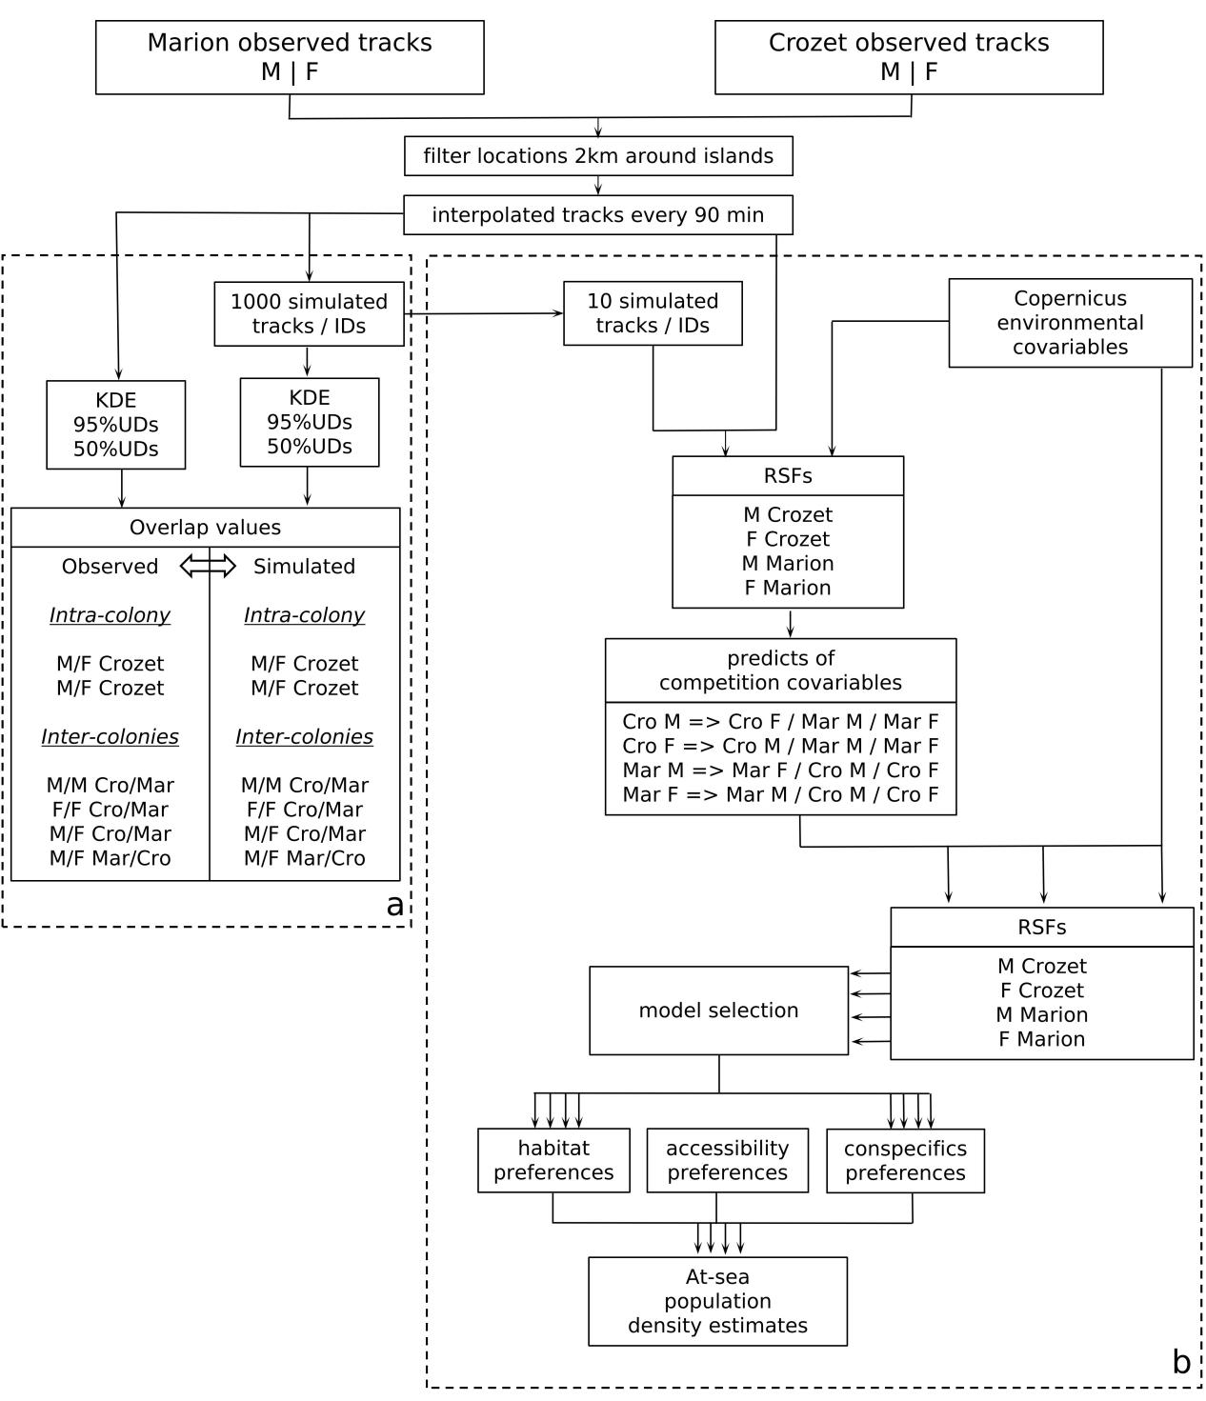
Figure 1: Schematic representation of the analytical protocol. The two main aims were: a. To compare overlap values between observed tracks and pseudo-tracks that assume no intraspecific competition for each site (Marion [Mar] vs. Crozet [Cro]) and sex (Males [M] vs. Females [F]) b. To disentangle effects of environmental and competition covariates to estimate individual densities at-sea for each site and sex.

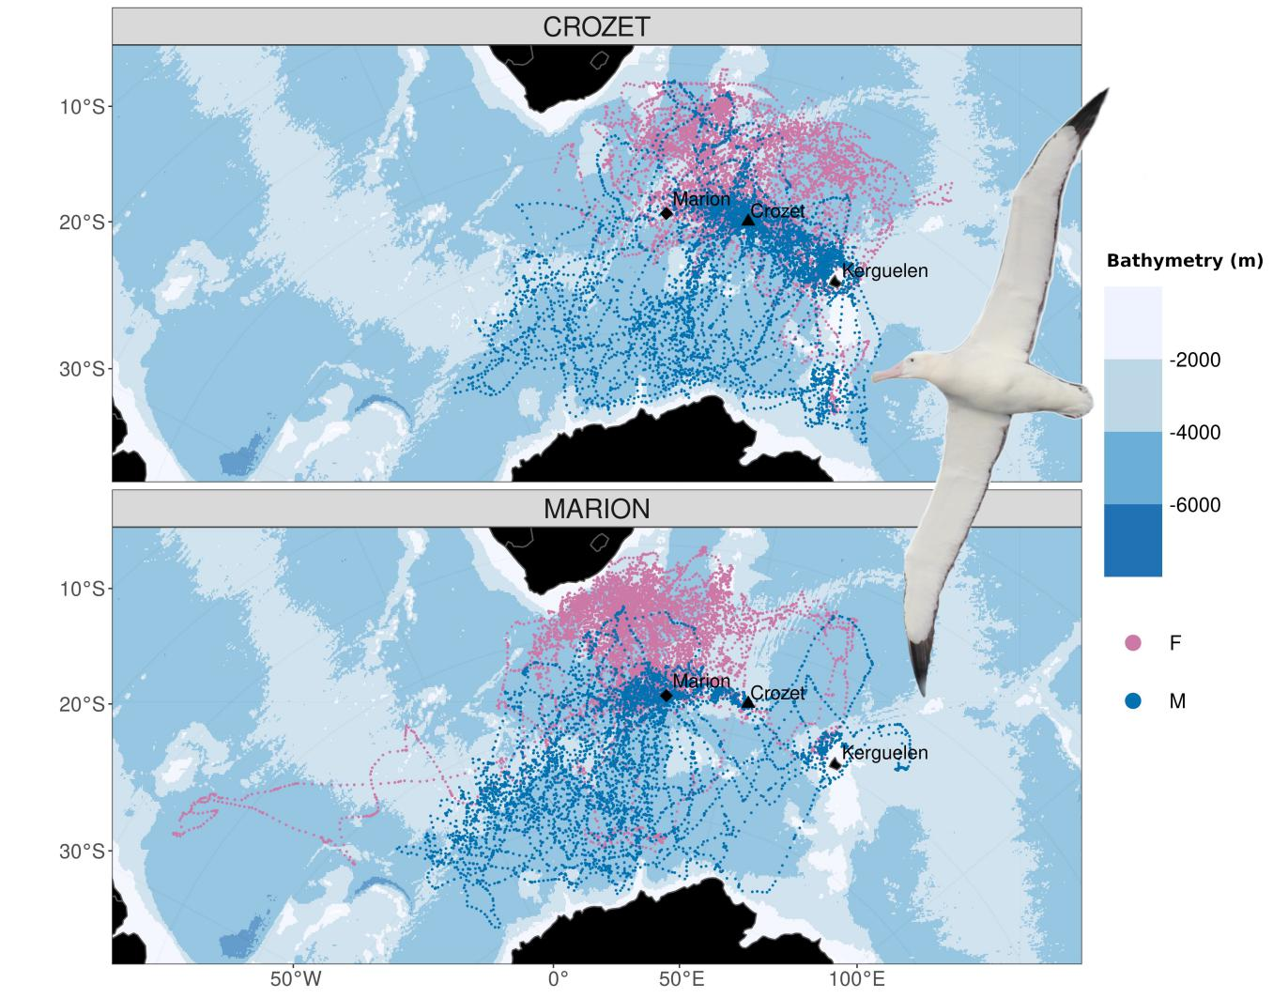
Figure 2: Foraging distribution of female (purple, N=110) and male (blue, N=82) incubating wandering albatrosses Diomedea exulans from Marion and Crozet. Kerguelen Archipelago is also indicated. Blue background indicates the bathymetry (in meters).

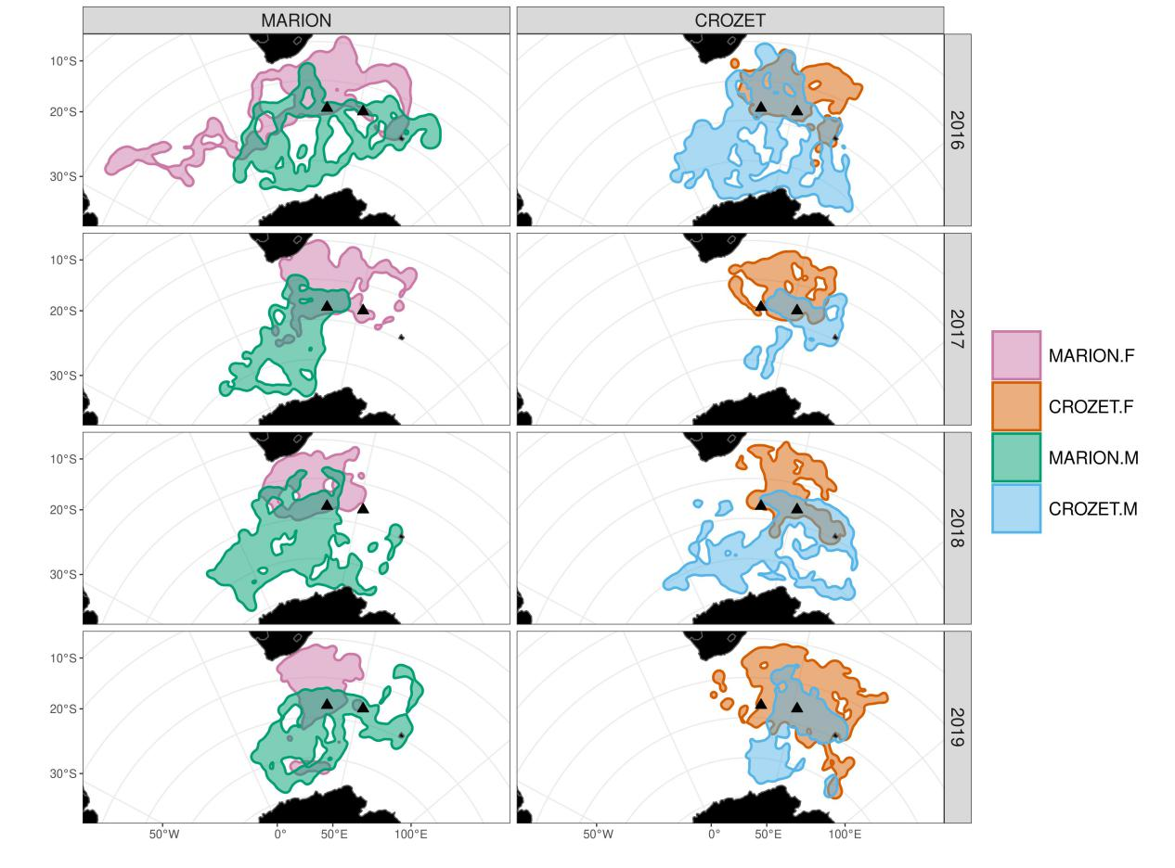
Figure 3: Kernel Utilization Distribution (UD) overlap between populations and sexes per year at 95% UD. Triangles indicate the locations of Marion (left) and Crozet (right).

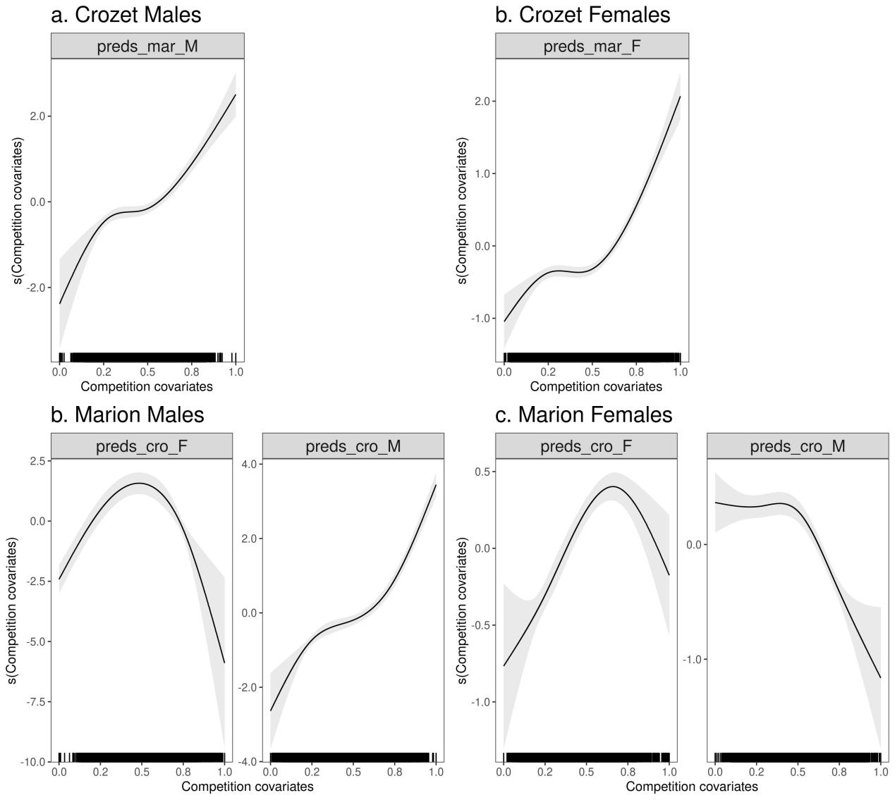
Figure 4: Preference probabilities (logit scale) showing different response curves as a function of competition covariates (‘preds’, i.e., habitat selection probability predicted by the first series of RSF, see Fig. 1b, with ‘cro’ for Crozet, ‘mar’ for Marion and ‘F’ for females and ‘M’ for Males) retained for the best GAMM per site and sex with 95% confidence intervals indicated by grey shading (competition covariates were non-significant for Crozet females and thus not shown here). Positive relationships can be interpreted as increases in selection of the response in relation to increases in preference for the same area of the other sex or site-sex considered.

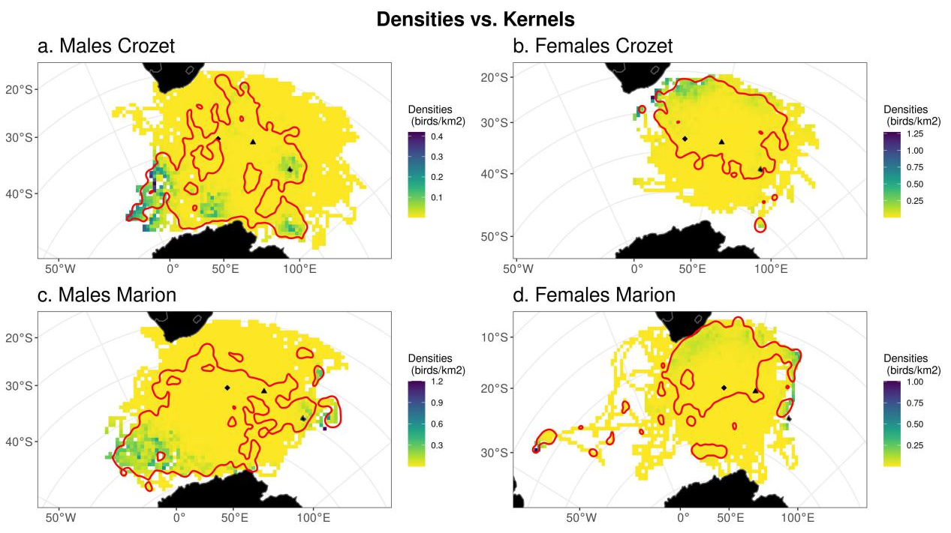
Figure 5: Comparisons between predicted population densities at-sea and the corresponding 95% Kernel Utilization Distribution (red contours) calculated with the observed tracks. Densities values have been averaged per 100 km² grid cell. Common areas of higher densities for males, from both sites, are situated in the south-west of the mapped region, below 50˚S, and on the Kerguelen plateau (island locations indicated in Fig. 2). Common areas among all sites and sexes are situated south-east of South Africa, over the continental shelf edge.

