3.9 μm emission in Nd³⁺ sensitized Ho³⁺ doped fluoroaluminate glasses

Jiquan Zhang¹, Haiyan Zhao², Ruicong Wang¹, Angzhen Li¹, Jie Zhang¹, Shijie Jia¹, Gilberto Brambilla³, Shunbin Wang^{1, *}, Pengfei Wang^{1, 2, **}
1 Key Lab of In-Fiber Integrated Optics of Ministry of Education of China, Harbin Engineering University, Harbin 150001, China
2 Key Laboratory of Optoelectronic Devices and Systems of Ministry of Education and Guangdong Province, College of Optoelectronic Engineering, Shenzhen University, Shenzhen, 518060, China
3 Optoelectronics Research Centre, University of Southampton, Southampton SO17 1BJ, United Kingdom
Corresponding author:* shunbinwang@hrbeu.edu.cn (S. Wang), **pengfei.wang@tudublin.ie (P. Wang)

Abstract:
Ho³⁺ and Nd³⁺/Ho³⁺ doped fluoroaluminate glass samples were fabricated by the melt-quenching method and showed high transmittance and a wide transparency window. Under 808 nm pumping, emission at 3.9 μm, corresponding to the Ho: ⁵I₅→⁵I₆ transition, was observed. The presence of Nd³⁺ strongly enhances the Ho³⁺ emission. The emission and absorption cross-sections were calculated using Judd-Ofelt, Füchtbauer-Ladenburg and McCumber theories and the energy transfer mechanism between Nd³⁺ and Ho³⁺ was analyzed. The most efficient 3.9 μm emission was obtained when the concentration ratio of Nd³⁺: Ho³⁺ is 1: 2.
Keywords: fluoroaluminate glass; mid-infrared fluorescence; Nd³⁺/Ho³⁺-codoped; 3.9 μm.
Introduction
Mid-infrared (MIR) lasers operating at 3-5 μm have drawn wide attention in recent years due to their applications in atmosphere sensing [1, 2], medical treatment [3-5] and defense [6]. Er³⁺, Dy³⁺ and Ho³⁺ are the most common dopants for 3-5 μm emission in glasses. After efficient dual-wavelength pumping (DWP) was proposed by Henderson-Sapir [7], in 2017 Frederic increased the 3.55 μm laser power output up to 5.6 W by using 976 nm and 1976 nm pumps in an Er³⁺ doped ZBLAN fiber [8]. As for Dy³⁺, in 2019 Vincent reported a 10.1 W fiber laser at 3.24 μm in a fluoride fiber [9]. However, the development of 3.9 μm lasers from Ho³⁺ (⁵I₅→⁵I₆) has lagged behind, with only 197 mW output power obtained using a fluoroindate fiber pumped at 888 nm [10]. This has been attributed mostly to lack of accessible and suitable commercial laser diode (LD) pumps and reliable low phonon energy host materials. The Ho³⁺ emission at 3.9 μm requires populations on the ⁵I₄ level, but low-cost and high-power commercial pumps at ~793 nm, ~808 nm, or ~980 nm have proven unsuitable for this task. In 2017, a new method to generate 3.9 μm emission was reported in Nd³⁺/Ho³⁺ codoped PbF₂ crystal pumped by an 808 nm LD [11], proving that Nd³⁺ can be used as an appropriate sensitizer to transfer the pump energy to the upper level Ho³⁺:⁵I₅ and deplete the population of the lower level ⁵I₆ by energy transfer (ET) processes. In 2020, Wang reported enhanced Ho³⁺ luminescence at 3.9 μm in fluoroindate glasses [12], which, similarly to the well-known fluorozirconate glass (ZBLAN), possess poor resistance to deliquescence and bad chemical stability, greatly limiting its development in long-term reliable laser devices. Thus, it is still imperative to find proper hosts for lasing in the region of 3-5 μm.
Fluoroaluminate glass material, which has a wide transparency window, high transmittance, low phonon energy and good chemical stability [13], is promising to achieve high-power and stable fiber devices. As for lasers in visible band, in 2010, Y. Fujimoto reported a 10.3 mW yellow laser oscillation in Dy³⁺ doped fluoroaluminate glass fiber pumped by GaN laser diodes [14]. In 2012, J.Nakanishi obtained a 638 nm laser beam and the maximum power is 1.24 W [15]. And one year later, Y. Fujitomo demonstrated over 1-W multi-color laser oscillation in Pr³⁺ doped fluoroaluminate glass fiber [16]. In recent years, the applications of fluoroaluminate fiber in MIR lasers have also drawn a lot of attention. In 2018 S. Jia obtained a 57 mW laser output at 2868 nm in an 84 cm long AlF₃-based glass fiber, and also proved that fluoroaluminate glass has much better water resistance than ZBLAN [17]. In 2020 Wang demonstrated a 2866 nm laser output in a 19 cm long Ho³⁺/Pr³⁺ codoped AlF₃-based glass fiber, and improved the power output to 173 mW with a slope efficiency of 10.3%, indicating that fluoroaluminate is a strong candidate for MIR lasing [18]. In 2021, this research group further improved the output power to 1.13 W and obtained a tunable laser from 2.842 to 2.938 μm [19]. Fluoroaluminate material is gradually proved to be a reliable laser gain material rather than just working as an endcap. Fluoroaluminate-based fiber laser with longer wavelength and higher power are expected to be further studied.
In this letter, emission at 3.9 μm in Nd³⁺/Ho³⁺ codoped fluoroaluminate glass is reported. The emission cross-section and the gain spectra are calculated. The transmission, thermal property, resistance to deliquescence and emission mechanism are also analyzed.
Experiments
The glass samples used in these experiments were fabricated by melt-quenching. The Nd³⁺/Ho³⁺ codoped glasses with molar compositions 30AlF₃-15BaF₂-(19-x)YF₃-25PbF₂-10MgF₂-1NdF₃-xHoF₃(x=0.2, 0.5, 1, 2, 3, 4) were named as 1Nd-xHo. The Nd³⁺ single doped glass with molar composition 30AlF₃-15BaF₂-19YF₃-25PbF₂-10MgF₂-1NdF₃ was named as 1Nd. Similarly, the Ho³⁺ doped glasses with molar compositions 30AlF₃-15BaF₂-(20-y)YF₃-25PbF₂-10MgF₂-yHoF₃ (y=0.2, 0.5, 1, 2, 3, 4) were named as yHo. Mixed dry high-purity (99.99%) raw materials were placed in platinum crucibles and melted in a furnace at 900°C for 60 minutes in a N₂ atmosphere. The molten mixture was then poured onto a preheated 370°C copper mold, annealed for 3 hours and then cooled down slowly to 25°C. These fluoroaluminate glass samples were polished to optical quality for later measurements. The transmission and absorption spectra in the wavelength range λ=250-2500 nm and λ=2500-10000 nm were measured using a Perkin Elmer Lambda 750 spectrophotometer and a Perkin Elmer FT-IR Spectrometer, respectively. The differential scanning calorimetry (DSC) result was obtained by a NETZSCH STA449F5 simultaneous thermal analyzer. The glass fluorescence spectra were recorded by a HITACHI F-4600 fluorescence spectrophotometer (λ<800 nm) and a Zolix Omni-λ300i fluorescence spectrometer (λ>800 nm) under the pump of a commercial 808 nm LD. Fluorescence decay curves were measured by using an optical parametric oscillator (Horizon II OPO) and a fluorescence spectrometer (Techcomp FLS1000). In water treatment experiment, fluoroaluminate glass with molar composition 30AlF₃-15BaF₂-20YF₃-25PbF₂-10MgF₂ and fluoroindate glass (26InF₃-14ZnF₂-19BaF₂-11GaF₃-8SrF₂-12PbF₂-5LiF-5LaF₃) were prepared by melt-quenching. Both 8 mm×8 mm×2 mm fluoroaluminate and fluoroindate glass samples’ weights and transmittance spectra were recorded before and after putting the samples in brown bottles for 24 h, which filled with deionized water. It is worth noting that the surface moisture on the samples after water treatment experiment was removed by drying at 100 °C for 12h. All measurements were performed at room temperature.
Results and Discussions
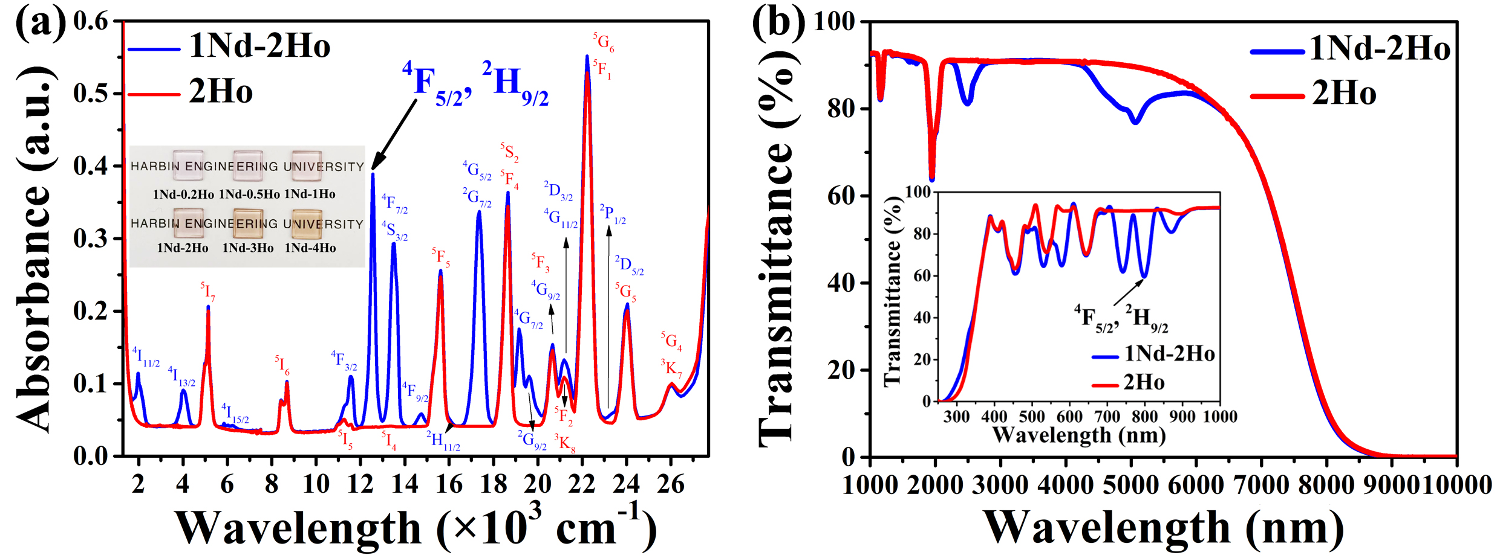
Fig.1 (a) Absorption spectra of 1Nd-2Ho and 2Ho fluoroaluminate glass samples. The inset shows a photograph of various Nd³⁺/Ho³⁺ codoped samples. (b) Transmittance spectra of 1Nd-2Ho and 2Ho fluoroaluminate glass samples in the range of 1000-10000 nm. The inset shows the details in the range λ=250-1000 nm.

Figure 1 (a) shows the absorption spectra of 1Nd-2Ho and 2Ho fluoroaluminate glass samples. The absorption peaks shows the positions of the levels, the blue characters represent the absorption peaks of Nd³⁺ and the red ones represent the absorption peaks of Ho³⁺. A strong absorption peak at the wavenumber k (=1/λ) ~12.563×10³ cm⁻¹, is ascribed to the ⁴F_{5/2} and ²H_{9/2} levels of Nd³⁺, and indicates that the Nd³⁺/Ho³⁺ codoped fluoroaluminate glasses could be pumped by a commercial 808 nm LD. The inset shows different Nd³⁺/Ho³⁺ codoped samples with the same size of 10 mm×10 mm×2 mm. Figure 1 (b) and its inset present the transmission spectra of 1Nd-2Ho and 2Ho. In the maximum transparency region, the transmittance is as high as 91%, much higher than that of chalcogenides (~60%), tellurites (~80%) and germanates (~84%) [13]. The high-transmittance fluoroaluminate glass material, with a cutoff wavelength at λ~9 μm has a significant potential as gain medium for MIR laser applications.

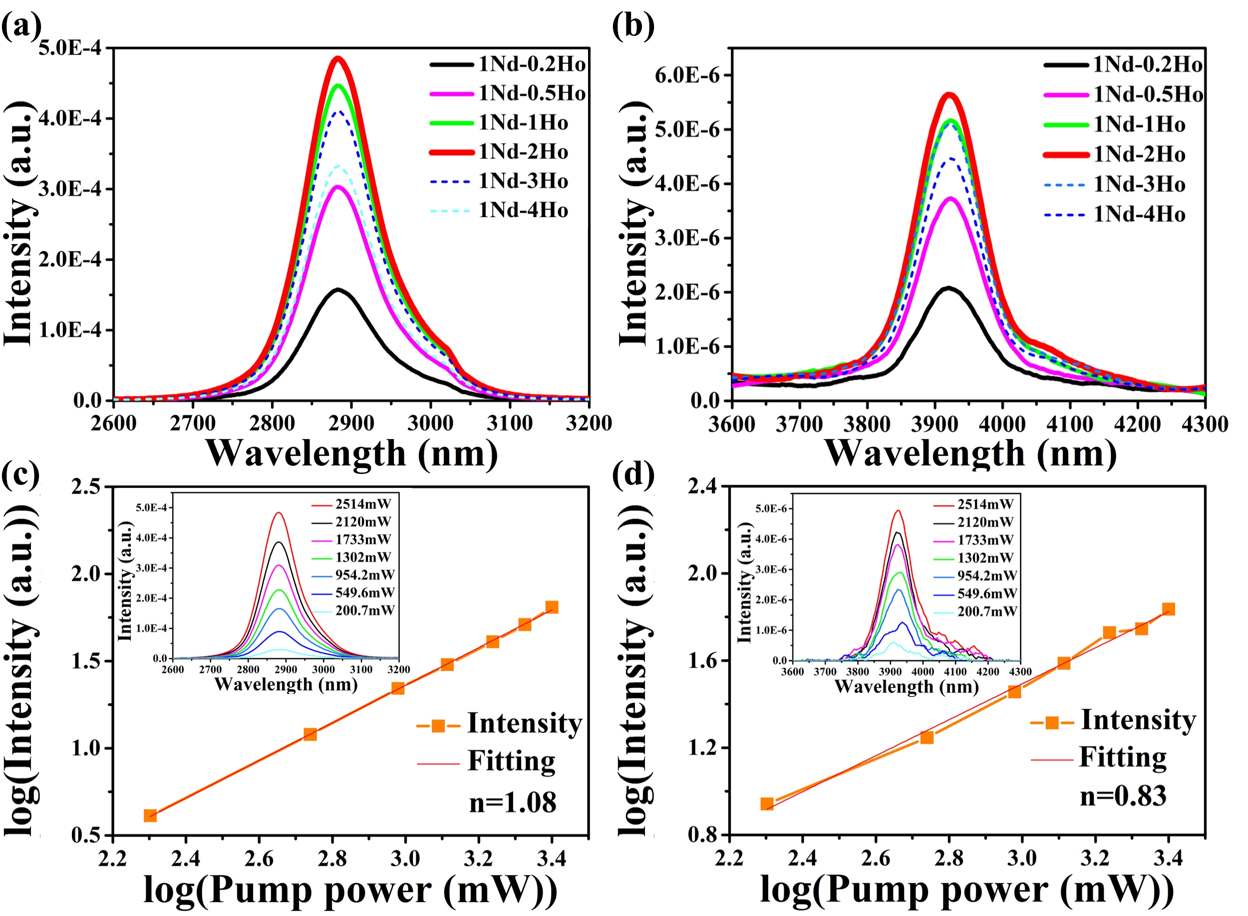
Fig.2 Emission spectra at (a) λ~2.9 and (b) λ~3.9 μm in Nd³⁺/ Ho³⁺ codoped fluoroaluminate glasses. Relationships between (c) ~2.9 μm, (d) ~3.9 μm emission intensities and the pump power. Insets: power dependent emissions profiles.
The emission at λ~2.9 μm resulting from the ⁵I₆→⁵I₇ transition can be observed in Nd³⁺/Ho³⁺ codoped samples, as shown in Figure 2 (a). The strongest emission intensity was detected with a peak position at 2882 nm. Higher Ho³⁺ doping concentrations caused quenching in 1Nd-3Ho and 1Nd-4Ho samples. Figure 2 (b) presents efficient emission at λ~3.9 μm (⁵I₅→⁵I₆) with a peak position at 3920 nm. Figure 2 (c) and (d) shows the relationships between the two MIR emissions intensities and the pump power. It can been seen from the insets that as the pump power increased from 200.7 mW to 2514 mW, the ~2.9 and ~3.9 emissions intensities would increase almost linearly. The slopes are 1.08 and 0.83, respectively, indicating that ~2.9 and ~3.9 μm emissions may be generated by a single photon. It is the first observation in this fluoride system and indicates that fluoroaluminate glasses could be a promising gain medium for lasing beyond λ~3 μm.

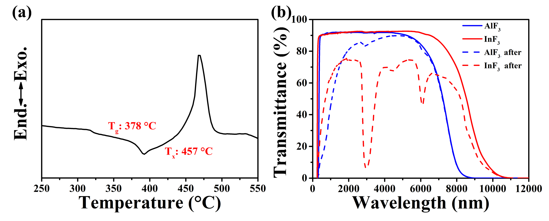
Fig.3 (a) DSC of fluoroaluminate glass. (b) Transmission spectra of fluoroaluminate and fluoroindate glasses before and after water treatment experiment.
Compared with the fluoroindate glass, which has been proved to be an effective gain medium for lasing at λ~3.9 μm [20], fluoroaluminate has better resistance to thermal damage thanks to the high glass transition temperature (fluoroindate has T_{g}: ~259 °C [12]) and better resistance to deliquescence, as shown in Figure 3 (a) and (b). The DSC curve shows that T_{g}=378 °C and T_{x}=457°C (thus with a large ΔT=79°C), indicating that fluoroaluminate glass has strong thermal stability for fiber drawing. Figure 3 (b) compares the chemical stability of fluoroaluminate and fluoroindate glasses. After removing the surface moisture on the fluoroaluminate and fluoroindate glass samples, the fluoroindate glass exhibited much stronger water absorption peaks at ~3 μm and ~6 μm than the fluoroaluminate glass, while the total weight loss for fluoroaluminate and fluoroindate glasses were 0.069% and 0.385%, meaning that water cause a significantly larger damage to the fluoroindate glass.

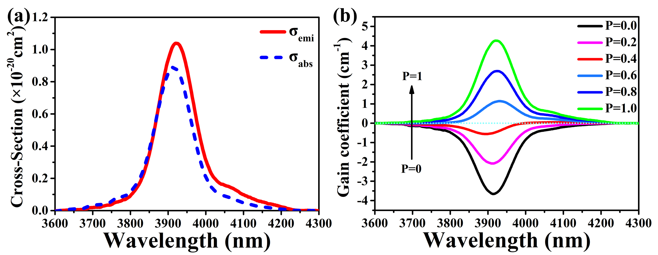
Fig. 4 (a) Emission and absorption cross-sections of the ⁵I₅→⁵I₆ transition. (b) Dependence of the gain spectra (based on σ_{abs} and σ_{emi}) on the P value.

Table.1 Judd-Ofelt spectroscopic parameters in fluoroaluminate glass.
SLJ | S'L'J' | EJJ'(cm⁻¹) | A(ij)=A_{ed}(ij)+A_{md}(ij)(s⁻¹) | β(%) | τ_{i}(ms)
⁵I₇ | ⁵I₈ | 5056 | 84.837 | 100.000 | 11.787
⁵I₆ | ⁵I₇ | 3514 | 27.629 | 14.609 | 5.287
 | ⁵I₈ | 8570 | 161.499 | 85.391
⁵I₅ | ⁵I₆ | 2567 | 10.557 | 6.864 | 6.502
 | ⁵I₈ | 11137 | 59.032 | 38.380
Ω₂=1.459×10⁻²⁰ cm² Ω₄=2.175×10⁻²⁰ cm² Ω₆=2.096×10⁻²⁰ cm²
3.9 μm emission cross-sections of Ho³⁺: ⁵I₅↔⁵I₆ in fluoroaluminate glass were calculated using the Judd-Ofelt [21] and Füchtbauer-Ladenburg [22] theories and the results are shown in figure 4 (a). The emission cross-section was calculated by:
(1)
where λ_{p} is the central wavelength of the fluorescence spectra, A_{rad} is the spontaneous transition probability, c, n are the speed of light and the refractive index, I(λ) is the emission intensity. The related spectroscopic parameters based on Judd-Ofelt theory are shown in table 1: it is worth noting that the contribution of magnetic dipole transitions is an important part in the calculations. The 3.9 μm absorption cross-sections could be calculated by McCumber theory [23]:
(2)
where Z_{low} and Z_{up} represent the partition functions of the lower and upper energy levels, respectively, h, k and T are the Planck constant, the Boltzmann constant, and the temperature. The maximum σ_{emi} value (1.038×10⁻²⁰ cm²) occurs at λ~3922 nm, while the maximum σ_{abs} value (0.891×10⁻²⁰ cm²) occurs at λ~3914 nm. Figure 4 (b) shows the gain spectra at λ~3.9 μm for different P values in steps of 0.2. The gain coefficient can be calculated by:
(3)
where N is the Ho³⁺ doping concentration, and P=(the population of the upper energy levels)/(the population of total energy levels). The calculation results indicate that when P≥0.4, a positive gain can be achieved.
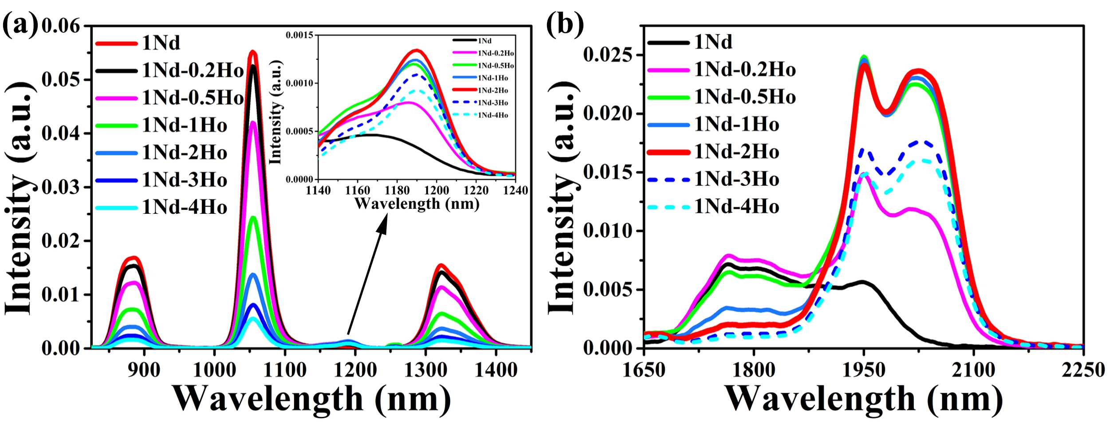
Fig.5 Fluorescence spectra (a) from λ=830 to λ=1450 nm and (b) λ=1650 to λ=2250 nm.
Inset: details of the region λ=1140-1240 nm.
Figure 5 (a) and (b) show the fluorescence spectra of 1Nd and 1Nd-xHo fluoroaluminate glass samples in the near-IR (λ~0.8-1.5 μm) and MIR (λ~2 μm). Several emission peaks at λ~0.876, 1.06, 1.19, 1.32, 1.81 and 2 μm can be clearly identified, corresponding to the transitions ⁴F_{3/2}→⁴I_{9/2}, ⁴F_{3/2}→⁴I_{11/2}, ⁵I₆→⁵I₈, ⁴F_{3/2}→⁴I_{13/2}, ⁴F_{3/2}→⁴I_{15/2} and ⁵I₇→⁵I₈, respectively. The inset of Figure 5 (a) is an enlargement of the λ~1.19 μm emission. For increasing Ho³⁺ concentrations, the fluorescence initially increases, but then begins to decline when Ho³⁺>2 mol%, as represented by thin dash lines. Emissions at λ~0.876, 1.06, 1.32, 1.81 μm exhibit a monotonous decrease, while that at λ~2 μm exhibits changes in peak intensities and wavelengths, ascribed to the transition Ho³⁺:⁵I₇→⁵I₈ at 2 μm.
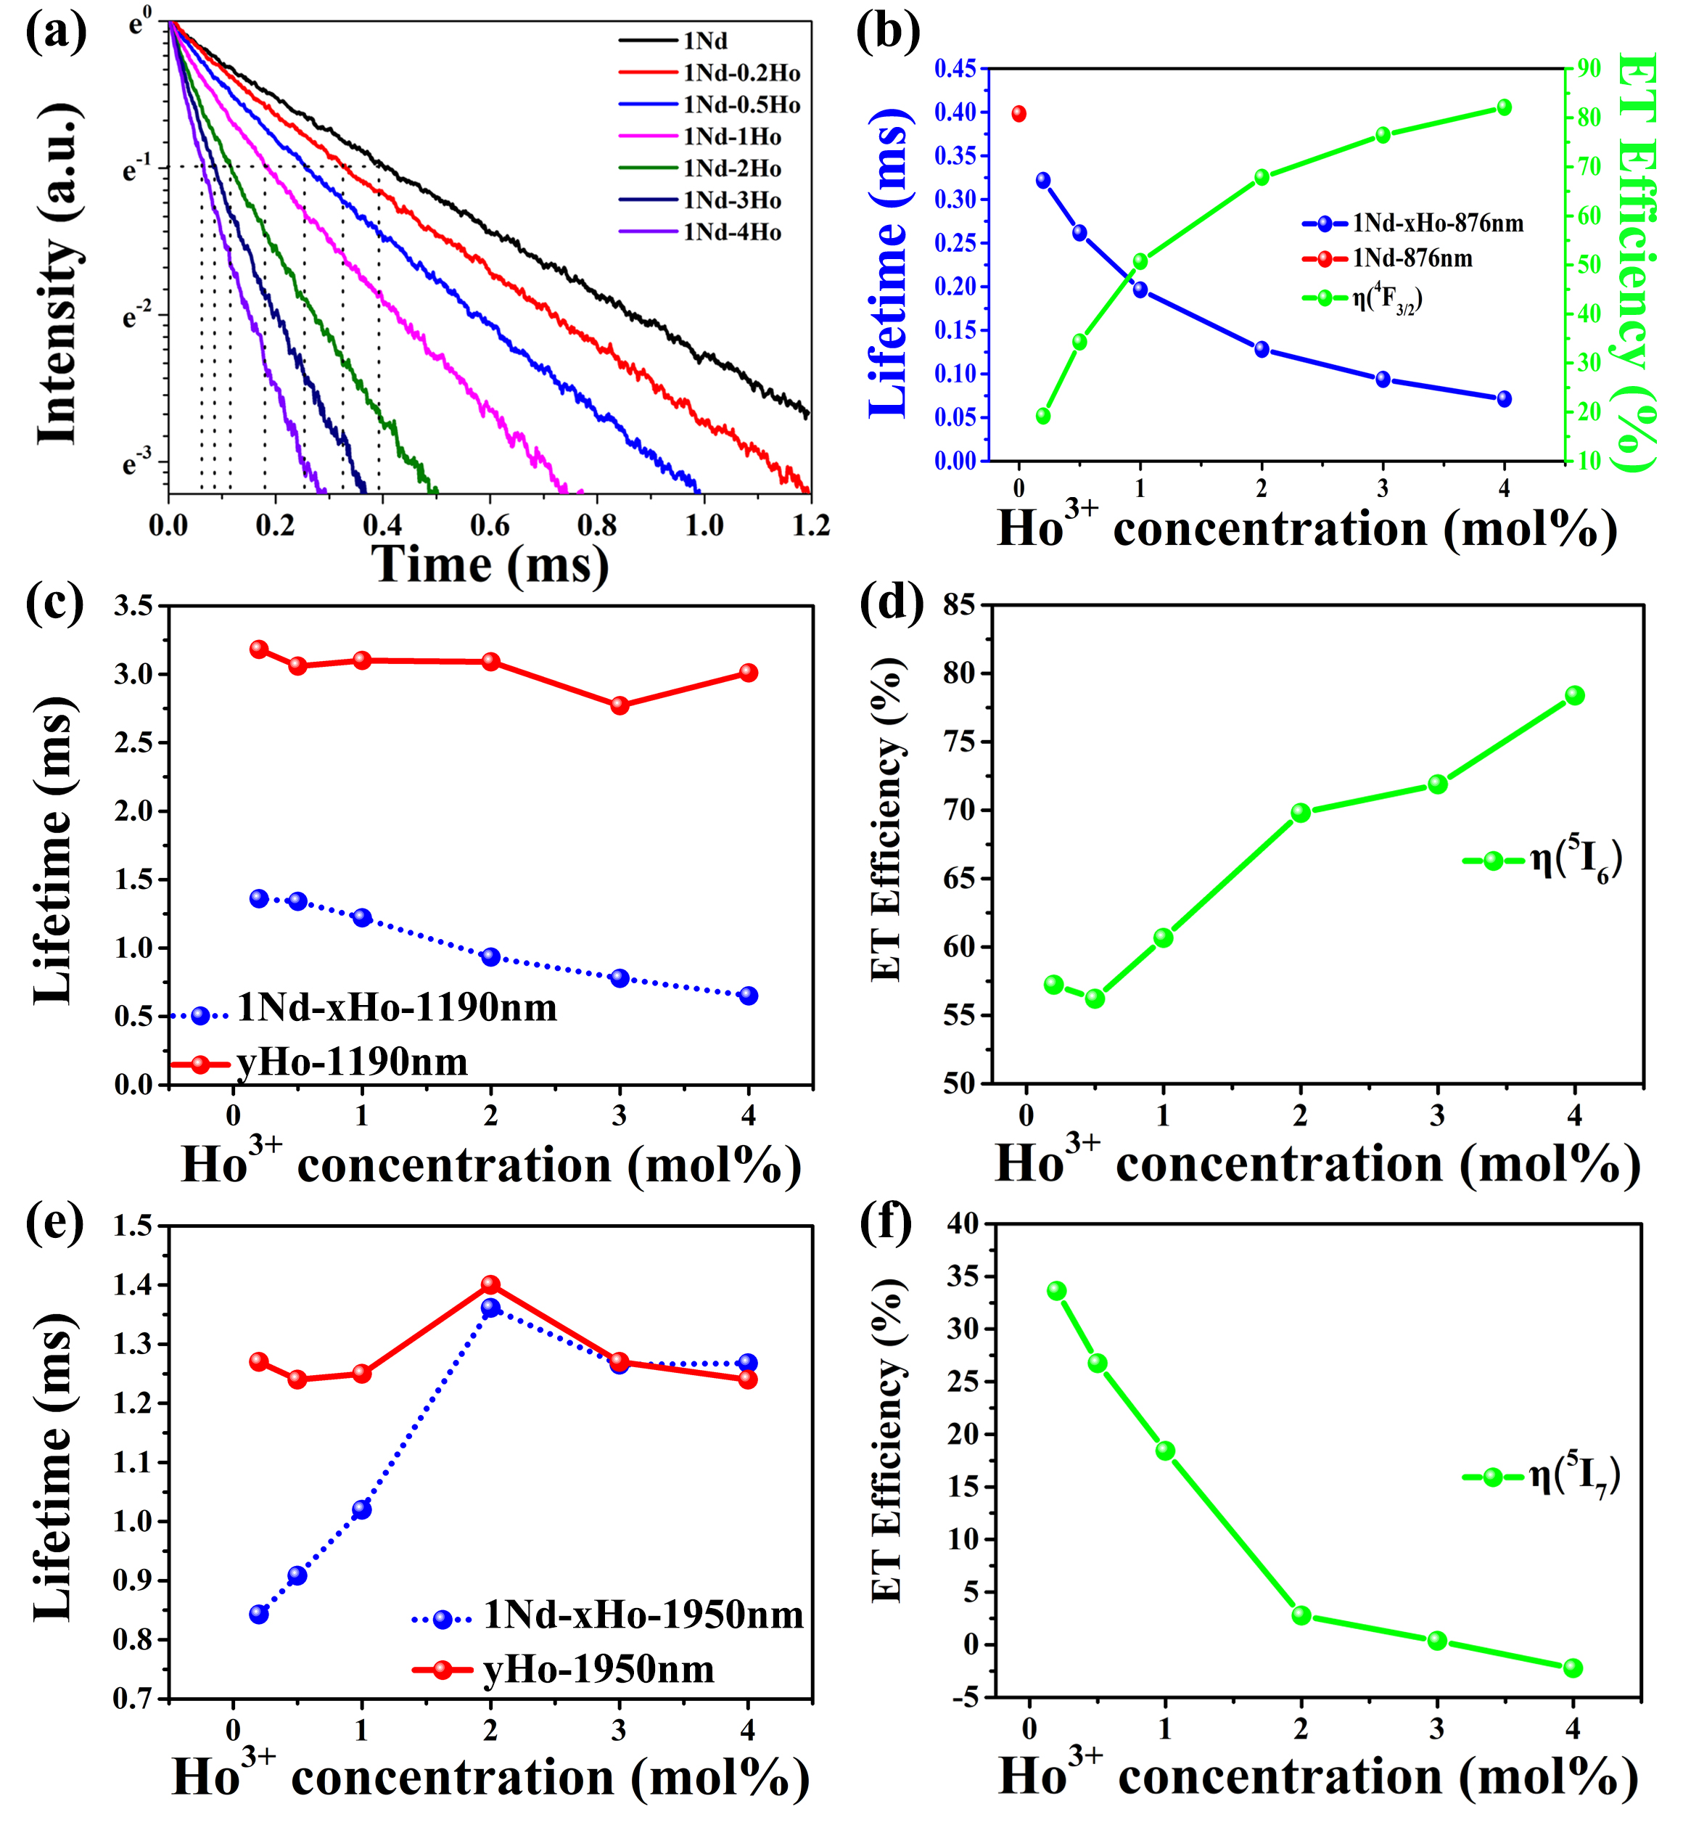
Fig. 6 (a) Fluorescence decay curves of 1Nd and 1Nd-xHo samples at λ~876 nm.
(b) Fluorescence lifetimes of 1Nd and 1Nd-xHo samples at λ~876 nm and the energy transfer efficiency from ⁴F_{3/2} to ⁵I₅.
Fluorescence lifetimes in 1Nd-xHo and yHo samples at (c) λ~1190 nm and (e) λ~1950 nm.
Energy transfer efficiency for the (d) ⁵I₆ and (f) ⁵I₇ levels.

To investigate the ET mechanism, the fluorescence lifetimes (τ) in Nd³⁺/Ho³⁺ codoped and Nd³⁺, Ho³⁺ single doped fluoroaluminate glasses were studied. Figure 6(a) shows the fluorescence decay curves of 1Nd and 1Nd-xHo samples at λ~876 nm under an 808 nm laser diode pumping. Figure 6 (b) shows the fluorescence lifetime values in 1Nd (shown as red dot) and 1Nd-xHo samples (blue dots). In the Nd³⁺ single doped sample, τ_{Nd}=0.40 ms. As the Ho³⁺ concentration increases, τ_{Nd/Ho} begins to decline thanks to the ⁴F_{3/2}→⁵I₅ energy transfer (ET1). The ET efficiency (Donor: Nd³⁺, acceptor: Ho³⁺) can be defined as:
(1)
Figure 6(b) shows that η_{ET} increases from 19.14% to 82.11% (green dots). On the contrary, fluorescence lifetime at λ~1190 nm in 1Nd-xHo samples decreases from 1.36 ms to 0.65 ms due to the energy transfer process from ⁵I₆→⁴I_{15/2} (ET2) [11, 12], as shown in Figure 6(c). The energy transfer efficiency from donor Ho³⁺ to acceptor Nd³⁺ can be calculated as:
(2)
where τ_{Ho} and τ_{Nd/Ho} are the 1190 nm fluorescence lifetimes in yHo and in 1Nd-xHo samples. The calculated η_{ET} shown in figure 6(d) increases from 57.2% to 78.4% for increasing Ho³⁺ concentrations. As for fluorescence lifetime at λ~1950 nm, Figure 6(e) shows that the ⁵I₇ level has the longest lifetimes in Ho³⁺ single doped sample as well as in the Nd³⁺/Ho³⁺ codoped sample when the Ho³⁺ concentration is 2 mol%. Figure 6(f) shows that in Nd³⁺/Ho³⁺ codoped samples, there is an obvious energy transfer from Ho³⁺: ⁵I₇ to Nd³⁺: ⁴I_{13/2} (ET3) for Ho³⁺ concentrations smaller than 2 mol%, as the energy transfer efficiency of ET3 varies from 33.6% to 2.77%: when the Ho³⁺ concentration ratio is higher, the lifetime is hardly affected by Nd³⁺.

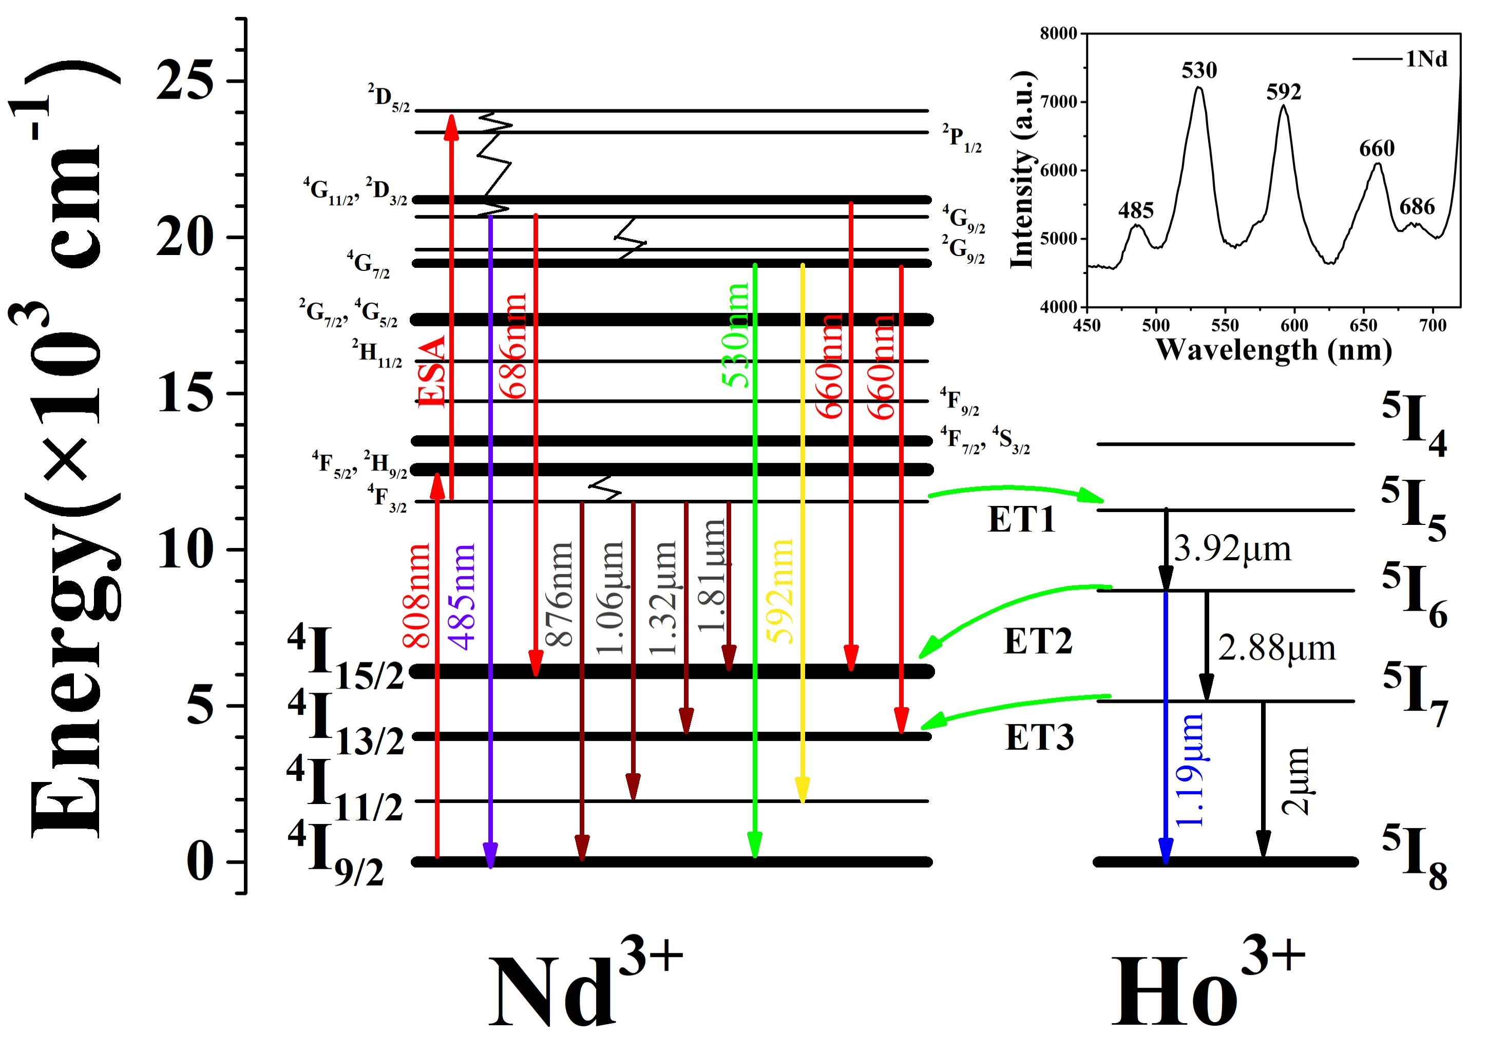
Fig. 7 Energy transfer mechanisms in Nd³⁺/Ho³⁺ codoped fluoroaluminate glasses.
Inset: the up-conversion emission spectrum in the 1Nd sample.

Figure 7 shows the energy transfer mechanisms between Nd³⁺ and Ho³⁺ in this co-doped glass sample, there are mainly the following processes:
1. When pumped at λ~808 nm, Nd³⁺ absorbs the pump energy to populate ⁴F_{5/2} and ²H_{9/2}, which then relax to ⁴F_{3/2}.
2. Part of Nd³⁺ ions on the ⁴F_{3/2} level are pumped to ²D_{5/2} through excited state absorption (ESA) and relax to ⁴G_{9/2}, emitting photons at λ~485 and ~686 nm, or relax to ⁴G_{7/2}, emitting photons at ~530 and ~592 nm. Fluorescence at ~660 nm could be generated by two possible transitions: ⁴G_{11/2} (²D_{3/2}) →⁴I_{15/2} and ⁴G_{7/2} →⁴I_{13/2}, as shown in the inset;
3. Part of Nd³⁺ ions on the ⁴F_{3/2} level transit to lower energy levels such as ⁴I_{9/2}, ⁴I_{11/2}, ⁴I_{13/2} and ⁴I_{15/2}, emitting photons at λ~876 nm, 1.06 μm, 1.32 μm and 1.81 μm.
4. The rest of the Nd³⁺ ions on the ⁴F_{3/2} level transfer energy to Ho³⁺: ⁵I₅ through ET1, which then Ho³⁺ ions decay to ⁵I₆, generating 3.92 μm emission. The ⁵I₆ level could also emit photons at λ~2.88 and 1.19 μm due to the transitions of ⁵I₆→⁵I₇ and ⁵I₆→⁵I₈. Population on ⁵I₆ level could transfer energy to Nd³⁺: ⁴I_{15/2} through ET2, which is benefit for 3.92 μm emission.
5. While the population of ⁵I₇ on one hand transfer energy to Nd³⁺: ⁴I_{13/2} thanks to ET3 process, on the other hand, transit to ⁵I₈ resulting in emission at λ~2 μm.
4. Conclusion
In summary, under pumping at λ~808 nm, intense 3.9 μm emission was observed in Nd³⁺ sensitized Ho³⁺ doped fluoroaluminate glasses with different Nd³⁺/Ho³⁺ concentrations. By using the Judd-Ofelt theory, Füchtbauer-Ladenburg and McCumber formulas, Ω_{2, 4, 6} and cross-sections of ⁵I₅↔⁵I₆ transition were calculated. The energy transfer mechanism was analyzed based on fluorescence spectra and fluorescence lifetimes. Results show Nd³⁺/Ho³⁺ codoped fluoroaluminate glass is a promising candidate medium for lasing at λ~3.9 μm and the optimal ratio of Nd³⁺:Ho³⁺ is 1:2.

Acknowledgement
This work was financial supported by National Natural Science Foundation of China (61905048, 61935006, 62005060, 62090062); Shenzhen Technical Project (JCYJ20190808173619062); 111 project to the Harbin Engineering University (B13015); Heilongjiang Touyan Innovation Team Program; National Key Research and Development Program of China (2020YFA0607602)

References
[1] G. Sonnabend, D. Stupar, M. Sornig, T. Stangier, T. Kostiuk, T.A. Livengood, A search for methane in the atmosphere of Mars using ground-based mid infrared heterodyne spectroscopy, Journal of Molecular Spectroscopy, 291 (2013) 98-101.
[2] J.R. Spencer, E. Lellouch, M.J. Richter, M.A. López-Valverde, K. Lea Jessup, T.K. Greathouse, J.-M. Flaud, Mid-infrared detection of large longitudinal asymmetries in Io's SO2 atmosphere, Icarus, 176 (2005) 283-304.
[3] A. Zajac, M. Skorczakowski, J. Swiderski, P. Nyga, Electrooptically Q-switched mid-infrared Er:YAG laser for medical applications, - 12 (2004) - 5130.
[4] G.S. Edwards, Mechanisms for soft-tissue ablation and the development of alternative medical lasers based on investigations with mid-infrared free-electron lasers, Laser & Photonics Reviews, 3 (2009) 545-555.
[5] M. Skorczakowski, J. Swiderski, W. Pichola, P. Nyga, A. Zajac, M. Maciejewska, L. Galecki, J. Kasprzak, S. Gross, A. Heinrich, T. Bragagna, Mid-infrared Q-switched Er:YAG laser for medical applications, Laser Physics Letters, 7 (2010) 498-504.
[6] A. Vizbaras, E. Dvinelis, A. Trinkūnas, I. Šimonyte, M. Greibus, M. Kaušylas, T. Žukauskas, R. Songaila, K. Vizbaras, High-performance mid-infrared GaSb laser diodes for defense and sensing applications, in: SPIE Defense, Sensing and Security, SPIE, 2014.
[7] O. Henderson-Sapir, J. Munch, D. Ottaway, Mid-infrared fiber lasers at and beyond 3.5 μm using dual-wavelength pumping, Optics Letters, 39 (2014) 493-496.
[8] F. Maes, V. Fortin, M. Bernier, R. Vallée, 5.6 W monolithic fiber laser at 3.55 μm, Optics letters, 42 (2017) 2054-2057.
[9] V. Fortin, F. Jobin, M. Larose, M. Bernier, R. Vallée, 10-W-level monolithic dysprosium-doped fiber laser at 3.24 μm, Optics letters, 44 (2019) 491-494.
[10] F. Maes, V. Fortin, S. Poulain, M. Poulain, J.-Y. Carrée, M. Bernier, R. Vallée, Room-temperature fiber laser at 3.92 μm, Optica, 5 (2018) 761-764.
[11] P. Zhang, Y. Hang, Z. Li, Z. Chen, H. Yin, S. Zhu, S. Fu, S. Li, M. Xu, Sensitization and deactivation effects of Nd³⁺ on the Ho³⁺:3.9 μm emission in a PbF₂ crystal, Optics Letters, 42 (2017) 2559-2562.
[12] R. Wang, J. Zhang, H. Zhao, X. Wang, S. Jia, H. Guo, S. Dai, P. Zhang, G. Brambilla, S. Wang, P. Wang, 3.9 μm emission and energy transfer in ultra-low OH⁻, Ho³⁺ /Nd³⁺ co-doped fluoroindate glasses, Journal of Luminescence, 225 (2020) 117363.
[13] W.C. Wang, B. Zhou, S.H. Xu, Z.M. Yang, Q.Y. Zhang, Recent advances in soft optical glass fiber and fiber lasers, Progress in Materials Science, 101 (2019) 90-171.
[14] Y. Fujimoto, O. Ishii, M. Yamazaki, Yellow laser oscillation in Dy³⁺-doped waterproof fluoro-aluminate glass fibre pumped by 398.8 nm GaN laser diodes, Electronics letters, 46 (2010) 586-587.
[15] J. Nakanishi, T. Yamada, Y. Fujitomo, O. Ishii, M. Yamazaki, Watt-order output power at 638 nm in wavelength by direct oscillation with Pr-doped fiber laser, in: 2012 Conference on Lasers and Electro-Optics (CLEO), IEEE, 2012, pp. 1-2.
[16] Y. Fujitomo, M. Murakami, J. Nakanishi, T. Yamada, O. Ishii, M. Yamazaki, Visible lasers in waterproof fluoro-aluminate glass fibers excited by GaN laser diodes, in: Advanced Solid State Lasers, Optical Society of America, 2013, pp. AM2A. 2.
[17] S.J. Jia, Z.X. Jia, C.F. Yao, S.B. Wang, H.W. Jiang, L. Zhang, Y. Feng, G.S. Qin, Y. Ohishi, W.P. Qin, Ho3+ doped fluoroaluminate glass fibers for 2.9 µm lasing, Laser Physics, 28 (2018) 015802.
[18] S. Wang, J. Zhang, N. Xu, S. Jia, G. Brambilla, P. Wang, 2.9 µm lasing from a Ho³⁺/Pr³⁺ co-doped AlF3-based glass fiber pumped by a 1150 nm laser, Opt. Lett., 45 (2020) 1216-1219.
[19] M. Liu, J. Zhang, N. Xu, X. Tian, S. Jia, S. Wang, G. Brambilla, P. Wang, Room-temperature watt-level and tunable∼ 3µm lasers in Ho³⁺/Pr³⁺ co-doped AlF₃-based glass fiber, Optics Letters, 46 (2021) 2417-2420.
[20] F. Maes, V. Fortin, S. Poulain, M. Poulain, J.-Y. Carrée, M. Bernier, R. Vallée, Room-temperature fiber laser at 3.92 μm, Optica, 5 (2018) 761-764.
[21] B.R. Judd, Optical absorption intensities of rare-earth ions, Physical review, 127 (1962) 750.
[22] L. Tarelho, L. Gomes, I. Ranieri, Determination of microscopic parameters for nonresonant energy-transfer processes in rare-earth-doped crystals, Physical Review B, 56 (1997) 14344.
[23] D.E. McCumber, Theory of phonon-terminated optical masers, Physical review, 134 (1964) A299.

Figure captions:
Fig.1 (a) Absorption spectra of 1Nd-2Ho and 2Ho fluoroaluminate glass samples. The inset shows a photograph of various Nd³⁺/Ho³⁺ codoped samples. (b) Transmittance spectra of 1Nd-2Ho and 2Ho fluoroaluminate glass samples in the range of 1000-10000 nm. The inset shows the details in the range λ=250-1000 nm.
Fig.2 Emission spectra at (a) λ~2.9 and (b) λ~3.9 μm in Nd³⁺/ Ho³⁺ codoped fluoroaluminate glasses. Relationships between (c) ~2.9 μm, (d) ~3.9 μm emission intensities and the pump power. Insets: power dependent emissions profiles.
Fig.3 (a) DSC of fluoroaluminate glass. (b) Transmission spectra of fluoroaluminate and fluoroindate glasses before and after water treatment experiment.
Fig. 4 (a) Emission and absorption cross-sections of the ⁵I₅→⁵I₆ transition. (b) Dependence of the gain spectra (based on σ_{abs} and σ_{emi}) on the P value.
Fig.5 Fluorescence spectra (a) from λ=830 to λ=1450 nm and (b) λ=1650 to λ=2250 nm. Inset: details of the region λ=1140-1240 nm.
Fig. 6 (a) Fluorescence decay curves of 1Nd and 1Nd-xHo samples at λ~876 nm. (b) Fluorescence lifetimes of 1Nd and 1Nd-xHo samples at λ~876 nm and the energy transfer efficiency from ⁴F_{3/2} to ⁵I₅.Fluorescence lifetimes in 1Nd-xHo and yHo samples at (c) λ~1190 nm and (e) λ~1950 nm. Energy transfer efficiency for the (d) ⁵I₆ and (f) ⁵I₇ levels.
Fig. 7 Energy transfer mechanisms in Nd³⁺/Ho³⁺ codoped fluoroaluminate glasses. Inset: the up-conversion emission spectrum in the 1Nd sample.

