|  |  |  |  |  |  |  |  |  |  |  |  |  |  |  |  |  |  |  |  |
| --- | --- | --- | --- | --- | --- | --- | --- | --- | --- | --- | --- | --- | --- | --- | --- | --- | --- | --- | --- |
|  | c.515T​>G | c.640T​>G | c.756G​>A |  |  |  |  |  | c.2674G>A | c.2774T​>C | c.2932T​>C |  |  | c.4644G>C | c.4780T​>A | c.4886G​>A |  |  | c.5638G​>A |

|  |  |  |  |  |  |  |  |  |  |  |  |  |  |  |  |  |  |  |  |  |  |  |  |
| --- | --- | --- | --- | --- | --- | --- | --- | --- | --- | --- | --- | --- | --- | --- | --- | --- | --- | --- | --- | --- | --- | --- | --- |
| c.304C​>T |  | c.605+1G​>A |  | c.1184G>A | c.1435​del | c.1696del | c.2467T​>G |  |  |  |  | c.3972+4A​>G |  |  |  |  | c.4543C>T |  |  |  | c.5192G​>A | c.5318C​>T |  |

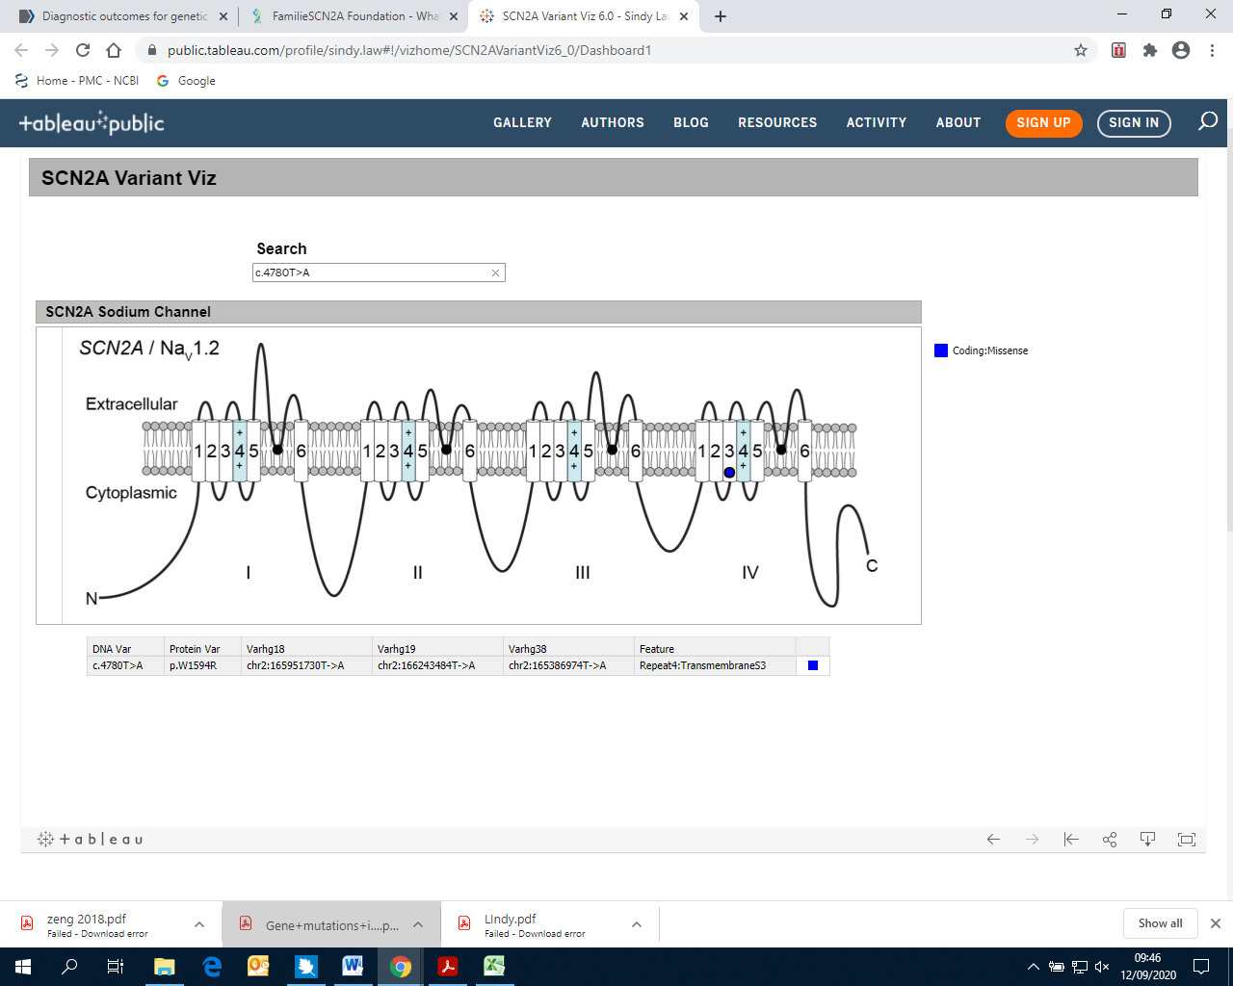

**Early onset seizures with DD/ID**

**ID/ASD with or without later onset seizures**

***Figure 1. Schematic representation of SCN2A protein with variant positions. The variants labelled above the protein are associated with an early onset seizure and DD phenotype and those labelled below the protein are associated with an ID/ASD phenotype (with or without later onset seizures). Created using*** SCN2A Variant Viz 6.0 ***with kind permission from the designer of this tool (Law 2020).***

**Variant type: Nonsense**  **Missense**  **Frameshift **  **Splicing**