Optical detection of ammonia in water using integrated up-conversion fluorescence in a fiberized microsphere

Abstract: A novel optical sensor for ammonia concentration in water is demonstrated using up-conversion (UC) fluorescence intensity ratio (FIR). The sensor element consists of (i) a Er³⁺-Yb³⁺ co-doped tellurite glass microsphere integrated inside a section of suspended tri-core hollow fiber (STCHF) and (ii) the pH indicator phenol red. When 980 nm pump is coupled into the microsphere, the Er³⁺ ions produce green and red UC emissions. Exposure to ammonia results in a strong increase in the 560 nm absorption of the phenol red, which acts as a filter for the green emission, while the red emission is unaffected. A simple linear relation between the FIR and the ammonia acqueous concentration has been established.

- Introduction:
Ammonia is an important constituent in explosives, fertilizers, and industrial coolants, and can be very harmful even at very low concentrations [1, 2]: 22.8 ppm can be lethal to water organisms and exposure to ammonia as low as 35 ppm for over 15 min can be dangerous to humans [3, 4]. In the past decade, many types of ammonia sensors have been proposed based on electrochemical sensing, such as chemiresistors [5] and chemically modified field effect transistors [6]. These electrochemical methods have high selectivity and low detection limits, but have issues with lifetime, miniaturization and stability of the reference electrodes, which have a negative effect on practical applications. Optical ammonia sensors have attracted increased attention because of their advantages in selectivity, repeatability, portability, and immunity to electromagnetic interference [7-9]. Usually, optical ammonia sensors are based on absorbance or fluorescence emissions of ammonia-selective dyes [10, 11]. For example, Tavoli et al. proposed a polypyrrole film doped with Eriochrome cyanine R to detect ammonia gas [12]: the sensor presented significant absorbance variations upon exposure to different ammonia gas concentrations at room temperature and exhibited fast response time and a low detection limit. Duong et al. reported an ammonia sensor based on FIR of a dye [13]: ethyl cellulose was combined with oxazine 170 perchlorate to form a thin membrane as sensing element: the FIR at 565 nm and 630 nm changed in different ammonia concentrations. In fact, ammonia is a weak base, thus can cause the pH to change, resulting in a change in color or fluorescence of the indicator dye [14, 15]. Based on this, Wolfbeis et al. designed a novel sensor film consisting of UC nanoparticles and the pH probe phenol red (PR), which showed excellent properties for ammonia detection [16].
To avoid complex synthesis of nanoparticles and/or of the indicator dye, here a Er³⁺-Yb³⁺ co-doped tellurite glass microsphere is used as UC fluorescence emission medium. The microsphere is integrated inside a section of STCHF and fixed naturally so that the whole sensing structure is more compact and easier to connect with other fiber devices.

- Experimental:

2.1 Materials
The STCHF used in these experiments, consisting of three suspended circular cores, a central air hole and an annular cladding (Fig. 1, inset), was produced by YEOC, Inc. The Er³⁺-Yb³⁺ co-doped tellurite glass (72TeO₂ - 20ZnO - 5Na₂CO₃ – 1.5Y₂O₃ – 0.5Er₂O₃ – 1Yb₂O₃), used for the microsphere, was prepared using a traditional melt-quenching method. The powdered PR (Aladdin, CAS number 143-74-8) was dissolved in deionized water and prepared into a 0.05% mass fraction solution for the further operations.

2.2 Sensing element
Figure 1 shows the schematic of the in-fiber integrated microsphere sensing structure used in our experiments. One end of STCHF was spliced with a section of multi-mode fiber (MMF) and then with a single-mode fiber (SMF) so maximize pump light coupling from SMF into the suspended cores and reduce the overall transmission loss. The STCHF was then taper down using a special fusion splicer to make the suspended cores thinner, thus enhance the evanescent field in the air hole, and to form a conical region that can host the microsphere stable. Finally, the tapered STCHF was cut and the microsphere was placed into the STCHF air hole before the STCHF was spliced to a SMF to complete packaging. Figure 2 shows the step-by-step process to introduce and position the microsphere in the sensing head.
Fig. 1. Schematic of the in-fiber integrated microsphere sensing structure; inset: microscope image of the cross section of the STCHF.
Fig. 2. Microscope images (a) – (c) of the microsphere positioning inside the STCHF and (d) of the resulting in-fiber integrated microsphere sensing unit.

The Er³⁺-Yb³⁺ co-doped tellurite glass microspheres were prepared by droplet method [17]: the bulk tellurite glass was ground into powders, which were then poured into a vertical furnace with an internal gas flow. At high temperature, the powders softened and became microspheres because of the action of the surface tension. The size of the microspheres can be changed by adjusting flow rate and temperature. Finally, a large number of microspheres were collected in a Petri dish attached to the end of a quartz tube. As shown in the Fig. 3(a), the microspheres have uniform size, smooth surface and no contamination. The optical properties of the microspheres integrated in the fiber were characterized using a 980 nm laser pump: strong green and red UC luminescence were observed, as shown in Fig. 3(b). The microscope image in the inset of Fig. 3 shows that the microsphere UC emission is visible at bare eye.
Fig. 3. (a) Microscope image and (b) UC fluorescence spectrum of the Er³⁺-Yb³⁺ co-doped tellurite glass microspheres. Inset: microscope image of microsphere emission under 980nm pumping

Fig. 4 shows the set-up used for the ammonia detection experiments. The fiber sensing unit was placed inside a transparent sealed box and immersed in the PR solution. A small hole was punctured at the top of the sealing box with hole size matching the diameter of the dropper. A two-component epoxy adhesive was used to glue the dropper to the sealed box and fill the gap between the dropper and the hole to ensure good sealing. A 980 nm laser diode (MCSPL-980, MC Fiber Optics, China) was used to pump the Er³⁺-Yb³⁺ co-doped tellurite glass microsphere through the suspended cores. In order to avoid any influence of the liquid level change on the measurements, the spectrometer (USB4000, Ocean Optics, China) optical probe was fixed below the sealed box to collect the microsphere UC fluorescence and the emission spectrum was obtained by processing the collected signals using computer analysis software (Ocean Optics). When ammonia solution was continuously added through the dropper, the ratio of UC green to red emission was monitored.
Fig. 4. Experiment setup for monitoring ammonia concentration in water.

- Results and discussion

3.1 Fluorescence properties of PR solution
PR is nontoxic and not fluorescent when pumped in the near IR. Fig. 5 shows the absorption spectra of PR at three typical pH values: for increasing pH values, the most prominent absorption band changes from 435 nm to 560 nm, which overlaps with the microsphere green emissions. The absorption wavelength shift is particularly pronounced for a pH change from 7 to 9: for increasing ammonia solution concentrations, the PR absorption at 560 nm increases, thus the microsphere green fluorescence emission is frustrated, while the red emission is largely unaffected.
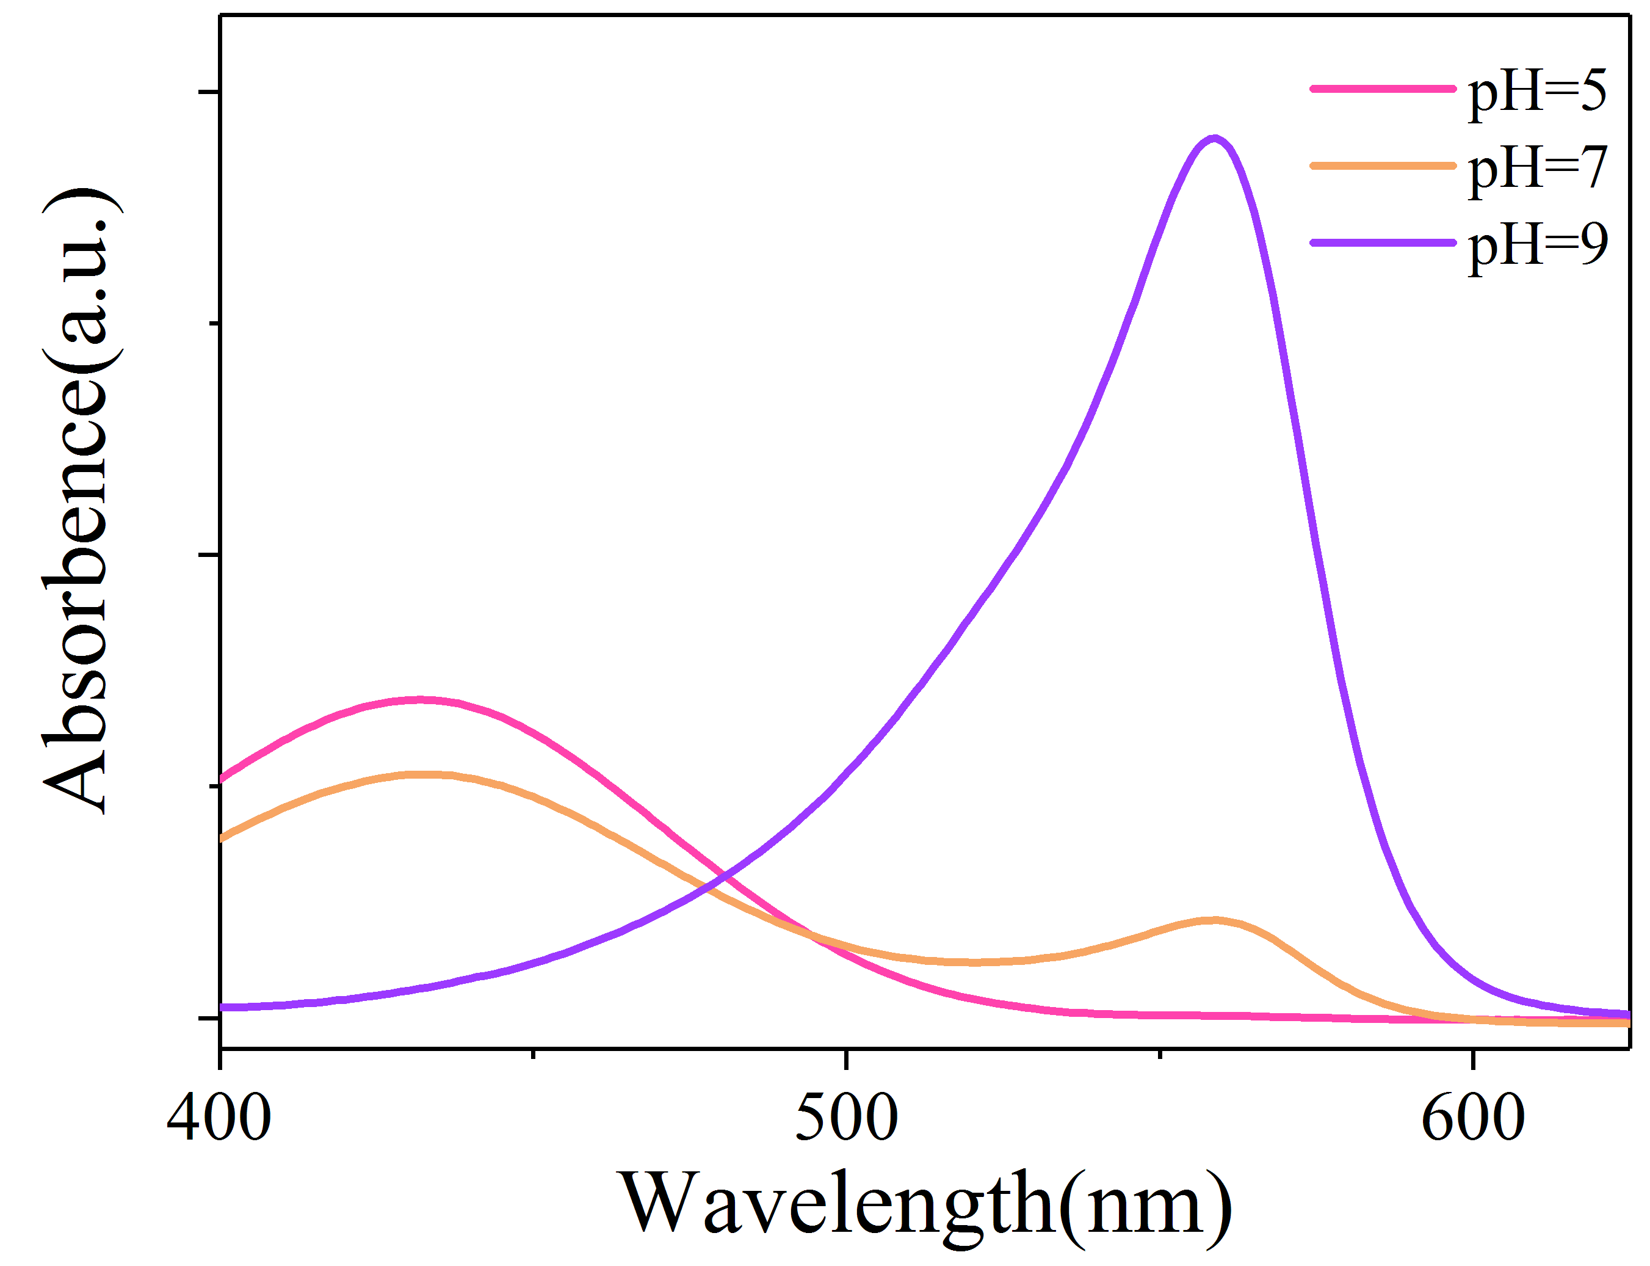
Fig. 5. The absorption spectra of PR in aqueous solutions of pH 5, 7 and 9, respectively.

The effect of PR solution on the microsphere UC luminescence in different pH environments was studied by fixing the STCHF integrated microsphere structure to the bottom of a petri dish, and placing above the microsphere the optical probe connected with a spectrometer to analyze and record the fluorescence spectra. Buffer solution with different pH values was dropped into the petri dish containing the sensing unit, and the UC fluorescence spectrum of the microsphere was recorded. Fig. 6(a) shows that the microsphere UC fluorescence emission is hardly affected by pH. Fig. 6(b) further proves that there is no significant difference in the intensities of green and red light and their ratio at different pH values. However, when PR solution is added into the buffer solution, the UC fluorescence emissions of the microsphere collected by the prove differs at different pH values, as shown in Fig. 6(c). When the solution pH value increases above 6, the microsphere green UC fluorescence emission detected by the probe begins to decrease, while the red signal remains nearly unchanged. The FIR as a function of pH is shown in Fig. 6 (d), which illustrates that in weak base environments the PR has an impact on the microsphere UC fluorescence spectrum collected by the probe.
Fig. 6. (a,c) UC fluorescence spectra of the Er³⁺-Yb³⁺ co-doped tellurite glass microsphere and (b,d) fluorescence peak intensity at 547 nm and 659 nm, and their ratio in different pH values buffer solutions without (a,b) and with (c,d) PR. The pump wavelength was 980 nm.

3.2 Detection of ammonia in water
The fiberized integrated microsphere structure properties were characterized by using the experiment setup shown in Fig. 4. Ammonia solution with concentration ranging from 0 to 4 ppm was dropped into the sealed box. The laser pump power was chosen to minimize any possible thermal effects on fluorescence. For increasing ammonia concentrations, the green fluorescence emission gradually weakened due to the absorption of PR, while the red fluorescence intensity remained unchanged, as shown in Fig. 7(a). For increasing ammonia concentrations, the ratio of fluorescence intensity at 547 nm and 659 nm shows an exponential decrease. The absorption of green light by PR gradually reaches saturation. At low ammonia concentrations, the volatilization rate of ammonia is fast, resulting in an unstable FIR during the set measurement time. The limit of detection (LOD) of ammonia concentration in water was determined to be 0.5 ppm for this sensing configuration.
Fig. 7. (a) Collected UC fluorescence spectra of the Er³⁺-Yb³⁺ co-doped tellurite glass microsphere in different ammonia concentration solutions; (b) relationship between FIR and ammonia concentration in water.

The response and recovery times of the sample sensor are shown in Fig. 8(a). The STCHF integrated microsphere sample was fixed at the bottom of petri dish. One end of multimode fiber was fixed above the microsphere to collect the UC fluorescence signal, while the other was connected to an oscilloscope to record the temporal signal changes. To distinguish the sensor response time from the diffusion time of ammonia in the PR solution, ready prepared solutions of ammonia in PR were used. The solutions were dropped into the petri dish for testing the response time and appropriate amounts of deionized water were added to dilute the ammonia solution for testing the recovery time. The intrinsic response time and recovery times were found to be about 0.20 s and 0.25 s respectively. The short jitter observed at the rising and the falling edges is attributed to the instability of the light intensity caused by the liquid drop.
Sensors repeatability and stability were checked by monitoring the UC fluorescence spectra of the STCHF integrated microsphere sample every second day. Great care was taken to ensure that the relative distance between the probe and the microsphere was constant, to avoid any effect on the fluorescence spectra. Fig. 8(b) shows that there is little difference in the fluorescence intensity at 547 nm and 659 nm, and in particular in their ratio, which illustrates that the STCHF integrated microsphere structure for ammonia detection has excellent repeatability .
Fig. 8. (a) Response and recovery times and (b) repeatability of the STCHF integrated microsphere sample at room temperature.

- Conclusion
In conclusion, a sensor for aqueous ammonia solutions was proposed and demonstrated integrating a STCHF with a Er³⁺-Yb³⁺ co-doped tellurite glass microsphere and PR. Under 980 nm laser pumping, the UC fluorescence emissions of the microsphere were obtained. Due to the increased absorption of PR at 560 nm in weak base environments, the green UC fluorescence of the microsphere was weakened when the sensor was exposed in ammonia. With increasing ammonia concentrations in water, the fluorescence intensity at 547 nm gradually decreased while at 659 nm remained unchanged. For ammonia concentrations from 0 to 4 ppm, the FIR is exponentially dependent on the ammonia concentration. The sensor had a limit of detection of 0.5 ppm, a fast response time (<1 s) and excellent repeatability. The optical sensor based on FIR technology fabricated in this work is low-cost, versatile, and fast for sensing of ammonia concentrations in water.

Funding: This work was supported by the National Key program of Natural Science Foundation of China (NSFC 61935006, 62090062), Shenzhen Basic Research Project (JCYJ20190808173619062), the 111 project (B13015) to the Harbin Engineering University and Heilongjiang Touyan Innovation Team Program.

Reference:
[1]. B. Timmer, W. Olthuis and A. V. D. Berg, "Ammonia sensors and their applications—a review", Sensors & Actuators B Chemical, 107, 2, 666-677, (2005).
[2]. V. Mahendran and J. Philip, "An optical technique for fast and ultrasensitive detection of ammonia using magnetic nanofluids", Applied Physics Letters, 102, 6, 5002-8879, (2013).
[3]. S. Paramasivam, K. Jayaraman, T. C. Wilson, A. K. Alva, L. Kelson and L. B. Jones, "Ammonia volatilization loss from surface applied livestock manure", Journal of Environmental Science & Health Part B, 44, 3, 317-324, (2009).
[4]. M. Pisco, M. Consales, S. Campopiano, A. Cutolo and A. Cusano, "Ammonia detection in water with a tin dioxide based optical sensor", Proceedings of SPIE - The International Society for Optical Engineering, 5952, 293-301, (2005).
[5]. Y. Li, Y.-Q. Liu, L.-W. Liu and G.-B. Pan, "Ammonia Chemiresistor Sensor Based on Poly(3-Hexylthiophene) Film Oxidized by Nitrosonium Hexafluorophosphate", Chemistry Letters, 41, 12, 1569-1570, (2012).
[6]. J. Yu, X. Yu, L. Zhang and H. Zeng, "Ammonia gas sensor based on pentacene organic field-effect transistor", Sensors and Actuators B: Chemical, 173, 133-138, (2012).
[7]. T. Tsuboi, Y. Hirano, Y. Shibata and S. Motomizu, "Sensitivity Improvement of Ammonia Determination Based on Flow-Injection Indophenol Spectrophotometry with Manganese(II) Ion as a Catalyst and Analysis of Exhaust Gas of Thermal Power Plant", Analytical Sciences, 18, 10, 1141-1144, (2002).
[8]. K. Waich, S. Borisov, T. Mayr and I. Klimant, "Dual lifetime referenced trace ammonia sensors", Sensors and Actuators B: Chemical, 139, 1, 132-138, (2009).
[9]. G. H. Mount, B. Rumburg, J. Havig, B. Lamb, H. Westberg, D. Yonge, K. Johnson and R. Kincaid, "Measurement of atmospheric ammonia at a dairy using differential optical absorption spectroscopy in the mid-ultraviolet", Atmospheric Environment, (2002).
[10]. A. H. Jalal, J. Yu and A. G. Agwu Nnanna, "Fabrication and calibration of Oxazine-based optic fiber sensor for detection of ammonia in water", Applied Optics, 51, 17, 3768-3775, (2012).
[11]. R. Claps, F. V. Englich, D. P. Leleux, D. Richter and R. F. Curl, "Ammonia Detection by use of Near-Infrared Diode-Laser-Based Overtone Spectroscopy", Applied Optics, 40, 24, 4387-4394, (2001).
[12]. F. Tavoli and N. Alizadeh, "Optical ammonia gas sensor based on nanostructure dye-doped polypyrrole", Sensors & Actuators B Chemical, 176, 761-767, (2013).
[13]. D. J. I. Rhee, "A ratiometric fluorescence sensor for the detection of ammonia in water", Sensors and Actuators B: Chemical, (2014).
[14]. C. Preininger, G. J. Mohr, I. Klimant and O. S. Wolfbeis, "Ammonia fluorosensors based on reversible lactonization of polymer-entrapped rhodamine dyes, and the effects of plasticizers", Analytica Chimica Acta, 334, 1-2, 113-123, (1996).
[15]. I. M. Raimundo and R. Narayanaswamy, "Simultaneous determination of relative humidity and ammonia in air employing an optical fibre sensor and artificial neural network", Sensors & Actuators B, 74, 1-3, 60-68, (2001).
[16]. H. S. Mader and O. S. Wolfbeis, "Optical Ammonia Sensor Based on Upconverting Luminescent Nanoparticles", Analytical Chemistry, 82, 12, 5002-5004, (2010).
[17]. G. R. Elliott, D. W. Hewak, G. S. Murugan and J. S. Wilkinson, "Chalcogenide glass microspheres; their production, characterization and potential", Optics Express, 15, 26, 17542-17553, (2007).

