Higher moment connectedness in cryptocurrency market

Mudassar Hasan
Lahore Business School, The University of Lahore, Lahore, 54000, Pakistan
Email: mudassar.hassan@lbs.uol.edu.pk

Muhammad Abubakr Naeem
School of Economics and Finance, Massey University, New Zealand
UCD College of Business, University College Dublin, Ireland
Email: m.naeem@massey.ac.nz

Muhammad Arif
Department of Business Administration, Shaheed Benazir Bhutto University, Shaheed Benazirabad, Pakistan
Email: marif@sbbusba.edu.pk

Larisa Yarovaya
Southampton Business School, University of Southampton, Southampton, United Kingdom
Email: l.yarovaya@soton.ac.uk

Abstract
Using 5-minute data, we capture higher-moment connectedness among three dominant cryptocurrencies. We find a moderate realized-volatility connectedness wherein Bitcoin and Litecoin (Ripple and Binance Coin) emerge as the leading spillover receivers (transmitters). A robust realized-skewness connectedness is found between Bitcoin, Ethereum and Litecoin, while a strong realized-kurtosis connectedness between Bitcoin and Ethereum. Furthermore, a time-varying connectedness analysis exhibits an enhanced higher-moment connectedness in the cryptocurrency market, which peaks during the COVID-19 pandemic. The study carries critical implications for higher-order pricing in the cryptocurrency market.
Keywords: Cryptocurrencies; high-frequency connectedness; higher-moments; spillovers.
JEL Classification: C5, C58, G10, G15

1. Introduction

Cryptocurrencies have evolved rapidly and turned into a global phenomenon, drawing attention from both professionals and academics. Bitcoin price hit 63,000 USD in April 2021, which originated another round of debates on the leading cryptocurrency's explosivity and fundamental value. The primary objective of cryptocurrencies is to provide an entirely independent, incorruptible, affordable, and secure platform for carrying out financial transactions. Hence, their acceptance as an alternative payment system is continuously increasing. Albeit their enormous potential and popularity, cryptocurrencies, especially Bitcoin, are infamous for extreme and synchronized price swings, posing various challenges for investors and financial regulators.
Cryptocurrency literature has evolved looking at the connectedness of either first (return) or second (volatility) moment in cryptocurrency markets (Corbet et al., 2018a; Yi et al., 2018; Omane-Adjepong & Alagidede, 2019; Balli et al., 2019; Zięba et al., 2019; Katsiampa et al., 2019; Xu et al., 2020; Borri & Shakhnov, 2019; Moratis, 2020; Huynh, 2019; Baumöhl, 2019; Ji et al., 2019; Antonakakis et al., 2019; Bouri et al., 2019). However, the existing studies overlook the connectedness between cryptocurrencies via higher moments, despite evidence that both the degree and structure of cryptocurrency connectedness may be sensitive to different moments.
For instance, Geuder et al. (2019) show that Bitcoin price experienced exponential growth between 2016 and 2017, indicating skewed returns in the form of bubbles. Blau (2017) demonstrates that Bitcoin is about twice as volatile as conventional currencies. Baek and Elbeck (2015) report that cryptocurrencies do not necessarily follow a Gaussian distribution. In this vein, many studies investigating the price behaviour of cryptocurrencies document stylized facts, including volatility clustering (Urquhart, 2017), lottery effect (Grobys & Junttila, 2020), asymmetry and tail-risk (Phillip et al., 2018), speculative bubbles (Cheah & Fry, 2015; Fry, 2018; Corbet et al., 2018b), and inefficient pricing (Wei, 2018). These higher-moment-like features suggest that the connectedness via first- and second-moment may not be enough to understand the interlinkages among cryptocurrencies and that attention to higher-moments would be revealing.
This paper investigates a higher-moment connectedness across major cryptocurrencies and thus distils critical information for cryptocurrency price formation. In the cryptocurrency market, higher-moments, namely skewness and kurtosis, occur due to speculative trading dominated by young investors with strong gambling preferences (Jain et al., 2019). Furthermore, given that cryptocurrencies may have no intrinsic value (Corbet et al., 2018), investors' attitude regarding extreme returns would also be expressed in cryptocurrency's higher-moments. Accordingly, the speculative and herding behaviour (Vidal-Tomás et al., 2019) of cryptocurrency investors would drive their connectedness over higher-moments. Since skewness refers to the return distribution's asymmetry, its connectedness would imply how cryptocurrencies are linked via asymmetry or downside (upside) or crash risk (Barndorff-Nielsen et al., 2010). Similarly, connectedness via kurtosis would imply how fat-tail risk spreads across cryptocurrencies, revealing information transmission that coincides with extreme events. Hence, connectedness via higher moments would provide critical information for the stability of cryptocurrency markets.
Using 5-minute data, we capture higher-moment connectedness among prominent cryptocurrencies by resorting to Diebold and Yilmaz (2012)’s spillover framework. We find moderate volatility connectedness wherein Bitcoin and Litecoin (Ripple and Binance Coin) emerges as the leading spillover receivers (transmitters). A robust skewness connectedness between Bitcoin, Ethereum and Litecoin. We observe a strong kurtosis connectedness between Bitcoin and Ethereum. The time-varying analysis exhibits enhanced higher-moment connectedness between selected cryptocurrencies, which reaches its peak during the extreme phases of the COVID-19 pandemic.
This study builds upon the recently documented evidence that higher-moments are priced in the cross-section of cryptocurrency returns, such as Jia, Liu, and Yan (2020), Zsolt and Botond (2020), and Ahmed and Al Mafrachi (2021). Contributing to this debate, we argue that higher-moments carry a significant potential to connect cryptocurrencies besides their price formation role. Thus, this study adds a vital piece of information for the cryptocurrency market's price formation and information transmission processes.
The rest of the paper unfolds as follows. Section 2 describes the dataset and methodology. Section 3 offers empirical findings. Section 4 concludes.

2. Data and Methodology
We consider high-frequency data on eight cryptocurrencies, namely Bitcoin (BTC), Binance Coin (BNB), Cardano (ADA), Ethereum (ETH), EOS (EOS), Litecoin (LTC), Ripple (XRP), Stellar (XLM). The size, liquidity, and popularity of these cryptocurrencies are critical factors behind their inclusion in our sample. Lately, these cryptocurrencies have attracted considerable attention from investors, policymakers, and academics (Caporale et al., 2018; Yi et al., 2018; Koutmos, 2018; Mensi et al., 2020). The 5-minute data are collected from https://www.binance.com/en over a period from 01 June 2018 to 25 December 2020.
Figure 1 presents the evaluation of selected cryptocurrency prices. We observe a decreasing trend in all cryptocurrencies’ prices from the start of the sample period to the end of 2018. After that, the prices show an exponentially increasing pattern that continues until mid-2019 before reverting to normal levels. Moreover, the onset of the COVID-19 crisis causes a sharp decrease in all cryptocurrency prices; however, we observe that prices start to recover by mid-2020 and approach new highs by the end of 2020.
[Figure 1 here]
Our methodology consists of two steps. First, we compute higher moments for each cryptocurrency, namely realized-volatility, realized-skewness and realized-kurtosis. Following the literature (Andersen et al., 2003; Amaya et al., 2015), we realized higher-moments, namely the realized variance (${RV}_{t}$), realized skewness (${RS}_{t}$) and realized kurtosis (${RK}_{t}$) as:
${RV}_{t}= \sqrt{\sum_{i=1}^{N}{r_{it}^{2}} }$ (1)
${RS}_{t}= \frac{\sqrt{N}\sum_{i=1}^{N}{r_{it}^{3}}}{{{RVol}_{t}}^{3/2}}$ (2)
${RK}_{t}= \frac{N\sum_{i=1}^{N}{r_{it}^{4}}}{{{RVol}_{t}}^{2}}$ (3)
Note that the three realized moments are all in percentage terms. Next, we follow Diebold and Yilmaz (2012) to ascertain the higher-moment connectedness between our sample cryptocurrencies. To preserve space, we provide details of Diebold and Yilmaz (2012) in Appendix A, which is provided at the end.
3. Empirical findings
3.1 Network-based connectedness
Figure 2a presents a connectedness network for cryptocurrencies' RVs. LTC emerges as the leading receiver of volatility spillovers, followed by BTC. LTC receives volatility spillovers from BTC, ETH and EOS, whereas ETH and BNB transmit spillovers to BTC. This observation reveals that BTC being the leading cryptocurrency and LTC, being its fork, are key players in the cryptocurrency market's volatility. This finding corroborates with Ji, Bouri et al. (2019) and Yi, Xu et al. (2018) that find BTC and LTC to be the most influential currencies.
[Figure 2a here]
Moreover, we observe a two-way spillover transmission between XRP and XLM. Ji, Bouri et al. (2019) report these two currencies to have strong return connectedness. These findings indicate that these currencies are strongly connected vis-à-vis first and second-order moment channels. Contrarily, ADA emerges as a distinct actor in the RV connectedness network, suggesting a potential diversification avenue for cryptocurrency investors. Figure 2b presents the net spillover status of selected cryptocurrencies, where XRP emerges as the dominant spillover transmitter, followed by BNB and ETH, respectively. On the contrary, LTC and BTC receive most volatility spillovers making them leading net receivers among selected cryptocurrencies.
[Figure 2b here]
Figure 3a presents an RS based connectedness network. We observe robust two-way spillover transmission between BTC, ETH and LTC, indicating that these currencies jointly experience extreme price moments. This finding relates to the price co-explosivity phenomena and tail-risk dependence in the cryptocurrency market reported by Bouri et al. (2019) and Nguyen et al. (2020), respectively. Moreover, the strong higher-moment connectedness between the two largest currencies, namely BTC and ETH, shows the price vulnerability of the cryptocurrency market and agrees with Nguyen et al. (2020) finding that these two currencies respectively are negative and positive shock drivers of the cryptocurrency market. This finding further confirms the prevalence of herding and speculative behavior among cryptocurrency investors (Vidal-Tomás et al., 2019). We observe higher-moment spillover transmission from ADA (EOS) to BTC (LTC), indicating that larger and established cryptocurrencies are more vulnerable to higher-moment spillovers than smaller and newer currencies. Contrarily, we observe that higher moments in BNB, XRP and XLM are detached from the rest of the cryptocurrencies. Hence, once included in cryptocurrency portfolios, these can offer protection from downside risk, which is also indicated by Borri (2019) regarding XRP.
[Figure 3a here]
Further, Figure 3b shows the net spillover status of cryptocurrencies, where one can quickly identify that larger and established currencies such as BTC and ETH are net spillover receivers. In contrast, relatively smaller coins such as XEM and EOS are net transmitters. This observation reinforces our suggestion that larger currencies are highly exposed to extreme price moments, making them potential beneficiaries/ benefactors of the drastic price moments in the cryptocurrency market.
[Figure 3b here]
Figure 4a presents the connectedness network based on RK. The figure exhibits that BTC and ETH are strongly connected. Moreover, we observe robust spillover transmission from EOS and ADA to LTC. It is apparent from the kurtosis connectedness results that there is stronger spillover transmission between larger cryptocurrencies concerning the higher return moments originating from extreme events such as market-wide turbulence, economic and financial crises i-e COVID-19 crisis. Moreover, Figure 4b presents the net spillover status summary, revealing that most of the cryptocurrencies being net spillover receivers are exposed to tail risk originating from extreme price moments in the cryptocurrency markets.
[Figure 4a and b here]
3.2 Time-varying connectedness
Next, we estimate the time-varying connectedness between higher moments of selected cryptocurrencies to ascertain the effects of different events that may alter the connectedness structure. In doing so, we use a rolling window of 215 days based on the length of the total sample. Figure 4 shows total connectedness between cryptocurrencies concerning RV, RS and RK using red, blue (dashed) and green (dotted) lines, respectively. Overall, we observe an increasing trend of higher-moment connectedness over the sample period, indicating increased information flow and integration in the cryptocurrency market. Specifically, RV connectedness shows an average score of 70% during the sample period and overrides RS and RK's connectedness, indicating a consistent and sizeable volatility transmission between the cryptocurrencies. This finding agrees with Yi, Xu, and Wang (2018) and Koutmos (2018) that report a higher volatility transmission level in the cryptocurrency market.
[Figure 5 here]
Moreover, we observe a swift increase in RS and RK connectedness during the COVID-19 crisis period, indicating an increased likelihood of crash risk in the cryptocurrency market and increased exposure to extreme financial and economic events. Higher-moment connectedness in the cryptocurrency market during the pandemic period relates to adverse herding behaviour reported by da Gama Silva et al. (2019). Besides, the enhanced RS and RK connectedness also indicate that cryptocurrencies are linked via extreme positive returns. This finding corroborates with the cryptocurrency market's co-explosivity trend observed by Bouri, Shahzad, and Roubaud (2019) and Shahzad et al. (2021). These findings signify that digital currencies, like other financial assets, are also exposed to market contagion effects, and investors should consider things while formulating digital currency portfolios and investment strategies.
4. Conclusion
This paper examined the higher-moment connectedness between eight prominent cryptocurrencies using high-frequency data. By employing a network-based approach, we find a moderate, robust, and strong connectedness over volatility, skewness and kurtosis, respectively, of the cryptocurrency market. The time-varying analysis reveals that the higher-moment connectedness peaked during the COVID-19 pandemic.
Our findings carry important implications for higher-order pricing in the cryptocurrency market as well as for cryptocurrency investors by looking through the lens of higher-moment connectedness of leading cryptocurrencies. These insights are equally important for investors and portfolio managers to formulate investment strategies using extreme returns of digital currencies, which is a fundamental feature of the cryptocurrency market. In particular, the higher-moment connectedness patterns uncovered by this study caution the investors to carefully track how crash risk and fat-tail risk spread across the cryptocurrency market. In this way, the crypto-investors may preempt the trajectory higher-moment shocks from one cryptocurrency to another and adjust their holdings accordingly. In other words, our findings highlight diversification opportunities for digital currency investors that are much sought after given the highly volatile nature of the cryptocurrency market. Adding to the previously documented evidence that higher-moments are priced in the cross-section of cryptocurrency returns (Jia et al., 2020; Zsolt & Botond, 2020; Ahmed & Al Mafrachi, 2021), we argue that not only the higher-moments but also their connectedness dynamics be accounted for in the higher-order price formation process of the cryptocurrency markets. Finally, by pointing out the cryptocurrencies that are primary transmitters and receivers of higher-moment shocks, this study provides critical insights to policymakers for the stability of cryptocurrency markets.

References
Ahmed, W. M., & Al Mafrachi, M. (2021). Do higher-order realized moments matter for cryptocurrency returns?. International Review of Economics & Finance, 72, 483-499.
Al-Yahyaee, K. H., Mensi, W., Ko, H. U., Yoon, S. M., & Kang, S. H. (2020). Why cryptocurrency markets are inefficient: The impact of liquidity and volatility. The North American Journal of Economics and Finance, 52, 101168.
Amaya, D., Christoffersen, P., Jacobs, K., and Vasquez, A. (2015). Does realized skewness predict the cross-section of equity returns. Journal of Financial Economics, 118, 135-167.
Andersen, T., Bollerslev, T., and Diebold, F. (2003). Modeling and forecasting realized volatility. Econometrica, 71, 579-625.
Barndorff-Nielsen, O., Kinnebrock, S., & Shephard, N. (2010). Volatility and time series econometrics: Essays in honor of robert f. engle, chapter measuring downside risk-realized semivariance.
Borri, N. (2019). "Conditional tail-risk in cryptocurrency markets." Journal of Empirical
Finance 50: 1-19.
Bouri, E., Shahzad, S. J. H., & Roubaud, D. (2019). Co-explosivity in the cryptocurrency market. Finance Research Letters, 29, 178-183.
Caporale, G. M., Gil-Alana, L., & Plastun, A. (2018). Persistence in the cryptocurrency market. Research in International Business and Finance, 46, 141-148.
Cheah, E. T., & Fry, J. (2015). Speculative bubbles in Bitcoin markets? An empirical investigation into the fundamental value of Bitcoin. Economics Letters, 130, 32-36.
Chen, C., Liu, L., & Zhao, N. (2020). Fear sentiment, uncertainty, and bitcoin price dynamics: The case of COVID-19. Emerging Markets Finance and Trade, 56(10), 2298-2309.
Conlon, T., Corbet, S., & McGee, R. J. (2020). Are Cryptocurrencies a Safe Haven for Equity Markets? An International Perspective from the COVID-19 Pandemic. Research in International Business and Finance, 101248.
Corbet, S., Larkin, C., Lucey, B, Meegan, A. Yarovaya, L. (2018). Exploring the Dynamic Relationships between Cryptocurrencies and Other Financial Assets. Economics Letters, 165, 28-34. https://doi.org/10.1016/j.econlet.2018.01.004
Corbet, S., Lucey, B, Yarovaya, L. (2018). Datestamping the Bitcoin and Ethereum bubbles. Finance Research Letters, https://doi.org/10.1016/j.frl.2017.12.006.
da Gama Silva, P. V. J., Klotzle, M. C., Pinto, A. C. F., & Gomes, L. L. (2019). Herding behavior and contagion in the cryptocurrency market. Journal of Behavioral and Experimental Finance, 22, 41-50.
Diebold, F. X., and Yilmaz, K. (2012). Better to give than to receive: predictive directional measurement of volatility spillovers. International Journal of Forecasting, 28, 57-66
Fry, J. (2018). Booms, busts and heavy-tails: The story of Bitcoin and cryptocurrency markets?. Economics Letters, 171, 225-229.
Ghorbel, A., & Jeribi, A. (2021). Investigating the relationship between volatilities of cryptocurrencies and other financial assets. Decisions in Economics and Finance, 1-27.
Grobys, K., & Junttila, J. P. (2020). Speculation and lottery-like demand in cryptocurrency markets. Available at SSRN 3551948.
Jain, P. K., McInish, T. H., & Miller, J. L. (2019). Insights from bitcoin trading. Financial Management, 48(4), 1031-1048.
Jia, Y., Liu, Y., & Yan, S. (2020). Higher Moments, Extreme Returns, and Cross–Section of Cryptocurrency Returns. Finance Research Letters, 101536.
Ji, Q., et al. (2019). "Dynamic connectedness and integration in cryptocurrency markets."
International Review of Financial Analysis 63: 257-272.
Koop, G., Pesaran, M. H., & Potter, S. M. (1996). Impulse response analysis in nonlinear multivariate models. Journal of econometrics, 74(1), 119-147.
Koutmos, D. (2018). Return and volatility spillovers among cryptocurrencies. Economics Letters, 173, 122-127.
Kumar, A. (2009). Who gambles in the stock market?. The Journal of Finance, 64(4), 1889-1933.
Mensi, W., Al-Yahyaee, K. H., Al-Jarrah, I. M. W., Vo, X. V., & Kang, S. H. (2020). Dynamic volatility transmission and portfolio management across major cryptocurrencies: Evidence from hourly data. The North American Journal of Economics and Finance, 54, 101285.
Nguyen, L. H., Chevapatrakul, T., & Yao, K. (2020). Investigating tail-risk dependence in the cryptocurrency markets: A LASSO quantile regression approach. Journal of Empirical Finance, 58, 333-355.
Pesaran, H. H., & Shin, Y. (1998). Generalized impulse response analysis in linear multivariate models. Economics letters, 58(1), 17-29.
Phillip, A., Chan, J. S., & Peiris, S. (2018). A new look at Cryptocurrencies. Economics Letters, 163, 6-9.
Shahzad, S. J. H., Bouri, E., Ahmad, T., Naeem, M. A., & Vo, X. V. (2020). The pricing of bad contagion in cryptocurrencies: A four-factor pricing model. Finance Research Letters, 101797.
Shahzad, S. J. H., Balli, F., Naeem, M. A., Hasan, M., & Arif, M. (2021). Do conventional currencies hedge cryptocurrencies?. The Quarterly Review of Economics and Finance.
Vidal-Tomás, D., Ibáñez, A. M., & Farinós, J. E. (2019). Herding in the cryptocurrency market: CSSD and CSAD approaches. Finance Research Letters, 30, 181-186.
Wei, W. C. (2018). Liquidity and market efficiency in cryptocurrencies. Economics Letters, 168, 21-24.
Yarovaya, Larisa and Zięba, Damian, Intraday Volume-Return Nexus in Cryptocurrency Markets: A Novel Evidence From Cryptocurrency Classification (October 14, 2020). Available at SSRN: https://ssrn.com/abstract=3711667 or http://dx.doi.org/10.2139/ssrn.371166
Yi, S., Xu, Z., & Wang, G. J. (2018). Volatility connectedness in the cryptocurrency market: Is Bitcoin a dominant cryptocurrency? International Review of Financial Analysis, 60, 98-114.
Zsolt, N. B., & Botond, B. (2020). Higher co-moments and adjusted Sharpe ratios for cryptocurrencies. Finance Research Letters, 101543.

Appendix A
The Connectedness Model of Diebold and Yilmaz (2012)
Diebold and Yilmaz (2012) resort to the generalized vector autoregressive (VAR) setting to obtain the connectedness computations. The VAR framework produces forecast error variance decompositions (FEVD), leading to the connectedness estimates. To this end, a covariance-stationary VAR (p) model for N-cryptocurrencies is constructed as $y_{t}=\sum_{i=1}^{p}{ϕ_{i}}y_{t-i}+ԑ_{t}$ , where $ԑ_{t}\sim N(0, Σ)$. Consequently, a moving average (MA) depiction driven from the VAR model, therefore, results in an MA ($∞$) process, $y_{t}=\sum_{i=0}^{∞}{ψ_{i}}ԑ_{t-i}$, where $ψ_{i}$ is a coefficient matrix of order $N×N$, which is recursively computed through $ψ_{i}=ϕ_{1}ψ_{i-1}+ϕ_{2}ψ_{i-2}+…+ϕ_{p}ψ_{i-p}$, where $ψ_{0}$ is the identity matrix.
Subsequently, we follow Koop et al. (1996) and Pesaran and Shin (1998) to achieve orthogonality through the generalized framework. Hence, a given cryptocurrency $j$’s contribution to another cryptocurrency $i$’s H-step-ahead generalized forecast error variance is represented by $ξ_{ij}(H)$, and estimated by:
$ξ_{ij}(H)=\frac{σ_{jj}^{-1}\sum_{h=0}^{H-1}{{\left(I_{i}^{'}ψ_{h}∑I_{j}\right)}^{2}}}{\sum_{h=0}^{H-1}{{\left(I_{i}^{'}ψ_{h}∑ψ_{h}^{'}I_{i}\right)}^{2}}}$, (1)
Where $∑$ and $σ_{jj}$ represent the covariance matrix of errors and the $j^{th}$ component of the standard deviation’s diagonal, respectively. For an $i^{th}$ component, $I_{i}$ takes a value of one and zero otherwise. In the non-orthogonalized VAR’s infinite MA representation, $ψ_{h}$ represents a coefficient matrix with the multiplication of h-lagged errors.
Accordingly, the pairwise connectedness from cryptocurrency j to cryptocurrency i is given by:
$Ω_{i←j}^{H}=ξ_{ij}(H)$ (2)
Consequently, we can capture the total directional connectedness from (to) other cryptocurrencies to cryptocurrency j (i). According to Diebold and Yilmaz (2012), it can be obtained by dividing the off-diagonal sum of columns (rows) by the sum of all elements. It is represented by:
$Ω_{i←•}^{H}=\frac{1}{N}\sum_{j=1 j≠i }^{N}{ξ_{ij}}(H)$ (3)
$Ω_{•←j}^{H}=\frac{1}{N}\sum_{i=1 i≠j }^{N}{ξ_{ij}}(H)$ (4)
Similarly, we can obtain the total or system-wide connectedness. According to the authors, it can be computed by dividing the sum of to others (from others) elements by the sum of all its elements:
$Ω^{H}=\frac{1}{N}\sum_{i,j=1 i≠j }^{N}{ξ_{ij}}(H)$ (5)

Figure 1: Evolution of high-frequency price series for cryptocurrencies
a) Bitcoin (BTC) b) Ethereum (ETH)
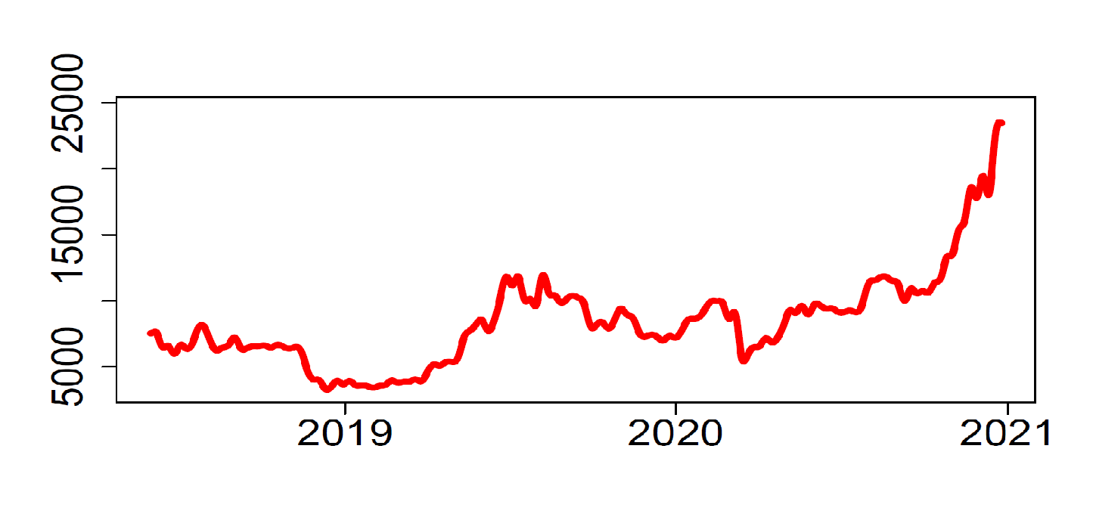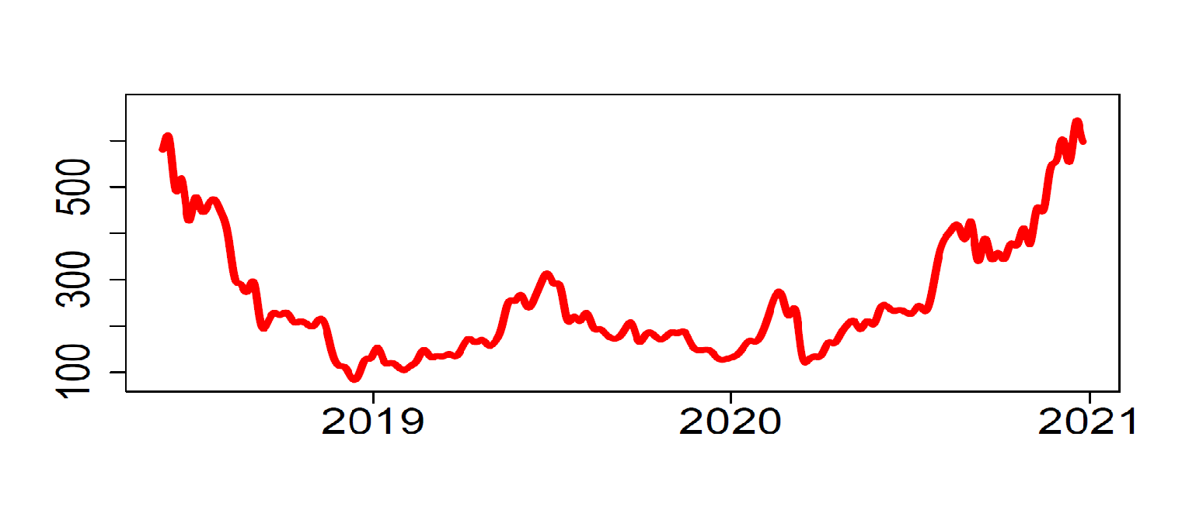
c) Ripple (XRP) d) Litecoin (LTC)
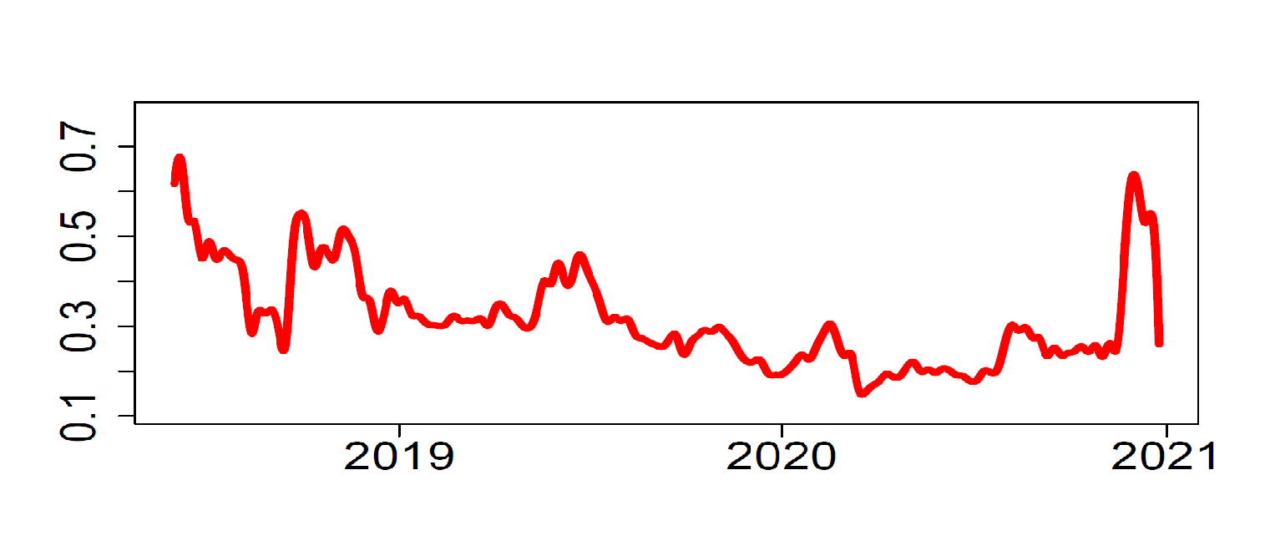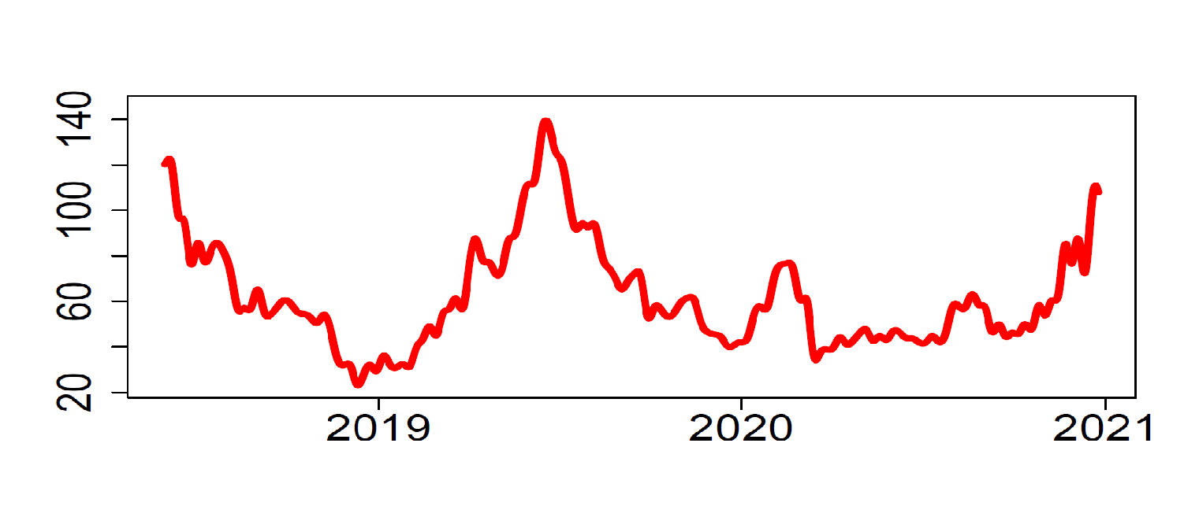
e) Binance Coin (BNB) f) Cardano (ADA)
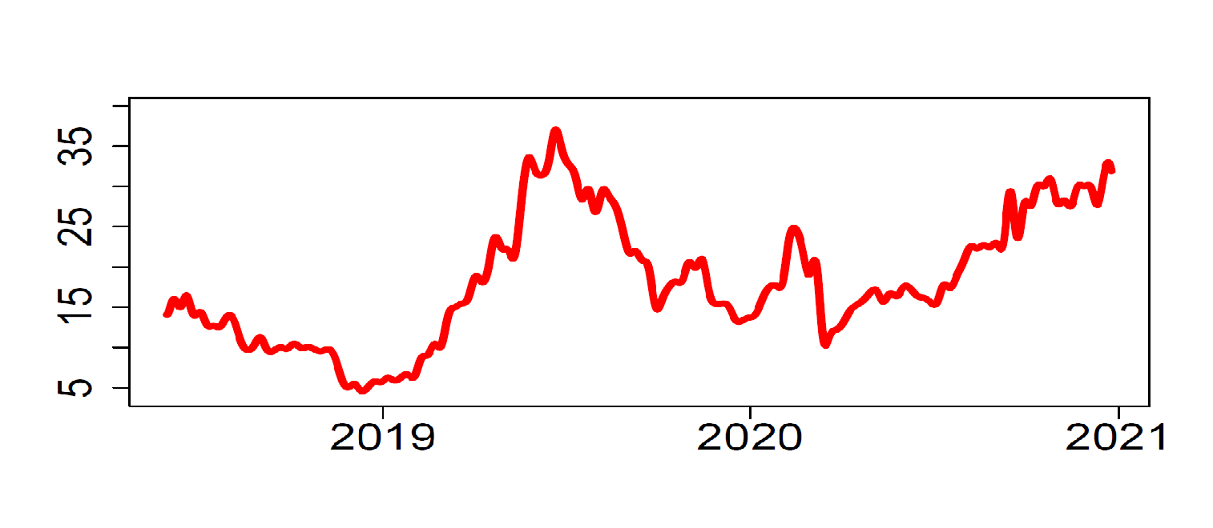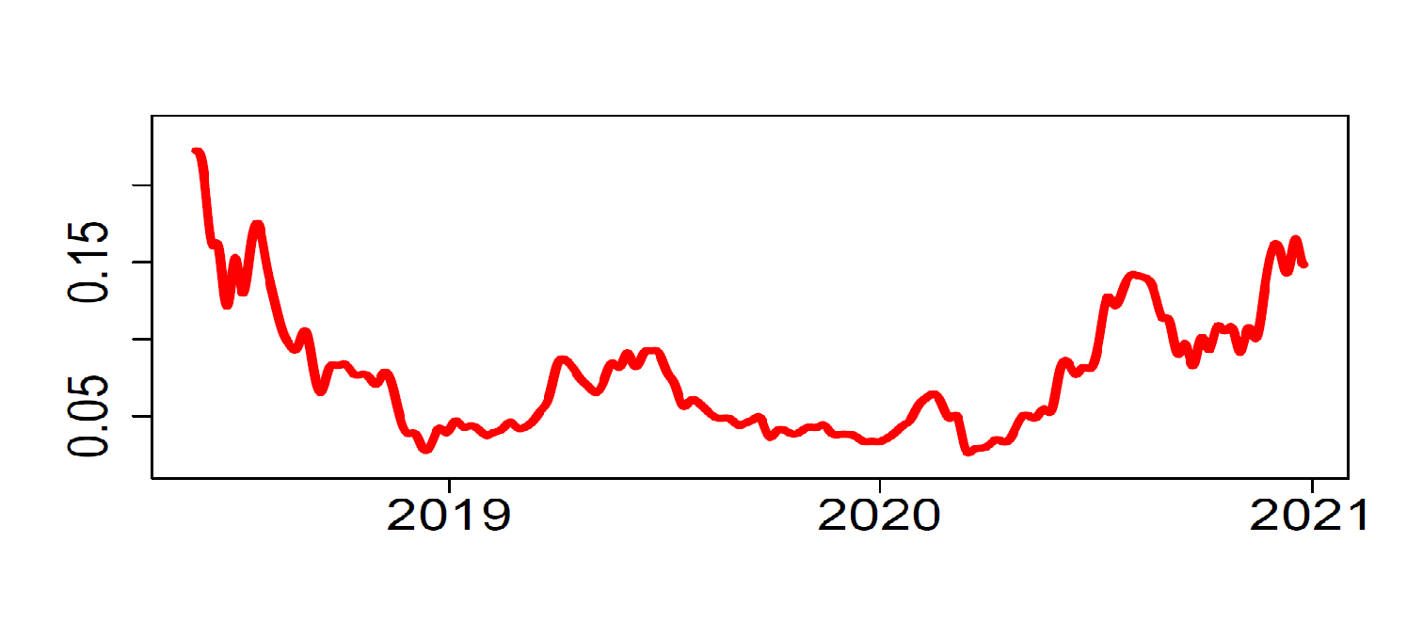
g) Stellar (XLM) h) EOS (EOS)
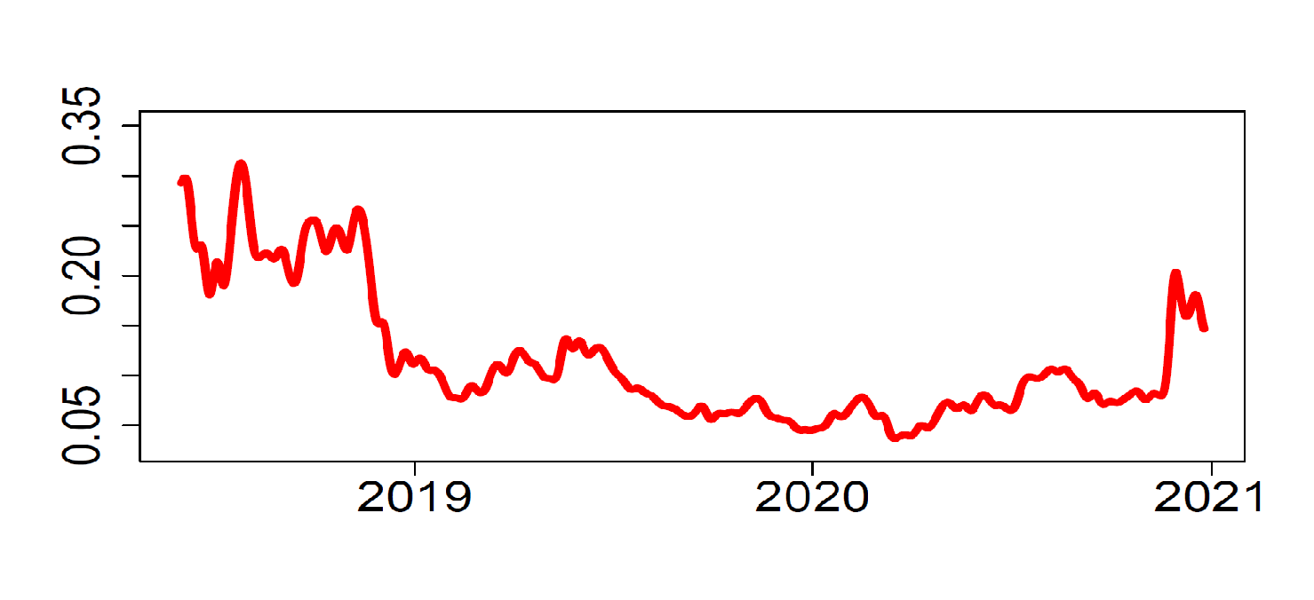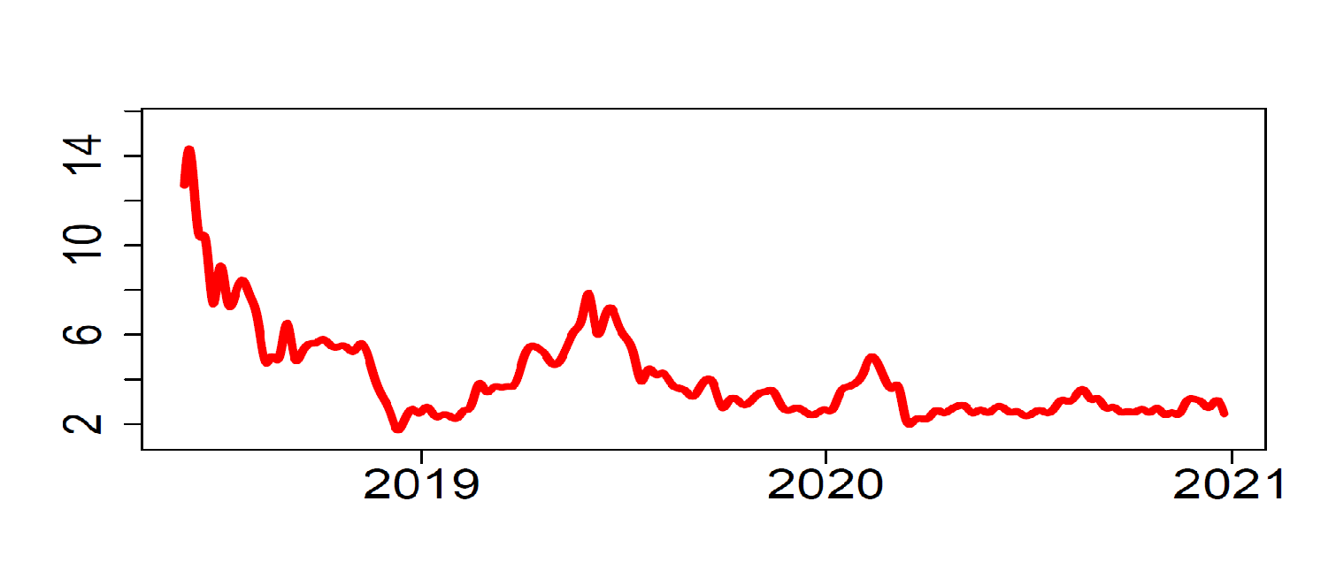
Note: The figure presents the time evolution of high-frequency 5-min data from 1/06/2018 – 25/12/2020

Figure 2. The network of realized volatility (RV) connectedness using Diebold and Yilmaz (2012)
a) Network of realized volatility (RV)
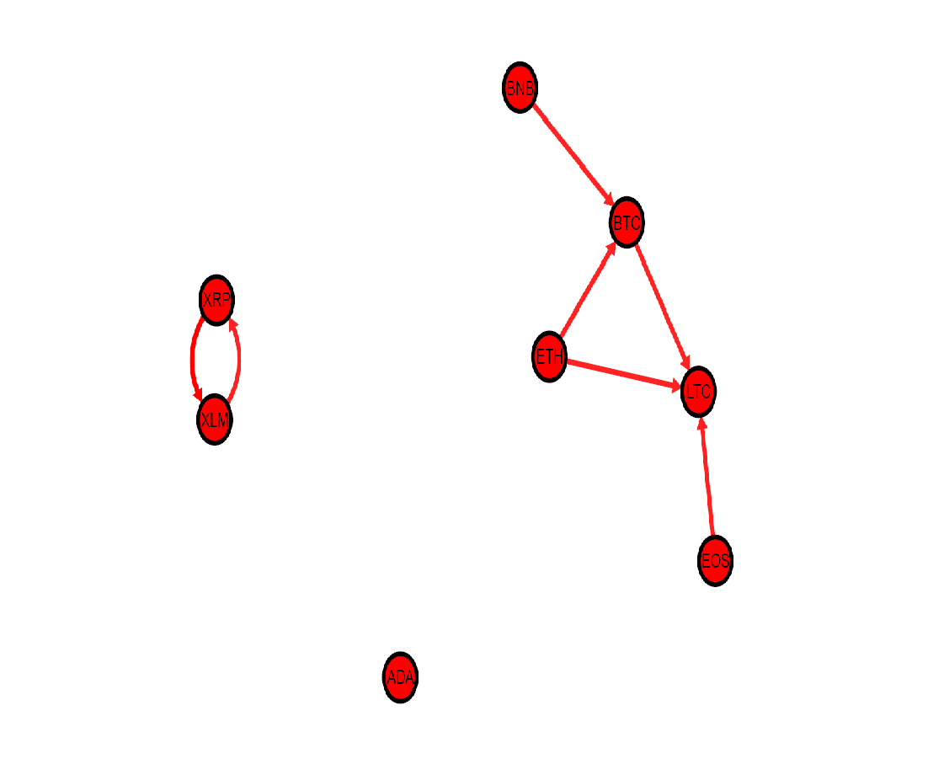

b) Summary measures of connectedness network
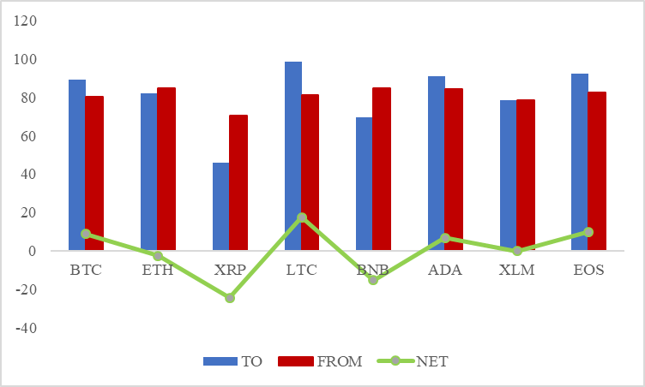
Note: Panel A shows the connectedness among 8 sampled cryptocurrencies using VAR (1). We only keep the connectedness values larger than the average of the 16 largest individuals pairwise connectedness measures. Panel B shows the three summary measures of the connectedness network. To, From, and Net. Net position is shown through a green dot with the line.

Figure 3. The network of realized skewness (RS) connectedness using Diebold and Yilmaz (2012)
a) Network of realized skewness (RS)
b) Summary measures of connectedness network
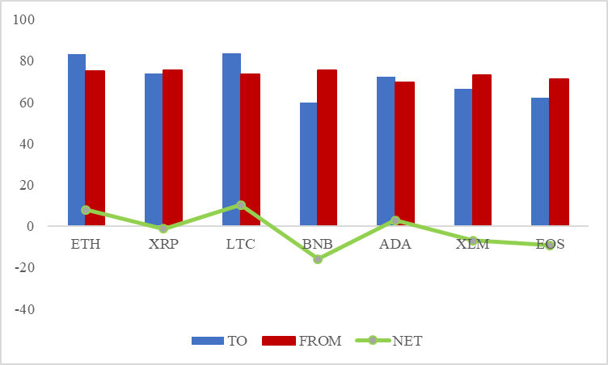
Note: Refer to Figure 2

Figure 4. The network of realized kurtosis (RK) connectedness using Diebold and Yilmaz (2012)
a) Network of realized kurtosis (RK)
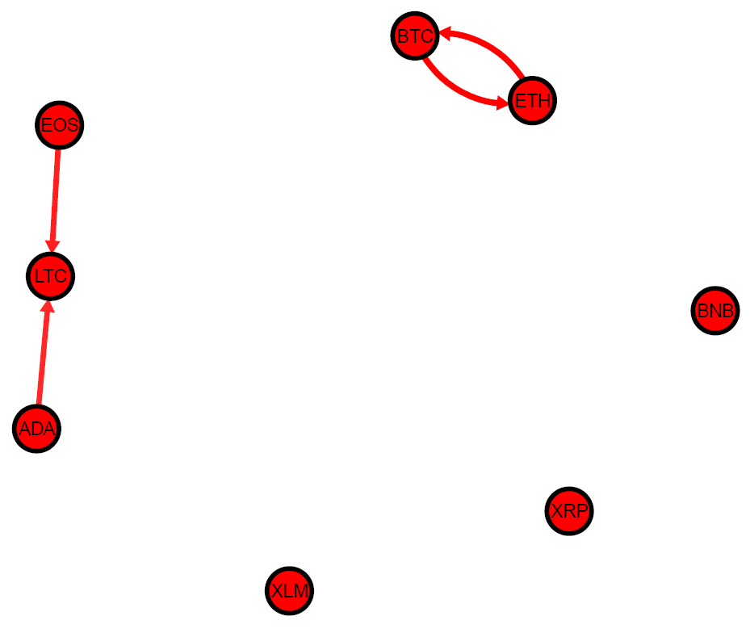
b) Summary measures of connectedness network
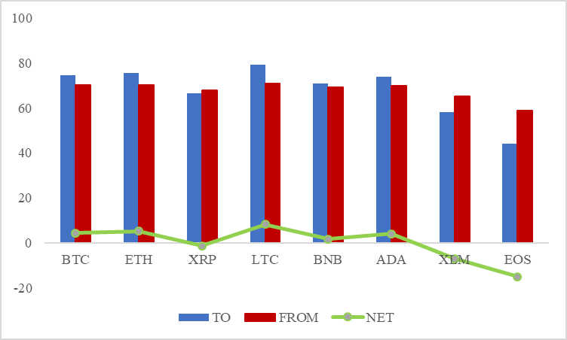
Note: Refer to Figure 2

Figure 5. Total time-varying connectedness using Diebold and Yilmaz (2012).
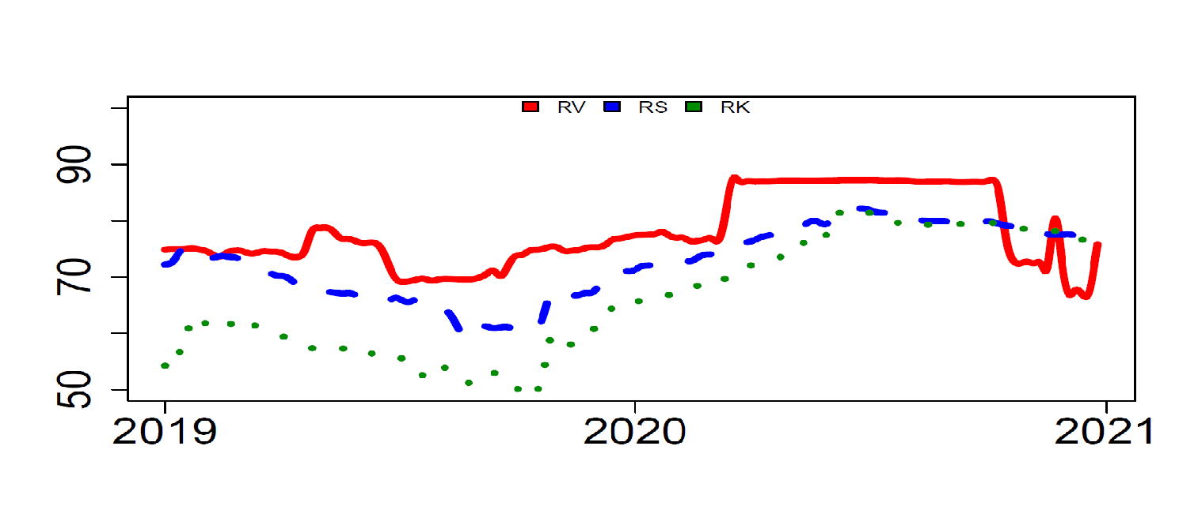
Note. This figure shows the rolling-window version of total connectedness. The rolling-window length is 215 days. Red, blue (dashed), and green (dotted) lines represent realized volatility (RV), realized skewness (RS), and realized kurtosis (RK), respectively.

As of March 5, 2020, the total size of the cryptocurrency market stood at US dollar 260 billion (Source: https://coinmarketcap.com/).
For a comprehensive survey of the cryptocurrency connectedness literature, see Kyriazis (2019).
Jain et al. (2019) show that about half of the cryptocurrency investors are young, aging between 25 and 34 years. In addition, Kumar (2009) suggest that young investors tend to have much stronger gambling preferences.
We use 5-min frequency following results by Yarovaya and Zieba (2020) who compared cryptocurrency intraday data of different frequencies 5-, 10-, 20-, 40-min and 1-hour, among others, and conclude that the use of 5-min data capture sufficient volatility and can be used in high-frequency cryptocurrency research.

