Supplementary Information for
Reversible Scavenging and Advection - Resolving the Neodymium Paradox in the South Atlantic
Ruixue Wangª*, Josephine A. Cleggª, Peter M. Scott^{bc}, Christina S. Larkin^{ad}, Feifei Deng^{be}, Alexander L. Thomas^{bf}, Xin-Yuan Zheng^{bg}, Alexander M. Piotrowskiª

Affiliations:
ª Department of Earth Sciences, University of Cambridge, UK
^{b} Department of Earth Sciences, University of Oxford, UK
^{c} now at Centre for Microscopy, Characterisation & Analysis, The University of Western Australia, Australia
^{d} School of Ocean and Earth Science, National Oceanography Centre, University of Southampton, UK
^{e} now at Helmholtz-Zentrum Geesthacht, Germany
^{f} now at School of GeoSciences, University of Edinburgh, UK
^{g} now at Department of Earth and Environmental Sciences, University of Minnesota-Twin Cities, USA
*Corresponding author: rw581@cam.ac.uk

This file contains:
Supplementary text 1 – 2
Supplementary data tables S1 – S3
Supplementary figure S1 – S4
Supplementary references

Supplementary text 1
1 Analytical precision and blank control of Nd concentrations and isotopes
1.1 Nd concentrations
Blank contributions for all REE (except Ce) were <0.5% of a typical sample. This is based on the results from repeated analyses of the same in-house seawater standard over a period of 3+ years. Each of seawater standard was individually treated like unknown samples through the whole co-precipitation process. The reproducibility of Nd concentrations based upon repeats of our in-house seawater standard ([Nd] ~12.5pmol/kg) over that period is +/-2% (2σ, n=15). The resulting reproducibility should incorporate uncertainties associated with every step of our sample processing and analysis, including uncertainties in spike concentrations, so it is a more robust estimate on the long-term analytical uncertainty of our method.
1.2 Nd Isotopes
In order to maximise the sensitivity, we used an Aridus II introduction system coupled with Ni Jet and X cones. The whole system was conditioned for 8 hours prior to running low concentration samples, alongside several hours of tuning to maximise the stability and sensitivity of the beam. Oxide production throughout analytical sessions was monitored and minimized to below 0.3%. The samples were tested for concentration first and measured in different sequences according to their concentrations: 20 ppb (sample size > 8 ng), 10 ppb (sample size 4 - 8 ng), and 5 ppb (sample size < 4 ng). All samples were measured in 400 μl with concentration match to the bracketing JNdi-1 standard, except for the samples lower than 4 ng size which were bracketed with 5 ppb JNdi-1. The internal error (2SE) ranged from 0.10 to 0.49 epsilon units with sample size from typical (8 ng) down to the smallest one (0.9 ng), while the external error (2SD) ranges from 0.15 to 0.43 epsilon unit with JNdi-1 concentration from 20 ppb to 5 ppb. The internal error is generally smaller than the external error except for a few samples (refer to research data list). The error which is bigger is quoted as the reported analytical uncertainty. Typical internal and external errors achieved on the Neptune Plus MC-ICPMS with number of JNdi standard in a run are listed in Table S1. Several full procedural blanks and column chemistry blanks were determined by isotope dilution using a ¹⁵⁰Nd spike on a Neptune Plus MC-ICP-MS at the University of Cambridge, and ranged from 1.6-8.7 pg, always representing <1% of the final sample size, and usually <0.5% of a typical sample. A sample from the Bermuda Atlantic Time Series Station BATS (15 m depth) was used as an intercalibration standard and measured on a 10 ppb and 5 ppb sequence separately, matched in concentration to the JNdi-1 standard. Results agreed within error with the international GEOTRACES intercalibration exercise obtained by 13 different laboratories (Table S2 and Fig. S1).

Table S1. Typical internal and external errors achieved on the Neptune Plus MC-ICPMS in the Department of Earth Sciences, University of Cambridge
Size of sample analysed | JNdi-1 concentration used | Number of JNdi std. in a run | Internal Error (2SE) | External Error (2SD) | Reported Error (2SD)
8 ng  4 ng  2 ng  1.4 ng  0.9 ng (smallest) | 20 ppb  10 ppb  5 ppb  5 ppb  5 ppb | n = 18  n = 15  n = 14  n = 27  n = 27 | 0.14 ƐNd  0.19 ƐNd  0.30 ƐNd  0.40 ƐNd  0.49 ƐNd | 0.23 ƐNd  0.31 ƐNd  0.35 ƐNd  0.43 ƐNd  0.43 ƐNd | 0.23 ƐNd  0.31 ƐNd
0.35 ƐNd
0.43 ƐNd
 |  |  |  |  | 0.49 ƐNd

Table S2. Neodymium isotopic composition for GEOTRACES intercalibration standard from the Bermuda Atlantic Time-Series Study (BATS) seawater 15m
 | Analysis date | ¹⁴³Nd/¹⁴⁴Nd | εNd | 2SE | 2SD | Size of sample analysed | JNdi-1 concentration used
BATS 15m | 26/06/2019 | 0.512173 | -9.08 | 0.17 | 0.28 | 4 ng | 10 ppb
 | 24/07/2019 | 0.512164 | -9.25 | 0.30 | 0.43 | 2 ng | 5 ppb
Reference |  |  | -9.19 |  | 0.57

Figure S1. Comparison of measured GEOTRACES intercalibration standard and referenced value (van de Flierdt et al., 2012).
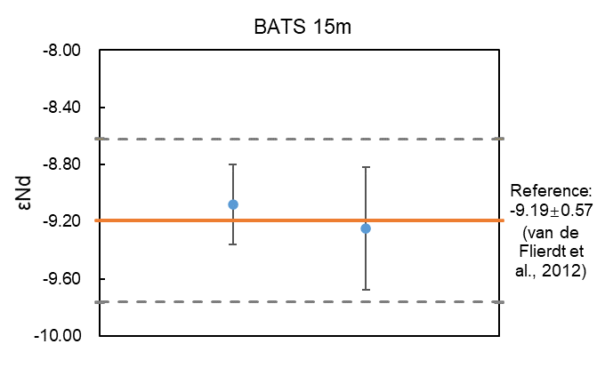

Supplementary text 2
- Data choice of endmember water masses
A water mass mixing model was utilised in this study and the averaged values (together with uncertainty and number of data used) for each endmember is shown in Table 1. The model was separately applied for the intermediate (600-2500 m) and the deep ocean (> 2500 m). For the intermediate ocean, the two endmembers were Antarctic AAIW (a-AAIW) and upper NADW (u-NADW). Indian AAIW (i-AAIW) was not defined as an endmember in the model due to the lack of data and its small distribution region in our study area. There is also a lack of Nd isotope values for a-AAIW in the literature (Tachikawa et al., 2017). However, consider that the formation area (~45 ⁰S) of a-AAIW is very close to our study area, we chose to use the values from this study. The data was selected between 700-1000 m (core of a-AAIW) from station 22 to 7. Averaged [Nd] and ƐNd value of u-NADW was reported by Lambelet et al. (2016). Salinity, temperature, and depth values are averaged from the database. For the deep ocean, the two endmembers were lower NADW (l-NADW) and AABW. The values of l-NADW was calculated with the same method as u-NADW. AABW was defined as the mixture of LCDW and WSDW. Therefore, the data was selected > 3200 m and within 49-70 ⁰S and 20-60 ⁰W. All the data was selected from stations away from the continental margin and any salinity or temperature outliers were excluded. The uncertainty of each parameter was defined as the standard deviation (1 SD). The propagated uncertainty (1 SD) of the conservative mixing is shown as the pink mixing envelope in Fig. 7, together with the conservative mixing curved calculated by the average values.

Table S3. Water mass endmembers of the Pacific Ocean
Water mass | Salinity | 1SD | T (℃) | 1SD | Depth (m) | 1SD | n | Reference
Pacific-AABW | 34.701 | 0.013 | 0.36 | 0.51 | 3773 | 720 | 21 | Tachikawa et al. (2017)
NPDW | 34.600 | 0.026 | 1.85 | 0.22 | 2957 | 571 | 27
Water mass | [Nd] (pmol/kg) | 1SD | n | εNd | 1SD | n | Reference
Pacific-AABW | 27.1 | 4.2 | 21 | -7.63 | 0.98 | 21 | Tachikawa et al. (2017)
NPDW | 35.1 | 9.5 | 27 | -3.39 | 1.07 | 27

Figure S2. REE pattern (normalized to PAAS, Taylor and McLennan, 1985) of stations. REEs data from The GEOTRACES Intermediate Data Product 2017 (Schlitzer et al., 2017) 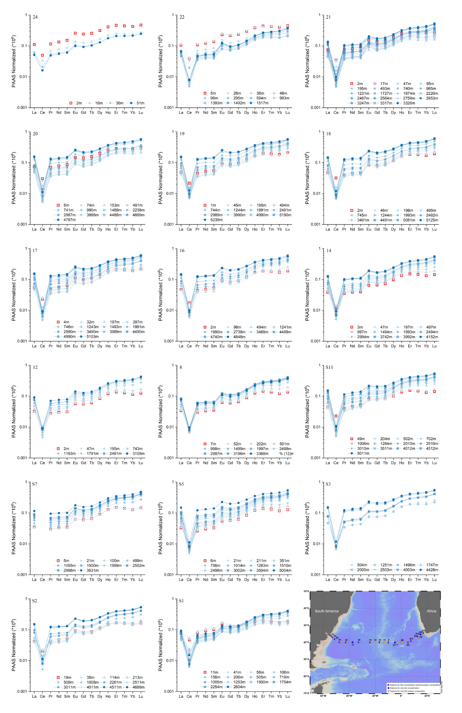
Figure S3. Profiles of Ce/Ce* ratio of stations on (a) west and (b) east side of the Mid-Atlantic Ridge. Ce/Ce* = 2*Ce_{N}/(La_{N}+Pr_{N}) where subscript _{N} denotes all elements are normalized to PAAS (Taylor and McLennan, 1985). Symbols are the same as that in Fig. 3. Blue lines accord to the depth boundaries of four trajectories in Fig. 5. REEs data from The GEOTRACES Intermediate Data Product 2017 (Schlitzer et al., 2017)
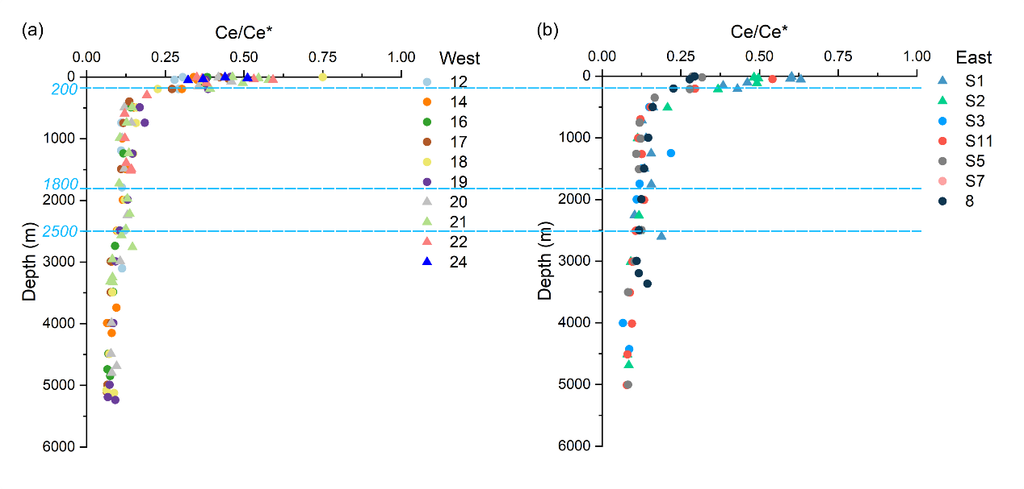

Figure S4. Transmissometer Beam Attenuation data profile of GA10 section. More attenuation indicates more particle mass per unit of seawater. Data from IDP 2017 (Schlitzer et al., 2017).
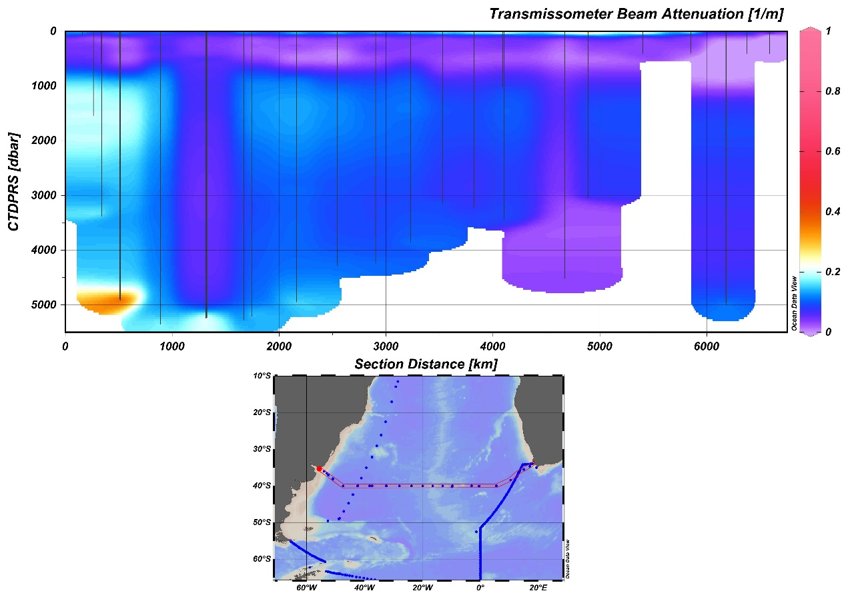

Supplementary references
Lambelet, M., van de Flierdt, T., Crocket, K., Rehkämper, M., Kreissig, K., Coles, B., Rijkenberg, M.J.A., Gerringa, L.J.A., de Baar, H.J.W., Steinfeldt, R., 2016. Neodymium isotopic composition and concentration in the western North Atlantic Ocean: Results from the GEOTRACES GA02 section. Geochim. Cosmochim. Acta 177, 1–29. https://doi.org/10.1016/j.gca.2015.12.019
Schlitzer, R., Anderson, R.F., Dodas, E.M., Lohan, M., Geibert, W., Tagliabue, A., Bowie, A., Jeandel, C., Maldonado, M.T., Landing, W.M., Cockwell, D., Abadie, C., Abouchami, W., Achterberg, E.P., Agather, A., Aguliar-Islas, A., van Aken, H.M., Andersen, M., Archer, C., Auro, M., de Baar, H.J., Baars, O., Baker, A.R., Bakker, K., Basak, C., Baskaran, M., Bates, N.R., Bauch, D., van Beek, P., Behrens, M.K., Black, E., Bluhm, K., Bopp, L., Bouman, H., Bowman, K., Bown, J., Boyd, P., Boye, M., Boyle, E.A., Branellec, P., Bridgestock, L., Brissebrat, G., Browning, T., Bruland, K.W., Brumsack, H.-J., Brzezinski, M., Buck, C.S., Buck, K.N., Buesseler, K., Bull, A., Butler, E., Cai, P., Mor, P.C., Cardinal, D., Carlson, C., Carrasco, G., Casacuberta, N., Casciotti, K.L., Castrillejo, M., Chamizo, E., Chance, R., Charette, M.A., Chaves, J.E., Cheng, H., Chever, F., Christl, M., Church, T.M., Closset, I., Colman, A., Conway, T.M., Cossa, D., Croot, P., Cullen, J.T., Cutter, G.A., Daniels, C., Dehairs, F., Deng, F., Dieu, H.T., Duggan, B., Dulaquais, G., Dumousseaud, C., Echegoyen-Sanz, Y., Edwards, R.L., Ellwood, M., Fahrbach, E., Fitzsimmons, J.N., Russell Flegal, A., Fleisher, M.Q., van de Flierdt, T., Frank, M., Friedrich, J., Fripiat, F., Fröllje, H., Galer, S.J.G., Gamo, T., Ganeshram, R.S., Garcia-Orellana, J., Garcia-Solsona, E., Gault-Ringold, M., George, E., Gerringa, L.J.A., Gilbert, M., Godoy, J.M., Goldstein, S.L., Gonzalez, S.R., Grissom, K., Hammerschmidt, C., Hartman, A., Hassler, C.S., Hathorne, E.C., Hatta, M., Hawco, N., Hayes, C.T., Heimbürger, L.-E., Helgoe, J., Heller, M., Henderson, G.M., Henderson, P.B., van Heuven, S., Ho, P., Horner, T.J., Hsieh, Y.-T., Huang, K.-F., Humphreys, M.P., Isshiki, K., Jacquot, J.E., Janssen, D.J., Jenkins, W.J., John, S., Jones, E.M., Jones, J.L., Kadko, D.C., Kayser, R., Kenna, T.C., Khondoker, R., Kim, T., Kipp, L., Klar, J.K., Klunder, M., Kretschmer, S., Kumamoto, Y., Laan, P., Labatut, M., Lacan, F., Lam, P.J., Lambelet, M., Lamborg, C.H., Le Moigne, F.A.C., Le Roy, E., Lechtenfeld, O.J., Lee, J.-M., Lherminier, P., Little, S., López-Lora, M., Lu, Y., Masque, P., Mawji, E., Mcclain, C.R., Measures, C., Mehic, S., Barraqueta, J.-L.M., van der Merwe, P., Middag, R., Mieruch, S., Milne, A., Minami, T., Moffett, J.W., Moncoiffe, G., Moore, W.S., Morris, P.J., Morton, P.L., Nakaguchi, Y., Nakayama, N., Niedermiller, J., Nishioka, J., Nishiuchi, A., Noble, A., Obata, H., Ober, S., Ohnemus, D.C., van Ooijen, J., O’Sullivan, J., Owens, S., Pahnke, K., Paul, M., Pavia, F., Pena, L.D., Peters, B., Planchon, F., Planquette, H., Pradoux, C., Puigcorbé, V., Quay, P., Queroue, F., Radic, A., Rauschenberg, S., Rehkämper, M., Rember, R., Remenyi, T., Resing, J.A., Rickli, J., Rigaud, S., Rijkenberg, M.J.A., Rintoul, S., Robinson, L.F., Roca-Martí, M., Rodellas, V., Roeske, T., Rolison, J.M., Rosenberg, M., Roshan, S., Rutgers van der Loeff, M.M., Ryabenko, E., Saito, M.A., Salt, L.A., Sanial, V., Sarthou, G., Schallenberg, C., Schauer, U., Scher, H., Schlosser, C., Schnetger, B., Scott, P., Sedwick, P.N., Semiletov, I., Shelley, R., Sherrell, R.M., Shiller, A.M., Sigman, D.M., Singh, S.K., Slagter, H.A., Slater, E., Smethie, W.M., Snaith, H., Sohrin, Y., Sohst, B., Sonke, J.E., Speich, S., Steinfeldt, R., Stewart, G., Stichel, T., Stirling, C.H., Stutsman, J., Swarr, G.J., Swift, J.H., Thomas, A., Thorne, K., Till, C.P., Till, R., Townsend, A.T., Townsend, E., Tuerena, R., Twining, B.S., Vance, D., Velazquez, S., Venchiarutti, C., Villa-Alfageme, M., Vivancos, S.M., Voelker, A.H.L., Wake, B., Warner, M.J., Watson, R., van Weerlee, E., Alexandra Weigand, M., Weinstein, Y., Weiss, D., Wisotzki, A., Woodward, E.M.S., Wu, J., Wu, Y., Wuttig, K., Wyatt, N., Xiang, Y., Xie, R.C., Xue, Z., Yoshikawa, H., Zhang, J., Zhang, P., Zhao, Y., Zheng, L., Zheng, X.-Y., Zieringer, M., Zimmer, L.A., Ziveri, P., Zunino, P., Zurbrick, C., 2017. The GEOTRACES Intermediate Data Product 2017. Chem. Geol. 493, 210–223. https://doi.org/10.1016/j.chemgeo.2018.05.040
Tachikawa, K., Arsouze, T., Bayon, G., Bory, A., Colin, C., Dutay, J.C., Frank, N., Giraud, X., Gourlan, A.T., Jeandel, C., Lacan, F., Meynadier, L., Montagna, P., Piotrowski, A.M., Plancherel, Y., Pucéat, E., Roy-Barman, M., Waelbroeck, C., 2017. The large-scale evolution of neodymium isotopic composition in the global modern and Holocene ocean revealed from seawater and archive data. Chem. Geol. 457, 131–148. https://doi.org/10.1016/j.chemgeo.2017.03.018
van de Flierdt, T., Pahnke, K., Amakawa, H., Andersson, P., Basak, C., Coles, B., Colin, C., Crocket, K., Frank, M., Frank, N., Goldstein, S.L., Goswami, V., Haley, B.A., Hathorne, E.C., Hemming, S.R., Henderson, G.M., Jeandel, C., Jones, K., Kreissig, K., Lacan, F., Lambelet, M., Martin, E.E., Newkirk, D.R., Obata, H., Pena, L., Piotrowski, A.M., Pradoux, C., Scher, H.D., Schöberg, H., Singh, S.K., Stiche, T., Tazoe, H., Vance, D., Yang, J., 2012. GEOTRACES intercalibration of neodymium isotopes and rare earth element concentrations in seawater and suspended particles. Part 1: Reproducibility of results for the international intercomparison. Limnol. Oceanogr. Methods 10, 234–251. https://doi.org/10.4319/lom.2012.10.234

