Intraday volume-return nexus in cryptocurrency markets: novel evidence from cryptocurrency classification

Larisa Yarovaya*
The Centre for Digital Finance, Southampton Business School.
Damian Zięba^{b}
University of Warsaw, Faculty of Economics Sciences.

Abstract

This paper analyses the volume-return relationships across the top 30 most traded cryptocurrencies from April 2013 to June 2019 using high-frequency intraday data. We use a novel approach for the classification of cryptocurrencies with respect to multiple qualitative factors, such as geographical location of headquarters, founder and founder’s origin, platform on which the cryptocurrency is built, and consensus algorithm, among others. We identify significant bidirectional causalities between trading volume and returns at different high-frequency intervals; however, those linkages are weakening with decreasing data frequencies. The findings confirm the leading position of the Bitcoin trading volume in the cryptocurrency price formation. This evidence will help investors to design effective trading strategies in cryptocurrency markets providing useful insights from cryptocurrency categorisation.

Jel: G12; G14.
Keywords: cryptocurrency classification; Bitcoin; volume-return relationships; Granger causality.

Introduction
How can one choose which cryptocurrency to invest in when there are more than 14,000 tokens and crypto assets available in the market? Investing in Bitcoin is the most obvious choice, since it attracts the highest attention from investors and the public according to analysis of Twitter and Google Trends data (e.g., Urquhart, 2018). The innovative nature of Blockchain technology allows money transfer from one party to another without authorisation by the bank. The pioneering investors in Bitcoin managed to build their fortune on speculative pricing bubbles around this new asset (e.g., Corbet et al., 2018). The abnormal returns available in cryptocurrency markets generated hype among not only investors but also various companies who wanted to change their corporate identity towards blockchain and cryptocurrency technology (Corbet et al., 2019; Akyildirim et al., 2020). Recent studies suggest that even small allocations in Bitcoin can help to increase the return of the portfolio (e.g., Platanakis & Urquhart, 2020) and offer diversification benefits (Damianov & Elsayed, 2020).
The cryptocurrency markets have become one of the most significant financial innovations in the last decade. Built on the Blockchain technology, cryptocurrency markets offer investors the advantages of decentralisation, anonymity, and a great variety of assets to choose from. When alternatives are many and search costs are high, attention may affect choice more profoundly than preferences do. If the attention-grabbing characteristics of an alternative coincide with the characteristics that increase utility, agents may benefit from the role of attention in reducing search costs (Barber & Odean, 2008). While the main liquidity was originally in Bitcoin since the cryptocurrency market matured, the trading volume on several popular cryptocurrencies become evident. However, to date, only limited research has been conducted beyond Bitcoin. In this paper, we claim that to continue successfully trading in more integrated and interconnected cryptocurrency markets, we need to look beyond Bitcoin and establish a better understanding of these markets.
Analysis of volume-return relationships is important for better understanding of the market microstructure. Aalborg et al. (2019) analysed the determinants of Bitcoin returns, volatility, and trading volumes in the period from March 2012 to March 2017 and found some significant relationships among the daily data and limited explanatory power for weekly data. For example, Bitcoin transactions volume predicts its daily returns; however, this is not evident for weekly returns. Daily volatilities are correlated and influenced by Bitcoin trading volumes, but not the weekly ones. The trading volume of Bitcoin can be predicted from Google searches for “Bitcoin”, as well as the volume of transactions on the Bitcoin network. Aloui et al. (2019) examined the relationships between Bitcoin price and trading volume using the multifractal detrended cross-correlation analysis. While linear correlation between price and trading volume is close to zero, the results reported significant nonlinear price-volume relationships in Bitcoin. Much research on Bitcoin trading volume and Bitcoin price discovery originated after the launch of Bitcoin futures in December 2017 on the Chicago Mercantile Exchange (CME) and the Chicago Board Option Exchange (CBOE); for example, Corbet et al. (2018b), Alexander et al. (2019); Fassas et al. (2020), among others. Balcilar et al. (2017) employed non-parametric causality-in-quantiles test to daily prices and volumes of Bitcoin index. The results showed that trading volume can predict returns, but only in the middle quantiles, when the market is neither bullish nor bearish. In the upper and lower quantiles, however, there is no evidence of volume-returns linkages. Furthermore, the results displayed inability of trading volume to predict volatility of Bitcoin index returns.
Makarov and Schoar (2020) analysed the cryptocurrency price deviations and arbitrage opportunities using tick prices from 34 exchanges across 19 countries for the three most tradable cryptocurrencies: Bitcoin, Ethereum, and Ripple. They found the existence of significant deviations of cryptocurrency prices between countries even with the most liquid exchanges, such as the US, Korea, and Japan, showing significant market segmentation. The arbitrage opportunities on the cryptocurrency market are most likely to be explored by the large institutional investors, rather than retail investors, due to challenges associated with stricter capital control in some countries. Baur et al. (2019) analysed time-specific anomalies in Bitcoin returns and trading volumes using intraday data from seven Bitcoin exchanges; however, no evidence of anomalies in the time-of-day, day-of-week, and month-of-year in returns was demonstrated. In trading volumes, alternatively, the results displayed the persistent weekend effect, where trading volumes are the lowest during the weekend. This suggests the presence of institutional investors in Bitcoin exchanges. Bouraoui (2020) analysed the determinants of Bitcoin trading volumes by looking at local Bitcoin trading volumes in 21 emerging countries. The results showed that restricted access to the banking systems in some emerging markets is a strong factor encouraging people to use decentralised payments systems as an alternative to traditional ones. Figa-Talamanca and Paracca (2020) explored the impact of the trading volume and internet search intensity on Bitcoin returns and volatility. Findings suggested the inverse relationships between attention measures and returns – i.e. an increase in returns increases trading volume. Khunita and Pattanayak (2020) examined the impact of trading volume on time-varying long memory of intra-day Bitcoin volatility and confirmed this effect for the bullish and bearish markets, but not for the normal period. Some papers have also included trading volume as a control variable, for example, Zhang and Li (2020), however, a further and more detailed look on cryptocurrency return-volume relationships is needed.
In this paper, we want to have a closer look at the top traded cryptocurrencies based on the cumulative trading volume from April 2013 to June 2019 and identify which characteristics can determine the existence and direction of return-volume relationships. We use intraday data of different frequencies ( , 10, and 25 minutes; one hour) and daily data as a robustness tests for the period from 15 February 2018 to 20 July 2019, providing novel empirical evidence from the non-parametric Granger non-causality test. To explain the empirical results, we utilise qualitative characteristics of selective cryptocurrencies, such as founder’s country of origin; headquarter of the company that developed the particular cryptocurrency; whether the currency is protocol or token; and type of consensus algorithm, among other measures.
All in all, the contribution of this article to the literature is multifold. First, we propose the approach of a qualitative classification of cryptocurrencies which aims to facilitate the interpretation of the results. In this case, the categorisation of cryptocurrencies helps to determine whether there exists a volume-return relationship within one asset and which direction that relationship takes. Second, we study the volume-return relationship for a broad range (i.e. 30) of cryptocurrencies using the non-parametric Granger causality test. To the best of the authors’ knowledge, such a broad range of cryptocurrencies has not been analysed using this methodology. The analysis of 30 assets enables us to generalise the results to the wider scope of the market, beyond Bitcoin. Third, we conduct the analysis using multiple data frequencies which allows for making an inference on the evolution of volume-return relationship as the frequency of data changes. Fourth, we provide the robustness check using the bivariate Copula analysis. Our results suggest that, for most of the cryptocurrencies, the returns Granger-cause trading volumes; however, several bi-directional causalities have been identified. Moreover, it can be concluded that the relationship between volume and return on the cryptocurrency market vanishes as the frequency of data decreases. Furthermore, in our analysis, we also focus on the role of Bitcoin. While this topic is studied often in the literature, we did not find any research analysing the impact of Bitcoin volume on the volumes and returns of the large scope of cryptocurrencies, with different high frequencies of data. Specifically, we study how changes in trading volume of Bitcoin are affecting the changes in returns and volumes of 29 other cryptocurrencies, as the frequencies of data change. The reason for such an approach to the analysis is based on the ongoing observation of the market dynamics. It can often be observed that changes in attention paid to Bitcoin affect the movements of the entire market.

Hypotheses development
Our paper is motivated by the seminal works on attention-driven investments and investors overconfidence (e.g., Lakonishock & Smidt, 1986; Odean, 1998a,b) that can also help to explain trading patterns in cryptocurrency markets. The high market returns in popular cryptocurrencies increases investors’ overconfidence and encourages them to trade more, while losses have the opposite effect, discouraging investors from trading (e.g., Gervais & Odean, 2001). Thus, we propose and test the following hypothesis:
Hypothesis 1 (H1): Changes in cryptocurrency returns affect changes in the trading volumes.
The investors’ overconfidence is often analysed in relation to the disposition effect (Lakonishok & Smidt, 1986; Odean, 1998a,b) and prospect theory (Kahneman & Tversky, 1979), and overconfidence has become one of the most well-known behavioural biases explaining the irrational behaviour of investors in financial markets. Individual investors tend to buy the stocks that attract their attention the most, which is not the case for selling decisions that are made by assessing the performance of existing holdings (Odean, 1999; Barber & Odean, 2002). The investors are likely to sell their worst performing stocks and often tend to postpone the selling decision influenced by increased feelings of regret associated with the losses (Shefrin & Statman, 1985). Thus, we assume that the down market will lead to a decrease in the trading volume of selected cryptocurrencies. Therefore, we propose that
Hypothesis 2 (H2) : Changes in cryptocurrency volumes affect changes in the returns.
The validity of H1 will indicate that trading volume of cryptocurrencies have been driven by the higher returns offered by these markets – i.e. high (low) returns bring more (less) attention of investors which leads to the increase (decrease) of trading volume. There are also some reasons to believe that these patterns can be asymmetric, and more pronounced in bullish than in bearish markets, or vice versa (e.g., Khunita & Pattanayak, 2020). Alternatively, rejection of this hypothesis will indicate that high trading volume of selected cryptocurrencies has been generated due to other attention-grabbing factors, beyond the high returns. Validity of both H1 and H2, implying a bi-directional relationship, will indicate that an increase in trading volumes leads to an increase in returns and such an event brings the attention of investors who make the trading volume increase even further, and so on. Such events are known to be present in the cryptocurrency market and initiated by so-called “whales” – i.e. big cryptocurrency holders – who are known to manipulate the prices by such sudden movements which lead to increased attention to a particular asset (Bouri et al., 2019; Manahov, 2020).
Previous research on equities has shown that attention-driven investments are not always able to generate the abnormal returns, and construction of well-diversified portfolios works better (e.g., Odean, 1999; Barber & Odean, 2000, 2008). Barber and Odean (2008) used three measures of attention in their studies: (i) news, (ii) a stock’s abnormal trading volume, and (iii) previous day returns. Thus, the trading volume can increase after reading the news and extracting the buying signals from the attention-grabbing event discussed in the media. The trading volume can also increase by trading activity of large investors and increased liquidity. While there are many factors that can be considered, in this paper we use the qualitative characteristics of the top 30 cryptocurrencies to explain the empirical results and help to understand which characteristics make the selected cryptocurrencies more popular, thereby increasing their trading volume.

Data and Methodology
Our empirical study is based on two main datasets. On the one hand, we use the high-frequency dataset on price and volume data of selected cryptoassets to provide empirical results. On the other hand, we use the single-handedly collected qualitative dataset containing characteristics of selected cryptoassets which serve to help in the interpretation of obtained results.

3.1 Data source
We collect the data from Coinpaprika.com, a service similar to Coinmarketcap.com, which uses a different algorithm than Coinmarketcap.com for aggregating the data on prices, volume and market capitalisation from multiple cryptocurrency exchanges. The Coinpaprika.com service offers an open-source API for cryptocurrency data of up to five-minute frequency. We perceive it as an advantage over Coinmarketcap.com which is pricing the high frequency data very high. We use a Python API to download the data for 779 cryptocurrencies at five-minute frequency in a form of .json files which we then aggregate into different frequencies after selecting a sample for the analysis, For the purpose of the preliminary analysis, we select many frequencies at five-minute intervals (e.g., 5-min, 10-min, 15-min, 20-min, etc.). However, after the preliminary stage of the analysis, we select only few of those, based on the vital changes in results between particular frequencies. For instance, the results for 5-min, 10-min and 15-min frequencies were very similar, so for the final analysis we skip the 10-min and 15-min frequencies and choose 5-min and 20-min frequencies, and so on. Moreover, when we select a particular frequency, e.g., 20-min frequency, we extract the data from every 20-minute tick. For example, having the data every 5-min, e.g., 2019-01-01 00:00:00, 2019-01-01 00:05:00, 2019-01-01 00:10:00, 2019-01-01 00:15:00, 2019-01-01 00:20:00, etc. while selecting a 20-min frequency, we take the data from 2019-01-01 00:00:00 and 2019-01-01 00:20:00, and so on. In other words, we do not interpolate the prices over the 20-min intervals but rather select the data every 20-minutes. The detailed selection of the sample is explained in the next section.

3.2 Price and volume data
To test the statistical relationship between the cryptocurrency trading volume and returns, we use high-frequency data with up to five-minute frequency. In this paper, we utilise data for the period from 15 February 2018 to 30 July 2019, which was the longest period available for the selected 30 most traded cryptocurrencies. Our selection of cryptocurrency differs from the approaches used in previous studies. Based on the data for 779 cryptocurrencies, we select the top 30 cryptocurrencies with the highest total cumulative 24-hours trading volume for the period between 01 January 2019 and 30 July 2019, most tradable in the last six months of observation sample. This preselection process distinguishes this paper from prior research where cryptocurrency markets have been selected based on their market capitalisation.
Furthermore, we aggregate the five-minute data to the lower frequencies in order to explore the dynamics of the market more thoroughly. Thus, our preliminary analysis consists of the results for over 25 frequencies – i.e. mainly between five-minute data and 240-minute, but also for six hours, eight hours, 12 hours, one day and one week. In this paper, we report the results for the following frequencies, 5-min, 20-min, 30-min, 1 hour, 6 hours, and 12 hours, as well as daily and weekly for comparison with the previous studies. To calculate returns we use the logarithmic returns at each frequency. First, we aggregate the data on prices into certain frequencies and then we calculate the logarithmic differences. For trading volume, we construct similar variable that allows us to analyse the relationships between two similar AR (1) processes.
The 24-hours trading volume is provided for each 5-minute interval. Therefore, the difference between the two consecutive data points of this variable, e.g., the 24-hours trading volumes on 02 January 2019 at 12:00 and at 12:05 can be presented as in Figure 1 below:

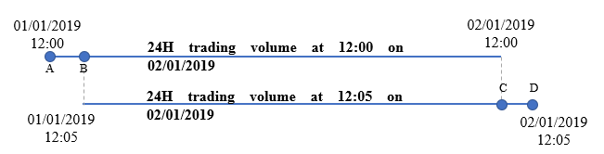
Figure 1 Illustration of the log-difference 24h trading volume variable
Therefore, our variable can be directly interpreted as a logarithmic difference between the trading volume during the period (C,D) and the trading volume during the period (A,B).

3.3 Cryptocurrency classification
We collect the qualitative data characterising each cryptocurrency in our dataset, as demonstrated in Table 1. Our qualitative variables describe each cryptocurrency regarding the following characteristics (where applicable):
• Founder’s country of origin.
• Headquarter of the company that developed the particular cryptocurrency.
• Whether the cryptocurrency operates on its own blockchain (if yes – what is the core protocol? If no, i.e. it is a token, which blockchain does it operate on?).
• Type of consensus algorithm (basically broken down into mineable and non-mineable).
• Whether the particular cryptocurrency (or rather the protocol behind it) enables issuance of tokens/creating dApps/creating Smart Contracts.
• Whether it is a so-called ‘stablecoin’.
• Whether the supply is limited.
• Whether it is a Bitcoin competitor (pure cryptocurrency for cash transfers) or Ethereum competitor (blockchain platform-enabling smart contracts/dApps).

[Table 1 to be here]
This is a new way of looking at cryptocurrencies’ data, from a qualitative perspective. We aim to identify whether any of the cryptocurrency qualitative attributes can help to interpret the empirical results.

3.4 Methodology
For the analysis of the relationship between the trading volume and returns on the cryptocurrency market, we use multiple approaches to capture this phenomenon from different perspectives. Moreover, we provide the results for multiple frequencies, mainly for five-minutes, 20 minute, 30minutes, 1-hour, six hours, eight hours, 12 hours, one day and one week.
First, we present selected results of the preliminary analysis – i.e. descriptive statistics of prices, log-returns, 24h volume and log-difference of 24h volume – as well as Spearman correlation results for volume-return pairs and cross-correlation among volumes. Moreover, we fit the bivariate copulas to each volume-return pair. Using the R software we first select the best-fitting copula, based on the AIC criterion, and then extract the following information: (i) type of copula family which is best fitted to particular volume-return pair, (iii) significance of the estimated copula dependency, (iv) empirical Tau parameter showing the strength of the relationship, and (v) the goodness-of-fit parameter for the copula fitted to the empirical data (difference between the empirical Tau and the theoretical Tau – the closer the value to zero the better fitted the model).
Second, as the main part of our empirical contribution, we use the non-parametric Granger non-causality test of Diks and Panchenko [DP] (Diks & Panchenko, 2005, 2006) which has been proposed as an answer to the problem of over-rejection of null hypothesis (especially as the sample size increases, which is particularly the case with high-frequency data) by the popular Hiemstra-Jones [HJ] test (Hiemstra & Jones, 1994) which had been widely considered as one of the most appropriate non-parametric test for Granger causality. We report the existence of statistically significant relationships between the volume-return pairs and provide the interpretation of results with respect to the proposed qualitative classification.

3.4.1 General definition of nonlinear Granger (non-)causality
As explained in Diks and Panchenko (2006), for a strictly stationary bivariate time series process {(X_{t}, Y_{t})}, , {X_{t}} is a Granger cause of {Y_{t}} if, for some k 1,
(Y_{t+1} , … , Y_{t+k} )|(_{X,t} , _{Y,t} ) (Y_{t+1} , … , Y_{t+k} )| _{Y,t} (1)
In other words, {X_{t}} is a Granger cause of {Y_{t}} if past and present values of X contain additional information about future values of Y, which are not contained in the past and present values of Y alone, where _{X,t} and _{Y,t} denote the information contained in past observations of X and Y, respectively, and “~” denotes equivalence in distribution (Granger, 1969).
To test for Granger causality, the convention is to verify the null hypothesis about the Granger non-causality:
H₀: {X_{t}} is not Granger causing {Y_{t}}.
In this research, we are only focusing on the case where k = 1, i.e. the lag length equals 1. Therefore, considering that under the null hypothesis Y_{t+1} is conditionally independent of X_{t}, X_{t-1}, …, given Y_{t}, Y_{t-1}, …, and assuming that the order of the process is finite, conditional independence is tested using finite lags l_{x} and l_{y}, such that:
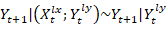, (2)
where and 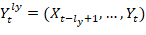. In the case of a strictly stationary bivariate time series {(X_{t}, Y_{t})} the null hypothesis is a statement about the invariant distribution of the (l_{x}+l_{y}+1)-dimensional vector 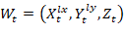, where Z_{t} = Y_{t+1} . For simplicity, the convention is to drop the time index, so W = (X, Y, Z). Considering that l_{x} = l_{y} = 1, W denotes a three-variate random variable distributed as W_{t} = (X_{t}, Y_{t}, Y_{t+1}).

3.4.2 Hiemstra-Jones test
Alternative test for nonlinear Granger causality was proposed by Hiemstra and Jones (1994) who argued that it is necessary to restate the null hypothesis in terms of ratios of joint distributions. Under the null hypothesis the conditional distribution of Z given (X, Y) = (x, y) is the same as that of Z given Y = y only, so the joint pdf and its marginals must satisfy:
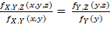 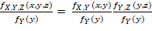 , (3)
which is identical to = . This implies that X and Z are independent conditionally on Y = y, for each fixed value of y. Furthermore, they argue that for a multivariate random vector V the associated correlation integral C_{V}() is the probability of finding two independent realisations of the vector at a distance smaller than or equal to :
, (4)
where is the indicator function, which takes the value of 1 if and 0 otherwise, while 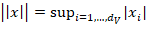 denotes the supremum norm. Then, they argue that Eq.3 implies that, for any ,
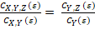 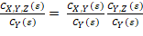 . (5)
The idea behind the Hiemstra-Jones test is to calculate the sample versions of the correlation integrals in Eq.5 and then test whether the difference between the left- and right-hand side of Eq.5 is significantly different than 0. The estimators for each of the correlation integrals are of the following form:
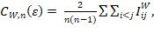 (6)
where

3.4.3 Diks-Panchenko test
However, Diks and Panchenko (2006) show, analytically and based on Monte Carlo simulations, that for small testing the equivalence of the ratios in Eq. 5 amounts to testing
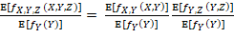 . (7)
instead of the null hypothesis. This implies that unless some additional conditions hold, this will typically not be equivalent to testing the null. Thus, rather than Eq.7, the null hypothesis implies that:
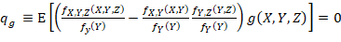, (8)
where g(x,y,z) is a positive weight function. The authors choose based on their previous analyses. Thus:
. (9)
The estimator of q is
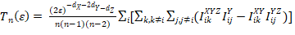, (10)
where .
If 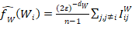 is a local density estimator of a -variate random vector W at the test statistic simplifies to:
. (11)
All in all, for a sequence of bandwidths given by (10) with C > 0 and 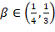 the test statistic satisfies
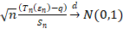, (12)
where denotes the asymptotic variance of .
In our research, considering the large number of conducted estimations, we considered the simplest case, where lag length l_{x} = l_{y} = 1 and the bandwidth equals 0.5.

Preliminary results
In this section we present descriptive statistics of prices, log-returns, 24h volume and log-difference of 24h volume as well as Spearman correlation results for volume-return pairs and Spearman cross-correlation among volumes. Furthermore, we analyse the bivariate copula dependencies between volume-return pairs. Since the results from the estimation of best-fitting copulas between volume-return pairs indicate the collective behaviour of the market, we also analyse the role of Bitcoin in the cryptoassets market.

4.1 Descriptive statistics
Based on the measures of central location (Q1, mean, median, Q3) it can be observed that nominal values of prices and trading volumes of analysed cryptoassets are of different scales (Table 2, Table 4). Therefore, coefficient of variation (CV) is used to measure the variation of those time series. Variation of log-returns and log-differences of 24h volume is measured with standard deviation (Table 3, Table 5).
[Tables 2, 3, 4, 5 to be here]
The variation of prices during the analysed period is particularly high in the case of NEO, QTUM, and ChainLink (above 100%), while, except for Tether and BITCNY (stablecoins), variation is relatively low in the case of Bitcoin, Dogecoin, and BAT (below 40%). It is understandable that the variation of price of Bitcoin and Dogecoin is relatively low, since these are two of the oldest cryptocurrencies so their prices are already established within a particular range. In the case of the rest of the analysed cryptoassets the variation is distributed between 40% and 100% indicating the diversity of the cryptoassets in that regard.
Moreover, returns of Bitcoin are also of relatively low volatility (0.17%), similar to Ethereum or DASH (below 0.25%). On the other hand, returns of Dogecoin and Metaverse are highly volatile (over 0.8%). Except for the mentioned outliers, the variation of returns in the entire analysed sample ranges from 0.2% to 0.6% among considered assets. Considering the nominal 24h trading volume, it is extraordinarily high for ChainLink (298%), Enjincoin (over 200%) and BitcoinGold (almost 200%). Dash and QTUM are characterised by with relatively low volatility in that regard (below 70%). Therefore, for other analysed cryptoassets, the variation of trading volume ranges between 70% and 200% which also indicates a high diversity of results.
The volatility of changes in trading volume are extremely high in the case of BITCNY (over 36%), which is due to the fact that there are many outliers which are far greater than the average. On the other hand, the volatility of changes in volume is very low for Ripple, Litecoin, and Tether (below 1.1%). This might be due to the fact that these three cryptoassets are mainly used for conducting transactions rather than as a trading or investment asset. Apart from the mentioned outliers, the variation of changes in trading volume ranges mainly between 1% and 2%; and up to 5% in a few other cases.

4.2 Spearman correlation
Since the dependencies on the cryptocurrency market are known to have a nonlinear character, in order to analyse the direction of relationships between volume-return pairs as well as among volumes of analysed cryptoassets, the Spearman correlation coefficient is used for preliminary analysis of strength and direction of considered dependencies. Correlations are examined for the following data frequencies: 5-min, 20-min, 30-min, 1h, 6h, 12h, one Day and one Week.
Strength of the correlations between volume-return pairs collectively decreases with the decreasing frequency up to 12h and tends to increase for one day and one week frequency (Table 6). In almost all cases dependencies between volume-return pairs are positive, except for Tether and BITCNY for which correlations are either negative or relatively closer to 0 compared to the other cryptoassets.
[Table 6 to be here]
The results of the Spearman cross-correlations between volumes of the 30 selected cryptocurrencies indicate that there is a strong correlation between the most highly traded cryptocurrencies, as demonstrated in Figure 2. Moreover, this correlation grows as the frequency of analysed data decreases.
[Figure 2 here]

4.3 Bivariate Copula fitting
The results from the copula-fitting procedure are presented in Figure 3 and Figure 4, demonstrating results for the best-fitting bivariate copula for each analysed pair of variables. Figure 3 contains results referring to the first part of our research, i.e. relationship between the volume and returns pairs of each analysed cryptocurrency. The results presented in Figure 4 refer to the role of Bitcoin in the cryptocurrency market, i.e. dependence between Bitcoin volume and other volumes as well as between Bitcoin volume and other returns.
Each graph has a constant X axis (data frequency) and consistent shapes of pointers representing a particular type of copula family. The graphs are, therefore, different with respect to the Y axis, where each row contains a different information, as follows:
- P-value for the independence test between two analysed variables.
- Tail Dependence coefficient - magnitude of particular dependence (described with the shape of pointer).
- Empirical Tau – magnitude of the correlation between two variables in Kendall Tau’s sense.
- Goodness-of-fit coefficient – calculated as the difference between the empirical Tau and theoretical Tau of this particular best-fitting copula (the closer to 0 the better)
The more precise summaries for types of best-fitting copulas are collected in Table 7. Detailed results are available on the reader’s request.
[Table 11 to be here]

4.3.1 Volume-return relationship
The results presented in Figure 3 indicate that, except for a few outliers, the dependence between the volume and return of each analysed cryptocurrency is highly significant (Figure 3a). Moreover, the Tail Dependence seems to slightly decrease until the 1H frequency and then increase collectively in the lower frequencies (Figure 3b). Such a pattern is even more evident with respect to the empirical Tau coefficient, where it collectively decreases until the 6H mark and then increases as the frequency of data decreases (Figure 3c). Furthermore, the goodness-of-fit parameter tends to 0 as the frequency of data decreases, meaning that the lower the frequency the better fitted the copula (Figure 3d). In fact, in the case of 5 min frequency, the goodness-of-fit is very low.
[Figure 3 to be here]
What is also interesting is that the types of copulas which fit the volume-return pairs better change as the frequency of data gets lower as well. For the highest frequencies the copulas with the symmetric tail dependence, i.e. mainly students’ t copula, is most frequent. As the frequency gets lower, the copulas with upper-tail dependence can be observed more often, i.e. Tawn type 1 copula for medium frequencies and Joe copula for the lowest frequencies (Figure 3). This indicates that the upper-tail dependence can be observed in the ‘longer runs’ (in terms of high-frequency data) while, in the short run, the tail dependence is symmetric.

4.3.2 Bitcoin Role
The results from copula-fitting suggest that the market behaves collectively as a whole, which leaves much room for further research. It indicates the potential existence of a common root of such collective behaviour; particularly, we hypothesise that trading volume of Bitcoin can be the vital driver of the behaviour of other cryptoassets. Thus, at the last stage of our preliminary analysis, we analyse the copula dependencies between Bitcoin volume and volumes of other cryptoassets as well as the dependencies between Bitcoin volume and returns of others.

4.3.3 Bitcoin volume vs other cryptoassets
The dependence between Bitcoin volume and volumes of other selected cryptocurrencies is highly significant in all cases up to the 1-day frequency (Figure 4a). On the other hand, the tail dependence coefficient varies between 0 and 0.7 (Figure 4b), similarly as in the case of empirical Tau coefficient (Figure 4c). Moreover, the goodness-of-fit parameter is close to 0 in all cases, particularly for the frequencies lower than 1-week, which indicates that the empirical copulas are very well fitted to the data (Figure 4d). Furthermore, it can be noticed that most of the copulas fitted to the relationship between Bitcoin volume and volumes of other cryptocurrencies are of symmetric-tail-dependence type, i.e. mainly student-t copula.
[Figure 4 to be here]
In the case of the relationship between Bitcoin volume and returns of other cryptocurrencies, it can be noticed that such dependence is highly significant in all cases up until the 60-min frequency, while for the lower frequencies significance largely varies between 0 and 1 (Figure 4e). Moreover, copulas with the low tail dependence – i.e. between 0 and 0.1 – are of upper-tail-dependence or no-tail-dependence types, while the copulas with tail dependence higher than 0.1 exhibit the symmetric tail dependence (Figure 4f). Furthermore, the empirical Tau coefficient tends to decrease as the frequency of data decreases while, in the case of 1-week frequency, the empirical Tau coefficient is relatively high (Figure 4g). Considering the goodness-of-fit parameter, similarly as in the case of p-value, it is very close to 0 up until the 60-min frequency, indicating high goodness-of-fit (Figure 4h). There are also five outliers in the case of the 5-min frequency – i.e. Waves (0.33) and Omisego, EOS, Qtum and Ethereum classic (0.16 – 0.18).

Non-parametric causal relationships analysis
The main part of the empirical analysis in this article is based on the non-parametric Granger causality test (Diks & Panchenko, 2006). Results obtained from both preliminary analysis and the analysis presented in this section shed a slightly different light on the relationship between volume and returns on cryptocurrency market as well as the relationship between Bitcoin volume and volumes/returns of selected cryptocurrencies.

5.1 Relationship between return-volume pairs
At first glance, it can be observed that in all cases (except for ETP Metaverse where there is no significant Granger causality at all) the analysed cryptocurrencies exhibit a significant one-directional causality, where the returns affect the volumes. These results are consistent with findings provided by Figa-Talamanca and Paracca (2020). However, in many cases, the bi-directional relationship can be observed as well, and therefore we attempt to classify our sample based on the categorical variables with respect to the type of Granger-type relationship.
First, we present the results with respect to the geographical roots of the particular cryptocurrency – i.e. the current region of cryptocurrency’s headquarters as well as the country of origin of its founder(s). We also observe that both the type of consensus mechanism of particular blockchain, i.e. whether a cryptocurrency is minable (usually Proof-of-Work) or not, and the type of blockchain in general (Bitcoin-like cash system or Ethereum-like dApp platforms) have influence on the Granger-causality-based type of relationship between volume-return pairs.
Considering the cryptocurrencies whose founders come from Western USA (Table 8a), the non-minable ones demonstrate the bi-directional Granger causality between the returns and the volume pairs while, in the case of minable ones, only the returns affect the volumes. In fact, minable cryptocurrencies in this group have their headquarters based in the USA as well, while the non-minable ones, mainly dApp platforms, are placed outside the US.
[Table 8a to be here]
On the other hand, in the case of the cryptocurrencies with their founders coming from China (Table 8b), the volumes do not Granger-cause the returns. However, in the case of BinanceCoin (BNB), which is the only token in this group, a bi-directional relationship may be observed. It is worth noticing that all other coins in this group, except for Bitcoin Gold (BTG), can be classified as non-minable dApp platforms – i.e. Ethereum competitors.
[Table 8b to be here]
Looking at the classification with respect to the Headquarters region, the influence of the type of blockchain and its type of consensus algorithm (mineability) on the type of Granger-based relationship is even more evident. The minable non-platforms, i.e. Bitcoin competitors, with HQ in the USA (Table 9a) exhibit the one-directional relationship, i.e. returns Granger-cause the trading volumes. On the other hand, Bitcoin itself, together with Bitcoin Cash and other types of cryptocurrencies with HQ in the USA exhibit the bi-directional relationship. In the case of most of the cryptocurrencies with headquarters in Asia (Table 9b), only the returns Granger-cause the volumes which, again, can be particularly observed for non-minable dApp platforms. On the other hand, tokens from this group exhibit the bi-directional relationship. However, there are no distinguishable patterns for the cryptocurrencies based in Europe or other regions (Tables 9c, 9d), which shows that such discovered patterns are more visible in the case of the USA and Asia.
[Tables 9a, 9b, 9c and 9d to be here]
Table 10 presents the results for all non-minable platforms only. It can be observed that the ones with founders from China exhibit the one-directional relationship, while the remaining ones are characterised by the bi-directional relationship between the returns and volume.
[Table 10 to be here]
All in all, there are potentially other possible ways to categorise the cryptocurrencies based on their qualitative characteristics, with respect to their empirical properties. Our future research will contain the extension of our analysis with more cryptocurrencies, taking into account more qualitative factors.

5.2 A role of Bitcoin
As an additional part of the analysis we explore the influential role of Bitcoin trading volume in the formation of prices and volumes of the other 29 cryptocurrencies in our sample.
The results from the non-parametric Granger causality test for the relationship between Bitcoin volume and volumes of other cryptocurrencies are presented in Table 11. For 15 cases the bi-directional causality is evident at all four considered frequencies. It can also be observed that, as the data frequency decreases, the bi-directional relationship is rarer.
[Table 11 to be here]
Similarly, the results for the relationship between Bitcoin volume and returns of other 29 cryptocurrencies (Table 12) indicate that Granger causality is bi-directional in all cases for 30-min and 45-min frequency. Moreover, such bi-directional relationships can be observed in the case of 20 cryptocurrencies for the frequencies between 5 min and 60 min. From these 20 cryptocurrencies, 12 also exhibit the bi-directional relationship between their volumes (in bold font in Tables 11 and 12).
[Table 12 to be here]

Summary and comparison of preliminary and main results
The results from the Spearman correlation between volume-return pairs of each analysed cryptocurrency (Table 6) show that in most cases, except for Tether and BitCNY, this relationship is positive but not very strong. In the case of higher frequencies (5-min, 20-min and 30-min) the magnitude of the correlation rarely exceeds the level of 0.5, while in the case of lower frequencies (between 1Hour and 1Day) it rarely exceeds the level of 0.3. However, the correlations measured at weekly frequency are again stronger, fluctuating around 0.5. These results are in line with the results obtained from the bivariate copula fitting of volume-return pairs (Figure 3), where the Kendall’s Tau coefficient decreases as the frequency of data decreases. Interestingly, Spearman’s rho coefficients and Kendall’s Tau coefficients are of similar values, contrary to the findings from the literature, where the relation between Spearman’s rho and Kendall’s Tau is 3/2 (Fredricks & Nelsen, 2007). Finally, based on results obtained from the analysis of non-parametric Granger causality between volume-return pairs (Tables 8a-b and Tables 9a-d), we may conclude which qualitative characteristics impact the direction of that causal relationship. We can distinguish two main groups, where either this relation is bi-directional or the returns Granger-cause volumes.
Considering the role of Bitcoin in the cryptocurrency market, based on the bivariate Copula fitting and non-parametric Granger causality, we analyse the relationship between Bitcoin volume and volumes of other cryptocurrencies and Bitcoin volume and returns of other cryptocurrencies. In the case of the relationships between Bitcoin volume and volumes of other cryptocurrencies, we cannot see any clear pattern with respect to changes in frequencies (Figure 4c), while the magnitude of the relation between Bitcoin volume and volumes of different assets is largely dispersed between the levels of 0 and 0.6. However, considering the directions of such relationships (Table 11), it can be observed that the lower the frequency, the fewer bi-directional relationships there are. On the other hand, considering the relationship between Bitcoin volume and returns of other cryptocurrencies, the pattern of the changes of magnitude of that relationship with respect to different frequencies is similar to the pattern of the changes in magnitude observed for volume-return pairs relationships. Namely, as the data frequency decreases, the relationship between Bitcoin volume and returns of other assets decreases (Figure 4g). Moreover, the results from Granger causality between Bitcoin volume and returns of other cryptocurrencies (Table 12) indicate that, as the frequency decreases, there are more bi-directional relationships, contrary to the results of Granger causality between Bitcoin volume and volumes of other cryptocurrencies.

Discussion and conclusion
The relationship between trading volume and returns of investment assets is one of the most important topics studied in the financial literature. It is a well-known fact that increased attention around particular assets coupled with investors’ overconfidence encourages individuals to make investment decision which, therefore, has an influence on changes in the trading volume. Since the cryptocurrency market is still in its early stage of development, it is worth examining how the relationship between the trading volume and returns is being formed when it comes to cryptoassets. Considering that the early cryptocurrency market literature focuses mainly on Bitcoin and a few other cryptocurrencies, the idea of this research is to study this relationship within a wider scope of the market, in order to provide grounds for generalisation of the results. Moreover, based on a qualitative classification of cryptoassets based on their qualitative characteristics, we propose an approach for interpretation of disparate results, considering that there are over 5,000 cryptoassets available on the market. Since the dependencies on the cryptocurrency market are known to have complex characteristics, for our analysis we use methods designed for examining nonlinear relationships, i.e. Spearman correlation, bivariate copulas, and nonlinear Granger causality (Diks & Panchenko, 2006).
The results of the preliminary tests show a large diversity with respect to the variation of prices and volumes. This indicates that it is difficult to generalise the results based on the analysis of only a few cryptoassets. Hence, in order to make investment decisions, it is recommended to analyse each asset separately at this point in the development of the market. However, the results of the cross-correlation between volumes of cryptoassets indicate that there is a relatively strong correlation between most highly traded – i.e. most popular – assets, particularly as the frequency of data decreases. This implies that investors tend to collectively rely on the most endorsed cryptoassets, which is not necessarily the case with high-frequency traders. Additionally, we provide results of the bivariate copula-fitting procedure, demonstrating patterns of collective behaviour of tail-dependencies among the analysed cryptoassets. This leaves room for further research, implying that bivariate copulas are a good fit for volume-return relationships within the wide scope of cryptocurrency market. Moreover, we also show that there is a significant relationship between the Bitcoin volume and volumes and returns of other cryptoassets, implying that trading volume of Bitcoin may drive the changes of behaviour of the rest of the market. These results are, to some extent, contrary to the results obtained by Balcilar et al. (2017), who imply that there is no significant relationship between volume and returns in the upper or lower quantiles in the cryptocurrency market. However, it is necessary to consider that the results of Balcilar et al. (2017) refer only to Bitcoin, are based on the daily data, and cover the period between 2015 and 2016.
The essential part of our empirical analysis focuses on the analysis of the nonlinear Granger causality between volume-return pairs of analysed cryptoassets. Based on the implications from our preliminary analysis, we also study the nonlinear causal relationship between volume of Bitcoin and volumes and returns of other cryptoassets. To support the interpretation of the results, we find patterns enabling us to group the empirical findings with respect to the qualitative characteristics, such as region of origin and the type of cryptoasset. Namely, we find that in most cases returns Granger-cause volumes, while bi-directional relationships can be observed as well. However, we have not observed the case where volumes Granger-cause returns only. These findings are in line with our hypotheses, indicating that the attention around the cryptocurrency market resulting from extraordinary returns drives the changes in volume. Such a finding is observed, for example, among mineable cryptoassets, i.e. pure cryptocurrencies originating in the USA (except for Bitcoin or Bitcoin Cash), which exist on the market for a long time. On the other hand, the bi-directional relationship observed among non-mineable cryptoassets, e.g., dApp platforms or tokens developed in Asia during the cryptocurrency hype in 2017, indicates that not only is the volume driven by changes in returns but also that the additional attention simultaneously drives the changes in returns even further. Moreover, we also observe that changes in volume of Bitcoin have a statistically significant effect on changes in both returns and volumes of other cryptocurrencies, while in many cases this relationship is bi-directional. This implies that the attention surrounding Bitcoin leads investors to invest in other cryptoassets as well.
Considering that we observe patterns of collective behaviour of cryptoassets in regard to the tail-dependency based on fitting bivariate copulas, future research on the relationship between trading volume and returns may focus on investigating it further among different quantiles of target variables. Moreover, we believe that the proposed qualitative classification might help to structure and better understand the results from an analysis of a wider scope of the cryptoassets market. For instance, it might be a good idea to use particular keywords for examining the investor sentiment using Twitter or Google Trends data.

References
Aalborg, H.A., Molnár, P., & de Vries, J. E. (2019). What can explain the price, volatility and trading volume of Bitcoin? Finance Research Letter, 29, 255-265. https://doi.org/10.1016/j.frl.2018.08.010
Akyildirima, E., Corbet, S., Sensoy,A. , Yarovaya, L. (2020). The Impact of Blockchain Related Name Changes on Corporate Performance. Journal of Corporate Finance, forthcoming.
Alaoui, M., Bouri, E., & Roubaud, D. Bitcoin price–volume: A multifractal cross-correlation approach. Finance Research Letters, 31, 374-381. https://doi.org/10.1016/j.frl.2018.12.011
Alexander, C., Choi, J., Park, H., & Sungbin, S. (2019). BitMEX bitcoin derivatives: Price discovery, informational efficiency, and hedging effectiveness. Journal of Futures Markets, 40, 23-43. https://doi.org/10.1002/fut.22050
Barber, B.M., & Odean, T. (2000). Trading is hazardous to your wealth: The common stock investment performance of individual investors. Journal of Finance, 55, 773–806. https://doi.org/10.1111/0022-1082.00226
Barber, B.M., & Odean. T. (2002). Online investors: Do the slow die first? Review of Financial Studies, 15, 455–89. https://doi.org/10.1093/rfs/15.2.455
Barber, B.M., & Odean. T. (2008). All That Glitters: The Effect of Attention and News on the Buying Behavior of Individual and Institutional Investors. Review of Financial Studies, 21, 785–818. https://doi.org/10.1093/rfs/hhm079
Baur, D. G., Cahill, D., Godfrey, K., & Liu, Z. (2019). Bitcoin time-of-day, day-of-week and month-of-year effects in returns and trading volume. Finance Research Letter, 31, 78-92. https://doi.org/10.1016/j.frl.2019.04.023
Balcilar, M., Bouri, E., Gupta, R., & Roubaud, D. (2017). Can volume predict Bitcoin returns and volatility? A quantiles-based approach. Economic Modelling, 64, 74-81. https://doi.org/10.1016/j.econmod.2017.03.019
Bouraoui, T. (2020). The drivers of Bitcoin trading volume in selected emerging countries. The Quarterly Review of Economics and Finance, 76, 218-229. https://doi.org/10.1016/j.qref.2019.07.003
Bouri, E., Gupta, R., & Roubaud, D. (2019). Herding behaviour in cryptocurrencies. Finance Research Letters, 29, 216-221. https://doi.org/10.1016/j.frl.2018.07.008
Corbet, S., Larkin, C., Lucey, B, Meegan, A. Yarovaya, L. (2018a). Exploring the Dynamic Relationships between Cryptocurrencies and Other Financial Assets. Economics Letters, 165, 28-34. https://doi.org/10.1016/j.econlet.2018.01.004
Corbet, S., Lucey, B., Peat, M., & Vigne, S. (2018b). Bitcoin futures—What use are they? Economics Letters, 172, 23–27. https://doi.org/10.1016/j.econlet.2018.07.031
Corbet, S., Larkin, C., Lucey, B, Yarovaya, L. (2019). KODAKCoin: a blockchain revolution or exploiting a potential cryptocurrency bubble? Applied Economics Letters, https://doi.org/10.1080/13504851.2019.1637512
Damianov, D. S., & Elsayed, A. H. (2020). Does Bitcoin add value to global industry portfolios? Economics Letters, 191. https://doi.org/10.1016/j.econlet.2019.108935
Diks, C., & Panchenko, V. (2005). A note on the Hiemstra-Jones test for Granger non-causality. Studies in nonlinear dynamics & econometrics, 9. https://doi.org/10.2202/1558-3708.1234
Diks, C., & Panchenko, V. (2006). A new statistic and practical guidelines for nonparametric Granger causality testing. Journal of Economic Dynamics and Control, 30, 1647-1669. https://doi.org/10.1016/j.jedc.2005.08.008
Fassas, A., Papadamou, S., Koulis (2020). Price discovery in bitcoin future. Research in International Business and Finance, 52. https://doi.org/10.1016/j.ribaf.2019.101116
Figa-Talamanca, G. & Patacca, M. (2020). Disentangling the relationship between Bitcoin and market attention measures. Journal of Industrial and Business Economics, 41, 71-91. https://doi.org/10.1007/s40812-019-00133-x
Fredricks, G. A., & Nelsen, R. B. (2007). On the relationship between Spearman's rho and Kendall's tau for pairs of continuous random variables. Journal of statistical planning and inference, 137(7), 2143-2150. https://doi.org/10.1016/j.jspi.2006.06.045
Gervais, S., & Odean, T. (2001). Learning to be overconfident. The Review of Financial Studies, 14(1), 1-27. https://doi.org/10.1093/rfs/14.1.1
Granger, C. W. (1969). Investigating causal relations by econometric models and cross-spectral methods. Econometrica: journal of the Econometric Society, 424-438. https://doi.org/10.2307/1912791
Hiemstra, C., & Jones, J. D. (1994). Testing for linear and nonlinear Granger causality in the stock price‐volume relation. The Journal of Finance, 49, 1639-1664. https://doi.org/10.1111/j.1540-6261.1994.tb04776.x
Kahneman, D., & Tversky, A. (1979). Prospect Theory: An Analysis of Decision under Risk. Econometrica, 47(2), 263-292. https://doi.org/10.1142/9789814417358_0006
Khuntia, S., & Pattanayak, J. K. (2020). Adaptive long memory in volatility of intra-day bitcoin returns and the impact of trading volume. Finance Research Letters, 32, 101077. https://doi.org/10.1016/j.frl.2018.12.025
Lakonishok, J., & Smidt, S. (1986). Volume for winners and losers: Taxation and other motives for stock trading. The Journal of Finance, 41(4), 951-974. https://doi.org/10.1111/j.1540-6261.1986.tb04559.x
Makarov,I, & Schoar. A. (2020).Trading and arbitrage in cryptocurrency markets. Journal of Financial Economics, 135, 293-319. https://doi.org/10.1016/j.jfineco.2019.07.001
Manahov, V. (2020). Cryptocurrency liquidity during extreme price movements: is there a problem with virtual money?. Quantitative Finance, 1-20. https://doi.org/10.1080/14697688.2020.1788718
Odean, T. (1998a). Are investors reluctant to realize their losses? Journal of Finance, 53, 1775–79. https://doi.org/10.1111/0022-1082.00072
Odean, T. (1998b). Volume, volatility, price, and profit when all trades are above average. Journal of Finance, 53, 1887–934. https://doi.org/10.1111/0022-1082.00078
Odean, T. (1999). Do investors trade too much? American Economic Review, 1279–98. https://doi.org/10.1257/aer.89.5.1279
Platanakis, E., & Urquhart, A. (2020). Should investors include Bitcoin in their portfolios? A portfolio theory approach. The British Accounting Review, 52. https://doi.org/10.1016/j.bar.2019.100837
Shefrin, H., Statman, M. (1985). The disposition to sell winners too early and ride losers too long: Theory and evidence. Journal of Finance, 40, 777–90. https://doi.org/10.1111/j.1540-6261.1985.tb05002.x
Urquhart, A. (2018). What causes the attention of Bitcoin?. Economics Letters, 166, 40-44. https://doi.org/10.1016/j.econlet.2018.02.017
Zhang, W., & Li, Y., 2020. Is idiosyncratic volatility priced in cryptocurrency markets? Research in International Business and Finance, 54, 101252.

Table 1. Qualitative factors of the selected 30 cryptocurrencies
Factor | Mineable | dApp platform | Founder country | HQ region | Own blockchain or token | Period of introduction
Coin name
BTC | Yes | No | Other | USA | Own | 0
USDT | No | No | West USA | Asia | Token | 0
ETH | Yes | Yes | Russia / Canada | Europe | Own | 1
LTC | Yes | No | USA | USA | Own | 0
EOS | No | Yes | Cayman Islands | Cayman Islands | Own | 2
XRP | No | No | West USA | USA | Own | 0
BCH | Yes | No | West USA / Europe | Unknown | Own | 2
TRX | No | Yes | China | Asia | Own | 2
ETC | Yes | Yes | West USA | USA | Own | 1
NEO | No | Yes | China | Asia | Own | 1
DASH | Yes | No | West USA | USA | Own | 0
BNB | No | No | China / Canada | Europe | Token | 2
ZEC | Yes | No | West USA | USA | Own | 1
QTUM | No | Yes | China | Asia | Own | 2
BITCNY | No | No | USA | USA | #N/A | 0
XLM | No | Yes | USA | USA | Own | 0
XMR | Yes | No | Other | Other | Own | 0
ADA | No | Yes | West USA | Europe | Own | 2
OMG | No | No | Singapore | Asia | Token | 2
LINK | No | No | West USA | Cayman Islands | Token | 2
DOGE | Yes | No | West USA | USA | Own | 0
BTG | Yes | No | Multiple | USA | Own | 2
BAT | No | No | USA | USA | Token | 2
XEM | No | Yes | Singapore | Asia | Own | 0
IOST | No | Yes | China | Asia | Own | 2
WAVES | No | Yes | Russia | Russia | Own | 1
AE | Yes | Yes | Liechtenstein | Europe | Own | 2
ENJ | No | Yes | Singapore / Poland | Asia | Token | 2
ETP | Yes | Yes | Canada / China | Asia | Own | 2
MIOTA | No | No | Norway | Europe | Own | 2
Note: The values for the variable ‘Period of introduction’ are denoted as follows: 0 – period before the introduction of Ethereum (08/08/2015), 1 – period between 08/08/2015 – 03/01/2017 (Bitcoin reaching $1000), 2 – period after 03/01/2017. Variables are sorted in the descending order with respect to the 24h trading volume during the 15.02.2018 – 31.07.2019 period.
Table 2. Descriptive statistics for 30 analyzed cryptocurrencies, nominal prices in USD, 02.2018 – 07.2019, 5-min frequency
Cryptocurrency | Q1 | mean | median | Q3 | Coefficient of Variation (CV)
Bitcoin (BTC) | 5016.27 | 6762.03 | 6598.78 | 8223.31 | 33%
Tether (USDT) | 1.00 | 1.00 | 1.00 | 1.01 | 1%
Ethereum (ETH) | 157.93 | 333.85 | 243.18 | 471.41 | 67%
Litecoin (LTC) | 53.20 | 88.01 | 78.36 | 119.33 | 54%
EOS | 4.20 | 6.36 | 5.58 | 7.81 | 53%
Ripple (XRP) | 0.32 | 0.47 | 0.42 | 0.53 | 41%
Bitcoin Cash (BCH) | 262.71 | 561.21 | 448.12 | 783.19 | 70%
Tron (TRX) | 0.02 | 0.03 | 0.03 | 0.04 | 47%
Ethereum Classic (ETC) | 5.54 | 11.47 | 9.51 | 15.79 | 63%
NEO | 9.47 | 30.81 | 16.69 | 39.72 | 102%
DASH | 108.81 | 216.59 | 160.49 | 264.67 | 70%
BinanceCoin (BNB) | 9.53 | 14.45 | 12.10 | 16.08 | 56%
ZCash (ZEC) | 65.60 | 147.58 | 116.65 | 195.49 | 70%
QTUM | 2.54 | 7.66 | 3.82 | 10.70 | 100%
BITCNY | 0.15 | 0.15 | 0.15 | 0.16 | 7%
Stellar (XLM) | 0.11 | 0.20 | 0.20 | 0.25 | 49%
Monero (XMR) | 64.46 | 118.48 | 102.21 | 140.05 | 59%
Cardano (ADA) | 0.06 | 0.12 | 0.08 | 0.16 | 76%
OmiseGO (OMG) | 1.62 | 5.46 | 3.21 | 8.68 | 93%
ChainLink (LINK) | 0.31 | 0.62 | 0.43 | 0.53 | 106%
Dogecoin (DOGE) | 0.00 | 0.00 | 0.00 | 0.00 | 38%
BitcoinGold (BTG) | 16.79 | 33.60 | 25.70 | 32.99 | 83%
Basic Attention Token (BAT) | 0.18 | 0.26 | 0.25 | 0.33 | 36%
NEM (XEM) | 0.07 | 0.15 | 0.09 | 0.20 | 86%
IOST | 0.01 | 0.02 | 0.01 | 0.02 | 76%
Waves | 2.15 | 3.11 | 2.67 | 3.54 | 49%
Aeternity (AE) | 0.46 | 1.27 | 0.97 | 1.81 | 82%
EnjinCoin (ENJ) | 0.04 | 0.09 | 0.09 | 0.14 | 56%
Metaverse (ETP) | 0.66 | 1.42 | 0.98 | 1.92 | 67%
Miota (IOTA) | 0.31 | 0.76 | 0.49 | 1.08 | 76%

Table 3. Descriptive statistics for 30 analyzed cryptocurrencies, log-returns,
02.2018 – 07.2019, 5-min frequency
Cryptocurrency | Q1 | mean | median | Q3 | Std. dev.
Bitcoin (BTC) | -0.0006 | -0.0000004 | 0.0000048 | 0.0006 | 0.17%
Tether (USDT) | -0.0006 | 0.0000001 | 0.0000010 | 0.0006 | 0.20%
Ethereum (ETH) | -0.0007 | -0.0000106 | 0 | 0.0007 | 0.20%
Litecoin (LTC) | -0.0010 | -0.0000036 | 0 | 0.0009 | 0.26%
EOS | -0.0011 | -0.0000067 | 0 | 0.0009 | 0.29%
Ripple (XRP) | -0.0008 | -0.0000082 | -0.0000108 | 0.0008 | 0.26%
Bitcoin Cash (BCH) | -0.0011 | -0.0000102 | -0.0000225 | 0.0011 | 0.33%
Tron (TRX) | -0.0012 | -0.0000054 | 0 | 0.0011 | 0.33%
Ethereum Classic (ETC) | -0.0012 | -0.0000100 | 0 | 0.0012 | 0.29%
NEO | -0.0013 | -0.0000161 | 0 | 0.0013 | 0.34%
DASH | -0.0008 | -0.0000122 | 0 | 0.0008 | 0.23%
BinanceCoin (BNB) | -0.0011 | 0.0000057 | 0 | 0.0011 | 0.30%
ZCash (ZEC) | -0.0018 | -0.0000112 | 0 | 0.0018 | 0.43%
QTUM | -0.0020 | -0.0000170 | 0 | 0.0019 | 0.44%
BITCNY | -0.0010 | 0.0000001 | 0 | 0.0010 | 0.48%
Stellar (XLM) | -0.0013 | -0.0000119 | 0 | 0.0013 | 0.37%
Monero (XMR) | -0.0009 | -0.0000079 | 0 | 0.0009 | 0.25%
Cardano (ADA) | -0.0012 | -0.0000136 | -0.0000135 | 0.0011 | 0.33%
OmiseGO (OMG) | -0.0001 | -0.0000148 | 0 | 0.0000 | 0.34%
ChainLink (LINK) | -0.0018 | 0.0000078 | 0 | 0.0018 | 0.51%
Dogecoin (DOGE) | -0.0025 | -0.0000043 | 0 | 0.0025 | 0.84%
BitcoinGold (BTG) | -0.0010 | -0.0000137 | 0 | 0.0010 | 0.38%
Basic Attention Token (BAT) | -0.0012 | -0.0000045 | 0.0000079 | 0.0013 | 0.35%
NEM (XEM) | -0.0010 | -0.0000159 | 0 | 0.0009 | 0.32%
IOST | -0.0016 | -0.0000108 | 0 | 0.0015 | 0.41%
Waves | 0.0000 | -0.0000110 | 0 | 0.0000 | 0.38%
Aeternity (AE) | -0.0010 | -0.0000144 | 0 | 0.0010 | 0.58%
EnjinCoin (ENJ) | -0.0016 | -0.0000057 | 0 | 0.0016 | 0.49%
Metaverse (ETP) | -0.0018 | -0.0000072 | 0 | 0.0017 | 0.91%
Miota (IOTA) | -0.0008 | -0.0000132 | 0 | 0.0008 | 0.32%

Table 4. Descriptive statistics for 30 analyzed cryptocurrencies, nominal 24h trading volume in million USD, 02.2018 – 07.2019, 5-min frequency
Cryptocurrency | Q1 | mean | median | Q3 | Coefficient of Variation (CV)
Bitcoin (BTC) | 3937.10 | 7812.36 | 5412.66 | 8395.53 | 77.25%
Tether (USDT) | 2490.99 | 6045.24 | 3122.92 | 6564.17 | 100.01%
Ethereum (ETH) | 1557.17 | 3154.74 | 2081.23 | 3837.91 | 76.95%
Litecoin (LTC) | 293.82 | 1080.61 | 434.43 | 1352.30 | 115.14%
EOS | 508.28 | 1110.12 | 754.41 | 1532.34 | 77.04%
Ripple (XRP) | 319.42 | 783.12 | 555.63 | 985.15 | 89.48%
Bitcoin Cash (BCH) | 290.72 | 626.90 | 448.04 | 813.41 | 83.89%
Tron (TRX) | 115.73 | 305.21 | 201.72 | 436.69 | 88.29%
Ethereum Classic (ETC) | 142.50 | 308.79 | 200.55 | 401.63 | 80.57%
NEO | 92.72 | 201.01 | 147.54 | 255.74 | 76.16%
DASH | 108.42 | 182.94 | 161.38 | 235.76 | 51.38%
BinanceCoin (BNB) | 31.29 | 121.55 | 72.24 | 160.27 | 108.31%
ZCash (ZEC) | 65.10 | 142.56 | 111.72 | 172.68 | 76.46%
QTUM | 112.29 | 172.67 | 145.99 | 202.16 | 67.88%
BITCNY | 14.92 | 89.83 | 28.28 | 81.67 | 167.36%
Stellar (XLM) | 52.68 | 112.21 | 86.54 | 146.88 | 74.65%
Monero (XMR) | 28.36 | 57.87 | 46.88 | 79.45 | 73.89%
Cardano (ADA) | 35.41 | 108.47 | 72.07 | 127.98 | 130.99%
OmiseGO (OMG) | 26.84 | 51.80 | 41.53 | 63.77 | 91.89%
ChainLink (LINK) | 1.76 | 20.28 | 4.80 | 10.33 | 298.66%
Dogecoin (DOGE) | 12.95 | 31.54 | 22.16 | 42.58 | 89.02%
BitcoinGold (BTG) | 5.86 | 21.18 | 11.80 | 22.82 | 198.93%
Basic Attention Token (BAT) | 3.83 | 14.70 | 6.07 | 18.83 | 127.72%
NEM (XEM) | 10.63 | 23.89 | 16.63 | 28.67 | 101.24%
IOST | 6.26 | 26.72 | 18.82 | 34.20 | 110.36%
Waves | 9.44 | 19.60 | 17.50 | 25.65 | 79.86%
Aeternity (AE) | 5.36 | 13.45 | 8.81 | 15.61 | 107.21%
EnjinCoin (ENJ) | 1.21 | 8.90 | 2.97 | 8.66 | 248.91%
Metaverse (ETP) | 1.70 | 9.13 | 4.19 | 7.73 | 179.61%
Miota (IOTA) | 10.03 | 34.00 | 21.54 | 47.55 | 102.55%

Table 5. Descriptive statistics for 30 analyzed cryptocurrencies, log-differences of 24h trading volume, 02.2018 – 07.2019, 5-min frequency
Cryptocurrency | Q1 | mean | median | Q3 | Std. dev.
Bitcoin (BTC) | -0.001096 | 0.000003 | 0.000139 | 0.001294 | 1.23%
Tether (USDT) | -0.001227 | 0.000014 | 0.000191 | 0.001516 | 1.08%
Ethereum (ETH) | -0.001255 | 0.000002 | 0.000120 | 0.001426 | 1.99%
Litecoin (LTC) | -0.001552 | 0.000011 | 0.000017 | 0.001591 | 1.02%
EOS | -0.001739 | 0.000003 | 0.000072 | 0.001702 | 1.49%
Ripple (XRP) | -0.001902 | -0.000002 | -0.000059 | 0.001664 | 0.98%
Bitcoin Cash (BCH) | -0.001830 | -0.000003 | -0.000026 | 0.001752 | 1.48%
Tron (TRX) | -0.001869 | 0.000006 | -0.000001 | 0.001757 | 1.13%
Ethereum Classic (ETC) | -0.001805 | 0.000004 | -0.000010 | 0.001676 | 1.50%
NEO | -0.001904 | -0.000003 | 0.000128 | 0.002034 | 1.52%
DASH | -0.001457 | 0.000003 | 0.000114 | 0.001784 | 1.73%
BinanceCoin (BNB) | -0.001851 | 0.000011 | -0.000094 | 0.001707 | 3.72%
ZCash (ZEC) | -0.002500 | 0.000003 | -0.000035 | 0.002420 | 3.26%
QTUM | -0.002360 | -0.000007 | 0.000046 | 0.002421 | 2.27%
BITCNY | 0.000000 | 0.000064 | 0.002075 | 0.004094 | 36.29%
Stellar (XLM) | -0.002011 | -0.000006 | 0.000132 | 0.002187 | 1.45%
Monero (XMR) | -0.001752 | -0.000001 | -0.000079 | 0.001594 | 2.16%
Cardano (ADA) | -0.002274 | -0.000017 | -0.000200 | 0.001910 | 1.68%
OmiseGO (OMG) | -0.001713 | 0.000002 | 0.000049 | 0.001767 | 1.37%
ChainLink (LINK) | -0.002717 | 0.000018 | -0.000146 | 0.002372 | 1.67%
Dogecoin (DOGE) | -0.002685 | 0.000009 | 0.000473 | 0.004001 | 3.11%
BitcoinGold (BTG) | -0.002027 | -0.000011 | -0.000093 | 0.001779 | 3.64%
Basic Attention Token (BAT) | -0.002265 | 0.000003 | -0.000062 | 0.002033 | 1.44%
NEM (XEM) | -0.001806 | -0.000001 | 0.000124 | 0.001897 | 1.81%
IOST | -0.002473 | 0.000014 | -0.000140 | 0.002157 | 1.69%
Waves | -0.002304 | -0.000008 | -0.000095 | 0.002091 | 1.61%
Aeternity (AE) | -0.002017 | 0.000013 | -0.000001 | 0.001935 | 2.21%
EnjinCoin (ENJ) | -0.002642 | 0.000010 | -0.000204 | 0.002199 | 2.39%
Metaverse (ETP) | -0.002367 | -0.000005 | 0.000000 | 0.002343 | 5.32%
Miota (IOTA) | -0.002003 | -0.000012 | -0.000089 | 0.001775 | 1.17%

Table 6. Spearman correlations between volume-return pairs for each analyzed cryptoasset, 02.2018 – 07.2019
Cryptocurrency | 5 min | 20 min | 30 min | 1H | 6H | 12H | 1D | 1W
Bitcoin (BTC) | 0.28 | 0.30 | 0.29 | 0.25 | 0.12 | 0.09 | 0.13 | 0.58
Tether (USDT) | -0.12 | -0.05 | -0.05 | -0.04 | 0.01 | 0.03 | -0.01 | 0.00
Ethereum (ETH) | 0.38 | 0.34 | 0.31 | 0.28 | 0.14 | 0.09 | 0.10 | 0.49
Litecoin (LTC) | 0.54 | 0.40 | 0.37 | 0.31 | 0.18 | 0.19 | 0.20 | 0.49
EOS | 0.41 | 0.32 | 0.29 | 0.25 | 0.14 | 0.13 | 0.16 | 0.45
Ripple (XRP) | 0.43 | 0.31 | 0.27 | 0.22 | 0.15 | 0.14 | 0.21 | 0.37
Bitcoin Cash (BCH) | 0.55 | 0.40 | 0.36 | 0.30 | 0.20 | 0.20 | 0.22 | 0.56
Tron (TRX) | 0.56 | 0.43 | 0.40 | 0.36 | 0.25 | 0.25 | 0.30 | 0.48
Ethereum Classic (ETC) | 0.51 | 0.40 | 0.37 | 0.32 | 0.21 | 0.20 | 0.25 | 0.42
NEO | 0.53 | 0.37 | 0.33 | 0.30 | 0.17 | 0.15 | 0.22 | 0.40
DASH | 0.45 | 0.33 | 0.30 | 0.26 | 0.16 | 0.14 | 0.12 | 0.47
BinanceCoin (BNB) | 0.35 | 0.28 | 0.27 | 0.23 | 0.23 | 0.29 | 0.47 | 0.62
ZCash (ZEC) | 0.69 | 0.48 | 0.42 | 0.36 | 0.24 | 0.20 | 0.21 | 0.49
QTUM | 0.45 | 0.41 | 0.38 | 0.34 | 0.24 | 0.22 | 0.27 | 0.43
BITCNY | -0.06 | 0.09 | 0.10 | 0.15 | 0.09 | 0.08 | 0.11 | 0.15
Stellar (XLM) | 0.55 | 0.38 | 0.34 | 0.29 | 0.20 | 0.18 | 0.24 | 0.18
Monero (XMR) | 0.47 | 0.35 | 0.32 | 0.28 | 0.20 | 0.16 | 0.19 | 0.39
Cardano (ADA) | 0.48 | 0.33 | 0.29 | 0.23 | 0.15 | 0.15 | 0.23 | 0.29
OmiseGO (OMG) | 0.41 | 0.36 | 0.34 | 0.31 | 0.19 | 0.17 | 0.24 | 0.44
ChainLink (LINK) | 0.49 | 0.38 | 0.36 | 0.31 | 0.27 | 0.24 | 0.35 | 0.57
Dogecoin (DOGE) | 0.70 | 0.46 | 0.38 | 0.27 | 0.08 | 0.03 | 0.07 | 0.14
BitcoinGold (BTG) | 0.48 | 0.36 | 0.32 | 0.27 | 0.21 | 0.21 | 0.21 | 0.55
Basic Attention Token (BAT) | 0.43 | 0.32 | 0.29 | 0.26 | 0.19 | 0.20 | 0.28 | 0.52
NEM (XEM) | 0.38 | 0.29 | 0.27 | 0.23 | 0.17 | 0.18 | 0.21 | 0.33
IOST | 0.43 | 0.31 | 0.28 | 0.23 | 0.14 | 0.19 | 0.22 | 0.56
Waves | 0.40 | 0.37 | 0.33 | 0.30 | 0.25 | 0.30 | 0.34 | 0.40
Aeternity (AE) | 0.45 | 0.32 | 0.29 | 0.25 | 0.16 | 0.16 | 0.23 | 0.37
EnjinCoin (ENJ) | 0.48 | 0.33 | 0.29 | 0.25 | 0.19 | 0.18 | 0.29 | 0.51
Metaverse (ETP) | 0.42 | 0.37 | 0.33 | 0.27 | 0.14 | 0.10 | 0.11 | 0.20
Miota (IOTA) | 0.42 | 0.33 | 0.30 | 0.24 | 0.12 | 0.08 | 0.15 | 0.27

Figure 2. Spearman Cross-correlation matrices between volumes of analyzed cryptocurrencies, 16.01.2018 – 30.07.2019
5-min  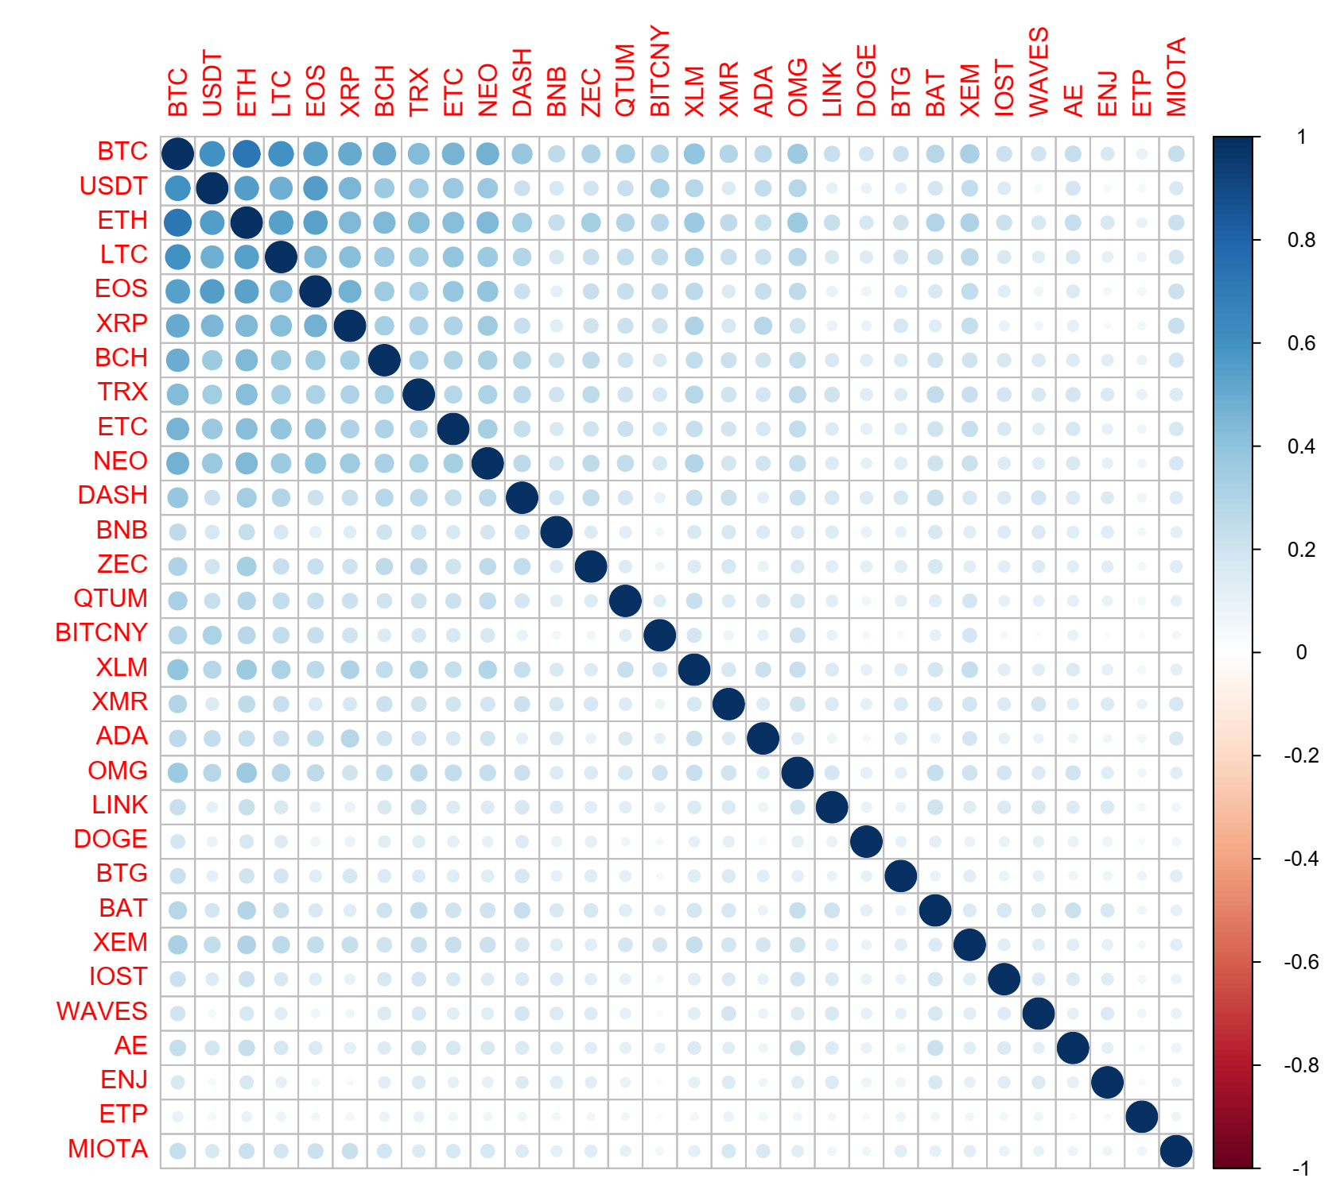 | 20-min  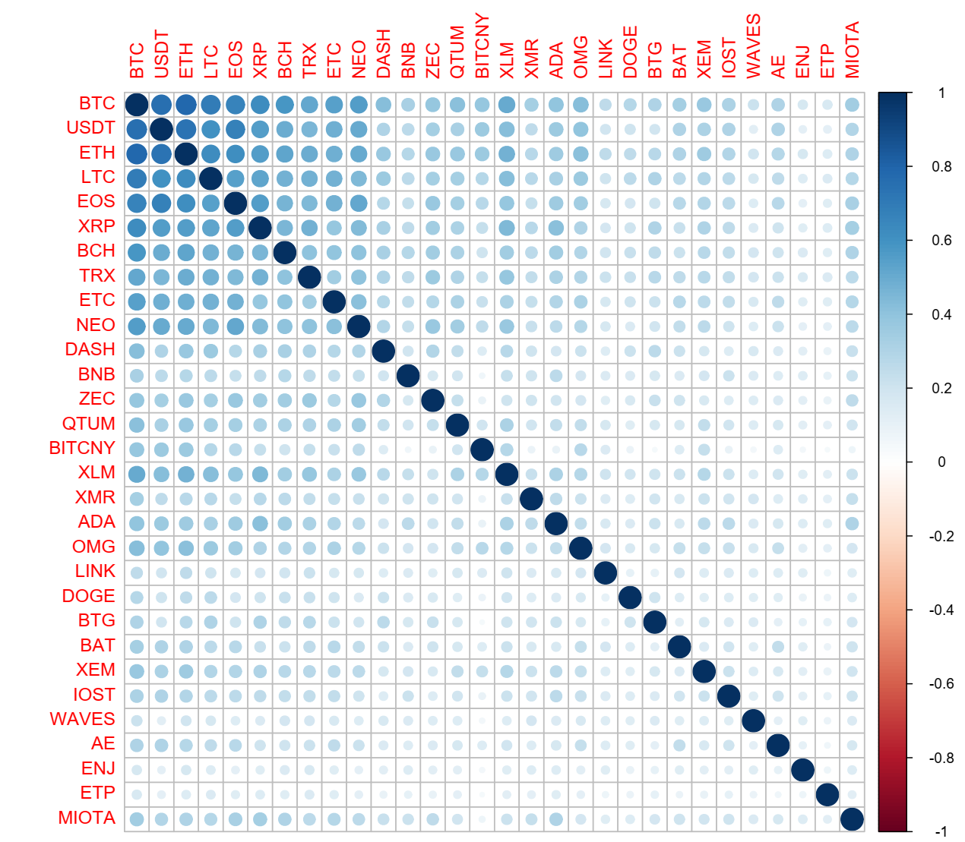
30-min  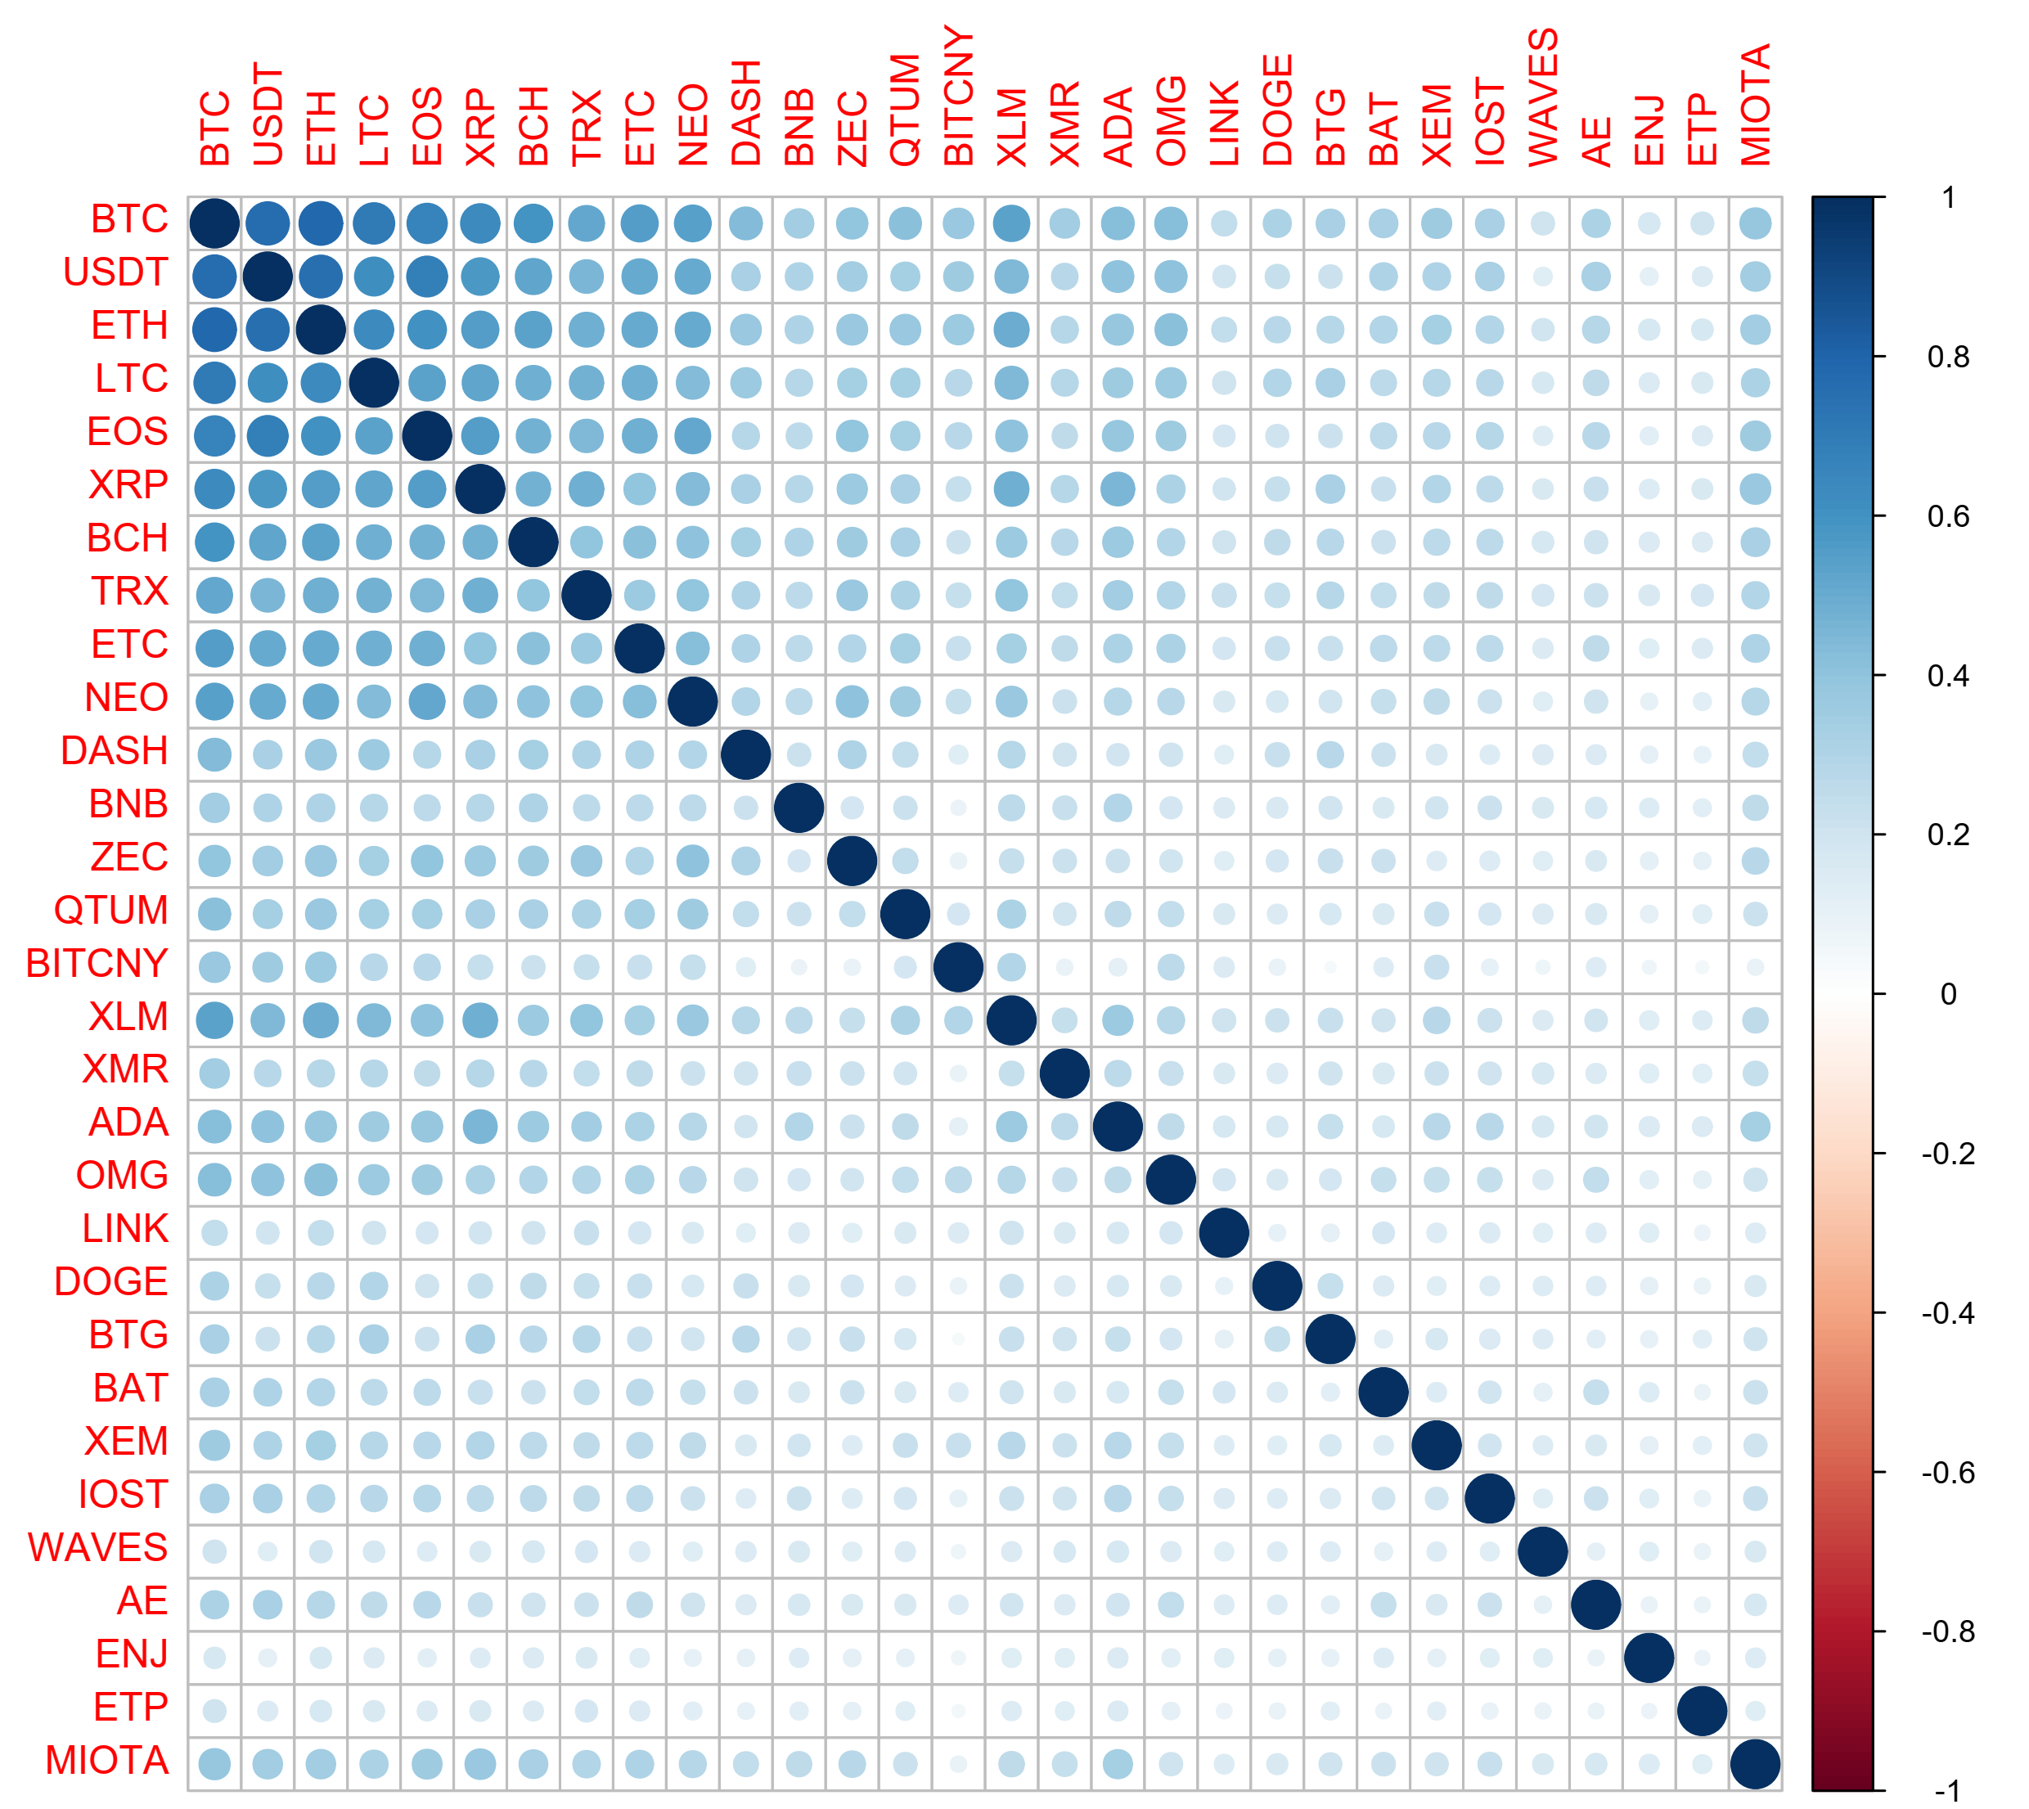 | 60-min  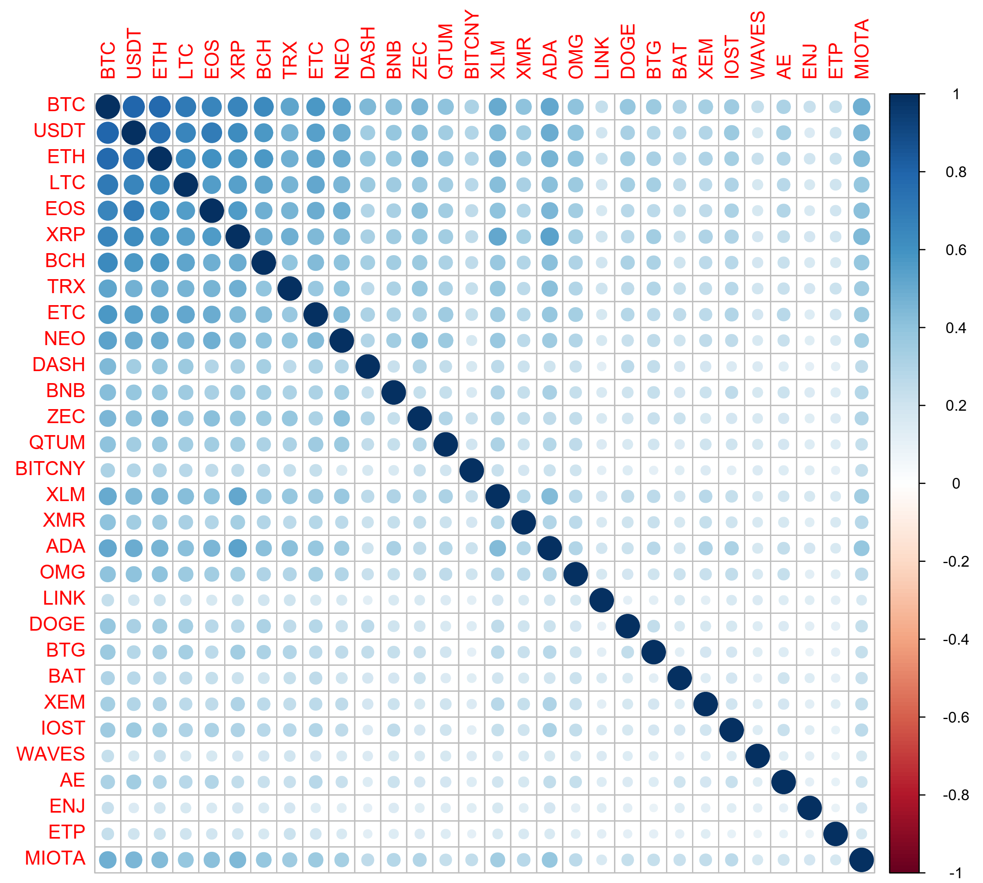
6-hour  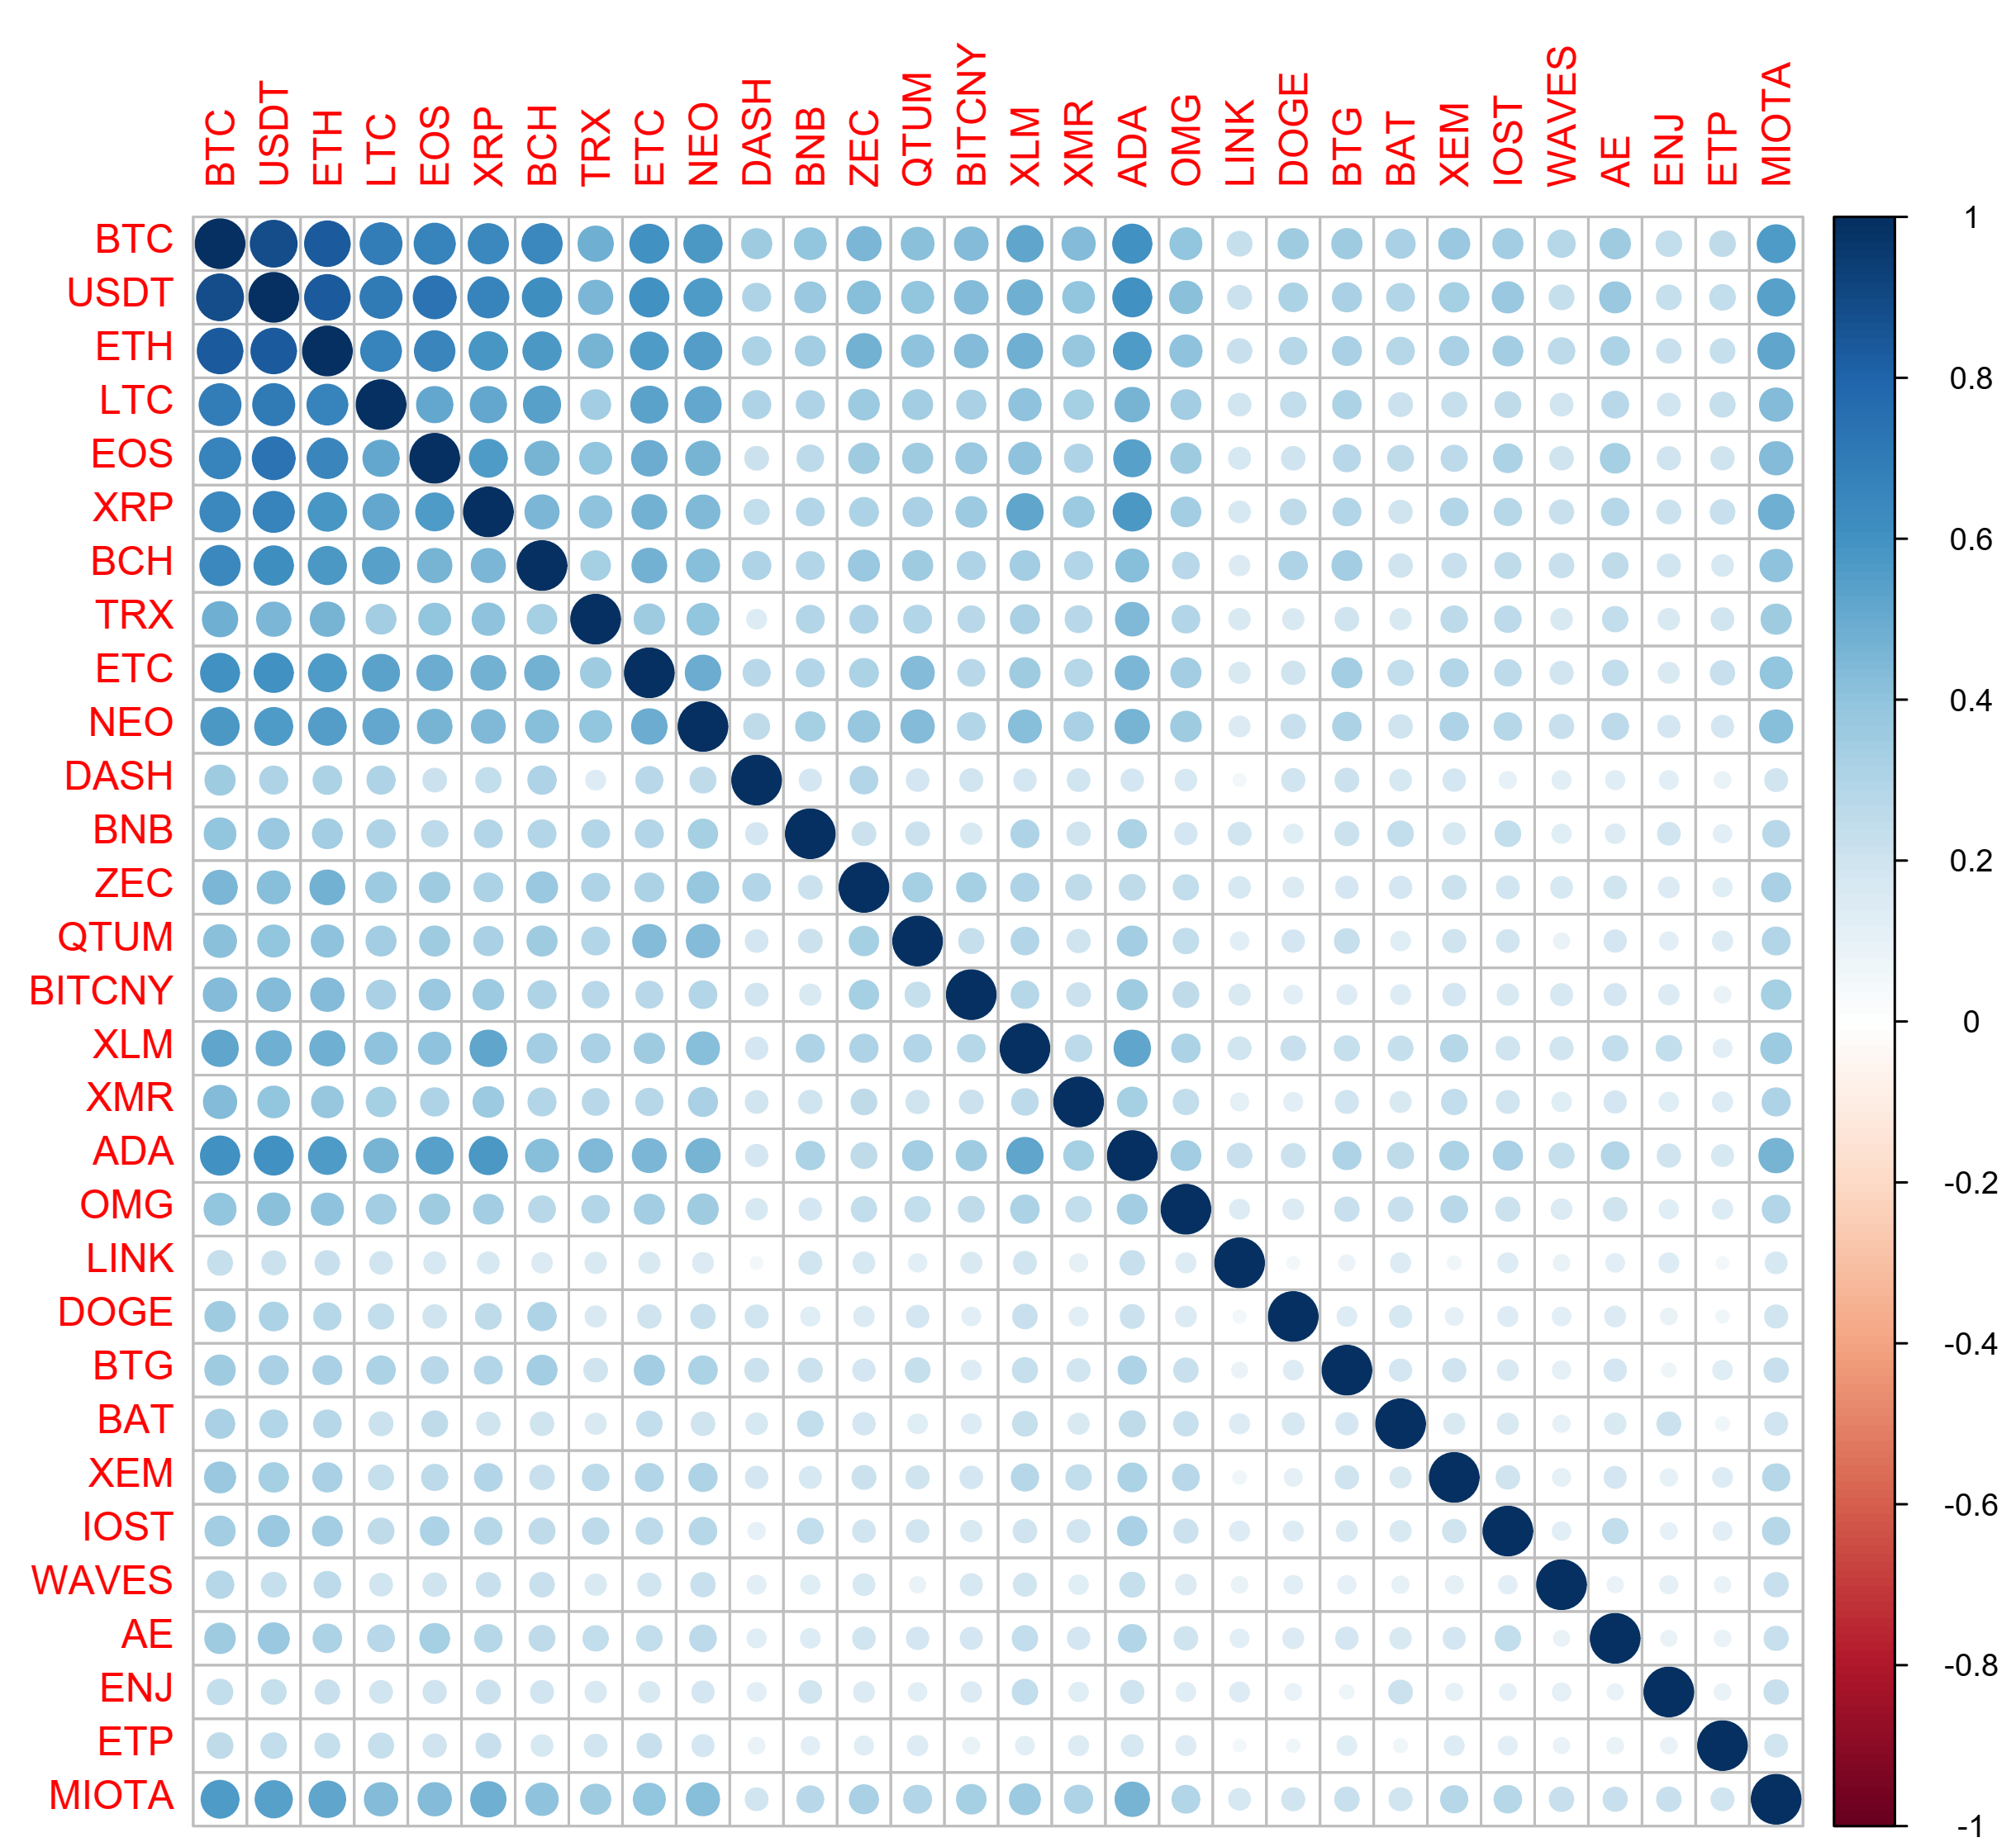 | 12-hour  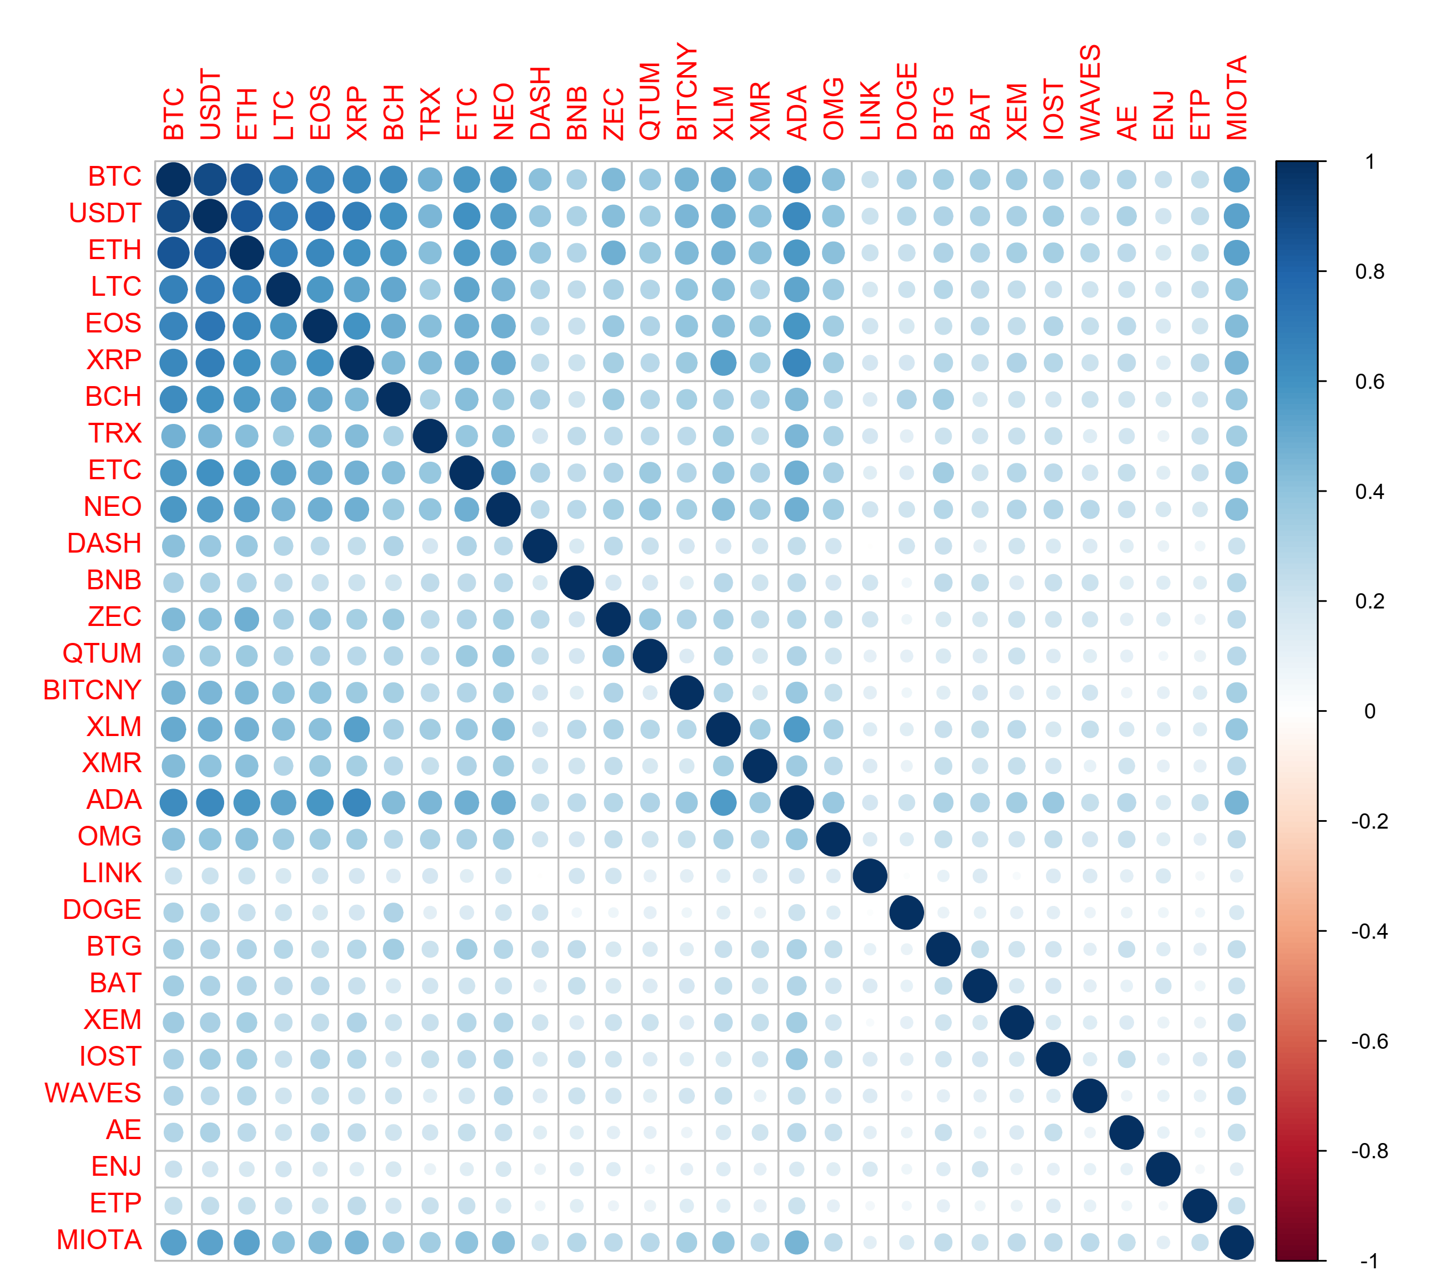
1-day  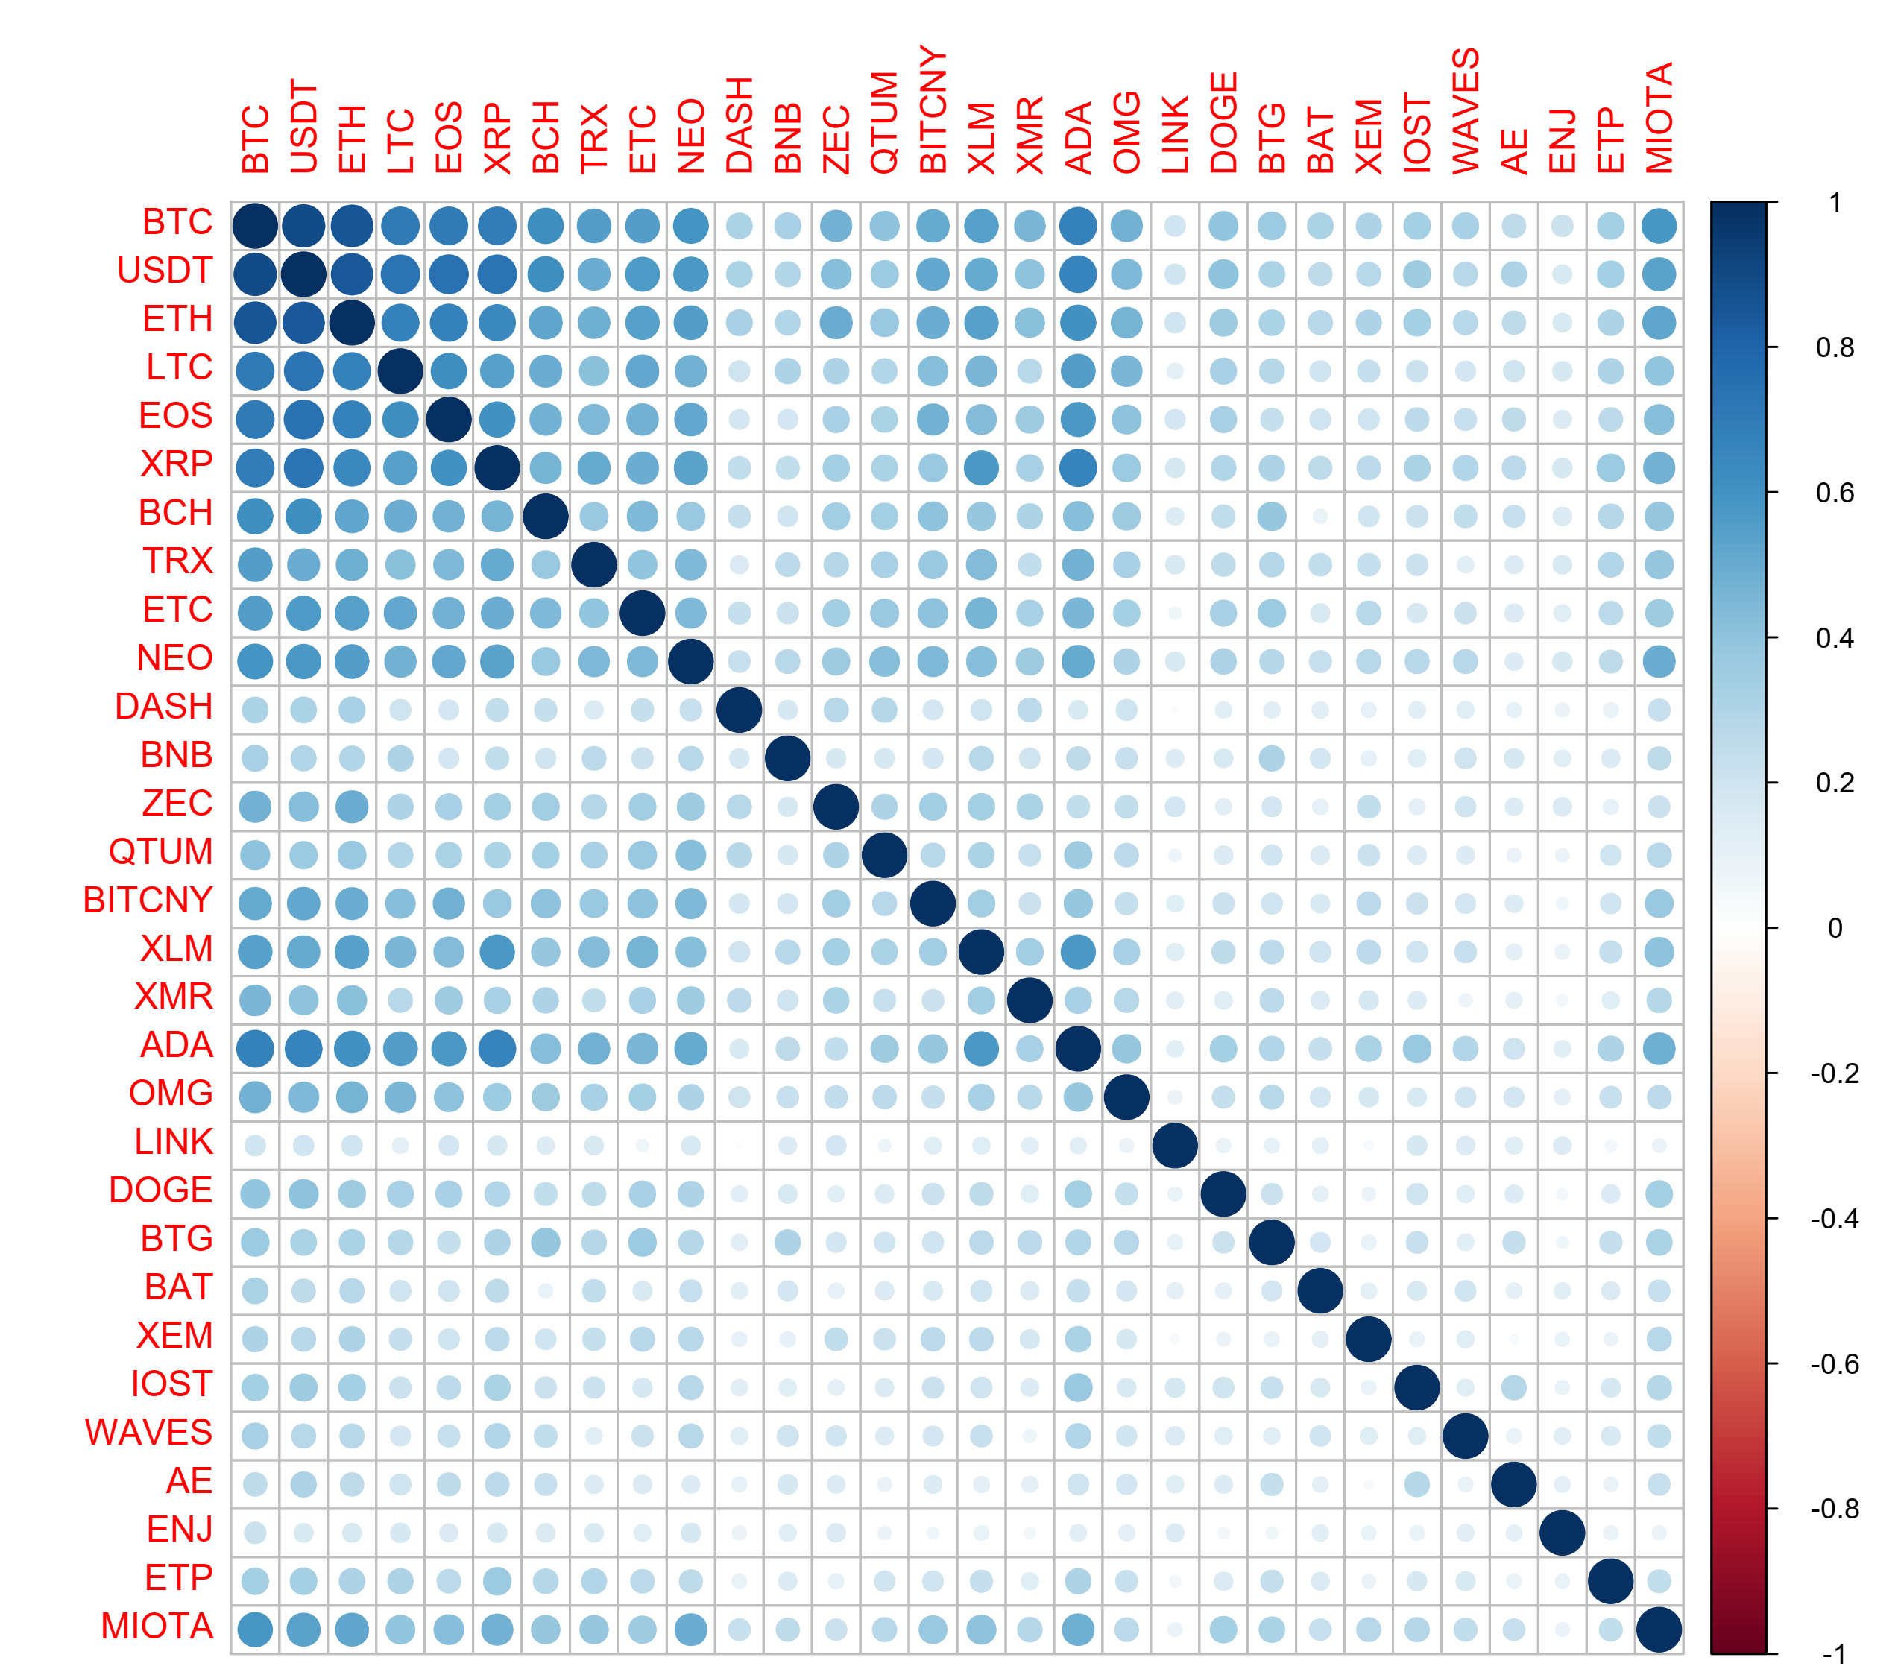 | 1-week  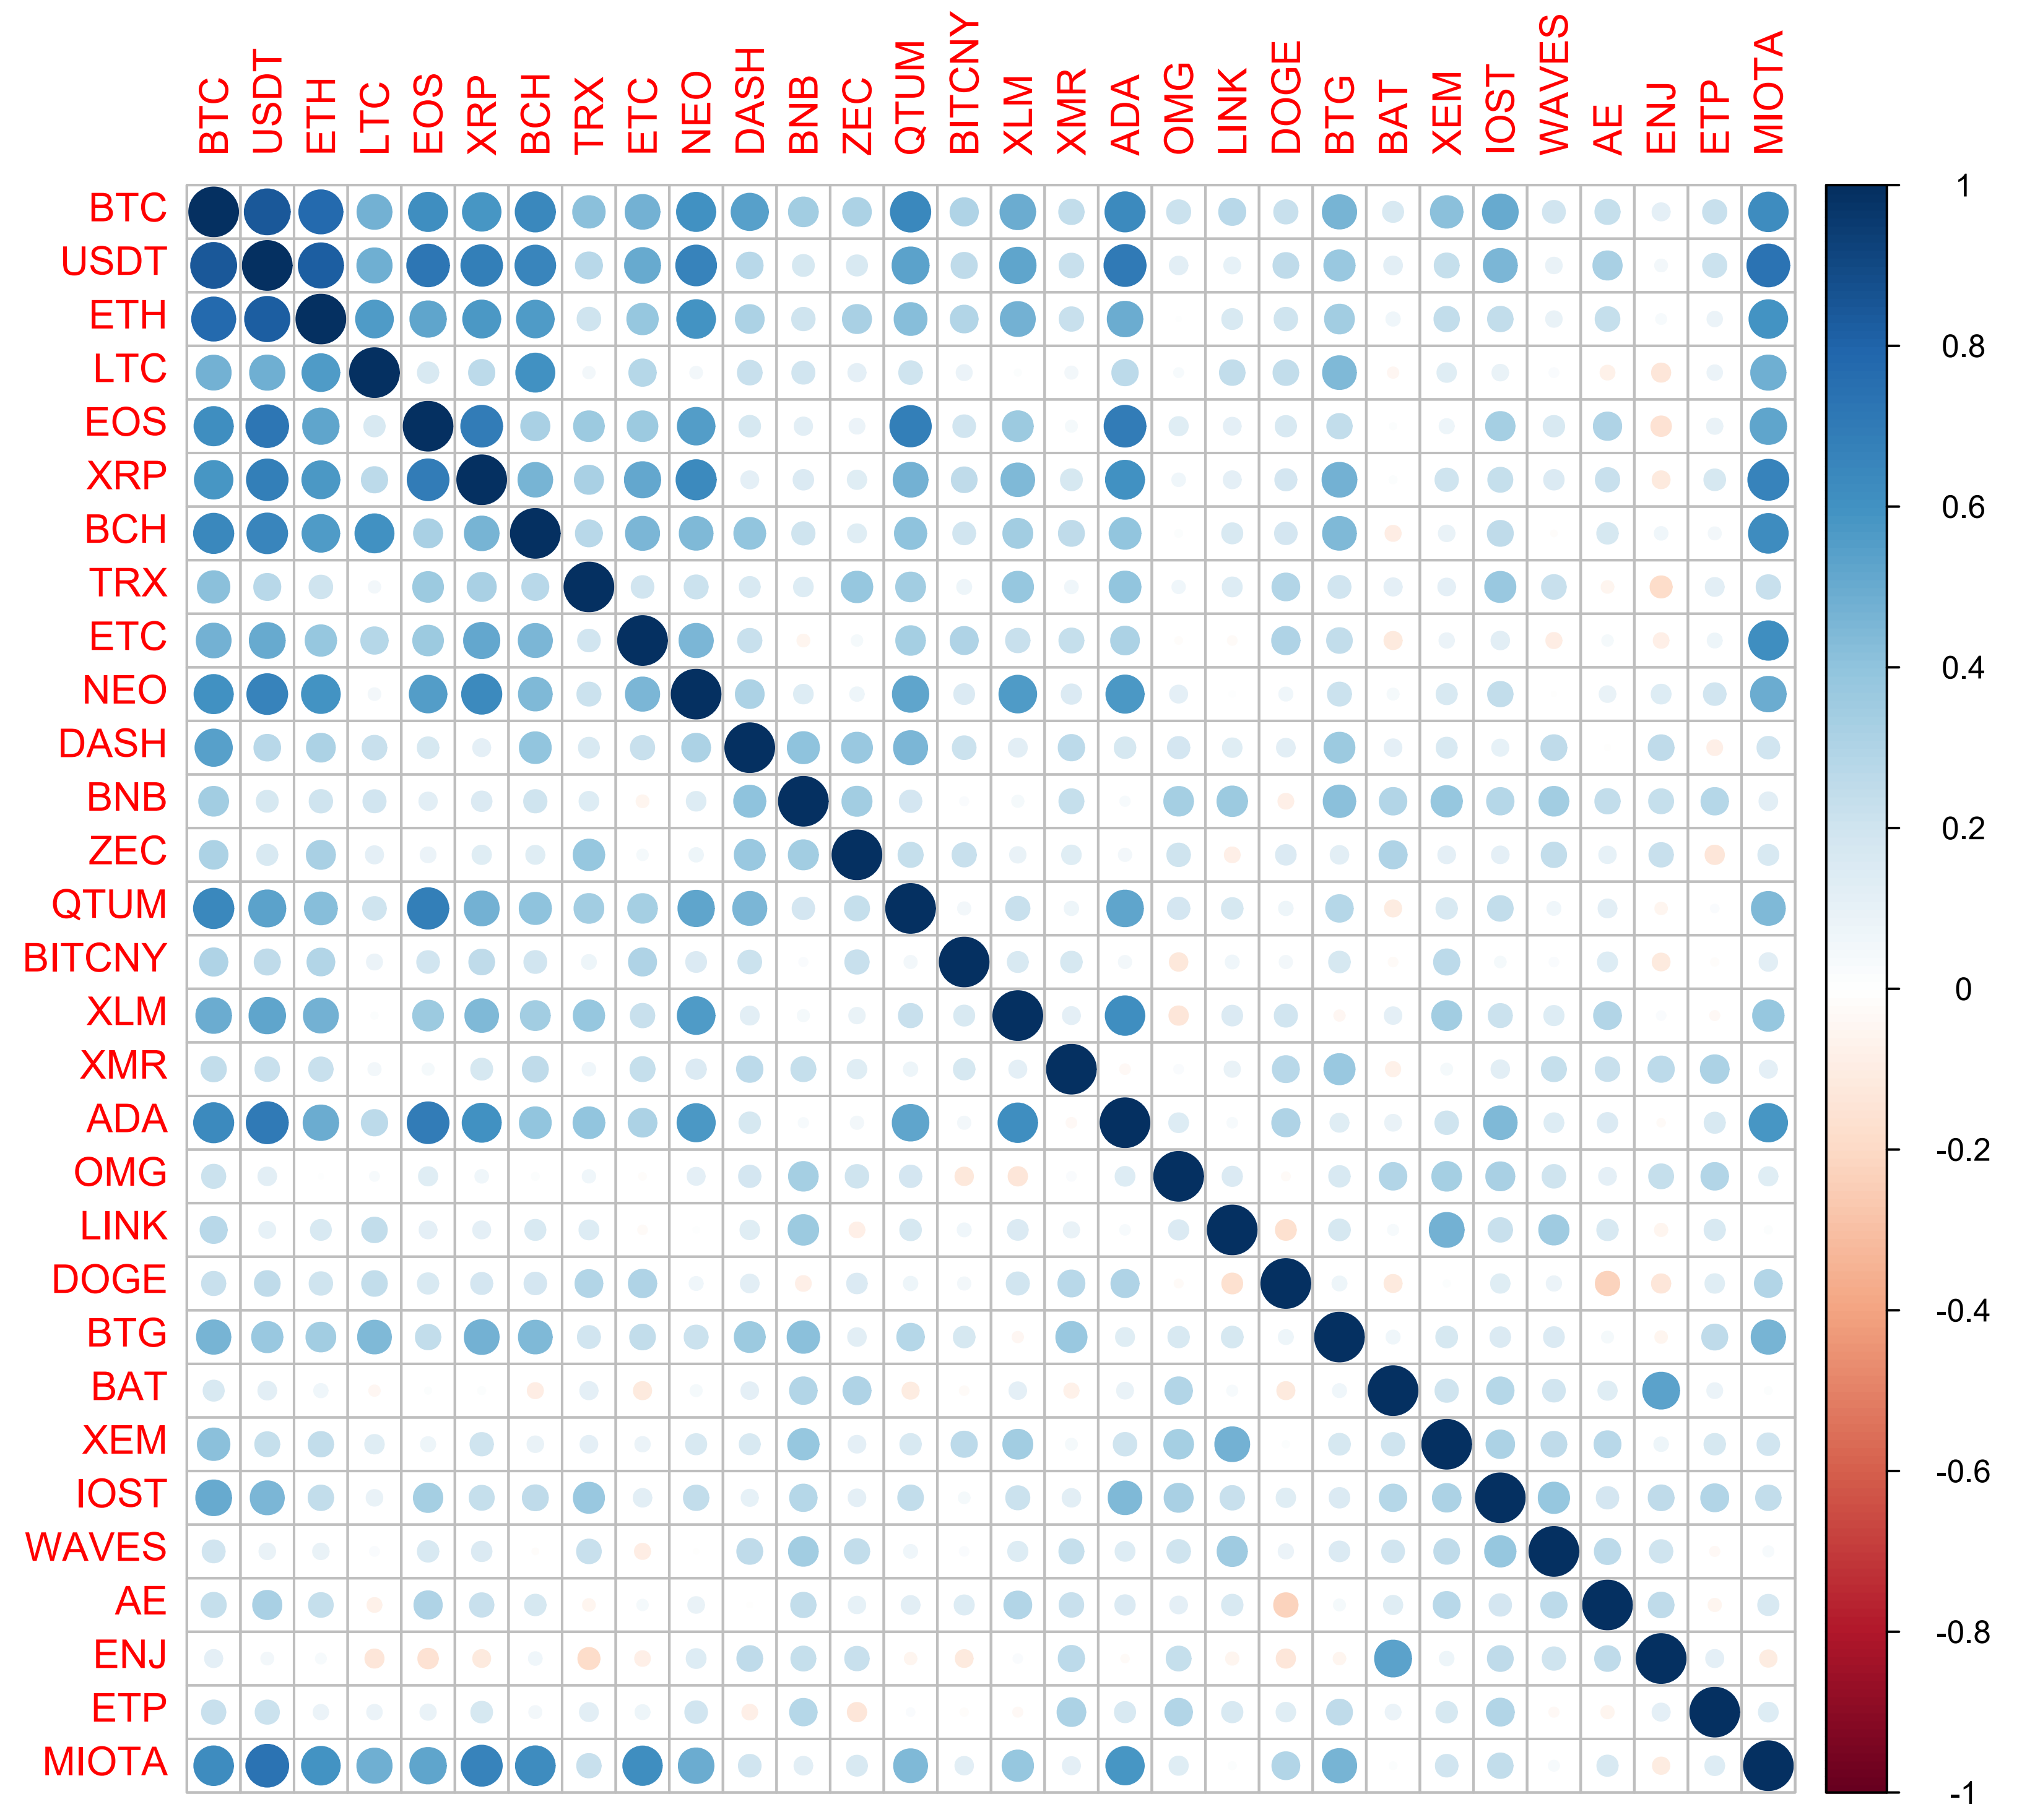
Note: Variables are sorted in the descending order with respect to the cumulative 24h trading volume during the 15.02.2018 – 31.07.2019 period, as in Tables 1-6.
Table 7. Number of occurrences of particular copula families within the sample of 30 analyzed cryptocurrencies, in total among following frequencies: 5-min, 20-min, 30-min, 60-min, 6-hour, 12-hour, 1-day, 1-week

 | Type of tail dependence | Volume-Return Pairs | BTC Volume vs Volumes | BTC Volume vs Returns
Student t copula (t-copula) | symmetric | 45 | 177 | 71
Tawn type 1 copula | upper-tail | 84 |  | 2
Joe copula | upper-tail | 80 | 2 | 41
rotated Clayton copula  (180 degrees; survival Clayton'') | upper-tail | 6
Tawn type 2 copula | upper-tail | 1 | 5
Gumbel copula | upper-tail | 1 | 3 | 4
BB6 copula | upper-tail |  |  | 14
rotated Clayton copula  (180 degrees; survival Clayton'') | upper-tail |  |  | 10
rotated Clayton copula  (180 degrees; survival Clayton'') | upper-tail |  | 2
BB8 copula | none | 12 | 3 | 56
rotated Tawn type 2 copula  (270 degrees) | none | 2 |  | 10
Gaussian copula | none | 2 | 5
Frank copula | none | 2 | 18 | 5
independence copula | none | 1 |  | 2
rotated BB8 copula  (180 degrees; “survival BB8”) | none | 1 | 4
rotated Joe copula  (270 degrees) | none |  |  | 1
BB7 copula | asymmetric | 1 | 2 | 9
rotated BB7 copula  (180 degrees; survival BB7”) | asymmetric | 1 |  | 1
BB1 copula | asymmetric |  | 4 | 6
rotated BB1 copula  (180 degrees; survival BB1”) | asymmetric |  | 5
rotated Joe copula  (180 degrees; survival Joe'') | lower-tail | 1
rotated Tawn type 1 copula  (180 degrees) | lower-tail |  | 1
Clayton copula | lower-tail |  | 1
Note: Provided results present the total number of estimated best-fitting copulas among considered frequencies. Detailed results are available on reader’s request.

Figure 3. Results from estimating best-fitting type of bivariate copulas to volume-return dependencies for 30 analyzed cryptoassets
Figure 3a. P-value of the independence test between volume and returns for each pair
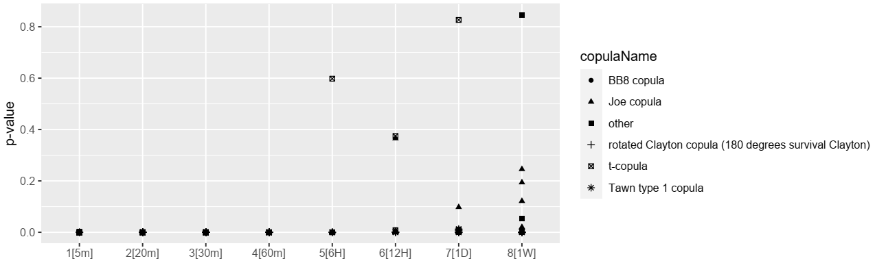
Figure 3b. Tail Dependence coefficient for estimated bivariate copula
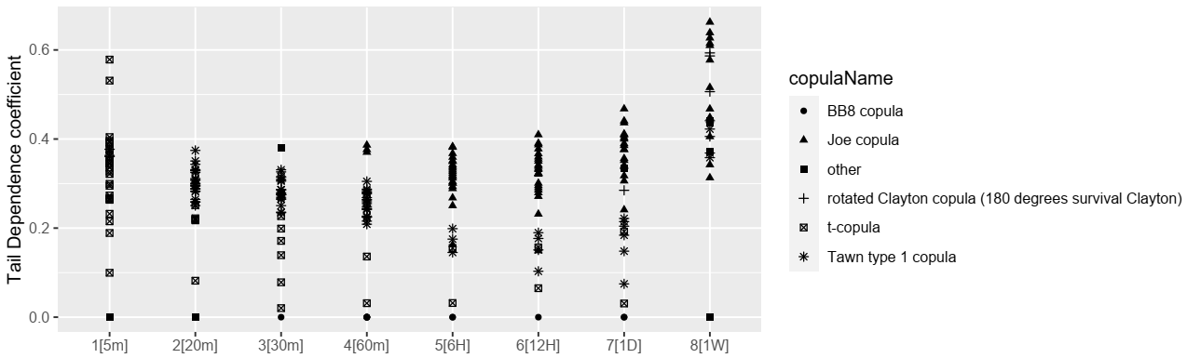
Figure 3c. Empirical value of Kendall’s Tau of estimated bivariate copula
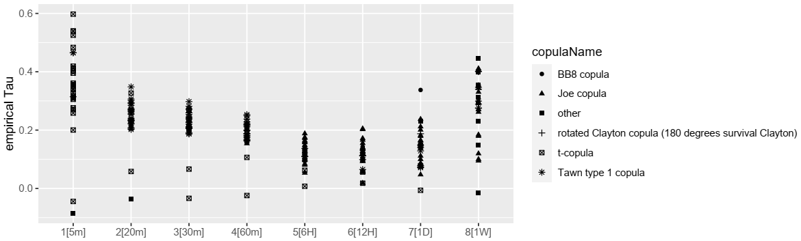
Figure 3d. Goodness-of-fit coefficient, measured as a difference between estimated empirical Kendall’s Tau and theoretical Kendall’s Tau of best-fitting copula type
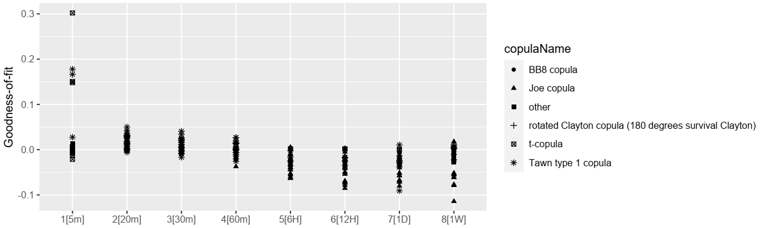
Note: For the convenience of visualization, types of copulas are grouped into five possible categories. Types of considered copulas, with corresponding categories, are listed in Table 11. Detailed results are available on reader’s request.
Figure 4. Results from estimating best-fitting bivariate copulas to dependencies between Bitcoin volume and volumes/returns of other 29 analyzed cryptoassets
Bivariate copulas of Bitcoin volume and volumes of other cryptoassets | Bivariate copulas of Bitcoin volume and returns of other cryptoassets
Figure 4a. P-value of the independence test between volume and returns for each pair  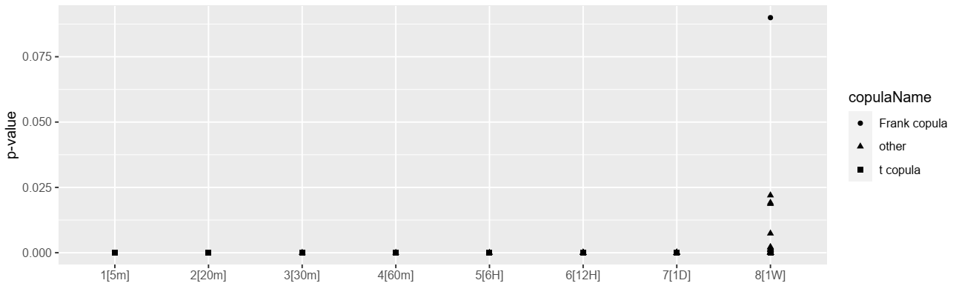 | Figure 4e. P-value of the independence test between volume and returns for each pair  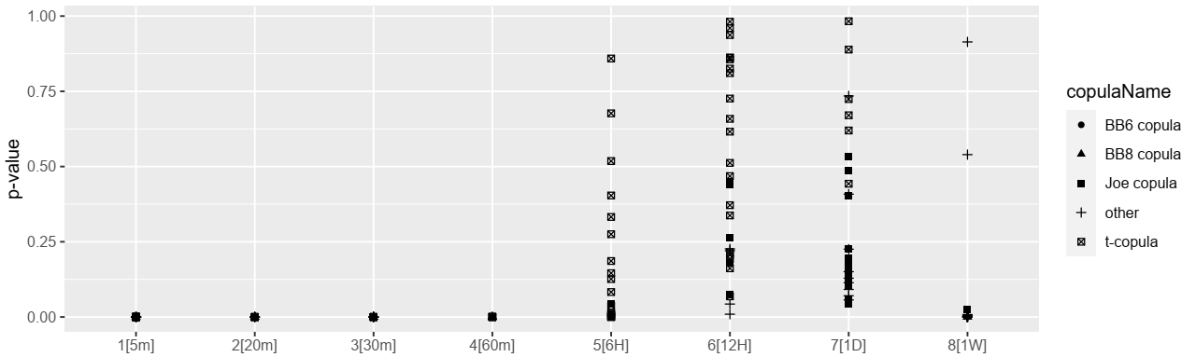
Figure 4b. Tail Dependence coefficient for estimated bivariate copula  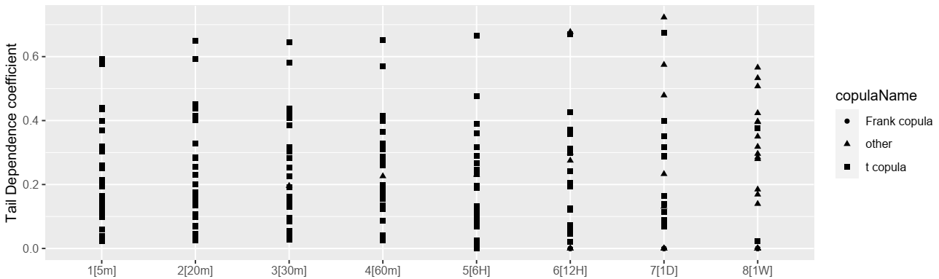 | Figure 4f. Tail Dependence coefficient for estimated bivariate copula  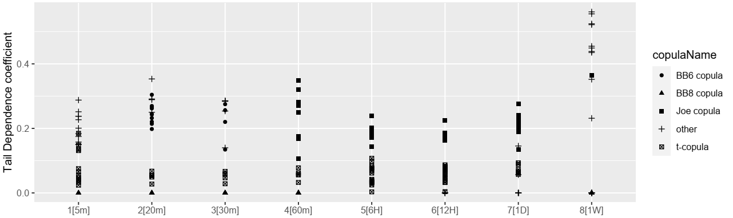
Figure 4c. Empirical value of Kendall’s Tau of estimated bivariate copula  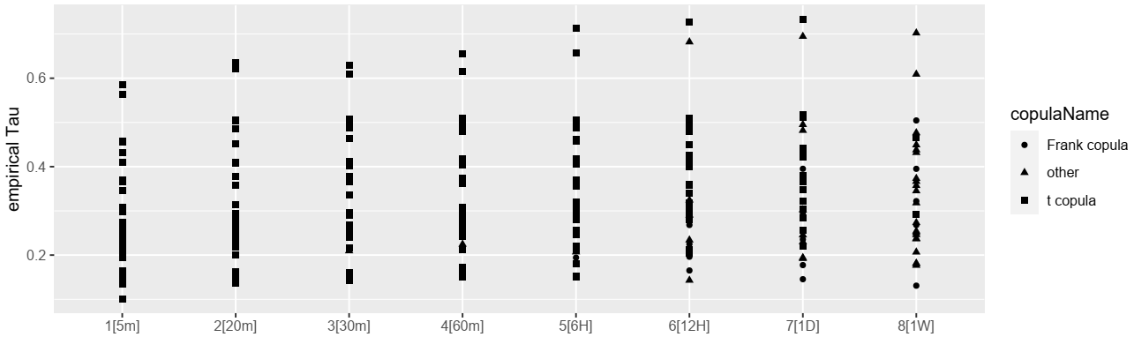 | Figure 4g. Empirical value of Kendall’s Tau of estimated bivariate copula  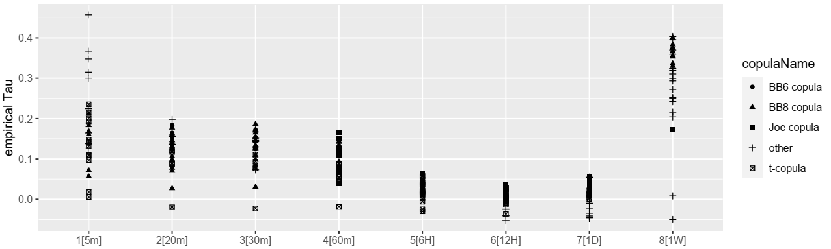
Figure 4d. Goodness-of-fit coefficient, measured as a difference between estimated empirical Kendall’s Tau and theoretical Kendall’s Tau of best-fitting copula type  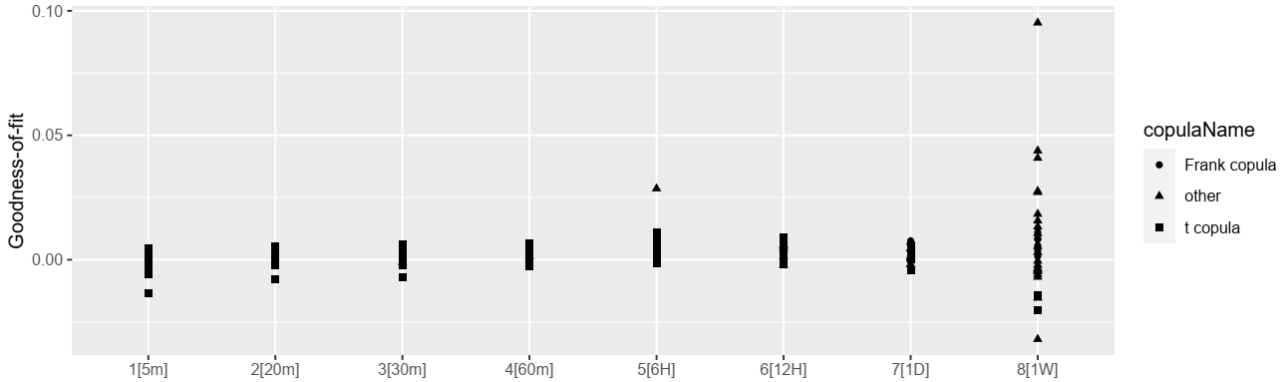 | Figure 4h. Goodness-of-fit coefficient, measured as a difference between estimated empirical Kendall’s Tau and theoretical Kendall’s Tau of best-fitting copula type  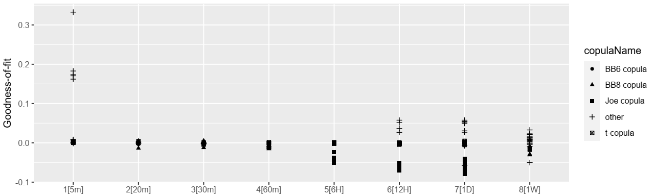
Note: For the convenience of visualization, types of copulas are grouped into five possible categories. Types of considered copulas, with corresponding categories, are listed in Table 11. Detailed results are available on reader’s request.
Table 8a. Results from nonlinear Granger causality estimation for volume-return pairs, classification with respect to founder country and mineability
Coin name | 5 min |  | 20 min |  | 30 min |  | 45 min |  | 60 min |  | Mineable | Founder country | HQ region | dApp platform (Ethereum-like) | Own blockchain / token | Period of introduction
Coin name | Ret GC Vol | Vol GC Ret | Ret GC Vol | Vol GC Ret | Ret GC Vol | Vol GC Ret | Ret GC Vol | Vol GC Ret | Ret GC Vol | Vol GC Ret
XRP | *** | *** | *** | *** | *** | *** | *** | *** | *** | *** | No | West USA | USA | No | Own | 0
ADA | *** | *** | *** | *** | *** | *** | *** | *** | *** | *** | No | West USA | Europe | Yes | Own | 2
USDT |  | ** | ** | *** | *** | *** | *** | *** | *** | ** | No | West USA | Asia | No | Token | 0
LINK | *** | *** | *** | *** | *** | ** | *** | " | *** |  | No | West USA | Cayman Islands | No | Token | 2
ETC | *** | *** | *** | *** | *** | *** | *** | *** | *** | *** | Yes | West USA | USA | Yes | Own | 1
DOGE | *** |  | *** |  | *** |  | *** |  | *** |  | Yes | West USA | USA | No | Own | 0
DASH | *** |  | *** |  | *** |  | * |  | * |  | Yes | West USA | USA | No | Own | 0
ZEC | *** |  | *** |  | *** |  | *** |  | *** |  | Yes | West USA | USA | No | Own | 1
BCH | *** | *** | *** | *** | *** | *** | *** | *** | *** | *** | Yes | West USA / Europe | Unknown | No | Own | 2
Note: Significant at 0.001 ‘***’, 0.01 ‘**’, 0.05 ‘*’, 0.1 ‘"’
Table 8b. Results from nonlinear Granger causality estimation for volume-return pairs, classification with respect to founder country and mineability
 | 5 min |  | 20 min |  | 30 min |  | 45 min |  | 60 min |  | Mineable | Founder country | HQ region | dApp platform (Ethereum-like) | Own blockchain / token | Period of introduction
 | Ret GC Vol | Vol GC Ret | Ret GC Vol | Vol GC Ret | Ret GC Vol | Vol GC Ret | Ret GC Vol | Vol GC Ret | Ret GC Vol | Vol GC Ret
NEO | *** | *** | *** |  | *** | * | *** | " | *** |  | No | China | Asia | Yes | Own | 1
QTUM | *** |  | *** | " | *** |  | *** |  | *** |  | No | China | Asia | Yes | Own | 2
IOST | *** | *** | *** |  | *** |  | *** |  | *** |  | No | China | Asia | Yes | Own | 2
TRX | *** |  | *** |  | *** |  | *** |  | *** |  | No | China | Asia | Yes | Own | 2
BTG | *** |  | *** |  | *** |  | *** |  | *** |  | Yes | China and others | USA | No | Own | 2
BNB | *** | *** | *** | *** | *** | *** | *** | ** | *** | ** | No | China / Canada | Europe | No | Token | 2
Note: Significant at 0.001 ‘***’, 0.01 ‘**’, 0.05 ‘*’, 0.1 ‘"’
Table 9a. Results from nonlinear Granger causality estimation for volume-return pairs, classification with respect to headquarters region: USA
 | 5 min |  | 20 min |  | 30 min |  | 45 min |  | 60 min |  | Mineable | Founder country | HQ region | dApp platform (Ethereum-like) | Own blockchain / token | Period of introduction
 | Ret GC Vol | Vol GC Ret | Ret GC Vol | Vol GC Ret | Ret GC Vol | Vol GC Ret | Ret GC Vol | Vol GC Ret | Ret GC Vol | Vol GC Ret
LTC | *** |  | *** |  | *** |  | *** |  | *** |  | Yes | USA | USA | No | Own | 0
DOGE | *** |  | *** |  | *** |  | *** |  | *** |  | Yes | West USA | USA | No | Own | 0
DASH | *** |  | *** |  | ** |  | * |  | * |  | Yes | West USA | USA | No | Own | 0
ZEC | *** |  | *** |  | *** |  | *** |  | *** |  | Yes | West USA | USA | No | Own | 1
BTG | *** |  | *** |  | *** |  | *** |  | *** |  | Yes | Multiple | USA | No | Own | 2
BCH | *** | *** | *** | *** | *** | *** | *** | *** | *** | *** | Yes | West USA / (Europe) | Unknown | No | Own | 2
BTC | *** | ** | *** | *** | *** | *** | *** | *** | *** | *** | Yes | Other | USA | No | Own | 0
ETC | *** | *** | *** | *** | *** | *** | *** | *** | *** | *** | Yes | West USA | USA | Yes | Own | 1
XLM | *** | * | *** | *** | *** | *** | *** | *** | *** | *** | No | USA | USA | Yes | Own | 0
XRP | *** | *** | *** | *** | *** | *** | *** | *** | *** | *** | No | West USA | USA | No | Own | 0
BAT | *** | *** | *** |  | *** |  | *** |  | *** |  | No | USA | USA | No | Token | 2
Note: Significant at: 0.001 ‘***’, 0.01 ‘**’, 0.05 ‘*’, 0.1 ‘"’
Table 9b. Results from nonlinear Granger causality estimation for volume-return pairs, classification with respect to headquarters region: Asia
 | 5 min |  | 20 min |  | 30 min |  | 45 min |  | 60 min |  | Mineable | Founder country | HQ region | dApp platform (Ethereum-like) | Own blockchain / token | Period of introduction
 | Ret GC Vol | Vol GC Ret | Ret GC Vol | Vol GC Ret | Ret GC Vol | Vol GC Ret | Ret GC Vol | Vol GC Ret | Ret GC Vol | Vol GC Ret
XEM | *** | ** | *** | *** | *** | *** | *** | ** | *** | ** | No | Singapore | Asia | Yes | Own | 0
NEO | *** | *** | *** |  | *** | * | *** | " | *** |  | No | China | Asia | Yes | Own | 1
QTUM | *** |  | *** | " | *** |  | *** |  | *** |  | No | China | Asia | Yes | Own | 2
IOST | *** | *** | *** |  | *** |  | *** |  | *** |  | No | China | Asia | Yes | Own | 2
TRX | *** |  | *** |  | *** |  | *** |  | *** |  | No | China/Asia | Asia | Yes | Own | 2
ETP |  |  |  |  |  |  |  |  |  |  | Yes | China / Canada | Asia | Yes | Own | 2
OMG | *** | *** | *** |  | *** |  | *** |  | *** |  | No | Singapore | Asia | No | Token | 2
USDT |  | ** | ** | *** | *** | *** | *** | *** | *** | ** | No | West USA | Asia | No | Token | 0
ENJ | *** | *** | *** | *** | *** | *** | *** | ** | *** | ** | No | Singapore / Poland | Asia | No | Token | 2
Note: Significant at: 0.001 ‘***’, 0.01 ‘**’, 0.05 ‘*’, 0.1 ‘"’
Table 9c. Results from nonlinear Granger causality estimation for volume-return pairs, classification with respect to headquarters region: Europe
 | 5 min |  | 20 min |  | 30 min |  | 45 min |  | 60 min |  | Mineable | Founder country | HQ region | dApp platform (Ethereum-like) | Own blockchain / token | Period of introduction
 | Ret GC Vol | Vol GC Ret | Ret GC Vol | Vol GC Ret | Ret GC Vol | Vol GC Ret | Ret GC Vol | Vol GC Ret | Ret GC Vol | Vol GC Ret
BNB | *** | *** | *** | *** | *** | *** | *** | ** | *** | ** | No | China / Canada | Europe | No | Token | 2
ADA | *** | *** | *** | *** | *** | *** | *** | *** | *** | *** | No | West USA | Europe | Yes | Own | 2
MIOTA | *** | *** | *** |  | *** |  | *** |  | *** |  | No | Norway | Europe | No | Own | 2
WAVES | *** |  | *** | ** | *** | " | *** |  | *** |  | No | Russia | Russia | Yes | Own | 1
AE | *** |  | *** |  | *** | * | *** | *** | *** | *** | Yes | Liechtenstein | Europe | Yes | Own | 2
ETH | *** | *** | *** |  | *** | * | *** | " | *** | * | Yes | Russia / Canada | Europe | Yes | Own | 1
Note: Significant at 0.001 ‘***’, 0.01 ‘**’, 0.05 ‘*’, 0.1 ‘"’

Table 9d. Results from nonlinear Granger causality estimation for volume-return pairs, classification with respect to headquarters region: other
 | 5 min |  | 20 min |  | 30 min |  | 45 min |  | 60 min |  | Mineable | Founder country | HQ region | dApp platform (Ethereum-like) | Own blockchain / token | Period of introduction
 | Ret GC Vol | Vol GC Ret | Ret GC Vol | Vol GC Ret | Ret GC Vol | Vol GC Ret | Ret GC Vol | Vol GC Ret | Ret GC Vol | Vol GC Ret
LINK | *** | *** | *** | *** | *** | ** | *** | " | *** |  | No | West USA | Cayman Islands | No | Token | 2
EOS | *** | *** | *** | ** | *** | *** | *** | *** | *** | *** | No | Cayman Islands | Cayman Islands | Yes | Own | 2
BCH | *** | *** | *** | *** | *** | *** | *** | *** | *** | *** | Yes | West USA / Europe | Unknown | No | Own | 2
XMR | *** | ** | *** | *** | *** | *** | *** | *** | *** | *** | Yes | Other | Other | No | Own | 0
Note: Significant at: 0.001 ‘***’, 0.01 ‘**’, 0.05 ‘*’, 0.1 ‘"’
Table 10. Results from nonlinear Granger causality estimation for volume-return pairs, classification with respect to non-minable platforms

 | 5 min |  | 20 min |  | 30 min |  | 45 min |  | 60 min |  | Mineable | Founder country | HQ region | dApp platform (Ethereum-like) | Own blockchain / token | Period of introduction
 | Ret GC Vol | Vol GC Ret | Ret GC Vol | Vol GC Ret | Ret GC Vol | Vol GC Ret | Ret GC Vol | Vol GC Ret | Ret GC Vol | Vol GC Ret
EOS | *** | *** | *** | ** | *** | *** | *** | *** | *** | *** | No | Cayman Islands | Cayman Islands | Yes | Own | 2
ADA | *** | *** | *** | *** | *** | *** | *** | *** | *** | *** | No | West USA | Europe | Yes | Own | 2
XLM | *** | * | *** | *** | *** | *** | *** | *** | *** | *** | No | USA | USA | Yes | Own | 0
XEM | *** | ** | *** | *** | *** | *** | *** | ** | *** | ** | No | Singapore | Asia | Yes | Own | 0
ENJ | *** | *** | *** | *** | *** | *** | *** | ** | *** | ** | No | Singapore / Poland | Asia | Yes | Token | 2
WAVES | *** |  | *** | ** | *** | " | *** |  | *** |  | No | Russia | Russia | Yes | Own | 1
NEO | *** | *** | *** |  | *** | * | *** | " | *** |  | No | China | Asia | Yes | Own | 1
QTUM | *** |  | *** | " | *** |  | *** |  | *** |  | No | China | Asia | Yes | Own | 2
IOST | *** | *** | *** |  | *** |  | *** |  | *** |  | No | China | Asia | Yes | Own | 2
TRX | *** |  | *** |  | *** |  | *** |  | *** |  | No | China | Asia | Yes | Own | 2
Note: Significant at 0.001 ‘***’, 0.01 ‘**’, 0.05 ‘*’, 0.1 ‘"’
Table 11. Results from non-parametric Granger causality between BTC Volume and volumes of other cryptocurrencies – type of statistically significant relationship
Coin name | 5m | 20m | 45m | 60m
USDT | bi-direct | bi-direct | bi-direct | bi-direct
LTC | bi-direct | bi-direct | bi-direct | bi-direct
EOS | bi-direct | bi-direct | bi-direct | bi-direct
XRP | bi-direct | bi-direct | bi-direct | bi-direct
BCH | bi-direct | bi-direct | bi-direct | bi-direct
ETC | bi-direct | bi-direct | bi-direct | bi-direct
BNB | bi-direct | bi-direct | bi-direct | bi-direct
ZEC | bi-direct | bi-direct | bi-direct | bi-direct
QTUM | bi-direct | bi-direct | bi-direct | bi-direct
XLM | bi-direct | bi-direct | bi-direct | bi-direct
ADA | bi-direct | bi-direct | bi-direct | bi-direct
XEM | bi-direct | bi-direct | bi-direct | bi-direct
WAVES | bi-direct | bi-direct | bi-direct | bi-direct
AE | bi-direct | bi-direct | bi-direct | bi-direct
MIOTA | bi-direct | bi-direct | bi-direct | bi-direct
NEO | bi-direct | bi-direct | bi-direct | BTC volume GC volume of X
IOST | bi-direct | bi-direct | bi-direct | BTC volume GC volume of X
ETH | bi-direct | bi-direct | BTC volume GC volume of X | bi-direct
TRX | bi-direct | bi-direct | BTC volume GC volume of X | BTC volume GC volume of X
LINK | bi-direct | bi-direct | BTC volume GC volume of X | BTC volume GC volume of X
ENJ | bi-direct | bi-direct | BTC volume GC volume of X | BTC volume GC volume of X
ETP | bi-direct | bi-direct | BTC volume GC volume of X | BTC volume GC volume of X
DASH | bi-direct | BTC volume GC volume of X | BTC volume GC volume of X | BTC volume GC volume of X
OMG | bi-direct | BTC volume GC volume of X | BTC volume GC volume of X | bi-direct
BAT | bi-direct | BTC volume GC volume of X | BTC volume GC volume of X | BTC volume GC volume of X
XMR | BTC volume GC volume of X | BTC volume GC volume of X | none | none
DOGE | BTC volume GC volume of X | BTC volume GC volume of X | BTC volume GC volume of X | BTC volume GC volume of X
BTG | BTC volume GC volume of X | bi-direct | BTC volume GC volume of X | BTC volume GC volume of X
Note: the relationship is considered statistically significant at 5% level.
Abbreviation “GC” refers to “Granger Causes”, while X refers to a cryptocurrency in particular row.
Bolded names of cryptocurrencies denote the ones where there is a bi-directional relationship between Bitcoin volume and both their volume and returns.

Table 12. Results from non-parametric Granger causality between BTC Volume and returns of other cryptocurrencies – type of relationship
Coin name | 5m | 20m | 45m | 60m
USDT | bi-direct | bi-direct | bi-direct | bi-direct
LTC | bi-direct | bi-direct | bi-direct | bi-direct
EOS | bi-direct | bi-direct | bi-direct | bi-direct
XRP | bi-direct | bi-direct | bi-direct | bi-direct
BCH | bi-direct | bi-direct | bi-direct | bi-direct
ETC | bi-direct | bi-direct | bi-direct | bi-direct
BNB | bi-direct | bi-direct | bi-direct | bi-direct
XLM | bi-direct | bi-direct | bi-direct | bi-direct
ADA | bi-direct | bi-direct | bi-direct | bi-direct
XEM | bi-direct | bi-direct | bi-direct | bi-direct
AE | bi-direct | bi-direct | bi-direct | bi-direct
IOST | bi-direct | bi-direct | bi-direct | bi-direct
ETH | bi-direct | bi-direct | bi-direct | bi-direct
LINK | bi-direct | bi-direct | bi-direct | bi-direct
ENJ | bi-direct | bi-direct | bi-direct | bi-direct
DASH | bi-direct | bi-direct | bi-direct | bi-direct
OMG | bi-direct | bi-direct | bi-direct | bi-direct
BAT | bi-direct | bi-direct | bi-direct | bi-direct
XMR | bi-direct | bi-direct | bi-direct | bi-direct
BTG | bi-direct | bi-direct | bi-direct | bi-direct
QTUM | BTC volume GC X returns | bi-direct | bi-direct | bi-direct
ETP | BTC volume GC X returns | bi-direct | bi-direct | bi-direct
DOGE | BTC volume GC X returns | none | bi-direct | bi-direct
ZEC | BTC volume GC X returns | X returns GC BTC volume | bi-direct | bi-direct
MIOTA | X returns GC BTC volume | X returns GC BTC volume | bi-direct | bi-direct
NEO | X returns GC BTC volume | X returns GC BTC volume | bi-direct | bi-direct
TRX | X returns GC BTC volume | bi-direct | bi-direct | bi-direct
WAVES | bi-direct | X returns GC BTC volume | bi-direct | bi-direct
Note: the relationship is considered statistically significant at 5% level.
Abbreviation “GC” refers to “Granger Causes”, while X refers to a cryptocurrency in particular row.
Bolded names of cryptocurrencies denote the ones where there is a bi-directional relationship between Bitcoin volume and both their volume and returns.

*Corresponding author l.yarovaya@soton.ac.uk
Data collected from coinpaprika.com
For the asymmetric tail dependence, the higher of two coefficients was chosen for convenience.
See Table 7 for dependence types corresponding to the type of copula.
bitCNY was excluded from the non-parametric Granger causality analysis, due to the technical problems with its time series.
We do not provide the Spearman correlation results, since we concluded from the analysis of volume-return pairs that the Spearman correlation results are in line with the results of bivariate copula fitting. We decided to provide the results of bivariate Copula fitting because it allows for a more comprehensive analysis.

