Environmental DNA sampling protocols for the surveillance of marine Non-Indigenous Species in Irish coastal waters.
Sara Fernandez^{1,2†*}, Dulaney L. Miller^{1,2*}, Luke E. Holman³, Arjan Gittenberger^{4,5}, Alba Ardura⁶, Marc Rius^{3,7}, Luca Mirimin^{1,2}.
¹ Marine and Freshwater Research Centre, Dublin Road, H91 T8NW, Galway, Ireland.
² Galway-Mayo Institute of Technology, School of Science and Computing, Department of Natural Sciences, Dublin Road, H91 T8NW, Galway, Ireland.
³ School of Ocean and Earth Science, National Oceanography Centre, European Way, Southampton, SO14 3ZH, University of Southampton, United Kingdom.
⁴ GiMaRIS, Rijksstraatweg 75, 2171 AK Sassenheim, Nederland.
⁵ Department of Marine Zoology, Naturalis Biodiversity Center, Pesthuislaan 7, 2333 BA Leiden, The Netherlands
⁶ Department of Functional Biology, University of Oviedo, 33006 Oviedo, Asturias, Spain.
⁷ Department of Zoology, Centre for Ecological Genomics and Wildlife Conservation, University of Johannesburg, 2006 Johannesburg, South Africa.
* co-first authorship
†Corresponding Author: Sara Fernandez; email: sara.fernandezfernandez@gmit.ie; sara_ff9@msn.com.
Abstract
Understanding the spread and distribution of Non-Indigenous Species (NIS) is key when implementing legislation to maintain good ecosystem health. Environmental DNA (eDNA) approaches have shown great potential to detect aquatic organisms in a rapid and cost-effective way, however their applicability to new environments and target communities must be assessed and validated prior to their successful implementation. Here, we tested different field sampling methods in combination with eDNA metabarcoding to develop a non-invasive, rapid, and cost-efficient tool to detect NIS along Irish coastal waters. Both large and small volumes of seawater were filtered, in addition to the collection of sediment and horizontal tow net samples at 12 locations across four distinct geographic areas in Galway Bay, Waterford estuary, Dublin Bay, and Carlingford Lough, Ireland. Sediment and tow net samples were the most dissimilar approaches in species recovery, while tow nets showed to be the most efficient in terms of number of species, outperforming other water filtration methods. Using a marker from the mitochondrial Cytochrome subunit 1, eDNA of a total of 357 taxa could be identified, including 16 NIS. Although combining all techniques would provide the most taxonomically comprehensive approach, the use of fine mesh tow nets was identified as the recommended and most cost-efficient method for large-scale monitoring and surveillance of NIS in Irish coastal waters.
Keywords: COI; eDNA; high throughput sequencing; rapid detection of species; non-indigenous species; metabarcoding.
Introduction
Non-Indigenous Species (NIS) are considered one of the main threats to global biodiversity (Mazor et al., 2018). Several countries have recently adopted Maritime Spatial Planning (MSP) frameworks to harness oceanic assets, boost maritime economies with sustainable practices, and preserve marine habitat biodiversity (Directive 2014/89/EU) (https://www.msp-platform.eu/countries-overview). The presence of NIS can negatively affect marine-based industries such as aquaculture and shipping, and interagency efforts are ongoing to address specific sectoral impacts (Lacoursière-Roussel et al., 2018; Molnar et al., 2008). Accordingly, NIS are being increasingly recognized in numerous regulations (e.g. EC 708/2007; EC 1143/2014) as a key agent driving the loss of native species and are known to have significant impacts on natural capital assets (Lovell et al., 2006; Mazor et al., 2018). The long-term sustainability of marine ecosystems relies on the effective management of NIS (Lehtiniemi et al., 2015; Lodge et al., 2006) and legislation [e.g. the EU Marine Strategy Framework Directive (MSFD) and the Habitats Directive] indicates the need for monitoring the distribution and spread of NIS as a crucial first step (Darling and Mahon, 2011; Duarte et al., 2020b). This stems from the evidence that early detection and rapid eradication of NIS is fundamental. The use of sensitive monitoring tools increases the rate of detection and successful eradication between introduction and establishment (Lodge et al., 2006). To facilitate the implementation of regulations and management strategies, standardized protocols are needed for in situ surveillance of marine NIS in both nearshore and offshore waters and benthic habitats.
The isolation of DNA from environmental samples coupled with High-Throughput Sequencing (HTS) technologies has emerged as a tool to unravel biodiversity patterns and detect NIS (Ardura et al. 2020; Rey, Basurko, and Rodriguez-Ezpeleta 2020; Brown et al. 2016; Comtet et al. 2015; Holman et al. 2019). The amplification of DNA barcoding regions from environmental samples such as sediment or water (eDNA metabarcoding) can determine the incidence of taxa by comparing sequenced regions against referenced databases (Creer et al., 2016; Duarte et al., 2020a). Existing survey methods for detecting marine NIS using net trawls and dredging are geographically limited, time consuming and can cause damage to ecosystems (Bohmann et al., 2014; Thomsen et al., 2016; Zou et al., 2020). The application of molecular surveys provides a cost-effective, sensitive, non-invasive, and rapid approach to characterize biodiversity in all seasons (Duarte et al., 2020b; Pochon et al., 2013; Thomsen et al., 2016; Yang and Zhang, 2020; Zinger et al., 2019). Several studies (e.g. Afzali et al., 2020; Closek et al., 2019; Deiner et al., 2017; Fernández et al., 2019; Olds et al., 2016) reported higher recovery of taxa captured with eDNA approaches than conventional counterparts; thus demonstrating that eDNA is a more sensitive method for general biodiversity assessments in many scenarios. Utilizing early detection of NIS and rapid eradication surveillance strategies while concurrently complying with internationally adopted MSP, eDNA-based biodiversity monitoring provides the capacity to detect new NIS arrivals in real-time and map the current spread to help predict future expansion/contraction of established populations.
Although many recent studies employing eDNA metabarcoding have recognised these benefits (e.g. Djurhuus et al. 2018; Holman et al. 2019; Jeunen et al. 2019; Koziol et al. 2019; Rey, Basurko, and Rodriguez-Ezpeleta 2019), the specific field methodology chosen requires validation depending on the environment, local communities and target taxa. Parameters such as salinity, UV exposure, and sediment composition, vary according to the geophysical location of the study, and can influence obtained sequence data (Cristescu and Hebert, 2018). High UV exposure may induce false negatives in surface water samples and rocky benthic zones may diminish eDNA capture from sediment cores (Turner et al., 2015). Depending on the species composition of the study site, sampling methodology can influence which species are recovered. For example, if a bulk sampling method is chosen, nontarget phytoplankton could assume a high read abundance percentage if abundant (Aylagas et al., 2016). Thus, sampling type is a key factor in reducing false negatives, as this will reduce the ability to pick up rare target taxa if fewer reads are available. Previous studies have concluded that a combination of sample types would be required to evaluate marine communities and detect NIS species (Holman et al., 2019; Rey et al., 2019), however, it is time-consuming and costly to use multiple sampling types at each location. Target organisms in biodiversity studies span the entire taxonomic spectrum of living organisms occurring on all substrata (benthos, plankton, etc.). Furthermore, detectability may change across the variable morphology of different life cycle stages, as is common for marine species with larval stages prior to settlement and establishment as adults. With the aforementioned broad range of abiotic parameters and vertical distribution of target species, it is necessary to conduct preliminary methodological studies to enhance sensitivity of detection.
Here, we tested several methodological approaches combining different sampling strategies and eDNA metabarcoding to unveil the most effective strategy to delineate the spatial distribution of marine NIS. The sampling approaches included some established protocols (1L of water filtered at the surface) as well novel methods (High volume samplers), and were tested in a range of environments encompassing locations with low to high numbers of expected NIS (e.g. ports, marinas, shores and open water) including areas previously identified as potential hotspots of NIS (Tidbury et al 2016). The main aim of this study was to evaluate rapid, practical, and cost-effective protocols for the monitoring and surveillance of marine NIS and invasive species in Irish coastal waters.
Materials and Methods
Study area
Four main areas were chosen around the Irish coast, including Galway Bay, Waterford Estuary, Dublin Bay and Carlingford Lough (Supplementary Figure 1). These were chosen to encompass a range of sites from known/expected NIS hotspots (due to convergence of NIS pathways and vectors) to less affected areas (e.g. Galway Bay) (Tidbury et al., 2016). Within each area, three sites were chosen to encompass a range of environments affected by the primary NIS pathways (shipping and aquaculture), including ports, marinas and open water locations (Supplementary Figure 1). To enable the full execution of all sampling methods, sites were chosen with at least two meters of water depth at lowest tide and were either accessed by boat or directly from fixed infrastructures (e.g. piers or floating docks). Physical-chemical parameters were measured using a Horiba U-50 multimeter probe when possible in order to characterize the sampling sites (Supplementary table 1).
Field sampling
Sampling took place between July and August 2019. At each location, we implemented four separate field sampling methods: sediment cores, low-volume water filtration, horizontal tow net sampling, and autonomous high-volume water filtration.
Sediment samples
Sediment samples were taken by deploying a box corer (150mm length, 150mm width and 170mm height) and taking three samples (field repetitions) within each site. Approximately 10 mL of sediment were removed from the top 5 cm layer using a sterile 50 mL falcon tube, which was subsequently preserved with 3X volume silica beads and kept in the dark at ambient temperature. Field blanks were taken at each site before deployment of the box corer by rising the device with 100% ethanol and retaining the ethanol (approximately 50mL) for later DNA extraction.
Low-volume water samples
Surface low-volume (SLV) water was sampled by taking three 1 L samples using sterile bags (Whirl-pak®, Nasco, WI, USA) either directly by hand or (when water surface was not easily accessible) using a Niskin sampler. Deep low-volume (DLV) water was also collected at depth (approximately 1 meter above the sea floor) at each location using a Niskin sampler. All water samples were filtered onsite using a peristaltic pump just after collection using 0.45 µm cellulose nitrate membranes with 47mm diameter preloaded into single-use sterile filter holders (Analytical Test Filter Funnels, Thermo Scientific™ Nalgene™; Fisher scientific). Upon filtration each membrane was placed in a sterile 15 mL tube and approximately 6 mL of silica beads were added to each tube for temporary storage in the dark at ambient temperature prior to final storage at -20°C. Field blanks for water samples were collected at each location and consisted of 1L of distilled water placed in the Niskin sampler prior to being transferred to a Whirl pack bag and processed in the same manner as other water samples.
Tow net samples
Tow net samples were taken with a 41 µm mesh net (length of 100 cm and diameter of 40 cm) (Hydro-Bios, Kiel, Germany) pulled by hand along floating docks/piers or on a boat at a half knot for 50 m (for an estimated max volume of water filtered of up to 6.3 m³). Once towing was completed, excess water from the tow net was flushed through the side window of the cod end bucket (with the same mesh size as the net). The retained sample was recovered into 50mL tubes by rinsing the net and bucket with molecular grade (200 proof) absolute ethanol. If visible plankton mass was greater than 10 ml, a second falcon tube was used and topped with ethanol to ensure a final sample:ethanol ratio of at least 1:5 (Taberlet et al., 2012). Tubes were kept in the dark and stored at -20°C upon arrival to the lab until further processing. Field blanks were taken before net deployment by rising the net with 100% ethanol and then collecting the ethanol to be analyzed as a sample.
High-volume water samples
High-volume (HV) water samples were collected using a semi-automated Mark II inDepth eDNA sampler (Mynott and Marsh, 2020) (Applied Genomics, Brixham, UK), which was deployed using an anchor-rope-buoy mooring system to keep the sampler upright approximately 1m from the sea floor at each sampling location. The sampler allowed in-situ filtration of approximately 50 L of water over a 25h period through a 1 µm polyethersulfone filter membrane (Effective Filtration Area 1300 cm²). The sampling algorithm operating the programmable pump ensures even sampling over this time period by progressively increasing sampling effort to compensate for reduced flow rate as suspended material progressively accumulates on the surface of the filter. The enclosed filter unit was removed from the sampling instrument, filled with fixative solution (Applied Genomics, Brixham, UK) and spiked with 1 mL of a synthetic DNA Internal Positive Control (Applied Genomics, Brixham, UK) to be used in downstream quality control steps. Samples were stored at room temperature away from any light source prior to further processing.
All samples (water, sediment, and tow net) were taken in rapid succession within the 25 hours of deployment of the HV sampler except for one site (Carlingford marina; Site 8) where sampling occurred approximately 12hrs post collection of the HV sampler due to adverse weather conditions.
All non-disposable sampling equipment (i.e. box corer, niskin samplers, tow nets, high-volume water samplers, anchors, ropes, and buoys required for deployment) was decontaminated with a sodium hypochlorite solution at a concentration of 10,000 parts per million available chlorine (20% dilution of a general-purpose commercial bleach; product code A065EEV2 - Evans Vanodine International plc) prior to visiting each sampling site. To avoid potential contamination during transport, all equipment was kept enclosed in clean bags and handled with gloves.
DNA isolation
DNA was extracted from sediment samples using DNeasy PowerMax Soil kit (Qiagen, Hilden, Germany) and following manufacturer’s instructions using 5 g of sample as starting material. The same kit was used to extract DNA from HV samples, extractions from HV samples were developed by Applied Genomics following manufacturer’s recommendations with some additional initial modifications to accommodate for pooling of large starting volumes (further details available at Applied Genomics, Brixham, UK).
For filter membranes, DNA was extracted using the DNeasy Blood and Tissue kit (Qiagen, Hilden, Germany) following manufacturer´s instructions on “Purification of Total DNA from Animal Tissues (Spin-Column Protocol)”, with the following modifications. Each filter membrane was cut in half with scissors and placed in a 10mL tube containing 0.25 g of 0.1 mm glass beads and 0.25 g of 0.5 mm glass beads (Oakton™ Glass Beads for Mills). Both scissors and tweezer used for cutting and handling the membranes were decontaminated with Dna exitus plus™ prior to use. An initial bead beating modification step was incorporated for 15 min at half speed using the mixer mill MM 400 homogenizer by Retsch (Haan, Germany). 720 μL of ATL Buffer, 950 μL of distilled water and 100 μL of Proteinase K (2 mg/L final concentration) were added in place of the recommended volumes. The final elution step was carried out by flushing 100μl elution buffer AE through the column twice for a final total volume of 200 μL. The same extraction protocol was used to extract DNA from tow net samples, with the starting material generated by pelleting 15 mL of the sample, removing the supernatant, and adding 1350 μL of ATL Buffer.
Extracted eDNA was quantified with a Qubit® 3.0 fluorometer using the High Sensitivity double stranded DNA (HS dsDNA) reagents kit (Invitrogen Carlsbad, CA, USA). An extraction negative control was included on each DNA extraction round and processed alongside samples throughout all subsequent steps. Field negative controls were also extracted following the pipeline of each technique. All extractions were performed in a pre-PCR room under a flow laminar hood with UV decontamination.
A further purification of the nucleic acids was conducted using an OneStep PCR Inhibitor Removal Kit (Zymo Research, D6030) according to manufacturer´s instructions using 100 μL volume of the sample.
Mock communities
A total of 20 species spanning a range of taxonomic groups were chosen to create five mock communities to be used as controls to assess the effectiveness of the metabarcoding pipeline. These included species belonging to Mollusca (Pecten maximus, Crassostrea gigas, Ensis siliqua, and Mytilus edulis), Annelida (Sabellaria alveolata, Arenicola marina, and Ficopomatus enigmaticus), Chordata (Styela clava and Botryllus schlosseri), Arthropoda (Amphibalanus improvisus, Amphibalanus amphitrite, Caprella mutica, Homarus gammarus, and Carcinus maenas), Bryozoa (Bugula neritina and Watersipora subatra), Ochrophyta (Thalassiosira weisspogii), Rhodophyta (Schizymenia apoda), and Cnidaria (Cordylophora caspia and Diadumene lineata).
Mock community 1 featured an equal proportion of all 20 species at the same concentration (0.5 ng/μL), while Mock communities 2 through 5 were comprised of varying concentrations of the 20 species, see %expected in Supplementary table 2.
To check if there was a correlation between the expected versus the observed percentage of reads belonging to each of the OTUs included in the five mock communities (Klymus et al., 2017), a Pearson correlation test was performed using excel software version 2016. Only reads that were an exact match to genus level were retained (except for Conticribra weissflogii that belongs to the same family than Thalassiosira weisspogii and are commonly misidentified).
eDNA amplification using high throughput sequencing
Inhibition testing
To check for potential presence of enzymatic inhibitors in the DNA extracts, a quantitative Polymerase Chain Reaction (qPCR) assay targeting an internal positive control was carried out using Applied Biosystems® TaqMan® Exogenous Internal Positive Control Reagents (Thermo Fisher Scientific, Waltham, MA, USA). Amplification (C_{t}) values were compared between reactions containing 2 μL PCR grade water and reactions containing 2 μL of template eDNA. To enable an appropriate assessment of potential inhibition during subsequent steps, Invitrogen™ Platinum™ II Hot-Start PCR Master Mix (2X) was used in the qPCR inhibition testing as in the subsequent HTS steps (i.e. amplicon generation and library preparation). Each qPCR was carried out in a 25 μL reaction volume containing, 2.5 μL of 10X Exo IPC Mix and 0.5 μL of 50X Exo IPC DNA. The thermal cycle profile consisted of a hot start at 94°C for 2 minutes, a denaturing step at 98°C for 5 seconds, and an annealing step at 60°C for 15 seconds for 45 cycles. Two technical replicates were performed for each sample and qPCR negative controls were included in each run.
Library preparation and HTS
For amplicon generation and library preparation, a 313 bp portion of the Cytochrome Oxidase subunit I (COI) mitochondrial DNA gene was amplified using primers mICOIintF‐XT (5’ GGW ACW RGW TGR ACW NTN TAY CCY CC 3’) and jgHCO2198 (5’ TAN ACY TCN GGR TGN CCR AAR AAY CA 3’)(Wangensteen et al., 2018), modified from Leray et al. (2013). These primers contained an adapter sequence used as a target for the second PCR.
For each sample, PCR was carried out in triplicate in a final volume of 20 µL, containing 1 µL of template DNA (ranging from 0.2 to 145 ng/μL), 0.4 µM of each primer, 1X Platinum™ II Hot-Start PCR Master Mix (Thermo Fisher Scientific), and ultrapure water up to 20 µL. The reaction’s thermal profile was as follows: an initial denaturation at 94 °C for 2 min, followed by 35 cycles of 94 °C for 15 s, 47 °C for 60 s, 68 °C for 60 s, and a final extension step at 68 °C for 10 min. Negative controls that contained no DNA (BPCR) were included in every PCR round to check for contamination during library preparation. The PCR products were run on 2 % agarose gels stained with GreenSafe (NZYTech) and imaged under UV light to verify the amplicon size. The three PCR replicates were pooled together in order to make one single library from each sample. The oligonucleotide indices which are required for multiplexing different libraries in the same sequencing pool were attached to the pooled triplicates in a second PCR round with identical conditions but only 5 cycles and 60 °C as the annealing temperature. For a schematic overview of the library preparation process, please see Figure 1 in Vierna et al. (2017). The libraries were run on 2 % agarose gels stained with GreenSafe (NZYTech) and imaged under UV light to verify the library size. Libraries were purified using the Mag-Bind RXNPure Plus magnetic beads (Omega Biotek), following manufacturer’s instructions. Then, libraries were pooled in equimolar amounts following quantification using a Qubit dsDNA HS Assay (Thermo Fisher Scientific). This pool also contained 10 µL of each of the negative controls (both the extraction negative controls and the PCR negative controls -BPCR-). The pool was sequenced in a NovaSeq using PE250 kit (Illumina). Library preparation and HTS services were carried out by AllGenetics & Biology SL (www.allgenetics.eu).
Bioinformatics
Illumina Paired-End raw files consisting of forward (R1) and reverse (R2) reads were sorted (demultiplexed) by library and quality scores. Indices and sequencing primers were trimmed during the demultiplexing step. The raw FASTQ files can be accessed at NCBI SRA file archive PRJNA678844 Biosample SAMN16815311.
The quality of the FASTQ files was checked using the software FastQC (https://qubeshub.org/resources/fastqc). R wrapper JAMP v0.67 (https://github.com/VascoElbrecht/JAMP) was employed to quality filter the data: sequences were merged using Usearch v11.0.667_i86 (Edgar, 2010) allowing for a 25% mismatch in overlap (setting “-fastq_maxdiffs 99 -fastq_pctid 75 -fastq_trunctail 0” as thresholds). Primers were trimmed and sequences were filtered by length (amplicon size 313 ±10 bp reads were retained) using Cutadapt v1.15 (Martin, 2011). Expected errors probabilities were calculated to filter reads qualities (Max ee=0.5; -fastq_qmax 60) using Usearch v11.0.667_i86 (Edgar, 2010). Denoising option was employed within JAMP pipeline, where sequences are dereplicated and denoised using the unoise3 algorithm from Usearch v11.0.667_i86 (Edgar, 2010) and clustered at 30% similarity. Then, OUT´s below 0.01% abundance are discarded, as well as haplotypes below 0.003%.
For taxonomic classification, filtered sequences were compared against a public COI reference Nt database (NCBI, accessed on 16/06/2020) and stored locally. The database was downloaded using the esearch query “COI NOT Bacteria NOT environmental NOT viruses NOT unclassified" and constructed with the respective taxonomic information using the script “Entrez_qiime.py” by (Baker, 2017). Finally, “qiime feature-classifier” command within QIIME™ 2 pipeline v2020.2 (Bolyen et al., 2019) was employed to assign the taxonomy, using a 97% as identity percentage and an e-value of 10⁻⁵⁰.
Resulting Operational Taxonomic Units (OTUs) from taxonomic assignation were edited and statistically analyzed using Microsoft Excel version 2016.
NIS species names were checked using the World Register of Introduced Marine Species
(Ahyong et al., 2021) and their status (i.e. native or introduced) scrutinized in both global and regional databases (i.e Minchin 2007, Ahyong et al., 2020).
Statistics
Statistical analyses were performed using R software v3.6.2 (R Core Team, 2020). Upset plots were constructed using “UpsetR” package (Conway et al., 2017). Read depths were adjusted to the same minimum depth using Subset function within JAMP pipeline prior to perform the statistical analyses. Shapiro-Wilk normality tests were performed to check if the data distribution was normal. Permutational analysis of variance (PERMANOVA) was used to test the influence of the factors “Method”, “Location” and “Site type (Port, Marina or Open Waters)” on the number of OTUs, using adonis2 function with “jaccard” method and 999 permutations within “vegan” package, betadisper function was performed to check the dispersion of the data (Supplementary table 3). Kruskal Wallis tests were performed to check if the influence of the Method in both the number of OTUs and NIS detected was significant. Ad-hoc pairwise comparisons using Wilcoxon rank sum test were later performed to check what levels were giving the significance to the factors if any significance was found.
Results
A total of 99,391,252 reads were obtained as raw output from sequencing. 23,567,217 (48.61%) reads were obtained after merging and quality filtering and from those, 2,240,625 (9.51%) were taxonomically assigned (Supplementary table 2). Evidence of contamination was found in some negative controls (Supplementary table 4). OTUs found in those controls were discarded from the analyses with the exception of NIS species that were deleted for statistical analyses but kept in NIS detection report if the number of reads found in the sample was higher than the number of reads found in the negative controls per site.
Mock communities
97% of the 349,699 reads recovered from mock community samples matched sequence data from the target species. Only OTUs resolved beyond the genus level were retained for the analyses and 3% of total reads (i.e. matching species not included in the original mock) were discarded. Reads originating from Thalassiosira weisspogii were erroneously assigned to Conticribra weissflogii, which belongs to the same family and isfrequently misidentified due to taxonomic uncertainty surrounding these two species. Mytilus sp. was the only target not identified to the species level (mostly due to presence of other closely related species and hybrids with other congeneric species). The percent of spiked species recovered by the JAMP pipeline in mock communities 1-5 was 85, 90, 90, 80, and 90, respectively (Supplementary Table 2). All 8 phyla were recovered in each mock community. Only two of the 20 species (Cordylophora caspia and Arenicola marina) were not present in any of the five communities (Supplementary Table 5). For each mock community, the percentage of expected reads and the percentage of observed reads per species are shown in Supplementary Table 2. The correlation between the observed and expected percent of reads was found to be positive and significant (r (98) = 0.39, p < 0.001).
Environmental samples
Evidence of inhibition was found in 22 out of 156 samples, including seven low volume water and 13 tow net samples (Supplementary Table 6). One cycle (C_{t}) delay from the IPC control was considered as evidence of inhibition. Six of the samples failed in the amplification process and were discarded from the final analyses (Supplementary Table 6); one DLV water, one HV water, and four sediment sample replicates. Raw assignation OTUs can be found in Supplementary table 7.
The number of both OTUs and NIS detected was significantly higher for tow net samples compared to any other sampling method. Shapiro Wilk results W = 0.76852, p-value = 3.537e⁻⁰⁸; W = 0.5946, p-value = 1.67e⁻¹¹ for the number of OTUs and NIS respectively, showed a non-normal distribution, whereby Kruskal-Wallis and PERMANOVA nonparametric tests were performed. The PERMANOVA showed a significant influence of the factor method (levels: SLV Filtration, DLV filtration, Tow net, Sediment core, HV sampler) in the number of NIS detected but not significant influence of neither the location (Dublin, Waterford, Galway, Carlingford) nor the number of NIS and the site type (Marina, Port or Open water) (Table 1).
Table 1. The model output for a PERMANOVA based on Jaccard similarity index exploring the effect of eDNA sampling method, location, type of site and number of NIS on OTU dissimilarity.
PERMANOVA | DF | SumOfSqs | R2 | F | Pr(>F)
Method | 4 | 1.2347 | 0.32407 | 6.5406 | 0.001***
Location | 3 | 0.0980 | 0.02571 | 0.6919 | 0.600
Site type | 2 | 0.1860 | 0.04883 | 1.9710 | 0.117
N_NIS | 1 | 0.0732 | 0.01920 | 1.5501 | 0.204
Residual | 47 | 2.2181 | 0.58219
Total | 57 | 3.8099 | 1.00000
Signif.codes: 0 ‘***’ 0.001 ‘**’ 0.01 ‘*’ 0.05 ‘.’ 0.1 ‘ ’ 1

Kruskal-Wallis tests were significant for both the Number of OTUs and NIS H = 31.004, df = 4, p-value = 3.056e⁻⁰⁶; H = 13.621, df = 4, p-value = 0.008608 respectively. Ad-hoc pairwise comparisons using Wilcoxon rank sum test showed tow net sampling as the significant level within method factor (Table 2). Tow net samples found significantly more species than the rest of the techniques. Regarding the number of NIS, it found significantly more than DLV water filtration samples, but the difference was not significant when comparing with the rest of the methods (Table 2).
Table 2. Kruskal-Wallis to test 2-2 the methods on the number of OTUs (N_OTUS) and NIS (N_NIS).
N_OTUS | HV | DLV | Tow Net | Sediment |  | N_NIS | HV | DLV | Tow Net | Sediment
DLV | 1 | - | - |  |  | DLV | 1 | - | -
Tow Net | 0.00038 | - | 0.00032 | - |  | Tow Net | 0.050 | 0.039 | - | -
Sediment | 1 | 0.49718 | 0.00036 | - |  | Sediment | 1 | 1 | 0.051 | -
SLV | 1 | 1 | 0.00038 | 0.33622 |  | SLV | 1 | 1 | 0.051 | 1

Different taxonomic composition was found depending on the method employed (Figure 1). The highest percentage of reads found by tow net samples and HV samplers belonged to diatoms, meanwhile the reads from filtered seawater were dominated by brown algae. Fungi was the most abundant taxa in sediment samples and arthropods and annelids were distributed along all sample methods, with tow nets recovering the most reads belonging to arthropods taxa and sediment found the most annelids. HV samples and tow nets have found similar taxonomic composition, having similar number of reads belonging to the same taxon, except for Chordata, which was more represented in tow net samples.
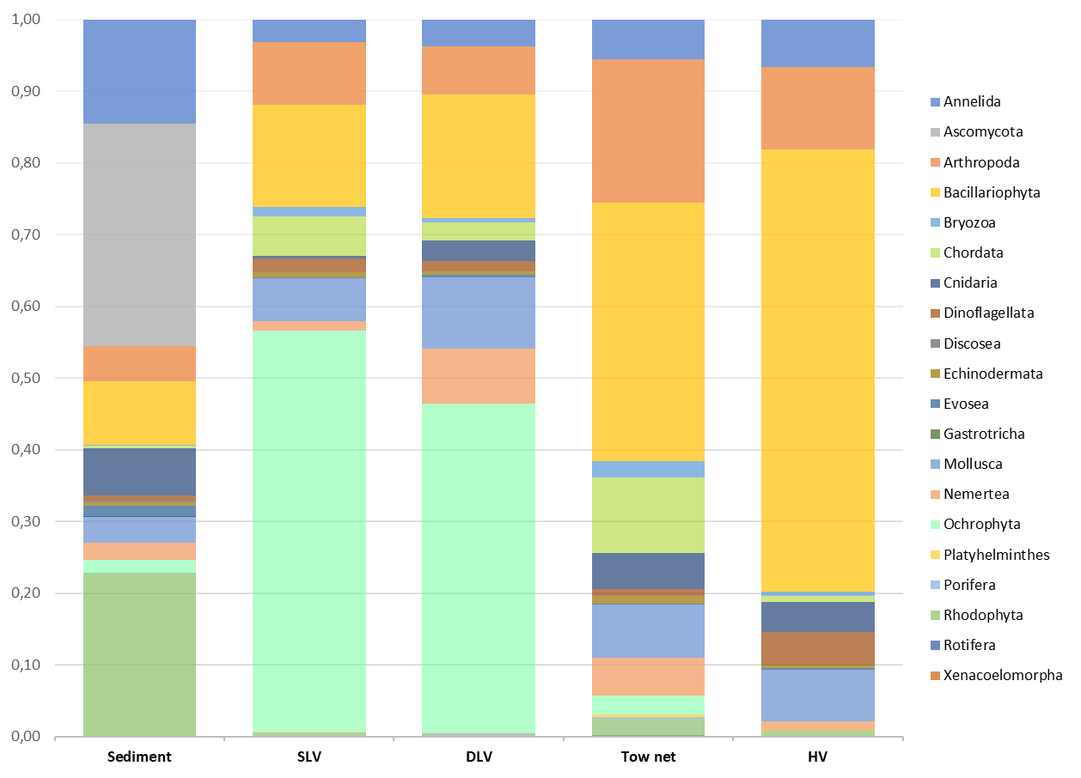
Figure 1. Proportion of reads belonging to different phyla per sampling method (SLV: Surface low-volume (3L); DLV: Deep low-volume (3L); HV: High-volume (50L)). Samples were pooled by field methodology across all sampling locations prior to analysis.

Tow net samples are richer in Annelida, Arthropoda, and Mollusca species than the rest of the sample types. Tow net samples are the most diverse with the highest number of species detected. Higher number of species was detected when using DLV samples than when using SLV, however, DLV were not able to detect Rotifera species (Figure 2). Rotifera are freshwater species so this is probably due to river Liffey influence in surface more than bottom samples in the site of detection.
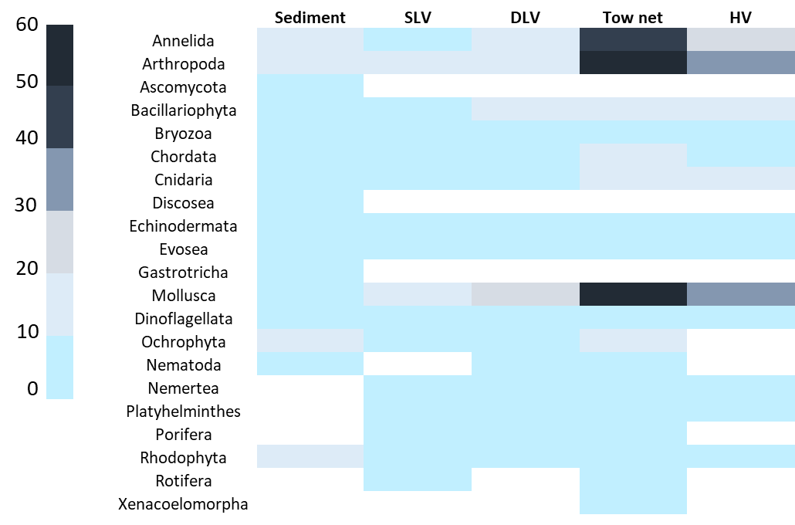
Figure 2. Heatmap representing the number of Species (0-60) belonging to each taxon (from Annelida to Xenacoelomorpha) detected per sampling type (SLV: Surface low-volume (3L); DLV: Deep low-volume (3L); HV: High-volume (50L)).

The Upset plot (Figure 3a) showed that 72 and 41 unique OTUs were detected from Tow nets and Sediment samples respectively. Five and four in the case of water filters (Surface and Deep respectively), and 15 by HV samples (Figure 3a). Sediment samples contained the highest number of uniquely detected species belonging to Rhodophyta (14) and tow net samples belonging to Arthropoda (23), Annelida (12) and Mollusca (11). Upset plot from NIS data illustrates four unique species were detected by tow nets and two by sediment samples (Figure 3b). The number of both NIS and OTUs found by the filter method was higher when collecting DLV samples than when collecting SLV seawater. HV samplers found the lowest number of NIS, followed by sediment. A total number of 16 NIS species were found using all sampling methods. Two were not detected using tow net samples (Sargassum muticum and Watersipora subatra), both uniquely detected when using sediment samples. Three NIS species were found using HV samplers (Mya arenaria, Ostrea angasi and Ruditapes philippinarum). Acartia tonsa, Caprella mutica, Myticola intestinalis and Myticola orientalis were detected only when using tow net samples. Ostrea angasi, Ficopomatus enigmaticus and Botrylloides violaceus were found only in DLV seawater, not in SLV seawater. Dasysiphonia japonica and Melanothamnus harveyi were found in SLV seawater and not in DLV seawater samples.
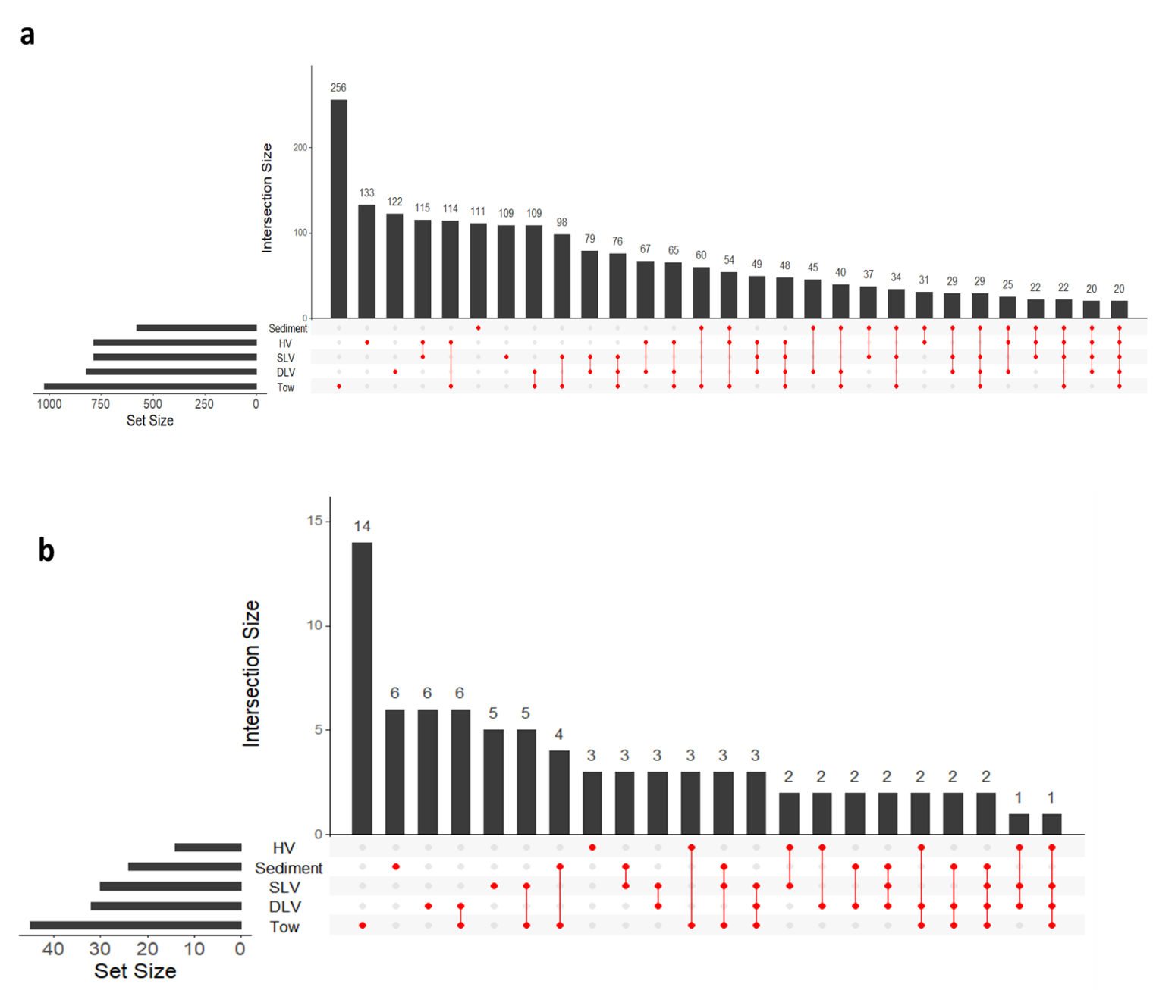
Figure 3. a. Upset plot showing the number of OTUs detected and uniquely detected by each method and how they overlap. b. Upset plot and bar graphs representing the number of NIS and OTUS and how they overlap by method.
Regarding location, the highest number of NIS was found in Carlingford, followed by Dublin. Waterford was the location with less NIS detected (Figure 4) and the only location where Acartia tonsa was detected. There are no previous records of A. tonsa in Ireland. Bonnemaisonia hamifera, Ruditapes philippinarum and Ostrea angasi were only detected in Galway, while Ficopomatus enigmaticus was only detected in Dublin. A significant difference in NIS richness was found between Carlingford and Waterford (Kruskal-Wallis chi-squared = 13.251, df = 3, p-value = 0.004125; Pairwise comparisons using Wilcoxon rank sum test P-value = 0.0032), which is in line with the large difference in detected NIS.
Each NIS OTU assignment was confirmed using a BLASTn search against the entire NCBI nucleotide collection (nt/nr) via the online NCBI portal (https://blast.ncbi.nlm.nih.gov/Blast, last accessed 07/12/2020). Reads assigned as Ostrea angasi could belong to Ostrea edulis. Reads assigned as Sargassum muticum, can also be Sargasum confusum or Sargasum nahozouense so both assignments should be considered to reach genus level.
Figure 4. Number of NIS detected per location and map showing where the locations are. Each species detection per location is shown using species names.

The level of impact of the 16 NIS detected varies, Bonnemaisonia hamifera, Botrylloides violaceus, Sargassum muticum and Undaria pinnatifida are considered to have a high impact in Irish waters, meanwhile the rest of NIS have less impact or has not been well described yet (Table 3). There are two NIS that were not previously reported in Ireland, Acartia tonsa and Dasysiphonia japonica.

Table 3. NIS found in the current study and the information regarding the Irish status, records on Global IS database, impacts and origin of the introduction.
Species name | Irish status | Origin | Known Impacts | High Impact | Global invasive species database
Acartia tonsa | Not present | Indo-Pacific. North-East Atlantic |  |  | NO
Bonnemaisonia hamifera | Established | Unclear |  | X | NO
Botrylloides violaceus | Established | North East Pacific |  |  | NO
Caprella mutica | Established | NW Pacific |  | X | NO
Dasysiphonia japonica | Not present | NW Pacific |  |  | NO
Ficopomatus enigmaticus | Established | Australia | Significant change in ecological and sedimentary dynamics. |  | YES
Melanothamnus harveyi | Established | Tropics |  |  | NO
Mya arenaria | Established | NW Atlantic | Benthic-pelagic interaction, bioaccumulation, community dominance and habitat change. |  | YES
Mytilicola intestinalis | Established | Mediterranean |  |  | NO
Mytilicola orientalis | Reported | Sea of Japan |  |  | NO
Ostrea angasi | Reported |  |  |  | NO
Perophora japonica | Reported | NW Pacific |  |  | NO
Ruditapes philippinarum | Reported | W Tropical Pacific |  |  | NO
Sargassum muticum | Established | NW Pacific |  | X | NO
Undaria pinnatifida | Established | NW Pacific | Change the structure of the ecosystem. Depends on the location. | X | YES
Watersipora subtorquata | Reported | Unclear | Facilitates the spread of other invasives by providing a non-toxic surface for other fouling species to settle. |  | YES

Discussion
In this study, we tested a range of eDNA sampling approaches to be used in future monitoring and surveillance programs for NIS in Irish coastal waters. A wide range of both indigenous and non-indigenous taxa was successfully recovered across all four sampling techniques and across different sampling environments.
The use of mock communities (mixtures of genomic DNA from known NIS) proved to be a crucial step to evaluate the success of the eDNA metabarcoding pipeline implemented in this study. The expected percentage of reads from those communities differed from the final values, but there was a positive significant correlation between them, thus we can conclude that the implemented pipeline is efficient. However, Cordylophora caspia and Arenicola marina were not detected in any of the five communities, which may have been due to primer competitivity or selectivity as uneven amplification of universal primers is typical in metabarcoding experiments (Piñol et al., 2018).
Direct quantitative assessments based on the differences in numbers of reads are not always appropriate as shown in Supplementary Table 2, and in previously published research (Fernández et al., 2018; Zaiko et al., 2018). In addition, some of the sequences from the mock community were assigned against species not added to the mock community (Supplementary table 5), therefore a number of false positive detections should be considered as part of the pipeline and must be reduced or accounted for following the guidelines suggested by Ficetola, Taberlet, and Coissac (2016). Indeed, the genus level reassignments of two of the NIS annotated by the automated pipeline (Ostrea angasi and Sargasum muticum) underline the importance of manually checking lists of species identifications where DNA reference data is incomplete. As discussed in Darling et al. (2020) without strict shared quality assurance, protocol and reporting standards DNA-based biomonitoring should not be used alone as evidence eliciting a management response.
Another key technical consideration when working with eDNA is the possibility of PCR inhibition. We found tow nets to be the most affected sample type by inhibition, although similar numbers of reads were obtained in the rest of the samples (Supplementary table 6). Tow net samples were also the most affected by contamination, with nine blanks compromised, probably due to the highest amount of DNA present in this type of sample and/or suboptimal decontamination procedures. Limited information is available about the recommended proportion of controls in an eDNA workflow (Goldberg et al., 2016) and each study should determine how many negative controls to apply depending on the research question or purpose of the study. In the present study, we implemented a large number of negative controls (n = 47) to provide further insights on the tested protocols, however in the context of detecting rare or newly introduced NIS as part of future monitoring programs, we recommend the inclusion of field negative controls especially when sampling gear is reutilized despite decontamination.
Notwithstanding above-mentioned disadvantages, tow net sampling has shown to be the most complete method to detect the largest number of species, finding the highest number of species and NIS (72 unique OTUs and four unique NIS). It did not detect two of the NIS (Sargassum muticum and Watersipora subatra), both only detected in soil samples, which could be due to the habitat of the species at the sampling timepoint, as both are normally fixed to solid substrates. Therefore, we have established in a metabarcoding context that low volume water filtering may not be the preferred eDNA sampling method as it has been previously suggested (Schabacker et al., 2020).
Some of the results showed here are not aligned with previously published data where tow nets were employed (Djurhuus et al., 2018; Sepulveda et al., 2019). The main difference is the mesh size of the tow net, while the smallest mesh size was used by Djurhuus et al. (2018) with 64 µm, here we employed 40 µm mesh. This explains the increased diversity recovered compared to other sampling techniques. Moreover, none of those studies tested for inhibition, which could affect the biodiversity recovered. Koziol et al. (2019) found that sediments recovered the largest number of OTUs, but they included an additional inhibition removal step for sediment samples that could have contributed to the increased efficiency.
As expected, for being high risk locations due to the highest concentration of NIS introduction vectors (Tidbury et al., 2016), more NIS were detected in Dublin and Carlingford (N= 10 and N= 11 respectively; Figure 6), and fewer NIS were detected in Galway (N=7) and the Waterford estuary (N=2)(Figure 6). The NIS species detected in Waterford were Acartia tonsa that was only detected in this location and Melanothammus harveyi also detected in the other three locations. The presence of Acartia tonsa Dana (1849), a planktonic crustacean (calanoid copepod), in Irish waters is not surprising, however to the best of our knowledge this species has never been officially reported in Ireland. While eDNA does not confirm the presence of a biologically active organism, in the context of a surveillance program, it can act as sentinel method to inform a more targeted follow-up survey using both molecular methods (Moseid et al., 2021) and non-molecular methods, whereby the actual NIS is captured and taxonomically identified.
These findings further highlight the utility of including eDNA approaches in monitoring and surveillance programs of NIS where early detection is important (Ammon et al., 2018; Brown et al., 2016). The combination of different sampling types results in a greater proportion of total taxa detected. However, it is more costly and can be time consuming (Evans et al., 2017; Hayes et al., 2005). To reduce costs (i.e. limit number of total samples by lowering number of sampling types) or to improve probability of detection (i.e. exchange number of sampling types for increased replicates), we recommend choosing the sampling technique based on the targeted taxa group (taking the target’s life history traits into account) before implementing surveyllance programs. Sampling type must be considered as the substrate can dramatically influence the number of species and which taxa are detected. For example, in the present study, fish species were not detected when collecting sediment and HV samples. In comparison, Fungi, Discosea and Gastrotricha species were only detected in sediment samples. If the target group is brown algae, then, water samples are the recommended approach; meanwhile, if targeting platyhelminths, either tow net or HV samples would be better choices. Furthermore, other factors such as abundance, behaviour and life cycle of target NIS can affect probability of detection, thus eDNA sampling approaches should be adapted accordingly.
Regarding the diversity found in each sampling technique, tow net and HV samples detected more arthropods, annelids, and mollusks; thus, we expect these sampling methods to be the most efficient at targeting those groups. If sediment samples are excluded, for being the most dissimilar a priori, when tow net samples are compared with water (SLV, DLV, and HV), it has been the only technique able to detect all the taxonomic groups, as Nematoda was only found by DLV samples and Rotifera by SLV samples, meanwhile, tow net samples have detected both (Figure 2).
Based on the results obtained in the current study, a combination of techniques is recommended to maximize the number of species detected. However, if only a single method can be deployed, our results showed that among those tested, tow net sampling are recommended. Mollusk species are among the most abundant NIS (Clusa et al., 2017), and in the present study tow nets detected the highest diversity of mollusks (followed by HV, DLV, SLV and finally sediment samples), as expected considering the larval state of mollusks is found in water opposed to sediments, and is therefore the most efficient method for the detection of these species.
Findings from the present study allowed the testing, validation and assessment of a range of eDNA sampling protocols and approaches that will be at disposal of future marine NIS monitoring and surveillance programs in Irish waters and adjacent areas.
Acknowledgements
The authors would like to thank staff at all locations and a wide range of stakeholders for their help with field work, the Irish Centre for High-End Computing (ICHEC) for the availability to use their resources and Sergio Fernández for software assistance. Specialized training was possible thanks to financial support by the Marine Institute’s Networking and Travel Award. LH was supported by the Natural Environmental Research Council (grant number NE/L002531/1). This research Initiative (SERV-19-MEFS-004) is part of a wider series of ongoing technical studies to support marine spatial planning and related Marine Strategy Framework Directive decision making. The Blue Growth & Marine Spatial Planning Scheme is established under Union Priority 6 (Integrated Maritime Policy) of Ireland’s European Maritime and Fisheries Fund (EMFF) Operational Program. It is co-funded by the Irish Government and the EU.
References
Afzali, S.F., Bourdages, H., Laporte, M., Mérot, C., Normandeau, E., Audet, C., Bernatchez, L., 2020. Comparing environmental metabarcoding and trawling survey of demersal fish communities in the Gulf of St. Lawrence, Canada. Environ. DNA. https://doi.org/10.1002/edn3.111
Ahyong, S., Costello, M.J., Galil, B.S., Gollasch, S., Hutchings, P., Katsanevakis, S., Lejeusne, C., Marchini, A., Occhipinti, A., Pagad, S., Poore, G.C.B., Rius, M., Robinson, T.B., Sterrer, W., Turon, X., Willan, R.C., Zhan, A., 2021. No Title [WWW Document]. World Regist. Introd. Mar. Species. https://doi.org/10.14284/347
Ammon, U. von, Wood, S.A., Laroche, O., Zaiko, A., Tait, L., Lavery, S., Inglis, G.J., Pochon, X., 2018. Combining morpho-taxonomy and metabarcoding enhances the detection of non-indigenous marine pests in biofouling communities. Sci. Rep. 8, 16290. https://doi.org/10.1038/s41598-018-34541-1
Ardura, A., Borrell, Y.J., Fernández, S., Arenales, M.G., Martínez, J.L., Garcia-Vazquez, E., 2020. Nuisance algae in ballast water facing international conventions. Insights from DNA metabarcoding in ships arriving in Bay of Biscay. Water (Switzerland) 12, 1–14. https://doi.org/10.3390/W12082168
Ardura, A., Juanes, F., Planes, S., Garcia-Vazquez, E., 2016. Rate of biological invasions is lower in coastal marine protected areas. Sci. Rep. 6, 33013. https://doi.org/10.1038/srep33013
Aylagas, E., Borja, Á., Irigoien, X., Rodríguez-Ezpeleta, N., 2016. Benchmarking DNA metabarcoding for biodiversity-based monitoring and assessment. Front. Mar. Sci. 3, 96. https://doi.org/10.3389/fmars.2016.00096
Baker, C., 2017. Workflow for generating a qiime-compatible blast database from an entrez search.
Bohmann, K., Evans, A., Gilbert, M.T.P., Carvalho, G.R., Creer, S., Knapp, M., Yu, D.W., de Bruyn, M., 2014. Environmental DNA for wildlife biology and biodiversity monitoring. Trends Ecol. Evol. https://doi.org/10.1016/j.tree.2014.04.003
Bolyen, E., Rideout, J.R., Dillon, M.R., Bokulich, N.A., Abnet, C.C., Al-Ghalith, G.A., Alexander, H., Alm, E.J., Arumugam, M., Asnicar, F., Bai, Y., Bisanz, J.E., Bittinger, K., Brejnrod, A., Brislawn, C.J., Brown, C.T., Callahan, B.J., Caraballo-Rodríguez, A.M., Chase, J., Cope, E.K., Da Silva, R., Diener, C., Dorrestein, P.C., Douglas, G.M., Durall, D.M., Duvallet, C., Edwardson, C.F., Ernst, M., Estaki, M., Fouquier, J., Gauglitz, J.M., Gibbons, S.M., Gibson, D.L., Gonzalez, A., Gorlick, K., Guo, J., Hillmann, B., Holmes, S., Holste, H., Huttenhower, C., Huttley, G.A., Janssen, S., Jarmusch, A.K., Jiang, L., Kaehler, B.D., Kang, K. Bin, Keefe, C.R., Keim, P., Kelley, S.T., Knights, D., Koester, I., Kosciolek, T., Kreps, J., Langille, M.G.I., Lee, J., Ley, R., Liu, Y.X., Loftfield, E., Lozupone, C., Maher, M., Marotz, C., Martin, B.D., McDonald, D., McIver, L.J., Melnik, A. V., Metcalf, J.L., Morgan, S.C., Morton, J.T., Naimey, A.T., Navas-Molina, J.A., Nothias, L.F., Orchanian, S.B., Pearson, T., Peoples, S.L., Petras, D., Preuss, M.L., Pruesse, E., Rasmussen, L.B., Rivers, A., Robeson, M.S., Rosenthal, P., Segata, N., Shaffer, M., Shiffer, A., Sinha, R., Song, S.J., Spear, J.R., Swafford, A.D., Thompson, L.R., Torres, P.J., Trinh, P., Tripathi, A., Turnbaugh, P.J., Ul-Hasan, S., van der Hooft, J.J.J., Vargas, F., Vázquez-Baeza, Y., Vogtmann, E., von Hippel, M., Walters, W., Wan, Y., Wang, M., Warren, J., Weber, K.C., Williamson, C.H.D., Willis, A.D., Xu, Z.Z., Zaneveld, J.R., Zhang, Y., Zhu, Q., Knight, R., Caporaso, J.G., 2019. Reproducible, interactive, scalable and extensible microbiome data science using QIIME 2. Nat. Biotechnol. https://doi.org/10.1038/s41587-019-0209-9
Brown, E.A., Chain, F.J.J., Zhan, A., MacIsaac, H.J., Cristescu, M.E., 2016. Early detection of aquatic invaders using metabarcoding reveals a high number of non-indigenous species in Canadian ports. Divers. Distrib. 22, 1045–1059. https://doi.org/10.1111/ddi.12465
Closek, C.J., Santora, J.A., Starks, H.A., Schroeder, I.D., Andruszkiewicz, E.A., Sakuma, K.M., Bograd, S.J., Hazen, E.L., Field, J.C., Boehm, A.B., 2019. Marine Vertebrate Biodiversity and Distribution Within the Central California Current Using Environmental DNA (eDNA) Metabarcoding and Ecosystem Surveys. Front. Mar. Sci. 6, 732. https://doi.org/10.3389/fmars.2019.00732
Clusa, L., Miralles, L., Basanta, A., Escot, C., García-Vázquez, E., 2017. eDNA for detection of five highly invasive molluscs. A case study in urban rivers from the Iberian Peninsula. PLoS One 12, e0188126. https://doi.org/10.1371/journal.pone.0188126
Comtet, T., Sandionigi, A., Viard, F., Casiraghi, M., 2015. DNA (meta)barcoding of biological invasions: a powerful tool to elucidate invasion processes and help managing aliens. Biol. Invasions 17, 905–922. https://doi.org/10.1007/s10530-015-0854-y
Conway, J.R., Lex, A., Gehlenborg, N., 2017. UpSetR: An R package for the visualization of intersecting sets and their properties. Bioinformatics 33, 2938–2940. https://doi.org/10.1093/bioinformatics/btx364
Creer, S., Deiner, K., Frey, S., Porazinska, D., Taberlet, P., Thomas, W.K., Potter, C., Bik, H.M., 2016. The ecologist’s field guide to sequence-based identification of biodiversity. Methods Ecol. Evol. https://doi.org/10.1111/2041-210X.12574
Cristescu, M.E., Hebert, P.D.N., 2018. Uses and misuses of environmental DNA in biodiversity science and conservation. Annu. Rev. Ecol. Evol. Syst. https://doi.org/10.1146/annurev-ecolsys-110617-062306
Darling, J.A., Mahon, A.R., 2011. From molecules to management: Adopting DNA-based methods for monitoring biological invasions in aquatic environments. Environ. Res. 111, 978–988. https://doi.org/10.1016/j.envres.2011.02.001
Darling, J.A., Pochon, X., Abbott, C.L., Inglis, G.J., Zaiko, A., 2020. The risks of using molecular biodiversity data for incidental detection of species of concern. Divers. Distrib. 26, 1116–1121. https://doi.org/10.1111/ddi.13108
Deiner, K., Bik, H.M., Mächler, E., Seymour, M., Lacoursière-Roussel, A., Altermatt, F., Creer, S., Bista, I., Lodge, D.M., de Vere, N., Pfrender, M.E., Bernatchez, L., 2017. Environmental DNA metabarcoding: Transforming how we survey animal and plant communities. Mol. Ecol. https://doi.org/10.1111/mec.14350
Djurhuus, A., Pitz, K., Sawaya, N.A., Rojas-Márquez, J., Michaud, B., Montes, E., Muller-Karger, F., Breitbart, M., 2018. Evaluation of marine zooplankton community structure through environmental DNA metabarcoding. Limnol. Oceanogr. Methods 16, 209–221. https://doi.org/10.1002/lom3.10237
Duarte, S., Vieira, P.E., Costa, F.O., 2020a. Assessment of species gaps in DNA barcode libraries of nonindigenous species (NIS) occurring in European coastal regions. Metabarcoding and Metagenomics 4, 35–46. https://doi.org/10.3897/mbmg.4.55162
Duarte, S., Vieira, P.E., Lavrador, A.S., Costa, F.O., 2020b. Status and prospects of marine NIS detection and monitoring through (e)DNA metabarcoding. Sci. Total Environ. https://doi.org/10.1016/j.scitotenv.2020.141729
Edgar, R.C., 2010. Search and clustering orders of magnitude faster than BLAST. Bioinformatics 26, 2460–2461. https://doi.org/10.1093/bioinformatics/btq461
European Union., 2014. EUR-Lex - 32014R1143 - EN - EUR-Lex, Journal officiel de l’Union européenne.
European Union, 2007. EUR-Lex - 32007R0708 - EN - EUR-Lex [WWW Document]. J. Off. l’Union Eur. URL https://eur-lex.europa.eu/legal-content/EN/TXT/?uri=celex%3A32007R0708 (accessed 11.18.20).
Evans, N.T., Shirey, P.D., Wieringa, J.G., Mahon, A.R., Lamberti, G. a., 2017. Comparative Cost and Effort of Fish Distribution Detection via Environmental DNA Analysis and Electrofishing. Fisheries 42, 90–99. https://doi.org/10.1080/03632415.2017.1276329
Fernández, S., Rodríguez‐Martínez, S., Martínez, J.L., Garcia‐Vazquez, E., Ardura, A., 2019. How can eDNA contribute in riverine macroinvertebrate assessment? A metabarcoding approach in the Nalón River (Asturias, Northern Spain). Environ. DNA 1, 385–401. https://doi.org/10.1002/edn3.40
Fernández, S., Rodríguez, S., Martínez, J.L., Borrell, Y.J., Ardura, A., García-Vázquez, E., 2018. Evaluating freshwater macroinvertebrates from eDNA metabarcoding: A river Nalón case study. PLoS One 13. https://doi.org/10.1371/journal.pone.0201741
Ficetola, G.F., Taberlet, P., Coissac, E., 2016. How to limit false positives in environmental DNA and metabarcoding? Mol. Ecol. Resour. https://doi.org/10.1111/1755-0998.12508
Goldberg, C.S., Turner, C.R., Deiner, K., Klymus, K.E., Thomsen, P.F., Murphy, M.A., Spear, S.F., McKee, A., Oyler-McCance, S.J., Cornman, R.S., Laramie, M.B., Mahon, A.R., Lance, R.F., Pilliod, D.S., Strickler, K.M., Waits, L.P., Fremier, A.K., Takahara, T., Herder, J.E., Taberlet, P., 2016. Critical considerations for the application of environmental DNA methods to detect aquatic species. Methods Ecol. Evol. https://doi.org/10.1111/2041-210X.12595
Hayes, K.R., Cannon, R., Neil, K., Inglis, G., 2005. Sensitivity and cost considerations for the detection and eradication of marine pests in ports. Mar. Pollut. Bull. 50, 823–834. https://doi.org/10.1016/j.marpolbul.2005.02.032
Holman, L.E., de Bruyn, M., Creer, S., Carvalho, G., Robidart, J., Rius, M., 2019. Detection of introduced and resident marine species using environmental DNA metabarcoding of sediment and water. Sci. Rep. 9, 11559. https://doi.org/10.1038/s41598-019-47899-7
Jeunen, G., Knapp, M., Spencer, H.G., Lamare, M.D., Taylor, H.R., Stat, M., Bunce, M., Gemmell, N.J., 2019. Environmental DNA (eDNA) metabarcoding reveals strong discrimination among diverse marine habitats connected by water movement. Mol. Ecol. Resour. 19, 426–438. https://doi.org/10.1111/1755-0998.12982
Klymus, K.E., Marshall, N.T., Stepien, C.A., 2017. Environmental DNA (eDNA) metabarcoding assays to detect invasive invertebrate species in the Great Lakes. PLoS One 12, e0177643. https://doi.org/10.1371/journal.pone.0177643
Koziol, A., Stat, M., Simpson, T., Jarman, S., DiBattista, J.D., Harvey, E.S., Marnane, M., McDonald, J., Bunce, M., 2019. Environmental DNA metabarcoding studies are critically affected by substrate selection. Mol. Ecol. Resour. 19, 366–376. https://doi.org/10.1111/1755-0998.12971
Lacoursière-Roussel, A., Howland, K., Normandeau, E., Grey, E.K., Archambault, P., Deiner, K., Lodge, D.M., Hernandez, C., Leduc, N., Bernatchez, L., Molnar, J.L., Gamboa, R.L., Revenga, C., Spalding, M.D., 2018. eDNA metabarcoding as a new surveillance approach for coastal Arctic biodiversity. Ecol. Evol.
Lehtiniemi, M., Ojaveer, H., David, M., Galil, B., Gollasch, S., McKenzie, C., Minchin, D., Occhipinti-Ambrogi, A., Olenin, S., Pederson, J., 2015. Dose of truth-Monitoring marine non-indigenous species to serve legislative requirements. Mar. Policy 54, 26–35. https://doi.org/10.1016/j.marpol.2014.12.015
Leray, M., Yang, J.Y., Meyer, C.P., Mills, S.C., Agudelo, N., Ranwez, V., Boehm, J.T., Machida, R.J., 2013. A new versatile primer set targeting a short fragment of the mitochondrial COI region for metabarcoding metazoan diversity: application for characterizing coral reef fish gut contents. Front. Zool. 10, 34. https://doi.org/10.1186/1742-9994-10-34
Lodge, D.M., Williams, S., MacIsaac, H.J., Hayes, K.R., Leung, B., Reichard, S., Mack, R.N., Moyle, P.B., Smith, M., Andow, D.A., Carlton, J.T., McMichael, A., 2006. Biological invasions: Recommendations for U.S. policy and management. Ecol. Appl. 16, 2035–2054. https://doi.org/10.1890/1051-0761(2006)016[2035:BIRFUP]2.0.CO;2
Lovell, S.J., Stone, S.F., Fernandez, L., 2006. The economic impacts of aquatic invasive species: A review of the literature, in: Agricultural and Resource Economics Review. Northeastern Agricultural and Resource Economics Association, pp. 195–208. https://doi.org/10.1017/S1068280500010157
Martin, M., 2011. Cutadapt removes adapter sequences from high-throughput sequencing reads, EMBnet.journal. Dortmund.
Mazor, T., Doropoulos, C., Schwarzmueller, F., Gladish, D.W., Kumaran, N., Merkel, K., Gagic, M., Di Marco, V., 2018. Global mismatch of policy and research on drivers of biodiversity loss. Nat. Ecol. Evol. 2, 1071–1074.
Minchin, D., 2007. Rapid coastal survey for targeted alien species associated with floating pontoons in Ireland. Aquat. Invasions 2, 63–70. https://doi.org/10.3391/ai.2007.2.1.8
Molnar, J.L., Gamboa, R.L., Revenga, C., Spalding, M.D., 2008. Assessing the global threat of invasive species to marine biodiversity. Front. Ecol. Environ. https://doi.org/10.1890/070064
Moseid, C.V.S., Falkenhaug, T., Slettan, A., 2021. Development of a TaqMan PCR assay for the identification of the non-native copepod Acartia tonsa , and detection of this species in Norwegian coastal waters. J. Plankton Res. 43, 497–499. https://doi.org/10.1093/plankt/fbab029
Mynott, S., Marsh, M., 2020. Development of a Novel (DNA-based) Method for Monitoring Inshore Fish Communities Using a Programmable Large-Volume Marine eDNA Sampler NECR180. Natural England Commissioned Reports, Number NECR330 Natural.
Olds, B.P., Jerde, C.L., Renshaw, M.A., Li, Y., Evans, N.T., Turner, C.R., Deiner, K., Mahon, A.R., Brueseke, M.A., Shirey, P.D., Pfrender, M.E., Lodge, D.M., Lamberti, G.A., 2016. Estimating species richness using environmental <scp>DNA</scp>. Ecol. Evol. 6, 4214–4226. https://doi.org/10.1002/ece3.2186
Piñol, J., Senar, M.A., Symondson, W.O.C., 2018. The choice of universal primers and the characteristics of the species mixture determine when DNA metabarcoding can be quantitative. Mol. Ecol. https://doi.org/10.1111/mec.14776
Pochon, X., Bott, N.J., Smith, K.F., Wood, S.A., 2013. Evaluating Detection Limits of Next-Generation Sequencing for the Surveillance and Monitoring of International Marine Pests. PLoS One 8, e73935. https://doi.org/10.1371/journal.pone.0073935
R Core Team, 2020. R: A language and environment for statistical computing.
Rey, A., Basurko, O.C., Rodriguez-Ezpeleta, N., 2020. Considerations for metabarcoding-based port biological baseline surveys aimed at marine nonindigenous species monitoring and risk assessments. Ecol. Evol. 10, 2452–2465. https://doi.org/10.1002/ece3.6071
Rey, A., Basurko, O.C., Rodriguez-Ezpeleta, N., 2019. Guidelines and considerations for metabarcoding-based port baseline biodiversity surveys: towards improved marine non-indigenous species monitoring. bioRxiv 689307. https://doi.org/10.1101/689307
Schabacker, J.C., Amish, S.J., Ellis, B.K., Gardner, B., Miller, D.L., Rutledge, E.A., Sepulveda, A.J., Luikart, G., 2020. Increased eDNA detection sensitivity using a novel high‐volume water sampling method. Environ. DNA 2, 244–251. https://doi.org/10.1002/edn3.63
Sepulveda, A.J., Amberg, J.J., Hanson, E., 2019. Using environmental DNA to extend the window of early detection for dreissenid mussels. Manag. Biol. Invasions 10, 342–358. https://doi.org/10.3391/mbi.2019.10.2.09
Taberlet, P., Coissac, E., Hajibabaei, M., Rieseberg, L.H., 2012. Environmental DNA. Mol. Ecol. 21, 1789–1793. https://doi.org/10.1111/j.1365-294X.2012.05542.x
Thomsen, P.F., Møller, P.R., Sigsgaard, E.E., Knudsen, S.W., Jørgensen, O.A., Willerslev, E., 2016. Environmental DNA from Seawater Samples Correlate with Trawl Catches of Subarctic, Deepwater Fishes. PLoS One 11, e0165252. https://doi.org/10.1371/journal.pone.0165252
Tidbury, H.J., Taylor, N.G.H., Copp, G.H., Garnacho, E., Stebbing, P.D., 2016. Predicting and mapping the risk of introduction of marine non-indigenous species into Great Britain and Ireland. Biol. Invasions 18, 3277–3292. https://doi.org/10.1007/s10530-016-1219-x
Turner, C.R., Uy, K.L., Everhart, R.C., 2015. Fish environmental DNA is more concentrated in aquatic sediments than surface water. Biol. Conserv. 183, 93–102. https://doi.org/10.1016/j.biocon.2014.11.017
Union, E., 2014. EUR-Lex - 32014L0089 - EN - EUR-Lex [WWW Document]. J. Off. l’Union Eur. URL https://eur-lex.europa.eu/legal-content/EN/TXT/?uri=celex%3A32014L0089 (accessed 11.27.20).
Vierna, J., Doña, J., Vizcaíno, A., Serrano, D., Jovani, R., 2017. PCR cycles above routine numbers do not compromise high-throughput DNA barcoding results. Genome 60, 868–873. https://doi.org/10.1139/gen-2017-0081
Wangensteen, O.S., Palacín, C., Guardiola, M., Turon, X., 2018. DNA metabarcoding of littoral hardbottom communities: High diversity and database gaps revealed by two molecular markers. PeerJ 2018, e4705. https://doi.org/10.7717/peerj.4705
Yang, J., Zhang, X., 2020. eDNA metabarcoding in zooplankton improves the ecological status assessment of aquatic ecosystems. Environ. Int. 134, 105230. https://doi.org/10.1016/j.envint.2019.105230
Zaiko, A., Pochon, X., Garcia-Vazquez, E., Olenin, S., Wood, S.A., 2018. Advantages and Limitations of Environmental DNA/RNA Tools for Marine Biosecurity: Management and Surveillance of Non-indigenous Species. Front. Mar. Sci. 5, 322. https://doi.org/10.3389/fmars.2018.00322
Zinger, L., Bonin, A., Alsos, I.G., Bálint, M., Bik, H., Boyer, F., Chariton, A.A., Creer, S., Coissac, E., Deagle, B.E., De Barba, M., Dickie, I.A., Dumbrell, A.J., Ficetola, G.F., Fierer, N., Fumagalli, L., Gilbert, M.T.P., Jarman, S., Jumpponen, A., Kauserud, H., Orlando, L., Pansu, J., Pawlowski, J., Tedersoo, L., Thomsen, P.F., Willerslev, E., Taberlet, P., 2019. DNA metabarcoding—Need for robust experimental designs to draw sound ecological conclusions. Mol. Ecol. 28, 1857–1862. https://doi.org/10.1111/mec.15060
Zou, K., Chen, J., Ruan, H., Li, Z., Guo, W., Li, M., Liu, L., 2020. eDNA metabarcoding as a promising conservation tool for monitoring fish diversity in a coastal wetland of the Pearl River Estuary compared to bottom trawling. Sci. Total Environ. 702, 134704. https://doi.org/10.1016/j.scitotenv.2019.134704

