The advice given by physiotherapists to people with back pain in primary care.

Lisa Osborn-Jenkins ^{a, b} *, Lisa Roberts ^{a, b}

ª University Hospital Southampton NHS Foundation Trust, Tremona Road, Southampton, UK.
^{b} School of Health Sciences, University of Southampton, Highfield, Southampton, UK.
*Corresponding author.

Present address:
Lisa Osborn-Jenkins
Physiotherapy Department
University Hospital Southampton NHS Foundation Trust,
Tremona Road,
Southampton,
SO16 6YD
UK.

Telephone number: (+44) 23 81 206459

Email: Lisa.Jenkins@uhs.nhs.uk

Conflicts of interest
None declared.

Ethical approval
Ethical approval for this study was granted by the Southampton and South 125 West Hampshire Local Research Ethics Committee (08/H0502/15).

Funding
No specific funding was sought for this cross-sectional observation study however the senior researcher Professor Lisa Roberts is funded by a National Institute for Health Research (NIHR) Senior Clinical Lectureship (round 3); and Arthritis Research UK funded the original data collection [grant number 17830].
The research time and preparation of the manuscript was funded by the NIHR as part of a funded Pre-Doctoral Clinical Academic Fellowship (PCAF) awarded to Lisa Osborn-Jenkins and undertaken at the University of Southampton. The NIHR had no involvement in the preparation of the article for publication or the study design, data collection, analysis or write up of the study report.

Acknowledgements
The authors gratefully acknowledge the support of study participants and the host NHS Trust.

The advice given by physiotherapists to people with back pain in primary care.

Highlights

- This research categorises the content of advice offered to people with back pain
- Advice and reassurance are integral to empower people to self-manage their pain
- Clinicians must avoid contradictory and unhelpful messages when giving advice
- Research is needed to identify how clinicians develop skilled advice-giving

Keywords: Advice; Low back pain; Physical therapy, Self-management, Reassurance

Abstract
Background:
Back pain guidelines endorse giving advice to enable people to self-manage and continue normal activities. Little is known however, about the content of advice that clinicians give and this project aimed to identify the advice given by clinicians to patients with back pain at their initial consultation.

Methods:
A secondary analysis was conducted with 25 audio-recordings and transcriptions of consultations between patients with back pain and physiotherapists in a primary care outpatients department. Using a Framework approach, the data were coded and analysed to identify the content of advice given and mode of delivery.

Results:
The mean duration of consultation was 38 minutes 59 seconds (range 26:21-53:16). Advice was given in 88% (n=22/25) of consultations and 96% included additional exercise instruction. Cognitive reassurance was evident, focussing on getting people confident to ‘move your back’ despite pain and encouraging active lifestyle changes. Beyond reassurance and discussion to enhance confidence, the key topics of advice given were: activity promotion; postural changes; practical self-help advice regarding ways to sit; pain-management advice including medication and using heat. Gaps were identified in the advice given, most notably there was a lack of specificity relating to the frequency and duration of recommended tasks and activities.

Conclusions:
Advice and reassurance are integral to enabling people to self-manage their back pain. It is important to avoid contradictory and unhelpful messages. Despite its importance, little is known about the advice offered by clinicians during initial back pain consultations highlighting the need for guidance to be patient-centred and tailored.

- Introduction
With a lifetime prevalence of up to 82.5%, back pain is a common concern (Hoy et al., 2010). Low back pain (LBP) is a leading cause of disability worldwide (GBD15, 2016) and in the Global Burden of Disease 2015 study, it was ranked highest in terms of disability with the greatest years lived with disability of all conditions. As levels of disability rise, especially among working age groups, Hartvigsen et al. (2018) highlight the need to reverse these trends, calling for action to address the growing burden of back pain and reinforcing the key message, that non-pharmacology treatments such as advice and activity are first line treatments (Lin et al., 2020).

Advice to stay active, and education about LBP have been strongly recommended in back pain literature (Traeger et al., 2019a), along with a recognition that health professionals need to help people with back pain live healthy lifestyles and promote wellbeing while addressing comorbidities (Buchbinder et al., 2018). Consequently, best practice guidelines for managing back pain universally endorse advice-giving to enable people to self-manage and continue with their normal activity (O’Connell et al., 2016, Oliveira et al., 2018). Likewise in the UK, the National Institute for Heath and Care Excellence (NICE) guidelines (2016) recognised that information and advice should be patient-specific to enable people to engage according to their needs and capabilities. The shift in this thinking about managing back pain in primary care focuses on screening and a stratified management approach, guiding patients with low to high risk of persistent pain, to non-pharmacological treatments such as advice and exercise (Foster et al., 2018 and Traeger et al., 2017). This recommendation is made, without knowing the mechanisms of these treatment modalities and a recognition that effect sizes of such treatment may be modest (O’Sullivan et al, 2019 and O’Keeffe, 2019).

Advice is a frequently-used treatment intervention in clinical practice and a survey of 271 physiotherapists in Western Sweden reported that advice-giving on posture (94%) and to keep active (92%) were the most-commonly used interventions in consultations involving people with subacute, non-specific LBP (Bernhardsson et al., 2015). Current evidence recognises that back pain is not caused by posture or bending (Wai et al., 2010, O’Sullivan et al., 2016, Slater et al., 2019), yet, there appears to be a common concern by people with back pain that their back is vulnerable (Darlow et al., 2015). Even among people who are pain-free, there is a common belief that lifting with a rounded back is associated with ‘danger’ (Caneiro et al., 2018). Physiotherapists commonly provide patient education (which generally entails offering condition-specific information and making specific contingency plans), rather than providing support for self-management (Hutting et al., 2020). Self-management is considered a dynamic and continuous process and is defined as the ‘individual’s ability to manage the symptoms, treatment, physical and psychosocial consequences, and lifestyle changes inherent in living with a chronic condition’ (Barlow et al., 2002). This concurs with a national survey by Liddle et al. (2009) of 419 physiotherapists in Ireland that reported high-preference for advice-giving to promote activity. The authors identified a need for greater emphasis on incorporating reassurance to ‘keep active’ in this process.

Reassurance and possible predictors of short-term outcome
Cognitive | Affective
Increased knowledge  Enhanced control  Enhanced self-efficacy  Changes in belief | Satisfaction  Perceived support  Trust in practitioner  Reduced anxiety
A systematic review by Pincus et al. (2013), identified that different components of reassurance may have different effects upon outcome for people in pain, suggesting that cognitive (informational) reassurance is important to reduce patients’ concerns and empower people and improve clinical outcomes. Meanwhile, affective (emotional) reassurance may be linked to improving patient experience rather than their actions (see Table 1). Furthermore, Holt et al. (2015) explored reassurance during low back pain consultations with GPs (n= 23) and recognised that both emotional (affective) and informational (cognitive) reassurance were valued by patients, who needed to feel listened to and receive clear explanations, to feel less concerned and more empowered.

Table 1: Types of reassurance and possible short-term outcomes based on work by Pincus et al. (2013)

Despite its importance, little is known about ways clinicians promote physical activity and it is recognised that current physiotherapy practice needs to align more closely with health policy literature (Lowe et al., 2018). This issue is not unique to physiotherapy, as the wider literature highlights many barriers and inconsistencies about how to counsel physical activity levels (Lobelo et al., 2014). Furthermore, differences exist in physiotherapists’ perceptions of their role in wider health promotion with barriers affecting confidence, especially in non-exercise based health conversations (Shore and Hebron, 2020).

A systematic review comparing evidence-based advice for people with acute non-specific LBP (21 clinical trials) and (international/national) guideline recommendations, reported there were many components of advice interventions, including ‘content’, ‘delivery’ and ‘regimen’ (Stevens et al., 2017). The specific content of advice was categorised into education about LBP and its prognosis; advice to stay active; self-management strategies including posture, pain management; and advice on the medical management of LBP (such as diagnostic tests). The method of advice delivery most-commonly reported was face-to-face (72%), but other media such as booklets, video and group settings have been explored. No single delivery method is recommended by back pain guidelines.

In summary, despite best practice guidelines endorsing advice in the primary management of LBP to enable people to self-manage, the incomplete guidance lacks standardisation and specificity of advice interventions (Stevens et al., 2017). Furthermore, there appears to be a consensus among physiotherapists to give advice about posture and maintaining activity despite back pain, in conjunction with exercise prescription (Bernhardsson et al., 2015). Likewise, patients with back pain consulting a physiotherapist expect to be informed about their condition, be reassured, while understanding possible causes and management strategies (Kamper et al., 2018 and Lim et al., 2019), which includes aspects of patient education and self-management.

As little is known about the content of advice for back pain, nor how it is delivered in clinical practice, the purpose of this research was to classify the content of advice offered to patients with back pain by physiotherapists during observed, initial consultations. To optimise advice interventions and promote self-management, it is necessary to understand both the content of advice given and how it is delivered in clinical practice.
- Methods

2.1 Design and setting
This paper reports a secondary analysis of qualitative data from a research programme exploring the communication that takes place during initial consultations between musculoskeletal physiotherapists and patients with low back pain. The original qualitative study, with a cross-sectional, observational design, was underpinned by an ontology of subtle realism. This post-positivistic / realistic approach recognises subjective perceptions and observations, and perceives the world in ways that are in some sense consistent with its immanent organisation (Murphy et al., 1998). This offers a valuable epistemology for healthcare research when studying relationships and experiences (Duncan and Nicol, 2004).

Using secondary analysis of existing qualitative data offers narratives that discuss issues related to, but different from, the primary questions in the original research. There is a well-established tradition of using quantitative datasets within social and health research, but this has not been the case until recently with qualitative datasets (Long-Sutehall et al., 2011). Secondary analyses have been criticised on epistemological grounds suggesting personal involvement is necessary in data production, however as Long-Sutehall et al. (2011) report, this can be mitigated with access to recordings of the original data, along with field notes and access to the primary researcher. For this research, express consent was gained from participants for secondary analysis, conditional upon the primary researcher being involved (to aid interpretation and reflexivity), and all the original research data (including audio-recordings) were accessed.

The setting was a primary care setting (an outpatient department in the South of England) (ref X). As per usual care, patients were referred to the service by their General Practitioner (GP), and appointments in this service were allocated 45 minutes for an initial consultation.

2.2 Participants
Patients: The patient sample (n=42) included adults aged ≥18 years, referred by their GP with low back pain (of unspecified duration), defined as pain in an area bounded by the 12th thoracic vertebra and ribs superiorly, gluteal folds inferiorly and contours of the trunk laterally. The inclusion criteria were: patients with a history of recurrent back pain; receiving no physiotherapy treatment within the preceding three months (to ensure the findings related to this episode of care). The exclusion criteria were: signs and symptoms suggesting possible serious spinal pathology (red flags); spinal surgery for current episode; another musculoskeletal disorder more troublesome than the back pain; consultations (for this episode) with other health care professionals (excluding the GP); a known severe psychiatric or psychological disorder; and people who were unable to communicate in English without assistance.

The inclusion criteria for clinicians were all physiotherapists working in the study setting (n=15), registered with the Health and Care Professions Council and currently managing patients with back pain.

2.3 Data collection
A small, digital Edirol audio-recorder (model R-09HR, Roland Corporation, Japan) was placed in the treatment cubicle. The senior researcher (LR) discreetly sat out of the direct field of vision of either participant and took no active part in the consultation, recording field notes to contextualise the events that took place. These notes were used alongside the audio-recordings, which were transcribed verbatim.

2.4 Data analysis
A content analysis was undertaken to identify the key content of advice given in the consultations and the mode of delivery. Where appropriate descriptive statistics are used to identify the prevalence of advice content and delivery and the qualitative data were managed using a Framework approach (Ritchie et al., 2003, Gale et al., 2013), on a Microsoft Excel 2016 spreadsheet. The categories were identified by the first author (LOJ) and verified by the senior researcher (LR) and any variations were discussed and resolved.

- Results

One hundred and fourteen patients were sent information packs and 27 were recruited to the study (response rate 24%). During recruitment, data were gleaned for two patients that rendered them ineligible and they were subsequently excluded. Therefore the sample comprised 25 participants (female n=12, male n=13) aged 20-81years (mean 47.8 years); with a 7 week to 9 years’ duration of back pain (mean 62.6 weeks, median 28 weeks).

Fourteen clinicians were recruited and nine (6 female, 3 male) successfully recruited patients within the study time frame. They included physiotherapists of varying experience (NHS job banding): 3 clinicians were in band 5 roles ‘early career’; 4 were band 6 ‘specialist’; and 2 were band 7 ‘advanced practitioners’. Clinicians’ post-graduate experience ranged from 6 months to 15 years (median 4 years).

The mean duration of the initial consultation was 38 minutes 59 seconds (range 26:21-53:16) and the total data set comprised 975 minutes.

3.0 Delivery of advice
Advice was given in 88% (n=22/25) of the initial consultations and 96% (n=24/25) included additional verbal exercise instruction. Written information / exercises were given to 36% (n=9/25). From this analysis, physiotherapists offered verbal advice throughout consultations, often in response to patients’ questions or statements and was frequently repeated and summarised towards the end of consultations.
The key topics of advice given are summarised in Table 2.

Table 2: Summary of categories relating to advice-giving
Specific content | Activity  - Activity promotion (n=18)  - Postural adaptations (n=10) including self-help advice regarding ways to sit
Pain management
- Medication (n=5)
- Non-pharmacological - Use of heat (n=7)
Well-being
- Promoting health and well-being (n=2)
Purpose | To reassure
 | To encourage
 | To explain
 | To prepare
Unhelpful | Contradictory advice
 | Fear-evoking

3.1 Specific content of advice
Activity – Moving and static activity advice
Activity promotion was a foremost aspect of advice given by physiotherapists in 80% (n=20/25) of initial consultations. This topic was frequently initiated by patients seeking approval for specific activities and therapists giving encouragement to continue positive involvement. There were nine examples of activity that were raised by patients (n=7) and endorsed by the therapist (n=4) (see Figure 1).

A female aged 58 years "I’ve been working very hard at trying to get fit after being ill, so I’ve joined a gym and… been doing some... cardio exercises as well" (P5).
The band 6 Physiotherapist responded "Brilliant, great! Yeah. Sounds like you’re doing all the right things, really. "

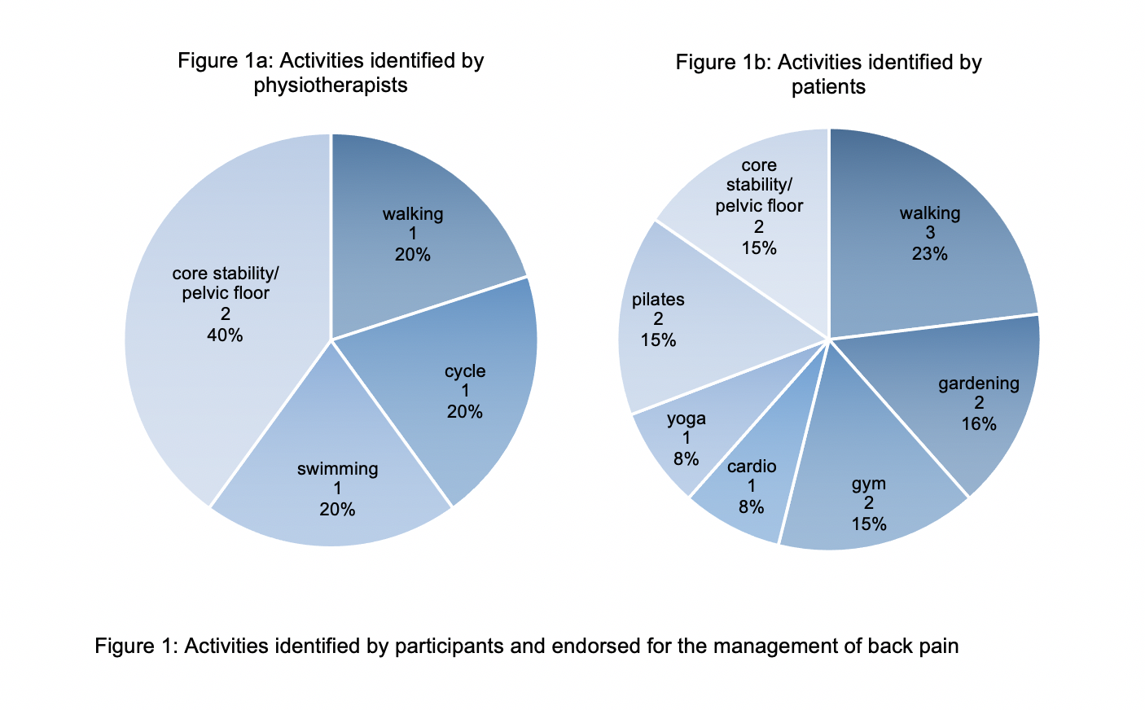

There were examples of advice involving education to avoid static positions, such as sitting “too long” and suggestions of ergonomic postures. Time was poorly defined in some scenarios and instead, physiotherapists related advice to functional tasks e.g. “driving for long periods” to a male age 36 years (P18) or giving vague ‘not to’ instructions e.g. “Just get up regularly when sitting in a chair, don’t just sit there for hours” to a female age 67 years (P27). Advice about maximum sitting times varied from 30 minutes to 60 minutes. Activity was recommended following prolonged static positions but specific guidance of how much activity was needed were less-frequently defined (n=3) and ranged from 20 seconds of activity to 5 minutes, with one example of a functional break to “get up and make a cup of tea” (P27).
There were examples of non-specific advice-giving surrounding activity:
Band 5 Physiotherapist "Small movements, it gets it moving. That’s all we want. And just stopping you getting in that prolonged posture where you’re quite stiff anyway …and just using it to change that position every so often" (to P13, female 65 years).

This contrasted with more clearly-defined prescriptive advice about activity promotion:
Band 6 Physiotherapist “If you can take regular breaks … Getting out, just even if you have a quick walk around for five minutes and then getting back into the car..." (to P18, male aged 36 years).

Practical self-help tips about sitting (n=5/25) included advice on the use of a “cushion or pillow into your hollow to give support” (to P12, male 39 years) and in some instances, more specific and detailed instruction about sitting defining a correct sitting posture;

Band 7 Physiotherapist "in the chair trying to sit in a good position where your knees and hips are about 90 degrees, and then your arms are resting nicely on the table, making sure you’re not leaning forward (to P14, male aged 43 years).

There were examples of patients describing activity avoidance (n=2) who were seeking approval from the physiotherapist, and the responses gave positive affirmations to continue this management strategy or avoid the activity.

A female aged 36 years " I leave it to my husband to do the heavy lifting" (P4)
Band 6 Physiotherapist “Yes good plan!"

Pain management – Medication and non-pharmacology
The use of medication was encouraged by physiotherapists to help manage flare-up of symptoms (n=5/25) but the specific analgesia advice given was mostly deflected to the care of the GP or patients were instructed to use the medication as per instructions/prescription.
Band 7 Physiotherapist "And definitely get your pain medications… and use it as prescribed” (to P3, male aged 20 years).

The use of heat, hot water bottles, baths, showers and wheat bags were described by patients and physiotherapists alike as a good method for managing pain and symptoms. Physiotherapists gave detailed instructions for the use of non-pharmacological pain relief (n=7/25) focusing on the location and reasons for use. There was one example of specific advice for the length of time to apply, however no advice about the frequency of use was given:

Band 7 Physiotherapist “Just 10 minutes and it should be luke warm, so if you’ve made it really hot then put a towel around it so you don’t burn the skin… So, don’t keep it there for 20/30 minutes. Take it off after 10, or when it starts burning, take if off... and then you can put it back on and off, on and off as many times in the day as you wish." (P27, female 67 years).

Well-being
Discussions around the effects of stress and its management were only prevalent in n=2/25 consultations. Similarly, healthy conversations about weight management were only prevalent in n=1/25 consultations.

Band 6 Physiotherapist “… you’re worried about your weight, and you know, and those sorts of things, and they’re obviously going to feed into the whole cycle of the stress, and then the pain in your back " (P23, male aged 20 years).

Beyond the content of advice given, there was variation in the purpose of the advice by physiotherapists in 21 consultations to increase ‘buy-in’ of the advice suggested to patients. These were categorised as reassurance, encouragement, explanation, preparation, and in some instances, unhelpful language, which may limit uptake and ‘buy-in’ of advice.

3.2 Purpose of advice
To reassure
Cognitive reassurance was evident, focussing on getting people confident to ‘move your back’ despite pain and encouraging active lifestyle changes and management strategies. Positive affirmations were given repeatedly and this strategy was rarely used in isolation and was often followed up with explanation, encouragement and preparation about what to expect next.

Band 6 Physiotherapist “your body loves movement”; “Now, I don’t want you to be frightened of exercise, cos I think that’s exactly what the body needs... But we need to find the right level for you."; “You’re doing the right things by trying to keep moving as best as you can” (to patient 10, male aged 49 years)

To encourage
Frequently, patients highlighted positive changes they had already tried and the physiotherapists responded with approval strategies to further encourage these changes.

A male aged 59 years “When I....dig a patch of garden, I can do about half a row then sit down and do a little bit more, then half another row, and It'd take me all morning to do a tiny patch" (P1)
Band 5 Physiotherapist "really good way, of managing, because you’re, you’re describing pacing"

To explain
A layering effect was noted that physiotherapists often used explanation and educational guidance as an additional delivery strategy to reinforce the reason for the suggested advice. Several categories of explanations were seen including: education about anatomical structures; movement related to pain neuroscience; and healing timescales.

Anatomical structures:
Band 6 Physiotherapist "but what’s really common after an episode of back pain is that the nerves become sensitive, and they become a little tighter"; "and they don’t like being stretched out. But that’s actually what they do need” (to patient 10, a 49 year old male).

Movement linked to pain neuroscience:
Band 6 Physiotherapist “but when you get to a certain er, position, the nerves will really tighten up, and because they’re sensitive they’re sending messages up to your brain … saying, “we’re not happy”. Um, so what we’ve got to do is try and get those nerves a bit happier at moving. (to patient 10).

Healing times:
Band 6 Physiotherapist “Due to the time frame … any injury you did at the time will have healed... Because we know things in the body heal within a pretty recognised time frame.” (to patient 10)

This educational approach was often seen paired with informational models of reassurance, reiterating phrases such as “it has healed now” (physiotherapist to patient 10) and “so there is nothing there that worries me” (physiotherapist to patient 25).

To prepare
There was evidence that in the delivery of advice, physiotherapists used signposting strategies to prepare patients for future rehabilitation and management of their condition.
Band 5 Physiotherapist "… it’s not going to be a sort of quick fix, there you go …, … do that and it’s fixed. I think it’s going to be a, take a bit of time to sort of set you in the right, right way and get the improvements over time rather than immediately."; "… we’ll get you moving the right way." (to patient 24, a male 35 years)

Following the content analysis these categories have been amalgamated (see Figure 2)

Figure 2:

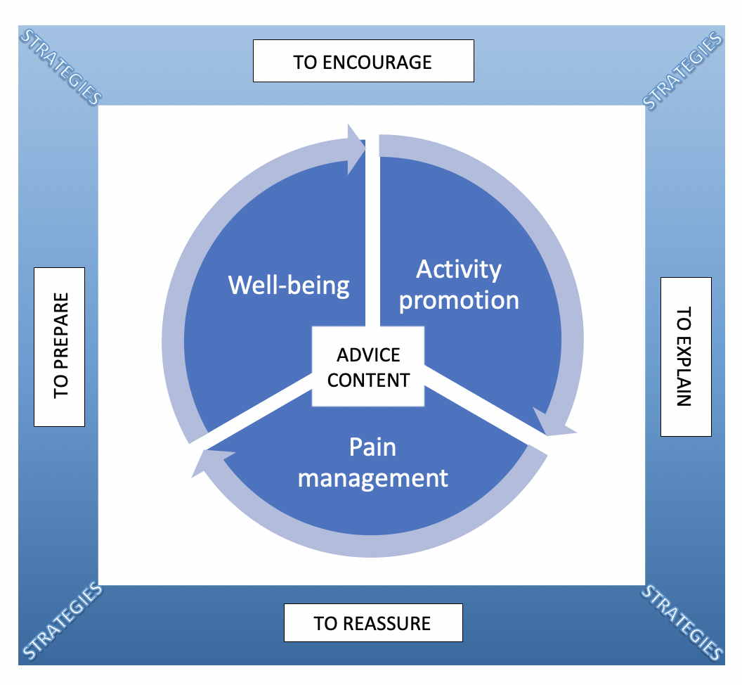

Figure 2: Information graphic model of advice given to patients with LBP showing the content and contextual categories

Figure 2 represents a summary of the content and purpose with strategies that physiotherapists use to deliver advice during initial consultations with patients experiencing low back pain

3.3 Unhelpful advice
Alongside the helpful examples of advice, there were 3 examples of contradictory and 7 unhelpful messages around advice for low back pain in this dataset including messages that were likely to be fear-evoking. These unhelpful messages may be considered ambiguous or contradictory, with potential to increase fear or disability as shown below.

Contradictory advice:
Band 6 Physiotherapist “…making sure that you don’t do too much and cause yourself to have a flare up of your back pain. But, equally, you don’t do so little that you do stiffen up and... reduce your mobility and find it harder to do things" (to P8, a female 46 years)

Band 6 Physiotherapist “So a little bit of exercise is good, (uum) but too much and then you’re, you sort of pole axe yourself for a few days” (to patient 23, male aged 20 years)

Fear-evoking advice:
In this quote the physiotherapist implies the patient’s posture is sub-optimal and by suggesting there is a ‘wrong’ posture, may generate fear.

Band 5 Physiotherapist "What we need to do is get you set in a bit more of a neutral position … it’s going to be a sort of a little bit technical so I don’t want to sort of rush through it and send you away with the wrong thing …". (to P24, male aged 35 years).

- Discussion

This secondary analysis provides novel insight and information about the content and delivery of advice offered by physiotherapists to people with back pain at the initial consultation. Advice to ‘keep active’ is prevalent among the data set and is strongly endorsed by evidence (Buchbinder et al., 2018) and best practice guidelines (O’Connell et al., 2016). This study demonstrates that patients often present with an awareness of the importance of activity and are seeking approval to continue activities. Interestingly, patients also present with strategies of activity avoidance in the management of their back pain, which physiotherapists endorsed as an appropriate self-management strategy, but may in fact further induce fear-avoidance and disability (O’Sullivan et al., 2016 and Darlow et al., 2015).

In general, health and well-being advice including strategies for self-management, were not prevalent in this dataset. These conversations were potentially missing opportunities to address patients’ health needs (Lim et al., 2019), the biopsychosocial influences of back pain such as lifestyle, emotional and general health factors (O’Sullivan et al., 2018) and a chance for health promotion (Buchbinder et al., 2018). Physiotherapists appear confident giving specific and detailed descriptions about the use of non-pharmacological pain management strategies for low back pain (although lack advice about frequency) although it was noted they often deflect pharmacological advice to the GP. With primary care services experiencing a rise in patients with musculoskeletal symptoms (Versus Arthritis, 2019) changes in legislation have enabled independent prescribing by physiotherapists and others in clinical practice (Chief Allied Health Professions Officer, 2017). However, this currently represents a minority of clinicians who are able to offer specific advice about medications, and there is still a need for non-prescribing physiotherapists to ensure patients take their medications as prescribed and are aware of potential side-effects in back pain consultations, in line with their prescribing scope of practice. The lack of basic pain relief pharmacology advice may fail to meet patients’ expectations (Kamper et al., 2018 and Lim et al., 2019), potentially impacting on their experience, satisfaction and outcome as enhancing information to improve understanding may affect patients’ safe and effective medication use (Carey et al., 2017).

Findings from a recent study showed that additional intensive patient education may not further improve clinical outcomes for people with acute back pain beyond first-line care, active listening and empathetic reassurance (Traeger et al., 2019b). This was a 2-arm trial of 202 participants with acute LBP and high risk of chronicity, who were randomised in a 1:1 ratio comparing first line care + placebo education with first line care + intensive additional education (which could be considered ‘cognitive reassurance’). The authors took care to standardise the duration of 2 × 1-hour sessions of patient education (information on pain and biopsychosocial contributors plus self-management techniques, such as remaining active and pacing) or placebo patient education (empathic, active listening, without information or advice). Whilst the findings showed the intensive education to be no better than first line care and active listening, the findings need to be interpreted with caution as the first line care arm included 2 hours of ‘active listening’ and thus these contextual factors are highly likely to have reduced any effect size of the patient education intervention.

It was interesting to see that advice offered by physiotherapists on posture was prevalent in the current study, as in other studies (Bernhardsson et al., 2015), despite a lack of evidence or best practice guidance endorsing this. Current evidence recognises that back pain is not caused by posture or bending (Wai et al., 2010, O’Sullivan et al., 2016, Slater et al., 2019) however there is a perception that people consider their spines vulnerable (Darlow et al., 2015 and Caneiro et al., 2018). Whist there is strong evidence for avoidance of bed-rest and use of paracetamol alone, there is no firm evidence base for supporting other messages of avoidance (Foster et al., 2018) and viewing the back as vulnerable and requiring protection/avoidance is associated with poor prognosis (Chen et al., 2018). Therefore, physiotherapists should replace non-evidence based education with offering advice that focuses on enhancing the patients’ skills and confidence in self-management, including reassurance that has been shown to improve outcome. Alongside this, an education campaign may still be required to encourage ‘trust your back’ messages (Nolan et al., 2019).

With an understanding that physiotherapists aim to provide education and self-management guidance to reassure patients, it is clear through this dataset that this could have a detrimental effect, for example leaving a patient with the notion if they do too much, they will be ‘pole-axed’ for ‘a few days’. Careful use of language is required to avoid contradictory advice and provoke fear, as the role of communication in clinical encounters is recognised as paramount to ensure both positive patient experience and optimal outcome (Roberts et al., 2013). It is important to consider both the content of the advice and strategy used when delivering it (see Figure 3).

Figure 3:

Figure 3: Components of advice-giving

4.1 Limitations
While this secondary analysis makes an important contribution to the evidence base as it uses direct observations rather than patients’/clinicians’ perceptions, it does have several limitations. Firstly, it was not designed as primary research to determine the effectiveness of the advice offered, patients’ adherence nor its effect upon their overall outcome. It should be considered that there may be some selection bias because participating physiotherapists were self-selecting, although this was mitigated by inviting all eligible physiotherapists in the department to participate, and all but one therapist (who had just started in her role) agreed.
It could be considered that audio-recording the consultation with the senior researcher present may have affected the communication, behaviours, and even the advice given by physiotherapists. Steps were taken to reduce this potential impact by the researcher sitting out of direct field of vision and attempts were made to minimise intrusiveness by discreet placing of the audio-recorder. The findings of this study should be generalised with caution as they were derived from the initial consultation within an outpatient department in a single site.
4.2 Implications
This novel analysis identifies the content of advice given by physiotherapists in back pain consultations and recognises the need for guidance to be patient-centred and specific. It also highlights the different strategies therapists use to enhance engagement and identifies examples of good practice.

Further research is required to identify the most effective way to offer advice to patients to optimise their knowledge, skills and confidence to enable them to self-manage. This study emphasises that if activity promotion is to be improved among the population of people with back pain, we need to further consider the language used and its impact upon clinical encounters (Roberts and Burrow, 2018, Chester et al, 2014). Using training time for observations, feedback through peer review and reflections can help identify any contradictory and unhelpful messages used, and raise clinicians’ awareness of their communication skills and the impact these have on their consultations.

Further work is needed with methodological rigour to explore what patients think about the advice given to them and ways to improve understanding and engagement with advice. It is also necessary to identify how clinicians and students acquire the knowledge, skills and confidence in advice-giving to enhancing this treatment modality efficacy and our team is undertaking further work in this area. Furthermore, a focus on ways to communicate and optimise self-management strategies beyond just exercises adherence in physiotherapy settings including in a digital contact is key in managing musculoskeletal conditions. This person-centred care must include greater understanding about patients’ preferences for receiving advice to help them develop effective self-management strategies.

5 Conclusion
This study identifies and categorises verbal advice given to patients with back pain in a physiotherapy setting and while there is evidence of helpful, practical recommendations for self-help and lifestyle changes, some content lacks specificity and at worse, is contradictory or unhelpful.
References

Barlow JH, Sturt J, Hearnshaw H. Self-management interventions for people with chronic conditions in primary care: Examples from arthritis, asthma and diabetes. Health Education Journal 2002;61(4):365-378. doi:10.1177/001789690206100408

Bernhardsson S, Öberg B, Johansson K, Nilsen P, Larsson MEH. Clinical practice in line with evidence? A survey among primary care physiotherapists in western Sweden. J Eval Clin Pract 2015;21:1169–77. doi:10.1111/jep.12380.

Buchbinder R, van Tulder M, Öberg B, Costa LM, Woolf A, Schoene M, et al. Low back pain: a call for action. Lancet (London, England) 2018;391:2384–8. doi:10.1016/S0140-6736(18)30488-4.

Caneiro JP, O’Sullivan P, Lipp O V, Mitchinson L, Oeveraas N, Bhalvani P, et al. Evaluation of implicit associations between back posture and safety of bending and lifting in people without pain. Scand J Pain 2018. doi:10.1515/sjpain-2018-0056.

Carey N, Stenner K, Edwards J, Gage H, Williams P, Otter S, Moore A, Courtenay M, Brown J, Westwood, S. Evaluation of Physiotherapist and Podiatrist Independent Prescribing, Mixing of Medicines and Prescribing of Controlled Drugs. Department of Health, 2017. 304

Chen Y, Campbell P, Strauss V, Foster N, Jordan K, Dunn K. Trajectories and predictors of the long-term course of low back pain: cohort study with 5-year follow-up. Pain, 2018;159 (2):252-260. doi: 10.1097/j.pain.0000000000001097.

Chester EC, Robinson NC, Roberts LC. Opening clinical encounters in an adult musculoskeletal setting. Man Ther 2014;19:306–10. doi:10.1016/j.math.2014.03.011.

Chief Allied Health Professionas Officers Team. Allied Health Professions into Action- Using Allied Health Professionals to transform hewlth, care ans wellbeing. 2017.

Darlow B, Dean S, Perry M, Mathieson F, Baxter GD, Dowell A. Easy to harm, hard to heal: Patient views about the back. Spine (Phila Pa 1976) 2015;40:842–50. doi:10.1097/BRS.0000000000000901.

Duncan EAS, Nicol MM. Subtle realism and occupational therapy: an alternative approach to knowledge generation and evaluation. BJOT 2004;67(10):453-6.

Foster NE, Anema JR, Cherkin D, Chou R, Cohen Steven P, Gross DP, et al. Prevention and treatment of low back pain: evidence, challenges, and promising directions. Lancet (London, England) 2018;391:2368–83. doi:10.1016/S0140-6736(18)30489-6.

Gale NK, Heath G, Cameron E, Rashid S, Redwood S. Using the framework method for the analysis of qualitative data in multi-disciplinary health research. BMC Med Res Methodol 2013;13. doi:10.1186/1471-2288-13-117.

GBD 2015 D and II and P collaborators, Vos T, Allen C, Arora M, Barber RM, Bhutta ZA, et al. Global, regional, and national incidence, prevalence, and years lived with disability for 310 diseases and injuries, 1990-2015: a systematic analysis for the Global Burden of Disease Study 2015. Lancet (London, England) 2016;388:1545–602. doi:10.1016/S0140-6736(16)31678-6.

Hartvigsen J, Hancock MJ, Kongsted A, Louw Q, Ferreira ML, Genevay S, et al. What low back pain is and why we need to pay attention. Lancet 2018;391:2356–67. doi:10.1016/S0140-6736(18)30480-X.

Holt N, Pincus T, Vogel S. Reassurance during low back pain consultations with GPs: a qualitative study. Br J Gen Pract 2015;65:e692–701. doi:10.3399/BJGP15X686953.

Hoy D, Brooks P, Blyth F, Buchbinder R. The Epidemiology of low back pain. Best Pract Res Clin Rheumatol 2010;24:769–81. doi:10.1016/J.BERH.2010.10.002.

Hutting N, Oswald W, Staal JB, Heerkens YF. Self-management support for people with non-specific low back pain: A qualitative survey among physiotherapists and exercise therapists. Musculoskeletal Science and Practice 2020;50:1-8. https://doi.org/10.1016/j.msksp.2020.102269

Kamper SJ, Haanstra TM, Simmons K, Kay M, Ingram TGJ, Byrne J, et al. What do patients with chronic spinal pain expect from their physiotherapist? Physiother Canada 2018;70:36–41. doi:10.3138/ptc.2016-58.

Liddle SD, David Baxter G, Gracey JH. Physiotherapists’ use of advice and exercise for the management of chronic low back pain: A national survey. Man Ther 2009;14:189–96. doi:10.1016/J.MATH.2008.01.012.

Lim Y, Chou L, Au R, Seneviwickrama K, Cicuttini F, Briggs A, Sullivan K, Urquhart D, Wluka A. People with low back pain want clear, consistent and personalised information on prognosis, treatment options and self-management strategies: a systematic review
J Physiother 2019;65:124-135 doi.10.1016/j.jphys.2019.05.010

Lin I, Wiles L, Waller R, Goucke R, Nagree Y, Gibberd M, et al. What does best practice care for musculoskeletal pain look like? Eleven consistent recommendations from high-quality clinical practice guidelines: Systematic review. Br J Sports Med 2020;54:79–86. doi:10.1136/bjsports-2018-099878.

Lobelo F, Stoutenberg M, Hutber A. The exercise is medicine global health initiative: A 2014 update. Br J Sports Med 2014;48:1627–33. doi:10.1136/bjsports-2013-093080.

Long-Sutehall T, Sque M, Addington-Hall J. Secondary analysis of qualitative data: a valuable method for exploring sensitive issues with an elusive population? Journal of Research in Nursing 2011;16(4):335-344. doi:10.1177/1744987110381553

Lowe A, Littlewood C, McLean S. Understanding physical activity promotion in physiotherapy practice: A qualitative study. Musculoskelet Sci Pract 2018;35:1–7. doi:10.1016/j.msksp.2018.01.009.

Murphy E, Dingwall R, Greatbatch D, Parker S, Watson P. Qualitative research methods in health technology assessment: a review of the literature. Health Technol Assess. 1998;2(16): 1-274. PMID: 9919458.

National Institute for Health and Care Excellence (NICE). Low Back Pain and Sciatica in over 16s: Assessment and Management (NG59). 2016.

Nolan D, O’Sullivan K, Stephenson J, O’Sullivan P, Lucock M. How do manual handling advisors and physiotherapists construct their back beliefs, and do safe lifting posture beliefs influence them? Musculoskelet Sci Pract 2019;39:101–6. doi:10.1016/J.MSKSP.2018.11.009.

O’Connell NE, Cook CE, Wand BM, Ward SP. Clinical guidelines for low back pain: A critical review of consensus and inconsistencies across three major guidelines. Best Pract Res Clin Rheumatol 2016;30:968–80. doi:10.1016/j.berh.2017.05.001.

O’Keeffe M. Non-pharmacological treatment of low back pain in primary care. Drug Ther Bull 2019;57:104–8. doi:10.1136/DTB.2018.000015.

Oliveira C, Maher C, Pinto R, Traeger A, Lin CW, Chenot JF, Tulder M, Koes B. Clinical practice guidelines for the management of non-specific low back pain in. primary care: an updated overview. European Spine Journal 2018;27:2791-2803. ﻿doi.org/10.1007/s00586-018-5673-2

O’Sullivan K, O’Sullivan PB, O’Keeffe M. The Lancet series on low back pain: Reflections and clinical implications. Br J Sports Med 2019;53:392–3. doi:10.1136/bjsports-2018-099671.

O’Sullivan P, Caneiro JP, O’Keeffe M, O’Sullivan K. Unraveling the complexity of low back pain. J Orthop Sports Phys Ther 2016;46:932–7. doi:10.2519/jospt.2016.0609.

O’Sullivan PB, O’Keeffe M, Smith A, Dankaerts W, O’Sullivan K. Perspective. vol. 98. 2018.
Oliveira CB, Maher CG, Pinto RZ, Traeger AC, Lin CWC, Chenot JF, et al. Clinical practice guidelines for the management of non-specific low back pain in primary care: an updated overview. Eur Spine J 2018;27. doi:10.1007/s00586-018-5673-2.

Pincus T, Holt N, Vogel S, Underwood M, Savage R, Walsh DA, et al. Cognitive and affective reassurance and patient outcomes in primary care: A systematic review. PAIN® 2013;154:2407–16. doi:10.1016/J.PAIN.2013.07.019.

Ritchie J, Spencer L, O’Connor W. Carrying out Qualitative Analysis. In: Richie J, Lewis J, editors. Qual. Res. Pract. A Guid. Soc. Sci. Students Res., London: Sage Publications Ltd; 2003, p. 219–62. doi:10.4135/9781452230108.

Roberts LC, Burrow FA. Interruption and rapport disruption: measuring the prevalence and nature of verbal interruptions during back pain consultations. J Commun Healthc 2018;11:95–105. doi:10.1080/17538068.2018.1449289.

Roberts LC, Whittle CT, Cleland J, Wald M. Measuring Verbal Communication in Initial Physical Therapy Encounters. 2013.

Shore H, Hebron C. Musculoskeletal physiotherapists’ perceptions of health promotion. Musculoskelet Sci Pract 2020;50. doi.org/10.1016/j.msksp.2020.102260

Slater D, Korakakis V, O’Sullivan P, Nolan D, O’Sullivan K. “Sit up straight”: Time to Re-evaluate. J Orthop Sports Phys Ther 2019;49:562–4. doi:10.2519/jospt.2019.0610.

Stevens ML, Lin CWC, de Carvalho FA, Phan K, Koes B, Maher CG. Advice for acute low back pain: a comparison of what research supports and what guidelines recommend. Spine J 2017;17:1537–46. doi:10.1016/j.spinee.2017.05.030.

Traeger A, Buchbinder R, Elshaug A, Croft P, Maher C. Care for low back pain: can health systems deliver? Bull World Health Organ 2019a;97(6):423-433. doi:10.2471/BLT.18.226050.

Traeger A, Buchbinder R, Harris I, Maher C. How can physicians decide if low-back pain has a serious cause? CMAJ 2017;189:E1386–95. doi:10.1503/cmaj.170527.

Traeger AC, Lee H, Hübscher M, Skinner IW, Moseley GL, Nicholas MK, et al. Effect of Intensive Patient Education vs Placebo Patient Education on Outcomes in Patients with Acute Low Back Pain: A Randomized Clinical Trial. JAMA Neurol 2019b;76:161–9. doi:10.1001/jamaneurol.2018.3376.

Versus arthritis. The state of musculoskeletal health 2019- Arthritis and other musculoskeletal conditions in numbers. 2019.

Wai EK, Roffey DM, Bishop P, Kwon BK, Dagenais S. Causal assessment of occupational lifting and low back pain: results of a systematic review. Spine J 2010;10:554–66. doi:10.1016/j.spinee.2010.03.033.

Reference omitted for initial manuscript submission anonymity

