Supplementary Information

Single photon double and triple ionization of allene

Veronica Ideböhn¹, Alistair J. Sterling², Måns Wallner¹, Emelie Olsson¹, Richard J. Squibb¹, Ugne Miniotaite³, Emma Forsmalm¹, Malin Forsmalm¹, Stefano Stranges^{4,5}, John M. Dyke⁶, Fernanda Duarte², John H.D. Eland⁷, and Raimund Feifel¹

1)Department of Physics, University of Gothenburg, Origovägen 6B, 412 58 Gothenburg, Sweden
2)Department of Chemistry, Chemistry Research Laboratory, Mansfield Road, Oxford OX1 3TA, United Kingdom
3)Department of Physics, Chalmers University of Technology, Kemigården 1, 412 96 Gothenburg, Sweden
4)IOM-CNR Tasc, SS-14, Km 163.5 Area Science Park, Basovizza 34149, Trieste, Italy
5)Dipartimento di Chimica e Tecnologie del Farmaco, Universitá Sapienza, Rome I-00185, Italy
6)School of Chemistry, University of Southampton, Highfield, Southampton SO17 1BJ, United Kingdom
7)Department of Chemistry, Physical and Theoretical Chemistry Laboratory, Oxford University, South Parks Road,Oxford OX1 3QZ, United Kingdom

Computational Supporting Information

Allene in its neutral form has 22 electrons (3 x 1s²2s²2p² from the C atoms, 4 x 1s¹ from the H atoms) and a D_{2d} geometry. Its ground state electronic configuration can be denoted as (1a₁)² (1b₂)² (2a₁)² (3a₁)² (2b₂)² (4a₁)² (3b₂)² (1e)⁴ (2e)⁴ [1] where double ionization from the outermost 2e (π_{C–C} in character) orbitals corresponds to the first four bands seen in the experimental spectrum. 1e and 2e are π orbitals and 3b₂ is a σ-orbital. Removal of two electrons from the 2e orbitals gives rise to four states: ³A₂, ¹A₁, ¹B₁ and ¹B₂. The lowest energy singlet state (¹A₁) of allene⁺⁺ undergoes a geometric distortion (D_{2d} →D_{2h}) to remove orbital degeneracy. This D_{2h} dication has 20 electrons, and its ground state electronic configuration is (1a_{g})² (1b_{1u})² (2a_{g})² (3a_{g})² (2b_{1u})² (4a_{g})² (3b_{1u})² (1b_{3u})² (1b_{2g})² (1b_{2u})²; the geometric distortion transforms ¹A₁ (D_{2d}) [----(2e)²] into ¹A_{g} (D_{2h}) [----(1b_{2u})²(2b_{3u})⁰].

All calculations were carried out using the ORCA program (v 4.1.2). Optimisations were carried out at the CASSCF(4,4) and CASSCF(2,4) levels with the def2-TZVP basis set for neutral and doubly-ionised states, respectively, reflecting ionisation from the 2e (π) orbitals of allene (Figure S1). Optimisation used ‘tight’ thresholds defined in ORCA, corresponding to an SCF energy convergence of 10^{–8} Ha. Ionisation energies were obtained at the NEVPT2 level based on CASSCF(4,4) and CASSCF(2,4) wavefunctions for neutral and doubly-ionised states, respectively, using the def2-QZVPP basis set. Electronic states were assigned based on the leading CASSCF configuration (see Table S1). Vertical ionisation energies were calculated as the difference in electronic energies between the dication and neutral states at the optimised ground state structure of allene. Each electronic state was fully optimised using the “weights[n]” option in the %casscf block – e.g., to obtain the electronic energy of the ¹B₁ state of allene⁺⁺, the input block looks as follows:

%casscf
nel 2 # 2 active electrons
norb 4 # 4 active orbitals
mult 1 # singlet multiplicity
nroots 2 # calculate 2 singlet roots
weights[0] = 0, 1 # optimise for second root
end

Adiabatic ionization energies were calculated as the difference in the electronic energies between the dication and neutral states, each at their optimised geometry. Excited state geometries were calculated using the same CASSCF procedure as above.

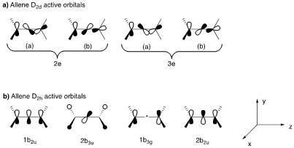

Figure S1. CASSCF active orbitals chosen for (2e)^{–2} double ionization.

Table S1. CASSCF wave functions for the neutral and doubly-ionized species.
Species | State | Point group | CASSCF wave function
C₃H₄ | ¹A₁ | D_{2d} | 0.92(2e_{(a)})²(2e_{(b)})²(3e_{(a)})⁰(3e_{(b)})⁰ + 0.03(2e_{(a)})¹(2e_{(b)})¹(3e_{(a)})¹(3e_{(b)})¹ + 0.01(2e_{(a)})²(2e_{(b)})⁰(3e_{(a)})²(3e_{(b)})⁰ + 0.01(2e_{(a)})⁰(2e_{(b)})²(3e_{(a)})⁰(3e_{(b)})² + ...
C₃H₄²⁺ | ¹A₁ | D_{2d} | 0.50(2e_{(a)})²(2e_{(b)})⁰(3e_{(a)})⁰(3e_{(b)})⁰ + 0.50(2e_{(a)})⁰(2e_{(b)})²(3e_{(a)})⁰(3e_{(b)})⁰ + ...
C₃H₄²⁺ | ¹A_{g} | D_{2h} | 0.96(1b_{2u})²(2b_{3u})⁰(1b_{3g})⁰(2b_{2u})⁰ + 0.02(1b_{2u})⁰(2b_{3u})⁰(1b_{3g})²(2b_{2u})⁰ + 0.01(1b_{2u})⁰(2b_{3u})⁰(1b_{3g})⁰(2b_{2u})² + ...
C₃H₄²⁺ | ³A₂ | D_{2d} | 1.00(2e_{(a}))¹(2e_{(b)})¹(3e_{(a)})⁰(4e_{(b)})⁰ + ...
C₃H₄²⁺ | ¹B₁ | D_{2d} | 0.98(2e_{(a)})¹(2e_{(b)})¹(3e_{(a)})⁰(3e_{(b)})⁰ + ...
C₃H₄²⁺ | ¹B₂ | D_{2d} | 0.97(2e_{(a)})¹(2e_{(b)})¹(3e_{(a)})⁰(3e_{(b)})⁰ + ...

Table S2. Diabatic and adiabatic electronic energies for allene and allene⁺⁺. Energies in Ha.
Species | Allene geometry |  |  | Allene⁺⁺ geometry
 | CASSCF/def2-TZVP energy | CASSCF/def2-QZVPP energy | NEVPT2/def2-QZVPP energy | CASSCF/def2-TZVP energy | CASSCF/def2-QZVPP energy | NEVPT2/def2-QZVPP energy
C₃H₄ (¹A₁) | -115.95997 | -115.96641 | -116.42206 | - | - | -
C₃H₄²⁺ (¹A₁) | - | -114.98861 | -115.37193 | -115.06627 | -115.07284 | -115.46263
C₃H₄²⁺ (¹B₁) | - | -114.94455 | -115.33889 | -114.95289 | -114.95947 | -115.34775
C₃H₄²⁺ (¹B₂) | - | -114.92758 | -114.93947 | -114.93305 | -115.33205 | -115.33931
C₃H₄²⁺ (³A₂) | - | -115.00076 | -115.38673 | -115.00506 | -115.01150 | -115.39364

Table S3. Calculated vertical (diabatic) and 0-0 (adiabatic) double ionisation energies, with a def2-QZVPP basis set. Energies in eV.
Electronic state | CASSCF |  | NEVPT2 |  | Experimental vertical double ionisation
 | Vertical double ionisation | 0-0 double ionisation | Vertical double ionisation | 0-0 double ionisation
¹A₁ (D_{2d}) or ¹A_{g} (D_{2h}) | 26.6 | 24.3ª | 28.6 | 26.1ª | 28.7
¹B₁ | 27.8 | 27.4 | 29.5 | 29.2 | 29.5
¹B₂ | 28.3 | 27.9 | 29.7 | 29.5 | 30.0
³A₂ | 26.3 | 26.0 | 28.2 | 28.0 | 28.0
ª D_{2h} geometry

Fitting of the First Double Ionization Band

The experimental data were fitted to four Gaussian functions using Matlab R2020b Curve Fitting ToolboxTM. The data set was limited to include data points of the energies from 26.81 to 30.21 eV, and the function that was fitted to was

y = a1*exp(-((x-b1)/c)^2)+ a2*exp(-((x-b2)/c)^2) +a3*exp(-((x-b3)/c)^2) + a4*exp(-((x-b4)/c)^2) + d.

Here y denotes the counts, x represents the double ionization energy, the a-coefficients are the amplitudes of the Gaussian distributions, c is the (same) width of the peaks, d is a base offset, the b-coefficients are the centers of the Gaussian distributions, and the values are taken as the vertical ionization energies.

In fit options, the a-coefficients are specified to lie in the interval 0 to Inf, with a starting point of 1000, c is set to be between 0 and 1 and d is permitted to lie between 0 and Inf with a starting point of 300. The b-coefficients are all specified to lie within 27 to 30 with separate starting values.

Table S4. The starting points of the coefficients as well as upper and lower bounds for the fit of the Gaussians to the double ionization energy. The Result is the value that Curve Fitting ToolTM calculates and the lower and upper bound make up the span of the 95% confidence interval.
Coefficients | Start point | Lower | Upper | Result | Lower bound | Upper bound
a1 | 1000 | 0 | Inf | 855.5 | 652 | 1059
a2 | 1000 | 0 | Inf | 1075 | 945.2 | 1168
a3 | 1000 | 0 | Inf | 1138 | 975.4 | 1300
a4 | 1000 | 0 | Inf | 491.1 | 311.6 | 670.6
b1 | 26 | 27 | 30 | 29.3 | 29.11 | 29.49
b2 | 27.5 | 27 | 30 | 27.92 | 27.86 | 27.98
b3 | 28 | 27 | 30 | 28.65 | 28.52 | 28.77
b4 | 29 | 27 | 30 | 30 | 29.79 | 30.21
c | 0.7664^{b} | 0 | 1 | 0.488 | 0.4211 | 0.5548
d | 300 | 0 | Inf | 384.1 | 311.7 | 456.5
^{b} The starting value that was automatically generated by Curve Fitting Tool

Besides the fit and the confidence thereof, the goodness of fit is also generated.

Table S5. The parameters that specify the goodness of fit of the result listed above.
Goodness of fit
Sum of Squares Due to Error | 8.638e+04
R-square | 0.9882
Degrees of Freedom Adjusted R-square | 0.9839
Root Mean Squared Error | 58.78

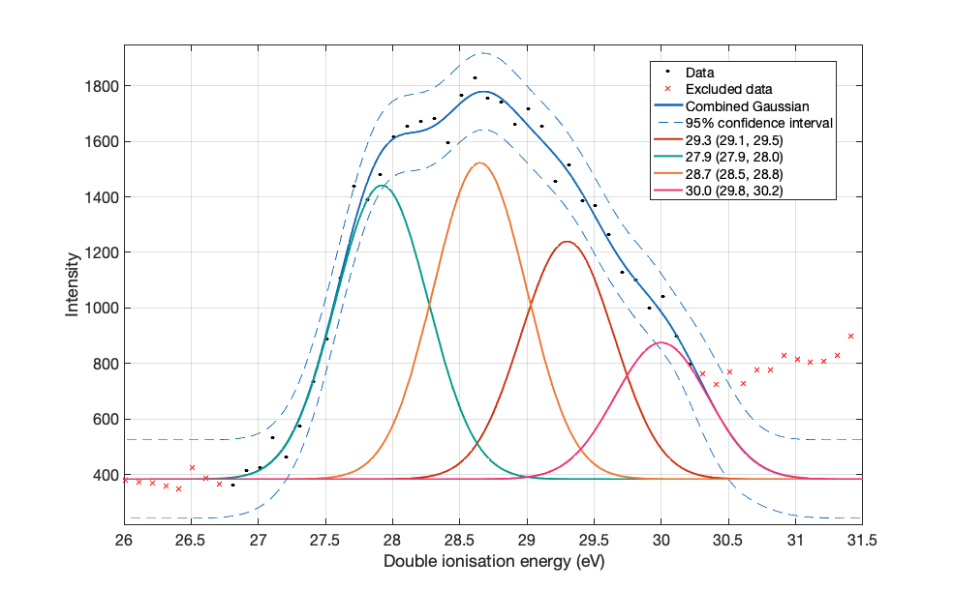
Figure S2: The experimental data of the first double ionization peak are represented by black dots, and the excluded data are marked by red crosses. Individual Gaussian fits of the four peaks are represented by the four last entries in the legend where the mean of the individual Gaussians is the first number and the values in the brackets are the 95% confidence interval of the means. The blue line is the combined function from the four Gaussians and the dashed blue line is the 95% prediction bound calculated by Curve Fitting ToolTM.

References
[1] Y. A. Kruglyak, H. Preuss, and R. Janoschek, Theor. Exp. Chem. 7, 241 (1973).

