Pyramidal dicationic Ge(II) complexes with homoleptic neutral pnictine coordination: a combined experimental and density functional theory study

Rhys P. King, Victoria K. Greenacre, William Levason, John M. Dyke, and Gillian Reid*
School of Chemistry, University of Southampton, Southampton SO17 1BJ, UK; Email: G.Reid@soton.ac.uk

Abstract
An unusual series of Ge(II) dicationic species with homoleptic phosphine and arsine coordination, [Ge(L)][OTf]₂, L = 3 x PMe₃, triphos (MeC(CH₂CH₂PPh₂)₃), triars (MeC(CH₂CH₂AsMe₂)₃) or κ³-tetraphos (P(CH₂CH₂PPh₂)₃) (OTf⁻ = O₃SCF₃⁻) have been prepared by reaction of [GeCl₂(dioxane)] with L and 2 mol. equiv. Me₃SiOTf in anhydrous CH₂Cl₂ (or MeCN for L = triars, triphos). X-ray crystal structures are reported for [Ge(PMe₃)₃][OTf]₂, [Ge(triars)][OTf]₂ and [Ge(κ³-tetraphos)][OTf]₂, confirming homoleptic P₃- or As₃-coordination at Ge(II) in each case and with the discrete OTf⁻ anions providing charge balance. The Ge-P/As bond lengths are significantly shorter than those in neutral germanium(II) dihalide complexes with diphosphine or diarsine coordination (Inorg. Chem., 2010, 49, 752). Solution NMR spectroscopic data indicate that the complexes are labile in solution. Using excess AsMe₃ and [GeCl₂(dioxane)] gives only the neutral product, [Ge(AsMe₂)₂(OTf)₂], the crystal structure of which shows four coordination at Ge(II), via two As donor atoms and an O-atom from two κ¹-OTf⁻ ligands; further weak, long-range intermolecular interactions give a chain polymer.
The electronic structure of the [Ge(PMe₃)₃]²⁺ dication has been investigated using density functional theory (DFT) calculations. The computed geometrical parameters for this dication are in good agreement with the experimental X-ray crystallographic values in [Ge(PMe₃)₃][OTf]₂. The results also indicate that the pyramidal arrangement of the [Ge(PMe₃)₃]²⁺ (computed P-Ge-P angle 96.8° at the B3LYP-D3 level) arises from a balance between electronic energy (E_{elec}) contributions, which favor a lower P-Ge-P angle, and nuclear-nuclear contributions (E_{nn}), which favor a higher P-Ge-P angle, to the total energy (E_{TOT}). An AIM (Atoms in Molecules) analysis reveals that one reason why E_{elec} decreases as the P-Ge-P angle decreases is because of C⋅⋅⋅H and H⋅⋅⋅H interactions between atoms on different CH₃ groups. The stability of the [Ge(PMe₃)₃]²⁺ dication is enhanced by the distribution of a significant part of the positive charge on Ge²⁺ to the atomic centres of the PMe₃ ligands. Similar results were obtained for [Ge(AsMe₃)₃][OTf]₂, showing the tris-AsMe₃ complex to be less stable compared to the PMe₃ analog. Related calculations were also performed for the neutral [Ge(PMe₃)₂(OTf)₂] and [Ge(AsMe₃)₂(OTf)₂] complexes.
Introduction
The last 20 or so years have seen much renewed interest in the organometallic and coordination chemistry of the main group elements fuelled by a combination of factors, including increased awareness of the chemical and structural diversity in this part of the periodic table, development of metal-free catalysts and reagents, new radio-imaging agents, as well as the discovery of unprecedented molecular complexes, clusters and radicals, etc. Within Group 14, germanium compounds have attracted considerable interest, including germylenes, Ge-Ge bonded species, radicals, clusters, Ge-based catalysts and precursors for semiconductor materials for technology applications.
While the +4 oxidation state dominates for germanium, cationic complexes based upon the +2 oxidation state, carrying a Ge-based lone pair of electrons, have attracted significant interest and have also stimulated the development of a range of unusual new dicationic Ge(II) coordination complexes. These have used a variety of ligand types, such as cryptands, crown ethers,, and tri- or tetra-aza macrocycles^{5,} that tend to encapsulate the metalloid ion, tetra-amines and isocyanides, as well as bulky acyclic ligands such as N-heterocyclic carbenes, and substituted imidazolyl ligands,, which provide some steric protection for the Ge(II) ion. A small number of examples with smaller chelates such as 2,2′-bipyridine (bipy), have also been described. Invariably the reported dications contain neutral ligands involve C-, N- and O-donor ligands. In contrast, Ge(II) cations bearing neutral, soft donor ligands are very scarce, comprising only the monocationic species with mixed thia/oxa crowns, [GeCl(L)]⁺ (L = [15]aneS₂O₃ and [18]aneS₃O₃), in which the O donor atoms promote endocyclic coordination and binding of the thioether groups, and [GeCl{o-C₆H₄(AsMe₂)₂}][GeCl₃].¹⁶
In this work we report the preparation of the first series of pyramidal Ge(II) dications bearing homoleptic tris-phosphine or tris-arsine donor sets, along with a combined experimental and computational study of their geometric and electronic structures via X-ray crystallography and density functional theory (DFT) calculations. The spectroscopic properties of the new complexes are also described. We have previously described a series of neutral Ge(II) dihalide complexes with diphosphine and diarsine ligands, however, with the exception of [GeCl{o-C₆H₄(AsMe₂)₂}][GeCl₃], in all cases the halide ligands were retained. Gray has reported the preparation and crystal structure of [GeCl(Me₂PCH₂CH₂PMe₂)]OTf, which adopts a distorted disphenoidal geometry with a long Ge⋅⋅⋅OTf contact (2.996(2) Å). We also note that a dication of general formula [Ge(PR₃)₃]²⁺ is isoelectronic with [Ga(PR₃)₃]⁺. The crystal structure of the pyramidal Ga(I) cation, [Ga(PPh₃)₃]⁺, with a weakly coordinating fluorous aluminate anion has been reported by Krossing and co-workers.
Results and discussion
Preparation of Ge(II) complexes
A series of dicationic Ge(II) pnictine complexes [Ge(L)][OTf]₂, was prepared by reaction of [GeCl₂(dioxane)] with two equivalents of TMSOTf (Me₃SiO₃SCF₃) and ligand L (L = 3 x PMe₃, triphos, tetraphos) in CH₂Cl₂ solution, or for L = triars, triphos using MeCN as the solvent, according to Scheme 1. In addition to the sterically small PMe₃ (and AsMe₃), the tripodal triphos, tetraphos and triars ligands were employed to probe the effect of ligand architecture, denticity and donor type on the resulting complexes. In all cases the products were isolated as powdered or crystalline solids in good yield and for the complexes with the tri- and tetradentate ligands the microanalytical data are consistent with the formulations in Scheme 1. We were unable to obtain a good match to the calculated %C and %H by microanalysis for [Ge(PMe₃)₃](OTf)₂, despite several attempts. Drying the complex under a stream of nitrogen gas led to values intermediate between those expected for a 3:1 and 2:1 PMe₃:Ge ratio even though several crystals were confirmed to be [Ge(PMe₃)₃](OTf)₂ as discussed below, while drying the tris complex in vacuo produced a white powder that fitted closely to the 2:1 species, [Ge(PMe₃)₂(OTf)₂], whose structure has been mentioned in a thesis, but not published. These results are consistent with one PMe₃ ligand being lost easily from the Ge(II) ion. Using three equivalents of AsMe₃ gave only the neutral bis-trimethylarsine species, [Ge(AsMe₃)₂(OTf)₂]. We were unable to isolate a tris-trimethylarsine complex even with excess AsMe₃, presumably reflecting the weaker σ-donor power of the arsine compared to PMe₃.
Finally, reacting the heavier stibine, SbEt₃, with [GeCl₂(dioxane)] and TMSOTf produced a mixture of several species as indicated by the ¹H NMR data, including [EtSb(SbEt₃)₂][OTf]₂, the [MeSb(SbMe₃)₂]²⁺ analog of which is known, hence this was not pursued further.

Scheme 1 Preparative routes to the new complexes reported in this work

Given the expected lability of the Ge(II) complexes with soft phosphine and arsine coordination, along with the presence of the potentially weakly coordinating OTf⁻ and the Ge-based valence electrons, establishing the solid state structures via X-ray crystallographic analysis was paramount. Hence the discussion will first focus on the solid state structures, followed by a brief discussion of the solution behavior, via NMR spectroscopic analysis. The electronic structure of these complexes as revealed by DFT calculations will then be discussed.
Structural studies
Crystals of the complexes were obtained as described in the Experimental section. The crystal structure of [Ge(PMe₃)₃][OTf]₂ confirms the presence of a Ge(II) dication with the three PMe₃ ligands creating a pyramidal coordination environment (Figure 1, Table S1), with Ge-P distances in the range 2.3747(5)-2.3970(5) Å and P-Ge-P angles spanning 98.085(17)-100.509(18)°. This is the first example of homoleptic neutral P₃-coordination to the Ge(II) dication. The top face of the Ge(II) ion can be assumed to accommodate the Ge-based lone pair. There are no significant interactions to neighboring OTf⁻ groups, which provide charge balance, but are discrete, with the closest Ge⋅⋅⋅O(OTf) distance being some 4.28 Å.
Figure 1 The crystal structure of the dication in [Ge(PMe₃)₃][OTf]₂ showing the atom numbering scheme. Ellipsoids are drawn at the 50% probability level. The triflate anions and H atoms are omitted for clarity. Selected bond lengths (Å) and angles (˚) are: Ge1-P1 = 2.3747(5), Ge1-P2 = 2.3828(5), Ge1-P3 = 2.3970(5), Ge1⋅⋅⋅O3 (closest oxygen to Ge) = 4.2853(17). P1-Ge1-P3 = 98.085(17), P1-Ge1-P2 = 100.509(18), P2-Ge1-P3 = 99.276(18).
Under similar experimental conditions, a 1:3 Ge:AsMe₃ ratio produces only the neutral, highly distorted tetrahedral bis-trimethylarsine complex, [Ge(AsMe₃)₂(OTf)₂], whose structure was also determined. The complex has 2-fold crystallographic symmetry (Figure S6a, SI), with Ge-As = 2.4297(2) Å, short Ge-O(Tf) distances of 2.0170(15) Å. The angle As-Ge-As = 119.600(15)°, with a much more acute angle O-Ge-O = 98.30(9)°, is presumably a consequence of both the smaller steric requirements of the triflate, as well as the intermolecular contacts. Further analysis of the crystal packing shows two weak, intermolecular Ge⋅⋅⋅O(OTf) contacts per molecule (2.994 Å), leading to a weakly associated chain polymer along the c-direction (Figure S6b, SI). The structure of the corresponding [Ge(PMe₃)₂(OTf)₂] has been included in a thesis,¹⁹ although it is not isostructural. The crystallographic data do not appear to be available in the CCDC.
In contrast to the bis-AsMe₃ coordination to Ge(II), using the tripodal triars ligand gives [Ge(triars)][OTf]₂. In this complex, the presence of the homoleptic As₃-coordinated pyramidal dication, [Ge(triars)]²⁺ was established from a crystal structure determination (Figure 2), which reveals two very similar, but crystallographically independent, molecules in the asymmetric unit, with Ge-As = 2.5095(9)-2.5550(10) Å. The Ge-As distances are longer than those is the neutral [Ge(AsMe₃)₂(OTf)₂] described above (despite its higher coordination number) and the As-Ge-As angles, ranging from 81.56(3)- 83.35(3)°, are also much more acute than in the [Ge(PMe₃)₃]²⁺ cation. These are most likely a result of the geometric constraints of the tripodal ligand structure of the triars. The closest Ge⋅⋅⋅O(OTf) distance is > 2.80 Å. These are within the sum of the van der Waals radii for Ge and O (3.63 Å), but constitute only very weak contacts to the triflate anions. Hence, the structure is best described as a pyramidal [Ge(triars)]²⁺ dication; a coordination environment unprecedented for Ge(II).

Figure 2 The structure of the dication in [Ge(triars)][OTf]₂ showing the atom numbering scheme. Ellipsoids are drawn at the 50% probability level, one of the two [Ge(triars)]²⁺ in the asymmetric unit is shown and H atoms and triflates are omitted for clarity. Selected bond lengths (Å) and angles (˚) are: Ge1-As1 = 2.5578(9), Ge1-As2 = 2.5543(9), Ge1-As3 = 2.5096(9), As1-Ge1-As2 = 81.56(3), As1-Ge1-As3 = 83.16(3), As2-Ge1-As3 = 82.40(3) Ge1⋅⋅⋅O5 (closest Ge-O(OTf) approach) = 2.804 Å.
In an effort to establish whether P₄--coordination would occur at Ge(II), the tripodal tetraphosphine, tetraphos, was also used as a ligand. The crystal structure of [Ge(tetraphos)](OTf)₂ shows (Figure 3) a discrete [Ge(tetraphos)]²⁺ dication with the OTf⁻ anions essentially discrete and just providing charge balance; the closest Ge⋅⋅⋅O distance of ~3.15 Å is very considerably longer than the 2.01 Å seen in [Ge(AsMe₃)₂(OTf)₂], where the OTf⁻ groups are clearly coordinated. Notably, the coordination in the cation occurs through three P donor atoms giving a pyramidal geometry, specifically via two terminal -PPh₂ groups and the P-donor atom at the bridgehead, forming two five-membered chelate rings and giving a κ³-coordination mode with the fourth P-donor atom remaining uncoordinated. The Ge-P distances (2.4280(9), 2.4298(9), 2.4583(9) Å) are slightly longer than those in [Ge(PMe₃)₃]²⁺, most likely due to a combination of the weaker donor -PPh₂ groups and the increased steric requirements of tetraphos.
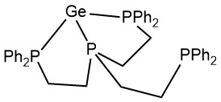
Figure 3 The structure of the dication [Ge(κ³-tetraphos)]²⁺ showing the atom numbering scheme (with structure showing coordination present). Ellipsoids are drawn at the 50% probability level and H atoms, CH₂Cl₂ and triflate anions are omitted for clarity. Selected bond lengths (Å) and angles (˚) are: Ge1-P1 = 2.4280(9), Ge1-P2 = 2.4298(9), Ge1-P3 = 2.4583(9), Ge1-P4 = 5.7051(3), Ge1-O6 (closest O to Ge) = 3.15114(12). P1-Ge1-P2 = 80.55(3), P1-Ge1-P3 = 91.14(3), P2-Ge1-P3 = 81.08(3).
Comparison of these dicationic structures with those of the neutral [GeX₂(L-L)] (L-L = diphosphine and diarsine; X = Cl, Br, I) complexes¹⁶ and [GeCl(Me₂PCH₂CH₂PMe₂)][OTf] ¹⁷ reveals significantly shorter Ge-P and Ge-As bond distances in the dications, probably reflecting their more strongly Lewis acidic character, coupled with the lower coordination numbers. The Ge-As bonds in the [GeCl{o-C₆H₄(AsMe₂)₂}]⁺ monocation are also longer (2.5847(5) Å)¹⁶ than in the [Ge(triars)]²⁺ dication reported here.
Spectroscopic data
The bulk products isolated in this study were also characterized using a combination of microanalysis, solution ¹H, ¹⁹F{¹H} and ³¹P{¹H} NMR and IR spectroscopy, as detailed in the Experimental section. As well as the ligand fingerprint, the IR spectra clearly show the peaks expected for OTf⁻ (Figures S1-S5, SI).
NMR spectra were recorded in CD₂Cl₂ or CD₃CN when solubility in the former was poor. The ¹H NMR spectra of the new Ge(II) complexes show resonances consistent with coordination of the pnictine in each case, typically showing high frequency shifts (by ca. 0.7 ppm) relative to the ligands themselves, most notably for the H’s closest to the pnictine donor atom, and with couplings to ³¹P nuclei for the phosphines. The resonances are also somewhat broadened, particularly so for the [Ge(AsMe₃)₂(OTf)₂], possibly indicating dynamic reversible ligand dissociation in solution. The ¹⁹F{¹H} NMR spectra for each of the dicationic species show a singlet due to the OTf⁻ at ca. −79 ppm, indicating that the anion is dissociated in CD₂Cl₂ or MeCN solution.
The ³¹P{¹H} NMR spectrum of [Ge(triphos)][OTf]₂ shows a sharp singlet at −3.7 ppm from the coordinated -PPh₂ groups, shifted significantly from that of the triphos itself (−26.3 ppm), and is indicative of symmetrical tridentate coordination to a pyramidal Ge(II) ion in solution. For [Ge(tetraphos)][OTf]₂, the ¹H NMR spectrum is very broad, indicating dynamic exchange between the ‘free’ and coordinated phosphine groups in solution rather than the κ³-coordination found in the solid state structure . This is also reflected in the ³¹P{¹H} NMR spectrum which shows two broad singlets at 64.5 ppm and 15.2 ppm, assigned to the apical P-donor atom and three exchanging PPh₂ groups. For [Ge(PMe₃)₃][OTf]₂, when a sample dried under a stream of N₂ gas is dissolved in CD₃CN, a broadened singlet is observed with δ(³¹P{¹H}) = -12.7, which compares with −60.5 ppm for PMe₃ itself.
Density Functional Theory (DFT) Calculations
DFT calculations were carried with the B3LYP-D3 and BP86-D3 functionals, and 6-311G(d) basis sets were used for all atoms. The X-ray crystallographic results for [Ge(PMe₃)₃]²⁺ show a three-coordinate, pyramidal Ge(II) cation with a homoleptic P₃-donor set and this unusual species was investigated using DFT calculations. Figure 4 shows the optimized structure of the [Ge(PMe₃)₃]²⁺ dication obtained at the B3LYP-D3 level. This matches well with the obtained diffraction data (Table S2, SI). Calculations performed at the BP86-D3 level yielded similar results. The computed Ge-P and P-C bond lengths are slightly longer than the experimentally determined values, by ca. 0.07 Å and ca. 0.025 Å, respectively. The computed P-Ge-P angles are all slightly smaller than the experimental values. These differences may well be a result of crystal packing effects in the solid state.
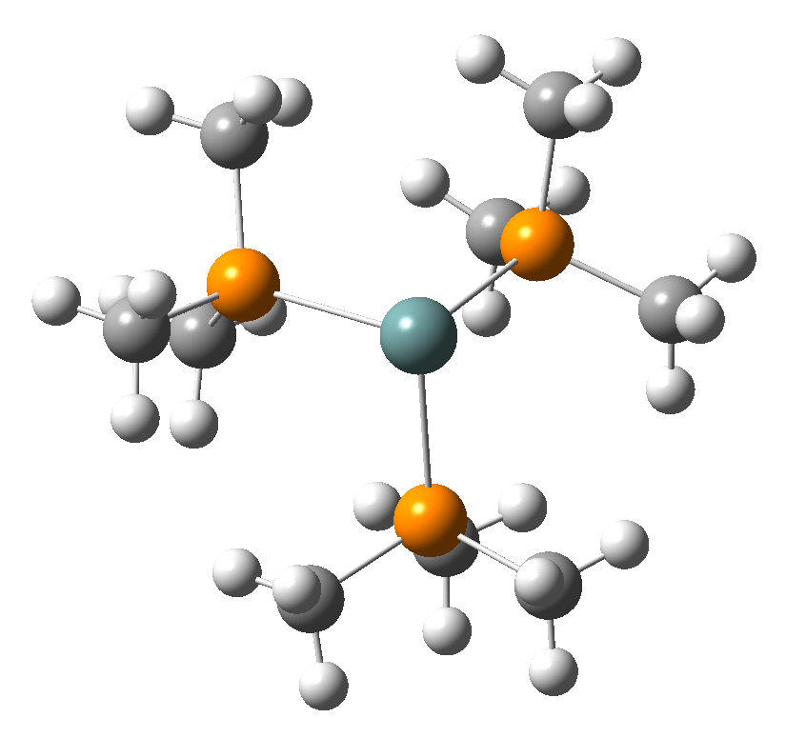
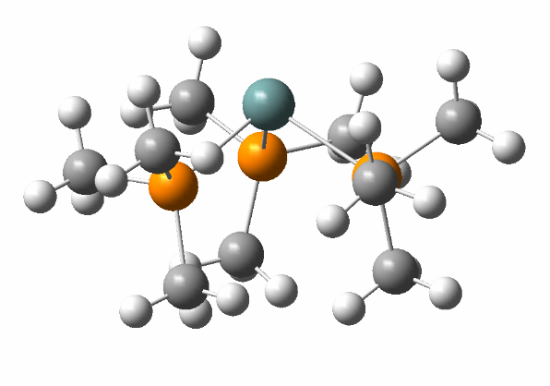

Figure 4 The optimized structure of the dication [Ge(PMe₃)₃]²⁺ obtained at the B3LYP-D3 level (views from two different directions are shown). Teal = Ge, orange = P, grey = C, white = H.
Due to the similarity of the results obtained from the two computational methods, the B3LYP-D3 data were used for all of the further analyses.
The calculated HOMO, HOMO-1, LUMO and LUMO+1 orbitals for [Ge(PMe₃)₃]²⁺ are shown in Figure 5. The HOMO exhibits strong P3p-P3p bonding between all three of the phosphorus atoms and the Ge4p-P3p interaction is non-bonding. In the HOMO-1 there are significant Ge4p-P3p bonding and P3p-P3p non-bonding interactions. In both the LUMO and LUMO+1 there are Ge4p-P3p antibonding and weak P3p-P3p antibonding interactions.

HOMO (-13.58 eV) | LUMO (-7.98 eV)
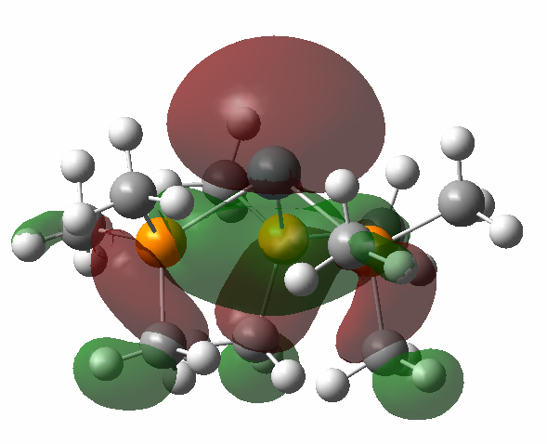 | 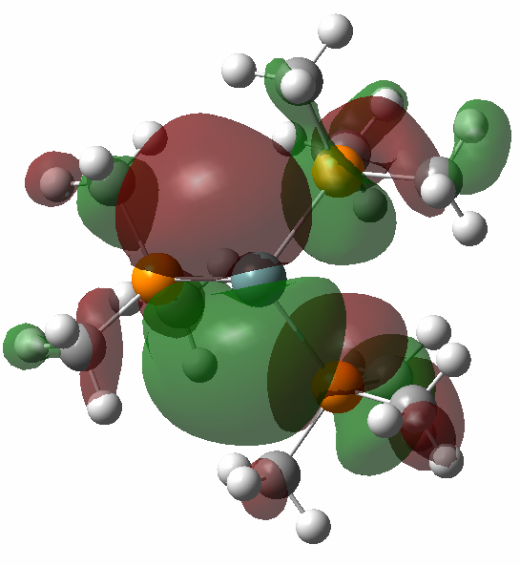
HOMO-1 (-15.18 eV) | LUMO+1 (-7.98 eV)
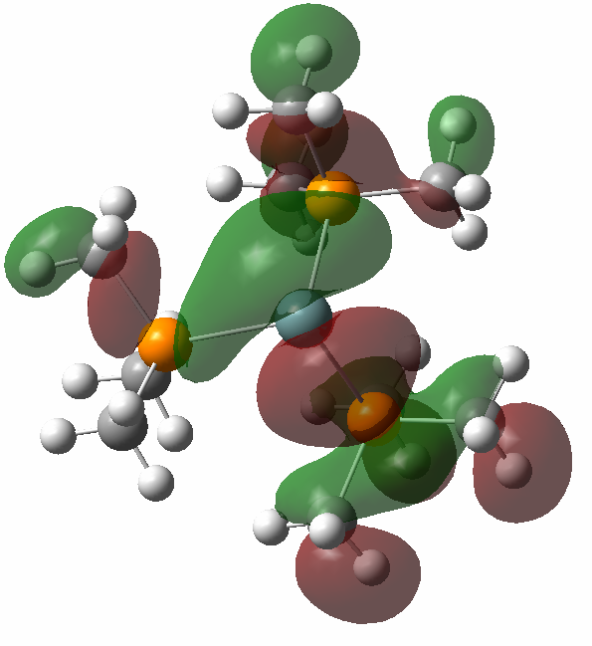 | 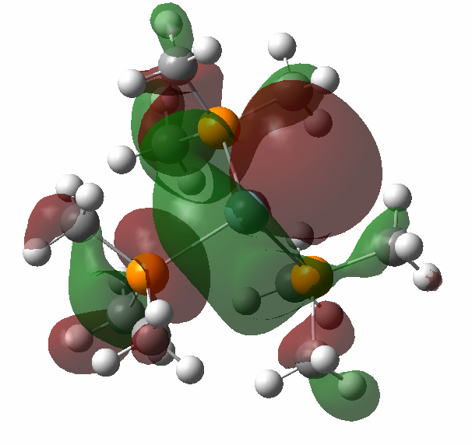

Figure 5 Representations of the HOMO-1, HOMO, LUMO, and LUMO+1 of [Ge(PMe₃)₃]²⁺ determined by B3LYP-D3 calculations.
As noted above, [Ge(AsMe₃)₃][OTf]₂ could not be synthesized, although analogous calculations to those made for [Ge(PMe₃)₃]²⁺ were made for [Ge(AsMe₃)₃]²⁺ using both B3LYP-D3 and BP86-D3, with good agreement between results from the two functionals (Table S3, SI). Comparing the B3LYP-D3 computed values for [Ge(AsMe₃)₃]²⁺ and [Ge(PMe₃)₃]²⁺, the Ge-As bonds are increased by ca. 0.1 Å from the Ge-P values, the As-C bonds are increased by ca. 0.13 Å from the P-C values and the As-Ge-As angles have decreased by ca. 1.8° from the P-Ge-P values.
In order to gain some understanding of the relative energy changes involved in forming this and other related cation-anion complexes of the type [M(EX₃)₃][OTf]₂, the energetics of the following model reaction were considered:
Ge²⁺ + 3(EX₃) → [M(EX₃)₃]²⁺ --------------------- (1)
where E = P or As. The results are summarized in Table 1.
Table 1: Summary of computed relative energies (ΔE) for reaction (1), average changes of NPA charge on each centre and average bond lengths and angles of [M(EX₃)₃]²⁺, at the B3LYP-D3 level.
 | ΔE eV  (kJ/mol) | Average change in natural population analysis (NPA) charge on M, E, C, H centres | Average bond lengths (Å) and angles (°) of [M(EX₃)₃]²⁺
Ge²⁺ + 3 PMe₃ → [Ge(PMe₃)₃]²⁺ | -14.19 (-1369) | Ge²⁺: -1.84  P: +0.282  C: -0.012  H: +0.041 | Ge-P = 2.455  P-C = 1.826  P-Ge-P = 96.44
Ge²⁺ + 3 AsMe₃ → [Ge(AsMe₃)₃]²⁺ | -13.48 (-1300) | Ge²⁺: -1.79  As: +0.217  C: +0.016  H: +0.037 | Ge-As = 2.561  As-C = 1.950  As-Ge-As = 94.637

This shows that the formation of [Ge(PMe₃)₃]²⁺ is associated with a decrease in the charges on the Ge²⁺ and the C atoms, while those on the P and H atoms increase., i.e. reaction (1) involves a transfer of electron density from the PMe₃ ligands to Ge²⁺,with the main loss of electron density occurring from the three P atoms and the 27 H atoms. The formation of [Ge(PMe₃)₃]²⁺ via reaction (1) is also more exothermic than the formation of [Ge(AsMe₃)₃]²⁺, consistent with our inability to isolate the latter experimentally.
In order to understand the factors that control the minimum energy geometry of [Ge(PMe₃)₃]²⁺, and in particular, the P-Ge-P angles in the optimised structure, the total energy of this dication was computed at different P-Ge-P angles. A series of geometry optimizations was performed at fixed P-Ge-P angles (all three P-Ge-P angles were assumed for convenience to be the same based on the experimental and the computational evidence). The total energy (E_{TOT}) obtained from these constrained geometry optimization calculations was then plotted against the P-Ge-P angle and a minimum was obtained at P-Ge-P = 96.8° at the B3LYP-D3 level (Figure 6(a); the mean P-Ge-P angle from the X-ray structure is 99.3°). This corresponds to Ge lying out of the P₃ plane by 1.259 Å, which compares with 1.133 Å seen in the X-ray structure.
The total energy can be written as:
E_{TOT} = E_{elect} + E_{nn}
where E_{nn} is the nuclear-nuclear energy and E_{elect} is the electronic energy, made up of electron kinetic energy (E_{T}), electron-nuclear (Ev), coulomb (E_{coul}), exchange (E_{x}) and electron correlation (E_{corr}) terms (E_{elect} = E_{T} + Ev + E_{coul} + E_{x} + E_{corr}). Values for E_{elect} and E_{nn} obtained from these constrained optimisation calculations were also plotted against the P-Ge-P angle, (Figures 6(b) and (c)). In Figure 6(c), E_{nn} increases from 114.1 to 80.0° and in Figure 6(b) E_{elect} decreases from 114.1 to 80°. AIM (Atoms in Molecules) calculations performed in this work indicate that one reason for this decrease in E_{elec} is that there are increased C⋅⋅⋅H (van der Waals) and H⋅⋅⋅H (hydrogen bonding) interactions between atoms on different CH₃ groups as the P-Ge-P angle decreases. It can be seen in Figure 6(a) that in the P-Ge-P angle range 80.0-96.8°, E_{nn} dominates, whereas in the P-Ge-P angle range 96.8-114°, E_{elec} dominates. More information on this is given in the SI (Tables S7, S8, Figures S9-S11).

(a)
(b)
(c)

Figure 6 Graphs of constrained optimised geometry energies vs. the P-Ge-P angles; (a) P-Ge-P angles vs. E_{TOT}, (b) P-Ge-P angles vs. E_{elect}, (c) P-Ge-P angles vs. E_{nn}. (see text).
(b)
In order to estimate the energy of [Ge(PMe₃)₃]²⁺ relative to the dissociation channel [Ge(PMe₃)₂]⁺ and PMe₃⁺, a constrained geometry (isolated ion) optimization was performed on Ge(PMe₃)₂⁺ -----PMe₃⁺ by calculating the total energy with a long Ge---P distance of 20 Å at the B3LYP-D3 level (an unrestricted open-shell singlet calculation). This gave a dissociation energy of 1.23 eV. Separate B3LYP-D3 calculations on the dissociation products, [Ge(PMe₃)₂]⁺, PMe₃⁺, [Ge(PMe₃)₂]²⁺ and PMe₃ placed the [Ge(PMe₃)₂]²⁺ and PMe₃ channel 2.61 eV higher than the [Ge(PMe₃)₂]⁺ and PMe₃⁺ dissociation limit (BP86-D3 value = 2.56 eV) (Tables S4 and S5). Hence the dication [Ge(PMe₃)₃]²⁺ has a modest dissociation energy, forming two monocations, [Ge(PMe₃)₂]⁺ and PMe₃⁺, on dissociation, and this is the favoured dissociation channel. When [Ge(PMe₃)₂]⁺ and PMe₃⁺ come together, Ge-P and P-P bonding occurs, accompanied by a reduction of Coulomb repulsion that would normally be present for two point charges as the positive charges are distributed between the Ge, P and H atoms. The B3LYP-D3 computed dissociation energy of the neutral [Ge(PMe₃)₃] to [Ge(PMe₃)₂] + PMe₃ is much lower than that of the dication (1.23 eV) at 0.33 eV. These calculations are for isolated species (ions and neutrals) and neglect the effect of interactions in the crystal lattice.
Minimum energy structures have also been computed for the neutral, four-coordinate [Ge(PMe₃)₂(OTf)₂] and [Ge(AsMe₃)₂(OTf)₂]. Comparison with available geometrical parameters derived from X-ray crystallographic measurements shows reasonably good agreement for all bond lengths, but poor agreement for the P-Ge-P (As–Ge-As) and O-Ge-O angles, suggesting that in these complexes long-range interactions and crystal packing effects are important in determining these structures in the solid state, as might be expected for a weakly associated chain polymer structure (Figure S6).
Experimental
Triars and SbEt₃ were prepared by the literature methods, while PMe₃, AsMe₃, triphos and tetraphos, as well as [GeCl₂(dioxane)], were obtained from Sigma-Aldrich and used as received. All reactions were conducted using Schlenk, vacuum line and glove-box techniques and under a dry dinitrogen atmosphere. IR spectra were recorded from Nujol mulls on a Perkin Elmer Spectrum 100 spectrometer across the range 4000 – 200 cm⁻¹. ¹H, ¹⁹F{¹H} and ³¹P{¹H} NMR spectra were recorded from solutions in CD₃CN or CD₂Cl₂ on a Bruker AV400 and referenced to the residual protio-solvent peak (¹H), external CFCl₃ (¹⁹F) or 85% H₃PO₄ (³¹P). Microanalytical data were obtained from Medac Ltd.
[Ge(PMe₃)₃][OTf]₂
To a suspension of [GeCl₂(dioxane)] (0.200 g, 0.863 mmol) in CH₂Cl₂ (5 mL), PMe₃ (0.264 g, 3.47 mmol) was added as solution in CH₂Cl₂ (2 mL) and stirred for 10 mins. to yield a slightly cloudy solution. To this was added TMSOTf (0.384 g, 1.73 mmol) as a solution in CH₂Cl₂, resulting in the precipitation of a white solid. MeCN was added until the solution became clear, it was then layered with hexane and cooled to -18˚C for 3 days, yielding colorless crystals. The solid were collected by filtration and this was then dried under a gentle stream of nitrogen. Unit cell determinations on several different crystals from this batch proved to be [Ge(PMe₃)₃][OTf]₂. Required for 1:3 complex C₁₁H₂₇F₆GeO₆P₃S₂ (598.97): C, 22.1, H, 4.5. Required for 1:2 complex C₁₁H₂₇F₆GeO₆P₃S₂ (598.97): C, 18.4, H, 3.5. Found: C, 19.0, H, 4.4%. For sample held at vacuum Found: C, 18.2, H, 3.60 Yield: 0.281 g (54%). ¹H NMR (d-MeCN, 298 K): δ = 1.88 (d ²J_{H-P} = 12.1, Me). ¹⁹F{¹H} NMR (d-MeCN, 298 K): δ = -79.3 (s). ³¹P{¹H} NMR (d-MeCN, 298 K): δ = -12.7 (s). IR (Nujol/cm⁻¹): 1156m (–OSO₂), 1223w, 1261m (CF₃).
[Ge(triphos)][OTf]₂
To a suspension of [GeCl₂(dioxane)] (0.222 g, 0.96 mmol) in MeCN (5 mL) was added triphos (0.600 g, 0.96 mmol), causing the solution to turn cloudy pink. To this was added TMSOTf (0.426 g, 1.92 mmol) as a solution in MeCN and the reaction mixture was stirred for 2 h. Volatiles were removed in vacuo to yield a light pink powder, which was washed with hexane (3 x 10 mL) and dried in vacuo. Crystals suitable for single crystal X-ray diffraction were grown by layering a CH₂Cl₂ solution of the complex with hexane. Yield: 0.816 g (85%). Required for C₄₃H₃₉F₆GeO₆P₃S₂⋅0.5CH₂Cl₂ (1037.84): C, 50.3, H, 3.9. Found: C, 50.3, H, 4.2%. ¹H NMR (CD₂Cl₂, 298 K): δ = 2.61 (q, ⁴J_{H-P} = 4 Hz, [3H], -CH₃), 3.48 (d, ²J_{H-P} = 12 Hz, [6H], -CH₂), 7.17-7.85 (m, [30H], -Ar). ¹⁹F{¹H} NMR (CD₂Cl₂, 298 K): δ =-78.3 (s, OTf⁻). ³¹P{¹H} NMR (CD₂Cl₂, 298 K): δ = -3.7 (s). IR (Nujol/cm⁻¹): 1148m (–OSO₂), 1223w, 1260m (CF₃).
[Ge(triars)][OTf]₂
To a suspension of [GeCl₂(dioxane)] (0.181 g, 0.78 mmol) in MeCN (5 mL) was added TMSOTf (0.347 g, 1.56 mmol) as a solution in MeCN (2 mL) and the reaction mixture was stirred for 10 mins. to yield a clear solution. Triars (0.300 g, 0.78 mmol) was then added as a solution in MeCN (2 mL) to yield a clear solution. Volatiles were removed in vacuo to leave a yellowish solid, which was then washed with hexane (3 x 10 mL) and dried in vacuo to yield a yellowish powder. Crystals suitable for single crystal X-ray diffraction were grown by layering a MeCN+CH₂Cl₂ solution of the complex with hexane. Yield: 0.391 g (66%). Required for C₁₃H₂₇As₃F₆GeO₆S₂ (754.84): C, 20.7, H, 3.6. Found: C, 20.1, H, 3.6%. ¹H NMR (d-MeCN, 298 K): δ = 1.33 (s, [3H] C-CH₃), 1.84 (s, [18H], As-CH₃), 2.23 (s, [6H], -CH₂-). ¹⁹F{¹H} NMR (d-MeCN, 298 K): δ = -79.4 (s, OTf⁻). IR (Nujol/cm⁻¹): 1151m (–OSO₂), 1223w, 1261m (CF₃).
[Ge(tetraphos)][OTf]₂
To a suspension of [GeCl₂(dioxane)] (0.069 g, 0.30 mmol) in CH₂Cl₂ (2 mL), was added tetraphos (0.200 g, 0.30 mmol) and the resulting pale purple solution was stirred for 5 mins. TMSOTf (0.133 g, 0.60 mmol) in 1 mL of CH₂Cl₂ was added and the reaction was stirred for ca. 1 h. Volatiles were removed in vacuo to yield a pale purple solid, which was then washed with hexane (3 x 10 mL) and dried in vacuo. Crystals suitable for single crystal X-ray diffraction were grown by layering a CH₂Cl₂ solution of the complex with hexane. Yield: 0.207 g (66%). Required for C₄₄H₄₂F₆GeO₆P₄S₂⋅0.5CH₂Cl₂ (1083.84): C, 49.3, H, 4.0. Found: C, 48.8, H, 3.6%. ¹H NMR (CD₂Cl₂, 298 K): δ = 2.81-3.00 (br, [12H], -CH₂-), 7.35-7.94 (m, [30H], Ar-H). ¹⁹F{¹H} NMR (CD₂Cl₂, 298 K): δ = -78.8 (s, -CF₃). ³¹P{¹H} NMR (CD₂Cl₂, 298 K): δ = 15.2 (s, [3P], PPh₂), 64.5 (s, [1P], P_{apical}). IR (Nujol/cm⁻¹): 1152m (–OSO₂), 1222w, 1259m (CF₃).
[Ge(AsMe₃)₂(OTf)₂]
To a suspension of [GeCl₂(dioxane)] (0.194 g, 0.837 mmol) in CH₂Cl₂ (5 mL) was added AsMe₃ (0.300 g, 2.50 mmol) as a solution in CH₂Cl₂ (2 mL), followed by TMSOTf (0.390 g, 1.75 mmol) as a solution in CH₂Cl₂ (2 mL) to yield a clear colorless solution, which was stirred for 2 h. The solution was then layered with hexane cooled to -18˚C for 3 months after which a white, crystalline solid had formed, which was dried under a stream of N₂ gas. Crystals suitable for single crystal X-ray diffraction were grown by layering a CH₂Cl₂ solution of the complex with hexane. Yield: 0.234 g, (46%). Required for C₈H₁₈As₂F₆GeO₆S₂ (610.80): C, 15.7, H, 3.0. Found: C, 16.2, H, 3.2%. ¹H NMR (CD₂Cl₂, 298 K): δ = 1.63 (Me). ¹⁹F{¹H} NMR (CD₂Cl₂, 298 K): δ = -78.40 (OTf⁻). IR (Nujol/cm⁻¹): 1155m (–OSO₂), 1221w, 1261m (CF₃).
Reaction of [GeCl₂(dioxane)], SbEt₃ and TMSOTf
To a suspension of [GeCl₂(dioxane)] (0.074 g, 0.319 mmol) in MeCN (2 mL) TMSOTf (0.142 g, 0.639 mmol) was added as a solution in MeCN (1 mL), the mixture was stirred until it went clear. Then SbEt₃ (0.200 g, 0.957 mmol) was added as a solution in MeCN (2 mL) the resulting mixture turned a yellow color and was stirred for 1 h before volatiles were removed in vacuo leaving a yellow sticky oily solid. ¹H NMR (CD₂Cl₂, 298 K): 1.41 (t, [18H], ³J_{HH} = 7.8, CH₃), 1.52 (t, [3H], ³J_{HH} = 7.9, CH₃), 2.01 (q, [12H], ³J_{HH} = 7.8, CH₂), 2.24 (q, [2H], ³J_{HH} = 7.9, CH₂). ¹⁹F{¹H} NMR (CD₂Cl₂, 298 K): δ = -78.3 (s, OTf⁻). Although the NMR data clearly indicate a mixture of products, a few poorly diffracting crystals of one of these, [EtSb(SbEt₃)₂][OTf]₂, were obtained by cooling a CH₂Cl₂ solution of the mixture and layering with hexane, thus serving to confirm its identity.
X-ray Crystallography: Crystals were grown by liquid-liquid diffusion using CH₂Cl₂ and hexane or a CH₂Cl₂ and MeCN mixture and hexane. Data collections used a Rigaku AFC12 goniometer equipped with an enhanced sensitivity (HG) Saturn724+ detector mounted at the window of an FR-E+ SuperBright molybdenum (λ = 0.71073 Å) rotating anode generator with VHF Varimax optics (70 micron focus) with the crystal held at 100 K (N₂ cryostream). Crystallographic parameters are presented in Table S1, SI. Structure solution and refinement were performed using SHELX(T)-2018/2, SHELX-2018/3 through Olex2 and were mostly straightforward. For [Ge(triars)][OTf]₂ one of the triflates was disordered and was satisfactorily modelled by using split occupancies and in [Ge(tetraphos)][OTf]₂ a disordered CH₂Cl₂ molecule was satisfactorily modelled using split occupancies. H atoms were added and refined with a riding model. Where additional restraints were required, details are provided in the cif file for each structure found on CCDC.
Computational Details
For the dication [Ge(PMe₃)₃]²⁺ and the neutral Ge(PMe₃)₃, geometry optimization and frequency calculations were performed with the B3LYP hybrid density functional, with the Grimme correction for dispersion (D3(BJ)),,,, using Gaussian 16. A 6-311G(d) basis set was used on all atoms.
Energy minima were confirmed by the absence of any imaginary frequencies. Charges on each centre were obtained from a NBO/NPA analysis of the converged wavefunctions (NBO = Natural Bond order; NPA = Natural Population Analysis). Similar calculations were also performed on the [Ge(AsMe₃)₃]²⁺ dication and the corresponding neutral molecules, as well as on PMe₃, AsMe₃ and PMe₃⁺. Some BP86-D3 calculations were repeated with the BP86 gradient corrected (GGA) functional., The results obtained were very similar to those obtained from the B3LYP-D3 calculations.
The outputs from the constrained geometry optimization calculations (at a fixed P-Ge-P angle) were used in AIM (Atoms in Molecules) calculations using GAUSSIAN16³⁰) and MULTIWFN.³³
CCDC numbers 2080944 ([Ge(AsMe₃)₂(OTf)₂]), 2080945 ([Ge(PMe₃)₃][OTf]₂), 2080946 ([Ge(tetraphos)][OTf]₂) and 2080947 ([Ge(triars)][OTf]₂) contain the crystallographic data for this paper in cif format. These data can be obtained free of charge from The Cambridge Crystallographic Data Centre via www.ccdc.cam.ac.uk/data_request/cif.
Conclusions
A series of pyramidal Ge(II) phosphine and arsine complexes with homoleptic, neutral P₃- or As₃-donor sets has been prepared and characterised spectroscopically and structurally. X-ray crystallographic data for [Ge(PMe₃)₃][OTf]₂, [Ge(triars)][OTf]₂ and [Ge(κ³-tetraphos)][OTf]₂ show that the Ge-P and Ge-As bond distances are significantly shorter than in the closest neutral or monocationic Ge(II) species known.
The electronic structures of the [Ge(PMe₃)₃]^{2+ ,}and [Ge(AsMe₃)₃]²⁺ dications have been investigated using DFT calculations at the B3LYP-D3 level, showing good agreement of the DFT optimized geometrical parameters for [Ge(PMe₃)₃]²⁺ with the X-ray crystallographic geometrical parameters for this dication in [Ge(PMe₃)₃][OTf]₂. The dications in this complex are stabilized by dication-anion (OTf⁻) interactions in the lattice and the DFT calculations show that they are further stabilized by distribution of the positive charge from Ge²⁺ to the atomic centres in the PMe₃ and AsMe₃ ligands. The calculations also show that the minimum energy geometry of [Ge(PMe₃)₃]²⁺ is determined by a balance between attractive electronic terms and repulsive nuclear-nuclear terms, with the pyramidal arrangement of the Ge atom and the three P atoms arising in part from increased C⋅⋅⋅H (van der Waals) and H⋅⋅⋅H (hydrogen bonding) interactions between atoms in different CH₃ groups as the P-Ge-P angle decreases, as well as steric effects.
Associated Content
Table of crystallographic parameters for the crystal structures reported; cif files for the crystal structures described; full details of the computational work; original IR, ¹H, ¹⁹F{¹H} and ³¹P{¹H} NMR spectra for the reported complexes This material is available free of charge via the Internet at http://pubs.acs.org.
Conflicts of interest
The authors have no conflicts to declare.
Acknowledgements
We thank the EPSRC for funding via the ADEPT programme grant (EP/N035437/1) and via EP/P025137/1.
References

. For examples see (a) Coordination Chemistry of the s, p, and f metals, Comprehensive Coordination Chemistry II, Eds. McCleverty, J. A.; Meyer, T. J., Elsevier, 2003, vol. 3; (b) Eds. Aldridge, S.; Jones, C., Modern Main Group Chemistry (special issue), Chem. Soc. Rev., 2016, 45, 763-764 and references therein; (c) Chansaenpak, K.; Vabre, B.; Gabbaı, F. P., [¹⁸F]-Group 13 fluoride derivatives as radiotracers for positron emission tomography, Chem. Soc. Rev., 2016, 45, 954—971; (d) Burt, J.; Levason, W.; Reid, G., Coordination chemistry of the main group elements with phosphine, arsine and stibine ligands, Coord. Chem. Rev., 2014, 260, 65– 115; (e) Rat, C. I.; Silvestru, C.; Breunig, H. J., Hypervalent organoantimony and -bismuth compounds with pendant arm ligands, Coord. Chem. Rev., 2013, 257, 818-879; (f) Benjamin, S. L.; Reid, G., Neutral organoantimony(III) and organobismuth(III) ligands as acceptors in transition metal complexes – Role of substituents and co-ligands, Coord. Chem. Rev., 2015, 297–298, 168–180.
Parr, J., Germanium, tin and lead, Comprehensive Coordination Chemistry II, Eds McCleverty, J. A.; Meyer, T. J., Elsevier, 2003, 3.7, 545-608; (b) Levason, W.; Reid, G.; Zhang, W., Coordination complexes of silicon and germanium halides with neutral ligands, Coord. Chem. Rev., 2011, 255, 1319-1341; (c) Milnes, K. K.; Pavelka, L. C.; Baines, K. M., Cycloaddition of carbonyl compounds and alkynes to (di)silenes and (di)germenes: reactivity and mechanism, Chem. Soc. Rev., 2016, 45, 1019-1035.; (d) Prasang, C.; Scheschkewitz, D., Reactivity in the periphery of functionalised multiple bonds of heavier group 14 elements, Chem. Soc. Rev., 2016, 45, 900-921; (e) Hadlington , T. J.; Hermann, M.; Frenking, G.; Jones, C., Low Coordinate Germanium(II) and Tin(II) Hydride Complexes: Efficient Catalysts for the Hydroboration of Carbonyl Compounds, J. Am. Chem. Soc., 2014, 136, 3028-3031; (f) Rittinghaus, R. D.; Tremmel, J.; Růžička, A.; Conrads, C.; Albrecht, P, Hoffman, A.; Ksiazkiewicz, A. N.; Pich, A.; Jambor, R.; Herres-Pawlis, S., Undiscovered Potential: Ge Catalysts for Lactide Polymerization, Chem. Eur. J., 2020, 26, 212-221.
Rupar, P. A.; Staroverov, V. N.; Baines, K. M., A Cryptand-Encapsulated Germanium(II) Dication, Science, 2008, 322, 1380-1363.
Bandyopadhyay, R.; Nguyen, J. H.; Swidan, A.; Macdonald, C. L. B., Water and Ammonia Complexes of Germanium(II) Dications, Angew. Chem. Int. Ed., 2013, 52, 3469 –3472.
Cheng, F.; Hector, A. L.; Levason, W.; Reid, G.; Webster, M.; Zhang, W., Germanium(II) Dications Stabilized by Azamacrocycles and Crown Ethers, Angew. Chem., Int. Ed., 2009, 48, 5152-5154.
Rupar, P. A.; Bandyopadhyay, R.; Cooper, B. F. T.; Stinchcombe, M. R.; Ragogna, P. J.; Macdonald, C. L. B.; Baines, K. M., Cationic Crown Ether Complexes of Germanium(II), Angew. Chem. Int. Ed. 2009, 48, 5155–5158.
Everett, M,; Jolleys, A.; Levason, W.; Light, M. E.; Pugh, D.; Reid, G., Cationic aza-macrocyclic complexes of germanium(II) and silicon(IV), Dalton Trans., 2015, 44, 20898–20905.
Raut, R. K.; Majumdar, M., Direct coordination of a germanium(II) dicationic ceneter to transition metals, Chem. Commun., 2017, 53, 1467-1469.
Swamy, V.S. V. S. N.; Yaday, S.; Das, T.; Vanka, K.; Sen, S. S., Facile access to a Ge(II) dication stabilized by isocyanides, Chem. Commun., 2016, 52, 7890-7892.
Rupar, P. A.; Staroverov, V. N.; Ragogna, P. J.; Baines, K. M., A Germanium(II)-Centered Dication, J. Am. Chem. Soc. 2007, 129, 15138-15139.
Suter, R.; Swidan, A.; Macdonald, C. L. B.; Burford, N.; Ferguson, M. J., Halogen and Sulfur Oxidation of Germanium and Tin Dications, Inorg. Chem. 2019, 58, 6238−6245.
Suter, R.; Swidan, A.; Macdonald, C. L. B.; Burford, N., Oxidation of a germanium(II) dication to access germanium(IV) fluorides, Chem. Commun., 2018, 54, 4140-4143.
Suter, R.; Gray, P. A.; Burford, N.; McDonald, R., Tris(1-methyl-imidazol-2-yl)phosphane Complexes of Pnictogen, Tetrel and Triel Cations, Chem. Eur. J., 2018, 24, 4718-4723.
Gray, P. A.; Krause, K. D.; Burford, N.; Patrick, B. O., Cationic 2,2’-bipyridine complexes of germanium(II) and tin(II). Dalton Trans., 2017, 46, 8363–8366.
Hector, A. L.; Levason, W.; Reid, G.; Webster, M.; Zhang, W., Supramolecular assemblies of germanium(II) halides with O-, S- and Se-donor macrocycles – the effects of donor atom type upon structure, Dalton Trans., 2011, 40, 694-700.
Cheng, F.; Hector, A. L.; Levason, W.; Reid, G.; Webster, M.; Zhang, W., Diphosphine and Diarsine Complexes of Germanium(II) Halides; Preparation, Spectroscopic, and Structural Studies, Inorg. Chem. 2010, 49, 752–760.
Gray, P. A., Cationic Complexes of the Group 13-15 Elements Supported by N-, P-, and O-based Ligands, Doctoral dissertation, University of Victoria, Canada, 2018.
Slattery, J. M.; Higelin, A.; Bayer, T.; Krossing, I., A Simple Route to Univalent Gallium Salts of Weakly Coordinating Anions, Angew. Chem. Int. Ed., 2010, 49, 3228-3231.
MacDonald, E., Cationic and Dicationic Phosphine Complexes of Tin and Germanium, Doctoral dissertation, Dalhousie University, Halifax, 2013.
Hering, C.; Lehmann, M.; Schulz, A.; Villinger, A., Chlorine/Methyl Exchange Reactions in Silylated Aminostibanes: A New Route To Stibinostibonium Cations, Inorg. Chem., 2012, 51, 8212−8224,
Mantina, M.; Chamberlin, A. C.; Valero, R.; Cramer, C. J.; Truhlar, D. G., Consistent van der Waals Radii for the Whole Main Group, J. Phys. Chem. A, 2009, 113, 5806–5812.
Johnston, D. H.; Shriver, D. F., Vibrational study of the trifluoromethanesulfonate anion: unambiguous assignment of the asymmetric stretching modes, Inorg. Chem., 1993, 32, 1045-1047.
Feltham, R. D.; Kasenally, A.; Nyholm, R. S., A new synthesis of di- and tri-tertiary arsines, J. Orgammetal, Chem., 1967, 7, 285-288.
Taylor, W.; Soto, U. H.; Lynch, V. M.; Rose, M. J., Antimony-Supported Cu4I4 Cuboid with Short Cu−Cu Bonds: Structural Premise for Near-Infrared Thermoluminescence, Inorg. Chem., 2016, 55, 3206−3208.
(a) Sheldrick, G. M., Crystal structure refinement with SHELXL, Acta Crystallogr., Sect. C: Struct. Chem., 2015, 71, 3-8; (b) Sheldrick, G. M., A short history of SHELX, Acta Crystallogr., Sect. A: Found. Crystallogr., 2008, 64, 112-122; (c) Dolomanov, O. V.; Bourhis, L. J.; Gildea, R. J.; Howard, J. A. K.; Puschmann, H., OLEX2: a complete structure solution, refinement and analysis program, J. Appl. Crystallogr., 2009, 42, 339-341.
Grimme, S., Semiempirical GGA-type density functional constructed with a long-range dispersion correction, J. Comput. Chem., 2006, 27, 1787-1799.
Grimme, S.; Ehrlich, S.; Goerigk, L., Effect of the damping function in dispersion corrected density functional theory, J. Comput. Chem., 2011, 32, 1456-1465.
Lee, C.; Yang, W.; Parr, R. G., Development of the Colle-Salvetti Correlation-Energy Formula into a Functional of the Electron Density, Phys. Rev. B: Condens. Matter Mater. Phys., 1988, 37, 785-788.
Stephens, P.J.; Devlin, F. J.; Chabalowski, C. F.; Frisch, M. J., Ab initio Calculation of Vibrational and Circular Dichroism Spectra using Density Functional Force Fields, J. Phys. Chem., 1994, 98, 11623-11627.
Gaussian 16, Revision C.01, Frisch, M. J.; Trucks, G. W.; Schlegel, H. B.; Scuseria, G. E.; Robb, M. A.; Cheeseman, J. R.; Scalmani, G.; Barone, V.; Petersson, G. A.; Nakatsuji, H.; Li, X.; Caricato, M.; Marenich, A. V.; Bloino, J.; Janesko, B. G.; Gomperts, R.; Mennucci, B.; Hratchian, H. P.; Ortiz, J. V.; Izmaylov, A. F.; Sonnenberg, J. L.; Williams-Young, D.; Ding, F.; Lipparini, F.; Egidi, F.; Goings, J.; Peng, B.; Petrone, A.; Henderson, T.; Ranasinghe, D.; Zakrzewski, V. G.; Gao, J.; Rega, N.; Zheng, G.; Liang, W.; Hada, M.; Ehara, M.; Toyota, K.; Fukuda, R.; Hasegawa, J.; Ishida, M.; Nakajima, T.; Honda, Y.; Kitao, O.; Nakai, H.; Vreven, T.; Throssell, K.; Montgomery, J. A., Jr.; Peralta, J. E.; Ogliaro, F.; Bearpark, M. J.; Heyd, J. J.; Brothers, E. N.; Kudin, K. N.; Staroverov, V. N.; Keith, T. A.; Kobayashi, R.; Normand, J.; Raghavachari, K.; Rendell, A. P.; Burant, J. C.; Iyengar, S. S.; Tomasi, J.; Cossi, M.; Millam, J. M.; Klene, M.; Adamo, C.; Cammi, R.; Ochterski, J. W.; Martin, R. L.; Morokuma, K.; Farkas, O.; Foresman, J. B.; Fox, D. J., Gaussian, Inc., Wallingford CT, 2016.
Becke, A. D., Density-functional exchange-energy approximation with correct asymptotic behaviour. Phys. Rev. A, 1988, 38, 3098–3100.
Perdew, J. P., Density functional approximation for the correlation energy of the inhomogeneous electron gas, Phys, Rev. B, 1986, 33, 8822-8824. ³³ Lu, T.; Chen, F. Multiwfn; A Multfunctional Wavefunction Analyzer, J. Comput. Chem. 2012, 33, 580-592. ³⁴ Bridgeman, A. J.; Cavigliasso, C.; Ireland, L. R.; Rothery, J. The Mayer bond order as a tool in inorganic chemistry, J. Chem. Soc., Dalton Trans. 2001, 2095-2108. ³⁵ Mantina, M.; Chamberlin, A. C.; Valero, R.; Cramer, C. J.; Truhlar, D. G. Consistent van der Waals Radii for the Whole Main Group, J. Phys Chem. A 2009, 113, 5806-5812.

