Past and future prediction of land cover land use change based on earth observation data by the CA-Markov model: A case study from Duhok governorate, Iraq
Nabaz R. Khwarahm^{1*}, Peshawa M. Najmaddin², Korsh Ararat³, Sarchil Qader^{4, 2}
¹Department of Biology, College of Education, University of Sulaimani, Sulaimani 334, Kurdistan Region, Iraq
²Natural Resources Department, College of Agricultural Engineering Sciences, University of Sulaimani, Sulaimani 334, Kurdistan Region, Iraq
³Department of Biology, College of Science, University of Sulaimani, Sulaimani 334, Kurdistan Region, Iraq
⁴WorldPop, Geography and Environmental Science, University of Southampton, Southampton SO17 1BJ, UK
*khwarahm21302@alumni.itc.nl https://orcid.org/0000-0002-0183-8388

Abstract
Understanding land cover land use change (LCLUC) dynamics is crucial for sustaining the integrity of structure and function of ecosystems. As such, frequent measuring and monitoring of LCLUC is necessary. Over the last four decades, Duhok governorate in the north of Iraq has undergone sweeping changes caused mainly by anthropogenic factors (e.g., population growth).This study used geospatial techniques and the synergy Cellular Automata (CA)-Markov approach to quantify past, current, and model the future changes of LCLU. The maximum likelihood classifier (MLC) was employed to conduct classification for three consecutive-year Landsat imagery (i.e., 1988, 2008, and 2017). From the classified imageries, three LCLU maps with several classes were created and then, change detection analysis was implied. The classified (1988–2008) and (2008–2017) LCLU maps were incorporated into the hybrid model to predict LCLU maps for 2017 and 2060, respectively. The classified 2017 LCLU maps was used as a reference to validate the model output for 2017.
Relatively high accuracy agreements were achieved between the classified and the modelled maps (Kno= 0.8315, Klocation= 0.8267, Kstandard = 0.7978). The model classes estimated for 2060 compare to the classified 2017 LCLU classes revealed that dense forest, sparse forest, agricultural land, and barren area would decrease by -26.26% (from 327.08 to 241.08 km²), -0.76% (from 2372.29 to 2355.82 km²), -5.86% (from 973.21 to 916.27 km²), -10.03% (from 2918.9–2626.19 km²), respectively. In contrast, the urban area would significantly increase by 271.19%, (from 161.99 to 602.19.8 km²).
Dense forest in Duhok governorate has seen remarkable decline from 1988 to 2017, and future predictions demonstrated that the declining trend would continue. Dense forest would predominantly convert to spares forest and barren areas, suggesting forest thinning and clearing. Urban areas were the most dynamic cover types that increased significantly between 1998 and 2017. This trend would continue to increase from 2.36 % (2017) to 8.76% (2060). Urbanization would be predominantly at the cost of agricultural land and barren area. Information on spatiotemporal dynamics of LCLUC has been proved as an effective measure for maintaining the integrity of the ecosystem components through sustainable planning and management actions.
Keywords: LULC, CA-Markov, Iraq, GIS, RS

Introduction
Land cover land use (LCLU) is an important component of the environmental systems. Any changes to LCLU can cause many environmental and ecological problems at various spatial scales (Karki et al. 2018; Tolessa et al. 2017). LCLU is continuously changing due to natural and artificial factors (Lambin and Meyfroidt 2011). Anthropogenic activities as an example of artificial factor make LCLU change faster than in the past, such as the transformation of natural habitats into agricultural land to sustain human livelihoods (Ramankutty and Foley 1999), agricultural land for urban development (Chen 2007; Tan et al. 2005; Xu et al. 2015), and rural migration which have been identified as one of the main drivers of global environmental change (Habitat and ESCAP 2015; Hyandye et al. 2015). In addition, the world's population increased from 2 billion in 1830 to 7.6 billion in 2017 (Wu et al. 2011) and is expected to reach 8.6 billion in 2030 (UN 2017), with the majority of these trends are in urban areas. For this reason, many landscapes around the world have been disturbed (Lambin and Meyfroidt 2011) particularly in developing countries than the developed countries (Dewan and Yamaguchi 2009). Monitoring these changes is therefore crucial to improving the resources management in developing countries (Hasanlou et al. 2018).
Geospatial technologies, remote sensing (RS) data and geographic information system (GIS) are currently considered to be the most cost-effective and accurate source of information for the detection of changes in LCLU (Corner et al. 2014; Dewan and Yamaguchi 2009; Jensen 1996; Ouyang et al. 2016) due to its availability at different spatiotemporal coverage (Wu et al. 2015). Applying RS data to detect changes in LCLU is the process by which objects in the same area of interest are measured over time using satellite images (Chen 2007; Wu et al. 2011). In this context, the Landsat imagery are widely applied to study land cover land use changes (LCLUC) and they have proven to be accurate (Gómez et al. 2016; Guan et al. 2011; Li et al. 2020; Pflugmacher et al. 2019; Su et al. 2012; Zhu and Woodcock 2014).
In addition, there are different models that can be used for LCLUC simulation and modelling, such as statistical models, evolutionary models (Rimal et al. 2018), cellular automata (CA), Markov chain models (Khwarahm et al. 2020), and convolutional neural network (CNN) (Seydi et al. 2020). Among them, CA and Markov chain analysis and their integration model which is well known as CA–Markov model is the best option for effective quantitative simulation and prediction of LCLU changes at different spatial scales (Rimal et al. 2017). For instance; the CA–Markov model was applied by Rimal et al. (2018) to explore the past, present and future changes in LCLU in the central east part of Nepal. Their analysis has shown that the cultivated land has been the most affected by urban expansion over the period 1988 to 2016 and is expected to continue in the future. The total urban area was 40.53 km² in 1988, increased to 144.35 km² in 2016, and projected significant urban growth of 200 km² in 2024 and 238 km² in 2032. Similarly, Wang et al. (2020) applied the CA–Markov model to detect and predict land use and land cover changes in Kathmandu city in Nepal over two decades (from 1990 to 2010). Their results reveal that the Kathmandu district has lost 9% of its forests, 10% of its agricultural land and 77% of its water bodies over 20 years due to growing urban areas, rapid development, and inadequate planning and significant migration from rural to urban areas.
According to the Intergovernmental Panel on Climate Change (IPCC) Report 2019 Arneth et al. (2019), the Middle East region undergoes severe changes in LCLU (e.g., desertification) due to increased land surface temperature and evapotranspiration, reduced precipitation in interaction with anthropogenic activities. As a result, Iraq (as part of the ME region) has been confronted with many challenges in LCLU management since the last three decades due to declining economies, random urbanization, population growth, drought, desertification and a series of wars, so Iraq's land is under enormous pressure. The study of LCLUC therefore plays an important role in better decision-making and improving future development actions without degrading the integrity of the environmental systems (i.e., assists sustainable development). Several studies have been conducted on LCLUC in Iraq, such as land cover classification using a phenology-base methodology (Qader et al. 2016), effect of land surface temperature on LCLU (Alkaradaghi et al. 2018), local land use land cover change in Duhok city (Ibrahim and Rasul 2017), effect of a series war on LCLU instability (Gibson et al. 2015), and using a panchromatic highly spatial resolution to modify LCLU classification methodology (Dibs et al. 2020). In Iraq, there have been limited studies addressing LCLUC quantification and prediction (Hadeel et al. 2010; Hadi et al. 2014; Khwarahm et al. 2020).
Tracing the impact of urban change on sustainability through time can supply vital information required for sustainable urban progress, particularly in areas where anthropogenic and natural factors are a constant risk (Barredo and Demicheli 2003; Hassan and Kotval-K 2019). The Duhok governorate in Iraq was chosen to carry out this study because it has faced several environmental, political, and economic threats to its quality and growth of life (Agha and Şarlak 2016; Natali 2013). In addition, the Duhok governorate has been impacted enormously by both the insurgency of the Islamic State of Iraq and Syria (ISIS), which began in June 2014 and the Syrian civil war, which began in 2011 (Kulaksiz 2015). The violence and insecurity associated with each of these two events have forced many people to flee their homes and displaced them to many Kurdish cities in the north of Iraq, particularly Duhok. These factors with the absence of an urban planning system posed huge pressure on the lands due to the increased need for housing and have been the main drivers of LCLUC. To address the past, present and future LCLUCs, adequate datasets with sophisticated approaches will be essential to develop an effective planning system for sustainable growth in the future. This study uses high-resolution satellite data to extract necessary datasets for this analysis and employs the CA-Markov model to simulate and predict LCLUC in Duhok governorate, in the republic of Iraq. The study outputs provide invaluable information for conservation ecologists for protecting the integrity of the ecosystems, urban planner, and decision makers.
Materials and methods
Study area
Duhok governorate is located in the north of Iraq, bordering Syria and Turkey, situated between latitudes 36° - 37.5° N and longitudes 42°- 44° E, with elevations >580 m above sea level (Fig. 1). This governorate is one of the four governorates of the Kurdistan region of Iraq (KRI) and covers an administrative area of 6872.56 km² with four main districts (Duhok, Amedi, Simele, and Zakho). The geomorphology of Duhok is characterised by the high terrains, complex mountains, steep slopes, and hills and the valleys giving way to plains in its west. The climate of the Duhok is influenced by the Mediterranean zone; characterised by hot and dry summers, and cold and wet (Najmaddin 2017), with the maximum temperature reaches 42°C in July and minimum reaches 3 °C , respectively (http://bot.gov.krd/duhok-province).
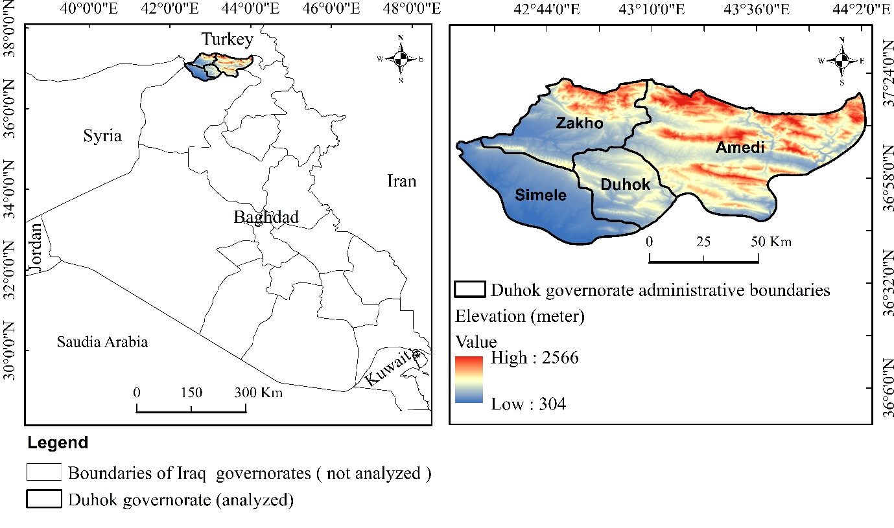
Fig. 1 Study site and administrative boundaries
Historical satellite imagery
Satellite images (30 m spatial resolution and the least cloud cover) from Landsat 5 Thematic Mapper (TM) and Landsat 8 (OLI TIRS) of three historical years (1988, 2008, and 2007), were downloaded ( Table 1) from the Earth Explorer portal of the United States Geological Survey (USGS) (https:/earthexplorer.usgs.gov).
Table 1 Description of the imagery used in the study
Path | Row | Latitude extent | Longitude extent | Bands used (RGB) | Acquisition time
169 | 34 | 36.40º N – 38.53º N | 43.43º E – 46.09º E | 432 (TM) , 543 (OLI) | July 1988, July 2008 (TM); July 2017 (OLI)
169 | 35 | 34.96º N – 37.10º N | 43.03º E – 45.64º E | 432 (TM) , 543 (OLI) | July 1988, July 2008 (TM); July 2017 (OLI)
170 | 34 | 36.37º N – 38.55º N | 41.86º E – 44.56º E | 432 (TM) , 543 (OLI) | July 1988, July 2008 (TM); July 2017 (OLI)
Dataset pre-processing and classification
Liang et al. (2002) argued that in order to obtain accurate quantitative surface information from satellite data, applying radiometric and atmospheric corrections is necessary. The Fast Line-of-sight Atmospheric Analysis of Hypercubes ((FLAASH) settings of the ENVI 5.2 platform was employed to correct the radiometric and atmospheric noises within the used satellite images prior to the classification process. In the setting, the required coefficients were obtained from the metadata of the images. The Imagery scenes were mosaicked with the same time window and year, and the study area was then extracted. For the purpose of accurate surface features identification, various band combinations such as RGB 5, 4, 3 for OLI and RGB 4, 3, 2 for TM were made to facilitate training data collection for the image classification. In addition, during the delineation of the feature classes (training sites), historical and current expert knowledge on the physiography of the study sites and useful supplementary data were incorporated. The following LCLU classes were identified: dense forest, sparse forest, agricultural land, urban area, barren area, and water bodies (Table 2). For every target year, around 130 spectral signatures (training-sits) in small polygons formats were extracted from mosaicked images (Congalton and Green 2019). The MLC which is based on the probability of a certain pixel belonging to a similar spectral distribution or similar pixel aggregate was applied with the spectral signatures to classify the image for each consecutive year. Three LCLU maps were then generated with a spatial resolution of 30 m.
Table 2 Identified LCLU classes from the satellite imagery and their interpretations
LCLU class | Interpretation
Dense forest | Areas covered with oak trees (predominantly Quercus aegilops )
Sparse forest | Areas covered thinly with oak shrubs and tree (predominantly Quercus aegilops )
Agricultural land | Fertile areas used for agricultural activities ,predominantly for crops (wheat and barley)
Urban area | Man-made infrastructure (unnatural surfaces)
Barren area | Waste land and open areas predominantly with annual vegetation covers (e.g. , grass)
Waterbody | Areas covered with water (natural and unnatural)

Classification assessment and change analysis
Accuracy assessment between automated classification data with reference data /ground control points is essential (Congalton and Green 2019) . 39 points out of 130 spectral signature samples (equivalent to 30% of the training dataset for each class) were randomly selected within a GIS environment using ArcMap 10.3 (Foody 2002). The accuracy of the 1988, 2008, and 2017 LCLU maps resulting from the maximum probability classification was assessed by independent datasets. To do this, 234 points spreading across each LCLU map for each year were generated based on an equalizing random sampling technique, and then they exported into Google Earth imagery as a ‘shapefile’ for identification and labelling. After that, the labelled points were used to create an error matrix with classified data (Rosenfield 1986; Van Oort 2007). From the error matrix, we then calculated the Kappa coefficient, overall accuracy, producer’s and user’s accuracy. After conducting the accuracy assessment for the generated LCLU maps between 1988 and 2017, the quantification of the dynamics of changes for each target year 1988, 2008, and 2017 was investigated (i.e., by calculating the area of specific class category per time window (Butt et al. 2015)). Finally, cross-tabulation matrices (Jensen 1996; Pontius Jr and Cheuk 2006) were performed for change detection (Fig. 2 flow chart part A).
Markov Chain model, Cellular automata (CA) model and CA-Markov models
The Markov chain model (MCM) depends on stochastic process which means that how random variable changes over time (Munthali et al. 2020) and the transition probability matrix (Koomen and Borsboom-van Beurden 2011). It has been widely accepted to simulate and predict future land-use change over time (Khwarahm et al. 2020). The predicted future LCLUC usually depend on the transition probability matrix, transition area matrix of two time- period (i.e. t0 to t1) LCLU maps. Therefore, MCM has demonstrated its ability to simulate LCLU change while not providing the right spatial allocation and distribution of LCLU change occurrences (Dbehera et al. 2012; Eastman 2012; Yang et al. 2012). On the other hand, the Cellular Automata (CA) model has the ability to represent non-linear and complex spatially distributed LCLU’s class category (Mishra and Rai 2016). CA model consists of regular grid-cells with each grid in one of a finite number of states, and its main principle is that changes in cell status can be explained by current status and changes in surrounding cells based on the previous status (Guan et al. 2011; He et al. 2014; Liping et al. 2018). Therefore, the CA model can be applied to fill the gap of the spatial dimension limitation of the MCM (Khwarahm et al. 2020).
The CA-Markov is an effective combination between the MCM to predict temporal changes in LCLU and Cellular Automata models to predict spatial LCLUC, hence, the integrated CA-Markov model can be used effectively to predict spatiotemporal changes in LCLUC (Parsa et al. 2016). In this study, an existing modelling technique, the CA-Markov model in the IDRISI 17.0 were adopted to predict LCLUC in the year 2060 for Duhok governorate based on the (1988–2008) and (2008–2017) LCLU maps produced from the maximum likelihood classification after we were satisfied with the accuracy assessment (Fig. 2 part B).
Fig. 2 Study flowchart (part A; represents LCLU classification, accuracy assessment and change analysis, part B; represents CA-Markov validation and LCLU modelling for 2060)

Model validation
Model validation is a crucial step to evaluate the accuracy of predicted data. In this study, the validation was completed by using the classified 2017 LCLU map as reference data against the predicted 2017 LCLU map based on the standard Kappa index of agreement variations, which have been widely used to validate LCLU predictions (Parsa et al. 2016). Kappa variations included: Kappa; (I) for location (Klocation); (II) for standard (Kstandard); (III) for locationStrata (KlocationStrata); and (IV) for no information (Kno) ((Pontius Jr 2000; Pontius Jr 2002; Pontius Jr and Millones 2011). Klocation and KlocationStrata measure the accuracy between reference and predicted map based on certain location and quantity of the LCLU map (Pontius and Malanson 2005; Sayemuzzaman and Jha 2014). For the general agreement between proportions of the reference and modelled maps, regardless of having information on the quantity location of certain class categories Kno is calculated. Kstandard is determined to assess the proportion of the class category that has been correctly correlated by chance. The Kappa values for these variations range from (0 to 1). The accuracy of the agreement is better is the value is closer to 1(Christensen and Jokar Arsanjani 2020).

Results
Land cover maps and accuracy assessment of the classification
The proposed method produces LCLU map of Duhok governorate for 1988, 2008 and 2017 (Fig. 3, 4, and 5). Confusion matrix and the maximum likelihood classification techniques used to estimate the classification accuracy. The overall accuracy and Kappa coefficient calculated from 234 points for the target years are listed in (Tables 3, 4 and 5). The overall kappa coefficients for the consecutive years: 1988, 2008, 2017 were 0.86, 0.89, and 0.92 respectively. The producer and user accuracy for 1988 LCLU map were ranged from 0.83 to 0.94, while for the 2008 and 2017 LCLU were ranged from 0.83 to 1.

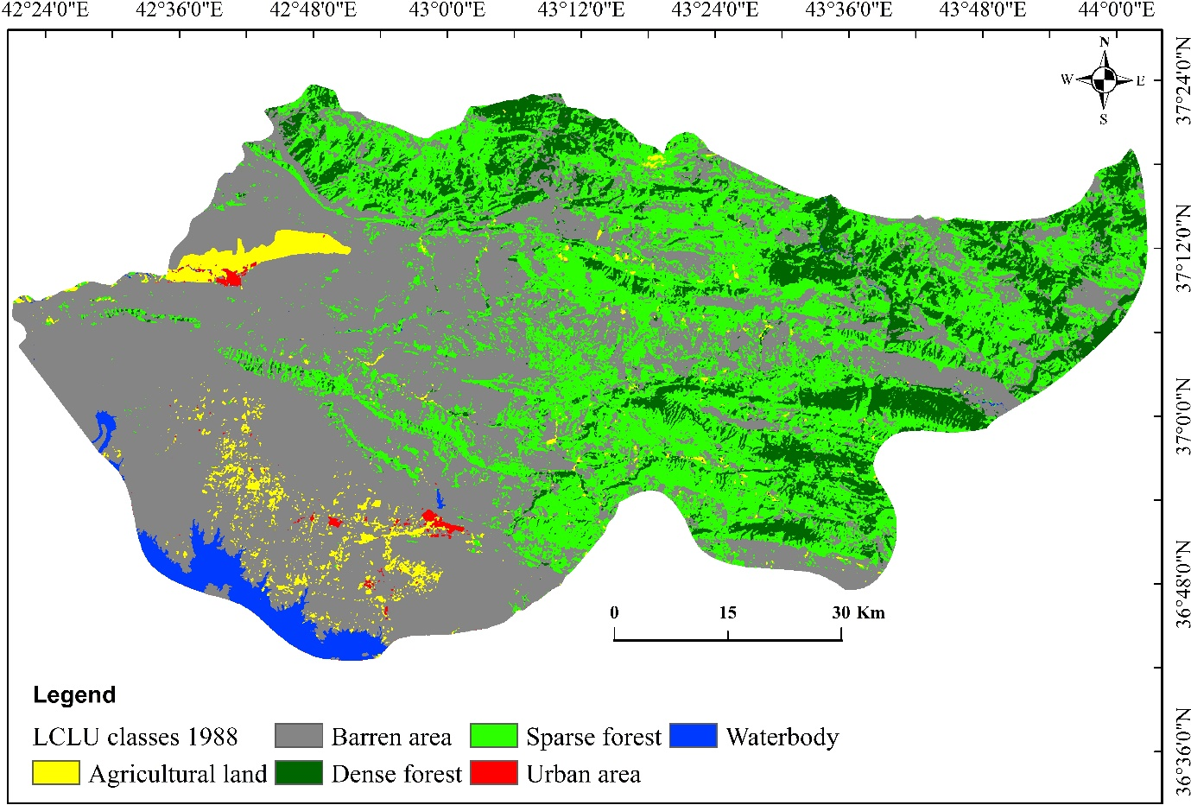
Fig. 3 Classified LCLU map for 1988
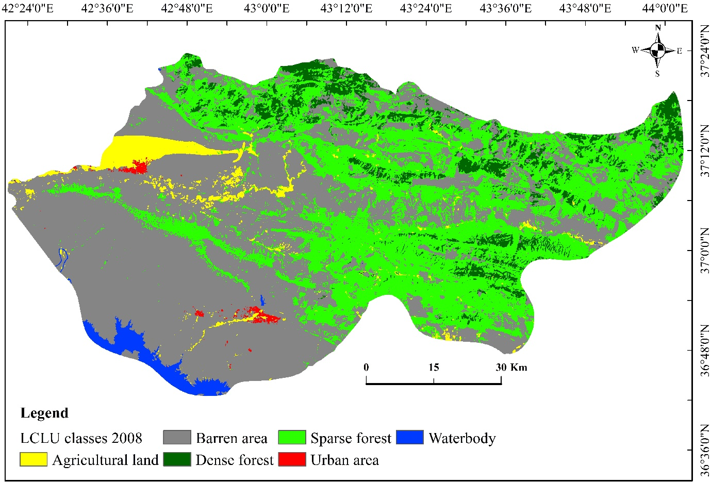
Fig. 4 Classified LCLU map for 2008

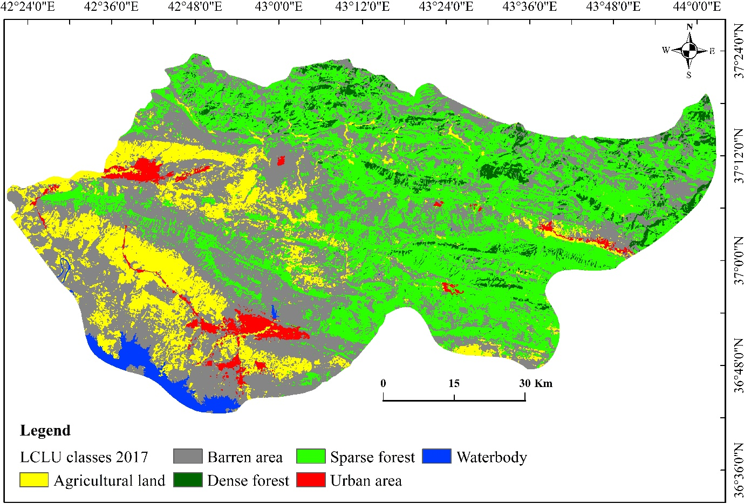
Fig. 5 Classified LCLU map for 2017
Table 3 Accuracy assessment (error matrix) for 1988
Class | Dense forest | Sparse forest | Agricultural land | Urban area | Barren area | Waterbody | Total | User Accuracy
Dense forest | 35 | 4 | 0 | 0 | 0 | 0 | 39 | 0.897
Sparse forest | 6 | 33 | 0 | 0 | 0 | 0 | 39 | 0.846
Agricultural land | 1 | 0 | 35 | 0 | 0 | 3 | 39 | 0.897
Urban area | 0 | 0 | 0 | 35 | 4 | 0 | 39 | 0.897
Barren area | 0 | 0 | 0 | 2 | 37 | 0 | 39 | 0.949
Waterbody | 0 | 0 | 6 | 0 | 0 | 33 | 39 | 0.846
Total | 42 | 37 | 41 | 37 | 41 | 36 | 234 | 0.000
Producer Accuracy | 0.833 | 0.892 | 0.854 | 0.946 | 0.902 | 0.917 | 0 | 0.889
Kappa | 0.867

Table 4 Accuracy assessment (error matrix) for 2008
Class | Dense forest | Sparse forest | Agricultural land | Urban area | Barren area | Waterbody | Total | User Accuracy
Dense forest | 36 | 3 | 0 | 0 | 0 | 0 | 39 | 0.923
Sparse forest | 5 | 34 | 0 | 0 | 0 | 0 | 39 | 0.872
Agricultural land | 0 | 0 | 39 | 0 | 0 | 0 | 39 | 1.000
Urban area | 0 | 0 | 0 | 35 | 4 | 0 | 39 | 0.897
Barren area | 2 | 0 | 0 | 2 | 35 | 0 | 39 | 0.897
Waterbody | 0 | 0 | 0 | 0 | 4 | 35 | 39 | 0.897
Total | 43 | 37 | 39 | 37 | 43 | 35 | 234 | 0.000
Producer Accuracy | 0.837 | 0.919 | 1.000 | 0.946 | 0.814 | 1 | 0 | 0.915
Kappa | 0.897

Table 5 Accuracy assessment (error matrix) for 2017
Class | Dense forest | Sparse forest | Agricultural land | Urban area | Barren area | Waterbody | Total | User Accuracy
Dense forest | 36 | 3 | 0 | 0 | 0 | 0 | 39 | 0.923
Sparse forest | 2 | 37 | 0 | 0 | 0 | 0 | 39 | 0.949
Agricultural land | 0 | 0 | 37 | 0 | 2 | 0 | 39 | 0.949
Urban area | 0 | 0 | 0 | 35 | 4 | 0 | 39 | 0.897
Barren area | 0 | 0 | 4 | 0 | 35 | 0 | 39 | 0.897
Waterbody | 0 | 0 | 1 | 0 | 0 | 38 | 39 | 0.974
Total | 38 | 40 | 42 | 35 | 41 | 38 | 234 | 0.000
Producer Accuracy | 0.947 | 0.925 | 0.881 | 1.000 | 0.854 | 1.000 | 0 | 0.932
Kappa | 0.918

Spatial analysis of LCLU changes classification
The LCLU changes were spatially analysed. As shown in (Table 6), the land cover/land use classes have changed between the period 1988, 2008 and 2017. For instance, between the period (1988-2008) the dense forest and waterbody have decreased by -42.91% (860 km² to 491 km²), and -19.08% (152 km² to 123 km²) respectively, while during that period the sparse forest, agricultural land , urban area and barren area have increased by 13.33%, 16.8%, 16.22% and 2.43% respectively. LCLU changes during the period 2008 - 2017 are slightly different from the period (1988-2008). During that period, the sparse forest has slightly increased by 1.47% while, agricultural land and urban area have significantly increased by 223.2% (300 km² to 973 km²), and 448.84% (29 km² to 161 km²) respectively. In contrast, the dense forest, barren area and waterbody have decreased by -33.43%. -18.69%, and -3.35%, respectively (Table 6).
Table 6 Change quantification (area percentage) for classified LCLU and modelled LCLU map from 1988 to 2060
 | LCLU 1988 |  | LCLU 2008 |  | LCLU 2017 |  | LCLU 2017 modelled |  | LCLU 2060 modelled
Class | Area Km2 | % | Area km2 | % | Area km2 | % | Area km2 | % | Area km2 | %
Dense forest | 860.99 | 12.53 | 491.55 | 7.15 | 327.08 | 4.76 | 260.03 | 3.78 | 241.08 | 3.51
Sparse forest | 2071.78 | 30.15 | 2338.08 | 34.02 | 2372.29 | 34.52 | 2509.69 | 36.52 | 2355.82 | 34.28
Agricultural land | 257.52 | 3.75 | 300.86 | 4.38 | 973.21 | 14.16 | 1124.45 | 16.36 | 916.27 | 13.33
Urban area | 25.51 | 0.37 | 29.64 | 0.43 | 161.99 | 2.36 | 171.41 | 2.49 | 602.19 | 8.76
Barren area | 3504.24 | 50.99 | 3589.38 | 52.23 | 2918.90 | 42.47 | 2715.11 | 39.51 | 2626.19 | 38.21
Waterbody | 152.52 | 2.22 | 123.05 | 1.79 | 119.09 | 1.73 | 91.88 | 1.34 | 131.01 | 1.91
Total | 6872.56 | 100 | 6872.56 | 100 | 6872.56 | 100 | 6872.56 | 100 | 6872.56 | 100

Comparison between actual LCLU and modelled LCLU map of 2017
The degree of agreement between the actual LCLU map and the modelled LCLU map for the 2017 was R² = 0.98 (coefficient of determination) (Fig. 6). The statistical summary for other coefficient variations (kappa variations) for quantity and allocation agreement between the actual LCLU map and the modelled LCLU map) (Table 7) were Kno = 0.8315, Klocation = 0.8267, KlocationStrata = 0.8267, and Kstandard = 0.7978, respectively.

Fig. 6 Relationship between modelled and classified LCLU maps for 2017
Table 7 Categorical comparison between classified LCLU map 2017 and modelled LCLU map 2017; the coefficient of Kappa variations for agreement and disagreement in quantity and allocation
 | Information of Quantity
Information of Allocation | No[n] | Medium[m] | Perfect[p]
Perfect[P(x)] | P(n) = 0.5611 | P(m) = 0.9750 | P(p) = 1.0000
PerfectStratum[K(x)] | K(n) = 0.5611 | K(m) = 0.9750 | K(p) = 1.0000
MediumGrid[M(x)] | M(n) = 0.4782 | M(m) = 0.8556 | M(p) = 0.8452
MediumStratum[H(x)] | H(n) = 0.1429 | H(m) = 0.2859 | H(p) = 0.2869
No[N(x)] | N(n) = 0.1429 | N(m) = 0.2859 | N(p) = 0.2869
AgreementChance = 0.1429
AgreementQuantity = 0.1430
AgreementStrata = 0.0000
AgreementGridcell = 0.5697
DisagreeGridcell = 0.1194
DisagreeStrata = 0.0000
DisagreeQuantity = 0.0250
Kno = 0.8315
Klocation = 0.8267
KlocationStrata = 0.8267
Kstandard = 0.7978

Predicting and mapping LCLU changes
Fig. 7 and 8 show the modelled LCLU map for 2017 and LCLU map for 2060, respectively. Future predictions demonstrated that between 2017 and 2060, dense forest, sparse forest, agricultural land, and barren area will decrease approximately by -26.26% (from 327.08 to 241.08 km²), -0.76% (from 2372.29 to 2355.82 km²), -5.86% (from 973.21 to 916.27 km²), -10.03% (from 2918.9–2626.19 km²), respectively. Whereas, urban area and waterbody will increase approximately by 271.19%, (161.99 to 602.19.8 km²), 10.4% (119.09 to 131.01 km²), respectively (Table 6 and Fig. 9). The proportionality (probability percentage) of changes from one class category to another class is demonstrated in Table 8.

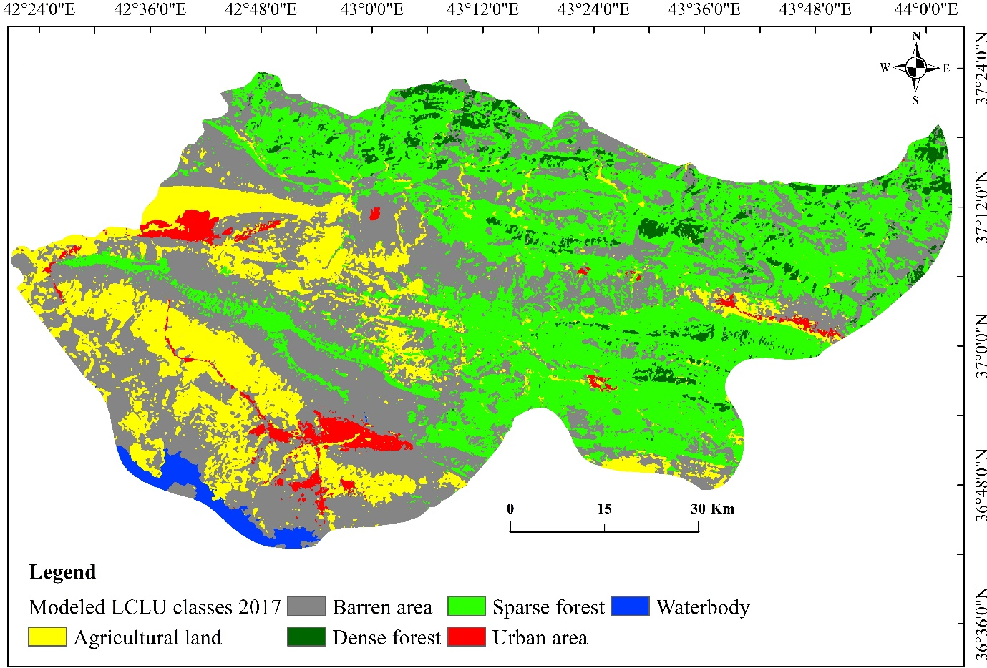
Fig. 7 Modelled LCLU map for 2017

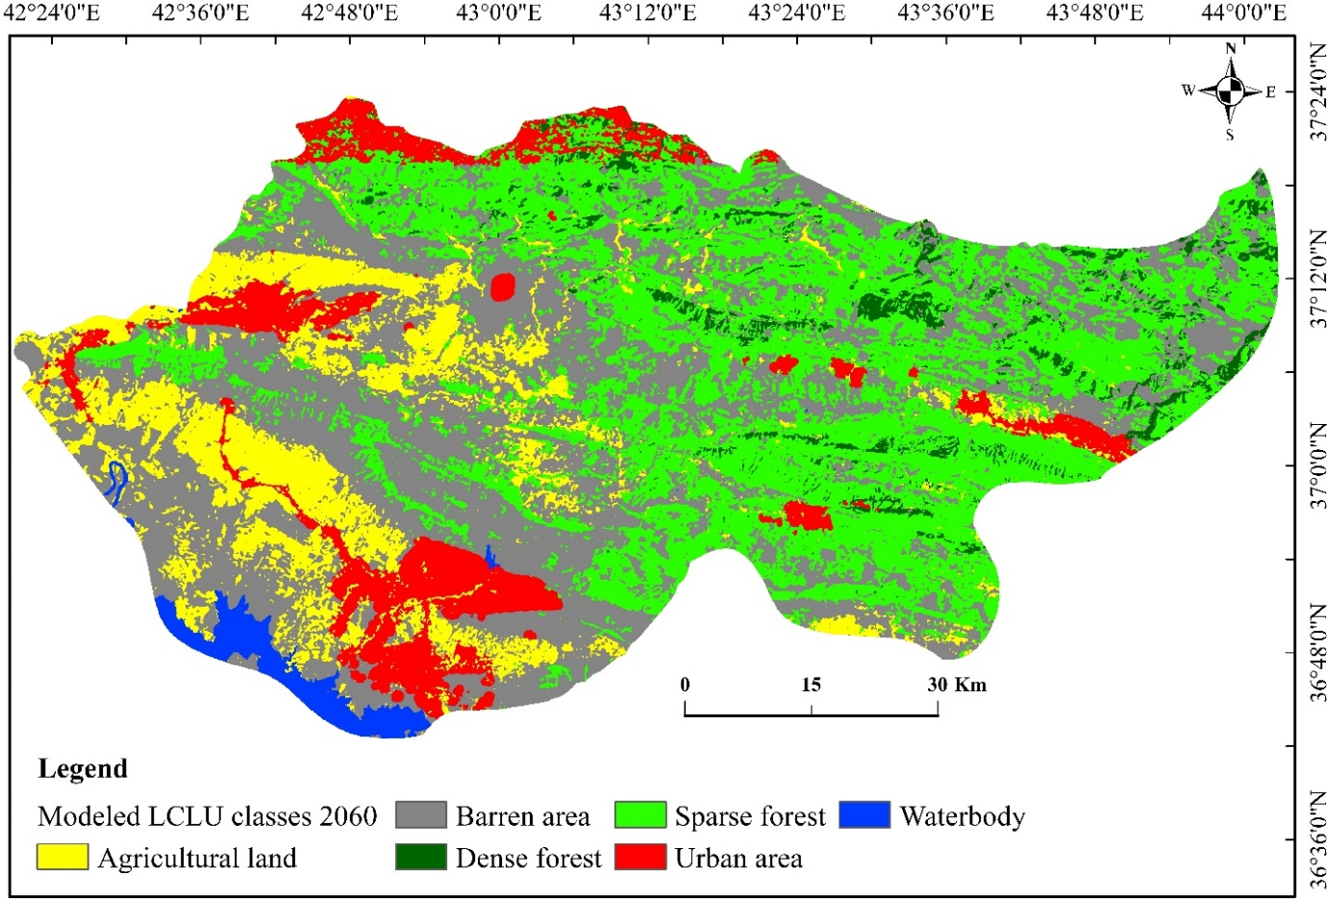
Fig. 8 Modelled LCLU map for 2060

Fig. 9 LCLUC dynamics between 2017-2060 years (area km² percentage)

Table 8 Transition matrix (probability percentage) of class category change from LCLU map 2017 to LCLU map 2060
Class | Dense forest | Sparse forest | Agricultural land | Urban area | Barren area | Waterbody
Dense forest | 0.0415 | 0.3786 | 0.1687 | 0.0486 | 0.3604 | 0.0021
Sparse forest | 0.0368 | 0.2966 | 0.1991 | 0.0651 | 0.3995 | 0.0029
Agricultural land | 0.0266 | 0.2766 | 0.1904 | 0.1453 | 0.3529 | 0.0082
Urban area | 0.0112 | 0.1247 | 0.198 | 0.4423 | 0.2123 | 0.0115
Barren area | 0.0289 | 0.3081 | 0.2354 | 0.1166 | 0.3056 | 0.0054
Waterbody | 0.0075 | 0.0739 | 0.0938 | 0.0352 | 0.1573 | 0.6322

Discussion
In the study of environmental change, ecosystem integrity (e.g., structure and function), urban planning, and sustainability, LCLUC has become a key subject that needs to be acknowledged and addressed. In this study, medium resolution satellite imagery from Landsat were used to derive LCLU maps (i.e. 1988, 2008 and 2017) using the MLC. In addition, future LCLU maps were predicted for year 2017 and 2060 using the synergy Cellular (CA)-Markov model, respectively. Historical socio-economic and instabilities have played some roles in selecting the time of the image acquisition. In 1988, Iraq just ceased 8 years of war with Iran and after that in 1991, Iraq was involved in Gulf war and followed by extensive economic sanctions by the United Nations (UN). Overall, six class categories were identified from the satellite imagery for the selected years. To train and validate the identified classes, two independent resources such as high-resolution Google Earth historical imagery and local expert knowledge were used. In places where resources are limited or access is restricted due to security issues, similar approaches were adopted to generate and validate LCLU classification (Qader et al. 2016; Xie et al. 2019). Theses independent resources were effectively helped producing accurate classification outputs with relatively high Kappa index and user and producer accuracies. Therefore, accurate LCLU maps can reliably be employed as a base for change analysis and prediction (Anderson 1976).
Interesting trends can be seen in the change statistics between 1988, 2008, and 2017. As shown in Table 6, a remarkable decrease was registered for the dense forest from 1988 to 2017. One of the main reasons for this loss could be harvesting the trees without replacing. Over the last few decades, Iraq and its people have suffered the consequences of an inactive economy and limited access to essential services because of successive sanctions, wars and sectarian conflicts (Martin 2018). These critical incidents resulted in burning vast areas of forests and forced thousands of people to migrate from rural areas to cities (Black 1993). In addition, other factors including farming, livestock feeding, mining and plowing the forest soil might have caused forest destruction in this area. The consequences and negative impacts of these events could destruct further the spatial extent of dense forest in the future, as it can be seen in the model prediction for 2060 and the transition probability matrix. Dense forest would predominantly change to spares forest (37%) and barren area (36%) respectively (Table 8), suggesting thinning and clearing activities. This finding is consistent with other work in which similar trends were found (Chapman 1950; Khwarahm 2020; Mosa 2016). Oppositely, the area of sparse forest slightly increased as this class, in some circumstances, can be a transition stage between dense forest and other classes. Respectively, agricultural lands were increased with a clear jump in 2017. This is likely due to the influence of a recent policy that was implemented by the central government which have encouraged local farmers to increase agricultural production particularly wheat. Across Iraq, the central government has allocated silos to buy wheat from farmers for a pre-declared price above the market price (Jongerden et al. 2019).
The land use type that increased the most over the last four decades is urban area, which increased by six times from 0.37% to 2.36% (between 1988 and 2017). Similarly, a substantial increase can be seen in the predicted urban area for 2060. From 2017 to 2060 the increasing trend would be from 2.36 % to 8.76% (almost four times). Agricultural land (by 14%) and barren area (by 11%) would have the highest probability of transition to urban area in 2060 (Table 6), suggesting urbanization shift toward new spatial extent and thus more disturbances. There are several possible explanations for this result. Increasing the population and development of infrastructure can result in accelerating urban expansion (Pandey and Khare 2017). Rapid population growth can be accounted as one of the main drivers of LCLUCs. In the last two decades, like the rest of Middle East, Iraq and KRI have experienced significant population growth and partial economic growth. For instance, in four decades, population has increased from ~12.46 million to ~ 38.275 in Iraq (increased by 308% from 1977 to 2017) (UN 2017). This rapid population growth can be seen particularly in Duhok governorate due its close geographic location to Syria and ISIS occupied areas (e.g., Mosul). The Duhok governorate has a total population of 1.47 million as well as 718,000 displaced people (internally displaced persons (IDPs) and refugees aggregated) (UNHCR 2016). These IDPs and refugees have fled their home because of recent conflicts in Syria and Iraq and posed substantial pressure on urban expansion. In KRI, the majority of IDPs (80% of more than 1 million and refugees (60% out of 250,000) lives in urban areas and sharing the scarce resources (UNHCR 2016). In Addition, the economic progress after 2003 and increase the fiscal income from the central government during 2005-2013 from around $2.5 to $13 billion has promoted new economic planning and community development in KRI (Leezenberg 2015). In accordance with present results, previous studies have demonstrated that urban area in Duhok has increased sprawl in all directions over last four decades (Hassan and Kotval-K 2019; Mohammed 2013).
With regards to the CA-Markov model validation, overall, there are a significant level of agreement between the predicted model outputs and LCLU maps (Table 7). The Kappa statistical values are considered acceptable as far as the reliability of model variation is considered for further use (Landis and Koch 1977; Pontius Jr and Millones 2011) . In some areas, the model might have underestimated the class areas, most likely due to the disagreement quantity value which in turn has impacted the overall model performance. In addition, the overall performance of the model in simulating future LCLU maps for 2060 based on the transition probability matrix of 2017-2060 produced a reasonable accuracy (Table 7). Various values of Kappa coefficient variations for CA-Markov have been reported in literature (e.g. Kstandard of 0.68 (Hyandye and Martz 2017), 0.88 (Rimal et al. 2017), 0.59 Singh et al. (2018) and 0.95 (Munthali et al. 2020). In addition, in terms of area, the overall relationship between the modelled and classified maps, a co-efficient of determination value of (R² = 0.988) was obtained. This result is in line with study of Akbar et al. (2019), which reported the R² = 0.90 between actual and modelled LCLU maps.
Conclusion
Quantifying and predicting spatiotemporal dynamics of LCLUCs has become a prerequisite for planning decisions and conserving the integrity of the ecosystems, particularly urban ecosystem as human population grows. Geospatial technologies together with land surface modellers (e.g., CA-Markov) are effective tools in providing invaluable information on the patterns of LCLCs over space and time. Understanding the patterns of changes would supply guidance to various scientific disciplines, for example, biodiversity conservation, sustainable urban systems, and environmental management actions.
Dense forest in the Duhok governorate has seen remarkable decline from 1988 to 2017, and future predictions demonstrated that this trend would continue (i.e., from 2017 to 2060). Dense forest cover would predominantly convert to spares forest and barren areas, suggesting forest thinning and clearing. Therefore, management actions should focus on protecting the forest areas as part of the sustainable development. Moreover, the most dynamic the land use type that increased the most over the last four decades was urban area, which increased by six times from 0.37% to 2.36% (between 1988 and 2017). Future predictions demonstrated that this trend would continue to increase from 2.36 % (2017) to 8.76% (2060) (i.e., by almost four times). Urbanization would continue to increase predominantly at the cost of agricultural land and barren area.

Declarations:
Funding (Not applicable)
Conflicts of interest/Competing interests (Not applicable)
Availability of data and material (Not applicable)
Code availability (Not applicable)

Acknowledgements
We would like to thank the United States Geological Survey (USGS) to make the Earth Observation data freely available. The support and assistance of the University of Sulaimani, in particular, Department of Biology is highly appreciated.

References

Agha OMAM, Şarlak N (2016) Spatial and temporal patterns of climate variables in Iraq Arabian Journal of Geosciences 9 doi:10.1007/s12517-016-2324-y
Akbar TA, Hassan QK, Ishaq S, Batool M, Butt HJ, Jabbar H (2019) Investigative spatial distribution and modelling of existing and future urban land changes and its impact on urbanization and economy Remote Sensing 11:105
Alkaradaghi K, Ali SS, Al-Ansari N, Laue J (2018) Evaluation of Land Use & Land Cover Change Using Multi-Temporal Landsat Imagery: A Case Study Sulaimaniyah Governorate, Iraq Journal of Geographic Information System 10:247-260
Anderson JR (1976) A land use and land cover classification system for use with remote sensor data vol 964. US Government Printing Office,
Arneth A et al. (2019) IPCC special report on climate change, desertification, land degradation, sustainable land management, food security, and greenhouse gas fluxes in terrestrial ecosystems Summary for Policy Makers Geneva: Intergovernmental Panel on Climate Change (IPCC)
Barredo JI, Demicheli L (2003) Urban sustainability in developing countries’ megacities: modelling and predicting future urban growth in Lagos Cities 20:297-310
Black G (1993) Genocide in Iraq: the Anfal campaign against the Kurds. Human Rights Watch,
Butt A, Shabbir R, Ahmad SS, Aziz N (2015) Land use change mapping and analysis using Remote Sensing and GIS: A case study of Simly watershed, Islamabad, Pakistan The Egyptian Journal of Remote Sensing and Space Science 18:251-259
Chapman G (1950) Notes on forestry in Iraq Empire Forestry Review:132-135
Chen J (2007) Rapid urbanization in China: A real challenge to soil protection and food security Catena 69:1-15
Christensen M, Jokar Arsanjani J (2020) Stimulating Implementation of Sustainable Development Goals and Conservation Action: Predicting Future Land Use/Cover Change in Virunga National Park, Congo Sustainability 12:1570
Congalton RG, Green K (2019) Assessing the accuracy of remotely sensed data: principles and practices. CRC press,
Corner RJ, Dewan AM, Chakma S (2014) Monitoring and prediction of land-use and land-cover (LULC) change. In: Dhaka megacity. Springer, pp 75-97
Dbehera M, Borate SN, Panda SN, Behera PR, Roy PS (2012) Modelling and analyzing the watershed dynamics using Cellular Automata (CA)–Markov model–A geo-information based approach Journal of earth system science 121:1011-1024
Dewan AM, Yamaguchi Y (2009) Land use and land cover change in Greater Dhaka, Bangladesh: Using remote sensing to promote sustainable urbanization Applied geography 29:390-401
Dibs H, Hasab HA, Al-Rifaie JK, Al-Ansari N (2020) An Optimal Approach for Land-Use/Land-Cover Mapping by Integration and Fusion of Multispectral Landsat OLI Images: Case Study in Baghdad, Iraq Water, Air, & Soil Pollution 231:1-15
Eastman J (2012) IDRISI selva: guide to GIS and image processing Clark Labratories, Clark University, Worcester, Massachusetts, USA
Foody GM (2002) Status of land cover classification accuracy assessment Remote sensing of environment 80:185-201
Gibson GR, Campbell JB, Zipper CE (2015) Sociopolitical influences on cropland area change in Iraq, 2001–2012 Applied Geography 62:339-346
Gómez C, White JC, Wulder MA (2016) Optical remotely sensed time series data for land cover classification: A review ISPRS Journal of Photogrammetry and Remote Sensing 116:55-72
Guan D, Li H, Inohae T, Su W, Nagaie T, Hokao K (2011) Modeling urban land use change by the integration of cellular automaton and Markov model Ecological Modelling 222:3761-3772
Habitat U, ESCAP U (2015) The State of Asian and Pacific Cities 2015: Urban transformations Shifting from quantity to quality UN Habitat, London, UK
Hadeel A, Jabbar MT, Chen X (2010) Environmental change monitoring in the arid and semi-arid regions: a case study Al-Basrah Province, Iraq Environmental monitoring and assessment 167:371-385
Hadi SJ, Shafri HZ, Mahir MD Modelling LULC for the period 2010-2030 using GIS and Remote sensing: a case study of Tikrit, Iraq. In: IOP conference series: earth and environmental science, 2014. vol 1. IOP Publishing, p 012053
Hasanlou M, Seydi ST, Shah-Hosseini R (2018) A sub-pixel multiple change detection approach for hyperspectral imagery Canadian Journal of Remote Sensing 44:601-615
Hassan A, Kotval-K Z (2019) A Framework for Measuring Urban Sustainability in an Emerging Region: The City of Duhok as a Case Study Sustainability 11 doi:10.3390/su11195402
He D, Zhou J, Gao W, Guo H, Yu S, Liu Y (2014) An integrated CA-markov model for dynamic simulation of land use change in Lake Dianchi watershed Acta Scientiarum Naturalium Universitatis Pekinensis 50:1095-1105
Hyandye C, Mandara CG, Safari J (2015) GIS and logit regression model applications in land use/land cover change and distribution in Usangu catchment American Journal of Remote Sensing 3:6-16
Hyandye C, Martz LW (2017) A Markovian and cellular automata land-use change predictive model of the Usangu Catchment International journal of remote sensing 38:64-81
Ibrahim F, Rasul G (2017) Urban land use land cover changes and their effect on land surface temperature: Case study using Dohuk City in the Kurdistan Region of Iraq Climate 5:13
Jensen JR (1996) Introductory digital image processing: a remote sensing perspective. vol Ed. 2. Prentice-Hall Inc.,
Jongerden J, Wolters W, Dijkxhoorn Y, Gur F, Ozturk M (2019) The Politics of Agricultural Development in Iraq and the Kurdistan Region in Iraq (KRI) Sustainability 11 doi:10.3390/su11215874
Karki S et al. (2018) Impact of land use land cover change on ecosystem services: a comparative analysis on observed data and people’s perception in Inle Lake, Myanmar Environmental Systems Research 7:25
Khwarahm NR (2020) Mapping current and potential future distributions of the oak tree (Quercus aegilops) in the Kurdistan Region, Iraq Ecological Processes 9:1-16
Khwarahm NR, Qader S, Ararat K, Al-Quraishi AMF (2020) Predicting and mapping land cover/land use changes in Erbil/Iraq using CA-Markov synergy model Earth Science Informatics:1-14
Koomen E, Borsboom-van Beurden J (2011) Land-use modelling in planning practice. Springer Nature,
Kulaksiz S (2015) Kurdistan Regional Government: Economic and Social Impact Assessment of the Syrian Conflict and ISIS Insurgency
Lambin EF, Meyfroidt P (2011) Global land use change, economic globalization, and the looming land scarcity Proceedings of the National Academy of Sciences 108:3465-3472
Landis JR, Koch GG (1977) The measurement of observer agreement for categorical data biometrics:159-174
Leezenberg M (2015) Politics, economy, and ideology in Iraqi Kurdistan since 2003: Enduring trends and novel challenges The Arab Studies Journal 23:154-183
Li W, Dong R, Fu H, Wang J, Yu L, Gong P (2020) Integrating Google Earth imagery with Landsat data to improve 30-m resolution land cover mapping Remote Sensing of Environment 237:111563
Liang S, Fang H, Morisette JT, Chen M, Shuey CJ, Walthall CL, Daughtry CS (2002) Atmospheric correction of Landsat ETM+ land surface imagery. II. Validation and applications IEEE transactions on Geoscience and Remote Sensing 40:2736-2746
Liping C, Yujun S, Saeed S (2018) Monitoring and predicting land use and land cover changes using remote sensing and GIS techniques—A case study of a hilly area, Jiangle, China PloS one 13:e0200493
Martin K (2018) Syria and Iraq ISIS and Other Actors in Historical Context. Feisal al-Istrabadi and Sumit Ganguly (2018) The Future of ISIS: Regional …,
Mishra VN, Rai PK (2016) A remote sensing aided multi-layer perceptron-Markov chain analysis for land use and land cover change prediction in Patna district (Bihar), India Arabian Journal of Geosciences 9:249
Mohammed J (2013) Rapid urban growth in the city of Duhok, Iraqi Kurdistan Region: an integrated approach of GIS, remote sensing and Shannon entropy application International Journal of Geomatics and Geosciences 4:325
Mosa WL (2016) Forest Cover Change and Migration in Iraqi Kurdistan: A Case Study from Zawita Sub-district. Michigan State University. Forestry,
Munthali M, Mustak S, Adeola A, Botai J, Singh S, Davis N (2020) Modelling land use and land cover dynamics of Dedza district of Malawi using hybrid Cellular Automata and Markov model Remote Sensing Applications: Society and Environment 17:100276
Najmaddin PM (2017) Simulating river runoff and terrestrial water storage variability in data-scarce semi-arid catchments using remote sensing. University of Leicester
Natali D (2013) The Kurdistan Region of Iraq: Stabilizer or Spoiler? Georgetown Journal of International Affairs:71-79
Ouyang Z, Fan P, Chen J (2016) Urban built-up areas in transitional economies of Southeast Asia: Spatial extent and dynamics Remote Sensing 8:819
Pandey BK, Khare D (2017) Analyzing and modeling of a large river basin dynamics applying integrated cellular automata and Markov model Environmental Earth Sciences 76:1-12
Parsa VA, Yavari A, Nejadi A (2016) Spatio-temporal analysis of land use/land cover pattern changes in Arasbaran Biosphere Reserve: Iran Modeling Earth Systems and Environment 2:1-13
Pflugmacher D, Rabe A, Peters M, Hostert P (2019) Mapping pan-European land cover using Landsat spectral-temporal metrics and the European LUCAS survey Remote sensing of environment 221:583-595
Pontius GR, Malanson J (2005) Comparison of the structure and accuracy of two land change models International Journal of Geographical Information Science 19:243-265
Pontius Jr RG (2000) Comparison of categorical maps Photogramm Eng Remote Sens 66:1011-1016
Pontius Jr RG (2002) Statistical methods to partition effects of quantity and location during comparison of categorical maps at multiple resolutions Photogrammetric Engineering and Remote Sensing 68:1041-1050
Pontius Jr RG, Cheuk ML (2006) A generalized cross‐tabulation matrix to compare soft‐classified maps at multiple resolutions International Journal of Geographical Information Science 20:1-30
Pontius Jr RG, Millones M (2011) Death to Kappa: birth of quantity disagreement and allocation disagreement for accuracy assessment International Journal of Remote Sensing 32:4407-4429
Qader SH, Dash J, Atkinson PM, Rodriguez-Galiano V (2016) Classification of Vegetation Type in Iraq Using Satellite-Based Phenological Parameters Ieee Journal of Selected Topics in Applied Earth Observations and Remote Sensing 9:414-424 doi:10.1109/jstars.2015.2508639
Ramankutty N, Foley JA (1999) Estimating historical changes in global land cover: Croplands from 1700 to 1992 Global biogeochemical cycles 13:997-1027
Rimal B, Zhang L, Keshtkar H, Haack BN, Rijal S, Zhang P (2018) Land use/land cover dynamics and modeling of urban land expansion by the integration of cellular automata and markov chain ISPRS International Journal of Geo-Information 7:154
Rimal B, Zhang L, Keshtkar H, Wang N, Lin Y (2017) Monitoring and modeling of spatiotemporal urban expansion and land-use/land-cover change using integrated Markov chain cellular automata model ISPRS International Journal of Geo-Information 6:288
Rosenfield GH (1986) Analysis of thematic map classification error matrices Photogrammetric Engineering and Remote Sensing 52:681-686
Sayemuzzaman M, Jha M (2014) Modeling of future land cover land use change in North Carolina using Markov chain and cellular automata model American Journal of Engineering and Applied Sciences 7:295
Seydi ST, Hasanlou M, Amani M (2020) A New End-to-End Multi-Dimensional CNN Framework for Land Cover/Land Use Change Detection in Multi-Source Remote Sensing Datasets Remote Sensing 12:2010
Singh SK, Laari PB, Mustak S, Srivastava PK, Szabó S (2018) Modelling of land use land cover change using earth observation data-sets of Tons River Basin, Madhya Pradesh, India Geocarto international 33:1202-1222
Su S, Xiao R, Jiang Z, Zhang Y (2012) Characterizing landscape pattern and ecosystem service value changes for urbanization impacts at an eco-regional scale Applied Geography 34:295-305
Tan M, Li X, Xie H, Lu C (2005) Urban land expansion and arable land loss in China—a case study of Beijing–Tianjin–Hebei region Land use policy 22:187-196
Tolessa T, Senbeta F, Kidane M (2017) The impact of land use/land cover change on ecosystem services in the central highlands of Ethiopia Ecosystem services 23:47-54
UN (2017) World population prospects: the 2017 revision, key findings and advance tables Department of Economics and Social Affairs PD, editor New York: United Nations
United Nations High Commissioner for Refugees (UNHCR) 2016. Displacement as challenge and opportunity Urban profile: Refugees, internally displaced persons and host community Duhok Governorate, Kurdistan Region of Iraq August 2016. https://reliefweb.int/sites/reliefweb.int/files/resources/DuhokUrbanProfileRefugeesIDPsandHostCommunityEnglishVersionUNHCRandDSONov.2016.pdf (Accessed 30/12/2020)
Van Oort P (2007) Interpreting the change detection error matrix Remote Sensing of Environment 108:1-8
Wang SW, Gebru BM, Lamchin M, Kayastha RB, Lee W-K (2020) Land Use and Land Cover Change Detection and Prediction in the Kathmandu District of Nepal Using Remote Sensing and GIS Sustainability 12:3925
Wu J, Jenerette GD, Buyantuyev A, Redman CL (2011) Quantifying spatiotemporal patterns of urbanization: The case of the two fastest growing metropolitan regions in the United States Ecological Complexity 8:1-8
Wu W, Zhao S, Zhu C, Jiang J (2015) A comparative study of urban expansion in Beijing, Tianjin and Shijiazhuang over the past three decades Landscape and Urban Planning 134:93-106
Xie S, Liu LY, Zhang X, Yang JN, Chen XD, Gao Y (2019) Automatic Land-Cover Mapping using Landsat Time-Series Data based on Google Earth Engine Remote Sensing 11 doi:10.3390/rs11243023
Xu Y, Chan EH, Yung EH (2015) Overwhelming farmland conversion for urban development in transitional China: Case study of Shanghai Journal of Urban Planning and Development 141:05014013
Yang X, Zheng X-Q, Lv L-N (2012) A spatiotemporal model of land use change based on ant colony optimization, Markov chain and cellular automata Ecological Modelling 233:11-19
Zhu Z, Woodcock CE (2014) Continuous change detection and classification of land cover using all available Landsat data Remote sensing of Environment 144:152-171

