Seasonal fission and fusion of killer whale (Orcinus orca) social structure at sub-Antarctic Marion Island

Rowan K. Jordaan¹
Ryan R. Reisinger^{2,3}
W. Chris Oosthuizen⁴
P. J. Nico de Bruyn¹

¹Mammal Research Institute, Department of Zoology and Entomology, University of Pretoria, Pretoria, South Africa
²Centre d'Etudes Biologiques de Chizé (CEBC), UMR 7372 CNRS‐La Rochelle Université, Villiers‐en‐Bois, France.
³Institute for Marine Sciences, University of California Santa Cruz, Santa Cruz, California, USA.
⁴Marine Apex Predator Research Unit, Institute for Coastal and Marine Research and Department of Zoology, Nelson Mandela University, Port Elizabeth 6031, South Africa

Abstract

Variation in the distribution and abundance of food resources are key factors affecting animal sociality. In environments with variable resources, dynamic social organisation - such as the fission and fusion of groups – is thought to increase the benefits of group living, while reducing the costs. We investigated the relationship between social organisation and prey abundance in a highly social predator, the killer whale (Orcinus orca). This was achieved by analysing 12 years (2006-2018) of seasonally delineated (coinciding with high and low prey abundances) association data obtained from nearly 90,000 identification photographs of killer whales in-shore at Marion Island in the sub-Antarctic Indian Ocean. Association network measures were compared between periods using randomised association matrices. Half-weight association index, degree, number of modules and group size were all greater during periods of high prey abundance while mean distance, centrality and modularity were lower during this same period. Results suggest that killer whales at Marion Island were more social, formed larger groups and had more associations during periods of high prey abundance. During periods of lower prey abundance, fewer interactions, stronger clustering and more division in the association network were observed. These results indicate that the social organisation of this population of killer whales is seasonally dynamic, with increased sociality measures coinciding with periods of higher prey abundance. These results are similar to those of other social species, emphasising the importance of resource abundance as driver of social structure in animal societies.

Key words: Association; delphinids; network; prey abundance; seasonality; sociality

Introduction

Annual variations in meteorological conditions (e.g. rainfall, temperature, ocean currents and wind patterns) result in climatic seasonality and associated periodicity in the distribution of resources, such as food, water and nutrients, that are essential for animal survival (Boyce et al., 1979). Animals respond to seasonal variation in the distribution of resources in various ways, including behavioural variation (Creel & Winnie Jr, 2005).
Some animals respond to changes in resource distribution and availability through fine-scale changes in their social structure (Whitehead & Kahn, 1992). One such response is a process called “fission-fusion”, where individuals join and leave social groups dynamically, thereby increasing foraging efficiency and resource exploitation while maintaining the benefits of group-living (Krumer, 1971). Fission-fusion dynamics occur over both short (e.g. hours) and long (e.g. years) time frames (Whitehead & Kahn, 1992; Archie et al., 2006) and are found in numerous taxonomic groups, including birds (Aplin et al., 2012), fish (Croft et al., 2003) and mammals (e.g., bats [Kerth et al., 2011], spotted hyenas, Crocuta crocuta, [Holekamp et al., 1997] and lions, Panthera leo [Mbizah et al., 2020]). Fission-fusion dynamics have, however, been best studied in animals typically considered highly cognitive, such as primates (Smuts et al., 1987), elephants (Archie et al., 2006) and dolphins (Wiszniewski et al., 2009).
Fission-fusion dynamics are associated with costs and benefits at the individual level. When smaller groups are formed (i.e. fission), individuals experience greater predation pressure and reduced ability to cooperatively defend resources (Manson & Wrangham, 1991; Beauchamp, 2017). However, fission can be beneficial as it reduces local resource competition and manages social conflicts (Asenio et al., 2008; Smith et al., 2008). Conversely, an increase in group size (i.e. fusion) has the potential to create conflict between individuals and can increase foraging costs (Aureli & Schaffner, 2007). Fusions can, however, be beneficial as individuals in larger groups experience reduced predation pressure, increased hunting efficiency and are better able to cooperatively defend resources from smaller groups (Manson & Wrangham, 1991; Beauchamp, 2017). Resource abundance is therefore an important determinant of fission-fusion dynamics; the costs associated with fusion events, resulting in larger groups, are lowest when resources are abundant (see Macdonald & Johnson, 2015 for review).
Seasonal resource variation is particularly evident in high-latitude environments such as the Southern Ocean, where broad- and fine-scale spatial and temporal fluctuations in various physical properties of regional water masses occur (Rintoul et al., 1997). These fluctuations influence the distribution, diversity, abundance and phenology of biological communities occupying this ocean (Rodhouse & White, 1995; Arrigo et al., 1998; Field et al., 2007; Lascara et al., 2007). Southern Ocean marine predators such as seals, penguins and flying seabirds often breed ashore in colonies during the short milder spring and summer season. In the case of Marion Island in the sub-Antarctic Indian Ocean, the peak abundance of breeding seals and penguins occur between September and December (du Plessis et al., 1994; Crawford et al., 2003; Kirkman et al., 2004; Hofmeyr et al., 2007). This period is also associated with increased inshore abundance of killer whales, Orcinus orca, at Marion Island in response to the influx of breeding seals and penguins (Condy et al., 1978, Reisinger et al., 2011a).
Despite their abundance peaking between September and December, killer whales are observed foraging in the inshore waters at Marion Island throughout the year (Condy et al., 1978; Keith et al., 2001; Reisinger et al., 2011a). These killer whales prey mainly on seals (southern elephant seals, Mirounga leonina, and Subantarctic fur seals, Arctocephalus tropicalis) and penguins (king penguins, Aptenodytes patagonicus, and macaroni penguins, Eudyptes chrysolophus) when foraging in-shore. Additionally, they likely feed on Patagonian toothfish, Dissostichus eleginoides, when not at Marion Island (Reisinger et al., 2011a; 2016).
Social group sizes of killer whales at Marion Island range in size from 1 to 16 individuals with a modal group size of 3 individuals (Tosh et al., 2008; Reisinger et al., 2017). Superficially, this makes them socially and ecologically similar to killer whales at the Galápagos Archipelago (mean group size = 4, range = 1-15) that prey opportunistically on a range of species (Denkinger et al., 2020), killer whales in the Atlantic (mean = 5, range = 1-15) that hunt both seal and herring Clupea harengus (Beck et al., 2012) and the “Bigg's” (formerly "transient") killer whales of the Eastern North Pacific (ENP) (mean = 2.4, range = 2-10), which feed on marine mammals (Ford et al., 1998; Baird & Whitehead, 2000; Ford, 2000). Relatively small group sizes, as observed in these populations, are thought to be the most energy efficient per-capita when preying on relatively large animals such as marine mammals. In ENP “Bigg's” killer whales, group sizes are consistent with the ‘maximisation of energy intake’ hypothesis where the risk of energy shortfall is minimised whilst foraging (Baird & Dill, 1996). An increase or decrease in group size from the mean would presumably decrease the per-capita energy intake of killer whales in these populations. However, group sizes in killer whales and other social predators are sometimes larger than the predicted optimum size, likely to better protect offspring, defend kills, when resource abundance is greater (resulting in increased energy intake) and for other social functions (Arnbom et al., 1987; Baird & Dill, 1996; Carbone et al., 1997; Alava et al., 2013). For example, larger than optimum group sizes are observed in lions and African wild dogs, Lycaon pictus, since the risk of kleptoparasitism by spotted hyenas decreases as hunting group size in these predators increases (Caraco & Wolf, 1975; Carbone et al., 1997).
Change in resource abundances may therefore evoke fine-scale changes in social structure such as the increase and decrease of group size, which will affect the number and nature of social relationships among group members. A better understanding of these changes provides insight into the potential ecological drivers of fission-fusion dynamics. We addressed this subject using data from a highly social top predator, the killer whale. We investigated the “seasonality” of social structure (group size and measures of association) of killer whales at Marion Island, i.e. how social structure changes between periods of high and low seasonal prey abundance. Some aspects of killer whale social structure at Marion Island have been investigated (Tosh et al., 2008; Reisinger et al., 2017) but differences in social structure between seasons are not yet known. Short-term fission-fusion has, however, been suggested to be present in this population due to the presence of unrelated individuals within the same social groups indicating a lack of philopatry (Reisinger et al., 2017).

Methods

Ethical note

The Animal Ethics Committee (AEC) of the Faculty of Veterinary Science, University of Pretoria provided ethics clearance for this study (EC077-15).

Study area

Marion Island is the largest island (296 km²) in the Prince Edward Islands archipelago (46°54’ S, 37°45’ E) and lies approximately 22 km south west of neighbouring Prince Edward Island (45 km²) in the sub-Antarctic Southern Indian Ocean. The archipelago is situated some 1800 km south east of South Africa, 2300 km north of Antarctica and 950 km west of Îles Crozet, the nearest landmass.

Data collection

Between May 2006 and April 2018, identification photographs of killer whales were collected during land-based observations at Marion Island (Jordaan et al., 2020). Photographs were taken during opportunistic sightings while doing other fieldwork or during dedicated observation sessions where trained observers would search for killer whales at a location for a predetermined, uninterrupted, period from 2-10 hours. Dedicated observations were performed throughout the year at various locations around the island, covering areas of the coastline most frequented by killer whales (Keith et al., 2001; Reisinger et al., 2015). During all sightings, the observer would attempt to photograph the dorsal fins and saddle-patches of all individuals in the group for as long as the group was in photographic range. Additionally, the groups’ size, age/sex composition and movement direction were estimated and later confirmed after photographic identification. Age classes used in this study were calf (male and female: 0 to 3 years), juvenile (male: 3-13 years, female: 3 to 10 years) and adult (male > 13 years, female > 10 years) (Olesiuk et al., 1990; Best et al., 2010). Sexes were only assigned to individuals that had reached sexual maturity or where sex-specific ventral markings were clearly observed. Sexual maturity was determined when females gave birth to calves or when no growth in fin size over a five-year period was evident (Olesiuk et al., 1990).

Photographic identification

Individual killer whales were identified through careful examination of any nicks, notches or mutilations in dorsal fins and saddle patches and through comparison to individuals in existing photographic identification catalogues (Reisinger & de Bruyn, 2014; Jordaan et al., 2019). A quality score, ranging from 1 (poor) to 5 (excellent), was assigned to all photographs and was based on the size, level of obscurity and angle of the dorsal fin in the photograph as well as lighting, exposure and focus. Analyses were done using only identifications of killer whales obtained from photographs with a quality score ≥3 (Reisinger et al., 2011b). To further strengthen the analyses, we excluded individuals (n = 15) that were seen less than four times during the study period (Tosh et al., 2008).

Social analysis

Social structure refers to a set of interactions between individuals that combine to form community dynamics (Hinde, 1976). A social network is a measure of social structure and consists of nodes (representing individuals, groups or other entities) and edges (the relationships that connect nodes). Edges typically represent the manner and magnitude of how nodes associate or interact and may have numeric values (weighted edges) describing the strength of the relationship (Farine & Whitehead, 2015). To determine measures of association for killer whales at Marion Island, we performed social network analyses in R (R Core Team, 2020) with the packages ‘asnipe’ (Farine, 2019) and ‘igraph’ (Csardi & Nepusz, 2006).
The data format for these analyses was an individual identification matrix where each row represented a group and each column an individual (i.e. node). In each row, a value of 1 represented an individual that was observed to be present in the given group and a value of 0 represented individuals that were not observed in the group (Farine, 2013). Individuals were considered to be part of the same group when they were photographically identified in the same group. In the field, a group was defined as all individuals within visual range of the observer that were in the same behavioural state (e.g. foraging, travelling, resting etc.) and moving in the same direction (Ford, 1989). Individuals within the same group were assumed to be associated according to ‘gambit of the group’ (Whitehead & Dufault, 1999). Group delineation was easily achievable in our study due to the spatial and temporal separation between nearly all sightings. For analyses, calendar days were defined as sampling periods, and we assumed that observed associations were maintained for the entire day. If an individual was observed in multiple groups during a sampling period (day), it was included in each group that it was observed in for that sampling period. The data were subdivided into two periods across all years, representing periods within the year when killer whale and prey abundance was greatest (September-December: ‘peak’) and lowest (January-August: ‘off-peak’) (Reisinger et al., 2011a).

We calculated the following measures of association for the weighted association networks obtained for peak and off-peak periods:
Dyad level metrics:
- Half-weight association index (HWI): an estimate of the proportion of time that two individuals spend together (Cairns & Schwager, 1987). This index was chosen as it reduces bias when not all members of a group are observed/identified during a sampling period.
- Strength: the sum of the weights of the adjacent associations for each individual in the association network. The greater the strength, the more closely associated individuals are (Barrat et al., 2004).
- Degree: the total number of associations per individual in the association network.
Network level metrics:
- Mean distance: the average path length in the association network determined by calculating the shortest paths between all pairs of individuals in the network. The smaller the mean distance, the shorter the average distance and the closer the association between individuals (West, 1996).
- Centrality (Closeness centrality): a measure of network-level centralisation determined by the sum of the distances between one individual and all other individuals in the association network. If this distance is small, the closeness centrality is high (Beauchamp & Murray, 1965; Wasserman & Faust, 1994).
- Modularity: a function to detect the quality of module division within the association network by calculating the leading non-negative eigenvector of the modularity matrix of the graph (Newman, 2006). The greater the modularity, the greater the strength of division of the association network.
- Number of modules: the number of social modules within the association network determined by Newman’s (2006) eigenvector-based function for modularity.
- Lagged association rate (LAR): a measure of the probability that an individual is observed re-associating with another individual at a given time lag (Whitehead, 2008).

To test the null hypothesis that there is no variation between peak vs off-peak periods, a set of ‘random’ association matrices were created to compare to the real (observed) matrix for each period (Whitehead et al., 2005). This ‘random’ set of association matrices was created through randomisations of the data stream, which involved assigning each group a season identifier (peak or off-peak) and randomising these sets of labels within each year while controlling for group size. This method keeps the number of groups within each season constant but permutes during which period specific groups occur (Franz & Alberts, 2015).
We randomised the data stream 1,000 times. Measures of association were calculated for random networks of each period and the difference between periods (peak minus off-peak) was compared to observed differences (peak minus off-peak). Statistical significance (P values) was calculated as the proportion of times the test statistics of the permuted data (i.e. ‘random’ association matrices) were more extreme than the test statistics of the real data (i.e. observed matrices) (Whitehead et al., 2005).
Data (igraph objects) were converted to 'GEXF' (Graph Exchange 'XML' Format) graph files using the ‘rgexf’ package (Vega Yon, 2020). Plots were constructed in Gephi (Bastian et al., 2009) using the Louvain method (Blondel et al., 2008) for layout and nodes are coloured according to Newman’s (2006) eigenvector-based function for modularity. Differences in group size between periods were compared with a Welch Two Sample t-test (Welch, 1938).

Results

We conducted 1,997 dedicated killer whale observation sessions totalling 11,158 hours from May 2006 to April 2018. Throughout this time, 89,792 photographs were taken across 2,668 sightings occurring during observation sessions (0.24/hr) and during 2,071 opportunistic sightings. A total of 41,763 suitable photographs (quality score ≥3) were obtained from 2,496 sightings with 1,810 of these sightings occurring within the peak period and 686 occurring during the off-peak period (Figure 1a) (Table 1). Fifty-two individual killer whales were seen at least four times; 16 of these were calves born to known individuals during the study.
Association network analyses indicated variation between network statistics measured during different periods of the year (Table 2) with significant differences in HWI, strength, centrality, modularity and number of modules between peak and off-peak periods (Table 3). Despite being significant, the permuted difference was greater than the observed difference for HWI and strength while opposite differences (i.e. positive vs. negative) were observed for centrality, modularity and the number of modules (Table 3). In the peak period, LAR is initially more stable than that in the off-peak period which steadily declines. Initially, LAR during the peak period is higher than that for off-peak but both peak and off-peak LAR gradually decay to similar levels before sharp declines after 900 days (Figure 2). Group size during the peak period (mean = 3.74; 95% confidence interval (CI) = 3.68 - 3.81; range = 1-17) was significantly greater than the mean group size during the off-peak period (mean = 2.98; CI = 2.90-3.05; range = 1-10) (t_{3903.9} = 15.22, P < 0.001) (Figure 3; Table 2).
Peak and off-peak network plots (Figure 4) show the differences in network and module structure between periods, as indicated by the network statistics. These plots show fewer nodes and fewer connections between nodes in the off-peak period compared to the peak period. Group composition associations were different between periods. This can be seen with M014 et al. who combined with M001 et al. during the peak period and M045 et al. during the off-peak period. M001 et al. and M045 et al. formed separate groups during the off-peak and peak periods, respectively, illustrating different fission-fusion tactics between social groups. As a whole, more division in the network can be seen in the off-peak period, with stronger within clustering of groups.
Overall, HWI, strength and the number of modules were greater during the peak period while centrality and modularity were lower during the peak period. These differences suggest that killer whales were more social during the peak period as individuals had higher probabilities of socialising (HWI), formed stronger associations (strength), the population was less divided (number of modules, centrality and modularity) and groups were larger (group size).

Discussion

Killer whale social structure at Marion Island varied significantly between seasons with fission-fusion dynamics evident. During ‘peak’ periods when killer whale and prey abundance is greatest in-shore at Marion Island, killer whales were more social and formed a fluid association network consisting of more groups that were larger in size. Killer whales spent more time with other killer whales (evidenced by higher HWI) and formed stronger associations (strength) during peak periods. There were also more subgroups within the network (number of modules) and the average group size of associating individuals was greater (group size) during peak periods. Stronger clustering and division and fewer interactions between social groups were observed in the association network during the off-peak period. There was a decrease in centrality and modularity during the peak period, indicating that the sum of all distances between individuals (i.e. the broadness of the network) increased (centrality) and the strength of division in the association network decreased (modularity).
Ultimately, these results indicate that in this killer whale population, fission and fusion of the social network occurs during off-peak and peak periods, respectively, with fission occurring when resources are constrained and fusion when resources are high (Wittemyer et al., 2005). Killer whales are known to benefit from fusion and larger group sizes in the presence of larger and/or more abundant prey, as their net rate of energy intake is then maximised (Baird & Whitehead, 2000). Although prey may be more likely to detect larger groups of killer whales (Baird & Dill, 1996), hunting success may increase through cooperative hunting strategies (Baird & Whitehead, 2000). Cooperative hunting strategies also benefit other social predators such as wolves, Canis lupus, which increase group size when targeting large, difficult to hunt species such as bison, Bison bison, resulting in an increased hunting success rate (MacNaulty et al., 2014). Similarly, killer whales in the Galápagos, Punta Norte and ENP (“Bigg's”) occasionally increase group size to hunt cetaceans with greater success (Hoelzel, 1991; Baird & Whitehead, 2000; Alva et al., 2013; Denkinger et al., 2020).
Reduced competition and maximised net rate of per capita energy intake are likely the main benefits that Marion Island killer whales experience by fission events and a reduction of group size when prey abundances are lower (January-August). Similar results were reported for ‘southern residents’ in the ENP where the social network was less interconnected during years of low Chinook salmon, Oncorhynchus tshawytscha, abundance (Foster et al., 2012). Lower prey availability results in increased time spent searching for prey and further travel distances, therefore decreasing opportunities for social interactions, leading to smaller group sizes with less interconnectivity (Felleman et al., 1991; Nickol & Shakleton, 1996; Parsons et al., 2009). Smaller groups of killer whales have the benefit of reduced probability of detection by prey and less potential for social conflicts but they sacrifice potential cooperative hunting opportunities and calf defence (Baird & Dill, 1996; Baird & Whitehead, 2000; Smith et al., 2008).
The abundance of the Marion Island killer whale populations’ primary prey is likely the main driver of their fission-fusion dynamics. However, seasonal variation in diet composition, not only absolute prey abundance, likely influences these social dynamics too. For example, different groups of Atlantic killer whales in the same social network show different levels of association dependent on prey, with groups hunting seals being smaller and displaying lower levels of association compared to larger, more closely associated groups that hunt herring (Beck et al., 2012). Similarly, in wolves from Yellowstone National Park, smaller packs (2-6 individuals) hunted elk, Cervus elaphus, while larger packs (9-13 individuals) hunted bison (MacNaulty et al., 2014). Similar patterns may be present in Marion Island killer whales. However, to what extent, or if, there is fine-scale temporal variation in the diet of social groups at Marion Island is uncertain. Furthermore, even less is known about social structure and potential fission-fusion dynamics of social groups when they are not observed inshore at Marion Island, when they are potentially foraging for Patagonian toothfish or other prey (Reisinger et al., 2015; 2016).
Although seasonal fissions and fusions of killer whale social structure were evident at Marion Island, these dynamics may potentially also be driven by primary factors other than per-capita energy maximisation. Additional explanations for observed seasonal fusion, and observed differences in fission-fusion strategies between social groups, may include fusions for social reasons such as mating, calf protection and alloparental care, although these are difficult to observe and measure in cetaceans (Packer et al., 1990; Beauchamp, 2017). For example, when facing increased predation threats, sperm whales Physeter macrocephalus increase group size to protect calves (Arnbom et al., 1987). Similarly, in lions, larger group sizes offer greater protection for their young and the increased ability to defend territories for long periods (Packer et al., 1990). Lastly, the social network characteristics we observed may have been influenced by our inclusion of all age classes in the analyses (Whitehead, 2008) although this should not account entirely for the observed differences between periods, since any biases should be similar in both periods.
Greater levels of association and increases in group size shown by killer whales at Marion Island during periods of greater prey availability are comparable to the responses made by other social species under similar situations (e.g. spotted hyenas [Smith et al. 2008], lions [Mbizah et al., 2020], wolves [MacNaulty et al., 2014], sperm whales [Whitehead & Kahn, 1992]). Therefore, fission-fusion events are likely largely driven by the net rate of energy gain per capita, particularly in this population of killer whales.

References

Alava, J.J., Smith, K.J., Hern, J,O., Alarcón, D., Merlen, G., & Denkinger, J. (2013). Observations of killer whale (Orcinus orca) attacks on Bryde's whales (Balaenoptera edeni) in the Galápagos Islands. Aquatic Mammals, 39, 196-201.

Aplin, L.M., Farine, D.R., Morand-Ferron, J., & Sheldon, B.C. (2012). Social networks predict patch discovery in a wild population of songbirds. Proceedings of the Royal Society B, 279, 4199-4205.

Archie, E.A., Moss, C.J., & Alberts, S.C. (2006). The ties that bind: genetic relatedness predicts the fission and fusion of social groups in wild African elephants. Proceedings of the Royal Society B, 273, 513-522.

Arnbom, T., Papastavrou, V., Weilgart, L.S., & Whitehead, H. (1987). Sperm whales react to an attack by killer whales. Journal of Mammalogy, 68, 450-453.

Arrigo, K.R., Worthen, D., Schnell, A., & Lizotte, M.P. (1998). Primary production in Southern Ocean waters. Journal of Geophysical Research, 103(C8), 15587-15600.

Asensio, N., Korstjens, A.H., Schaffner, C.M., & Aureli, F. (2008). Intragroup aggression, fission–fusion dynamics and feeding competition in spider monkeys. Behaviour, 145(7), 983-1001.

Aureli, F., & Schaffner, C.M. (2007). Aggression and conflict management at fusion in spider monkeys. Biology Letters, 3, 147-149.

Baird, R.W., & Dill, L.M. (1996). Ecological and social determinants of group size in transient killer whales. Behavioral Ecology, 7, 408-416.

Baird, R.W., & Whitehead, H. (2000). Social organization of mammal-eating killer whales: Group stability and dispersal patterns. Canadian Journal of Zoology, 78, 2096-2105.

Barrat, A., Barthelemy, M., Pastor-Satorras, R., & Vespignani, A. 2004. The architecture of complex weighted networks, Proceedings of the National Academy of Sciences of the United States of America, 101, 37-47.

Bastian, M., Heymann, S., & Jacomy, M. (2009). Gephi: an open source software for exploring and manipulating networks. International AAAI Conference on Weblogs and Social Media.

Beauchamp, MA. (1965). "An improved index of centrality." Behavioral Science, 10(2), 161-163.

Beauchamp, G. (2017). Disentangling the various mechanisms that account for the decline in vigilance with group size. Behavioural Processes, 136, 59-63.

Beck, S., Kuningas, A., Esteban, R., & Foote, A.D. (2012). The influence of ecology on sociality in the killer whale (Orcinus orca). Behavioral Ecology, 23(2), 246-253.

Bigg, M.A., Ellis, G.M., Ford, J.K.B., Balcomb, K.C. (1987). Killer whales: a study of their identification, genealogy, and natural history in British Columbia and Washington State. Phantom Press and Publishers, Nanaimo, BC, Canada.

Best, P.B., Meÿer, M.A., & Lockyer, C. (2010). Killer whales in South African waters – a review of their biology. African Journal of Marine Science, 32, 171-186.

Blondel, V.D., Guillaume, J-L., Lambiotte, R., & Lefebvre, E. (2008). Fast unfolding of communities in large networks. Journal of Statistical Mechanics: Theory and Experiment, 10, P1000.

Boyce, M.S. (1979). Seasonality and patterns of natural selection for life histories. American Naturalist, 114, 569-583.

Cairns, S., & Schwager, S. (1987). A comparison of association indices. Animal Behaviour, 35, 1454-1469.

Caraco, T., & Wolf, L.L. (1975). Ecological determinants of group sizes of foraging lions. The American Naturalist, 109, 343-352.

Carbone, C., Du Toit, J.T., & Gordon, I.J. (1997). Feeding success in African wild dogs: Does kleptoparasitism by spotted hyenas influence hunting group size? Journal of Animal Ecology, 66(3), 318-326.

Condy, P.R., van Aarde, R.J., & Bester, M.N. (1978). The seasonal occurrence and behaviour of killer whales Orcinus orca, at Marion Island. Journal of Zoology, 184, 449-464.

Crawford, R.J.M., Cooper, J., & Dyer, B.M. 2003. Population of the macaroni penguin Eudyptes chrysolophus at Marion Island, 1994/95–2002/03, with information on breeding and diet. African Journal of Marine Science, 25, 475-486.

Creel, S., & Winnie, Jr. J.A. (2005). Responses of elk herd size to fine-scale spatial and temporal variation in the risk of predation by wolves. Animal Behaviour, 69, 1181-1189.

Croft, D.P., Arrowsmith, B.J., Bielby, J., Skinner, K., White, E., Couzin, I.D., Magurran, A.E., Ramnarine, I., & Krause, J. (2003). Mechanisms underlying shoal composition in the Trinidadian guppy, Poecilia reticulata. Oikos, 100, 429-438.

Csardi, G., & Nepusz, T. (2006). The igraph software package for complex network research, InterJournal, Complex Systems 1695. 2006. http://igraph.org

Denkinger, J., Alarcon, D., Espinosa, B., Fowler, L., Manning, C., Oña, J., & Palacios, D.M. (2020). Social structure of killer whales (Orcinus orca) in a variable low-latitude environment, the Galápagos Archipelago. Marine Mammal Science, 36(3), 774-785.

du Plessis, C.J., van Heezik, Y.M., & Seddon, P.J. (1994). Timing of King Penguin breeding at Marion Island. Emu, 94, 216-219.

Farine, D.R. (2013). Animal social network inference and permutations for ecologists in R using asnipe. Methods in Ecology and Evolution, 4, 1187-1194.

Farine, D.R., & Whitehead, H. (2015). Constructing, conducting and interpreting animal social network analysis. Journal of Animal Ecology, 84, 1144-1163

Farine, D.R. (2019). asnipe: Animal Social Network Inference and Permutations for Ecologists. R package version 1.1.12. https://CRAN.R-project.org/package=asnipe

Felleman, F.L., Heimlich-Boran, J.R., & Osborne, R.W. (1991). The feeding ecology of killer whales (Orcinus orca) in the Pacific Northwest. In K. Pryor & K. Norris (Eds.), Dolphin Societies. Discoveries and Puzzles (pp. 113-147). Berkeley: University of California Press.

Field, I.C., Bradshaw, C.J.A., Burton, H.R., & Hindell, M.A. (2007). Differential resource allocation strategies in juvenile elephant seals in the highly seasonal Southern Ocean. Marine Ecology Progress Series, 331, 281-290.

Ford, J.K.B. (1989). Acoustic behaviour of resident killer whales (Orcinus orca)
off Vancouver Island, British Columbia. Canadian Journal of Zoology, 67, 727-745.

Ford, J.K.B., Ellis, G.M., Barrett-Lennard, L.G., Morton, A.B., Palm, R.S., & Balcomb, K.C. (1998). Dietary specialization in two sympatric populations of killer whales (Orcinus orca) in coastal British Columbia and adjacent waters. Canadian Journal of Zoology, 76, 1456-1471.

Ford, J.K.B., Ellis, G.M., & Balcomb, K.C. (2000). Killer whales: the natural history and genealogy of Orcinus orca in the waters of British Columbia and Washington. University of British Columbia Press and University of Washington Press, Vancouver and Seattle.

Foster, E.A., Franks, D.W., Morrell, L.J., Balcomb, K.C., Parsons, K.M., van Ginneken, A., & Croft, D.P. (2012). Social network correlates of food availability in an endangered population of killer whales, Orcinus orca. Animal Behaviour, 83, 731-736.

Franz, M., & Alberts, S. (2015). Social network dynamics: the importance of distinguishing between heterogenous and homogenous changes. Behavioural Ecology and Sociobiology, 69(12), 2059-2069.

Hinde, R.A. (1976). Interactions, relationships and social-structure. Man, 11, 1-17.

Hoelzel, A.R. (1991). Killer whale predation on marine mammals at Punta Norte, Argentina; food sharing, provisioning and foraging strategy. Behavioral Ecology and Sociobiology, 29, 197-204.

Hofmeyr, G.J.G., Bester, M.N., Pistorius, P.A., Mulaudzi, T.W., de Bruyn, P.J.N., Ramunasi, A.J., Tshithabane, N.H., McIntyre, T., & Radzilani, P.M. (2007). Median pupping date, pup mortality and sex ratio of fur seals at Marion Island. South African Journal of Wildlife Research, 37, 1-8.

Holekamp, K.E., Cooper, S.M., Katona, C.I., Berry, N.A., Frank, L.G., & Smale, L. (1997). Patterns of association among female spotted hyenas (Crocuta crocuta). Journal of Mammalogy, 78, 55-64.

Jordaan, R.K., Reisinger, R.R., de Bruyn, P.J.N. )2019). Marion Island Killer Whales 2006-2018. DOI: https://doi.org/10.6084/m9.figshare.11938680.v1

Jordaan, R.K., Oosthuizen, W.C., Reisinger, R.R., & de Bruyn, P.J.N. (2020). Abundance, survival and population growth of killer whales (Orcinus orca) at Subantarctic Marion Island. Wildlife Biology, DOI: 10.2981/wlb.00732

Keith, M., Bester, M.N., Bartlett, P.A., & Baker, D. (2001). Killer whales (Orcinus orca) at Marion Island, Southern Ocean. African Zoology, 36, 163-175.

Kerth, G., Perony, N., & Schweitzer, F. (2011). Bats are able to maintain long-term social relationships despite the high fission–fusion dynamics of their groups. Proceedings of the Royal Society B, 278, 2761-2767.

Kirkman, S.P., Bester, M.N., Hofmeyr, G.J.G., Jonker, F.C., Pistorius, P.A., Owen, R., & Strydom, N. (2004). Variation in the timing of the breeding haulout of female southern elephant seals at Marion Island. Australian Journal of Zoology, 52, 379-388.

Kummer, H. (1971). Primate societies: Group techniques of ecological adaptation. Chicago: Aldine.

Lascara, C.M., Hofmann, E.E., Ross, R.M., & Quetin, L.B. (2007). Seasonal variability in the distribution of Antarctic krill, Euphausia superba, west of the Antarctic Peninsula. Deep-Sea Research I, 46, 951-984.

Macdonald, D.W., & Johnson, D.D.P. (2015). Patchwork planet: the resource dispersion
hypothesis, society, and the ecology of life. Journal of Zoology, 295(2), 75-107.

MacNulty, D.R., Tallian, A., Stahler, D.R., & Smith, D.W. (2014). Influence of Group Size on the Success of Wolves Hunting Bison. PLoS ONE, 9(11), e112884.

Manson, J.H., & Wrangham, R.W. (1991). Intergroup aggression in chimpanzees and humans. Current Anthropology, 32, 369-390.

Mbizah, M.M., Farine, D.R., Valeix, M., Hunt, J., Macdonald, D., & Loveridge, A. (2020). Effect of ecological factors on fine-scale patterns of social structure in African lions. Journal of Animal Ecology, e1365-2656

Newman, M.E.J. (2006). Finding community structure using the eigenvectors of matrices. Physical Review E, 74, 036104.

Nichol, L.M., & Shackleton, D.M. (1996). Seasonal movements and foraging behavior of northern resident killer whales in relation to the inshore distribution of salmon (Oncorhynchus spp.) in British Columbia. Canadian Journal of Zoology, 74, 983-991.

Olesiuk, P.F., Bigg, M.A., & Ellis, G.M. (1990). Life history and population dynamics of resident killer whales (Orcinus orca) in the coastal waters of British Columbia and Washington State. Report of the International Whaling Commission Special Issue, 12, 209-243.

Packer, C., Scheel, D., & Pusey, A. (1990). Why lions form groups: food is not enough. American Naturalist, 136, 1-19.

Parsons, K.M., Balcomb, K.C., Ford, J.K.B., & Durban, J.W. (2009). The social dynamics of southern resident killer whales and conservation implications for this endangered population. Animal Behaviour, 77, 963-971.

R Core Team. (2020). R: A language and environment for statistical computing. R Foundation for Statistical Computing, Vienna, Austria. URL https://www.R-project.org/.

Reisinger, R.R., de Bruyn, P.J.N., Tosh, C.A., Oosthuizen, W.C., Mufanadzo, N.T., & Bester, M.N. (2011a). Prey and seasonal abundance of killer whales at Subantarctic Marion Island. African Journal of Marine Science, 33(1), 99-105.

Reisinger, R.R., de Bruyn, P.J.N., & Bester, M.N. (2011b). Abundance estimates of killer whales at subantarctic Marion Island. Aquatic Biology, 12, 177-185.

Reisinger, R.R., & de Bruyn, P.J.N. (2014). Marion Island Killer Whales 2006-2013. DOI: 10.6084/m9.figshare.971317

Reisinger, R.R., Keith, M., Andrews, R.D., & de Bruyn, P.J.N. (2015). Movement and diving of killer whales (Orcinus orca) at a Southern Ocean archipelago. Journal of Experimental Marine Biology and Ecology, 473, 90-102.

Reisinger, R.R., Gröcke, D.R., Lübcker, N., McClymont, E.L., Hoelzel, A.R., & de Bruyn, P.J.N. (2016). Variation in the diet of killer whales Orcinus orca at Marion Island, Southern Ocean. Marine Ecology Progress Series, 549, 263-274.

Reisinger, R.R., Beukes (née Janse van Rensburg), C., Hoelzel, A.R., & de Bruyn, P.J.N. (2017). Kinship and association in a highly social apex predator population, killer whales at Marion Island. Behavioral Ecology, 28(3), 750-759.

Rintoul, S.R., Donguy, J.R., & Roemmich, D.H. (1997). Seasonal evolution of upper ocean thermal structure between Tasmania and Antarctica. Deep-Sea Research I, 44, 1185-1202.

Rodhouse, P.G., & White, M.G. (1995). Cephalopods occupy the ecological niche of epipelagic fish in the Antarctic polar frontal zone. Biology Bulletin, 189, 77-80.

Smith, J.E., Kolowski, J.M., Graham, K.E., Dawes, S.E., & Holekamp, K.E. (2008). Social and ecological determinants of fission–fusion dynamics in the spotted hyaena. Animal Behaviour, 76(3), 619-636.

Smuts, B.B., Cheney, D.L., Seyfarth, R.M., Wrangham, R.W., & Struhsaker, T.T. (1987). Primate societies. Chicago: University of Chicago Press.

Tosh, C.A., de Bruyn, P.J.N., & Bester, M.N. (2008). Preliminary analysis of the social structure of killer whales, Orcinus orca, at subantarctic Marion Island. Marine Mammal Science, 24, 929-940.

Vega Yon, G. (2020). rgexf: Build, Import and Export GEXF Graph Files. R package version 0.16.0. https://CRAN.R-project.org/package=rgexf

Wasserman, S., & Faust, K. (1994). Social network analysis: Methods and applications. New York: Cambridge University Press.

Welch, B.L. (1938). The significance of the difference between two means when the population variances are unequal. Biometrika, 29, 350-362.

West, D.B. (1996). Introduction to Graph Theory. Upper Saddle River, N.J. Prentice Hall.

Whitehead, H., & Kahn, B. (1992). Temporal and geographical variation in the social structure of female sperm whales. Canadian Journal of Zoology, 70, 2145-2149.

Whitehead, H., Bejder, L., & Ottensmeyer, C.A. (2005). Testing association patterns: issues arising and extensions. Animal Behaviour, 69, e1–e6.

Whitehead, H. (2008). Analyzing animal societies. University of Chicago Press, Chicago.

Wiszniewski, J., Allen, S.J., & Möller, L.M. (2009). Social cohesion in a hierarchically structured embayment population of Indo-Pacific bottlenose dolphins. Animal Behaviour, 77, 1449-1457.

Wittemyer, G., Douglas-Hamilton, W., & Getz, W. (2005). The socioecology of elephants: Analysis of the processes creating multitiered social structures. Animal Behaviour, 69, 1357-1371.

Table 1. Observation effort of killer whale research at Marion Island from 2006-2018.
 | Season
Number of: | Peak | Off-peak | Total
Observations sessions | 751 | 1246 | 1997
Observation hours | 5245 | 5913 | 11158
Photographs | 29854 | 11909 | 41763
Sightings | 1810 | 686 | 2496
Unique individuals | 52 | 51 | 52
Only photographs with a quality score ≥3 and sightings that included these photographs are shown.

Table 2. Social structure measures of killer whales at Marion Island, from 2006-2018.
 | Peak |  | Off-peak
 | Mean | SD | Mean | SD
HWI | 0.029 | 0.099 | 0.022 | 0.087
Mean distance | 1.45 | - | 2.35 | -
Strength | 1.53 | 0.78 | 1.13 | 0.55
Centrality | 0.20 | - | 0.47 | -
Degree | 26.81 | 11.12 | 9.80 | 5.54
Modularity | 0.64 | - | 0.68 | -
Number of modules | 12 | - | 10 | -
Group size | 3.74 | 2.25 | 2.98 | 1.52
Measures are summarised into Peak (September to December across all years) and Off-peak (January to August across all years). Means (± standard deviations (SD)) are presented only for Half-weight association index (HWI), strength, degree and group size as these are the only measures that were determined per dyad and not for the association network as a whole.

Table 3. Difference in social structure measures of Marion Island killer whales between peak (September to December) and off-peak (January to August) resource availability periods from 2006-2018.
Statistic | Observed difference (peak - off-peak) | Permutated difference (peak - off-peak) | P value
HWI | 0.007 | 0.014 | P < 0.001
Mean distance | -0.900 | -0.870 | 0.37
Strength | 0.398 | 0.754 | P < 0.001
Centrality | -0.271 | 0.430 | 0.045
Degree | 17.004 | 16.033 | 0.11
Modularity | -0.048 | 0.019 | 0.006
Number of modules | 2 | -3.87 | 0.01
Observed difference is the difference between actual values obtained for each period (peak minus off-peak). Permuted difference is the difference between the mean values obtained from random networks permuted 1,000 times for each period (peak minus off-peak). Statistical significance was calculated as the proportion of times the test statistics of the permuted data were more extreme than the test statistics of the real data (i.e. observed difference). Significant p values (P < 0.05) are represented in bold text.

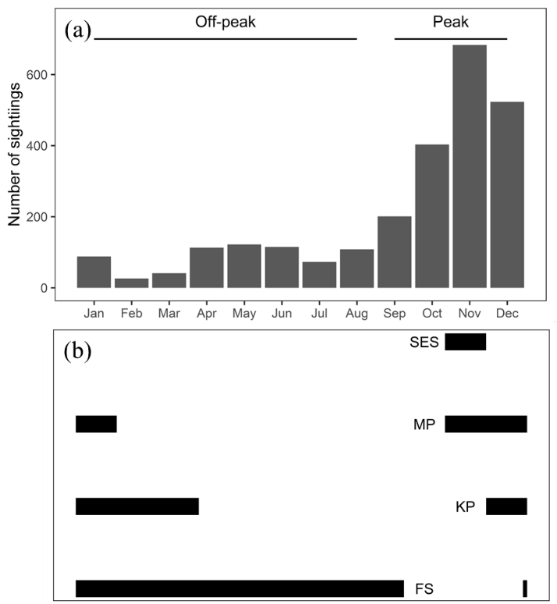
Figure 1. (a) The total number of killer whale sightings per month at Marion Island between 2006 and 2018, and (b) the reproductive period of seal and penguin species at Marion Island. The reproductive period for southern elephant seals (SES) (Kirkman et al. 2004) and Subantarctic fur seals (FS) (Hofmeyr et al. 2007) is the time between the median pupping and weaning dates. For king (KP) (du Plessis et al. 1994) and macaroni penguins (MP) (Crawford et al. 2003) the reproductive period is between the median date of adult penguin arrival and median crèching date. See Table 1 for observational effort data.

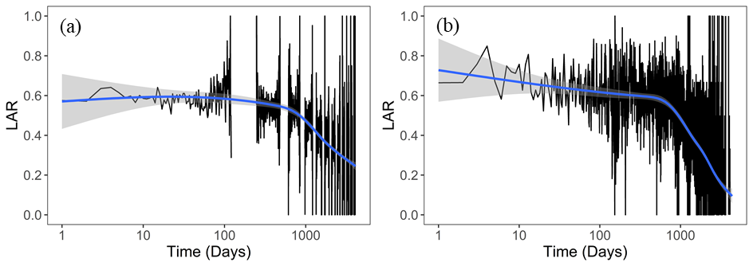
Figure 2. Lagged association rates (LAR) of killer whales at Marion Island for a) all peak periods (September to December) and b) all off-peak periods (January to August) from 2006 to 2018. LAR is a measure of the probability that an individual is observed re-associating with another individual at a given time lag (Whitehead 2008). Regression lines (and 95 % confidence intervals represented by the shaded area) are drawn.

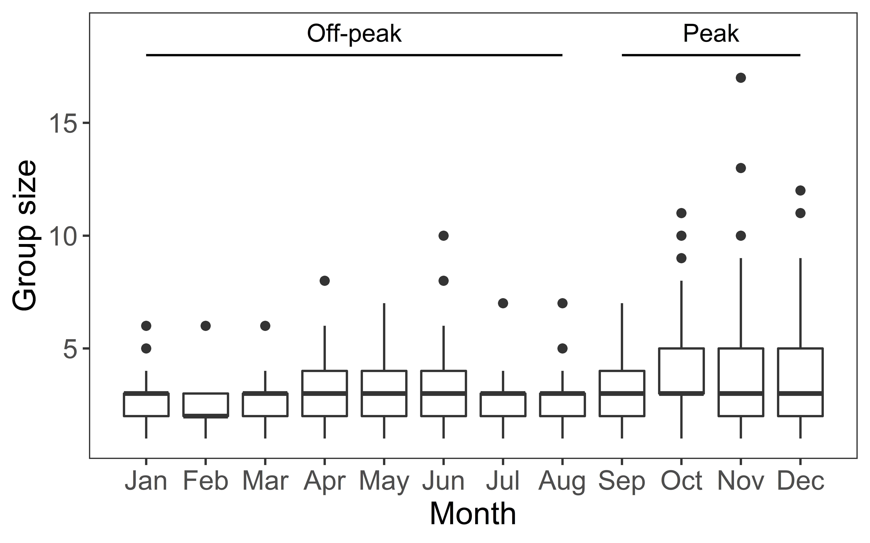
Figure 3. Variation in monthly killer whale group size at Marion Island during 2006-2018. Dark lines represent the median. Edges of the box represent the upper (4th) and lower (1st) quartiles with the lines above and below representing the maximum and minimum values (excluding outliers, which are shown).

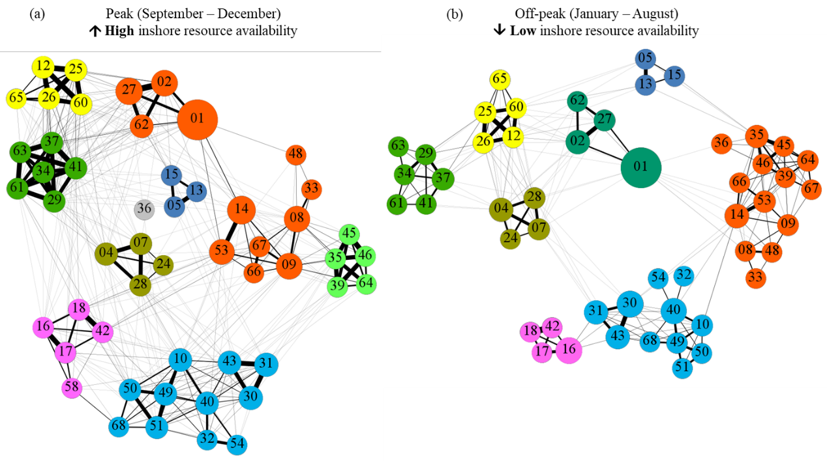
Figure 4: Network plots for Marion Island killer whales over a) all peak periods (September- December) and b) all off-peak periods (January-August) during 2006-2018. Each node (coloured circle) represents an individual killer whale and each vertex/edge (line between two nodes) represents the association between two killer whales. Numbers in nodes indicate the unique ID code for each individual but ‘M0’ was omitted from node labels (e.g. M001 is labelled as 01). The size of the node represents ‘betweenness’ centrality (how social, or gregarious, the killer whale is) with larger nodes reflecting more social individuals. Edges are weighted by the half-weight association index (HWI; higher HWI indicated with darker lines) and only weights > 0.01 are shown. Individuals were grouped into social units, represented by different colours, using the Louvain method for community detection (Blondel et al. 2008).

