RENEWING INDUSTRIAL REGIONS? ADVANCED MANUFACTURING AND INDUSTRIAL POLICY IN BRITAIN

Peter Sunley¹, Emil Evenhuis², Jack Harris¹, Richard Harris ³, Ron Martin⁴ and Andy Pike⁵

¹ School of Geography and Environmental Science, University of Southampton, UK
² PBL, Netherlands Environmental Assessment Agency, The Netherlands
³ The Business School, University of Durham, UK
⁴ Department of Geography, University of Cambridge, UK
⁵ CURDS, School of Geography, University of Newcastle, UK

ACCEPTED VERSION, September 2021
Forthcoming in Regional Studies

Keywords: Manufacturing, industrial regions, location, policy, innovation

ABSTRACT

The UK’s industrial strategy, with local variants, aims to support manufacturing in ‘traditional industrial regions’ (TIRs). Using novel data for advanced manufacturing (AM) industries over several decades, we examine long-term changes in their geography by regions and Local Authority Districts (LADs). These industries have shifted away from large urban regions and LADs in TIRs have lost ground relative to those in other regions, although there are variations between industries. Foreign direct investment hast ended to locate in non-TIR locations. AM industries have not shifted decisively towards research intensive regions. We consider the implications for policy initiatives seeking to spark clusters around innovation districts.

1. Introduction: ‘Levelling Up’ Ambitions and Advanced Manufacturing

Britain suffers from severe geographical inequalities stemming from the decline of manufacturing and the uneven growth of service industries (Gardiner et al, 2013; Martin and Gardiner, 2018; McCann, 2016). Regional and local economic disparities have been intensified by the global financial crash and its aftermath, and further widened by the COVID-19 pandemic recession (Davenport et al, 2020). The plight of formerly industrial regions has fuelled the growing concern with ‘left behind places’ in Britain, western Europe and the USA (Hendrikson et al, 2018; Martin et al, 2021; Rodríguez Pose, 2017). In mature industrialised countries, “former industrial regions have presented a persistent problem for public policy across the developed world for several decades” (Tomaney and Pike 2018, p. 140).

In response to these problems, recent UK governments have experimented with forms of industrial policy to reinvigorate the country’s manufacturing base (HM Government, 2017; 2018). The UK government from late 2019 has articulated the priority of ‘levelling up’ opportunity across the country and ‘unleashing growth’ in the post-Brexit era (HM Government, 2019). During the last decade or so, after many years of indifference, manufacturing in the UK experienced a brief ‘policy renaissance’ (Bailey et al, 2015; Christopherson et al, 2014). The tentative adoption of industrial policy in the UK, however, has been constrained and in 2021 cut short by the shortcomings of longstanding political-economic paradigms and institutional frameworks (Berry 2016; Berry and Hay, 2016). After briefly developing a national industrial strategy with local variants that included support for manufacturing, the strategy fell victim to the UK’s endemic policy and institutional churn and has been replaced by a new ‘Build Back Better: Our Plan for Growth’ (HM Government, 2021).
This UK industrial policy experiment emphasised the more advanced or knowledge intensive parts of manufacturing, which offer the promise of raising productivity and generating more skilled jobs, export-earnings, and innovation (OECD, 2017; Haldane, 2019). This focus appears likely to continue under the 2021 growth plan which highlights infrastructure, skills and innovation investments, although it is not clear precisely how much of the former industrial strategy will survive. To date, UK industrial policies have involved a shifting mixture of different types of ‘horizontal’ and innovation mission initiatives (House of Commons, 2018). The central goal is to develop research-based collaborations between public and private sectors, and deliver new technologies to meet key challenges. The national Catapult centres are designed to engage with advanced manufacturing (AM) industries to translate and commercialise innovations thereby seeding new firms and industries (UKRI, 2020). University research facilities, in close conjunction with their industry partners, have been given a leading role in meeting innovation missions and creating new clusters.
Despite the rhetoric of ‘levelling up’ and industrial policy endeavour, however, geography has been somewhat neglected. The utilisation of a vague conception of ‘place’ has obscured critical issues of economic geography. Explanation is lacking of how these policies relate to the differing needs and capabilities of the UK’s regions (Bernick et al, 2017; Bowman et al., 2015), nor how the focus on innovation and high-technology will benefit regions specialised in lower-skilled manufacturing activities (Fothergill and Wells, 2019). Whether and how the new growth plan will deliver benefits for traditionally industrial regions and support the current government’s ‘levelling up’ ambitions remains a difficult and contentious question.
Cross-cutting the UK’s evolving industrial policy, three key assumptions have dominated concerning the higher growth and productivity improvement potential of AM and its geography. The first is that AM’s potential is widespread across the country. The apparent hope is that AM can be further regionally dispersed and offer a geographical opportunity for ‘levelling up’. While AM is certainly more regionally spread than other leading sectors such as finance concentrated in the City of London, there has been very little detailed analysis of the geographies of the kinds of industry that policy is seeking to target. The second assumption is that AM has sufficient presence in traditionally industrial regions (TIRs) in the Midlands and Northern England, Scotland and Wales, to provide the basis for further growth. Third, it is widely believed that the best way to encourage and support AM’s growth is by developing innovation-oriented clusters in each region. ‘Urban innovation districts’ are seen as ways to regenerate northern cities by geographically concentrating investments in knowledge intensive and globally competitive sectors, local universities and research institutes to create localised innovation ‘hotspots’ (Grodach and Gibson, 2018; Katz and Wagner, 2014).

Focusing upon the UK as a critical case with wider international relevance, this paper assesses in turn these three key assumptions and the policies based upon them in relation to the changing geographies of AM industries. Informing considerations of their potential effectiveness, the aim is to assess whether such assumptions and their policy corollaries are working with, or against, the grain of long-term trends. Using time-series data of the output of different AM sectors, we examine the evolution of AM in industrial regions to better understand the challenges facing the UK’s ‘levelling up’ and industrial policies. The first section reviews spatial dynamics in AM and industrial renewal in TIRs. Addressing the definition of AM and operationalisation, we tackle the first assumption by examining long-term trends in AM output and employment to assess whether it is becoming more spatially concentrated or dispersed, and highlight important differences between different sectors and industries emergent in recent decades. We then address the second assumption on sufficient presence and further growth potential by focusing on the degree to which AM in TIRs has shown evidence of path renewal and upgrading and the explanations of different patterns between AM industry types. Finally, we consider the assumption that AM’s development can best be supported through the promotion and growth of urban innovation districts and associated clusters.

2. Regional Change and Paths in Advanced Manufacturing
There is little consensus about the dominant trends in the geographies of AM industries, as relevant theories highlight contrasting spatial processes and outcomes. The movement of AM away from cities has been widely reported internationally (Helper et al, 2012). There is strong and sustained evidence of a long-term dispersal of manufacturing industry due to an urban-rural shift, and firms’ rising needs for space, modern premises and accessible locations, and the move of mature sectors to lower cost locations (Crafts and Klein, 2017; Dauth et al, 2015).
On the other hand, many recent approaches assert that benefits of local clustering in AM are significant. Some (conventional, or ‘First Generation’ ) versions of New Economic Geography (NEG) predict the increasing concentration of firms to realise local externalities as transport costs fall (up to a certain level) (Brülhart, 2001; Krugman, 1993), although later (‘Second Generation’) versions of NEG question this (Baldwin, 2016). Much recent research on knowledge-intensive industries has argued that local spillovers and pools of skilled labour (‘brain-hubs’) are increasingly significant (Moretti, 2013; Van Agtmael and Bakker, 2016). Thus, geographically concentrated ‘industrial commons’ are seen as essential for rebuilding manufacturing in ‘Rustbelt’ areas (Helper et al, 2012).

AM is also being restructured by radical changes such as the so-called ‘4th Industrial Revolution’ or ‘Industry 4.0’, involving AI, digitisation, and cyber-physical systems. Such changes may potentially lead to re-shoring and more decentralised forms of production involving close proximity to markets (Bailey and De Propris, 2019). They could feasibly produce both greater concentration and dispersal, and these two may be complementary rather than alternatives. It is plausible then, that AM in Britain is undergoing both regional dispersal and localised clustering simultaneously.
Uncertainty is further compounded by conflicting views on whether old industrial regions provide a conducive context for advanced and high-technology manufacturing. Peter Hall’s (1985) seminal view was the strong legacies of old industries inhibit the transition to, or emergence of new, more advanced industries. These legacies produce constraining forms of ‘canonical’ path dependence and lock-in to outmoded technologies, and infrastructures, ageing workforces, and dated (even obsolete) skills (Hall, 1988; Martin and Sunley, 2006).
However, empirical research has found a more complex picture in traditional industrial regions. Various traditional industrial places across America’s Midwest and ‘rust belts’ in Europe, have recovered as firms have adopted new processes and products (Cooke, 1995; Cowell, 2015; Florida, 1996). According to Christopherson’s (2009) ‘phoenix industry’ view, manufacturing has been revived in TIRs by networks of small firms. Legacy capabilities have been recombined and re-worked in networks of small firms that are often more design-intensive (Bryson et al., 2013; Doussard and Shrock, 2015). Often these have been facilitated by collective intermediary institutions (Clark, 2014).
Thus, the industrial paths witnessed in former manufacturing regions have been categorised into several different types. At one end of a continuum is path extension involving only incremental innovations and often leading to stagnation and decline (Isaksen, 2016). Path upgrading refers to more substantial positive changes through the infusion of major new technologies, re-organizations, or the development of niches (Grillitsch et al, 2018; Isaksen and Trippl, 2014; Isaksen et al, 2016). Thirdly, path importation refers to the setting up of established industries that are new to the region, often through inward investment. Path branching and diversification describe the emergence of new industries building on the capabilities of existing industries (Boschma and Iammarino, 2009), or by combining existing capabilities with unrelated knowledge. Path creation is the most radical form of change as it involves the growth of new industries based on new knowledge (Martin and Sunley, 2006; Tödtling and Trippl, 2013). It is argued that many ‘Rustbelt’ regions become stuck in path extension as they have highly specialized innovation systems which lack diversity (Isaksen and Trippl, 2017; Grabher, 1993; Hassink, 2010). This paper makes some initial observations on how these types of paths relate to regional AM change in Britain and whether this perspective helps to explain their uneven fortunes.

3. The Changing Geographies of Advanced Manufacturing in Britain

Although varied, AM is usually defined as manufacturing that is capital and knowledge intensive, using a high level of technology, elements of service provision, and specialist skills (Livesey, 2015). It includes activities that make use of cutting-edge materials and scientific advances, and involves the creation, utilisation and co-ordination of information, computation and software. These features have spread more widely across manufacturing as some firms have upgraded to products and processes with higher value-added content, including tangibles such as innovative technology and intangible services such as branding, product support, after-care and disposal (described as ‘manu-services’ or ‘servitisation’) (Pike, 2015).
A comprehensive empirical investigation of AM would require a very detailed examination of firm activities. However, in the absence of this, in this paper we use a widely used industrial definition of core industries associated with AM (Table 1). We also separate these into high-technology and medium-technology groups after the distinctions by Eurostat and Helper et al. (2012). This three-digit SIC classification has its compromises and disadvantages, of course. It certainly does not include all parts of manufacturing that are using advanced processes and materials. Instead it highlights industries that have been found to rely more intensively on high and medium technological knowledge. Using this basic core definition allows us to examine long-term historical trends. Of course, SIC industry classifications have been modified over time, they are eclectic and the continuity of SIC categories hides many changes in firm markets, processes and practices, and the emergence of whole new industries (Phillips and Ormsby, 2016). Nevertheless, more rigorous longitudinal classifications are simply not available over this period, and the data used here provide an introduction to spatial patterns of change in broad groupings of more technologically intensive manufacturing, which we hope will open up questions for more intensive research.

Table 1: Definition of Advanced Manufacturing Industries

Very High Technology*

Computers, electronic and optical products (SIC 2007: C26)
Pharmaceuticals (SIC 2007: C21)
Air- and spacecraft (SIC 2007: C30.3)

Moderately High Technology*

Other transport equipment, other than Air and spacecraft (SIC 2007: C30 excl. C30.3)
Manufacture of chemicals and chemical products (SIC 2007: C20)
Motor vehicles, trailers and semi-trailers (SIC 2007: C29)
Machinery and equipment n.e.c. (SIC 2007: C28)
Electrical equipment (SIC 2007: C27)

*Based on classification used by Eurostat and by Helper et al. (2012), Table 1, page 7. (based on technological intensity of industries).

Source: Eurostat and Helper et al (2012).

Government reviews of manufacturing in Britain have consistently highlighted areas of comparative advantage in AM such as aerospace, automobiles and pharmaceuticals (Department for Business, Innovation and Skills (BIS) (2012). However, AM has been hit by a series of shocks including the 2008-10 recession, prolonged uncertainty amidst Brexit, and most recently the COVID-19 recession (Harris et al, 2020; Rhodes, 2018). There is considerable heterogeneity in performance within the AM category. Figure 1 shows the marked differences in trends in output by value for our selected industries. While the value of output in motor vehicles and machinery has been level since 1971, most other sectors grew until the early 2000s but have since declined (see Appendix A for a note on data sources).
Many of these industries (with the exceptions of pharmaceuticals, other transport and chemicals) saw output declines prior to the 2008 crash. The effects of crash were marked in pharmaceuticals and compounded the longer-term difficulties facing the industry’s innovation model (Malerba and Orsenigo, 2015). In contrast, the level of GVA in the automobile industry has been static, so that its decline has been halted (Bailey and DePropris, 2014; 2017). The best performing sector has been transport equipment, including aerospace and shipbuilding, which has shown strong growth from around 2002. However, aerospace is not among the largest AM sectors and there are, of course, doubts about its future given the impact of COVID-19 crisis on aviation.

Figure1: GVA (2012 current market value) in Selected Advanced Manufacturing Industries in Britain, 1971-2015

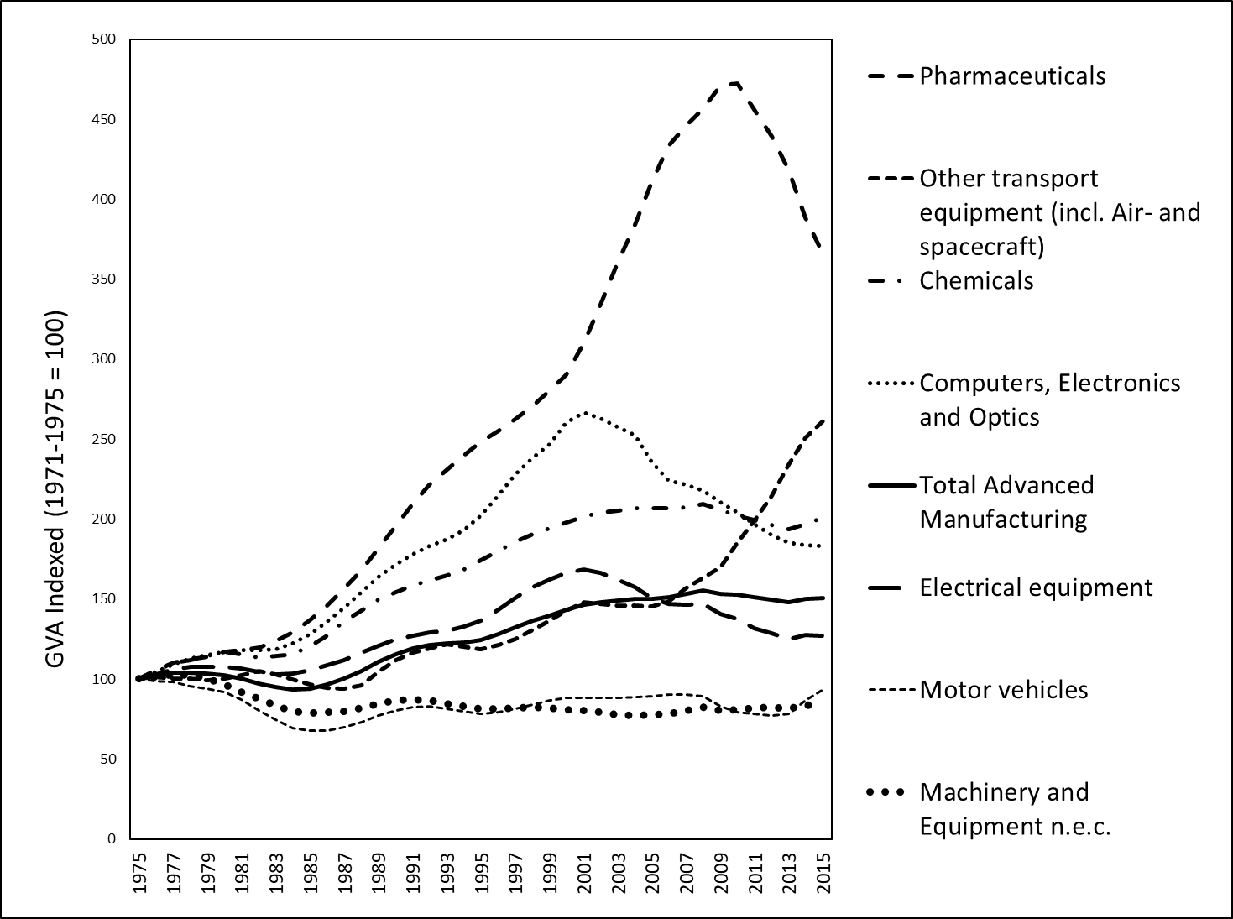

Source: Cambridge Econometrics Data.

In this context, there have been important shifts in the geography of AM industries across the country. Figure 2 shows the shares of output in AM by region. It shows that there has been something of a drift to the South outside London, as regions such as the South East and South West (and East and East Midlands to a lesser extent) have seen their shares of output increase. The outcomes for Northern regions appear strongly divergent. The North West has increased its share strongly since the end of the 1990s, while Wales, the East Midlands, Yorkshire-Humberside and the North East have experienced only slight increases in their shares. In Scotland and the West Midlands, shares of output have fallen. The fall in the West Midlands share, reflects the declining relative significance of the automobile industry over much of the period (see Donnelly et al, 2017).

Figure 2: Regional Shares of Advanced Manufacturing GVA

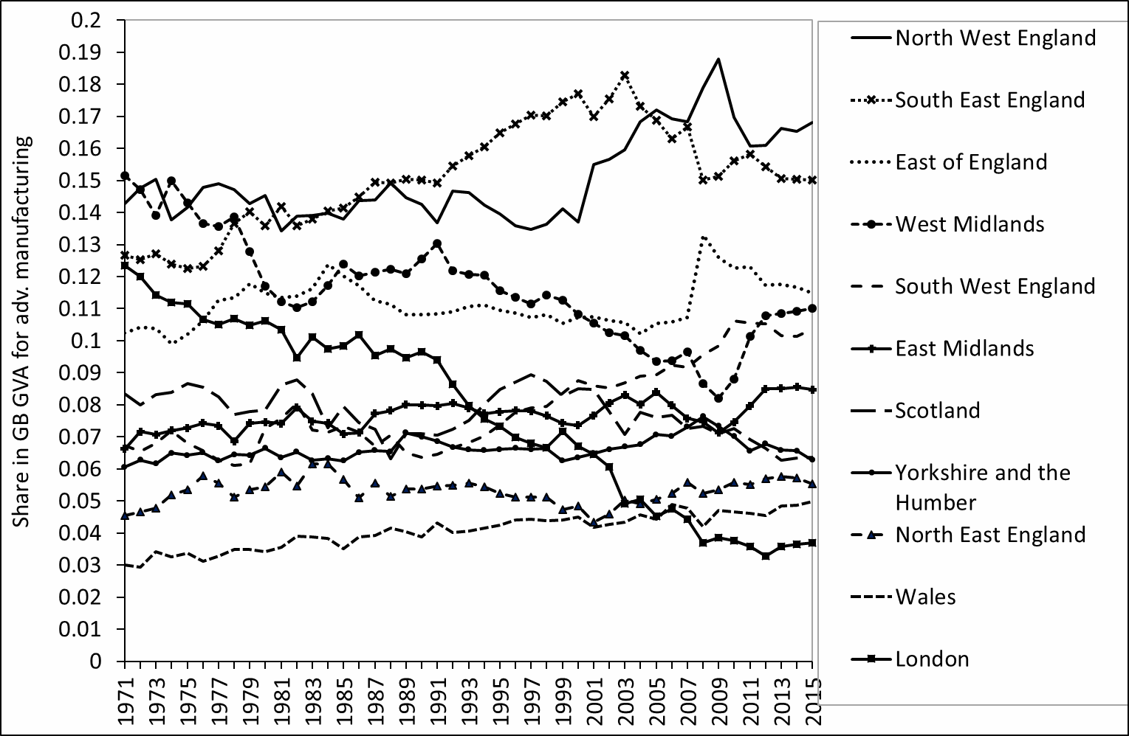
NB The shares refer to the total for Great Britain, as data for Northern Ireland are not available.
Source: Cambridge Econometrics data

In order to examine whether the spatial distribution of AM industries is becoming more concentrated or more dispersed, indices of relative concentration have been calculated using the Theil index (see Cutrini, 2010), given for industry i as
$$\sum_{r=1}^{R}{\frac{{GVA}_{ri}}{{GVA}_{i}}\ln\left(\frac{{{GVA}_{ri}}/{{GVA}_{i}}}{{{GVA}_{r}}/{GVA}}\right)⁡}$$
and the summation is across all regions, r.
A higher Theil index i indicates greater relative regional concentration. Figure 3 shows that at a NUTS2 regional scale, and using five-year averages, geographical concentration fell in most industries up until around 2000 but has risen since. The degree of regional concentration has increased particularly strongly in pharmaceuticals. Figure 3 also reveals that there are substantial and persistent differences in concentration across industries, with pharmaceuticals, motor vehicles and other transport equipment being much more strongly concentrated at this regional scale. Chemicals occupies an intermediate position, while computing, electronics and machinery are much more dispersed.

Figure 3: NUTS2-level: Theil index (5-year averages)
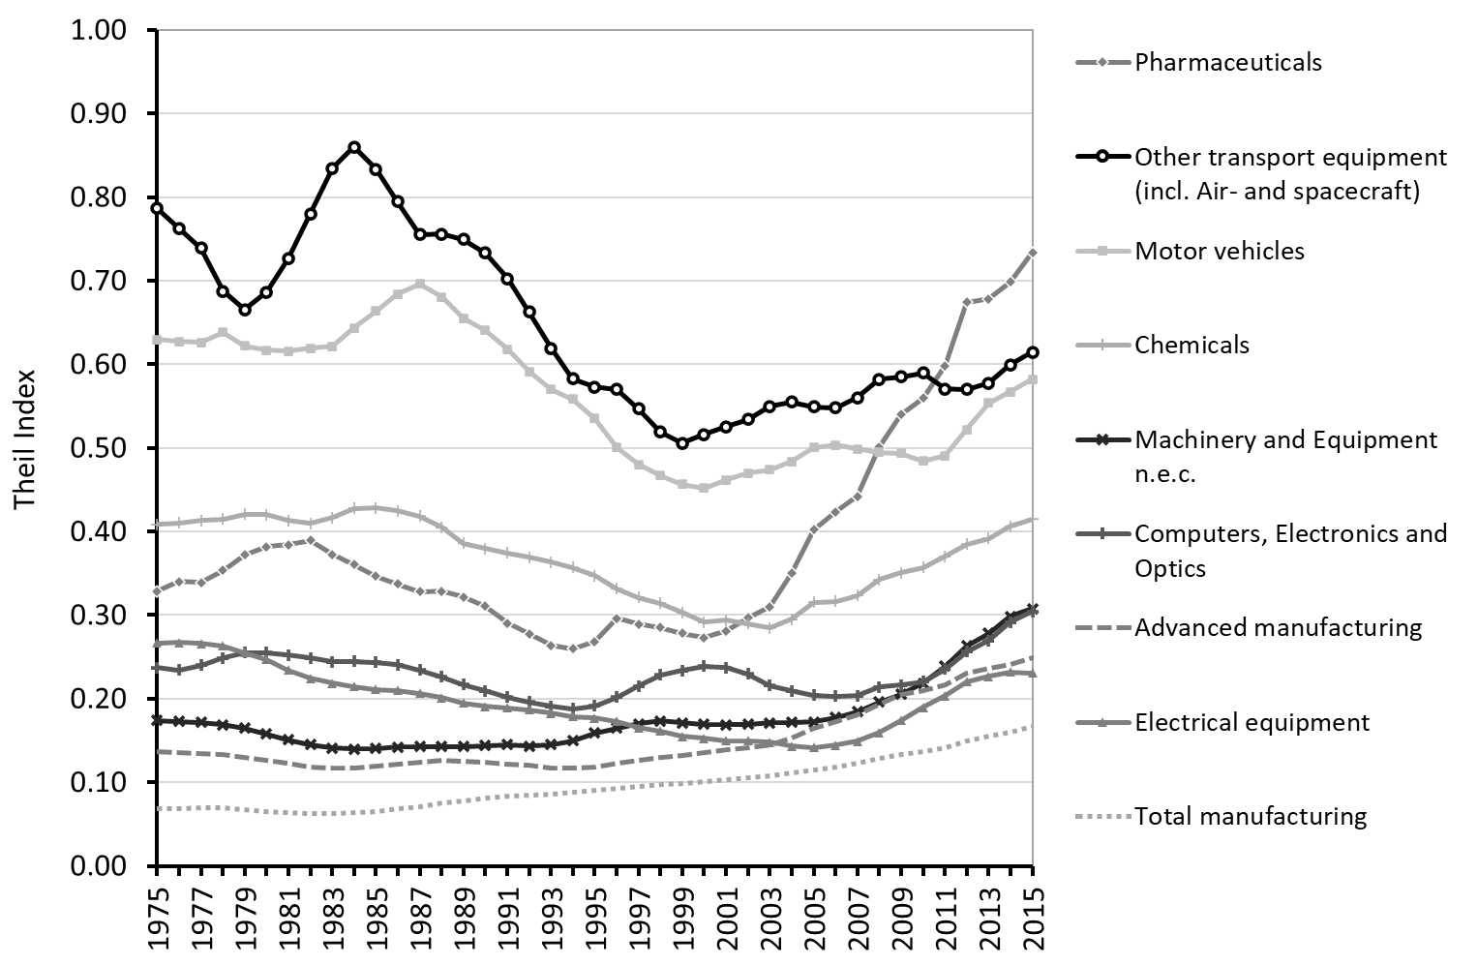
Source: Authors’ calculation based on Cambridge Econometrics data.

The pattern of dispersion or concentration at a smaller Local Authority District scale indicates whether this has also involved the formation of local clusters of AM firms within regions. That is, it shows whether the concentration of AM in a somewhat smaller number of regions after 2000, was accompanied by concentration in LADs within these regions. Figure 4 shows the Theil index at a LAD scale from 1995. With the exception of weapons and munitions, there is no clear trend to either strong dispersal or concentration over the period, suggesting that most AM has not formed strong clusters within LADs.

Figure 4: Local Authority District-level: Theil-index (5-year averages)
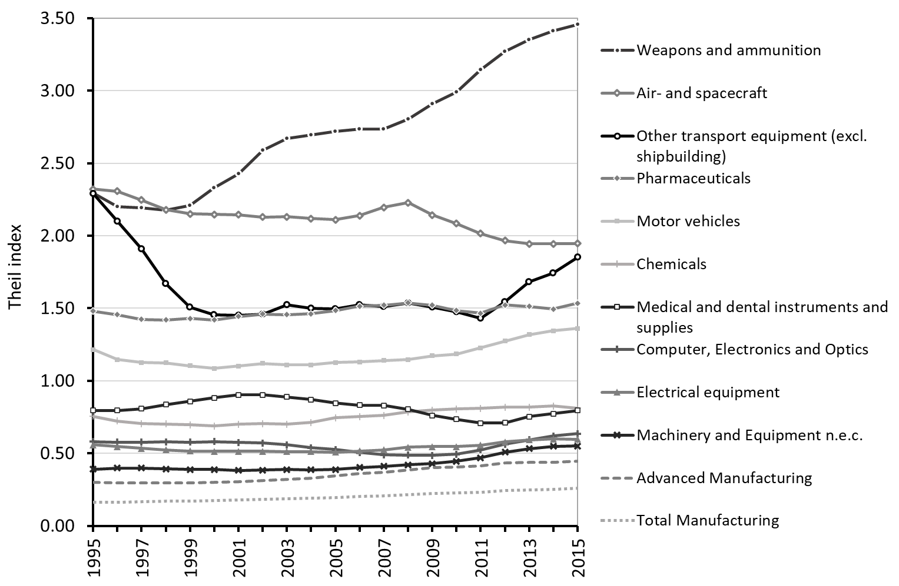
Source: Authors’ calculation based on Cambridge Econometrics data.

In summary, there has been a slight tendency towards geographical concentration at a regional scale in most AM industries since around 2000. This is most likely due to a mixture of pressures and processes. In some cases, it reflects the strengthening of regional ecosystems, especially around some significant foreign direct investors (Beverland et al., 2015). However, in most industries there is no evidence of a trend to concentration at a local authority scale. AM in Britain has struggled in a highly competitive global environment during this period and regional concentration has been the result of selective consolidation, firm rationalisation and disappearance of some sites (Hannon 2016). Employment has consolidated in some established centres of production. The appearance of new concentrations has been important in some industries but, in general, it has been more unusual. The following section focuses more closely on the consequences of these processes for TIRs.

- Advanced Manufacturing in Traditional Industrial Regions
So how have these spatial dynamics in AM impacted traditionally industrial regions? TIRs are defined here as those where in 1971 manufacturing and mining employment was more than one standard deviation above the national mean (i.e. above 33.8 percent of total employment). This definition identifies a total of 12 NUTS 2 regions. In the analysis that follows, those Local Authority Districts (LADs) within these 12 regions are defined as traditionally industrial. LAD data by three-digit SIC class for 82 sectors are available from that date. Figure 5 shows the shares of GVA in the traditionally industrial LADs. It illustrates that, since 1991, LADS in TIRs, including those with the most important concentrations of these industries, have lost ground relative to other LADs in terms of their share of output. LADS in TIRs do not appear to have benefited from strong phoenix effects, and output has shifted away from them. However, these aggregate findings obviously mask important variations both between regions and industries.

FIGURE 5 Shares of AM GVA by Type of Local Authority District
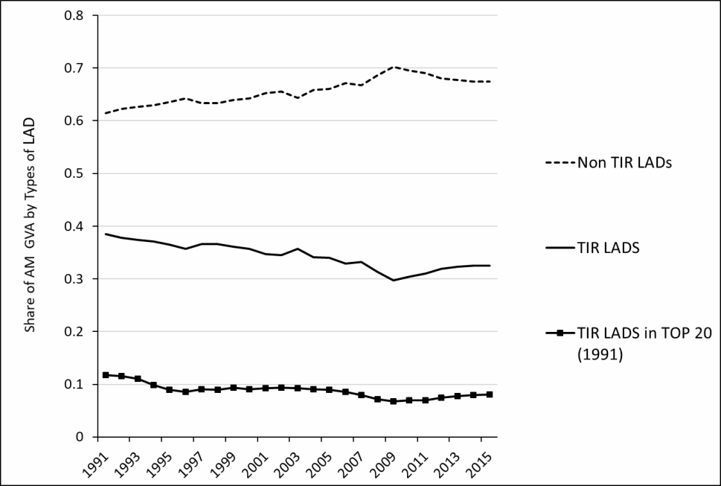
Source: Authors’ calculations, Cambridge Econometrics data

Figure 6 summarises the trends in location quotients in TIRs and non-TIR districts in different industries. There are evident differences between patterns seen in different industries. In pharmaceuticals, computers, optics and photo, the location quotients show a strong and widening divergence between industrial LADs and other centres. While motor vehicles and electrical equipment have seen a switch of output growth away from traditionally industrial LADs, some TIRS continue to show a higher level of specialisation in these industries. In aerospace, chemicals, and in machinery and equipment, specialisation in the TIR LADs has been stronger than in other LADs, and has increased over the period.

Figure 6: Change in Location Quotients of Output (GVA) in LADS in TIRs, and in non-TIRs in Industry Sectors 1995-2015

Pharmaceuticals
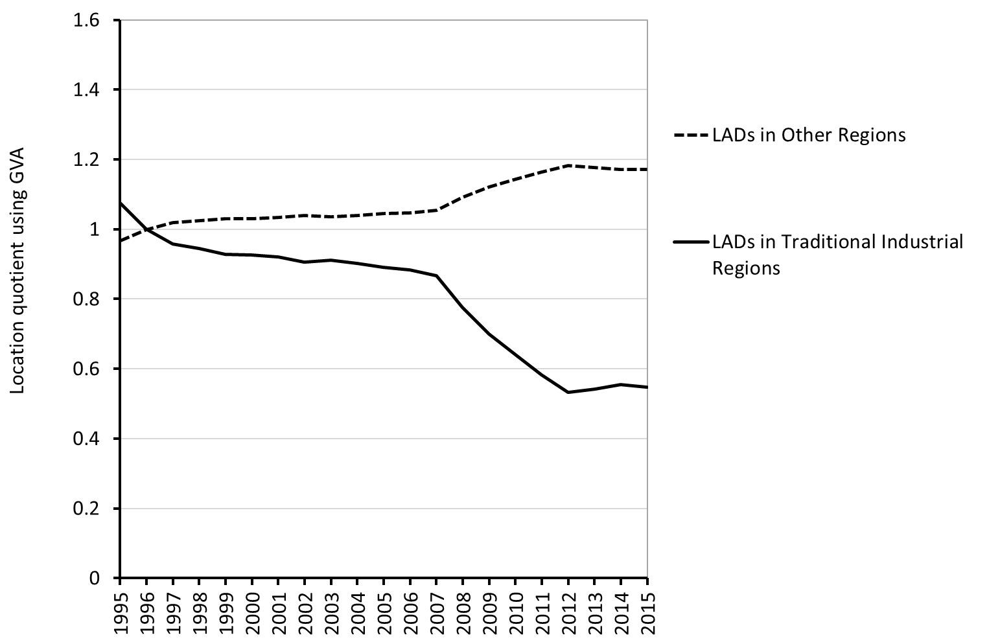

Computers, Electronics and Optics
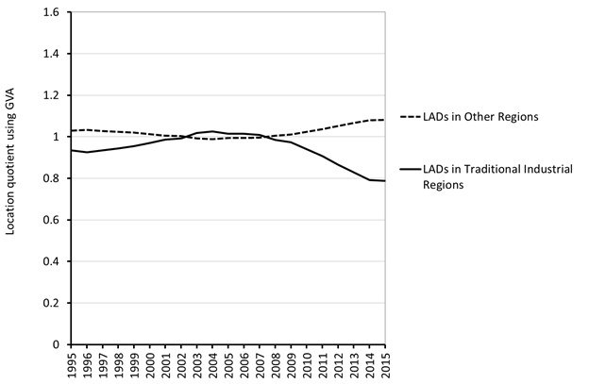

Electrical Equipment
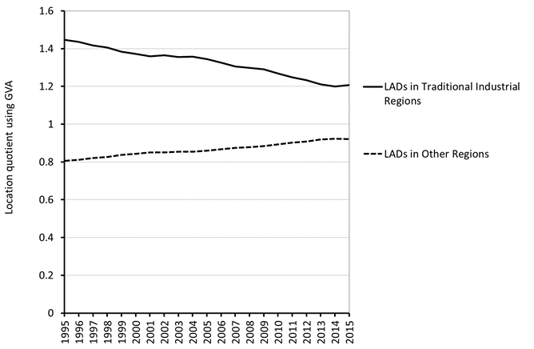

Chemicals
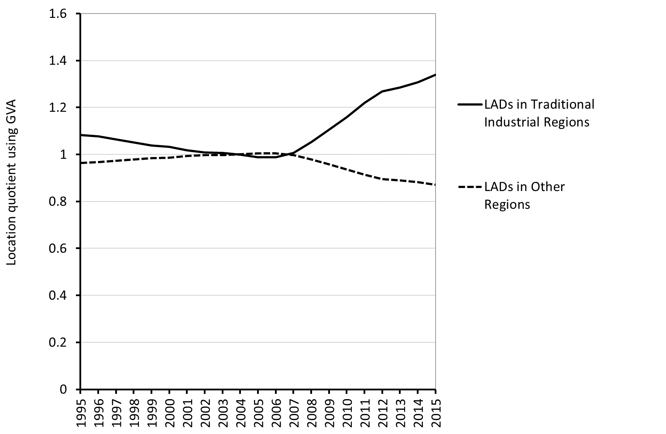

Motor Vehicles and Trailers
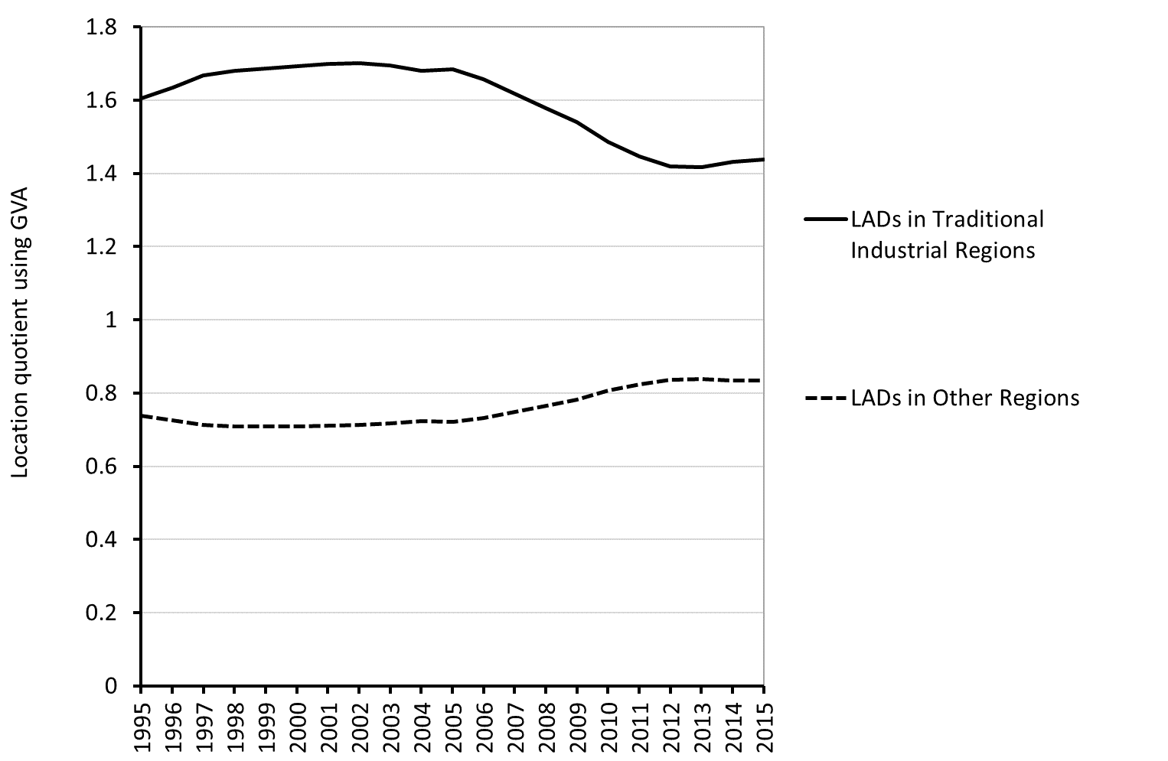

Air and Spacecraft
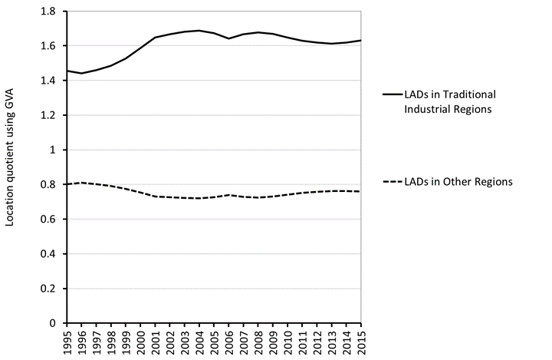

Machinery and Equipment (NEC)

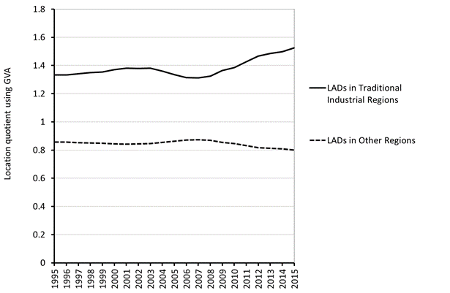

Other Transport Equipment

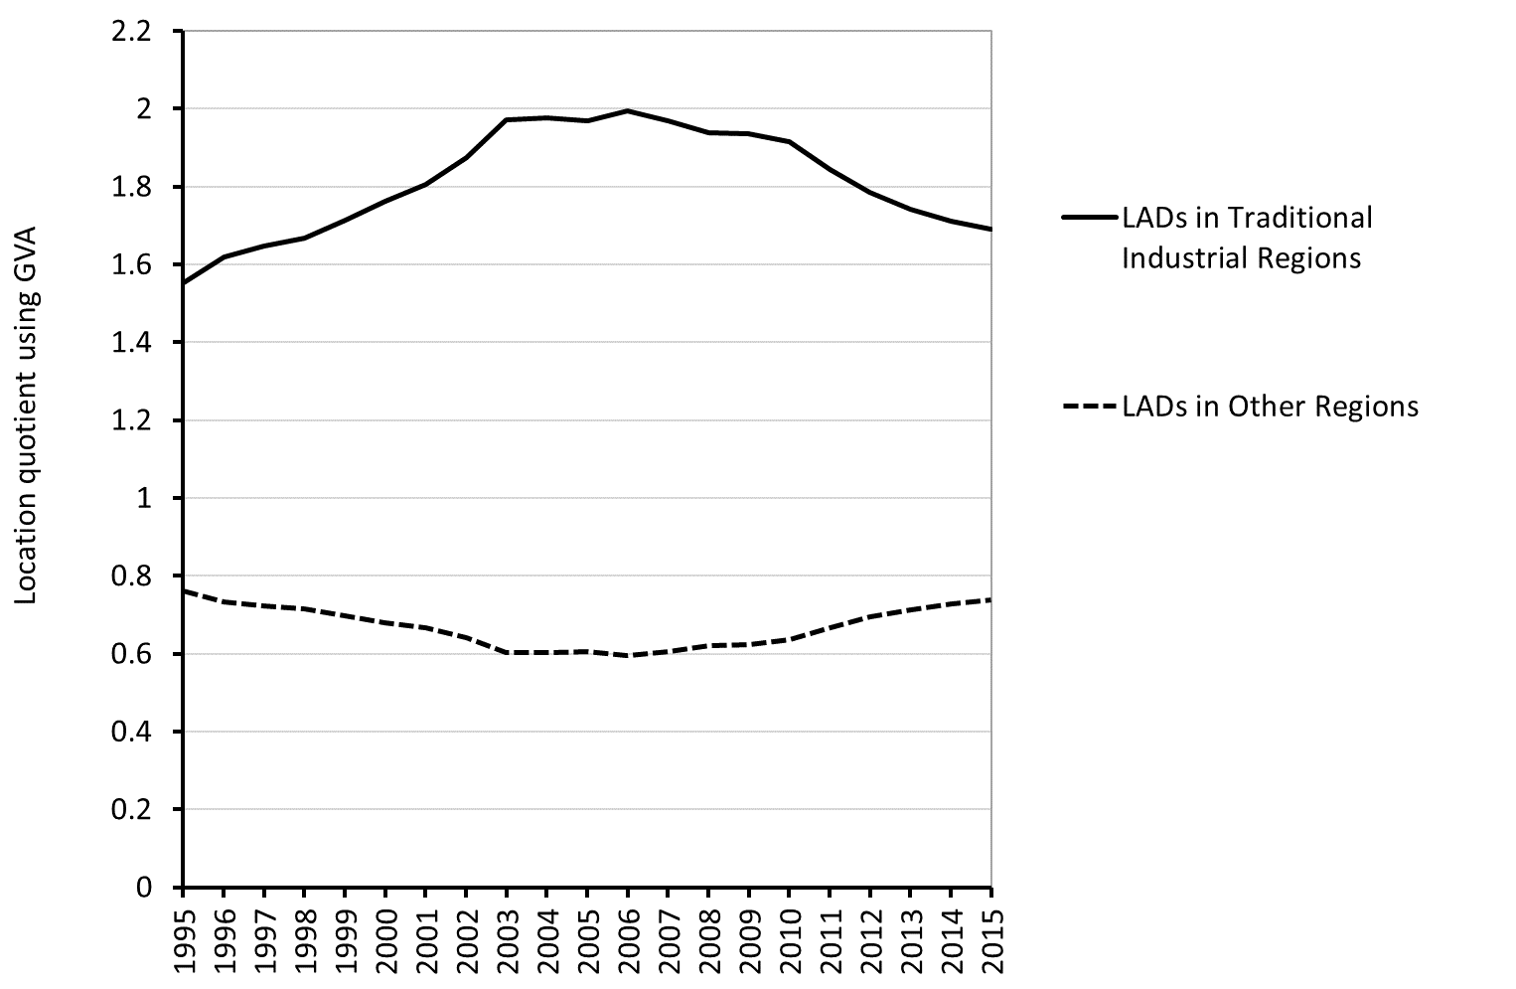

In summary, Table 2 compares AM industries on two key dimensions. While some relatively concentrated sectors appear to have maintained specialisation in TIRs, others appear to have struggled in these kinds of regions. Similarly, among more geographically dispersed industries there also appears to have been a difference between industries that show continued specialisation in TIRs, and those that have seen rapidly declining specialisations in these regions. In general, those that do relatively well appear to have stronger connections with predecessor and related industries, while those that do less well appear to be based on newer and science-based capabilities. This key point is explored further in the next section.

Table 2: Regional Concentration* and Relative Specialisation ** in TIRS

 | Concentrated sector | Dispersed sector
Relatively high specialisation in TIRs* | - Aerospace  - Other transport equipment (excl. aerospace  - Chemicals  - Motor vehicles | - Machinery and equipment  - Electrical equipment
Weaker specialisation in TIRs | - Pharmaceuticals | - Computers, Electronics and Optics

Source: Authors’ own elaboration
* Regional concentration is gauged from Figure 3 (above a Theil value of 0.4)
** Specialisation is judged by location quotients by type of LAD shown in Figure 6.

The shift in AM away from TIRs reflects trends in FDI. It is well known that since the 1980s FDI in manufacturing has been relatively strong in Britain, until recently (Driffield and Munday, 2000). However, manufacturing FDI has tended to shift away from peripheral regions towards the South and East (Wren and Jones, 2012). Table 3 is based on a micro-analysis of firms in seven AM sectors to examine the contributions of firm openings and closures, that distinguishes between domestic and foreign-owned firms (see Harris et al, 2018 for details on this dataset). This analysis subdivides manufacturing plants into those that were open both in 1973 and 2016, those that were open in 1973 but not in 2016, and those that were open in 2016 but not in 1973. Each of these subgroups is then divided into GB-owned and foreign-owned (note many plants that were GB owned in 1973 were foreign-owned in 2016 indicating the importance of internationalised mergers and acquisitions activity). The table shows the percentage of the total change attributed to each group. For AM between 1973-2016, real gross output increased by £81.2 billion. This increase was mostly (44.1%) due to foreign-owned plants that were opened post-1973 in areas outside of TIRs (some of these would have been brownfield plants that were acquired by inward FDI). Of next importance (26.6%) is foreign plants that were opened after 1973 within TIRs. The loss of capacity in AM sectors is primarily due to GB-owned plants opened after 1973 (-8.2%) and those that operated throughout (-4.9%).

Table 3: (Weighted) Real Gross Output Change by Types of Firm (£m 2000 prices) in GB Manufacturing, 1973 and 2016*

Region | Firm | Ownership | % Contribution to Output Change
Non TIR | Firms Open throughout | GB-owned firms | -1.8
 |  | Foreign-owned firms | 17.0
 | Firm openings and closures | GB-owned firms | 16.1
 |  | Foreign-owned firms | 44.1
TIR | Firms open throughout | GB-owned firms | -4.9
 |  | Foreign-owned firms | 11.1
 | Firm openings and closures | GB-owned firms | -8.2
 |  | Foreign-owned firms | 26.6

* TIR defined as above, see endnote 8

Source: Office for National Statistics (2018) Annual Business Survey, 2008-16: Secure Access. [data collection]. 9th Edition. UK Data Service. SN: 7451 http://doi.org/10.5255/UKDA-SN-7451-9 Office for National Statistics (2012) Annual Respondents Database, 1973-2008: Secure Access. [data collection]. 3rd Edition. UK Data Service. SN: 6644 http://doi.org/10.5255/UKDA-SN-6644-5. These data and their use is described in Harris et. al. (2019)

Table 3 reveals just how dependent the growth of AM has been on inward FDI, but also shows that it has produced greater output growth outside of TIRs. This suggests that AM path importation has been higher in non-TIR and less-industrialised locations. Nevertheless, the analysis confirms that AM in TIRs is highly dependent upon strategic decisions by anchor firms and foreign investors (Firn, 1975). Moreover, in the context of Brexit, the nature and strength of couplings with foreign investors will prove critical to the prospects and survival of AM in such TIRs. Furthermore, the negative figure for GB firms opened and closed during the period in TIRs suggests that endogenous path creation and renewal in many of these areas has been weak, and more than offset by path extension and decline.

- Urban Innovation Districts and AM Renewal?
This study has found that while some AM industries have grown in some TIRs, others have been subject to strong instability and decline. There is no evidence of strong local concentration dynamics in TIRs and the evidence suggests that where growth has occurred it has been based primarily on path importation and branching. This is not to argue that path creation has not taken place in AM in TIRs, instead it appears that it has not been of sufficient scale and momentum to produce large growth in GB-owned manufacturing firms. The differences across TIRs also appear to arise, in part, from the differences between the high and medium-technology parts of AM. In the high-technology sectors of computing, optics and electronics, and pharmaceuticals, the performance of TIRs has been worse than in other types of areas. The trajectory of these sectors has been highly unstable with major state-supported and incentivised investments followed by rapid declines. Of the three high-technology sectors, only aerospace has effectively offered some potential for growth in industrial regions. Pharmaceuticals and electronics are often associated with a Science Technology Innovation (STI) mode of innovation which generates explicit and codified knowledge or analytical knowledge (Asheim et al., 2011; Fitjar and Rodriguez Pose, 2013; Isaksen and Karlsen, 2010). Most industries combine STI and DUI innovation modes, to varying degrees. While results vary between contexts and firm-types, a combination of both modes has been found to be most beneficial (Parrilli and Alcade Heras, 2016; Hervás-Oliver et al, 2021). Our findings suggest that industries requiring more STI innovation systems have tended to shift away from TIRs, towards such system in the South which offer more science expertise and venture capital finance.
However, in industries such as aerospace, motor vehicles, and other transport equipment, some TIRs have had the necessary capabilities to upgrade; and there has been some new expansion into other TIRs, especially in the Midlands and North West, which has been drawn to engineering skillsets. Most of these sectors have been associated with a Doing Using and Interacting (DUI) innovation mode that is more typical of production-focused and design-centred innovation ecosystems (Fitjar and Rodriguez Pose, 2013; Parrilli and Radicic, 2021). This emphasises learning through exchanges, in which analytical knowledge is synthesised with practical engineering and design knowledge. Many of these sectors are to a greater degree based upon an engineering and synthetic, metals-related knowledge base and pools of skilled labour where TIRs typically have more advantages. This has some important implications for debates on innovation strategy.
As we noted in the Introduction, industrial policy thought has been drawn to a greater focus on innovation districts. However, on the basis of the historical evidence reviewed here, this switch faces a number of challenges. There are reports about the success of particular urban innovation districts (especially the Advanced Manufacturing Research Centre (AMRC) in Sheffield, for example, Breach, 2019). While the AM Catapault centres have been more effective in involving industry than other Catapaults, supporting local economies and clusters has not been a priority (DBEIS, 2021). Wider reviews of the relationships between innovation spending in Britain and AM have suggested a lack of connection and co-ordination (Jones and Wilsdon, 2018). Our evidence does not show a return of AM to large urban conurbations or a concentration of AM in innovative districts in large cities. In contrast, AM remains located primarily outside the dense centres of large cities in semi-urban and smaller cities and the shift of these industries away from large cities has continued (Figure 7). The areas gaining AM have tended to be smaller cities and moderately urban areas rather than rural locations.

Figure 7 Shares of Advanced Manufacturing Output (GVA) by Type of Region (NUTS2)
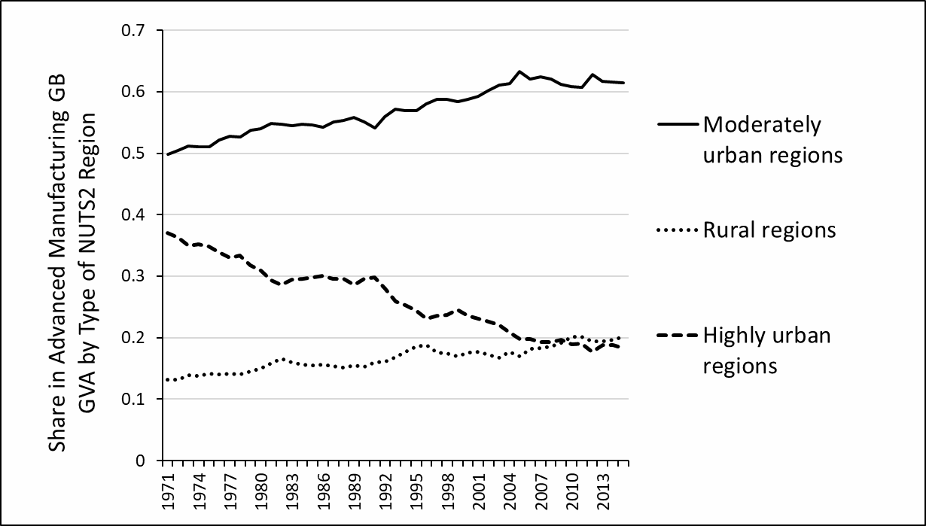
Source: Authors’ calculations, Cambridge Econometrics data. (Rural regions population density in 1971 below 186 km², Moderately urban between 186 and 846 km², Urban over 846 km²).

The co-location between AM and R&D appears to have been fairly weak. Figure 8 shows the relationship between R&D intensity and the growth of AM value across NUTS2 regions between 2000 and 2015. In general, it reveals only a very weak positive relationship between research intensity and AM growth, which suggests that any cumulative relationship between the two has been patchy at best. Most TIRs, with the exception of Derbyshire and Nottinghamshire, have also not been among the most research intensive regions. The concentration of pharmaceuticals in Cheshire underlies the growth of AM in this research-intensive region. Many parts of AM have not been located in high R&D expenditure regions which suggests that production location decisions by AM firms, and especially foreign investors, have been influenced by other factors, such as distance and access to markets and labour (Wren and Jones, 2012). Large foreign investors have a strong reliance on internal resources, are now deeply-connected into global innovation networks with other lead firms, so that regional and local knowledge spillovers are much less important to these firms (Parrilli and Radicic, 2021). Furthermore, building STI research does not by itself deliver strong AM growth as many SMEs and suppliers struggle to absorb the innovations produced by such systems (Beverland et al., 2015).

Figure 8: R&D intensity in Regional (NUTS2) GDP (2011-16) against Growth of AM GVA, 2000- 2015

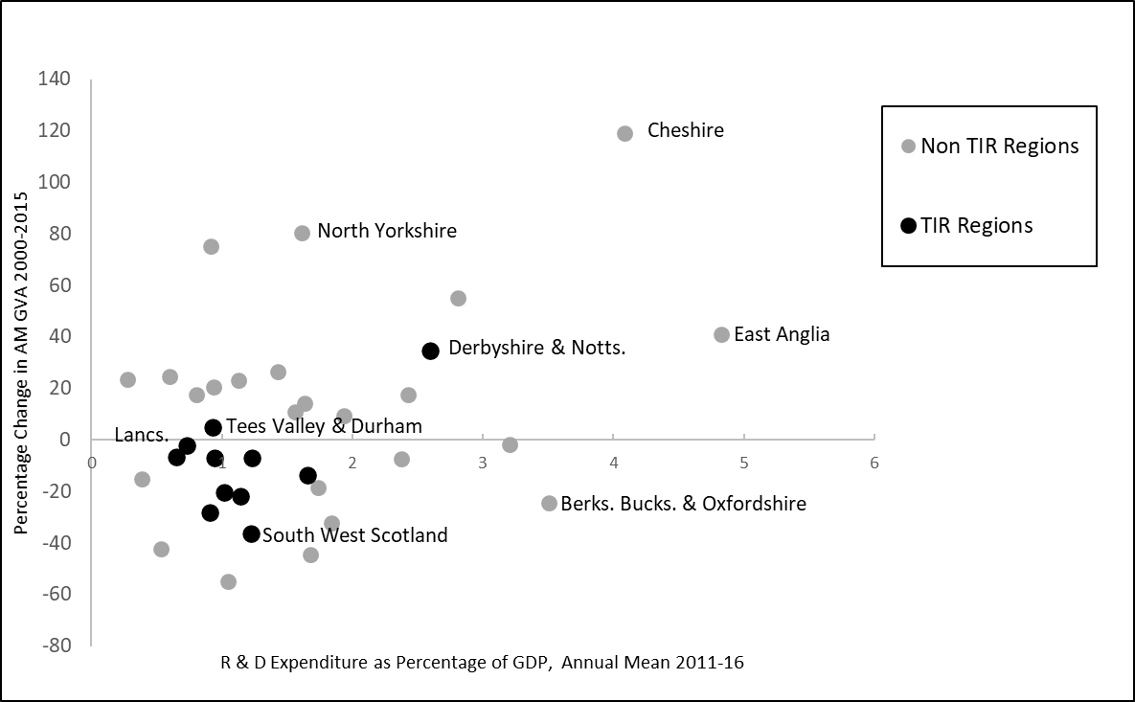
Source: Cambridge Econometrics and Eurostat.

There is little evidence that university research has been a key driver of regional AM performance (Howells et al, 2012; Kempson, 2019). Innovation and research policy has in general taken a supply-side and place-blind approach that has not been key to fostering regional innovation capacity (Jones, 2016). Public support for R&D spending in the UK has been heavily focused on bioscience and medical research (Jones and Wilsdon, 2018), so that it has had a selective STI focus. The STI mode of innovation characteristic of much university research has not been well connected to the practices of DUI innovation seen in large parts of AM. In particular, most SMEs have found it hard to connect with university research centres (Howells et al, 2012). Thus suggests that, unless there is a radical change, research institutes and urban innovation districts based primarily on STI are unlikely to provide a sufficient foundation for local industrial strategies capable of stimulating AM industries’ growth. Mission-focused innovation centres aimed at meeting the ‘Grand Challenges’ risk neglecting the needs of the local economic context and diffusion processes (Brown, 2020), and thus may entrench this gap. In order to be successful, any place-based innovation policy would require a more comprehensive and integrated attempt to build and sustain local innovation ecosystems that combines STI and DUI modes through knowledge diffusion, product application, commercialisation, skills development, firms’ absorptive capacity and innovation support throughout supply chains.

- Conclusions

This paper has examined three key assumptions underpinning UK policy thinking on using advanced manufacturing (AM)-focused industrial strategies as a means of addressing geographical inequalities through ‘levelling up’. Examining historical evidence, the analysis has revealed a complex and differentiated picture of change with important variations across scales, between different traditional industrial regions (TIR)s and different AM industries. Regarding the first assumption that AM is widely geographically dispersed, we have found a complex pattern at both regional and local scales. There is continued spatial dispersal of AM away from large and dense cities. Most AM industries are spread across several regions. However, there has been regional re-concentration since the turn of the century due to the consolidation and decline of some industries, and the stability and growth specialisations in other regions. Considering the second assumption that AM has a significant presence in TIRS and provides the basis for further growth, our results reveal a similarly mixed picture with important differences between industries. In aerospace, other transport equipment, motor vehicles, and chemicals, concentrations in TIRs, especially in the East Midlands, North West and West Midlands, have continued to do well until recently, and there has been some new expansion into other TIRs and also into non-TIRs. The stronger performance of some TIRs in these sectors suggests they have benefitted from path upgrading, importation and branching. In contrast, in other AM industries founded upon more science-based analytical knowledge, notably pharmaceuticals and computers, optics and electronics, TIRs have provided a less conducive context. This finding raises doubts about the third assumption of using urban innovation districts as the key means of revival. While regional preconditions can be changed through effective policy leadership and institutional change, on the basis of past trends TIRs would better advised to focus on those AM industries with more engineering and synthetic knowledge bases where there is a continuing regional base of human capital and skills.
These findings are not deterministic of the future geographies of AM and the potential roles of national and subnational industrial policies. Path importation has been central to AM in Britain. Most output growth in AM has been driven by foreign direct investors which have tended to locate in non-TIRs. Nonetheless, where foreign investors have invested in TIRs, these plants have performed much better in output terms than domestically owned plants. Foreign investors appear to have been better at either diversifying TIR economies through transplants of knowledge and practice, or more adept at re-using old capabilities and assets by combining and fusing them with new ideas. The policy implication is that the more Brexit uncertainty and its eventual arrangements alienates, limits or deters foreign-owned manufacturing investors, then the harder it will be to support regional dispersion through manufacturing. A widespread decoupling of foreign investors in AM resulting from Brexit is clearly incompatible with ambitions for ‘levelling up’ across Britain.
The damaging consequences of the COVID-19 recession on parts of AM increase the need for place-based industrial strategies and the difficulties faced by these interventions (Harris et al, 2020). Packages of place-specific support will need to be carefully adapted to locations and industries. Our findings suggest that the current preoccupation with Science Technology Innovation (STI)-based centres and start-up clusters will struggle to strengthen many parts of AM in Northern regions. The argument that TIRs have suffered from dense and over-specialised innovation systems that are too adapted to traditional industries does not work well in the case of Britain’s TIRs. Instead, innovation systems have lacked leadership, co-ordination and resources, and have suffered from a failure to adapt and support the kinds of innovation required by most AM industries (Jones and Wilsdon, 2018). In order to build post-COVID transitions in AM, the key policy challenge will be to combine provide support for both STI and Doing Using Interacting (DUI) innovation modes as combinations of these modes are likely to become ever more important in the context of Industry 4.0. and environmental transitions. Combining both modes is especially challenging for SMEs (Alhusen and Bennat, 2021), but achieving this is essential to raising productivity in the ‘long tail’ of firms. Without appropriate DUI focused innovation policies, we cannot assume that knowledge spillovers will raise innovation and productivity growth in SMEs and other firms in supply chains. Innovation strategies to support both STI and DUI require a broadening of innovation support and a different focus for Universities in TIRs, involving the supply of skilled and technical labour, applied research services, and access to national and global research and industry networks (Isaksen and Karlsen, 2010).
In order to strengthen AM ecosystems and localised supply-chains, a place-specific strategy will need to include a mix of policy interventions including services to firms, infrastructural investment, skills and education, and support for knowledge diffusion connecting with global innovation networks. Questioning the assumptions underpinning existing industrial policies, our research demonstrates this is a potentially more effective approach rather than relying upon a more narrowly-based innovation and high-technology push which may only produce ephemeral successes, rather than lasting path creation. Based on UK experience and reflecting a past disconnection between much university research and AM, a policy model focused upon urban innovation districts based primarily on STI innovation will no doubt be highly valuable for some frontier AM firms, but it is unlikely to reach across the distribution to other lagging firms and make a meaningful contribution to ‘levelling up’. The hope and hype around what urban innovation districts can achieve needs to be tempered. Our analysis demonstrates that place-specific support for AM will need to integrate innovation and research efforts within broader programmes of support, especially services that aid knowledge transfer and skills development for AM SMEs, and promote regional efforts to determine a more appropriate combination of STI and DUI mode innovation policies.

Acknowledgements
This research was funded by ESRC via grant ES/P003923/1 ‘Manufacturing renaissance in industrial regions?’. The authors wish to thank the referees for their comments and suggestions.
References

Alhusen, H. and Bennat, T. (2021) Combinatorial innovation modes in SMEs: mechanisms integrating STI processes into DUI mode learning and the role of regional innovation policy, European Planning Studies 29, 4, 779-805.
Asheim, B., Boschma, R. and Cooke, P. (2011) Constructing regional advantage: platform policies based on related variety and differentiated knowledge bases, Regional Studies 45, 893-904.
Bailey, D., Cowling, K. and Tomlinson, P. (2015) New Perspectives on Industrial Policy for a Modern Britain, Oxford: Oxford University Press.
Bailey, D. and DePropris, L. (2014) Manufacturing reshoring and its limits: The UK automotive case, Cambridge Journal of Regions Economy and Society 7, 3, 379-395.
Bailey, D. and DePropris, L. (2017) Brexit and the UK Automotive Industry, National Institute Economic Review 242, R51-59.
Bailey, D, and De Propris, L. (2019) Industry 4.0, Regional Disparities and Transformative Industrial Policy, Regional Studies Policy Impact Books, 1:2, 67-78, DOI: 10.1080/2578711X.2019.1621102
Baldwin, R. (2016) The Great Convergence: Information Technology and the New Globalization, Cambridge Mass.: Belknap Press.
Bernick, S., Davies, R. and Valero, A. (2017) Industry in Britain – An Atlas, CEPR London Special Paper 34.
Berry, C. (2016) Industrial policy change in the post-crisis British economy: Policy innovation in an incomplete institutional and ideational environment, The British Journal of Politics and International Relations 18, 829-847.
Berry, C. and Hay, C. (2016) The Great British ‘Rebalancing’ Act: The construction and implementation of an economic imperative for exceptional times, British Journal of Politics and International Relations 18, 3-23.
Beverland, M., Nilesen, B. and Pryce, V. (2015) Redesigning Manufacturing: Reimagining the Business of Making in the UK, London: Palgrave Macmillan.
Boscha, R. and Iammarino, S. (2009)Related Variety, Trade Linkages, and Regional Growth in Italy, Economic Geography 85, 289-311.
Bowman, A., Froud, J., Sukhdev, J., Leaver A. and Williams, K. (2015) Reframing Industrial Policy Chapter 4 in Bailey, D., Cowling, K. and Tomlinson, P. (Eds.) New Perspectives on Industrial Policy for a Modern Britain, Oxford: Oxford University Press, 60-78.
Breach, A. (2019) Parks and Innovation: lessons from Sheffield’s Advanced Manufacturing Park, London: Centre for Cities.
Brown, R. (2020) Mission-oriented or mission adrift? A critical examination of mission-oriented innovation policies, European Planning Studies, DOI: 10.1080/09654313.2020.1779189
Bryson, J., Clark, J. and Mulhall, R. (2013) The competitiveness and evolving geography of British manufacturing, Future of Manufacturing Evidence Paper 3, Government Office for Science.
Brülhart, M. (2001) Evolving geographical concentration of European manufacturing industries, WeltwirtschaftlichesArchiv 137, 215-243.
Christopherson, S. (2009) Building Phoenix industries in our old industrial cities Chapter 8 The Smith Institute.
Christopherson, S., Martin, R., Sunley, P. and Tyler, P. (2014) Reindustrialising regions: rebuilding the manufacturing economy? Cambridge Journal of Regions, Economy and Society 7, 351-358.
Clark, J. (2014) Manufacturing by design: the rise of regional intermediaries and the re-emergence of collective action, Cambridge Journal of Regions, Economy and Society 7, 433-448.
Cooke, P. (ed) (1995) The Rise of the Rustbelt. London: UCL Press.
Cowell, M. (2013) Dealing with Deindustrialization: Adaptive Resilience in American MidWestern Regions, Oxford: Routledge.
Crafts N. and Klein, A. (2017) A long-run perspective on the spatial concentration of manufacturing industries in the United States, CEPR DP 12257.
Cutrini, E. (2010) Specialisation and concentration from a twofold geographical perspective, Regional Studies 44, 315-336.
Dauth, W., Fuchs, M. and Otto, A. (2015) Long-run processes of geographical concentration and dispersal: Evidence from Germany, Papers in Regional Science 97, 569-593.
Davenport, A., Farquharson, C., Rasul, I., Sibieta, L. and Stoye, G., (2020) The Geography of the Covid-19 Crisis in England, London: Institute for Fiscal Studies and Nuffield Foundation.
Department for Business, Energy and Industrial Strategy (2021) Catapault Network Review: How the UK’s Catapaults can strengthen research and development capacity, London: BEIS Research Paper 2021/013.
Department for BIS (2012) Industrial Strategy: UK Sector Analysis, BIS Economics Paper No. 18.
Donnelly, T., Begley, J. and Collis, C. (2017) The West Midlands automotive industry: the road downhill, Business History 59, 1, 58-74.
Doussard, M. and Shrock, G. (2015) Uneven decline: linking historical patterns and processes of industrial restructuring to future growth trajectories, Cambridge Journal of Regions, Economy and Society 8, 149-165.
Driffield, N. and Munday, M. (2000) Industrial performance, agglomeration and foreign manufacturing investment in the UK, Journal of International Business Studies 31, 1, 21-37.
Firn, R (1975) External control and regional development: The case of Scotland, Environment and Planning A 7, 4, 393-414.
Fitjar, R. and Rodriguez-Pose, A. (2013) Firm collaboration and modes of innovation in Norway, Research Policy 42, 128-138.
Florida, R. (1996) Regional Creative Destruction: Production Organization, Globalization, and the Economic Transformation of the Midwest, Economic Geography 72, 314-334.
Fothergill, S. and Wells, P. (2019) Industrial strategy and the regions: Sectorally narrow and spatially blind, Cambridge Journal of Regions, Economy and Society 12, 445-466.
Gardiner, B., Martin, R., Sunley, P. and Tyler, P. (2013) Spatially unbalanced growth in the British economy, Journal of Economic Geography 13, 1-40.
Grabher, G. (2993) ‘The Weakness of Strong Ties: The Lock-in of Regional Development in the Ruhr Area’, in G. Grabher (ed), The Embedded Firm: On the Socioeconomics of Industrial Networks. London: Routledge, 255-277.
Grillitsch, M., Asheim, B. and Trippl, M. (2018) Unrelated knowledge combinations: The unexplored potential for regional industrial path development, Cambridge Journal of Regions, Economy and Society 11, 257-274.
Grodach C. and Gibson, C. (2018) Advancing manufacturing? Blinkered visions in U.S. and Australian Urban Policy, Urban Policy Research 37, 279-293.
Haldane, A. (2018) The UK’s Productivity Problem: Hub No Spokes, London: Academy of Social Sciences Annual Lecture. https://www.bankofengland.co.uk/-/media/boe/files/speech/2018/the-uks-productivity-problem-hub-no-spokes-speech-by-andy-haldane.pdf
Hall, P. (1985) The geography of the fifth Kondratieff?, Chapter 1 in Hall, P and Markusen, A. (Eds.) Silicon Landscapes, Winchester, MA: Allen and Unwin, pp 1-19.

Hannon, E. (2016) Industrial policy and employment in the UK: evidence form the pharmaceutical sector, Industrial Relations Journal 47, 1, 2-20.
Harris, R., Moffat, J., Martin, R., Sunley, P., Evenhuis, E., and Pike, A. (2019) Does Spatial Proximity Raise Firm Productivity? Evidence from British Manufacturing, Cambridge Journal of Regions, Economy & Society, November 2019, vol. 12, pp. 467-487 https://doi.org/10.1093/cjres/rsz017
Harris, J., Sunley, P., Evenhuis, E., Martin, R., Pike, A. and Harris, R. (2020) The Covid-19 crisis and manufacturing: How should national and local industrial strategies respond? Local Economy https://doi.org/10.1177/0269094220953528
Hassink, R. (2010) ’Locked in Decline? On the Role of Regional Lock-ins in Old Industrial Areas’, in R. Boschma and R. Martin (eds) The Handbook of Evolutionary Economic Geography. Cheltenham: Edward Elgar, pp. 450-468.
Helper, S., Krueger T., and Wial, H. (2012) Locating American Manufacturing: Trends in the Geography of Production, Brookings Metropolitan Policy program.
Hervás-Oliver, J-L. Parrilli, M., Rodriguez-Pose, A. and Sempere-Ripoli, F. (2021) The drivers of SME innovation in the regions of the EU, Research Policy 50, https://doi.org/10.1016/j.respol.2021.104316
HM Government (2017) Building Our Industrial Strategy - Green Paper. London.
HM Government (2018) Industrial Strategy: Building a Britain Fit for the Future, London.
HM Government (2019) Her Majesty’s Speech to both Houses of Parliament 19 December, London: The Prime Minister’s Office.
HM Government (2021) Build Back Better: Our Plan for Growth, https://www.gov.uk/government/publocations/build-back-better-our plan-for-growth/ build-back-better-our plan-for-growth-html/
House of Commons Business, Energy and Industrial Strategy Committee (2018) The Impact of Brexit on the Aerospace Sector, Sixth Report 2017-19 Session, HC 380.KrugmanHowells J., Ramlogan, R. and Cheng, S. (2012) Universities in an open innovation system: A UK perspective, International Journal of Entrepreneurial Behaviour and Research 18, 440-456.

Isaken, A. (2016) Industrial development in thin regions: trapped in path extension? Journal of Economic Geography, Volume 15, 585–600,
Isaksen, A. and Karlsen, J. (2010) Different modes of innovation and the challenge of connecting Universities and industry: Case studies of two regional industries in Norway, European Planning Studies 18, 1993-2008.

Isaksen, A. and Trippl, M. (2014) Regional industrial path development in different regional innovation systems: A conceptual analysis, CIRCLE Papers in Innovation Studies 2014/17.

Isaksen, A. and Trippl, M. (2017) Exogenously led and policy-led new path development in peripheral regions: Analytical and synthetic routes, Economic Geography 93, 436-457.

Isaksen, A., Tödtling, F. and Trippl, M. (2016) Innovation policies for regional structural change: combining actor-based and system-based strategies SRE Discussion Paper 2016/05.

Jones, R. (2016) Innovation, research and the UK’s productivity crisis, SPREI paper number 28.

Jones, R. and Wilsdon, J. (2018) The Biomedical Bubble: Why UK research needs a greater diversity of priorities, politics, people and places, London: NESTA.
Katz, B. and Wagner, J. (2014) The rise of innovation districts: A new geography of innovation in America, Brookings Metropolitan Policy Program.
Kempton, L. (2019) Wishful thinking? Towards a more realistic role for universities in regional innovation policy, European Planning Studies, 27, 2248-2265.

Krugman, P. (1993) First nature, second nature, and metropolitan location, Journal of Regional Science 33, 129-144.
Livesey, F. (2015) Searching for advanced manufacturing in the United Kingdom and United States: definitions, measurement and policy, Chapter 25 in J/Bryson, J. Clark and V. Vanchan (eds.) Handbook of Manufacturing Industries in the World Economy, Cheltenham: Edward Elgar, 397-408.
Malerba, F. and Orsenigo, L. (2015) The evolution of the pharmaceutical industry, Business History, 57, 5, 664-687.
Martin, R. and Gardiner, B. (2018) Reviving the ‘Northern Powerhouse’ and Spatially Rebalancing the British Economy: The Scale of the Challenge, 23-58 in C. Berry
A. Giovannini (Eds.) Developing England’s North: The Political Economy of the Northern Powerhouse, London: Palgrave Macmillan.

Martin, R., Sunley,P. and Gardiner, B. (2021) The Policy Challenge of ‘Levelling Up’, Chapter 19 in Berry, C., Froud, J. and Baket, T. (Eds) The Political Economy of Industrial Strategy in the UK, Newcastle Upon Tyne, Agenda Publishing, pp. 215-234.

Martin R. and Sunley, P. (2006) Path dependence and regional economic evolution, Journal of Economic Geography 6, 395-437.
McCann, P. (2016) The UK Regional-National Economic Problem: Geography, Globalisation and Governance, Oxford: Routledge.
Moretti, E. (2013) The New Geography of Jobs, Boston: Houghton Mifflin Harcourt.
OECD (2017), The Next Production Revolution: Implications for Governments and Business, OECD Publishing, Paris. http://dx.doi.org/10.1787/9789264271036-en
Parrilli, M. and Alcade Heras, H. (2016) STI and DUI innovation modes: Scientific-technological and context-specific nuances, Research Policy 45, 747-756.
Parrilli, M. and Radicic, D. (2021) STI and DUI innovation modes in micro, small, medium and large-sized firms: distinctive patterns across Europe and the US. European Planning Studies 29, 346-368.
Phillips, R. and Ormsby, R. (2016) Industry classification schemes: An analysis and review, Journal of Business and Finance Librarianship, 21, 1-25,
Pike A. (2015) Origination: The Geographies of Brands and Branding, Oxford: Wiley Blackwell.
Rhodes, C. (2018) Manufacturing: Statistics and Policy, House of Commons Library Briefing paper 01942.
Rodriguez Pose, A. (2017) The revenge of the places that don’t matter (and what to do about it), Cambridge Journal of Regions, Economy and Society 11, 189–20
Tödtling, F. and Trippl, M. (2013) Transformation of regional innovation systems: From old legacies to new development paths, 297-312, in P.Cooke (ed.) Reframing Regional Development London: Routledge.
Tomaney, J. and Pike, A. (2018) Local Industrial strategy and ‘left-behind’ regions Chapter 23 in What Industrial Strategy, 140-144
UKRI (2020) The Catapult Network: Driving Prosperity Across the UK, https://s3.eu-west-1.amazonaws.com/media.www.catapult/wp-content/uploads/2020/08/21135914/Catapult-Network_Driving-Prosperity_BRIEF_20Aug-2020.pdf
Wren, C. and Jones J. (2012) FDI location across British regions and agglomerative forces: a Markov analysis, Spatial Economic Analysis 7, 265-286.

The principal datasets were sourced from Cambridge Econometrics, and contain time-series data for the various Advanced Manufacturing industries both the level of NUTS2-regions (for 1971-2015) and at the level of Local Authority Districts (for 1991-2015) in Great Britain. More information can be found in an Annex to this paper.
https://ec.europa.eu/eurostat/statistics-explained/index.php/Glossary:High-tech_classification_of_manufacturing_industries
The Data Appendix explains why we have not been able to include Northern Ireland.
We have conducted a sensitivity analysis by applying similar locational analyses (the Locational Gini Coefficient and the Hirschman-Herfindahl index) to this data and they confirm the pattern of regional dispersion followed by a switch to gradual concentration. Using the Theil index with the size of the surface area of each NUTs 2 region as the reference, rather than the size of the regional economy, shows a similar trend but with a weaker return to concentration in recent years, suggesting that AM industries have tended to concentrate regionally but in lower density regions.
LAD level data were only available from 1991 so the first 5 year average is calculated for 1995. This data allows a more detailed disaggregation to 82 sectors.
This is confirmed by the output share of the top 5% of LADs in each industry ( 19 out of a total of 380 ) which, with the exception of weapons and munition, has remained highly varied across industries and broadly stable over the period.
This threshold indicates specialisation in manufacturing and mining which was well above average, so as to be sure that we are focusing analysis on the majority of local areas with historical legacies and in manufacturing and mining.
These comprise: Tees Valley and Durham; Greater Manchester; Lancashire; South Yorkshire; West Yorkshire; Derbyshire and Nottinghamshire; Leicestershire, Rutland and Northamptonshire; Shropshire and Staffordshire; West Midlands; West Wales and the Valleys; and, South Western Scotland.
We are not using this administrative unit term in the way it is usually employed in the neo-Marshallian literature on (typically) Italian industrial districts.
Notably, automobile output grew most rapidly in Swindon in Southern England as a result of Honda’s major plant which has now closed. The town was home to an earlier Rover Group factory and railway engineering workshops.

