Timo Szczepanskaª*[0000-0003-2442-8223], Patrycja Antosz^{b}, Jan Ole Berndt^{c}, Melania Boritª, Edmund Chattoe-Brown^{d}, Sara Mehryar^{e}, Ruth Meyer^{f}, Stephan Onggo^{g} and Harko Verhagen^{h}
ªNorwegian College of Fishery Science, UiT The Arctic University of Norway, Tromso, Norway;
^{b}Department, University, City, Country
^{c}Department, University, City, Country
^{d}Department, University, City, Country
^{e}Department, University, City, Country
^{f}Department, University, City, Country
^{g}Department, University, City, Country
^{h}Department, University, City, Country

Provide full correspondence details here including e-mail for the *corresponding author
GAM on! Six ways to explore social complexity by combining Games and Agent-Based Models
GAM, combining Games and Agent-based Models, shows potential for investigating complex social phenomena. Games offer engaging environments generating insights into social dynamics, perceptions, and behaviours, while agent-based models support the analysis of complexity. Games and agent-based models share the important ability both to input and output qualitative and quantitative data. Currently, there is no overview of GAM approaches. In a systematic literature review, we identified six research design types in empirical studies to date. The functional range of these design types is wide, with diverse application domains involving analogue, digital, and hybrid games. This makes GAM a highly versatile approach, appealing to researchers in both natural and social sciences, along with the gaming community itself. To consolidate the GAM field, we propose recording the design and implementation of studies that combine games and agent-based models by using a dedicated documentation scheme.
Keywords: Agent-based modelling, Games, Game design, Research design, Systematic literature review

1) Introduction
The gaming sector has grown to enormous size. With estimates of about 2.4 billion active gamers worldwide (Clement, 2021), approximately one third of the human population is playing regularly. The potential of games to create engaging environments where people interact, explore, and take on collective challenges is well known (Ampatzidou and Gugerell, 2019). “Computer-assisted gaming has moved into social studies, urban and land-use management, ecology education, international relations, healthcare, and natural resources“ (Klabbers, 2009), often to support public participation or to communicate research findings to wider audiences (Pfirman et al., 2021). In recent years, we have observed the rising popularity of research applications combining games and approaches used to explore social complexity, such as agent-based models (ABMs). Today, we find manifestations of these combinations in hybrid composite simulation (Le Page et al., 2014), agent-based participatory simulation (Guyot and Honiden, 2006), or experimental setups (Ren et al., 2018). However, the consolidation of the emerging field combining Games and Agent-based Models, which we propose to call GAM, is hindered by the absence of methodological advice about how and when to use this combination, slowing down its uptake, replicability, and systematisation. First-time practitioners are particularly affected by this issue because they cannot rely on intuitions and tacit knowledge available to their more experienced colleagues who often pioneered the field. This lack of systematic methodological description leads to local innovations and reinvention of research designs. This article aims to lay a methodological foundation for GAM by developing a structured overview and analysis of existing practices (how and when the GAM has been used) and by proposing a documentation scheme to maintain consolidation. This can serve as a first basis for future methodological debates. In particular, the study a) identifies general patterns in GAM papers (e.g., frequency of publication over time, application domain, publication outlet, authorship), b) synthesises existing research design types used to combine game and ABM applications, c) describes application areas of such design types (over time, purpose, field, and collaboration practices), and d) proposes a structure to document research studies using GAM. In order to make the GAM methodology explicit, we characterised each research design type by four features: (1) sequencing of research elements, (2) correspondence between elements, (3) relationship with the real-world phenomenon under investigation (target system), and (4) purpose of combining the two elements. Thus, this article will inform and inspire both novices and experienced researchers in choosing context-appropriate designs for applied research and improving current practice. The study targets practitioners in gaming and social simulation communities by providing evidence, insight, and guidance on how to combine the two approaches effectively. Consequently, results presented here are also of value to practitioners interested in integrating qualitative and quantitative evidence (which is a strength of both games and ABM). While the study reviews research applications, combinations of games and ABM can also be used for other purposes, mainly learn-based interventions to trigger and facilitate change (e.g. Rodela, Ligtenberg and Bosma, 2019).
This paper continues with a description of games and ABMs, highlighting the benefits of combining them. Subsequently, we outline the criteria developed to describe the diverse research designs implemented in past empirical studies. Methodology and limitations of our review are reported in Section 3, followed by the results in Section 4, focusing on the research design types identified. Recommendations for using and reporting the GAM approach are then presented in Section 5. The article closes with a summary and suggestions for future development.

2) Conceptual background

2.1 Games and ABMs
Defining what a game is in general terms is not an easy task. Various attempts highlight specific characteristics of games. Some authors point out that a game is fun or at least entertaining (Caillois, 2001), while others define it as a system in which players engage in an artificial conflict (Salen and Zimmerman, 2003). In this study, we follow an inclusive definition of games formulated by game designer Jane McGonigal (2011, p. 21), offering analytical advantages: “When you strip away the genre differences and the technological complexities, all games share four defining traits: a goal, rules, a feedback system, and voluntary participation.”
Some unique traits of games are particularly interesting for researchers. For example, games can provide an imaginary setting in which players take on particular roles in a defined situation (Barreteau, 2003). The imaginary settings of games allow players to explore, cooperate, or compete without experiencing real-life consequences. The act of playing a game can be interpreted as a mode of communication in which players use a rule-based language to transmit and receive messages (Duke, 1974). In science, games have been used to support social learning, communication, collective decision-making and increase the overall engagement of stakeholders in participatory approaches (Bakhanova et al., 2020). Additionally, games are used as data collection tools, successfully engaging volunteers in citizen science projects (e.g. www.fold.it).
ABMs are abstract representations of complex systems depicted from the perspective of their components and inter-relationships instantiated as computer programmes. In an ABM, heterogeneous agents characterised by multiple attributes interact with one another and the environment based on a defined set of formal rules (Miller and Page, 2007). By analysing the outputs of the programme, emergent macro-level phenomena can be rigorously related to the individual characteristics and behaviours of the implemented software agents. Importantly, agent-based modelling allows researchers to systematically explore counterfactual scenarios in an in silico environment.
In combining a game with an ABM in a single research application (i.e. using a GAM approach), researchers can benefit from both their individual strengths and the synergy between them. This potential was initially employed in the field of natural resource management. The idea of combining games with ABMs was first described by Barreteau (1998) and Bousquet et al. (1999) to support integrated management approaches. Barreteau et al. (2002) pointed out that there is a striking correspondence between the features of an ABM and those of a game: agents and players, model rules and game rules, model time steps and game turns, simulation runs and game sessions, a model interface and a gameworld and so on. In a GAM setting, the ABM offers opportunities to 1) create counterfactual what-if scenarios, e.g. by digitally replaying the gaming sessions with altered parameters or attributes, 2) scale up gaming sessions, e.g. by expanding spatial and temporal dimensions, 3) continuously update the characteristics of the environment and agents to react to player actions as the game unfolds, and 4) provide generative properties (i.e. population level phenomena originating from local interactions) and the ability to model dynamics. In the same context, games can provide a platform for players (e.g. stakeholders) to discuss and agree how best to manage real-life challenges (Salvini et al., 2016), or collectively create development scenarios (Voinov and Bousquet, 2010). Moreover, they can help understand heterogeneous behavioural strategies and interactions among players. This particular strength can be used either to develop plausible context-specific behavioural ABMs, or for validation purposes (e.g., by comparing the behaviours of players in the game with those of the computational agents). A significant trait of both games and ABMs is that they can input and output qualitative as well as quantitative data. Depending on the research design sequence, data can feed from the game to the ABM or vice versa.
Previous research examined games and ABMs applications in a participatory context (Voinov et al. 2016, 2018; Voinov and Bousquet, 2010). In these three studies, games are limited to role-playing games (RPGs) with stakeholders and fall into one of two types: 1) companion modelling, which is usually associated with a stakeholder process that involves a combination of ABMs and RPGs with the aim of co-designing a system model; 2) participatory simulation, in which stakeholders manipulate a dynamic system in the context of a game where every decision and each interaction is registered for further analyses, while the settings and the rules of the underlying model cannot be modified by the players. In a systematic literature review, Farias et al. (2019) identified four ways to integrate combinations of multiagent systems (MAS) and RPGs in natural resource management: a) RPG -> MAS, where the analogue RPG is used to collect information about a problem and how the stakeholders take their decisions - this information is used to make a MAS; b) MAS -> RPG, where the MAS is developed prior to playing an analogue RPG, and it is validated via running the RPG; c) RPG + MAS, where an analogue RPG uses a MAS to calculate game processes; d) RPG ++ MAS, where a computational RPG is developed as software that integrates MAS calculations. The presented results are significant but limited in their applicability because of the small dataset and limited scope of the review. Our study tries to overcome these limitations by analysing an extensive dataset rooted in the entire disciplinary spectrum of GAM applications.

2.2 Criteria for describing games and ABMs research designs
In order to identify and categorise research designs used in GAM, we determined three criteria that we then applied in this study: sequencing, target system, and game/ABM correspondence. We borrowed the first and the third criteria from mixed methods research (Creswell and Clark, 2017). The second criterion was chosen because it sets the boundaries of the ABM and of the game model.
- Sequencing refers to the relationship between research components over time (Morgan, 2017). In our case, a sequence describes the order in which game and ABM components are designed (and sometimes implemented) in a particular study. The sequence influences the flow of information between elements, usually from the first to the second. Analysing sequencing, games and ABMs can be combined in three ways: a game is followed by an ABM, a game follows an ABM, and the two can be merged in a single application.
- The target system describes the real-world phenomenon under investigation (Elliott-Graves, 2020). Both games and ABMs are designed as simplified models of the studied phenomenon, where researchers highlight elements significant for a specific question and heavily simplify and/or disregard other features. Therefore, we analyse to what extent the game and the ABM highlight the same aspects of the phenomenon investigated.
- Game/ABM correspondence indicates whether the later component in the research design depends on processes present in the earlier component (Schoonenboom and Johnson, 2017). It can also be the case that the two components are completely or partially inseparable.

3) Method
In order to address our research questions, we employed a systematic literature review (SLR), which is a structured way to gather, review, and analyse relevant texts, followed by content analysis. In emerging fields, SLRs can reveal consistencies in practice, provide a structure for these, and identify areas needing further organisation. At a later stage, an SLR can be repeated to re-evaluate findings and observe long-term developments in the field. SLRs have been used in a variety of domains with the purpose to assess developments, including natural resource management (Weber et al., 2019), business (González et al., 2010), software engineering (Šmite et al., 2010), and social simulation (Farias et al., 2019; Gu and Blackmore, 2015). In this study, we followed the SLR phases described in (Bearman et al., 2012) and the content analysis methodology as described in (Krippendorff, 2012). Figure 1 summarises the steps that were taken during the SLR.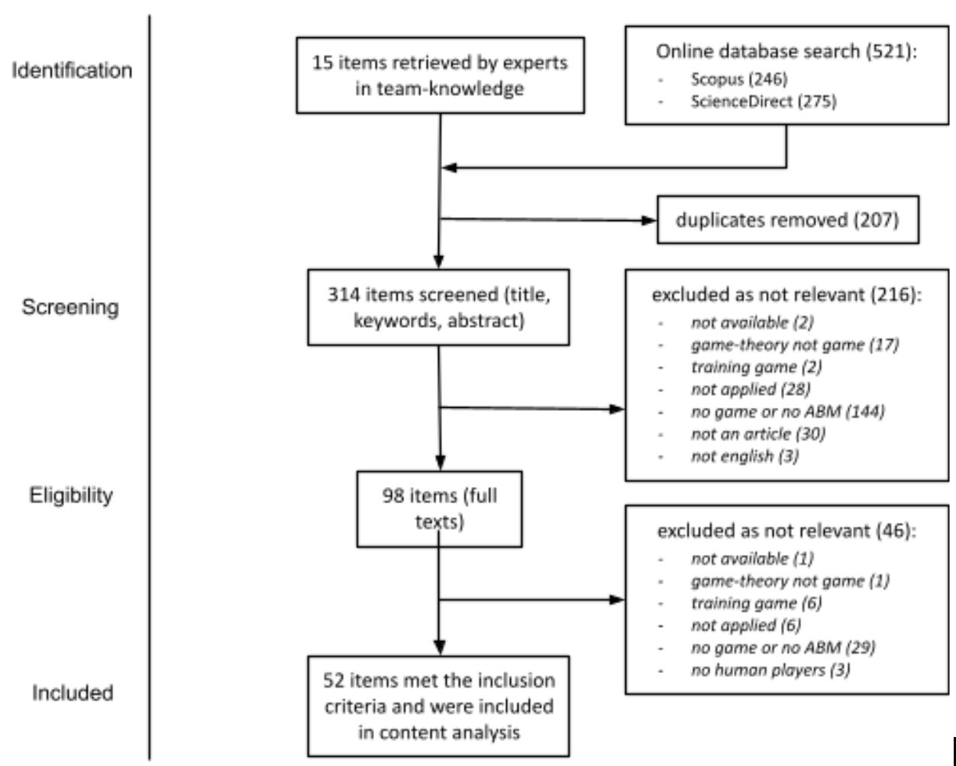
Figure 1: Flow of information through the different phases of the systematic literature review. Search date: 25.02.2020.

Available metadata such as article’s author(s), publication year, abstract, journal, keywords, and publication outlet were collected and served as the basis of the screening process, in which eight of this article’s co-authors assessed all articles with respect to relevance and eventually included or excluded them from the review. Articles where inclusion was uncertain (based on the screening of title, keywords, and abstract) underwent additional full text assessment by two co-authors. To control for inclusion consistency between reviewers, two co-authors cross-checked all final decisions for 5% of randomly selected papers. The list of items that were selected for in-depth analysis can be found in Appendix A, Table A1.
The abstracts and full texts of items selected for investigation were then subjected to content analysis. Qualitative coding was used to identify patterns in the ways games and ABMs were combined. The codebook was developed and tested using a combination of deductive and inductive coding. After finalising the codebook, the co-authors harmonised their coding practices through three iterations. After reaching satisfactory reliability, we analysed the entire qualitative dataset using NVivo. Figures were made using SPSS 26.0.0.0. After coding, we used the categorisation criteria described in Section 2.2 (main text) to identify recurring research design types.
In order to identify authorship patterns, we identified a study field matching affiliation of the author with the scientific fields descriptors from Marie Skłodowska-Curie Actions -List of Descriptors (European Commission, n.d.). We have also counted the number of authors per article, categorised authors as belonging to academic or non-academic domains, and assigned a geographical location based on affiliation.
Table 1: Search strategy of the systematic literature review performed for this study.
Data sources | Expert knowledge: selected articles known to team members.  Databases: selected articles after an initial investigation into the quantity and quality of the search results and into the accessibility of an application programming interface to the research team:  Scopus: www.scopus.com  ScienceDirect: www.sciencedirect.com
Search terms | TITLE-ABS-KEY((“gaming” OR “role playing game OR “serious game” OR “board game” OR “online game” OR “computer game”) AND (“agent based model” OR “agent based simulation” OR “individual based model” OR “individual based simulation”))
Inclusion criteria | Article in English.  Published in a peer reviewed journal, proceedings, or book.  Application in research domain.  A game and an Agent-Based Model were included (though they could be the same).

The main limitations of the SLR approach are the literature selection process and the population of publications used for analysis. Articles that are not stored in one of the two online databases or do not include our search terms are excluded from the review (Table 1). This means that it is possible that important articles escaped our review. However, this is always a price that must be paid for “automated” search of a much larger sample relative to “qualitative” analysis of articles following up references. We did not include any articles after the database search was concluded (on 25.02.2021). All our findings refer to the sample used for the analysis and therefore have finite generalisability. Although it is a limitation of the study that subjective interpretation of criteria may have affected this categorisation, this is the first systematic attempt and is therefore subject to evaluation and further improvements.

4) Results and discussion

4.1 General patterns
Combining games with ABMs for the purpose of research (i.e. using the GAM approach) is a relatively new field. The 52 analysed papers analysed were published between 2001 and 2020 (Figure 2). The GAM approach is mainly published in three journals: Environmental Modelling & Software (n=6), Journal of Artificial Societies and Social Simulation (n=6), and Journal of Environmental Management (n=5). The remaining 35 papers were published in 35 different outlets (16 conference proceedings, 12 peer-reviewed journals, 7 books or book series). Almost one third of the papers were published as conference proceedings from computer science-oriented conferences. The variety of publication outlets shows that the relatively low number of GAM research projects are widespread over different application areas, which paints the image of a scattered field. However, eleven publications in this review are from journals that focus on environmental management, highlighting the significance of the approach when working with cross-sectoral complex problems.
The practice of combining games and ABMs has been growing in popularity (Figure 2). While in our sample the first decade under investigation (2001-2010) produced a total of fourteen papers on the topic, in the subsequent one (2011-2020) publications increased almost threefold (38 papers). The 2010 peak is traceable to a series of publications in Environmental Modelling and Software, driven by an author group publishing on companion modelling, while the slight downward trend in 2019 and 2020 is most likely an artefact of our data collection that took place in February 2020.
The combination of games and ABMs was applied in 14 different fields, showing a high degree of flexibility. The most prominent application domain is natural resource management (54%), followed by group dynamics (14%), public health (6%), and city logistics (4%). This pattern might also reflect the popularity of ABMs in environmental, agricultural, and biological sciences in general (Figure D1), most probably due to the complexity approach being popularised in these domains in the last 30 years calling for application of mixed methods.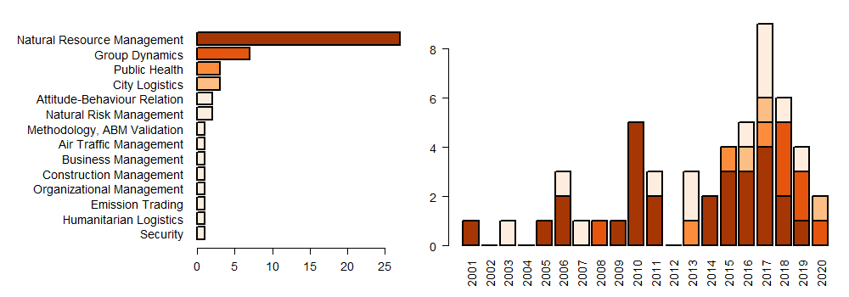Figure 2: Distribution of publications over time and application domain.

Almost half (48%) of the studies used computer-based games, a third (31%) used analogue games, and a fifth (21%) used games that combined physical and digital elements. The popularity of computer games can be attributed to several factors. They are easy to set up and efficient for tracking data; furthermore, an online game makes a study independent of the location because it offers players the possibility to participate from anywhere. Almost all the analogue games were RPGs. The prevalence of this category of games might be due to the underlying assumption that RPGs can be seen as ABMs that use humans instead of artificial agents. Only in one case (Table A1, #44), a commercial off the shelf game was used. The remaining studies used games made for the research purpose or employed games designed or used in previous research applications.
The structure of authorships shows that there are no “lone wolves” among the authors and that the field is dominated by small to medium collaborations, as 70% of publications are authored by 2-4 scholars. The largest collaboration included 19 authors.
Most of the collaborations are international (67%) and established between universities and non-academic institutions (57%). Non-academic institutions are mostly research institutes and private companies, but sporadically also government agencies and hospitals. This reflects the transdisciplinary potential of the GAM approach, with cooperation between scientists, stakeholders, and experts from the (often rural and remote) field.
Moreover, the authors of the studies included in our dataset have a plurality of research backgrounds. The affiliation of the majority of authors matched “Environmental and Geosciences” (40%), a highly multi- and interdisciplinary domain, and “Information Science and Engineering” (39%), a domain where computer models and games are well-known, with significantly fewer authors being affiliated with “Social sciences and Humanities” (8%), “Economic Sciences” (4.5%), “Life Sciences” (4.5%), “Physics” (2.3%), “Mathematics” (1%), and “Chemistry” (0.5%).
We found two types of collaborations: 1) field studies where specialists cooperate with practitioners in the field, oftentimes in international cooperations between research institutions and non-research organisations, and 2) studies organised around research institutions where cooperating researchers come from different scientific backgrounds. Thus, the complexity of applying games and ABMs in a single research design seems to stimulate collaborations. However, exact reasons for establishing cooperative efforts were not provided in the analysed papers. It might be difficult for a single scholar to have the knowledge and expertise related to all study components e.g., the methodology and the application field or the methodology and the location of the case study. It is also possible that the complex organisation and execution of the study simply requires the participation of multiple scholars.
Table 2: Description of the six research design types combining games and ABMs identified by this Systematic Literature Review. (n = number of articles with corresponding research type).
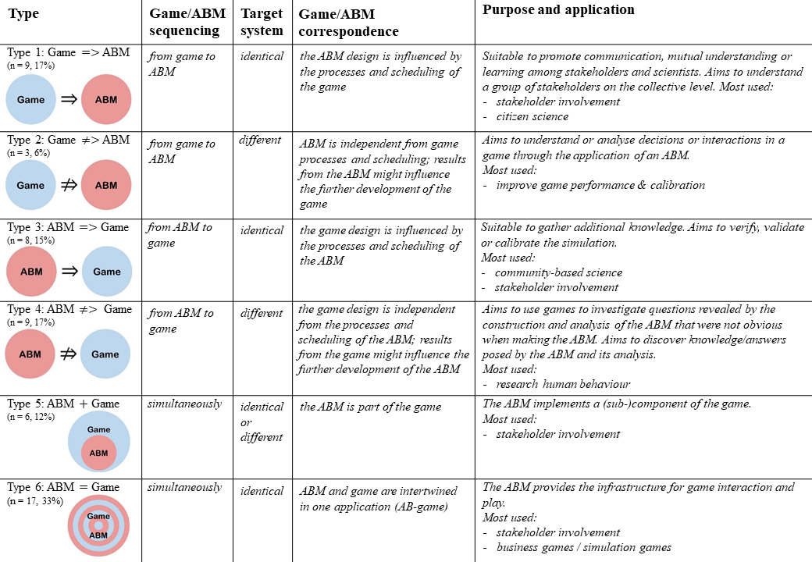

4.2 Research design types: description and patterns
When applying the three criteria (described in Section 2.2) on the 52 papers included in the content analysis phase of the SLR, we identified six types of research designs. These types are visualised and their characteristics are summarized in Table 2. An in-depth description of the data that made up each of these types is given in Appendix B. The research design types have some similarities with those described by Farias et al. (2019) in an SLR that included ten papers from natural resource management that had used multi-agent systems (MASs) and RPGs. The previous study used sequencing and level of RPG computerization as characterisation criteria. Our types 1, 3, and 5 are similar with their integration ways a, b, and c with respect to sequencing. Our study differentiates three more types: types 2 and 4, because of using the target system as a characterization criterion (inspired by the category shared or different underlying conceptual model in the analysis of the joint use of role-playing games and models in Barreteau (2003)); and type 6, because of the simultaneous sequence. Farias et al. (2019) differentiates integration way d because of the level of computerization of the game as a characterization criterion, something that our study does not regard.
GAM field is not only increasing in the number of publications but also in variations of applied research design types (see Figure D2). Types 3, 5 and 6 are present in the first third of the observation period, while the other three types appear later on. The first appearance of type 1 studies was in 2010, with four publications in one year. Since then, it has slowly faded out with no new publication for the last four years. Type 3 studies are distributed over the whole observation period, with a slight increase in the fourth quarter. Since both types (1 and 3) can be used for similar research purposes, one should also review them in relation. This combined perspective shows a constant distribution with peaks in 2010 and 2015. Although type 6 is an early occurrence in our dataset, it became the most popular design type only in the second period. Type 4 studies constitute a recent development in the field. The rising popularity of types 4 and 6 can be attributed to the increase in popularity of (video) games and the increased availability of user-friendly development platforms.
While the combination of games and ABMs was applied across many different fields, the research design types were not equally distributed (see Figure D3). Almost all research design types (except type 2) are used in natural resource management. Type 6 seems to be the most versatile, being used in 10 out of 14 application domains. Research design type 1 finds applications solely in natural resource management, while all the other types are present in at least two out of 14 application domains. Type 2 is used exclusively in the two application domains concerned solely with human social behaviour (group dynamics, attitude behaviour relation) as opposed to the socio-ecological or socio-technical systems under investigation in the other domains. This is probably because using a game to elicit knowledge about people’s decision making and attitudes and then validating these findings via an ABM seems to be especially suitable for studies in these fields.

5. Recommendations for future developments:
Drawing on the studies included in this SLR, we give brief implementation guidance for using each of the research design types and a description of the limitations of the GAM approach. The recommendations provide (especially new) researchers with a helping hand to identify an appropriate design type for their research purpose. These recommendations are useful to ABM developers and game designers alike. We also invite academics and practitioner-researchers to join a methodological discussion and critically reflect on the GAM research design types and provide robust advice in relation to shaping the GAM methodology.
Type 1 (Game ⇒ ABM) research design is suited for studies that aim to gather insider and local knowledge to widen the understanding about a specific target system. The purpose is to support decision making processes by involving stakeholders in the co-construction of an abstract representation of a real-world system i.e., the concept model. The game is used to support the design process of the subsequent ABM. It is employed to create a concept model of the system under investigation through play-testing and debating of the system elements. This concept model outlines the system under investigation and will, at a later stage, be used as the blueprint for the ABM. The ABM component is then used to present and discuss development scenarios.
Type 2 (Game ⇏ ABM) research design is well equipped to support game development. The aim of a type 2 design is to enhance the performance or calibration of game aspects by utilizing ABM. This design is also suitable when recreating a scalable version of the game in silico to explore social patterns and dynamics of players. Type 2 designs aim to use an ABM to understand/analyse the decisions and interactions in the game and sometimes evaluate and compare different theories on cooperation, group interactions, collective decision-making, etc.
Type 3 (ABM ⇒ Game) research design has the same aim and purpose as type 1 research designs i.e., gathering player knowledge. Hence, the game is used to co-design and discuss system concepts through play-testing and debating its elements in a concept model. Uniquely for type 3 designs, the study is initiated with an ABM and subsequently a game is created to mirror the basic concepts of the ABM. This sequence allows for model validation to improve or undergird an existing ABM with knowledge gathered through the game. Type 3 designs aim to verify, validate or calibrate the simulation.
Type 4 (ABM ⇏ Game) research design aims to enrich ABMs with more realistic agent behaviours or to compare implemented agents to real humans. In this design, games are utilized in controlled settings (e.g., experiments) to track behaviour of players during gameplay. On the basis of the gathered data, new agent behaviours are then created or existing agent behaviours are validated. Type 4 designs aim to use games to investigate questions revealed by the construction and analysis of the ABM.
Type 5 (Game + ABM) research design use ABMs to calculate and present the effect of players’ actions on the gameworld during the gameplay ,e.g., to demonstrate the effects of players’ decisions and actions on the environment parameters such as groundwater level, land production, government budget etc. Therefore, at each game-turn, the gameworld parameters get updated based on the ABM processes, and new values are presented to the players. As such, the game will not be able to run without the ABM and its results. Type 5 designs aim to implement ABM as a (sub-)component of the game.
Type 6 (ABM = Game) research design combine an ABM and a game in one fully integrated application, i.e. agent-based game. This approach is particularly suitable for decision support tools, but studies utilizing the design can also be used for all previously mentioned study purposes. The integration of game and ABM comes with strong ups- but also downsides. On the one hand, using this type of research design makes data integration between the game and ABM obsolete. On the other hand, this design limits the possibilities of players to show unexpected gameplay, e.g. by modifying the game rules or implementing “house rules”. Type 6 designs aim to use an ABM to provide the infrastructure for game interaction and play.
When considering using any of these research design types, one has also to be aware of the limitations of the GAM approach. Implementing this approach requires a double set of design and implementation skills, i.e. for games and for ABM. In addition, one has to have the knowledge of combining the two in an effective way. To the authors knowledge, with the exception of this current study, there is only one overview of general methodological approaches in combining games and ABMs (i.e. the analysis of six cases by the initiators of the companion modelling approach by Bousquet et al., 2002). Implementing a GAM study is a time and labour-intensive process. Therefore, it is recommended to plan well in advance both the time needed to acquire the necessary skills and the time to implement the combination of games and ABMs.
A peculiarity of papers included in this review is that they frequently lack a clarification of basic concepts, e.g., a study purpose or research questions. Moreover, explanations of the reasons behind design choices and how they are translated into a specific combination of games and ABMs are non-existent or unstructured. Consequently, it is unclear if a GAM research design is fit for purpose. Therefore, the classification of some studies was generally challenging because the texts did not include sufficient details or explicit descriptions for identifying a clear sequence, distinguishing between the target systems, or describing the game/ABM correspondence. We also realized that the uneven distribution between sections to document the game and the ABM component of GAM is because, while there is a call for rigour in game modelling (Raghothama and Meijer, 2018), there are no schemes for game documentation. There are, however, several protocols available for reporting ABM (e.g., Overview Design concepts and Details Protocol (Grimm et al., 2020), Rigor and Transparency Reporting Scheme (Siebers et al., 2021)). To facilitate writing and reading of research methods descriptions, enable replication of GAM research, and further the field through structuring it and using a GAM-specific vocabulary, we recommend practitioners to use a simple documentation scheme, as outlined here. It should be noted that this is just a first attempt to design such a scheme and requires further study and validation in future. We welcome feedback on the content, use, and usefulness of this scheme (printable version in Appendix C).
Games and Agent-Based Models (GAM) Documentation Scheme:
A) General aspects:
- Purpose of the study. [open ended]
- Research questions of the study. [open ended]
- Application field. [open ended]
- Type of GAM. [1.Game --> ABM, 2.Game -/-> ABM, 3. ABM --> Game, 4. ABM -/-> Game, 5. Game + ABM, 6.ABM = Game]
- Additional comments. [open ended]
B) GAM:
- Purpose of using the GAM methodology. [open ended]
- What is the GAM design (e.g. sequences, phases, procedures, iterations, information flow)? [open ended]
- How are the game and ABM linked (e.g. specific information from gameplay that was used to validate the ABM, how was the gameplay data used to inform ABM rules, how ABM simulations are used in the game)? [open ended]
- Limitations of the specific GAM implementation. [open ended]
- How did using GAM contribute to answering the research questions of the study? [open ended]
- Advice for others. [open ended]
- Additional comments. [open ended]
C) Game:
- Target system. [open ended]
- Kind of game. [commercial of the shelf; build for purpose, but not for this study; build for purpose for this study].
- Game type.[analogue; computer-based; mixed]
- Game category:
  - Dice and Luck: dice games, start-goal-games, search and catch games
  - Layout games: letter layout games, lottery games, figure layout games, picture layout games
  - Thinking games: strategic games, tactical games, combination games, memory games, solitary games
  - Quiz-/Communication games: question & answer games, quiz games, fortune-telling games, creativity games
  - Role-play games and simulations: economy games, criminal games, adventure games, conflict games
  - Dexterity games: dexterity games, action games, reaction games, sport games
  - Other: _______________.
- Who are the players (e.g. stakeholders, students, fellow researchers, general public)? [open ended]
- How were the players selected?[open ended]
- Game objective. [open ended]
- What are the core game mechanics? [open ended]
- What data are collected from gameplay? [open ended]
- How are the data collected from gameplay (e.g. observation, tracking etc.)? [open ended]
- If debriefing was performed, how was this done? (If debriefing was not performed, give a reason for that decision.) [open ended]]
- What data are collected after the gameplay? [open ended]
- How are the data collected after the gameplay (e.g. questionnaire, interview, focus group)? [open ended].
- What does the game add that would not be known otherwise? [open ended]
- Additional comments [open ended].
D) ABM:
- Target system. [open ended]
- Link to filled in documentation/reporting protocol/scheme: ______________
- What does the ABM add that would not be known otherwise? [open ended]
- Additional comments. [open ended].

6. Conclusions
Combining games and ABMs shows great potential to become a significant methodology in applied interdisciplinary or transdisciplinary research settings. As the GAM approach profits from the enormous popularity of digital and analogue games and the ability of ABMs to tame complexity, it can be scaled up in three dimensions: 1. Quantity of data: By using online games for data collection, researchers can attract big crowds to participate in the research process. Using games in research also takes advantage of the tendency of humans to spend many hours engaging in games. This allows researchers to collect data from many sources and over an extended period of time. 2. Quality of research: Standardising the GAM methodology will allow researchers from various fields to replicate research designs adequate for specific research settings. Using GAM applications tailored to investigate player behaviour in small groups can lead to a new wave of context-specific insights on human group dynamics and social behaviour. 3. Empowerment of stakeholders: Creating compelling and engaging environments for participants to engage in research processes will increase the impact and sustainability of decision-making processes that build on stakeholder involvement.
Employing a systematic literature review, this study identified six research design types that characterize the GAM approach. This characterization describes the current state of the field and helps to introduce the GAM approach to new research domains. The functional range of these design types is wide, with applications in 15 domains that mainly focus on decision making and managing complex systems. The six types can accommodate any type of game: analogue, digital, and hybrid. This makes the GAM approach a highly versatile tool. We describe these six types by explaining key concepts of their designs: sequence, correspondence between game and ABM, how they represent target systems, and their purpose. In order to help newcomers in the field, we give advice in what circumstances each design can be used. The six types provide a framework for scientists to communicate their work by relating it to a broader context without the danger of reinventing (re-labelling) existing concepts. The gained transparency and definiteness of the categories set the scope for methodological discussions that can lead to advancements in the field and the documentation of applications. In addition, the overview helps to identify novel research designs that have not been categorized in this review.
To consolidate the GAM field, we propose to keep track of the design and implementation of studies combining games and ABMs by using a dedicated documentation scheme, as suggested here. To further the field, a thorough description of each of the six design types is needed, together with detailed expositions of implementation examples that open the black box of how specific combinations of games and ABMs can integrate qualitative and quantitative data. Increased cooperation between ABM practitioners from any application domain and members of the games community (designers, players, researchers etc.) is needed in order to achieve the full potential of the GAM approach.

Literature
Ampatzidou, C., & Gugerell, K. (2019). Participatory game prototyping – balancing domain content and playability in a serious game design for the energy transition. CoDesign, 15(4), 345–360. https://doi.org/10.1080/15710882.2018.1504084
Bakhanova, E., Garcia, J. A., Raffe, W. L., & Voinov, A. (2020). Targeting social learning and engagement: What serious games and gamification can offer to participatory modeling. Environmental Modelling & Software, 134. https://doi.org/10.1016/j.envsoft.2020.104846
Barreteau, O. (1998). Un système multi-agent pour explorer la viabilité des systèmes irrigués: Dynamique des interactions et modes d’organisation (Sénégal) [Thesis, ENGREF].
Barreteau, O., d'Aquino, P., Bousquet, F., Le Page, C. (2002). Le jeu de rôles à l'interface entre systèmes réel et virtuel pour la gestion de ressources renouvelables : exemples d'application au Sénégal. In D. Orange, R. Arfi, M. Kuper, P. Morand and Y. Poncet (eds.), Gestion intégrée des ressources naturelles en zones inondables tropicales, 799-814.
Barreteau, O. (2003). The joint use of role-playing games and models regarding negociation processes: characterization of associations. Journal of Artificial Societies and Social Simulation, 6(2). https://www.jasss.org/6/2/3.html
Bearman, M., Smith, C. D., Carbone, A., Slade, S., Baik, C., Hughes-Warrington, M., & Neumann, D. L. (2012). Systematic review methodology in higher education. Higher Education Research & Development, 31(5), 625-640. https://doi.org/10.1080/07294360.2012.702735
Bousquet, F., Barreteau, O., Le Page, C., Mullon, C., & Weber, J. (1999). An environmental modelling approach: The use of multi-agent simulations. In Blasco, F., Well, A. (eds.), Advances in environmental and ecological modelling, 113–122.
Bousquet, F., et al. (2002). Multi-agent systems and role games: collective learning processes for ecosystem management. In Janssen, M. (eds.) Complexity and ecosystem management. - The theory and practice of multi-agent systems. 248-285.
Caillois, R. (2001). Man, play and games. University of Illinois Press.
Clement, J. (2021). Number of gamers worldwide 2023. Retrieved February 23, 2021, from https://www.statista.com/statistics/748044/number-video-gamers-world/
Cresswell, J. W. & Clark, V. L. P. (2017). Designing and Conducting Mixed Methods Research (3rd ed.). Sage Publication.
Duke, R. D. (1974). Toward a General Theory of Gaming. Simulation & Games, 5(2). doi:10.1177/003755007452001
Elliott-Graves, A. (2020). What is a target system?. Biology and Philosophy, 35(2). https://doi.org/10.1007/s10539-020-09745-3
European Commission. (n.d.). Marie Skłodowska-Curie Actions -List of Descriptors. Retrieved February 23, 2021, from https://ec.europa.eu/research/participants
/data/ref/h2020/other/call_ptef/pt/h2020-call-list-descr-msca-itn_en.pdf
Farias, G., Leitzke, B., Born, M., Aguiar, M., & Adamatti, D. F. (2019). Systematic Review of Natural Resource Management using Multiagent Systems and Role-Playing Games. Research in Computing Science, 148(11). https://doi.org/10.13053/rcs-148-11-7
González, L. S., Rubio, F. G., González, F. R., & Velthuis, M. P. (2010). Measurement in business processes: A systematic review. Business Process Management Journal, 16(1), 114-134. https://doi.org/10.1108/14637151011017976
Grimm, V., Railsback, SF., Vincenot, CE., Berger, U., Gallagher, C., DeAngelis … Ayllón, D. (2020). The ODD Protocol for Describing Agent-Based and Other Simulation Models: A Second Update to Improve Clarity, Replication, and Structural Realism. Journal of Artificial Societies and Social Simulation, 23(2) 7. https://doi.org/10.18564/jasss.4259
Gu, X., & Blackmore, K. L. (2015). A systematic review of agent-based modelling and simulation applications in the higher education domain. Higher Education Research and Development, 34(5), 883-898. https://doi.org/10.1080/07294360.2015.1011088
Guyot, P., & Honiden, S. (2006). Agent-based participatory simulations: Merging multi-agent systems and role-playing games. Journal of Artificial Societies and Social Simulation, 9(4). https://www.jasss.org/9/4/8.html
Klabbers, J. H. B. (2006). The magic circle: Principles of gaming and simulation. Sense Publishers.
Krippendorff, K. (2012). Content analysis: An introduction to its methodology (3rd ed.) Sage Publications.
Le Page, C., Abrami, G., Barreteau, O., Becu, N., Bommel, P., Botta, A. … Souchère, V. (2014). Models for Sharing Representations. In Étienne M. (eds) Companion Modelling: A Participatory Approach to Support Sustainable Development, 69–101, 69-101 . https://doi.org/10.1007/978-94-017-8557-0_4
McGonigal, J. (2011). Reality is broken: Why games make us better and how they can change the world. Penguin Press.
Miller, J.H., & Page, S.E. (2009). Complex Adaptive Systems: An Introduction to Computational Models of Social Life. Princeton University Press.
Morgan, D. L. (2017). Integrating Qualitative and Quantitative Methods: A Pragmatic Approach. SAGE Publications. https://doi.org/10.4135/9781544304533
Pfirman, S., O’Garra, T., Bachrach Simon, E., Brunacini, J., Reckien, D., Lee, J. J., & Lukasiewicz, E. (2021). “Stickier” learning through gameplay: An effective approach to climate change education, Journal of Geoscience Education, 69(2), 192-206. https://doi.org/10.1080/10899995.2020.1858266
Raghothama, J., & Meijer, S. (2018). Rigor in gaming for design: Conditions for transfer between game and reality. Simulation & Gaming, 49(3), 246-262. https://doi.org/10.1177/1046878118770220
Ren, Y., Cedeno-Mieles, V., Hu, Z., Deng, X., Adiga, A., Barrett, C., ... Macy, M. W. (2018). Generative Modeling of Human Behavior and Social Interactions Using Abductive Analysis. 2018 IEEE/ACM International Conference on Advances in Social Networks Analysis and Mining, 413–420. https://doi.org/10.1109/ASONAM.2018.8508282
Rodela, R.; Ligtenberg, A.; Bosma, R. (2019.) Conceptualizing Serious Games as a Learning-Based Intervention in the Context of Natural Resources and Environmental Governance. Water 2019, 11(2). https://doi.org/10.3390/w11020245
Salen, K., & Zimmerman, E. (2003). Rules of Play: Game Design Fundamentals. The MIT Press.
Salvini, G., Ligtenberg, A., van Paassen, A., Bregt, A. K., Avitabile, V., & Herold, M. (2016). REDD+ and climate smart agriculture in landscapes: A case study in Vietnam using companion modelling. Journal of Environmental Management, 17, 58-70. https://doi.org/10.1016/j.jenvman.2015.11.060
Schoonenboom, J., & Johnson, R. B. (2017). How to Construct a Mixed Methods Research Design. Kölner Zeitschrift für Soziologie und Sozialpsychologie, 69(2), 107–131. https://doi.org/10.1007/s11577-017-0454-1
Siebers PO., Achter S., Palaretti Bernardo C., Borit M., Chattoe-Brown E. (2021) First Steps Towards RAT: A Protocol for Documenting Data Use in the Agent-Based Modeling Process. In Ahrweiler P., Neumann M. (eds), Advances in Social Simulation. ESSA 2019. Springer Proceedings in Complexity. Springer. https://doi.org/10.1007/978-3-030-61503-1_24
Šmite, D., Wohlin, C., Gorschek, T., & Feldt, R. (2010). Empirical evidence in global software engineering: A systematic review. Empirical Software Engineering, 15(1), 91–118. https://doi.org/10.1007/s10664-009-9123-y
Tykhonov, D., Jonker, C., Meijer, S., & Verwaart, T. (2008). Agent-Based simulation of the trust and tracing game for supply chains and networks. Journal of Artificial Societies and Social Simulation, 11(3). https://www.jasss.org/11/3/1.html
Voinov, A., & Bousquet, F. (2010). Modelling with stakeholders. Environmental Modelling and Software, 25(11). https://doi.org/10.1016/j.envsoft.2010.03.007
Voinov, A., Jenni, K., Gray, S., Kolagani, N., Glynn, P. D., Bommel, P., … Smajgl, A. (2018). Tools and methods in participatory modeling: Selecting the right tool for the job. Environmental Modelling & Software, 107, 1268-1281. https://doi.org/10.1016/j.envsoft.2018.08.028
Voinov, A., Kolagani, N., McCall, M. K., Glynn, P. D., Kragt, M. E., Ostermann, F. O., Pierce, S. A., & Ramu, P. (2016). Modelling with stakeholders – Next generation. Environmental Modelling & Software, 77, 196-220. https://doi.org/10.1016/j.envsoft.2015.11.016
Weber, C. T., Borit, M., & Aschan, M. (2019). An Interdisciplinary Insight Into the Human Dimension in Fisheries Models. A Systematic Literature Review in a European Union Context. Frontiers in Marine Science, 6. https://doi.org/10.3389/fmars.2019.00369

Appendix A. Selected Literature
The exact search configuration, the python crawlers and the result of the automated search can be found on GitHub (https://github.com/tmrmn/gam).
Table A1. List of items that met the inclusion criteria and were included in the content analysis of this study (T = research design type).
# | T | Reference
1 | 1 | Abrami, G., & Schlueter, M. (2009). Building an agent-based model for exploring how informal rules impact the functioning of newly established water user associations in central Asia. Conference Proceedings - 6th Conference of the European Social Simulation Association (SSC2009).
2 | 5 | Adamatti, D. F., Sichman, J. S., Bommel, P., Ducrot, R., Rabak, C., & Camargo, M. E. S. A. (2005). JogoMan: A prototype using multi-agent-based simulation and role-playing games in water management. Joint Conderence on MultiAgent Modelling for Environmental Management (CABM-HEMA-SMAGET), 1–18.  For further details and a discussion on the GMABS methodology (Games and Multi-Agent-Based Simulation) see: Adamatti, D. F., et al. (2009). An Analysis of the Insertion of Virtual Players in GMABS Methodology Using the Vip-JogoMan Prototype. Journal of Artificial Societies and Social Simulation, 12(3) 7. https://www.jasss.org/12/3/7.html
3 | 3 | Anand, N., Meijer, D., van Duin, J. H. R., Tavasszy, L., & Meijer, S. (2016). Validation of an agent based model using a participatory simulation gaming approach: The case of city logistics. Transportation Research Part C: Emerging Technologies, 71, 489–499. https://doi.org/10.1016/j.trc.2016.08.002
4 | 6 | Anderson, B., Coulter, S., Orlowsky, R., Ruzich, B., Smedley, R., Purvis, M., Learmonth, G. P., & Gerling, G. J. (2017). Designing user experiences for policymakers in serious games in the domain of global food security. 2017 Systems and Information Engineering Design Symposium (SIEDS), 89–94. https://doi.org/10.1109/SIEDS.2017.7937759
5 | 3 | Barreteau, O., Bousquet, F., & Attonaty, J. M. (2001). Role-playing games for opening the black box of multi-agent systems: Method and lessons of its application to Senegal River Valley irrigated systems. Journal of Artificial Societies and Social Simulation, 4(2). https://ideas.repec.org/a/jas/jasssj/2000-18-1.html
6 | 6 | Becu, N., Amalric, M., Anselme, B., Beck, E., Bertin, X., Delay, E., … Rousseaux, F. (2017). Participatory simulation to foster social learning on coastal flooding prevention. Environmental Modelling and Software, 98, 1–11. https://doi.org/10.1016/j.envsoft.2017.09.003
7 | 3 | Belem, M., Bazile, D., & Coulibaly, H. (2018). Simulating the Impacts of Climate Variability and Change on Crop Varietal Diversity in Mali (West-Africa) Using Agent-Based Modeling Approach. Journal of Artificial Societies and Social Simulation, 21(2). https://doi.org/10.18564/jasss.3690
8 | 8 | Bhattacharya, K., Takko, T., Monsivais, D., & Kaski, K. (2019). Group formation on a small-world: Experiment and modelling. Journal of The Royal Society Interface, 16(156), 20180814. https://doi.org/10.1098/rsif.2018.0814
9 | 6 | Briot, J. P., de Azevedo Irving, M., Filho, J. E. V., de Melo, G. M., Alvarez, I., Sordoni, A., & de Lucena, C. J. P. (2016). Participatory management of protected areas for biodiversity conservation and social inclusion: Experience of the SimParc multi-agent-based serious game. In Multi-Agent-Based Simulations Applied to Biological and Environmental Systems, 295–332). https://doi.org/10.4018/978-1-5225-1756-6.ch013
10 | 33 | Castella, J. C., & Verburg, P. H. (2007). Combination of process-oriented and pattern-oriented models of land-use change in a mountain area of Vietnam. Ecological Modelling, 202(3–4), 410–420. https://doi.org/10.1016/j.ecolmodel.2006.11.011  For a more detailed description of methodological details, see Castella, J. C., et al. (2005). “Participatory simulation of land-use changes in the Northern Mountains of Vietnam: the combined use of an agent-based model, a role-playing game, and a geographic information system.” Ecology and Society 10(1): 27.
11 | 4 | Cedeno-Mieles, V., Hu, Z., Ren, Y., Deng, X., Adiga, A., Barrett, C., … Self, N. (2020). Networked experiments and modeling for producing collective identity in a group of human subjects using an iterative abduction framework. Social Network Analysis and Mining, 10(1), 11. https://doi.org/10.1007/s13278-019-0620-8
12 | 12 | D’Aquino, P., & Bah, A. (2014). Multi-level participatory design of land use policies in African drylands: A method to embed adaptability skills of drylands societies in a policy framework. Journal of Environmental Management, 132, 207–219. https://doi.org/10.1016/j.jenvman.2013.11.011
13 | 5 | Daré, W., Venot, J. P., Page, C. L., & Aduna, A. (2018). Problemshed or watershed? Participatory modeling towards IWRM in North Ghana. Water (Switzerland), 10(6), 721. https://doi.org/10.3390/w10060721
14 | 6 | Delaney, L., Kleczkowski, A., Maharaj, S., Rasmussen, S., & Williams, L. (2013). Reflections on a virtual experiment addressing human behavior during epidemics. Simulation Series, 45(11), 131–138.
15 | 25 | Dubois, E., Barreteau, O., & Souchère, V. (2013). An agent-based model to explore game setting effects on attitude change during a role playing game session. Journal of Artificial Societies and Social Simulation, 16(1), 1–14. https://doi.org/10.18564/jasss.2065
16 | 5 | Dumrongrojwatthana, P., Le Page, C., Gajaseni, N., & Trébuil, G. (2011). Co-constructing an agent-based model to mediate land use conflict between herders and foresters in northern Thailand. Journal of Land Use Science, 6(2–3), 101–120. https://doi.org/10.1080/1747423X.2011.558596
17 | 17 | Dupont, H., Gourmelon, F., Rouan, M., Le Viol, I., & Kerbiriou, C. (2016). The contribution of agent-based simulations to conservation management on a Natura 2000 site. Journal of Environmental Management, 168, 27–35. https://doi.org/10.1016/j.jenvman.2015.11.056
18 | 28 | Gomes, S., Dias, J., & Martinho, C. (2019). GIMME: Group Interactions Manager for Multiplayer sErious games. 2019 IEEE Conference on Games (CoG), 2019, 1–8. https://doi.org/10.1109/CIG.2019.8847962
19 | 49 | Gu, J., Huang, J.-P., & Chen, Y. (2018). A Preliminary Study of Human Decision-Making, Risk Attitude, and Social Preference on Knowledge Management. In Developmental Cognitive Neuroscience, 591, 297–311. https://doi.org/10.1007/978-3-319-60591-3_27
20 | 6 | Guyot, P., Drogoul, A., & Honiden, S. (2006). Power and negotiation: Lessons from agent-based participatory simulations. Proceedings of the International Conference on Autonomous Agents, 27–33. https://doi.org/10.1145/1160633.1160636
21 | 6 | Guyot, P., & Honiden, S. (2006). Agent-based participatory simulations: Merging multi-agent systems and role-playing games. Journal of Artificial Societies and Social Simulation, 9(4). https://www.jasss.org/9/4/8.html
22 | 32 | Joffre, O. M., Bosma, R. H., Ligtenberg, A., Tri, V. P. D., Ha, T. T. P., & Bregt, A. K. (2015). Combining participatory approaches and an agent-based model for better planning shrimp aquaculture. Agricultural Systems, 141, 149–159. https://doi.org/10.1016/j.agsy.2015.10.006
23 | 63 | Kikuchi, T., Tanaka, Y., Kunigami, M., Yamada, T., Takahashi, H., & Terano, T. (2019). Debriefing Framework for Business Games Using Simulation Analysis. Communications in Computer and Information Science, 999(1), 64–76. https://doi.org/10.1007/978-981-13-6936-0_8
24 | 6 | Kleczkowski, A., Maharaj, S., Rasmussen, S., Williams, L., & Cairns, N. (2015). Spontaneous social distancing in response to a simulated epidemic: A virtual experiment. BMC Public Health, 15(1), 973. https://doi.org/10.1186/s12889-015-2336-7
25 | 15 | Le Page, C., Naivinit, W., Trébuil, G., & Gajaseni, N. (2014). Companion Modelling with Rice Farmers to Characterise and Parameterise an Agent-Based Model on the Land/Water Use and Labour Migration in Northeast Thailand. In Empirical Agent-Based Modelling—Challenges and Solutions. Springer, New York. 207–221. https://doi.org/10.1007/978-1-4614-6134-0_11
26 | 6 | Le Page, Christophe, & Perrotton, A. (2017). KILT: A Modelling Approach Based on Participatory Agent-Based Simulation of Stylized Socio-Ecosystems to Stimulate Social Learning with Local Stakeholders. In Lecture Notes in Computer Science (including subseries Lecture Notes in Artificial Intelligence and Lecture Notes in Bioinformatics): Vol. 10643 LNAI, 31–44. https://doi.org/10.1007/978-3-319-71679-4_3
27 | 3 | Le Pira, M., Marcucci, E., & Gatta, V. (2017). Role-playing games as a mean to validate agent-based models: An application to stakeholder-driven urban freight transport policy-making. Transportation Research Procedia, 27, 404–411. https://doi.org/10.1016/j.trpro.2017.12.060
28 | 38 | Lim, H. C., Barlow, M., Larkin, H., & Stocker, R. (2011). Generative Experimentation and Social Simulation: Exploring Gaming for Model Verification and Validation. 2011 International Symposium on Computer Science and Society, 336–340. https://doi.org/10.1109/ISCCS.2011.94
29 | 69 | Maeda, Y., Ito, N., & Miyakawa, M. (2008). An agent model and its gaming simulation reproducing the emergence of a minority. Conference Proceedings - IEEE International Conference on Systems, Man and Cybernetics, 2413–2418. https://doi.org/10.1109/ICSMC.2008.4811656
30 | 4 | Maity, S. K., Porwal, A., & Mukherjee, A. (2013). Understanding how learning affects agreement process in social networks. Proceedings - SocialCom/PASSAT/BigData/EconCom/BioMedCom 2013, 228–235. https://doi.org/10.1109/SocialCom.2013.40
31 | 6 | Masoodian, M., & Luz, S. (2017). Ecoepidemiological Simulation as a Serious Game Engine Module. Proceedings - IEEE Symposium on Computer-Based Medical Systems, 193–194. https://doi.org/10.1109/CBMS.2017.45
32 | 6 | Mizuta, H., & Yamagata, Y. (2002). Transaction cycle of agents and web-based gaming simulation for international emissions trading. Winter Simulation Conference Proceedings, 801–806. https://doi.org/10.1109/wsc.2002.1172963
33 | 1 | Naivinit, W., Le Page, C., Trébuil, G., & Gajaseni, N. (2010). Participatory agent-based modeling and simulation of rice production and labor migrations in Northeast Thailand. Environmental Modelling and Software, 25(11), 1345–1358. https://doi.org/10.1016/j.envsoft.2010.01.012
34 | 6 | Nguyen-Duc, M., & Drogoul, A. (2007). Using computational agents to design participatory social simulations. Journal of Artificial Societies and Social Simulation, 10(4).
35 | 6 | Perez Estrada, L. E., Groen, D., & Ramirez-Marquez, J. E. (2017). A Serious Video Game To Support Decision Making On Refugee Aid Deployment Policy. Procedia Computer Science, 108, 205–214. https://doi.org/10.1016/j.procs.2017.05.112
36 | 46 | Pierce, T., & Madani, K. (2014). Online Gaming for Understanding Agents’ Behavior in Water-Sharing Problems. World Environmental and Water Resources Congress 2014: Water Without Borders - Proceedings of the 2014 World Environmental and Water Resources Congress, 1867–1875. https://doi.org/10.1061/9780784413548.187
37 | 4 | Ren, Y., Cedeno-Mieles, V., Hu, Z., Deng, X., Adiga, A., Barrett, C., … Macy, M. W. (2018). Generative Modeling of Human Behavior and Social Interactions Using Abductive Analysis. 2018 IEEE/ACM International Conference on Advances in Social Networks Analysis and Mining (ASONAM), 413–420. https://doi.org/10.1109/ASONAM.2018.8508282
38 | 5 | Rouan, M., Kerbiriou, C., Levrel, H., & Etienne, M. (2010). A co-modelling process of social and natural dynamics on the isle of Ouessant: Sheep, turf and bikes. Environmental Modelling & Software, 25(11), 1399–1412. https://doi.org/10.1016/j.envsoft.2009.10.010
39 | 19 | Ruankaew, N., Le Page, C., Dumrongrojwattana, P., Barnaud, C., Gajaseni, N., Van Paassen, A., & Trébuil, G. (2010). Companion modelling for integrated renewable resource management: A new collaborative approach to create common values for sustainable development. International Journal of Sustainable Development and World Ecology, 17(1), 15–23. tps://doi.org/10.1080/13504500903481474  For more methodological details about the case study see: Barnaud, C., et al. (2013). Spatial representations are not neutral: Lessons from a participatory agent-based modelling process in a land-use conflict. Environmental Modelling & Software, 45, 150-159.
40 | 10 | Salvini, G., Ligtenberg, A., van Paassen, A., Bregt, A. K., Avitabile, V., & Herold, M. (2016). REDD+ and climate smart agriculture in landscapes: A case study in Vietnam using companion modelling. Journal of Environmental Management, 172, 58–70. https://doi.org/10.1016/j.jenvman.2015.11.060
41 | 4 | Schill, C., Wijermans, N., Schlüter, M., & Lindahl, T. (2016). Cooperation is not enough—Exploring social-ecological micro-foundations for sustainable common-pool resource use. PLoS ONE, 11(8), e0157796. https://doi.org/10.1371/journal.pone.0157796
42 | 32 | Shelton, R. E., Baeza, A., Janssen, M. A., & Eakin, H. (2018). Managing household socio-hydrological risk in Mexico city: A game to communicate and validate computational modeling with stakeholders. Journal of Environmental Management, 227(August), 200–208. https://doi.org/10.1016/j.jenvman.2018.08.094
43 | 53 | Souchère, V., Millair, L., Echeverria, J., Bousquet, F., Le Page, C., & Etienne, M. (2010). Co-constructing with stakeholders a role-playing game to initiate collective management of erosive runoff risks at the watershed scale. Environmental Modelling and Software, 25(11), 1359–1370. https://doi.org/10.1016/j.envsoft.2009.03.002
44 | 6 | Tavcar, A., & Gams, M. (2018). Surrogate-agent modeling for improved training. Engineering Applications of Artificial Intelligence, 74(July), 280–293. https://doi.org/10.1016/j.engappai.2018.07.001
45 | 25 | Tykhonov, D., Jonker, C., Meijer, S., & Verwaart, T. (2008). Agent-Based simulation of the trust and tracing game for supply chains and networks. Journal of Artificial Societies and Social Simulation, 11(3), 1–30.
46 | 66 | Ueda, K., & Kurahashi, S. (2018). How Can We Utilize Self-service Technology Better? In S. Staab, O. Koltsova, & D. I. Ignatov (Eds.), Lecture Notes in Computer Science (including subseries Lecture Notes in Artificial Intelligence and Lecture Notes in Bioinformatics): Vol. 11186 LNCS. Springer International Publishing, 299–312. https://doi.org/10.1007/978-3-030-01159-8_29
47 | 4 | Verwaart, T., Dijkxhoorn, Y., Plaisier, C., & van Wagenberg, C. (2019). Agent-Based Simulation of Local Soy Value Chains in Ghana. In Lecture Notes in Computer Science (including subseries Lecture Notes in Artificial Intelligence and Lecture Notes in Bioinformatics): Vol. 11805 LNAI, 654–666). https://doi.org/10.1007/978-3-030-30244-3_54
48 | 18 | Vieira Pak, M., & Castillo Brieva, D. (2010). Designing and implementing a Role-Playing Game: A tool to explain factors, decision making and landscape transformation. Environmental Modelling & Software, 25(11), 1322–1333. https://doi.org/10.1016/j.envsoft.2010.03.015
49 | 4 | Villamor, G. B., & van Noordwijk, M. (2016). Gender specific land-use decisions and implications for ecosystem services in semi-matrilineal Sumatra. Global Environmental Change, 39, 69–80. https://doi.org/10.1016/j.gloenvcha.2016.04.007
50 | 10 | Worrapimphong, K., Gajaseni, N., Le Page, C., & Bousquet, F. (2010). A companion modeling approach applied to fishery management. Environmental Modelling and Software, 25(11), 1334–1344. https://doi.org/10.1016/j.envsoft.2010.03.012
51 | 5 | Yang, L., Zhang, L., Philippopoulos-Mihalopoulos, A., Chappin, E. J. L., & van Dam, K. H. (2020). Integrating agent-based modeling, serious gaming, and co-design for planning transport infrastructure and public spaces. URBAN DESIGN International. https://doi.org/10.1057/s41289-020-00117-7
52 | 62 | Zhang, J., Issa, R. A. R., & Liu, R. (2016). Development of an Immersive game for Human Behavior data Collection. Construction Research Congress, 2332–2339.

Appendix B. In-depth description of six Research Design Types
Research design type 1 (Game ⇒ ABM) is characterised by a sequence that moves from the game to the ABM. The game is leading the process, even though the sequence might be repeated over multiple iterations to include multiple data sources, and is used as a facilitation tool to collect, discuss and integrate stakeholder knowledge into an overarching model concept. The ABM is constructed after the game, reflecting the components, scheduling processes and flow of the game. Subsequently, both components represent the same target system. Type 1 research designs are most commonly found in research projects with stakeholder involvement at their core. The game is then used as a vehicle to develop a concept model in a participatory fashion. We found nine publications using this research design, all of which apply RPGs, as a participatory approach, in the field of natural resource management. Six of these articles label their approach as companion modelling (A1#17 ( = Table A1, row #17), A1#25, A1#33, A1#39, A1#40, A1#50), and three refrain from self-description (A1#1, A1#12, A1#48).
The sequence of research design type 2 (Game ⇏ ABM) begins with either creating a game or using an existing game. Similar to type 1 (Game ⇒ ABM), the ABM is developed or employed after the game. However, in type 2 research design, the ABM depicts a different target system (section 2.2.). The ABM is constructed with the goal to improve the game performance or to simulate the game itself. It is a relatively rare occurrence in our dataset (three articles) applied to explore player decision making (A1#45), the effects of the game settings on player attitudes changes (A1#15) or introducing group management with the purpose of enhancing the performance of a serious game in achieving learning goals (A1#18). In all these studies, the system simulated in ABM is either a part of the system defined for the game or a different target system.
In research design type 3 (ABM ⇒ Game), the sequence transitions from the ABM to the game. A research project initiates with a (simple) ABM of the investigated phenomenon. The game is constructed either to mirror the ABM or highlight its specific aspects. Both the ABM and the game explore the same target system and employ identical or vastly similar mechanics. Type 3 research designs are found in community-based approaches aiming at engaging stakeholders and improving communication among different interest groups. Five out of eight papers representing type 3 explore natural resource management by using analogue RPGs to engage stakeholders in validating (A1#5, A1#7, A1#10, A1#42 ) or calibrating (A1#22) the ABM. Additional two articles are related to urban logistics and employ RPGs to validate and improve model ontology and dynamics (A1#3) or to test the predictive ability of the ABM (A1#27). The last publication of type 3 refers to ethics and trust, and exercises the game for ABM verification and validation purposes (A1#28).
Research design type 4 (ABM ⇏ Game) starts with the creation of an ABM and the subsequent game that aims to collect additional knowledge to feed back in the ABM. Although observations from the gaming session are applied to enhance the initial ABM, the game itself is a stand-alone product representing a distinct target system. Type 4 designs are mainly employed in studies investigating human interactions in social or socio-technical systems. While the purpose of the game can be similar to the one in type 3 designs (i.e. validating an ABM), the approach here offers opportunities to extend prevailing models with new dynamics or triangulate by linking results. The type 4 approach employs games in experimental settings with the goal to extend or tune existing ABMs. Four out of nine type 4 publications focus on natural resource management and use digital RPGs to collect data on player behaviours (A1#36, A1#41, A1#49). In all of these studies, subjects interact directly with a computer via a user interface in an experimental setting. The digital RPGs were used in a similar fashion to the analogue games described in type 3. They are used as a data collection set up to test different intervention scenarios with the players in an experimental setup (A1#19), to evaluate and calibrate ABMs through controlled laboratory experiment with an online game platform (A1#30, A1#37) and anagram games (A1#11), and to extend agents capacities of agents to make them more “human-like” (A1#8). One example (A1#47) uses behavioural economics games in a mix of methods, e.g. desk research and interviews, to calibrate simulations.
Research design Type 5 (Game + ABM) showcases studies where the ABM is an inherent element of the game and is therefore created as a part of game development. During a gaming session, the ABM simulates complex mechanics (e.g. dynamic effects on an environment resulting from player interactions). Depending on what simulated effects are needed to support the gameplay, the target systems may be equivalent or different. Similar to types 1 and 3, type 5 research designs in our sample study use community-based approaches. Five of the six studies are on the natural resource management domain and combine an ABM with an RPG. In these studies, ABM is used to calculate and represent the impacts of player actions on an ecological system (water management (A1#2, A1#13, A1#43); biodiversity (A1#38); or land management (A1#16)). One study uses the ABM to supplement a city logistics game by visualizing an additional layer of information (A1#51).
Research designs Type 6 (ABM = Game) describes projects in which an ABM is built as a game either by creating a brand new application or transforming an existing ABM into a game. Since the ABM and the Game have one application, they represent one target system. Their components are intertwined and comprise the application’s mechanics, rules and user interface(s). Type 6 research design is increasingly popular (17 examples in this review - between 2017 and 2018 type 6 represented more than 50% of analysed publications) and relatively diverse. They are present in community-based approaches and studies that research human behaviour, explore socio-technological systems, or experiment with business games. More recently, ABM=games (or agent-based simulation games) have been the most common research design to support policy development. The first type 6 study (in our sample study) was used to describe emissions trading (A1#32). Later, it has been applied in a variety of fields e.g. public health (A1#14, A1#24, A1#31), construction management (A1#52), security (A1#44), group dynamics (A1#29) or businesses games (A1#23, A1#46). Moreover, type 6 design has been used in studies engaging stakeholders e.g. in natural resource and risks management (A1#4, A1#6, A1#9, A1#20, A1#21, A1#26), air traffic management (A1#34), and humanitarian logistics (A1#35)
In addition, there are few research setups that include multiple design types in one study. For example, a study initially designed in a type 1 or type 3 research design sequence can transition to a type 5 at a later stage if additional resources are available (e.g. A1#13).

Appendix C. GAM Documentation Scheme
Table C1. Games and Agent-based Models (GAM) Documentation Scheme. Answer options are given in square parentheses.
A) General aspects | - Purpose of the study. [open ended]  - Research questions of the study. [open ended]  - Application field. [open ended]  - Type of GAM. [1.Game --> ABM, 2.Game -/-> ABM, 3. ABM --> Game, 4. ABM -/-> Game, 5. Game + ABM, 6.ABM = Game]  - Additional comments. [open ended]
B) GAM | - Purpose of using the GAM methodology. [open ended]  - What is the GAM design (e.g. sequences, phases, procedures, iterations, information flow)? [open ended]  - How are the game and ABM linked (e.g. specific information from gameplay that was used to validate the ABM, how was the gameplay data used to inform ABM rules, how ABM simulations are used in the game)? [open ended]  - Limitations of the specific GAM implementation. [open ended]  - How did using GAM contribute to answering the research questions of the study? [open ended]  - Advice for others. [open ended]  - Additional comments. [open ended]
C) Game | - Target system. [open ended]  - Kind of game. [commercial of the shelf; build for purpose, but not for this study; build for purpose for this study].  - Game type.[analogue; computer-based; mixed]  - Game category:  - Dice and Luck: dice games, start-goal-games, search and catch games  - Layout games: letter layout games, lottery games, figure layout games, picture layout games  - Thinking games: strategic games, tactical games, combination games, memory games, solitary games  - Quiz-/Communication games: question & answer games, quiz games, fortune-telling games, creativity games  - Role-play games and simulations: economy games, criminal games, adventure games, conflict games  - Dexterity games: dexterity games, action games, reaction games, sport games  - Other: _______________.  - Who are the players (e.g. stakeholders, students, fellow researchers, general public)? [open ended]  - How were the players selected?[open ended]  - Game objective. [open ended]  - What are the core game mechanics? [open ended]  - What data are collected from gameplay? [open ended]  - How are the data collected from gameplay (e.g. observation, tracking etc.)? [open ended]  - If debriefing was performed, how was this done? (If debriefing was not performed, give a reason for that decision.) [open ended]]  - What data are collected after the gameplay? [open ended]  - How are the data collected after the gameplay (e.g. questionnaire, interview, focus group)? [open ended].  - What does the ABM add that would not be known otherwise? [open ended]  - Additional comments [open ended].
D) ABM | - Target system. [open ended]  - Link to filled in documentation/reporting protocol/scheme: ______________  - What does the ABM add that would not be known otherwise? [open ended]  - Additional comments. [open ended].

Appendix D - Figures:
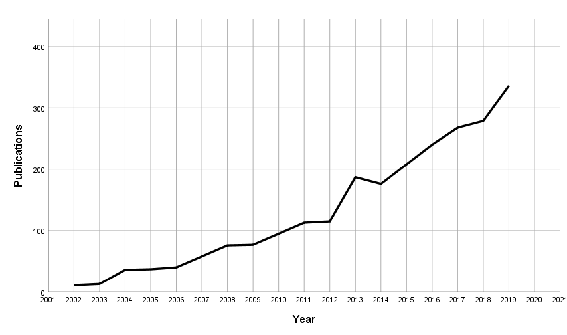
Figure D1: Results of searching for the keyword “agent-based model” on ScienceDirect (23.03.2021) filtered by ”Year” and “Subject areas” (environmental, agricultural, and biological sciences).
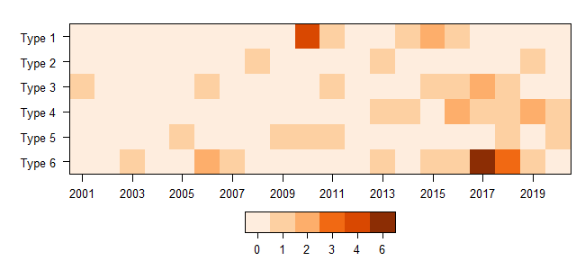Figure D2: Publications per year per research design type.

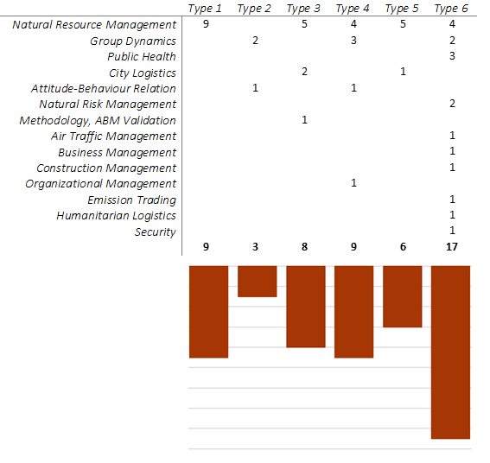
Figure D3: Number of publications per research design type.

