Angle-resolved Spectrophotometry for the Optical Characterisation of Material Surfaces
Jack J. Tyson, Tasmiat Rahman, and Stuart A. Boden
Abstract—Surface reflectance is a practical metric of the optical performance of a material. Applications such as glass manufacturing, light sensing, satellite reflectors, and photovoltaics, depend on their reflectance properties and generalised optical performance. Reflectance measurements are rarely reported comprehensively, with only a single angle of incidence common in most datasets. Here we present a new spectrophotometry system capable of performing angle-, wavelength-, and polarisation-resolved reflectance measurements on various surfaces. Data from such a system yields significant information regarding the everyday, real-world performance of said materials. We perform exemplar studies by characterising several standard thin-film anti-reflectance coatings and comparing the results to their known theoretical optical response. We also present results from measurements on an optical insulating material as well as a selection of wall paints to showcase the versatility of the technique. We highlight the parallels between measurement and theory, whilst analysing the realistic implications of the measurements on their respective material’s practical performance under real-world conditions.

Index Terms—angle-resolved, characterisation, reflectance, materials, spectrophotometry.

INTRODUCTION
R
EFLECTANCE is an important property in the design of materials for specific applications. This property can be measured in several ways, which usually involve illuminating the sample at a single angle of incidence and collecting the light reflected in a particular direction, through the use of a detector mounted on an arm in a goniometer set-up [1], or the total reflected light (hemispherical reflectance) using an integrating sphere. These single angle reflectance (SAR) approaches provide spectral information either through the use of a monochromator which scans the wavelength range at the input, or using a broadband light source and coupling the output to a spectrometer. SAR methods, despite being insightful, do not provide a complete picture of true reflectance characteristics, particularly for applications in which the angle of incidence varies. Many tools do not resolve hemispherical reflectance with respect to both incident angle, $θ$, and wavelength, $λ$, distributions simultaneously, as well as for different polarisations due to the complexity of such measurements, particularly in an automated process with a high degree of control.
One exception to this was a tool developed by Parretta et al. known as the Reflectometer for Optical measurements in Solar Energy (ROSE) [2]. The ROSE system uses a series of portholes and a sample mounted on the side of the sphere to achieve variable angle incidence. This methodology, in comparison to that presented here, is limited in angular resolution by the positioning of the manufactured entrance portholes - $10°$ in this case. Resolution can only be increased with the use of a different (and larger) sphere featuring more entrance portholes at the required angles. By moving the light source instead of the sample, the number of portholes required directly increases the prominence of the general integration error by tarnishing the spherical nature of the sphere itself [3].
Many cases of custom-designed systems within laboratory settings have been reported as exceeding commercial, pre-built systems’ performance and costs, often being far more applicable to their respective research applications as well [4,5]. In the case of optical measurement devices, this has been increasingly reported in recent years [6-8]. Developed here is a broadband, angular-resolved, and elective linearly polarised hemispherical spectrophotometer capable of both enhanced SAR and variable angle reflectance (VAR) measurements. The use of a sample bypass beam, commonly referred to as the double beam approach, corrects errors introduced relating to the placement of a sample within the system's integrating sphere, providing accurate data regarding the optical response characteristics of a given surface.
In this work, we first outline the design decisions behind the angle-resolved spectrophotometer (ARS), emphasising the key details behind the processing workflow, and highlighting the advantages and disadvantages of our methodology. We then move on to qualifiying the system with thin film samples of known reflectance, comparing measurements to theory. Once qualified, a range of other samples, such as coloured paints and a material designed to block light in the visible spectral range, are then characterised using the same workflow.

The Integrating Sphere and Reflectance
Integrating spheres, also known as Ulbricht spheres [9,10], are hollow spheres for which the internal wall is coated with a highly reflective, highly scattering material such as pressed barium sulphate (BaSO₄), smoked magnesium oxide (MgO), or polytetrafluoroethylene ([C₂F₄]_{n}) [11]. Light enters the sphere through a hole or ‘port’ in the side of the sphere. A sample is placed at a port on the opposite side of the sphere. A detector is placed at a third port, usually at the top or bottom of the sphere. Ideally, the integrating sphere permits input light, directed at a sample to be reflected around the sphere without attenuation [12]. Such propagation of light causes the surface of the sphere to be illuminated uniformly with the light reflected off the sample. This can then be sampled with a sensor and a value for reflectance calculated by comparing the signal to that from a surface of known reflectance.
Advanced material characterisation includes a probability metric for specular and diffuse denoted by $γ_{s}$ and $γ_{d}$ respectively, where $γ_{s}+γ_{d}=1$. By first conducting a specular included (SPIN) measurement, followed by a specular excluded (SPEX) measurement, these probabilities can be determined. For SAR, this is a rudimentary process and merely requires the specular component to be directed out of the system through a port 16° across from the input port (where the angle of incidence is 8 degrees). For VAR, where the sample is mounted on a rotating stage in the centre of the sphere, this is far more convoluted and not feasible with most integrating spheres, save at 8° angles of incidence due to the fixed port location. It is possible to undertake SPEX measurements in variable angle goniophotometry, as opposed to an integrating sphere based approach, but this not explored here.

$R_{x}\left(θ,λ,φ\right)=\left(\frac{S_{x}\left(θ,λ,φ\right)-S_{d}\left(λ\right)}{S_{y}\left(θ,λ,φ\right)-S_{d}\left(λ\right)}\right)\left(\frac{S_{c,y}\left(λ,φ\right)-S_{d}\left(λ\right)}{S_{c,x}\left(λ,φ\right)-S_{d}\left(λ\right)}\right)R_{y}\left(θ,λ,φ\right)$ (1)

Sample reflectance, $R_{x}$, as defined in equation (1), is determined through a ratio between several intensity spectra, $S$, measured as counts, and calibrating to a sample of known reflectance, $R_{y}$; a reflectance standard. The sample's intensity spectrum, $S_{x}$, is divided by the standard's, $S_{y}$, and a ratio is formed indicative of the relative difference between the two. To quantify this as absolute reflectance, as opposed to relative reflectance, this ratio must be multiplied by the true reflectance values for the measured standard, $R_{y}$, concerning the same angles, 𝜃, wavelengths, 𝜆, and polarisation, 𝜑.
Equation (1) also includes the electronic dark correction, $S_{d}$, and double-beam correction, $S_{c}$, factors. All spectrometers exhibit some form of electronic noise within each of the pixels in the charge-coupled device (CCD) array. This can be corrected for by taking a dark measurement, S_{d}, and subtracting this from each measured spectrum. The double-beam correction measurement is used to counteract the single-beam sample absorption error. This is due to the presence of the sample to be measured modifying the overall throughput of the sphere to a different extent than the reference sample. This is corrected by taking a second measurement (the double beam) where light is incident on the sphere wall.

System Design and Operating Principles

Hardware Configuration
The ARS is designed to perform VAR studies on given material samples. Fig. 1 is a schematic of the system and its constituent components. This system uses a quartz-halogen lamp, with a steady state power dissipation of 100 W, configured as a point light source. This is achieved using a series of plano-convex lenses employing Köhler illumination. Köhler illumination is used to ensure only a uniformly distributed circular spot of light is incident on the illuminated sample, free from any optical aberration, rather than an image of the filament within the lamp. A Glan-Thompson polariser is also used to switch between S- and P-polarisations and can be dropped out of the system entirely for measurements with unpolarised light. We can also calculate hybrid polarisation, which is an average of both S- and P-polarisation modes. Such illumination is more indicative of the natural lighting conditions from a variety of sources, including the Sun.
Fig. 1. The system outline for our variable angle reflectometer. Included here are the integrating sphere, spectrophotometer, collimating lenses, polariser, and light source.

A high-resolution B&W Tek Glacier-X BTC112E-ST1 linear CCD spectrophotometer, connected to an integrating sphere via a ThorLabs BFL200LS02 round-to-linear (RTL) optical fibre bundle, detects light within the sphere across its certified wavelength range of 350 to 1,050 nm with a resolution of $∼0.5$ nm/pixel. The LabSphere RT-060-SF integrating sphere has a diameter of 15 cm and contains a Spectraflect® diffuse reflectance coating with an operational range of between 300 and 2,400 nm. The ports on this sphere have a diameter of 1 inch, with the exception of the rear port (for side-mount reflectance), and the double-beam input port, which are both 1.25 inches in diameter. Samples are held in the centre of the sphere using a LabSphere CSMH-RTC-CLIP-SF holder. This suspends a sample directly in the path of input light using a clip designed to interface with the sample in a very small area – preventing the holder from interfering with optical measurements. This holder is also coated with Spectraflect® to match the inside of the sphere.
The sphere is situated on a rotational stage, designed to rotate the entire measurement assembly, enabling double beam corrective measurements to be taken. These measurements require incident light to be directed through a different input port, offset from the centre of rotation to direct the beam away from the sample. This is required as the sample will remain suspended in the centre of the sphere during such corrective processes. Inside the integrating sphere are sensor baffles to ensure only integrated light is transmitted to the spectrometer for sampling through the RTL fibre bundle. A detailed overview of the sphere assembly can be seen in the supplementary materials (Fig. SM2).
This system is capable of discretising light intensity into 65,536 levels, making it highly sensitive to changes in reflected light intensity. When calibrated to a low reflectance standard, e.g. a 10% diffuse standard, the system can accurately determine the reflectance of low reflectance samples by calibrating the higher end of its dynamic range to this value, yielding the rest to represent everything from 0 to 10% reflectance. Representative sensitivity in reflectance measurement in this case would be as low as 0.015%, though the increased dominance of electronic dark noise, $S_{d}$, would likely yield a more realistic sensitivity of around 0.05%.
A reflectometer will, commonly, illuminate a sample with only one wavelength at a time using a broadband light source, followed by a monochromator. Such systems allow the user to sweep through the spectrum with the use of a diffraction grating. This method is slow and introduces an additional point of failure. Our system instead works under polychromatic illumination, directing white light into the sphere. It is important to note how no two light sources will have identical emission spectra, though due to the use of a reflectance standard, as in equation (1), this does not have any effect on measurements taken with different lamps. The output from such a light source can be approximated to a black body emission spectrum. By displaying the output from the spectrophotometer when the sphere is illuminated without any sample present, we can determine the spectral sensitivity of the spectrophotometer (Fig. 2).
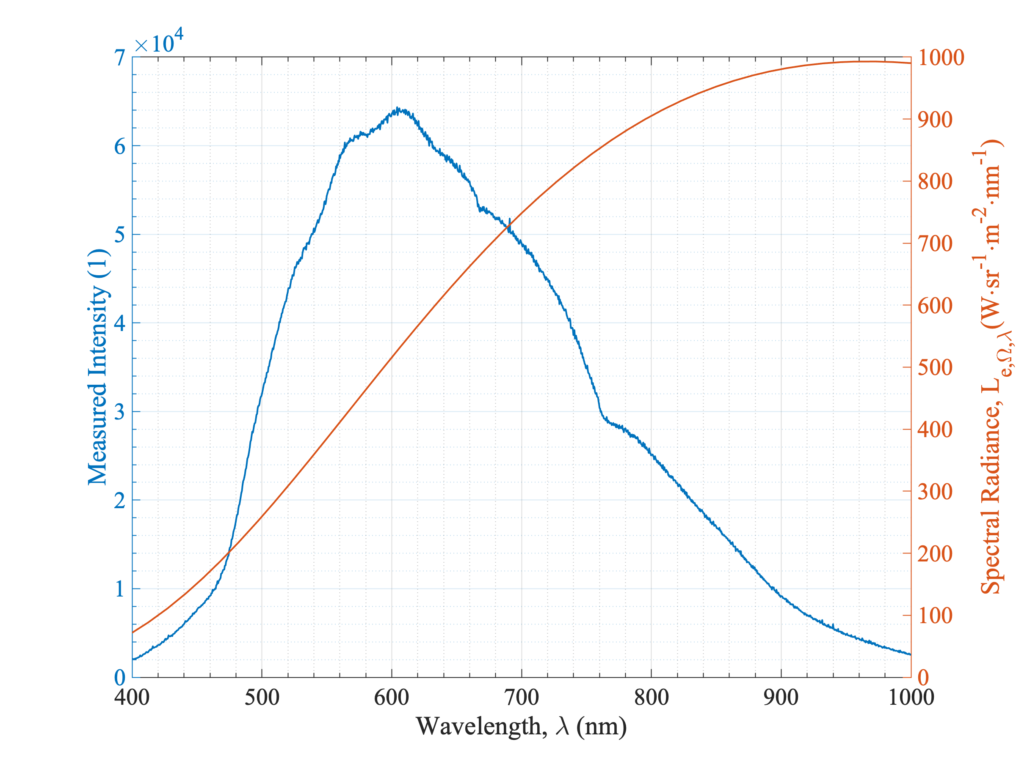
Fig. 2. The polychromatic irradiance detected for the light source alongside its calculated black body emission spectrum. Black body spectral radiance data is calculated for a light source with colour temperature 3,000 K (the colour temperature of the lamp) using SpectraPlot [13].

The ARS has a low irradiance below 450 nm. This is appropriate to prevent the solarisation of the RTL optical fibres. Wavelengths approaching and below the NUV region of the spectrum have excessively high energy levels that can damage optical fibres with low hydroxyl ion content. Damage by solarisation causes the glass to become cloudy with an orange tint, prompting it to attenuate light propagation asymmetrically. Quartz-halogen lamps do not have high spectral radiance in the NUV, instead peaking at ~960 nm as seen in Fig. 2.
Despite this system being designed foremost for angular-resolved reflectance measurements, it can also be used to do traditional side-mounted SAR and transmission measurements. This configuration requires the integrating sphere to be moved along the beam path, bringing the focal point from the centre to the back (for reflectance) or to the front (for transmission). The system incorporates three rotational stages and one linear stage, each driven by dual or single tuned piezoelectric resonance coil assemblies, respectively. The rotation stages incorporate opto-electronic and magnetic sensors to determine at which angle, between 0 and 360°, the stages are situated with a resolution of 0.0025°. The electromechanical stages used in the ARS are driven by ThorLabs Elliptec™ based coils. These are low-power, robust, and versatile devices capable of being used in a variety of OEM applications thanks to their open serial communications protocols.

Software and Process Automation
All aspects of our system, save moving the porthole cover for double beam correction measurements, have been automated to significantly reduce the probability of human error during the extensive measurement process and to speed up the collection of results. The automation is governed by tailor-made open-source software written in Python 3.9. The graphical user interface (GUI), which can be seen in the supplementary materials (Fig. SM1), permits the user to enter scan parameters such as polarisation mode(s), angular distribution, and scans-to-average (STA). The angular distribution is validated prior to any scans being taken, where the start angle must be greater than or equal to zero and be less than the end angle, the step size must be greater than or equal to one, and the end angle must not be greater than 80° and be greater than the start angle. If the step size is greater than the difference between the start and end angles, then only these two angles will be measured, and if the start and end angles are the same value, then only this angle will be measured regardless of the step size input.
A higher value of STA, $N$, smooths much of the noise measured in a single spectrum. Typically, $3≤N≤5$ is adequate for most measured samples. However, darker samples require a higher value here to counteract the slightly more dominant electrical dark noise due to a decrease in the signal-to-noise ratio (SNR). For such samples, we would set the STA as $5<N≤10$. For $N>10$, scan time is proportionately increased for little gain in noise reduction. As well as reducing sample throughput, longer scans can result in changing properties in optically less-stable samples and so should be avoided where possible. The number of spectra required per sample, $n_{S}$, is determined by the STA ($N$), the number of polarisation modes, $n_{φ}$, and the total number of angles scanned,$n_{θ}$ which are all user-defined input parameters (equation (2)).
$n_{S}=2Nn_{φ}n_{θ}+1$ (2)

Here, the single dark scan is added on, and the sample scans are multiplied by two to take account of the reference scans (mirroring the sample scans). The number of polarisation modes, $n_{φ}$, can be either two or one depending on whether S and/or P modes are selected, respectively. Let us assume that we wish to take five STA, for both S- and P-polarisations, and for an angular distribution of $θ=8:1:80°$. Using (2) we can determine that the system must take $n_{s}=877$ spectra – a considerable amount of data to manage and process. To make a comparative statement, let us assume the integration time, the period over which the system accumulates light for a discrete intensity measurement, is two seconds. Now, in a manually-controlled system, the operator will need to adjust the system to a new angle, polarisation, and/or configuration dependent on the stage in the process workflow. Let us assume that these interactions would take an average of 10 s each. We can then determine that the time to fully complete a reference and sample scan with a manual system would be ~3 hours. Taking our automated system, with an average hardware response time of 0.5s between measurements, this processing is reduced to just over 37 minutes – almost five times faster. This also takes into account the four occasions the operator must interact with the automated system throughout the measurement process (to change port covers).
Each spectrum is stored in a composite data matrix, saved with the suffix .var. These matrices are created and saved using open-source frameworks, enabling it to be opened and processed in other software packages in lieu of the built-in alternative. Such a file structure enables us to store all the required information for the determination of sample reflectance, $R_{x}$, in one ordered file. A sequencing subsystem provisions custom-made frameworks for the correct and reliable operation of the system hardware. To correctly sequence such a convoluted series of measurements, a process workflow needed to be drafted to better visualise the succession of both the virtual and physical events required to take place, as well as outline their inter-dependencies. For example, the integration time of the spectrophotometer needs to be calibrated to the reference sample at the point of highest reflection. Failure to correctly set the integration time at this point will cause the erroneous clipping of spectra to be measured later. This highlights the importance of selecting a suitable reflectance standard for a given sample; one that is more reflective than the sample itself, but not overly-so.
For data resolved against angle and polarisation, the point of highest reflectance is at an incident angle of $80°$ under S-polarisation. This polarisation mode is used for this calibration due to its monotonically increasing magnitude for increasing angles of incidence. On non-textured samples, P-polarised light does not behave like this, and instead dips to a minimum before rising again, due to the presence of Brewster’s angle.

Limitations
Though VAR measurements are enlightening, there are some innate limitations to this form of reflectometry that should be mentioned. There are four types of measurement that this system is capable of, each requiring a slightly different configuration of the integrating sphere and sample stage. These configurations are: centre-mount standard angle reflectance (CMSAR), centre-mount variable angle reflectance (CMVAR), side-mount standard angle reflectance (SMSAR), and side-mount standard angle transmission (SMSAT).
The data forthcoming showcases the distinctiveness of this reflectometry system and are therefore recorded by means of the CMVAR configuration. Note that the ARS employs the double-beam correction measurement for all reflectance modes. The use of a centre-mount sample stage, in of itself, introduces certain margins within which the spectrophotometer must operate. These margins relate to how the sample and spot of light correlate to one another in free space. There are two primary concerns here: spot translation and aberration. As the centre-mount sample stage rotates, it does so about its own central rotational axis. If this axis is not aligned to the incident light beam and the sample surface, then the spot of light will move across the surface of the sample as the angle of incidence is changed. This means that we would be measuring the reflectance for different parts of the sample surface as the angle of incidence increases. Spot translation can be negated, with the delicate alignment of the collector, field, and condenser lenses, with respect to the sample stage.
A more significant concern is spot aberration. This occurs in any system where the relative angle between a fixed plane (the sample surface) and some incident light is changing. Whilst the input power remains unchanged, the power density at the surface of the sample is reduced as the spot encompasses a greater area of that surface. Similarly, this means that different parts the sample surface are included in any measured data over variable angles, meaning that both spot aberration and translation are dependent on angle, not wavelength or polarisation. Two key points arise from this observation: the sample must be of a minimum size to ensure the beam of light remains incident on the sample, not skirting the edges and partially impacting the integrating sphere wall directly, and to ensure the spot size is focussed to a diameter small enough to ensure the prominence of aberration is limited.

Methodology
The ARS was first qualified by carrying out confirmation studies. Here, two thin film coated silicon wafer samples of theoretically determinable reflectance were placed within the system and processed in accordance with the system's standard operating procedure. Two 500 µm thick crystalline silicon (c-Si) based samples were used, with anti-reflectance coatings (ARCs) consisting of 80 nm of silicon nitride (SiN_{x}) and 110 nm of silicon dioxide (SiO₂), respectively, deposited by plasma enhanced chemical vapour deposition. The thickness of these films were confirmed prior to measurement using ellipsometry. The spectral reflectance for such coatings was sourced from the optical simulator, OPAL 2 [14].
There were no regular standards resolved against wavelength and angle simultaneously. To address this, we took two solid $3×3×1$ cm blocks of [C₂F₄]_{n}, of approximately 99, and 50% reflectance, and modelled them as ideal Lambertian reflectors. Such a reflector will exhibit identical reflectance characteristics at any angle Therefore, our LabSphere certified reflectance at $8°$ can be inferred across the entire angular distribution. The data shown in the supplementary materials (Fig. SM3) represents the $R_{y}$ component in equation (1), and the measured spectra for this standard are $S_{y}$ and $S_{c,y}$.
Upon verification of the systems accuracy, different samples were measured to demonstrate the versatility of VAR measurements across multiple subject fields. Here, two different colours of wall paint, alongside a matte-black optical insulation material, were each placed inside the system for analysis. The scan parameters were as follows: $λ=400:0.5:1,000$ nm, $θ=8:1:80°$, STA = 3, and the spot radius is 3 mm. All samples have a surface area of $30×30$ mm, and were scanned in hybrid polarisation mode (S- and P- average). The sample size used here grants a maximum angle of incidence of $\sim 83°$ before the beam encompasses the sample and hits the integrating sphere wall directly, and their thickness is sufficient to assume light transmission is zero, allowing us to measure only the reflectance spectra.

Results and Analysis
Presented in Fig. 3 are the SAR measurements, taken in CMSAR and SMSAR system configurations, compared against the theoretical reflectance at $8°$, for 80 nm SiN_{x} and 110 nm SiO₂ thin film ARCs. The 50% PTFE diffuse standard was used for these samples with the 99% for the remaining. The low broadband difference between theory and measurement is clearly visible here.
Both datasets in Fig. 3 demonstrate slight differences to theory over the broadband spectrum. SiN_{x} deposited by chemical vapour deposition can vary in chemical content from silicon rich to nitrogen rich depending on the relative concentrations and flow rates of the precursor gases used. In practice, there will also be spatial nonuniformities in the deposited film. Given the system’s sample illumination surface area is $\sim 30$ mm², this would imply that the same surface area of the SiN_{x} sample being illuminated is not uniform. These factors explain the differences between measurement and theory for $650≤λ≤850$ nm with CMSAR in Fig. 3a. This can also be seen looking at the SAR spectrum for SiO₂ in Fig. 3b. Deposited SiO₂ coatings are more uniform and their optical properties are less sensitive to differences in deposition conditions. Consequently, the difference between theory and measured reflectance is smaller for the most part, topping-out at $±0.2\%$ for $650≤λ≤850$ nm in CMSAR configuration.
Deviation between CMSAR and SMSAR can be seen for $λ≤450$ nm. Though these two measurements, in theory, should be identical, the difference seen here can be explained when we examine the structure of our samples. These ARCs are single-side polised c-Si, meaning that they are planar on the front surface and rough on the back. When in centre-mount configuration, both of these surfaces, as well as the sides of the sample, are exposed to the light integrated by the sphere. The ratio between sample and reference standard in CMSAR configuration therefore encompasses differences in the rear and the sides, as well as the front. In contrast, when side-mounted, only the front surface contributes to the integration of light. This is the cause of the differences between the results from the two measurements in this spectral region.
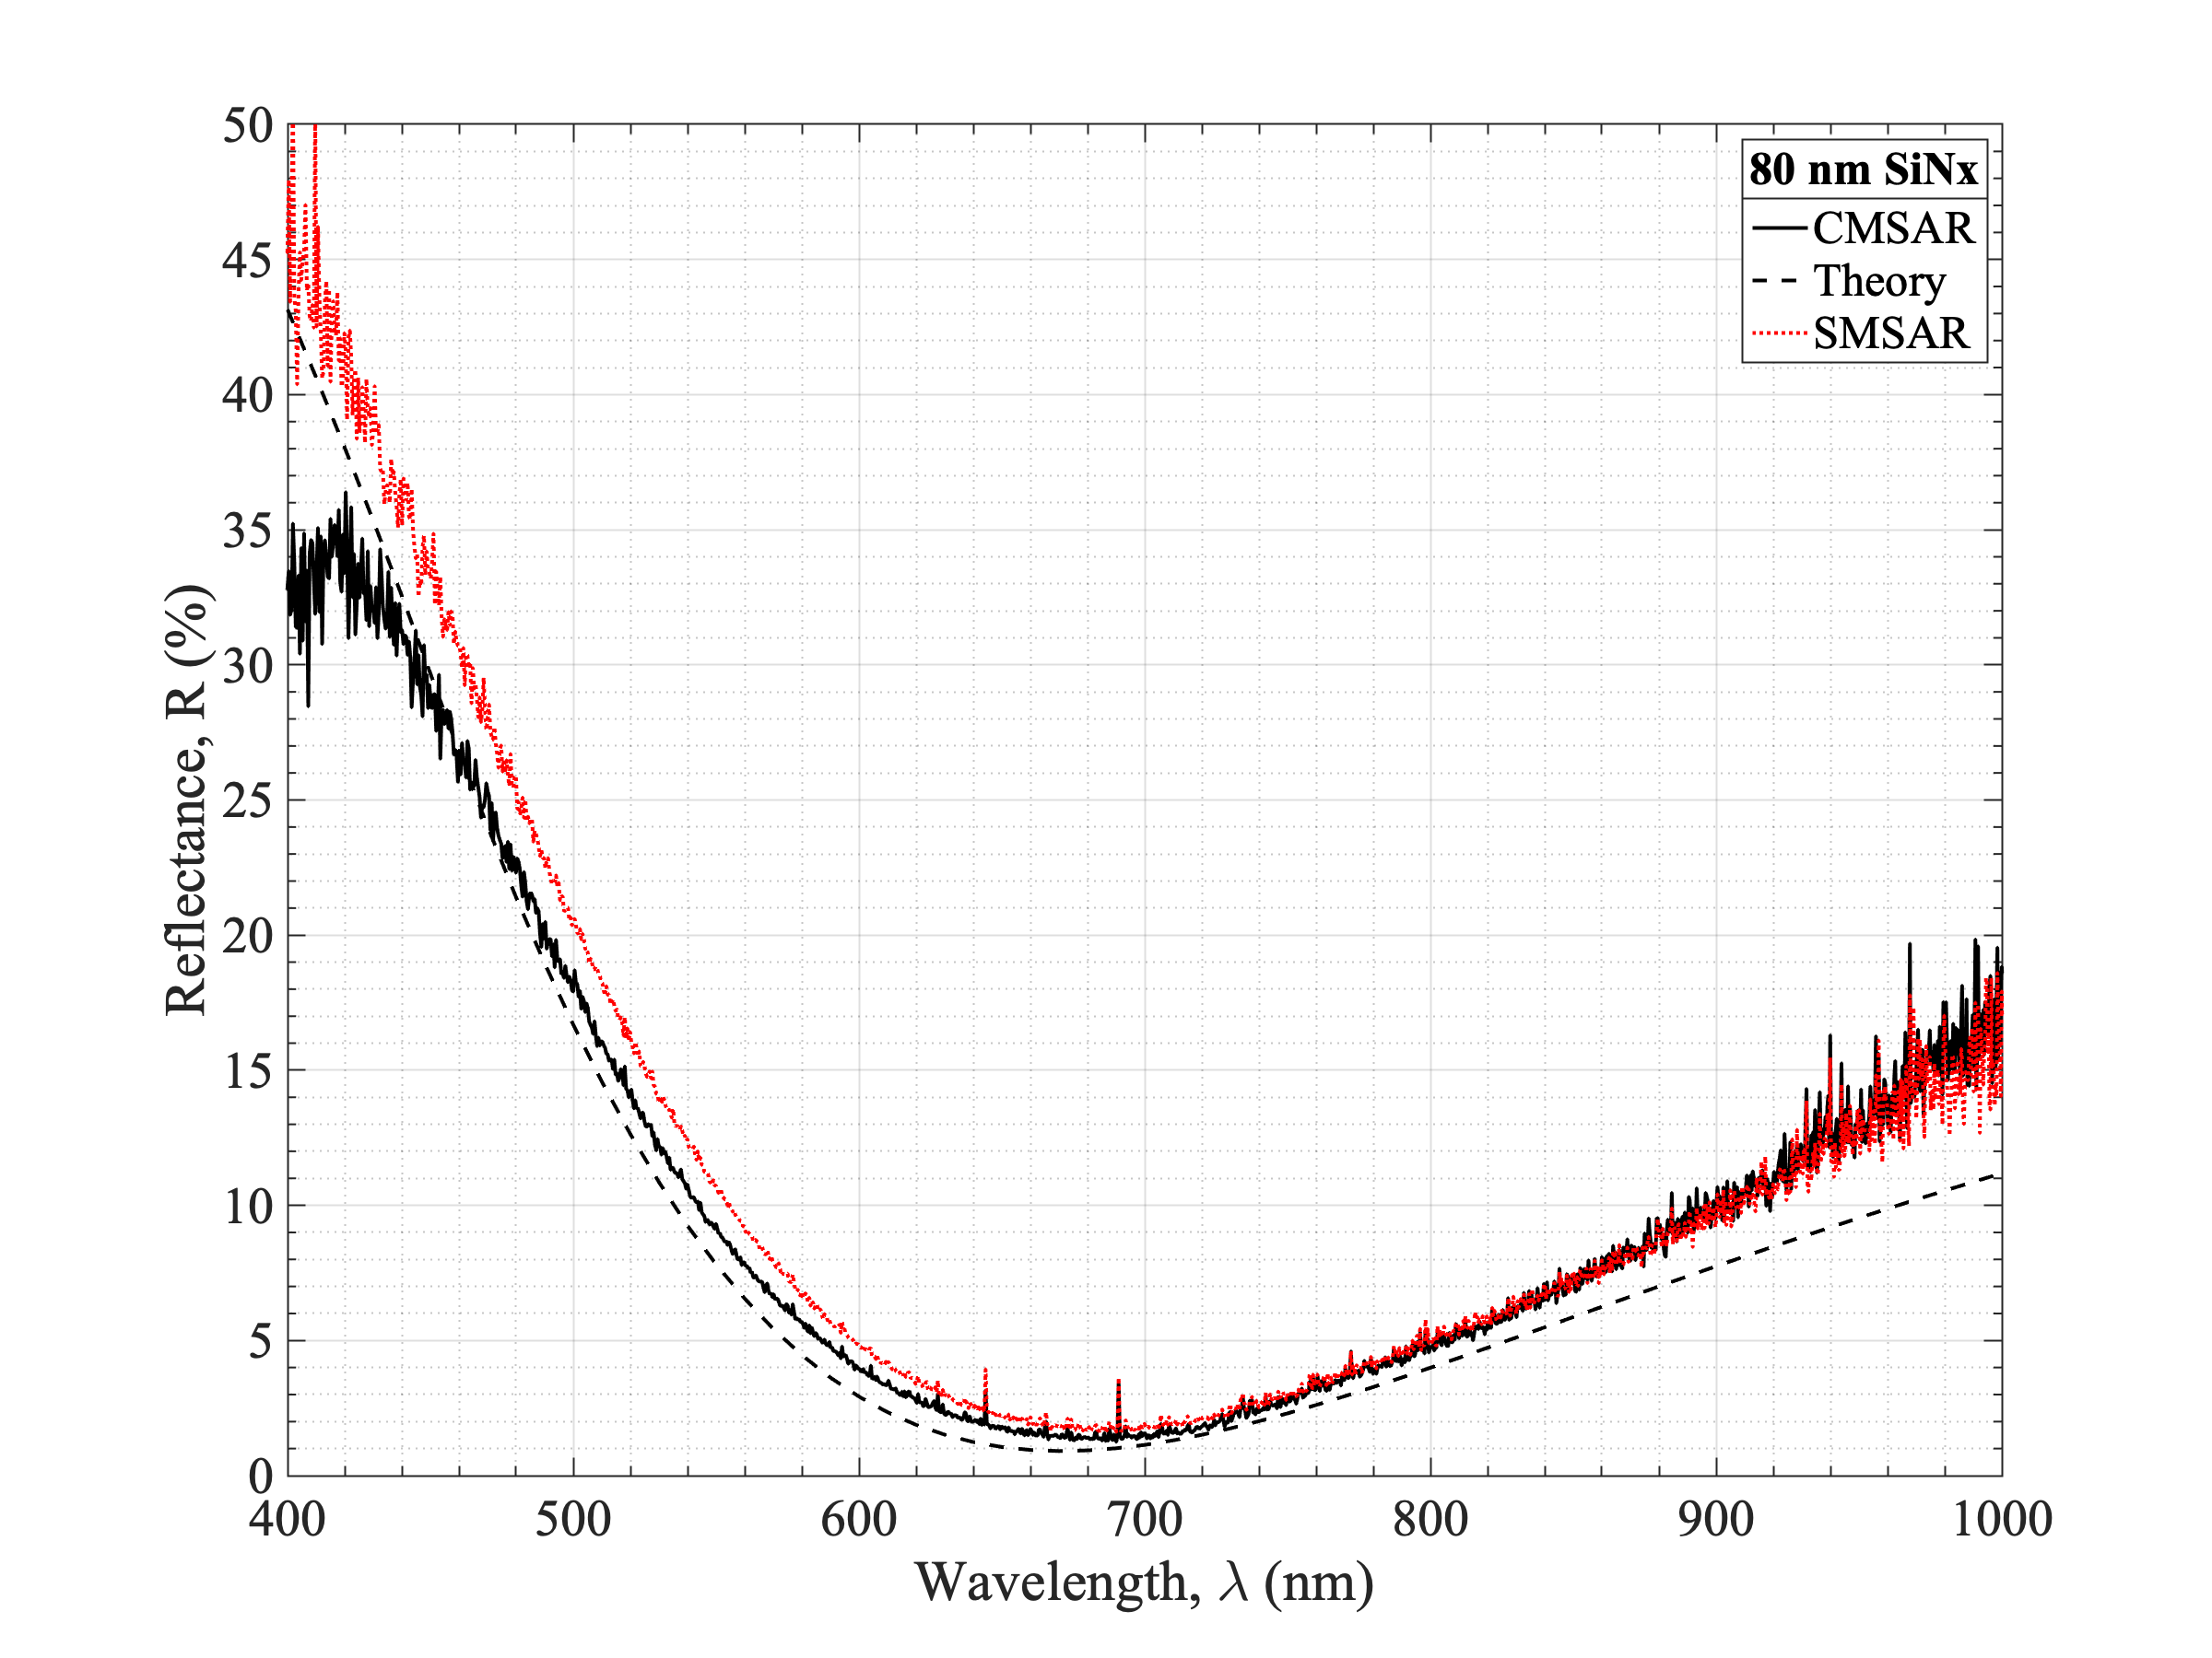
(a)
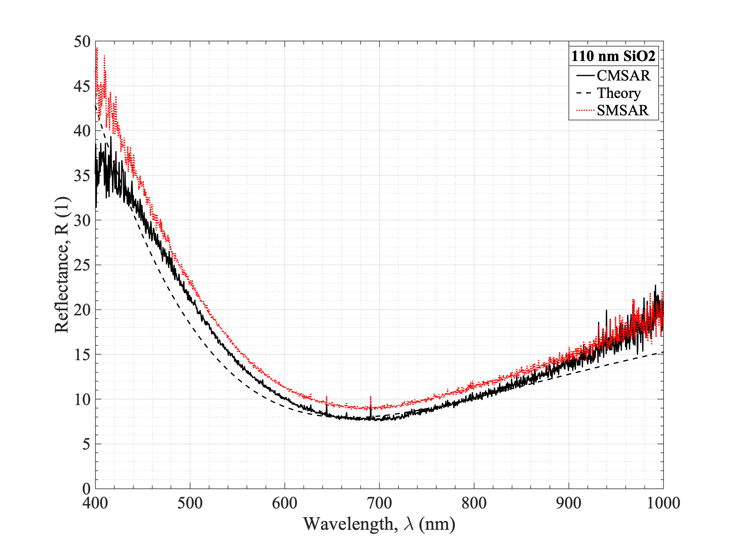
(b)
Fig. 3. The SAR measurements for 80 nm SiN_{x} (a) and 110 nm SiO₂ (b) ARCs.

In the theoretical data shown here, back-reflections were not accounted for. Such reflections occur when light passes through the front surface of the sample and subsequently reflects off of the back surface. This light then returns to the front surface and leaves the sample, contributing to overall reflectance measured. These reflections are prevalent at the longer wavelengths in the NIR, and actively contribute to the difference between measured and theory in these cases. Specifically, note how measured reflectance is always higher than theory for CMSAR measurements. In reference back to Fig. 2, the spectral radiance of our source against the spectrophotometer’s sensitivity readout, above this wavelength measured intensity decreases steadily. This, coupled with the low (sub-15%) reflectance at this point, dramatically decreases the SNR ratio, which in turn causes electrical noise to become more dominant in the determination of R_{x}. The same is not observed in the NUV region as reflectance is much higher, resulting in a greater signal intensity, and thus a greater SNR. This effect can be seen with greater clarity when we look at VAR instead of SAR.
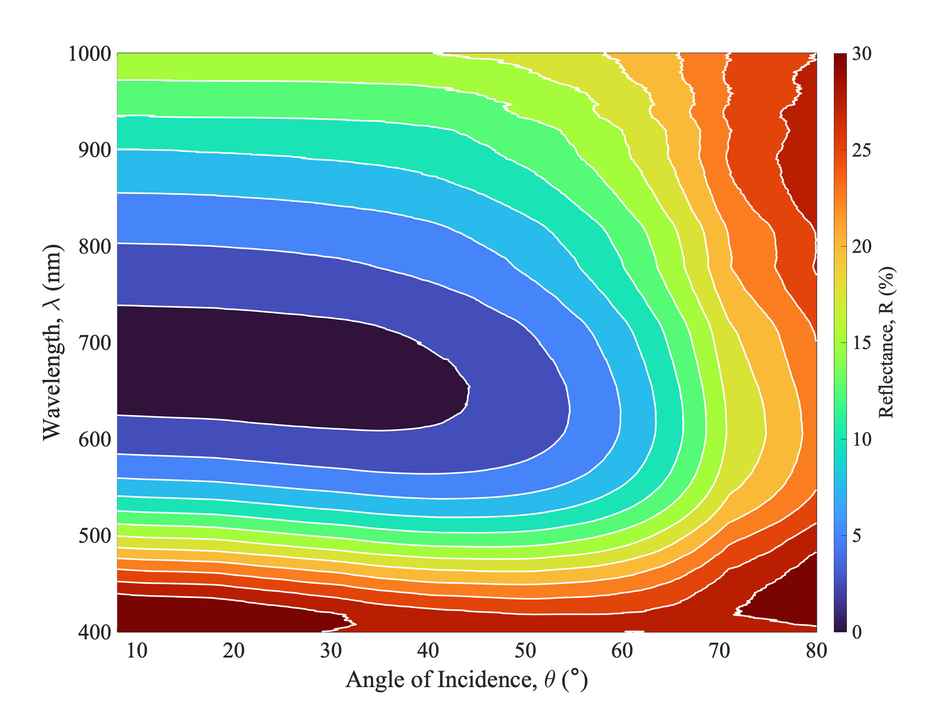 |  | 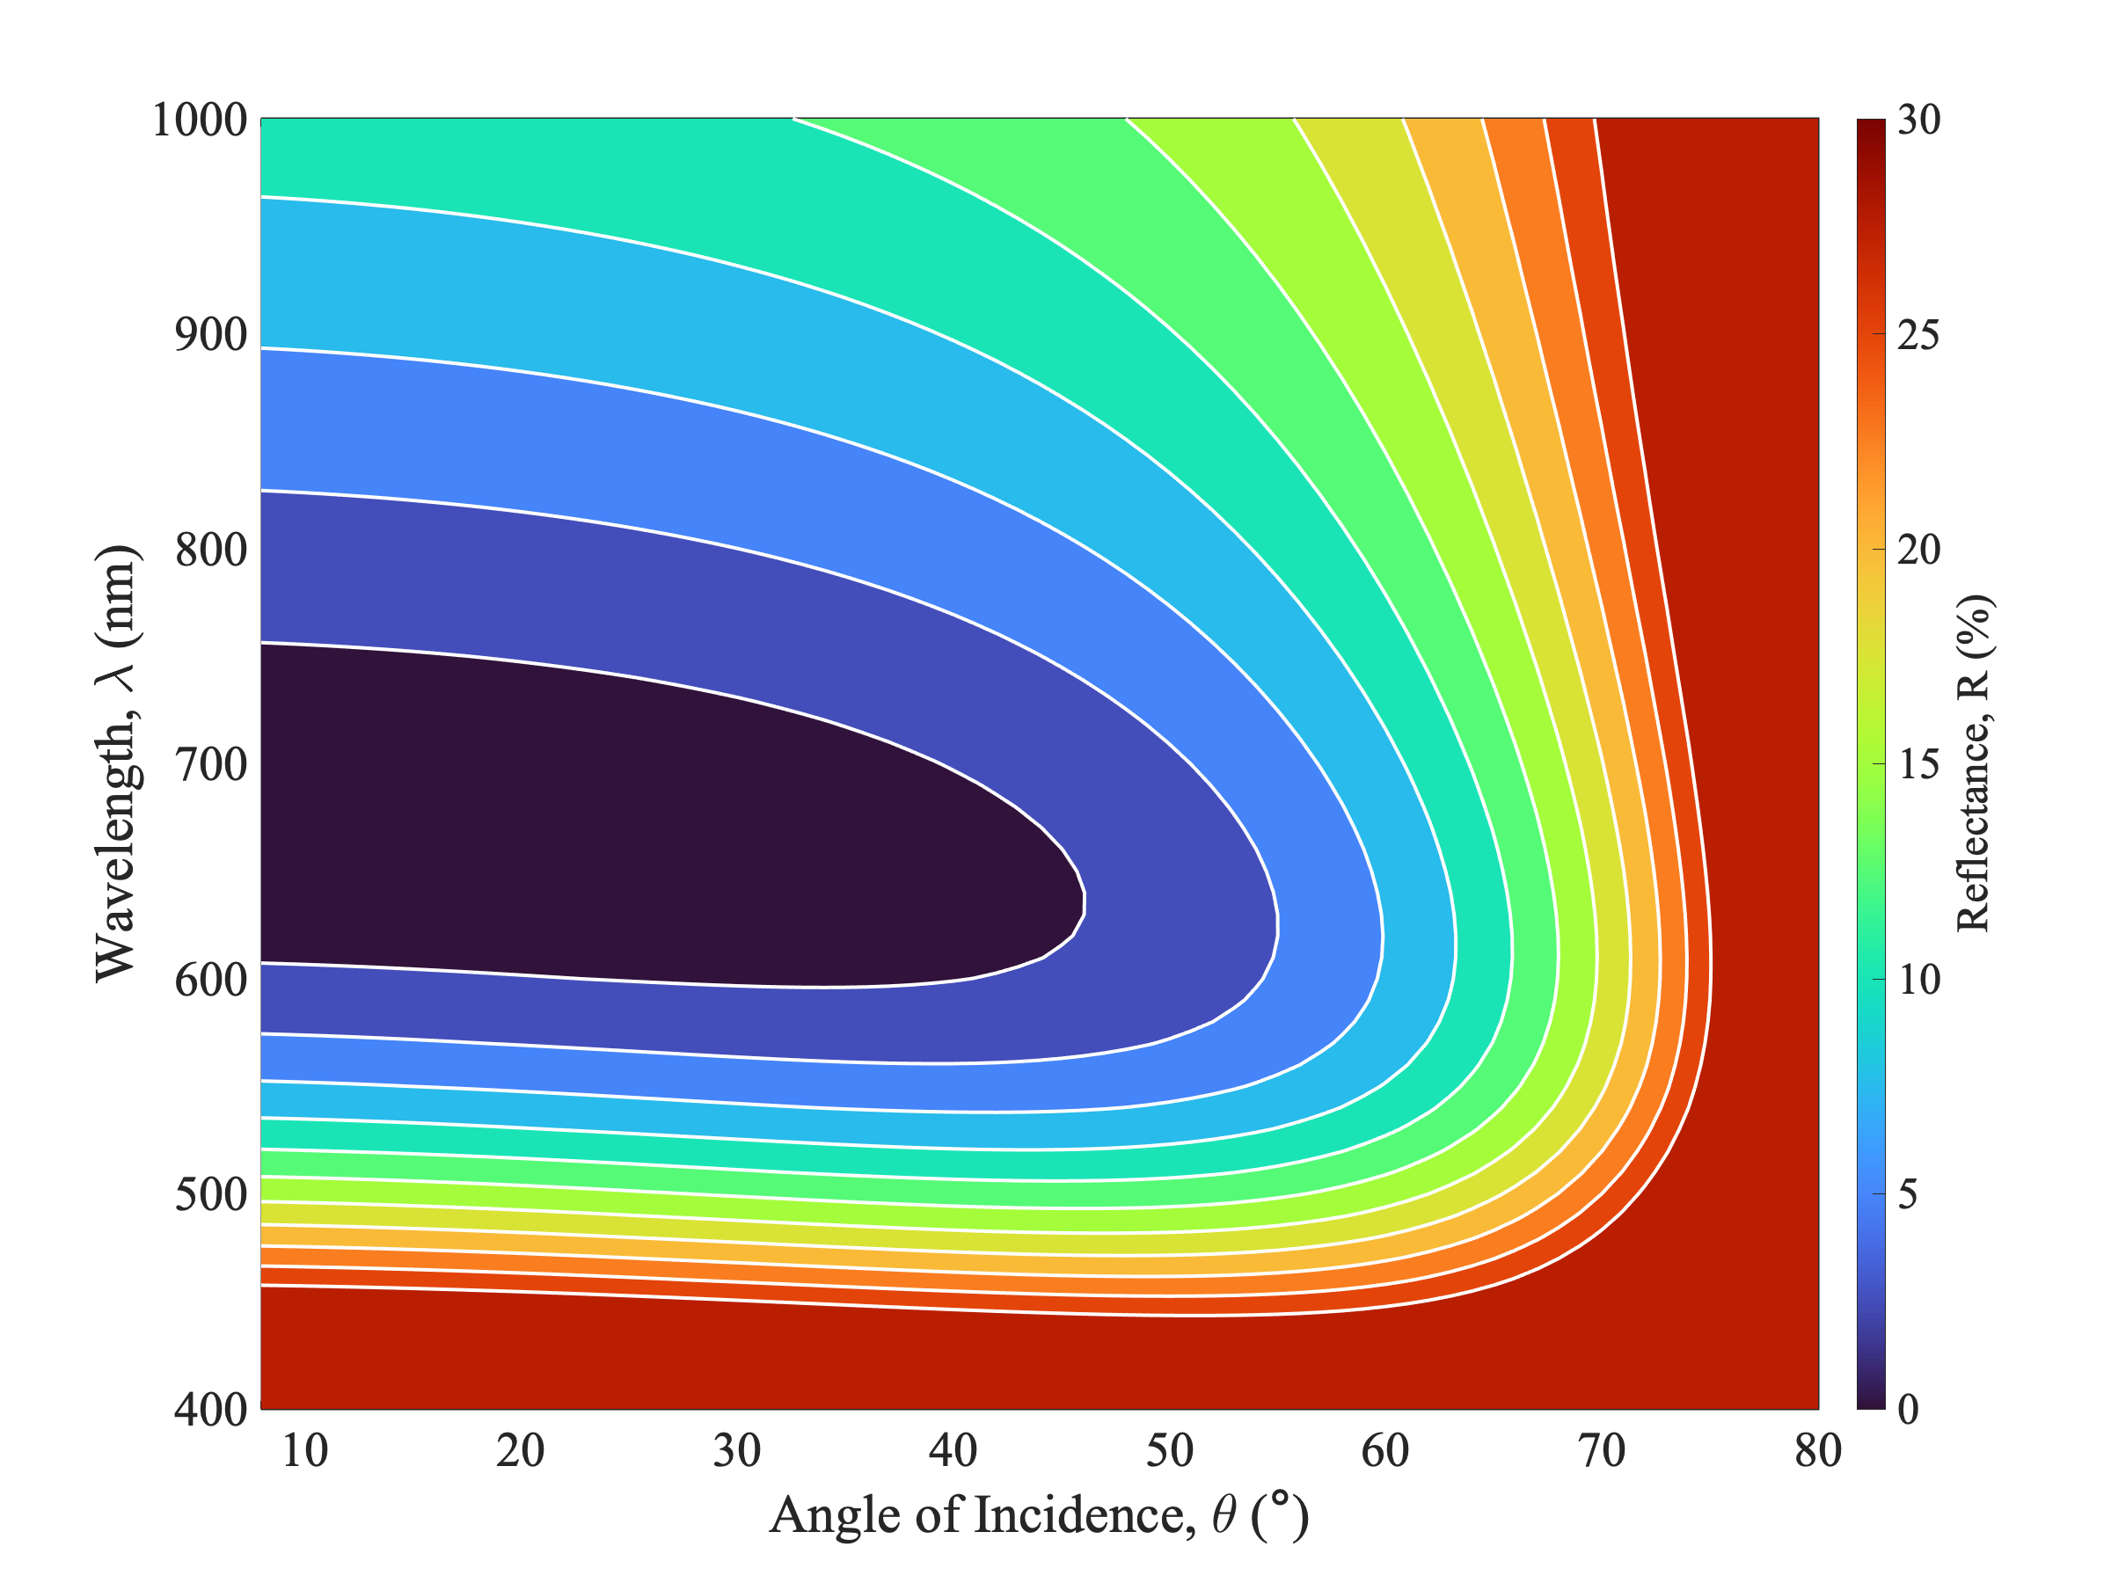
(a) |  | (b)
Fig. 4. The VAR contours as measured (a) and according to theory (b) for an 80 nm thick coating of SiN_{x} on planar Si. Reflectance is represented by a colour scale as a percentage. The reflectance scale is identical for each of the thin film ARCs to aid with comparison.
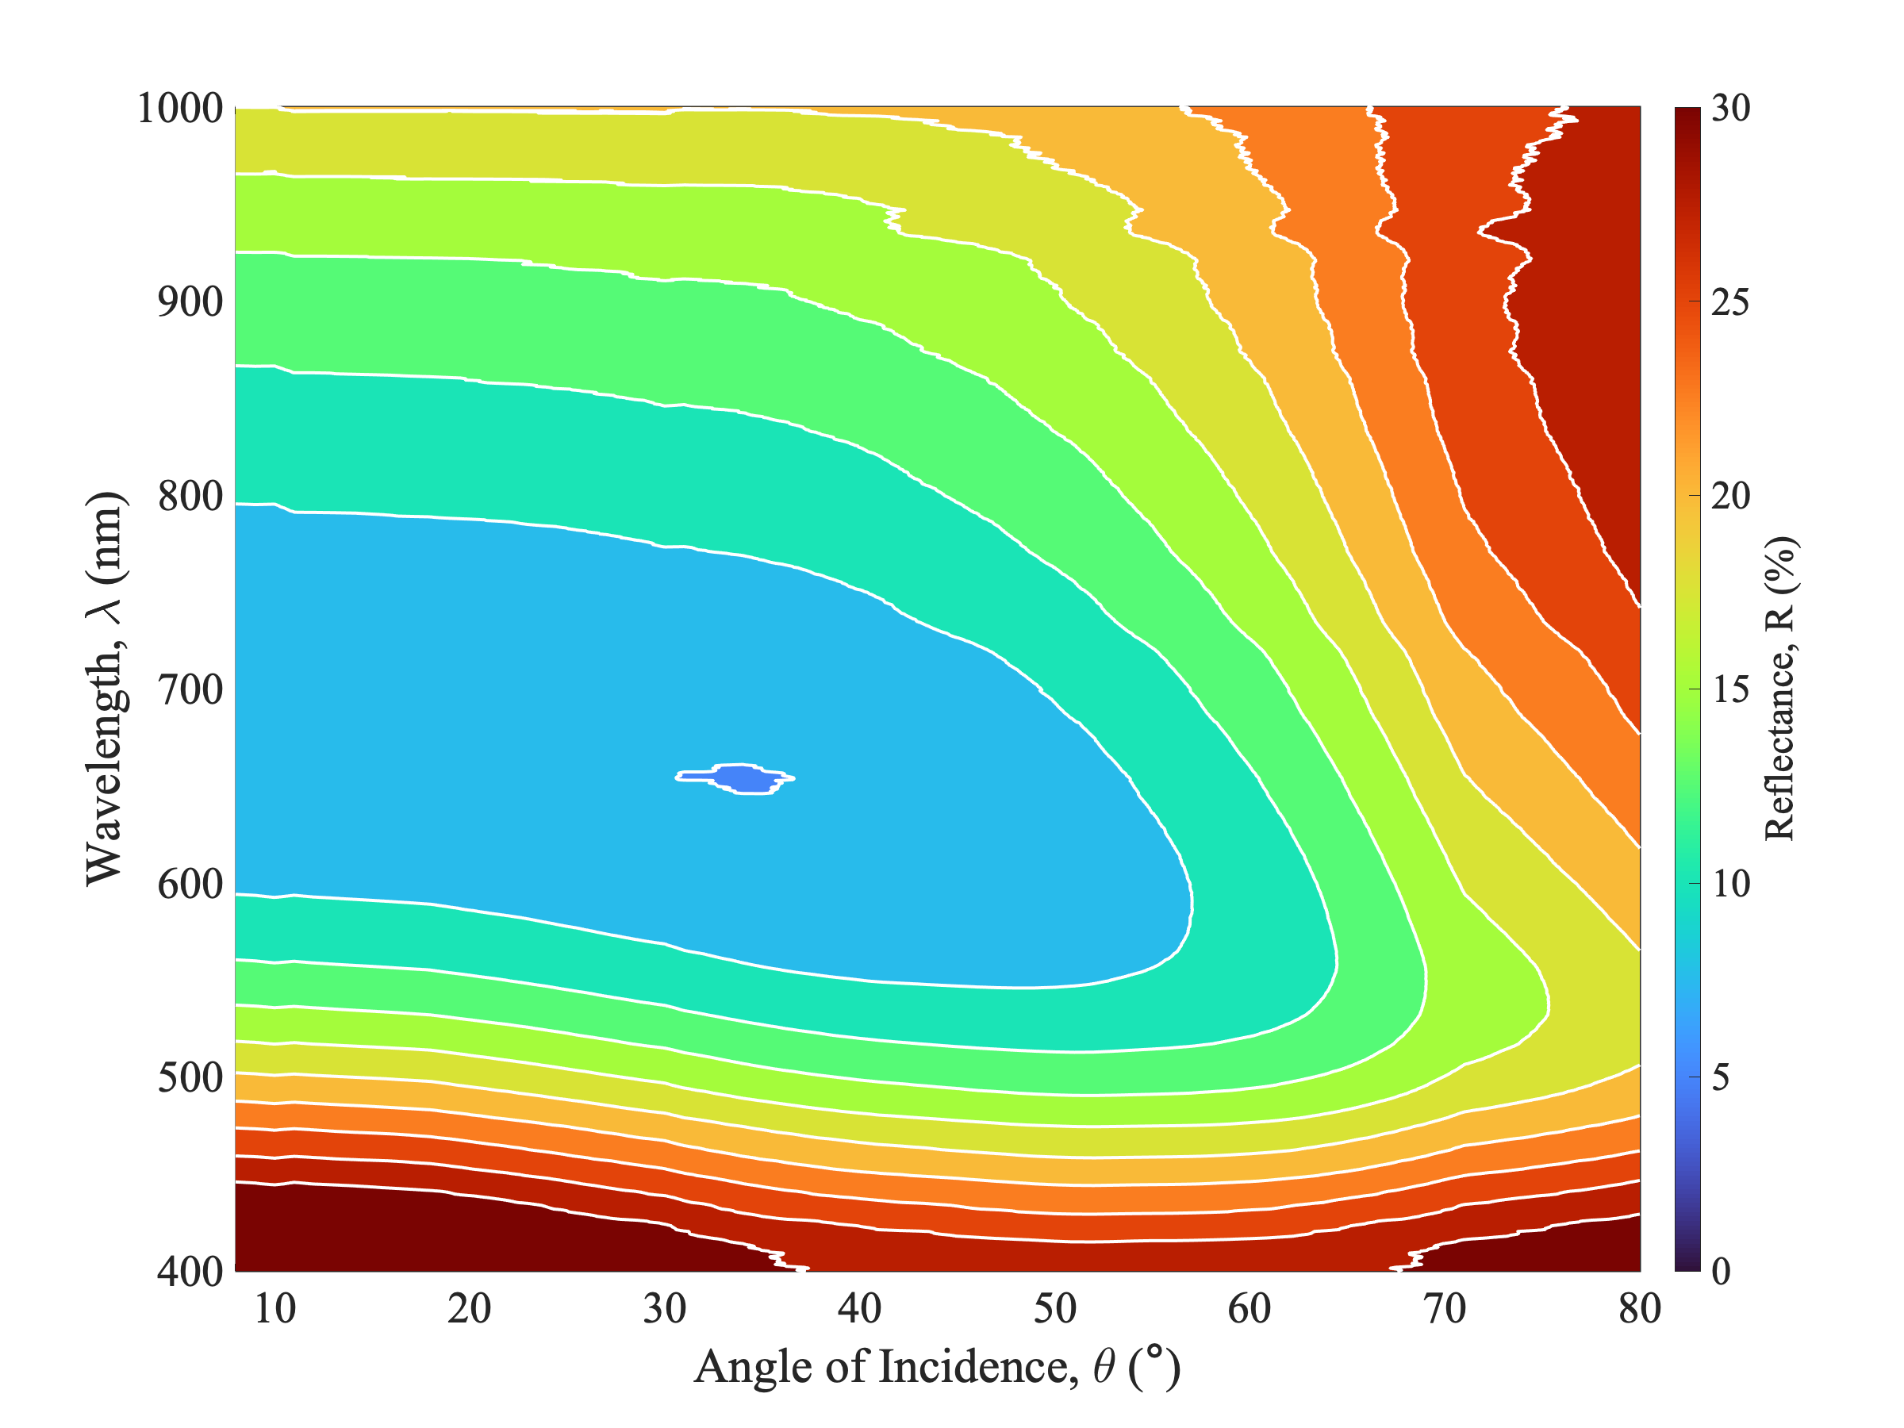 |  | 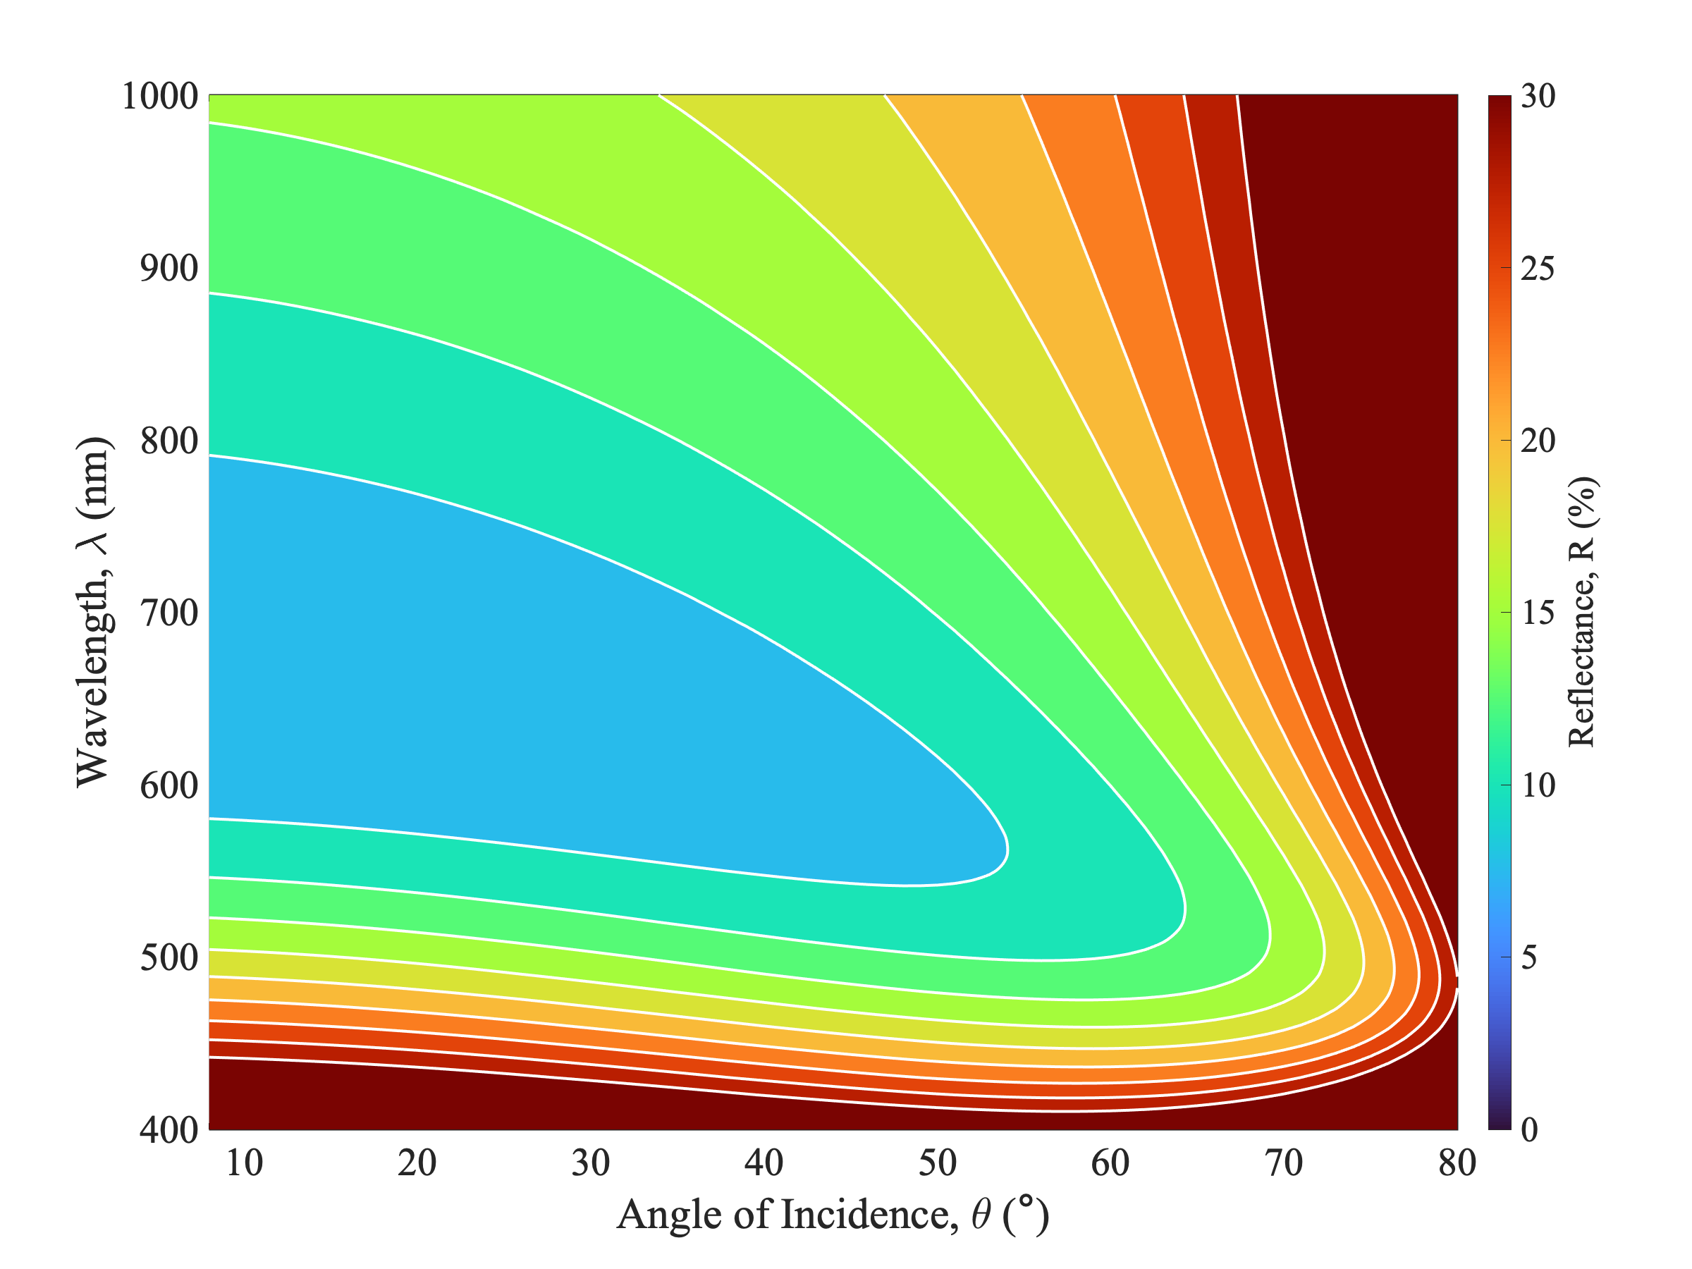
(a) |  | (b)
Fig. 5. The VAR contours as measured (a) and according to theory (b) for a 110 nm thick coating of SiO₂ on planar Si. Reflectance is represented by a colour scale as a percentage. The reflectance scale is identical for each of the thin film ARCs to aid with comparison.
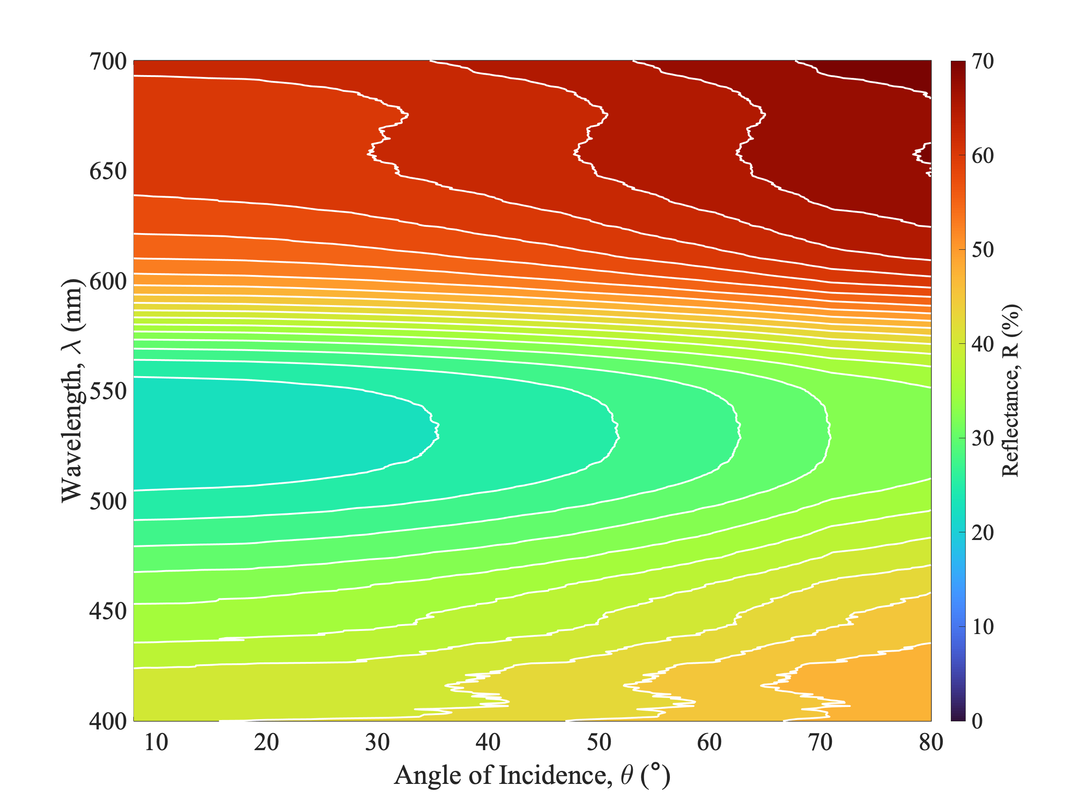 | 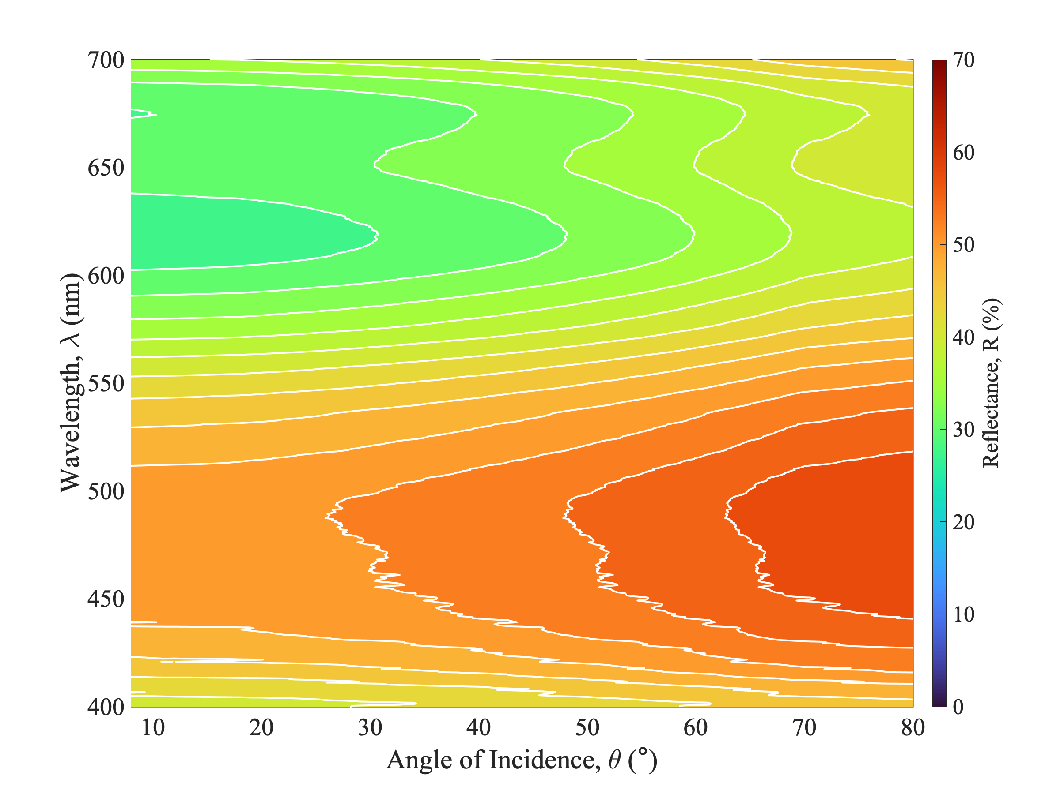
 | 
Fig. 6. The variable-angle reflectance of industrial red paint for the visible spectrum (above), and the calculated colour variance from the reflectance data (below). | Fig. 7. The variable-angle reflectance of industrial blue paint for the visible spectrum (above), and the calculated colour variance from the reflectance data (below).

Plots of reflectance versus wavelength and angle of incidence for the thin film ARC samples measured in CMVAR mode are presented in Figs. 4 and 5, alongside the results from simulation. The reflectance of these samples rises steadily as the angle of incidence, $θ$, increases. This is to be expected for optical interactions at a dielectric interface due to the presence of specular reflection. Note how the average broadband reflectance increases over angle, tending toward values of 20-25% beyond angles of $70°$, particularly in the visible and NIR spectral regions. Reflectance in the NUV remains relatively constant due to silicon’s ability to reflect very high energy light.
Average sample reflectance, $\overline{R_{x}}$, usually taken over only wavelength in SAR measurements, can now also be taken over wavelength, angle and polarisation. The difference between calculating this value for SAR and VAR measurements is outlined in Table 1. The white contour lines plotted in Figs. 4 and 5 allow for easy comparison of measurement with theory and reveal a good match between the two.

TABLE I. SAR and VAR measured averages for the two thin film samples.
Sample | $$\overline{R_{x}}\left(8°\right)$$ | $$\overline{R_{x}}\left(θ,λ,φ\right)$$ | $$Δ\overline{R_{x}}$$
80 nm SiN_{x} | 13.65% | 18.76% | +5.11%
110 nm SiO₂ | 17.74% | 22.21% | +4.47%

Given the validity of the VAR data for thin films, we next measured the reflectance of two paint samples, red and blue, as well as that of an optical insulating material. These samples are highly diffuse reflectors, and as such, no reflected image can be seen at any angle. Both red and blue paints, as shown in Figs. 6 and 8, respectively, demonstrate how the reflected light changes with angle of incidence. Notably, each colour paint reflects highly in the region of the visible spectrum that is associated with that colour: The red paint can be seen to reflect noticeably higher above 550 nm, and the blue paint does the same below 550 nm. Fig. 7 also demonstrates how, at the upper end of the visible spectrum, reflectance of the blue sample also increases. The sample remains apparent blue because of the reflectance dominance in the sub-550 nm region. Reflection towards the NIR end of the visible spectrum has implications on the material’s thermal properties rather than its optical performance.
The reflectance of both these paints remains reasonably consistent even at high angles of incidence. This is due to the diffuse/matte nature of the paint surface, where the angle at which the light impacts the surface has a reduced significance on the subsequent scattering of light in all directions simultaneously. This is unlike specular reflection, where the angle of incidence has a dominant effect on ensuing surface reflection at that same angle. With both the red and blue paints, the reflectance spectra, in the ranges representative of their colour, both expand to encompass surrounding wavelengths at high angles of incidence ($θ≥50°)$.
Fig. 7 shows a peak reflectance for $440≤λ≤515$ nm at low angles of incidence, expanding to $410≤λ≤550$ nm in the wide-angle. This indicates that the colour of these paints changes when illuminated from these wider angles. By combining the VAR data with information about illumination conditions and the photopic response of the human visual system, it is possible to plot perceived colour as a function of angle of incidence. Using the CIE standard illuminant D65 [15], often used in colormetry, we determine the optical colour variance as a result of the changing angle. Though only slight, the colour of both paints does vary with angle of incidence. This is more apparent with the red paint (Fig. 6) than the blue (Fig. 7), where a more significant ingress of both violet and blue light can be seen beyond the $60°$ mark. The higher reflectance from the red wavelengths also diverges outward into the yellow area of the visible spectrum.
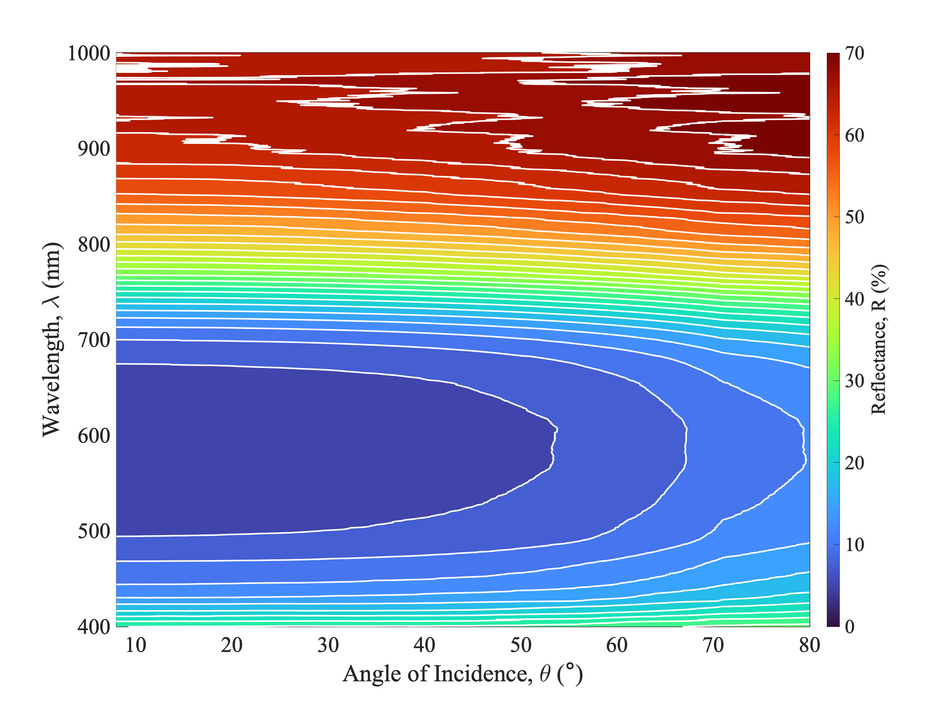

Fig. 8. The wide-angle reflectance of a matte-black optical insulating material (above), and the calculated colour variance from the reflectance data (below).

Fig. 8 shows that, in the NIR spectral region, the optical insulator also acts as a thermal insulator. Infrared radiation is transmitted primarily as heat and therefore high reflection in this region would equate to heat being reflected as well. There is no significant component of visual reflection here, as one would expect from a sample that appears black to the naked eye. As with the samples shown in Figs. 7 and 8, the colour of this material becomes lighter at higher angles of incidence, though this increase is not as noticeable as that seen in largely specular reflectors, such as the two thin film samples shown in Figs. 4 and 5.

Conclusions
In summary, we have shown a novel and enlightening methodology in the determination of material reflectance. Resolution over angular and wavelength distributions provides a more complete picture regarding the true optics of a sample. Two thin film ARCs were measured, with the results showing a good match with theory. The commonly used SMSAR configuration was also demonstrated, as in Fig. 3, with the pitfalls of such an approach outlined.
VAR measurements offer a more comprehensive picture of the overall reflectance properties of a sample, which is of particular interest for applications where surfaces operate under varying illumination conditions. We demonstrated how, under constant angle, reflectance can be determined as either higher or lower than that calculated over variable angles, with implications on the design of material surfaces for glass, paint, and solar photovoltaics. We also showed that the colour of samples can be extracted from these datasets, with implications on the manufacturing of paints and coatings for visual consistency over varying illumination angles.
Angle-resolved reflectance measurements, though more complicated than traditional reflectometry, are beneficial to both academic studies, as well as industry-based research and development. The likelihood of human error is significantly reduced using our approach, which is highly automated, and permits a significant increase in the throughput of samples with a rapid turnover of data.

References
[1] A. Parretta, A. Sarno, and H. Yakubu, Non-destructive optical characterization of photovoltaic modules by an integrating sphere. Optics Communications, Elsevier BV, 1999, 161, 297-309
[2] A. Parretta et al., Angle-dependent reflectance measurements on photovoltaic materials and solar cells. Optics Communications, Elsevier BV, 1999, 172, 139-151
[3] T. E. Scheul et al., Wavelength and angle resolved reflectance measurements of pyramidal textures for crystalline silicon photovoltaics. Progress in Photovoltaics: Research and Applications, Wiley, 2020, 28, 1248-1257
[4] E. Lopez-Fraguas, J. M. Sanchez-Pena, and R. Vergaz, A Low-Cost LED-Based Solar Simulator. IEEE Transactions on Instrumentation and Measurement, Institute of Electrical and Electronics Engineers (IEEE), 2019, 68, 4913-4923
[5] J. Xu, Y. Liu, and Y. Wu, Automatic Defect Inspection for Monocrystalline Solar Cell Interior by Electroluminescence Image Self-Comparison Method. IEEE Transactions on Instrumentation and Measurement, Institute of Electrical and Electronics Engineers (IEEE), 2021, 70, 1-11
[6] X. Tao et al., A novel and effective surface flaw inspection instrument for large-aperture optical elements. IEEE Trans. Instrum. Meas., vol. 64, no. 9, pp. 2530-2540, Sep. 2015.
[7] F. Carpignano et al., Low-coherence reflectometry for refractive index measurements of cells in micro-capillaries. Sensors, vol. 16, no. 10, Oct. 2016.
[8] V. Bello, A. Simoni, and S. Merlo, Spectral Interferometric Detection of NIR Optical Resonances of Rectangular Microcapillaries for Refractive Index Sensing. IEEE Transactions on Instrumentation and Measurement, Institute of Electrical and Electronics Engineers (IEEE), 2021, 70, 1-9
[9] R. Ulbricht, Die bestimmung der mittleren räumlichen lichtintensität durch nur eine messung. Elektrotech, 1900, 21, 595-597.
[10] J. Palmer and B. Grant, The art of radiometry. Bellingham, Wash. <1000 20th St. Bellingham WA 98225-6705 USA>: SPIE, 2010, p. 5.
[11] Integrating Sphere Fundamentals and Applications. Newport Corporation, 2020.
[12] F. J. J. Clarke. and J. A. Compton, Correction methods for integrating-sphere measurement of hemispherical reflectance. Color Research & Application, Wiley, 1986, 11, 253-262.
[13] C. S. Goldenstein et al., SpectraPlot.com: integrated spectroscopic modeling of atomic and molecular gases. Journal of Quantitative Spectroscopy and Radiative Transfer, Elsevier BV, 2017, 200, 249-257.
[14] K. R. McIntosh and S. C. Baker-Finch, OPAL 2: Rapid optical simulation of silicon solar cells. 2012 38th IEEE Photovoltaic Specialists Conference, IEEE, 2012.
[15] J. J. Hsia et al., CIE Standard Illuminants for Colorimetry. CIE, 1999

This paragraph of the first footnote will contain the date on which you submitted your paper for review, which is populated by IEEE. This work has been supported by the Centre for Doctoral Training in New and Sustainable Photovoltaics (EPSRC grant number EP/L01551X/1), and completed as part of Black Silicon Photovoltaics (EPSRC grant number EP/R005303/1). Corresponding author: Jack J. Tyson. All authors are with the School of Electronics and Computer Science, University of Southampton, Southampton, SO17 1BJ, UK (e-mail: j.j.tyson@southampton.ac.uk, t.rahman@soton.ac.uk, sb1@ecs.soton.ac.uk). Color versions of one or more of the figures in this article are available online at http://ieeexplore.ieee.org

