Many-objective design optimisation of a plain weave fabric composite
Zhenzhou Wang^{1,*} & Adam Sobey^{1,2}

- Maritime Engineering Group, University of Southampton, Southampton, UK(*, corresponding author: Zhenzhou.Wang@soton.ac.uk)
- Marine and Maritime Group, Data-centric Engineering, The Alan Turing Institute, The British Library, London, UK
Highlights
- For the first time a 5-objective optimisation is compared to a 3- and 2- objective optimisation.
- The 5-objective optimisation contains solutions that are not in the 3- or 2- objective Pareto Sets.
- Genetic Algorithm selection is shown to be important, with cMLSGA shown to be the strongest solver.
- 101 fabrics improve performance on all the five objectives compared to a current design.
- 77% improvements in mechanical properties and 38% lower densities are possible.

Graphical abstract:
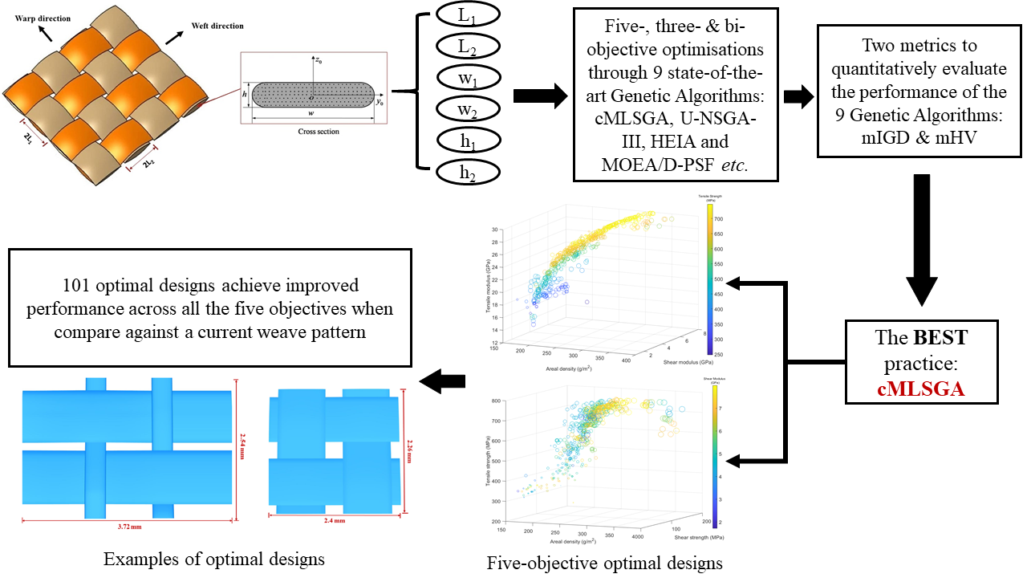

Abstract: Plain weave fabrics provide low-cost composites used in many applications. Their mechanical properties are dependent on the weave and the yarn dimensions, which provides a complex design space to ensure optimal properties for a given application. Genetic Algorithms are commonly used in the literature to optimise the performance of composite materials but are currently limited to two or three objectives, where the optimisation may improve the specified properties but degrade others. In this paper 9 top performing Genetic Algorithms are benchmarked to find designs that respectively satisfy five-objective, three-objective and bi-objective formulations. The results show that the consideration of the five-objective problem is important, since the designs for the five-objective formulation give a wider range of results. These results do not include designs from the optimisation with the more limited objectives, meaning that these designs would need to be redesigned to be practical and demonstrating the benefits of optimisation with more objectives. cMLSGA is shown to be the strongest solver for these problems, contradicting the findings from the Evolutionary Computation literature. When compared with a current weave pattern, the five-objective optimisation provides 101 designs which improve all 5 material properties, with up to 76.61% improvements on the four mechanical properties and a maximum 37.73% reduction on areal density; there are weave patterns with designs that are specific to each of the properties individually.
Keywords: Plain weave fabric (PWF); Many-objective optimisation; Tensile properties; Shear properties; Genetic Algorithms.

1. Many-objective optimisation in the design of plain weave fabric composites
Plain weave fabric (PWF) composites are a low-cost material often found in civil, offshore, marine and rail structures. They are generally limited to these applications because they exhibit lower mechanical properties than unidirectional composite laminates, which becomes a problem in lightweight applications. To utilise them in a wider range of applications, such as wing stiffeners, composite helical structures and rotor blades, they must have improved tensile and shear properties while reducing the density. To improve these properties the yarn specifications: the undulation length, the width and the thickness of the yarns, significantly influence the mechanical properties and the density of the material. Optimisation techniques can be used to improve these properties, and in combination with modern manufacturing, makes the use of bespoke high-performance plain weave fabric composites a possibility for a wider range of applications.
While there is the potential for improving the properties of weave fabrics, solving the full problem is complex due to the larger numbers of objectives and variables. Genetic Algorithms (GAs) are a popular tool for solving these complex engineering optimisation problems, with a recent review showing that 56% of engineering multi-objective optimisation problems are solved by Genetic Algorithms in the past 30 years [1]. However, the review shows that ~80% of the optimisation problems solved in the last decade, using Genetic Algorithms, are based on single objective problems. However, multi-objective problems, those with 2 or 3 objectives, and many-objective problems, those with 4+ objectives, are considered to be more interesting as they are generally more complex and the results are often more realistic. From a review of 321 papers only 61 of them focus on bi-objective optimisation problems and 8 of them utilise three-objective optimisation [1]. However, there are no examples of optimisation being performed on problems that satisfy more than three objectives.
Bai et al. [2,3] and Wang and Sobey [4] develop models that show robust and accurate predictions of the mechanical properties of plain weave fabric composites under tension and shear. However, there is limited knowledge about which weave patterns provide optimal mechanical properties and lowest density under combined tensile and shear loadings. Therefore, a five-objective formulation is compared to three-objective and bi-objective formulations, to determine how solving the problem with more objectives may provide beneficial results. The five-objective composite optimisation problem is complicated. The possibility of finding a non-dominated solution is significantly reduced with the increased number of objectives [1]. As the number of objectives grows the number of non-dominated solutions exponentially increases, increasing the multi-modality of the search space. This requires a higher diversity of search, which conflicts with mechanisms that provide higher convergence, making it challenging to find algorithms that can get close to the true Pareto Front while navigating the large number of near optimal solutions. According to the ‘No Free Lunch’ theorem, randomly picking a state-of-the-art Genetic Algorithm is not guaranteed to find optimal solutions. Wang and Sobey [1] stated that rigorous benchmarking is compulsory for understanding the composite optimisation problems, as the engineering problems are dominated by different characteristics. In addition, it is difficult to select the correct Genetic Algorithm from the evolutionary computation literature since there are limited benchmarking problems of this size in the Evolutionary Computation literature, with U-NSGA-III dominating the many-objective literature [1,5,6]. Therefore, the current study benchmarks 9 state-of-the-art Genetic Algorithms, most of which are not common in the composite’s optimisation literature, to find the optimal designs for plain weave fabric composites and the dominant characteristics of these optimisation problems. It also determines whether the problem can be decomposed into a series of simpler 2- or 3- objective problems, an approach more similar to the currently available literature.

2. Plain Weave Fabric model for the areal density, strengths and moduli under tension and shear
The tensile modulus and strength of the plain weave fabric composites are predicted by an analytical model developed by Bai et al. [2,3]. The shear modulus and strength of the plain weave fabric composites are predicted by an analytical model developed by Wang and Sobey [4]. Both analytical models provide accurate and robust predictions for a set of different materials and yarn specifications, where the mean errors of the two models proposed by Bai et al. and Wang and Sobey are respectively 5.50% for biaxial tensile modulus, 11.22% for biaxial tensile strength, 15.24% for shear modulus and 8.51% for shear strength and the standard deviation of prediction errors are respectively 2.27%, 2.66%, 4.10% and 6.76%. All of them use the same geometric parameters, which are shown in Figure 1. Bai et al. [2,3] and Wang and Sobey [4,7] provide a detailed derivation and verification of the two analytical models.
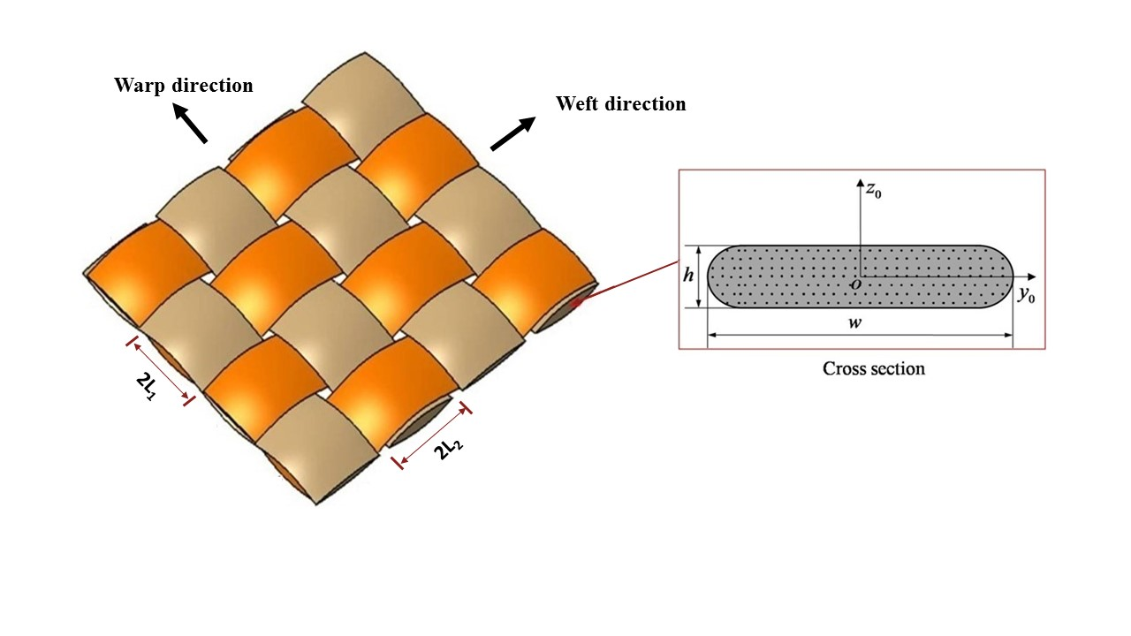
Figure 1. Geometric parameters of plain weave fabric composites [2,3]
In order to evaluate the areal density of the plain weave fabric composites, the same geometric parameters and idealised undulation shape from Bai et al. [2,3] and Wang and Sobey [4,7] are used. The density of a tow, , is expressed as eq. (1),
(1)
where the density of the EW220 fibre, , is 2.5 g/cm³ and the density of the 5284 epoxy resin, , is 1.2 g/cm³. The tow fibre volume fraction, V_{f}, is expressed as eq. (6) of [2]. According to the volume of the yarns calculated in eqs. (1) - (5) of [2], the areal density of a EW220/5284 plain weave fabric composite ply is expressed as eq. (2),
(2)
where A₁ and A₂ are the tow cross-sectional areas, which are the sum of the areas of a rectangle and two semi-circles shown in Figure 1. In order to validate the accuracy of eqs. (1) and (2) for calculating the areal density of plain weave fabric composites, the prediction is compared against a weight measurement. The fabric parameters are: one quarter of the tow undulation lengths, , is 0.714 mm and is 0.556 mm; the tow widths, is 1.0 mm and is 1.2 mm; the thickness of the tows, , is 0.08 mm and is 0.067 mm and the thickness of the EW220/5284 plain weave fabric composite ply, H, is 0.167 mm. The mean value of the measured areal density of the EW220/5284 plain weave fabric composite ply is 330.18 g/m² from experiments. The predicted areal density is 319.81 g/m² and the prediction error is 3.14% from the comparison. Eqs. (1) and (2) provide adequate accuracy for the areal density prediction of plain weave fabric composites.

3. Many-objective design methodology
In order to find the best practice of solving the many-objective optimisation problem, 9 top performing Genetic Algorithms from the evolutionary computation literature are selected for benchmarking: MOEA/D [8], MOEA/D-PSF [9], MOEA/D-MSF [9], HEIA [10], BCE [11], IBEA [12], MTS [13], U-NSGA-III [14], and cMLSGA [15]. All individuals in the population are evaluated using the two analytical models for the tensile and shear properties and eqs. (1) and (2) for the areal density.
3.1 Formulation of many-objective optimisation problem
A set of five optimisation problems are selected to maximise the strengths and moduli under tensile and shear loads and to minimise the areal density for a Plain Weave Fabric composite. Since many-objective optimisation problems are complex, transforming the design variables’ constraints to the limits of the range of design variables helps to resolve the problem. The benefits have been shown in [5], where all of the benchmarked Genetic Algorithms achieve more complete Pareto fronts when solving the unconstrained formulation of bi-objective optimisation of the triaxial weave fabric tensile strength and stiffness. Therefore, the optimisation problems in the current study are formulated using an unconstrained formulation for the plain weave fabric composite material in eqs. (3)-(7). Eq. (3) is a five-objective optimisation problem maximising the moduli and strengths under tension and shear while minimising the areal density,
(3)
eq. (4) is a three-objective problem optimising the tensile and shear moduli and the areal density,
(4)
eq. (5) is a three-objective problem optimising the tensile and shear strengths and the areal density,
(5)
Since the projection of the results from eqs. (4) and (5) can reflect the optimal designs of specific tensile and shear strengths and specific tensile and shear moduli, a bi-objective problem optimising the specific tensile strength and modulus is shown in eq. (6),
(6)
and eq (7) is a bi-objective problem optimising the specific shear strength and modulus,
(7)
The specific shear and tensile properties are calculated using the shear and tensile properties respectively divided by the areal density. The optimisation problems all use the same range of variables and variable constraints, which are shown in eq. (3). EW220/5284 is selected as a type of E-glass plain weave fabric composite currently used in aerospace applications and where the required material properties are available in the open literature. The range of these variables, shown in eq. (3), are determined to ensure they are representative for a range of existing applications for plain weave fabric composites. To compare the optimised weave pattern with a currently available one, the fibre volume fraction and the yarn fibre volume fraction of the EW220/5284 plain weave fabric composites are fixed at 0.55 and 0.73 in the optimisation and the thickness of the composite ply, H, is calculated using a combination of eqs. (4) and (5) [2]. The material properties of the current EW220/5284 plain weave fabric composite design, the tensile modulus of the EW220 fibre is 73 GPa and the shear modulus is 11.5 GPa [2–4]; the tensile modulus of the 5284 resin is 3.4 GPa and the shear modulus is 1.1 GPa [2–4]; the tensile strength of the fibre is 2000 MPa and the interlaminar shear strength of the yarn is 40 MPa [2–4]. In order to make sure the optimal designs can be manufactured, the sum of the warp and weft tow thicknesses must be smaller than the thickness of the ply, and half of the undulation length of the warp tow, , must be larger than the width of the weft tow, , and vice versa.
To ensure the accuracy of the models the half of the undulation length over thickness ratio is set to be larger than or equal to seven, according to the verification cases of the analytical models. Additionally, Wang and Sobey [4] demonstrate that the proposed model is not accurate for predicting shear properties when the half of the undulation length over thickness ratio and width over thickness ratio are simultaneously larger than 40; therefore, the variables are also constrained under these limits.
3.2 Genetic Algorithms selection
The benchmarking Genetic Algorithms are selected as the top performing algorithms from six distinct categories: MOEA/D-PSF/-MSF [9] are updated versions of MOEA/D which include improved diversity retention mechanism, penalty scalarizing function (PSF) and multiplicative scalarizing function (MSF), where the MOEA/D family of algorithms is based on a weight vector decomposition of the search space; HEIA [10] and BCE [11] are co-evolutionary algorithms; IBEA [12] uses an indicator-based selection approach; MTS [13] is a population based local search method; U-NSGA-III [14] is a non-dominated sorting based niching algorithm and co-evolutionary Multi-Level Selection Genetic Algorithm (cMLSGA) [15] is a multi-level selection method. The details of these algorithms are documented in their original paper and Wang and Sobey [1] have compared the main mechanisms of these algorithms.
In order to perform a fair benchmarking across these Genetic Algorithms, the values of parameters in the solvers are selected from their original paper, which is the same as in Wang et al. [5]. The parameters of the genetic operators for are listed in Table 1. All of the algorithms are real value coded, random initialised and terminated when they reach the total number of function calls. 300,000 total function calls are used with a population size of 1500, which results in 200 generations for most of the algorithms. Each solver is run over 30 independent cycles to obtain a statistically significant mean value due to the stochastic nature of these solvers.
To quantitatively evaluate the performance, two indicators are introduced in the current study which are the mimicked inverted generational distance (mIGD) and mimicked hyper volume (mHV). The mIGD is introduced in [5] and evaluated in eq. (8),
$mIGD\left(O, M^{*}\right)=\frac{\sum_{v∈M}{d\left(v,O\right)}}{\left|M^{*}\right|},$ (8)
where $M^{*}$ is a set of points along the mimicked Pareto front, O is a set of points on the currently obtained Pareto front, v represents each point in the set $M^{*}$ and $d\left(v,O\right)$ is the minimum Euclidean distance between v and the points in O; lower mIGD value reflects a better quality and diversity of the obtained Pareto front. The mimicked Pareto Front is created using the non-dominated solutions from all of the Pareto Fronts from the 270 simulations. The mHV is inspired by the HV indicator proposed by [16]. The HV indicator calculates the summation of the objective space volume between the obtained Pareto front points and a predefined reference point. The predefined reference point in the mHV is developed in the same manner as the mimicked Pareto Front for mIGD. A higher mHV value indicates a solver with a better performance. When comparing the results from the two metrics, the mHV metric is more representative of the diversity of the population but mIGD is more representative of the accuracy and uniformity of the obtained Pareto fronts, which is especially true when there are a small number of points in the Pareto Front. Therefore, using both indicators together allows an evaluation of the accuracy and the diversity of the obtained Pareto fronts for each solver. In addition, since it is hard to visually distinguish the difference between the Pareto front results generated by different Genetic Algorithms, a Wilcoxon test was implemented in order to quantitatively evaluate whether the 9 solvers provide significantly different optimal solutions. When the p-value of Wilcoxon test is lower than 0.05, the null hypothesis can be rejected which means the two Pareto front results from the two solvers have significantly different distributions.

Table 1. The hyperparameters used for each of the Genetic Algorithms
Algorithms | Crossover type | Crossover rate | Mutation type | Mutation rate | Algorithm specific parameters
U-NSGAIII | Simulated binary crossover (SBX) | 0.7 | Polynomial | 0.08 | User-defined distribution index for SBX and polynomial mutation, η = 20.
MOEA/D (including -PSF and -MSF) | Differential evolution crossover | 1 | Polynomial | 0.08 | Mating chance = 0.9; Neighbourhood size, T = 0.1 of population; Maximum No. of replaced individuals = 0.01 of population; Differential weight, F = 0.5.
MTS | N/A | N/A | N/A | N/A | No. of local search per generation = 45; Local search grade bonus 1 = 9; Local search grade bonus 2 = 2
HEIA | SBX & differential evolution crossover | 1 & 0.9 | Polynomial | 0.08 | η = 20; F = 0.5.
BCE | SBX | 1 | Polynomial | 0.08 | η = 20; F= 0.5.
IBEA | SBX | 1 | Polynomial | 0.08 | η = 20.
cMLSGA | HEIA & IBEA | HEIA & IBEA | Polynomial | 0.08 | No. of eliminated collectives = 1; Generations between collective elimination = 10.

4. Optimisation of plain weave fabric composites
4.1 Selection of the Genetic Algorithms
To evaluate the convergence of each of the benchmarked algorithms, the Pareto front results are extracted from each run at every 75,000 function calls, labelled as 50 generations, until 300,000 function calls, labelled as 200 generations. To reduce the number of results the best of the three MOEA/D variants, MOEA/D-PSF, is chosen for the illustration. The results of the Wilcoxon tests report that most solvers have significantly different distributions of Pareto front results when solving the five optimisation problems. Only cMLSGA and IBEA don’t show significantly different distributions of Pareto front results when solving the bi-objective problem of specific shear strength and shear modulus. Therefore, the values of mIGD and mHV can directly reflect the performance of different solvers since they provide different optimal results. The convergence of the mIGD and mHV values for the seven solvers are illustrated in Figures 2 to 6 for each problem formulation.
cMLSGA achieves the best performance on the five-objective optimisation problem, as shown in Figure 2, with a mean mHV of 0.0966 and a mean mIGD of 0.0123 at 200 generations in comparison to MTS which performs second best for mHV with a mean value of 0.0964 and BCE which performs second best for mIGD with a mean value of 0.0164. cMLSGA starts as the strongest solver after 50 generations and retains this position for both metrics, eventually achieving the strongest performance with the lowest number of function calls. This provides a contradiction to the Evolutionary Computation literature where U-NSGA-III has previously been shown to have a dominant performance on many-objective problems [14], but in this case shows the 4th best performance behind MTS and BCE for diversity and 5th place, behind BCE, MTS and even the older IBEA, for convergence and uniformity.
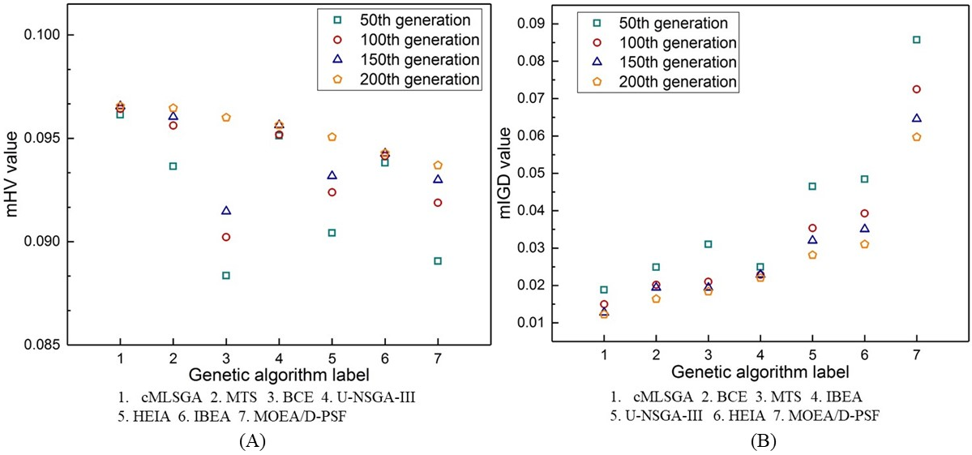
Figure 2. The rank of the seven solvers for the five-objective optimisation problem based on the two indicators: (A) mHV mean value; (B) mIGD mean value.
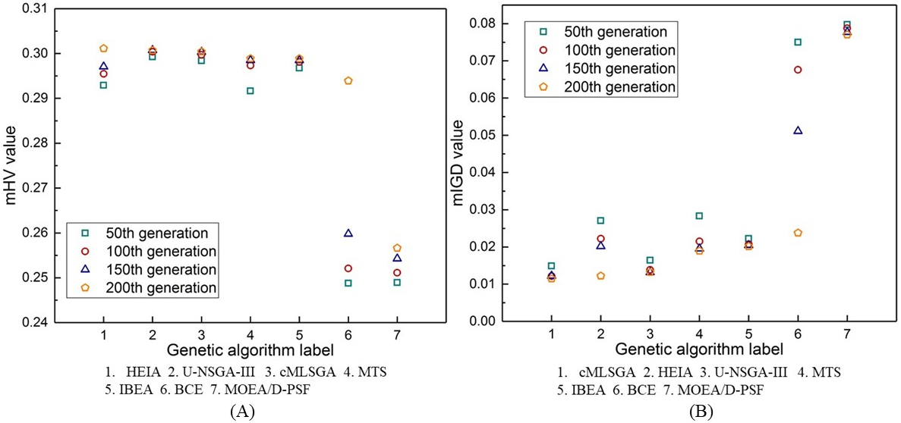
Figure 3. The rank of the seven solvers for the tensile and shear moduli and areal density three-objective optimisation problem: (A) mHV mean value; (B) mIGD mean value.
HEIA performs best when measured using the mHV metric and cMLSGA is the best when measured using the mIGD metric for the three-objective moduli optimisation problem, shown in Figure 3. U-NSGA-III and cMLSGA require fewer function calls to provide similar results to HEIA on the mHV metric. For the mIGD metric HEIA is second but takes a larger number of function calls to reach this result than cMLSGA. For these metrics cMLSGA, HEIA and U-NSGA-III share the top three places, confirming results from Sobey et al. [17] that the more modern and diversity based algorithms are the strongest at solving these problem types, which have a higher complexity of search space, with cMLSGA preferred due to its rapid convergence to its best solution and higher performance on the convergence metric.
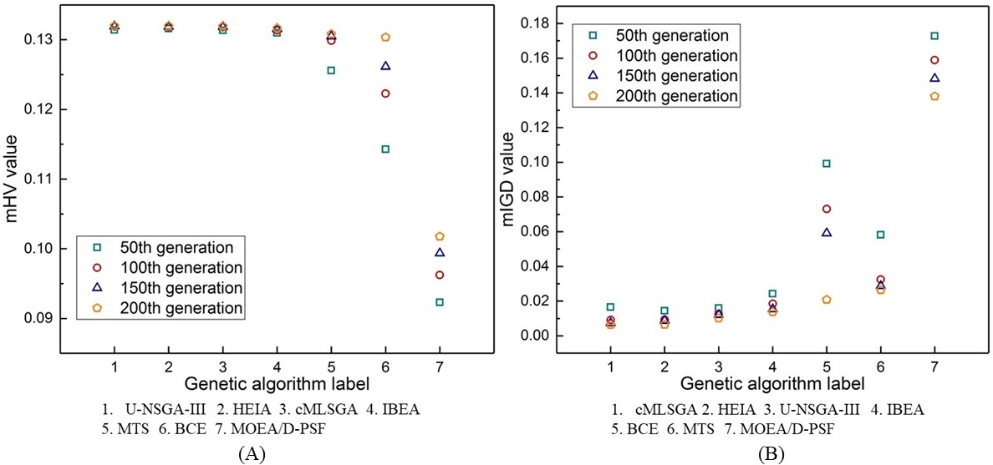
Figure 4. The rank of the seven solvers for the tensile and shear strengths and areal density three-objective optimisation problem: (A) mHV mean value; (B) mIGD mean value.
For the three-objective strength optimisation problem cMLSGA, HEIA and U-NSGA-III are tied for first place for the mHV metric, in Figure 4a. For the mIGD metric then cMLSGA provides the top performance, shown in Figure 4b. The results reach the final values with the fewest function calls, when compared to the previous problems, and a larger range of solvers provide the highest performance, indicating that this problem is easier than solving the three-objective moduli optimisation problem and the resulting set is shown to be in a narrow part of the design space, correlating with an increased performance from the high convergence solvers. It confirms cMLSGA, HEIA and U-NSGA-III are the best solvers for the two three-objective optimisation problems with cMLSGA preferred again due to equal performance on mHV and stronger performance on mIGD.
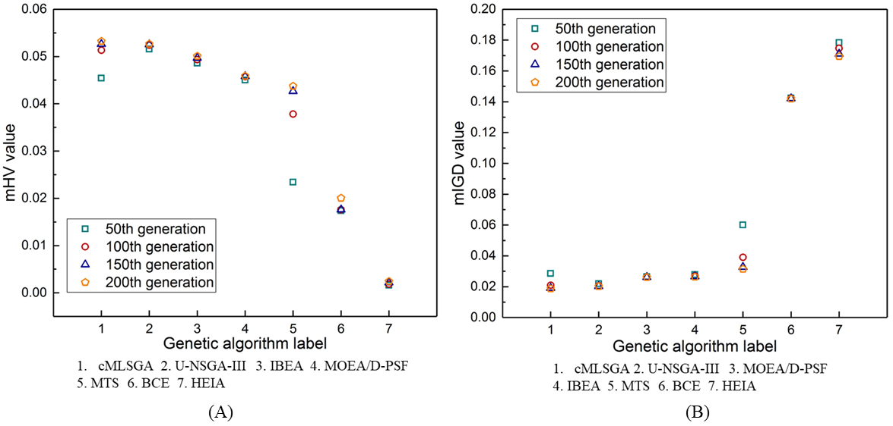
Figure 5. The rank of the seven solvers for the specific tensile strength and modulus bi-objective optimisation problem: (A) mHV mean value; (B) mIGD mean value.
For the bi-objective strength optimisation, cMLSGA is the strongest performer and U-NSGA-III achieves the second, as shown in Figure 5, although U-NSGA-III requires fewer function calls to provide this solution, reaching its top performing results between 50 and 100 generations. The stronger performance from cMLSGA on these problems is postulated to be from the disconnected Pareto front, shown in Figure 9, and the collective mechanism in cMLSGA guarantees the diversity of the obtained Pareto front.
In this case U-NSGA-III shows the strongest performance on the specific shear strength-modulus bi-objective problem, by a considerable margin, with MOEA/D-PSF demonstrating stronger performance and ranking in 2nd place with both metrics, after poorer performance on the previous 4 problems. As shown in Figure 6, cMLSGA is ranked 4th on mHV and 3rd on mIGD. As the Wilcoxon test shows the Pareto front results from cMLSGA and IBEA are not significantly different, they are considered to be tied for the 3rd place. Despite strong performances on the previous 4 formulations, cMLSGA shows moderate performance when solving the specific shear strength-modulus bi-objective problem. Although this problem also has a disconnected Pareto front, it only has a small gap and most solutions are concentrated within a small region. Therefore, those algorithms with strong convergence mechanisms have a better performance.
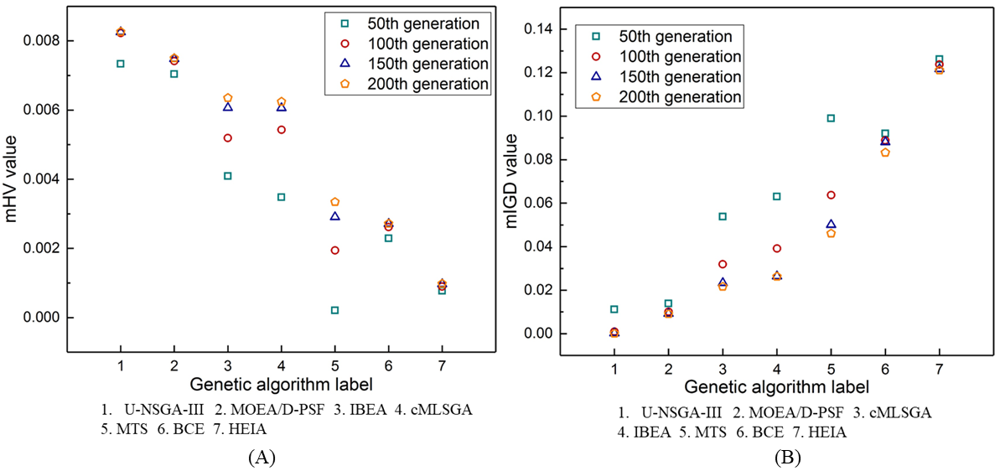
Figure 6. The rank of the seven solvers for the specific shear strength and modulus bi-objective optimisation problem: (A) mHV mean value; (B) mIGD mean value.
4.2 Pareto fronts among five-objective, three-objective and bi-objective optimisation
In order to compare the Pareto front results from the five-objective, three-objective and bi-objective formulations, the runs generating the best Pareto set results of the five-objective from cMLSGA are projected to two and three dimensions, which are shown in Figures 7 to 10. These are compared to the best Pareto set results of the three-objective optimisation problems, also taken from cMLSGA, and to the bi-objective optimisation problems, taken from U-NSGA-III due to its improved performance on the shear problems. In these figures the Pareto set results overlap, due to the projection from five dimensions to two or three dimensions but these are all non-dominated solutions as they have different properties in the other dimensions.
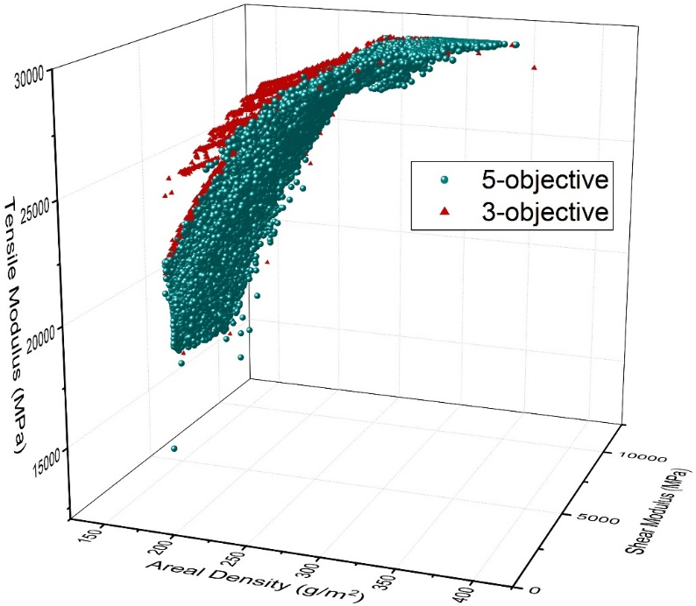
Figure 7. Comparison of Pareto Sets from the five-objective
The Pareto set results from the three-objective tensile-shear moduli and areal density optimisation in Figure 7 have the same shape as the projected Pareto set results from the five-objective optimisation. However, most of the Pareto set results from the five-objective optimisation are dominated by those from the three-objective optimisation. This shows that the tensile and shear moduli and areal density must be compromised to achieve better tensile and shear strengths in the five-objective optimisation with any of the results from the three-objective problem needing to be redesigned to account for these additional factor, unless being used in applications with low loads.
Compared with the Pareto set in Figure 7, the three-objective optimisation Pareto set results for the tensile-shear strength and areal density, shown in Figure 8, are concentrated on a small area of the objective space, showing why convergence mechanisms provide the top performance and showing a limited diversity of weave patterns that result in high strength. It is found that the majority of optimal designs that have a high shear modulus are concentrated at the region where the areal densities are between 200 g/m² and 250 g/m². However, it is difficult to determine any specific rule from the constitutive relations shown in the analytical model [4]. When designing a plain weave fabric composite structure, the weight of each ply is expected to be between 200 g/m² and 250 g/m² if high shear modulus is expected. Therefore, designers can find multiple choices from the Pareto front solutions in this study and they can further search a specific choice from these designs.
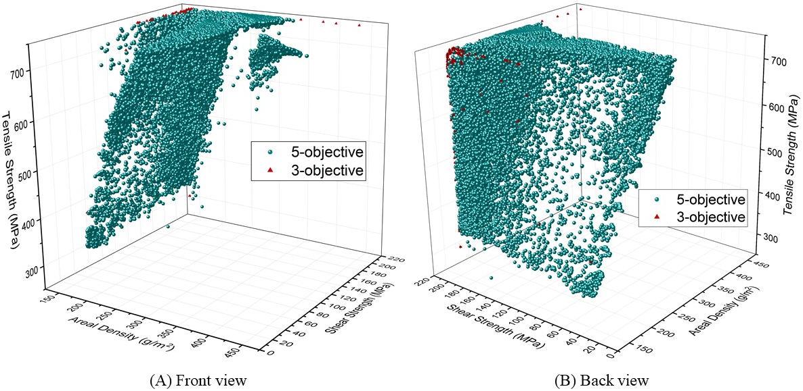
Figure 8. Comparison of Pareto Sets from five-objective: (A) front and (B) back views.
To illustrate the complexity of the optimisation the simultaneous changing of width and the undulation length of the yarns has a positive correlation to the tensile modulus and strength but a negative correlation to the shear modulus and strength. The shear modulus and strength increase and then decrease when increasing the undulation length of the warp or weft yarn, with an optimal value in the middle. This is because increasing the undulation length of the yarns in one-direction causes increased yarn spaces in the other direction. The increased yarn spaces give a benefit in mass by reducing the total areal density but also reduces the tensile strength and modulus in that direction. However, simultaneously changing the thickness and width of yarns has a positive correlation to the areal density, but the thickness has a negative correlation to the tensile modulus, shear modulus and shear strength. The increased warp/weft yarn thickness first increases and then decreases the tensile strength in warp/weft direction. It shows that the relationships between the objectives and variables is nonlinear and complicated, where changes to a single variable, or a combination, influences all five objectives in different ways, depending on where the weave starts in the design space. Several examples are summarised in Appendix A, which demonstrates how the variable space variation influences the changes in objective space. The areal density and shear properties have nonlinear correlations to several design variables, including the yarn thickness, undulation length, yarn space and width, and they are also sensitive to the combined influences of these variables.
A similar phenomenon is found for the two bi-objective problems in Figures 9 and 10 as for the three-objective problems. This confirms that the optimal solutions from the simulations with fewer objectives have better results for these objectives, such as the specific tensile strength and modulus optimisation in Figure 9, but compromise on the performance of other objectives, such as shear. Therefore, many-objective optimisation is necessary to ensure that all the mechanical properties remain high, as changes to improve one material property degrade those of another.
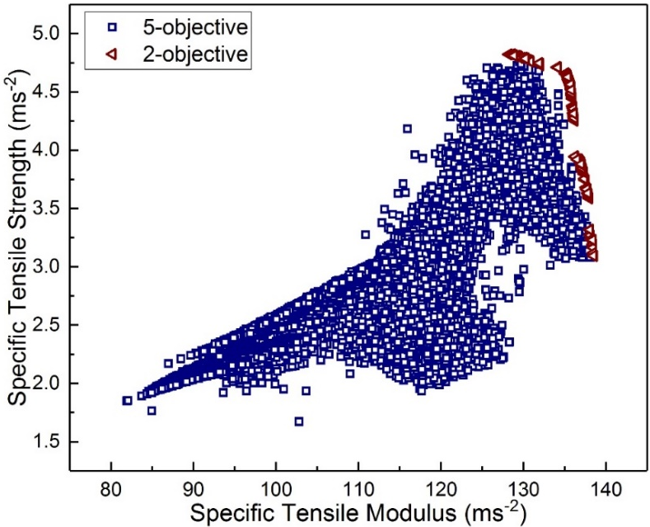
Figure 9. Comparison of Pareto fronts from the five-objective and bi-objective optimisation of specific tensile strength and modulus.
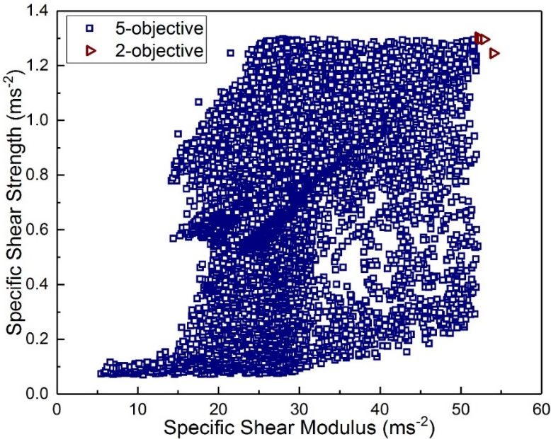
Figure 10. Comparison of Pareto fronts from five-objective and bi-objective optimisation of specific shear strength and modulus.
The bi-objective optimisation Pareto fronts found in both Figures 9 and 10 are disconnected Pareto fronts but the Pareto front in Figure 10 has smaller gaps between the two fronts and most results are concentrated on one of the two fronts. In addition, five-objective optimisation Pareto front results show the correlation between the specific tensile strength and modulus in Figure 9 but the correlation between specific shear strength and modulus are not explicit as the projected Pareto front results are distributed in the plot. The reason is also considered similar to that causing the uncorrelated areal density and shear strength shown in Figure 8.

5. Discussion
The Pareto front results from the best run of cMLSGA from the five-objective optimisation problem with 1500 population size and 200 generations are selected to demonstrate the implications for plain weave fabric composite designs, since they achieve the best performance. Each solution is assumed close to the optimal design of the plain weave fabric composites since the standard deviation of mHV and mIGD values are 0.000712 and 0.000103 among the 30 independent runs of cMLSGA and the best run has mHV and mIGD values of 0.0968 and 0.0104, which are the best values among all the 9 solvers. Five extreme points: maximum tensile strength and modulus, maximum shear strength and modulus and minimum areal density, on the five-dimensional Pareto front are selected to illustrate the five different types of designs. The resulting topologies are illustrated in Table 2.
Table 2. Proportionally illustrated the optimal designs of PWF composites.
Designs | Weave pattern | Values of design variables (mm)
A. Maximum tensile strength | 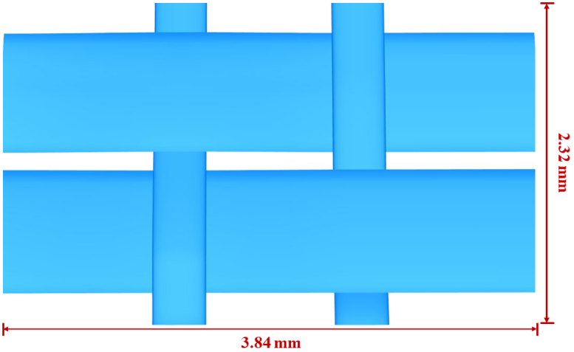 | L₁ = 0.96;  L₂ = 0.58;  w₁ = 1.10;  w₂ = 0.62;  h₁ = 0.10;  h₂ = 0.05.
B. Maximum tensile modulus |  | L₁ = 1.17;  L₂ = 1.10;  w₁ = 1.94;  w₂ = 1.57;  h₁ = 0.12;  h₂ = 0.10.
C. Maximum shear strength |  | L₁ = 0.60;  L₂ = 0.57;  w₁ = 0.83;  w₂ = 1.00;  h₁ = 0.04;  h₂ = 0.04.
D. Maximum shear modulus | 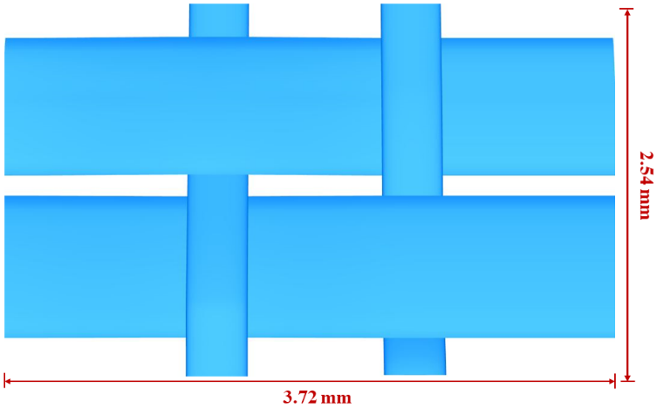 | L₁ = 0.93;  L₂ = 0.64;  w₁ = 1.21;  w₂ = 0.55;  h₁ = 0.11;  h₂ = 0.05.
E. Minimum areal density |  | L₁ = 0.23;  L₂ = 0.77;  w₁ = 1.34;  w₂ = 0.32;  h₁ = 0.04;  h₂ = 0.04.

The maximum tensile strength and modulus, shear strength and modulus and minimum areal density of the five extreme optimal designs are respectively 744.66 MPa, 29.87 GPa, 197.40 MPa, 7.88 GPa and 153.21 g/m². It is found that thick yarns provide a high tensile strength and modulus but significantly increase the areal density of the material. In addition, the weave patterns illustrated in Table 2a, 2b and 2d for maximum tensile strength, modulus and shear modulus have large undulation lengths and widths on the warp yarns and all three weave patterns provide high tensile strength and tensile modulus along the warp direction. When comparing the maximum tensile modulus design with the maximum shear strength design, it is found that the proportions of the warp and weft yarns geometric parameters are similar but the maximum shear strength weave is more compact than that of the maximum tensile modulus. When comparing the maximum shear strength and minimum density against the maximum tensile modulus, tensile strength and shear modulus, it is found that smaller undulation lengths, widths and thicknesses of warp and weft tows provide lower areal densities but significantly reduce the mechanical properties of the materials. Bai et al. [2,3] and Wang and Sobey [4] have summarised the fabric specifications of 10 experimental specimens with nine obtained from the open literature. It is found that eight of the 10 existing designs have the same fabric specifications in both the warp and weft directions and the other two specimens also have similar fabric specifications in these two directions. Seven of them have small undulation lengths and widths for both tows, which are smaller than those shown for the maximum shear strength, but thicker tows, which have similar thicknesses as those shown in the tensile modulus. The yarn specifications give these experimental specimens low tensile properties and high areal densities, giving poor performance for light-weight structures.
Table 3. Comparison of properties from the different weave patterns generated by the Genetic Algorithm and a commonly used real weave pattern, where text in red shows reduced performance and green shows improved performance compared to the real weave pattern
Designs | Tensile Strength (MPa) | Tensile Modulus (GPa) | Shear Strength (MPa) | Shear Modulus (GPa) | Areal Density (g/m²)
A real weave pattern: EW220/5284 | 492.52 | 19.30 | 111.09 | 6.45 | 330.18
Maximum Tensile Strength | 744.66 | 28.64 | 138.72 | 5.56 | 268.40
Maximum Tensile Modulus | 629.00 | 29.87 | 181.87 | 4.20 | 349.28
Maximum Shear Strength | 452.99 | 14.43 | 197.40 | 4.09 | 167.25
Maximum Shear Modulus | 728.29 | 28.54 | 67.64 | 7.88 | 310.61
Minimum Areal Density | 313.71 | 15.03 | 53.91 | 3.88 | 153.21

A current EW220/5284 weave pattern [2,3,18] is used for comparison, which has = 0.714 mm, = 0.556 mm, = 1.0 mm, = 1.2 mm, = 0.08 mm and = 0.067 mm which is a similar weave pattern to that shown for the maximum shear strength, although the real design has larger geometric parameters; the comparison of the properties are summarised in Table 3. When comparing the five extreme optimal designs against the current weave pattern, although the minimum areal density design reduces the areal density by 53.60%, it compromises the performance on the rest 4 objectives. However, there are some designs that show increased performance across a range of the objectives. The weave pattern shown in Table 2a improves on 4 of the objectives by up to 51.19%, with a small reduction in shear modulus, 13.80%. The weave pattern of the maximum shear modulus design also improves on 4 of the objectives by up to 47.87% with a compromise of shear strength by 39.11%. The weave pattern of tensile modulus improves on 3 of the objectives by up to 54.77% with a reduction in shear modulus, 34.88%, and a small increase in areal density, 5.78%. In addition, 101 optimal designs among the total 1000 Pareto front solutions are found to have improved performance across all of the five objectives, when compared to the current weave pattern. The 101 optimal designs achieve improvements by up to 51.17% on the tensile strength, 54.66% on the tensile modulus, 76.61% on the shear strength, 21.86% on the shear modulus and reductions of up to 37.73% on the areal density.
The different dominant characteristics between the plain weave fabric composite optimisation problems and the benchmark problems in the evolutionary computation literature make the selection of the best practices of Genetic Algorithms for solving composite optimisation problems difficult, which supports the findings in Wang et al. [5]. In the Evolutionary Computation literature the top performing algorithm on five-objective problems is clearly U-NSGA-III, but the number of problems in this literature are limited and developed by the author of the algorithm. The composites community needs to continue to benchmark and understand the problems in its literature, to be able to select and use the correct algorithms from the Evolutionary Computation community.

6. Conclusions
The combination of low-cost manufacturing and highly optimisable fabrics makes the wider application of plain weave fabric composites a possibility in industries that do not traditionally use them. In this paper, 9 state-of-the-art Genetic Algorithms are employed to find high mechanical properties and low-density designs of plain weave fabric composites under tension and shear. These algorithms are benchmarked to determine the best solvers and the dominant characteristics of the problems. cMLSGA is shown to be the strongest solver for these problems, as well as the three objective and bi-objective tensile optimisations with the shear bi-objective problem requiring a more convergence-based approach, where U-NSGA-III has the strongest performance. The consideration of the five-objective problem is important, as the designs for the bi- and three-objective problems are unrealistic. From these designs there are a wide range of different properties that can be generated from changing the weave fabric, with 101 designs that show an improvement of performance on all five properties over a real design. However, the design of these is challenging for a human due to the complexity in the search space and that Genetic Algorithms can be used to explore this space, but this requires careful selection of the algorithm being used. The dominant characteristics found within this study help the selection of appropriate Genetic Algorithms when solve a similar optimisation problem.

Acknowledgements
This project was supported by the Lloyds Register Foundation and China Scholarship Council.
References
[1] Wang Z, Sobey A. A comparative review between Genetic Algorithm use in composite optimisation and the state-of-the-art in evolutionary computation. Compos Struct 2020;233:111739. https://doi.org/10.1016/j.compstruct.2019.111739.
[2] Bai JB, Xiong JJ, Shenoi RA, Wang Q. A micromechanical model for predicting biaxial tensile moduli of plain weave fabric composites. J Strain Anal Eng Des 2017;52:333–43. https://doi.org/10.1177/0309324717707858.
[3] Bai J, Wang Z, Sobey A, Shenoi A. Micromechanical model for rapid prediction of plain weave fabric composite strengths under biaxial tension. Compos Struct 2021;255:112888. https://doi.org/10.1016/j.compstruct.2020.112888.
[4] Wang Z. Computationally Efficient Micromechanical Model-Aided Woven Fabric Composite Design based on Genetic Algorithms. University of Southampton, 2020.
[5] Wang Z, Bai J, Sobey AJ, Xiong J, Shenoi RA. Optimal design of triaxial weave fabric composites under tension. Compos Struct 2018;201:616–24. https://doi.org/https://doi.org/10.1016/j.compstruct.2018.06.090.
[6] Mutlu U, Grudniewski PA, Sobey AJ, Blake JIR. Selecting an optimisation methodology in the context of structural design for leisure boats. Des. Constr. Super Mega Yachts, 2017.
[7] Wang Z, Sobey A. Analytical model for computationally efficient prediction of plain weave fabric composite shear moduli and strengths 2021. https://doi.org/doi.org/10.5281/zenodo.3235555.
[8] Zhang Q, Li H. MOEA/D: A Multiobjective Evolutionary Algorithm Based on Decomposition. IEEE Trans Evol Comput 2007;11:712–31. https://doi.org/10.1109/TEVC.2007.892759.
[9] Jiang S, Yang S, Wang Y, Liu X. Scalarizing Functions in Decomposition-Based Multiobjective Evolutionary Algorithms. IEEE Trans Evol Comput 2018;22:296–313. https://doi.org/10.1109/TEVC.2017.2707980.
[10] Lin Q, Chen J, Zhan Z-H, Chen W, Coello Coello C, Yin Y, et al. A Hybrid Evolutionary Immune Algorithm for Multiobjective Optimization Problems. IEEE Trans Evol Comput 2016;20:711–29. https://doi.org/10.1109/TEVC.2015.2512930.
[11] Li M, Yang S, Liu X. Pareto or Non-Pareto: Bi-criterion evolution in multiobjective optimization. IEEE Trans Evol Comput 2016;20:645–65. https://doi.org/10.1109/TEVC.2015.2504730.
[12] Zitzler E, Simon K. Indicator-Based Selection in Multiobjective Search. 8th Int Conf Parallel Probl Solving from Nat (PPSN VIII) 2004;3242:832–42. https://doi.org/10.1007/b100601.
[13] Tseng L-Y, Chen C. Multiple trajectory search for multi-objective optimization. IEEE Congr. onEvolutionary Comput., 2007, p. 3609–16.
[14] Seada H, Deb K. U-NSGA-III: A unified evolutionary optimization procedure for single, multiple, and many objectives. InInternational Conf. Evol. Multi-Criterion Optim., Springer, Cham; 2015, p. 34–49. https://doi.org/10.1007/978-3-319-15892-1_3.
[15] Grudniewski PA, Sobey AJ. cMLSGA: co-evolutionary Multi-Level Selection Genetic Algorithm. Swarm Evol Comput 2019.
[16] While L, Bradstreet L, Barone L. A fast way of calculating exact hypervolumes. IEEE Trans Evol Comput 2012;16:86–95. https://doi.org/10.1109/TEVC.2010.2077298.
[17] Sobey AJ, Blanchard J, Grudniewski PA, Savasta T. There’s no free lunch: A study of Genetic Algorithm use in maritime applications. Int. Conf. Comput. Appl. Inf. Technol. Marit. Ind. (COMPIT 19), Tullamore, Ireland: 2019.

Appendix A. Samples of optimal designs
Mechanical Properties & Density |  |  |  |  | Geometric Parameters
Shear Strength  (MPa) | Shear Modulus  (GPa) | Tensile Strength (MPa) | Tensile Modulus (GPa) | Areal Density (g/m²) | L₁ (mm) | L₂ (mm) | w₁ (mm) | w₂ (mm) | h₁ (mm) | h₂ (mm)
81.23 | 4.27 | 317.70 | 16.39 | 153.69 | 0.32 | 0.67 | 1.23 | 0.44 | 0.040 | 0.040
156.16 | 5.44 | 391.70 | 17.91 | 161.18 | 0.60 | 0.91 | 1.79 | 0.66 | 0.043 | 0.040
120.35 | 6.35 | 336.74 | 18.18 | 171.41 | 0.36 | 0.94 | 1.86 | 0.49 | 0.043 | 0.041
144.38 | 4.39 | 620.88 | 22.85 | 188.20 | 0.75 | 0.55 | 1.09 | 0.70 | 0.058 | 0.041
117.55 | 5.45 | 552.37 | 23.12 | 196.29 | 0.61 | 0.59 | 1.16 | 0.54 | 0.062 | 0.042
186.38 | 5.91 | 487.00 | 23.66 | 204.25 | 0.42 | 0.54 | 1.08 | 0.50 | 0.061 | 0.040
143.75 | 6.20 | 630.59 | 24.72 | 211.58 | 0.73 | 0.54 | 1.08 | 0.54 | 0.070 | 0.040
95.45 | 6.56 | 604.41 | 25.45 | 217.85 | 0.96 | 0.99 | 1.96 | 0.70 | 0.073 | 0.042
124.67 | 5.30 | 656.06 | 26.10 | 223.77 | 1.20 | 0.90 | 1.80 | 0.83 | 0.077 | 0.040
140.80 | 6.11 | 709.26 | 27.21 | 239.27 | 0.88 | 0.54 | 1.08 | 0.57 | 0.085 | 0.052
134.65 | 6.99 | 723.21 | 27.09 | 241.22 | 0.93 | 0.54 | 1.08 | 0.53 | 0.086 | 0.046
136.91 | 6.80 | 728.96 | 27.93 | 252.43 | 0.92 | 0.54 | 1.07 | 0.56 | 0.090 | 0.055
41.09 | 4.94 | 678.88 | 28.57 | 264.51 | 0.40 | 0.33 | 0.66 | 0.33 | 0.095 | 0.041
127.84 | 7.33 | 735.12 | 28.92 | 276.03 | 0.88 | 0.54 | 1.08 | 0.55 | 0.100 | 0.043
73.52 | 6.59 | 739.80 | 29.22 | 282.93 | 0.92 | 0.59 | 1.17 | 0.55 | 0.110 | 0.049
39.72 | 6.99 | 720.68 | 29.77 | 296.19 | 0.72 | 0.81 | 1.62 | 0.47 | 0.110 | 0.044
183.49 | 6.89 | 742.12 | 29.41 | 305.95 | 1.60 | 1.00 | 2.00 | 1.03 | 0.110 | 0.040
162.34 | 7.85 | 740.20 | 28.88 | 315.60 | 1.31 | 0.90 | 1.79 | 0.89 | 0.110 | 0.040
196.75 | 6.99 | 585.01 | 28.59 | 343.19 | 0.47 | 0.90 | 1.80 | 0.73 | 0.110 | 0.044

