Slippery Liquid-Like Solid Surfaces with Promising Antibiofilm Performance in both Static and Flow Conditions
Yufeng Zhu¹, Glen McHale², Jack Dawson¹, Steven Armstrong², Gary Wells², Rui Han¹, Hongzhong Liu³, Waldemar Vollmer⁴, Paul Stoodley^{5,6}, Nicholas Jakubovics⁷, Jinju Chen^{1*}.
¹ School of Engineering, Newcastle University, Newcastle Upon Tyne, NE1 7RU, UK. ² School of Engineering, University of Edinburgh, Edinburgh, EH9 3FB, UK. ³ School of Mechanical Engineering, Xi’an Jiaotong University, Xi’an 710054, China; ⁴ Centre for Bacterial Cell Biology, Biosciences Institute, Newcastle University, Newcastle upon Tyne, NE2 4AX, UK. ⁵ Department of Microbial Infection and Immunity and the Department of Orthopaedics, The Ohio State University, Columbus, OH, 43210, USA. ⁶ National Centre for Advanced Tribology at Southampton (nCATS), National Biofilm Innovation Centre (NBIC), Mechanical Engineering, University of Southampton, Southampton, S017 1BJ, UK. ⁷ School of Dental Sciences, Faculty of Medical Sciences, Newcastle University, Newcastle Upon Tyne, NE2 4BW, UK.
KEYWORDS: Antibiofilm, Slippery polymer surfaces, Liquid-like surface, Biofilm detachment, Surface wetting.

ABSTRACT
Biofilms are central to some of the most urgent global challenges across diverse fields of application, from medicine to industry to the environment and exert considerable economic and social impact. A fundamental assumption in anti-biofilm has been that the coating on a substrate surface is solid. The invention of slippery liquid-infused porous surfaces (SLIPS) - a continuously wet lubricating coating retained on a solid surface by capillary forces - has led to this being challenged. However, in situations where flow occurs, shear stress may deplete the lubricant and affects the anti-biofilm performance. Here we report on the use of slippery omniphobic covalently attached liquid (SOCAL) surfaces, which provides a surface coating with short (ca. 4 nm) non-cross linked PDMS chains retaining liquid-surface properties, as an antibiofilm strategy stable under shear stress from flow. This surface reduced biofilm formation of the key biofilm forming pathogens Staphylococcus epidermidis and Pseudomonas aeruginosa by 3-4 orders of magnitude compared to the widely used medical implant material polydimethylsiloxane (PDMS) after 7 days in static and dynamic culture conditions. Throughout the entire dynamic culture period of P. aeruginosa, SOCAL significantly outperformed a typical antibiofilm slippery surface (i.e. swollen PDMS in silicone oil (S-PDMS)). We have revealed that significant oil loss occurred after 2-7 days flow for S-PDMS, which correlated to increased contact angle hysteresis (CAH), indicating a degradation of the slippery surface properties, and biofilm formation. While SOCAL has stable CAH and sustainable antibiofilm performance after 7 days flow. The significance of this correlation is to provide a useful easy-to-measure physical parameter as an indicator for long-term antibiofilm performance. This biofilm-resistant liquid-like solid surface offers a new antibiofilm strategy for applications in medical devices, and other areas where biofilm development is problematic.
Introduction
Many microorganisms form sessile communities, called biofilms, in self-produced extracellular polymeric substances (EPS), which often attach to solid surfaces. Biofilm associated infections have dramatic economic and societal impacts. For instance, it was estimated that biofilm infections cost about $94 billion p.a. in the United States healthcare system ¹. Moreover, around 6–14% of hospitalised patients suffer from biofilm infections associated with medical devices, such as urinary catheters, peritoneal dialysis catheters, tracheal prostheses, pacemakers, endotracheal tubes, dental implants, and orthopaedic implants ². Among these, catheter-associated urinary tract infections (CAUTI) in hospitals, are estimated to cause additional health-care costs of £1–2.5 billion in the UK alone ³. Catheter-related bloodstream infections (CRBSIs) are mainly responsible for nosocomial infection in intensive care units (ICUs), resulting in morbidity, mortality, and significant economic cost ⁴⁻⁵.
Methods to prevent biofilm formation and growth on medical devices surfaces include immobilisation of antimicrobial agents ⁶ (i.e. antibiotics, peptide, silver particles or nitric oxide), the use of special surface texture ⁷⁻¹¹, surface grafting with poly (ethylene glycol) (PEG) or zwitterionic polymers ¹²⁻¹³, quaternary ammonium salt functionalized fluorinated copolymers¹⁴ and the use of biofilm-dispersing enzymes ¹⁵. All anti-biofilm surfaces have their own challenges. For instance, surfaces based on antimicrobial agents lose their efficacy over time and they can potentially trigger antimicrobial resistance ^{7, 15}. Antibiofilm surface textures have either nanospears to mechanically rupture the bacterial cell wall, causing cell lysis ^{7-9, 11}, or they trap air within micro- or nanostructures to restrict direct contact between the solid surface and micro-organisms ¹⁶⁻¹⁸. For the former, the fast-growing surviving bacteria mask the nanospear structures which restricts their long-term antimicrobial efficiency ⁷. For the latter, the anti-biofilm efficacy strongly depends on the lifetime of the non-wetting (Cassie) state, which is often short in submerged environments ^{16, 19-20}. The antibiofilm performance of surfaces grafted with poly (ethylene glycol) (PEG) or zwitterionic polymers is also transient because the adsorption of proteins and surfactants secreted by bacteria can mask the underlying surface ²¹. Although these surfaces are promising, new developments are required to improve their durability.
Recently, anti-biofilm approaches have been developed based on endowing the surface with a liquid lubricant. There are many physical and chemical methods which can potentially maintain a stable lubricant layer by capillary force, chemical interactions, swelling and employing microcapsules to lock the lubricants²². Typically, a porous or textured solid surface is infused with a liquid lubricant locked-in to the structure by capillary forces to create a stable hemi-solid/hemi-liquid surface ²³ or a continuous lubricant coating (a slippery liquid-infused porous surface – SLIPS) ²⁴⁻²⁵. Another complementary liquid lubricant-based approach uses a polydimethylsiloxane (PDMS) matrix infused with silicone oil (known as S-PDMS) causing it to swell and locking in a large reservoir of oil in the polymer chains ²⁶⁻²⁷. These liquid lubricant-based surfaces inhibit the surface attachment of bacteria and have great promise as antibiofilm surfaces ²⁷⁻³⁷. However, the potential loss of lubricant through repeated usage or shear ³⁸⁻⁴⁰ remains a key limiting factor to wider adoption as a practical solution. In clinical settings, this may be a safety risk for patients.
In the present work, we report an anti-biofilm surface strategy using liquid-like solid surfaces where the risk of lubricant loss is removed. Our coating is uses a Slippery Omnipobic Covalently Attached Liquid-like (SOCAL) surface, obtained through acid- catalyzedgraft polycondensation of dimethyldimethoxysilane, first proposed by Wang & McCarthy as an ultra-slippery non-pinning surface for sessile droplets ⁴¹⁻⁴². This SOCAL surface displays similar wetting properties to SLIPS through its grafted PDMS coating that behaves as a liquid phase approximately 150 °C above its glass transition temperature ^{41, 43}. The wetting properties of SOCAL coatings have been increasingly cited, but only a handful of groups have implemented the techniques and successfully fabricated SOCAL with contact angle hysteresis (CAH) below 3 degrees^{41, 43}. The optically transparent SOCAL surface has often been discussed in the context of superhydrophobic surfaces with interesting surface wetting properties^{41, 43}. No work has been done to assess and understand its antibiofilm performance.
We demonstrate antibiofilm performance of SOCAL, as a permanently bound liquid-like solid lubricant surface, in both static cell culture without flow and dynamic culture with continuous flow. The anti-biofilm performance against two major nosocomial pathogens, Staphylococcus epidermidis and Pseudomonas aeruginosa is presented. We also discuss possible new mechanisms that oil depletion of S-PDMS can affect the colonization of Staphylococcus epidermidis and Pseudomonas aeruginosa in a different way.
Results
Surface preparation
SOCAL was prepared following the procedure in Wang and McCarthy⁴¹ as implemented by Armstrong⁴³. This used dip coating of a reactive solution of isopropanol, dimethyldimethoxysilane, and sulphuric acid onto plasma treated glass and drying in a controlled humidity environment to cause an acid-catalyzed graft polycondensation of dimethyldimethoxysilane resulting in a liquid-like polymer coating. Fig.1 displays the schematic diagram for preparing S-PDMS. The detailed protocols for sample preparations were provided in the Methods. To ensure that PDMS was a suitable control for SOCAL surfaces, the surface chemistry of the two materials was assessed by X-ray photoelectron spectroscopy (XPS) spectrum analysis (see Fig. S1 in supporting information). The XPS of the SOCAL coating prepared by such a dip coating approach was similar to that of PDMS⁴⁴. Our atomic force microscope nanoindentation tests with an empirical model have shown an estimated modulus of SOCAL is about 8.8kPa, which should be treated as upper bound because the substrate from the underlying glass cannot be completely removed⁴⁵.
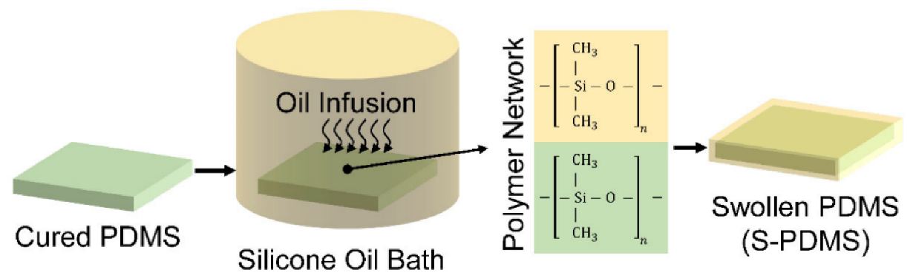
Figure 1. Schematic diagram for preparing S-PDMS prepared by infusing silicone oil into PDMS (silicone) .

Surface wettability
The static contact angle (CA) and the contact angle hysteresis (CAH) are important parameters for water repellency and the ability of a surface to shed water, which could be correlated with the repellency to bacterial adhesion. Both CA and CAH of water droplets on PDMS (control sample), SOCAL and S-PDMS are summarized in Table 1. S-PDMS and SOCAL have a CA of 100.0 ± 1.4° and 104.9 ± 1.6°, respectively, which is consistent with previous measurements ^{37, 43} and theoretical predictions based on surface free energy approach ⁴⁶⁻⁴⁷. The measured oil thickness of the S-PDMS surface is estimated to be 26.1± 5.3 µm. The thickness of SOCAL measured by ellipsometry was (3.9 ± 0.6) nm which is consistent with that previously reported ⁴¹. Such a thickness of SOCAL is important for achieving CAH below 3° ⁴¹. Both SOCAL surfaces and S-PDMS have CAH an order of magnitude less than PDMS, which implies an order of magnitude reduction in force to induce droplet shedding by motion along the surface ⁴⁸, thereby confirming its slippery surface properties.
As S-PDMS was reported to suffer from oil loss in continuous flow⁴⁰, we also measured the oil loss and investigated how the oil loss may affect the contact angle and CAH. The key results are presented in Fig. 2. After continuous flow ($τ_{w}=$0.007 Pa) for 7-days, for S-PDMS CA remained unchanged but CAH increased significantly to an average of 8.9 °, which is associated with oil loss (see Fig.2). In contrast, there was no detectable change of CA and CAH for SOCAL surfaces.
Table 1. The static contact angle and the contact angle hysteresis of water droplets on different surfaces. Data represent the mean and SD of five independent measurements.
Surface | Contact angle (°) | Advancing angle (°) | Receding angle (°) | Contact angle hysteresis (°)
PDMS | 117.5 ± 1.1 | 116.8 ± 1.5 | 95.4 ± 1.3 | 21.4 ± 2.1
SOCAL | 104.9 ± 1.6 | 105.1 ± 0.8 | 103.0 ± 1.3 | 2.0 ± 1.0
S-PDMS | 100.3 ± 1.4 | 99.1 ± 3.2 | 95.9 ± 2.4 | 3.2 ± 0.7

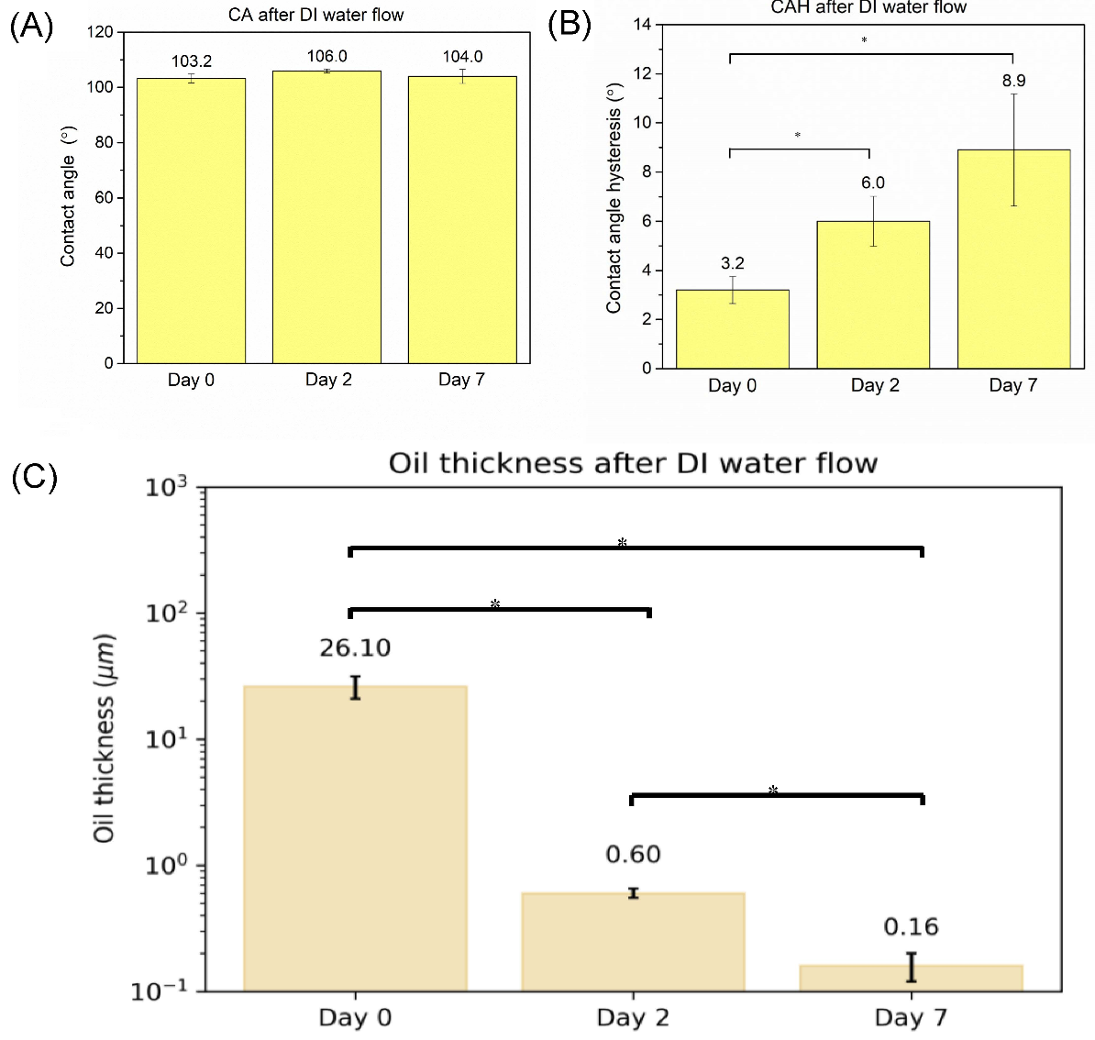
Figure 2. (A) The oil thickness atop S-PDMS and the corresponding (B) contact angle and (C) contact angle hysteresis subjected to the continuous flow ($τ_{w}=$0.007 Pa) for 2 days and 7 days. * p<0.05

Anti-biofilm tests against S. epidermidis
We started by examining the growth of S. epidermidis FH8, a recent clinical isolate from a mucosal biofilm, on PDMS and SOCAL after different culture periods under static conditions. PDMS was used as a comparative control surface because it has similar surface chemistry characteristics to SOCAL. The former is crosslinked PDMS, and the latter is a liquid-like uncrosslinked PDMS thin film. To assess the anti-biofilm performance of SOCAL, we also performed the tests on swollen PDMS for comparison. We created a SLIPs-type surface using silicone oil swollen PDMS (S-PDMS). This gives a large reservoir of oil compared to liquid infused porous structures (LIPs) and has demonstrated excellent antibiofilm performance in static culture in recent studies ³⁷. S-PDMS also has a similar chemistry to PDMS and SOCAL, so any impact from surface chemistry will likely be very similar between each of the surfaces. Fig. 3A displays the fluorescence images after growth of S. epidermidis for 2 hours, 2 days and 7 days on the different surfaces. After 2 hours, the control PDMS surface was covered by bacteria with some bacterial aggregates or clusters. Only sparse and isolated bacterial cells were present on SOCAL and S-PDMS, however. After 2 days culture, a large amount of biofilm had formed on PDMS; however, there was only sparse coverage of single cells on SOCAL and S-PDMS. After 7 days, a thick biofilm had formed on PDMS, whilst only limited bacterial clusters were observed on SOCAL and S-PDMS (Fig.3A). By quantifying the biomass on these surfaces based on fluorescence imaging, it was found that SOCAL and S-PDMS significantly reduced initial bacterial attachment (2 h) by 92 ± 3% and 87 ± 3% (Fig. 1B), respectively. After 2 days, both SOCAL and S-PDMS resulted in 3 orders of magnitude biomass reduction compared to PDMS (p=1.3e-15). While, after 7 days, the total biomass of the SOCAL and S-PDMS were three orders of magnitudes less than PDMS (p=3e-11), respectively (Fig.3B).
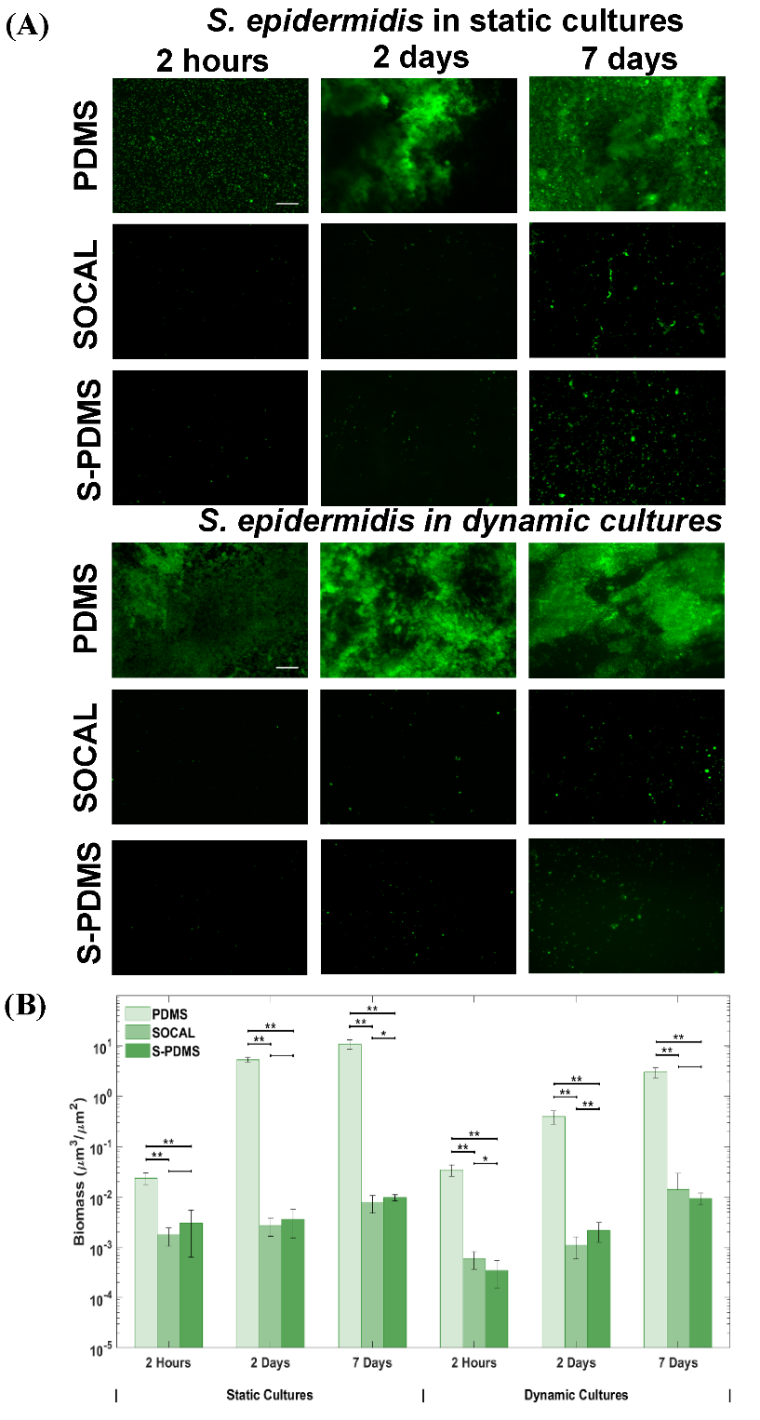
Figure 3. (A) Representative fluorescent images and (B) biomass of the growth of S. epidermidis FH8 on PDMS, SOCAL and S-PDMS for 2 h, 2 days and 7 days in static cell culture and dynamic cell culture. Scale bar = 50 µm for all images. In all cases, 15 images were analyzed for each surface from 3 independent experiments. Values presented are mean ± SD. * p<0.05, ** p<0.001.
For the dynamic bacterial culture with continuous flow, flow condition resulting in a wall shear stress ($τ_{w}$) of 0.007 Pa was chosen to match the flow conditions present in urinary catheters ⁴⁹. S. epidermidis biofilms grew substantially with time on PDMS (Fig.3A). However, throughout the experiment (up to 7 days), only sparse and isolated bacteria (with no visible extracellular polymeric substances) were observed on the SOCAL and S-PDMS surfaces under identical flow conditions. Compared to PDMS control samples, after 2 hours, the SOCAL and S-PDMS surfaces resulted in 98 ± 1% and 99 ± 1% reduction of bacterial attachment. After 2 days, SOCAL and S-PDMS led to over 360- and 180-fold reductions in biofilm volume compared to PDMS (p=3.2e-9), respectively. After 7 days, SOCAL and S-PDMS led to over 200- and 300-fold biofilm volume reductions compared to PDMS (p=9.6e-11), respectively (Fig.3B). For the 7-days dynamic culture, there was no significant difference (p=0.26) between biomass on SOCAL and S-PDMS surfaces.
When comparing S. epidermidis colonisation in static and flow conditions, there was a significant difference for PDMS throughout the 7-day culture period (p<0.001). By contrast, differences between SOCAL and S-PDMS were only significant for the first 2 days. There was no significant difference in S. epidermidis colonization after 7 days colonisation under static or flow conditions for either SOCAL (p=0.14) or S-PDMS (p=0.70).
Our SEM images (see Fig.4) also confirmed that very dense S. epidermidis biofilm growth occurred on PDMS for both 7-days static and dynamic cultures. Only sparse bacteria were found on SOCAL or S-PDMS after static or dynamic culture for up to 7 days. Quantitative analysis of SEM images for the bacteria attached on SOCAL and S-PDMS have revealed similar results compared to fluorescence images.
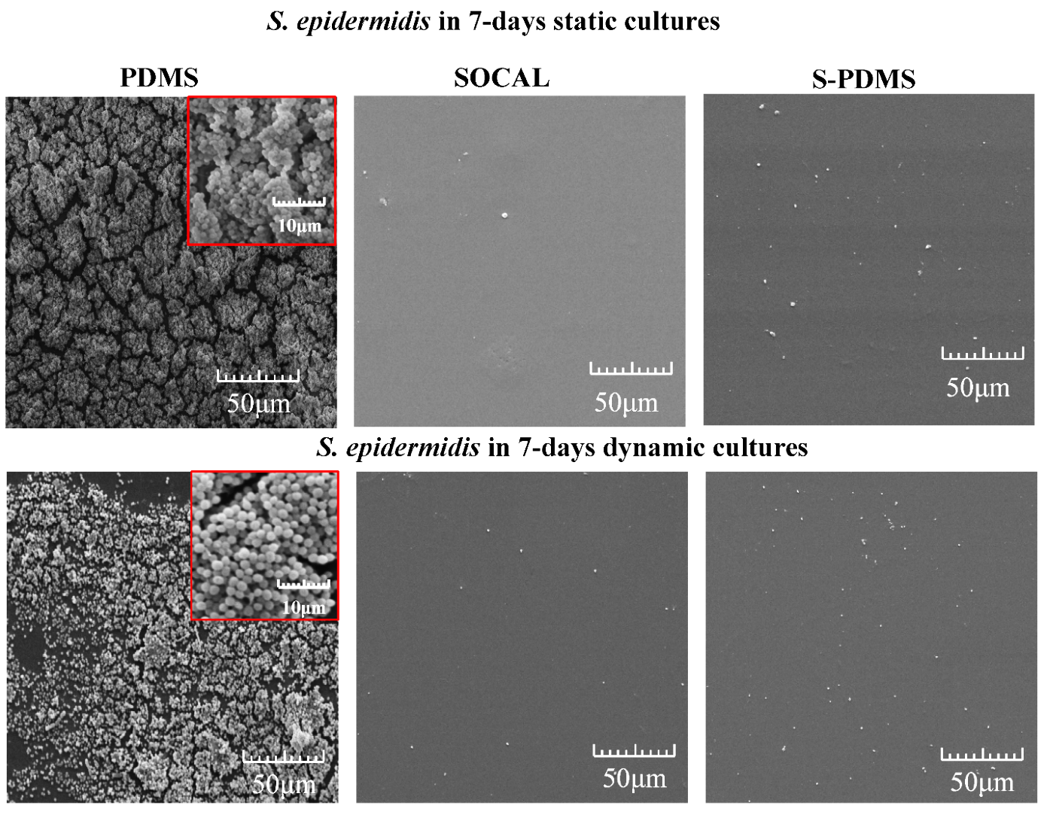
Figure 4. Representative SEM images of 7-day growth of S. epidermidis FH8 on PDMS, SOCAL and S-PDMS in static and dynamic cultures. Dense EPS and biofilm growth were found on PDMS. In contrast, no EPS was found on SOCAL or S-PDMS and bacteria were also very sparse.
Anti-biofilm tests against Pseudomonas aeruginosa
P. aeruginosa PAO1, a well-characterized strain originally isolated from a wound, was grown on each of the surfaces under static and flow conditions. P. aeruginosa initially grew rapidly on the control PDMS surfaces in static culture (Fig. 5A). The P. aeruginosa biomass appeared mucoid when removing the PDMS samples from the petri dish. However, over the longer term (up to 7 days), only sparse and isolated bacteria were found on either SOCAL or S-PDMS (Figure 5A). As seen in Figure 5B, SOCAL and S-PDMS significantly reduced initial bacterial attachment, by 95.0 ± 4.3% or 88.7 ± 11.0%, respectively, compared to the PDMS control. After 2 days, compared to the control surface, the total biomass reduction on the SOCAL and S-PDMS surfaces were over 4 orders and 3 orders of magnitude, respectively. Even after 7 days, the total biomass reduction on both SOCAL and S-PDMS surfaces was almost 4 orders of magnitude less, compared to the control surface (see Fig.5B). However, even though there were significant differences (p<0.05) at 2 hours and 2 days, these slippery surfaces performed equally well (p=0.86) at retarding biofilm compared to the PDMS control.
Under flow, P. aeruginosa grew significantly over time on the control PDMS surfaces, and dense biofilms were observed after 7 days (Fig. 5A). In contrast, throughout the experiment only sparse and isolated bacteria were found on the SOCAL and S-PDMS surfaces. For 2 hours attachment, SOCAL and S-PDMS led to 2 orders and 1 order of magnitude reduction of bacterial adhesion compared to PDMS, respectively (Fig.5B). For the 2-day culture, SOCAL and S-PDMS led to at least 3 order of magnitude biofilm reduction compared to PDMS. After 7 days culture in flow, when compared to PDMS, SOCAL and S-PDMS led to greater than 4 orders of magnitude and two orders of magnitude biofilm reduction, respectively. Throughout the entire dynamic culture period of P. aeruginosa, SOCAL significantly outperformed S-PDMS (p=1.1e-6 for 2 days and p=5.7e-5 for 7 days, respectively).

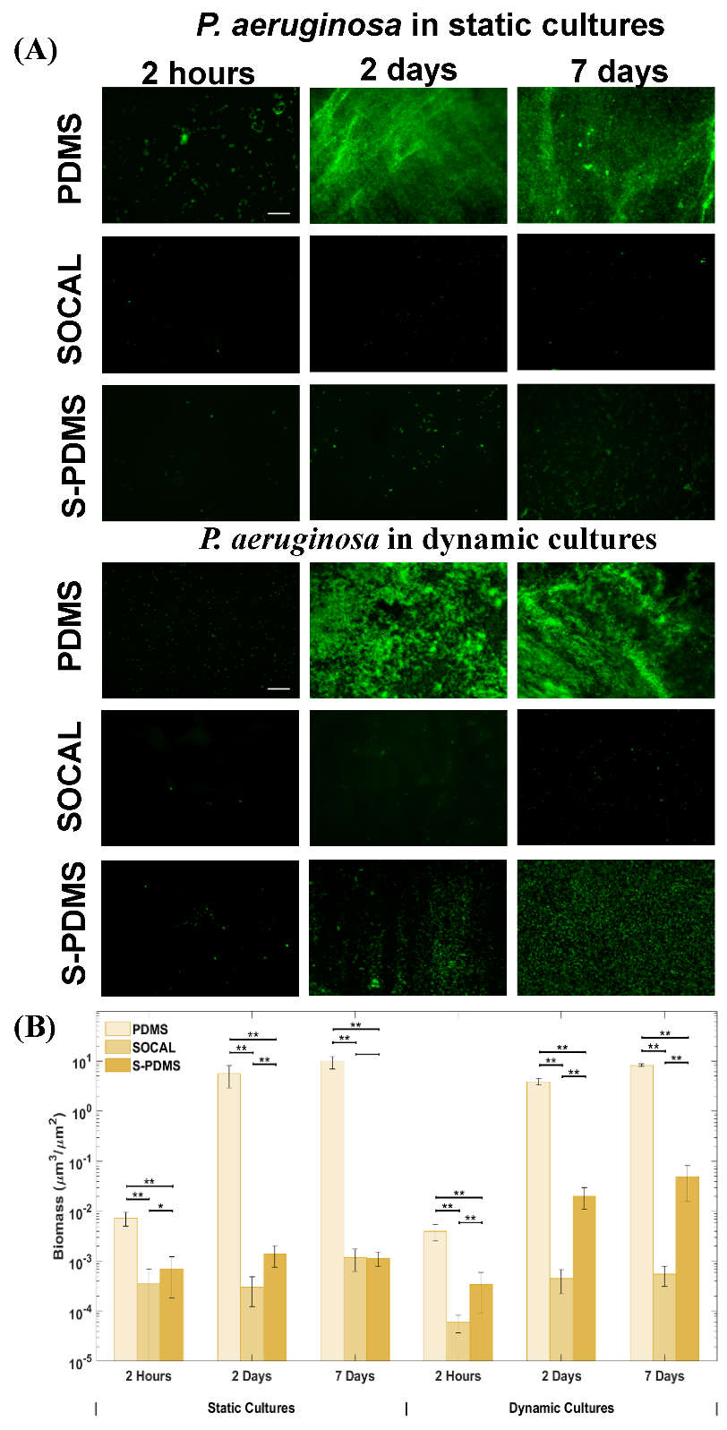
Figure 5. (A) Representative fluorescent images and (B) biomass of the growth of P. aeruginosa PAO1 on PDMS, SOCAL and S-PDMS for 2 h, 2 days and 7 days in static cell culture and dynamic cell culture. Scale bar = 50 µm for all images. In all cases, 15 images were analyzed for each surface from 3 independent experiments. Values presented are mean ± SD. * p<0.05, ** p<0.001.
For P. aeruginosa colonisation within the initial 2 hours, there was a significant difference between static and flow conditions for each surface. After 2 days, there was a significant difference between static and flow conditions for PDMS or S-PDMS but without a significant difference for SOCAL (p=0.06). After 7 days colonisation, there was no significant difference between static and flow conditions for PDMS (p=0.06) but significant differences for either SOCAL (p<0.001) or S-PDMS (p<0.001).
The SEM images (Fig.6) also confirmed that very dense P. aeruginosa biofilm growth was apparent on PDMS. Loose fibrous EPS and dense EPS of P. aeruginosa biofilm were observed on PDMS for 7-days static and dynamic cultures (see high resolution images in Figure S2), respectively. By contrast, only sparse bacteria were found on SOCAL or S-PDMS for the 7-days static cultures. After 7 days under dynamic cultures, SOCAL retained excellent antibiofilm characteristics. However, the initial antibiofilm performance for S-PDMS diminished after 7-days and more bacteria were found compared to SOCAL. Quantitative analysis of SEM images for the bacteria attached on SOCAL and S-PDMS have revealed similar results compared to fluorescence images.

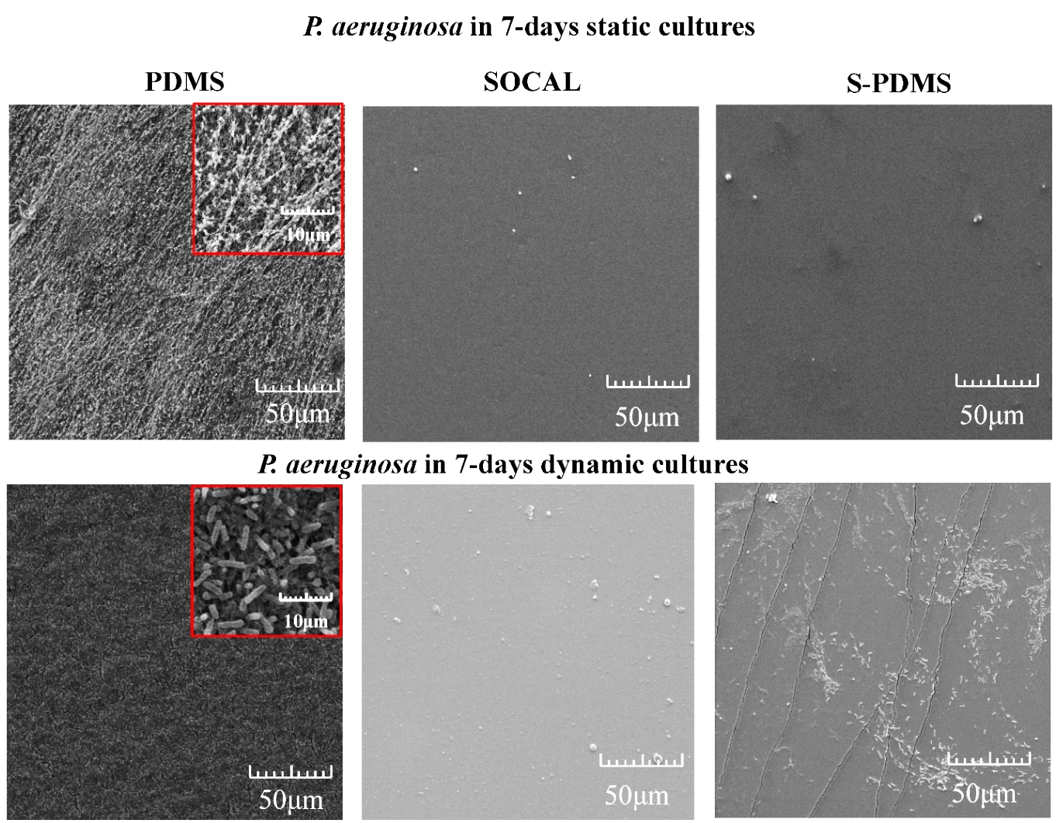
Figure 6. Representative SEM images of 7-days growth of P. aeruginosa PAO1 on PDMS, SOCAL and S-PDMS in static and dynamic cultures. Where dense biofilms were found on PDMS. Very few bacteria on SOCAL in both static and dynamic cultures. However, more bacteria were found on S-PDMS after 7-days dynamic culture.

Biofilm detachment tests by flow
The detachment results for the pre-grown 7-days biofilms in static culture in Fig.7 also confirmed that even at low shear stress ($τ_{w}$= 0.007 Pa), 55-68% of S. epidermidis bacteria detached from SOCAL and S-PDMS surfaces; however, there was no significant change (p=0.40) in S. epidermidis biomass on PDMS. Increasing $τ_{w}$to 0.07 Pa (almost 10 times the shear stress commonly found in urinary catheter), biomass of S. epidermidis on PDMS was still one order of magnitude higher than on the initial biomass on SOCAL or S-PDMS without flow (Fig. 7C). Even at the highest $τ_{w}$ tested (0.1 Pa), the biomass volume of S. epidermidis biofilm on PDMS was still several times higher than what was on SOCAL or S-PDMS without flow.
P. aeruginosa could be more easily detached from PDMS by applying flow compared to S. epidermidis. Increasing $τ_{w}$to 0.035 Pa (almost 5 times the shear stress commonly found in urinary catheter), biomass of P. aeruginosa on PDMS was still two order of magnitude higher than on the initial biomass on SOCAL or S-PDMS without flow (Fig. 7D). When $τ_{w}$ reached 0.07Pa, the biomass volume of P. aeruginosa biofilm on PDMS was decreased to that on SOCAL or S-PDMS without flow.
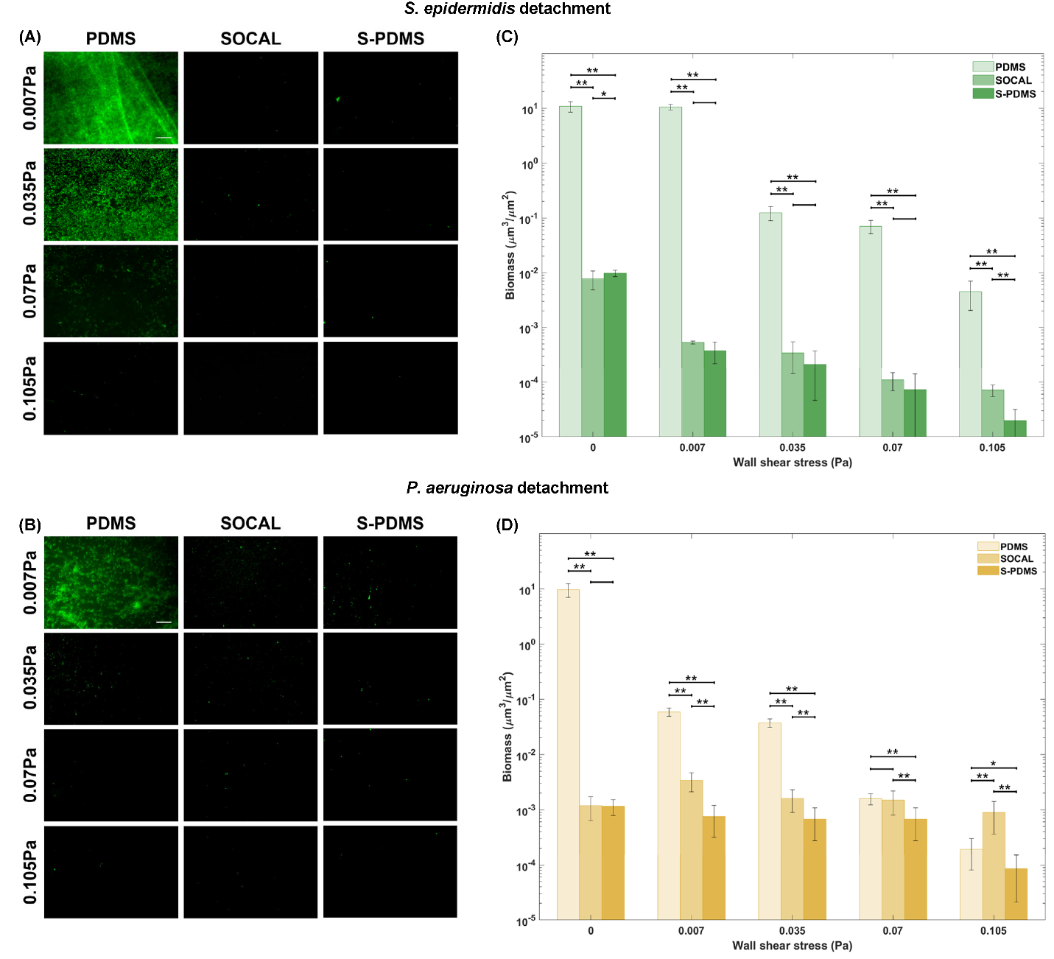
Figure 7. Representative fluorescent images and biomass change with wall shear stress for 7-days biofilms grown in static culture: (A, C) S. epidermidis FH8 and (B, D) P. aeruginosa PAO1 on PDMS, S-PDMS and SOCAL after flow shear at 0.007 Pa, 0.035 Pa, 0.07 Pa and 0.105 Pa. At least 6 images were analyzed for each surface at each wall shear stress based on 3 replicates. * p<0.05, ** p<0.001.

The reusability tests after removing pre-grown biomass
After gently wiping off the pre-grown 2-days biomass from SOCAL or S-PDMS, the samples were reused for bacteria growth tests in static cell culture for 7 days. Both surfaces were shown to be reusable without significant difference after wiping off 2-days biofilm (p=0.58 and p=0.29 for S. epidermidis on SOCAL and S-PDMS; p=0.92 and p=0.43 for P. aeruginosa on SOCAL and S-PDMS and, which suggested that both surfaces retained excellent anti-biofilm properties against both S. epidermidis and P. aeruginosa (see Fig. S3 in Supporting Information).
Discussion
Surface wetting is considered important for bacterial control ⁵⁰⁻⁵¹. For hydrophobic surfaces (CA>90°), very low contact angle hysteresis (CAH<5°) often indicates strong resistance to bacterial attachment ^{27, 37}. The SOCAL surfaces fabricated here have low CAH (~2° on average), which is better than S-PDMS (~3.2° on average). SOCAL has highly mobile PDMS chains, behaving like a liquid, which are responsible for the very low CAH ⁴¹ and antibacterial adhesion. AFM results have also revealed that SOCAL is over 2 orders of magnitude softer than PDMS (1:10). It is almost one order of magnitude softer than the solid PDMS with lowest crosslinker ratio (1:50) ever reported ⁵². If the crosslinker ratio is below 1:50, PDMS can hardly be crosslinked and just flows like liquid. This might also imply that SOCAL is likely to be a liquid-like solid.
Under all conditions tested for 7 days, the SOCAL or S-PDMS surfaces resulted in over two to four orders of magnitude less biofilm formation than PDMS. It is highly unlikely that this inhibition of biofilm formation was due to a bactericidal effect because all three surfaces (PDMS, SOCAL, and S-PDMS) were based on PDMS, which is biocompatible ⁵³. This suggests that there was limited bacterial accumulation on SOCAL or S-PDMS or the bacteria were easily detached from the surface.
The antibiofilm results of SOCAL and S-PDMS surfaces presented here were similar to other SLIPs reported in the seminal paper by Epstein et al. ²⁸. In their paper, SLIPS prevented 99.6% of P. aeruginosa biofilm formation over a 7-d period under both static and flow conditions. Other studies have also demonstrated that SLIPs surfaces are capable of preventing biofilm formation by 1-3 order of magnitudes for 1-7 days static cultures ^{6, 37, 54-55}. The antibiofilm results of both slippery surfaces in the present study compare well to commercial antimicrobial agent coated materials used for catheters. For example, silver coated silicone (PDMS) has been shown to reduce P. aeruginosa biofilm formation by ~97% when grown statically for 1 day, compared to pure silicone ⁵⁶. For silicone coated with antibiotics (e.g., rifampin/minocycline, vancomycin, or amikacin), particularly rifampin/minocycline, no significant bacterial colonization was found on these surfaces after seven days static culture ⁵⁷. Therefore, the slippery surfaces presented here are possible alternatives, which will not cause antimicrobial resistance but may achieve similar antibiofilm performance.
Furthermore, the wall shear stress required to largely detach pre-grown biomass in static cultures from PDMS, to reach the level of the original biomass on SOCAL and PDMS before flow detachment tests, was above 0.1 Pa and around 0.07 Pa for S. epidermidis and P. aeruginosa, respectively. These stresses were at least one order of magnitude higher than those found in medical devices (e.g., catheters) ⁵⁸.
Therefore, we propose the following antibiofilm mechanisms for liquid and liquid-like surfaces (as presented in Fig.8): 1) The ultra-low CAH inhibits initial bacterial attachment. 2) The attached bacteria exhibit a planktonic state when they contact with a liquid or liquid-like surface (i.e., dominated by proliferation with no little or EPS production, as seen in our SEM images). 3) Bacterial cells are unable to establish stable, strong interactions with liquid or liquid-like surface, resulting in detachment from the surface during growth or by the action of very gentle external forces. This mechanism would explain why we did not observe cell clusters or biofilms on SOCAL and S-PDMS even after 2 days and 7 days culture in static and dynamic conditions.
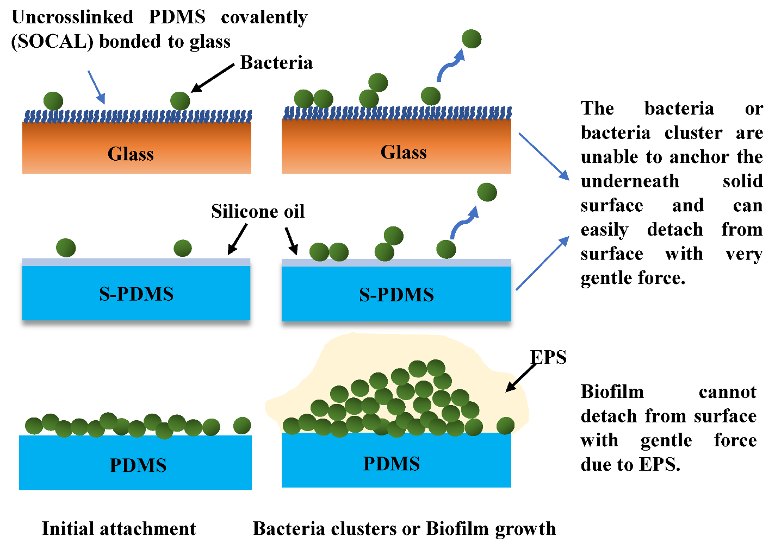
Figure 8. Schematic diagram of bacteria attachment on SOCAL (uncrosslinked PDMS covalently bonded to glass substrate), S-PDMS and PDMS.
When the oil atop S-PDMS is sufficiently thick, the S-PDMS can have equally good antibiofilm performance to SOCAL in all conditions (fresh samples and reused samples after removing 2-days pre-grown biofilms in static cultures). When S-PDMS experienced significant oil loss in flow, it still has similar antibiofilm performance to SOCAL against S. epidermidis. However, the antibiofilm performance of S-PDMS against P. aeruginosa, after oil depletion in continuous flow for 2-7days, has decreased significantly by almost 2 orders of magnitude (p<0.001) compared to SOCAL.
One possibility could be that flow during dynamic culture emphasizes differences in bacterial shape and adhesion appendages such as flagella which allow polar adhesion ⁵⁹⁻⁶⁰ and which are present in P. aeruginosa but not S. epidermidis. The polar adhesion can transit to body adhesion ⁵⁹⁻⁶⁰ which may enable stronger attachment (see Fig.9). This is likely to happen for S-PDMS after 7-days flow as the measured oil thickness atop the PDMS surface is less than the cell size of P. aeruginosa, which would explain the significantly increased biofilm growth on S-PDMS after 7-days dynamic culture.
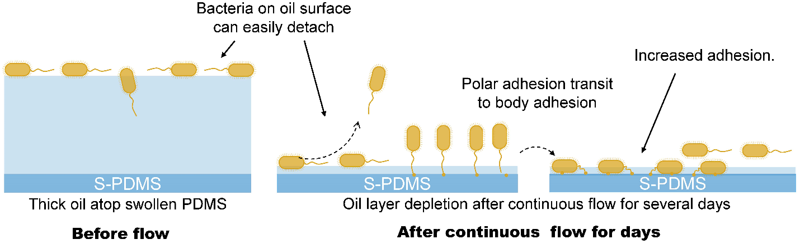
Figure 9. The schematic of P. aeruginosa PAO1 attachment on S-PDMS before and after flow induced oil depletion.
In summary, the liquid-like solid surface strategy of SOCAL is promising for applications where continuous flow is important, such as catheters. The transparency of visible light is an advantage of this material, which adds value for potential use in other medical devices

Materials and Methods
SOCAL, PDMS and S-PDMS fabrication
Slippery Omniphobic Covalently Attached Liquid (SOCAL) surfaces were created on 25 × 75 mm glass slides using the method detailed by Wang & McCarthy ⁴¹. The protocol was optimized as described by Armstrong et al ⁴³. The clean glass slides were placed into a Henniker plasma cleaner (HPT-100) at 30% power for 20 minutes, which adds OH bonds to the surface. The slides were then dipped into a reactive solution of isopropanol, dimethyldimethoxysilane and sulphuric acid (90, 9 and 1% wt.) for 5 seconds, then slowly withdrawn. The slides were then placed in a bespoke humidity chamber in a controlled environment at 60% relative humidity and 25 °C for 20 minutes. The acid-catalyzed graft polycondensation of dimethyldimethoxysilane creates a homogeneous layer of polydimethylsiloxane (PDMS) chains, grafted to the surface. The excessive unreacted material was then rinsed away with deionized (DI) water, isopropanol, and toluene.
PDMS was used as a control surface because its surface chemistry is similar to SOCAL. To further examine the excellent anti-biofilm performance of SOCAL, tests on swollen PDMS were also performed for comparison. SLIPs were created using silicone oil swollen PDMS (S-PDMS). This has a large reservoir of oil compared to liquid infused porous structures (LIPs) and has demonstrated excellent antibiofilm performance in static culture in recent studies ³⁷. S-PDMS has an almost identical chemistry to PDMS and SOCAL, so any impact from surface chemistry will be similar between each of the surfaces.
To prepare PDMS, a mixture of PDMS solution was prepared using SYLGARD 184 Elastomer Kit (Dow Corning Corporation, Midland, MI) with a curing agent-to-base ratio of 1:10 (wt/wt). The solution was thoroughly mixed and degassed in a vacuum chamber for 30 minutes to eliminate air bubbles. The PDMS (~2 mm thick) was cured in a 37°C incubator for 1 day. Finally, the cured PDMS sheet was gently cut into 4 cm ×3 cm samples. To prepare S-PDMS, the cured PDMS surfaces were completely immersed in a silicone oil (10 cSt, 0.93 g/mL, Sigma-Aldrich) bath and left for 24 hours to allow the oil to fully infiltrate into the PDMS polymer networks. The excess oil was gently removed from the surface by wiping with filter paper. This was done to reduce the effects of excess lubricant-layer (i.e., wetting ridge ³⁷) on the following tests.
Characterization of slippery surfaces
The thickness of the oil layer atop the surface of liquid infused porous structures is typically measured using confocal microscopy, ellipsometry, or by calculation using the weight gained after layering in oil. In our case, however, the refractive index values of silicone oil and PDMS are almost the same which makes it difficult to quantify the oil thickness of S-PDMS optically. Furthermore, as the oil diffuses into the PDMS, measuring the weight of the swelling oil cannot be used to find the thickness of the surface oil layer. By assuming the PDMS samples swell isotropically, however, measurements of weight and volume before swelling, after swelling, and after vigorous wiping could be used to approximate the layer thickness and volume of infused oil. By solving a cubic polynomial function, the oil thickness can be calculated. The details have been described in the supporting information. Using this approach, we also quantified the oil thickness change after continuous flow for 2 days and 7 days.
An in-house goniometer ^{37, 61-62} was set-up to measure the static water contact angle and contact angle hysteresis under ambient conditions. Advancing angles on slippery surfaces were measured via a syringe-pump system (needle gauge size ~25, water droplet ~8 μl, with the max volume change of 4 μl using the protocol described in ⁴⁸) and receding angles were measured by withdrawing liquid. Contact angle hysteresis (CAH) was determined as the difference between advancing and receding contact angles. At least five measurements were taken.
SOCAL was claimed to be liquid-like coating which may be expected to be softer than solid PDMS with the lowest crosslinking density. Therefore, nanoindentation tests were done with atomic force microscope using a Flex Bio-AFM (NanoSurf, Switzerland). A pyramidal AFM cantilever (ContAI-G, BudgetSensors) with a spring constant of k~0.2 N/m was used. The substrate effect is inevitable for nanoindentation of such a thin coating like SOCAL (several nm), therefore, a simple empirical model was used to estimate its modulus (see details in Fig.S4 in Supporting Information).
Flow cell setup
Most submerged biofilm formation occurs under various flow conditions (e.g., catheters, implant surfaces). Therefore, cell culture was also done in flow conditions. The parallel plate flow chamber (PPFC) was designed where the inlet is sufficiently long to allow fully developed flow, which is important for dynamic culture of bacteria ⁶³. A flow cell (length=10 mm, width=10 mm, height=0.1 mm) made of PDMS was made by pattern moulding off a milled acrylic block. This was connected to a syringe pump. The samples (PDMS, S-PDMS, or SOCAL), which were used as a bottom surface, were connected to the top chamber using a press-fit device. In addition, three holes on the flow cell chamber were created: one for pumping broth inoculated with bacteria, another one for fresh TSB medium and the third one for collecting waste liquid (see Figure S5 in Supporting Information). Bacterial culture was pumped into the flow chamber until the trapped air had been eliminated, after which the pump was operated for the desired periods of time at 37⁰C. When laminar flow is well established in the parallel plate flow chamber, the wall shear rate σ is given by ⁶⁴,
(1)
The wall shear stress $τ_{w}$ is given by the following formula,
(2)
where Q is the volumetric flow rate, h and w are the height and width of the parallel plate chamber, respectively, and η is the viscosity of the culture medium at 37°C. TSB culture medium has shown almost the same rheological characteristics to deionised water at 37°C. Therefore, the average viscosity value of 0.7 mPa*s for TSB culture medium measured by a rheometer (Malvern Kinexus Pro +) was used for the calculation of wall shear stress.
Bacterial culture and antibiofilm tests
S. epidermidis FH8 which was isolated from a chronic rhinosinusitis patient at the Freeman Hospital (Newcastle Upon Tyne) was used ⁶⁵. P. aeruginosa PAO1, biofilm-forming bacterial pathogen responsible for many infections ⁶⁶ was also selected. For bacterial adhesion and biofilm formation assays, cells were routinely cultured in Tryptic Soy Broth (TSB) (Melford Laboratories Ltd, UK), in a shaker at 180 rpm, 37 ̊C for 16 hours and then diluted to OD600=0.2 for S. epidermidis FH8 with a spectrophotometer (Biochrom Libra S11, Biochrom Ltd., Cambridge, UK). P. aeruginosa PAO1 colonizes surfaces rapidly. Therefore, to avoid overloading the system, a lower bacterial inoculum (OD600 = 0.01) was chosen for P. aeruginosa. Prior to seeding, samples were added to a petri dish. 20 ml of the diluted bacterial culture was incubated with the PDMS (as control), S-PDMS and SOCAL surfaces in petri dish plates (diameter=10 cm) at 37 ̊C, for 2 hours (bacterial adhesion assay), 2 days and 7 days (biofilm assay) respectively. For the biofilms developed up to 7 days, half of the TSB medium was changed every 3 days. At the least three independent experiments were performed for each surface type.
Flow is an important factor in many applications and should be considered in assessing antibiofilm effects. For dynamic culture, the syringe pump and the flow cell were placed in a 37⁰C incubator. For the 2hrs bacterial culture, diluted bacterial inoculated media (with the same OD in static cell culture) was pumped into the flow cell chamber at a flow rate of 0.01 ml/min (with Reynolds number of 0.024) and wall shear stress ($τ_{w}$) of 0.007 Pa, comparable to typical wall shear stresses in urinary catheters ⁴⁹ and ventricular catheters ⁵⁸. For 2 days and 7 days bacterial culture, after 2 hours of flow of diluted bacterial inoculated media, fresh TSB media was continuously pumped into the flow chamber at the same flow rate (i.e., 0.01 ml/min) at 37⁰C.
Biofilm detachment tests
To examine if the bacteria may be weakly attached to the SOCAL and S-PDMS grown under static conditions, biofilm detachment tests were performed in the same parallel flow cell chambers used for dynamic culture. The 7-day biofilms grown on different surfaces in static culture for 7 days were placed in the parallel flow chamber and different flow rates (0.01 ml/min, 0.05 ml/min, 0.1 ml/min, 0.15 ml/min) were applied for a duration of 1 min. The samples were then removed from the flow chamber for subsequent imaging using a fluorescent microscope (Olympus, BX-61). According to equation (1)-(2), the resultant wall shear stresses ($τ_{w}$) at 37 ⁰C ranged from 0.007 Pa to 0.105 Pa, which corresponds to similar wall shear stress in catheters (a few mPa) ⁵⁸ and was extended to over an order of magnitude higher to observe trends of biofilm detachment.

Reuse the samples after removing pre-grown biofilms
In practice, it will be useful to reuse the antibiofilm surfaces (e.g., non-disposable medical devices or ship hulls) after removing biofilms. To examine the reusability of SOCAL and S-PDMS, the CA and CAH were measured for each surface after removing 7-days pre-grown biofilm formed in static or dynamic culture. The antibiofilm performance of SOCAL and S-PDMS was also tested after wiping off these pre-grown biofilms.
Biofilm imaging
Following bacterial adhesion or biofilm formation assays, surfaces were gently rinsed three times with Phosphate Buffered Saline (PBS, pH=7.4) to remove loosely adhered bacteria. Bacterial cells were stained with Syto 9 and fluorescent images were taken on an Olympus BX61 upright fluorescent microscope with a 20x objective lens (N.A.=0.75). The bacterial cells after 2 hours’ incubation were visualized by acquiring 2D fluorescent images in a single focal plane. The surface coverage of the bacteria was analyzed using ImageJ (ImageJ (nih.gov)). Based on the bacteria size for S. epidermidis and P. aeruginosa, the surface coverage was converted to volume (in COMSTAT software termed biomass) to enable the direct comparisons with longer period bacteria culture. For biofilms or multi-layered bacteria, z-stacks were taken through the thickness of biofilm from 5 random locations on the surfaces. The biomass under each field of view was determined using the COMSTAT2 plugin (Lyngby, Denmark) in ImageJ.
To provide insights of possible EPS in biofilms, high resolution Scanning Electron Microscope (Tescan Vega LMU) was used to visualize7 days biofilm samples grown in both static and dynamic cultures for PDMS, SOCAL and S-PDMS. The beam voltage and current were set to 8 kV and 62 µA, respectively. Prior to SEM imaging, the samples were washed with PBS and fixed in 2% glutaraldehyde in 3M Sorenson’s phosphate buffer overnight at 4 ̊C, which were then transferred to a new plate and dehydrated through a series of ethanol solutions of 25% (v/v), 50%, 75%, and 100%, followed by critical point drying. After critical point drying, the samples were sputter-coated with 5 nm gold coating using Polaron SEM Coating Unit.
Statistical analysis
Data has been represented as mean values and standard deviations. Student’s t-test, assuming unequal variations, was applied and p < 0.05 was considered statistically significant in this study.
ASSOCIATED CONTENT
Supporting Information.
The Supporting Information is available free of charge at https://pubs.acs.org/doi/XXX/acsami.XXX.
The measurement of oil thickness of S-PDMS, The XPS spectrum of SOCAL (Figure S1), high resolution SEM images of EPS in 7-day P. aeruginosa biofilm on PDMS in static and dynamic cultures (Figure S2), the comparison of 7-days biofilms grown in static culture for S. epidermidis FH8 or P. aeruginosa PAO1 on fresh SOCAL or S-PDMS and their re-used counterparts after wiping off pre-grown 2-days biofilms (Figure S3), AFM nanoindentation data analysis of SOCAL (Figure S4), the experimental set-up for the dynamic culture adopted in this study (Figure S5). (PDF).

AUTHOR INFORMATION
Corresponding Author
Jinju Chen.
Email: Jinju.chen@ncl.ac.uk
Author Contributions
All authors contributed to this work. The study was conceived by JC and GM. The experimental work was jointly designed by JC, NJ, GM, GW, PS, HL and WV. SA, GW, and GM designed and optimised the protocol for SOCAL samples. SA and JD prepared SOCAL samples. YZ carried out all the biofilm experiments. YZ and JD designed and manufactured the flow cells. JC, YZ and JD characterised the surface wetting and oil thickness of S-PDMS. JC, YZ and JD did rheology measurements. JC, YZ, and JD analyzed and visualize the data. RH and JC did AFM nanoindentation tests and results analysis. JC drafted, wrote and reviewed the paper. JC, NJ and GM provided supervision. GM, YZ, NJ, WV and PS wrote and reviewed the paper with contributions from JD, SA, GW and HL. All the authors reviewed the manuscript.

Funding Sources
Engineering and Physical Sciences Research Council EP/K039083/1 (JC)
Engineering and Physical Sciences Research Council EP/R025606/1 (JC).
The Royal Society IEC\NSFC\191070 (JC, HL).
Engineering and Physical Sciences Research Council EP/N509528/1 (JD, JC)
Chinese Scholarship Council (CSC) studentship (RH)
Notes
Competing interests. The authors declare no competing financial and non-financial interests.
Data and materials availability. All the data that support the findings of this study are present in the paper and the Supplementary Materials. Additional data related to this paper may be requested from the authors.

ACKNOWLEDGMENT
We thank Dr. Rolando Berlinguer-Palmini, Dr. Alex Laude, Ross Laws and Tracey Davey for technical support of imaging. We also acknowledge the technical assistance from Mr. Dave Race, Mrs. Ekaterina Kozhevnikova and Dr Nadia Rostami. We also acknowledge Dr. George Roberts and Prof. Anthony O'Neill for technical support on ellipsometry. We also acknowledge Prof. Lidija Siller at NEXUS, Newcastle University for the XPS measurements.

ABBREVIATIONS
EPS, extracellular polymeric substances; CAUTI, catheter-associated urinary tract infections; CRBSIs, Catheter-related bloodstream infections; ICUs, intensive care units; SLIPS, slippery liquid-infused porous surface; PDMS, polydimethylsiloxane; S-PDMS, polydimethylsiloxane (PDMS) matrix infused with silicone oil; SOCAL, Slippery Omniphobic Covalently Attached Liquid-like; CA, contact angle; CAH, contact angle hysteresis.
REFERENCES
(1) Wolcott, R. D.; Rhoads, D. D.; Bennett, M. E.; Wolcott, B. M.; Gogokhia, L.; Costerton, J. W.; Dowd, S. E. Chronic Wounds and the Medical Biofilm Paradigm. J. Wound Care 2010, 19 (2), 52-53.
(2) Sousa, C.; Henriques, M.; Oliveira, R. Mini-review: Antimicrobial Central Venous Catheters – Recent Advances and Strategies. Biofouling 2011, 27 (6), 609–620.
(3) Ramstedt, M.; Ribeiro, I. A.; Bujdakova, H.; Mergulhão, F. J.; Jordao, L.; Thomsen, P.; Alm, M.; Burmølle, M.; Vladkova, T.; Can, F. Evaluating Efficacy of Antimicrobial and Antifouling Materials for Urinary Tract Medical Devices: Challenges and Recommendations. Macromol. Biosci. 2019, 19 (5), No. 1800384.
(4) Rupp, M. E.; Karnatak, R. Intravascular Catheter-Related Bloodstream Infections. Infect. Dis. Clin. North Am 2018, 32 (4), 765-787.
(5) Hollenbeak, C. S. The Cost of Catheter-Related Bloodstream Infections: Implications for the Value of Prevention. J Infus Nurs 2011, 34 (5), 309-13.
(6) Li, J.; Kleintschek, T.; Rieder, A.; Cheng, Y.; Baumbach, T.; Obst, U.; Schwartz, T.; Levkin, P. A. Hydrophobic Liquid-Infused Porous Polymer Surfaces for Antibacterial Applications. ACS Appl. Mater. Interfaces 2013, 5 (14), 6704-6711.
(7) Cao, Y.; Su, B.; Chinnaraj, S.; Jana, S.; Bowen, L.; Charlton, S.; Duan, P.; Jakubovics, N. S.; Chen, J. Nanostructured Titanium Surfaces Exhibit Recalcitrance Towards Staphylococcus epidermidis Biofilm Formation. Sci. Rep. 2018, 8 (1), No. 1071.
(8) Diu, T.; Faruqui, N.; Sjostrom, T.; Lamarre, B.; Jenkinson, H. F.; Su, B.; Ryadnov, M. G. Cicada-Inspired Cell-Instructive Nanopatterned Arrays. Sci. Rep. 2014, 4, No. 7122.
(9) Bhadra, C. M.; Truong, V. K.; Pham, V. T.; Al Kobaisi, M.; Seniutinas, G.; Wang, J. Y.; Juodkazis, S.; Crawford, R. J.; Ivanova, E. P. Antibacterial Titanium Nano-Patterned Arrays Inspired by Dragonfly Wings. Sci. Rep. 2015, 5, No. 16817.
(10) Fadeeva, E.; Truong, V. K.; Stiesch, M.; Chichkov, B. N.; Crawford, R. J.; Wang, J.; Ivanova, E. P. Bacterial Retention on Superhydrophobic Titanium Surfaces Fabricated by Femtosecond Laser Ablation. Langmuir 2011, 27 (6), 3012-3019.
(11) Ivanova, E. P.; Hasan, J.; Webb, H. K.; Truong, V. K.; Watson, G. S.; Watson, J. A.; Baulin, V. A.; Pogodin, S.; Wang, J. Y.; Tobin, M. J.; Lobbe, C.; Crawford, R. J. Natural Bactericidal Surfaces: Mechanical Rupture of Pseudomonas aeruginosa Cells by Cicada Wings. Small 2012, 8 (16), 2489-2494.
(12) Cheng, G.; Zhang, Z.; Chen, S.; Bryers, J. D.; Jiang, S. Inhibition of Bacterial Adhesion and Biofilm Formation on Zwitterionic Surfaces. Biomaterials 2007, 28 (29), 4192-4199.
(13) Cheng, G.; Li, G.; Xue, H.; Chen, S.; Bryers, J. D.; Jiang, S. Zwitterionic Carboxybetaine Polymer Surfaces and their Resistance to Long-term Biofilm Formation. Biomaterials 2009, 30 (28), 5234-5240.
(14) Fu, Y. C.; Jiang, J. X.; Zhang, Q. H.; Zhan, X. L.; Chen, F. Q. Robust Liquid-Repellent Coatings based on Polymer Nanoparticles with Excellent Self-cleaning and Antibacterial Performances. J. Mater. Chem. A 2017, 5 (1), 275-284.
(15) Howell, C.; Grinthal, A.; Sunny, S.; Aizenberg, M.; Aizenberg, J. Designing Liquid-Infused Surfaces for Medical Applications: A Review. Adv. Mater. 2018, 30 (50), No. 1802724 .
(16) Truong, V. K.; Webb, H. K.; Fadeeva, E.; Chichkov, B. N.; Wu, A. H. F.; Lamb, R.; Wang, J. Y.; Crawford, R. J.; Ivanova, E. P. Air-directed Attachment of Coccoid Bacteria to the Surface of Superhydrophobic Lotus-like Titanium. Biofouling 2012, 28 (6), 539-550.
(17) Ma, J.; Sun, Y.; Gleichauf, K.; Lou, J.; Li, Q. Nanostructure on Taro Leaves resists Fouling by Colloids and Bacteria under Submerged Conditions. Langmuir 2011, 27 (16), 10035-10040.
(18) Tang, P.; Zhang, W.; Wang, Y.; Zhang, B.; Wang, H.; Lin, C.; Zhang, L. Effect of Superhydrophobic Surface of Titanium on Staphylococcus aureus Adhesion. J. Nanomater. 2011, 2, No. 178921.
(19) Friedlander, R. S.; Vlamakis, H.; Kim, P.; Khan, M.; Kolter, R.; Aizenberg, J. Bacterial Flagella Explore Microscale Hummocks and Hollows to Increase Adhesion. PNAS 2013, 110 (14), 5624-5629.
(20) Cao, Y.; Jana, S.; Bowen, L.; Tan, X.; Liu, H.; Rostami, N.; Brown, J.; Jakubovics, N. S.; Chen, J. Hierarchical Rose-Petal Surfaces Delay the Early-stage Bacterial Biofilm Growth. Langmuir 2019, 35, 14670-14680.
(21) Banerjee, I.; Pangule, R. C.; Kane, R. S. Antifouling Coatings: Recent Developments in the Design of Surfaces That Prevent Fouling by Proteins, Bacteria, and Marine Organisms. Adv. Mater. 2011, 23 (6), 690-718.
(22) Chen, X. S.; Wen, G.; Guo, Z. G. What are the Design Principles, from the Choice of Lubricants and Structures to the Preparation Method, for a Stable Slippery Lubricant-Infused Porous Surface? Mater. Horiz. 2020, 7 (7), 1697-1726.
(23) Lafuma, A.; Quere, D. Slippery Pre-Suffused Surfaces. Epl 2011, 96, No. 56001.
(24) Wong, T. S.; Kang, S. H.; Tang, S. K. Y.; Smythe, E. J.; Hatton, B. D.; Grinthal, A.; Aizenberg, J. Bioinspired Self-Repairing Slippery Surfaces with Pressure-Stable Omniphobicity. Nature 2011, 477 (7365), 443-447.
(25) Jamil, M. I.; Ali, A.; Haq, F.; Zhang, Q. H.; Zhan, X. L.; Chen, F. Q. Icephobic Strategies and Materials with Superwettability: Design Principles and Mechanism. Langmuir 2018, 34 (50), 15425-15444.
(26) Wei, C.; Zhang, G.; Zhang, Q.; Zhan, X.; Chen, F. Silicone Oil-Infused Slippery Surfaces based on Sol–Gel Process-Induced Nanocomposite Coatings: A Facile Approach to Highly Stable Bioinspired Surface for Biofouling Resistance. ACS Appl. Mater. Interfaces 2016, 8 (50), 34810-34819.
(27) Sotiri, I.; Tajik, A.; Lai, Y.; Zhang, C. T.; Kovalenko, Y.; Nemr, C. R.; Ledoux, H.; Alvarenga, J.; Johnson, E.; Patanwala, H. S.; Timonen, J. V. I.; Hu, Y. H.; Aizenberg, J.; Howell, C. Tunability of Liquid-Infused Silicone Materials for Biointerfaces. Biointerphases 2018, 13 (6), No. 06D401.
(28) Epstein, A. K.; Wong, T.-S.; Belisle, R. A.; Boggs, E. M.; Aizenberg, J. Liquid-Infused Structured Surfaces with Exceptional Anti-Biofouling Performance. PNAS 2012, 109 (33), 13182-13187.
(29) Zhao, L. Z.; Li, R. S.; Xu, R.; Si, D. D.; Shang, Y. L.; Ye, H. Y.; Zhang, Y. Z.; Ye, H.; Xin, Q. P. Antifouling Slippery Liquid-Lnfused Membrane for Separation of Water-in-Oil Emulsions. J. Membr. Sci. 2020, 611, No. 118289.
(30) Ouyang, Y. B.; Zhao, J.; Qiu, R.; Hu, S. G.; Chen, M.; Wang, P. Liquid-Infused Superhydrophobic Dendritic Silver Matrix: A Bio-Inspired Strategy to Prohibit Biofouling on Titanium. Surf. Coat. Technol. 2019, 367, 148-155.
(31) Xiao, Y. M.; Zhao, J.; Qiu, R.; Shi, Z. Q.; Niu, S. Y.; Wang, P. Slippery Liquid-Infused Surface from Three-Dimensional Interconnecting Net Structure Via Breath Figure Approach and its Usage for Biofouling Inhibition. Prog. Org. Coat. 2018, 123, 47-52.
(32) Kratochvil, M. J.; Welsh, M. A.; Manna, U.; Ortiz, B. J.; Blackwell, H. E.; Lynn, D. M. Slippery Liquid-Infused Porous Surfaces that Prevent Bacterial Surface Fouling and Inhibit Virulence Phenotypes in Surrounding Planktonic Cells. ACS Infect. Dis. 2016, 2 (7), 509-517.
(33) Tenjimbayashi, M.; Park, J. Y.; Muto, J.; Kobayashi, Y.; Yoshikawa, R.; Monnai, Y.; Shiratori, S. In Situ Formation of Slippery-Liquid-Infused Nanofibrous Surface for a Transparent Antifouling Endoscope Lens. ACS Biomater. Sci. Eng. 2018, 4 (5), 1871-1879.
(34) Ware, C. S.; Smith-Palmer, T.; Peppou-Chapman, S.; Scarratt, L. R. J.; Humphries, E. M.; Balzer, D.; Neto, C. Marine Antifouling Behavior of Lubricant-Infused Nanowrinkled Polymeric Surfaces. ACS Appl. Mater. Interfaces 2018, 10 (4), 4173-4182.
(35) Yong, J. L.; Chen, F.; Yang, Q.; Fang, Y.; Huo, J. L.; Zhang, J. Z.; Hou, X. Nepenthes Inspired Design of Self-Repairing Omniphobic Slippery Liquid Infused Porous Surface (SLIPS) by Femtosecond Laser Direct Writing. Adv. Mater. Interfaces 2017, 4 (20), No. 1700552.
(36) Zhou, X.; Lee, Y. Y.; Chong, K. S. L.; He, C. B. Superhydrophobic and Slippery Liquid-Infused Porous Surfaces Formed by the Self-Assembly of a Hybrid ABC Triblock Copolymer and their Antifouling Performance. J. Mater. Chem. B 2018, 6 (3), 440-448.
(37) Cao, Y.; Jana, S.; Tan, X.; Bowen, L.; Zhu, Y.; Dawson, J.; Han, R.; Exton, J.; Liu, H.; McHale, G.; Jakubovics, N. S.; Chen, J. Antiwetting and Antifouling Performances of Different Lubricant-Infused Slippery Surfaces. Langmuir 2020, 36 (45), 13396–13407.
(38) Peppou-Chapman, S.; Neto, C. Mapping Depletion of Lubricant Films on Antibiofouling Wrinkled Slippery Surfaces. ACS Appl. Mater. Interfaces 2018, 10 (39), 33669-33677.
(39) Adera, S.; Alvarenga, J.; Shneidman, A. V.; Zhang, C. T.; Davitt, A.; Aizenberg, J. Depletion of Lubricant from Nanostructured Oil-Infused Surfaces by Pendant Condensate Droplets. Acs Nano 2020, 14 (7), 8024-80353.
(40) Howell, C.; Vu, T. L.; Johnson, C. P.; Hou, X.; Ahanotu, O.; Alvarenga, J.; Leslie, D. C.; Uzun, O.; Waterhouse, A.; Kim, P.; Super, M.; Aizenberg, M.; Ingber, D. E.; Aizenberg, J. Stability of Surface-Immobilized Lubricant Interfaces under Flow. Chem. Mater. 2015, 27 (5), 1792-1800.
(41) Wang, L. M.; McCarthy, T. J. Covalently Attached Liquids: Instant Omniphobic Surfaces with Unprecedented Repellency. Angew. Chem. Int. Ed. Engl. 2016, 55 (1), 244-248.
(42) Krumpfer, J. W.; Bian, P.; Zheng, P. W.; Gao, L. C.; McCarthy, T. J. Contact Angle Hysteresis on Superhydrophobic Surfaces: An Ionic Liquid Probe Fluid Offers Mechanistic Insight. Langmuir 2011, 27 (6), 2166-2169.
(43) Armstrong, S.; McHale, G.; Ledesma-Aguilar, R.; Wells, G. G. Pinning-Free Evaporation of Sessile Droplets of Water from Solid Surfaces. Langmuir 2019, 35 (8), 2989-2996.
(44) Louette, P.; Bodino, F.; Pireaux, J. J. Poly(dimethyl siloxane) (PDMS) XPS Reference Core Level and Energy Loss Spectra. Surf. Sci. Spectra 2005, 12, 38-43.
(45) Chen, J.; Bull, S. J. On the Factors Affecting the Critical Indenter Penetration for Measurement of Coating Hardness. Vacuum 2009, 83 (6), 911-920.
(46) McHale, G.; Orme, B. V.; Wells, G. G.; Ledesma-Aguilar, R. Apparent Contact Angles on Lubricant-Impregnated Surfaces/SLIPS: From Superhydrophobicity to Electrowetting. Langmuir 2019, 35 (11), 4197-4204.
(47) Semprebon, C.; McHale, G.; Kusumaatmaja, H. Apparent Contact Angle and Contact Angle Hysteresis on Liquid Infused Surfaces. Soft matter 2017, 13 (1), 101-110.
(48) Barrio-Zhang, H.; Ruiz-Gutierrez, E.; Armstrong, S.; McHale, G.; Wells, G. G.; Ledesma-Aguilar, R. Contact-Angle Hysteresis and Contact-Line Friction on Slippery Liquid-like Surfaces. Langmuir 2020, 36 (49), 15094-15101.
(49) Nowatzki, P. J.; Koepsel, R. R.; Stoodley, P.; Min, K.; Harper, A.; Murata, H.; Donfack, J.; Hortelano, E. R.; Ehrlich, G. D.; Russell, A. J. Salicylic Acid-Releasing Polyurethane Acrylate Polymers as Anti-Biofilm Urological Catheter Coatings. Acta Biomater. 2012, 8 (5), 1869-1880.
(50) Werb, M.; Garcia, C. F.; Bach, N. C.; Grumbein, S.; Sieber, S. A.; Opitz, M.; Lieleg, O. Surface Topology Affects Wetting Behavior of Bacillus Subtilis Biofilms. npj Biofilms Microbiomes 2017, 3, No. 11.
(51) Jahed, Z.; Shahsavan, H.; Verma, M. S.; Rogowski, J. L.; Seo, B. B.; Zhao, B. X.; Tsui, T. Y.; Gu, F. X.; Mofrad, M. R. K. Bacterial Networks on Hydrophobic Micropillars. ACS Nano 2017, 11 (1), 675-683.
(52) Brown, X. Q.; Ookawa, K.; Wong, J. Y. Evaluation of Polydimethylsiloxane Scaffolds with Physiologically-Relevant Elastic Moduli: Interplay of Substrate Mechanics and Surface Chemistry Effects on Vascular Smooth Muscle Cell Response. Biomaterials 2005, 26 (16), 3123-3129.
(53) Howell, C.; Grinthal, A.; Sunny, S.; Aizenberg, M.; Aizenberg, J. Designing Liquid‐Infused Surfaces for Medical Applications: A Review. Adv. Mater. 2018, 30 (50), No. 1802724.
(54) MacCallum, N.; Howell, C.; Kim, P.; Sun, D.; Friedlander, R.; Ranisau, J.; Ahanotu, O.; Lin, J. J.; Vena, A.; Hatton, B. Liquid-infused Silicone as a Biofouling-Free Medical Material. ACS Biomater. Sci. Eng. 2014, 1 (1), 43-51.
(55) Kovalenko, Y.; Sotiri, I.; Timonen, J. V.; Overton, J. C.; Holmes, G.; Aizenberg, J.; Howell, C. Bacterial Interactions with Immobilized Liquid Layers. Adv. Healthcare Mater. 2017, 6 (15), No. 1600948.
(56) Wang, R.; Neoh, K. G.; Kang, E. T.; Tambyah, P. A.; Chiong, E. Antifouling Coating with Controllable and Sustained Silver Release for Long-Term Inhibition of Infection and Encrustation in Urinary Catheters. J. Biomed 2015, 103 (3), 519-528.
(57) Li, H. K.; Fairfax, M. R.; Dubocq, F.; Darouiche, R. O.; Rajpurkar, A.; Thompson, M.; Tefilli, M. V.; Dhabuwala, C. B. Antibacterial Activity of Antibiotic Coated Silicone Grafts. J. Urol. 1998, 160 (5), 1910-1913.
(58) Lee, S.; Kwok, N.; Holsapple, J.; Heldt, T.; Bourouiba, L. Enhanced Wall Shear Stress Prevents Obstruction by Astrocytes in Ventricular Catheters. J R Soc Interface 2020, 17 (168), No. 20190884.
(59) Berne, C.; Ellison, C. K.; Ducret, A.; Brun, Y. V. Bacterial Adhesion at the Single-Cell Level. Nat. Rev. Microbiol. 2018, 16, 616-27.
(60) Li, G. L.; Brown, P. J. B.; Tang, J. X.; Xu, J.; Quardokus, E. M.; Fuqua, C.; Brun, Y. V. Surface Contact Stimulates the Just-In-Time Deployment of Bacterial Adhesins. Mol. Microbiol. 2012, 83 (1), 41-51.
(61) Gart, S.; Mates, J. E.; Megaridis, C. M.; Jung, S. Droplet Impacting a Cantilever: A Leaf-Raindrop System. Phys. Rev. Appl. 2015, 3 (4), No. 044019.
(62) Huhtamäki, T.; Tian, X.; Korhonen, J. T.; Ras, R. H. Surface-Wetting Characterization Using Contact-Angle Measurements. Nat. Protoc. 2018, 13 (7), No. 1521.
(63) Bakker, D. P.; van der Mats, A.; Verkerke, G. J.; Busscher, H. J.; van der Mei, H. C. Comparison of Velocity Profiles for Different Flow Chamber Designs Used in Studies of Microbial Adhesion to Surfaces. Appl. Environ. Microbiol. 2003, 69 (10), 6280-6287.
(64) Elimelech, M. Particle Deposition on Ideal Collectors from Dilute Flowing Suspensions- Mathematical Formulation, Numerical-Solution, and Simulations. Sep. Technol. 1994, 4 (4), 186-212.
(65) Shields, R. C.; Mokhtar, N.; Ford, M.; Hall, M. J.; Burgess, J. G.; ElBadawey, M. R.; Jakubovics, N. S. Efficacy of a Marine Bacterial Nuclease Against Biofilm Forming Microorganisms Isolated from Chronic Rhinosinusitis. PLoS One 2013, 8 (2), No. e55339.
(66) Cole, S. J.; Lee, V. T. Cyclic Di-GMP Signaling Contributes to Pseudomonas aeruginosa-Mediated Catheter-Associated Urinary Tract Infection. J. Bacteriol. 2016, 198 (1), 91-97.

BRIEFS
Stable and transparent liquid-like solid surfaces strongly inhibited biofilm formation in both static and flow conditions.

SYNOPSIS
