Effect of Perindopril or Leucine on physical performance in older people with sarcopenia: the LACE randomised controlled trial

Supplementary information

Supplementary Table 1: Body mass index and sex-specific screening cut offs for bioimpedance derived appendicular muscle mass:
 | Muscle mass cutoffs
 | Men | Women
Body mass index <18.5 kg/m² | <=6.02 kg/m² | <=5.25 kg/m²
18.5 – 24.9 | <=7.14 | <=5.70
25.0 – 29.9 | <=8.00 | <=6.19
>=30 kg/m² | <=8.77 | <=6.72

Supplementary Table 2: Exclusion criteria
a) Contraindications or existing indications to therapies or placebo
-Known clinical diagnosis of chronic heart failure (by European Society of Cardiology criteria)
-Confirmed LV systolic dysfunction on any imaging modality
-Known aortic stenosis (peak gradient >30mmHg)
-Systolic BP<90 mmHg (supine)
-Dizziness on standing associated with a postural drop of >20/10mmHg (asymptomatic orthostatic hypotension will not be a contraindication)
-Serum Creatinine >170 umol/L or eGFR<30ml/min by MDRD4 calculation
-K>5.0 mmol/L; Na<130 mmol/L
-Using ACEi, Angiotensin receptor blocker, aldosterone blocker or leucine already
-Previous adverse reaction to ACEi or leucine
-Current use of oral NSAIDs (aspirin is permitted, as are topical NSAIDs)
-Current use of potassium supplements, aliskiren, spironolactone or other potassium-sparing diuretics
-Hereditary or idiopathic angioedema
-Lactose intolerance
b) Contraindications to consent or undertaking study outcomes
-Implantable cardioverter defibrillator or pacemaker with atrial sensing lead (pacemakers with ventricular sensing lead only are allowed)
-Peripheral oedema present above knee level
-Unable to mobilise without human assistance (walking aids allowed)
-Unable to give written informed consent
-Currently enrolled in another intervention research study, or less than 30 days since completing another intervention research study. Concomitant enrolment in observational studies is permitted.
c) Overlap with other myopathic conditions or important confounders
-Currently enrolled in a time-limited exercise-based rehabilitation programme
-Any progressive neurological or malignant condition with life expectancy <6 months
-Severe COPD (GOLD stage IV)
-Known myositis or other established myopathy
-Self-reported weight loss of >10% in last 6 months (to exclude significant cachexia)
-Known uncontrolled thyrotoxicosis
-7.5mg/day or greater prednisolone use (or equivalent)

Supplementary Table 3: List of all secondary outcomes
Outcome | Measurement details | Measurement timepoints
Maximum grip strength | Jamar dynamometer; best of three [1] | 0, 6 and 12 months
Maximum Quadriceps strength | Lafayette dynamometer; best of three [2] | 0, 6 and 12 months
Six-minute walk distance | 25m course with standardised encouragement [3] | 0, 6 and 12 months
Four metre walk speed | Done as part of Short Physical Performance Battery [4] | 0, 6 and 12 months
Five times sit to stand test | Done as part of Short Physical Performance Battery [5] | 0, 6 and 12 months
Instrumental Activities of Daily Living | Nottingham extended ADL questionnaire [6] | 0, 6 and 12 months
Health-related quality of life | EuroQoL EQ5D-3L questionnaire [7] | 0, 6 and 12 months
Appendicular muscle mass / height squared | Dual energy X-ray absorptiometry (DXA) | 0 and 12 months
Neck of femur bone mineral density | Dual energy X-ray absorptiometry (DXA) | 0 and 12 months
Insulin resistance | Homeostatic measure of Insulin Resistance (HOMA-IR) [8] | 0, 3 and 12 months

Supplementary Table 4. Adverse events by System Order Class
 | Perindopril and leucine | Perindopril and leucine placebo | Perindopril placebo and leucine | Double placebo
Number with at least one adverse event (%) | 38 (97) | 31 (91) | 29 (88) | 33 (85)
Number of adverse events: | 117 | 101 | 70 | 95
Blood and lymphatic system disorders | 0 | 2 | 2 | 0
Cardiac disorders | 5 | 1 | 2 | 5
Eye disorders | 2 | 1 | 2 | 3
Gastrointestinal disorders | 20 | 17 | 12 | 14
General disorders and administration site conditions | 3 | 6 | 2 | 4
Hepatobiliary disorders | 0 | 0 | 1 | 0
Infections and infestations | 20 | 20 | 14 | 24
Injury, poisoning and procedural complications | 13 | 9 | 6 | 6
Investigations | 2 | 0 | 1 | 1
Metabolism and nutrition disorders | 7 | 1 | 1 | 2
Musculoskeletal and connective tissue disorders | 12 | 9 | 8 | 11
Neoplasms benign, malignant and unspecified (incl cysts and polyps) | 0 | 5 | 1 | 3
Nervous system disorders | 15 | 11 | 9 | 8
Psychiatric disorders | 1 | 5 | 1 | 0
Renal and urinary disorders | 2 | 3 | 0 | 1
Reproductive system and breast disorders | 0 | 2 | 0 | 0
Respiratory, thoracic and mediastinal disorders | 6 | 4 | 3 | 6
Skin and subcutaneous tissue disorders | 5 | 4 | 1 | 7
Vascular disorders | 4 | 1 | 4 | 0

Supplementary Table 5: Trials included in meta-analysis
 | Country | N | Mean age | % women | Inclusion criteria | Intervention | Comparator | Primary outcome | Secondary outcomes | Duration of treatment
ACEi/ARB trials
Leonetti  1991 [9] | Italy | 36 | 66 | 72 | Older people with hypertension | Captopril 25-50mg twice daily | Placebo | Bicycle endurance exercise time | None | 2 months
Gerdts  2006 [10] | Norway | 51 | 68 | 49 | 55-80 years with hypertension and LVH on ECG | Losartan 50-100mg once daily + HCTZ if required | Atenolol 50-100mg once daily + HCTZ if required | VO₂max | Maximum load (W) | 1 year
Sumukadas 2007 [11] | Scotland | 130 | 79 | 71 | 65 and over with impairment of ADLs | Perindopril 2-4mg once daily | Placebo | 6MWD | TUAG  10-rep STS | 20 weeks
Bunout  2009 [12] | Chile | 120 | 75 | 76 | 70 and over with stage I hypertension | Enalapril 10-20mg once daily + HCTZ if required | Nifedipine slow-release 20mg once daily | 12MWD | Handgrip strength  Quadriceps strength  SPPB  TUAG | 9 months
Cesari  2010 [13] | USA | 294 | 66 | 42 | 55 and over with elevated cardiovascular risk | Fosinopril 20-40mg once daily | Placebo | Rescaled SPPB | Handgrip strength | 6 months
Sumukadas 2013 [14] | Scotland | 170 | 76 | 42 | 65 and over with SPPB ≤ 10 | Perindopril 2-4mg once daily + mixed modality exercise training | Placebo + mixed modality exercise training | 6MWD | SPPB  Quadriceps strength  Handgrip strength | 20 weeks
Sumukadas 2018 [15] | Scotland | 80 | 78 | 75 | 65 and over with >1 self-reported fall in last 12 months | Perindopril 2-4mg once daily | Placebo | Postural sway | 6MWD  Quadriceps strength | 15 weeks
Heisterberg 2018 [16] | Denmark | 71 | 72 | 0 | Healthy, untrained males without hypertension or other disease | Losartan 50-100mg once daily + resistance training | Placebo + resistance training | Quadriceps mass | Isometric Quadriceps strength  Isokinetic quadriceps strength | 16 weeks
Leucine trials
Verhoeven 2009 [17] | Netherlands | 30 | 71 | 0 | Healthy older men | Leucine 2.5g three times a day | Placebo | Leg press strength | Fat free mass  Leg extension strength  Insulin resistance | 12 weeks
Leenders 2011 [18] | Netherlands | 60 | 71 | 0 | Older men with type 2 diabetes mellitus | Leucine 2.5g three times a day | Placebo | Leg press strength | Fat free mass  Leg extension strength  Insulin resistance | 6 months
Ispoglou 2016 [19] | England | 25 | 72 | 56 | Healthy non-smokers aged 65-75 | Essential amino acid mix with 0.08g/kg/day leucine | Essential amino acid mix with 0.04 g/kg/day leucine | Lean body mass | 6MWD  Chair stand test  Arm curl test  Handgrip strength | 12 weeks
Martinez-Arnau 2020 [20] | Spain | 50 | 79 | 67 | Nursing home residents aged 65 and over | Leucine 3g twice a day | Placebo | Handgrip strength | Walking time  Whole body muscle mass  Calf and arm circumference  Peak flow | 13 weeks

SPPB: Short Physical Performance Battery. TUAG: Timed Up And Go test. 6MWD: Six minute walk distances. 12MWD: Twelve minute walk distance. VO₂max: Maximal oxygen uptake. STS: Sit to stand test.

Supplementary Figure 1: Flowchart for perindopril uptitration
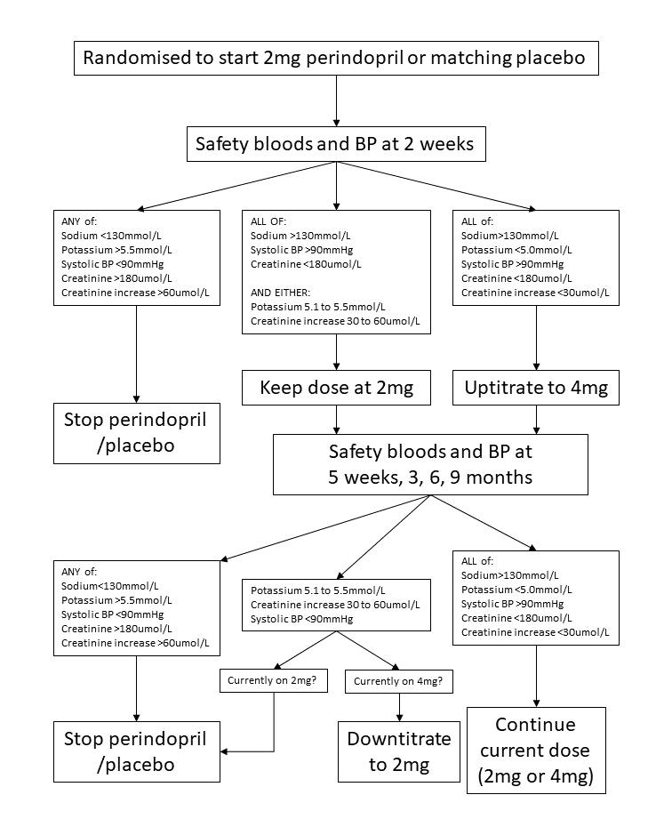

Supplementary Figure 2: Change in lying blood pressure and postural blood pressure drop for perindopril vs placebo analysis
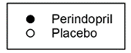
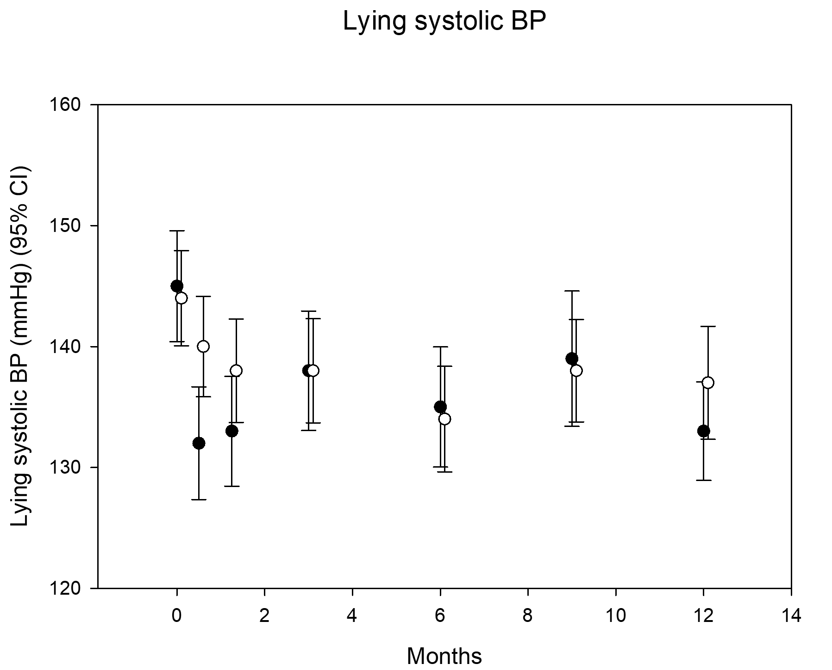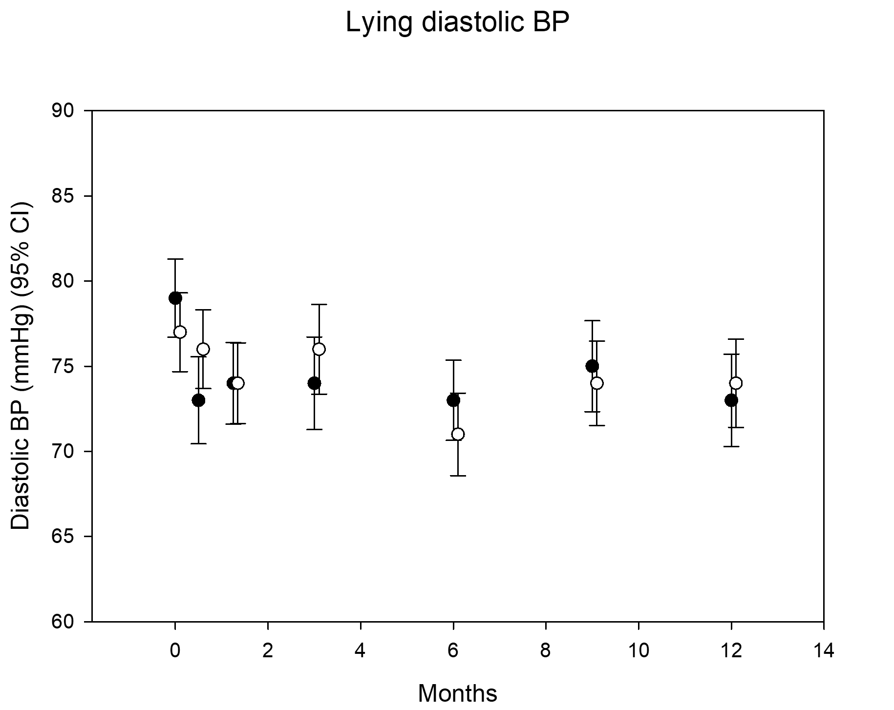
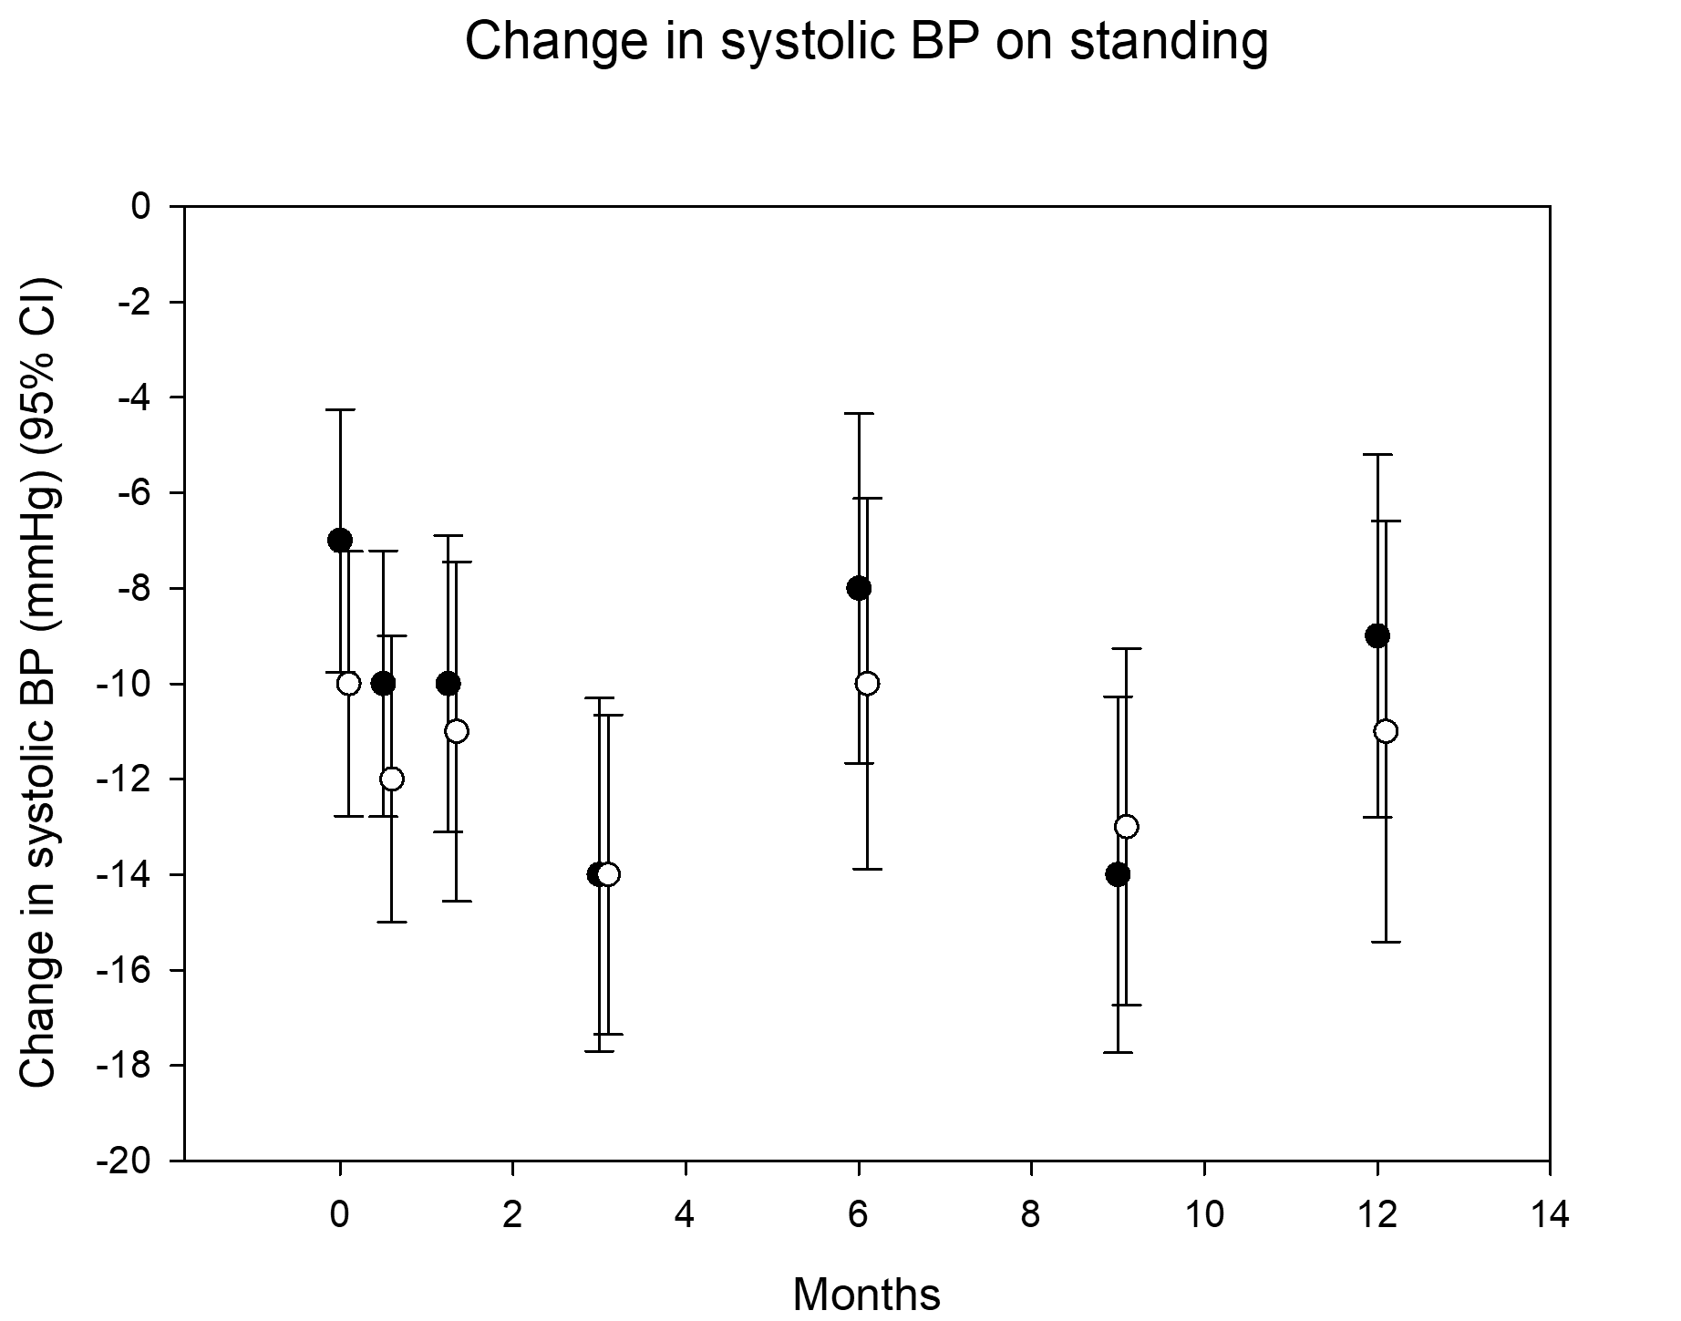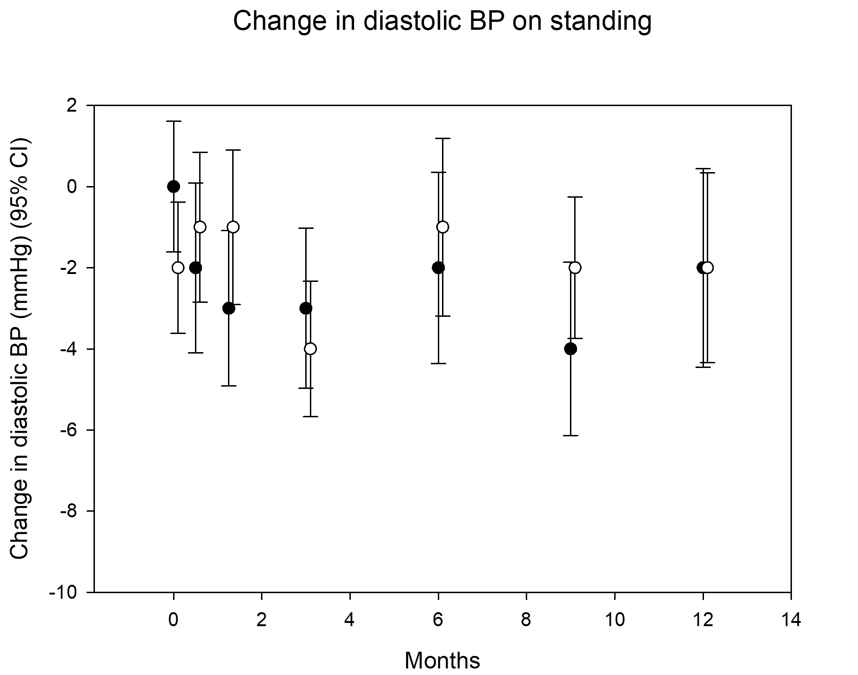

Supplementary Figure 3. Meta-analysis Forest plots
- Effect of ACEi/ARB on Short Physical Performance Battery
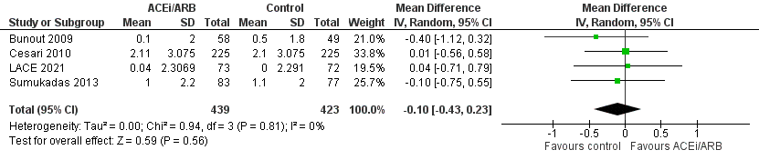

- Effect of ACEi/ARB on six-minute walk distance (in metres)
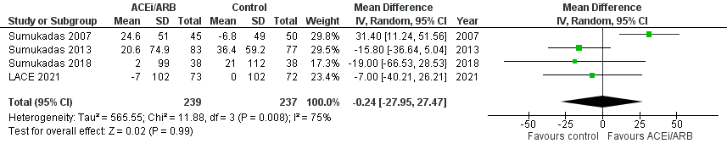

- Effect of ACEi/ARB on handgrip strength (in kg)
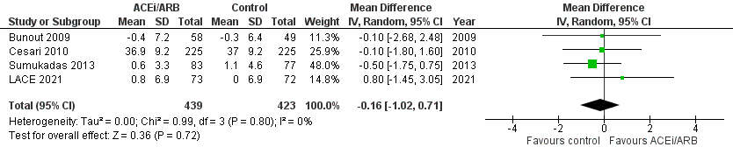

- Effect of ACEi/ARB on quadriceps strength (in kg)
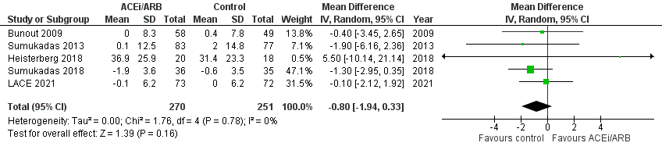

- Effect of Leucine on six-minute walk distance (in metres)
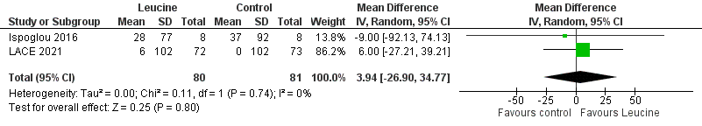

- Effect of Leucine on walk speed (in m/s)
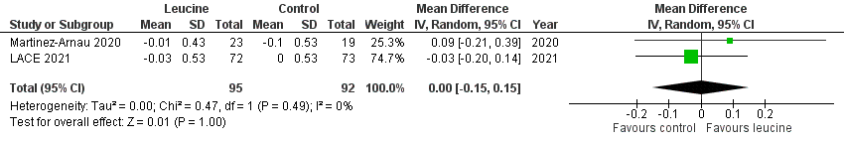

- Effect of Leucine on handgrip strength (in kg)
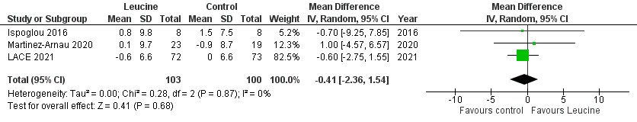

- Effect of Leucine on quadriceps strength (in kg)
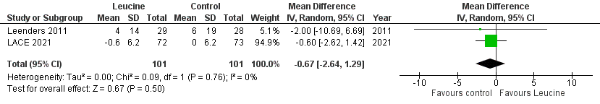

- Effect of Leucine on lean body mass (z scores)
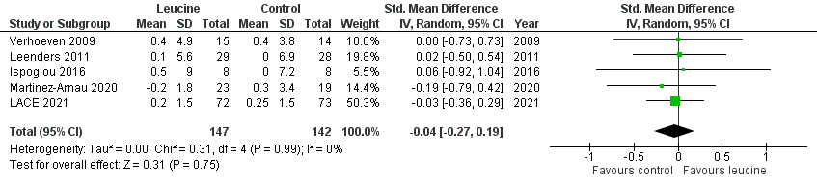

References for Supplementary Material
[1] Roberts HC, Denison HJ, Martin HJ, Patel HP, Syddall H, Cooper C et al. A review of the measurement of grip strength in clinical and epidemiological studies: towards a standardised approach. Age Ageing 2011;40:423-9.
[2] Mentiplay BF, Perraton LG, Bower KJ, Adair B, Pua YH, Williams GP et al. Assessment of Lower Limb Muscle Strength and Power Using Hand-Held and Fixed Dynamometry: A Reliability and Validity Study. PLoS One 2015;10:e0140822.
[3] Guyatt GH, Sullivan MJ, Thompson PJ, Fallen EL, Pugsley SO, Taylor DW et al. The 6-minute walk: a new measure of exercise capacity in patients with chronic heart failure. Can Med Assoc J 1985;132:919-23.
[4] Wennie Huang WN, Perera S, Vanswearingen J, Studenski S. Performance measures predict onset of activity of daily living difficulty in community-dwelling older adults. J Am Geriatr Soc 2010;58:844-52.
[5] Bohannon RW. Reference values for the timed up and go test: a descriptive meta-analysis. J Geriatr Phys Ther 2006;29:64-8.
[6] Nouri FM, Lincoln NB. An extended activities of daily living scale for stroke patients. Clin Rehabilitation 1987;1:301-5.
[7] EuroQol Group EuroQol--a new facility for the measurement of health-related quality of life. Health Policy 1990;16:199–208.
[8] Matthews DR, Hosker JP, Rudenski AS, Naylor BA, Treacher DF, Turner RC. Homeostasis model assessment: insulin resistance and beta-cell function from fasting plasma glucose and insulin concentrations in man. Diabetologia 1985;28:412–419
[9] Leonetti G, Mazzola C, Pasotti C, Angioni L, Vaccarella A, Capra A et al. Treatment of hypertension in the elderly: Effects on blood pressure, heart rate, and physical fitness. Am J Med 1991;90:12S-13S.
[10] Gerdts E, Björnstad H, Devereux RB, Lund-Jhansen P, Davidsen ES, Omvik P. Exercise performance during losartan- or atenolol-based treatment in hypertensive patients with electrocardiographic left ventricular hypertrophy (a LIFE substudy). Blood Press 2006;15:220-6.
[11] Sumukadas D, Witham MD, Struthers AD, McMurdo MET. Effect of perindopril on physical function in elderly people with functional impairment: a randomised controlled trial. CMAJ 2007; 177: 867-74.
[12] Bunout D, Barrera G, de la Maza MP, Leiva L, Backhouse C, Hirsch S. Effects of enalapril or nifedipine on muscle strength or functional capacity in elderly subjects. A double blind trial. J Renin Angiotensin Aldosterone Syst 2009;10:77-84.
[13] Cesari M, Pedone C, Incalzi RA, Pahor M. ACE-inhibition and physical function: Results from the Trial of Angiotensin-Converting Enzyme Inhibition and Novel Cardiovascular Risk Factors (TRAIN) study. J Am Med Dir Assoc 2010;11:26-32.
[14] Sumukadas D, Band M, Miller S, Cvoro V, Witham MD, Struthers AD, McConnachie A, Lloyd SM, McMurdo ME. Do ACE inhibitors improve the response to exercise training in functionally impaired older adults?: a randomised controlled trial. J Gerontol A Med Sci 2013;69:736-43.
[15] Sumukadas D, Price R, McMurdo MET, Rauchhaus P, Struthers A, McSwiggan S et al. The effect of perindopril on postural instability in older people with a history of falls—a randomised controlled trial. Age Ageing 2018;47:75-81.
[16] Heisterberg MF, Andersen JL, Schjerling P, Lund A, Dalskov S, Jønsson AO et al. Losartan has no additive effect on the response to heavy-resistance exercise in human elderly skeletal muscle. J Appl Physiol (1985). 2018;125:1536-54.
[17] Verhoeven S, Vanschoonbeek K, Verdijk LB, Koopman R, Wodzig WKWH, Dendale P et al. Long-term leucine supplementation does not increase muscle mass or strength in healthy elderly men. Am J Clin Nutr 2009;89:1468-75.
[18] Leenders M, Verdijk LB, van der Hoeven L, van Kranenburg J, Hartgens F, Wodzig WK et al. Prolonged leucine supplementation does not augment muscle mass or affect glycemic control in elderly type 2 diabetic men. J Nutr 2011;141:1070-6.
[19] Ispoglou T, White H, Preston T, McElhone S, McKenna J, Hind K. Double-blind, placebo-controlled pilot trial of L-Leucine-enriched amino-acid mixtures on body composition and physical performance in men and women aged 65-75 years. Eur J Clin Nutr 2016;70:182-8.
[20] Martínez-Arnau FM, Fonfría-Vivas R, Buigues C, Castillo Y, Molina P, Hoogland AJ et al. Effects of Leucine Administration in Sarcopenia: A Randomized and Placebo-controlled Clinical Trial. Nutrients 2020;12:932.

