Received 00th January 20xx,
- School of Chemistry and Biological Engineering, University of Science & Technology Beijing, Beijing 100083, P. R. China.
- Department of Electronics and Computer Science, University of Southampton, Southampton SO17 1BJ, United Kingdom.
- State Key Laboratory of Power System, Department of Electrical Engineering, Tsinghua University, Beijing 100084, P. R. China.
- Beijing Advanced Innovation Center for Materials Genome Engineering, University of Science & Technology Beijing, Beijing 100083, P. R. China
Accepted 00th January 20xx
DOI: 10.1039/x0xx00000x

High-Temperature Polyimide Dielectric Materials for Energy Storage: Theory, Design, Preparation and Properties
Broader context
To meet the demands of energy storage for advanced electronics and electrical systems in severe environment, dielectric materials with high thermotolerance are eagerly required to prepare capacitors. polyimide (PI) attracted lots of attention because of its high breakdown strength, excellent heat-resistance, simple synthesis process and easy designability of molecular structure, which makes it a great potential high-temperature dielectric material. Depending on the different applications, reactive monomers can be selected to provide groups with special functions (e.g. low dielectric loss). Various nanofillers were also used to improve the dielectric properties of PI, together with the design engineering of nanofillers and multilayer structures in the PI matrix. Herein, recent progresses in all-organic PI dielectrics and PI nanocomposites dielectrics were discussed. The technological challenges and future developments for high temperature capacitor materials are analysed. This review will provide directions for the design and practical application of high-temperature energy storage materials of dielectric capacitors.

Xue-Jie Liu,ª Ming-Sheng Zheng,*ª George Chen,^{b} Zhi-Min Dang *^{c} and Jun-Wei Zha *^{a,d}
The high operating temperature of dielectric capacitors applied in electric vehicles, aerospace and underground exploration require dielectric materials with high temperature resistance and high energy density. Polyimide (PI) turns out to be a potential dielectric material for capacitors applications at high temperature. In this review, the key parameters related to high temperature resistance and energy storage characteristics were introduced and recent developments in all-organic PI dielectrics and PI-matrix dielectric nanocomposites were discussed. Synthetic strategies of new functional PI via modification at the molecular level together with the design engineering of nanofillers and multilayer structures of PIs were also analysed. Finally, a systematic summary of the current challenges and future developments for capacitor materials used at high temperatures were presented.

1. Introduction
Dielectric materials are well known as the key component of dielectric capacitors. Compared with supercapacitors and lithium-ion batteries, dielectric capacitors store and release energy through local dipole cyclization, which enables rapid charge and discharge rates (high power density).^{1,2} Biaxially oriented polypropylene (BOPP) films have been widely used as dielectric films in capacitors. However, the maximum operating temperature of BOPP is lower than 105 ℃ due to the inferior melting point (~ 165 ℃). In addition, the dielectric loss (tanδ) rises sharply and the charge-discharge efficiency (η) decreases accordingly above 80 ℃.³⁻⁵ While the maximum operating temperature of other capacitor films such as poly(ethylene-terephthalate) (PET), polycarbonate (PC) and polystyrene (PS) etc. were also limited to 125 ℃.⁶ Therefore, no commercial capacitor films can meet the growing demand for high temperature (> 125 ℃) applications. As a result, to meet the demands of energy storage in high temperature conditions, extra cooling systems are required to maintain a low operating temperature of BOPP film capacitors, which led to low energy utilization efficiency, large weight/volume of the power system and high costs of production and operation.⁷ To achieve better performances at high operating temperature, capacitors require higher energy density and more excellent temperature resistance.⁸
Many dielectric materials have been developed for high temperature capacitor applications, but each has its limitations. Ceramic film capacitors have some of the smallest specific volumes and are particularly suitable for microelectronic systems, mobile platforms and miniaturized power devices.⁹ Generally, ceramics could endure high temperature and show a high dielectric permittivity (ε_{r}), but their low breakdown strength (E_{b}) and poor flexibility limit their applications in energy storge field.³ Dielectric polymer have been the preferred materials for capacitors due to their excellent electrical properties and the ease of customizing continuous large-area films with micron thickness.¹⁰ Various polymer dielectrics that are stable at high temperature have been Table 1. The energy storage performance of advanced dielectric materials in high temperatures ¹²
Polymer | PC | PEEK | PEI | FPE | PI
U_{e} (J·cm⁻³) | ~ 0.85 | ~ 0.53 | ~ 1.1 | ~ 0.08 | ~ 0.18
Maximum operating temperature (℃) | 150 | 150 | 200 | 250 | 250

developed such as polyetheretherketone (PEEK), fluorene polyester (FPE) and polyimide (PI), which exhibit higher working temperature (> 125 ℃) as shown in Table 1. Most high-temperature polymers had a high degree of aromaticity or fused-ring heterocyclic structures, the presence of thermally stable rigid imide rings was one of the factors in the selection of PI as a candidate of high-temperature dielectric material.^{11.12} Ma et al. used high-throughput density functional theory (DFT) to identify polymers that have the potential to be applied to capacitors. Among 267 polymers with unique and reasonable structures, PIs were selected for further research because of the high dielectric permittivity and wide band gap. In addition to the advantages of good flexibility and ease of mass preparation commonly found in polymers, the synthesis of PI offered excellent discretion in fabrication process. Depending on the application, reactive monomers could be selected to provide groups with special functions (e.g. high thermal stability, low tanδ) during the preparation of PIs. Thus, the ε_{r} of PI (ε_{r} = 3−5) was promoted by rational design of molecular structure.¹³⁻¹⁶ Moreover, the development of multiphase materials based on PI is a promising method. For example, the dielectric properties of PI can be improved by introducing ceramic nanofillers (e.g. Al₂O₃,^{17,18} TiO₂,¹⁹⁻²³ CaCu₃Ti₄O₁₂,²⁴⁻²⁷ and BaTiO₃ ²⁸⁻³¹) and conductive nanofillers (e.g. graphene,^{32,33} carbon nanotubes (CNT) ³⁴⁻³⁶)
There are many reviews for film materials with high energy density at normal temperature for capacitors such as ceramic
dielectrics,^{9, 37}polymer dielectrics^{38,39} and nanocomposite dielectrics ^{2,10,40−46}. Similarly, reviews of high-temperature capacitors were also available.^{3,8,11,47−49} However, publications concerning the use of PI for energy storage applications at elevated temperature were not widely available. Developments in the properties of PI are expected to find applications in the various fields requiring high-temperature energy storage, such as oil exploration, power grid, electric vehicles, aircraft, wind turbine generators and electronic circuits etc., as shown in Fig. 1. The factors affecting the high-temperature energy storage properties of dielectric polymers including thermosetting aromatic polyimides and thermoplastic aromatic polyimides (such as polyetherimide, PEI) and their nanocomposites were analysed. Moreover, the microstructure and interface properties of these materials, and the internal relationship between these factors and high-temperature dielectric properties were explored. This review will provide meaningful guidance of the molecular and structure design, preparation process and practical use of PI capacitor materials for high temperature applications.
2. Basic parameters of high temperature capacitor materials
2.1 Energy storage performance
Generally, the energy storage density (U) of the dielectric capacitor can be given by Equation 1:
U $=\int{E dD}$ (1)
where E is the applied electric field and D represents the dielectric displacement. The discharge energy density (U_{e}) is more important than the stored energy density in practical applications. The η is also a basic performance parameter to evaluate capacitors as shown in Equation 2:

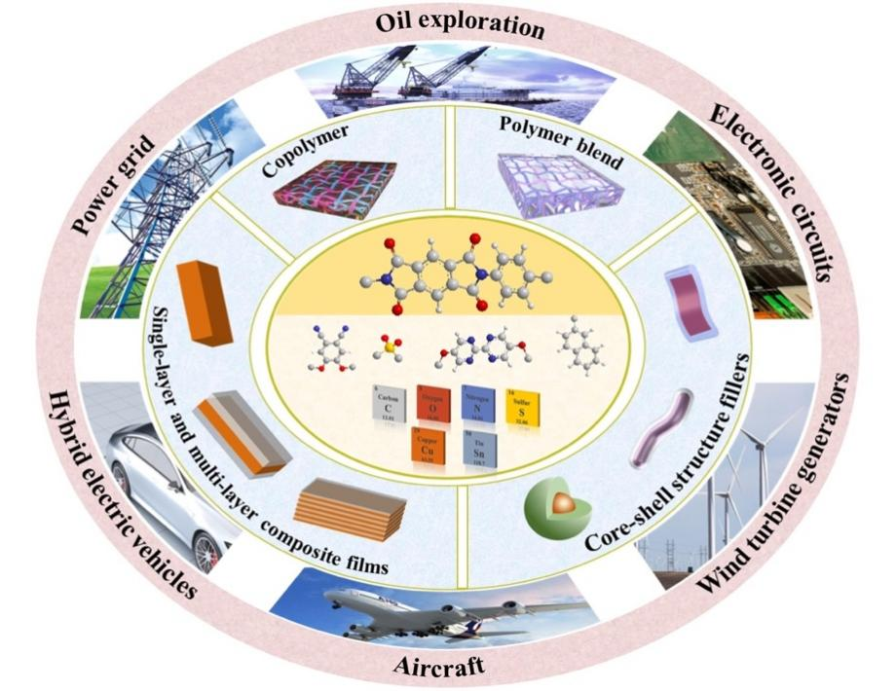

Fig. 1. Structures and future applications of the PI-matrix for dielectric capacitors.

η $=\frac{U_{e}}{U}$ (2)
The relationship between the electrical displacement (D) and the applied electric field (E) can be expressed by Equation 3:
$D=ε_{0}ε_{r}E$ (3)
where ε₀ (8.85×10⁻¹² F·m⁻¹) is the vacuum dielectric constant. Because $ε_{r}$ remains constant under the changing electric field for linear dielectrics (e.g. PI), U_{e} can be described as follows:
U_{e} $=\frac{1}{2}$ DE $=\frac{1}{2}ε_{0}ε_{r}$E_{b}² (4)
It can be seen from the Equation 4 that both ε_{r} and E_{b} are the key factors for the improvement of U_{e}. And how to achieve a higher U_{e} in high temperature conditions is the main issue discussed in this work.
2.1.1. Dielectric permittivity and dielectric loss (tanδ). Dielectric properties are related to the polarization mechanism. The principle of energy storage and release arises from the polarization and depolarization process within the dielectric materials. Polarization (P) is defined as the total dipole moments in a dielectric per unit volume and related to ε_{r} under a homogeneous applied field, which is shown as follow:⁴¹
$P=(ε_{r}-1)ε_{0}E$ (5)
The macro-polarization of dielectric materials under an electric field is essentially the sum contributions of the various micro-polarization mechanisms, including electronic polarization (P_{e}), ionic polarization (P_{i}), dipolar polarization (P_{d}), and interfacial polarization (P_{int}). These polarizations can be divided into the resonance and relaxation regimes as shown in Fig. 2, ^{41,43} which will be introduced briefly.
The positive and negative charge centers of the atom coincide in the absence of an external electric field. The displacement of the electron distribution in the presence of an applied electric field
induces a dipole moment referred to as electronic polarization. The dipole moments of electronic polarization are very small, which occurs in all dielectrics.
The dipole moments generated by cations and anions in materials are neutralized in the absence of an external electric field. When an external electric field is applied, the anions and cations move in opposite directions resulting in polarization, referred to as ionic polarization. The dipole moments of ionic polarization are larger, which can give the material higher ε_{r}. This polarization is common in ceramic materials such as barium titanate (BaTiO₃).
Dipolar polarization results from molecules or molecular chains, which usually own inherent dipole moments. When there is no applied electric field, these dipole moments are randomly oriented. When an external electric field is applied, the molecules or molecular chains tend to distribute parallel to the direction of the electric field, thereby exhibiting macroscopic polarization. For polymers, the dipolar polarization depends on the presence of polar groups and the geometry of the polymer chains.⁴¹
Interfacial polarization is mainly related to the differences in the electrical characteristics of the constituent phases. When there is no external electric field, space charges distribute uniformly exhibiting non-polarization. While space charges accumulate in an applied electric field at the interface resulting in interfacial polarization.
PI has high electron mobility arising from the conjugated system of benzene rings and the lone pairs of electrons on the O and N of the imide rings, which will lead to the generation of electron polarization. However, the high-ε_{r} of PI is mainly contributed by dipolar polarization of their polar groups. Tong et al. analysed the ε_{r} of PIs with different structures as a function of temperature. As the operating temperature increases, only a slight change in the ε_{r} of PI is observed.^{50,51} Moreover, it should be noted that the high glass transition temperature (T_{g}) of PIs (usually higher than 200 ℃) restricts the movement of the molecular chains, which endows PIs high thermal stability dielectric characteristics in a wide temperature range.

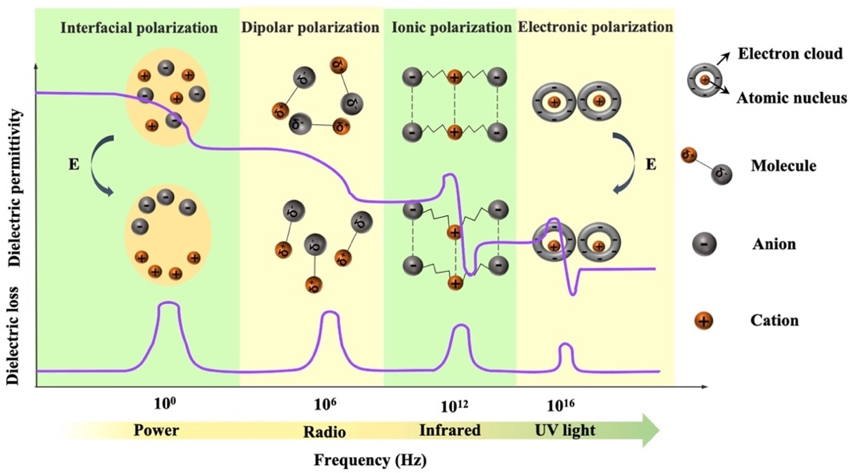

Fig. 2. Four types of polarizations and their frequency dependencies: interfacial polarization, dipolar polarization, ionic polarization and electronic polarization.

The tanδ is a measure of the rate of energy loss during polarization and depolarization of dielectric materials.⁴⁷ The tanδ mainly comes from polarization and electrical conduction. As shown in Fig.2, electronic polarization and ionic polarization generally depend on the band gap of the polymer, and their loss peaks occur at high frequency range (infrared and UV light level).⁴¹ Dipolar polarization loss presents at lower frequency (radio level), and the loss peak of interfacial polarization occurs at lowest frequency range (power level). PI is a linear dielectric with a low tanδ. However, the promotion strategies of ε_{r} usually bring higher tanδ. Thus, systematic consideration of molecular/structure design according the polarization mechanisms are necessary to improve the dielectric loss of PIs.
2.1.2 Electrical conduction and mechanisms. Charge carriers in dielectric materials will move directionally as the leakage current in the presence of an electric field. The magnitude of the conduction current is determined by the nature of the dielectric itself. And the conduction current consumed in the form of heat leading to conduction loss. Furthermore, the fraction of energy dissipation will enlarge as a function of the increasing temperature and electric field, which not only significantly reduces the charge-discharge efficiency, but also inevitably generates heat and causes thermal instability. Thus, suppressing the high-temperature conduction loss of the dielectrics has become a key means to improve the high-temperature energy storage performances.
An ideal dielectric material under an electric field should exhibit high insulation and low conductivity. However, due to the combined effect of multiple conduction mechanisms, the current through the dielectric layer becomes larger when a stronger electric field is applied. According to the source of current, the conduction mechanism of the dielectrics can be divided into two types.⁵² The conduction mechanisms that depend on the electrical properties at the electrode-dielectric contact are called the electrode-limited conduction mechanisms, including Schottky emission, Fowler-Nordheim tunneling, direct tunneling, and thermionic-field emission. The bulk-limited conduction mechanisms only depend on the properties of the dielectric itself, including Poole-Frenkel emission, hopping conduction, ohmic conduction, space-charge-limited conduction, ionic conduction, etc.
Schottky emission, Poole-Frenkel emission and hopping conduction play a dominant role at high temperature condition. As shown in Fig. 3(a), Schottky emission describes the mechanism by which electrons in metal electrodes obtain sufficient energy from thermal activation to overcome the energy barrier at the metal/dielectric interface and be injected into the dielectrics to participate in the formation of conduction current. Poole-Frenkel (P-F) emission is sometimes called internal Schottky emission, that is, the thermal excitation of electrons can be emitted from the trap into the conduction band of the dielectrics as shown in Fig. 3(b). The Coulomb potential energy of the electron in the trapping center can be reduced by the applied electric field. The reduction in potential energy will increase the possibility of electrons being thermally excited out of the trap and entering the conduction band of the dielectrics. Hopping conduction is the tunneling effect in which electrons trapped in a dielectric film "hopping" from one trap site to another as shown in Fig. 3(c). P-F emission corresponds to the thermionic effect, and hopping conduction corresponds to the tunnel effect. In P-F emission, through the thermionic mechanism, carriers can overcome the trap barrier. In hopping conduction, even if the carrier energy is lower than the maximum energy of the barrier between the two trapping sites, carriers can still transit using the tunneling mechanism.
When the temperature is higher than a certain threshold, the continuous increased temperature will cause the internal current of the polymer dielectrics to increase exponentially.⁵³ It can be said that high temperature has a significant destructive effect on dielectrics. The conduction loss in the dielectrics will be effectively suppressed by taking appropriate measures, such as the increase of the potential barrier at the electrode/dielectric to inhibit charge injection, the introduction of deep traps inside the dielectrics to reduce carrier mobility and the reduction of internal defects in the dielectrics.
2.1.3. Dielectric breakdown mechanisms. Maximum U_{e} is dependent on the square of E_{b}, so a high E_{b} is extremely important for energy storage capacitors. Understanding the breakdown mechanism is instructive in improving E_{b}. Although the breakdown process appears complex and unclear, several generally accepted mechanisms such as inherent breakdown, electromechanical breakdown, thermal breakdown, and partial discharge breakdown
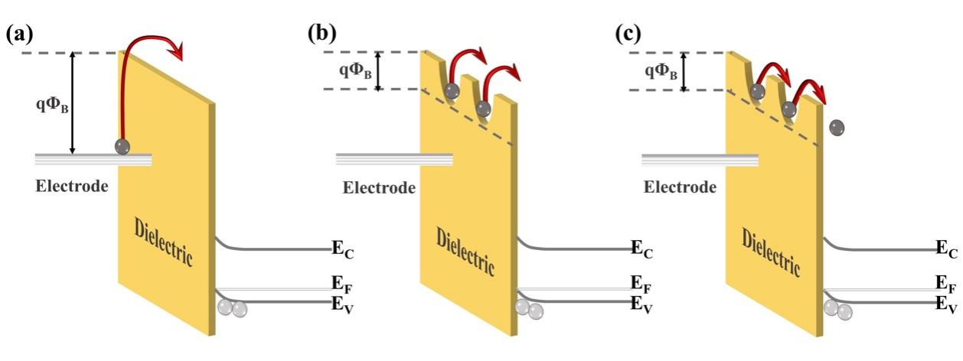
Fig. 3. Schematic energy band diagram of (a) Schottky emission, (b) Poole-Frenkel emission, and (c) hopping conduction in dielectrics. (qΦ_{B} is the barrier height, E_{c} is the conduction band, E_{v} is the valence band and E_{F} is the Fermi level.)

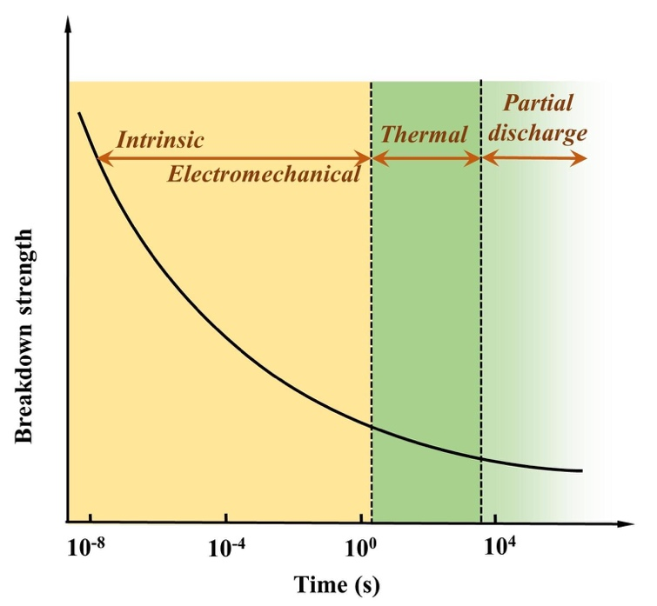
Fig. 4. Breakdown mechanisms and E_{b} as a function of the time after the application of a voltage ^{37.}

have been proposed, as shown in Fig. 4.³⁷
Intrinsic E_{b} can be defined as the highest breakdown value of a pure and homogeneous material where the measurement conditions are accurately controlled. Thus, the intrinsic E_{b} is an ideal value. There are two main types of intrinsic breakdown mechanism, i.e. tunnel breakdown and avalanche breakdown. As shown in Fig. 5(a), electrons in the dielectrics can obtain enough energy from the electric field to cross the forbidden energy gap between the valence band and the conduction band. As more electrons accumulate in the conduction band, tunnel breakdown is achieved. The tunnel breakdown is related to the band gap of the dielectrics. It increases rapidly with the increase of the electric field, which will inevitably cause the dielectrics to lose the insulating properties. Electrons within dielectrics obtain energy from the electric field and collide
with atoms. When the collision energy obtained by the atom exceeds the ionization potential, an electron is liberated (Fig. 5(b)). The collision ionization process proceeds as a chain reaction causing the number of electrons to increase sharply, resulting in an electron avalanche.³⁷ The avalanche breakdown shows a high temperature dependence.
Electromechanical breakdown generally occurs in solid dielectrics with low elastic modulus and easy mechanical deformation. Charges are induced on the surface of the dielectrics at high electric fields, and the electrostatic attraction of these charges causes compressive forces in Fig. 5(c). Electromechanical breakdown occurs if the forces exceed the mechanical compressive strength of the dielectrics.³⁷
Thermal breakdown originates from the internal thermal instability of the dielectrics. Under the action of high electric field, tanδ can cause energy dissipation to be consumed as heat, which raises the temperature of the dielectrics. The enhanced temperature increases the conductivity of the dielectrics exponentially, and the resulting higher conductivity loss will bring more heat. Thermal breakdown may occur when the rate of heat generation exceeds the rate of heat dissipation, as shown in Fig. 5(d). The thermal breakdown is not only related to the properties of the dielectrics, but also largely to happen at cooling condition and environmental temperature. PI dielectrics are often used in high-temperature fields, but the applications also show fatal problems. For example, they have good dielectric properties at room temperature, but the conduction current increases rapidly at high temperatures causing the loss to rise sharply. The temperature rises until the critical current density is reached, which leads to the breakdown of the PI dielectrics. So thermal breakdown is the key mechanism of PIs.
The discussion above mainly concerning the breakdown of a uniform dielectric, but in fact it is very difficult to prepare a continuous and uniform solid dielectric material. In solid dielectrics containing gas (e.g. in bubbles or pores) or liquid (e.g. residual organic solvents), partial discharge breakdown can occur. As shown
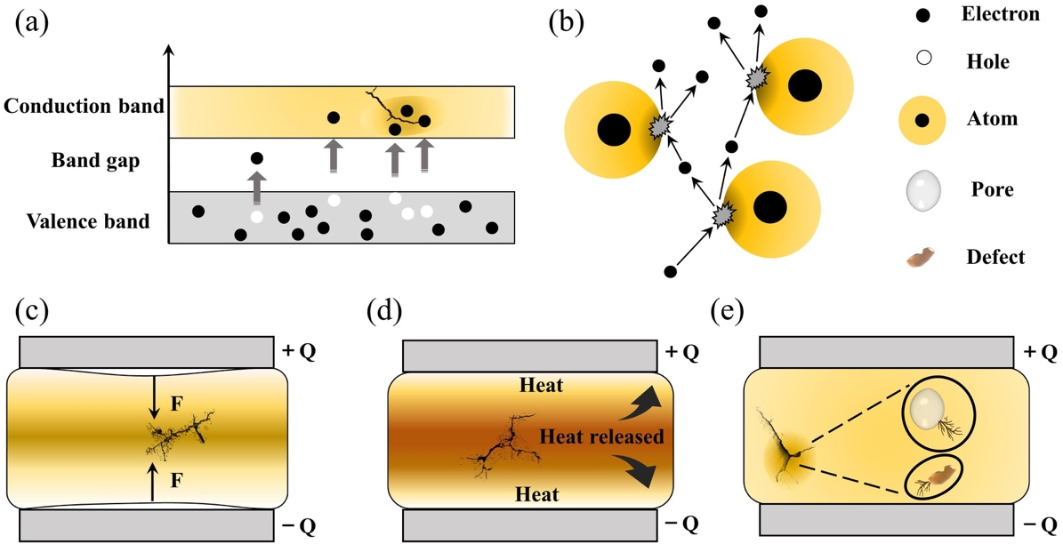

Fig. 5. Different types of breakdown mechanisms after the application of electric fields: (a) electronic breakdown, (b) avalanche breakdown, (c) electromechanical breakdown, (d) thermal breakdown, (e) partial discharge breakdown.

in Fig. 5(e), gases and liquids have lower E_{b} and will breakdown when their local electric field strength reaches the threshold. This partial discharge breakdown is initially localized in the dielectric, but long-term partial discharge gradually extends breakdown to the entire dielectric.
For the idealized PI without defects and impurities, E_{b} depends on the band gap. Polymers with wider band gaps have a higher breakdown field strength because it is more difficult for electrons to transition from the valence band to the conduction band in the presence of an applied electric field.¹⁵ Since the "perfect" PI is difficult to achieve, the breakdown of polymers usually dependent on other mechanisms such as thermal breakdown and partial discharge breakdown. As mentioned above, thermal breakdown is a crucial mechanism in PIs. When fillers are added to heterogeneous materials such as PI nanocomposites, E_{b} depends on additional factors including the morphology (such as type, size and shape), dispersion and distribution of the fillers, and the compatibility of the interfaces for the two-phases. Shen et al. developed a comprehensive phase-field model to investigate the breakdown behavior of polymer nanocomposites arising from electrostatic stimuli.⁵⁴ Taking poly(vinylidene fluoride) (PVDF)-BaTiO₃ nanocomposites as examples, some typical 3D microstructures were simulated. Fig. 6(a) showed a pure polymer matrix (S0) and five types of 3D nanocomposites with a 10% nanofiller volume fraction that were studied, including vertical nanofibers (S1), vertical nanosheet (S2), random nanoparticles (S3), parallel nanofibers (S4), and parallel nanosheets (S5). The ease of breakdown, expressed as the breakdown volume fraction (%) in Fig. 6(b), was highest for S1 lowest for S5. Fig. 6(c) illustrated that the E_{b} of nanocomposites from S0 to S5 were 230, 151, 195, 216, 223, and 310 kV·mm⁻¹ respectively. Only the nanocomposite filled with parallel nanosheets had a higher E_{b} than the pure polymer matrix. Here, the growth of the breakdown phase was hindered because
the parallel nanosheets disperse the electric field. However, the E_{b} predicted by this model for polymer nanocomposites were only applicable to room temperature.
An electrothermal breakdown phase-field model that included the contribution of thermal energy generated by Joule heating was also developed.⁵⁵ The E_{b} at 298 K ($E_{b}^{298K}$) for the PI-SrTiO₃ nanocomposite was applied as an example. As shown in Fig. 7(a), the deterioration factor (β) was zero (point A). The β reached a maximum of 0.67 (point B) at a temperature of 500 K. The average electrostatic energy density ($f_{ele}^{A}$) changed little with temperature under an electric field of 100 kV·mm⁻¹, while the average Joule heating energy density ($f_{Joule}^{A}$) increased exponentially with temperature. Electrostatic energy was predominant below T_{C} (395 K; point C) while Joule heating energy was predominant above T_{C}. The increase in the Joule heating accelerated the growth of the breakdown phase, resulting in a decrease in E_{b}. Fig. 7(b) and (c) showed that when the particles were broken at 300 K, the electrostatic energy density inside the particles was much higher than outside the particles, and the same was true for the Joule heating energy density. However, the Joule heating energy density dominated almost everywhere inside the nanocomposite at 500 K as shown in Fig. 7(d) and (e). It accumulated mainly at the two shoulders of the fillers where these regions were more likely to be punctured. This was not the case for the electrostatic energy density. The model could predict the E_{b} as a function of temperature for many common polymer nanocomposites. However, in addition to electrothermal breakdown, other mechanisms (e.g. electromechanical breakdown) can also influence the breakdown process of polymer nanocomposites. Therefore, the development of a phase-field model that can consider all the above breakdown mechanisms should be given priority in order to assist experimental design.

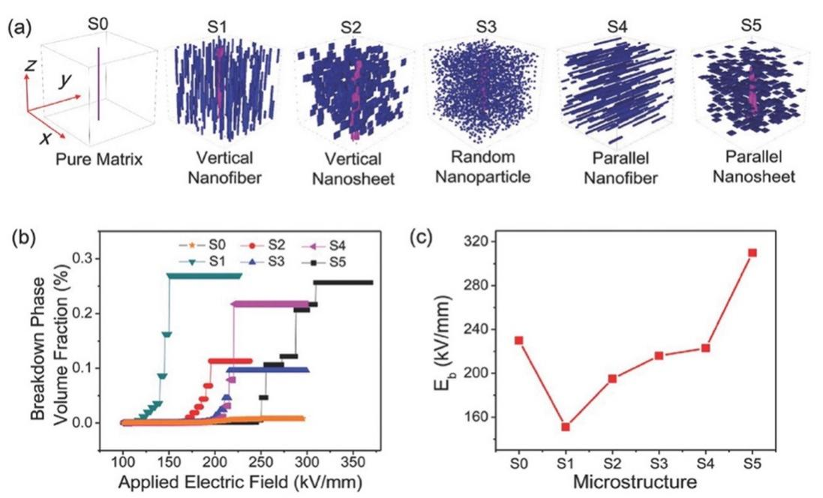
Fig. 6. 3D microstructures simulations for PVDF-BaTiO₃ nanocomposites: (a) Simulation of the breakdown phase morphology of nanocomposites with different 3D microstructures, (b) evolution of the breakdown phase volume fraction with the applied electric field, (c) extracted E_{b}.⁵⁴

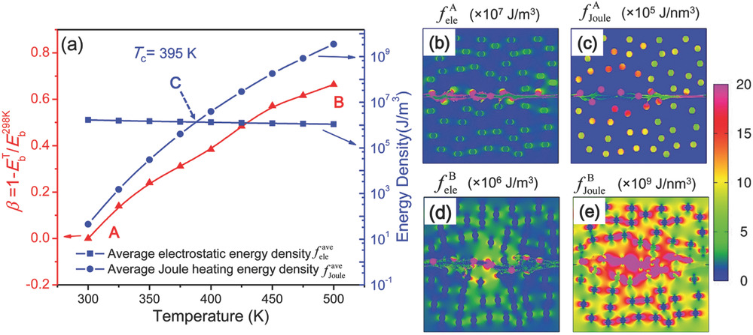
Fig. 7. Electrothermal breakdown phase-field model according to Shen et al.: (a) Effects temperature on the E_{b} (left axis) and the average electrostatic and Joule heating energy densities (right axis), (b) local electrostatic energy density ($f_{ele}^{A}$) and (c) Joule heating energy density ($f_{Joule}^{A}$) at 300 K, (d) local electrostatic energy ($f_{ele}^{A}$) and (e) Joule heating energy density ($f_{Joule}^{A}$) at 500 K.⁵⁵

2.2. Thermal stability
Thermal stability determines the ability of materials for maintaining optimum performance under thermal stress. It is a prerequisite for assessing the reliable insulation performance of dielectric materials at high temperatures.⁴⁷ Polymer dielectrics are susceptible to thermal damage,^{56,57} and T_{g} is usually the main parameter for evaluating the stability of polymer dielectrics at high temperatures. For crystalline polymers, the melting point (T_{m}) is also used to evaluate high temperature performance. When the polymers have a high degree of crystallinity, the role of the crystalline phase is more important, and T_{m} becomes the dominant factor for evaluating high temperature performance. The rigid structural units of PIs increase the stiffness of the main polymer chains, and the chemical cross-linking in PIs also severely restricts intermolecular motion significantly increasing T_{g}, both of that are effective ways for the improvement of PI thermal stability.
3. All-organic PI dielectrics
All-organic polymer dielectrics are ideal materials for capacitor applications due to their high E_{b}, low quality density, flexibility, low-cost and good processing. In this section, the discussion is divided into two parts. The first part considers the PIs that has already been commercialized. The next parts focus on multiple strategies for improving the performances of all-organic PI.
3.1. Commercial PI resins
The limitations of commercially available capacitors (e.g. PP, PC and PET) have promoted the development of high temperature capacitor dielectrics based on commercially available heat-resistant polymers.¹¹ In general, the imide cyclic structures in PIs are conducive to high thermal stability and high electrical insulation, so they are considered a promising dielectric for high-temperature applications.
Table 2 provided a summary of the thermal stability and dielectric properties for a range of commercial PIs.¹¹ Kapton polyimide film produced by DuPont has a continuous operating temperature of 300 to 350 ℃ and been widely used as a high-temperature wire and cable insulation material for aircraft. Upilex-S PI film from ICI has high heat-resistance and good isothermal stability at 300 ℃. Perfluoro polyimide (PFPI) developed by TRW and SIXEF-44 from Hoechst Celanese are two types of fluorinated polyimide. Most of these PIs were difficult to process due to their high degree of aromaticity, which prompted researchers to develop flexible Ultem PEI from SABIC. Introduction of the ether linkage and alkyl groups increased flexibility at the expense of the thermal stability. The T_{g} of Ultem is about 215 ℃, which is much lower than many PIs. Potential candidate materials for capacitor films can be identified from the heat-resistant polymers available. These commercially available PI resins also provide a basis for the development of new capacitor materials for future high temperature applications.
3.2. Modification of the molecular structure of PI
PVDF-matrix or PVDF copolymer-matrix nanocomposites have received much attention.⁵⁸⁻⁶⁵ These ferroelectric polymers exhibit high ε_{r}, high tanδ and low T_{g} due to their high dipole density.¹³ PIs, however, are potential high temperature capacitor materials due to their inherent high E_{b}, low tanδ, and high thermal stability. Consequently, research has focused on improving the ε_{r} of PI. And the flexibility of synthesis makes it easier for PI to increase the ε_{r} by introducing various types and numbers of functional groups into the molecular structure. It is found that the symmetry of the PI unit structure, the length of the cross-conjugation system, and other adjustments based on the molecular structure scale, also play a pivotal role in the improvement of PI's dielectric properties, as shown in Table 3.
3.2.1. Introduction of polar groups on the main PI chain. The cyano group (CN) has a high dipole moment (3.9D), and it is often introduced at different positions of the PI structure.⁶⁶⁻⁶⁹ For example, Treufeld et al. synthesized 12 novel PIs with one or three polar CN dipoles attached to aromatic diamines.⁶⁸ The addition of highly polar CN groups to the PI structure increased ε_{r} and therefore electrical energy storage, especially at higher temperature, and the effect of three CN dipoles was better than one CN. At the same time, ε_{r} also decreased in the order of para-para, meta-para, and meta-

Table 2. Dielectric properties of commercial PIs ^{11, 47 49}
Structural formula | Name | T_{g} (℃) | ε_{r} | tanδ % | E_{b} (MV·m⁻¹)
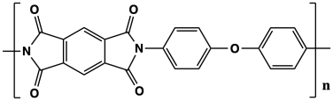 | Kapton | 360 | 3.1@25 ℃ at 1 kHz  2.8@300 ℃ at 1 kHz | 0.1@25 ℃  6@300 ℃ | 154–303 (7.6–127μm)
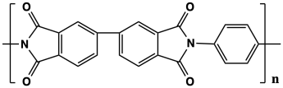 | Upilex-S | 355 | 3.3@25 ℃ at 1 kHz  3.3@300 ℃ at 1 kHz | 0.1  25 ℃ and 300 ℃  at 1 kHz | 272 (25um)
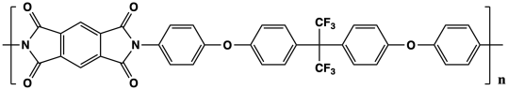 | PFPI | > 300 | 3.1@25 ℃ at 1 kHz  2.9@300 ℃ t 1 kHz | 0.1  25 ℃ and 300℃  at 1kHz | --
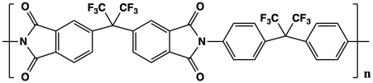 | SIXEF-44 | 323 | 2.8 at 1 kHz  < 10% change (from−55 to 300 ℃) | 0.1  25−250 ℃  at 100 −10 kHz | --
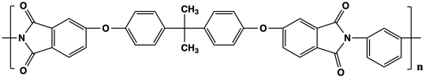 | Ultem | 215 | 3.1  25−200 ℃  at 100−10 kHz | ~ 0.3  25−200 ℃  at 100−10 kHz | 200 (25μm)

meta linkage to the diamine, which indicated that the para-para linkage favored easier dipole rotation than the meta-para and meta-meta linkages. It should be noted that the CN dipoles attached to the main PI chains increased not only ε_{r}, but also their tanδ. In Fig. 8(a), Zhang et al. introduced two ortho-position aromatic nitrile groups into PI (2CN-PI), which greatly improved its polarizability and ε_{r}.⁶⁹ As shown in Fig. 8(b)−(d), the 2CN-PI had a high ε_{r} of 4.80, low tanδ of 1.57×10⁻³ at 1 kHz (25 ℃), high T_{g} value of 325 ℃ and U_{e} of 1.02 J·cm⁻³.The re-exploration of Clausius-Mossotti equation revealed the essence of designing intrinsic high-k-low-loss polymers. The total polarizability should be maximized, and the chain stacking should be as close as possible, that is, rigid polymer backbone, small-sized polar groups (such as CN) and spatial positions that are conducive to oriented polarization are preferred. This work provides novel ideas for designing intrinsic PIs in the
future.
The introduction of bipyrimidine units also enables PI to obtain a high ε_{r} (7.1 at 100 Hz), which is related to the high polarity of N and electron mobility.⁷⁰ There are four lone electron pairs in the conjugated system in each bipyrimidine unit, which are provided by the four N of the two pyrimidine rings. The high T_{g} (291 ℃) of the PI was attributed to the incorporation of rigid bipyrimidine units into the polymer backbone and strong intermolecular interactions. However, the synthesis of diamines containing pyrimidine units was complicated and time-consuming, which limited large-scale preparation. Peng et al. also synthesized a new diamine (5,5’-bis [(4-amino) phenoxy]-2,2’-bipyridine (BPBPA)), which contained bipyridine units.¹³ The PI were prepared by polymerizing BPBPAs with dianhydrides, which had a high ε_{r} (up to 7.2), high E_{b} (295 MV·m⁻¹) and excellent U_{e} (2.77 J·cm⁻³). The excellent ε_{r} were
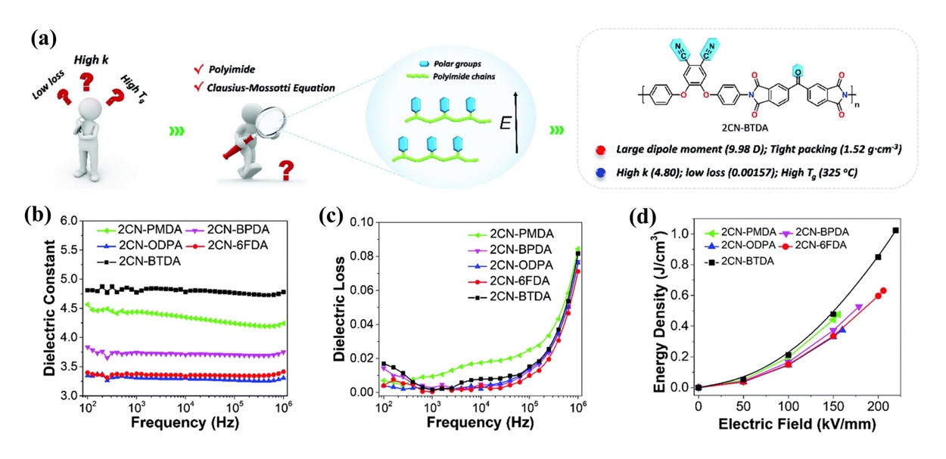

Fig. 8. (a) Schematic illustration of designing high-performance PI dielectrics. Frequency dependence of the (b) ε_{r}, (c) tan δ and (d) energy density of 2CN-PI films.⁶⁹

Table 3. Summary of all-organic PIs and PI nanocomposites.

Material | T_{d5%} / T_{g}  (℃) | ε_{r}  @1 KHz | tanδ  @1 KHz | E_{b}  MV·m⁻¹ | maximum U_{e}  (J·cm⁻³⁾ | η | Processing of films | Ref.
3,4-APBN-PIs | 536(N₂)¹ / 267 | 3.62 | 0.009 | -- | -- | -- | TI², SC³ | 66
2CN-BTDA | 508(N₂) / 325 | 4.8 | 0.00157 | 219.4 | 1.023 | -- | TI, 350 ℃ ⁴, SC | 69
BPDA-BAPBP | 506(N₂) / 291 | ~ 7 | ~ 0.008 | -- | -- | -- | TI, SC | 70
BTDA-BPBPA | 525(N₂) / 296 | ~ 7.1 | ~ 0.014 | 295 | 2.77 | -- | TI, SC | 13
crown ether-containing PI | 423.1(N₂) / 342 | ~ 6.4 | ~ 0.005 | -- | -- | -- | TI, 300 ℃, SC | 71
SPI-1 | -- / 290 | 5.98 | 0.00373 | 536 | 7.60 | 91.3%@500 MV·m⁻¹ | TI, 350 ℃, SC | 51
CPI-5 | -- / 277 | 523 | 0.00324 | 511 | 6.34 | 92.3% | TI, 350 ℃, SC | 50
BTDA-HK511(B2) | -- / 78 | 7.80 | 0.00555 | 676 | 15.77 | -- | TI, 170−180 ℃, SC | 15
PI-DPEM | 375(air) / 163 | 3.5@100Hz | < 0.02 | -- | -- | -- | CI⁵, RT⁶, SC | 72
poly(pyridine imide) | 527(air) / -- | 4.2 | -- | -- | -- | -- | CI, 100 ℃, SC | 73
PI-ADE | 375(air) / 163 | 2.85@10KHz | 0.005@10KHz | 367 | -- | -- | SC | 74
BTDA-HK25 | -- / -- | 4.5 | < 0.01 | 780 | 12 | > 90% | TI, 250 ℃, SC | 69
Polymer 9 | -- / -- | 6.55 | 0.00626 | -- | -- | -- | CI, 180 ℃, SC | 76
30 wt% CuPc–PI | -- / -- | ~ 13 | ~ 0.3 | 97.4 | 0.55 | -- | TI, 380 ℃, SC | 14
40 wt% PSF/PI | 463(N₂) / 285 | 6.4 | 0.0155 | 152.2 | 0.64 | -- | TI, 350 ℃, SC | 78
5 wt% LNBR/PI | -- / -- | 4.79 | 0.0075 | 303.59 | 1.95 | -- | TI, 250 ℃, SC | 79
50 wt% PVDF/PI | -- / -- | 7.7 | ~ 0.9 | -- | -- | -- | CI, 180 ℃, SC | 80
50 wt% β-CD/PI | > 300 (N₂) / 283 | ~ 7 | ~ 0.06 | 217 | 1.46 | -- | TI, 300 ℃, SC | 81
60% pDMTDMG /PI | -- / -- | 5.1@150 ℃ | 0.06@150 ℃ | 464 | 6 | -- | Two-phase blending, SC | 82
15 wt% PEEU/PI | 491 (air) / 353 | 4.73 | 0.00299 | 495.65 | 5.14 | -- | Two-phase blending, TI, 250 ℃, SC | 83
10 wt% ArPTU/PI | 568 (air) / 419 | 4.52 | 0.00349 | 443 | 4.0 | -- | Two-phase blending, TI, 250 ℃, SC | 84
0.5 vol% PCBM/PI | -- / -- | ~ 3.3@200 ℃ | -- | 649@200 ℃ | 3.0@200 ℃ | > 90%@ 200 ℃ | Two-phase blending, SC | 85
25 wt% PcLS/PI | -- / -- | ~ 8.2 | ~ 0.07 | ~ 345 | 4.33 | -- | Two-phase blending, TI, 250 ℃, SC | 86
PEI  15 vol% PVTC  PEI | -- / -- | ~ 6.5 | ~ 0.02 | 504 | 2.6@125 ℃ | 63%@125 ℃ | Layer-by-layer, SC | 87
PEI  20 vol% PEI/P(VDF-HFP)  P(VDF-HFP) | -- / -- | ~ 5.2@10KHz | < 0.02@10KHz | 535 | 12.15 | 89.9% | Layer-by-layer, SC | 88
0.084 vol% AgNWs / PI | > 500 / -- | ~ 126 | ~ 0.06 | -- | -- | -- | TI, 250 ℃, SC | 91
12 vol% MWCNTs / PI | ~ 560(N₂) / -- | ~ 145 | ~ 0.05 | -- | 1.957 | -- | TI, 250 ℃, SC, hot-pressed at 300 ℃ | 34
30 wt% rBT/PI | -- / -- | ~ 34 | ~ 0.075 | 262.8 | 9.7 | -- | TI, ℃, SC | 29
1 vol% BaTiO₃/PI | -- / -- | ~ 3.8 | ~ 0.025 | 550 | 2.1@150 ℃ | -- | TI, 300 ℃, SC | 120
7 vol% Al₂O₃/PI | -- / -- | ~ 3.6 | -- | 422 | 1.12@150 ℃ and 250 MV·m⁻¹ | 93.7%@150 ℃ and 250 MV·m⁻¹ | TI, 300 ℃, SC | 94
1 vol% MoS₂/PI | > 540(N₂) / -- | 4.4 | < 0.02 | 395 | 3.35 |  | TI, 300 ℃, SC | 96
50 wt% PANI-HNTs/PI | 535(N₂) / -- | ~ 12.4 | ~ 0.29 | ~ 110 | 0.93 | -- | TI, 350 ℃, SC, Fp⁷ | 105
4 wt% PPD-CFGO/PI | 602(N₂) / -- | 36.9 | 0.0075 | 132.5±9.3 | -- | -- | TI, 400 ℃, SC, Fpg⁸ | 1
20 wt% RGO@R-PANI/PI | 480(N₂) / -- | 25.84 | 0.11 | -- | -- | -- | TI, 300 ℃, SC, Fpr⁹ | 32
1 vol% BT@PDA/PI | 520(N₂) / -- | 4.4 | ~ 0.007 | 315 | 1.94¹⁸ | -- | TI, 300 ℃, SC, Fosc¹⁰ | 104
3 wt% MoS₂-g-PMMA/PI | -- / -- | 4.2 | ~ 0.015 | 450 | 3.92@150 ℃ | 61.7%@150 ℃ | TI, 200 ℃, SC, Fsep¹¹ | 121
3 vol% BaTiO₃@SiO₂/PI | 576(N₂) / -- | ~ 4.3 | ~ 0.095 | 346 | 2.31 | -- | TI, 300 ℃, SC, Fsm¹² | 106
2 vol% BT@ZrO₂/PI | -- / -- | ~ 3.9 | ~ 0.008 | 361 | 2.53 | -- | TI, 300 ℃, SC, Fe¹³ | 107
20 wt% SiO₂@GO/PI | -- / -- | ~ 40 | ~ 0.24 | -- | -- | -- | TI, 300 ℃, SC, Fsm | 111
20 wt% BT@GO/PI | -- / -- | ~ 1 37 | ~ 0.65 | -- | -- | -- | TI, 300 ℃, SC, Fcc¹⁴ | 110
3 vol% CCTO@Ag/PI | -- / -- | ~ 100 | ~ 0.018 | -- | -- | -- | TI, 300 ℃, SC, Fsem¹⁵ | 112
8.4 vol% AgNW@C/PI | >500(Air) / -- | 126 | ~ 0.063 | -- | -- | -- | TI, 300 ℃, SC, Fhm¹⁶ | 91
11 vol% Al₂O₃@ZrO₂/PEI | -- / -- | 3.89 | ~ 0.004 | 585@150 ℃ | 3.11@150 ℃ and 400 MV·m⁻¹ | 92.6%@150 ℃ and 400 MV·m⁻¹ | SC, Fsgm¹⁷ | 109
5 vol% CCTO@TiO₂/PI | -- / -- | 5.85 | ~ 0.16 | 236 | 1.6 | -- | TI, 240 ℃, SC, Fe | 108
P(VDF-CTFE)  20 vol% BT/PI | -- / -- | 7.9 | ~ 0.025 | 370 | 14.2 | 51.2 | TI,250 ℃, layer-by-layer, SC | 113
PI  5 wt% NH₂-MWCNT/PI  PI | >560(Air) / -- | ~26 | ~0.0012 | ~130 | 1.95 | -- | TI, 300 ℃, layer-by-layer, SC | 122
2 vol% KTN/PI  PI  2 vol% KTN/PI | ~ 550(N₂) / -- | ~ 4.7 | ~ 0.05 | ~ 315 | 3.0 | > 88% | TI, 330 ℃, layer-by-layer, SC | 115
5 vol% h-BN/PI  1 vo% BZT-BCT/PI  5 vol% h-BN/PI | -- / -- | ~ 3.82 | < 0.0025 | 350@150 ℃ | 1.83@150 ℃ | -- | TI, 350 ℃, layer-by-layer, SC | 101
1 vol% SiO₂@BCZT/PI  1 vol% BN/PI  1 vol% SiO₂@BCZT/PI | -- / -- | ~ 3.6 | -- | 418.62 | 3.37 | 84.89% | TI, 350 ℃, layer-by-layer, SC | 123
19-layer h-BN  PEI  19-layer h-BN | -- / -- | ~ 3.2 | -- | -- | 2.93@100 ℃ | > 95%@100 ℃ | CVD | 7
SiO₂  PEI  SiO₂ | -- / -- | -- | -- | -- | 2.12@150 ℃ | > 90%@150 ℃ | PECVD and roll-to-roll processing | 90
1.90 wt% RGO-PI  1.90 wt% BNNS-PI | -- / -- | 579 | 0.25 | 74.4 | -- | -- | sequential bidirectional freeze casting technique, TI, hot-pressed | 102
0.05 wt% BT-PI  2 vol% BT-PI  0.05 wt% BT-PI | -- / -- | 4.1@100 ℃ | 0.0047@100 ℃ | 500@100 ℃ | 3.9@100 ℃ | 54%@100℃ | TI, 300 ℃, layer-by-layer, SC | 124
1 vol% BNNS/PI  0.4 vol% ZnO/PI  1 vol% BNNS/PI | -- / -- | 4.96 | < 0.004 | 403@150 ℃ | 5.29@150 ℃ and 400 MV·m⁻¹ | > 90%@150 ℃ and 300 MV·m⁻¹ | TI, 350 ℃, layer-by-layer, SC | 114
PI  3 vol% BT-PI  PI | -- / -- | ~ 3.85 | ~ 0.0024 | 344 | 1.94 | -- | TI,350 ℃, SC | 125

All values, including ε_{r}, tanδ, E_{b}, U_{e} and η, are measured at room temperature, unless the temperature is indicated at the back
1: The atmosphere of the TGA test is N₂
2: Thermal imidization
3: Solution casting
4: Maximum temperature used for thermal imidization
5: Chemcial imidization
6: Room temperature
7-17: Fp, Fpg, Fpr, Fosc, Fsep, Fsm, Fe, Fcc, Fsem, Fhm and Fsgm represent the filler processing methods as polymerization, polymer grafting, polymerization-reduction, one-step solution coating, seeded emulsion polymerization, stöber method, electrospinning, covalent coupling, seeding method, hydrothermal method and sol-gel method, respectively.
18: Energy storage density

mainly due to the longest cross-conjugated system of the carbonyl bridge in the benzophenone structure. Crown ether groups were also used to increase the polarization of molecular chains in PI films.⁷¹ High ε_{r} (5.8−6.4) and low tanδ (< 0.03) were obtained in the frequency range 10²−10⁵ Hz without loss of thermal stability (T_{g} = 341−343 ℃).
Tong et al. explored the impact of introducing highly polar carbonyl ⁵⁰ and sulfonyl groups ⁵¹ on the improvement of PI energy storage performances. For example, polar sulfonyl groups with high dipole moment (4.30 D) and flexible linkages between various configurations of benzene rings were introduced into the PI chains to enhance dipole density (see Fig. 9(a)). The ε_{r} and tanδ over the frequency range of 10¹–10⁶ Hz were shown in Fig. 9(b). Compared
with SPI-3 and SPI-7, -SO₂- in SPI-1 and SPI-2 had a higher ε_{r} resulting from their greater mobility, i.e. more “effective dipoles”. Compared with meta-meta linked SPI-2, the para–para linked SPI-1 had more symmetry and a lower energy barrier in free rotation, which increased ε_{r} and reduced tanδ. Below 10³ Hz, the tanδ values of SPI-5 and SPI-7 were very close. As the frequency increased beyond 10³ Hz, SPI-5 maintained a relatively low tanδ due to its more flexible ether linkage and symmetrical structure. Fig. 9(c) showed that the ε_{r} of SPI-1 were almost constant above 100 ℃ at each frequency, and stable up to 150 ℃. This differed from BOPP which had a maximum operating temperature not exceeding 105 ℃. And Fig. 9(d) illustrated that the U_{e} and η were as high as 7.04 J·cm⁻³ and 91.3% at 500 MV·m⁻¹, respectively. The highly
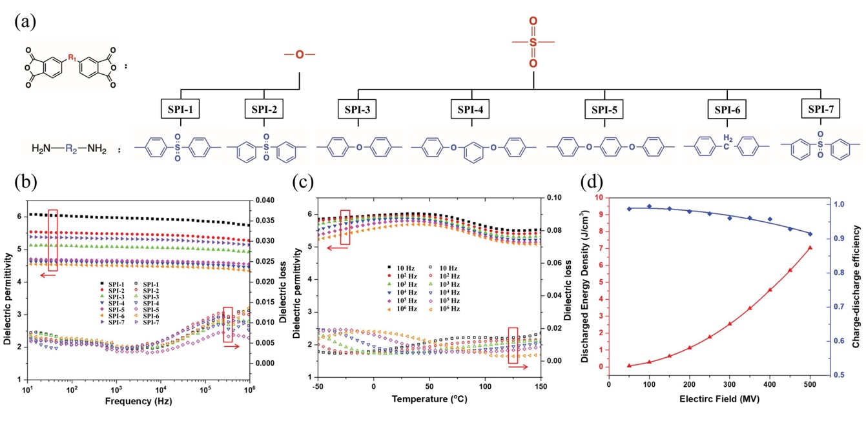
Fig. 9. (a) Monomers of sulfonyl-containing polyimides. The ε_{r} and tanδ of sulfonyl-containing polyimides: (b) SPI-1 to SPI-7 at room temperature, (c) SPI-1 at elevated temperature. (d) The U_{e} and η of SPI-1.⁵¹

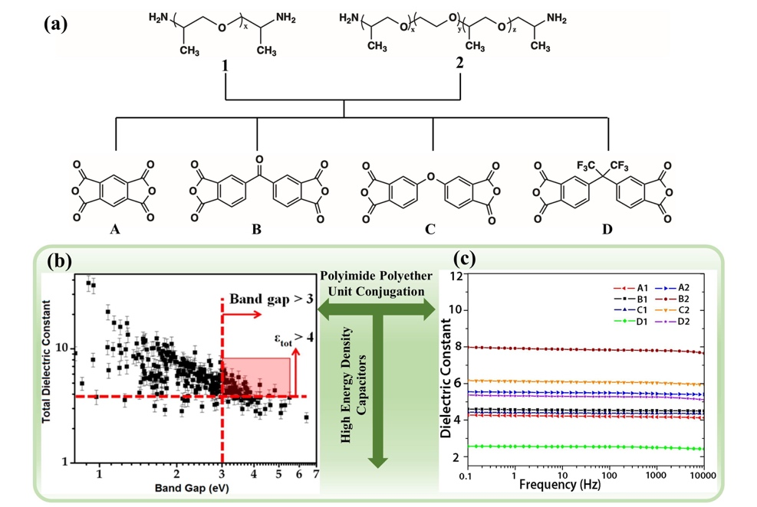

Fig. 10. (a) Monomers of Polyimides A1−D2. (b) DFT-based initial screening results. (c) ε_{r} vs frequency for various types of PI at room temperature.¹⁵

polar sulfonyl moiety, moderately flexible structure and aromatic nature of the PI were the main reasons for the excellent heat resistance and dielectric properties.
Ma et al. used high-throughput DFT computations to identify polymers with high ε_{r} and band gap.¹⁵ As shown in Fig. 10(a), a series of PIs were selected as potential polymer materials. PI of B2 (fabricated by B and 2) with the longest cross-conjugated system and polyether segment exhibited the highest ε_{r} (7.80) of all samples, but lowest band gap (3.48 eV). A further PI with a trifluoromethyl group, which resulted in less efficient molecular packing, gave a much lower ε_{r} (2.50), but exhibited the highest band gap (3.98). As a result, a negative correlation between the band gap and the ε_{r} was observed for these samples shown in Fig. 10(b) and (c).
3.2.2. Introduction of side chains on PI. Groups containing bulky or long molecular chains also have been introduced in the side chain of PI to improve its dielectric properties. Zuo et al. designed and synthesized novel polymers containing a cross-linkable olefin group and a long alkyl chain with biphenyl.⁷² These two polyimides showed low tanδ es (<0.02; 10³−10⁷ Hz) and good thermal stability. The crosslinked polymer also showed a relatively low leakage current density due to the inhibition of ion migration and a pinhole-free surface morphology. Liaw et al. used a novel diamine to prepare poly(pyridine imide).⁷³ The polymer also exhibited good thermal stability and high ε_{r} (4.20 at 10³ Hz), which was attributed to the rigid pyridine heterocyclic diamine and the naphthyl group. Venkat et al. synthesized a fluorinated polyimide post-functionalized with pendant adamantyl esters.⁷⁴ The PI had a high thermal stability (T_{g}=305 ℃) and ε_{r} was relatively stable (2.85−2.91) from room temperature to 250 ℃ at 10⁴ Hz.
3.2.3. PI copolymer. PI copolymers with high energy density can be obtained by regulating the dipolar polarization at the molecular level. However, the dipoles are restricted because of the weak dipolar polarization caused by the rigid structure of PIs. Adding flexible segments to the backbone can provide the polymer chain rotational flexibility for partial segment movement and increase the dielectric permittivity. The combination of rigid and
flexible segments create free volume in the polymer and reduces the restriction on dipoles, helping to reduce dielectric loss. For example, Li et al. prepared a PI copolymer (BTDA-HK25) that exhibits low tanδ (< 0.01) and high ε_{r} (4.5) and energy density (12 J·cm⁻³, η > 90%).⁷⁵ There are also cases of using physical methods (blending of two polymers) to reduce the restriction on the dipole to increase the ε_{r}, which will be explained in section 3.3.
Ma et al. also used pyromellitic dianhydride and various short-chain diamines to produce PIs with high imide density.⁷⁶ The ε_{r} of the synthesized homopolymers and copolymers ranged from 3.96−6.57. An improved understanding of the structure-property relationship of these PIs was obtained by combining these experimental results with the theoretical dielectric calculations from DFT.
Introducing conductive oligomers into the PI matrix is another strategy. Among them, copper phthalocyanine has attracted attention as a semiconductor. Chen et al. synthesized a homogeneous organometallic copolymer of copper phthalocyanine oligomer grafted to polyimide (CuPc–PI) via a polycondensation between copper phthalocyanine anhydride oligomer (o-CuPcA) and an amino-capped polyamic acid, as shown in Fig. 11(a) and (b).¹⁴ The CuPc-PI, containing 30 wt% o-CuPcA, showed high ε_{r} (23.2; 10² Hz) and energy density (0.55 J·cm⁻³) in Fig. 11(c) and (d). The tanδ, due to dipolar polarization and interfacial polarization, was increased by increasing the o-CuPcA content and reduced by increasing the frequency.
3.3. PI blends
By mixing two or more polymers with different molecular structures and dielectric properties to combine their respective advantages, the resulting blend can be improved in energy storage performances. This is a simple and feasible preparation method that can obtain satisfactory interface compatibility. Two high-T_{g} glassy state dipolar polymers, i.e., PEI and poly(ether-methyl-ether-urea) are blended to improved free volume for dipoles in the composites.⁷⁷ This proved that significantly reduces the constraints in dipoles produces a higher ε_{r} without compromising the tanδ.
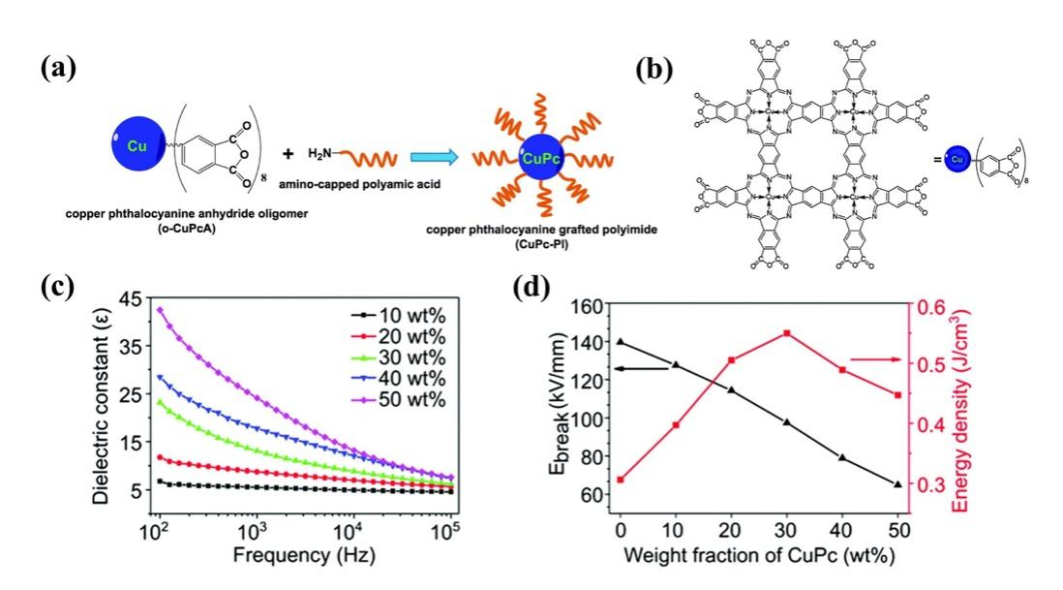

Fig. 11. (a) The polycondensation between o-CuPcA and amino-capped polyamic acid. (b) The chemical structure of o-CuPcA. (c) The frequency dependent ε_{r} of the CuPc–PI films. (d) The E_{b} and U_{e} of the CuPc-PI films.¹⁴

Researchers have tried to improve PI energy storage performances by introducing high-ε_{r} polymers such as of PSF,⁷⁸ LNBR,⁷⁹ PVDF,⁸⁰ β-CD⁸¹ and Sn-polyester⁸². Regrettably, it comes at the cost of a drop in breakdown strength. A substantial increase in energy density cannot be guaranteed. At present, researchers are more inclined to pay attention to the synergistic improvement of ε_{r} and E_{b}.
Ahmad et al. designed all-organic blend films made of poly(arylene ether urea) (PEEU) and PI. The blend film with 15 wt% PEEU exhibited a high ε_{r} of 4.73, low tanδ of 0.3%, high T_{g} of 353 ℃ and the highest energy density of 5.14 J·cm⁻³ at 495.65 MV·m⁻¹.⁸³ Moreover, the dielectric properties of the PEEU/PI films showed excellent temperature stability in the range of −50 ℃−250 ℃. Next, Ahmad et al. introduced aromatic polythiourea (ArPTU) into the PI matrix and found that the 10 wt% ArPTU blend film exhibited the highest E_{b} of 443 MV·m⁻¹, which was 74% higher than pure PI, as well as high U_{e} of 4 J·cm⁻³.⁸⁴
Molecular semiconductors have higher electron affinitie than dielectric polymers, which can capture injected and excited electrons through strong electrostatic attraction in Fig. 12(a) and (b). This can generate a larger trap energy level, compared with the insulating nanostructures in previous high-temperature polymer nanocomposites. As shown in Fig. 12(c), the latter mainly introduces trap sites by modifying the polymer chain conformation and the arrangement in the two-phase interface. Yuan et al. chose three molecular semiconductors, namely ITIC, PCBM, and DPDI, with electron affinities of 3.9, 4.2, and 4.0 eV, respectively.⁸⁵ The electronegative elements in these molecules were shown in the DFT
calculation of the electrostatic potential distribution in Fig. 12(d)−(f). Quantitative molecular surface analysis revealed more positive electrostatic potential on their surface, indicating the attraction to electrons. The activation energy associated with carrier trapping was determined by the temperature-dependent electrical conductivity results in Fig. 12(g). Obviously, the all-organic composites had higher activation energies than PEI/BNNS, indicating larger trap depths. Molecular semiconductors had a significant impact on the charge injection and transport in polymers, which were more effective than insulating nanostructures in fixing free charges. The emphasis of the evaluation was on U_{e} achieved at a high η level (above 90%), in order to avoid overwhelming device heating by the energy loss in the applications. At 150 ℃, the U_{e} of the composites ranged from 3.4 to 4.5 J·cm⁻³ with η > 90%, while that of pure PEI is only 1.0 J·cm⁻³ (Fig. 12(h)). What is more noticeable was that the maximum U_{e} of the composites with η > 90% is still as high as 3.0 J·cm⁻³ at 200 °C in Fig. 12(i). The PI composite films containing polyconjugated ladder structure (PcLS) treated at high temperature (480 ℃) was also prepared. The PcLS-PI composite film achieved a maximum U_{e} of 4.33 J·cm⁻³.
3.4. Multi-layer structure
Compared with single-layer polymer composite films formed by blending different polymers, multi-layer polymer films can easily combine the advantages of different polymer layers. In addition, the interface between adjacent layers can form interfacial polarization and restrain the growth of breakdown paths, leading

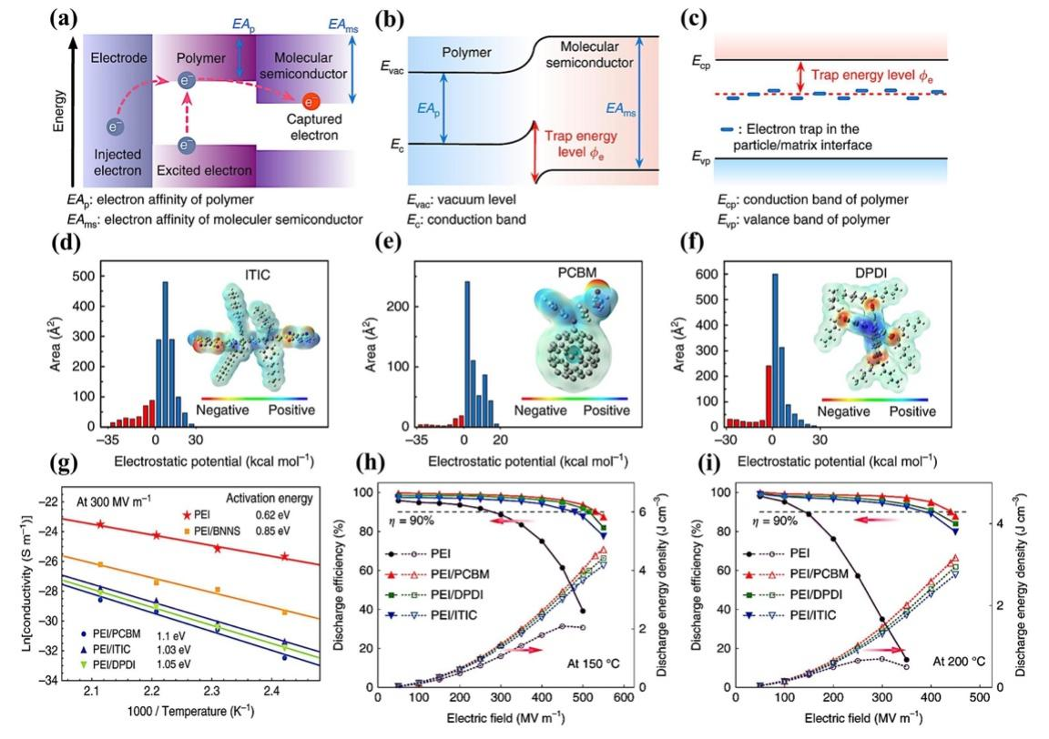

Fig. 12. (a) Band diagram showing possible charge transfer in the all-organic composites. Schematic illustrations of trap energy level in (b) all-organic composites and (c) polymer/insulating particle nanocomposites. Electrostatic potential distribution and area percentage in each electrostatic potential range of (d) ITIC, (e) PCBM and (f) DPDI. (g) Arrhenius function of conductivity for the pure PEI, all-organic composites and PEI/BNNS nanocomposite measured at 300 MV·m⁻¹. The energy density and discharge efficiency of PEI, PEI/PCBM, PEI/DPDI and PEI/ITIC composites at (h) 150 ℃ and (i) 200 ℃.⁸⁵

to an increase in ε_{r} and E_{b}. And the design of the film as a layered structure also provides conditions for further enhancing U_{e} by optimizing the stacking structures. Sandwich structure strategy is applied to improve the energy storage performance of polymer composites, and can be divided into positive sandwich structure and reverse sandwich structure. The basic principle of the positive sandwich structure composite is to insert a high-ε_{r} polarization layer between two insulating layers with high E_{b}. The insulating layer will withstand most of the applied voltage and restrain the breakdown of the nanocomposites. The reverse sandwich structure composite has high-ε_{r} polarization layers as the outer layers, and a high-E_{b} insulating layer as the middle layer. Wang et al. prepared positive sandwich structure films (the middle PVTC layer and the outer PEI layers), reverse sandwich structure films and single-layer blend films for comparison.⁸⁷ The positive sandwich film PEI-15vol%PVTC-PEI showed excellent temperature stability between 25 ℃ and 100 ℃. For example, its U_{e} and η were mainly maintained at about 8 J·cm⁻³ and 80%, respectively. However, the U_{e} of the reverse sandwich structure film 7.5 vol% PVTC-PEI-7.5 vol% PVTC had a sharp decline after 75 ℃, which showed that the PEI outer layer can effectively protect the energy storage performances of the middle PVTC layer at high temperature condition. So far, the design of most layer-structured composite films is trying to achieve higher U_{e}. However, enhanced U_{e} is always accompanied by suppressed η. As shown in Fig. 13(a), Sun et al. introduced a transition layer the PEI/P(VDF-HFP) blend composite between the linear dielectric layer PEI and the nonlinear dielectric layer P (VDF-HFP), forming a unique asymmetric trilayer linear-transition-nonlinear (LTN) structure.⁸⁸ Compared to single-layer films (pure PEI, pure PVDF, blended PEI/PVDF ) and PEI-P(VDF-HFP) bilayer composites, asymmetric trilayer composites with LTN structure exhibited significantly excellent energy storage performance in Fig. 13(d) and (e). The E-20 vol% E/F-F composite had obtained both a high η of 89.9% and a
high U_{e} of 12.15 J·cm⁻³. The composite with LTN structure was effective to realize the synergistic improvement of U_{e} and η. In Fig. 13(f), the U_{e} of E-20 vol% E/F-F films almost kept constant after 1.5×10⁵ charge-discharge cycles, indicating the outstanding cycling stability. Fig. 13(b) and (c) described that the radar plots intuitively illustrated the influence of the LTN structure configuration of the composite films on the energy storage performance. Compared with the symmetrical NTN structure, the asymmetrical LTN structure exhibited a lower tanδ, higher U_{e} and significantly improved η.
4. PI nanocomposite dielectrics
High-temperature performance is critical for next-generation of polymer dielectric capacitors operating in harsh environments. The properties of polymer matrices play an important role in determining the high temperature resistance and energy storage of composites. Composites of different polymer matrices exhibit different high-temperature dielectric properties, despite using the same fillers and preparation methods.⁸⁹ Zhou et al. deposited SiO₂ on both sides of a variety of polymer films (PEI-SiO₂, PEN-SiO₂, PI-SiO₂, PC-SiO₂ and FPE-SiO₂) using the same production technique.⁹⁰ At 150 ℃, when η > 90%, the U_{e} value of the PEI-SiO₂, PEN-SiO₂, PI-SiO₂, PC-SiO₂ and FPE-SiO₂ composite films reached 2.12, 1.75, 1.24, 1.79, and 2.06 J·cm⁻³, which were 236, 672, 510, 1279 and 644% greater than the corresponding pure films, respectively. The preparation of various films demonstrated the versatility of this method. Both the PEI-SiO₂ and PI-SiO₂ films achieved satisfactory performance while and the former attained the highest U_{e} value.
4.1. Effects of fillers on PI nanocomposites
4.1.1. Morphology of fillers. The nanofillers used to reinforce the PI can be mainly divided into conductive and non-conductive
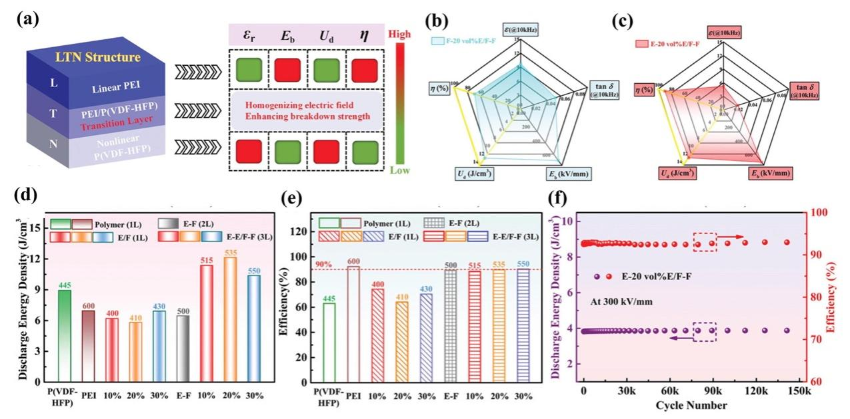

Fig. 13. (a) Schematic illustration of the dielectric energy-storage characteristics of the asymmetric LTN structure. The radar plots of the (b) F-20vol% E/F-F symmetric trilayer composite and (c) E-20vol% E/F-F asymmetric trilayer composite. The (d) U_{e} and (e) η of pure PEI, pure P(VDF-HFP), PEI-P(VDF-HFP) bilayer composite and asymmetric trilayer composites. (f) The cycling stability performance of E-20vol% E/F-F asymmetric trilayer composite.⁸⁸

fillers. When conductive fillers are introduced into polymers, the dielectric properties of nanocomposites are mainly determined by percolation mechanism. When the concentration of conductive fillers reaches a critical volume faction, the fillers will tend to contact each other to form conductive paths in the nanocomposites.⁴⁴ A significantly higher ε_{r} can be achieved by adding a small amount of conductive filler at concentrations below the percolation threshold. For example, when the content of silver nanowire (AgNW) in AgNW/PI composite film was 0.084, the ε_{r} reached 126.⁹¹ Nanocomposites of PI with multiwalled CNT (PI/MWCNTs) containing 12 vol% MWCNT achieved a U of 1.96 J·cm⁻³ and good thermal stability.³⁴ Non-conductive fillers mainly comprise ceramic fillers with high ε_{r} or wide band gap. For example, the U_{e} of the BaTiO₃ nanofiber/PI composite film was > 2.1 J·cm⁻³ at 150 ℃ when the efficiency was > 90%.²⁹ Beier et al. prepared a Ba_{0.7}Sr_{0.3}TiO₃ (BST)/PI nanocomposites.⁹² At an addition level of 10 vol% BST, the observed increases in ε_{r} and E_{b}, together with a decrease in tanδ, were desirable characteristics. Li et al. prepared a ternary PEI/BTNP/BNNS nanocomposite with optimized filler compositions to provide a U_{e} of 2.92 J·cm⁻³ at 150 ℃.⁹³ Ai et al. also showed that the introduction of Al₂O₃ or HfO₂, which possessed a large band gap and a moderate ε_{r}, significantly improved E_{b}, U_{e} and η of the composites.⁹⁴
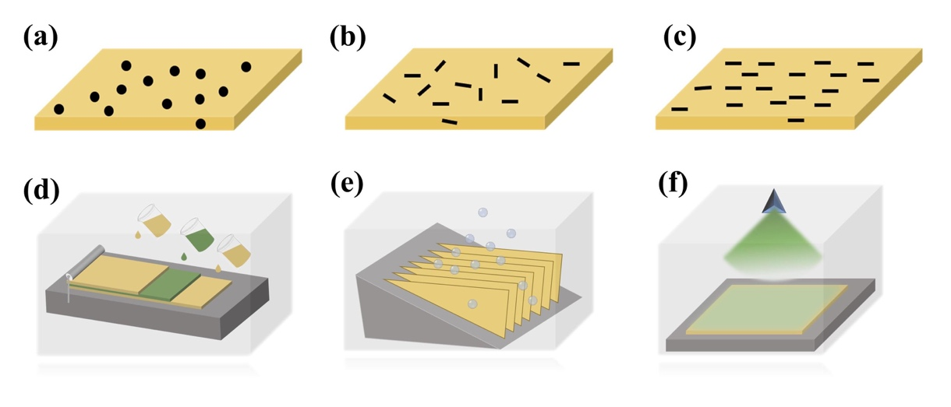
The diameter and shape of nanoparticle fillers in the PIs matrix cause changes in dielectric properties. Compared with BaTiO₃ nanoparticles/PI (BT-NP/PI) composites, the introduction of BT nanowires showed more obvious improvement on the dielectric properties of the composites.⁹⁵ Cheng et al. incorporated wide-band gap two-dimensional MoS₂ into PI, and the energy density of the nanocomposite film increased to 3.35 J·cm⁻³.⁹⁶ Li et al. also explored the strong dependence of conductive behavior and E_{b} on the filler morphology of polymer composites.⁹⁷ In addition, the effect of filler particle size was also studied. For example, the effect of alumina nanofiller particle size on the dielectric response of PEI nanocomposites was investigated.⁹⁸ The composition range in which the dielectric enhancement occur was broader for larger-size nanoparticles. Large size nanofillers required a higher volume content to achieve the similar interfacial effects of smaller size
nanofillers.
4.1.2. Distribution of fillers. Zero-dimension (0D) fillers, such as spherical nanoparticles, are generally dispersed in polymers by means of self-assembly. One-dimension (1D) and two-dimension (2D) fillers can be aligned to improve dielectric properties, as shown in Fig. 14(a)−(c). Dong et al. reported that the ε_{r} of the parallel-aligned MWCNT@Fe₃O₄/PI film (1.6 wt%) was 52.75 at 58 Hz.⁹⁹ Similar phenomenon was also observed in other polymer matrices. For example, BaTiO₃/P (VDF-HFP) composites containing orthotropic-oriented BaTiO₃ nanofibers exhibited the highest energy density of about 25.5 J·cm⁻³ at 690 kV·mm⁻¹, and the discharge efficiency was about 76.3%.¹⁰⁰
Multi-layer structures can be used to change the distribution of the physical field controlled by fillers, and thus improve the dielectric properties.⁴⁰ The multilayer structure have been constructed by a variety of methods, such as layer-by-layer solution casting,¹⁰¹ freeze-drying,¹⁰² vapor deposition⁷ and magnetron sputtering,¹⁰³ as shown in Fig. 14(d)−(f). For instance, when boron nitride nanosheets (BNNS) and reduced graphene oxide (RGO) were distributed in PI and assembled into a novel micro-sandwich structure, a high permittivity (~579) and high energy density (14.2 J·cm⁻³) were obtained.¹⁰² When a hexagonal boron nitride (h-BN) film was prepared using chemical vapor deposition (CVD) and transferred to a PEI film, the energy density of the film was 1.19 J·cm⁻³ at 200 ℃.⁷
4.1.3. Simple surface modification of fillers. Nanoscale fillers are easily agglomerated in the matrix due to their high surface energy. The low surface energy of polymers makes a significant difference of surface energies between them, resulting in poor interface compatibility. This causes structural defects and an electric field concentration, resulting in a sharp decrease in E_{b} of the dielectrics. Therefore, improving interface compatibility and filler dispersion is vital to nanocomposites. At present, the surface of nanoparticles has been modified by hydroxylation, carboxylation and the use of other molecules. However, these methods still have some limitations, as the modifier does not usually contribute to the performance enhancement of nanocomposites.⁴⁶ To realize the full potential of nanofillers, researchers prefer to use core-shell

Fig. 14. Distribution of fillers in polymer: (a) 0D fillers, (b) self-assembled 1D or 2D fillers and (c) oriented 1D or 2D fillers. Multilayer films preparation process: (d) layer-by-layer solution casting, (e) freeze-drying and (f) vapor deposition or magnetron sputtering.

structures (see section 4.1.4).
4.1.4. Core-shell structure nanofillers. To increase the energy density and high temperature resistance of PI nanocomposites, considerable progress has been made in the design and synthesis of core-shell structure nanofillers. They can be divided into two types, i.e. organic shell structure and non-organic shell structure, as shown in Fig. 15. The organic shell layer contains organic molecules with specific functions coated on the surface of the nanofiller, which can be connected to the monomers or terminal-groups through physical or chemical methods. The non-organic shell layer (e.g. ceramic shell, metal shell, carbon shell) is deposited on the surface of the nanofillers by various methods.⁴⁶ The commonly used methods contain hydrothermal, sol-gel and electrostatic spinning etc. The selection of a method depends on the nature and thickness of the non-organic shell and the morphology of the core. Table 3 summarizes the dielectric properties of PI nanocomposites containing different core-shell structure fillers.
4.1.4.1. Organic shell layer. The interaction between nanoparticles and polymers is critical to the microstructure and even the final performances of nanocomposites. Organic shells can provide strong interaction with nanofillers and polymer matrix, thereby improving uniform dispersion of the nanoparticles. And because of the similar chemical structure, the polymer matrix and the nanofillers with organic shells have better compatibility.
Wu et al. designed PI nanocomposites with core-shell structure of barium titanate @polydopamine (BT@PDA) nanoparticles.¹⁰⁴ The existence of the PDA shells optimized the dispersion uniformity and interface compatibility of BT nanoparticles in the PI matrix, thereby reducing the local electric field distortion in the nanocomposites. The PI nanocomposite containing 1 vol% BT@PDA nanoparticles exhibited the highest energy density of 1.94 J·cm⁻³ at 315 MV·m⁻¹.
Zhu et al. modified the surface of halloysite nanotubes (HNTs) with polyaniline (PANI) to prepare PANI-HNTs/PI nanocomposite film, which possessed the ε_{r} of 17.3 with a low tanδ of 0.2 at 100 Hz, and the U_{e} of 0.93 J·cm⁻³.¹⁰⁵ Fang et al. coated PANI on graphene oxide (GO) using in situ polymerization to obtain GO@PANI, which
then reduced with hydrazine to fabricate RGO@R-PANI.³² The obtained "insulator-conductor-insulator" structures were evenly distributed in the PI matrix. RGO nanosheets were completely isolated by R-PANI, which was conducive to the formation of a microcapacitor structure and prevented current leakage. The ε_{r} and tanδ of the 20 wt% RGO@R-PANI/PI nanocomposite film were 25.84 and 0.11, respectively. Furthermore, the T_{d5%} of the 20 wt% RGO@R-PANI/PI was 480 ℃, indicating that the nanocomposite film had great potential in the field of high temperature dielectric materials.
Fang et al. introduced the oxygen functional groups on the surface of GO to prepare NH₂- and carboxyl-functionalized GO (PPD-CFGO), which participated in the in-situ polymerization of PI.¹ Since the polymer chains were anchored on the surface, the GO was effectively prevented from irreversible agglomeration. The ε_{r} of the 4 wt% PPD-CFGO/PI nanocomposite film was up to 36.9, which was 12.5 times higher than that of pure PI, while the tanδ was only 0.0075.
4.1.4.2. Non-organic shell layer. Organic shells may cause additional energy loss at high temperatures due to molecular relaxation and relatively poor thermal stability.^{10,44} It is expected that inorganic shells have better thermal stability, allowing nanofillers to obtain low energy loss. When high-ε_{r} fillers are introduced into low-ε_{r} polymers, the large difference in ε_{r} between the two phases can cause a local electric field concentration. The introduction of an inorganic buffer layer with a moderate ε_{r} is usually an effective method to achieve the desired dielectric properties of the nanocomposites. Wang et al. prepared BaTiO₃@SiO₂ nanofibers by electrospinning prior to the preparation of BT@SiO₂/PI nanocomposite films.¹⁰⁶ SiO₂ has an extremely low tanδ and moderate ε_{r}. The SiO₂ layers that isolated the PI and BT nanofibers alleviated the electric field concentration between the two phases and enhanced the E_{b} of the PI nanocomposite films. Compared with the pure PI (maximum U_{e}=1.42 J·cm⁻³; E_{b}=308 MV·m⁻¹), the composite film containing 3 vol% BT@SiO₂ had a maximum U_{e} of 2.31 J·cm⁻³ at an E_{b} of 346 MV·m⁻¹. The TGA results
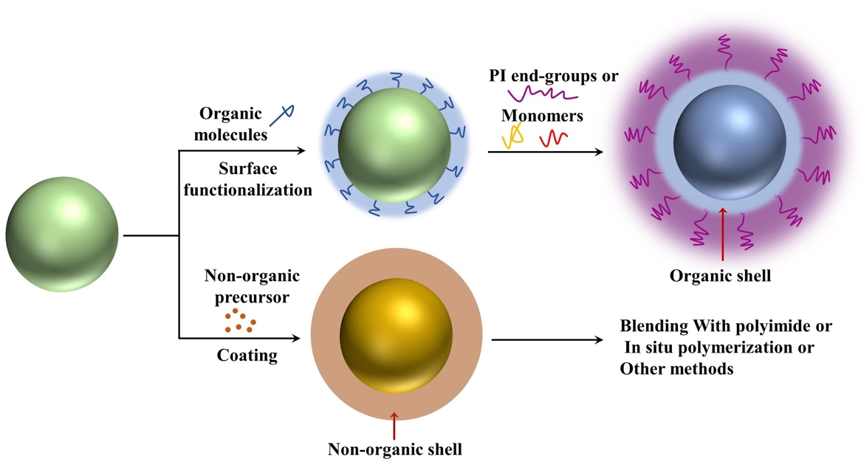

Fig. 15. General methods for the synthesis of core-shell nanofillers for PI nanocomposites.

indicated that the BT@SiO₂/PI nanocomposite films had good thermal stability below 500 ℃. Wang et al. also adopted the same method to prepare the 2 vol% BT@ZrO₂/PI composite film, which achieved a maximum U_{e} of 2.53 J·cm⁻³ at an E_{b} of 361 MV·m⁻¹.¹⁰⁷ The PI nanocomposites filled with CaCu₃Ti₄O₁₂@TiO₂ (CCTO@TiO₂) nanofibers have also been studied, which obtained the maximum energy density of 1.6 J·cm⁻³.¹⁰⁸
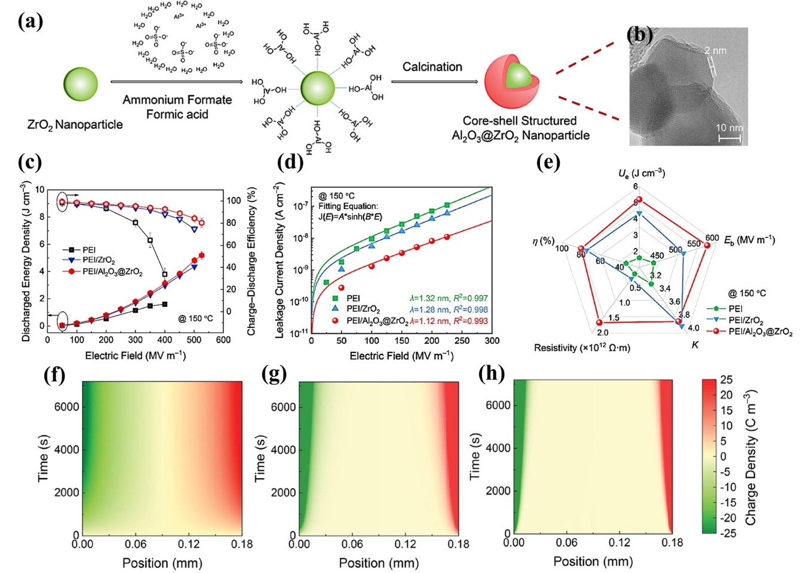
Ren et al. described the PEI nanocomposites filled with core-shell structured nanoparticles composed of ZrO₂ core and Al₂O₃ shell, as shown in Fig. 16(a) and (b).¹⁰⁹ The introduction of the core-shell structures had achieved both improved E_{b} and ε_{r}, along with greatly reduced energy loss, so that high U_{e} was obtained. For example, Fig. 16(c) showed that the U_{e} of the PEI/Al₂O₃@ZrO₂ nanocomposite was 3.11 J·cm⁻³ and η was 92.6% at 150 ℃ and 400 MV·m⁻¹. In Fig. 16(d), compared to pure PEI and PEI/ZrO₂ nanocomposites, the core-shell structured nanocomposites with wide band gap Al₂O₃ shell showed impressive improvements in dielectric and capacitance properties, including electrical resistivity, ε_{r}, E_{b}, U_{e} and η. In terms of microscopic mechanism, Fig. 16(e) showed that the hopping distance decreases from 1.32 nm of pure PEI to 1.28 and 1.12 nm of the PEI/ZrO₂ and PEI/Al₂O₃@ZrO₂ nanocomposites. The reduction in the hopping distance indicated a higher level of trap density caused by the encapsulation of the Al₂O₃ shell. As shown in Fig. 16(f)−(h), the space charge behavior
in pure PEI and nanocomposites was simulated. After an electric field of 50 MV·m⁻¹ was applied, electrons and holes were gradually injected from the electrode, forming the homocharge accumulation near the electrodes. Compared with pure PEI, the space charge injection was restrained after adding ZrO₂ nanoparticles, and further suppressed by using core-shell Al₂O₃@ZrO₂ nanoparticles.
Conductive fillers often use shell structure strategies to buffer the huge difference in the dielectric permittivity of the polymer/filler two-phase interface, thereby suppressing leakage current and reducing tanδ. Liu et al. prepared BT@GO/PI composites by the incorporation of covalently bonded BT@GO hybrids.¹¹⁰ The ε_{r} was as high as 285 (100 Hz), which was 80 times that of pure PI film, and the tanδ was 0.25. Similarly, Liu et al. obtained a SiO₂@GO/PI composite film, which achieve a ε_{r} of 73 and low tanδ of 0.38.¹¹¹
In addition to coating the ceramic dielectrics on the filler surface, conductive materials such as C and Ag were also considered as new surface coatings to modify the dielectric properties of nanocomposites. Yang et al. prepared a PI embedded with CCTO/Ag nanoparticles by functionalizing the surface of CCTO nanoparticles with an Ag coating.¹¹² At the 3% CCTO@Ag loading, the ε_{r} of the CCTO@Ag/PI nanocomposite was as high as 103 at 10² Hz. This could be attributed to the increased conductivity of the silver layer between CCTO and PI, which enhanced the space charge

Fig. 16. (a)Schematic of the synthesis and (b) TEM of the Al₂O₃@ZrO₂ nanoparticles. (c) The U_{e} and η, (d) leakage current density and (e) comparison of the dielectric and capacitive parameters of pure PEI, PEI/ZrO₂ nanocomposites and PEI/Al₂O₃@ZrO₂ nanocomposites at 150 ℃. Simulation results of space charge distribution of (f) pure PEI, (g) PEI/ZrO₂ nanocomposites and (h) PEI/Al₂O₃@ZrO₂ nanocomposites with a decay time of 7200 s under 50 MV·m⁻¹.¹⁰⁹

polarization and the Maxwell-Wagner-Sillars effect. The electric field distortion in the CCTO/PI and CCTO@Ag/PI nanocomposites was numerically simulated (COMSOL Multiphysics®). The introduction of CCTO nanoparticles resulted in high ε_{r} and high tanδ due to the pores and electric field distortion. Although Ag particles on the surface of the CCTO were conductors, the low tanδ (0.018 at 10² Hz) for CCTO@Ag/PI was due to the improved electrical distortion and blocked charge transfer by the insulating PI chains. Wang et al. prepared functionalized core-shell structure AgNW/PI hybrid films.⁹¹ The hybrid films exhibited good thermal stability (T_{d5%} > 500 ℃). The maximum ε_{r} was 126 at 10² Hz, while maintained a relatively low dielectric loss.
4.2. Effect of multi-layer structures on PI nanocomposites
It is generally believed that the introduction of high-ε_{r} nanofillers significantly reduces the breakdown strength due to local electric field concentration, which limits the increase in energy density to a large extent. Therefore, the simple surface modification and core-shell structure design techniques discussed in Section 4.1.3 and Section 4.1.4 are explored from the perspective of fillers. Recently, dielectric polymer nanocomposites with multilayer structures have emerged to solve the paradox between high-ε_{r} and high-E_{b} in single-layer composite films. By systematically changing the interface, chemical structure and ratio of the constituent layers, the electric field distribution can be adjusted to greatly improve the energy density.⁴⁰ Table 3 summarizes the properties of multilayered PI nanocomposite films. Xie et al. used PI as the bottom insulating layer to provide high E_{b}, and the P(VDF-CTFE)/BT nanocomposite as the top layer to ensure high ε_{r}.¹¹³ The linear/ferroelectric bilayer dielectric material exhibited enhanced E_{b} and ε_{r}, which was attributed to the interface barrier and interface polarization effects between the two layers. The bilayer structure revealed the influence of the synergistic double interface effects on the energy storage performances of nanocomposites, and achieved an ultra-high U_{e} of 14.2 J·cm⁻³.
The structural characteristics of the sandwich structure nanocomposites bring additional opportunities to adjust the energy storage performance. Positive sandwich structure nanocomposites have been constructed. Cai et al. used the BNNS/PI nanocomposites as the outer layers and ZnO/PI nanocomposite as the middle layer to prepare positive sandwich structure nanocomposites (ZnO/PI-S).¹¹⁴ The outer layers served as an effective barrier to leakage current, thereby simultaneously improving the E_{b} and η, while the ZnO/PI middle layer was used to increase the ε_{r}. Due to the advantages of filler selection and structural design, the U_{e} of the ZnO/PI-S film can reach 5.29 J·cm⁻³ at 150°C. Moveover, the ZnO/PI-S film exhibited the reduction of U_{e} and η were less than 5% over 10,000 cycles at 150°C. Chi et al. prepared composite films using 0.5Ba(Zr_{0.2}Ti_{0.8})O₃-0.5(Ba_{0.7}Ca_{0.3})TiO₃/PI (BZT-BCT/PI) with different volume fractions as the middle layer and 5 vol% h-BN/PI as the top and bottom layers.¹⁰¹ The h-BN in the top and bottom layers introduced good thermal and insulating properties, which improved heat dissipation and decreased the energy loss in the three-layer composite film. At 25 ℃ and 150 ℃, the breakdown strengths and storage densities of the composite film with 1 vol% BZT-BCT were 360 and 350 MV·m⁻¹, 2.3 and 1.83 J·cm⁻³, respectively.
The reverse sandwich structure nanocomposites also have been designed. For example, Chen et al. used pure PI (high E_{b}) as the middle layer with KTa_{0.5}Nb_{0.5}O₃ nanoparticle/PI (KTN/PI) composite films as two outer layers to prepare a three-layer KTN/PI structure (t-KPI) composite film.¹¹⁵ The maximum U_{e} of t-KPI containing 2 vol% KTN was 3.0 J·cm⁻³ at an E_{b} of 300 MV·m⁻¹, which was much higher than the single-layer KTN/PI (1.5 J·cm⁻³, E_{b} 210 MV·m⁻¹).
The above sandwich-structured composite films were prepared by in-situ polymerization and layer-by-layer solution casting. These solution-based methods were tedious and unsafe, and many polymers were insoluble. Azizi et al. prepared h-BN films using CVD prior to transfer onto PEI to obtain h-BN/PEI/h-BN composite films.⁷ At 100 ℃, the U_{e} and η of h-BN-coated PEI could attain 2.93 J·cm⁻³ and > 90%, respectively. It was interesting to note that the h-BN/PEI/h-BN films operated efficiently and provided high energy densities at a temperature close to the T_{g} of the polymer, i.e. at a temperature where the dielectric properties of pure PEI usually failed. The film also showed excellent cyclability and dielectric stability at high temperatures over 55000 consecutive charge-discharge cycles. However, the preparation of the h-BN/PEI/h-BN films required multiple steps, including the transfer of BN obtained by CVD to PEI, hot pressing and removal of the catalyst layer. Zhou et al. demonstrated that improved high-temperature dielectric polymers could be prepared via a combined dielectric-barrier-discharge plasma-enhanced chemical vapor deposition (PECVD) and roll-to-roll processing.⁹⁰ The method was readily adaptable to large-scale production of various surface-functionalized polymer films, as shown in Fig. 17(a). BOPP films modified each side with SiO₂ (BOPP-SiO₂) were prepared. The wide-band gap SiO₂ layer increased the potential barrier at the electrode/dielectric interface, which impeded the charge injection and greatly reduced space charge densities. Compared with the pure BOPP films, the BOPP-SiO₂ films had an improved U_{e}, as shown in Fig. 17(b) and 17(e). In Fig. 17(c) and 17(d), various polymer dielectric films were prepared, such as PI, FPE, PEI, PEN, and PC films. At 150 ℃, when η > 90%, the maximum U_{e} of PEI-SiO₂, PEN-SiO₂, PI-SiO₂, PC-SiO₂ and FPE-SiO₂ composite films reached 2.12, 1.75, 1.24, 1.79 J·cm⁻³, respectively. At 100 ℃ and η > 90%, U_{e} was 3.0 J·cm⁻³ for the PEI–SiO₂ film versus 2.9 J·cm⁻³ of the h-BN/PEI/h-BN film. Cheng et al. prepared BN/PI films using physical vapor deposition (PVD) technology, which discharged an energy density of 0.493 J·cm⁻³ with η of over 90% at 150 ℃.¹⁰³
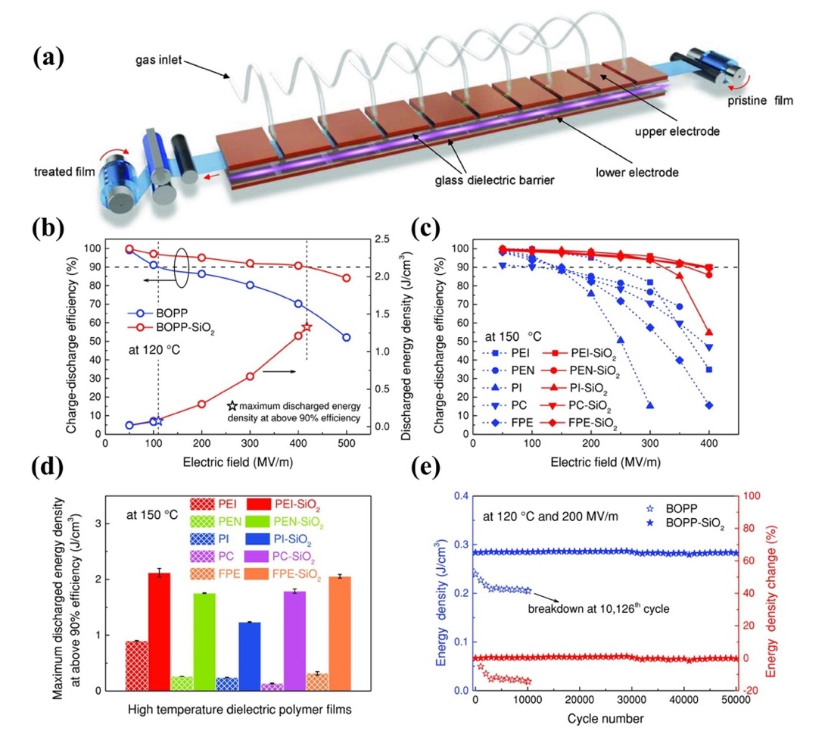
Guo et al. fabricated novel RGO-PI/BNNS-PI micro-sandwich composites by assembling conductive RGO and insulating BNNS layers in a PI matrix using a sequential bidirectional freeze casting technique.¹⁰² The large difference in electrical conductivities originated from the alternate stacking of RGO and BNNS achieved a high ε_{r} and a moderate E_{b}. The separated RGO and BNNS layers ensured that phonons were transmitted between the same species through the interface, resulting in higher thermal conductivity, as shown in Fig. 18(a). The micro-sandwich structure films achieved a high ε_{r} (~ 579), low tanδ (~ 0.25), high thermal conductivity (1.49 W·m⁻¹·K⁻¹) and high energy density (14.2 J·cm⁻³) by optimizing filler content as shown in Fig. 18(b)−(e). Dong et al. fabricated a series of o-BNNS-AgNW/PI nanocomposites by combining ice-templating
Fig. 17. Preparation and dielectric performances of various surface-functionalized polymer films: (a) Schematic of the roll-to-roll PECVD method, (b) η and U_{e} of BOPP and BOPP-SiO₂ films at 120 ℃, (c) η at 150 ℃ of five dielectric films, (d) maximum U_{e} above 90% efficiency at 150 ℃ of five dielectric films before and after coating, (e) U_{e} obtained from cyclic fast discharge tests of BOPP and BOPP-SiO₂ films.⁹⁰
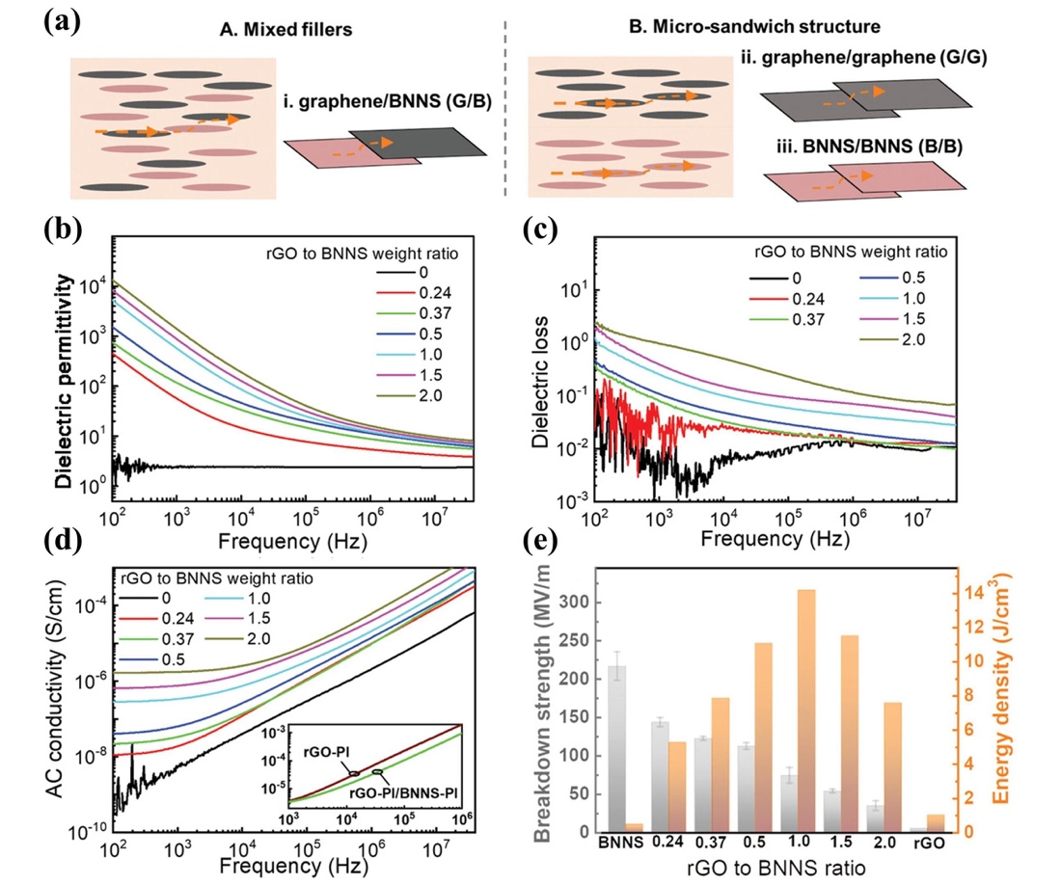
Fig. 18. Phonon pathways and dielectric properties of BNNS-PI, RGO-PI, and RGO-PI/BNNS-PI nanocomposites with different RGO to BNNS weight ratios: (a) Phonon transport pathways in composites containing randomly mixed fillers of graphene and BNNS (A) and composites with a micro-sandwich structure (B), (b) ε_{r}, (c) tanδ, (d) AC conductivity, (e) E_{b} and U_{e}.¹⁰²

self-assembly and hot-pressing technology.¹¹⁶ The oriented distribution of BNNS and the thermal conduction bridge formed by introducing AgNW achieved a significant improvement in thermal conductivity. In addition, the nanocomposites maintained excellent electrical insulation properties and improved dimensional stability.
5. The device of PI
As an excellent polymer, PI, due to its outstanding high temperature resistance, flexibility, and ease of synthesis, has made great progress in both structural and functional materials, especially in the field of energy utilization. In the energy conversion field, PI has been fabricated into devices. For example, He et al. reported a new type of dynamic piezo-thermoelectric generator, in which Bi₂Te₃ based devices supported by the flexible PI substrate was fixed on the outer surface of a copper tube to form an annular multi-stage energy converter.¹¹⁷ The generator provided a feasible solution to utilize the low-grade mechanical/thermal energy and industrial waste heat of heating fluids. A high-performance flexible thermoelectric device with PI as the substrate was also introduced, which can be used in self-powered wearable mechatronics and flexible chip cooling in the Internet of Things. Liu et al. designed and manufactured a wearable thermoelectric generator that used flexible Cu/PI electrodes.¹¹⁸ The device achieved a high peak power density of 13.8 mW·cm⁻² at a temperature difference of 50 K. Moreover, it withstood 10,000 bending cycles, which indicated that the proposed wearable thermoelectric generator may provide real-time power supply for some applied wearable electronic products in the future.
The current field of dielectric energy storage is mainly dominated by BOPP capacitor films. However, as mentioned in the previous part of the review, BOPP have a lot of drawbacks at high temperatures, forcing our research to focus on the development of PI. The academic and commercial circles have made a lot of efforts on the performance control and processing technology of PI dielectrics in this regard, as shown in Table 3. The synthesis of PI
basically adopts the methods of thermal imidization, and the highest imidization temperature is mostly above 300 ℃. This may be to obtain a dense structure of PI film and ensure that the PI has a sufficiently high degree of imidization. In addition to traditional solution casting methods, new PI film preparation methods such as CVD and freeze casting techniques have also begun to emerge. In terms of performance improvement, the joint adjustment mechanism of E_{b}, ε_{r}, and tanδ still requires continuous attention. From the perspective of application, the performances of the new all-organic PI and PI nanocomposites summarized in this review have been greatly improved, but there is no matching large-scale preparation equipment and commercial-level capacitor assembly technology. This is one of the reasons hindering the realization of commercial-grade PI capacitor assembly technology. We look forward to overcoming the challenges to apply PI dielectrics into film capacitors (such as Winding capacitors and Embedded capacitors etc.) and organic thin film transistors, as shown in Fig. 19. In general, there have not been enough attempts to realize PI capacitor devices. From laboratory research results to commercial products, every step here requires a lot of technical effort and interdisciplinary coordination. Fortunately, various research institutions and companies have understood the necessity of developing large-scale high-temperature-resistant dielectric films and capacitor devices.
6. Summary and outlook
In the past few years, the research on the energy storage performances of intrinsic PI and PI composites has been intensified from the macro-scale to the micro-scale, especially at high temperatures. The focus of PI dielectric energy storage performance improvement has always been on the enhancement of ε_{r} and E_{b}, but it has paid a price in terms of energy loss, cost and processability. And from basic research to large-scale applications, its future still has a long way to go. Through reviewing previous work and looking forward to the future, it is believed that these
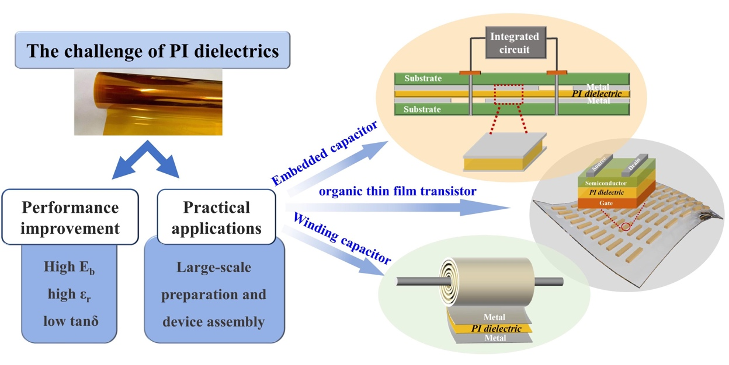

Fig. 19. The challenges and the devices of PI dielectrics in the future.

strategies require researchers to pay attention.
- From the current view, all-organic composite materials are most promising for practical applications. It can still maintain good processability while obtaining good energy storage performances. And the film forming process can be compatible with the current production process. Commercial films that can be mass-produced (such as Kapton) for organic or inorganic surface coating are also one of the feasible methods. The surface coating can have a higher uniformity of the surface structure of the polymers. Depending on the application, different types and thicknesses of coatings can be deposited on the surface of the polymer films. The key factor that needs to be considered is that the selected coating material should adhere well to the polymer films and have a temperature resistance similar to or higher than that of the polymer films.
- Then, PI synthesis is very flexible, so the molecular structure modification of PI has great potential to be tapped. In current research, the design and synthesis of intrinsic PI dielectrics are basically focused on how to improve ε_{r} and T_{g}. However, more attention should be paid to the problem of tanδ in the later stage. Especially in high temperature applications, the reduction of the tanδ of the polymer dielectrics will reduce the possibility of thermal instability to improve the efficiency and reliability of the capacitor. Dipolar polarization can increase the ε_{r} while maintaining low tanδ by methods such as introducing conjugated structures or highly polar groups into the polymer main chains or side chains. To clarify the structure-property relationships of polymer dielectrics and select the appropriate polymer molecular structure and additional groups, the "co-design" method can be employed.¹¹⁹ This method includes high-throughput computing, materials synthesis, testing and validation. The combination of theory and experiment could greatly improve the efficiency of research. The screening conditions for polymers should not be limited to ε_{r} and band gap. These properties, together with high thermal stability, low tanδ, film formation, and mechanical properties should be considered collectively to improve the overall performances. In addition, the novel PI modified in molecular structure is basically in the laboratory preparation stage, and the reaction process and yield need to be continuously optimized. Its complicated organic synthesis method and precisely controlled film manufacturing process are far from large-scale production. Therefore, new film manufacturing methods also need to be explored.
- Compared with the traditional solution-mixing methods, the core-shell structure strategy provides more possibilities for optimizing the microstructure and even electrical properties of nanocomposites. The designed polymer shell and polymer matrix have a similar chemical structure, which is critical to greatly improve the overall performance of nanocomposites. The introduction of the inorganic shell acts as a buffer layer to minimize local electric field enhancement, thereby increasing the E_{b} of the nanocomposites. Significant progress has been made in the development of nanocomposites for high-ε_{r} and energy storage through the core-shell structure strategy. By adjusting the type and thickness of the shell layer and the two-phase interface, the nanocomposites that meet the expectations can be prepared. However, it is still very laborious to maintain precise control of the synthesis of core-shell nanoparticles and the coordinated regulation of the overall performances of the nanocomposites. For example, how to ensure the quality of core-shell structured nanoparticles in large-scale production. And how to design the nanocomposites with low tanδ, good thermal stability and other ideal characteristics while having high ε_{r} and high E_{b}.
- Regardless of whether the multi-layer structures are all-organic composites or nanocomposites, the electric field distribution can be effectively adjusted through the combination of dielectric layers and insulating layers. While ensuring high ε_{r}, the composites can maintain the good insulating ability, thereby increasing the energy density. Candidates with high T_{g} that are expected to be used in the high-temperature dielectrics fields have been studied on the effect of multilayer structure on performance, but there is still a lack of systematic exploration of their high-temperature dielectric properties, especially their temperature-dependent breakdown strength. In addition, problems concerning the optimization of structural design and the development of scalable processing methods for multi-layer structure films still need to be solved urgently.
- Further research should consider the effect of thermal conductivity on the performance of high-temperature capacitors. A high T_{g} or T_{m} is not sufficient to protect a polymer from failures caused by extended heating. Increasing the thermal conductivity can improve heat dissipation and reduce potential energy losses. Therefore, thermal conductivity is an important parameter of high-temperature capacitor films that should not be overlooked. The thermal conductivity of polymers can be improved by controlling the stacking and orientation of the chains. It can also be promoted by adding thermally conductive fillers to build conductive pathways.
- The application of capacitor films requires high-quality, low-cost, and fast mass production technology. The high-performance capacitor films obtained in the laboratory should be integrated into the simple energy storage device related to their potential applications, together with a large-scale production process.
- The depletion of non-renewable energy sources such as petroleum and coal has attracted widespread interest in the use of renewable polymer materials. Research into bio-dielectric materials such as cellulose should be expanded. In addition, a reasonable structural design inspired by nature, which improves performances by imitating the structure or characteristics of natural materials, may prove to be an effective solution.
Conflicts of interest
There are no conflicts to declare.
Acknowledgements
This work was financially supported by National Natural Science Foundation of China (No. 51977114) and Fundamental Research Funds for the Central Universities (No. FRF-NP-19-008 and FRF-TP-20-02B2, FRF-BR-20-03B).

Notes and references
- X. Fang, X. Liu, Z.-K. Cui, J. Qian, J. Pan, X. Li and Q. Zhuang, J. Mater. Chem. A, 2015, 3, 10005−10012.
- M. Guo, J. Jiang, Z. Shen, Y. Lin, C.-W. Nan and Y. Shen, Mater. Today, 2019, 29, 49−67.
- B. Fan, F. Liu, G. Yang, H. Li, G. Zhang, S. Jiang and Q. Wang, IET Nanodielectr., 2018, 1, 32−40.
- J. M. Wang, L. Z. Zhang, L. F. Wang, W. W. Lei and Z. S. Wu, Energy. Environ. Mater., 2021, 0, 1-35.
- C. Buttay, D. Planson, B. Allard, D. Bergogne, P. Bevilacqua, C. Joubert, M. Lazar, C. Martin, H. Morel, D. Tournier and C. Raynaud, Mater. Sci. Eng. B, 2011, 176, 283−288.
- M. Rabuffi and G. Picci, IEEE Trans. Plasma. Sci., 2002, 30, 1939−1942.
- A. Azizi, M. R. Gadinski, Q. Li, M. A. AlSaud, J. Wang, Y. Wang, B. Wang, F. Liu, L. Q. Chen, N. Alem and Q. Wang, Adv. Mater., 2017, 29, 1701864.
- D. Tan, L. Zhang, Q. Chen and P. Irwin, J. Electron. Mater., 2014, 43, 4569−4575.
- H. Palneedi, M. Peddigari, G.-T. Hwang, D.-Y. Jeong and J. Ryu, Adv. Funct. Mater., 2018, 28, 1803665.
- H. Luo, X. Zhou, C. Ellingford, Y. Zhang, S. Chen, K. Zhou, D. Zhang, C. R. Bowen and C. Wan, Chem. Soc. Rev., 2019, 48, 4424−4465.
- J. S. Ho and S. G. Greenbaum, ACS Appl. Mater. Interfaces, 2018, 10, 29189−29218.
- Q. Li, L. Chen, M. R. Gadinski, S. Zhang, G. Zhang, H. U. Li, E. Iagodkine, A. Haque, L.-Q. Chen, T. N. Jackson and Q. Wang, Nature, 2015, 523, 576−579.
- X. Peng, W. Xu, L. Chen, Y. Ding, T. Xiong, S. Chen and H. Hou, React. Funct. Polym., 2016, 106, 93−98.
- L. Chen, Y. Ding, T. Yang, C. Wan and H. Hou, J. Mater. Chem. C, 2017, 5, 8371−8375.
- R. Ma, A. F. Baldwin, C. Wang, I. Offenbach, M. Cakmak, R. Ramprasad and G. A. Sotzing, ACS Appl. Mater. Interfaces, 2014, 6, 10445−10451.
- D. H. Wang, B. A. Kurish, I. Treufeld, L. Zhu and L.-S. Tan, J. Polym. Sci., Part A: Polym. Chem., 2015, 53, 422−436.
- A. Alias, Z. Ahmad and A. B. Ismail, Mater. Sci. Eng. B, 2011, 176, 799−804.
- J. W. Zha, B. H. Fan, Z. M. Dang, S. T. Li and G. Chen, J. Mater. Res., 2010, 25, 2384−2391.
- M. A. Olariu, C. Hamciuc, L. Okrasa, E. Hamciuc, L. Dimitrov and Y. Kalvachev, Polym. Compos., 2017, 38, 2584−2593.
- J. W. Zha, H. T. Song, Z. M. Dang, C. Y. Shi and J. Bai, Appl. Phys. Lett., 2008, 93, 192911.
- J. W. Zha, Z. M. Dang, H. T. Song, Y. Yin and G. Chen, J. Appl. Phys., 2010, 108, 094113.
- J. W. Zha, Z. M. Dang, T. Zhou, H.-T. Song and G. Chen, Synth. Met., 2010, 160, 2670−2674.
- J. W. Zha, G. Chen, Z. M. Dang and Y. Yin, J. Electrost., 2011, 69, 255−260.
- X. Wang, Q. G. Chi, Q. Q. Lei, L. Gao and C. X. Yu, IEEE Trans. Dielectr. Electr. Insul., 2014, 21, 1471−1477.
- Q. G. Chi, J. F. Dong, C. H. Zhang, C. P. Wong, X. Wang and Q. Q. Lei, J. Mater. Chem. C, 2016, 4, 8179−8188.
- Z. M. Dang, T. Zhou, S. H. Yao, J. K. Yuan, J. W. Zha, H. T. Song, J. Y. Li, Q. Chen, W. T. Yang and J. Bai, Adv. Mater., 2009, 21, 2077−2082.
- C. Qian, T. Zhu, W. Zheng, R. Bei, S. Liu, D. Yu, Z. Chi, Y. Zhang and J. Xu, ACS Appl. Polym. Mater., 2019, 1, 1263−1271.
- Y. H. Wu, J. W. Zha, Z. Q. Yao, F. Sun, R. K. Y. Li and Z. M. Dang, RSC Adv., 2015, 5, 44749−44755.
- S. Yue, B. Wan, Y. Liu and Q. Zhang, RSC Adv., 2019, 9, 7706−7717.
- Z. M. Dang, Y. Q. Lin, H. P. Xu, C. Y. Shi, S. T. Li and J. B. Bai, Adv. Funct. Mater., 2008, 18, 1509−1517.
- J. W. Zha, Q. Liu, Z. M. Dang and G. Chen, IEEE Trans. Dielectr. Electr. Insul., 2016, 23, 113−120.
- H. Feng, X. Fang, X. Liu, Q. Pei, Z. K. Cui, S. Deng, J. Gu and Q. Zhuang, Compos. Pt. A: Appl. Sci. Manuf., 2018, 109, 578−584.
- G. Sun, S. Zhang, Z. Yang, J. Wang, R. Chen, L. Sun, Z. Yang and S. Han, Prog. Org. Coat., 2020, 143, 105611.
- W. Xu, Y. Ding, S. Jiang, J. Zhu, W. Ye, Y. Shen and H. Hou, Eur. Polym. J., 2014, 59, 129−135.
- T. Akhter, S. C. Mun, S. Saeed, O. O. Park and H. M. Siddiqi, RSC Adv., 2015, 5, 71183−71189.
- J. W. Zha, F. Sun, S. J. Wang, D. Wang, X. Lin, G. Chen and Z. M. Dang, J. Appl. Phys., 2014, 116, 134104.
- L. Yang, X. Kong, F. Li, H. Hao, Z. Cheng, H. Liu, J. F. Li and S. Zhang, Prog. Mater Sci., 2019, 102, 72−108.
- Y. Qiao, X. Yin, T. Zhu, H. Li and C. Tang, Prog. Polym. Sci., 2018, 80, 153−162.
- J. Wei and L. Zhu, Prog. Polym. Sci., 2020, 106, 101254.
- Y. Wang, J. Chen, Y. Li, Y. Niu, Q. Wang and H. Wang, J. Mater. Chem. A, 2019, 7, 2965−2980.
- B. Fan, M. Zhou, C. Zhang, D. He and J. Bai, Prog. Polym. Sci., 2019, 97, 101143.
- J. W. Zha, M. S. Zheng, B. H. Fan and Z. M. Dang, Nano Energy, 2021, 89, 106438.
- Prateek, V. K. Thakur and R. K. Gupta, Chem. Rev., 2016, 116, 4260−4317.
- X. Zhang, B. W. Li, L. Dong, H. Liu, W. Chen, Y. Shen and C. W. Nan, Adv. Mater. Interfaces, 2018, 5, 1800096.
- D. Q. Tan, Adv. Funct. Mater., 2019, 1808567.
- X. Huang and P. Jiang, Adv. Mater., 2015, 27, 546−554.
- Q. Li, F. Z. Yao, Y. Liu, G. Zhang, H. Wang and Q. Wang, Annu. Rev. Mater. Res., 2018, 48, 219−243.
- N. Zhu, G. Liang, L. Yuan, Q. Guan, A. Gu, IET Nanodielectr., 2018, 1, 67−79.
- X. M. Zhang, J. G. Liu and S. Y. Yang, Rev. Adv. Mater. Sci., 2016, 46, 22−38.
- H. Tong, A. Ahmad, J. Fu, H. Y. Xu, T. Fan, Y. D. Hou and J. Xu, J. Appl. Polym. Sci., 2019, 136, 47883.
- H. Tong, J. Fu, A. Ahmad, T. Fan, Y. Hou and J. Xu, Macromol. Mater. Eng., 2019, 304, 1800709.
- F. C. Chiu, Adv. Mater. Sci. Eng., 2014, 2014, 1−18.
- Y. Zhou and Q. Wang, J. Appl. Phys., 2020, 127, 240902.
- Z. H. Shen, J. J. Wang, Y. Lin, C. W. Nan, L. Q. Chen and Y. Shen, Adv. Mater., 2018, 30, 1704380.
- Z. H. Shen, J. J. Wang, J. Y. Jiang, Y. H. Lin, C. W. Nan, L. Q. Chen and Y. Shen, Adv. Energy Mater., 2018, 8, 1800509.
- J. W. Zha, J. Lv, T. Zhou, J. K. Yuan and Z. M. Dang, J. Adv. Phys., 2012, 1, 48−53.
- J. W. Zha, F. Sun and Z. M. Dang, IEEE Int. C. Sol. Diel., 2013, 923−926.
- S. Liu, S. Xue, S. Xiu, B. Shen and J. Zhai, Sci. Rep., 2016, 6, 26198.
- G. Wang, X. Huang and P. Jiang, Sci. Rep., 2017, 7, 43071.
- X. Zhang, C. Tan, Y. Ma, F. Wang and W. Yang, Compos. Sci. Technol., 2018, 162, 180−187.
- Q. Zhao, L. Yang, K. Chen, Y. Ma, H. Ji, M. Shen, H. Huang, H. He and J. Qiu, Nano Energy, 2019, 65, 104007.
- Z. H. Dai, T. Li, Y. Gao, J. Xu, J. He, Y. Weng and B.-H. Guo, Compos. Sci. Technol., 2019, 169, 142−150.
- Prateek, R. Bhunia, S. Siddiqui, A. Garg and R. K. Gupta, ACS Appl. Mater. Interfaces, 2019, 11, 14329−14339.
- G. Chen, X. Lin, J. Li, S. Huang and X. Cheng, Appl. Surf. Sci., 2020, 513, 145877.
- J. W. Zha, S. C. Yao, Y. Qiu, M. S. Zheng, Z. M. Dang, IET Nanodielectr., 2019, 2, 103−108.
- D. H. Wang, J. K. Riley, S. P. Fillery, M. F. Durstock, R. A. Vaia and L. S. Tan, J. Polym. Sci., Part A: Polym. Chem., 2013, 51, 4998−5011.
- D. H. Wang, B. A. Kurish, I. Treufeld, L. Yang, L. Zhu and L. S. Tan, MRS Proceedings, 2013, 1541.
- I. Treufeld, D. H. Wang, B. A. Kurish, L. S. Tan and L. Zhu, J. Mater. Chem. A, 2014, 2, 20683-20696.
- T. Zhu, Q. Yu, W. Zheng, R. Bei, W. Wang, M. Wu, S. Liu, Z. Chi, Y. Zhang and J. Xu, Polym. Chem., 2021, 12, 2481−2489.
- X. Peng, Q. Wu, S. Jiang, M. Hanif, S. Chen and H. Hou, J. Appl. Polym. Sci., 2014, 131, 40828.
- T. Yang, W. Xu, X. Peng and H. Hou, RSC Adv., 2017, 7, 23309−23312.
- J. Zou, H. Wang, X. Zhang, X. Wang, Z. Shi, Y. Jiang, Z. Cui and D. Yan, J. Mater. Chem. C, 2019, 7, 7454−7459.
- D. J. Liaw, K. L. Wang, F. C. Chang, K. R. Lee and J. Y. Lai, J. Polym. Sci., Part A: Polym. Chem., 2007, 45, 2367−2374.
- N. Venkat, T. D. Dang, Z. Bai, V. K. McNier, J. N. DeCerbo, B. H. Tsao and J. T. Stricker, Mater. Sci. Eng. B, 2010, 168, 16−21.
- Z. Li, Gregory M. Treich, M. Tefferi, C. Wu, S. Nasreen, S. K. Scheirey, R. Ramprasad, G. A. Sotzing and Y. Cao, J. Mater. Chem. A, 2019, 7, 15026−15030.
- A. F. Baldwin, R. Ma, C. Wang, R. Ramprasad and G. A. Sotzing, J. Appl. Polym. Sci., 2013, 130, 1276−1280.
- Q. Y. Zhang, X. Chen, T. Zhang and Q. M. Zhang, Nano Energy, 2019, 64, 103916.
- P. Li, J. J. Yu, S. H. Jiang, H. Fang, K. M. Liu and H. Q. Hou, e-Polymers, 2020, 20, 226−232.
- X. Mao, B. Wu, F. F. Zhang, C. Y. Wang, T. Deng and X. Z. Tang, J. Mater. Sci.: Mater. Electron., 2019, 30, 16080−16086.
- X. Mao, J. Yang, L. R. Du, W. F. Guo, C. Z. Li and X. Z. Tang, JOM, 2017, 69, 2497−2500.
- C. Zhang, Y. Yu, Y. Ding, T. Yang, G. Duan and H. Hou, J. Mater. Sci.: Mater. Electron., 2017, 29, 1182−1188.
- S. Nasreen, M. L. Baczkowski, G. M. Treich, M. Tefferi, C. Anastasia, R. Ramprasad, Y. Cao and G. A. Sotzing, Macromol. Rapid Commun., 2018, 40, 1800679.
- A. Ahmad, H. Tong, T. Fan and J. Xu, J. Polym. Sci., 2021, 59, 1414−1423.
- A. Ahmad, H. Tong, T. Fan and J. Xu, J. Appl. Polym. Sci., 2021, 138, 50997.
- C. Yuan, Y. Zhou, Y. Zhu, J. Liang, S. Wang, S. Peng, Y. Li, S. Cheng, M. Yang, J. Hu, B. Zhang, R. Zeng, J. He and Q. Li, Nat. Commun., 2020, 11, 3919.
- X. J. Liao, Y. C. Ding, L. L. Chen, W. Ye, J. Zhu, H. Fang and H. Q. Hou, Chem. Commun., 2015, 51, 10127−10130.
- C. Wang, G. H. He, S. Chen, D. Zhai, H. Luo and D. Zhang, J. Mater. Chem. A, 2021, 9, 8674−8684.
- L. Sun, Z. Shi, B. He, H. Wang, S. Liu, M. Huang, J. Shi, D. Dastan and H. Wang, Adv. Funct. Mater., 2021, 31, 2100280.
- X. Huang, B. Sun, Y. Zhu, S. Li and P. Jiang, Prog. Mater Sci., 2019, 100, 187−225.
- Y. Zhou, Q. Li, B. Dang, Y. Yang, T. Shao, H. Li, J. Hu, R. Zeng, J. He and Q. Wang, Adv. Mater., 2018, 30, 1805672.
- L. Wang, X. Piao, H. Zou, Y. Wang and H. Li, Appl. Phys. A, 2014, 118, 243−248.
- C. W. Beier, J. M. Sanders and R. L. Brutchey, J. Phys. Chem. C, 2013, 117, 6958−6965.
- H. Li, L. L. Ren, D. Ai, Z. B. Han, Y. Liu, B. Yao and Q. Wang, InfoMat, 2020, 2, 389−400.
- D. Ai, H. Li, Y. Zhou, L. Ren, Z. Han, B. Yao, W. Zhou, L. Zhao, J. Xu and Q. Wang, Adv. Energy Mater., 2020, 1903881.
- M. Wang, W. L. Li, Y. Feng, Y. F. Hou, T. D. Zhang, W. D. Fei and J. H. Yin, Ceram. Int., 2015, 41, 13582−13588.
- D. Cheng, H. Wang, B. Liu, S. Wang, Y. Li, Y. Xia and C. Xiong, J. Appl. Polym. Sci., 2019, 136, 47991.
- H. Li, D. Ai, L. Ren, B. Yao, Z. Han, Z. Shen, J. Wang, L. Q. Chen and Q. Wang, Adv. Mater., 2019, 31, 1900875.
- Y. Thakur, T. Zhang, C. Iacob, T. Yang, J. Bernholc, L. Q. Chen, J. Runt and Q. M. Zhang, Nanoscale, 2017, 9, 10992−10997.
- M. Dong, Z. Tong, P. Qi and L. Qin, J. Mater. Sci.: Mater. Electron., 2020.
- X. Zhang, J. Jiang, Z. Shen, Z. Dan, M. Li, Y. Lin, C. W. Nan, L. Chen and Y. Shen, Adv. Mater., 2018, 30, 1707269.
- Q. Chi, Z. Gao, T. Zhang, C. Zhang, Y. Zhang, Q. Chen, X. Wang and Q. Lei, ACS Sustain. Chem. Eng., 2018, 7, 748-757.
- F. Guo, X. Shen, J. Zhou, D. Liu, Q. Zheng, J. Yang, B. Jia, A. K. T. Lau and J. K. Kim, Adv. Funct. Mater., 2020, 1910826.
- S. Cheng, Y. Zhou, J. Hu, J. He and Q. Li, IEEE Trans. Dielectr. Electr. Insul., 2020, 27, 498−503.
- Z. Q. Wu, H. H. Zhou, Q. Guo, Z. G. Liu, L. Gong, Q. Y. Zhang, G. J. Zhong, Z. M. Li and Y. H. Chen, J. Alloys Compd., 2020, 845, 156171.
- T. Zhu, C. Qian, W. Zheng, R. Bei, S. Liu, Z. Chi, X. Chen, Y. Zhang and J. Xu, RSC Adv., 2018, 8, 10522−10531.
- J. Wang, Y. Long, Y. Sun, X. Zhang, H. Yang and B. Lin, Appl. Surf. Sci., 2017, 426, 437−445.
- J. Wang, Y. Sun, P. Wang, X. Yu, H. Shi, X. Zhang, H. Yang and B. Lin, J. Alloys Compd., 2019, 789, 785−791.
- J. Wang, Y. Long, Y. Sun, X. Zhang, H. Yang and B. Lin, J. Mater. Sci.: Mater. Electron., 2018, 29, 7842−7850.
- L. Ren, H. Li, Z. Xie, D. Ai, Y. Zhou, Y. Liu, S. Zhang, L. Yang, X. Zhao, Z. Peng, R. Liao and Q. Wang, Adv. Energy Mater., 2021, 11, 2101297.
- L. Liu, Y. Zhang, F. Lv, W. Tong, L. Ding, P. K. Chu and P. Li, RSC Adv., 2016, 6, 86817−86823.
- L. Liu, F. Lv, Y. Zhang, P. Li, W. Tong, L. Ding and G. Zhang, Compos. Pt. A: Appl. Sci. Manuf., 2017, 99, 41−47.
- Y. Yang, H. Sun, D. Yin, Z. Lu, J. Wei, R. Xiong, J. Shi, Z. Wang, Z. Liu and Q. Lei, J. Mater. Chem. A, 2015, 3, 4916−4921.
- B. Xie, Q. Zhang, L. Zhang, Y. W. Zhu, X. Guo, P. Y. Fan and H. B. Zhang, Nano Energy, 2018, 54, 437−446.
- L. X. Cai, J. M. Wu, H. M. Qin, Z. W. Li, S. Wang, G. H. Hu and C. A. X. Xiong, J. Appl. Polym. Sci., 2021, 138, 51268.
- G. Chen, J. Lin, X. Wang, W. Yang, D. Li, W. Ding, H. Li and Q. Lei, J. Mater. Sci.: Mater. Electron., 2017, 28, 13861-13868.
- J. Dong, L. Cao, Y. Li, Z. Wu and C. Teng, Compos. Sci. Technol., 2020, 196, 108242.
- Y. Zhou, S. Zhang, X. Xu, W. Liu, S. Zhang, G. Li and J. He, Nano Energy, 2020, 69, 104397.
- Y. Liu, L. Yin, W. Zhang, J. Wang, S. Hou, Z. Wu, Z. Zhang, C. Chen, X. Li, H. Ji, Q. Zhang, Z. Liu and F. Cao, Cell Rep. Phys. Sci., 2021, 2, 100412.
- A. Mannodi-Kanakkithodi, G. M. Treich, T. D. Huan, R. Ma, M. Tefferi, Y. Cao, G. A. Sotzing and R. Ramprasad, Adv. Mater., 2016, 28, 6277-6291.
- P. Hu, W. Sun, M. Fan, J. Qian, J. Jiang, Z. Dan, Y. Lin, C.-W. Nan, M. Li and Y. Shen, Appl. Surf. Sci., 2018, 458, 743−750.
- J. Y. Li, J. X. Zhang, S. Z. Zhang and K. L. Ren, Macromol. Mater. Eng., 2021, 306, 2100079.
- Y. Chen, B. Lin, X. Zhang, J. Wang, C. Lai, Y. Sun, Y. Liu and H. Yang, J. Mater. Chem. A, 2014, 2, 14118−14126.
- Q. Chi, B. Wang, T. Zhang, C. Zhang, Y. Zhang, X. Wang and Q. Lei, J. Mater. Sci.: Mater. Electron., 2019, 30, 19956−19965.
- J. S. Ru, D. M. Min, M. Lanagan, S. T. Li and G. Chen, Mater. Design, 2021, 197, 109270.
- Q. Chi, Z. Gao, C. Zhang, Y. Cui, J. Dong, X. Wang and Q. Lei, J. Mater. Sci.: Mater. Electron., 2017, 28, 15142−15148.

