Influence of hospital facilities on patient outcomes following cancer surgery: an international, prospective observational study

Summary
Background
Early death after cancer surgery is higher in low- and middle-income countries, yet the impact of facility characteristics on early postoperative outcomes is unknown. The aim of this study was to examine the association between hospital infrastructure, resource availability, and processes on early outcomes following cancer surgery worldwide.
Methods
A mixed-methods analysis was performed as part of the GlobalSurg 3 study, a multicentre, international prospective cohort study of patients who underwent surgery for breast, colorectal or gastric cancer. The primary outcomes were 30-day mortality and major complication rates. Potentially beneficial hospital facilities were identified by variable selection to select those associated with 30-day mortality. Adjusted outcomes were determined using generalised estimating equations to account for patient characteristics and country-income group, with population stratification by hospital.
Findings
Between April 1, 2018, and April 23, 2019, facility-level data was collected for 9685 patients across 238 hospitals (91 hospitals, 20 high income countries; 57 hospitals, 19 upper middle income countries; 90 hospitals, 27 low/lower middle income countries). The availability of five hospital facilities were inversely associated with mortality: ultrasound, CT scanner, critical care unit, opioid analgesia, and oncologist. After adjustment for case-mix and country income group, hospitals with three or less characteristics (62 hospitals, 1294 patients) had higher mortality (adjusted odds ratio 3.46, 95% CI 2.38-5.03; P<0.001), with excess mortality predominantly explained by limited capacity to rescue following the development of major complications (69.4 vs. 80.1%; P=0.008). Across LMICs, improvements in hospital facilities would prevent one to three deaths for every 100 patients undergoing surgery for cancer.
Interpretation
Hospitals with higher levels of infrastructure and resources achieve better outcomes following cancer surgery, independent of country income. Without urgent strengthening of hospital infrastructure and resources, the reductions in cancer-associated mortality associated with improved access will not be realised.
Funding National Institute for Health Research Global Health Research Unit.
Key words cancer, surgery, LMIC, health systems, quality, outcomes

Research in context
Evidence before this study
Excess mortality following cancer surgery in LMICs has recently been described, however the impact of hospital facilities on early patient outcomes is unknown. The quantification and effect of hospital facilities on early outcomes following cancer surgery worldwide are important to understand, guide further research, and provide additional rationale for inclusion in national surgical plans. We reviewed the evidence for hospital infrastructure and resource availability on early outcomes following cancer surgery. We searched PubMed, MEDLINE, Google Scholar, and ClinicalTrials.gov for articles published between Jan 1, 1990, and May 19, 2021, using the terms “cancer” OR “malignancy” AND “surgery” AND “hospital” OR “characteristics” OR “facilities” AND “outcomes”, without language restrictions. Identified studies largely focused on single tumour types and compared outcomes within single high-income countries. No studies explored the impact of hospital characteristics on outcomes after cancer surgery across different income settings.
Added value of this study
To our knowledge, our study is the first to provide comprehensive data across income settings on the effect of hospital facilities on early outcomes in patients undergoing surgery for three common cancers. Even after case-mix adjustment, patients treated in hospitals with reduced hospital infrastructure and resources had higher postoperative mortality, despite similar complication rates. Excess mortality following surgery in these hospitals is explained by the absence of these hospital facilities which aid early identification and treatment of postoperative complications. The presence of five key hospital facilities correlates with a hospital’s ability to perform safe elective operations for a broad range of cancers, highlighting their importance for access to high quality, effective global surgical cancer care.
Implications of all the available evidence
We estimate one to three early surgical deaths per 100 patients undergoing cancer surgery in LMICs can be saved with improvements in hospital services. These estimates could help policy makers develop national cancer plans which include the up-scale in hospital cancer care facilities, together with the current focus on improving access to cancer services.

Introduction
Of the 15.2 million individuals diagnosed with cancer in 2015, 80% required surgery.¹ In tumours amenable to surgical resection, surgery often offers the best chance of cure, particularly in early stage disease. It has been estimated that 45 million surgical procedures are needed worldwide each year to address and treat cancer, yet fewer than 25% of patients with cancer have robust access to safe, affordable and timely surgery.²
Simultaneous investment in cancer treatment, imaging, and quality of care could yield substantial health and economic benefits, particularly in LMICs.³ A compelling rationale for investing in the global scale-up of cancer care exists, however these data are predominantly based on simulation and extrapolation.^{1,3,4} The general state of cancer systems for surgically treatable disease for prevalent global cancers is unknown.
This insufficiency of high-quality data currently limits global efforts to improve cancer care. Given the increasing burden of cancer, suboptimal survival in many countries, and the rising costs of care, there is a pressing need to demonstrate how investments in improving surgical cancer treatment will benefit populations. The quantification of surgical cancer services has been identified as a global priority.⁵
Structural characteristics such as volume, facility availability, and the presence of specialised services are known to impact surgical outcomes in high-income settings.^{6–8} Improving hospital facilities through additional infrastructure and resources, translating to greater capacity, is thought to influence clinical outcomes in lower income settings. We recently reported patients in low income countries have higher levels of mortality after cancer surgery,⁹ however the impact of hospital facilities on patient outcomes was not explored.
Using a systems-based approach, we aimed to describe critical surgical oncology services available worldwide and determine whether hospital facilities are associated with better outcomes following cancer surgery worldwide, particularly in low-income settings, and the potential effects of improving these resources.

Methods
Study design and participants
A collaborative, international, multicentre, prospective, observational cohort study was conducted according to a pre-specified, published protocol¹⁰ (ClinicalTrials.gov identifier: NCT03471494). The collaborative network methodology has been described elsewhere.¹¹ Briefly, any hospital worldwide providing surgical services for breast, colorectal, or gastric cancer was eligible to take part, with centres collecting observational data on consecutive patients undergoing primary emergency or elective surgery for breast, gastric or colorectal cancer between April 1, 2018 , and Jan 31, 2019. Case ascertainment and data accuracy were high.⁹
The survey design followed a system-based approach adapting the framework for Comprehensive Cancer Centres in LMICs.¹² Hospital infrastructure and process resources identified as core clinical service components to ensure access to high quality cancer care were captured, such as the presence of imaging modalities, oncological services, surgical treatment and perioperative care (Appendix 1). The ability of hospitals to perform elective operations for eleven globally prevalent cancers was also ascertained.³ Twenty surgical experts across nine LMICs reviewed multiple survey iterations, with specific criteria to ensure included hospital facilities had relevance in low-income settings.
Definitions for each hospital facility were taken from the World Health Organisation,¹³ where available, the National Health Service data dictionary¹⁴ or American Association of Clinical Oncology¹⁵ (Appendix 1). Members listed within the tumour board structure were taken from the recently published National Institute for Health & Care Excellence (NICE) guidelines.¹⁶
Beta testing at two LMIC hospital sites was performed to ensure survey clarity prior to formal release across all collaborating hospitals. Collaborators at hospitals who had entered patient-level data for GlobalSurg 3 were invited to complete the hospital level survey via a secure online link and entered directly onto the REDCap database. Collaborators were provided with a data extraction sheet to aid completion. The survey remained open for eight weeks, until April 23, 2019, with reminders sent every four weeks if the survey remained incomplete.
A UK National Health Service (NHS) Research Ethics proportionate review considered this study exempt from formal research registration (South East Scotland Research Ethics Service, reference NR/161AB6) because it was deemed a clinical audit. Individual centres obtained their own audit or institutional approval, together with ethical approval as per local regulations. This study is reported according to the Strengthening the Reporting of Observational Studies in Epidemiology (STROBE) and Standards for Quality Improvement Reporting Excellence (SQUIRE 2.0) guidelines^{17,18}
Outcomes
The primary outcome measures were 30-day mortality and 30-day major complication, as defined by Clavien-Dindo grade III, IV, or V.¹⁹ Death was included in the definition of major complication and therefore was not a competing risk. Capacity to rescue was defined as the absolute risk difference of death in patients sustaining a complication of surgery. Secondary outcomes measures, as defined previously in the protocol,¹⁰ were selected as potential surrogate measures for patient safety and cancer care quality within hospitals. These included; use of surgical safety checklists,^{20,21} negative resection margin rates,^{22,23} length of in-patient stay,^{24,25} readmission rates,^{26,27} and follow-up method.²⁸ Patients were assessed at 30 days to determine postoperative outcomes, with follow-up done in person, by telephone, or by review of medical or re-admission records, dependent on local practices.

Statistical analysis
Eleven hospital facilities were selected a priori on the basis of their potential to directly or indirectly affect patient outcomes following cancer surgery.^{3,6,7,12,29,30} They were categorised into four areas potentially representing structure and process measures within the hospital that support the management of high-risk surgical patients:^{6,12} imaging modalities (ultrasound and CT scan); oncological service organisation (oncologist, pathologist, tumour board); perioperative care organization (postoperative recovery area, opioid analgesia, palliative care, HDU and/or ITU area); and specialist cancer services (specialist hospital and capability to perform elective oesophagecetomy). The relationship between elective oesophagectomy, facility availability, service complexity and mortality is well described in high-income settings.^{6,7,29}
Variable selection was performed to select those hospital facilities associated with 30-day mortality using the Akaike information criterion, as described by Moon et al.³¹ All hospital facilities were included as explanatory variables within this model, but with the exclusion of patient-level data. Only main interactions were included to avoid overfitting. Hospital facilities with a P value of <0.05 were identified as candidate covariates. As a sensitivity analysis, a bootstrap procedure (n=5000) was performed to investigate variability in hospital facility selection.
To obtain adjusted outcomes at hospitals with different numbers of facilities, we created an ordinal variable (0–5) which represented the number of facilities at each hospital. Hospitals were then categorised into different facility levels by patient distribution.
Variation across different international health settings was assessed by stratifying countries by World Bank country group classifications. Differences between groups were tested with the Pearson χ2 test for categorical variables and with the Kruskal-Wallis test for continuous variables. To characterize the relationship between hospital facilities and mortality, generalised estimating equations (GEE) were constructed to account for income group, case mix (patient and disease factors) and operative characteristics known to be associated with worse outcomes following cancer surgery,³² with population stratification by hospital.
Adjusted outcomes were calculated as predicted probabilities from a GEE logistic regression model, including potential confounders (patient age, gender, American Society of Anesthesiologists (ASA) grade, performance status, disease stage and operative urgency) across income group and cancer type (colorectal and gastric). We obtained confidence intervals (CIs) and a P value for trend by fitting the GEE logistic regression model with facility capability.
Sensitivity analyses for adjusted outcome rates, by imputing the average number of available hospital facilities by nearest neighbour HDI rank for missing hospitals, was also performed. As an additional comparison, adjusted outcomes were also calculated using all eleven hospital facilities (ordinal value 0-11) across included hospitals using the same methodology.
The relationship between hospital facility levels and 30-day mortality were calculated from logistic regression models for different covariate levels (patient and disease characteristics). Absolute risk differences were calculated, and CIs determined using bootstrap resampling (5000 draws). The number needed to treat to benefit was defined as the reciprocal of the absolute risk difference.
All P values were 2-sided and were considered statistically significant if the P value was less than 0.05. All analyses were done using R (version 3.6.3), using the finalfit, tidyverse, geepack, epitools and bootStepAIC.
This trial was prospectively registered with ClinicalTrials.gov, NCT03471494.

Role of the funding source
National Institute for Health Research (NIHR) Global Health Research Unit Grant (NIHR 17–0799) funded hub development in a subset of contributing countries. The views expressed are those of the authors and not necessarily those of the NHS, the NIHR or the UK Department of Health and Social Care. The funder of the study had no role in study design, data collection, data analysis, data interpretation, or writing of the Article. The corresponding author had full access to all the data in the study and had final responsibility for the decision to submit for publication.

Results
Between April 1, 2018, and April 23, 2019, hospital-level data was collected for 238 hospitals across 66 countries, who surgically-treated 9685 patients with cancer (high income 91 hospitals, 20 countries, 3636 patients; upper middle income 57 hospitals, 19 countries, 2119 patients; low/lower middle income 90 hospitals, 27 countries, 3930 patients; Figure 1). The characteristics of included hospitals across income-group is summarised in Table 1. Hospital facilities varied across income group except for the presence of ultrasound and pathology services. Elective procedures were similar across all income groups, except for liver surgery (Appendix 3).
A stepwise increase in all hospital facilities was seen as the total number of available facilities within a hospital increased (Appendix 4). Across all included cancers, unadjusted mortality rates reduced as overall hospital facility count increased (Figure 2). For hospitals where hospital-level data were not available, adjusted mortality rates were found to be similar across each income group (Appendix 5).
Hospital system characteristic selection
Five hospital facilities were strongly associated with 30-day mortality and covered a broad range of resources within the Donabedian framework of Structure and Process³³ (Imaging: Ultrasound and CT scanner; Provider: Oncologist; Supplies: Opioid analgesia; Process: HDU/ITU; Appendix 6). The same five facilities were identified in a sensitivity analysis (Appendix 7). Of the 238 hospitals included, 47% (n=113) had all five hospital facilities present (Figure 3). The number of available hospital facilities declined with worsening Human Development Index (HDI), particularly in countries with a HDI rank above 150 (Figure 3C).
Following categorisation by patient distribution, three hospital facility levels were identified (five facilities, 113 hospitals; four facilities, 63 hospitals; three or less facilities available, 62 hospitals) Patient distribution across the three hospital facility levels is shown in Table 2. Patients at hospitals with three or less facilities were more likely to be from low income settings and present with colorectal or gastric cancer. Also, these patients had poorer performance status, advanced disease and were more likely to require an emergency operation.
Hospitals with three or fewer facilities were less likely to use the surgical safety checklist (73.6 vs. 83.7%; P < 0.001), achieve a negative resection margin (87.5 vs. 90.8; P = 0.001), review patients in clinic after discharge (45.6 vs. 75.9%; P < 0.001), and had longer in-patient stays (5 days [IQR 3-9] vs. 3 [1-7]; P < 0.001), compared to hospitals with more facilities available (Appendix 8). The availability of surgical treatment for common cancer types was also reduced in these hospitals (Appendix 9).
Multilevel Logistic Regression Modelling
After adjusting for patient and disease factors, mortality rates were higher in hospitals with three or less facilities across all cancers (3.7 vs. 1%, OR 3.85, 2.58-5.75; P<0.001; Table 3). No difference in adjusted mortality rates were seen in hospitals with four facilities available compared to five. Sub-analysis demonstrated a similar finding in colorectal and gastric cancer patients (6.9 vs 4.1%; OR 1.73, 1.18-2.52; P=0.006). Both effects were robust in sensitivity analysis (Appendix 10).
Adjusted major complication rates for all three cancers were higher in hospitals with three or less facilities (11.4 vs 9.1%, OR 1.28, 1.05-1.57; P=0.017) but not in patients following colorectal and gastric cancer surgery (14.0 vs. 16.4%, P=0.14; Table 4). However, if a major complication occurred, the capacity to rescue patients was significantly lower in hospitals with a reduced number of facilities (mortality = 69.4 vs. 81.2%, OR 0.53, 0.34-0.8; P=0.005: Table 5). These effects persisted in sensitivity analysis (Appendix 10-13).
The absolute risk differences for 30-day mortality across hospital facility level were examined for common patient covariates in patients with colorectal and gastric cancer (Figure 4, Appendix 14). The presence of four or more hospital facilities were associated with fewer deaths in both the low-income and lower-middle-income group (two to three fewer deaths per 100 operations, number needed to treat 33-50), upper-middle-income group (one to two fewer deaths per 100 operations, number needed to treat 50-100) and high-income groups (one fewer death per 100 operations, number needed to treat 100). Absolute differences across the all three hospital facility levels are shown in Appendices 15 and 16.
In posthoc analysis, we determined the absolute risk for 30-day mortality for higher risk surgical patients, using common patient covariates for patients with an ASA grade ≥3 (Appendix 17 and 18). An increase in absolute risk difference was found across different levels of hospital facility for all income groups; low-income and lower-middle-income group (four to five fewer deaths per 100 operations, number needed to treat 20-25), upper-middle-income group (two to three fewer deaths per 100 operations, number needed to treat 33-50) and high-income groups (one fewer death per 100 operations, number needed to treat 100).

Figure 1. Study flowchart
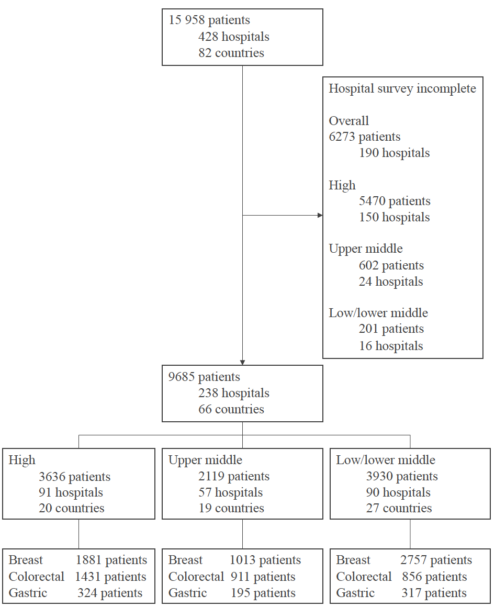

Table 1. Distribution of hospital facilities by country income group
WB income (tertile) |  | High  (n = 91) | Upper middle  (n = 57) | Low/lower middle  (n = 90) | Total  (n = 238) | p
MDT availability |  | 89 (97.8) | 53 (80.3) | 71 (73.2) | 213 (83.9) | <0.001
Oncologist available in hospital |  | 85 (93.4) | 46 (80.7) | 63 (70.0) | 194 (81.5) | <0.001
Palliative care available in hospital |  | 68 (74.7) | 31 (47.0) | 38 (39.2) | 137 (53.9) | <0.001
Opioid medication available |  | 84 (92.3) | 53 (80.3) | 51 (52.6) | 188 (74.0) | <0.001
Ultrasound available |  | 77 (84.6) | 58 (87.9) | 81 (83.5) | 216 (85.0) | 0.737
CT scan available |  | 87 (95.6) | 54 (81.8) | 61 (62.9) | 202 (79.5) | <0.001
Postoperative care facilities |  | 86 (94.5) | 52 (78.8) | 69 (71.1) | 207 (81.5) | <0.001
HDU/ITU bed available |  | 84 (92.3) | 48 (72.7) | 62 (63.9) | 194 (76.4) | <0.001
Pathology available in hospital |  | 66 (72.5) | 52 (78.8) | 67 (69.1) | 185 (72.8) | 0.391
Hospital type | Non-referral hospital | 25 (27.5) | 5 (7.6) | 7 (7.2) | 37 (14.6) | 0.001
 | Referral hospital | 56 (61.5) | 53 (80.3) | 78 (80.4) | 187 (73.6)
 | Specialist cancer hospital | 10 (11.0) | 8 (12.1) | 12 (12.4) | 30 (11.8)
Elective oesophagectomy available |  | 44 (48.4) | 35 (53.0) | 47 (48.5) | 126 (49.6) | 0.811

Figure 2. Distribution of outcomes across number of available hospital facilities
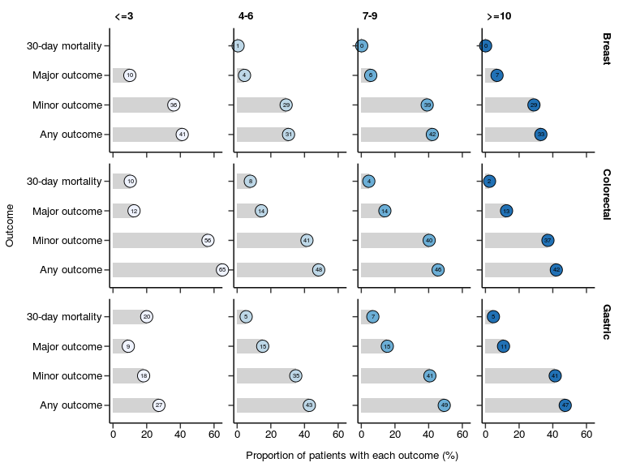

Figure 3. Distribution of hospital facilities by country income group (A), individual hospital facility (B), and Human Development Index (HDI; C)
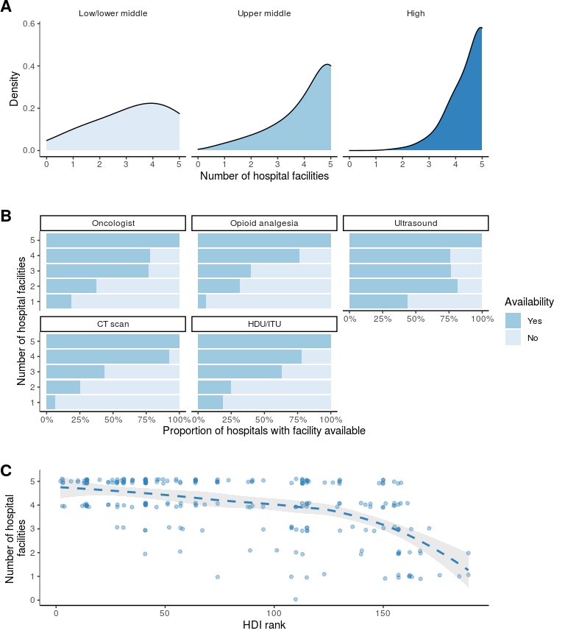

Table 2. Patient characteristics by hospital facility level
Hospital facility level |  | 5  (n = 6378) | 4  (n = 2013) | ≤3  (n = 1294) | Total  (n = 9685) | p
Distribution of patients across WB income (tertile)
 | High | 2669 (41.8) | 867 (43.1) | 100 (7.7) | 3636 (37.5) | <0.001
 | Upper middle | 1375 (21.6) | 251 (12.5) | 493 (38.1) | 2119 (21.9)
 | Low/lower middle | 2334 (36.6) | 895 (44.5) | 701 (54.2) | 3930 (40.6)
Cancer type
 | Breast | 3834 (60.1) | 1192 (59.2) | 625 (48.3) | 5651 (58.3) | <0.001
 | Colorectal (colon or rectum) | 2010 (31.5) | 654 (32.5) | 534 (41.3) | 3198 (33.0)
 | Gastric (stomach) | 534 (8.4) | 167 (8.3) | 135 (10.4) | 836 (8.6)
Age (years) |  | 57.9 (14.4) | 58.5 (14.2) | 56.2 (13.8) | 57.8 (14.3) | <0.001
Sex (%)
 | Male | 1489 (23.3) | 465 (23.1) | 379 (29.3) | 2333 (24.1) | <0.001
 | Female | 4886 (76.6) | 1546 (76.8) | 914 (70.6) | 7346 (75.8)
 | (Missing) | 3 (0.0) | 2 (0.1) | 1 (0.1) | 6 (0.1)
ECOG performance status
 | 0 | 3668 (57.5) | 1007 (50.0) | 612 (47.3) | 5287 (54.6) | <0.001
 | 1 | 1520 (23.8) | 519 (25.8) | 356 (27.5) | 2395 (24.7)
 | 2 | 750 (11.8) | 226 (11.2) | 157 (12.1) | 1133 (11.7)
 | 3/4 | 198 (3.1) | 94 (4.7) | 115 (8.9) | 407 (4.2)
 | (Missing) | 242 (3.8) | 167 (8.3) | 54 (4.2) | 463 (4.8)
ASA
 | I | 1385 (21.7) | 387 (19.2) | 382 (29.5) | 2154 (22.2) | <0.001
 | II | 3469 (54.4) | 1099 (54.6) | 668 (51.6) | 5236 (54.1)
 | III | 1191 (18.7) | 359 (17.8) | 148 (11.4) | 1698 (17.5)
 | IV | 89 (1.4) | 32 (1.6) | 22 (1.7) | 143 (1.5)
 | V | 6 (0.1) | 11 (0.5) | 3 (0.2) | 20 (0.2)
 | (Missing) | 238 (3.7) | 125 (6.2) | 71 (5.5) | 434 (4.5)
Stage
 | 0 | 192 (3.0) | 51 (2.5) | 11 (0.9) | 254 (2.6) | <0.001
 | I | 2631 (41.3) | 812 (40.3) | 334 (25.8) | 3777 (39.0)
 | II | 593 (9.3) | 216 (10.7) | 146 (11.3) | 955 (9.9)
 | III | 2456 (38.5) | 777 (38.6) | 608 (47.0) | 3841 (39.7)
 | IV | 453 (7.1) | 146 (7.3) | 179 (13.8) | 778 (8.0)
 | (Missing) | 53 (0.8) | 11 (0.5) | 16 (1.2) | 80 (0.8)
Urgency
 | Elective | 6081 (95.3) | 1850 (91.9) | 1180 (91.2) | 9111 (94.1) | <0.001
 | Emergency | 295 (4.6) | 161 (8.0) | 114 (8.8) | 570 (5.9)
 | (Missing) | 2 (0.0) | 2 (0.1) | 0 (0.0) | 4 (0.0)

Numbers are n (%) or mean (SD). High income included 20 countries and 91 hospitals. Upper-middle income included 19 countries and 57 hospitals. Lower-middle income or low income included 27 countries and 90 hospitals. The total column therefore includes 66 countries and 238 hospitals. ASA=American Society of Anesthesiologists. ECOG=Eastern Cooperative Oncology Group.

Table 3. Adjusted mortality rate across hospital facility level
Adjusted mortality rates were calculated using generalized estimating equations (GEE) to account for clustering of patients by hospital and potential confounders (WB tertile, age, gender, cancer type, ECOG performance status, ASA grade, disease stage, and operative urgency). Confidence intervals (CIs) and a P value for trend were fitted using the multilevel logistic regression model with the number of hospital facilities and all confounders as covariates

 | Hospital facility level | Hospital number (%) | Number of Patients (%) | Adjusted mortality (95% CI) | Odds ratio | P value
All cancers | 5 | 113 (47.7) | 5912 (66.6) | 1 (0.7 to 1.2) | Ref
 | 4 | 63 (26.6) | 1787 (20.2) | 1.5 (0.9 to 2) | 1.49 (0.94 to 2.37) | 0.092
 | ≤3 | 61 (25.7) | 1169 (13.2) | 3.7 (2.6 to 4.8) | 3.85 (2.58 to 5.75) | <0.001
Colorectal and gastric cancer | 5 | 105 (48.0) | 2388 (63.8) | 4.1 (3.8 to 4.3) | Ref
 | 4 | 57 (26.0) | 753 (20.1) | 5.2 (4.6 to 5.8) | 1.29 (0.88 to 1.89) | 0.217
 | ≤3 | 57 (26.0) | 602 (16.1) | 6.9 (6 to 7.8) | 1.73 (1.18 to 2.52) | 0.006

Table 4. Adjusted major complication rates across hospital facility level
Adjusted major complication rates were calculated using generalized estimating equations (GEE) to account for clustering of patients by hospital and potential confounders (WB tertile, age, gender, cancer type, ECOG performance status, ASA grade, disease stage, and operative urgency). Confidence intervals (CIs) and a P value for trend were fitted using the multilevel logistic regression model with the number of hospital facilities and all confounders as covariates

 | Hospital facility level | Hospital number (%) | Number of Patients (%) | Adjusted major complication rate (95% CI) | Odds ratio | P value
All cancers | 5 | 113 (47.5) | 5951 (66.7) | 9.1 (9 to 9.3) | Ref
 | 4 | 63 (26.5) | 1789 (20.1) | 10.3 (9.9 to 10.6) | 1.14 (0.96 to 1.36) | 0.139
 | ≤3 | 62 (26.0) | 1175 (13.2) | 11.4 (10.9 to 11.9) | 1.28 (1.05 to 1.57) | 0.017
Colorectal and gastric cancer | 5 | 105 (47.7) | 2405 (63.8) | 14 (13.7 to 14.3) | Ref
 | 4 | 57 (26.0) | 755 (20.1) | 15.8 (15.1 to 16.5) | 1.16 (0.92 to 1.45) | 0.210
 | ≤3 | 58 (26.3) | 608 (16.1) | 16.4 (15.6 to 17.2) | 1.21 (0.95 to 1.54) | 0.140

Table 5. Capacity to rescue patients following major complication following case-mix adjustment
Adjusted mortality rates after major complication were calculated using generalized estimating equations (GEE) to account for clustering of patients by hospital and potential confounders (WB tertile, age, gender, cancer type, ECOG performance status, ASA grade, disease stage, and operative urgency). Confidence intervals (CIs) and a P value for trend were fitted using the multilevel logistic regression model with the number of available hospital facilities and all confounders as covariates

 | Hospital facility level | Hospital number (%) | Number of Patients (%) | Adjusted capacity to rescue (95% CI) | Odds ratio | P value
All cancers | 5 | 86 (50.6) | 569 (65.0) | 81.2 (78 to 84.4) | Ref
 | 4 | 43 (25.3) | 173 (19.7) | 76.3 (69.9 to 82.7) | 0.75 (0.5 to 1.12) | 0.159
 | ≤3 | 41 (24.1) | 134 (15.3) | 69.4 (61.6 to 77.2) | 0.53 (0.34 to 0.8) | 0.005
Colorectal and gastric cancer | 5 | 73 (49.3) | 320 (58.3) | 71.5 (69.3 to 73.7) | Ref
 | 4 | 41 (27.7) | 119 (21.7) | 69.5 (65.5 to 73.5) | 0.92 (0.58 to 1.45) | 0.723
 | ≤3 | 34 (23.0) | 110 (20.0) | 56.4 (51.8 to 60.9) | 0.51 (0.33 to 0.8) | 0.004

Figure 4. Absolute risk for 30-day mortality associated with four or more hospital facilities within each income group stratified by cancer type and gender
Estimates for a patient of age 60 years, performance status 1, ASA grade 2, cancer stage III, and elective surgery.
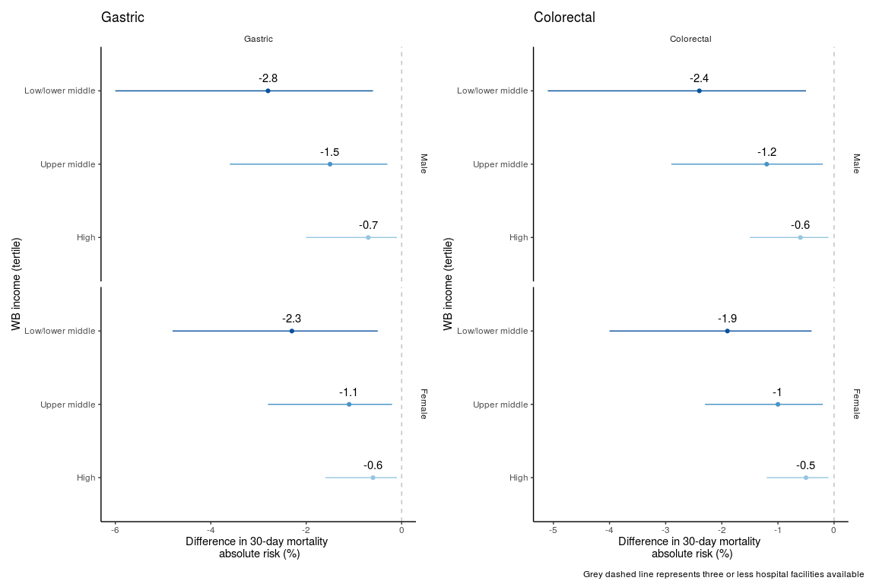

Discussion
In this prospective study of patients undergoing cancer surgery in 238 hospitals from 66 countries, higher availability of specific hospital infrastructure and resources were associated with improved outcomes. In particular, these capacities indicated an improved ability to prevent mortality following the development of postoperative complications, with up to four fewer deaths per 100 operations performed. Importantly, these findings were independent of country income group. Improving hospital facilities has long been thought to influence clinical outcomes in lower income settings; the magnitude of this effect is now clear.
Despite the overall mortality benefit seen in hospitals with more resources and strong processes, many patients do not have access to such facilities, particularly in low income settings.^{34,35} Improvements in hospital facilities are known to be cost-effective,³ however the absence of high-quality data limits interpretability, while the impact of specific hospital facilities on outcomes following cancer surgery worldwide were previously unclear. Strategic planning mandates detailed and accurate information, so that appropriate resources can be allocated and quality improvement prioritised. Determining the effectiveness of specific facilities can guide future investment and provide a platform for continued assessment of hospital performance.
Our results offer a concrete approach by focusing on specific infrastructure and resources in hospitals worldwide. Such hospitals perform significantly better than others without them: in the 62 hospitals with three or less facilities, mortality rates were three times higher than in 113 hospitals with all facilities present. This difference was explained by a 50% increase in the capacity to rescue patients following the development of a major complication, despite similar complication rates. These relationships were robust in sensitivity analysis and a similar trend was identified when all eleven hospital facilities were included. This suggests that a strategy of expanding system capabilities at hospitals, particularly in low- and middle-income settings, could markedly improve outcomes and patient access to safe, effective surgical care.
Others have found similar relationships between key hospital facilities and mortality. Funk et al found that the presence of complex medical oncology services and specific radiology services were important to lowering mortality in oesophagectomy patients.⁶ Similarly, Joseph et al found that several institutional characteristics had a stronger influence on operative mortality following pancreatic resection than hospital volume.³⁶ However, differences in major morbidity following surgery are often undescribed.^{6,29}
To our knowledge, this study is the first global analysis to assess the impact of hospital facilities on short-term outcomes in cancer surgery. The synergistic effect of scaling up of imaging, treatment modalities and quality in low-income settings on oncological outcomes has recently been shown.^{3,4} In particular, investments in imaging modality availability are a critical component for comprehensive improvement in global cancer survival.³ We suspect that they are markers for the expertise, resources, and complex processes of care required to facilitate surgery, including the optimisation of preoperative, intraoperative and postoperative care for patients undergoing surgery for cancer.
The five key facilities that were included in our multivariable models are likely indirect markers for other structural and process measures that are also closely related to outcomes following cancer surgery. For example, we found hospitals with more resources were more likely to use the WHO surgical safety checklist and achieve negative resection margins, potentially reflecting related organizational processes associated with these facilities. A similar pattern in outcomes was demonstrated in models including all eleven hospital facilities originally assessed, suggesting the five identified in our analysis may also reflect further development of additional hospital services. Higher levels of hospital facilities were also associated with increased access to surgical care for a broad range of cancer types. The majority of hospitals with all five facilities present were able to perform elective operations for eleven different cancers, which represent 60% of all incident cancers and 70% cancer deaths worldwide over the next ten years.³
Our study has important limitations. We have detailed hospital-level data for 55% of hospitals within the primary study, with responses low from high-income hospitals. However, we covered 87% patients in LMIC settings, where the majority of all cancer deaths occur.³⁷ Furthermore, adjusted mortality rates of non-included hospitals were similar, while a sensitivity analysis demonstrated robust findings across all measured outcomes. Therefore, a relationship between missing responses and measured outcomes is unlikely.
The five hospital facilities identified could represent additional, unmeasured structural and complex care processes. Despite capturing a broad range of hospital infrastructure and resources, we are unable to extrapolate our results to all additional resources a hospital may contain. However, as the number of hospital facilities increased, a clear trend in the capacity to rescue patients was demonstrated. Therefore, investment and improvement in overall hospital capability is likely to greatly improve early patient outcomes following cancer surgery. Further work validating our findings and exploring the effect of specific combinations, particularly in LMIC settings, is required.
We were also unable to follow up patients beyond 30-days after surgery. Little is known about longer-term outcomes such as cancer-free survival in resource-limited settings.^{1,3} Nevertheless, postoperative complications following major surgery can influence longer-term outcomes, including patient survival and disability.³⁰ Longer-term disease and overall survival following surgery may be lower in LMICs, particularly as patients presented with later stage disease. The impact of delayed surgery in life-years lost for stage I to III disease is well described in high-income countries,³⁸ however knowledge gaps exist globally.
Finally, we did not have information on surgeon volume or nurse to bed ratio, which are both known mediators in the relationship between hospital facilities and mortality.^{36,39,40} Debate still exists whether hospital volume versus hospital process is the primary reason for lower perioperative mortality in cancer surgery,^{36,41} particularly as available clinical resources often increase with hospital volume.^{36,42} Additional studies are required to determine their impact on hospital mortality globally.
In conclusion, the number of patients undergoing surgery in hospitals with reduced resources and weak processes of care is higher in low and middle-income settings, putting these patients at additional risk. Although early mortality following cancer surgery is known to be elevated in LMICs, the improvement of facilities can dramatically reduce perioperative mortality in these settings. A more comprehensive study of systems strengthening and improvement interventions to reduce postoperative mortality would provide important information on mechanisms to impact cancer surgery outcomes for the large numbers of patients who receive care at these institutions.

Data sharing
The dataset can be explored using an online visualisation application online (cancer.globalsurg.org). Hospital-level data can be shared by application to the corresponding author. For analyses of patient-level identifiable data within our trusted research environment, please contact the corresponding author.

References
1. Sullivan R, Alatise OI, Anderson BO, Audisio R, Autier P, Aggarwal A, et al. Global cancer surgery: delivering safe, affordable, and timely cancer surgery. Lancet Oncol. 2015 Sep;16(11):1193–224.
2. Meara JG, Hagander L, Leather AJM. Surgery and global health: a Lancet Commission. Lancet. 2014 Jan 4;383(9911):12–3.
3. Ward ZJ, Scott AM, Hricak H, Atun R. Global costs, health benefits, and economic benefits of scaling up treatment and imaging modalities for survival of 11 cancers: a simulation-based analysis. The Lancet Oncology. 2021 Mar 1;22(3):341–50.
4. Hricak H, Abdel-Wahab M, Atun R, Lette MM, Paez D, Brink JA, et al. Medical imaging and nuclear medicine: a Lancet Oncology Commission. Lancet Oncol. 2021 Mar 3;
5. National Institute for Health Research Global Health Research Unit on Global Surgery. Prioritizing research for patients requiring surgery in low- and middle-income countries. Br J Surg. 2019 Jan;106(2):e113–20.
6. Funk LM, Gawande AA, Semel ME, Lipsitz SR, Berry WR, Zinner MJ, et al. Esophagectomy outcomes at low-volume hospitals: the association between systems characteristics and mortality. Ann Surg. 2011 May;253(5):912–7.
7. Sheetz KH, Dimick JB, Ghaferi AA. Impact of Hospital Characteristics on Failure to Rescue Following Major Surgery. Ann Surg. 2016 Apr;263(4):692–7.
8. Reames BN, Ghaferi AA, Birkmeyer JD, Dimick JB. Hospital volume and operative mortality in the modern era. Ann Surg. 2014 Aug;260(2):244–51.
9. Global variation in postoperative mortality and complications after cancer surgery: a multicentre, prospective cohort study in 82 countries [Internet]. Vol. 397, Lancet (London, England). Lancet; 2021 [cited 2021 Feb 3]. Available from: https://pubmed.ncbi.nlm.nih.gov/33485461/
10. Surgery NGHRU on G. Quality and outcomes in global cancer surgery: protocol for a multicentre, international, prospective cohort study (GlobalSurg 3). BMJ Open [Internet]. 2019 May 1 [cited 2020 Jan 20];9(5). Available from: https://bmjopen.bmj.com/content/9/5/e026646
11. Bhangu A, Kolias AG, Pinkney T, Hall NJ, Fitzgerald JE. Surgical research collaboratives in the UK. Lancet. 2013 Sep 28;382(9898):1091–2.
12. Gospodarowicz M, Trypuc J, Cruz AD, Khader J, Omar S, Knaul F. CHAPTER 11. CANCER SERVICES AND THE COMPREHENSIVE CANCER CENTER. :43.
13. Health topics [Internet]. [cited 2021 Mar 24]. Available from: https://www.who.int/health-topics
14. NHS Data Model and Dictionary [Internet]. [cited 2021 Mar 24]. Available from: https://datadictionary.nhs.uk/
15. Types of Oncologists | Cancer.Net [Internet]. [cited 2019 Jan 10]. Available from: https://www.cancer.net/navigating-cancer-care/cancer-basics/cancer-care-team/types-oncologists
16. Oesophago-gastric cancer | Guidance and guidelines | NICE [Internet]. [cited 2019 Jan 10]. Available from: https://www.nice.org.uk/guidance/qs176/chapter/Quality-statement-2-Multidisciplinary-review
17. von Elm E, Altman DG, Egger M, Pocock SJ, Gøtzsche PC, Vandenbroucke JP, et al. The Strengthening the Reporting of Observational Studies in Epidemiology (STROBE) statement: guidelines for reporting observational studies. J Clin Epidemiol. 2008 Apr;61(4):344–9.
18. Ogrinc G, Davies L, Goodman D, Batalden P, Davidoff F, Stevens D. SQUIRE 2.0 (Standards for QUality Improvement Reporting Excellence): revised publication guidelines from a detailed consensus process. BMJ Qual Saf. 2016 Dec 1;25(12):986–92.
19. Dindo D, Demartines N, Clavien P-A. Classification of surgical complications: a new proposal with evaluation in a cohort of 6336 patients and results of a survey. Ann Surg. 2004 Aug;240(2):205–13.
20. Treadwell JR, Lucas S, Tsou AY. Surgical checklists: a systematic review of impacts and implementation. BMJ Qual Saf. 2014 Apr 1;23(4):299–318.
21. Walker IA, Reshamwalla S, Wilson IH. Surgical safety checklists: do they improve outcomes? British Journal of Anaesthesia. 2012 Jul 1;109(1):47–54.
22. NICE | The National Institute for Health and Care Excellence [Internet]. NICE. NICE; [cited 2021 Apr 9]. Available from: https://www.nice.org.uk/
23. November 15 U on, 2019. CoC Quality of Care Measures [Internet]. American College of Surgeons. [cited 2021 Apr 9]. Available from: http://www.facs.org/quality-programs/cancer/ncdb/qualitymeasures
24. Freitas A, Silva-Costa T, Lopes F, Garcia-Lema I, Teixeira-Pinto A, Brazdil P, et al. Factors influencing hospital high length of stay outliers. BMC Health Services Research. 2012 Aug 20;12(1):265.
25. Englert J, Davis KM, Koch KE. Using clinical practice analysis to improve care. Jt Comm J Qual Improv. 2001 Jun;27(6):291–301.
26. Haneuse S, Dominici F, Normand S-L, Schrag D. Assessment of Between-Hospital Variation in Readmission and Mortality After Cancer Surgical Procedures. JAMA Netw Open. 2018 Oct 5;1(6):e183038.
27. Manzano J-GM, Yang M, Zhao H, Elting LS, George MC, Luo R, et al. Readmission Patterns After GI Cancer Hospitalizations: The Medical Versus Surgical Patient. J Oncol Pract. 2018 Mar;14(3):e137–48.
28. Aiello Bowles EJ, Tuzzio L, Wiese CJ, Kirlin B, Greene SM, Clauser SB, et al. Understanding high-quality cancer care: a summary of expert perspectives. Cancer. 2008 Feb 15;112(4):934–42.
29. McCrum ML, Lipsitz SR, Berry WR, Jha AK, Gawande AA. Beyond volume: does hospital complexity matter?: an analysis of inpatient surgical mortality in the United States. Med Care. 2014 Mar;52(3):235–42.
30. Khuri SF, Henderson WG, DePalma RG, Mosca C, Healey NA, Kumbhani DJ, et al. Determinants of long-term survival after major surgery and the adverse effect of postoperative complications. Ann Surg. 2005 Sep;242(3):326–41; discussion 341-343.
31. Moons KGM, Altman DG, Reitsma JB, Ioannidis JPA, Macaskill P, Steyerberg EW, et al. Transparent Reporting of a multivariable prediction model for Individual Prognosis or Diagnosis (TRIPOD): explanation and elaboration. Ann Intern Med. 2015 Jan 6;162(1):W1-73.
32. GlobalSurg Collaborative and National Institute for Health Research Global Health Research Unit on Global Surgery. Global variation in postoperative mortality and complications after cancer surgery: a multicentre, prospective cohort study in 82 countries. Lancet. 2021 Jan 30;397(10272):387–97.
33. Donabedian A. The quality of care. How can it be assessed? JAMA. 1988 Sep 23;260(12):1743–8.
34. Bray F, Jemal A, Grey N, Ferlay J, Forman D. Global cancer transitions according to the Human Development Index (2008-2030): a population-based study. Lancet Oncol. 2012 Aug;13(8):790–801.
35. Allemani C, Matsuda T, Carlo VD, Harewood R, Matz M, Nikšić M, et al. Global surveillance of trends in cancer survival 2000–14 (CONCORD-3): analysis of individual records for 37 513 025 patients diagnosed with one of 18 cancers from 322 population-based registries in 71 countries. The Lancet. 2018 Mar 17;391(10125):1023–75.
36. Joseph B, Morton JM, Hernandez-Boussard T, Rubinfeld I, Faraj C, Velanovich V. Relationship between hospital volume, system clinical resources, and mortality in pancreatic resection. J Am Coll Surg. 2009 Apr;208(4):520–7.
37. Cancer [Internet]. [cited 2021 Mar 24]. Available from: https://www.who.int/news-room/fact-sheets/detail/cancer
38. Sud A, Jones ME, Broggio J, Loveday C, Torr B, Garrett A, et al. Collateral damage: the impact on outcomes from cancer surgery of the COVID-19 pandemic. Ann Oncol. 2020 Aug;31(8):1065–74.
39. Aiken LH, Clarke SP, Sloane DM, Sochalski J, Silber JH. Hospital nurse staffing and patient mortality, nurse burnout, and job dissatisfaction. JAMA. 2002 Oct 23;288(16):1987–93.
40. Elixhauser A, Steiner C, Fraser I. Volume thresholds and hospital characteristics in the United States. Health Aff (Millwood). 2003 Apr;22(2):167–77.
41. Birkmeyer JD, Stukel TA, Siewers AE, Goodney PP, Wennberg DE, Lucas FL. Surgeon Volume and Operative Mortality in the United States. New England Journal of Medicine. 2003 Nov 27;349(22):2117–27.
42. Wasif N, Etzioni DA, Habermann E, Mathur A, Chang Y-H. Correlation of Proposed Surgical Volume Standards for Complex Cancer Surgery with Hospital Mortality. J Am Coll Surg. 2020 Jul;231(1):45-52.e4.

